

QUANTIFYING THE IMPACTS OF URBANISATION ON URBAN AGRICULTURE OVER THREE DECADES, THE CASE OF EKURHULENI, SOUTH AFRICA

PERCEVERENCE KHUMALO (724740)

A research report submitted to the Faculty of Science, University of the Witwatersrand, Johannesburg, in partial fulfilment of the requirements for the degree of Master of Science (Geographical Information Systems and Remote Sensing) at the School of Geography, Archaeology & Environmental Studies

SUPERVISOR: DR. ELHADI ADAM

MAY 2019

DECLARATION
I, the undersigned, hereby declare that this research submitted for the degree Master of Science in Geographical Information Systems and Remote Sensing, at the University of the Witwatersrand, Johannesburg, is my own original work and has not been previously submitted to any other institution of higher education. I further declare that all sources cited or quoted are indicated and acknowledged by means of a comprehensive list of references.

………………………….
(Signature of candidate)

29 May 2019

ABSTRACT

Human beings affect the functioning of the earth system through the key process of Land use and Land cover change (LULCC). Among the many drivers of LULCC today are the rapid growth in population, the spread of urban centres, an increase in demand for food production and the scarcity of agricultural land. One of the main threats to urban agricultural system is urbanisation and urban extension. In South Africa, approximately 13% of the country is agricultural land and at least 22% is highly arable. However, this small agricultural land has continuously been lost due to intensive and rapid growths and extension of the industrial and residential land uses. This study aims is to investigate the impacts of the rapid urban growth in the Ekurhuleni on urban agriculture from 1985 to 2017 using Landsat multi-temporal data. Eight Landsat images were used to cover the period 1985 to 2017 with a 5-year interval to quantify the impacts of urbanisation on urban agriculture. The images were geometrically corrected and georeferenced to ensure that they conform to one another. 2017 image was used as the reference image. SVM was used to classify the images and the holdout test dataset was used for validation and accuracy assessment. Change detection techniques were then used to quantify the temporal extent of the urban area on the agricultural land. The overall accuracies from SVM for the images varied between 70 and 95%. The Kappa coefficient ranged from 0.7 to 0.9. Change detection statistics were produced from the classified maps in ENVI classic and the overall results showed that there was a decrease in the agriculture LULC class and an increase in the built-up area over the period of 30 years. The simulated LULC for 2049 was done using the cellular automata coupled with the artificial neural network model in QGIS MOLUSCE plugin. The prediction results for the year 2049 showed that built up area will continue to increase as a result of population growth and economic growth while urban agricultural land will continue decreasing. It is recommended in this study that higher resolution imagery should be used in further studies. Ancillary data such as socio-economic relationships will aid in better understanding LULCC in Ekurhuleni. This study recommends that more effort is put in place to protect land that is zoned out for agricultural purposes.

This study is dedicated to;

God, who has seen me through it all;

my mother Cecilia Mdluli
and
my beloved grandmother Mirriam Mdluli

and my fiancé Victor Mavika

ACKNOWLEDGEMENTS

Praise and honour be to God for seeing me through till this time, for his enduring mercies and his grace.
I would like to sincerely appreciate my Supervisor Dr Elhadi Adam for his great support and the supervision he offered during my research. His constructive comments proved as guidance for me to do better. I respect your work ethic and dedication. Thank you for your commitment and persistence.
I am very grateful to the lecturers for the fundamentals of GIS and RS that you taught me and their dedication to helping students. My thanks also extend to the staff members at the school of Geography, Archaeology and Environmental Studies.
I would like to express appreciation to my friends Nkanyiso Cele, Reneilwe Malatji, Bonolo Mahlatsi and Galalestang for making this journey bearable and fun.

Contents
ABSTRACT iii
ACKNOWLEDGEMENTS v
LIST OF FIGURES viii
LIST OF TABLES ix
ABBREVIATIONS AND ACRONYMS x
CHAPTER 1: INTRODUCTION 1
1.1 Background 1
1.2 Problem statement 3
1.3 Research aim 4
1.4 Objectives 4
1.5 Structure of the research report 5
CHAPTER 2: LITERATURE REVIEW 6
2.1 Urban Agriculture 6
2.2 Urbanisation 7
2.3 Land conversion 9
2.4 The role of Remote Sensing in monitoring urban growth in urban agriculture 10
2.5 Change Detection 13
2.6 Summary of lessons learnt in the literature review 14
CHAPTER 3: METHODOLOGY 15
3.1 Study Area 15
3.2 Data Acquisition 16
3.3 Data pre-processing 18
3.4 Reference Data 18
3.5 Image Classification 20
3.6 Accuracy assessment 21
3.7 Change Detection 22
3.8 Modelling future LULCC 23
CHAPTER 4: RESULTS 26
4.1 LULC Mapping 26
4.2 Accuracy Assessment 35
4.3 Summary of Land use and Land cover classes 37
4.4 Change detection statistics 38
4.5 Analysing Future LAND use and Land cover changes in Ekurhuleni 45
CHAPTER 5: DISCUSSION 47
CHAPTER 6: CONCLUSIONS, LIMITATIONS AND RECOMMENDANTIONS 51
6.1 Conclusions 51
6.2 Limitations of the Research 52
6.3 Recommendations 53
References 54

LIST OF FIGURES
Figure 1: Study Area (Ekurhuleni Metropolitan Municipality) 1
Figure 2: Summary of steps taken in processing Landsat imagery for Ekurhuleni 24
Figure 3: Ekurhuleni LULC Map in 1985 25
Figure 4: Ekurhuleni LULC Map in 1990 26
Figure 5: Ekurhuleni LULC Map in 1995 27
Figure 6: Ekurhuleni LULC Map in 2000 28
Figure 7: Histograms for land use land cover for the year (a) 1985 and (b) 1990 in percentage area…………………………………………………………………………………………...29
Figure 8: Histograms for land use land cover for the year (c) 1995 and year (d) 2000 in percentage…………………………………………………………………………………….29
Figure 9: Ekurhuleni LULC Map in 2005………………………...…………………………30
Figure 10: Ekurhuleni LULC Map in 2010……………………………………...…………..31
Figure 11: Ekurhuleni LULC Maps in 2015………………………………...………………32
Figure 12: Ekurhuleni LULC Maps in 2017……………………………………...…………32
Figure 13: Histograms for land-use and land cover for the year (a) 2005 and the year (b) 2010 in percentage area…………………………………………………………………………….33
Figure 14: Histograms for land use land cover for the year (a) 2017 and (b) 2015 in percentage area……………………………………………………………………………………..…….33
Figure 15: Histogram showing the overall relationship between agriculture and built-up area…………………………………………………………………………………………...34
Figure 16: Final changes for the classes agriculture and built up area from the year 1985 to the year 2017…………………………………………………………………………………35
Figure 17: Projected LULC for Ekurhuleni in 2049………………………...………………45

LIST OF TABLES
Table 1: Summary of studies previously done on the remote sensing of urban growth and urban agriculture 11
Table 2: Remote Sensing data acquisition 17
Table 3: LULC classes and description 19
Table 4: Confusion matrices for validation of classified maps (1985-2017) 36
Table 5: Summary of Land Use and Land Cover Classes in percentage and hectares from the year 2017 to the year 2005 37
Table 6: Summary of Land Use and Land Cover Classes in percentage and hectares from the year 2017 to the year 2005 38
Table 7: Percentage change matrix of LULC classes in Ekurhuleni Municipality from 1985 and 1990 39
Table 8: Percentage change matrix of LULC classes in Ekurhuleni Municipality from 1990 and 1995 40
Table 9: Percentage change matrix of LULC classes in Ekurhuleni Municipality from 1995 and 2000 40
Table 10: Percentage change matrix of LULC classes in Ekurhuleni Municipality from 2000 and 2005 41
Table 11: Percentage change matrix of LULC classes in Ekurhuleni Municipality from 2005 and 2010 42
Table 12: Percentage change matrix of LULC types in Ekurhuleni Municipality from 2010 and 2015 42
Table 13: Percentage change matrix of LULC types in Ekurhuleni Municipality from 2015 and 2017 43
Table 14: 2049 projected LULC changes in % 45

ABBREVIATIONS AND ACRONYMS

ASTER Advanced Spaceborne Thermal Emission and Reflection Radiometer
AVHRR Advanced Very High-Resolution Radiometer
CA Cellular Automata
CA-ANN Cellular Automata-Artificial Neural Network
DEM Digital Elevation Model
ENVI Environment for Visualizing Images
ETM Enhanced Thematic Mapper
ETM+ Enhanced Thematic Mapper Plus
GIS Geographic Information Systems
LULC Land use and land cover
LULCC Land use and land cover change
RADAR RAdio Detection and Ranging
RMSE Root Mean Square Error
SPOT Satellite Pour l’Observation de la Terre
SVM Support Vector Machine
TIRS Thermal Infrared Sensor
TM Thematic Mapper
USGS United States Geological Survey
UTM Universal Transverse Mercator
WGS World Geodetic System
UN United Nations
GADS Gauteng Agricultural Development Strategy
SACN South African Cities Network
CoE City of Ekurhuleni, Annual Report
GAPA Gauteng Agricultural Potential Atlas
DACE Department of Agriculture, Conservation and Environment
StatsSA Statistics South Africa
UNDP United Nations Development Programme
FAO Food and Agriculture Organisation

DAFF Department of Agriculture, Forestry and Fisheries

CHAPTER 1: INTRODUCTION

1.1 Background

Humans affect how the earth system functions through the key process of Land use and Land cover change (LULCC) (Turner et al, 2007). Among the many causes of LULCC today are the exponential growth of the population, the spread of urban centres, an increase in demand for production and the scarcity of land (Lo and Yang, 2002). Land use and land cover change have become a concerning issue to decision makers and researchers around the world today (Yun-long, 2001). LULCC responds to many factors such as cultural, environmental, political and socioeconomic conditions, which are highly influenced by human populations (Masek et al. 2000). LULCC has thus become a serious concern (Cheruto et al., 2016).

Agricultural land is decreasing continuously owing to intensive and increased growths and extension of the industrial and residential land uses (Niemand, 2011). One of the many diversions of land from its agricultural intended purpose is urbanisation and there has been an increasing awareness of the extent of conversion of the most fertile urban agricultural land (Ramsey and Corty, 1982). Urbanisation has become a pivotal factor in altering the landscape structure during the last two decades (Qviström 2017; Grimmond 2007). Statistics show that urban expansion is increasing with projections that by 2050, 68% of the global population will reside in urban areas, with 60% of rural areas becoming urban (United Nations [UN], 2018). Monitoring of urban growth has therefore over the years become an essential component for better management of natural resources and environmental changes (Ramsey and Corty).

Lambian and Geist (2007) suggest that there are many processes that contribute to urban growth such as social, economic and cultural processes. As the population grows and people are attracted by many factors to the cities, land needs to be cleared for more houses to be built (Ramsey and Corty, 1982). The conflict between land being used for other purposes other than what it is mainly zoned out for remains a raging war (Malik and Ali, 2015). Fuggle and Rabie (1992) agree that agriculture is the backbone of many societies as it provides the needs of our country and allows for future development in terms of food security for the growing population. It is therefore not only important to protect already cultivated land but also to protect land that has been zoned out for agricultural purposes, especially in our country where there are so much land ownership issues and only a small amount of arable land (Gauteng Agricultural Development Strategy [GADS], 2006).

Urbanisation is a leading human cause of the loss of agricultural land, decrease in natural vegetation cover and destruction of habitat (Malik and Ali, 2015; Lopez et al, 2001). The unprecedented rate at which the development is currently occurring is shocking (Turner et al., 2007). The increasing populations in urban areas have caused rapid changes in the LULC and because of this; urban growth has received notable attention towards monitoring its changes and its impacts (Dewan and Yamaguchi, 2009; Chen and Stow, 2002).

Only three to four percent of agricultural land in South Africa is suitable for growing crops; however, because of competition between agricultural and non-agricultural sectors, it has been degraded or converted for other commercial or residential use (Zhou et al., 2014; Collett, 2013). Arable land located mostly in urban area fringes can rarely be considered because there are always conflicts for other developments (Collett, 2013). Glaeser and Kahn (2012) point out that farmers are forced to sell their land as many government departments support the construction of residential developments, golf courses and other land uses on the urban fringe where most farms in the urban areas are located.

Quantifying LULCC is important as it enables us to better appreciate the relationship between natural phenomena and human interactions (Lu et al., 2004). Quantifying LULC is also important for planning land use and for the sustainable management of natural resources (Verburg et al., 1999). Accurate historical data are vital in mapping LULC changes over time (Abd El-Kawy et al., 2011). To monitor the interaction between urban growth and urban agriculture, timely spatial data and effective management systems are required (Jombo et al., 2016; Abd El-Kawy et al., 2011).

Remote sensing techniques have long been used to monitor urban growth (Abd El-Kawy et al., 2011). This is because remote sensing data is cost effective and its repetitive collection of digital data makes it easy for computer processing and sharing (Lu et al., 2004; Jensen, 1996). Different remote sensing data have been employed in studying urban growth. However, Landsat earth observation data have been preferred for urban growth studies due to its global wall-to-wall coverage and long archive data (Roy et al., 2014).

1.2 Problem statement

The great need for housing and the development of industries in most districts of Gauteng is rapidly contributing to land conversion and this is putting huge pressure on arable land (Bergstrom et al, 2005). This affects urban agricultural land negatively as the expansion of urban land means encroachment upon arable land (Malik, 2015). Not only does urban expansion result in loss of arable land, probably more importantly it adversely affects the farmers living in the highly populated urban fringes (South African Cities Network [SACN], 2004; Department of Agriculture, Conservation and Environment [DACE], 2006). The loss of urban agricultural land does not only threaten livelihoods of people who depend on agriculture for employment, but it also threatens the food security of the municipality as the food that is grown in the surrounding farms often supplies the local Ekurhuleni population (City of Ekurhuleni, Annual Report [CoE], 2011/2012). As such, urban agricultural land must be closely monitored (Malik and Ali, 2015; Sali, 2012).

The conversion of arable land to other uses has been seen more strongly in the municipality of Ekurhuleni than in any other municipalities in the Gauteng province. This is because of increased development in the economy and rapid population growth in the area over the years (SACN, 2004). The area is highly agricultural but most of this land has been used in various other ways such as residential activities, the building of industrial firms and more recently golf courses (Letlalo, 2016). In 2006 the (Gauteng Agricultural Potential Atlas [GAPA]) produced by (Department of Agriculture, Conservation and Environment [DACE], 2006) reported that the northern, southern and north-eastern parts of the municipality had been previously zoned out for agriculture. However, over the years, much of this agricultural land has been encroached on by building of settlements (Marutlulle, 2017). Settlements (both formal and informal) have taken over the southern and northern parts of Ekurhuleni due to the increased population which has led to inadequate housing services (CoE Report, 2010/2011; DACE, 2003). According to SACN (2004), Ekurhuleni has experienced rapid population growth and is reported as having had the fastest growing population country. The population growth has been greatly influenced by the influx of people coming into the municipality for job opportunities (Marutlule 2017; Statistics South Africa [StatsSA] 2006). The population for the years 1996, 2001, and 2011 were 2 026 087, 2 480 276 and 3 178 470 respectively (StatsSA, 2006). The projected population in 2019 is 4 874 225 (SACN, 2011).

Monitoring and understanding of urbanisation and urban agriculture is vital and requires opportune and accurate information (Mosammam et al., 2017; Shalaby et al., 2012). Monitoring urban growth and urban agriculture can be accomplished by using multi-temporal remotely sensed data (Shalaby and Tateishi, 2007). Remotely sensed data are inherently suited to provide information on urban growth attributes and the changes over time. It provides this information at various spatial and temporal scales (Hegazy and Kaloop, 2015; Shalaby et al, 2011). The multi-decade information that remote sensing provides serves as an important source for monitoring and assessing urban growth and the impacts that this growth has on agricultural land (Hegazy and Kaloop, 2015). The use of remote sensing and GIS will enable the municipality’s urban database to be monitored and continually updated to detect new changes (Yikalo and Pedro, 2010). Observing urban areas using remote sensing will aid in making predictions about future growth (Yikalo and Pedro, 2010). The constantly increasing accessibility and availability of remote sensing technologies will continue providing a unique capability in supporting decision makers with spatial, quantitative data that will help plan sustainable urban spaces and protect urban agriculture (Shalaby et al., 2012; Yikalo and Pedro 2010).

The importance of properly mapping urban growth and analysing its trends has been recognized by several researchers. Updating this growth and analysis through time is also important for decision-making activities (Shalaby et al., 2012). Deng et al. (2005) assessed the LULCC in an urban environment in Brazil. Shalaby et al. (2012) quantified the impacts of urban growth on agricultural land in Egypt. Urban growth results in loss of agricultural land which significantly changes the overall agricultural ecosystem (Shalaby and Tateishim, 2007). This research seeks to assess the impacts that urban growth has had on urban agricultural land in Ekurhuleni.

  - Research aim

This research aims to establish a better understanding of the impacts of the rapid urban growth in the Ekurhuleni on urban agriculture from 1985 to 2017.

  - Objectives

The specific objectives of this study are to;

- Map the urban growth from 1985 to 2017 with 5-year intervals, aided by the use of multi-temporal Landsat data and SVM.
- Quantify the impacts of growth of urban areas on agricultural land use using change detection
- Predict the future of urban growth in relation to agricultural lands in 30 years

  - Structure of the research report

The research report is presented in 6 chapters. Chapter 1 comprises of the introduction, background of the study, aim of the research and objectives. Chapter 2 is a review of the literature on related theoretical concepts and previous studies that are related to the research topic. An overview of the area of study and the methods will be addressed in chapter 3. Chapter 4 describes the main results of image classifications as well as the results from the simulation of LULCC model. The results were reviewed and discussed in Chapter 5 together with related studies and their findings. Chapter 6 will conclude the research by stating the overall achievement of the objectives, limitations of the study and recommendations.

CHAPTER 2: LITERATURE REVIEW

2.1 Urban Agriculture

Most developing countries have been practising urban agriculture for some time (Bryld, 2003). Approximately 800 million people residing in urban areas in the mid-1990s were involved in urban agriculture, both commercial and subsistence (United Nations Development Program [UNDP], 1996). However, since the 1970s urban agriculture has undergone radical transformation (Bryld, 2003), in some countries for the good and in most countries for the bad (Bryld, 2003; Egal et al., 2001). For example, between 1967 and 1991, the number of families engaging in farming in Dar es Salaam increased from 18% to 67% (Ratta and Nasr, 1996). This makes agriculture in Dar es Salaam the leading source of employment, after petty trade (Ratta and Nasr, 1996; UNDP 1996). The city of Kathmandu in Zambia produces more than a third of its food within the city (Bryld, 2003). While the urban agriculture of some countries is increasing, in most world urban areas it is the opposite (Nsiah-Gyabaah, 2000). In Asia, for example, urban agriculture has decreased from 70% to 46% in the period from the 1960s to the early 2000s (Bryld, 2003). It appears that over the years, urban agriculture has decreased overall globally and the main driving force behind the continuous loss of urban agricultural land is increased urban growth (Jiang et al, 2013; Nsiah- Gyabaah, 2000; Bentinck, 2000; Smith, 1996).

It is expected that 83% of the global population will reside in cities by 2050 and that the global population will be a staggering 9.7 billion (United Nations [UN], 2015). This poses a major challenge to the agricultural sector as it has to sustain such a significant population (Shalaby et al., 2012; Food and Agriculture Organization [FAO], 2008). This calls for drastic and sustainable strategies at both local and international level, to tackle the problem of future food security (FAO, 2008). As rural areas transform into towns and cities due to population and economic growth, peri-urban agriculture is negatively affected. Pro-urbanists argue that agriculture is meant for the ‘rural areas’ but as land conversion is happening at such a rapid pace, it begs the question of where this would happen (Viljoen 2005).

Egal et al. (2001) emphasize that urban agriculture significantly contributes to increased food security, accessibility and availability; it operates in the land of South Africa as a strategy for poverty alleviation and brings significant income to poor middle-income urban dwellers. Over the years, a decrease has been noted in the number of farms in the outskirts of the cities as the cities continue to expand (Shalaby et al, 2012). Over 60% of the urban population in Ghana cities depend solely on urban agriculture as a mainstream of employment and if agricultural land is then transformed to other land uses, depriving this sector of land, it means that the unemployment rate increases and people’s livelihoods are affected as they are left with no source of sustenance (Naab and Kasanga, 2013).

In urban areas, the cumulative effect of succession has increasingly made land very scarce for farmers on urban outskirts (Naab and Kasanga, 2013). Since there is so much competition in what land must be used for in urban centres, the value of land has shifted from considering the fertility of land that can be used for the urban agriculture purpose to that of its functions (Naab and Kasanga, 2013). This has caused procurement of some of the most fertile urban agricultural land for housing developments. The consequent decline in urban agriculture affects livelihoods and, in most cases, the poor, as well as the peri-urban farmers as they depend on agriculture for livelihood (Naab and Kasanga, 2013; Heilig, 2002).

2.2 Urbanisation

Urbanisation is traditionally measured by demographers as the population of urban dwellers divided by the population of a region (Asamoah, 2010; Mundia, 2005; Olima, 2003). It is also defined as the rate of change in the percentage of people living in urban areas annually (Hope et al, 1999). Nsiah (2000) further defines it as the alteration of a rural to an urban population; this also includes a significant increase in the number of people living in urban areas. Urbanisation, when defined loosely, can refer to rural-urban transition that involves growth in population, land use, increased economic activity and many other factors (McGranahan and Satterthwaite, 2014). From all the above definitions, it stands out that the term urbanisation has to do with a concentration of people. For the purposes of this research therefore, urbanisation will be defined as the concentration of population in a space at a time.

In over six continents, rapid pollution growth has become a very salient feature (Gong et al., 2012). Many countries that are developing are experiencing an urbanisation explosion not anticipated (Bhattacharya, 2002). Bentinck (2000) confirms that the cities are growing at a rapid rate and shall continue to grow for the foreseeable future. Urban areas globally are growing at an unparalleled rate with an increasing number of people residing in urban areas than in any other human habitations (UN, 2008), and this simply implies that the world is increasingly becoming urban (Nsiah, 2000). Urbanisation is an inter-sectorial phenomenon and is the result of the political, economic and social developments that subsequently influence the growth of population and concentration in urban areas (World Bank, 2000).

Many people in the third world countries are moving from rural areas to urban areas, mainly escaping hostile rural conditions, subsequently, urban areas continue to attract people because of better opportunities (Naab and Kasanga, 2013). In Africa, the estimated sub-Saharan population was 688.9 million in 2002. It was expected to grow at a rate of 2.7% annually. The population of Africa is fast growing and is expected to double in 20 years as it doubled in the 1960s. (Naab and Kasanga, 2013). The same cannot be said about the economic growth which has a disappointing gross national product [GNP] rate of only 0.2% per annum (World Bank, 2000). This augment to already existing problems in Africa and the main one being food security (Egal et al., 2001).

Mundia and Aniya (2015) studied the rapid urbanisation in the city of Nairobi and found that the population increased from 500 000 in 1970 to 3 million people in 2015. The increased urbanisation has spiralled out of control, which has resulted in large sections of the population resorting to living in slums in marginal urban areas. Marutlule (2017) studied the causes of increased informal settlements in Ekurhuleni, South Africa and reached a conclusion that increased population influx into the city has made it impossible for the municipality to be able to provide adequate housing and services. Njoh (2003) identified that economic growth and industrialisation encourage rural-urban migration. As an area develops economically, the formal sector expands and creates job opportunities, which necessitate the movement of people into urban areas. Statistics show that the number of individuals residing in urbanised areas rose from 25% in the 1930s to 52% in 1980 (StatSA, 2006). Migration and immigration are the main contributing factors to urbanisation in South Africa (Cloete, 1985).

Urbanisation is the leading driver of loss of urban agricultural land in many countries and this poses dire consequences (Omomoh and Adeofun, 2005). From the year 1990 to the year 2020, it is estimated that at least 14 million hectares of land per year are converted for urban purposes in developing countries (Omomoh and Adeofun, 2005). Undoubtedly, this rapid urbanisation removes land for agricultural purposes and the competition for land use in urban areas leaves the urban agricultural sector neglected (Olawole et al., 2011).

2.3 Land conversion

Land conversion is defined as the process whereby land is converted from its original use to another. For example, lands being converted from agricultural to built-up area use (Malik and Ali, 2015). The idea of land being converted from one use to another is an ongoing debate. The two perspectives that reveal clearly this fright is the ongoing debate between ‘pro-ruralists’ and ‘pro-urbanists’ (Malik and Ali, 2015).

Pro-ruralists argue that converting agricultural land to non-agricultural uses has very negative impacts in that it reduces agricultural jobs, destroys investments in the irrigation infrastructure and livelihoods (Tan et al., 2009). It affects the overall production of agriculture and threatens food security (Asadi and Kalantari, 2014). This view also supports the argument that at least quarter of the earth’s population are living in dire poverty and therefore, conversion of land will only add to the problem (Malik and Ali, 2015; Asadi and Kalantari, 2014; United Nations, 2011). Pro-ruralists emphasize that agricultural land should be protected and reserved to maintain steady food production (Malik and Ali, 2015; Azadi et al., 2012).

Pro-urbanists have argued that land conversion is a natural expected result of urban growth (Azadi and Hasfiati, 2011). The decrease of agricultural production is an issue that can be solved by intensive agriculture and technological development on the already existing cultivated lands. Hence in their view, land conversion is not regarded as a threat now or in the near future (Azadi et al., 2012). Pro-urbanists conclude that land conversion is inevitable if economic development must take place and if the population will continue growing (Sherbinin et al., 2007).

Unrestrained conversion of land has a greater impact on the environment and notable impact in agricultural yield in particular (Asadi and Kalantari, 2014). USA, Egypt, China and Japan, among others, have tried conserving agricultural land without much success (del Mar Lopez et al., 2001). In African countries such as South Africa, Egypt, and some parts of Sudan, rapid economic development, higher population growth and urbanisation are the contributing factors to agricultural land conversion (Mundia and Aniya, 2007). Countries such as Germany have been reported to be losing at least 17ha of agricultural land a day while China and Indonesia lose up to 114ha of agricultural land a day (Azadi, 2010). Land conversion is thus a very serious issue that needs to be closely monitored (Ramsey and Corty, 1982).

2.4 The role of Remote Sensing in monitoring urban growth in urban agriculture

The scarcity of food and continuous conversion of agricultural land are matters of worldwide concern and urban growth is a major problem that threatens fertile land across the globe (Shalaby et al., 2012). Although urbanisation is a predictable process due to population growth and economic development, the encroachment of settlement areas on urban agricultural land poses dire consequences (Lee-Smith, 2010). The analysis of urban growth has thus assumed a critical role in decision making and planning activities, seeing that the world is getting more and more urbanised (Pedro et al., 2017). Determining and analysing the rate of urban growth spatially and the conversion of urban agriculture is necessary.

Remote sensing is extensively recognized as a powerful tool in mapping urban growth and monitoring of urban land use and land cover changes (Aboel et al., 2004). Many studies have acknowledged the importance of accurately mapping urban growth (Almutairi and Warner 2010). Using remote sensing, many studies have found that the expansion of urban areas occurs at the expense of agricultural land (Mendoza and Etter 2002; Rembold et al., 2000; Lambin and Ehrlich 1997). Olawole et al. (2011) used remote sensing data and GIS to monitor and quantify urban encroachment onto agricultural land in Zimbabwe. Their results showed an increase in urbanisation owing to the loss of urban farmlands. Olawole’s et al. (2011) findings are supported by Oyinloye (2010) who studied spatial growth in Ondo State in Nigeria and obtained results that showed agricultural conversion to urban use. More studies similar to the report that has been previously done are summarised in table 1. Recent studies seem to agree that as urban growth increases; increased fertile lands are destroyed and cannot be recovered. It is therefore very important to closely monitor the impacts that urban growth has had on urban agriculture for future planning activities.

Table 1: Summary of studies previously done on the remote sensing of urban growth and urban agriculture
Author/s and year | Study Area | Data | Methods | Main Findings
Hegazy and Kaloop (2015) | Daqahila Governorate, Egypt | -Landsat imagery | -Pre-processing and image interpretation was done ERDAS imagine software  -Used maximum likelihood classification | - Overall accuracy obtained was above 84%  -The main cause of urbanization was the rapid population growth  -built-up area increased from 28 to 255km² and a decrease in agricultural land by 33%
Mundia and Aniya (2005) | Nairobi, Kenya | -Landsat imagery  -Aerial photographs  -Geology and Soil Maps | -Pre-processing and image interpretation was done ERDAS imagine software  -used SVM classifier for classification | -overall accuracy obtained was 85%  -urban areas increased from 13.99% to 61.23%  -agriculture increased from 49% to 57% overtaking rangelands and grassland  -population influx from rural areas was one of the contributing factors of urban growth
Kurucu and Christina (2008) | Torbali, Turkey | -Topographic maps  -aerial photographs  -ASTER imagery | - Microstation (Bentley) and Geomedia, Image Analyst (Integraph) software were used for analysis and data input.  -mirror stereoscope was used to interpret aerial photographs | -fertile arable land was lost irretrievably due to the building of unplanned settlements and industrialisation  -15% of the area has been used for residential areas without planning  -urbanisation not only encroaches in agricultural land but creates new industrial zones
Shalaby and Ali (2012) | Qalubiya, Egypt | -Landsat  -Egypt Sat-1  -Soil Map | -Support Vector Machine was done in ENVI 4.7 for classification and analysis  -ArcGIS 9.2 was sued to study spatial distribution and for cross tabulation between areas of urban sprawl and soil data  -Maximum likelihood was used for classification | -overall accuracy was set between 80% and 90%  -expansion of urban areas was a result of urban agricultural land loss  -The conversion of agricultural land to urban area was due to the setting up of industrial zones  -population growth was found to be a high contributing factor to the loss of agricultural land.
Bolca, Turkyilmaz, Kurucu, Altinbas, Esetlili, and Gulgun, (2007) | Balcova, Turkey | -Aerial photographs  -IKONOS | - Intergraph Image Software  -Microstation-Bentley software was used to analyse aerial photographs | -urbanisation increased from 182ha to 686 ha  -urban farming land wetlands decreased from 1,121 ha to 656 ha  -population increase influenced by rapid migration to the area led to a rapid decrease in agricultural land.

2.5 Change Detection

Change detection is described by Singh (1989) as a process that is used to detect differences in the attribute of an object which are observed at different time intervals (Jovanović et al., 2015; Shalaby and Tateishi, 2007; Singh, 1989). Multitemporal data sets are used to quantify temporal effects over time (Singh, 1989). There are three categories of change detection proposed by Shaoqing and Lu (2008) and these methods are; analysing the spectral type, analysing the spectral changes through vector analysis and the commonly known time series analysis. Change detection is useful in the management and monitoring of natural resources (Shalaby and Tateishi, 2007).
The four aspects of good change detection results listed by Macleod and Conglaton (1988) are;
- Change in the area
- The rate at which change is occurring
- Spatial distribution of the changes that occurred
- Accuracy assessment of change detection results

Some of the application where change detection has proved to be useful include habitat fragmentation, assessing coastal changes, land use change, quantifying urban sprawl and other cumulative changes that happen over time (Lu et al., 2004). The methods that are used to achieve change detection have improved over the years as a result of increasing computer power and digital data manipulation. Some of the most commonly used change detection methods include image referencing, post classification, principal components analysis and image rationing (Lu et al., 2004).

Various studies have been done to assess how change detection has been used to monitor urban growth in urban agriculture. For example, Hegazy and Kaloop (2015) monitored urban growth and detected changes in land use in Egypt. The study found that over the years, Egypt has become highly urbanised and the expansion of urban areas is happening at the expense of agricultural land. Through change detection analysis, it was reported that at least 20% of the total agricultural area has been lost owing to rapid urbanisation. The analysis of the change detection results also provided a rate at which change is happening which may be useful in helping decision making and establishment of land policies. Prenzel and Treitz (2004) used change detection techniques to help the government in implementing environmental strategies to preserve the watersheds in Chakrar.
Often, LULC change is influenced by some factors and change detection can play a role in assessing whether specific changes have occurred due to certain factors (Moore, 2007). Some of these factors include land reform, land conflicts, natural disasters, wars, etc. (Jombo et al.,2016; Gorsevski, 2012). Mosammam et al. (2017) used change detection techniques in Qom city in Iran to monitor land use change and quantify urban sprawl. As with many studies, this research used a post-classification method to detect changes. Changes were detected between the years 1987 and 2013 and it was found that 31.91 % of agricultural land was lost to the built-up area and that built up area increased from 12% to 29.16%. Magidi and Ahmed (2018) assessed urban sprawl in the city of Tshwane, South Africa between the years 1984 and 2015. The research found that urban areas increased from 80557.54 ha in 1984 to 168475.14 ha in 2015. The rate of change was reported to be 3.25 ha per annum. Change detection is therefore useful as it provides a detailed insight of changes and quantifies the actual amount of changes (Butt et al., 2015).

2.6 Summary of lessons learnt in the literature review

The lesson learnt in the above literature review can be summarised as thus;
- The increase in urban areas causes drastic loss of urban agricultural land
- Urban agriculture serves as a source of supporting livelihoods in many African countries
- Remote sensing provides timely and accurate data that is used in monitoring urban growth and urban agriculture

CHAPTER 3: METHODOLOGY

3.1 Study Area

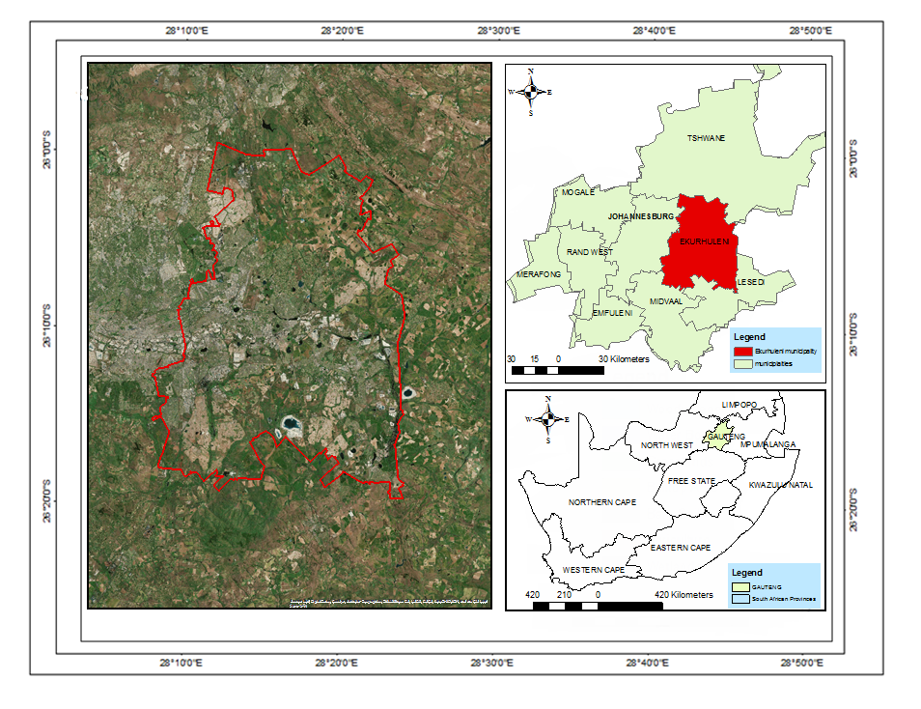
Ekurhuleni Municipality is located 26.1777° S and 28.3462° E. It is nested within the Gauteng Province, to the northeast of Johannesburg and is home to one of the busiest airports in Africa; OR Tambo international airport. Ekurhuleni Metropolitan Municipality comprises of 1924 square kilometres (average population density of 1313 per square kilometre) with an estimated population of 3 178 500 according to the 2011 statistics. It is reported to be a fast-growing municipality in South Africa ranking third in terms of average population (StatsSA, 2011; SACN, 2004). According to Ekurhuleni report (2011), the Ekurhuleni Metropolitan Municipality’s population has increased by more than 30 percent between 1996 and 2001, attributed to the influx of people.

Figure 1: Study Area (Ekurhuleni Metropolitan Municipality)

Ekurhuleni lies on the plateau at about 1600 metres in altitude. The city is rich in streams, pans, wetlands and rivers (CoE, 2011). The Southern and Northern parts of the study area were zoned out by the Department of Agriculture, Forestry and Fisheries [DAFF] as highly arable land (DAFF, 2013), which means that it has all the right conditions for agricultural activities. Agricultural activities of Ekurhuleni consist of annual crop cultivation, pivot irrigation, small farms and subsistence farming. Annual crop cultivation is dominant and some of the produces include maize, wheat, soya beans, sugar beans and sorghum (LED, 2002). Subsequently, over the years, the area has experienced urban sprawling with an increased number of informal settlements adversely affecting agricultural land (CoE, 2010/11).

3.2 Data Acquisition

The Landsat satellite multi-temporal imageries were acquired from the United States Geological Survey (USGS) website; (http://www.usgs.gov/). Landsat images for the years, 1985, 1990, 1995, 2000, 2005, 2010 and 2017 were downloaded. 1985, 1995 and year 2000 images were downloaded from Landsat 5 TM+ and 1900 image from Landsat 1-5 MSS. The images for the years 2005 and 2010 were downloaded from Landsat 7 ETM+, and finally, 2015 and 2017 images were from Landsat 8 OLI/TIRS. The Landsat data was selected since it is easily accessed and it is obtained free of charge. Landsat also offers a continuous collection of data records dating back to 1972 (Chander et al., 2009).
The cloud-free images were downloaded between the months of October and April (summer) which is the agricultural season. An interval of 5 years was used in this study to show any changes in urban growth and urban agriculture. However, to gather the most recent changes an interval of 2 years was allowed between the years 2015 and 2017.

Table 2: Remote Sensing data acquisition
Year |  | Date of Acquisition | Sensor |  | Spatial Resolution |  | Spectral Resolution
1985 |  | 17 January 1985 | Landsat 5 TM+ |  | 30 |  | 1. 0.45-0.52 (Blue)  2. 0.52-0.60 (Green)  3. 0.63-0.69 (Red)  4. 0.76-0.90 (NIR)
1990 | 24 January 1990 |  |  | Landsat 1-5 MSS |  | 60 |  | 1. 0.5-0.60 (Green)  2. 0.6-0.70 (Red)  3. 0.70-0.80 (NIR)  4. 0.80-1.10(NIR)
1995 | 08 December 1995 |  |  | Landsat 5 TM+ |  | 30
2000 |  | 08 January 2000 | Landsat 7 TM |  | 30 |  | 1. 0.45-0.52 (Blue)  2. 0.52-0.60 (Green)  3. 0.63-0.69 (Red)  4. 0.76-0.90 (NIR)
2005 | 24 February 2005 |  |  | Landsat 7 TM+ |  | 30
2010 | 6 February 2010 |  |  | Landsat 7 TM+ |  | 30
2015 |  | 14 January 2015 | Landsat 8 OLI\TRS |  | 30 |  | 1. 0.435-0.451 (Ultra Blue)  2. 0.42-0.512 (Blue)  3. 0.533-0.590 (Green)  4. 0.636-0.673 (Red)  5. 0.8.51-0.879 (NIR)
2017 | 18 January 2017 |  |  | Landsat 8 OLI\TRS |  | 30

3.3 Data pre-processing

Pre-processing is inevitable when performing change detection as there may be inaccuracies that result from bigger or smaller systematical mistakes, sensing device failures, angle noises, earth-sun distance, topography etc (Lu et al, 2004). Analysis requires very high accuracy in radiometric, geometric and atmospheric correctness, therefore correction is done to eliminate these factors (Lu et al, 2004). In this study, radiometric, atmospheric and geometric corrections were performed on the images. Radiometric correction involves matching histograms of the images from different years. Geometric correction entails co-registering the images so that they are directly aligned and the images ‘conform’ to each other (Baboo and Devi, 2011). The images were geometrically corrected using the image to image registration method. The overall Root Mean Square Error [RMSE] was 0.5 as recommended by Jensen (1996). 1985, 1990, 1995, 2000, 2005, 2010, and 2015 images were geometrically corrected to the 2017 image as it was chosen as the reference data. Spatial resampling of the images is important so that the spatial resolution of the images match (Baboo and Devi, 2011). The 1990 MSS image was resampled to 30m resolution using the nearest neighbour resampling method.

ENVI provides atmospheric correction tools such as Atmospheric Analysis of Spectral Hypercubes (FLAASH) and Quick Atmospheric Correction (QUAC) (Agrawal and Sarup, 2011). Multispectral and Hyperspectral sensors are supported by the ENVI correcting tools (Lu et al., 2004). Before the images are atmospherically corrected, radiometric calibration must be performed on the images. Radiometric calibration compensates for defects caused by the sensor, variations in scale angle and any noise that may be caused by the system (Lu et al., 2004). The FLAASH tool in ENVI was used to correct the reflectance of the surface and remove unwanted errors and noise (Lu et al., 2004). The images were rectified to Universal Transverse Mercator (UTM) projection, World Geodetic System (WGS) 1984- Zone 35 South.

3.4 Reference Data

The reference data was derived from two sources namely, Google Earth and satellite images. Google earth provides very good ground truth data in the absence of aerial photographs, if field work is not done or if the satellite images are not clear (Levi, 2010). Jin et al (2011) notes that the use of proportionally weighted training samples for each class reduced the probability of models over classifying classes that are under-represented while the use of balanced training samples reduced the probability of omission of under-represented classes from the model. This study relied on a balanced training sample range of between 400 to 500 points for all the seven classes for each year. The established understanding of the number of points collected for each class is 30 points; however, because the study area is huge, the range of points above 30 was considered adequate (Jin et al, 2011; Stehman, 1998). Digitising of the training samples for the year 1985, 1990 and 2000 was done in Google Earth as digitising on the Landsat images for the years proved to be hard because the images were not clear. Digitised polygons for each year were imported from Google as KML and then converted to shapefile using ArcMap 10.4. The feature to point function in ArcMap was used to convert the polygons into points. Ground points for the remaining years were digitised on the Landsat images as they were clear and classes could be easily identified. Although this was the case, Google Earth was used to visually verify the classes. The classes identified together with training and testing data samples for the study area are shown in table 3. For the accuracy assessment, the data was split using R software into 70% training data and 30% testing data.

Land use and land cover classes | Attributes | Training dataset | Test dataset | Total for each class
1. Water bodies | Rivers, Streams, dams, rivers, ponds, and reservoirs | 287 | 123 | 410
2. Built-up areas | Residential, Industrial, commercial structures band and factories | 343 | 147 | 490
3. Bare Soil | Un-vegetated land and exposed rocks. | 294 | 126 | 420
4. Grasslands | Land dominated by the continuous cover of grasses | 301 | 129 | 430
5. Woody Vegetation | Reserved and protected forest and trees growing in residences, along roads and near farms | 289 | 128 | 427
6. Agriculture | Land that is used for the production of food and fibre primarily. Both commercial and subsistence farming is included | 336 | 144 | 480
7. Wetlands | Consisting of swamps, marshes and very saturated land | 330 | 141 | 470
Table 3: LULC classes and description

3.5 Image Classification

Support Vector Machine [SVM] is a non-parametric supervised classification method that finds optimal classification hyperplane. It does so by the grouping of classes based on the Statistical Learning theory developed by Vladimir Vapnik in 1992 (Mather, 2004). SVM’s by root was used in the Statistical Learning Theory and only recently have been applied to satellite image classification due to its merits in overcoming high dimensionality, noisy data and non-Gaussian distribution of data (Bhavsar and Panchal, 2012; Mather, 2004). The training data was used to develop the SVM hyperplane and the testing data was then used to validate the hyperplane. SVMs are robust and they function by nonlinearly projecting the training data in the input space to a higher dimension by using a kernel function (Bhavsar and Panchal, 2012). SVMs also minimise the risk of misclassification by maximising the margin between data points and the decision boundary (Misra et al, 2009). The radial basis function is the most commonly used as it produces better results than other kernels and its use has gained popularity in remote sensing studies (Kumar et al., 2008). The model works by using the kernel trick transforms data and then based on the transformations of the data, finds the optimal boundary between possible outputs (Bhavsar and Panchal, 2012).
The equation for the Radial Basis Function is as follows (Kumar et al., 2017):

$$K:(x,xj)=(-y‖(xi,xy)‖ 2 ), y>0$$

Where y represents the gamma, which controls the width of the Gaussian kernel function

The accuracy of the algorithm is optimised based on defining kernel parameter y and the parameter C-cost (Kavzoglu and Colkesen, 2009). In this study, the radial basis function was used as the kernel type, with the gamma function of 0.144, classification threshold of 0.47 and penalty parameter of 100. A 10-fold cross validation which overcomes overfitting was utilised. The best performance that resulted from the testing of the kernel parameter and C was used in the SVM model training. The images were then classified using the optimised SVM parameter values (Misra et al, 2009). The R software was used to run the model for each image.

3.6 Accuracy assessment

The process of classification may yield errors as classification in images is not always 100% accurate. The errors may be as a result of many factors such as spectral confusion, system noise and in many cases the type of classifying algorithm used (Congalton, 2001). The accuracy of each class is determined by identifying pixels that are correctly classified in an area and then diving by the sum of all the correct pixels of all classes in a classified image (Congalton, 1991). The error confusion matrix gives an overall accuracy that shows the number of correctly classified pixels of an image.
The process of classification may result in errors such as errors of commission and errors of omission. Commission errors are a result of not identifying pixels correctly (Congalton, 1991). These pixels are incorrectly identified when one class is split into two or more classes or when incorrectly identified pixels are associated with a class as other classes (Congalton, 1991). When pixels that must have belonged to a certain class are not classified as such, errors of omission result (Congalton, 1991). The test dataset (30%) was used to generate the confusion matrix for the accuracy assessment. The confusion matrix was then used to calculate the overall, user’s and producer’s accuracies.
The percentage of the overall accuracy represents the probability that a random point is correctly classified on the map as is on the ground. The equation used to calculate overall accuracy is;

Overall accuracy = Σ (𝑐𝑙𝑎𝑠𝑠𝑒𝑠 𝑐𝑜𝑟𝑟𝑒𝑐𝑡𝑙𝑦 𝑐𝑙𝑎𝑠𝑠𝑖𝑓𝑖𝑒𝑑 𝑎𝑙𝑜𝑛𝑔 𝑑𝑖𝑎𝑔𝑜𝑛𝑎𝑙)
𝛴(𝑅𝑜𝑤 𝑡𝑜𝑡𝑎𝑙 𝑜𝑟 𝐶𝑜𝑙𝑢𝑚𝑛 𝑡𝑜𝑡𝑎𝑙)

The producer accuracy represents the number of pixels that are classified correctly in a particular class in the percentage of the pixel number that actually belongs to that class in the image and is calculated as;

Producer’s accuracy = 𝑁𝑢𝑚𝑏𝑒𝑟 𝑜𝑓 𝑡ℎ𝑒 𝑐𝑜𝑟𝑟𝑒𝑐𝑡𝑙𝑦 𝑐𝑙𝑎𝑠𝑠𝑖𝑓𝑖𝑒𝑑 𝑐𝑙𝑎𝑠𝑠 𝑖𝑛 𝑎 𝑐𝑜𝑙𝑢𝑚𝑛
𝑉𝑒𝑟𝑖𝑓𝑖𝑒𝑑 𝑖𝑡𝑒𝑚𝑠 𝑡𝑜𝑡𝑎𝑙 𝑛𝑢𝑚𝑏𝑒𝑟 𝑖𝑛 𝑡ℎ𝑎𝑡 𝑐𝑜𝑙𝑢𝑚𝑛

The consumer accuracy, commonly known as the user’s accuracy is computed by using pixels that are correctly classified to the overall pixels assigned to a particular class. The equation used to calculate user’s accuracy is;

User or Consumer accuracy = 𝐶𝑜𝑟𝑟𝑒𝑐𝑡𝑙𝑦 𝑐𝑙𝑎𝑠𝑠𝑖𝑓𝑖𝑒𝑑 𝑛𝑢𝑚𝑏𝑒𝑟 𝑜𝑓 𝑖𝑡𝑒𝑚 𝑖𝑛 𝑎 𝑟𝑜𝑤
𝑉𝑒𝑟𝑖𝑓𝑖𝑒𝑑 𝑖𝑡𝑒𝑚𝑠 𝑡𝑜𝑡𝑎𝑙 𝑛𝑢𝑚𝑏𝑒𝑟 𝑖𝑛 𝑡ℎ𝑎𝑡 𝑟𝑜𝑤

The Kappa coefficient was also used to measure the difference between the actual agreement between reference data and the classifier used to perform the classification versus the likelihood of agreement between the reference data and a random classifier. Kappa values range between 0 and 1. The strength of the relation between ground truth pixels and classification increases from 0 to 1.

3.7 Change Detection

Change detection statistics was used in ENVI Classic to see overall changes of the LULC of Ekurhuleni. Detailed change detection statistics between two periods are produced by a change detection model. The changes are reported in area changes, percentage changes and pixel changes. The change detection statistics were produced for the following year intervals (1985-1990, 1990-1995, 1995-2000, 2000-2005, 2005-2010, 2010-2015 and 2015-2017). Understanding how features are changing over time is very essential for sustainable planning and for natural resource management (Chen et al., 2012). Change detection identifies the changes that have occurred, the extent to which change has occurred and also the projection with which change is occurring (Macleod and Congalton, 1998).

Remote sensing uses a different number of techniques to detect change. Some of the techniques may include but are not limited to image regression, image digitising, image differencing, change vector analysis, and post-classification. Although the above methods have been used over time, it has not been identified which one is the best to use (Lu et al., 2004).

In this study, change detection statistics in the post classification tool in ENVI classic 5.2 was used. This provided detailed results of changes between the two images. The earlier image is recognised as the initial state and the later image as the final state. The classes where pixels have changed are reported in the form of an area, pixel count and percentage changes. In this report, only the changes in percentage were recorded. The change detection statistics were analysed in order to identify, describe and quantify the changes that have occurred (Hegazy and Kaloop, 2015).

3.8 Modelling future LULCC

Future LULC can be modelled using software packages like DINAMICA EGO, Land Change Modeller, CLUE-S and CA-MARKOV. These approaches use historical LULC to predict future LULC (Mas et al. 2014). The Markov Chain Analysis, Cellular Automata (CA), Logistic regression and GEOMOD are among the commonly used approaches for modelling and predicting future LULCC (Agrawal et al., 2002).

The Markov based approach involves the use of an object’s earlier state to predict its future state (Bell et al, 1977). The MOLUSCE (Modules of Land Use Change Evaluation) plugin in QGIS enables the use of the Markov approach to preparing transition matrices which are then used to predict future LULC (Jogun, 2016). It trains the simulation model based on four models namely; ANN (artificial neural networks), WoE (weights of evidence), LR (logistic regression) and multi-criteria evaluation (MCE) (Rahman et al., 2017). The cellular automata model approach is then used to produce the simulated land use map (Jogun 2016; Li and Li 2015; NEXTGIS 2017).

The simulation in this study was carried out using the MOLUSCE plugin in QGIS following the CA model approach. The CA model was coupled with the ANN (artificial neural network) method as this method has proven to be more accurate than linear regression (Jogun 2016). More importantly, the calculation of the parameters for the CA model is quite tedious, therefore, to overcome this problem and increase accuracy and efficiency CA was coupled with ANN. Simulation environment of CA models consists a grid of raster cells (Hedge et al., 2008). The ability and simplicity of the CA model to embody both mathematical and logistical based transition rules have made CA models very successful (Sanchez et al., 2014). The classified LULC maps of 1985 and 2017 were input into the model. 1985 was assigned for the initial state (time t1) and the 2017 map was assigned the final state (time t2). The spatial variables included were population density, main road networks and the DEM of Ekurhuleni. These variables were chosen based on previous studies findings that show them as main drivers of LULC change (Han et al., 2015; Al-sharif and Pradhan, 2013; in et al., 2008). The plugin has cellular automata simulation which was used to project the change in LULC (Wagner, 1997).

The CA-ANN model was selected for this study because it represents an advancement in spatiotemporal dynamic modelling and forecasting and it has been proved by recent studies to be effective in computing land use land cover change (Al-Rubkhi et al., 2017). Li and Li (2015) used a combination of CA-ANN model to simulate land changes. Using the CA-ANN model, Roy et al. (2015) predicted and monitored LULC in Bangladesh from 2010 to 2030. The above model is therefore popular and has been used in many studies.

Figure 2: Summary of Methodology

CHAPTER 4: RESULTS

4.1 LULC Mapping

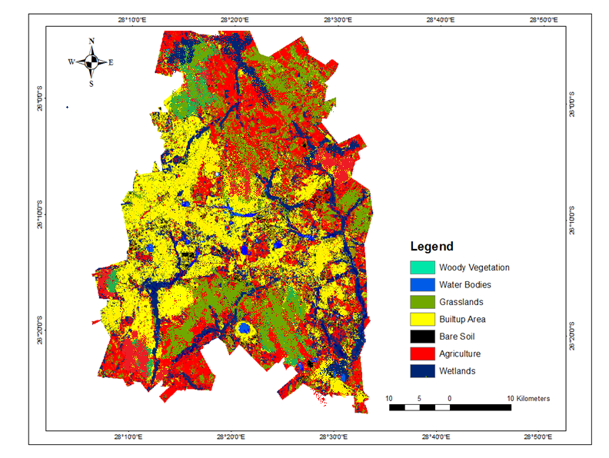
The LULC map for the year 1985 in figure 3 and the histograms in figure 7 show that LULC in Ekurhuleni was dominated by three major classes which are grasslands, agriculture and wetlands with a little built-up area, woody vegetation, bare soil and very little area covered by water bodies. At least 33% of the Ekurhuleni was covered in agriculture, 26% in grasslands and 21% in wetlands, with only 7.2% of built-up area. Water bodies only covered 0.2% and 5.41% of the area was covered by bare soil. It is shown in figure 3 that agriculture was mainly spread out in the southern and northern parts of the area.

Figure 3: Ekurhuleni LULC Map in 1985

The LULC map of the Ekurhuleni municipality in 1990 in figure 4 and the histogram in figure 8 shows that grasslands covered at least 11% of the area and wetlands covered at least 32% of the area. Over this period, there was a decrease in land covered by agriculture from 33% in the year 1985 to 30% in the year 1990. An increase in built-up area is also seen between the years 1985 and 1990, from 7.2% to 14.3%. Other LULC classes such as water bodies and woody vegetation do not show much change.
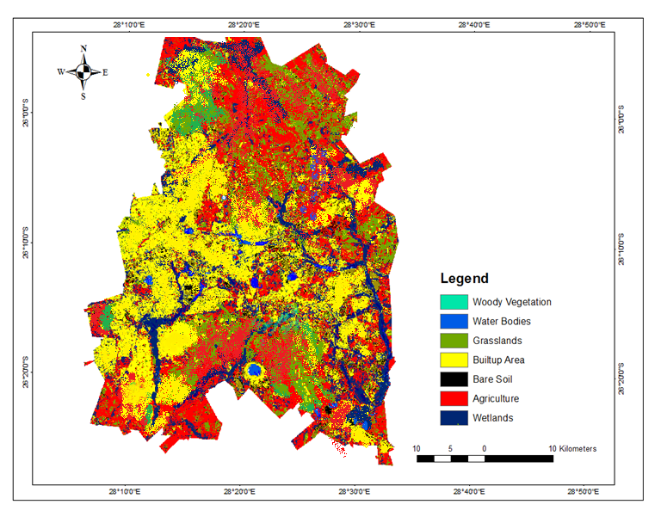
Figure 4: Ekurhuleni LULC Map in 1990
The 1995 LULC map is shown in figure 5 and the area coverage is shown in the histogram in figure 8 illustrate that there was a significant increase in both agriculture and built-up area, with a built-up area covering at least 36.7 % of the municipality and 27% covered by agriculture. A decrease in grasslands is shown from 30 % in 1990 to only 12% in the year 1995. Bare soil increased from 1% to 3%, woody vegetation and water bodies had negligible change, and no significant change is shown by the other classes. The LULC map in figure 5 shows that the built-up area was starting to encroach on agricultural land and grassland area.

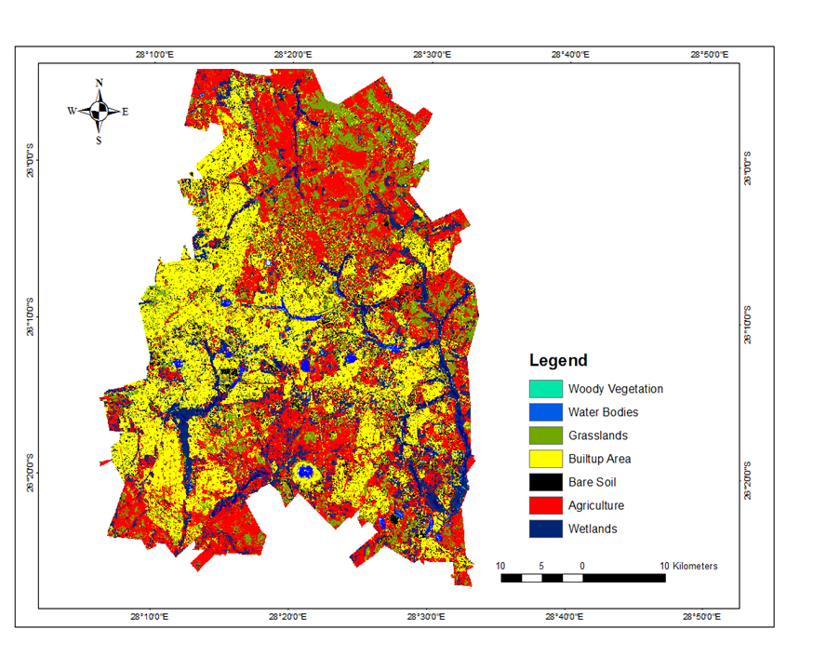
Figure 5: Ekurhuleni LULC Map in 1995
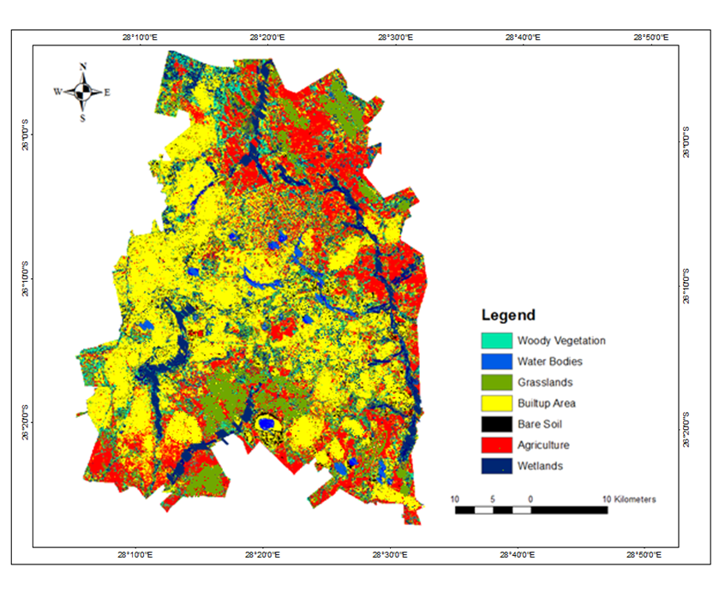
Figure 6: Ekurhuleni LULC Map in 2000

The year 2000 shows slight changes in the LULC classes. Wetlands covered 23% of the area, agriculture covered 21% of the area and the built-up area did not increase much from the year 1995 and covered 37%. Bare soil, water bodies and woody vegetation show not much significant change.

a)b)
Figure 7: Histograms for land use land cover for the year (a) 1985 and (b) 1990 in percentage area

c) d)
Figure 8: Histograms for land use land cover for the year (c) 1995 and year (d) 2000 in percentage

For the year 2005, a slight increase in water bodies is illustrated in figure 13 from 0.8% area coverage in the year 2000 to 4% in the year 2005. The histogram also shows that the area covered by woody vegetation class decreased from 8% in the year 2000 to 1% in the year 2005. Grasslands and bare soil show negligible change. Wetlands show a decrease from 23% to 14% in area coverage. The built-up area covered 35% of the area and agriculture covered 33% of the area.

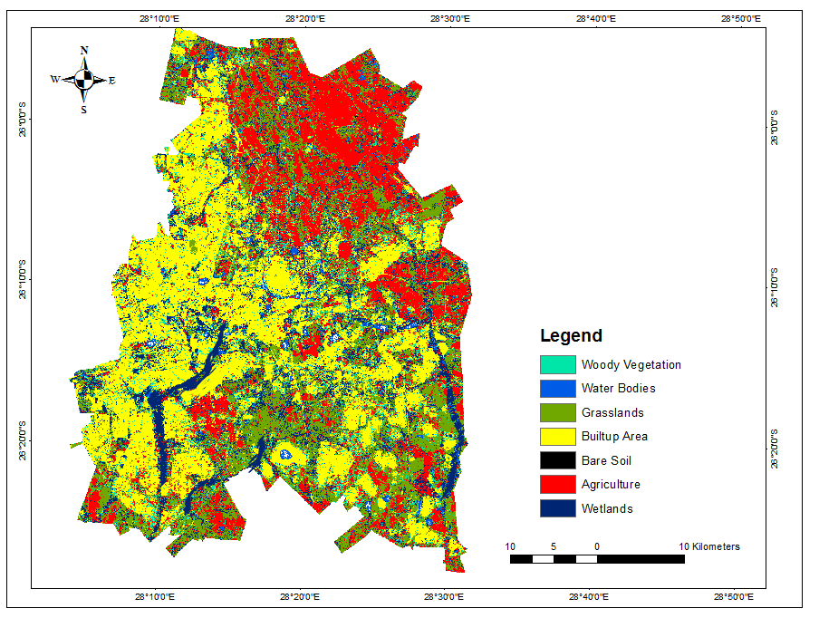
Figure 9: Ekurhuleni LULC Map in 2005

The histograms in figure 13 and figure 10 for the year 2010 show that there was a decrease in the bare soil and water bodies. The LULC map in figure 10 shows that built up area was continuing to spread towards the south of the area where most agricultural lands are found. An increase in grassland area coverage is illustrated in the LULC map in figure 10 and in the histogram in figure 13, from 10% for the year 2005 to 23% in the year 2010. A significant decrease is shown in the area coverage of agriculture from 33% in the year 2005 to 21% in the year 2010. The built-up area covered 35% of the area and there was no significant change in the wetland LULC class.

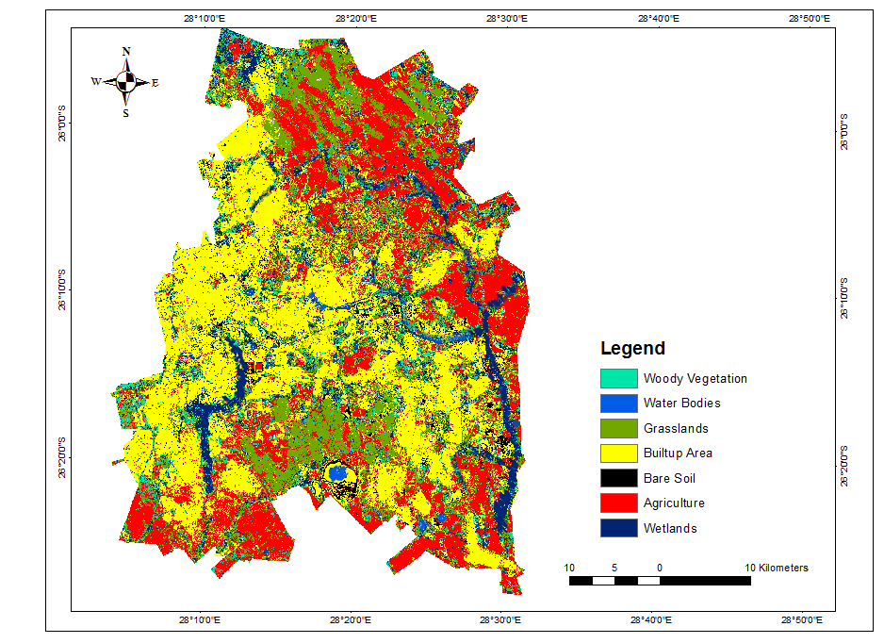
Figure 10: Ekurhuleni LULC Map in 2010
The LULC map of the Ekurhuleni Municipality in 2015 shown in figure 11 and also illustrated in the histogram in figure 14 illustrates that built up area covered 38% of the area. Agricultural land covered 20% of the Ekurhuleni. The land covered by grasslands was 24%, 8% by wetlands, 6% by woody vegetation, and 0, 7% by waterbody and bare soil. The LULC map in figure 11 shows a spread of built-up area in the south and towards the north of the study area. The western parts of the municipality are covered in a built-up area with little or no agricultural activity. From the year 2005 to 2015, there is a visible build-up of built-up area mostly in the southern parts of the area extending also to the eastern parts of the area. It is during this period that there was an influx of population in the area and erecting of informal settlements.
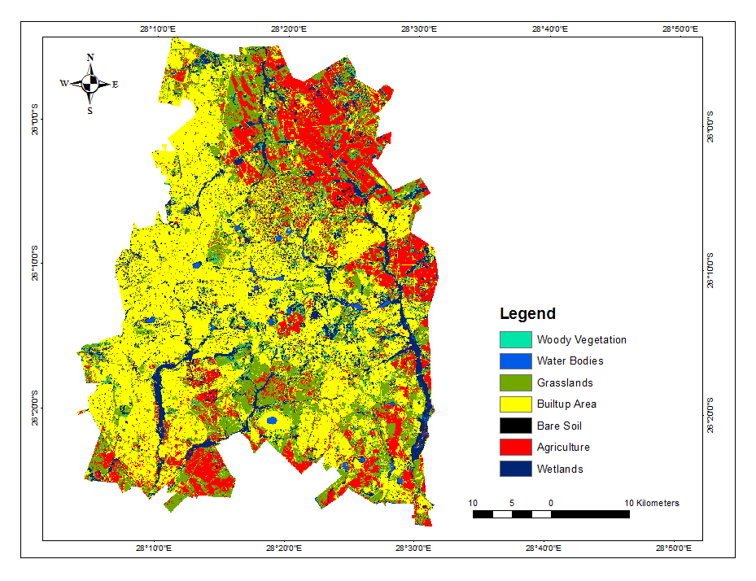
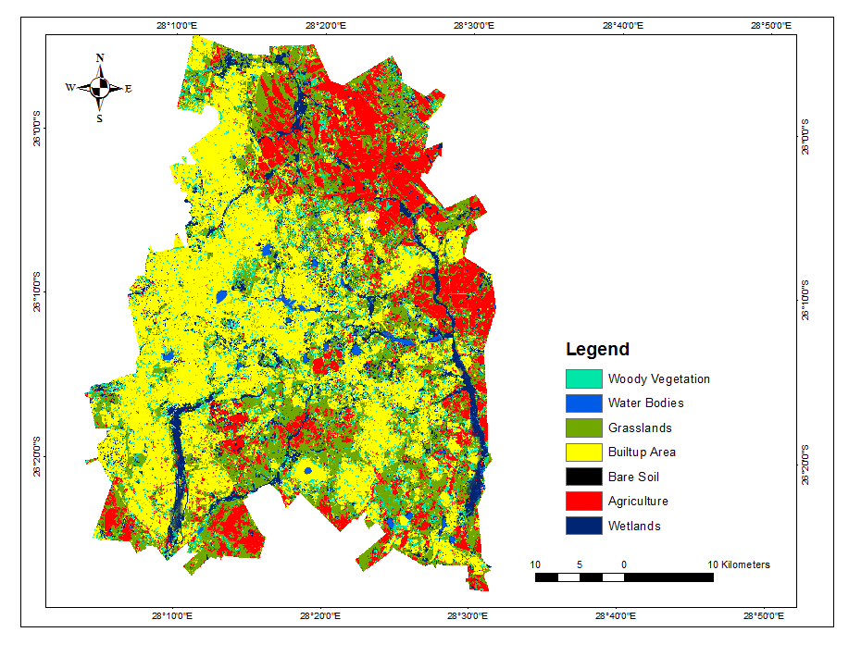
Figure 11: Ekurhuleni LULC Maps in 2015
Figure 12: Ekurhuleni LULC Maps in 2017
Figure 12 shows the 2017 LULC map illustrated in the histogram in figure 14. It is illustrated that built up area has a coverage of 48% of the Ekurhuleni Municipality, close to half of the area in Ekurhuleni, with other LULC classes sharing the remaining proportion. The land covered by agriculture is 18% and the area covered by grasslands is 19%, 1% by water bodies, 11% by wetlands, 2% by woody vegetation and less than 1% of bare soil. It can be clearly seen from the LULC map in figure 12 that most southern parts of the area that used to be agricultural land are now covered by built-up area and there appears to be a slow encroachment of built-up area in the north, where remaining thriving agricultural lands are found.

a) b)
Figure 13: Histograms for land-use and land cover for the year (a) 2005 and the year (b) 2010 in percentage area

c) d)
Figure 14: Histograms for landuse land cover for the year (a) 2017 and (b) 2015 in percentage area

The overall relationship between the built-up area and agriculture is shown in figure 15. It can be clearly seen that over the years the area covered by the built-up area has increased while the area covered by agriculture has decreased.

Figure 15: Histogram showing the overall relationship between the agriculture and built-up area

4.2 Accuracy Assessment

The confusion matrix function in ENVI classic 5.2 was used to produce the accuracy assessment of the classified images. The confusion matrix was produced using the ground control points that were digitised on google earth and satellite imagery. For the validation of the classified images, the 30% test data was used for each class. Anderson et al. (1976) recommend a threshold of above 80% for the error matrix and a recommended Kappa Coefficient above 0.5 for classification to be considered accurate. Table 4 illustrates the overall accuracy for the eight images and shows that the accuracy ranged from 70.5% to 91%. The year 2000 had the lowest overall accuracy in all the classes.

In table 4, it can be noted when comparing the user and producer accuracies that water bodies and woody vegetation have a higher level of accuracy than other classes. The accuracies of agriculture ranged from 65% to 90%. Bare soil class had the lowest accuracy for the year 1995 and wetlands had a low accuracy of 57.1% for the year 2000. The Kappa Coefficients ranged from 0.7 to 0.9 which meets the threshold of the recommended Kappa coefficient (Anderson et al, 1976).

Table 4: Confusion matrices for validation of classified maps (1985-2017)
Year | Accuracy Type | Overall  Accuracy % | Kappa  Coefficients | Water bodies % | Wetlands% | Woody Vegetation % | Grasslands % | Agriculture% | Built-up Area % | Bare Soil %
1985 | Producer | 80.4 | 0.70 | 97.2 | 84.5 | 80.2 | 95.4 | 74.4 | 80.1 | 81.3
 | User |  |  | 92 | 80.4 | 73.4 | 80.6 | 80.0 | 75.7 | 69.4
1990 | Producer | 83.4 | 0.76 | 94.6 | 86.7 | 83.5 | 92.8 | 64.5 | 82.3 | 82.5
 | User |  |  | 96 | 72.4 | 68.6 | 91.4 | 86.4 | 79.4 | 68.7
1995 | Producer | 86.5 | 0.80 | 96.8 | 86.4 | 86.8 | 69.8 | 86.6 | 86.6 | 70.2
 | User |  |  | 89.4 | 79.8 | 100.0 | 87.2 | 68.4 | 72.4 | 57.8
2000 | Producer | 78.2 | 0.76 | 94.6 | 65.4 | 97.3 | 68.5 | 74.8 | 69.4 | 74.3
 | User |  |  | 87.6 | 57.1 | 100.0 | 72.3 | 69.2 | 78.4 | 71.2
2005 | Producer | 85.8 | 0.79 | 98.6 | 75.8 | 89.6 | 78.2 | 72.3 | 72.7 | 69.5
 | User |  |  | 100.0 | 81.4 | 70.4 | 84.1 | 65.6 | 79.4 | 80.2
2010 | Producer | 86.6 | 0.83 | 92.5 | 84.2 | 82.3 | 86.5 | 85.7 | 100.0 | 70.3
 | User |  |  | 100.0 | 75.9 | 60.4 | 78.4 | 69.4 | 73.5 | 80.1
2015 | Producer | 90.3 | 0.91 | 96.7 | 88.8 | 70.2 | 93.4 | 87.6 | 100.0 | 79.4
 | User |  |  | 88.9 | 98.2 | 56.7 | 98.2 | 74.3 | 75.5 | 77.2
2017 | Producer | 94.1 | 0.94 | 98.9 | 90.5 | 82.5 | 90.4 | 96.7 | 100.0 | 86.7
 | User |  |  | 100.0 | 98.4 | 60.5 | 93.6 | 98.4 | 94.5 | 67.4

4.3 Summary of Land use and Land cover classes

SVM was used to generate the generated LULC maps of Ekurhuleni. Summary of the LULC class and the statistics of change over the period of over 30 years are tabulated in table 5 and 6 below:

Table 5: Summary of Land Use and Land Cover Classes in percentage and hectares from the year 2017 to the year 2005
 | 2017 |  | 2015 |  | 2010 |  | 2005
LULC class | ha | % | ha | % | ha | % | ha | %
Water bodies | 1243.17 | 0.628282 | 1396.17 | 0.758118 | 3610.53 | 1.989962 | 8491.77 | 4.310138
Wetlands | 21813.84 | 11.02443 | 15449.85 | 8.389244 | 25940.07 | 14.297 | 29437.65 | 14.94157
Woody Vegetation | 4476.42 | 2.262324 | 12243.87 | 6.648402 | 2921.22 | 1.61.046 | 1446.03 | 0.733956
Grasslands | 40610.61 | 20.52407 | 45752.94 | 24.84377 | 43405.2 | 23.923 | 21145.95 | 10.73298
Agriculture | 36545.85 | 18.46979 | 39494.43 | 21.44541 | 43754.94 | 24.11576 | 65581.38 | 23.28691
Built-up Area | 92216.61 | 46.60507 | 68493.42 | 37.19182 | 60906.24 | 33.56879 | 60919.2 | 30.92055
Bare Soil | 961.74 | 0.486051 | 1331.91 | 0.723225 | 898.92 | 0.495444 | 9996.48 | 5.073879

Table 6: Summary of Land Use and Land Cover Classes in percentage and hectares from the year 2017 to the year 2005
 | 2000 |  | 1995 |  | 1990 |  | 1985
LULC class | ha | % | ha | % | ha | % | ha | %
Water bodies | 436.32 | 0.880277 | 1929.6 | 0.576189 | 457.74 | 0.441998 | 422.82 | 0.258008
Wetlands | 11593.35 | 23.38961 | 21673.71 | 10.96478 | 33492.24 | 32.34044 | 35180.91 | 21.46768
Woody Vegetation | 3967.47 | 8.00438 | 15210.45 | 7.695003 | 8996.13 | 8.686751 | 9895.14 | 6.038095
Grasslands | 5294.16 | 10.68098 | 25632 | 12.96729 | 31906.53 | 30.80926 | 44060.76 | 26.88624
Agriculture | 10788.03 | 21.76487 | 53535.42 | 27.0837 | 12395.88 | 31.96958 | 53535.42 | 32.66775
Built-up Area | 16294.23 | 32.87365 | 72643.86 | 36.7507 | 14889.51 | 14.37746 | 11911.41 | 7.26844
Bare Soil | 1192.68 | 2.406235 | 7041.6 | 3.562362 | 1423.44 | 1.374488 | 8872.02 | 5.413779

4.4 Change detection statistics

In analysing and assessing change in the area of Ekurhuleni, change detection statistics for the years 1985, 1990, 1995, 2000, 2005, 2010, 2015 and 2017 images were produced. Assessment of the differences in the images was done by loading an earlier image and a later image on ENVI classic 5.2 to produce change detection matrices. The change was compared on the 1985 and 1990; 1990 and 1995; 1995 and 2000; 2000 and 2005; 2005 and 2010; 2010 and 2015 and 2015 and 2017 images. The result was a table that shows the initial state and the final state. The change matrix produced a total area of change for each class in the initial image. In this study, only the percentage of change was tabulated. The matrix also shows the class total, class changes and the image difference. The class total must always sum up to 100. The class changes show how much percentage area of the class has changed from that class into other classes between the earlier image and the later image and finally, the image difference shows the total change between images of two periods. A decrease in the class is shown by an image difference that is negative whilst a positive image difference shows a gain in the class. The change detection matrix of the class types in the area of Ekurhuleni between 1985 and 1990 is shown in table 6. Change detection matrix between 1990 and 1995 is shown in table 7. The percentage areas that are bolded indicate a state of no change in the initial and final state.

Table 7: Percentage change matrix of LULC classes in Ekurhuleni Municipality from 1985 and 1990
YEAR | Initial State (1985)
Final state (1990) | CLASS | WV | W | WB | G | BU | BS | A
Final state (1990) | WV | 46.6 | 0.77 | 2.27 | 2.86 | 3.42 | 1.10 | 2.51
Final state (1990) | W | 2.59 | 36.50 | 2.45 | 9.23 | 10.23 | 3.26 | 12.52
Final state (1990) | WB | 0 | 1.82 | 61.4 | 0 | 0.05 | 0.03 | 2.06
Final state (1990) | G | 12.30 | 16.23 | 7.53 | 52.4 | 1.85 | 1.24 | 5.63
Final state (1990) | BU | 32.45 | 29.56 | 12.56 | 21.52 | 76.00 | 10.29 | 23.26
Final state (1990) | BS | 3.00 | 8.23 | 12.23 | 3.65 | 5.52 | 82.5 | 5.12
Final state (1990) | A | 3.06 | 6.89 | 1.56 | 10.34 | 2.93 | 1.58 | 48.9
Final state (1990) | Class Total | 100.0 | 100.0 | 100.0 | 100.0 | 100.0 | 100.0 | 100.0
Final state (1990) | Class changes | 53.4 | 63.5 | 38.6 | 47.6 | 24.00 | 17.5 | 51.1
Final state (1990) | Image  Difference | 125 | -71.09 | -784 | 1278 | 12003 | -2334 | -4123
NOTE: WV=Woody Vegetation, W=Wetlands, WB=Water bodies, G= Grasslands, BU=Built-up area, BS=Bare Soil, A=Agriculture. Percentage figure rounded off to two decimal places

Table 7 shows that built-up area, woody vegetation, grasslands had a positive image difference and increased by 12003, 125 and 1278 percentage area respectively. The table also illustrates that agriculture; bare soil, water bodies and wetlands had a negative image difference and decreased by 4123, 2334 and 71.09 percentage area respectively. The highest transformation in the agriculture class was to the built-up area and the second highest transformation was from woody vegetation to built-up area. Table 7 shows the highest transformation in the class wetlands to bare soil. The class that did not have much change was water bodies with 78.65% and the second being built-up area with 68.58%. The most change happened in the class of bare soil with 33% being transformed into a built-up area.

Table 8: Percentage change matrix of LULC classes in Ekurhuleni Municipality from 1990 and 1995
YEAR | Initial State (1990)
Final state (1995) | CLASS | WV | W | WB | G | BU | BS | A
Final state (1995) | WV | 46.50 | 3.40 | 2.56 | 1.83 | 3.56 | 6.35 | 0
Final state (1995) | W | 1.48 | 40.48 | 6.33 | 13.54 | 2.51 | 0.18 | 3.35
Final state (1995) | WB | 4.88 | 12.63 | 78.65 | 1.13 | 2.14 | 1.49 | 4.79
Final state (1995) | G | 18.47 | 16.66 | 5.23 | 41.65 | 12.37 | 11.29 | 12.19
Final state (1995) | BU | 16.56 | 14.53 | 1.14 | 18.56 | 68.58 | 33.68 | 21.50
Final state (1995) | BS | 1.44 | 23.604 | 10.029 | 14.26 | 8.238 | 33.83 | 0.10
Final state (1995) | A | 10.67 | 12.83 | 6.09 | 9.03 | 10.84 | 13.18 | 58.07
Final state (1995) | Class Total | 100.0 | 100.0 | 100.0 | 100.0 | 100.0 | 100.0 | 100.0
Final state (1995) | Class Changes | 53.50 | 59.52 | 21.35 | 58.35 | 31.42 | 66.17 | 41.93
Final state (1995) | Image Difference | 11.65 | -96.43 | 3227.78 | -120.74 | 93.93 | 354.45 | -61.453
NOTE: WV=Woody Vegetation, W=Wetlands, WB=Water bodies, G= Grasslands, BU=Built-up area, BS=Bare Soil, A=Agriculture. Percentage figure rounded off to two decimal places

The change detection matrix of the class types in the area of Ekurhuleni between 1990 and 1995 is shown in table 8 in percentages. LULC classes such as agriculture, grasslands and wetlands decreased by 61.45, 120.74, and 96.43 respectively. Woody vegetation, water bodies, built up area and bare soil increased subsequently with 11.65, 322.78, 93.93 and 354.45 respectively. Water bodies and built up area were not transformed in the year 1995. The biggest transformation was in the bare soil class to the built-up area. Water Bodies and Built-up area have the least class changes.

Table 9: Percentage change matrix of LULC classes in Ekurhuleni Municipality from 1995 and 2000
YEAR | Initial State (1995)
Final state (2000) | CLASS | A | BS | BU | G | WB | W | WV
Final state (2000) | A | 43.67 | 8.02 | 1.55 | 3.56 | 1.77 | 8.60 | 0.54
Final state (2000) | BS | 13.86 | 41.34 | 2.78 | 5.65 | 0 | 1.59 | 0.93
Final state (2000) | BU | 36.42 | 21.39 | 68.89 | 23.80 | 20.23 | 16.29 | 16.56
Final state (2000) | G | 11.13 | 12.75 | 3.07 | 40.95 | 7.639 | 9.25 | 9.29
Final state (2000) | WB | 0.69 | 0.47 | 1.06 | 1.28 | 52.34 | 0.08 | 0.14
Final state (2000) | W | 2.29 | 10.17 | 22.65 | 19.97 | 12.69 | 61.58 | 14.93
Final state (2000) | WV | 1.94 | 5.86 | 8.071 | 4.79 | 5.34 | 2.69 | 57.61
Final state (2000) | Class Total | 100.0 | 100.0 | 100.0 | 100.0 | 100.0 | 100.0 | 100.0
Final state (2000) | Class Changes | 56.33 | 58.66 | 31.11 | 59.05 | 47.66 | 38.42 | 42.39
Final state (2000) | Image Difference | -126.05 | -81.61 | 1705.12 | -51.196 | -97.133 | 21058.13 | -63.721
NOTE: WV=Woody Vegetation, W=Wetlands, WB=Water bodies, G= Grasslands, BU=Built-up area, BS=Bare Soil, A=Agriculture. Percentage figure rounded off to two decimal places

Table 10: Percentage change matrix of LULC classes in Ekurhuleni Municipality from 2000 and 2005
YEAR | Initial State (2000)
Final state (2005) | CLASS | BU | WV | W | G | A | WB | BS
Final state (2005) | BU | 37.72 | 27.56 | 10.23 | 6.85 | 10.59 | 15.23 | 35.10
Final state (2005) | WV | 8.78 | 46.86 | 3.02 | 3.35 | 3.67 | 3.85 | 2.88
Final state (2005) | W | 1.48 | 0.80 | 40.45 | 10.00 | 2.20 | 11.56 | 5.48
Final state (2005) | G | 22.78 | 10.56 | 17.34 | 43.10 | 18.24 | 0 | 8.96
Final state (2005) | A | 26.45 | 5.26 | 23.47 | 20.56 | 56.78 | 1.58 | 1.67
Final state (2005) | WB | 1.56 | 0 | 5.49 | 2.69 | 2.46 | 66.78 | 2.34
Final state (2005) | BS | 1.23 | 8.96 | 0 | 13.45 | 5.86 | 1.00 | 43.57
Final state (2005) | Class Total | 100.0 | 100.0 | 100.0 | 100.0 | 100.0 | 100.0 | 100.0
Final state (2005) | Class Changes | 62.28 | 53.14 | 59.55 | 56.9 | 43.22 | 33.22 | 53.43
Final state (2005) | Image Difference | 67.55 | -76.89 | 12.89 | -53.6 | -100.0.36 | -56.78 | -85.73
NOTE: WV=Woody Vegetation, W=Wetlands, WB=Water bodies, G= Grasslands, BU=Built-up area, BS=Bare Soil, A=Agriculture. Percentage figure rounded off to two decimal places

The transformations between the LULC between the years 1995 and 2000 are shown in table 9. As with the previous years, most agriculture classes were transformed into built-up with a percentage of 36.42%. 43.67% of agriculture did not change by the year 2000. 61.58% of the wetland class did not change between the years 1995 and 2000. Table 8 also shows built-up area and wetlands are the only classes that increased with 11705.12 and 21058.13 respectively. Waterbody, woody vegetation, agriculture, grassland and bare soil decreased with 97.133, 63.721, 1126.05, 51.196, and 81.61 respectively between the years 1995 and 2000.

It is shown in table 10 that a total of 66.78% and 56.78% in the year 2000 did not change by the year 2005 for water bodies and agriculture respectively. Class changes for water bodies amounted to 53.43%, 43.44% for agriculture. The highest class change between the years 2000 and 2005 was for the class built-up area with 62.28% change. The least class change was in the water bodies LULC class with 33.22%. It is also illustrated in the table that there was a decrease in the net image change for most classes except for the built-up area which increased by 67.55.

Table 11: Percentage change matrix of LULC classes in Ekurhuleni Municipality from 2005 and 2010

YEAR | Initial State (2005)
Final state (2010) | CLASS | WV | W | WB | G | BU | BS | A
Final state (2010) | WV | 54.61 | 0 | 0.08 | 1.35 | 2.60 | 10.25 | 3.50
Final state (2010) | W | 0.35 | 67.56 | 2.36 | 12.46 | 8.63 | 2.57 | 9.34
Final state (2010) | WB | 0 | 0.03 | 77.63 | 0 | 0.56 | 0 | 0
Final state (2010) | G | 5.32 | 8.74 | 0 | 70.44 | 0.23 | 2.56 | 7.63
Final state (2010) | BU | 20.63 | 18.24 | 10.54 | 11.19 | 78.46 | 32.61 | 10.46
Final state (2010) | BS | 8.57 | 1.75 | 6.52 | 2.36 | 3.63 | 42.33 | 0.06
Final state (2010) | A | 10.52 | 3.68 | 2.87 | 2.20 | 5.89 | 9.68 | 69.01
Final state (2010) | Class Total | 100.0 | 100.0 | 100.0 | 100.0 | 100.0 | 100.0 | 100.0
Final state (2010) | Class changes | 45.39 | 32.44 | 22.37 | 29.56 | 21.54 | 57.67 | 30.99
Final state (2010) | Image  Difference | 30.59 | -52.67 | -32.34 | -6.77 | 152.17 | -5.99 | -12.47
NOTE: WV=Woody Vegetation, W=Wetlands, WB=Water bodies, G= Grasslands, BU=Built-up area, BS=Bare Soil, A=Agriculture. Percentage figure rounded off to two decimal places

The percentage area coverage of 78.46% and 77.63% did not change between the period of 2005 and 2010 for the built-up area and water bodies LULC classes. 70.44% of grassland, 69.01% of agriculture, 42.33% of bare soil, 67.56% of wetlands did not change between the period of 2005 and 2010. Table 10 shows that the class with the most class changes was bare soil to other classes amounting to 57.67%. The least class change occurred in the built-up with only 21.54% change. The greatest transformation of bare soil was into the built-up area with a percentage of 32.61% and the lowest was into grassland with 2.56%.

Table 12: Percentage change matrix of LULC types in Ekurhuleni Municipality from 2010 and 2015
YEAR | Initial State (2010)
Final state (2015) | CLASS | WV | W | WB | G | BU | BS | A
Final state (2015) | WV | 65.44 | 0.16 | 3.78 | 1.23 | 2.36 | 4.63 | 1.23
Final state (2015) | W | 1.35 | 70.63 | 12.34 | 0 | 1.53 | 0.60 | 0
Final state (2015) | WB | 0 | 5.46 | 78.47 | 0 | 1.22 | 0 | 0
Final state (2015) | G | 4.63 | 2.90 | 0.12 | 60.59 | 0.01 | 1.83 | 1.80
Final state (2015) | BU | 13.54 | 18.23 | 2.40 | 34.67 | 86.45 | 34.62 | 25.63
Final state (2015) | BS | 4.59 | 0.32 | 1.86 | 0 | 5.43 | 56.41 | 5.60
Final state (2015) | A | 10.45 | 2.30 | 1.03 | 3.48 | 0 | 2.45 | 65.72
Final state (2015) | Class Total | 100.0 | 100.0 | 100.0 | 100.0 | 100.0 | 100.0 | 100.0
Final state (2015) | Class changes | 34.44 | 29.37 | 21.53 | 39.41 | 13.55 | 43.59 | 34.28
Final state (2015) | Image  Difference | 30.58 | -50.77 | -9.77 | 10.41 | 141.89 | -38.27 | -67.36
NOTE: WV=Woody Vegetation, W=Wetlands, WB=Water bodies, G= Grasslands, BU=Built-up area, BS=Bare Soil, A=Agriculture. Percentage figure rounded off to two decimal places

Table 13: Percentage change matrix of LULC types in Ekurhuleni Municipality from 2015 and 2017
YEAR | Initial State (2015)
Final state (2017) | CLASS | WV | W | WB | G | BU | BS | A
Final state (2017) | WV | 67.6 | 0.11 | 4.75 | 1.0 | 3.2 | 1.13 | 0.4
Final state (2017) | W | 0.11 | 74.5 | 0 | 1.8 | 0 | 0 | 2.4
Final state (2017) | WB | 1.3 | 3.4 | 93.11 | 0.9 | 0 | 0 | 0.1
Final state (2017) | G | 2.3 | 1.8 | 1.0 | 57.9 | 2.7 | 3.25 | 5.4
Final state (2017) | BU | 15.4 | 16.8 | 0.5 | 32.4 | 88.4 | 50.2 | 40.4
Final state (2017) | BS | 8.79 | 0.8 | 0.0 | 2.5 | 3.4 | 42.74 | 1.3
Final state (2017) | A | 4.5 | 1.51 | 0.64 | 3.5 | 2.3 | 2.68 | 46.4
Final state (2017) | Class Total | 100.0 | 100.0 | 100.0 | 100.0 | 100.0 | 100.0 | 100.0
Final state (2017) | Class changes | 32.4 | 25.5 | 6.89 | 42.1 | 11.6 | 57.26 | 53.6
Final state (2017) | Image  Difference | -9.00 | -13.45 | 13.24 | -50.56 | 124.67 | -3.55 | -55.90
NOTE: WV=Woody Vegetation, W=Wetlands, WB=Water bodies, G= Grasslands, BU=Built-up area, BS=Bare Soil, A=Agriculture. Percentage figure rounded off to two decimal places

Table 12 shows the transformations of the LULC types between the year 2010 and 2015. It is illustrated that water bodies, wetlands, grasslands, bare soil, and agriculture decreased by 9%, 50.77%, 38.27 % and 67.36% respectively. A percentage increase is shown in built-up area and grasslands with 141.89% and 30.58% respectively. Table 12 illustrates that 25.63% of agricultural land transformed into a built-up area. Another higher transformation occurred in the grasslands class with 34.67 % of grasslands transformed into built-up area. 13.54 % of woody vegetation also transformed into built-up area. The highest class changes occurred in the bare soil and grassland LULC classes between 2010 and 2015. Table 12 also illustrates that overall, the built-up area increased by 141.8. Woody vegetation, wetlands, water bodies, bare soil, and agriculture decreased by 30.58, 50.77, 9.77, 38.27, and 67.36 respectively.

Table 13 shows the transformations of the LULC types between the year 2015 and 2017. It is illustrated that woody vegetation, grasslands, bare soil and agriculture decreased by 9%, 13.45%, 50.56%, 3.55% and 55.90% respectively. A percentage increase is shown in built-up area and water bodies with 124.76% and 13.24% respectively. Table 13 illustrates that 40.4% of agricultural land transformed into built-up area. Another higher transformation occurred in the bare soil class. 50.2 % of bare soil transformed into built-up area. 15.4 % of woody vegetation also transformed into built-up area. The highest class changes occurred in the agriculture and bare soil LULC between 2015 and 2017. Table 13 also illustrates that overall, built-up area increased by 124.67 and water bodies also increased by 13.24. Woody vegetation, wetlands, grasslands, bare soil and agriculture decreased by 9.00, 13.45, 50.56, and 55.90 respectively.

Figure 16: Final changes for the classes agriculture and built up area from the year 1985 to the year 2017.

The final changes for the LULCC between the years 1985 and 2017 are shown in figure 16. It is illustrated that over the years there has been a rapid growth of the built-up area. The most change in the built-up area occurred between the years 1990 and 1995 and between 2010 and 2015. A significant decrease in agriculture is also shown in figure 16. The most significant decrease in agriculture occurred between the years 1985 and 1990; 1990 and 1995 and between 2010 and 2015. The above results have shown that the built-up area is the land use class that is using up agricultural space over the years.

4.5 Analysing Future LAND use and Land cover changes in Ekurhuleni

The modelling of the future LULC was done using a combination of two techniques, the cellular automata and artificial neural network model in QGIS’s MOLUSCE plugin which is based on cellular automata. The LULC in figure 17 indicates that the built-up area will continue overtaking urban agriculture especially in the southern parts of the area and approaching the northern-eastern parts of the area. The middle parts of the area will completely be covered by built-up area.

Table 14: 2049 projected LULC changes in %
LULC | 2017 | Projected percentage for 2040 | Percentage Change (2017-2040)
WV | 2.26 | 3.20 | 0.94
WB | 0.62 | 1.12 | 0.5
G | 20.52 | 14.20 | -6.32
BU | 46.61 | 58.70 | 12.09
BS | 0.48 | 1.48 | 1.00
A | 18.46 | 12.29 | -6.17
W | 11.02 | 9.01 | -2.01

Table 14 shows that built up area will increase by 12% and agriculture will decrease by 6%. A slight increase in the woody vegetation is shown in table 13 which is spread all over the area. Grasslands will decrease by 6% and bare soil will increase by 1%. Water bodies will increase slightly with 0.5% and 0.94% for the woody vegetation LULC class.

The increase in built-up area will likely be as a result of growth in population that is estimated to increase by 4% in the next census count. Ekurhuleni is an industrial hub and houses the best transport networks in Gauteng, this will continue serving as a destination for employment seekers and this will indefinitely result in a population increase in the area.

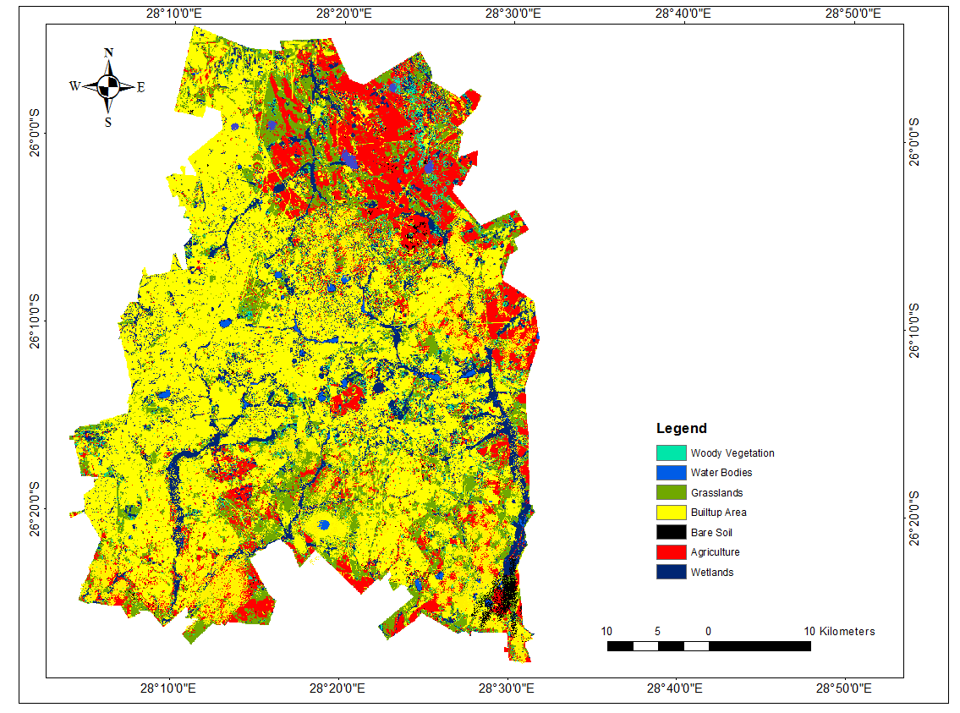
Figure 17: Projected LULC for Ekurhuleni in 2049

CHAPTER 5: DISCUSSION

This research sought to establish a better understanding of the impact of urbanisation on urban agricultural land. This was achieved by mapping land use and land cover of the municipality and quantifying the impacts of urban growth on urban agriculture using change detection. The overall study findings show that there is a remarkable increase in urban area land uses which have caused a drastic decrease in urban agricultural land.

Information regarding LULC changes is very important as it gives an understanding between the interactions of different land covers and land uses and helps in assessing environmental consequences that may result from these changes (Alqurashi and Kumar, 2017). Assessing LULC changes additionally aids in decision making which supports sustainable development for current and future planning (Alqurashi and Kumar, 2017). Numerous researches have been done looking into the rapid growth of urban areas and how that affects other land uses. Most recent studies have focused on the use of remote sensing on urban agriculture and on the use of remote sensing to quantify and predict urban growth in different parts of the world (Alqurashi and Kumar, 2017; Naab et al, 2013; Brilly et al, 2006; Abd El-Kawy et al, 2011).

The results of this study show that the dynamics of LULC classes changed rapidly over the period between 1995 and 2015 in the study area. For example, the built-up areas increased significantly during this period. The most converted land use to build up area was from agriculture, followed by bare soil and grasslands. The increase of new built-up area developments is clearly visible between the years 1990 and 2000 and the years 2000 and 2010. Eddy (2010) noted that an influx of people opted to move to Ekurhuleni as it is now an industrial hub of Gauteng and presents better job prospects (both in formal and informal sectors). He further states that the sprawling of the urban areas and settlements in the area are due to the population growth.

Ekurhuleni struggles to meet the housing demand caused by the population influx into the municipality; this has caused a rapid growth of informal settlements. Higher growth of population has been seen occurring mostly to the south of the area and in recent years towards the north and to the east because of the shortage of land (CoE, 2011). Informal settlements tend to concentrate mostly around and in the periphery of existing low-income areas such as Katlegong, Duduza, Kwa-Thema and Thokoza. The growth in the informal settlements had spiralled since the year 2005 (The Housing Development Agency [HDA], 2013). According to the Ekurhuleni City Annual Report (2011/2012), Ekurhuleni houses at least 130 000 households in informal settlements (about 22%) of the entire Ekurhuleni population. Zangiabadi (2013) found that informal settlements are growing across the globe and planners are struggling to solve this concerning issue. Ekurhuleni in no exception. According to the City of Ekurhuleni Annual Report (2010/11/7), the densification of urban areas post-1990 has led Ekurhuleni to become highly urbanised housing the most number of informal settlements in Gauteng. DAFF (2003) reports that many of the houses which are informal are situated on land that is not suitable for land housing but rather for agricultural purposes. Land for housing development has not been readily available (GAPA, 2003).

A gradual decrease is shown in agriculture in the Ekurhuleni over a period of 30 years. A massive decrease was recorded between the years 1990 and 2000 and between 2010 and 2015. The multi-temporal results and the change detection statistics show that most agricultural lands changed to built-up area. This was due to the population growth of the area. The study area has been the preferred destination for population movement because it offers job opportunities. The Statistics South Africa recorded that during the year 1991 and 2011, the population of Ekurhuleni grew by over 4% compared to other municipalities in Gauteng namely Tshwane and Johannesburg which grew by 2.60% and 2.49% respectively between 1991 and 2011. The increased population puts pressure on housing demands and the clearing of land for this has resulted in the loss of urban agricultural land (Marutlulle, 2017; GAPA, 2006).

The OR Tambo international airport, located in Ekurhuleni is the busiest airport in Africa. It links to major cities throughout the world and services the entire continent (Marutlulle, 2017). The main railway hub in South Africa is also found in Ekurhuleni, Germiston. It connects the city to major urban centres and ports in the Southern African Development Community [SADC] region (Marutlulle, 2017). The transportation projects include the Wadesville Alrode industrial corridor, City deep container terminal, the Gautrain rapid rail link to Tshwane and Johannesburg and the OR Tambo International industrial zone (Marutlelle, 2017). All the above factors make Ekurhuleni a likely target for job seekers from outside and inside the country. The great transport network in the study area has attracted creation of new businesses and establishment of industrial zones that produce material for the road network infrastructure and subsequently creating job opportunities (Marutlulle, 2017; Duranton and Turner, 2012). As more people move to Ekurhuleni for job opportunities urban area continue to grow.
Naab et al. (2013) noted that in urban areas land has become increasingly scarce for peri-urban farmers because of the cumulative effect of dominance and succession. Rapid urbanisation in Ghana has badly affected land cover and the changes in land use have subsequently led to agricultural land decrease in favour of built-up areas. As with Ekurhuleni, most peri-urban agricultural lands have transformed to built-up and this is reflected in the results that show the development of satellite townships which were agricultural land in the urban setting. Such townships include southern parts of Voslorus, Greater Nigel, Duduza, Palm Ridge greater parts of Katlegong, Emaphupheni, Glenmarais and many others. Alqurashi and Kumar (2017) also assessed the impact of urbanisation in the fastest growing cities of Saudi Arabia. It was found that LULC changes have been significant in the Saudi Arabia cities in the last 30 years and the results showed that most agricultural land has been converted to the built-up area.

The results illustrated that over the years there has been a drastic decrease in agriculture and a drastic increase in urban area. In 2003 (Department of Agriculture, Fisheries and Forestry [DAFF]) reported that at least 24.4% of existing agriculture and highly agricultural land have been lost to new developments and the developments consisted of industrial and residential. In light of the GAPA (2006) and the latest updated version of 2013 produced by DACE, confirms that agricultural land is still being converted to other land uses. In their findings, at least 10% of agricultural land has been lost to other land uses since the GAPA report in 2006 and this supports the findings of this research. Letlalo (2016) submitted that government officials are aware of the loss of agricultural land loss to other land uses and is of the view that little is done to put in place proper policies to protect land that is zoned for agriculture.

The economic growth of South Africa depends on infrastructure development, which several authors pointed out that as contributing to the transformation of agricultural land (Collett, 2013; Ranjith, 2011). It was further pointed out by Knox and McCarthy (2012) that there seem to be very little means put in place to preserve urban agricultural space. Numerous studies have been carried out by many researchers in different parts of South Africa with the concern of preserving agricultural space but daily, agricultural land is lost (Letlalo, 2017; Collett, 2013;).

The predicted LULC of the year 2049 shows that the built-up areas will increase by 12.09 % mainly covering the southern and north-eastern parts of the area. The increase in the built-up area will likely be as a result of population growth which is expected to be 4 874 225 in 2019 (SACN, 2011). Urban Agricultural land will decrease by 6.17% owing to increased urban growth. The findings of this research are aligned with Alrubkhi (2017) who simulated LULC in Boasher Willayat, Oman by 2025 using the logistic regression model coupled with cellular automata in QGIS MOLUSCE plugin. Both studies show an increase in built-up areas and a decrease in agriculture. The findings of these studies only differ in that Al-Rubkhi (2017) produced a projection for the year 2025 whilst the projection results for this study are for the year 2049. Mienmany (2018) also used a combination CA-ANN model in QGIS MOLUSCE plugin to simulate land use and land cover changes in Kyson Phomvihan District, Laos for the year 2022. The overall results of the study showed that built-up areas will increase by 7% and agricultural areas will decrease by 8.2%. Compared to the above studies, the model was accurate in simulating and predicting the urban growth of urban agriculture. Letlalo (2017) also confirmed that population growth in the Ekurhuleni will result in a lot of settlements being built which will adversely affect agricultural activities. This would be as a result of most peri-urban farmers likely losing their land due to being outbid by residential and industrial developments.

The projected continued loss of agricultural land as shown by the projection statistics and results could block economic growth in Ekurhuleni and affect the livelihoods of people who depend on the agricultural land for survival. Agriculture plays an important role in alleviating poverty and in providing food security. Continued loss of agricultural land could pose a threat to food security. Fuggle and Rabie (1992) reported that agricultural land is the most important component of South Africa’s natural resource base and provides the source for future development of the country, in terms of food security of its populations. United Nations assets that “agriculture is important in meeting the demands of future populations, especially in terms of eradicating poverty, providing food security and empowering rural communities in countries such as South Africa. Therefore, an adequate supply of quality agricultural land is essential for the economic, social and environmental wellbeing of the citizens of a country (Lyson and Olson, 1999).

CHAPTER 6: CONCLUSIONS, LIMITATIONS AND RECOMMENDANTIONS

The final chapter of this study consists of conclusion, limitations and recommendations. The analysis of Landsat images provided results which enabled analysis and quantification and provided a rich understanding of LULCC changes in Ekurhuleni and how urbanisation has impacted agricultural lands from 1985 to 2017.

6.1 Conclusions

In this study, eight Landsat images were used to quantify the impact of urbanisation on agricultural land in Ekurhuleni from 1985 to 2017. Remote sensing techniques and change detection method were found to be a very useful approach in achieving the research objectives. The objectives for the research were thus all achieved.

The following conclusions are drawn out from this study;
- The LULCC in the Ekurhuleni from the year 1985 to 2017 shows that bare soil decreased from 5% to 0.4 %. It was shown in the study that most of this bare soil was transformed into built-up area.

The area covered by woody vegetation decreased from 6% to 2%. Most of this LULC class was converted into grassland and very little into the built-up area.

Land covered with wetlands declined from 21% to 11% over the period of 30 years and the change detection statistics showed that most of this land was converted into built-up area.

In the year 1985, 33% of agricultural land covered the Ekurhuleni, due to urbanisation, this number decreased to only 15% by 2017. Ekurhuleni has therefore lost half of its agricultural land to urbanisation.

The land covered by water bodies increased significantly. Only 0.25% of land in 1985 was covered in the water bodies and this increased to 4%. Most of these water bodies consist of manmade dams and lakes in high-income settlements.

There was a decrease in the land covered by grassland. 26% of the land was covered by grasslands in the year 1985 and by the year 2017, grasslands only cover 18% of the Ekurhuleni.

- The impact of urbanisation on agriculture in Ekurhuleni was observed in this study. The classified images show that built up area has increased over a period of 30 years adversely impacting agricultural lands. The amount of agricultural land decreased from 33% in 1985 to 18% in 2017.

- The only impact on agricultural land was found to be urbanisation in form of built-up area

- Landsat data was used to quantify the LULCC in terms of hectares and percentages. Landsat can be analyzed to show LULCC and coupled with change detection methods together with GIS and remote sensing techniques, accurate results can be obtained. ENVI 5.2 software was used in this study to quantify the impact of agriculture to produce accurate results which are supported by the accuracy assessment which was done.

- Finally, the projection results which were produced for the Ekurhuleni for the year 2049 show that built-up area will increase by 12%. The main contributing factor to the increase of the built-up area would be increasing population. The increase in the built-up area will adversely affect agricultural land.

  - Limitations of the Research

- There were inadequate aerial photos with full coverage of the area for training samples collection for some of the years and as such the only reliable source was Google Earth
- Some years on Google Earth did not have data loaded and as such it made visual interpretation very hard in order to collect the training samples and this might have affected the classification process.
- There was a lot of inconsistencies in the Landsat images with the local datum and as such a lot of time was consumed in the making the formats consistent.
- The absence of high-resolution data such as World View and GeoEye-2, socio-economic data and other ancillary data hindered the production of more accurate results.

  - Recommendations

- The study showed that from the year 1985 to the year 2017, there has been a drastic increase in built-up area, of which part of the built-up area consists of informal settlements. It would be prudent for the city of Ekurhuleni to implement measures and policies on housing and to increase the housing services for its population.

- Findings of research studies similar to this one can be presented to policy makers and decision makers to serve as guidelines in assisting decision making

- This study showed that the main reason for the increase in built-up area was due to the population increase resulting from other factors that make Ekurhuleni attractive for settlement. It would be interesting if future studies to explored other factors that may be impacting agricultural land.

- This study used Landsat imagery to quantify LULCC. In future researches, high-resolution imagery should be used to improve classification accuracy.

- In this study, little ancillary data was used and the expansions of urban areas were found to be the only factor that causes the loss of agriculture. In future research studies, it would be interesting to use ancillary data such as economic growth data, climate data to determine if there are any other factors that lead to the agricultural loss in Ekurhuleni.

References

Abd El-Kawy, O.R., Rod, J.K., Ismail, H.A. and Suliman, A. S., 2011. Land use and land cover change detection in the western Nile delta of Egypt using remote sensing data, Applied Geography, vol. 31, no. 2, pp. 483-494.

Aboel Ghar, M., Shalaby, A., and Ryutaro, T. 2004., Agricultural Land Monitoring in the Egyptian Nile Delta Using Landsat Data, International Journal of Environmental Studies, 1(6) pp. 651–657.

Agrawal, G and Sarup, J., 2011. Comparison of QUAC and FLAASH atmospheric correction modules on EO-1 Hyperion data of Sanchi, International Journal of Advanced English Science Technology, 4, pp. 178-186.

Agrawal, C., Green, G., Grove, J., Evans, T., Schweik, C., 2002. A review and assessment of land-use change models: dynamics of space, time, and human choice. Delaware OH: USDA Forest Service.

Almutairi, A. and Warner, A.T., 2010. Change Detection Accuracy and Image Properties: A Study Using Simulated Data, Remote Sensing, 2, pp. 1508–1529.

Alqurashi, A.F. and Kumar, L., 2013. Investigating the use of remote sensing and GIS techniques to detect land use and land cover change: A review. Advances in Remote Sensing, 2(2), pp.193-204.

Alqurashi, A.F. and Kumar, L., 2017. An assessment of the impact of urbanization and land use changes in the fast-growing cities of Saudi Arabia. Geocarto International, pp. 1-20.

Al-Rubkhi, A.N.M., Talal, A.A. and Mohammed, A.B., 2017. Land Use Change Analysis and Modelling using Open Source (QGIS); A case study in Boasher Willayat (Doctoral Disserattion).

Al-sharif, A.A.A., Pradhan, B., 2013. Monitoring and predicting land use change in Tripoli Metropolitan City using an integrated Markov chain and cellular automata models in GIS. Arabian Journal of Geoscience. 2009

Asadi, A., Barati, A.A. and Kalantari, K., 2014. Analyzing and modelling the impacts of agricultural land conversion. The Business & Management Review, 4(4), p.176.

Asamoah, B., (2010). Urbanisation and Changing Patterns of Urban Land Use in Ghana: Policy and Planning Implications for Residential Land Use in Kumasi. (Unpublished MSc Theses) Department of Planning, Kwame Nkrumah University of Science and Technology.

Azadi, H., Ho, P. and Hasfiati, L., 2011. Agricultural land conversion drivers: A comparison between less developed, developing and developed countries. Land Degradation & Development, 22(6), pp.596-604.

Azadi, H., Van Acker, V., Zarafshani, K. and Witlox, F., 2012. Food systems: New‐Ruralism versus New‐Urbanism. Journal of the Science of Food and Agriculture, 92(11), pp. 2224-2226.

Baboo, S.S. and Devi, M.R., 2011. Geometric correction in recent high-resolution satellite imagery: a case study in Coimbatore, Tamil Nadu. International Journal of Computer Applications, 14(1), pp.32-37.

Bell, E. J. and Hinojosa, R.C., 1977. Markov analysis of land use change: continuous time and stationary processes. SocioEconomic Planning Sciences, 11, pp.13-17.

Bentinck, J., 2000. Unruly urbanization on Delhi’s fringe: changing patterns of land use and livelihood. Utrecht/Groningen: The Netherlands Geographical Studies.

Bergstrom, J.C., Dillman, B.L. and Stoll, J.R., 1985. Public environmental amenity benefits of private land: the case of prime agricultural land. Journal of Agricultural and Applied Economics, 17(1), pp. 139-149.

Bergstrom, J.C., Goetz, S.J. and Shortle, J.S., 2004. Post-productivism and changing rural land use values and preferences. In Land Use Problems and Conflicts, pp. 82-94.

Bhattacharya, P.C., 2002. Urbanisation in developing countries. Economic and Political weekly, 37, pp.4219-4228.

Bhavsar, H. and Panchal, M.H., 2012. A review on support vector machine for data classification. International Journal of Advanced Research in Computer Engineering & Technology, 1(10).

Bolca, M., Turkyilmaz, B., Kurucu, Y., Altinbas, U., Esetlili, M.T. and Gulgun, B., 2007. Determination of the impact of urbanization on agricultural land and wetland land use in Balçovas’ Delta by remote sensing and GIS technique. Environmental monitoring and assessment, 131(1-3), pp. 409-419.

Book, C., 2008. Advances in photogrammetry, remote sensing and spatial information sciences, 7. ISPRS Congress book. CRC Press.

Brilly, M., Rusjan, S. and Vidmar, A., 2006. Monitoring the impact of urbanisation on the Glinscica stream. Physics and Chemistry of the Earth, Parts A/B/C, 31(17), pp.1089-1096.

Bruzzone, L., Prieto, D.F. and Serpico, S.B., 1999. A neural-statistical approach to multitemporal and multisource remote-sensing image classification. IEEE Transactions on Geoscience and remote Sensing, 37(3), pp.1350-1359.

Bryld, E., 2003. Potentials, problems, and policy implications for urban agriculture in developing countries. Agriculture and human values, 20(1), pp.79-86.

Butt, A., Shabbir, R., Ahmad, S.S. and Aziz, N., 2015. Land use change mapping and analysis using Remote Sensing and GIS: A case study of Simly watershed, Islamabad, Pakistan. The Egyptian Journal of Remote Sensing and Space Science, 18(2), pp.251-259.

Campbell, J.B. and Wynne, R.H., 2011. Introduction to remote sensing. Guilford Press. New York, USA.

Chen, D. and Stow, D., 2002. The effect of training strategies on supervised classification at different spatial resolutions. Photogrammetric Engineering and Remote Sensing, 68(11), pp.1155-1162.

Chen, G., Hay, G.J., Carvalho, L.M. and Wulder, M.A., 2012. Object-based change detection. International Journal of Remote Sensing, 33(14), pp.4434-4457.

Cheruto, M.C., Kauti, M.K., Kisangau, P.D. and Kariuki, P.C., 2016. Assessment of land use and land cover change using GIS and remote sensing techniques: a case study of Makueni
County, Kenya, 5, pp. 175-176.

City of Ekurhuleni Annual Report, 2010/11 EMM human settlements, City of Ekurhuleni, Germiston. pp. 25.

City of Ekurhuleni Annual Report, 2011/12 EMM human settlements, City of Ekurhuleni, Germiston. pp. 97–101.

City of Ekurhuleni, 2011, A ten year history of Ekurhuleni – Housing, 2011, City of Ekurhuleni, Germiston, pp. 16.

Cloete, F. and Mokgoro, J., 1995. Policies for public service transformation, Juta and Company Limited, Cape Town.

Cloete, F., 1995. Local government transformation in South Africa, J.L. Van Schaik Publishers, Pretoria.

Cloete, J. J. N., 1997. South African Municipal government and administration, J.L. Van Schaik, Pretoria.

Cohen, B., 2006. Urbanization in developing countries: Current trends, future projections, and key challenges for sustainability, Elsevier, vol 28, pp. 63-80.

Collett, A., 2013. The impact of effective (geospatial) planning on the agricultural sector. South African Surveying and Geomatics Indaba, pp.22-24.

Congalton, R.G., 1991. A review of assessing the accuracy of classifications of remotely sensed data. Remote sensing of Environment, 37(1), pp.35-46.

Congalton, R.G., 2001. Accuracy assessment and validation of remotely sensed and other spatial information. International Journal of Wildland Fire, 10(4), pp.321-328.

del Mar López, T., Aide, T.M. and Thomlinson, J.R., 2001. Urban expansion and the loss of prime agricultural lands in Puerto Rico. Ambio: a Journal of the Human Environment, 30(1), pp.49-55.

Demirkesen, C. and Cherifi, H., 2008. A comparison of multiclass SVM methods for real world natural scenes. In International Conference on Advanced Concepts for Intelligent Vision Systems, pp. 752-763. Springer, Berlin, Heidelberg.

Department of Agriculture (DAFF)., 2003. Draft Sustainable Utilisation of Agricultural Resources Bill 2003 Department of Agriculture, Forestry and Fisheries, Republic of South Africa. Available at: https://www.daff.gov.za/daffweb3/Branches/Forestry-Natural-Resources-Management/Forestry-Regulation-Oversight/Projects-and-Programmes/Protected-Area-Planning

Department of Agriculture, Conservation and Environment (DACE) 2006. Protection of Agricultural Land in Gauteng, Revised Policy, 2006; Gauteng: DACE.

Dewan, A.M. and Yamaguchi, Y., 2009. Land use and land cover change in Greater Dhaka, Bangladesh: Using remote sensing to promote sustainable urbanization. Applied geography, 29(3), pp.390-401.

Eckert, S., 2011. Urban Expansion and its impact on urban agriculture-remote sensing based change analysis of Kizinga and Mzinga Valley-Dar Es Salaam, Tanzania. EARSeL eProceedings, 10(1), pp.46-55.

Eddy, G., 2010, ‘Fast Facts – South African Institute of race relations’, Economic Growth and Education Are the Keys 9(1), pp. 12–18.

Egal, F., Valstar, A. and Meershoek, S., 2001. Urban agriculture, household food security and nutrition in Southern Africa. Sub-Regional Expert Consultation “Urban and Peri-Urban Horticulture in Southern African Countries”, Stellenbosch, South Africa, pp.16-18.

Ekurhuleni Municipality.,2003b Ekurhuleni local economic development policy, Department of Local Economic Development, Ekurhuleni Metropolitan Municipality.

FAO., 2004. Globalisation of Food Systems in Developing Countries: Impact on Food Security and Nutrition. FAO Food and Nutrition Paper. 83, Rome.

FAO, 2008.Urbanization and food security in sub-Saharan Africa. Paper prepared for the regional conference for Africa, Nairobi, Kenya [Sourced June 16-20-2018] available at: http://www.fao.org/3/a-i0100e.pdf.

Fuggle, R.F. and Rabie, M.A. eds., 1992. Environmental Management in South Africa. Juta & Company Limited.

GISLAB, (2014). Landscape change analysis with MOLUSCE-methods and algorithms. http://wiki.gislab.info/w/Landscape_change_analysis_with_MOLUSCE_methods_and_algorithms. [sourced 18 February 2019].

Glaeser, E.L. and Kahn, M.E., 2004. Sprawl and urban growth. In Handbook of Regional and Urban Economics, 4, pp. 2481-2527. Elsevier.

Gong, P., Liang, S., Carlton, E.J., Jiang, Q., Wu, J., Wang, L. and Remais, J.V., 2012. Urbanisation and health in China. The Lancet, 379(9818), pp.843-852.
Gorsevski, V., 2012. Impacts of Conflict on Land Use and Land Cover in the Imatong Mountain Region of South Sudan and Northern Uganda (Unpublished Doctoral dissertation), University of Maryland.
Grimmond, S.U.E., 2007. Urbanization and global environmental change: local effects of urban warming. Geographical Journal, 173(1), pp.83-88.

Han, H., Yang, C., Song, J., 2015. Scenario simulation and the prediction of land use and land cover change in Beijing China. Sustainability, 7 (4), 4260–4279.

Hegazy, I.R. and Kaloop, M.R., 2015. Monitoring urban growth and land use change detection with GIS and remote sensing techniques in Daqahlia governorate Egypt. International Journal of Sustainable Built Environment, 4(1), pp.117-124.

Hegde, N.P., Muralikrishna, I.V. and Chalapatirao, K.V., 2008. Settlement Growth Prediction Using Neural Network and Cellular Automata. Journal of Theoretical & Applied Information Technology, 4(5).

Heilig, G. K., 2002. The Multifunctional Use of Landscapes– Some thoughts on the diversity of land use in rural areas of Europe; Paper presented at 2nd Expert meeting on European Land Use Scenarios, European Environmental Agency, November 25-26, 2005, Copenhagen, Denmark.

Hope Sr., K. Roland and Le korwe H. M., 1999. Urbanization and the Environment in Southern Africa: Towards a Managed Framework for the Sustainability of Cities. Journal of Environmental Planning and Management. 42 (6). London, Rutledge.

Jensen, J. R. 1996. Introductory Digital Image Processing: A Remote Sensing Perspective, New Jersey: Prentice Hall.

Jiang, L., Deng, X. and Seto, K.C., 2013. The impact of urban expansion on agricultural land use intensity in China. Land Use Policy, 35, pp.33-39.

Jin, H., Stehman, S.V., Mountrakis, 2014. Assessing the impact of training sample selection on the accuracy of an urban classification: A case study in Denver, Colorado. International Journal of Remote Sensing, 35, 2067–2081.

Jombo, S., Adam, E. and Odindi, J., 2017. Quantification of landscape transformation due to the Fast Track Land Reform Programme (FTLRP) in Zimbabwe using remotely sensed data. Land Use Policy, 68, pp.287-294.

Jogun, T, 2016.The simulation model of land cover change in the Požega-Slavonia County. Diploma thesis, Faculty of Science, Department of Geography. http://digre.pmf.unizg.hr/4908/ Sourced on 20 January 2019.

Jovanović, D., Govedarica, M., Sabo, F., Bugarinović, Ž., Novović, O., Beker, T. and Lauter, M., 2015. Land cover change detection by using remote sensing: A case study of Zlatibor (Serbia). Geographica Pannonica, 19(4), pp.162-173.

Kavzoglu, T. and Colkesen, I., 2009. A kernel functions analysis for support vector machines for land cover classification. International Journal of Applied Earth Observation and Geoinformation, 11(5), pp.352-359.

Knox, P. L. and McCarthy, L., 2012. Urbanisation: An Introduction to Urban Geography. Third Edition. Boston, Pearson.

Kressler, F. and Steinnocher, K., 1996. Changes Detection in Urban Area using Satellite images and Spatial Mixture Analysis. International Achieves of Photogrammetry and Remote Sensing, 31(7), pp. 379-383.

Kumar, M., Gromiha, M.M. and Raghava, G.P.S., 2008. Prediction of RNA binding sites in a protein using SVM and PSSM profile. Proteins: Structure, Function, and Bioinformatics, 71(1), pp.189-194.

Kurucu, Y. and Chiristina, N.K., 2008. Monitoring the impacts of urbanization and industrialization on the agricultural land and environment of the Torbali, Izmir region, Turkey. Environmental Monitoring and Assessment, 136(1-3), pp.289-297.

Lambin, E.F. and Ehrlich, D., 1997.Land-Cover Changes in Sub-Saharan Africa (1982–1991): Application of a Change Index Based on Remotely Sensed Surface Temperature and Vegetation Indices at a Continental Scale, Remote Sensing of Environment, 61(2), pp.181–200.

Lee-Smith, D., 2010. Cities feeding people: an update on urban agriculture in equatorial Africa. Environment and Urbanization, 22(2), pp.483-499.

Letlalo, M.O., 2016. Transformation of agricultural land by fragmented legislations within the Ekurhuleni Metropolitan Municipality of Gauteng Province (Doctoral dissertation). University of Pretoria.

Levi, P., 2010. Digitising the past: The beginning of a new future at the Royal Tropical Institute of The Netherlands. Program, 44(1), pp.39-47.

Li, T., & Li, W. 2015. Multiple land use change simulation with Monte Carlo approach and CA-ANN model, a case study in Shenzhen, China. Environmental Systems Research, 4(1).

Lin, Y.P., Lin, Y.B., Wang, Y.T., Hong, N.M., 2008. Monitoring and predicting land-use changes and the Hydrology of the Urbanized Paochiao Watershed in Taiwan using remote sensing data, Urban Growth models and a hydrological model. Sensors, 8 (2), 658–680.
Lo, C.P. and Yang, X., 2002. Drivers of land-use/land-cover changes and dynamic modelling for the Atlanta, Georgia metropolitan area. Photogrammetric Engineering and Remote Sensing, 68(10), pp.1073-1082.

López, E., Bocco, G., Mendoza, M. and Duhau, E., 2001. Predicting land-cover and land-use change in the urban fringe: a case in Morelia city, Mexico. Landscape and Urban Planning, 55(4), pp.271-285.

Lu, D., Mausel, P., Brondizio, E., and Moran, E., 2004. Change detection techniques. International Journal of Remote Sensing, 25(12), pp.2365-2407.

Lyson, T.A. and Olson, R.K, 1999. Under the blade: The conversion of agricultural landscapes. Boulder: Westview Press.

Macleod, R. D. and Congalton, R.G., 1998. A Quantitative Comparison of Change Detection Algorithms for Monitoring Eelgrass from Remotely Sensed Data, Photogrammetric Engineering and Remote Sensing 64 (3), pp. 207-216. 38.

Magidi, J. and Ahmed, F., 2018. Assessing urban sprawl using remote sensing and landscape metrics: A case study of City of Tshwane, South Africa (1984–2015). The Egyptian Journal of Remote Sensing and Space Science, pp. 1-12.
Malik, R. and Ali, M., 2015. The impact of urbanization on the agriculture sector: A case study of Peshawar, Pakistan. Journal of Resources Development and Management, 8, pp.79-85.

Mas, J. F., Kolb, M., Paegelow, M., Olmedo, M. T. C., Houet, T., et al. (2014). Inductive pattern-based land use/cover change models: a comparison of four software packages. Environmental Modelling & Software, 51(2014), pp. 94–111.

Marutlulle, N.K., 2017. Causes of informal settlements in Ekurhuleni Metropolitan Municipality: An exploration. Africa’s Public Service Delivery and Performance Review, 5(1), pp.1-11.

Masek, J.G,. Lindsay,F.E. and Goward, S.N., 2000. Dynamics of urban growth in the Washington DC metropolitan area, 1973-1996, from Landsat observations. International Journal of Remote Sensing, 21(18), pp.3473-3486.

Mather, P.M. and Koch, M., 2011. Computer processing of remotely-sensed images: an introduction. John Wiley & Sons. Wiley Press.
McGranahan, G. and Satterthwaite, D., 2014. Urbanisation: concepts and trends. London: IIED.
Mendoza, J.E., and Etter, R., 2002. Multitemporal Analysis (1940–1996) of Land Cover Changes in the Southwestern Bogota Highplain (Colombia), Landscape and Urban Planning, 59(3), pp. 147–158.
Mienmany, B., 2018. Analysis of Land use and Land cover changes and the driving forces. A case study in Kaysone Phomvian District, Laos. (Unpublished thesis), University of Porto.
Misra, D., Oommen, T., Agarwal, A., Mishra, S.K. and Thompson, A.M., 2009. Application and analysis of support vector machine based simulation for runoff and sediment yield. Biosystems Engineering, 103(4), pp.527-535.

Moore, M.L., 2007. ‘An examination of contributing factors to land use/land cover change in southern Belize and the use of satellite image analysis to track changes. (Unpublished Doctoral
Dissertation). IOWA State University.
Mosammam, H.M., Nia, J.T., Khani, H., Teymouri, A. and Kazemi, M., 2017. Monitoring land use change and measuring urban sprawl based on its spatial forms: The case of Qom city. The Egyptian Journal of Remote Sensing and Space Science, 20(1), pp.103-116.

Mundia, C.N. and Aniya, M., 2005. Analysis of land use/cover changes and urban expansion of Nairobi city using remote sensing and GIS. International Journal of Remote sensing, 26(13), pp.2831-2849.
Mutavhatsindi, M.A., 2013. Church planting in the South African urban context–with special reference to the role of the Reformed Church Tshiawelo (Unpublished Doctoral dissertation), University of Pretoria.
Naab, F.Z., Dinye, R.D. and Kasanga, R.K., 2013. Urbanisation and its impact on agricultural lands in growing cities in developing countries: a case study of Tamale, Ghana. Modern Social Science Journal, 2(2), pp.256-287.

NEXTGIS. (2017). MOLUSCE—quick and convenient analysis of land cover changes. https://nextgis.com/blog/molusce. [Sourced 10 March 2018].

Niemand, B.B.J.P., 2011. Transformation of agricultural and undeveloped land in the Boland region of the Western Cape (Doctoral dissertation, Stellenbosch: University of Stellenbosch).

Njoh, A.J., 2003. Urbanization and development in sub-Saharan Africa. Cities, 20(3), pp.167-174.

Nsiah-Gyabaah, K., 2000. Characteristics of peri-urban villages, In Final Workshop of Kumasi Natural Resources Management Project, 6799, pp. 129-131.
Olawole, M.O., Msimanga, L., Adegboyega, S.A. and F.A Adesina., 2011. Monitoring and Assessing Urban Encroachment into Agricultural Land - A Remote Sensing and GIS Based Study of Harare, Zimbabwe. Ife Journal of Science, 13(1), pp 149-160.

Olima, Washington H. A., 2003. Urbanisation and Housing Challenges. Cities in Africa Conference. Rapporteur’s report.

Omomoh, E. and Adeofun, C.O., 2005. An Assessment of Urban Agricultural Land Use Changes Using Geospatial Information System: A Case Study Of Jos – Bukuru. Paper presented at the Farm Management Association of Nigeria Conference, Asaba, Nigeria.

Oyinloye, M.A., 2010. Spatial Analysis of Urban Growth in Akure, Nigeria. Unpublished PhD Thesis, Department of Urban and Regional Planning, Federal University of Technology, Akure.
Qviström, M., 2017. Landscape histories of urbanisation. Landscape Research, 42(3), pp. 239-243.

Prenzel, B., and Treitz, P., 2004. Remote sensing change detection for a watershed in north Sulawesi, Indonesia. Progress in Planning, 61, pp. 349-363.

Rahman, M.T.U., Tabassum, F., Rasheduzzaman, M., Saba, H., Sarkar, L., Ferdous, J., Uddin, S.Z. and Islam, A.Z., 2017. Temporal dynamics of land use/land cover change and its prediction using CA-ANN model for southwestern coastal Bangladesh. Environmental Monitoring and Assessment, 189(11), p.565.

Islam, K., Rahman, M.F. and Jashimuddin, M., 2018. Modeling land use change using cellular automata and artificial neural network: the case of Chunati Wildlife Sanctuary, Bangladesh. Ecological Indicators, 88, pp.439-453.

Ramsey, A.F. and Corty, F.L., 1982. Conversion of Prime Agricultural Land to Nonagricultural Uses in One Area of the Sunbelt. Journal of Agricultural and Applied Economics, 14(2), pp.23-29.

Ranjith, P., 2011. Planning Interventions as a Major Driving Force for Transforming Unitary Habitats into Multi-habitats in the Ladkrabang District of Bangkok Metropolitan Area, Asian Social Science, 7(1), pp. 5345-5347.

Ratta, A. and Nasr, J., 1996. Urban agriculture and the African urban food supply system. African Urban Quarterly 11(2/3), pp.154–161.
Rawat, J.S. and Kumar, M., 2015. Monitoring land use/cover change using remote sensing and GIS techniques: A case study of Hawalbagh block, district Almora, Uttarakhand, India. The Egyptian Journal of Remote Sensing and Space Science, 18(1), pp.77-84.

Rembold, F., Carnicelli, S., Nori, M. and Ferrari, A., 2000, Use of Aerial Photographs, Landsat TM Imagery and Multidisciplinary Field Survey for Land-Cover Change Analysis in the Lakes Region (Ethiopia), International Journal of Applied Earth Observation and Geoinformation, 2(3–4), pp.181–189.
Richards, J.F. and Xu, Jianchu., 2001. The causes of land-use and land-cover change: Moving beyond the myths. Global Environmental Change-Human and Policy Dimensions 11 (2001).

Roy, D.P., Wulder, M.A., Loveland, T.R., Woodcock, C.E., Allen, R.G., Anderson, M.C., Helder, D., Irons, J.R., Johnson, D.M., Kennedy, R. and Scambos, T.A., 2014. Landsat-8: Science and product vision for terrestrial global change research. Remote sensing of Environment, 145, pp.154-172.

Roy, S., Farzana, K., Papia, M., Hasan, M., et al., 2015. Monitoring and prediction of land use/land cover change using the integration of Markov chain model and cellular automation in the southeastern tertiary hilly area of Bangladesh. International Journal of Sciences: Basic and Applied Research (IJSBAR), 24(4), 125–148.

SACN (South African Cities Network), 2004. State of the Cities, SACN, Cape Town.

SACN (South African Cities Network), 2011. State of the Cities, SACN, Cape Town.

Sali, G., 2012. ‘Agricultural land consumption in developed countries’, American Journal of Agricultural 86, pp. 1-17

Sanchez, A., Medina, N., Vojinovic, Z. and Price, R., 2014. An integrated cellular automata evolutionary-based approach for evaluating future scenarios and the expansion of urban drainage networks. Journal of Hydroinformatics, 16(2), pp.319-340.

Shalaby, A., and Tateishi, R. 2007. Remote Sensing and GIS for Mapping and Monitoring Land Cover and Land-Use Changes in the Northwestern Coastal Zone of Egypt, Applied Geography, 27(2007), pp. 28–41.
Shalaby, A.A., Ali, R.R. and Gad, A., 2012. Urban sprawl impact assessment on the agricultural land in Egypt using remote sensing and GIS: a case study, Qalubiya Governorate. Journal of Land Use Science, 7(3), pp.261-273.
Shaoqing, Z., Lu, X. 2008. The Comparative Study Of Three Methods Of Remote Sensing Image Change Detection. School of Resource and Environment Science, Wuhan University, 129 Luoyu Road, Wuhan, China, 430079.

Sherbinin, A.D., Carr, D., Cassels, S. and Jiang, L., 2007. Population and environment. Annu. Rev. Environ. Resour., 32, pp.345-373.

Singh, A., 1989. Review article digital change detection techniques using remotely-sensed data. International Journal of Remote Sensing, 10(6), pp.989-1003.

Smith, D., 1996. Urban agriculture in Harare: socio-economic dimensions of a survival strategy.” In D. Grossman, L. M. van den Berg, and H. I. Ajaegbu (eds.), Urban and Peri-Urban Agriculture in Africa: Proceedings of a Workshop: Netanya, Israel, 23–27 June. Aldershot, UK: Ashgate Publishing.
Statistics South Africa, 2011. Census 2011, Statistics Release (Revised) 0301.4. Statistics South Africa, Pretoria.

StatsSA, 2006. Migration and urbanization in South Africa. Statistics South Africa, Report no. 03-04-02, 2006. http://www. statssa.gov.za/publications/Report-03-04-02/Report-03-04-02.pdf. [sourced 20 February 2019].

Stehman, S. V., & Czaplewski, R. L. (1998). Design and analysis for thematic map accuracy assessment: fundamental principles. Remote Sensing of Environment, 64(3), 331-344.

Swinburne, R., 2004. Bayes' Theorem. Oxford University Press.

The Housing Development Agency, 2013, Informal settlements status, Government Printers, Pretoria.
Turner II, B. L., Lambin, E. F. and Reenburg, A., 2007. The Emergence of Land Change Science for Global Environmental Change and Sustainability, Proceedings of the National Academy of Sciences, 105(7), pp. 20666-20671.

UNDP, 1996. Urban Agriculture – Food, Jobs and Sustainable Cities. New York: United Nations Development Programme Publication Series for Habitat II, Volume One.
United Nations, 2011. Available online http://www.un.org/en/development/desa/publications/world-urbanization-prospects-the-2011-revision.html [sourced 21 February 2018].

United Nations, 2018, available online https://www.un.org/development/desa/en/news/population/2018-revision-of-world-urbanization-prospects.html [sourced 21 February 2019].

United Nations. 2008 World urbanization prospects: the 2007 revision, CD-ROM edition. New York, NY: United Nations Department of Economic and Social Affairs, Population Division.
United Nations. Department of Economic and Social Affairs 2015 http://www.un.org/en/development/desa/news/population/2015-report.html[sourced 21 February 2018].

United States Geological Survey (2014) Landsat Missions [online], available from http://landsat.usgs.gov/band_designations_landsat_satellites.php/ [sourced 5 October 2018].

Vapnik, V., 1995. The Nature of Statistical Learning Theory. Springer-Verlag, New York,
Verburg, P.H., Veldkamp, A. and Fresco, L.O., 1999. Simulation of changes in the spatial pattern of land use in China. Applied Geography, 19(3), pp.211-233.

VILJOEN, A.., 2005. Continuous Productive Urban Landscapes. Oxford: Elsevier.
Wagner, D. F., 1997. Cellular automata and geographic information systems. Environment and Planning B, 24(2), pp. 219-234.

World Bank., 2000. World Development Report 1999/2000. Entering the 21st Century. New York, World Bank.
Yikalo, H.A. and Pedro, C., 2010, Analysis and Modeling of Urban Land Cover Change in Setúbal and Sesimbra, Portugal, Remote Sensing, 2, 1549–1563.
Yun-long, C.A.I., 2001. A study on land use/cover change: the need for a new integrated approach. Geographical Research, (20)6, pp. 645-652.

Zhou, D., Shi, P., Wu, X., Ma, J. and Yu, J., 2014. Effects of urbanization expansion on landscape pattern and region ecological risk in Chinese coastal city: a case study of Yantai city. The Scientific World Journal, 2014(10), pp.821781.

