List of Corrections for
"Drone-Based Delivery of Clinical Specimens In A Rural Environment: A Feasibility Study" by Joshua Shlomo Berman
Date: 27 February 2017

Initiation Variables are now kept constant throughout scenarios. The scenarios are saved and compared with one another.

Chapter 7 has been reworked to present an appropriate discussion and conclusion

The methodology has been improved by assessing the findings based on scenario comparisons as the variables are now static and can be altered individually.

Corrections/Issues

dissertation"
Section | Issue
Abstract | No title and author should be on this page. Should fit on 1 page Title and author removed. Fitted to single page
Pg 1 para 1 | Typo "ward" not "void"- corrected to "ward"
Pg 2 | This is a thesis or dissertation, not a paper - Corrected to "
Pg 4 para 2 | "In general" typo -corrected caps lock
Pg 5 | Typo "In the context OF a rural..." - corrected to "of"

Pg9 Pg 10
"As depicted in figure 2" There is no figure 2 - corrected to figure 2.1 Referencing still not correct. Putting a reference at the end
of a paragraph does not "cover" the whole paragraph corrected placement of
(zip explained

Pg 11
No references in para 2 - a lot of
Reference added - reference

supposition. Para 3 - what is "zip"

previously)

Pg 12

Pg 18-19
Pg 20
Pg 19-20

Pg24 Pg 27
Pg31 Pg 37

Pg 38

Pg 39
Pg 51
Chapter 6

Pg 59
Pg 61
"CAA" acronym has been used earlier without explaining
what he acronym means. relocated acronym Referencing is sparse Reference added
Lack of referencing Added references
What is "PSM"- Patient self management as explained in section 3.1 Chapter 3 is misplaced and confusing. Needs revision and clarification of point of this chapter added an explanation
Sparse referencing added references
Section 4.5 much better and clearer than previous submission - noted
Section 4.5.3 referencing not correct. Whole paragraphs have no references - references moved to relevant sentences Saying that you are optimising using the MATLAB function "optimoptions" is not a valid technique. What does this function do? explained what the function does
Again, stating that you are using a MATLAB function to do something is not sufficient. What/how does this function work? explained what the function does and how it works Insufficient referencing added references
Fig 6.2 Some labels are unable to be read will be corrected with new simulation
Huge issues with this chapter.
  - Control of variables Variable are now static and constant throughout scenarios
  - To accurately compare one algorithm against another the parameters/variables have to be the same.
  - The reasoning of the difference between the
scenarios is supposition - you can't compare them!
  - Why was only 1 test of each scenario made?
All the testing in this chapter has a "perfect storm" quality to it ie all the variables might have aligned perfectly for the 1 instance you test it and then it might never work again! "affected" not "effected" corrected to "affected"
Section 6.8.9 The fact that you ran 1000 iterations to determine the delivery times should be in the text not just in the figures added it to the text

Pg64
"whether'1 not
11weather -'
Corrected to whether

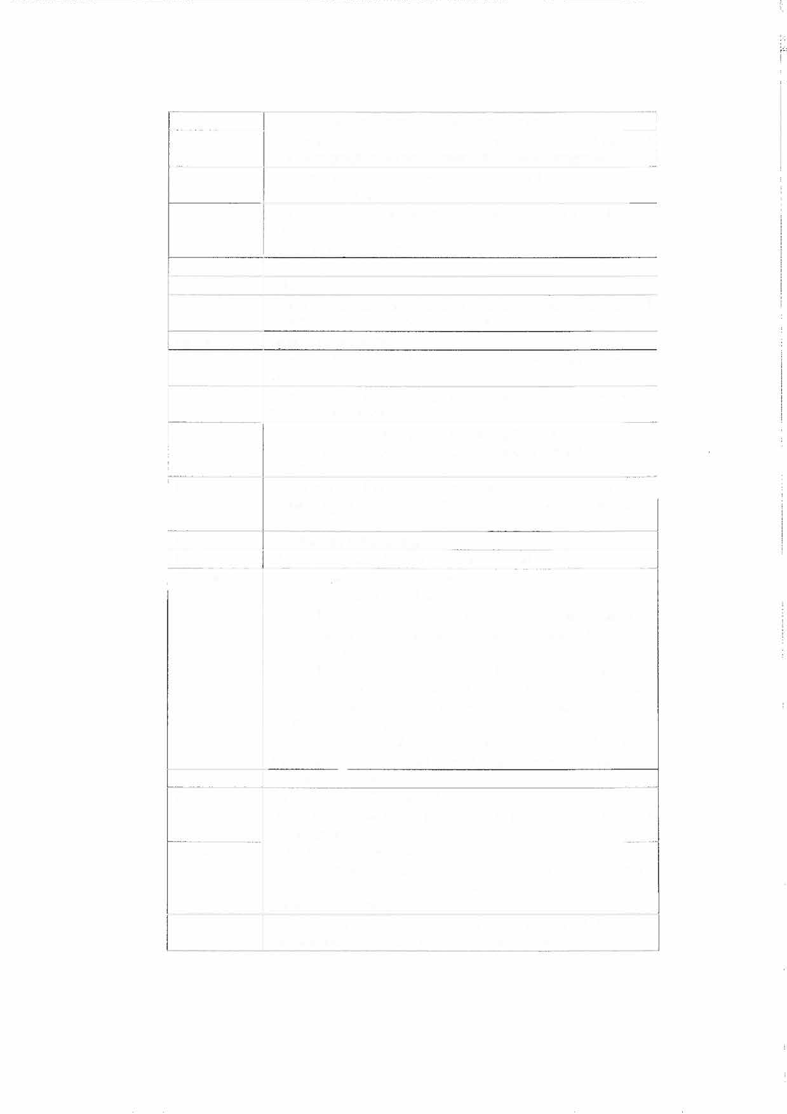

Chapter 7
"No pattern is present" - too many variables. I don't know
how many iterations you would have to run to get a solution to converge!
Contents of this chapter should be reworked into the introductory chapters. It is incongruous here - moved over to chapter one and absorbed into relevant sections

