TOOLS TO DETERMINE ENFORCEMENT DRIVEN REHABILITATION OBJECTIVES ON URBAN RIVER REACHES

HOW TO INSTALL THE LEGISLATION SEARCH TOOL

Step 1: Insert the CD into the CD-ROM drive.
Step 2: Open the CD drive, usually the d:\ drive.
Step 3: Click on the Legislation Search folder.
Step 4: Click on the LegSearch.exe file. The program will install automatically. Follow the prompts of the installation.
Step 5: When installation is complete,
- click on the windows “start” button in the bottom left hand side of the screen,
- select the “Legislation Search” program from the pop up menu,
- Click on “Legislation Search” to run the program.
- Refer to Figure 1.1, which shows the relevant computer screen.

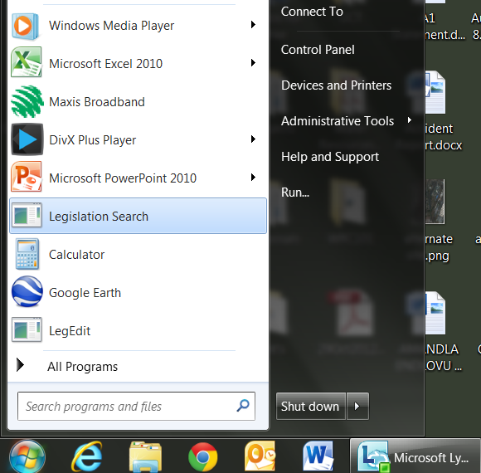
Click on Start
Figure 1.1: Click on “start” icon, select Legislation Search

HOW TO USE THE LEGISLATION SEARCH TOOL

Open the Legislation Search Tool. Two types of searches are available. Choose one of the two tabs in the top left hand side of the screen, labelled “Search by Clause” or “Search by Tag”. These two types of search are discussed separately below.
Search Type 1: Specific legislation search
Step 1: Click on the “Search by Clause” tab as shown in Figure 2.1 below.
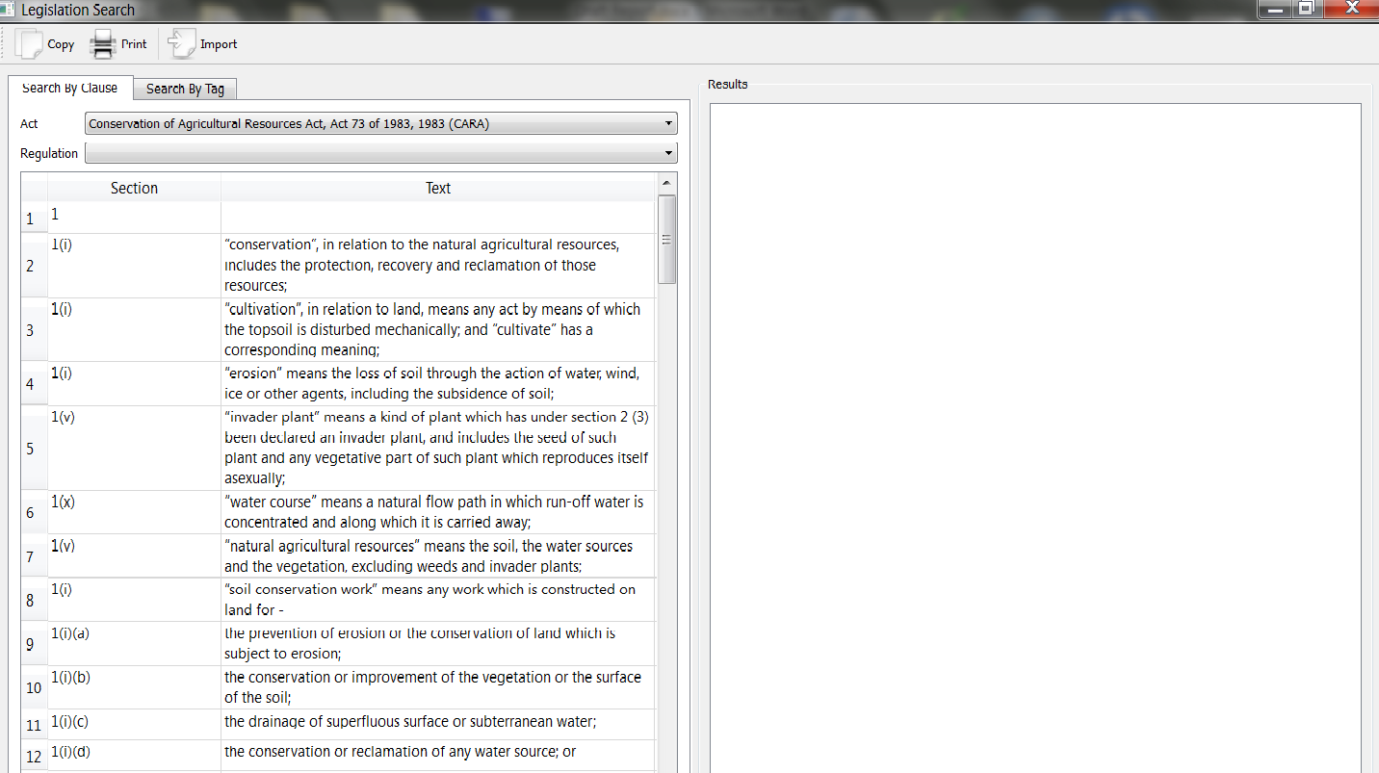
Figure 2.1: Select the tab labelled “Search by Clause” (Step 1)

Step 2: Select the particular legislation (or “Act”) you are interested in, by clicking on the drop down arrow, and then clicking on your choice of “Act” from the drop down menu. The relevant screen is illustrated in Figure 2.2, where the red arrow indicates that the “National Water Act” has been selected.
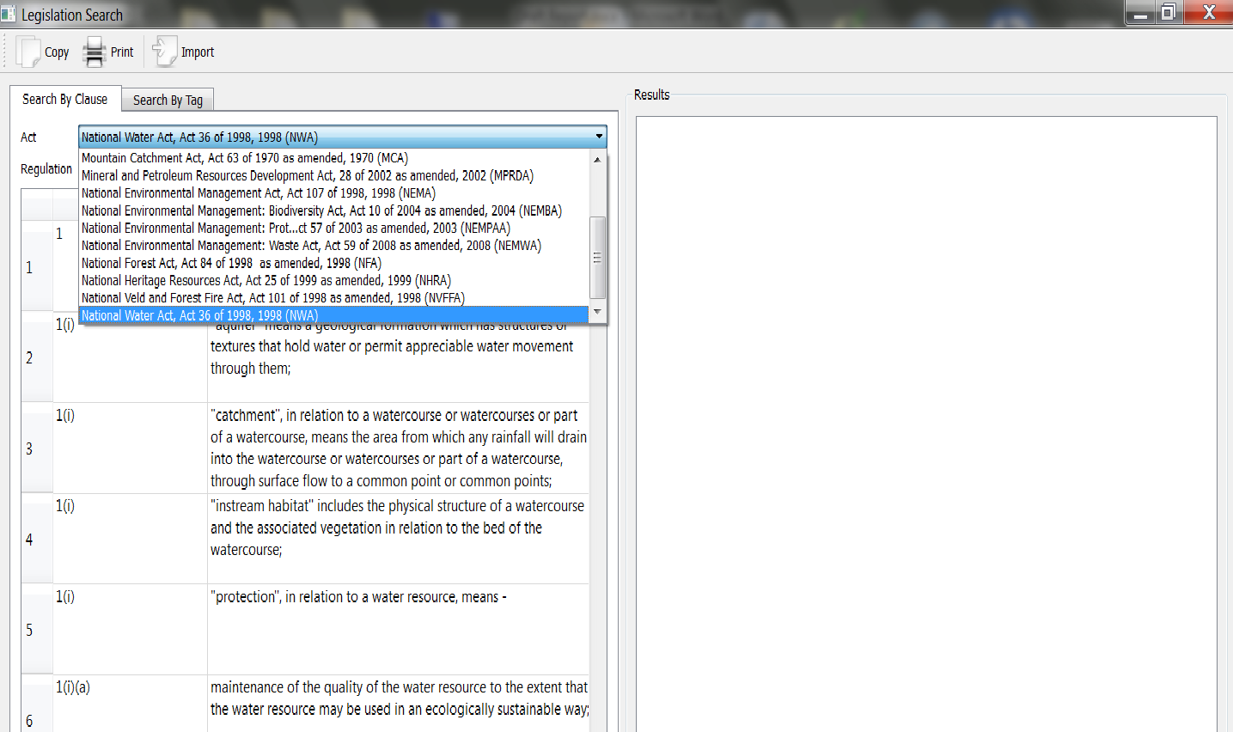
Figure 2.2: Select the “Act” you are interested in (Step 2)
Step 3: A list of all the different sections of that particular Act will appear in the window below. Scroll down and select appropriate section of the legislation you are interested in.
Step 4: When you click on your selected section, the details contained in that section will appear on right hand pane of the screen under the heading “Result”, as shown in Figure 2.3. You can now work with this information as needed.
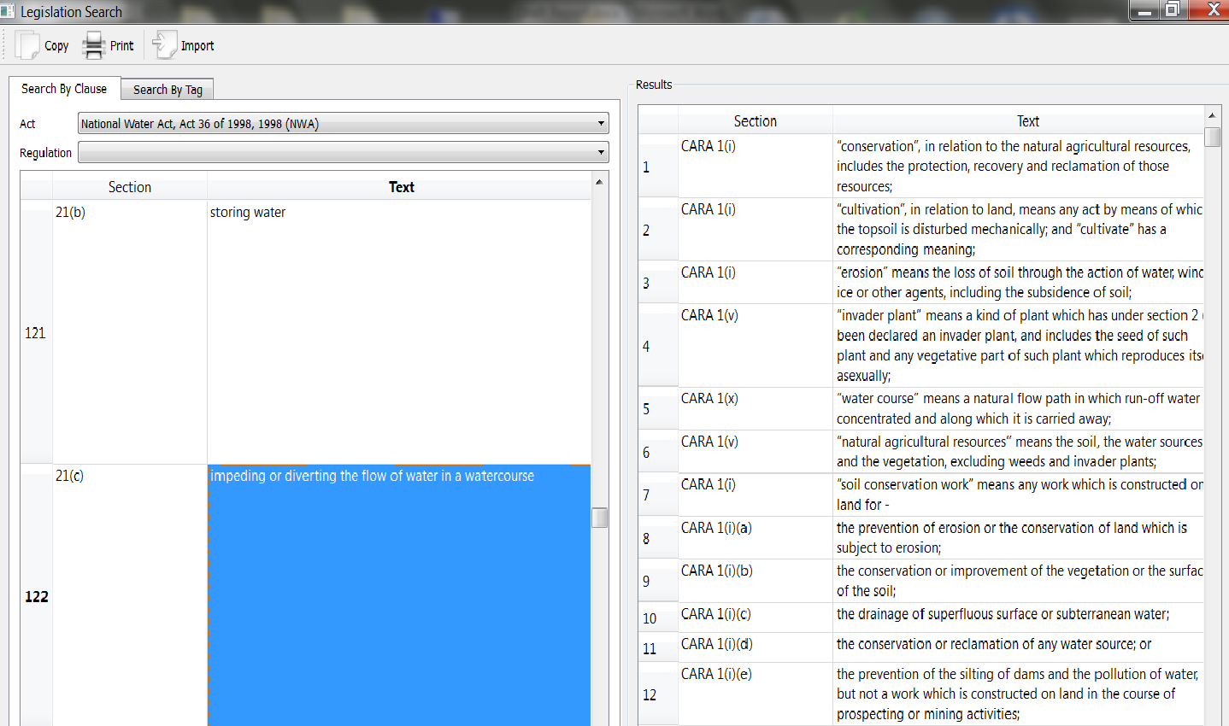
Figure 2.3: Select the Text of the Section you are interested in, and all references will appear on the right hand side (Steps 3 and 4)
Step 4: Adjust the size of the panes to view all the information in the results pane.
- Scroll over the centre column between the search and results panes;
- When the double sided arrow appears, left-click on the mouse and hold, and drag the mouse (box border) to the left or right as you require.
- The viewing pane of the results box will increase or decrease respectively.

Search Type 2: Search by Tag word
Step 1: Select “Search By Tag”.
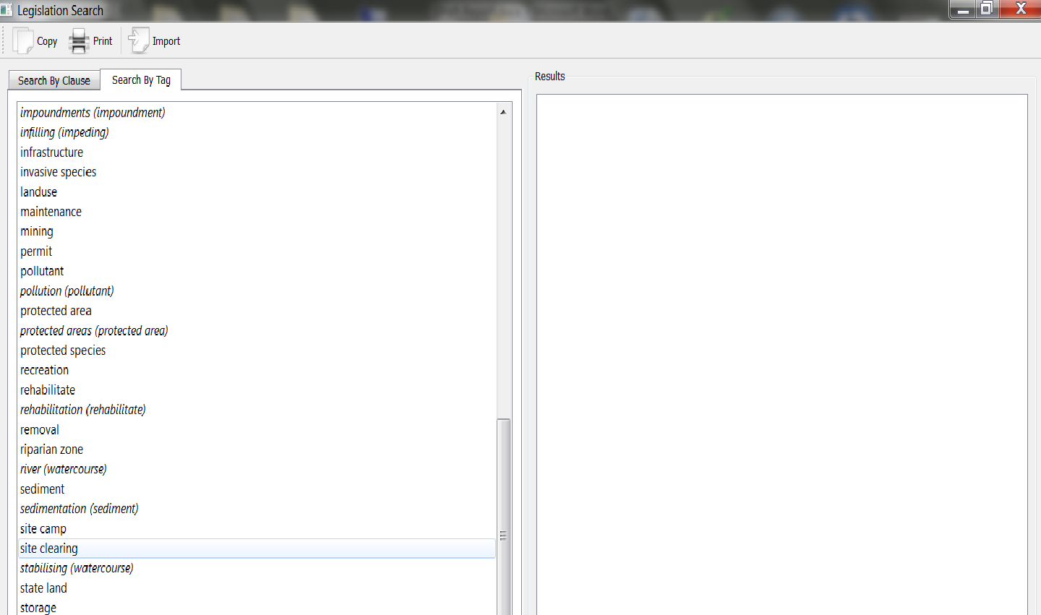
Figure 2.4: Select the tab labelled “Search by Tab” (Step 1)

Step 2: A list of key words (Tag words) appears on the screen listed in alphabetical order. Scroll down the list of words and select appropriate Tag word. The clauses in the relevant legislation which deal with that concept will appear on the right hand pane, under ‘Results’, as shown in Figure 2.5.
You will notice that clicking on words written in italics on the list will not produce a response. Use the alternative word written in brackets next to the word in italics. For example, the word “cultivation” appears in italics with the word “cultivate” in brackets next to it. Clicking on the word “cultivate” gives a result on the right hand pane of the screen.
The results are contained in four columns as follows:
Column 1: The first column contains a list of the clauses containing that Tag word. They are listed alphabetically by the name of the relevant Act. The list can be very long, so scroll down to the end to ensure you cover all the relevant Acts.
Column 2: Gives the detailed text in the clause itself.
Column 3: Contains all ‘Tag words’ in that clause, and
Column 4: lists the responsible Government Departments.
(Note that Columns 3 and 4 do not appear on Figure 2.5, but they do in Figure 2.6).

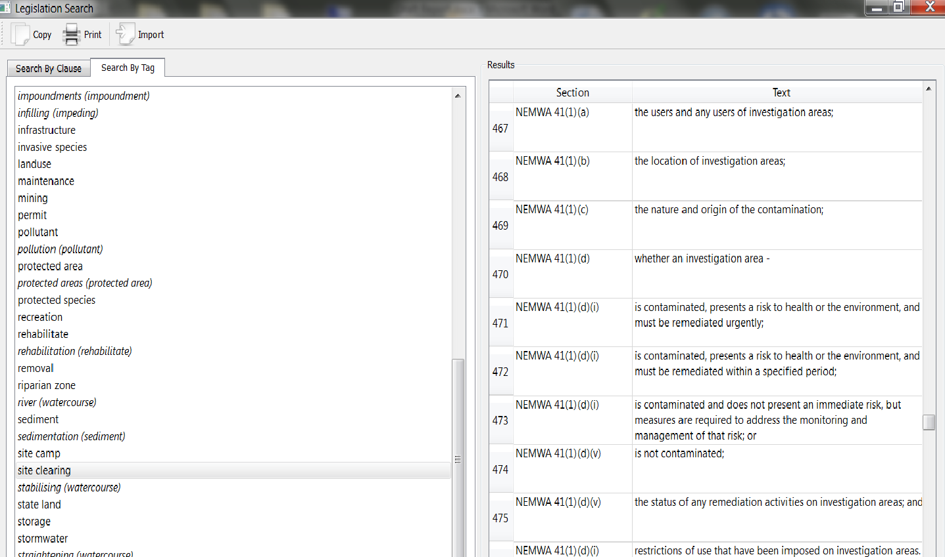
Figure 2.5: Select the Tag word you are interested in, and all references will appear on the right hand side (Step 2)

Step 3: Adjust the size of the panes to view all the information in the results pane, as shown in Figure 2.6.
- Scroll over the centre column between the search and results panes;
- When the double sided arrow appears, left-click on the mouse and hold, and drag the mouse (box border) to the left or right as you require.
- The viewing pane of the results box will increase or decrease respectively.
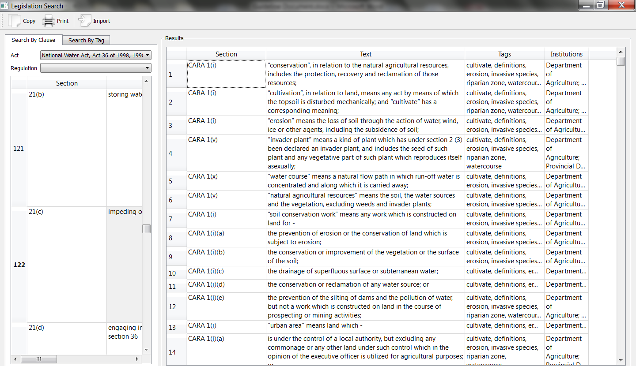
Figure 2.6: The size of the various columns can be adjusted to show what you need to see (Step 4)

UPDATING THE LEGISLATION SEARCH TOOL
The legislation captured in the database was the legislation on the day of compilation. The environmental legislation is regularly revised and amended. Officials should contact the National Department of Environmental Affairs for the updated database of environmental legislation if they are unsure of the latest amendments.

