Declaration

I, Francesc Xavier Gómez-Olivé Casas, declare that this thesis is my own work. It is submitted for the degree of Doctor of Philosophy, in the Faculty of Health Sciences at the University of the Witwatersrand, Johannesburg. It has not been submitted for any other degree or examination at any other university.

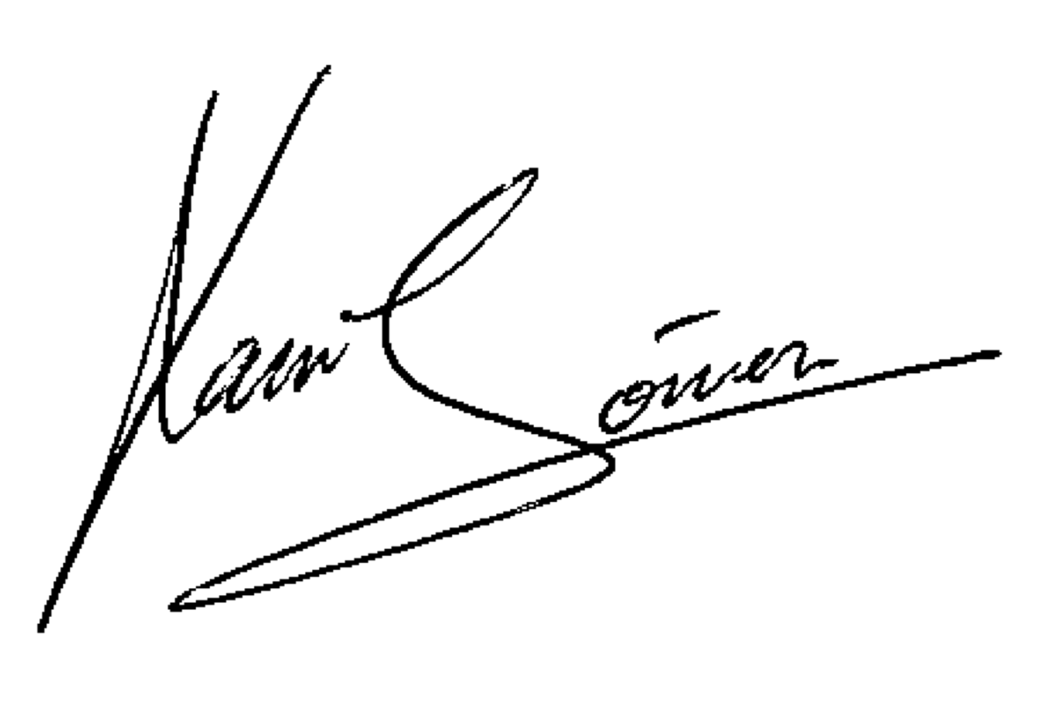

Francesc Xavier Gómez-Olivé Casas, 25 August 2014

