
The project team’s perceptions around premature construction: Impacts and Consequences of incomplete designs
David Kenneth Widdop
1507047

Supervisor: Professor David Root

Research report submitted in fulfilment of the BUQS7027 course and part fulfilment of the degree Master of Science in building at the School of Construction Economics and Management at Wits University

“Like one that draws the model of a house beyond his power to build it; who, half through, gives o'er and leaves his part-created cost a naked subject to the weeping clouds and waste for churlish winter's tyranny.” William Shakespeare. 1564–1616

March 2018

Declaration
I, David Kenneth Widdop hereby declare, that this research and report is entirely my own work, under the supervision of Prof. David Root. The research was done during the BUQS 7027 module and it was submitted in completion of the Master of Science in Building degree at the University of Witwatersrand, Johannesburg.

_____________________ Signed
_____________________ Dated

Abstract
Modern construction project delivery is accelerating, and fast track and concurrent engineering are becoming the norm. When projects are put out to tender under these fast-paced construction methods, there is evidence that the designs are not always complete before the documents are sent out, Kikwasi (2012) refers to incomplete designs at the time of tender when discussing the effects of delays and disruptions. Whilst there is no direct research targeting incomplete designs, especially at time of tendering, the evidence uncovered whilst researching the causes of project inadequacies, with regards to project deliverables trail, points to this phenomenon being relatively common. Reference is made to premature construction as a causation factor by, inter alia, Ramabodu et al (2010) who reported that it was the second most critical factor in cost over runs in their study. Likewise, Lee (2011) ranked delays in producing design documents fourth in importance of delay causes and 7th in frequency of delay causes. Despite numerous tools, programs and methods, projects still experience costly stops or pauses in the construction stage. Griego (2016), declares that at least one Project Team Member on most projects benefits from a premature start to construction, and although project team members may not be ready to start they are affected by peer pressure. Hence when a project starts construction prematurely, it experiences interruptions to construction at least once.
This study exposes how the project team perceives the motives of premature construction, their influence on the project and project team along with their effects.

Acknowledgements
I would like to thank Professor David Root for his inciteful guidance and direction during this course. Grant my construction partner who has always given me the freedom and trust I have needed to grow. To my Wife Jane and children Caitlin and Joshua, I owe them more than any husband or father could owe for their sacrifice of time without me, commitment to and acceptance of me doing my masters. They have been hugely supportive in getting me through the long nights, early mornings, holidays and weekends. Finally, to my parents for their life time support and for clearly setting the boundaries of trust, reliability, honesty and integrity. No matter what I chose to do they were there for me in every way.

Table of Contents
Declaration i
Abstract ii
Acknowledgements iii
Table of Contents iv
List of Figures ix
List of Tables x
Acronyms and Abbreviations xi
1. Introduction and Background 1
1.1 Construction Projects 2
1.2 The Joint Building Contracts Committee® NPC (JBCC®) 3
1.3 Project Team and Project management 4
1.4 Project Stages 6
1.5 The Project life cycle 6
1.6 Incomplete designs 8
1.7 Impacts and consequences of incomplete designs 9
1.8 Problem Statement 11
1.9 Primary Research Question 11
1.10 Secondary Research questions: 11
1.11 Research Hypothesis 11
1.12 Importance of this study 11
1.13 Scope of the study 12
1.14 Research design and methodology 12
1.15 Ethics 13
1.16 Structure of the Dissertation 14
2 Literature Review 15
2.1 Introduction 15
2.2 What is an Incomplete design 16
2.3 What are the Causes of Tendering with Incomplete designs 17
2.4 What are the Impacts and consequences of tendering with incomplete designs 20
2.5 Other associated topics with incomplete designs 23
2.6 Results of literature review 24
2.7 Key findings 26
3 Research 27
3.1 Introduction 27
3.2 Research discussion and configuration 27
3.3 Population 28
3.4 Structured interview 29
3.4.1 Sampling 29
3.4.2 Design 30
3.4.3 Administration 31
3.4.4 Data analysis techniques 32
3.4.5 Trustworthiness 32
3.5 Questionnaire 33
3.5.1 Sampling 33
3.5.2 Design 33
3.5.3 Administration 36
3.5.4 Data analysis techniques 37
3.5.4.1 Question 1 - When calling for tenders with incomplete designs the following status' were cited as adequate. Please select those with which you agree and Question 2 - Where projects commence with incomplete designs the following reasons are frequently cited. 37
3.5.4.2 Questions 4-6 - Understand the consequences of commencing construction with an incomplete design on the project team 38
3.5.4.3 Question 7 - Determine the consequences of commencing construction with an incomplete design on the project itself. 38
3.5.5 Reliability 38
3.6 General reliability 40
3.7 Ethics 40
4 Results 42
4.1 Introduction 42
4.2 Guided interview Results and Discussion 42
4.2.1 Q1. Describe what is considered an incomplete design by the project team 45
4.2.2 Q2. Determine when is it justified to commence construction with an incomplete design. 47
4.2.3 Q4-6. Understand the consequences of commencing construction with an incomplete design on the project team. 49
4.2.4 Q7. Determine the consequences of commencing construction with an incomplete design on the project itself. 50
4.3 Questionnaire Results 50
4.3.1 Q1. Describe what is considered a complete design by the project team 54
4.3.2 Q2. Determine when is it justified to commence construction with an incomplete design. 56
4.3.3 Q4-6 Understand the consequences of commencing construction with an incomplete design on the project team. 58
4.3.4 Q7. Determine the consequences of commencing construction with an incomplete design on the project itself. 62
5 Discussions and Data Analysis 65
5.1 Introduction 65
5.2 Guided interview Discussions and Analysis 66
5.2.1 Q1. Describe what is considered an incomplete design by the project team 66
5.2.2 Q2. Determine when is it justified to commence construction with an incomplete design. 66
5.2.3 Q4-6. Understand the consequences of commencing construction with an incomplete design on the project team. 67
5.2.4 Q7. Determine the consequences of commencing construction with an incomplete design on the project itself. 70
5.3 Questionnaire Discussions and Data Analysis 71
5.3.1 Question 1. Describe what is considered an incomplete design by the project team? 71
5.3.2 Question 2. Determine when it is justified to commence construction with an incomplete design. 72
5.3.3 Question 4-6. Understand the consequences of commencing construction with an incomplete design on the project team. 73
5.3.4 Question 7. Determine the consequences of commencing construction with an incomplete design on the project itself. 74
5.4 Summary 76
5.4.1 Introduction 76
5.4.2 Q1. Describe what is considered an incomplete design by the project team? 76
5.4.3 Q2. Determine when is it justified to commence construction with an incomplete design. 77
5.4.4 Q4-6. Understand the consequences of commencing construction with an incomplete design on the project team. 78
5.4.5 4. Q7 - Determine the consequences of commencing construction with an incomplete design on the project itself. 78
5.4.6 Primary research question 78
6 Conclusion and Recommendations 80
6.1 Introduction 80
6.2 Hypothesis - Incomplete designs result in adverse consequences on the project team. 80
6.3 Conclusions 82
6.3.1 Question 1. Describe what is considered an incomplete design by the project team? 82
6.3.2 Question 2. Determine when is it justified to commence construction with an incomplete design. 82
6.3.3 Question 4-6. Understand the consequences of commencing construction with an incomplete design on the project team. 82
6.3.4 Question 7 - Determine the consequences of commencing construction with an incomplete design on the project itself. 83
6.4 Recommendations and Further work 83
6.4.1 Question 1. Describe what is considered an incomplete design by the project team? 83
6.4.2 Question 2. Determine when is it justified to commence construction with an incomplete design. 84
6.4.3 Questions 4-6. Understand the consequences of commencing construction with an incomplete design on the project team. 84
6.4.4 Question 7 - Determine the consequences of commencing construction with an incomplete design on the project itself. 85
7 References 1
Appendices 1
APPENDIX 1 Informed consent form 1
APPENDIX 2 - Participation Information Form 2
APPENDIX 3 – Ethics clearance 4
APPENDIX 4 – Guided Interview sheet 4
APPENDIX 5 – Questionnaire form 7
APPENDIX 6 – Interview responses 87
APPENDIX 7 - Questionnaire responses 97

List of Figures
Figure 1 - GDP by Sector 3rd Quarter 2017 1
Figure 2 - Project life cycle 7
Figure 3 – Time-Cost relationship graph 9
Figure 4 – Interviewee’s profession 42
Figure 5 -Interviewee’s JBCC Constituent member 43
Figure 6 – Interviewee’s Age 44
Figure 7 – Interviewee’s years of experience 44
Figure 8 – Interviewee’s qualification 45
Figure 9 - Questionnaire respondents profession 51
Figure 10 - Questionnaire respondents JBCC Association 52
Figure 11 – Questionnaire respondent’s qualifications 53
Figure 12 - Questionnaire respondent’s industry of operation 53
Figure 13 – Ranked variable extract – complete design 77

List of Tables
Table 1 - Question 1 Interviewee’s description of an incomplete design 46
Table 2 - Question 2 Interviewee’s justifications 48
Table 3 - Question 4 Planning - response categorisation and reduction 49
Table 4 - Question 5 Implementation - response categorisation and reduction 49
Table 5 - Question 6 Close out - response categorisation and reduction 50
Table 6 – Incomplete design description 56
Table 7 – Questionnaire Incomplete design justifications 58
Table 8 – Questionnaire consequences on the project team planning phase 58
Table 9 – Questionnaire consequences on the project team construction phase 59
Table 10 – Questionnaire consequences on the project team Close out phase 60
Table 11 – Questionnaire consequences on the project team by team member 62
Table 12 – Questionnaire consequences on the project team in totality 63
Table 13 – Data analysis justifications – top rankings 72
Table 14 – Data analysis justifications – top 5 rankings 73
Table 15 – Data analysis Consequences on the Project team by phase versus frequency of impact 74
Table 16 – Ranking of the consequences on the project itself 75

Acronyms and Abbreviations
Arc Architect
C&SE Civil and Structural Engineer
CII Construction Industry Institute (2002) as discussed in Adeoye (2014)
Cont. Contractor
GDP Gross Domestic Product
JBCC Joint Building Contracts Committee
PBA Principle Building Agreement
PC Practical Completion, i.e. The building’s contractual usable date
PM Project Manager
PT Project Team
QS Quantity Surveyor
RT323 Research Team of 323 members that worked with Griego (2016)
SACPCMP The South African Council for the Project and Construction Management Professions

Introduction and Background
The construction industry, which is a significant contributor to employment and growth in South Africa has been in a slump since 2009 ((PWC), 2016). However, it still contributes 3.9% to national GDP (Stats SA 2017). The 2016 financial year followed form with a poor start with margins under pressure, tight liquidity and decreasing order books. ((GIAA), 2017) got off to a shaky start in a similar fashion but after a 1st Quarter contraction, the economy ended up growing by 1.3% in 2017. However, the construction sector still contracted by 0.3% in total for 2017 and by the 4th quarter of 2017 had contracted by 1.4%, the second worst performer behind mining at -4.4%.
Figure 1 - GDP by Sector 3rd Quarter 2017

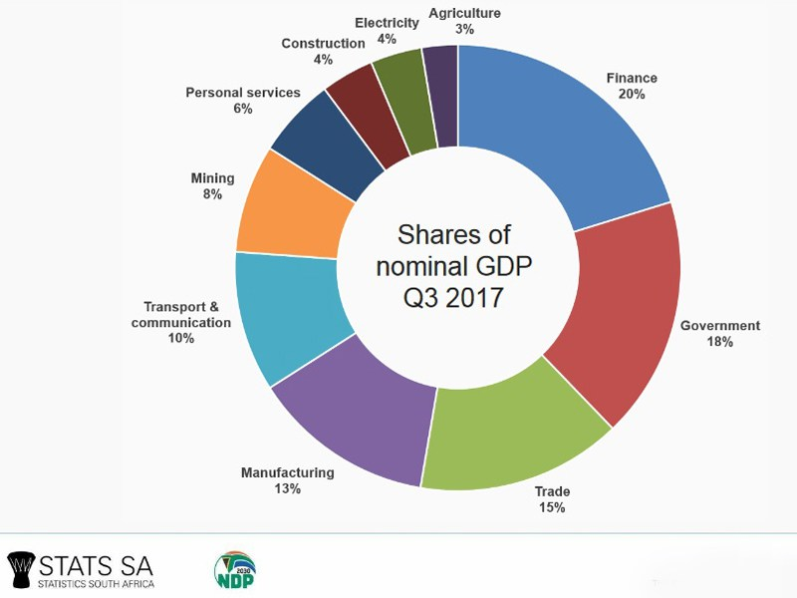
Strikes and labour unrest continue to negatively impact the construction sector causing delays on significant projects around the country (Standard Bank 2016). The construction industry is inherently a high impact, and hazardous, industry for workers to be in (Standard bank 2016). Major incidents, such as the collapse of a pedestrian bridge in Sandton, while a tragedy, also reflects poorly on the whole industry. The implications on the reputation and ability of the construction company to procure work in certain sectors can become compromised, which means it will take many successful projects before a bridge-collapse incident is forgotten or its damage is lessened. The construction industry has a high debt to equity ratio, and in fact was recorded the highest at 3,3 in 2014 comparable to the national average in the private sector of 1,9 (Stats SA 2016).
Collectively, these are indications of an already risky industry being put under further pressure and that this further squeeze is likely to exacerbate the risks and consequences of a fast-paced industry.

Construction Projects
Construction is loosely defined as the action of building something, typically a large structure (Oxford living dictionary). The process of construction is a capital-intensive technical service where resources (plant, material and tradesmen) are managed by human capital in a process that results in a physical structure. The main sectors that drive demand for construction are agricultural, residential, commercial, institutional, industrial, heavy civil, and environmental.
Capital is invested in infrastructure such as new builds, expansion of current assets or optimising current structures. To invest the capital, clients require a return for their capital which is mainly monetary but can also be related to other values such as welfare, social etc. There is however a move towards capital investment decisions that are typically weighted towards asset performance and long-term value creation, rather than short-term gain ((GIAA), 2017).
Fast track projects and concurrent engineering have no doubt sped up the delivery of projects by increasing time pressure on those involved (Adeoye, 2014) and have introduced complexities such as the use of assumptions and increased the risk to all parties. Whilst this process is well understood by the project team and construction supply chain, most occasional clients (clients who do not regularly build) are unaware of the processes in construction; they have little knowledge of the project phases and may not understand the management practices. This is due mainly to their proficiency and area of knowledge being concentrated on their core business even if it falls in the same industry (Richards, et al., 2005). Their primary objectives are pitched at a high level of integration of their core business and they have employed the contract team for their specialist services to fulfil their need; e.g. A developer may only be interested in financing a block of flats to get a higher return on his/her capital that is in the bank, but does not need to know how to build it, or a vehicle manufacturer requires to start a new vehicle line but does not want to know the design parameters etc. This characteristic of occasional clients engaging ad hoc groupings of professionals and contractors for once off projects has resulted in attempts to standardise many of the practices and procedures to mitigate the impacts of this fragmentation. One example of this is the JBCC in South Africa.”

The Joint Building Contracts Committee® NPC (JBCC®)
The Joint Building Contracts Committee® NPC (JBCC®) was registered in 1997 as a Non-Profit Company. The Committee is representative of building owners and developers, professional consultants and general and specialist contractors who contribute their knowledge and experiences to the compilation of the JBCC documents. The objective was to formulate a set of standardized contractual documents which would support an efficient and effective building process. These contractual documents were first published in 1991 and were replaced by the Series 2000.
The JBCC documents were compiled in the interests of standardization and portray the consensus view of the Joint Building Contracts Committee of good practice and an equitable distribution of contractual risk. The document is intended to provide a clear, balanced and enforceable set of procedures, rights and obligations, which when competently managed and administered, protect the employer, contractor and subcontractor alike. The Series 2000 covers all aspects for most types of building projects. It should be noted that each document has been formulated for use specifically as part of the Series 2000 and is unlikely to be suitable for use with other forms of contract.
The Principal Building Agreement is the cornerstone of the JBCC Series 2000 document range. The agreement is made up of nine sections starting with the definitions of all the primary elements and phrases that regularly occur in the document and is the dominant contract used for construction work throughout South Africa.
Under the JBCC PBA the parties to the Contract are; the Employer (The party contracting with the contractors for the execution of the works), the Contractor (The party contracting with the employer for the execution of the works) and various Agents (Entities appointed by the employer to deal with specific aspects of the works).
The principle agent, a person appointed by the client to represent them during the construction process who historically was the Architect, a Project Manager, the Engineer or the Quantity Surveyor; is appointed by the employer to act on his/her behalf and assumes the role of co-ordinating the consultants (Othman & Harinarain, 2009).

Project Team and Project management
The Project Construction Team is made up of various organisations and people tasked to achieve the required outcome as specified by the customer. The Major stakeholders in the project construction teams are Project Managers (PM), Architects (Arc), Structural and Civil Engineers (S&CE), Quantity Surveyor (QS) and the Contractor (Cont.).
The roles and responsibilities of the major disciplines vary slightly from project to project but can be summarised as follows; The Project Manager’s main responsibilities are to plan and co-ordinate the project construction team and guide them to a successful outcome. The Architect generally leads the building design and concept and provides detailed construction drawings and information for the building to be built although sometimes also carries the responsibilities of the project manager as well. The engineer’s main function is to ensure the structural integrity of the architect’s design and provides details and information for the structural frame and foundations for the building to be built from. The Quantity Surveyor provides the budget from the preliminary design and guides the project construction team financially to stay within project costs. Finally, the Contractor or Builder provides overall management for the construction and employs various resources to complete the construction work from beginning to end.
These roles are expressed in the contractual conditions both for the appointment of professional services (typically using Procsa, a set of standard conditions of contract for professional services), and in the relationships between the client project team and main contractor which in the majority of private sector construction projects is the JBCC® Series 2000 Principal Building Agreement (JBCC PBA).
The project team in this study will be representatives from the JBCC associated constituents below that align with the project team professions of Project Managers, Architects, Structural and Civil Engineers, Quantity Surveyors and Contractors.
Membership of the JBCC
JBCC Constituents
Association of Construction Project Managers | (ACPM) | www.acpm.co.za
Association of South African Quantity Surveyors | (ASAQS) | www.asaqs.co.za
Consulting Engineers of South Africa | (CESA) | www.cesa.co.za
Master Builders South Africa | (MBSA) | www.mbsa.org.za
South African Institute for Architectural Technologies | (SAIAT) | www.saiat.org.za
South African Institute of Architects | (SAIA) | saia.org.za
Latham, (1994: p. 24) highlights some of the roles of the project team and goes on to show how complex the whole situation is. “Architects are expected to produce working drawings and the builder is expected to carry out works in accordance with such drawings. The structural engineer relies upon the manufacturers to design the connections for a steel frame. The services engineer expects a subcontractor, appointed after the builder, to prepare all installation (i.e. working) drawings. Design co-ordination before construction starts is therefore impossible and ad hoc alterations on site are inevitable. Further, the tender and contract procedures adopted by architects and service engineers are at variance one with the other and this leads to difficulties and animosity in the management of cost and the administration of the contract conditions. Architects’ designs are usually the subject of Bills of Quantities, but services engineers resolutely require tenders to be based on drawings and specifications. The common range of conditions of contract place responsibility for the cost of a project solely upon one person, usually an architect or engineer. The procedures adopted by the services engineer effectively prevent the architect or engineer from exercising control over the cost of the services element of a project. Urgent attention should therefore be given to the elimination of this muddle.”.

Project Stages
The South African Council for Project and Construction Management Professions (SACPCMP), explain that each phase has specific deliverables and stage gates to complete before proceeding to the next stage.
The definitions of the phases are detailed in the SACPCMP’s guideline scope of services and defined as below.
- Stage 1 - Agreeing client requirements and preferences, assessing user needs and options, appointment of necessary consultants in establishing project brief, objectives, priorities, constraints, assumptions and strategies in consultation with the client.
- Stage 2 - Finalization of the project concept and feasibility.
- Stage 3 - Manage, co-ordinate and integrate the detail design development process within the project scope, time, cost and quality parameters.
- Stage 4 – The process of establishing and implementing procurement strategies and procedures, including the preparation of necessary documentation, for effective and timeous execution of the project.
- Stage 5 – The management and administration of the construction contracts and processes, including e execution of the works.
- Stage 6 - The process of managing and administering the project closeout, including preparation and co-ordination of the necessary documentation to facilitate the effective operation of the project.
However, the 6 stages are compared to the 4 project life cycles as describe below, and then reduced for this study to the last 3 project life cycles.

The Project life cycle
The 6 project stages highlighted by SACPCMP were simplified into the 4 project life cycle phases are discussed below. This is later reduced to the latter three of the four phases described below, due to this being when the Contractor becomes involved and completes the previously described project team.
A project goes through four project life cycle phases, namely Initiation, Planning, Execution (Implementation) and Closure; similarly represented below.

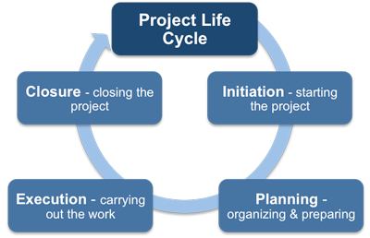
Figure 2 - Project life cycle
(http://www.free-management-ebooks.com/faqpm/principles-08.htm)
1 The Initiation Phase: - “Agreeing client requirements and preferences, assessing user needs and options, appointment of necessary consultants in establishing project brief, objectives, priorities, constraints, assumptions and strategies in consultation with the client.”
This encompasses Stages 1 and 2 and parts of Stage 3 and 4 of the stages of a construction project described by SACPCMP previously. It includes the project brief, procurement policies, consultant client agreements and project initiation program from Stage 1; Indicative project document and construction programme from Stage 2; Part detailed design and documentation and part indicative programme update from Phase 3; and contractors procurement strategy, project procurement programme and project tender/contract conditions.
This phase was excluded from this research and is described for assist the reader with a complete understanding and the background of the phases.
2 Planning Phase: - “Finalization of the project concept and feasibility and “Manage, co-ordinate and integrate the detail design development process within the project scope, time, cost and quality parameters.” And “The process of establishing and implementing procurement strategies and procedures, including the preparation of necessary documentation, for effective and timeous execution of the project.”
This includes parts of Stage 3 and 4 of a construction project described by SACPCMP. It would not normally have been included, however since the design is carried over to the execution phase in ‘incomplete designs at tender stage’, hence parts of stage 3 and 4 are also carried over into the execution phase. It includes Detailed design and documentation programme from Stage 3; and Contractors procurement strategy and project procurement programme from Stage 4.
3 Implementation Phase: - This encompasses Stage 5 and includes parts of stage 3 and 4 of a construction project described by SACPCMP. It includes Signing up the contractor, progressing with work to completion from stage 5; includes incomplete detailed design from stage 3; and not yet appointed sub-contractors’ procurement from stage 4.
4 Close out Phase: - The management and administration of the construction contracts and processes, including the preparation and co-ordination of the necessary documentation to facilitate effective execution of the works.
“The process of managing and administering the project closeout, including preparation and co-ordination of the necessary documentation to facilitate the effective operation of the project”. It is generally characterised by snagging and handing over of the building for the client fit out, followed by commissioning and training of the client’s representatives.

Incomplete designs
Perhaps due to the uncertainty around the viability of a project, the design is not always 100% complete when the decision to proceed is taken. It is proposed that based on time constraints, costs restrictions or possibly ignorance to what is considered complete, projects proceed with insufficient information. There are numerous definitions and phases of described design completeness within the architectural domain, such as, Programming, Schematic, design development and Construction drawings or Conceptual, Schematic, Design development, Construction documents, Construction bidding and Construction admin etc, but an explicit list that documents, what is complete or incomplete when it comes to the design cannot be found. The difficulty in explicitly listing the requirements to consider a design complete /incomplete, could be exaggerate when you consider who will use it or what its purpose is at that stage of the design. Can a design be complete enough for a certain stage, i.e., for a client to understand its concept, or a Quantity Surveyor to cost it, a contractor to program off of it or only when all details are available to build absolutely everything. Can a design be considered complete when the documents themselves, that communicate the design to a secondary person, are not complete or flawed?
Griego (2016) attempted to define a premature start as “a decision, by at least one party, to start construction with at least one risk that exceeds an acceptable tolerance to another party and which can result in an interruption to construction”.

Impacts and consequences of incomplete designs
It is likely that tender documents are being based on many assumptions and the appears that designs only begin in earnest during or immediately after the bidding process and given the above there are likely to be negative impacts on the project and the project team. These impacts might be amplified by the fact that the client may well not be intensely involved in the project beyond the planning phase or that the client possibly might not be fully aware of the design and construction process. Thus, they possibly are not aware of the implications of going to tender with an incomplete design or even be aware that the design is not fully developed in a sense that it is not sufficient to construct from.
Incomplete designs result in the design being carried over into the construction phase. The Commission for Architecture and the Built Environment (2011) shows below that the further a project has progressed in time, the less control there is of the effects on the cost when changing or hence finalising an element or design. This may also lead to time and quality consequences.
Initially there may be the issue of escalation due to inflation or currency fluctuations. Or if procurement is done at a later stage the speed of getting resources, materials or equipment to site may also impact on the pricing. Unexpected changes to costs arising from over-runs may lead to redesigns, rework or changes to the specifications. The schedule implications of late procurement of critical items may lead to delays due to long lead times, unavailability of resources, changes in methodology or the effects of rework. Substandard materials and workmanship may stem from cost over-runs, decisions to down grade the specification to meet budget, excessive rework of wet trades for late installations, damaged material and cleaning issues.
Figure 3 – Time-Cost relationship graph
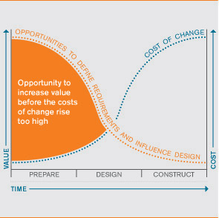
There is no certain way of completing a set of critical tasks in the shortest period, but there could be increased probably by ensuring all the design, planning, procurement and resource arrangements are done prior to commencing. In incomplete designs there may be many assumptions which may only be resolved during the progress of construction. The mere fact that decisions must be relooked at, reworked, rescheduled, discussed, finalised and implemented at unknown times, leaves a high level of uncertainty around their completion. Also considering that once the information becomes known there is a separate level of uncertainty.
From the above it can be argued that when a construction project is tendered on the basis of an incomplete design, and where the final or detailed design only commences on appointment of the successful contractor, there will be adverse impacts and consequences. The intense time period, highly integrated project construction team and specific outcomes required by the client will also be affected. Although the project construction team has a deep knowledge of the process of a project and the roles and relationships between the stakeholders, a large number of clients inadvertently and /or due to their own pressures and challenges, pressurise the project team to proceed with construction with an incomplete design. This invariably results in cost and time overruns along with adverse impacts on the project team and the project itself. However, what appears to comprise a sufficient design may differ between professionals. In addition, the response to the pressure from clients may also differ between professionals in respect of how they justify commencing construction with incomplete design information.

Problem Statement
Premature construction is not well studied, clearly understood or defined and its impacts and consequences on the project team are not explicitly stated. The secondary information pointing to premature construction as an impact or consequence on a project has never been consolidated and discussed as in a study.

Primary Research Question
How does the project team perceive the impacts and consequences of commencing construction with an incomplete design?

Secondary Research questions:
- What are the perceptions and characteristics of an incomplete design?
- What is the perception of why this agenda is pursued and how is it justified?
- What are the perceived factors that lead to commencing construction with an incomplete design?
- What are the perceptions of impacts, on the project team, of commencing with premature construction?
- What are the impacts and consequences on the project team of commencing construction with an incomplete design?
- What are the impacts and consequences on the project of commencing construction with an incomplete design?

Research Hypothesis
Hypothesis : - Incomplete designs result in adverse consequences for the project team.

Importance of this study
The significance of premature construction is not studied but numerous authors are highlighted referring to its impacts leading to various adverse impacts and or consequences such as time, cost and quality. Project teams are willingly embarking on premature construction without fully understanding the impacts on the project itself and on the project team and a deeper understanding of the phenomena could change the way in which this is undertaken.
With the available references to adverse impacts and ill consequences, a study of a broad, exploratory and investigatory nature, will unpack phenomena that will point researchers towards more narrow, complex and specific areas around incomplete designs whilst confirming the significance of the impacts and consequences.
Once a better understanding of the phenomenon is detailed, some referrals may be unpacked and possibly proved or disproved.

Scope of the study
A wide-reaching investigatory study taking into consideration the large numbers of people implied will be difficult to represent as a representation of an entire population, but none-the-less, the information uncovered will be of significant value.
In order that the small sample of participants involved in the interview contributed valuable information, their selection is important. Interviewees with a credible backgrounds, lengthy service and high educational achievements will provide the best information. Ensuring that the participants come from firms well known in the industry is important to ensuring credible participants. This possibly may impact the study with a bias towards a certain category of participants but will not degrade the information acquired and may only reduced its ineffability on the greater population.
The questionnaire is less selective on targeting specific participants and therefore more random, however due to the small participant group and the large population as discussed later in the study will also not represent the total population.
Proving the existence of the postulation and that it has a significant impact with consequences for both the project and project team is the main objective whilst uncovering other related phenomena in the process.

Research design and methodology
A traditional literature review is to be carried out on incomplete designs and the impacts and consequences of incomplete designs. Should there be a poor return of knowledge on incomplete designs, the review will be extended to include studies of other effects that pointed to incomplete designs as an impact. The main aim is to understand the knowledge available and secondly to provide a starting point for the exploratory interviews.
A two-stage positivist approach to the research will overcome the lack of available knowledge and create a starting point. Going through both stages at a high level will best be done investigatively with a perceptive study. This will also assist with the limited time frame and large volume of data that will be received.
Exploratory guided interviews will be carried out to collect data from the Project team. This will include probing questions to describe incomplete designs and their justifications and questions based on topics found in the literature review relating to the impacts and consequences of incomplete designs.
The information from the guided interviews will be used to formulate a questionnaire that will be distributed to a wider population to test the integrity of the information collected and understand the perceived impacts on a singular group of people.
The results of both the interviews and questionnaires will be tabulated to provide useful information for further studies and interrogated to understand what useful information was to be used to support or reject the hypothesis, whilst being compared to the literature.
It is surmised that methodological triangulation will be useful in overcoming the sampling and procedural bias caused by the convenience population samples and targeted individuals bias.

Ethics
The topic that is under research is not sensitive or controversial and will not raise any such fears. It will not create any negative connotations around the businesses that will be involved in the data capture however the interviewees and respondents will be offered anonymity and/or confidentiality.
Objectivity in the form of Bias will be noted as a concern since the researcher is a contractor i.e. one of project team profession being studied.

Structure of the Dissertation
Chapter 1 - Introduction: This chapter provides a justification for the research identifying the problem and formulating the primary and secondary research questions and the formulation of the hypothesis.
Chapter 2 - Literature Review: This chapter summarises the currently available knowledge and discusses the information in relation to the research questions and hypothesis.
Chapter 3 - Research: This chapter summarises the literature information carried into the interview stage. It then details the interviews and questionnaires and provides preliminary information from each stage that is used in the research.
Chapter 4 - Survey results: This chapter lists and summarises the results of both the interview and questionnaire. It also highlights some key results.
Chapter 5 - Data Analysis: This chapter analyses both the interview and questionnaire result and provides some insight in the links across the phases and their similarity with the current available literature.
Chapter 6 - Conclusion and recommendations: This chapter discusses the results and data analysed and makes explicit the findings. These are discussed in detail and interpolating the perceptions of the project teams with the available knowledge from chapter 2, the hypothesis is tested and determined. Finally, based on the determination some recommendations are proposed with a view that a larger population be tested to confirm or support these results.

Literature Review

Introduction
Initially when searching for literature on premature construction no papers were discovered. The search was broadened to synonyms such as early, rash and hasty starts, again without success. Early starts returned a few documents, which were mainly confined to the scheduling understanding of early starts, i.e. the earliest date a task can begin in the critical path method of scheduling.
Incomplete design searches returned ‘construction’ in the term used in creating and not in the sense of building, and incomplete designs was wide spread across various disciplines. However lower down in the search results, a few papers more than 10 years old emerged around the design interface in construction, which were usable.
Poor results required that a more strategic focus be devised. One drive which looked to the consequences first and then worked backwards through the influences and then causes was successful. Using terms such as cost overruns, delays and quality were useful. These returned numerous results, but the “premature start” and “incomplete designs” component was rare and as the main focus of the study not found at all.
In order to unpack the problem 173 papers, books and articles were collected that referred to the golden triangle and other related impacts and consequence as well as incomplete designs.
Another approach that returned numerous results was the search that delved into quality management that relied on client satisfaction and linked the golden triangle to the client’s required outcomes. This was further unpacked into scoping of the project which related to client needs and the project attributes were expanded to better understand dis-satisfaction and in turn highlighted unfavourable impacts and consequences.
These papers were separated and filtered into categories of which 138 papers were rejected and 35 relevant papers that seemed usable were highlighted for in-depth analysis.
The rejected articles were related to, enablers of premature construction (10); 24 Articles on incomplete tenders that were further categorised as, Indirect strong cases but unrelated (9 ); Indirect but weak cases (9); Inappropriate design (3); Direct and strong but unrelated (3);and articles on quality with a weak case (5), articles on risk with a weak case (2); Articles on the viability of projects (9); articles on quality management (8); articles on client satisfaction (14); other unrelated topics such as project culture, concept satisfaction, including the contractor in the team at design, contractor claims and briefing were also rejected (66).
The articles highlighted as relevant and that were earmarked for in-depth review were categorised as follows: - related to risk (6) ;incomplete designs (2) ; contracts (1) ; impacts (1) ; time delays (8) ; costs (7); quality (1); design (4); dissatisfaction (1); premature start (1) and stress (3). These were studied, and the results follow.

What is an Incomplete design
The only scholar who directly described what an incomplete design is, was Griego (2016) who only used a superficial description to highlight what is was by when it commenced and that it only had to be to the detriment of only one team member. Most scholars when referring to incomplete designs unpacked or described the phenomenon in very simple terms or phrases as described below.
Tilley, et al (1997), highlight how complex commercial construction can be, stating that “In an ideal world, the design and documentation provided for construction projects would be complete, precise and unambiguous”. They highlight though that is rare, and that project documentation is generally, “incomplete, conflicting or erroneous” leading to “revisions and clarifications”. Their study of the request for information (RFI) process in the Australian context, measures the efficiency of the design and documentation process and discussed the related causes and highlighted information clarification as the major cause of RFI’s and concluded that the quality of design information and documentation was a major concern to the point that they deemed it necessary to propose three performance indicators of its measure of deficiencies.
Kikwasi (2012) highlighted incomplete and unclear drawings, incomplete documents and information delays as prevalent and concluded finalization of design and project management skills should be the focus of the parties in project procurement process.
Whilst unearthing the causes of delays to study the effects, Lee (2011) stated that the effects of delays are usually combined with that of the delays themselves and rarely are potential effects listed and discussed. They found that most authors conclude that the impacts of delays are the increased timing of project delivery and the negative cost associated with delays. He later tabled in Table 2.2: Importance of delay causes - "Delays in producing design Documents" ranked 4th and Table 2.3: Frequency of delay causes - "Delays in producing design documents" ranked 7^{th.} (ibid.)
Kikwasi (2012) highlighted incomplete and unclear drawings, incomplete documents and information delays as prevalent and concluded finalization of design and project management skills should be the main focus of the parties in project procurement process. Likewise, incomplete drawings and incomplete contract documents by the consultant, are mentioned by Ren et al (2008) whilst determining the causes of delays and the procedures to avoid delays or mitigate the impacts of delays in Dubai.
Incomplete designs and their consequences in the literature can therefore be summarised as :- Conflicting, erroneous, inefficient designs leading to revisions and clarifications. (Tilley, et al., 1997); Unclear drawings and incomplete drawings lead to delays (Kikwasi, 2012); Delays in producing design documents results in increased timing and negative costs (Lee, 2011); Incomplete drawings and incomplete contract documents cause delays (Ren, et al., 2008).

What are the Causes of Tendering with Incomplete designs
Monyane (2013) concludes that because of rushing to get the project out to tender, it often goes out with incomplete designs that are subject to revisions and lead to cost escalations. They highlight that in many ways the end results of incomplete designs often lead to cost escalations as opposed to cost savings as envisaged. The incomplete designs allow the client liberty to increase the scope of the project, in the end leading to detrimental cost escalations. This precipitated from the finding that ‘incomplete design at time of tender’ ranked second behind ‘inadequate planning’ as a causes of cost overruns in the design phase. He also found that the scope of work directly influenced the design being complete at time of tender and completed designs at the time of tender assisted in modulating changes that the client could exploit. Completed designs also sets the anticipated boundaries for the project team providing a clear overall picture to control and manage progress. They sum up that projects that are better prepared and sufficiently planned for have less disruptions and hence less unnecessary expenses (ibid).
Monyane (2013) discussed that often public officials approached project roll-outs in relation to fulfilling current budget expenditure or aligning with a new budget and that better communication between public officials and professionals would lead better preparations (ibid).
Complexity and uncertainty are the two characteristics common to most contemporary projects (Wysocki, et al., 2016). The easy and simple projects are completed quickly but with time the projects become more complex and complexities become the norm rather than the exception. The increasing complexity has a chain effect on uncertainty and the more complex a project the higher the levels of the unknown. Change has become one of the common underlying challenges and in order to overcome it, flexibility, adaptability and creativity must be embraced. Charles Darwin is also often quoted, correctly or not, referring to adaptability to change as being more essential to survival than other attributes such as intelligence or strength.
Emuze (2011) shows us that projects are often delivered by temporary and multi-disciplinarian teams from different locations and that the team is highly dependent on information. He points to poor communication as a contributing factor to poor performance in projects.
In a study of two projects during the tender stage, Laryea (2011) found that the main causes of unclear documents relate to time and money and in another question posed to clarify underlying problems, revealed that “most tender documents received are rushed and put together in a hurry; reluctance of client to invest money in getting good quality documents; ignorance (client just does not know what to do); and incompetence” (ibid.:284). They also found one contractors pricing and tender strategy was to exploit flaws and lack of specifics in the tender documents.
If, because of the client's own instructions or through some problem on the part of the design team, the design drawings and specifications are not fully complete, and provisional sums are used, the consultants must make the client aware of the risks of incomplete design. Latham (1994) cleverly points out the importance of the client’s drive to implement the project, his/her significance in promoting a good design that will provide value for money and the need for the client to formulate a strategy as the first building block to a successful and cost-effective scheme. He continues to drive the point home that the client should refrain from rushing to a designer before the procurement strategy is finalised and encourages him/her to first understand and decide upon the risks they wish to manage, minimise, share, transfer or accept; and that a balance between risk and control be determined.
Othman et al (2009) lists the possible risk classifications in construction projects as; according to their outcome i.e. better or worse than expected; according to their probability of happening e.g. an accident or volatility; according to possibility of reduction which is split into diversifiable risk e.g. insurance or non-diversifiable risk that cannot be pooled; political, legal or economic; physical, technical or design etc. Their research focuses on internal risk i.e. those risks within their control and separated into those which reduce organisational strength and those that increase organisational weakness; and external risk being those which fall out of their field of control and subdivide them into those that reduce organisational opportunities and those which increase organisational threats.
Under the JBCC PBA Othman et al (2009) identify the risk sources as Client, Principle agent, Architect, Quantity Surveyor, Engineer, Suppliers, Sub-constructors and government authorities. The results of the data show the client as the main source of risk, followed by the sub-contractors however the suppliers are seen as the lowest risk source. One of their conclusions was that the construction industry is under pressure from client’s demands for better quality, at lower costs and tighter time frames increasing their risk greatly.
(Arain & Pheng, 2005) in (Ndihokubwayo & Haupt, 2009), state that a variation is any deviation from an agreed well-defined scope and schedule. They agree with (Wysocki, et al., 2016) in that variations are inevitable in modern contracts where the design is incomplete. Most contracts cater for the changes to work, cost or schedule by allowing budgetary and contingency amounts in the bill of quantities. (Ndihokubwayo & Haupt, 2009) Arain et al (2005) identified 16 effects of variation orders from their literature review, namely; progress affected without delay to the schedule, increase in project cost, hiring new professionals, increase in overheads expenses, delay in payment, quality degradation, productivity degradation, procurement delay, rework and demolitions, logistics delays, damage to firm’s reputation, poor safety conditions, poor professional relations, additional payments for contractor, disputes among professionals and completion schedule delay. From these, the top five effects of variation orders rank by frequency in descending order, from the developer’s point of view were: Increase in project costs, additional payment for the contractor, Progress is affected but without delay, Completion schedule delay and lastly, Increase in overhead expenses. (Arain & Pheng, 2005) Their recommendations however, were mostly were based broadly on the professional’s contract understanding, professionals design, client briefing and co-ordination during design.
“The nature of a variation order can be determined by referring to both the reasons for their occurrence and subsequent effects”. (Arain & Pheng, 2005).
Causes of tendering with incomplete designs and its consequences were summarised as follows :- Rushing to get the tender out which often leads to cost escalation (Monyane, 2013) and allows the client liberty to increase the scope resulting in adverse cost escalations, this is often driven by public officials fulfilling annual budgets; Complex projects are discussed by (Wysocki, et al., 2016) as a cause for incomplete designs but state this is the norm and that modern projects should be prepared for change as it is the new constant; Temporary and multidisciplinary teams are pointed to for incomplete designs (Emuze, 2011); Laryea (2011) refers to a reluctance by the client to invest in the design stage or possibly an incompetence and found that one contractors tendering strategy was to capitalise on the rushed documents and Latham (1994) highlights the design team’s use of provisional sums for incomplete designs and reminds the design team to make the client aware of this fact to enable them balance the risk and control and the outcome of the project.

What are the Impacts and consequences of tendering with incomplete designs
Whilst many researchers point to complete information as the answer to many challenges, just as many researches advocate and justify providing for change in the project. Either way there are consequences.
Hanson (2006) who included incomplete/inadequate base information at tender stage in his study of client dissatisfaction and concluded that although it did not feature as a significant cause of dissatisfaction, it did not rank at the lowest level and was rated twelfth out of seventeen listed causes in both large and medium contracting companies. Although not studying the impacts or consequences, it highlights incomplete information as the cause of dissatisfaction, which is an emotion in reaction to undesirable circumstance and therefore informs such circumstances exist.
The highest ranked contributors to time delays on projects are concentrated around client actions, namely ‘incomplete designs’, ‘design changes’, ‘slow decision-making’ and ‘late issue of instructions. (Baloyi & Bekker, 2011). Monyane (2013) agrees in part Baloyi (2011), in highlighting that the contractors in Palestine, that projects were delayed but adds it is the reasons for cost overruns caused by continuous changes in design and drawings due to incomplete initial drawings prepared with insufficient design data along with other reasons. Ramabodu (2010) reflects both Baloyi (2011)’s time delays on the project and Monyane (2013)’s cost inclusion in reporting on the main five very critical causes of cost overruns on public projects. In their results they highlight (i) changes in scope of work on site, (ii) incomplete design at time of tender, (iii) contractual claim, that is, extension of time with cost claims, (iv) lack of planning and monitoring of funds and (v) delays in costing variations and additional work. Similarly, they appear to share views around scope changes and planning in relation to incomplete design at time of tender.
Al-Najjar in a literature review done by Mukuka (2014) downplays the effects in identifying a total of 42 factors that cause cost overruns by ranking "incomplete design at the time of tender" in 9th place.
Ren (2008) discovered that ’incomplete drawings’ rated highest for delays caused by consultants, along with ‘late approval of submittals. Incomplete drawings were discussed to be caused by pressures from the client in reducing the design time frame whereas the late approvals of constructor submissions of approvals were noted as a time-consuming exercise and hence causing a delay. In doing so highlight the clients influence on the project and loosely links these to time and cost overruns. They also found that “changes in drawings” and “incomplete contract documents” rated second in line together with “drawings and bills of quantities” in relation to consultant’s delays.
Tolson (2007) shares most common views on the impacts of incomplete designs when they arise stating in his paper on design risk that, “In practice, entering into a contract and commencing construction based on a design that is incomplete can significantly increase the risk of problems arising. Such problems invariably lead to delays, disruption and therefore increased costs” ibid.
A variation is any deviation from an agreed well-defined scope and schedule. Variations are inevitable in modern contracts where the design is incomplete. Most contracts cater for the changes to work, cost or schedule by allowing budgetary and contingency amounts in the bill of quantities. (Arain & Pheng, 2005). Arain et at identified 16 effects of variation orders from their literature review, namely; progress affected without delay to the schedule, increase in project cost, hiring new professionals, increase in overheads expenses, delay in payment, quality degradation, productivity degradation, procurement delay, rework and demolitions, logistics delays, damage to firm’s reputation, poor safety conditions, poor professional relations, additional payments for contractor, disputes among professionals and completion schedule delay.
From these, the top five effects of variation orders rank by frequency in descending order, from the developer’s point of view were: Increase in project costs, additional payment for the contractor, Progress is affected but without delay, Completion schedule delay and lastly, Increase in overhead expenses. Their recommendations mostly were based broadly on the professional’s contract understanding, professionals design, client briefing and co-ordination during design. They were unclear whether there was a correlation between frequency and severity of impact i.e. Whether the higher frequency effects had less or greater impact or if specific effects had specific impacts.
“Although, there has been a considerable amount of research into this area, the factors that cause revisions, delays and rework are not fully established.”, (Adeoye, 2014) . He continues later with a discussion around rework, firstly costing between 3% and 23% and then defining rework from several angles as “the unnecessary effort spent in redoing a process or an activity that was incorrectly implemented the first time" (ibid). “The construction industry institute (CII) defines rework as activities that have been done more than once”. Adeoye brings to our attention the definition by CII (2002) as being on point because the client may want something different. This is termed as a change order by the client rather than rework. Rework in construction projects has serious negative impacts in terms of time and cost performance.
Whilst studying the performance of the design-construction interface, and detecting problems around working on incomplete designs, they highlighted the consequences being a great number of change orders and hence rework (Alarcón & Mardones, 1998).
Various influencing factors and consequences started to become clear but most particularly with regards to the project such as changes leading to cost over runs, schedule delay and poor quality. However, for example changes influenced rework by the project team but did not often discuss the effects on the project team such as costs to the team or additional hours required by the team. Most discussion such as with Arain (2005), highlight allowances and budgets for the project but the absence of such discussions around allowances for the team’s disruptions is deadly silent. This of course is concerning that it is either not important or even worse, not catered for or avoided. Either way, there must be consequences.

Other associated topics with incomplete designs
The consequences of incomplete designs and associated challenges were also apparent in the less studied social effects as highlighted below. Good examples of this are hostile environments, stress, relationships, inefficiency and workmanship.
Adeoye (2014) highlighted that construction design is often once off, executed in a hostile environment and that a large portion of failures on multidisciplinary projects was caused by adversarial relationships. Clients underestimated professional fees versus design demands, additional fees for design changes and inaccurate specifications and working drawings as a cause of conflict between the owner and the designer. They go on to link the design fee quoted should match the quality of design expected by the client and advocate avoiding design fee cutting in order to get work.
Enshassi (2015), highlighted that stress has become a general phenomenon for construction professionals and more than half of the construction professionals felt that the construction industry today is far more stressful, and they are likely to experience job burnout. However, they state that stress is not always bad, sometime necessary and that a world without any stress would be a boring place. Stress helps optimise work performance but should be managed to produce effective work.
Ndihokubwayo (2009) focussed on five impacts of variation orders on project performance’ being cost overruns and time overruns; which is in line with most other literature, however, also added quality degradation, Health and safety and Professional relations. Waste associated with variation orders often referred to as physical loss but also defined as any inefficiency that results in the use of resources. They highlight that direct costs are easily correlated with variation orders, but indirect costs were subjective and discretionary and therefore not easily correlated with the variations. The seven origins of variation orders they researched were; “Design change that can be caused by all parties to the team”, “Design errors or mistakes in the design”, “Design omissions – whereby an item is omitted” (but it is not clear whether on purpose of by mistake), “Construction change which can be by any party”, “Construction error such substandard material, workmanship or procedure”, “Construction omission, occurring during construction” (but again whether in error or purposefully) and “Damage by accident or inclement weather” etc. (ibid 2008). Subramani (2014)’s evidence also pointed to the consultants ranking their impacts on costs as first driven by a poor design or delay in providing their design
Constructability is a term used to describe how easily a design can be put into practice and whether it can achieve the quality required by the end user. Said differently buildability, is the aim to determine the optimum balance between/integration of knowledge and experience in planning, design, and implementation to achieve the project objectives. This is required because the construction industry is fragmented due to historic contracting processes, generally the designer and constructor are separate organisations that are separated even in the processes of the project, i.e., planning, design and construction (Othman & Harinarain, 2009). Othman’s literary research discovered that various institutions modelled constructability guidelines for implementation as highlighted below. However due to the most common contracting bidding process, the contractor is not involved in the early stages of the project.

Results of literature review
There is consensus of evidence that the design should be complete or mostly complete to allow for detailed planning, prevent opportunistic behaviour, prevent delays in construction and avoid additional costs. But there exist situations beneficial to only one or some parties to proceed although the entire project design is not complete.
The initial literary survey did not uncover any direct studies of premature construction or studies on tendering or commencing construction with incomplete designs. However, in the late stages ‘of the documentation preparation of the dissertation’, during the literature re-review Griego (2016)’s study “Finding leading indicators to prevent premature starts, assuring uninterrupted construction” was discovered. This proved a good comparative study on several of the findings.
Although very little information exists around premature construction and tendering or commencing construction with an incomplete design, there are various studies that point directly to the postulation such as (Ramabodu & Verster, 2010), (Tolson, 2007), (Mukuka, et al., 2014) and (Monyane, 2013). And there are numerous studies that point to related implications of the postulation such as incomplete drawings, late information etc in (Kikwasi, 2012), (Lee, 2011), (Laryea, 2011) and (Latham, 1994).
The literature referring to our postulations were focusing on “causes of” and “delays to” projects etc., based mainly on the “Golden triangle” referred to by (Richards, et al., 2005), of Cost, Time and Quality. However, many other studies included rework such as (Arain & Pheng, 2005), (Adeoye, 2014) and (Alarcón & Mardones, 1998). (Tolson, 2007) stated “entering into a contract and commencing construction based on a design that is incomplete can Significantly increase the risk of problems arising and invariably lead to delays, disruption and therefore increased costs.”
No studies were found around justifications that could be used in the search for information. Extrapolations from the causal factors found in the literature had to be used. This theory was similarly discussed by (Arain & Pheng, 2005) and (Ndihokubwayo & Haupt, 2009), when they inferred that the type of a variation is governed by both the underlying reasons and follow on effects. Complexity and uncertainty was mentioned by (Wysocki, et al., 2016), (Ren, et al., 2008) discovered incomplete drawings were discussed to be caused by pressures from the client in reducing the design time frame. Time delays on projects were noted to be caused by client actions, ‘incomplete designs’, ‘slow decision-making’ and ‘late issue of instructions’ to name a few. (Baloyi & Bekker, 2011). Ndihokubwayo (2009), when correlating variations from causes, alluded to variations that arose due to budgetary allowances.
Adeoye (2014) highlighted that construction design is often executed in a hostile environment and the Chartered Institute of Building (CIOB, 2006), stated that stress affected nearly three quarters of construction professionals in the form of anxiety or depression caused by participating in the construction industry. Enshassi (2015) state that early stress was studied as physical stress, but more recent studies focussed on works loads, time pressures, work environments, job satisfaction and commitment. (Xing, et al., 2017) conclude, “The factors that constitute the occupational stress of workers in the construction project are: Work Itself, Family-Work, Career Development, Organizational Style, Interpersonal Relationship and Role Management.”

Key findings
Thus, one can see from the literature review that:
- There is a lack of available descriptions and information on incomplete designs.
- The views that available were diverse and wide spread,
- The information relied upon was inferential and may be determined by interpolation.
- An interesting element discovered, that is to be investigate more intensely is the human factor. This was brought into the study as the term “stress”.
- Rework or change played an instrumental role in the search for information.

Research

Introduction
Since no studies around premature construction were located initially, this study was designed to determine the prevalence, uncover information pertaining to the topic and place it in the lime light for further investigation. Due to the references located in literature referring to the prevalence of the existence and its consequential impacts, premature construction was confirmed as a material rationale to be studied. To uncover information pertaining to premature construction a positivist, exploratory and perceptive study was ideal. Using a two-stage mixed methods study, information was collected during a guided interview and then tested in an electronic questionnaire. The results that were received were interesting, and although not sufficient to be representative of the entire population, brought to light the phenomenon of stress and mirrored most of the information discovered in the literature.

Research discussion and configuration
A literary review was carried out to confirm the depth and breadth of the current available knowledge with regards to Incomplete designs. Whilst re-reviewing the current knowledge in preparing the dissertation, (Griego, 2016) had in fact done a study of a similar topic using case studies and highlighted the drivers of premature construction. It was the only study found that targeted premature starts to construction. His study with the Construction Industry Institute (CII) commissioned Research Team (RT) 323 and proposed a description of premature construction and set out to design predictive indices on premature starts. He also declared how rarely premature construction was studied and that in their evidence collecting literary review stage, topics were indirectly searched to gather sufficient data. This aligned with this study’s challenges and findings to some extent.
Also, from the literature circumstances pointed to the existence of projects being tendered and/or commenced construction when the design was still incomplete, and that it appeared to become more prevalent with the onset of fast track construction. Whilst researching the phenomena, an understanding of what one would consider an incomplete design was also tested along with the causation, impacts and the effects it had on the project and the Project team. The study was designed to be done in 2 phases, focusing on speculative qualitative methods and then translating these into measurable quantitative methods for testing their prevalence.
The research data collection was firstly investigative and exploratory, collecting perceptions and information through a guided interview around an incomplete design and how that affected the project construction team stakeholders and the final success of the project. The second step was to prepare and test the information over a wider audience through a questionnaire. Finally, the data was collated, tabled and interrogated to determine the effects, links and consequences.
Although the research was based on a longitudinal look at the phases of projects, it was cross sectional in that it was a “snap shot” of current trends, assumptions and paradigms in relation to the project and the people involved.
The five main themes that came through from the literature were time i.e. delays, cost i.e. increased costs, stress, poor quality and rework. These themes were used in the guided interview to prompt the participants when they ran out of ideas for examples.
These themes were used in the guided interview to prompt the participants when they ran out of ideas for examples. In order that the information in phase 1, the interview stage, be dissected and grouped, a commonality was needed which was linked to the literary review. These themes are mentioned and studied in the following articles :- TIME was studied by (Frimpong, et al., 2003), (Adeoye, 2014), (Kikwasi, 2012), (Lee, 2011), (Mukuka, et al., 2014); COST studied in (Frimpong, et al., 2003); (Kaliba, et al., 2009); (Ahsan & Gunawan, 2010); (Fourie, 2014), (Baloyi & Bekker, 2011), (Mukuka, et al., 2014); STRESS studied in, (Enshassi & Al Swaity, 2015), (Xing, et al., 2017) and (Bhatt, et al., 2015); QUALITY was studied in (Richards, et al., 2005), (Tilley, et al., 1997), (Alarcón & Mardones, 1998), (Adeoye, 2014), (Kikwasi, 2012), (Ramabodu & Verster, 2010) and (Mukuka, et al., 2014); RISK was studied in (Othman & Harinarain, 2009), (Zou, et al., 2007) and (Kiang, 1991), (Tolson, 2007) and (Fourie, 2014); and REWORK studied in (Tilley, et al., 1997), (Alarcón & Mardones, 1998), (Adeoye, 2014)and (Griego, 2016).

Population
As discussed in the introduction and methodology, the target population must be members of the JBCC associated professions. The population was selected from JBCC associated constituents which at the time of the interviews in 2016 had only 7 members being ACPM, SAIAT, SAIA, CESA, ASAQS, MBSA and SACPCMP. This then increase by 2 to include SABTACO and SECC, which were included in the questionnaire, but no responses were received from any of these members. The focus on the JBCC constituents was reduced to the project team main stakeholders, described in this study, as the Project Managers, Architects, Structural and Civil Engineers, Quantity Surveyors and Contractors.
There are 119 ASAQSs members registered in Gauteng on their website search, 310 ACPM members registered in South Africa on their website, SAIAT does not show how many members they have, MBSA shows 243-member companies in Gauteng, CESA records over 230 company registered in Gauteng and GIfA which is SAIA’s Gauteng regionally recognized affiliate does not list any members. Since a conservative estimate of JBCC constituent members could be over 2000 members in just the Gauteng region, a study of the entire population would be impossible.
Getting the population in the interview stage with project managers, architects and quantity surveyors was less challenging than with engineers and contractors. However, engineers redeemed themselves in the questionnaire stage moving from the fewest responses to nearly the maximum responses following the architects. The researcher surmised that project managers and architects were more social, being open to discussion and that engineers being technical and could be more introverted preferred the questionnaire to go through thoroughly at their own pace. Finding contractors to both interview and send questionnaires to, was challenging, as contractors do not fraternise or have much professional interaction.

Structured interview

Sampling
Highly purposive and convenience individuals were chosen from the researcher’s network of contacts, targeting highly qualified and experienced interviewees to ensure access to quality information. A clustered, stratified approach was used to target 20 Project Team individuals with whom the researcher had JBCC linked associations with over the last 3 years. Coming from varying backgrounds, the interviewees were chosen in the commercial sector with a reputation of being involved in medium to medium/large projects i.e. 30-130 million-rand projects i.e. CIDB Grades 6 to 8. Examples of such projects are motor dealerships, hotels, office buildings, storage facilities and warehouses etc. Of the 20 targeted, 13 were able or willing to be included in the interview stage. Most (5) of those that could not be included cited time as the limiting factor and the balance (3) did not return requests or respond to requests. 2 additional Project Team members were approached on short notice to reach the design quota of 15 individuals. An Architects and a Quantity Surveyor replaced the Engineer and Project Manager shortfall.

Design
The structured interview was designed with a question phase which consisted of statistical data such as age, qualifications and job titles and also had questions to ensure the target audience was being reached including their Role in the Project team and JBCC associated membership?
The following investigative and probing questions were formatted as follows in line with the secondary research questions.
Firstly question 1 and 2, asked them if they were involved in premature construction and to describe in a single phrase, short sentence or lists of requirements of what an “incomplete design” is at time of going to tender.
Secondly question 3, asked them to list why they would recommend and/or agree to its implementation.
Thirdly breaking down the construction process into the three phases, question 4-6, (1 planning phase, 2 implementation phases and 3 close out phase), the interviewees were required to list systematically examples of impacts and consequences they had been exposed to in their field of operation as a PT member.
Fourthly question 7 was designed to gather information and list situations of impacts and consequences on the project itself.
And the final question 8, was a broader question that asked them to determine and understand if there were any situations they perceived that impacted and/or had affected other PT members or the team in its entirety, to explore if there were any situations that a PT member is involved in but does not understand the impacts or consequences on themselves.

Administration
After agreeing to the interview, the informative introductory letter was emailed with a copy of the ethics clearance. A mutual location, being offices, coffee shops and before or after site meetings, the interviews always began with an introduction to the study as described in the introductory letter. The informed consent form was discussed and signed, and the level of privacy selected between anonymous, private and/or confidential. The statistical and targeting questions were answered briefly. Each question was read out and discussed briefly and the researcher took notes as the interviewees made their points and descriptions. Whenever an interviewee ran short of specific responses, they were prompted by referring to the following items on the capture sheet “Time, cost, stress, quality, risk, rework”, and after all responses were captured they were reminded that positive responses were also welcome. Often whilst answering one question they would refer to a previous question, and information would be added to that section.
After questions 1-8 had been complete in the above process, the discussion was opened up to allow the interviewee to provide any information on the topic they felt needed to be discussed. The interview was then closed, and the answer sheet was dated and filed. The informed consent was kept separately from the answer sheet.
The interviews were limited to not more than 60 minutes including the general discussion, to keep the interviewee focussed but also to not tie up the senior staff’s valuable time. The information was then recorded in writing during the discussion, captured into a table form for analysis and then saved in a file and copied to cloud software.
The expectation of achieving 1 interview a week was often achievable, but occasionally there were no interviewees available for several weeks, and then occasionally a few interviewees scheduled the interviews in the same week.
The data collected on the interview sheets, a copy of which is in the appendices, were destroyed after being scanned and saved electronically in a secure folder in the “cloud”. The information was tabulated and summarised into an excel spreadsheet and prepared for interrogation for two purposes. Firstly, to commence answering the four main study questions and secondly to prepare the questionnaire for further distribution and market testing.

Data analysis techniques
The responses were tabled according to the questions which is attached as Appendix 6.
The statistical data was tabulated, and various depictive graphs were used to show the results and highlights the data collected in graphic form.
A preliminary descriptive analysis was required to build phase two of the study. The response to the questions was overwhelming and had to be reduced whereby each result could be linked to its primary impact or consequence as related to the literature. The results were as below.
All duplicates, similar information and irrelevant data was removed analytically to reduce the size of the questionnaire since large volumes of data was received during the first stage. The data was formulated into the electronic questionnaire as per Appendix 5 and was distributed to the target population. A total of 33 responses were received of which 20 were completed questionnaires and 13 partial questionnaires. 10 of the 13 partially completed questionnaires exited the survey between Question 3 and Question 4, and 3 responses were omitted from the study due to them not fulfilling the target population requirements.

Trustworthiness
To test the trustworthiness of the data, the credibility, transferability, dependability and confirmability must be proved.
The interviewees that responded were from the PT, were of high calibre and had vast experience and education. Although only a miniscule proportion of the possible population, vast volumes of responses were received in regard to the questions that would later be tested against the literature and questionnaire. The process had followed strict guidelines and can easily be repeated, with the responses recorded clearly.
At this early stage it was difficult to prove completely trustworthy but since the information collected is a perceptive view of PT members, the information can be used further in the study to tests if similar groups have similar or the same views and to build a case towards the existence, prevalence and Impacts and Consequences of incomplete designs.
However, the volumes of data provided in response to the questions around premature construction especially its impacts and consequences in the three stages can be a basis to highlight its prevalence at this stage.
If one considers that the opinions and perceptions of only 15 people were used, in relation to the possibility of over 3500 people, it is clear that it cannot be purveyed as a representative sample. However, if we consider the educational achievements, the years of experience and the average age of the respondents, we could infer that information gathered has major significance. Using the minimum years of experience of the interviewees, we can conclude that there is at least 279 years of experience. In each year the interviewees would have been exposed to at least one project but probably more likely 5 or more.
Hence conservatively the responses could be built on the knowledge of at least 279 projects or less conservatively 5 times that number. However, since the interview stage was an exploratory study the information gathered, none-the less is extremely valuable in that it provides a basis to explore the topic of premature design and it effects and consequences further.

Questionnaire

Sampling
The same target population was used but without clustering or stratification. Similarly, purposive, convenience samples were used, however both firms and individuals were targeted with a request added to further distribute the questionnaire by the participants.

Design
The main purpose of the questionnaire was to test the data collected from individuals in the interview stage and test each person’s perception against the broader Project team. In questions 1 and 2, which were attempting to unpack the questions descriptively only selections pertaining to their agreement with the citing was required. Whilst in questions 4-6 impacts collected in the interview stage were tested by linking them firstly to adverse consequences on the team i.e. it cost me more, it took me longer, it reduced the quality of my output, it resulted in rework and it resulted in undue stress and secondly frequency to understand how prevalent each consequence was. Question 7 was a hybrid of the questions 1 and 2 and 4 through 6.
The Questionnaire’s was designed to follow the form of the interview through a similar approach, starting with the statistical data and audience targeting data to ensure the correct target population was being captured.
This stage filtered the exploratory information collected from the Interview stage and distributed it to determine the agreement or disagreements amongst the PT. This was achieved by:
- Listing the descriptive phrases of what an incomplete design is based on phase 1 responses and request the respondents to select which items they agreed with in the list;
- Listing the justification reasons of proceeding with ID at tender stage and requested the respondents to select the phrases they agreed with;
- Listing the impacts on the project team itself and requested the respondent to select the consequence to the team and rate the frequency of the consequences;
- Listing the consequences of the ID on the project itself and requested the respondent to select those with which they agreed to or had been affected by and finally
- Listing the information on a broadened view of the consequences on the project team as a whole and requested the respondents to select those with which they agreed with.
Questionnaire Question 1, determining how the respondents would describe an incomplete design when commencing construction, was amended to conform with the majority interviewees who chose to rather inversely describe what they would be deem as a complete design. Hence which ever response falls short of this description could be described or accepted as being incomplete. Since the study was exploratory and the responses unknown, the challenge was in predicting how the responses would be interrogated and used. All interviewees responses were used with grammatical corrections, however there were 4 situations where the responses could be expanded into two responses. Multiple choice selection variables were chosen to allow the respondents to include what they believed was a complete design or omit what they believed to be an incomplete design and frequency was not required when answering a descriptive question. It was required that a definitive answer be sought by consensual agreement or disagreement and therefore uncertainty to the response was not to be filled in and taken as non-consensual.
Questionnaire Question 2, pertaining to what the respondents would deem justifiable for commencing construction with an incomplete design, was easily transferred to the questionnaire with only a few grammatical corrections, the reduction of 3 duplications and removal of 1 irrelevant statement was actioned. Multiple choice selection variables were chosen to allow the respondents to include what they believed was an acceptable justification for proceeding with premature construction or omit what they believed not to be, and frequency was not required when answering a descriptive question. It was required that a definitive answer be sought by consensual agreement or disagreement and therefore uncertainty to the response was not to be filled in and taken as non-consensual.
Research Question 4-6, understanding the impacts and consequences of and on the project team, was easily transferable from the interview to the questionnaire, but the tremendous volume of responses was time consuming to reduce the duplicates, remove irrelevant data and decide what to do with very similar responses.
Questionnaire question 4-6, when determining the impacts of premature construction on the project itself and sorting the data to be transferred to the questionnaire, a strong focus was placed on highlighting impacts on the projects itself because many of the responses were strongly swayed towards the impacts on the project team still. In order that in the questionnaire the focus is returned to the impacts on the project itself, the response was designed as multiple choice to ensure the impacts on the project were in fact responded on.
To reduce the enormous quantity of responses, the researcher had to first link the impacts with a consequence to enable a calculated reduction method to attempt to accurately resemble the initial sample. Consequence categories were selected from both the literature review and data collected i.e. Time, Cost, Quality, Stress and Rework. This also allowed the researcher to understand the predominant consequential effects from the situations cited.
Reducing the responses brought in ethical questions such as when a very similar but not identical answer is considered a duplicate such that it can be omitted, or can two similar responses be combined to provide one that has the same essence of both without prejudicing either. E.g. “The cost of working on risk, only paid after construction commences”, Engineer and “Architects working on risk or a limited fee whilst arranging funding, once secured instant start and have to revisit brief”, Architect and “Time wasted with meetings before the project proceeds or don’t go ahead due to costs”, Engineer. Combing these into one regard working at risk and only being paid on contractor’s appointment, prejudices the response referring to having to revisit the brief and rework information. Such decisions were made when there were sufficient other responses covering the omitted portion. An attempt was also made to maintain representable presentation of consequence categories after reduction of duplicate and omission of irrelevant data. This was only not achieved in questions 4. Where the initial responses were strongly orientated towards time consequences and after reduction were swayed towards changes and rework, but the rest of the categories were evenly represented.
In question 8 when determining the impacts, it was nearly impossible to maintain this balance without proper response representation. Cognisance of this needs to be assessed in analysis, summary and conclusions, and should this play any role in the findings. However, since this is a perceptive study and that all impacts and consequence are relevant it should not affect the result. During the phases of the project a matrix table was used to determine the occurrence of the impact and the frequency of the consequence. It was initially intended to carry this thinking through to the net impacts (question 8.1 in the survey or question 8 in the interview) however, the survey was already lengthy and there was already risk that a longer survey would lose interest and not receive enough complete responses.
20 complete responses and at least 3 responses from each profession were required before closing out the questionnaire.

Administration
The questionnaire was distributed on an online platform in both web browser and cell phone or mobile compatible response sheets. A link produced by the software was attached to an email, with the informative introductory letter and a kind request from the researcher to answer the questionnaire and pass it on to their associates and social network. A follow up email was required to remind them to respond, and for the last 20%, a phone call or discussion was required to prompt them to respond. The Questionnaire flow followed almost identically to the interview sheet but included more detailed multiple-choice responses and sometime included frequency. Once complete, the software platform notified the user by email of the complete survey. If the respondent included their contact details, a follow up email thanking the participant was sent and a request to pass it on to more respondents in their network was included.
The questionnaire was less selective in its distribution even though the respondents were still from the researcher’s broader network of contacts and their colleagues. The distribution was by mass email aimed only at PT members associated with the JBCC constituents excluding the clients and developers.
63 Project Team members with whom the researcher had JBCC linked associations with over the last 10 years were sent the questionnaire out of which initially 24 responded within the originally requested time line. An additional 6 responded after the second request and an addition 1 responded after the third request. An additional 5 Project Team member were approached of which 2 responded reaching a total of 33.
Also seen in the questionnaire, was an early uptake of acceptances which slowed before reaching the targeted quota. This could have been a combination of exhausting the willing audience, the effort put in to secure the response or the persistence of the researcher to complete the list.

Data analysis techniques
The responses collected were tabled and summarised as attached in Appendix 7.
The statistical data was tabulated, and various depictive graphs were used to show the results and highlights the data collected in graphic form.

Question 1 - When calling for tenders with incomplete designs the following status' were cited as adequate. Please select those with which you agree and Question 2 - Where projects commence with incomplete designs the following reasons are frequently cited.
The cited responses collected from stage one was cross tabulated with the PT member associations. This was used firstly to indicated whether there was agreement amongst associations, secondly to understand whether there was agreement amongst PT members and finally to rank the order of the cited descriptions by agreement within the whole team.
This approach was not only to highlight what the team mostly agreed upon as acceptance of the citing or also to highlight what they agreed upon as rejecting the citing but also to highlight on what they completely disagree about.
A correlation between design level and vagueness was investigated in figure 13.

Questions 4-6 - Understand the consequences of commencing construction with an incomplete design on the project team
Initially questions 4-6 was cross tabulated by Consequences and frequency versus Project team member. From the numerous variables a very large data set existed of 1653 responses. The categories was the three construction phases, with sub-categories of cost, time, quality, stress and re-work and finally variables of often, seldom and never. Assuming consensus at over 80%, only 8 variables could be assumed to be concurred on and if assuming consensus was achieved by a mere majority of greater than 50%, then 255 variables were agreed upon. This made the data difficult to analyse.
The data was therefore summarised into phase vs consequence and removing the large data set of citing and team member. This produced a manageable data set that could be assessed and since the project team was being assessed, the variable of PT member could be removed.

Question 7 - Determine the consequences of commencing construction with an incomplete design on the project itself.
Similarly to Question 1 and 2 above, the cited responses collected from stage one were cross tabulated with the PT member associations. Again, to firstly indicate whether there was agreement amongst associations, secondly to understand whether there was agreement amongst PT members but more importantly that questions 1 and 2 the ranking proved far more important in this question.
This approach was also useful to highlight what the team mostly agreed upon as acceptance of the citing or also to highlight what they agreed upon as rejecting the citing but also to highlight on what they completely disagree about, but the ranking was key in the result.

Reliability
Only 30 responses were returned which in relation to a total population estimated at over 3500 would be deemed insignificant and would refute the fact that it could be used as a population representation. However, this study’s purpose was not to represent the entire population but to highlight perceptions around the postulation of the effects and consequences of premature construction. The value of the questionnaire phase lies in the linking back of information to the interview phase and literature and to determine if there is consensus across a wider audience in order to highlight which independent statements appear to ‘hold water’.
As revealed in the table below, there was at least acceptable internal consistence and representation of the data and mostly good to excellent internal consistency and representation. This determines that the summarised data can be used as a good to excellent representation of the sample, but not of the entire population.
Cronbach’s alpha is a statistical test that determines if an average correlation of a set of items is an accurate correlation of an average of all items. It states that a result higher than 0.7 is an acceptable representation of internal consistency, 0.8 as a good representation of internal consistency and 0.9 an excellent representation of internal consistency. Below 0.6 would be questionable as a representation of internal consistency.
Cronbach’s Alpha for Each Field of the Questionnaire
The results of the questionnaire are;
Question 1 – Cronbach’s alpha 0.7486 – therefore acceptable representation
Question 2 – Cronbach’s alpha 0.8563 – therefore a good representation
Question 3 – Cronbach’s alpha 0.9590 – an excellent representation
Question 4 – Cronbach’s alpha 0.9648 – an excellent representation
Question 5 – Cronbach’s alpha 0.9616 – an excellent representation
Question 6 – Cronbach’s alpha 0.8036 – therefore a good representation
Question 7 – Cronbach’s alpha 0.8835 – therefore a good representation
Question 8 – Cronbach’s alpha 0.8405 – therefore a good representation
There were sufficient similarities between the questionnaire stage and literature and interview stages as follows. It was difficult to describe an incomplete design, time was the main justification for premature construction, less than 7% of respondents represented they were never affected by the postulation, most respondents linked the postulation to the project taking longer and the overall effect on the project team was increased stress.

General reliability
The sample sizes were very small in relation the entire population and hence their reliability and or validity could be questioned. The first phase was a probing study to determine information to use, aligning with the literary review, it could be relied upon to provide a starting point of information for the study. The second phase i.e. the questionnaire phase was distributed to a far wider population geographically than the interview phase and with less recent influence. However, the number of responses was still small in comparison to the total possible population. Therefore, with the total study being a perceptive study, no inference on the entire population could be made. The internal consistency of the questionnaire stage was mostly a good representation with Cronbach’s alpha above 0.8, and several responses an excellent representation with Cronbach’s alpha above 0.9. This inferred that there was good correlation between respondents and a strong indication that the data was consistent. Although the information could not be relied upon to represent the whole population some insights were becoming clear and the need to follow some of the results further could be paramount.

Ethics
No ethical problems were unearthed, or lines crossed, during both the interview and the questionnaire phases. The questions were easily answered without prejudice and all the interviewees were very open, direct and often critical of themselves. The researcher was surprised how many members of the project team seemed oblivious to the other profession’s challenges except for the obvious and as a contractor he was quire astounded by the challenges the other members of the project team endured.
Access to the interviewees although not as difficult as expected, was not around the willingness to be part of the research but more swayed to fitting the interviews in both the interviewer and interviewee’s diary. Once an interview commenced there was very keen interest in understanding the topic as well as contributing to the body of knowledge. Most interviewees were apprehensive at the beginning of the interview possibly to do with having to share their time and disrupt their schedule, but almost always relaxed, opened up and became interested and interesting once the questions were in progress.
The short introductory note attached was carefully worded appropriate to the research populace, which was sent to the target population and/or read out during introductory meetings and phone calls. This was to highlight who the researcher was, explain a brief description of the research, describe what was hoped to be achieved and to lure the person’s interest and willingness to be involved. Once the person was committed to participate, further engagement was around arranging the meeting and discussing their concerns.
The information under research was not sensitive nor controversial and so did not raises any fears. The research did not create any negative connotations around the people involved and most interviewees elected to remain anonymous.
The challenges were as expected and access to more senior staff and a contest for their most valuable resource which was time. The topics chosen were intriguing and appealed widely to the research group who drew great interest in the subject and spoke at length in offering up information. The interview questions were short, concise, to the point, well thought out and relevant to the topic in all aspects. Several interviewees and respondents requested summary feedback on the research which is still to be completed.
A deontological view was ensured during information collection and storage of the data is secure. Cognisance of Sanders’ list of Participants and Researchers rights were taken into account in that the participants had been ensured privacy, all participation was of a voluntary nature, with informed consent, and without deception, confidentiality was assured, anonymity offered; no-one was embarrassment, stressed, harmed, discomforted; and objectivity was a priority. Finally, the results were analysed in an extremely objective state of mind. Careful consideration confirmed that no conclusions have been made in relation to those researched and determined that all recommendations have no effects on those researched. The research was not done for any organisation that has benefitted from the outcome however the researcher’s views as a contractor may have inadvertently skew the perception of results.

Results

Introduction
This chapter is separated in to two sections. Section 4.2 will present the results of the guided interviews and section 4.3 will present the questionnaire results. Each section will deal with the statistical data initially and move on to present the results of each question. The interview and questionnaire followed the same logic from Questions 1 through 7. Question 3 was omitted from the results as it was a statistical question.
Question 1 - Describe what is considered an incomplete design by the project team
Question 2 - Determine when it is justified to commence construction with an incomplete design.
Question 4-6 - Determine the consequences of commencing construction with an incomplete design on the project team (Planning(Q4), Implementation(Q5) and Close out(Q6)
Question 7 - Determine the consequences of commencing construction with an incomplete design on the project itself.
Section 4.2 does provide some data analysis due to the fact that the results of the guided interview were needed as input to the questionnaire for section 4.2.
The results have been tabled/figured where possible to provide easily interpreted and understandable information, and a discussion around each set of data either precedes or follows the table/figure as necessary.

Guided interview Results and Discussion
Figure 4 – Interviewee’s profession

Figure 4 shows the highest qualification of the interviewees. 15-interviewees primary professions were 4 Architects, 4 quantity surveyors, 3 contractors, 2 engineers and 2 project managers. 5 interviewees were multi-disciplinary and worked across professions, PM1 was also a Quantity Surveyor, Arc 3 and Arc 5 were also Project Managers, Quantity Surveyor 12 was a Project Manager and Contractor 13 was also a Project manager. 5 PT members were Project Managers along with another role, albeit that only 1 was primarily a Project Manager who came from a Quantity Surveying background and secondary function Project Managers primary roles were 2 Architects, 1 Quantity Surveyor and 1 Contractor.
Figure 5 -Interviewee’s JBCC Constituent member

Figure 5 shows which JBCC constituent the interviewees were associated with. Two PT members were not registered with a JBCC associated constituent, however S&CE 8 and Cont. 13 were included in the survey as they confirmed that the majority of the projects they were involved in, in the past 5 years, used the JBCC contracts.
Using their primary roles, the five Architects memberships were split 2-3 between SAIAT and SAIA, all 4 Quantity Surveyors were members of ASAQS, 2 Contractors were members of the MBA and 1 was a member of SACPCMP. 1 Engineer was a member of CESA and the other of SAICE. One Project manager was a member of ACPM and the other a member of ASAQS.

Figure 6 – Interviewee’s Age

Figure 6 shows the interviewees age category group. Since highly qualified and experienced PT members were targeted, the only PT member S&CE 7 that was under 36 years of age but had at least 16 years of experience and a master’s degree.
Figure 7 – Interviewee’s years of experience

Figure 7 shows the interviewees years of professional experience. All the professionals had at least 10 years of work experience and many had more than 20 years of experience with their ages ranging between 20 and 65 years of age.

Figure 8 – Interviewee’s qualification

Figure 8 shows the interviewees highest qualification.
All except one professional, an Architect admitted to being significantly affected by incomplete designs at time of tender. This however correlates with his description on an incomplete design being quite high level, “When the concept is not clear to the architect”, (Arc6) and whilst justifying the cause of premature construction “I would not justify due to lack of trust in once off teams”, (Arc6).

Q1. Describe what is considered an incomplete design by the project team
Table 1 below shows how the 15 interviewees responded to the question of describing what they perceived an incomplete design is.
There was a strong sway of PT members preferring to describe a complete design (10) as opposed to a design that is incomplete (5).
There was very little consensus across the professions on describing what an incomplete design is, and a very wide range of specifics that should be considered, from “When the concept is not clear to the architect”, Arc6 and “At a high level not reflecting entire scope and not sufficiently detailed”, QS12 to the inverse of “Complete design means the design team can virtually walk away when the contractor starts”, Cont14 and, “It could be considered complete if the main contractor has all details required to execute the works and no retrospective changes to completed work is required”, PM 2.
All the contractors were predictable in that they considered the design as incomplete unless it had a high level of information for them to plan and commence construction from and drawings must be complete. Most of the architects were predictable in that they considered an incomplete design only if they did not understand or have a strong interpretation of the project, except for Arc 3 who felt unless various design iterations of the project had been cycled, i.e., a high level of design. With only 2 engineers providing feedback, it was difficult to get consensus of this field, however they were moving towards the opposite ends of the spectrum albeit it centrally, with S&CE7 stating that insufficient information to plan the whole project implied an incomplete design and S&CE7 requiring only earthworks and foundations designs to be complete. Unless one would assume that being engineers, their focus was on the finer detail and that they assumed that the overall design had been finalised to a high level. The Project managers being only 2 seemed to portray that a lack of balance of overall understanding and sufficient information to proceed without delay was considered incomplete. The quantity surveyors were also in line with expectations inversely stating they required a lot of high-level detail reflecting the scope that can be measured but not requiring the finer details
Table 1 - Question 1 Interviewee’s description of an incomplete design
Interviewee | Profession |  | 10 | 5
 |  |  | Complete | Incomplete
1 | PM | The concept must be complete, a clear overview of what the work consists of and sufficient information to start building such as foundations and a flow of information thereafter, | 1 | 0
2 | PM | It could be considered complete if the main contractor has all details required to execute the works and no retrospective changes to completed work is required. | 1 | 0
3 | ARCH | The design is considered complete after various design profession iterations and coordination's stage 4.1. | 1 | 0
4 | ARCH | An understanding of how the structure will work, services must be coordinated, main layouts complete and look and feel described. | 1 | 0
5 | ARCH | Enough information to plan, resource and start; building envelope complete with roof; 60% structure and first fix resolved; finish and details still outstanding; | 1 | 0
6 | ARCH | When the concept is not clear to the architect | 0 | 1
7 | ENG | When there is insufficient information to program the works and request information. | 0 | 1
8 | ENG | Earthworks and foundation complete can commence on site | 1 | 0
9 | QS | Insufficient information to level of comfort on quantities, few assumptions limit to project specific, PC sum information missing, finishing detail unresolved, drawings sufficient to understand scope and not too many assumptions, | 0 | 1
10 | QS | Final finishes not agreed and internal layouts not complete | 0 | 1
11 | QS | When scope is design based on history - EIA, soil studies, Geotech, bearing capacity - no cost change | 1 | 0
12 | QS | At a high level not reflecting entire scope and not sufficiently detailed | 0 | 1
13 | CONTRA | 90% of the design must be done and the final 10% of finer details not yet complete - with realistic feasibility done | 1 | 0
14 | CONTRA | Complete design means the design team can virtually walk away when the contractor starts. | 1 | 0
15 | CONTRA | Drawings must be fully detailed and dimensioned including sections, elevations and Sop's | 1 | 0

Q2. Determine when is it justified to commence construction with an incomplete design.
Table 2 below shows how the 15 interviewees responded to the question of describing when it is justified to commence construction with an incomplete design.
There was a strong consensus in the motivation or justification of commencing construction with an incomplete design with regards to saving time as 11 interviewees mentioned this in their justification. Only 3 interviewees mentioned cost savings but linked the cost savings to effects of time savings i.e. time = money. Only 1 interviewee justified commencing construction by cost unqualified but mention time savings as well.
However, 9 of the 15 interviewees showed reservations to the justification stating that it was not recommended, and they only justified their agreement with strong/extenuating circumstances and/or would lead to other consequences such as risks, costs and quality compromises.

Table 2 - Question 2 Interviewee’s justifications
Question 2 - justification of tendering with incomplete/inadequate designs | interviewee | profession |  | time | cost | disagree or reserved
 | 1 | PM | Its mot a good idea, but it can be used for cost savings with time and cost restraints. | 1 | 1 | 1
 | 2 | PM | There are commercial and time advantages to commencing construction with incomplete designs at tender stage. | 1 | 1
 | 3 | ARCH | When there is a time constraint, however this raises the risk on cost overruns. | 1 |  | 1
 | 4 | ARCH | To save the client time or money by reducing the risk of escalation or give early occupancy and if a client's lease expires otherwise it is a bad idea without extenuating circumstances. | 1 | 1 | 1
 | 5 | ARCH | To get the contract going if feasible, accepting risk to get it moving | 1 |  | 1
 | 6 | ARCH | Would not justify, lack of trust in once off teams. |  |  | 1
 | 7 | ENG | Finance of the project, client not committing to the scheme/tenant/finance not ready 70-80% risk ??? |  |  | 1 | duplication
 | 8 | ENG | To save time but = cost risk - lump sum will be conservative – re-measurable will affect price | 1 |  | 1 | duplication
 | 9 | QS | Time of year completion of project (openings), informed assumptions on repeat projects, experience and long-term relationships, | 1
 | 10 | QS | Fast track time = money escalation | 1 | 1
 | 11 | QS | Time constraints - in meeting budget spend min current financial year and changes absorbed by contingencies, | 1
 | 12 | QS | Attempt to gain time is only basis, cost and quality will be compromised | 1 |  | 1
 | 13 | CONTRA | Testing market pricing and demand for property,
 | 14 | CONTRA | Fast tracking for time saving - reality its tenant driven - lack of end user information | 1 |  |  | duplication
 | 15 | CONTRA | Do not support incomplete designs but will qualify all assumptions if no alternative |  |  | 1 | statement
 |  |  |  | 11 | 4 | 9

Q4-6. Understand the consequences of commencing construction with an incomplete design on the project team.
There were 203 responses to the questions 4-6 represented in Appendix 6, that were mostly predictable referring to cost, time, quality, risk, etc, however some interesting (soft) information was brought to the fore such as reputational damage, relationship damage, indecision, mistakes, certainty, stress, expectations etc.
With large volumes of data being collected, there was a lot of duplication, repetition and non-relevant information produced which had to be sorted and filtered for the questionnaire, where it could be best interrogated. Tables 3, 4 and 5 below shows the response categorisation before and after systematic reduction of the to remove duplicates and to simplify similar responses into smaller data samples, as described in chapter 3.
Table 3 - Question 4 Planning - response categorisation and reduction
 | time | cost | quality | stress | changes | other | positive
Before reduction | 31 | 22 | 6 | 1 | 6 | 13 | 3
74 | 42% | 30% | 8% | 1% | 8% | 18% | 4%
Post Reduction
27 | 12 | 9 | 3 | 1 | 4 | 5 | 0
 | 44% | 33% | 11% | 4% | 15% | 19% | 0%

Table 4 - Question 5 Implementation - response categorisation and reduction
 | time | cost | quality | stress | changes/rework | other | positive
Before reduction | 25 | 22 | 11 | 8 | 28 | 8 | 1
73 | 34% | 30% | 15% | 11% | 38% | 11% | 1%
After reduction | 12 | 11 | 4 | 1 | 8 | 3 | 0
20 | 60% | 55% | 20% | 5% | 40% | 15% | 0%

Table 5 - Question 6 Close out - response categorisation and reduction
 | time | cost | quality | stress | changes/rework | other | positive
Before reduction | 25 | 10 | 18 | 1 | 17 | 3 | 0
56 | 45% | 18% | 32% | 2% | 30% | 5% | 0%
After reduction | 5 | 3 | 6 | 1 | 10 | 1 | 0
19 | 26% | 16% | 32% | 5% | 53% | 5% | 0%

There were 45 responses to question 8 represented in Appendix 6, that were also quite predictable referring to increased costs, less time, pressure, conflict etc. but some interesting information was also highlighted such as designs were highly conservative to allow for change such as over specifying (S&CE8), boss worker relationships still exist (Arc5) and bad teamwork and covering up was a result (Cont14)

Q7. Determine the consequences of commencing construction with an incomplete design on the project itself.
There were 38 responses to Question 7, Appendix 6 attached, which highlighted a strong prevalence of cost implications, poor quality and long snag lists resulting in time and costs; changes and additional work snowballing into delays (QS9); indecision and client changes resulting in rework and mistakes leading to various outcomes such as inefficient or non-ideal compromises (Arc3, Arc, Arc10,Cont15, S&CE7, QS12 and PM2).

Questionnaire Results
There were 33 responses to the questionnaire of which 20 responses were complete, 11 were partially complete and 2 did not proceed past the statistical data.
Figure 9 below shows the respondents by profession. Amongst the valid and semi-valid responses, a total of 6 questionnaires were returned by Project Managers, 8 by Architects, 7 by Structural Engineers, 4 by Quantity Surveyors, 4 by Contractors and 2 were Others. The 2 Others remained part of the study due to their membership with the JBCC associated constituents.

Figure 9 - Questionnaire respondents profession
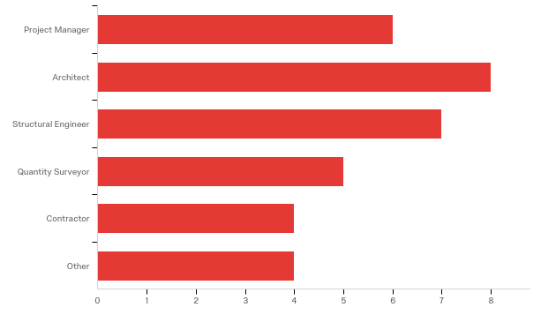
Figure 10 below shows the respondents JBCC associated constituent.
9 Respondents were from CESA, 6 respondents were from SAIA, 5 from ASAQS, 3 from MBSA, 2 from SAPOA, 1 each from SAIAT and ACPM. 4 were from unknown associations.

Figure 10 - Questionnaire respondents JBCC Association
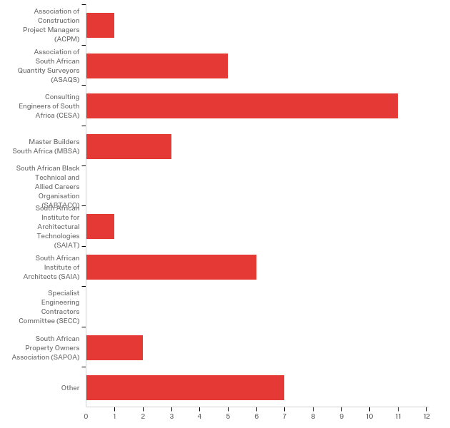
Figure 11 below shows the respondents highest qualification.
80% of the respondents had a Batchelors degree or higher, the mean age was 43 with more than a quarter of the respondents over 50 years of age.
55% of the respondents had more than 10 years of experience, more than 30% with over 20 years’ experience and over one quarter 27% over were over 30 years of age.

Figure 11 – Questionnaire respondent’s qualifications
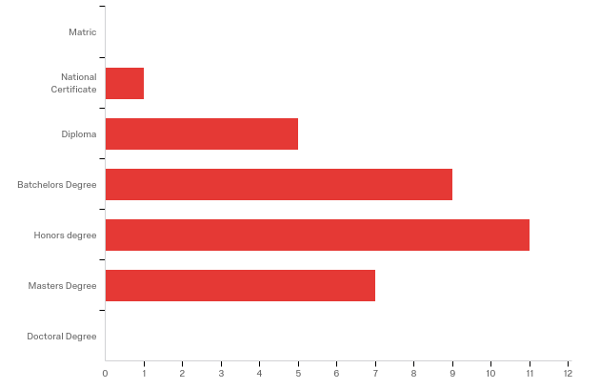
Figure 12 below shows the respondents industry of operation in the last three years.
The majority of respondents were involved in commercial projects (23) and there was an almost even spread involved in public sector, residential, industrial and retail. 1 response was recorded to be involved in mining. The majority operated in Gauteng (25) whilst the remainder operated in the Northern Cape (2), Northwest (1), Mpumalanga (3), Natal (1) and Limpopo (1).

Figure 12 - Questionnaire respondent’s industry of operation
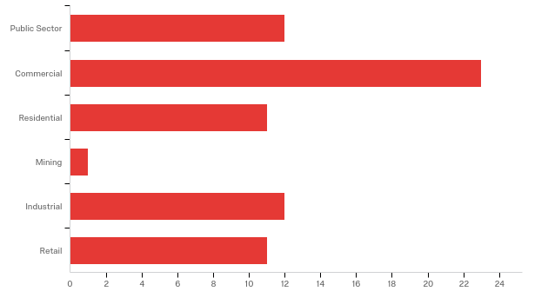
Of the 33 responses 2 were excluded due to not passing the statistical stage, consisting of a Quantity Surveyor registered with ASAQS and the Other registered with CESA but currently not participating in the project team. One other was rejected due to not being in the target population on the basis that they did not represent either a Project Team member or a JBCC committee constituent (Other). 30 responses were usable, of which all answered up until question 3 including the key questions “How would you describe a design that is incomplete” and “justification of tendering with incomplete/inadequate designs”.
The 10 partial responses were from 2 Project Managers, 2 Architects, 3 Structural Engineers and 3 Contractors.
In the interview stage, despite being instructed to describe an incomplete design, a two third majority chose to describe a complete design, because most respondents found difficulty in describing an incomplete design. The question was therefore changed to support predominant logic to describe what a complete design is and hence determine by inverse deduction of what would fall short of a complete design would be considered as being incomplete.

Q1. Describe what is considered a complete design by the project team
Table 6 below depicts the ranking of response by profession when describing a complete design..
The only complete consensus across the professions was that “Finishing and finer details must be complete”, was outright rejected and therefore highlighted that they were not required in the design to be sufficient to be tendered on.
Ranked in order preference the follow status was cited as adequate by the corresponding number of responses (R) and percentage of respondents (R%).
“Sufficient drawings to obtain reasonable quantities”, (21) (68%),
“An understanding of the structure must be clear”, (18) (58%),
“Sufficient information exists to start the earthworks and/or foundations and a flow of sufficient information so as not to delay the project thereafter”, (18) (58%),
“The concept must be clear to the architect “, (17) (55%),
“Founding conditions must be understood”, (17) (55%),
“Sufficient information is available to plan, resource and commence the construction (16) (52%),
The concept must be complete”, (14) (45%),
“The building envelope design must be complete”, (13) (42%),
“Assumptions should be limited to project specific unknowns as provisional sums”, (12(39%),
“90% of the architectural design must be complete”, (10) (32%),
“All layout must be complete”, (9) (29%),
“Services must be coordinated”, (9) (29%),
“Drawings must be fully complete and dimensioned, including all sections and elevations”, (8) (26%),
“All the require details must be available to construct the project with no retrospective changes to complete the work”, (5) (16%),
“Specialist contractors must be finalised”, (4) (13%),
“Internal layouts must be complete”, (4) (13%),
“After the various professional's design iterations are complete”, (2Arc&Other) (6%),
“The design must be fully complete such that no further design participation is required”, (1PM) (3%) and
“Finishing and finer details must be complete”, (0) (0%).

Table 6 – Incomplete design description
When calling for tenders with incomplete designs the following statuses were cited as adequate. | PM | Arc | S&CE | QS | Cont. | Other | Total | rank#
Sufficient drawings to obtain reasonable quantities | 33.33 | 100 | 85.71 | 75 | 50 | 50 | 70 | 1
An understanding of the structure must be clear | 50 | 87.5 | 85.71 | 25 | 25 | 50 | 60 | 2
The concept must be clear to the architect | 66.67 | 100 | 42.86 | 25 | 0 | 100 | 56.67 | 3
Sufficient information exists to start the earthworks and/or foundations and a flow of sufficient information so as not to delay the project thereafter | 16.67 | 100 | 85.71 | 25 | 0 | 100 | 56.67 | 4
Sufficient information is available to plan, resource and commence the construction. | 50 | 100 | 28.57 | 50 | 50 | 0 | 53.33 | 5
Founding conditions must be understood | 50 | 75 | 85.71 | 25 | 25 | 0 | 53.33 | 6
The concept must be complete | 50 | 75 | 42.86 | 25 | 0 | 100 | 46.67 | 7
The building envelope design must be complete | 66.67 | 62.5 | 28.57 | 25 | 25 | 50 | 43.33 | 8
Assumptions should be limited to project specific unknowns as provisional sums | 16.67 | 75 | 42.86 | 50 | 0 | 0 | 40 | 9
90 of the architectural design must be complete | 0 | 62.5 | 14.29 | 75 | 0 | 50 | 33.33 | 10
Services must be coordinated | 0 | 37.5 | 42.86 | 25 | 25 | 50 | 30 | 11
All layout must be complete | 0 | 25 | 28.57 | 50 | 25 | 50 | 26.67 | 12
Drawings must be fully complete and dimensioned, including all sections and elevations | 0 | 37.5 | 14.29 | 50 | 25 | 0 | 23.33 | 13
All the require details must be available to construct the project with no retrospective changes to complete the work, | 0 | 25 | 0 | 25 | 25 | 50 | 16.67 | 14
Internal layouts must be complete | 16.67 | 37.5 | 0 | 0 | 0 | 50 | 13.33 | 15
Specialist contractors must be finalised | 0 | 12.5 | 0 | 0 | 25 | 50 | 10 | 16
After the various professional's design iterations are complete, | 0 | 12.5 | 0 | 0 | 0 | 50 | 6.67 | 17
The design must be fully complete such that no further design participation is required | 0 | 12.5 | 0 | 0 | 0 | 0 | 3.33 | 18
Finishing and finer details must be complete | 0 | 0 | 0 | 0 | 0 | 0 | 0 | 19

Q2. Determine when is it justified to commence construction with an incomplete design.
Table 7 below depicts the ranking of response by profession when describing the justifications behind commencing construction with an incomplete design.
There was no complete consensus across the professions on when it is justified to commence construction with an incomplete design. Figure B5a depicts the response by percentage respondents and Figure B5b depicts it by response count. Ranked in order preference the follow status was cited as justified by the corresponding number of responses (R) and percentage of respondents (R%).
“To save time when the client needs the project delivered earlier due to deadlines such as lease expiration”, (23) (74%),
“To save time by starting construction earlier”, (22) (71%),
“To save time but cost contingencies must be the provided for”, (15) (48%),
” To save time and avoid costs such as escalation”, (13) (42%),
“To save time but it raises the risk of cost overruns during the project”, (13) (42%),
“To save time on repeat projects when the product is well known”, (12) (39%),
“To save time in teams where long-term relationships and understandings have been developed”, (10) (32%),
“To save time as various elements can only be designed during construction such as tenant fitouts”, (8) (26%),
“To save time but cost and quality may be compromised”, (7) (23%),
“To save time when team members are extremely experienced at designing whilst construction is ongoing”, (6) (19%),
“when meeting expenditure budgets and with contingencies to allow for change”, (3) (10%),
“Only under extenuating circumstances with thorough interrogation”, (2PM’s) (6%) and
“When testing market prices”, (1PM) (3%).

Table 7 – Questionnaire Incomplete design justifications
Where projects commence with incomplete designs the following reasons are frequently cited. | PM | Arc | S&CE | QS | Cont. | Other | Total | rank#
To save time when the client needs the project delivered earlier due to deadlines such as lease expiration | 83.3 | 87.5 | 85.7 | 50 | 50 | 50 | 73.3 | 1
To save time by starting construction earlier | 50 | 75 | 85.7 | 25 | 100 | 100 | 70 | 2
To save time but cost contingencies must be the provided for | 33.3 | 75 | 57.1 | 25 | 25 | 50 | 50 | 3
To save time and avoid costs such as escalation | 33.3 | 37.5 | 28.6 | 50 | 50 | 100 | 43.3 | 4
To save time but it raises the risk of cost overruns during the project | 33.3 | 50 | 14.3 | 75 | 0 | 100 | 40 | 5
To save time on repeat projects when the product is well known | 33.3 | 50 | 14.3 | 75 | 25 | 50 | 40 | 6
To save time in teams where long-term relationships and understandings have been developed | 33.3 | 62.5 | 14.3 | 0 | 50 | 0 | 33.3 | 7
To save time as various elements can only be designed during construction such as tenant fitouts | 16.7 | 62.5 | 0 | 0 | 25 | 50 | 26.7 | 8
To save time but cost and quality may be compromised | 16.7 | 50 | 28.6 | 25 | 0 | 0 | 23.3 | 9
To save time when team members are extremely experienced at designing whilst construction is ongoing | 16.7 | 50 | 0 | 0 | 25 | 0 | 20 | 10
when meeting expenditure budgets and with contingencies to allow for change | 0 | 25 | 0 | 0 | 0 | 50 | 10 | 11
Only under extenuating circumstances with thorough interrogation | 0 | 25 | 0 | 0 | 0 | 0 | 6.67 | 12
When testing market prices | 0 | 12.5 | 0 | 0 | 0 | 0 | 3.33 | 13

Q4-6 Understand the consequences of commencing construction with an incomplete design on the project team.
Table 8 – Questionnaire consequences on the project team planning phase
Consequence | Phase of construction | Often | Seldom | Never
It cost me more | Planning phase | 58.35% | 36.12% | 5.54%
It took me longer | Planning phase | 56.63% | 36.68% | 6.68%
My quality of output was reduced | Planning phase | 37.35% | 50.10% | 12.54%
I had to redo work | Planning phase | 49.65% | 42.47% | 7.86%
It contributed to undue Stress | Planning phase | 63.17% | 31.98% | 4.85%

Table 8 above summarises the consequences of the studied impacts during the planning phase (question 4).
During the planning phase there was consensus that “it contributed to undue Stress”, was highlighted as the most significant effect on the Project team at 63% that occurred often. Secondly there was also consensus that “it costs me more”, was the next most significant effect at 58% that occurred often, thirdly there was consensus “it took me longer”, as was a significant effect at 57% that occurred often and finally there was consensus that “my quality of output was affect”, at 50% but occurred only seldom. Quality which ranked 5th at 49% did not reach consensus as an effect but must be mentioned since it was ranked to occur often.
The most significant causes of impacts on the planning stage, where there was strong consensus i.e. More than 80%, which all occurred often were
“There was insufficient time to deal with unforeseen design or site issues” – “It increased my costs”, at 87%
“There was insufficient time to deal with unforeseen design or site issues” – ‘It contributed to undue stress”, at 87%
“There was insufficient time for detailed planning” – “It contributed to undue stress”, at 83%
“There was insufficient time to review and check construction information” – “It increased my costs”, at 83%
“There was a lack of services coordination” – “It increased my costs”, at 83%
“There was a lack of services coordination” – “It contributed to undue stress”, 83%.
Table 9 – Questionnaire consequences on the project team construction phase
 |  | Often | Seldom | Never
It cost me more | Construction phase | 64.79% | 31.46% | 3.64%
It took me longer | Construction phase | 66.91% | 29.82% | 3.28%
My quality of output was reduced | Construction phase | 44.59% | 48.64% | 6.76%
I had to redo work | Construction phase | 66.12% | 29.05% | 4.83%
It contributed to undue Stress | Construction phase | 69.32% | 27.74% | 2.90%

Table 9 above summarises the consequences of the studied impacts during the construction phase (question 5).
During the construction phase there was consensus that “it contributed to undue stress”, was highlighted as the most significant effect on the Project team at 69%, that occurred often. Secondly there was also consensus that “it took me longer”, was the next most significant effect at 67%, that occurred often, thirdly there was consensus that “I had to redo work”, was a significant effect at 66%, that occurred often and finally there was consensus that “it cost me more”, was a significant effect at 65%, and occurred often. “My quality of output was reduced”, which ranked 5th, just below 49% for seldom, did not reach consensus as an effect but can be mentioned since it was also high in the frequency, often at just below 45%.
The most significant causes of impacts on the Construction stage where there was strong consensus i.e. More than 80%, which all occurred often were
“Lack of coordination results in clashes and changes” – “I had to redo already complete work”, at 85%
“There were clashes between services due to lack of coordination between disciplines” – “It increased my costs”, at 81%
“There were clashes between services due to lack of coordination between disciplines” – “It contributed to undue stress”, at 81%
“Lack of coordination results in clashes and changes” – “It contributed to undue stress”, at 81%
“There were clashes between services due to lack of coordination between disciplines” – “I had to redo already complete work”, at 80%
“Lack of coordination results in clashes and changes” – “It took me longer”, at 80%
“Increased time pressure results in errors and omissions” – “It increased my costs”, at 80%.
Table 10 – Questionnaire consequences on the project team Close out phase
 |  | Often | Seldom | Never
It cost me more | Close out phase | 61.72% | 28.44% | 9.84%
It took me longer | Close out phase | 58.94% | 32.11% | 8.95%
My quality of output was reduced | Close out phase | 41.84% | 43.95% | 14.21%
I had to redo work | Close out phase | 53.16% | 32.90% | 13.95%
It contributed to undue Stress | Close out phase | 65.61% | 26.11% | 8.30%

Table 10 above summarises the consequences of the studied impacts during the close out phase (question 6).
During the close out phase there was consensus that “it contributed to undue stress”, was highlighted as the most significant effect on the Project team at 66% that occurred often. Secondly there was also consensus that “it cost me more”, was the next most significant effect at 62% that occurred often, thirdly there was consensus that “it took me longer”, was a significant effect at 59% that occurred often and finally there was consensus that “I had to redo work”, was a strong effect at 53% and occurred often. Quality which ranked 5th just below 44% for seldom, did not reach consensus as an effect but can be mentioned since it was also high in the frequency “often” at just below 42%.
Table 11 below, depicts the responses described by project team members as they see the entire team being impacted and highlights their ranking.
“Over all stress levels for the entire team”, was nearly a unanimous response 96% with only 1 Quantity Surveyor not agreeing with the effect. Secondly the team was forced to work within unreal budgets garnered 82% agreement. These two are to be noted as significant due to their significant agreement.
“The team was expected to work within unrealistic time frames”, garnered 78% agreement with full support of the Project Manager, Contractor and other whilst 3 of 4 Quantity Surveyors supported the cited impact, but the Architects and Engineers only gave 50% support.
“There was lack of time to coordinate the information and/or implementation”, at 75% was the only other unanimously cited impact, which just the Project Managers and Other dropping to just 50% in support.

Table 11 – Questionnaire consequences on the project team by team member
The following commonly cited impacts were felt by the construction project team.
 | Project Manager | Architect | Structural Engineer | Quantity Surveyor | Contractor | Other
Overall stress levels were increased for the entire team | 100 | 100 | 100 | 75 | 100 | 100 | 95.71
The team was expected to work within unrealistic time frames | 100 | 50 | 50 | 75 | 100 | 100 | 77.86
The team was force to work within unrealistic budgets | 50 | 66.67 | 75 | 100 | 100 | 100 | 81.67
A culture of covering up resulted in incohesive teams | 25 | 33.33 | 25 | 0 | 100 | 0 | 29.76
Teams were unmotivated to achieve the common goal | 0 | 50 | 25 | 0 | 100 | 50 | 36.43
Team relationships were soured | 25 | 83.33 | 50 | 75 | 100 | 100 | 71.19
There were sequencing issues in the information and/or implementation | 50 | 33.33 | 25 | 25 | 100 | 50 | 46.19
There was lack of time to coordinate the information and/or implementation | 50 | 100 | 75 | 75 | 100 | 50 | 75.00
Additional resources were required to deal with the resulting changes | 50 | 66.67 | 75 | 25 | 100 | 100 | 68.10
A conflictual environment was created | 0 | 50 | 50 | 50 | 100 | 50 | 49.29
The contractual risk transference between members was accelerated by changing scope | 25 | 33.33 | 75 | 25 | 100 | 100 | 58.33
There was knee jerk thinking in responding to ideas or changes | 50 | 50 | 75 | 25 | 100 | 50 | 57.86

It is also noteworthy to highlight that “culture of covering up resulted in incohesive teams”, was the least supported citing with 30% support, however the contractors were fully behind this citation with 100% support.

Q7. Determine the consequences of commencing construction with an incomplete design on the project itself.
Table 12 below, depicts the summarised responses described by project team members as they see the consequences on the project in relation to the listed impacts.
The full list of impact responses is attached in appendix 7 question 7 attached.
“The project occupation was delayed due to scope changes”, resulting in the project taking longer with 95% and near complete consensus with just 1 Quantity Surveyor not agreeing with the citation.
“Property rights and restriction were not resolved timeously and resulted in the project taking longer”, with 90% and only Architects and Engineers not fully putting their weight behind the citation.
“Late council approvals or no approvals resulted in the project taking longer”, with 85% and the Project Managers joining the Architects and Engineers on withholding some of their votes. However, whilst assuming 50% is consensus across Professions, it could still be considered agreement.
The next two were split between Time and Quality, “The handover process was disrupted, and the snags process could not be clearly defined resulting in the project taking longer”, and “Design sacrifices, quality compromises and functionality vs quality resulted in the quality of the project being compromised”, both on 75%. The Project managers withheld their agreement on the former to hold it back at 75% or it could have been higher and with the latter, there was 50% minimum consensus.
The most significant result is that the first mention of the project costing more was ranked 6th with “The project occupation was delayed due to scope changes resulting in the costs being increase significantly”, at 65%.
Table 12 – Questionnaire consequences on the project team in totality
 | Project Manager | Architect | Structural Engineer | Quantity Surveyor | Contractor | Other
Cost | 23% | 21% | 53% | 38% | 63% | 94% | 42%
Time | 73% | 68% | 69% | 63% | 63% | 100% | 72%
Quality | 41% | 33% | 50% | 28% | 38% | 88% | 43%
Nil | 17% | 19% | 11% | 3% | 11% | 0% | 10%

When considering the entire sample group, the only consensus is that “it resulted in the project taking longer”, at 72% which is quite significantly higher than the other cited consequences, “The quality of the project being compromised”,43%, “the costs being significantly increased”, 42% and “no effects on the project” 10%.
It was unanimous and there was clear consensus on there be being “no effects on the project”, at 10% was a near outright rejected.

Discussions and Data Analysis

Introduction
This chapter is separated in to two sections. Section 5.2 will present further results and data analysis of the guided interviews and section 5.3 will present the questionnaire data analysis. Each section will deal with the statistical data initially and move on to present the results of each question. The interview and questionnaire followed the same logic from Questions 1 through 7. Question 3 was omitted from the results as it was a statistical question.
The results of the interviews were analysis mostly in a qualitative, descriptive and comparative context with some ranking analysis where as the results of the questionnaire were analysed in a qualitative descriptive and comparative context balanced with quantitative testing and ranking.
Question 1 - Describe what is considered an incomplete design by the project team
Question 2 - Determine when it is justified to commence construction with an incomplete design.
Question 4-6 - Determine the consequences of commencing construction with an incomplete design on the project team (Planning(Q4), Implementation(Q5) and Close out(Q6)
Question 7 - Determine the consequences of commencing construction with an incomplete design on the project itself.
Section 4.2 does provide some data analysis due to the fact that the results of the guided interview were needed as input to the questionnaire for section 4.2.
The results have been tabled/figured where possible to provide easily interpreted and understandable information, and a discussion around each set of data either precedes or follows the table/figure as necessary.

Guided interview Discussions and Analysis

Q1. Describe what is considered an incomplete design by the project team
Depending on the profession there is some correlation on what is considered an incomplete design however as a global project team there is great variance. For example, the contractors require, as with Kikwasi (2012), Lee (2011) and Ren (2008) that a great level of detail be provided to consider the design to be complete enough to commence construction, whereas the architects describe only high levels of understanding to consider the designs complete for construction. Interestingly, no-one in this study referred to contract documents as did (Ren, et al., 2008),when discussing premature starts. It is also interesting, that the engineers, who are renowned for being conservative, did not require complete and detailed information to deemed the design to be complete for commencement.
Judging by the fact that more interviewees preferred to describe what a complete design is may also highlight how difficult it is to describe an incomplete design. This is surprising as all the interviewees were highly educated with 14 of the 15 interviewees holding at least a Batchelor degree.
Tilley (1997) refers to conflicts, errors and inefficiencies in designs leading to effects. This view is not reflected in this part of the study.
In question 1 the themes that came to the fore were decided upon as referring to complete, incomplete or irrelevant. Complete would refer to those interviewees who chose to describe a design in the positive and describing what they would consider sufficient information, incomplete was the opposite using the negative and describing what falls short of sufficient information and irrelevant was determined for responses that satisfied neither.

Q2. Determine when is it justified to commence construction with an incomplete design.
In question 2, the overriding themes were cost and time, which aligned with (Lee, 2011), (Monyane, 2013), (Kikwasi, 2012) and (Ren, et al., 2008), however there was also an element of disagreeing with the postulation which became significant and aligns with the literature in that many studies concluded that the completion of information in high detail is required (Monyane, 2013) or finalised (Kikwasi, 2012), to avoid cost and time implications.
- ARCH (5), QS (12) and CONT (14) refer in some way to a speedy start which reflects Monyane (2013) and Laryea (2011) where they discuss rushing the start and rushing documents and parties discuss the risks it brings about.
- 11 of the 15 or 73% of the interviewees stated that a time saving would be a justification for commencing construction with an incomplete design.
- 4 of the 12 or 33% of the interviewees stated that a cost saving would be a justification for commencing construction with an incomplete design, but it is noteworthy to highlight that all linked this to the time saving in some way.
- 9 of the 15 interviewees or 60% of the interviewees, although justifying premature construction by time saving, only justified it under clarification. This view is echoed in Latham (1994) and Monyane (2013) whereby they highlight the consequences that must be considered.
- Only 1 or 7% of the 15 interviewees, a Project manager (PM2) justified costs savings unreservedly, which interesting was not found in the literature.
The justification of commencing construction with an incomplete design was easily answered by the interviews but again did not produce a conclusive answer that was widely agreed upon by all professions.

Q4-6. Understand the consequences of commencing construction with an incomplete design on the project team.
Through questions 4 to 6, Cost and Time were pronounced in all, and Quality, Stress and rework fluctuated through the phases. This was in strong correlation to the literature but could have been influenced by the prompts in some instances. In phase 1, questions 3-5 it was noted that there were almost no positive responses, despite the study questions highlighting both positive and negative responses were applicable.
The consequences and impacts on the project team was widely answered with large volumes of information but insufficient detail to determine the links and differences between the professions. It was found to be useful to understand the various causes and impacts and the data was reduced as far as possible to test against a wider and different audience in the questionnaire.
It was difficult to compare the Project Team members to the literature since a similar study was not discovered, but the
- Planning phase
- 30 out of 74 or 41% of responses refer to time implications
- 22 of 74 or 30% of responses refer to cost implications
Cost and Time consequences were by far the highest studied impacts and consequences in the literature and this is mirrored by the results in this study,
- 6 of 74 or 8% of responses refer to both quality implications and change implications
- 3 of 74 or 4% of responses were positive which require special mentions
  - “It enables the client to commence and complete projects sooner”, PM2
  - “The scope can be finalised earlier”, S&CE7
  - “Repeat business is much easier…but results in…consenting…fee reduction”, S&CE8
- Other noteworthy consequences
  - There were several mentions of working at risk by some of the design professionals. i.e. not getting paid for the work done unless and until the project proceeds to the implementation stage of construction), Arc5, S&CE 7&8 and Cont. (15)
  - Several mentions of a shift where architects are being forced to design into a budget where the feasibility is financial only, (PM1, Arc3&4, S&CE 7, QS9 and QS12).
- Stress was not a significant factor in the planning stage.
- Implementation phase
- 28 out of 73 or 38% of responses refer to change implications
- 25 of 73 or 34% of responses refer to time implications
- 22 of 73 or 30% of responses refer to cost implications
- 11 of 73 or 15% of responses refer to quality implications
- 8 of 73 or 11% of responses refer to stress implications
- Only 1 of 73 or 1% of responses were positive which requires special mention, “Other designers can continue their work before the final design is done by the architect.”, QS9.
- Other noteworthy mentions were;
  - “There was time pressure debating design, completion dates were fixed and once the agreed time is reduced; conservative designs followed to allow for change but resulted in cost increases.”, S&CE8.
  - “Everything being done becomes difficult or hard work.”, Cont14
  - “Poor information is worse than no information.”, Cont14
  - “More liberty with scope changes increases with incomplete design”, QS12
  - “With cost overruns, comes question of honesty/morality with rates and measures which leads to relationship breakdown/integrity issues.”, Cont15
- Close out phase
- 25 out of 56 or 45% of responses refer to time implications
- 18 of 56 or 32% of responses refer to quality implications
- 17 of 56 or 30% of responses refer to change implications
- 10 of 56 or 18% of responses refer to cost implications
- Other noteworthy mentions
  - “Quality suffers the worst - do not underestimate time and/or sequence – you only have 1 or 2 chances of doing it right.”, Cont14
  - “The definition of PC becomes difficult with major changes.”, Cont13
- Overall impact on the project team
- 13 out of 45 or 29% of responses refer to change implications
- 11 of 45 or 24% of responses refer to quality implications
- 7 of 45 or 16% of responses refer to time implications
- 6 of 45 or 13% of responses refer to cost implications
- Other noteworthy mentions
  - There were several mentions of bad or broken relationships from stress and pressure, (PM1&2, Cont13 and QS12)
  - “The notion of a complete design is idealistic not realistic.”, QS12.

Q7. Determine the consequences of commencing construction with an incomplete design on the project itself.
Finally, the impacts on the project itself was queried and a good volume of data was received in this respect as well. This information was also selectively reduced to a manageable portion and included in the questionnaire for further testing.
- 12 out of 38 or 32% of responses refer to quality implications
- 10 of 38 or 26% of responses refer to time implications
- 9 of 38 or 24% of responses refer to change implications
- 7 of 38 or 18% of responses refer to cost implications
- Other noteworthy mentions
  - “When a project is accelerated the quality goes down”, Cont13
  - “Final completion guarantees are outstanding for 12-14month (noted as a study by a financial institution),” Cont13.

Questionnaire Discussions and Data Analysis

Question 1. Describe what is considered an incomplete design by the project team?
It is interesting to note that, the top 5 ranked descriptions as shown in table 13 below are very high level and not very explicit or detailed. This is conflicting with as with (Kikwasi, 2012), (Lee, 2011) and (Ren, et al., 2008) in the literature. It is also interesting to highlight that the contractors did not demand complete designs, unlike in the interviews and that it was the quantity surveyors that were more explicitly requiring a higher level of design. This conflict may lead some to believe that the data is erroneous however it is my opinion that this proves that the description is elusive due to lack of detailed context and can be resolved when the context is fixed.
The 6th ranked citation is the only explicit description and not at a high-level understanding. This requirement must be critical in its nature to obtain consensus, assuming that consensus is achieved at 50% or more agreement.
Ranked at 1, “Sufficient drawings to obtain reasonable quantities”, with 70% total agreement, but not with complete consensus in all professions as only 1 of 3 project managers agreeing. Ranked at 2,” An understanding of the structure must be clear” and with 60% total agreement, the QS’ and Cont.’s did not fully agree. Ranked at 3, “The concept must be clear to the architect”, at 57% total agreement, the S&CE, QS and Cons did not fully agree. Ranked at 4 “Sufficient information exists to start the earthworks and/or foundations and a flow of sufficient information so as not to delay the project thereafter”, at 57% total agreement, the PM, QS and Arc did not agree. Ranked at 5,” Sufficient information is available to plan, resource and commence the construction”, at 53% total agreement, the S&CE and others did not agree. Ranked at 6, “Founding conditions must be understood”, the QS, Cont. and Other did not agree.

Table 13 – Data analysis justifications – top rankings
When calling for tenders with incomplete designs the following statuses were cited as adequate | PM | Arc | S&CE | QS | Cont. | Other | Total | rank#
Sufficient drawings to obtain reasonable quantities | 33.33 | 100 | 85.71 | 75 | 50 | 50 | 70 | 1
An understanding of the structure must be clear | 50 | 87.5 | 85.71 | 25 | 25 | 50 | 60 | 2
The concept must be clear to the architect | 66.67 | 100 | 42.86 | 25 | 0 | 100 | 56.67 | 3
Sufficient information exists to start the earthworks and/or foundations and a flow of sufficient information so as not to delay the project thereafter | 16.67 | 100 | 85.71 | 25 | 0 | 100 | 56.67 | 4
Sufficient information is available to plan, resource and commence the construction | 50 | 100 | 28.57 | 50 | 50 | 0 | 53.33 | 5
Founding conditions must be understood | 50 | 75 | 85.71 | 25 | 25 | 0 | 53.33 | 6

Question 2. Determine when it is justified to commence construction with an incomplete design.
There was strong consensus across the team in only one category, “To save time when the client needs the project delivered earlier due to deadlines such as lease expiration”, at 73% and a minimum of 50% across team members. In all the other categories in the top 5 there was disagreement. Saving time was a strong theme in the top five categories, however as costs became integrated into the citation, the justification became less relevant.
Architects had the strongest showing across the citations, concurring with 9 citations and the Project managers with the smallest showing, concurring with only 2 citations. The S&CE also had low consensus showing in only 3 categories.
These results are similar in nature to Griego (2016)’s study on page 93, Figure 5, where the top three drivers were all related to saving time and the top two were incredibly similar to this studies top two i.e. “Owner mandated overly aggressive schedule” versus ”To save time when the client needs the project delivered earlier due to deadlines such as lease expiration” and “Owner perceived benefit to early start” versus “to save time by starting construction earlier”.

Table 14 – Data analysis justifications – top 5 rankings
Where projects commence with incomplete designs the following reasons are frequently cited. | PM | Arc | S&CE | QS | Cont. | Other | Total | rank#
To save time when the client needs the project delivered earlier due to deadlines such as lease expiration | 83.3 | 87.5 | 85.7 | 50 | 50 | 50 | 73.3 | 1
To save time by starting construction earlier | 50 | 75 | 85.7 | 25 | 100 | 100 | 70 | 2
To save time but cost contingencies must be the provided for | 33.3 | 75 | 57.1 | 25 | 25 | 50 | 50 | 3
To save time and avoid costs such as escalation | 33.3 | 37.5 | 28.6 | 50 | 50 | 100 | 43.3 | 4
To save time but it raises the risk of cost overruns during the project | 33.3 | 50 | 14.3 | 75 | 0 | 100 | 40 | 5

Question 4-6. Understand the consequences of commencing construction with an incomplete design on the project team.
With reference to table 8, in the results, Stress was the main effect on the PT. These results interestingly aligned with (Ndihokubwayo & Haupt, 2009) and (Enshassi & Al Swaity, 2015), though Enshassi had a more positive outlook on stress.
With focus on the less summarised table 15, Cost and Time were grouped closely together as with the Interview, but these differed in that the interview responses did not include any other effects until the close out stage where quality became the dominant effect. This can be related to the fact that often in a project, the focus by all parties is to drive and complete the project, and often only once the primary deliverables are being met does the team focus on the clients next most important deliverable of quality. It may also relate to the fact that quality is a very difficult deliverable to measure. Various scholars have tried to measure quality; however the consensus generally returns back to meeting the clients expectation. This also differed from the questionnaire stage in that quality effect although prevalent in the interview stage at close out construction phase was not in the majority, but re-work became noticeable. This supports the previous statement in that only once the focus is set on quality does the project team start highlighting work that is not acceptable and that has to be redone.
The main correlations were that there was strong agreement that the effects were almost always prevalent, with never more than 15% responses rejecting effects or an average of 8%. This proves that the Project Team Members studied did not disagree with the hypothesis that there are adverse Impacts and Consequences caused by incomplete designs and that in fact 11 of the categories agreed that there was often an effect on the project team, and only 1 category highlighted that the effects were seldom, being “Quality” in the planning phase.
In addition, responses to effects on quality seemed to be divided between Often and Seldom in all construction phases.
Table 15 – Data analysis Consequences on the Project team by phase versus frequency of impact
 |  | Often | Seldom | Never
Cost | Planning phase | 58.35% | 36.12% | 5.54%
 | Construction phase | 64.79% | 31.46% | 3.64%
 | Close out phase | 61.72% | 28.44% | 9.84%
Time | Planning phase | 56.63% | 36.68% | 6.68%
 | Construction phase | 66.91% | 29.82% | 3.28%
 | Close out phase | 58.94% | 32.11% | 8.95%
Quality | Planning phase | 37.35% | 50.10% | 12.54%
 | Construction phase | 44.59% | 48.64% | 6.76%
 | Close out phase | 41.84% | 43.95% | 14.21%
Rework | Planning phase | 49.65% | 42.47% | 7.86%
 | Construction phase | 66.12% | 29.05% | 4.83%
 | Close out phase | 53.16% | 32.90% | 13.95%
Stress | Planning phase | 63.17% | 31.98% | 4.85%
 | Construction phase | 69.32% | 27.74% | 2.90%
 | Close out phase | 65.61% | 26.11% | 8.30%

Question 7. Determine the consequences of commencing construction with an incomplete design on the project itself.
In Table 16 below, in the top 10 ranked responses, 6 out of 10 referred to time, 2 out of 10 referred to quality(R5&R7) and 2 out of 10 referred to cost (R6&R8). In the top three ranked citations, R1 at 95% “The project occupation was delayed due to scope changes resulting in”, R2 at 90% “Property rights and restriction were not resolved timeously and resulted in” and R3 at 80% “Late council approvals or no approvals resulted in”, all cited, “The Project taking longer” as the dominant effect with extremely strong correlations with all exceeding 2 out of 3 professions agreeing. R4 at 75% “The handover process was disrupted, and the snags process could not be clearly defined resulting in “, cited “The Project taking longer” as the dominant effect but failed to get full consensus with one PM disagreeing.
Table 16 – Ranking of the consequences on the project itself
Where projects commence with incomplete designs the following consequences to the project are frequently cited. Please rank the consequences in order of effects.
Citing | Consequence | Agreement  coefficient | Ranking  (R)
The project occupation was delayed due to scope changes resulting in | The Project taking longer | 95 | 1
Property rights and restriction were not resolved timeously and resulted in | The Project taking longer | 90 | 2
Late council approvals or no approvals resulted in | The Project taking longer | 85 | 3
The handover process was disrupted, and the snags process could not be clearly defined resulting in | The Project taking longer | 75 | 4
Design sacrifices, quality compromises and functionality vs quality resulted in | The quality of the project being compromised | 75 | 5
The project occupation was delayed due to scope changes resulting in | The costs being increased significantly | 65 | 6
The structural integrity and longevity of the building was compromised resulting in | The quality of the project being compromised | 65 | 7
Unclear assumptions in the design resulted in | The costs being increased significantly | 65 | 8
Unclear assumptions in the design resulted in | The Project taking longer | 60 | 9
There was an increase in snags and defects resulting in | The Project taking longer | 57.89 | 10

The top 4 rankings with strong agreement and approval and 2 additional citings ranked 9 and 10, shows that the Project Team members in this study agree that the main consequence on the project is it taking longer. It was surprising to find quality being compromised ranking in 5th and 7th place ahead of significant costs increases ranked 6th and 8th place. It is surprising that although the project takes longer there is not much clarity on whether this could be linked to the project costing more and this set of data cannot confirm or reject that link. Perhaps the costs incurred due to the project taking longer are burdened on the Project Team as apposed to the Project itself.

Summary

Introduction
The answers to the secondary questions as perceived by the project team must be unpacked to fully understand the primary question. In answering these secondary questions we will understand why it is so difficult to understand the characteristics of an incomplete design, what are the factors that lead to commencing with an incomplete design or why is the agenda pushed and how is it justified, what are the impacts and consequences on the project team and what are the consequences on the project itself. In understanding these elemental parts, the primary question can be answered.

Q1. Describe what is considered an incomplete design by the project team?
Explicitly describing what is perceived as an incomplete design was not achieved since PT members found it difficult to describe in the interview stage and there was only some agreement in the questionnaire stage as to what components of the design must be complete but more strikingly poignant was the consensual agreement as to what is not required. As shown in figure 13 below, an extract from the ranked variables Table 6, there is a strong inverse correlation whereby at high-level and vague variables there a is good agreement which systematically reduces as the variables become more direct and detailed in description. This relationship clearly points to a hypothesis that as the variables become vaguer and more high-level there is higher acceptance and as the variables become more explicit and detailed there is more rejection of the citing.

Figure 13 – Ranked variable extract – complete design

Since there is no clear description of premature construction in the literature, a comparison cannot be done but when looking at the impacts of consequences on projects, the literature points to incomplete designs as some causal factors and recommends all designs should be complete. Although this is in agreement with some PT members describing a detailed level of design as complete, this however does not necessarily prove in context that failure to achieve this would result in an incomplete design.
The inverse correlation points to the fact that at some point of description there is a strong case for a unanimous agreement on decryption. The worry is that, should there never be agreement, then the question begs whether the PT can have the same objectives and hence be considered a team.

Q2. Determine when is it justified to commence construction with an incomplete design.
It was fundamentally clear to the studied populace in both the interviews and questionnaire responses that the only agreed reason to tender and/or commence construction with an incomplete design was to save time but most agreed that it had an opportunity cost. This was in line with the literature as was the varying reasons for this, such as to start the project earlier, finish the project sooner or save time related costs such as; a shorter project period, avoid inflation, avoid penalty costs with absolute deadlines etc. However, it was also abundantly clear in their opinions that the time saving generally carried consequences that were mainly cost, and risk based.

Q4-6. Understand the consequences of commencing construction with an incomplete design on the project team.
In the interview stage, the majority of responses related to Cost and Time implications which accounted for around 80% of cases in the planning and implementation phase and reduced to an almost even 1/3 split including Quality implications. However, in the questionnaire stage Stress leaped up from well below 7% in the interview stage to the top of the ranking tables in all three construction phases. This overall impact as perceived by the studied PT was an increase in stress which was mainly attributed to meeting budgets, working in unrealistic time frames, poor co-ordination and team relationship strains.
It must also be noted that in all 3 project phases studied in regard to the premature start of the project, it was noted as a common occurrence to cost the Project Team members more, it regularly took them longer to carry out tasks, rework was a common occurrence and this all resulted in undue stress.

4. Q7 - Determine the consequences of commencing construction with an incomplete design on the project itself.
What was very intriguing is that the top ranked consequences determined by the studied populace on the project was noted by consensus as, “it resulted in the project taking longer”. When looking into the detail of the responses the top four ranked consequences also pointed to the project taking longer, as well as six of the top ten rankings pointing to the project taking longer. Only two referred to compromised quality and only two referred to the costs being increased significantly. There is little evidence of whether there is any influence by an incomplete design in relation to rework or change having much effect on the project and it can be taken that it is insignificance in this case.

Primary research question
The interview stage highlighted the overwhelming negative responses to the postulation despite prompts to provide positive statements as well. There was confusion over what was an incomplete design especially at the time of tender and various member attempted to describe the occurrence however a large majority chose to describe a complete design. The studied population agreed that the agenda was pursued to save time but with consequences to the project itself and to the project team. These consequences were almost always highlighted in the negative.
Therefore, members of the PT studied, perceive that commencing construction with an incomplete design results in increased stress on the project team, it costs them more to participate, it took longer to perform their role and results in rework. They also perceive that it takes the project longer.

Conclusion and Recommendations

Introduction
This study set out to understand what an incomplete design was, how or why it was justified, how it impacted the Project and Project Team and what the consequences are on the Project and Project Team.
The literature review endeavored to uncover what was known about the phenomena and how it impacted the Project and Project team with little success, except to highlight that little was know in the documents. The interviews were carried out to confirm the knowledge understood in the public domain and collected testable impacts, that were transferred into the questionnaire to test their implications and consequences. Vast amounts of information were collected with mostly expected results in relation to the literature but also some very interesting un-expected impacts. Finally, the questionnaire returned largely expected results but had a notable revelation regards stress.
These conclusions and recommendations must be viewed in the context that a convenience sample was used and that they do not represent the entire populations views as contemplated in chapter 3. However, this does not diminish the importance of what has been discovered since the learnings of this study can be reproduced and tested in clustered, random, systematic, stratified or another purposive population since the entire population is in fact too large to study completely.
Firstly, the hypothesis will be concluded, then the research questions will be answered and finally some recommendations and further work will be highlighted.

Hypothesis - Incomplete designs result in adverse consequences on the project team.
Tilley (1997) highlighted commercial construction complexities and discussed how rare it was for the construction projects information to be complete, precise and unambiguous. They went on to uncover that it leads to adverse impacts such as revisions and clarifications which result in additional work for the design team. Othman (2009) provided that pressure from client’s demands for better quality, at lower costs and tighter time frames increased the project teams risk greatly. Incomplete drawings were discussed (Ren, et al., 2008) to be caused by pressures from the client in reducing the design time frames increasing pressure on the project team to perform. Tolson (2007) discussed the impacts of incomplete designs and advised that commencing construction with incomplete designs can increase the risk of adverse happenings which invariably results in the impacts of delays and disruption and the consequences were increased costs., It was also highlighted that once off multidisciplinary projects do impact on adversarial relationships and that professional fees versus design demands was a cause of stress. (Adeoye, 2014)
These assertions are reflected in the interview stage whereby PM2 declared, “Design consultants are placed under more pressure to complete construction details by the required issue dates.” and “with the lack of documentation time, everyone starts at once and has to revisit stages 1-3 i.e. conceptual design”, Arc5. This led to “Possible changes to the structure as the design of various members were concurrent and lead to redesign and rework with cost and time implications.”, S&CE8, and is highlighted by PM2, in that “Rework was required if changes were required to accommodate incomplete design requirements i.e. Cores for additional services etc.” This finally leads to, “Creating conflict between team members due to various cost/time pressures.” QS12.
In all three phases of the project studied, an outright majority of fifty seven percent of the respondents selected that the cited impacts often lead to all five consequences i.e. “it contributed to undue stress”, “it took me longer”, “it cost me more”, “I had to redo work” and “my quality of output was reduced”. An additional thirty five percent selected that it seldomly occurred and only eight percent said it never happened. When separating the consequences into the five categories and looking at them separately, only three of the consequences fell below a majority of 50% in the frequency “often” and all being in the category “my quality of output was reduced”, namely planning phase 37%, construction phase 45% and close out phase 42%. However, when combing often and seldom together the average was still well over 80%.
It can be confirmed that several scholars in the literature refer to the prevalence of incomplete designs and their impacts; 203 impacts were highlighted by 15 project team members studied in the interview stage, or an average of nearly 14 impacts per interviewee were collected for study; and over 20 questionnaire respondents agreed in majority (57%) that the impacts of incomplete designs resulted in adverse consequences; it can therefore be confirmed that the hypothesis, “Incomplete designs result in adverse consequences for the project team ”, is true.

Conclusions

Question 1. Describe what is considered an incomplete design by the project team?
The view of premature construction and understanding of what it is perceived by the project team members was not explicit and points more to a logic or hypothesis which may be in contrast to the literature. This view rather pointed to a higher-level understanding of the design as apposed to a desire for more clear and detailed information. However, the literature only pointed to incomplete designs when unpacking various consequences and impacts but has not yet been tested.

Question 2. Determine when is it justified to commence construction with an incomplete design.
The reasons ascertained from this population for proceeding with premature construction that were apparent do not differ from the literature in that most of the project team members related the early start to saving time on the completion date. This study goes further to highlight that most project team members understand that the early start does have opportunity costs including offsetting the main driver of time saving by extending the project.

Question 4-6. Understand the consequences of commencing construction with an incomplete design on the project team.
What was never anticipated at the onset of the study, was the human factor in that the effect on the project team is mainly stress. This however did relate back to the newer literature in (Bhatt, et al., 2015), (Enshassi & Al Swaity, 2015) and (Xing, et al., 2017). Stress is a relatively new field of study, especially in the construction industry. This is apparent by the fact that 4 of the 5 papers discovered during the literature review, referring to the human element are less than 3 years old. If most of the team members studied agree that stress is the main effect of premature construction, what are the consequences of stress on the project team. Stress must have been one of the factors that lead to the bridge collapse discussed in the introduction? If so this is a very important topic to study further and although it is often overlooked in project feasibilities or more importantly in collapse investigations, this important topic should be studied in great detail.
In the modern era of lifestyle diseases, perhaps the topic of stress and more especially avoidable stress should be studied to understand it in more detail. The causes should be identified, the effects of it should be highlighted and an approach to how it should be best managed could be determined.

Question 7 - Determine the consequences of commencing construction with an incomplete design on the project itself.
The data collected in this study clearly points to the fact that incomplete designs impact the project in a such a way that it results in the project taking. There is evidence that it also affects the quality of the project and that there is some influence on the final cost as well. It is unclear whether the longer time frame affects the final cost of the project from this set of data. Rework or change does not have an impact or consequence on the project directly but may be a cause that results in the quality being compromised.

Recommendations and Further work

Question 1. Describe what is considered an incomplete design by the project team?
This studied Project Team makes it clear, that making explicit what an incomplete design is without detailed context and in agreement within the project team environment is impossible. This extremely important agreement is imperative to achieve, as a team requires common objectives in order to perform at a high level without hidden agendas. A common understanding would provide a measuring tool that will align or determine how aligned the team is at the commencement of the project and even throughout the project process.
In order to bring context and determine an explicit description, the following should be tested;
A well-known design stage description such as SACAP’s 5 stages of design can be overlaid or linked to steps within the 4 project phases or the project life cycle described in Chapter 1. This would match design objectives within each phase to align output and process.
The hypothesis stated in Chapter 5 and depicted in figure 13 based on an inverse correlation between ‘the level of agreement by team members versus the variable depth/breadth of design understanding by project team members’ must be tested. This can be done in the context of known design stages or levels of understanding as collected in the interview stage for question 1.

Question 2. Determine when is it justified to commence construction with an incomplete design.
The view that ‘saving time’ must be the only reason to commence with premature construction was very important to this studied populace and their understanding of the consequences was clear that it most probably came with an opportunity cost, the most common being cost but can also be lengthening of the project as well.
Griego (2016)’s Premature start impact analysis (PSIA) covers this in great detail. He collects the main drivers from his studied projects, which provide the leading indicators that result in project impacts. Griego’s PSIA is the result of his study and in adapting it to more simplistic software utilised by professionals, he created a tool that he proved to predict the impacts from the drivers and leading indicators. This tool must be used when a premature start is indicated or when it is proposed as an agreed strategy.
Griego’s PSIA can be adapted to predict high levels of misalignment and diagnosis can lead to action to correct the trajectory such as when he suggested that early and regular meetings can contribute to the success of the project or the risks can be discussed and mitigated by the team.
A detailed list of drivers of premature construction must be collected from various sources including those described in Griego’s and this study. These should be described in detail with members of the project team whom should all become well versed in this knowledge to understand the risks, impacts and effects as well as to anticipate if a project team member is trying to advantageously direct a project towards this route for their own benefit.

Questions 4-6. Understand the consequences of commencing construction with an incomplete design on the project team.
It is imperative to understand that premature construction comes with the modern life style ill’s, confirmed by the fact that stress is the main consequence on the project team. Since it is suggested that the construct is entrenched in the construction industry, the Project team must be;
- Equipped for tight client budget management
- Have sufficient teams to deal with the fast-paced projects and be prepared and equipped for rework.
- Stress management programs need to be in place for all team members
- Project Team organisations need to be aware and to have allowed for the additional costs and human resources to deal with the consequences of premature construction.
A study similar to (Enshassi & Al Swaity, 2015) ‘s main stresses of personal, task, physical and organisational stresses, must be carried out to determine if similar cases exist in the South African Environment.

Question 7 - Determine the consequences of commencing construction with an incomplete design on the project itself.
It is recommended therefore that before commencing construction with an incomplete design, there should be a mechanism to determine the proposed time saving, and compare it to the possible consequences, of increased costs and compromised quality. It must also weigh up the strong possibilities that the project may also take longer.
It must also be made explicit when a project commences with an incomplete design at tender stage. It is recommended that the clause that refers to the completeness of documentation i.e. clause 2.3 in the JBCC May 2005 version, be included in the ‘Form of tender’ document, and especially highlighted for acknowledgement when a project goes to tender with an incomplete design.

References

(GIAA), G. I. I., 2017. www.giia.net. [Online]
Available at: https://www.pwc.com/gx/en/industries/assets/pwc-giia-global-infrastructure-investment-2017-web.pdf
(PWC), P. W. C., 2016. Highlighting trends in the South African Coonstruction industry. [Online]
Available at: https://www.pwc.co.za/en/assets/pdf/sa-construction-2016.pdf
Adeoye, O., 2014. An identification fo factors influencing delay, revision and rework in multidisciplinary infrastructure design projects in South Africa., Johannesburg: Unitversity of the WItswatersrand.
Ahsan, K. & Gunawan, I., 2010. Analysis of cost and schedule performance of international development projects.. International Journal of Project Management 28.1, pp. 68-78.
Alarcón, L. F. & Mardones, D. A., 1998. Improving the design-construction interface.. Guarunja, Proceedings of the 6th Annual Meeting of the International Group for Lean Construction.
Arain, F. M. & Pheng, L. S., 2005. The potential effects of variuation orders on institutional projects.. Facilitites Volume 23, pp. 496-510.
Baloyi, L. & Bekker, M., 2011. Causes of construction cost and time overruns: The 2010 FIFA World Cup stadia in South Africa.. Acta Structilia 18.1, pp. 51-67..
Bhatt, R. R., Desai, G. J. & Verma, P. B., 2015. Psychological stress among un-organized building construction workers in Gandhinagar, Gujarat, India.. JMR 1.4, pp. 129-131..
Emuze, F. A., 2011. Performance improvement in South African construction, Nelson Mandela Bay: Nelson Mandela Metropolitan University.
Enshassi, A. & Al Swaity, E., 2015. Key Stressors Leading to Construction Professionals' Stress in the Gaza Strip, Palestine.. Journal of Construction in Developing Countries 20.2, p. 53.
Fourie, J. A., 2014. The impact of transaction costs in incomplete contracts on prices submitted in the tendering process., Pretoria: University of Pretoria.
Frimpong, Y., Oluwoye, J. & Crawford, L., 2003. Causes of delay and cost overruns in construction of groundwater projects in a developing countries; Ghana as a case study.. International Journal of project management 21.5, pp. 321-326..
Griego, R. P., 2016. Finding leading indicators to prevent premature starts, assuring uninterupted construction., Austin: The University of Texas.
Hanson, D. N., 2006. Causes of client dissatisfaction in the South African building industry and ways of improvement: the contractor's perspectives., Johannesburg: University of the Witwatersrand.
Kaliba, C., Muya, M. & Mumba, K., 2009. Cost escalation and schedule delays in road construction projects in Zambia.. International Journal of Project Management 27.5, pp. 522-531.
Kiang, Q. L., 1991. Perceptions and management of the risks in tendering for refurbishment work: Results of survey into UK contractors’ claims on higher risks in refurbishment work.. Building research and information 19.6, pp. 356-359..
Kikwasi, G. J., 2012. Causes and effects of delays and disruptions in construction projects in Tanzania. s.l., s.n., pp. 52-59.
Laryea, S., 2011. Quality of tender documents: case studies from the UK. Construction Management and Economics 29.3 , pp. 275-286.
Latham, S. M., 1994. Constructing the team, London: HMSO publications.
Lee, C., 2011. The causes and effects of project delays in the coal mining industry in South Africa, s.l.: Graduate School of Business Leadership – UNISA.
Monyane, T. G., 2013. Identifying causes of cost overruns and effective cost control measures of public projects in the Free State province., Tshwane: Tshwane University of Technology.
Mukuka, M. J., Aigbavboa, C. O. ,. & Thwala, W. D. .., 2014. A Theoretical Review of the Causes and Effects of Construction Projects Cost and Schedule Overruns.. International Conference on Emerging Trends in Computer and Image Processing.
Ndihokubwayo, R. & Haupt, T. C., 2009. Variation orders on construction projects:Value adding or waste., s.l.: Nova Science Publishers, Inc..
Othman, A. & Harinarain, N., 2009. Managing risks associated with the JBCC (principal building agreement) from the South African contractor's perspective." . Acta Structilia: Journal for the Physical and Development Sciences 16.1, pp. 83-119.
Ramabodu, M. & Verster, J., 2010. Factors Contributing to Cost Overruns of Construction Projects. Durban, s.n., pp. 131-143.
Ren, Z., Atout, M. & Jones, J., 2008. Root causes of construction project delays in Dubai.. s.l., s.n., pp. 749-757.
Richards, P., Bowen, P., Root, D. & Akintoye, A., 2005. CLIENT STRATEGIC OBJECTIVES: THE IMPACT OF CHOICE OF CONSTRUCTION CONTRACT ON PROJECT DELIVERY. Construction Law Journal No. 7 Sweet & Maxwell Ltd. and Contributors,.
Subramani, T., Sruthi, P. S. & Kavitha, M., 2014. Causes of cost overrun in construction.. IOSR Journal of Engineering 4.6, pp. 1-7.
Tilley, P. A., Wyatt, A. & Mohamed, S., 1997. Indicators of design and documentation deficiency. s.l., s.n.
Tolson, S. J. A., 2007. Design liabillity defective buildings and remedies at law 2007. IBC Construction Law Summer School Construction Law.
Wysocki, R., Bentley, C. & Ross, J., 2016. Combining the Best of PRINCE2 and Agile: Using Selected Artifacts from the ECPM Framework, s.l.: s.n.
Xing, L. et al., 2017. Empirical research on the influencing factors of the occupational stress for construction workers.. s.l., IOP Publishing,.
Zou, P. X., Zhang, G. & Wang, J., 2007. Understanding the key risks in construction projects in China.. International Journal of Project Management 25.6, pp. 601-614..

Appendices

APPENDIX 1 Informed consent form
Informed consent

RE Perceptions around premature construction: Impacts and consequences of incomplete design?

I Mr/Mrs/Other_____ Name___________________ Surname ___________________
hereby consent to participation in the research by interview/questionnaire under the following conditions: -
1 That I may request to have all my information kept private, confidential and not linked to my responses.
2 That I can withdraw my participation from the research at any time without adverse consequences in any way.
3 That I have the right to NOT answer any or all of the questions.
4 All results and information recorded will be confidential and not linked to any interviewee or responder of questionnaires.
5 No independent or individual results will be published.
6 Only the questionnaire group responses may be published without link to any specific person/persons.
7 I have read the participation information letter and understand that the information I provide may be used anonymously in the research.

Date ___________________ Signature ___________________
The information I provide must be kept (cross out where applicable)
1 Anonymous
2 Private
3 Confidential

APPENDIX 2 - Participation Information Form
XXXX
Melville
Randburg
2092

16th August 2016

Dear Sir/Madam

RE Perceptions around premature construction: Impacts and consequences of incomplete design?
I am currently conducting research on the impacts and consequences of incomplete designs. This study forms part of The School of Construction Economics and Management’s Master’s Degree in Building. The first part of this research will take place with interviews to determine the causes, impacts and consequences of premature construction and the second part will request participations in questionnaires to determine the prevalence of the discovered impacts and consequences. The interview should take approximately 1 hour to complete, and the questionnaire should take no more than 30minutes to complete.
You have been selected to take part in
1 The interview Yes No
2 the questionnaire Yes No
I understand that this is a substantial investment of your time. However, your response is valuable as it will contribute towards the understanding of incomplete designs and may have an impact on research nationally and internationally. I would therefore like to invite you to participate in this research.
Your responses will remain confidential and anonymity is guaranteed. At no time will your information be recorded with your responses. Should you choose not to participate, this will not be held against you in any way. As I am only interested in group trends and have no way of linking any individual’s identity to a particular interview or questionnaire, I will not be able to give you individual feedback. Feedback in the form of a one-page summary sheet will be available on request approximately six months after completion of this interview and/or questionnaire. If you have any further questions or require feedback on the progress of the research, please feel free to contact me. My contact details appear below my signature. The data from this study will be used in conjunction with data collected from Gauteng samples to determine the impacts and consequences of incomplete designs.
Thank you for considering taking part in the research project. Please detach and keep this sheet.
__________________
David Widdop
1507047@students.wits.ac.za
Cell 082 xxxxxxx

APPENDIX 3 – Ethics clearance

APPENDIX 4 – Guided Interview sheet
Interview date: _____________
Profession: PM ARCH ENG QS CONTR
JBCC associated organisation: ACPM ASAQS CESA MBSA SAIAT SAIA SACPCMP OTHER ________________
Age: <20 20-35 36-50 51-65 >65
Highest qualification : _______________
Job Description : _______________
Years of experience : <1 1-2 3-5 6-10 11-20 >20 ___________________
- How would you describe a design that is incomplete?

- In your opinion what justification would you give to support going to tender with an incomplete design?

- Have you been affected by an incomplete/inadequate design during construction? (Time, cost, stress, quality, risk, rework)?

YES NO

- During the planning phase on projects with an incomplete/inadequate design, please provide examples of how participating affect you (Time, cost, stress, quality, risk, rework) ?
a)
b)
c)
d)
e)

- During the implementation phase on projects with an incomplete/inadequate design, please provide examples of how participating affect you (Time, cost, stress, quality, risk, rework) ?
a)
b)
c)
d)
e)
- During the handover/close on projects with an incomplete/inadequate design, please provide examples of how participating affect you (Time, cost, stress, quality, risk, rework) ?
a)
b)
c)
d)
e)

- Please provide examples of how commencing construction with an incomplete design impacted the outcome of the project (Time, cost, stress, quality, risk, rework)?
a)
b)
c)
d)
e)

- Please provide examples, of how you experienced other team members of the construction project team, were affected by premature construction?
a)
b)
c)
d)
e)

- General discussion

APPENDIX 5 – Questionnaire form
Perceptions around premature construction: Impacts and consequences of incomplete design?

Start of Block: Statistical Data

Q1.1 Please select your profession below.
- Project Manager (1)
- Architect (2)
- Structural Engineer (3)
- Quantity Surveyor (4)
- Contractor (5)
- Other (6)

Q1.2 Please select you Joint Building Contracts Committee Constituent (JBCC) ?
- Association of Construction Project Managers (ACPM) (1)
- Association of South African Quantity Surveyors (ASAQS) (2)
- Consulting Engineers of South Africa (CESA) (3)
- Master Builders South Africa (MBSA) (4)
- South African Black Technical and Allied Careers Organisation (SABTACO) (5)
- South African Institute for Architectural Technologies (SAIAT) (6)
- South African Institute of Architects (SAIA) (7)
- Specialist Engineering Contractors Committee (SECC) (8)
- South African Property Owners Association (SAPOA) (9)
- Other (10)

Q1.3 Which projects have you been involved in whilst using the JBCC suite of documents in the past 3 years?
- Public Sector (1)
- Commercial (2)
- Residential (3)
- Mining (4)
- Industrial (5)
- Retail (6)

Q1.4 What is your highest level of qualification?
- Matric (1)
- National Certificate (2)
- Diploma (3)
- Batchelors Degree (4)
- Honours degree (5)
- Master’s Degree (6)
- Doctoral Degree (7)

Q1.5 How many years of experience do you have?
 | 0 | 3 | 6 | 9 | 12 | 15 | 18 | 21 | 24 | 27 | 30

Click to write Choice 1 (1) | 

Q1.6 What is your age?
 | 18 | 25 | 32 | 39 | 46 | 53 | 60 | 67 | 70

Click to write Choice 1 (1)

Q1.7 Which geographical region do you work in?
- Gauteng (1)
- Western Cape (2)
- Northern Cape (3)
- North West (4)
- Mpumalanga (5)
- Free State (6)
- KwaZulu Natal (7)
- Limpopo (8)
- Eastern Cape (9)

End of Block: Statistical Data

Start of Block: Block 8

Start of Block: Incomplete designs

Q3.1 When calling for tenders with incomplete designs the following statuses were cited as adequate. Please select those with which you agree.
- The concept must be clear to the architect (1)
- The concept must be complete (2)
- An understanding of the structure must be clear (3)
- The building envelope design must be complete (4)
- After the various professional's design iterations are complete, (5)
- Sufficient information exists to start the earthworks and/or foundations and a flow of sufficient information so as not to delay the project thereafter (6)
- All the require details must be available to construct the project with no retrospective changes to complete the work, (7)
- Services must be coordinated (8)
- All layout must be complete (9)
- Sufficient information is available to plan, resource and commence the construction. (10)
- Finishing and finer details must be complete (11)
- Sufficient drawings to obtain reasonable quantities (12)
- Assumptions should be limited to project specific unknowns as provisional sums (13)
- Specialist contractors must be finalised (14)
- Internal layouts must be complete (15)
- Founding conditions must be understood (16)
- 90% of the architectural design must be complete (17)
- The design must be fully complete such that no further design participation is required (18)
- Drawings must be fully complete and dimensioned, including all sections and elevations (19)

Q3.2 Where projects commence with incomplete designs the following reasons are frequently cited. Please select those with which you agree.
- To save time by starting construction earlier (1)
- To save time when the client needs the project delivered earlier due to deadlines such as lease expiration (2)
- To save time and avoid costs such an escalation (3)
- To save time but it raises the risk of cost overruns during the project (4)
- To save time but cost contingencies must be the provided for (5)
- To save time as various elements can only be designed during construction such as tenant fitouts (6)
- Only under extenuating circumstances with thorough interrogation (7)
- To save time on repeat projects when the product is well known (8)
- To save time in teams where long-term relationships and understandings have been developed (9)
- To save time when team members are extremely experienced at designing whilst construction is ongoing (10)
- when meeting expenditure budgets and with contingencies to allow for change (11)
- To save time but cost and quality may be compromised (12)
- When testing market prices (13)

End of Block: Incomplete designs

Start of Block: Impacts during the Planning phase

Q4.1 During the PLANNING phase, whilst participating in projects that were tendered with an incomplete design, the following impacts were cited.
Please rate if and how often you have been affected by each impact.

Q4.2 There was insufficient time to review and check construction information
 | Often (1) | seldom (2) | never (3)
It increased my costs (1)
It took me longer (2)
The quality of my output was reduced (3)
It contributed to undue stress (4)
I had to redo already complete work (5)

Q4.3 There was a lack of services coordination
 | Often (1) | seldom (2) | never (3)
It increased my costs (1)
It took me longer (2)
The quality of my output was reduced (3)
It contributed to undue stress (4)
I had to redo already complete work (5)

Q4.4 There was insufficient time to deal with unforeseen design or site issues
 | Often (1) | seldom (2) | never (3)
It increased my costs (1)
It took me longer (2)
The quality of my output was reduced (3)
It contributed to undue stress (4)
I had to redo already complete work (5)

Q4.5 There was insufficient time for detailed planning
 | Often (1) | seldom (2) | never (3)
It increased my costs (1)
It took me longer (2)
The quality of my output was reduced (3)
It contributed to undue stress (4)
I had to redo already complete work (5)

Q4.6 There was confusion on the latest details
 | Often (1) | seldom (2) | never (3)
It increased my costs (1)
It took me longer (2)
The quality of my output was reduced (3)
It contributed to undue stress (4)
I had to redo already complete work (5)

Q4.7 The start was delayed because the financing was not in place yet
 | Often (1) | seldom (2) | never (3)
It increased my costs (1)
It took me longer (2)
The quality of my output was reduced (3)
It contributed to undue stress (4)
I had to redo already complete work (5)

Q4.8 The start was delayed because council approvals were not in place and caused work stoppages
 | Often (1) | seldom (2) | never (3)
It increased my costs (1)
It took me longer (2)
The quality of my output was reduced (3)
It contributed to undue stress (4)
I had to redo already complete work (5)

Q4.9 The information was not detailed sufficiently and lead to changes later in the project
 | Often (1) | seldom (2) | never (3)
It increased my costs (1)
It took me longer (2)
The quality of my output was reduced (3)
It contributed to undue stress (4)
I had to redo already complete work (5)

Q4.10 There was lack of tenant/fitout knowledge
 | Often (1) | seldom (2) | never (3)
It increased my costs (1)
It took me longer (2)
The quality of my output was reduced (3)
It contributed to undue stress (4)
I had to redo already complete work (5)

Q4.11 Budgets were vague and lead to poor decision making
 | Often (1) | seldom (2) | never (3)
It increased my costs (1)
It took me longer (2)
The quality of my output was reduced (3)
It contributed to undue stress (4)
I had to redo already complete work (5)

Q4.12 Team members did not commit to the project initially due to working at risk financially
 | Often (1) | seldom (2) | never (3)
It increased my costs (1)
It took me longer (2)
The quality of my output was reduced (3)
It contributed to undue stress (4)
I had to redo already complete work (5)

Q4.13 Inexperienced team members were appointed to the project due to fee cutting
 | Often (1) | seldom (2) | never (3)
It increased my costs (1)
It took me longer (2)
The quality of my output was reduced (3)
It contributed to undue stress (4)
I had to redo already complete work (5)

Q4.14 Late appointment of team members caused delays and disruptions e.g. ancillary designers
 | Often (1) | seldom (2) | never (3)
It increased my costs (1)
It took me longer (2)
The quality of my output was reduced (3)
It contributed to undue stress (4)
I had to redo already complete work (5)

Q4.15 The client brief was not done properly or the wrong people were allocated the client role
 | Often (1) | seldom (2) | never (3)
It increased my costs (1)
It took me longer (2)
The quality of my output was reduced (3)
It contributed to undue stress (4)
I had to redo already complete work (5)

Q4.16 There were inconsistencies with property information, rights and/or zoning
 | Often (1) | seldom (2) | never (3)
It increased my costs (1)
It took me longer (2)
The quality of my output was reduced (3)
It contributed to undue stress (4)
I had to redo already complete work (5)

Q4.17 The clients expectations of desires vs budget allowable were not aligned
 | Often (1) | seldom (2) | never (3)
It increased my costs (1)
It took me longer (2)
The quality of my output was reduced (3)
It contributed to undue stress (4)
I had to redo already complete work (5)

Q4.18 Major assumptions were incorrect (especially refurbish works)
 | Often (1) | seldom (2) | never (3)
It increased my costs (1)
It took me longer (2)
The quality of my output was reduced (3)
It contributed to undue stress (4)
I had to redo already complete work (5)

Q4.19 Preferred contracting methods were not discussed due to no involvement of contractors prior to tender
 | Often (1) | seldom (2) | never (3)
It increased my costs (1)
It took me longer (2)
The quality of my output was reduced (3)
It contributed to undue stress (4)
I had to redo already complete work (5)

Q4.20 Additional staff had to be deployed to finalise design details in time
 | Often (1) | seldom (2) | never (3)
It increased my costs (1)
It took me longer (2)
The quality of my output was reduced (3)
It contributed to undue stress (4)
I had to redo already complete work (5)

Q4.21 Structural assumptions were not made or were incorrect
 | Often (1) | seldom (2) | never (3)
It increased my costs (1)
It took me longer (2)
The quality of my output was reduced (3)
It contributed to undue stress (4)
I had to redo already complete work (5)

Q4.22 Designs were reverse engineered from budgets resulting in compromises
 | Often (1) | seldom (2) | never (3)
It increased my costs (1)
It took me longer (2)
The quality of my output was reduced (3)
It contributed to undue stress (4)
I had to redo already complete work (5)

Q4.23 Statutory approvals are run concurrent with the works resulting in updated requirements
 | Often (1) | seldom (2) | never (3)
It increased my costs (1)
It took me longer (2)
The quality of my output was reduced (3)
It contributed to undue stress (4)
I had to redo already complete work (5)

Q4.24 Programs did not include the full scope
 | Often (1) | seldom (2) | never (3)
It increased my costs (1)
It took me longer (2)
The quality of my output was reduced (3)
It contributed to undue stress (4)
I had to redo already complete work (5)

Q4.25
The focus was on cost proposals and not design details to proceed to tender
 | Often (1) | seldom (2) | never (3)
It increased my costs (1)
It took me longer (2)
The quality of my output was reduced (3)
It contributed to undue stress (4)
I had to redo already complete work (5)

Q4.26 All team members were instructed to proceed on the same day including the contractor resulting in fast track construction
 | Often (1) | seldom (2) | never (3)
It increased my costs (1)
It took me longer (2)
The quality of my output was reduced (3)
It contributed to undue stress (4)
I had to redo already complete work (5)

Q4.27 Time was spent on meetings and designs without commitment that the project would proceed
 | Often (1) | seldom (2) | never (3)
It increased my costs (1)
It took me longer (2)
The quality of my output was reduced (3)
It contributed to undue stress (4)
I had to redo already complete work (5)

End of Block: Impacts during the Planning phase

Start of Block: Impacts during the Construction phase

Q5.1 During the CONSTRUCTION phase, whilst participating in projects that were tendered with an incomplete design, the following impacts were cited.
Please rate if and how often you have been affected by each impact.

Q5.2 The information was insufficient and inaccurate
 | Often (1) | seldom (2) | never (3)
It increased my costs (1)
It took me longer (2)
The quality of my output was reduced (3)
It contributed to undue stress (4)
I had to redo already complete work (5)

Q5.3 Works has to be constantly remeasured
 | Often (1) | seldom (2) | never (3)
It increased my costs (1)
It took me longer (2)
The quality of my output was reduced (3)
It contributed to undue stress (4)
I had to redo already complete work (5)

Q5.4 Information flow did not keep up with the project requirements causing stoppages and delays
 | Often (1) | seldom (2) | never (3)
It increased my costs (1)
It took me longer (2)
The quality of my output was reduced (3)
It contributed to undue stress (4)
I had to redo already complete work (5)

Q5.5 The quality of the information was not up to standard due to time pressures e.g.- missing dimensions etc
 | Often (1) | seldom (2) | never (3)
It increased my costs (1)
It took me longer (2)
The quality of my output was reduced (3)
It contributed to undue stress (4)
I had to redo already complete work (5)

Q5.6 Every task that was done was onerous due to constant changes
 | Often (1) | seldom (2) | never (3)
It increased my costs (1)
It took me longer (2)
The quality of my output was reduced (3)
It contributed to undue stress (4)
I had to redo already complete work (5)

Q5.7 Site meetings were long due to design coordination inclusion
 | Often (1) | seldom (2) | never (3)
It increased my costs (1)
It took me longer (2)
The quality of my output was reduced (3)
It contributed to undue stress (4)
I had to redo already complete work (5)

Q5.8 There were clashes between services due to lack of coordination between disciplines
 | Often (1) | seldom (2) | never (3)
It increased my costs (1)
It took me longer (2)
The quality of my output was reduced (3)
It contributed to undue stress (4)
I had to redo already complete work (5)

Q5.9 Incorrect assumptions on site conditions (especially refurbish contracts) e.g. height of existing structures
 | Often (1) | seldom (2) | never (3)
It increased my costs (1)
It took me longer (2)
The quality of my output was reduced (3)
It contributed to undue stress (4)
I had to redo already complete work (5)

Q5.10 Incorrect design assumptions resulting changes e.g. internal loadings
 | Often (1) | seldom (2) | never (3)
It increased my costs (1)
It took me longer (2)
The quality of my output was reduced (3)
It contributed to undue stress (4)
I had to redo already complete work (5)

Q5.11 Lack of coordination results in clashes and changes
 | Often (1) | seldom (2) | never (3)
It increased my costs (1)
It took me longer (2)
The quality of my output was reduced (3)
It contributed to undue stress (4)
I had to redo already complete work (5)

Q5.12 Unscrupulous team members using changes to justify their own errors
 | Often (1) | seldom (2) | never (3)
It increased my costs (1)
It took me longer (2)
The quality of my output was reduced (3)
It contributed to undue stress (4)
I had to redo already complete work (5)

Q5.13 Increased time pressure result in errors and omissions
 | Often (1) | seldom (2) | never (3)
It increased my costs (1)
It took me longer (2)
The quality of my output was reduced (3)
It contributed to undue stress (4)
I had to redo already complete work (5)

Q5.14 Additional resources are required to cope with scope changes
 | Often (1) | seldom (2) | never (3)
It increased my costs (1)
It took me longer (2)
The quality of my output was reduced (3)
It contributed to undue stress (4)
I had to redo already complete work (5)

Q5.15 Efficiencies were not optimised due to time pressures and regular changes
 | Often (1) | seldom (2) | never (3)
It increased my costs (1)
It took me longer (2)
The quality of my output was reduced (3)
It contributed to undue stress (4)
I had to redo already complete work (5)

Q5.16 Changes to details due to concurrency of various design codes
 | Often (1) | seldom (2) | never (3)
It increased my costs (1)
It took me longer (2)
The quality of my output was reduced (3)
It contributed to undue stress (4)
I had to redo already complete work (5)

Q5.17 Omissions made in interpreting information due to scant details
 | Often (1) | seldom (2) | never (3)
It increased my costs (1)
It took me longer (2)
The quality of my output was reduced (3)
It contributed to undue stress (4)
I had to redo already complete work (5)

Q5.18 Specification changes imposed or decided
 | Often (1) | seldom (2) | never (3)
It increased my costs (1)
It took me longer (2)
The quality of my output was reduced (3)
It contributed to undue stress (4)
I had to redo already complete work (5)

Q5.19 Scope creep leading to new or excessive work
 | Often (1) | seldom (2) | never (3)
It increased my costs (1)
It took me longer (2)
The quality of my output was reduced (3)
It contributed to undue stress (4)
I had to redo already complete work (5)

Q5.20 Actual effects of changes were not justifiable to client
 | Often (1) | seldom (2) | never (3)
It increased my costs (1)
It took me longer (2)
The quality of my output was reduced (3)
It contributed to undue stress (4)
I had to redo already complete work (5)

Q5.21 Retrofit designs that were not completely incorporated
 | Often (1) | seldom (2) | never (3)
It increased my costs (1)
It took me longer (2)
The quality of my output was reduced (3)
It contributed to undue stress (4)
I had to redo already complete work (5)

End of Block: Impacts during the Construction phase

Start of Block: Impacts during the Close Out phase

Q6.1 During the CLOSE OUT phase, whilst participating in projects that were tendered with an incomplete design, the following impacts were cited.
Please rate if and how often you have been affected by each impact.

Q6.2 The finish scope was reduced due to structure scope creep
 | Often (1) | seldom (2) | never (3)
It increased my costs (1)
It took me longer (2)
The quality of my output was reduced (3)
It contributed to undue stress (4)
I had to redo already complete work (5)

Q6.3 Addition scope was added or part scope was removed out of contract to accommodate changes without affecting completion
 | Often (1) | seldom (2) | never (3)
It increased my costs (1)
It took me longer (2)
The quality of my output was reduced (3)
It contributed to undue stress (4)
I had to redo already complete work (5)

Q6.4 Statutory approvals resubmission due to changes/new information caused delays
 | Often (1) | seldom (2) | never (3)
It increased my costs (1)
It took me longer (2)
The quality of my output was reduced (3)
It contributed to undue stress (4)
I had to redo already complete work (5)

Q6.5 Quality was compromised by rework regardless of the cause
 | Often (1) | seldom (2) | never (3)
It increased my costs (1)
It took me longer (2)
The quality of my output was reduced (3)
It contributed to undue stress (4)
I had to redo already complete work (5)

Q6.6 Definition of practical completion become unclear with major scope changes
 | Often (1) | seldom (2) | never (3)
It increased my costs (1)
It took me longer (2)
The quality of my output was reduced (3)
It contributed to undue stress (4)
I had to redo already complete work (5)

Q6.7 Late handovers or concurrent handovers due to scope change
 | Often (1) | seldom (2) | never (3)
It increased my costs (1)
It took me longer (2)
The quality of my output was reduced (3)
It contributed to undue stress (4)
I had to redo already complete work (5)

Q6.8 Excessive close out documentation due to changes such as built drawings
 | Often (1) | seldom (2) | never (3)
It increased my costs (1)
It took me longer (2)
The quality of my output was reduced (3)
It contributed to undue stress (4)
I had to redo already complete work (5)

Q6.9 High volumes of snags due to unexpected interface of changes or unclear scope
 | Often (1) | seldom (2) | never (3)
It increased my costs (1)
It took me longer (2)
The quality of my output was reduced (3)
It contributed to undue stress (4)
I had to redo already complete work (5)

Q6.10 Maintaining commitment became difficult when moral was low due to constant scope change difficulties
 | Often (1) | seldom (2) | never (3)
It increased my costs (1)
It took me longer (2)
The quality of my output was reduced (3)
It contributed to undue stress (4)
I had to redo already complete work (5)

Q6.11 Accelerated work for excessive changes or unclear scope to meet rigid deadlines
 | Often (1) | seldom (2) | never (3)
It increased my costs (1)
It took me longer (2)
The quality of my output was reduced (3)
It contributed to undue stress (4)
I had to redo already complete work (5)

Q6.12 Changes in scope for unclear requirements such as fire signage/fire doors/balustrades etc,
 | Often (1) | seldom (2) | never (3)
It increased my costs (1)
It took me longer (2)
The quality of my output was reduced (3)
It contributed to undue stress (4)
I had to redo already complete work (5)

Q6.13 Cutting corners to save time and budget
 | Often (1) | seldom (2) | never (3)
It increased my costs (1)
It took me longer (2)
The quality of my output was reduced (3)
It contributed to undue stress (4)
I had to redo already complete work (5)

Q6.14 Returning to complete work due to additional instructions and snags
 | Often (1) | seldom (2) | never (3)
It increased my costs (1)
It took me longer (2)
The quality of my output was reduced (3)
It contributed to undue stress (4)
I had to redo already complete work (5)

Q6.15 Extension of guarantees due to delays caused by scope change
 | Often (1) | seldom (2) | never (3)
It increased my costs (1)
It took me longer (2)
The quality of my output was reduced (3)
It contributed to undue stress (4)
I had to redo already complete work (5)

Q6.16 Commitment of team members once fees have been exhausted due to fix fee structures
 | Often (1) | seldom (2) | never (3)
It increased my costs (1)
It took me longer (2)
The quality of my output was reduced (3)
It contributed to undue stress (4)
I had to redo already complete work (5)

Q6.17 Remeasuring works several times due to changes
 | Often (1) | seldom (2) | never (3)
It increased my costs (1)
It took me longer (2)
The quality of my output was reduced (3)
It contributed to undue stress (4)
I had to redo already complete work (5)

Q6.18 Work being aborted due to new instructions
 | Often (1) | seldom (2) | never (3)
It increased my costs (1)
It took me longer (2)
The quality of my output was reduced (3)
It contributed to undue stress (4)
I had to redo already complete work (5)

Q6.19 Instructions for external works overlook such as landscaping/signage/gates etc
 | Often (1) | seldom (2) | never (3)
It increased my costs (1)
It took me longer (2)
The quality of my output was reduced (3)
It contributed to undue stress (4)
I had to redo already complete work (5)

Q6.20 Agreeing and settling final account became onerous and painstaking
 | Often (1) | seldom (2) | never (3)
It increased my costs (1)
It took me longer (2)
The quality of my output was reduced (3)
It contributed to undue stress (4)
I had to redo already complete work (5)

Q6.21 Reworked items remaining on snag lists
 | Often (1) | seldom (2) | never (3)
It increased my costs (1)
It took me longer (2)
The quality of my output was reduced (3)
It contributed to undue stress (4)
I had to redo already complete work (5)

End of Block: Impacts during the Close Out phase

Start of Block: Consequences of incomplete designs on the project.

Q7.1 Where projects commence with incomplete designs the following consequences to the project are frequently cited. Please rank the consequences in order of effects.

Q7.2 The project occupation was delayed due to scope changes resulting in
- The costs being increased significantly (1)
- The Project taking longer (2)
- The quality of the project being compromised (3)
- no effects to the project (4)

Q7.3 There was an increase in snags and defects resulting in
- The costs being increased significantly (1)
- The Project taking longer (2)
- The quality of the project being compromised (3)
- no effects to the project (4)

Q7.4 The structural integrity and longevity of the building was compromised resulting in
- The costs being increased significantly (1)
- The Project taking longer (2)
- The quality of the project being compromised (3)
- no effects to the project (4)

Q7.5 The handover process was disruption and the snags process could not be clearly defined resulting in
- The costs being increased significantly (1)
- The Project taking longer (2)
- The quality of the project being compromised (3)
- no effects to the project (4)

Q7.6 Securities and guarantees were outstanding for long periods resulting in
- The costs being increased significantly (1)
- The Project taking longer (2)
- The quality of the project being compromised (3)
- no effects to the project (4)

Q7.7 Late council approvals or no approvals resulted in
- The costs being increased significantly (1)
- The Project taking longer (2)
- The quality of the project being compromised (3)
- no effects to the project (4)

Q7.8 Design sacrifices, quality compromises and functionality vs quality resulted in
- The costs being increased significantly (1)
- The Project taking longer (2)
- The quality of the project being compromised (3)
- no effects to the project (4)

Q7.9 Unclear assumptions in the design resulted in
- The costs being increased significantly (1)
- The Project taking longer (2)
- The quality of the project being compromised (3)
- no effects to the project (4)

Q7.10 Property rights and restriction were not resolved timeously and resulted in
- The costs being increased significantly (1)
- The Project taking longer (2)
- The quality of the project being compromised (3)
- no effects to the project (4)

End of Block: Consequences of incomplete designs on the project.

Start of Block: Impacts of incomplete designs on the project team.

Q8.1 The following commonly cited impacts were felt by the construction project team. Please select those that affected you significantly.
- Overall stress levels were increased for the entire team (1)
- The team was expected to worked within unrealistic time frames (2)
- The team was force to work within unrealistic budgets (3)
- A culture of covering up resulted in incohesive teams (4)
- Teams were unmotivated to achieve the common goal (5)
- Team relationships were soured (6)
- There were sequencing issues in the information and/or implementation (7)
- There was lack of time to coordinate the information and/or implementation (8)
- Additional resources were required to deal with the resulting changes (9)
- A conflictual environment was created (10)
- The contractual risk transference between members was accelerated by changing scope (11)
- There was knee jerk thinking in responding to ideas or changes (12)

End of Block: Impacts of incomplete designs on the project team.

Start of Block: Feed back

Q9.1 Do you wish to be included in a distribution of the preliminary results?
- Yes (1)
- No (2)

Skip To: Q9.3 If Do you wish to be included in a distribution of the preliminary results? = No

Q9.2 Please enter your email address ?
________________________________________________________________

Q9.3 Please provide any other information below, that you feel is relevant.
________________________________________________________________

End of Block: Feed back

APPENDIX 6 – Interview responses
Question 1 - How would you describe a design that is incomplete?
- Interviewee | - Profession | - Response
- 1 | - PM | - The concept must be complete, a clear overview of what the work consists of and sufficient information to start building such as foundations and a flow of information thereafter,
- 2 | - PM | - It could be considered complete if the main contractor has all details required to execute the works and no retrospective changes to completed work is required.
- 3 | - ARCH | - The design is considered complete after various design profession iterations and coordination's stage 4.1.
4 | - ARCH | - An understanding of how the structure will work, services must be coordinated, main layouts complete and look and feel described.
- 5 | - ARCH | - Enough information to plan, resource and start; building envelope complete with roof; 60% structure and first fix resolved; finish and details still outstanding;
6 | - ARCH | - When the concept is not clear to the architect
- 7 | - ENG | - When there is insufficient information to program the works and request information.
- 8 | ENG | - Earthworks and foundation complete can commence on site
- 9 | - QS | - Insufficient information to level of comfort on quantities, few assumptions limit to project specific, PC sum information missing, finishing detail unresolved, drawings sufficient to understand scope and not too many assumptions,
- 10 | QS | - Final finishes not agreed and internal layouts not complete
- 11 | - QS | - When scope is design based on history - EIA, soil studies, Geotech, bearing capacity - no cost change
- 12 | - QS | At a high level not reflecting entire scope and not sufficiently detailed
- 13 | - CONTRA | - 90% of the design must be done and the final 10% of finer details not yet complete - with realistic feasibility done
- 14 | - CONTRA | - Complete design means the design team can virtually walk away when the contractor starts.
- 15 | - CONTRA | - Drawings must be fully detailed and dimensioned including sections, elevations and Sop's

Question 2 - justification of tendering with incomplete/inadequate designs
Interviewee | Profession
1 | PM | - Its mot a good idea, but it can be used for cost savings with time and cost restraints.
2 | PM | - There are commercial and time advantages to commencing construction with incomplete designs at tender stage.
3 | ARCH | - When there is a time constraint, however this raises the risk on cost overruns.
4 | ARCH | - To save the client time or money by reducing the risk of escalation or give early occupancy and if a client's lease expires otherwise it’s a bad idea without extenuating circumstances.
5 | ARCH | - To get the contract going if feasible, accepting risk to get it moving
6 | ARCH | - Would not justify, lack of trust in once off teams.
7 | ENG | - Finance of the project, client not committing to the scheme/tenant/finance not ready 70-80% risk ???
8 | ENG | - To save time but = cost risk - lump sum will be conservative - measurable will affect price
9 | QS | - Time of year completion of project (openings), informed assumptions on repeat projects, experience and long-term relationships,
10 | QS | - Fast track time = money escalation
11 | QS | - Time constraints - in meeting budget spend min current financial year and changes absorbed by contingencies,
12 | QS | - Attempt to gain time is only basis, cost and quality will be compromised
13 | CONTRA | - Testing market pricing and demand for property,
14 | CONTRA | - Fast tracking for time saving - reality its tenant driven - lack of end user information
15 | CONTRA | - Do not support incomplete designs but will qualify all assumptions if no alternative

Question 4 - impacts on construction team - Planning phase
Interviewee | Profession
2 | PM | Design consultants are placed under more pressure to complete construction details by the required issue dates.
2 | PM | Enables client to commence and complete projects sooner.
2 | PM | Less time to review and check construction info before issue
2 | PM | Design and services coordination can be compromised
2 | PM | Due to tighter time frames less float to deal with unforeseen design/site issues
2 | PM | Quality can be compromised as consequence of the increased time pressure,
2 | PM | Ability of main contractor to undertake detailed planning at an early stage is reduced
2 | PM | Competitiveness and accuracy of pricing is reduced due to assumptions required at tender stage.
11 | QS | Fee proposals detailed/meeting design amendments - phase time cost and fees
11 | QS | Confusion and communication - with changes to design
11 | QS | Delays - application of capital - overrun time/capex- deny start
11 | QS | Reallocation not meeting deadlines
11 | QS | Delays in approvals
14 | CONTR | Starting too early affect everyone later on.
14 | CONTR | Information schedule - not clear - results in changes
13 | CONTR | Lack of tenant knowledge(sign up tenants late) -results in designs build, affects base decisions extends construction period
13 | CONTR | Lots of running around -feasibility with banks - escalation , shareholders - management
13 | CONTR | Base build easy if tenants known
1 | PM | Client not understanding of how projects run(brief)
1 | PM
1 | PM | Thinking through details - budgets vague poor decisions
1 | PM | Time commitment to the project - fees not payable until construction
1 | PM | Municipal approvals/authorities and stoppages in flow
1 | PM | Fee cutting = junior members on team
3 | ARCH | Using computers prevents planning and removes thinking
3 | ARCH | Stage 3. Designing without full design team participation will result in rework (e.g. ceiling voids and stair widths etc.)
3 | ARCH | Client not brief or incomplete OR wrong people involved.
3 | ARCH | Property information or Property rights e.g. rezoning = time
3 | ARCH | Vision vs affordability - managing expectations vs budget
3 | ARCH | Assumptions made in existing buildings
3 | ARCH | No early contractor involvement
4 | ARCH | Rushing requires flooding the project with staff which increases the costs.
4 | ARCH | design development without engineers input main strut???
4 | ARCH | Compromising aesthetics rushing and missing structural requirements from engineers - e.g. Column in middle of building
4 | ARCH | QS early estimate - missing stage results in reverse designing to budgets
4 | ARCH | Compromise quality and aesthetics to meet budget
4 | ARCH | Statutory approval at risk as run concurrent with construction from SDP's
4 | ARCH | Programs without full scope are not done properly
5 | ARCH | Focus on cost proposal to proceed not looking at drawings before commencement
5 | ARCH | Only forced back into design by client decisions
5 | ARCH | Revisions, close out of design and design freeze date
5 | ARCH | Risk Stage 3 - minimum resources - uncertainty
5 | ARCH | Lack of documentation time -everyone starts at once and has to revisit stages 1-3 conceptual design
5 | ARCH | Approved plans will force developers to sort drawings properly, get finance in place, reduce payment risk, better quality information
6 | ARCH | Changes to the design will always be accommodated but may result in time delays.
6 | ARCH | Council delays and 7/6 approval is common cause
6 | ARCH | Coverage, parking issues and council approvals,
7 | ENG | Time wasted with meetings before the project proceeds or don’t go ahead due to costs.
7 | ENG | Cost working on risk , only paid after construction commences.
7 | ENG | Rework scheme 5/6times, ??
7 | ENG | Feasibility - budget subject to market forces on profitability - high costs of land
7 | ENG | Clients expectations - get to work fast, rework fast and free late ??
7 | ENG | Scope to be finalised earlier
8 | ENG | Incomplete information from architect = incomplete design
8 | ENG | Architects working on risk or limited fee whilst arranging funding, once secured instant start and have to revisit brief
8 | ENG | Brief not complete properly not drawn from client sufficiently
8 | ENG | Repeat business much easier due to as more certainty in design - results in electing or consenting repeat project fee reduction
8 | ENG | Time certainty reliant on information from architect - quality of output in relation to quality of input information
9 | QS | Time planning, workload stress - information to close to deadlines and late designs
9 | QS | Assumptions lead to accuracies, budget correctness and board approvals
9 | QS | Council approvals and SDP's
9 | QS | design layouts not frozen – results in delays
10 | QS | Feasibility - understanding assumptions/communication
10 | QS | Provide historic information/brand new design
10 | QS | Shift QS tells architect allowance or finishes
10 | QS | Provisional sums and additional sub tenders
12 | QS | Lack of certainty of costs
12 | QS | Unsure of what will unravel time uncertainty
12 | QS | Especially when contractor is appointed before QS
12 | QS | Clients reaction to advising risks to budgets
12 | QS | Time risks on all fronts
12 | QS | Provisional amounts high = incomplete design
15 | CONT | Plan materials based on info at hand, when details come out – time effect e.g. special materials e.g. ceilings tiles/doors
15 | CONT | take risks to secure contract – based on assumptions which could be incorrect – leads costs over runs

Question 5 impacts on construction team - Implementation phase
Interviewee | Profession
2 | PM | Overall project risks are increased (consultants and contractors) due to increased time pressure and lack of accurate information
11 | QS | Remeasurement - time costs rework as work was done
11 | QS | Delayed start -accelerated program - cost claims accelerated
14 | CONTRA | Flow of works or lack thereof leads to cost and time delays
14 | CONTRA | Information not ready as project progresses.
14 | CONTRA | Repetition of work due to various reasons.
14 | CONTRA | Quality of information is reduced.
14 | CONTRA | Everything being done becomes difficult or hard work.
14 | CONTRA | Poor information is worse than no information.
14 | CONTRA | Carry knowing happy practically
14 | CONTRA | Site meeting take time mot fast designing and coordinating.
13 | CONTRA | Coordination issues with services
13 | CONTRA | Changes to space usage due to uncertainty - access middle of building - Client changes
13 | CONTRA | Parking ratios may be affected - council requirements - in relation to changes
1 | PM | Stoppages and problems - possible extension to project - council approvals experience etc
1 | PM | Building work incorrect leads to rework or compromise acceptance of quality
1 | PM | Stress things go wrong - fast track
1 | PM | Political clouts
3 | ARCH | Assumptions around existing buildings and actual measures = time and or cost issues redesign rework
3 | ARCH | Lack of co-ordinated designs - assumptions from other designer ducts sizes etc
3 | ARCH | consultant assumptions - subsidiary designs such as electrical or mechanical rework
3 | ARCH | Allocation of resources vs fee structure
3 | ARCH | Discounting of fees = time
3 | ARCH | Client changes results in rework = poor quality
3 | ARCH | Architect should only focus on design and quality but due to being PA is involved in cost and time management.
4 | ARCH | New details arising out of changes
4 | ARCH | Design fast track/crash track result in assumption e.g. engineers don’t allow internal brickwork etc
4 | ARCH | Short programs - tenants fit outs unknown - results in compromises when clashes arise
4 | ARCH | Lack of co-ordination results in surprises e.g. ducts in board rooms
4 | ARCH | Office care compromised by rushing - space tolerance, services, sleeves and small details neglected
4 | ARCH | Façade and slab tolerances where shopfronts don’t fit
4 | ARCH | Unscrupulous contractors take opportunities - time, accuracy, complexity and crainage
5 | ARCH | Fast track stages 1-4, lots of provisional sums, coordination not happening
5 | ARCH | Small job not resourced due to income / coordination complete
5 | ARCH | Eliminate provisional sums??
5 | ARCH | tenant’s late appointment, end date stays
5 | ARCH | Client changes - find tenants - interior designers
5 | ARCH | Co-ordination - finishes are consequence
6 | ARCH | Envelope or frame not complete leads to a lot of stress
6 | ARCH | Finishes not complete won’t result in stress - are on-going and lesser impact initially but higher impact the later they are resolved
6 | ARCH | Client changes resulting in rework
6 | ARCH | If project has to be phased, may affect completion date/occupancy certificate,
7 | ENG | Cost assumptions not correct
7 | ENG | Time pressure resulting in mistakes /omissions = costs
7 | ENG | Stress on backfoot, late start - keeping up with program
7 | ENG | Commit more resources due to time constraints = costs
7 | ENG | Efficiency not optimised due to time pressure i.e. safe assumption
7 | ENG | massive amounts of rework - sufficient info to plan and nuances to be resolve minor details
7 | ENG | Not involving contractor early results in rework e.g. coffer slabs changes to precast
7 | ENG | Late changes lead to stress
8 | ENG | Client changes
8 | ENG | Possible changes to structure as design of various member are concurrent and can lead to redesign and rework with cost and time implications
8 | ENG | Time pressure debating design, completion dates fixed, once agreed time is reduced so conservative designs to allow for change results in cost increases
8 | ENG | Engineers delays result in direct delays to project
8 | ENG | Engineers interpretation of design - assumptions
9 | QS | Late information -managing cost controls
9 | QS | Information conflicting between design members - time crunch
9 | QS | Beginning of contract -Relationship set up - pressure on relations-managing of time - costs
9 | QS | team members following on or put under pressure
9 | QS | other designers can’t continue their part of the work
10 | QS | Additional work due to alternative specifications i.e. cost comparisons
10 | QS | Incomplete drawings requiring Remeasurement
12 | QS | Stress coping with new information that was not anticipated
12 | QS | New drawings not budgeted for
12 | QS | Hope everything goes according to plan
12 | QS | Predictable avoidable surprises will occur
12 | QS | More liberty with scope changes increases with incomplete design
12 | QS | Creep to a lesser extent
15 | CONTRA | Details initially did not include expansions/bulkheads/ cross sections leading to going over budget – extras not allowed for
15 | CONTRA | Changes to details for expansion joints – to retrofit details.
15 | CONTRA | becomes costly retrofitting – Qs’ won’t pay (clients can’t just)
15 | CONTRA | retrofit leads to bad workmanship
15 | CONTRA | with cost overrun – question honesty/morality with rates which leads to relationship breakdown/integrity issues

Question 6 impacts on construction team - Handover close out phase
Interviewee | Profession
2 | PM | Takeover could take place with certain exclusions due to late issue of information.
2 | PM | Reduced ability to accommodate subcontractor price and lead time constraints.
2 | PM | Rework may be required if changes are required to accommodate incomplete design requirements i.e. Cores for additional services.
11 | QS | Change to approvals - resubmitting regulation signoff.
11 | QS | Delays in P.C due to council approvals
14 | CONTRA | Quality suffers the worst - do not underestimate time/sequence - only have 1/2 chance of doing it right.
14 | CONTRA | Contract delay concrete pours - etc results in poor quality
14 | CONTRA | Professional forget that they are not perfect
13 | CONTRA | Definition of PC difficult with major changes
13 | CONTRA | phases running concurrently - quality issues and leads to time
13 | CONTRA | Theft and security risks due to late handovers and concurrent handover
13 | CONTRA | Negative consequence on relationships
13 | CONTRA | Timing of occupation difficult
13 | CONTRA | De-establishment takes longer due to quality and snags
13 | CONTRA | Insurance/cost certainty vague
1 | PM | Quality issues/detail issues - lengthens time to completion certificate
1 | PM | Once people leave site -it difficult to complete
1 | PM | Teach clients to use whilst contractor and professional team around
1 | PM | Unhappy team and client - difficult to determine who caused issues, delay costs
1 | PM | More issues the longer you hang around
1 | PM | Inadequate design = not thought out = inadequate finish
3 | ARCH | As built require changes due to redesign and rework - extra work costs and time
3 | ARCH | Approved building plans require changes
4 | ARCH | As built are required that add extra work - luckily software has helped reduce this,
4 | ARCH | High volumes of snags result from various issues mentioned before.
4 | ARCH | Lots of quality issues
4 | ARCH | Quality compromises of quality issues not working properly
4 | ARCH | New design changes - other professionals at plan approval e.g. fire doors/fire ratings etc
4 | ARCH | Cutting corners when clash in designs
5 | ARCH | Too much left until PC date especially snagging
5 | ARCH | Short programs and building time frames too short
5 | ARCH | Going back into buildings to complete and snag
5 | ARCH | Decent hand over manuals, coc's, colours cleaning not done
5 | ARCH | Maintenance manuals, guarantees for 5-year painting
5 | ARCH | Settlement cracks and expansion cracks
6 | ARCH | Client changes, rework additional costs or time
6 | ARCH | Brand corporate identity issued - always ongoing and being upgraded - tenant requirements
6 | ARCH | Occupancy certificate could be delayed due to minor portions of the site
6 | ARCH | Historic issues
7 | ARCH | Time to get all revisions done
8 | ENG | More time required to sort out quality, however most engineering quality resolved during construction
8 | ENG | As builts are required that add extra work but not excessive
8 | ENG | Fees are fixed and late changes no fee increase have to absorb costs
9 | QS | Financial - income pressure - extension of time
9 | QS | Delayed projects all member spending more time on project than allowed
9 | QS | Project has to be remeasured several times
10 | QS | Tenant fit outs
10 | QS | Client changes to design
10 | QS | Abortive costs
12 | QS | Scope creep changes - more liberty with incomplete design
12 | QS | Late inclusions decisions such as landscaping
12 | QS | Final account much more involved, hunting information and quotations
12 | QS | Creating conflict between team members due to various cost/time pressures
15 | CONTRA | Quality becomes issue due to workmanship on reworked items
15 | CONTRA | financial implication that no-one wants to pay
15 | CONTRA | agreeing and settling final accounts takes ages – fight with professionals

Question 7 Impact on the entire project
Interviewee | Profession
2 | PM | Increased risk
11 | QS | Delay in occupation
11 | QS | Reputational damage
11 | QS | Mistakes cost more - extra resources builders
14 | CONTRA | Increased snags, defects, leaks etc - quality
14 | CONTRA | Relationship destruction
14 | CONTRA | Life span of the building reduced - looks pretty but poorly built
14 | CONTRA | Design sustainability
13 | CONTRA | When a project is accelerated the quality goes down
13 | CONTRA | Hand over process is disruptive and not clear snagging - takes 3monht or more not 30days
13 | CONTRA | Final completion guarantees are outstanding for 12-14month (Hollard)
1 | PM | Not thought through results in wrong concept or use
1 | PM | Lost clients due to poor completion
1 | PM | Late approvals or worse no approvals
3 | ARCH | Design sacrifices - overlook mistakes and compromise for errors or functionality vs quality
3 | ARCH | Quality is the main shortfall and results in time delays and or costs.
4 | ARCH | Budget rushing results in underbudget pressure or overbudget project cancelling
4 | ARCH | Client changes such as adding additional floor e.g. weights aesthetics
5 | ARCH | Focus on wrong aspects - documents perfect - instead of managing project
5 | ARCH | Quality - not information - checks - designers
6 | ARCH | Time extensions resulting in costs,
7 | ENG | Cost over runs due to complicated designs, assumptions in design foundation surprises = costs
7 | ENG | Additional work - delayed contract = time
7 | ENG | Time to resolve finer details
7 | ENG | Changes to design on refinement of details - mostly coordination - new beams, wider columns, ducts?
8 | ENG | Surprises relating to services and unknowns in the ground
8 | ENG | Servitudes, sewers, way leaves etc,
9 | QS | tendered whole project/different sections – assumptions made – budget constraint – on top of that client decides to remove work out of contract – three contracts instead of 2 – time increase in admin – contracts /reporting structures
9 | QS | tendering – under pressure – saving time using steel instead of concrete (changes)
9 | QS | white box fit out – beneficial occupations
9 | QS | snow ball – everything following on will be affected
10 | QS | Costs always higher-escalation
10 | QS | Indecision = extension of time = costs
10 | QS | Client not aware of final costs - changes requirements continually
12 | QS | Cost offset - double on large projects - stadiums/pipelines/hospitals
12 | QS | Wayleaves comm??? Double time
15 | CONTRA | Long snag list
15 | CONTRA | details not accepted by the architect (not happy with – compromise)

Question 8 Impact on the team
Interviewee | Profession
2 | PM | Overall stress levels are increased for the entire team.
11 | QS | Unreal expectations on time
11 | QS | Design followed budget - design affect cost more than budget
14 | CONTRA | All equally affected Architect - poor design
14 | CONTRA | Bad teamwork - War -covering up - not thinking fit for purpose
13 | CONTRA | Pressure and stress on the entire team
13 | CONTRA | Coordination -clashes/costs - moving services
1 | PM | Results in bad relationships in team, difficult in motivating members and reputational damage
1 | PM | Stress results in Brocken relationships
3 | ARCH | Over specify of design to save time but increases costs
3 | ARCH | Mechanical design efficiency can be reduced
3 | ARCH | Electrical compromise on requirements
4 | ARCH | QS's rule the world, value engineer provisional amounts, deflect blame, risks associated with assumptions
4 | ARCH | Engineers are rushed, many assumptions, not time to check become reactive and overdesign - design coordination needed
4 | ARCH | Services issues with Power, mechanical equipment leads times, services coordination required early
4 | ARCH | Construction erratic information/last minute changes/bad quality/ bad sequence of information
5 | ARCH | Engineers don’t start until certainty - service engineers
5 | ARCH | QS budget on minimal information
5 | ARCH | Service only on RFI
5 | ARCH | Lack of coordination time
5 | ARCH | Boss worker relationship instead of team environment
5 | ARCH | Minute takers
5 | ARCH | Council application 3 months of being on site, forced by mechanical/electrical only
5 | ARCH | Provisional sums should be removed before tender - is indication of completeness of tender 50/50 or 75/25
6 | ARCH | Qs is affected by new items and cost escalations, points under consideration in contract amount vs client budget
6 | ARCH | Contractor is affected by both cost and time
7 | ENG | Clients/QS put unreasonable pressure on everyone
7 | ENG | Clients don’t understand implications of changes or requests,
7 | ENG | Experience to deal with assumptions
7 | ENG | Architects require time to deal with coordination
7 | ENG | Commit resources to changes
7 | ENG | QS based costs on a lot of assumptions and in controlling costs prohibit some necessary things,
7 | ENG | Architects don’t compromise on design to suite budget - resultant from client
8 | ENG | Drawings not approved and building inspectors refusing to inspect sewer without approved plans delaying occupation certificate
10 | QS | Client changes and knock on effect
10 | QS | Design team changes
12 | QS | Conflict/stressful and conflictual
12 | QS | Contracts risk transference accelerated by changing scope
12 | QS | Surprises by client
12 | QS | Knee jerk thinking responding to ideas or changes
12 | QS | Notion of complete design is idealistic not realistic
15 | CONTRA | Program details – out of sequence work
15 | CONTRA | A/C design – e.g. ducts not designed/delivered
15 | CONTRA | sprinkler design forgotten
15 | CONTRA | unpractical designs - design fire

APPENDIX 7 - Questionnaire responses
Perceptions around premature construction: Impacts and consequences of incomplete design?
Q1.1 - Please select your profession below.
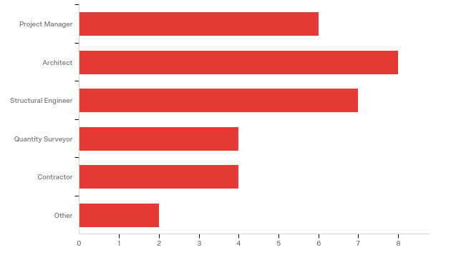

# | Answer | % | Count
1 | Project Manager | 19.35% | 6
2 | Architect | 25.81% | 8
3 | Structural Engineer | 22.58% | 7
4 | Quantity Surveyor | 12.90% | 4
5 | Contractor | 12.90% | 4
6 | Other | 6.45% | 2
 | Total | 100% | 31

Q1.2 - Please select you Joint Building Contracts Committee Constituent (JBCC) ?
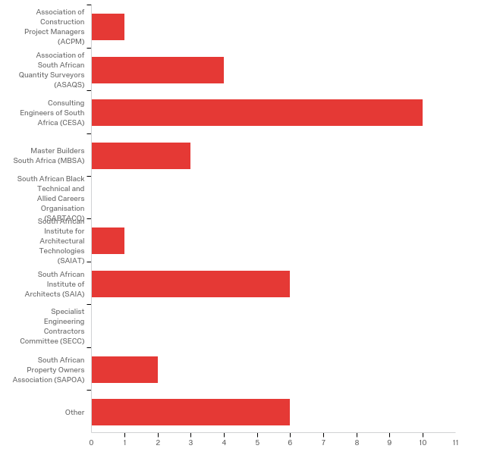

# | Answer | % | Count
1 | Association of Construction Project Managers (ACPM) | 3.03% | 1
2 | Association of South African Quantity Surveyors (ASAQS) | 12.12% | 4
3 | Consulting Engineers of South Africa (CESA) | 30.30% | 10
4 | Master Builders South Africa (MBSA) | 9.09% | 3
5 | South African Black Technical and Allied Careers Organisation (SABTACO) | 0.00% | 0
6 | South African Institute for Architectural Technologies (SAIAT) | 3.03% | 1
7 | South African Institute of Architects (SAIA) | 18.18% | 6
8 | Specialist Engineering Contractors Committee (SECC) | 0.00% | 0
9 | South African Property Owners Association (SAPOA) | 6.06% | 2
10 | Other | 18.18% | 6
 | Total | 100% | 33

Q1.3 - Which projects have you been involved in whilst using the JBCC suite of documents in the past 3 years?
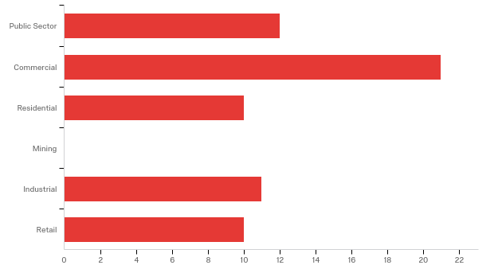

# | Answer | % | Count
1 | Public Sector | 18.75% | 12
2 | Commercial | 32.81% | 21
3 | Residential | 15.63% | 10
4 | Mining | 0.00% | 0
5 | Industrial | 17.19% | 11
6 | Retail | 15.63% | 10
 | Total | 100% | 64

Q1.4 - What is your highest level of qualification?
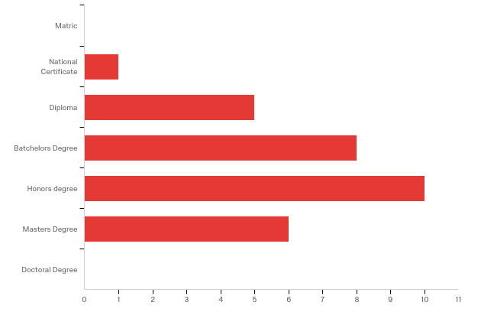

# | Answer | % | Count
1 | Matric | 0.00% | 0
2 | National Certificate | 3.33% | 1
3 | Diploma | 16.67% | 5
4 | Batchelors Degree | 26.67% | 8
5 | Honours degree | 33.33% | 10
6 | Master’s Degree | 20.00% | 6
7 | Doctoral Degree | 0.00% | 0
 | Total | 100% | 30

Q1.5 - How many years of experience do you have?

# | Field | Minimum | Maximum | Mean | Std Deviation | Variance | Count
1 | Click to write Choice 1 | 4.00 | 30.00 | 16.43 | 10.19 | 103.85 | 30

Q1.6 - What is your age?

# | Field | Minimum | Maximum | Mean | Std Deviation | Variance | Count
1 | Click to write Choice 1 | 26.00 | 70.00 | 42.53 | 14.05 | 197.38 | 30

Q1.7 - Which geographical region do you work in?
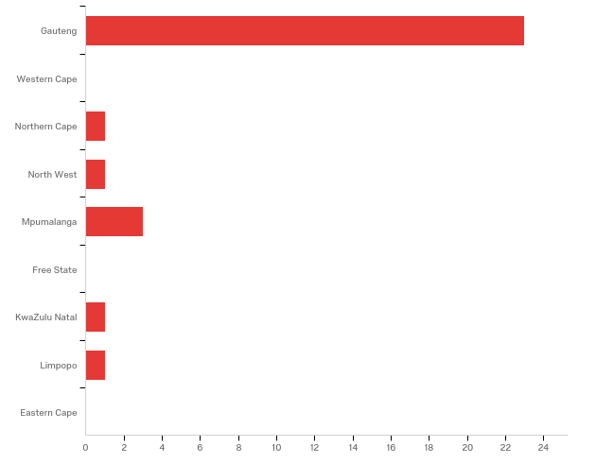

# | Answer | % | Count
1 | Gauteng | 76.67% | 23
2 | Western Cape | 0.00% | 0
3 | Northern Cape | 3.33% | 1
4 | North West | 3.33% | 1
5 | Mpumalanga | 10.00% | 3
6 | Free State | 0.00% | 0
7 | KwaZulu Natal | 3.33% | 1
8 | Limpopo | 3.33% | 1
9 | Eastern Cape | 0.00% | 0
 | Total | 100% | 30

Question 1 - When calling for tenders with incomplete designs the following status were cited as adequate. Please select those with which you agree.
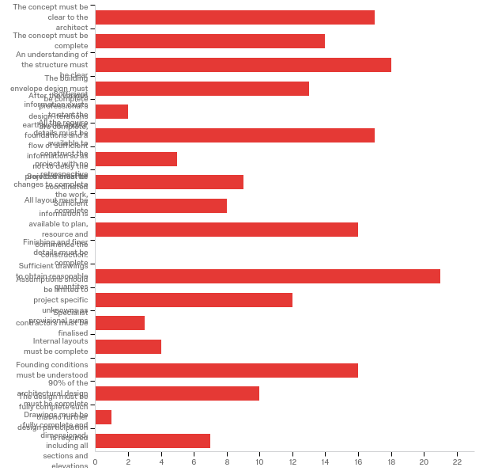

# | Answer | % | Count
1 | The concept must be clear to the architect | 8.81% | 17
2 | The concept must be complete | 7.25% | 14
3 | An understanding of the structure must be clear | 9.33% | 18
4 | The building envelope design must be complete | 6.74% | 13
5 | After the various professional's design iterations are complete, | 1.04% | 2
6 | Sufficient information exists to start the earthworks and/or foundations and a flow of sufficient information so as not to delay the project thereafter | 8.81% | 17
7 | All the require details must be available to construct the project with no retrospective changes to complete the work, | 2.59% | 5
8 | Services must be coordinated | 4.66% | 9
9 | All layout must be complete | 4.15% | 8
10 | Sufficient information is available to plan, resource and commence the construction. | 8.29% | 16
11 | Finishing and finer details must be complete | 0.00% | 0
12 | Sufficient drawings to obtain reasonable quantities | 10.88% | 21
13 | Assumptions should be limited to project specific unknowns as provisional sums | 6.22% | 12
14 | Specialist contractors must be finalised | 1.55% | 3
15 | Internal layouts must be complete | 2.07% | 4
16 | Founding conditions must be understood | 8.29% | 16
17 | 90% of the architectural design must be complete | 5.18% | 10
18 | The design must be fully complete such that no further design participation is required | 0.52% | 1
19 | Drawings must be fully complete and dimensioned, including all sections and elevations | 3.63% | 7
 | Total | 100% | 193

Question 2- Where projects commence with incomplete designs the following reasons are frequently cited. Please select those with which you agree.
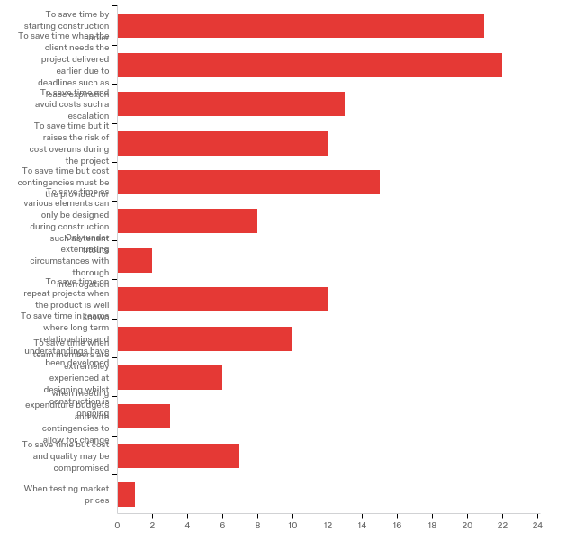

# | Answer | % | Count
1 | To save time by starting construction earlier | 15.91% | 21
2 | To save time when the client needs the project delivered earlier due to deadlines such as lease expiration | 16.67% | 22
3 | To save time and avoid costs such an escalation | 9.85% | 13
4 | To save time but it raises the risk of cost overruns during the project | 9.09% | 12
5 | To save time but cost contingencies must be the provided for | 11.36% | 15
6 | To save time as various elements can only be designed during construction such as tenant fitouts | 6.06% | 8
7 | Only under extenuating circumstances with thorough interrogation | 1.52% | 2
8 | To save time on repeat projects when the product is well known | 9.09% | 12
9 | To save time in teams where long-term relationships and understandings have been developed | 7.58% | 10
10 | To save time when team members are extremely experienced at designing whilst construction is ongoing | 4.55% | 6
11 | when meeting expenditure budgets and with contingencies to allow for change | 2.27% | 3
12 | To save time but cost and quality may be compromised | 5.30% | 7
13 | When testing market prices | 0.76% | 1
 | Total | 100% | 132

Question 4, 5 and 6 Understand the consequences of commencing construction with an incomplete design on the project team.
Q4.2 - There was insufficient time to review and check construction information
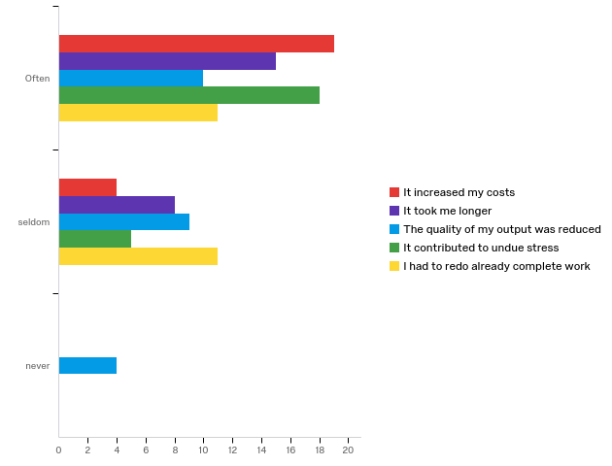

# | Question | Often |  | seldom |  | never |  | Total
1 | It increased my costs | 82.61% | 19 | 17.39% | 4 | 0.00% | 0 | 23
2 | It took me longer | 65.22% | 15 | 34.78% | 8 | 0.00% | 0 | 23
3 | The quality of my output was reduced | 43.48% | 10 | 39.13% | 9 | 17.39% | 4 | 23
4 | It contributed to undue stress | 78.26% | 18 | 21.74% | 5 | 0.00% | 0 | 23
5 | I had to redo already complete work | 50.00% | 11 | 50.00% | 11 | 0.00% | 0 | 22

Q4.3 - There was a lack of services coordination
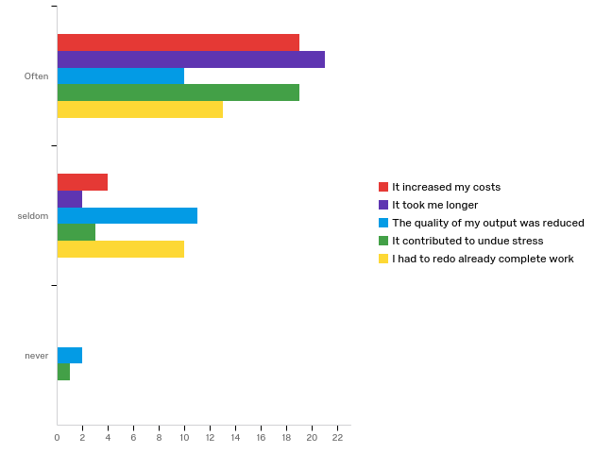

# | Question | Often |  | seldom |  | never |  | Total
1 | It increased my costs | 82.61% | 19 | 17.39% | 4 | 0.00% | 0 | 23
2 | It took me longer | 91.30% | 21 | 8.70% | 2 | 0.00% | 0 | 23
3 | The quality of my output was reduced | 43.48% | 10 | 47.83% | 11 | 8.70% | 2 | 23
4 | It contributed to undue stress | 82.61% | 19 | 13.04% | 3 | 4.35% | 1 | 23
5 | I had to redo already complete work | 56.52% | 13 | 43.48% | 10 | 0.00% | 0 | 23

Q4.4 - There was insufficient time to deal with unforeseen design or site issues
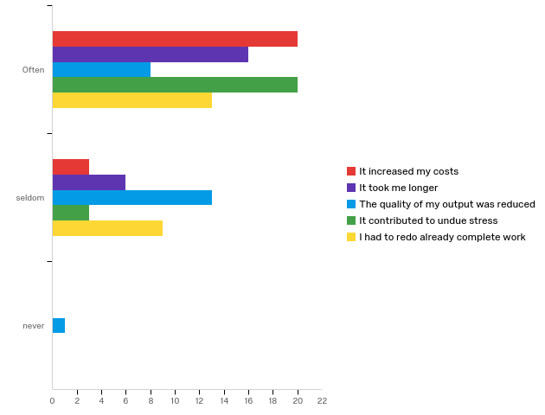

# | Question | Often |  | seldom |  | never |  | Total
1 | It increased my costs | 86.96% | 20 | 13.04% | 3 | 0.00% | 0 | 23
2 | It took me longer | 72.73% | 16 | 27.27% | 6 | 0.00% | 0 | 22
3 | The quality of my output was reduced | 36.36% | 8 | 59.09% | 13 | 4.55% | 1 | 22
4 | It contributed to undue stress | 86.96% | 20 | 13.04% | 3 | 0.00% | 0 | 23
5 | I had to redo already complete work | 59.09% | 13 | 40.91% | 9 | 0.00% | 0 | 22

Q4.5 - There was insufficient time for detailed planning
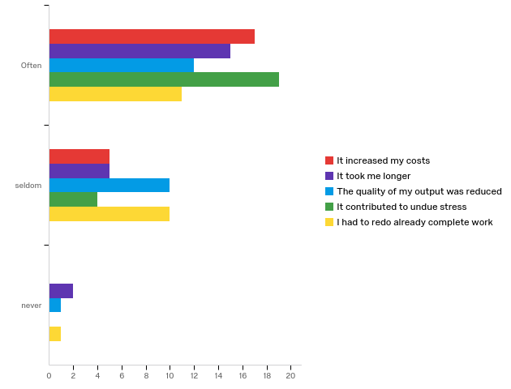

# | Question | Often |  | seldom |  | never |  | Total
1 | It increased my costs | 77.27% | 17 | 22.73% | 5 | 0.00% | 0 | 22
2 | It took me longer | 68.18% | 15 | 22.73% | 5 | 9.09% | 2 | 22
3 | The quality of my output was reduced | 52.17% | 12 | 43.48% | 10 | 4.35% | 1 | 23
4 | It contributed to undue stress | 82.61% | 19 | 17.39% | 4 | 0.00% | 0 | 23
5 | I had to redo already complete work | 50.00% | 11 | 45.45% | 10 | 4.55% | 1 | 22

Q4.6 - There was confusion on the latest details
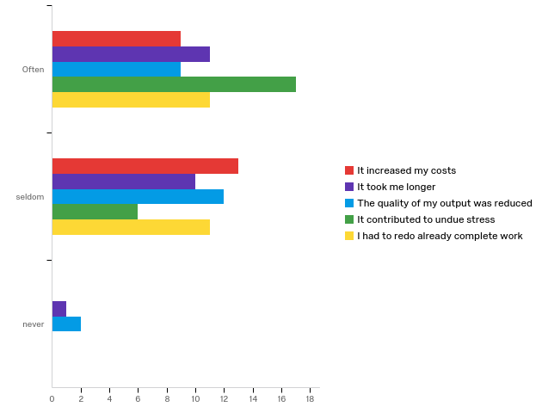

# | Question | Often |  | seldom |  | never |  | Total
1 | It increased my costs | 40.91% | 9 | 59.09% | 13 | 0.00% | 0 | 22
2 | It took me longer | 50.00% | 11 | 45.45% | 10 | 4.55% | 1 | 22
3 | The quality of my output was reduced | 39.13% | 9 | 52.17% | 12 | 8.70% | 2 | 23
4 | It contributed to undue stress | 73.91% | 17 | 26.09% | 6 | 0.00% | 0 | 23
5 | I had to redo already complete work | 50.00% | 11 | 50.00% | 11 | 0.00% | 0 | 22

Q4.7 - The start was delayed because the financing was not in place yet
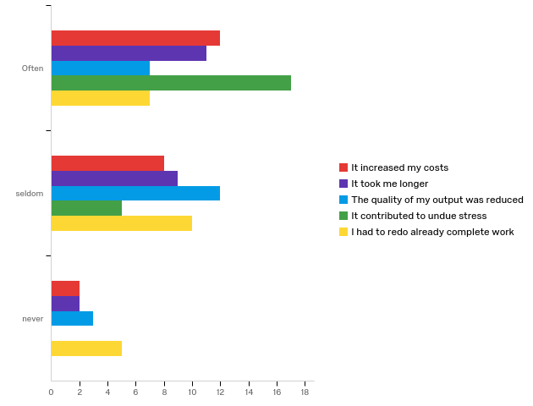

# | Question | Often |  | seldom |  | never |  | Total
1 | It increased my costs | 54.55% | 12 | 36.36% | 8 | 9.09% | 2 | 22
2 | It took me longer | 50.00% | 11 | 40.91% | 9 | 9.09% | 2 | 22
3 | The quality of my output was reduced | 31.82% | 7 | 54.55% | 12 | 13.64% | 3 | 22
4 | It contributed to undue stress | 77.27% | 17 | 22.73% | 5 | 0.00% | 0 | 22
5 | I had to redo already complete work | 31.82% | 7 | 45.45% | 10 | 22.73% | 5 | 22

Q4.8 - The start was delayed because council approvals were not in place and caused work stoppages
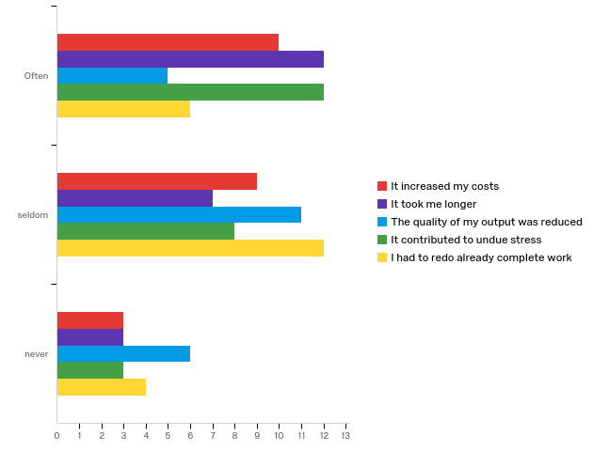

# | Question | Often |  | seldom |  | never |  | Total
1 | It increased my costs | 45.45% | 10 | 40.91% | 9 | 13.64% | 3 | 22
2 | It took me longer | 54.55% | 12 | 31.82% | 7 | 13.64% | 3 | 22
3 | The quality of my output was reduced | 22.73% | 5 | 50.00% | 11 | 27.27% | 6 | 22
4 | It contributed to undue stress | 52.17% | 12 | 34.78% | 8 | 13.04% | 3 | 23
5 | I had to redo already complete work | 27.27% | 6 | 54.55% | 12 | 18.18% | 4 | 22

Q4.9 - The information was not detailed sufficiently and lead to changes later in the project
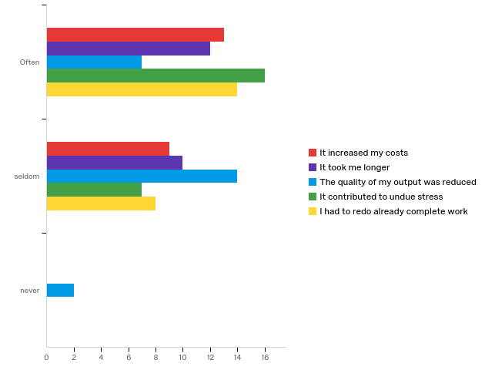

# | Question | Often |  | seldom |  | never |  | Total
1 | It increased my costs | 59.09% | 13 | 40.91% | 9 | 0.00% | 0 | 22
2 | It took me longer | 54.55% | 12 | 45.45% | 10 | 0.00% | 0 | 22
3 | The quality of my output was reduced | 30.43% | 7 | 60.87% | 14 | 8.70% | 2 | 23
4 | It contributed to undue stress | 69.57% | 16 | 30.43% | 7 | 0.00% | 0 | 23
5 | I had to redo already complete work | 63.64% | 14 | 36.36% | 8 | 0.00% | 0 | 22

Q4.10 - There was lack of tenant/fitout knowledge
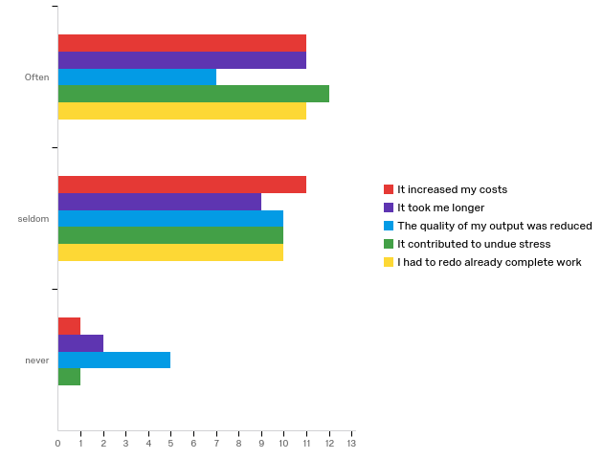

# | Question | Often |  | seldom |  | never |  | Total
1 | It increased my costs | 47.83% | 11 | 47.83% | 11 | 4.35% | 1 | 23
2 | It took me longer | 50.00% | 11 | 40.91% | 9 | 9.09% | 2 | 22
3 | The quality of my output was reduced | 31.82% | 7 | 45.45% | 10 | 22.73% | 5 | 22
4 | It contributed to undue stress | 52.17% | 12 | 43.48% | 10 | 4.35% | 1 | 23
5 | I had to redo already complete work | 52.38% | 11 | 47.62% | 10 | 0.00% | 0 | 21

Q4.11 - Budgets were vague and lead to poor decision making
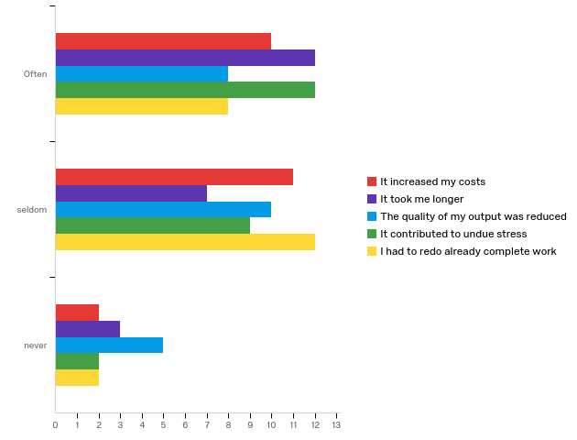

# | Question | Often |  | seldom |  | never |  | Total
1 | It increased my costs | 43.48% | 10 | 47.83% | 11 | 8.70% | 2 | 23
2 | It took me longer | 54.55% | 12 | 31.82% | 7 | 13.64% | 3 | 22
3 | The quality of my output was reduced | 34.78% | 8 | 43.48% | 10 | 21.74% | 5 | 23
4 | It contributed to undue stress | 52.17% | 12 | 39.13% | 9 | 8.70% | 2 | 23
5 | I had to redo already complete work | 36.36% | 8 | 54.55% | 12 | 9.09% | 2 | 22

Q4.12 - Team members did not commit to the project initially due to working at risk financially
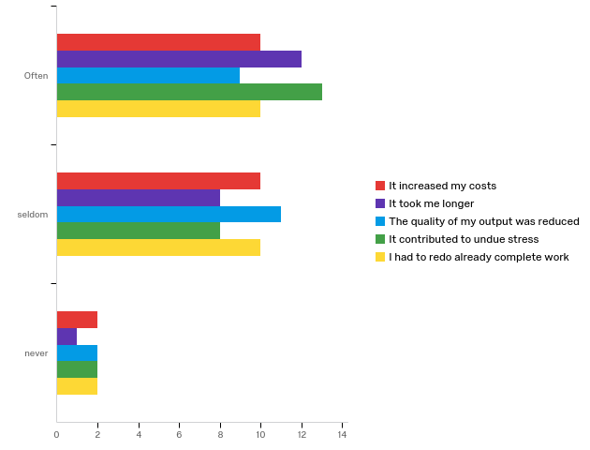

# | Question | Often |  | seldom |  | never |  | Total
1 | It increased my costs | 45.45% | 10 | 45.45% | 10 | 9.09% | 2 | 22
2 | It took me longer | 57.14% | 12 | 38.10% | 8 | 4.76% | 1 | 21
3 | The quality of my output was reduced | 40.91% | 9 | 50.00% | 11 | 9.09% | 2 | 22
4 | It contributed to undue stress | 56.52% | 13 | 34.78% | 8 | 8.70% | 2 | 23
5 | I had to redo already complete work | 45.45% | 10 | 45.45% | 10 | 9.09% | 2 | 22

Q4.13 - Inexperienced team members were appointed to the project due to fee cutting
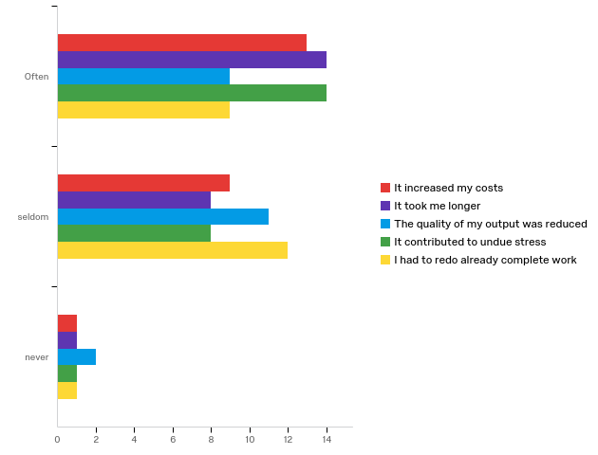

# | Question | Often |  | seldom |  | never |  | Total
1 | It increased my costs | 56.52% | 13 | 39.13% | 9 | 4.35% | 1 | 23
2 | It took me longer | 60.87% | 14 | 34.78% | 8 | 4.35% | 1 | 23
3 | The quality of my output was reduced | 40.91% | 9 | 50.00% | 11 | 9.09% | 2 | 22
4 | It contributed to undue stress | 60.87% | 14 | 34.78% | 8 | 4.35% | 1 | 23
5 | I had to redo already complete work | 40.91% | 9 | 54.55% | 12 | 4.55% | 1 | 22

Q4.14 - Late appointment of team members caused delays and disruptions e.g. ancillary designers
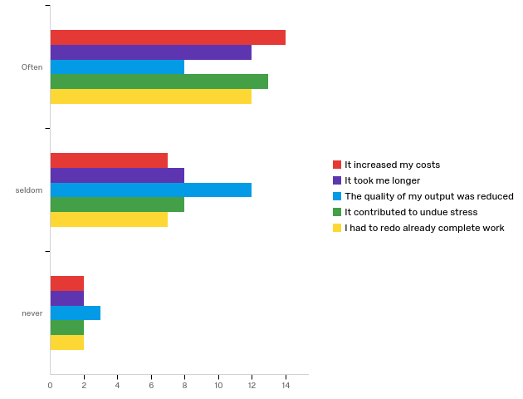

# | Question | Often |  | seldom |  | never |  | Total
1 | It increased my costs | 60.87% | 14 | 30.43% | 7 | 8.70% | 2 | 23
2 | It took me longer | 54.55% | 12 | 36.36% | 8 | 9.09% | 2 | 22
3 | The quality of my output was reduced | 34.78% | 8 | 52.17% | 12 | 13.04% | 3 | 23
4 | It contributed to undue stress | 56.52% | 13 | 34.78% | 8 | 8.70% | 2 | 23
5 | I had to redo already complete work | 57.14% | 12 | 33.33% | 7 | 9.52% | 2 | 21

Q4.15 - The client brief was not done properly or the wrong people were allocated the client role
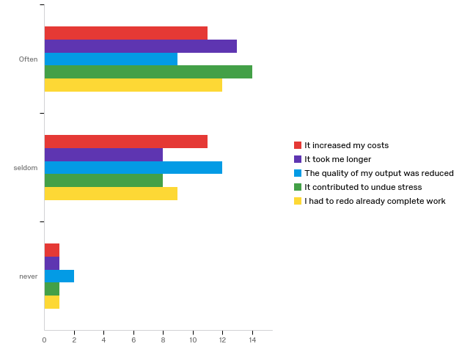

# | Question | Often |  | seldom |  | never |  | Total
1 | It increased my costs | 47.83% | 11 | 47.83% | 11 | 4.35% | 1 | 23
2 | It took me longer | 59.09% | 13 | 36.36% | 8 | 4.55% | 1 | 22
3 | The quality of my output was reduced | 39.13% | 9 | 52.17% | 12 | 8.70% | 2 | 23
4 | It contributed to undue stress | 60.87% | 14 | 34.78% | 8 | 4.35% | 1 | 23
5 | I had to redo already complete work | 54.55% | 12 | 40.91% | 9 | 4.55% | 1 | 22

Q4.16 - There were inconsistencies with property information, rights and/or zoning
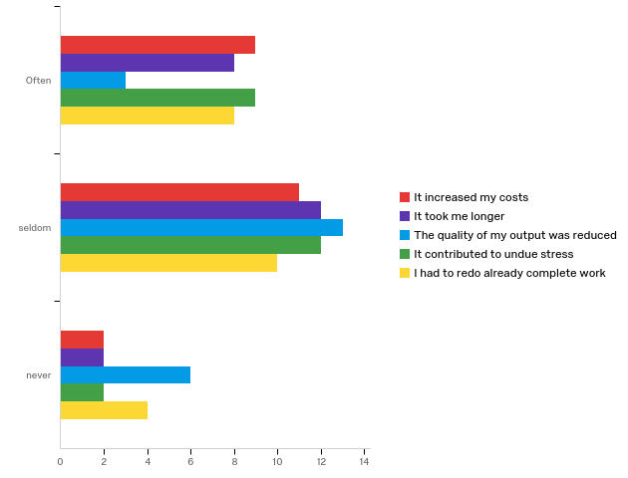

# | Question | Often |  | seldom |  | never |  | Total
1 | It increased my costs | 40.91% | 9 | 50.00% | 11 | 9.09% | 2 | 22
2 | It took me longer | 36.36% | 8 | 54.55% | 12 | 9.09% | 2 | 22
3 | The quality of my output was reduced | 13.64% | 3 | 59.09% | 13 | 27.27% | 6 | 22
4 | It contributed to undue stress | 39.13% | 9 | 52.17% | 12 | 8.70% | 2 | 23
5 | I had to redo already complete work | 36.36% | 8 | 45.45% | 10 | 18.18% | 4 | 22

Q4.17 - The clients expectations of desires vs budget allowable were not aligned
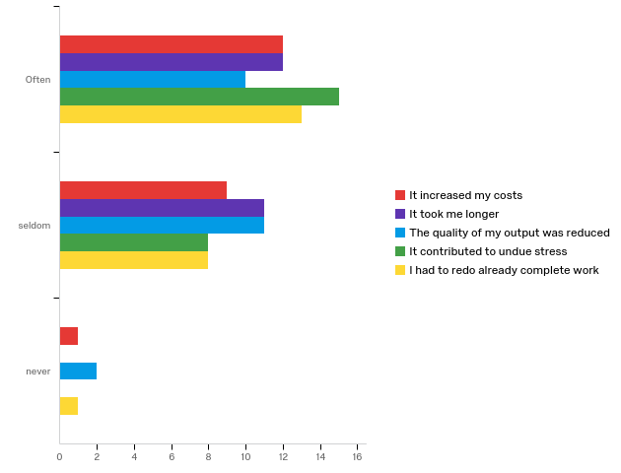

# | Question | Often |  | seldom |  | never |  | Total
1 | It increased my costs | 54.55% | 12 | 40.91% | 9 | 4.55% | 1 | 22
2 | It took me longer | 52.17% | 12 | 47.83% | 11 | 0.00% | 0 | 23
3 | The quality of my output was reduced | 43.48% | 10 | 47.83% | 11 | 8.70% | 2 | 23
4 | It contributed to undue stress | 65.22% | 15 | 34.78% | 8 | 0.00% | 0 | 23
5 | I had to redo already complete work | 59.09% | 13 | 36.36% | 8 | 4.55% | 1 | 22

Q4.18 - Major assumptions were incorrect (especially refurbish works)
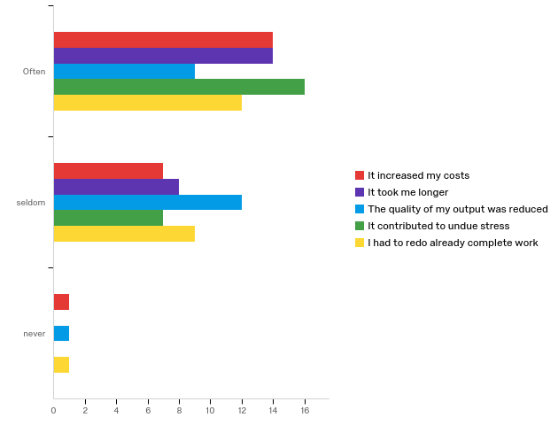

# | Question | Often |  | seldom |  | never |  | Total
1 | It increased my costs | 63.64% | 14 | 31.82% | 7 | 4.55% | 1 | 22
2 | It took me longer | 63.64% | 14 | 36.36% | 8 | 0.00% | 0 | 22
3 | The quality of my output was reduced | 40.91% | 9 | 54.55% | 12 | 4.55% | 1 | 22
4 | It contributed to undue stress | 69.57% | 16 | 30.43% | 7 | 0.00% | 0 | 23
5 | I had to redo already complete work | 54.55% | 12 | 40.91% | 9 | 4.55% | 1 | 22

Q4.19 - Preferred contracting methods were not discussed due to no involvement of contractors prior to tender
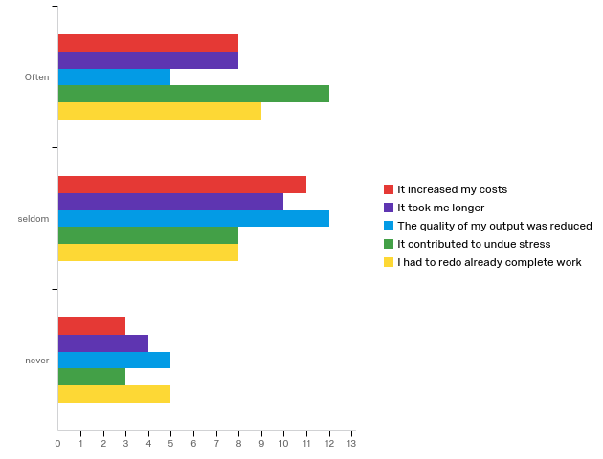

# | Question | Often |  | seldom |  | never |  | Total
1 | It increased my costs | 36.36% | 8 | 50.00% | 11 | 13.64% | 3 | 22
2 | It took me longer | 36.36% | 8 | 45.45% | 10 | 18.18% | 4 | 22
3 | The quality of my output was reduced | 22.73% | 5 | 54.55% | 12 | 22.73% | 5 | 22
4 | It contributed to undue stress | 52.17% | 12 | 34.78% | 8 | 13.04% | 3 | 23
5 | I had to redo already complete work | 40.91% | 9 | 36.36% | 8 | 22.73% | 5 | 22

Q4.20 - Additional staff had to be deployed to finalise design details in time
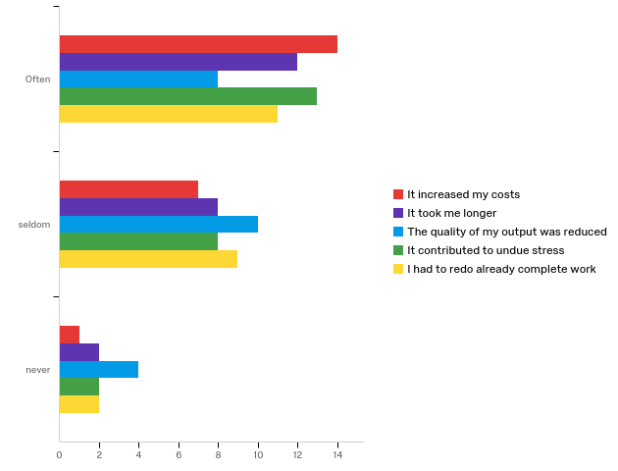

# | Question | Often |  | seldom |  | never |  | Total
1 | It increased my costs | 63.64% | 14 | 31.82% | 7 | 4.55% | 1 | 22
2 | It took me longer | 54.55% | 12 | 36.36% | 8 | 9.09% | 2 | 22
3 | The quality of my output was reduced | 36.36% | 8 | 45.45% | 10 | 18.18% | 4 | 22
4 | It contributed to undue stress | 56.52% | 13 | 34.78% | 8 | 8.70% | 2 | 23
5 | I had to redo already complete work | 50.00% | 11 | 40.91% | 9 | 9.09% | 2 | 22

Q4.21 - Structural assumptions were not made or were incorrect
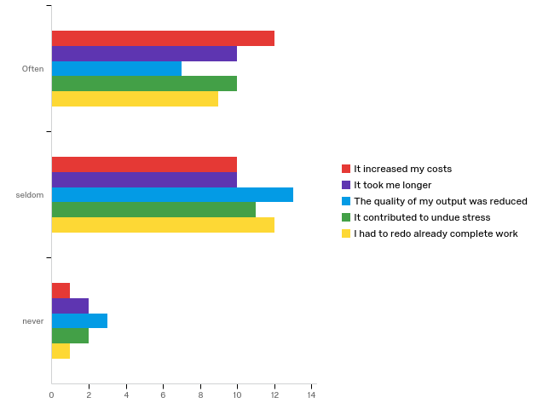

# | Question | Often |  | seldom |  | never |  | Total
1 | It increased my costs | 52.17% | 12 | 43.48% | 10 | 4.35% | 1 | 23
2 | It took me longer | 45.45% | 10 | 45.45% | 10 | 9.09% | 2 | 22
3 | The quality of my output was reduced | 30.43% | 7 | 56.52% | 13 | 13.04% | 3 | 23
4 | It contributed to undue stress | 43.48% | 10 | 47.83% | 11 | 8.70% | 2 | 23
5 | I had to redo already complete work | 40.91% | 9 | 54.55% | 12 | 4.55% | 1 | 22

Q4.22 - Designs were reverse engineered from budgets resulting in compromises
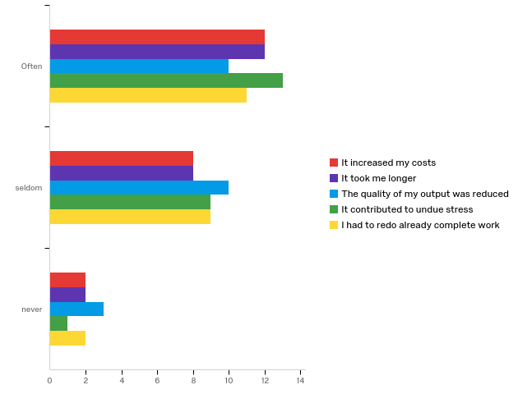

# | Question | Often |  | seldom |  | never |  | Total
1 | It increased my costs | 54.55% | 12 | 36.36% | 8 | 9.09% | 2 | 22
2 | It took me longer | 54.55% | 12 | 36.36% | 8 | 9.09% | 2 | 22
3 | The quality of my output was reduced | 43.48% | 10 | 43.48% | 10 | 13.04% | 3 | 23
4 | It contributed to undue stress | 56.52% | 13 | 39.13% | 9 | 4.35% | 1 | 23
5 | I had to redo already complete work | 50.00% | 11 | 40.91% | 9 | 9.09% | 2 | 22

Q4.23 - Statutory approvals are run concurrent with the works resulting in updated requirements
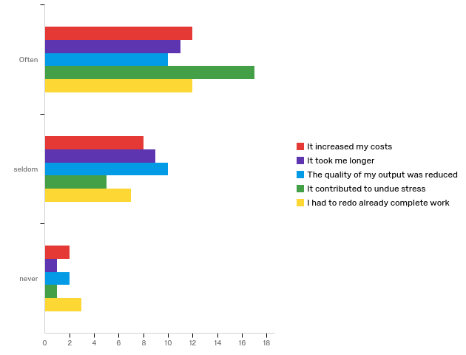

# | Question | Often |  | seldom |  | never |  | Total
1 | It increased my costs | 54.55% | 12 | 36.36% | 8 | 9.09% | 2 | 22
2 | It took me longer | 52.38% | 11 | 42.86% | 9 | 4.76% | 1 | 21
3 | The quality of my output was reduced | 45.45% | 10 | 45.45% | 10 | 9.09% | 2 | 22
4 | It contributed to undue stress | 73.91% | 17 | 21.74% | 5 | 4.35% | 1 | 23
5 | I had to redo already complete work | 54.55% | 12 | 31.82% | 7 | 13.64% | 3 | 22

Q4.24 - Programs did not include the full scope
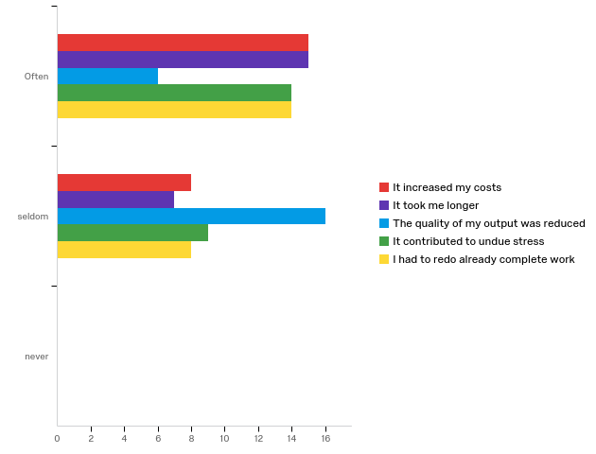

# | Question | Often |  | seldom |  | never |  | Total
1 | It increased my costs | 65.22% | 15 | 34.78% | 8 | 0.00% | 0 | 23
2 | It took me longer | 68.18% | 15 | 31.82% | 7 | 0.00% | 0 | 22
3 | The quality of my output was reduced | 27.27% | 6 | 72.73% | 16 | 0.00% | 0 | 22
4 | It contributed to undue stress | 60.87% | 14 | 39.13% | 9 | 0.00% | 0 | 23
5 | I had to redo already complete work | 63.64% | 14 | 36.36% | 8 | 0.00% | 0 | 22

Q4.25 - The focus was on cost proposals and not design details to proceed to tender
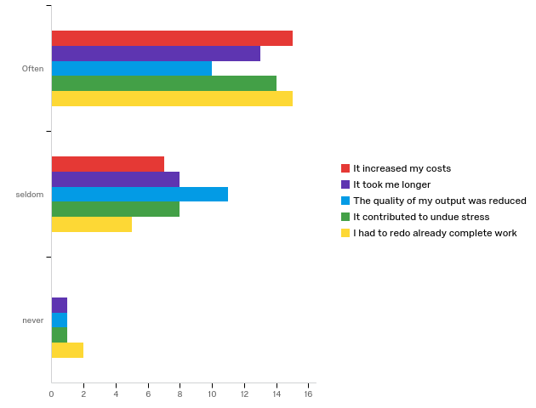

# | Question | Often |  | seldom |  | never |  | Total
1 | It increased my costs | 68.18% | 15 | 31.82% | 7 | 0.00% | 0 | 22
2 | It took me longer | 59.09% | 13 | 36.36% | 8 | 4.55% | 1 | 22
3 | The quality of my output was reduced | 45.45% | 10 | 50.00% | 11 | 4.55% | 1 | 22
4 | It contributed to undue stress | 60.87% | 14 | 34.78% | 8 | 4.35% | 1 | 23
5 | I had to redo already complete work | 68.18% | 15 | 22.73% | 5 | 9.09% | 2 | 22

Q4.26 - All team members were instructed to proceed on the same day including the contractor resulting in fast track construction
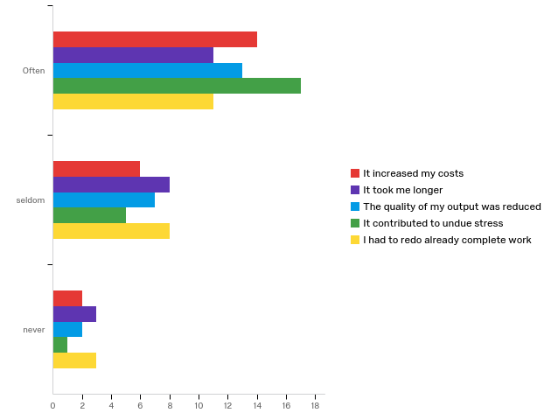

# | Question | Often |  | seldom |  | never |  | Total
1 | It increased my costs | 63.64% | 14 | 27.27% | 6 | 9.09% | 2 | 22
2 | It took me longer | 50.00% | 11 | 36.36% | 8 | 13.64% | 3 | 22
3 | The quality of my output was reduced | 59.09% | 13 | 31.82% | 7 | 9.09% | 2 | 22
4 | It contributed to undue stress | 73.91% | 17 | 21.74% | 5 | 4.35% | 1 | 23
5 | I had to redo already complete work | 50.00% | 11 | 36.36% | 8 | 13.64% | 3 | 22

Q4.27 - Time was spent on meetings and designs without commitment that the project would proceed
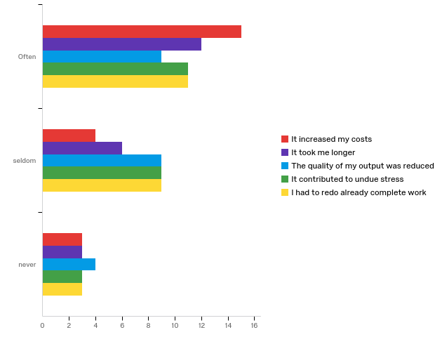

# | Question | Often |  | seldom |  | never |  | Total
1 | It increased my costs | 68.18% | 15 | 18.18% | 4 | 13.64% | 3 | 22
2 | It took me longer | 57.14% | 12 | 28.57% | 6 | 14.29% | 3 | 21
3 | The quality of my output was reduced | 40.91% | 9 | 40.91% | 9 | 18.18% | 4 | 22
4 | It contributed to undue stress | 47.83% | 11 | 39.13% | 9 | 13.04% | 3 | 23
5 | I had to redo already complete work | 47.83% | 11 | 39.13% | 9 | 13.04% | 3 | 23

Q5.2 - The information was insufficient and inaccurate
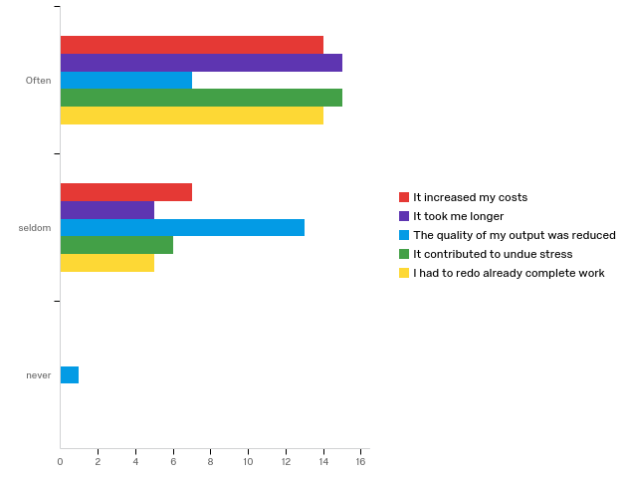

# | Question | Often |  | seldom |  | never |  | Total
1 | It increased my costs | 66.67% | 14 | 33.33% | 7 | 0.00% | 0 | 21
2 | It took me longer | 75.00% | 15 | 25.00% | 5 | 0.00% | 0 | 20
3 | The quality of my output was reduced | 33.33% | 7 | 61.90% | 13 | 4.76% | 1 | 21
4 | It contributed to undue stress | 71.43% | 15 | 28.57% | 6 | 0.00% | 0 | 21
5 | I had to redo already complete work | 73.68% | 14 | 26.32% | 5 | 0.00% | 0 | 19

Q5.3 - Works has to be constantly remeasured
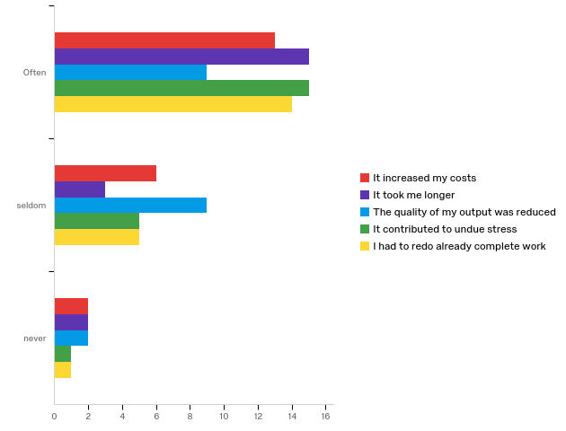

# | Question | Often |  | seldom |  | never |  | Total
1 | It increased my costs | 61.90% | 13 | 28.57% | 6 | 9.52% | 2 | 21
2 | It took me longer | 75.00% | 15 | 15.00% | 3 | 10.00% | 2 | 20
3 | The quality of my output was reduced | 45.00% | 9 | 45.00% | 9 | 10.00% | 2 | 20
4 | It contributed to undue stress | 71.43% | 15 | 23.81% | 5 | 4.76% | 1 | 21
5 | I had to redo already complete work | 70.00% | 14 | 25.00% | 5 | 5.00% | 1 | 20

Q5.4 - Information flow did not keep up with the project requirements causing stoppages and delays
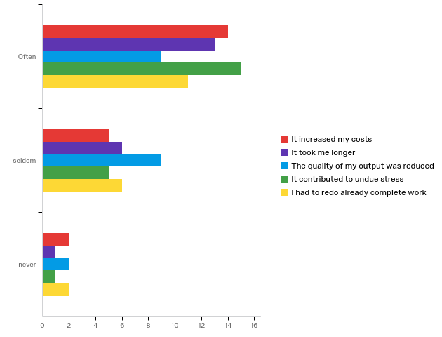

# | Question | Often |  | seldom |  | never |  | Total
1 | It increased my costs | 66.67% | 14 | 23.81% | 5 | 9.52% | 2 | 21
2 | It took me longer | 65.00% | 13 | 30.00% | 6 | 5.00% | 1 | 20
3 | The quality of my output was reduced | 45.00% | 9 | 45.00% | 9 | 10.00% | 2 | 20
4 | It contributed to undue stress | 71.43% | 15 | 23.81% | 5 | 4.76% | 1 | 21
5 | I had to redo already complete work | 57.89% | 11 | 31.58% | 6 | 10.53% | 2 | 19

Q5.5 - The quality of the information was not up to standard due to time pressures e.g.- missing dimensions etc
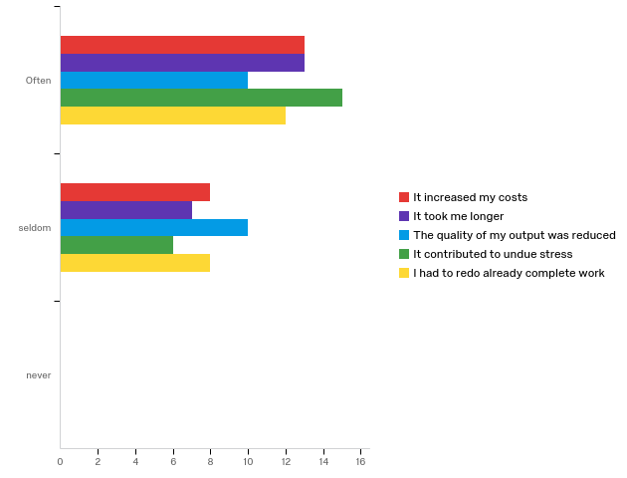

# | Question | Often |  | seldom |  | never |  | Total
1 | It increased my costs | 61.90% | 13 | 38.10% | 8 | 0.00% | 0 | 21
2 | It took me longer | 65.00% | 13 | 35.00% | 7 | 0.00% | 0 | 20
3 | The quality of my output was reduced | 50.00% | 10 | 50.00% | 10 | 0.00% | 0 | 20
4 | It contributed to undue stress | 71.43% | 15 | 28.57% | 6 | 0.00% | 0 | 21
5 | I had to redo already complete work | 60.00% | 12 | 40.00% | 8 | 0.00% | 0 | 20

Q5.6 - Every task that was done was onerous due to constant changes
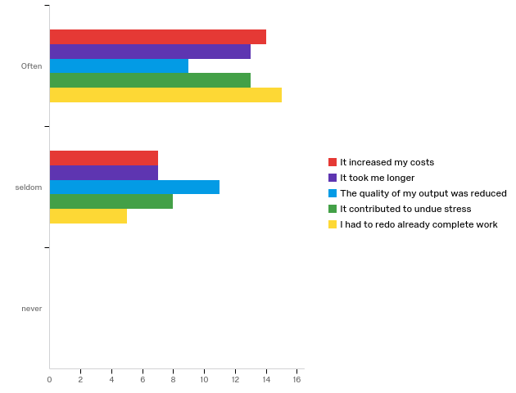

# | Question | Often |  | seldom |  | never |  | Total
1 | It increased my costs | 66.67% | 14 | 33.33% | 7 | 0.00% | 0 | 21
2 | It took me longer | 65.00% | 13 | 35.00% | 7 | 0.00% | 0 | 20
3 | The quality of my output was reduced | 45.00% | 9 | 55.00% | 11 | 0.00% | 0 | 20
4 | It contributed to undue stress | 61.90% | 13 | 38.10% | 8 | 0.00% | 0 | 21
5 | I had to redo already complete work | 75.00% | 15 | 25.00% | 5 | 0.00% | 0 | 20

Q5.7 - Site meetings were long due to design coordination inclusion
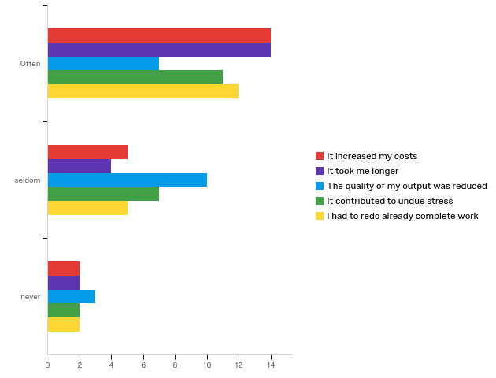

# | Question | Often |  | seldom |  | never |  | Total
1 | It increased my costs | 66.67% | 14 | 23.81% | 5 | 9.52% | 2 | 21
2 | It took me longer | 70.00% | 14 | 20.00% | 4 | 10.00% | 2 | 20
3 | The quality of my output was reduced | 35.00% | 7 | 50.00% | 10 | 15.00% | 3 | 20
4 | It contributed to undue stress | 55.00% | 11 | 35.00% | 7 | 10.00% | 2 | 20
5 | I had to redo already complete work | 63.16% | 12 | 26.32% | 5 | 10.53% | 2 | 19

Q5.8 - There were clashes between services due to lack of coordination between disciplines
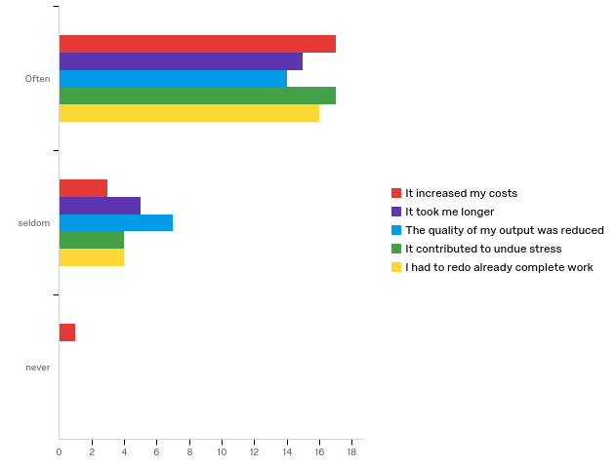

# | Question | Often |  | seldom |  | never |  | Total
1 | It increased my costs | 80.95% | 17 | 14.29% | 3 | 4.76% | 1 | 21
2 | It took me longer | 75.00% | 15 | 25.00% | 5 | 0.00% | 0 | 20
3 | The quality of my output was reduced | 66.67% | 14 | 33.33% | 7 | 0.00% | 0 | 21
4 | It contributed to undue stress | 80.95% | 17 | 19.05% | 4 | 0.00% | 0 | 21
5 | I had to redo already complete work | 80.00% | 16 | 20.00% | 4 | 0.00% | 0 | 20

Q5.9 - Incorrect assumptions on site conditions (especially refurbish contracts) e.g. height of existing structures
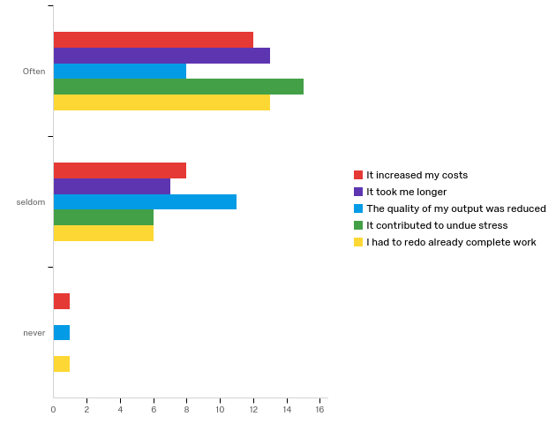

# | Question | Often |  | seldom |  | never |  | Total
1 | It increased my costs | 57.14% | 12 | 38.10% | 8 | 4.76% | 1 | 21
2 | It took me longer | 65.00% | 13 | 35.00% | 7 | 0.00% | 0 | 20
3 | The quality of my output was reduced | 40.00% | 8 | 55.00% | 11 | 5.00% | 1 | 20
4 | It contributed to undue stress | 71.43% | 15 | 28.57% | 6 | 0.00% | 0 | 21
5 | I had to redo already complete work | 65.00% | 13 | 30.00% | 6 | 5.00% | 1 | 20

Q5.10 - Incorrect design assumptions resulting changes e.g. internal loadings
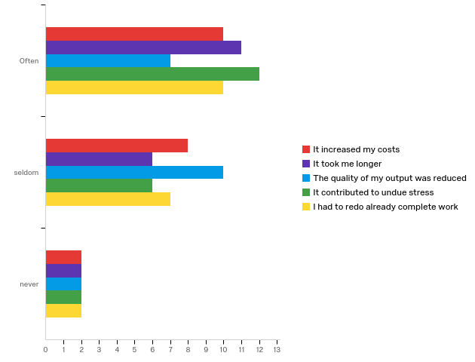

# | Question | Often |  | seldom |  | never |  | Total
1 | It increased my costs | 50.00% | 10 | 40.00% | 8 | 10.00% | 2 | 20
2 | It took me longer | 57.89% | 11 | 31.58% | 6 | 10.53% | 2 | 19
3 | The quality of my output was reduced | 36.84% | 7 | 52.63% | 10 | 10.53% | 2 | 19
4 | It contributed to undue stress | 60.00% | 12 | 30.00% | 6 | 10.00% | 2 | 20
5 | I had to redo already complete work | 52.63% | 10 | 36.84% | 7 | 10.53% | 2 | 19

Q5.11 - Lack of coordination results in clashes and changes
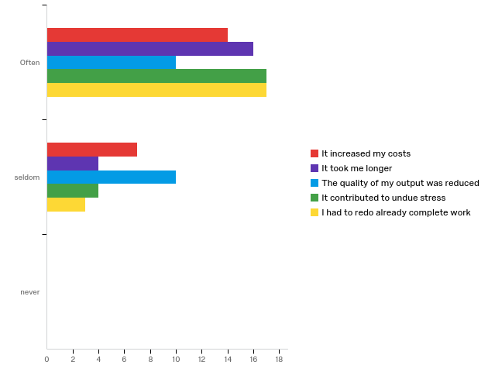

# | Question | Often |  | seldom |  | never |  | Total
1 | It increased my costs | 66.67% | 14 | 33.33% | 7 | 0.00% | 0 | 21
2 | It took me longer | 80.00% | 16 | 20.00% | 4 | 0.00% | 0 | 20
3 | The quality of my output was reduced | 50.00% | 10 | 50.00% | 10 | 0.00% | 0 | 20
4 | It contributed to undue stress | 80.95% | 17 | 19.05% | 4 | 0.00% | 0 | 21
5 | I had to redo already complete work | 85.00% | 17 | 15.00% | 3 | 0.00% | 0 | 20

Q5.12 - Unscrupulous team members using changes to justify their own errors
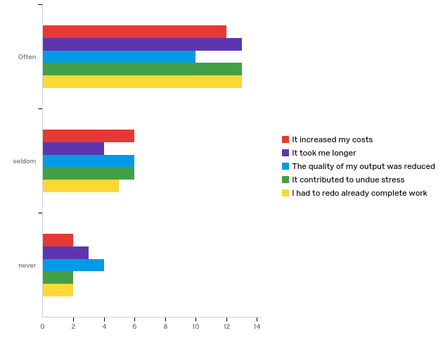

# | Question | Often |  | seldom |  | never |  | Total
1 | It increased my costs | 60.00% | 12 | 30.00% | 6 | 10.00% | 2 | 20
2 | It took me longer | 65.00% | 13 | 20.00% | 4 | 15.00% | 3 | 20
3 | The quality of my output was reduced | 50.00% | 10 | 30.00% | 6 | 20.00% | 4 | 20
4 | It contributed to undue stress | 61.90% | 13 | 28.57% | 6 | 9.52% | 2 | 21
5 | I had to redo already complete work | 65.00% | 13 | 25.00% | 5 | 10.00% | 2 | 20

Q5.13 - Increased time pressure result in errors and omissions
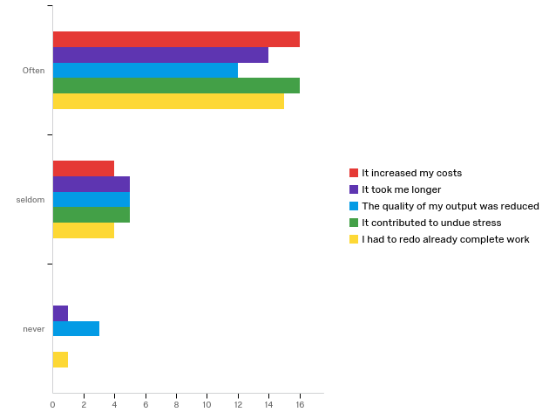

# | Question | Often |  | seldom |  | never |  | Total
1 | It increased my costs | 80.00% | 16 | 20.00% | 4 | 0.00% | 0 | 20
2 | It took me longer | 70.00% | 14 | 25.00% | 5 | 5.00% | 1 | 20
3 | The quality of my output was reduced | 60.00% | 12 | 25.00% | 5 | 15.00% | 3 | 20
4 | It contributed to undue stress | 76.19% | 16 | 23.81% | 5 | 0.00% | 0 | 21
5 | I had to redo already complete work | 75.00% | 15 | 20.00% | 4 | 5.00% | 1 | 20

Q5.14 - Additional resources are required to cope with scope changes
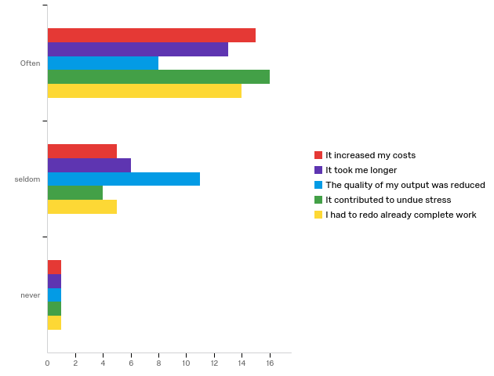

# | Question | Often |  | seldom |  | never |  | Total
1 | It increased my costs | 71.43% | 15 | 23.81% | 5 | 4.76% | 1 | 21
2 | It took me longer | 65.00% | 13 | 30.00% | 6 | 5.00% | 1 | 20
3 | The quality of my output was reduced | 40.00% | 8 | 55.00% | 11 | 5.00% | 1 | 20
4 | It contributed to undue stress | 76.19% | 16 | 19.05% | 4 | 4.76% | 1 | 21
5 | I had to redo already complete work | 70.00% | 14 | 25.00% | 5 | 5.00% | 1 | 20

Q5.15 - Efficiencies were not optimised due to time pressures and regular changes
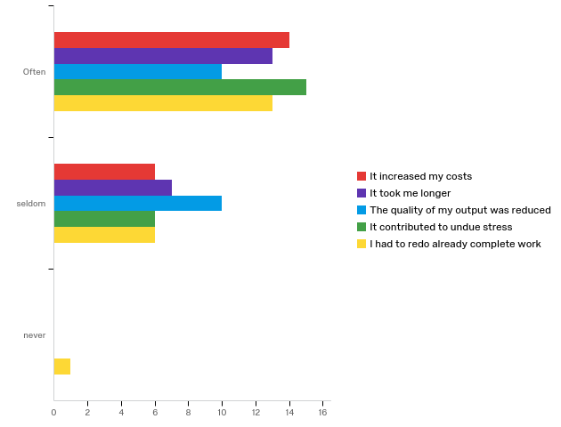

# | Question | Often |  | seldom |  | never |  | Total
1 | It increased my costs | 70.00% | 14 | 30.00% | 6 | 0.00% | 0 | 20
2 | It took me longer | 65.00% | 13 | 35.00% | 7 | 0.00% | 0 | 20
3 | The quality of my output was reduced | 50.00% | 10 | 50.00% | 10 | 0.00% | 0 | 20
4 | It contributed to undue stress | 71.43% | 15 | 28.57% | 6 | 0.00% | 0 | 21
5 | I had to redo already complete work | 65.00% | 13 | 30.00% | 6 | 5.00% | 1 | 20

Q5.16 - Changes to details due to concurrency of various design codes
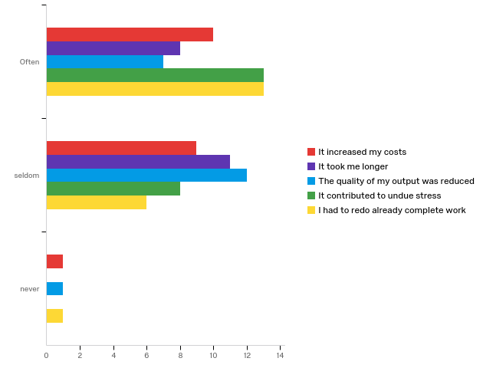

# | Question | Often |  | seldom |  | never |  | Total
1 | It increased my costs | 50.00% | 10 | 45.00% | 9 | 5.00% | 1 | 20
2 | It took me longer | 42.11% | 8 | 57.89% | 11 | 0.00% | 0 | 19
3 | The quality of my output was reduced | 35.00% | 7 | 60.00% | 12 | 5.00% | 1 | 20
4 | It contributed to undue stress | 61.90% | 13 | 38.10% | 8 | 0.00% | 0 | 21
5 | I had to redo already complete work | 65.00% | 13 | 30.00% | 6 | 5.00% | 1 | 20

Q5.17 - Omissions made in interpreting information due to scant details
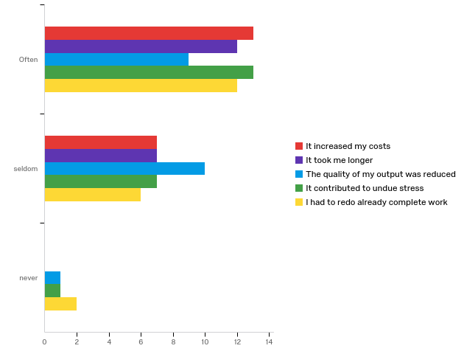

# | Question | Often |  | seldom |  | never |  | Total
1 | It increased my costs | 65.00% | 13 | 35.00% | 7 | 0.00% | 0 | 20
2 | It took me longer | 63.16% | 12 | 36.84% | 7 | 0.00% | 0 | 19
3 | The quality of my output was reduced | 45.00% | 9 | 50.00% | 10 | 5.00% | 1 | 20
4 | It contributed to undue stress | 61.90% | 13 | 33.33% | 7 | 4.76% | 1 | 21
5 | I had to redo already complete work | 60.00% | 12 | 30.00% | 6 | 10.00% | 2 | 20

Q5.18 - Specification changes imposed or decided
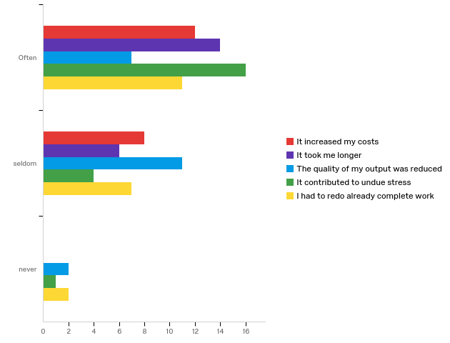

# | Question | Often |  | seldom |  | never |  | Total
1 | It increased my costs | 60.00% | 12 | 40.00% | 8 | 0.00% | 0 | 20
2 | It took me longer | 70.00% | 14 | 30.00% | 6 | 0.00% | 0 | 20
3 | The quality of my output was reduced | 35.00% | 7 | 55.00% | 11 | 10.00% | 2 | 20
4 | It contributed to undue stress | 76.19% | 16 | 19.05% | 4 | 4.76% | 1 | 21
5 | I had to redo already complete work | 55.00% | 11 | 35.00% | 7 | 10.00% | 2 | 20

Q5.19 - Scope creep leading to new or excessive work
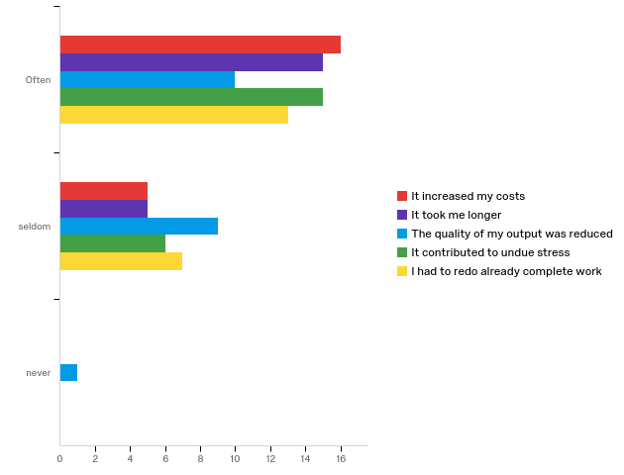

# | Question | Often |  | seldom |  | never |  | Total
1 | It increased my costs | 76.19% | 16 | 23.81% | 5 | 0.00% | 0 | 21
2 | It took me longer | 75.00% | 15 | 25.00% | 5 | 0.00% | 0 | 20
3 | The quality of my output was reduced | 50.00% | 10 | 45.00% | 9 | 5.00% | 1 | 20
4 | It contributed to undue stress | 71.43% | 15 | 28.57% | 6 | 0.00% | 0 | 21
5 | I had to redo already complete work | 65.00% | 13 | 35.00% | 7 | 0.00% | 0 | 20

Q5.20 - Actual effects of changes were not justifiable to client
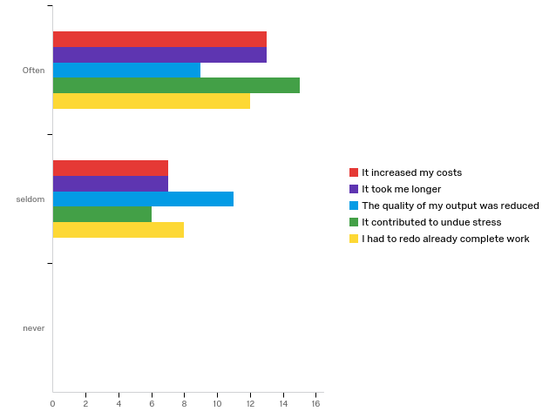

# | Question | Often |  | seldom |  | never |  | Total
1 | It increased my costs | 65.00% | 13 | 35.00% | 7 | 0.00% | 0 | 20
2 | It took me longer | 65.00% | 13 | 35.00% | 7 | 0.00% | 0 | 20
3 | The quality of my output was reduced | 45.00% | 9 | 55.00% | 11 | 0.00% | 0 | 20
4 | It contributed to undue stress | 71.43% | 15 | 28.57% | 6 | 0.00% | 0 | 21
5 | I had to redo already complete work | 60.00% | 12 | 40.00% | 8 | 0.00% | 0 | 20

Q5.21 - Retrofit designs that were not completely incorporated
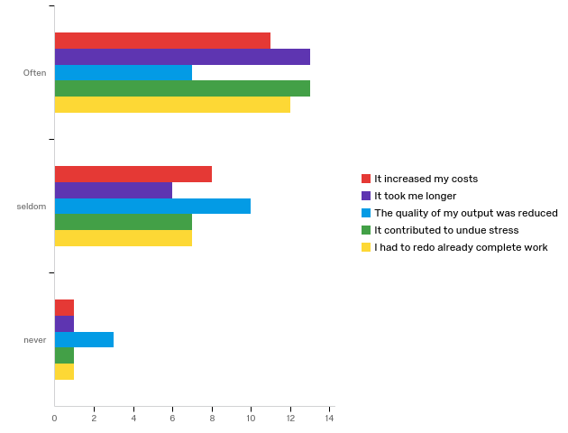

# | Question | Often |  | seldom |  | never |  | Total
1 | It increased my costs | 55.00% | 11 | 40.00% | 8 | 5.00% | 1 | 20
2 | It took me longer | 65.00% | 13 | 30.00% | 6 | 5.00% | 1 | 20
3 | The quality of my output was reduced | 35.00% | 7 | 50.00% | 10 | 15.00% | 3 | 20
4 | It contributed to undue stress | 61.90% | 13 | 33.33% | 7 | 4.76% | 1 | 21
5 | I had to redo already complete work | 60.00% | 12 | 35.00% | 7 | 5.00% | 1 | 20

Q6.2 - The finish scope was reduced due to structure scope creep
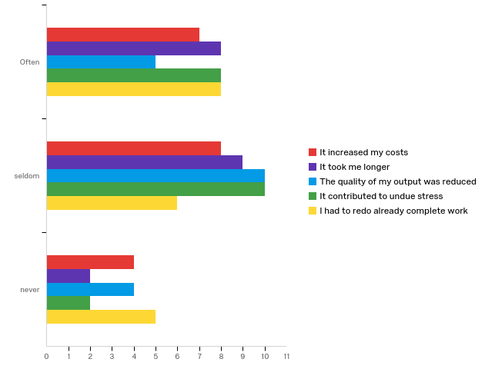

# | Question | Often |  | seldom |  | never |  | Total
1 | It increased my costs | 36.84% | 7 | 42.11% | 8 | 21.05% | 4 | 19
2 | It took me longer | 42.11% | 8 | 47.37% | 9 | 10.53% | 2 | 19
3 | The quality of my output was reduced | 26.32% | 5 | 52.63% | 10 | 21.05% | 4 | 19
4 | It contributed to undue stress | 40.00% | 8 | 50.00% | 10 | 10.00% | 2 | 20
5 | I had to redo already complete work | 42.11% | 8 | 31.58% | 6 | 26.32% | 5 | 19

Q6.3 - Addition scope was added or part scope was removed out of contract to accommodate changes without affecting completion
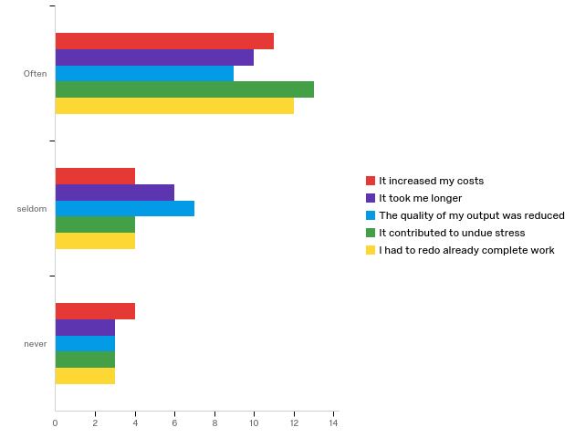

# | Question | Often |  | seldom |  | never |  | Total
1 | It increased my costs | 57.89% | 11 | 21.05% | 4 | 21.05% | 4 | 19
2 | It took me longer | 52.63% | 10 | 31.58% | 6 | 15.79% | 3 | 19
3 | The quality of my output was reduced | 47.37% | 9 | 36.84% | 7 | 15.79% | 3 | 19
4 | It contributed to undue stress | 65.00% | 13 | 20.00% | 4 | 15.00% | 3 | 20
5 | I had to redo already complete work | 63.16% | 12 | 21.05% | 4 | 15.79% | 3 | 19

Q6.4 - Statutory approvals resubmission due to changes/new information caused delays
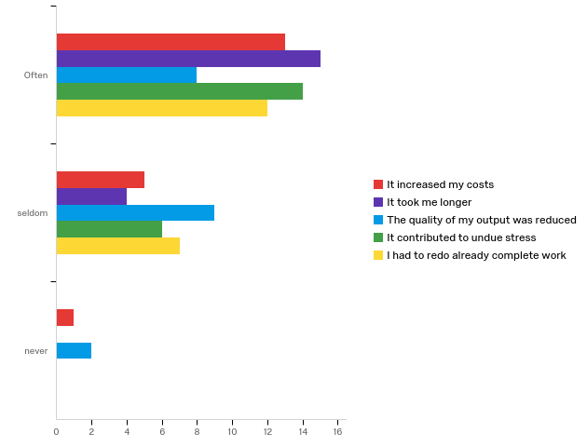

# | Question | Often |  | seldom |  | never |  | Total
1 | It increased my costs | 68.42% | 13 | 26.32% | 5 | 5.26% | 1 | 19
2 | It took me longer | 78.95% | 15 | 21.05% | 4 | 0.00% | 0 | 19
3 | The quality of my output was reduced | 42.11% | 8 | 47.37% | 9 | 10.53% | 2 | 19
4 | It contributed to undue stress | 70.00% | 14 | 30.00% | 6 | 0.00% | 0 | 20
5 | I had to redo already complete work | 63.16% | 12 | 36.84% | 7 | 0.00% | 0 | 19

Q6.5 - Quality was compromised by rework regardless of the cause
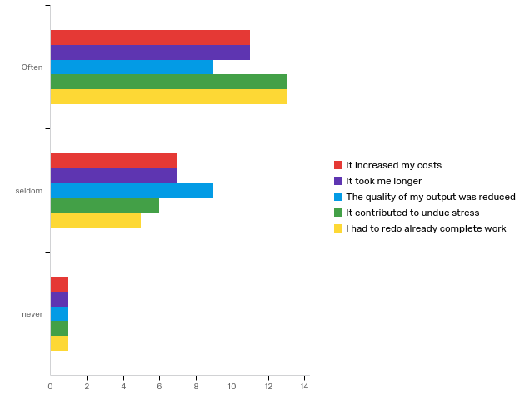

# | Question | Often |  | seldom |  | never |  | Total
1 | It increased my costs | 57.89% | 11 | 36.84% | 7 | 5.26% | 1 | 19
2 | It took me longer | 57.89% | 11 | 36.84% | 7 | 5.26% | 1 | 19
3 | The quality of my output was reduced | 47.37% | 9 | 47.37% | 9 | 5.26% | 1 | 19
4 | It contributed to undue stress | 65.00% | 13 | 30.00% | 6 | 5.00% | 1 | 20
5 | I had to redo already complete work | 68.42% | 13 | 26.32% | 5 | 5.26% | 1 | 19

Q6.6 - Definition of practical completion become unclear with major scope changes
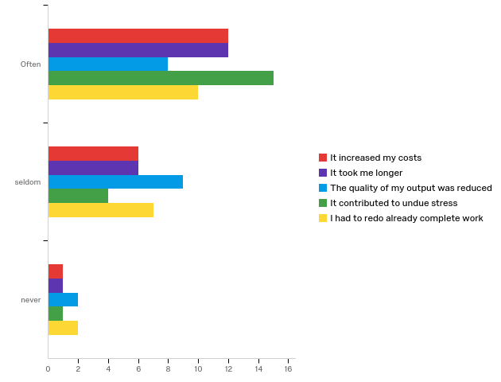

# | Question | Often |  | seldom |  | never |  | Total
1 | It increased my costs | 63.16% | 12 | 31.58% | 6 | 5.26% | 1 | 19
2 | It took me longer | 63.16% | 12 | 31.58% | 6 | 5.26% | 1 | 19
3 | The quality of my output was reduced | 42.11% | 8 | 47.37% | 9 | 10.53% | 2 | 19
4 | It contributed to undue stress | 75.00% | 15 | 20.00% | 4 | 5.00% | 1 | 20
5 | I had to redo already complete work | 52.63% | 10 | 36.84% | 7 | 10.53% | 2 | 19

Q6.7 - Late handovers or concurrent handovers due to scope change
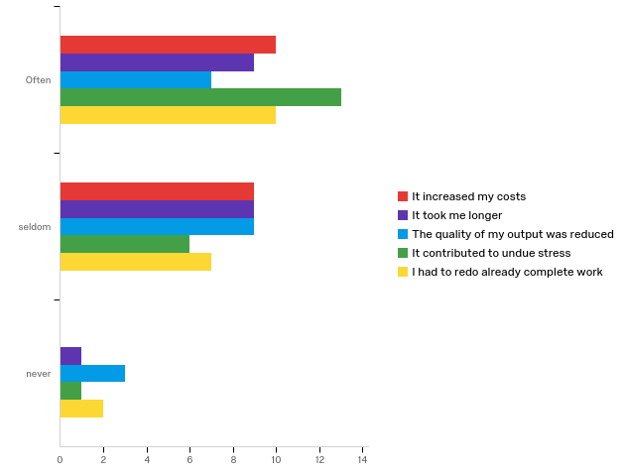

# | Question | Often |  | seldom |  | never |  | Total
1 | It increased my costs | 52.63% | 10 | 47.37% | 9 | 0.00% | 0 | 19
2 | It took me longer | 47.37% | 9 | 47.37% | 9 | 5.26% | 1 | 19
3 | The quality of my output was reduced | 36.84% | 7 | 47.37% | 9 | 15.79% | 3 | 19
4 | It contributed to undue stress | 65.00% | 13 | 30.00% | 6 | 5.00% | 1 | 20
5 | I had to redo already complete work | 52.63% | 10 | 36.84% | 7 | 10.53% | 2 | 19

Q6.8 - Excessive close out documentation due to changes such as built drawings
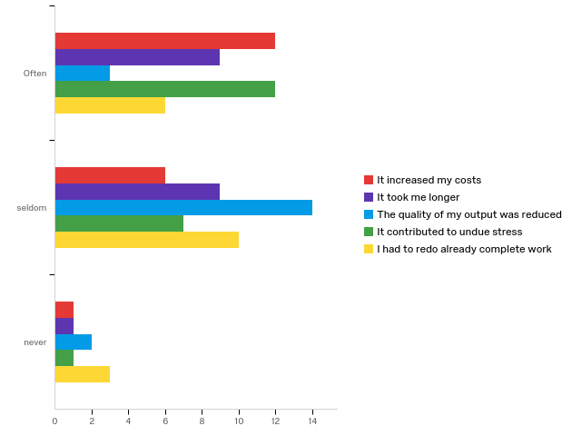

# | Question | Often |  | seldom |  | never |  | Total
1 | It increased my costs | 63.16% | 12 | 31.58% | 6 | 5.26% | 1 | 19
2 | It took me longer | 47.37% | 9 | 47.37% | 9 | 5.26% | 1 | 19
3 | The quality of my output was reduced | 15.79% | 3 | 73.68% | 14 | 10.53% | 2 | 19
4 | It contributed to undue stress | 60.00% | 12 | 35.00% | 7 | 5.00% | 1 | 20
5 | I had to redo already complete work | 31.58% | 6 | 52.63% | 10 | 15.79% | 3 | 19

Q6.9 - High volumes of snags due to unexpected interface of changes or unclear scope
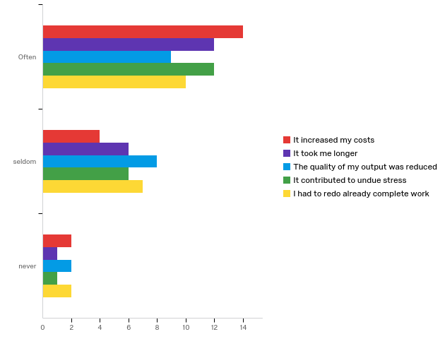

# | Question | Often |  | seldom |  | never |  | Total
1 | It increased my costs | 70.00% | 14 | 20.00% | 4 | 10.00% | 2 | 20
2 | It took me longer | 63.16% | 12 | 31.58% | 6 | 5.26% | 1 | 19
3 | The quality of my output was reduced | 47.37% | 9 | 42.11% | 8 | 10.53% | 2 | 19
4 | It contributed to undue stress | 63.16% | 12 | 31.58% | 6 | 5.26% | 1 | 19
5 | I had to redo already complete work | 52.63% | 10 | 36.84% | 7 | 10.53% | 2 | 19

Q6.10 - Maintaining commitment became difficult when moral was low due to constant scope change difficulties
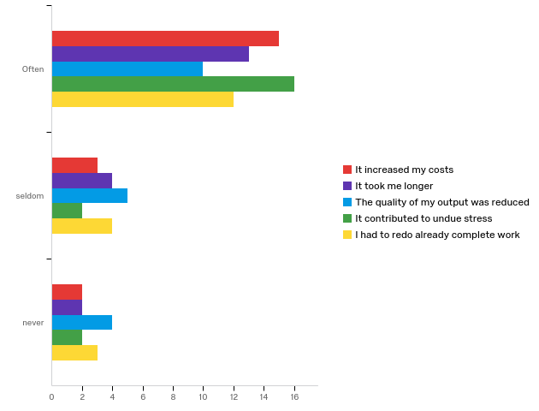

# | Question | Often |  | seldom |  | never |  | Total
1 | It increased my costs | 75.00% | 15 | 15.00% | 3 | 10.00% | 2 | 20
2 | It took me longer | 68.42% | 13 | 21.05% | 4 | 10.53% | 2 | 19
3 | The quality of my output was reduced | 52.63% | 10 | 26.32% | 5 | 21.05% | 4 | 19
4 | It contributed to undue stress | 80.00% | 16 | 10.00% | 2 | 10.00% | 2 | 20
5 | I had to redo already complete work | 63.16% | 12 | 21.05% | 4 | 15.79% | 3 | 19

Q6.11 - Accelerated work for excessive changes or unclear scope to meet rigid deadlines
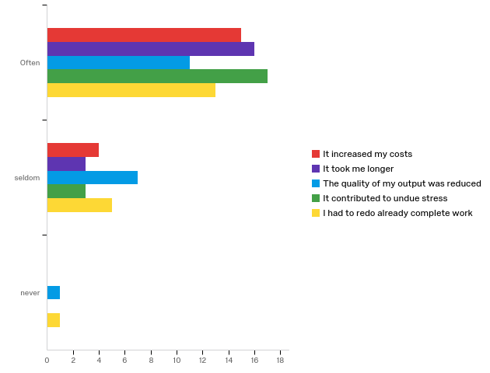

# | Question | Often |  | seldom |  | never |  | Total
1 | It increased my costs | 78.95% | 15 | 21.05% | 4 | 0.00% | 0 | 19
2 | It took me longer | 84.21% | 16 | 15.79% | 3 | 0.00% | 0 | 19
3 | The quality of my output was reduced | 57.89% | 11 | 36.84% | 7 | 5.26% | 1 | 19
4 | It contributed to undue stress | 85.00% | 17 | 15.00% | 3 | 0.00% | 0 | 20
5 | I had to redo already complete work | 68.42% | 13 | 26.32% | 5 | 5.26% | 1 | 19

Q6.12 - Changes in scope for unclear requirements such as fire signage/fire doors/balustrades etc,
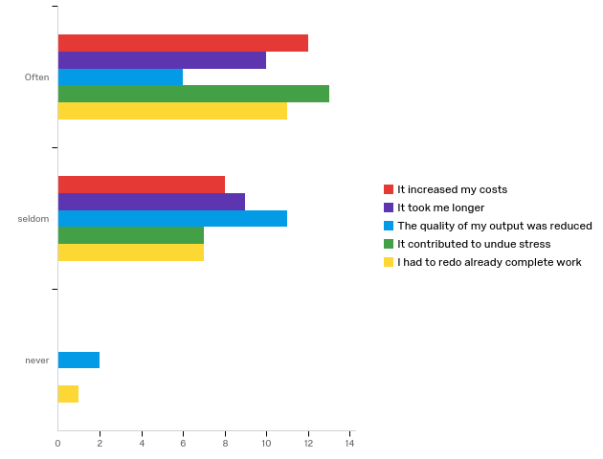

# | Question | Often |  | seldom |  | never |  | Total
1 | It increased my costs | 60.00% | 12 | 40.00% | 8 | 0.00% | 0 | 20
2 | It took me longer | 52.63% | 10 | 47.37% | 9 | 0.00% | 0 | 19
3 | The quality of my output was reduced | 31.58% | 6 | 57.89% | 11 | 10.53% | 2 | 19
4 | It contributed to undue stress | 65.00% | 13 | 35.00% | 7 | 0.00% | 0 | 20
5 | I had to redo already complete work | 57.89% | 11 | 36.84% | 7 | 5.26% | 1 | 19

Q6.13 - Cutting corners to save time and budget
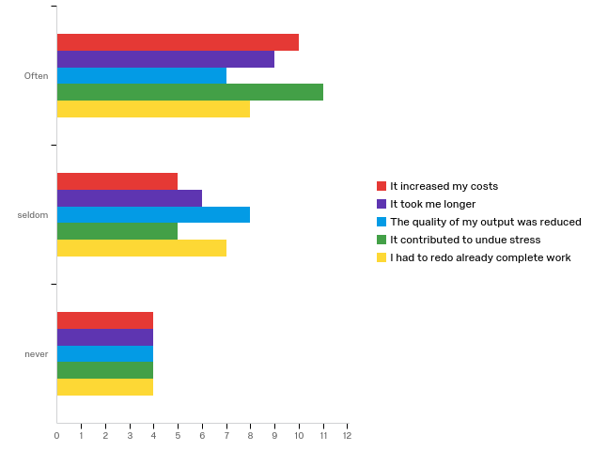

# | Question | Often |  | seldom |  | never |  | Total
1 | It increased my costs | 52.63% | 10 | 26.32% | 5 | 21.05% | 4 | 19
2 | It took me longer | 47.37% | 9 | 31.58% | 6 | 21.05% | 4 | 19
3 | The quality of my output was reduced | 36.84% | 7 | 42.11% | 8 | 21.05% | 4 | 19
4 | It contributed to undue stress | 55.00% | 11 | 25.00% | 5 | 20.00% | 4 | 20
5 | I had to redo already complete work | 42.11% | 8 | 36.84% | 7 | 21.05% | 4 | 19

Q6.14 - Returning to complete work due to additional instructions and snags
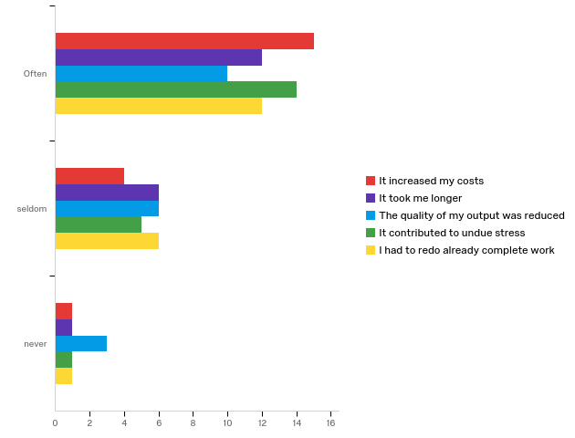

# | Question | Often |  | seldom |  | never |  | Total
1 | It increased my costs | 75.00% | 15 | 20.00% | 4 | 5.00% | 1 | 20
2 | It took me longer | 63.16% | 12 | 31.58% | 6 | 5.26% | 1 | 19
3 | The quality of my output was reduced | 52.63% | 10 | 31.58% | 6 | 15.79% | 3 | 19
4 | It contributed to undue stress | 70.00% | 14 | 25.00% | 5 | 5.00% | 1 | 20
5 | I had to redo already complete work | 63.16% | 12 | 31.58% | 6 | 5.26% | 1 | 19

Q6.15 - Extension of guarantees due to delays caused by scope change
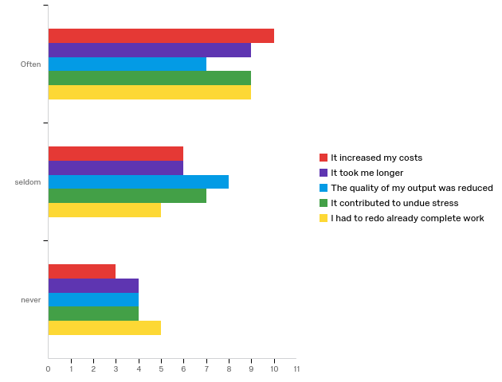

# | Question | Often |  | seldom |  | never |  | Total
1 | It increased my costs | 52.63% | 10 | 31.58% | 6 | 15.79% | 3 | 19
2 | It took me longer | 47.37% | 9 | 31.58% | 6 | 21.05% | 4 | 19
3 | The quality of my output was reduced | 36.84% | 7 | 42.11% | 8 | 21.05% | 4 | 19
4 | It contributed to undue stress | 45.00% | 9 | 35.00% | 7 | 20.00% | 4 | 20
5 | I had to redo already complete work | 47.37% | 9 | 26.32% | 5 | 26.32% | 5 | 19

Q6.16 - Commitment of team members once fees have been exhausted due to fix fee structures
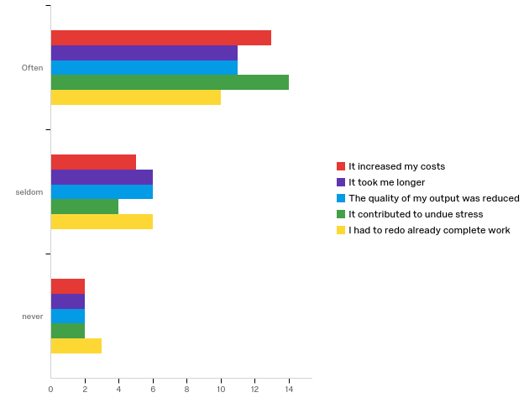

# | Question | Often |  | seldom |  | never |  | Total
1 | It increased my costs | 65.00% | 13 | 25.00% | 5 | 10.00% | 2 | 20
2 | It took me longer | 57.89% | 11 | 31.58% | 6 | 10.53% | 2 | 19
3 | The quality of my output was reduced | 57.89% | 11 | 31.58% | 6 | 10.53% | 2 | 19
4 | It contributed to undue stress | 70.00% | 14 | 20.00% | 4 | 10.00% | 2 | 20
5 | I had to redo already complete work | 52.63% | 10 | 31.58% | 6 | 15.79% | 3 | 19

Q6.17 - Remeasuring works several times due to changes
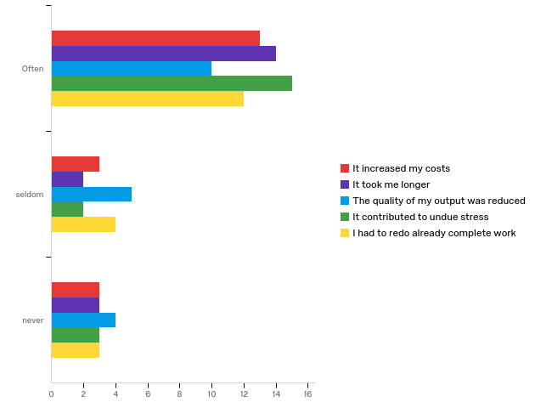

# | Question | Often |  | seldom |  | never |  | Total
1 | It increased my costs | 68.42% | 13 | 15.79% | 3 | 15.79% | 3 | 19
2 | It took me longer | 73.68% | 14 | 10.53% | 2 | 15.79% | 3 | 19
3 | The quality of my output was reduced | 52.63% | 10 | 26.32% | 5 | 21.05% | 4 | 19
4 | It contributed to undue stress | 75.00% | 15 | 10.00% | 2 | 15.00% | 3 | 20
5 | I had to redo already complete work | 63.16% | 12 | 21.05% | 4 | 15.79% | 3 | 19

Q6.18 - Work being aborted due to new instructions
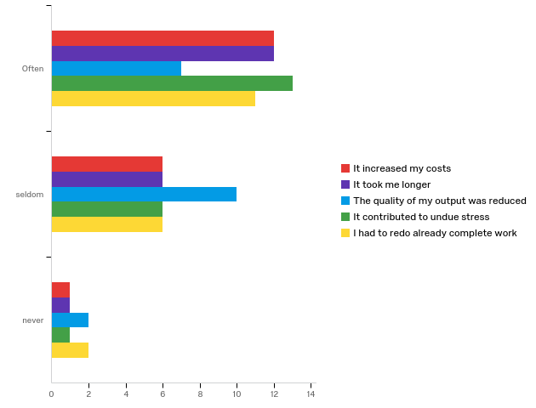

# | Question | Often |  | seldom |  | never |  | Total
1 | It increased my costs | 63.16% | 12 | 31.58% | 6 | 5.26% | 1 | 19
2 | It took me longer | 63.16% | 12 | 31.58% | 6 | 5.26% | 1 | 19
3 | The quality of my output was reduced | 36.84% | 7 | 52.63% | 10 | 10.53% | 2 | 19
4 | It contributed to undue stress | 65.00% | 13 | 30.00% | 6 | 5.00% | 1 | 20
5 | I had to redo already complete work | 57.89% | 11 | 31.58% | 6 | 10.53% | 2 | 19

Q6.19 - Instructions for external works overlook such as landscaping/signage/gates etc
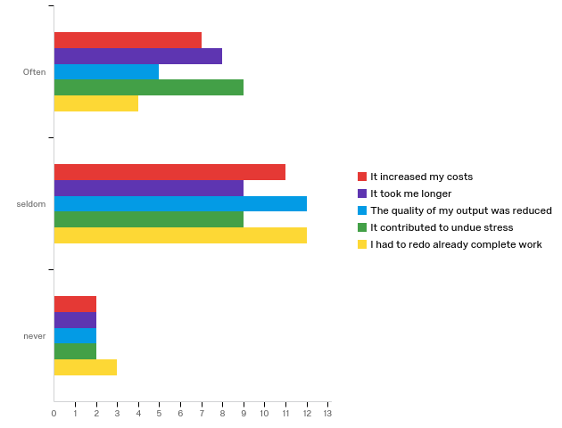

# | Question | Often |  | seldom |  | never |  | Total
1 | It increased my costs | 35.00% | 7 | 55.00% | 11 | 10.00% | 2 | 20
2 | It took me longer | 42.11% | 8 | 47.37% | 9 | 10.53% | 2 | 19
3 | The quality of my output was reduced | 26.32% | 5 | 63.16% | 12 | 10.53% | 2 | 19
4 | It contributed to undue stress | 45.00% | 9 | 45.00% | 9 | 10.00% | 2 | 20
5 | I had to redo already complete work | 21.05% | 4 | 63.16% | 12 | 15.79% | 3 | 19

Q6.20 - Agreeing and settling final account became onerous and painstaking
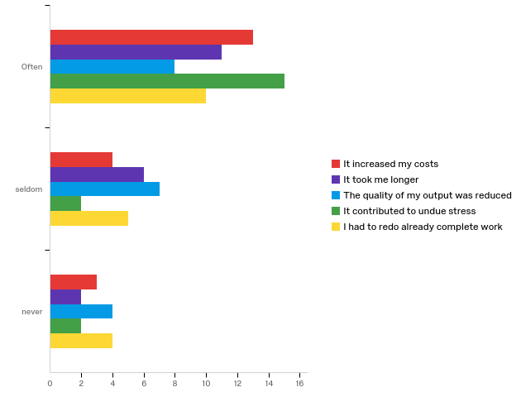

# | Question | Often |  | seldom |  | never |  | Total
1 | It increased my costs | 65.00% | 13 | 20.00% | 4 | 15.00% | 3 | 20
2 | It took me longer | 57.89% | 11 | 31.58% | 6 | 10.53% | 2 | 19
3 | The quality of my output was reduced | 42.11% | 8 | 36.84% | 7 | 21.05% | 4 | 19
4 | It contributed to undue stress | 78.95% | 15 | 10.53% | 2 | 10.53% | 2 | 19
5 | I had to redo already complete work | 52.63% | 10 | 26.32% | 5 | 21.05% | 4 | 19

Q6.21 - Reworked items remaining on snag lists
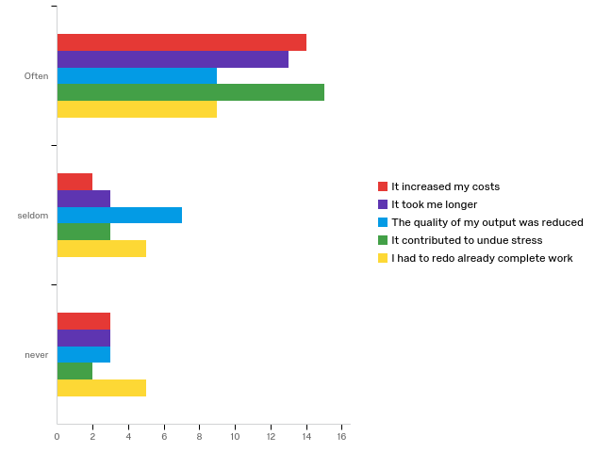

# | Question | Often |  | seldom |  | never |  | Total
1 | It increased my costs | 73.68% | 14 | 10.53% | 2 | 15.79% | 3 | 19
2 | It took me longer | 68.42% | 13 | 15.79% | 3 | 15.79% | 3 | 19
3 | The quality of my output was reduced | 47.37% | 9 | 36.84% | 7 | 15.79% | 3 | 19
4 | It contributed to undue stress | 75.00% | 15 | 15.00% | 3 | 10.00% | 2 | 20
5 | I had to redo already complete work | 47.37% | 9 | 26.32% | 5 | 26.32% | 5 | 19

Question 7 Impact on the entire team
Q7.2 - The project occupation was delayed due to scope changes resulting in
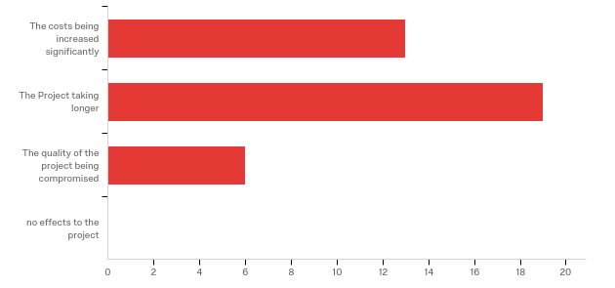

# | Answer | % | Count
1 | The costs being increased significantly | 34.21% | 13
2 | The Project taking longer | 50.00% | 19
3 | The quality of the project being compromised | 15.79% | 6
4 | no effects to the project | 0.00% | 0
 | Total | 100% | 38

Q7.3 - There was an increase in snags and defects resulting in
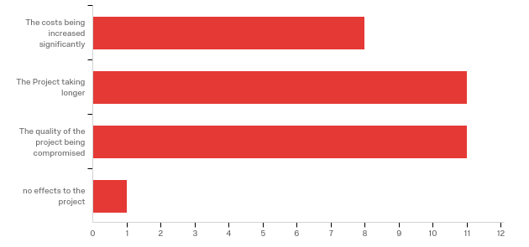

# | Answer | % | Count
1 | The costs being increased significantly | 25.81% | 8
2 | The Project taking longer | 35.48% | 11
3 | The quality of the project being compromised | 35.48% | 11
4 | no effects to the project | 3.23% | 1
 | Total | 100% | 31

Q7.4 - The structural integrity and longevity of the building was compromised resulting in
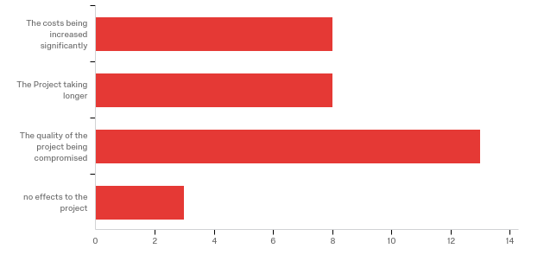

# | Answer | % | Count
1 | The costs being increased significantly | 25.00% | 8
2 | The Project taking longer | 25.00% | 8
3 | The quality of the project being compromised | 40.63% | 13
4 | no effects to the project | 9.38% | 3
 | Total | 100% | 32

Q7.5 - The handover process was disruption and the snags process could not be clearly defined resulting in
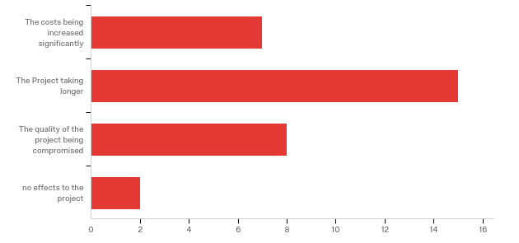

# | Answer | % | Count
1 | The costs being increased significantly | 21.88% | 7
2 | The Project taking longer | 46.88% | 15
3 | The quality of the project being compromised | 25.00% | 8
4 | no effects to the project | 6.25% | 2
 | Total | 100% | 32

Q7.6 - Securities and guarantees were outstanding for long periods resulting in
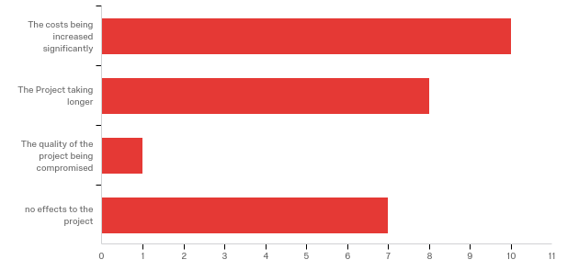

# | Answer | % | Count
1 | The costs being increased significantly | 38.46% | 10
2 | The Project taking longer | 30.77% | 8
3 | The quality of the project being compromised | 3.85% | 1
4 | no effects to the project | 26.92% | 7
 | Total | 100% | 26

Q7.7 - Late council approvals or no approvals resulted in
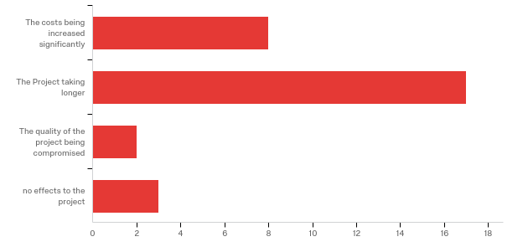

# | Answer | % | Count
1 | The costs being increased significantly | 26.67% | 8
2 | The Project taking longer | 56.67% | 17
3 | The quality of the project being compromised | 6.67% | 2
4 | no effects to the project | 10.00% | 3
 | Total | 100% | 30

Q7.8 - Design sacrifices, quality compromises and functionality vs quality resulted in
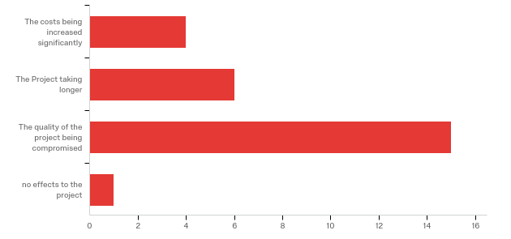

# | Answer | % | Count
1 | The costs being increased significantly | 15.38% | 4
2 | The Project taking longer | 23.08% | 6
3 | The quality of the project being compromised | 57.69% | 15
4 | no effects to the project | 3.85% | 1
 | Total | 100% | 26

Q7.9 - Unclear assumptions in the design resulted in
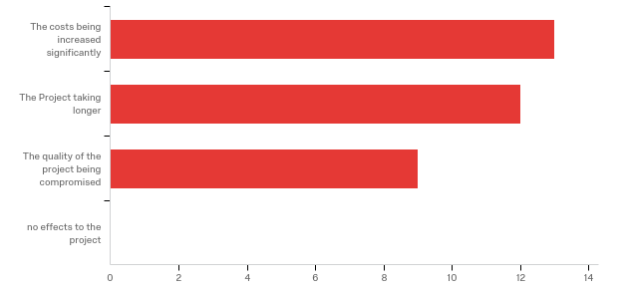

# | Answer | % | Count
1 | The costs being increased significantly | 38.24% | 13
2 | The Project taking longer | 35.29% | 12
3 | The quality of the project being compromised | 26.47% | 9
4 | no effects to the project | 0.00% | 0
 | Total | 100% | 34

Q7.10 - Property rights and restriction were not resolved timeously and resulted in
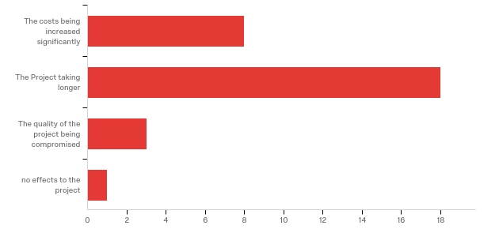

# | Answer | % | Count
1 | The costs being increased significantly | 26.67% | 8
2 | The Project taking longer | 60.00% | 18
3 | The quality of the project being compromised | 10.00% | 3
4 | no effects to the project | 3.33% | 1
 | Total | 100% | 30

Q8.1 - The following commonly cited impacts were felt by the construction project team. Please select those that affected you significantly.
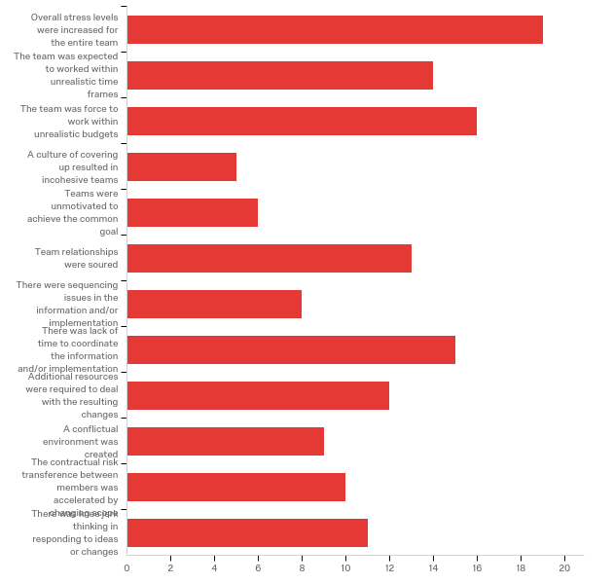

# | Answer | % | Count
1 | Overall stress levels were increased for the entire team | 13.77% | 19
2 | The team was expected to worked within unrealistic time frames | 10.14% | 14
3 | The team was force to work within unrealistic budgets | 11.59% | 16
4 | A culture of covering up resulted in incohesive teams | 3.62% | 5
5 | Teams were unmotivated to achieve the common goal | 4.35% | 6
6 | Team relationships were soured | 9.42% | 13
7 | There were sequencing issues in the information and/or implementation | 5.80% | 8
8 | There was lack of time to coordinate the information and/or implementation | 10.87% | 15
9 | Additional resources were required to deal with the resulting changes | 8.70% | 12
10 | A conflictual environment was created | 6.52% | 9
11 | The contractual risk transference between members was accelerated by changing scope | 7.25% | 10
12 | There was knee jerk thinking in responding to ideas or changes | 7.97% | 11
 | Total | 100% | 138

