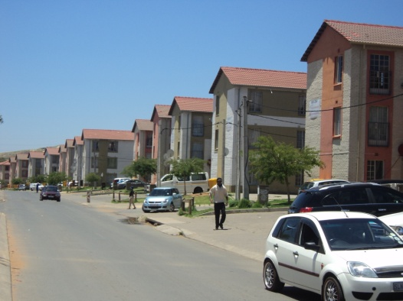
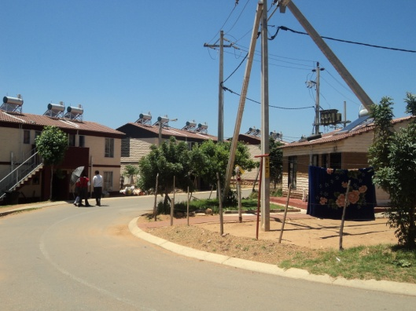
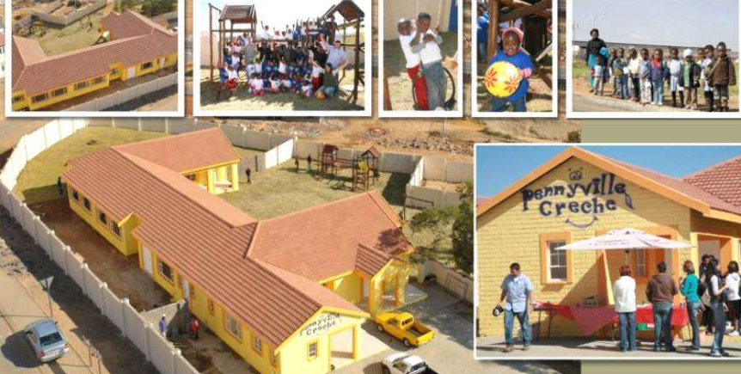
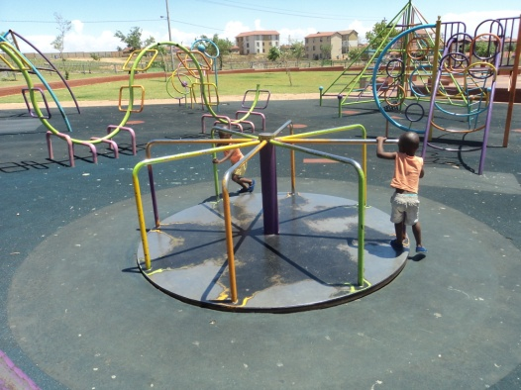
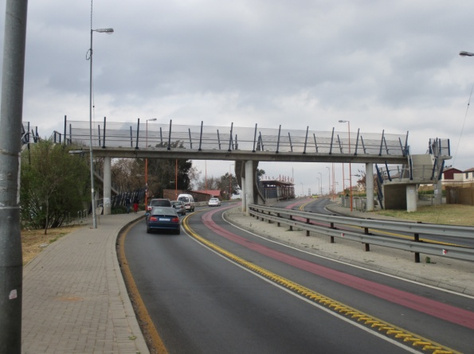
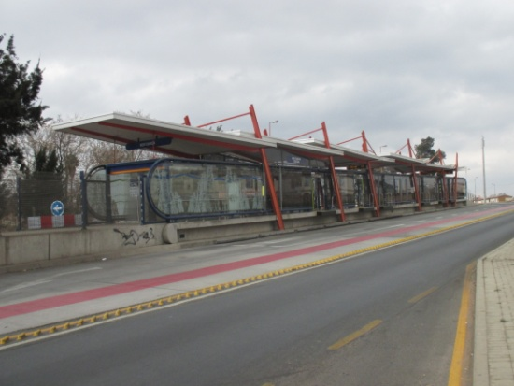
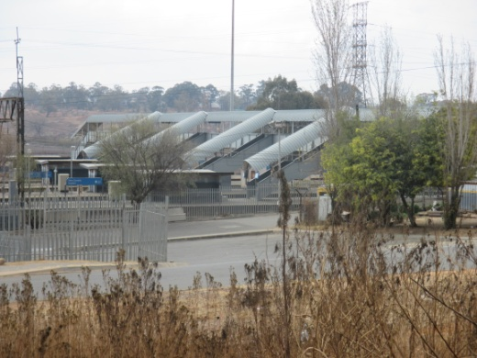
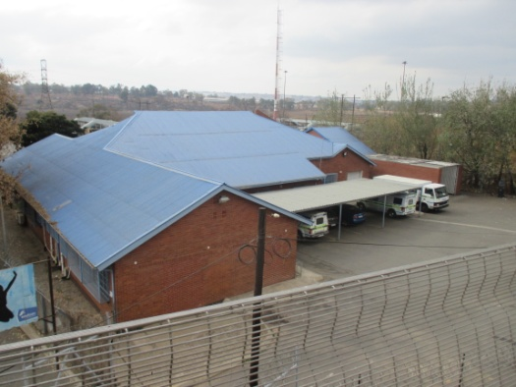
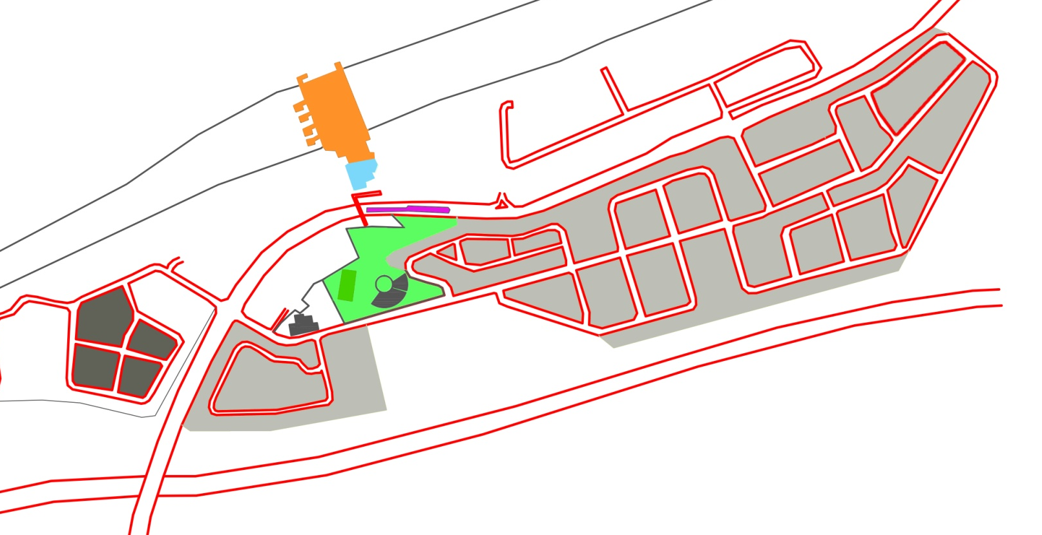
57
Private developed housing (Nyiko 2013)
Subsidized housing (Nyiko 2013)

Pennyville crèche (CalgroM3, 2014)
Pennyville Park (Nyiko 2013)
Pedestrian Bridge (Nyiko 2014)

Pennyville Rea Vaya station (Nyiko 2014)
Pennyville railway station (Nyiko, 2014)
Police Station (Nyiko 2014)

Pennyville layout of units and location of facilities Figure 3
Phase 2
Phase 1

