Job Demands, Resources and the Propensity to Comply with Safety Procedures and Interventions associated with Needlestick Injuries



Jenna Andrea Wing

Master of Arts
Organisational Psychology
University of the Witwatersrand
March 2017

“A research project submitted in partial fulfilment of the requirements for the degree of Master’s (Industrial/Organisational Psychology) in the Faculty of Humanities, University of the Witwatersrand, Johannesburg, March 2017.”

Abstract

A South African study, based on a sample of 208 medical personnel working in public and private institutions, was conducted in order to determine whether job demands and job resources led to differences in the propensity to comply with Needlestick Injury (NSI) intervention scores.

Three self-report questionnaires were completed by the participants, namely the self-developed demographic questionnaire, the Job Demands-Resources Scale (JDRS) which measured job demands and resources, and thirdly the self-developed Propensity to Comply with Interventions for Needlestick Injuries Scale (PCINS) which measured the propensity to comply with interventions for NSIs.

Accidental needle stick, as well as sharp, injuries occur frequently within the medical context and are associated with high risks for blood-borne infections (Adefolalu, 2014). Specifically within South Africa blood-borne infections such as HIV carry heavy significance. Needlestick injuries often go unreported by healthcare professionals, and these injuries are widely prevalent. The researcher aimed to explore the job demands and resources that contribute to and mitigate against these injuries. Therefore support for the analysis of job demands and resources and the propensity to comply with NSI interventions exists.

The results of the study suggested that there were mostly no significant differences between Job Demands and Resources and the propensity to comply with NSI Interventions scores. However significant relationships were found between length of shift and the propensity to comply with NSI interventions and growth opportunities and the propensity to comply with NSI interventions. The findings did not follow the proposed hypotheses that job demands would lead to a decrease in the propensity to comply with NSI interventions and job resources would lead to an increase in the propensity to comply with NSI interventions as longer length of shift (job demand) led to an increase in propensity to comply with NSI interventions and an association between high levels of growth opportunity (job resource), and low levels of propensity to comply with NSI interventions, was found.

Declaration

“I declare that this research project is my own, unaided work. It has not been submitted before any other degree or examination at this or any other university.”
Signature:
Date: 15 March 2017
Word count: 28064

Acknowledgements
To my research supervisor, Professor Fiona Donald, your time and patience as well as your continuous guidance, and feedback have been invaluable. Thank you for your kindness and calm presence that has influenced me to become more than what I thought I was capable of.
To my parents Jeffrey Wing and Marion Wing who gave me support, acknowledgement and continuous encouragement. I appreciate all that you have done for me throughout my studies, and express eternal gratitude for your love, lessons and graciousness.
Lastly, to my sister Jessica Wing for her interest and unwavering support throughout the duration of my Masters degree.

Table of Contents

CHAPTER 1
  - Introduction 1
  - Rationale 1
CHAPTER 2: THEORETICAL AND CONTEXTUAL BACKGROUND
  - Introduction 4
  - Job Demands and Resources 4
  - Current Research on NSIs 6
    - Working Hours 7
    - Length of Shift 8
    - Overload 10
    - Organisational Support 11
    - Growth Opportunities and Advancement 12
    - Job Security 13
  - Research Aims 14
  - Hypotheses 14
CHAPTER 3: METHOD
  - Research Design 16
  - Sample and Sampling 16
    - Pilot Sample 16
    - Descriptive Statistics for Pilot Sample 16
    - Main Sample 20
    - Descriptive Statistics for Main Study 20
  - Instrumentation 24
    - Demographic Questionnaire 24
    - Job Demands-Resources Scale (JDRS) 25
    - Job Demands-Resources Scale (JDRS) Internal Consistency 26
    - The Propensity to Comply with Interventions for NSIs Scale (PCINS) 26
    - The Propensity to Comply with Interventions for NSIs Scale (PCINS) Internal Consistency 27
  - Procedure 27
  - Data Analyses 29
    - Reliability of Instruments 30
    - Descriptive Statistics 30
    - Pearson’s Correlation Coefficient 30
    - Multiple Regression 32
    - Analysis of Variance (ANOVA) 35
    - Kruskal-Wallis H 39
  - Ethical Considerations 40
CHAPTER 4: RESULTS
  - Part 1: Primary Analysis 43
    - Descriptive Statistics for variables 43
    - Examination of Hypotheses (Correlations) 44
    - Assumptions of Statistical Technique : Pearson’s Correlations 44
    - Correlations 46
    - Examination of Hypotheses (Multiple Regression) 48
    - Assumptions of Statistical Technique: Multiple Regression 48
    - Confirming Predictor Variables (Multiple Regression) 49
    - Part 1 Conclusion 51
  - Part 2: Secondary Analyses 53
    - Introduction 53
    - Descriptive Statistics of Job Title Categories 53
    - Assumptions of Statistical Technique: Kruskal-Wallis H 54
    - Results: Job Title and Propensity to Comply with NSI Interventions 54
    - Part 2 Conclusion 56
  - Part 3: Return to Primary Analyses 57
    - Introduction 57
    - Descriptive Statistics: length of Shift 57
    - Examination of Hypotheses: Length of Shift and Working Hours 59
    - Assumptions of Statistical Technique: One-way ANOVA 59
    - Results: Length of Shift and Propensity to Comply with NSI Interventions 60
    - Part 3 Conclusion 65
    - Results: Working Hours and Propensity to Comply with NSI Interventions 66
    - Part 3 Conclusion 66
    - Results Overall Conclusion 67
CHAPTER 5: RESULTS
  - Introduction 68
  - Discussion of Findings: Job Demands 68
    - Non-significant Statistical Findings for Overload 68
    - Significant Statistical Findings for Length of Shift 69
    - Non-significant Statistical Findings for Working Hours 70
  - Discussion of Findings: Job Resources 71
    - Non-significant Statistical Findings for Advancement 71
    - Non-significant Statistical Findings for Job Security 72
    - Non-significant Statistical Findings for Organisational Support 73
    - Significant Statistical Findings for Growth Opportunities 74
  - Summary of Statistical Findings: Propensity to Comply with NSI Interventions 76
  - Limitations of the Study 77
  - Theoretical and Practical Implications and Directions for Further Research 79
  - Conclusion 81

Reference List 82
Appendices 90
Appendix 1: Letter Requesting Access 90
Appendix 2: Participant Information Sheet 92
Appendix 3: Demographic Questionnaire 94
Appendix 4: Job Demands-Resource Scale (JDRS) 97
Appendix 5: The Propensity to Comply with Interventions for NSIs Scale (PCINS) 102
Appendix 6: Ethics Clearance Certificate (Non-Medical) 103
Appendix 7: Ethics Clearance Certificate (Medical) 104
Appendix 8: Site Approval Letter 1 105
Appendix 9: Site Approval Letter 2 106
Appendix 10: Normality Histogram (Multiple Regression) 107
Appendix 11: Normal Q-Q Plot (Multiple Regression) 108
Appendix 12: Scatter Plot (Multiple Regression) 109
Appendix 13: Normality Histograms for Job Title 110
Appendix 14: Normal Q-Q plots for Job Title 114
Appendix 15: Normality Histograms for Length of Shift 118
Appendix 16: Normal Q-Q Plots for Length of Shift 121
Appendix 17: Normality Histograms for Working Hours 124
Appendix 18: Normal Q-Q Plots for Working Hours 126
CHAPTER 1
1.1 Introduction
Healthcare workers are often exposed to unhealthy work environments, unreasonable workloads and unfavourable work-relaxation imbalances (Wilburn & Eijkemans, 2004). In fact, occupational health hazards amongst healthcare workers has been a well-researched topic worldwide (Orji et al., 2002; Swallow, 2006; Perry & Jagger, 2005; Jaskolka, Andrews & Harold, 2009; Glenngård & Persson, 2009). However, in South Africa the well-being of healthcare professionals deserves further assessment. South Africa carries one of the highest burdens of communicable diseases and one of the lowest ratio of healthcare workers to population (WHO, 2010). The relative underinvestment in the promotion of health and safety of healthcare professionals is of significant national importance. Globally, a common occupational injury among medical and allied personnel is that of needle stick injuries (NSIs) which have serious implications for the physical and psychological health and well-being of healthcare workers (Van der Molen, Zwinderman, Sluiter & Frings-Dresen, 2012). In this study, NSIs in South African hospitals and their relation to job demands and resources receive focal attention. The researcher intends to determine whether job demands will lead to a higher propensity to comply with NSI interventions and whether job resources will lead to a lower propensity to comply with NSI interventions.
1.2. Rationale
Worldwide, the World Health Organisation (WHO) (2002) reports in their World Health Report that of a total of 35 million healthcare professionals, 2 million have experienced potential exposure to infectious diseases. Furthermore, of those that had been exposed to patients with diagnosed infectious diseases (4.4% of HIV, 37.6% of Hepatitis B and 39% of Hepatitis C) exposure was dominantly attributable to needlestick injuries (WHO, 2002). Accidental needle stick, as well as sharp, injuries therefore are associated with high risks for blood-borne infections (Adefolalu, 2014). Although up to 60-80% of needlestick injuries often go unreported by healthcare professionals, these injuries are still widely prevalent (Adefolalu, 2014).
This is especially troublesome in the South African setting as the number of people living with HIV is estimated at 7.03 million indicating that some 12.7% of the population in the country is HIV positive (Statistics South Africa, 2016). Hospitals are workplaces where HIV assumes a double significance as it presents a major risk of morbidity and mortality for both patients and healthcare personnel (Stevens & Dickinson, 2007). In an unpublished retrospective South African study by Marais and Cotton (2001), 62% of nurses and doctors reported a NSI within a 2-year time span, with 91% of incidents occurring in house doctors and medical officers (as cited in Rabbits, 2003). Majority of these incidents happened “while cleaning up after inserting an intravenous line or drawing blood (Rabbits, 2003, p. 3). Furthermore a South African study which explored occupational exposure to blood in medical students indicated that during a 15-week period 19 incidences occurred, out of which 16 were sharp injuries (Rabbits, 2003). In addition out of the 16 sharp injuries, 14 were with hollow needles filled with blood (Rabbits, 2003). Therefore due to high risks associated with blood-borne infections such as HIV, an investigation on how and why injuries occur needs to be carried out in order to highlight where health education for healthcare workers requires improvement. Furthermore, exploration on why current preventative interventions for NSIs are suboptimal needs to be carried out. In addition to preventative procedures, reactive interventions such as post-exposure prophylaxis of antiretroviral therapy (PEP) need to be investigated. As there is a high prevalence of NSIs and a high risk of exposure to HIV in South African hospitals, a course of ARVs is usually prescribed in cases where there is suspected exposure to HIV via a NSI (Stevens & Dickinson, 2007). Adverse side effects to ARVs occur commonly and treatment is often not completed (Stevens & Dickinson, 2007). Despite anecdotal evidence, there remains a lack of comprehensive and published statistical data regarding the management of NSIs.
After a review of the fore-mentioned literature, it is evident that the focus on preventative and reactive measures regarding needlestick / sharps injuries should receive further attention. Although occupational health hazards in general have been explored in previous research, the epidemiology of work-related exposure to blood hazards among hospital staff (specifically) is poorly documented. Lastly the poor adherence to the preventative and prophylactic measures in South Africa remains unresolved and research in this regard is lacking. It is assumed that health personnel who work with sharp instruments take safety precautions and follow strict universal guidelines (Adefolalu, 2014). However, current research suggests that NSIs remain a frequent occurrence. Considering the above mentioned statistics and the prevalence of blood-borne infections such as HIV, it is essential that further research be conducted in this area. It is possible that the rate of adherence to the regimen of practicing preventative, as well as secondary reactive interventions such as PEP remains suboptimal due to exhaustion, time constraints, demanding workloads and the lack of adequate resources. Thus it is important to ascertain the reasons why healthcare workers do not fully adhere to self-care protocols and treatment measures in the setting of ongoing high risk and high frequency exposure to NSIs in the workplace.

In a study which assessed effectiveness of the job demands–resources (JD–R) model in explaining the relationship of job demands and resources with safety outcomes (i.e., workplace injuries and near-misses) (Li, Jiang, Yao & Li, 2013), results indicated that job demands (psychological and physical demands) and job resources (decision latitude, supervisor support and coworker support) could affect emotional exhaustion and safety compliance, and thus influence the occurrence of injuries and near-misses. This study was however not conducted within a medical context (oil production) although indicates the potential role of job demands and resources the importance of exploring these in relation to safety compliance.

CHAPTER 2: THEORETICAL AND CONCEPTUAL BACKGROUND
2.1 Introduction
The definitions and research pertaining to needlestick injury and job demands and resources will be discussed below. In addition these constructs will be discussed in relation to one another. Through discussion of logical and rational links between the respective constructs, this provides a thorough motivation as to why these relationships should be investigated. Thus in doing so, a rationale for the relevant hypotheses will become apparent. Below follows a definition and theoretical discussion of each of the constructs selected for the current study, after which the proposed relationships between the constructs are outlined.
2.2 Job Demands and Resources
The Job Demands Resources (J-DR) model is based on the central assumption that although every occupation may have its own specific risk factors with regards to job stress, these factors can be classified according to two general categories –job demands and job resources (Demerouti, Bakker, Nachreiner & Schaufeli, 2001).The model has been adopted within a medical context in previous research (Hakanen, Bakker & Demerouti, 2005; Jourdain & Chenevert, 2010). Job demands refer to the physical, psychological, social, or organisational aspects of the job that may require sustained physical and/or psychological effort, and are therefore associated with certain physiological and/or psychological costs (Bakker, Demerouti, & Schaufeli, 2003). They primarily measure the challenges at work which, however, may also eventually evolve to become stressors (Friedman, 2014). In a study with a sample of nurses, their tasks and roles led to work overload resulting in the development of burnout (Jourdain &Chenevert, 2010). In contrast, job resources refer to those aspects of the job that may reduce job demands and the resulting morbidity and that stimulate personal growth, learning, and development (Bakker et al., 2003).
The JD-R model is also based on the assumption that two different underlying psychological processes play a role in the development of burnout and engagement (Demerouti et al., 2001). The first process is known as the health impairment process, whereby poorly designed jobs or chronic job demands exhaust employees’ mental and physical resources. The second process is motivational in nature, whereby it is assumed that job resources have motivational potential and lead to high work engagement, low cynicism, and excellent performance (Xanthopoulou et al., 2007). Implicit in this, is the prospect of promoting growth opportunities and advancement in the organisation. In a study with a sample of dentists, positive job resources (for example variability of professional skills) mitigated the negative effect of job demands (Hakanen et al., 2005).
There is a severe lack of research regarding a pragmatic approach to the causation and resolution of NSIs. However, the JD-R model proposes that high job demands and low job resources form a breeding ground for disengagement and what is known as burnout (Demerouti et al., 2001). Job demands and resources are constructs that have received significant interest within the South African healthcare services however more research is needed to confirm the robustness of this model (Narainsamy &Van Der Westhuizen, 2013). It is well known that the working environment of medical professionals is classified as a potential risk zone due to numerous hazards endemic to the environment (Osazuwa-Peters, Azodo & Obuekwe, 2012). Therefore the JD-R model becomes relevant as this implies that medical professionals may experience job demands that exceed resources in their working environment. In addition, the potential dissatisfaction of unmet needs and the possibility of burnout is detrimental to the individual and highlights the significance of the health impairment process (Demerouti et al., 2001). Work engagement however is characterised by vigour, dedication, absorption and mental resilience thus minimising potential for human error (Narainsamy &Van Der Westhuizen, 2013). Thus the JD-R model is appropriate to use as it provides a framework through which job demands are placed inextricably in contrast to job resources; however both provide the necessary theoretical foundation for why NSIs may or may not occur.
The JD-R model states that a health-impairment process takes place wherein job demands lead to the exhaustion of mental and physical resources (Bakker & Demerouti, 2007) and in situations such as these, employees tend to value performance over safety (Mullen 2004). They look for less effortful ways to deal with goals that they consider to be of lower priority, such as those related to safety thereby lowering their compliance to safety (Mullen, 2004). In their model of safety behavior, Neal & Griffin (2006) outline safety compliance as an individual behaviour. Safety compliance describes the core activities that need to be carried out by employees to maintain workplace safety (e.g., adhering to incident reporting procedures). Employees subject to high work pressure will be less inclined to use safety equipment (physical safety) or start incident reporting. Thus job demands and resources have been linked to safety compliance. The term propensity refers to an inclination to behave in a specific way and therefore is adequate with regards to determining the behavioural capacity to adhere to safety protocol, procedures and interventions.
The current research explores job demands and the resources of healthcare professionals. A specific focus on NSIs and compliance to NSI interventions is used and this adverse occurrence is assessed within demands-resources framework.

  - Current Research on Needlestick Injuries
“Universal Precautions are a simple set of effective practices designed to protect health workers and patients from infection with a range of pathogens including blood-borne viruses” (World Health Organisation, 2002, p. 2). It is impractical to test all patients for infections prior to consultation with a healthcare worker and thus all medical personnel are advised and required to follow personal protection guidelines (using prevention devices, wearing gloves/ glasses), immunize themselves against hepatitis and, if an injury has occurred, engage in post-exposure management (e.g. reporting the incident, PEP, counselling) (World Health Organisation, 2002). Thus changing risk behaviours, using protective barriers, using safety engineered devices or substituting invasive procedures and enforcing administrative controls are some of the broad interventions available (Hanrahan & Reutter, 1997).
Needlestick injuries are percutaneous which implies a breach of the skin’s epidermis usually accompanied by bleeding (Gounden & Moodley, 2000). According to the literature, most needlestick injuries occur during surgical procedures (Adefolalu, 2014) such as caesarean sections (Gounden & Moodley, 2000). In contrast to developed countries where estimated annual cases of sharp or needlestick injuries of medical personnel are given (as accurately as possible) (Osazuwa et al., 2012), South Africa as a developing country is bereft of such data.
Osazawu et al. (2012) propose that the occurrence of injuries could be attributed to the lack of experience when dealing with uncooperative or aggressive patients as well as a lack of handling skills and caution, freak accidents, and iatrogenic incidents. Anxiety and stress levels may potentially increase the possibility of injuries (Osazawu et al., 2012). In addition, research suggests that a contributing factor to the overburdening of NSIs is that of the behaviour of the healthcare worker individuals themselves (Hanrahan & Reutter, 1997; Osazawu et al., 2012; Adefolalu, 2014). Although well documented post-exposure protocols are outlined, evidence suggests that medical personnel do not always comply with them (Osasawu et al., 2012). Improper disposal of needles, as well as needle recapping, account for many accidental NSIs (Adefolalu, 2014). In addition to the following of post-exposure protocol, another factor is that of inconsistent compliance with preventive measures like the use of gloves, reporting of NSIs (Osasawu et al., 2012). Many healthcare workers have the knowledge regarding risks associated with needlestick injury, but fail to put this knowledge into meaningful practice (Hanrahan &Reutter, 1997). However, it hardly seems accurate and reliable to label this type of behaviour and attitude as voluntary. There may be pragmatic factors that fuel this behaviour in medical personnel and this is important in terms of assessing the true nature of the problem. The current research assessed practical reasons (causality and modifying factors) associated NSIs.
2.3.1 Working Hours
Worldwide there has been increasing interest in the impact of resident-physician and nurse work hours on patient safety (Landrigan et al., 2008). According to Landrigan et al., there has been a multitude of studies that have demonstrated the risks of long work hours in health care to both patients and providers (2008). “Compared with nurses working shorter hours, nurses working greater than 12.5–13 consecutive hours report (1): a 1.9- to 3.3- fold increased odds of making an error in patient care; (2) a significantly increased risk of suffering a needlestick injury and (3) significant decrease in vigilance on the job” (Landrigan et al., 2008, p.7). This is problematic as this increases their chances of exposure to an increased risk of acquiring hepatitis, HIV, or other blood borne illnesses.

Landrigan et al. also emphasise the greatly increased risk (of injuring patients and themselves) that physicians-in-training face when working long hours (2008). They underline the statistics stating that in contrast to those whose work is limited to 16 hours, physicians-in-training make 36% more serious medical errors (Landrigan et al., 2008). In addition, they make five times as many serious diagnostic errors, have twice as many on-the-job attentional failures performing night / after hour duties, and following their 20th consecutive hour of work double their risk of a motor vehicle crash when driving (Landrigan et al., 2008). Thus according to this literature not only do medical personnel endanger others, but pose a threat to themselves when working long hours. Most relevantly they suffer 61% more needlestick and other sharp injuries (Landrigan et al., 2008). Trinkoff et al. conducted a longitudinal study concerning nurses’ working conditions (2007). The study included data from 2 273 nurses between November 2002 and April 2004 (Trinkoff et al., 2007). The results indicated that 16.3% of respondents had suffered a needlestick injury. In addition the number of needles estimated to be used per day was significantly associated with the odds of incurring an injury (Trinkoff et al., 2007).

Most relevantly, findings suggested that the hours worked per day, weekends worked per month were each significantly associated with needlestick injuries (Trinkoff et al., 2007).
The neurobiological pathways that drive human performance and alertness cannot be ignored when discussing the effects of lengthy working hours and error-making (Landrigan et al., 2008). Conditions of sleep deprivation that affect health and learning lead to decrements in performance of medical personnel (Landrigan et al., 2008). When faced with long working hours, it has been stated that medical staff experience a 1.5 to 2 standard deviation (S.D.) deterioration in performance relative to baseline rested performance on both clinical and nonclinical tasks and “suffer decrements in performance commensurate with those induced by a blood alcohol level of 0.05 to 0.10%” (Landrigran et al., 2008, p. 7).

Specifically within a South African context, a campaign for safer working hours has gained momentum within the past 2 years. The formation of the campaign occurred after a newly qualified junior doctor passed away in a motor vehicle accident while driving home after a call (van der Westhuizen, 2016). The incident has sparked outrage among medical personnel and has caught the attention of the media. Fellow class mates and colleagues believe that this tragedy could have been avoided if South African authorities regulated the working hours of junior doctors in a safer way (van der Westhuizen, 2016). One of the origins of the long-working-hours problem lies within the recommendations of the Health Professions Council of South Africa (HPCSA). The 2013 edition of the HPCSA Handbook on Internship Training states that continuous service worked by interns should not exceed 30 hours. This is strongly contested as there is research to suggest that working continuous shifts beyond 16 hours leads to cognitive impairment and poor decision-making as well as increasing risk of harm to patient and practitioner (Landrigan et al., 2008). Thus long working hours as well as continuous shift work lead to fatigued doctors who are then significantly at risk of sustaining needle-stick injuries.

2.3.2 Length of Shift
Shift work can be defined as a work schedule involving irregular or unusual hours in contrast to those of a normal daytime work schedule (Wang, Armstrong, Cairns, Key & Travis, 2011). There are multiple different work schedules that are described as shift work, such as night work, rotating shift work, weekend shift work and (most relevantly to medical personnel) on-call shift work (Wang et al., 2011). Shift work is one of the defining characteristics of the medical field. Unlike various other occupations where working and leisure times are fixed, the arrangement of working hours within the medical field is crucial in order to provide a prompt adaptation of service systems to sick patients and emergency situations at all times (Costa, 2003).

Therefore health care providers commonly work during the biological night, when the endogenous drive for alertness is lowest (Landrigan et al., 2008). An observational study of interns over 2203 patient-days by Landrigan et al. (2004) explored a comprehensive comparison of errors occurred while interns followed a traditional work (included day and night shifts) schedule and errors that occurred during an intervention work schedule designed to reduce sleep deprivation. Results suggested that interns “made 36 percent more serious medical errors during a traditional work schedule than during an intervention schedule that eliminated extended work shifts” (Landrigan et al., 2004, p. 1846).

“The endogenous circadian pacemaker, situated in the suprachiasmatic nuclei (SCN) of the hypothalamus, controls the intrinsic rhythms of sleep, alertness, and performance, among many other physiological and behavioural parameters, with the maximal drive for alertness emanating from the pacemaker during the biologic day, and maximal drive for sleepiness during the biologic night” (Landrigan et al., 2008, p. 8). As previously mentioned, biological sciences cannot be ignored and literature places heavy emphasis on the fact that changes in work schedules from days to nights or from days off to nights are often too rapid to allow adaptation of the circadian system to the scheduled wakefulness at night (Costa, 2003; Landrigan et al., 2008; Wang et al., 2011; Suzuki et al., 2004; Sparks, Cooper, Fried & Shirom, 1997). According to Landrigan et al., attempting to stay awake and work at the incorrect internal circadian phase or subsequently attempting to sleep at the incorrect time places many employees in a permanent state of “jet lag” (2008). Thus such circadian misalignment could potentially contribute to the higher rates of accidents by night-shift workers which include that of accidental needlestick injury (Landrigan et al., 2008), although Landrigan et al. did not correlate the time of day or night with errors. Acute sleep deprivation, chronic partial sleep deprivation and sleep inertia are also biological factors that contribute to increased decrements in performance and error-making (Landrigan et al., 2008).

Research conducted on long working hours and length of shift seems to focus on the impact on health and disorders. Landrigan et al.’s (2007) article which reviews previous studies is seminal as it links the biological mechanisms underlying error-making and injuries including NSIs. The current research aims to explore long working hours and length of shift as markers of job demands specifically as these relate to increased occurrence of NSIs among medical staff. Although these variables were not measured in the JDRS, they are an implicit component of work demands of medical personnel. It is hypothesised that long working hours and length of shift are two variables that cannot be separated within the medical context and both may influence the propensity to comply with NSI safety interventions.

2.3.3 Overload

“Burnout in the life of health care workers is the construct used to describe the psychological state resulting from a prolonged period of high stress levels in their professional lives” Grunfeld et al., 2000, p. 164). Originally it was conceptualised as a syndrome / disease. However it is now associated with a stressful working environment (Grundfeld et al., 2000). Burnout is classified as physical and emotional exhaustion and is associated with depersonalisation, low productivity and turnover (Grunfeld et al., 2000). A predictor of burnout is that of work/ job overload (Grunfeld et al., 2000). Work overload refers to pressures that employees may experience whilst carrying out their work responsibilities which include working long, difficult hours and being subjected to unrealistic demands within a given context (Gould-Williams, 2013). According to Weaver, (2015), organisational pressures may also include pressure to work overtime, few holidays, vacation days or breaks, unreasonable work load, an unreasonable expectation of performance within the time allowed, role ambiguity, role conflict, as well as interpersonal conflict. Job overload is often noticeable and expressed through physical symptoms such as fatigue, headaches, nausea, insomnia, anxiety, and stress (Weaver, 2015). Thus overload is conceptualised as unfavourable which hinders one’s physical, mental, and emotional health (Rothmann et al., 2006).

The nature of the medical environment is dynamic and complex (Burke, Salas, Wilson-Donnelly & Priest, 2004). In addition the concept of emergency is inherent within the nature of the job. Medical personnel are “frequently called upon to perform several life-saving duties simultaneously, thereby becoming mired in resource diversions, possibly associated with worse patient outcomes” (Kobayashi, Shapiro, Gutman & Jay, 2007, p. 1143). Performing a task such as attending to a patient is not always simple and involves many other interconnected factors (Burke et al., 2004). For example nurses, surgeons, anaesthesiologists, and operating room staff must work together in a coordinated fashion to make decisions regarding patient prioritisation and the best manner in which to deal with a stressful situation given the current constraints (Burke et al., 2004). Not only are there a multitude of tasks, but they are also complex and are related to criticality of conditions, teamwork, and have costly consequences for error-making that are often life-threatening (Burke et al., 2004).

A study with a sample of 2087 Canadian physicians aimed to examine and identify sources of stress and to explore potential antecedents (Burke & Richardson, 2000). Of the sample 38% described medical practice as very or extremely stressful and major sources of stress were identified, namely difficulties with patients and concerns about work overload (Burke & Richardson, 2000). The current research classifies overload as a job demand for medical personnel and aims to examine the variable further in relation to occurrence of NSIs and lowered propensity to comply with NSI interventions. Research regarding healthcare workers and overload does not address this and has mainly focused on building teamwork skills in order to improve communication and reduce error (Burke et al., 2004; Risser et al., 1999; Rauhala et al., 2007). “Task work skills are those skills that members must understand and acquire for individual task performance, while teamwork skills are the cognitive, behavioural, and attitudinal actions that members need to function effectively as part of an interdependent team” (Burke et al., 2004, p. 98). This relates strongly to the variable organisational support.

2.3.4 Organisational Support

The variable organisational support has been considered as a factor that would mitigate job overload. It refers to the relationship that individuals may have with their supervisors and colleagues as well as flow of information, communication, role clarity and participation in decision-making (Rothmann, Mostert & Strydom, 2006). In a study of employees at a large Mid-Western university in the United States, perceived organisational support was found to mitigate the effects of job demands (as cited in Weaver, 2015).

The organisational support theory emphasizes overall feelings of appreciation and belonging. It is emphasized that if an employee feels that they are a part of and matter to the organisation, their relationship with their employer will be viewed positively (Mathumbu & Dodd, 2013). When individuals work well together, they provide adaptive systems that allow organisations to mitigate errors within complex domains and thereby promote safety (Burke et al., 2004). This means that their colleagues and respective supervisors act as a form of support and their sense of meaning derives from making decisions and carrying out certain tasks that are valued. “The level of support provided by the organisation as perceived by the employee may have a direct relationship with how employees engage in both their job and other work related behaviours” (Mathumbu & Dodd, 2013, p. 89). Bronkhorst (2014) discusses safety participation which refers to behaviours that do not directly contribute to an individual's personal safety, but which do help to develop an environment that supports safety (e.g., addressing physically dangerous behaviour). Organisations which necessitate a positive safety climate will therefore increase the frequency of safety behaviour among employees exposed to physical or psychosocial strain. Within a clinic or hospital, the culture of individual well-being and health is inherent and therefore safety climate and safety participation should be considered as core aspects of organisational support. Organisational support has been linked to work engagement (Mathumbu & Didd, 2013).The physical aspect of work engagement, namely higher levels of vigour, suggests that an individual is easily willing to exert effort within their work (Geldenhuys et al., 2014). Thus they will not become easily fatigued, and will develop the tendency “to remain resolute in the face of task difficulty or failure” (Geldenhuys et al., 2014, p. 3). Specifically in relation to NSIs, if medical personnel are engaged and fully committed to completing a given task, significantly fewer NSIs are likely to ensue.

In South Africa, hospitals (especially public sector institutions) are characterised by major staff shortages and thus organisations and human resources practitioners must identify means of retaining and engaging staff (Mathumbu & Dodd, 2013). Staff shortages mean that staff are now facing increased workloads and are expected to demonstrate safety behaviour in adverse conditions. Although there is ample research on organisational support, organisational citizenship behaviour and work engagement (Mathumbu & Dodd, 2013; Geldenhuys et al., 2014; Colakoglu et al. 2010;), there is a lack of research considering organisational support as a job resource in relation to error-making and NSIs. The current research then proposes to draw a link between organisational support (and thus safety behaviour and work engagement) and reduction in NSI occurrence in medical personnel. It is then hypothesised that organisational support predicts increased propensity to comply with NSI interventions.

2.3.5 Growth Opportunities and Advancement

The variable growth opportunities refers to individuals’ requirements of enough variety, opportunities to learn and achieve independence within the job space (Rothmann et al., 2006). Advancement includes items relating to remuneration, career possibilities and training opportunities (Rothmann et al., 2006). Both variables are interpreted as job resources and can be classified as motivating factors from Herzberg’s Hygeine-Motivator theory (Dieleman, Cuong, Anh & Martineau, 2003). Motivator factors can be described as “achievement, recognition for achievement, the work itself, responsibility, and growth or advancement” (Dieleman et al., 2003, p. 1479). As hospitals in South Africa are often short-staffed, changes in resource allocation, better management, changes in the role of the government such as more responsibility at lower levels through decentralisation, should be introduced (Dieleman et al., 2003). In addition, “a prerequisite of a well-functioning system is a well-motivated workforce” (Dieleman et al., 2003, p. 1478). Motivation to improve performance and thus eliminate error is linked to a feeling of self-fulfillment, achievement and recognition and these feelings can be influenced by supervision, training, performance appraisal, pay and career development (Dieleman et al., 2003). There is little or no research regarding growth opportunities and advancement in relation to the occurrence of NSIs. However, if medical personnel are motivated by career growth and advancement, these may act as job resources thus improving their performance and increasing their propensity to comply with NSI interventions. The current research aims to further explore this link.

2.3.6 Job Security

This refers to certainty with regards to financial stability and tenure (Rothmann et al., 2006). According to Chirumbolo (2005), who has reviewed literature in relation to job security, a greater perception of job insecurity is associated with lower job satisfaction and organisational commitment, intention to leave the organisation, reduction in organisational trust, proactive job searching and noncompliant job behaviours, work withdrawal behaviours such as absenteeism, tardiness and task avoidance, and lower job performance. Most relevantly a study by Probst (2004) with 136 manufacturing employees aimed to explore the relationship between job insecurity and safety. Findings suggested that higher levels of job insecurity impaired safety outcomes such as higher levels of workplace injuries and accidents (Probst, 2004). In her previous research regarding this topic, Probst and colleague Brubaker (2001) found that employees’ safety knowledge and motivation to comply with safety policies and procedures decreased when job security decreased. Thus safety compliance was adversely affected and “employees with insecure jobs suffered more accidents and injuries compared with employees with relatively more secure jobs” (Probst, 2004, p. 3). Due to the uncertainty of outcomes and complexity that is inherent within the very nature of a medical job, job insecurity may act as a demand. However, within a South African context, there is a great need for healthcare personnel and thus qualified individuals within this field of work must be retained. This means that job security is considered a job resource. The current research hypothesises that job security predicts an increased propensity to practice NSI interventions.

Thus, hypotheses and arguments regarding job demands and resources (and the relevance to NSIs) have been developed above. The present research intends to explore the following aims and hypotheses.
  - Aims:
    - To determine whether job demands are associated with a lowered propensity to comply with interventions regarding NSIs among health care workers.
    - To determine whether job resources are associated with a higher propensity to comply with interventions regarding NSIs among healthcare workers.

  - Hypotheses
- There is a relationship between overload and the propensity to comply with interventions regarding NSIs among healthcare workers.
- Overload predicts a lower propensity to comply with interventions regarding NSIs among healthcare workers.
- There is a relationship between growth opportunities and the propensity to comply with interventions regarding NSIs among healthcare workers.
- Growth opportunities predict a higher propensity to comply with interventions regarding NSIs among healthcare workers.
- There is a relationship between organisational support and the propensity to comply with interventions regarding NSIs among healthcare workers
- Organisational support predicts a higher propensity to comply with interventions regarding NSIs among healthcare workers.
- There is a relationship between advancement and the propensity to comply with interventions regarding NSIs among healthcare workers.
- Advancement predicts a higher propensity to comply with interventions regarding NSIs among healthcare workers.
- There is a relationship between job security and the propensity to comply with interventions regarding NSIs among healthcare workers.
- Job security predicts a higher propensity to comply with interventions regarding NSIs among healthcare workers.
- Longer length in shift (in hours) leads to a lower propensity to comply with interventions regarding NSIs among healthcare workers.
- Longer working hours (per week) leads to a lower propensity to comply with interventions regarding NSIs among healthcare workers.

CHAPTER 3: METHOD
3.1 Research Design
This study employed a quantitative, cross-sectional, non-experimental, correlational design (Babbie, 2010). Due to the fact that this study has been conducted using self-report psychometric scales and that there is no manipulation of variables, no control group, and no presence of random assignment, its design is non-experimental (Cozby, 2009). Furthermore, as it is cross-sectional, it will involve the study of medical staff/ personnel at various hospitals that will be made at one point in time (Babbie, 2010). In addition, this study is correlational as it aims to explore and describe the relationships between job demands and resources and the propensity to practice NSI interventions (Stangor, 2014).
3.2 Sample and Sampling
3.2.1 Pilot Sample
A pilot study was carried out in order to validate the self-developed measure (see appendix 5). The sample consisted male and female medical personnel (who might be at risk to needlestick injury) such as medical students, interns, medical officers, registrars, consultants, nurses and phlebotomists. Ethical clearance and permission by the hospital CEO were given, and this sample has been drawn from a ward in a Johannesburg Government Hospital. The final pilot sample size consisted of 15 medical personnel who were also demographically diverse. This sample was not included in the main study. Participation in the pilot study was on a strictly voluntary basis and therefore the sample relied on the availability and willingness of medical personnel to respond and participate. The type of sampling strategy that was therefore used is a non-probability, convenience sample (Cozby, 2009).The biographical statistics are recorded below.

3.2.2 Descriptive Statistics for Pilot Study

Gender
The final pilot sample consisted of 15 medical personnel (n= 14 females, n= 1 male; see Table 1).

Age Category
In terms of age, 46.7% of participants were between the ages of 18-29, 20% were between the ages of 30-39, 26.7% were between the ages of 40-49 and 6.7% were ages 50 and above (see Table 1).

Race
With regards to race/ ethnicity majority of the participants were Black (66.7%), 26.7% were White and 6.7% were Asian (see Table 1).

Home Language
In addition the pilot sample consisted of 33.3% of participants who regarded English as their home language, 26.7% regarded IsiZulu as their home language, 13.3% were IsiXhosa, 13.3% were Setswana, 6.7% were Sesotho and 6.7% were Xitsonga (see Table 1).

Job Title
Only nurses (73.3%) and Medical Officers (26.7%) participated in the pilot study (see Table 1).

Working Hours
Participants mostly worked 40 hours per week (93.3%) and 6.7% worked 50 hours per week (see Table 1).

Shift
All 15 participants worked 12-24 hour shifts (100%) (see Table 1).

NSI Experiences
Just over half of the sample has acquired a needlestick injury whilst at work. In fact approximately 53.3% of participants have endured a NSI and out of this group 20% have experienced a NSI once, 26.7% have experienced it twice, and 6.7% have acquired NSIs three-six times. However, 46.7% have not experienced a NSI whilst at work. In addition 86.7% of participants believe that there are enough NSI safety devices and interventions readily available in their workspace whilst 13.3% believe that there are not enough available (see Table 1).

Table 1. Demographics of Pilot Sample
Variable | Category | Frequency | Percentage
Gender | Male | 1 | 6.7
 | Female | 14 | 93.3
 | Total | 15 | 100
Age Category | 18-29 | 5 | 46.7
 | 30-39 | 3 | 20
 | 40-49 | 4 | 26.7
 | 50+ | 1 | 6.7
 | Total | 15 | 100
Race | Black | 10 | 66.7
 | White | 4 | 26.7
 | Asian | 1 | 6.7
 | Total | 15 | 100
Home Language | English | 5 | 33.3
 | IsiZulu | 4 | 26.7
 | IsiXhosa | 2 | 13.3
 | Setswana | 2 | 13.3
 | Sesotho | 1 | 6.7
 | Xistonga | 1 | 6.7
 | Total | 15 | 100
Job Title | Medical Officer | 11 | 73.3
 | Nurse | 4 | 26.7
 | Total | 15 | 100
Working Hours | 40 | 14 | 93.3
 | 50 | 1 | 6.7
 | Total | 15 | 100
Shift | 12-24 | 15 | 100
 | Total | 15 | 100
Sustained NSI | Yes | 8 | 53.3
 | No | 7 | 46.7
 | Total | 15 | 100
No. of NSI | Zero | 7 | 46.7
 | Once | 3 | 20
 | Twice | 4 | 26.7
 | Three-six | 1 | 6.7
 | Total | 15 | 100
Intervention Availability | Yes | 13 | 86.7
 | No | 2 | 13.3
 | Total | 15 | 100
Table 1. Demographics of Pilot Sample continued

3.2.3 Main Sample

The main sample included male and female, South African medical personnel (which are at risk of needlestick injury). Initially, 147 medical personnel manually completed hard copies of the questionnaire of which 6 of these were incomplete. There were 114 total online responses where participants accessed the online version of the Questionnaire. However 47 were incomplete suggesting that there were 53 incomplete online and hardcopy responses in total. The final sample size was 208 medical personnel. The sample was drawn from public and private sectors. Apart from two sites (A Private Medical Centre and Private Wards located within the Johannesburg government hospital), the majority of the site reflected the public sector. A number of public sector wards were utilised. These public sector areas represented in-patient and out-patient facilities and included the following disciplines: respiratory, cardiac, oncology, renal, infectious diseases, endocrinology and surgery. Permission has been obtained from the University of the Witwatersrand Human Research Ethics Committee and hospital CEOs, and thus medical personnel were accessed from the Johannesburg government hospital, and Medical Centre (Private).

Participation in the study was on a strictly voluntary basis and therefore the sample relied on the availability and willingness of medical personnel to respond and participate. The type of sampling strategy that was therefore used is a non-probability, convenience sample. As not all subjects in the sample population had an equal chance of being selected to participate in this study, the sampling strategy reflects a non-probability cohort (Cozby, 2009).

3.2.3 Descriptive Statistics for Main Study
Gender
The final sample consisted of 208 medical personnel (n =54 males, n =153 females, n = 1 other; see Table 2). This means that the sample was largely female (73.6%) which may be interpreted as a limitation (discussed in Chapter 5).

Age Category
In terms of age, 38.5% of participants were between the ages of 18-29, 32.2% were between the ages of 30-39, 14.4% were between the ages of 40-49 and 14.9% were ages 50 and above (see Table 2).

Race
With regards to race/ ethnicity more than half of the participants were Black (56.7%), 23.6% were White, 9.6% were Indian, only 1.9% were Asian , and 1.9% classified themselves under other (see Table 2).

Home Language
The main sample consisted of 36.5% of participants who regarded English as their home language, 8.2% regarded Afrikaans as their home language, 17.8% regarded IsiZulu as their home language, 3.8% spoke IsiXhosa, 8.2% spoke Sepedi, 6.3% spoke Setswana, 3.8% spoke Sesotho, 3.8% spoke Xitsonga, 1.4% spoke SiSwati, 4.8% spoke Tshivenda, 0.5% spoke IsiNdebele and 4.8% categorise their home language under other (see Table 2).

Job Title
A large number of nurses participated in the sample (42.8%). In addition, 9.6% of participants were medical students, 13% were interns, 10,1% were Medical Officers, 7.7% were Registrars, 13.5% were Consultants, and 3.4% were Phlebotomists (see Table 2).

Working Hours
Participants mostly worked 40 hours per week (61.1%); 18.3% worked 50 hours per week, 16.8% worked 80 hours per week and 3.8% worked 90 hours per week (see Table 2).

Shift
Participants mainly worked 12 hour shifts when on call (38%), whilst 12% worked less than 8 hours, 21.2% worked 8 hours, 18.8% worked 12-24 hours, 4.8% worked 24-30 hours and 5.3% worked over 30 hours per shift (see Table 2).

NSI Experiences
More than half of the sample has acquired a needlestick injury whilst at work. In fact approximately 56.7% of participants have endured a NSI and out of this group 24% have experienced a NSI once, 15.9% have experienced it twice, 13% have acquired NSIs three-six times and 3.8% have experienced one more than six times. However, 43.3% have not experienced a NSI whilst at work. In addition 64.9% of participants believe that there are enough NSI safety devices and interventions readily available in their workspace whilst 35.1% believe the contrary (see Table 2).

Table 2. Demographics of Main Study
Variable | Category | Frequency | Percentage
Gender | Male | 54 | 26
 | Female | 153 | 73.6
 | Other | 1 | 0.4
 | Total | 208 | 100
Age Category | 18-29 | 80 | 38.5
 | 30-39 | 67 | 32.2
 | 40-49 | 30 | 14.4
 | 50+ | 31 | 14.9
 | Total | 208 | 100
Race | Black | 118 | 56.7
 | White | 49 | 23.6
 | Coloured | 13 | 6.3
 | Indian | 20 | 9.6
 | Asian | 4 | 1.9
 | Other | 4 | 1.9
 | Total | 208 | 100
Home Language | English | 76 | 36.5
 | Afrikaans | 17 | 8.2
 | IsiZulu | 37 | 17.8
 | IsiXhosa | 8 | 3.8
 | Sepedi | 17 | 8.2
 | Setswana | 13 | 6.3
Table 2. Demographics of Main Study continued | Sesotho | 8 | 3.8
 | Xistonga | 8 | 3.8
 | SiSwati | 3 | 1.4
 | Tshivenda | 10 | 4.8
 | IsiNdebele | 1 | 0.5
 | Other | 10 | 48
 | Total | 208 | 100
Job Title | Med Student | 20 | 9.6
 | Med Intern | 27 | 13
 | Medical Officer | 21 | 10.1
 | Registrar | 16 | 7.7
 | Consultant | 28 | 13.5
 | Nurse | 89 | 42.8
 | Phlebotomist | 7 | 3.4
 | Total | 208 | 100
Working Hours per week | 40 | 127 | 61.1
 | 50 | 38 | 18.3
 | 80 | 35 | 16.8
 | 90 | 8 | 3.8
 | Total | 208 | 100
Length of Shift | Less than 8 | 25 | 12
 | 8 | 44 | 21.1
 | 12 | 79 | 38
 | 12-24 | 39 | 18.8
 | 24-30 | 10 | 4.8
 | 30+ | 11 | 5.3
 | Total | 208 | 100
Acquired NSI I | Yes | 135 | 56.7
 | No | 73 | 43.3
 | Total | 208 | 100
No. of NSI | Zero | 90 | 43.3
 | Once | 50 | 24
 | Twice | 33 | 15.9
 | Three-six | 27 | 13
 | More than six | 8 | 3.8
 | Total | 208 | 100
Intervention Availability | Yes | 135 | 64.9
 | No | 73 | 35.1
 | Total | 208 | 100
Table 2. Demographics of Main Study continued

3.3 Instrumentation
In order to gather data for the proposed study, the following instruments were used.
3.3.1 Demographic Questionnaire
Firstly a self-developed demographic questionnaire was administered to both participants within the pilot study and participants who were part of the main study in order to capture demographic characteristics about the sample (see appendix 3). The demographic details requested involve gender, age, race, home language, job title (e.g. medical intern), whether or not the participant has experienced an NSI, and if so how frequently. In addition, medical personnel experience very long working hours, and shift work (Fischer et al., 2006)). Within a South African medical context, availability of safety engineered equipment and whether or not medical staff has access to these needs to be considered (WHO, 2002). Thus the demographic questionnaire addresses such variables. The following demographic questions are for statistical purposes and are in no way meant to be offensive.
3.3.2 Job Demands-Resources Scale (JDRS)
Secondly, in order to measure job demands and resources, the Job Demands-Resources Scale (JDRS) developed by Rothmann, Mostert and Strydom (2006) was used. The instrument includes 42 items about “pace and amount of work, mental load, emotional load, variety in work, opportunities at work, independence in work, relationships with colleagues, relationship with immediate supervisor, ambiguities about work information, communication, participation, contact possibilities, uncertainty about the future, remuneration and career possibilities” (Rothmann et al., 2006, p. 78).
Items were rated on a five-point scale ranging from 1 (Never) to 5 (Very Often) (see appendix 4). Dimensions of the JDRS consisted of seven reliable factors (Rothmann et al., 2006). According to George and Mallery (2003), an alpha value greater than 0.7 is acceptable and thus displays moderate-strong reliability; an alpha value greater than 0.8 is ‘good’ and thus suggests strong reliability; an alpha value that is greater than 0.9 is excellent and suggests very strong reliability. The JDRS has been tested on South African samples and has yielded high reliability scores (Rothmann, et al., 2006). Factor 1 (18 items) is growth opportunities which refer to variety, opportunities given to learn and independence (α = 0.86). Factor 2 (7 items) is labelled as organisational support which refers to relationships with colleagues and supervisors, communication, flow of information and participation in decision-making (α= 0.92). Factor 3 (6 items) is labelled advancement which relates to remuneration, career possibilities and training opportunities (α= 0.83). Factor 4 (8 items) is overload which relates to mental and emotional load, pace and amount of work (α= 0.76). Factor 5 (3 items) is job security which refers to certainty about the future (α= 0.89) (Rothmann et al., 2006). The five observed factors result in a two-factor structure overall, namely job demands (overload) and job resources (growth opportunities, organisational support, advancement and job security) (Rothmann et al., 2006). Items which loaded onto the factor job security included “Do you need to be more secure that you will still be working in one year’s time?” where 1 (Never) represented high levels of job security and 5 (Very Often) represented low levels of job security. Therefore due to the wording of the items, job security items were reversed scored whereby “Never” would attract a score of 5 and “Very Often” would attract a score of 1. This ensures that the numerical scoring scale is the same amongst all factors that are considered job resources and whereby 5 indicates the high levels of job security and thus high levels of job resource.

3.3.3 Job Demands-Resources Scale (JDRS): Internal Consistency
The internal consistencies of the respective variables were computed by correlating all of the items which made up the scale thereby producing an intercorrelated score of agreeability between the items. As previously mentioned a score above 0.7 was acceptable to use as a cut-off for acceptable reliability. The Cronbach alpha scores are presented in Table 4.
The Cronbach alpha scores represent the degree to which the respective variables had low, moderate or high levels of internal consistency. The job demands variable consists of the scale overload (α= 0.86) which indicates a high level of internal consistency reliability. All variables relating to job resources also maintain a high level of internal consistency reliability with scores ranging between α= 0.81 and α= 0.94. These results are consistent with that of previous research done in South Africa by Rothmann et al. which supports the notion that these items are highly correlated, and thus ‘agree’ with one another. This suggests that the predictor variables display acceptable levels of internal consistency.
3.3.4 The Propensity to Comply with Interventions for NSIs Scale (PCINS)
Thirdly, in order to measure the propensity to comply with interventions for NSIs a self-developed questionnaire was used. Previous research has measured absolute safety outcomes such as the no. of NSIs experienced by individuals in a specific given time (Adefolalu, 2014). As Organisational Psychology focuses on human behavioural aspects within the workplace, the researcher aimed to better understand the behavioural capacity to comply with NSI interventions and protocol as well as the tendency to not comply with NSI interventions. As this particular construct has not been previously measured, the researcher made a decision to develop the PCINS scale. Once again items have been rated on a five-point scale ranging from 1 (Never) to 5 (Very Often) (see appendix 5). Items from the instrument include “When in close contact with needles I take my own safety seriously.” These items were based on previous research on NSIs and discussions with experts.

3.3.5 PCINS: Internal Consistency

The pilot study was initiated with an amount of 15 people in order to evaluate reliability of the scale and the wording of items. This sample is not part of the main study. The reliability analysis produced a Cronbach’s alpha coefficient of 0.76 indicating acceptable reliability (see Table 3). Reliability analyses were conducted on the responses of the main sample. The dependent variable, termed the propensity to comply with NSI interventions indicates high internal consistency reliability (α=0.79). Although no previous research has been carried out on this scale, the results are consistent with the findings from the pilot study whereby α=0.76. This suggests that both predictor variables and the dependent variable display acceptable levels of internal consistency and thus further statistical analyses may be explored.
Table 3. PCINS Reliability Table for Pilot Sample
Cronbach’s Alpha | N of Items
0.76 | 7

Table 4. Internal Consistency for Dependent and Independent Variables
Variable | Cronbach’s Alpha
Job Demands
Overload | 0.86
Job Resources
Organisational Support | 0.81
Growth Opportunities | 0.94
Job Security | 0.88
Advancement | 0.85
Propensity to Comply with NSI Interventions | 0.79

3.4 Procedure
Regulatory permission and ethical review-clearance to conduct this research in the selected institutions was obtained. A letter requesting access (see appendix 1) into the institution and to the participants (medical students, interns, registrars, consultants, nurses and phlebotomists) was sent to the CEO’s of the CMJAH (Jubilee Road, Parktown), and director of Kloof Medical Centre (Kloof Road, Bedfordview). Ethical clearance from the University of the Witwatersrand Human Research Ethics Committee (medical and humanities faculties) was obtained. The current research was conducted in two phases. As permission was granted from both the hospital CEOs (please refer to appendix 1) and the Ethics Committee, the pilot study was carried out in order to evaluate the face validity of the self-developed questionnaire which measures the propensity to comply with NSI interventions. A sample size of 15 medical personnel was obtained. Employees that were included consisted of medical officers and nurses. The invitation to participate was distributed by the representative of ward 584 in CMJAH, however they will not be able to track whether or not employees have chosen to participate or not and there has been no negative consequences for non-participation. Employees were informed of this.
Thus the self-developed questionnaire was distributed manually along with a participant information sheet (see appendix 2) to each participant. A box was left by the researcher whereby completed questionnaires were then collected by the researcher. This particular questionnaire took approximately 5 minutes to complete (although all the questionnaires together took 15 to 20 minutes). Following completion of questionnaires, data was then cleaned and coded and entered into an Excel spreadsheet. The data will then be uploaded to SPSS version 23 whereby relevant reliability analyses have been carried out. Expert opinion was also included in validating the instrument and its reliability. Only once acceptable reliability of the instrument was achieved, commencement of collection of the main study began.
The second phase involves the main study whereby a sample of 208 medical personnel had been acquired from the hospital and the medical centre. The questionnaires (demographic, JDRS, and propensity to comply with NSI interventions- see appendices 3, 4, 5) as well as participant information sheets (see appendix 2) were electronically and manually distributed to facilitate flexible and convenient options for participants. Participants were able to choose to respond either manually or electronically. In an attempt to approach all potential participants, the researcher enquired the number of medical staff per ward and ensured that the number of hardcopy questionnaires matched this (some extra questionnaires were provided) all potential participants have been approached. An estimated total number of 300 questionnaires were distributed amongst medical personnel at the sites. Therefore the response rate is at 69%. Manual copies and the weblink were distributed via the ward representative (chart sister). Employees were invited to participate in the study available electronically via LimeSurvey as it is an open source, online web application that enables development, publishing and collection of responses. In addition the researcher physically entered each institution in order to make contact with relevant representatives of the nurses, interns, registrars, consultants and phlebotomists for the manual distribution of questionnaires and weblinks. Invitation to participate was distributed by the representative of each ward in CMJAH, and the supervisor in Kloof Medical Centre. Therefore there was no personnel database required. They will not be able to track whether or not employees chose to participate or not and there were no negative consequences for non-participation. Employees were informed of this. Employees that were included within the following groups of healthcare personnel consist of: medical students, interns, medical officers, registrars (specify speciality), consultants (specify speciality), nurses and phlebotomists. The research included both medical personnel who have previously experienced NSIs and those who have not. The paper-based questionnaires were then circulated and a box was left for completed questionnaires. The researcher collected completed questionnaires. All participants that have responded either manually or electronically were included in the proposed study’s sample. The questionnaire took approximately 15minutes to complete. Data from the questionnaire was compiled into an Excel spreadsheet and relevant variables have been cleaned and coded. The resulting data was uploaded to SPSS version 23 where relevant statistical analyses were run. Feedback on the analysis and on the results of the study was posted online on a blog for participants to view (www.nsifeedback.com). A typed summary of the results was made available to the representatives that were previously approached and the participating hospital/ clinic. An email address was also provided for debriefing purposes.

  - Data Analyses
Data was entered into a computer database using an excel spreadsheet. The coded spreadsheet was then imported into SPSS version 23 for statistical analysis. Various statistical analyses were conducted in order to approve or disprove the hypotheses proposed.

The following techniques were used for the purposes of this study:
    - Reliability of instruments (Cronbach’s Alpha Coefficient)
    - Descriptive Statistics
    - Pearson’s Correlation Coefficient
    - Multiple Regression
    - 1-way Analysis of Variance (ANOVA)
    - Kruskal-Wallis H

3.5.1 Reliability of Instruments
Reliability concerns the matter of whether a particular technique, applied repeatedly, would produce the same result (Babbie & Mouton, 2001). This ensures that the scale used is evaluated and made sufficiently reliable for use (Huck, 2004). According to Huck (2004), a score of 1.00 infers perfect reliability and therefore the closer the value to 1.00, the more reliable the scale. Scores above 0.70 are regarded as acceptable (Huck, 2004) and thus a cut-off of 0.70 was adopted and thus all subscales were regarded as having acceptable reliability. Cronbach alpha coefficients measure the degree to which each item positively correlates with another in contributing to a particular scale or subscale; this technique was appropriate to utilise in determining reliability scores of instruments. Internal consistency reliability assesses reliability by using individuals’ responses at one point in time to establish the extent to which individual questions or subsets of questions within each scale and subscale measured the same thing (Huck, 2004). In order to establish the internal consistency reliability of the instrumentation used in the current study, Cronbach alpha coefficients were addressed for each subscale total.

3.5.2 Descriptive Statistics
Using SPSS frequency counts were carried out in order to determine participant biographical information as well as participant background data regarding NSIs. This information was then used to describe the sample and was also used in order to observe trends between categories. The Demographic questionnaire consisted of 10 questions pertaining to participant gender, age, race, home language, job title, working hours, shift length, NSI experience and availability of safety equipment.

3.5.3 Pearson’s Correlation Coefficient
Analyses relating to the research questions were conducted. The analysis includes Pearson’s correlation coefficient based on variables meeting the following assumptions:

- Random independent sampling was required;
- Variables must be continuous and randomly distributed;
- Both variables must be normally distributed;
- Both variables must be at least interval in measure;
- Variables x and y must be independent of each other;

Firstly, random sampling cannot be guaranteed completely however every individual in the target population was handed a participant information sheet which stated that they could participate in the questionnaire online or via hard copy. Therefore they either had access to a computer and the Internet (thereby participating in the online questionnaire) or subsequently had an equal chance of contributing to the study by filling out the hard copy of the questionnaire. Due to practicality limitations, it can be assumed that this assumption was met. Independence of observations can be assumed as all the participants who completed the surveys only have one set of scores and thus were sampled once. The online questionnaire does not allow for a single participant to complete a questionnaire more than once and it was communicated to all potential participants and participants to fill out one complete questionnaire each. Questionnaires were completed by individuals who work within the same organisation, however the individuals or their responses, are not linked in any way leading to the assumption that there was independence of observations. Both the predictor variables (job demands and job resources) and the dependent variable (propensity to comply with NSI interventions) are assumed to be measured on an interval scale and can be classified as continuous variables (Field, 2009). Each item demonstrates a numerical value, logical order when relating to another response and finally it is assumed that there is an equal distance between each observation. Normality checks were carried out in order to satisfy the assumption that both variables should be normally distributed. When addressing normality, skewness coefficients should lie in-between 1 and -1 and those closer to 0 are most normally distributed (Babbie & Mouton, 2001). In terms of kurtosis, a statistic closer to zero indicates a more normal distribution (Babbie & Mouton, 2001)

Once all assumptions were met, an initial investigation into the nature of the relationships between the variables was then conducted. Pearson’s correlation coefficients are used to summarise and communicate the strength and direction of the relationship between two quantitative variables (Huck & Cormier, 2004). The Pearson correlation coefficient ranges from 0.00 to +1.00 as well as from 0.00 to -1.00 (Huck & Cormier, 2004). A correlation of 0.00 indicates that the two variables are not related at all, while the closer a correlation is to +1.00 or -1.00, the stronger the relationship (Huck & Cormier, 2004). Positive and negative signs give information regarding the direction of the relationship as when the correlation coefficient is positive, there is a positive linear relationship (high scores on one variable are associated with high scores on another variable) (Huck & Cormier, 2004). However, when the correlation coefficient is negative, there is a negative linear relationship (high scores on one variable are associated with low scores on another variable (Huck & Cormier, 2004).Thus, Pearson’s correlation coefficient was appropriate to use to establish whether there was an association between job demands or job resources and the propensity to comply with NSI interventions. However, one should not draw causal conclusions regarding the variables; an association between variables does not imply causation due to the fact that a correlation does not establish temporal precedence (i.e. that variable x preceded variable y) (Huck & Cormier, 2004).

    - Multiple Regression
Once association between particular variables was determined, a multiple regression analysis was undertaken in order to assess variables that did have a significant correlation. Multiple regression analysis is an extension of simple linear relationship and is used in order to predict the value of a variable (in this case the propensity to comply with NSI interventions) based on the value of more than two other variables (e.g. overload and advancement) (Babbie & Mouton, 2001). The Multiple regression technique also allows one to determine how much total variance is explained by each of the predictors (Babbie & Mouton, 2001). In summary, the study was designed to determine which of the variables (job demands and resources) will predict a lower or higher propensity to comply with NSI interventions. In order to carry out multiple regression analysis, assumptions of the regression model need to be evaluated (Field, 2013). These include: no presence of multivariate outliers, multicollinearity, no influential cases, presence of linearity, normality and homoscedasticity (Field, 2013).

Variable type
In order to run a multiple regression analyses, predictor variables must be quantitative or categorical (with two categories), and the outcome variable (dependent variable) must be quantitative, continuous and unbounded (Field, 2009). The current predictor variables (job demands and resources) are categorical and are measured on an interval scale. The outcome variable, termed the propensity to comply with NSI interventions, occupies any value over a continuous range. Therefore this assumption has been met.

Multivariate Outlier
Mahalanobis distances must be computed through SPSS in order to detect multivariate outliers. These distances must be non-significant and therefore the value in the tables provided must be smaller than the following (Field, 2013):
No. of independent variables: 2= 13.82
3= 16.27
4=18.47
5=20.52
6= 22.46
In this case there were five independent variables (predictors) and thus when data was sorted into descending order in (in SPSS), there were no values bigger than 20.52. Therefore no outliers existed and thus this assumption was met.

No Multicollinearity
Multicollinearity occurs when two or more independent (predictor) variables share the same amount of variance and thus are highly correlated (Field, 2009). When there is no unique variance, this limits research conclusions that can be drawn from the analysis. If collinearity increases this leads to untrustworthy bs, limits the size of R and minimises importance of predictors (Field, 2009).
In order to check for multicollinearity, the researcher scanned a correlation matrix of all of the predictor variables to determine if any variables correlated very highly. The researcher observed and reported that there were no variables with a score of 0.80 when running correlations. This suggests that no two variables are measuring the same thing. The VIF statistic indicates whether a predictor has a strong linear relationship with the other predictors and that this value must not be greater than 10 (Field, 2009). VIF values were observed and reported on (these were all lower than 10).Tolerance values are related to VIF statistics and dictate that values below 0.1 indicate problems of multicollinearity. Tolerance statistics were observed and reported on (these were not smaller than 0.1). There was no multicollinearity found among factors and thus this assumption was met.

Influential Cases
Cook’s distance considers the effect of a single case on the model as a whole (Field, 2009). It is suggested that values greater than one may be cause for concern Field, 2009). If these values are bigger than 1 they are deemed influential cases that may potentially make a large impact on the regression model (Field, 2009). Therefore this analysis was carried out whereby Cook’s distance values were sorted into descending order in SPSS. No influential cases were present and thus this assumption was met.
Mahalanobis distances are used to detect outliers in the space of the predictors (Stevens, 1984). However these outliers are not necessarily influential points and in order to determine which outliers are influential the statistical techniques termed Cook’s distances must be used (Stevens, 1984).
Linearity
A linear relationship should exist between the dependent variable and each of the predictor variables, and the dependent variable and the independent variables collectively. The researcher analysed these relationships through the use of scatterplots and partial regression plots using SPSS. The scatter plots indicate a positive linear relationship between growth opportunities and propensity to comply with NSI interventions, as well as a positive linear relationship between overload and the propensity to comply with NSI interventions. Lastly only a positive but weak linear relationship between organisational support and propensity to comply with NSI interventions was observed. These plots are found in appendices 11 and 12. Through the use of the plots it was clear that assumption was satisfied.

Normality
It is a requirement that residuals (errors) are approximately normally distributed (Field, 2013). It is an assumption that residuals in the model are random, normally distributed variables with a mean of 0 (Field, 2009). Therefore the differences between the model and the observed data are most frequently zero or very close to zero. Methods to check this assumption include using a histogram and normal probability plot (Field, 2009). The histogram should display a bell-shaped curve and any deviation from this curve is a sign of non-normality (Field, 2009). The researcher observed the histogram which displayed a normally distributed curve. The histogram is found in appendix 10. The normality plot depicts deviations from normality and thus points (observed residuals) which lie on the straight line in this plot represent a normal distribution (Field, 2009). The researcher observed the normality plot and observed slight deviation from the straight line (see appendix 11). However, the deviation was slight and thus a decision was made to accept normality of residuals.
Homoscedasticity
At each level of the predictor variable(s), the variance of the residual terms should be constant and therefore variance of the residuals for each level of the predictor variables should be the same (Field, 2009). This is referred to as homoscedasticity. In order to test for this assumption, the researcher plotted the studentized residuals against the unstandardized predicted values. The graph should display evenly dispersed/ distributed dots around zero, however if this graph funnels out, then there is heteroscedasticity in the data (Field, 2009).The graph indicated that the data was not funnelled but rectangular in shape (see appendix 12).The researcher made a decision to accept homoscedasticity. Therefore this assumption has been met.

Once data was obtained, the researcher ensured that all of the abovementioned assumptions for the multiple regression analysis were met.

    - Analysis of Variance (ANOVA)
This statistical technique is used to determine potentially statistically significant differences between the means of three or more independent (unrelated) groups. Ratios of variances are used to determine whether or not the means of a variable differ from one group to another (Field, 2013). Variance is partitioned, within the total sample, into differences between the means of the sample groups and a portion that is not influenced by the differences in these means (Howell, 2008). “Between group variance’ is calculated and assessed - sample means of each group are calculate in order to determine whether there are variations between groups(Howell, 2008). “Within group variances” are also calculated and assessed which describes the deviation of scores within each group from the sample means (McCall, 1990). To determine variance estimates from between and within group sum of squares, one divides each by the appropriate number of degrees of freedom which is calculated by adding the number of cells and subtracting that number, by one, in order to work out the between group variance but the within group variance is determined by calculating the total number of the sample (N) minus the number of cells (Runyon & Haber, 1980). The F-ratio, termed as Fischer’s F-distribution, is then calculated to determine whether the two variance estimates are drawn from the sample population (Runyon & Haber, 1980). The F-ratio compares the ‘between group variance estimate’ with the ‘within group variance estimate’ (Runyon & Haber, 1980). If the between group estimate is large then the F-ratio is considered to be large, suggesting a significant difference among the group means (Howell, 2008). Conversely, if the between group estimate is small, then the F-ratio is small and a no significant difference among the group means is considered to exist (Howell, 2008). If the obtained F-ratio is greater than or equal to the appropriate table entry, the difference between the means is considered to be statistically significant (Howell, 2008). In this case the null hypothesis, which suggests that there are no differences between the means, is rejected at the chosen significance level (typically 0.05, which was the level of significance utilised throughout the present study). While a significant F-value does demonstrate a significant difference among groups, it does not specify between which groups these differences occur. To investigate specific hypotheses concerning population parameters, one can use post hoc comparisons to give a more detailed account of the differences as used in this study (Runyon & Haber, 1980). When conducting an ANOVA, as mentioned, one needed to look at the post hoc tests in order to analyse the data in a more complex way. In the present study post hoc comparisons were analysed but only focused on in the event that a significant result was obtained (a significant F-ratio). The one-way ANOVA is carried out when one is investigating the differences in means between a single categorical, independent variable, with two or more levels, and one, interval dependent variable.
Although the variables work shift and working hours are not classified within Rothmann et al.’s (2006) job demands, they are directly relevant to job demands and thus have been included in the primary analysis. A regression analysis was not conducted to establish whether these variables predicted a lowered propensity to comply with NSI interventions due to the categorical nature of these variables; rather two one-way ANOVAs were conducted to establish differences between means. A single one-way ANOVA was therefore conducted to explore the differences in work shifts in their total propensity to comply with intervention scores. Similarly a single one-way ANOVA was conducted to explore the differences in working hours in their total propensity to comply with intervention scores.
Effect sizes for significant parametric ANOVAs were calculated using Cohen’s d (Huck 2004). As per Cohen (1988) effect sizes of less than or equal to 0.20 are regarded as small, those greater than 0.50 as moderate and greater than 0.80, respectively, regarded as large. However there are ranges to these typical cut-offs, thus an effect size of between 0.35 to 0.50 would be considered to be moderate while an effect size of between 0.30 to 0.35 would be considered moderate to small. Similarly an effect size between 0.65 to less than 0.80 would be considered moderate to large. The present study did take into account where within these ranges the effect sizes could be regarded to lie. Cohen’s d is calculated by dividing the difference between two population (group) means by the standard deviation of either population (group) (Howell, 2008).
In order to carry out an ANOVA, assumptions need to be evaluated (Field, 2009). These include: normal distribution of the data, homogeneity of variance between groups, random sampling, independence of observations and the dependent variable is at least interval in measure. Random sampling cannot be guaranteed completely however every individual in the target population was handed a participant information sheet which stated that they could participate in the questionnaire online or via hard copy. Therefore they either had access to a computer and the Internet (thereby participating in the online questionnaire) or subsequently had an equal chance of contributing to the study by filling out the hard copy of the questionnaire. Furthermore no individual was sampled more than once and thus no single individual had more than one set of scores. The dependent variable (propensity to comply with NSI interventions) was measured on an interval scale. Therefore, the assumptions: random sampling and independence of observations and interval scale (dv) were met.
Normality
Similarly to multiple regression, it is a requirement that residuals (errors) are approximately normally distributed (Field, 2013). Therefore it is important to test whether the dependent variable is normally distributed for each level of the independent variable (Field, 2009). Normal distribution of data relating to job title, length of shift, working hours and the propensity to comply with NSI interventions. The researcher observed histograms for each variable’s respective levels as well as observed normal probability (Q-Q) plot for these (Field, 2009).
For the variable job title, all variables displayed normally distributed curves, however the nurse category and the phlebotomist category displayed slightly platykurtic curves in terms of kurtosis (see appendix 13). Next, the normal probability plots were observed. The normality plot depicts deviations from normality and thus points (observed residuals) which lie on the straight line in this plot represent a normal distribution (Field, 2009). The researcher observed the normality plots for each job title category. Very slight deviation from the straight line was analysed for medical students, interns, officers, medical officers, registrars consultants and nurses (see appendix 14). However, for the phlebotomist category, deviations from the straight line were observed. Thus violations to normality were observed and thus a non-parametric statistical test was used in place of an ANOVA.
For the variable length of shift, all histograms displayed a normally distributed curve. However, the categories 8 hours and 12 hours displayed slightly platykurtic curves in terms of kurtosis. The histograms are found in appendix 15. The researcher observed the normality plots for each level of the independent variable and observed very slight deviation from the straight line for all length of shift categories (see appendix 16). However, the deviation was slight and thus a decision was made to accept normality of residuals. Although slight platykurtic peak of the histogram for 8 hours and 12 hours existed, the researcher made a decision to assume normality for the variable job title as the ANOVA is deemed to be robust test against the normality assumption (Field, 2009). Therefore small violations to its normality assumption are tolerated (Field, 2009).
For the variable working hours, the histograms displayed normal bell-shaped curves. The category 50 hours however appeared to be very slightly skewed to the left. The researcher however made a decision to assume normality for this variable for the same reasons mentioned in relation to the variable length of shift.
Homogeneity of Variance
Levene’s test for homogeneity of variance was used to assess the variances for each of the statistical analyses conducted. Non-significance, and thus failing to reject a difference between respective variances, would be favourable as this suggests that the sample is normal and therefore parametric testing, such as the use of the ANOVA, would be conducted. A significant result suggests that there is difference in variance and thus would not meet the required assumptions of the statistical analyses proposed.
For the variable job title, homogeneity of variance was not met (F_{6, 201} =3.35 where p =0.004 [α= 0.05]). Therefore p< 0.05 and thus there was no equality of variance for the variable length of shift (F_{5, 202} =3.35 where p =0.006[α= 0.05]) the assumption for homogeneity of variance was violated. Therefore the non-parametric Kruskal-Wallis H test was then used to test both variables on the propensity to comply with NSI interventions. Lastly, Levene’s statistic suggests homogeneity of variance for the variable working hours (F_{3, 204} =2.06 where p =0.11 [α= 0.05]).

    - Kruskal-Wallis H
As normal distribution and equal variance of each group was not assumed, The Kruskal-Wallis H test (on ranks) was used - a nonparametric (distribution free) test (Kruskal-Wallis, 1952). Therefore a Kruskal-Wallis H test was used to examine the relationship between both variables job title and length of shift and the propensity to comply with NSI interventions. Similarly to the ANOVA, the Kruskal-Wallis H test assesses for significant differences on a continuous dependent variable by a grouping independent variable (with three or more groups) (Kruskal-Wallis, 1952). A significant Kruskal-Wallis test indicates that at least one sample stochastically dominates one other sample - Stochastic dominance refers to the notion that one gamble (a probability distribution over possible outcomes, also known as prospects) can be ranked as superior to another gamble for a broad class of decision-makers (Kruskal-Wallis, 1952). Mean Ranks were used to determine stochastic dominance. In instances where assumptions cannot be met, it is advantageous to use ranks instead of the original observations- “that is, to array the N observations in order of magnitude and replace the smallest by 1,the next-to smallest by 2, and so on, the largest being replaced by N” (Kruskal & Wallis, 1952, p). As the idea of a "mean" makes little sense for ordinal data (such as length of shift and job title), the procedure is to take all of the scores for the groups and rank order them from lowest to highest. The mean of the ranks in each group is computed through SPSS. The Kruskal-Wallis H test identifies whether groups are significantly different from one another, although it does not specify between which groups these differences occur (Kruskal & Wallis, 1952). In this case, post-hoc tests were used to determine significant differences between specific groups. The epsilon-squared estimate of effect size ($E_{R}^{2}=\frac{H}{(n+1)}$) was used to determine effect sizes (Tomczak & Tomczak, 2014).
The following assumptions need to be met in order to run a Kruskal-Wallis H statistical analysis:

Variable Type
The dependent variable should be measured at the ordinal or continuous level (i.e., interval or ratio) (Field, 2009). The variable the propensity to comply with NSI interventions, occupies any value over a continuous range. Therefore this assumption has been met.The independent variable should consist of two or more categorical, independent groups. The variable job title meets this assumption as it consists of seven categorical independent groups, namely medical student, intern, medical officer, consultant, registrar, nurse and phlebotomist.
Independence of Observations
In the current study, different participants in each group with no participant being in more than one group. As previously mentioned,independence of observations can be assumed as the all participants whom completed the surveys only have one set of scores and thus were sampled once.
Distributions
In order to interpret the results from a Kruskal-Wallis H test, the distributions in each group (i.e., the distribution of scores for each group of the independent variable) must be observed and one must determine whether these have the same shape (which also means the same variability) (Field, 2009). The research observed the histograms and concluded that the distributions for each category were not the same. Therefore only mean ranks could be used in interpreting the results.
  - Ethical Considerations
Emphasis should be placed on the ethical integrity of the research. The researcher has attempted to ensure the dignity, privacy and psychological welfare of all study subjects. In using human participants, ethical clearance was obtained. Before this study commenced, ethical clearance was obtained from the University of the Witwatersrand Human Research Ethics Committee (medical and humanities departments) as well as permission from the CEOs of all hospitals involved (see appendix 6 and 7). It was the responsibility of the researcher to fully inform all participants about the purpose of the research, the expected duration and procedures involved, along with anything that may influence their decision to participate before the research is to begin. A participant information sheet was supplied to all participants informing them of the above mentioned aspects as well as their right to choose whether or not to participate with no penalties or negative consequences for either choice (see appendix 2). Information on how to access a summary of the results of the research once complete was included. These were supplied to each participant manually and electronically (online link). Participating hospitals were sent an executive summary on completion of the study.
Completion and submission of the questionnaire was taken as consent to participate. All participants were provided with the contact details of the researcher as well as the supervisor involved should any issues or any questions concerning the research arise.
No foreseeable risks to participants who participated are predicted; however it is possible that NSIs and questions concerning these could evoke negative emotions for some. Accidental NSIs are associated with high risks for blood-borne infections and thus potentially participants may have been exposed to these. It should also be noted that 60-80% of NSIs often go unreported by healthcare professionals and thus participants may have felt uncomfortable with answering questions concerning this. If any of the issues raised in the questionnaire had concerned the participant or evoked negative emotions, he/ she was provided with contact details for LifeLine (telephone counselling). The participant information sheet included the contact details for LifeLine whom was contacted by the researcher to provide this service.

Data obtained did not include names of participants or the institution in which they work or other identifying variables and thus anonymity is guaranteed. Completed questionnaires were not seen by any person other than the researcher and her supervisor and thus any information supplied by the participant will be kept confidential. All data collected is stored in a secure location electronically and only the researcher and her supervisor have access to it. After completion of the study, the data collected is being maintained in the form of password-protected electronic spreadsheet.

Participants were asked to provide their gender, job title, age, home language, and needlestick experience as demographic variables. The questionnaires and the content, however, remained the same for all participants. The wellness questionnaire was constructed in a neutral language (English) that assumingly all medical personnel knew. As there were self-report questionnaires it was important that participants not be coerced and answered freely. This was ensured through convenient sampling as those who did not fill out the questionnaire were simply not included in the study. Participants have received a debriefing and participants were also provided with information on how to access the overall results of the research once completed.

CHAPTER 4: RESULTS
Introduction
This chapter provides the results of this research which is structured according to hypotheses. Part 1 refers to the primary analysis which aimed to identify whether an association between job demands/ resources and the propensity to comply with NSI interventions existed. In addition, analyses were run to identify which variables predicted the propensity to comply with NSI interventions. Part 1 analyses yielded unexpected results and therefore secondary analyses were conducted.
Part 2 refers to secondary analyses which included biographical variables and the propensity to comply with NSI interventions in an effort to explore unexpected results from Part 1. Once further analyses were conducted in Part 2 and a conclusion on Part 1 results was reached, the researcher then moved on to Part 3.
Part 3 refers to a continuation of the primary analyses which aimed to explore the relationship between two biographical variables, namely length of shift (per hours) and working hours (per week), and the propensity to comply with NSI interventions. As previously mentioned, these biographical variables were not included in Rothmann et al.’s (2005) JDRS, however they were argued to be directly relevant to job demands. Therefore, these two variables were considered to be part of the primary analyses in the current study and thus the relevant hypotheses were addressed in this section. The data obtained through the participants’ responses was analysed through a statistical programme called SPSS (V23).

4.1 Part 1: Primary Analysis
4.1.1 Descriptive Statistics of the Job Demands and Resources and the Propensity to Comply with NSI interventions
Table 5 displays the descriptive statistics for the various job demands and resources, as well as the descriptive statistics for the propensity to comply with NSI interventions.
Table 5. Descriptive Statistics for Independent and Dependent Variables
Variables | N | Mean | SD | Min | Max | Skewness | Kurtosis
Job Demands
Overload | 208 | 30.46 | 6.59 | 14 | 40 | -0.45 | -0.602
Job Resources
Org Support | 208 | 24.38 | 5.42 | 7 | 35 | -0.35 | 0.045
Growth Opportunities | 208 | 63.32 | 14.22 | 21 | 90 | -0.29 | -0.25
Job Security | 208 | 8.82 | 3.70 | 3 | 15 | 0.01 | -0.95
Advancement | 208 | 15.58 | 5.83 | 6 | 30 | 0.15 | -0.80
Propensity to comply with NSI interventions | 208 | 30.14 | 4.49 | 11 | 35 | -1.10 | 1.61
Overload had a mean of 30.46 with a standard deviation of 6.59 and minimum and maximum scores of 14 and 40 (across 8 items). As the maximum score is 40, a large mean of 30.46 suggests that the trend of overload scores reflects high levels of overload in the sample of medical personnel. Organisational support had a mean of 24.38 with a standard deviation of 5.42 and minimum and maximum scores of 7 and 35 (across 7 items). A mean score of 24.38 (maximum score 35) reflects a trend of medium to high scores in organisational support amongst the sample of medical personnel. Growth opportunities had a mean of 63.32 with a standard deviation of 14.22 and a minimum of 21 and a maximum of 90 (across 18 items). A mean score of 63.32 reflects a trend of high scores in growth opportunities amongst the sample of medical personnel. Job security had a mean of 8.82 and a standard deviation of 3.70 with a minimum score of 3 and a maximum score of 30 (across 3 items). A mean score of 8.82 reflects a trend in relatively low levels of job security amongst the sample of medical personnel in comparison to a maximum score of 30. Advancement had a mean of 15.58 and a standard deviation of 5.83, with a minimum and maximum of 6 and 30 respectively (across 6 items). A mean of 15.58 (maximum score 30) reflects a trend in medium levels of advancement amongst the sample of medical personnel. Propensity to comply with NSI interventions had a mean of 30.14 and a standard deviation of 4.49, with a minimum of 11 and a maximum of 35 (across 7 items). A mean score of 30.14 suggests a trend in bery high levels of Propensity to comply with NSI interventions amongst the sample of medical personnel.

There was considerable variability between participants in terms of their perceptions of each variable, specifically growth opportunities. Growth Opportunities had a large standard deviation thus indicating that individuals rated each variable considerably differently. This could be expected due to the variety of types of medical personnel that are included in the sample. For example, medical interns may have rated growth opportunities differently to the other types of medical personnel.
4.1.2 Examination of Hypotheses: Correlations
Hypothesis 1: There is a relationship between overload and the propensity to comply with NSI interventions.
Hypothesis 3: There is a relationship between growth opportunities and the propensity to comply with NSI interventions.
Hypothesis 5: There is a relationship between organisational support and the propensity to comply with NSI interventions.
Hypothesis 7: There is a relationship between advancement and the propensity to comply with NSI interventions.
Hypothesis 9: There is a relationship between job security and the propensity to comply with NSI interventions.
The Pearson’s Product Moment Correlation was selected as the appropriate statistical technique to address the above-stated hypotheses.
4.1.3 Assumptions of Statistical Technique: Pearson’s Product Moment Correlation
Certain assumptions must be met before conducting the relevant statistical analyses. Pearson’s correlations required that variables be normally distributed. Other assumptions required involve variables that are continuous and at least interval in measure, linearity, random sampling and independence of observations.
Most of the variables above appeared to display normal tendencies as their skewness coefficient values lay between -1 and 1. The skewness values for the respective variables was as follows; overload (-0.45; SE = .0.17); organisational support (-0.35; SE =0.17); growth opportunities (-0.29; SE = 0.17); job security (0.010; SE =0.17) and advancement (0.15; SE=0.17). However, the dependent variable the propensity to comply with NSI interventions displayed skewness coefficients that are not in-between 1 and -1 (See Table 5). This variable appeared to be skewed to the left (-1.10; SE=0.17) and thus a log transformation (and reflection: Log10(35+1-Total propensity to comply with NSI interventions) was carried out in order to obtain normal distribution (see Table 6). The final skewness coefficient for propensity to comply with NSI interventions can be regarded as normally distributed (-0.31; SE=0.17). Thus the assumption of normality can be assumed for this variable.

Table 6. Post Log Transformation Descriptive Statistics for Propensity to Comply with NSI Interventions
Variable | N | Mean | SD | Min | Max | Skewness | Kurtosis
Propensity to comply with NSI interventions | 208 | 0.62 | 0.39 | 0.00 | 1.4 | -0.31 | -1.10

The kurtosis for overload was -0.60 (SE = 0.34); for organisational support (-0.35; SE =.20); growth opportunities (-0.29; SE =-.219) job security (-0.95; SE = .200); and advancement (-0.80; SE=0.34). In terms of kurtosis, a statistic closer to zero indicates a more normal distribution (Babbie & Mouton, 2001) and therefore all of these variables followed normal peaks according to normality testing. However the propensity to comply with NSI interventions displayed a leptokurtic peak (1.61; SE=0.34) and thus a log transformation was carried out in SPSS. The resulting kurtosis coefficient (-1.10) is somewhat closer to zero than the previous coefficient and therefore this will be accepted and meet the assumption of normality.

The above data illustrates that all the variables, as well as subscales met the assumption of normality. The ways in which the other assumptions, namely variables that are continuous and at least interval in measure, random sampling and independence of observations, have been met were outlined in Chapter 3, as these assumptions cannot be statistically tested.

4.1.4 Job demands, Job Resources and the Propensity to Comply with NSI Interventions: Correlations

In order to confirm associations between variables (as stated within the relevant hypotheses), Pearson’s correlations were run on the respective independent and dependent variables (see Table 7). The relationships between job demands/ resources and propensity to comply with NSI interventions are displayed below.

Table 7. Correlations of Variables
Variables | 1 | 2 | 3 | 4 | 5 | 6
- Overload | 1
- Advancement | 0.11 | 1
- Job Security | -0.06 | -0.05 | 1
- Org Support | 0.13 | 0.35** | -0.10 | 1
- Growth Opportunities | 0.06 | 0.21** | -0.25** | 0.56** | 1
- Propensity to Comply with NSI Interventions | -0.14 | 0.05 | 0.13 | -0.17* | -0.33** | 1

** Correlation is significant at the 0.01 level
* Correlation is significant at the 0.05 level

The results indicated a non-significant correlation between overload and the propensity to comply with NSI interventions (r= -0.14, p>0.05), advancement and the propensity to comply with NSI interventions (r=0.05, p>0.05), and job security and the propensity to comply with NSI interventions (r=0.13, p>0.05).

In addition a significant, but very weak negative correlation was observed between organisational support and the propensity to comply with NSI interventions (r=-0.17, p<0.05). A significant, weak, negative relationship appeared to exist between growth opportunities and propensity to comply with NSI interventions (r=-0.33, p<0.01).
Having conducted the Pearson’s correlations, which indicated the degree and direction of the relationships between the respective variables, some relationships were not congruent with the proposed hypotheses. No association was found between advancement and the propensity to comply with NSI interventions; and no association was found between the variables overload and job security and the propensity to comply with NSI interventions. Therefore as there is no association between these variables, further analyses regarding these variables were not carried out. However, two variables (growth opportunities and organisational support) appeared to be negatively related to the propensity to comply with NSI interventions, although these relationships were considered very weak or weak. Therefore the results of Pearson’s Correlational analysis support the following hypotheses:
Hypothesis 3: There is a relationship between growth opportunities and the propensity to comply with NSI interventions.
Hypothesis 5: There is a relationship between organisational support and the propensity to comply with NSI interventions.
The next step was to conduct the remaining statistical analyses proposed, namely multiple regression.

4.1.5 Examination of Hypotheses: Variables that Predict a Higher/ Lower Propensity to Comply with NSI Interventions

In this section multiple linear regression analyses were conducted to examine the relationship between job resources and the propensity to comply with NSI interventions. Job resources: growth opportunities and organisational support functioned as predictor variables in the multiple regression analysis. The propensity to comply with NSI interventions functioned as the outcome variable.
The following hypotheses were explored further:
Hypothesis 4: Growth opportunities predict a higher propensity to comply with interventions regarding NSIs among healthcare workers.

Hypothesis 6: Organisational support predicts a higher propensity to comply with interventions regarding NSIs among healthcare workers.

4.1.6 Assumptions of Statistical Technique: Multiple Regression Analysis

In order to conduct a multiple regression analysis the following assumptions must be met: multivariate outliers must be non-significant, there should be no multicollinearity, it should be ensured that no influential cases impact the regression model, and there should be normality, linearity and homoscedasticity. The assumptions of the regression model have been evaluated below.

Firstly, variable type was discussed in Chapter 3. Similarly multivariate outliers were not detected using Mahalanobis distances. This was also discussed in Chapter 3. A check for multicollinearity occurred next.

Table 8. Collinearity Statistics for Predictor Variables
Predictor Variables |  | Collinearity Statistics
 |  | Tolerance | VIF
Org Support |  | 0.67 | 1.49
Growth Opportunities |  | 0.68 | 1.46
Outcome Variable: Propensity to comply with NSI interventions
- There were no predictor variables that were highly correlated with one another. As previously mentioned within the Methods section, values remained between 0.56 and -0.33 and thus did not exceed 0.80.
- Tolerance values for predictor variables were observed: organisational support (0.67); and growth opportunities (0.68). These values were bigger than 0.1 suggesting no mulitcollinearity between variables.
- VIF values were also observed: organisational support (1.49); and growth opportunities (1.46). Thus all VIF values were smaller than ten thus suggesting no mulitcollinearity between variables.
The assumption that no multicollinearity should exist between predictor variables was therefore met based on the above techniques. Next the researcher explored whether or not any influential cases were impacting the regression model. This assumption was discussed further in Chapter 3. Through the utilisation of Cook’s distance as a statistical technique, no influential cases existed. Therefore this assumption was met. Linearity, as well as normality and homoscedasticity assumptions have been evaluated and were discussed in Chapter 3.
Therefore the above data illustrates that all the variables, as well as subscales met the required assumptions in order to run the relevant statistical testing (multiple regression analysis).

4.1.7 Confirming Predictor Variables of the Propensity to Comply with NSI Interventions
Multiple regression analyses were then conducted in order to confirm the variables that predict the propensity to comply with NSI interventions (as stated within the relevant hypotheses).

Table 9. Overall Model Summary of Predictor Variables and Propensity to Comply with NSI interventions
Model | R | R Square | Adjusted R Square | Std. Error of Estimate
1 | 0.38 | 0.12 | 0.11 | 0.37

Table 10. Model as a Predictor the Propensity to Comply with NSI Interventions (ANOVA table)
Model | Sum of Squares | Df | Mean Square | F | Sig.
Regression | 3.8 | 3 | 1.27 | 9.39 | 0.000
Residual | 27.51 | 204 | 0.14
Total | 31.31 | 207
- Outcome Variable: Propensity to comply with NSI interventions
- Predictors: growth opportunities, org support

The above ANOVA table (Table 10) tests the overall linear regression model fit. These statistics indicate that the regression model is significant ($F_{3}$, 204= 9.39 where p= 0.000, p<0.05). This implies that the null hypothesis was rejected and thus propensity to comply with NSI interventions differs in relation to job demands and resources (at least one of the regression coefficients differs from zero). However, $R^{2}$is a measure for how much of the variability in the outcome is accounted for by the predictors (Field, 2009).The $R^{2}$ value is small (0.12) indicating that 12% of the variations in propensity to comply with NSI interventions can be explained by job resources (see Table 9

Model | Unstandardized Coefficients |  | Standardized Coefficients | T | Sig. | Correlations
 | B | Std. Error | Beta |  |  | Part
Org Support | 0.002 | 0.01 | 0.03 | 0.40 | 0.69 | 0.03
Growth Opportunities | -0.01 | 0.002 | -0.34 | -4.23 | 0.00 | -0.28
Table 11. Parameters of the Model (Coefficients table)

The coefficients table (Table 11) indicates significant and non-significant relationships between the predictor variables and the dependent variable. The relationship between organisational support and the propensity to comply with NSI interventions is non-significant (where p= 0.69, p>0.05). The Pearson’s correlation suggested that a significant, negative relationship between organisational support and propensity to comply with NSI interventions existed (p. 44). Therefore the Pearson’s correlational findings do not correspond with the regression findings, however this relationship was primarily classified as very weak and therefore the researcher made a decision to accept a non-significant relationship between organisational support and the propensity to comply with NSI interventions. Lastly, the relationship between growth opportunities and the propensity to comply with NSI interventions is significant (where p= 0.000, p<0.05).
Therefore the variable growth opportunities (job resource) was further explored. A dominance analysis which includes observation of the ‘part’ correlation (see Table 11) indicates that growth opportunities account for 28% of the variance in the outcome variable.
The direction of the relationship between growth opportunity and the propensity to comply with NSI interventions was determined through the interpretation of the unstandardized b-values (See Table 11). A one unit increase in growth opportunity leads to a 0.01 decrease in the propensity to comply with NSI interventions.
4.1.8 Part 1 Conclusion
The overall regression model is significant, but only the variable growth opportunities make a significant contribution in this model by predicting the propensity to comply with NSI interventions. However, results from the multiple regression analysis do not support the following hypothesis:
Hypothesis 4: Growth opportunities predict a higher propensity to comply with interventions regarding NSIs among healthcare workers.

Results suggest that Growth opportunities in fact predict a lower propensity to comply with interventions regarding NSIs among healthcare workers. Lastly, “hypothesis 6: Organisational support predicts a higher propensity to comply with interventions regarding NSIs among healthcare workers” was not explored further within the multiple regression analysis as results provided evidence that the relationship between organisational support and the outcome variable was non-significant.

4.2 Part 2: Secondary Analyses
4.2.1 Introduction
In view of unexpected significant results for the hypothesis regarding the growth opportunities and lowered propensity to comply with NSI interventions, biographic variables were analysed with the aim of identifying factors that could explain the results. The researcher aimed to explore the relationship between job title (the various groups of medical personnel) and their propensity to comply with NSI interventions in an effort to identify whether or not there was a difference between the types of medical personnel (job titles). However before conducting this analysis underlying assumptions of an ANOVA were tested. The parametric assumptions of normal distribution of the dependent variable for every level of the independent variable and homogeneity of variance were not met and thus an ANOVA could not be used as the statistical technique. A non-parametric Kruskal-Wallis H test was used.
4.2.2 Descriptive statistics for Job Title
Table 12. Distribution of Job Title Categories
Job Title | Frequency | Percent
Med Student | 20 | 9.6
Med Intern | 27 | 13
Medical Officer | 21 | 10.1
Registrar | 16 | 7.7
Consultant | 28 | 13.5
Nurse | 89 | 42.8
Phlebotomist | 7 | 3.4
Total | 208 | 100

Table 12 captures the distribution of medical personnel across the job title categories. The majority of the medical personnel were nurses (42.8%).In addition, 9.6% of participants were medical students, 13% were interns, 10,1% were Medical Officers, 7.7% were Registrars, 13.5% were Consultants, and 3.4% were Phlebotomists. Figure 1 displays this distribution visually.

Figure 1. Histogram of Job Titles
4.2.3 Assumptions of Statistical Technique: Kruskal-Wallis H
Before conducting this analysis underlying assumptions for this test were tested. The assumptions regarding variable type and independence of observations were met and have been discussed in depth in Chapter 3, as these two assumptions cannot be statistically tested. In addition, distributions of the categories were not similar in shape and thus mean ranks can only be used in the interpretation.

4.2.4 Results of the Kruskal-Wallis H for Job Title and the Propensity to Comply with NSI Interventions
A Kruskal-Wallis H test was conducted to examine the relationship between job title and the propensity to comply with NSI interventions.

Table 13. Mean Rank Scores for Job Title on the Propensity to Comply with NSI Interventions
Job Title | N | Mean Rank
Med Student | 20 | 114.32
Med Intern | 27 | 106.48
Medical Officer | 21 | 121.12
Registrar | 16 | 129.06
Consultant | 28 | 113.09
Nurse | 89 | 89.83
Phlebotomist | 7 | 115.00
Dependent Variable: Propensity to Comply with NSI interventions (Transformed)
The mean rank scores obtained by each job title group are presented in Table 13. Mean ranks indicate which group can be considered as having the higher as well as lower propensity to comply with NSI interventions. The lowest mean rank obtained, on the propensity to comply with NSI interventions, was for the nurse group (89.83). In contrast the highest mean obtained, on the propensity to comply with NSI interventions, was for the registrar group (129.06). The medical officer group also obtained a fairly high mean rank (121.12). Mean rank scores on the propensity to comply with NSI interventions between the phlebotomist group (115.00), the consultant group (113.09) and the medical intern group (106.68) were similar.
The test statistics table (Table 14) below suggests this as there was no significant difference between mean rank scores of the propensity to comply with NSI interventions on the basis of the various job titles (χ²(6) = 11.03, p = 0.090).

Table 14. Kruskal-Wallis–Job Title and the Propensity to Comply with NSI Interventions
 | Transformed Propensity to Comply with NSI Interventions
Chi-Square | 11.03
Df | 6
Asymp. Sig. | 0.09

4.2.5 Part 2 Conclusion
The relevant analyses regarding job title and the propensity to comply with NSI interventions were run to better understand the unexpected results obtained from the primary analyses. It was noted that the negative relationship between growth opportunities and propensity to comply with NSI interventions may have been due to the types of medical personnel involved in the study. Once again unexpected results were obtained as there were no differences in propensity to comply with NSI interventions between different types of medical personnel (job titles). These non-significant results will be discussed further in Chapter 5.

4.3 Part 3: Return to Primary Analysis
4.3.1 Introduction
Once secondary analyses had been performed and a conclusion regarding job title and the propensity to comply with NSI interventions was reached, the researcher continued with the primary analyses in an effort to address hypotheses regarding length of shift, working hours and the propensity to comply with NSI interventions. The variable length of shift refers to the various types of shift work that involve irregular or unusual hours in contrast to those of a normal daytime work schedule, and the length of these (in hours). The variable working hours refers to the total number of hours worked per week.
4.3.2 Descriptive statistics: Length of Shift
The following table illustrates the spread of the participants across the six different length of shift categories (Table 15).
Table 15. Distribution of Length of Shift Categories
Length of Shift (in Hours) |  | Frequency | Percent
 | Less than 8 | 25 | 12
 | 8 | 44 | 21.1
 | 12 | 79 | 38
 | 12-24 | 39 | 18.8
 | 24-30 | 10 | 4.8
 | 30+ | 11 | 5.3
 | Total | 208 | 100

Table 15 captures how the participants were spread in terms of their length of shift. The majority of medical personnel worked 12-hour-long shifts (38%), followed by 21.1% who worked 8 hour-long shifts. In addition, 18.8% worked 12 to 24 hour-long shifts and 12% worked less than 8 hour-long shifts. Only 5.3% of medical personnel worked more than 30-hour long shifts and lastly, 4.8% of medical personnel worked 24 to 30 hour-long shifts. Figure 2 visually displays the overall distribution of length of shift categories.

Figure 2. Histogram of Length of Shift Categories

Table 16. Distribution of Working Hours Categories
Working Hours per Week |  | Frequency | Percent
 | 40 | 127 | 61.1
 | 50 | 38 | 18.3
 | 80 | 35 | 16.8
 | 90 | 8 | 3.8
 | Total | 208 | 100

Table 16 captures how the participants were spread in terms of their working hours per week. Medical personnel mostly worked 40 hours per week (61.1%). This was followed by an 18.3% who worked 50 hours per week, 16.8% who worked 80 hours per week and only 3.8% of medical personnel worked 90 hours per week. Figure 3 below visually represents the distribution of medical personnel across the working hour’s categories.

Figure 3. Histogram of Working Hours per Week

4.3.3 Examination of Hypotheses: Length of Shift and Working Hours
Hypothesis 11: Longer length of shift (in hours) leads to a lower propensity to comply with interventions regarding NSIs among healthcare workers.

Hypothesis 12: Longer working hours leads to a lower propensity to comply with interventions regarding NSIs among healthcare workers.

An ANOVA was identified as the relevant statistical analyses to address the above hypotheses. However before conducting the relevant analysis underlying assumptions of an ANOVA were tested
4.3.4 Assumptions of Statistical Technique: One-way ANOVA
In order to test the proposed hypothesis, the statistical technique employed was that of a one-way ANOVA. However, before conducting this analysis and in order to assess the relationships proposed, the assumptions underlying the utilisation of ANOVA had to be tested. These include: normal distribution of the dependent variable for every level of the independent variable, homogeneity of variance between groups, random sampling, independence of observations and the dependent variable is at least interval in measure. As previously discussed in Chapter 3, the assumptions namely random sampling, independence of observations and that the dependent variable is at least interval in measure, were met (p. 35). Below follows the assumption tests and results for this technique.
Normality
Normal distribution of the dependent variable for every level of the independent variable was determined using histograms and normal probability plots. This was discussed in Chapter 3 whereby this assumption was not met for the variable length of shift. In addition distribution of the categories were not similar in shape and thus mean ranks can only be used in the interpretation. However, the assumption of normality was met for the variable working hours.

Homogeneity of Variance
Levene’s test for homogeneity of variance provides calculated variance that assesses whether or not the variances of the populations from which the sample was drawn are equal (Babbie & Mouton, 2001). Levene’s statistic suggests homogeneity of variance for the variable length of shift (F_{5, 202} =3.35 where p =0.006[α= 0.05]). Therefore p< 0.05 and thus the assumption for equality of variance has been violated. As the assumptions of normality and homogeneity of variance were violated for the variable length of shift, the parametric ANOVA could not be utilised to test the relationship between length of shift and the propensity to comply with NSI interventions. The non-parametric Kruskal-Wallis test was therefore used in this regard.

Levene’s statistic suggests homogeneity of variance for the variable working hours (F_{3, 204} =2.06 where p =0.11 [α= 0.05]). Therefore p> 0.05 and thus equality of variance can be assumed.

4.3.5 Results of the Kruskal-Wallis H test for Length of Shift and the Propensity to Comply with NSI Interventions
In this section, a Kruskal-Wallis H analysis was conducted to examine the relationship between length of shift (job demand) and the propensity to comply with NSI interventions.

Table 17. Mean Rank Scores for Length of Shift (in hours) on the Propensity to Comply with NSI Interventions
Length of Shift | N | Mean Rank
Less than 8 | 25 | 116.00
8 | 44 | 108.20
12 | 79 | 91.37
12-24 | 39 | 117.49
24-30 | 10 | 70.90
30+ | 11 | 142.36
Dependent Variable: Propensity to Comply with NSI Interventions (Transformed)
The mean rank scores obtained by each length of shift category are presented in Table 17 above. The lowest rank mean, on the propensity to comply with NSI interventions was obtained by24-30hours (70.90), followed by 12 hours (91.37). The higher mean ranks obtained, on the propensity to comply with NSI interventions were for8 hours (108.20),less than 8 hours (116.00), 12-24 hours (117.49), and the highest mean rank score obtained, on the propensity to comply with NSI interventions, was for30+ hours (142.36). The propensity to comply with NSI interventions tends to be at its highest when medical personnel either worked the shorter shifts or the longest shift (30+).Figure 4 displays the distribution of propensity to comply with NSI interventions across the various length of shift categories. The graph suggests that propensity to comply with NSI interventions tends to spike and then dip continuously across the length of shifts.

Figure 4. Line Graph of Length of Shift and Propensity to Comply with NSI Interventions

The test statistics table (Table 18) below suggests this as there was a significant difference between mean rank scores of the propensity to comply with NSI interventions on the basis of the various length of shift categories (χ² (5) = 14.29, p = 0.014).As a result, the post-hoc tests were carried out in order to identify significant differences between specific length of shift categories.
Table 18. Kruskal-Wallis: Length of Shift and the Propensity to Comply with NSI Interventions
 | Transformed Propensity to Comply with NSI Interventions
Chi-Square | 14.29
Df | 5
Asymp. Sig. | .014

A Kruskal-Wallis H post-hoc test was performed to determine if propensity to comply with NSI interventions differed between medical personnel who worked different lengths of shifts (in hours). The researcher reran the analysis in SPSS but only between specific groups, for example: between Less than 8 and 8, between less than 8 and 12 etc. A significant difference in propensity to comply with NSI interventions was found between 30+ hours and 12 hours (χ2 (5) = 12.72, p = 0.005) (see Table 19).
Effect sizes for significant Kruskal-Wallis H results were obtained by calculating the epsilon-squared estimate of effect size ($E_{R}^{2}=\frac{H}{(n+1)}$) (Tomczak & Tomczak, 2014). For the groups 12 and 30+, 14.3% of the variability in the propensity to comply with NSI interventions was accounted for by the length of shift. However, medical personnel who worked 30+ hour-long shifts had a significantly higher mean rank score (97.36) for the propensity to comply with NSI interventions than those who worked 12 hours (63.36) (see Table 20). A high score on the PCIN scale indicates higher levels of propensity to comply with NSI interventions thus according to results those who worked longer shifts (30+ hours) had a higher propensity to comply with NSI interventions than those who worked 12 hour-long shifts. Although the category less than 8 hours originally obtained one of the highest mean ranks, no significant difference was found. There were no significant differences in propensity to comply with NSI interventions between other length of shift categories.
Table 19. Kruskal-Wallis H Post-hoc Test Statistics: 30+ Hours and 12 Hours on the Propensity to Comply with NSI Interventions
 | Transformed Propensity to Comply with NSI Interventions
Chi-Square | 12.72
Df | 5
Asymp. Sig. | .005

Table 20. Mean Ranks: 30+ Hours and 12 Hours on the Propensity to Comply with NSI Interventions
 | Shift | N | Mean Rank
Transformed Propensity to Comply with NSI Interventions | 12 hours | 79 | 63.36
 | 30+ hours | 11 | 97.36
 | Total | 90

In addition, a significant difference in propensity to comply with NSI interventions was found between 30+ hours and 24-30 hours (χ2 (1) = 7.07 p = 0.008) (see Table 21). The effect size was calculated and the proportion of variability in the propensity to comply with NSI interventions accounted for by the length of shifts was 35.4% (large effect size). However, once again 30+ hour-long shifts had a significantly higher mean rank score (14.41) for the propensity to comply with NSI interventions than those who worked 24-30hours (7.25) (see Table 22). Thus, those who worked longer shifts (30+ hours) had a higher propensity to comply with NSI interventions than those who worked 12 hour-long shifts.
Table 21. Kruskal-Wallis H Post-hoc Test Statistics: 30+ Hours and 24-30 Hours on Propensity to Comply with NSI Interventions
 | Transformed Propensity to Comply with NSI Interventions
Chi-Square | 7.07
Df | 1
Asymp. Sig. | .008

Table 22. Mean Ranks: 30+ Hours and 24-30 Hours on Propensity to Comply with NSI Interventions
 | Shift | N | Mean Rank
Transformed Propensity to Comply with NSI Interventions | 24-30 hours | 10 | 7.25
 | 30+ hours | 11 | 14.41
 | Total | 21

4.3.6 Part 3 Conclusion: Length of Shift and the Propensity to Comply with NSI Interventions
According to results obtained the following hypothesis is not supported:

Hypothesis 11: Longer length of (in hours) leads to a lower propensity to comply with interventions regarding NSIs among healthcare workers.

Within the current study, the longest length of shift (30+ hours) lead to a higher propensity to comply with NSI interventions. However, results from this particular analysis are seemingly contradictory as although the longest length of shift (30+ hours) led to a higher propensity to comply with NSI interventions, 12-24 hour-long shifts lead to a lowered propensity to comply with NSI interventions among medical personnel (14.41). With regard to the current study 12-24 hour-long shift was considered to be a longer shift (one category away from 30+ hours). These unexpected results will be discussed further in Chapter 5.

4.3.7 Results of the ANOVA for Working Hours per week and the Propensity to comply with NSI Interventions
As parametric assumptions were met, a one-way ANOVA was conducted to examine the relationship between working hours (job demand) and the propensity to comply with NSI interventions.
As presented in Table 23 below, the overall model for the ANOVA was deemed non-significant(where p=0.12 p> 0.05)., indicating that there was no significant difference between the various working hours categories and the dependent variable of the propensity to comply with interventions. Therefore, there were no significant differences in the mean scores of propensity to comply with NSI interventions on the basis of the various working hours categories. As a result, no further post-hoc tests were carried out.
Table 23. One-Way ANOVA: Working Hours and the Propensity to Comply with NSI Interventions
 | Sum of Squares | Df | Mean Square | F | Sig.
Between Groups | 0.89 | 3 | 0.30 | 1.99 | 0.116
Within Groups | 30.42 | 204 | 0.15
Total | 31.31 | 207

4.3.8 Part 3 Conclusion: Working Hours and the Propensity to Comply with NSI Interventions
There is no difference in propensity to comply with NSI interventions when medical personnel work long hours (per week) as opposed to shorter hours (per week). Thus results from the ANOVA reject the following hypothesis:
Hypothesis 12: Longer working hours leads to a lower propensity to comply with interventions regarding NSIs among healthcare workers.

4.3.9 Results Overall Conclusion
The results observed above have been summarised under their respective sections. The significant and non-significant findings from the results chapter will be discussed in the following chapter namely Chapter 5: Discussion.

CHAPTER 5: DISCUSSION

5.1 Introduction

In this chapter, statistically significant and non-significant findings are discussed. In light of these data, discussion is also directed at results that either support or challenge current concepts that link job demands (overload, length of shift and working hours) and job resources (advancement, job security, organisational support, and growth opportunities) to workplace injuries. In this regard, complimentary, intuitive and counterintuitive findings are highlighted thereby contributing to or challenging existing concepts outlined in previous reports. Included in the discussion are the conclusions from the analysis regarding job title and its contribution to propensity to comply with NSI interventions.

5.2 Discussion of Findings: Job Demands and Propensity to Comply with NSI Interventions

5.2.1 Non-significant Statistical Findings for Overload and Propensity to Comply with NSI Interventions

Overload was not related to propensity to comply with NSI interventions and thus the directional hypothesis which proposed to find a relationship between these two variables was rejected. In addition a multiple regression analysis was run which confirms that not only was there no significant association between the two variables, and that overload did not predict a lower propensity to comply with NSI interventions. This finding was unexpected as previous research suggested otherwise. There is a plethora of research stating that job demands such as overload cause burnout in individuals (Demerouti et al., 2001; Schaufeli & Bakker, 2004; Crawford, LePine & Rich, 2010; Nahrgang, Morgeson & Hofman, 2011). Workload has been classified as a determinant of burnout in medical personnel (Askarian & Malekmakan, 2006) and when these individuals experience burnout they experience a lapse in their mental, emotional and physical capacities leading to the depletion of energy (Demerouti et al., 2001). Exhausted medical personnel are prone to making mistakes (Demerouti et al., 2001). Thus based on this research it was hypothesised that increased NSIs would parallel surrogate indicators of overload, especially if the majority of participants indicated that they experience work overload. According to Askarian, Malekmakan (2006) work overload and fatigue lead to more occupational sharp injuries. As stated, this was not found in the current study.
Due to the complex nature of work in the healthcare field, there are a wide and varied number of clinical tasks and duties performed by healthcare personnel. In totality, these collectively contributed to the daily experience of overload in the workplace. However, within this multitude of tasks that must be performed, overload and stress may be related to more dominant components of the total basket of clinical work such as attending to ill patients, dealing with emergencies, tending to clerical tasks, administering medication, addressing hostile family members and reporting to demanding supervisors. The routine of handling needles may occupy a relatively small space within the total component of the work demands. The use of needles as a work tool may reflect repetitive tasking, a daily and common routine and as such represent an almost incidental procedure. For example a nurse will be expected to insert intravenous cannulas, withdraw blood samples (venesection) and administer injections (intramuscularly or subcutaneously) to patients frequently and repeatedly. Therefore contact with needles is an inevitable, almost automatic component inherent to clinical work. Although participants commonly perceived work overload, the association of using needles as a defined procedure may be overlooked. Further research would need to be carried out in order to confirm/ explore this notion and the setting of needle use as a more focused procedure of significance (for example in a unit dealing with highly contagious blood borne diseases) would be important.

In addition there may be external factors which may contribute to feelings of overload which the current study did not measure. In a study on medical staff in Germany, work-related injuries were significantly related to distance from home to practice, number of dependent children, gender, and job-related stress (Kirkcaldy, Trimpop & Cooper, 1997). These external factors are likely to be as, if not more important within the socio-economic landscape of South Africa.

5.2.2 Significant Statistical Findings for Length of Shift and Propensity to Comply with NSI Interventions

We found a significant difference between the medical personnel in groups: 30+ hours compared to 12 hours, and 30+ hours compared to 12-24 hours. Those who worked 30+ hours had higher mean propensity to comply with NSI intervention scores than those who worked 12 hours, and 12-24 hours. This long shift group scored higher in propensity to comply with NSI interventions than the two groups working shorter shifts. These findings are contrary to what was hypothesized, namely that the longer shift medical personnel worked, the lower the propensity. This was an unexpected result due the significant findings relating to growth opportunities and propensity to comply with NSI interventions in the current study. If length of shift (in hours) is extremely long then it is plausible to suggest that the type work may be tedious and complex. Thus this means that opportunities for growth and learning may arise. When growth opportunities increased, propensity to comply with NSI interventions decreased. Thus it was expected that those working the longest shift would have a decrease in propensity to comply with NSI interventions. As mentioned, significant findings are in contrast to this logic. This discrepancy might be plausibly explained by NSIs occurring in the very long shift group thus alerting and reinforcing medical personnel in this shift to be more compliant with NSI interventions. This notion is reinforced by the theory of social priming. According to Molden (2014), it is widely accepted by social psychologists that exposure to significant stimuli can prime and result in many responses and actions even those beyond one’s obvious intention or awareness.
Lastly, it should be noted that although the length of shift category 24-30 hours is shorter than the 30+ length of shift, it cannot be regarded as a “short” shift. Propensity to comply with NSI interventions decreased in those who worked 24-30 hours. Follow-up analyses on these variables within the medical context would need to be performed in order to ascertain why the 30+ hour shift represents an important inflection point in propensity to comply with NSI interventions.
5.2.3 Non-significant Statistical Findings for Working Hours and Propensity to Comply with NSI Interventions

No significant difference in propensity mean scores was found between those who worked longer hours as opposed to those who worked shorter hours per week. This is contrary to what was hypothesized, namely that a lower propensity to comply was expected when medical personnel worked longer hours per week. Further research is needed to explain this dichotomy. However a study using industry-level data on weekly hours of work and frequency of new worker compensation claims investigated the relationship between longer working hours and workplace injuries (Wilkins, 2004). Findings suggested that there was no relationship between working time of full-time workers and workplace safety performance. Wilkins (2004) states that the correlation between work-related injuries and working hours can be attributed mainly to physical work. “Thus it may be that, rather than longer hours causing more injuries, the physical nature of the work causes both higher injury claims and longer hours of work” (Wilkins, 2004, p. 16). In addition, in part-time/ shift workers the duration of working hours better correlates with the number of work related injuries and claims.
Wilkin’s study may provide insight to the current study where senior medical personnel in the public sector conform more to full-time work/ hours while junior staff conform to the pattern of shift work.
5.3 Discussion of Findings: Job Resources and Propensity to Comply with NSI Interventions

5.3.1 Non-significant Statistical Findings for Advancement and Propensity to Comply with NSI Interventions

Pearson’s correlation coefficient indicated that the variable advancement had no association with the propensity to comply with NSI interventions. In addition a multiple regression analysis confirmed that the variable advancement was not related to the dependent variable and thus could not be classified as a predictor of the dependent variable. To date there have been no studies relating to advancement in the work place and NSIs. Advancement is related to remuneration, career possibilities and training opportunities (Rothmann et al., 2006) and is classified as a motivator factor. The researcher hypothesised that if medical personnel are motivated by advancement, these may act as job resources thus improving staff performance and increasing their propensity to comply with NSI interventions. Research suggests that motivation is strongly linked to performance (William, 2010; Lambrou, Kontodimopolous & Niakas, 2010; Dieleman et al., 2003). Therefore if medical personnel received financial incentives, opportunity for training and wider avenues for promotion, these would affect their performance positively. In contrast, if medical personnel did not perceive these motivator factors their performance may be affected negatively increasing the risks for error to occur.
Therefore the current findings were unexpected. Possible reasons for non-significant findings may be related to the construct of performance and what is considered as good performance within a hospital/ clinical setting. Health care professionals tend to be motivated more by intrinsic factors and in a study by Lambrou et al. (2010) on healthcare professionals and motivation, ‘achievements’ were ranked first among four other motivators. Achievement includes activities in the work environment that create satisfaction by fulfilling an individual's higher needs (Lambrou et al., 2010). Therefore overall success and achievement is considered as a motivator factor (Lambrou et al., 2010). It is possible that medical personnel do not consider avoiding a NSI as a primary achievement and thus an indicator of good performance. Thus if an individual were to experience a NSI, this would not affect their overall perception of performance. This may be an explanation for why the variable advancement had no association with the propensity to comply with NSI interventions. Thus achievement is dependent on attending to more patients and inherent to this aim is the inherent and routine use and application of more procedures, including needles. Further research would need to be carried out in order to confirm this assumption.

Also, monetary incentives rank as top motivators amongst medical personnel (Lambrou et al., 2010; Chen et al., 2004; Basinga et al., 2010; Mathuaer & Imhoff, 2006). The analysis of parameters assessing advancement indicated that the majority of medical personnel felt underpaid for the work that they undertake. The study cohort was largely representative of the public sector and in this setting salaries are fixed irrespective of the given workloads. However, within the context of gaining experience in the public sector in preparation for subsequent private sector work, many personnel would be attuned to the model of fee for service where financial reward is largely dependent on achieving bigger workloads.

5.3.2 Non-significant Statistical Findings for Job Security and Propensity to Comply with NSI Interventions

No correlation was found between job security and the propensity to comply with NSI interventions (Pearson’s correlation coefficient). In addition a multiple regression analysis involving these two variables confirms that no association exists and that job security does not predict a higher propensity to comply with NSI interventions. Once again the researcher did not expect to find these results as previous research has found a strong positive relationship between job insecurity and injury at work (Probst, 2004; Probst & Brubaker, 2001). Landisberger, Cahill, and Schnall (1999) stated that “studies examining the impact of lean production on employee safety found detrimental effects on employee health and injury rates in a variety of industries, including automobile manufacturing, telecommunications, and health care” (as cited in Probst & Brubaker, 2001, p. 139). Job insecurity has been linked to job dissatisfaction as job insecurity causes negative job attitudes in the form of anxiety and depression (Probst et al., 2001). These attitudes may result in the reduction in adherence to safety policies such as adhering to NSI interventions. Again within the public sector environment of South Africa, this discordant finding may be related to the fact that job insecurity is a minor component of work stress as the public health sector remains with a chronic and large number of vacancies.

Similarly, if an individual feels secure in their job (resource) they may be more motivated to comply with safety procedures. According to Neal, Griffin and Hart (2000) employees would be less motivated to comply with safety policies to the extent that they are not rewarded for performing in a safe manner. Thus an individual is more likely to follow safety procedures when they feel secure (in regards to pay and promotion opportunities) in return. They stipulate that an employee’s motivation to perform safety behaviours is an important factor in predicting safety compliance (Neal, Griffin & Hart, 2000).

The findings of the current study do not align with previous reported research. The most plausible explanation for this discrepancy may be attributable to the manner in which job security was assessed in the current study. Only three items were used to measure job security. These consisted of statements such as “Do you need to be more secure that you will still be working in one year’s time?” (Rothmann et al., 2006, p. 80). These appear to be vague statements that do not address the financial aspect inherent in the construct of job security and thus pose as a possible limitation to the study.

5.3.3 Non-significant Statistical Findings for Organisational Support and Propensity to Comply with NSI Interventions

A Pearson’s correlation coefficient analysis indicated that organisational support was significantly related to the propensity to comply with NSI interventions. However the association between these two variables is categorised as very weak. When a multiple regression analysis was undertaken the relationship between organisational support and the propensity to comply with NSI interventions was non-significant. Thus organisational support did not predict propensity to comply with NSI interventions. Although not originally hypothesised, the researcher opted to accept non-significance between these two variables due to the ‘very weak’ nature of the significant result. There is currently no reported data outlining previous research on the direct link between organisational support and NSI. However literature on work engagement and a social support necessitates this linkage and appropriate investigation.
According to recent literature, when an employee perceives a certain level of support provided by the organisation and peers this indicates that workers are valued and that the organisation is committed to them (Nahrgang et al., 2011). Workers may then be more motivated to participate in safety prevention activities, such as compliance. Previous studies have confirmed positive relationships between supportive environments and safety compliance. Bronkhorst (2014) discusses safety participation which refers to behaviours that do not directly contribute to an individual's personal safety, but which do help to develop an environment that supports safety (e.g., addressing physically dangerous behaviour). Organisations which necessitate a positive safety climate will therefore increase the frequency of safety behaviour among employees exposed to physical or psychosocial strain. Within a clinic or hospital, the culture of individual well-being and health is inherent and therefore safety climate and safety participation should be considered as core aspects of organisational support. Secondly, Geldenhuys et al. (2014) state that organisational support has a direct relationship with work engagement. Work engagement is characterised by vigour, dedication and absorption (Geldenhuys et al., 2014) and thus this variable should logically become influential in reducing NSIs. The current study’s findings do not align with the above previous research and theory.

The current study may have yielded these results due to the operationalisation of the variable organisational support. The items which measure organisational support focus on flow of information, communication, role clarity and participation in decision-making. There are however no items which measure support from colleagues or supervisors, an integral component of organisational support. This counts as a potential limitation to the study and this will be further discussed (p. 75).

5.3.4 Significant Statistical Findings for Growth Opportunities and Propensity to Comply with NSI Interventions

Growth opportunities had a significant negative, weak relationship to the propensity to comply with NSI interventions (Pearson’s correlation coefficient). This means that an association between high levels of growth opportunity, and low levels of propensity to comply with NSI interventions, exists. These findings are consistent with results obtained from a multiple regression analysis - increased growth opportunity predicts a 0.009 decrease in propensity to comply with NSI interventions. Although it was hypothesised that there would be an association between these two variables, the researcher did not expect there to be a negative relationship. The researcher suggested a difference in rating and perception of growth opportunity between the various types of medical personnel (job titles).However, within the cohort of medical personnel doctors (senior and junior) and allied personnel (nurses, phlebotomists, medical students and medical interns) all demonstrated uniformity in their responses. As such no significant difference in propensity to comply with NSI interventions were found within this multi-disciplinary and varied teams of medical personnel. However, sample size for each individual grouping was small and thus follow-up analyses on a bigger sample size is needed to improve accuracy and generalisability of results. Once again there have been no studies relating to growth opportunities and NSIs however, through research regarding intrinsic motivation these variables become relevant to each other.
As previously mentioned, medical personnel tend to be motivated by intrinsic factors that may satisfy self-fulfillment (Lambrou et al., 2010). Growth opportunities are classified within this category as they refer to variety, opportunities to learn and independence within the job space (Rothmann et al., 2006). In fact low opportunities to obtain a better position and low opportunities to improve knowledge frustrate employee growth needs leading to an increased rate in turnover (Janssen, de Jonge & Bakker, 1999). Thus growth opportunities are said to increase an individual’s intrinsic motivation which is critical in healthcare management settings (Janssen et al., 1999). This involves “principles that ideally can guide policies in being effective in achieving stated purposes of institutions and at the same time in being consistent with historic professional values” (Janssen et al., 1999, p. 1362). Thus hypothesising that an increase in growth opportunities would lead to motivation to complete one’s job effectively (thereby complying with NSI safety rules and regulations) is in line with the relevant literature. However findings from the current study challenge this research.
Plausible explanations for the current study’s findings relate to the work context. With analysis of the items that measure growth opportunities, it is clear that the majority of participants felt that they had sufficient opportunity to grow. Within healthcare settings, individuals have already acquired highly regarded qualifications and thus their opportunities to grow may be attributable to becoming busier and generating a larger workload. Medical personnel are service-oriented and thus growth is linked to acquiring more patients. Thus the busier an individual becomes, the greater the chances of acquiring injuries as a necessary adverse outcome of successful growth. Growth dictates that employees are gaining new knowledge and thus are completing tasks that are not repetitive (or mundane) but rather challenging. This may suggest that an increase in medical procedures/ tasks, that are also more complex, may decrease the propensity to comply with NSI interventions. Furthermore as high levels of growth opportunity predict lowered propensity to comply with NSI interventions, medical personnel may feel that growth outcome is worth breeches in protocol adherence (regarding NSIs).
5.4 Summary of Statistical Findings: Propensity to Comply with NSI Interventions
Job Demands
5.4.1. Overload and Propensity to Comply with NSI Interventions

There is no relationship between overload and the propensity to comply with interventions regarding NSIs among healthcare workers. Overload does not predict a lower propensity to comply with interventions regarding NSIs among healthcare workers.
5.4.2 Length of Shift and Propensity to Comply with NSI Interventions
A significant relationship was found between length of shift and the propensity to comply with NSI interventions. Specifically a difference between the groups 30+ hours and 12 hours, and 30+ hours and 24-30 hours existed. The longest length of shift (30+ hours) lead to a higher propensity to comply with NSI interventions.
5.4.3 Working hours and Propensity to Comply with NSI Interventions
No significant relationship between working hours and the propensity to comply with NSI interventions was identified. Therefore no difference in propensity to comply with NSI interventions when medical personnel work long hours (per week) as opposed to shorter hours (per week).
Job Resources
5.4.4 Growth Opportunities and Propensity to Comply with NSI Interventions

There is a weak negative relationship between growth opportunities and the propensity to comply with interventions regarding NSIs among healthcare workers. Growth opportunities predict a lowered propensity to comply with interventions regarding NSIs among healthcare workers.

5.4.5 Organisational Support and Propensity to Comply with NSI Interventions

There is no relationship between organisational support and the propensity to comply with interventions regarding NSIs among healthcare workers. Organisational support does not predict a higher propensity to comply with interventions regarding NSIs among healthcare workers.

    - Advancement and Propensity to Comply with NSI Interventions

There is no relationship between advancement and the propensity to comply with interventions regarding NSIs among healthcare workers. Advancement does not predict a higher propensity to comply with interventions regarding NSIs among healthcare workers.

    - Job Security and Propensity to Comply with NSI Interventions

There is no relationship between job security and the propensity to comply with interventions regarding NSIs among healthcare workers. Job security does not predict a higher propensity to comply with interventions regarding NSIs among healthcare workers.

5.5 Limitations of the Study
Certain limitations exist within the current study.
5.5.1 Research Design
The core distinguishing characteristic of non-experimental designs is that there is no manipulation of the independent variables. This means that the design itself is inherent of limitation as there is no manipulation and therefore this limits the extent to which causal claims can be drawn from these designs (Babbie & Mouton 2001). Thus there are issues of establishing temporal precedence, covariation and non-spuriousness (Babbie & Mouton, 2001). However one can still establish patterns of relationships between variables (Babbie & Mouton, 2001).

5.5.2 Self-report Bias
The JDRS and PCINS instruments are regarded as self-report questionnaires and thus these may have been subjected to certain biases. Participants may have answered PCINS positively in order to help maintain a positive self-concept and to uphold the perception that they follow rules and regulations. Thus false correlations may exist among the items measuring these variables due to factors such as response styles, social desirability or priming effects which are independent from the true correlations among the variables being measured (Babbie & Mouton, 2001).
5.5.3 JDRS Items
Operationalisation of certain variables such as organisational support and job security pose as a limitation to the study. Organisational support items did not measure support from colleagues which is an integral component to consider in this instance. This therefore affects the content validity of the JDRS. Secondly job security items were low in number (approximately 3) and were vague as they did not address the financial aspect inherent in the construct of job security. Content validity of the overall instrument may therefore have been affected.

The JDRS has been subject to many criticisms. In general the strength of this model lies in its simplicity; however this may also be interpreted as a weakness (Bakker & Demerouti, 2007). In reality, and specifically within the healthcare environment, a handful of variables with simplistic items may not be sufficient to accurately determine complexity (Bakker & Demerouti, 2007). However, the Rothmann et al.’s (2006) JDRS instrument has been tested on many South African samples and has previously yielded valid and reliable results.

5.5.4 Analyses
A significant limitation of the study is that the propensity to comply with NSI interventions does not necessarily translate into practice. The researcher acknowledges that actual incidents experienced could have strengthened the outcome of the study, although the study aimed to focus on human behavioural aspects (reasons for why non-compliance to NSI interventions) rather than actual occurrence of NSI incidences.

5.5.4 Sample

This research included a sample of 208 participants, however (n =54 males, n =153 females, n = 1 other; see Table 7). This means that the sample was largely female (73.6%) which may be interpreted as a limitation due to generalisability. This is possibly a reflection of South African occupational healthcare society, where the number of females in the healthcare profession is high. This affects internal validity as the results are female-dominated and thus may not be reflective of the population (generalisability). However there is high external validity as the sample was not manipulated and thus the experiment tends to be more naturalistic (Babbie & Mouton, 2001). Secondly, the subgroups of medical personnel were often represented by small sample sizes and were comprised of medical personnel that were heterogeneous in rank (senior managerial nurse versus junior operational nurse, discipline (e.g. a nurse in intensive care versus a nurse in the outpatients department), and experience. This may have accounted for the direction of the results where findings may not have conformed to the entrenched hypotheses.

Convenience sampling (non-probability technique) took place and although this provided an easier way to gain participants, there is a high vulnerability to selection bias, and generalisability may be unclear (Babbie & Mouton, 2001). However as medical personnel face many demands and have limited time, this type of sampling method aided in data collection from population members who were conveniently able to participate in the study.

Although limitations regarding the sample existed, the sample largely reflects the public sector with constraints – chronic overload, underfunded, limited scope for promotion, limited financial incentives; but positives – vast learning experience, vast array of patients with different diseases, and opportunities to gain expertise. Similar responses in terms of the propensity to comply with NSI interventions were found between doctors (senior and junior) and allied workers (nurses, phlebotomists, technicians).

  - Theoretical and Practical Implications and Directions for Further Research

The current study aimed to determine whether increased job demands are associated with a lowered propensity to comply with interventions regarding NSIs among health care workers. It also aimed to determine whether enhanced job resources are associated with a higher propensity to comply with interventions regarding NSIs among healthcare workers.

To date, limited research (universally and nationally) is available that explores the links between job demands and resources and the propensity to comply with NSI interventions or the actual occurrence of NSIs. The current research therefore offers some insight into the South African healthcare workspace environment regarding job demands and resources and the propensity to comply with NSI interventions. The study yielded insignificant results regarding the association between job demands (such as overload) and a lower propensity to comply with interventions regarding NSIs. Thus further research may aid in identifying variables that do predict a lowered propensity to comply with NSI interventions and safety procedures. This would be beneficial and may contribute to reducing NSIs that consequently carry risk of disease and infection. Secondly, three out of four job resource variables were not associated to a higher propensity to comply with NSI interventions as expected. It can therefore be concluded that job security, organisational support and advancement are not related to the propensity to comply with NSI interventions in the current study. If the propensity to comply is an accurate predictor of actual NSIs, this challenges previous research pertaining to work engagement and motivation which states that more engaged and motivated employees perform their jobs more effectively and with fewer injuries. There is a surplus of literature regarding the legitimacy of these theories and therefore a larger sample (in the current study) may have possibly yielded more definitive significant values. In this regard, a more focused cohort of medical personnel working in an infectious diseases ward, may yield more accurate information as in this setting NSIs are associated with significant morbidity. Alternatively more focus can be given to specific groups of personnel to limit intragroup variability (i.e. target senior doctors, junior doctors etc. as distinct study groups comprising larger sample sizes). The discrepancy in findings may reflect the public sector health environment in South Africa; previous investigations on these broader topics are largely derived from studies undertaken in developed countries. The researcher did not perform a comparison between private and public sector and therefore, this provides opportunity for further research to confirm or challenge the non-significant results between these variables and potential to increase propensity to comply with NSI interventions and safety protocol.

The secondary analyses found no differences in propensity to comply with NSI interventions between different types of medical personnel (job titles) amongst the sample of medical personnel. The researcher did not further analyse and include gender and age in relation to propensity to comply with NSI interventions and therefore recommends this for future research. Within the South African context, medical students and interns (and thus assumingly a younger generation) are well researched and are considered to be Interns are a vulnerable group of healthcare workers and they have the highest incidence of accidental NSIsand splashes with blood or body fluids (Karani, Rangiah & Ross, 2001). According to Karani, Rangiah & Ross (2001) lack of experience and confidence, as well as underdeveloped dexterity skills, increase risk of exposure to occupational hazards such as NSIs.

Within the study, growth opportunities were significantly associated to the propensity to comply with NSI interventions but in fact predicted a lower propensity to comply. This significant finding may contribute to further understanding of the complex nature of the healthcare workspace environment. It provides evidence that the medical personnel that were included in the study may be at risk of experiencing more NSIs (due to lowered propensity) when their growth opportunities are at an optimal state. Thus, hospitals and clinics can be made aware of this and can be encouraged to address this with appropriate measures.

From a more practical approach, the PCINS instrument was developed specifically to measure the propensity to comply with NSI interventions. It is to the best of the researcher’s knowledge that to date, no such instrument has been developed. Although this instrument may provide a practical tool to research NSIs within a healthcare setting, it remains imperfect and requires further development form its initial stage of utilisation. In addition, the Future use of this instrument may lead to improved development such that it may better contribute to assessing unique aspects of the healthcare setting in South Africa.

  - Conclusion

Globally, a common occupational injury among medical and allied personnel is that of needle stick injuries (NSIs) which has serious implications for the physical and psychological health and well-being of healthcare workers(Van der Molen et al., 2012). This carries even more weight within a South African context where communicable diseases are common (and have assumed epidemic proportions) and healthcare professionals are low in number. The current study aimed to investigate in the promotion of health and safety of healthcare professionals in South Africa through identifying the influence that job demands and resources had on the propensity to comply with NSI interventions.

Significant relationships were found between job demands and the propensity to comply with NSI interventions, namely length of shift. As previously mentioned, most relationships were not congruent with the proposed hypotheses. The longest shift was associated with higher propensity to comply with NSI interventions. Within the study, significant relationships were also identified between job resources and the propensity to comply with NSI interventions. The variable growth opportunity however was significantly, negatively correlated to the propensity to comply with NSI interventions. Perhaps future researchers may build on this study by considering the limitations described above. Despite the limitations, interesting findings have been unveiled, which will hopefully contribute in the understanding of the relationships between job demands and job resources and the influence that these have on the propensity to comply with NSI interventions.

Reference List
Adefolalu, A. O. (2014). Needle stick injuries and health workers: A preventable menace. Annals of medical and health sciences research,4(Suppl 2), S159.
Askarian, M., & Malekmakan, L. (2006). The prevalence of needle stick injuries in medical, dental, nursing and midwifery students at the university teaching hospitals of Shiraz, Iran. Indian Journal of Medical Sciences, 60(6), 227.
Field, A. (2013). Discovering statistics using IBM SPSS statistics. Sage.
Babbie, E. (2010). The Practice of Social Research-12/E.
Babbie, E., & Mouton, J. (2001). The practice of social science research.Cape Town.
Bakker, A. B., & Demerouti, E. (2007). The job demands-resources model: State of the art. Journal of managerial psychology, 22(3), 309-328.
Bakker, A., Demerouti, E., & Schaufeli, W. (2003). Dual processes at work in a call centre: An application of the job demands–resources model. European journal of work and organizational psychology, 12(4), 393-417.
Basinga, P., Gertler, P. J., Binagwaho, A., Soucat, A. L., Sturdy, J. R., & Vermeersch, C. (2010). Paying primary health care centers for performance in Rwanda.
Bronkhorst, B. (2015). Behaving safely under pressure: the effects of job demands, resources, and safety climate on employee physical and psychosocial safety behavior. Journal of safety research, 55, 63-72.
Burke, R. J., & Richardson, A. M. (2000). Psychological burnout in organizations. Handbook of organizational behavior, 327-368.
Burke, C. S., Salas, E., Wilson-Donnelly, K., & Priest, H. (2004). How to turn a team of experts into an expert medical team: guidance from the aviation and military communities. Quality and Safety in Health Care, 13(suppl 1), i96-i104.
Chen, L., Evans, T., Anand, S., Boufford, J. I., Brown, H., Chowdhury, M., ... & Fee, E. (2004). Human resources for health: overcoming the crisis. The Lancet, 364(9449), 1984-1990.
Chirumbolo, A., & Areni, A. (2005). The influence of job insecurity on job performance and absenteeism: The moderating effects of work attitudes. SA Journal of Industrial Psychology, 31(4), 65-71.
Cohen, J. (1988). Statistical power analysis of the behavioral sciences. (2nd ed.). New York:
Academic Press.
Colakoglu, U., Culha, O., & Atay, H. (2010). The effects of perceived organisational support on employees’ affective outcomes: evidence from the hotel industry. Tourism and hospitality management, 16(2), 125-150.
Costa, G. (2003). Shift work and occupational medicine: an overview. Occupational medicine, 53(2), 83-88.
Cozby, P. C. (2009). Studying behavior. Methods in behavioral research.
Crawford, E. R., LePine, J. A., & Rich, B. L. (2010). Linking job demands and resources to employee engagement and burnout: a theoretical extension and meta-analytic test.
Demerouti, E., Bakker, A. B., Nachreiner, F., & Schaufeli, W. B. (2001). The job demands- resources model of burnout. Journal of Applied psychology,86(3), 499.
Dieleman, M., Cuong, P. V., & Martineau, T. (2003). Identifying factors for job motivation of rural health workers in North Viet Nam. Human resources for health, 1(1), 10.
District, H. K. (2007). Evaluation of a Needle Remover Demonstration Project.
Field, A. (2009). Discovering statistics using SPSS. Sage publications.
Field, A. (2013). Discovering statistics using IBM SPSS statistics. Sage.
Fischer, F. M., Borges, F. D. S., Rotenberg, L., Latorre, M. R. D. O., Soares, N. S., Rosa, P. F. L. S., & Landsbergis, P. (2006). Work ability of health care shift workers: what matters? Chronobiology international, 23(6), 1165.
Friedman, G. (2014). Student Stress, Burnout and Engagement (Masters Degree in Organisational Psychology dissertation).
Geldenhuys, M., Laba, K., & Venter, C. M. (2014). Meaningful work, work engagement and organisational commitment. SA Journal of Industrial Psychology, 40(1), 01-10.
George, D., & Mallery, M. (2003). Using SPSS for Windows step by step: a simple guide and reference.
Glenngård, A. H., & Persson, U. (2009). Costs associated with sharps injuries in the Swedish health care setting and potential cost savings from needle-stick prevention devices with needle and syringe. Scandinavian journal of infectious diseases, 41(4), 296-302.
Gounden, Y. P., & Moodley, J. (2000). Exposure to human immunodeficiency virus among healthcare workers in South Africa. International Journal of Gynecology & Obstetrics, 69(3), 265-270.
Grunfeld, E., Whelan, T. J., Zitzelsberger, L., Willan, A. R., Montesanto, B., & Evans, W. K. (2000). Cancer care workers in Ontario: prevalence of burnout, job stress and job satisfaction. Canadian Medical Association Journal, 163(2), 166-169.
Hakanen, J. J., Bakker, A. B., & Demerouti, E. (2005). How dentists cope with their job demands and stay engaged: The moderating role of job resources. European journal of oral sciences, 113(6), 479-487.
Hanrahan, A., & Reutter, L. (1997). A critical review of the literature on sharps injuries: epidemiology, management of exposures and prevention. Journal of advanced nursing, 25(1), 144-154.
Howell, D. (2008). Best practices in the analysis of variance. Best practices in quantitative methods, 341-357.
Huck, S. W. (2004). Reading statistics and research, NY: Pearson Education Inc.
Huck, S. W., & Cormier, W. H. (2004). Research statistics and research.
Janssen, P. P., De Jonge, J., & Bakker, A. B. (1999). Specific determinants of intrinsic work motivation, burnout and turnover intentions: a study among nurses. Journal of advanced nursing, 29(6), 1360-1369.
Jaskolka, J. V., Andrews, D. M., & Harold, L. (2009). Occupational injuries reported in a Canadian university setting: A five year retrospective study.Work, 34(3), 273-283.
Jourdain, G., & Chênevert, D. (2010). Job demands–resources, burnout and intention to leave the nursing profession: A questionnaire survey. International journal of nursing studies, 47(6), 709-722.
Karani, H., Ross, A. J., & Rangiah, S. (2011). Occupational exposure to blood-borne or body fluid pathogens among medical interns at Addington Hospital, Durban. South African Family Practice, 53(5), 462-466.
Kirkcaldy, B. D., Trimpop, R., & Cooper, C. L. (1997). Working hours, job stress, work satisfaction, and accident rates among medical practitioners and allied personnel. International Journal of Stress Management, 4(2), 79-87.
Kobayashi, L., Shapiro, M. J., Gutman, D. C., & Jay, G. (2007). Multiple Encounter Simulation for High‐acuity Multipatient Environment Training. Academic Emergency Medicine, 14(12), 1141-1148.
Kruskal, W. H., & Wallis, W. A. (1952). Use of ranks in one-criterion variance analysis. Journal of the American statistical Association, 47(260), 583-621.
Landrigan, C. P., Czeisler, C. A., Barger, L. K., Ayas, N. T., Rothschild, J. M., & Lockley, S. W. (2007). Effective implementation of work-hour limits and systemic improvements. The Joint Commission Journal on Quality and Patient Safety, 33(11), 19-29.
Landrigan, C. P., Fahrenkopf, A. M., Lewin, D., Sharek, P. J., Barger, L. K., Eisner, M., ... & Sectish, T. C. (2008). Effects of the accreditation council for graduate medical education duty hour limits on sleep, work hours, and safety. Pediatrics, 122(2), 250- 258.
Lambrou, P., Kontodimopoulos, N., & Niakas, D. (2010). Motivation and job satisfaction among medical and nursing staff in a Cyprus public general hospital. Human resources for health, 8(1), 26.
Landisberger, P. A., Cahill, J., & Schnall, P. (1999). The impact of lean production and related new systems of work organization on worker health. Journal of Occupational Health Psychology, 4, 108-130.

Mathauer, I., & Imhoff, I. (2006). Health worker motivation in Africa: the role of non- financial incentives and human resource management tools. Human resources for health, 4(1), 24.
Mathumbu, D., & Dodd, N. (2013). Perceived organisational support, work engagement and organisational citizenship behaviour of nurses at Victoria Hospital. Journal of Psychology, 4(2), 87-93.
McCall, M. W., & Kaplan, R. E. (1990). Whatever it takes: The realities of managerial decision making. Pearson College Division.
Molden, D. C. (2014). Understanding priming effects in social psychology: An overview and integration. Social Cognition, 32(Supplement), 243-249.
Nahrgang, J. D., Morgeson, F. P., & Hofmann, D. A. (2011). Safety at work: a meta-analytic investigation of the link between job demands, job resources, burnout, engagement, and safety outcomes.
Narainsamy, K., & Van Der Westhuizen, S. (2013). Work related well-being: Burnout, work engagement, occupational stress and job satisfaction within a medical laboratory setting. Journal of Psychology in Africa, 23(3), 467-474.
Neal, A., Griffin, M. A., & Hart, P. M. (2000). The impact of organizational climate on safety climate and individual behavior. Safety science, 34(1), 99-109.
Neal, A., & Griffin, M. A. (2006). A study of the lagged relationships among safety climate, safety motivation, safety behavior, and accidents at the individual and group levels. Journal of applied psychology, 91(4), 946.
Orji, E. O., Fasubaa, O. B., Onwudiegwu, U., Dare, F. O., & Ogunniyi, S. O. (2002). Occupational health hazards among health care workers in an obstetrics and gynaecology unit of a Nigerian teaching hospital. Journal of obstetrics and gynaecology, 22(1), 75-78.
Osazuwa‐Peters, N., Azodo, C. C., & Obuekwe, O. N. (2012). Occupational health issues of oral health care workers in Edo State, Nigeria. International dental journal, 62(3), 117-121.
Perry, J., & Jagger, J. (2005). Sharps safety update: “Are we there yet?”. Nursing2015, 35(6), 17.
Probst, T. M. (2004). Safety and insecurity: exploring the moderating effect of organizational safety climate. Journal of occupational health psychology, 9(1), 3.
Probst, T. M., & Brubaker, T. L. (2001). The effects of job insecurity on employee safety outcomes: cross-sectional and longitudinal explorations. Journal of occupational health psychology, 6(2), 139.
Rabbits, J. A. (2003) Occupational exposure to blood in medical students. South African Medical Journal, 93, 621-814.

Rauhala, A., Kivimäki, M., Fagerström, L., Elovainio, M., Virtanen, M., Vahtera, J., & Kinnunen, J. (2007). What degree of work overload is likely to cause increased sickness absenteeism among nurses? Evidence from the RAFAELA patient classification system. Journal of Advanced Nursing, 57(3), 286-295.
Ross, A., Cheevers, S., & Campbell, L. (2014). A review of occupational exposure to blood and blood products in medical students in a South African university. South African Family Practice, 56(6), 305-308.
Rothmann, S., Mostert, K., & Strydom, M. (2006). A psychometric evaluation of the job demands resources scale in South Africa. SA Journal of Industrial Psychology, 32(4).
Runyon, R. P., & Haber, A. (1980). Fundamentals of behavioral statistics Reading, MA: Addison-Wesiey.
Schaufeli, W. B., & Bakker, A. B. (2004). Job demands, job resources, and their relationship with burnout and engagement: A multi‐sample study. Journal of organizational Behavior, 25(3), 293-315.
Sparks, K., Cooper, C., Fried, Y., & Shirom, A. (1997). The effects of hours of work on health: a meta‐analytic review. Journal of occupational and organizational psychology, 70(4), 391-408.
Stangor, C. (2014). Research methods for the behavioral sciences. Nelson Education.
Statistics South Africa, (2014). HIV prevalence estimates and the number of people living with HIV, 2002-2014. South Africa: Pretoria.
Stevens, J. P. (1984). Outliers and influential data points in regression analysis. Psychological Bulletin, 95(2), 334.
Stevens, M., & Dickinson, D. (2007). Needlestick injuries in an era of HIV: technical and personal aspects. African Journal of AIDS Research, 6(1), 41-48.
Suzuki, K., Ohida, T., Kaneita, Y., Yokoyama, E., Miyake, T., Harano, S., ... & Uchiyama, M. (2004). Mental health status, shift work, and occupational accidents among hospital nurses in Japan. Journal of occupational health, 46(6), 448-454.
Swallow, A. D. (2006). Cutting down on sharps injuries. Nursing management, 37(11), 6-7.

Tomczak, M. A. C. I. E. J., & Tomczak, E. (2014). The need to report effect size estimates revisited. An overview of some recommended measures of effect size. Trends in Sport Sciences, 21(1), 19-25.
Trinkoff, A. M., Le, R., Geiger-Brown, J., & Lipscomb, J. (2007). Work schedule, needle use, and needlestick injuries among registered nurses. Infection Control & Hospital Epidemiology, 28(02), 156-164.
Van der Molen, H. F., Zwinderman, K. A., Sluiter, J. K., & Frings-Dresen, M. H. (2012). Interventions to prevent needle stick injuries among health care workers. Work, 41(Supplement 1), 1969-1971.
Van der Westhuizen, H. (2016). Call for Safer Working Hours for Junior Doctors. Retrieved from https://www.change.org/p/minister-of-health-south-africa-call-for-safe-working- hours-for-junior-doctors
Wang, X. S., Armstrong, M. E. G., Cairns, B. J., Key, T. J., & Travis, R. C. (2011). Shift work and chronic disease: the epidemiological evidence. Occupational medicine, 61(2), 78-89.
Wilkins, R. (2005). Do Longer Working Hours Lead to More Workplace Injuries? Evidence From Australian Industry-Level Panel Data‟, Australian Bulletin of Labour, 31(2): 155-171.
William, A. N. (2010). Employee motivation and performance. Unpublished dissertation). Mikkeli University of Applied Science, Finland.
World Health Organization. (2002). The world health report 2002: reducing rsks,
promoting health life. World Health Organisation, Geneva.

Xanthopoulou, D., Bakker, A. B., Demerouti, E., & Schaufeli, W. B. (2007). The role of personal resources in the job demands-resources model. International journal of stress management, 14(2), 121.

Appendices
Appendix 1: Letter Requesting Access

Psychology
University of the Witwatersrand
Private Bag 3, WITS, 2050
Tel: (011) 717 4500 Fax: (011) 717 4559

xxx

07.04.2016

Re: Letter Requesting Permission To Conduct Research At xxx

Dear X,

My name is Jenna Wing. I am conducting research for the purposes of obtaining a Masters Degree in Organisational Psychology at the University of the Witwatersrand. As part of this degree I am required to complete this research. The focus of my research is on Job Demands and Resources and the propensity of medical staff to comply with Needlestick Injury (NSI) Interventions. My research is quantitative and non-experimental in design. I am requesting permission to carry out my research in your institution and I hope to access three departments nd include medical students, interns, nurses, doctors and allied personnel in my survey. The research will include both medical personnel who have previously experienced NSIs and those who have not. I am hoping that 2 other medical centres will participate in the study.

Participation in this research will involve completion of online / typed questionnaires (based on participant preference). The questionnaire (a copy is attached a copy) will take 15 minutes to complete. Participation is completely voluntary and will not disadvantage participants in any way.

Anonymity and confidentiality for participants, departments and the institution will be maintained. The completed questionnaires will not be seen by any person other than my supervisor and myself. Also the responses will only be compared to other responses and group trends rather than individual results reported. There are no foreseeable risks or benefits to staff members participating in the study. However if any participant finds that the study evokes negative feelings in them, access details to external counselling services such as LifeLine will be provided. No study costs will accrue to the hospital.

Completion and submission of the questionnaire will be regarded as consent to participate in this study. However participants will be able to withdraw from the study at any time without penalty or prejudice. On completion of the study a summary of the findings will be provided to you and the participants on a blog: www.nsisfeedback.com

If you are willing to grant access to your hospital, please would you let me know what the best way would be to proceed. Your consent for this in this study to be conducted at CMJAH would be greatly appreciated. Please contact either myself or my supervisor should you have any further questions or concerns.

Yours sincerely

Student: Jenna Wing, Masters in Organisational Psychology



Supervisor: Professor Fiona Donald



Contact details for LifeLine Johannesburg: 011 728 1331

Appendix 2: Participant Information Sheet

Psychology
University of the Witwatersrand
Private Bag 3, WITS, 2050
Tel: (011) 717 4500 Fax: (011) 717 4559

Good day

My name is Jenna Wing. I am conducting research for the purposes of obtaining a Masters Degree in Organisational Psychology at the University of the Witwatersrand. The focus of my research is on Job Demands and Resources and the propensity of health care personnel to comply with Needlestick Injury Interventions. These are common work-related injuries and are potentially a source of significant ill-health amongst health care workers. Especially important in this regard is the possible transmission of infectious diseases. My research is quantitative and non-experimental in design and I would like to invite you to take part in this research. I hope to include medical students, interns, nurses, doctors and allied personnel in my survey. The research will include both medical personnel who have previously experienced NSIs and those who have not.

Participation in this research will involve completion of an online or paper-based questionnaire based on your own preference. The questionnaire will take approximately 15 - 20 minutes to complete.

Your participation is completely voluntary and you will not be disadvantaged in any way for choosing to complete or not complete the questionnaire. You will not benefit directly from completing the questionnaire but your participation may assist your institution in improving preventative and treatment protocols and operating procedures in the future. No harm or discomfort is anticipated if you decide to participate. However should any negative emotions be provoked or should anything concern you on completing the questionnaire, you may contact Lifeline (contact detail provided below).

Your anonymity and confidentiality will be maintained. Your completed questionnaire will not be seen by any person other than my supervisor and myself. Furthermore, all the responses will be assessed in relation to all other responses and group rather than individual responses will be assessed. There are no foreseeable risks or benefits to taking part in this study.

The study has been reviewed and cleared by the following regulatory authorities: relevant sites, Committee for Research on Human Subjects University of the Witwatersrand, Department of Humanities University of the Witwatersrand.

If you choose to participate in this study please complete the questionnaires online using the following link http://tools.health.wits.ac.za/limesurvey/index.php/913582?lang-en or alternatively use the paper-based copy. Completion and submission of the questionnaire will be regarded as your consent to participate in this study. However you are free to withdraw from the study at any time without any penalty or prejudice. Feedback will be given to you in the form of a summary of the overall findings of the research at the following web link www.nsisfeedback.com.
I appreciate your consideration to participate in this study.

Please contact either myself or my supervisor should you have any further questions or concerns.

Yours Sincerely,

Student: Ms Jenna Wing Supervisor: Professor Fiona Donald

Lifeline Johannesburg: 011 728 1331

Appendix 3: Demographic Questionnaire
Please answer the questions below by choosing the correct option or filling in the information requested. Please note that the following demographic questions are for statistical purposes only and are in no way meant to be offensive.

- What is your gender?

- Male
- Female
- Other

- What is your age?

- 18-29
- 30-39
- 40-49
- 50+

- Which race or ethnicity best describes you?

- Black
- White
- Coloured
- Indian
- Asian
- Other
If other please specify:

- What is your home language?

- English
- Afrikaans
- IsiZulu
- IsiXhosa
- Sepedi
- Setswana
- Sesotho
- Xitsonga
- SiSwati
- Tshivenda
- IsiNdebele
- Other
If other please specify:

- Which best describes your job title

- Medical student
- Intern
Specify rotation:
- Medical Officer
- Registrar
Specify specialty:
- Consultant
Specify specialty:
- Nurse
- Phlebotomist

- Please indicate the length of your working hours per week.

- 40
- 50
- 80
- 90

- Please indicate the length of your shift (when on call).

- Less than 8
- 12
- 12-24
- 24-30
- 30+

- Have you ever experienced a needlestick injury?

- Yes
- No

- If yes, how many times have you experienced a needlestick injury?

- Once
- Twice
- Three to six times
- More than seven times

- Do you feel that NSI interventions are readily available in your workspace?

- Yes
- No

Appendix 4: Job Demands-Resource Scale (JDRS)
Directions: Please read each statement carefully and answer questions (as honestly as possible) based on aspects of your work. Please rate each question on a five-point scale where:
- Never
- Sometimes
- Average
- Often
- Very Often
Item | Never | Sometimes | Average | Often | Very Often
- Do you have too much work to do? | 1 | 2 | 3 | 4 | 5
- Do you work under time pressure? | 1 | 2 | 3 | 4 | 5
- Do you have to be attentive to many things at the same time? | 1 | 2 | 3 | 4 | 5
- Do you have to give continuous attention to your work? | 1 | 2 | 3 | 4 | 5
- Do you have to remember many things in your work? | 1 | 2 | 3 | 4 | 5
- Are you confronted in your work with things that affect you personally? | 1 | 2 | 3 | 4 | 5
- Do you have contact with difficult people in your work? | 1 | 2 | 3 | 4 | 5
- Does your work put you in emotionally upsetting situations? | 1 | 2 | 3 | 4 | 5
- Do you have enough variety in your work? | 1 | 2 | 3 | 4 | 5
- Does your job offer you opportunities for personal growth and development? | 1 | 2 | 3 | 4 | 5
- Does your work give you the feeling that you can achieve something? | 1 | 2 | 3 | 4 | 5
- Does your job offer you the possibility of independent thought and action? | 1 | 2 | 3 | 4 | 5
- Do you have freedom in carrying out your work activities? | 1 | 2 | 3 | 4 | 5
- Do you have influence in the planning of your work activities? | 1 | 2 | 3 | 4 | 5
- Can you participate in the decision about when a piece of work must be completed? | 1 | 2 | 3 | 4 | 5
- Can you count on your colleagues when you come across difficulties in your work? | 1 | 2 | 3 | 4 | 5
- If necessary, can you ask your colleagues for help? | 1 | 2 | 3 | 4 | 5
- Do you get on well with your colleagues? | 1 | 2 | 3 | 4 | 5
- Can you count on your supervisor when you come across difficulties in your work? | 1 | 2 | 3 | 4 | 5
- Do you get on well with your supervisor? | 1 | 2 | 3 | 4 | 5
- In your work, do you feel appreciated by your supervisor? | 1 | 2 | 3 | 4 | 5
- Do you know exactly what other people expect of you in your work? | 1 | 2 | 3 | 4 | 5
- Do you know exactly for what you are responsible? | 1 | 2 | 3 | 4 | 5
- Do you know exactly what your direct supervisor thinks of your performance? | 1 | 2 | 3 | 4 | 5
- Do you receive sufficient information on the purpose of your work? | 1 | 2 | 3 | 4 | 5
- Do you receive sufficient information on the results of your work? | 1 | 2 | 3 | 4 | 5
- Does your direct supervisor inform you about important issues within your department/ organisation? | 1 | 2 | 3 | 4 | 5
- Are you kept adequately up-to-date about important issues within your organisation? | 1 | 2 | 3 | 4 | 5
- Is the decision-making process of your organisation clear to you? | 1 | 2 | 3 | 4 | 5
- Is it clear to you whom you should address within the organisation for specific problems? | 1 | 2 | 3 | 4 | 5
- Can you discuss work problems with your direct supervisor? | 1 | 2 | 3 | 4 | 5
- Can you participate in decisions about the nature of your work? | 1 | 2 | 3 | 4 | 5
- Do you have a direct influence on your organisation’s decisions? | 1 | 2 | 3 | 4 | 5
- Do you need to be more secure that you will still be working in one year’s time? | 1 | 2 | 3 | 4 | 5
- Do you need to be more secure that you will keep your current job in the next year? | 1 | 2 | 3 | 4 | 5
- Do you need to be more secure that next year you will keep the same function level as currently? | 1 | 2 | 3 | 4 | 5
- Do you think that your organisation pays good salaries? | 1 | 2 | 3 | 4 | 5
- Can you live comfortably on your pay? | 1 | 2 | 3 | 4 | 5
- Do you think you are paid enough for the work that you do? | 1 | 2 | 3 | 4 | 5
- Does your job offer you the possibility to progress financially? | 1 | 2 | 3 | 4 | 5
- Does your organisation give you opportunities to follow training courses? | 1 | 2 | 3 | 4 | 5
- Does your job give you the opportunity to be promoted? | 1 | 2 | 3 | 4 | 5

Appendix 5: The Propensity to Comply with Interventions for NSIs Scale (PCINS)
Directions: Please read each statement carefully and answer questions (as honestly as possible) in relation to NSIs. Please rate each question on a five-point scale where:
- Never
- Sometimes
- Average
- Often
- Very Often
Item | Never | Sometimes | Average | Often | Very Often
1. When in close contact with needles I take my own safety seriously. | 1 | 2 | 3 | 4 | 5
2. I regularly make use of equipment that prevents needlestick injury. | 1 | 2 | 3 | 4 | 5
3. I advise/ warn my colleagues to take preventative measures when working with needles. | 1 | 2 | 3 | 4 | 5
4. If someone advises me to use protective equipment when working with needles I usually listen to them. | 1 | 2 | 3 | 4 | 5
5. I am willing/ would be willing to take reactive measures if a needlestick injury occurs e.g. ARVs. | 1 | 2 | 3 | 4 | 5
6. If a needlestick injury occurs/ has occurred I will complete treatment as required. | 1 | 2 | 3 | 4 | 5
7. I think that guidelines on needlestick prevention should be followed and enforced more strictly. | 1 | 2 | 3 | 4 | 5

Appendix 6: Ethics Clearance Certificate (Non-Medical)

Appendix 7: Ethics Clearance Certificate (Medical)

Appendix 8: Site Approval Letter 1

Appendix 9: Site Approval Letter 2

KlOOF ROAD MEDICAL CENTRE
DR xxx D xxx DR xxx DR xxx
DR xxx DR xxx

Practice number: xyz
Physical address
Bedfordview
Postal address
Bedfordview
Telephone: Fax: E-mail:

19th July 2016

Dear Miss Jenna Wing

Study Title: Job Demands, Resources and the Propensity to Comply with Safety Procedures and Interventions associated with Needlestick Injuries.

Permission is granted for you to conduct research at Kloof Road Medical Centre. Kindly forward your results on completion of the research.

Approved

Dr. xxx

Appendix 10: Normality Histogram (Residuals): Total Advancement, Total Job Security, Total Overload, Total Organisational Support, Total Growth
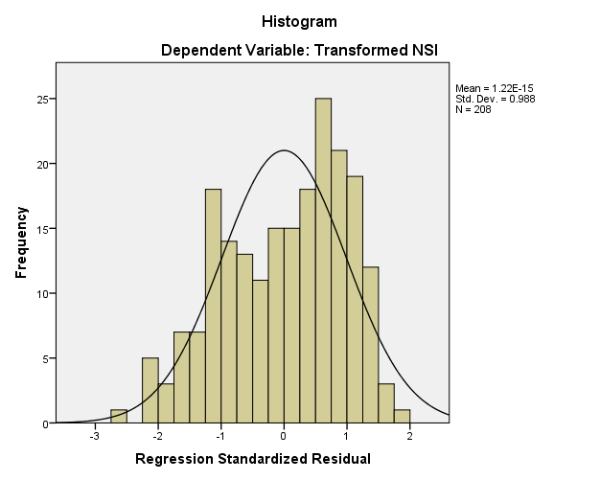

Appendix 11: Normal Q-Q Plot for Total Advancement, Total Job Security, Total Overload, Total Organisational Support, Total Growth

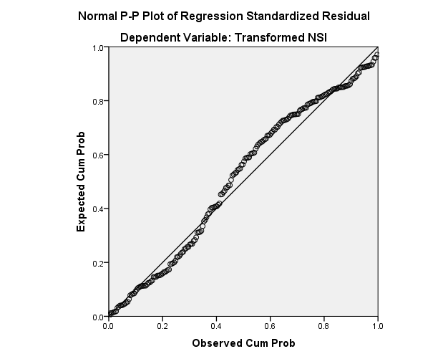

Appendix 12: Scatter Plot for Total Advancement, Total Job Security, Total Overload, Total Organisational Support, Total Growth
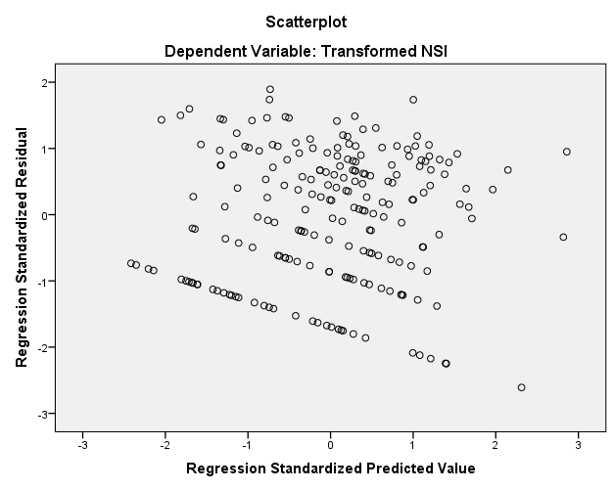

Appendix 13: Normality Histograms for Job Title
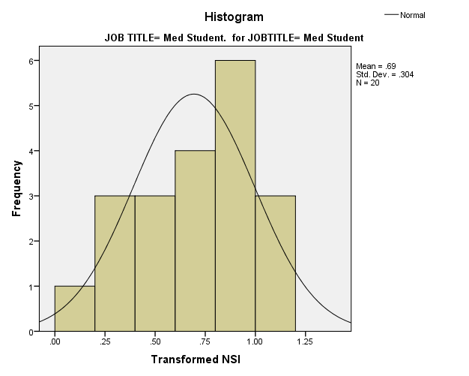

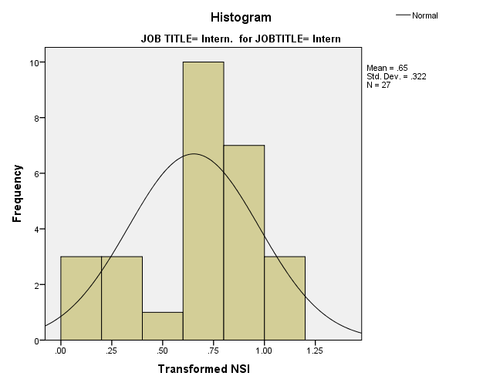

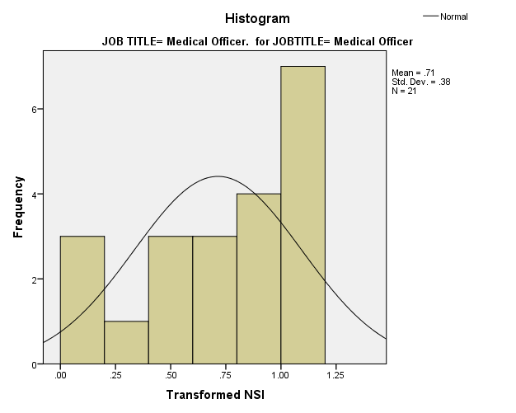

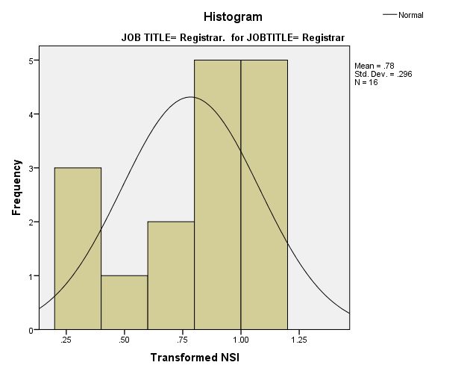

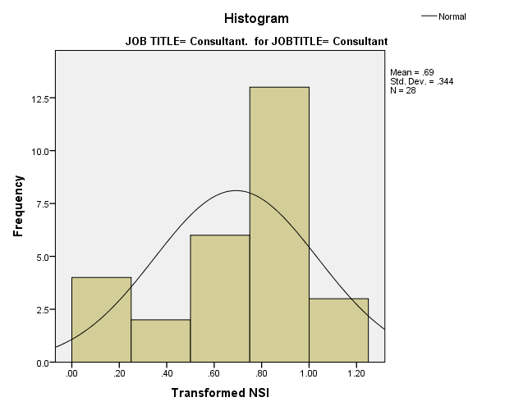

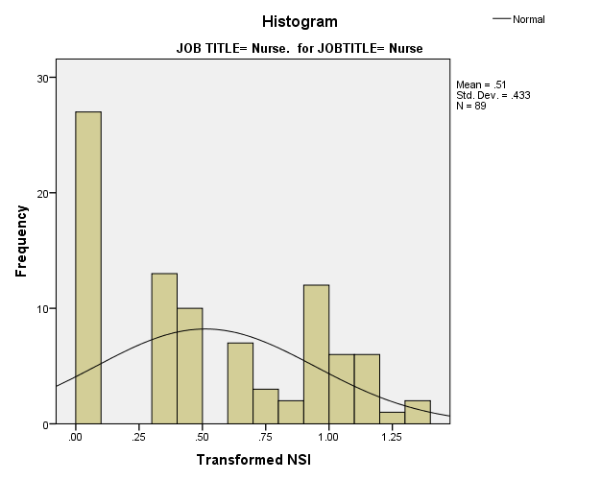

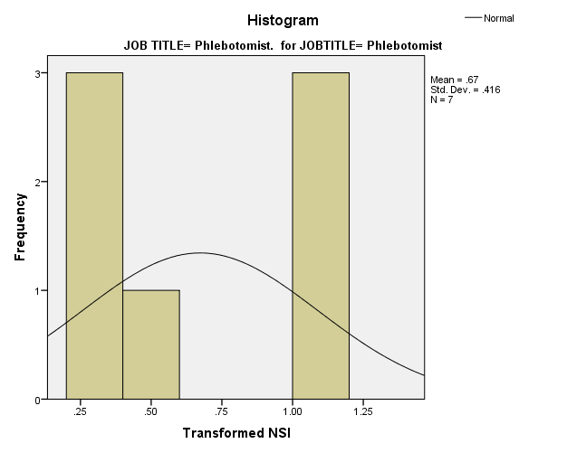

Appendix 14: Normal Q-Q plots for Job Title
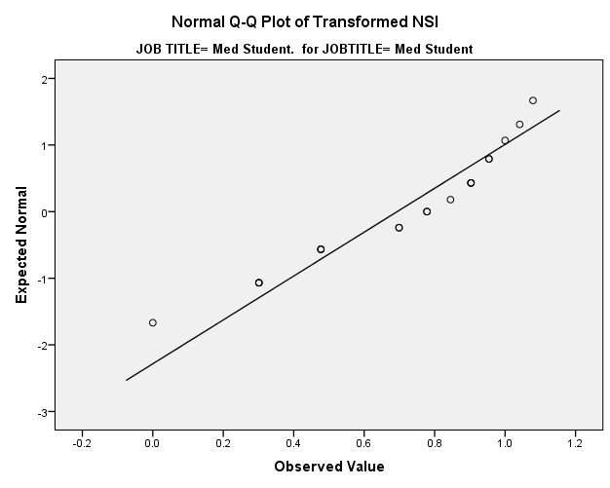

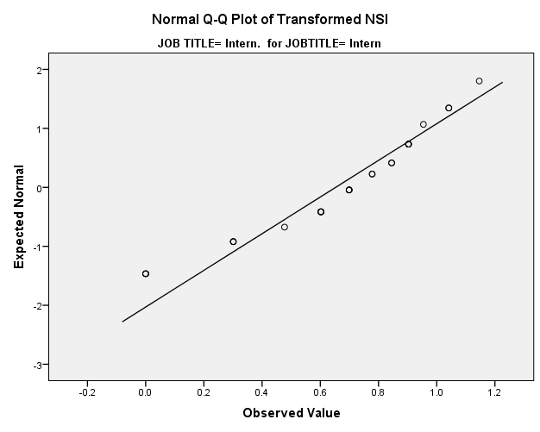

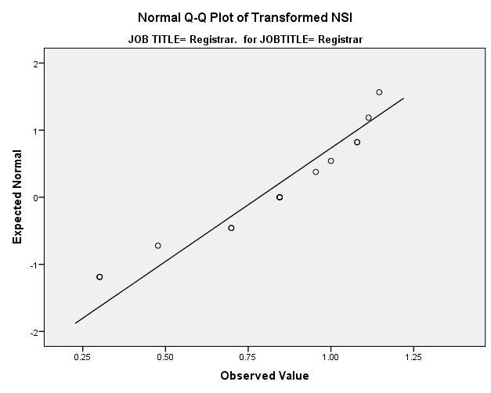
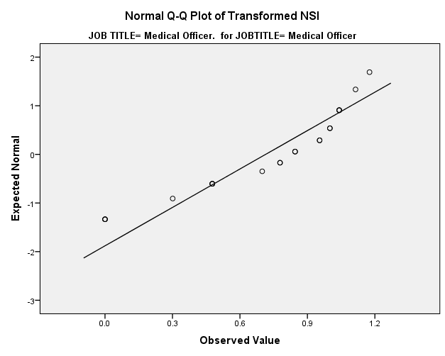

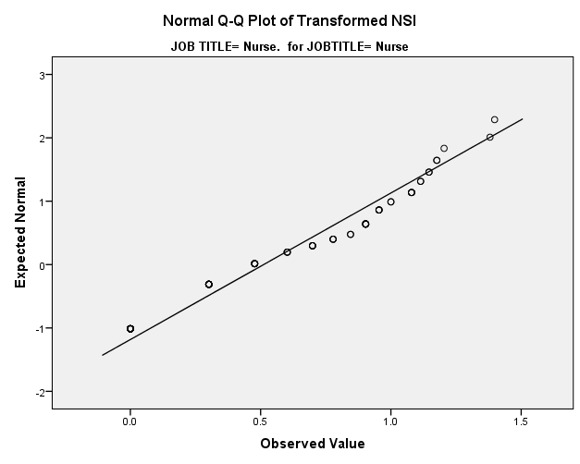
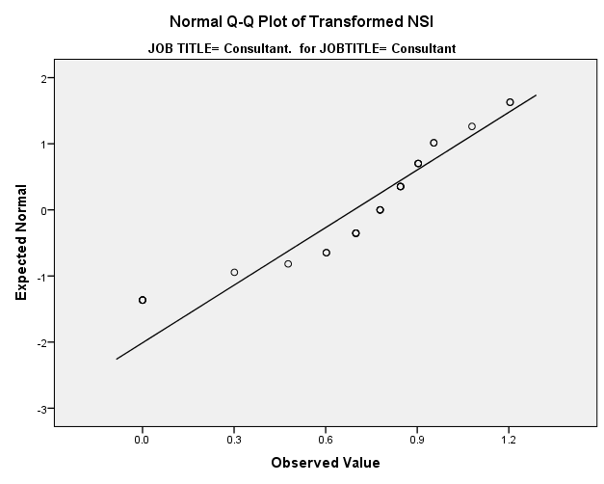

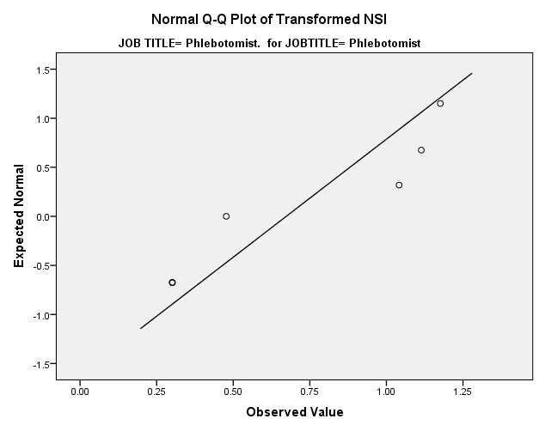

Appendix 15: Normality Histograms for Length of Shift
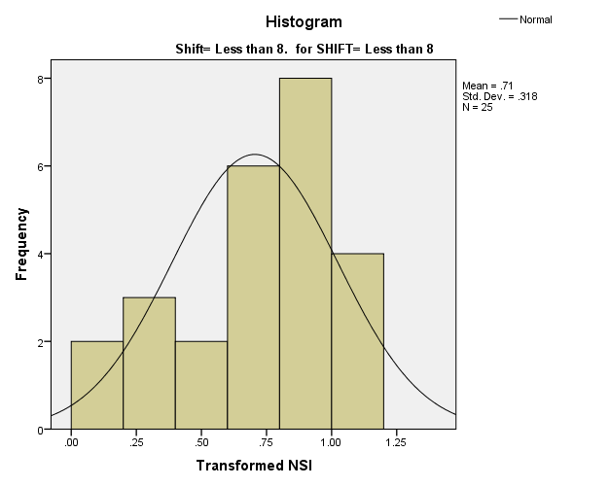

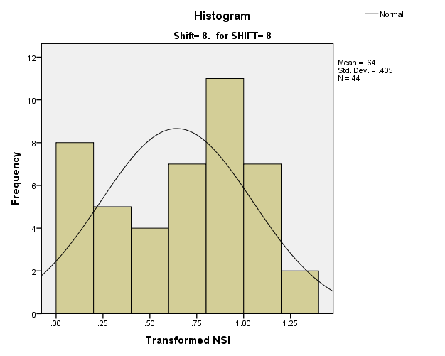

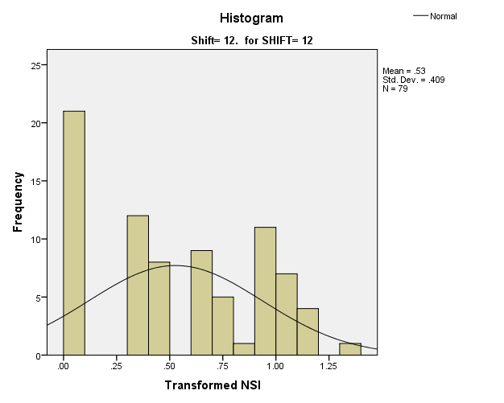

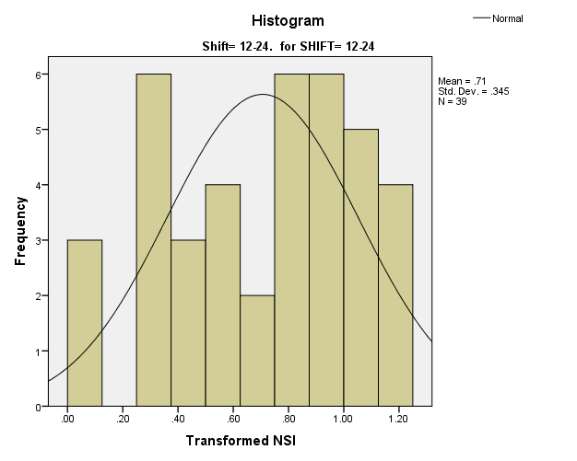

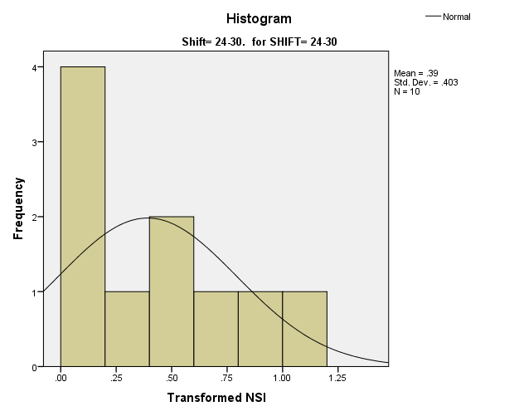

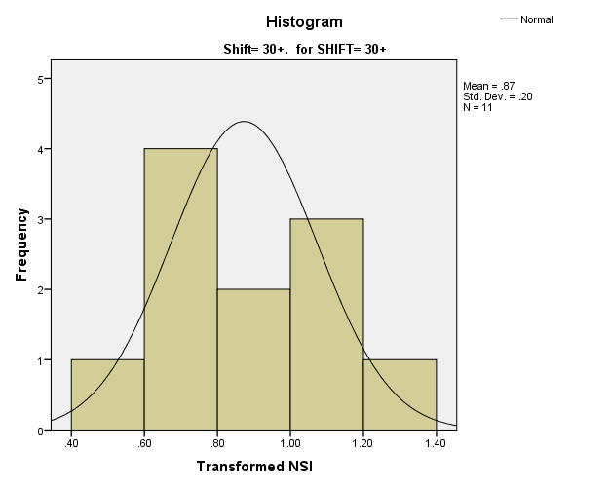

Appendix 16: Normal Q-Q Plots for Length of Shift
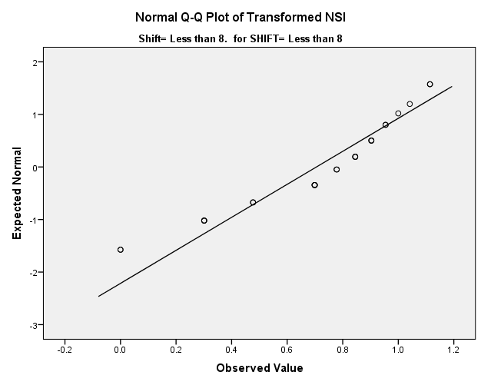

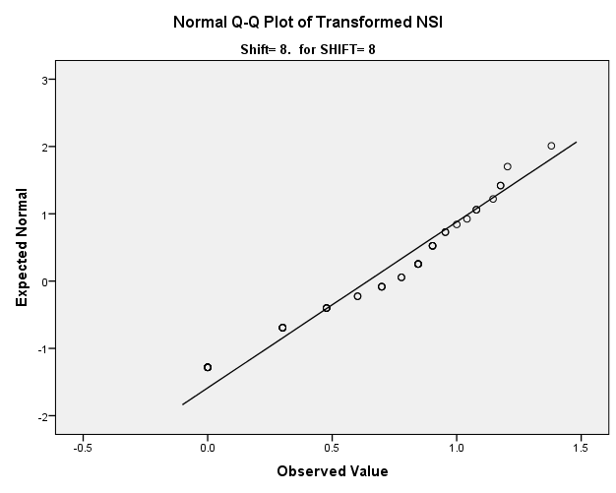

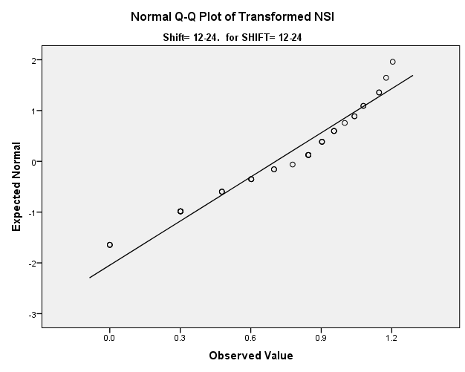
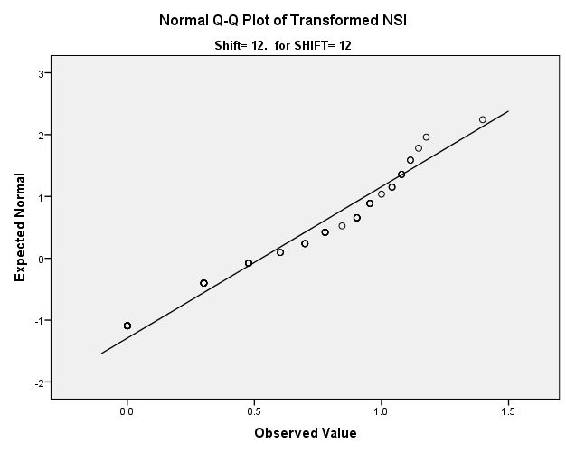

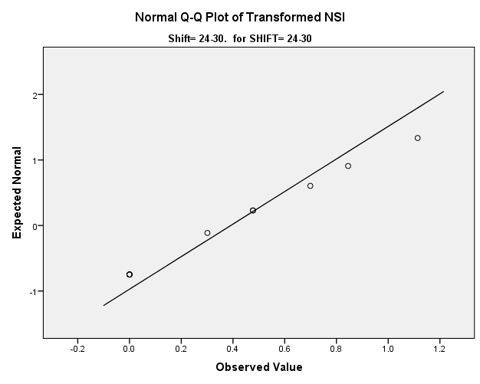
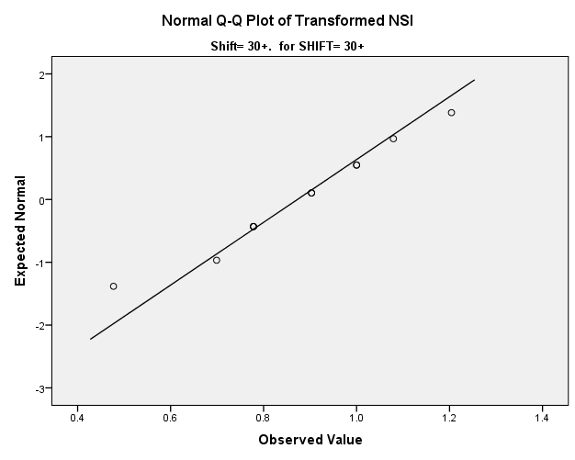

Appendix 17: Normality Histograms for Working Hours
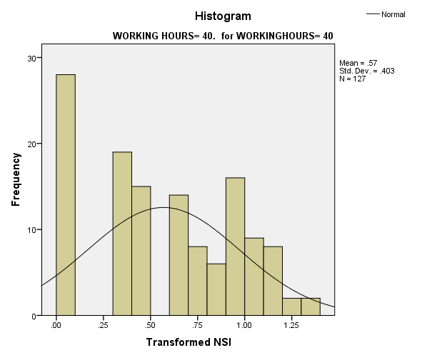

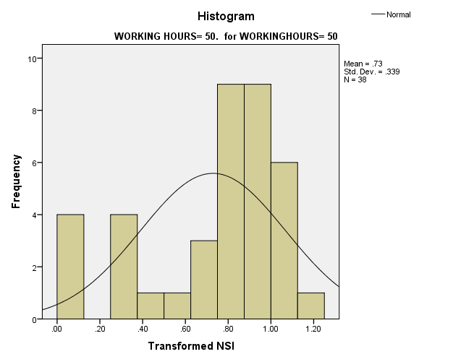

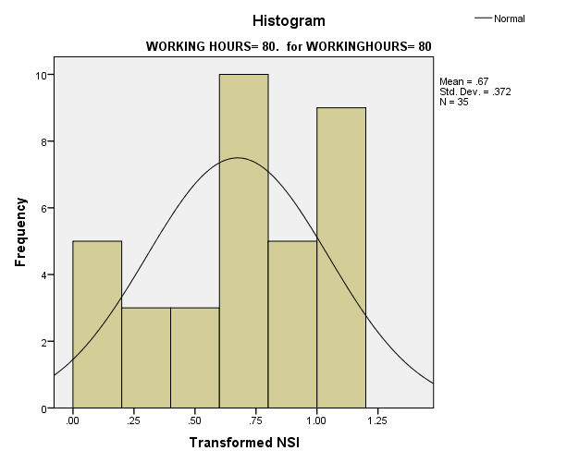

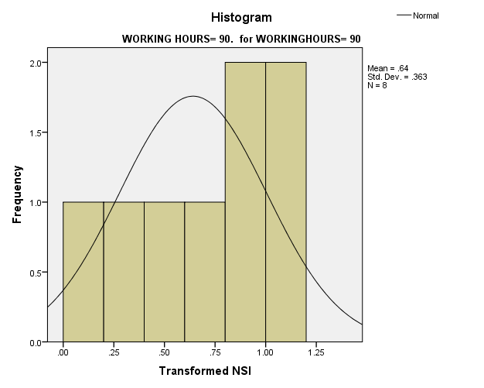

Appendix 18: Normal Q-Q Plots for Working Hours
