The Burden of Knowing
“Using Drama Therapy as a lens, what can we learn about the intergenerational effects of political violence in communities, even through socially constructed silence?”

[Document subtitle]
NOKUZOLA SONGO 688248 MA
Drama Therapy

Table of contents

Acknowledgements………………………………………………………………………………………………………3
Abstract………………………………………………………………………………………………………………………. 4
Context……………………………………………………………………………………………………………………….. 5-6
Overview………………………………………………………………………………………………………………………6-7
Theoretical Models………………………………………………………………………………………………………7
Complex collective trauma…………………………………………………………………………………..7-8
Silence………………………………………………………………………………………………………………….8-9
Legacy/transgenerational……………………………………………………………………………………..9-10
Methodologies…………………………………………………………………………………………………..………10
Autoethnography……………………………………………………………………………………………….10
Performance Ethnography…………………………………………………………………………………..11
Medicinal Histories………………………………………………………………………………………………12
The purpose of using medicinal histories a frame………………………………………………...13-14
Research Design………………………………………………………………………………………………………… 14
Phase One: The Interview Process…………………………………………………………………………15
Ethical Considerations……………………………………………………………………….15-17
Approach………………………………………………………………………………………….18
- Demographics …………………………………………………………………..18
- Semi-Structured Interviews………………………………………………. 18-19
- Historical Information………………………………………………………. 19
Phase Two: Performance Preparation and Performance………………………………………20
Process……………………………………………………………………………………………..
- Casting………………………………………………………………………………..20
- Enrolling and Scripting……………………………………………………….. 20-21
- Narradrama…………………………………………………………………………21-24

Limitations of the Study…………………………………………………………………………………………………24-25
Findings ……………………………………………………………………………………………………………………..…25-26
Silence……………………………………………………………………………………………………………………….26-27
A community in disequilibrium…………………………………………………………………………………28-29
Generational dispossession………………………………………………………………………………………29-30
Dispossession through loss of bread winners…………………………………………………30
Intercommunity trust…………………………………………………………………………………….30
The interruption of education…………………………………………………………………………………. 30-33
Domestic abuse and abuse in general……………………………………………………………………… 33-35
Discussion…………………………………………………………………………………………………………………… 36
Overview………………………………………………………………………………………………………36-38
Trauma mutation across generations and spaces………………………………………...38
Drama Therapy…………………………………………………………………………………………….38-40
Conclusion……………………………………………………………………………………………………………………40-41
Reference List………………………………………………………………………………………………………………43-49
Appendix A
Youtube Link to Performance………………………………………………………………………………50
Appendix B
The Burden of Knowing script………………………………………………………………………………51-66
Appendix C
Performance Exhibition photography……………………………………………………………………67-73
Appendix D
Figure 1……………………………………………………………………………………………………………………74
Figure 2……………………………………………………………………………………………………………………75
Figure 3……………………………………………………………………………………………………………………75
Figure 4……………………………………………………………………………………………………………………75
Figure 5……………………………………………………………………………………………………………………75

Acknowledgements
I am grateful to
- My interviewees: your courage made me stronger and continues to do so.
- My family: I feel your love always, no matter where I am.
- My cast: we faced the devil and our wounds are still healing.
- My friends: even though I was a slow bloomer and the black sheep, you loved me.
- My big brother Juergen: my gratitude could be its own thesis.
- My sister in consciousness Busiswa: your intelligence and talents inspire me.
- My MA class: I was never ready for how quickly you became family.
- My mother: you have always done your best and I could not ask for more.
- My 911s: Jhono, Amanda, Khayelihle, Mandisa, Vicky.
- My friend Stella: the way you always make me laugh when things are really bad.
- My supervisor Warren: without you this project would not have been possible.
- My supervisor Petro: your pragmatism always has room for humour and friendship.
- My co-director Sibusiso Fihlani: you found symbols where words failed me.
- My mngani Munyaradzi: you gave me the audacity to believe in myself
- My Gogo: you are my heart beat.
- My Everest: you simply are valued and appreciated by me.

Abstract

In this Performance Ethnographic study, personal narrative is used to trace and analyse the various faces of trauma and its complexity. This study physically takes place in KwaZulu-Natal and Gauteng, and through the mitigation of drama therapy the two geographical locations find an intersection and a language for healing. 18 young actors who live in Gauteng and are living under the shadow of a grossly violent South Africa embody the narratives from 21 mostly older people that survived political violence in Kwazulu-Natal over 20 years ago. The results indicate that even though people do not talk about the political violence, the next generation is not exempt from its traumatic burden. Using Drama Therapy tools, one begins to understand potential methods to navigate the silence with minimum exposure to traumatisation to yourself or your clients.

Keywords: trauma, complex trauma, political violence, silence, drama therapy, intergenerational

There are things that seal your lips and which hide deep inside of you. Things we feel we are not strong enough to face; we are afraid they will consume us whole and keep us alive in their belly.
There is a well of pain in my grandmother’s eyes. I long for it to evaporate, I reach out but I slip into it. I begin to paddle just to stay afloat. It’s not me, it’s my arms, they are getting tired.
I was in my flat in Johannesburg on a winter night in 2017 when I woke up due to an urge to go to the bathroom. I remember that, while pleading with my bladder to quieten down because I needed to sleep, a moment of nostalgia swept over me and I visualised the pee bucket that used to be located under my grandmother’s bed. For a brief moment I yearned for rural living. Something had served as a primary trigger earlier that day: While at a symposium on the decolonisation of education, I watched a play called ‘Coming Home’. The work was abstract but carried many themes around being raised in a village by a grandmother. The narrative was circular yet specific. I could feel my grandmother’s wrath and warmth all in one breath.
Just like that, while negotiating with my bladder, I remembered what it was like to live in hiding when I was only four years old. I remembered the gun shots that would sound without warning, the wailing that would go on all night and my grandmother constantly attending funerals. It was then that I realised there had been something wrong with where I was born and raised. It suddenly dawned on me that my concept of normality was formed in fear and pain. The words 'It was a Civil War' formed in my head, technically classified as political violence or armed conflict, but to me, it was war! I could not trust my narrative of something I thought I had experienced 24 years ago. I guess I knew it back then but I did not comprehend it. I had somehow normalised the instability, the running, the moving, the constant militia harassment. It was also a stage in my life I had completely banished from consciousness. I had always known I did not have a great time during childhood but I could never fully identify the reason. That is how I found myself carrying the burden of knowing.

Context
This South African province [KwaZulu-Natal] faced a civil war-scale political conflict in the 80s and early 90s in which the two fighting parties – the African National Congress (ANC) and the Inkatha Freedom Party (IFP) – used large-scale violence to establish and protect no-go areas of territorial control. This study finds that in the first decade after South Africa’s miraculous transition, these spatial structures of violence and control persisted at local levels (Schuld, 2013, p. 101-102).
It is a commonly known, yet often an unacknowledged, fact that during the 1980s and the early 1990s, many South African people bore witness to, were victims of, and in some cases perpetrated, some of the bloodiest and most violent acts seen under apartheid. This period arguably also marks the profound political and social transformation which, eventually, resulted in the first democratic elections in 1994. This period also saw the political violence between the African National Congress (ANC) and the Inkatha Freedom Party (IFP) escalate to its bloodiest level, with violent acts being committed across the eastern regions of South Africa. Essentially it was a struggle for power and crucial political control during South Africa’s transition. Most of the violence and gross violations of human rights occurred during what was effectively a civil war fought within the borders of what is now the southern province of KwaZulu-Natal (Mchunu, 2013).

Visual and audible recollections haunted me from then on, I remembered terms such as “Black on Black Violence”, “Political Violence” and “Civil war". I remembered the whistles and how they meant: Wherever you are, hide! I remembered the dust on the road rising but never seeing it settle again because I would already be out of sight. The songs also came back to me; they were sung by herds of men holding sticks and machetes. I can’t tell you what the songs said but they were never jubilant, just daunting. The streets would clear, and the doors would shut, the whole village would hold their breath waiting for a wail that would pierce the heavens.

Overview
This research report aims to show the various faces of collective trauma that became part of the social fabric in Mvutshini, the community of my upbringing. Furthermore, it will briefly discuss the use of Drama Therapy approaches such as Narradrama, which can be utilised as a tool to express, in a distanced manner, what lies beneath the silence that often surrounds victims of violence. In addition, I shall outline the importance of exploring collective trauma as a means of helping to unpack and understand the intergenerational transmission of trauma. In particular, this report looks at the trauma currently affecting black and historically poor communities in post-apartheid South Africa.
In this report, I further demonstrate the effects of how political violence can be transferred across generations even when – and perhaps especially when – the events are not spoken about. The specific research question I have sought to answer is “Using Drama Therapy as a lens, what can we learn about the intergenerational effects of political violence in communities, even through socially constructed silence?”
To do so, I have used creative writing and a stream of consciousness as a thread to demonstrate and connect my autoethnographic testimony with the theatrical exploration (performance) of this research. The former appears in indented, italicised sections.
Although I will briefly highlight my experiences in the auto-ethnographic performance aspect of the research, the main findings of this research report will point out the effects of trauma on the people of Mvutshini. These will fall under a frame, which I will later unpack, called a Community in Disequilibrium. I will demonstrate how this is layered with numerous catalysts such as: generational dispossession partly due to interrupted education, habituation towards violence, substance abuse and generational displacement. In so doing, I will also demonstrate the potential interruption of the African philosophy known as Ubuntu.

Suddenly, in my Johannesburg apartment my whole concept of self fell into shambles. How could I have suppressed such significant aspects of how I became who I am? I had wilfully embraced the archetype of the warrior, Zola the fearless, Zola the brave, without fully investigating the origins of these characteristics. I was fixated on survivalism and I had finally discovered one of the sources. In a war where women and children were fair game, I had cheated death countless times. What about the people that never forgot and never spoke of it? People like my grandmother, that lost their homes and family to a beast that had suddenly arisen in their backyard?

Theoretical Models: Complex Collective Trauma, Silence, Legacy
There are three theoretical models I used as a lens to explore this question which are Complex Collective Trauma, Silence and Legacy. In in this section I will unpack these theories for a basic understanding in order to contextualize the research framework as I unpack the research process.
We can identify these theories in the research question; “Using Drama Therapy as a lens, what can we learn about the intergenerational [legacy] effects [trauma] of political violence in communities, even thro\ ugh socially constructed silence?”.
Complex Collective Trauma
According to the American Psychiatric Association, trauma is defined as:
A direct personal experience of an event that involves actual or threatened death or serious injury, or other threat to one’s physical integrity; or witnessing an event that involves death, injury, or a threat to the physical integrity of another person; or learning about an unexpected or violent death, serious harm, or threat of death or injury experienced by a family member or other close associate (APA, 2000, p.463).
Jones (2015) introduces to us a concept that claims that the term trauma does not have a singular meaning. He describes it as being context specific and the way it is experienced being constructed by us and communities. This feeds into the idea of Complex collective trauma and its fluidity in its multi-layered nature.
Complex Collective Trauma has recently been included in trauma literature (Possick et al, 2017). It is a term that combines complex trauma and collective trauma. Complex trauma can be described as exposure to multiple traumatic events as well as prolonged exposure to harmful situations (Courtois and Ford, 2009). Collective trauma can be understood as certain extreme events that destroy the collective well-being, such as political repression (Alexander, 2012). One such example of complex collective trauma is the ongoing warfare in the Eastern Congo (Riedel, 2014)
Understanding this theory requires one to break it down into the two theories. Collective trauma, can be viewed as the social tissues of a community being affected like those of the body and mind (Erikson, 1995). Another way to understand collective trauma is through Volkan who calls it “chosen trauma” and asserts that it is a mental representation of an event that has caused large group great distress, feeling of helplessness and victimization by another group (1998). Trauma is not a linear term or experience. Possick et al. (2017) argues that collective trauma is always complex considering the various levels it permeates such as self, community and culture (p.241)

Reimann and Koning (2017) propose three ways that demonstrate the process from collective trauma to transgenerational trauma. Transgenerational trauma does not require an offspring to have witnessed the traumatic event or events in their parent’s passed (Burchert et al., 2017), it can be considered an inherited trauma.
- Individuals may be exposed to a traumatic experience. This may lead to transgenerational effects in a group or in a family. If insufficient coping mechanisms are used in the case of highly stressful traumatic experiences, they may become a psychological legacy.
- Collective memory or narrative of victimhood is transmitted through mental models (such as scapegoating and black and white non-nuanced thinking) from generation to generation. This can be observed in the education system and politics of a formerly destabilized community that has not addressed the collective trauma sufficiently.
- Individuals from the second or third generation may not have experienced the trauma but overall subscribe to collective memory of victimhood.

Silence
Traumatic silence has numerous definitions and can relate to literal silence known as selective mutism or avoiding talking about the traumatic event or period which can be seen as the “key to the unspoken world of the patient“ (Ritter 2014, n.p.n). Taking a look at these two concepts: trauma and silence in relation to their effect in a global context, we find that the question of their co-existence is not just a local or event-specific phenomenon. Studies have shown that there is a strong correlation between trauma and silence, and it is fuelled by shame, the fear of vulnerability, judgement and disconnection (Carr, 2013). There is also a fear that talking about the horrendous violation suffered is in itself recreating it, and a fear that this is taboo and invites further traumatisation (Carr, 2013). Judith Herman (1997) examines these complexities with great clarity and eloquence. She describes a silent battle that occurs within communities regarding the contrasting choices of “remembering” or “forgetting” and how the side of “forgetting” almost always wins, silencing everyone else:
War and victims are something the community wants to forget; a veil of oblivion is drawn over everything painful and unpleasant. We find the two sides face to face; on one side the victims who perhaps wish to forget but cannot, and on the other all those with strong, often unconscious motives who very intensely both wish to forget and succeed in doing so. The contrast . . . is frequently very painful for both sides. The weakest one . . . remains the losing party in this silent and unequal dialogue. (Herman, 1997, p. 4)
Returning to the South African context, the eminent scholar, Professor Gobodo-Madikizela, has for many years focused on the effects of trauma on individuals and communities in post- apartheid South Africa. She looks into “a profound, particularly human-induced trauma such as mass political violence”. In the same breath she states: “Psychological trauma is a state in which the ego is so overwhelmed that it is forced to employ defence mechanisms to avoid immensely distressing material.” (Gobodo-Madikizela, 2003, p.4) One such defence mechanism is silence.

Legacy/ Intergenerational
Alongside the trauma and silence lies a crucial component of community life; legacy. If one is a strong believer in the idea that “what you don’t know can’t hurt you”, one is a victim of a popular misconception, as numerous studies have demonstrated that trauma permeates through the unspoken and often affects generations to come, until the trauma is adequately addressed (Goodman, 2013). For example, Audergon (2004) states that when communities suffer atrocities, the trauma remains in the fabric of family, community and society for generations. The transgenerational effect of collective trauma can also be described as the “survivor syndrome” (Bako and Zana).
In support of the concept of the intergenerational transmission (Baranowsky et al., 1998; Kellerman, 2001) provide these findings:
Clinicians began recognizing that children of parents who were Jewish Holocaust survivors exhibited similar symptoms of trauma exposure as if they themselves lived through the atrocities.” (Xiong, 2015, pp. 6-7). Furthermore, he states, “without proper intervention and healing, this chaotic rupture to identity and fixity is sustained into the future and transmitted to generations thereafter. This transmission can occur through words, writing, body language, and even silence. (Xiong, 2015, p. 7).
One can consider the theory of legacy as behavioural re-enactment interpersonally and within communities of traumatic memories (Gobodo-Madikizela, 2003). Through the silence, trauma permeates across generations. Gobodo tells a compelling story about what she witnessed in a township called Mlungisi in the Eastern Cape. She narrates a story of children who were not born during the apartheid era but somehow played with great accuracy and distinction a game called “necklacing”. She illustrates how the one child suggested the game and how naturally the roles fell on the children; playing such a brutal scene, showing anguish and a cheering crowd (Gobodo-Madikizela, 2003). Through this, we begin to see it in our own country how violence translates and manifests even in play.
This repetition of real events from the past seems like a transformation of traumatic experience into ritual, perhaps a cathartic way of putting into action the struggle to find language that expresses the frustrations, helplessness, disempowerment, and dire poverty of people whose lives have become meaningless (Gobodo-Madikizela, 2003, p. 4)

Then it was time to confront the story in its entirety. I started consulting the Internet and found very little information; it was as if this was a chapter of the South African story that was being buried by the African National Congress, the Inkatha Freedom Party and the National Party. No narrative wholly suited any party, so the stories were buried and our dignity with them. I spent days in the lower South Coast looking for museums and books and found only museums commemorating colonial settlers. Eventually I called the South Coast Fever and asked if they had any archives of newspaper articles from the early 90’s, they gave me permission to come browse through them. These big binders were drawn out of storage and brought to me, and were far from accessible. I had to sift through thousands of pages and had very limited time.
I reluctantly reached out to my mother for help with browsing. Then there was no turning back. I could no longer protect her concept of protecting me, I needed to open some doors and she knew where to find the key. Her lips were unsealed, her narrative overflowed, spilling stories of tragedy and resilience. I began to paint pictures in my mind. I am my mother’s only child, the apple of her eye, but here I was digging through dirt and asking her to carry the dust with me.

Methodologies: Autoethnography and Performance Ethnography.
Autoethnography
Autoethnography is an autobiographical style of writing and research that demonstrates multiple layers of consciousness and finding ways to connect the self, cultural, political and community (Ellis and Bochner, 2000). It translates to the social world and the beliefs and behaviours of people that reside in it (Anderson 2010). In understanding that autoethnography is both a process and a product (Ellis et, al. 2011), we can see the breakdown in the word itself. Autoethnography is a personal experience (auto) plus the comprehension of cultural experience (ethno), which could be considered the process (graphy) to systematically analyse and write, which in turn can represent a product. (Ellis, 2004; Holman Jones, 2005).
Even though this methodology is said to blur the lines between fact and fiction or true and imagined (Richardson, 2000, p. 926), it honours the complexity and nuanced nature of the research without pretending to be neutral or impersonal (Dzenin and Lincon 2000). The matter of fact is this is a story about me, my family, my community. Autoethnography became means to access and practice self-observation and reflexive investigation (Marechal 2010),
It was important to me that I participate in accessible and interactive research that not only extracted information for the sake of new knowledge for the academy in a distant and stoic tone (Adams, 2008), but also allowed for personal experiences to be unsilenced and transformed democratically (Ellis et, al. 2011) hence the need for Performance Ethnography as a co-methodology.
Performance Ethnography
Performance ethnography is an arts-based research method of qualitative inquiry (Alexander, 2005); it transforms the theatre from being a performance venue into a participatory action research site (Kemmis & McTaggart, 2005). I selected performance ethnography as a complementary methodology to autoethnography because it is inclusive in nature, both in data collection as well as presentation. Performance ethnography not only takes into account oral histories, race and gender, it allows room for democratized witnessing and interaction with presented material. It is concerned with the ‘here and now’, and with projecting an image through social exploration that promotes dignity and democracy (Finley, 2005). I practiced constant reflexivity and awareness of transference and countertransference as a performance ethnographer, and autoethnographer, that cannot be ignored.
In projective identification, the patient projects disavowed aspects of himself onto the analyst, who becomes unconsciously identified with those parts and may begin to feel or behave in accordance with them. The first aspect of this process is clearly allied to transference while the second can be correlated with countertransference in view of its obvious interactional aspects. (Bateman and Holmes, 1995, p. 111)
Denzin (2003) highlights two essential qualities one must embody when embarking on a performance ethnographic journey. One is that as a researcher you need to understand that culture is a verb not a noun. It’s a fluid process rather than a static object. While emphasizing the significance of fluidity, Denzin (2003, p. 11) states: “We cannot study experience directly, we study it through and in its performative representation”. Secondly, he urges ethnographers to consider fieldwork as a collaborative process and co-performance (p. 12). I will highlight my journey through this process.

As much as I could theorize, investigate or contextualize that period in my life and its unwavering effect in my adult life, I could not undo what time had done to me. I was haunted by a memory. This memory filled me with laughter and grief, it was unwavering and stood its ground. My late grandfather’s sister who was about 70 at the time, “Nkoti”, used to hide me and her granddaughter in her garden or her big banana plantation. When she heard the whistle, no matter what time it was, we would have to put out the candles and we would shuffle our way past her outside toilet, down her steep garden to the banana trees for refuge. When my cousin and I would get restless and we would start whispering and giggling, Nkoti would pinch us with such fury that it would wipe the smiles off our faces and silence us for the rest of the night. As a child, I began to think of her as the pinching granny, now I think of her as the woman who saved my life.
The true loss is that I never got the chance to thank her, two years before I remembered, she passed away.

She stood, displaced in her own home,
Chasing shadows of living ghosts
Resuscitating spirits
She stood, But her standing was no longer erect.
Medicinal Histories
The frame of Medicinal Histories became a container for my project providing a guiding principle to maintain my obligation as a researcher to acquire information (Histories), in a manner that was framed by my ethical duty as a training therapist. Therefore, my first prerogative was to do no harm, and secondly that I should provide cathartic or healing spaces (Medicinal).
In Medicinal Histories, Morales (1998) argues that the traumas of oppression endured by women, black people, and the underprivileged in the Americas are further perpetuated by the invisibility of their experiences in historical narratives. This is applicable in the South African context. We need to build a path which will ensure that there is an inclusive and representative historical narrative. In choosing to work under the umbrella of Medicinal Histories, I created a container for these histories. Although the methodology proposed by Levins Morales (1998) is extensive and thorough, for the scope of this research, I focused on one of the fourteen proposed principles. The principle I applied was: Tell Untold or Under-told Histories:
The first and most obvious choice is to seek out and tell those histories that have not been told or have not been told enough. If history books looked like the population of the world they would be full of women, poor people, workers, children, people of colour, slaves, and the colonized (Levins Morales, 1998, p. 26).
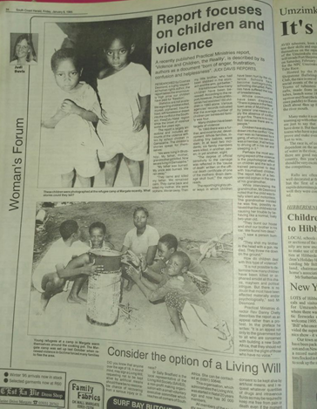
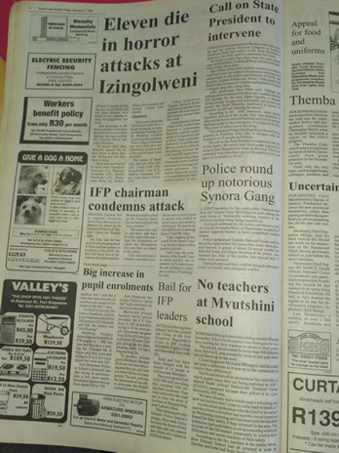
There was a man, his name was Sgoloza. I knew nothing about him except for the fact that I should fear him and run even when only his name was mentioned. He had somehow become the brand name of the political violence; at age four, I knew his name. He was some sort of a mythical figure to me, putting his name in your mouth was taboo. In naming him as an adult, even though he died 20 years ago still had a chilling effect. I was still under the shadow of fear, I carried it with ignorance. While helping me go through archives at the local newspaper, my mother called me to look at an article she found. There he was! No longer a red giant with horns, no longer a figure of fear, he was a man. He was smiling in the picture on the article. My mother told me that she went to school with him before the unrest, he was a grade below her. Suddenly, I felt like I was stroking the beast. This is the man that had terrorised my grandmother and many like her, hunted my uncle and many like him and killed with what was said to be pure ruthlessness. Here he was, on a piece of worn out paper with a smile on his face, inviting relatability through his normal demeanour. He was no longer a myth, he became humanized in an instant. What I had felt for over 20 years suddenly released its grip. His name no longer brings fear because I have faced him.
Sample archives

The purpose of using Medicinal Histories as a frame
Levins Morales (1998) sheds light on some fundamentally oppressive principles of traditional imperial histories. I understood and experienced the affirmative cathartic power of validation and bringing the unknown to the light when I experienced it myself using this frame. This occurred throughout my investigation for my Practice as Research heuristic study in 2017 which reflected on the gap in my knowledge of my experiences of growing up in Mvutshini during the political violence. However, I was aware that entering people's lives to collect information required a more compassionate, observant and holistic approach which I found in purposing the work through the frame of Medicinal Histories.
All historians have points of view. All of us use some process of selection through which we choose which stories we consider important and interesting. We construct history from some perspective, within some particular world view. Storytelling is not neutral. One of the most significant ways in which Remedios differs from conventional historical writing is in how explicitly I proclaim that my interest in history lies in its medicinal uses, in the power of history to provide those healing stories that can restore the humanity of the traumatized, and not for any inherent interest in the past for its own sake (Levins Morales, 1998, p. 25).
Furthermore, by looking into historical trends and trauma, Audergon (2004) demonstrates why the storying of history is an inherently subjective practice. There is no way to remove the biases, perspectives, and agendas of witnesses or participants and to craft a 'complete' or 'objective' account of a past event. When examining historical conflicts, there is an inherent tension between the interests of different groups, both past and present. The story told by victims will differ from that told by perpetrators, and, in the case of my study, by politicians. For example, there is a movement to revise or entirely erase the history and trauma of the Holocaust saying it never happened or was grossly overstated. Less commonly known is the 1992 massacre of Muslims in the Bosnian towns of Foca and Zvornik. After mosques were burnt down in Zvornik, the Serbian mayor was asked why the mosques were burnt down, not only did he deny the burning of the mosques, he claimed that the mosques were never there (Bartov et al., 2001).
In terms of access to human knowledge, a linear acknowledgement of only written narratives of accounts could prove very limiting as our bodies are also containers which hold textured and nuanced information particularly regarding events we have experienced (Van der Kolk, 2014). Neglecting to acknowledge the body as a site not only of trauma, but also of memory, is limiting to the body of knowledge. Johnson and Emunah (2009) address drama therapy’s ability and flexibility to play out in different conditions, such as gender, socio economic status, ethnicity, location and the therapist's personality. This research aims to understand conditions and people’s state of being, rather than being a simple account of events or what could be considered objective information.

I was terrified, I needed to ask for permission from each participant before I went over to interview them. So, I practiced my point of entry. I have known these people my whole life, so how do I go about it, “Gogo, um, I am doing research on political violence. I was hoping you could talk to me about your experience. Will you be available to talk tomorrow?” Subconsciously I’m thinking, I don’t know why I haven’t heard about what happened to you but I hope you are ready to tell me; I am thinking, I played with your grandchildren, do they know what happened to you, what happened to them, what happened to us? Am I ready to know?

Research Design
1. I did interviews with 21 people from the area in question, I had basic questions but they were in a loose format.
2. Process of making and performing
3. Receiving participant and audience feedback, which contributes to the conclusion of this written report.
There are two phases to this research. Phase one encompasses the preliminary findings; phase two dives deeper into the therapeutic application and the medicinal aspect of the research. I was assessed in April 2018 on phase two through performance ethnography observation and oral defence. I will, however, give a brief overview of the process I underwent to prepare for phase two.
Phase One: The Interview Process
The data gathering tools consisted of semi-structured interviews which can be seen as in-depth interviews with open-ended questions such as why and how (Adams 2015). I hoped that the use of Drama Therapy through group Narradrama activities such as visual mapping of historical narratives would assist in data collection, while leaving space for cathartic release because of the sharing of personal experiences used in these methods.
Narradrama can be used in a group and individual setting. It combines the concepts of narrative therapy with some of the core processes of Drama Therapy as proposed by Jones (1996) and the creative arts (Dunne 2009). I used semi-structured and Narradrama because I thought they would allow for fluidity and a non-linear atmosphere. I planned to capture the interviews through recordings and wanted to interview eight participants in total from both genders and across generations because I wanted an inclusive sample and a variety of perspectives. The plan was to interview them in small focus groups so that they would share narratives and perspectives that they perhaps had not been exposed to before.

I was lying with my grandmother in her bed last year; she feels like home to me, she always feels safe. This was a good place to start and to test the waters. When I told her about my intention to start a study, she looked shocked and asked how I remembered any of that. I told her I remembered the fear, the anxiety, the knocks that would shake the house and the hiding. I remember I was not allowed to go play outside. Inside, I am thinking, this probably scared me, but I cannot tell her that. Instead, I tell her I remember how furiously she protected me and carried me on her back. I told her that I needed to know what had happened and I would like to hear it from her. She looked at me and said she didn’t know what happened. She woke up one day and they were running. She could not contextualize the events as much as she could describe feelings and impulses. My grandmother has always been a devout Christian, and that became her refuge.

Ethical considerations
As explained above, my intention was to use Narradrama as a tool in an initial semi-formal interview with a few focus groups. However, the idea of focus groups fell away as soon as I realized the sensitive nature and the intimate nature of the potential interview content. Plus, I understood that there were points of contention within the narrative itself as people may have different and conflicting versions of what happened and people may not be open to share it in front of others. I then considered interviewing eight participants individually across age groups and genders to provide a cross-section of perspectives. This idea evolved as each person led me to the next person through a trail of comments. Therefore, the sample group increased and turned the data collection into snowball sampling (Naderifar, Goli and Ghaljaie, 2017)
In order to look at the intergenerational effects of the trauma, I interviewed three generations in two families and two generations within three families. All of the interviews, even within the families, were conducted in quiet, confidential spaces. My attempts to introduce Narradrama as an interviewing technique hindered my interviewing process as it felt unauthentic, especially since I was interviewing participants I already had strong relationships with and I rarely had a predictable interview setting. Thus, the Narradrama element was abandoned in the interview process but not in the process of making the performance.
By the time the interviews were completed, three interviews had taken place under a tree, one while my hair was being braided, two in my moving car, two in kitchens, one in a school staffroom, one while fetching water with a 20l bucket of water on my head, two in bedrooms of the elderly interviewees, one at the beach and eight in living rooms over a cup of tea or cold drink and biscuits. In total, instead of the eight intended interviews, I had completed 21 interviews, ranging in duration from 40 minutes to 2 hours each.
Phase one consisted of initial data collection. I visited homes and asked them if I could come over later or in a few days to interview them about their experience of Mvuthshini before, during and after the political violence. None of the participants declined my request. The interviews, though semi-formal, all had some framing questions around the political violence and the extent to which participants spoke about it.
This study consisted of 21 participants mostly residing in the Mvutshini community and a few residing in other communities within the same chiefdom of Kwaxolo, while some interviewees have moved to Johannesburg and Durban. Participants in the study were made up of 8 men and 13 women, ranging from 18 to 79 years. The participants were made up of five families and four individual community members from different socio-economic income brackets. All of the participants were volunteers in the study and had direct access to a local therapist. I conducted the interviews in isiZulu and translated the text as seen later in the findings. By listening to the interviews, I created a thematic analysis based on the most common themes and I present them as findings later in the paper.
Due to the diverse levels of education of the participants, I read the consent forms to them and obtained verbal consent from all participants to conduct this study. The consent form consisted of information such as the researcher's and the university’s contact information, the purpose of the study, the content to be discussed, the tools to be used and the amount of time required for the interviews. Furthermore, it also provided participants with the phone numbers of two local healthcare professionals whom they could contact free of charge, if they felt there was a need, or if the interviews evoked some form of emotional distress. Participants were also informed on how to retrieve and obtain the research report. Audio recording was used, authorization of which was also included in the consent form.

I got overwhelmed. It all become too much in too short a space of time. One day I woke up and I just couldn’t. The pain of the interviewees was carving scars while my ethical frame silenced me. I couldn’t process the drowning I was feeling. Every day, I would come home from the interviews enriched but drained. The emotional exhaustion was paralysing. I would be tired, but sleep would not come. It was eating me and I could not tell my grandmother or mother how I had been pulled in different directions and stretched thin by words.
So, I took a day off and took my grandmother and her friends to the beach. I had interviewed some of them, but we pretended that they had not opened up. We returned to our regular roles: I was a granddaughter to all of them, and that is all I would be that day. Not a training therapist, not an interviewer, just a granddaughter to all four of them.
Mvutshini is roughly seven kilometres from the ocean. However, these women had not been to the beach in years, or even tens of years. One of the grannies who is over 90 said she had not been to the beach since she was a little girl. They were thrilled for the outing, and while driving, I heard them gossiping and laughing out loud.
My grandmother insisted she knew which beach she wanted us to go to. I obliged. We drove away from the Ramsgate beach to a deserted beach. I convinced her that we would be better off in a beach with changing facilities and a rock pool. I later found out that the beach Gogo took me to was a formerly a Blacks only beach. I somehow was drawn into a haunting past unintentionally.
Naturally when the waves approached, they would run away and scream until I suggested they sit. How my heart was elated. How I wished I could capture the utter joy in their eyes and freeze it for them and for myself.
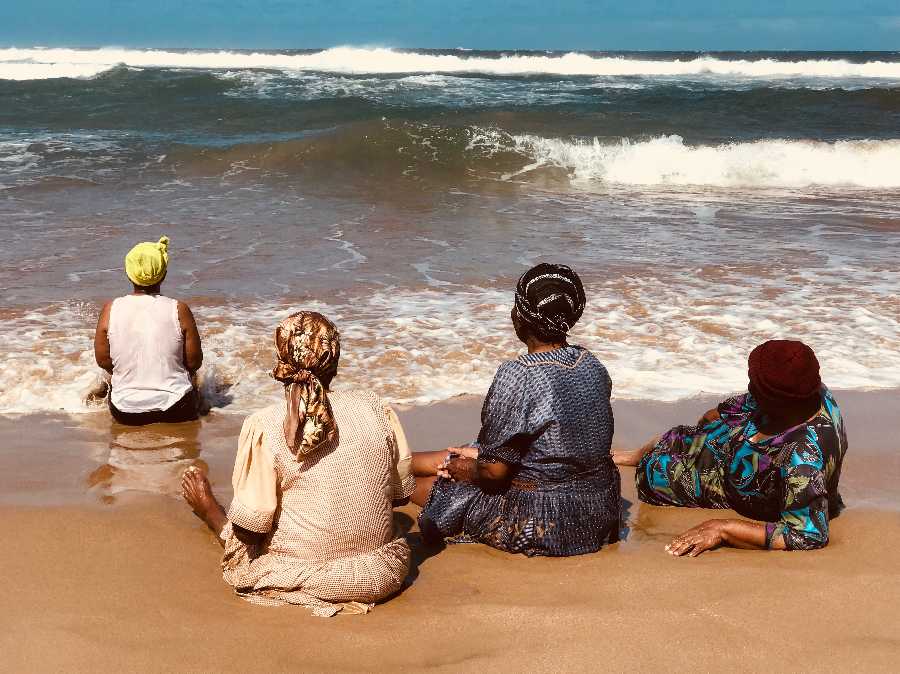
Every time I call my grandmother, she talks about that day. She talks about her friends running away as if she was the bravest one. We laugh, then she asks me to come home so I can take them to the beach again. When she says this, all I hear is her asking me to come home to recreate a moment, and a feeling of liberation and uncontained joy. I laugh while we talk but cry when she hangs up. I cry because as if lack of access to opportunities was not enough, they carry memories of atrocities, and I cannot make it go away. My grandmother has never experienced the liberty, though she lives so close, to go to the beach whenever she wants; nor will she ever. This hurts me deeply.
Gogo and friends
Approach
In my choice to conduct semi-formal interviews, I was being critically conscious of my relationship to the participants, as family or community members, and the challenge to hold the authenticity of the conversation through genuine and familiar interaction. This pursuit was supported by the variety of settings for the interview as mentioned earlier. What became more important than occupying the perfect interview setting was the conviction to maintain the intentional purposes of the conversation, thus avoiding getting side tracked by the familiarity and comfort of the relationship I had with the interviewee.
Though the interviews did not follow a rigid list of questions, the process was still framed through an approximated structure of reflective values. This core interview frame consisted of the following information attainment structure:

1. Demographics
2. Semi Structured Interview
3. Historical information

1. Demographics
This part of the study, in stark terms, looked at some objective and indisputable information in order to evaluate the diversity of the sample group through creating correlations based on the age group (18-79) and gender (8 male 13 female) and whether a participant had moved out of their home at any stage to escape the violence and how many people they had lost during the political violence. This information also allowed me to understand the extent of the spatial and architectural disparities resulting from the political violence, and simultaneously enabled me to determine the post-violence community spatial reengineering after 1997 and the family demographics of the current interviewee. Of course, this is not a quantitative study and by no means do I attempt to provide a statistical or in-depth analysis of population movements - this is an attempt to understand the effects of the violence on the living spaces of the specific participants. (See graph- Appendix D Figure.1,2,3,4)

2. Semi-structured Interviews

There were two standardized questions that I asked all of the interviewees and the rest of the conversation was based on follow-ups to those questions and follow-ups on new information that emerged. (See graph- Appendix D Figure.5)

Questions
1. Have you heard of the political violence? (18 to 29-year-old participants)
2. Where were you during the political violence?
3. Do you ever speak of the political violence?
If yes - with whom and how often?
If no - why not?

3. Historical Information

Following the flow of the semi structured introduction questions, I asked if the participants wanted to share any information that was event specific regarding the political violence. Numerous themes emerged from this question and many of them overlapped between participants. The event specific nature of the information allowed me to find tangible data around the question about the “effects” of the political violence. As foundation research, I searched local libraries and found nothing on the political violence until I called the South Coast Herald and dug up some of the archives of their newspaper. This took me 40 hours, and I found over 300 articles between 1992-1995. The themes that emerged from the articles also emerged from the interviewees, but it was more personalised from the interviewees as they remembered what they had been eating or doing when an incident occurred. In an attempt to synthesize the thematic content I produced the following graph which serves as a representation of the themes that emerged in the 21 interviews which, in my analysis, correlated with the newspaper clippings.
Figure 6.

It was time to let the stories breath, it was time to let the narrative shape itself in to my new perception of a community I call home. This was deeply personal and extremely silencing. This story would silence my body and I would fall asleep whenever I tried to get into the interviews. I was pregnant with a plethora of somewhat competing emotions. I had to let it breath so I could see its form. It had to breath outside of me.

Phase Two
Performance preparation and performance
This phase took place at Wits university in 2018. Although I will not write an in-depth analysis of the theatre making process as it would require space to be a thesis on its own, I will utilise the stream of consciousness as a tool to demonstrate the making process and theories of the performance aspect of this ethnographic research.
1. Casting
2. Enrolling and Scripting
3. Narradrama

1. Casting

I identified a class in the Drama For Life department that I wanted to work with, I invited them to a meeting and told them about the content and research journey and by the end I had 18 cast members, a co-director and choreographer. The cast was paid. One of the main reasons I compensated them was to allow them to perceive the performance as a job and an exchange of skills, which would allow them to distance themselves more from the material at hand.
I was a director without a cast, when I got the cast, I became a director without a play. I met these strangers and asked them to embark on a journey with me. I found myself getting lost in translation when I was trying to brief them about the nature of the research and its findings. When I was choking, trying to invite them into my journey, I realised, I was far from understanding the journey I had undertaken myself.
What’s yours, what’s mine, what’s theirs and what’s ours? We will journey, and when we meet between what’s yours, what’s mine and what’s theirs, it is there that we will find what’s ours. It will fill our mouths with a song we can sing in a universal language that no one speaks but everyone understands.

2. Enrolling and Scripting

This is where the use of Drama Therapy tools became invaluable. I gave the group character descriptions and requested they chose the characters which most resonated with them or they just thought they would be good at playing.
When roles were selected, I listened to the interviews with the individual actors and asked them to pick out the themes that resonated with them or sounded representative of the character. The intention behind not scripting the piece on my own was mainly that I did not want to present my unchecked subjective assessment of the data. Taking ownership of the data together with other individuals further allowed me to distance myself and observe the emerging themes happen in a theatrical embodied manner.
It was like we were in the mines like some of our great grandfathers, digging for gold, entering tunnels and sometimes losing each other in the dark. Excavation of gold resulted in bones. Bones that turned into dust in our hands. We were not scared, we were just careful. I invited cast members that were not home for Easter to my apartment for dinner. They came and we became. The songs oozed out of our souls as we stood in a circle in my garden. There was laughter, a few tears but lots of containment. We felt safe. We were each other’s keepers, we wrote each other’s songs.
Just before all of that, there was this: the pressure fell on my shoulders a month before my Performance Ethnography presentation. I had not touched the interviews in a month. I was afraid to press play to try to translate the essence of what I had been told. I was afraid to learn again what I had experienced during the interviews. So, I silenced them. I silenced the voices I was trying to unleash, the burden weighed on me and I called it “perspective distancing”. But I was just afraid. Not of the voices, not of the words, but of the burden they impose.
Each day we were together, we found a bit of healing, at times for scars we didn’t even know we had. And there it was, the Drama Therapy. The medicine even for wounds we never explicitly shared. Something was shifting in us. I was a co-director holding, observing, directing, but I felt the healing compel me.

3. Narradrama - Drama Therapy

Narradrama is known to borrow from psychology, sociology, anthropology, experimental theatre and many forms of expressive art in order to help a person become aware of internalised, and potentially harmful, narratives (Dunne, 2006). In using this approach, I was equipped with a tool that intersected individual storying and community connections, thus locating the individual and collective narrative, where they met and separated.
To observe the link between Narradrama and Medicinal Histories, I will demonstrate the correlation between the two principles. In drawing the comparison, Narradrama is adapted from narrative therapy, and some of the core principles of narrative therapy are similar to those of Medicinal Histories, for example narrative therapies attempt to make one aware of the lived experiences of marginalised, underprivileged, and diminished voices, (Dunne, 2009). When writing about Narrative Therapy, White (1989) refers to the idea of stories people have about their lives and how those stories determine both their meaning to experience as well as aspects of those experiences that are to be expressed. “It follows therefore that the stories are constitutive of shaping a person’s life” (White, 1989, p. 7)
The argument here is that when people are aware of the different stories in their lives, they decide which stories to hold onto and build their lives upon. Through the process of re-authoring, people constantly reinvent their lives (Dunn, 2009).
Narradrama is enriched and diversified by including aspects of puppetry, poetry, music, dance, art, folktales and other creative activities to achieve the same goals as that of narrative therapy. I used poetry, dance, photography and music in producing the play and as an aid when processing the results. Narradrama also serves as a bridge between the necessities of talking and the expression of the already lived experience. It allows access to contributors of information, negating the restraints of verbal expression or eloquence. While working to elicit stories from the community members regarding their lived experiences I, as a training therapist and researcher, was aware of the danger of reinforcing a biased type of story that confirmed my beliefs and agenda. One of the checks and balances I used was to make sure I interviewed people from both the ANC and the IFP political parties about their experiences and beliefs around the silence. Although the work had very little mention of political parties, it aimed to understand the effects of the violence on the community on a human experience basis and not on a party basis. Both parties were represented but only one of the interviewees mentioned which party they belonged to.
I noted that even those who considered themselves to be victims of the violence had positive and humorous aspects to their stories that demonstrated agency, will and strength to survive atrocities and victimisation. My family who came to watch the Performance Ethnography developed a new understanding of self and the witnessing of each other through the theatre presentation. In the months that followed, I witnessed a social cohesion that is not dominated by a single defeatist narrative but rather a complex one that allowed them to see each other and themselves as survivors and which gave them pride in sharing that legacy. This observation is further enforced by Dunne (2009) when she states:
”whenever new descriptions of identity and values emerge, participants experience the transformative power of personal agency stories, power that can help them change their lives. They see new alternatives, and may choose to move or act proactively in preferred ways.” (Dunne, 2009: 175).
Narradrama rejects the idea that the therapist knows best or is an authoritative figure. Rather, it stresses that the therapist/researcher plays a facilitative role. So, I encouraged the interviewees and cast members to take ownership of the outcome of the process either during the interview process or the theatre making process, thus allowing the expertise of the participant to emerge. Working with marginalised groups, this principle put the onus on me as the therapist and researcher to avoid silencing, overpowering or domineering the interviewees and cast as a means to driving the process.
This all speaks to the principle of double listening as a researcher, learning to hear between the lines and looking for what is not being said and then trying to grapple with that (Dunne, 2009). In an article called Silence as The Voice of Trauma, Ritter further supports this idea. She equates silence to a key that could grant you access to the unspoken world of the client, suggesting that rather than perceiving the silence to be some kind of defence mechanism, one should understand it as a path to the client’s traumatic experience (Ritter, 2014)

What was I doing! Why did I insist my family come all the way from KwaZulu-Natal? Who did I invite again and why? Are the newspaper articles ready, the photos? I hope cast member G does not forget his lines. This is it. My family is here and they are looking all proud of me for something they haven’t seen and all anxious to see what I have done. What have I done!?
On a separate note, I was triggered into crying in the shower two hours before showtime. My family was in my apartment getting ready so I couldn’t outright cry in front of them, I was somehow still hiding whilst preparing for an unveiling. I had received a text from a friend that was coming to record the performance, he had been in a car accident on his way to me. The shock overcame me, suddenly all of the pain that had been building up throughout this project besieged me and I got into the shower and cried.
I had made copies of the 300 A3 pages of newspaper articles I had found at a local Port Shepstone daily. They all somehow linked to the political violence. I needed that they allow my invited guests to begin to understand the context and magnitude of what they were about to witness. I printed my photographs which were all taken in violence affected areas, creating a then and nowness. I printed quotes about invisible devastation that is trauma. That didn’t seem like enough. There had to be more ways to further contextualize, as if I was trying to justify the realness of what had happened. So, I asked my family to bring me banana tree leaves and my grandmothers’ clothes.
It was time.
I observed people looking confused. Many of them didn’t know what any of this was about, they were simply friends I had met in Johannesburg. I heard my 19-year-old cousin ask her mother about an article, and for the first time ever her mother spoke to her about political violence. I saw her eyes widen, she had more questions – but I suspect not quite the words to ask. She could not comprehend the idea of her mother living in the world the newspaper articles described.
I saw my other aunt step back a little and look out the window, as if she was wondering how I remembered after all of these years, as if she was wondering if her efforts to protect me had failed.
I looked at an uncle of mine quietly walking around the room as if to map the locations he had been to on the articles and the brothers he had lost.
I couldn’t find my mother’s eyes.
After I made my framing opening remark, my uncle walked up to speak. I didn’t know what to say, him being the head of the family and all. Him being accustomed to having a word. The academic part of me panicked, there is a process here and it does not welcome interruption. The rural girl in me said, this is the order of things and I will oblige. In all fairness, I hadn’t told him what my exam was about, I just asked him to come to Johannesburg to see my work. Then there, he saw reflections, memories and ghosts. For the first time in my life, in that moment I heard him acknowledge the political violence and the scar it left. He pointed at an article and said “I remember that like it was yesterday….. To think that I came all the way to Joburg to find what happened to us mapped so publicly.” He testified to the brutality of the times and how they had caught up to today and how he was going to a funeral the next day because the scars have not healed.
Then the performance happened. It started in the exhibition room but people read the social cues to go into the theatre. There was nothing I could do. I could no longer yell or tell someone they were off key or even congratulate, laugh and celebrate each scene with the cast. Now they not only had to carry the audience, they had to carry me as well.
There was silence in the room, there was great laughter, there were tears and even embraces among audience members. I did not know what we had done, I couldn’t have; I was going through my own process of letting go.
When the audience walked out, I was sitting in the exhibition foyer next to candles in black like all of the women I had interviewed had at some stage during the violence. I was wearing my grandmother’s clothes. She wanted to come but was not well enough for such a long trip. I had a piece of her with me. I had asked my family to sing a particular song always sung while people were holding candles as a ritual of acknowledging what was. I was sitting on a thatch mat. When my family had to start the song, they couldn’t. There was uncomfortable silence for a while, I motioned for my other cousin to come kneel besides me and I whispered the instructions to him again. He relayed the message and the song started. I would later find out that they were catching their breath, processing, shocked and relieved. They had just seen themselves and their whole community on stage, it seemed like a mirror, and for a moment, right there and then, they did not have to be brave.
The room joined the song. Over 60 people. They had candles. They sang and I wept, mourned for the silences, the pain, the humiliation, the dehumanisation and injustice of it all. When the audience left one by one to meet in the debriefing room, I finished my tears. When they were finished, I took off my grandmother’s clothes and I felt parts of the burden lift off my spirit.

Limitations of study
I have found that there are a few papers that provide sequential accounts of the political violence, namely that of Taylor (2002) in Justice Denied and Bonnin (2011) in Political Violence - Disrupting Ways of ‘Doing’ Politics, however these papers emerge mostly from the school of political sciences and fail to address the psychosocial experiences and the decline of community structures or of the social cohesion due to people’s various involvement as perpetrators, victims or witnesses of these catastrophic events. Let us consider the findings in the following frame;
“Using Drama Therapy as a lens, what did I learn about the intergenerational effects of political violence in communities, even through socially constructed silence?”
Although Bochner (2000) supports the notion that auto-ethnographers identify the immeasurable ways the individual experience influences one, I acknowledge that it would be untruthful to consider my findings as truly representative of the community in an objective sense to the extent of the political sciences as all truths are subjective to the lived experience. The testimonies offered and the interpretation come through my own subjective understanding as a researcher and themes that emerged from the performance piece. However, I emphasize that there is value in the new revelations that comes from experiencing the work with some degree of unconscious subjectivity due to my being a part of the community. This allows me to perform transcendental and more nuanced work, as I can pull more knowledge from my existing interpersonal, social and political understanding of the Mvutshini community and of early post-apartheid South Africa. I understand that there are a multitude of barriers that could distort the information such as my gender, my age, my relationship to the interviewees or even my perceived position of privilege. I am also aware that my presentation risks distortion through my unconscious political alliance and my position as an academic. However, I still maintain that the themes presented in these findings have space to be further developed through more research into political violence in South Africa.
Through all of the adversity I heard during the fieldwork, I was left with a sense that no matter what happened here, in this place, the violation, the bloodshed and the fear, this was still home. I am a part of this and it is a part of me.
Findings
These findings loosely consider geographical contexts and the effect of the violence on the community’s architectural and agricultural landscape as well as population fluctuation in Mvutshini. Though one might argue that numerous communities in South Africa did not experience political violence but suffer some ingredients of this cocktail of societal ills, I would argue that in spite of the intersection between multiple complex systems, the ills of my community can be linked to the violence as evidenced by the stories. The findings here explore relationships between interviewees’ recurring themes and the translation through my autoethnographic lens, dramatherapeutic insight as well as the casts perception, interpretation and contribution. Since autoethnography draws upon my observation and interaction with the people in a particular setting (Watson 2011), I will relate the words spoken and the cultural framework in which they occur (Jarzabkowski et, al. 2014)
I asked the questions and did not realize that he would answer by confessing to killing people. Yes, it was protection, for women and children like myself and my grandmother. But what does it make him, and why does this bother me so much? How to distinguish between someone that killed people and a murderer? I mean, when do you move from the “verb” sense to the “noun” nature of the word? Strangely enough, I become aware that I was both appalled and grateful. How is that even possible?
This new information somehow allowed me to see him more - even though I grew up right in front of him. I have a new respect for what he carries. I am grateful he allowed himself to speak to me about it. I am in the boys’ club now; I am also in the old women’s and in the youth club, as I remind myself. His mother does not know what he told me. I do not utter a word - due to both my ethical limits as a researcher, as well as being a member of the boys’ club. In more ways than one, I too am buying into the silence. I feel after every interview that I no longer want to talk about this, I no longer want to ask, and I am tired of finding people’s demons that are somehow attached to my narrative. I want to head back to my room in Johannesburg and just sleep it all away. I want to run, but I can’t; it’s my legs, they are tired.

Silence
While interviewing the participants in Mvutshini, one of my core assumptions around trauma and silence were debunked to a certain extent. It became evident as I went from interview to interview that the community members of Mvutshini were not all silent regarding their experiences and the atrocities they had witnessed, perpetuated or were victims of. This is not to say they were vocal about them either. However, there was a reason for why I had never heard about the political violence even as a grown woman - I was not part of any of the two generations that discussed it. It was not silent, it was selective and an exclusive communication almost like a rite of passage. Through the interviews, it emerged that my grandmother and her peers discussed it, my uncle and his peers discussed it if it came up, but the two generations never mentioned it in the same space nor to each other. The narratives flowed horizontally between peer-survivors and never vertically across generations. I belonged to a generation that had nearly forgotten that it happened, separated by a few years from those that didn’t know anything happened at all, and we had no foundation on which to discuss our vague, unconfirmed memories.
When interviewed, two generations in two families stand out in demonstrating an initial contract of silence and how it transferred from generation to generation.
Family 1:
“When I heard the gunshot, I knew my husband was dead. I was hiding in the bed with my children, I wanted to scream! My 12-year-old daughter covered my mouth and said - mom- don’t make a noise or they will come in here and kill us all…………. When the footsteps settled, I went to the living room, he was lying face down, shot behind the head. I was afraid to cry so we covered his body with a blanket and we sat by his body quietly till the break of dawn then we wailed.” (interviewee 7)

"I don’t know how my grandfather died, I know it has something to do with something called the political violence, I’m not sure what that was. …….. I am afraid to ask, everyone is quiet about it” (interviewee 8)

Family 2:
“One man jumped from the bushes and grabbed me then closed my mouth so I couldn’t scream. The second bullet hit him in the stomach and his guts spilt out and the last one took his eye from behind and that’s when he hit the ground. When they let me go I was too shocked to scream.” (interviewee 6)

“When my daughter was young, I found her playing on her grandfather’s grave, I was in shock so I shouted at her and when she asked me questions about his death, I told her to keep quiet, I know I should have explained it now that we are talking about it but it was just easier to shout than tell her the truth.” (interviewee 5)
This is a testament to the notion that certain violations of the social contract are too dreadful to utter aloud; this is the meaning of the term 'unspeakable'. Herman explains the necessity for breaking this silence due to the detrimental effect it has on the victims or communities it holds hostage (Herman, 1997).
Additionally, in Audergon's study, Collective Trauma: The Nightmare of History (2004), the phenomenon of the silence of a traumatised individual who needs time before they can heal or share their story is noted. If this process could take several years for one individual, then 50 to 100 years is a short time for a community to grapple with atrocity (Audergon, 2004). In relation to this phenomenon, Judith Herman (1992) tries to encapsulate the core of the traumatised human experience. In “Speaking of the 'Unspeakable'” she states that the ordinary response to atrocities is to banish them from consciousness” (1992, p. 1), both the individual and the collective consciousness.

I can no longer be here. It’s getting dark, I am afraid. I am afraid I will find what it is I am looking for, it will be big and unnameable, it will consume me and I will have to brace for fighting it. I don’t want to lose strength fighting, I want to use it to build. I want to build a legacy rather than negotiate for space with demons.
It’s as if I was given a light. Each interview was a lamp to my feet, guiding me. It was a microscope in which I could view this world. It was as if each narrative was holding my hand, guiding me to a dawn I was yearning for. It was then that I realised I was no longer afraid of the dark.
A community in disequilibrium
Jean Piaget’s theory of cognitive development defines cognitive disequilibrium as a state of cognitive imbalance (Kibler, 2011). This imbalance or disturbance occurs when new information is introduced to us, thus challenging or developing the old, or merely establishing a position of its own (Kibler, 2011).
“Equilibrium occurs when a child's schemas can deal with most new information through assimilation. However, an unpleasant state of disequilibrium occurs when new information cannot be fitted into existing schemas (assimilation)” (Mcleod, 2018.n.p.n)
This process encourages us to either develop new or modify already existing knowledge. The successful integration of the new knowledge is known as accommodation (Goldstein and Naglieri, 2011). The state between the introduction of the new information and the accommodation is called disequilibrium, and this implies that what you know or think you know has been challenged, and you can do one of two things - acknowledge a new reality or discard the new information (Kibler, 2011). For this paper I would like to propose a third alternative, one that is more uncomfortable than the previous two; which is to remain fixed in the discomfort of disequilibrium struggling to find a resolution to an invisible and existential conundrum. This, I believe, is what unresolved collective trauma can do to a community. This radical third alternative is critical in order to understand communities that have been subjugated to prolonged political violence and victimization from people they know as neighbours, schoolmates and other community members in general and are now required to re-establish a new social and societal identity. In the same breath, I too, am destabilized in trying to accommodate all of this new information as well as understanding a more integrated and conscious self.
While exploring collective trauma, one cannot presume that simply accepting new information can form a cohesive equilibrium. It is similar to the ‘edge of chaos’, a term used in complexity theory and referring to the actual dynamics of systems that are ‘far-from-equilibrium’(Audergon, 2004, p. 18). This state is when a system is ready for evolution. This is just before it has gone over the border of chaos. Around this point, a system tends to have non-linear tendencies, which means even minor inputs can yield enormous change. Here, a community can be rapidly aroused and polarized into war. And here, apparently small interventions can also support a community to transform and evolve (Audergon, 2004). I have interpreted the concept of disequilibrium from interviews that carry numerous themes and distorted self-concepts, as well as the interrupted trajectory of a person’s life, demonstrating how it affects them, their family as well as their community. In reading one of these testimonies one should begin to think about the thousands of mostly young men and women who can identify with this narrative and how it is that these events can be interpreted into the community and the generations to follow.
“Zola, what you are asking is unspeakable. You know (says his name), he was brilliant in school. … Yes, I know you only know him as a drunk but he was the future his family. He was so talented. He was very athletic and he was academically gifted. What happened between the way you know him and the young man we grew up with was the political violence. He became actively involved in it and he took it with him to school. He joined some comrades and decided to fight for the cause of an ANC he didn’t even know. He then got arrested a few times and dropped out of school to go into hiding at the training camps. Soon after the political violence, he could no longer perform at school, so he got a part time jobs. He used all of the money he had on alcohol and beat every girlfriend he had. He became “ill” a few years ago. He confessed to having murdered numerous people long after the political violence. He did not know how not to kill. The war had consumed him and no one had bothered to get him out.” They further added, “Zola that is one example of someone you know that holds the effects of the political violence on his mother, himself and his children. To state it broadly, in a way it affects you as well in ways you may not yet understand.” (Interviewee 2)
In not so many words, the interviewee was telling me that people are still dying because of what they went through and because of the invisibility of their wounds and stoicism. Although that was one of my earlier interviews, I quickly learnt that people wanted to talk about the political violence and how it had robbed them but did not have a safe platform to do so or a tangible reason to bring it up.

Generational dispossession.
It would be a disservice to the community to not acknowledge the previous political injustices that served as a platform for this violence. There was generational degradation, dehumanization and dispossession suffered by the people of Mvutshini and black South Africans at large, long before this political violence emerged. It was, in a way, an extension of apartheid known as the Group Areas Act of 1950. The community came into this violence having been forcibly removed from coastal land along the lower South Coast to Mvutshini, which is roughly 7 kilometres from the coast where they had to rebuild their lives among other displaced strangers. This was done so that white people could build retirement and holiday homes that the “natives” could only access when working in domestic services, gardening or as low-wage construction hands. By the time this political violence occurred, they had already had to endure an immeasurable loss of quality of life and physical dispossession. Having been born in Mvutshini, this dispossession and displacement was not so obvious to me because Mvutshini was my home and the home to many of those born there who never knew our lost heritage of coastal living. During the violence most people in Mvutshini found themselves in a position of having to migrate, as their grandparents had done when they were forced out of their coastal homes. Leaving your home, destitute, to be burned or burglarized became as banal a reality as that of living in a shack, landless and without dignity. A sense of urgency became evident in the survival of many of these families as they had to forge new lives, endure loss of family and friends and their only possessions. Without compensation, they had to rebuild homes instead of investing in the future of their children or dealing with the tremendous trauma they had just endured. These things played a significant part in perpetuating the silence. In demonstrating the extent of the dispossession an interviewee states:
“I refused to leave my home but that didn’t stop the attacks. They burnt the school that I taught at, and then burnt the tuck-shop that was my means to feed my family and clothe my children. Furthermore, my house was also burnt with petrol bombs while I was there with my children and elderly mother and I continued to live in its broken shell. By the time they had burnt my house, it stopped being a matter of pride or bravery as I simply had nowhere to go and had nothing left to my name, I don’t know how I am still alive” (Interviewee 16)
In an interview conversation, the interviewee mentioned that her father left Mvutshini during the political violence and moved to a refugee camp called Masinenge that took the shape of cardboard shacks. My grandmother tells a compelling story of how my grandfather’s family was forcibly removed from the coast and moved to Mvutshini a generation before the political violence but some people moved to Masinenge, which is located near Margate where they built cardboard shacks. Most of the people that fled Mvutshini went to this squatter camp as some had relatives already living there. An interviewee’s father went out drinking one day and fell asleep in his shack. A nearby shack caught fire and he slept through the fire. One can only wonder about the extent and depth of the violence that led him to leave a well-built secure home and reside in a shack, which subsequently led to his death.

Dispossession through the loss of bread winners was also a prevalent theme that emerged through the interviews. One of the widows I interviewed said the months following her husband’s death were the worst. They tried moving to Durban, but had no financial means to sustain the move so they returned to their home in Mvutshini. She recalled the days and nights when she and her children had no food. She recalled her children crying from hunger unable to move; it was only through the grace of neighbours that they had some maize meal or potatoes. They would ration it so that there was just enough food to stay alive, taking daily intervals without eating. Currently, her son who is in his mid-30s, is unemployed and has never held a job. His mother has no doubt that it is due to the trauma. Her daughter works at a grocery store as a packer, while she gets a pension and sells home-grown sweet potatoes. One cannot minimise the effects following the loss of a bread winner, as well as the multifaceted companionship that was ripped away - leaving anger, guilt and bitterness in the hearts of many families.

Another non-monetary area of dispossession was that of broken intercommunity trust. Affiliation, either suspected or true, to opposite political parties, meant neighbours stopped talking to each other out of fear of reprisal. This leads me to re-emphasize the notion of community disequilibrium as an overarching current theme, as trust is often difficult to rebuild and the community inevitably takes a different shape, even though the violence ended 20 years ago.

When I was 19, I became aware of a trend in Mvutshini. This was 10 years ago. I realized that the career course for both men and women were hand-me-down jobs. Girls would work at Wimpy, or become domestic servants if their mothers worked those same jobs. Boys would become petrol attendants or pack in grocery stores. In a South Africa that was booming with possibility and career options, why were we recycling jobs? I figured it was due to a lack of exposure to options. So, at age 22, I founded a Non-Profit Organization. The aim was to address the world of possibilities through life skills-themed recreational activities. However, violent and oppressive themes emerged, since I had not yet become conscious of the violence. I was too inexperienced, and I did not have a language for it, I was unable to link the pieces. How I wish I had known then what I know now.

The interruption of education:
Davis-Kean (2005), in addressing the influence of parent education and family income on child achievement concludes that the educational level of the parents is an imperative gauge of children’s educational and behavioural outcomes, meaning active parental involvement is crucial if there is to be inspiration and an understanding of the inherent and instrumental worth of education. This obviously impacts on the intellectual and collective progress of children that do not have that baseline and are likely to under-value education. It is clear that the child’s intellectual growth is influenced to a great degree by the home environment and practices. In considering these testimonies, one should be aware that the learners referred to in these interviews are now parents who lost the meaning of education in a context of war. Their education was learning how to survive. Most of them were teenagers at the brink of a Rainbow Nation that promised to reward education with monetary value. More importantly, they are now parents of teenagers but are failing to support their children by stimulating their various levels of consciousness. Every single interviewee referred to the disrupted course of education, be it in regard to their own personal development or in terms of their children’s experience. Some of the testimonies that support this finding are:
“My son was only 12 when his father was killed; he was still in primary school. He heard the gunshots and heard me wail while he was on his way to school. It was from that day that he became numb. He couldn’t concentrate on conversations or school. From the bright kid he was, we saw his grades plummet until he dropped out, his life has been dull ever since.” (Interviewee 6)

“School was repurposed to refugee camps. You would cook in your house. Have dinner by 3pm then head to school. There was no teaching going on over there anymore. Mandela didn’t give us guns but he sent troops to protect us. We could have used guns. But we would go to the schools and sleep there. No one would have time to clean the classrooms that were plastered with baby shit and adult piss. So even if teachers tried, they could no longer teach in such unsanitary conditions.” (Interviewee 16)
Eccles’ framework emphasises in particular the importance of children’s expectations for success, with parents assuming the role of “expectancy socializers” (Frome & Eccles, 1998, p. 437). Conversely, McLoyd’s (1989) review found that parents who had experienced difficult economic times have children who are more pessimistic about their educational and vocational prospects (this generation sometimes wonders why they have parents who cannot set a bar that they have to push themselves to achieve). This is not to disregard the value of perseverance under very difficult circumstances, nor am I stripping away agency from the people of Mvutshini. Indeed, one must acknowledge how tremendously hard one has to work to reach what children with supportive and educational family structures achieve. Without doubt, there is a vast educational achievement gap between a child who is raised by a parent who did not experience sudden educational ejection and one whose parent went through this:
“We used to walk past bodies on our way to school. Sometimes we knew the people and sometimes we didn’t. Since school was the only place we were allowed to go, we began to associate school with corpses, so we stopped going.” (Interviewee 4)
Another interviewee stated:
“They came to school looking for a boy who wore a Mandela shirt under his school uniform; they called him out of class and took him to the Bushes. I don’t know why I snuck behind and followed them. Before they shot him in the chest, they said, I am not shooting you, I am shooting the Mandela you are wearing. I don’t know how I ran with the kind of paralysing fear I had.” (Interviewee 18)
“We had transferred my son to a school in the township away from the village. Before they killed my husband in our home, they went to my son’s school looking for him. They believed he was working with the one of the parties and conspiring against and killing the other parties’ members. Soon he had to leave school for his own safety and live in a camp for young men being trained to defend themselves. That’s partly why he is working a below minimum wage job. We had such big dreams for him.” (Interviewee 7)
Davis-Keen further paints a picture of a child influenced by parents who promote achievement-oriented behaviour by providing the child with achievement-oriented activities such as visits to the library, museum trips, extracurricular enrichment programs and educational materials. These develop the core belief that achievement is valued and will therefore be pursued with greater confidence. Now, when looking at the data, one sees there is a great disconnect between children supported in their extracurricular activities and those who found that the schools themselves were closed. Many learners did not find their way back into the education system. The question is: what is the benchmark, based on parental achievement, that is jeopardizing the generation that is currently at school, the children of the survivors, survivors who tend to remain in the shadow of their petrol attendant and packer jobs?
“I was a teacher at the local school. In 1993, the school closed due to the violence in the community that had begun to pierce the schools. We were teachers, not soldiers and when imminent danger came, we had to serve the students and ourselves by closing the school. Yes, learners were transferred to numerous schools in the region but many couldn’t afford to go there and others lost motivation, so most of the scholars between 1993 and 1994 did not complete high school. Staying alive became a greater priority than going to school to die or witness death.” (Interviewee 13)
The correlation between parents’ levels of education and parents’ expectations for their children’s success (Davis-Kean, 2005) suggests that when more highly educated parents actively encourage their children to develop high expectations of their own, successes will follow, e.g. matriculation, the pursuit of higher education or access to higher earning occupations. Thus it is not surprising that I found the disruption of education to be a significant factor in the stagnation and the recycling of low-income jobs among my peers in the Mvutshini community. South Africa’s brutal past attitude towards the progression and advancement of black people could be considered to have innumerable consequences for communities such as Mvutshini.
Education became a contending force with survival, and survival won. The generational effects demonstrate themselves as the youth of today continue to grapple to value an education, while their parents are unable to either help them with their homework or promote the intrinsic and instrumental value of education. Bandura (1986) also stipulates that parental education and family interaction patterns during childhood also might be linked directly to the child’s developing academic success and achievement-oriented attitudes. In the general social learning and social-cognitive framework, behaviour is influenced in part through observational and direct learning experiences. These external experiences lead to the formation of internalized cognitive scripts, values, and beliefs that guide and maintain behaviour over time (Anderson & Huesmann, 2003; Huesmann, 1998).
This inevitably feeds into the notion of disequilibrium in the most heavily affected post-apartheid communities. The challenge is to authentically reinvent a way to rebuild the national education system so that learners whose parents carry a school trauma, and teachers that have witnessed- and continue to witness - violence within the learning environment can become achievement-orientated.

Domestic abuse and abuse in general.
Amongst other findings, substance abuse was a theme that emerged numerous times and constantly attached itself to domestic abuse. According to (Hanna, 2017) increasing trends of substance abuse in conflict and post-conflict areas, and among displaced people can be attributed to several reasons such as mental health needs, readjusting to life as well as the need to deal with the past. Additionally, when people who have already been exposed to extremely stressful conditions gain access to drugs, they may use them to relieve stress or mental conditions such as depression and anxiety. According to Ezard et al. (2011), several reasons are given for using harmful substances, including: self-medication for pain and mental health problems; the stress of acclimatising to life in a new environment; and exposure to unfamiliar patterns of alcohol and other substance use. Although none of the male interviewees explicitly brought this up, this was a theme which surfaced in the way their mothers and other interviewed women responded to the question on effects witnessed in their children or their peers, who were actively or indirectly part of the struggle. The testimony of two mothers bears compelling parallels as both of their children started abusing substances during and increasingly after the political violence. One abused alcohol and marijuana, while the other abused alcohol and cigarettes. One mother stated that her son started beating his girlfriends following the political violence. The mother of his first child eventually left him because he was so violent. She says he never demonstrated the potential to be violent or an alcoholic until the trauma experienced during the violence. She described his violence as a force that dominated him so that she too became afraid of him. As the only son, he became the man of the house and embodied a toxic anger attached to his masculinity. Another mother recalled how she once had to call the police when her son was beating his girlfriend hard. She, too, was afraid to intervene as she feared his wrath, but chose to call the police as she feared that he would kill his girlfriend. This illustrates that the extent of violence experienced is often worse in post-conflict settings. This generally occurs when community, psychosocial and healthcare systems have been compromised. The pattern observed of violence against women and girls as seen in post-conflict settings impedes social cohesion and limits healing potential and the building of secure relationships in these communities (Ward and UN Women, 2013).
A psychiatric nurse who served the community of Mvutshini and surrounding areas spoke to me of the outbreak of domestic violence after the political violence. The nurse equated it to a displaced violence that was the residue of unprocessed and unaddressed violence that had been built up as a coping mechanism in the camps and the resulting pressure, accompanied by the need to protect women and children. It suddenly turned into an uncontainable violence towards them as there was no longer an active enemy to fight. Schuld (2013) investigates the general continued violence that occurs in the affected regions, despite the official ending of the armed conflict. She asserts that people who have endured such violence for a prolonged period of time become habituated to the violent stimuli and atrocities become “ordinary crimes” that are accepted as “banal” and, in this case, accepted as a consequence of post-apartheid South Africa
Any kind of violent outbreak sees women becoming collateral damage as sex is used from a position of power, an act of war, as well as a means to trade for basic needs. It emerged in four different testimonies that guardianship over children - both girls and boys - became contentious.
“Parents lost track of their teenagers” as Interviewee 16 stated, “It is said that Mandela’s soldiers started sleeping with the girls in exchange for food and protection, as well as a means for girls to feel prestigious. These were not said to be relationships in a monogamous sense but as promiscuous behaviour. Girls became pregnant in rapid numbers and HIV became a common illness in the community. Many of the girls are said to have given birth to children whose fathers they did not know.”
An interviewee demonstrated the reality of this statement when discussing the trajectory of the women who were her peers, as teenagers, when the violence started. She stated that since her aunt was a fighter in the struggle, she was closely guarded and envied the girls who were sleeping with the soldiers and whomever else they wanted to sleep with. In times of war there was no time for morals, she reflected. She also mentioned that of her peers, she is one of two that did not bear children from that time of conflict, and that many others died of HIV in the years that followed. The other woman is now the local drunkard, the type that begs you for a mere R2.
The presence of peacekeeping organizations in post-conflict settings sometimes has negative ramifications on public health, again with severe repercussions for women and girls. Personnel and military forces used for peacekeeping missions are predominantly adult men from differing cultures, health and education statuses and, subsequently, expectations for conduct. Increased demand for the commercial sex trade has serious ramifications for the entire community, particularly through the presence of sexual, physical and economic exploitation (United Nations Population Fund, 2001, p. 4).
Though she never speaks about the violence, the purge of her community is evidence enough to her of what happened and how much she lost. She herself never managed to return to school to finish her matric. She currently survives on her salary as a domestic worker.

I lived with Gogo before, I lived with my aunt because my mother was working in Durban and came home once every two weeks, even though it felt like forever to me. She and my aunts pulled their resources together and managed to get me into a “white” school. Suddenly I was positioned differently. We had moved from Mvutshini by then because of the unrest and we lived in a township that had muscle for protection. We lived with relatives and relatives of relatives but it wasn’t our house either. When we returned to Mvutshini, the house my grandfather had built was gone. It was then that life started chipping away at her. I wanted to capture the glow of her skin, magic of her laughter and the thunder of her wrath. But in her roses, there were thorns.

Discussion
- Overview
To further contextualise the extent of the detrimental effects of civil war violence in Sub-Saharan Africa, Justino (2012) in his paper “War and Poverty”, indicates his studies showed that civil wars are one of the most common forms of conflict. The subsequent damage to infrastructure, social institutions and networks also affect the economy negatively. Civil war, for those reasons, has been said to be one of the main causes of poverty in Sub-Saharan Africa. Not only is poverty a problem, but the high rates of diseases such as cholera, tuberculosis and HIV/AIDS among others, play a distinct role in the types of trauma suffered by citizens of this region (Smigelsky and Aten, 2014). These findings frame some of the biggest challenges that the Mvutshini community faces, as Kwa-Zulu Natal is known to have the highest prevalence rate of HIV infections in South Africa (Nel et al., 2012).
I now understand, in a new way, how this research, through accessibility, serves as a platform for transforming the history of the region. During the interview process, it became very apparent to me that there was a disconnect in the narrative: People hold contrasting beliefs about similar events because they collectively never talked about them. I seem to have accessed a puzzle, the pieces of which are held by three generations. Through my individual conversations with them, I have had the privilege to peek into the different pieces of memory and their perspectives. The stories are currently stagnant and not shared. This leads to a fragmented communal history, with the truth, or different versions of the truth, becoming lost in the generational silences. I am afraid we will be angry and not know why.
In the narrative of political violence, very little attention has been paid to the effect on civilians and their suffering, and how it has interrupted their daily lives across generations. Being forgotten seems to be the cost of marginalised living where forced removals have been translated into lived experiences of pain and hardship. The term “Black on Black violence” also serves as a weapon to demonise and dehumanise the very victims of this political violence. These are people, who have served as pawns while being manipulated by perverse political powers, have been caught in the fray of political battles that don’t consider them, as they are merely the collateral damage of an era they are ashamed to speak of. The inherited shame pierces through generations, across parties, and then translates into an overwhelming silence in communities. The landscape shifts and nobody is able to recognize their own home and their own community, nor can they recognize their son or daughter because there has been a deep existential shift - nothing will ever be the same again. There is no winning.
The concept of Ubuntu generally refers to a social cohesion that stems from individuals caring for each other, sharing with each other, working together. “A person is a person through other people, my humanity is caught up, bound up, inextricably, with yours, when I dehumanize you, I inextricably dehumanize myself” (Tutu, 1999, p. 31). Further contextualizing this he states:
A person is a person through other persons. None of us comes into the world fully formed. We would not know how to think, or walk, or speak, or behave as human beings unless we learned it from other human beings. We need other human beings in order to be human. (Tutu, 2004, p. 25).
How can communities that are guided with a value system such as Ubuntu find itself in a position where neighbours are hiding from each other? Can Ubuntu survive such atrocities? If it can what does it look like? If it cannot, what replaces it in the social thread of communities that have faced such conflict?
My thinking around trauma and community trauma has evolved through the course of this research. Understanding how the very fibre of our African philosophy “Ubuntu” was perversely violated by these atrocities leads me to question its steadfastness especially when it is being challenged by undefendable behaviours of “abantu” (people) towards “abantu” (people). If the concept of Ubuntu is in disequilibrium, how does it bounce back or does it transform itself? In isiZulu there is no word that directly translates the word 'fair'. Fairness is a concept I myself learnt in eurocentric schools and integrated into my psyche. So, if fairness is not a concept to challenge atrocities, what are the culturally competent ways to restore Ubuntu? If Ubuntu is a social currency then the people in my community have been robbed of the very source of their livelihoods. Phumla speaks to an inherited violence in post-apartheid South Africa, a violence once directed to the fight for freedom but now lingering about without a cause (2003), its victims being the defenceless and vulnerable. This is not to refute that in my community, our communities, there is an inherent trait of the philosophical quality (ubuntu) embedded in us causing us to be resilient and survivalists amidst challenges, but, are we still realizing its full potential in order to move forward as communities?
This then forces me to ask: what now? I have been compelled through my research process - which was Drama Therapy informed - to acknowledge that there is a great need to consider performance as a 'memorial', a way of acknowledging the pervasive brokenness and a way to work toward fixing the disequilibrium that hangs over the communities. Through this Performance Ethnography, I have managed to have over 80 people become research participants through interacting with the work. Some were direct interviewees, some Mvutshini community members that live in the South African diaspora, as well as others that still reside in Mvutshini; some were the cast members, some examiners and others the audience. Through interactive dissemination of the information acquired through the interviews, I find that it has deeply connected with, and has been imprinted on different lives, even people that had nothing to do with Mvutshini in any context. The most common feedback has been the deeply innate desire in participants to return home to field questions they too were silenced from asking; to fill in gaps in their own narrative and their own understanding of the communal and national narrative, with direct reference to the individual and collective lived black post-apartheid experience.

After this research process I found a language to talk to my grandmother. I asked her a question and 30 minutes later, I had a thesis of detailed nuanced answers that prior to this research I was not privy to. It was as if this process had been some kind of rite of passage. I felt her sigh after she told me about the last stretch of my grandfather’s life. My grandmother is a stoic woman, but this time, I felt her heart beating. We laughed. Then she said your grandfather loved good things, and you are a good thing. I somehow felt validated for living up to the expectations of a man that passed away before I was even conceived. I felt the rush of legacy, the good kind, the kind that manifests in memories we cling on to. The kind that makes it easy to be resilient.

- Trauma mutation across generations and spaces:
The methodology used in creating the play begins to speak back to the cross-mutation of the concept of trauma. Having exposed the cast to the material I sent them a character brief so that they would select the archetype/interviewee they wanted to represent. This began to uncover a vortex of connections between the cast and their understanding and interpretation of trauma. Inviting the cast members to excavate material from interviewees they had chosen to represent allowed me to find voices to synthesize my findings so I could check my bias and it helped me to work on identifying the universal facet of trauma that seeps through generations and consciousnesses. Essentially, the trauma we carry with us becomes evident and identifiable even in a space far removed from its origin, such as Wits University.
To unpack this observation, I had to revert to the macro aim of this research which was to try to understand the socio-political legacy of this silent trauma and the notion of intergenerational trauma. In attempting to do so, I utilized a specific flash-point - the early 90’s Mvutshini political violence. This became an entry point to a conversation that holds themes that spread across that timeframe and that geographical location. The evidence of its cross-geographical location can be seen in the interpretation and connection my cast excavated from the data.

- Drama Therapy.
Jennings (1988) frames Drama Therapy as tool that allows the use of metaphor to explore
relationships between group members, however, the meaning over the years has evolved
(Listiakova, 2015). Drama Therapy can create a space where participants share stories
(Dunne, 2009), explore roles and ways of being (Landy, 1994), set goals, embody
experiences and explore interpersonal relationships (NADT, 2016). The goal for the use of
dramatherapy can differ from group to group, however, the core aims range from
strengthening of health and wellbeing (Pitruzzella, 2004) developing imagination, personal
growth and improving quality of life (Kerkar, 2013).
Looking into the tools Drama Therapy provides in its core processes and Narradrama, we begin to see the need for intentional storying and re-storying, understanding the same events in different ways and locating the intersection between yourself and the narrative. Through group and individual sessions with the cast, we began to unearth this journey.
In my personal consultations with the cast members, while still navigating the role of co-director, producer, researcher and therapist, I asked them why they selected certain characters. What emerged were connections I could not have imagined I would find in Johannesburg, roughly 700 kilometres from Mvutshini. Some of the lived experiences linked to the trauma were direct, such as ...
“I was a boy. I didn’t know what was happening. I just remember being scared when I heard the singing. This process has enlightened me to what was actually happening.” Cast member X
“I was a little girl myself. We grew up in a township here in Johannesburg; I was with my mother and we were running when I saw a boy get hit by a stray bullet. He must have been about 10. And when I think of it, it must have been the early 90’s. I’ve just never had a language for what I witnessed or context to place it in. It was not white people or cops that were shooting. They all looked like civilians........ my mother is late now. I am not sure there is anyone I can ask for clarity.” Cast member Y
This was my first experience of people in a different province speaking back to a childhood experience I had in rural Kwa-Zulu Natal. The parallels I was hoping to draw were no longer only semiotic but quite literal. The violence, the silence, the “gash” in the narrative so to say. It was imperative that through the help of my co-director, I create a space where the material could be processed without causing harm, but rather, enhancing healing.
Some cast members had never heard of the political violence. This work was their first introduction to it as historical information and a concept that they were now grappling with, nonetheless they spoke of trauma fluently and at times it was unclear if their source of understanding was personal experiences of trauma, witnessing of trauma or just inherited trauma.
“I understand even though I have never experienced anything like this. But I understand the pain and the need to release it. “Cast member Z
Essentially, through this thread, there seemed to be a universality within the trauma that they were analysing and an innate understanding of the trauma that I was dealing with; a validation that trauma, while personally experienced, is not personal. It has recognisable traits that belong to more than just the person.
In regards to the risk of re-traumatization for the presenting cast, it was partially mitigated by the fact that they were already external to their own real and raw trauma because they were acting a trauma that is emblematic, symbolic and universal. They are then empowered with theatrical tools which allow them to navigate how they will respond to the trauma. This is the core Narradrama of the medicinal component.

I worked in the South Coast of KwaZulu-Natal for a few years with NPOs; poverty, violence and HIV were recurring themes. I now remember the numerous explicitly violent stories that emerged - that only now, through this research, I have a tangible frame for. For example, in 2015 in KwaZulu Natal, I ran psychosocial groups for a Non-Profit Organization. One of the young people - we were roughly the same age - began discussing her family structure and referred to the day her grandmother died. She said in the early 90s her grandmother was standing outside when her uncle came home. The uncle lifted his shirt to show his mother he had been hurt. When he lifted it, his guts spilt out of his stomach as he had been sliced open with a machete. Her grandmother fainted and died on the spot from the sheer shock. My friend then had to take care of her siblings, which she does to this day. Only now through this research, do I understand this story and the severe effect it had on her and her community, especially considering that she comes from the village where the infamous Shobashobane Christmas Day Massacre occurred. Only now can I hold such narratives in perspective as a therapist, a researcher, as a community member, as family and as a friend.

Conclusion
Through the lens of Medicinal Histories, there is evidence of the contracting of the silence suffered by marginalised communities. Some stories clearly matter more than others and your narrative is only worthwhile if you are perceived to be of value. Un-silencing means leaning into the trauma and holding its hand while maintaining your balance. The sense of individualism and isolation around narratives of the political violence in Mvutshini is in direct contrast to the community philosophy that promotes collectivism. Since staging the artistic offering of the work months ago, I have observed the medicinal effect on the cast, myself, the audience and community members that came to witness. I refer to my family and extended family members as community members because most of them live in Mvutshini, and some of them left due to the violence. While working on the play, numerous cast members said that they had never had a platform to express what they had witnessed during the political violence but the resonance of the narratives was deep and the participation was cathartic for them. Some expressed concern about how they would find the courage to discuss with their families what had happened to them in their childhood, during the violence and other violent experiences in their lives. They had not only bought into making the work with me, but they bought into un-silencing their own narratives.
My family on the other hand, after processing the work and the testimonies of their neighbours, started a rehabilitation session for young people in the communities that abuse various substances. They found a way to be less judgemental and inclusive in their Christianity. They are still reflecting on the ethnography they witnessed.
In understanding framing, contextualizing and containment, I would be reluctant to take this exact play to Mvutshini, it is too close to the trauma and the gushing wounds. I would however consider taking this play to other affected areas and collect more interview material from other places to put on at Mvutshini. That’s a basic principle of distancing. Familiar but non-specific narratives being witnessed. The idea of people feeling like they are seen but not exposed is essential to this process. One has to tread lightly while unearthing narratives and if you will perform these narratives, more care should be given to yourself, your interviewees as well as you team. This is not a quick fix, in fact I do not believe we should try play god and attempt to fix people. This was just a window to seeing people beyond statistics and I think that is where we will begin to find our humanity.
There are things that seal your lips and which hide deep inside of you. Things we feel we are not strong enough to face; we are afraid they will consume us whole and keep us alive in their belly. Living in the belly of the beast has preserved me, strengthened me. Now I, too, can carry some of the pain seen in my grandmothers’ eyes without fear, so that she may be able to rest.

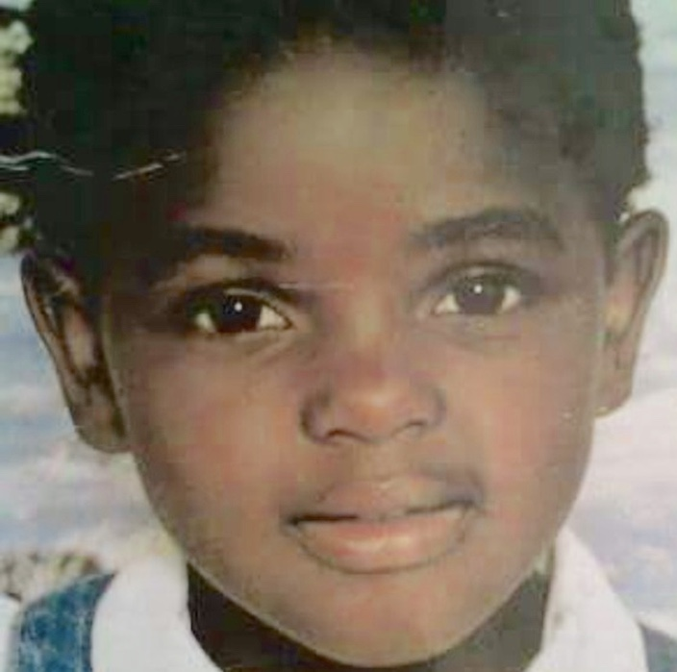
What Now?
I was in psychodrama class on a Monday morning before the burden became mine. I don’t know if I volunteered or was selected for an activity but I remember sitting on a chair facing one of my good friends in class. She was representing my inner child. I remember goofing around and not taking anything seriously that morning. The lecturer asked me what I want to say to 6-year-old Zola. I looked at my friend and I visualized this girl, suddenly the world wasn’t a joke anymore.
Then I tried to speak but I choked, the only words that could come out of my mouth were I’m so so sorry, I repeated this apology while swallowing my tears. I was sorry I didn’t keep her safe, at times didn’t defend her. I was not aware of the political violence at the time but I knew there was a gushing wound and I had somehow failed her. Here I was now. Was any of her still in me or had the world stripped her from this body.
This process has brought me back to her, I want to play with her and reconcile. Tell her we are ok, we made it. We are still healing but that’s a process. It gets harder but you become stronger. You learn the white man’s language and you navigate his world. You learn to embrace and appreciate complexity both in others and yourself. You are a good person but you are not exempt from doing bad things. I am sorry for the way I have treated you and allowed others to treat you, but hurt people hurt people.
There is a scent that make limping hearts easy to find, and we are finally found!

Reference List
- Adams, W. (2015). conducting Semi-Structured Interviews. 4th ed. [ebook] Jossey-Bass, pp.492-504. Available at: https://www.researchgate.net/publication/301738442_Conducting_Semi-Structured_Interviews [Accessed 2 Mar. 2019].
- Adams, Tony E. (2008). "A Review of Narrative Ethics". Qualitative Inquiry. 14 (175): 175–191. doi:10.1177/1077800407304417.
- Alexander, B. K. (2005). Performance ethnography. The re-enacting and inciting of culture. In N. K. Denzin & Y. S. Lincoln (Eds.) Handbook of Qualitative Inquiry, 3rd edition, (pp. 411-441). Thousand Oaks, CA: Sage.
- Alexander, J (2012) Trauma: A social theory. Cambridge: Polity. ISBN 978-0-7456-4912-2 pbk. Pages vii + 226
- American Psychiatric Association. (2000). Diagnostic and statistical manual of mental disorders (4th ed.)
- Anderson, C. and Huesmann, L. (2003). Human aggression: A social-cognitive view (pp. 296-323). In M. A. Hogg & J. Cooper (Eds.) The Handbook of Social Psychology, Revised Edition.
- Anderson, T.K. (2010). Using storytelling to describe and analyse fieldwork experiences of knowledge generation, In Anne Sigfrid Gronseth and Dona Lee Davis (Eds), Mutuality and Empathy: Self and Other in the Ethnographic Encounter (pp. 83-106). Wantage, UK: Sean Kingston.
- Audergon, A. (2004). Collective trauma: the nightmare of history. Psychotherapy and Politics International, 2(1), (pp.16-31).
- Bakó, T. and Zana, K. (2018). The Vehicle of Transgenerational Trauma: The Transgenerational Atmosphere. American Imago, 75(2), pp.271-285.
- Bandura, A. (1986). Social foundations of thought and action: A social cognitive theory. Englewood Cliffs, NJ: Prentice-Hall.
- Baranowsky, A. B., Young, M., Johnson-Douglas, S., Williams-Keeler, L. & McCarrey, M. (1998). PTSD transmission: A review of secondary traumatization in Holocaust survivor families. Canadian Psychology, 39(4), (pp.247-256).
- Bartov, O., Mack P., Sells M (2001) In God’s Name: Kosovo Mythology and the Bosnian Genocide. Oxford: Berghan Books,
- Bateman A, Holmes J. 1995 Introduction to Psychoanalysis – contemporary theory and practice; Routledge edition
- Bochner A (2000) Criteria against ourselves. Qualitative Inquiry 6(2): 266–72.
- Bonnin, D. (2001) Political Violence - Disrupting Ways of ‘Doing’ An Exploration of Organisational and Political Life in Mpumalanga Township, 1970s-1980s Journal of Natal and Zulu History Vol. 29, 2011 101, (pp. 101-130)
- Burchert, S., Stammel, N. and Knaevelsrud, C. (2017). Transgenerational trauma in a post-conflict setting: Effects on offspring PTSS/PTSD and offspring vulnerability in Cambodian families. Psychiatry Research, 254, pp.151-157.
- Carr, R. (2013). Silence and Trauma. [online] Psychology Today. Available at: https://www.psychologytoday.com/blog/tour-duty/201209/silence-and-trauma [Accessed 2 Dec. 2017].
- Courtois, C. A., & Ford, J. F. (2009). Treating complex traumatic stress disorders: An evidence-based guide. New York, NY: Guilford Press. doi:10.1037/e608902012-109
- Davis-Kean P. E. (2005). The influence of parent education and family income on child achievement: the indirect role of parental expectations and the home environment. J. Fam. Psychol. 19: (pp.294-304).
- Denzin, N. K. (2003). Performance ethnography: Critical pedagogy and the politics of culture. Thousand Oaks, CA: Sage.
- Denzin, Norman K. & Lincoln, Yvonna S. (2000). Introduction: The discipline and practice of qualitative research. In Norman K. Denzin & Yvonna S. Lincoln (Eds.), Handbook of qualitative research (2nd ed., pp.1-28). Thousand Oaks, CA: Sage.
- Dramatherapy. Teory andPractice 1. (pp. 1–18) London; New York: Routledge.
- Dunne, P. (2006). The narrative therapist and the arts: 2nd edition. Los Angeles, CA: Possibilities Press.
- Dunne, P. (2009). Narradrama. In: R. Emunah and D. Johnson, ed., Current Approaches In Drama Therapy. Springfield: Charles C. Thomas, (p.172).
- Ellis, C., Adams, T. and Bochner, A. (2019). Autoethnography: An Overview. [online] Qualitative-research.net. Available at: http://www.qualitative-research.net/index.php/fqs/article/view/1589/3095 [Accessed 15 Mar. 2019].
- Ellis C, Adams T and Bochner A (2011) Autoethnography: An overview. Historical Social Research 36(4): 273–90.
- Ellis, C & Bochner, A, P. (2000). Autoethnography, personal narrative, reflexivity. In Norman K. Denzin & Yvonna S. Lincoln (Eds.), Handbook of qualitative research (2nd ed., pp.733-768). Thousand Oaks, CA: Sage.
- Ellis, Carolyn (2004). The ethnographic I: A methodological novel about autoethnography. Walnut Creek, CA: AltaMira Press.
- Emunah, R. (1994). Acting for real. New York: Brunner/Mazel Publishers, 9
- Erikson, K. (1995) Notes on trauma and community. In: C. Caruth, ed. Trauma: explorations in memory. 183-199.
- Ezard, N., Oppenheimer, E., Burton, A., Schilperoord, M., Macdonald, D., Adelekan, M., Sakarati, A. and van Ommeren, M. (2011). Six rapid assessments of alcohol and other substance use in populations displaced by conflict. Conflict and Health, 5(1), p.1.
- Figley, C. (2012). Encyclopedia of trauma. Thousand Oaks, Calif.: SAGE, (p.146).
- Finley, S. (2005). Arts-based inquiry: Performing revolutionary pedagogy. In N. K. Denzin & Y. S. Lincoln (Eds.) Handbook of Qualitative Inquiry, 3rd edition, (pp. 681- 694). Thousand Oaks, CA: Sage.
- Frome P. M. & Eccles J. S. (1998) Parents’ influence on children’s achievement-related perceptions. Journal of Personality and Social Psychology, [PubMed] 74, (pp. 435-452).
- Gobodo-Madikizela, P. (2003). The Dynamics of Violence in Peacetime: Trauma-tic Continuities. Paper presented at the 56th DPI/NGO conference. UN, New York City, 8 September 2003.
- Goldstein, S. and Naglieri, J. (2011). Encyclopedia of Child Behavior and Development. Boston, MA: Springer Science+Business Media, LLC.
- Goodman, R. (2013). The transgenerational trauma and resilience genogram. Counselling Psychology Quarterly, 26(3-4), pp.386-405.
- Hanna, F. (2017). Alcohol and substance use in humanitarian and post-conflict situations. Eastern Mediterranean Health Journal, [online] 23(3), pp.231-235. Available at: http://www.emro.who.int/emhj-volume-23-2017/volume-23-issue-3/alcohol-and-substance-use-in-humanitarian-and-post-conflict-situations.html [Accessed 29 Oct. 2018].
- Herman, J. L. (1992). Trauma and recovery. New York, NY: Basic Books.
- Herman, J. L. (1997) Trauma and Recovery. New York: BasicBooks.
- Holman Jones, Stacy (2005). Autoethnography: Making the personal political. In Norman K. Denzin & Yvonna S. Lincoln (Eds.), Handbook of qualitative research (pp.763-791). Thousand Oaks, CA: Sage.
- Huesmann LR. 1998. The role of social information processing and cognitive schema in the acquisition and maintenance of habitual aggressive behavior. See Geen & Donnerstein 1998, pp. 73–109
- Jarzabkowski, P., Bednarek, R. and Lê, J. (2014). Producing persuasive findings: Demystifying ethnographic textwork in strategy and organization research. Strategic Organization, 12(4), pp.274-287.
- Jennings, S. (1988). Dramatherapy and Groups. In S. Jennings (Ed.)
- Johnson, D. and Emunah, R. (2012). Current approaches in drama therapy.
- Jones, P. (1996). Drama as therapy. London: Routledge.
- Jones, P. (2015). Trauma and dramatherapy: dreams, play and the social construction of culture. South African Theatre Journal, 28(1), pp.4-16.
- Justino, P. (2012, April). War and poverty. Institute of Development Studies.
- Kemmis, S. & McTaggart, R. (2005). Participatory action research: Communicative action and the public sphere. In N. K. Denzin & Y. S. Lincoln (Eds.) Handbook of Qualitative Inquiry, 3rd edition. (pp. 559-603). Thousand Oaks, CA: Sage.
- Kerkar, P. (2013). Drama Therapy Aim Techniques Benefits Drama Therapist’s Role in Healing Clients|. [online] ePainAssist. Available at: http://www.epainassist.com/alternative-therapy/drama-therapy-aim-techniques-benefits-drama-therapists-role-in-healing-clients [Accessed 8 Sep. 2018].
- Kibler, J. (2011) Cognitive Disequilibrium. In: Encyclopedia of Child Behavior and Development. New York: Springer. (p. 380).
- Landy, R. (1994). Drama therapy: Concepts, theories and practices. Springﬁeld, IL: Charles C. Thomas.
- Levins Morales, A. (1998). Medicine stories. Cambridge, MA: South End Press.
- Lištiaková, I. (2015). Analysis of three approaches in dramatherapy. [ebook] Journal of Exceptional People, 2015, pp.19-28. Available at: https://www.academia.edu/35806358/Analysis_of_three_approaches_in_dramatherapy_overview_essay_ [Accessed 13 Mar. 2019].
- Maréchal, Garance. (2010). Autoethnography. In Albert J. Mills, Gabrielle Durepos & Elden Wiebe (Eds.), Encyclopedia of case study research (Vol. 2, pp. 43-45). Thousand Oaks, CA: Sage Publications
- Mchunu, N. (2013) Kwazulu-Natal, South Africa. Journal of Peacebuilding & Development, 8(1), (pp.60-73).
- Mcleod, S. (2018). Jean Piaget's Theory of Cognitive Development | Simply Psychology. [online] Simplypsychology.org. Available at: https://www.simplypsychology.org/piaget.html?utm_source=outbrain.com-internet&utm_medium=cpc&utm_campaign=vertical_criminal+justice&campaignid=70161000001Cq4dAAC&vid=2117383%3FStartPage%3FStartPage [Accessed 18 Feb. 2019].
- McLoyd, V. C. (1989) Socialization and development in a changing economy: The effects of paternal job and income loss on children. American Psychologist, PubMed 44, (pp.293-302).
- Naderifar, M., Goli, H. and Ghaljaie, F. (2017). Snowball Sampling: A Purposeful Method of Sampling in Qualitative Research. Strides in Development of Medical Education, 14(3).
- Nadta.org. (2017). What is Drama Therapy. [online] Available at: http://www.nadta.org/what-is-drama-therapy.html [Accessed 10 Aug. 2017].
- Ormrod, J. E. (2008). Educational psychology: Developing learners(6th ed.). Upper Saddle River, NJ: Merrill.
- Pitruzzella, S. (2004). Introduction to dramatherapy: person and threshold . Hove; New York:Brunner-Routledge.
- Presentation of Pumla Gobodo-Madikizela, Speaker at the 56th Annual DPI/NGO Conference, Human Security and Dignity: Fulfilling the Promise of the United Nations Monday, 8 September 2003, United Nations Headquarters, New York The Dynamics of Violence in Peacetime:Trauma-tic Continuities Pumla Gobodo-Madikizela University of Cape Town South Africa.
- Possick, C., Shapira, M. and Shalman, V. (2017). Complex Collective Trauma Following a Terror Attack in a Small Community: A Systemic Analysis of Community Voices and Psychosocial Interventions. Journal of Loss and Trauma, 22(3), pp.240-255.
- Reinmann, C. and konig, U. (2017). Collective trauma and resilience. [online] Berghof-foundation.org. Available at: https://www.berghof-foundation.org/fileadmin/redaktion/Publications/Handbook/Dialogue_Chapters/dialogue11_reimannkoenig_comm.pdf [Accessed 13 Mar. 2019].
- Richardson L (2000b) Writing: A method of inquiry. In: Denzin NK and Lincoln YS (eds) The Sage Handbook of Qualitative Research, 2nd edn. Thousand Oaks, CA and London: Sage, pp. 923–48.
- Riedel, E. (2014). A depth psychological approach to collective trauma in Eastern Congo. Psychological Perspectives, 57, 249–277.
- Ritter, M. (2014). Silence as the Voice of Trauma. The American Journal of Psychoanalysis, 74(2), (pp.176-194).
- Schuld, M. (2013). The Prevalence of Violence in Post-Conflict Societies: A Case Study of. Voting and violence in KwaZulu-Natal's no-go areas : coercive mobilisation and territorial control in post-conflict elections / Maria Schuld
In: African Journal on Conflict Resolution: (2013), vol. 13, no. 1, p. 101-123 : krt.
ASC Subject Headings: democratization ; elections ; political violence ; South Africa ; voting
- Smigelsky, M. and Aten, J. (2014). Trauma in Sub-Saharan Africa: Review of Cost, Estimation Methods, and Interventions. International Journal of Emergency Mental Health and Human Resilience, [online] 16(4). Available at: https://www.omicsonline.org/open-access/trauma-in-subsaharan-africa-review-of-cost-estimation-methods-and-interventions-1522-4821-16-129.php?aid=31891 [Accessed 15 Oct. 2018].
- Taylor, R. (2002). Justice Denied: Political Violence in KwaZulu-Natal after 1994. Violence and Transition Series, Vol. 6, 2002.
- Tutu, D. (1999). No future without forgiveness. NY: Doubleday
- Tutu, D. (2004). God Has a Dream: A Vision of Hope for Our Time, NY: Doubleday Religion.
- United Nations Population Fund (2001). The Impact of Armed Conflict on Women and Girls. [ebook] Available at: https://www.unfpa.org/sites/default/files/pub-pdf/impact_conflict_women.pdf [Accessed 13 Oct. 2018].
- Van der Kolk, B. A. (2014). The body keeps the score: Brain, mind, and body in the healing of trauma. New York, NY, US: Vikingev.). Washington, DC: Author
- Volkan, V. (2001). Transgenerational Transmissions and Chosen Traumas: An Aspect of Large-Group Identity. Group Analysis, 34(1), pp.79-97.
- Ward, J. and UN Women (2013). Violence against Women in Conflict, Post-conflict and Emergency Settings. [ebook] Available at: http://www.endvawnow.org/uploads/modules/pdf/1405612658.pdf [Accessed 27 Oct. 2018].
- Watson, T. J. (2011) “Ethnography, Reality, and Truth: The Vital Need for Studies of ‘How Things Work’ in Organizations and Management,” Journal of Management Studies 48(1): 202–17.
- White, M. (1989) Papers by Michal White. Adeline, Australia: Dulwich Centre Publications.
- Xiong, I. (2015). Interrupting the Conspiracy of Silence: Historical Trauma and the Experiences of Hmong American Women. [online] Dc.uwm.edu. Available at: https://dc.uwm.edu/cgi/viewcontent.cgi?referer=https://www.google.co.za/&httpsredir=1&article=2100&context=etd [Accessed 1 Dec. 2017].

Appendix A
Link the performance recording
https://youtu.be/X9nlEktWdTU

Appendix B

THE BURDEN OF KNOWING (Script)

*The script enrols the audience as the interviewer
*All of the names used on the script are pseudonyms

Act 1: Scene 1

Music - Sudden Throw by Olafur Arnalds.
Projection - Images from political violence
Lighting - Orange and Red blended

The actors walk through the audience in the foyer with bodies strapped to their backs, some hanging upside down. They walk slowly, displaying no emotion, just emptiness. Their strength and resilience is in their ability to carry these bodies and keep walking. The audience follows them inside.
Then they gently put down the bodies when they get to the stage and they chalk outline the bodies. When the full frame is outlined, the bodies gently rise.
By the end of the music, the full cast is standing facing the audience.
The lights fade out.

Act 1: Scene 2
The lights come back on.
Dim stage and spotlight shines on each cast member as they speak.
One by one they unfreeze from their positions and say lines from the interviews
They display very little emotions as they say the lines.

WOMAN 1
We used to pass dead bodies on our way to school, so…..we stopped going.

WOMAN 2
As far as we knew we were IFP members, all of KZN was. We didn’t care about politics then next thing we knew, IFP members were chasing us with guns. We didn’t know what was going on, it turns out our boys had joined the ANC; we didn’t even know what that was. We just woke up one day and had to run.

WOMAN 3
I don’t remember anything, I was too young.

WOMAN 4
When you and your gogo left Amakhaya, I used to sometimes go sleep in your house because no one would suspect anyone was there. Yes, my 8 year old daughter and I would sleep in different people’s homes every night. If I left, who was going to look after my stuff? Where would my child go to school? Where would I go? I already had two of my sons living with relatives.

MAN 1
At first, they weren’t killing women and children and then they got desperate to kill and killed everyone they laid eyes on.

MAN 2
I don’t want to burden the children with stories of our pain. Yebo, if they asked, I would tell them.

WOMAN 5
It was difficult living in an ANC community that killed my husband because he was IFP.

WOMAN 6
My child, why are you asking us such painful questions?

WOMAN 7
You had to cook your supper by 3pm and eat it by 4pm or else you would not eat that night, then you would have to leave your house and figure out where to sleep for the night.

MAN 3
No, I haven’t spoken to my children about how their grandfather died. One day my daughter was playing on my father’s grave and I told her that what she was doing was wrong and to never do it again; now she is a woman and I still can’t tell her the truth. Maybe one day she will ask.

WOMAN 8
We moved to a smelly tent, Kwakunuka (it stank), we could see people take a shit outside, we could hear drunk people walking around us, there were flies everywhere, yet it was much safer than home.

MAN 4
I don’t want to hurt my family by asking questions because I don’t see how it affects my life.

WOMAN 9
Funerals were always difficult, we would be afraid to go. But when someone close to us died, we would get in a taxi from the refugee camps, go to the funeral while looking over our shoulder and run back into the taxis and drive back to the slums. We would wave good bye to our homes and laugh at each other.

MAN 5
Awazi wena, I lost many brothers before they died. Do you remember your uncle Thami? Yes, well you know him as an alcoholic but he wasn’t always like that. He was a bright boy when we were young. He did very well at school and could have been a national soccer player. When the unrest started, he got involved, he started getting arrested and his education was disrupted. After the violence, he didn’t finish school, he just became the drunk you knew and not the man we thought he would be.

WOMAN 10
All of my peers are either dead or alcoholics, lenhlobo ecela o R2(The type that begs for R2)

WOMAN 11
The girls slept with the peace keeping soldiers, they gave them food, attention and aids. As a result, you will find many orphaned children here, their mothers have died of aids and they don’t know their fathers.

MAN 6
The boys were walking from the translation where they had set up camp and one day they got surrounded and the bullets showed no mercy. I think it was almost 10 boys, all teenagers.

MAN 7
Mshana’m, is this research going to heal you?

WOMAN 12
I saw them as they were shooting him, they said “I am not shooting you; I am shooting the Mandela on your T-shirt”.

MAN 8
Heeeeeh Mshana’m, this thing is so deep. On his deathbed, when he was dying of “natural causes” in 2008, he confessed to murdering numerous people. People he killed after the violence. I guess since there was never an official ending of the violence and his veil of killing had been broken, he could not stop killing. The switch was left on. He said he had even killed people for petty cash. Yes, because no one is going to announce it and you are a child.
SONG - THINA SIZWE

Thina Sizwe, esimnyama
Sikhalela, izwe lethu
Elathathwa udlame

Mabawuyeke umhlaba wethu
Mabawuyeke umhlaba wethu.

Black out-

Act 2 : Scene 1

(Cultural music and cultural dancing. Chaos. Ululation. Gidda, sina etc.
Everyone sits around the chief - it’s a Mbizo, sounds of cows in the background).

Oliver, Ushi
Oliver, Ushi
Babengaphi na?
Babengapha, singapha,
Sahlangana ngamakhanda.

(Facing the audience, the chief speaks)

CHIEF
Awu Mshana’m, now you can say “Ndabezitha”, hayi sowukhulile. The last time I saw you, you were this little. Bheka manje! You are even taller than me (he laughs).

Hay ngiyakuzwa (looking at the audience), this is a very important topic and one that I think has not been addressed adequately. (he motions for someone to put a wooden bench for him to sit on) As you can see today a lot of our people have separated because of what happened in the past. No one apologized and no one forgave each other. Some are trying to move on, but it’s difficult. Yabona ubaba, he was a much-respected chief in this village and he was a man of integrity. This whole thing affected my family badly when my father had to be a refugee as a chief. Imagine, a chief running away from his chieftaincy, because he was shot. No one was safe.

(His bench gets there and he sits) Good, you did right to decide against focused groups, because these people, as much as they can work together now, I don’t think they can reflect on what happened peacefully in the same room. You did right by talking to them individually.

Uyabona Mshanam, recently there was this case, from another village that suffered this violence. The case of a teenage boy that was accused of raping a 3-month-old baby. The matter was taken to court, la koMkhulu. That teenage boy was nearly murdered. I overheard people saying “You see this thing of following other political parties, is the reason they rape innocent babies, ngelinye ilanga sizonibamba, and we will kill all of you”. I mean in that tone, you can feel that even if this happened because the boy was being mischievous, it’s getting pinned on political parties because the wound hasn’t healed

This thing is very important and you must treat it with integrity, masengiyivala le interview noma I research noma yini le oyenzayo, I am granting you permission to conduct your research and Mshana’m, come back once you have done with your research, so we can talk about how it has helped you and see how the village will benefit from this.

(One of the cast members jumps up and waves their hand as if they are ringing a school bell and make ringing sound. The rest of the cast begins to run around like learners at the end of recess. They move to the corner of the stage and sit; the teacher stands by a white board or a wall with chalk in their hands.)

Act 2: Scene 2
Full Light
(Teacher gets the class to settle down, he looks at them and begins.)

TEACHER
Who can tell me about what is known as “Black on Black” violence?
(He points at one of the learners)
STUDENT
(He stands and faces the audience, and speaks)
Violence? Well, all I know is that there was a little unrest;
but no, we have never spoken about it at home.

TEACHER
(He looks at the audience and continues to address them as the interviewee)
You find that parents fear talking about their past with their children

STUDENT
Ahh, well my history teacher mentioned it in class once. I don’t think I was paying attention.

TEACHER
There is a big shift; cognitive ability has declined which I suspect is caused by what the parents observed: kids dying, parents dying, yet the mind was not attended to so no one can accept what they went through and you can see it in these ones that weren’t even born at the time. Their behaviour! (Shakes his head)

STUDENT
I heard something about my grandfather being shot in the house during the violence, but I’m unclear on the details.

TEACHER
There is some political tension in the school. It is just unspoken. It comes from the misinformation that the children have been given.

STUDENT
I would like to know what happened but I don’t know how to ask. I don’t know why I don’t ask but there is a fear. I wouldn’t know how to bring it up; asking my gran might be hurtful and I don’t want to bring her pain.

TEACHER
You find that these children have things eating them up internally.

STUDENT
It’s just an uncomfortable topic cuz. I’m 21, still in high school and I don’t know who to ask so I avoid it all together…No, I don’t think our cousins know.

(Bell rings and class is dismissed, cast goes to sit between the audience.)

Act 2 :Scene 2
(Gogo Khumalo is a retired psychiatrist, she enters and there is a chair in the centre of the stage waiting for her. She sits under the spotlight. Looks at the audience and addresses them as if they were the interviewer. She calls the interviewer “mzukulu”(grandson/granddaughter))

Gogo Khumalo

Ngiyengithi ke it’s pointless to open a tin of worms if you’re not going to catch it.

If I can make you an example wena Mzukulu, errr ukufika kwe HIV, ukufa kwabantwana nge HIV, by that time I was already kwa Sakha Isizwe, siqeqesha onompilo kwi first level how to identify, to render emotionally and psychologically and networking and referral. Wawutholukuthi onompilo angithi bona babe kade benza ama home visit o-TB. Uma esefika la, bhatholukuthi there are victims o-sexually abused, domestic violence, drugs. You connect? I remember komunye umuzi, sathi masifika le kwa-Shobashobane kwatholukuthi ugogo, usengcwaba abazukulu yi-HIV AIDS. Uthi ugogo I can’t go to the garden, my four boys zafa during the violence and so labantwana babesebehamba belalwa beyizinto zonke. Already ama values and norms asephelile, and so that is the impact kwi youth.

You go to Gcilima, eGcilima kwalwiwa kwaba ne-massacre. Amadoda afa. The boys who were 12, 14 years during the violence are now men with no love, violent and rapists. That’s why we have a women’s shelter because I was looking geographically to the impact. Kwa-Shobashobane it’s political violence basakukhombisa la izidumbu zaginqeka khona. I am trying to say each village lapho kwalwiwa khona, you do see impact. And abantu abadala abakhulumi ngayo ngoba they don’t want to go there emotionally.

Go to the community mzukulu, talk to the people, ask, what must we do to assist? Can we talk about the past, where were you during the violence?
Phela mzukulu, to give you a picture, there was a thing called camping where boys involved in the war would go to the bush and train to kill, they would dismantle their victims’ bodies, basike amasende nezitho zangasese, they would cook it and eat it for supreme strength. Then the war ended. I am trying to say i-approach ka political violence inama stages because those boys are now men. Can they love? We are talking emotionally and psychologically scars.
There are no happy families. There’s war. Internal wars unfortunately. So, the family fabric, the structure of the family nucleus is destroyed ngoba akekho owathi ngilwile ke kwabakhona ibridge of healing. There were no healing programmes. People are having emotional load without disclosing it. Angibasoli ke mzukulu, there’s no environment for disclosing. How do we create a therapeutic environment of healing, of talking?

(Gog’ Khumalo stands up and walks, shuffles like old people do, mumbling to herself and while heading back to immerse herself with the audience and cast.)

Act 2 :Scene 3
(Thando is a 42 year old woman, she refers to the interviewer as her “mzala”(cousin). She walks onto the stage as Gog’ Khumalo walks out. She faces the audience, there is an imaginary person sitting on the chair. Thando starts plating and talking.)

THANDO
(Interview setting, creating the atmosphere with a pause and response kind of feel. Linda is busy plaiting her cousin’s hair; her eyes keep locking with the TV (looking at the audience as if they are the TV). She is smiling and talking to her cousin. Linda is a beautiful soft spoken woman, who has experienced a lot but is very calm about it. Her interview is very effortless.)

Yazi mzala, ziyakhula inwele zakho. Yho lezitayela zenu! Yazi ngibone intombazane efana nawe kwiTV ngelinye ilianga ngathi uyafana nomzala ke lo. Uzomodela nini? Umosha imali njengoba ungamodeli, phela kulezinsuku bathi black is beautiful.(Watching TV and concentrating on what she is watching she comments on what she sees.) Haibo, wake wezwaphi, umuntu aze kwiTV ezotshela umhlaba wonke ukuthi uyakufuna? Weh, ngingamshiya lapho (she has a good laugh) i-worse uma emubi kanjeya. Abantu bayazithanda izinto. Wena ungathini umuntu ekushela kwi TV? (Waits for a response)

Eish- ngiyiqale laphi lento, udlame lwahlukumeza abantu abaningi. Phela ukuqala kwami ukubona isidumbu, I was in highschool, I think standard 6? Angisazi. Kodwa the IFP guys walked onto the school premises and came to our class; these were boys we knew so we weren’t scared. That was until they took a guy from the class and dragged him to the nearest bush, laphaya ngakwaCele estobhini. We thought they would slap him around for wearing a Mandela T-shirt, but they took out a gun and shot him, yoh, into engayi baleka weMzala! That’s when schools closed. (turns around and asks her husband, Zavalwa nini izikole baba?) Yes, 1993.

Were they carrying big guns? (Looks at the imaginary head she is platting) Ama AKA 47? I think the day you are talking about was the day Gumbi was shot while sitting with us. We ran as fast as we could, but Khetho and Nsizwa were sitting next door drinking. They killed Nsizwa, so Kheto hid because he couldn’t run far. (listens) Yeah, he was in, konje bathi yini leyanto ocashiswa kuyo amaphoyisa uma ufakazile? Ehe, I witness protection, well that’s because when he was hiding, he saw the men that shot Nsizwa cut his testicles and his eyes out and he testified against them. (Listens, looks surprised) Where is he now? Don’t you know? Usejele! Weee, he gave a 4 year old girl R2 and raped her. Can you believe he was claiming she was his girlfriend? He was just never normal after he came back from witness protection.
(Refers back to the TV)
Heeeeee! I thought this girl wasn’t interested, isimanga, uzomqabula kanjani umntu onje?

(She laughs as she walks off the stage)

Act 2 :Scene 4
(Mam’ Sho walks with purpose onto the stage, she is wearing a full apron and a doek. She walks around the whole stage. She refers to the interviewer as mntanami(my child))

Mam Sho
Eeeeyi (drags the word) wemntanami, kwa kungeve kunzima those days.
The children would be at school and we would hear random gunshots and someone would then blow the whistle for everyone to run, we would have to take the children and run out of school, from such events kwaba-impossible for the children to go back to school baba extremely traumatized.
Eyi, izikole were used as refuge and i-transit place and were left in the most unhygienic conditions because no one had time to clean. This further violated the school's purpose as an environment where learning should take place.
Nalokho ke was main reason the children took drugs. (looks questioningly) Ye? Where did they get the drugs? (she stands still and looks at the audience) The soldiers Mandela sent brought drugs and HIV into our community, they slept with young girls, we lost our cultural way of life, there was no one to take care of the girl child and the boys were butchered like animals.
Another event that traumatised me, ngikhumbula the morning an aunty from the neighbourhood carrying a baby on her back came to me. She asked how we slept, mind you I never ran away from my house, I always slept here and always had a gun ready. She said "I am so proud of my grandchild he didn’t cry while we spent the night on a tree”, I noticed that the child's legs were lifelessly dangling from here back, then I said to myself; this child is dead. I move closer to pinch the baby (while demonstrating leaning closer and pinching the air), to confirm my suspicions. I then say to this aunty “you know what, I see a small wound and some blood on the baby, mhlawumbe it’s a scratch from the tree”. I suggested that we rush the child to the local clinic. I didn’t tell her what I was suspecting, Ngangizivikela kwi-burden of comforting her - I didn’t need her wailing in my yard (confrontational exclamation look). So, I walked ahead when we got closer to the clinic and I quickly told the nurses ama-suspicions ami. I escaped kanjalo kuleyo situation. Kwakunzima in those days. Wemntanami, phela she thought that the child was quite because he was sleeping but he caught a bullet ye-silent gun, I will never forget that baby’s funeral.

Enye futhi eyayisihlukumeza wenamntanami, ngesikhathi u-Mandela wasn’t out as yet, we were attacked at broad daylight, there where white people, we weren’t attacked by black people.

Random Woman
(woman stands and sings loudly)
AYASIQHATHALAM BHUNU ÀTHI!

Mam’ Sho (continues)

u-Gatsha would send i-police force yabelungu , ngaphuma ngigijima out of my
house while being hit by these policemen with guns. We all knew these policemen would hide laphaya on the hill (pointing), waiting to attack, when the community saw them run down, awu yayisho impempe (whistle blows, mam’ Sho looks around as if experiencing dejavu).
(She collects herself, takes a deep breath and starts a new topic) We-mntanami we were smuggling guns illegally, the police force was supplying inkatha with guns amaG3. While the IFP was heavily armed, Mandela didn’t give us guns. I went to Hlakaniphani, I sought for guns with a former church member of mine who was very active in the struggle. She had moved away because of the violence. We kept in touch and I met up with her to buy guns. The place we got the guns kwa ku-protected, you weren’t allowed entry unless they knew you, there were teenage boys guarding the gate with petrol bombs and this lady I was with saved my life because they knew her. She introduced me to the dealers we would buy i-AK47 for R 1 800 iyodwa vo! (showing one finger) I owned a green graduation gown, I would wear it to protect myself and strap two guns to (demonstrate strapping) hide them right lana lana(pointing).
Then word was out that I had access to big guns and that’s when I started smuggling in volumes for our members. I would use my van to collect them and we would hide them under bags of maize meal and cabbage. I pretended to be a trader so this was the perfect cover, the authorities wouldn't suspect me. They couldn't offload all these goods in the van ngangi sinda kanjalo. There was this day after collecting the guns, immediately after we turned, we were stopped by amaphoyisa. The policeman shouted "license" -Ngathi wehh, kwashuba- I pretended to be sick from a pregnancy (she makes a barfing face and hold her mouth) and he quickly let us go. If I was caught, I would have been arrested immediately. Phela, ngelinye ilanga I almost shot this Afrikaner man and authorities repossessed my small gun, the following morning I went to court and I asked them; Nifuna ukungibulala? Can’t you see there is a war? They responded by saying "It was trouble"

RANDOM WOMAN
(woman stands and sings loudly)
AYASIQHATHALAM BHUNU ÀTHI!

REST OF CAST
MASIBULALANENI

Mam’ Sho (continues)

(She has reflective look) On the day of the massacre my elderly mother’s life was saved by my pigs. About 17 people who were killed that day. While running she collapsed into i-pigs den and when we found her she wasn’t the same. Truthfully speaking, I lost my mother that day although she passed on a few years later. The fact is that things were so bad, that pigs saved my mother’s life, pigs! (She shakes her head)
I almost killed my son, they threw petrol bombs at the house, I panicked, I threw out the gun and my son fell on it…. I instructed him not to move. Ngacishe ngambulala. (looking regretful)
Kodwa ngacishe ngabulala nephoyisa lana kuvrandi wami,(points with a smug proud look) he caught a young man who used to help me and they interrogated him about my guns, I’d long disposed of those guns. I then walked out with my small gun, I struggled with a cop, (she comically demonstrates the struggle) and I threatened him, (pointing a gun at the invisible cop’s mid-section) “ngathi eyi wena, uke uzame ukungithinta futhi, ngizokuhlakaza amasende”. (looking fierce)
Enye nje intombazane e-bank was gossiping ethi “We don’t sleep aboSho terrorising us with guns” and I asked her if she knew Sho? And she replied ehhe uBab’ Sho. People thought I was a man. (laughs and walks off stage)

(Cast sings as Mam’ Sho leaves stage)
AYASIQHATHALAM BHUNU ÀTHI,
MASIBULALANENI
ASISALALI EMAKHAYA
HAY’ HAY’

(The lighting changes as Sizwe walks on stage onto a chair to stand trial with his head down. A judge walks and stands behind the podium. The lighting should enlarge the judges shadow and make Sizwe’s shadow long and narrow)

JUDGE
All rise in court (with a smug look)

(cast encourages to rest of audience to stand)

JUDGE
I said ALL rise in court of order

(Everyone in the room stands)

(A video plays in the back ground. Source -The Bloody Miracle 00:00 - 00:30)

JUDGE
You may be seated.
(Everyone sits)

JUDGE
Today we are here to listen to Mr Sizwe Sibiya who is both the complainant and defendant of this court. No matter the outcome he will win and he will lose. The sentence and reward will be guilt and impunity. Prosecutor, you may begin.

(Sizwe looks at the audience as if he is listening to a question for a few seconds)

Sizwe
I was a teenager, I was probably 16. I was doing grade 10 at the time. I had moved from the village to the township, they had better resourced schools there.(Listens and answers) Yes, that’s when I was introduced to politics (crowd mummers - mmmmm, some shake their heads, one puts up a fist).
I was not interested at first, but then I started watching the news and I wanted to be like Mandela, so I started going to the meetings. Some of the boys I had grown up with from the village were still IFP members; I had no problem with that. We were all just people. (Listens to question)

Listen, the trouble started when we were at Sfiso’s funeral. He had been killed in what seemed like a political assassination.

How do we know? Because before the funeral we were told to drink some muthi for protection. And when we were digging his grave as comrades, we were attacked with gun fire. Thanks to the muthi the bullets missed all of us. That confirmed our suspicions that it was political and that’s when we realised we had to protect ourselves.

(Listens and responds with remorse) Cha, akunjalo! The death of that woman was an accident. Her husband was a spy (someone from the crown shouts, murderer, there is commotion, judge bangs the table, yelling “order, order in court”).

The target was her husband, and when she didn’t give him up there was a bit of a struggle, she had that Xhosa woman temper and we are Zulu men, we don’t tolerate that nonsense, anyways those guns were burning in our hands.

(Listens and responds) Yes, this was before they killed my brother. They were looking for him because of my affiliation with the ANC.

(Listens and responds) No, there was a chain of command, we only worked through assassinations. Unlike Inkatha, we didn’t have a reign of terror, we just had targets. You also need to understand that we didn’t have guns, it was illegal for us to have guns and the ANC leadership did not supply us with any.

(Listens and responds) Hahahah, this was not a Rambo movie, the gun shots you heard were real though. There was a protocol, if we had a target, we would have to report to leadership in the township. He would then send a message to Durban and the leader in Durban would then send a message to eGoli and then they would send us a hit man. This was unsustainable, (sounds defensive) we got frustrated, our mothers and children like you were being run out of their homes and we had no means of protecting them except for an assassination at a time, while they burnt houses with people in them as their strategy!

(Looks down and looks up again and has a slight nod) Yes, I have seen a man lose his life.

(Keeps quiet for a while) There is a difference between seeing a life escape its body and being the one who is taking the life. The first few times are the hardest.

I had a promising future ahead of me, now I work as a gardener in the Suburb. I will do anything to feed my family.

(Looks at audience and listens then squints his eyes as he replies) I would never tell my children even if they are your age, this is too much pain to pass on, and I am just trying to live my life as peacefully as possible.

(listens and responds neutrally) No, my mother and I have never spoken about those times, she lost her first-born son in my name, I don’t know how they still love me. But I have changed. And I am sorry for all the wrong that I have done.

ACT 3.
(Cast begins to sing as the light fades and goes onto the stage assuming tableaux positions)
Recorded accounts of witnessed brutality are played.
(The tableaux’s follow the narrative as appropriately as possible)

There is sound of wailing and humming as the cast indulges in the ritual of mourning. A song should come from the rehearsals.

A choreography of the two people who’s testimonies were heard in the recording. A choreography that seeps into the process of anguish, mourning and the ritual of burial. This should be both abstract and clear, what could help is projecting a picture of a burial in the background. Allowing the audience to feel and release the sense of the Burden of Knowing and allow for an integration of the experience.

Appendix C
Exhibition Photography and titles

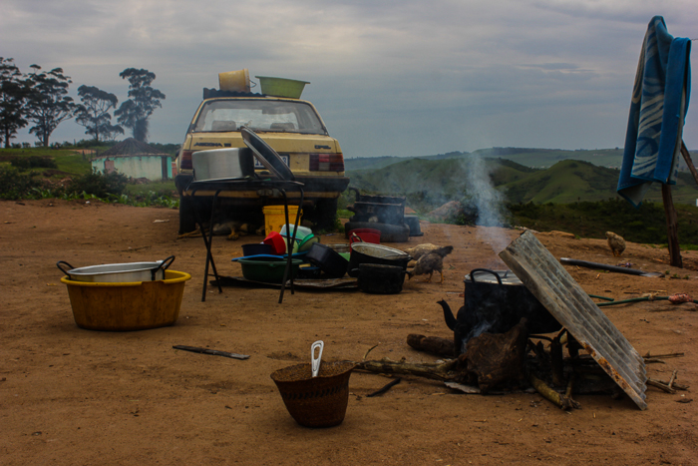
“You had to cook and eat your supper by 3PM or else you would eat your dinner in a tree like an animal. When the whistle blew, you would have to leave everything you were doing, run and hide.”
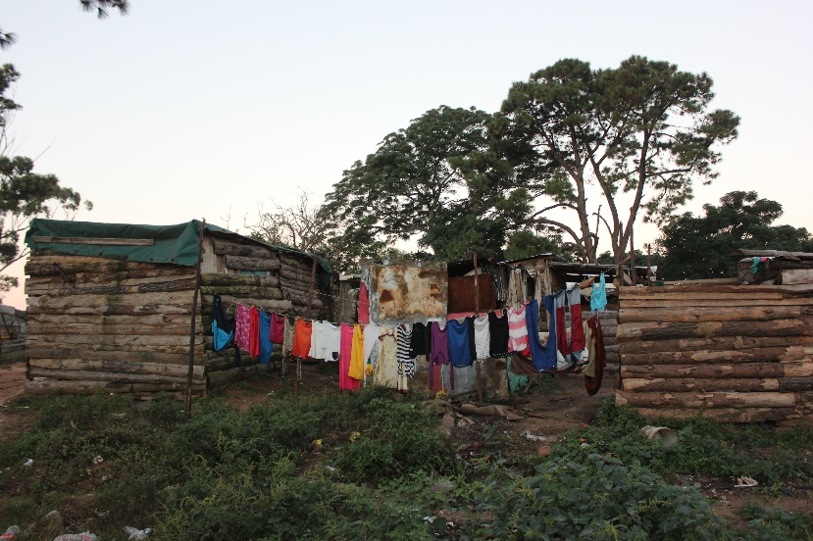
“The first group of people to live in this informal settlement were due to the group areas act. They were moved from their coastal villages and had nowhere to go. During the political violence many of us went to shack there, we left our brick-built homes, with our furniture, to sleep in smelly tents on the floor.

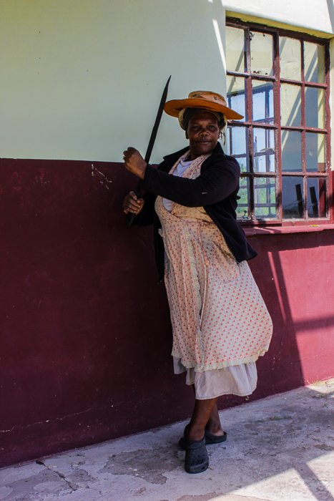


“To Nkoti, who hid me in her banana plantation even though I didn’t understand why. I’m sorry it took me so long to understand, I am sorry. I am thanking you now when you are no longer with us. Thank you gogo.”

“I would always sleep in my house, I had a gun.”

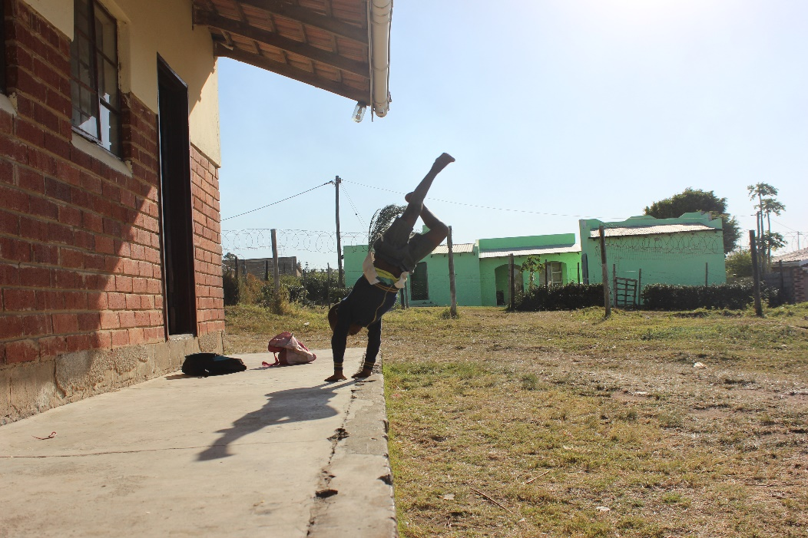
“We were no longer allowed to play, no longer allowed to be children.”
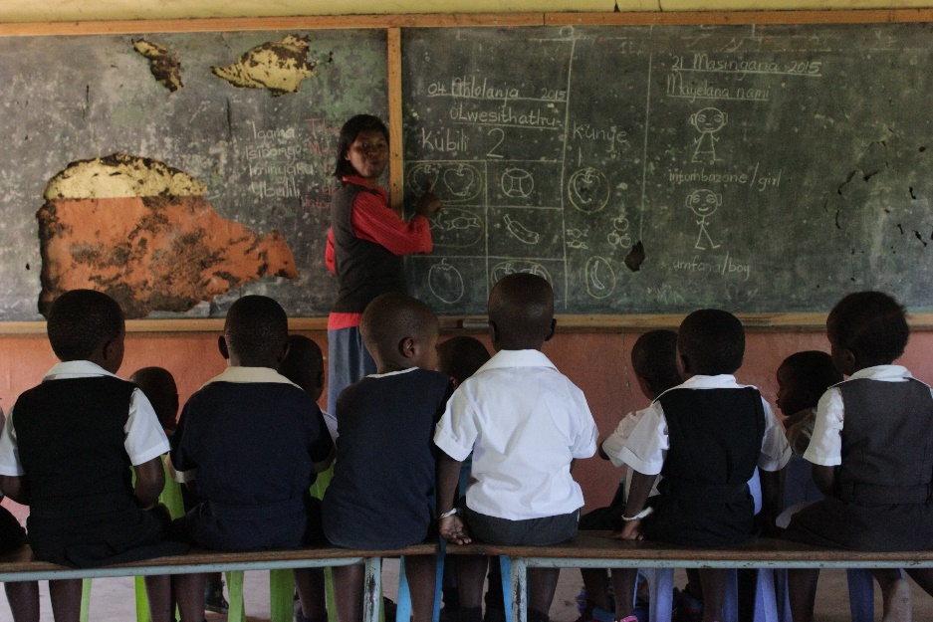

“We used to walk past dead bodies on our way to school, eventually we stopped going.”
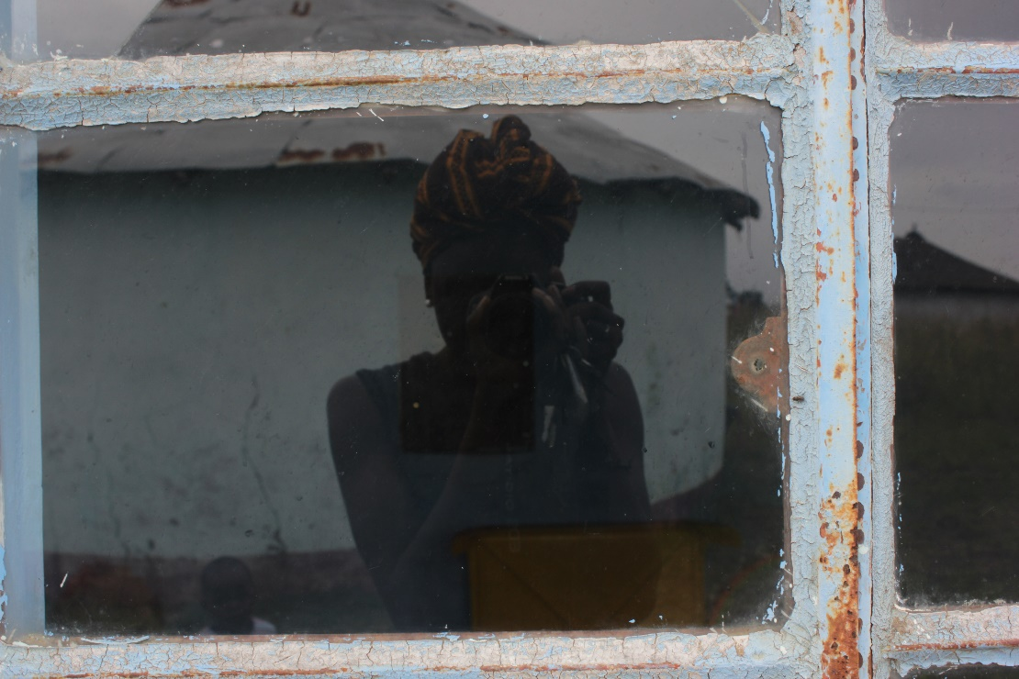
“I had a deep desire to fill in the missing pieces of the narrative so it does not remain stagnant and I do not fixate on a 4-year old’s truth.”

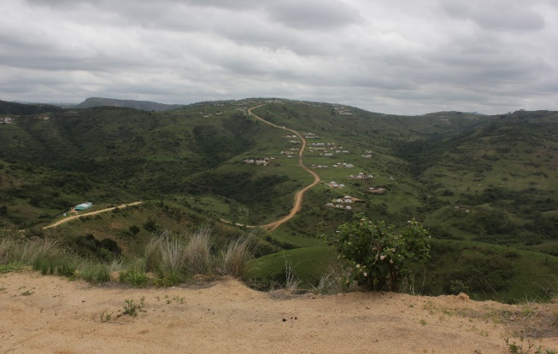
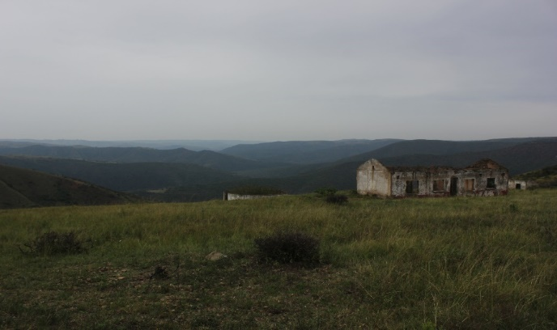

“My husband was IFP, we lived in an ANC community, they killed him in front of me, they said he was a spy.”

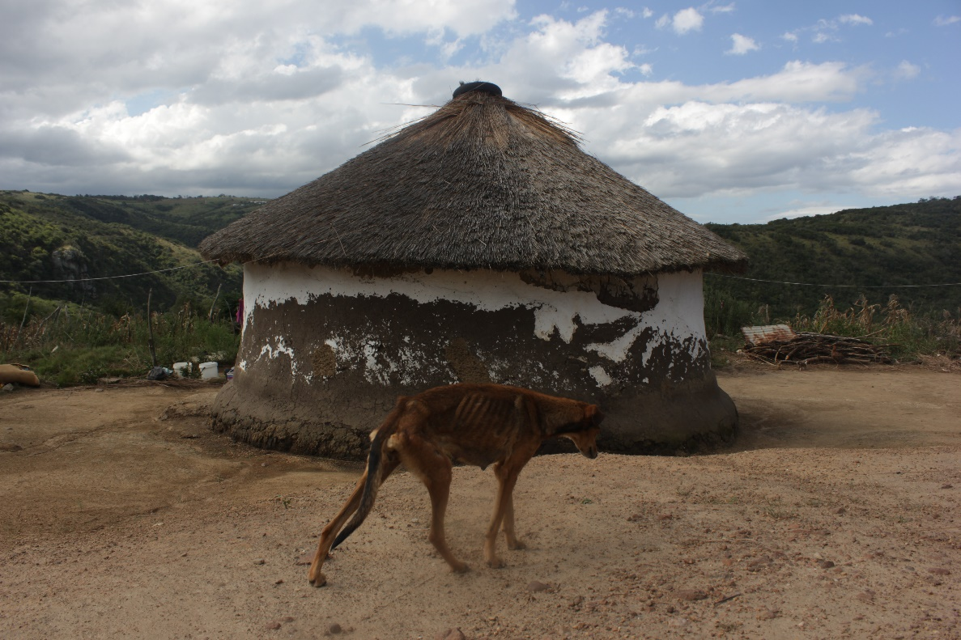
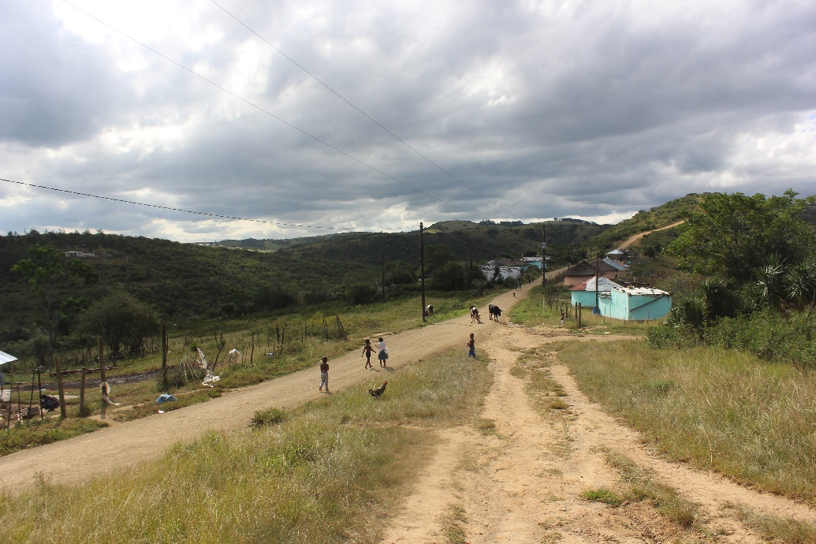
“During the violence we lost each other, we only found each other two years ago.”

“I watched hunger eat my children after the death of my husband.”

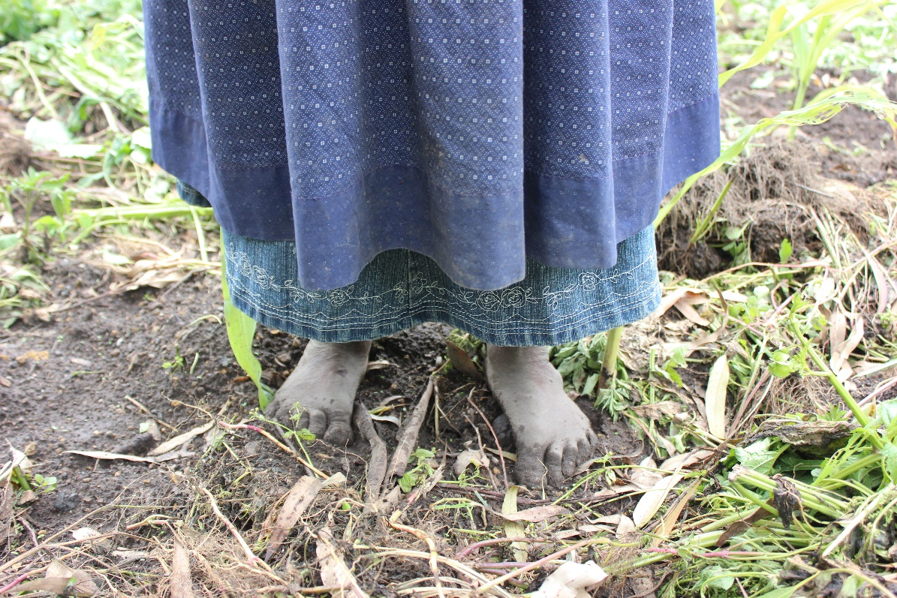
“I cannot go to the garden, I buried my four boys there during the violence”

Appendix D
Figure.1
Participant Code | Age | Gender | Occupation | Location of Residence. | Interview Duration
Interviewee 1 | 30-39 | M | Engineer | Johannesburg | 1 Hour
Interviewee 2 | 40-49 | M | Corporate | Johannesburg | 1 Hour
Interviewee 3 | 70-79 | F | Retired - Nurse | Margate | 2 Hours
Interviewee 4 | 30-39 | F | Service Industry | Mvutshini | 40 Min
Interviewee 5 | 40-49 | M | Unemployed | Mvutshini | 70 Min
Interviewee 6 | 60-69 | F | (Pensioner)Retired-  Domestic Worker | Mvutshini | 90 Min
Interviewee 7 | 60-69 | F | (Pensioner)Retired-  Domestic Worker | Mvutshini | 1 Hour
Interviewee 8 | 18-21 | M | High School | Mvutshini | 40 Min
Interviewee 9 | 50-59 | F | Teacher | Mvutshini | 40 Min
Interviewee 10 | 50-59 | F | Farmer | Mvutshini | 2 Hours
Interviewee 11 | 70-79 | F | (Pensioner) Retired nurse. | Mvutshini | 1 Hour
Interviewee 12 | 40-49 | F | Corporate | Durban | 2 Hours
Interviewee 13 | 50-59 | M | Teacher | Mvutshini | 1 Hour
Interviewee 14 | 50-59 | F | Service Industry | Mvutshini | 50 Min
Interviewee 15 | 40-49 | M | Community worker | Izingolweni | 45 Min
Interviewee 16 | 60-69 | F | Retired Teacher | Gcilima | 2 Hours
Interviewee 17 | 18-21 | F | Unemployed | Durban | 40 Min
Interviewee 18 | 30-39 | F | Service Industry | Mvutshini | 2 Hours
Interviewee 19 | 20-29 | M | Unemployed | Mvutshini | 1 Hour
Interviewee 20 | 60-69 | F | (Pensioner)Retired-  Domestic Worker | Mvutshini | 90 Min
Interviewee 21 | 30-39 | M | Service industry | Mvutshini | 1 Hour

Figure 2. Figure 3.

Figure 4. Figure 5.

