Title: Portraits of Displacement – Memory and Narratives of South African Durban Communities through the photographic exhibition Proclamation 73

Authors: Cloete, Nicola & Bentel, Claudia
Wits University

This paper spans two temporal locations - on the one hand it holds the historical events of indentured labour in the then British Colony of Natal in the 19th century in mind, on the other is the contemporary photographic exhibition produced in 2019, which includes images that broadly relate to apartheid era law but also extends as far back as the 1800s.
We suggest there are ways in which the visually constituted archive material starts to shift our expectations and understandings of what the narratives of forced migration may mean and where their resonances may reside, particularly in the South African context. In the analysis we undertake of the exhibition and the images they encompass; we zoom in on the ongoing racialised regimes of looking and knowing and simultaneously show how these regimes have consistently been disrupted in the space of the personal family album.

Indentured Labour Histories and Forced Migration

In our various research work we are continually thinking about the connection and relationship between indenture and forced migration- both within their nuances and discontinuities - and we are largely interested in disrupting the neatness of these narratives. In this paper we consider how might this exhibition provide a lense into these connections as a ‘visual cultural tool’?
Whilst slaves from Bengal and South India had been brought to the Cape from as early as 1850, the history of Indian indentured labour in South Africa begins in roughly 1860 in Natal where workers were brought to the region to develop the sugar industry in that province (SAHO online). The shifts between slavery and indentured labour in the South African context are well documented (Dhupelia-Mesthrie 2000, Henning 1993, Reddy 1991, Shell 2001, Tinker 1974, Worden 1985, 1992 & 2011). Our focus in this discussion is rather on the legacies of these practices that have generationally informed racial politics, cultural life and aspects of the everyday more than 200 years after the arrival of the first person indentured. As Desai and Vahed (2010) take on in their work, “searching in the direction of ‘unconventional or neglected sources (citing Said 1998:vi) of trawling the ‘official’ archives, while simultaneously listening to the voices of indentured through letters, newspaper reports and anecdotes handed down through time, matching them with stories of the indentured in different locations” (1-2). Proclamation 73, we suggest takes on this role of examining the intricate intimacies and focuses on the space of the family album - to resist the overtly dominant narratives that have structured how we have come to know about these histories within our historical context.
We thus explore the disruption of this historical canon of knowing, and the production of subsequent narratives, through our interpretation of Proclamation 73.

Conceptual lense
The history of indentured labour in this context is predominantly understood and read in terms of a specific extension of Cheryl Findley’s (2019) idea about mnemonic aesthetics. Findley proposes that mnemonic aesthetics are “a process of ritualized [our emphasis] remembering, underlying the contemporary presentations of the art of slavery” (2019, 5). As such they are also ritualised politics of remembering and they are intricately linked to identity politics and aesthetic practices. For the purposes of our analysis we consider how ritualised politics of remembering may be understood in a different political and aesthetic location but that is intimately tied to histories of oppression and forms of forced servitude as alluded to earlier in the ongoing work on the linkages and disruptions between slavery and the multiple forms of neo-slavery, indenture being one.Coupled with this conceptual lense we also consider the material object as/of? the family portrait. Here we take up the opportunity for thinking through the ‘rebirth of sentiments’ through images and work through the afterlife of the object as part of our analysis. Using the theory of the mnemonic aesthetic, we explore how the family album can be a process of ritualised remembering, and the family portrait as an icon of memory; through both conventional (Werstern) norms as outlined my Santu Mofekeng and unconventional re-presentations through Proclamation 73.The exhibition and the images we’ve selected interrupt the established narratives and understanding of how we come to read and know the legacies of indentured labour and its associated memories and opens up new possibilities, although always limited, for us to think through the contemporary resonances of this cultural memory.

Proclamation 73 Exhibition
Curatorial statement
“Proclamation 73 Explores questions of memory, archives, race, and geography in Durban and its surroundings. Inspired by their own largely unknown family histories in Durban, Zara Julius and Chandra Frank set out to collect photographs that represent “everyday” lived experiences. Grappling with questions of presence and absence in personal photo album collections, this exhibition experiments with different forms of documentation. Working with family histories, selected works from renowned documentary photographers, Peter McKenzie and Rafs Mayet, and archival documents, Proclamation 73 contends with different uses of archives in the present. The materials in the exhibition do not present ‘complete’ or ‘finished’ archive, but rather offer an entry point into larger ongoing and existing conversations related to the need for documenting the experiences of lesser represented communities in Durban. Specifically engaging the narratives of people racialised as coloured and indian under the Group Areas Act (GAA) in 1950, Proclamation 73 seeks to make sense of how the Apartheid policy displaced communities, broke up families and friends. The GAA impacted the lives of Black South Africans most severely, and in the process relegated people racialised as coloured and indian to specific areas in Durban. The exhibition takes its title from the Proclamation 73, issued on the 30th March 1951, in which indians were created as a sub-division of people racialised as coloured. In delving into the neglected and interwoven history of these two communities, the works and materials portrayed disrupt static racial categories, and take into account how the classifications such as ‘coloured’ and ‘indian’ were and continue to be used as tools of anti-blackness, as they set out to perpetuate racial hierarchy. The use of family photos in this exhibition is not a nostalgic endeavor into the past, but provides insight into how ordinary objects such as the photograph are interwoven with the political. Family photos tell us something about the way we remember and mourn and ask us to consider what displacement and belonging mean in the past and in the present. The narratives presented in the exhibition are not complete and are often complex and messy. Yet, the family albums offer a re-imaging of disavowed communities that function as a reminder of silenced pasts.” This curatorial statement offers the first clues as to how the visual is able to offer an interruption of the established histories of South Africa as separate - instead of only presenting the history of (indian) communities through the lense of indenture as historical fact, the narrative of this community is told through its connections and discontinuities with other communities, through ordinary experiences that foreground the familial, the affective, the past and the present as always experienced simultaneously and significantly we want to echo the curators suggestion, as able to provide the space to consider the messy and incomplete as valuable ways of knowing and articulating experiences of displacement. For the purposes of this presentation we’ve focused on one image that captures a series of tensions that underscore our broader argument. Unlike some of the more dominant images we might come to associate with histories of indentured labour or even the legacies of segregation in South Africa’s more recent past, the familial images available in the exhibition are not overly mired or explicitly marked by trauma or loss. It is due to these qualities, and our interpretation of the photographs, that we suggest that the exhibition is a remediated narrative of forced migration through the mnemonic aesthetic of the family album.

Case Study within the Exhibition
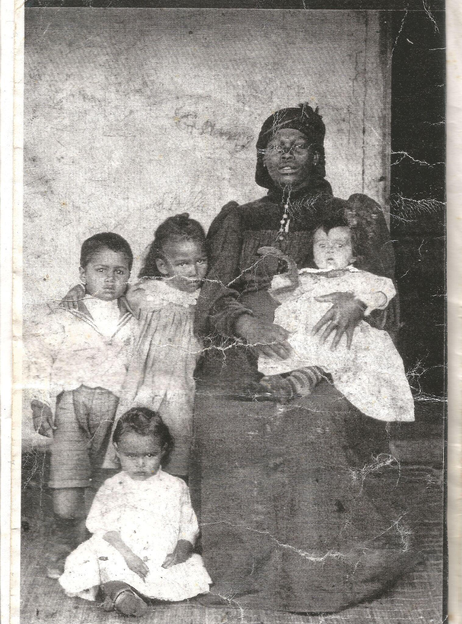
Mr Green's wife and children. W. Read studio. Location Pietermaritzburg. Date unknown.. Photo courtesy: Jenny Catin
Who is this woman who seems part of but removed from this image? The children’s skin tone (another gaze I cannot refuse or turn off and am trying to unlearn) beg questions of my categorizing sight. How does this family relate? How does this family reflect their time? Where is this place and time in which this family is possible? Where is Mr Green? The haptic nature of the image are the various cracks, and fold lines. Is it writing on the photograph itself? And what does it say? Perhaps these were their names? A suggestion of an identity, a clue of the past, to the present, to the future.
Our normative association with race and racial classification has been constructed to place these children and their mother as separate entities within the frame, as objects of racial representation and a disassociation with each other. However, we argue that Proclamation 73 challenges these classifications, and their place- making in history, through this visual narrative, re- presenting a range of what constructs a family portrait, and indeed, what constructs the family.

“Questions on ancestry become particularly visible in the family photos that enter the domestic sphere, in which the European white grandfather would be prominently featured in the dining room or living room. Yet, the “of colour” counterparts, often Khoi, San, Zulu, Xhosa or Indian, of these white men remained silenced and visually absent. This makes archival projects challenging as family tracing becomes centred on legitimizing whiteness in a way that Blackness is not. This calls for new forms of engagement with family photos that visually disrupt linear static racial narratives.” We refer to Santu Mofekeng’s The Black Photo Album/ Look at Me:1890-1950 (2013) in relation to the family portrait, particularly pertinent to the image in our case study because it appears to have been taken in a similar period to those in Mofokeng’s book. Within the frame, this image falls into colonial trappings that in James T. Campbell’s essay in The Black Photo Album he notes “Yet even as they reject one set of visual conventions, the photographs accept another. Studio portraiture in the late Victorian and Edwardian eras was a highly conventionalised art, with its own protocols, props, and poses, virtually all of which can be seen here. Subjects sit or stand in front of painted backdrops featuring floral arrangements or classical columns” (Campbell, Mofokeng ed, 2013, para. 4)
In its materiality, the image functions in a way which challenges our interaction with it. Tina Campt talks about the social life of the photo in her book Image Matters, Archive, Photography and the African Diaspora in Europe (2012) considering both the “social, cultural and historical relationships within the image, as well as a larger set of relationships outside and beyond the frame” (2012: 6). Campt refers to Stuart Hall’s Politics of Reading as reductive in engaging in an image’s ‘perpetual inscription in multiple historical contexts’; its (subsequent) implications in current systems of classifications; and the significance of absence in those histories and truths which remain uncaptured, and to a large extent, untold.
How we read this image as the social life of the photo in our context optically foregrounds race. The image interrupts our trained sense of place and placement- we can’t place race easily in this image because our racialized gaze is always around categorization because of our social context. We argue that this image requires us to unlearn seeing race in these terms but also interrupts that optical intent to place. It challenges how race functions and how family functions in that way. The image interrupts reading narratives of history and race and their legacies, in their established ways particularly within the South African context. The aspect that this photo as a part of someone’s family photo album prompts questions of identity and belonging, along with race and placement- and what it might mean for this to be included as part of the family photo album. It is displaced as a family portrait, as an object, when placed in these traditional (constructed) family portraits. The subjects of the photo are also displaced, their names unknown. It is displaced temporarily, as its date is unknown, and only by recognition of the clothing, can we possibly place it within a certain period, but with no specific date.

In narrativizing the initial reading of this image we make use of the personal register. We see family photos as arguing for the intimacy of looking - either as a projection of our own familial histories or of their absences in relation to the images. We are arguing for the place of the intimate in the reading; and arguing for the placement of the viewer as explicit.
The exhibition and the curatorial methods resist the inclusion of the official, the overtly political, the explicitly activist - instead we see in the exhibition and the images themselves the focus on the quotidian. Zara Julius notes “All those questions around concealment. That’s where the album becomes really beautiful and important because it’s a way for us to explore ourselves without having to be on the frontlines protesting and picketing. And whilst I think that being on the frontline is important there’s other more subtle ways of protesting and activism that I think people enacted in the ways that they curated themselves for themselves. That’s why I liked the album as a medium.” (Pers.comm, 2019)

Conclusions
Through the mnemonic aesthetic we place this image as an active ritualised process of remembering, politically implicit and visually explicit. If, as we suggest, the mnemonic aesthetic in this image visually constitutes a ritualised politics in remembering then, the politics of memory (both memory-making and memory-meaning) informs the rite of representation.
The exhibition reinstates this rite, and offers an alternative political inscription into memory.
In this, the family album’s rite of representation manifests as a ritualised process of remembering through a visual narrative of forced migration. Through this visual narrative, the re-presention of what constructs a family portrait requires us to unmake the political processes of representing and remembering; and re-ritualise the making of what constructs a family in order to place these visual narratives of displacement.

