The crafting of Malende rhythmic motifs in indigenous Venda music
with specific reference to Tshigombela and Tshikona dance – A fieldwork-based composition research enquiry

Evans Ntshengedzeni Netshivhambe

Thesis presented for the degree of Doctor of Philosophy in Music at the
University of the Witwatersrand

Department of Music

Faculty of Humanities

Supervisors:

Professor Jeanne Zaidel-Rudolph and Professor Brett Pyper
Declaration

By submitting a hardcopy or electronic copy of this thesis, I declare that the entirety of the research work contained therein is my own creative enquiry and an original work of which I am the sole author unless stated otherwise. The reproduction and publication of this research enquiry by the University of the Witwatersrand will not be an infringement on any third party rights and I declare that I have not previously submitted any of this work in part or in its entirety for obtaining any qualification.

________________________
19 August 2019

Copyrights © 2019 University of the Witwatersrand
All rights reserved

Table of Contents
Acknowledgements iii
Introduction 1
Research methodology 6
Chapter 1 15
Understanding referencing through the composer’s ear 15
Chapter 2 35
A brief historical account of Malende, Tshigombela and Tshikona, dances since the 1960s to the present 35
Chapter 3 56
Composing indigenous musical history: my fieldwork in Venda 56
Chapter 4 80
Analysis of Malende, Tshigombela and Tshikona rhythmic motifs 80
Chapter 5 119
Reflections on the processes applied to selected Venda-inspired works in my composition portfolio 119
BIBLIOGRAPHY 151
ARTICLES 155
THESISS 156
INTERVIEWS 157
DISCOGRAPHY 157
MUSIC SCORES 158
INTERNET SOURCES 159
APPENDIX A 160
Music Transcriptions 160

Acknowledgements

One component of this PhD research consists of a composition portfolio, while the other component consists of a thesis. I am very grateful first to Professor Jeanne Zaidel-Rudolph for offering her precious time to guide and direct me in my composition studies. She has given me her valuable guidance, advice, mentorship and expertise. You are such a great asset to the University of the Witwatersrand as well as South Africa and the world at large. I have always been inspired by your contribution to the music world, your love for music and your dedication to educating others. I am grateful for your contribution from the start to the end of the entire project. You continue to guide and direct my thoughts and I have learnt much from your teaching style and your passion for composition.
Professor Brett Pyper, your support has carried me through the research experience and I am grateful for everything. Your experience in the ethnography field has been very helpful for me in undertaking my fieldwork. I benefitted from your guidance and supervisory leadership. I could always count on your assistance and support throughout my research project. Your insights and academic scholarship have profoundly enriched me.
Professor David Andrew, without any reservations I would like to say from the depth of my heart, thank you for all your unconditional support, which you showed throughout my studies, particularly in the beginning phase. I strongly believe that without your intervention as the chair and coordinator of the postgraduate committee I would not have pursued my PhD.
Mr Samson Ratshalingwa Netshifhefhe, working with you was a wonderful experience that I will always cherish. Your dedication in training me and teaching me how to understand Tshigombela music and Venda indigenous music has been invaluable. You have taught me how to dance the Tshigombela and to understand Venda music at the deepest level. Your guidance and references to other practitioners have been helpful to me. I would also like to extend my appreciation to Mr Wilson Raphalalani also known as “Mr Sinyegwe, or Vho-Maine”, who taught me a great deal about Tshikona music. I sincerely appreciate the support from the Tshaulu and Matondoni Tshigombela communities under the leadership of Mr Netshifhefhe. Thank you for taking the time to dance for me in order to record your performances for the purposes of my analysis - as well as answering many of my questions.
I am grateful to the amazing group of composers that I have interviewed and worked with throughout my research. This project would not have been possible if not for your intellectual insights. All the composers I have worked with were willing to go the extra mile to answer my questions. It was wonderful sharing your aesthetic philosophies, which have added considerable value to my research.
My grateful thanks go to my wife, my daughters and my mother who have been so supportive during this research journey, and whose sacrifice I deeply appreciate.
I would also like to thank the SAHUDA scholarship entity for their doctoral support programme. Due to this generosity, I have been able to make extended trips to Venda and to stay with the practitioners in order to complete the research. I would like to say thank you very much to the National Institute for Humanities and Social Sciences (NIHSS) for their financial contribution.

Introduction

This creative doctoral research interrogated the complex rhythmic elements found in Venda traditional music and explored how these can inform my work as a composer. I proposed to focus on the varied rhythmic layerings and their congruities, which characterise the three traditional genres: Tshikona, Tshigombela and Malende. In order to understand these dances it is important to start with Malende because I found it to be the rhythmic key to understanding the other two genres. I was particularly interested in the relationship between dance and rhythmic organisation. Based on my experience as a dance practitioner and fieldwork, I maintain that dance movements function as coded signals to communicate specific messages that inform change in the music. My choice of pitches in my original compositions is an individual one, using poetic license while still composing in the style of, and inspired by Venda music. Therefore, much of my own music is not necessarily directly referencing Venda music melodies. My primary music reference is the rhythmic parameter which is reproduced in melodic form simultaneously– the actual pitch choices are original but in the service of the rhythmic motifs and patterns.

In the thesis that accompanies my composition portfolio and transcriptions, I demonstrate this interaction between dance and rhythmic structure, and I draw on this as material for my original compositions. I was interested in researching these dance forms because I am an “insider” and this is my own culture and therefore I have a huge advantage in being able to have experienced the dance forms personally growing up and being a practitioner of these dances my entire life. By being an ‘insider’ I am referring to the fact that I am a Venda-speaking person and I am doing my research in the community of Venda people, even though I am from a different community from the villages in which I conducted my research. I do speak the same language as the people who form the subject of my research but possessed little experience of their practices and knowledge regarding the three music genres at the core of my study. Some of the composers chosen for referencing in this research also originate from Venda. However, it is important to note that their referencing approach from Venda traditional music is different from mine, as I have training in Western art music.
This research aimed to shed light on the process of referencing indigenous music for the purposes of creating original new compositions. This study reflects my practical experience in the field, working with traditional practitioners and using elements from their music, particularly rhythmic patterns and how these combine in selected songs from the Malende, Tshigombela and Tshikona traditional music sources. My participation in the traditional live performances greatly enriched my understanding of how the many different rhythmic layerings interact with one another. I engaged in a constructive dialogue that would seek to find areas of convergence or divergence between ‘modern’ and ‘traditional’ music, with a view to exploring how compositional elements of the three selected styles can be used as a resource for my creative research and output. I interviewed selected composers who have used techniques such as quoting rhythms in their contemporary compositions with specific reference to Venda contemporary/traditional music.
There are foreground and background composers in this context based on their approach to referencing indigenous Venda music. The foreground composers are Venda composers who are drawing significantly on Venda music as I am. These composers refer to the same material as I do, but in a different manner, as they are not classically trained like me. I originate from the same place as these composers, but my outcomes are different. These composers and I are quoting from the same musical sources and music, but with different trajectories. The ‘background’ composers originate from environments such as choral, popular and contemporary music that do not draw on Venda music. Not all the composers chosen have drawn on Venda traditional music for inspiration. My criteria for selecting composers for this study hinged on composers who demonstrated that they quoted rhythmic elements together with indigenous music references in their compositions. A primary outcome of this research was to compose music that establishes an integration of my own creative composition devices together with elements of Venda indigenous music, particularly rhythmic devices. Participating in the field performances was also one of the most enriching consequences towards a profound learning experience.
Through this research, I am demonstrating that the use of different compositional principles found in indigenous music can be integrated with one’s creative work and be reshaped, remodelled and incorporated as one’s own composition techniques. I would also like to acknowledge that composers have been doing this for some time, even if not with reference to the specific genres on which I have focused. I aimed to identify rhythmic motives that are distinct in the three selected music/dance genres in order to incorporate them later as part of my creative process. I have investigated how the elements of dance impact on the creation of the music in Venda indigenous culture and have transcribed these dance movements employing a notation aligned with music notation. These rhythmic motifs form the basis of my pattern referencing; in this case transforming the rhythmic patterns into melodic shapes and contours. I have attempted to notate the rhythmic motifs created by drums, dance movements, hand clapping and some singing patterns in order to analyse and synthesise my findings.
The conventional Western Classical staff notation needed to be adapted by integrating it with my own original notation symbols, which accommodate the dance movements. This research also elaborates on the important social functions of Venda indigenous dances and how they are used in several contexts to support the signification or coding concept that I will discuss in detail in Chapter Three. There is a specific body-coding used as a signifier by the dancers to indicate to the drummers as to when to begin playing a particular rhythm at a specific time. Due to time constraints, I have decided not to use this feature in my own compositions, although it plays an important role in the Venda music practice.
I maintain that these rhythmic motifs can be best illustrated and comprehended by applying a semiotic approach. I have applied a semiotic approach by referring to how meaning is created during a performance and how signifying is understood as a code in this context. My approach in theorising the reading of body dance movements as coded signals that communicate certain messages is informed by the live performances I have observed of the three genres. The theoretical approach is that the dance movements function as coded signals that can be compared to the way Western-trained musicians read a musical score.
There are two broad reasons for undertaking this research. First, there is a paucity of literature about Venda music, which I believe is an under-researched and under-documented area of study, particularly relating to the aspect of the existence of standard rhythmic motifs in the traditional music forms. While some aspects of Venda music have been more widely studied than other indigenous South African genres (particularly in the light of John Blacking’s work (1967, 1973, 1995)), the compositional elements of Venda indigenous music, both within its cultural context and as a tool and source for composition in aspects of rhythmic layering to which I refer, is under-researched. I would like to acknowledge Blacking’s contribution to research into Venda music. However, I would also like to point out that much of his research was on children’s music, women’s initiation schools and possession music - with some aspects of cultural music such as Tshikona, Tshigombela and Malende. Jaco Kruger’s research (1986, 1993, 1996, 1999 and 2000) covers the socio-cultural politics relating to the three genres; Kruger pursued his research during the time of major political changes in Venda. This has had an impact on the coverage and focus of his research in Venda.
I wish to contribute my personal knowledge of Venda music and culture as an inside practitioner by adding to the body of literature that relates to the topic of Venda music. I have a strong interest in Venda indigenous dance music composition, particularly within the context of my training as a Western art music composer. I will specifically focus on the rhythmic patterns and motifs found in the three Venda dance-music genres. My transcriptions of the indigenous music reveal how these patterns form rhythmic layerings consisting of singing, handclapping, drums and other instruments – refer to the APPENDIX for the transcriptions of the different genres.
I discuss the manner in which the gestures and movements of a dancer’s body during a performance can be understood as ‘reading’ music; just as musical notes on a sheet of paper are presented for practical application. I have considered how the signs and symbols of music notation can contribute to the broader understanding of these music-dances, and how these signs or symbols can be applied in further creative work. This research has explored whether the rhythmic layerings used in the three particular forms of indigenous Venda music could also be understood through the idea of embodiment from the dancer’s perspective. Namely, that some aspects of the musical structure may be embodied in the rhythmic movement rather than necessarily be articulated in sound or signs by the drummer and other instrument players. The aspect of embodiment would only be explored from the dancer’s perspective - while reading signal codes would be explored from the drummers’ perspective. The two concepts ‘reading’ and ‘embodying’ are used and understood differently, depending on who is decoding the rhythmic structure. Dancers embody the rhythmic structure while instrumental players read the body movement to interpret and understand the embodied code. Another reason for embarking on this area of research relates to the possibility that the transcriptions emanating from the fieldwork research will provide a body of documented music for future scholars and contribute to the documentation and preservation of Venda music as a pedagogical contribution. Institutions such as the SAMRO archive could be the hosting homes for such transcriptions in the future.
In addition, my personal experience as an indigenous dancer has encouraged me to pursue this investigation. Some of the information gleaned will be from my own experience as a dance practitioner - one who has performed in many indigenous settings and competitions while still doing my undergraduate studies. I also seem to have an instinctive rhythmic ability when it comes to interpreting and understanding indigenous dance music. I was curious to establish if this is in fact a ‘natural’ inborn skill and sense, which others refer to as ‘inherent talent’, or whether it is actually a ‘learned’ artistic skill and phenomenon.
I have also discovered that much contemporary Venda popular music incorporates elements of indigenous music sourced by referencing or quoting directly from traditional music, which stimulates my curiosity. Being an indigenous traditional Venda music dancer has played an important role in my desire to understand the relationship between the rhythmic layers that form part of performance and the so-called ‘inherent rhythms’ in the dances. Most importantly, being a contemporary art music composer has also inspired me to increasingly want to research the rich indigenous creativity in traditional Venda music by referencing its rhythmical elements in my own creative work. Indeed, many modern contemporary Venda musicians are returning to their roots by redefining new music that is based on fundamental indigenous music features. I believe I have gained valuable insights during my time as a traditional dancer in the field of Venda indigenous music during this project when it comes to interpreting or ‘reading’ musical cues and signs indicating changes of rhythmic patterns.
I embarked on this research because I had always been impressed by great performances displayed by Venda indigenous groups dancing at various competitions. Cultural heritage traditional music performances, traditional music competitions organized by different cultural groups that display the rich and yet complex polyrhythmic textures have been a source of inspiration, as they never ceased to amaze me. I was also a cultural dance activist during my undergraduate studies, when I participated in indigenous dance competitions at the University of the Witwatersrand with other South African cultural groups on Cultural Heritage Day from 2005-2009. I have personally led a traditional Venda dance group during my undergraduate studies, which won three competitions in a row year after year from 2006 to 2008. I led this group for three years while I was still at University but others have taken over since then.
Competitions are organised to encourage participation by communities, as well as for reviving cultural practices. However, in my own experience, having grown up dancing and participating in traditional Venda performances from a young age, the competitions were a later attraction, and not my initial exposure to my own cultural music. The competitions have played a role in reframing indigenous performance – by encouraging participation with monetary temptation. Based on my above experiences, I believe that there is something unique and special about Venda indigenous music that draws people’s attention. This cultural treasure has motivated my determination to pursue my research in Venda music, with a view to utilising some of the special features contained therein as reference or source in my own creative work.

Research methodology

Research methodology can be one of the most challenging aspects of research that involves fieldwork engagement, particularly of a compositional nature. This is because for a long time composers and ethnomusicologists have been debating the problems relating to a formal or standardised practice for conducing field research. However, since every research project is unique and different, it is impossible to come up with a standard methodology that can suit every type of field research. Composer-researchers define their methodologies individually according to their experiences but most of them adopt principles that are viable and for maximal outcome relevant for their research.
Having read about the early experiences of several of the leading ethnomusicologists and researchers of African music, such as Alan Merriam, Bruno Nettl, Philip Bohlman, Willie Anku, Simha Arom, John Blacking, Meki Nzewi, Kofi Agawu to name but a few, it is apparent that research methodology is distinctive for each research. I set out to investigate and study the rhythmic designs in the practice of three indigenous Venda genres (Tshikona, Tshigombela and Malende).
My methodology has been to analyse and later synthesise the dance rhythms by initially transcribing what I heard, saw and performed myself. This has been a praxis-based project to explore the formal structures of the traditional dances and music in relation to their rhythmic components revealed in live performance. The relationships intrinsic in the different rhythmic structures and their internal connections are discussed. By their nature, there are flexible fluctuations in each performance, though any improvisatory element is controlled.
The field trip to Venda was a ‘wake-up call’ for me in terms of my understanding of the importance of documenting the history and practice of the participants and how this documentation should be regarded as an integral part of a scholarly pursuit. When I pondered over this, it seemed that I should be looking for my own shadow as a composer; especially as an ‘insider’ researcher who seeks to use a cultural study as knowledge enhancement for creative research, namely new compositions. By “shadow” in this context, I am referring to my previous experience as a Venda dancer-practitioner who was not aware of the hidden potential to be discovered in the traditional dance practices; this experience would later be an influence in my desire to compose. I am using the metaphor of the shadow in a different way to that in which Barz and Cooley have in the literature.
A human shadow is part of one’s life, a doppelganger that accompanies one everywhere and needs to be taken cognisance of. In the same way, my previous experience as a traditional dancer has always been there, but was never activated until I started this project - to be later translated into a compositional referencing tool. By looking at my footsteps and rich experiences gained as a dance practitioner, I realised these footsteps became the catalyst for my future compositional endeavours.
I went to Venda for my first field trip in December 2015 in order to consult, meet with and greet the practitioners identified for the research. It was during this trip that I also arranged for the signing of ethics, consent and participation forms. This was an important meeting for both practitioners and for me to clear any questions that may arise concerning their participation in the research project. I had to translate the consent forms into the Venda language so that the practitioners would be able to understand the implications thereof for themselves and give their consent by signing.
I needed to also clear any misconceptions relating to copyright usage of the material being recorded and transcribed for research purposes. My intention was to make the practitioners aware that the content recorded would solely be used for research purposes and academic use only. However, in the future, if the need arises for my compositions to be used for broadcast or public performance, I would inform the user that the music would not infringe anyone’s copyright, as these would be new compositions informed by Venda music.
I worked with two groups from two different villages, one from Tshaulu and another from Matondoni village. For the minors who were already part of the Tshigombela dance group with whom I was working, their parents had signed on their behalf. I did not want to include minors in my research project but I discovered that, the Tshaulu group also included some young people in their Tshigombela music; it is the young girls who do most of the dancing while the older women play the drums and sing. The other reason is that young people have the energy to dance as compared to the older people. Involving young girls in traditional music performance is also seen as training for the young girls to become better performers of Tshigombela music in the future.
I made seven trips in total to the field in Venda for my data collection and where I arranged to meet different groups that participated in the research. Four of the excursions were set up to meet individual leading group members and leading dance practitioners for specific interviewing sessions. Meetings with specialists were more constructive in relation to questions I had but less effective in terms of the practical application of their information. Group gatherings were more effective for question and answer sessions. Each time I went to visit either the specialists or the group members, I would take along my video and audio recording devices so that I could capture the discussions with the practitioners – I had no assistant when recording the material, which became quite a challenge, especially when trying to dance with the group myself.
I had to position the camera in one spot, press record and start performing with the group. Being part of the performances became the key data collection for me. My active participation later helped me analyse the music with better insight as compared to only using recorded material. I soon realised that I needed to always have the camera switched on when I was with the practitioners as there were many performances that just occurred unplanned and I needed to capture these spontaneous performances, which later become a valuable source of information.
I recorded many pieces for each of the musical styles about which I was researching and for each form of indigenous music needed, I recorded and analysed more than three songs; this helped me to isolate one rhythm at a time for each musical style being studied. Since I registered for the PhD degree in the second half of 2015, my research and musical processes began in December 2015, when I arranged a series of interviews with Samson Ratshalingwa Netshifhefhe, the person responsible for the Tshigombela and Malende dance groups of the Tshaulu village. Tshaulu is a rural village in the far north of Limpopo towards the Zimbabwean border. The significance for my choosing this region in preference to others within the former Venda area is that it is the only habitation in Venda where Tshikona pipes are found. It is also the only area in Venda that has a ‘queen’, as it is believed that the throne in that kingdom refuses male leaders but only accepts female.
I was fortunate to have had the opportunity to have a conversation and an interview with the biological brother of the ruling queen in that area who has explained to me the taboos of their kingdom. He has also given me better insight regarding training of Tshikona dance in the Tshaulu area. This place is very remote with very little access to things such as water, electricity and proper road infrastructure. Most people in this village practice the old traditional ways of doing things, such as honouring their leaders through cultural performances and are still under the rulership of kings and chiefs - following their orders. I visited Tshaulu in 2015, 2016 and 2017 to interview Netshifhefhe and the dance groups, to participate in the village dances as well as to record my research material. This experience was immensely useful, as I had to learn to correct my dance steps on the spot while observing the lead dancer as part of the valuable learning experience.
The purpose of these visits was to immerse myself in the village’s musical culture and to understand its traditional dances through first-hand participation and observation. Eating their food, sleeping in the vicinity of their village, dancing with them and talking to them to better understand how they conceive their music, was most helpful to my data collection. My approach and aim was to establish trust between the practitioners and me. I also believed that the best way to understand cultural dance is to be a participant in order to best internalise the rhythms. This also afforded me the opportunity to ask questions that could only be answered through active participation in some of the dances, and not through the completing of a questionnaire by the musicians/dancers. When I would struggle with a dance movement, I would be shown a practical solution immediately on the spot - something that was easy to later remember. During the entire process, I introduced my creative dance moves into the practice to make it easier for the dancers to get used to learning new dances when the time for the composition concert performance comes. This experience was priceless and could not be compared to recording the material and analysing it later in the laboratory.
During my interactions with village leaders and music practitioners, I experienced initial difficulty obtaining information; this was due to their previous dealings with other researchers and their negative experiences with them. This was based largely on the village leader’s experience; he mentioned to me that the lecturers and students, who had previously approached him, sought out his indigenous knowledge, without demonstrating any sensitivity or reciprocity regarding any benefit to him or his people. As I questioned him deeper, I discovered that Netshifhefhe was concerned more about the respectful manner and cordiality in which the research is done that can become an issue. I also discovered that he appreciated favours such as opportunities for the group to perform in Gauteng and other places that are far away from the group’s village and the buying of uniforms for the group if this became possible financially. I later found out that the group likes to enter into local traditional music dance competitions and it often does not have the means to participate due to financial difficulties or if it does compete, it does not have a representable performance uniform.
There is a subconscious perception, which is often not negotiated, namely, “what is in it for us ‘group members’ in order for us to participate in your research project? This is one of the reasons why traditional practitioners feel that they have not been respected as they put great effort into assisting the researcher but receive nothing in return – and feel ‘used’. Most researchers are white, or people who do not speak their language; this situation results in poor communication between research and the practitioners, who do not have the freedom to express their wishes.
My first visit to the Tshaulu group was similarly affected by negative experiences related to previous researchers. In spite of arranging my visit in advance, when I arrived there almost none of the participants were available on the day, ostensibly because of a soccer match-taking place at a local stadium. Netshifhefhe admitted that the soccer match was merely an excuse to avoid having to talk to me. I took great pains to emphasise the legitimacy of my visit (displaying my student card as proof) and I had to explain the purpose of my visit in great depth. Netshifhefhe played a very important role in connecting me to the participating groups because he lives in the same village as the performers. I have also learned that he knows many people since most of these practitioners perform in some kind of ‘group network’ in which they all seem to know each other, or the practitioners sometimes meet at local traditional dance music competitions.
I made sure that each participant understood and completed consent forms to participate, before I undertook any research. I ensured that they understood the particulars of the consent forms by translating all the forms into Venda language. While there were some who were unable to even sign their names, these were assisted by the village leader, who wrote their names on their behalf, only once they acknowledged that they understood their role and participation in the research.
During my research trips, I also had the opportunity to benefit from one-on-one lessons with Netshifhefhe, who taught me the dances and how to master the dance steps. Netshifhefhe also arranged for a young drummer to provide instruction on various drum patterns, as well as how to respond to the dance steps while playing the drums during a performance. During this, a young woman by the name of Musiwalo Munyai was very helpful in teaching me the dances and was patient with my efforts throughout the process. The combined efforts of these villagers have helped me memorise the rhythmic patterns integral to the Tshigombela and Malende dance forms. The participation exercises also helped ensure that I understood the standard rhythmic patterns found in all the dance forms.
I created a set of questions that were intended to elicit longer answers instead of simply ‘yes’ or ‘no’ answers to guide the practitioners. However, I did find that it was occasionally difficult for practitioners to offer direct answers because their understanding of music practices was either absent or completely different from a scholar’s approach. I also discovered that they do not even have a vernacular word for music; instead, they use a borrowed word from English called “Muzika” meaning music. It was difficult to find relevant terminologies to sufficiently express the intended meaning.
The fact that I spoke the same language as these practitioners went a long way towards expediting the process of unlocking some complexities in the use of some musical terminologies. They would sometimes employ traditional riddles or parables, which I was able to understand immediately in explaining their understanding of their music. This allowed them to speak more freely with me. I was able to connect with and work with the group – both through my teacher, who was also the dance group’s leader, and with their freedom to approach me directly.
Following my first visit to Tshaulu, I returned to Johannesburg and downloaded the videos and audio recordings I had made during my time there. This enabled me to begin the analysis process. I then discovered that the rhythmic motifs in all three forms confirmed my initial belief regarding a distinct standard or common rhythmic pattern to be found in the styles. I wanted to understand the relationship between the rhythmic patterns employed in the dances and what characterized each dance. A standard rhythmic pattern in this case is used as an identifying rhythm that synchronizes with other rhythmic layerings in a performance, with which all Venda people (who practice and know about such dance music) are able to associate, regardless of their geographical location. I am confident to make this latter statement having attended many competitions from different places (in Venda and Gauteng) with traditional dances that were the same throughout. Even though they did not form part of my data collection, they helped me in making a comparative analysis. However, I noticed the same practice occurring in different locations where these dances were performed.
It was exceptionally rewarding to find that my initial enquiry regarding the distinctive rhythmic motifs could be answered through the rhythmic analysis of the dance steps. Participating in the performances was crucial in helping me to recall the necessary dance steps that would enable my analysis and subsequent synthesis to be conducted with greater accuracy and ease. In many instances, I would dance out the rhythms physically, particularly when I was unable to discern them from merely listening to or watching the recordings. After identifying the one distinct standard rhythmic motif, I then transcribed the music into score notation. It was great eventually to find out that there is a distinct rhythmic identity, which is found in the Malende music.
All transcriptions once again confirmed that my main research question could be answered by personal participation in the rhythmic dance steps. Analysing through observation, as well as through reviewing the recorded videos proved to be more difficult than through dancing the rhythms myself. Furthermore, understanding certain valuable techniques for strategic data collection in the field proved to be very helpful, as it minimised unnecessary and excessive time in the field. Upon completion of the analysis and subsequent transcriptions, I began employing the distinct standard rhythmic motif in my own music; I needed to apply what I had discovered regarding the distinct rhythms and to compose a creative portfolio of music based on the traditional framework of Venda rhythmic structures.
The process of transcribing the authentic Venda music was profoundly helpful in my being able to create new original music that is both rhythmically and technically challenging; this is quite different from my previous music compositions, which were created in a quasi avant garde style. I use the team authentic with extreme caution here knowing very well that it is a loaded term and requires careful consideration. Other than my previous experience as a child in these musical genres, the competitions have also informed my research and to an extent changed my practice as a composer. Had it not been for these experiences I do not think I would have had an interest in referencing traditional music.
One of my initial rationales for my research involved finding out if this entire process was going to assist me in discovering my compositional voice, or at the very least contributing towards the development of my own compositional technique. This turned out to be the case – I have always been very passionate about incorporating indigenous Venda rhythmic patterns in my compositions, but to this point had not understood how to do this in a creative and holistic manner. My compositions over the last two years have been greatly and positively influenced as a result of both my research and my immersion in performing the above practices. My work in this area has contributed enormously to my overall development as a composer, finding my individual voice and in the creation of my personal portfolio.
The activity and process of listening involved devising a strategy for identifying separate rhythmic layers in order to identify the district rhythmic motif, played by a variety of instruments during a single performance. Initially, I simply replayed my recordings numerous times in an attempt to identify and isolate the rhythms. This was a difficult and laborious exercise. In the majority of the songs, there were three, and sometimes four or five layers of rhythms being played simultaneously. I had to then isolate each rhythm and its relation to every other rhythm in the songs.
These layers could include hand clapping, multiple drums, singing, whistle blowing, as well as dance-step rhythms. It actually took me some time to either realise that frequently the distinct standard rhythmic motif is played by hand clapping or dance steps. The one for Tshigombela is strictly applied by dance steps while the one for Malende is communicated by hand clapping with an exception when both dance steps and hand clapping are occasionally combined.
Each of these would integrate into the song at different entry points, and each would possess a disparate rhythmic structure. What became helpful to me, especially with regard to isolating different rhythmic layers in the songs, was to listen to the big drum (the Ngoma Khuwalene) as a guiding reference that invariably plays the same pulse throughout the performance. Its steady pulse helped me to locate starting points for cyclical rhythmic patterns as a reference point with which to identify the beginning of the rhythmic pattern. This big drum pins the varied rhythms together, sustaining the whole of the song. Furthermore, the rhythm of the dance steps is exceedingly complicated, making it difficult to isolate them within a song.
This is largely because it entails physically watching the dancer/s in order to identify the rhythms. Some of the dance rhythms are “kick rhythms” (where the foot kicks into the air or sometimes hangs gently in mid-air), while other rhythms involve stepping on to the ground - these may include the accented or unaccented rhythms. While some of them are easier to remember or identify if one has participated in the performance themselves, other rhythms are not easy to identify without physically looking at the dancer in question.
Sometimes, the singing can also be used as a point of reference, as a number of songs use the same structure with ‘call-and-response’ patterns/phrasing. This can also be used as a point of reference to identify other rhythms, because the response portion of the singing will remain the same throughout the song (and its starting point can be used to identify the beginning of each rhythmic cycle in the song).
My thesis is divided into five sections. This previous section introduces the reader to the flow of arguments that will be unfolded throughout the chapters. The second section, which is entitled Chapter One, introduces the reader to the investigation techniques and methods used by other composers as compositional approaches in quoting traditional material. This includes relevant compositions from the literature created by other composers, who reference traditional musical elements. This includes literature that speaks directly to the compositional approach by other composers. The chapter will also discuss factors that have informed my focus on certain musical principles as an important part of the research process.
This discussion will then lead to Chapter Two that discusses the historical view and background of three dances. The historical account does not go into depth due to time constraints. The intention with this chapter is to bring the reader into close proximity with some background information relating to the three musical styles chosen for this research. The history section will take into account the matters of performance practice relating to the socio-cultural tendencies in relation to how the three musical genres are perceived in the Venda community.
Chapter Three concentrates on the fieldwork research and all the excursions taken to Venda to meet the practitioners. After deliberating on this chapter, I then focus on the analytical processes that have informed my composition.
The Fourth Chapter focuses on the analysis of the rhythmic motifs of the three musical forms with a view of trying to identity elements that can be used as part of the creative project. I found a rhythmic motif from each style that is very distinct and usable in my compositions, except for the Tshikona music, which uses fragments or some parts of Malende main motif. This chapter analyses how the different rhythmic patterns found in the three music styles can be used as compositional features. My entire composition portfolio has adopted the standard rhythmic motif for Malende as the main feature for my creative process. This was informed by the discovery that in order for one to understand rhythmic structures found in the other two genres one has to understand the Malende rhythmic structure first.
The standard rhythmic motif for Tshigombela is very long as compared to the one for Tshikona and Malende and it is used in its entirety but in different permutations of the Malende standard rhythmic motif. This was one of the guiding reasons why I chose to use the motif for Malende music in most of my compositions. The motif for Malende is short in length and easy to work with. Tshikona did not really have a standard rhythmic motif that is distinct in musical form; however, there are fragments of the Malende standard rhythmic motif that can be put together to form a complete structure.
This chapter leads to Chapter Five, which is the last chapter - this is a reflection of the entire research experience from discussions with other composers, analysing their music, field research experience, analysis of Venda rhythmic strata, compositions ending with the final concert performance. Chapter Five is a reflective introspection from fieldwork trips to the end of the concert performance. The focus here was to give the reader an overview of the research experience while discussing areas of difficulties and those that succeeded in the research project.

Chapter 1

Understanding referencing through the composer’s ear

This research aims to demonstrate, analyse and elucidate the rhythmic structures prevailing in the indigenous music of Venda culture, with particular reference to the integral relationships between music and dance of the three selected forms Malende, Tshigombela and Tshikona. The three genres have a dominant presence amongst the different genres of Venda music practices. There are certain rhythmic similarities when compared to the musics of other surrounding cultures –in Southern African and broader neighbouring African musics that share common practices with the Venda. The Bapedi people in Limpopo, for example, share similarities to the reed-pipe dance, Tshikona, that they call Dipina, while the other neighbouring traditions across the border in Zimbabwe also share similar practices, such as the possession music (Malombo) and other dance music. None of my three chosen music styles involve possession music. I am familiar with many contemporary (popular) Venda composer(s) who draw their compositional material and techniques from elements of Venda music in their compositions. I will cite a few examples of such composers in this chapter.
The concept of borrowing from existing traditional material is not a new one as many composers in all genres have done it in the past and continue to do so. There are some important references in the ethnomusicological literature by researchers like John Blacking, Jaco Kruger and Kaiser Netshitangani who have largely focused their research on the practices of Venda people. However, it is important to point out that none of their research concentrated on the technical analysis of the characteristic rhythmic patterns. Blacking has done much analysis of children’s songs, like Kruger, while Netshitangani has focused his research on initiation school music for male circumcision practice.
I am not aware of any contemporary Western art music composers that have engaged with and been inspired by practical experience in the field, rather than simply from the scholarly literature on Venda music. The order in which I have selected composers in this study is not based on historical sequence but on the type of referencing they apply in their music in relation to my core research. I began by investigating researchers who are part of the Venda culture as native composers, and later incorporated the native composers who were not part of Venda culture but have used the same approach of engaging with traditional practitioners, and lastly interviewed composers who have applied other methods of quoting traditional music in their compositions.

One of the most difficult tasks for a composer is the aspect of choosing musical aesthetics. By this I am referring to a composer’s expressive voice that differentiates him/her from other composers. There is also the element of sound design, which demonstrates how a musician uses the parameters of sound as his/her artistic signature, which characterises the style of a composer. The performer of this genre has a responsibility to approach the music with a sensitivity and understanding of the aesthetics.
I would like to add that composition, performance and improvisation as research have become topics of debate for many scholars in the 21st century and these practices have been recognised as creative research. Since the methodology employed in these practical and creative spheres is different from that employed by musicologists and others in written texts, it is difficult to quantify the different value of these contributions. It has become clear that practical creative pursuits like composition have as much validity as research as conventional research. One can no longer view practice-based output as a less important area of research – since written texts rely on the composer to produce work upon which the ethno/musicologists depend for their research material.
It is important to note that universities at large, including ones in South Africa, have advanced towards recognising artistic work as research. I am also aware that in 2018 the Department of Higher Education and Training (DOHET) embarked on road shows around South Africa giving workshops on how to equate creative research with written research. The assumption that only musicologists are the ones who do research is not correct, as composers and performers have to be involved in copious readings and background research in order to produce valuable creative outputs.
Mine Dogantan-Dack (2015) explains that this is a global challenge, experienced by many institutions that are mainly text- research based. In my opinion, any product that is aimed at enriching the body of knowledge regardless of the approach should be considered as research. According to the Oxford English Dictionary the definition of research is “a systematic investigation into and study of material and sources in order to establish facts and reach new conclusions”. This definition summarises research as consisting of an investigative process that is aimed at finding new insights, in which both forms of research qualify to be considered as research.
This chapter explores in particular, the art of referencing by popular indigenous composers, who use quoting and borrowing of material from traditional sources to enhance their music, by applying multi-layered rhythmic structures and techniques in their compositions.
An interesting Venda popular music composer, Naledzani Netshirembe, has utilised a unique approach in her referencing of traditional Venda music. She comes from Makwarela, which is a modernised location in Venda. She has used two traditional instruments, called Tshihwana and Lugibe lwa Lutanga, which are traditional mouth bows that are played by plucking the string to produce a sound that emits four tones. She composes using these instruments by juxtaposing them with modern contemporary instruments (like drum kit, Western guitars etc.) whilst referencing elements from the traditional music, as her way of quoting. She also uses a famous traditional Venda story-telling format, but infuses it with her own tale, as a consistent trademark of her music in all her CD compilations – this is called Salungano-Salungano. In an interview I conducted with her, she explained the following regarding her method of referencing:
Ndi tou nununa, I hum the music within me, I do not dream of my music, I think of what I want to do. When I start to compose my whole mind focuses on the sound, I start by humming the tune and then record it on the phone so that I must not forget the tune. When I get enough time I then put all songs together. My songs are Mafhuwe songs that are composed from humming, and then the words come later. Ordinary songs are not difficult to compose, as opposed to the composition of a salungano reference of traditional music. Salungano-salungano is a Venda traditional riddle that teaches tail stories about all kinds of things. The salungano songs have to have a good story telling as part of the song (Netshirembe 2015).

She uses rhythmic quotations from traditional Venda music and includes them in her contemporary compositions. Although she uses the traditional instruments as inspiration for her original music, she does not include these in her final compositions. She has chosen to marry the traditional and modern in her music to keep the traditional practice alive and as a reminder to Venda people that if people stop referring to their traditional music, it will soon be lost and disappear. When I asked during the interview why she focuses on traditional referencing in her music, she answered:
What encourages me to always refer to traditional music is that I have discovered our tradition is getting lost and there is not enough education done to make sure that the traditional heritage of Venda people is preserved (Netshirembe 2015).

This is her way of contributing to the preservation of traditional heritage Traditional Venda music, such as Malende, is often created with a special message to teach others something in society. For example, for many generations pre-1979 before Venda ‘independence’, women would not be able to be publicly vocal about matters that affect them socially, or about problems they have with their men. In fact, Jaco Kruger best states it as a very frustrating time for women, as young girls were not even allowed to go to school because it was assumed that they will go mad (1999:130). Traditional music, such as Malende and Tshigombela, have been a platform for women to freely express their grievances or problems facing them in their lives. Netshirembe also adds, in support of this practice, that women found singing to be a better way of self-expression than engaging in talking. She says that if you give a woman “mavhele a dzhenisa mutuluni a sinda”, meaning “maize-meal that is ground by hand on a traditional pot made from tree", she will use “Mafhuwe which means humming” to speak out about her problems while she is grinding the maize-meal. She says that she has copied the style of Mafhuwe as one of her compositional principles, which derive from the concept of humming in songs as a traditional reference, that gives her inspiration to compose more songs. She further explains, “Whenever I have something to talk or sing about, I start by humming the tune using a traditional instrument Tshihwana while humming in my heart” (2015).
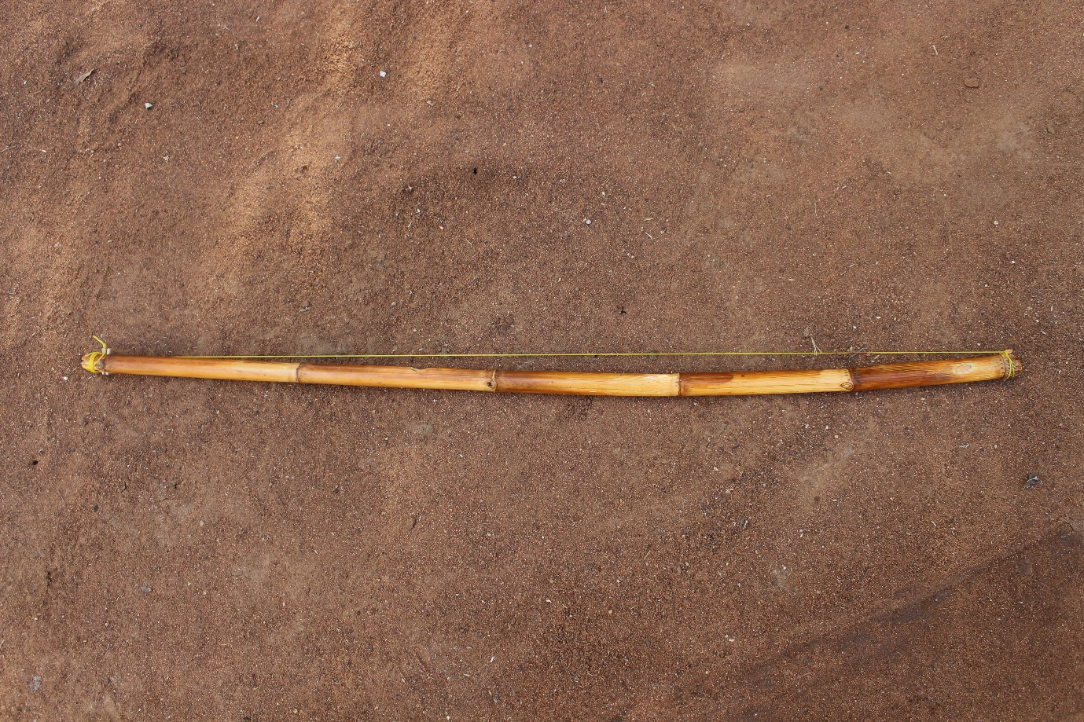
Figure 1.2 an example of an instrument called Lugube lwa Lutanga (another type of mouth bow) used by Netshirembe, which I photographed in 2018 while visiting traditional composers.
This bow also uses the mouth to amplify the sound, but the mouth is placed at the opening of the pipe with the other finger closing the other end of the pipe. The main difference between Lugube lwa lutanga and Tshihwana is not only the type of bow material used but also the string used. Lugube lwa lutanga uses a nylon string, while Tshihwana uses a steel string to produce a different tone. Both instruments are plucked, though in a slightly different finger technique.

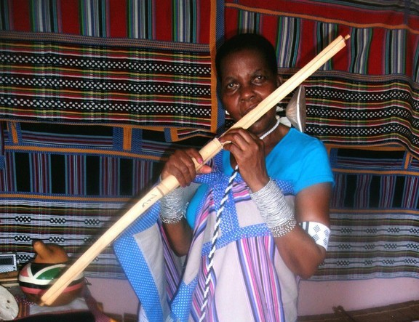
Figure 1.3 Naledzani Netshirembe playing Tshihwana (mouth bow).
Tshihwana has four notes, or four tones, which are used as compositional material by Netshirembe. She is not reliant on modern technology to compose her music; she uses memory, together with a recording device to make sure that she does not forget her new compositions. She uses traditional Venda instruments in her music to inspire her works. Murumba, Tshihwana, Lugube lwa Lutanga, Mbila Mutondo are all traditional instruments she uses to in her compositions. She plays the Murumba drum exactly the same way it is used in Malende traditional music to maintain the traditional rhythms. Murumba would be played as the common standard rhythmic motif of Malende in her music. Her style of referencing rhythmic motifs and patterns from traditional music, particularly Malende music, is derived from the incorporation of Murumba instrument in her music. This is the third mode of how she references from traditional music; the first being the “tale” as above; the second being the use of traditional instruments.
Maluta Matsheka from Mbahe village in Venda is one of the indigenous African instrumentalists who is proud of incorporating indigenous music elements in his popular traditional music. He uses a traditional instrument called Dende (male bow) in which he explores a special technique of creating multiple variations by varying and permutating the original Malende motif. He taught me how to use the Dende creatively to achieve many variations and thus compose many songs. The example below is an extract from a song called Musadzi ndi Maungedzo composed by Matsheka. I have only extracted two bars to show where the rhythmic motif is used.
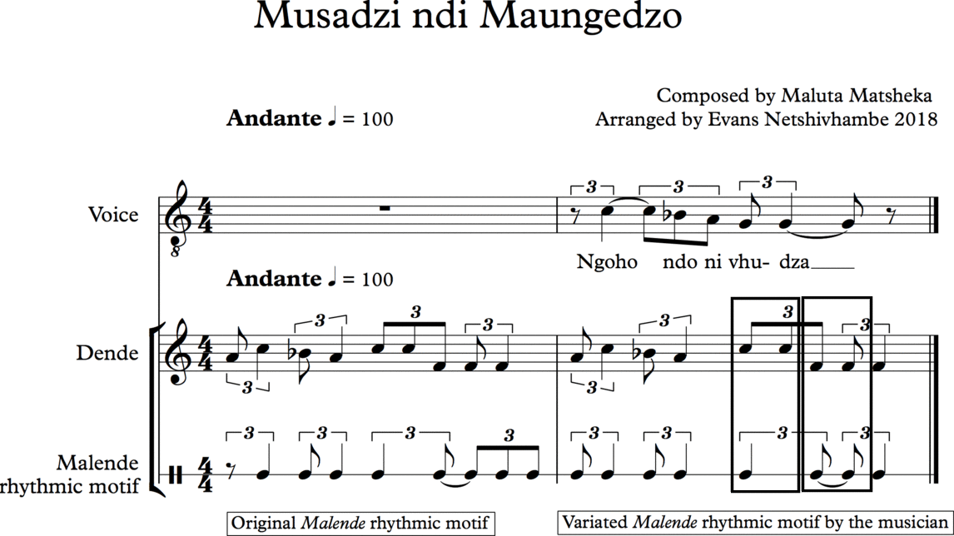
Figure 1.5 Musadzi ndi Maungedzo, a composition by Maluta Matsheka (Dende instrument and voice). The two lines namely, Dende and Malende rhythmic motif indicate how the original motif is used as compared to when it is varied by the artist. The two-boxed figures show the subdivided crotchets into quavers.
This means that the rhythmical design of the Malende main motif is guided by the composition of the lyrics. Important words and accents are often aligned with the energetic part of the rhythmic pattern. This will be explained in detail in Chapter Three. The figure 1.5 above shows an example of the original Malende rhythmic motif used in the music of Matsheka. The variation often takes the form of subdividing the note values as a compositional technique. Matsheka is different from Netshirembe because he records his music with indigenous instruments while Netshirembe uses indigenous instruments to compose but does not incorporate them in her music. They both, however, have a similar trademark, namely using Malende rhythmic motifs in their music but with a unique style. An example below shows Matsheka playing the Dende for one of his songs called Musadzi ndi maungedzo.
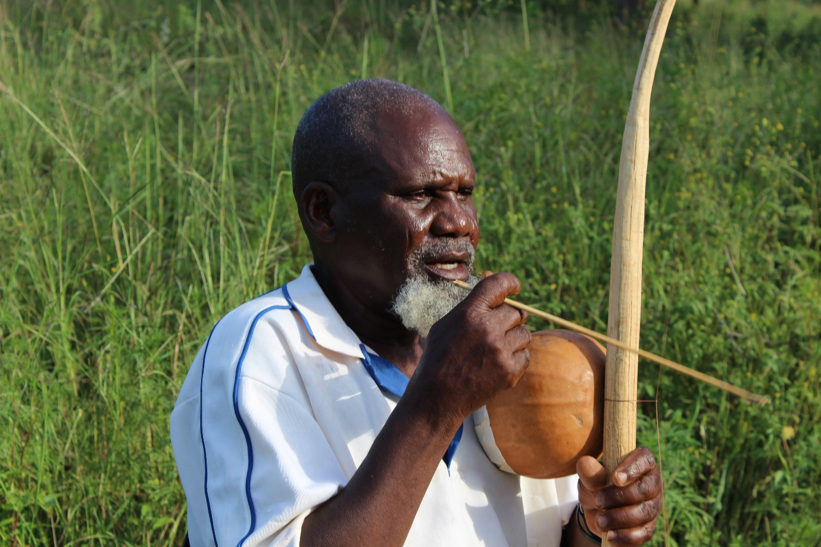
Figure 1.6 Maluta Matsheka playing Dende in Mbahe Village, a picture I photographed in 2018 at his house. Popular musicians use quoting from traditional music in order to remain relevant in their music.
Mbangiseni Avhapfani Netshamutshedzi is one of the popular traditional musicians from Mutshedzi in Venda, a place just before Tshaulu. He has released at least one album playing the Mbila instrument as the main feature of indigenous music in his compositions. He is a very passionate composer of traditional music. He uses the Mbila instrument of which he is also a maker, to make his music traditionally as well as contemporary appealing to the public. An example below is a song titled Malende, which talks about the power of Malende music in the community.
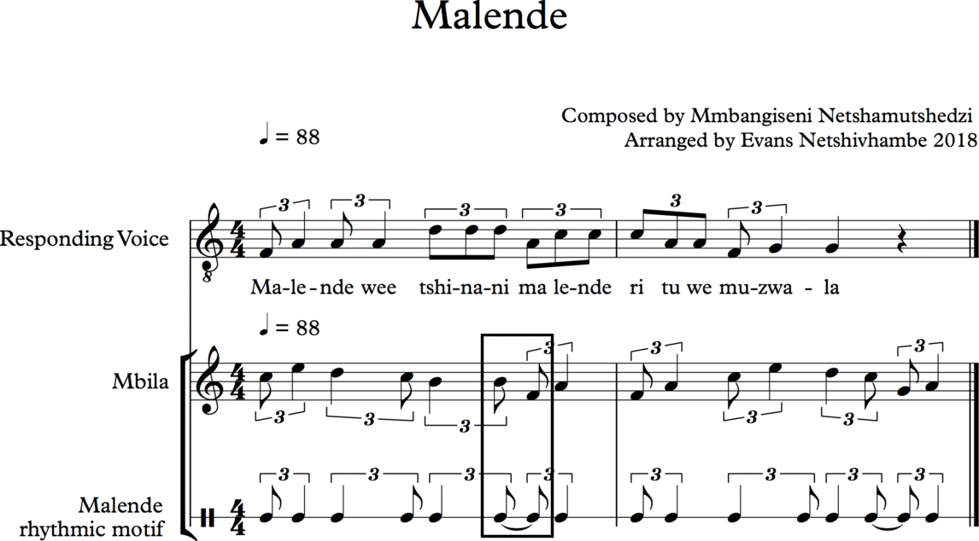
Figure 1.8 Malende, a popular song by Mmbangiseni Netshamutshedzi. Note (in the box), the creative subdividing of the crotchet into 2 quavers
Netshamutshedzi uses the same Malende rhythmic motif in his compositions as quoted in the music of Matsheka. However, the difference between the two is how they use the rhythm in their own particular way. Both Matsheka and Netshamutshedzi use indigenous instruments in their compositions as a link to their roots and culture, while Netshirembe uses concepts and principles from traditional customs such as tales, and the use of a traditional drum in her music. Netshamutshedzi uses the Malende rhythmic motif in his Mbila compositions, which include techniques of shifting of rhythmic starting points as well as subdividing some of the crotchets into two quavers in the rhythmic cycle. The variation techniques used by Matsheka and Netshamutshedzi each have a symbolic meaning as a cultural identity feature. Netshamutshedzi purely uses indigenous instruments in his songs without an overlay of any Western instruments. Matsheka combines both traditional and Western instruments in his music, while Netshirembe uses purely Western instruments in her final compositions.
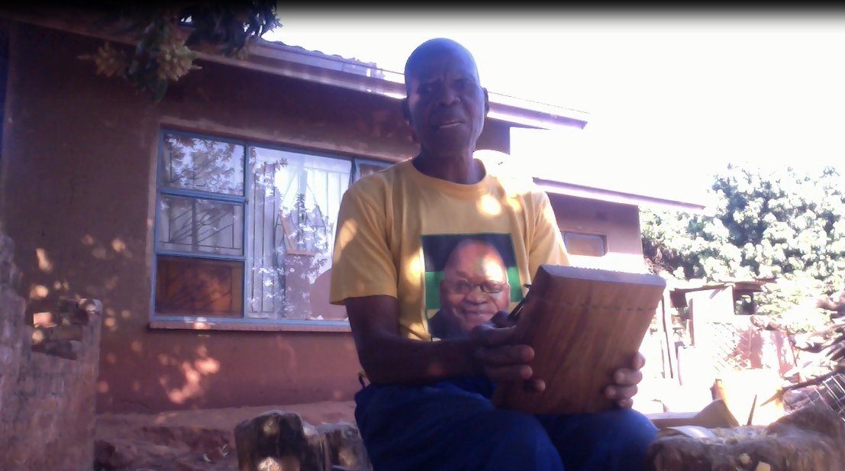
Figure 1.9 Mbangiseni Avhapfani Netshamutshedzi playing Mbila at his home in Mutshedzi (2018)
Netshamutshedzi is a very talented composer, Mbila player and a master musician who is also an indigenous instrument maker in his community. The way he believes in traditional quoting, he composed a dedicated piece as a tribute to that Malende traditional music within the popular music genre. He called this particular composition Malende and plays it with the Mbila instrument. This special song uses the main rhythmic motif of Malende, which is very distinctly heard in the Mbila melody. There is a text dual function in this song; one for aligning important words with the rhythmic structure and another for showing the importance of Malende music in Venda community through the message of the song. The lyrics speak to the importance of unifying, bringing peace and joy to the people. The rhythmic feature in his composition carries the structural point of reference for those who are familiar with the music, but at the same time, he uses words to re-emphasise the importance of Malende for those who are not able to decode the rhythmical quotation in the composition.
He advocates for peace and happiness through Malende dance in society, as he believes that this has always been the traditional way of uniting people in the community. People resolve their problems and celebrate their live’s events through cultural dance music. He has the ability to play the Mbila without looking at the keys as an advanced master of the instrument, who performs with excellent technique. Netshamutshedzi and Matsheka have mastered the rhythmic motifs of Malende in that they play its variations and permutations with ease. They have both developed a performance memory that automatically remembers which variation or permutation to play at a specific time. The common feature between these two musicians (Matsheka and Netshamutshedzi) is that they insist on using their indigenous instruments as part of their popular music identity. Venda traditional musicians that are part of this study maintain that it is important for one to know the target audience in order to create a successful piece of music. Using traditional music quotes is in great alignment with their cultural identity.
Other art music composers who do not reference from indigenous Venda music but use other ways of quoting traditional, music are discussed below. I refer to these composers because they have referenced from traditional African music but not Venda music in particular. Robert Fokkens, for example, a South African UK-based composer composed a piece called, “Tracing Lines”, in which he used techniques such as gradually varying cycles, pitch ideas learned from Xhosa bow music, and accretion, repetition and gradual variation techniques learned from minimalist music. A composer such as Robert Fokkens is a perfect example of a musician whose music reflects the influence of traditional Xhosa bow music. He is a firm believer in the adage, “All composition and artwork is referential; there is no other way to compose” (Fokkens 2015). Many composers quote from a number of life events, whether from nature, experience, in memory of something or their place of birth and upbringing.
This chapter focuses on composers who have used traditional music elements as referencing sources in their music (contemporary or traditional) as well as composers of art music. The chapter explores compositional techniques used by selected composers in order to reveal connections between popular, traditional and art music. Another example of a musician who has quoted from traditional music is a popular South African composer/musician by the name of Pops Mohamed. He composed a work that incorporates an entire Khoisan music quotation, including the original singing and hand clapping, in one of his compositions called Quandodo. Mohamed takes a traditional song from the Khoisan performance and overlays it with western instruments like guitar, piano, drums and bass guitar while using the traditional performance as a background track. Many composers have attempted to find connections between ‘modern popular, classical and traditional music’. One’s early upbringing environments, one’s roots and ancestral homes inspire many composers, some to such an extent that it would be difficult to imagine how their music would sound if they had been born elsewhere.
What are the sources from which music is drawn? Is music composed only through the agency of superhuman assistance and sanction, or is it a purely human phenomenon? How do new songs come into existence? If the composer has a recognized status in the society, how does he compose, and what does he say, if anything, about the process of composition? (Merriam 1964: 47).

What does a composer say and where does he/she get the musical ideas that inspire a composition? Such questions have encouraged musicologists and researchers to investigate patterns that may connect the dots in a composer’s music. Most of these patterns are preserved as either recorded audio or as sheet music. It is easier to dig deeper and discover more about a composer’s work if it is related to a living composer; as one would have the opportunity to ask questions of that composer relating to his/her composition.

Robert Fokkens also emphasises the importance of having a personal signature in one’s composition, which is something that many composers attempt to do regardless of their source of reference. Fokkens believes that in his case it is a combination of his experiences, interests, and chosen sound worlds that make his music contemporary and relevant. He says that:
I consider my music to be personal – it reflects who I am and what interests me. It is contemporary/modern because I wrote it a few years ago, and – if we are talking stylistically – it's language, performance context and resources, soundworld, and many of the influences suggest that it exists in the very broad category of ‘contemporary classical music'. But the most important thing to me is that it is personal and only I could have written it with my experiences, interests, and influences (Fokkens, 2015).

The sense of what one knows and what one has experienced in life is a reality that cannot be erased nor relived, and cannot have been done differently. Who one is and what one is deeply influences the musical result. I have a different perception about music composition. I see it as a vessel containing a multitude of objects that are alive and in a world of their own, waiting for the moment to become actualised through a human being, through the composer’s imagination. These objects are like forces with their own powers available for composers to choose and to bring to life.
The process of music composition reveals that the composer’s inner expression cannot be expressed verbally, but only through the medium of music. Merriam raises questions with regard to the composer’s intention that not only leave people without answers, but with a sense of despair in trying to understand the music aesthetic behind the composition. In the case of an indigenous composer, he/she finds the deepest channel for creativity in the traditional music realm of their culture.
This research focuses on the process of notating music as a method of preservation. In this highly contested compositional space, particularly in the realm of Western art music, I chose to position myself as a traditional music dancer, using my own experience to inform new and original compositions. I decided to use traditional Venda music as my source of inspiration, to engage in conversations with indigenous music practitioners, something that I can relate to from my childhood. My research project has enabled me to develop my own compositional voice, informed by my cultural identity. I have also incorporated the influences from traditional popular Venda music by negotiating ways to compose my own traditional music applying creative rhythms.
In preparing for undertaking my new original composition, I investigated some of the contemporary scores that have addressed issues of incorporating traditional music, specifically those with an orientation towards focusing on rhythmic structures. Most of the compositions that I analysed are original inter-cultural compositions, even though they referenced traditional music in their work.
At the core of many examples, referencing traditional music, amongst other features of African music, is the ‘Call and response’ technique. John Blacking (1995), an anthropologist who has done extensive research on Venda people, is a theorist who discourages the ideology of generalising certain terms that have been used to describe African music: ‘Call and response’ is one of the generalised terms used in compositions as well as in the literature. He explains that the term ‘call and response’ has been widely used generically and is meant to highlight African music practices
The use of the term Call and Response is not sufficiently general, because it implies a socially derived musical form, rather than seek[ing] a basic structure from which both responsorial form and solo/chorus or leader/follower social situations may be derived (Blacking 1995: 67).

Blacking’s proposition of alternative terms to ‘call and response’ namely, tone/companion tone, tonic/counter-tonic, call/response, individual/community, them/variation, chief/subject, etc. are informed by the structural form of Venda music, suggesting that some terminologies should not just be used as generic terms. However, although attempting to justify his lack of finding a better word to express certain musical practices of Venda people, such as ‘call and response’, he then reverts to generalising at the end. He further indicates that:
In [a] Venda context, some general structural principle would be more appropriate, so that in different contexts the following structures might be generated: tone/companion tone, tonic/counter-tonic, call/response, individual/community, them/variation, chief/subject, etc. (Blacking 1995: 67–68).

Therefore, a feature such as ‘call and response’ should be used with extreme caution and understanding of the socio-cultural context from which the quoted music comes and not as a generic approach.
Although not a new concept, my intent in engaging with traditional material as part of my contemporary composition efforts was to pursue a fresh new form of expression in my creative work by bringing the two compositional worlds together (indigenous Venda and Western art composition). Merging the two resulted in a completely new sound-world, which runs the risk of threatening the integrity of each culture, while trying to create something new from both. In an African music context, creativity lies in community participation. Indeed, in many cases, the composition material of a culture’s music remains the property of the community and hence the main emphasis is not on the individual talent but on the ability to participate in and contribute to an indigenous African ensemble. Conversely, to succeed in the conventional Western classical music tradition, one needs to learn the necessary skills in order to personally master the technique of composition.
In his book, Music, Criticism, and The Challenge of History, which seeks to challenge some of the problems offered by history when it comes to representation, Kevin Karnes (2008) uses Brahms as an example of a composer who practised learning to master the skills and the technique of composition before becoming a publicly known composer. Karnes explains that Brahms stressed to his students the necessity of learning the skill of continuous composing as a way to master one’s composing ability. This skill also enables the composer to develop a composing technique. He advised his students not to rely on talent alone, as talent is relative and transitory, whilst mastering writing technique and combining it with talent is a process and legacy that stays with the composer for life. Brahms said that:
Don’t just talk to me about natural gifts or innate talent! We could name great men of every kind who were only slightly gifted. But they acquired greatness, became ‘geniuses’ (as we say), by means of qualities, of which when they are lacking, those who are aware of them do not readily speak: they all had that diligent earnestness of the artisan, which learns first to shape the parts perfectly before it dares to make any great whole (Karnes 2008: 123).

In Western cultures, the composition remains the property of the composer, which is the antithesis of what occurs in African traditional music. Hence, “the importance of mastering the disciplines of harmony, counterpoint, and orchestration before pursuing further compositional studies” (Karnes 2008: 123). African music practices do not rely on Western conventional theories to master any particular compositional craft but relies on traditional customs. This is because in African cultures music is inseparable from social and human interaction.
The composer Heinrich Schenker attributed his compositional accomplishments to having had a great mentor by his side – Johannes Brahms. In an African setting, participating in many traditional performances enables one to master the skills needed by an African composer with the help of the African expert or the master artist (drummer, dancer or instrumentalist). I chose to be a participant in traditional dances in order to master the music, dance and craft of Venda people. The emphasis then is not on the ability to master the compositional aspect of the music but rather on the ability to participate in an African ensemble and to promote cultural cohesion and unity in the community – which will in turn, enhance the compositional insights of the participant. An African cultural participatory performance is where musicians are born and bred, where one gains life lessons in becoming an accomplished artist. The ability to participate brings an element of deeper understanding of the compositional structures and principles of the music. It also allows the performer a chance to be confident about improvising, to be spontaneous and to foster togetherness within African music philosophies.
Brahms was a great believer in the saying: ‘practice makes perfect’ towards greater music achievements. He constantly stressed to his students to put more hours into creating music and to write many compositions before the music becomes acceptable. Thus, it has become my routine practice to compose a new piece each time I have the opportunity to do so. Karnes explains that:
Before one can develop one’s own compositional voice, one must study the works and creative experiences of the great artists of the past and strive to internalize the lessons garnered from them. This, Brahms, counselled, was the way in which Bach, Mozart, and Beethoven had all learned (Karnes 2008: 124).

Many factors play a role in discovering one’s compositional voice, such as elements of cultural identity, the type of compositional techniques learned (indigenous, classical, jazz, world music, etc.), the composition teacher, style, taste of music and one’s passion and interest in music composition. I decided to position my original compositions as part of my final creative product in a portfolio that incorporates elements from the music of my own people, Venda people. In the beginning of the project, I did not know how referencing from transcribed Venda traditional rhythms would enhance my own compositional voice, but the more I worked with the references the more interesting my compositions became.
I do believe that the totality of my research project has enhanced my creative compositional element. Writers have stressed that: “refined artistic sensibilities, honed by disciplined work and practice, are indispensable for the creation of great musical works” (Karnes 2008: 124). I believe that embarking on this project as a developing composer taught me to be disciplined and gave me many valuable lessons to persist in my efforts to attain excellent results.
Brahms felt that talent was overly emphasised as an attribute to greatness by his predecessors, to the point where it became more important to other composers than the actual learning and mastering of the craft of composition. Karnes further explains that Brahms believed that “studying the music and experiences of past masters is essential for discovering one’s voice” (Karnes 2008: 124). I believe that studying some of the works of composers who have engaged in traditional music referencing has played a role in the development of my own knowledge and a more advanced compositional voice.
Engaging with composers who have explored and used certain principles of referencing traditional music has taught me that the general understanding by composers is that inasmuch as each one uses different influences, gathered from a variety of sources as inspiration, the idea of quoting is central to their music. I have studied and analysed compositions by several composers, whom I believe are relevant to my understanding of the use of traditional quotations in music. Most of these composers have used referencing elements in their music as part of their creative processes. It is clear to me that there is no rule or guide on how to use reference material; however, there is a principle that appears to be prevalent in the work of these, which is to include one’s personal creative voice or individual signature when using material that already exists – namely use the material from an informed position before engaging with it. I have come to understand that the general rule of thumb, as exemplified by other composers when it comes to referencing existing traditional material, is that it is always safer for a composer to not quote material directly, without first effecting change.
I am one of those composers who prefers to create music rather than analyse it. However, I still support those who take the trouble to analyse music in order to give readers a deeper understanding and meaning behind it. Meaning in music is always a subjecting aspect and it can have many explanations. The structure of music can reveal endless patterns. During my interviews with selected composers, there was one particular South African composer residing overseas who asked not to be included as part of any study, because he strongly believed that no one understands his music better than he does. He says that most musicologists have misrepresented his music in their writing and as a result he does not want to be part of any musicological study.
The reason I am raising this in my research, is that I too believe that the solution to understanding one’s music is not exclusively through critical analysis but also through obtaining the viewpoint of the composer. Music occurs - , and not all music is necessarily associated with an inspirational idea; sometimes creativity just takes over and music comes alive. Even in the real world, some of the greatest inventions emerged from mistakes or improvisation in jamming sessions when people were involved in another activity. Creating something else. In most cases, such inventions have become even greater than those originally planned. A critical analysis would use a technical approach for finding patterns in the music in order to arrive at with meaning; some musicologists would even disregard what the composer has told them in pursuit of their own personal theories.
Several of the composers interviewed for this research have given their views on how they understand the concept of referencing from existing sources of music. For most composers, it is not a strange phenomenon to do this. One composer held a very strong view regarding his position, in relation to using traditional material in his music as a point of reference. He stated that:
I can see that some people would view the racial dynamics of the South African situation to give a charge to that relationship, which is absent in other relationships of a similar type, but I understand it from a different angle. It makes sense to me that as a South African I am influenced strongly by other South African musicians and musics –- I have often found them musically and aesthetically to be influences which really resonate with me. Obviously there are many other influences I've found which resonate well, and in the global world we live in now these can come from anywhere (Fokkens 2015).

When speaking about the development of his writing ability, Robert Fokkens expressed that it is inevitable for a composer to absorb other influences that later, become part of his/her creative process. The world around us informs our thoughts - and influences our perceptions as composers. We feel the need to say what is relevant at a given time in history; as a result of the changing world around us and new modes of doing things keep evolving. All these changes form part of the composer’s growth and impact on his/her approach to composing.
I like the music I write now – at least the pieces, which I feel, are successful! – But I hope it is always changing. Certain ideas and influences push forward at different times, in different contexts and in different pieces as I grow and learn more about the world, different musics and myself – so hopefully my music is always growing and changing (Fokkens 2015).

. Fokkens further elaborates
It is worth saying that I was very wary of referencing traditional South African music as a student at UCT – despite always being drawn to it – because there was consensus that this was always problematic, both because of the exploitation/appropriation issue and because there was still a general belief amongst senior figures in classical music that African music and European music couldn't interact positively or effectively. Studying in the UK gave me a perspective on that, away from the personal and political issues, which guided that debate – I realised that the process of creating is ALWAYS about borrowing and bringing together things you love and synthesizing them into a language, which only you as a creator can speak. So I needed to find a way to bring the big range of musics I love into a multi-voiced conversation with each other in order to find my voice. I was really inspired in this process by looking at how many styles and voices have emerged from Africa in, for example, popular, jazz and choral fields: so many African creators have taken the unavoidable hybridity of being a modern African (Fokkens 2015).

Many other South African composers have quoted traditional music in their compositions; most of whom I never managed to interview to discuss their approaches. However, I have selected a few that were within my reach and in alignment with my style of composition. I am not aware of any composer who has undertaken field research before using the quoted material to the level of my approach as a composition student. Some composers such as Neo Muyanga, Mokale Koapeng, Pheleni Mnomiya come from a different school of thought which emanate from choral music roots. James Stephen Mzilikazi Khulamo comes from a choral background and he started composing music as a teacher in 1959, some people also referring to him as a great folk song arranger. I am purely trained in Western classical music as a composer but not as a choir conductor or music arranger like Khumalo who later became interested in classical music. Having gone through my classical music training and the Venda traditional upbringing experience, surrounded by indigenous music developed in me an interest of to mix the two worlds, which feed my creative music compositions.

Other South African composers who may not necessarily be black but have engaged with indigenous music material in their compositions, such as Jeanne Zaidel-Rudolph with indigenous Xhosa music, have widened my knowledge in their links between African and Western art music composition. She has worked with the Ngqoko women from the Eastern Cape who specialise in throat singing. She produced a Western art composition called, Lifecycle, from her engagement with this group. In the article written by Jeanne Zaidel-Rudolph and Martin Watt titled “Musical Symbiosis in Jeanne Zaidel-Rudolph’s Lifecycle”, there is a clear explanation of how the composer negotiated her way around using traditional music and incorporating it into a western composition. The composition Lifecycle explores Zaidel-Rudolph’s thought processes when engaging with traditional Xhosa music of the Ngqoko women.
She uses the concept of musical symbiosis as a conscious nurturing of dualities, which embody both inheritance and variation-an imperative for cultural cross-pollinations enrichment within a framework of mutual respect (Zaidel-Rudolph and Watt 2006:136)

Another white South African composer who has worked with traditional Zulu music and produced a western composition at the end is Peter Klatzow. The way this came about was that South African Music Rights Organisation (SAMRO) commissioned Mzilikazi Khumalo to transcribe and arrange 8 songs, which were originally composed by Constance Magogo KaDinuzulu Buthelezi. SAMRO also commissioned Peter Klatzow to write the piano accompaniment for this song cycle The 8 traditional songs in this cycle arrangement by Mzilikazi together with the piano accompaniment by Klatzow resulted in another commission by Opera Africa for Khumalo to write an opera on Princess Magogo. The title page of the SAMRO publication reads - Haya, Mntwan' Omkhulu (Sing, Princess!). Mntwana, Constance Magogo KaDinuzulu Buthelezi, composed the original songs. The commission to Khumalo and Klatzow dates back to 1999. Klatzow was never credited by Khumalo with the work he did on this important composition.

Michael Hankinson orchestrated the work of Princess Magogo uShaka, which is an Opera that was based on a traditional story, which was successfully orchestrated by Christopher James and Robert Maxym. The second orchestrated version was later commissioned by SAMRO for Maxym. This was because Maxym is a conductor who conducted this work but felt that the James’s orchestration did not necessarily work. He also produced the piano accompaniment for uShaka. Veronica Mary Franke (2017) indicates how many African works came to be known through the Western music genre. Her discussion supports the exploration of African and Western music acculturation. In her article South African Orchestration Music: Five Exponents, she explains that South Africa has been producing many Western classical music composers but very few from the black community. Much of the black South African composers that have been active in the choral space have never received formal training in Western classical music and unfortunately not in orchestration. Those that have had the opportunity to be trained formally have composed works that were largely for the choral or vocal repertoire with very little fully orchestrated works. She says
Post-apartheid era has, in fact, produced a number of classically trained black composers, but they have worked largely in the domain of vocal and choral genres, composing few works for full orchestra (2017 93).

There is one element in music that affects all the other elements if not properly treated – the element of rhythm. Some composers, such as Béla Bartók and Vinko Globokar stretched the boundaries of traditional music notation in the quest for different expressions that would best direct a particular music idea.
Béla Bartók literally reinvented a new way of thinking in the practice of ethnomusicology, particular for research-based composers who engage with traditional material in their creative work. Some people such as David Taylor Nelson (2012) refer to him as the father of ethnomusicology. Nelson wrote an entire article on the topic of Bartók as a great contributor in the field of research-based composition. Bartók is considered one of the greatest ethnomusicological explorers of folk music to an extent that some people even think that he is one of the greatest composers of his time particularly in the practice of traditional material referencing. Nelson explains that he believes that Bartók deserves the title of being called ‘the father of ethnomusicology’ because he is one of the first musicians who chose to compile a great collection of folk tunes, which he later transcribed and incorporated into his compositions (Nelson 2012: 75).
It should be quite notable that the time that Bartók conducted his research was around the same time, as comparative musicology became the focus of ethnomusicology for many researchers. However, his approach departed from prevailing scholarly practice at the time and has become a game changer in the practice of research as composition. However, as an ethnomusicological practice at the time, it was heavily criticised by later specialists in the field. This is because this practice was seen as promoting the collecting of field recordings for other composers who may not even go to the field to engage with the community. Through my own practice, I have experienced that it is important for a composer to go to the field and to record the music for themselves; to capture as much content and repertoire as possible in order to have a wider pool of material from which to choose.
My creative research has yielded the composition of an entirely new repertoire, which can be used in Venda culture as traditional or indigenous music. I wanted to make sure that all material used in my composition portfolio was my own original composition. The group from Tshaulu and Matondoni was performing the music, which I composed from scratch in the style of Tshigombela music. The Tshaulu and Matondoni groups performed two new Tshigombela compositions as part of my music portfolio. Bruno Nettl (1983) takes cognisance of the problems a composer may experience when creating a new song to be included in the indigenous repertory list, largely because of the practicality, as well as the perception of the song in the culture. He says that
Introducing [a] new repertory into the tradition should theoretically be feasible but as a matter of fact it is quite possible that new songs synthesized from a description might not be accepted in traditional music (1983: 48).

Other complications relating to this may include protocols or rules when introducing new repertoire in a particular society, as many of these cultural communities can still be under the ruling powers of kings. However, having a close relationship with a master trainer whom the community trusts helps one to get new repertoire used and practised by the people through the introduction of the master trainer. Nettl also points out some of these problems by stipulating that:
There are probably certain rules that must be observed in the introduction of new music, rules that have to do with the way the society works and that may be completely independent of the musical system as defined by characteristics of style (1983: 48).

Nettl also suggests that it is better for the new repertoire to at least conform to the standards of indigenous repertories, as this would be a big step towards getting the new repertoire to be accepted by the community. This is why I composed the pieces in my portfolio in the traditional style of Tshigombela music that the Tshaulu and Matodoni groups were familiar with - but incorporating my own patterns such as new lyrics, hand clapping and new rhythmic structures. The society will decide if the new repertoire is acceptable or not based on how often the song is performed. Nettl says the culture may or may not reject the new repertoire depending on its conformity to the cultural practice.
And so rather than accepting anything that conforms to style, a culture might not consider a newly introduced tune to be part of its music unless it also can be related to specific extant musical works. Similarly, a new word does not enter a language even though it may fit the phonology unless there is a way in which the culture can make use of its meaning or conceptualization (1983: 48).

According to Bolhman and Nettl (1991), the core function of the fieldwork researcher includes being able to interpret and represent the music of the other, in a truthful manner that does not deviate from the original representation. They maintain that,
It may well be that one of the most distinctive features of ethnomusicological experimentation is its ability to draw techniques from many different scientific domains, but [also] to focus those techniques on the common problem of interpreting and representing music (1991: 141).

The fieldwork experience of engaging with practitioners at grassroots level to understand the music from their viewpoint has richly enhanced my compositional voice. Engaging with composers directly and indirectly that are actively negotiating conversations with traditional music has further expanded my knowledge. I have learned a great deal from these compositions as a result of their engagement with traditional material. I have developed my own creative abilities during this process and I believe that the research has influenced me in a positive way. I have also developed various compositional principles, which are now my guiding rules on how to compose.

Chapter 2

A brief historical account of Malende, Tshigombela and Tshikona, dances since the 1960s to the present

The three music forms, Malende Tshigombela and Tshikona, are considered the trademarks of Venda culture. Important performances in Venda rarely happen without one of these forms being present; this is even more so when there is a king present. These three indigenous music forms are regarded as unifiers of communities, nation healers as well as peacemakers within the society. These three dances in their social hierarchy order are categorised in the following manner, (Tshikona, Tshigombela and Malende). This classification is based on social priorities and mass participation. However, in my findings of the musical structure they should be properly ordered in the following manner: Malende, Tshigombela and Tshikona. The reason for my classification is based on the order of importance from the one that mostly uses the core rhythm to the one that least uses the fundamental rhythm.
The classification by social order is based on authoritative powers in the Venda community while my order is based on the musical structure of the original cultural identity. The three forms are the leading categories presented in competitions for traditional Venda performances. Malende often gets excluded in competitions due to the big number of competitors in this category as compared to the other two that are group performance. My choice for these three forms in this study was not based on the competitions that I attended, which are hosted every year to encourage mass participation by different event organisers in Venda. My choice was based on the experiences of my upbringing and practically of engaging with them through dancing. The socio-cultural role that they play in the community is of great importance to Venda people. In fact, these music forms are like a heartbeat, supplying blood to the society. In a book called African Dance (1996), edited by Kriamu Welsh Asante, Pearl Primus wrote an article that introduces the reader to the unbundling of complexity that is found in African dance.
Research about African dance styles and their different meanings has been one of the largest contributing African knowledges as it is the root of African music structures. Pearl Primus states in her study that “dances have also been created to commemorate everyday activities” (Primus 1996: 14). This becomes the most important social priority to make sure that cultural dances celebrate the lives of those who are part of a particular community. Victories and key moments of a culture require a celebratory show. This reality of commemorating everyday life through dance is a way of uniting people in their communal spaces. Dancing is not an exclusive specialized activity that can only be performed by specific people in an African community, as it does not require a special skill for a dancer to participate. Even though there are choreographed dances and free medley dances, depending on the requirement of the performance, there are no restrictions based on dance ability. Meki Nzewi and Odyke Nzewi (2007) in a book called “A contemporary study of Musical Arts”, talk extensively about the free medley and the pre-choreographed dance performances. They explain that free medley is open to any performer who is able to improvise but pre-choreographed dance music requires rehearsal and only those that are part of the performance can be allowed to dance. This is to maintain order and structure in the music and it also brings an element of style and form to the dance.
A celebration of a new life, marriage ceremony, rite of passage or academic achievement of someone can be accompanied by a small dance performance that does not require any pre-choreographed dance steps and drumming accompaniment - but an improvised rendition can accomplish the task. However, performances required for an installation of a king or competitions, need to be rehearsed in advanced and choreographed well to show the difference between medley and planned dance performances. Free medley dancing can be featured in pre-choreographed performance but it has to be within the style of the dance. Dancing can serve as a symbol of excitement that does not require any verbal communication for the message to reach the receiver. Sometimes the dancing can be accompanied by a few words – renditions of praise – in order to be specific with the message communicated to the receiver. As one of the core aims of my research is centred on the dance rhythmic formation.
The three selected indigenous Venda genres are all similar in structure in terms of their rhythms; they all have signifying rhythms (to be elaborated in detail in Chapter Three) that are regarded as standard rhythmic motifs or patterns. Malende is the archetype from which the other two are constructed in terms of rhythmic design through permutations and variations. This research looks into the depth of how each motif found in each dance style can be further explored for incorporation as compositional tools for my creative work. Using these three distinct motifs as an identity reference to Venda cultural music has helped me understand the importance of re-using these motifs in an informed manner. These patterns relate to each other in their form and structure. They require careful consideration and interpretation when applied in one’s own music.
History plays an important role in changes and variations taking place in music practice; I believe therefore that there must have been substantial changes motivated by political movements in the messages attached to the performances of Malende, Tshigombela and Tshikona music from earlier times to the present. These changes are affected by multiple socio-cultural, political and traditionally based influences. This research addresses the central question as to how the three forms have been influenced by the aspects above. The research investigates selected early literature that covers the period from the 1960s up to post 1994. The two periods represent the transition referred to as pre- and post- ‘independence’. ‘Pre-independence’ is recorded in the literature as occurring from the 1960s to 1979, while ‘post- independence’ is represented in the literature from 1979 to 1994. The word ‘independence’ is referring to Venda independence in this context.
The dynasty dynamics have largely affected changes in ruling powers and disputes between national leaders of Venda people. Problems relating to leadership issues directly and indirectly impact the development of Venda cultural music. Jaco Kruger (1991) devoted much of his time unpacking the social dynamics embedded in Venda music, especially Tshigombela, due to changes in the ruling powers. The power struggles did not come without their ripple effects on the music practiced on the ground by indigenous practitioners. Those in favour of particular leaders would sing and dance music that praises their leader of choice while those not in favour would demonstrate their disapproval of the leader through music messages. The composition of Malende, Tshigombela and Tshikona engaged with social problems created by the power struggles between leaders. Situations such as these yield positive results for traditional music because there is naturally a wider pool of new songs being added to the music repertoire.
Although I will be referencing earlier literature, the main focus of this research will examine the period from 1994 to the present time. This period represents the South African democratic dispensation, which is more current, not just the Venda ‘independence’ period of pre-1979. I believe that these two political contexts have played a major role in the socio-cultural, political and traditional changes in the three Venda dances. John Blacking who conducted his research in the 1960s and Jaco Kruger in the 1999s support this. Kruger in particular investigated the effects of the changes in the music. The two researchers conducted their work in two different political dispensations.
The political ramifications that play out in the society that is affected by leadership conflicts over throne-ownership, cultural imbalances, gender inequalities, poverty and socio-cultural ills inform these three forms. My selection of the three genres and my treatment of them does not take cognisance of these political agendas. I have deliberately chosen to stay away from interfering in political agendas to avoid any complications that may arise. The music performed by most cultural groups accentuates these political agendas in favour of the leaders in power. The choice of songs that I have transcribed and used as sample material have no connection to such political struggles. My own original compositions do not reference any political shifts or agendas in the Venda community.
Malende dance music form

The dance associated with Malende music encourages individualistic expression in the community. Most dance steps and movements can vary from one village to another even when they are part of the same repertoire. This music does not necessarily require a group performance, as one or two people can dance without any instrument or drum accompaniment; it is regarded as a valid performance. This dance form is more politically and socially orientated in its expression, just like Tshigombela. It is often used by adults for teaching young men and women how to conduct themselves in society, including attitudes towards sex, AIDS, marriage, teenage pregnancy and the importance of education, as well as behaviour and manners relating to respecting adults in the community. It is used to resolve conflicts within the community, ranging from individual to group conflicts between members - but not between kings.
The Malende dance promotes individual creativity and artistic development in people. It can be agreed that some popular musicians were groomed or have developed their individuality from this music style. It also gives people an opportunity to be vocal about anything in the society regardless of their gender, rank, status or position they hold in the society. Malende is a type of dance that is often accompanied by one traditional drum, or a set of up to three traditional drums if there is a need - and can be performed unaccompanied. When Malende is performed in an informal setting, handclapping, singing and a drum would often accompany it. It can occasionally be accompanied by anything that can produce a sound, e.g. like any empty container that can be used as a drum. Tshigombela or Tshikona dance normally perform Malende in a formal setting - before, during or after their main performance.
The manner in which all three dances are used differs, depending on the location in which the practice is taking place, and the interpretation thereof, which correlates with the social connotation of the performance of the music. For example, the Malende dance is performed differently at a formal function as compared to an informal one. When it is performed for a chief or in the presence of the king, the dancers’ gestures are more respectful than when it is regularly performed in barani, which is a borrowed word from English, meaning ‘bar’ or a beer drinking place. In this latter scenario, a dancer can make any kind of provocative dance gestures as a form of entertainment. This dance form is individualised and free in terms of the choreography, while dance steps can vary even though they are of the same style. There are certain repertoires that are used as standard ones across Venda culture that can be danced by anyone. There are also many individual dance compositions that have been choreographed by expert practitioners of Venda indigenous music. This form is not predominantly used for social or political occasions, even though it may carry the same message, but rather as entertainment and as a show of individual virtuosic dance skills.
The dancers that primarily play the drums or clap hands while others are performing take turns in dancing. Each dancer chooses a song of his/her own to perform or may continue with the one that was used by the previous dancer. Malende dance music has a particular phrase that many people incorporate as a way of showing that it is a very energetic and expressive dance. The phrase is ‘u fhufha vhavhili vha sera’, which is a figurative expression that means the dancer makes his/her highest jump in such a way that two people can go beneath the dancer. This is illustrated in the picture example below.
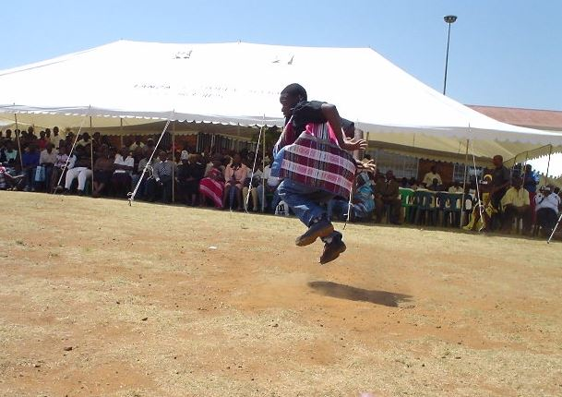
Figure 2.1: Example of “u fhufha vhavhili vha sera” of Malende traditional dance by the Maitazwitoma Wits Student Society, of which I was a part in 2008. This is a photograph of me, Evans Netshivhambe, dancing and taken by Shadrack Mphaphuli, at Mutingati Primary School on Heritage Day (24 September 2008).

Venda people often celebrate any cultural or family victories through Malende dance - such as a celebration of a graduation, new birth, wedding and so on. One day, while I was recording a Tshigombela performance at Tshaulu, I witnessed something very special regarding Malende music. After the recording of the Tshigombela music, the performers unexpectedly began a Malende song, because they were feeling that Tshigombela was a little too formal for them and it did not give them room for self-expression for which they were longing and this is exactly what Malende does for people.
A husband may initiate a particular dance with the intention of ridiculing his wife who, through her laziness, is not able to keep her family together, which could lead to some men losing interest in their wives; on other occasions, women may ridicule their menfolk in their own dances. It is the skill with which the essential message is blended with the nonverbal elements that draws popular acclaim and enhances its moral force (Spencer 1985: 13).

In a situation like this, Malende is the appropriate music with which to send non-verbal messages. Another example can be when a child graduates from school; a mother can show her excitement by dancing Malende (even if there is no drum accompaniment), as a way to congratulate her child and show her excitement towards the child. In this case, the best form of accompaniment is hand clapping and ululating while someone is dancing. This example is completely different from other settings where Malende music is performed, such as formal or informal environments.
Another example that makes Malende music distinct from the other two forms is cited by Paul Spencer (1985) who calls it using an ‘oratory’ type of singing as a weapon to express dissatisfaction in the public domain. He states that “a widespread form of interaction that might be compared with oratory occurs where singing is used as a pointed weapon to air grievances or to discredit adversaries, making the issues more explicit and public than mere gossip” (1985: 13). This is a direct provocation or interrogation of a situation through music without any fear of what others will say especially if the person wants to make a statement or clear their name in public. This way the music takes on the role either of a mediator to resolve conflicts or to further fuel a dispute between two people. This is more so particularly in situations where people are fighting over a partner or accusing each other of infidelity. Malende music can be used to air people’s personal grievances in public.
Jaco Kruger (1999) classifies Malende music under a general term called ‘beer’ music or ‘beer’ songs, which can give a wrong impression about the kind of people associated to it and performance location of the music (1991: 125). This classification can make the reader think that this kind of music is only performed by drunkards or by those under the influence of alcohol. Kruger explains that:
Beer songs are the largest category of Venda traditional music. They comprise singing, dancing and dramatic action that accompany beer drinking. The term “beer song” refers here to traditional as well as contemporary music. Traditional beer songs are called Malende, and they are accompanied by handclapping or drumming. Contemporary beer songs have several names such as jive. (1999: 45)

Bars and drinking spots are merely the most convenient places to display this kind of dance music, but this does not mean that the music should be called ‘beer’ music or ‘beer’ songs. Blacking also uses the same term to classify Malende music. Even though it is common general knowledge that in traditional African cultures, traditional beer is brewed for various family celebrations and ritual occasions, outside of commercial bars, it does not qualify Malende music to be called ‘beer’ music. The majority of people who go to beer drinking places expect there to be music playing in the background. However, in traditional beer drinking spots when the music does not reflect their mood, they naturally start a traditional informal dance performance as a form of entertainment. Jaco Kruger separates Malende from the other two dances because he discusses the performances of Tshigombela and Tshikona music differently. Those have a very strong socio-cultural relevance as they are connected and “associated with traditional politics”. He explains that “beer songs feature less directly in politics; they comprise the largest category of adult songs and give additional insight into the political experiences of ordinary people” (1999: 125).
The beer songs to which Kruger is referring are the free expression performances of Malende music, which depict personal expression in society. I believe that both Kruger and Blacking may have misunderstood the exact meaning of Malende from their interpreters during their research in Venda. Venda language expressions often have double or triple meanings, which may be confusing if not interpreted correctly. There may be people who refer to Malende as music that is played in beer drinking places due to the actual location of the venues. However, the proper term for the music is Malende not ‘beer music or songs’ as this distorts the meaning and can create an inappropriate definition of the music. There may have been a lack of a better word to express a more appropriate term, which led to the use of such an inappropriate term.
The generalisations carried out by other scholars perpetuate negative perceptions associated with the music, which forms one of my strong debates relating to the image of African music. Blacking explains that “there are beer songs whose words allow wife-givers and wife-takers systematically to exchange formal, and often ribald, complaints about each other’s’ performance of the duties associated with their relationship” (1995: 40). Songs that Blacking and Kruger are referring to as ‘beer’ songs are Malende dance tunes that may have lyrics about beer, or may be songs that are often performed at shebeens, taverns or bars in a very informal way; they are however, not classified as beer songs by Venda people, but rather as Malende songs.

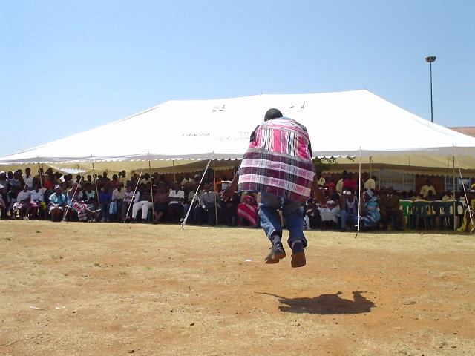
Figure 2.2: Example of Malende traditional dance by the Maitazwitoma Wits Student Society, of which I was a part. This is a photograph of me, Evans Netshivhambe, dancing and taken by Shadrack Mphaphuli in 2008, at Mutingati Primary School on Heritage Day (24 September 2008).

In a cultural context Malende music is not taken seriously when compared to Tshigombela and Tshikona, due to factors that are already attached to the style of ‘beer music’. However, it is still the most quoted form in Venda popular music and it is more widely performed than the other two. In fact, the other two forms are built upon the foundation of the Malende rhythmic motif. This music is able to bring together the rich and poor, the young and old as well as the noble and the commoner. It has a rhythmic motif that is easy to remember and to dance to for performers. These characteristics make it the most important dance relegated to a lesser importance in the Venda community in terms of hierarchy. The other two styles are characterised by mass participation by delegated groups, but they do not give everyone an opportunity to perform because those dances are strict when it comes to rehearsals and composition – whereas Malende needs no rehearsal and is free, in that, it is mainly improvised and anyone can join in.
Tshigombela dance form

Many traditional dances are part of the music performance in the communities of Venda. Those who hold the most controlling power in the community determine the hierarchy of traditional performances. These are the kings and chiefs, who are able to determine such music hierarchy in the society. Tshikona is considered at the top of the hierarchy of cultural dances because it is strictly for the kings. Other communal group dance performances such as Tshigombela, Malende, Tshifasi follow this order. However, in this research the opposite prevails, as Malende is the core genre - then followed by Tshigombela and the last one is Tshikona. This is based on the music structure and rhythmic construction of the main rhythmic motif.
Other cultural performances are more specific to particular events such as Tshikanganga, Givha, Visa and Domba (initiation for women), Murundu (initiation for men). All these are different cultural dances that are performed at various cultural events and ceremonies in Venda communities. Tshigombela music is perceived to be different from all the other Venda indigenous music forms, because it advocates for women in the Venda community. I used Tshigombela music as one of the references in my research because it applies two permutations to the rhythmic design from the original Malende main motif. These permutations result in distinct dance rhythmic patterns, which lead to more permutations in the virtuosic fourth dance phase in Tshigombela form. All further permutations are explained in detailed in chapter Four and there are transcriptions presented for referential purposes.
Most of these Tshigombela indigenous practices are area-specific in terms of messages that are communicated through performances but the form remains the same in structure, style and dance steps. The messages differ because of political influence associated with the kings of a particular area or village(s). According to Samson Ratshalingwa Netshifhefhe, one of the foremost experts and trainer in Tshigombela music explains that, “Tshikona na Tshigombela ndi zwithu zwa musanda” (Netshifhefhe 2016), which means Tshikona and Tshigombela are musical practices that belong to royalty; it is the mandate of a king to invite everyone to come to the royal palace to celebrate through music and dance.
It is not common for men to participate in Tshigombela dance because the practice is for women. However, the men who do participate in the Tshigombela dance are mainly there for training and for protection for the women. They are called ‘tshi via mbudzi’, which refers to a man responsible for slaughtering a goat after the performance. This practice is part of the tradition of the kings and chiefs who offer a goat to be slaughtered for the Tshigombela group after the main performance. Tshigombela and Tshikona dance forms are mainly defined by the three distinctive and different drums (known as murumba, ngoma-khulwane, thungwa and dumbula), which play different rhythmical patterns as part of the dance. The structures of the Tshigombela and Tshikona dances are very important in Venda culture because they both require a group of participants to form a cohesive and collaborative ensemble. The group formation symbolises unity and traditional performance order. Tshigombela dance forms serve as healing music for those women in society who miss their husbands or family members due to their temporary absence or migration to cities like Johannesburg. In Tshigombela music, the kings or chiefs regarding an individual’s freedom of expression exercise much control. This kind of authority is also demonstrated by keeping the drum instruments in the chief’s home as part of their control - as Kruger explains:
Tshigombela music was performed under the auspices of rulers, and consequently functioned as a symbol of political power. Tshigombela dancers required permission from their ruler to practice and perform. Rehearsals took place at the ruler’s homestead. The ruler was the only person possessing the drums needed for Tshigombela (1999: 122–127).

Today the situation that refers to the ‘auspices of rulers’ is not strongly practised like before in many Venda communities. In the Area where I conducted my research in Tshaulu the control is exercised only for Tshikona but not for Tshigombela.
Kruger says, “The involvement of women in the political economy of Tshigombela was a logical extension of views regarding their traditional social role as mother[s] and housekeeper[s]” (1999: 130). This kind of role gave women a better chance to participate in Tshigombela music, as their men were unavailable at home due to the migrant labour situation. Nowadays Tshigombela performances demonstrate a shift from older historical practices, as impacted by the migrant labour system. Kruger says, “During early years of schooling many families kept girls from going to school, arguing that it would make them mad.
Also, girls had to remain at home while young men became migrant labourers. Uneducated rural women whose existence centered around the home hence became the logical choice for involvement in Tshigombela. (Kruger 1999: 128).

This type of situation put women at the centre of having a political voice, even though they were “under the auspice of rulers”, as the absence of their husbands placed greater responsibility on their shoulders.
Jaco Kruger wrote in depth about the Tshigombela dance and its political as well as traditional implications in Venda society. He echoes the same sentiments mentioned by Blacking – that the form of Tshigombela has changed a great deal, as the society changes. Women have different views on how they are treated by men in their own communities; as a result, traditional Venda women use Tshigombela dance as a political weapon to voice their problems to the community. They use the Tshigombela dance to indirectly tell their husbands how they feel about the way they are being treated by men. The body movements in these songs have different rhythmical structures and a particular message to communicate, which is different from other cultural dances.
Kruger points out that the Tshigombela dance was used as a way to politically correct and re-direct the way of life in society; as Meki Nzewi (2007) suggests - that an African concept of philosophical thinking, puts a woman as the main figure in the society because of her fertility asset. It is very difficult for women to find a strong voice in a typical patriarchal African societal system where men are dominant in many areas of communal life. However, women regard music and dancing as a very strong tool for them to bring strong messages across relating to their men, without being particularly offensive as it is a group effort. Amongst all the three dance forms Tshigombela is the one that has the power to pass on a social message without being offensive, as it is a group effort; unlike Malende, which consists mainly of an individual who starts a song and then sings about something, which could potentially be offensive because it is about one person’s individual issue(s).
Matters of social delivery can be advocated by Tshigombela music such as water shortages, electricity supply as well as education, schools and health facilities. Nzewi and Kruger’s ideas are supported by Blacking who suggests that women find Tshigombela music liberating and a means of self-expression. Blacking supplements to this by saying that:
…dance and music were partially independent: in the girls’ dance Tshigombela, changes of dance step were accompanied only by variations in the drum rhythms accompanying a melody and its counterpoint, while different melodies did not require different kinds of dance steps (1995: 95).

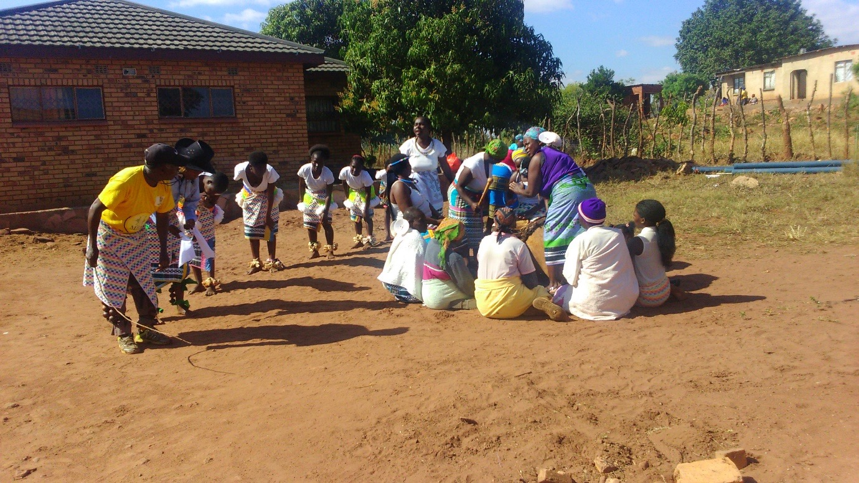
Figure 2.3: Example of the Tshigombela indigenous dance by the Tshaulu dance group, a photograph taken by Evans Netshivhambe in June 2016 at the Tshaulu village.

Kruger elaborates, “Tshigombela had become more important because its performance practice was best suited to political needs” (2007: 39). Women found Tshigombela music to be used as a tool regarding their freedom of speech, to voice some of their problems and frustrations in the society, and to bring about solutions to these problems. The other significant role a woman plays in these three musical forms is the role of playing the drums. The women always play the Murumba drums in all three forms, even though there might be some exceptions where the men do play the drums. Traditionally, it is understood that women play the drums better and their soft hands are able to bring out a particular tone from the Murumba drum.
In a book entitled, A Contemporary Study of Musical Arts (2007), Meki Nzewi and Odyke Nzewi discuss the theory, as well as the practice, of modern African classical drumming as an approach to understanding how drumming functions in an African context. They use the structure of an African drumming ensemble practice, based on a combination of a few drums during a performance as a case study for their argument. I agree with their analogy of contextualising the African drum ensemble as a structure that copies the role of male and female responsibility in the society. However, I maintain that even though their analogy equates the drums to human characters it does not make it a general theory for all big and small drums. In fact, in Venda traditional context their suggestion is the other way around. The big drum, which Meki and his son refer to as the ‘mother’ drum (because of its power and prominent role) plays the supporting role in Venda Tshigombela and Tshikona music. The relationship between the drummer and the dancer helps to establish signal gestures or cues for changing a rhythmic pattern. This is what Paul Spencer calls ‘rapport establishment’, and explains that “such gestures are significant in the rapport established during conversation in which attentive people may echo one another’s gestures and achieve a rhythm in their interaction, or they may fail to do so where rapport is absent” (1985: 12).
Traditional music performers develop knowledge of rhythmic coding and a working relationship between two or more performers in order to communicate effectively during a performance. Spencer also indicates that, “given this general observation, dance is an obvious metaphor that has been used to describe the nonverbal signalling” (1985: 12). This establishment of a synchronised conversation, which is created by a metaphor between two people, is important and connects with the idea of communicating non-verbal messages: Nzewi and Nzewi below best describe this:
In most cultures, drums may be used in pairs of different sizes and thereby provide primary tone levels played by different performers in music ensembles. One drum is designated as female, the other male. Most African cultures regard the larger drum of a pair as female. The female drum of a pair has a lower, more commanding tone and would normally play the ensemble role of the mother instrument that takes major solos and also talks. When drums are paired, the phrases or fragments played on the female and male drums in combination would generally complement one another to produce a single primary ensemble theme. Otherwise, the male acts as the support for the female playing the prominent or ‘mother’ instrument role (2007: 2).

This non-verbal tool is regarded as the highest form of expression in an African dance music context. Spencer explains, “with oratory, the emphasis shifts from informal interaction to a performance before an audience when the nonverbal component is a vital aspect of eloquence” (1985: 12).
It is generally thought that the most effective way to weaken a strong man in society is through his wife, as she possesses a great deal of power in the African culture as the home-maker. Nzewi and Nzewi (2007) use the character of a woman in a family situation as symbolic to the African drumming ensemble, while Louise Meintjes (2004) uses the body of a dancer as symbolic to political characterisation - in the same way that Jaco Kruger (1999) relates dance movements to political shifts. Meintjes conducted her research in Zulu culture with specific investigation into the traditional male dance. She talks about the body movement in the male Zulu dance as a story-telling characterisation that can be understood in many different contexts. Using the body as an instrument to decode non-verbal messages that can only be understood through the movement of the body is a feature that is very prominent in Malende, Tshigombela and Tshikona music. Meintjes analyses the traditional male Zulu dance choreography in attempting to understand the coded messages, such as political agendas, conflicts between community members and other non-verbal messages that are coded in the body movements during the Zulu male dance. She says that it is not easy to isolate a political agenda in a lyrical musical expression from the artistic characteristics that are also motivated by politics in a performance.
Even when work is politically agentive and historically contingent, there remains the challenge of retaining in the analysis the artistry of the moving body and the presence of the singer-dancer shaping his or her expressive practice in the moment (2004: 177).
The traditional male Zulu dance, ngoma, has a similar structure to that of the Venda female dance, Tshigombela. Using Meintjes discussion of ngoma dance to explain Tshigombela music one may be able to better understand the music by focusing mainly on the combination of choreographed and improvised dance. Meintjes explains that “each style combines choreographed groundwork and individual improvisation and is danced to singing, clapping and a marching bass drum” (2004: 178). This kind of dance is a combination of what Nzewi and Nzewi refer to as free medley and pre-choreographed dance. However, in Venda Tshigombela music, the individual dance is performed in pairs at the end part of the performance instead of an individual person dancing alone, which would be equivalent to Malende dance.

This specific choreography is called u gaya in Tshigombela, which basically means to finish with a bang. It is not free medley or improvised dance but it is a pre-choreographed and planned dance. It is in this special paired dance where most political messages are explored, as Kruger explains (1999:137). He further says that “hocketing and solo dancing (gaya) generate a sense of individuality as well as community” (1999:38). The other main differentiator between the two forms of dance is the aspect of rhythmic structures contained in the performance. In the male Zulu ngoma dance, which contains three main styles, all styles feature the kick, though with stylistic differences in its execution (Meintjes 2004:177), while in the female Venda Tshigombela dance there are different rhythmic permutations. These are performed as part of the choreography throughout the dance. In Venda dance, particularly in the three forms in question (Malende, Tshigombela and Tshikona dance), dancing gestures are in the form of significant kicks, which are symbolic to Venda indigenous music. However, these kicks are not accentuated as in the Zulu traditional dances and their gestural kicks are not identical. In fact, what is very different about the two kinds of kicks is that Tshigombela has back kicks while Zulu ngoma dance has front kicks.

Tshikona dance/music form
Tshikona music is like the signature of Venda people, because of the music’s cultural association with kings. A group of men in a circular formation mainly performs Tshikona music, with three to four drums similar to those used in the Tshigombela dance form. Men perform this music but women often play the drums. It is very rare to find a group of women performing Tshikona music. Tshikona is associated only with honorary kingdom functions, not with the chiefs; however, Tshigombela can be used for both kings and chiefs. The movements of this dance are different from those found in a Tshigombela dance. The dance is called u shela and the moves are called milenzhe, which is a word with a double meaning: firstly, it refers to feet, and secondly, it refers to dance steps in a performance. This meaning is also the same in Tshigombela but it is a little different for Malende as the words are in the ‘plural’ in Tshikona and Tshigombela but in the ‘singular’ in Malende.

In Tshikona and Tshigombela dance, steps are referred to as milenzhe while in Malende it would be mulenzhe. The difference is largely because of the number of participants in each style. Tshikona and Tshigombela are music styles that are performed by a group of people while one dancer mainly performs Malende at a time. These terms are explained in detail under each dance style. Tshikona is very majestic and gentle in its presentation as a sign of honouring the king’s presence. All the three dance forms have something in common, which is the ability to jump up and down on both feet during a performance. There is a belief amongst Venda people that this characteristic is one of the cultural identifiers.

The particular dance form that often involves jumping up and down and landing on the ground with both feet at the same time, is similar to the Maasai people in Kenya. I once attended a heritage event in 2008, where a Venda chief by the name of Luvhaivhai Tshivhase, who was the keynote speaker, made a claim that supports this Venda dancing feature. He said that Venda people are the only cultural group in South Africa that is able to dance with both two feet jumping up and down at the same time. The Maasai are a cultural group in Kenya that still has many of its indigenous practices intact in their communities. Maasai people use the jumping dance that is known as Adumu or Aigus, which means ‘to jump’. Neal Sobania (2003) emphasizes this in her studies of the Culture and Customs of Kenya, where she explains how the jumping dance is done, which she refers to as the warrior contestation of identifying who the bravest warrior is to be the last man standing in the longest jump of males leaping up in the air. When the various stages of such a warrior’s dance are considered in total, one can clearly see how the transitions correspond with the social structure.
The first stage, with the warriors’ distinctive thrusting of their heads coupled with grunting and vertical leaping into the air, is a competitive all-male affair (Sobania 2003: 204).

The Maasai people use the jumping dance as a showcase that signifies the strength of a warrior in the community. There are no drums accompanying the vertical jumps but they do chant as they jump. This is very important for the community - to be reassured that there are warriors that will protect the people as well as the livestock from the attacks by wild animals. For these warriors it can signify being able to take care of a family if one becomes the winning warrior, in which case the warrior can be crowned with a young woman who is ready for marriage. In Venda culture, the jumping dance in Tshikona music has a different significance, which is used by the leader who is called Malogwane to direct dancing cues, that is, for signifying change of dance steps. This is more evident when the king performs with the Tshikona group, as he would be the only director or leader in the performance for changing dance steps. Men only do the jump dance in the Maasai while in Venda the jumps are done by both men and women in the Tshikona, Malende and Tshigombela dances. The purpose of the jump for Venda people is mainly for symbolic gestures that indicate authority, leadership role, changing dance steps, or sometimes to connect two dance steps or forms.

I was very fortunate to have been introduced to an expert trainer for Tshikona music by the name of Wilson Raphalalani, also known as ‘Sinyegwe’, or ‘Vho-Maine’, which means traditional doctor, who has taught me a great deal about Tshikona music. During the course of this research project, I also heard the sad news that Wilson Raphalalani passed away in the beginning of 2018, just after I spent some time with him learning Tshikona music. Netshifhefhe referred me to him as Senyegwe’s Tshikona group was always taking the first position during Tshikona traditional competitions. He was a master trainer and he believed that his experience was one of the reasons why his group always won.

He led the well-known group by the name of “vhutavhatsindi” Tshikona that was famous for winning competitions. The essence of Tshikona, as he explained to me, is captured in this sentence, “Tshikona zwi amba mmbi ya musanda,” meaning “Tshikona is an army of royalty”. This army is always ready for any performance that has to do with royal activities, for example, when a bad person is ordered by the king to leave the community. The king is able to send the Tshikona army to forcefully evacuate or remove that person from the community. When there are people who are offenders in the community not wanting to change their lifestyles, kings are left with no choice but to remove such people from their land by force. Louise Spencer (1985) explains that music can also be used to deal with social offenders, where “those that have offended public morality are chastised through a popular idiom that carries with it a wide appeal and an element of license, leaving the victims isolated – unless they can respond with conviction in [a] similar vein” (1985: 13).

This kind of individual chastising in the community is not only to embarass the person who has offended the people, but is also an example for others who may have tendencies such as stealing, robbing, raping, killing, fighting, etc. Another very important role that Tshikona plays in the socieyt is when a family member in the royal family has passed away, it is the only respectful thing for the Tshikona dance to be perform as an official and honorable send-off. Tshikona music is also a major accompaniment at the burial site before the royal family bids farewell to a member who is no longer amongst the living.

John Blacking (1995) explains how the authority of a king can have many socio-cultural ramifications in the community if the king’s word is not honoured. He maintains that one of the reasons why the Tshikona army has to have many members is not only to show the authority of the king but also for the king to use the army to deal with those that are difficult people in the community. He explains that the number of Tshikona performers is a socio-cultural symbol of the powers the ruler has over other rulers too. The other very important aspect of Tshikona is its power to act as a peacemaker/mediator between kings. Blacking states that:
In Venda national dance (Tshikona), the volume of sound indicates the amount of support a ruler enjoys, so that comparison of the music of two political rivals can lead to a peaceful solution of a dispute (1995: 40).

Blacking classifies Tshikona as ‘Venda national dance’ basing his argument on the social hierarchy of musical importance in the community. Tshikona music has the power to bring two kings that do not see eye-to-eye under one roof. The power of music to reconcile two fighting kings and their followers is remarkable because when the two kings fight, the people who are under the two kings become enemies by default. According to Sinyegwe, Tshikona also has the power to bring two kings with a dispute closer together, and to forge a peaceful treaty with one another. He states that, “Tshikona tshi a konanya mahosi uri vha pfumedzane” (Sinyegwe: 2016), which means, “Tshikona is able to bring peace to kings that have a dispute”.

To support this notion, Paul Spencer also indicates, “the rhythm, music, dancing, and social life itself merge into the highest expression of collective emotion” (1985: 14). Primus maintains that: “dance in Africa is not a separate art, but a part of the whole complex of living. Dance is only a part of the whole or the complex. The ceremony is the complex” ( 1996: 4).

Another common function of Tshikona music is for zwifho, a word that means clan heritage. When a clan that is able to afford Tshikona music is about to perform its traditional rituals it will be led by a Tshikona army, as a sign of respect and dignity of the clan. The one non-negotiable important function is to ‘u swita mahosi’, which means ‘to bury the kings’. There is a phrase that is used by Venda people to show that Tshikona has been summoned to be performed somewhere – which is ‘Tshikona tsho bva bepha’. It is when the Tshikona army has been sent somewhere to perform. In fact, during my second field research visit to Venda, I could not spend enough time with Sinyegwe because he was preparing for a Tshikona music performance that was scheduled for the funeral of King Netshidzivhe’s aunt, who had passed away during my visit to the village.

A clearly visible conductor, who is traditionally at the centre of the entire army, directing and changing the leading dance steps, always leads Tshikona army. This conductor is called “Malogwane” as aluded to earlier, who is then the official conductor of the entire Tshikona army. Malogwane is also the one who is responsible for changing the rhythmic motif during a performance. Malogwane also teaches discipline to the entire Tshikona army, because everyone has to look at him in order for the entire army to be coordinated with one another, including the drummers. He is also responsible for training dance steps in the group. Tshikona and Tshigombela are the only forms of Venda indigenous music that have a conductor who is responsible for rhythmic changes in the music. This is also because both performances are based on mass participation, which require someone to lead the group.

Sinyegwe says the indigenous reed pipes that are used to play Tshikona are not found just anywhere in Venda, but there is a special place where they are located in the village, which is the exact place I conducted this research, called Tshaulu. He elucidates that “Nanga dzi wanala Tshaulu dza musununu” (Sinyegwe: 2016), which means, “Tshikona pipes are made from a tree called Musununu, which is found in a place called Tshaulu.” During the interview with Sinyegwe, he also pointed out the fact that most Tshikona groups are moving away from using the traditional bamboo pipes, due to the inaccessibility of the Musununu tree. He said that the white plastic pipes that are used to protect house electricity wires have become the modern preference for many Tshikona groups when it comes to replacing reed pipes. There is also a belief that electric white pipes have a better sound quality than Musununu pipes. While Blacking was conducting his research in Venda in the 1960s, he discovered the bamboo tree - Musununu in Tshaulu, a finding that also coincides with what Sinyegwe alluded to in his explanation about Tshikona. It confirms the authenticity of this unique belief about this tree, about which I have read and heard from many people.

I also had the opportunity to visit –the place where Tshikona reed pipes, which are called Musununu, are found in Tshaulu. Blacking makes mention of these unique bamboo trees as an important part of keeping Tshikona music authentic and original. Regarding the Musununu tree, Blacking explains that:
The heptatonic reed-pipes for the national dance are made from a species of bamboo found in a sacred grove at Tshaulu, in eastern Vendaland, while the pentatonic reed-pipes used for the youths (tshikanganga, givha, and visa) are made from the common river reed (1995: 136).

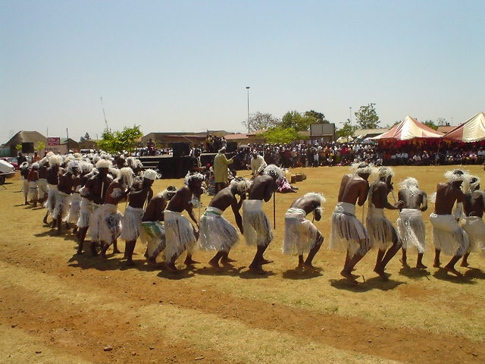
Figure 2.4 Example of Tshikona traditional dance, in a photograph taken by Shadrack Mphaphuli in 2008 at Mutingati Primary School which I visited on Heritage Day (24 September, 2008). I have used this picture because of the performance uniform, which is unique and not found in many Tshikona groups.

Bruno Nettl (1983) claims that it is important for an ethnomusicologist to look at the change in a society because it also impacts on the outcome of one’s research. Nettl maintains that researchers should be interested in the socio-cultural change within a society in order to understand how music was perceived previously and is currently perceived. He argues that:
We are interested in the way, in which a culture musically defines itself, but also in the way it changes its music, and thus we also stress the understanding of musical change, less in terms of the events than in the process (1983: 9).

Further to Nettl’s ideas, Blacking also indicates that it is important to try to understand music from the socio-cultural context in relation to the depiction of cultural meaning. He says:
The retention of traditional music can be enlightening and positively adaptive as it can be maladaptive and stultifying: the meaning of musical change or non-change depends on their structural and functional characteristics in the particular context under review (1995: 151).

Blacking argues that by missing the cultural context of a particular music, one might not be able to understand the intended message, because the meaning is completely and deeply rooted in the cultural context. He posits that, “music is not an immediately understood language so much as a metaphorical expression of feeling. But it is able to transmit its message precisely, provided it is heard in context” (1995: 45). Socio-cultural change may lead to musical change and new modes of musical expression, which may bring about a revolutionary musical change in a society. That is why it is very important to understand socio-cultural changes and to study the musical history of a culture before interrogating the currently practiced music. Blacking states:
The study of musical change must be concerned ultimately with significant innovations in music sound, but innovations in music sound are not necessarily evidence of musical change, (1995: 150).

Understanding these socio-cultural politics helps one to know that the words used in the music may express cultural problems relating to community conflicts. Cultural groups sing about their leaders and praise them for the prosperity of their society. A community that is under a great king would have songs that praise him more than the others. The words play a major role in understanding the performance of these three selected traditional dances. The dance steps may remain the same while the message of the song is different. Sometimes the dance steps change due to the change of words in the song. The socio-cultural changes affect the music performance from one generation to another. Music that early researchers listened to, as compared to the examples I have listened to, are not exactly the same in terms of the political messages that are expressed. This is because traditional performances are not just about dancing, but the message is more important as a political agency to correct, rebuke and direct people’s lives in an African communal setting.

Chapter 3

Composing indigenous musical history: my fieldwork in Venda

While on a journey to Limpopo to carry out research in December 2015, I was pondering on my life as a composer. At the same time, I was ruminating about my experiences as a traditional dancer involved in music competitions as a lead dancer. This was the music that I was part of during my undergraduate studies in music. Having been in a position to compose some of the winning traditional dance tunes and steps; and at the same time researching this music, was a humbling and fulfilling experience for me, knowing that my skills were informing my research project. It also confirmed for me that the direction of my research was the appropriate one. This synergy contributed in particular to my investigation of rhythmic aspects in Venda music. Having been exposed to Venda indigenous music from an early age, this played an important role in developing my interest to pursue this research topic.
Arriving in Venda and being welcomed by the scorching summer sun I found it to be both challenging and discouraging, but at the same time, I was reminded of the home I am familiar with and of the beautiful scenery and lush vegetation. When considering the long research journey ahead of me, I contemplated on how it will be filled with interviews, performances, and the traditional dances I would have the opportunity to record. Observing the crops in the green valleys, I interpreted the abundance of vegetables and fruits as a ‘welcome back’ omen to the rich land of the Venda. Amongst the riches that Venda-land is known for, such as edible produce, lies the cultural wealth of indigenous music practices of the people.
Embarking on this journey was greatly fulfilling for me, especially knowing that I would be contributing to the enrichment and documentation of the cultural life and music of Venda people; the knowledge that I would be adding to the scholarship that I believe has not been sufficiently explored particularly in the area of rhythmic strata in Venda indigenous music. I also believe that efforts such as these are crucial to the renaissance of indigenous knowledge systems and community upliftment programmes; particularly by African scholars - and more needs to be done in order to document and preserve indigenous African music within South Africa. My early active activity as a dance practitioner gave me the courage to creating a fresh legacy within this rich musical heritage. This would take the form of transcriptions of the music that can be used for future study purposes by other researchers, as well as for my own use. In addition to reference some of the traditional influences as part of my creative composition work. I was also filled and imbued with a strong zeal for making such music available to other educational facilities – as part of information sharing – before this music is completely extinct, especially in its natural setting. The threat of indigenous knowledge extinction has been a critical discussion in twenty-first century academic circles. However, being aware of this situation as a scholar prompts me to use the word with extreme caution in my research. However, knowledge extinction is not the only reason for researchers to pursue the area of indigenous knowledge, but the drive to produce new knowledge is at the core of research itself. I was also encouraged to undertake this project because of the lack of Venda traditional music in notated sheet-music format – a format that would be useful for institutions of higher learning and entities that offer indigenous African Music education. Being a traditional music practitioner and a traditional dance activist, inspired and motivated me to want to archive and preserve this music in notational format (as it then mostly existed in audio format with very few recordings properly archived).
The absence of archived indigenous African sheet music could lead to the music failing to become known anywhere else in the world. Curt Sachs (1962) maintained that music is a very important part of culture; “as an indispensable and precious part of culture, it commands respect. And respect implies the duty to help in preserving it” (1962: 3). Having considered how much information is available about Tswana or Sepedi or Tsonga and other South African musics, the literature is much less extensive in relation to Venda music; it is therefore extremely important to do research into Venda music. Traditional music performed for rites of passage at life events, such as weddings and funerals - and even children’s songs - are in danger of dying out altogether with the practitioners of this unique African treasure.
The story of African knowledge systems is an interesting one, because of its unique history. The history of African cultures is rich in knowledge that has seldom been written in books, nor documented for preservation. Thanks are due to the late 20th century ethnomusicologists who took it upon themselves to begin documenting some of the music stories of African cultures. Thankfully, not all was lost; the African story has always relied on oral traditions and memory documentation rather than the written word to preserve knowledge. Having said this, though, I am also aware that much research, including my own, needs to be sourced from the oral tradition of the community. In this case, my own insider knowledge and experience contributes to formulating my theoretical arguments in this research. I believe that locating myself, as a scholar within the community would also reaffirm the theory of documentation through memory as a valid tool; at the same time my research aims to prove that this traditional knowledge needs to be documented for it to survive for posterity. There are numerous and obvious challenges regarding memory documentation, particularly when it comes to those who have the cultural knowledge, but pass away before it is transferred to the next generation. This then becomes a great loss to one’s cultural heritage:
On the rather flimsy ground that handing over knowledge about the past has traditionally occurred in African societies through oral tradition and rarely through written documents, the West had declared Africa a continent without history (O’Brien, Nicodemus, Chiu, Genocchio, Coffey, Tejada 2013: 18).

This problem presents scholars like me with the challenge of trying to make sure that future generations should not suffer the same absence of a written cultural history in the same way that our ancestors did. Having worked on this research project with two different Tshigombela dance groups from Tshaulu and Matondoni, situated in two different communities in Venda that are led by the same leader, Netshifhefhe, I want to stress the importance of understanding the practitioner’s perception of a researcher. The practitioner has a different perspective of an ‘insider’ researcher rather than of an ‘outsider’. It was the first time that I engaged with the two groups when I visited Tshaulu for the first time in 2016. I had been to Matondoni before I embarked on this research but was not aware of a Tshigombela cultural group in Matondoni.
In fact, the reason for working with these two groups was that the leader, Netshifhefhe, had two wives living in different places. During the time of my first visit to Tshaulu (2016) he was staying there with his second wife. After some misunderstanding with the Tshaulu group members, he dissolved it and then formed another group in Matondoni in the same year. He later introduced me to this new group in order for me to continue my research working with the new people as this is the area where his first wife lived. The implications for me were actually positive because I managed to confirm some of my beliefs about the practices of these dance genres; namely whether being village-specific or not.
There are different kinds of ‘insider’ levels that can be unpacked. Being an insider scholar can have a dual significance from the viewpoint of a traditional practitioner. One can be an ‘insider’ to the indigenous group by virtue of speaking their language and having been born within the same culture. This may not necessarily mean that the ‘insider’ researcher in this context understands the music of the practitioners. On the one hand engaging with practitioners as an ‘insider’ could be perceived in the same light as that of an outsider’s approach – namely that it makes practitioners want to hold back their participation. This view has been perpetuated by the practitioners’ previous experiences with other researchers. Some traditional practitioners from certain villages have developed a negative attitude towards outsider researchers. This negative attitude has had an impact on their quality of participation in outside community researchers as they occasionally feel exploited (this is particularly common in communities that have participated in research practices with outsiders).
Out of the two groups with whom I worked, the one group from Tshaulu, with whom I started working from the beginning, gave me a clearer insight into understanding the dynamics of the relationship between the groups and the researchers. This became evident when I made the practitioners sign the consent forms after explaining the purpose of my research. Immediately they expressed concerns indicating that I was not the first one to come to the village and ask to do research, even though I was the first ‘insider’ (African and black; speaking the same language as the practitioners). There was initially a negative attitude towards working with me due to the group’s previous negative experience with others before me.
The leader informed me that there had been outsider researchers who engaged with the same group at Tshaulu who made them feel that they did not appreciate their time and efforts. I was initially perceived in the same light at my arrival; however, the group leader cleared such perceptions. The leader also informed me that there may be fewer members who would be participating in my research as compared to what I initially anticipated due to this perception.
On the other hand, since I was the first insider to engage with the group, the negative perceptions soon disappeared and there was an improved level of trust - this became a positive experience. When an ‘insider’ researcher engages with traditional practitioners, they develop a positive perception, which could be associated with viewing the researcher as a possible role model for the young members in the community. An ‘insider’ could be viewed as a symbol to could champion positivity as a cultural ambassador from whom young people can learn. It encourages participants to feel free to share their knowledge, knowing that this will help their children in the future. When the researcher is one of their own, they feel comforted that other young community members may be inspired to follow in his/her footsteps. This positive perception helps the practitioners to share their knowledge knowing that a researcher is documenting their traditional knowledge – a factor that will benefit and empower the community at large, instead of national or international beneficiation, which may manifest without anyone witnessing it.
I realised that being an African scholar gives one a sense of responsibility and obligation towards continuing to research one’s own music. African scholars are in the best position to write about their own cultures and stories, because they understand the subtleties of their own language better than any outsider can do, who does not speak the vernacular. The biggest challenge found in many African stories is, that most African music has been studied by outsiders through the aid of ‘informants’ - what I call ‘African knowledge holders’. The documentation of African music knowledge is mostly credited to outsider researchers. Much African music knowledge has been at risk of becoming extinct and still is – this includes the knowledge and existence of many African indigenous instruments. The outsiders, who often do not understand the language of the practitioner(s) eventually theorised about African music, which then led to some misrepresentation and misguided conclusions. The majority of these conclusions have left African music with the dilemma of being classified in an unverified general theoretical structure. As an example, if someone is relying solely on a translator to find meaning, it is inevitable that much can, be misinterpreted and lost in translation. It gives the reader the impression that what has been written is correct and true.
The insider has a better understanding of the language problems and consequently music expressions. An important problem lies in the fact that terminologies for music in African languages are very limited and a word is generic for many different meanings. African scholars need to write their own stories from African perspectives and should rise to the call of writing, documenting and preserving their own indigenous knowledge. Energies could be directed at undoing some of the damage already done by certain outsider theorists, who have come to conclusions based on generalisations of how African music is erroneously perceived. I believe Africa needs fresh minds of young indigenous scholars, who are willing to take the initiative of documenting their own cultural histories - so that they should not be lost completely or retold by others in the wrong way. Many contemporary African scholars have already demonstrated their dissatisfaction with false stories due to injustices perpetrated by ignorant theorists who grouped all African music into one pot that is supposedly cooking the same food for all Africans. Some of the theories that have perpetuated a negative perception about African music are, for example, that African rhythm is an inborn characteristic in black people; that African music is a polyphonic music and that African music is recreational; the African man is musical etc.
The view that many scholars have painted which presents Africa as one country with similar practices across the continent, has made me locate my argument in a position such as Kofi Agawu’s, who strongly opposes such naïve and negative views. He states in his book 'The African Imagination in Music' (2016) that the consequences of such general theorisation in scholarly literature have detrimental ripple effects in general African literature.
Agawu says universities rely on previous knowledge in order to build up and produce new knowledge; however, in the case of African music the ‘new’ knowledge would rely on some of the misrepresented ‘old’ knowledge of African music, which would spread ignorant theories in academia and would take time to correct and undo. Agawu unpacks the complexity of studying African instruments, as many Western researchers wrote about African music without taking into perspective the African view. Agawu uses a case study of the “Hornbostel-Sachs” instrument classification system applied to African instruments. In his quest for a fresh look into the literature of African music he proposed that “it is time for African musicologists to replace the Hornbostel-Sachs system with schemes that are more reflective of African realities” (Agawu 2016: 79). This view takes into consideration the many things that have already given African music a bad reputation and have resulted in different perspectives that are not reflective of African realities.
In identifying indigenous practitioners who were known in their communities to be the most knowledgeable about the three musical styles of my research I was also faced with trials and complications. As I began to search for an expert in Tshikona music, I was confronted with the sad reality that the expert had already passed away some years ago. According to the villagers, he was the only person who knew a great deal about Tshikona dance music in his community. He knew about the tuning system used in the music, the instrumentation, and the use of drums. Most importantly, he was also a good trainer for this music and he understood many dance steps. The loss of such a person is a great one indeed and unless their knowledge is documented, while they are alive, this valuable cultural knowledge is forever lost – lost for education and research purposes for future generations.
This has also been one of my main motivations for wanting to do this research; to make sure that preservation of the musical heritage of Venda people must not disappear and remain undocumented, particularly the music that has the potential of being documented in notational format. This knowledge has gradually been disappearing as a result of colonisation and globalization: however, even though some documentation by earlier ethnomusicologists exists in scholarly literature, much more needs to be done from African perspectives. A new approach has to be devised to better preserve and document African life experience on the ground.
In order to fit into the new world order of the fast-changing global village, most African people view history was no longer as relevant to them as the development of their communities and accessibility of modern lifestyles and technologies.
This has been particularly so in the urbanised African communities, who show less interest in their own cultural heritage due to poverty and a growing number of unemployed people. That is why authorities in some communities in rural settlements make it mandatory for people, particularly the young ones, to participate in their cultural activities. This is an example of the loss I am describing and of attempts to preserve the culture. Many people in their communities regard indigenous African music as less important, because they are not able to survive though music; practitioners become victims of their changing environments, and with the adoption of new lifestyles, they are not able to make ends meet. It is likely that very little indigenous South African music has been documented, particularly Venda music, due to the colonial yoke inherited by most South Africans, a state in which most people were not able to find ways of self-expression and to promote their cultures in the apartheid regime.
It was only after 1994, that South Africans finally achieved independence from the white apartheid regime and the power shifted to black people; most cultural activists and artists started to freely express themselves in music and lyrics without fear of being locked up; and to document their own musical experiences in relation to their cultural practices on the ground. The issue of how culture was at the basis of the apartheid ideology of “separate development” and that Bantustan governments themselves used culture in particular ways, is beyond the scope of this research – yet aligns itself perfectly with this topic. Democratisation has had a profound effect on the performances of Malende, Tshigombela and Tshikona music with the restrictions having been removed. There were greater rhythmic gestures and the words were much more expressive.
Yuri Lotman (1990), a scholar who wrote the book ‘The Universe of the Mind – A Semiotic Theory of Culture’ explains that
“the idea of re-establishing the past involves elucidating the facts and making connections between them. The facts are established by collecting and comparing documents and adopting a critical approach to them” (1990: 217).

History is not only told through written documents, in spite of arguments of this nature being by Yuri Lotman. He maintains that without written documentation there is no history that can be traced down in a chronological order, as it would be altered each time it is told by a different person at a different time - this is according to the Western understanding of how history is constructed. One might then ask why it is that Western theorists are so interested in doing research in Africa if they believe that there is no history without written documentation. This is because they prefer to document it themselves from oral accounts, but the important point here is that history does not only exist in a document but in the stories that form the oral tradition.
This is well supported by the political scientist, economist and author Francis Fukuyama (2006) in ‘The end of History and The Last Man’, which explores the nature of historical documentation as a phenomenon that is based on the selection of important versus unimportant historical events. He explains that
For “history” is not a given, not merely a catalogue of everything that happened in the past, but a deliberate effort of abstraction in which we separate out important from unimportant events (Fukuyama 2006:138).

Even though these special selections of history documentation shift from different movements in the history of human race focus such as military, social, human rights, political or diplomatic history, they do not do so without maintaining the standards of historical selection of what is important and what is not. Researchers interview and interact with different indigenous practitioners with different views, their perspective of cultural history and historical accounts of their cultural music practices, which also leads to a particular careful selection of what is important and unimportant to them, as part of history documentation.
It is inevitable that researchers are mainly going to rely on oral data to construct their research arguments and this data would have to be provided by someone referred to as the living proof of the very history that the researcher wishes to validate. This indicates that as long as there are still people who know and understand the history of their music, that there are historical facts to be constructed and these can validate that history also exists aside from written documents. This practice of oral preservation has created many challenges - such as the ownership of songs that are considered part of traditional circular music. Individual performing artists often play these with added personal creativity and then claim their ownership of the music.. Since traditional circular music is not notated to indicate the original composer, it then leaves room for copyright and royalty disputes when these artists decide to commercialize this music for financial gain. The fact of the matter is that when music is documented it clarifies its source, ownership and copyright issues.
Lotman presents confusing argument: on the one hand he is opposing the existence of history without written documentation (used in order to extract the ‘facts’ by the historian); but on the other hand, his statements support the view that history can exist without written documentation. For example, we see this in his validation of a scientific fact based in its historical existence. He argues that as long as there is scientific evidence that can be taken to a laboratory and be tested for a statistical fact, then that can be regarded as factual historical proof. I see traditional music as evidence that validates itself as an historical fact, namely that Africa records its history without necessarily a written documentation. Lotman says that the primary objectives of the historian are to “be able to read a document and, by textological procedures as well as intuition, to arrive at an understanding of its historical meaning” (1990: 217). Inasmuch as Lotman is saying that documentation is a way to gain an insight into historical facts and how one understands them, there remains the question of authenticity in the same way as present in undocumented oral history.
According to Lotman, “the historian is condemned to deal with texts” in order to validate historical facts. On the other hand, a scientist has a different approach, which is based either on deductive science, that construes its premises logically or on the experimental sciences that relies on subjective observation (1990: 217). The historian in a way acts as a decoder of information while using texts from documents; he/she then has to use his or her discretion and discernment in order to deconstruct the text with a view to creating a real event of the past. This then also invalidates the point that Lotman is making, namely, finding the actual ‘facts’; because in this case, the ‘facts’ can be subjective as a result of the historian’s interpretation and findings. This could then mean that the actual ‘facts’ are questionable, when they are scrutinised by a different historian. This is because there is no such thing as an absolute fact – there are many interpretations and viewpoints. This is also supported by Fukuyama’s point that history is not only about the past, but that it is a careful selection of what is important and not important to the storyteller.
An example of this would be a director who reads a Shakespeare story and tries to bring the text to life in a film or a live show, based on his or her view of an adaptation of the Shakespearian text. Different directors reading the same text of Shakespeare would have different interpretations and outcomes of the literature, based on their selection of what they perceive as significant or not, according to their subjective viewpoint. In the same way, the historian is faced with the challenge of making his/her own interpretation of the text. Either way the historian’s interpretation would differ from another historian’s interpretation, depending on whether he/she is an expert on the subject or is an amateur who is reading the text superficially without any theoretical background. In other words, the written documentation is subject to manipulation, depending on the bias of the documents being assessed. One could then question the reliability of the actual discoveries that are made by the researcher regarding the veracity, as this would depend on the historian’s own interpretation. It is a given that the historian will apply his/her own interpretation as long as the material is not deliberately corrupted by the writer for a disingenuous purpose. The point is, whether the history is transferred through oral or written documentation there is always the risk of an erroneous interpretation based on the researcher’s own viewpoint. It does not necessarily mean that if the knowledge is preserved through the oral tradition method, that it is less authentic or unreliable as compared to the documented knowledge.
The danger is that when the traditional knowledge keepers pass away that their wealth of knowledge and information will remain undocumented. The practitioner tells his or her view of the past with passion and with life’s experience that transcend the dry documented information, and with a deeper meaning that surpasses the decoding of the written texts as ‘facts’ - oral history is very different from a theoretical approach. Oral history does not formulate a philosophical bias and it is not the same as a carefully constructed text that was created with a specific view or perception and audience in mind. Even though documenting history from oral accounts also presents its own problems, what the reader perceives as facts is based on the researcher’s choice of historical events.
The bottom line of this observation above is that the researcher would have to analyse the information he/she receives from the indigenous knowledge expert.
History continues to redefine itself through many modes of cultural and artistic forms that might not have necessarily been documented but rather passed on as an oral or verbal record. Dance music is one of the most important forms of expression in African cultures and it continues to tell the story of the past in different ways.
A fact for a myth is not one for a chronicle, a fact on the fifteenth page of a newspaper is not a fact for the front page. So from the point of view of the addresser, a fact is always the result of selecting out of the mass of surrounding events an event which according to his or her ideas is significant (Lotman 1990: 203).
According to Lotman, the facts presented by the researcher have to be in the form of an event, in order to validate the text. The fact of the matter is that history will be told by the researcher regardless of what research material he/she has presented as ‘facts’ or not in order to validate a particular notion of that history.
The pursuit for this research was motivated by the existence of historical facts of Venda traditional music and my early discovery of being talented at composing music for traditional dances. This skill allows me to compose music that uncovers a strong connection between my previous practice as a traditional music dancer and my current practice as a contemporary music composer with a Western classical training background. When I reflect deeply about all these experiences, I feel as though my ability to incorporate traditional elements in my compositions is a reflection of the totality of my previous experiences. I see my previous experiences as a spotlight projected on to a ‘see-through canvas’ which reflects in my compositions. Taking a practice-based approach to understanding the music of a culture through field research from the practitioners’ point of view was a leap of faith and a first-time experience for me.
I did not wish to be like some composers who use and engage with traditional material in their compositions without first connecting with the people on the ground. A compositional approach, which addresses the essence of a particular culture, as well as the behaviour of the members, has guided my research and led me to an improved music-making practice for the Venda people. These important aspects have become my guiding principles in understanding the traditional music in its cultural context before using it as reference material in my compositions. Before I decided to do fieldwork in Venda, I was discouraged and a little unclear by the fact that the literature that I read in the ethnomusicology discipline before conducting field research, did not present a a standardised methodological approach. The literature referred to researchers such as Alan Merriam (1964), Stephen Feld (1990), Bruno Nettl (1991), Philip Bohlman (1991 and 92), Paul Berliner (1993) and Gregory F. Barz and Timothy J. Cooley (1997). These scholars indicated that the approach of studying community music does not provide a standard methodology for fieldwork researchers, particularly in the area of composer researchers who embark on an enquiry in the field. However, at the same time, this was also an encouraging discovery as it gave me the opportunity to focus on several methodologies used independently by some researchers could be relevant for me.
The other positive thing about not having a standard methodology in doing field research in this area was that I had the opportunity to develop my own methodology. The lack of a standard methodology also gave me an opportunity to explore the many experiences and techniques that ethnomusicologists applied in the past for gathering data and analysing it. Bruno Nettl vents his frustration on the discipline of ethnomusicology for not being able to produce a standard definition for the term ‘ethnomusicology’ as a field of study, which for me was also not much help, as I was interested in investigating field practice methods as a composer-researcher, doing field research for purposes of my creative work. According to him, the terminology has evolved so many times in that every practitioner comes up with his/her own definition of the term. After looking at how other ethnomusicologists have tried to define the discipline, Nettl comes up with his own definition that is tied to a set of beliefs in the form of a ‘credo’, which he argues provides guiding principles that can be used when conducting ethnomusicological research. The principles of by Nettl’s credo can be summarised as follows: it is a study of music in culture, of the world’s musics from a comparative and relativistic perspective, with the use of fieldwork and engaging with all the manifestations of a society (l2005:13).
This study takes into account the role of music in a culture as a core focus, while trying to understand how the people practicing it make sense of it. In order to do this, ethnomusicologists have to take a comparative approach (vis a vis Western music) while taking into account that this could only be achieved through fieldwork and by observing the social activities that form part of the society. This is the reality of the art of fieldwork with its complexities and challenges. My approach has been to be an active participant in the culture and in the indigenous style of the people’s music, in order to absorb it and use it as a point of reference in my own original compositions.
Alan Merriam, in the process of exploring the various definitions used by other ethnomusicologists, presents his own, which splits the term into two words, namely ‘ethnological and musicological’. The former is a term that deals with the function of music as part of the human culture, while the latter deals with the structure of music. Merriam believes that the two are inseparable, as the one affects the other. People who perform music express their own behaviour, which in turn affects the quality of the music they perform. Merriam’s definition of the nature of ethnomusicology is concerned with the dual characteristic that involves an ethnological and musicological approach to research.

He then comes up with three key indicators that are important when conducting field research: the collection of data, data collation analysis, and the compilation of research conclusions. This is directly opposed to Nettl’s guiding principles of conducting ethnomusicological research, because Nettl’s principles cover other important aspects when conducting field research - while Merriam’s key indicators only deal with data (gathering, analysing and formulating it into critical research arguments). There has been a visible evolution in the discipline and practice of ethnomusicology which appears to have borrowed some of its methodologies and techniques from its sister discipline, anthropology as well as its other ‘sister discipline’, musicology.
Fieldwork in ethnomusicology seems particularly concerned with the abrogation of geographical and cultural distance, hence its distinguishing characteristic of representing the music of the Other, with a verifiable level of scientific observations and in the contexts of the society where it is found (Bohlman and Nettl 1991: 142).

Undertaking this research as a composer and wanting to use traditional elements as creative resources, I believed that the appropriate approach was to do fieldwork in order to better understand the musical practice of Venda people in its natural and cultural context. This kind of practice-based research is also well documented in the book edited by Dogăntan-Dack, (2015) called Artistic Practice as Research in Music. Theory, Criticism, Practice. The book explores practice as research as a core discussion for scholars, particularly those that are artistic practicing researchers. The book uses different case studies of artistic practices that are perceived as a methodological approach to research in music as. Academia sees artistic practice as research differently from research purely based on the written text. Some art schools bring the indigenous practitioners to their schools to engage with their practices and develop research from this interaction.
I am also aware that there is a recognition of creative practices (performance and composition) as valid forms of research, and that these are now recognised as such by the National Research Foundation and by selected South African universities. This development is well documented by Celia Duffy and Stephen Broad in a book published in their conservatory studies in the United Kingdom. It is well detailed in the chapter Practicing Research, Playing with Knowledge. Duffy and Broad have used case studies of conservatories in the UK that are ‘artistic practice- based research’ art schools that attract some university researchers (professors and lecturers) to engage with practitioners in these schools which is more convenient than having to go to the field for research purposes. The focus for Duffy and Broad’s chapter is around knowledge-exchange instead of the traditional methodology practiced by many universities regarding knowledge-transfer from an informant to the researcher. This discussion is very central to my research, as I have taken the same approach of sharing my knowledge while learning at the same time through participating with the indigenous practitioners creating a two-way learning experience. Duffy and Broad share that:
Conservatories traditionally have a highly vocational, rather than a research-led or ‘academic’ focus (and it is not insignificant that among some conservatoire students and staff, the word ‘academic’ is a loaded and even pejorative term) (2015: 36).

Artistic practice as research also allows the artist to document the practical process of engaging with the art from a creative and innovative stance, which is equally valid to the documentation of an ethnomusicologist’s detailed encounter with practitioners in the field. My creative method also documents the preparation leading to a performance, as well as the reflection after the performance. The experience of engaging in fieldwork as well as presenting a composition concert required thorough documentation of both processes leading to the written work.
As a key form of inquiry within the discipline of ethnomusicology, fieldwork has been deemed to be the most reliable practice, because of the many dynamics this discipline offers the researcher. This is probably due to the intricacies of the musics of different cultures, which demand personal observation, participation and close interaction with the practitioners, even though the history of ethnomusicology as a discipline is much more specific. More recently, some researchers have questioned and critiqued the historical legacy of ethnomusicology and its methodologies, while others have embraced the changes and challenges that have come with fieldwork practice. Researchers such as Gregory Barz and Timothy Cooley (1997) have questioned the values and ethics of the researcher in relation to the music being researched. In the book, Shadows In The Field – New Perspectives for Fieldwork in Ethnomusicology, edited by Gregory Barz and Timothy Cooley, they question the very reason why fieldwork should be a primary focus, whilst arguing that the writing up of that fieldwork potentially undermines the music of the ‘Other’ in the way it is presented or interpreted:
Why do we focus on fieldwork, when the most lively debate among social sciences in recent years, especially in North America, has concerned the adequacy and legitimacy of our means for describing the cultural ‘Other’ in writing? Though the literature that addresses this ‘crisis in representation’ does give more attention to fieldwork, it also includes an implied or stated claim that the quality of fieldwork is less important than the scholar’s ability to represent convincingly the other (Barz and Cooley 1997: 3).

The assumption of “otherness” has been questioned and critiqued, which is also relevant to my project as I am talking as a native scholar who can be viewed on both sides of the equation as an ‘insider’ as well as an objective researcher. Researchers such as Bruno Nettl, Alan Merriam, and Philip Bohlman have both advanced and critiqued some of the approaches and aims of ethnomusicology throughout history, and have noted the lack of a common methodology in the literature that could be used to help researchers to formulate a hypothesis when doing fieldwork. The problem of not having a standard fieldwork methodology presented me with an opportunity to apply a methodological approach as a participant researcher. Although the main purpose of doing ethnomusicological fieldwork is to collect data for analysis and to then reflect on the findings, there have been many other approaches by various researchers who apply different techniques in collecting data; but without a clear methodological strategy before going into the field. They would rather rely on the on-site experience while experimenting during fieldwork (Merriam 1964: 37). Taking the risk of ‘going with the flow’ regarding where the research would lead them in terms of their approach has also helped many researchers to arrive at a methodological method that is guided by the research.
After reading some of the literature about Venda traditional music, and discovering that there is limited literature pertaining to Venda indigenous dances, particularly on the three above-mentioned Venda music styles, I then realised the need for me to pursue this research. My research was informed by the prior work of scholars such as John Blacking (1995), Kaiser Netshitangani (1997) and Jaco Kruger (1999) - all of whom have contributed towards this important body of knowledge. All these three writers have discussed and highlighted how the practice of these musical genres has been politically influenced and in turn, they too have influenced politics regarding the socio-cultural lives in Venda culture. In my research, I briefly looked at some of the socio-cultural politics that affect the three selected genres while using rhythmic motifs as a central focus.
Barz and Cooley’s research indicates the importance of fieldwork being at the core of being in a position to best contribute to the humanities and social sciences discipline. They explain that,
fieldwork distinguishes ethnomusicology and ethnographically-based disciplines from other social sciences, and ethnographers derive from fieldwork their most significant contributions to the humanities in general” (Barz and Cooley 1997: 4).

My previous research efforts and my being a traditional dancer at university exposed me to traditional music and I became much more aware of the music of my own culture. I visited the village called Ha-Makuya in 2008 in Venda, to learn about the cultural music dances of Venda people; during which time I was also actively involved in dance competitions at the University while I was studying for my undergraduate degree. All these experiences made me develop strong connections to my roots and tradition and this has influenced my initial interest in doing this particular research. However, I became more aware that in doing so, I became more critical of my own perceptions regarding my culture as a native researcher.
My research has enabled me to understand the relationship between these genres during the time I visited Ha-Makuya while reading for my Masters degree in (2008) and again in 2016. I visited Tshaulu and Matondoni villages between 2016 and 2018, which reminded me of the rich indigenous knowledge existing in those communities. Throughout my visit to all villages, I experienced the same music performed by different groups. However, as a composer and researcher, I tried to ensure that I remained as objective as possible regarding political matters and sensitive to the people who are the proprietors of this rich musical repository. Following Lotman’s argument of validating history, I felt that allowing the practitioners to tell their story in their own way without leading them to conclusions, would open up ways of better documenting and better understanding their musical experience. I shared my experiences with the people of Tshaulu and Matondoni and enjoyed their company, whilst learning from them in return. I believe that doing my research in Tshaulu and Matondoni has enriched my indigenous knowledge and given me opportunities to pursue my creative endeavours; and explore more techniques to become a better composer.
Fieldwork research becomes an enjoyable tool when there are mutual benefits for both parties; in other words the researcher and the researched sharing each other’s experiences. Steven Feld (1982) did his research on the Kaluli people, in his book entitled Sound and Sentiment – Birds, Weeping, Poetics and Song in Kaluli Expression, in which he explains that maintaining a good relationship with the people one is researching is key to successful research. He calls this shared experience the “process of developing a co-aesthetic relationship” (1982: 231). Sharing musical experiences in this research with the groups I worked with was also a beneficial factor for me. I found out that ‘knowledge exchange’ is a more efficient research tool than ‘knowledge transfer’ from the practitioner to the researcher.
I was raised in a different cultural environment from the groups that I worked with that come from Tshaulu and Matondoni. I come from a more developed area that rarely practises traditional music performance as compared to the groups with which I worked. They are still very traditionally acculturated – they are people who are still practising their traditional musical rituals that still personify the rich culture of Venda people. Even though I spoke the same language as the people with whom I was conducting the research, there was a clear cultural difference between them and me regarding how we separately understand indigenous music knowledge. This realisation made me re-evaluate my approach to the study and re-examine my research questions very carefully in order to avoid misconceptions between us. I have benefited a great deal by asking them direct questions for my research (which were instantly translated into Venda. The groups shared with me how beneficial it was for them to be part of the research.
When I was in the Tshaulu village doing my research, I particularly enjoyed participating in performances with the practitioners. This experience has given me a greater depth of understanding of the music of Venda people, which I would not have realised by merely observing the performances without participating as a co-aesthetic practitioner and witness. Participating enabled me to understand certain rhythms by performing them and imitating them through body movements and dance steps. This helped me to know how to signify as a dancer in relation to the drummers, singers and other instrument players who depend on reading the dancer’s body movements to signal the code in order to change of dance steps as part of the performance dialogue.

It was through my participation that I started to understand that rhythmic patterns are structured in a hierarchical system, based on importance. There are certain rhythmic patterns by the dancer(s), and rhythmic layers produced by the drums, that are shared between the performers. I learned that one has to be part of the performance in order to decode these complex and secret webs of rhythmic movements that form part of a complete performance. Feld explains how his experience with the Kaluli people enabled him to have a closer relationship with his research subjects. He argues that:
Yet for me it was the physical sensations of vocalising and drumming that brought me closer to the performance aesthetic and brought some Kaluli closer to talking with me about its inner dimensions. At that point, too, they began to disappear from my mind and notes as ‘functionally beautiful art forms’ and to take hold as ‘affecting presences’ that I could experience in a feelingful way (1982: 231).

My experience taught me a lot about the relationship between a researcher and the traditional music expert. Engaging in fieldwork requires one to identify a specialist who will be able to assist the researcher in terms of simplifying the language and in understanding the music better. Language issues in this context mean decoding musical idioms that are better understood by the practitioners. There are musical terminologies that are not easy to understand if not explained from the practitioner’s viewpoint. One has to adjust to the fact that some African music expressions have no direct English translation from vernacular to English, which requires the borrowing of a word from English. It is something that Nettl as a fieldwork researcher believed helps in solving complex matters and also simplifies issues for the researcher. It is therefore very important to identify a specialist in the area in which one is doing the research in order to be much more efficient. He explains that:
Most cultures have some sense of a musical specialist who, for whatever reasons – religious, aesthetic, social – knows the music better and is able to produce it more adequately and in larger quantity than others (1983: 42).

It should be noted that the musical specialist is not an all-knowing person about the culture but they have a better understanding as compared to other practitioners; they also act as mediators between the researcher and other practitioners. In some cases, the interpreter who many not be the musical specialist is given attention by the researcher because of his/her ability to translate from vernacular to the English language. This situation can lead to a practitioner who possesses the indigenous knowledge becoming a little uncomfortable, as his/her information has to be filtered by the translator before it reaches the researcher. The disadvantage of this exercise is that a trail of though often gets lost in the process of translation. This happens during the interruption of translating while the knowledge expert waits for the translator to explain to the researcher.

Having an interpreter helps to have one centre of communication to avoid misunderstandings between practitioners. However, if the interpreter is not knowledgeable about the practice there is a risk of wrong interpretation and a loss of subtle meaning. This choice of selecting a musical specialist can have dire consequences on the outcome of the data collection. I do not think I would have produced the same results if it were someone different that I was working with as a specialist. Some interpreters who are not necessarily specialists may be motivated by money, greed or poverty but without any understanding of the traditional musical context, while others may be too conservative in withholding information that may be considered traditional secrets that have to be ‘earned’ by the researcher.

Paul Berliner (1993) cites a perfect example of a scenario that could result in documenting incorrect knowledge due to trust matters between the researcher and the practitioner. Berliner studied the Mbira of the Shona people of Zimbabwe. He discovered that it is very difficult to get the correct information from some indigenous knowledge experts until one proves to them that he/she is serious and can be entrusted with secret musical knowledge of their culture. Berliner waited for six years before the Mbira masters could trust him with the secret information of the culture, which is not told to people randomly before they earn it. He explains that his experience taught him a lot about field research technique:
I will long remember the lesson that Bandambira and the members of his village taught me about field research technique and about the nature of knowledge as privileged information (Berliner 1993:7)

Berliner had worked with many other Mbira players during his six years’ experience in Shona music. However, he could only get to interview the master sometime later in his research. When he was finally happy that he found the master known by everyone in the village to be the guru of a particular knowledge, he was still not entrusted with the correct information, as he had to prove his worth to the master player. He explains this through his personal relationship with the master trainer of Shona mbira music:
In my relationship with Bandambira, for example, he decided that I was worthy of being entrusted with the single piece of information that I sought to collect from him only after six years of studying mbira music, three trips to Africa, and many rigorous tests (1993:7).

This is a valuable lesson that can cost the researcher time, money and effort. One therefore has to forge a good relationship with the practitioners in order to achieve to a favourable outcome for both parties involved. I was very fortunate to have worked very closely with Samson Ratshalingwa Netshifhefhe, who was a very close person to me, not only did he provide me with correct and relevant answers to the questions I was asking him but he also referred me to other specialists in the field. My meeting with Netshifhefhe also led to another specialist in Tshikona music by the name of Simon Ratshitanga, known as ‘Sinyegwe’ popularly known in his village as ‘vho-maine’, meaning a traditional doctor, who became a very useful resource for my research regarding Tshikona (just as Netshifhefhe was for Tshigombela music). Unfortunately, he passed away during the time I was still conducting my research in early 2018.
Most often when I went into the field to ask questions or to participate in the performances, Netshifhefhe made it easier for me by introducing me to the practitioners and also by mentioning that I was a student who was there to document the music of Venda people and not for financial gain. Netshifhefhe would immediately ease the minds of the practitioners so that they should not think I have come to manipulate them, or in order to make money out of their music heritage (as this was the perception with some of them when I first arrived in their villages). Before he eliminated this perception, most people were not interested in participating in my study because they thought I was one of those researchers who did not respect their time by using them purely for my own benefit. After explaining this to the practitioners, they were happier to come to the practice and performances where I was recording and asking questions about the music.
Netshifhefhe also taught me the dance steps for Tshigombela music on a one-on-one basis, and he allowed me to participate with the groups he was leading as part of my learning experience. This was a very helpful exercise because for much of the time, when I was doing transcriptions and not sure about certain rhythmic articulation in the music, I would try to dance it the way he taught me in order to remember the accurate rhythmic structures. Netshifhefhe also asked one of the master dancers to teach me how to play the drums, which was very helpful in remembering the dance steps when performing. He also emphasized that it is much easier to understand the dance drum rhythms if one is able to dance the steps. I was constantly thinking about how to refer to elements of their dance rhythms in their musical style in order to create something new as a composer.
Conducting fieldwork was a very fulfilling experience for me, considering the fact that I am very passionate about Venda music culture. When the traditional practitioners learned that I am also Venda-speaking, they were encouraged to be more forthcoming, as they knew that their music was going to be studied by a person from within Venda culture. There have been many misconceptions and perceptions by these traditional groups, with researchers perceived as exploiters of information for their own academic pursuits, while leaving nothing of importance behind in the villages. I made a conscious decision in my fieldwork research to not be biased about the music of my own people and to maintain the dignity of the musical practices of Venda people. As Merriam emphasises the responsibility that the ethnomusicologist has in protecting and preserving the cultures of other people – that they should not misrepresent these – and ensure they do not offer the wrong impression of their music. He maintains that:
This is the point of view, basically protective in nature, that the music of other peoples of the world is much abused and maligned; that such music is, in fact, fine and worthy both of study and appreciation; that most Westerners do not give it its due; and that therefore it is up to the ethnomusicologist to protect it from the scorn of others and to explain and champion it wherever possible (1964: 8).

It is also important for the researcher to safeguard the musical values of others while at the same time preserving and promoting their music. For me, even though it was not the other culture, but my own, it became a source of pride to research the music of my culture, as I also strongly believed that this was going to help me in developing my own compositional voice in addition to better understanding the music of Venda people. As a Western-trained composer who is inspired to write music that incorporates selected influences from Venda music culture, for me this research was a humbling experience. I believe that having a Western perspective in my compositional style and in addition learning elements of Venda traditional music have enhanced my compositional ability for the future.
Even though I was very aware that earlier researchers have been criticised for producing research, based on Western perspectives, it warned me not to fall into the same trap. I used my Western training as a guide to understanding analytical processes of the music but not viewing African music from a Western perspective. The responsibility of the researcher goes even further by making available research material for future reference in the form of a documentation of traditional music heritage – as Merriam states, “some have stated specifically that it is the duty of ethnomusicology to preserve materials; that in writing about tribal folk and Oriental music, Curt Sachs comments” (1964: 9). I have a beneficiation plan to provide the Tshaulu and Matondoni communities with copies of my research.
The fieldwork research approach is a reinvention of knowledge through the documentation of what has been culturally practised as musical experience. Kofi Agawu (1995) states that the ideology of people doing fieldwork in order to come up with the concept of African music based on Western analogy of a theoretical approach could be misleading to the scholarship of African music. The concept of primitivism is an underlying factor used by many outside theorists who are not African researchers themselves but studying African music from other counties. Their theories always have the differentiator between African and Western music practitioners. For example, there will always be the concept of ‘us and them’ attributed to the common understanding of each one’s historical theoretical musical perceptive, i.e. Europeans and Westerners are ‘conventional’, whereas Africans are rhythmical or traditional.
The challenge comes from a long history of ethnomusicological studies reflecting tribal mistrust and disdain during the colonial era. This has resulted in the early research approaches being more about comparative methods, while contemporary research has moved away from this practice by focusing on music in society made by people who are part of the culture. The previous approach took a Western-perspective approach, and placed its research under the auspices of comparative anthropological and ethnomusicological studies focused on the role music played in the related communities, while the contemporary approach ignored the comparative methods in order to deal with the nature of music in the context of its society without comparing it to Western music.
Using the fieldwork research approach in enriching my understanding of practical artistic research as a composer has enhanced my compositional knowledge. In addition to enriching my own compositional practise and knowledge this experience has also enabled me to understand the ethnomusicological side of fieldwork studies. I have learned that when taking the ethnomusicological route one would have to expand one’s knowledge to related disciplines in the field, which share common practices between the humanities and social sciences, like anthropology. This is with a view to blending, sharing information, as well as reinforcing the existing relationships between the disciplines that share a common practice. Taking the artistic research practice as a composer requires one to be practically involved in the music-making in order to understand the compositional approaches within the culture.
Researchers such as Alan Merriam traced the field practice of ethnomusicology by looking at two schools of thought that have contributed to the development of ethnomusicology as a practice in the late 19th century: The American International School, as well as the Deutsche Internationale Schule, both of which had a different approach and focus in the field of ethnomusicology. The American school focused purely on the technical analysis of the sound of the music, while the German school was not overly concerned with music structure. Understanding these schools of thought helped me to better position myself in the core argument of my research, while taking into consideration factors that contributed to my research project.
Merriam explores how closely related anthropology and ethnomusicology are; such that they often draw sources from each other, and are in fact known to be sister disciplines in the humanities. He also reveals that anthropology emerged from the need to know more about social information beyond one’s territory, in a form of data collection for comparison and statistics, which led to ethnomusicology using the same methodology of practice in the form of comparative musicology. Entering into the fieldwork with the knowledge drawn from other disciplines in the humanities, such as social science studies, was very beneficial in coming up with a clear methodological approach that worked for this research. Locating my compositional argument in Dogăntan-Dack (2015) who explores different approaches that are used in practice-based investigation, was a positioning stance within my research enquiry. It is important to understand different approaches used such as practice-based research, performing, composing, creative research and improvisation as a mode of inquiry.
When conducting field research with indigenous practitioners it is important to understand that the perspective from the expert’s point of view does not change on account of the researcher’s opinion. What perpetuates most of these pre-set outcomes of research is what Kofi Agawu (1995) refers to as the challenge of doing research for the sake of discovering difference instead of sameness. This is the same as comparative study, which focuses on differences between Western music and the music of other cultures. However, Agawu is emphasizing that the need to discover differences by these researchers tends to overpower the one to discover sameness. The approach in my research has taken a different form from these approaches as I am doing the research in order to discover musical elements from a particular culture to be used as part of my portfolio of creative compositions, instead of comparing forms of music. Agawu explains that:
When was the last time an ethnomusicologist went out to discover sameness rather than difference? When did we last encourage our students to go and do fieldwork, not in order to come back and paint the picture of a different Africa, but of an Africa that, after all the necessary adjustments have been made, is the ‘same’ as the West? So strong and powerful is the founding premises of difference that the ongoing invention and reinvention of ‘African rhythm’, far from buttressing epistemological claims, presents the writer with a mirror image of the dictates of this very ideology of difference (1995: 390).

Ethnomusicology literature shows that anthropology’s contribution to the building blocks of shaping the discipline (from earlier studies of ethnomusicology), began when it was still called ‘comparative musicology’, to its newer phase, when it was called (ethno-musicology), and then to the removal of the hyphen in the 1950s, and has played a great role in the broader understanding of the discipline. The chronological development of ethnomusicology has been used in this research as a reference for doing field research, while my main focus was to understand the approaches used by others.
Fieldwork is key to unlocking most research queries that can only be fixed by face-to-face encounters with the practitioners in order for the researcher to understand cultural studies. Fieldwork was the perfect solution for me to unlock the deep practice of Venda indigenous musical practice, especially in relation to rhythmic layers. Barz and Cooley (1997) further outline the significance of being part of fieldwork research in order to understand cultural studies better. They posit that:
Fieldwork distinguishes ethnomusicology and ethnographically based disciplines from other social sciences, and ethnographers derive from fieldwork their most significant contributions to the humanities in general (1997: 4).

Similar to my approach to investigating, recording and documenting music from my own culture, a composer like Bela Bartok researched not only his own traditional folk melodies but also borrowed from other cultures. Barz and Cooley explains that:
Fieldwork was associated with romantic nationalism and a quest for the natural and the pure. Even musical folklorists, such as Bartok, who did significant fieldwork outside their native country, tended to relate music from other countries (or other ethnic groups within their home country) to the folk music of their native country (1997: 9).

Composers like Bela Bartok were therefore less interested in comparing the music of other cultures to his own, but focused on enriching his own music primarily with elements from his own culture but also drawing from other cultures. In doing this, he was less concerned about the social aspects occupying the thinking of ethnomusicologists. In Agawu’s philosophy, the word ‘relate’ leans more toward sameness than towards difference. I believe that this would also be validated by the compositions by Bartok included elements of his own folk music as well as others.
Conclusion
Through this research and fieldwork practice, I have realised that documenting a cultural history can also reveal hidden elements one’s creative life – elements that can.be triggered only through research inquiry. This process has made me aware that engagement with my own culture as well as being a dancer has influenced my own original creative vocabulary. This has enabled me to be bold in introducing new dance steps, a previously unacceptable practise as tradition held fast to the customs without challenging them. In addition, introducing new repertoire in music was something very new to the community but my whole experience with the practitioners encouraged me to be innovative and original.
Dance is visual in nature, as one could not imagine a visually impaired person understanding the messages being expressed through dance movements and steps without decoding them visually. This is also supported by Omofolabo Ajayi (1998) who further discusses the importance of the visual aspect of dance in a performance. He explains that, “the channel of communication most commonly acknowledged in dance is the ‘visual’, which in fact, until quite recently, was the only channel though which dance was believed to communicate” (Ajayi 1998: 21). Ajayi emphasises that, “dance conveys messages through the visual, aural, olfactory, tactile, proxemics, and kinaesthetic channels” (1998: 22). My research experience into the cultural dance of Venda people and the nature of dance movements has enabled me to better understand my cultural identity. This will further enhance my compositional voice.

Chapter 4

Analysis of Malende, Tshigombela and Tshikona rhythmic motifs

In this chapter, the critical inquiry is focused on the topic of a suitable music notation for African music. I am aware that writers such as Kofi Agawu have a distaste for, and strong reservation with regard to using the generic term, “African Music”. The term is an unfortunate generalization in light of the African continent, which comprises 54 countries and myriad cultures. However, I use it here to illustrate the complexities of an ongoing debate, as well as for lack of a better means of categorisation for these purposes at this time. I consider how other writers in the field have debated the importance of developing a notation specifically for African music, as opposed to resigning oneself to using the Western notation system. In this chapter, I made the decision to use a form of ‘numbers notation’ to represent dance rhythms, thus making my notation of choice a hybrid form of Western art music notation. I am aware that prior to this, numbers as note values and pitch class representation have been extensively explored and applied. For the purposes of this present study, I am employing this notation as a rhythmic guide for Venda dance music.

This chapter presents a technical analysis of three prominent Venda dances, with theoretical, analytical and synthetical analyses of the three dances presented. I have formulated an analytical tool, using numbers to demonstrate how the dances can be understood in terms of number counting. In this notation, my numbers indicate relative time durations. The numbers are used as symbols to represent musical notes. A quaver in this analysis system is represented by the number 1 (the basic unit), and a crotchet by number 2. A zero represents a quaver rest and a [2] represents a crotchet rest. This serves to reveal the rhythmic patterns and resultant layers found in Venda dance praxis. The example below shows how the numbers are used in relation to the note durations, with the quaver as the pulse unifier.

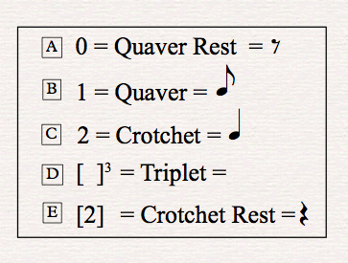

Many scholars in the field of African music studies have debated the use of an appropriate music notation system for transcribing African music. In several debates, strong arguments have been made against using standard Western notation for African music. This is due to the Western notation system’s limitations with specific reference to African music, and its ability to capture its nuances and complexities, especially regarding the accompanying movement and dance. Having said that, however, it is acknowledged that Western staff notation is inadequate for addressing the numerous nuances and expressions of Western art music as well. However, among many scholars who have used conventional Western notation, there resides consensus (and advocacy) for documenting African music using the occidental system. Despite this notation system being described as restrictive in its ability to capture the true essence of the African performance spirit, it is still, however, able to largely reveal the rich heritage of African music knowledge and practice.
Indeed, though music may have sonic similarities, it is not functionally perceived in the same way by different people. Most cultures share some form of musical practice, which makes the concept a universal phenomenon; however, it is not understood in the same way from one culture to another. This means that if music is to be viewed as a language, it cannot be perceived as a universal one, in the sense that various cultures understand their own practices on a deeper level than an outsider would. For this reason, I believe that there is a definite need for an entirely new music notation system within the African context.
Some researchers, who are in favour of retaining the Western notation system, argue that at the very least, the Western notation system is able to capture and preserve select elements of indigenous music . Should an appropriate notation for African music eventually be developed, previously documented performances can be re-transcribed more accurately using an improved notation. Many musicologists and scholars have discovered that their attempts to create an appropriate new notation system for African music do not work for the entirety of African music practices, as African music structures are not all the same. As Bohlman and Nettl (1991) elucidate, “All musics are not rooted in the biblical soils of cultural creationism,” (1991: 137). Indeed, not all musics of Africa share the same cultural and traditional meanings through their performances; this makes finding a singular notation system difficult for the entire repository of African music. For the reasons stated above, my new dance notation includes the Numbers Notation presented in the tables that will follow, which will be the basis upon which my analysis will be clarified. I have used both the Western notation system, together with my Numbers Notation, to assist in the understanding of my analysis. For my own transcriptions of selected songs and dances, I have used Western notation as the basic material (in conjunction with my original dance notation).
After a thorough investigation into the complex elements of dance in indigenous Venda music, I studied the impact of the dance steps on the structure of the music and how these influence each other. I used my existing transcriptions to extract the standard dance steps and movements, especially in the form of standard rhythmic motifs (this refers to a unique or distinct rhythmic shape that is identifiable in all Malende and Tshigombela dance forms), to develop a new simplified music notation for rhythmic pattern-referencing material intended for use in my own compositions. I have notated the various rhythmic layers created by the combination of drums, dance steps, hand-clapping and singing patterns, as a means of documenting and analysing my findings. In the initial phase, I adapted and used Western conventional staff notation and integrated this with my own notation system; this is referred to as “Numbers’ Notation”. This accommodates the added dance notation and provides a new, composite notation system for understanding song and dance rhythms.

Various alternative notation systems have been developed by ethnomusicologists and researchers, and applied to various musics. These systems have been used in transcriptions, composition, and essentially for notating musical practices that are not essentially Western. In terms of finding an accurate transcription, there is an ongoing debate - with certain researchers arguing that it is better to use a more mechanical method, such as the Melograph notation system. As previously mentioned, many researchers support using the conventional staff notation system (also known as longhand transcription), in spite of its shortcomings; for instance, Allan Merriam argues that, “The Melograph is the most accurate transcription device presently available,” (1964: 59). However, the disadvantage of a machine-produced transcription is it only yields the transcription results according to what the machine has scanned or screened. This is similar to a computer-generated music analysis, in which many of the nuances are lost or, conversely, details are reflected that are not perceptible to most human listeners. Merriam supports the accuracy of a machine as the best method that researchers can use in the field of transcription; but time has also revealed that the advancement of technology presents both advantages and disadvantages. Conventional transcription, however, incorporates elements of the transcriber’s observations and participation in the music. “Each of these is equally important,” as a transcription method (1964: 58); and as Merriam argues, it depends entirely on the researcher on which approach he/she wants to take. The entire debate around which method to use revolves around concerns of accuracy in the music; some prefer to use electronic methods, whilst others prefer to listen to the audio recording or review the video material before documenting it. I have adopted the conventional transcription approach in my research.
Counting is part of people’s everyday lives, and throughout the world it is used in many modalities as a mathematical tool to improve people’s lives. Indeed, music is a mathematical art based on the subdivision of numbers represented as notes, or played back in real time as sounds that are represented by music notes. Hence, this formal notation system I have adopted (which I call “Numbers’ Notation”), is based on music played back in real time, but shown as subdivisions of number units representing durations, instead of note symbols. This notation method offers an alternative way of notating music without using musical notes, rather using numbers as sound representations. Alan R Thrasher, who has conducted extensive research into Chinese music, particularly in the Sizhu instrumental music of South China (which also includes Chinese musical instruments in performance), has explored the numbers system they use for notating music. The Chinese use a numerical system somewhat similar to mine, which was developed for music notation, as early as the 1900s, called Jianpu. It is best for explaining modal and linear relationships between the notes, as indicated by Alan Thrasher (2016). Thrasher explains that:
This system is easily understood: the numbers 1 through 7 represent do through ti in solfége, with in-text examples commonly showing both (e.g., do/1, re/2). Dots above and below numbers represent higher or lower octaves; dots following numbers represent dotted quarter or eighth notes (as in the staff system); ‘0’ indicates a one-beat rest. Any number or rest can be extended one or more beats by a horizontal line or lines (-) following the digit. Lines under digits indicate faster rhythms, single lines for eighth notes (e.g., 3 5 6 1), double lines for sixteenth notes, and so forth (2016: x).

The Chinese numbers represent pitches from 1 to 7, with note values and dotted notes represented by lines and dots. Indeed “pitch class set theory”, using numerical nomenclature, became the analysis tool of choice for atonal music in the 20th century. I relied on my active participation in the field as the primary reference and source of analysis for my music transcriptions, as I have participated in many performances; the secondary source for my analysis comprised video material recorded in the field. The former helped me consolidate the counting system I have applied in this research, while the latter helped facilitate an effective transcription method, based on visual and audio memory. Video recordings were valuable to cross-check the recall reliability of my findings that emerged through practice, before transcribing the music.
One of the predominant challenges regarding musical transcription is that music is governed by time, and is therefore transient. This then raises a plethora of challenges when one aims to capture an accurate representation of the music, as live performances are not “rewindable”, “fast-forwardable”, “pausable” or “stoppable”. Merriam argues that most researchers have relied on trying to notate the music in the field, which has led to significant misrepresentation of the music of other cultures, as accuracy is not easily achieved in the field as the music goes by so quickly. Contrary to this argument, is the rationale most field researchers use, which is their desire to transcribe the music immediately, as well as the ability to cross-check everything directly in the field. However, they mostly relied on live transcription, which required one to be very knowledgeable about aural notation, as Merriam explains:
Early in the history of ethnomusicology, transcriptions were made by ear in the field, but this method has long been eschewed because of its unreliability. Not only does the song usually go too fast for the transcriber, but if repetitions are demanded, it is likely that variations may occur to such an extent that the transcriber receives a mottled version of the singer’s efforts (1964: 57).
Merriam also talks about the benefit of transcribing in a laboratory, post-fieldwork, which is a method I also adopted for this research. Most African music displays several variations for each performance of the same song, which means that for one to avoid transcribing one song with multiple variations in the field, it is better to record the music for later transcription, rather than transcribing it by ear as it is performed. This is because one is able to use a concentrate during the transcription process, without experiencing distractions from field activities. Merriam also argues that the best way to transcribe in the laboratory is to ensure that “recorded material can be played over and over, and the accuracy of transcription checked repeatedly, in detail,” (1964: 57). Laboratory transcription offers “accurate methods of transcribing music [from] sound to paper,” (Merriam 1964: 57); Although there may still be challenges with regard to rendering an accurate representation of the performance; with any transcription, this is still the best approach for transcribing music.
With a view to better understanding African music representation, modes of musical enquiry and transcription in African music have been questioned and criticised by many scholars of the 21st century. Native scholars, such as Willie Anku, Kofi Agawu and Joseph Hanson Kwabena Nketia, are some of the African scholars who have refrained from the “ethno” field practice approach in their critical debates; they have instead engaged with the existing literature that addresses matters of African music in making their arguments. They have also contributed to unpacking some of the implications of early ethnomusicological representation regarding African music. Nketia (2005: 39) in particular points out that the literature on the history of African ethnomusicology indicates that musicology was mainly conducted to compare Western and African cultural practices through identification of differences and similarities; this is a view that some ethnomusicologists such as Kofi Agawu have already echoed strongly in African music literature. Nketia explains that the music researchers came to Africa to do their ethnic studies amongst the African cultures – something that they could not do in their own countries in Europe.

Nketia (2005) explains that the development of ethnomusicology in the 20th century could be credited to technological advancements, which offered many resources at the researcher’s disposal. This allowed for a broader critique of the field, which also contributed to the rise of many African scholars engaging with the literature of their predecessors, attempting to attain a better understanding of the music while critiquing the field, more than comparing musics between cultures. This movement was necessary to decentralise the ethnocentrisms that had already clouded the characterisation of African music (2005:40). European ethnomusicologists then moved from the historical viewpoint of comparative practice to the field-focus enquiry with the aid of technological advancements. It should also be noted that while comparative musicologists often based their analysis of pitch systems etc., on recordings made possible by technology, ethnomusicologists in the Euro-American tradition moved towards conducting fieldwork that involved learning the musics they studied themselves. The latter approach ties in seamlessly with my research project, which involves eschewing recordings made by others in favour of the practical experience of going into the field to perform, record, play and analyse the music myself.
Many transcribers believe that to render a comprehensive, considered transcription, one has to have a complete picture of the song in one’s mind beforehand. Merriam explains that, “Ethnomusicologists agree that the ultimate aim of translation to paper is to obtain an accurate picture of a song, which can then be analysed to reveal elements of structure and style,” (1964: 57). Though not easy to achieve, transcribers have to aim for 100% precision for a more accurate representation of the music. As Merriam points out,
It has normally been assumed that every transcription must be as precise and detailed as possible, but the advent of certain mechanical and electronic equipment seems to suggest that precision is a relative matter, which can be interpreted in many ways (1964: 58).

This again points to the view that the outcome is dependent on the ethnomusicologist’s discretion in yielding the most accurate method of transcription. Transcriptions of African music done by earlier researchers are not only a critical reference source for most native scholars, but they also offer native scholars an alternative viewpoint of an outsider’s perception. Some of the transcriptions have led to new notation systems being invented, with the intention of trying to find a way to best represent African music on paper. Kofi Agawu reviews some of these efforts and acknowledges that though many have good intentions, their approach was flawed, and the methodology inappropriate, and therefore none resulted in a completely suitable African music notation.
Agawu uses the Time Unit Box System (TUBS) developed by James Koetting and Hewitt Pantaleoni, as a critical enquiry in the pursuit of understanding the reasons for the above notation system(s) failing to represent African music accurately. Agawu explains that the challenge for some researchers is in their attempts to fit African music within a box, skewed by their desire to be the first to develop the ultimate African music notation. The prescriptive nature of music notation requires one to process multiple levels of understanding, such as the “translation of actions, the reading of codes, the deciphering of signs, and ultimately, the subjectivising of meaning,” (2014: 390).
John Blacking highlights the challenge of multiple variations existing in traditional music transcription, for which he proposes a solution based on the amalgamation of different performances, into a synthesised transcription. The challenge Blacking refers to – that of multiple variation possibilities – is that whilst many traditional songs vary in performance, the song itself remains the same. This requires the transcriber to have several recordings of the same performance, in order to compare the variations, before arriving at the final structure of the song. Most importantly, the transcriber or researcher must understand the core structure of the song before attempting any transcription. This is in order to identify where the variations occur relative to the original structure. He argues that:
The final transcription should, if possible, be as straightforward and as easy to read as a standard music score, which in any case is only a guide to musical performance, and an approximation of the sound produced (1959: 15).

Whilst Blacking is concerned about making the music score simple and readable in its presentation, he neglects the core matter of finding the “truest” representation of the score. He supports his argument by saying it is not possible to compile a precise transcription of a traditional performance due to the many variations African music can present. He argues that musical transcriptions “do not represent the exact sounds that are made every time,” (1959: 15), when a particular performance of the same piece occurs or is recorded; however, one could create a “synthesis of several performances of the same piece” as a final transcription (1959:15). I believe, however, that Blacking fails to identify and produce the core structure of the music before identifying the variations, thus disregarding accuracy in, and faithfulness to, the music. Regardless of the transcriber hearing several variations of the same music, there always exists the original or core structure of the song.
One of the challenges that Blacking faced was that of transcribing in the field; this did not allow him sufficient time to understand the structure of the music before producing a final transcription. Blacking primarily transcribed children songs, children’s games and individual instrument specialisation, with very little focus on transcriptions of Tshikona, Tshigombela and Malende. The deep understanding of the other songs he transcribed is hidden in the original music found in traditional dance such as Malende, Tshigombela and Tshikona. It should also be noted that Blacking used Western notation system for his transcriptions. The core structure of the standard rhythmic pattern for Tshigombela and Malende is rarely found in children songs, but can be found in many individual instrument specialisation songs. It can always be traced in the traditional dance songs and it is for this reason that I believe that as evidenced in his transcriptions, he does not grasp the core structure of the music.
In the Principles of Rhythm Integration in African Drumming, Willie Anku (1997) also points out the enormous gap that exists between analytical observations and ethnographic evidence in researchers’ conclusions about African music. He concurs with James Koetting, who suggests that it is not enough to focus on isolated drumming performances while ignoring the holistic performance of a drumming ensemble, in order to avoid gaps between ethnographic evidence and analytical observations. In fact, Anku says he was able to relate to Koetting’s explanation as a native scholar, because of his holistic experience in an African drumming ensemble. Being a native scholar affords one the opportunity to view ethnographic evidence, while comparing the analytical observations through an African lens and praxis.
Anku explains that in analysing drumming ensembles, the sound should be perceived as a unified sound, instead of in isolation – based on the separation of melody and rhythmic structure (1997: 211–238). Anku’s criticism of James Koetting’s analysis (1970: 213), on Akan’s drumming ensemble, represents a single view based on one practice, similar to the analyses of David Locke (1992: 70) and Arthur Morris Jones (1954: 26–47), which were based on Ewe’s drumming ensembles (1997: 211–238).

Like Agawu, Koetting uses the example of a notation system called the Time Unit Box System (TUBS), which was developed by researcher Philip Harland in 1962, for the purposes of teaching performing ensembles of West African drums. A notation tool such as TUBS becomes problematic when it is not able to represent other fundamental elements embedded in African cultural music practices. Koetting adds that,
TUBS can be an effective tool for transcribing and analysing Western African drum ensemble music; a person who is at least partly familiar with the ensemble playing techniques could use the system as a basis for performing or teaching the music (1970: 125).

This kind of TUBS notation has been widely criticised by scholars and is exceptionally limited in its nature due to its specific development as a means of expression for West African drums, which cannot be applied to all African musical practices. Koetting also argues that:
Though many scholars are fully aware that Western notation cannot adequately represent much non-Western music, they continue to use it because it is readily at hand and understandable to their usual readers (1970: 125).

In spite of Koetting’s above concession, he believes the notation is still popular because there is no alternative for people to use. Even though Koetting acknowledges that “TUBS is no more rhythmically accurate than Western notation,” he also points out that this notation system “has several distinct advantages in dealing with West African drum ensemble music” (1970: 125). Using a widely understood notation system, such as staff notation, has many benefits for the global consumption of researchers, rather than using a system that would only be understood by a certain group of people. With notation systems such as TUBS, some of the problems that arise include challenges of accuracy; this is one of the biggest problems when using a newly-discovered notation system untried and untested regarding its conformity to worldwide standards of music notation within the global arena. The argument here is not that each notation developed for African music should first be tested globally before it is used, but rather that the notation should accurately possess elements of faithful representation.
African music has often been misunderstood as not having a structure in place. The cyclical nature of most African music, which is based on repetitive motifs, has widely contributed to this misunderstanding. If one is not clear about the core or fundamental structure of the music, then transcription challenges can lead to misrepresentation; it is for this reason that I believe theorists such as Blacking have resorted to one synthesised version (rather than variations) of the transcription. Fundamental structure refers to the supportive structure of the music or the skeleton, which is the connecting thread that becomes the point of reference in the music. In most cases, the variations exist because of the social functionality of the music in a certain culture or because of the individual artistic creativity in the music – a different performance for a different occasion. Blacking proposes a synthesis of several performances as a solution to transcription of an African traditional piece, which presents many variations in repeat performances. The following is Blacking’s explanation and support for this proposition:
Detailed transcriptions of every performance that I heard or recorded are not given, since I do not consider that the early stages of an analysis need be printed, any more than the field notes of an anthropologist do. The transcriptions are intended to represent the musical patterns desired by any two Venda who set out to play the duets (1959: 15).

Nevertheless, having different variations of the same piece rather than offering a transcription of only one particular performance, should still demonstrate the main musical structure. Though the music may have different interpretations, it does not mean that there is not a fundamental structure holding all variations of the music together. Other problems that could lead to this kind of uni-transcription might arise because some researchers prefer to do transcriptions in the field:
Longhand notation is the best method possible for checking up on impromptu composing and frauds. Phonograph records and longhand notations of the same song may be compared with advantage (Merriam 1964: 58).
Merriam also explains that:
Given the fact that the investigator cannot possibly consider every minute variation because of the simple limits of time, how can he ever know what is the ‘proper’ or ‘correct’ version of a song? The answer lies in the distinction made between an absolute correctness and an understanding that such an absolute probably does not exist (1964: 47).

The ability of the transcriber to work within confined boundaries and variation limits, such that members of the culture being sampled may still recognise the fundamental support structure of the variation as part of their music, was the key motivator for me to remain within the cultural understanding of the music style when doing transcription. Due to most African music being based on variation techniques, it is not always easy to determine the exact notation of a piece of music as it changes. One has to understand the original source of the music and thereafter unpack the variations according to different players or performances. However, the transcriber should still be able to produce an accurate and culturally acceptable transcription of the music by both the people within the culture’s standards and outsiders too.
The challenge of accuracy is an ongoing debate, particularly when it relates to the choice of notation systems for transcription purposes. This is particularly true for cultures that use the Western notation system. This research proposes the creating of a new notation system that will maximally represent indigenous Venda dance music. However, it is not a simple task to develop a system of notation that can be used across all musical practices because of their diversification globally. This is even truer in African musical practices, with their many cultural differences and social nuances. Hence, this research proposes a very simple rhythmic notation system based on a numbering system used to determine rhythm in a form of numbers representing durations, sounds and silences. I believe a notation system like this could be useful for other musical practices that use a scale classification.

Composers, such as Bela Bartok and Vinko Globokar, have stretched the boundaries of traditional music notation in search of definitive expressive modes of manifestation that would best express a particular music phrase. As a composer who transcribes indigenous Venda music, I have had to remind myself to remain objective with regard to all the various possible notations for use in transcriptions. Understanding the concept of spatial and proportional notation helped me to view the research from both a transcriber’s point of view, as well as that of a composer.
Gardner Read (1980) cautions a transcriber from deviating or ignoring certain compositional principles when notating music. He argues that “a cardinal principle of traditional notation tacitly states that the component beats (pulses, or ‘counters’) of a measure within any firmly established meter, be as clearly defined from a visual – as from an aural – standpoint,” (1980: 8). Such a principle should not however, prevent the transcriber or composer from making his/her own choice regarding how the bar of music should be notated. Whilst this should be applied as a guiding principle, for the sake of the simplicity, readability, and playability of the music, the transcriber should always have the performer’s best interests in mind.
Some African notation systems developed by researchers include graphic notation, Western percussion notation, xylophone graph notation, Ethiopian notation, textual notation and tonic sol-fa. All these notation systems are efforts at trying to find an adjunct to the Western notation system. This suggests that African music has no structural notation system of its own yet, but rather has to create one within the framework of using and adapting the Western conventional notation system.
Ruth M Stone (2010) relates the problems of African notation to the inability of staff notation to represent all other important aspects of the music, from a performance perspective. She explains that:
There further exists the chance that the major theoretical issues in African musical studies, in particular the debate over aspects of rhythm, derive (in part) from the incapability of staff notation to represent the complexities of multi-part musics and its tendency to force African music into a rigid, binary time continuum (2010:36).

The challenge of notating African music has to do with what Katherine Bergeron and Philip V Bohlman (1992: 133) refer to as the influence of music knowledge possessed by the researcher prior to learning the music of the “other”. This knowledge plays a significant role in influencing the research outcome. Bergeron et al. maintain that it is very difficult for many Western researchers not to relate to their Western musical experience when they study the music of other cultures. Part of this may be because the music has been part of their lives and is in their psyches:
Western art music has been our music all along and it therefore refracts the language with which we describe another music (1992: 133).
Theorists, such as James Koetting (1970) and Hewitt Pantaleoni (1968), were convinced that African music should have a musical notation of its own, given its individuality and its centrality to rhythmic emphasis. I believe that because the notation is unique to each musical style, a “one size fits all” diagnosis to the problem is not always the solution when it comes to notating African music, particularly given its polyrhythmic nature. Notation, even in Western art music, does not tell the whole story and is, at best, a guide to how the music should sound. However, theorists had to standardise music notation to a certain degree in order to make it globally accessible. As Agawu points out that this is one of the reasons why the two theorists who attempted to devise an African drumming notation failed, because the one transcribed an Akan drumming ensemble, while the other transcribed an Ewe drumming ensemble. This idea, of having a “universal language” can be advantageous; just in the same way that English became the lingua franca (or common language) for a simplified global dialogue. Having said this, however, it does not mean that a universal language takes precedence over other languages. Likewise, if we want to classify music as a form of language, it should be understood in its vernacular as a musical idiom that has its own particular expression intrinsic to its people.
The same applies in terms of a musical language: it is necessary to have one conventional form of musical notation. However, this does not mean that other forms of music notations are less important or that they lack structural relevance, and that one conventional notation system – “staff notation” – is the only acceptable system. This would mean a total disregard for the possibility of inventing or developing a musical language that can better express the musical idioms of different cultures. Kofi Agawu also explains how problematic the discourse of notation has been in the musical landscape, to the extent that it is understood to be a universal problem throughout world musics, as not all music is best expressed through conventional staff notation.
This study attempts to provide ways to best notate the dance movements contained in the songs, by applying an existing notation system as the basis for finding a more comprehensive system, specifically for notating dance movements and steps with distinctive signs and symbols. Researchers, such as Louise Meintjes, have used the Western notation system with new invented symbols to transcribe Zulu Ngoma dance music, in order to indicate special articulations in the music. Meintjes’s notation worked for the Zulu Ngoma dance, but it may not work for other African indigenous dance forms. This is because the various dance forms are specific to each African culture.
- Analysis of Malende standard rhythmic motif
Malende is the prototype upon which other Venda music styles such as Tshigombela and Tshikona construct their rhythmic motifs; Malende, which chronologically preceded the other dances, contains the core rhythmic structure upon which the others are based. Briefly, the Tshigombela is the extended Malende dance that repeats the essential Malende rhythmic motif in two different permutations, while Tshikona uses one particular permutation that is found in fragments of the Malende (both Tshigombela and Tshikona will be explained in detail later in this study). The examples below will represent exclusively the standard rhythmic patterns of the dances and not the melodic lines.
Though not applying it in this analysis, my “Numbers Notation” system is, however, able to represent both melodic and rhythmic values; the examples in this chapter will be solely based on rhythmic values. Applying this notation to the standard rhythmic patterns from all three Venda indigenous music practices (Malende, Tshigombela and Tshikona), will simplify the concept of the various rhythmic structures. Below is a diagram of the notation used for the standard rhythmic motif in Malende music. The boxes indicate the groupings of five and seven quavers.
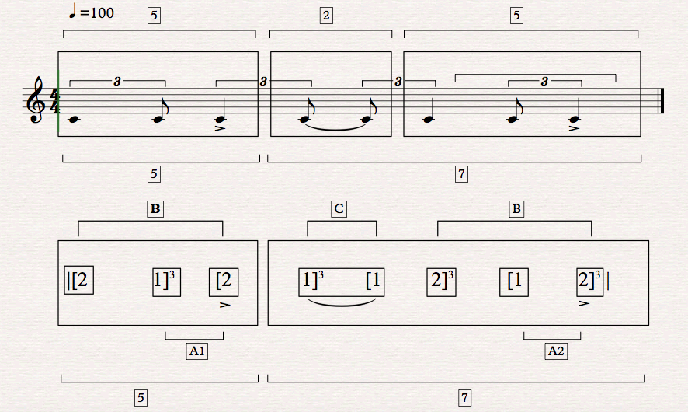
Figure 4.1.1 Standard rhythmic motif for Malende music, using both the Numbers Notation system and staff notation, representing rhythmic patterns with no pitch values
The Numbers Notation system in Figure 4.1.1 above is an example of note value grouping found in the standard rhythmic motif of Malende music. The rhythmic subdivision has a peculiar grouping of five (5) and seven (7) quavers to make up a complete rhythmic motif. This rhythmic pattern has been widely used in almost all Malende music because of its ability to lead the dancer to easily synchronise the dance steps with the other rhythms, particularly in the drums. Growing up, I always questioned what makes the rhythmic motif for Malende music predominant as a cultural identity in most traditional Venda traditional music; it is through this research that I am able to answer this question. Through this research, I have been able to confirm that it has indeed become an integral part of a musical identity in all the communities in which I conducted this study, as it is quite significant and unique in its form and shape. This rhythmic motif has been quoted in many Venda music genres, such as indigenous, cultural dance music (Tshigombela and Tshikona), instrument specialisation and popular music. Its original pattern shown in Figure 4.1.1 means it can be effortlessly applied in many musical styles in Venda music performance.
Paul Spencer (1985) talks about the irresistible reaction to an African when he refers to the element of referencing the commonly used musical identity in any community performance. He refers to this “irresistible reaction” as the urge to respond to a musical sound in an African performance, which is guided by identifying a distinct musical feature. When a musical phrase within a traditional setting with which people are familiar reaches their ears, it is impossible for them not to respond, in the form of a dance or some other physical reaction (such as hand clapping). This urge triggers the body response through dance, due to the ability of most African people to internalise rhythmic variations of indigenous music and respond accordingly. This kind of exposure to dance music from an early age is the reason many Africans can interpret complex rhythmic structures found in indigenous music. Spencer further explains that the sounds, rhythms, and movements become the building blocks for a child to emulate at a later stage – as a result of frequent exposure to the music from an early age. He points out that,
Together sound and movement build up as a single pattern linked though a conditioned reflex molded by his culture, so that in later life, when he hears the music, there is an inner response within his body that makes it difficult for him to sit still (1985: 10).
Using these building blocks, the dancer “may spontaneously want to dance, or without difficulty, he [sic] may turn his attention to some novel way of reproducing the rhythm,” (1985: 10). Spencer is not talking about Malende music in this context, but his analogy of reproducing the dance rhythm in a simple manner during dance could be applied to Malende, based on the understanding of the standard rhythmic motif by indigenous practitioners.

Numbering structure for Malende standard rhythmic pattern
Description | Five quaver family grouping | Seven quaver family grouping
Complete Pattern | 2+ [1+2] | 2 +2+ [1+2] | 12 pulses
The pulses on which articulations sound | 1 3 4 | 6 8 10 11 | 7 articulations
Pulses not producing sound | 2 5 | 7 9 12 | 5 silences
Likely synchronisation points on accents | [2nd beat, 1st pulse]  See 4.1.1 accents | [4th beat, 2nd pulse]  See 4.1.1 accents

Figure 4.1.2 Standard rhythmic layer of Malende music, using a numbering structure based on its rhythmic patterns
NB: The numbers in the square [ ] brackets indicate where the energetic rhythm happens – (only when one quaver is immediately followed by a crotchet in the rhythmic pattern – this occurs only twice)
The below example below demonstrates how the music would be notated by using the Numbers Notation system, together with the staff notation to the standard rhythmic pattern for Malende music:
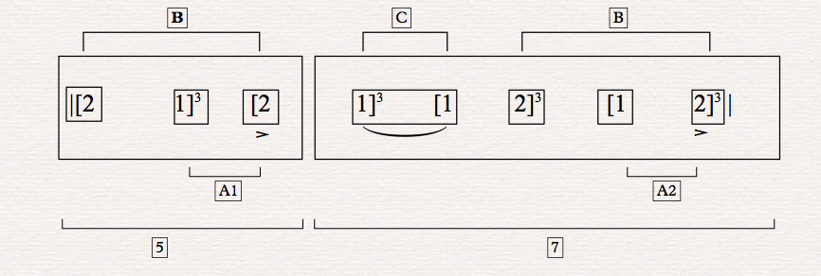
Figure 4.1.3-(I) Standard rhythmic motif for Malende music, using the Numbers Notation system, based on its rhythmic patterns
Explanation of letters A B C
A1 and A2 indicate the figure of an accented crotchet preceded by a quaver – this occurs only twice in the pattern. Letter B denotes the two symmetrical five quavers sequence separated by the central pivotal crotchet. The letter C indicates the pivotal note, around which the 2, 5-note patterns revolve. This brings balance and facilitates alternating dance steps between the left and right feet. The pivotal note also prepares the dancer for a reverse (backwards) dance. This is part of the motivation behind my decision to group the notes as five plus seven. The pivotal note that starts the next sequence is not danced with the same foot as used to start the initial rhythmic motif; however, it creates a shift in the pattern that compels the next "five group" of quavers to start on the same foot. This prepares the foot change in the next cycle. The example below demonstrates the alternating dance steps between the left and the right feet.

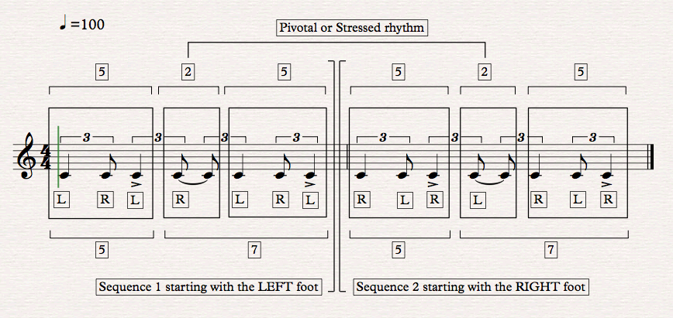
Figure 4.1.3-(II) Standard rhythmic motif for Malende music, using the staff notation system, based on the left and right feet rhythmic patterns
Both rhythmic groupings of five-plus-seven quavers look similar in design, (see brackets: 5) except that the grouping with seven quavers appears to have an added crotchet in the beginning as compared to the five quaver grouping. The first five quavers look the same as the second five quavers that start from pulse eight in bar 2, or the added crotchet in the seven quaver grouping that I was referring to earlier. However, the rhythmic structure of the first five quaver grouping starts on beat number 1, while the second group of five quavers after the added crotchet starts on the second quaver of the triplet grouping of beat number 3 (Bar 2) . This shift of placing in the pattern defines a strong contrast in emphasis between two similar patterns. This is also used as a technique to eliminate regularity in the repeating of a figure, as well as to prepare for the next starting point in the repetition of the rhythmic cycle. This is indicated by letter B in Figure 4.1.3-(I) above, while letter A shows a quaver that leads straight to the accented crotchet in the rhythmic figure. The two separate quavers indicated by letter A (which are found in this rhythm), are key features in the entire pattern, because their role is to indicate where the accented crotchets are for synchronisation purposes in the music. The two quavers help isolate the two most important accented crotchets, from the rest of the note values, which consist of five crotchets and two quavers (when counting the complete pattern).
Another interesting observation in this pattern is that the numbers of rhythmic articulations with sound are seven, while the number of pulses without sound are five the important synchronisation points are only two in the remainder of the motif. This yields a contrast from the two main groupings of five plus seven quavers per bar. The first grouping of five quaver pulses has three sounding values with two that are silent. The second grouping of seven quaver pulses has four sounding values with three points that are silent; the rhythmic pattern indicates that there are more sounds than silences. Cooper and Meyer (1960), talk about an accented rhythmic emphasis that indicates where a particular synchronisation with other instruments should happen. They describe this in the following manner.
An unaccented beat may belong to more than one rhythmic group, while an accent, because it is the focal point about which weak beats are arranged, generally belongs to only one rhythmic group (1960: 8).

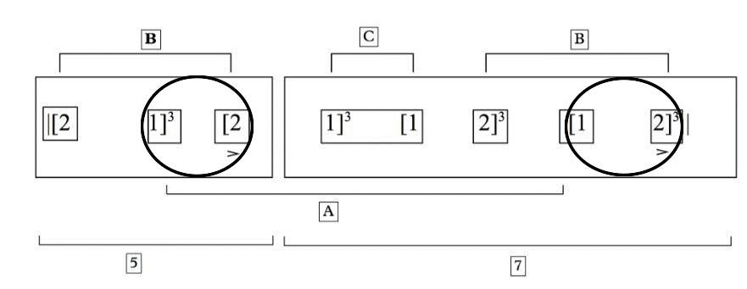
Figure 4.1.4 This 1 Bar of the standard rhythmic figure of Malende music, using the Numbers Notation system, and based on its rhythmic patterns and groupings
The example in Figure 4.1.4 shows both structures labelled B having the same note value groupings, but starting at a different pulse each time. The first B (which is indicated in bold) indicates the typical Malende figure which occurs on the 1st beat of the bar: (2,1,2), The note with the accent sign underneath (the 2nd crotchet) is the note that indicates the focal point of the pattern for synchronization by the dancers. B1, however, which is exactly the same figure as B (2,1,2) has been shifted, by a quaver in the pattern and occurs on Beat 3, 2nd quaver. The 2 exact pattern figures are separated by a “pivotal” note of crotchet value (2 tied quavers). Cooper and Meyer also talk about ‘stressed rhythm’, which should not be confused with an accent, as they are different. Either when talking about a stressed rhythm it can occur on an accented or an unaccented note, depending on the dynamic level and emphasis intended in the music. It reflects an increase in intensity rather than a specific accented note. The authors refer to a stressed rhythm as “the dynamic intensification of a beat, whether accented or unaccented,” (Cooper and Meyer 1960: 8). This means it can be louder in intensity but without an accent. The letter C in the example in Figure 4.1.4 indicates a stressed rhythm, which in this case is used as a link to connect the two rhythmic structures that are similar but with different starting points.
The rhythmic structures above, which are circled, show the rhythmic strength. This pattern consists of a leading quaver going to an accented crotchet note, which indicates a strong emphasis, while the ones that are not circled, show a weak rhythmic emphasis in a song. The circled rhythms indicate where the dancer perform emphasised rhythmic gestures. The weak beat does not entice a dancer to synchronise with the other rhythms. These emphases determine how the rhythms will be synchronised with the other layers in a music performance. The dancers can cue changes in the dance through indicating new rhythmic patterns in the music by introducing pattern A, B and C. By starting a pattern in a completely different place or beat in the bar, one creates a sense of freedom outside of a strict bar-line delineation.
What determines how the Malende rhythmic motif is structured in a bar is the type of permutation required for that particular performance, which would be guided by the synchronisation intention.
By understanding these kinds of rhythmic shifts as a dancer and a performer, and how the rhythms connect with each other, a practitioner is able to quickly adapt and dance with fluency in any African music form. It is also helpful for a composer intending to use the rhythmic elements found in Malende music, to understand the aesthetics of the dance related to the meaning behind the music. It is important for a practitioner to dance from an informed position. It is with this view that I believe that the standard rhythmic motif of Malende music is able to outshine other rhythmic motifs and distinguish itself as a unique rhythmic pattern in traditional Venda music.
This is where Omofolabo Ajayi (1998), in the study of Yoruba dance, takes the concept of rhythmic flow in an African context even further and elaborates on how rhythm creates a continuous pendulum that enables the dancer to link or connect rhythmic cycles in an African music context. He argues that,
In the dance medium, the effect of rhythm is no less; it gives continuity and smoothness to the dancer’s movements and allows the performer to concentrate on honing the aesthetics of the dance and imparting fuller significance to the movements being performed (1998: 20).
According to Ajayi, the dancer is able to create a specific dance form through understanding the internal structure of any rhythmic motif. This comprehension will also inform the interpretation thereof, by guiding the dancer when improvising dance steps. It is also important to emphasise that this understanding is gained through much practice focusing on the same dance steps and movements repeatedly.
Essentially, the Malende standard rhythmic structure is the most reduced and simple rhythmic motif; it is the core of all three indigenous forms - Malende, Tshigombela and Tshikona. It is then followed by the Tshigombela standard rhythmic pattern (which will be explained in detail in the following analysis). The Malende standard rhythmic pattern is formulated on dance steps as well as on hand clapping patterns, making it completely percussive. This rhythmic design has its own uniqueness, which is also referenced by other Venda traditional music styles (such as Tshigombela and Tshikona), as permutations that are used to construct new rhythmic structures. This is how the Malende rhythmic pattern distinguishes itself as a unique standard rhythmic motif, separate from other rhythmic layers within the Malende dance form. In Malende music, a common practice exists of alternating the left and the right foot during a dance performance but changing the starting foot at certain intervals with the pattern. This is used as a technique to shift short identical rhythmic structures to asymmetrical sound patterns of the same rhythmic construction. Central to these shifts is the use of “pivotal” note in realising the asymmetrical patterns.

- Analysis of the Tshigombela standard rhythmic motif
The first step in analysing the Tshigombela standard rhythmic motif requires an explanation of its rhythmic pattern structure, as it is derived directly from permutations of the Malende rhythmic motif. The complete rhythmic motif of Tshigombela is divided into two sections (these sections are made up of 11 and 13 crotchets respectively, which add up to 24 crotchets in total). In order for the rhythmic motif to be recognised as the Tshigombela motif, it must be performed in its entirety. However, unlike the rhythmic motif for Malende music, its design and structure never changes nor is it rearranged. The Tshigombela standard rhythmic motif does not have permutations. It is important to know that, even though it is unchangeable, it is made up of two different complete permutations of the Malende rhythmic motif, each one repeating itself immediately. It begins with the first permutated pattern, and then overlaps in the last beat of the repeating pattern, with the second permutation, beginning where the overlaps occurs. The two permutations shown are different from the original Malende structure, even though based on it revealing different groupings of quavers and crotchets. See below for an analysis of the patterns.

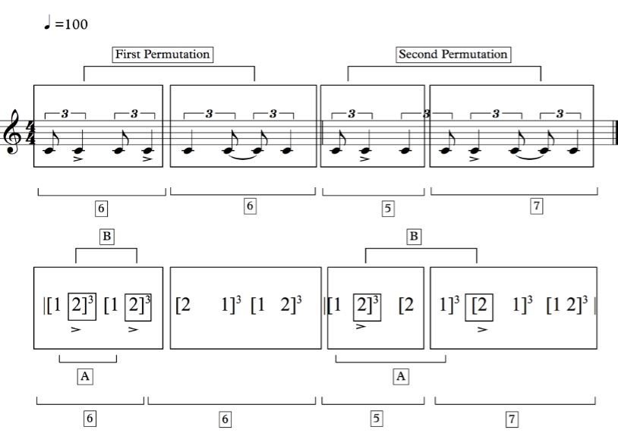
Figure 4.2.1Standard rhythmic pattern of Tshigombela music, using Numbers Notation, based on its rhythmic permutation patterns.
The first permutation has a six-plus-six grouping of quavers, while the second permutation has a five-plus-seven grouping of quavers. Even though it has a five-plus-seven, like the original Malende motif, the second permutation does not have the same arrangement of note value. I will use the diagram on figure 4.2.2 below to explain the structure of Tshigombela rhythmic motif. Letters A and B indicate where the emphasised rhythm happens.

The rhythmic groupings show different possible point of synchronisation, located on the emphasised notes with accents. The two permutations shown above are intended to distinguish between the two groupings of six plus six, and five plus seven. However, in the actual complete rhythmic motif for Tshigombela the last repeat starts its cycle by overlapping with the last beat of the first permutation. The best example to demonstrate my point is shown In the diagram below figure 4.2.2, which shows all repeats included in the complete rhythmic pattern. A1 and A2, B1 and B2, as well as C1 and C2, indicate the emphasised rhythmic pattern.
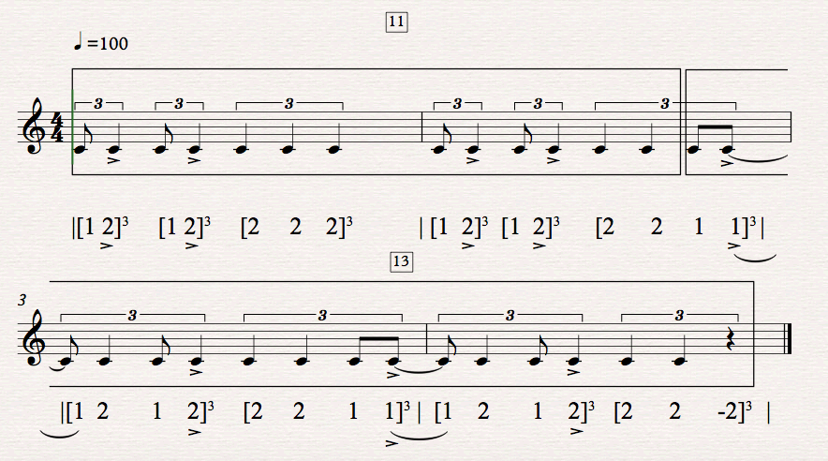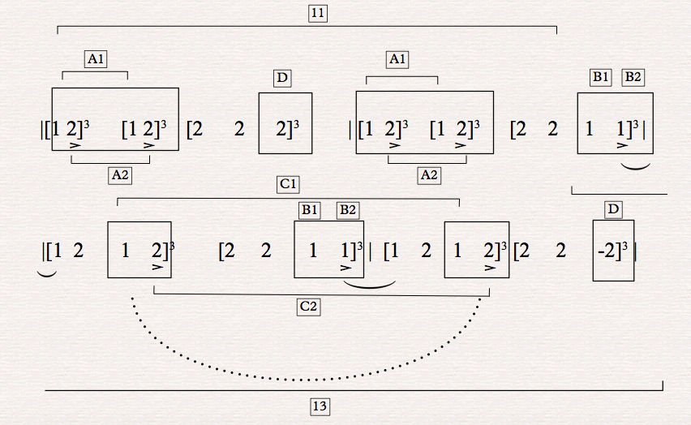

Figure 4.2.2 Standard rhythmic pattern of a complete piece of Tshigombela music, using staff and Numbers Notation, based on its rhythmic groupings of 11 and 13 crotchets.

This irregularity due to the overlapping of the rhythms. The pivotal note however is re- inserted to bring balance to the irregularity in the repeat pattern of the 1st structure.
Through rhythmic compensations and adjustments, the irregular patterns of 11 and 13 are shifted in such a way to utilise the “pivotal” note in these shifts to balance and re-regularize the accumulated patterns into 10 and 12, and ultimately to 12 + 12. In spite of the presence of triplets in the first bar, when considering Figure 4.2.2 above, there are in reality six crotchets; and in the second bar, there are five crotchets; but, the next pattern overlaps at the beginning, with the last crotchet in a twelve-crotchet pattern, making it 11 plus 13. In counting crotchets within the pattern, had it been written in 12/8, there would have been 22 quavers representing 11 crotchets. My choice of a simple 4/4 as a substitute for a compound quadruple 12/8 (to illustrate the rhythmic motif), is based on the critical necessity for underpinning the whole pattern with four regular crotchet beats, which constitute the guiding principle of this genre (played by the big drum – Ngoma Khulwane – the drum that keeps the beat).
The letters shown in the Numbers Notation in Figure 4.2.3 below indicate the leading quaver that precedes the emphasised crotchet with an accent. A1, B1 and C1 are indicative of the leading quaver while A2, B2 and C2 are examples of an accented crotchet. Where the leading quaver and accented crotchet are placed also determines where the pivotal note will be in the music, as indicated in the Malende analysis earlier. In Figure 4.2.2 above, the permutation of aggregates 1 and 2 (in the second part of the structure) does not demonstrate the original intensity of the close accentuation found at the beginning of the pattern. The second part of the pattern feels more protracted because of the kind of permutation used, which possesses a crotchet ‘pivot’ note to divide the two leading and accented notes.
The alternation of the left and right feet guide the separation of the rhythmic structures as indicated below in Tshigombela music.
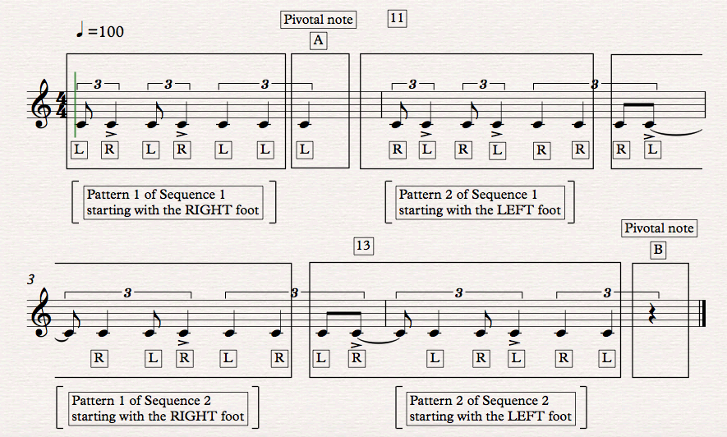
Figure 4.2.3 Standard rhythmic pattern of a complete piece of Tshigombela music, using staff notation, based on the dance patterns alternating between left and right feet.

Explanation of the structures in boxes shown in the diagram above
Patterns 1 and 2 show that the dancers do not start with the same foot each time they start a pattern but alternate them as indicated by L and R - left and right. This is made possible by the "stressed rhythm", which I refer to as the “pivotal note” and is a crotchet indicated with the letter A in the centre of the two symmetrical rhythmic sequences in figure 4.2.3. The pivotal or stressed note, which is also found in the Malende music, is found in the Tshigombela music as well, where the left and right feet are interchanged, and both feet repeat the dance steps. The pivotal note is found on the last note of the crotchet triplet. It divides the first sequence into two symmetrical rhythmic structures. Letter B, however, is a different kind of pivotal or stressed note because it is a rest and it is not in the middle of the second sequence pattern but at the end of the entire rhythmic structure. This makes the length of the second sequence longer, with two identical Malende rhythmic motifs following one another. Understanding this analysis helps to make informed decisions for a composer when using this rhythmic material in a creative composition. Whether to make the pivotal note central or not in the music is a choice of preference in one’s composition - or moving it around can also be a creative choice.

Similar to the Malende structure, the Tshigombela standard rhythmic motif is made up of two unequal numbers of 11 plus 13 crotchets, while Malende is made up of two unequal numbers of five plus seven. The two have a different and distinct set of rhythmic value groups. The Tshigombela standard rhythmic motif is four times the size of the Malende standard rhythmic motif, which makes the Tshigombela rhythmic pattern the longest of all three dances under discussion in design and structure.
In the Tshigombela standard rhythmic motif, the first and the second sections of the rhythmic pattern are composed of an irregular rhythmic structure. This is used very cleverly, and in such a way that it is not easily recognisable, because of the fragmentation and the rhythmic shift that occurs in the second bar of the rhythmic pattern. It is in fact the same structure of the Malende rhythmic motif used in two sequences, but represents an imbalanced structure owing to the shifting rhythmic patterns. The second section (see 4.2.4 below) is a repetition of the first section, but with a note reshuffle technique, which contains a crotchet note inserted between the leading quaver and the accented crotchet sequence. This relates to what Cooper and Meyer call “the nucleus of rhythm,” (1960: 8), which refers to the centre of its rhythmic strength. Accented rhythms highlight the difference between contrasting articulations and “a series of pulses,” (1960: 8). The authors support their argument by further indicating that:
The difference between accented and unaccented beats lies in the fact that the accented beat is the focal point, the nucleus of the rhythm, around which the unaccented beats are grouped and in relation to which they are heard (1960: 8).

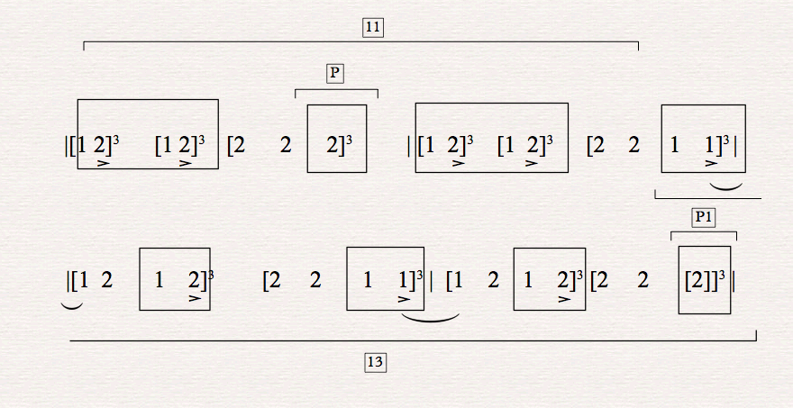
Figure 4.2.4 Standard rhythmic layer of Tshigombela music, using the Numbers Notation system, based on its rhythmic patterns and rhythmic groupings with accented notes
Due to the unevenness of the first structure as seen above in 4.2.4, (consisting or 11 crotchets of the Tshigombela rhythmic motif), the third crotchet in the triplet at
“P” acts as the pivotal as stressed rhythm; an additional stressed rhythm occurs at the end of the musical structure in the form of a rest at “P1”. This note value creates the link between two rhythmic structures with identical rhythmic values, regardless of their arrangement in the pattern. The first part of the rhythmic motif creates a sensation of momentum, which builds towards the second section of the pattern, leading to a rhythmic climax. The accents are important for synchronising the rhythm with the other rhythms played by different music lines; these layerings are indicated in Chapter 5, in the analysis of my own compositions. The 4/4 meter governs my entire discussion for this analysis as a basis for understanding Venda music, while the triplets in the 4/4 meter are for establishing synchronisation patterns.

Both sections of the Tshigonbela rhythmic motif are danced by both feet in an alternating pattern, The Malende rhythmic structures, which are repeated twice, enable the changing of feet, namely, the alternating of the left and right feet. The first pattern is started by the left foot, while the right foot starts the second pattern during the Tshigombala dance. This dancing format of equalizing the pattern for both feet is consistent throughout both the Malende and Tshigombela dance steps. What the left does is repeated by the right foot. The first part of the first section is initially performed by the left foot, up to the stressed pivotal note (letter P); then, the second part of the first section is danced by the right foot, repeating what the left foot has already done. The alternating principle is very common in many regular Malende rhythmic motif structures, where a rhythmic pattern danced by the one foot is repeated by the other foot.

- Analysis of the Tshikona standard rhythmic motif

The standard rhythmic motif for the Tshikona dance is somewhat different from both the Malende and Tshigombela forms, as it is made up of fragments from the Malende, with potentially only one bar that resembles the Malende rhythmic structure. According to a well-known Tshikona dance trainer, Sinyegwe, “there is no specific dance rhythmic step that is unique [to] all Tshikona music; however, there are some dance steps that are the same and used by all Tshikona groups, even though there might sometimes be slight variations depending on where the Tshikona group originates,” (Sinyegwe 2016). During my analysis of the Tshikona rhythmic motif, I drew a different conclusion, based on some of the rhythmic patterns that are used by the kings, particularly when they are dancing alongside the Tshikona group. Additionally, I have observed an opening dance step, which is the same throughout all Tshikona groups, and which Sinyegwe confirmed as the same dance step all Tshikona groups use when the music begins. Both the opening dance step as well as another dance movement used mainly by the king during a performance, are symbolic of permutations of the Malende rhythmic motif. The Tshikona performances are intended mainly to pave the way for the king, before and after he addresses his people. It is, therefore, obligatory for Tshikona music to be performed first, before the king addresses his nation. It is then also inevitable that the king will participate in the Tshikona dance that follows, particularly if his message to the people is well received following the address. The music itself brings a “sixth sense”. Spencer (1985) refers to it as a powerful musical force that spurs people to dance suddenly to the music with great passion. This kind of powerful force calls for a response by the king himself. Spencer explains that:
The excitement of the throng and the aura of the occasion alerts some sixth sense that the dance reflects powerful social forces and demands some explanation; or perhaps an intriguing pattern reveals itself and lead to further enquiry (1985: 2).
A powerful force is roused whenever I see the king performing alongside the Tshikona group, with an army of bodyguards and servants dancing. It is this experience, which inspired me to explore a standard rhythmic motif in Tshikona dance music. It is then also inevitable that the king will participate in the Tshikona dance that follows, particularly if his message to the people is well received following the address. It is also understood that when the king performs certain, select rhythmic patterns (this is in spite of the entire Tshikona group also knowing them), they sound more majestic when he dances to them. They reveal his authority and status amongst all the performers. When the king is performing with the Tshikona group, he often takes the lead as the malogwane, the director who changes the dance steps of the Tshikona group during the performance. This kind of performance is often a very short presentation, with one or two dance steps predominantly being used before the king sits down. The king leads this kind of performance in the front of the entire Tshikona group, even the formation of the performance changes from a circle to a long line behind the king as he is dancing to where he will be sitting.

It is through observing this that I discovered that the king chooses particular rhythmic figures that include majestic gestures with specific rhythmic punctuations (which can then be argued to be standard rhythmic motifs for Tshikona music). My emphasis will be on the two distinct rhythms that are performed by the Tshikona group when the king is a dancer amongst them. In relation to how a king communicates with his people (this instance in the Zulu culture), Louise Meintjes (2004), in her study of the traditional male Zulu dance, describes this as the hierarchy of power in public performances – and as something vitally important to the Zulu people. This is because it is able to separate people of different classes in the community. Meintjes further explains that it is through a,
sense of power represented in artistic expression and valued as an artistic principle harnessed into a process of obtaining forms of political power. This may sometimes be a process that is self-consciously manipulated by dancers (2004: 175).

In the same way, Spencer also supports this ideology, of power ranking in a public performance as a communal lifestyle in dance music. Certain dance steps are designed to show power and dignity amongst the people in an African community. Spencer explains that:
Public performances proclaim formal allegiance to rank, while at the same time dance gesture may be used to shift and even invent the stress. It is this subtle eloquence that enhances the occasion, legitimising a more complex reality within the formal hierarchy of the system (1985: 13).

This is how – in an African context – dance music is able to separate the men from the boys, and kings from ordinary people. It is through dance music that a king can connect to his people in a different, non-verbal way – as a metaphoric statement. This is something that is often well received by the people, because there are other traditional matters that are better left unsaid verbally and rather expressed through the medium of dance. That is the reason Spencer says that “given this general observation, dance is an obvious metaphor that has been used to describe the nonverbal signaling,” (1985: 12). In the same way, Ajayi (1998) explores the semioticism of using the coded signals through a non-verbal mode, as a significant African tool to signify a specific message that is communicated through dance. He maintains that:
The conventional semiotic studies of body codes as non-verbal means of communication include clinical and structural approaches, concentrating on the encoding and decoding of the use of gaze, facial expressions, gestures, use of space, proxemics, kinetics, posture, general body movements, and numerous aspects of other body actions (1998: 15).

It is important to start the analysis below with the opening rhythmic motif, as it is key to the beginning of each Tshikona performance. The initial dance steps are very energetic, as they prepare the dancers for opening the Tshikona cycle and welcoming the Tshikona group on to the dance floor. The example below (Figure 4.3.1) is a very energetic rhythmic motif, forming a set of opening dance steps; this is a common rhythmic pattern used to begin all Tshikona dance music. In spite of opinions that claim there are no specific Tshikona rhythmic shapes (Sinyegwe 2016), this design can definitely be seen as a standard rhythmic motif for Tshikona music – every Tshikona group uses it as part of the opening dance. This is also a perfect example of a fragmented rhythmic structure of the Malende rhythmic motif. There is a continuous repeat of the leading quaver that is followed by the accented crotchet; this indicates the majestic opening of a Tshikona performance. It is, however, composed of many strong rhythmic “emphases” in comparison with the rhythms in the other dance genres.
Below is the analysis of one of the two main rhythmic motifs used by the king when he performs alongside his subjects. By using his own gestures as symbols of power, a king seals his authority in the community.

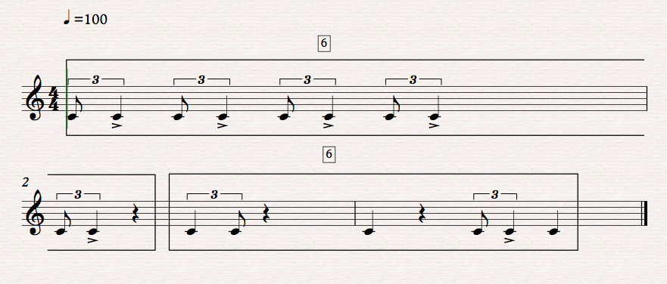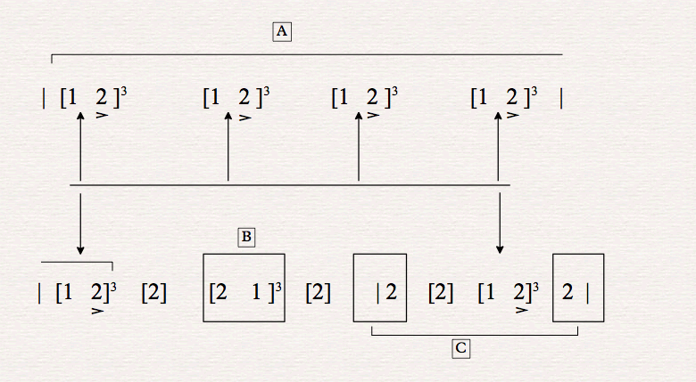
Figure 4.3.1 Opening energetic rhythmic pattern of Tshikona music, using both staff and Numbers Notation, based only on its rhythmic patterns and beat subdivisions in groups

The strong emphasis coincides with the leading quaver linked to an accented crotchet. In Figure 4.3.2 below, one can clearly see how many times, with the cycled markings, the strong rhythmic pattern is repeated in the entire motif. It has been used on every beat of the first bar, while in the second bar it has been used on beat number one as well as on beat number three in the third bar. The only difference between the two bars is that in bar two, beat number three has a weak rhythmic emphasis, while it is a strong rhythmic emphasis in bar number three. As a commonly used practice for weaker beats, the unaccented note is either preceded or followed by rests.

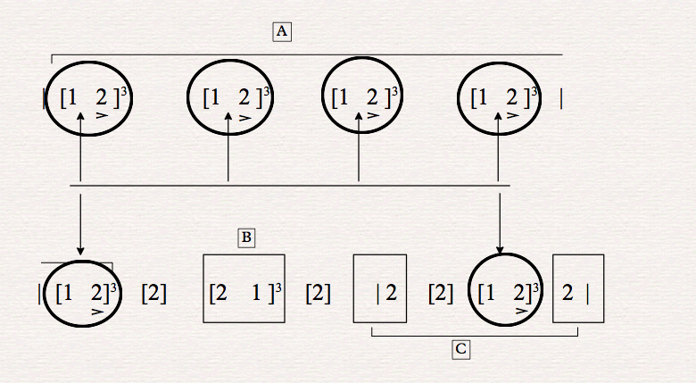

Figure 4.3.2 Opening energetic rhythmic pattern of Tshikona music, using the Numbers Notation, only based on its rhythmic patterns and beat subdivisions in groups, including emphasised strengths

Some of the accented rhythms are designed to help the dancer find a perfect balance between the force of gravity and rhythmic articulation. Maintaining balance is very important in a dance rehearsal, because when one is standing on one leg, it is very difficult to avoid falling if perfect balance is not achieved.

Louise Meintjes (2004) explains how a traditional male Ngoma dance is performed in Zulu culture. There are many rhythmic signals that the body performs as preparation for the main kick, which the dancer executes. Meintjes describes how the dancer makes a staggeringly high kick with his one leg, while the other leg remains on the ground, and he immediately moves his torso with his arm in order to retain his balance on the standing leg. Meintjes indicates the importance of balance for men during the Zulu dance. She explains that:
The forward thrust of his left arm balances his taut and arching body. Then, as if a spring [is] suddenly triggered, he kicks his left leg into the sky, curls his torso and shoots his right arm forward to balance his one-legged stance (2004: 174).

The king performs the rhythmic motif as shown below in Figure 4.3.3, in a Tshikona performance. This rhythmic motif has a complete Malende rhythmic structure instead of fragments in different permutations (as found in Tshigombela music). This particular permutation is a complete reverse of the Tshigombela’s variation in its first half. The dance action of raising a knee in the air requires a very quick note value, so it coincides with a quaver value - and in this instance this quaver is the accented value, unlike the crotchet note in the Malende figure and is represented by the letter A. This dance step is performed in order to land back with the same foot on the next note. The act reverses the original structure of accent placement, which is always placed on the crotchet that follows the leading quaver. Letters A and B indicate the two very different 2-bar structures in the same Tshikona pattern indicated in the Numbers Notation.
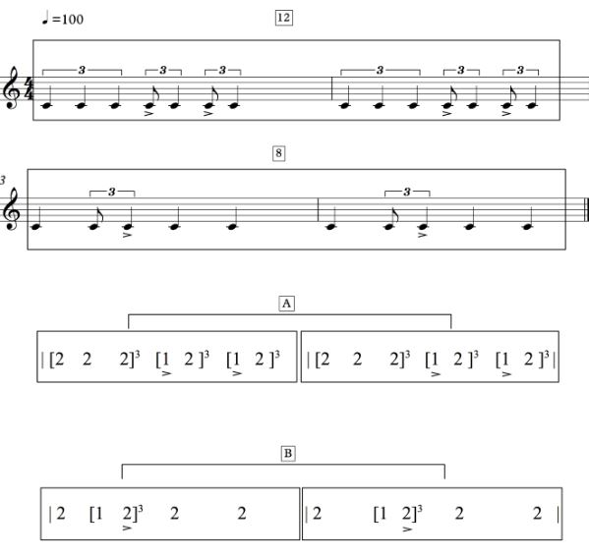
Figure 4.3.3 Standard rhythmic pattern of Tshikona music, using both staff and Numbers Notation, based on its rhythmic patterns and rhythmic groups
The rhythmic motif above in Figure 4.3.3 demonstrates a specific rhythmic pattern, which is performed by any Tshikona dance group; however, amongst all the dance steps (which amount to seven or eight in total) this is the one always singled out by the king (if the king happens to perform alongside the entire Tshikona group). Most Tshikona dance steps have a rhythmic cycle that repeats itself after three bars, or after being cycled three times before the new dance step takes over. The above rhythmic motif has been shown in both staff and the Numbers Notation system for clarity. The number 12 in the above Figure 4.3.4, above the first two bars, is calculated in quaver pulses considering the triplet crotchets, while the number 8 in the next two bars indicates the number of beats in a bar, irrespective of the triplet’s groupings. It also incorporates the standard rhythmic pattern of Malende in a different permutation.
Figure 4.3.4 below shows the standard rhythmic motif of Tshikona music, using the Numbers Notation based only on its rhythmic patterns and beat divisions of rhythmic groups

Figure 4.3.4

Looking at the rhythmic motif in Figure 4.3.4 above, one can clearly see by accent markings, how certain rhythmic patterns are grouped with a leading quaver as the emphasised note. The strong rhythmic patterns, which are often between the leading quaver, followed by an accented crotchet, are shown in the section labelled B, between bars 3 and 4. In the first section labelled A, the rhythmic structure shows a strong emphasis or accent on the third and fourth beats of both bars 1 and 2, with an accented quaver followed by a crotchet. Bars number three and four have one strong beat, which represents the original rhythmic emphasis indicated by a leading quaver followed by an accented crotchet. These two bars mostly consist of weaker notes that are situated on beats one, three and four. A rhythmic motif such as this requires to be used in soft passages of the music that do not require strong emphases in the rhythm when incorporating it into a creative composition.

The dance steps, which use the rhythmic motif of Malende, have two significant functions. The one opens the Tshikona dance, while the other is used to accompany the king when he is dancing with the group. The first function uses fragments of the Malende main rhythmic motif, while the second function, which is associated with the king’s authority and power in the Tshikona music, uses a permutation of the Malende rhythmic motif. These rhythmic patterns always stand out as significant when a Tshikona group performs with the king. The king will dance two dance patterns when he is performing with the Tshigombela group to mark his authority.
The rhythmic motif in Figure 4.3.5 below is the second example that demonstrates the king’s power and authority. Letters A, B and C indicate the grouping of notes in their rhythmic structures.

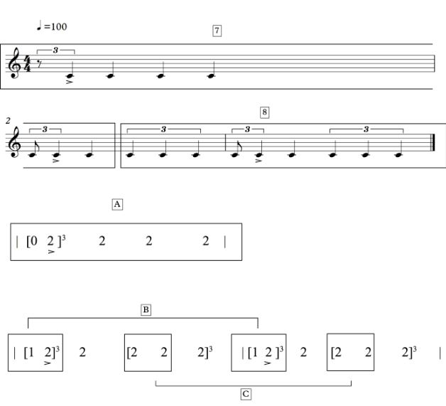Figure 4.3.5 Second standard rhythmic motif found in Tshikona music, using both staff and the Numbers Notation, based on its rhythmic patterns and aggregates of groupings
The above rhythmic motif takes the form of a three-bar cycle, with two strong beats and a weak one. The strong emphasis is shown by the crotchet, which always follows the leading quaver.
Using the diagram below (Figure 4.3.6), based solely on Numbers Notation, one can see the letters A, B, and C, all markings on the three bars denoting the strong and weak rhythmic emphases. They all appear on beat one, indicated by accented crotchet in all the bars, with some very “relaxed” crotchet note values. This is to allow the king to move with ease during his performance, and without any complications. This particular rhythmic motif is simple but unique as it allows the king to refrain from overexerting himself in the dance and to avoid perspiring heavily during the performance. In fact, it shows the gentleness of the king when he performs with the people.

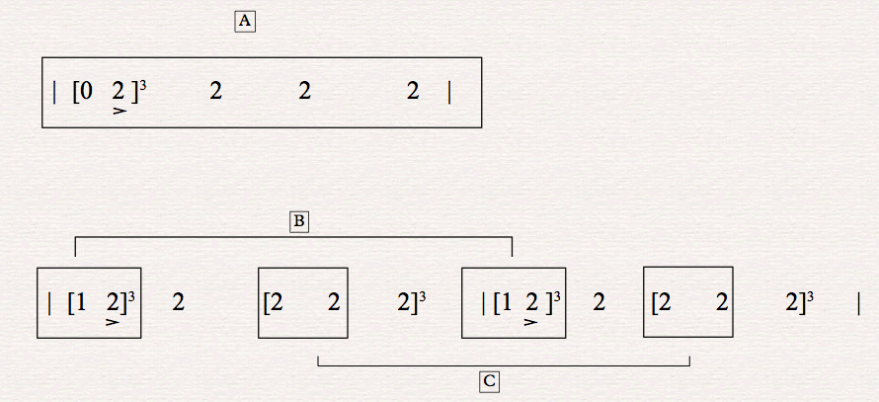
Figure 4.3.6 Standard rhythmic pattern of Tshikona music, using only the Numbers Notation, based on its rhythmic patterns and subdivisions of note groups, including stronger tensions labelled by the letter B, and the weaker tension labelled by letter C.

Conclusion:

The summation of much of my research material in the previous chapters contributes to my ‘conclusion’, which is embedded in the techniques and style of my original composed music in the accompanying portfolio of original compositions. I have used the essential rhythmic patterns revealed in the Malende and two other related dance forms as the inspiration and source for my original music. In my portfolio, however, I have transformed many of the purely rhythmic motifs into melodic/rhythmic motifs with contours, shapes and song associations in the melodic traditions of much Venda music. These have been transcribed and transformed into both instrumental and vocal lines. The following characteristics epitomise the source material for my own compositions:
In all three Venda indigenous music styles, the dancer’s balance is the key to performing the dance and keeping the body movements faithful to the tradition. Amongst all three Venda indigenous musical forms, the Malende standard rhythmic motif is the shortest, with the Tshikona motif second in terms of length; thereafter, the Tshigombela rhythmic motif is the longest (in terms of both structure and design). This is not surprising, as it is the music danced to by the women, who are considered pillars of strength in the society – the women embody qualities of stamina and endurance. However, the most frequently used rhythmic motif is the one found in the Malende dance. These rhythmic variations (with their source in Malende) bind the cycles together, forming the basis of an “African music” structure, embedded in Venda music.
This Chapter Four explored the importance of using the core motif in Malende music in different permutations with fragments that sometimes omit certain beats found in the original structure. Understanding these rhythmic motifs and how they are applied to dance and in a musical structure has enabled me to utilise these generative motifs in my own compositions. The deep music analysis of the three genres above has proven that the Malende rhythmic motif is the ‘master rhythm’ or the foundation upon which Tshigombela and Tshikona rhythmic motifs are constructed. This research has revealed that the standard rhythmic motif found in Malende is at the core of the rhythmic tradition and is the rhythmic archetype that generates extended patterns and creative features, which signify cultural identity of Venda music; thus Malende as well as Tshikona and Tshigombela are regarded as the most significant Venda musical genres. And therefore, I have used these rhythmic motifs, with Malende as the “Ur-pattern”, as points of reference in quoting Venda cultural music in my own compositions.

Chapter 5

Reflections on the processes applied to selected Venda-inspired works in my composition portfolio

My research experience has enriched my ability as a composer to further develop my compositional voice. Many composers have referenced from traditional, indigenous music sources over time. Composers are drawn to interesting material from their own cultures as well as from other cultures as a source of creative exploration. I have interviewed selected composers who have quoted indigenous material in their original compositions and found that on the whole they exhibited respect for this material. My criteria for choosing these composers were based on the success or otherwise of the methodology they used in referencing external material. What was important for me was to approach the composers who had a practical engagement with the practitioners on the ground, rather than a composer who had not gone into the field. This was relevant to my research as I also used the same approach in my enquiry. Having discussed various approaches with selected composers I was pleased to hear that these composers confirmed that any referencing and quoting from traditional material should be done with a level of understanding and preferably engagement with the practitioners in the field. Connecting with these practitioners, who are traditional custodians of the material, is key to understanding the history behind the material. This connection assists a composer to approach his/her treating of the material from an informed position.

My intention as a composer in this project was to be both a participant as well as an observer researcher. I believe that being a participant researcher would help me not only to better understand the material but also to develop an appropriate methodology. This was a particularly helpful exercise as I found myself having to rely on my memory of the performance rehearsals in which I participated, rather than studying recorded material only.

While I was working with the practitioners, I was imagining the kind of music I wanted to compose at the end of the project. I decided that the main music parameter with which I wanted to work was the rhythmic aspect. Given that many patterns exist in this traditional music, namely, hand-clapping, singing, dancing, drums, whistles etc. it was difficult for me to decide on which to focus specifically as the core element. I was most intrigued by the dance step rhythms, which caught my attention, as these are distinctive to Venda music - and I decided to concentrate predominantly on this component of the music, namely; the standard rhythmic motif of the Malende dance. This distinctive rhythmic pattern referred to above can be found either in the dance steps and/or in the hand-clapping. It is easy to isolate in a performance because it is percussive and not melodic by nature. Many other instruments can create rhythmic counterpoints to be added to an African traditional song. These instruments range from bells, animal horns, drums, whistles as well as other indigenous instruments combined with the singing. All these add rhythmic layers and also colour and texture of African cultural dance music. Below I quote an extract from one of my original compositions as an indication of how I have referenced material from Venda traditional music. The quaver value always remains the unit pulse whereas the crotchet indicates the beat unit in (4/4):

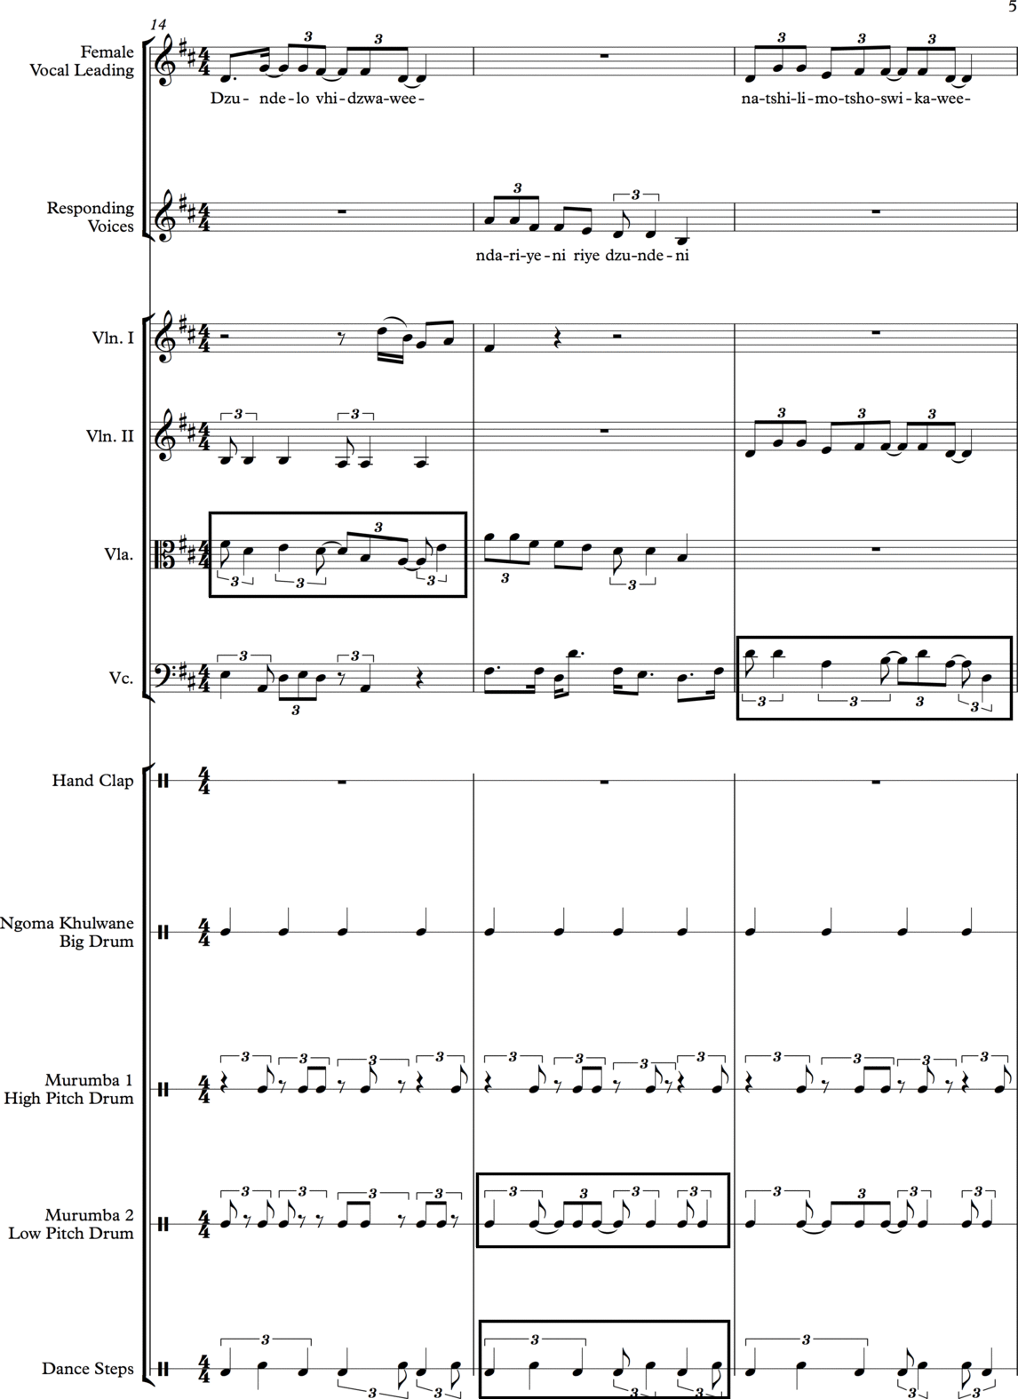

Figure 5.1 An extract of my composition called Dzunde based on a Tshigombela song incorporating indigenous dance steps and string quartet, together with the indigenous instruments.

Note the responsorial singing between the female lead voice and the responding voices and note the boxed rhythmic figures denoting the Malende rhythmic motif used in Tshigombela music. I decided to use the Malende rhythmic motif but in my own individual way. I have used a fragment of the Malende in Murumba 2 bar 15. I have loosely used fragments of the Malende rhythm in different permutations. The reference is very non-literal because I have taken a fragment in the one box while in the other I have taken two fragments and permutated them. There appears to be a contradiction in that block where one sees six crotchets, since the value structure, namely a quaver triplet and a crotchet triplet only occupies four beats. Thus, my choice of rhythmic structure is only loosely based on the Tshigombela rhythmic pattern with my own individual permutations.

Dzunde is a song that I composed in the style of the traditional Tshigombela music; this includes my own dance steps, lyrics and choreography. The lyrics express the idea of the King’s calling, which should be honoured by the villagers. My research is focused on identifying and adapting different traditional rhythmic patterns used as standard rhythms in Venda culture and moulding, permutating and incorporating them into my compositions. This composition demonstrates how I transform the original Malende/Tshigombela-derived patterns in my music. I have also used Western instruments to blend the two worlds together. The performance includes traditional dancers who are specialists in the Tshigombela dance form and music. I studied the dance movements with a master dancer who instructed me to clap these rhythms at the same time as dancing, in order to internalise the rhythms and better understand the music. I had to dance with the indigenous practitioners to demonstrate to my dance teacher what I had learnt from him. I also included a Malende dance in this composition in order to show the shared rhythmic relationships between Tshigombela and Malende music. In composing this piece, I wanted to combine my training experience as a Western classically trained musician with my traditional dancing skills.

This piece requiring collaboration between traditional dancers and the string quartet was one of the most difficult pieces to assemble due to challenges of coordination between the two groups. However, I believe that the collaboration was successful in the end as evidenced in the attached DVD recording of the concert performance. In my concert performance the exact same format of gender and instrumentation was followed as occurs in the traditional setting.

The main rhythm that was used as the key feature in the Dzunde piece was the standard rhythmic motif that is found in Malende music. The beauty about this rhythmic motif is that it is able to be used flexibly together with other rhythmic patterns. I decided to use it as a flexible rhythmic motif throughout. Sometime I would use the rhythm over two bars, starting on different beats. In other instances, I would use the rhythm in one bar but with added or less notes. The complete rhythmic motif is constructed out of 6 crotchets or 12 quavers. In the original Venda song, it would be split into five crotchets plus two quavers that are shifted in the sequence depending on where the two quavers are placed. If it is perceived from the 12-quaver approach, it would contain two divided structures of 5 and 7 quavers. In most cases, I would split the sequence according to how I want to use it as a compositional tool. Regardless of splitting the sequence according to my own design, I have also divided some of the crotchets into quavers to move away from the regularity of the original standard rhythmic design.

When I composed Dzunde I was trying to create the music in the Tshigombela style. A number of Tshigombela songs to which I listened during my research informed this. Most of the song has a falling melody that is assigned to the leading or the calling voice. The falling or descending melody would finish on the same note at the end of the phrase as a signal to the responding voice (sometimes overlapping). Generally, the responding voice would then pick up its entrance cue after the last note of the calling voice. It would also do likewise and end on the same note each time as a signal for the calling voice to pick up its entrance cue. This ‘call and response’ signalling technique helps in joining the two phrases smoothly. This also guides both singers (calling and responding voices) as to where their phrase would start and end to avoid confusion. The form of the responding voice is always the same throughoutbut with some added colouring in the melody by extending it and changing registers. This is traditional practice, as the responding voice represents the communal voice of the group. However, the calling voice does not have the same design all the time, as it represents an individual artistic expression. It is dependent on the length of the words being sung at the time. It is not based on the same rhythmic or melodic structure as the responding voice. This also became a guiding principle when I was composing this traditional song, in other words so that it would not completely deviate from the Tshigombela style characterised by the rise and fall in the melodic design.

The other important aspect to remember when composing a traditional piece is the important choice of applying simple or compound time signatures. In this style of music even when one uses a 4/4 metre there is always the ambiguous ‘feel’ of 12/8 and vice versa. Within the concept of the dual ‘feel’ it was evident when working with the practitioners that the 4/4 metre as a choice is the most important way of notating the music – this is because the stability is contributed by the drum in 4/4. The blending of the two metric orientations, namely the actual time signature and the implied triplet feel, is used to keep the main beat in simple time while the rhythmic patterns create a contrasting counterpoint with a compound feel. The purpose of using the simple time signature is to provide a fundamental beat against which all the varied rhythmic patterns find a point of reference in the song and dance. The beat keeper is always given to the instrument that is playing the main beats in the simple time signature as I have transcribed for the music. The other rhythmic and melodic patterns counter this with the compound time feel (12/8) to produce a dual feel of both simple and compound metres. For instance, in the song above, the main beat, which contains the simple time signature, is played by the women on the Ngoma instrument, which is the big drum for keeping the tempo. In fact, the main purpose of this drum is to keep the beat going, which reduces its function to playing the same regular consistent rhythm from the beginning to the end of the song. Other drums that are playing a counter-rhythm automatically take the compound time feel against the main drumbeat. This combination makes it easier for other patterns using the standard rhythmic motif to synchronise well with other players. The standard rhythmic pattern is designed in such a way that it synchronises on the beat with the other rhythms only three times in the rhythmic sequence - and the rest of the rhythmic sequence occurs on the off-beat. The entire rhythmic pattern is comprised of 12 quavers, which are split into five plus seven quavers in total. The number of quavers that are used as part of the synchronisation on the beat are five out of twelve which means there are seven that are on off -beats. This then means more beats are off beats as compared to the on -beat.

The example below demonstrates the complete structure of the standard rhythmic Malende motif with the ‘on’ and ‘off’ beats. The significance of identifying the on and off beats occurring in the Malende motif is in order to show that even when a note is not seen as being “on” the main beat (in other words “off” the beat), it can still be the stressed note traditionally. In the example below, on the first beat, consisting of a quaver followed by a crotchet, the accent or stress falls not on the quaver but on the crotchet following. This determines the element of synchronisation that guides the other voices in the music, whether on an accented or unaccented note. The singers and the dancers attempt to find the best pulses to synchronise with the rhythmic motif. This is also important for the dancers who pick up their musical cue from the rhythm in order to be able to coordinate and synchronise either with the “on” or “off” beats.
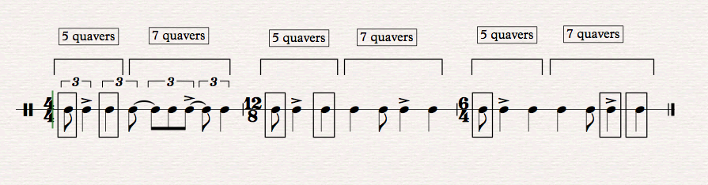

Figure 5.2. A complete standard Malende rhythmic motif in three different time signatures showing on and off beats.

These are on-beat points at which synchronisation occurs between the various rhythmic motifs. The notes inside the boxes indicate the on beats notes while the rest of the notes are off the beat. The actual stressed notes are not necessarily these “on the beat notes” but can occur either on “on-the-beat” or “off-the-beat” notes.

If one looks at how the rhythmic figure (5.2) above has been designed, it is only in the 6/4 example above that one finds that beats 1, 5 and 6 are on the beat. These are only found on the first and second beats of the first two examples (in 4/4 and 12/8). The rest of the notes in these bars occur off the beat. When one looks at the compound 12/8 time signature, it is only the first and the second beats, that are on the beat and the rest are off the beat. In the 6/4 time signature it is only beats one, five and six that are on the beat. Although the same rhythmic design is used in all three examples, they will have a different result because they are presented in three different time signatures, which generate a different feel and a different emphasis. The placement of the same sequence in different metres of the standard rhythmic pattern determines the number of on and off beats. One would choose a particular metre depending on the type of synchronisation one wants to create in a piece, yielding more permutations that are possible. All three time signatures have the same rhythmic structure but the interpretation would be quite different for each. Of the three possible designs, to my ear the placement within the 4/4 metre comes closest to my concept of the truly traditional style. In addition, the other metres cause the synchronisation points to deviate from the traditional.

As a researcher engaged with the practitioners on the ground, I was constantly reminded by their focus on the four main beats of the Ngoma large drum, which plays only the main four beats throughout that dictated my decision to notate the rhythmic motif in simple 4/4 rather than in a compound metre. Had I chosen either 6/8 or 12/8 as the metre, I would not have been faithful to their understanding of the whole rhythmic structure. In spite of using 4/4 metre there are sub-divisions grouped into five plus seven quaver pulses illustrating the basic original design from which other permutations are derived. This also determines the synchronisation choices of how one can use the rhythm with or against the other rhythmic patterns in the song. The choice of the starting point of the rhythmic motif as well as how one groups the beats also determines the kind of synchronisation one wants to achieve. These shifts or cyclical permutations of rhythms are quite commonplace in Venda culture. These choices also affect how other counter-rhythms will respond to the pattern of the standard or basic rhythmic design in order to create different synchronisation points. This also affects the vocal part because most of the vocal lines take their cue from the design of the standard rhythmic pattern. The structure of the lyrics will also be affected and will change in such a way that they synchronise smoothly with the other rhythmic patterns. The principle of positioning the lyrics is guided by the placement of the words falling correctly on either the short or long values, which cannot be changed; namely the choice of quaver or crotchet. Therefore, the standard rhythmic motif is adjusted accordingly.

Standard rhythmic pattern for Malende music
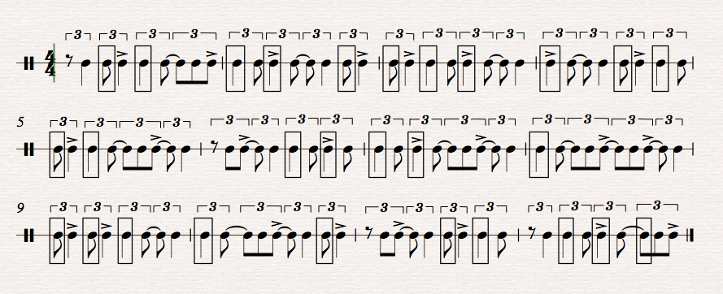

Figure 5.3. Standard rhythmic figure for Malende in eight permutations beginning at different points in the pattern, demonstrating various on (boxed notes) and off beats.

These examples shown above will determine the intended off-beat synchronisation when combined with other counter-rhythms in performance. For example, if one looks at bar one, five, six and seven there are only two rhythmic points of on-beat synchronisation. These on-beat synchronisations occur at different points in each bar. This is different from bar two, three and four, which have three on-beat synchronisation points. The only bar which has one on-beat synchronisation point due to its design is bar number eight.
Below is an excerpt from my original composition called Pfunzo.
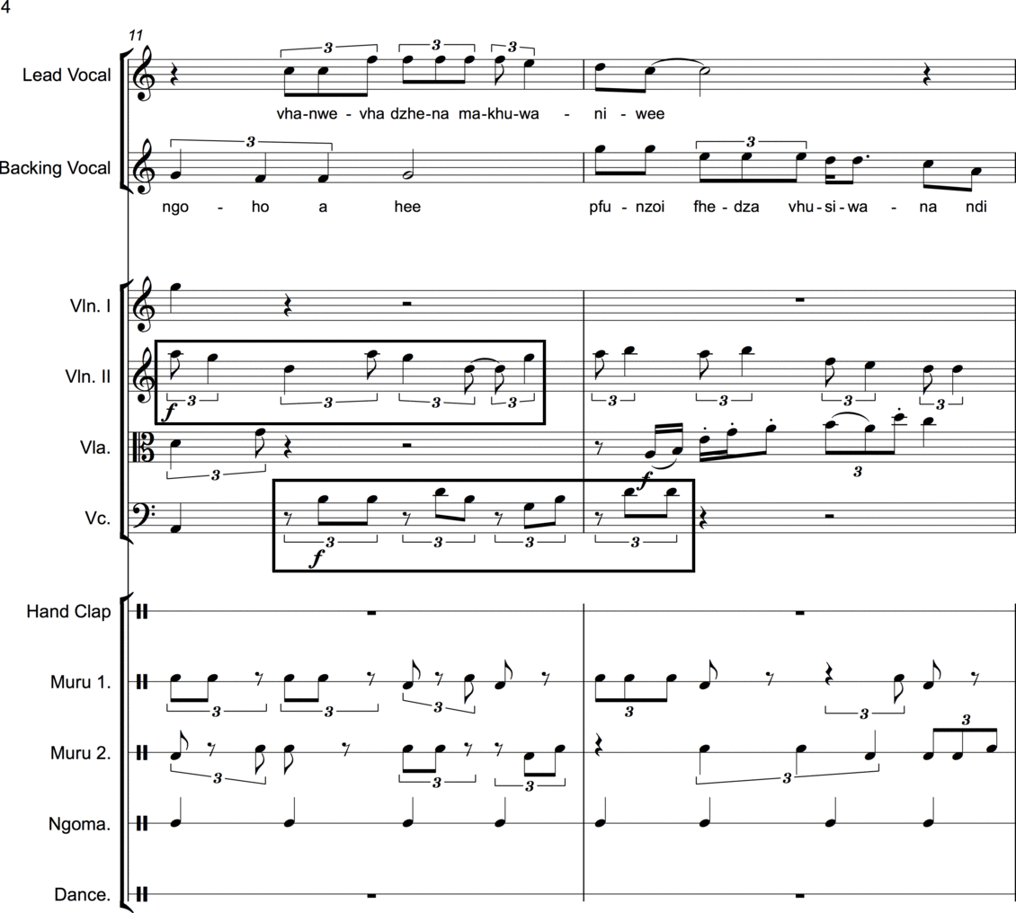
Figure 5.4. An extract from my composition called Pfunzo based on the Malende rhythmic patterns; this is another composition in which the string quartet and the traditional dancers collaborate.

I have used the exact Malende rhythmic motif in this composition in its original structure but in a different permutation. This is shown in the violin part, which is indicated by a box. The cello part uses the same length of the Malende rhythmic motif but I have transformed all the crotchets in the structure in such a way that the main motif would not be recognisable.

Education is one of the most important components in traditional music since music is used as a prominent vehicle for educating people in social behaviour. The performance of this music resulted in a demonstration of pure Tshigombela dance style without the string quartet. This was to illustrate how the music feels in its purest form. I composed this piece with a view to expressing the importance of education, particularly for young people. The message in the lyrics addresses the importance of education. When I worked with the Matondoni Tshigombela group, I realised that they often use the same dance steps in their songs - some of which are borrowed, while others are recycled from other well-known songs with very little change in them. That is one of the reasons why I ended up introducing my own original dance steps, which the group was reasonably happy to use. The group leader, Netshifhefhe, approved all the new elements I introduced to the group including innovative dance and singing features. I composed this song with a view to demonstrating that traditional performances are not supposed to be stagnant without the flair of creative additions. The dance steps I introduced to the group have since become part of their own repertoire.

I have selected page 4 of Pfunzo in particular because of the way I used the standard rhythmic motif which displays the pattern that crosses over the bar line. This is one of the features that creates a different synchronisation outcome in the music. If one looks at how the standard rhythmic pattern has been used in the cello part, there is a particular subdivision of the quavers, which gives a completely different audio result with respect to the rhythm. In my piece, I have divided all the crotchets into quavers in the example above, but removed the first quaver from each beat in order to create a variation on the original rhythm. The compositional style for Pfunzo is the same as in Dzunde to remain within the Venda cultural boundaries and in order to retain the identity of Tshigombela music. Both my compositions follow the cultural philosophy of the melodic and rhythmic contour in the vocal lines while keeping the structural design of the Tshigombela music. The main drum Ngoma that plays the role of beat-keeper is used as a point of reference in a 4/4-time signature. This allows other rhythmic patterns to focus on the contrasting compound metre in order to create the dual metric feel.
Below is an excerpt of my original composition called Tshisima tsha Mukundi.
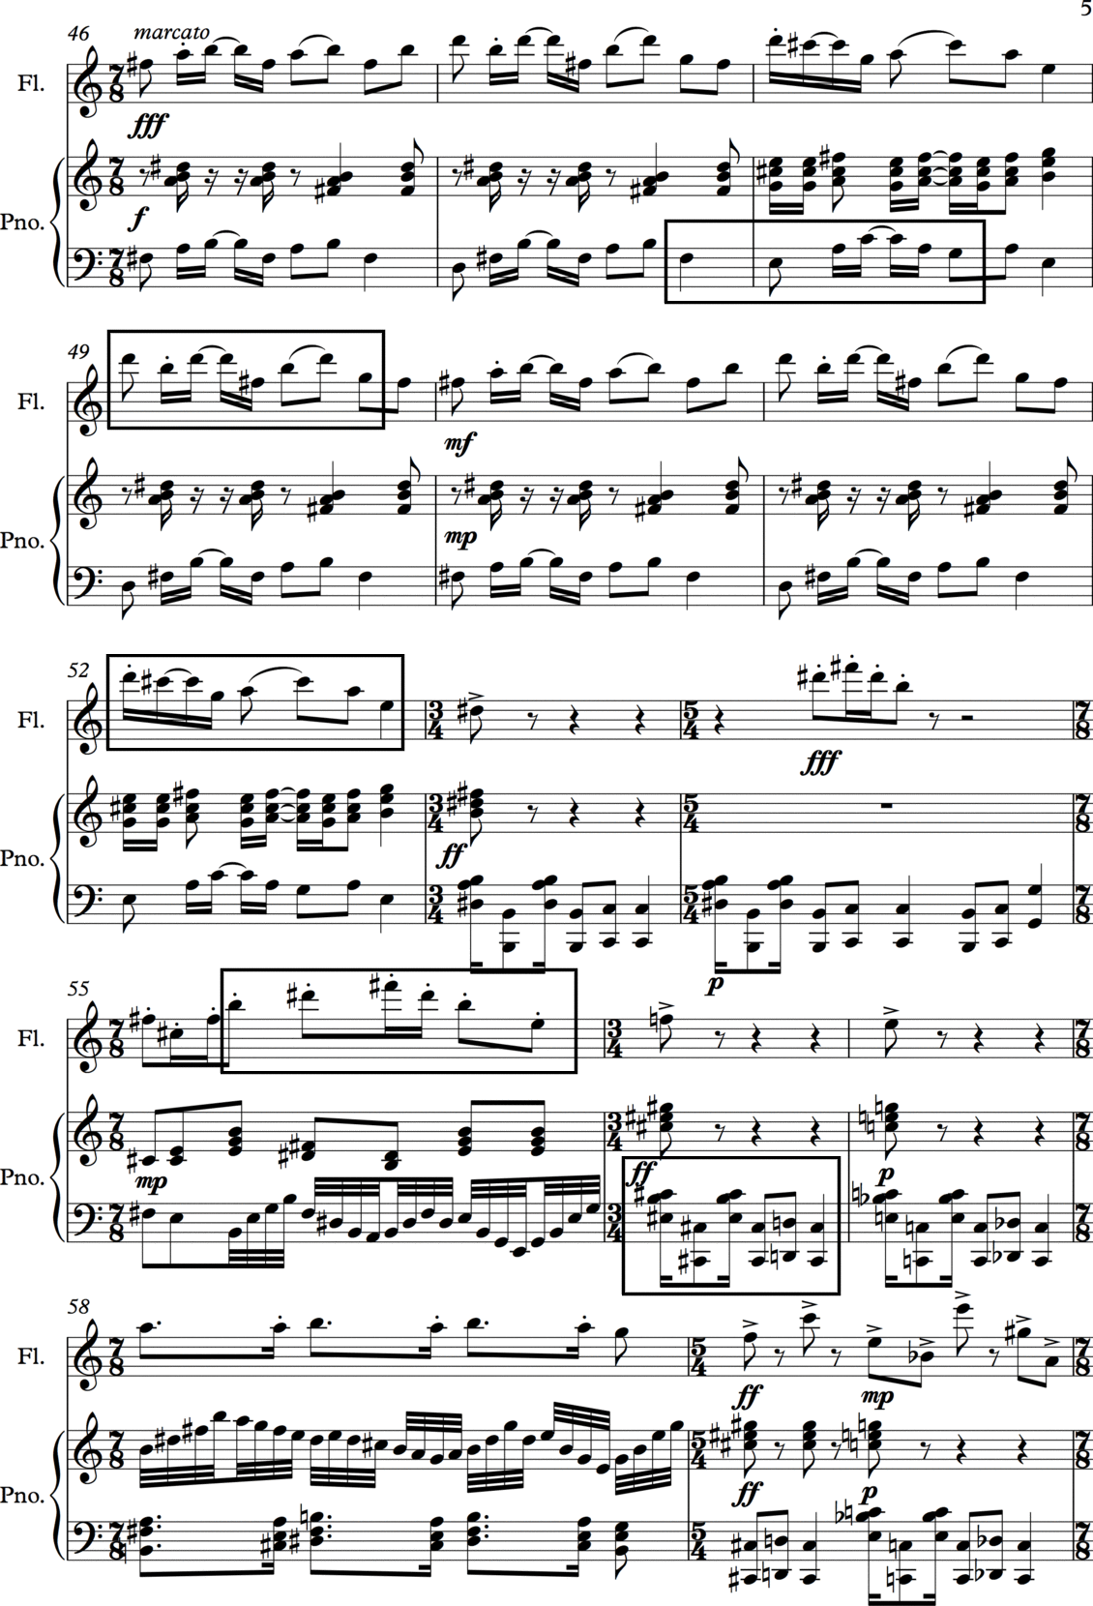
Figure 5.5 Tshisima tsha mukundi - a piano and flute composition, which is part of my composition portfolio.

Tshisima tsha Mukundi is a piece that emerged from exploring a different scale that I created while playing the piano. The scale is based on a pattern from the tonic note up which is retrograded halfway up the octave. This is how the scale looks like from the note C, C-D-E-F-G-Ab-Bb-C. The fascinating aspect about this scale is that it gives the impression of being located on a subdominant chord being interpreted in the root key while it is not. This is because this retrograde scale has a minor dominant chord, (which is usually found in a regular major or minor key though not in certain modes) and makes it easy to modulate smoothly between keys. The main feature in this piece is the use of different time signatures while intentionally not focusing on the compound metre. The use of the standard Malende rhythmic figure in this piece is completely different from the way I use it in all the other compositions. The rhythmic pattern for Malende uses crotchets and quavers as the main values while in this composition I have used quaver and semiquaver note values instead. This subdivision of the notes gives the impression that the music is faster than it is - while this is not the case. I have used this feature of reducing note values in a particular way that is not traditionally recognisable - designed to extend the experience of those who are familiar with the core standard rhythm of Malende.

My unique approach in this piece was to superimpose the standard rhythmic motif for Malende on to Tshigombela music, since Tshigombela music uses permutations of this rhythm. I wanted to demonstrate how this standard rhythm could be shared between two musical styles. In fact, Tshigombela has the longest rhythmic pattern, which is based on two different permutations of the standard Malende pattern. Below is an excerpt from my composition for string quartet called Thendo na Gundo (Second Movement) which uses this figure:
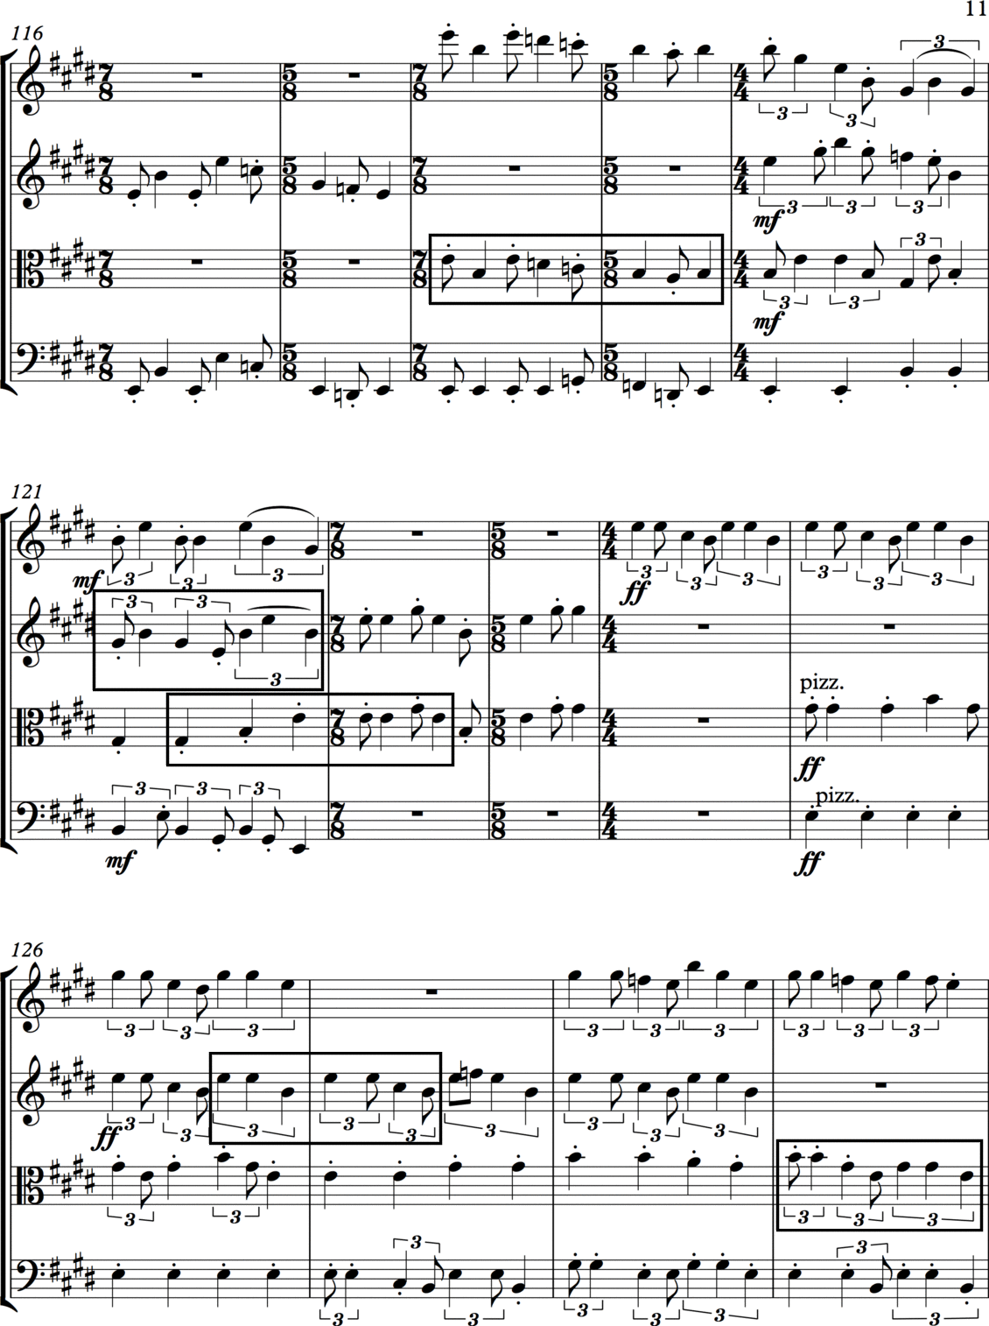
Figure 5.6 Thendo na Gundo

The boxed rhythmic patterns in the example figure 5.6 above represent the standard rhythmic motif for Malende used differently. This is a string quartet piece, composed as part of my composition portfolio. I have used the Malende rhythmic motif in different permutations in each separate instrument. For example, in the violin II part, the pattern I used starts with a triplet crotchet figure while the same rhythm in the cello part is in reverse in bars 126-127 and 129. The same rhythmic figure in bar 121 in violin II is repeated in bar 129. Bars 118 and 119 use the Malende rhythmic motif differently over two bars since the time signature changes from 7/8 to 5/8. I did this with the purpose of achieving a different shape of the same rhythm, while using a different time signature that uses a quaver instead of a crotchet pulse. I have also used the Malende main motif loosely in this instance while exploring it in two different metres. The purpose was also to have the rhythmic figure played over two bars instead of being in one bar in a regular 4/4 time signature.

Thendo na Gundo are my two daughters who have featured in many of my compositions. Most of the time when I compose a work, I dedicate a piece to one of them, based on her particular personalities. These dedications are special tributes to them and they differ in character and mood from one piece to another. The string quartet is in two movements and is based on a specific traditional Venda Malende rhythmic motif, which is, as already stated, also found in Tshigombela dance music in an extended form. The rhythm has been used in most of my compositions as a feature. The two movements explore how the same rhythm can be used but starting from different points in the music, exploring and exploiting many different rhythmic variations. The original pattern is predicated on hand-clapping and dance steps, that is, without any melody assigned to it (as mentioned in the beginning of the chapter). However, I decided to transplant the rhythmic device onto the melodic contour as a compositional feature. Again, I selected a particular page that best demonstrates the intended purpose regarding this:
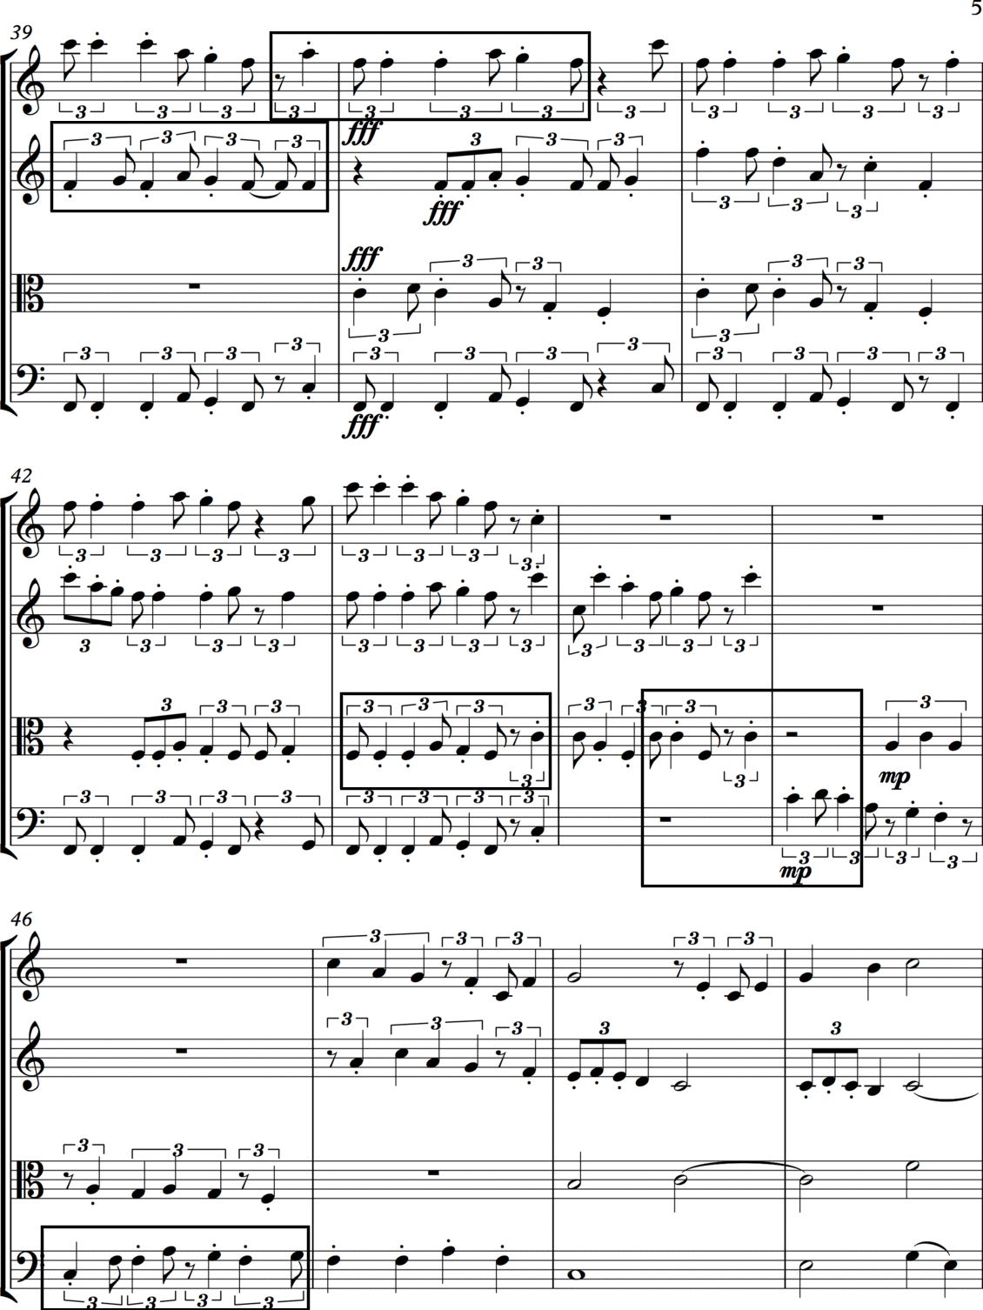
Figure 5.7 Thendo na Gundo is a composition for string quartet composed incorporating the Malende standard rhythmic pattern; above is an example from the First Movement.

In this movement of Thendo na Gundo I explored the same technique which applies the standard rhythmic pattern for Malende. However, the features used in the first movement differ from those used in the Second Movement, as discussed above. For example in violin I, I have used the same rhythmic pattern over two bars but starting on the last beat of the first bar until the third beat of the second bar. In bar 43 I have used the same rhythmic motif as for Malende but I decided to remove a quaver, which was supposed to be tied with the previous quaver in the rhythmic structure. I wanted to shorten one of the crotchets that form part of the rhythmic figure. All the other crotchets are staccato, except this crotchet that would have comprised of two quavers tied together. The purpose was to get a different melodic feel that would complement the staccati in the other crotchets. Bar 44 and 45 demonstrate one rhythmic figure that is split into two parts (seven plus five quavers); the choice of splitting the notes in this way was guided by the melody. I wanted to start and also end on the note C when looking at the complete rhythmic structure.

Composing Thendo na Gundo for String Quartet was to demonstrate a mode of referencing original material extensively throughout the piece. I wanted to illustrate different kinds of rhythmic juxtapositions and overlapping techniques that could be explored in a piece. I have used many variations in this particular composition that demonstrate many ways of using the standard rhythmic pattern found in Malende. The principle is: depending on where one starts the rhythmic figure, there are several different outcomes and endless possibilities to be achieved. I used the standard rhythmic pattern for Malende music because it is the shortest of the three dances and it is the foundation upon which the other two musical styles (Tshigombela and Tshikona) are built. It is also the most distinct of all the standard rhythmic patterns of Venda indigenous music and is the most used pattern in traditional songs. The rhythmic pattern for Tshigombela music, which is based on the Malende rhythmic pattern, has 23 crotchets in the music pattern, which are all in triplet groupings, though by including one crotchet rest at the very end, makes it 24 crotchets in total. This irregular number of crotchets is as a result of the pattern being split into two components and the second one overlaps with the first on the last crotchet. The dancers begin the second part before the first one ends.
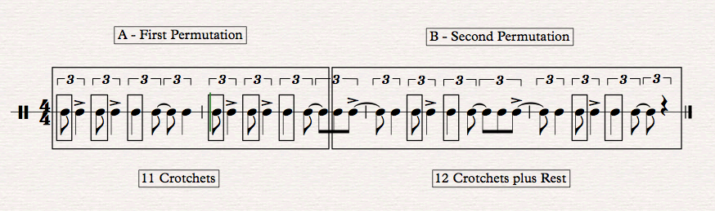 Figure 5.8 Tshigombela rhythmic motif based on two permutations of Malende rhythmic pattern.

When counting the beats it would be 15 sounding notes ending with one crotchet rest, making it 16 crotchet beats in total. The Malende rhythmic motif has four beats that are counted in triplet groupings. It is easier to remember a shorter structure than a longer one. This is evident when traditional dancers teach people how to use these two rhythmic patterns. In my own experience as a learner, it was easier to learn the Malende than the Tshigombela dance. It is more difficult to learn the rhythmic pattern for Tshigombela than learning the one for Malende music. One has to understand the Malende dance first as the foundation for understanding the Tshigombela dance. When one has mastered the main rhythmic motif for Malende in its original structure, one is able to transform it into twelve possible cyclic variations. However if the order of the notes is rearranged and shuffled around the number of variations is infinite.

My traditional dance teacher is an expert in Tshigombela music and he wanted me to master the Tshigombela dance first because this is his area of traditional music expertise. I was initially not aware that it is based on permutations of the Malende rhythmic motif. If I had known that, I would have started by learning the Malende dance. It was difficult for me to learn the Tshigombela dance without first breaking it down into small segments. If one starts with the Malende rhythmic pattern, one just needs to remember two shorter groupings, whereas, the Tshigombela standard rhythmic pattern requires one to remember two longer groups of 11 and 13 triplet crotchets. In fact, the standard rhythm for the Malende is often assigned to hand clapping while the rhythm for the Tshigombela is assigned to the dance, even though the one for Malende could also be assigned to the dance. The way Venda practitioners learn the two rhythmic motifs is that they dance to the one for Tshigombela while clapping and dancing to the one for Malende. The rhythmic pattern for Tshigombela is never assigned to hand clapping but always to dance steps and sometimes to the high pitch drum (Murumba).
The process of setting up and preparing for the concert with the Matondoni Cultural Dance Group

When I began with my research, I was anxious about the creative process that involved the participation of the indigenous practitioners in my compositions -this being a process I had never attempted before. I knew that other composers had achieved this type of collaboration but it was a ‘first’ for me. I was concerned about many things; such as synchronisation challenges, intonation problems, singing within a key and tight coordination between the two groups of performers. However, the select excursions I made to Venda to practice in advance with the practitioners helped a great deal with this process - leading to the final concert. I had to creatively use my imagination in guiding the indigenous practitioners how to perform with other musicians as this was also their first experience. The traditional musicians and I had only a few rehearsals in Venda at which I was using just a laptop and singing along as a simulation process. This was intended to give them a feel of how their collaboration with the other musicians would sound. I would frequently be very frustrated, as I was not able to have a real-time experience with the combined groups before the scheduled rehearsals. On several occasions, I was tempted to use a digital Sibelius audio rendition from my computer as a guide during my initial rehearsals with them. However, I thought it would not work, as I needed a large amplification system to be able to hear the composition while singing and dancing at the same time. All the rehearsals I had with them were in an open space at the school premises where we had obtained permission to rehearse. This was not an ideal space for using a computer-generated sound with other background noise and the sound of loud drums and singing Eventually I relied on faith and hope that the collaboration would.

What was constant and illuminating throughout this entire experience was that I had to frequently adjust my original compositional ideas, to accommodate what was practical - bearing in mind that I would still be their chief guide throughout the entire rehearsal experience. This became even more evident when the two groups met for the first time to rehearse. The process of integrating indigenous traditional elements into my creative output and how I wrote myself into the dances was a learning experience that substantially enriched my compositional skill. I had to create sections in the composition, which were not in the original arrangement so that the traditional dancers could dance freely without intimidation by Western instruments. I realised throughout the rehearsals even before the main concert that there was disturbing lack of confidence among the indigenous practitioners. They were holding back and restraining their expressiveness and were not secure enough in their dance steps. I particularly noticed this when they were rehearsing initially with the string quartet. I soon realised that the uninhibited manner in which they danced and moved when they were performing alone was different to when they danced with the string quartet. I had to literally keep on directing them while dancing with them myself giving critical some cues and marking points of entry for them throughout the performance. This was very difficult, as I had to learn to multitask. Their lack of confidence also began undermining my own sense of confidence as to the possible success of the final performance at the concert. This situation contributed to my feeling emotionally and psychologically vulnerable prior to the concert. I believe that their response was due to the limited number of rehearsals they had with the string quartet.
Coordination between the two groups of musicians was for me the most challenging task of the entire performance - I had to dance, conduct the performance and cue in the traditional musicans as well as occasionally cue in the string quartet I had the responsibility of making or breaking my own performance.. As a composer, I am used to giving musicians the score to play without worrying about how the performance would be realised. In this case, I was also an intrinsic part of the performance.

I also realised that putting notes down on paper does not necessarily translate to a smooth performance, as there are technical variables to be taken into consideration, such as balance etc. . However, the lessons l learned far surpassed what I could have imagined had I not been part of the performance itself. During this experience, I literally found myself being ‘in the performers’ ‘shoes’ which is not usually the case when one is the composer. In addition, there are technical challenges involved in writing for instruments one does not play.
The experience also awakened in me an awareness as a composer as to what musicians go through when they play someone else’s music. This had completely changed my perception towards performing a composer’s work and it has also enhanced my knowledge about creative live performances. The experience indicated to me the extent to which a composer should be involved in organising every aspect of arranging a performance of his/her work. The only time the traditional musicians challenged me was when I introduced new dances to them. The young people who were part of the group were willing to learn the new dances. However, the older people were reluctant to learn new dance steps. I had to explain to them that year in and year out, they play the same music and do the same dance steps without any change or development. They would occasionally even put dance steps from a different song to a new song, as if there was no possibility to create new dance steps within traditional parameters. I believe that I changed this perception.

To introduce new dance steps to the group was a major challenge - I had to convince the older people to accept new steps by making some of the moves simpler. At the end of the entire exercise, I received positive feedback from the group regarding the new dances I introduced. I think having some younger people in the group also helped to convince the older people to learn new steps. The older people in the group were ultimately also grateful that they were offered an opportunity to be break down the barrier created by their fear and belief regarding their traditional customs.

Eventually, they thanked the younger people and me for not giving up on them and my pursuit to open their minds to new things. They have in fact, confirmed that they entered a competition after the concert and that they have been using the new compositions and dance steps I taught them. This reassurance from them proved to me and to them that introducing new ideas and concepts into the cultural performance domain is not viewed as taboo as was the case prior to this experience. I believe I could not have done this entire performance correctly had it not been for the guidance provided by Professor Jeanne Zaidel-Rudolph whose experience with creative performances included traditional dancers. This experience taught me a great deal about patience and about being truthful to one’s culture – even with the addition of new ideas.

If I was given the opportunity to go through this process again I would have done it differently; by focusing more on the rehearsals, in order to achieve a superior performance and definitely with more rehearsal time. I still believe that if most of the rehearsals were done in the venue itself, namely the Great Hall, there would have been far less challenges; especially involving sound production and balance and the positioning of both groups of musicians on the stage. Other than these issues, I believe that the performances were a great experience for all musicians involved in the project. For me, the final performance answered many of my research questions, which I had set out at the beginning of the project. My main aim in this research was to identify, analyse and synthesise e the standard rhythmic patterns, which exist in the three-selected Venda indigenous music forms - the ultimate purpose being to apply them in a variety of ways that are creative, yet remain true to representing the identity of Venda culture. The crux of my own music is the choice that I made to use the standard rhythmic motif for Malende music as a melodic tool and feature in my compositions, rather than the original rhythmic format. The norm for Malende music is to delegate the rhythmic aspects to dance steps or hand clapping. Using a melodic adaptive approach as a feature in my compositions was intended to make those who are familiar with the rhythm be able to recognise its structure in a melodic form.

Analyses, Annotations and Descriptions of the methodology used to transcribe the CDs and DVDs into notated scores.

- The listening and observing process.

The listening and observing process has been one of the most demanding, though one of the most illuminating endeavours I have had the privilege to pursue. I had thought my status as an insider in the Venda culture, as well as my having had some experience in performing traditional Venda dances, would make the process easier; but to my surprise I was proven wrong during the entire listening, observing and notating process. I had to request the practitioners to repeat their performances several times for me to truly and deeply understand what they were doing. When I didn’t comprehend how the various elements all fitted together, I would just comfort myself by knowing that I could still listen to the recordings and observe the video material repeatedly; at least until I had grasped the workings of the inner components and the combined performances. I had also requested the group leader, Netshifhefhe to teach me the dances on a one-on-one basis so that I could integrate them in a practical manner.

To understand the music as a participant and from a dancer’s point of view was one of the most fulfilling activities I experienced during my research. I participated in many dance performances to reassure myself that my body movements were like the rest of the dancers or at least in a faithful way. I also requested Netshifhefhe to give me critical feedback on my performance. Although I took the audio and video recordings home with me, there was nothing in my experience that could replace the live experience of observing the dancers in the field. I am aware that some writers such as Kofi Agawu disagrees with this in some of his writings. The live participation with the group itself became the core of my listening and observing experience in order to embark on the transcription process to document the fieldwork research.

Later, when watching the recordings, my flashbacks to the live events were invaluable to my notating the dance steps and rhythms of the music. During the process of analytical observance and deep listening, I was able to get up and dance with the music, which proved to be exceedingly useful. I would vividly recall and use my fieldwork experience to transcribe the music and develop the dance notation. Even though I had to repeat the songs many times to accurately transcribe the correct rhythmic patterns, I found myself relying more on the memory of the practical work than the DVDs. Some of the aspects I did not fully understand during my fieldwork came to light while I was dancing at home and analysing and documenting the material. It was extremely difficult to isolate the dance rhythms because of the many other instrumental rhythms occurring at the same time. There is always an overlap of rhythmical textures between dance steps and the drums. The strategy that I used to isolate rhythms was to listen to one rhythm at a time and try to block out the other patterns of sound.

- Decision about STYLE of notation: a mixture of conventional notation and my own original notation for dance steps - why and how it works

It was difficult to decide which music notation system to use for the music incorporating dance. I researched several notation systems intended for African music. However, there was not one single system that accommodated the various modalities intrinsic in the combination of music and dance appropriate for my transcriptions. I decided to remain within the norms of the standard Western classical staff notation because it could offer the symbols I needed to interpret the combined sounds and movements. Nevertheless, staff notation has its own limitations in that the visual aspects of the dance movements and rhythms are not catered for in this notation. The symbols used by Louise Meintjes (2004) in her Zulu dance research proved to be very useful; I incorporated these into my own notation to expand its vocabulary.

I have explained in a glossary of symbols how they are applied and how one can interpret them during a performance. Analysing indigenous dance steps is very complex because of the way the entire body is used as an instrument to accentuate and interpret the dance. The body movements indicate not only the rhythms, but also where the specific accents are placed – both the hands and feet must be observed to draw these conclusions. Sometimes the head or even fingers are used to add meaning to the dance. If one only listens to the audio recordings without watching the dancers themselves, this renders it inadequate and incomplete. An appropriate notation should incorporate specific dance symbols to illustrate the dancers’ body gestures to attain meaning.

When one creates new symbols to express new music or dance ideas, one should aim to make these signs visually meaningful with an explanatory glossary, in order for the performer to interpret the symbol as accurately as possible. Such innovations have become increasingly common amongst contemporary composers, due to the fact that many of them find existing music notations limiting. Twentieth century composers such as Stravinsky expressed frustration with Western staff notation due to its many limitations. The art of adding symbols to existing signs is inevitable in the 21st century to cater for extended techniques and world music.

- Rationale for choice of metre/time signature.

The choice of metre, namely the time signature, has been one of the most important decisions for me. This is because applying a different metre to a music rhythmic motif can alter the audio result even if only in emphasis and nuance. Most of the songs have, to my ‘insider’ ear, a triplet feel within a simple time signature, in this case 4/4; this is in contrast to the interpretation documented by many other researchers and ethnomusicologists, who appear to have heard and analysed the metre as a compound 12/8. In the Venda music with which I have grown up, my strong sense of the rhythm is one of a clear -four beats per bar foundation as the point of reference, together with the other patterns which embellish the basic beat. When listening, the illusion is created that the basic metre is in 12/8, namely compound quavers in dotted crotchet groupings; but the reality in practise, is that the overriding beat of four dictates the notational values of the other voices against the simple 4/4 beat and rhythmic structure. This beat is what provides the cue, stability and starting point for the other patterns of music and dance to overlay and integrate. In other words, although the more obvious foreground ‘feel’ seems to be in compound time of 12/8, the background beat, especially given the regular drum beats, dictates a simple 4/4-time structure (metre) with quaver triplets above, underneath and against it, which accommodate the slight freedom to ‘swing’ a little within the 4-beat foundation.

Thus, in my analysis through deep listening, as well as through the physical act of dancing to the music, I concluded that the simple time signature is the most appropriate as the background metre, together with the foreground figures in the compound ‘feel’. The logical solution to having to accommodate six crotchet beats in the dance within a 4/4 metre was to create two triplet groups of three crotchets each against the four crotchet basic beats played on the big drum as shown in Figure 5.9 below. However, variation is introduced in the dance rhythms by varying the second half of the bar and introducing smaller subdivisions of the triplet feel.

In certain African cultural musics, such as the generic rhythms found in Xhosa music, the subdivisions within the bars dictate that indeed the 12/8-time signature best accommodates the need for subdivisions of twos and threes. For example, a bar would consist of five plus seven beats (=12), again subdivided as 2 + 3 + 2 + 2 + 3. Therefore 12/8 in this case would be the most suitable metre.
Although not necessarily written down or notated in Western notation, to my knowledge, most Venda practitioners count in 4/4 instead of in 12/8. If an African practitioner is taught to count in 12/8, he/she may have problems fitting in the rhythmic values when dancing to the music, since the norm is to be guided by the four main beats of the big drum. The example below illustrates how the Ngoma drum keeps the basic 4/4 beat while the other voices play triplet figures against it.
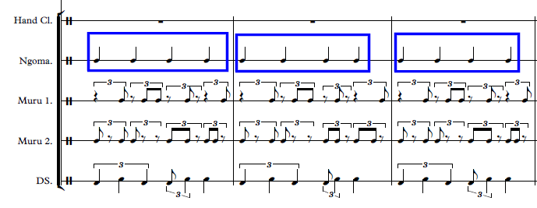
Figure 5.9 an example of a 4/4 groove that is maintained by the drum. (DS on the image stands for dance steps)

The example below shows how the triplet grouping of three crotchets work together with the triplet grouping of quavers as part of a dance, remembering of course that the accent is on the crotchet following the quaver in the triplet quaver group. The dancers’ right foot is also used to mark the main beat of the 4/4 count as a point of reference for them to know whereabout in the dance they are during a performance. This is more evident when a song has six crotchets that should be fitted into a 4/4-time signature.
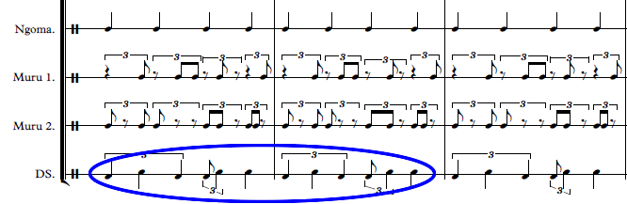
Figure 5.10 an example of the standard Malende rhythmic dance pattern in my transcription and later used in my compositions. (DS on the image stands for dance steps

- Why I chose to use certain values in a particular tempo

The tempo indications that I have used in my transcriptions range from 60 to 100 beats per second, due to the fact that the music is neither too fast nor too slow. This average pace defines most of the songs. Either the drummer or the lead singer makes this choice. The beat unit is the crotchet and the unit against it is the quaver pulse. In addition, the songs have to be able to accommodate the dancers in performance at a comfortable tempo and pace.
Since the practitioners do not adhere to any written tempo marking, they are guided by the senior male leader in the case of the group I was working with, who either approves (or not) of the choice of the song and the tempo set by either the drummer or the singer. In addition, the leader joins the performers in the dance for some or all of the time to make sure they are on the right track - he is basically the director of the performance. He determines the tempo of the song based on the kind of dance steps that would be performed for each particular song.

When one uses Western classical staff notation, one understands that there will be note values that are based on a ‘feel’ rather than on a rigid tempo. An example of the choice of metre is shown in the figure 5.11 below. The rhythm circled in blue in Figure 5.11 below symbolises the use of the standard rhythmic pattern incorporated into my composition. Again, in this example, which is an extract from my symphonic composition, I have used the standard rhythmic motif for Malende in its original design, but including my own alterations in the first and the last beat of the rhythmic structure. In most of the examples, I decided to use the Malende rhythmic motif loosely and to add my own creativity into the original structure of the rhythm.
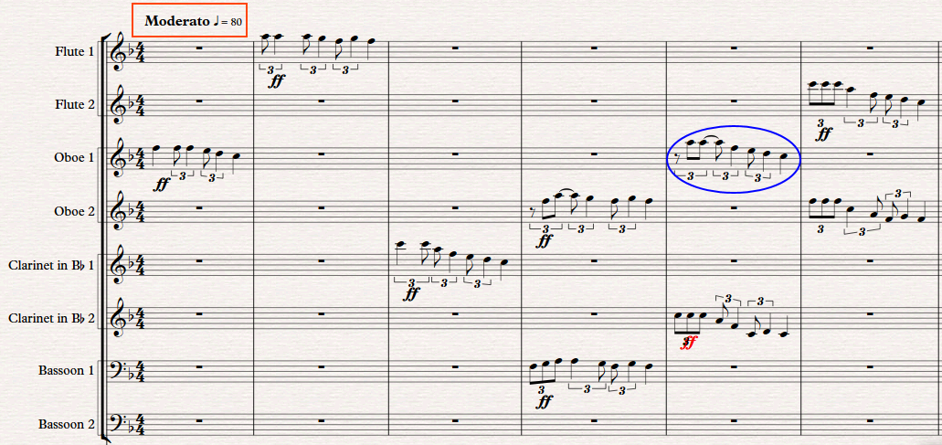
Figure 5.11. an example of tempo choice.

- The main parameter that guided my compositional process – choice between the melodic and rhythmic parameters as primary elements (drums).
The rhythmic pattern in each of the three different dance styles Malende, Tshigombela, and Tshikona is unique and definitive to each style in its distinctiveness. Even though the foundation of all the three-music forms is the Malende rhythmic pattern, there is a distinct structure for each. My focus is on the rhythms found in the actual dances and hand clapping patterns. Rather than on the melodic or the other rhythmic structures occurring in, for example, the other drums and instruments. It is the dance rhythm itself, which defines the standard rhythmic motif.

This then became the guiding feature in the choices made for own my creative work. The main difference here though was that it became my melodic lines that were then based on and extracted from the rhythmic dance pattern – this in turn generated the polyrhythmic textures in my music. Drums are not the basic guide to Venda indigenous rhythm as one may think, motif, but it is the dance steps and rhythmic patterns made by hand clapping.. The role of the drums is rather to set the tempo, be the main point of reference (beat-keeper) and be the instigator of cueing in the other participants.

- The technical recording process for the songs/dances.

I was satisfied that the songs were well recorded technically, even though I had to do a few ‘takes’ to make sure that I didn’t rely on just one recording. What I also discovered with multiple takes was that the starting and the ending points of a song were not always the same - this was not a problem but just for noting. This only affects the final transcription of the song, as the starting point would be different each time. The leader of the dance decides on when the song will start or end. Most of the performance activities happen at the leader’s discretion. This will include features such as when to change the rhythmic pattern, when to reach the climax of the song as well as how many times a certain cyclical pattern should be repeated. However, this would still be within the parameters of the structure of the music. This means that within the rhythmic cycle, namely the interlocking of different rhythms, there would be one rhythm that the leader uses as a guide to start and end the song. I made audio plus video recordings, but I consulted the video material more than the audio, because of the critical visual aspect of the dances in relation to the music being played. Another method, which was very helpful, was to do a second recording of the same song on my return to the field for the second time. The second recordings confirmed that my first recordings were technically well done and that they represented the music as accurately as possible.

- The incorporation of the rhythms into my original compositions

Although the rhythmic dance elements dictate the basis of the music, I decided to incorporate melodic elements into the basic rhythmic structure - and thereby foreground the melody using the rhythms as the basis. When the rhythms are used as a melodic function, the music portrays a different colour from that of the original traditional cultural focus. In each of my original compositions, I have used the standard dance rhythm of Malende with adaptations to achieve different timbres and colours in the music.
Some of the compositions in my portfolio are not entirely inspired by the traditional dance rhythms analysed, but they symbolise a new approach to the referencing of indigenous Venda music. I have used both the referencing technique and my own style of writing that is inspired by traditional music as part of my original material. . Even though the entire research was centred on the crafting of rhythmic patterns, these current compositions show a new development in my approach towards my compositions. The entire process followed during this research has had many positive benefits in the development of my compositional style. I have gained great insights into the many ways of engaging with existing indigenous music material. I am grateful that my research has fed so positively into the advancement of my composition technique and craft.

Although I have worked with indigenous music materials previously, my current approach is significantly more informed and developed - and shows a deeper understanding of and connection to the material. A number of composers have engaged with indigenous music as their source and reference though ostensibly without having actual live experience of the origins of the music material they use. This can lead to the composer being detached from the source material and its cultural meaning. Engaging with indigenous material as an active participant who has lived with the culture, will inevitably produce different results from one who engages with the material as an outsider. The two circles below, both blue and red; in figure, 5.12 are examples of rhythmic patterns I have used in one of my original compositions in my Portfolio. Both examples indicate how I have used a different approach to the same rhythmic material in different ways. I have used the blue material in an overlapping technique that cuts across the regularity of bar line. Before the one figure ends, the next one immediately starts to highlight the colours of different instruments. Both examples in figure 5.11 and 5.12 demonstrate how I have incorporated the indigenous rhythmic material in my compositions.
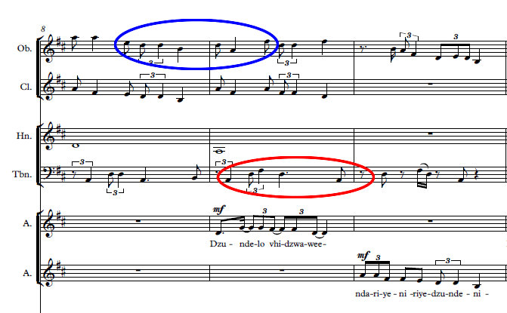
Figure 5.12. The use of standard rhythmic patterns across bar lines and overlapping with other melodic, rhythmic lines

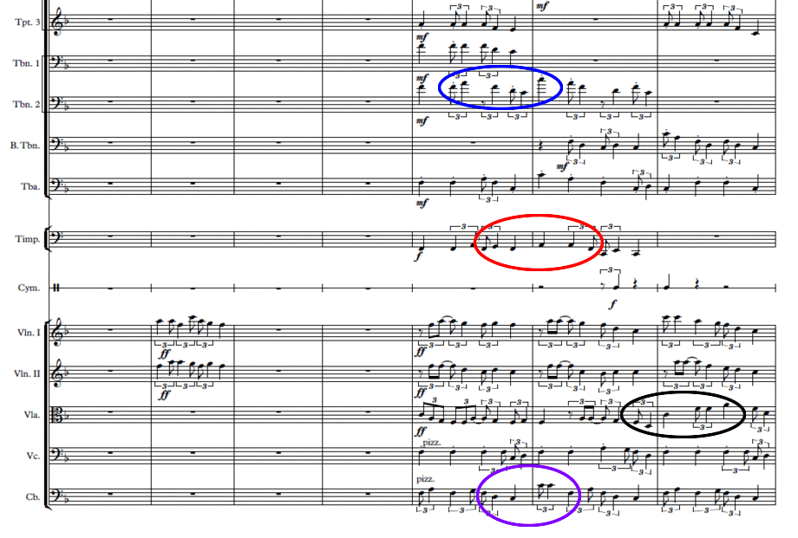
Figure 5.13. The different use of the standard rhythmic motif in another piece of music called Collage, here again to cross over bar lines.

During the concert performance, I observed the traditional group while my string quartet was being performed I was sitting next to the traditional performers which allowed me to confirm some perceptions I initially had before I embarked on this research.. I was sitting next to Netshifhefhe when the string quartet was playing Thendo na Gundo. I noticed that he was nodding his head during the performance. This caught my attention and made me curious to know the reason for his reaction I then asked him why he was nodding to the music. He answered, “this is nice; these instruments can play Tshivenda tune”. This was exciting for me to hear being a traditional dancer who is not only an insider to the culture but also a practitioner. For him to be able to associate with the rhythm used, even though it had been used differently from its traditional context was confirmation that my intention was successfully executed. He was actually very surprised that Western strings can play t traditional tunes. He kept saying to his group members that “the white people can play our music with their strings”.

Conclusion
The experience I gained through this research project has helped me to develop my own compositional approaches and ultimately my own individual compositional voice; I believe that with time it will even become more developed as I mature in my ideas and creative writing. I have also learnt how to work with indigenous practitioners in a manner that benefits both the researcher and the practitioners. This took the form of a knowledge-exchange experience instead of the traditional knowledge-transfer practice of research methodology. This was a practice-based research that was also guided by knowledge-exchange principles as its core focus. Inasmuch as I learnt many things from the indigenous practitioners, I do believe that they have also learnt extensively from my experience as a professionally trained Western classical musician and composer. I also believe that being a composer-researcher opened the eyes of the people I was working with to critically push the boundaries of creativity, as they should, and not to be limited by cultural restrictions set for people as artistic creators. I hope they will understand that being an active individual contributor to a cultural practice is also vital in the development of indigenous African music practice as a whole. I was able to analyse my own music as a critical reflection of how I engaged with the identified standard rhythmic patterns found in the music of Venda people.

This experience has also taught me that being an insider or a native researcher to the culture requires one to be unbiased in one’s beliefs when engaging with one’s own music and open to my opinions - through constantly asking questions from the practitioners. Being born in the culture by virtue of speaking the same language as the indigenous practitioners has allowed me to understand matters of auto-ethnography better. The research has encouraged me to start looking at sheet music preservation of indigenous musics very seriously as my next endeavour in engaging with indigenous practitioners. Cultural dances are rich in music heritage that sustains itself in the community - due to the traditional priorities set by local authorities on music practice. The threat against sustainability of indigenous African music continues to threaten the existence of such practices in many communities. Creativity is largely credited to the community, which also removes the right for an individual or group practitioner to rightfully claim his/her copyright in a cultural setting. Having said this, it is also virtually impossible for indigenous practitioners to earn a living through their music as a career in their communities. They are not able to rely on indigenous music practice as their only source of income to provide for their needs and their families. Sustainable ways need to be discovered for such indigenous groups to continue practising their music and guarantee the survival for such practices for future generations.

The aim for this research was to identify rhythmic motifs from Venda traditional music as elements of reference for my creative work. I used the Malende dance rhythmic motif as the prototype for my creative process in my compositions. Tshigombela and Tshikona are other cultural dance styles that I used to enrich the use of the Malende rhythmic motif in my compositions as they are based on different permutations of the Malende motif. My original work explored further rhythmic permutations of the Malende rhythmic motif as part of my creative process. The transcriptions helped me to understand the original structure of the music and how the main rhythmic motif has been traditionally used in its cultural context. The identification of the main motif was guided by the dance and hand clapping patterns. I have managed to achieve my aim for this research and I believe the enquiry is adding value to the academic dialogue regarding African music.

Bibliography
Books
Agwu Kofi. 1995. 1995 African Rhythm: A Northern Ewe Perspective, Cambridge
2003 Representing African Music, New York and London: Routledge
___________ 2003. Representing African Music. Taylor & Francis Books, Inc. United States
of America
____________2016. The African Imagination in Music. Oxford University Press, Oxford

Arom Simha.1991. “Africa Polyphony and Polyrhythm”. Musical structures and Methodology. Cambridge University Press. Selaf

Berliner, F. Paul. 1993. “The Soul of Mbira”. Music and Traditions of the Shona People of Zimbabwe. United States of America, University of Chicago Press, Ltd, London

Blacking, John. 1995. Music, Culture, and Experience. The University of Chicago Press, United States of America
___________ 1973. How Musical Is Man? University of Washington Press. Seattle
___________ 1967. Venda Children’s Songs. Witwatersrand University Press,
Johannesburg
___________1995. Music, Culture, and Experience: Selected Pater of John Blacking. Edited by Reginald Byron. University of Chicago Press. London

Blacking, John and Joann W. Kealiinohomoku, eds. 1979. The Performing Arts. Mouton Publishers. New York

Bohlman, Philp V. 1988. The Study of Folk Music in the Modern World. Library of Congress Cataloging-in-Publication Data. United States of America

Bohlman, Philip V and Bergeron, Katherine. 1992. Disciplining Music, Musicology and Its Canons. University of Chicago Press, Ltd, London

Bohlman, Philip V and Nettl, Bruno. 1991. Comparative Musicology and Anthropology of Music. University of Chicago Press, Ltd, London

Celia Duffy and Stephen Broad. (2015). Practising Research, Playing with Knowledge. In Dogăntan-Dack, M (ed.), Artistic Practice as Research in Music: Theory, Criticism, Practice, pp. 35- 51. Farnham: Ashgate

Collins, Nick. 2010. Introduction to Computer Music, University of Sussex, UK

Cooper, G and Meyer, L. 1960. The Rhythmic Structure of Music. University of Chicago Press, Ltd, London

Dargie, David. 1988. Xhosa Music: Its Techniques and Instruments, With A Collection of Songs. David Philip, Cape Town

Eco, Umberto. 1976. A Theory of Semiotics. Indiana University Press. United States of America

Feld, Steven. 1982. Sound and Sentiment – Birds, Weeping, Poetics and Song in Kaluli Expression. University of Pennsylvania Press, USA

Floyd, Samuel. 1995. The Power of Black Music. Oxford University Press. New York

Francis Fukuyama. 2006. ‘The end of History and The Last Man’. Free Press, United States of America

Gates, Henry Louis, Jr. 1988. The Signifying Monkey. Oxford University Press, New York
___________________1987. Figures in Black: Words, Signs and the Racial Self. Oxford University Press. New York

Gay, Geneva. “Expressive Ethos of Afri-American Culture”. In Gay, G and Barber, WL, eds. 1987. Expressively Black: The Cultural Basis of Ethnic Identity. Praeger. New York

Herndon, Marcia and Mcleod.1990. Music as Culture. MRI Press. Richmond

Janet Lansdale. 2008. Decentering Dancing Texts: The Challenge of Interpreting Dances. Palgrave Macmillan. UK

Kangas, Matthew. 2006. Craft and Concept. The Materialization of the Art Object. Midmarch Arts Press. New York

Karnes, Kevin C. 2008. Music, Criticism, and the Challenge of History. Oxford University Press. New York

Kofie N. Nicholas. 1994. Contemporary African Music in World Perspectives. Ghana University Press. Accra

Korsyn, Kevin. 2003. Decentering Music. A Critique of Contemporary Musical Research. Oxford University Press. New York

Kariamu Welsh Asante. 1996. African Dance: An Artistic, Historical and Philosophical Inquiry. Canada. Africa World Press, Inc. Canada

Kubik, Gerhard. 1994. Theory of African Music, Vol. 1. Wilhelmshaven: Florian Noetzel Verlag. Indiana University Press, USA

Locke, L, David. 1992. Kpegisu: A War Drum of the Ewe, with audio compact disc and video, White Cliffs Media Company

Lotman, Yuri M. 1990. Universe of the Mind: A Semiotic Theory of Culture. Indiana University Press. Bloomington and Indianapolis

Marian-Bălaşa Marin: “Who Actually Needs Transcription? Notes on the Modern Rise of a Method and the Postmodern Fall of an Ideology”. The World of Music, Vol. 47, 2005(2): pp. 5–29

Meki Nzewi. 2007. A Contemporary Study of Musical Arts. Vol. 1. CIIMDA Publishing. South Africa
__________ 2007. A Contemporary Study of Musical Arts. Vol. 2. CIIMDA Publishing. South Africa
___________2007. “Learning the Musical Arts in Contemporary Africa”. Informed by Indigenous Knowledge Systems, Vol. 1. CIIMDA Publishing. South Africa
___________2007. “Learning the Musical Arts in Contemporary Africa”. Informed by Indigenous Knowledge Systems, Vol. 2. CIIMDA Publishing. South Africa

Merriam, Alan P. 1982. African Music in Perspective. Garland Publishing, Inc. New York and London
______________1964. The Anthropology of Music. NorthWestern University Press. USA
Mine Doğantan-Dack, ed. 2015. Artistic Practice as Research in Music: Theory, Criticism, Practice. Burlington, VT: Ashgate

Monelle, Raymond. 1992. Linguistics and Semiotics in Music. Hardwood Academic Publishers

Neal Sobania. 2003. “Culture and Customs of Kenya”. Greenwood Press. London

Nettl, Bruno. 1983. The Study of Ethnomusicology. University of Illinois. USA
__________ 2005. The Study of Ethnomusicology: Thirty-One Issues and Concepts. University of Illinois. USA

Nketia, J.H. Kwabenia. 1974. The Music of Africa. Cambridge University Press. New York
__________ 2005. “Introduction: Thinking About Music in Ethnomusicological Terms.” In Ethnomusicology and African Music: Collected Papers. Volume One. Modes of Inquiry and Interpretation, compiled by J. H. Kwabena Nketia, 1-20. Accra, Ghana: Afram Publications (Ghana) Ltd

O’Brien, Elaine. Nicodemus Everyln. Chiu, Melissa. Genocchio, Benjamin. Coffey, Mary K. and Tejada Roberto. 2012. Modern Art in Africa, Asia, and Latin America: An Introduction to Global Modernism. Blackwell Wiley Publishing Ltd

Omofolabo S. Ajayi. 1998. Yoruba Dance: The Semiotics of Movement and Body Attitude in a Nigerian Culture. Africa World Press, Inc. Canada

Perrit, Philip. 1997. The Concept of Structuralism: A Critical Analysis. University of California Press. USA

Ruth M. Stone. 2013. ‘The Garland Encyclopaedia of World Music: Africa’. Routledge, New York
Spencer, Paul ed. 1985. Society and the Dance: The Social Anthropology of Process and Performance. Cambridge University Press. USA

Stokes, Martin. 2010. The Republic of Love. The University of Chicago, United States of America

Stone, Ruth M. 2008. Theory for Ethnomusicology. Pearson Education, Inc. Upper Saddle River, New Jersey

Veben, Kari K. Messenger, Stephen J. Silverman, Marissa and Elliott David J. 2013. Community Music Today. Rowman & Littlefield Publishers, Inc. Lanham. New York. Toronto. Plymouth, UK

Veit, Erlmann, ed. 2004 Hearing Cultures: Essays on Sound, Listening and Modernity
Oxford. Berg

Yearwood, Gladstone L. 2000. Black Film as a Signifying Practice: Cinema, Narration and the African-American Aesthetic Tradition. Africa World Press, Inc. Trenton

Articles

Agawu, Kofi. 2006. “Structural Analysis or Cultural Analysis? Competing Perspectives on the ‘Standard Pattern’ of West Africa Rhythm”. Journal of the American Musicological Society, 59(1): pp. 1–46
___________1995. “The Invention of African Rhythm”. Journal of the American
Musicological Society, XLV III (3), pp. 380–395

Anku, Willie. 1997. “Black Music Research Journal”, Principles of Rhythm Integration in African Drumming. Vol. 17, No. 2 (Autumn, 1997), pp. 211-238

Franke, Veronica Mary. 2017. South African Orchestral Music: Five Exponents. Acta Musicologica, [Vol.] 84, [Fasc.] 1 (2012), pp. 87-125. International Musicological Society

Hewitt, Pantaleoni. 1972. “Toward Understanding the Play of Sogo in Atsia,” Ethnomusicology 16 (1972): 1-37

Jaco, Kruger. 1996 “Wada: A sacred Venda drum”, South African Journal of Musicology,
16:48-57
___________1999 “Of heroes and madmen: Venda Zwilombe, part 1”, South African Journal
of Musicology, 19/20:15-31
___________1999 “Singing psalms with owls: A Venda 20th century musical history, art
One”, African Music, 7(4): 122-146
___________2000 “Mitambo: Venda dance theatre”, South African Theatre Journal,
14: 73-96

Jones, Arthur M. 1954. “African Rhythm.” Africa: Journal of the International African Institute 24(1): 26-47

Koetting, James. "Analysis and Notation of West African Drum Ensemble Music". Selected Reports in Ethnomusicology, Vol. 1, No. 3 (1970):115-46

Louise Meintjes. 2004. “Shoot the Sergeant, Shatter the Mountain: The Production of Masculinity in Zulu Ngoma Song and Dance in Post-Apartheid South Africa”. Ethnomusicology Forum. Vol. 13, No. 2 (Nov. 2004), pp. 173–201. Taylor & Francis, Ltd

Moses, Serwadda and Hewitt, Pantaleoni. 1968. “A Possible Notation for African Dance Drumming”. African Music, Vol. 4, No. 2 (1968), pp. 47–52. International Library of African Music. Grahamstown

Nattiez, Jean-Jacques. 1999. “Inuit Throat-Games and Siberian Throat Singing: A Comparative, Historical, and Semiological Approach”. Ethnomusicology, 43(3): pp. 399–418

Nelson, David Taylor (2012) "Béla Bartók: The Father of Ethnomusicology," Musical Offerings: Vol. 3: No. 2, Article 2. DOI: 10.15385/jmo.2012.3.2.2

Netshitangani, K. 1997. “The Songs of the Venda Murundu School”. Papers Presented at the Symposium on Ethnomusicology Number 13, 1995, ed. A. Tracey, pp. 13–19. International Library of African Music. Grahamstown

Nketia, J.H. Kwabenia. 1962. “The Hocket-Technique in African Music”. Journal of the International Folk Music Council Vol. XIV, pp. 44–52

Zaidel-Rudolph, Jeanne. 2006. “Musical Symbiosis in Jeanne Zaidel-Rudolph’s Lifecycle” : by Zaidel-Rudolph, J. and Watt, M. in The World of Music, Vol 48 (2), pp. 135-150

Theses

Kruger, Jaco. 1986 “Venda Instrumental music with reference to certain chordophones and
idiophones”, M.MUS Dissertation, University of Cape town
___________1993 “A cultural analysis of Venda guitar songs, Ph.D. Thesis, Rhode
University

Interviews

Netshivhambe, Evans. 2015 Interview with Naledzani Netshirembe on 23 December 2015, Makwarela - Venda Limpopo, (unpubl.)

Netshivhambe, Evans. 2016 Interview with Matsheka Maluta on 15 June 2016, Mbahe - Venda Limpopo, (unpubl.)

Netshivhambe, Evans. 2017 Interview with Mbangiseni Netshamutshedzi on 08 September 2017, Tshaulu - Venda Limpopo, (unpubl.)

Netshivhambe, Evans. 2016 Interview with Robert Fokkens on 24 March 2016, Email Interview, Johanesburg (unpubl.)

Discography

Georg Friedrich Haas, “String Quartet no. 3” in “In iij. Noct – for String Quartet” (2001), performed by Darragh Morgan. [Accessed February 22, 2016.]

Netshirembe Naledzani, “Salungano-Salungano” from Bele (2007). Marketed and distributed by Netshirembe Naledzani
__________________ “Maiwangu Tshilombe (Salungano-Salungano)” from Bele (2007). Marketed and distributed by Netshirembe Naledzani
_________________ “Nyangalambuya (Salungano-Salungano)” from Nyangalambuya (2009). Marketed and distributed by Netshirembe Naledzani
_________________ “I shavha muinga iyafhi (Salungano-Salungano)” from Rolivha ngafhi (2011). Marketed and distributed by Netshirembe Naledzani
__________________“Salungano-Salungano” from Salungano-Salungano (2013). Marketed and distributed by Netshirembe Naledzani

Maluta Matsheka,” Zwahashu” from Zwahashu Album 2018. Marketed and distributed by Maluta Matsheka

Mmbangiseni Philemon Netshamutshedzi “Vhutsila Ha Mmbangiseni Netshamutshedzi” (2016) Marketed and distributed by Mmbangiseni Philemon Netshamutshedzi

Mohamed, Pops. 1997. “Quandodo (God Help Us), Feat. The Bushmen of the Kalahari” from African Classics: How Far Have We Come. M.E.L.T 2000 – BW088

Mulatu Astatke, “Asiyo Bellema” from Asiyo Bellema (1994). Omega Studios, Rockville, Maryland, USA

Robert Fokkens, “Tracing Lines – for Violin and Cello” (2007), performed by Darragh Morgan (violin) and Robin Michael (cello), from the Fidelio Trio. [Accessed February 22, 2016.]

Music Scores

George Friedrich Haas, “String Quartet no. 3” in “In iij. Noct – for String Quartet” (2001)
Robert Fokkens, “Tracing Lines – for Violin and Cello” (2007), Germany
Evans Netshivhambe “Concert composition portfolio” 2018, South Africa

Internet Sources

https://ucaref.wordpress.com/2017/05/24/practice-based-research/
http://www.journal-the-world-of-music.com/archive/wom_47_2005_2.html
http://ethio-pain-music.blogspot.co.za/2011/12/mulatu-astatke-assiyo-bellema-1994_1444.html
https://itunes.apple.com/us/album/how-far-have-we-come/id922961007
http://www.universaledition.com/sheet-music-and-more/String-Quartet-No.-3-In-iij.-Noct-fuer-Streichquartett-Haas-Georg-Friedrich-UE32339
http://robertfokkens.co.uk/en/page/1429
http://the-world-of-music-bibliography.blogspot.co.za/
http://pages.towson.edu/lwoznick/docs/music/cms_music_citations.pdf
http://www.melmartin.com/html_pages/Articles/trans.html
http://www.melmartin.com/html_pages/Articles/trans.html

APPENDIX ‘A’

Music Transcriptions

Titles
- Maele – Malende transcription
- Liagwa mutshini ndi Teretere – Malende transcription
- Ndo lunwa nga Phame yo mbaisa – Tshigombela transcription
- Yo vhulawa yola Magerere – Tshigombela transcription
- Tshikona transcription

The Maasai people are warriors and are known for their hunting and very fast running, and after a victorious hunt or run the jumping dance is used to celebrate the victory. They also use this dance as a way of introducing young warriors into the clan by jumping high, which demonstrates the man’s authority within the society.
This includes audio collections by John Blacking, Jaco Kruger and the DOMUS archive. Other recordings are stored at institutions such as UKZN, University of Venda and University of Washington. .
I also acknowledge the fact that after a point in the history of African music scholarship, it was in fact expected that foreign scholars should learn the languages in which they conduct research and there are many examples of this scenario. However, the time spent by the researcher to learn the languages of the people they are researching about reduced the time of their main focus which is the understanding of the music.
The term “standard” in this context refers to an identifiable rhythmic pattern that can be found, irrespective of where the dance takes place.
It is a notation that uses numbers-naming to represent rhythmic pulsations and values, which can be applied to melodic durational values and well.
The Melograph, similar to the Melodiograph, is a mechanical apparatus for ethnomusicological transcription, usually producing some sort of graph that can be preserved and filed, similar to a recording of music.
TUBS notation was designed in such a way that it is a horizontal row of boxes that represents equal lengths of music in time (Koetting: 1970). The notation is represented in empty boxes or with objects inside, symbolising a musical event in pulses. Empty boxes represent silence, while those with objects inside represent sound. Boxes with colours different from the normal un-coloured box represent different sounds. The notation is mainly designed to represent each instrument playing a single line as part of an ensemble. Ives Chor suggests that the note duration does not matter when notated in the TUBS system. He explains that this seems to be an “African principle”; provided the starting point of the note is correct, then it is acceptable; how long it lasts for is not a matter of importance as opposed to the measure in Western music. A statement like this may further undermine the value and credibility of “African music”, because it gives the general perception that all that matters in “African music” is rhythm. (Chor: 2010:32). I believe that one of the weaknesses of this system is that it was not developed to improve African music, but to address the ethnocentrism that has long been debated by Western musicologists imposing their own ideas on African music. The intention behind the development of this notation (as explained by Chor) was to avoid this bias in transcribing African music by Western musicologists (2010:33).
The terms ‘measure’ and ‘bar’ are interchangeable
Without the short quaver-starting note, there is much less tension in dancing the rhythmic figure in longer notes.

