Appendix 1: Representatives Interviewed
Pseudonyms are used along other measures to protect the identity of the representatives who kindly provided their perspectives on pressures of representation.
Table A1: Characteristics of the representatives interviewed
Pseudonym | Party | Gender | Elected (decade) | Race/population group
Ali | DA | Male | 2000 | Black African
Andrew | DA | Male | 2010 | Black African
Bianca | ANC | Female | 1990 | Black African
Brendan | ANC | Male | 2010 | Black African
Danielle | ANC | Female | 2010 | Black African
Ferdinand | ANC | Male | 2010 | Black African
Kopano | ANC | Male | 2010 | Black African
Lily | ANC | Female | 1990 | Black African
Nelson | ANC | Male | 1990 | Black African
Nicholas | DA | Male | 2010 | Black African
Nicola | ANC | Female | 2010 | Black African
Richard | ANC | Male | 2010 | Black African
Thomas | DA | Male | 2010 | Black African
Roger | ANC | Male | 2000 | Coloured
Arnold | DA | Male | 2010 | White
David | DA | Male | 2010 | White
Declan | DA | Male | 2010 | White
Ebrahim | DA | Male | 2010 | White
Emershan | DA | Male | 2010 | White
Julia | DA | Female | 2010 | White
Maria | DA | Female | 2010 | White
Olivia | DA | Female | 1990 | White
Patrick | DA | Male | 1990 | White
Ryan | DA | Male | 2010 | White
Sarah | ANC | Female | 2010 | White

Appendix 2: Additional Analysis

Regression Models: Should Represent
Results of a plain regression model with results corresponding to Figure 2. See Figure A1 for regression models with control variables.
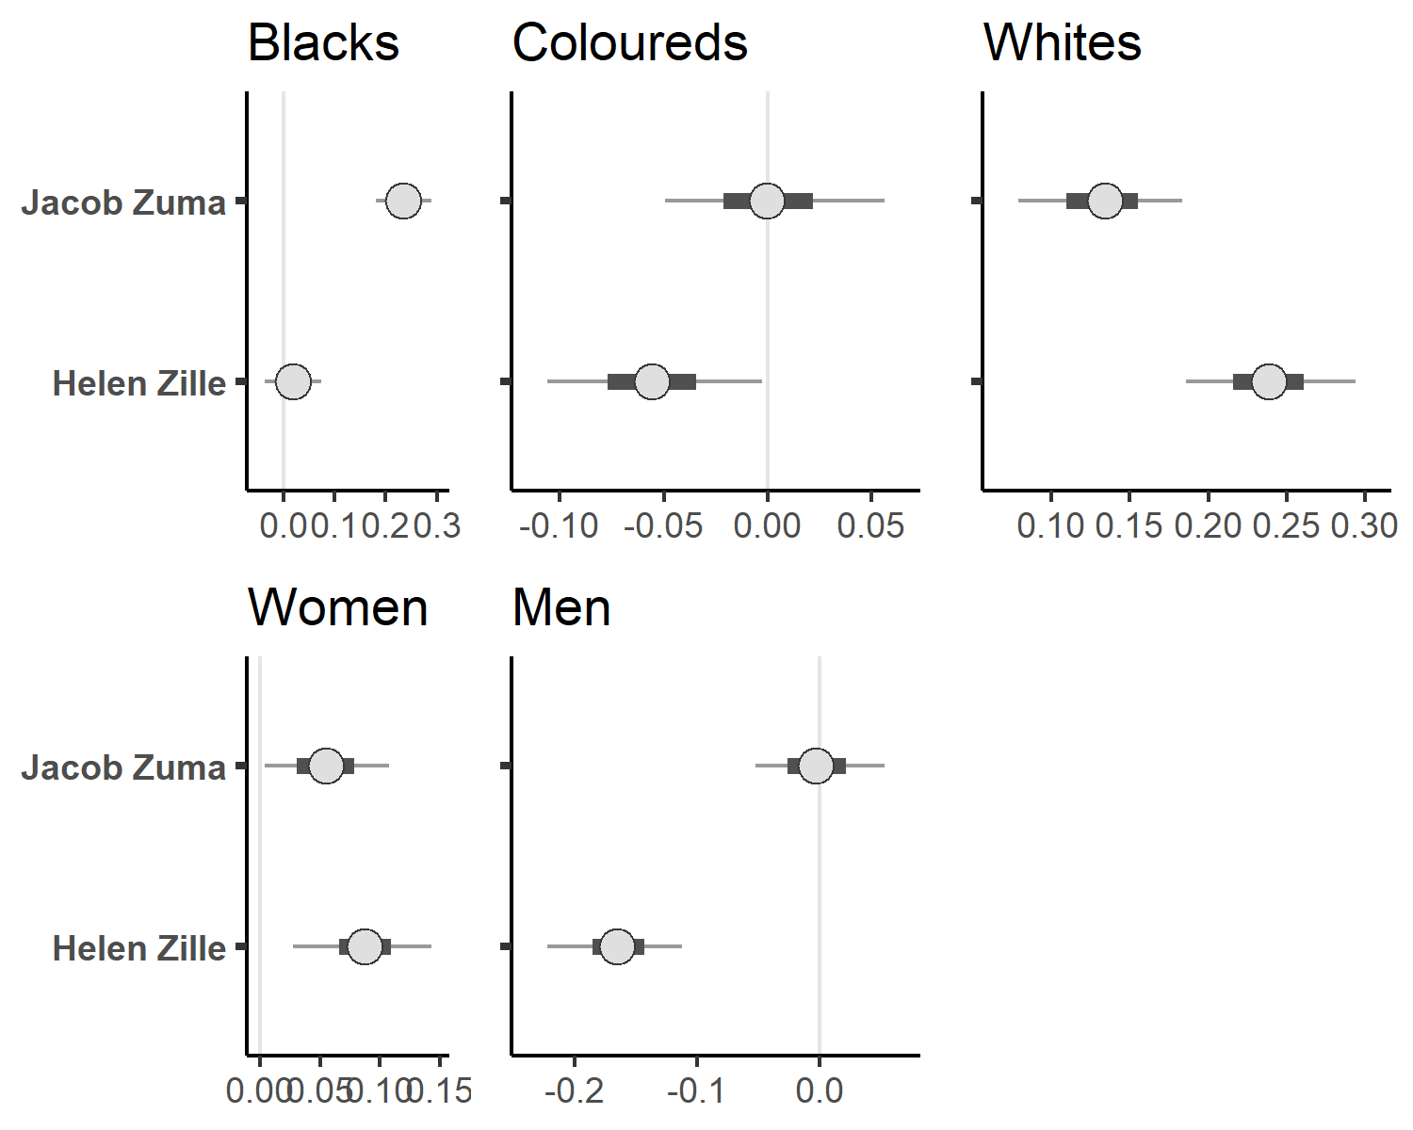
Figure A1: Expectation whom three well-known politicians in South Africa should represent. Wording: ‘Whom should [this politician] represent?’. The politicians are given on the left (Ebrahim Rasool as reference category). Separate models for the groups offered as answer categories, because respondents could indicate multiple groups. The top-left panel shows the expectations to what extent Jacob Zuma and Helen Zille are expected to represent Blacks. Respondent-level control variables included in the models: age group, gender, race/population group, province, level of education, size of settlement, relative income, preferred party, interest in politics, frequency of voting.
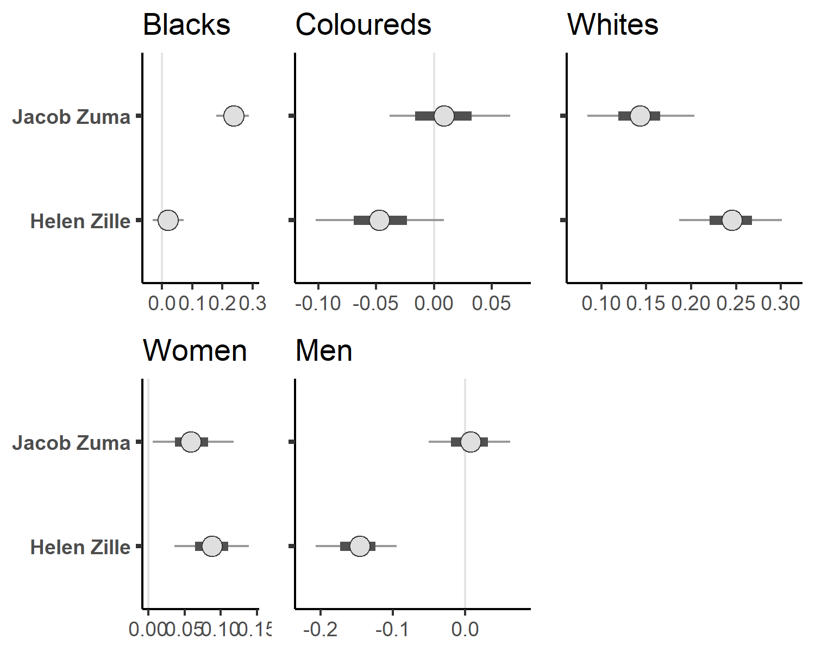
Figure A2: Expectation whom three well-known politicians in South Africa should represent. Wording: ‘Whom should [this politician] represent?’. The politicians are given on the left (Ebrahim Rasool as reference category). Separate models for the groups offered as answer categories. The top-left panel shows the expectations to what extent Jacob Zuma and Helen Zille are expected to represent Blacks. No additional variables in the models.

In this model, respondent race/population group (top row) and gender (bottom row) were interacted with the expectation that politicians represent ‘their’ group. Otherwise, this model corresponds to Figure A2.
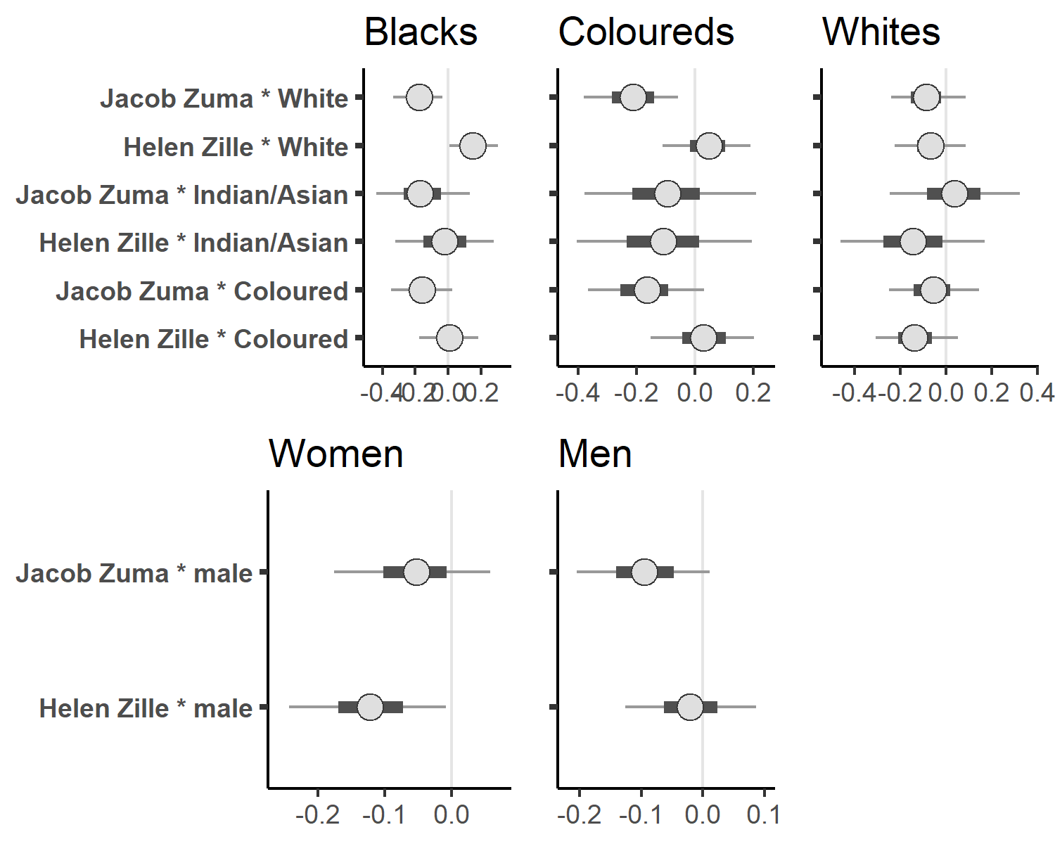
Figure A3: Expectation whom three well-known politicians in South Africa should represent, with interaction effects for race/population group (top row) and gender (bottom row). Separate models for the groups offered as answer categories. No additional variables in the models.

Cross tables: Best represents
Table A2 to Table A4 show the percentage of respondents who think that different actors best represent the interests of women, Blacks, and Whites. The responses are separated by gender and race/population group.
Table A2: Percentage of respondents who think that the interests of women is best represented by different political actors, by gender of the respondent. Wording: ‘Who best represents the interests of these groups?’.
Gender | Who best represents women | %
female | ANC | 24
female | DA | 28
female | EFF | 4
female | civil society | 44
male | ANC | 37
male | DA | 22
male | EFF | 4
male | civil society | 37

Table A3: Percentage of respondents who think that the interests of Blacks is best represented by different political actors, by race/population group of the respondent. Wording: ‘Who best represents the interests of these groups?’.
Race/population group | Who best represents Blacks | %
Black African | ANC | 40
Black African | DA | 11
Black African | EFF | 39
Black African | civil society | 10
Coloured | ANC | 56
Coloured | DA | 13
Coloured | EFF | 20
Coloured | civil society | 11
Indian or Asian | ANC | 41
Indian or Asian | DA | 18
Indian or Asian | EFF | 25
Indian or Asian | civil society | 16
White | ANC | 38
White | DA | 32
White | EFF | 23
White | civil society | 8

Table A4: Percentage of respondents who think that the interests of Whites is best represented by different political actors, by race/population group of the respondent. Wording: ‘Who best represents the interests of these groups?’.
Race/population group | Who best represents Whites | %
Black African | ANC | 9
Black African | DA | 79
Black African | EFF | 4
Black African | civil society | 8
Coloured | ANC | 2
Coloured | DA | 74
Coloured | EFF | 1
Coloured | civil society | 24
Indian or Asian | ANC | 2
Indian or Asian | DA | 80
Indian or Asian | EFF | 2
Indian or Asian | civil society | 16
White | ANC | 1
White | DA | 71
White | EFF | 1
White | civil society | 28

Cross tables: Trusting politicians
There are two tables for the men because the experiment was run as separate streams to avoid participants seeing the same picture with different manipulations.
Table A5: Trust in a Black female politician, by race/population group of the respondent.
Race/population group of the respondent | Trust
Black African | 1.9
Coloured | 1.4
Indian or Asian | 2.0
White | 1.6

Table A6: Trust in a White female politician, by race/population group of the respondent.
Race/population group of the respondent | Trust
Black African | 1.9
Coloured | 1.9
Indian or Asian | 1.5
White | 1.4

Table A7: Trust in a Black male politician, by race/population group of the respondent (experiment 1).
Race/population group of the respondent | Trust
Black African | 1.7
Coloured | 1.4
Indian or Asian | 1.8
White | 1.9

Table A8: Trust in a Black male politician, by race/population group of the respondent (experiment 2).
Race/population group of the respondent | Trust
Black African | 1.8
Coloured | 1.6
Indian or Asian | 1.2
White | 1.3

Table A9: Trust in a White male politician, by race/population group of the respondent (experiment 1).
Race/population group of the respondent | Trust
Black African | 1.7
Coloured | 1.7
Indian or Asian | 2.2
White | 1.4

Table A10: Trust in a White male politician, by race/population group of the respondent (experiment 2).
Race/population group of the respondent | Trust
Black African | 1.7
Coloured | 1.7
Indian or Asian | 1.8
White | 1.4

Regression models: Trusting politicians
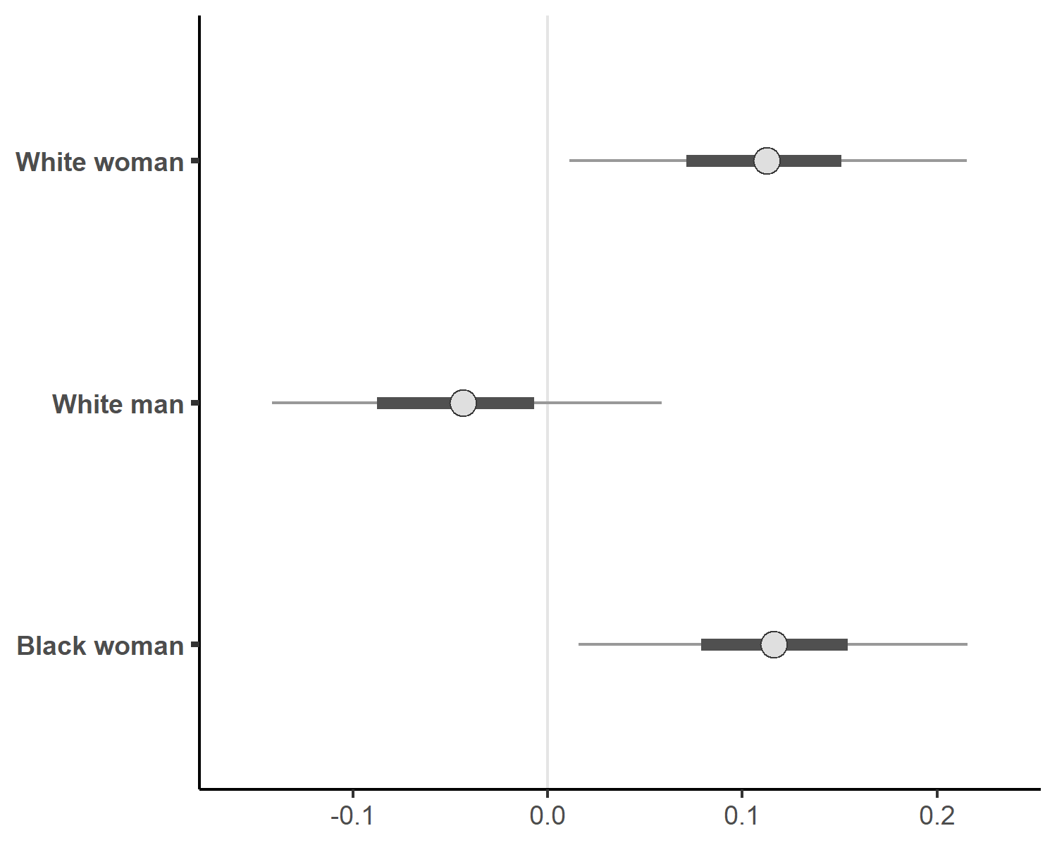
Figure A4: Trust politician, plain model

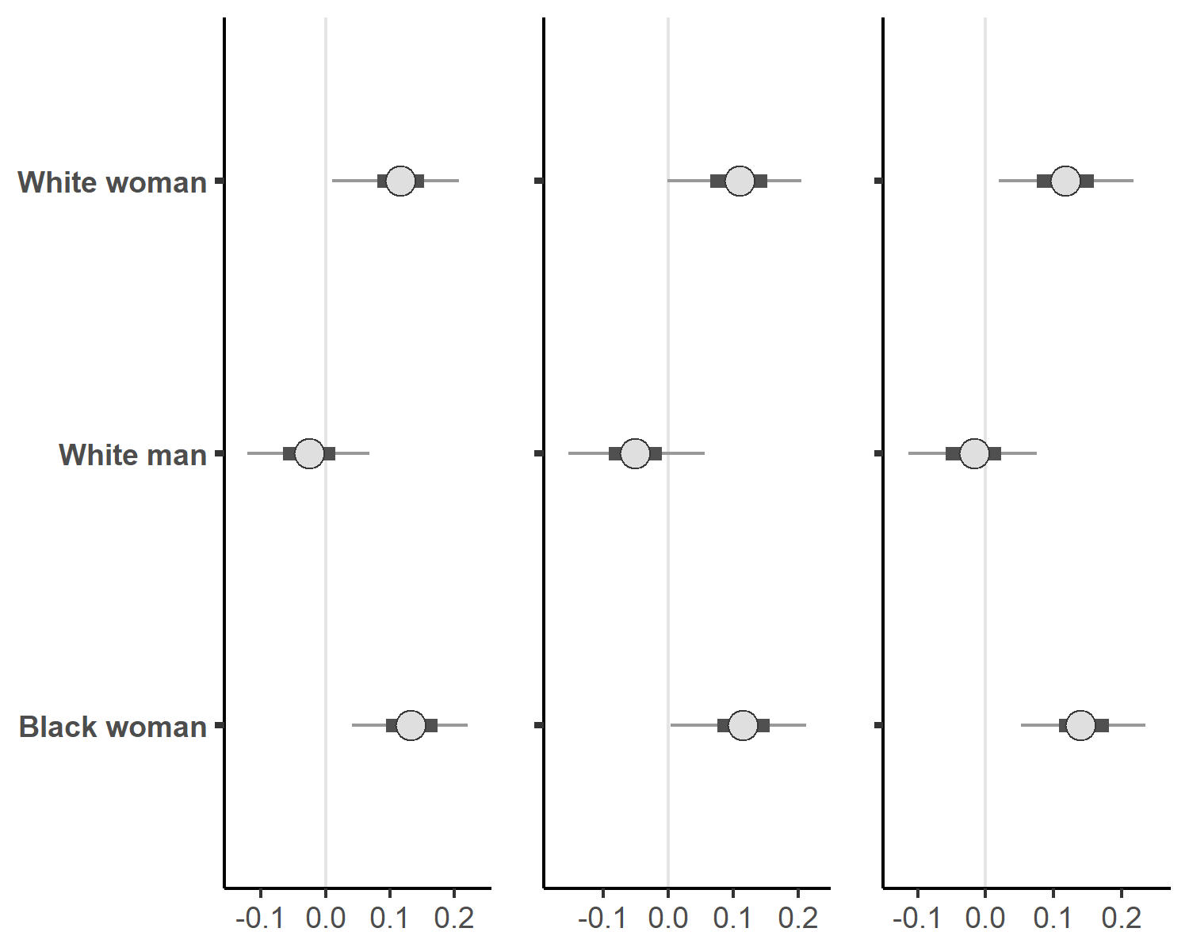
Figure A5: Trust politician, models with respondent-level control variables. Left panel: age group, gender, race/population group, province, level of education, size of settlement, relative income, preferred party, interest in politics, frequency of voting. Middle panel: generic trust question (Wording: ‘Are you generally a person who is fully prepared to take risks in trusting strangers or do you try to avoid taking such risks?’). Right panel: feeling represented by political parties (Wording: ‘Do you feel represented by political parties?’.)
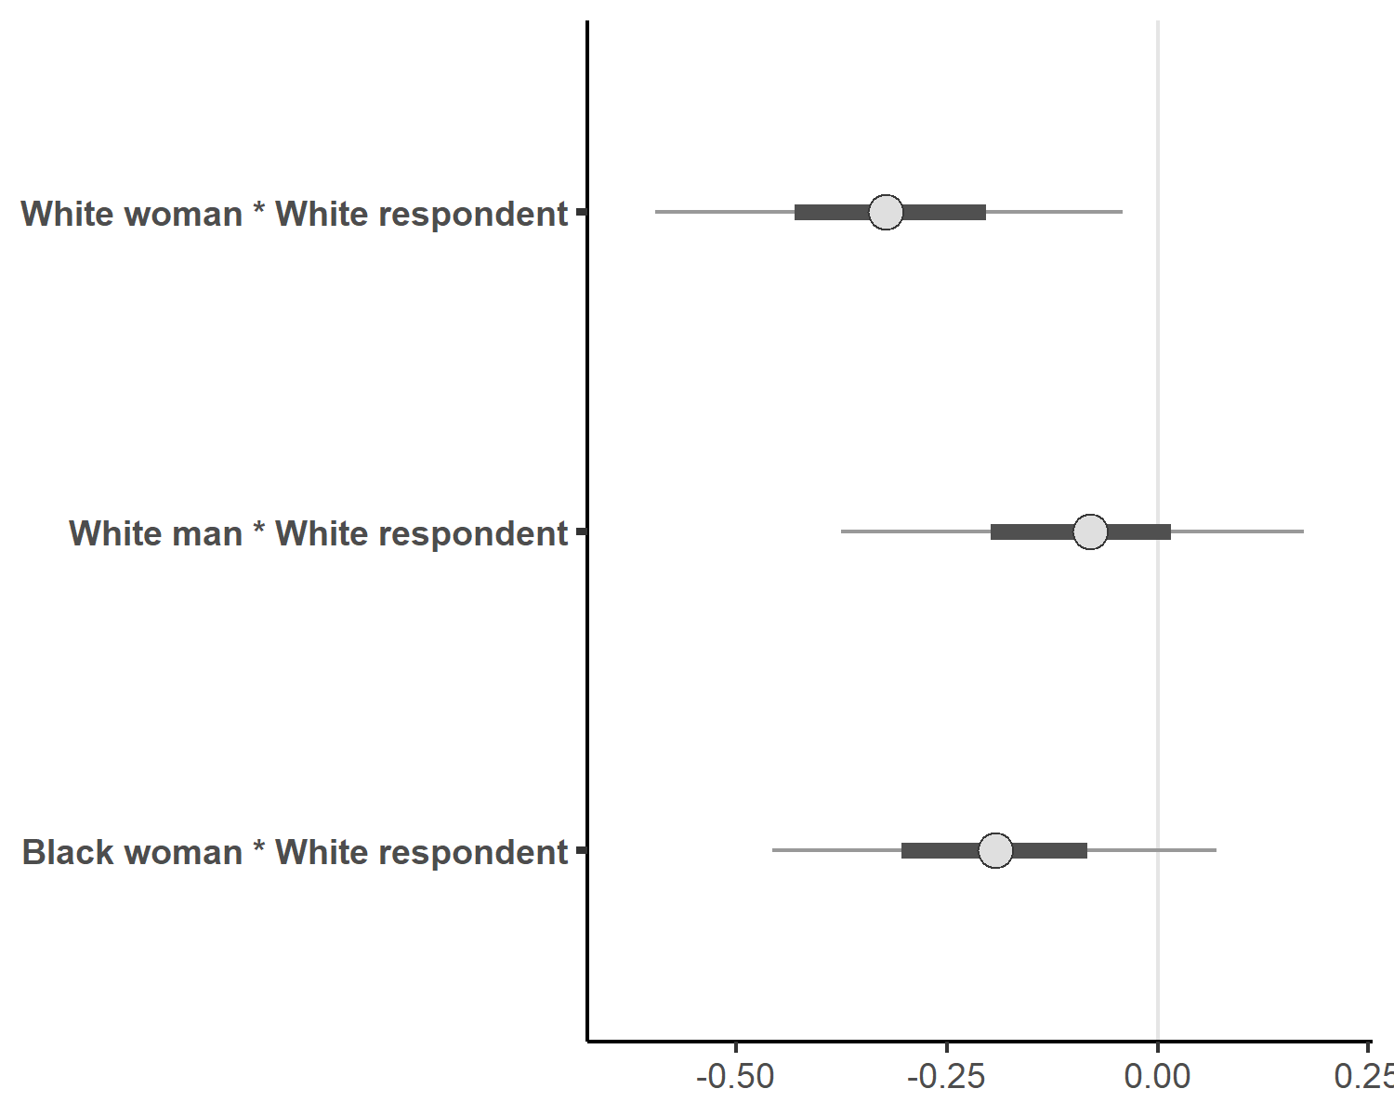
Figure A6: Trust politician, interaction with race/population group of the respondent

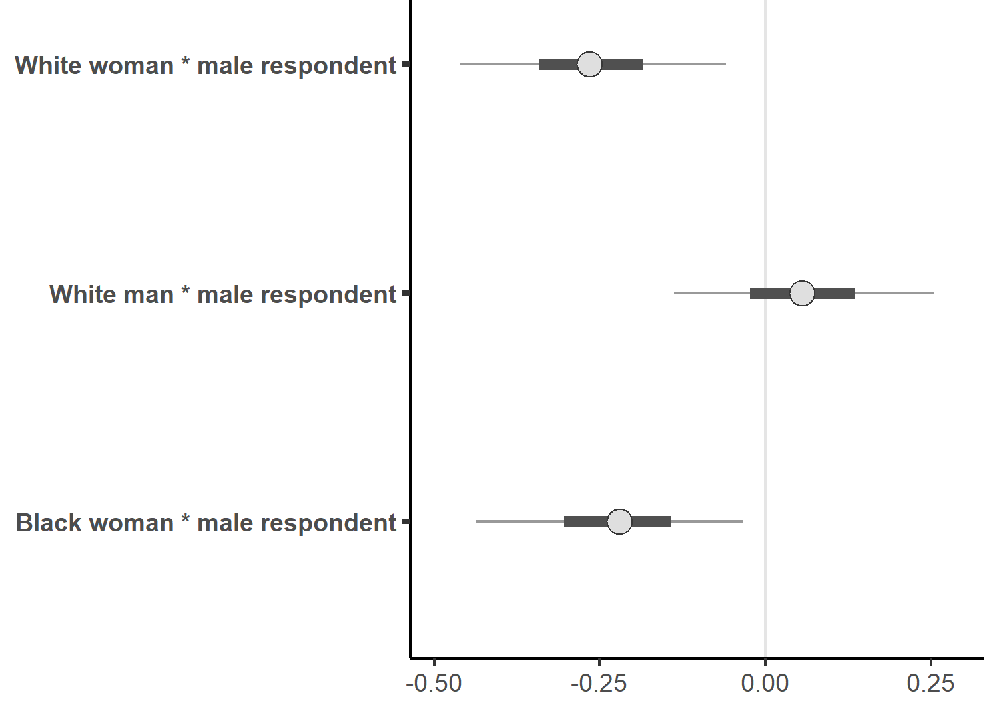
Figure A7: Trust politician, interaction with gender of the respondent

Appendix 3: Ethics
In line with the suggestions by Salganik (2017), we provide an ethical appendix. Ethical questions arise from the survey experiment, where participants are not made aware of the experiment. Participants were remunerated through the survey companies Qualtrics partnered with, and to the participants the experience was the same as if no survey experiment took place. The images of the representatives were manipulated to appear either ‘Black’ or ‘White’, and we carefully pre-tested these stimuli to ensure that they are plausible: the idea of manipulating skin colour is to many disturbing, and we wanted to prevent disturbing the participants. For this reason, the survey experiment was run in two streams, which ensured that none of the participants saw both manipulations of the same picture.
For the interviews, we have followed the institutional procedure (ethics checklist: SFM-2016-08-26). Because we interviewed politicians, we no longer deemed political issues inherently sensitive topics, as they could be in other contexts. All participants gave their informed consent. Discussing ‘race’ and ethnicity in South Africa did not strike us as problematic. In South Africa, these divisions remain highly salient. None of the participants in the survey has used the option to describe their population group as anything other than the official population groups on offer, suggesting that identifying ‘race’ in South Africa remains unproblematic. We chose a regional government to ensure access, and also to help us anonymize participants to protect them and provide as much privacy as we can — even though we did not ask particularly sensitive questions. We anonymized the transcripts in several rounds and have modified small details to not only hide the identity of the participants, but also to provide them with credible deniability should they wish to.

