CHAPTER ONE
BACKGROUND AND ORIENTATION

1.1 INTRODUCTION

Global events such as 11 September 2001 have changed the nature of threats in most countries when issuing a visa or permit. Diseases prevalent in other countries that can be transmitted rapidly worldwide, incidents of terrorism, and organised crime around the world have shown the importance of identifying individuals who present a risk and preventing their entry into any country. The risk or threat that should be assessed during the visa application process varies from one country to another. It is a highly complex process to identify visa applicants that are inadmissible or not permitted to the country. This mainly relies on the judgment and the experience of a Visa or Consular Officer in an Embassy or Mission abroad, and also on the available information or data. It is thus apparent that Consular Officers become more cautious in making the best decision with the information available at that time (Report of Auditor General of Canada, 2011, p.3).

The South African immigration policy or the regulation of population flows is not new. During the apartheid era, these laws included restrictions on internal movement (such as population registration, pass laws, 'independent' Bantustans) that were harsher than many other states' policies regulating cross-border migration. The new South African government has already eliminated the most outrageous of these internal policies, but has retained much of the legislative legacy for dealing with external migration. One significant change was the 1990 reduction of the voltage on South Africa's electrical fence on the border of Mozambique from a lethal to stun level (Muanamoha et al, 2010, no page).

The RSA Immigration Act (Act No. 13 of 2002) clearly stipulates that “there is no 'right' for a non-South African to be given a permit or visa to come to South Africa, or to live and work here”. It is always a permission which may be granted or refused. People who apply for the permission have the right to administrative justice. This means they have the right to be given reasons, in writing, why permission was not given” (Immigration Act, 2002). Section 11 to 23 of the Immigration Act stipulates that different kinds of temporary permits can be applied for such as: Visitor's permit or Tourist visa, Diplomatic permit, Study permit, Medical treatment permit, Work permit, etc. (RSA Immigration Act No.13, 2002).

1.2 BACKGROUND

The Southern African Development Community (SADC) region initiated a 1995 Draft Protocol on the free movement of persons within the region, which was seen to be more ambitious than simply trying to foster regional integration in Southern Africa. Such regional initiatives were rather taken as a first step towards building an African Economic Community (AEC) by the year 2000. These initiatives were to result in a free movement of people throughout the continent. This free movement of people and regional integration as it is connected was taken as the first steps in realising Kwame Nkhruma's vision of a 'United States of Africa', by the compilers of the Protocol (Solomon, 1997, p.2).

Solomon, 1997, argues that one of the objectives of the Protocol was to see the visa-free entry of SADC nationals into member states for short visits not exceeding six months. However the 1995 Protocol could not be realised due to wide wage-gap and economic imbalances within SADC countries. These were seen by other countries i.e. South Africa, Botswana and Namibia, as placing an additional burden on the socio economic infrastructure (Solomon, 1997, p.2). This was not a strange decision because if this 1995 Protocol was to be compared with a case of the North American Free Trade Association (NAFTA), which is between Canada, the United States (US) and Mexico, there is no free movement of people within those countries. Rather, the signing of NAFTA saw US strengthening its border controls with Mexico, as well as the promulgation of new anti-illegal immigration legislation. Another example is that of 1991 MERCOSUR (Common Market of the South) an economic and political agreement between Brazil, Argentina, Paraguay and Uruguay, where again there are no specific provisions related to the free movement of persons (Solomon, 1997, p.4).

The 1995 Protocol was retracted due to the identified weaknesses and later replaced by the 1997 Draft Protocol on the Facilitation of Movement of Persons in the SADC region. The 1997 Protocol has a practical and realistic tone pertaining to the free movement of people throughout, where the visa-free entry of SADC nationals into member states is only for short visits i.e. a period not exceeding thirty days, as opposed to the 1995 Protocol of six months. In addition, Article 13 states that such a person must meet the requirements for entry into that member state, which include proof of financial support during the period of stay (Solomon, 1997, p.4).

The 1997 Protocol is more modest in its aims. This is evinced by its very title: the 'facilitation of movement of persons', as opposed to the 1995 Protocol's 'free movement of persons'. More specifically, Chapter Two, Article 2 of the 1997 Protocol lists the objectives as follows:

- To facilitate the movement of citizens of member states within the region by gradually eliminating obstacles which impede such movement;
- To expand the network of bilateral agreements among member states in this regard, as a step towards a multilateral regional agreement;
- To co-operate in preventing the illegal movement of citizens of member states and the illegal movement of nationals of third states within and into the region;
- To co-operate in improving control over external borders of the SADC community; and
- To promote common policies with regard to immigration matters where necessary and feasible (Solomon, 1997, p.3).

Williams, 2006, states that the Facilitation Protocol was accepted and approved in principle at the SADC Summit of August 1997. During the September 1998 summit all discussions related to the Facilitation Protocol were put on hold indefinitely on the basis that the provisions of the Facilitation Protocol, and particularly those related to 'establishment' went beyond the mandate that was given to its drafters. In July 2005, the Ministerial Committee of the Organ met in South Africa where they considered and approved the ‘Draft Protocol on the Facilitation of Movement of Persons’. The Draft Protocol was subsequently tabled at the SADC Summit that was held in August 2005 where it was approved and signed by six member states, South Africa being one of them (Williams, 2006, p.7).

In order for the Protocol to be effective, at least nine member states must have both signed and ratified it; a process which may yet take some time. Once the protocol has been ratified by nine member states, time-frames for its implementation will be developed (Williams, 2006, p.8).

It therefore implies that currently there is no free movement for the SADC nationals. After thirty days of stay, a visa or permit is required and the purpose of stay should be stated and it should also be approved by the hosting country. According to the speech of Minister of Home Affairs, Dr M G Buthelezi, 15 February 1996 during a parliamentary briefing week, he declared that:

“A computerised visa system has been developed and complemented at Head Office and a number of South African Missions abroad have an extremely controlled mechanism. This system will, to a great extent, eliminate the forging of visas and therefore prevent foreigners from obtaining visas unlawfully to enter the Republic. The Department is confident that the influx of illegal immigrants poses a threat to the Reconstruction and Development Programme and the prosperity of the South African citizens. Influx of illegal immigrants can be stemmed, only if all the central and regional governments, as well as all political parties, are willing to support the Department with the application of strict control measures and intensified law enforcement actions”.

Therefore without proper border control, crime will continue to increase in South Africa. As SADC moves towards a free trade area, this presents the region with a number of challenges. The consequences of weak or poor controls at borders and ports of entry include the proliferation of firearms and drugs, increased criminal activity by organised crime and international syndicates, the entry of smuggled goods and contraband, fraud through non-payment of customs and excise duties, round-tripping of vehicles and other manufactured goods, and many more (Minaar, 2001, p.4).

Solomon ,1997, Minaar,2001 and the speech by the then Home Affairs Minister, Dr Buthelezi, 1996, all concur that the influx of immigrants has a negative impact towards the socio-economic development of the country which eventually affects national security as a whole. They also agree that there should be stricter control measures during visa issuance process and at the borders and ports of entry..

Stricter control of cross border movement of people is necessary in order to limit the criminal activities by organised crime and international syndicates and the entry of illegal goods. These criminal activities have a negative impact towards the South African socio-economy, which is a serious threat to national security. The emphasis should be put more where the visas are being issued, as this is the frontline of defence towards the country’s national security.

The interconnection between migration, border management and internal and external aspects of security is clearly seen in the Migration Strategy Paper. Countries are concerned with both internal and external security issues that might arise as a result of migration. It is therefore imperative for countries to make border management a policy priority. Effective border management should facilitate legal migration while reducing illegal migration, trafficking and smuggling. Elements of such a policy include upgrading the capacities of border officials, physical infrastructure and enhancing communication and cooperation between original, transit and destination countries (African Union Migration Policy Framework, 2006, p.41).

In as far as the visa processing is concerned, the policies that shape it, the procedures that regulate it, the data systems that support it, and the training and diligence of the officials that make visa decisions, are all part of the country’s first line of defence against fraudulent or unlawful entry into a state. Each and every country has its sovereign right to decide as to who may or may not come in to its territory. With that in mind, a person holding a visa does not guarantee admission but only authorises the holder to proceed to an immigration officer at a port of entry for examination purposes in order to comply with the entry requirements. The Immigration Officer at the border post has to make the final decision about admission (Yale-Loehr et al, 2005, p.115).

According to Yale-Loehr et al, 2005, the purpose of a visa application is to ensure that proper screening of applicants is conducted so that undesirable persons are not admitted to the country and on the other hand to facilitate the entry of approved applicants at ports of entry. Visas provide immigration officers with the necessary information to ensure that applicants are admitted for the correct purpose and period into the RSA (Yale-Loehr et al, 2005, p.115).

According to the Principal Secretary in the Ministry of Home Affairs in Swaziland, Anthony Masilela, in 2013, he declared that:

“Travel documents were seized from different border gates around the country and the owners have since been blacklisted. He said travel documents’ owners work in South Africa without working visa or permit. After the 30 days have elapsed, they give their travel documents to kombi drivers who operate between Swaziland and South Africa, who in turn give them to immigration officials for renewal” (Times of Swaziland, 2013, p.3).

These are some of the cases where some travellers use fraudulently obtained visas to conduct illegal activities inside the country. Some people choose to work in South Africa without a valid working permit and they take an advantage of being closer to the border gates by returning home before 30 days expiry i.e. every month end. Some will go to an extent of bribing the immigration officials at the borders so that they can stamp their passport in absentia using kombi drivers as their agents, as stated above (Times of Swaziland, 2013).

This places a huge burden on the socio-economic factors and it sends a clear message to the state that visa application processes must be efficient, effective and also robust in ensuring that those who pose a security risk do not enter the country. Again the visa application process is supposed to give a balance between facilitating lawful travel and identifies those entries that might be detrimental to South African national security.

This research report is going to provide detailed information regarding the visa application process at the South African High Commission in Swaziland in the context of national security.

In in Chapter One: the Introduction, the significance of the research and research methodology used to compile and analyse the findings will be presented.

In Chapter two: the literature reviews will be presented where definitions of some terms will be given, the RSA Immigration laws will be discussed, the history of Southern African migration will also be looked at and finally the implications of migrants in South Africa will be discussed.

In Chapter three: will present historical background of Swaziland and visa application process.

In Chapter four: will present the Research Findings and analysis of the results that were collected during the survey that was conducted with visa / permits applicants and the staff members at the South African High Commission (SAHC) in Swaziland.

In Chapter five: Conclusion and Recommendations for improving the service at the Mission thus minimising the security challenges that are experienced by both applicants and staff members. In summary chapter outline of the study is as follows:

Chapter 1: Introduction and background information

Chapter 2: Literature review
Chapter 3: Historical background of Swaziland and visa application process

Chapter 4: Research Findings and Analysis

Chapter 5: Conclusion and recommendations

The following sections are going to give details on the significance of the research and the research methodology that was employed in collecting and analysing data.

SIGNIFICANCE OF THE STUDY

For many years South Africa has been known to be a popular destination for holiday makers, students, work seekers and business owners, investors and retirees. Due to its sound legal and democratic structures and its healthy economy, it is regarded as one of the main destinations for immigrants from the entire African continent. However, to obtain a relevant visa can be a very challenging process as the applicable laws, regulations and procedures appear to be very complex to most applicants. This can cause many setbacks and thus resulting in huge delays which may jeopardise the application (Willand, 2005, p.2).

A lot of researches have been conducted on the South African immigration system that mainly focus on illegal immigration, porous border control between South Africa and its neighbours, Swazis migration to South Africa and the effects of illegal immigration on South African economy. However, little focus has been made on the visa application process at RSA missions or embassies abroad.

According to the preamble of SA Immigration Act, (Act no. 13 of 2002), the Act was, among others, aimed at ensuring that security considerations are fully satisfied. In effect, this means that only people who do not pose a security risk are allowed to enter into the country. Despite the set objective of the legislation, the security considerations stated above have not been realised (SA Immigration Act no. 13 of 2002).

The section below will give details of the problem statement of the research study.

1.4 PROBLEM STATEMENT

In as far as the services at the South African High Commission (SAHC) are concerned; they are not easily accessible to all Swazis as the Mission is located in only one region (Hhoho region) in the country. This creates a challenge to visa applicants that are from other regions who have to come for more than once to the Mission. In terms of the White Paper on Transforming Public Service Delivery, RSA 1997, efforts must be made in ensuring that public services are easily accessible to all potential customers in an area. The inaccessibility leads to customers having to travel long distance at great cost in order to obtain South African services. Again this inaccessibility and delays in obtaining a visa might entice applicants to try and use illegal means of obtaining the visa. This therefore means that those travellers will not be subjected to screening and thus increase threats to national security.

Another difficulty is that the visa issuance process is perceived by most Swazis as very complicated, time consuming and very expensive when taking into consideration the country’s economy. This means that only applicants who are privileged to afford will come to apply for a visa or permit in the SAHC. Also the current technology being used at the Consular Section creates a great challenge during the screening of visa applicants as it is out-dated and does not provide access to critical systems that can enable visa officers or Consular staff to check and verify movement patterns of visa applicants and previous visa violations.

Furthermore, valuable resources in the visa issuance process are not always allocated efficiently. The issue of training and staffing at the visa section is a major problem. Currently there are only three staff members who facilitate the applications and there is no formal training but members are given on-the-job training. There is a space shortage for filing of completed visa applications and the Consular Section does not have a separate room for conducting interviews. Therefore, there is a need for transparency and consistency in terms of visa issuance process, the interpretation and appropriate application of South African Immigration laws.

Taking into consideration the problems that have been stated above, the problem that arises is: What are the implications of visa processes towards South Africa’s national security? This study will, therefore, examine the visa process in the context of national security at the South African High Commission in the Kingdom of Swaziland.

The following section will discuss the reason why it is crucial to conduct this research.
1.5 PURPOSE STATEMENT

The purpose of this research is to explore the visa application process in the context of national security. In order to achieve this, the research will try to:

Determine the South African visa system’s effectiveness and efficiency;

Identity inherent security challenges in the process; and

Provide recommendations that can assist in improving the process thus minimising security challenges.

The following section will present the research questions that guided this research.

1.6 RESEARCH QUESTIONS

To achieve the above-mentioned purpose, the following research questions were answered in the study:

How complicated is the visa application process?

What are the security challenges that are experienced in the visa processing?

How is the verification of supporting documents being conducted?

Which type of visa is mostly applied for at the Mission?

What are the most common reasons for rejections / declining of visa?

The following section will discuss the methodology that was used for gathering and analysing the research findings of this study.

1.7 RESEARCH METHODOLOGY

The purpose of this chapter is to describe the research design that was used in the study. The target population, sample and sampling method, data collection and analysis methods to ensure validity and reliability as well as ethical considerations involved, are explained.
The methodology used in this study will now be briefly explained and described.

1.7.1 Qualitative method

A qualitative research design, using both secondary and primary sources such as a literature review, semi-structured interviews and questionnaires, was used to conduct this research. A literature study on the functioning of modern consular services was done using both primary and secondary literature. The literature included books, newspapers, government reports and related journals that are available in the institutions’ library.

Malterud, 2001, defines qualitative research as a naturalistic inquiry, developed within the social and human sciences, and refers to theories on interpretation (hermeneutics) and human experience (phenomenology). They include various strategies for systematic collection, organization and interpretation of textual material obtained while talking with people or through observation. The aim of such research is to investigate the meaning of social phenomena as experienced by the people themselves (Malterud, 2001, p.398).

By definition qualitative research is a form of social inquiry that focuses on the way people interpret and make sense of their experiences and the world in which they live. A number of different approaches exist within the wider framework of this type of research, but most of these have the same aim: to understand the social reality of individuals, groups and cultures. Researchers use qualitative approaches to explore the behaviour, perspectives and experiences of the people they study. The basis of qualitative research lies in the interpretive approach to social reality (Holloway, 1997, p.2).

As indicated above, qualitative method was used to gather data for this study. This inter alia include: (i) observations by the researcher; (ii) semi-structured interviews; (iii) available data and statistics regarding access to South African consular services in Swaziland and (iv) the scientific analysis and interpretation of results with the help Microsoft excel.

The aim of the study was to explore the visa application process in the context of national security. As noted above, the study focused on the South African High Commission in Swaziland. In this regard, semi-structured interviews were conducted with the following respondents,

Members of the top management of the South African High Commission in Swaziland;

Chief Director: Consular Services at the Department of International Relations and Cooperation;

Chief Director: Foreign Office Coordination at the Department of Home Affairs;

Sample of 50 customers of the South African High Commission; and

Local staff members from SA High Commission, Visa or Consular Section.

Semi-structured interviews normally entail a sample of between six and twenty participants according to which questions are asked using a questionnaire with a selected list of questions (Davies, 2007, p.29). According to Davies, 2007, semi-structured interviewing,is best used when a person will not get more than one chance to interview someone and when one will be sending several interviewers out into the field to collect data. They provide a clear set of instructions for interviewers and can provide reliable, comparable qualitative data. They are often preceded by observation, informal and unstructured interviewing in order to allow the researchers to develop a meaningful semi-structured questions (Davies, 2007, p.29).

1.8 RESEARCH INSTRUMENT

1.8.1 Justification of the survey

The reason for selecting this survey method was that semi-structured questionnaires were a quick way of collecting data from a large group of people who did not have much time at the Mission, in this case visa applicants. The study was conducted whilst the researcher was studying part time, employed full time and had no budget to conduct the research; hence the semi-structured questionnaires were used through random sampling of applicants and purposeful sampling for staff members.

1.8.2 Reliability and validity

Efforts were made to ensure that verification of data complies with truth, value, applicability, consistency, objectivity, and furthermore, the information was presented in a scientific manner. The profile of the sample that was obtained from selected sample of visa applicants was representative and also reflective of Swaziland’s diversity.

1.9 DATA COLLECTION STRATEGY

Both primary and secondary data were collected and used for this research using different sources such as library books and the internet. Information that is not in the public domain that was collected through interviews with applicants and staff members at the mission was also used.

PRIMARY | SECONDARY | LITERATURE
Raw data was collected from the surveys, questionnaires, interviewing and processed data from the archives documentation.  The type of questions were specific to the category of the interviewee. Current Acts, Legislations, policy documents. | This was achieved by focusing on any processed data from media, intra/internet, and any related published reports. | This included any related thesis, journals relevant to the research problem, media news data.  Catalogue of theses and dissertations held by South African Universities;  Emerald;  Google Scholar, and  Science Direct Academic Journals.

1.10 DATA ANALYSIS STRATEGY

This is where the researcher addressed each research question, the recording of the data and what statistical techniques was be used for each. When an adequate data had been collected from the visa applicants and staff members through interviews, it was then recorded. The quantitative data collected from the survey was condensed into numbers. The numbers were then manipulated and used as evidence and compared and analysed in order to see patterns or relationships. Quantitative data also gave the perspective of the applicant’s profile and their attitudes towards visa issuance process at the South African High Commission in Swaziland (Neuman, 2011).

The data that was condensed into numbers was entered into an Excel spread sheet, and charts were created in order to display the data for ease of comprehension. Qualitative data was analysed and compared and this assisted the researcher in clarifying a sequence of steps in the visa issuance process. It will also help in answering the questions that relate to the security challenges that are faced at the mission and to relate it to the issue of national security. The qualitative data was analysed by organising it into categories on the basis of themes, concepts or similar features. New concepts were developed, formulated conceptual definition and examined the relationships among concepts which were then linked to each other in terms of sequence a (Neuman, 2011).

Text was summarised by checking key themes, phrases or passages that were used in a more detailed analysis. The analysis process was guided by the original aim of the study. The data obtained from literature study, semi-structured interviews and structured questionnaires, was studied in order to reach a conclusion. An empirical analysis was also made to interpret the set research objectives. In as far as the whole study is concerned the procedure stated below was followed:

A literature study was undertaken to explore the visa application process and how it deals with challenges that may impact on a country’s national security. Furthermore, the statutory and the regulatory framework governing the issuing of visas in South Africa was outlined; and

Structured questionnaires were used to obtain the viewpoints of the South African High Commission’s visa applicants on the challenges that they face in acquiring SA visas in Swaziland; and the profile of the sample that was obtained from selected sample of visa applicants was in a way be a representative and reflect Swaziland’s diversity.

The challenges that were encountered when applying for visa were also used to analyse the effectiveness and the efficiency of the visa issuance process.

1.11 ETHICAL CONSIDERATIONS

The research that was conducted was strictly confidential and participation was voluntary. During the period of the research, the researcher was based at the South African High Commission in Swaziland as a transferred staff and had to ensure that the research was conducted in a professional manner. Ethical principles that were considered in this study are the principles of permission for the study, informed consent, and respect for human dignity, anonymity and confidentiality.

1.12 LIMITATIONS OF THE STUDY AND RESEARCH

The limitations of the study were that interviews were only conducted from the applicants and the staff members within Mission. As it was stated on the proposal, there was no previous data statistics obtained from the Consular Section for the previous five years. Due to limited time of conducting the survey, it was observed that most applicants during January and February were applying for study permits. There was less inflow of visitors’ visa applications during that time of the year, as people were just back from the holidays. The High Commissioner could not be interviewed because he had left the Mission for retirement and the Mission was still waiting for a replacement.

1.13 CONCLUSION

In this chapter, the background of the study, significance of the study, problem statement, purpose statement, research questions, research methodology, research instrument, data collection and analysis strategies, ethical considerations and limitations of the study were outlined.

In the next chapter, the literature review of the study will be outlined so that the basis for conducting the research can be clearly understood.

CHAPTER TWO
LITERATURE REVIEW

2.1 INTRODUCTION

In the first chapter, the background of the study was, among others, outlined. In this chapter, the literature review will be outlined in order to understand the body of work on the theoretical background of the study. The following points will be dealt with in the literature review:

- Definitions of terms
- Overview of South African Immigration Laws
- History of migration in Southern Africa
- Implications of migrants in South Africa

According to Brink, 2006, literature review is a process that involves researching, reading, understanding and forming conclusions about published works and literature on a particular topic. The multiple purposes of the literature review for any thesis or dissertation are as follows:

It provides a historical background for one’s research;

It gives an overview of the current context in which one’s research is situated by referring to contemporary debates, issues and questions in the field;

It includes a discussion of relevant theories and concepts which underpin one’s research; and

It introduces relevant terminology and provides definitions to clarify how terms are being used in the context of one’s own work (Brink, 2006, p.69).

The literature search for this study included relevant national policy documents relating to immigration laws, history of Swazi migration to South Africa and the visa application process. Documents, textbooks, journal articles and internet information were researched. Librarians at Wits Business School library, Parktown campus, assisted the researcher in identifying relevant literature.

2.2 DEFINITIONS OF TERMS

2.2.1 Visa / Permit

According to the RSA Immigration Act of 2011, visa means the authority to temporarily sojourn in the Republic for the purposes of:

(a) Transit through the Republic as contemplated in section I or; 25

(b) A visit as contemplated in section 1 L

(c) Study as contemplated in section 13;

(d) Conducting activities in the Republic in terms of an international agreement to which the Republic is a party as contemplated in section 14; 30

(e) Establishing or investing in a business as contemplated in section 15:
(f) Working as a crew member of a conveyance in the Republic as contemplated in section 16:

(g) Obtaining medical treatment as contemplated in section 17: 35

(h) Staying with a relative as contemplated in section 18;

(i) Working as contemplated in section 19 or 21;

(J) Retirement as contemplated in section 20;

(k) An exchange programme as contemplated in section 22; or

(J) applying for asylum as contemplated in section 23, 40, whichever is applicable in the circumstances;" (RSA Immigration Amendment Act No. 13 of 2011, p.6.).

2.2.2 National Security

According to Koetje 1999, national security is defined as an interactive and integrative system consisting of the individual as the irreducible basic unit, who is connected both to the state and the international political system by way of civil society (Koetje, 1999, p.2). In 1996 the former Minister of Defence, Joe Modise argued that:

“In the new South Africa national security is no longer viewed as a predominantly military and police problem. It has been broadened to incorporate political, economic, social and environmental matters. At the heart of this new approach is a paramount concern with the security of people. Security is an all- encompassing condition in which the individual citizens live in freedom, peace and safety; participate fully in the process of governance; enjoy the protection of fundamental rights; have access to resources and the basic necessities of life; and inhabit an environment which is not detrimental to their health and well-being”

Security is defined in broad terms, in line with current international thinking. In a document entitled ‘Ready to govern: ANC policy guidelines for a democratic South Africa’, adopted at its national conference in 1992, the ANC identified lack of security in terms of underdevelopment, poverty, and an absence of democratic values as promoting conflict within and between states. Therefore, ‘national and regional security should not be restricted to military, police and intelligence matters, but as having political, economic, social and environmental dimensions’ (Hough and Du Plessis, 2000, p.16–17).

According to the new Democratic South Africa, security is defined as “an all-encompassing condition in which all South Africans live in freedom, peace and safety, participate fully in the process of democratic governance, enjoy the protection of fundamental rights, have access to resources and the basic necessities of life, and inhabit an environment which is not detrimental to their health and well-being” (Defence Update, 2007, p.16).

External national security is based on advancing the principles of collective security, non-aggression, and the peaceful settlement of disputes, while some of the transnational threats identified are the proliferation of weapons of mass destruction, international terrorism and extremism, organised crime and narcotics trafficking, and issues related to environmental degradation. The defence white paper of 1996 implies the recognition or perception of a number of threats that are related to the economic, political, and societal dimensions of a broad definition of security:

The spread of disease;

The burden of refugees;

Civil war in some SADC member countries;

Regional instability; and

Chronic under development.

The above threats could result in inter-state disputes, tensions, and conflict in the region, with the possibility of extra-regional interference and intervention that might make it ‘necessary to deploy the SANDF in multi-national peace support operations’ (Hough and Du Plessis 2000, p.79–80).

2.2.3 Migrant

The United Nations (UN) defines “migrant” is a person living outside his or her country of birth for more than a year. It is estimated that the number of such people roughly doubled between 1985 and 2010 from 111 million to 214 million. The number of migrants in any society is not uniform across the globe as most migrants are found in industrial countries, because economic theory predicts that people tend to move from poorer places to richer ones (Bernstein, 2011, no page).

2.2.4 Migration

Migration is the process of moving, either across an international border or within a state. It encompasses any kind of movement of people, whatever its length, composition and causes; it includes migration of refugees, displaced persons, uprooted people and economic migrants (IOM Glossary on Migration, International Migration Law, 2004).

2.3 OVERVIEW OF SOUTH AFRICAN IMMIGRATION LAWS

According to the Vienna Convention, 1963, article 5 (d), the consular function is to issue passports and travel documents to nationals of the sending State, and visas or appropriate documents to persons wishing to travel to the sending State (Vienna Convention, 1963, p.4).

At the beginning of the 1990s, laws regulating immigration in RSA were basically inherited from the 1937 Aliens Control Act, a piece of legislation adopted in a context of widespread anti-Semitism aimed at the influx of refugees from Eastern Europe following the rise of Nazi Germany. It is through this Aliens Control Act of 1937 that the term ‘alien’ was first officially established in the legislation as an everyday language. Above all, the Act explicitly introduced, for the first time, the ‘racial’ criterion as a condition of entry into South African territory. Section 4(3) (b) of this act actually stated that all applicants should be “likely to become readily assimilated” with the European inhabitants of the Union and that they did not represent a threat to ‘European culture’ (Segatti & Landau, 2008, p.61).

This law was soon complemented by the Aliens Registration Act of 1939 that marked a decisive turn in the control of foreigners on South African territory. Until then, the legislation on immigration was essentially meant to work as a ‘racial filter’ on entry into South African territory. The Aliens Registration Act of 1939 stressed, for the first time, not only control on entry but also the monitoring of foreigners inside the territory of the Union (Segatti and Landau, 2008, p.61). The 1991 Aliens Control Act actually survived until 2002, with only incremental modifications despite mounting criticisms from the Non-Governmental Organisations (NGOs) and academic sectors as well as the business community (Segatti and Landau, 2008, p.58).

The Aliens Control Act was amended in 1995 (Act No. 76) and 1996 (Act No. 32). The rationale, according to the Deputy Minister of Home Affairs, was to "improve control over immigration". All applications for immigration and work permits had to be made from outside South Africa to prevent people from using visitor’s visas to look for work. Applicants also had to start paying large nonrefundable fees for applications for permanent residence and for temporary residence permits. In 1998 the Department of Home Affairs declared that "no one in the unskilled and semi-skilled categories would normally be accepted as an immigrant worker." Employers wishing to introduce skills, even on a temporary basis, have to justify why the positions cannot be filled by South African citizens or permanent residents (Peberdy, 2011, p.18).

In 1958 the National Party (NP) realised that the British Labour Party would not allow the incorporation of Botswana, Lesotho and Swaziland into South Africa as originally agreed between South African and British governments, and they declared that Africans from these three territories were prohibited immigrants from entering South Africa except for work in specified industries such as mining and agriculture through the Bantu Laws Amendment Act, 1963. The Aliens Control Ac, of 1963 made it an offence for any such citizens to enter South Africa without a travel document issued by his/her own country. This meant that he could no longer obtain South African travel documents, and employers entering into contracts with Africans from these three countries had to undertake their repatriation (Bỡhning, 2004, p.29).

In the 1980s, the supplier states for labour migrants to South Africa formed the Southern African Labour Commission (SALC) in an effort to form a common policy on labour migration to South Africa. The SALC was unsuccessful in its efforts to develop a policy of phased withdrawal, primarily because countries such as Lesotho and Mozambique were unable to dispense with contract labour migration (Crush et al, 2005, p.2).

Johnson, 2010, argues that for nearly a decade after the first democratic elections (which took place in April 1994), the African National Congress (ANC) government continued to operate under the Aliens Control Act of 1991, often called "Apartheid's last act," because it was designed in the interests of the old regime, and not in the interest of those with progressive aspirations like the ANC. Also, South Africa began to move in a more aggressive and enlightened manner on both domestic and regional immigration policies. In 2002 a new Immigration Act was passed that accepted South Africa's role in the "age of globalisation," placing greater emphasis on admitting skilled workers, while continuing to crack down on illegal entrants (immigration Act, 2002: 2-3). South Africa was still trying to keep certain classes of immigrants out of the country, but it did need to retain its own skilled labour force and attracted such workers from other countries. The 2004 amendment to the Act placed added emphasis on economic growth, and the need for "exceptionally skilled" foreign labour (Johnson, 2010, p.3).

The Immigration Act was signed into law by President Thabo Mbeki on 30 May 2002 as Act No 13 of 2002. The Act set out to “provide for the regulation of admission of persons to their residence in and their departure from the Republic; and for matters
connected therewith. The journey toward legislation aimed at regulating immigration took six years, beginning in 1996 and culminating with the Act in 2002 (Gutteridge, 2009, p.131). The Act set out a new system of immigration control which ensured: the terms for temporary and permanent residence permits; security considerations for the state; ensuring interdepartmental co-ordination on matters pertaining to immigration; globalisation impacts; border monitoring; administration of ports of entry; administrative capacity of enforcing the Act; South African economic requirements; non adverse conditions of SA labour; training of South Africans; addressing push factors encouraging immigration; an application of human rights and countering xenophobia (Gutteridge, 2009, p.132).

Immigration of both legal and illegal migrants from neighbouring less developed countries into South Africa has a long history especially in the mining and agriculture sectors, which had largely depended on migrant mine works for the labour. During and after the apartheid years migrant labour from Southern African states has always been a thorny issue. In the post-apartheid era there were long delays in developing a new progressive immigration policy in South Africa and this has been attributed to national politics, bureaucratic bungling and the real dilemma of formulating democratic, rights-based migration in such a highly xenophobic society (Muanamoha et al, 2010, p.1).

With the demise of apartheid, as the strongest economy on the continent, South Africa has now become a magnet for immigrants from all over Africa. According to former Home Affairs Minister Buthelezi, 1996, he stated that:

“On the immigration policy I would say that the Department’s functions regarding international migration relate to the control over the admission of aliens to their
residence in and departure from the Republic. The existing immigration policy is first and foremost directed towards the protection of the interest of the sovereign worker and creation of employment opportunities”
Home Affairs Minister Buthelezi, 1996).
The migration laws and policies of most SADC member states date back to the colonial era and are largely ‘protectionist’ and discourage the movement of persons across borders. This places immigration laws and policies at odds with the historical reality of cross-border migration and in fact encourages undocumented (illegal) movements (Williams, 2006, p.6). Again in most SADC member states, cross-border migration certainly creates a ‘dilemma of jurisdiction’ as it becomes a tug-of-war between the Ministry / Department of Home Affairs / Immigration and the Ministry / Department of Labour. In its extended form, it also involves Foreign Affairs and Social and Welfare Services. The question is: who decides on the number of people who should be allowed into a country and the purpose and conditions under which they will be allowed? Once they’ve been granted access, what social and welfare services are they entitled to? How does the movement of citizens from one country to another impact on the relationship between the governments of the host and source countries (Williams, 2006, p.6).

Most countries of the region tend to see in-migration more as a threat than an opportunity. Migrants are viewed as carriers of disease, takers of jobs and perpetrators of crime. Policy has tended to focus, as a result, on control and exclusion. Perhaps, unfortunately, this general mentality extends to legal immigration.

Few, if any, of the SADC states have pro-active immigration policies. Rights of permanent residence and settlement are extremely difficult to obtain in most countries. Until the 1990s, South Africa was the only country with a pro-active immigration policy (in that case to recruit white immigrants to boost the economy and
shore up white rule). After 1994, the policy tide turned against immigration and skills import (Crush et al, 2005, p.9).

2.4 HISTORY OF MIGRATION IN SOUTHERN AFRICA

According to Bond et al, 2010, labour migrancy in Southern Africa dates back to the 1850s, when large numbers of men migrated to work in sugar plantations in Natal (now known as KwaZulu-Natal), where British colonial capitalism was taking shape. At this juncture, the hunting and ivory trade of Southern Mozambique was in decline. The opening up of diamond mines in Kimberley in 1870 resulted in large numbers of workers from all over Southern Africa flocking to the new mines, which paid better than the plantations. As a result, labour was attracted away from the plantations in Natal. An estimated 50 - 80,000 migrant workers came to work on the diamond mines at Kimberley. Labour shortages were experienced following the opening of the diamond mines in Kimberley and the discovery of gold in the Eastern Transvaal in 1874 (Bond et al, 2010, p.9).

The discovery of diamonds in the Orange Free State in the 1860s and the subsequent discovery of gold on the Witwatersrand in 1886 gave rise to massive population movements in the nineteenth century in Southern Africa. The demands of the mining industry resulted in the creation of the migrant contract labour system which criss-crossed the whole of Southern Africa. Neighbouring states such as Lesotho, Mozambique, Swaziland, Zimbabwe and Botswana became labour reservoirs to feed the hungry demands of South African mining magnates for cheap, unskilled black labour. Increasingly, the economies of South Africa’s neighbours became dependent on the migrant contract labour system for foreign exchange (Solomon, 1996, p.6).

Bỡhning, 2004, argues that the history of labour migration in Southern Africa begins with the discovery of vast mineral wealth in South Africa, during the second half of the nineteenth century. The discovery of minerals wealth resulted in the growing need for labour supplies because of the rapid expanding economy. Thus lots of blacks migrated from various countries within southern Africa such as Botswana, Lesotho, Swaziland, Mozambique, Zimbabwe and Malawi into South Africa to work on the gold-mines and agriculture (Bỡhning, 2004).

Both Solomon 1996, and Bỡhning, 2004, agree that the migration of labour immigrants from most neighbouring states around South Africa was mainly as a result of discovery of gold in Witwatersrand, now known as Gauteng in the nineteenth century. The gold discovery resulted in a high demand of cheap, unskilled labour and Swazis with other Southern African countries such as Lesotho, Mozambique, Malawi soon started migrating to South Africa. Bỡhning, 2004, states that prior to the1960s, un-recruited Africans from Botswana, Lesotho and Swaziland seeking employment in South Africa either made their own way of obtaining the “necessary documentation” after they found employment or they will register with a district labour bureau in order to obtain a “pass” to seek employment. Again, employers who had recruited Africans from these countries were not legally bound to repatriate their recruits upon completion of their contracts (Bỡhning, 2004, p.29).
- Informal movement of people across borders also has a long history in Southern Africa. There are a number of well-documented reasons for this:
- Many colonial boundaries severed societies and cut communities in half. In many parts of the sub-continent, members of the same family or lineage live on opposite sides of the border. Cross-border social interaction continued unabated.
- International borders are long in the region and have never been well-policed.
- Before the 1960s, there were no border controls between many SADC states.
- Many migrants found it easy to move to other countries to find work.
- The regional mining industry was the only sector to establish a formal contract labour system. Other employers hiring migrants did not have access to this labour and often hired migrants outside the law, e.g. commercial agriculture and domestic service.
- Colonial regulations and the formal contract system for labour migrants were gender-biased. Female migrants could not migrate legally across borders for work. They therefore had to migrate illegally, which many did.
- Employers often preferred to hire non-locals because they were cheaper and more exploitable. Employers were rarely punished for this, so there were no incentives not to break the law. Instead enforcement has focused on identifying and deporting migrants (Crush et al, 2005, p.5).

It is said that the most significant receiver of migrants within the sub-continent is South Africa, which uses bilateral agreements to manage the temporary admission of migrant workers from neighboring countries for employment in the mining sector. According to one study, poverty would increase by about fifteen percent (15%) in Lesotho if migrant workers in South African mines were to stop sending remittances home (Africa Focus Bulletin, 2006, p.5).

The primary historical legacy of decades of migration to South Africa is a deeply entrenched dependence on migration amongst many communities and households outside South Africa, particularly in countries such as Lesotho and Mozambique. The other legacy is the legal and institutional framework erected to ensure that all migrants remained migrants and never settled in South Africa. Under South African immigration legislation, only whites could qualify as immigrants (a stipulation modified in the 1980s to meet the homelands policy). Blacks were consigned to the ranks of contract migrants, forced to return home at regular intervals, and once and for all when they were no longer useful as workers (SAMAT Policy Paper Series, 1998, p.9).

Entry to South Africa was on a temporary basis on fixed contract and governed by bilateral treaties between South Africa and the supplier states. All migrants were recruited by a single industry-financed monopoly, The Employment Bureau of Africa (TEBA), which operated an extensive network of recruiting offices in supplier states. At the end of a contract, migrants had to return home to renew. If they became diseased or disabled (a common occurrence), they were sent home. The mine migrant system was highly gendered since only male migrant were recruited and were prohibited from bringing spouses and other dependents with them to South Africa. Until 1963, there were no restrictions on the movement of migrants from Botswana, Lesotho and Swaziland. Thereafter, they were forced into irregular channels along with migrants from other countries such as Mozambique, Malawi and Zambia (Labour Market Review Report, 2007, p.2-3).

Since 1990 there has been a dramatic increase in legal cross-border movements within the Southern African region, from less than 500 000 in 1990 to 3.3 million in 1995 (Table 2.2). The bulk of this registered and legal cross-border traffic consists of people moving temporarily to South Africa for a range of non-work related reasons — mainly tourism, visiting relatives, shopping, medical attention and education. Only a very small portion of these entrants are in possession of work permits. However, some who enter do work illegally or engage in informal sector and other trading activity once inside South Africa (SAMAT Policy Paper Series, 1998, p.11).

Table 1: SADC visitors to South Africa, 1980-1995
Year | Botswana | Lesotho | Mozamboque. | Namibia | Swazi. | Zambia | Zimbabwe | Totals
1980 | 45,585 | 20,262 | 3,600 |  | 35,642 | 9,325 | 173,581 | 287,995
1981 | 33,698 | 17,315 | 5,888 |  | 25,928 | 12,343 | 149,758 | 244,930
1982 | 29,335 | 18,247 | 6,971 |  | 28,634 | 8,319 | 166,192 | 257,698
1983 | 35,967 | 19,201 | 6,844 |  | 36,872 | 8,835 | 174,274 | 281,993
1984 | 41,090 | 22,181 | 6,219 |  | 42,439 | 10,069 | 196,861 | 318,619
1985 | 40,669 | 19,740 | 8,082 |  | 40,665 | 9,627 | 181,836 | 300,619
1986 | 60,721 | 33,652 | 11,399 |  | 56,631 | 10,434 | 146,465 | 319,302
1987 | 61,670 | 38,933 | 12,847 |  | 61,558 | 10,092 | 153,910 | 339,010
1988 | 60,973 | 37,025 | 14,381 |  | 66,234 | 11,863 | 189,359 | 379,835
1989 | 61,670 | 36,450 | 17,568 | 2,757 | 72,568 | 14,943 | 210,664 | 416,620
1990 | 70,901 | 36,957 | 24,601 | 5,360 | 71,510 | 18,107 | 255,988 | 483,424
1991 | 135,002 | 243,710 | 35,507 | 140,527 | 182,792 | 20,193 | 362,082 | 1,119,813
1992 | 240,683 | 887,811 | 88,851 | 180,927 | 429,195 | 26,774 | 392,634 | 2,246,875
1993 | 294,338 | 1,037,630 | 121,488 | 163,772 | 464,772 | 35,600 | 474,756 | 2,592,356
1994 | 371,494 | 1,184,893 | 140,536 | 188,877 | 546,551 | 40,409 | 534,865 | 3,007,625
1995 | 363,890 | 1,097,351 | 192,987 | 213,063 | 664,863 | 48,323 | 729,971 | 3,310,448

Source: SAMP Migration Data Base (p.15)

It can be seen from the table above that the total number of Swazis who came to visit in South Africa were more than half the number of their current population which is estimated at 1.2 million people. According to the table 1.1, it can be noted that the number of SADC visitors to South Africa started doubling from 1991 to 1995, which was a period of transition in the country i.e. all political parties opposing apartheid were unbanned in February 1990 and Mandela was also released from prison in the same month. Negotiations between National Party (NP) and African National Congress (ANC) started in 1991 and first democratic elections in South Africa took place in 1994.

Crush and Williams, 2010, also concur that the total number of legal entrants into South Africa increased from 1 million in 1990 to 5.1 million in 1996 and over 9 million in 2008 (Figure 1). The number from the rest of Africa rose from less than a million in 1990 to 3.8 million in 1996 and 7.4 million in 2008. In 2008, three quarters of all entrants were from the rest of Africa (Crush and William, 2010, p.6).

Source: SAMP (by Crush and William, 2010, p.6)

Recently, South Africa has become the primary destination for students in the region, although students from other SADC countries are also found in most other SADC countries. The SADC Education Protocol has made it much easier for students from other SADC countries to attend institutions of higher learning in other countries. The total number of international students registered at South African universities rose from 12,500 in 1994 to nearly 53,000 in 2005. The majority (68%) are from SADC countries (Crush and Williams, 2010, p.26).

Again most women are now seen to be moving independently of their spouses or partners. It is estimated that women account for almost half of all international migrants. The increasing feminisation of migration is a reflection of the changing demands for particular types of skills including the growing demands in the service industries especially for domestic workers, nurses, teachers and other typically female dominated professions (AU Migration Policy Framework, 2006, p.38).

The computerised National Movement System of the Department of Home Affairs records every person who crosses legally into South Africa and their date of exit. The implication is on any given day, the system has a record of how many people are legally in the country and where they are from. The system also knows how many people have overstayed their allotted time in the country by allowing their permits or visas to expire. The resulting data points to sharply rising numbers of over-stayers since 1990. As of March 1997, some 830 000 people were recorded as being in South Africa with expired papers. Of these, only 33 000 had entered the country before 1990; 250 000 between 1991 and 1994; and 363 000 in 1995 and 1996 (SAMAT Policy Paper Series No. 4, 1998, p.14).

Minister of Labour and Social Security in Swaziland, Lutfo Dlamini declared that:

“In the next five years Swazis will not be able to get jobs in neighbouring South Africa, except for those who have special skills. This comes along with new RSA immigration laws which prevent foreigners from getting jobs there. The laws state that South Africa must use its own labourers. For a long time, South Africa had provided many Swazis with jobs, especially in the mining sector as it was open to all other neighbouring countries. He also said there was already a decline in the number of Swazi migrant mine workers from 30% in 2011 to 12% in 2012” (Swazi Observer, 23 October 2012, p.3).

However Crush and Simelane 2004, argue that cross-border movement by Swazis to South Africa should no longer be seen exclusively or even predominantly as a work-related phenomenon (labour migration). The high proportion of visitors to family and friends in South Africa simply confirms the strong cultural and social ties of the two countries, a fact that South Africans might well take more seriously in future. (Crush and Simelane, 2004, p.10).

The economic activity in South Africa and the rest of the Southern African Developing Communities (SADC) region can be increased although expensive, tedious and inconsistent requirements for cross-border travel and inefficient management of borders and ports of entry can weaken the regional trade. Issues like difficulty in visa requirements for residents of different countries within the region, frequently changing requirements, political and practical difficulties that arise when requirements differ from country to country. These include the lack of appropriate permits such as multi-entry permits for traders and people living close by the national border posts (Bernstein, 2011).

2.5 IMPLICATIONS OF MIGRANTS IN SOUTH AFRICA

The African Union (AU) Migration Policy Framework 2006, states that well-managed migration has the potential to yield significant benefits to origin and destination States. For instance labour migration has played an important role in filling labour needs in agriculture, construction and other sectors, thus contributing to economic development of many destination countries in Africa. Conversely, the beneficial feed-back effects of migration such as remittances, knowledge and skills transfers, and return migration have in some cases made major contributions to economies of origin countries. However, mismanaged or unmanaged migration can have serious negative consequences for States’ and migrants’ well-being, including potential destabilising effects on national and regional security, and jeopardizing inter-State relations. Mismanaged migration can also lead to tensions between host communities and migrants, and give rise to xenophobia, discrimination and other social pathologies (AU Migration Policy framework for Africa, 2006, p.3-4).

This AU statement, while emphasizing the developmental potential of migration, clearly recognizes the complexities of managing migration in relation to notions of 'insiders' and 'outsiders' and citizen’s opinions about those who belong and should benefit from development and those who do not belong and should not benefit (Williams, 2006, p.2).

The Republic of South Africa's historic position as the hub of the regional economy has continued, and today it is also vying for economic leadership of all of sub-Saharan Africa. A system of migratory labour which operated throughout Southern Africa was central to the developing of both mining and agriculture in South Africa. With the demise of apartheid, as the strongest economy on the continent, South Africa has now become a magnet for immigrants from all over Africa. Yet, as a country that went through a long struggle to end white supremacy and bring democratic rule, the post-apartheid South African government had the huge responsibilities of uplifting the Black majority from poverty and constructing a political mythology that would unite citizens of all races around that project (Johnson, 2012, p.1).

South Africa is deeply indebted to foreign publics and states for their role in its political transformation. It owes a particular debt to the African bloc of states at the UN and the Organisation of African Unity for their diplomatic support in international forums over the decades. That debt is perhaps most profound to the states of the Southern African region who braved South African destabilisation as they aided and abetted exiled guerrillas of the African National Congress (ANC) and the Pan Africanist Congress (Johnson, 2012, p.2).

It is estimated that about 400 crime syndicates operate in the SADC region and the scrapping of all internal controls in the SADC region would only serve to boost their illicit activities (Solomon, 1997, p.5). According to the Southern Africa Political and economical monthly, 1996, Zimbabwe’s Home Affairs minister, Dumiso Dabengwa declared that:

"We are not ready to sign the protocol on the free movement of people. Doing it at the moment would be like opening floodgates to criminals” (Solomon, 1997, p.5).

South Africa is currently facing problems with the illegal movement of goods, contra-band and the sheer magnitude of flows that have dramatically increased since 1994. Although insufficient data exists on the extent and exact size of the problem, in 1997 it was estimated that the value of illegal goods crossing South Africa’s borders was in the order of US $2.5 billion (Minaar, 2001, p.4). Such illegal movement obviously represents an enormous loss to the South African fiscus in terms of revenue and customs and excise duties through the non-declaration of values or the provision of false values and forged manifests. This has also impacted negatively on international investor confidence, apart from other serious effects such as deaths as a result of firearm crime, increased health hazards, drug use and other social effects (Minaar, 2001, p.4).

Moreover, Minaar, 2001, argues that it is difficult to prioritise specific crimes, but the current flow of drugs and weapons and the illegal movement of motor vehicles are possibly the most serious crime problems facing South Africa. All these three are linked to the cross border movement of people and the exploitation of porous borders. The laxity in controlling of these porous borders can promote criminal activities (Minaar, 2001, p.4).

Solomon, 1996, also argues that it has also been determined that a practical relationship also exists between illegal immigrants and the crime rate. During 1993, for example, 4 969 illegal aliens were arrested in South Africa in connection with the commitment of serious crimes (rape, murder, theft, burglary, etc.). In 1994, however, 12 403 illegal immigrants were arrested for committing a serious crime. Police note that fourteen per cent of crimes within the borders of South Africa involve illegal immigrants. These crimes were generally gun running; drug trafficking, prostitution and money laundering. Crime and the violence associated with it, has an effect on the economy in two ways. Firstly, rising crime and violence rates reduce investor confidence. Secondly, state resources which would have been utilised for the service delivery end up being channelled to the security equipment of the state (Solomon, 1996, p.51).

It is also alleged that the increasing influx of illegal immigrants also contributes to unlawful squatting in South Africa. Most migrants arrive in South Africa destitute, jobless and homeless. The result is that the vast majority find their way to squatter areas. It is estimated that eighty per cent of illegal aliens reside in informal housing settlements and squatter camps (Solomon, 1996, p.9).

Crush and Williams, 2010, argue that many governments see irregular migration as a significant and growing problem in SADC. Although, not all labour migrants are irregular, but increasing numbers are. This is leading to significant problems of migration management in many SADC destination countries. The main problems that are caused by uncontrolled irregular labour migration include:

- Undermining of respect for national sovereignty, the integrity of borders, legal channels of border crossing and the right of states to determine who will enter their territory and not,
- Lack of respect for the rule of law,
- Trafficking and human smuggling across borders lead to significant abuse and exploitation of desperate migrants,
- Widespread corruption at borders and amongst law enforcement agents. Migrants do “deals” with corrupt officials and police to obtain false documentation or pay bribes in order to avoid arrest and deportation,
- Exploitation by employers of vulnerable migrants who are afraid of reporting violations of their rights to the authorities,
- Undermining labour legislation as irregular migrants are used to undercut local workers and collective agreements,
- The high cost of enforcement including arrest, detention and (largely ineffectual) deportation, and
- Growing hostility and resentment towards migrants leading to violence against migrants, including those (such as refugees) who are legally in a country (Crush and Williams, 2010, p.38).

The huge spontaneous and unregulated flows can have a significant impact on national and international stability and security, including by hindering States’ ability to exercise effective control over their borders, and creating tensions between States of origin and destination, as well as within local host communities. Recent international terrorist activity has also turned the focus on individual migrants and the potential for public order to be comprised by individuals whose intent is to undermine the security and stability of States and societies (AU Migration Policy Framework, 2006, p.19).

  - CONCLUSION

The laws regulating immigration in RSA were basically inherited from the 1937 Aliens Control Act, a piece of legislation adopted in a context of widespread anti-Semitism aimed at the influx of refugees from Eastern Europe following the rise of Nazi Germany. The Aliens Control Act was amended in 1995 (Act No. 76) and 1996 (Act No. 32). The rationale, according to the Deputy Minister of Home Affairs, was to "improve control over immigration". All applications for immigration and work permits had to be made from outside South Africa to prevent people from using visitor’s visas to look for work. Applicants also had to start paying large nonrefundable fees for applications for permanent residence and for temporary residence permits (Segatti and Landau, 2008, p.58).

Solomon,1996, and Bỡhning, 2004, both agree that the migration of labour immigrants from most neighbouring states around South Africa was mainly as a result of discovery of gold in Witwatersrand now known as Gauteng in the nineteenth century. The gold discovery resulted in a high demand of cheap, unskilled labour and Swazis with other Southern African countries such as Lesotho, Mozambique, Malawi soon started migrating to South Africa. Bỡhning, 2004, states that prior to the 1960s, un-recruited Africans from Botswana, Lesotho and Swaziland seeking employment in South Africa either made their own way of obtaining the “necessary documentation” after they found employment or they will register with a district labour bureau in order to obtain a “pass” to seek employment.

However, Crush and Simelane, 2004, argue that cross-border movement by Swazis to South Africa should no longer be seen exclusively or even predominantly as a work-related phenomenon (labour migration). The high proportion of visitors to family and friends in South Africa simply confirms the strong cultural and social ties of the two countries, a fact that South Africans might well take more seriously in future. (Crush and Simelane, 2004, p.10).

The brief historical background of Swaziland and the visa application process will be discussed in the following chapter.

CHAPTER THREE
BRIEF HISTORICAL BACKGROUND OF SWAZILAND

3.1 INTRODUCTION

Since the study is looking into the visa application process in the context of national security at South African High Commission in Swaziland, a brief history of Kingdom of Swaziland will be outlined below in order to give a background of the country.

3.2 BRIEF BACKGROUND HISTORY OF SWAZILAND

Fig. 1: Map of the Kingdom of Swaziland
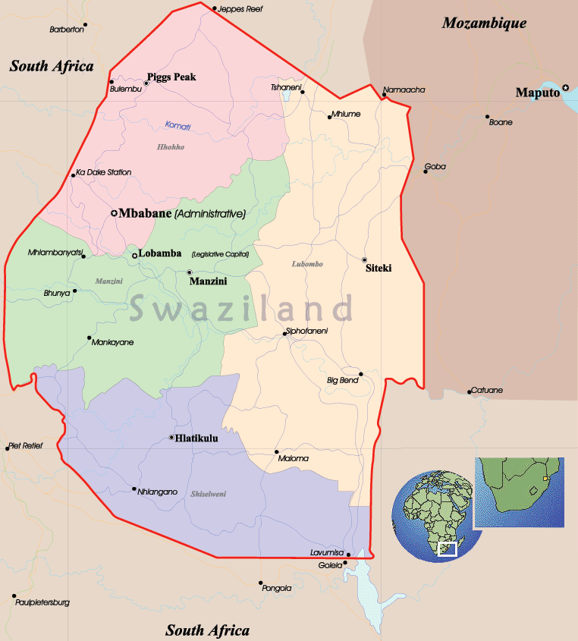

Source: USAID Report, 2010, p.1

The map in figure 1 above shows the Kingdom of Swaziland and also its location in Southern Africa. Furthermore, the 4 regions into which the country is divided into are also reflected in different colours for ease of reference. These regions include:

Hhoho region – in pink

Manzini region – in green;

Lubombo region in orange; and

Shiselweni region – in purple.

Swaziland is arguably, one of the countries where the visa application process at the South African government is very complex and inaccessible to majority of its citizens. It is the smallest country in Southern Africa, covering approximately 17,000 km². In spite of a relatively high GDP per capita and its middle income status, the country still ranks 146 out of 177 countries in terms of human development, only one country above those ranked as ‘low’ (USAID Report, 2010, p.10).

The country’s population is estimated to be 1.3 million (July 2011, estimated) with about 70% of the country’s population being rural and about 30% urban. The official languages are English and siSwati and the most dominant religion is Christianity. The unemployment rate is estimated to be above 40%. The capital city of Swaziland is Mbabane, which is located in Hhoho region (World Bank Report, 2011).

Ancient Swaziland was inhabited by the San and evidence suggests the area now known as Swaziland was populated as early as 40,000 years ago. The birth of modern Swaziland can be seen as the period during the 15th century when Bantu migration brought people south from central Africa to what is now Mozambique. After moving into Zululand in neighbouring South Africa at around 1750, the Swazi community finally moved north to settle in the area now known as Swaziland during the early 1800s. The most notable early leader of Swaziland was Mswati II, who during the 1840s solidified the territory of the nation and encountered the first European immigrants in the area (ACTSA, 2010, p.2).

After the death of Mswati II, agreements were made between Swaziland, South Africa and Britain on issues such as authority and independence; promises that the white settlers would later renege on. South Africa administered Swaziland from 1894 until 1902, when the British began ruling the country as a protectorate in order to preserve an element of control in the region. This administration lasted for around sixty years and during this time, the British - who ruled Swaziland by decree via the High Commissioner for South Africa – issued a Native Authorities Proclamation which recognized the status of the Ngwenyama, or paramount chief, (a position held

by King Sobhuza II from 1921 until his death in 1982) of the Swazi and granted the chief a degree of power to rule his Kingdom (ACTSA, 2010, p.2).

Having fear that the apartheid regime in South Africa would incorporate Swaziland into its rule; the British prepared the country for independence and introduced a constitution which granted Swaziland limited self-governance as of 1963. In anticipation of independence, numerous political parties formed during the early 1960s, with Sobhuza’s Imbokodvo National Movement (INM) proving to be the most successful given its close identification with the majority rural population. After enhanced constitutional talks for a number of years which saw the INM elected to share power with the British through multi-party elections, Swaziland was granted full independence in 1968 and adopted a new constitution (ACTSA, 2010, p.2).

Maroleng, 2003, states that Swaziland gained its independence from British colony in 1968, and that saw the establishment of a parliamentary multiparty system. However this was short lived when King Mswati II’s father (King Sobhuza II) suspended the Constitution and thus banning all political opposition parties on 12 April 1973. Since then the governing power remains firmly in the hands of the monarchy, and is the last remaining absolute monarchy in Africa. It is further stated that the current King Mswati III acts wholly in his own discretion, consulting whomsoever he wishes and not bound by any law (Maroleng, 2003, p.1-2).

Swaziland has 11 official border posts with South Africa and the Swaziland name is given first, followed by the name (in brackets) by which the border posts is known in South Africa and these are:

Bulembu (Josefsdal);

Gege (Bothashoop);

Lavumisa (Golela);

Lundzi (Waverly);

Mahamba (Mahamba);

Mananga (Border Gate);

Matsamo (Jeppes Reef);

Ngwenya (Oshoek);

Salitje (Onverwacht);

Sandlane (Nerston); and

Sicunusa (Houdkop) (Thwala, 2004, p.1).

Ngwenya/Oshoek is the busiest border post and it becomes heavily congested at certain times such as at long weekends or when there are special events such as concerts or Swaziland annual events such as the Reed dance, Incwala ceremony, Buganu ceremony etc. (Canadian Report, 2012). For now there is only one international airport called Matshapha airport that is situated in Manzini Region. Out of all these 11 borders between Swaziland and South Africa, none of these are open 24 hours. They open at 07h00 am earliest and close at 12h00 pm latest and this has a very negative impact to most South African business traders.

For a person to commute in Swaziland, he / she should use buses and taxis as a means of a public transport system that is currently available. There are no trains or railway systems that are used as public transport. There are few industries in the country and some are even closing down due to the current economic crisis. The Primary and High school education in the country is very much expensive than in South Africa. There is only one recognised University in Swaziland called University of Swaziland (UNISWA) and some teachers and nursing colleges and Further Educational Training (FET) Colleges. They do not offer a wide scope of courses as most tertiary institutions in South Africa and elsewhere. Limkokwing is a private university based in Malaysia that has opened campuses in Swaziland, Botswana and Lesotho on the African continent. Controversy has dogged Limkokwing wherever it goes, because of the often controversial way it sets up in a country and the low standards of its courses and teaching staff. Limkokwing opened its campus in Mbabane in May 2011 (Rooney, 2012, p.1).

South Africa has always provided a safe outlet for the potentially unemployed Swazis by allowing them access to job opportunities in the Republic, especially the gold-mines where employment was guaranteed. Bỡhning, 2004, argues that up to about 1894 Swazis were able to provide for their own food requirements. However, in 1897 when a substantial poll tax of two pound per adult male and 10 shillings per wife was imposed by the South African administration, Swazis were forced to seek work on the Transvaal mines in order to earn the needed cash. This clashed with the attempts of King Ngwane V to retain his men for military purposes, as there was a continuous outflow of men mostly to neighbouring Barberton (in Mpumalanga Province) gold-mines (Bỡhning, 2004).

Crush, 1986, states that between 1920 and 1940, about 5000-7000 Swazi men were recruited annually by the South African mining industry. In 1895 the first formal colonial administration was installed in Swaziland when the country became a protectorate of the Kruger Republic. In the late 1897, a hut and poll tax or colonial taxation which was accompanied by battering and cattle confiscation was imposed in order to enforce the Swazis to take mining or agricultural labour in South Africa. Crush further argues that during the late 1895, Swaziland was hit by a series of unprecedented environmental calamities such as four years of drought, locust invasions and the rinderpest epidemic that swept the Southern African region. Swazi stockholders lost 80-90% of their cattle within weeks and the whole country was thrown in the state of destitution and turmoil, thus resulting in large numbers of young Swazi men to be forced to find work in Transvaal and Natal so to feed their families (Crush, 1986, p.30).

According to Simelane and Crush, 2004, Swazis migration to South Africa began in the late nineteen century when Swazi men started working in Johannesburg and the Natal coal mines so that they are able to pay dowry or lobola. By 1980s the number of Swazis working in SA mines was close to 20 000. During the 1990’s the number of Swazis coming to work in SA fell by half (Simelane and Crush, 2004, p.4).

Furthermore, Simelane and Crush, 2004, note that the following changes in migration between Swaziland and South Africa were identified since after political liberation in SA:

The number of people travelling between both countries increased from 162 792 in 1991 to 809 049 in 2003;

Legal and clandestine movements between the two countries for employment or economic gain increased;

Brain drain in education and health sector from Swaziland to South Africa; and

Cross border trade between two countries also increased (Simelane and Crush, 2004, p.14-15).

According to the survey conducted by Crush and Simelane, 2004, it was found that Swazis certainly feel that official South African immigration policy should be more relaxed with nearly thirty percent (30%) who feel that there should be a policy of unrestricted access. Moreover, they also feel that there should be a policy of access tied to job availability. Their view of a desirable South African policy differs markedly from that of South Africans themselves, who favour a much more restrictive approach. Again the survey found that less than five percent (5%) said they had entered South Africa without a passport on their last visit. The border has been porous for decades as people have crossed anywhere along it to visit friends and family on the South African side. Such movements have been so numerous and frequent that even members of the South African security forces who patrol the border have given up arresting the culprits (Crush and Simelane, 2004, p.23).

3.3 VISA ISSUANCE PROCESS

Since the terrorist attacks of 11 September 2001, the United State Department has been engaged with other U.S. government agencies in an extensive and ongoing review of visa issuing practices as they relate to the security of its borders and its nation. The Department of State has increased its security procedures in connection with the visa issuance process. New visa application forms that request detailed information from applicants as well as security background checks have been introduced. These additional security measures that have been implemented increased the visa processing times from one day to several weeks (GTIO, 2002).

The visa issuance procedures are no longer a simple "drop off and pick up" procedure. What used to be a routine procedure seems to be anything but that in the post September 11 climate of heightened scrutiny and security. Visa applications are now subject to a greater degree of scrutiny than in the past and individual applicants may experience inconvenience and hardship if their application takes longer to process than they expected and also these additional security measures may affect the travel plans of visa applicants (GTIO, 2002, no page).

The application of set visa requirements involves prior scrutiny or inspection by the destination state of the personal circumstances for an applicant as well as the purpose of his or her trip. The scrutiny aims at ensuring that the planned trip is legitimate and does not jeopardise the security of the state. These requirements have an impact on the international relations between countries and their nationals as they suggest a prior suspicion towards visitors (Faure-Atger and Guild, 2011, p.1).

According to Chapter 2, of the RSA Immigration Act, 2002, a person that would like to come legally to South Africa must have a valid passport from her/his country or a certificate applied for and issued by the Department. Such a person must also have some kind of permit to enter South Africa. If it is not the case, his/her passport must be valid for not less than 30 days after expiry of intended stay (Immigration Act, 2002). The South Africa Immigration Laws stipulate the following types of visa or permit that a foreign national may apply for in any South African Embassy or Consulate i.e.,

Tourist Visa

Depending on the country of origin, a tourist may stay in South Africa visa-free for 90 days. Other nationalities may qualify for a shorter visa-free stay such as 30 days or less. Swaziland is one of those countries that qualify for 30 days visa-free (RSA Immigration Act, 2002).
- Study Visa

Study visas are issued to foreigners who plan to spend more than three months studying at an educational institution in South Africa. According to the South African Department of Home Affairs, a foreign applicant for a study visa may not displace a South African citizen from his studies by being granted a visa to come study (RSA Immigration Act, 2002).

- Work Permit / visa

Work permits are issued to foreign employees who can demonstrate that their jobs in South Africa cannot be filled using the South African labour force. In some cases, however, such as when foreign employees are transferred to South Africa by a company with affiliations in the country, the applicant may apply for an intra-company transfer work permit, which requires no evidence that the job can be filled by a South African (RSA Immigration Act, 2002).

Of particular interest is the fact that a quota work permit can now be issued even if no job offer or contract can be shown by the applicant. Such a contract is to be submitted to the Department within 90 days of issuing of the permit. This way what was formerly known as work seekers permit has been re-introduced. As is the case in the general work permit category, here, too, the applicant’s qualifications need to be evaluated by the South African evaluation authority which is costly and time consuming (Willand, 2005, p.14).

- Permanent Residency Permit

A permanent residency visa is granted to those who wish to remain in South Africa permanently. Permanent residents who leave South Africa for a period of three years run the risk of having their residency revoked. Generally speaking, permanent residence visas are not issued to unskilled or semi-skilled workers. According to the Department of Home Affairs, there is already a large reserve of those workers in South Africa (RSA Immigration Act, 2002).

For any person that wishes to obtain any visa as stated in the above paragraph should apply before coming to South Africa by completing the application forms at any South African embassy or Consulate or direct from the Department of Home Affairs in Pretoria. An application fee will be charged. If the permit is refused there is no review procedure. There are two kinds of permits: permanent residence/immigration permits and temporary residence permits. The legislation makes provision for no less than 13 types of temporary residence permits (Immigration Act No. 13 of 2002).

Travel agents have played a role in the visa process since at least the early 1970s. Some posts find that agents are helpful in collecting applications from clients and submitting them for processing. In some countries agents assist in explaining the visa application process to applicants. Travel agents often provide a first review, ensuring that basic requirements are met (forms signed, photos attached, passports valid) before applications are sent to the visa section. Having the applications on hand also allows posts to pre-screen them and schedule necessary interviews, while specifying any additional information or documentation required. Travel agencies have proved to be useful at a limited number of posts. The majority of visa issuing posts, however, have found travel agents either uninterested in the extra work or unreliable (U.S. Department of State, 2002, p.7).

South African High Commission (SAHC) in Swaziland does not employ or subscribe to any travel agents, although they are useful and very effective in some other countries. To a certain extent, national security can be very much undermined when visa process is being facilitated by travel agents since some security aspects might be disregarded. Although the entry requirements have been raised for all applicants i.e. permanent and temporary, the new regulations and restrictions are directed primarily at people from other African countries. The fee structures create much higher barriers of entry for African immigrants than, say, those from Europe and North America. Furthermore, the new government has not only had a negative and exclusionary attitude to skilled immigrants in general, but to Southern Africans in particular (Peberdy, 2011, p.19).

For any person in Swaziland who needs to apply for a visa or permit of a long term stay in South Africa, he or she has to travel from whichever region they are in country to reach the SAHC which is situated in the capital city of Mbabane, in Hhoho region. Thus, visa applicants in the Kingdom end up having to face long queues and waiting time because of the SAHC being located only in one region in the country. Besides long queues and waiting times, few administrative staff to receive and process the visa applications add to the problem facing South African visa issuing process in Swaziland.

The first step in applying for a South African visa is to approach the South African Embassy or Consulate in your country. The Embassy or Consulate will provide you with the necessary visa application form. This form is known as a BI-84, and since the South Africa government is not fully web-enabled at present. Therefore the application forms have to be collected and be manually filled at the relevant consulates. In order to complete the form, you will need to supply these basic required documents:

  - Passport valid for 6 months beyond date of departure;
  - 2 passport-size photos with signature on reverse side;
  - 1 completed application form (failure to complete the application fully and in detail may result in visa being delayed or refused);
  - Proof of sufficient funds to cover visit;
  - Onward/return ticket and, if in transit, proof of sufficient documentation for admission to the country of destination;
  - No criminal record;
  - Visitors should be of sound mind and body;
- Official letter of acceptance from South African academic institution (for study permits; and
- Official letter of employment from South African company stating salary and position (for work permits) (RSA Immigration Act No. 13 of 2002).

Currently the immigration policy in South Africa is tight due to the emphasis placed on giving jobs to the general population of South Africa. This is seen with the focus on Affirmative action laws being passed where all businesses need to report on what their 'quotas' are and where they will be in the future.

Persons wishing to attend school, university or other institutions of learning in South Africa can obtain a study permit or visa. The applicant needs to furnish a letter by the educational institution confirming the applicant’s provisional acceptance and the minimum period of the studies or course. Holders of a study permit for higher education may take up part-time work of up to 20 hours per week (Willand, 2005, p.10).

Personal interview is required for all applicants, 21 years and above. Interviews will be conducted by Consular at the South African Missions depending on applicant's point of residence. If a personal interview is not feasible for the reason that the applicant's point of residence is of great distance from/to the respective South African Mission, a telephonic interview should be considered. Interviews are arranged by the respective Missions provided that all requirements have been duly complied with by the applicant (South African Visa Information, 2012, p.2).

The Minister of Home Affairs may withdraw an immigration permit by notice in writing and will order the holder of such permit to leave the Republic within the period indicated in the notice on the basis of the following:

- Application contains false information;
- Holder fails to comply with a condition imposed under Section 25(3);
- Holder, within a period of three (3) years from date of issue of such permit, engages in an occupation other than the occupation stated in the permit, without the consent of the Minister;
- Holder obtained the permit on the basis of a marriage entered into less than two (2) years prior to the date of the issue of the permit and such marriage is judicially annulled or terminated within two years subsequent to the said date;
- Holder did not enter the Republic for the purpose of permanent residence therein, and upon the expiration of the period mentioned in said notice, the permit shall become null and void (South African Visa Information, 2012, p.1).

According to the Swazi Observer, the 2012 report stated that

“Swazi students wishing to study in South African tertiary institutions yesterday flooded the SA High Commission offices to re-apply after they were turned down for failure to comply with a directive that they should have a medical aid that is recognised in South Africa. Most of them had since taken up medical cover with Swazimed while others had taken theirs with some of the South African medical aid providers, who are now operational in the country” (Swazi Observer, 2012, p.3).

This was after the South African High Commission turned down their study visas if they had not complied with such a ruling. The students had to move fast as most of the colleges and universities they had been admitted to were already open. Further complicating the issue is the fact that a South African temporary residence permit/study visa application takes about 10 days to be processed hence most of them were harbouring fears that they could lose their places. Most of them are still bitter at this turn of events, stating that they were not informed in time about these developments” (Swazi Observer, 2012, p.3).

This news article raised some of the major challenges that visa applicants experience whenever they come to the South African High Commission to apply for a visa. The first issue being that applicants should be registered with the South African recognised medical cover, of which they are re-applying students i.e. they have been studying in South Africa before using other medical cover or did not have any medical cover. They are also complaining that number of days i.e. ten (10) days, which it takes to process the study visa at the Mission, seems to be very long.

The visa verification process relies heavily on information provided by the applicant, who is legally obligated to respond honestly to questions on the application form. Unfortunately, some applicants tend to provide false information or fraudulent documentation. The verification process, therefore, relies on visa officer’s judgment, training, and experience to analyse and validate information they receive from applicants. Visa officers should also take into consideration the information provided by key partners i.e. Police, banks, medical cover company, tertiary institutions etc. They are expected to make the best decisions they can with the information on hand (Report of Auditor General of Canada, 2011, p.7).

Table 2: Immigration Statistics at the South African High Commission in Swaziland during the Year 2012
MONTH (2012) | VISITOR’S VISA | STUDY VISA | WORK VISA
JANUARY | 242 | 730 | 01
FEBRUARY | 226 | 524 | 03
MARCH | 261 | 93 | 03
APRIL | 314 | 95 | 02
MAY | 313 | 93 | 05
JUNE | 181 | 44 | 07
JULY | 251 | 103 | 03
AUGUST | 252 | 48 | 05
SEPTEMBER | 239 | 21 | 02
OCTOBER | 335 | 28 | 02
NOVEMBER | 378 | 30 | 00
DECEMBER | 306 | 188 | 01
TOTAL | 3298 | 1997 | 34
Source (Consular Section at SAHC in Swaziland).

Table 2 above, illustrates the statistics of visas that were applied for and issued at the South African High Commission in Swaziland during the year 2012. It can be seen that visitor’s visa is the most applied for and this is followed by the study visa and finally the work visa. The study visa is mostly applied for in December, January and February months during the school holidays i.e. its application is seasonal (SA Consular Section Statistics Report, 2012).

  - CONCLUSION

Swaziland is the smallest country in Southern Africa, covering approximately 17,000 km² with a country’s population estimated to be 1.3 million (July 2011, estimated) and about 70% of the country’s population being rural and 30% being urban. The unemployment rate is estimated to be above 40%. The capital city of Swaziland is Mbabane, which is located in Hhoho region (World Bank Report, 2011). Swaziland gained its independence from British colony in 1968, and that saw the establishment of a parliamentary multiparty system. However this was short lived when King Mswati II’s father (King Sobhuza II) suspended the Constitution and thus banning all political opposition parties on 12 April 1973. Since then the governing power remains firmly in the hands of the monarchy, and is the last remaining absolute monarchy in Africa. It is further stated that the current King Mswati III acts wholly in his own discretion, consulting whomsoever he wishes and not bound by any law (Maroleng, 2003).

However, South Africa has always provided a safe outlet for the potentially unemployed Swazis by allowing them access to job opportunities in the Republic, especially the gold-mines where employment was guaranteed. Bỡhning, 2004, argues that up to about 1894 Swazis were able to provide for their own food requirements. Event such as terrorists attacked during September 11, 2001 resulted in stricter security measures being introduced into the visa issuance process. The issue of visa issuance was soon regarded as the state security matter after the terrorist attacked in the United State. These stricter restrictions can be a major problem in promoting tourism and since huge delays and frustrations are experienced by the applicants. Visa applicants often have difficulties completing visa application forms properly and completely, and in understanding the strict supporting documentations that are required. Incomplete or improperly prepared visa applications can affect issuance and thus creating undesirable delays and increased workloads for immigration and consular officials.

The visa applicant’s concerns that were raised in the Swazi Observer, February 2012, confirm the general perceptions that visa process is very complicated and time consuming and they were not well informed in time regarding these new changes. The question that should be asked is how these challenges are being addressed in order to be effective and efficient regarding visa processing so that the risk that is involved is minimised.
The visitor’s visa is the mostly applied for at the mission in Swaziland and it is followed by the study visa which is mostly applied for during the months of December, January and February.

Proper scrutiny or screening of visa or permit application process is essential at any South African Mission or Embassy abroad in order to allow entry of only lawful applicants into the Republic of South Africa and thus ensuring national security. This can be achieved when effective and efficient service is provided, when there is enough staffing, efficient training that is relevant to the security aspects of visa and that enough resources are provided for the Consular or Visa Section.

The following chapter will be discussing the results obtained from the survey that was conducted with visa applicants and the Mission staff at the South African High Commission in Swaziland.

CHAPTER 4
RESEARCH FINDINGS AND ANALYSIS

4.1 INTRODUCTION

In the previous chapters, a detailed exposition of the literature that forms the basis of the study was provided. Furthermore, brief history of the Kingdom of Swaziland was also provided in order to show the origin of the migration of its people to South Africa and also the statutory framework that is used to manage it.

In this chapter the empirical findings of the study are outlined. The purpose of the survey was to understand the visa application process, develop the profile of the visa/ permit applicants and to identify challenges that are faced by applicants when coming to apply for visa at the South African High Commission.

The findings of the study are outlined below.

4.2 METHODOLOGY FOR THE RESEARCH STUDY

The survey was conducted over a period of two months where applicants were randomly selected to participate in the survey. Data was collected using semi-structured questionnaires where the researcher conducted face-to-face interviews with visa applicants and Mission Staff members. Since the researcher was working for the South African High Commission in Swaziland during the time of the research, it was possible to also make an observation of the surrounding environment. For visa applicants, fifty (50) questionnaires were conducted and completed and seven (7) questionnaires were completed by mission staff on behalf of the respondents whilst conducting an interview. All questionnaires were completed by the researcher during the interview with all questions answered.

A purposive sampling method was used to reach out to staff members at the Mission that were included in the study. A purposive sampling method refers to a sample in which the researcher deliberately obtain units of analysis in such a manner that the sample obtained may be regarded as being representative of the relevant population (De Vos et al, 2005, p. 296).

Both questionnaires for visa applicants and the staff members consisted of two sections. Section A was dealing with demographic information of each applicant or staff member and section B was more specific to the accessibility of the mission, service being rendered and the challenges that applicants or staff members are faced with when applying or processing visa /permits at the South African High Commission in Swaziland. Descriptive statistics which is described as a general type of simple statistics used by a researcher to describe basic patterns in the data (Neuman, 2011, p.347) was used to analyse the collected data in this study. It was then entered into excel computer software program where pie charts and columns were used in the analysis of the data.

The analysis of data and interpretation of each item from the questionnaires is discussed below, with reference to the literature review where applicable.

4.3 SECTION A - DEMOGRAPHIC PROFILE FOR VISA APPLICANTS

4.3.1 Gender

The breakdown of the rating is illustrated by the table below:

GENDER FOR APPLICANTS
MALE | FEMALE
52% | 48%

Fifty two percent (52%) of the visa applicants were male, while forty eight percent (48%) were female. Gender of respondents was important for this study, as it helped to identify views from both sexes. The results demonstrated that most visa applicants that were interviewed were males.

4.3.2 Marital status

The breakdown of the rating is illustrated by the table below:

MARITAL STATUS OF APPLICANTS
SINGLE | MARRIED | DIRVOCED
76% | 24% | 0%

The majority of applicants that were interviewed were single with seventy six percent (76%), and twenty four percent (24%) were married. There was no divorced applicant that was interviewed. This illustrated that the marital status of the majority of visa applicants that were interviewed were single.

4.3.3 Age

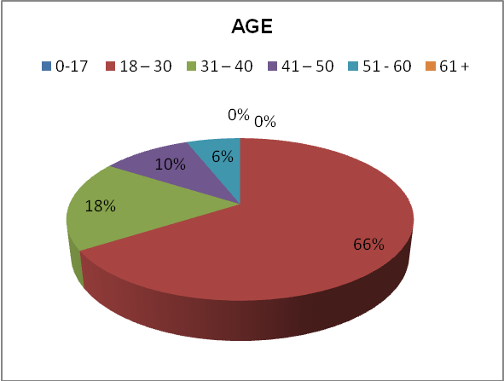

The ages of the respondents ranged from 17 to 61+ years. Sixty six percent (66%) of the applicants were between the ages categories of 18 to 30 years; Eighteen percent (18%) were between the ages of 31 to 40; Ten percent (10%) were between 41 years to 50 years; and six percent (6%) were aged between 51 to 60 years. All the respondents were adults, having mature reasoning abilities and able to distinguish between right or wrong. All applicants had views or opinions on the challenges of the visa application process and on how the service being rendered at SAHC can be made to be more effective and efficient.
4.3.4 Nationality

The breakdown of the rating is illustrated by the table below:

NATIONALITY OF APPLICANTS
SWAZIS | OTHER
76% | 24%

The majority of visa applicants interviewed were Swazis with Seventy six percent (76%) and twenty four percent (24%) represented other nationals from countries which included India, Pakistan, Bangladesh, Nigeria, British, Zambia and Zimbabwe. This illustrated that the majority of visa applicants that were interviewed were Swazis by origin.

4.3.5 Regions in Swaziland

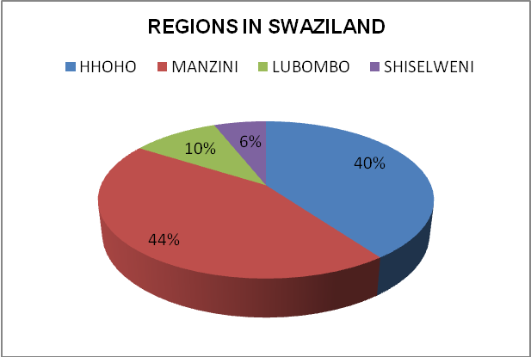

As stated in chapter three on the background history of Swaziland, it is divided into four regions and the South African High Commission is only located in Hhoho region in Mbabane. It was found that visa applicants interviewed were from all over the Kingdom but most of them were from Manzini region with forty four percent (44%), with forty percent (40%) from Hhoho region, ten percent (10%) from Lubombo and only six percent (6%) were from Shiselweni region. This indicated that the largest part of visa applicants which were interviewed were form Manzini region.

4.3.6 Educational Background

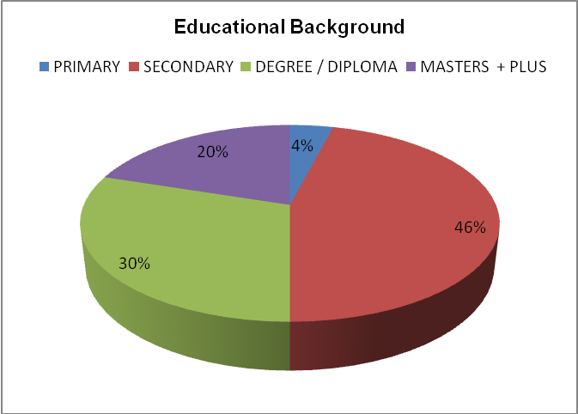

Nearly half of the visa applicants had completed matric, with forty six percent (46%) reached secondary school, while only four percent (4%) had completed primary education. Thirty percent (30%) of the applicants had completed a three-year degree or diploma and twenty percent (20%) had their master’s degree or additional tertiary qualifications. This means that most applicants were learned and able to read.

  - SECTION B - VISA APPLICATION PROCESS AND CHALLENGES EXPERIENCED BY APPLICANTS AT SAHC – SWAZILAND

    - Purpose of application

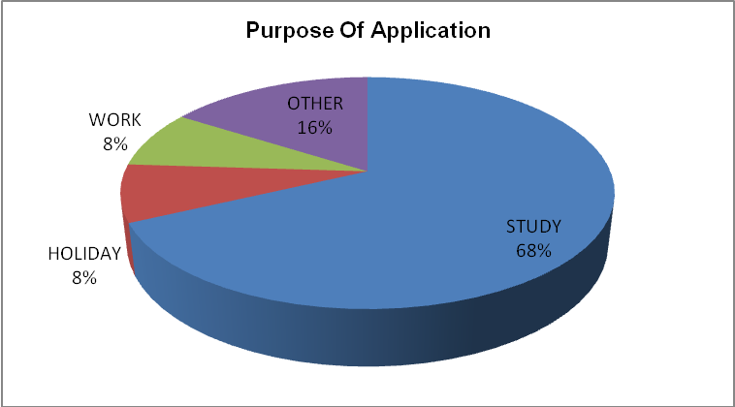

Sixty eight percent (68%) of the applicants interviewed were applying for a study permit, eight percent (8%) were applying for work, another eight percent (8%) were applying for holiday and sixteen percent (16%) were applying for other things such as transit visa and others were applying for the refund of repatriation fee. This shows that most applicants were coming to South Africa to further their studies. However it should be mentioned that the study visa applications are seasonal mostly during December, January and February of each year at the beginning of the South African school and tertiary opening terms. The study was also conducted during January and February months, hence the results of more study visas being applied for.

4.4.2 Accessibility of SAHC

The breakdown of the rating is illustrated by the table below:

ACCESSIBILITY OF THE SAHC BUILDING TO APPLICANTS
YES | NO
90% | 10%

Most applicants interviewed stated that the High Commissioner was easily accessible. This was due to the fact that the SAHC is in Mbabane, the capital city and is located in the Mall which is situated directly opposite the main taxi and bus rank. Ninety percent (90%) of the applicants stated that it was easily accessible and only ten percent (10%) were in disagreement to the statement.

4.4.3 Province where visa applicants are going to be based in RSA

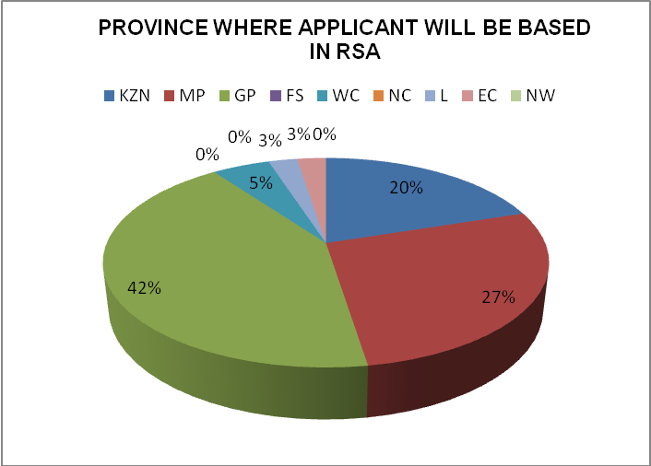

The most popular province in South Africa where majority of the visa applicants interviewed were going to be based was in Gauteng (GP) with forty two percent (42%). It was followed by Mpumalanga (MP) province with twenty seven percent (27%). Twenty percent (20%) of applicants were going to be based in kwa Zulu- Natal (KZN). Five percent (5%) of the applicants were going to be based in Western Cape (WC), with both Eastern Cape (EC) and Limpopo (L) provinces having three percent (3%) each of respondents going to be based there. Finally, Northern Cape (NC), North West (NW) and Free State (FS) all had no applicants going to be based there. This illustrates that most visa applicants interviewed were going to study in Gauteng province.

4.4.4 How can the accessibility of SAHC be improved?
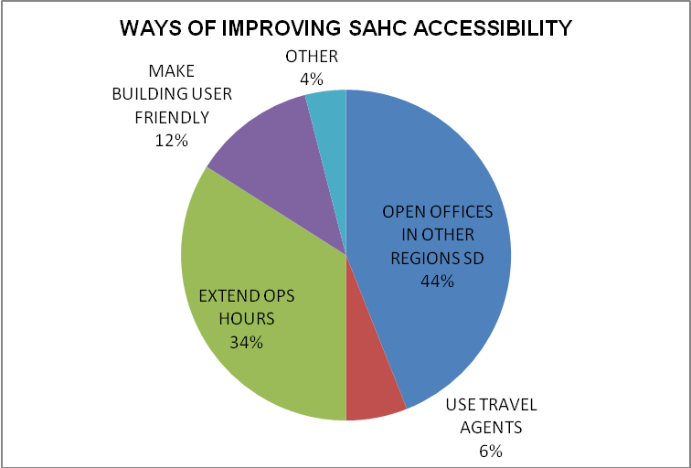

When applicants were asked as to how the accessibility of the SAHC can be improved, about nearly half (44%) of the respondents suggested that the South African High Commission should open offices in other regions of Swaziland. Another thirty four percent (34%) of the applicants recommended that operation hours should be extended. Twelve percent (12%) suggested that the building should be made to be more user friendly in terms of its layout. Six percent (6%) suggested the use of travel agents to facilitate the application. Four percent (4%) suggested other things like using the internet to apply rather than coming to the Mission. This indicated that majority visa applicants wanted the Consular to have offices in other regions of the Kingdom.

4.4.5 Frequency of visits to SAHC
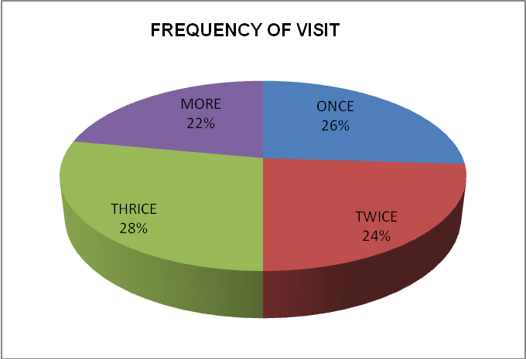

Twenty eight percent (28%) of the applicants had been to the Mission three times to follow up on their applications, twenty six percent (26%) were at the Mission for the first time, twenty four percent (24%) had been at the Mission twice and twenty two percent (22%) had been at the Mission for more than three times. This shows how complicated and costly the visa application process is, especially for applicants who are commuting from far regions. This illustrates that the visa application is no longer a drop and pick up process and it also shows that the visa process is not effective and efficient towards its clients. If there was a dedicated line for clients to ask about the progress regarding their applications, they will not frequent the mission to ask very insignificant things.

4.4.6 Knowledge of turnaround time

The breakdown of the rating is illustrated by the table below:

KNOWLEDGE OF TURNAROUND TIME
YES | NO
90% | 10%

About ninety percent (90%) of the visa applicants who were interviewed were aware as to when they will be issued with the visa / permit as they were told by staff about the turnaround time and only ten percent (10%) of the applicants were not aware when they will be issued with their visas. This was because some of them were still supposed to submit other supporting documents for their applications to be processed.

4.4.7 Service rating

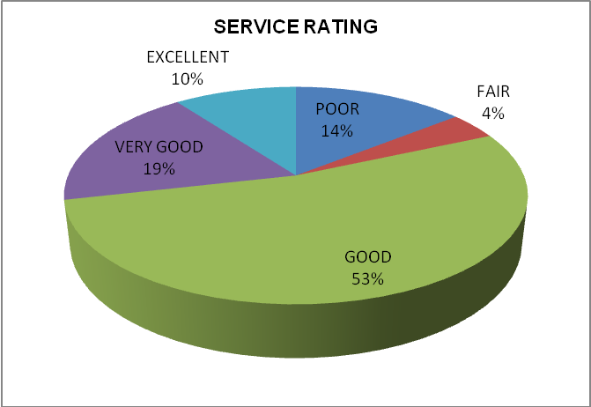

About fifty three percent (53%) of the applicants rated the service that is being rendered at the Mission as good. Nineteen percent (19%) rated it as very good, with only ten percent (10%) of the applicants rating the service as excellent. Only fourteen percent (14%) of the applicants rated the service as poor and four percent (4%) rated it as fair. The results indicate that the majority of respondents view the service at the South African High Commission as good. Most of the applicants suggested that the service can improve to very good or excellent if the mission staff can be increased and be properly trained on client services.

4.4.8 Challenges faced when applying for visas / permit

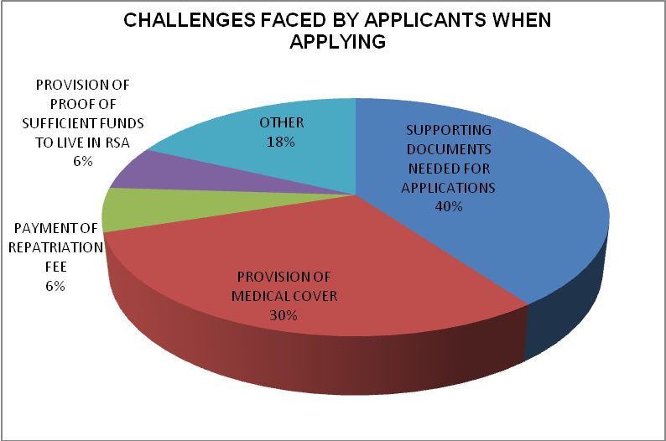

Forty percent (40%) of the visa applicants indicated that supporting documents needed for issuing of visa was the most challenging issue that they faced when applying for a visa. Applicants stated that this was caused by the inconsistency and unclear communication by the staff members at the Consular Section. Thirty percent (30%) of the applicants faced challenge with the provision of medical cover, especially students who were from poor backgrounds who could not afford medical cover.

Eighteen percent (18%) of the respondents indicated that they faced other challenges that were not mentioned in the questionnaires. They mostly mentioned the provision of South African Police Clearance Certificate which requires that applicants who are re-applying should travel to South Africa and request Police clearance certificate before their applications can be considered. According to applicants this step has cost implications as they must commute to South Africa to request it and they suggested that this Police certificate should be obtained from the Mission in Swaziland. Six percent (6%) faced a challenge of paying for the repatriation fee, and finally another six percent (6%) faced challenges in terms of provision of sufficient funds for support in South Africa i.e. bank statements for the proof of sufficient funds to support oneself in South Africa.

4.4.9 Suggested measures that can be put in place in order to improve visa application process

These were the most suggested measures to be put in place in order to improve service by applicants:

Consular Staff needs to clearly communicate and be consistent in terms of the supporting documents that are required. Applicants suggested that if the requirements are changing they need prior notification through Swazi media i.e. radio and newspapers. They also suggested an updated High Commission Consular website where all the details regarding visa application and changes are put. They also suggested that there must be a telephone line that is purely dedicated to assist them when enquiring rather than coming all the way from far just to ask a simple question which could have been answered over the phone.

A lot of applicants also suggested that there is a need for more staffing at the counter. Although the Consular Section has only two counters due to space shortage, applicants suggested that one experienced staff member should be at the entrance to assist applicants before they sit on the queue when sometimes they need to ask about a minor issue. They also suggested that staff should be trained in client service and about the visa application process also.

It was also suggested that the Consular service should try to shorten the study visa issuance period. The ten days is a lot for them and it delays them from starting schooling in South Africa. They also suggested that when re-applying for a study visa it should be a shorter process than the first time application, since they believe that all documentation is already filed and stored in the system at the Consular Section.

They also suggested that the RSA Police Clearance Certificate should be issued at the South African High Commission, as this was time consuming and very costly for them to cross the border to South African Police Services in order to apply for the Police Clearance Certificate.

Some suggested that the Consular Office should extend operating hours as Mission is only in one region in Mbabane and people from far incur lots of cost since they normally returned twice or more for application process.

4.5 SECTION A: DEMOGRAPHIC PROFILE FOR STAFF MEMBERS

4.5.1 Gender

The breakdown of the rating is illustrated by the table below:

GENDER FOR STAFF MEMBERS INTERVIEWED
MALE | FEMALE
57% | 43%

The gender profile for the staff members was also conducted in order to see the most dominant gender. Out of seven (7) staff members interviewed, fifty seven percent (57%) of the staff members that were interviewed were male and forty three percent (43%) were female, i.e. three (3) females and four males (4) were interviewed. This illustrates that the staff at the mission is dominated by males.

4.5.2 Age

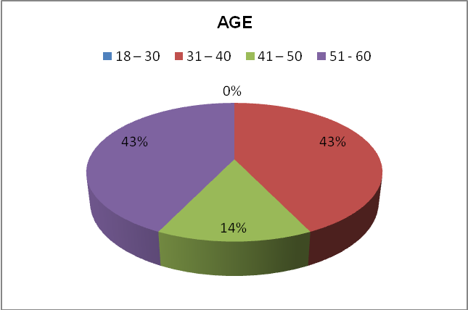

The age for the staff members was conducted to demonstrate the maturity level of the staff members. It was found that forty three percent (43%) of the staff members were between the ages of 31 – 40, another forty three percent (43%) of staff members were between the ages of 51 -60 years old. Only fourteen percent (14%) constituted the age between 41 – 50 years old. This illustrated that the dominant age group was between 31 to 40 old and 51 to 60 years old.

4.5.3 Position or level at Mission

The breakdown of the rating is illustrated by the table below:

POSITION OF STAFF MEMBERS INTERVIEWED
CONSULAR STAFF | OTHER
71% | 29%

Seventy one percent (71%) of the staff members interviewed were working for the Consular Section or visa section and only twenty nine percent (29%) of the staff members were working at the High Commission from other departments i.e. Defence attaché, and South African Police Attaché. This was relevant as the researcher needed the views from all angles from the Mission staff. It also illustrated that the majority of the staff interviewed were working at the consular section and therefore are much conversant with the process and major challenges that they face when processing visa applications.

4.5.4 Educational Level

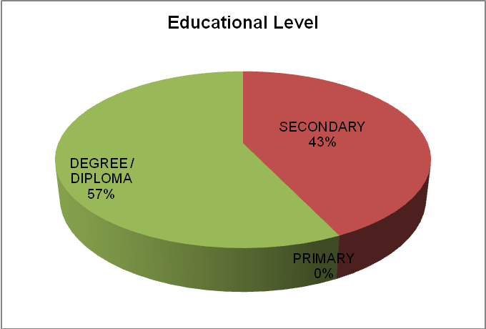

Most staff members who were interviewed had degree or diploma or higher with fifty seven percent (57%) and about forty three percent (43%) of the interviewed staff had only completed matric. This illustrated the level of education of staff members at the Mission. However, it was stated that the Consular training of local staff is mostly on the job training as there is no formal course or training being offered by the Home Affairs Department.

4.6 SECTION B - VISA APPLICATION PROCESS AND CHALLENGES EXPERIENCED BY STAFF MEMBERS AT SAHC - SWAZILAND

4.6.1 Type of visa or permit mostly applied for

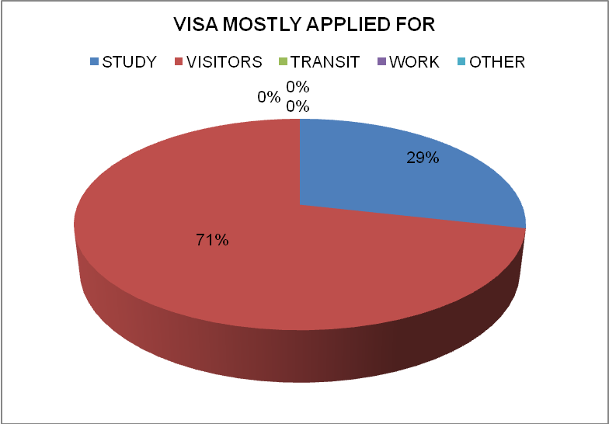

Seventy one percent (71%) of the staff members interviewed suggested that visitors’ visa was the most applied for at the Swaziland Mission and only twenty nine percent (29%) thought that study visa was mostly applied for. This should be stated that the study visa was seasonal, i.e. mostly applied for during December to February and the visitors’ is mostly applied for throughout the year. This is confirmed by the statistics that were obtained in the Consular section for visas issued during the year 2012.

6.2 Type of visa least applied for

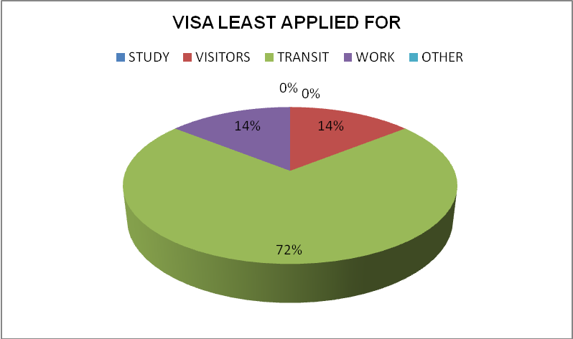

The type of visa that was least applied for was transit visa with about seventy two percent (72%) of the staff interviewed suggested that, this is followed by visitors’ and work visas both at fourteen percent (14%) each. This illustrated that transit visas were least applied for, meaning that most applicants were applying to enter the country not to transit to other countries.

6.3 Challenges faced when processing visa or permit application

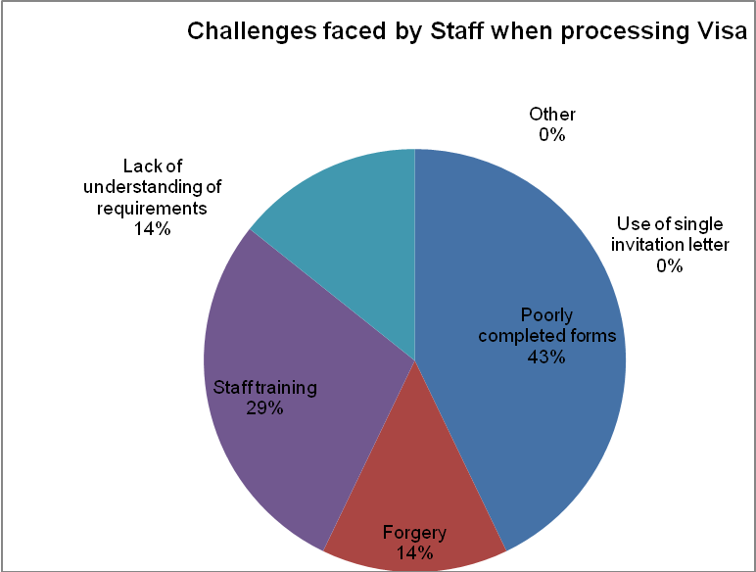

The challenges that were encountered by staff members when processing visas were mostly the poorly completed forms with forty three percent (43%). This was followed by staff training at twenty nine percent (29%), and forgery at fourteen percent (14%). This therefore illustrated that the most challenge that was faced by staff members when processing visas was poorly completed forms or false information being provided by applicants.

4.6.4 Verification of supporting documents

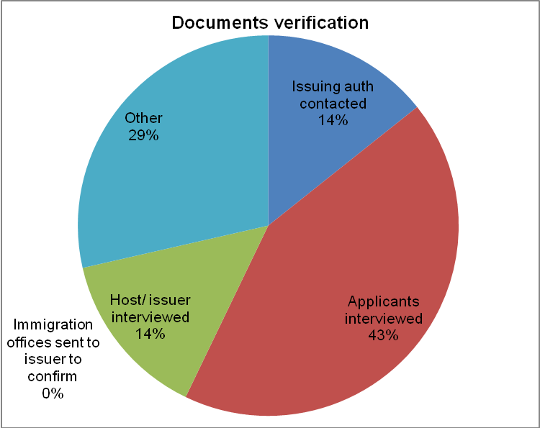

Forty three percent (43%) of the staff members interviewed stated that in order to verify supporting documents they normally interview applicants, fourteen percent (14%) suggested that issuer of the documents are interviewed and another fourteen percent (14%) suggested that issuing authorities are contacted by telephone. Twenty nine percent (29%) suggested that they only depend on the Consular Head’s discretion for verification since they only collect the application form with relevant documents. The Consular Section does not have an interview room, when the interview is conducted it is done in the full view of other applicants without any privacy. There is also no storage space for the completed application forms, as there were found on the floor in the Consular Head Office and in the office where three local staff members are sharing. The Consular office layout needs to be redesigned and more space is needed to store documents and have a separate interview room.

However this cannot be immediately done since the current building for the Mission is being leased and therefore no major changes can be done since there is shortage of space.

4.6.5 Challenges faced when conducting the verification process

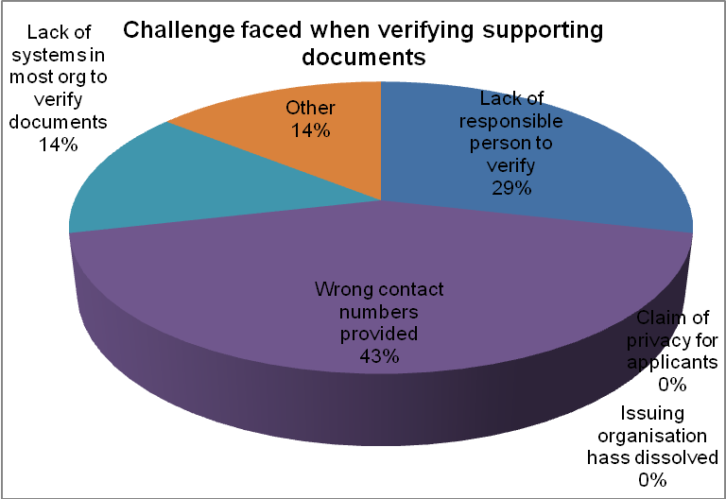

Forty three percent (43%) of the staff members interviewed suggested that incorrect contact numbers is the most challenge they face when trying to verify supporting documentation, whilst twenty nine percent (29%) stated the lack of the responsible person from the issuing organisation to confirm those documents. Only fourteen percent 14% suggested the lack of systems in most organisations to verify the supporting documents and another fourteen percent 14% stated that other challenges such as lack of staff training was the issue that promoted challenges faced when trying to select and detect fraudulent documents.

Again, most African countries do not have a central database which can be used to verify the applicant’s information; SAHC also experienced the same problem as some departments in Swaziland did not have the central database which could assist in verifying the visa supporting documents.

4.6.6 Document that are found to be easily or mostly forged

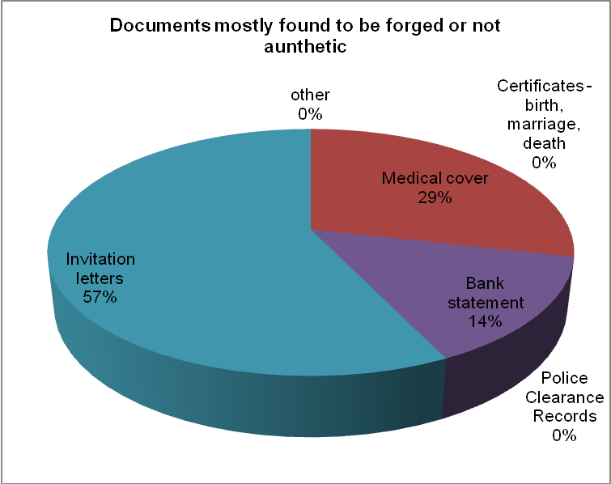

The invitation letters were found to be the mostly forged documents by the applicants at a fifty seven percent (57%). The medical cover was at twenty nine percent (29%) and it was followed by bank statements at fourteen percent (14%). The staff observed that when applying for the visitor’s visa, most Asian applicants residing in Swaziland use the same invitation letter or the letter is created by the applicant in the computer using a company letter head or forged signature. As the technology is advancing every day and the staff training is not consistently conducted, it becomes difficult for the staff to be able to detect if the documents are forged or authentic. Medical cover was also found to be forged by most applicants especially those who were applying for study visas.

One of the requirements for a study visa is that an applicant should be medically covered by one of South African recognised medical schemes such as Momentum and others. This is very difficult for most underprivileged Swazis as they do not have any medical cover and these recognised medical cover are very expensive for them. This results in an applicant making a decision to obtain forged documents in order to be issued with a visa.

4.6.7 Security challenges faced by mission when processing visa / permits

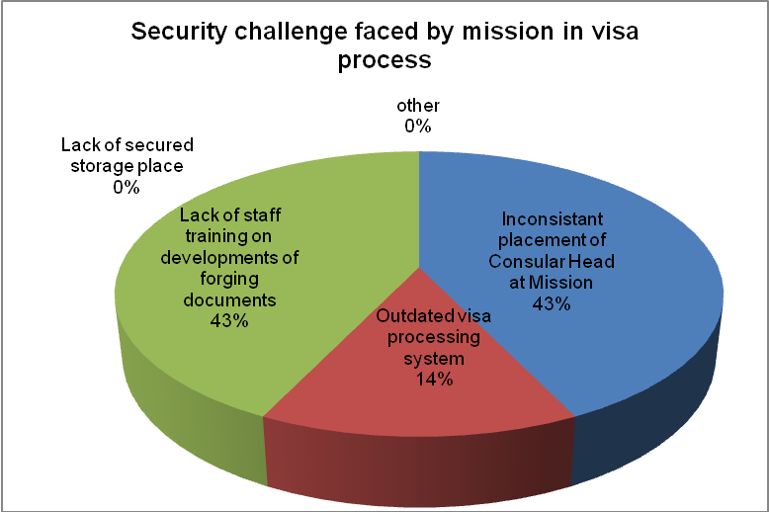

The lack of staff training on developments of forging documents and the inconsistent placement of Consular Head at Mission were both rated as higher security challenge at forty three (43%), this was followed by outdated visa processing systems with fourteen percent (14%). It was also observed that there were only three local staff members who were working at the Consular Section and the Consular Head (South African transferred staff) who approves the visa. The staff training is done on the job training. There is no formal training of staff members by the Department of Home Affairs. The current Consular Head is on a relief-duty as currently there is no member being permanently appointed for the post. The visa processing system being used was said to be outdated as they are not connected to other Missions or Head Office and the current system cannot provide information on applicants that are on the Home Affairs blacklist. The staff solely relies on the Head Office to verify if the applicant is blacklisted or not.

4.7 CONCLUSION

The analysed data was presented and described. The results revealed areas of concern as identified by the applicants and staff members that were interviewed in trying to discover security challenges in the visa application process at the SAHC in Swaziland.

The findings of the survey was that in terms of applicants demographic profile, majority of visa applicants that were interviewed during the period of the survey (January and February 2013) were mostly single males within the ages of 18 – 30 years. Most applicants were from Manzini region in Swaziland and not Hhoho where the Mission is situated. The majority of applicants interviewed had some form of schooling with matric at forty percent (40%) and degree or diploma at thirty percent (30%). Most of the applicants were applying for study visas and they were mostly going to be based in Gauteng followed by Mpumalanga provinces.

However it is interesting to note that the number of female applicants interviewed were less than those of male i.e. forty three percent (43%) female applied, but not very far from half of the sample (n=50) which shows that young women were also interested in going to study or work in South Africa. In terms of the South African High Commission accessibility to the applicants, the majority of the respondents suggested that the mission should open offices in other regions of the country since about twenty eight percent had been to the Mission three times to apply for the visa. About fifty three percent of the visa applicants rated the service as good, since they say there is a much room for improving if the issues as suggested in paragraph 4.4.9 can be addressed.

About forty percent (40%) of the applicants had a challenge in as far as supporting documents that were required was concerned. This was said to be due to the forever changing visa requirements and the process was stricter and expensive than before. This leads to people bypassing the process and cross the border without proper visas and opt to come back on a monthly basis so that they do not overstay in South Africa. It means there the stricter process tends to repel visa applicants and they travel to South Africa without proper documentation.

When conducting a survey with applicants, study visas were found to be the most applied for and the visitors’ visas were the least applied for. This was contrary to what was found when conducting an interview with staff members where the majority of staff suggested that the visitors’ visa was mostly applied for and study visa was the least applied for. However it was justified that visitor’s visa is applied for throughout the year and the study visa was on seasonal i.e. mostly applied for in December to February of each year, just before the schools and tertiary institutions in South Africa opens.

The conclusion and recommendations of the research are discussed in chapter five below.

CHAPTER 5
CONCLUSION AND RECOMMENDATIONS

5.1 INTRODUCTION

The purpose of this study was to explore the visa application process in the context of national security in order to determine the South African visa system’s effectiveness and efficiency; identity inherent security challenges in the process; and provide recommendations that can assist in improving the process thus minimising security challenges. The empirical study was conducted to obtain the viewpoints of the visa applicants and staff members at the mission.
This final chapter summarises the findings of the study in line with the data that was collected and processed from questionnaires and semi-structured interviews. Recommendations are presented based on research objectives, literature study, empirical investigation and findings.

  - RECOMMENDATIONS

The following recommendations are made based on the empirical findings of the study: Recommendations to the South African High Commission can be taken from the following most suggested measures that were provided by visa applicants during interviews which should be put in place in order to improve Consular Services at the South African High Commission:

Consular Staff needs to clearly communicate and be consistent in terms of the required supporting documents. Applicants suggested that if the requirements are changing they need prior notification through the Swazi media i.e. radio and newspapers. They also suggested an updated High Commission Consular website where all the details regarding visa application and changes are put. They also suggested that there must be a telephone line that is purely dedicated to assist them when enquiring rather than coming all the way from far just to ask a simple question which could have been answered over the phone.

Majority of applicants also suggested that there is a need to add more staff personnel at the visa counter. Although the Consular Section has only three counters due to space shortage, applicants suggested that one experienced staff member should be at the entrance to assist applicants before they sit on the queue when sometimes it is for asking about a minor issue. They also suggested that staff should be trained in client service and about the visa application process also so that they could render professional and valuable service.

It was also suggested that the Consular service should try to shorten the study visa issuance period. The ten days is a lot for them and it delays them to go and start schooling in South Africa. They also suggested that when re-applying for a study visa it should be a shorter process than the first time application, since they believe that all documentation is already filed and stored in the system at the Consular Section.

They also suggested that the RSA Police Clearance Certificate that is needed for reapplication should be issued at the South African High Commission, as this was time consuming and very costly for them to cross the border to the South African Police Services in order to apply for that Clearance Certificate.

Some suggested that the Consular Office should extend operating hours as Mission is only located in one region in Mbabane and applicants from remote regions are faced with high cost implications since they normally returned more than three times at the Mission before their visas are issued.

Furthermore, applicants should be provided with general guidance on the criteria for successful visa applications. This can be done in a way that leads to more predictable outcomes without compromising security. The Consular Section should draft guidelines to assist applicants in filling out applications accurately and properly; doing so will also lead to productivity gains (Yale-Loehr et al, 2005, p.43).
Given the challenging situation in which Consular staff operate, they need to be supported with adequate training and tools to do their job effectively, particularly in situations where the visa officer has not yet had job experience to draw upon (Report of Auditor General of Canada, 2011, p.7).

It is further recommended that in order for consular officers to identify potential security risks, visa application forms should be revised periodically to make certain that visa officers / staff obtain only information relevant to their decision and that they are easy for applicants to understand and use (Yale-Loehr et al, 2005, p.41).

Finally, the Consular staff should seek to strike a balance between the need to issue a visa, on the one hand, , and the need, on the other hand, to ensure the smooth handling of visa applications submitted by persons who fulfill the entry conditions. Consular staff must always be vigilant in order to detect persons posing a risk to public policy and internal security as well as potential illegal immigrants. Where no clear guidance is given, consular staff should process visa applications in full compliance with the spirit of the common visa policy.

5.3 CONCLUSION

A qualitative descriptive study on the visa application process at the South African High Commission in Swaziland was conducted where fifty (50) applicants that came for the service and seven staff members were interviewed and included in the study sample. Data was collected through semi-structured questionnaires and analysed by means of descriptive statistics.

The shortfalls were identified as being inefficient and ineffectiveness of the visa application process as most applicants had to come to the Mission for more than twice and lack of visa updated systems where visa applicant’s data could be stored and be used for future applications. Lack of staff training was another major concern as this could pose a very serious risk to national security. Although visa officials should be dedicated to a career of consular service, and provide the cultural awareness, knowledge, and objectivity to ensure that the visa function remains the frontline of border security, continuous training of staff to new developments in documents forgery should always be conducted.

The research objective was to explore the visa application process in the context of national security in order to determine the South African visa system’s effectiveness and efficiency; identify inherent security challenges in the process; and provide recommendations that can assist in improving the process thus minimising security challenges. The focus was on the efficiency and effectiveness of the process and the challenges faced by both visa applicants and the staff members at the Mission.

During the survey, it was established that most challenges that were found to be faced by visa applicants were, firstly, the supporting documents required which seems to be forever changing. Secondly the non-uniform communication of the staff members about the required documents. Thirdly, the Mission was only located in one region, which has cost implications to other people who are from other regions. Fourthly, visa applicants recommended that more staff members should be added at the Consular Section, and that the staff should be trained on client services. Fifthly, that operating hours should be extended. Sixthly, in the long term there is a need for Consular services to open offices in other regions.

On the other hand, the staff members at the mission had challenges when verifying supporting documents in a sense that, the Mission does not have an interview room, the visa system being used is outdated i.e. not connected to the Home Affairs Head Office and they cannot check whether the applicants are blacklisted or not. The staff training was also found to be a challenge as most local staff were trained on the job, and there was no formal training in place. The invitation letters for visa applicants who are applying for visitors’ visa were found to be easily forged and also the medical covers mostly needed for study visa were also easily forged.

In conclusion, the visa process at the South African High Commission in Swaziland, in the context of national security, was researched and it is suggested that the process should be constantly revised in order to be efficient and effective so that applicants will not opt to obtain visas illegally as this has huge implications to the national security of South Africa.

REFERENCES

Action for Southern Africa, ACTSA, 2010: Swaziland country profile, July.

Africa Focus Bulletin (2006): Africa: Migration and Development, 16 September. African Studies Center – University of Pennsylvania @ africafocus@igc.orc.

African Union (AU) Migration Policy Framework for Africa, Executive Council Ninth Ordinary Session, 25 – 29 June 2006, Banjul, The Gambia.

Bernstein, A. (2011): South Africa’s Migration Policy: A Regional Perspective, CDE Workshop no. 8. Centre for Development and Enterprise, Parktown, Johannesburg, South Africa. Internet @ www.cde.org.za, February.

Bỡhning, W. R. (2004): Black Migration to South Africa. A selection of policy-oriented research. International Labour Office, Geneva.

Bond, P., Ngwane, T., and Amisi, B. (2010): Xenophobia and civil society: Why did it happen? University of KwaZulu-Natal Centre for Civil Society, 15 July.

Brink, H.I. (2006): Fundamentals of research methodology for health care professionals. 2nd edition. Cape Town: Juta.

Canada Foreign Affairs and International Trade, Travel report on Swaziland, 27 June. @ http://www.voyage.gc.ca/countries_pays/report.

Canadian Report of the Auditor General, (2011): Chapter 2. Issuing Visas. @ www.oag-bvg.gc.ca.

Crush, J. (1986): Swazi migrant workers and the Witwatersrand gold mines 1886-1920. Journal of Historical Geography, 12 1, p. 27-40.

Crush, J. (1999): Fortress South Africa and the deconstruction of Apartheid migration regime.
Crush, J., and Williams, V. (2010): Labour migration trends and policies in Southern Africa. SAMP Policy Brief No. 23. March.

Crush, J., Williams, V., and Peberdy, S. (2005): Migration in Southern Africa. Global Commission on International Migration. September @ www.gcim.org.

Defence Update 2007.

Department of Labour RSA, 2007. Labour Market Review: Labour migration and South Africa. Towards a fairer deal for migrants in the South African Economy

De Vos, A.S., Strydom, H., Fouche, C.B., and Delport, C.S.L. (2005): Research at Grass roots. For the Social Sciences and Human Service Profession. 3rd Edition. Van Schaik Publishers.

Drislane, R., and Parkinson, G. (2002): The online dictionary. A product of Athabasca University and ICAAP.

Faure-Atger, F., and Guild, E. (2011): Reinforcing Interregional Cooperation between the EU and the GCC Scenarios for a Modification of Visa Policies, January. Centre for European Policy Studies (CEPS).

GT Business Immigration Observer, (2002): Delays in Visa Issuance. Issue No. 09 September. http://www2.gtlaw.com/practices/immigration/newsletter/archives/009/item02.htm.

Gutteridge, N.J.S. (2009): The Policy of the African National Congress Toward African Foreigners in South Africa, 1990 – 2002. Wits University, Johannesburg

Holloway, I. (1997): Basic Concepts for Qualitative Research. Oxford. Blackwell Science.

Hough, M., and du Plessis, A. (2000): Selected Official South African Strategic and Security Perceptions: 1992–2000. Pretoria: ISSUP.
Jasso, G. (2011): Migration and Stratification. Department of Sociology, New York University, United States, 31 May.

Johnson, V., D. (2010): Emigration and immigration - Political aspects. Ethnic Studies Review, 22 June.

Koetje, F. (1999): South African national security policy: an international relations perspective.African Security Review, 8(6). http://www.iss.co.za.innopac.wits.ac.za/ASR/8No6/SASecurity.html.

Malterud, K. (2001): The art and science of clinical knowledge: Evidence beyond measures and numbers. The Lancet 358: 397-400.

Maroleng, C. (2003): Swaziland: The King’s Constitution. African Security Analysis Programme, Situation Report. Institute for Security Studies, ISS, 26 June.

Minaar, A. (2001): Border Control and Regionalism- The Case of South Africa. Senior researcher at the Institute for Human Rights and Criminal Justice Studies of the Technikon SA i n Johannesburg, South Africa. Published in African Security Review Vol. 10 No. 2.

Muanamoha, R.S., Maharaj, B., and Preston-Whyte, E. (2010): Social Networks and undocumented Mozambican migration to South Africa. University of Eduardo Mondlane, Mozambique & School of Development, UKZN, RSA, 09 May.

Neiman, B., and Swagel, P. (2009): The impact of post-9/11 visa policies on travel to the United States. University of Chicago, United States. 27 January.

Neuman, W.L. (2011): Social Research Methods: Qualitative and Quantitative Approaches, 6th Edition. Pearson International Edition, University of Wisconsin at Whitewater.

New Agriculturist Article on Swaziland Country Profile.

Tati, G. (2008): The Immigration Issues in the Post-Apartheid South Africa: Discourses, Policies and Social Repercussions. p. 423-440.

Tati, G. (2010): The Immigration Issues in the Post-Apartheid South Africa: Discourses, Policies and Social Repercussions.

Thwala, P. (2004): Hide and Seek: Taking Account of Small Arms in Southern Africa: Swaziland country study. Co-ordinating Assembly of Non-Governmental Organisations (CANGO) Swaziland.
@ http://www.iss.co.za/pubs/Books/Hide+Seek/Contents.htm.

Office of the Auditor General Report of Canada. (2011): Chapter 2- Issuing Visas.
Internet @ www.0ag-bvg.gc.ca.

Parliamentary Briefing Week: The Minister of Home Affairs, Dr M G Buthelezi, 15 February 1996, @ Http://Www.Info.Gov.Za/Speeches/1996/F26homeaffr.Htm.

Peberdy, S. (2011): Imagining Immigration: Inclusive Identities and Exclusive.
RSA Immigration Amendment Act No. 13 of 2011.

Rooney, R. (2012): Swaziland: Limkokwing Reduces Minister to Tears. All Africa Media, Swazi News. 15 November 2012.

SA Consular Section in Swaziland, Statistics Report, 2012.

Southern Africa Multidisciplinary Advisory Team (SAMAT), Policy Paper Series No. 4 (February 1998): Labour Migration to South Africa in the 1990s International Labour Office, Harare, Zimbabwe.

South Africa Visa Information, 2012: Applying for visa to South Africa.

Segatti, A.W., and Landau, L. (2008): Migration in Post-apartheid South Africa: Challenges and Questions to Policy-Makers. Forced Migration Studies Programme, University of the Witwatersrand, Research Department Agence Française. http://www.afd.fr/webdav/site/afd/shared/PUBLICATIONS/RECHERCHE/Archives.

Simelane, H.S., and Crush, J. (2004): Swaziland Moves: Perceptions and Patterns of Modern Migration. Southern African Migration Project.

Solomon, H. (1996): Strategic Perspectives on illegal immigration into South Africa. Senior Researcher, Human security Project, Institute for Defence Policy. Published in African Security Review Vol. 5 No. 4.

Solomon, H. (1997): Towards the Free Movement of People in Southern Africa?
Senior Researcher, Human Security Project, Institute for Security Studies (ISS),
Occasional Paper No 18.

South Africa Immigration Law, Act No 13, of (2002), as amended by Act No 19 of 2004; Immigration Regulations of 27 June 2005.

Southern Africa Multidisciplinary Advisory Team (SAMAT) Policy Paper Series No.4 February 1998. Harare, Zimbabwe International Labour Office.

Southern Africa Political and Economic Monthly (1996): “Nipping Drug Trafficking in the Bud” 9 (12), September 1996, p. 21.

Swazi Observer. “South Africa to Stop Recruiting Local Miners”, 23 October 2012, p.3.

Swazi Observer,”Students flood SA High Commission offices” (an article by Fanyana Mabuza) on 07 February, 2012.

USAID Report on Swaziland. (2012): Country Assessment, by International Organization for Migration, February 2012.

U.S. Department of State Office of Inspector General. (2002): Review of Non-immigrant Visa Issuance: Policy and Procedures. Memorandum Report ISP-I-03-26.

Vienna Convention on Consular Relations, 1963. Done at Vienna on 24 April 1963. Entered into force on 19 March 1967. United Nations, Treaty Series, vol.1.

Wasem, R. E. (2004): Visa Issuances: Policy, Issues, and Legislation. Congressional Research Service Report for Congress, 13 October.

White Paper on Transforming Public Service Delivery, Batho Pele – “People First”. (1997).

Willand, J. (2005): Immigration Laws in South Africa. Immigration and Consulting South Africa cc. @ http://www.ritztrade.com/downloads/Immigration-Laws-SA-July-2005.html.

Williams, V. (2006): Southern African Development Community (SADC). Southern Africa Migration Project, Centre for Policy Studies, Johannesburg.

William, V. (2006): In Pursuit of Regional Citizenship and Identity. The Free Movement of Persons in the Southern African Development Community. Southern Africa Migration Project (SAMP). Policy- issues & actors. Vol. 19 no. 2.

Yale-Loehr, S., Papademetriou, D.G. and Cooper, B. (2005): Secure Borders, Open Doors: Visa Procedures in the Post-September 11 era. Cornell Law School and Migration Policy Institute.

APPENDICES

APPENDIX A: Interview Questionnaire for the Visa Applicants
APPENDIX B: Interview Questionnaire for the Consular Staff members

APPENDIX A:

STRUCTURED QUESTIONNAIRE FOR VISA APPLICANTS AT THE SOUTH AFRICAN HIGH COMMISSION: MBABANE

Ms Zanele Hlongwane is pursuing studies for the Masters in Management Security at Witwatersrand University in Johannesburg, South Africa and would like to solicit your assistance in completing the questionnaire below.

The objective of this survey is to collect data regarding the challenges you are facing in obtaining documents that you will need in order to study, work, or even live in RSA. The survey is also aimed at identifying the actual challenging facing you in obtaining any service from SAHC: Mbabane also how they can be improved in the future.

It is noteworthy that participation in this survey is voluntary. Please note that all the answers are confidential and will be used for this research only. Participation will also remain anonymous. Your gender, age and occupation are required for our records, in order to facilitate the process of data analysis.

SECTION A: PERSONAL INFORMATION

Please mark with an ‘X’.

Gender
Female |  | Male

Marital Status
Single |  | Married |  | Divorced

Age
12-17
18-30
31-40
41-50
51- 60
60+

Nationality
Swazi |  | Other

If other, state your nationality: ______________________

Which region of Swaziland do you come from?
Hhoho |  | Manzini |  | Lubombo |  | Shiselweni

Educational Qualifications
Primary Education |  | Secondary Education |  | 3 – year degree / Diploma |  | Masters Degree + plus

SECTION B: STRUCTURED QUESTIONS REGARDING THE CHALLENGES EXPERIENCED IN OBTAINING SERVICE FROM SAHC: MBABANE
- What is the purpose of your application to enter RSA?
Study |  | Holiday |  | Work |  | Other

If other, please, specify: ________________________________

- Which province in RSA will you be based in?
KZN | MP | GP | FS | WC | NC | L | EC | NW

- Is the SAHC: Mbabane accessible to you?
YES |  | NO

- How can SAHC be accessible to you?
Open offices in major urban centres of Swaziland.
Use travel agencies.
Extend operating hours.
Make the building to be user-friendly to disabled people.
Other

If other, please specify: ________________________________

- How many times have you been to SAHC: Mbabane to obtain services rendered by it?
Once | Twice | Thrice | More

- Kindly rate the service you received from SAHC: Mbabane
Poor | Fair | Good | Very Good | Excellent

- Do you know the current turnaround time for the document you applied for?
Yes |  | No

- What is/are the challenges that face you when trying to obtain any document from SAHC: Mbabane?

Supporting documents needed for the applications take time to be issued.
Provision of medical cover for the duration of the study.
Payment of repatriation deposit.
Provision of proof of sufficient funds for livelihood in SA.
Other

If other, please, specify: ________________________________________

- What measures can be put in place in order to improve the visa / permit application process for you?

Thank you for your contribution to the study.

APPENDIX B

STRUCTURED QUESTIONNAIRE TO STAFF MEMBERS OF THE SOUTH AFRICAN HIGH COMMISSION IN SWAZILAND, MBABANE

Ms Zanele Hlongwane is pursuing studies for the Masters in Management Security Studies at Witwatersrand University in Johannesburg, South Africa, and would like to solicit your assistance in completing the questionnaire below.

The objective of this survey is to collect data regarding the challenges you are facing in obtaining documents that you will need in order to study, work, or even live in RSA. The survey is also aimed at identifying the actual challenging facing you in obtaining any service from SAHC: Mbabane also how they can be improved in the future.
It is noteworthy that participation in this survey is voluntary. Please note that all the answers are confidential and will be used for this research only. Participation will also remain anonymous. Your gender, age and occupation are required for our records, in order to facilitate the process of data analysis.

SECTION A: PERSONAL INFORMATION

- Gender | Male |  | Female

- Age | 18-30 |  | 31-40 |  | 41-50 |  | 50+

- Position or level in SAHC: Mbabane | Consular Staff |  | Other, specify

- Educational level | Primary |  | Secondary |  | Degree / Diploma

SECTI.ON B: STRUCTURED QUESTIONS REGARDING THE CHALLENGES EXPERIENCED IN OBTAINING SERVICES FROM SAHC: MBABANE

- What type of visa or permit is mostly applied for?
Study |  | Visitors |  | Transit |  | Work |  | Other

If other, please, specify: _______________________

- Which type of visa /permit is least applied for?
Study |  | Visitors |  | Transit |  | Work |  | Other

If other, please, specify: _______________________

- What are the challenges that are faced by the staff member in the visa application process?
Poorly completed forms.
Forgery
Use of single invitation letter for multiple applicants.
Staff training
Lack of understanding of the requirements for visa and the reason for asking them.
Other

If other, please, specify: _______________________

- How is the required documentation that are submitted by applicants verified?

Issuer/Issuing authorities are contacted.
Applicants are interviewed about the origin of the document(s).
Host/issuer is interviewed.
Immigration officers are sent to the issuer to confirm document authenticity.
Other

- What challenges are faced with when conducting verification process?
Lack of responsible person in most organisations to verify the documents.
Claim of protection of privacy of applicants/customers.
Issuing organisation has dissolved.
Contact numbers providers are wrong.
Lack of systems in most organisations to verify documents.
- Which are the documents that are mostly found not to be authentic /forged?
Certificates – Birth, marriage, death
Medical cover
Police Clearance records
Bank Statements
Invitation letters
Other

- What are the security challenges that are faced by the Mission with regard to the visa application process?
Inconsistent placement of DHA in mission
Out-dated visa application systems
Lack of staff training on developments on forging documents
Lack of secured placed for filing and storage of completed applications
Other

Thank you for your contribution to the study.

Dr. Kwame Nkrumah was the first President of Ghana in 1957 and actively contributed towards the liberation struggle, and the need for African unity through speeches, statements and books.
Minister of Defence, Modise in 1996, quoted in Cawthra, From ‘Total Strategy to ‘Human Security’, pp. 7-8
Swazis are exempt for only 30 days. They have to apply for visas to stays for days that are longer than 30 days in RSA.

