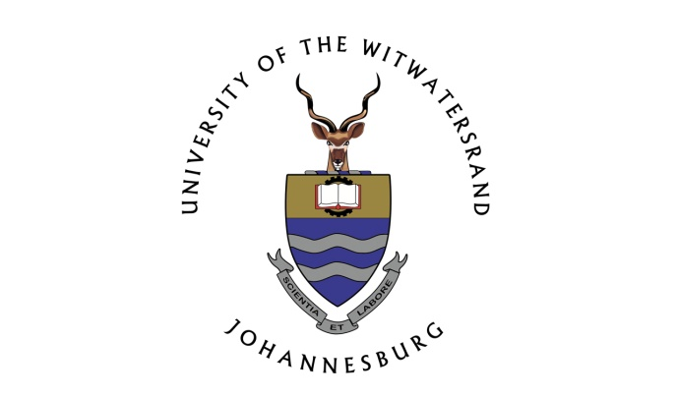

School of Literature, Language and Media

Department of Linguistics

The language of post-apartheid urban development:
The semiotic landscape of Marshalltown in Johannesburg

By

Gilles Baro

Student No. 701673

A dissertation submitted to the School of Language, Literature and Media, Faculty of Humanities for the degree of Doctor of Philosophy

Supervisor
Prof. Tommaso M. Milani
March 2017

DECLARATION
I, Gilles Baro, declare that this research report is my own unaided work except as stated in the acknowledgements. No other person’s work has been used without due acknowledgment in the main text of the report. It is submitted for the degree of Doctor of Philosophy at the School of Literature, Language and Media, Faculty of Humanities, University of the Witwatersrand, Johannesburg. It has not been submitted before for any degree or examination at any other universities.
Signature of Candidate Date: _____________

Gilles Baro
Student Number: 701673

ABSTRACT
Although the burgeoning fields of linguistic and semiotic landscapes (LL and SL) studies provide extensive coverage of urban settings around the globe, it lacks a focus on urban development and the associated phenomenons such as gentrification, with the notable exception of Lou (2016). This dissertation looks at the neighbourhood of Marshalltown, located in the inner city of Johannesburg. Marshalltown is known as the mining district because of its proximity to the original goldmines that sparked the growth of the city. The neighbourhood’s SL has radically shifted from a place of urban decay to a trendy neighbourhood since the late 1990s, after urban development efforts financed by the private sector made the area stand out from the rest of the inner city. The developers working in Marshalltown have purposefully filled it with signs indexing the mining heritage its businesses which tend to cater to the middle-to-upper-classes, thus excluding poorer residents which make up most of the inner city’s population.
Against this backdrop, the dissertation aims to answer the following three research questions: 1) How is Marshalltown constructed as a space of heritage, both in its materiality and in its representation in a corpus of media texts? 2) Considering that heritage entails a selection process from a more general historic field, which sections of history are curated in Marshalltown’s SL, which are silenced, and what are the implications for the narratives displayed in the context of post-apartheid South Africa? 3) How is Marshalltown’s urban environment experienced by social actors in a context of globalized trends in urban design which rely on heritage and authenticity to market formerly ignored city centres?
The data for this study consists of a corpus of 25 media articles from various outlets, 255 photographs of Marshalltown and its vicinity, ethnographic field notes written between 2012 and 2016, as well as interviews with developers, heritage architect, a deputy director of immovable heritage at the City of Johannesburg, shop owners and people who work in the area.
This dissertation aims to contribute to the young field of SL studies, while bringing forth Scollon and Scollon’s (2003) methodological toolkit of geosemiotic which allows for an analysis of signs in place and how people interact with them to draw a pertinent analysis of the construction of place. Geosemiotics is coupled with specific themes for each analytical chapter which brings forth a new way of analysing a SL. Those themes are 1) the language of urban development which drawing on Markus and Cameron (2002) helps analyse the representation of city neighbourhoods; 2) heritage, which brings a temporal perspective to SL studies that I call a chronoscape; 3) authenticity, which brings a visual analysis addition to the recent debate on the topic within sociolinguistics scholarship (Coupland 2003, Bucholtz 2003 and Eckert 2003) and its focus on the discursive construction of what counts as authentic.
This study argues that Marshalltown’s post-apartheid SL is carefully designed by a majority of (white) developers wanting to give the area a heritage feel, borrowing from the mining history of the city; thus anchoring a European influenced heritage within their own interpretation of what an African city should look like. The heritage feel of Marshalltown is part of a broader plan to reclaim the city, which means changing the image it acquired previously during an era of urban decay as a dangerous no-go area, into an attractive tourism-friendly urban space. Those changes are achieved by inserting development efforts into the market for authentic urban lifestyle which Marshalltown can provide thanks to its preserved history. The neighbourhood stands out from the rest of the inner city by being privately controlled and maintained thus distancing itself from the popular discourse of inner city Johannesburg and instead developers redesign it as an ideal space for consumption.

Keywords: urban development, semiotic landscape, linguistic landscape, sociolinguistics, heritage, authenticity, gentrification, privatization, CSR, Johannesburg, post-apartheid, memory, amnesia, visual culture.
Keywords: sociolinguistics, urban development, white capital, heritage, authenticity, semiotic landscape studies

AKNOWLEDGMENTS
Many people have made the completion of this dissertation possible. First of all, I am grateful to the participants involved in the life of Marshalltown for allowing me to interview them and share their thoughts and stories relating to the neighbourhood. Because of the lack of academic research on the topic, your insights and knowledge were extremely valuable in helping me make sense of Marshalltown today.
Furthermore, I am thankful for the guidance, support and mentoring I received from my supervisor, Prof. Tommaso M. Milani. From the drafting of the proposal to the last minute comments, Prof. Milani has encouraged me to take ownership of my ideas and provided me with a lot emotional support when I struggled with my writing. His many comments on the multiple drafts have pushed me to write more intelligibly and to shape my ideas more clearly. I am additionally appreciative of Libby Meintjes, Nicky Falkoff and Polo Moji for taking the time to read and comment on parts of this dissertation.
I am deeply grateful to the School of Literature, Language and Media for the opportunity to be a teaching assistant for two years which gave me financial stability and invaluable teaching opportunities. I also owe gratitude to the Graduate Centre for awarding me with a PhD completion grant in 2016. Furthermore, I want to thank my colleagues and fellow PhD candidates at the Faculty of Humanities for helping to create a fun, engaging and stimulating environment, particularly Mehita Iqani, Katlego Disemelo, Dylan Valley, Koki Kapa, Lerato Motaung, Saaliha Ahmed, Steven Fielding and all the academics in the Department of Linguistics.
Finally, I would like to thank my partner Meghan Judge for the constant support, inspiration, for taking the time to help me with my frustrations and anxieties and also for reminding me to take breaks. I want to also thank my mother for teaching me to question the meaning of things at an early age and without realising it made me fall in love with visual culture through her brilliant mind and her capacity to read any sign. I am thankful to my father for the unconditional support and for having faith in me. Lastly, a big thank you to friends who helped me believe in myself and inspired me to keep going.
This dissertation is dedicated to all the students and workers fighting for free education in South Africa. You have taught me so much.

TABLE OF CONTENT
CHAPTER 1: INTRODUCTION 8
CHAPTER 2: LITERATURE REVIEW 16
2.1 The beginnings of a field 18
2.2 Linguistic landscape 28
2.3 The qualitative turn in LL studies 35
2.4 Semiotic landscapes 42
2.5 Summary 48
CHAPTER 3: ANALYTICAL AND METHODOLOGICAL FRAMEWORK 50
3.1 Socio-semiotic landscapes 50
3.2 Geosemiotics 59
3.3 Chronotopes 66
3.4 Summary 69
CHAPTER 4: THE LANGUAGE OF JOHANNESBURG’S INNER CITY 76
4.1 The Language of the urban 77
4.2 Representations of Johannesburg’s inner city 81
4.3 Urban development as a signifier for safety in the city 88
4.4 Smellscape of Johannesburg’s inner city 107
4.5 Urban enclaves or the new private spaces 119
4.6 Compassionate capitalism as urban regeneration: The case of Anglo American 136
4.7 Summary 144
CHAPTER 5: HERITAGE IN THE CITY 146
5.1 The chronoscape 149
5.2 Heritage as memory and nostalgia 155
5.3 Africa in the city 174
5.3.1 Africa in typography 183
5.3.2 Blackness in photographs 202
5.4 The Gold Mine Café 208
5.5 Invisible heritage: Semiotic landscape of amnesia 215
5.6 Summary 227
CHAPTER 6: AUTHENTICITY 229
6.1 Authenticity and urban development: A historical overview 230
6.2 The debate on authenticity in sociolinguistics scholarship 240
6.3 Authenticity and Heritage in Marshalltown 245
6.4 ‘The Sheds’ and the authentic urban lifestyle 253
6.5 Urban Aspirations and the Language of Gentrification 264
6.5.1 Reclaiming Johannesburg 272
6.5.2 The Gentrification of Johannesburg 278
6.6 Summary 288
CHAPTER 7: CONCLUSION 290
LIST OF REFERENCES 302

LIST OF ILLUSTRATIONS
Figure 1. Location of the original Marshall Square. 87
Figure 2. Security officer controlling pedestrian and car traffic in Marshalltown. 93
Figure 3. Flags installed on Marshall Street by the SWID. 106
Figure 4. Sidewalk sign as found on each entrance into the FNB Bank City district. 133
Figure 5. Defensive architecture in FNB Bank City. 135
Figure 6. Signage on the Anglo American campus along pedestrianized Main Street. 138
Figure 7. More signage on the Anglo American campus. 139
Figure 8. Scaffolding in front of the former Standard Bank headquarters on Main Street. 156
Figure 9. London House on Loveday Street after renovation in 2015. 159
Figure 10. A map of Johannesburg’s inner city Blue Plaques. 161
Figure 11. Mining headgear at the corner of Main and Simmonds Street. 167
Figure 12. One of the old stamp mills, displayed between Main and Marshall Street. 168
Figure 13. Engines displayed on a side-walk. 169
Figure 14. Recycled mine vent, now a rubbish bin on Main Street. 170
Figure 15. The turret on Marshall Street. 171
Figure 16. Street sign for “Marshall Street” in front of the turret. 172
Figure 17. FNB’s “Urban Savannah”. 175
Figure 18. The façade of two buildings owned and managed by OPH. 180
Figure 19. Building owned by the Anglo American Corporation on Main Street. 184
Figure 20. Neuland as showcased by its designer, Rudolf Koch in 1923. 188
Figure 21. Restored edition of Richard Wright’s 1940 novel “Native Son” with the original cover. 190
Figure 22. Promotional logo for the film Jurassic Park (1993). 192
Figure 23. Promotional poster for the 1997 film “George of the Jungle”. 194
Figure 24. An article in The Times Record & Roane County Reporter. 195
Figure 25. Cover for Herbie Mann’s 1959 album “African Suite”. 195
Figure 26. Cover of “Dancing the Blues” by African American blues artist Taj Mahal. 197
Figure 27. Promotional flyer designed by Andile Cele of DOPE Store. 199
Figure 28. Promotional poster for the movie “My Life in Ruins”. 201
Figure 29. A rare representation of black people in Marshalltown. Here on Marshall Street. 206
Figure 30. Photograph illustrating the Langlaagte Stamp Mill on the Main Street Mall. 207
Figure 31. Authentic elevator shaft sign on display on the walls of Gold Mine Café. 210
Figure 32. Menu from the Gold Mine Café. 211
Figure 33. Other signs index the mining industry in the Gold Mine Café. 214
Figure 34. Old tram railways coming out of the tarmac after years of wear. 216
Figure 35. The Instawalk group poses in front of the BHP Billiton Ltd. Headquarters. 217
Figure 36. Gandhi Square as seen looking east towards the Absa tower, seen in the background. 222
Figure 37. Left-over white paint thrown on the defaced statue of Gandhi on Gandhi Square. 226
Figure 38. The headquarters of the Mutual & Federal insurance company on Pritchard Street. 250
Figure 39. Poster for a festival held at One Eloff in May 2016. 254
Figure 40. Parking sign adjacent to The Sheds. 257
Figure 41. Parking sign at The Sheds. 258
Figure 42. Brick wall in The Sheds to symbolise the past. 259
Figure 43. Wooden structure in The Sheds used to symbolise the past. 260
Figure 44. Display in the Sheds reminiscent of egg baskets at a farmers market. 262
Figure 45. Newly renovated apartment building on Rissik Street offering “New York Style Living”. 268
Figure 46. Poster inside Cramers Coffee on Main Street. 269

CHAPTER 1: INTRODUCTION
On May 10th 1994, Nelson Mandela was inaugurated as the first president of post-apartheid South Africa. A concert in Johannesburg that day to celebrate the event was headlined by African American soul singer Timmy Thomas, whose song “Why Can’t We Live Together?” had been a big hit in the country in 1972, especially among the oppressed black population. The song had been written in reaction to the deaths of young American soldiers in the Vietnam War. The simple lyrics spoke to a South Africa where people of non-European descent were not able to move or live wherever, or be with whomever, they chose. Indeed, in Johannesburg’s inner city, black workers had to carry at all times a “pass” that determined the amount of time they were allowed in the city before having to return to their place of residence in “townships”. The song became the anthem of the inauguration at the request of Nelson Mandela (according to Timmy Thomas) because it fit the rainbow nation discourse of the young post-apartheid South Africa, where previously divided communities based on racial factors were invited to “move on”, “forget the past” and live together in peace and harmony.
In 1974, when Nelson Mandela was still incarcerated on Robben Island, Timmy Thomas came to South Africa to perform in Soweto. Below is his recollection of the event in a recent interview from 2016:
I had the opportunity to go to South Africa in 1974. Now this is not… I was not the first black person to play in Soweto, I was the first American. ‘Cause nobody else would go because of the apartheid, which means division of races, I didn’t know anything about that either. In my history books, they talked about diamonds… gold. You know? They didn’t go down and say: oh by the way, they have division of races, apartheid, and this and that. So I never knew it. I’m on my way to a country where a lot of people wouldn’t go because they were afraid something might happen. Black or white, you know? [...]
The fact that apartheid was omitted from Timmy Thomas’s history book was not an accident. The positive image of South Africa rendered by mentions of diamonds and gold served as a mask for the ideology of apartheid, whereby people where classified and treated unequally based on their race. While apartheid was not exactly popular around the world, due to growing international awareness of its racist policies and repression of social movements, the image of a modern, sophisticated, rich, and quasi-European state at the tip of Africa endured. This dissertation looks at a site where the foregrounding of South Africa’s gold and diamond mining heritage similarly seems to eclipse its apartheid past, in the context of urban development. A study of what is included, and what is excluded, in the landscape of Marshalltown, located in the inner city of Johannesburg, which serves as the site of study for this dissertation, will show how these historical discursive processes play out in the present.
Marshalltown is known as the mining district because of its proximity to the original goldmines that sparked the growth of the city. It is the historic location of the headquarters of many mining houses. The neighbourhood’s semiotic landscape (henceforth SL) has radically shifted from a place of urban decay to a trendy neighbourhood since the late 1990s, after urban development efforts financed by the private sector made the area stand out from the rest of the inner city. This process of urban development is what this thesis will explore. Marshalltown is filled with signs indexing “diamonds and gold” as well as the respective industries which excavated them and the (white) people in charge of those operations. At the same time, one might think that Marshalltown had been spared by apartheid, as signs referencing this era of the country’s history are lacking. It is as if the neighbourhood did not have the “division of races” as explained by Timmy Thomas in the interview above, because all the signs indexing its past do not refer to apartheid. Against this backdrop, I aim to look at the SL of Marshalltown’s urban development, a task pursued by others in different contexts: Gendelman and Aiello (2010) looked at the renewal of building façades in the former Eastern European bloc after the collapse of the USSR; Papen (2012) examined Berlin’s Prenzlauer Berg since Germany’s reunification; and most significantly Lou (2016) worked on Washington D.C.’s Chinatown. The main aim of this thesis is to bring under close scrutiny the signs found in Marshalltown’s SL, as well as representations of Marshalltown in the media, with a view to understanding the relationship between language, heritage and urban development. More specifically, the dissertation aims to answer the following three research questions:
1) How is Marshalltown constructed as a space of heritage, both in its materiality and in its representation in a corpus of media texts?
2) Considering that heritage entails a selection process from a more general historic field, which sections of history are curated in Marshalltown’s SL, which are silenced, and what are the implications for the narratives displayed in the context of post-apartheid South Africa?
3) How is Marshalltown’s urban environment experienced by social actors in a context of globalized trends in urban design which rely on heritage and authenticity to market formerly ignored city centres?
The data I have collected for this study comprise a corpus of 25 media articles from various outlets such as the City of Johannesburg’s official website, lifestyle blogs, and opinion pieces. I have also taken 255 photographs of Marshalltown and its vicinity, as well as field notes written whilst walking or cycling through the area at least once a week from 2012 to 2016. Finally, the remainder of the data consists of interviews with the social actors (Scollon and Scollon 2003) of Marshalltown, such as developers John Dewar and Gerald Olitzki, heritage architect and consultant at the Gauteng Provincial Government Brian Kent McKechnie, deputy director of immovable heritage at the City of Johannesburg Eric Itzkin, shop owner Andile Cele, and former Standard Bank employee Hussain van Roos.
The dissertation is divided into seven chapters, including three analytical ones. Chapter 2 introduces the theoretical framework by presenting an overview of the literature on SL. The chapter also offers some theoretical clarifications on the notion of landscape and the field of semiotic studies which, I believe, have been missing in the framing of SL studies. The field’s methodological framework will be discussed in chapter 3 as I introduce the analytical toolkit with which I analyze the signs in Marshalltown, namely Scollon and Scollon’s (2003) geosemiotic approach, which looks at discourse in place through a nexus of three semiotic systems which index meanings of social actions taking place in the material world: interaction order, place semiotic and visual semiotic. This analytical framework runs through all three analytical chapters of the dissertation as a way to unearth the meanings contained in the signs of the SL of Marshalltown, in terms of their discursive representation (chapter 4), links with the past (chapter 5) and authenticity (chapter 6). At the end of chapter 4, I introduce Bakhtin’s (1981) notion of the chronotope, which is useful in order to understand the construction of time-space in Marshalltown, meaning how certain spaces come to represent certain eras, and the geosemiotic tools required to achieve this.
The analytical section of the dissertation begins with chapter 4, in which I focus on the discourse employed by property developers to frame Marshalltown as “different” from the rest of the inner city. It follows Markus and Cameron’s (2002) work on language architecture, applied to urban development. They argue that language is necessary in the construction process, and that the study of this language enables us to get a better picture of how buildings come to be represented and experienced. I attempt then to apply Markus and Cameron’s (2002) approach to a broader urban design setting whereby the language used by developers and planners is analysed to investigate the representation of Marshalltown, and how it compares to the rest of inner city Johannesburg. In this chapter I sketch the historical background of Marshalltown, and then analyse representations of “safety” and “cleanliness” in the city. This latter theme of cleanliness is presented in conversation with Pennycook and Otsuji’s (2015) notion of the smellscape, explores the salience of smell in the otherwise sight-oriented SL tradition. Their proposal is to analyse the smell of a particular SL in order to make sense of it, and I thus look at how smell and cleanliness are represented and interacted with in Marshalltown, and the greater inner city of Johannesburg. I then interrogate the urban planning practice of the private sector active in the area. Indeed, parts of Marshalltown have become private spaces since the beginning of post-apartheid development and I will present how it was achieved, and which ends this served from the perspective of the developers I interviewed. Chapter 5 presents my findings about how heritage is discursively constructed in Marshalltown, using a methodology that I introduce as the ‘chronoscape’, which focuses on the factor of time in SL analysis. Signs in Marshalltown are investigated with particular attention to the era(s) they index. The built environment is also looked at from a diachronic perspective as certain objects such as street signs have had their meaning altered between the times of their conception, and current development efforts in Marshalltown. Initially, I illustrate heritage in the overall landscape of the neighbourhood, first in terms of nostalgia and second in terms of the representation of ‘Africa’. Then, I zoom into a particular space – the Gold Mine Café, and its mining theme – before questioning the invisibility of some of the alternative histories of Johannesburg, which are missing from Marshalltown’s SL. Finally, chapter 6 explores the role played by “authenticity” in the discourse of urban development. I analyze empirical data from specific parts of Marshalltown, and then use the analysis to investigate the similarities with different urban development contexts under the umbrella of the global discourse of gentrification. I argue that a discourse of authenticity is used to legitimize the signs of heritage in Marshalltown and, looked at in relation to global contemporary urban development in the West, to make the area attractive for the middle-to-upper-classes. In this last chapter, I aim to broaden current discussions about authenticity within sociolinguistics (Eckert 2003; Bucholtz 2003; Coupland 2003), arguing for the importance of considering visual elements in the production of authenticity in urban spaces. I conclude the dissertation with a discussion on post-apartheid urban development in Marshalltown, in which I review the answers I have found to my research questions, and propose future directions of investigation based on the mixing of theories and concepts I applied in this dissertation.

CHAPTER 2: LITERATURE REVIEW
In this chapter, I offer an overview of different strands of research that have investigated meaning-making systems (including language) in their material and representational forms, and space. The two disciplines most commonly attached to these areas of research – linguistics and geography – have tended to avoid each other. In the Anglo-Saxon tradition, geographers have typically not to paid attention to the language(s) found in space. On the other hand, it is only in the 1990s that linguists started to take into serious account the “material world” of linguistic artifacts.
As an exception to this division it could be mentioned that as early as 1974, a group of French linguists and semioticians questioned the dismissal of linguistic and semiotic analytical tools within the field of geography and the study of space more broadly. Drawing upon Saussure’s theorisation of the “sign”, they argued that
[...] we wish to search, within current and old scholarship by geographers, implicit (and even explicit) traces of a reflection which distinguishes, using different terms, 'signifier' and 'signified' – and why this reflexion does not seem to have resulted in essays of formalisation: was it because of a justified reluctance to transpose methodologies from the field of linguistics? Or because of overly diverse preoccupations? (Berdoulay, Bertrand, Brunet, Claval, Dollfus, Durand-Dastès, Fel, Metton, Piveteau, Raffestin, Robic and Rougerie, 1974: 152) [Own translation]
Furthermore, the group called for elements present in any landscape to be treated as signs:
Any element of the landscape being produced (voluntarily or not) by nature and/or by men should have the possibility to be considered as a sign, containing one of more signifiers (what is visible) and one or more signifieds (what the signifier refers to: the action, the system which left some marks). (1974: 150) [Own translation]
Against this backdrop, I want to provide in what follows a reflection on the importance of the notion of sign in the study of space and place within the field of (socio)linguistics, how its definition came to be contested, especially in the field of linguistic landscapes, and, how there seems to be a return to a conceptualisation of the sign that is very much similar to the one quoted above, at least in the burgeoning field of semiotic landscapes studies (Jaworski and Thurlow 2010).
My goal here is not to answer the question asked above – namely why scholars in the field of geography tend not to use linguistic terminologies – as such a task would require an overview of pluridisciplinary human geography studies, some of which have borrowed concepts from the field of linguistics. Instead, I argue that linguists and semioticians have taken up the task themselves of applying their analytical tools and terminologies - such as ‘signifier’ and ‘signified’ - to the study of space and place, usually reserved to geographers.
Within sociolinguistics scholarship, the study of how people use language in particular environments has been taken up under the umbrella of two main sub-fields of sociolinguistics research, namely linguistic landscapes (henceforth LL) and semiotic landscapes (Henceforth SL). One of the main differences between a linguistic and a semiotic approach to signs lies in the very definition of what counts as “language”. While some scholars subscribe to a view of language as “verbal” or “written” code, others take a broader approach according to which language is any form of meaning-making system, thus including visual images, bodies, emotions, and any other forms of communication (Kress and van Leeuwen 1996; Machin 2007). However, the borders between LL and SL are very fluid, as scholars share theoretical frameworks, and even those who take a broad view of language as meaning-making practices might position themselves under the label of the “linguistic.”

2.1 The beginnings of a field
Arguably, the first researchers to employ the expression “linguistic landscape” were Landry and Bourhis (1997), in an article reporting on the perceptions by Francophone high school students of public signs in Canadian provinces. There, they famously stated that “the language of public road signs, advertising billboards, street names, place names, commercial shop signs, and public signs on government buildings combines to form the linguistic landscape of a given territory, region or urban agglomeration” (1997: 25) [emphasis added]. This first definition would later become the groundwork for the field of research known today as LL.
In order to investigate the different power and status of linguistic communities in a particular territory, Landry and Bourhis (1997) studied the visibility and salience of the languages of such communities on the public and commercial signs of that territory. They worked with three main hypotheses: 1) that the experience of the LL by members of the linguistic community would have a positive effect on their bilingual development; 2) that this effect would be more important to speakers of a particular language than other factors of their various identities such as class or gender; and 3) that language use, especially within commercial and public institutions, would be affected by its frequency on public signs in the LL, proving a “carryover effect”. These statements raise the following questions: 1) if there is a large number of signs written in a particular language in a given space; would this influence the acquisition of that language by the people inhabiting the space? 2) Would that effect be more salient than, say, their ethnicity? 3) Would the presence of a language in the LL affect its use in conversation?
The ethno-linguistic context in question was francophone Canada and the maintenance and vitality of the French language. Following their definition of a LL mentioned above, Landry and Bourhis (1997) concentrated exclusively on written codes on public signs, as opposed to other forms of communication such as sounds or images.
To test their hypotheses, they first considered language policies, and noted that linguistic territories were defined with the help of regulations of language use on government and private signs. For example, they noted that language policies determined which languages should be used in public signage, and which should not. Landry and Bourhis distinguished between government signs and private signs. The former were defined as “public signs used by national, regional, or municipal governments in the following domains: road signs, place names, street names, and inscriptions on government buildings including ministries, hospitals, universities, town halls, schools, metro stations, and public parks” (1997: 27). Private signs were instead “commercial signs on storefronts and business institutions (e.g., retail stores and banks), commercial advertising on billboards, and advertising signs displayed in public transport and on private vehicles.” (1997: 26). They noted that the private signs often showed more linguistic diversity, except when a government imposes requirements for private signs as well.
Besides language policy review, Landry and Bourhis also conducted a survey of grade 11 and 12 students from certain provinces of Canada. They investigated 2,010 Francophone students, who come from regions as diverse as Quebec – where the population is 99% francophone - and Newfoundland where they only constitute 1% of the population. Two different sets of variables were considered: Individual Network of Linguistic Contacts (INLC) variables, and psychological variables. The INLC variables consisted of three types of contact: 1) interpersonal contacts (proportion and frequence of contacts with francophones) 2) contacts with the French media (access to twelve different media sources since childhood) and 3) educational support (the degree of instruction in French and English, dimension of the linguistic ambience of the school, including the language of school materials as well as on posters and message).
The psychological variables dealt with three different dimensions: 1) beliefs in ethnolinguistic vitality (EV), 2) the ethnolinguistic identity of the students and 3) their language behaviour in French. In order to calculate the beliefs in EV, the subjective EV of the school and the students’ desire to belong to the francophone community were contrasted. For their ethnolinguistic identity, students were asked to rate their francophone identity according to culture, language, ancestors, the future, education received, ethnicity and territory. Finally, for language behaviours in French, students rated how often they used French in relation to relatives, other students, friends outside of school, social gatherings, cultural activities, etc.
The results were then analysed statistically with the help of factor analysis and regression analysis with a view to testing the three hypotheses mentioned above. Factor analysis verified the first hypothesis, that indeed, the LL “emerges as a distinct factor in bilingual settings such as those that exist in different provinces across Canada” (1997: 42). Regression analysis also verified the second hypothesis, leading Landry and Bourhis to conclude that “the French linguistic landscape experienced by the respondents was a significant correlate of subjective francophone vitality” (1997: 45) and that “the linguistic landscape, at least in the Canadian context, may indeed constitute the most visible and most salient marker of perceived in-group versus out-group ethnolinguistic vitality” (1997: 45). Finally, the third hypothesis was also verified as they claimed the existence of a “carry-over effect of the linguistic landscape on language behaviours” (1997: 45).
In other words, their study showed that the presence or absence of French in the LL had an effect on francophone vitality. The variables suggested a carry-on effect: the more French was present in the LL, the more it positively influenced the language behaviour of the people in that area in their in-group language, in social gatherings and in cultural activities. They thus concluded that “the presence of private and government signs written in one’s own language may act as a stimulus for using that language and thus contribute to its vitality” (1997: 45). Landry and Bourhis also argued that their study justified the analysis of the LL as a salient way to do research on the sociolinguistic character of ethnolinguistic groups, urging language planners and language activists to look at other LLs in order to “promote language maintenance and language shift” (1997: 46) but also for the purposes of “consolidating the vitality of their own ethnolinguistic groups in multilingual settings” (1997: 46).
While these results might have been true of the specific situation of Francophone Canada, the same cannot be said of migrants’ languages and their visibility in the Italian LL. As Barni and Bagna’s (2010) study demonstrated, “there is no direct relationship between the presence of a language in an area, its vitality and its visibility” (2010: 15). Such a conclusion is built on a variety of factors such as the characteristics of the area where migrants settle, how long they stay, and the attitudes of the speakers towards their own language, as some do not feel the need to have their language represented in the local LL for the purpose of assimilation.
Landry and Bourhis might have been the first to coin the expression “linguistic landscape”, but, as I mentioned earlier, they were certainly not the first ones to investigate signs in public spaces. A comprehensive overview of this literature has already been offered by Backhaus (2007: 66-68) in his book on urban language contact in the written form on signs in Tokyo, so I will not repeat it here. Instead, what I want to do in the remainder of this section is to concentrate on two studies which have in my view been particularly significant for the development of LL as a field of inquiry. These are Spolsky and Cooper’s (1991) investigation of multilingualism in Jerusalem, because of the scale of their research and the fact that their methodology has been replicated in several other contexts over time, and Calvet’s (1990; 1994) analysis of Dakar because it is arguably the first LL study of an African city.
Spolsky and Cooper’s (1991) study concentrated on the complexity of language patterns present on street signs, advertising placards and building plaques. After some historical and contextual background about the old city of Jerusalem, they delve into the visibility of multilingualism on public signage. Such an interest was sparked by a sign they noticed on a shop window which read: “ENGLISH, ARABIC & HEBREW NAMES IN GOLD & SILVER”. Even though this sign makes reference to three different languages – English, Arabic and Hebrew – it is actually monolingual and in English. This feature lead Spolsky and Cooper to comment that it was most likely aimed at foreign tourists, which made this sign interesting in that, albeit monolingual, it marketed multilingualism to a variety of potential customers. A second set of signs – this time multilingual – are then brought into focus: two street name signs placed very close to each other, written in three languages, both signs in the same order: Hebrew, then Arabic, and then English.
Spolsky and Cooper argued that these two signs were recent records of the history of the city, as one sign was first designed to be trilingual with the English name translated from the dominant Hebrew one, whereas the second one had been set up at a previous time and was designed to be only bilingual, with the English name translated from Arabic, the dominant language at the time, before having the Hebrew name added later on, suggesting a change in power and language policy in the city, following the annexation of East Jerusalem to Israel in 1967. In other words, they argued that the signs contained multiple scripts as well as languages, because they matched the reality of multilingualism in spaces of the old city such as the market place. For them, the power relations between social groups – such as the Jewish and Arab population, as well as tourists – are translated onto the linguistic signs.
They then collected a corpus of 339 signs containing 12 languages, including Hebrew, Arabic, English, Armenian, French, German, Aramaic, Greek, Italian, Latin, Coptic, and Swedish. These signs were of eight different types: street signs, advertising signs, warning notices and prohibitions, building names, informative signs, commemorative plaques, signs labelling objects, and graffiti. They argued that the choice of these languages was interesting, especially considering the absence on public signage of about thirty other languages claimed to be spoken by people they interviewed who lived in the old city, such as Turkish, Spanish or Romany. The three main languages in the corpus, however, did correspond to the languages claimed to be spoken by people in the old city: Arabic (88%), English (45%) and Hebrew (31%) (1991: 13).
Spolsky and Cooper analysed the signs in light of three “rules”: 1) the limitation of the sign to languages that the sign-writer knows; 2) the preference to write signs in the language or languages that intended readers are assumed to read; 3) the preference to write signs in one’s own language or in a language with which one wishes to be identified. Rule 1 allowed Spolsky and Cooper to demonstrate the reason behind the dominance of Arabic, English, and Hebrew in their corpus, as local sign-makers tended to speak the most common languages of the area. The rule also explained the prevalence of grammatical errors and spelling mistakes in their corpus, as sign-makers can have varying degrees of knowledge in a particular language, and also why the medium of the sign influences its languages as permanent signs tend to use fewer languages and are more likely to have been made by an expert. Rule 2 explained that the major motivation of a sign-writer is an economic one, and thus aims to transmit information and be read by as many potential readers as possible. Finally, rule 3 marks the importance of symbolic value in the decision-making process. Indeed, “just as language use can proclaim a speaker’s regional origin or educational level, so the language of a sign can proclaim the language loyalty and values of the sign-writer” (1991: 84). In other words, it is what the writer of the sign wants to do with the language he or she chooses, how to “declare power over the space designated” by “controlling the languages of the sign” (Spolsky and Cooper, 1991: 85) and how to claim solidarity or identity; it is the choice of the language which becomes the message. The writer will be identified through this choice.
These three rules are applied to the deeper analysis of the corpus in order to answer questions such as why advertising signs are not in at least the first three languages. Why aren’t signs written in more languages? Why do certain signs such as warning and informational signs have the same three languages but in different order over time? Why do names on buildings and homes reflect the greatest variety in languages? This deeper analysis also investigates why commemorative plaques sometimes include translations directed at tourists, even though the main language reinforces the ownership of the plaque, or how rule 1 governs graffiti, meaning that the writer used his or her own language, unless aiming to inform a broader audience, such as reminding passersby of the Armenian genocide. A particularly interesting example is when Arabic is erased from signs at a police station. This example is analysed as a political statement from the powers in charge of the conception of these signs, as explained by Spolsky and Cooper:
The use of these bilingual police signs, on which one of the languages is not an official language, is doubly insulting: there is room for two languages, but there is no room for Arabic. […] To Arab residents of the Old City the bilingual police signs give a clear message: the Old City, in which you are a majority, is not under your control; this police station, staffed primarily by Arab policemen, is not your station; this state is not your state. (1991: 116-117)
This example emphasizes their conclusion that the old city of Jerusalem's LL was influenced by political regimes and that the politics of the state of Israel could be mirrored in the languages used on street signs. They noticed that for the majority of the signs, the sign-writer's language is presumably on its own or used in the first position, following rule 1. And in most of these cases, rule 2 also applied. Thus, the assumed reader of the sign has his or her language present on the sign, alone or in first position. This means that the political powers in charge of making these signs enforced mostly their own language and expected speakers of this same language to be the main readers of these signs, symbolically excluding certain languages and their speakers. They even noticed that attached to buildings of foreign institutions, many signs did not contain the language of the assumed reader, thus implying that the symbolic value of the sign is more important or as they claimed: “Proclaiming ownership of the sign is more important than being understood” (1991: 85).
Nearly at the same time as Spolsky and Cooper analysed the LL of a section of a larger urban area, Calvet (1990; 1994) conducted a comparative study of two cities, Paris and Dakar, which display a high degree of linguistic diversity as a result of migration flows. In Paris, Calvet found that some linguistic communities are much more visible than others in the LL, such as ”Asians” (sic) and North Africans, as opposed to the Spanish and the Portuguese, for example. He paid particular attention to the neighbourhood of Belleville, which displayed a high density of signs with Arabic and ‘Asian’ scripts. He argued that signs on Chinese restaurants served two functions in this context: to signify “authentic” Chinese food for non-Chinese speaking Parisians, and to give information about the restaurant to the Chinese-speaking patrons, such as the restaurant’s menu and the type of cuisine it serves (1990: 76).
In Dakar, Calvet (1994) analysed language usage on the city’s walls. Wolof, the most spoken language, is considered the language of integration, whereas French, which is the official language, is considered the language of power (Calvet 1994: 208). Finally, Arabic, the language of religion, is also present in the city’s LL. Calvet makes a distinction between what he refers to as in vitro and in vivo signs, which, according to Backhaus (2007: 44), is a very similar to the top-down and bottom-up taxonomy (Ben Rafael et al. 2004; 2006). Briefly, in vitro or top-down refers to signs written by the state actors and institutions such as place names, traffic signs, etc. On the other hand, in vivo or bottom-up refers to signs written by citizens such as billboards, advertisements, graffiti, etc. For Calvet, this distinction is important because it allows us to indicate “two different ways of marking the territory” (1990: 75; emphasis in the original). Looking at the walls in Dakar, Calvet found three languages and two scripts for in vivo signs: French, Arabic and Wolof written in either Roman or Arabic script. The in vitro signs, however, were only in French, which had kept its power as the language of the colonial administration, even in postcolonial Senegal. This contrast in the city’s LL revealed a gap between official language policies and language practices (Backhaus 2007: 43-44).
The key difference between the LLs of Dakar and Paris lay in the use of different scripts for the same language, a feature only observed in Dakar. Indeed, Arabic and Wolof could be seen written in either Roman or Arabic script, which according to Calvet (1994) was indicative of contrast between orality and literacy in Dakar. He concludes his comparative study by stating that in both cities, the walls “speak to those who can see and decipher them” (1994: 267), but sees a crucial difference in the relationship between the form and content of the signs. Indeed, in Paris the language determines the graphic form: Arabic is written in Arabic, French using the Roman alphabet, and Chinese in Chinese characters. In Dakar, however, the trend of the society to move from orality to literacy is represented in the “fluctuant” (1994: 268) relationships between language and scripts.
The work summarized thus far was in many ways pioneering, since it was pivotal for the elaboration of a new field of sociolinguistics, giving it its first definition, and introducing a methodological framework. However, this research has focused only on the purely “textual” aspect of signs, leaving out visual and other meaning-making elements. The authors also relied nearly exclusively on quantitative methodologies, counting instances of certain languages on signs in order to make claims about the language vitality and language a policy at work in particular places. Some LL studies are still designed on the basis of such a quantitative approach to public signage (Torkington, 2009; Edelman, 2010; Akindele, 2011; Botterman, 2011), which, as Blommaert (2016) puts it, could be called the “first wave” of LL studies. In his view, this first wave is characterised by “a synchronic, static and quantitative approach to hypostatized ‘languages’ in a given physical arena” (2016: 1). Degrees of multilingualism are compared based on quantitative prevalence of certain “languages” over others, without engaging with the sociopolitical contexts of the studies territory, and its actual language practices (2016: 1-2).
Blommaert seems to be annoyed by the fact that some LL studies still use these methodologies, as can be seen from his fierce critique of an article by Ben-Rafael and Ben-Rafael (2015) published in the inaugural issue of the journal Linguistic Landscape. Similarly to Spolsky and Cooper (1991) and Calvet (1990; 1994), the Ben-Rafael study involves counting instances of languages used on signs in public spaces in three different cities: Berlin, Tel Aviv and Brussels. The most recurrent languages in the LL are seen as the dominant ones, and they are explained as the result of migration patterns and the effects of globalisation. This is a conclusion that Blommaert condemns, by saying that “once more, we see how LL studies practitioners believe that change can be analyzed by looking at everything that does not index it, in ways that preclude any advanced understanding of its dynamics” (2016: 5). This then leads him to “sadly” observe that “the “first wave” of LLS will never really end” (2016: 5).
Blommaert’s critique may be linked to the reluctance of some contemporary studies to follow the kind of ethnographic approach developed by himself and his associates (Blommaert and Maly 2014), who coined the acronym ELLA - Ethnographic Linguistic Landscape Analysis ELLA. It is indeed valid to wonder why scholars engaging in LL studies continue to rely on quantitative “first wave” methodologies. Considering the numerous critiques published on such approaches and the ethnographic, multimodal, online, and material turns in the field, as we will see below, counting instances of languages on signs found in public spaces can be seen as only a rough entry point into understanding the semiotics of public spaces. However, no matter how unnuanced it might be, such an approach should not be dismissed a priori. In the field of language learning, for example, Rowland (2013) and Malinowski (2015) have illustrated how a quantitative approach to LL may be a beneficial first step in language learning as a way for learners to find and engage and identify with the target language in the LL of the classroom and of the city, before moving to more qualitative and multimodal investigations.

2.2 Linguistic landscape
As already mentioned earlier, the language used on signs in the built environment received some attention in the 1990s, but it was only in the 2000s that the large majority of studies would overtly position themselves within the field of LL, borrowed from Landry and Bourhis’ (1997) definition above. The formation of this academic strand of research can be testified by the publication of monographs (Backhaus 2007; Blommaert 2013; Blackwood and Tufi 2015; Lou 2016), edited collections with contributions by scholars from around the globe (Gorter 2006; Shohamy and Gorter 2009; Shohamy, Ben-Rafael and Barni 2010; Blackwood, Lanza and Woldemariam 2016), an annual international series of workshops which have taken place in Tel Aviv, Israel (2008), Siena, Italy (2009), Strasbourg, France (2010), Addis Ababa, Ethiopia (2012), Namur, Belgium (2013), Cape Town, South Africa (2014), Berkeley, USA (2015) and Liverpool, UK (2016) as well as an eponymous journal published by John Benjamins since 2015.
LL studies was placed on a firmer footing following Shohamy and Gorter’s (2009) (re)definition of LL as “the attention to language in the environment, words and images displayed and exposed in public spaces” (2009: 1). This definition marks a clear shift from the one given by Landry and Bourhis (see section 2.1.) Since it broadens the landscape of signs from specific places to “public spaces”, and adds the term “images”, which isn't a medium traditionally studied by sociolinguists, it could be considered a more broadly applicable definition. The public spaces studied using the LL framework have focused mainly on urban areas because of their recurrent and publicly visible multilingualism. Blommaert and Maly (2014) justify this preference because the “late-modern globalized city” offers “detailed inventories of urban multilingualism” due to multiculturalism in urban area in the age of globalization (2014: 1). However, notable exceptions that have analysed the LL of rural areas do exist: Du Plessis (2012) worked on the Free State province of South Africa; Laitinen (2014) studied rural (as well as urban) Finland; and Banda and Jimaima (2015) focused on rural Zambia.
It would be impossible to give an overview or even mention all of the studies conducted under the umbrella of LL studies since Shohamy and Gorter’s (2009) redefinition of the terminology. Because of the geo-political focus of this dissertation on Johannesburg, and South Africa, I want to concentrate here on the LL studies that have investigated South African contexts. Such scholarship tends to unpack how the political shift from apartheid to democracy in the early 1990s affected the country’s LL. For example, Kamwangamalu (2008) explored the emergence of isiZulu-English codeswitching (CS) in South African print advertising, including billboards. Kapatamoyo (2007) investigated the rise of English as a lingua franca, and the growth of indigenous African languages, at the expense of Afrikaans in the televised LL of the South African Broadcasting Corporation (SABC). Kotze (2010) looked at the post-1994 LL in the town of Philippolis in Free State province, and found that the changes in the LL reflected changes in language attitudes and perceptions as English became the dominant language in the LL (even though only 1% of the population speaks English as a first language) whilst Afrikaans became less and less visible. African languages are rather absent from the LL even though they are recognised in the municipality’s language policy, and Kotze (2010) argues that it is because speakers of African languages tend to prefer to use English on signs to create their new identity by power of association. Hibbert (2016) examined discursive practices, and language ideologies in post-apartheid South Africa, particularly how the discourses emanating from the newly ruling African National Congress (ANC) affected people’s identities. In this monograph, Hibbert (2016) also touches on the changing sociolinguistics of post-apartheid South Africa and how those changes have impacted the country’s LL.
Finally, Du Plessis (2010; 2011; 2012) published case studies on the LL of South African municipalities. The first investigation (Du Plessis 2010) explores the municipality of Mangaung which includes Bloemfontein, a historically Afrikaans-speaking city, and the most central city in South Africa. Here the assumption is that the regime change in 1994, and the concomitant transformation of the country’s language dispensation, would be reflected in Mangaung’s LL. Instead of increased multilingualism in the LL, however, Du Plessis illustrates how the most salient change is in the “anglicization” of signs from Afrikaans, which are used as public statements on the transformation of the city. He concludes that the overt language policy – giving equal weight to all eleven languages recognized by the new South African constitution, and which is aimed at “unit[ing] contending speech communities and legitimis[ing] a previously marginalised language” (2010: 92) – is not valued or applied in the LL. Rather, a more covert language policy “from below” (2010: 92) sees the emergence of English as a global language in the municipality.
In the second case study, Du Plessis (2011) casts a critical gaze on the Kopanong municipality, also in the Free State. The research investigates if the new constitutional language requirements such as having one African language on public sign is respected. He argues that the removal of Afrikaans from the municipality’s LL could be due to the fact that the LL seems affected more by national government agencies than by the municipality itself, which is reluctant to promote bi- or multilingual language visibility.
Finally, the third study (Du Plessis 2012) is a response to the first two as he aims to see if similar findings can be found in the rural areas of the southern Free State, as opposed to more urban municipalities. He analysed a corpus of 1,549 signs looking for evidence of change in language choices. Du Plessis indeed found that post-1994 regulations have translated into changes in the LL of the studied sites, which seem to favour English monolingual signs as opposed to English/Bantu-language bilingual signs. He argues that the use of English on monolingual signs is the result of a “perceived language policy” (2012: 279) and the desire for the local population to “move with the times” (2012: 279), trying to avoid language conflicts, and the opening up of the area to tourism.
These three studies provide a general critique of poor implementation of formal language policy in the Free State province, often at the expense of Afrikaans, which seems to pay the price for being a signifier of apartheid. This sees English become the dominant language in the LL, representing post-apartheid South Africa’s opening up to the rest of the world after years of boycotts and sanctions. Du Plessis’ last argument about the effect of the rise of the tourism industry in South Africa on English dominating the LL is relevant to the research presented in this dissertation, as I will develop further in section 5.2. Marshalltown’s LL is greatly dominated by English signs, with monolingual and bilingual Afrikaans and Afrikaans/English signs having become “authentic” markers of a time passed. But, contrary to the municipalities in the Free State, Marshalltown’s language regulations are dictated by the private sector, having acquired the private leases of some of the main spaces of the district.
Two more “first-wave” LL studies taking place in South Africa need to be mentioned, namely Abongdia and Foncha (2014) and Kadenge (2015) who explore the implementation of language policies at two South African universities, the University of the Western Cape (UWC) and the University of the Witwatersrand (Wits), respectively. Both studies celebrate as progressive the new language policies put in place by the Universities after the end of apartheid, in that they seek to include previously marginalised indigenous African languages. However, they found that the change in policy does not translate into transformation in practice. The new language policies remain tokenistic gestures towards the acknowledgment of multilingualism on the two campuses, but the lack of implementation ultimately reproduces a monolingual bias towards English (for Wits) and a bilingual bias towards Afrikaans and English (for UWC). In the case of Wits (Kadenge 2015), the inclusion of Sesotho in the new language policy did not result in increased visibility on the official signage on campus; nor is the language taught to staff or students.
Having now provided an overview of LL studies in South Africa relying on a quantitative methodology, I want to move on to contemporary debates within the LL field. Indeed, LL studies worldwide have not gone unchallenged. For example, reasons why certain LL items are designed and placed in public spaces have been neglected. Indeed, Ben-Rafael (2009) argues that LL is the “only aspect of the urban landscape to be under the direct and instant influence of social actors” (2009: 42). The important point in this statement is that LL is not a fixed setting, but is constantly changing because of a wide variety of factors such as shops closing down, new ones opening up, fliers and posters posted on top of each other on walls, updates of visual displays or changes in the technology of displays, gentrification of a neighbourhood or moving of official institutions. Thus, many different social actors contribute and help shape the LL of a given space, and these actors come from different backgrounds, have different purposes for putting up signs in the urban space and have different means and authorizations. For example, officials in public administrations and independent shopkeepers have different means and aims for installing signs in a city’s landscape.
The critique raised by Ben-Rafael (2009) is about a lack of focus in LL studies on the people who engage with the signs (the readers, the producers, the designers) and a limitation to quantitative research in a diachronic setting, when we take into account the constant change of a LL. Moreover, Huebner (2009) points out that different signs cannot be seen as equal, and that the lack of a clearly identified unit of analysis in LL research is problematic. For example, viewed from Landry and Bourhis' (1997) viewpoint, an entire storefront could be considered a sign. But the storefront itself can be a complex aggregate containing brand names and other texts which themselves could be viewed as signs. Storefronts thus need to be classified into different categories depending on their content, design or location, among other factors, for a clearer analysis. Also, Backhaus (2006) points out that a small sticker with the word “PULL” written on it is as much a sign as a giant banner floating on top of a shop's entrance. They are indeed both signs but probably do not have the same value in terms of possible interactions with passers-by and were not designed with equal resources.
In addition, Huebner (2009) claims that LL “provides no principled way to take into account the variety of possible intended audiences for items found in a given LL” (2009: 72). Indeed, different stores will have different target audiences when it comes to their street signs and the different signs on their storefronts have different assumed audiences. For example, an organic grocery store can have two signs next to each other on its front door, one that advertises for a low price on tomatoes, and one that states that the bathrooms are reserved for customers only. The first sign is designed to be read by people who want, need or simply have the economic capital to buy some organic tomatoes, whereas the second one is designed to differentiate the audience of the sign between possible customers and 'free-loaders' who might want to use the space of the store for the purpose of going to the bathroom only, and not to shop. The sign is then placed on the door for this particular audience, which is often the marginal homeless population. Against this backdrop, Huebner proposes a new framework for the field of LL, to avoid the problems mentioned above: various artifacts found in a given LL should be identified and described by genre. Each genre would share common communicative purposes and would allow researchers to look at the variation found among various genres found in the LL. Then, the artifacts would be analysed in terms of new factors: their placement vis-à-vis their readers and details of their design such as font, frame, colours, highlights, lights and even attached images (2009: 72-3).
Despite the theoretical and methodological shifts in the late 2010s, the field of LL is still facing critiques as its cataloguing of multilingualism in particular territories “failed to explain how the presence and distribution of languages could be connected with specific populations and communities and the relationships between them, or with the patterns of social interaction in which people engage in the particular space” (Blommaert and Maly 2015: 3). As a result, a shift towards more qualitative research, and semiotic approach, emerged in the field, as will be summarised in the next section.

2.3 The qualitative turn in LL studies
A critique of the theoretical and methodological frameworks used in the 1990s such as Huebner’s (2009) or Ben-Rafael’s (2009) have paved the way for what Milani calls “a more qualitative turn” (2013a: 2) with researchers moving away from counting street signs in a whole city or neighbourhood, and instead privileging smaller data sets, sometimes limited to a single neighbourhood (Blommaert 2013) or a street (Stroud and Mpendukana 2009). This shift allows for closer attention to the signs themselves, their meaning-making elements (including visual ones) and their mutual relationships (Blommaert and Maly 2015: 3). Another outcome of the qualitative turn is the introduction of ethnography as a methodology through which to gather and analyse data from a given LL (see Lou 2016: 17 for an overview). Admittedly, over ten years earlier, Scollon and Scollon (2003) had already called for an ethnographic approach to analysing what they call “language in the material world” (see also 2.2.) For the Scollons, ethnography of place helps understand the visual semiotic systems at play and what it means to certain people who traverse that space. Through interviews and participant observation, one can tell what social actors of a location and users of its semiotic systems mean by their actions and signs (Scollon and Scollon 2003: 160). However, ethnography of public spaces received renewed impetus more recently as a result of several theoretical and methodological interventions (see e.g. Stroud and Mpendukana 2009; Lou 2012; 2016; O’Connor and Zentz 2016; Izadi and Parvaresh 2016; Train 2016). The most vocal of these scholars is perhaps Blommaert (2013), who goes as far as suggest that ethnography is the best possible way or even the only way through which to understand the complexity of meaning-making processes in public spaces. For him, space is the central object and concern of analysis, which gives the field an “immense interdisciplinary value” (2013: 5) because space can be the object of analysis in sociolinguistics like it has been in anthropology, social geography, urban studies and sociology of diversity, even though it is studied differently in each one. LL studies would thus mark a move away from a dialectological concern with physical spaces as static canvases or maps onto which dialects could be plotted, to a more dynamic view of space as itself the result of discursive activities. As Blommaert puts it,
Physical space is also social, cultural and political space: a space that offers, enables, triggers, invites, prescribes, proscribes, polices or enforces certain patterns of social behaviour; a space that is never no man's land but always somebody's space; a historical space, therefore, full of codes, expectations, norms and traditions; and a space of power controlled by as well as controlling people. (2013: 7).
Here, space is seen as a fluid and complicated object of research and no longer fixed and predictable. Drawing from this theorization, Blommaert and Maly (2015) propose the previously mentioned qualitative research method ELLA for the field of LL studies. The method relies on four main points: 1) Public spaces are ever-changing social arenas – where power relations and negotiations of identities take place within the constraints of power gate-keepers such as authorities that regulate language usage; 2) In public spaces, communication is bound to certain regimes such as normative conduct and expectations, and it is thus important to ask how space organizes such regimes; 3) Signs in these spaces can be looked at in terms of past (how they were produced), future (their intended audience and expected effects), and present (their non-arbitrary positioning and relation to other signs); and 4) Taking the other three points into account, the LL is understood as a social landscape, where signs index “social relationships, interests and practices, deployed in a field which is replete with overlapping and intersecting norms” (2015: 4-5), some of which are historical. Blommaert and Maly argue that ELLA allows scholars of the semiotics of public spaces to go beyond simply giving an accurate demography of multilingualism of a particular place, but also to “the particular dynamic and complex features of the social fabric of a superdiverse neighborhood” (2015: 5).
Adding on to Blommaert’s problematization of the study of space through ethnographic methods, Lou (2016) analyzes the qualitative turn in LL studies, and particularly the use of ethnography, as a problematising practice that questions the researcher’s gaze, and the nature of what is being gazed at. In her view, the “objective is no longer to map out LL comprehensively from a bird’s eye view but to examine it on the move” (2016: 19). In fact, different people will collect different data while walking, driving or cycling, based on who they are and their privileges, or restrictions, in the given environment. For example, the fact than I am tall allows me to have a broader view of the landscape and notice signs that others would not necessarily. Because people see me as cis-gendered man, I am not subjected to the practice of “cat-calling”. I am also white, which in a place like South Africa implies multiple historical power relations. Indeed, because of growing up under apartheid, black security guards of Marshalltown treat me with respect, since my skin colour still is associated with the (local) ruling class. I am also able to enter guarded closed buildings because I am not seen as a threat or a potential criminal, an identity indexed by black men in the South African context. A LL is then no more a “still artefact” (Lou 2016: 19) but a fluid space, constantly changing because of all of the social actors involved in it.
A key addition to the scholarship on qualitative LL studies is Scollon and Scollon’s (2003) theorisation of language in the material world. Interestingly, the Scollons never overtly aligned themselves with LL studies. One reason for this is that their work consisted of looking at language in place, but taking into account other semiotic systems of meaning-making such as images, and social interactions between social actors. It is important to point out that Shohamy and Gorter (2009), in their definition of LL which introduced a focus on images, do not align themselves with Scollon and Scollon (2003). Indeed, Shohamy and Gorter’s focus was mainly on the multimodal aspect of LL signs within a context of multilingualism whereas Scollon and Scollon (2003) focus on signs as part of social actions in the material world and how they contribute to the construction of place, as explained bellow.
In their view, geosemiotics is the meeting of three main systems: (1) the interaction order (a conversation, a meeting, a walk with a friend in a city park), (2) visual semiotics (the design, layout, and production of all the signs, pictures, books, newspapers, and other images which are either being used by the interaction order or being ignored by them) and (3) ‘place’ semiotics (the built environment along with the ‘natural’ landscape within which the action takes place) (Scollon and Scollon 2003: 8-9). They propose that geosemiotics is very useful when studying any social action or interaction with signs since these actions take place at the intersection of the three systems. As I will argue below, geosemiotics could be particularly useful when looking at waves of tourists going through Marshalltown; their interactions with each other, with businesses, locals, workers, and security guards; the visual semiotic signs found around the place they are interacting in - which visual signs can be found in the area; and finally place semiotics, that which makes the place a tourist area, and defines these passers-by as ‘tourists’. I will give a broader summary of the theorisation and application of geosemiotics as my chosen research method in a section 3.2.
Some significant LL studies have used ethnographic methods, although not explicitly referring to ELLA. For example, Stroud and Mpendukana (2009) looked at multilingualism in the South African township of Khayelitsha through a material ethnographic approach. They investigated the changes in “new multilingual spaces” in South Africa due to the country’s democratic shift and embracing of globalization which resulted in the transformation of how meaning circulates, and the implications for the resemiotization of artifacts in the landscape. They argue that these new landscapes contain “evolving perceptions of multilingualism and localized practices of English and African languages” (2009: 364). They categorised signs from their data as being indicative of either sites of necessity or sites of luxury, which manifest different organizations of language. They argue that “how language is manifested in different types of signage impacts on how space and place is represented and read” (2009: 380). For example, language found in sites of necessity tends to be ephemeral, involving little economic and social investment and prioritising face-to-face interactions, helping to make the township an “imagined local place” (2009: 381). On the other hand, sites of luxury involve signs of more expensive materiality, discourses of aspiration and different linguistic registers, linking the township to other places as indexed in the language (pan-African languages, African American vernacular English, etc.).
While Stroud and Mpendukana looked at landscapes changing due to a democratic shift, Lou (2016) investigates the impact of a different kind of societal change – urban development – on the landscape. Her focus is the LL of Chinatown in Washington, D.C., and relies on ethnographic fieldwork including interviews, analysis of community meetings and policies, as well as photographs of shop signs. Her study looks at the representation of the district – what makes it Chinese? – and how its identity is being produced within the context of urban renewal of a neighbourhood previously mostly populated by Chinese migrants. First, Lou (2016) gives a presentation of the historical and discursive construction of Chinatown as a bilingual space of consumption where the district’s shop signs contain similarities and differences depending on whether they are for Chinese or non-Chinese-owned stores. Indeed, those shop signs rely on a common language choice, layout and emplacement indexing Chinese aesthetic, but they differ in code choice, content and colour. She argues that non-Chinese corporations – having come into the traditionally ethnic enclave as part of contemporary urban development – use Chinese language on their signs in order to “comply with a mandatory design policy in order to gain entry into a profitable central urban location” (2016: 179). Lou’s (2016) study is in a way similar to mine, as it partly relies on Scollon and Scollon’s (2003) methodology of geosemiotics (see section 3.2) and also looks at Chinatown’s LL from a temporal perspective, shedding light on how “multiple socio-historical processes flow into the design of shop signs in Chinatown” (2016: 179). Indeed, she argues that urban development has reconfigured the agency of the Chinese community in shaping the district’s LL because of unequal economic and political power, compared to corporations. Thus, multiple times are indexed in the same space: when the Chinese community had the resources to design and implement proposals; and when they this function is taken over by corporations. Finally, Lou (2016) argues that Chinatown is semiotically constructed as a Chinese space in its LL spatial context, using resources such as Chinese New Year celebrations, an archway and the district Chinese-dominated LL. However, the experience of the place “contrasts sharply with the lived place of Chinatown, which is divided along linguistic as well as ethnic and economic lines” (2016: 180).
While Lou (2016) relied on ethnographic fieldwork to study the phenomenon of urban development, a notion until then absent from LL scholarship, Milani (2014) also introduces overlooked notions. Indeed, he argues that LL studies should pay attention to the mainly ignored “gendered and sexualized nature of public space” (2014: 202), an oversight he blames on LL studies being tightly linked with traditional sociolinguistic fields of language attitude and language behaviour, which have historically preferred to focus on other aspects of identity, such as ethnicity and nationality. Using the theoretical lens of queer theory, Milani analyses what he calls “banal sexed signs” because, as he argues “how language is manifested in different types of signage impacts on how space and place is represented and read” (2014: 203-4). Whilst aiming to be self-reflective in the poststructuralist and ethnographic tradition, Milani admits that feeling othered and out of place for being queer has had an influence on him noticing how “gender and sexuality are deeply intertwined and performed in daily life” (2014: 205), which explains his interest in sexed signs in the LL. After giving a multimodal analysis of banal sexed texts such as a newsstand in an American airport and T-shirts in a Stockholm tourist shop, he goes on to look at a Johannesburg coffee-shop and how it is discursively constructed as an alternative, political, and queer space (via an interview with a co-owner). Adopting a queer theoretical approach, Milani argues that although the space itself is advertised as queer, it falls back onto using identity categories in its attempts to police its premises, as seen on the signage inside, disrupting its political potential of being a truly queer space.
I have summarised the qualitative turn in LL studies which calls for theoretical questioning in terms of how one defines landscapes (fluid as opposed to fixed) and a methodological shift in order to better understand power relations at play in spaces, the historicities represented, and social interactions. These changes have made space for the study of broader themes within LLs, such as gender and sexuality, and in multiple cases saw the adoption of ethnography as a methodology for collecting data including interacting with spaces over longer periods of times, at various paces. In the next section, I will present a slight nominative shift in the field but with significant empirical and theoretical implications as LL become SL.

2.4 Semiotic landscapes
We saw in the previous section that the Scollons were pioneering in proposing a multimodal analysis to language in the public space, and that it is only with Shohamy and Gorter (2009) that LL is redefined so as to include images and visual aspects of signs. However, LL as a field remained anchored in the study of multilingualism in public spaces, dominated by the sociolinguistic fields of language policy and language attitudes. It is only with Jaworski and Thurlow’s (2010) edited collection that we witness an overt proposal to rename the field as a whole. Using the term “semiotic” instead of “linguistic”, they call for scholars to look at every meaning-making system having interacting with the environment, instead of language alone.
Thurlow and Jaworski aimed to make the field more open to the study of meaningful signs, in any place, as highlighted in their definition of SL: “any (public) space with visible inscription made through deliberate human intervention and meaning making” (2010: 2). Instead of listing places to look for signs and what types of signs to look for as in Landry and Bourhis (1997) and Shohamy and Gorter’s (2009) definitions, Thurlow and Jaworski make the scope of possibly studies as broad as possible. Indeed, SL studies can be about urban centres, rural areas or even in the natural life with its wildlife, as long as there are human inscriptions in the landscape, such as hiking signs for example, aiming to communicate meaning to someone. One could argue that other non-human species also communicate to other species using inscriptions in the landscape, which is studied by ethologists, but that is not the focus of sociolinguists who focus on human communication, at least for now. By broadening the items to look at “[any] visible inscription made through deliberate human intervention and meaning making”, they no longer restrict us to only look at linguistic and multimodal signs but other material or immaterial, sometimes less formal - as in not originally designed as signs - signs communicating meaning to the potential audience. In that way, SL studies have included statues and monuments (Abousnnouga and Machin 2010), museums (Shohamy and Waksman 2010), building façades (Gendelman and Aiello 2010; this dissertation), sexed signs (Piller 2010; Milani 2013, 2014, 2015), protests (Kitis and Milani 2015), mobility (Stroud and Jegels 2014) and more recently the body itself (Peck and Stroud 2015) and smells, with a call to examine other neglected senses (Pennycook and Otsuji 2015). As I will argue in section 5.1, I propose in this dissertation to look at signs and their meaning(s) through time, in particular their multimodal evolution, and where the meaning comes from, a framework I call the chronoscape.
Similarly to Scollon and Scollon (2003), Thurlow and Jaworski (2010) emphasize paying attention to visuals, discourse and geographical context when looking at signs in space. Even though there is a move away from the term linguistic in their title, the chapters do deal with “written language 'in place'” (2010: 2). Their focus is on the interactions of written discourses with other discursive modalities such as images, non-verbal communication, architecture and the built environment (2010: 2). They make sure to point out that language and linguistics are still an extremely important element for the construction and interpretation of space, but are no longer enough. Their other goal in renaming and redefining LL, is to open up the discipline to collaborations with other fields and studies which had already looked at non-verbal and semiotic elements in place as a way of constructing and interpreting spaces, such as human and cultural geography, urban semiotics, urban planning and architecture. This goal has been put to work more recently in a workshop entitled “Beside words” organised by Thurlow in 2016 with the aim of encouraging doctoral students to think about meaning and discourse outside of the traditional scope offered by sociolinguistics, with the help and collaboration of scholars from creative writing, poetry, dance and performative writing and corporeality studies. Furthermore, Jaworski and Thurlow were perhaps the first ones to remind us of the “human element” in the semiotic study of space. As they put it, each individual experiences, creates and imagines space differently (see also Cosgrove, 1985). People view and interpret space “in ways that are contingent on geographical, social, economic, legal, cultural and emotional circumstances, as well as our practical uses of the physical environment” (Jaworski and Thurlow 2010: 3).
Within their theorisation of SL, Jaworski and Thurlow give an overview of what they mean by landscape, how it has been studied, how it could be studied and what it represents. This particular detailed explanation of the term landscape had been missing from LL scholarship until then. Jaworski and Thurlow favour a theorising of landscape “as incorporating the individual, imaginative and creative aspects of human experience” (2010: 2). They bring up the history of the concept of landscape, at least in the West, tracing it back to the 15th and 16th centuries during the Italian Renaissance, and summarize it as the project of representing a three-dimensional space on a two-dimensional surface using linear perspective, a technique heavily used in architecture and map-making, which consists of giving a realistic illusion of distances and scale on a surface.
Casey (2002) on the other hand is astonished that full-scale representations of landscapes only appeared a few centuries ago, knowing that human beings have been experiencing and enjoying landscapes “from time immemorial” (2002: 5) and examples of maps and landscape representations appeared in the non-Western world much earlier. For Casey, landscapes are extraordinary things, because while we experience one as a whole, we can’t equate it to the tally of all the objects in it, qualifying it as “untotalizable” (2002: 6). In other words, some details in the landscape which make it a landscape remain invisible, and not all signs are spottable. This problem is brushed aside by Casey who prefers studying how particular items and their attached meanings work together to produce a landscape. As he puts it: the “mystery resides in understanding how ‘individual elements,’ that is, discrete objects, are assembled in such a way as to constitute a representation that can justifiably be called ‘a landscape’” (2002: 6). Based on this statement, Casey dismisses the conceptualization of landscape being the representation of a three-dimensional reality into a two-dimensional frame as given by Jaworski and Thurlow above. Instead, the issue for him is to ask how something untotalizable, which cannot be perceived completely, can be represented as something with definite dimensions in a delimited frame. In other words: “how can the decisively determinate contain the inestimably indeterminate?” (2002: 7). Casey’s remark on the notion of landscape is important to keep in mind to acknowledge that when one does SL studies, it is impossible to spot all signs in the landscape which might contribute to its meaning-making. For the example, the landscape of Marshalltown as presented and studied in my dissertation remains incomplete as it cannot encompass all signs at play.
With the theoretical background given above in mind, on the notion of representation of landscape, we can say that one has to make choices when representing an environment, in terms of position - the audience sees the representation of the landscape from the point of view of the observer - and of details, as some points in the landscape will be highlighted or made invisible by the observer. This is why Thurlow and Jaworski see landscapes as a “way of seeing the external world”, quoting Cosgrove (1985) who borrows John Berger’s (1972) terminology. Having said that, SL aims to understand what semiotic processes and signs contribute to the construction and representation of a landscape. For example, desks, chairs, a blackboard, a teacher, and students are all signs indexing the landscape of a classroom. But this landscape is also subjectively represented - how are we positioned to see a classroom in the previously mentioned example – because someone else might experience and make sense of the representation differently.
The new theoretical agenda as part of SL involves qualitative methodologies which, in turn, entail a focus on smaller data sets including interviews with sign makers, city planners, users of particular landscapes, multimodal critical discourse analyses of verbal and non-verbal signs (Milani 2013; Piller 2010) as well as testimonies of researchers who experience the space themselves through walking through it (e.g. Stroud and Mpendukana 2009; Stroud and Jegels 2014 and see De Certeau 1984).
Empirically, some SL studies have focused on South Africa (Stroud and Mpendukana 2009; Peck and Stroud 2015; Williams and Lanza 2016) but rarely on the city of Johannesburg (see Milani 2013; 2014; 2015 for notable exceptions) and particularly its inner city, which is the focus of this research. Admittedly, there is a very broad literature on Johannesburg from a variety of fields including heritage studies (King and Flynn 2012), urban studies and architecture (Nuttall and Mbembe 2008; Murray 2011; Bremner and Law-Viljoen 2010) as well as visual culture (Malcomess and Kreutzfeld 2013) but no social semiotics study of Johannesburg has been done to date. It is precisely in order to partly fill this gap that this dissertation aims to shed light on the re-semiotisation of Marshalltown in inner city Johannesburg through urban development and the manufacture of heritage within the field of SL. It does so by engaging seriously with Jaworski and Thurlow’s re-theorisation of what counts as a “sign” in (public) spaces, which include language, images, facades, smell, dirt, museums, statues, memorials and friezes. As for the analytical toolkit, I use the Scollons’ (2003) tripartite model of analysis (see section 2.3 above, and section 3.2).
This dissertation also aims to talk back to Jaworski and Thurlow’s (2010) theorization of SL; first by giving a clarification on which strand of the broad field of semiotics I wish to align myself with, something for which Jaworski and Thurlow were criticized for not clarifying (see section 3.1), and secondly by questioning the notion of landscape itself, as sparked by Casey (2002) mentioned above and proposing a new terminology for the context of Johannesburg’s inner city. Finally, each of the following three chapters of the dissertation is aiming to bring in additional concepts to the field of SL studies. Indeed, chapter 4 relies on Markus and Cameron (2002) to highlight the fact that signs in the built environment also take meaning in their representation by how they are being talked about by designers of the urban landscape. Chapter 5 focuses on heritage, which emerges as a key aspect of the signs in Marshalltown as a way to reconnect the city’s present to its original mining past through urban regeneration. Although heritage as a concept has been studied under the umbrella of SL (Abousnnouga and Machin 2010; Shohamy and Waksman 2010; Gendelman and Aiello 2010), I propose a different methodological toolkit which I call the chronoscape, which allows the researcher to take the notion of time into greater account, using tools such as the chronotope which I shall explore in chapter 3. Lastly, chapter 6 looks at the other key aspect emerging out of the signs in Marshalltown, authenticity, which is used to index a globalized coolness and thus increasing the cultural and economical capital of the neighbourhood by changing its image and raising property values, and legitimizing the history put on display. The concept has been missing in SL scholarship, and I intend on filling that gap, but keeping it in conversation with the contemporary sociolinguistics debate around authenticity, as summed up in section 6.2.

2.5 Summary
In this chapter, I have given a somewhat detailed overview of the fields of LL and SL studies, dating back to when it was merely the study of language and space (Spolsky and Cooper 1991). Such an introduction is important as it shows how the fields have changed over time in terms of what is considered an LL sign, what in those signs is analysable (language only at first, other modalities more recently) and which others signs in the built environment can be brought into relation with LL to study space itself, as is the case for SL research. These evolutions have also had methodological implications. Indeed, a quantitative method of counting up instances of certain languages on street signs in particular cities in order to create statistical conclusions about language dominance in that particular setting. Shohamy and Gorter (2009), and the Scollons (2003) before them, argued for the study of multimodal signs in the material world in order to understand the discourses of particular societies. I ended the chapter with the theoretical framework of SL studies, which is what I would like this study to be aligned with. However, I also questioned the notion of landscape, which will come back in the conclusion of the dissertation.
In the next chapter, I move on to question the notion of ‘semiotic’ in SL studies, from a methodological perspective. I will present the Scollons’ (2003) toolkit of geosemiotics which will be used throughout the three analytical chapters of the dissertation, and finally I will introduce the concept of the chronotope, which will be useful when analyzing the signs of Marshalltown that index particular eras of the city’s history.

CHAPTER 3: ANALYTICAL AND METHODOLOGICAL FRAMEWORK
In the previous chapter, I summarised and engaged with Jaworski and Thurlow’s (2010) theorisation of the notion of landscape in SL research. They have however been criticised for not clarifying which stream of semiotic theory they align themselves with in proposing their “semiotic approaches to the study of space” (2010: 6). Gottdiener mounted a fierce critique, finding no evidence of “any deep level analysis of signifying processes” (2012: 108) and accusing Jaworski and Thurlow’s introduction of a failure to engage with postmodernism and its associated material issues, which for Gottdiener is necessary when trying to understand contemporary cultural processes.
In this section, I aim to lay out through a theoretical investigation the kind of semiotics that could be anchored within LL and, more particularly, SL research. Though I will not be as critical as Gottdiener is in his analysis of Thurlow and Jaworski’s book, in an attempt to align my project within SL scholarship, I will also take onboard some critiques against its paradigm. Thus, I accept Gottdiener’s advice to engage with postmodern semiotics and its relationship with the material environment, and summarise Gottdiener’ work on urban semiotics in collaboration with his collaborator Lagopoulos (1986) in this section.

3.1 Socio-semiotic landscapes
Studies on signification in the built environment have developed for many years in several fields such as cognitive geography, cognitive psychology, and human ecology (Gottdiener and Lagopoulos 1986: 2). Examples from very different times are evidence of a scholarly interest in studying signs in the urban environment, and what they communicate about the city and its built environment (Preziosi 1979), and tourist spaces (Metro-Roland 2011). Gottdiener and Lagopoulos align themselves with the field of urban semiotics, and study material objects in a particular environment and the signification they transmit. Such objects include streets, squares, buildings, and façades.
The interest of the present research resides in understanding the material culture of the neighbourhood of Marshalltown. This understanding is based on a semiotics perspective, namely the study of the construction of meaning through signs. Gottdiener (1995) argues that semiotics is a usable tool in the analysis of culture in its material form despite a strong emphasis on representation and a deconstructionist trend towards the “disappearance of the real” (1995: 4). I will argue that in order to study the semiotics of Marshalltown, the life of its signs and the (re)production of meanings, a focus on the material spaces in the district, discursive representations and relationships of power in social interactions is necessary (see also Stroud and Mpendukana 2009). I thus aim for this theoretical investigation to justify some of the methodological framework of SL; namely a focus on the material emplacement of signs in the built environment.
Semiotics is not simply the study of the life of signs in society (as defined by Saussure, see below); it also contains different branches and definitions which in turn take a greater or lesser number of factors into account. Two important scholars are considered the forefathers of the two main different strands in semiotics: Ferdinand de Saussure, a Swiss linguist; and Charles Sanders Peirce, an American philosopher.
For Saussure, in semiology – which usually translates to semiotics in English even though a distinction exists, as I will explain below – each sign consists of two separate components: a signifier (the acoustic image of the spoken word, the superposition of phonemes) and a signified (the meaning of the acoustic image as appearing in the mind of the recipient when hearing the phonemes). When someone hears the sound /'dɒg/, the image of a canine furry animal comes to mind only if that person comes from the culture where these signifier and signified are linked. This unity is a cultural convention. Saussure extended his theory of language as a structure to all cultural forms because they are also structured as languages; this extension is what he called semiology, defined as “the study of the life of signs in society” (Saussure, 1966).
Peirce, like Saussure, did not publish his work in the form of a book, but only as a collection of papers later on. This is why it is difficult to say exactly at what point he coined the term semiotics. The fact that he was a philosopher did not limit Peirce in his study of language, which he considered essential to any study of truth (Peirce 1931; Gottdiener 1995: 9). He also used the study of signs, which he termed semiotics, in his theory of logic that depended on language structure. The main difference between Saussure and Peirce’s conceptions of semiotics is the consideration (Peirce), or not (Saussure), of the material world. Unlike Saussure, who did not consider in his system “whether or not an objective world was essential to language” (Gottdiener 1995: 10), Peirce believed that the real material world played a role in signification. His point was that our experience of the material world and our cognition together play a role in the interpretation of signs. Zeman (1977) explains Peirce’s argument as follows:
I would suggest that the participation of an object in semiosis as a sign implies a dual nature for that object. On the one hand, the sign – and this includes interpretants – is an object “in the world”; it is empirically describable in terms of its effects in a variety of ways as is any object in the world – it exists, so to speak, in a “public forum.” Insofar as it is in this forum, it is accessible to you in the same way that it is accessible to me. But as a sign, it also stands in a “private forum.” It is accessible to me in a way which by its very nature is cut off from you – it is an “element of my consciousness” (of course, I infer that it is accessible to you too in this unique way – unique in this case to you). (Zeman 1977: 22)
With Peirce, the object is never ignored in the relationship between modes of representation and culture, whereas Saussure privileged consciousness and communication (Gottdiener 1995: 11). Peirce’s conception of the sign is about the relationship between the representatem (signifier) and the interpretant (signified). The third entity is the object and its encryption in the material world, and the relation between this object and its representation is mediated by the interpretant. This divergence from Saussure, whose conception was binary, is important because, following Peirce’s conception of the sign, meaning is always deferred since the “psychological event” (interpretant) in the mind of the interpreter will vary depending on the interpreter themselves. Different people will have different relationships to an object and hence give it a different meaning. In other words, for Peirce, meaning is always a “volatile process of interpretation” (Gottdiener, 1995: 14). His triadic conception of meaning results in a classification of signs as either icon, index or symbol. These three classes refer to how signs denote meaning, or in other word, how they refer to their object(s). An icon imitates or resembles the object it is denoting. A symbol is arbitrary as it does not resemble what it denotes, nor points to it; people interpret symbols after having been trained to interpret them in that way. A symbol’s relationship to meaning is how Saussure views all signs. Finally, an index points to its meaning, such as smoke (index) points to fire (meaning). The concept of an index is highly important because it can be said that it helps the other two types of signs become meaningful because of where they are in the world (their material positioning) through indexicality. This typology, and the notion of indexicality are used by the Scollons (2003) in relation to place in their geosemiotic framework, as developed in section 3.2.
Applications of semiotics became increasingly popular throughout the 20th century, especially in French academic circles, particularly with Roland Barthes and Algirdas Greimas. For Barthes, a sign carries a form of denotation, a plain description: the signifier links a particular object directly to its referent. But signs can also have additional meaning, or connotations; they can refer to culturally determined implications (Gottdiener, 1995: 15). The connotation is like a second order sign, since a sign can itself become a signifier of another sign (Barthes, 1967). In other words, a sign can become a hypostatization that condenses an entire ideology in a single word or image, as in Barthes’ example of the Eiffel Tower being an antenna attracting meanings, connoting Paris or even France (Barthes 1986 in Gottdiener and Lagopoulos 1986: 87-98). Barthes introduced the notion of myth, where the connotation becomes its own referent. In other words, the Eiffel Tower no longer needs its material description as a metallic spire; its representation of France and Paris itself connotes travel, romance, love, etc, turning it into a myth. The notion of the myth is important because the more well-spread the myth, the less important the material object becomes, vis-à-vis its connotations (Gottdiener, 1995: 16). For example, in Mythologies (Barthes, 1972), Barthes carries out a semiotic analysis of a picture from the popular French magazine Paris Match showing an African soldier saluting the French flag. The picture denotes a salute and connotes patriotism and nationalism, as well as military discipline. But for Barthes, this image itself connotes a hypostatization of colonial subservience and imperialism by showing an African person saluting the French flag. At the higher level of myth, the image can be associated with the personification of colonialism and the French subjugation of African people. At this level of connotation, the size and quality of the magazine or even the flag becomes unimportant; the juxtaposition of the three colours – blue, white and red – with an African soldier, is enough to reach the level of myth.
For Greimas, meaning is created through oppositions or well-defined differences. Thus, binary opposition and the identification of codes are what are important for him. As Gottdiener explains:
Greimas analyses urban space according to spatial oppositions, some of which are: expanse vs. space; here vs. elsewhere; enclosed vs. enclosing. Every particular place, or “topia”, has a meaning only because it can be contrasted by the inhabitant with a place that exists elsewhere, even in fantasy, or a “heterotopias”. Elaborate fantasy worlds, of course, are called “utopias.” These place oppositions articulate with various social values or judgments or meaning, or even ideologies, which can themselves be ordered by opposition such as: sacred vs. profane; private vs. public; superior vs. inferior; masculine vs. feminine. (Gottdiener, 1995: 18)
The problem with such a methodology resides in its structuralist character: the interpreter is the privileged source of distinction and observation. The object of analysis is studied in isolation from society, social practices and social contexts. The meaning created out of an opposition is fixed and arbitrary.
Semiotic analysis shifted with the emergence of postmodernist and poststructuralist thought (see Nicholson 1990). Derrida (1976) underlined the importance of polysemy, questioning Saussure’s theory and claiming that there exist no one-to-one correspondences between signifier and signified, and that signifiers are always open to interpretation, which forced a move away from simple structuralist models. For him, Saussure ignored the volatility of meaning in his theory of signs. Polysemy is understood as “the ambiguous nature of the signifier and the possibility (likelihood, actually) that any given signifier would be interpreted as linked to a different signified by different people.” (1995: 20). In other words, this relates to Peirce’s claim that meaning is decoded differently by different people because of their own different relation to the world or culture. Thus, signification is a social process which involves polysemy and an active search for meaning among participants (see also Bakhtin 1981).
French cultural theorist Jean Baudrillard developed further Barthes’ idea of the myth, introducing the notion of hyperreality, which is defined as a universe of images (Baudrillard, 1994). His point was that in an advanced capitalist world, people live off images produced and fed by the media. Reality itself does not exist anymore, since it is how people and objects are labelled that counts rather than the objects and people themselves. In other words, in Baudrillard’s world, signifieds no longer exist.
This distinction in the field of semiotics between the relevance and the erasure of the material world is important. Saussure, as taken up by Barthes and Baudrillard, excludes the material world or minimizes its importance in the meaning-making process. In contrast Peirce claims that we must acknowledge reality in our daily experience and that the object to which we give meaning cannot be ignored.
Gottdiener follows the same path as Peirce in order to develop a semiotic model for the analysis of language in public spaces, which he calls socio-semiotics. Somewhat foreshadowing Stroud and Mpendukana’s (2009) material ethnographic approach to LL, Gottdiener’s proposal is grounded in a serious attempt to take into account the material world. As he puts it, “despite the dilemma of polysemy, there are constraints to meaning that reign in the free play of signifiers, and perhaps the most formidable of these is the presence of the material world itself” (1995: 24). Socio-semiotics implies that systems of signification are multi-level structures containing denotative signs. These systems of signification contain several signs for any given material object. It is on these grounds that socio-semiotics distances itself from structuralism, which hides the biases of the independent observer when choosing oppositions (Greimas) and is based on one-to-one correspondences between signifiers and signifieds. Gottdiener argues that the “meaning of material culture is discovered not through the logocentric textual analysis of some independent observer, but from an analysis of the articulation between codified ideology and material forms illustrated in the socio-semiotic model of the sign” (1995: 28). In other words, what is highlighted here is the importance of taking into account the point of view of both the producers of culture and the consumers of culture when doing an analysis.
To sum up what has been said so far, socio-semiotics is the study of signs and social context, and includes the symbolic-material articulation. Semiotic analysis influenced by Saussure, such as that of Barthes, confines itself to the sign alone and can only describe a symbolic relation. In contrast, Gottdiener understands culture as a sign system articulating with exo-semiotic processes (economics and politics) (1995: 30). Places in the material world are engineered for effect through denotations, symbols, or even myths, and in order to analyse the full meaning-making process, one must take into account the relationship between the cultural material form and the user of culture. As Gottdiener puts it: “[to] forget everyday life and the users of culture is to neglect the formative aspect of culture itself” (1995: 31).
I do not question Jaworski and Thurlow’s (2010) deployment of semiotic landscape in response to linguistic landscape, because I agree that focusing a study of space on language only is unduly limiting, as it blocks out all other meaning making systems at play in the construction of space. Jaworski and Thurlow (2010) rather call for the expansion of the field of LL studies, and more broadly the study of space using sociolinguistics terminologies and methodologies – as requested by the group of French linguistics in section in the introduction to chapter 2 – which would allow for the study of other meaning-making systems or semiotic systems. What I take from Gottdiener’s critique of their work is that a lack of theoretical placement within semiotic studies forecloses closer consideration of how the term makes other types of research on space possible, such as the investigation of space and other multimodal themes such as sex and gender (Piller 2010; Milani 2013; 2014; 2015); heritage and museums (Abousnnouga and Machin 2010; Shohamy and Waksman 2010; Gendelman and Aiello 2010; Abdelhay et al. 2016); urban development (Aiello 2011); and protests (Stroud and Jegels 2014; Kitis and Milani 2015). Gottdiener (1995) and the Scollons (2003) both refer to Peirce’s framing of semiotics as necessary for the study of language in place (for the Scollons) and culture in space (for Gottdiener). In other words, Jaworski and Thurlow’s framing of the field of SL studies and the authors following this framework cited above do investigate material signs and their placement in the material world – for example, what signs embodied by protestors in Greece (Kitis and Milani 2015) make them protestors, and what kind of protestors? – and this study aims at investigating what signs give Marshalltown the impression of being a space of heritage, and what kind of heritage space it is, which is why this dissertation is written in the SL framework. What I argue is in response to Gottdiener’s (2012) critique of the SL field – and not of the empirical studies in it – is that the term semiotic in SL studies should be better explained and strategically unpacked in order to justify its use for the study of space itself, a task Gottdiener and Lagopoulos (1986) undertook however removed from sociolinguistic scholarship. As I have explained in this section, Gottdiener (1995) and Gottdiener and Lagopoulos (1985) argue for the importance of the material world when studying semiotic systems, as theorised by Peirce and as opposed to Saussure. Because of the fact that SL studies do deal with materiality, I am arguing for SL to follow Peirce’s branch of semiotics. This argument is similar to the one made by the Scollon’s (2003) who, in the framing of their methodological toolkit of geosemiotics argue that the meaning of discourse is fully realised when in place, meaning in relation to its materiality, and justify briefly the use of the term semiotics in their coined geosemiotics relying on Peirce’s theory of semiotics.
In the next section, I introduce in greater detail Scollon and Scollon’s (2003) geosemiotic framework and argue for its use in analysing signs in Marshalltown in terms of their visual properties, how readers of signs interact with them, and how their placement in the material world of Marshalltown turn the area into a site of memory developed thanks to privatisation, as opposed to the rest of the inner city of Johannesburg. I also argue for its use in relation to the SL framework as it helps investigate signs in the environment and their impact on the construction of place and social actions.

3.2 Geosemiotics
In the previous section, I explained how for Gottdiener (1995), signs can only be potentially meaningful in relation to the material world in which they belong. Reasoning along similar lines, Scollon and Scollon (2003) argue that the meaning of signs cannot be dissociated from where and how these signs are placed. For example, an advert can be analysed for its visual properties, but it is important to know if it is placed in a magazine (see e.g. Iqani 2012; Milani 2013a), on a giant billboard covering an entire building in a metropolitan area (see e.g. Iqani and Baro 2017), on television, or popping up in an internet browser, etc. Its emplacement in the material world will have an impact on how it is read, by whom and how the interpreter will interact with it.
The importance of the material world in the production of discourse is key for Scollon and Scollon (2003) in the development of the theoretical framework they call geosemiotics, which refers to “the study of the social meaning of the material placement of signs and discourses and of our actions in the material world” (2003: 2). It gathers insights from multiple fields such as linguistics, cultural geography, sociology, and communication studies, etc., each of which have influenced sociolinguistics individually, but which the Scollons bring together in a coherent analytical framework. Geosemiotics has not been used frequently in LL and SL scholarship, with the notable exception of Lou (2007; 2016) who justifies its use because of its ability to “bring together various strands of research on the three dimensions of space and place” (2016: 32). Indeed, the works contained in Jaworski and Thurlow’s (2010) collection of essays do investigate space and place similarly, but without a clear methodology with regards to meaning-making system in place – how the placement of signs in a particular place affects its materiality and vice-versa. Instead, they tend to focus on the multimodal texts as signs, thus missing out on the environment in which signs are placed and how they are experienced by social actors.
The most important feature of geosemiotics is indexicality which, as I have already discussed, is a notion originally developed by Peirce in his study of semiotics. Four questions can be asked in respect of any sentence produced in languages: 1) Who has uttered it? 2) Who is the viewer/hearer? 3) What is the social situation? 4) Is it part of the material world relevant to the sign? For example, when hearing the words “Can you feel it?”, we need to ask ourselves these questions in order to make sense of them. We need information on the person (who is the speaker?), on the social relationship (who hears it?), on the social situation (what are they doing while hearing/saying?) and the physical world (what is ‘it’?). Indexicality captures how meaning is anchored in the material world because we need material details against which words or signs are indexed in the material world in order to make sense of the sentence. For Peirce, indexicality is an inherent part of language and shows the importance of context for signs.
Scollon and Scollon see geosemiotics as a toolkit for understanding the signs of daily life which often go unnoticed – signs that Milani (2013) has recently called “banal signs”. By sign, they mean any material object that indicates or refers to something other than itself (2003: 3). These signs index the world in many ways. To give an example from the ethnography that underpins this thesis, my first experience with Marshalltown was walking around after having recently moved to the neighbouring Retail District in Johannesburg’s inner city. I noticed that the area of Marshalltown seemed different to the rest of the CBD, and began looking for signs which would make me understand this difference. I often found my answers in apparently mundane “nooks and crannies of daily life” (Besnier 2009: 11), that is, signs that we usually see but don’t reflect upon. The goal of these early exploratory walks was also to try to demystify certain areas of the CBD which usually have the reputation of being dangerous, no-go zones. In order to explore this discourse of safety/danger, I started to pay attention to the bodies of security guards, the signs communicating the municipal government’s redevelopment activities, the kind of people walking in the street, as well as their body language (What are they wearing? What are they doing?). In other words, a geosemiotic approach is interested in everything that is indexable. The banal signs mentioned above rely on systems of meaning that are not immediately apparent, but are no less powerful. For, as Bilig (1995) argues, it is these banal signs and systems of meaning which form the socio-political systems that so closely define us and our actions in the world, hence the importance of studying them.
The Scollons (2003) set out the work of geosemiotics in three different systems of social semiotics: the interaction order, visual semiotics and place semiotics. These three semiotic systems had been widely studied in linguistics (especially the first two), but never together in a single framework, and in relation to place. Even in LL studies, the focus had been on visual and place semiotics, but not the interaction order, and had also initially focused on language, excluding other visual signs. The meaning created out of these three semiotic systems is what Scollon and Scollon refer to as ‘place’ in opposition to ‘space’. In other words, place is a space which contains social actions, and so meaning. Geosemiotics analyses the semiotic systems in which we take action in the world (2003: 13); it is about what we do when we see or hear something, somewhere in particular. The ‘what we do’ part refers to the study of social interaction, ‘something’ refers to the study of texts (including visual ones) and ‘somewhere in particular’ refers to the study of the material world in which human action takes place.
To the three elements of geosemiotics mentioned above (interaction order, visual semiotics, and place semiotics), Scollon and Scollon add the importance of the social actor, the physical body in space and time. Any person in action brings his/her own history of experience, knowledge, interests, motivations and dispositions (2003: 15) into the meaning-making process. The social actor’s physical body is moving in the physical world, always ‘giving off’ expressions to others within view. Bodies are also read for aspects of identity such as race, age, gender, ability, etc. Like buildings and the built environment, as we will see in section 5.1 on the chronoscape, bodies are bundles of histories. It is important to note that the reference to bodies in place being vectors of meaning was missing from Gottdiener and Lagopoulos (1986).
The interaction order refers to how different structures of social interaction are used by people to produce discourses in place (2003: 17). People interact with signs all the time, producing meaning. Their interactions ‘add’ to the meaning of a certain sign, changing more or less that initial meaning. To give an example, I witnessed someone asking for money from a white collar worker walking in Marshalltown. When the worker turned down the request, the beggar continued to follow him, insisting on receiving something. The worker then turned around and shouted: “This isn’t Cape Town, leave me alone!”. This interaction is quite telling in terms of the different discourses produced out of similar social interactions. By making this statement, the white collar worker introduced a discourse on what type of panhandling is typical but also acceptable in Johannesburg as opposed to Cape Town. This discourse is strongly associated with the location of the interaction.
Visual semiotics is the representations of the interaction order in images and signs. It makes reference to the grammar of visual design as theorized by Kress and Van Leeuwen (1996). They are usually applied to two-dimensional representations such as images or paintings. Within geosemiotics Kress and Van Leeuwen’s work is used to analyse how actions taking place in the material world are visually represented, the importance of place in the meaning-making process of images, and how these images are used to do things. Scollon and Scollon draw from four of the semiotic systems outlined by Kress and Van Leeuwen, all of which serve to analyse how the interaction order is visually represented. First, Kress and Van Leeuwen look at how participants, meaning people or any other graphic element in the image, are represented either as a narrative (in action) or as a concept (generalisation). Second, they rely on modality which analyses contrast between realistic and modification. Third, the composition of the visual sign or what is the meaning of the location of representation on the sign - what information is at the centre or periphery of the sign. Fourth, interactive participants is about how represented participants on a sign interact with the audience in terms of social distance and attitude – in other words, what are they trying to make the audience do or feel? Geosemiotics looks at how the interaction order is represented visually as well as how the visual symbols affect the interpretation of a place and the interaction order.
Finally, having borrowed the concepts of the interactive order and visual semiotics from Goffman (1983) and Kress and Van Leeuwen (1996) respectively, the Scollons coined place semiotics as another important layering of geosemiotics. According to them, any human action takes place somewhere in the material world. Where the action takes place is an important part of its meaning. This is what place semiotics is about: the three-dimensional semiotic systems that play a role in social actions but are not represented in social actors nor in the material artifacts. The Scollons see place semiotics as an aggregate of multiple systems in interaction with each other (2003: 12). For example, the place semiotics of the Main Street Mall in Marshalltown includes heritage mining artifacts, art deco buildings, workers, security guards and visitors, storefronts, and green landscaping,. Each of these elements has their own semiotic organisation and can be analysed as such. For the Scollons (2003), such organisations say something about the geopolitics of the studied space – how do we know it is in South Africa/Johannesburg/the CBD/Marshalltown? Elements of place semiotics can also index or symbolise a period of time – How do artifacts in Marshalltown symbolise the past; and which ones make it visible we are in the 2010s? The Scollons propose three different ways of looking at elements of place semiotics: (1) code preference, which indicates how the multiple codes on a sign are assembled, (2) inscription, which is what makes signs salient and different in the landscape, and most importantly (3) emplacement, which captures where the sign is located in the material world.
In this dissertation, the Scollon’s methodological toolkit of geosemiotics is applied to the signs in Marshalltown. I believe that the three semiotic systems composing geosemiotics allow me to offer a multi-faceted analysis which not only deconstructs the meanings of Marshalltown’s SL, but also gives a rich description of the ways in which people such as developers, tourists and workers interact with it, and how a sense of an “authentic” heritage urban regeneration neighbourhood is thereby created. A geosemiotic approach also allows me to operationalise Gottdiener’s (2012) critique about the lack of engagement with the materiality of SL (see also Stroud and Mpendukana 2008, Peck and Stroud 2015).
Applied to the study of Marshalltown, geosemiotics refers to the study of the discourses produced by the signs of heritage and memory found in the district (discourse of authenticity, urban development, safety, historical discourse, tradition, tourism, coolness, etc.) but also which actions are connected to these discourses. In other words, how do people interact with these discourses (Who looks at these signs? What do they see? What do they feel?). For example, someone may feel safe walking in the streets of Marshalltown because the discourse of the signs they see indicates that someone is in charge, security guards are patrolling, the streets are clean, and everything is in order. This information plays a role in the individual’s decision-making process for his or her interaction with the space.
Lastly, there is one element that remains under-developed in geosemiotics: time, and its discursive construction. Time is especially relevant to the context of Marshalltown because of the multiple signs indexing time-related themes in the landscape, whether they refers to the city’s mining heritage or to its apartheid past (as discussed in chapter 5). With regards to the construction of place semiotics, the Scollons note that “to the extent that code preference indexes sociocultural or sociopolitical processes, we can see the potential for many of the sociopolitical processes of change in a society to be written through this system of code preferences on the times and spaces of our world” (2003: 124). However, while their methodology is in fact useful in understanding the making of place by looking at signs and how social actors interact with them, it is not adequate in investigating the evolution of the signs’ meaning, how their visual and place semiotics has varied through time, nor the possibility that they might be experienced differently today as opposed to a previous era. Indeed, any social actions like the ones analysed by the Scollons (2003) are inscribed in place, but are also read because of the time in which they take place. For example, as will be discussed in section 5.2, a monolingual street sign in Afrikaans in Marshalltown today is read as a relic of the past, indexing another era when an Afrikaner nationalist government ruled the country; the logic behind its current placement could be to give the building it is found on a heritage feel, legitimized by the authenticity of the sign. However, during apartheid, such a monolingual sign in Afrikaans (as opposed to English, the norm for street signs today) would have been read as “normal” because it was similar in design and linguistic composition to others found in the area: today, it stands out. In the next section, I will introduce Bakhtin’s notion of the chronotope which, in conversation with geosemiotics, can become seen as a salient element of place semiotics indexing or symbolising time within social action.

3.3 Chronotopes
As we have seen in the previous two sections, Gottdiener (1995) and the Scollons (2003) put a strong emphasis on the material world when referring to the context of semiotic systems. It is a hugely important factor when it comes to the meaning-making process in terms of place (where is the sign placed in the material world?) and observer (who am I as a historical being when analysing a social action?). Recently, Blommaert (2015) has proposed a new way of contextualising “language signs in an attempt to understand their meaning effects” (2015: 2). His goal is for the object of study in linguistic disciplines to be more precise, which, according to him would entail creating “objects that are no longer linguistic in the strict disciplinary sense of the term, but more generally semiotic, complex objects.” (2015: 2). Blommaert (2015) proposes using the concept of the chronotope (Bakhtin 1981) – which literally translates into “time-space” – as an instrument to allow a fundamentally historical semiotics (Blommaert 2015: 2). In other words, Blommaert (2015) is aiming to investigate the historical layers contained in the meaning of signs using Bakhtin’s (1981) chronotopes as a methodological add-on.
Chronotopes refer to the ways in which time and space are woven together in a particular text. Bakhtin used the term in his analysis of literary texts in which different chronotopes are used in different genres to realise particular historical conceptions of space and time. Bakhtin sees language – or discourse as he puts it – as indexing sociocultural stratification included within the language at the specific moment in time of its use or performance. In other words, a sign (a word) might have a fixed form, but its assigned meaning is only relevant at a particular moment in history. Bakhtin claims that nothing is neutral in the semiotic process, not even time and space. Each meaning is tied to a particular place at a particular time, which is why he designed the chronotope, to “express the inseparability of time and space in human social action” (Blommaert, 2015: 8). Chronotopes are the combination of spatial and temporal indicators in any texts. They are tools through which to explain how time and space are represented in discourse. As an example one can take Naguid Mahfouz’s literary masterpiece The Cairo Trilogy, which includes the novels Palace Walk, Palace of Desire and Sugar Street. The series deals with the history of Egypt from the height of the British occupation until the end of World War II. In the introduction to the trilogy, Egyptian literary scholar Sabry Hafez explains:
Chronotopic dialectics permeate the texture of the narrative. The greater the gap between the time of the narrative and the present, the greater the need to employ detailed social codes in order to reproduce the sociocultural milieu and make it vivid, authentic and lively. Hence the narrative needs more time and space to develop a sense of reality regarding the years between 1917-19 than it does for the more recent years of the 1940s. (Hafez in Mahfouz, 2001: xvi).
Chronotopes are used to connect space and time to a narrative in discourse. In a novel, each character, plot or narrator are linked to a certain place at a certain time through the usage of a plethora of particular linguistic features.
In Marshalltown, complex and multi-layered histories of the area are configured to give the impression of a linear, one-dimensional, authentic history, through the choice of specific chronotopes. It is as if events, places and people are set and reset in different time-space frames, in order to give a particular image of the time and place and “in such a way that the setting and resetting enable and prompt indexicals ordered as socioculturally recognizable sets of attribution” (Blommaert, 2015: 11).
Application of the concept of the chronotope is not new to sociolinguistic scholarship. For example, Mortensen (2017) makes use of it to analyse flirting on online dating sites. She describes the chronotope as “a term that describes an imagined world or context brought into existence through a fusion of spatiotemporal indicators” (2017: 128). Mortensen looks in particular at the strategy of “imagined togetherness” which is constructed by users through the use of chronotopes to “open up the potential of being together at some future point in space and time” (2015: 129). This chronotope of imagined togetherness in Mortensen’s study is constructed by grammatical, lexical, and syntactical devices (2017: 141).
For Blommaert, certain signs can operate as tropic emblems because they bring chunks of history to the forefront, as relevant context: “They invoke the ‘type’ of which the actual enactment is a ‘token’” (2015: 11). In Marshalltown, mentioning the history of certain buildings from their erection until now, such as on the signboards, without mentioning the sociopolitical context in which they existed (activists being arrested, non-Europeans being tortured or controlled, etc.) invokes a chronotope in which these buildings have only witnessed the glory of Johannesburg, thus creating a linear timeline, denying the context of certain patterns of change and development, such as apartheid. Hobsbawm and Ranger (1983) similarly explore how chronotopes of tradition are not necessarily anchored in concrete historical facts, but rather disconnected for political purposes, such as the glorification of colonisation or nationalism.
These chronotopes are what Blommaert calls “tropes of unbroken transmission” (2015: 14), in other words, a contemporary vision of heritage in the urban context. This type of heritage is actually an ideal nostalgia which normalises a time and place through the use of chronotopes and their ideologies. The goal of this type of heritage is to be understandable by potential tourists. So even though the narratives found in historical artifacts in Marshalltown might be accurate, they constitute multiple controlled chronotopes in order to lay out a structured heritage with targeted roles (urban development and the rise of property values).

3.4 Methods and data
Before listing the type of data I have collected for this study and which will be analysed in the upcoming analytical chapters, I shall explain the main method I relied on to collect this data. For this study, I undertook an ethnographic method of collecting data in Marshalltown between 2012, when I moved into the neighbouring Retail District and 2016. Ethnography as a methodology has been widely used in the field of sociolinguistics in the past (see Blommaert, 2013: 20; 29-30 for a brief recap). However, it has been seen as a complex methodology in social sciences; developed in anthropology but under-theorized and relying too much on subjectivity (Blommaert, 2013: 29). I overcame this theoretical obstacle with the help of Scollon and Scollon (2003; 2004) who attempted to theorise ethnographic research for the studies of language in the material world and propose Nexus Analysis as a methodology to analyse the discourses found in spaces and places.
The critiques of ethnographic academic work are that it generates data that is bounded in time and space. The observer and informants are unique bodies which differ physically but also in their discursive representation of space and time. For example, different observers might get different data from one single informant because of the different attributes of the observers and one single observer can get very different data from a few different informants on one same issue (language practice, narrative of an incident, ideologies, etc.) because of the informant's physical attributes and their role in society. This issue, as observed by Fabian (1983), is ignored by social scientists who tend to generalize their findings and prefer the use of the present tense in their academic reports, a strategy which “'freezes' a society at the time of observation” (1983: 81). Blommaert (2013) adds that it “detaches ethnographic knowledge from the dialogical and context-sensitive frame in which it was constructed” (2013: 31). The importance of context is immense, but context is a complex term. It is layered with time, location and social factors. In other words, it is not fixed but fluid, always changing, which means that the data cannot be generalized or universalized One feature can be a certain way one day and a different way another day.
One way to avoid generalization of validity of the data is to introduce history as a real category of analysis, to use “concepts that are intrinsically historical; that is: concepts whose very nature and direction point towards connections between the past and the present in terms of social activities” (Blommaert, 2013: 33). In short, the study should also feature research on the historical production of the data, how did things come to be this way, in order to fully understand the data of the present and predict that of the past. Therefore, for this specific project, I looked in archives for photographs of and documentations on buildings and signs that caught my attention during the ethnography period in order to perceive the data collected at present time as historically bound.
Introducing history to avoid problems such as collecting data from one single observer can be reflected in the theorisation of space and body, conceptualized by Scollon and Scollon as Historical bodies and historical space (2003). For Blommaert (2013), the historical body can be explained as such: “Whenever people enter into social action, they bring along their own skills, experiences and competences, and this 'baggage', so to speak, conditions and constrains what they can do in social action” (2013: 36). An example of implicit reference to the historical body while doing ethnographic research on LL is a chapter entitled “The 'I' on the scene” by Milani (2014) where the author reminisces on his 'life trajectory' in order to explain his interest in Gender in Sexuality studies and his views on the matter. In the same fashion, I have to mention details about my own historical body in order to clarify and honestly state how I undertook ethnographic research.
Without falling into the trap of exaggerated identity politics, I situate myself in a post-structuralist notion of identity, meaning that it is fluid rather than fixed, performed rather than given. I am a white, tall, non-South African individual. I had no past experience of the city of Johannesburg before my move in early 2012. The fact that I immigrated to South Africa only recently and am thus not a native is important to point out because someone who has grown up in the CBD of Johannesburg before or since the 1980s and has moved away to the northern suburbs at the collapse of the apartheid government, or not, will have a different experience of the spaces than mine, thus possibly getting different data due to perceiving the spaces differently and being perceived differently by informants. As Blommaert (2013) states: “What is being perceived, and acted upon semiotically by other people is a body in a particular space” (2013: 36). The fact that I am rather tall is also relevant to point out when theorising data collecting and analysing. My height allows me to see certain signs that others don’t while walking in Marshalltown, be it images on top of a bar, a particular design on the upper part of a lamp post or traces of a building’s name carved in an original façade. Shorter people might see them as well but these signs are not as central to their vision as they are for me. At the same time signs located closer to the ground would not be central to my own vision either and thus more difficult to spot. Finally, the fact that I am white-skinned is important to mention. Even though South Africa no longer lives under the racist government of Apartheid, its society is still very much ruled by identity politics. Individuals are seen by who they are in terms of race rather than by what they do. Unlike what the BBC recently tried to argue, being white in South Africa entitles an individual to a great deal of privilege. An example relevant to my research is the ease with which I access buildings in and around Marshalltown. Buildings in the district, particularly the ones under development, often have restricted access and private security guards are posted at each entrance. When I ask permission to access these buildings to check for signs, the guards do not see me as a threat or potentially trying to highjack an abandoned building; I am perceived as a genuine and honest researcher wanting to do some research in the building.

During my ethnography of Marshalltown, I have walked the streets of the area at least one a week as well as gone through the neighbourhood by bicycle, car and public transport regularly to get a different perspective. During those walks, I collected a corpus of 255 photographs of signs relevant to my study. Those photographs were taken with a small digital camera or a smartphone. I have had multiple informal, unrecorded conversation with people I met in the area, either workers, passersby or even friends to get their impressions and perspectives of the area in order for me not to miss relevant signs to document. I also tried to go to as many service-type businesses in Marshalltown where I wrote field notes about my impressions of the area such as coffee shops, restaurants or bars. Finally, I organised to meet with and agreed to interview social actions (Scollon and Scollon 2003) of Marshalltown, such as developers John Dewar and Gerald Olitzki, heritage architect and consultant at the Gauteng Provincial Government Brian Kent McKechnie, deputy director of immovable heritage at the City of Johannesburg Eric Itzkin, shop owner Andile Cele, and former Standard Bank employee Hussain van Roos. I had planned to interview other social actors such as current or past employees of certain businesses but they either declined or remained unreachable.
In this dissertation, the data mentioned above will be analysed following the geosemiotics methodology explained in section 3.2 but also relying on theoretical principles such as the chronotopes as described in section 3.3 and Markus and Cameron’s (2002) discourse analytical approach to architectural signs as introduced in the following fourth chapter of the dissertation.

3.5 Summary
This methodological section has presented the analytical tools I plan to rely on in order to analyse the data collected around Marshalltown in the following three empirical chapters. First, in the section on the field of semiotics I clarified which strand of semiotic theory is more salient when doing SL research, something pointed out by Gottdiener (2012) as missing from Jaworski and Thurlow’s (2010) introduction of the SL framework. Peirce’s conception of meaning as existing only in relation to the material world, as opposed to Saussure’s is, I believe, the more relevant for SL research because signs in the landscape have a material form, and can thus be interacted with. Additionally, the landscape itself is material and needs to be analysed as such.
This clarification – rather than addition – of the theoretical framework of SL has methodological implications, which were discussed by Scollon and Scollon (2003) who, like Gottdiener, prefer Peirce’s framework of semiotics to look at signs in place. Their toolkit of geosemiotics allows for the analysis of semiotic systems in the material world, such as discourse and human actions. Indeed, the superposition of the three semiotic aggregates (Scollon and Scollon 2003: 12) visual semiotics (what signs look like), the interaction order (how do social actors interact with signs) and place semiotics (what the place where the social action takes place looks like) allows for the analysis of social actions, and the analysis of how human beings interact with spatial environments. Missing from the geosemiotic framework however is the placement of social actions in time. In order to investigate which time(s) are indexed in social actions and semiotic signs, I propose the use of chronotopes as also suggested by Blommaert (2015) and conceptualised by Bakhtin (1981). In the context of post-apartheid Johannesburg, chronotopes are ever-present in the landscape, indexing particular eras of the city’s history. The concept of the chronotope helps investigate which sections of history are present or absent and for which purpose, a recurring question throughout the analytical chapters.
Finally, I explained the ethnographic approached used to gather my data within the Sociolinguistics field of research. Following Blommaert (2013) and Scollon and Scollon (2003; 2004)’s notion of the historical body, and influenced by Milani (2014), I gave a personal account of my identity and interested and how those factors influences which data I collected and how I gained access to it. I then gave a detailed breakdown of the data I gathered during the 4-year ethnography of Marshalltown and how I plan on analysing it in the following analytical chapters.
With these theoretical and methodological observations laid out, I now move on to the analytical chapters of the dissertation. I question the sites of memory put on display in Marshalltown as well as the agency of people with the capacity to construct such chronotopes of Johannesburg’s past. I argue that the people with the power to affect the area’s SL have not changed a lot between the apartheid era and the present. These people, such as urban planners and private developers, tell their own history of the city, and are unable to relate a truly post-apartheid history of Johannesburg. The people walking the streets might have changed in terms of race and social class, but the people responsible for the design of the architectural environment and the telling of its history are not the oppressed: they are still the ones who were part of the dominant group under apartheid. More ordinary people might have created histories of Johannesburg, or even Marshalltown (through art, or novels), but as long as they lack access to the genre acceptable on formal signs, this history will remain buried, and frustrate the development of a social history in the heritage industry of Marshalltown.

CHAPTER 4: THE LANGUAGE OF JOHANNESBURG’S INNER CITY
As discussed in chapter 3, the geosemiotic framework conceptualised by Scollon and Scollon (2003) aims to study the “semiotic aggregates” contained within social actions taking place in the material world. Those social actions are looked at from multiple semiotic systems, namely the interaction order, visual semiotics and place semiotics, the latter being specifically of interest in this chapter. Place semiotics is concerned with the built environment, or where the social action takes place, something partly shaped by urban planning. In other words, place semiotics is the nexus of the semiotic systems forming the typology or planning of the spatial environment where social action takes place, turning space into public or private place, safe or unsafe, attractive or “no-go”. In order to investigate these semiotic systems, and the representation of built environment, I will refer to Markus and Cameron (2002), whose main thesis is that architects’ work is both visual and verbal, since they must communicate with each other, with builders, developers, buyers and users of the built environment. They argue that buildings can be investigated from a sociolinguistic perspective in order to answer questions regarding their representation, their usage and their role as markers of identity. In this chapter, I aim to apply Markus and Cameron’s arguments and methodologies, such as the use of (critical) discourse analysis, to the broader field of urban planning and design. I will explore the ways in which Johannesburg’s inner city is represented in texts produced by urban planners, journalists, authors, developers, and laypeople, such as users of the area. After introducing Markus and Cameron’s work, I give an extensive historical background of Marshalltown, including plans for its redevelopment in the late 1990s, and developers’ current hopes for the future of the district. I then focus on four themes which emerge from the data: (1) the representation of the area in terms of smell and dirtiness; (2) the perception of its various districts as safe or unsafe; (3) the linguistic construction of urban private enclaves; and finally (4) the use of the discourse of inner city development, by corporations, to position themselves as compassionate.

4.1 The Language of the urban
Markus and Cameron’s (2002) main aim is to bring into dialogue two disciplines – architecture and (socio)linguistics – which have not typically engaged with one another, and through such engagement offer a new perspective on investigations of the meanings of buildings. More precisely, they claimed that an examination of the language used to plan, build and represent buildings could “yield insight into the buildings we have now, and the ones we may create in future” (2002: 2). Markus, an architecture scholar, and Cameron, a sociolinguist, remind us that language is not simply a way to communicate factual information neutrally. As a social practice, rather, language transmits beliefs, opinions and the values of the interlocutors in conversation. Thus, “[t]exts about buildings often turn out to be a source for the social, political and ideological values which other critical techniques reveal by analysing buildings directly” (2002: 4). Markus and Cameron claim that by looking at the language of and about buildings, we not only find factual information about buildings, but also how they are represented, perceived and sometimes politicised, when, for example, they are designed to be exclusionary of certain groups of people or meant to represent a particular ideology.
To take an example from Marshalltown, the Anglo American complex located on 44 Main Street served as the headquarters of what was the largest mining corporation in South Africa until its listing on the London Stock Exchange in 1999. The company has kept a base in Johannesburg because of its continuous mining activity in South Africa. One can read the building in terms of its architectural style, and point out such features as its long stained-glass windows and dark sandstone eagles on the front facade, but looking at the language used by Ernest Oppenheimer, who commissioned the building, gives another layer of meaning to the site. Oppenheimer famously proclaimed that he wanted “something between a cathedral and a bank” (Johannesburg City Council 1986: 130 in Rajak 2011: 3). The comparison to a cathedral explains the long and high stain-glassed windows which give the building a sense of gravitas, suggesting that one should enter it in silence. But it also imbues the company with a sense of ‘higher’ power. Rajak (2011) compares the complex to a command centre for an “alternative government” (2011: 4) because of the supposed high influence each chief executive of Anglo American could have on the apartheid state in terms of its finances.
Markus and Cameron (2002) also point out that buildings are themselves texts (see also Forty 2000), in which elements such as windows, bricks, shapes, décor, and so on, are like components in a sentence, following certain formal rules: windows are selectively placed in order to let light into a room as well as some of the outside air, smell and noise when opened in much the same way as adjectives are carefully selected in a sentence to have nouns portrayed in a negative or positive way. This analogy is germane to the field of SL (Jaworski and Thurlow 2010) where man-made signs in the environment are read to make sense of place (see chapter 2), meaning that signs in the environment are treated as texts to be analysed. However, this is not Markus and Cameron’s focus. For them, the meaning communicated by buildings cannot be directly understood by looking at them. Rather, one has to look at the language surrounding the buildings, how are they are described, conceptualised and commented on:
Buildings, it seems, do not explain themselves. While something like the contrast between light and dark in a Gothic cathedral may be apprehended directly, the significance of that contrast is not apprehended directly. Rather it is apprehended with the assistance of language, in the primary and literal sense of the term. (Markus and Cameron 2002: 8)
For them, reading buildings and conceptualising architecture as a language poses the danger of diminishing the effect played by written and spoken language “in shaping our understanding of the built environment” (2002: 8), and so they argue instead for “an interactive relationship between buildings and language rather than [an] analogical one” (2002: 8).
It is important to note that Markus and Cameron (2002) do not pretend that a visual analysis of the architecture of a particular building is not relevant when investigating its meaning, but that it is not enough, as we need to take into account the whole context of the building: “social, temporal and spatial” (2002: 10). This requirement demands the asking of certain questions regarding the building, necessitating an understanding of a building using (socio)linguistic tools. For Markus and Cameron, such questions about a particular building include: “‘who built it?’, ‘why?’, ‘with what historical events and social institutions is it associated?’, ‘how has its use changed over time?’” (2002: 10). This is where their theoretical framework when making sense of buildings meets the one proposed by Gottdiener (1995) (see section 3.1), who highlights the importance of both the material world (a building and its architectural form) and the socio-representational world (the context in which the building was built) when doing semiotic analysis. For Markus and Cameron, the buildings are material, but the texts about buildings are representational, and these texts are “products of linguistic choices which construct reality in particular ways” (2002: 15-16).
This dissertation focuses not only on certain buildings located in Marshalltown, but on the area as a whole, including every item in the SL of Marshalltown: heritage artifacts, street signs, pedestrians, commuters, shops within buildings, white-collar workers, security personnel, etc. This broad SL analysis is the reason why I would like to apply Markus and Cameron’s main argument on a broader scale: instead of focusing solely on buildings and their architecture, I believe the language of buildings methodology can be turned into a language of urban development. Indeed, just like buildings are designed and built by architects using language, cities, neighbourhoods, precincts, districts and private enclaves are planned by developers from the public and private sectors. Each man-made sign in a SL, from a streetlight to a billboard or rubbish bin, has been discussed by developers as part of an urban development project. The plans of architects, as well as the explanations for new urban spaces on official websites all contain verbal language, and are thus sociolinguistic data that may be investigated in order to understand the representation and use of these spaces.
Following Markus and Cameron (2002), the following sections explore the language used to refer to Johannesburg’s inner city and its development. These texts include interviews with developers, planners, shop owners, and users of Marshalltown, but also media and academic texts about the inner city as a whole. In this way, I hope to present the broad context of Johannesburg’s inner city, while answering the following questions: When and how was it built? By whom? For whom? For what purpose? How has it changed over time? How are different areas represented? Who seems to be excluded? And: what is the model for development?

4.2 Representations of Johannesburg’s inner city
Because of shifting political landscapes in South Africa, Johannesburg has been talked about very differently over time. In order to understand how Johannesburg came to be, I will first sketch the historical background of the city from its foundation until today, based on academic sources, but also narratives put forward by developers which help understand variations in the city’s representations. The urbanization of Johannesburg began with Marshalltown, soon after the discovery of gold on the Witwatersrand ridge, which is why, also for the sake of this dissertation, this historical section will focus in more details on the area of Marshalltown.
Marshalltown’s recent history has received little scholarly attention. To the best of my knowledge, there is no study specifically dedicated to contemporary Marshalltown, as scholarship has tended to focus on the history of the city, and inner city, as a whole (Beavon 2004; Nuttall and Mbembe 2008; Bremner and Law-Viljoen 2010; Murray 2011; Malcomess and Kreutzfeldt 2013). In what follows, the reconstruction of the history of Marshalltown is based on two main sources: The Barnett Collection, an archive of historical photographs published by the newspaper The Star in 1966 to celebrate Johannesburg’s 80th birthday with some text on the early history of the city and Marshalltown in particular; and Keith Beavon’s book entitled “Johannesburg: The Making and Shaping of the City”, which is in my view the most complete academic and historical account of the city of Johannesburg. Some non-academic sources contain information which need to be taken with a pinch of salt; such as Gerald Gardner’s “Joburg: Space and Place” guide book, and the signboards posted all over Marshalltown relating the area’s history of mining and its important figures. However, the most informative sources about the history of Marshalltown have been the interviews I conducted as part of my doctoral research, most notably with John Dewar of the Johannesburg Land Company, who is responsible for bringing ‘heritage’ into Marshalltown’s open spaces, and with Gerald Olitzki from OPH, an urban developer who has remained active in the inner city since the mid-1970s, and is proud never to have left the CBD unlike almost all other firms in the 1980s and 1990s. Because of the close involvement of these two men in the redevelopment of the neighbourhood since the early 2000s, the information they gave me was first-hand, and most of it has not been documented or published before. It is important to note that these texts reflect their personal, and partial, history of the city.
If there is one word that encapsulates the history and character of Marshalltown, it is mining. The first mining camp to be built after the discovery of gold on the Witwatersrand in 1886 was at Ferreirasdorp, an area directly adjacent to Marshalltown. Many fortune seekers flocked to the area. Very soon, an informal camp was no longer enough to sustain the growing population. Marshalltown was the first formally planned residential area; plans were drawn up by Henry Brown Marshall, a Scotsman after whom the area is named. Before delving into the social implications of the expanding gold mining industry and its direct ties to the development of Johannesburg as a city, I first want to give an environmental overview of the location of Johannesburg at the time of its birth, and a timeline of how mining started in the area.
The discovery of the Main Reef of the Witwatersrand in 1886, whose gold became the basis of South Africa’s economy and sparked the creation of the city of Johannesburg, was not an isolated event. Since the middle of the 19th century fortune seekers had been looking for gold along the Vaal River. Before the discovery at the Witwatersrand, other deposits had been found such as at Barberton, and at other places in the eastern Transvaal. Many people had already migrated to South Africa to help the search, and mine the ore. The Barnett Collection (Godfrey, Barnett and Barnett 1966) offers the following narrative of the discovery of “the world’s greatest treasure store”:
Then in February, 1886, George Harrison and his friend George Walker discovered the Main Reef, which was exposed on the farm Langlaagte, owned by the widow Oosthuizen. Others had searched in the neighbourhood before this – the Strubens of Pretoria, Godfrey Lys, George Honeyball and Jan Bantjies – but it was left to the Australian miner and odd-job man Harrison to find in his prospecting pan the first clue to the world’s greatest treasure store. And out of this discovery Johannesburg was born in September, 1886.
The type of equipment used for mining gold in the Transvaal had already been tested at other places such as Barberton (the headgear), or in California (the stamp batteries), which helped make mining of the Main Reef rapidly successful. A replica of one of these 1,250lb batteries can be found today on Main Street in Marshalltown. The first mine shaft was the Ferreira Mine which was located near what is today Diagonal Street, at the western border of Marshalltown. It belonged to the old Langlaagte Royal Gold Mining Company, and had its headgear and engine room near the western end of Commissioner Street. Today, a replica of a smaller but similar headgear can be found just a stone’s throw away at the corner of Main Street and Pixley ka Isaka Seme Street (known as Sauer Street until 2015). Marshalltown was not chosen randomly as the site for a display of the city’s mining heritage; rather, it was chosen because mining began, developed, and helped build Johannesburg and South Africa’s economy from that very location. The site of Johannesburg is not ideal for the establishment of a large population hub: there is no major river, or lake for fresh water, or sea to use for commerce or transportation. There was only wilderness at the time of the discovery, which is why Johannesburg is the largest metropolis in the world not built near a large body of water. Without gold, the city would never have been created.
In December 1886, 986 stands of land around the newly proclaimed gold-mining settlement of Johannesburg were auctioned, and 936 were sold. The area went from being a “treeless waste”, as described by the first inhabitants, to a booming, orderly town (Barnett Collection 1966) with growing trees, but still not enough water. Many trees were quickly planted. The reason was to keep the dust coming from the mine away from street level as much as possible to make the air breathable. The interiors of the miners’ houses were collecting a lot of dust, and had to be cleaned manually before electricity and the invention of the vacuum cleaner. The lack of wood was not a problem, as a large quantity of it would be brought from the Natal region to build the many new structures and houses in Johannesburg. At the dawn of the 20th century, Johannesburg was no longer “a treeless wasteland” (Godfrey, Barnett and Barnett 1966).
Marshalltown developed because miners needed a more formal township than a camp on a farm. Initially, the first city officials did not think the gold would last very long, and tried to find a way to make as much money from it in the shortest possible time. They drew a triangular residential area next to the first mining camp, and filled it with as many plots as they could, in order to have more streets, and consequently more properties to build, rent or sell. This is why Marshalltown is the only part of Johannesburg that has a non-horizontal and non-vertical street, practically named Diagonal Street, which is what is left of the drawn up triangular residential area. Some of the streets designed back then are still in existence today, such as Commissioner, Troye, Ferreira, Albert and Cornelius streets.
The years between 1889 and 1891 saw a lot of development. By the end of the 19th century, public transport had appeared in the form of horse-drawn trams. The rails used by the trams were covered with tar in the 1970s when the growing market for automobiles and its powerful lobby wanted trams removed from the streets, seeing public transportation as competition for the automotive industry. Today, certain streets of Johannesburg, most of them in Marshalltown, are “spitting out” these historic rails; they are literally coming out of the ground like the ‘undead’ making invisible heritage visible again.
The first open-air stock exchange was established on Simmonds Street, also in Marshalltown, around the same period. At the same time, the first government buildings started to appear, such as City Hall between Commissioner Street and Market Street (today, Albertina Sisulu Road), the first Public Library originally on Von Brandis Square in 1894, and the Rissik Street Post Office at the north-eastern end of Marshalltown. The Post Office had been standing empty and waiting for redevelopment since the 1980s, when any progress came to a halt in 1998 with most of the inside of the building being consumed by fire. Today, it is seen as the most complicated heritage building to revive by The Heritage Portal because of its damaged structure.
Other important buildings built in Marshalltown include the old Chamber of Mines on Market Street, which was completed in 1895. In 1888, Johannesburg’s oldest pub, the Guildhall Bar, opened its doors on the corner of Market Street and Harrison Street. This bar is still open today, in its original design (at least the bottom floor) and is a regular place to go for after-work drinks for people working in Marshalltown. So not only did Johannesburg literally begin in Marshalltown, but the neighbourhood remained the central hub of the city through its early stages of development.
The main economic and social hubs of the growing gold town and then city were also located in Marshalltown: Market Square, where farmers would bring their produce for sale, and was surrounded by the main financial institutions such as the Chamber of Mines and the National Bank (the market was moved to Newtown in 1915, and the Square disappeared to make space for new developments), and Marshall Square, named after the same Henry Brown Marshall, which was an open space on which cattle and other goods were auctioned. Marshall Square didn’t last very long: it became the police charge office in 1899, and then the Marshall Police Barracks, which has a large social history that, unlike the history of mining, is not put on display contrary in contemporary Marshalltown. This point will be investigated in the fifth chapter of this dissertation (section 5.5) in relation to heritage that is kept invisible, as it is not chosen to be highlighted by developers.
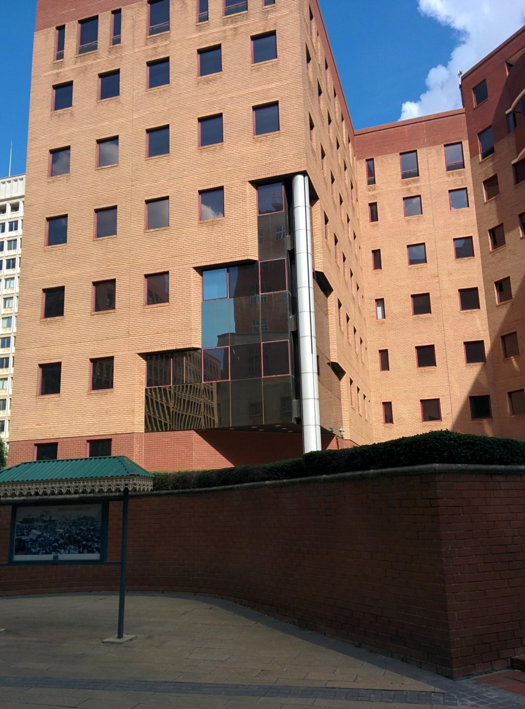
Figure 1. Location of the original Marshall Square, which later became the Marshall Police Barracks. Today is it an office building occupied by the Anglo American Corporation.

By the 1890s, Johannesburg was large enough to establish its first suburbs, Jeppestown and Doornfontein, on its eastern edge. According to the Barnett Collection (Godfrey, Barnett and Barnett 1966), Johannesburg had changed extremely rapidly from a town with tin shanties, to an attractive city of trees and gardens. The mining industry was the most powerful force in the country for most of the 20th century, and most of the largest mining corporations’ headquarters are still in Marshalltown. Since its creation, Marshalltown has been a place of office work for people employed by mining houses and other corporations. An outdoor museum, the Main Street Mall, is mostly dedicated to the mining history of Johannesburg. It was implemented by John Dewar strategically in Marshalltown to highlight the area’s mining heritage in the actual place where it began.
It is important to note that those mining corporations worked in close collaboration with the apartheid government to access cheap labour in pursuit of profit. Even after the country’s transition to democracy, as Rajak (2011) notes, corporations such as Anglo American remained very powerful, and continued to influence the South African economy:
The picture of the omnipresent influence of Anglo American working behind the scenes to broker deals and mold South Africa in its image has passed into public mythology. But as one young Johannesburger said to me: “I’m convinced that Anglo actually runs South Africa. Who do you think got us the 2010 world cup?” (2011: 274).
So not only has Marshalltown been at the epicentre of Johannesburg’s development, it is also still perceived as the heart of many of the country’s most important processes.

4.3 Urban development as a signifier for safety in the city
While Marshalltown is located within the administrative limits of the CBD of Johannesburg – in the south-west of it to be precise – the neighbourhood distinguishes itself very clearly from other areas of the inner city which have been associated with violence, insecurity, decay and crime since the mid-1980s (Beavon 2010: 1). Marshalltown is known both as the ‘banking district’ and as the ‘mining district’ because of the many mining and banking headquarters having historically been established there. Their presence has associated Marshalltown with wealth, while the rest of the inner city experienced capital flight, which saw buildings go uncared for by missing owners and banks redlining the areas for fear of not having loans repaid. Early private urban development efforts led by Marshalltown’s wealthy corporate and private residents have made the area distinguish itself from the rest of the inner-city known for its urban decay and crime statistics. The privatization of some parts of Marshalltown by these developers has allowed them to regulate urban life, indexing a feeling of safety through CCTV cameras and patrolling security guards. In order to present the striking contrast between Marshalltown and the rest of the inner city in terms of representation of safety and urban decay, it is important to first introduce the general discourses about Johannesburg’s inner city before highlighting what makes Marshalltown stand out.
In an interview with Thomas Coggin, the editor of the popular blog Urban Joburg, I asked him about his relationship with the inner city. He pointed out that he used to counter the narrative of Johannesburg being a no-go area by taking friends and relatives to see “the nice parts” of the city in the mid-2000s. This would usually include a walk through “the financial district” (another term for Marshalltown) from the Magistrate’s Court going east. At that time, he saw the area as containing the “original” beauty of Johannesburg because of its heritage buildings, but also because it was a diverse, multiracial place with white (collar) and black workers alike walking the streets and having lunch on the benches. Today, however, his experience of the beauty of Johannesburg is significantly wider; he tends to see the Financial District negatively as a place controlled by “corporate commercial interest” which makes it a nice-looking area but “not really diverse compared to other parts of the city”. Following the Scollons’ (2003) methodology of geosemiotics, I tried to understand which social actions in Marshalltown made him feel compelled to take people there as a way to change their negative views on the city. In terms of interactions, racial identities seemed to play a role, because Marshalltown is seen as more diverse, meaning that there are white people there too, unlike the rest of the inner city where being white is being part of a very small minority. Thomas elaborates, rather uncomfortably:
I felt safe there as this white upper-class student I suppose. If you were to go into other parts of the city you do end up being a minority so you sort of have to dive right in. I know how fucked up that sounds but you do have to dive right in and once you do you get less nervous, you realise it’s the city, it’s normal. You do have to have this introduction, sort to speak. And that’s where the financial district is helpful.
In his explanation, it is interesting how the experience of being a minority in public spaces is something new and required getting used to, as white people in South Africa are by far a minority with around 8% of the population, compared to Black people, who make up 80% of the population. So for a well-off white individual such as Thomas, a safe social action is perceived as involving a group of social actors where you don’t feel like a minority. Being a minority is thus an important part of Thomas’ structure of social interaction used to produce his discourse of Marshalltown (Scollon and Scollon 2003: 35). Indeed, his actions in Marshalltown are in direct interaction with the fact that he is a part of a racial minority. This narrative of social interactions links up with Murray (2011), who argues that the rise of gated communities and restricted areas in the suburbs of Johannesburg allows white citizens to avoid having to live the reality of being a minority in South Africa, because their neighbours or fellow shoppers in malls are mostly white, and also well-off.
Thomas later mentions taking his uncle to Marshalltown to challenge his uncle’s negative perceptions of Johannesburg post-apartheid, as he had immigrated to Australia in order to avoid “majority rule”. But Thomas confesses that he took him to Marshalltown on purpose, knowing that if he had taken him to Bree Street – known for being a crime hotspot – it would have made his uncle “uncomfortable”. Once again, the issue of experiencing being a minority seems to put off visitors from visiting other parts of the Johannesburg CBD. They would rather go somewhere relatable, which Marshalltown can provide thanks to its nostalgic development targeted at people who may have experienced the inner city before democracy, or who value signs of white European culture, which are abundant in Marshalltown.
Later in my interview with Thomas, I tried to grasp his vision of Marshalltown and what made it attractive, safe and worthy of visiting in terms of visual and place semiotics. His response was that first of all, “it was clean”, which is opposed to being dirty, a term usually kept for describing the rest of the inner city. An analysis of this discourse will follow in the next section. His other answers include the flowers, the security guards in neat uniforms, a sense of order such as a pedestrianized street, statues and signboards, and signage, such as for Anglo American: “You think, if Anglo American is here, then I as a white male can be here”. It seems the sense of order is signifying of someone being in charge, and this ‘someone’ is later mentioned as being Anglo American. He later argues that these signs were put there for the white or upper-class employees of all these companies, to make them feel safe, and since he could get a job there, then he feels safe too and not out of place. My interviews with private developers in Marshalltown such as John Dewar show that some signs are not consciously designed with white collar workers in mind, but more out of passion for history and heritage, or wanting to relive past experiences in the inner city by renovating and thus recreating the built environment. However, some signs are clearly there for the white collar workers, such as security guards holding “STOP” signs in front of pedestrian crossings between offices in the Anglo American campus and the car parks two blocks away to the south. I have never witnessed such a practice anywhere else in the city of Johannesburg, but it seems relevant considering car driver behaviour in the CBD. Drivers regularly stop their vehicles over the pedestrian crossings while waiting at a traffic light. Some pedestrian crossings in Marshalltown are even in the zebra design of thick lines parallel to the street whereas for most of the city, two simple narrow lines perpendicular to the street mark the area for pedestrians to cross, which is usually ignored by car drivers.

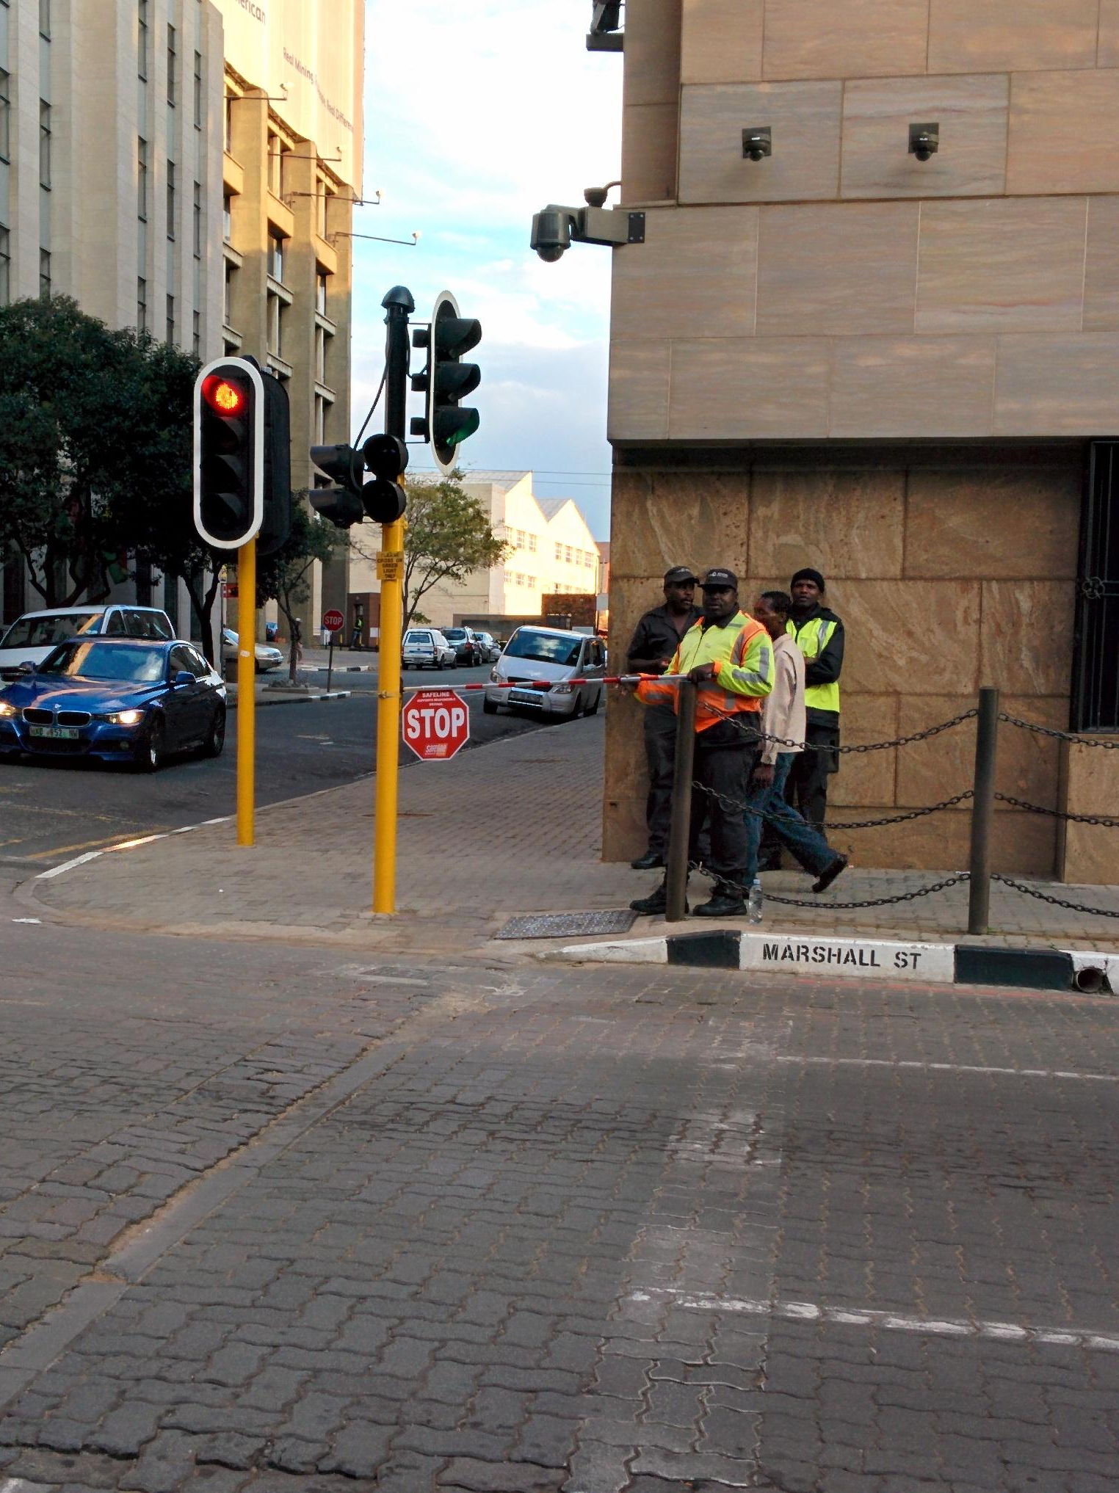
Figure 2. Security officer controlling pedestrian and car traffic in Marshalltown to make worker’s walk back to the car park safer. The street corner is also equipped with a CCTV camera, monitoring the area.

Coggin’s decision to go into the CBD to experience urban life is facilitated by what he sees as signs of safety and control. Today, people sometimes visit the Johannesburg CBD after seeing positive representations of the area in the media, as well as hearing mentions of places such as retail spaces or restaurant and activities offered which are deemed attractive. In 2013, the publication City Buzz emerged as a way to show the inner city in a good light, with articles on its quirky places such as the Ethiopian quarter, the Main Street Mall or the Kerk Street Market. The goal of this publication was to improve the image of the inner city by highlighting the types of urban lifestyles available, or the kinds of products one could consume there. I will expand on the role of the media in representing the Johannesburg inner city bellow.
In 1999, the well-respected UK daily The Guardian labelled Johannesburg “the most dangerous city on earth” in an infamous news report. The article reports violent attacks on workers from the northern suburbs while commuting to and from their place of work in the CBD, sometimes resulting in their deaths. As the article frames it, these crimes are committed by black individuals living in extreme poverty in the young post-apartheid Johannesburg; they are so desperate that taking money, possessions and sometimes the life of richer, sometimes white individuals seemed like their only choice. The journalist reports in the beginning of the article on the murder of a white man working in the CBD, killed during a carjacking after stopping at a McDonald's restaurant on his way home to the northern suburbs. The racial descriptive “white” is repeated along the article when mentioning the growing number of people protecting themselves from crime, which can make it seem as if white people were the primary victims of these types of crime at the time. What the article doesn’t mention is that black people bore the brunt of the crime wave. They could not afford the security gates, private guards, and CCTV cameras for their houses and neighbourhoods that went some way towards protecting whites. Even though muggings, carjackings and “smash and grabs” would happen in many other spaces within the borders of the Johannesburg municipality, the inner city underwent a dramatic image change in the 1980s and 1990s to become known as the no-go area, a war zone-like place, to avoid at all cost.
At the same time, the decentralization of office and retail spaces, first from the CBD to the immediate suburbs of Braamfontein and Parktown, and later on to the new municipalities of Randburg and Sandton, just north of the borders of Johannesburg, led to large numbers of former (white) residents of the CBD and the historic suburbs along the Witwatersrand ridge (Parkview, Melville, Houghton, Greenside, Emmarentia, among others) moving closer to their new place of work in the north. These choices were highly impacted by the construction of large shopping malls first in the eastern suburbs (Eastgate) and shortly after in the north (Randburg Waterfront, Sandton City, Killarney Mall, Rosebank Zone, etc.). These shopping centres would attract middle-class consumers away from inner city shops (Beavon 2010).
As explained by Beavon (2004; 2010), petty crime certainly rose in the Johannesburg CBD after the shift to democracy in 1994, but it assuredly wasn’t a new trend as the decline of the inner city had started as early as 1959, with the beginning of decentralization. What is interesting is how the CBD came to be seen as the representative image of the decay of Johannesburg: full of crime and unrestored buildings, even though the major shift at that time in the area was of the population living in the CBD, from a white to black majority, and thus most affected by crime. In fact, the black South African and pan-African population became dominant in the early 1990s, and black-owned retail spaces in the late 1990s, as office spaces remained mostly empty, especially in the financial district (Beavon 2010). What seemed to be “the last straw” for pushing big businesses either out of the CBD or to close down entirely, such as the five-star hotel The Johannesburg Sun in 1998, was the emergence of serious crime such as murder and physical attacks near the areas around Park Station, Joubert Park and the Carlton Centre (Beavon 2010). According to statistics from the City of Johannesburg, as well as news reports, the major criminal trend emerging in the years after 1994 were “burglaries at residential premises” involving robberies and sometimes physical harm. These crimes are also the most feared by residents (South Africa Crime and Safety Report, released in 2014). Even though the rates remain high in 2014, the numbers have been going down since the middle of the 2000s (South African Police Service “Crime Situation in South Africa”, released in 2014). These residential robberies tend to mostly happen in the suburbs (South Africa Crime and Safety Report 2014). All in all, it is interesting that the CBD came to be represented a decaying Johannesburg, when crime statistics actually show that similar trends were evident in the suburbs in the period after 1994.
After the flight of (mostly white) capital and residents throughout the 1980s and 1990s, in 1998 the Johannesburg Stock Exchange relocated from Diagonal Street in Marshalltown to the rapidly growing southern part of Sandton, today proudly claiming to be the “richest square mile in Africa” (as proclaimed on the webpage of the shopping mall Sandton City). What resulted over the years was the emergence of a dichotomy between the allegedly unsafe, unclean CBD, and the supposedly secure and controlled northern suburbs – the further north, the better – with a growing compoundization of suburban residences in Johannesburg (Murray 2011). This compoundization includes fences, walls, electric wires, sharp spikes, alarms, gates, burglar bars, and other architectural devices geared to keep unwanted bodies out of public spaces. In an op-ed published on the South African online news media outlet The Daily Maverick, Johannesburg is described as “unquestionably one of the most unequal and divided societies in the world, not just economically but spatially and socially”. The author goes on to state that “there are very few points at which the lives of the poor and those in the middle classes intersect”. The discourse of fear and violence attached to crime statistics helps to explain these deep divisions in Johannesburg, as the wealthy spatially separate themselves from the poor, and the local government treats the rare points of engagements such as street corner intersections as security risks in need of strict control. Indeed, it is common in Johannesburg to see poor people trying to make a living at busy intersections by selling cheap items like sunglasses or power cables for mobile phones as well as services such as windscreen cleaning or rubbish collection. The Daily Maverick op-ed condemns the fact that “the City is attempting to blame [crime at these spaces] on all people who try to make a living at these spaces, rather than on a small criminal minority”.
I had first-hand experience of this discourse as soon as I arrived in Johannesburg in 2012, which had an impact on how I imagined spatial divisions in Johannesburg. Colleagues from the French Institute where I had started working were quick to warn me to avoid the CBD, and described it as a place where one is bound to get mugged or attacked. This experience worsened when I moved into the CBD nine months later, as some people told me they would not come to visit me in the centre of town for fear of being victims of “smash and grabs”. Another conversation at the beginning of my stay in Johannesburg helped shape this dichotomy in my mind. I had gone to Wanderers Street to find a bicycle shop close to my workplace at the University of the Witwatersrand, which I found on a mapping website. Upon my return to the university, I told a colleague I had found what I was looking for in order to fix my bicycle, which I use as my main mode of transport. When I told him exactly where I had found a bicycle shop, he was shocked I hadn’t been mugged and called me “daring”. The bicycle shop was located between Hillbrow and Joubert Park, well known crime hotspots at of the inner city. Multiple colleagues and friends who have moved to Johannesburg from abroad told me about researching facts on Johannesburg online before their arrival and finding mostly crime statistics. Additionally, once settled in Johannesburg, they would be told by local residents to avoid the CBD in order to remain safe.
Another result of the appearance and development of the dichotomy between inner city and northern suburbs in popular discourses around Johannesburg was the emergence of a discourse of seeing the inner city as a whole, erasing distinctions between different areas, and eschewing names of particular districts in favour of “the CBD” or “Town” (as opposed to the suburbs). All inner-city neighbourhoods were conflated into one. The neighbouring area of Braamfontein and cultural hub of Hillbrow kept their distinction to be known as urban neighbourhoods filled with students (Braamfontein) or migrants, drugs and criminals (Hillbrow), but anything south of “the bridges” bordering the inner city (referring to Mandela Bridge, Queen Elizabeth Bridge and Rissik Street Bridge, linking the CBD to Braamfontein and Park Station, the main train station in the city) was seen on the whole as a no-go area. Of course the description “no-go area” was more relevant to middle-class suburbanites than to the new inhabitants of the CBD, mostly black working class people, from the townships or other African countries, looking to live closer to their place of work (Gardner, 2010). In fact, residents of the inner city and other working class people having to go through the transport hubs, usually through mini-bus taxi ranks, were the main victims of crimes such as mugging in the city. Police statistics point out that most of the crime happening in the country is located in the (poor) townships, away from city centres and (rich) suburbs. Those privileged enough to be able to avoid the inner city would be the ones strengthening the discourse of crime attached to the inner city, or even the whole city on a global level. Examples of this can be found from South African expats who have moved away to Canada, Australia or New Zealand during and after the collapse of the apartheid government for fear of civil war, racial attacks, or the collapse of the national government under Nelson Mandela.
Comments on blogs and websites, such as The Death of Johannesburg or reddit.com/johannesburg and reddit.com/southafrica paint pictures of violence and decay in Johannesburg. Such descriptions are strategically deployed in order to blame the democratically elected African National Congress (ANC) party for the failure of the new South Africa; they are also used to legitimize the authors’ choice to emigrate to what they see as “better” destinations. What is striking is that these comments come from people who have not set foot in Johannesburg, let alone its inner city, for many years. It is conceivable that people unfamiliar with South Africa and Johannesburg have a poor opinion of the city after having read articles full of crime statistics and stories of murder such as the Guardian story mentioned above. They do not distinguish between the city as a whole and its inner city; they promote the idea that the whole city is extremely dangerous and unsafe. In fact, as Simone has concluded after extensive study of Johannesburg (2008; 2010), if one experiences the “mixed-up worlds of central Johannesburg” one has to admit that the areas of the inner city are so different that “it is often not clear what facets of urban life have a better claim on being more viable, legitimate, or right for the city” (2010: 258). Most of the people I interviewed talked about being pleasantly surprised when coming to Marshalltown for the first time, or returning there after many years of avoiding it, and realizing that it “wasn’t bad at all”. This attitude was exemplified by John Dewar, the designer and developer of the Main Street Mall in Marshalltown:
So I went along with my then partner and we walked down Loveday Street, from City Hall to Main Street; we had our hands in our pockets and thinking we were going to be beaten on the head any minute, and suddenly realised it wasn’t bad at all. So we then started looking at buildings and what would be available.
John Dewar’s revelation happened in the early 2000s, but it seems that general negative perceptions persisted at least for the remainder of the decade. Tourists visiting South Africa made sure to skip Johannesburg when visiting South Africa to go directly to Cape Town or the Kruger National Park near the border with Mozambique, even though they would have had to fly into South Africa through O.R. Tambo airport, the biggest in the country, located 20km from central Johannesburg. A 2008 article in the travel section of The Telegraph claims that South Africa’s high crime statistics deterred 22 million potential visiting tourists for the period 2003 to 2008.
A striking example of the fear of visiting Johannesburg’s inner city can also be found in an online article from the BBC news website from 2002, which on the basis of crime statistics calls South Africa (as a whole) “the most dangerous country in the world, which is not at war”. The BBC asked its readers if they had been victim of crime in South Africa and if they answered in the affirmative, asked if they would share their stories. The article includes fifty-three stories from South Africans or visitors who had been to the country and had since then moved away, or not been back. They described how they had themselves been victims of carjackings, muggings, armed robbery, or had witnessed crimes, and how their relatives and friends had been victims of, or witnesses to, crime in South Africa. Johannesburg is mentioned thirteen times while Cape Town and Durban appear only five and four times respectively. One commenter trying to remain optimistic about South Africa still paints a disturbing picture of Johannesburg as a place to avoid as a whole:
I have just spent 2 months there. Seems to me a distinction can be made between Joburg & the rest. In Joburg even the taxi drivers wouldn't take me near the city centre. The well off whites stay in heavily armed fortresses of shopping mall suburbia, whilst the blacks occupy the inner city and townships. This is no way to live. SA is bound to have a difficult time ahead to reverse the impact of decades of apartheid. I hope it can achieve this peacefully. I would add that I had a safe trip, and would go back - avoiding Joburg of course.
Even though the author mentions the city centre as the worst place to be since even taxi drivers won’t take him there, giving credit to local knowledge, they conclude that “Joburg” (a common abbreviation of Johannesburg) as a whole should be avoided, to focus more on “the rest”.
However, while the image of an unsafe inner city remains a trope among many residents of Johannesburg’s suburbs the situation seems to be changing, as tourists are coming in growing numbers to visit the “City of Gold”. The organisation of the FIFA World Cup in South Africa helped spark progress in the tourism industry, with the public and private sectors working together to make football supporters feel safe in the host cities, and comfortable to explore them. Major efforts were made to rebrand the country’s violent image, on grounds that it would benefit ordinary South Africans. These efforts entailed major securitisation of South African cities using military equipment and tactics, as well as heavy police presence. Studies have shown that this display of power resembled a country preparing for war, and a “spectacle of security” (McMichael 2013). In addition, even though these measures to secure spaces were successful in allaying the fears of tourists during the World Cup, its benefits seem to have been enjoyed by the middle class, as the homeless and lower-class residents of city centres were forcibly removed (McMichael 2012, 2013): “In practice, security measures pivoted around the enforcement of social control and urban marginalization while serving as a training ground for an increasingly repressive state security apparatus.” (2012: 519).
Since then, the path towards the image change of South African cities from a violent one to a tourist-friendly one has only widened, especially for Johannesburg, as travel guides and articles in mainstream Western publication praise the “rejuvenation” of the city and urge readers to go see it for themselves. Rough Guides named Johannesburg its top destination for 2015 and, even though it mentions no-go areas, especially while travelling on foot, these do not include the CBD:
Although significant effort has gone into making the riskiest central areas safer – such as the installation of security cameras – remain alert when exploring the central business district (CBD), Braamfontein and Newtown, do your touring in daylight, use busy streets and never be complacent. Joubert Park, Hillbrow and Berea are regarded as no-go zones; Yeoville and Observatory are safer and generally fine if you’re confident or have someone to show you around. You’re very unlikely to be mugged on the streets of Melville, Parktown or Rosebank.
Even though the online article tells potential visitors to “remain alert” when walking in the CBD, the fact that it is considered “explorable” is a sign of change, although once again, the inner city is portrayed as a homogenous whole, with Braamfontein and Newtown the only distinctive adjacent areas. Another case of the slow progress made towards an image change for the Johannesburg CBD is a 2013 Wall Street Journal article which documents young investors bringing capital back into the inner city, but still calling the moves a “high-wire act”. Finally, a GQ article from 2015 urges the publication’s readers to “get [themselves] to Johannesburg: the new cool capital of the southern hemisphere”, comparing its appeal to Buenos Aires, Rio de Janeiro, Sydney and national rival Cape Town. The piece mentions walking tours of the inner city as a “must” in order to witness “the city’s once stunning architecture being restored to its former glory”. The author explains that improvements in the city are the result of investments over the last five years, which coincides with the FIFA World Cup as the moment Johannesburg’s image problem began to change, as I argued above.
Despite prevailing discourses that present the inner city as an undifferentiated whole, the CBD contains several distinct administrative districts, or less formalised areas, which today look and feel different in terms of population and visual landscape. The retail district in the north of the CBD is filled with residents and informal traders; the east side is where the most urban decay is visible, especially in the so-called Fashion District, the Joubert Park area, and around the industrial buildings in the south east of the CBD; in the centre and west, we find several institutions which, unlike the Johannesburg Stock Exchange, never left the inner city. Among these are the ANC headquarters, and the corporate offices of the three main banks in the country: FNB, Standard Bank, and Absa, which are scattered within 15 or so blocks.
Henry Brown Marshall (1852-1948), the Scottish township developer and director of numerous mining companies is seen as being responsible for turning the area adjacent to the first gold mines on the Witwatersrand from farms into townships with streets and squares. The current borders of Marshalltown are not as formal as when the area was first delimited shortly after the birth of the city, but they were outlined in order to link up the institutions mentioned above, particularly the banks and mining houses. Today, Marshalltown includes the formally delimited South-Western Improvement District, based on the concept of city improvement districts; borrowed from the United States by private developers in the late 1990s, which I shall discuss in more detail later. I will also address how these developers first picked Marshalltown as a place for redevelopment in the CBD because it could connect corporate institutions along a “spine” where workers from the many offices spaces in Marshalltown could walk safely, shop, and consume during working hours, an idea that was unheard of in the late 1990s. According to Gerald Olitzki, founder and CEO of Olitzki Property Holdings (OPH), which invested a lot in the private redevelopment of the inner city from the 1990s, notable on Fox Street and Gandhi Square, one should “[bear] in mind that it never really died because there was always, never less than a million people came into the city daily. After hours it was dead, 5 o’clock the city died it was gone, there was nothing”.
The spatial, economic and social inequalities in the greater city of Johannesburg are present on a smaller scale in the inner city, as, for example, Marshalltown radically distinguishes itself from other areas of the CBD. Marshalltown is the wealthiest neighbourhood of the CBD: the most expensive apartments, restaurants and shops are found there, surrounded by corporate offices and heritage buildings waiting to be renovated and rented out. The difference with the rest of the CBD is that there is no sign of poverty and urban decay, or almost none, thanks to a very controlled environment created through the establishment of a City Improvement District (CID) in 1999, the second in the city. The CID covers most of Marshalltown and is simply named the South-Western Improvement District (SWID). It is closely connected to the other CIDs in the inner city such as the Central Improvement District which encompasses the Carlton Centre, the tallest building in Africa, as well as the Retail Improvement District, which is characterised by informal street traders and outdoor markets. But even within the CIDs in the City, the SWID and Marshalltown stand out because its property owners are the wealthiest. This means that the SWID has private means to improve the neighbourhood, and to control its development. As can be seen in the picture below (Figure 3), there is a multitude of banners all around Marshalltown informing the people that they find themselves in an improvement district that is “Safe and Clean”.

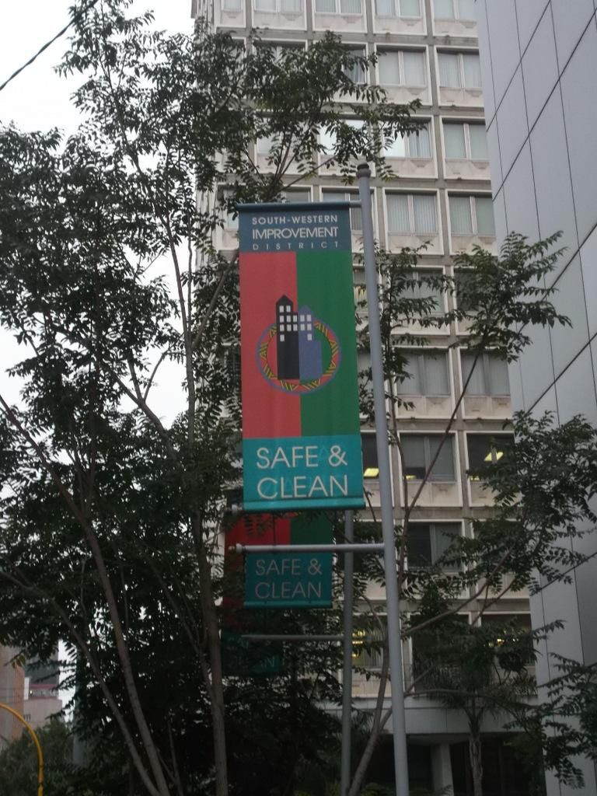
Figure 3. Flags installed on Marshall Street by the SWID.

These flags are erected high above the streets of the district, in long rows, and are reminiscent of the regalia of a sports team, with specific colours and the SWID logo to show that “Safe and Clean” is more than just a statement: it is the motto of the property owners in the neighbourhoods. It is as if these two adjectives were the first thing people should know about the area: it is controlled, taken care of, and different from the rest of the CBD with its image as a no-go zone. This statement is displayed in order to attract people to the neighbourhood: visitors or tourists, developers, young entrepreneurs and urban dwellers; it also allows the workers in the area to feel safe, so that they in turn can let other people know that Marshalltown is safe enough to visit. Many people I have talked during my ethnography in the neighbourhood have told me they first came to Marshalltown after being told it was safe by a friend working in the area.
The statement present on these flags indexes a discourse of safety and cleanliness around the inner city, that some areas are safer and cleaners than others. Since the first discourse on safety has been investigated in this section, I shall examine the discourse of cleanliness in the inner city in relation to smell in the following section.

4.4 Smellscape of Johannesburg’s inner city
Whilst the discourse of safety in Johannesburg was present in the previous section, I am going to focus here on the second element of Marshalltown’s motto, cleanliness. The CBD is often referred to as a dirty place by people from the outside, or passers-by. Before examining sociolinguistically how smells, cleanliness, and dirt are used in the language of Johannesburg’s inner city, it is useful to review how the sense of smell has been addressed in LL research by Pennycook and Otsuji (2015). They argue that smell is an important aspect of how we relate to space through an ethnography of a multicultural Sydney suburb in Australia. They borrow the suffix for their terminology from Appadurai (1996) who coined terms for each dimension of global cultural flows: ethnoscapes, mediascapes, technoscapes, financescapes and ideoscapes. Pennycook and Otsuji included the semiotics of smell in the understanding of the global culture economy, which, according to Appadurai, “has to be seen as complex, overlapping, disjunctive” (1996: 33). He goes on to argue for the use of the suffix because
[it] allows us to point to the fluid, irregular shapes of these landscapes, shapes that characterize international capital as deeply as they do international clothing styles. These terms with the common suffix -scape also indicate that these are not objectively given relations that look the same from every angle of vision but, rather, that they are deeply perspectival constructs, inflected by the historical, linguistic, and political situatedness of different sorts of actors: nation-states, multinationals, diasporic communities, as well as subnational groupings and movements (whether religious, political, or economic), and even intimate face-to-face groups, such as villages, neighbourhoods, and families. Indeed, the individual actor is the last locus of this perspectival set of landscapes, for these landscapes are eventually navigated by agents who both experience and constitute larger formations, in part from their own sense of what these landscapes offer. (1996: 33)
This argument is crucial for understanding the smellscape of the Johannesburg CBD, because it does not, as Appadurai puts it, look the same from every angle. Social actors of the area might smell different things, experience those smells differently, and signify them according to their respective cultures, but it does allow each of them to personally construct a sense of place, pointing to which areas are desirable, which ones to avoid, and constructing the people that populate them (such as refugees, or white collar workers).
For Howes (2005), senses such as smell “are the media through which we experience and make sense of gender, colonialism and material culture” (2005: 4). For him, it has been under-considered in the humanities, even after the linguistic turn in the 1960s which saw
a shift from library to ‘open-air’ research required a corresponding shift in their investigative approach, the assurance from semioticians such as Barthes and Ricoeur that the world (and action in the world) was itself a ‘text’ has enabled legions of scholars to comfortably go right on ‘reading’ even when the book was replaced by a meal, a dance, or a whole way of life. (2005: 1)
Howes argued that even though the meaning of language as a site of research came to be broadened, there is a need to stop it from becoming the only model dictating “all cultural and personal experiences and expressions” (2005: 4). He advocates for a revolt against the domination of language in the humanities, and closer consideration of the senses, since “they are still heavy with social significance” (2005: 4).
Pennycook and Otsuji (2015) argue that smell is an important sense and should be considered more broadly in semiotic and LL studies which tend to favour other senses, mainly sight, but also sound. It seems this preference is not new in the humanities, and has been blamed on the heritage of the Enlightenment, whose mind/body duality divided up the senses, placing sight and sound on top of the hierarchy because of their relation to language and thought (thus, the mind) whereas smell, taste and touch were deemed inferior senses, involving the body. There was also a linkage between people from the upper levels of the social hierarchy (white, upper-class, men) with the intellectual senses while other races, classes, species (animals) and women were “linked with more bodily, sensual and less controllable senses (touch, smell, taste)” (2015: 193). Pennycook (2002) also argues that these distinctions and relationships strengthened through colonial projects, as the West became represented as odourless because the colonies smelled. Low (2008) explains that societies had to stage sanitary wars in order to become civilised and modern, removing “dirt and foul scents, regarded as emblems of disorder” (2008: 167). Low’s explanation is important when thinking again of the descriptions of smell in inner city Johannesburg by journalists, residents and the municipality. Through the politics of urban redevelopment, the city wants to reach an ideal odourless metropolis in order to become more modern, aligning with its aspirational motto “A World Class African City”.
Modan (2002), in a discourse analysis of grant proposals for public toilets in an American neighbourhood, argues that policy makers rely on a discourse of smell and filth in their construction of space and in particular for their practice of “spatial purification practice” (2002). Indeed, certain linguistic strategies are used to construct an appropriate use of public toilets, usually by white residents, as opposed to an inappropriate use of the toilets, usually by the neighbourhood’s immigrant population, thus indexing smell and filth to a particular group of people. This study is relevant for this dissertation as it connects wealthy developments to discursive construction of smell and filth, as will be similarly analysed bellow.
I will now discuss how the smellscape of Johannesburg’s inner city is contested in discourse by different social actors. Indeed, the inner city has the reputation of being a dirty and smelly place, but the blame for this is placed on different causes. The adjective ‘dirty’ when qualifying the inner city usually refers to people loitering in the streets, but mostly to the municipal government’s lack of capacity to control public spaces. This is how the privatisation of spaces such as through the SWID are legitimised, as private management really does make sure they are clean and free of rubbish. This is exemplified in my interview with Gerald Olitzki:
[W]hy did I want the private lease? Number one was for the management of it, because what was important was that before the Improvement District come around, my concept was, if I leave the kind of management to the city frankly they don’t do a good job. If I have a private lease I’ve got the rights to the local stands, I’ve got the right do something, to institute a no-hawking zone, if hawkers come, I could say could you please move, cause I’ve got my lease and I’ve got the authority to do it…
Other people I have interviewed rely on a discourse of smell when referring to the inner city, or at least certain parts of it. Hussain van Roos, for example, who is a former Standard Bank employee who worked in Marshalltown at the end of the 2000s and beginning of the 2010s, describes Bree Street (now Lillian Ngoyi Street) as “the real downtown of Joburg, the filthy part of Joburg” as if downtown is what signifies filth. John Dewar, owner of the Johannesburg Land Company and main investor and designer of the Main Street Mall describes his perception of the inner city in the 2000s, at the time when he and his business partner were buying buildings: “everybody had the perception, like we did, it was dirty, it was dangerous and nobody wanted to come back”. Finally, Gerald Olitzki also mentions that major avenues such as Main Street in the CBD were “a little bit dirty” before his involvement.
In Western societies, what is seen as dirty, or impure is often linked with having a bad smell (Douglas 2003: 7-8), and with being dangerous (Bradley 2014: 14-15). As anthropologist Mary Douglas (2003) has shown, these binary relations are very much socially constructed, linked to particular religions (in that case, Christianity) and not relevant in other cultures. As South Africa is a country with a history of colonialism, and descendants of these settlers are still living on the land, I would argue that issues of cleanliness and smell in the inner city expose different viewpoints because of the multitudes of cultural perspectives of the people in the CBD. In the interviews, dirt is linked with bad urban management, because better (private) management such as theirs has gotten rid of dirt. Since their involvement; spaces are now clean, and even advertised as such as on the flags pictured above (Figure 3).
It is then possible to make an argument that the old (white) population of the CBD has a problem with dirt, which they have associated with the new (black) population, and thus imagine the inner city as inhospitable and unattractive because of this dirt. This brings to mind the Scollon’s notion of the interaction order. As they argue, “[however] we organize ourselves, we cannot fail to project some set of relationships which group us together with some others in our vicinity and apart from the rest” (2003: 45). Indeed, here people in the inner city of Johannesburg interact with its spaces partly based on their smell and cleanliness, which then results in people being grouped together and apart from others because of how they make sense of those senses. This argument implies, as will be discussed later on, that the recent private development of Marshalltown is largely coming from white capital. But the question remains: inhospitable and unattractive to whom? During my ethnographic excursions in Marshalltown and the greater inner city, I have witnessed many times pedestrians throwing away litter on the ground or inside open holes of the road infrastructure whilst having designated rubbish bins in their proximity.
As mentioned above, what is seen as dirty is often linked to being smelly. A discourse of smell can be found in descriptions of Johannesburg’s inner city. Hankela (2014) gives accounts of migrants living in churches in the inner city. Someone working near the Central Methodist Mission, the main church in the inner city used as a refuge for migrants, gives a description of the smell surrounding it: “That heavy flower box over there used to be the local toilets. That door over there used to be the local toilets. [...] You get the smell how this place smelt like - of effluent” (2014: 117). Hankela also comments on how crime, bad smells and loitering in the area are blamed on the foreign migrants staying in the church. Some of the interviewed migrants talk about being called smelly themselves. This narrative constructs a certain hierarchy of people in the inner city using (their) smell as factor. This hierarchy puts “foreigners” as lower class citizens because of their supposed smell and the bad smell of the areas in which they live. A migrant recalls a woman telling her outside the church: “Go back home, you Zimbabweans, you are dirty!”. Locals are described as seeing refugees at the very bottom of this social hierarchy, according to this interview: “I cannot talk to a refugee because he’s not a human being. I cannot talk to a refugee because most of the refugees do not think. [...] You see, I cannot talk to a refugee because a refugee doesn’t bath. Have you ever, have you ever had the smell of a refugee?” (2014: 325).
A piece in the Daily Maverick gives this introduction to the CBD: “Your lungs expand wider than what is necessary, the fumes take up too much space when you breathe. You open your eyes and you are here, you are at a place you loathe to call home, you are in Joburg CBD.” The author continues, explaining what she means by fumes and how they differ from smells: “Those oblivious to it may refer to it as a bad smell, but how can it be a smell when smells come and go? A smell is testament to something having been there, a dustbin left for too long, a leakage, a bowl with no self-control, the death of a rat which will be found one day and thrown out. A smell belongs to something that has come and gone, but fumes stay. A fume is singular, a moving growing, and producing body. Fertile and breeding, alive.” Here, the smellscape of the CBD is linked to the experience of people living under conditions of economic oppression, struggling to get by because of their social status or gender; how the smell of the area (in this case, Bree Taxi Rank) and people’s restrictions when trying to breathe deeply because of it, is similar to people’s being restricted from living freely.
Another Daily Maverick piece describes the life of residents in the Joubert Park area: “The smell of sewage in the garage was as strong as ever, but it had long stopped bothering [the residents of San Jose, a building in Olivia Street].” Again, this discourse of smell and dirt as experienced by locals seems to differ from the one expressed by the developers quoted above. The developers refer to the place as “dirty” whereas these testimonies by residents or social actors highlight the (bad) smell of the inner city, indexing a different duration of state of uncleanliness. A news report on hijacked buildings in the north and east of the CBD in the weekly Mail & Guardian published in 2015 mentions the “inescapable” smell of urine. Finally, another news report in the Mail & Guardian on the state of downtown Johannesburg in 2010 describes walking there as “a stinky affair”. It goes on: “Commuters hold their breath while street vendors sell plates of fruit near overflowing bins.” This last article is interesting because it documents a contradiction between the smellscape of the CBD from the point of view of the authorities, residents, and the journalist. In fact, in the article we learn that the city claims to have reached a level four out of five in terms of cleanliness where level 5 is completely clean on a 24/7 basis. This is described in the article as a “vast improvement” by PIKITUP, the waste management company owned by the City of Johannesburg. It implemented a campaign in 2010 to have workers cleaning the streets of the city every day of the week. These workers, often paid low wages, can be seen at night wearing staked up large garbage bags around their waist as a piece of clothing, pushing waste into these bags, leaving them on sidewalks to be picked up by garbage trucks before the sun rises.
PIKITUP, although confident that the city is almost free of rubbish, on paper at least, is quoted in the article as blaming the failure to reach level five in terms of cleanliness on “the culture of littering and people’s attitudes towards waste”. In addition, the city claims that recurrent illegal dumping costs them one million rand per year. During my ethnographic research in Marshalltown, Johannesburg was affected by two major strikes by PIKITUP workers demanding better working conditions, fairer contracts (most are not employed full time) and higher wages. The first one happened for two weeks at the end of November and beginning of December 2015. The second one was much more significant, lasting almost a full month in March 2016.
The municipality, seeing the unmanaged waste piling up all over Johannesburg, affecting certain parts more than others, responded by employing the so-called “Red Ants” to clean up the streets. The Red Ants are private security guards named after their iconic red uniforms, usually hired by the city or property owner to evict residents from illegally occupied buildings. The collection of the increasingly smelly waste by the Red Ants was carried out after dusk while PIKITUP strikers would protest during the day in the streets of Braamfontein, where the City of Johannesburg headquarters are located. They would also protest on major arteries of the inner city, mainly Rissik Street and Simmonds Street, but never went south of Commissioner Street into Marshalltown, maybe because they feared the heavy private security presence. Tensions escalated every week as marches increasingly involved the destruction of urban structures, mostly rubbish bins made of concrete, which once broken into pieces would be used as projectiles to throw at the police. They would also purposefully spread waste from rubbish bags on all sides of the streets in order to make it more difficult to clean up.
From the privileged comfort of my apartment, located in the Retail District, I witnessed Red Ants and PIKITUP strikers clashing at night, trying to interrupt the waste removal process aimed at weakening the strike. These clashes involved verbal and physical threats and altercations as well as gun shots, the Red Ants being assisted by additional armed private security guards while on duty. At the Kerk Street fruit and vegetable market, I heard rumours of bombs being hidden underneath the rubbish aimed at whoever would dare remove them before the end of the strike. I did not witness or hear any bomb explode, but the fruit sellers at the market were most affected by the strike as their activity generates a lot of waste, which quickly rots under the sun, filling up the street with an intense smell, right at their place of work. No wonder that the strike was the main topic of conversation on Kerk Street that month.
During the strike, I compared its impact in terms of waste accumulation between Marshalltown and the rest of the CBD. Even though there were more rubbish bags on the street than usual, it was much less significant in Marshalltown than in the retail district. One could assume that since a large portion of Marshalltown is privatised, it can hire a separate company to collect its waste and not solely rely on the City’s services. But once again, the contrasting images painted different pictures of private and public urban management as Marshalltown remained mainly unaffected by the strike, while the rest of the CBD experienced piling up, rotting waste that filled the air with a distinct smell. Urry (2008) highlights the significance of smell in the construction of the modern 19th century western city and how its influence remains today with the emergence of modern technologies conceived to “purify smells out of everyday life” (2008: 394). As Marshalltown is a wealthier area, its corporate residents had access to a better technology to get rid of waste using privatized cleaning services during the strikes and its security (CCTV cameras and guards on patrol) made sure the protests would not reach their streets.
The City of Johannesburg’s goal to reach level 5 in waste management, meaning having no sign of rubbish in the city at all times, is also an attempt to be more hygienic and odourless, which, according to Henshaw (2013) is part of modern urban renewal, a process Johannesburg has been undergoing for the past fifteen to twenty years. At the time of the construction of new cities in North America, urbanists adopted a grid system and built higher and higher residential buildings to allow air to travel through the streets, cleansing them partly of their smell and for the higher classes to live above the street, high enough to be immune to the smells of the city below (Urry 2008).
During the industrial revolution, common urban design in the north was to build heavy fumes and pollution producing industries on the east of each city, so that the upper-classes living in suburbs and the value of their land wouldn’t be affected by the pollution which would usually flow towards the east because of the prevailing winds blowing from west to east (Heblich, Trew & Zylberberg 2016). Studies have shown that the effects of the now reduced pollution still remains on the eastern side of multiple cities in the northern hemisphere, lowering their value (Heblich, Trew & Zylberberg 2016) but also causing health problems to the populations which have historically been poor and non-white. In Johannesburg, the wind patterns are similar, but the city relied on mining more than industry, which was done underground. Instead of factory smoke, dust coming from the mine dumps surrounding the city have been causing health problems in residents of nearby townships.
People coming to the city not wanting to experience the expected bad smells and sights of waste find ways around the issue. One way to experiencing the city from above without the issues on street level is, as Urry (2008) argues, the tourist buses which have become more and more present in city centres, which give the tourists on board a bird’s eye view of the city;
[...] in but not of the crowd, gazing down on the crowd in safety, without the heat, the smells, and the touch. It is as though the scene is being viewed on a screen, and sounds, noises, and the contaminating touch are all precluded because of the empire of the gaze effected through the windows of the bus. (2008: 392)
Johannesburg saw the arrival of iconic tourist Red Buses in 2013, transporting sight-seers to places around the city such as the Carlton Centre, Park Station, Gold Reef City theme park, the Apartheid Museum and most importantly for this research, what is labelled The Mining District: Marshalltown. This last stop promises tourists “art, sculptures, sidewalk cafés and the fascinating history of mining”. These buses transport tourists from all over the world, but also older locals who have perhaps not been in the CBD for many years as well as younger one who have never set foot there. In order to get to stops such as The Carlton Centre or The Mining District, the bus has to go through other parts of the CBD not deemed tourist-friendly enough. Tourists listen to lectures about the history of Johannesburg streets, such as Eloff Street and its past as the main shopping street of the city and the most expensive property on the Johannesburg edition of the popular board game Monopoly. The buses are double decker, with the top, roofless section being especially popular in good weather, where tourists sit gazing at the inner city sights and sounds. The arrival of these buses signalled an increasing interest in the experience of inner city Johannesburg, highlighting its positive side and avoiding what is often negatively connoted in the media, such as insecurity, smell and waste. The buses act as portals, transporting tourists through the parts of the inner city they would usually avoid and dropping them off in Marshalltown where they can feel safe, and where the air and the streets are clean.
As we have seen, looking at how waste and smell is treated in different areas of the inner city reveals contrasting visions of urban management. Another example of that is the City of Johannesburg’s practice of sponsoring informal waste reclaimers by providing them with trolleys to go around the city and its suburbs to reclaim, organize and then sell recyclable waste. In Marshalltown, these same reclaimers and their trolleys are immediately policed and asked to go elsewhere by security guards as a way to avoid signs of informality in the privatized, tightly control area. In the next section, I will show how certain areas of the inner city like Marshalltown manage to control its environment thanks to privatization. This phenomenon is considered a global trend by Murray (2015) who dubs those new urban spaces “enclave urbanism” (2015: 506).

4.5 Urban enclaves or the new private spaces
In Marshalltown, the Johannesburg municipality has less power than in any other area of the inner city. This is due to the fact that some sections of Marshalltown became private property when developers started to implement their plans to redevelop the area. As mentioned before, Marshalltown includes the SWID, which, thanks to its wealthy property owners, is responsible for uplifting and maintaining the environment within strict formal borders. For Murray, this way of doing urban planning “bears little relation to conventional practices of city building.” (Murray 2015: 506). By gaining access and control to formerly public spaces, private developers get to implement their own vision of city planning, without the public sector intervening. Murray goes on to argue that “[t]his process of radical reurbanism has fundamentally recast the conventional balance between public authority and municipal governance, on the one side, and corporate real estate interests and private proprietorship, on the other.” (Ibid).
In Marshalltown, the urban environment is managed so that anything considered impermissible, such as loitering, is immediately policed and stopped. Security guards patrol the streets, garbage bins have been installed, and cleaners are employed to make sure the area looks spotless at all times. Anything out of the ordinary is immediately sanctioned, and taken care of. I found out about this practice when coming to the neighbourhood one day on my bicycle. I began locking it to a lamp-post on the corner of Main Street and Sauer Street (Pixley ka Isaka Seme Street since 2015) in front of an FNB banking branch, and a security guard came to ask me to move the bicycle away, since they were not allowed on the premises by order of management. When I asked Gerald Olitzki, who also sits on the board of the SWID, about this incident, he told me that the reason for this was that there is no infrastructure in place for bicycles:
I just don’t want people to do their own things. Cause if it’s done unregulated, very often one man’s liberty is another man’s disadvantage. For example, if somebody wants to do something that prejudices somebody else, we gotta control the impact of that. So if people want bicycles, the space to lock up bicycles, great, if there is a real demand. But we try avoid people doing anything they like in the city.
This shows that every use of the spaces in Marshalltown is highly regulated through infrastructure and planning, in order to stay in control of the area, supposedly to keep it safe and clean. In an interview with Johannesburg Mayor Mpho Parks Tau, radio host John Robbie from 702 Talk Radio describes how he went on a walk in Johannesburg CBD prior to the interview (the exact location of the walk was not mentioned) and was surprised to see clean streets and sidewalks, and praised the Mayor’s work since being elected in 2011 as being at the root of this change. The interview is relevantly headlined “Joburg mayor cleaning up the inner city”.
During the introduction of his show, prior to Tau’s interview, Robbie presents the inner city as having “pockets of excellence” in contrast to the usual “gloom and doom” discourse surrounding the inner city. The word pocket is carefully chosen to entail that some areas are excellent, but the rest is just as people think it is: not excellent. Robbie then goes on to give the geographical locations and borders of these pockets of excellence: “Go see Gandhi Square, go South of Commissioner Street, it is magnificent!” and reminds doubtful listeners that “it is all in the inner city!”. The area he is describing, south of Commissioner Street, is, of course, Marshalltown. During my interview with Gerald Olitzki, he told me that most of the people working in Marshalltown enjoy discovering the inner city on their lunch breaks but will never explore “north of Commissioner” because streets there “are still rough”. Commissioner Street is then an imagined frontier in the city, which showcases the success of the marketing strategy of the SWID and the municipality: to show that the city isn’t fully in decay and full of litter and crime; some areas are safe, clean and worth visiting.
In his show, Robbie does not only congratulate the mayor for his efforts and highlight “pockets of excellence”, he also goes on to remind his listeners of the problems of the inner city: “There is also lots of issues, there is rubbish, there is litter, there is stealing of electricity, we’ve got calls about these things every single day”. The calls he is referring to are actually complaints, which he uses to frame his interview with Mayor Tau in order to argue that the job to “clean” the inner city is half done: that people are still upset and want to see the whole inner city cleaner and safer.
However, the use of the verb to clean does not only refer to the discourse of waste as discussed in the previous section. Here, it is also used to signify more than taking away the litter. By “cleaning the inner city”, Robbie also implicitly refers to the removal of the individuals responsible for the loitering and criminal culture: criminals or tsotsis, illegal street traders, and the homeless. In late 2013, the South African Police Services (SAPS) launched “Operation Clean Sweep” to implement new plans by the city government. This operation targeted unlawful street trade, seen as helping drug trafficking and sales of stolen goods. This operation resulted in SAPS evicting “undesirable” street traders or “hawkers” from the inner city streets and confiscating their goods. Two-third of the traders removed were actually paying rent to the municipality for their trading space, and a court later judged the police operation illegal. However, hundreds of traders, already in economic precarity, went without income for the last two to three months of 2013. So the fight to restore cleanliness in inner city Johannesburg is also a fight against informality and illegality from the authorities, as part of the “Johannesburg 2040” plan to become a “World Class African City”. “World class” generally implies anti-poor, anti-informal policies, and more landscapes of power such as high-end luxury apartments, privatization of public space, removal of the homeless, controlled environments, and infrastructure only for the privileged few. During an interview I conducted with Brian Kent Mckechnie, an architect working at the Gauteng provincial government on issues of heritage, he stated his issue with informal traders in the inner city explicitly: “I know I am controversial, but I really don’t like the traders. They’re a problem in the inner city”.
Brian Kent Mckechnie is not the only person who is not afraid to state his disapproval of the visibility of individuals deemed not fitting with the World Class African City label. The weekly publication Sunday Independent ran an opinion piece in 2015 on the “sad state of the Johannesburg Public Library” which is located on Beyers Naudé Square, at the northern tip of Marshalltown in the inner city. The piece was written by Sipho J. Mabaso, former librarian at the library, who explains that the change of hierarchy at the institution has resulted in an unclean, badly managed library with homeless people sleeping at the entrance doors at night, and drugs being sold on the plaza. The author argues for a library which aims to be world class, just like the city, which is a cry echoed in many other publication. There seems to be a lot of popular support for the “world-class” African city that is both a tourist destination and a CBD to be proud of. It seems the project starts with the cleaning of the streets, both physically and metaphorically, of rubbish and undesirable people.
These critiques show an assimilation of formality with cleanliness and order where informality such as street traders or the homeless pose a threat to the urban development efforts, as they represent what potential visitors or investors want to avoid. Whatever appears in the urban SL needs to be approved and to fit in with what people in power consider an authentic urban experience. Enclave urbanism with its privatization of developing spaces allows for the control of the environment and the removal of what poses a threat to it, even when it goes against official city planning, such as allocating informal trading spaces all over the inner city, but not in Marshalltown.
This clash between formality and informality in the redevelopment of central Johannesburg can also be exemplified by the recent implementation of bicycle lanes in the neighbouring student districts of Braamfontein and Brixton, just north of the inner city. These neighbourhoods contain multiple signs of informality such as street traders, reclaimers and often poorly demarcated lanes on the roads, which results in pedestrians, cars and other vehicles having to fight for space. These formal bicycle lanes were implemented by the Johannesburg Road Agency (JRA) and the Johannesburg Development Agency (JDA) as instructed by the municipality. It reveals a will to bring “world-class” infrastructure to the city in order to make it more attractive, and cleaner, without taking into account the very informal nature of transportation in the City. The fact that the first partitions of lanes to be completed in Braamfontein, in close proximity to the iconic Nelson Mandela Bridge, coincided with the C40 cities meeting taking place in Johannesburg, is cause for cynicism. The 2014 meeting included 40 mayors from cities around the world who came to discuss how to make cities greener.
Such examples of the City of Johannesburg privileging formal infrastructures such a bicycle lanes, or the policing of informal ones such as in “Operation Clean Sweep”, show an alignment with policies implemented privately in Marshalltown, where tight urban management is in place. Marshalltown, and particularly the SWID, wants to be at the forefront of this vision. This way, a privatized, controlled public space allows the property owners and developers to make sure their plans and visions for a clean and safe urban landscape remain uncontested.
I will now look in more detail at how the concept of the CID has changed the way urban spaces are being managed, and how it continues to help create an attractive globalized vision of the urban landscape, and how it ought to be experienced.
As mentioned before, Marshalltown encompasses a City Improvement District (CID), the South-Western Improvement District (SWID). This model entails the property owners in a specified area creating a joint forum with the city that contributes some funds into upgrading the landscape of their district. This might include projects such as pedestrian infrastructure, landscaping, transport hubs, security services, or cleaning services, etc. It allows them to have more control over their environment and their image. This means that the richer the property owners of a particular area are, the more money they have at their disposal to invest in the upgrading and maintaining of that area.
The concept of the CID emerged in Canada in the 1960s and the United States in the 1970s. They were formally known as Business Improvement Districts (BIDs). It made its way into South Africa in the 1990s, in Johannesburg as well as in Cape Town and the capital city Pretoria, as a specific variation on the model. In South Africa, CIDs are defined as “a geographic area within which property owners and/or tenants agree to pay for certain services supplementary to those supplied by the Local Authority and which will enhance the physical and social environment of the area” (Peyroux 2008: 139). In Johannesburg, CIDs have had the support of the municipality since the 1994 transition to democracy. This policy position arose because when the newly elected ANC took office in the Johannesburg municipality in 1995 after the first democratic municipal elections, it went through many years of seeing capital and population flights, and had no other choice but to turn to the private sector and the property owners themselves to maintain and upgrade the city.
Gerald Olitzki claims that his business partner, Neil Freiser, is responsible for bringing the concept of CID into Johannesburg in the late 1990s, a move which required the acquisition of the private leases of spaces from the city. He explains:
What happened was that [Neil Freiser] started the Central Johannesburg Partnership, which became something else today, it’s not the same Central Johannesburg Partnership. He’s a very principled man, in fact he is a pastor in the country somewhere, in some community, in the Northern Cape, he’s just a very principled man. He thought that the improvement districts were a good idea for the city, and at the time it coincided with my dream, my vision of the city. So he got a hold of me and said I need you to come with me and together we… we got to give credit, he was the man, who spearheaded it. Together with us, but he conceptualised it. He brought the concept of the Improvement District from… we borrowed it from the States! It had already been proved successful in New York for example. He was the facilitator of that. And whatever I’m going to tell you about the work that I did, could not have been possible without that, because that brought the cleaning and the security aspect to what I had in mind. So what did I have in mind? I put together Gandhi Square, Fox Street and Main Street, this was a complete spine, from Carlton Centre down to Anglo American, the Magistrate’s Court, so this was my original dream. [...] Once having put all that money into the landscaping of that zone, it was necessary to be able to sustain it. So that was where I was at.
Olitzki frequently uses the first person pronoun in his narrative, highlighting his authority on the project, his dream, but also over the space he managed to get a private lease for, allowing him to control these spaces, to pursue his dream without government intervention. He is also open about his business partner Neil Freiser having borrowed the concept of a CID from the United States, having seen it work in a city like New York. When I asked him if he was also influenced by other urban policies from other parts of the world or particular theory and concept from urban studies he replied “I’m not bound by any textbook or any academic parameter. So basically I took the attitude, what might work.” After pushing further to try to understand how he came up with his vision for the renewal of inner city Johannesburg, he puts it down to his being born and bred in the city, and most importantly never having left, unlike many whites (companies and residents) in the 1970s onwards until the late 1990s. It is as if since he stuck with Johannesburg CBD, he gets to decide what is best for its future:
I ask myself that question too. I’m Joburg born and bred. I was born in Yeoville you know. I’ve never ever left the city as I said. I started working here in 1973; I’ve never left the city, so I know the city. I got to know other people, I got to love the city, most importantly I understood the dynamics. We ask ourselves where do we get any concept. You wake up one morning and you’ve got an idea, who knows where this is from, if you’re religious you say it comes from one place, if you’re not you say it comes from another place but you know, it arrived.
His positioning in Johannesburg’s history and dedication (and love) seems to reinforce his position as someone with the competence and capacity to do what is best for the city. What is interesting is how he is very unclear as to where his vision came from (“it arrived”), using a discourse of fate as well as alluding to a religious discourse to explain this almost inexplicable appearance (“who knows where this is from”?). His claim to be able to understand the dynamics of the city is only according to his own judgement, and again, not tied to academic urban theories. In the previous extract of the interview quoted above, he mentions that the concept of CID works well in New York, which indicates at least some knowledge of the urban planning policies of that city, which also went through urban decline, especially in its lower-east side in the 1970s and 1980s before being rejuvenated through neoliberal policies and tough crime fighting, mostly under Mayor Rudolph Giuliani between 1994 and 2001, and continued by his successor Michael Bloomberg (Zukin 2009; Harvey 2005: 185).
In the lobby and hallways leading up to Olitzki’s office on Fox Street, one can read many framed newspaper clippings and magazine articles reporting on Olitzki and his company’s successes in urban regeneration in the Johannesburg CBD, often with an attached picture of him looking over Gandhi Square, his first and most iconic success story. It is possible to assume that these reports influence Olitzki’s narrative of his vision, framing it with few academic details (“we borrowed it from the States!”) and highlighting the fact that it came to him, thanks to his knowledge of the dynamics of the city; because even though he doesn’t mention it quite as bluntly, his narrative is constructed around his involvement in achieving this success.
John Dewar, another private developer in Marshalltown, explains that he was convinced that he should invest in the redevelopment of the inner city after it was suggested to him by a friend and business partner from Scotland, who argued that he should go and find buildings to buy as the property value would increase after the likely turn in the real-estate market at some point in the future. As for the idea of redesigning and pedestrianizing Main Street, he mentions that it was while visiting this friend of his in Edinburgh, Scotland:
And then I was in Scotland and I noticed in one of the streets in Edinburgh that they closed the street off and pedestrianized the thing, and that stuck in my mind. And I thought that’s a very good idea. So when we came back from Scotland, I thought well, let’s see if we can close Main Street off.
What is interesting here is that Edinburgh went through a wave of gentrification and urban renewal in the late 1990s (Bondi 1999). It is then highly possible that John Dewar’s business partner saw an economic opportunity in the Johannesburg CBD after witnessing a movement of capital in the previously less-developed centre of Edinburgh, as Johannesburg offered multiple vacant buildings with little competition to buy them, and thus cheaper prices. This narrative evokes a chronotope of urban centres ‘sorting themselves out’ and becoming attractive and profitable again, which is why John Dewar needs to see that private urban development and street control through a CID works in Edinburgh to then implement a similar vision in Johannesburg.
As we will see later on, the implementations of the CID played a major role in convincing the developers of post-apartheid Marshalltown to invest their own money in exchange for private leases of public transportation and public space from the City, which is why the SWID in Marshalltown currently has so much influence and power over its environment, and why it played and is still playing a role at the forefront of urban regeneration in Johannesburg. In the meantime, since 2000, then mayor Amos Masondo declared the regeneration of inner city Johannesburg a priority when he launched the “World-Class African City” slogan. This was followed by ambitious programmes with public-private partnerships to restore Johannesburg’s core (Itzkin 2008). CIDs and BIDs were and are still generally implemented as a response to urban decay and insecurity (Peyroux 2008: 139).
The South African CID model focused more on security and cleaning, while following the North American BID model in other respects. The goal was to boost economic development in downtown areas, which supports the narratives I was offered while interviewing Gerald Olitzki of OPH and John Dewar of the Johannesburg Land Company, the two main actors in the creation and development of the SWID. That narrative can be summarised, as follows: The area is derelict, unsafe, and unclean, and capital won’t come near it; while at the same time there is potential value in all the buildings sitting empty and the fact that the area is the heart of historic Johannesburg, which gives it an additional heritage value. The idea was that by upgrading the environment, capital would come back in the forms of offices, workers staying after hours to eat at restaurants and go to bars, maybe some entertainment, and eventually there would be a turn in the real-estate market and the property value would go up. In order to reach that goal, property owners such as the Johannesburg Land Company and OPH voluntarily self-imposed a certain levy in order to enhance the environment.
The Main Street Mining Mall was the first project after the establishment of Gandhi Square, which was already a symbol of public-private partnership in post-apartheid Johannesburg. Since then, according to Eric Itzkin, head of Heritage Services at the City of Johannesburg, “business interests in central Johannesburg have funded a network of privately-managed CIDs, where property owners from private administrations to manage the public environment and pay for added services such as security, cleaning and marketing” (2008: 28).
Today, urban development in Marshalltown has never been so energetic. During the span of three years of my ethnographic work, I have seen Marshalltown’s landscape change: statues have been added, shops have opened, there are more restaurants, and more housing and renovated buildings with office spaces have been added. This development has come from both the private sector (SWID) and the municipality, who has reaffirmed its commitment to regenerate the inner city as its main priority, with most of its budget going towards that area.
The current Marshalltown landscape is a mixture of signs of modernisation and signs of the past, as if the future needs to embrace its past in order to go forward. Each new regeneration project is highlighted through marketing strategies in newspapers, on the official City of Johannesburg webpage, as well as on billboard signs spread accord the neighbourhood. These layers of upgrades are what have made and still contribute to make Marshalltown look and feel different from the rest of the CBD. Indeed, heritage buildings are being preserved, remaining empty or turned into offices, but always with an intact or renovated facade to restore their original aesthetic.
However, this highly controlled spatial environment is also a sign of exclusion, which is touched up by Zukin (1995) who comments on the privatisation of public spaces. She argues that the new public spaces managed by private agencies, in the United States at least, use spatial controls to exclude those considered to be undesirable. The increasing role of private interests threatens to erode public space in terms of two basic principles: open access and public stewardship. Yet many city dwellers value these privatised sites as public space, finding them safe and attractive. Such is the complex intersection of public and private, confounding simple distinctions between the two categories, that Zukin implies the need to re-conceptualise the public and private spheres.
Spatial exclusion was apparent and highly legislated in Johannesburg under apartheid. However, there are more “opaque” instances of exclusion which arise from controls embedded in ordinary life. Such exclusions take place without people noticing, as part of the routine of daily life, and these mechanisms of exclusion involve barriers, restraints and prohibitions which are more implicit than explicit (Sibley 1995). These signs of control are often taken for granted and can also be hidden, some more than others. They operate at different levels which are mutually reinforcing. For example, design elements of an urban improvement area frequently signal who is deemed to belong there and who is not. Should ‘undesirables’ or ‘loiterers’ fail to interact with the space as power dictates, security guards may step forward to ask them to move on. I have witnessed this policing of privatised public space on several occasion during my ethnography of Marshalltown, where beggars were asked to leave a particular street and not ‘harass’ pedestrians or a certain shop’s customers. I was personally asked not to cycle on a section of Main Street, and also not to securely lock my bicycle to a lamp post ‘by order of management’. This behaviour shows intense control in the spaces of Marshalltown.
In the neighbouring Bank City district, a privatised space owned and controlled by First National Bank (FNB), one can see signs engraved on the sidewalks’ pavement stating that the space is private property. The bank’s headquarters are inside the buildings, which are designed as a compound, working as walls or barriers from the rest of the inner city, as if to protect its employees from the outside world. Heavily armed security guards patrol each entrance to the district. Employees are given a sense of public space even though most of the spaces such as parks are reserved for them and not accessible to other urban dwellers. The signs of shops and restaurants in the district are highly controlled: they must all have the iconic FNB colours as well as the FNB logo, to remind people that this is not the city, but FNB (Bank) City. The “private property” signs on the sidewalks of the arcades surrounding the district are bilingual, in English and Afrikaans. Even though the two languages are symbols of the dual heritage of the bank, having previously been named The Nationale Bank der Zuid-Afrikaansche Republiek Beperk though the name was changed from Afrikaans to an English one following the second Anglo-Boer war in 1902, it symbolises who is in control of the space in Bank City. The inner city is mostly populated today by black African people, speaking mostly isiZulu as a lingua franca (Bembe and Beukes 2007). This language isn’t present on the ‘private property’ sign. It shows that FNB employees working and walking around the district are meant to understand English and Afrikaans as the two dominant languages of the company. This sign also echoes signs found in the inner city during apartheid which were mostly also bilingual English and Afrikaans. Some of these preserved older signs can still be found on bus stops on Eloff Street, or as street name signs on certain street corners in Marshalltown, aimed at signifying historicity rather than apartheid. The fact that the ‘private property’ signs are silver and grey make them hard to notice while walking. In fact, the first time I noticed them while walking through Bank City, I could hardly believe that there were such signs in the space, as Bank City seemed so ‘public’ with its large sidewalks and stairs, green spaces, trees, etc. After noticing this ‘private property’ sign, other sides of privatisation of the space became more noticeable to my eye, such as the abundance of FNB logos, flags, security guards, and the absence of litter, and the absence of informal traders, who are prominent on all streets adjacent to Bank City, such as on Kerk Street and its outdoor market, for example.

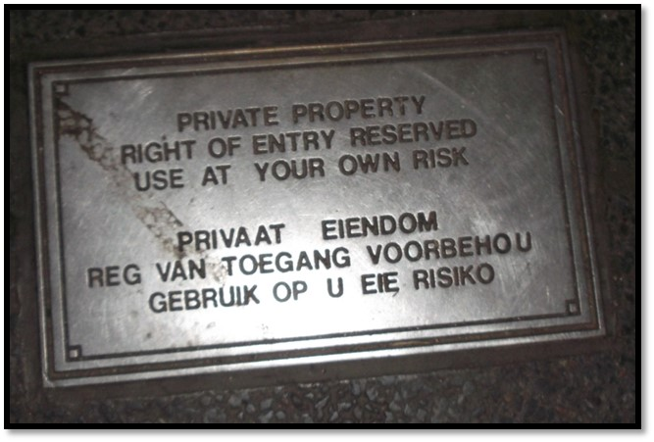
Figure 4. Sidewalk sign as found on each entrance into the FNB Bank City district.

The signs of privatisation are hidden to give sense of public space, when in fact the space is extremely controlled and heavily policed. “Right of entry reserved” signifies that certain individuals might not be granted access to the district, and might be asked to walk away by the patrolling security guards. Even though the sign doesn’t state exactly who might be denied access, one can guess it would be beggars, the homeless, informal traders and anyone described as potentially doing ‘crime’. This is characterised by other signs of control on the private street going from Bank City to the public library on Beyers Naudé Square. Indeed, the concrete pots surrounding trees and flat surfaces slightly higher than the ground all along the street are covered in spikes, designed to prevent people from sitting or lying down on these spaces. These are part of a ‘defensive architecture’, a term coined by Newman (1973), aimed at controlling public and private space, limiting access to dwellers based on their activities. Usually, in urban spaces, the people potentially using urban surfaces to sit or lie down are people who are not in movement, they can be smoking a cigarette, having a chat with someone else, resting, engaging in flânerie, or simply interacting with the space, as homeless people do, using urban centres as places of survival to find shelter (benches, etc.) and food (markets, etc.). With this defensive architecture, Bank City prohibits these activities, or rather only accepts certain ones, by providing the adequate infrastructure selectively. The enclosed parks in the centre of the district are reserved for FNB employees and contain chairs, benches, and tables for conversations, cigarettes, and lunch breaks. Bank City forbids anyone else from engaging in such activity and makes it clear that it is simply a site of passage for non-FNB employees; they cannot stop and sit, except inside a café or a restaurant on the ground floor of its buildings, which requires one to be able to afford it.

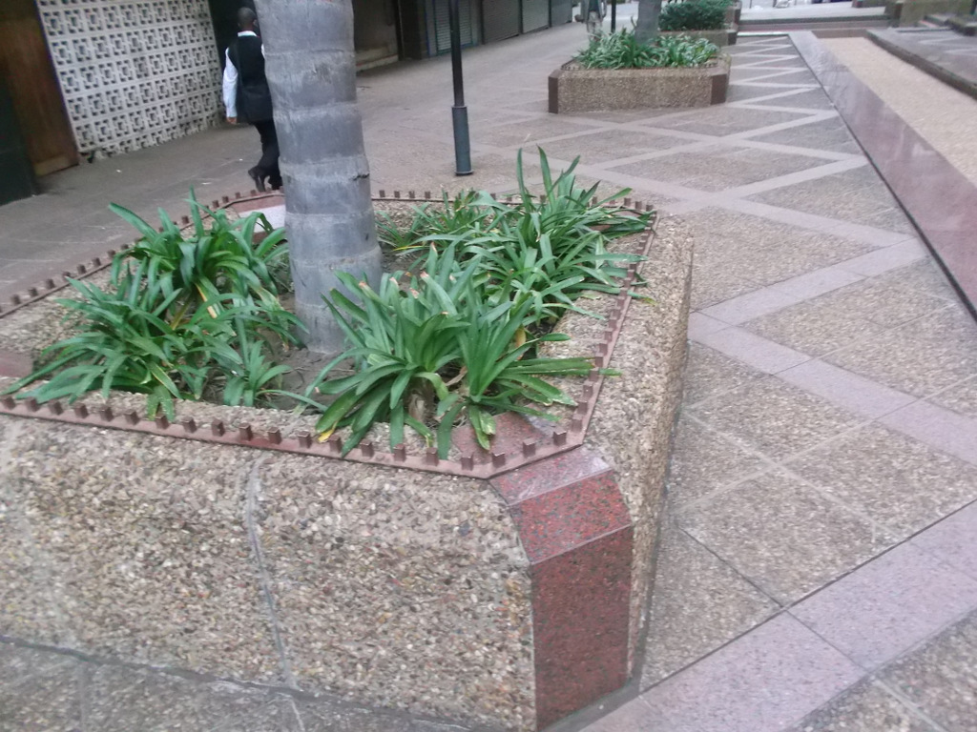
Figure 5. Defensive architecture in FNB Bank City.

Finally, “use at your own risk” suggests that people enter a place which could potentially be harmful or dangerous. It is almost as if Bank City is saying that even though it is a strongly controlled private space, it admits that it is not fully in control and cannot prevent anything that might happen. And if something does happen to anyone on FNB property, the sign frees Bank City from being responsible for the people’s safety, in case of a court battle. In other words, this ‘private property’ bilingual signs includes a warning: It warns people of potential danger; that there are specific rules about Bank City and one can only interact with it in a certain way based on if they are a FNB employee or not; that even though the space looks public and free, there is someone in control of it; and that English and Afrikaans are the dominant languages. Speakers of these languages are thus interpellated as the dominant group.
As we have seen, the privatization of public spaces with the addition of a CID like the SWID has allowed Marshalltown to be modelled and controlled by its main developers with a particular vision in mind. Some of this vision was influenced by looking at what was happening in other cities around the world, and particularly their inner cities, which, like Johannesburg, had been victims of the suburbanization trend and had to find new ways to grow and attract capital. In the next section, I analyze the language used by developers to talk about their concept of the aspired urban experience for Marshalltown, how it interconnects with global cultural representation of what the urban means today, and finally how it correlates with descriptions of Marshalltown by its social users.

4.6 Compassionate capitalism as urban regeneration: The case of Anglo American
Gerald Olitzki mentions in his narrative of his own redevelopment effort in Marshalltown that other actors from the private sector were not receptive at first to the idea of investing in the inner city in the late 1990s:
I spent a good two years going up and down Main Street, to all the players, to all the money houses, etc. I got thrown out the first time around, “this madman here he wants to pedestrianize our street”. You know Anglo American; I went down to all of them.
Anglo American is mentioned as not receptive to his vision because for them, at the time, only the maintaining of their campus mattered. However, a change in how they were perceived contributed to them changing their mind, and had an effect on the redevelopment of the inner city, as explained bellow.
Anglo American is a multinational mining corporation, founded in Johannesburg in 1917 by British entrepreneur Ernest Oppenheimer and American bank J.P. Morgan & Co., hence the name. The company is mostly known for its mining of gold and coal, and being South Africa’s biggest corporation (and third-largest mining company in the world), at least during the 20th century. Some reports claim that the company was very close to the apartheid government, sitting in on important meetings, and participating in some of the decision-making processes, to the extent that some even called it an alternative government (Rajak 2011). These claims have been repeatedly denied by previous CEOs. Nevertheless, Anglo American is well known in Johannesburg, and its headquarters at 44 Main Street in Marshalltown has grown so much that it is referred to as a complex, or campus. It was designed by Ernest Oppenheimer himself, who wanted it to look like something in between a cathedral and a bank. Indeed, its tall façade with columns signifies power, reinforced by long flag-like billboards with photographs of smiling miners, imagery that is reminiscent of political rallies.

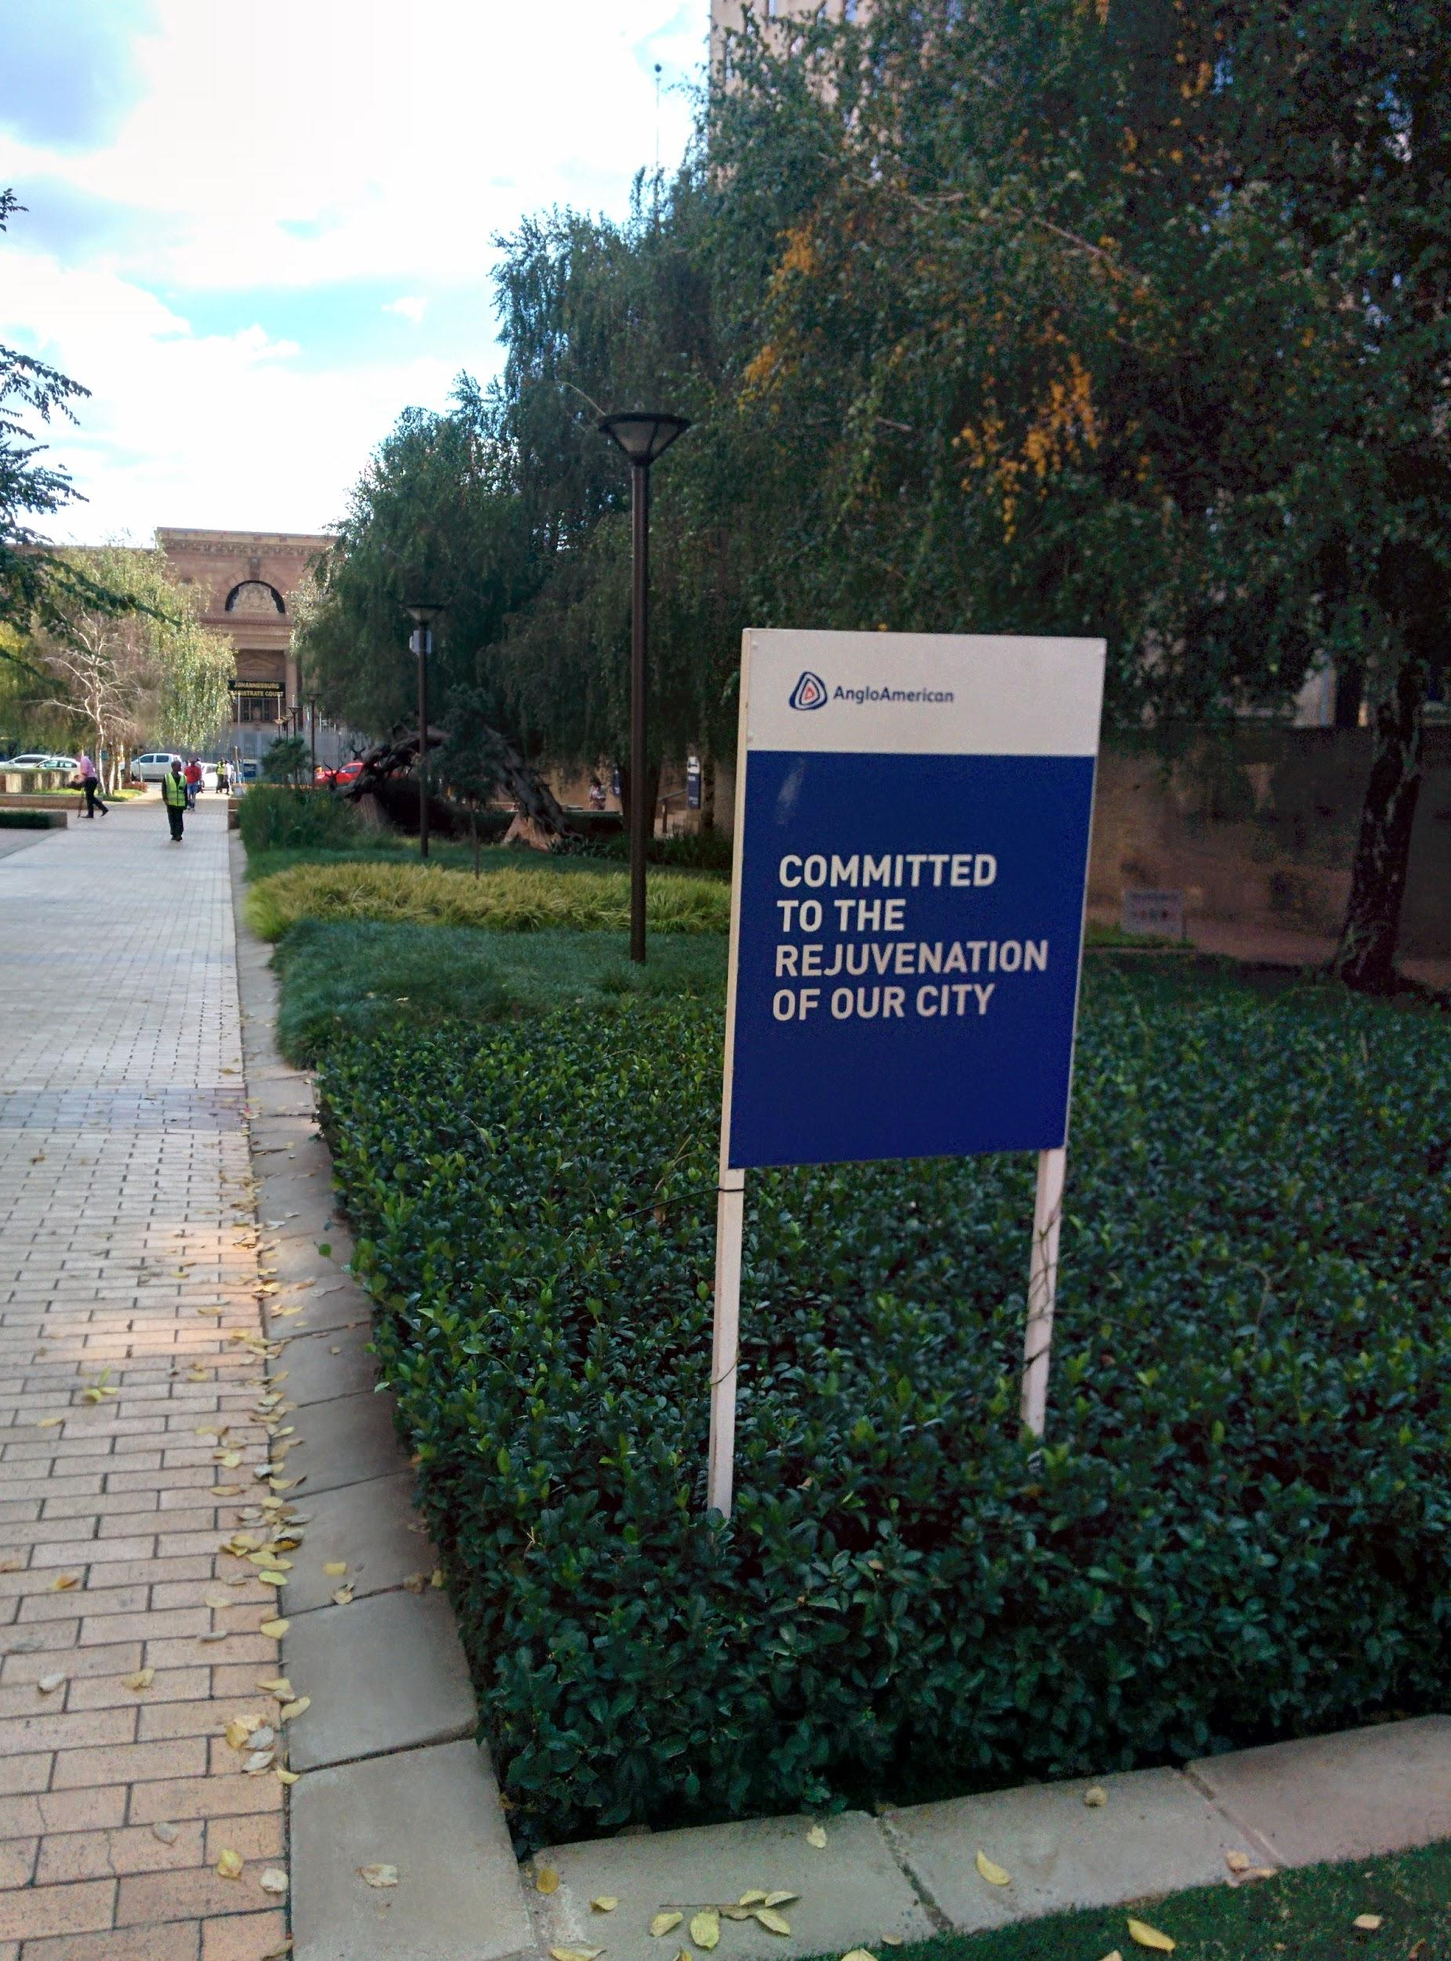
Figure 6. Signage on the Anglo American campus along pedestrianized Main Street.
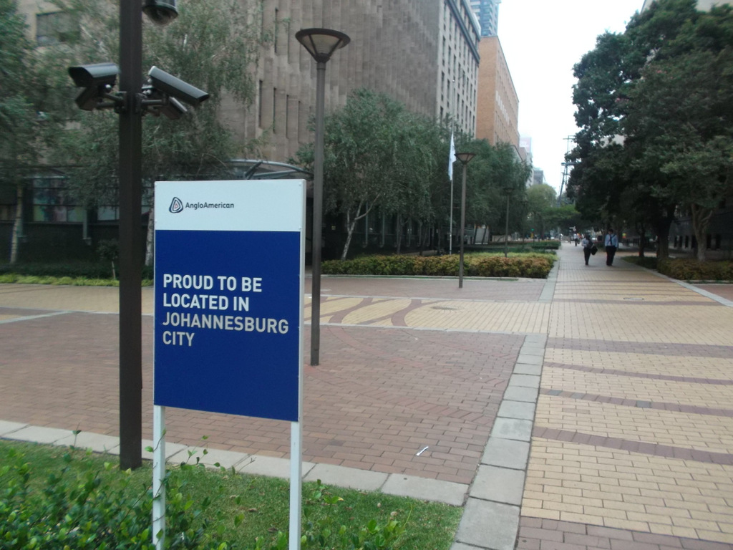
Figure 7. More signage on the Anglo American campus.

These signs serve to mark the company’s territory, which according to Thomas Coggin’s narrative mentioned in section 4.3 also indicates safety, because of the power of the company. If the hundreds of well-off white-collar employees of Anglo American work and walk around the area, then it must be safe. The bottom part of the signs is more understandable with some historical context.
In the 1980s, as previously mentioned, many companies and corporations left the Johannesburg CBD for more affluent and safer premises such as Sandton in the north. The last major business to leave was the stock exchange, in 1998. However, banks such as FNB, Standard Bank, and Absa, stayed, as well as most of the mining houses, perhaps because they were attached to their historical locations and former mines nearby. Anglo American might have remained in the Johannesburg CBD, but in 1999 moved its primary listing from the Johannesburg to the London stock exchange, keeping Johannesburg as its secondary base. The move was heavily criticised in the South African press at the time as it meant profits from a South African company would end up overseas, and would no longer benefit South Africa.
The text on the sign above can then be interpreted as a statement in response to the critiques of the company’s move to London. Terms such as proud and committed index a certain discourse of social responsibility. Indeed, Rajak (2011) has studied Anglo American’s following of the global trend of compassionate capitalism which turns transnational corporations (TNCs) into champions of sustainable development. This phenomenon is known as corporate social responsibility (CSR) and it is tied to the introduction of TNCs into development, which gives TNCs more power, but also responsibility, which can be good for their corporate image. TNCs have been using this opportunity to revamp their image as CSR is “widely held up as the triumph of corporate good over the selfish pursuit of profit” (2011: 2). This translates into TNC communication strategies using a language of social compassion together with one of enterprise, to show that their corporate power can do good, while delivering profit to shareholders and accumulating power the company. Hence, the term compassionate capitalism. Rajak (2011) explains that Anglo American, being the largest private sector employer in Africa, has become a champion of CSR worldwide, pushing for sustainable development, branding itself as a “global corporate citizen of tomorrow” and “proudly South African” (2011: 3). In an interview with Rajak (2011), an Anglo American senior executive explains that the company’s interest in CSR came from NGOs “brand-jacking” the company, the multiple critiques of its exploitation of black labour under apartheid, and the slow change of its corporate culture since the transition to democracy. He goes on to say: “we were sick of getting rotten fruit thrown at us on our way in to work, so we decided to engage rather than hide” (2011: 8). TNCs can also gain legitimacy through CSR in places where local government are not seen as doing enough to fight social blight, such as poverty. But, as Rajak argues, CSR also helps TNCs sustain corporate capitalism, “[not] because it provides corporations with ethics, but because it provides them with a moral mechanism through which their authority is extended over the social order.” (2011: 13).
I would argue that the position of Anglo American historic headquarters in the decaying Johannesburg CBD came to be seen as an ideal opportunity to sustain its CSR, as the area was seen as unsalvageable, and the local government as not powerful enough to bring capital back into the city. Anglo American’s remaining in the CBD is seen as them doing good – not jumping off a sinking ship – and the company may therefore be praised for having contributed to the saving, and then renewal, of the inner city. This gain of social capital for the company can even be topped with more economic capital, as buildings surrounding the Anglo American campus were sold at lower prices that the company could invest in, maintain and renovate these buildings, waiting for their value to increase, and eventually realise a profit. I was told by Eric Itzkin, heritage practitioner at the City of Johannesburg’s department of arts, culture and heritage, that most of the floors in the Chamber of Mines in Marshalltown, an organization which Anglo American is a member of, are actually empty, even though the building’s façade is well taken care of.
Considering the context summarized above, I would argue that the pictured signs (Figures 6 and 7) index (Scollon and Scollon 2003) safety as found in Thomas Coggin’s narrative. They also symbolise (Scollon and Scollon 2003) the company’s CSR, giving Anglo American a better image of a good company participating in the collective regeneration of the inner city, using their capital to show what a better, safer and cleaner urban life would look like.
Of course, the pictures above (Figure 6 and 7) also show numerous CCTV cameras, and there are also security guards along Main Street at all times to make sure that their vision of street life is respected and maintained. Additionally, the Anglo American website highlights other efforts to help Johannesburg, as part of their CSR, such as the MES initiative. Mould Empower Save (MES) is non-profit organisation started in 1986 to “uplift the heart of the inner-city”. Focusing on Hillbrow, they provide the poor, homeless and unemployed with meals, pre-school care for children and skill-training centres for adults. Anglo American has greatly helped the organization financially to help it expand its capacity. As stated on the company’s website: “Together with the Chairman’s Fund, MES is changing the heart of inner cities, making a real difference to real people”. A transitivity analysis of this sentence (Machin and Mayr 2012 based on the work of Halliday 1985) shows two active participants: Anglo American under the umbrella of its chairman, and the organization MES. In terms of processes, it appears to be a material one (Machin and Mayr 2012: 106) in that it describes the process of doing with a material result such as “making a real difference [helping the poor in Hillbrow]”. Here, “real difference” is used in reference to other humanitarian projects in poor neighbourhoods such as Hillbrow. The sentence is also constructed in such a way as to locate the “Chairman” directly beside “MES,” separated only by a comma, which at first glance could be read to imply that the Chairman’s fund (and thus Anglo American) is doing the changing, even though the company is simply helping the organisation financially, and this fact was mentioned in the previous sentence already, which make its repetition in this final sentence seem deliberate.
Finally, the last sentence and the rest of Anglo American’s narrative of them doing good by financing MES is filled with presuppositions (Machin and Mayr 2012: 153; Fairclough 2000: 163) or what Fairclough calls “pre-constructed elements” (1995: 107). First, the title of the page is “Changing the heart of the inner city with MES” which once again puts MES on the sideline giving the impression that Anglo American is doing the “changing”. It presupposes that there is an inner city (Johannesburg is only mentioned later) and that it needs change, highlighted by the play on the word “heart” which can mean ‘centre’ even though Hillbrow is situated in the northern side of the inner city, but also that the area either lacks heart as in emotions, empathy, or good intentions, or simply that it has a bad heart, needing to be changed into a good one. The term “heart” together with “changing” and later on “non-profit organisation”, “challenge”, “uplift”, etc. are part of a humanitarian discourse which helps constructs the presupposition of the heart of the inner city, or in this case Hillbrow, as in need of help, because it is in a bad situation. The decline of the CBD and white capital flight from Hillbrow is never mentioned on the webpage. Lastly, the expression “heart of the inner city” is repeated throughout the webpage making it salient in Anglo American’s narrative of CSR in Johannesburg. It can be seen as a metaphor (Machin and Mayr 2012: 163) for the bad side of town as opposed to the good Anglo American campus in Marshalltown. Calling a place a “heart” is famously used in Conrad’s 1899 novel The Heart of Darkness which draws a parallel between places of “darkness” in Africa, in Europe, and in the human psyche: the deeper one goes, the darker it gets. Anglo American’s use of the metaphor is reminiscent of Smith’s (1996) study of the narratives of frontier exploration in contemporary urban redevelopment and gentrification. Against this backdrop, I would argue that Anglo American is portraying themselves as pioneers of urban regeneration, presupposing that they are doing it in a good way, and that they remain on the frontier of the inner city, which greatly needs more help from the corporate private sector, giving them a win-win scenario where they financially help an organisation do good in the dark area of town where most of their employees and executives don’t set foot, and at the same time they enhance their CSR, changing their image of a profit-driven exploitative mining company to a compassionate corporation.
In this section, I have shown some of the efforts made by the private sector to change the negative image of the inner city, while changing their own image through corporate social responsibility, as in the case of Anglo American. These processes are not isolated in contributing to a place semiotics of a safe and attractive inner city. In the next chapter, I will show how authenticity as a socially constructed imaginative aimed at consumption strategies is also used in changing an inner city image problem.

4.7 Summary
The fourth chapter of this dissertation has focused on the language of the urban (Markus and Cameron 2002). I have looked at the language used by developers when explaining their plans for Johannesburg’s inner city, and in particular Marshalltown. I have investigated where the meaning of such plans such as the CIDs comes from, and the material implications that this has. Indeed, a discourse of Johannesburg’s inner city being too dangerous to visit comes out of the media corpus, while Marshalltown stands out in its representation as being “safe and clean”. I then looked at how Marshalltown contrasts with the rest of the inner city in terms of its representation of smell and cleanliness. Drawing on Pennycook and Otsuji (2015), I showed how social actors in the inner city interact (Scollon and Scollon 2003: 63) with smell and dirt differently; Marshalltown and its CID tightly control the way rubbish is collected and removed from the area to keep it clean because it signifies attraction for its developers and also makes it contrast with the mainstream image of the inner city as being smelly, a characteristic some social actors associate with foreign cultures and their relationship with waste. I then looked at the privatization of Marshalltown through the implementation of US-inspired CIDs which allow developers to not only upgrade the environment according to their own plans (as opposed to the city government’s) but also to make sure that the environment is not negatively affected by outsiders and that social actors interact with it (Scollon and Scollon 2003: 63) in exactly the way that they had planned. This is why parking a bicycle is forbidden: because it was not planned. Finally, I introduced the concept of CSR (Rajak 2011), which undergirded the analysis of signs put up by the Anglo American Corporation on Main Street in Marshalltown, as a way for the corporation, which has a reputation for having profited from the exploitation of black labour under apartheid, and then moving its capital offshore shortly after South Africa’s transition to democracy in 1994, to redeem itself by using urban development in the inner city as a humanitarian cause and reasserting themselves in the narrative of the building of a new Johannesburg.
The next chapter will move away from Markus and Cameron’s (2002) methodology to look instead at the SL of Marshalltown through the lens of what I call the chronoscape, which enables a focus on how the representation of time (such as the heritage on display) affects the construction of place.

CHAPTER 5: HERITAGE IN THE CITY
Boyer (2006) and Zukin (2009) have argued that cities in the late 20th and early 21st centuries preserved, renovated and highlighted historical architecture, narratives, and aesthetics with the aim of returning to the representation of a “traditional” city from the late 19th to early 20th century (Boyer 2006). Many almost erased modernism from their landscapes, partly in order to fit in with global consumer trends that value re-living an “authentic” past (Zukin 2009), a trend that will be explored in chapter 6 of this dissertation. Urry (2002) has advocated for a shift from the question of whether preserving the past is or is not necessary, to questioning “what kind of past we have chosen to preserve” (2002: 99). His sentiment echoes Graham et al.’s (2000) definition of heritage as a concept which implies a particular preservation of the past with a conscious plan to highlight, and thus also background, certain aspects of the past. They argue that heritage is “that part of the past which we select in the present for contemporary purposes, be they economic, cultural, political or social” (2000: 17). Many signs in contemporary cities index the past, be it certain characters, buildings, industries, or aesthetics. These signs become ‘signs of heritage’ when their layering (Scollon and Scollon 2003: 157) form the place semiotic (Scollon and Scollon 2003) of a city, highlighting a part of that city’s past for particular purposes. In this chapter, I argue that the signs of heritage laid out by private developers in Marshalltown are strategically placed to ‘decorate’ the area, giving it a refurbished, clean, look. Problematically, these signs highlight the mining history of the area while at the same time backgrounding the legacy of apartheid, and its oppressed subjects.
The streets of Marshalltown are filled with signs of heritage. When I first walked in the area, I found out about its mining history because of the iconized (Scollon and Scollon 2003: 26) relics of the mining industry put on display on the sidewalks of the Main Street Mall, also known as “the heritage trail”. The link with the headquarters of the mining houses located on adjacent streets seemed logical to me. These old machines reminded the public of the role played by mining in the construction and development of Johannesburg from a digger’s camp established on farm lands in 1886, to a modern metropolis with a skyline full of skyscrapers. The heritage on display was multimodal: I noticed storyboards housed under corrugated iron rooves, using an architectural style typical of Johannesburg, which told the history of the area and highlighted the work of some important actors in the development of the city and its mining industry. Those storyboards include archival photographs in black and white, showing modern visitors what Marshalltown looked like in the past. Most photographs were taken in the late 19th and early 20th century, when Johannesburg was going through a process of rapid expansion. None of the photographs showed the state of the area during the time when the inner city went into crisis, and started to show signs of urban decay (late 1970s to late 1990s).
After further visits to the area, I noticed more signs that index the past: old street signs, vintage lampposts, and original building facades left standing in front of newer, modern buildings. Some artifacts and signs were reminiscent of the old city centres of Europe: stone and wooden pillars separating the road from the sidewalk; or restaurant signs, like one for The Shop Around The Corner, which was designed using the same typeface as the old Metro signs in Paris. Buildings from an older architectural school, such as art deco, were fully renovated, though sometimes empty. Many looked the way they would have at the time of the their construction in the 1920s or 1930s.
An even closer look at the SL of Marshalltown led me to notice other signs signifying not necessarily the city’s mining history, or a particular period in time, but simply something old. This effect was achieved by using particular materials like wood for advertising signs, or nostalgically using a brand’s original logo, employing old-timey typefaces, displaying rusty signs, or the practice of new businesses in old buildings leaving exposed the antique structure of their building, such as bricks or tins roofs, instead of hiding it with fresh paint and plaster. I also found other storyboards telling the pre-mining history of the area.
Together, these signs give Marshalltown the feeling of an outdoor museum. Wherever one looks, some sign points to a different time in a particular era of Johannesburg. This predominance of time in the SL is what sparked my interest in the area as a possible subject for this dissertation. For me, Marshalltown cannot be studied without taking into account this factor of time, which is why I developed the notion of the chronoscape, in order to study Marshalltown’s SL as revealing different layers of time, which I argue is the most present signifying force in the area.
In this chapter, I will look at the signs of heritage and the past in Marshalltown through the lens of the chronoscape. After presenting in more detail what I mean by the notion, I shall give an overview of the signs of heritage, and explore how the past is highlighted in Marshalltown: how did these signs come to be, for what purpose, and which history of Johannesburg do they tell through their multimodality. Then, I analyze one discourse apparent in Marshalltown’s SL: the representation of ‘Africa’, ‘africanness’ and ‘African people,’ with a particular focus on how the multimodal use of this discourse in the environment aimed and still aims to legitimize both the construction of Johannesburg from Marshalltown outwards, and its redevelopment today in the post-apartheid ‘Rainbow Nation’ context. Then, I look at two particular sites: first the Gold Mine Café on Anderson Street, and how it relies on a particular mining history to brand itself as a modern, yet historic urban consumer space; and secondly, at Gandhi Square on the eastern edge of Marshalltown, which was a regeneration project involving private and public sector players, and a rare inclusion of social history in Marshalltown’s SL. Finally, I highlight the heritage that has been invisibilized through waves of urban development in the area, such as Marshalltown’s social history, and signs reminiscent of the apartheid era, as well as signs that intrude unintended, such as tram rails emerging from the tar, or the unavoidable mine dumps on the horizon.

5.1 The chronoscape
In their geosemiotic framework, Scollon and Scollon (2003) stipulate that the meaning of signs is derived from their location in a particular place, at a particular time. Pavlenko and Mullen (2015) have highlighted that although the Scollons’ approach requires consideration of all signs in a given environment to understand the meaning of any sign, they fail to account for diachronicity; their model could thus be understood as an “all signs on one street on one day approach” (2015: 117, emphasis in original). In light of this, Pavlenko and Mullen propose that “the interpretation of signs is intrinsically linked to the preceding signs in the same environment and to related signs elsewhere and is thus diachronic in nature” (2015: 114-115). Their point implies some temporal elements for LL research which should take into account all signs present in one place over time, but also the length of the experience of signs in the environment, as it is clear that the viewer’s interpretation of one sign can be affected by what they have seen before. Their intervention also aims to highlight notions of normativity, and the familiarity of signs as viewers experience them, which implies that corpora including signs from different times may be collected in order to be compared. Building on Pavlenko and Mullen’s argument, it is clear that a focus on the past lives of signs also implies that we must keep in mind what made a particular sign meaningful, in the past, and to whom these signs were salient. I therefore propose that we analyse these signs as a chronoscape. Especially in contexts of socio-political change such as post-apartheid Johannesburg, where rapid change in the social actions of Marshalltown has affected place semiotics, in the context of a built environment that has changed less rapidly, I would argue that the chronoscape opens important avenues for investigation.
The affordances of the notion of chronoscape are the possibility to capture the past layers of meaning which are aggregated in the built environment. Indeed, buildings, streets or parks did not come out of the ground naturally. Past social actions and social actors contributed to the present landscape. As Kropotkin (1995 [first published in 1943]) argues:
Whole generations, [...] have handed an immense inheritance to our century. For thousands of years millions of men have laboured to clear the forests, to drain the marshes, and to open up highways by land and water. Every rood of soil we cultivate in Europe has been watered by the sweat of several races of men. Every acre has its story of enforced labour, of intolerable toil, of the people’s sufferings. Every mile of railway, every yard of tunnel, has received its share of human blood. The shafts of the mine still bear on their rocky walls the marks made by the pick of the workman who toiled to excavate them.” (1995: 14)
Kropotkin reminds us that we cannot take for granted that humans created the built environment. The chronoscape helps us to trace which history of the built environment is being celebrated, and which one is being side-lined. This in turn allows us to draw conclusions about the negotiations of power relationships in urban spaces. More specifically, through the chronoscape it is possible to map out how elements of the built environment have changed over time, and for what purpose. Gendelman and Aiello (2010), in a study about changes in building façades in post-eastern bloc cities undergoing urban regeneration, do not refer to the chronoscape, but their way of looking at the SL is similar to how I will use the term. They argue that urban change requires new uses for pre-Soviet and communist-era façades. Indeed, pre-Soviet façades are highlighted as historic, thus worthy of renovation because of their global, tourist appeal, heightened by the performance of an authentic but staged local identity. Buildings are thus celebrated for their pre-Soviet aesthetic in order to attract global attention and hide their use during the Soviet era. Communist-era façades, on the other hand, are either hidden away through urban decay and lack of care, or they are “refashioned” (2010: 270) through the use of billboards and other types of advertisement for global consumption. Gendelman and Aiello conclude by saying that “façades do not necessarily offer accurate renditions of any given local reality; they can instead be seen as (visual) texts realizing imaginative meanings that are to be attached to the city” (2010: 270).
A similar trend is taking place in Marshalltown, though enacted differently. Buildings from the early stages of Johannesburg in the 1880s to the modernist 1960s are being preserved and renovated because their appeal in terms of authenticity and historicity make them worthy and attractive for the tourism market. More recent buildings are not given as much attention, and tend to be renovated internally, adding more office space to the inner city. The social actions taking place in and around all these buildings during apartheid are thereby erased in favour or a more “authentic” and appealing time, which simultaneously glorifies white colonial capital. This phenomenon will be dissected in more details in the sixth chapter of this dissertation.
Another example of literature which investigate signs of heritage in urban centres is Aiello (2011), who looks at how the industrial neighbourhood of Manifattura delle Arti in Bologna, Italy. She argues that urban renewal has had an effect of exclusion in the neighbourhood as development brought new consumerism. Indeed, she regrets that this renewal is catering for a new, wealthier market and not historically working-class residents. This phenomenon is understood as the result of advanced capitalism. Aiello concludes by stating that “in late modern times it is not only media based in representation and communication technology that are mobilized to carry professionally crafted meanings across cultural and national borders” (2011: 360), which equates to Appadurai’s notion of the mediascape (1996). On the contrary, we should pay attention to how meaning is communicated through the material environment in addition to discourse and images, as part of what Thurlow and Aiello (2007) call the semioscape of contemporary communication.
Thurlow and Aiello’s coined semioscape in response to Appadurai’s stratification of the complex global economy into five dimensions of global cultural flows such as the mediascape as mentioned above, but also ethnoscapes, technoscapes, financescapes and ideoscapes (1996: 33). His framework was previously mentioned in section 4.4 in relation to Pennycook and Otsuji’s notion of the smellscape which is also coined in relation to Appadurai’s stratification. Appadurai’s goal is to analyse the disjuncture between economy, culture, and politics, which intensify systemic complexity. Appadurai justifies the use of the suffix -scape as
[it] allows us to point to the fluid, irregular shapes of these landscapes, shapes that characterize international capital as deeply as they do international clothing styles. These terms with the common suffix -scape also indicate that these are not objectively given relations that look the same from every angle of vision but, rather, that they are deeply perspectival constructs, inflected by the historical, linguistic, and political situatedness of different sorts of actors. (1996: 33)
I argue that the chronoscape intersects with Appadurai’s other five elements: its situatedness is similar as it is fluid and constructed by various processes such as the ones mentioned above. My aim is for the chronoscape to also intersect with the SL of Marshalltown to reveal flows of communication related to time such as the use of the old to give a sense of progress, or to focus on how the construction of a future landscape hides uncomfortable events from the past. Having given the theoretical background to the chronoscape, and before diving into the analysis, I would like to give some example of ‘signs of the past’ in Marshalltown and Johannesburg more broadly.
As previously mentioned, a discourse of time is highly visible in the SL of Marshalltown. Examples forming this discourse include signboards scattered along Main Street which talk about the history of the area; relics of the past, usually related to mining; and the mining corporations’ headquarters, most of which are located in Marshalltown. Parts of the neighbourhood are privately controlled and maintained under the name of South-Western Improvement District (SWID, as discussed in chapter 4), improvement signifying a progression from the past to the present. The guards, streets and shops appear better maintained and more recently renovated than the rest of the city, and the web-pages for certain activities offered to tourists talk about the district as a growing and future major destination in Africa. Other signs of temporality can be observed from the district, such as the abandoned mine dumps to the south, the wasted remains of the ore from which the city’s wealth was extracted, and ruins of once prestigious buildings such as the Library Hotel on Commissioner Street. All of these signs help construct the place semiotic (Scollon and Scollon 2003) of Marshalltown, inflecting the social action that takes place there.
In the suburbs of Johannesburg one can find other examples of signs of the past which are repurposed for particular economic reasons, obscuring their original meanings. Falkoff (2015) points out that almost all middle-class houses in former whites-only suburbs have a “garden cottage” in the backyard which the owners rent out to students or other middle-class people today. These structures were actually “servants’ quarters” that used to be filled with cheap materials and furniture. Today, the renters list descriptions such as “separate entrance” as marketable features when putting up online ads for the cottage; in the past, these separate entrances were to avoid having the (black) workers interact with the (white) residents outside of the house (Falkoff 2015). Today, the meanings of these garden cottages relate to extra income for home owners, and not to relics of the apartheid era. Under apartheid, black people were only allowed to live in these suburbs if they were housed in these cottages, using a separate entrance to the property. Most of them are rather small, poorly lit, and almost always built at the back of a property.
This example gives an idea of the reasons why it is relevant to examine a SL considering the factor of time in order to understand the juxtaposed layers of meaning that have sedimented over time, creating what we see today. The meaning of these signs has changed, and the construction of their meaning isn’t linear. In other words, if we take such signs as the ones presented above as signs of heritage, we have to take into account that they have been highlighted in the landscape for a particular purpose and we have to critically investigate these purposes, and which narratives from history are foregrounded and which backgrounded. In order to unveil such historical intertextualities, it is also important to consider the “real historical actors” (Blommaert 2013) responsible for the construction of the built environment
It is for the reasons explained above that I would like to look at Marshalltown as a chronoscape, considering the semiotics of the built environment from a temporal perspective. A chronoscape would then be a landscape with multiple historicities layered on top of each other, where neither meaning nor built structures are fixed, each one requiring dissection in order to be understood in all its past and present political and social complexity. The chronoscape is tightly connected to the notion of memory because signs in the landscape directly or indirectly act as remembering tools, or forces viewers to forget. Planners and architects design a place in order to highlight certain moments, but also to hide others.
Having introduced the concept of the chronoscape, I shall now analyse multiple signs of heritage in Marshalltown’s SL which index feelings of memory and nostalgia: people interacting with these signs may be reminded of a Johannesburg they used to know. These signs can also index amnesia because, as we will see, the concept of heritage entails a selection from history for particular purposes that leaves behind other historical realities deemed not relevant.

5.2 Heritage as memory and nostalgia
Many signs in Marshalltown indicate that the area is in constant flux because of urban development efforts. Indeed, this change is exemplified by scaffolding covering buildings being renovated; new businesses open regularly, filling up previously empty street-level commercial spaces. On Main Street, a building where Standard Bank had its headquarters in the 1970s is under renovation. A fence prevents the public from getting too close to the structure. Provincial government employees who occupied the building previously have been relocated to Commissioner Street. The bottom floor of the building where the entrance is located is covered by a semi-transparent sheet with a photograph of a classroom. The Gauteng provincial government logo in the bottom left corner which makes it a top-down, official sign, maybe placed there with the purpose of hiding the decaying, messy entrance hall. Finally, the top of the banner contains three titles in bold typeface and framed, stating “Radical Transformation”, “Modernisation” and “Re-Industrialisation”.

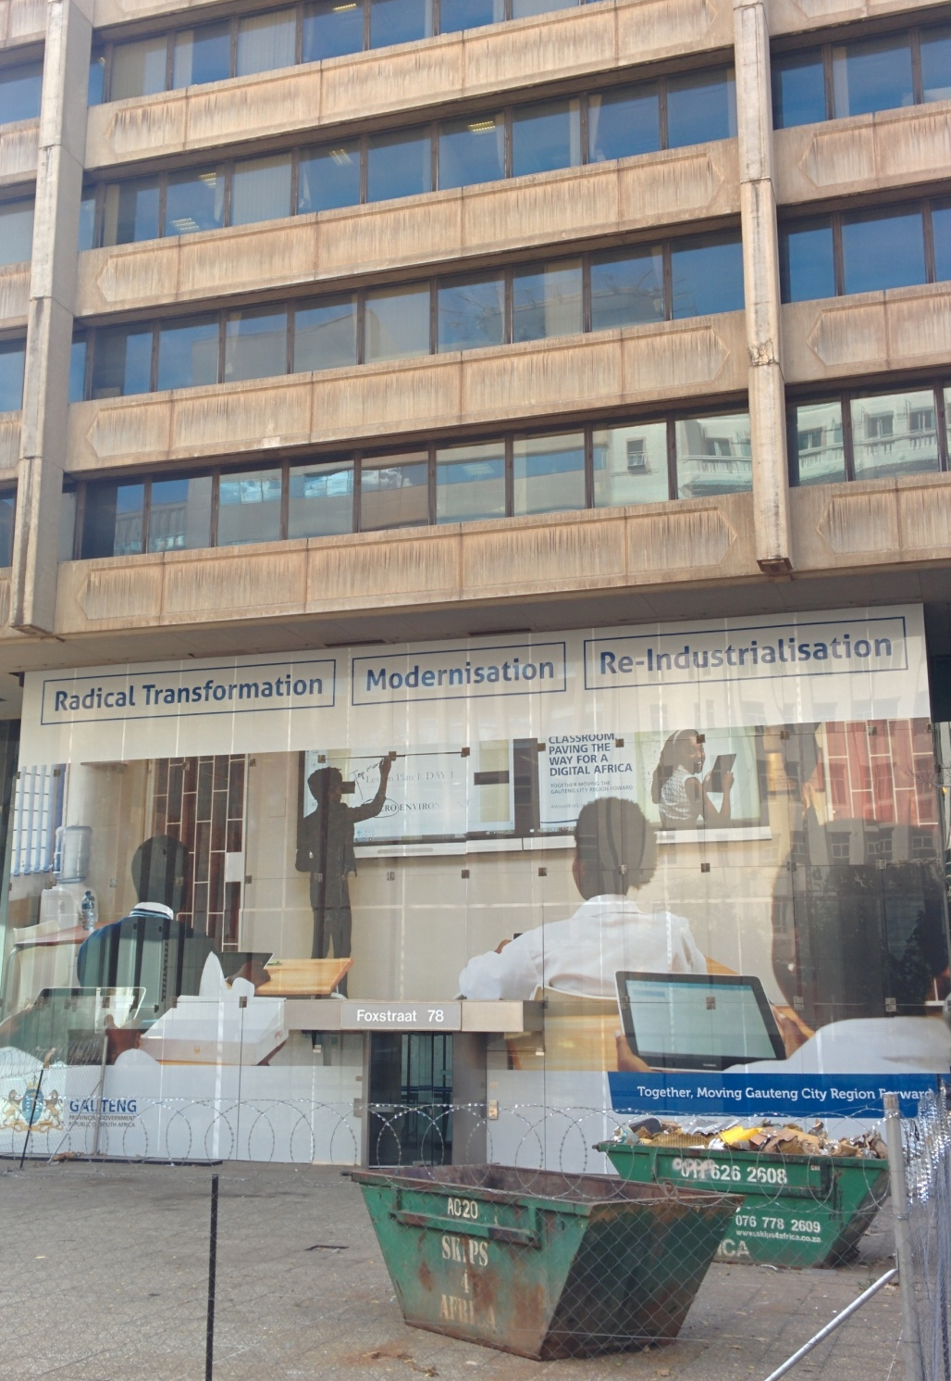
Figure 8. Scaffolding in front of the former Standard Bank headquarters on Main Street.

The first title uses the strong adjective ‘radical’ – referring to an upcoming change that is fundamental, and unlike anything experienced in the present. This sign can be read in relation to the rubbish bins in front of the building, very present reminders what must disappear in order for things to change. Stroud and Mpendukana argue that “meaning and languages are represented differently in semiotic artifacts and technologies across spaces” (2009: 365). Here, a language-based sign is read in relation to a material object in the same space, exposing the meaning of transformation from ‘decay’ and ‘construction’, as iconised (Scollon and Scollon 2003) by the bin, to ‘modernisation’. As opposed to an upgrade or renovation, a transformation means getting rid of something in order to make space for the new. The second linguistic sign (‘modernisation’) entails a move from a time period to another, more present. It seems to make reference to the adoption of newer technologies because of the laptop, digital tablet and smartboard pictured in the image (Figure 8). Finally, the third sign evokes a reference back in time, as opposed to the previous one. Indeed, by saying ‘re-industrialisation’, the sign presupposes that there was industrialisation, and then de-industrialisation, and that the Gauteng province is now bringing it back.
In the context of urban development, industrialisation is part of a discourse of construction, meaning that in order to have urban regeneration or ‘radical transformation’, various industries will have to be active and relocate their efforts to the developing area. And in the context of South Africa, and Johannesburg particularly where unemployment is rife, re-industrialisation presupposes the creation of jobs and economic expansion. This sign of urban development installed by the Gauteng City Region gives hope because it seems to announce a move forward in time for the inner city after being neglected, a way to re-activate it, which would bring jobs for the people in need.
Another sign that makes reference to the discourse of urban regeneration, is found on Loveday Street, half a block away from Main Street where the other signs are located. On the first floor of the newly renovated London House, a large billboard contains the logo of City Property, the city-owned company providing affordable housing in renovated buildings in the CBD. In large bold letters it says “Another Urban Renewal Project”. The middle words – “Urban Renewal” – are in red, while the others are in blue. This contrast contributes to giving salience to notion of urban renewal: it is central to the message of the billboard. The designer(s) of this sign wanted to highlight that there is urban renewal taking place in the city and that the concept should be taken seriously. The adverb ‘another’ is also key here: the project is one in a series of developments that started in the past, are on-going today, and will continue into the future. Other buildings have been renovated by City Property; more are to come. It invokes an active process, perhaps even an unstoppable one. By placing this sign in front of a newly renovated building, City Property is also advertising newly available housing to prospective renters. However, the fact that the sign doesn’t mention housing, but urban renewal in general, suggests that the project aims not merely to house people, but to bring a range of changes to the area, catering to the needs of the incoming population.

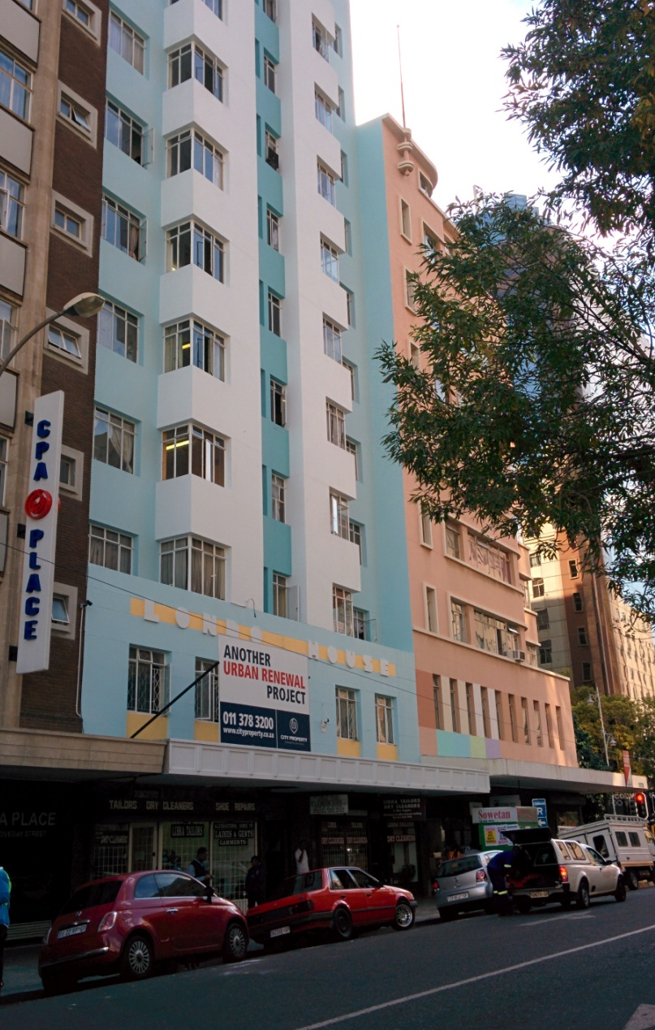
Figure 9. London House on Loveday Street after renovation in 2015.

The term ‘renewal’ in this sign also contains a marker of time. It presupposes that there was something before and something different is being created (what the other two signs discussed also pointed to). However, unlike other signs in Marshalltown, none of these signs points specifically to which era is being referred to.
Similar to other cities around the world (London, Paris and Rome) blue historical plaques can be found around the city of Johannesburg. Those ceramic or resin circular signs, also named ‘heritage plaques’, highlight “special buildings and sites, historic struggles, remarkable personalities, and other pieces of history (Blue Plaque [booklet]. Directorate Arts, Culture and Heritage, City of Johannesburg, 2013). About 100 plaques have been installed in Johannesburg. At first this task was performed by heritage organisations, volunteer groups with their own specific focus; from 2003, the City of Johannesburg’s Department of Community Development joined in. Those introduced by the ANC-led municipality have focused on the homes of activists during the struggle against apartheid, important places in townships such as Alexandra, Soweto, and Sophiatown, and the locations of historical social movements such as marches and clashes. The majority of the plaques, however, focus on industrial, architectural and mining heritage and were introduced by independent bodies. A look at a map showing where some of the plaques are located in Johannesburg’s inner city shows a particularly high concentration in Marshalltown.

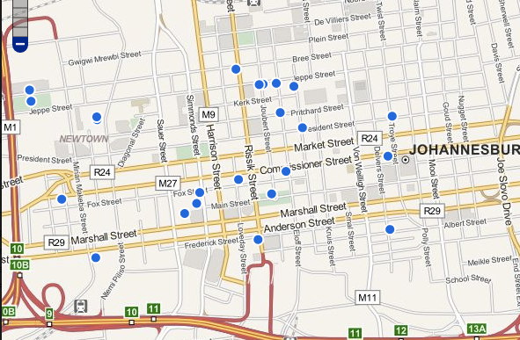
Figure 10. A map of Johannesburg’s inner city showing show blue dots which each represent a Blue Plaque commemorating a heritage space.

It would seem that the selection of locations worthy of a blue plaque is based on a narrative about the origins of the city, where its foundation were laid, and where landmark buildings once stood before being replaced by modern skyscrapers. This pattern can also be found in other cities (Boyer 2006). Because cities expand over time to make space for an increasing population, the former centre where foundations were laid has to compete for attention with newly developed suburbs, parks, and shopping malls designed for consumption (Zukin 1993; for a discussion of Johannesburg, see Beavon 2010). Tourists in search of historic narratives and buildings are thus likely to learn about how a city began.
The word ‘heritage’ is often found in discourses of growth and development in Johannesburg’s inner city, because the renovation and repurposing of buildings or structures left decaying for years is considered a sign of capital moving back into the inner city. However, not all the old buildings in the inner city are selected for preservation, renovation or conversion. Many of these buildings are standing empty, some in derelict condition, hijacked by criminal landlords charging rent to low-income residents unable to afford other options in the inner city. Some buildings in Marshalltown are also standing empty, but most of them have had their façade renovated in the last few years, and security guards prevent illegal occupations. Many buildings are freshly painted, with completed renovation process signs to announce new owners, or advertise spaces to let or buy. In many cases the interior is either untouched since the 1990s, or gutted and empty.
The Barbican, Johannesburg’s first skyscraper, completed in 1931 on the corner of Rissik and President (now Helen Joseph) streets was bought by investment and banking group Old Mutual in 1995 to finally be renovated in 2011 after being pressured by the municipality and heritage bodies such as the Heritage Portal of Johannesburg. The skyscraper was symbolic of Johannesburg’s aspiration to become a major global metropolis; it was designed to look like the skyscrapers of Chicago and New York. It went into decay in the 1980s and 1990s before being bought by Old Mutual. Articles published around the time of the completion of its renovation 2011, reflect the excitement of prospective tenants to move into the building. But by 2016 the building remained empty, with only a mattress store on its ground floor.
This practice is common in Marshalltown: buildings are renovated, or at least their façade, but left empty. In the past four years since I started my fieldwork, I witnessed multiple “FOR SALE” signs, followed rather soon by “SOLD” signs on some of the older, still vacant buildings in Marshalltown. These buildings either remain the same as the “SOLD” sign goes into decay itself, or they get renovated, turned into office spaces and property management companies such as Propertuity, Mafadi or Urban Ocean are hired to look after and let the units in the buildings. The fact that these buildings are being bought and some are getting renovated for the first time in thirty to forty years is a sign that expected shift in the inner city property market is edging closer and closer. This trend might be steadier now, but it wasn’t always the case, especially in the years immediately after the collapse of the apartheid system and the shift to democracy in South Africa. John Dewar of the Johannesburg Land Company, a major actor in the redevelopment of Marshalltown, and the designer of the multiple signs of heritage in the neighbourhood, claims to have been one of the first people from the private sector to have ventured into buying decaying buildings in the Johannesburg CBD.
Dewar recalls initially being indifferent to the idea of investing in the area, after the idea was suggested to him by a friend. Only later did he become convinced of the business venture, after taking a walk in Marshalltown. From his narrative of this walk, a picture emerges of an adventurer or pioneer, venturing into unknown territory:
[I]t must be ten or twelve years ago, a friend of mine from England, also a good Scot, says look, you know those old buildings in the centre of town, I want to go and buy some because the market is going to turn and I want to be in the forefront of that. I said you’re bloody mad. [...]. It took him two years until one day he said I’ve had enough of you, you go and walk in town, analyse the thing and then come back to me, so you know what you’re talking about. So I went along with my then partner and we walked down Loveday Street, from City Hall to Main Street, we had our hands in our pockets and thinking we were going to be beaten on the head any minute, and suddenly realised it wasn’t bad at all. So we then started looking at buildings and what would be available. And we started collecting buildings. Old buildings, new buildings. And at one stage, we owned quite a lot of buildings. We owned half of Main Street. So I decided that we’d stick in Main Street between Rissik Street and the Magistrate Court. Concentrate on that, which is what we did.
The part of Main Street he is describing is what is now known is the Main Street Mall, with the Heritage Trail and its multiple signs and installations of heritage displayed along the street. It is delimited by Gandhi Square in the east and the Magistrates Court in the west. This section of the street became private property in the early 2000s when John Dewar’s Johannesburg Land Company along with other property owners in the area decided to contribute to already existing efforts of urban regeneration. John Dewar and his company show how powerful they are in terms of having an impact on the semiotic landscape of Marshalltown. His “historical body” (Blommaert 2013; Scollon and Scollon 2003; 2004) (see also section 3.4) is highly relevant in his implication in the preservation and development of the neighbourhood because being of Scottish descent and having had family members work in the area since the beginning of the city seem to give him legitimacy to decide what is best of Marshalltown, what should be preserved and he has no issue borrowing urban principles from Edinburgh judging by the fact that he is of Scottish descent.
Before John Dewar decided to invest in the area, Gerald Olitzki of OPH remembers office workers having to remove their expensive belongings such as jewellery for fear of being mugged while crossing Main Street on the way to the bus terminal in what is today Gandhi Square. According to Olitzki, drug addicts and homeless people used to hang around the street, which was not good for his plans to attract capital back into the inner city. As we have discussed before, the implementation of the CID, and the gaining of the private lease of certain streets allowed developers to strictly control the appearance and usage of those streets. Main Street was one of them. But for John Dewar keeping the street clean and safe was only a first step, as exposed in the previous chapter, in order to make the area attractive for people to want to spend time there. A self-proclaimed history enthusiast, he decided it was necessary to write the history of the area where he and his relatives had been working for many years, and that that history should be made available to the public. The Main Street Mall contains most of the signs of heritage in Marshalltown, displayed for this purpose; they combine with other signs indexing, other histories of Johannesburg and Marshalltown, that are present in the area.
The signs of heritage along the Main Street Mall were chosen and displayed by John Dewar himself. For him, redevelopment entails going back in time to when his family grew up and lived in the CBD. He claims his father was a miner who died of silicosis as a result of breathing dust underground. His family heritage is tied to Marshalltown, and its mining industry. In his youth in the mid 20th century, he would explore the CBD on foot, and his various jobs kept him in the vicinity of Marshalltown. After getting involved in finance, he got to know important people in Johannesburg, including the owners of most of the buildings in Marshalltown, which was of great help when he decided to buy many of them in the early 2000s with his redevelopment plan in mind. While his connection to Marshalltown and the mining industry seems very personal, I wanted to know why he decided to include the heritage of the area in his urban redevelopment plan. He first told me this:
...we were buying all these buildings and everybody had the perception, like we did, it was dirty, it was dangerous and nobody wanted to come back. So if we wanted to own buildings we had to get people to come back, clean it up, we had to protect it and we had to modernize it.
It seems that for him, “modernizing” the area actually meant bringing it back to the way it used to look, by renovating buildings, he meant restoring them to their former glory, even when they would have to stay empty for a few more years. He adds that he wanted people to see what buildings once looked like and for them to understand their architectural style. He also claims to favour the old buildings because they were very well-built, and durable, and that to demolish them to build new ones would have resulted in buildings of inferior quality. His statement is made in relation to many buildings being “knocked down”. When speaking of this, he told me: “This is very sad, Johannesburg is disappearing”. This fear and sadness of seeing the Johannesburg he once knew disappearing is what led him to want to preserve what was left, and enhance the feeling of nostalgia by bringing back more artifacts reminiscent of the area’s history. And since he had managed, along with other land owners, to obtain a private lease for a section of Main Street, he could then solely decide on which heritage would be selected to ‘decorate’ the rejuvenated, ‘modernised’ Marshalltown.
Examples of such signs of heritage selected by John Dewar include the original headgear installation that stood on top of a mine, two stamp mills used to break down the rocks mechanically in order to extract the gold, and engines used to power the tools handled by the miners underground; the mine vents designed to let fresh air into underground shafts to prevent miners from suffocating are now repurposed as rubbish bins on Main Street.
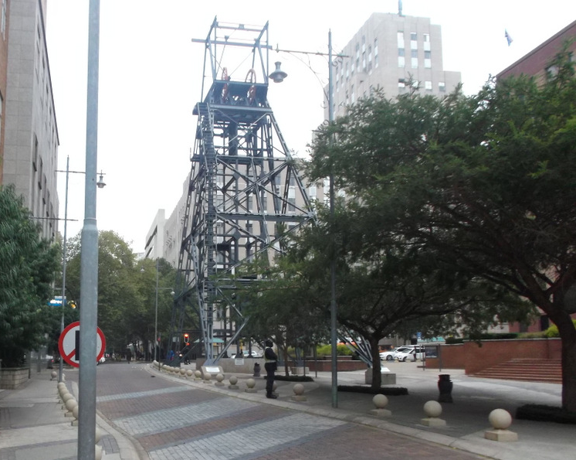
Figure 11. Mining headgear at the corner of Main and Simmonds Street.
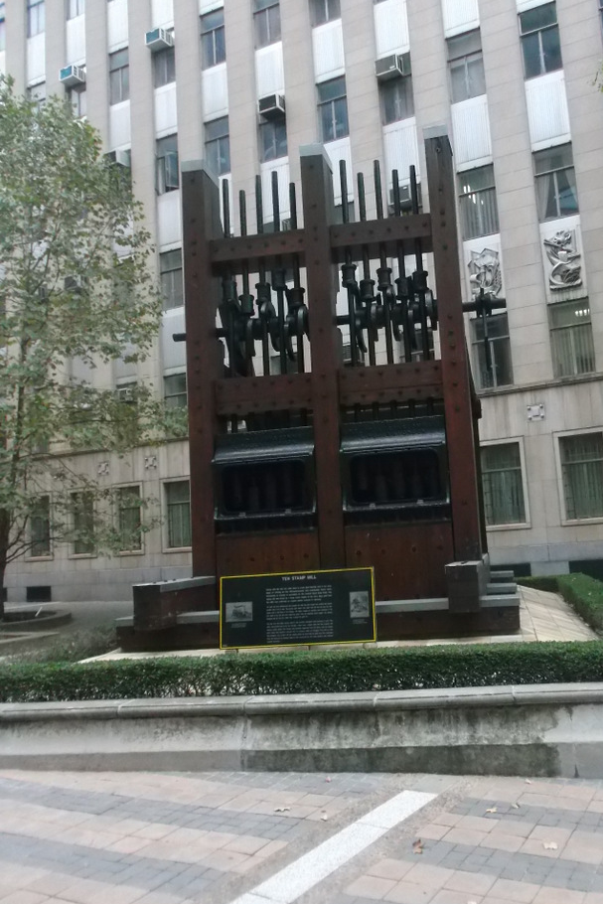
Figure 12. One of the old stamp mills, displayed between Main and Marshall Street.
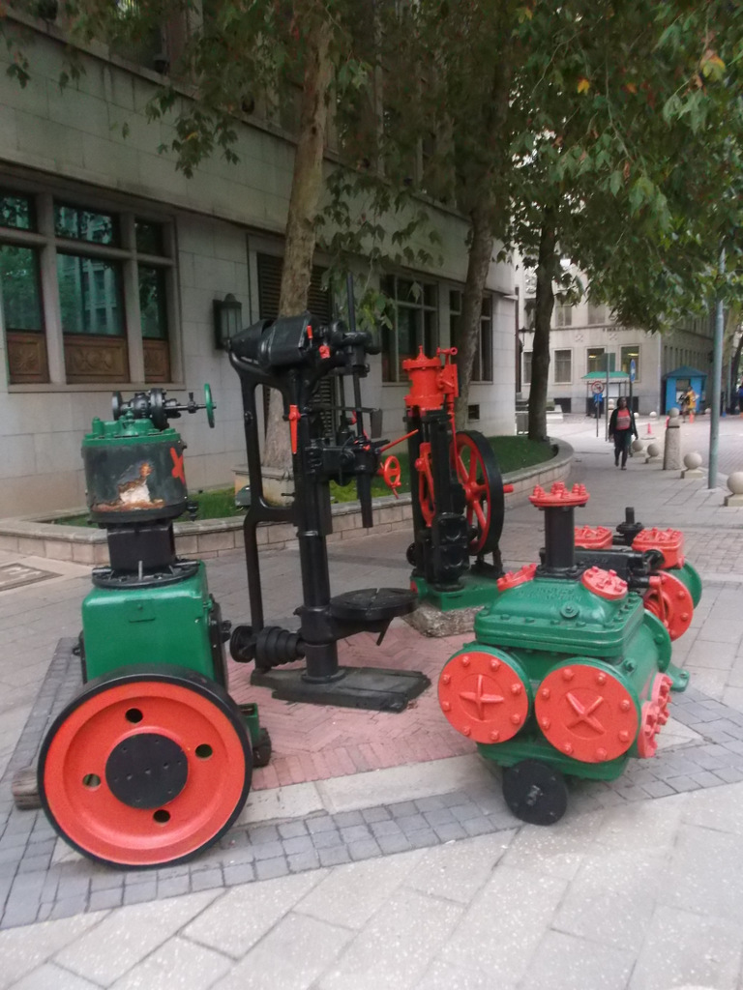
Figure 13. Engines displayed on a side-walk.
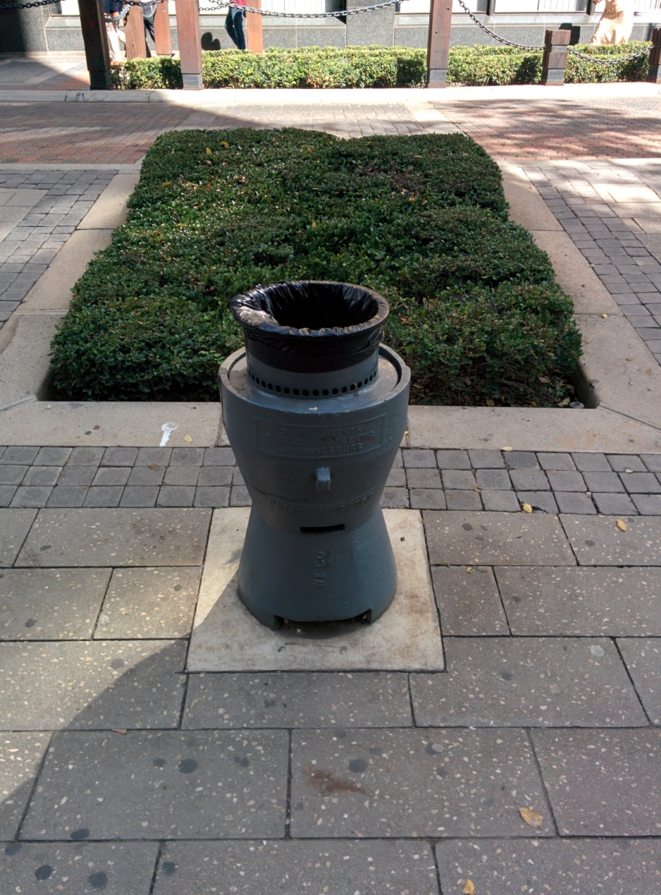
Figure 14. Recycled mine vent, now a rubbish bin on Main Street.

John Dewar was not the only one in control of the area’s redevelopment. Other signs index a history of the city different than the one tied to its mining industry. For example, on the corner of Loveday and Marshall Street stands a recently renovated turret. Its façade is so well painted that it looks like the building was built during the 21st century. However its architectural style with its pillars and roof tiles index rather an early 20th century building; it was completed in 1906, according to Gerald Gardner. The turret seems to be missing parts of its edifice on each side, as its roof is abruptly cut off. The remainder of the block it is located on is an open air parking lot for white-collar workers at the NED Bank building across the street. Archival photographs indeed show that the edifice was part of a much larger structure, which was demolished as part of previous redevelopment strategies in the 1960s when taller, more modern buildings, were preferred (Beavon 2010). In 2013, Gerald Gardner, author of the Spaces & Places book series about Johannesburg, took up tenancy in the turret, using it as a base for the newly founded Joburg City Tourism Association. The location is used as the starting point for the heritage tours Gardner offers in the area.
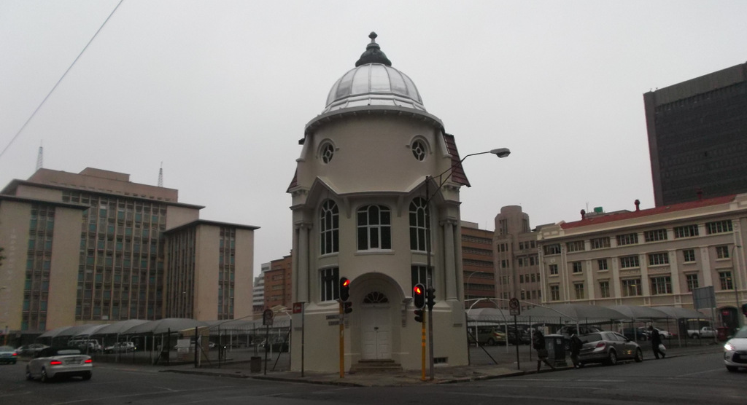
Figure 15. The turret on Marshall Street.

On closer inspection, the turret is both itself a sign of heritage, and the host of other signs, such as the old street sign for “Marshall Straat” on its façade. It is interesting to note that the old street sign is in Afrikaans, while the modern street sign a metre away on the sidewalk is in English. This language shift from Afrikaans to English (Dyers 2008) materially represented here, is due to the “massive social transformation that democratic South Africa is presently experiencing” (Stroud and Mpendukana 2009: 363).
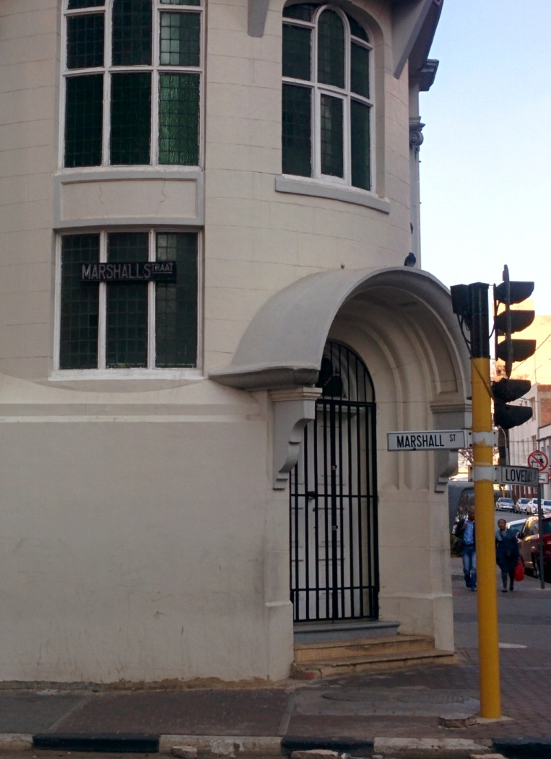
Figure 16. Street sign for “Marshall Street” in front of the turret on the corner with Loveday Street.

Both signs index the same street, but are different in language, design and material. One is made out of galvanized iron and thus looks brown with the name in white whereas the modern one is made out of white plastic, with the name in black. Each sign achieves its indexicality in naming the street by being placed differently in the material world (Scollon and Scollon 2003: 29). Indeed, the Afrikaans sign does not index that the turret is named “Marshall Straat”; rather, the placement of the sign indexing the street name also iconizes (Scollon and Scollon 2003: 26) a different era, when Afrikaans was the norm on street signs, and such signs were attached to buildings rather than in English, on a pole. The fact that there is already a modern street sign indicating the street name on the corner means that the old Afrikaans sign is there to highlight that the building is a heritage building, preserved in its past state. In the whole of Marshalltown’s LL, it is the only sign I have found in Afrikaans. The linguistic contrast of the sign thus indexes something other than merely ‘the past’ and ‘heritage’, but a time when Afrikaans was the national language and was required on top-down signs such as street signs. Indeed, the use of Afrikaans here is chronotopic as it reminds viewers of the apartheid era under successive Afrikaner nationalist administrations. It is thus not surprising that other signs from that era are not celebrated as having heritage value: this part of South Africa’s history is very rarely highlighted in the SL of heritage in Marshalltown, at least not in a celebratory way. Texts on the storyboards focus on the early days of Johannesburg, before the implementation of apartheid laws.
This practice dovetails with Urry’s (2002) vision of heritage mentioned at the beginning of this chapter which highlighted that a particular version of the past is chosen to be preserved for particular purposes. In the case of Marshalltown, the purpose is one of urban redevelopment, making sure the old Johannesburg doesn’t disappear, exemplified by John Dewar’s position. But the purpose here is only to highlight a certain era, mainly focusing on mining, and ‘skip past’ the apartheid era, deemed not attractive for potential visitors. Indeed, Nuttall and Coetzee (1998) argue that in post-apartheid South Africa, negotiation of the past, especially the era of apartheid, is a complicated process that is sometimes avoided for the sake of moving forward. In our interview, John Dewar states: “It’s not the white or the black man; this is South African history, which is very important”. For him, the past selected as heritage is post-racial; it is of national interest in the context of a democratic state, as opposed to an apartheid one.
This provokes the question: how are black people represented in Marshalltown’s SL and where do their narratives fit into the heritage on display? Since none of the storyboards about the buildings’ history give any indication of the social context in which they were built (was it by black labour?), and all the characters celebrated are European, it can be assumed that the fact that the developers are white and have managed to privatize some of Marshalltown, that they chose to celebrate their own European history of the area, thus erasing any indigenous or black history of the area. Indeed, some representations of indigenous culture and black people can be found in Marshalltown. However, as I shall argue in the next section, those representations need to be problematized.

5.3 Africa in the city
Many other signs in Marshalltown, such as coffee shops and upscale apartment buildings, presenting a vibrant lifestyle for its social actors, give the area the aura of a global metropolis. On a closer look, however, one can find many signs of a feral discourse (wildness) and Africanness. Bank City, just south of Marshalltown, where FNB’s head offices are located, went as far as naming its new private park (reserved for employees) the “Urban Savannah”. This gives the impression of nature in the city (culture), materialising the dichotomy.

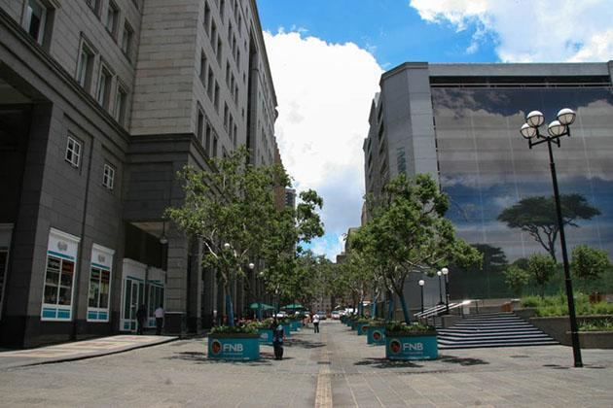
Figure 17. FNB’s “Urban Savannah” (a sign with this title appears behind the real tree on the right-hand side). The space over the stairs on the right-hand side is reserved for FNB employees.

In Marshalltown, multiple buildings built between the 1930s and 1970s represent wild animals such as lions, impalas, hippopotamuses, and giraffes, among others. Again, these seem to represent what is native to the land (Africa), away from civilization, and to give a taste of the great outdoors to the urban jungle. These iconized animals (Scollon and Scollon 2003: 26) help construct the place semiotic of Marshalltown (Scollon and Scollon 2003: 142) which give the impression, or act as a reminder to social actors, that social actions are taking place in a material urban environment situated on the African continent, as imagined by the planners and architects responsible for such design features. As I will show further on, this trend was also part of the Art Deco architectural movement in the 1920s, 1930s and 1940s, a type of building still visible on multiple blocks in Marshalltown. In relation to this feral discourse, is the presence of an African visual discourse.
Indeed, most of the representations of people in the displayed sites of memory in Marshalltown concern white people who are framed as the architects of the city, discoverers of gold or diamonds, and contributors to the emergence of the city. Very few representations are of black people. One exception is the statue in honour of the black miners which was erected on Sauer Street (now Pixley ka Isaka Seme Street) in 2013 to commemorate the black mineworkers who are often unnamed in the histories of Johannesburg, and the region. There is also a rare social history site in Marshalltown: the statue of Mahatma Gandhi on Gandhi Square. Other representations of black people can be found on building façades for decoration, in the same fashion as for the animals. Each time, the black character is represented as almost naked, holding a spear, being killed by the Boers (as on the frieze on the BHP Billiton building), or in their most “traditional” way. Since these representations were designed during apartheid in the heart of the economic hub of the country, we they were most probably designed by white people. Indeed, some of the signboards scattered along the Main Street Mall include textual narratives giving visitors the history of buildings located in Marshalltown; some still standing, some dismantled. Not a single non-white person is mentioned on those signboards and pictures of the white architects and designers often accompany the text.
During my interview with Gerald Olitzki, he explained his disappointment in the lack of embracing of African culture(s) in Johannesburg’s contemporary architecture and development. It felt too European to him:
…if you look at Sandton particularly you see lots of English architecture, lots of French architecture, lots of English, you know… Tuscanese, you know all kinds, it was this desire to try and create this European bubble. There was no desire whatsoever to embrace Africa, despite the fact that we all live in Africa.
Olitzki notices that the new business district and economic hub of the region is designed to look European and not (South) African. Bearing in mind that the original CBD of Johannesburg was designed similarly, with an aspiration of becoming a Western-like metropolis (as argued above), he seems progressive for pointing out this flaw. His discourse is similar when talking about the redevelopment of Marshalltown by other private investors:
To some extent, sorry I show my political colours, but to some extent, it’s great, people who come into the city love [the heritage feel of Marshalltown], they think it’s marvellous, everybody thinks it’s marvellous. I got a small small small reservation about this, in the sense that it’s a celebration of a part of apartheid history. [...] That’s my reservation. I would not have done it that way. If you see my buildings it’s embracing Africa and not that part of the history of Africa. If you go into the entrance of most of my building, I hope you get an African feel, if you go to Gandhi Square I’ve got a lovely story about the building where McDonald’s is, by the way it’s the busiest McDonald’s in the country. Go look at the entrance. I try embrace Africa. To me that’s a little bit of celebration of perhaps an area where black people were exploited, sorry if I get too political. It’s very much a personal view, overriding that is the people love it; it has been a great catalyst for change. Positive catalyst for change.
In his narrative, Olitzki uses a nexus of political discourse (“sorry I show my political colours”; “a part of apartheid history, that’s my reservation”; “black people were exploited”; “sorry if I get too political”; “a great catalyst for change”), economical discourse (“by the way it’s the busiest McDonald’s in the country”) and African discourse (“I try embrace Africa”; “I hope you get an African feel”) which contribute to the legitimisation of his position as a successful private developer in the CBD of a South African city, celebrating heritage yet embracing native cultures and traditions. Earlier in our interview, he was already uncomfortable when talking about the oppression of black people in the inner city under apartheid:
We’ve got to understand that this used to be, Joburg used to be, it’s slightly political I’m afraid, but life is full of politics when one has to be so, is that this was originally a white city. Black people didn’t feel comfortable walking in the streets of Johannesburg. We had a seriously abnormal situation. White people came here to shop, they came here to the restaurants, they came here to watch movies, you know this was where white people came. The shopping centres hadn’t yet been established. Black people as I say, you didn’t really walk the streets of Johannesburg much because they didn’t feel comfortable here. We started normalising, where more and more black people started going in the streets of Johannesburg through the 70s into the 80s.
His discomfort is noticeable with the use of fillers such as “sorry” and “I’m afraid” when mentioning black people’s experiences and representations in the city, which supposes the existence of a discourse of non-racialism where segregating people in discourse based on skin colour is not tolerated. This possibility comes from the call to see South Africa as a rainbow nation where people of all colours are asked to be united and move on from their past racial conflicts, as famously proclaimed by newly elected president Nelson Mandela in 1994. It is important to note that the affect contained in Olitzki’s interview might have been different had I not been a white foreign PhD candidate.
The racial discourse attached to the rainbow nation project is one of colour-blindness. It is important to point out that under apartheid, the LL of South Africa, to which the inner city of Johannesburg was no exception, was full of signs indexing a racial discourse, restricting individuals from certain spaces based on skin colour. This is the kind of discourse that rainbowism was an attempt to move beyond, as critically examined by Alexander (2013), which explains why Olitzki feels distressed. He also justified his position as a progressive by employing the term “abnormal” when referring to the social structure of the past, accepting that it was problematic, but also highlighting that things are better now: he and the country have moved on, and the social situation has “normalised,” black people are now allowed into all spaces. When talking about this normalisation process, he used the plural first person pronoun “we”, including himself in the progress, maybe as a private investor and urban developer, since he doesn’t mention his law practice as a “catalyst for change”. However, for him, what is considered catalytic is including representations of Africa in the redeveloped urban environment. He does not mention the signs indexing Africa described above but it is interesting to point out visually what he refers to as “embracing Africa” on his buildings:
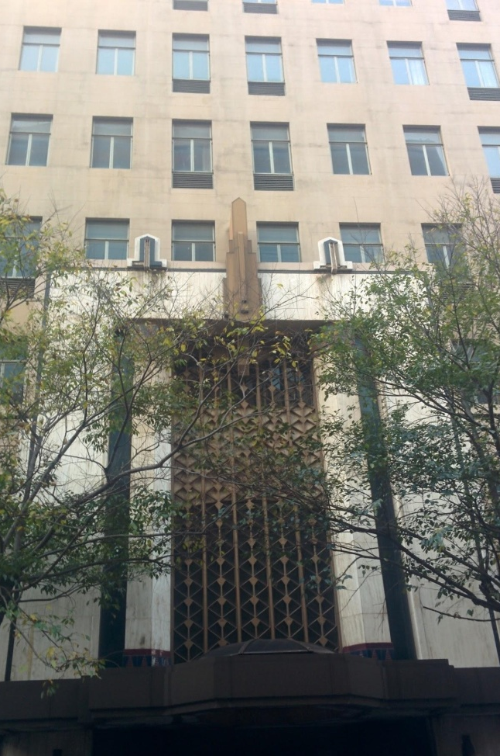
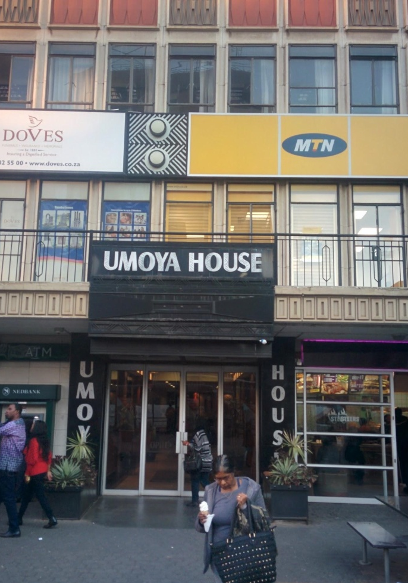
Figure 18. The façade of two buildings owned and managed by Gerald Olitzki’s company OPH, located on Loveday and Rissik Street respectively, both in Marshalltown.

On the left, the reproduction of a traditional mask overlooks the entrance of the building. On the right, a design containing black and white lines and a circle can be seen above the entrance in between advertisements for MTN and Dove’s, and on the walls of the terrace. These echo patterns on traditional Zulu shields, as in the repetition of rectangular shapes. The building is even given a Zulu name: “Umoya” meaning “spirit” in isiZulu. The similarity with the architecture described above is that those signs symbolize (Scollon and Scollon 2003: 45) ‘something African’. However, those symbols differ slightly. Here the goal of these signs is to make the buildings African, whereas before the buildings were often Art Deco, very much European-looking but with representation of Africanness. As we will see later on when studying the typography used on one particular building, representations of Africa and Africans as cultural Other was very much part of the Art Deco movement, embraced by architects in the 1920s, a period, where the majority of the pre-superblock buildings still standing in Marshalltown were erected.
It is interesting to point out that black people and wild animals are used in SLs around the world to signify Africa. Similar trends can be found in the design of Disney’s Epcot theme park in Orlando, Florida in the United States. The park aims to be a perpetual World’s Fair, bringing the world to one place with different sections of the parks designed to represent different cultures and countries such as Norway, Mexico, Japan, China, the United Kingdom, Canada, and even outer space. But besides Morocco, which has its dedicated section, there is no part of Epcot for sub-Saharan Africa. There is however an Africa exhibit, but in the neighbouring Disney theme park: Animal Kingdom. The Africa exhibit there does not only represent animals but also African people, depicted for example as dancers. The explanation from the park’s website is that each country was asked to pay for their own representation and African countries were too unstable and precarious to represent themselves financially. Blogger Cosmic Hoboes explains in an analysis of the park’s design why Africa is placed “outside of the world”, as part of the animal kingdom and links it with a statement from Hegel (1861):
At this point we leave Africa, not to mention it again. For it is no historical part of the World; it has no movement or development to exhibit. Historical movements in it—that is in its northern part—belong to the Asiatic or European World.… What we properly understand by Africa, is the Unhistorical, Undeveloped Spirit, still involved in the conditions of mere nature, and which had to be presented here only as on the threshold of the World's History" (1861: 103)
The blogger goes on to ask “Is the human world defined in opposition to Africa? If not, African certainly shows up that way in the modern imaginary quite often”.
A great portion of the history put on display in Marshalltown seems to be put in opposition with the wilderness, to reinforce the idea that Johannesburg was built by (white) men out of nothing, from a “treeless wasteland” as was described around the time of the discovery of gold. And black, native Africans are represented as part of that wilderness, and not on at all like the creators, the builders, the architects of Johannesburg. This analysis makes the statue of the black miner mentioned above even more relevant as a reminder of the collective memory of the role played by black workers in the construction and development of Johannesburg, giving them a certain agency, even though they remain nameless.
The signs portraying black people in Marshalltown only focus on their arbitrary representation, or symbols because they do not “resemble their meaning and do not point to it” (Scollon and Scollon 2003: 45). The signs focus on having black people represented in the background, erasing their individuality, and not allowing the variety of a group to be depicted (Machin and Mayr, 2012: 101). Lutz and Collins (1993) remark that these depictions of indigenous people fulfil a number of expectations. These stereotypical representations of black Africans and Africanness are used as a reminder that even though Johannesburg is designed by Europeans and might look like Northern cities, it is indeed located in Africa, where wild animals roam its open spaces and black people live in ‘harmony’ with it. These stereotypes are continuously used in the media to represent Africa, and form part of a commonsense discourse, unchallenging to the eye of the passer-by (e.g. see Lutz and Collins 1993).
Such stereotypical expectations are embodied in the very texture of the typeface used on the address sign on 56 Main Street (excluding the numeral), which gives a sense of goofiness, as the opposite of European typefaces with their perfect lines and symmetry, whereas this one seems written by a child or an untrained calligrapher. Bellow, I would like to argue that aesthetic choices embedded in the design features of signs such as typography can contain ideologies.

5.3.1 Africa in typography
The Scollons (2003) argue, drawing from Kress and Van Leeuwen (1996) that design features part of larger signs “represent the real social world …[and]…index the real world in which they are placed” (2003: 102). Those ideologies are thus not present at random but are rather “arbitrary or conventional” (2003: 45) in order to give a particular meaning and to be indexed by social actors. In this section, I want to look at a particular design feature of signs, their typography, and investigate what it represents in the real world, and how these meanings have come about. I mainly want to look at the sign on the building façade located on 56 Main Street in Marshalltown, which if read in relation to other signs relying on the same typographic choice, makes the building “something African”.

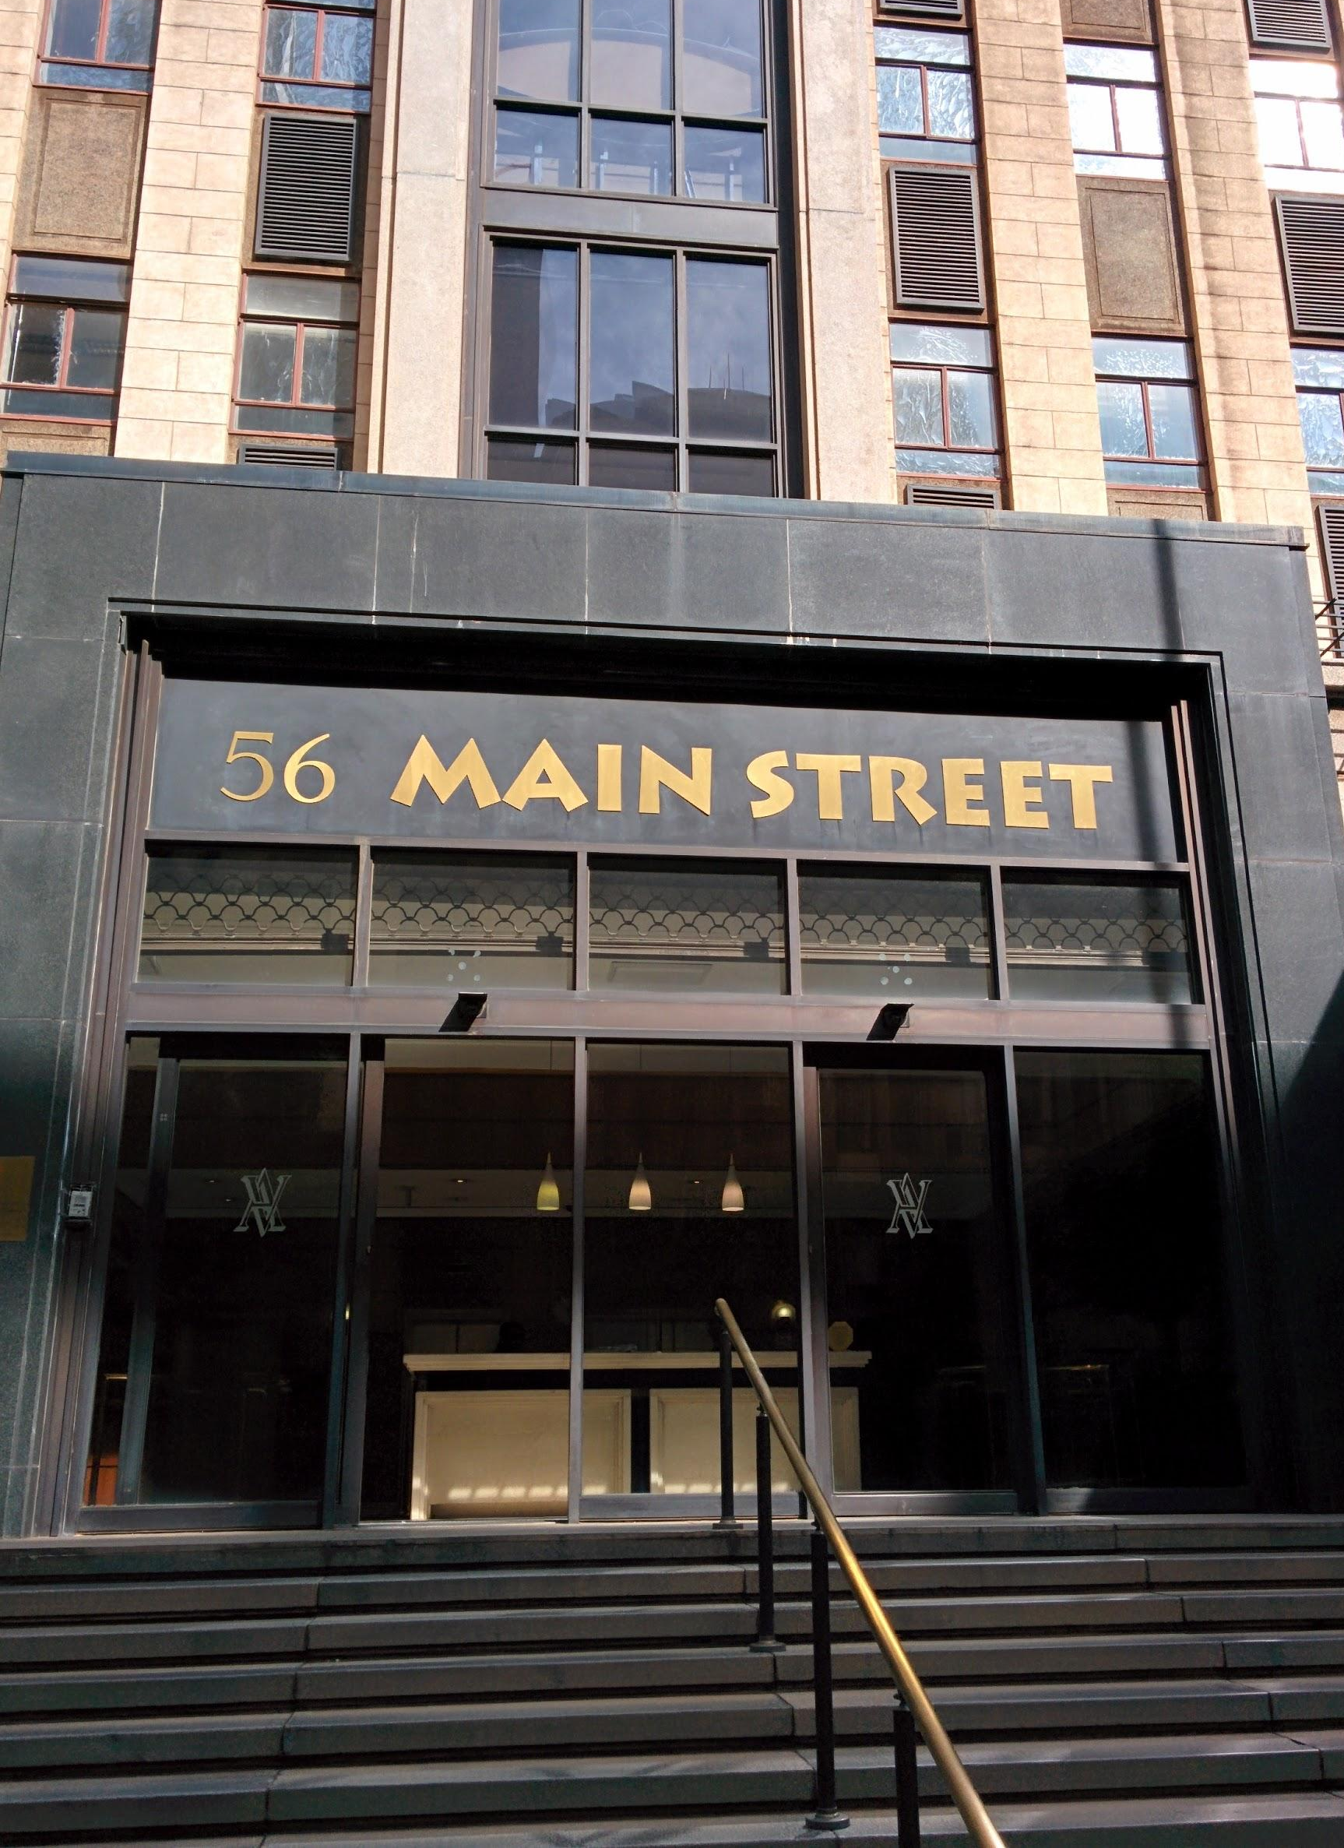
Figure 19. Building owned by the Anglo American Corporation on Main Street.

The typeface used for the sign above is Lithos. It was created by the designer Carol Twombly in 1989 after it was ordered by the American computer software company Adobe for the release of the first version of their graphic editor Photoshop in 1990. Thanks to the popularity of the software, Lithos was used widely by graphic designers throughout the 1990s. It can be seen on posters of films, covers of books, compact discs and on corporate logos. It is the typeface used today by the National Arts Council of South Africa for their logo on the façade of their offices in Newtown, and on their webpage. The frequency of the usage of Lithos on signs, also within Johannesburg, makes the sign pictured above (Figure 19) visually intertextual (Walker and Chaplin 1997; Werner 2004), meaning that it takes a new meaning when “interpreted in the light of another” (Werner 2004: 64). In other words, the meaning symbolized by the usage of the typeface Lithos is constructed in connection with its use on other signs: we read the sign in a certain way because its aesthetic and typeface choice is similar to other signs we have seen previously. Walker and Chaplin (1997) argue that intertextuality “increases audiences’ enjoyment by mobilising their existing knowledge, by treating them as sophisticated viewers” (1997: 124). It is thus important that on top of presenting the history of the typeface, we also examine its use in various formats, because the “56 Main Street” sign has to be read and interpreted in relation to these other signs.
Before analysing the use of Lithos on the “56 Main Street” sign in Marshalltown, I would like to give an overview of the literature on typefaces in LL studies, and in sociolinguistics more broadly, in order to articulate why it is important analyse what details in the design of the typeface have indexical functions. In LL studies, Sloboba (2009) mentions the possibility of paying attention to typeface as part of the design of a LL item and Huebner (2009) proposes looking at “font style” and “font type” (2009: 76) for the linguistic analysis of LLs but none focus on details of the fonts.
However, Van Leeuwen (2006) and Norgaard (2009) do attempt to study the grammar of typography and the semiotics of it, respectively. Norgaard points out that typography is generally ignored in literary criticism in favour of a “[monomodal focus] on word-meaning only” (2009: 141). For van Leeuwen however, writing itself has changed: “Much of the cohesive work that used to be done by language is now realised, not through linguistic resources, but through layout, colour and typography” (2006: 139). In the digital age, it is easy to give a certain font a different weight, make it italic, highlighted or in a different colour, thus changing the impact of the words and letters on the readers. Choosing a particular typeface can give a text a different feeling or mood. In fact, in 2013, acclaimed filmmaker and author Errol Morris ran an experiment in the New York Times which provided evidence that readers believed the content of a story more if it was written in Baskerville, a 250-year old serif typeface. Indeed, Machin (2007) highlights the increasing attention given to typography in graphic design today in newspapers, websites, brochures, or on book covers. But Machin also mentions the tendency for typography to be analysed solely based on impressionism, and calls for “systematic description and analysis of typographic meaning-making” (2007: 143). Van Leeuwen and Norgaard do just that in their respective articles. Van Leeuwen applies his and Kress’ grammar of visual designs (1996) by reading typography in a similar fashion to how they read images. The method is similar as it aims to show that typography fulfils all three of Halliday’s ‘metafunctions’ (1978) or “broad communicative functions” (Van Leeuwen 2006: 142): ideational, interpersonal, and textual. He then offers a methodology to analyse the use of typefaces according to specific characteristics, which should describe their metafunctions. These characteristic features are what make each typeface unique and different from others; they include weight, expansion, slope, curvature, connectivity, orientation and regularity. These features will be used to analyse Lithos and its use in Marshalltown. Before doing this, it is interesting to note that Lithos is based on a much older typeface named Neuland, designed in Germany after World War I. The design and use of Neuland throughout the 20th century is what led to what Lithos can potentially iconize and index today.
Twombly claims lapidary writing was the influence for the design of Lithos, particularly the kind of ancient Greece: “Inscriptions honoring public figures or dedications for temples were intended for public viewing in ancient Greece. Geometric letterforms, free of adornment were chiselled into the stone. These basic shapes are the inspiration for Lithos” (Giampietro 2004: 4-5). Twombly’s goal was to modernise (and digitise) this type of writing still found today on ancient Greek temples, but decided to give it a significant modification: she designed it as a bold-weighted letterform, a type that did not exist in ancient Greece. It seems her reasoning was to make it more marketable, but in doing so, Lithos became almost identical, at least to the untrained eye, to a German-designed font from 1923 named Neuland, to the point that Giampietro calls Lithos “Neuland’s bastard child”, in particular pointing to its “flared edges, heavy lines, square characters, and pen-like strokes” (2004: 5). The history of Neuland and its early use in the United States notably is essential for understanding its intertwining with Lithos today and for the analysis of its use on the building on 56 Main Street in Marshalltown.

Figure 20. Neuland as showcased by its designer, Rudolf Koch in 1923.

Giampietro (2004) gives a detailed history of the typeface, from its conception in post World War I Germany to its association with Lithos today, and contemporary connotations such as ‘the jungle’ or ‘adventure’. Rudolf Koch designed Neuland after witnessing the horrors of the First World War on the front line, which resulted in him choosing a path of religion. The original concept of the typeface was to update the German black letter style, making it sans-serif and bold. Koch thought it could be used for important texts (such as religious texts, previously using German black letter style typefaces) but also to “shout to other Germans that following God’s path would help them find comfort from the trauma of war.” (2004: 4). Koch noticed that his font could be seen from a distance and was easily distinguishable from lighter-weight typefaces on a page, thanks to it being sans-serif and composed of heavy black forms. This enticed him to promote Neuland as suitable for use in religious texts. The typeface had little success in Germany, but travelled well to the United States where the blooming advertising industry adopted it.
However, Neuland was used for a particular kind of advertising: marketing aimed at African Americans (Giampietro 2004). Since they did not have great buying power, having been freed from slavery in the late 19th century, the products marketed to them tended to be associated with slavery: cotton and tobacco. Advertisers were prompted to use Neuland because they associated it with woodblock types, which were seen as lower-class in the 1950s and “as cheap as garbage” (2004: 5). Woodblock types at the time were stereotypically used to represent non-Western cultures, especially through circuses which claimed to showcase people and creatures from faraway lands. The stereotype was heightened by the racist use of these typefaces in representing other cultures on cigarette packagings, such as Egypt and Turkey. For Giampietro, the association with Lithos’ Greek forms came from the fact that these cultures were present in antiquity and these were seen as “cultural others” to the West (2004: 6), much like Africa. The key in the link between a stereotyped representation of Africa and Neuland is in the fact that Koch designed it at a time when Art Nouveau and Art Deco were blooming. In fact, Giampietro explains that the fantasy of Art Nouveau often included a taste for the exotic: anything non-Western, romanticised. Art Deco borrowed a lot from Art Nouveau and its referencing of “other” cultures was linked to the Primitivism art movement in France, which borrowed heavily from non-Western cultures seen as “primitive” or “naïve” at a time of colonial expansion (2004: 6). When reaching the United States, Neuland was classified as an “Informal Sans” because of its Art Deco-like aesthetic. In fact, Koch had actually carved each letter directly into the type blocks instead of drawing them, a technique now seen as archaic, but already associated with informality in the mid 20th century. The informal nature of Neuland is what associated it with “primitive cultures” as well as from the past because of its Greek influence. Giampietro argues that the informality of Neuland is tied it to a lower-class image and stereotypical representations of the “Other” because it did not follow these conventions. It would be associated with the representation of African American art, and African American people themselves, which were also othered. During the height of the Art Deco movement, Neuland was used by book publishers on the cover of novels touching on themes such as cannibalism, illiterate characters, or characters with deformity. After Art Deco, the use of Neuland to illustrate African American themes remained, such as the cover for Richard Wright’s Native Son.
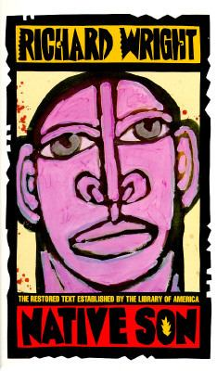
Figure 21. Restored edition of Richard Wright’s 1940 novel “Native Son” with the original cover.

Woodblock typefaces were used by advertisers for products marketed to African Americans at the beginning of the 20th century because they were cheap. Later, the Art Deco movement associated informal typefaces using woodblocks with the cultural “other” and with exotic people and cultures, including African Americans. This is the reason why Neuland today indexes Africanness. With the emergence of Lithos in the 1990s, designers working on digital media started associating it with similar signifiers because of its clear resemblance to Neuland. Both typefaces came to be used to index similar ideas, especially after Neuland was used on the poster of the globally successful film Jurassic Park in 1993. For Giampietro, “[b]oth fonts appear frequently on all sorts of extreme sports paraphernalia. These uses seem to indicate that in addition to Neuland and Lithos’ prior associations with informality, ineptitude, ugliness, cheapness, and unusability, they have since acquired qualities that suggest ‘jungle’, ‘safari’, and ‘adventure’ – in short, Africa” (2004: 6-7). He goes on to interestingly point out that the repeated use of Lithos and Neuland in the 1990s up until today happens within “the white-controlled industries of book publishing, movie making, car dealing, adventure seeking, font designing, and designer clothing” (2004: 7). He remarks that African American-controlled sectors of business and culture, like Ebony magazine or jazz label Blue Note, have used neither of the typefaces. In South Africa, similarly, for example, DRUM magazine also did not use the font. However, as previously mentioned, the ANC-led National Arts Council of South Africa does use Lithos in their logo.
I now would like to expand on Van Leeuwen’s previously mentioned list of the characteristic features that make each typeface unique and different from others, applying this to the historical use of Neuland and Lithos. It is important to note that Van Leeuwen’s article mentioned that it was a “first attempt at identifying the distinctive features of typography” (2006: 147). However, Norgaard claims that the list “does not provide an exhaustive description of typography” (2009: 145). She then argues for the addition of colour in the list of features which would imply the analysis of further choices such as saturation, hue, and modulation. I would argue that although Van Leeuwen and Norgaard’s combined list of features is very relevant and helpful, the examples given, notably in Van Leeuwen’s piece, are of stock typefaces, available for free when installing software. What it doesn’t take into account are the more complex graphic design features of certain typefaces, as I argue using the visuals I have come across bellow. For example, the Jurassic Park logo pictured bellow (Figure 22) used the typeface Neuland, but also includes lines at the centre of each letter. I will call this feature ‘decoration’.

Figure 22. Promotional logo for the film Jurassic Park (1993).

In my view, these lines turn the letters into artworks, in the sense that they move away from a ‘Western’ typographic tradition to become more ‘hand-made’, as definitely not made using technology, which would help explain its association with signifiers such as ‘primitive’, ‘wild’, ‘savage’ or ‘junglish’. This feature is also reminiscent of the hand-made linear decorations on ‘African’ weapons, such as shields, as opposed to crosses and emblems on European ones. It would pre-suppose that non-Western calligraphers would decorate manually their letters as they do for their weapons. The link with the Jurassic period of history to which the film makes reference would be that since the graphic features of Lithos – which will be discussed later on – signify the ‘primitive’ non-modern other, it generally and broadly means “from the past” where ‘past’ mean “before modernity”. This problematic representation of non-Western cultures as “traditional” and thus from a general and broad past has been deconstructed by Hobsbawm and Ranger (1983). The release of Jurassic Park helped popularise the feature of decorating Lithos, as seen in the poster for the film “George of the Jungle” which decorated the typeface using animal skin print to signify “jungle”. This trend of decorating Neuland can be traced back to 1959 on the album cover for white jazz musician Herbie Mann’s African Suite. The decoration of the typeface talks to the representation of black dancers, giving the potential listener a teaser of the content of the album: jazz (indexed by the known name of the artist) with African rhythms (indexed by the dancing black bodies, the traditional drum, the use of Neuland and its association with African representation, and finally its decoration into a ‘primitive’ art typeface).

Figure 23. Promotional poster for the 1997 film “George of the Jungle” using a decorated version of Neuland.


Figure 24. An article in the Lifestyle section of The Times Record & Roane County Reporter uses the same decorated version of Neuland in its title to highlight the fact that it is about a white man’s adventure in Africa (both signifiers for Neuland).

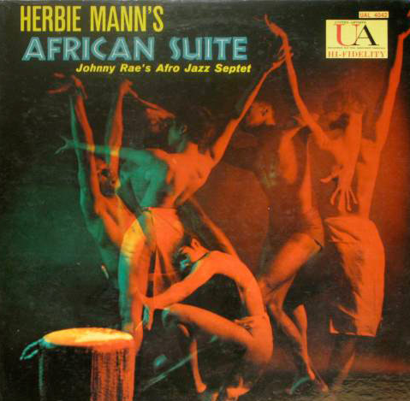
Figure 25. Cover for Herbie Mann’s 1959 album “African Suite”.

In order to analyse the meaning-making potential of the description of typography using the features mentioned above, Norgaard proposes following Peirce’s notions of ‘icon’ and ‘index’, also used by the Scollons (2003: 43-62), replacing Van Leeuwen’s similar concept of ‘metaphor”, in addition to his ‘discursive import’ (Norgaard 2009: 147). For Norgaard, applying Peirce’s terminology for the study of typography means that “the same kinds of meaning occur when a typographical signifier either looks like that which it signifies (icon), or invokes the material origin of its own coming into being (index)” (2009: 147).
I have demonstrated why looking into the history of a particular typeface can help understand what it indexes today and where the indexed meaning come from. I have also presented the history of Lithos and its predecessor Neuland in order to trace their respective meaning construction through their use in popular media culture. I can now analyze the use of Lithos in Marshalltown, relying on Van Leeuwen’s (2006) list of typographic features and the Scollons’ (2003) notions of icon and index applied to typography.

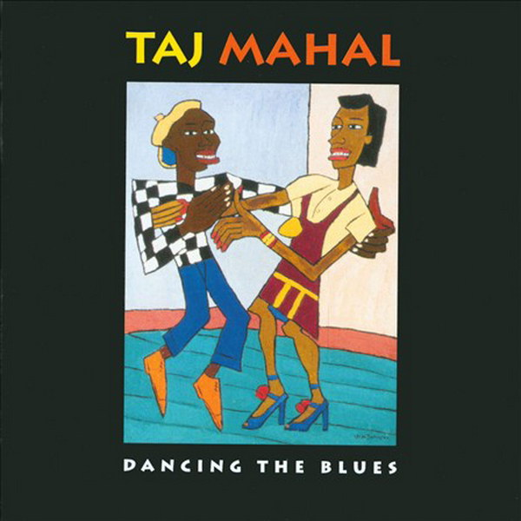
Figure 26. Cover of the 1993 album “Dancing the Blues” by African American blues artist Taj Mahal.

In my interviews with Gerald Olitzki of OPH and John Dewar of the Johannesburg Land Company, they said that they own most of the buildings in the Marshalltown area, except for the ones still owned by the mining houses (such as Anglo American or BHP Billiton) and the banks (Standard Bank and Nedbank particularly). Number 56 Main Street is situated on the Anglo American campus of Marshalltown, a private section of the district. The building in question is owned by Anglovaal Mining Ltd. and contains offices only. It was built before the end of apartheid. We can assume that the use of Lithos in the LL of their building is actually a projection of something African, which actually contrasts greatly with the other Anglo American-owned buildings around it with their cathedral-like architecture (see Rajak 2011: 3-4). It also resonated with Olitzki’s will to “embrace Africa” as mentioned earlier.
I will now analyse the particular features of the sign “56 Main Street” in the Lithos typeface following Van Leeuwen and Norgaard’s methodology. Lithos’ letters are in bold weight, making them visible from a distance. Parts of the M, A, S and R are pointing outward diagonally instead of vertically or horizontally as is the case of more formal typefaces. These letters appear extended. Even though they are disconnected, avoiding a hand-written or informal style, they have irregular weight. For example, each side of the A is thicker at the bottom than at the top; the top bar of the T is thicker at its extremities whereas the S is thinner at its extremities and thicker where it curves. This feature can be traced back to the influence of Neuland, which Koch carved directly into the woodblock instead of drawing it, giving uneven thickness to each letter. It is also important to point out that the number 56 is not in Lithos but in a serif typeface, giving the same sign a small dose of formality, since Lithos itself is sans serif. This visual contracts iconically signifies the differences between the owner and people in charge of the environment (formal, white-owned mining corporation) and the continent it is trying to embrace as its actual location (Africa, home of informality, and its romanticised representations of being less modern and less technologically advanced, hence using a hand-written-like typeface with a history of being associated with the African ‘other’). The design and choice of Lithos here indexes informality because of its woodblock origins (through Neuland). The letters’ irregular forms and the fact that they are sans serif make them look somewhat less modern.
Lithos comes up in other signs in Marshalltown. DOPEstore on Commissioner Street, whose owner Andile Cele was interviewed during my ethnography, started organising “Breakfast runs” in April 2016, an event for people wanting to run together on a specific morning around the inner-city, mostly within Marshalltown as indicated by the places visited mentioned on the flyer:

Figure 27. Promotional flyer designed by Andile Cele of DOPE Store.

The flyer also includes a group shot of runners taken in the township of Soweto in front of the THESIS lifestyle shop. When asked about his decision to use Lithos while designing the flyer, Andile claimed he didn’t think about it too much, and that he had found the typeface in the graphic editor Photoshop and thought it seemed easy to read. He also mentioned that he had not noticed the “56 Main Street” sign before. Besides the name of the event (“DOPEstore Breakfast Run”), the rest of the text on the flyer is typed using the Lithos typeface, but in two different variations. The date is typed in a heavy-weight, or bold, version of Lithos, making is look very similar to Neuland; whereas the rest is in a light-weight variation of Lithos with thinner letters. This feature gives the typeface a return to its Greek roots, in terms of its iconicity (Norgaard 2009: 147), resembling the carved letters found on ancient temples. In fact, in recent years in the global consumer and visual culture, there has been a trend to re-appropriate Lithos and shift its signifiers back to “something Greek” as documented by the blog LOSANJEALOUS: “Coffee Garden (symbols) Sanjang (A Korean coffee shop chain) is attempting to return Lithos to its Grecian roots. Truly, the Garden of Coffee may be subtly and steadily tapping into the transplants’ collective subconscious for, as anyone who’s ever purchased a cup of coffee in New York will attest, Greek lettering shall be equated with coffee until the end of the earth.”

Figure 28. Promotional poster for the movie “My Life in Ruins”. A light-weight version of Lithos is used for the title, whereas the text at the top is in regular heavy-weight Lithos. It gives the title a Greek feel, reminiscent of the writings carved on ancient Greece temples.

In this section, I have argued that a typographic choice on the “56 Main Street” sign in Marshalltown symbolises (Scollon and Scollon 2003: 45) “something African” because of its intertextuality (Walker and Chaplin 1997) with other signs throughout history relying on the same typographic choice. I have also shown how specific features (Van Leeuwen 2006) such as non-perfectly-straight lines have come to signify non-modern societies and thus linked with African cultures throughout the 20th century. The “56 Main Street” sign can thus be read in relation to other signs representing “Africa” as presented in the previous section. However, while previous signs relied on visual semiotic features such as shape and colour (Scollon and Scollon 2003: 100), “56 Main Street” relies on a typographic feature. In the next section, I present and analyse representations of black people in photographs exposed in Marshalltown which contribute in giving the place semiotic (Scollon and Scollon 2003: 186) of the area an “African” feel, however problematically represented.

5.3.2 Blackness in photographs
On the information boards scattered along the Main Street Mall, photographs are juxtaposed with texts giving the viewers the history of the area. These photographs are of buildings or landscapes of street life in the early days of Johannesburg. They also show portraits of famous figures involved in the development of Marshalltown. All of these figures are white. Black people do appear on two occasions in the photographs, as workers represented either with a dominant white protagonist, or an object that is the topic of the information board. The first instance concerns the reconstruction and restoration of a wagon from the 1880s, where we can see two black workers in green uniforms about to carefully pull down the restored wagon from a trailer. The photograph shows the wagon in its entirety, and the workers behind it slightly to the side, as they are working, thus looking at the wheels of the wagon, not engaging with the viewer, as not to distract from the centre of attention in the picture, the wagon. The photograph documents the action of the wagon being moved, showing that it was a difficult process, also described in the text accompanying it, and that it required human labour, indicated by the presence of two black workers.

The second picture (Figure 30) is much bigger and covers a third of the information board about the Langlaagte Stamp Mill, placed next to the restored stamp mill. The photograph is black and white and, judging from the clothes worn by the protagonists, the tools they use, and the facial hair style of the central white miner, one can guess that the photograph was taken in the early days of mining on the Reef. The text on the side of the photograph explains that the Stamp Mill was used between 1887 and 1912, and that the tunnel shown on the photograph is part of the Langlaagte mine, which bears the same name as the stamp mill, suggesting it was taken at some point in that period. The photograph is also given a title: “Creating a tunnel deep inside Langlaagte Mine” which gives it a higher value than the one with the workers and the wagon, which was a simple documentation of a restoration process, and not itself an historical artifact.
The black and white photograph might have been also taken for documentation at the time, but its high contrast and age, in addition to its having a title, gives it an artistic value. Another detail points to that argument; the five protagonists on the photographs, all miners, are all looking at the photographer, suggesting the photograph was posed. This would be understandable considering how difficult it was to take photographs in low light (or in that case, using only artificial light) underground with all the dust, noise, and smoke characteristic of the mining industry, using old cameras which were much bigger and complicated to use than modern ones. It is probable that the actors in the photograph were asked to stop working (in that case, drilling), and to look at the camera for a while, in order to let the smoke and dust settle. The photograph is taken from a distance in order to show the scale of the tunnel, portraying these men as completely surrounded by rocks, pointing to the difficulty of their work. But the camera is not close enough to the miners’ faces to give us access to their thoughts. None of the five men are smiling; their facial expressions are neutral, suggesting that even though they are posing, and know they are being photographed, they don’t really care about how they look. In their minds, they are still probably focused on their labour, exemplified by the tools they are holding. Their work clothes are dirty and have traces of the rocks surrounding them. This photograph is what Scollon and Scollon (2003) refer to as a “posed group image” (2003: 104) because the photographed protagonists voluntarily pose to become represented participants (Kress and van Leeuwen 1996). However, it is difficult to know anything about the agency of the miners in choosing how they would pose.
Thanks to the high contrast of the photograph, we notice that the light source from its trail pointing outside of the frame on the right-hand side. The light is pointing straight at the white miner in the centre of the frame, surrounded by the other four black miners. Clues for this detail are the fact that only his face is fully lightened, and visible. The faces of all four black miners have shadows on their sides depending on their position around the white miner. The white miner is also the only one of the five who isn’t holding a tool or appearing to be doing something, which could suggest that his pose is even more selective than the others, who simply had to pause what they were doing when the photograph was taken. It is even possible that the white miner was operating from somewhere else not as deep into the tunnel and thus safer, simply instructing the others. The fact that he is in the central position makes him the centre of attention (Dyer 1997), which is accentuated further by the lighting, which suggests that he is a manager of some kind, instructing the miners below him, as represented by the four black men in the photograph. In addition to connoting the roughness of the mines at the time, with their dust, dirt, and wooden pillars to keep the roof from crushing the miners to death, the photograph also connotes a hierarchy within the mines, with whites in a protected and higher position, and black miners relegated to manual labour, in more dangerous conditions. The narrative relationship (Scollon and Scollon 2003: 105) between the black miners and the white one is constructed not through their gaze – they all look at the camera – but by the fact that they are sidelined, forming a halo around the white miner, representing their different places and power in the hierarchy. This is also achieved because of our common knowledge of gravity (Scollon and Scollon 2003: 106) which means that we see the black miners as gravitating around the white one.
The denotation of the photograph (Barthes 1977) is of the social hierarchy of the times with the black miners forming a halo around the white miners, being side-lined. The viewer is meant to care about the white miner and the mine itself, the black miners are simply positioned as the almost invisible labour one can look from a distance, and not completely. In terms of composition of the photograph (Scollon and Scollon 2003: 111), the white miner in the centre is made more important, while the black miners are placed on the margins. For Machin and Mayr (2012: 97) this distance and backgrounding on the photograph signifies social relations in real life. They also argue that key lighting in photographs can suggest optimism (2012: 52). In this case, the photograph symbolises (Scollon and Scollon 2003: 45) mining work rather than giving an accurate documentation of it – there would then be movement to index the miners work actions (Scollon and Scollon 2003: 106) – as it is not obvious that the white miner is actually engaged in any kind of manual labour. His face seems less marked by the labour in the mine. The strong lighting on his face, and his ‘sure of himself’ look signifies the hopeful modernism in the mines, using new technology (held by the black miners) to help get more gold out of the ore. In other words, this photograph symbolizes progress, and the success of mining in Johannesburg, showing a white miner in the centre of that success (the brain, in light) but requiring black labour, which may be side-lined and made almost invisible (the hands, in shadow). This relationship is repeated in representations throughout the Main Street Mall: white men are celebrated for their endeavours, courage and perseverance in pursuing mining in the Witwatersrand region, while most of the labour necessary for achieving this is invisibilised, in the background, concealing the agency and active role played by black mineworkers in building Johannesburg and its mining industry. Lou (2010) found similar findings in an analysis of billboards in the gentrifying neighborhood of Chinatown in Washington DC whereby (white) developers would de-racialize the visual landscape of the neighbourhood, thus erasing the Chinese identities prevalent in the neighbourhood from the newly developed semiotic landscape.

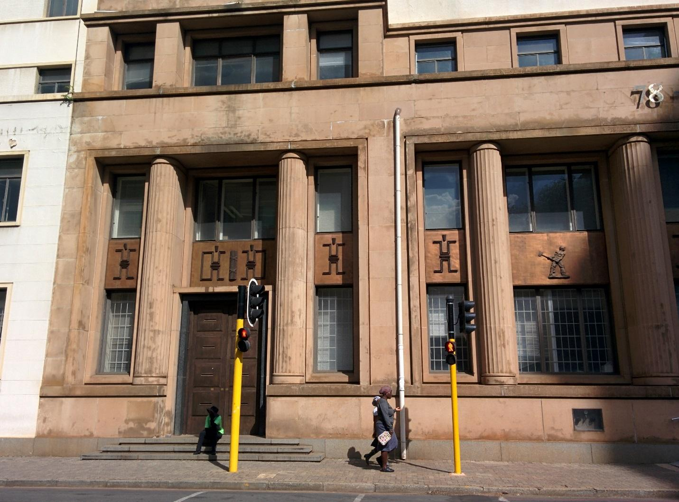
Figure 29. A rare representation of black people in Marshalltown. Here on Marshall Street.
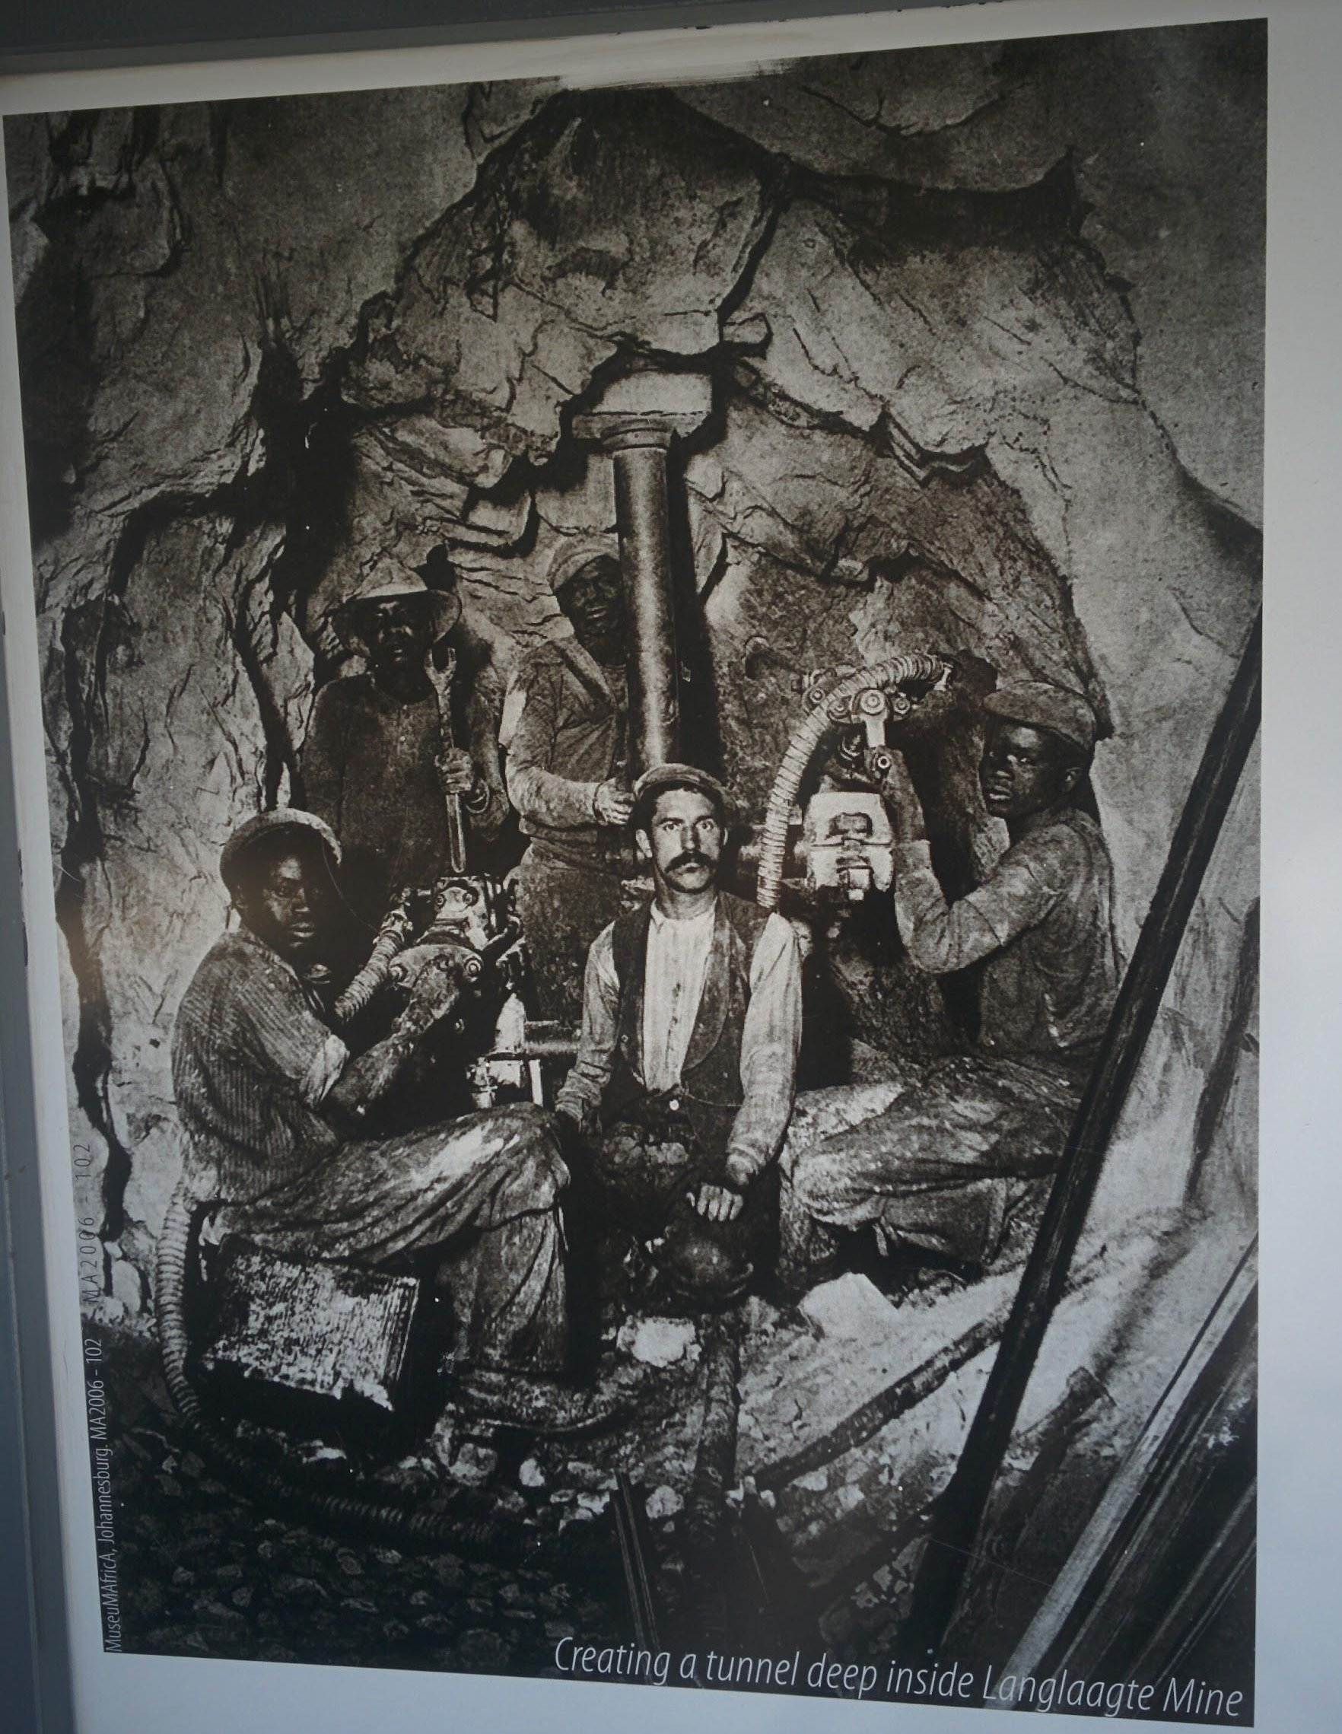
Figure 30. Photograph illustrating an information board about the Langlaagte Stamp Mill on the Main Street Mall.

I have shown how the visual semiotic (Scollon and Scollon 2003: 100) of signs of heritage in Marshalltown contain problematic representations of Africa and blackness in order to fit in with the goal of anchoring the area in the “World Class Africa City” and I have argued that this has entailed the erasure of other aspects of African culture in apartheid-era urban design. White developers have indeed continued the tradition, dating back to the Art Deco architectural trend of the 1920s and 1930s, of imposing their own interpretation of Africa and black people on the city, often denying Africans the agency of representing themselves. Viewers may question who is in control of the contemporary urban design of Marshalltown. The mix of signs of heritage indexing different representations of (South) African history have successfully been included in the private sector-led regeneration efforts in Marshalltown. The streets are busy with people on weekdays, as more and more offices are filling up, taking advantage of rental prices that are much lower than wealthy Sandton in the north. Businesses have emerged since the early 2000s when regeneration efforts began, catering for the increasing white-collar worker population needing consumer outlets and services during working hours. In the next section, I analyze how one of those businesses taps into the area’s mining heritage and top-down SL in order to market itself as a theme café and restaurant.

5.4 The Gold Mine Café
The Reef Hotel is a four-star hotel in Marshalltown which claims to be located in “the heart of the financial district” on its official webpage, only five minutes away from City Hall and major transport hubs such as the Gautrain and Bus Rapid Transport (BRT) system, twenty minutes away from the Sandton Convention Centre, but more precisely “close to major social hotspots, yet away from the frantic pace of the city centre.” The mentioned social hotspots are the restaurants and cafés opened during weekday office hours for workers employed in Marshalltown. With this description, it clearly states that it is in a quiet part of town, away from the chaos usually linked with the Johannesburg CBD. It doesn’t mention any particular place worthy of visiting, except for the Sandton Convention Centre in the north, which indicates that their usual customers are out-of-towners coming to Johannesburg for work, and not leisure. They might go out for a drink, but probably not venture out for a walk exploring the rest of the CBD. An anecdote sums up this insecurity and fear discourse: a friend from Cape Town recently stayed there to attend a workshop in Sandton. None of her colleagues who were staying at the Reef Hotel left the premises on foot. They were shocked to learn that my friend had gone to the Guildhall Pub on Albertina Sisulu Street, just four blocks away, to meet me for a drink. They were mostly shocked that she hadn’t been mugged, attacked or otherwise bothered. This shows the length still to go for Johannesburg’s image to change, especially that of its city centre, especially for out-of-towners.
In 2012, the owner of the Reef Hotel bought the empty Magnet House building, neighbouring the hotel on the other side of Loveday Street, to develop its ground floor into upscale shops. So far, only a barber shop has opened. The main development by the hotel has been the Gold Mine Café, which opened on 2012 on its ground floor, to cater both to people staying at the hotel, to save them the hassle of having to go outside of the hotel premises (many seem scared to do that), and to customers working in the financial institutions in Marshalltown. One can spot a few residents of the CBD alongside hotel customers on a Saturday morning for coffee or brunch, which is served until 10am. This early ending time is in stark contrast to other restaurants that serve brunch outside of the city centre: they usually serve breakfast until noon. The ‘10am’ sign signifies the café mostly expects hotel customers to eat there on a Saturday, before checking out, and does not cater to consumers who might live in the area. People staying at the hotel can even enter the café directly from the hotel lobby without having to go outside. The Gold Mine Café is named this way because of the rich mining heritage in the area. The theme of mining is mostly represented in the visual aesthetic of the café-restaurant with numerous relics put on display such as old elevator shaft signage, tables made with recycled wood from the mines, waiting staff wearing miners’ security helmets, and the café’s menu.

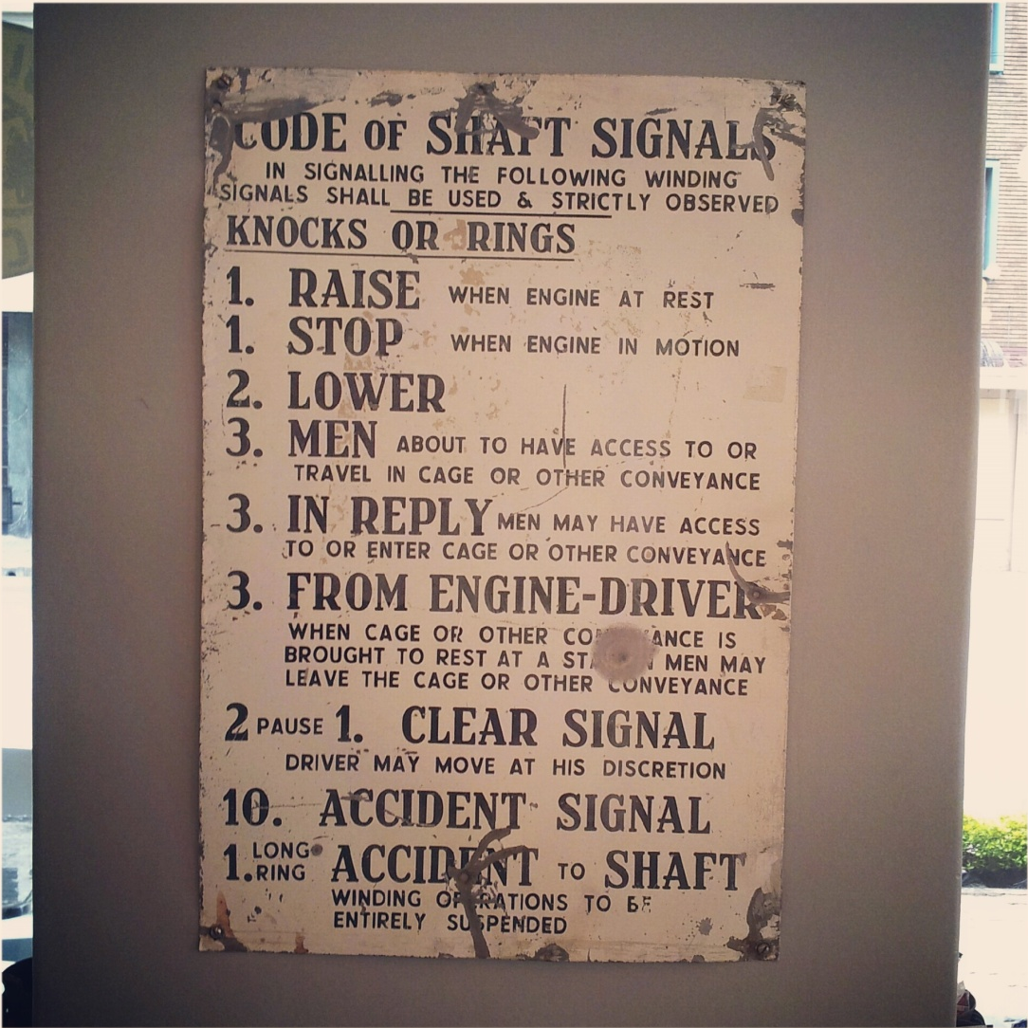
Figure 31. Authentic elevator shaft sign on display on the walls of Gold Mine Café.

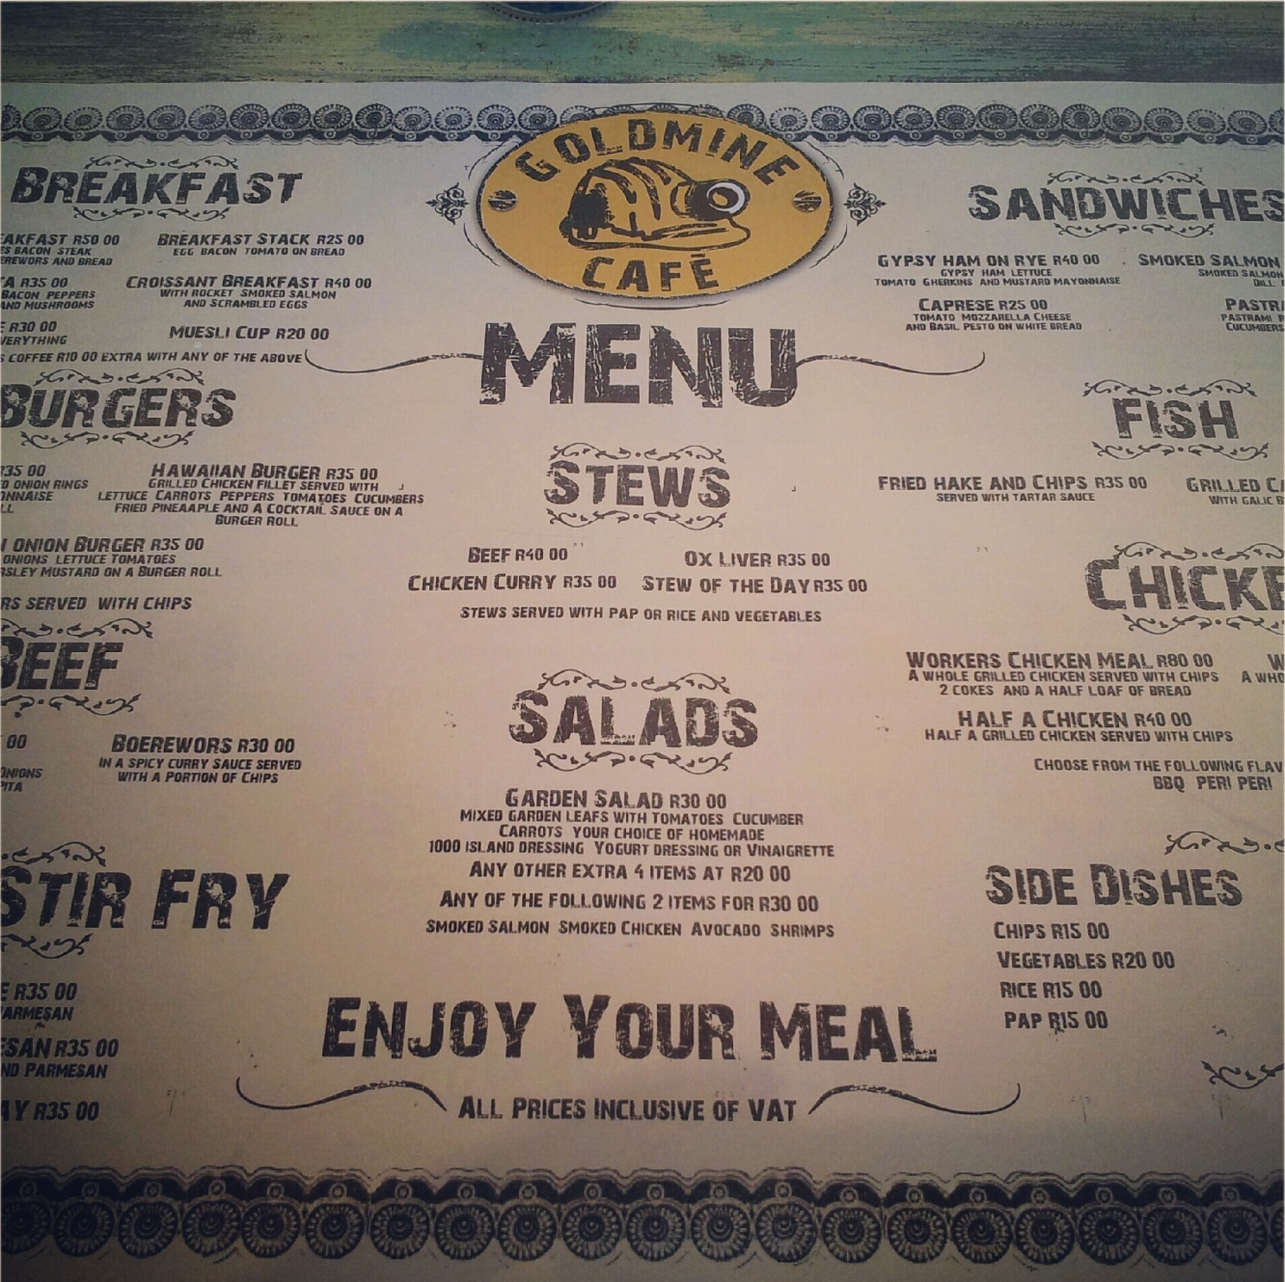
Figure 32. Menu from the Gold Mine Café which uses rusty typefaces to appear more authentic, connoting the grit from the mines.

By being placed on a wall like a painting in a museum, the Code of Shaft Signals sign is included as an authentic artifact, removed from its original place semiotics (Scollon and Scollon 2003) of a mining elevator shaft, into transposed into a themed café. It indexes that Johannesburg has had a mining history, in addition to the café’s name, but also symbolises old Johannesburg, giving the place a ‘retro’ feel. In order to study what makes artifacts real and authentic, Kress and Van Leeuwen (1996) propose the notion of modality. Based on the linguistic concept of modals, modality “refers to the truth value or credibility of (linguistically realized) statements about the world” (1996: 160). They argue than in Western aesthetics, the primary modality is naturalistic representation, meaning that things appear as if they had not been touched or modified. In Marshalltown in general, but specifically in the Gold Mine Café, high modality seems to be associated with the colours of mining, which are gold and yellow because of the extracted minerals, still visible in the form of mine dumps on the outskirts of the inner city, and brown which evokes the colour of the earth being drilled in the mines. The wood used for building mine tunnels, as well as the rust appearing on the metal machineries used for extracting gold, deepen the impression of authenticity. In the case of the Code of Shaft Signals sign, rust appears where the paint has been stripped from usage, probably due to the sign being hit by workers’ tools or small rocks and dust. This modality is then replicated in the aesthetic of the typeface used for the café’s menu, as letters also contain marks of wear and tear. This does not index that the menu itself has been heavily used (it is in fact plasticized to protect it from wear), but rather symbolises the theme of mining and its positioning in the past. The fact that the sign is put on display as opposed to being used in a real mining shaft in addition to the modality of wear and rust is what makes it authentic.
The Gold Mine Café embraces the heritage of the area, informing its customers of the history, almost turning them into tourists even though only they might only be staying at the hotel on business. They get to leave the hotel or restaurant with the feeling of having seen sites of heritage in Johannesburg. Other signs give the café its heritage and mining theme such as the light bulbs used for lighting, simply hanging down from the ceiling in a very simple fashion, like they would be inside a mine shaft, the security helmets worn by the waiters, or even the wood used for the tables which is worn on purpose, leaving the possibility that it might have been used in the mines as well. These signs might denote a mining theme, but their modality connotes authenticity, as they appear to be original, showing signs of wear, or put on display like in a museum in order to be protected and enjoyed. They are attributes of the space used to give it the setting of a mine (Machin and Mayr 2012). The nexus of discursive elements which these signs all form is used to change the image of the inner-city of Johannesburg and make it more attractive and appealing. However, this nexus does not give visitors the “real” experience of being in a mine, they rather merely symbolise it, but in a sanitized way: what is erased are the diseases, the pollution, and the noise, which were part of the work in the mines in the early years of Johannesburg (see Malcomess and Kreutzfeldt 2013: 220-221).

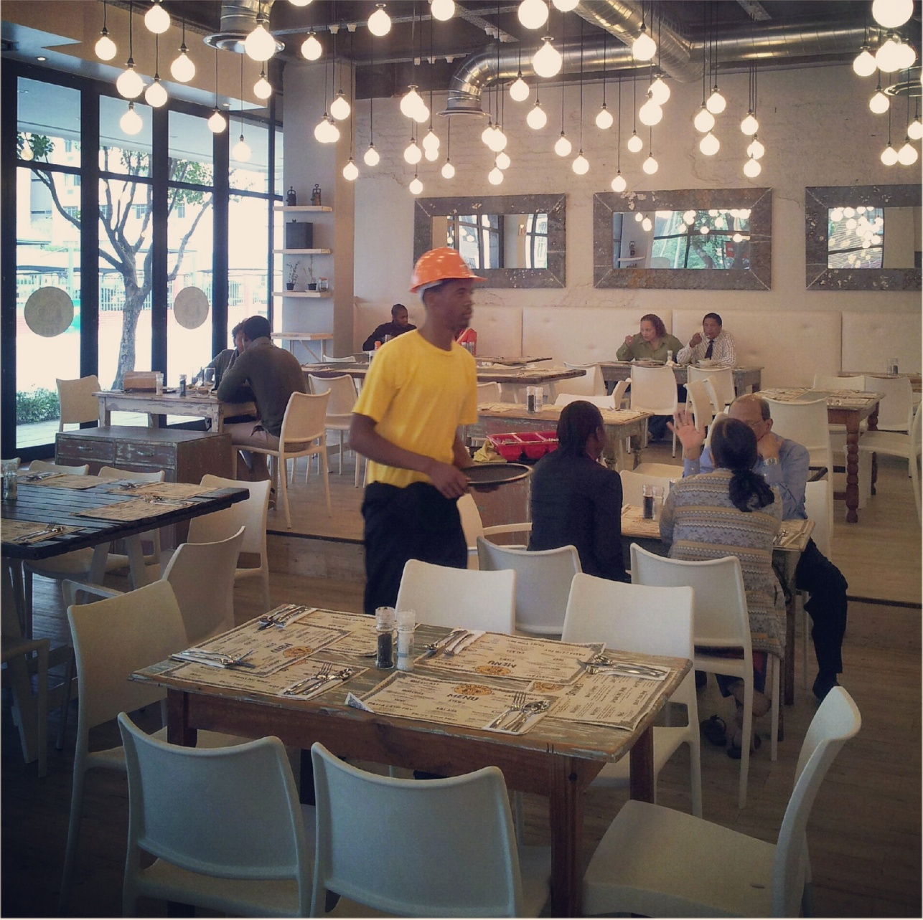
Figure 33. Other signs index the mining industry in the Gold Mine Café such as the modality of the t-shirt and helmet colour, yellow, reminiscent of gold.

Finally, these signs are also part of a spectacle to shift the attention away from the associations of crime and danger usually so wound up with the Johannesburg CBD, to the more appealing theme of the city’s gold-mining heritage. But it is a particular kind of heritage that is being celebrated and made appealing, as of course the consumer does not have to experience being in a mine, breathing dust, and risking their lives, as workers once did and still do today in South African mines. Consumers merely experience a themed environment. The signs used to index the area’s mining history are commodified into symbolic capital for marketing purposes.
The Gold Mine Café relies on Marshalltown’s mining heritage to brand itself as a local place. It seems legitimate as a business venture because of the authorized, top-down mining heritage scattered all over the area. Other signs of the past can be found nearby in Marshalltown, but those are either not placed and highlighted on purpose, or tell a different kind of history of Johannesburg and its people. In the next section, I present other signs forming Marshalltown’s chronoscape, which have not been strategically located in the area.

5.5 Invisible heritage: Semiotic landscape of amnesia
When looking out from the top of most buildings in Marshalltown, one can spot yellow mountains of gravel and sand on the area’s southern and western side, beyond the delimiting highways. These are ‘mine dumps’ that contain the rocks and dirt excavated from the earth by the mining industry over time. These signs index Johannesburg’s past in a way that is disconnected from urban redevelopment projects, but they are present nonetheless. Another example of intruding, unavoidable signs are the old tram railways on Pritchard Street in the taxi rank between Commissioner and Albertina Sisulu streets, which have started to protrude from the tarmac over time. These tracks were covered when the trams were retired in the 1960s. The fact that they are not displayed on purpose puts them in a layer of the chronoscape which I consider to be invisible, as it echoes a time and social context not selected to be highlighted by the developers.
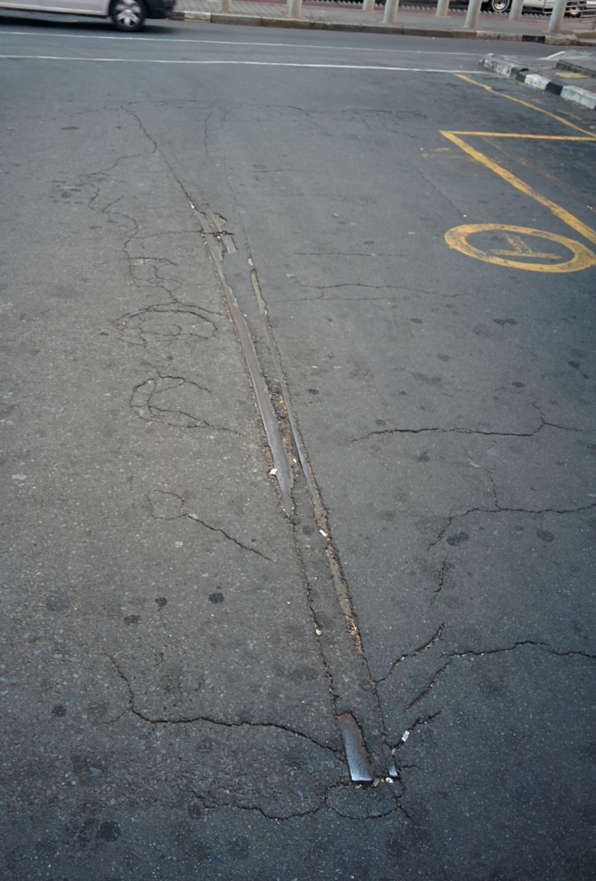
Figure 34. Old tram railways coming out of the tarmac after years of wear.

In June 2015, an Instawalk was organized in Marshalltown. The concept was for amateur photographers to walk together through an area to shoot what makes it interesting, and share the results on the popular social media platform Instagram. Many Instawalks have been organized in the past five years all over Johannesburg, sometimes by the municipality itself to promote certain areas, but none had had as much success as this one: over two hundred people came to Marshalltown on Youth Day in 2015, a holiday in South Africa. Interestingly enough, the walk ended in front of the BHP Billiton Ltd. building between Marshall Street and Main Street, with a group photo of all the participants, below the frieze ordered in the 1970s by the apartheid government to celebrate Afrikaner nationalism, and representing a one-sided history of South Africa, including colonisation and education of the “natives”. What is interesting is that the participants of the Instawalk probably had no idea what this sign of the past originally signified. The fact that it stands in the middle of a controlled, regenerated urban environment probably made them feel comfortable enough to pose in front of it collectively.

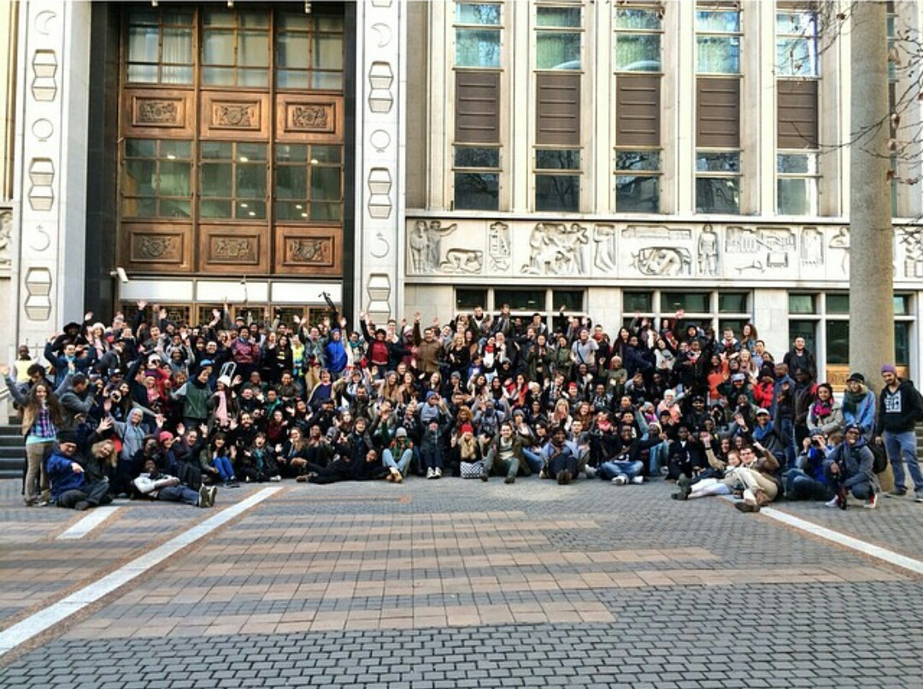
Figure 35. The Instawalk group poses in front of the BHP Billiton Ltd. Headquarters. Photo found on social media platform Instagram.

The frieze is a reminder of the colonial processes which saw a white minority control and exploit the land of South Africa at the expense of its indigenous black populations. I believe that the fact that the building’s architecture is being preserved in a context of urban rejuvenation in a highly controlled urban area invisibilized the frieze’s true significance, while offering these visitors the impression of being in an authentic urban environment with old buildings and where they could walk and embrace the landscape.
The colonial past of South Africa also appears at 80 Albert Street, where the former ‘Pass Building’ still stands as a shelter used by homeless people. The building was built in 1954 as the head office of the Johannesburg Non-European Affairs Department (JNEAD). This department would control black people’s movements into and out of the Johannesburg CBD for the next three decades, requiring them to gain and produce a pass allowing them to go into the city centre, in which they were only allowed to stay for a restricted period. Such an oppressive building, for the majority of the historic population of greater Johannesburg and its townships, should surely be of cultural and historical significance. However, except for the introduction of a blue plaque, no plans for the refurbishment of the building have emerged.
In contrast, a site like Constitutional Hill just north of the Johannesburg CBD has been redeveloped despite its history of being a prison where struggle activists were incarcerated and often tortured. It was developed on the site of the Old Fort prison in Johannesburg after the transition to democracy. It contains a museum and memorial site as well as the new Constitutional Court, completed in 2004. It is a prominent site for post-apartheid heritage, serving both as a reminder of the atrocities committed by the apartheid government over the years, and a centre for the promotion of human rights and a hub for urban regeneration (King and Flynn 2012). As recommended by the Truth and Reconciliation Commission (TRC) post-transition, Constitution Hill is part of the symbolic reparations for apartheid. In fact, the site both strengthens human rights and constitutionalism discourse as a founding principle for a democratic South Africa, as well as correcting the biased heritage politics of apartheid, which were implemented in favour of the white minority. This is why Constitution Hill symbolically represents both the oppressive heritage of prison buildings (such a Robben Island in the Western Cape) but also incorporates a heritage of human rights values. However, as King and Flynn (2012) have pointed out, plans to include heritage in the redevelopment of the site were only introduced in 2002, eighteen months before the Constitutional Court opened, even though Constitution Hill was earmarked as a leading site of post-apartheid heritage long before 2002.
For Dubin (2006: 163), Constitution Hill is “a pivotal place where South African democracy has put down its roots”. However, King and Flynn (2012) remain critical, stating that “[a]lthough the fact that the court is built and functioning is an important development, Constitution Hill’s incomplete progress militates against a coherent vision for the site, and its role in post-apartheid South Africa remains to be fully realised (2012: 79). I would further argue that, since 2012, Constitution Hill as part of the sightseeing route taken by for example the Red Bus tour that includes the Apartheid Museum, the “Mining District Walk” in Marshalltown along Main Street, Gold Reef City, the Origins Centre and a few more, is one of the key sites of tourism for the new commercialisation of Johannesburg, following efforts from the City and private developers to attract tourists again into the City as opposed to seeing Johannesburg simply as a site of transit to other, more popular destinations. One of the successes of the site, if not economically then symbolically, is to make its heritage relevant to ordinary people, “it avoids the great leader narrative of, for example, Robben Island, by focusing on the site’s history as an everyday prison” (2012: 78). This is evidenced by the fact that the site can be used or even claimed by various groups and organisations working or fighting for human rights, such as Young in Prison, an organisation helping young people recently having come out of prison, which hosts art exhibitions and talks by and for young ex-prisoners, or, since 2013, for People’s Pride, a movement aimed at reclaiming Pride events from commercial organisers who, according to their manifesto, do not adequately address the issues faced by LGBTIAQ people across differences of race, class, gender and geographic location. For the last three years, the People’s Pride has hosted events, workshops, concerts and marches at Constitution Hill, not only following the lines of human rights discourse as dictated by the space itself, but also reclaiming the political history of the neighbourhood where the site stands, Hillbrow, where many anti-apartheid and gay rights activists lived and worked during the anti-apartheid struggle.
Finally, I would like to look at one last site of amnesia within Marshalltown, namely Gandhi Square. It was the first place which was redeveloped in 1999, mainly due to efforts led by Gerald Olitzki of OPH, who financed the project in exchange for obtaining the private lease on it. He extracted this concession from the newly elected ANC local government which had inherited a city on the verge of bankruptcy, and simply did not have enough funds to spark development in the inner city which had by then had a majority black population. Known as Van der Bijl Square under apartheid, Olitzki had plans to rename it ‘Renaissance Square’ in the spirit of his plans to give the inner city of Johannesburg a rebirth. However, efforts by Eric Itzkin of the directorate Arts, Culture and Heritage at the City of Johannesburg led to its being renamed as Gandhi Square, in celebration of the Indian anti-colonial icon that lived in Johannesburg at the beginning of the 20th century. Gandhi Square lies at the eastern edge of Marshalltown. It is the inner city’s biggest bus terminal, and in close proximity to commuter’s workplaces such as mining houses and the various other offices of Marshalltown, as well as shops, the area around Carlton Centre, and the major. The retail and fashion districts are also a short walking distance from Gandhi Square. These places are filled with formal and informal workers commuting to and from the suburbs five to six days a week to work in offices or stalls on the sidewalks of the inner-city. Gandhi Square is one of the rare open spaces in the city where one can see tall buildings in their entirety, thanks to the depth of field. Pedestrians immediately notice the tall billboards taking advantage of the mentioned depth of field. These billboards advertise corporations and brands present on the square such as Nando’s, Kentucky Fried Chicken, and the City Press newspaper. There is also a large sign showing a quote and picture of the famous (white) South African short story writer Herman Charles Bosman, who lived in the inner-city between the 1920s and 1940s, and wrote extensively about his love for Johannesburg. Gandhi Square also serves as a frontier between bourgeois Marshalltown, and the rest of the inner-city, which tends to be more working class, just like Commissioner Street is as well, as I mentioned in section 4.4 taken from the narrative of radio host John Robbie about the “clean” part of the CBD, which he considers to be “South of Commissioner”. Most of the workers in Marshalltown never venture out east of Gandhi Square, which seen as too dangerous.

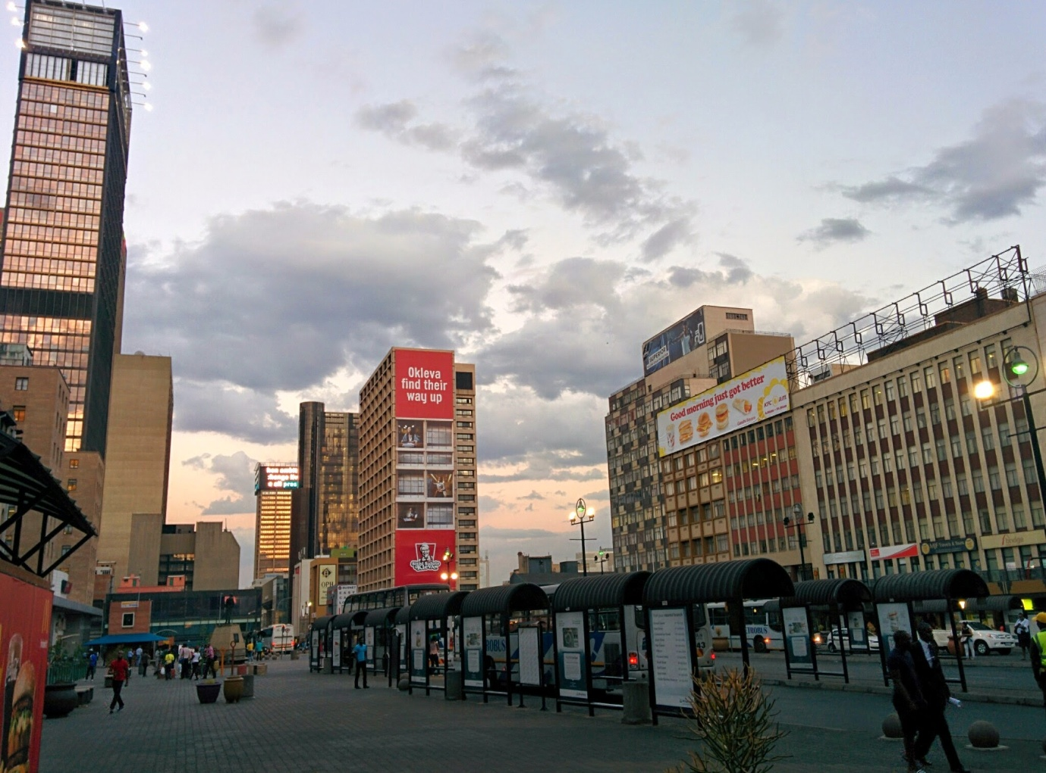
Figure 36. Gandhi Square as seen looking east towards the Absa tower, seen in the background.

As mentioned above, Gandhi Square is one of the major transport hubs of inner-city Johannesburg. The large majority of the transportation going through Gandhi Square is done by Metrobus, the public bus company managed by the City of Johannesburg. One can buy tickets at the counter next to the statue of Mahatma Gandhi, and people hop on and off buses at the dozen covered bus stops on the Square and adjacent streets. As with Marshalltown, the liveliness of the neighbourhood depends on the office hours of its work places, which is why many of the businesses of Gandhi Square as well as the rest of Marshalltown usually close at 5 p.m. Businesses target customers working in the area, passing through on their way to catch their bus, or take a lunch break. The very limited amount of residents living in Marshalltown reinforces these decisions. However, Gerald Olitzki in his efforts to redevelop the square in the late 1990s envisioned a place where workers would want to stay outside of office hours, eating and drinking with colleagues. Today, only clubs or restaurants like Ko’spotong and Chesa Nyama are open in the evenings, and only cafés such as Mugg & Bean and Gold Mine Café on weekends. Other businesses such as a florist, a pie shop, a McDonald’s restaurant (the most successful in the country according to Gerald Olitzki) and a Spar supermarket mostly serve the passing working (sometimes) resident trade.
Created as a socially inclusive space after the collapse of the apartheid government in the 1990s, and in reaction to increased freedom of movement of non-white people in the inner-city and other public space in South Africa, Gandhi Square operates as a privately-managed public space (Itzkin, 2008). In 1999 it became the first major public space to be renamed in Johannesburg, from Van der Bijl to Gandhi Square. This renaming is seen as a forerunner of a more concerted campaign to rename a number of places which gathered momentum in the years that followed, and is on-going today. Since then, in the city, important name changes have included the renaming of the Library Gardens as Beyers Naudé Square in 2001; the naming in 2003-2004 of streets in Newtown after popular artists and musicians such as Miriam Makeba; the renaming of Harrow Road to Joe Slovo Drive in 2006; and more recently in 2014 the renaming of streets after female activists of the anti-apartheid struggle such as Albertina Sisulu (formerly Market Street), Rahima Moosa (formerly Jeppe Street), Lilian Ngoyi (formerly Bree Street), Helen Joseph (formerly President Street), Sophie de Bruyn (formerly Noord Street).
Prior to the name change, the redesign of the Square was meant to be done through heritage interventions, with the express goal of addressing a legacy of spatial exclusion through the creation of a socially inclusive social space. The site is, according to Itzkin (2008: 2) “on both a symbolic and functional level, broadly inclusive of diversity in the context of the Johannesburg inner city”. This redevelopment project was to address a history of racial exclusion and oppression, and project democratic values into the city, hence the use of the term “symbolic” by Itzkin. Gandhi Square was both an urban renewal and a heritage project. In addition to a physical makeover of the Square, the site was re-imagined along heritage lines, drawing on the story of M.K. Gandhi’s involvement in the area. The cultural transformation and marketing of the site has involved the erection of a Gandhi statue at the Joubert Street entrance to the Square, and a series of interpretive plaques and other heritage material. As Itzkin puts it: “This heritage project was envisioned as promoting the development of more democratic, hospitable and inclusionary public space” (2008: 10). Itzkin (2008) also argues through an analysis of symbols, historical representations, and imagery that heritage interventions intersect with processes of urban reconstruction in the post-apartheid inner-city. He examines attempts to introduce heritage imagery meant to promote spatial justice and social inclusion in a prominent central city public space, focusing on the re-naming and re-development of the Square, and how it arose from a merging of urban restructuring and heritage interests. For him, the role of heritage in the re-development of Gandhi Square is used to promote cultural diversity, multiculturalism and interculturalism as seen within a context of the democratisation of urban space (2008: 11).
Itzkin also noticed the lack of tourism as a business activity on the Square as the area developed towards a combination of public transport, and food and beverages services. Additionally, Govender (2002) raises concerns around the over-commercialisation of Gandhi Square through the “economisation of culture”, seen as possibly threatening to eclipse heritage as a public good for the site. Govender (2002) also considered the politics of difference at symbolic sites.
Taking into account the redevelopment process of the square as a place of heritage designed to be a more inclusive democratic space in the spirit of the country’s recent transition to democracy, it is then interesting to note that the statue of Gandhi was vandalized in 2015. Indeed, an ANC member threw white paint on top of the statue during a protest. Placards that read “Racist Gandhi Must Fall” were displayed at the time, in reference to the ongoing battle at the University of Cape Town to remove the statue of Cecil John Rhodes under the protest campaign “#RhodesMustFall” whose effect spread across the country that year, as well as to Gandhi’s own well-documented racism towards black South African people during his stay in the country (Itzkin 2008).

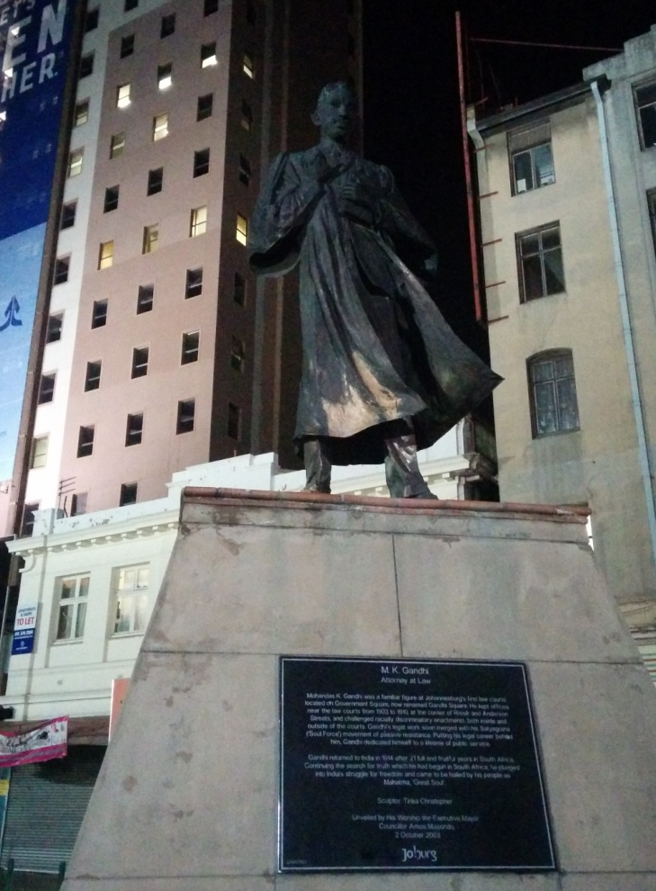
Figure 37. Left-over white paint thrown on the defaced statue of Gandhi on Gandhi Square.

Considering the signs making reference to the white colonial history and oppression of native people mentioned earlier in this section, it is interesting that this particular site was defaced, and not any of the others in Marshalltown redeveloped under a heritage umbrella. The fact that the rest of Marshalltown is heavily protected by patrolling private security guards, which is also true but to a lesser extent on Gandhi Square might have discouraged the protesters from going there. I would argue that it is also highly probable that the protesters were not aware of the signs of European heritage in Marshalltown, and the way that they reference colonial history, because those are so well concealed beneath an urban redevelopment project designed to give visitors a feeling of a world-class authentic experience, that the problematic social context in which the area was built and its colonial history become part of the city’s amnesia and are thus sidelined for rather being signs that the area (and the city) is being modernised and changing for the better.

5.6 Summary
In this chapter of the dissertation, I have presented the heritage of Marshalltown and how it is displayed in the area’s SL. Looking at these signs through the lens of the chronoscape has enabled me to argue that only a certain layer of history is being highlighted with a particular purpose in mind: making the neighbourhood look restored and attractive. At the other end of this development strategy are other layers of Johannesburg’s history which are sidelined, or made invisible. I have also argued for a correlation between the privatization of Marshalltown by mainly white developers, who may then impose their vision of heritage, which is mainly European, onto what an African city should look like, using strategies of inclusion and legitimization with problematic histories, such as the use of typefaces and representations of the ‘African’ cultures and environment. This is similar to what Lou (2016) in employing the Scollons’ (2003) visual semiotic approach identified in how corporations moving into Chinatown in Washington D.C. rely on a Chinese aesthetic norm inherited from the migrant population already populating the area, but with different codes than the more authentic signs, in order to access the area’s profitable central location. In Marshalltown, some signs of heritage symbolize African cultures, thus also “complying with a mandatory design policy” (Lou 2016: 179) but being designed by white developers, they differ in their materiality, indexing Marshalltown as a site of luxury (Stroud and Mpendukana 2009) with it predominance of English and grand-scale visual signs such as the “56 Main Street” sign or the “African print” on buildings’ façades, as opposed to the rest of the inner city of Johannesburg which is has a large majority black population and where blackness and “Africanness” is indexed using different codes and languages choices.
In the next and final analytical chapter, I shall examine how many of the signs of heritage in Marshalltown and its surrounds are semiotized as authentic, and for what purpose. The strategy of the pursuit of authenticity then turns the area into a multi-layered SL where different actors can affect - and be affected by - it.

CHAPTER 6: AUTHENTICITY
The private developers in Marshalltown that I interviewed about the heritage signs scattered around the neighbourhood, and presented in the previous chapter, often insisted that those artifacts were in fact authentic, or at least recreated as authentically as possible. They justified using this term by explaining to me the process they went through in order to make sure these signs would be ‘real’ and not replicas. For example, John Dewar describes the process of bringing in an ox wagon – used by the Voortrekkers, Afrikaners who migrated from the Cape colony to avoid living under British administration in the early to mid-19th century, and who were among the first to prospect for gold in the country’s interior – and displaying it on the Main Street Mall:
So, we got this wagon and a friend of mine who’s an interior designer, historian, he’s rebuilt it, I mean he built it from scratch, everything is authentic, like he bought all of the skins to make the ropes, that is as authentic as can be, so that was the modes of moving around… in ox wagons, they travelled in it, they slept in it, those are the wagons that are [inaudible] to South Africa.
On top of the recurrent use of the term “authentic”, Dewar constructs this discourse by referring to the authority of the person who helped display the wagon, stating that he is a designer and a historian, and thus implying that accurate historical research and the building of replicas are done professionally. He then highlights what he means by authentic, namely, that it was used in the past, and is brought back into the present, thus creating a direct connection between the past and the present. For him, an authentic sign of heritage is something which existed and was used in the past and is conserved without alteration today. As I will lay out, this aim to ‘authentically’ represent the past in contemporary urban settings is not isolated. Indeed, I argue that such signs are intertextually (Walker and Chaplin 1997) linked to others in cities like New York or San Francisco in the United States, and in particular to other neighbourhoods with urban development efforts. I will also expose how the direct link with the past as explained by John Dewar is not always accurately described, specifically when coupled with spaces of consumerism where authenticity is merely a modality (Scollon and Scollon 2003: 36) to make the place semiotic these spaces seem old, and thus attractive to the middle-to-upper classes. Drawing on discourses of heritage in Marshalltown, this chapter aims to contribute to recent sociolinguistic debates around the construction of authenticity, and how to study it. After giving a theoretical overview of authenticity and how it became a trend in 21st century urbanism, I analyze the way in which authenticity is displayed in the SL, how it helps the heritage industry capitalize on urban development, and finally how the growth of the authenticity aesthetic in Johannesburg questions its relationship with global cultural trends, and how these are interpreted in a city of the global south.

6.1 Authenticity and urban development: A historical overview
Zukin (2009) suggests that the pursuit of ‘authenticity’ is crucially important in relation to contemporary urban development because of the obsession of planners and consumers with ‘old-looking things’. This trend isn’t about conserving any trace of the past in modern cities, but rather about selecting what is worth remembering, usually for development purposes. As Zukin puts it: “today, all big cities are erasing their gritty bricks-and-mortar history, to build a shiny vision of the future” (2009: 1). The trend tracks the city dweller’s desire for authentic origins (Zukin 2009: 2), to (re)discover their roots through the urban experience, to see how their predecessors used to live, and how traditional urban living looked like before different waves of residents lived there one after the other changing communities over time. The pursuit of “authenticity” is a response to what Zukin calls “manhattanization” (as in downtown New York City), which entails ever-growing high-rise modern buildings, dense crowds, the kind of anonymity where one doesn’t know or speak to the person even living in the apartment next to theirs, and intense competition to fit in with the latest style. This lifestyle, which is seen as “modern” goes against what is understood as “authentic” or “traditional”. One might expect this dichotomy between manhattanization and authenticity to be clearly noticeable in the SL of many cities, as there are countless examples around the world of city developments and trends that look to the origins of a city, a neighbourhood, or its inhabitants, to reclaim an aesthetic.
For example, Lindsay Brown, in a piece for Briarpatch magazine, analyses the authenticity aesthetic of linguistic and visual signs deployed to regenerate Vancouver’s historic neighbourhood of Chinatown. The title of the piece, “When Hipsters Dream of the 1890s”, is a reference to the cult American television series Portlandia which portrays the Portland, Oregon as an embodiment of the “dream of the 1990s” as exemplified by the iconic theme song of its first episode where the “dream” of that era – mainly radical culture and liberal politics – is still alive. For the case of the Canadian city, it’s the dream of the colonial enterprise from the 19th century that is showed to be still alive, through the re-aestheticization of the neighbourhood and its new target market: young white middle-class urbanites who have grown up in the suburbs, and want to live a true urban experience. A communication strategy put in place by the contracted development companies used signs of authenticity and heritage to lure these wannabe urbanites into the city centre of Vancouver. The centre includes the historic Chinatown, a neighbourhood traditionally made up of low-income immigrants many of whom have now been forced out of the area due to rent increase and foreclosures. Such signs include brochures in magazines portraying 19th century white men labelled “snappy dressers,” to highlight that people used to dress in a way which resembles the fashion aesthetic of the modern ‘hipsters’ in these parts of town: usually trendy young men. Quite unsurprisingly, all the men in the black and white picture (Figure 30) are white, and associated with the colonisation of the area, as opposed to the first nation people who used to inhabit the area first long before the European settler-colonialism project, or even the Asian migrants and Chinese Canadians which have inhabited Chinatown for decades.
Another sign analysed by Brown perfectly sums up this relationship with ‘the old’ and ‘the new’ of development: an advertisement for a boutique condominium in Vancouver which is titled “Reassuringly Old, Refreshingly New”. The ad includes a picture of a room with 19th century-style light bulbs, and cases on shelves made of wood, reminiscent of the traditional simplistic boxes used in markets to sell and carry products, free of brands and plastic. The slogan gives an overview of the eras the boutique wants to be associated with: the past and the future. And not the immediate past, but rather the past that is understood as being more ‘authentic’, as if the communities having lived in the areas for decades aren’t themselves authentic. This past and the future are tied up as linear in a timeline of fashion accessories, such as taxidermy and explorer type outfits, sported in trendy restaurants and cafés.
This selected past, which is presented as ‘authentic’, is used to advertise an area targeted for development, and aims at echoing a certain commodified style, rather than achieving any historical accuracy, as explained by Zukin: “Lately, though, authenticity has taken a different meaning that has little to do with origins and a lot to do with style. The concept has migrated from a quality of people to a quality of things, and most recently to a quality of experiences.” (2009: 2-3). This last qualitative aspect of authenticity is the most important, because it is also the most contemporary. Property developers want to give the experience of origins to targeted urban dwellers to make a place seem authentic. In other words, it is a regulated authenticity. Just as heritage is what is selected from the past for particular purposes in the present (Graham et al. 2000: 17), modern authenticity is a sort of floating signifier (Hall, 1996) where what is considered authentic is actually artificial, supposedly coming directly from the past, without having been shaped and modified over time. This phenomenon is obtained, according to Zukin, by “preserving historic buildings and districts, encouraging the development of small-scale boutiques and cafes, and branding neighbourhoods in terms of distinctive cultural identities” (2009: 3). This phenomenon does not claim to represent authenticity from everybody’s perspective, but only according to the tastes of those with the power to construct their own ideal authenticity, turning it into a tool of power. Investing in particular narratives, and specific heritage sites, can potentially “disinherit and exclude those who do not subscribe to [them]” (Graham and Howard 2008: 120).
In other words, there is nothing natural about what is presented as authentic: it is socially constructed by people in power, who seek to dictate what a reading of history should be, and add layers of meaning to a commodified aesthetic of the past. Such representations give those in power legitimation, and control. In the case of Vancouver’s Chinatown, the history of low-income migrant residents is erased from the promotional signs, so that middle-to-upper class people will move into the neighbourhood. The urban, community feel of the neighbourhood, however, which is the result of years of migrant workers living there, is being used to give it an authentic feel. As Zukin puts it, “[in] the gentrified and hipster neighborhoods that have become models of urban experience since then, authenticity is a consciously chosen lifestyle and a performance, and a means of displacement as well” (2009: 4).
In large metropolises around the globe, corporate urban developers have tried to lure new, hip, middle class residents into the inner cities using the arguments mentioned above; at the same time, there is a desire from these sectors of the population to have an authentic, urban experience as a reaction to the urban crisis in the second half of the 20th century. These ‘crises’ occurred in the 1960s and 1970s in the United States, and in the 1980s and 1990s in South Africa. During these periods, inner cities were seen as too congested, and middle-class populations moved to larger suburban spaces, leaving behind urban neighbourhoods struggling to find capital to keep themselves afloat. But in these suburbs, the next generation of people complained about the lack of authentic human interactions where neighbours know each other and one can walk to a store to buy groceries. Public city officials in need of capital for their city centres looked to business executives to use these issues to fix the image crisis of cities, and make people want to go into city centres again. Suburban sprawl meets every need with shopping malls and lawns, instead of public parks and mom-and-pop shops. In a city like New York in the United States in the 1980s, the business executives changed the local economies to present a ‘clean’ image of diversity for mass consumption through the integration of artists’ lofts, cultural districts and ethnic tourists zones (Zukin 2009: 5). The City had to appear safe, interesting, and worth visiting. It wasn’t until later that developers started looking into the notion of origins to achieve these goals, to give urban dwellers the experience of the authentic inner city, and create a collective imaginary of what a city centre once looked like, or rather, what people thought it ought to look like.
In the case of urban heritage, the notion of origin is relative: the people with the power to affect the landscape of the city will have the power to decide which roots of a particular neighbourhood are more worthy of notice than others. When city dwellers complain about a lack of authenticity, they really mean a loss of (their) origins; there is a need to see oneself in the origins on display, portrayed as authentic. Hobsbawm and Roger (1983) have questioned this complex interaction between past and present, showing a desire for contemporary (Western) societies to sometimes literally invent bridges with the past, constructing them as tradition, often to legitimise power.
For example, the (white) gentrifiers of Chinatown in Vancouver mentioned above portrayed themselves visually as being part of the authenticity. Their attitude seems to be that they are discovering urban centres, much as their colonial ancestors discovered valleys and built borders and countries, in both cases removing in-place populations and their heritage, creating a bridge between the colonial past and the (neo-colonial) urban present (Atkinson and Bridge 2004; Lees, Slater and Wyly 2010).
Neighbourhoods like Chinatown in Vancouver seem attractive to modern urban dwellers because of an aggressive politics of policing and displacement to lower the crime rate, businesses that cater to their middle-class needs, such as coffee shops or upscale restaurants, and also because they cultivate the image of an authentic working-class neighbourhood, which contrasts immediately with suburban vastness, or high rise CBDs where buildings and houses look the same from one city to the next. “Authentic” neighbourhoods represent change and difference, as well as continuity with the past, as opposed to the modernist aesthetic which required that the past is given up. This is the same reason why Henry James critiqued New York skyscrapers as lacking “the authority of things of permanence or even of things of long duration” (James 1907: 77). Authentic neighbourhoods have this sense that things have remained the same for years, and will stay the same in the future. Having a past thus creates capital for buildings, parks or even entire streets. This past is celebrated as being authentic by developers, and not necessarily by the original residents, who might have to move on; developers aim to promote the image of the neighbourhood, and not the neighbourhood itself.
Smith (1996) says that neighbourhoods in cities around the world are constantly changing and evolving. Communities come and go to be replaced by different ones; crime increases or decreases; developers are interested, or look away; tourists visit, or avoid places, according to their guidebooks; and the police come either to oppress the population or protect it, depending on who resides there. This constant change through the ages is perfectly summed up by Will Eisner in his graphic novel “Dropsie Avenue” (2006) which recounts the history of a fictional street in New York City through five hundred years as it becomes populated by Dutch, Irish, Italian and finally Jewish immigrants. Dropsie Avenue becomes an image of the birth and rebirth of the city, of how a neighbourhood goes through bad and good times, and of how different populations move in while others move out because of social tensions that can be traced back to European history. One recurring theme in the story is who has control over the neighbourhood, and who ‘belongs’ there. When a new population starts moving into the neighbourhood, the one already in place claims to have the original right to be there over the new one, claiming the factor of origins: “We are from here, you are not”. In terms of control over the landscape of the neighbourhood, local politicians and corporate agencies dictated the rise and fall of property values based on what kind of people lived there, and what kind wanted to live there.
This example very much resonates with today’s hip authentic neighbourhoods where the local communities have almost no control over how the neighbourhood should be represented, and are used as a source of ‘authenticity’ capital, which then gets used to attract wealthier people, who will eventually push out the communities claiming an origin in that space. This phenomenon is what is today known as gentrification. The term will be discussed in relation to its application to the Johannesburg context in section 6.5.
The pursuit of authenticity as part of urban development efforts can be traced to the late 1990s, with Gerald Olitzki’s OPH Company renovating buildings, but the practice intensified in the 2000s as John Dewar integrated signs of heritage into the privatised sections of Marshalltown. However, as was outlined in the discussion of the CID in section 4.5, the developers borrowed urban planning concepts from the global north, and implemented them in Johannesburg. Indeed, authenticity is not a new trend in other cities around the world, and in order to analyse its meaning in the Marshalltown context, we have to look at its origins in the United States.
In the 1960s, people such as famous journalist and activist Jane Jacobs, or urban planning researcher Herbert Gans, spoke out in favour of ‘authentic’ urban spaces as an argument against urban renewal. Gans (1962) coined the term “urban village” to describe the type of neighbourhood on New York City’s West Side, which was being destroyed by local elites, through a process of “urban renewal” that in fact amounted to slum clearance. Gans depicted an ethnic community of Italian migrants, where entire families lived together, and everyone in the neighbourhood knew each other. Jacobs (1961) argued against modern urban planning, whose aim she described as being to destroy the old to make space for the new. Her activism resembled the work of a preservationist. Jacobs argued for the authenticity of human contact in these neighbourhoods, made possible by the unplanned messiness of old patterns of urban development. According to Zukin (2009), gentrifiers started moving into areas of New York City such as the Lower East Side, then considered a poor neighbourhood, in order to buy and restore late 19th century houses with “great symbolic value” (2009: 11). These gentrifiers were obviously welcomed and supported by historic preservationists, who deplored the destruction of old buildings that embodied urban memory. This combination of historic and community preservationists, and activists, ultimately won the battle against the form of urban renewal that required bulldozing historic buildings to make space for high-rise buildings and skyscrapers for upper-class residents and corporations in a city built on a peninsula which was doomed to be rapidly desperate for and limited in space. Numerous public policy changes were made following Jane Jacob’s pleas, protecting urban villages of poor communities, very often the ones least likely to be able to afford to move somewhere else. Historic preservation laws were passed first in New York City, and then in many other cities around the world, in order to oversee and sometimes to prevent the tearing down of old buildings. But for Zukin (2009), these changes “nonetheless left a gap between celebrating the authenticity of historic houses and acknowledging the authenticity of the lower-class families who lived in them” (2009: 12), since the historical preservationists fighting for historic buildings not to be taken down did not really care about the low-income families living in them, and these families did not worry about the historical value of their building, being concerned instead with the inflation of prices in the neighbourhood that made it harder for them to afford living there.
On the other end of the spectrum were business executives cheering on urban renewal, such as urban planner Robert Moses who aimed at “destroying New York’s uneven origins in his pursuit of sanitized, efficient new beginnings” (Zukin 2009: 13). Moses headed the most important city redevelopment agency from the 1930s to the 1960s, and his vision of urban development was a very corporate one with many highways, high rise buildings, and few parks and residential houses. This dichotomy between Moses and Jacobs’ visions ultimately merged into one ideology for contemporary urban developers: support urban renewal projects but with a preservationist twist. This twist was that heritage and ‘authenticity’ will ultimately attract young and rich urban dwellers. The result would be somewhat similar in that neighbourhoods would be upgraded, and made more secure, catering to a sector of the population that pays more taxes, but buildings would be preserved and the authenticity traditionally embodied by the low-income families would be commodified in order to give the urban dwellers the experience of authenticity. In other words, the new regeneration projects in cities around the world which are marketing themselves using heritage and authenticity (Hewison 1987) are textbook application of Jane Jacob’s manifesto, except that the people originally living in these places, members of working class communities, are long gone.
However, as time went on, the concern of the consumers shifted from experiencing an authentic place to “lifestyle goals of liberation and personal authenticity” (Zukin 2009: 15). The authentic feel of a neighbourhood may feel like an outdoor museum, but personal authenticity was yet to be achieved. This embodiment of authenticity was linked with the looser, more liberal ‘hippy’ lifestyle, which made older neighbourhoods the symbol of a more interesting way to live. The goal of the modern liberal consumer became to access a certain symbolic capital of authenticity through deciding to live away from alienating suburbs or big glass box buildings and instead in an “old red brick building and cobblestone street which has been gaining cultural distinction” (Zukin 2009: 14). And also living the authentic urban village lifestyle by not buying from corporate supermarkets, but from artisanal shops and fair-trade outlets, where ethical business models and the latest fashion trends were on display. Dressing simply with locally made clothes, these new settlers modelled themselves on the original colonialists seen on billboards in the gentrified neighbourhoods of Vancouver. As Zukin puts it: “In a curious and unexpected way, the counterculture’s pursuit of origins – by loosening the authentic self and bonding with the poor and underprivileged – opened a new beginning for urban redevelopment in the 1970s” (2009: 16). Media texts played a significant role in shifting the image of city living in the collective memory of modernizers and suburbanites, glamorizing old neighbourhoods, showing them as great places for consuming authenticity.
In Johannesburg, the monthly newspaper City Buzz launched in 2013 has been playing this role of selling an image of the city as authentic, and full of history, but also as a great place to consume goods in an authentic way, in markets and in heritage buildings. These types of publications brand neighbourhoods as cool, local and diverse, investing in them the symbolic capital of authenticity. For Zukin (2009), this step marks the advent of a new kind of journalism called “lifestyle journalism” where readers are told where to look for trends and authenticity in all aspects of their lifestyles; from shopping for culinary experiences, guided tours of neighbourhoods, to farmer’s markets and galleries.
The pursuit of authenticity and heritage as cultural capital is what property developers are hoping will fuel the rise of real estate values by attracting consumers interested in a different kind of consumption in spaces forgotten by capital for many years, offering them the opportunity to embody their subjective identity through a performance of urban authenticity: be different, unique, live differently, somewhere different. The emphasis is on the word ‘different’ which contrasts with the suburban sameness known to these urban dwellers. For Zukin (2009), these capitalist strategies of retail store owners aren’t attached to the old as “their needs represent the interests of a cultural community that contrasts with that of longtime residents” (2009: 19). They represent new beginnings, erasing certain traces in favour or new ones shaped in the image of the old ones.

6.2 The debate on authenticity in sociolinguistics scholarship
Authenticity has been studied by sociolinguists since the early 2000s (Eckert 2003; Bucholtz 2003; Coupland 2003; Jaworski 2007). Eckert defined it as “an ideological construct that is central to the practice of both speakers and analysts of language” (2003: 392). In LL research, it has not been investigated, with the recent exception of Moriarty (2014) who looked at the use of the Irish language to index the town of Dingle, where Irish is a minority language, as an authentic tourist space. Eckert (2003), Bucholtz (2003) and Coupland (2003) published related articles in reaction to a panel entitled “Elephants in the Room” at the New Ways of Analysis Variations conference at Stanford University in 2002. For them, authenticity has been an elephant in the room of sociolinguistics studies, as it remained under-investigated while remaining central to many works within sociolinguistics. Indeed, the notion of “authentic speaker” has been heavily used, justified by the notion that it is gives a “direct access to language untainted by the interference of reflection or social agency” (Eckert 2003: 392). Such a belief implies that there are inauthentic speakers, ones whose language attitudes have been contaminated by a social environment, or other speakers. The authentic speaker is expected to speak the variety of a language assigned to his or her identity. If they do not, their way of speaking is deemed “less natural” (Eckert 2003: 393). For Coupland, the notion of the authentic speaker “was a liberal, idealised socio-political construct designed by sociolinguists to supplant a hegemonic idealised alternative” (2003: 425).
Eckert also reminds us of another problematic aspect of authenticity in sociolinguistics: its relationship with gender ideology. Women are often seen as being better than men at learning and speaking multiple languages (Sunderland 2004), which results in them being refused claims of being authentic speakers, a discourse sociolinguists are not innocent of sustaining by focusing on boys or men when studying varieties of English, like African American Vernacular English for example (Eckert 2003: 393). For Eckert, the major problem with authenticity in sociolinguistics studies is its heritage of structuralism, as language varieties are seen as fixed, uniform, and static, adjectives that often accord well with definitions of “authenticity”. Bucholtz remarks that the idea of authenticity “gains its force from essentialism” (2003: 400), which posits that attributes and characteristics of people are inherent in their social group, thus opening up the possibility of grouping someone based on their behaviour and attributes (such as language attitudes). On the contrary, identities, language varieties, and social locations are not static, their meanings and characteristics vary constantly depending on a variety of factors including context. One way of speaking will be judged as authentic in one social setting by certain people, and may be seen as tainted in a different location by a different group of people.
Bucholtz (2003) makes similar comments regarding the problematic views of authenticity with regards to language attitudes and identities in sociolinguistics. However, she mentions that the concept itself remains under-studied. The quest for authenticity isn’t new, but the questioning of authenticity as a concept is brushed aside (2003: 399). She summarizes the theorisation of authenticity in sociolinguistics and its problematic use as well as the methodological steps made by sociolinguists to access authentic language speakers and attitudes, such as participant-observation ethnography when the researcher becomes ‘part’ of the community (2003: 406). She concludes by condemning the collection and analysis of authentic speech as doomed to failure because it would involve “extremely unethical research practices” (2003: 406).
For Coupland (2003), authenticity is something we seek out, but are also sceptical of (2003: 417). In other words, people aim to seem authentic, to have authentic experiences, and to speak authentically, but they also know that they can’t really be authentic, as the notion itself is flawed. Full authenticity doesn’t exist. Instead, people co-construct through discourse what counts as authentic or not. Inauthenticity is something regularly critiqued, as lacking something. Coupland argues that authenticity can be achieved or discredited through language, thus “sociolinguistics has a role to play in the analysis of how we engage with authenticity” (2003: 417). Just like other social characteristics of identity and everyday experience such as gender or nationality, authenticity is socially constructed. What we define as an authentic speaker, place or experienced is achieved through “patterns of discursive representation” and “specific ways of speaking” (Coupland 2003: 417).
Similarly to the notion of tradition (see Hobsbawm and Ranger 1983), authenticity implies that something, from a distant or recent past, has remained, as if what is qualified as authentic is directly connected to its origin, untainted. If it is authentic, it means it is being compared successfully to something ancient being used as a norm; everything deviating from that norm will be deemed inauthentic. Bucholtz (2003) adds that authenticity has been used more recently as a way to access the past: “[T]his desire for origins [...] led to a concerted effort to valorise via scholarship an earlier epoch imagined as directly tied to – yet irrevocably sundered from – the present day. Access to the past was provided through the study of those in whom it was thought to be most authentically retained” (2003: 399).
Coupland also remarks that every community relies on experts to establish whether something is authentic or not. In order to be authentic, something or someone has to be accepted and authorised as such. This is why artifacts such as the ones in Marshalltown sometimes simply cannot appear authentic: in order to be accepted as such, developers have added signboards and given interviews about the process of authenticating the artifacts, identifying which era they come from, and who they collected them from (someone with the authority and proof to deem something authentic, like museums or collectors in the case of mining memorabilia in Marshalltown). For, Bucholtz (2003), authenticity tends to be achieved rather than given, and she proposes the notion of authentication as something sociolinguists should investigate. As she puts it: “sociolinguists should speak not of authenticity but more accurately of authenticity effects, achieved through the authenticating practices of those who use and evaluate language” (2003: 408).
Finally, Coupland gives a possible explanation for the resurgence of authenticity as a concept investigated in the social and human sciences, recently exemplified by significant mainstream literature on the subject, the most famous being “The Authenticity Hoax” by Andrew Potter (2010). For Coupland, authenticity is experiencing a resurgence, and needs to be investigated, because it is in crisis. It has reached this point because of globalisation, a process which is responsible for “detraditionalising social life, breaking the continuities and certainties that characterised the phase of the ‘modern’ period, which is where our traditional understandings of social structure were conceived” (2003: 425).
Following the concept of authenticity as a discursively constructed and authorised concept, and in parallel with Coupland’s reasoning behind the concept, its crisis and its possible application, I would argue for authenticity itself to be investigated in sociolinguistics, and not be applied solely to linguistics-specific concepts. As Bucholtz argues: “Rather than attempt to track down authentic speakers, sociolinguists might instead devote more time to figuring out how such individuals and groups have come to be viewed as authentic in the first place, and by whom”, in other words “undoing authenticity” (2003: 407). The resurgence and recent obsession of people with authenticity as a key organiser of social life discourse suggests that scholars should take it on as a topic of study to question how certain spaces, people, or cultural items are authorised and authenticated through discourse, often for consumption purposes.
In the following sections of this chapter, I investigate how authenticity is constructed, how it is used in Marshalltown by developers and for what purpose, with the aim of participating in the recent debate (Coupland 2003; Bucholtz 2003; Eckert 2003) surrounding sociolinguistic research on authenticity, and how it comes to be discursively (and visually) constructed. Additionally, I look at broader empirical data than those considered by Coupland, Bucholtz and Eckert: I want to look at how visual signs are authentified in the context of Marshalltown, thus giving the sociolinguistic concept of authenticity a visual analysis.

6.3 Authenticity and Heritage in Marshalltown
In chapter 5 of the dissertation, I gave examples of signs of heritage in Marshalltown. Those included buildings built in late 19th to early 20th century architectural styles, streets signs, and various artifacts installed in the area. In this section, I would like to go into more detail about some of these signs, investigating through closer description what makes them appear to belong to a different era; I will also explore the processes that lend them this ‘authenticity’.
Many artifacts in Marshalltown remind people of the Johannesburg of the past, and in particular, its mining background. A giant headgear, as well as an old stamp mill, have been placed along Main Street; nearby is an authentic replica of a kakebeen or ox-wagon, used by the Afrikaner Voortrekkers (pioneer farmers) on their great trek from the 1830s until the late 1880s which saw them travel from the Cape Colony to establish their own Boer republics in the present-day KwaZulu-Natal, Free State, Limpopo, North West and Gauteng provinces of South Africa. When Main Street was renovated and redesigned, original lampposts common in Johannesburg in the 1960s, as well as dustbins made out of mine vents used in the mines, were installed.
While these signs serve a practical function, some seem only to serve nostalgic purposes. One such sign is the leftover lintel of the Cullinan building on Fox Street, which was donated by the Cullinan family to the Johannesburg Land Company, responsible for the installation of most of the signs of heritage in Marshalltown. The lintel acts as a chronotope of the original building, which was named after British aristocrat Thomas Cullinan, who mined diamonds in the late 19th century, and founded of the Premium Diamond Mining Company. Two signboards have been erected near the lintel; one relates the history of the building alongside a photograph of it, and the other one offers a biography of Thomas Cullinan, providing a chronotopic representation of the urban environment and its social context at the time when the building was still standing. The original Cullinan building was demolished in the late 1960s to be replaced by a building of great significance: the new Standard Bank headquarters, which was one of the first “superblock” buildings in Johannesburg, after restrictions on the height of buildings were lifted. The new regulations allowed more street space in exchange for the extra sky space. In the case of the new Standard Bank headquarters, 74 per-cent of the block is an open plaza, where the lintel and many of the signboards stand today. Standard Bank, however, did not remain in the new skyscraper for long, as an energy crisis saw them move in the southernmost part of Marshalltown with a wider, shorter, but more energy-efficient building a mere eight years later.
As already mentioned in section 6.2, it is important to look at how authenticity is constructed through language. John Dewar, for example, made sure to mention during our interviews that the artifacts he put on display in the Main Street Mall were indeed authentic, or at least authentically replicated:
So we got this wagon and a friend of mine who’s an interior designer, historian, he’s rebuilt it, I mean he built it from scratch, everything is authentic, like he bought all of the skins to make the ropes, that is as authentic as can be [...].
All these mining headgears, we spoke to the Chamber of Mines, and we managed to get that mining headgear brought in. That came in pieces, we put it up over three weekends. That is an authentic, old, mining headgear. And as of all the various other bits and pieces, every one is authentic. That’s all there is of the theme, of Johannesburg. What did it look like? How did the people dress? How did they move around? What are their buildings like? That is what it’s all about.
[About the replica of the golden rhino on Main Street] But it’s made of fibreglass. Couldn’t have anything made of gold, wouldn’t have lasted a day. And so we paint that every now and again, it’s authentic...
[About the stamp mill, also on Main Street] That’s absolutely authentic, it used to be out in Gold Reef, on the west of Johannesburg, and that was a pretty well known museum piece. But then it was just being neglected and inside, we brought it there, we’ve restored it, cleaned it up, and we look after it. That’s one of the few originals stamp mills. [...] We wanted it to look historical. The whole idea is… you can make it look like anything, or you can make it look authentic.
When asked which era specifically was being referenced, Dewar replied, “it’s authentic to old Johannesburg”. For him, these artifacts act as a chronotope to give the audience not just the impression of seeing old Johannesburg, but an accurate, almost real picture of it. As explained in section 3.3, when referencing an era further away in the past, one needs to rely more and more on chronotopes to paint an accurate description of social life at that time, in that place. Here, John Dewar highlights that not just the artifacts are authentic, but that each piece used to assemble them is as well. Even when talking about the replica of the golden rhino, which is much larger than the original and of course not in real gold, he insists that it is authentic, but can’t really articulate what is authentic about it. His goal is to portray the social life of old Johannesburg as accurately as possible, as well as the gold mining heritage in southern Africa. His use of an authenticity discourse could be to avoid having the artifact’s being placed there questioned, as a strategy to legitimise their positioning in the landscape, as if they belong there today because they were there in the past.
Another example of meaningful but functionless heritage is the typical Johannesburg 1920s building facade on the corner of Harrison Street and Pritchard Street, which is simply standing in front of the steps of the headquarters of the Mutual & Federal Insurance Company. The façade serves no particular purpose, except to remind people of what building structures used to look like in central Johannesburg during the first decades of the existence of the city. What makes this type of façade typical of early Johannesburg architecture is the design of its edging, which is done in iron in a style named broekie-lace, after the Afrikaans term broekie meaning ladies’ underwear, which had lace-like patterning. This design can also be found in its original form on older buildings in the suburb of Jeppestown, situated on the east of the inner city. I give more example of broekie-lace design found in Marshalltown later on.
For the Scollons (2003), this urban design expresses an “aesthetic of elegance” (2003: 149-150) which is typical of the turn of the 20th century in Europe. A prominent feature of this style was to have an arcade in front of buildings to hide the shops on the street-level floors. In this way, architects gave priority to elegance over commercial visibility. The Scollons also highlight that this urban design was replicated on buildings built at the same time in the urban centres of the colonies of the Western world such as Shanghai, Hong Kong or New Orleans (2003: 150).
Architects of Johannesburg seem to have followed this trend, as many arcades can be found on old buildings in the city and its suburbs. In the case of the Mutual & Federal Insurance Company building, the arcade is part of a postmodern layering of urban forms, as it is left standing in front of a more modern building. A blue plaque placed on one of the pillars indicates that it is an authentic reconstitution of a heritage building which used to stand there. It obscures the signage of the building behind, attracting the attention of passers-by, and thus fulfils its original purpose of prizing elegance over commercial visibility. On most days, however, a man sells snacks such as crisps and candy from a metal cart underneath the arcade, much like other hawkers all over the inner city. It is important to point out that the Mutual & Federal Insurance Company is located on Pritchard Street, outside of the formal limits of the SWID, which is still a public space, and the restrictions against informal traders in force in the SWID do not apply here. The man’s small business constitutes what Scollon and Scollon refer to as “transgressive semiotics” (2003: 147-151), which means in this case that the original purpose of the design is “thwarted” by the sign of an informal business. What makes the semiotic assemblage transgressive is the fact that having a small informal business underneath the arcade interrupts the intended elegance of the architectural. The façade’s location in front of a functioning modern building makes it purely decorative, and the fact that the plaque highlights that it is authentic reinforces its original purpose of expressing elegance over its commercial benefit.

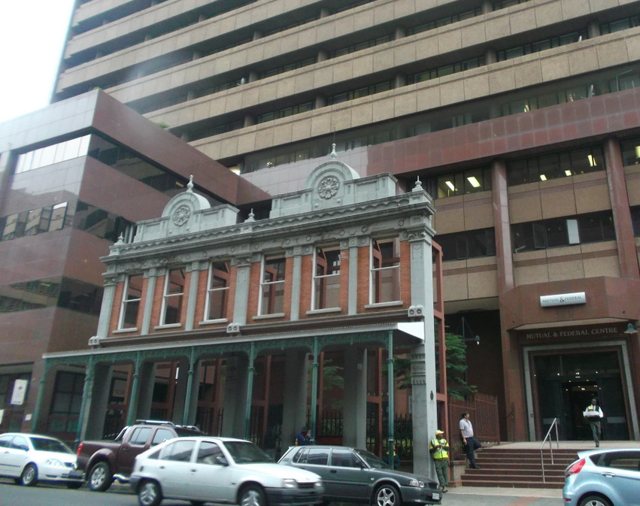
Figure 38. The headquarters of the Mutual & Federal insurance company on Pritchard Street gives a semiotic assemblage of a superposition of two architectural eras.

An aesthetic of elegance can also be noticed on the recently built FNB Bank City headquarters, which were erected in 1994. The commercial shops on the ground floor are only visible when walking underneath the arcades. Having spent time at Bank City during my ethnography, I noticed a high turnover of shops, with many premises remaining unoccupied for a long time, and occasional new openings. Bank City is also a very formal space, where the semiotics of the environment is “situated” as opposed to “transgressive” (Scollon and Scollon 2003: 146), meaning that the commercial signs in Bank City take all their geosemiotic meaning when in their particular placement in the material world. Any transgressive sign such as graffiti or non-authorized informal signs are strictly forbidden, and would be removed immediately. The environment is highly controlled by private security guards, as we shall see later on. The area just north of Bank City around the Bree Taxi Rank, in contrast, is filled with a high quantity of “transgressive semiotics” (Scollon and Scollon 2003: 147-151) meaning that signs are not supposed to be where they are, such as litter or illegal signs, as well as numerous bottom-up signs indexing sites of necessity. At Bank City, in addition to giving the building an aesthetic of elegance, the arcades are also frontiers that demarcate where employees may go, as most employees tend to remain inside the premises, and outsiders tend not to come in, except perhaps to use the Automatic Teller Machines, as most of the businesses within the arcade cater for people in a much higher income band than the ones outside of this cordon.
Broekie-lace design is so closely associated with Johannesburg’s early building style, almost as a synecdoche for ‘old Johannesburg, that it was used on the many information boards placed along the Heritage Trail which give the history of old Johannesburg. As is clear from the interview texts cited above, John Dewar was keen to remind people of what early Johannesburg architecture looked like. One particular information board offers a panoramic picture comparison of Main Street at the end of the 19th century, and modern Main Street, showing many building with the elegant arcade aesthetic. These information boards give the impression of walking through an outdoor museum when exploring Marshalltown with the walking tourist’s attention is drawn towards buildings and artifacts, and distracted from what is happening in the rest of the CBD. These boards are markers of what is worth noticing, constructing some sort of artificial flâneur experience, an activity which has been commodified and controlled over time and around the world. Contemporary urban design gives the explorer the impression of engaging in flânerie freely, whereas the visual landscape one sees is actually very much controlled and designed to be experienced in a particular way, as exemplified by the aesthetic of elegance used in the modern setting, to bring heritage and tourism capital into the urban landscape, and avoid allowing the inner city to become purely business-oriented. The potential tourist or urban dweller, such as white-collar workers on their lunch break, come here to consume history, as represented visually in the architectural environment. This is evident in the following description by Hussain van Roos of his experience of walking in the greater Marshalltown area:
…there’s a couple of pictures I also snapped, with my phone you know, of the area, and yeah definitely, you just stand there and you’re reading [the signboards] and people walk past telling themselves this guy’s got time, and yeah at some point you do feel like a tourist.
In this section, I have analyzed multiple signs in Marshalltown which connote the past, and ‘heritage’ through specific properties that are highlighted as being ‘authentic’. The legitimization of these signs as being part of Johannesburg history helps produce a chronotope of early Johannesburg life, through imagining what someone from that time would see in their own SL. I have argued that the authenticity of these signs makes them and the area more attractive to potential visitors, simple flâneurs and tourists who look for the most accurate representation of Johannesburg’s urban environment, as opposed to a made-up one. However, even though those authenticated signs of heritage are top-down signs, meaning they were placed there by people with the authority over the urban landscape, some can be transgressed, and have their original meaning changed by a more horizontal hierarchy, such as informal traders in front of a building, or through the intervention of pedestrians.
In the next section, I look at a particular space immediately beyond the western edge of Marshalltown which relies on reinterpreted authenticity to market itself. This site brings into question the way in which authenticity is constructed in a culture where authenticity is trendy, and sought-after.

6.4 ‘The Sheds’ and the authentic urban lifestyle
In the overview of the history of Johannesburg’s inner city I laid out in section 4.2, I explained that the area has suffered from an image problem since the 1980s. This was a time of capital flight, and abandonment by the municipality. However, as things started to turn around during the 2000s, with pockets of privately funded development in certain areas of the inner city, mainly Marshalltown, investors started to prepare for a shift in the real estate market, or in some cases realized they could profit off the working-class population of the inner-city. In order to secure their investments, private interests partnered with the City of Johannesburg to change the image of the city, and present it as more desirable. In service of this aim, promotional campaigns convinced media publications to write about the small islands of excellence, and ‘beautiful’ heritage buildings and artifacts. Publications such as City Buzz began writing about the changing urban lifestyle in central Johannesburg, which was reminiscent of a “world class” metropolis overseas. The City is being celebrated through media for its “raw authenticity” as for example in a TedX talk by architect Brian Kent McKechnie. What type of hip foods are now available, or fashionable shops are open, is also covered by the media.
In this section, I analyze examples from two related ‘markets’ opened by Gerald Gardner, travel writer, tourist guide, and advocate of the Johannesburg CBD. These two venues hosting the markets are The Sheds and One Eloff, located on opposite sides of the limits of Marshalltown, and offering food, arts and crafts to a middle-class clientele wanting to explore and experience the inner city.

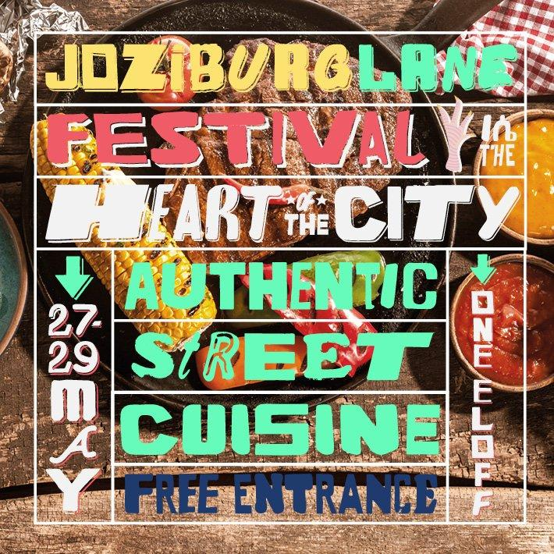
Figure 39. Poster for a festival held at One Eloff in May 2016 relying on a discourse of authenticity to promote city life.

The image above (Figure 39) advertises a festival where “authentic street cuisine” can be enjoyed. The written text refers to a discourse of authenticity, though the terms “street” and “cuisine” may seem to be opposed because “street” is usually associated with “street food” whereas “cuisine” usually refers to a more refined, higher quality, and certainly more expensive way of consuming food. It is possible that the terms were chosen purposefully to signal that the type of food being offered at the festival is similar to the food sold on the streets of the inner city, but with much higher quality ingredients, and more attention given to preparation and presentation. This argument is strengthened when looking at the multimodality of the image. In the background, a photograph shows tasty-looking food laid out on a place setting on a wooden table. The food presented is carefully placed on the plate, as would be expected in the “cuisine” discourse. As for the “street” part of the food pictured, it uses semiotic resources to discursively produce authenticity. First, the aged, non polished wooden structure where the plate is laid out gives the meaning of a humble, cheap and informal business. Secondly, the crinkled tinfoil paper on the top left corner of the photograph also gives the meaning of informality, as it would not be offered on a place in a formal restaurant.
The fact that the festival is described as taking place in the “heart of the city” also references authenticity: the idea that the most authentic, original street food culture is found in the very centre of the city, away from supposedly ‘inauthentic’ suburbs. In the context of Johannesburg’s inner city, locals know that the heart of the inner city is attached to a discourse of danger and violence, but also that it is largely populated by pan-African migrants, and black South Africans. Again, in relation to Joseph Conrad’s 1899 novel “Heart of Darkness” which tells the story of a white explorer voyaging into the heart of the Congo to find the most authentic, uncivilized and raw culture, untamed by (Western) civilization, the trope of the white explorer is invoked. On the promotional image above, the authenticity of the culture found in the heart of the city is symbolized by the informal typefaces in the text. Indeed, different typefaces are used, most with non-straight lines, giving the impression what the characters were hand-drawn or painted. There is also a character from the ge’ez alphabet used to write in Amharic, one of the two main languages of Ethiopia, in the top right corner. However, in this case, the character is resemiotized to represent the letter ‘n’ from the Roman alphabet. This multimodal assemblage points to the multiculturalism of the inner city and profits off of its supposed authentic informal food culture.
Opened in late 2014, the market called The Sheds situated in a historic warehouse in Ferreirasdorp on the western edge of the Johannesburg CBD is a set of renovated warehouses used for a food and art market, live music events, artists’ studios, and offices. Owned by the Anglo American Corporation before being sold to the Johannesburg Land Company, it was remodelled in 2014 in partnership with Gerald Gardner, author of the Joburg: Space and Place guide-book series, and tour guide in the inner city. In terms of branding, the venue references the mining heritage theme also present in Marshalltown, as Ferreirasdorp was the location of the first mining camp in what was to become Johannesburg. The Sheds’ website even claims it is rumoured the warehouses are located where the first miner’s bar of the gold rush was located. However, unlike the Gold Mine Café described in section 5.4, the mining theme stops at the Sheds’ historic location. The interior of the space, especially its market, is however filled with signs indexing old things, ‘authentic’ origins, and reminiscences of bygone, supposedly simpler lifestyles.
The Sheds are surrounded by informal parking lots for the Magistrates Court. The venue itself has demarcated a more formal parking lot for its customers directly across from its entrance. The two types of parking lots offer two different semiotic arrangements, which can be described as sites of necessity and luxury (Stroud and Mpendukana 2009). Indeed, the parking lots around the court are indexed by hand-made signs and managed by informal guards. These signs can be removed each day as their placement, as well as the parking spaces, are not legally the property of the guards managing them. The Sheds’ parking lot on the contrary is indexed with formal, digitally designed signs in bright orange, which contrast with the decaying environment, indicating the address (1 Fox Street) and location of the site of luxury. The parking space itself is managed by guards in uniforms hired by the venue, who let vehicles in and out from their booth, opening and closing a boom gate.

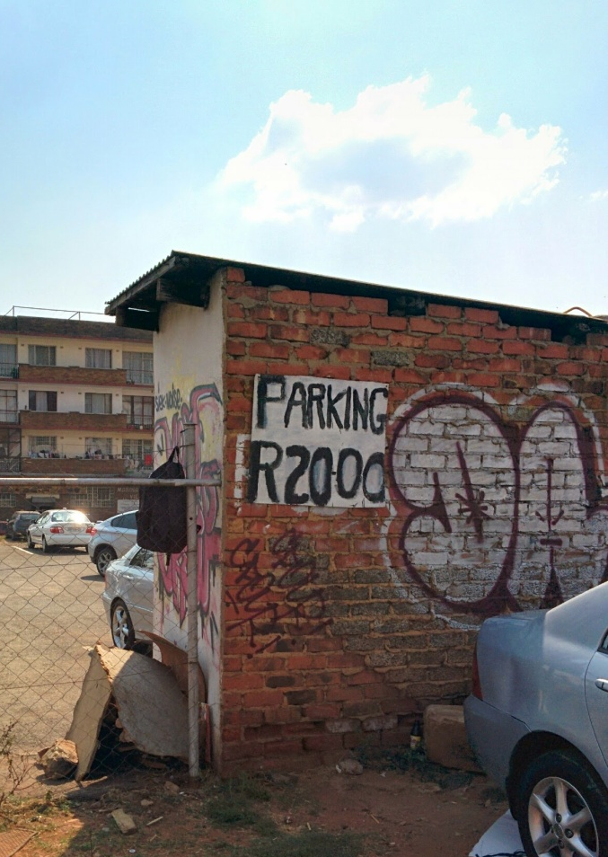
Figure 40. Parking sign adjacent to The Sheds.
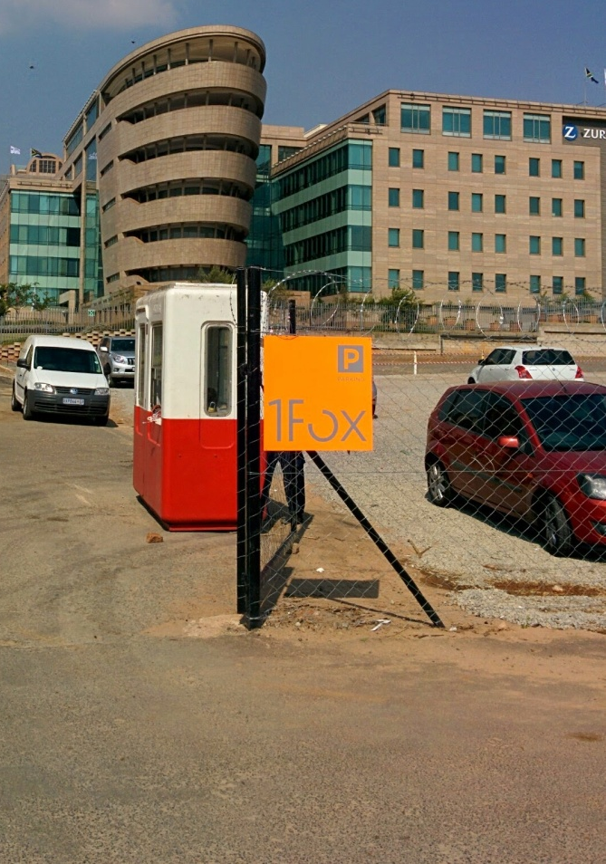
Figure 41. Parking sign at The Sheds.

The Sheds’ sign is placed on a new fence, and the parking spaces have been covered with gravel. The sign for the informal parking area, on the other hand, is painted on a decaying brick wall and surrounded by material used by the guards to sit on, or store their belongings under, such as leftover bricks, cardboard boxes and wood.
Interestingly, similar brick walls can be seen inside the Sheds, though they not covered in graffiti. These walls have been renovated to look like old brick walls, not painted over, and showing traces of wear. I would argue that the use of the brick wall as aesthetic is used to legitimise the authenticity and heritage aspect of the Sheds, indexing and symbolising a time when structures were not covered, so that the bricks in the wall are visible as opposed to hidden underneath layers of paint. For Scollon and Scollon (2003), the construction of an authentic scene means that there should be the “absolute minimum divergence from the ‘natural’ scene” (2003: 108). Here, the exposed bricks represent the bare minimum of construction, as in modernist architecture they would either be replaced by concrete or hidden by paint or wallpaper. Such discourses of origin and simpler architectural style are also salient in the structure used for the various booths in the market that sell arts and craft, food or drinks. In this setting, wooden pallets are used as separators and stands which, similarly to the brick walls, allow visitors to not only experience the heritage and old impression of the market, but also sense it through touch.

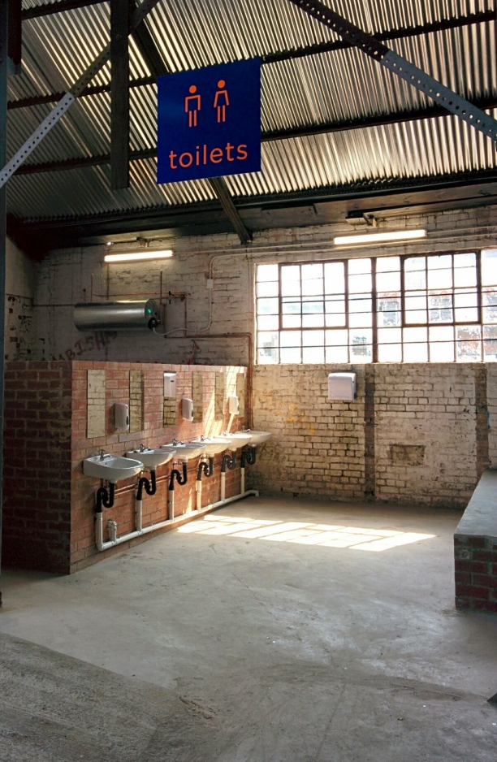
Figure 42. Brick wall in The Sheds to symbolise the past.

Figure 43. Wooden structure in The Sheds used to symbolise the past. An old rusty bicycle reinforces its authentic theme.

De la Pradelle (2006), in a study of French markets in Provence, shows that the authenticity of those markets is performed by farmers to meet the demand of the visitors, who expect certain qualities from the fruits, vegetables and other products that are more constructed in their imagination than available from actual produce. Highlighting that the renewed interest in farmer-style markets has experienced global growth recently, de la Pradelle argues that even though a simpler time and economy is symbolised in these market – with free samples, ‘real’ food as opposed to the kind offered in supermarkets, and small talk with the producers - it still relies on free-market economics. This means that both buyers and sellers rely on the construction of an atmosphere of an old farmer’s market in order to make the whole experience more authentic itself, and thus legitimise the high prices and a profit-driven economic model.
I would argue that the Sheds rely on similar strategies to attract their clientele into this authentic, urban, market experience. A lot of the produces offered for sale at the Sheds market are marketed in opposition to mass-produced ones found in supermarkets. The origins of the produce which could be a farm, or even the backyard of the Sheds itself where organic vegetables are being grown, are mentioned, or pictured. The venue is located in a low density of population area, which means it relies on a target market that must drive to get there: hence, its dedicated parking lot and close proximity to a highway exit. It is interesting to note that nearby in the centre of the CBD, the pedestrianized Kerk Street fruit and vegetable market offers high quality produce to inner city residents for much lower prices than the Sheds, which caters to a wealthier market.
In order to attract a market which has to drive to get to the venue, the Sheds must give the impression of being a worthy attraction, offering produce and experiences not available elsewhere. It also has to compete with similar markets elsewhere that have been operating since 2010 in the neighbouring areas of Braamfontein and Maboneng, responding to the growing demand. The Sheds has the advantage of being much more spacious, and thus offering a wider variety than its competitors. As opposed to restaurants where one has to book, sit, and be waited on, the Sheds offers street food options where customers eat with recyclable cutlery while sitting on wooden furniture. Other strategies used to convey the meaning of authenticity at the Sheds is placing the food in a position where is looks as if it is coming straight from the producer. For example, glass bottles of drinks with brands that cannot be found in the supermarkets of the CBD are displayed in a woven basket on a bed of straw-like material. This composition is reminiscent of fresh eggs collected by the farmer and sold directly at the market, placed in straw to prevent them from breaking. This strategy cannot index the freshness of these drinks, as they are clearly industrialised and mass-produced, although the brands are specialist, and hard to come by. Its presentation symbolises a different kind of consumption, one that is more direct, where available products are carefully selected and stores are curated as opposed to mass-consumption, a facet of modernity.


Figure 44. Display in the Sheds reminiscent of egg baskets at a farmers market.

I would argue that although the place semiotics (Scollon and Scollon 2003: 9) of The Sheds is presented as authentic, the place itself is not. In other words, the built environment where actions such as eating, walking, and consuming take place, the place semiotics, is presented as authentic because of the fact that the original warehouse and its brick walls have been conserved. However, the other two semiotic systems that would make The Sheds a authentic market, namely visual semiotics (as analyzed above) and the interactive order (Scollon and Scollon 2003: 12), give the space a different meaning. Indeed, the interaction order between the consumers, the venue and its produce is performed as authentic because it gives a sense of going back to an ancient way of consuming – straight from the producer – in an environment containing multiple signs of the past, which help to curate the experience. People with the means to consume the products sold at the Sheds go there hoping to have a ready-made ‘authentic’ experience, as they buy from small businesses, see their food being made in front of them and presented with hand-made displays, as in imagined pre-modern times. Unlike the Gold Mine Café, the Sheds is not meant to be experienced as a museum, as items are not put on displayed to be enjoyed, but rather to be consumed, and the oldness of the warehouse is merely used to convey a sense of an authentic old environment. Its link with mining and Johannesburg is not highlighted in the place’s SL.
In this section, I have analysed the global trend towards authenticity in redeveloped consumer urban spaces, and how it relies on a specific construction of what needs to be seen as authentic. Authenticity is also tied to time, as it symbolises pre-modernity, and must perform ‘authenticity’ in order to be recognised and valuable for urban development. In the next section, I investigate where the cultural trend of integrating authenticity within urban regeneration projects comes from, its reappropriation in Johannesburg through global cultural flows, and its relationship with the urban phenomenon known as gentrification.

6.5 Urban Aspirations and the Language of Gentrification
In section 4.5, I explained that the modern urban concept of the CID was borrowed from the United States to aid developers in Marshalltown such as Gerald Olitzki to implement their plans for the redevelopment of the area. Using this imported language, Olitzki explained how it seemed logical to him that since major Western cities had had hard times, much like Johannesburg was having, and managed to get through them to a sort of rebirth by taking control of their environment, implementing strict rules to keep them clean and safe, then the same should be the case for Johannesburg. In this section, I investigate how the fact that authenticity (and heritage) as an urban development trend was applied in Marshalltown points to a certain aspiration to a Western urban experience. I also argue that the modern discourse of the authentic urban experience desired by Marshalltown developers has fused with the discourse of gentrification, which has seen a resemiotization in the post-apartheid Johannesburg context.
Urban developers in Johannesburg have looked abroad for inspiration on how to build an attractive urban environment for decades. In order to be considered a “true” metropolis, planners and entrepreneurs in Johannesburg throughout the 20th century hired architects and designers from abroad to give the city a world-class feel. For example, the Barbican building on Rissik Street, and the Astor Mansions on von Brandis Street, were built respectively in 1930 and 1932 with the intension to “be influenced by the skyscrapers of New York and Chicago”. Indeed, they were the tallest buildings in Johannesburg at the time. In 1965, the tallest building was the Schlesinger Building, which was designed as a (smaller) replica of the MetLife building in New York City, but stripped in black and white, into an almost diamond-like shape. The multiplications of skyscrapers gave Johannesburg a skyline which could be compared to those of major metropolises abroad.
For Beavon (2010), Johannesburg reached the status of metropolis in the 1960s with change in building restrictions, especially in terms of height, which gave the city a new architectural landscape. He argues that the construction of higher and larger buildings on superblocks (using multiple blocks of land for a single building, which became necessary for the development of Johannesburg in the 1960s since the city’s original blocks were so small) upgraded the skyline to the scale appropriate to a metropolis. He adds: “Johannesburg, it was felt, had finally broken with the constraints of a digger’s camp, and could create cityscape appropriate to a place of a million people” (2010: 4). Nonetheless, for Mbembe (2008), what makes Johannesburg a metropolis today is its introduction into global flows of capital, “by saturating its public, social, and cultural spheres with the commodity and by asserting its identity as a city of consumption mindful of the status of the ornament, the arts of commercial entertainment, and imaginary travel” (2008: 61). Furthermore, Nuttall and Mbembe (2008) remind us of the constant aspiration for Johannesburg’s architects and city planners to develop the city into a metropolis, based on Western models:
[...] the entire history of Johannesburg’s built structures testifies not only to its inscription into the canons of modern Western urban aesthetics, but also to the originary tension virtually built into its morphology and geological structure between the life below the surface, what is above, and the edges. After all, until very recently, Johannesburg described itself as the largest and most modern European city in Africa. As amply demonstrated by Clive Chipkin, this meant that Johannesburg was the progeny of nineteenth-century European industrial society. This inland city developed as an industrial metropolis supported by gold mining. A breeding ground for modernism, it grew as a frontier city closely tied to the global market economy and the world of consumption and at the same time was mired in bigotry and prejudice, constantly caught between what it could be (potentiality) and what is ended up being (actuality). (2008: 18)
In section 4.5, I explained how developers in Marshalltown relied on a concept like CID to control and maintain the environment they aimed to develop. For them, Johannesburg was facing a situation similar to the one in other major cities around the world, where middle-to-upper-class populations were leaving the inner cities for the greener, more spacious suburbs. Gerald Olitzki of OPH acknowledges that the phenomenon of population and capital flight wasn’t isolated to Johannesburg, but was particularly significant here:
[...] we got to understand, the flight from the inner city is not unique to Johannesburg, you know we’ve seen it in Paris, it’s happened in London, it’s happened in New York, it’s happened all over the world, but it was so much amplified by the politics of South Africa, that the people just left and fled.
Seeing population and capital coming back into North American and European cities in the late 1990s must have convinced developers such as Gerald Olitzki and John Dewar that Johannesburg was the perfect business opportunity for urban renewal because if it had become popular to move back in these global cities, it might also become popular in Johannesburg.
The desire to live in a metropolis, with its global visual discourse of a specifically Western aesthetic, is evidenced in the interviews I conducted with two young Johannesburgers, a white collar worker and a business owner. They tell their story of discovering Marshalltown, and what it felt like:
I was walking through Joburg for months looking for the perfect spot [to open my store] and I fell in love with Marshalltown. I had never been to New York but I thought Marshalltown represented New York. It gave me the feeling of a working city with the potential to be bigger than what it was. I thought I could contribute into making it the London or New York of Johannesburg. (Andile Cele, owner of DOPE clothing and art shop)

When the bank called me for an interview, I remember getting lost. I walked from Bree taxi rank because I had no car. When I got to Marshalltown, it felt cleaner. I saw people in suits and ties and I saw fancy cars and I thought, jeez, I’ll definitely make it there somehow! So from Bree which is the real downtown, the filthy part of Joburg, and as I walked up I started realizing the buildings were starting to change, I saw old structures and buildings having been kept the way they were back in the days. It felt wonderful to be in a cleaner area. (Hussain van Roos, former Standard Bank employee​)
Again, a discourse of cleanliness is employed to describe Marshalltown as well as to differentiate it from the rest of the CBD. In both narratives, this discourse of cleanliness, of finding a different environment, echoes the narrative of Gerald Olitzki in section 4.4 when talking about his planning of the area. John Dewar, responsible for the Main Street Mall, also uses a similar discourse when explaining his manifesto for urban redevelopment:
Well first of all, any area that you go into, anywhere in the world, you’ve got to feel safe. So we’ve got very good security. 24 hours a day, 7 days a week. Trained security guards who patrol. The second thing is it’s got to be clean, so we make sure it’s clean. Thirdly it’s got to be attractive. People got to come and say “ah this is nice, let’s sit here...”. Those are the components for the possibility to feel safe, happy to be there, it’s got to be attractive, you must be able to relax, and you must be able to get there.
What is striking in Andile’s narrative is the feeling of being abroad, in places which he had only seen through films and photographs (New York) or lived in (London). References to the United States, and New York particularly, are often present in Johannesburg’s inner city SL. For example, a new student accommodation building in Braamfontein is named “The Manhattan”; a billboard on top of the arcade of the newly renovated Stuttafords Building on Rissik Street advertises “NEW YORK STYLE LIVING”.
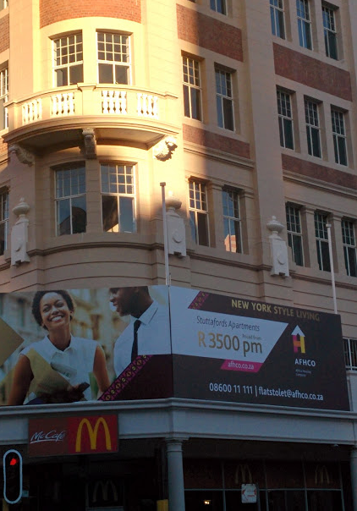
Figure 45. Newly renovated apartment building on Rissik Street offering “New York Style Living”.

Finally, when entering Cramer’s Coffee Shop on Main Street, one can see a large poster with a quote from the David Lynch TV series Twin Peaks which says “I’ve just arrived in New York City – what a place! Just smell those skyscrapers. Had breakfast at a little cafe on Ninth Avenue. Cinnamon croissant and a cup of coffee, black as a moonless night. Hit the spot.” The quote makes a connection between drinking coffee, which one does in a place like Cramer’s, and being in this urban environment, highlighted in the quote by the exclamation “what a place!” and the mention of skyscrapers. It is as if the superposition of skyscrapers and a coffee equates to the desired urban experience. Cramer’s is located in the heart of Marshalltown, and is thus surrounded by old skyscrapers. The poster is actually multimodal since the quote is placed on top of a photograph of a New York City street.

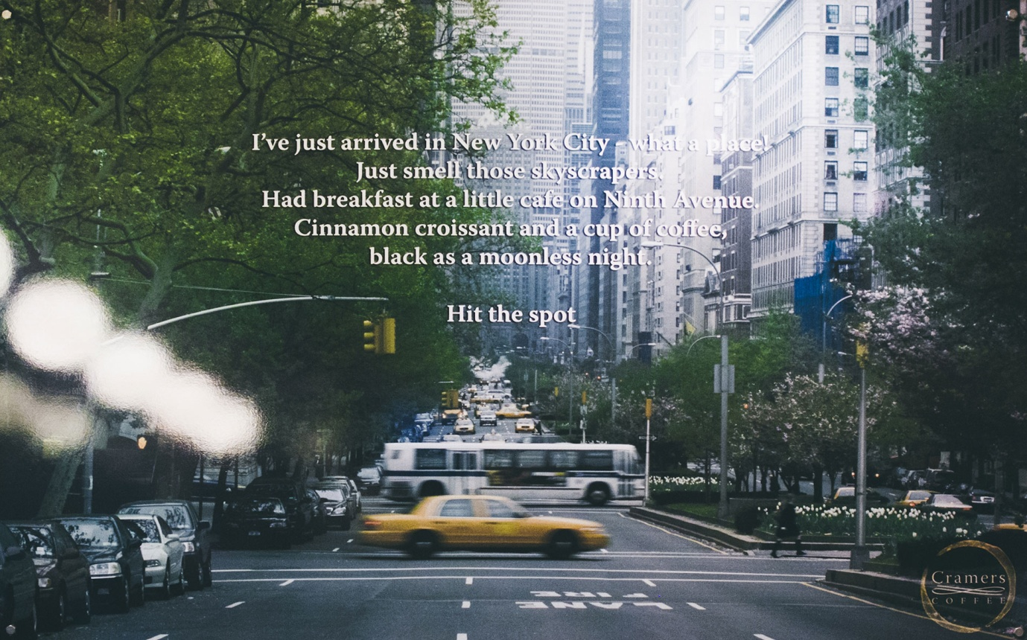
Figure 46. Poster inside Cramers Coffee on Main Street.

The photo is taken from the middle of the street, and looks down far into the distance, where the horizon is obscured by skyscrapers so tall we don’t see the top of them. We can also see a row of trees on the side, as well as flowers separating the lanes of the busy street. Main Street, where Cramer’s is located, has a similar design, with a row of trees and flowers separating the street from the sidewalk. The quote informs us that the photograph was taken in New York City because it says “I’ve just arrived in New York City”. However, many other metropolises look similar, and could easily include a row of trees and tall skyscrapers. The detail which indexes New York City definitely is the crossing yellow cab in blur, iconic of the American city.
During a walk I took through Marshalltown in 2012 on a Sunday afternoon, I saw an exact replica of a New York yellow cab being used on Commissioner Street for a commercial. It is not uncommon to see commercials, feature films and other TV programs being shot in Marshalltown, usually on Sundays because workers are not present and the neighbourhood is almost empty, leaving space for directors and producers to use it as a backdrop for their stories. The Marshalltown landscape looks enough like that of a global metropolis that adding a yellow cab allows it to pass as New York City.
This visual proximity to global Western metropolises is what makes Marshalltown attractive to younger urban dwellers wanting to live the urban experience. In Andile and Hussain’s narratives, it is the fact that Marshalltown looks like New York or London, meaning a safe and clean area with an energy to it and signs of wealth, that makes it attractive.
In August 2014, self-styled art activists dropped buckets of bright pink-coloured paint from the higher levels of a handful of buildings in Johannesburg’s central business district. Even though the group contained mostly South African artists, they were led by an American: Yazmany Arboleda, who after being caught pouring paint on Shakespeare House in Marshalltown took the blame for the action and went back to New York City following his release. The painted buildings were targeted because they had been standing empty for years, going into decay with desperate people stealing the window frames or any other metal they can find to make a little bit of money. The result was reminiscent of street art aesthetic because of the contrast between, on the one hand, the aging and decaying but original textures of the buildings and, on the other hand, the bright and almost fluorescent pink paint.
On the website called “#bewareofcolor”, launched by the activists to explain their action, one can see the pictures of the buildings today post-‘painting’ with a manifesto-like text. In it, the activists talk about the sadness of seeing such beautiful buildings going into decay and not being used, or as they put it: “they have been left behind by time”. Their goal is to draw attention to these building standing empty while at the same time inner city residents are in need of affordable housing, or being evicted by city authorities. In a now deleted post, they bemoan the “de-gentrification” (sic) of the city over the past 25 years. They could be referring to the opposite of gentrification as a way to expose the lack of an urban development project catering for the middle and upper classes, and not to the academic sense of the term which refers to the income gap between the richer and poorer residents of a neighbourhood which leads to the expulsion of the latter group. Brushing aside the problematic polysemy of the term, their manifesto clearly demands change in the inner city. What they want is more colours and art in public spaces, and more housing for the unemployed and evicted. For them, this would bring “messages of hope instead of fear” as the decay and “de-gentrification” of the city is signifying crime and danger. They dub their manifesto a “love letter from our creatives to our land owners, our chief executives, our politicians” which seems to call for a top-down model of urban development.
Two discourses come out of the #bewareofcolour campaign; one about ‘reclaiming’ the city and one surrounding the term ‘gentrification’ and what it means for the redevelopment of the city. I will thus explore these concepts in the next section.

6.5.1 Reclaiming Johannesburg
In section 4.2, I gave an extract from my interview with developer John Dewar of the Johannesburg Land Company where he describes being convinced by a friend of his to purchase buildings in the Johannesburg CBD before the property market turns which would make them some profit. He also talks about going to the area for the first time in many years fearing for his life but soon realises that “things aren’t that bad”. John Dewar’s narrative evokes going into a dangerous territory with caution, in order to exploit a business opportunity. It is reminiscent of what Smith (1996) refers to as the language of gentrification, but as I will demonstrate bellow, is tightly connected with a discourse of reclaiming. Indeed, Smith sees a similarity between contemporary urban explorers, or gentrifiers, and late 19th century frontier explorers in the United States (also reminiscent of the example of Chinatown in Vancouver laid out in section 6.1). For Smith, American inner-cities became known as dangerous urban wildernesses in the second half of the 20th century following the rise of suburban development, and racially biased loss of service delivery in mostly ethnic inner cities. Urban dwellers venturing into these environments are compared to settlers in the western United States, where life on the frontier is equated with the urban experience (often the first time for a generation having grown up in suburbs) and the constant threat of petty or serious crime from the native population to.
In Johannesburg, a discourse of rediscovery of the CBD appeared frequently in the early 2010s, as pockets of private and public development began to attract daring customers eager to feel the thrill of going places they had been told not to go to. Words such as “claim” or “reclaim” were being linked with the inner city of Johannesburg, such as in events organised under the name “Claim your city” which consisted of young people working in the creative industry and the arts meeting in interesting places of the city to make use of its spaces, being able to be in town, and not anxiously drive through it. The term “reclaim” was also used to describe the popular cycling initiative Critical Mass, which has spiked in popularity in Johannesburg since its inception in 2011. The monthly rides contain mostly white riders going through inner city streets and stopping only in safe and heavily guarded spots such as Maboneng or the Sheds in Marshalltown to consume food and drinks. In 2012, I attended the only ride which did not have its halfway stop in the aforementioned places: instead, it stopped in supposedly dangerous Hillbrow. Even though a Nigerian bar had prepared for the cyclists to come inside to refresh themselves, most of the 2,500 or so riders did not enter, feeling petrified in the streets of Hillbrow at night.
In a piece entitled “Reclaiming Johannesburg’s inner city” published in 2014 in the South African Jewish Report, Critical Mass cyclists were praised for “[making] a statement that this is their city and its decline, which started some 20 years ago, must be stopped. They are ‘gatvol’ of it being hijacked, and are reclaiming it.” This statement might seem an exaggeration, but considering the history of the inner city and the white flight of the 1980s and 1990s, the term reclaiming seems appropriate. The term signals the moment when white people venture into the CBD again; the irony is of course that people who are not white were legally not allowed to live in the CBD until the end of apartheid, unless it was in the servants’ quarters of some buildings, usually situated on the top floor, and were only allowed to access their accommodation using rickety emergency stairs.
The city is mentioned as being “hijacked” but it is unclear by whom and in what form. Usually, in popular discourse, the terms “hijacked” and “CBD” are usually used together to refer to buildings being left abandoned by their original white owners, with no water or electricity, and then rented out to poor residents of the inner city by self-proclaimed landlords. The cause of the hijacking isn’t mentioned, but its victim is: the people reclaiming the city, encompassed in the personal pronoun “they”, are described as if the city had been taken from them, and they had a right to return to it. The use of such terms almost invoked a war discourse, as a territory is fought for, lost, and then regained.
The author of the piece also applauds “daring entrepreneurs” for “moving into the inner city and buying up dilapidated buildings – many of them architecturally beautiful and worthy of heritage status”. The description of the entrepreneurs fits the comparison invoked by Smith (1996). They are being praised for taking a financial risk as they are buying buildings in need of a lot of repair, with few people interested at the time. But their potential beauty, once renovated and awarded heritage status, affords them the right to benefit from their foresight. The notion of heritage here is being used to signify buildings that are recognised as historic, and thus should be preserved. It also legitimises the building as having been built, experienced, remembered and celebrated as part of the social fabric of the city. As we shall discuss further on, this is a typical use of heritage in inner city Johannesburg, where place semiotics is favoured as being better where there is “heritage” while social actors and their interactions and experiences with the place are ignored.
The conclusion of the piece introduces a feeling of nostalgia as an argument for a desired future: “Imagine the Johannesburg CBD in 10 years’ time as a place we again all frequent to shop, to browse, enjoy and relax in”. The term “again” brings into being a chronotopic image of the city – the golden age of a Johannesburg in the past – and its possibility of existence in the near future. The glory days in this case are the years of apartheid. In a previous paragraph in the article, the journalist mentions the Anstey’s Buildings, and its terrace, where middle class urbanites used to have tea on a break from shopping in the department store below from the 1940s to the 1970s (Lewis and Zack 2015), the period when apartheid was being designed, implemented, and intensified.
The piece received two comments from readers. The first was from someone who believes Johannesburg’s regeneration could turn it into a city even better than what it was before, perhaps making reference to an ‘original’ glory but with a different social context in which black people would not be restricted from travelling into and out of it. The second comment reads as follows:
[F]ast forward July 2015. i had to go into town to collect a bank card because it had been sent to my old branch. was very irritated for having to go into "slum" Johannesburg CBD. but what a pleasant surprise! what a joy it was to walk down Main Street and the surrounding areas! it looks like any other suburb streets with some well known restaurants placing tables and chairs on the pavement. the Marshalltown part of the CBD is clean and uncluttered and the city is indeed being reclaimed block by block. many thanks to those who had the courage and vision to stay and revitalise the city. [sic]
Although the author first conceives the Johannesburg as a whole (see section 4.2) as a “slum”, they are pleasantly surprised by Marshalltown, which they see as different from the rest. The discourse of war and battle comes up again as the city is seen as being reclaimed block by block, and the HQ for this manoeuvre is indeed Marshalltown. Reclaiming here seems to be synonym for cleaning up, and brings up multiple dichotomies between Marshalltown and the rest of the CBD. Marshalltown is constructed as the epicentre of present and future urban development in Johannesburg, and is used as an example of successful regeneration, and an access door into urban experience. This could be nostalgic for people coming back or reclaiming the inner city after leaving thirty to forty years ago, or as a taste of city life for a younger generation having grown up in the suburbs. This is why Marshalltown can be seen and in a way has to be seen as an authentic urban neighbourhood, to convince people that the rest of the city could be similar, and that it can claim to be at the centre of regeneration, because of its heritage and former centre of Johannesburg.
A term such as reclaiming can also mean something different in the South African context. It can be used to highlight the return of services which would then be reclaimed from the local government, or creatives reclaiming decaying city blocks to paint murals and graffiti (even though some street art in Marshalltown is ordered by property companies to increase the cultural and economic capital of the neighbourhood). Finally, considering South Africa’s history of forced removal of non-white communities during apartheid, reclaiming can be a powerful political practice to demand a reversal of these actions, as in the case of the Cape Town based organisation Reclaim The City, which demands the return of working class coloured communities to Tafelberg, an area in the upscale and highly sought after neighbourhood of Sea Point in Cape Town.
The City of Johannesburg has drafted a policy for public art and performances in the inner city entitled Johannesburg: Reclaiming Public Space. Public life, which includes art, spaces and performance, is portrayed as having been damaged in the inner city. First, apartheid tightly controlled access and interactions to non-white citizens. Artists such as musicians were not allowed to perform in the streets of the CBD, whereas drumming bands and dance competitions were prominent in townships and in workers hostels on the edges of the inner city. Secondly, public art is described as being impacted by the escalation of crime in the city as artworks and statues were vandalised or stripped. Similarly to the examples cited above, the City also relies on a war and battle discourse to describe its progress as it mentions “winning back control” of areas of the city thanks to by-laws and regulations.
If they are winning back control, the answer to the question “from whom?” would obviously be the people responsible for crime and decay because of it being mentioned in the same paragraph, but in the context of inner city Johannesburg, another battle is at play, namely the one between the public sector and would-be investors. Increasingly privatisation-oriented entities took advantage of the weakness of the near-bankrupt municipality facing capital flight. The resultant privatisation of public space is exemplified by the phenomenon of shopping malls serving as entertainment centres, the rise of gated-communities, and privately-managed CIDs. Even though some benefits of having improvement districts are mentioned, such as offering well-serviced, clean and safe spaces, and the protection of some aspects of heritage from vandalism, the CIDs are also portrayed as “sterile and sanitized, more concerned with business interests than free expression” (Policy for Public Art and Performances, City of Johannesburg) and simply shifting the problem with crime, poverty, and decay into neighbouring areas. The critique doesn’t stop there, as improved areas tend to favour wealthy consumers, and exclude the urban poor which led the drafters of the policy to ask “which sections of the public are served by privately managed “public” space – which do they attract and who might be excluded?” (Policy for Public Art and Performances, City of Johannesburg). The policy is careful not to draw a dichotomy between good public spaces, and bad private spaces, but a title such as “Reclaiming public places” does emphasize that the growing privatisation of public spaces is a problem, and thus the City calls for less sanitised public spaces in the CBD to allow all people to claim them for themselves through art and performance, thus breaking away from the heritage of apartheid.
The blog Urban Joburg also gives a critique of the use of terms such as claiming or reclaiming in the discourse of redevelopment of Johannesburg, because of its racial and class undertone. Indeed, the blog argues that the term reclaiming hints at the displacement of the population currently living in the CBD once white suburbanites return there. The narrative of returning is also critiqued as white people are not supposed to take back spaces from which they were never evicted, but rather they “abandoned cities and withdrew their resources, mostly for nakedly racist reasons”. A return would then have to be in respect to the current black population which did not claim the city from the previous population but merely “entered a space from which they were previously unjustly excluded” (Policy for Public Art and Performances, City of Johannesburg). In terms of class, the blog mentions that the return of big businesses to the inner city can be seen as problematic, as the area is now symbolised with small business and informal trade.
Besides the critique mentioned above, the blog does aim to celebrate a return of white people in the inner city, making it more multiracial, something seen as lacking in other South African cities. Urban Joburg seems to centre its critique on the language of urban regeneration in Johannesburg, a phenomenon often dubbed as gentrification, a term which I will question in the next section in relation to its association to discourses of development in Johannesburg’s inner city.

6.5.2 The Gentrification of Johannesburg
The term ‘gentrification’ was coined in the early-1960s when the emergence of counter culture in the United Kingdom and the United States saw an influx of hip young people moving to urban neighbourhoods in search of a more authentic lifestyle (Smith 1996; Zukin 2009). After being documented in most major cities in the global north, it was also active in smaller cities in town in the United States and later went global, with Smith describing it in the 1990s as “ubiquitous in the central and inner cities of the advanced capitalist world” (1996: 38). In Johannesburg, it was during the 1980s when rapid urban change occurred particularly in the CBD, as more and more white residents moved north thanks to the development of new municipalities and shopping malls replacing their needs for a consumer experience previously found in the inner city, and a continuous decentralisation of public and private companies also moving north, particularly to Sandton (Beavon 2010). At first their move was because of cheaper investment opportunities and higher quality of life, but later on in the 1990s, when vacant buildings desperately lowered their rental prices in order to attract companies in need of office spaces, the few remaining companies ended up also fleeing increases in violent crime in certain parts of the inner city. This resulted in the emergence of the city as a no-go, dangerous, crime-ridden area as explained in section 4.1, but also in a radical change in demography, as black South Africans and migrants from other African countries moved into an area previously restricted to them, which was now stocked with affordable apartments closer to their places of work, in contrast to the distant townships which require often costly minibus taxi rides to and from the city. However, as some buildings were left unmanaged by fleeing owners, they were hijacked by desperate people seeking business opportunities, charging vulnerable tenants cheap rent, but not reinvesting their profit in the maintenance of the buildings, resulting in some of them rapidly decaying, and tenants living in difficult condition, sometimes without direct access to water or electricity.
Beavon (2010) talks of successful gentrification and development projects in the inner western suburbs around that time such as Mayfair, Brixton, Richmond and Mellville. According to him, the rapid decline of the inner city as described above made additional gentrification efforts, notably in the eastern inner suburbs of the CBD such as Jeppe, Malvern, Kensington, Bertrams or Bezuidenhout Valley, unsuccessful. Indeed, capital made available for development preferred the most stable market of the northern suburbs and new municipalities of Sandton and Randburg where a wealthier population was rapidly increasing (2010: 20-21).
For Steinberg, van Zyl and Bond (1992), the decline of the Johannesburg CBD was due to a broad economic crisis which saw the emergence of a “crusade for inner-city redevelopment” at a time when “urban desegregation permits the space of the city to play a greater role in the broader formation of class alliances” (1992: 266). Indeed, they see blatant contradictions in the transition from urban apartheid to a peculiar kind of gentrification which they see as a possible solution. The type of gentrification they advocate for is aimed at the ascendant black middle class “more than the traditional white yuppies” (1992: 267). In fact, even though the demise of the apartheid regime meant that there were no longer racial barriers as to where people were allowed to live, suburbs remained predominantly white (Beavon 2010: 20). By 1998, Beavon paints a picture of the real estate market and demographics of residential areas as “business as usual” with “no real signs of genuine inter-mingling of races in the former whites-only suburbs” (2010: 20). In fact, in 1997, only one or two percent of all sales in the north suburbs were to black buyers (Beavon 2010: 20).
This slow or even almost non-existent change can be explained by the fact that only a small minority of the black population managed to access such housing markets, while most stayed at the margins of society, struggling to access a good education and find a good job. It is in this context that Steinberg, van Zyl and Bond proposed a project of gentrification of the inner eastern suburbs of the Johannesburg CBD by the black working class unable to buy or rent properties in the fast developing and still segregated northern suburbs. They see this option as a “spatial fix to economic crisis [...] and on the social and political contradictions of post-apartheid urbanization” (1992: 267).
Murray (1994) points out that a black population had already established itself in the Johannesburg CBD in the years before democracy, sometimes illegally because of formal systems of exclusion, to get away from overcrowded, distant townships, which required travelling back and forth to employment opportunities. Indeed, the inner city became a ‘grey’ area, as few black residents were arrested for transgressing the Group Areas Act which legally forbids them from living in the city, making unlawful and unsupervised housing commonplace (1994: 46). For Murray, this phenomenon resulted in the increase of slum areas as landlords stopped taking care of buildings, and banks “red-lined” the north-east CBD which “reinforced a pernicious pattern of disinvestment in inner-city neighbourhoods, and the resulting physical decay and social blight accelerated ‘white flight’ to the relative safety and comfort of the outlying suburbs” (1994: 46).
For Smith (1996), the phenomenon of gentrification in Johannesburg in the 1980s was “significantly attenuated by a new kind of ‘white flight’ since the election of the ANC in April 1994” (1996: 38). In fact, this phenomenon entails the middle-to-upper classes moving back to urban centres in the post-war era in Europe and the United States resulting in the improvement of certain neighbourhoods thanks to higher levies, but causing the removal of more marginal working class residents who had taken over the spaces left vacant or affordable by the initial white flight to the suburbs.
In South Africa, the use of the term ‘gentrification’ in the discourse of urban development is interesting. It shifts between something positive and negative depending on which circle is mentioning it (academics, cultural critics and activists tend to see it as negative, whereas entrepreneurs and hipsters use it in a positive way). In South Africa, a term like gentrification seems to undergo constant semantic reappropriation, signifying either the cool Western neighbourhoods as seen through popular culture and social media, or the problematic effect of urban policies which cut down on social services in working class areas, opening doors for the private sector to invest, redevelop, and relocate historical residents to make space for the higher social classes and their consuming hotspots. It seems that for many (young) South Africans, urban development means having access to global consumer trends, identities, and friendlier multicultural environments. This is what the #bewareofcolour activists might be referring to about what has been missing from Johannesburg, as the city is seen as unsafe, grim and unappealing. A similar example of this discourse of urban development in South Africa can be found in a 2011 CNN documentary on the neighbourhood of Woodstock in Cape Town which has seen a strong wave of urban regeneration through art since the end of the 2000s. A local artist is interviewed about his role in what he calls “uplifting” the area by inviting local and international artists to paint murals on the decaying walls of the working class and industrial neighbourhood. When asked about how he sees the future of the area, he seems quite aware that “gentrification is coming”. His reaction is quite paradoxical because although he claims not be responsible for it, he wants to be a part of it, in order to control it: “I’m not instigating the gentrification but I can influence the gentrification with art”. Without any reference to what could cause the coming of gentrification, it makes it seem as if its arrival is inevitable, almost natural.
There is a lot of talk about urban renewal, gentrification, and urban regeneration or plain renovation happening in South African cities, particularly Johannesburg. Neighbourhoods such as the student-filled Braamfontein, or recently renamed ones like Maboneng or 44 Stanley, have become enclaves of middle-class consumption in post-industrial settings, close enough to the city centre that people (mostly visitors from the suburbs) can think that they are having a truly authentic urban experience. Most of the discourses of gentrification and urban regeneration come out of discussion about these places in Johannesburg. They create a contrast with the usual urban landscape of the city which has become infamous for being unattractive, decaying and crime-ridden. It is often referred to as chaotic, or even as a “jungle”. The three rejuvenated places mentioned above do contrast with the rest of the inner city because they seem “ordered” thanks to private security guards on patrol, and security cameras. These enclaves present a ‘new’ urban aesthetic reminiscent of the creative city designed for a creative class as explained by Florida (2005), or the utopian ‘authentic’ urban neighbourhood of Jane Jacobs on the lower-east side of Manhattan. It is as if private developers and entrepreneurs took Jacobs’ work literally in order to create their own (artificial) authentic neighbourhood where people know each other, use public spaces and shops are multicultural and “mom and pop”-style, i.e. they are not chain stores. What you get is a feeling of an authentic urban place, fooling residents and visitors by hiding the real, poor, derelict city behind invisible walls (the cordon established by the patrol of security guards). Ever since the beginning of the 20th century, people in the United States and later in the globalized world have been wanting more and more to experience this authentic urban life with the rise of craft beer, farmers’ markets, small designers’ shops and the comeback of the middle-class flâneur, walking the streets to be seen more than to see, embodied in what is called “the hipster”.
Today, in the regenerated areas of Johannesburg such as the ones mentioned above, as well as in Marshalltown, some aspects of the redeveloped urban landscape seem to come straight out of Jacobs’ textbooks. As I will reference later, private developers do not make direct reference to Jacob or Florida, but admit the influence of American urban policies to rejuvenate inner cities and combat capital flight and crime. American and Western examples of rejuvenated neighbourhoods bear the mark of influence from Jacobs (Gans 1991). It explains why some aspects of Johannesburg today are reminiscent of the authentic urban village. However, studies in the fields of anthropology (Nevin 2014) and human geography (Gregory 2015) have shows how in Maboneng, for example, urban development branding itself as inclusive and integrated has been catering to the city’s elite and middle-class youth, thus restricting working class residents and workers of the neighbouring districts to inhabit and move within Maboneng.
Such examples can be seen in Marshalltown to make its users (mostly white-collar workers) feel safe and comfortable in a true urban landscape. Examples include a café named “The shop around the corner”, green spaces, security guards on segways using signs to regulate pedestrian traffic on adjacent streets, information boards reminding visitors of what the street used to be like. All these signs of urban regeneration are carefully selected and kept in place to insure a controlled environment which appears “safe and clean,” as stated on the flags seen all over the district. What is interesting about this place is that it has very little residential space, and plenty of office space. It is mostly a place of work and consumption, as well as a growing tourist destination thanks to the touring Red Buses and the walking tours. The neighbouring Fox Street, which runs partially through Marshalltown, is controlled by one man: Gerald Olitzki. Every business sign along the renovated strip that runs from the Carlton Centre to the Magistrates Court has to be approved by him, as well as any new business venture, in order to fit in with his vision for the street.
During the interviews I did with social actors in Marshalltown as well as in the media corpus I collected, I found multiple mentions of the term “gentrification”. The term seems to be in a constant negotiation for what it means because of the negative connotations attached to it, and also due to its recent inclusion in the South African discourse. Gerald Olitzki explains that for “many people gentrification means something else, it means giving it a European feel, a western feel or what have you. It pre-supposes that anything that’s African is ugly, or anything that’s African is dirty...”. Even though he doesn’t agree with this definition, he assumes that the process implies a travelling of urban ideologies from the global north. He later articulates what his definition of the term is: “so basically my gentrification is to keep it in an African city but clean and safe and neat and nice!”. For him, a sense of locality is important to be represented in the urban landscape. This idea was discussed in length in section 5.3 in relation to the African discourse in Marshalltown. However, Olitzki also ties gentrification with a place which looks nice, clean, safe and neat, which are similar terms used to describe his reasoning behind the implementation of a CID in Marshalltown, to be able to control the environment and make it safe and clean, as it would not happen naturally otherwise.
Zukin (2009) reminds us that the first gentrifiers in search of authenticity in lower-class urban life, long before the term gentrification ever existed, were poets and novelists who lived among the most marginalized groups of society in opposition to the comfort of conformist upper-class lifestyle, in search of artistic inspiration. The spaces which were considered slums appealed to artists because they were different, and feared by the middle-classes, because they embodied an aesthetic of history and handmade uniqueness. These marks of distinction go against the sameness of mass production embodied in shopping malls and supermarkets in middle-class suburbs. The real estate developers have since understood that bohemian artists followed by gentrifiers add aesthetic value to a neighbourhood via the products that they seek and lifestyles that they celebrate. Since what they desire needs to be more unique, natural and organic, it can be sold for more. That is the true paradox of modern day simulated authentic urban villages: it copies the style of ethnic working class communities living in brick house and cobblestones, but at a higher cost, excluding the original communities from the consuming market made unaffordable by the higher demand from middle-class dwellers. Zukin traces the origins of this new consumption lifestyle trend to city policies:
Rezoning has become the city government’s preferred tool of redevelopment. [...] it has opened the door to the type of development that private investors think will be most profitable while giving a nod of approval to Jane Jacobs’ kind of authenticity [...] They broaden the sweep of demolition and new construction while making the historic districts and small-scale neighborhoods that represent the city’s origins rarer, more precious - and more authentic. (2009: 23-24).
The situation of modern cities around the world, including Johannesburg, is heading this way as city planners take into account a Jacobs-like philosophy of preserving a small-scale interactive urban living, but more to keep existing structures in place through heritage policies rather than keeping working-class families who inhabited these spaces after the suburban flights of the 1970s to 1980s in their homes. In other words, there has been a radical shift over the past half-century in what property developers and city planners want for their city, a shift from Robert Moses’ modern city, to the authentic city. Cities work hard to offer modern urbanites the possibility of moving into these neighbourhoods in order to transform them into something new, more upscale, but still ‘original’.
Appadurai (1996) argues that through globalisation, popular consumption patterns are increasingly available in countries all around the world. The demand for certain lifestyles is generated through media, and takes different and inventive forms. Appadurai also points out the importance of the imagination sparked by mediated images, giving audiences around the world a taste of modernity, or at least what comes to be represented as modernity. I would argue in the next section that authenticity is used in Johannesburg to create and respond to a demand for urban experiences, a lifestyle popularised in the media using signs of the past in order to give a curated representation of what contemporary urban dwellers should seek. Following Appadurai’s (1996) theory, a politics of aspiration seems to be at play for young South Africans (Nuttall 2004) wanting to consume authenticity within their urban experience to feel connected to other neighbourhoods in overseas metropolises.
In my interview with Andile Cele, owner of DOPEStore on Commissioner Street in Marshalltown, we discussed the similarities between the urban aesthetic abroad, and the one being implemented more and more in South Africa today. His narrative relies on the pioneer and almost frontier discourses as explained by Smith (1996) and summarized above:
I just think most of the people that have that vision are people that lived in South Africa and then maybe lived abroad and then they see a lot of the abroadness in such areas of South Africa, but you still need the pioneers to pioneer the vision.
My argument is that developers and some social actors in Marshalltown try and replicate through urban renewal the type of urban lifestyle and environment which has been socially constructed as authentic abroad, but relying on their own vision of South African authenticity. Indeed, authenticity in the Marshalltown context is constructed by mixing the aesthetic found in the global cultural flows of urban experience and other signs indexing Johannesburg’s particular history with mining, European colonialism, and a place of economic growth. In Zukin’s words, our rhetoric of authenticity becomes the developer’s rhetoric of growth (2009: 27). The more authentic and close to origins a neighbourhood appears, the more modern urban dwellers will want to consume its authenticity. They apply this definition to their lifestyle to gain cultural capital, resulting in ‘growth’ for the developers will see thanks to rising property values.
In this section, I have argued that the discourse of authenticity represented in the redevelopment project of Marshalltown both supports the legitimacy of the heritage industry, which aims to reconnect with the city’s past, and ties into a broader discourse of gentrification. The term ‘gentrification’ has been heavily influential in urbanism literature in the past twenty years and, by analyzing its use in the Johannesburg context, I have shown that it carries a unique meaning here. Even though the history of Johannesburg’s inner city has some resemblance to that of major Western cities, its gentrification process is tied to the specific context of apartheid, and post-apartheid South Africa, which influences the discourse of ‘moving-back’ or ‘reclaiming’ the inner city.

6.6 Summary
This chapter has dealt with authenticity and how it is used as a modality (Scollon and Scollon 2003) in signs of heritage in Marshalltown. In conversation with Coupland (2003), Eckert (2003) and Bucholtz (2003), I contribute to the current debate on authenticity in sociolinguistics research by focusing on the discursive construction of what counts as authentic. The data I have analysed show that it can signify an uninterrupted link with the past, as in the description of the redevelopment of Marshalltown by John Dewar, or as something fitting the collective imagination of what “looks old” or “not modern”, either something from non-Western cultures as in the case of the “authentic street cuisine” or the highlighting of the bricks in the walls of The Sheds. However, Coupland (2003), Eckert (2003) and Bucholtz (2003) limit their questioning of authenticity to the textual realm. I showed how authenticity can be constructed visually as well, using the Scollons’ (2003) visual semiotic tools, and also how it takes its meaning from visual intertextuality (Walker and Chaplin 1997). Indeed, Zukin (2009) has shown that authenticity as a modality in contemporary urban development in former inner cities is not an isolated trend, and I argue that the meaning of “authentic” spaces can be understood by looking at other spaces developed using similar modalities, meanings, and images which travel through global flows of information on the gentrification aesthetic (Appadurai 1996). The authenticity present in the gentrification discourse of Johannesburg’s redevelopment shows how it correlates with Western aspirations in terms of urban landscape, since the early years of the city. I have also argued that the search for an authentic urban experience in Johannesburg’s inner city is coupled with what is referred to as “gentrification”. Indeed, the term has come to signify the modern urban experience, where people can walk down the streets safely while enjoying the sight of skyscrapers and other monumental architectural objects, and consuming in trendy shops marketed to them in fashionable media. For me, this aspiration feels like it was owed to Johannesburg in the mind of certain people, as if it was bound to happen after the shift to democracy, as if apartheid and its global resistance through blockages prevented such cultural meanings from coming to South Africa at the time when it was spreading in the West. Johannesburg could enter into the global urban market by offering people an authentic urban experience.

CHAPTER 7: CONCLUSION
In the three analytical chapters of this dissertation, I have offered some insights into the multimodal discourse of urban redevelopment in Marshalltown in Johannesburg’s inner city. Overall, the dissertation has looked at a SL of urban development in dialogue with other similar work such as Lou (2016), and has relied on Scollon and Scollon’s (2003) methodological toolkit of geosemiotics in order to investigate the semiotic aggregates present in Marshalltown. However, the specific context of post-apartheid Johannesburg has demanded some theoretical and methodological tweaking, such as bringing in Markus and Cameron’s (2002) concept of looking at the language used in the conception and construction of building, applied to a broader urban planning context, in order to question the discursive representation of Marshalltown as a safe and clean space, different from the rest of the inner city, which suffered from an image problem after the shift to democracy in the 1990s. I have also introduced the concept of the chronoscape to investigate the multiple temporalities contained in the place semiotic of Marshalltown, making it a space of heritage in need of critical inquiry about which past is conserved, and which is sidelined.
Finally, this work was in conversation with the current sociolinguistics debate on the notion of authenticity, which Coupland (2003), Eckert (2003) and Bucholtz (2003) has deemed “the elephant in the room” for not being critically analysed in terms of its discursive construction, as opposed to its traditional inquiry of what counts as authentic. In this study, I have introduced innovations by looking at the multimodality of authenticity, and how it is used for consumption purposes. I believe these theoretical and methodological innovations – although in conversation with previous work – have the potential of enriching the study of language (in the broad sense) in space, and the fields of LL and SL studies.
As mentioned previously, this work is in conversation with Lou’s (2016) path-breaking SL study of urban development, a contemporary and common phenomenon which I argue has been neglected in LL and SL scholarship, even though it is a catalyst for change in the landscape. Because urban development implies change in the SL, with the construction of new things and the erasure of others, my results are in a way similar to Lou’s (2016). Both studies had to look at the multiple temporalities encompassed in the changing place semiotics (Marshalltown, and Washington, D.C.’s Chinatown). Indeed, specific eras of each area’s history are highlighted, such as the mining boom in Marshalltown, and different groups of social actors have various degrees of agency over the design of the place semiotic, as in the Chinese population, versus newcomer corporations in Washington D.C. There is also a battle for what counts as authentic in order to maintain a certain identity, and stabilize the image of neighbourhoods. Indeed in Marshalltown, the white private developers highlight a European history of the area, and make sure to mention that it is authentic, as a way to legitimize their place and activities in Marshalltown; because their direct ancestors built the city, they can participate in its rebirth. Whereas in Washington D.C., corporations aiming to target the prime location of Chinatown for consumption borrow on its authentic Chinese visual semiotic, but with different marketing aims. Both studies also observe a difference in the visual semiotics of signs based on who is in charge of their design: in Marshalltown, the SL is radically different from that in the rest of the inner city, as workers and residents come from different income-brackets. In Washington, D.C., the Chinese signs appear similar to the ones erected by the corporations, but the established Chinese community has unequal economic and political power to shape Chinatown’s LL, meaning that their signs now index a different era, when they had the power to shape the LL.
Before summarising each chapter of this dissertation and their findings, I would like to refer back to the aim and research questions originally posed I will also revisit the theoretical and methodological frameworks within which I aimed at investigating these questions, and how my propositions made it a relevant contribution to existing scholarship. After listing the findings of the analytical chapters, I will engage in a discussion about the broader meaning of Marshalltown’s redevelopment, and what it might imply for its contribution to the field of SL studies. Finally, I will open the discussion into future paths for studies in this vein, such as looking at concepts traditionally taken up by urbanists and geographers, but from a SL point of view, among others.
With this study of Marshalltown, I aimed to investigate the role played by heritage in urban development from a multimodal semiotic perspective. I set out to answer the following specific research questions: 1) how is Marshalltown constructed both in its materiality and in its representation in a media corpus? 2) having established that it is constructed as a space of heritage, and taking for granted that heritage is part of a selection process from a more general historic field, which parts of history are curated in Marshalltown’s SL, which parts are silenced and what are the implications of the narratives displayed in the context of post-apartheid South Africa? 3) how is Marshalltown’s urban environment experienced by social actors in a context of globalized trends within urban design, which rely on heritage and authenticity to market formerly ignored city centres?
In order to answer these questions, and contribute to the field of SL studies, I relied on Scollon and Scollon’s (2003) methodological toolkit of geosemiotics. Its nexus of three semiotic systems – the interaction order, place semiotics and visual semiotics – have helped me analyse signs in Marshalltown in relation to their placement in the material world, as well as how they are interpreted based on their linguistic and visual characteristics. I also brought in Markus and Cameron’s (2002) methodology of analysing the discourse used by architects when designing and erecting buildings, and applied this approach to urban design. Indeed, the way in which place is represented in texts by those with the power to influence it gives insight into what meanings are present in the SL, something which the Scollons touched on but did not develop. Furthermore, I proposed the concept of the chronoscape as a tool to see the SL of Marshalltown through time, incorporating the multiple layers of historical narratives in my vision of the contemporary material landscape. The chronoscape has allowed for an analysis of signs of heritage, and specifically the eras of time that they index.
This dissertation has aimed at contributing to the young field of SL studies, while bringing forth empirical data from the city of Johannesburg, which has previously been absent in SL scholarship. It has also been in conversation with previous SL scholarship on signs of heritage (Abousnnouga and Machin 2010; Shohamy and Waksman 2010; Gendelman and Aiello 2010; Abdelhay, Ahmed and Mohamed 2016) as well as on urban development (Lou 2016), although the combination of the two is precisely what makes my contribution to the field innovative, as this had not been investigated in the past. Additionally, it contributed to the contemporary debate in sociolinguistics on the concept of authenticity. Drawing upon Coupland (2003), Bucholtz (2003) and Eckert (2003), it set out to look at the way in which signs are constructed as authentic, and avoided taking signs deemed authentic for granted. However, in chapter 6 of the dissertation, I showed that authenticity is constructed using multimodal semiotic systems, both visually and linguistically, which was not taken into account by sociolinguists who take a rather logocentric approach to discursive data. All in all, I hope this study of Marshalltown has been a productive addition to the field of SL studies, and I believe that those theoretical and methodological insertions can be applied to other environments such as other parts of Johannesburg’s inner city, as described below. Having now recalled the theoretical issues I expanded on with this dissertation, I will move on to recapitulating each of the three analytical chapters and their findings. These results will then be addressed in relation to the three research questions aforementioned.
In chapter 4 of the dissertation, I set out to examine the language used by urban developers, planners, visitors, and business owners when representing Marshalltown. After introducing Marshalltown and its historical, social and cultural context, I employed Markus and Cameron’s (2002) conceptualization of the language of buildings to analyze the discourse around the redevelopment of Marshalltown since the late 1990s. I first focused on two discourses prevalent in the literature about Johannesburg’s inner city, broadly: 1) a discourse of safety which frames the inner city as a whole as a dangerous, crime-ridden place with “pockets” of redevelopment which are the only places accessible to visitors because of the controlled urban environment, and language in the media that argues for the “reclaiming” of the rest of the inner city, implicitly from criminals, in order to make it attractive again; and 2) a discourse of smell, cleanliness and dirt in the inner city, which leads to a ‘smellscape’ of the area, following Pennycook and Otsuji’s (2015) methodology. This analysis showed a different relationship to smell and cleanliness in different parts of the inner city. Indeed, a wealthier neighbourhood such as Marshalltown controls its urban environment to the point that littering is almost nonexistent, whereas other neighbourhoods rely on a more informal, bottom-up form of waste control and removal. These two analyses showed a disparity between Marshalltown and the rest of the inner city in terms of urban design and development, explained by the fact that Marshalltown is mostly privately controlled, whereas the rest of the inner city is under the supervision of the City of Johannesburg, which inherited a municipality close to bankruptcy immediately after the dismantling of the apartheid regime. In order to make sense of this disparity, I then set out to explain how Marshalltown’s SL is controlled, through Murray’s (2015) framework of enclave urbanism. Using imported concepts such as the CIDs, spaces around Marshalltown are improved thanks to the higher income of corporate residents, which contrasts with the other CIDs in the inner city. The urban environment is then chosen and maintained through heavy policing by the few developers wanting to develop the area according to their vision. Lastly, I analysed how one of those wealthy corporate land owners in Marshalltown, the Anglo American mining company, relies on a discourse of humanitarianism to justify its private urban development prospects. Following Rajak’s (2011) concept of CSR, I critiqued the idea that their compassionate investment in the poor neighbourhood of Hillbrow positively affects their image, which has been spoiled over years because of overt collaboration with the apartheid government, exploitation of black labour, and an exit from the South African financial market after the transition to democracy.
Chapter 5 of this dissertation focused on how Marshalltown is constructed as a site of heritage. Looking at the neighbourhood through the lens of the chronoscape, I argued that, intentionally, only a certain history of the city is displayed. Indeed, the direct connection of a private developer like John Dewar with the city’s mining history makes the selection of signs of heritage biased towards a particular European pioneer history, erasing the black labour required for the building of Johannesburg and the policing of the black workforce in the city. In other words, Marshalltown, apart from a few exceptions, portrays the Euro-colonial history of Johannesburg, invisibalizing the social history which shaped the city and its evolution through time. The rare signs of African cultures in the neighbourhood are then problematized, as they serve to legitimize the redevelopment of the area as a symbol of post-apartheid and ‘rainbow nation’ Johannesburg, thus whitewashing the apartheid history in the SL. The most salient example of this is in the form of a typeface choice on one of the Anglo American buildings on Main Street, which carries a racist interpretation of native culture, although it is supposedly deployed as a way to diversify the SL of the street, contrasting with the European influence in architecture and its history present on the many of the storyboards.
Authenticity was the main focus of the last analytical chapter of the dissertation. Drawing on the current debate in sociolinguistic scholarship which calls for authenticity to be studied in terms of how it is discursively constructed, as opposed to focusing on what is or is not authentic, I set out not only to analyse the visual and discursive construction of what counts as authentic in the SL of Marshalltown, but also what purpose it serves. I argued that authenticity is strategically used for two reasons: 1) developers highlight the fact that their signs of heritage are in fact authentic using a narrative of thorough historical reconstruction, thus giving those signs more symbolic capital and legitimizing the history on display as accurate; and 2) when not indexing a particular heritage sign, authenticity is part of an aesthetic of gentrification, found in other major cities around the world, which give the impression for visitors of being in an urban village where social customs are the same as they were in the past, as opposed to the ones typically associated with modernity. For example, the emergence of markets in Marshalltown is not surprising, as their aesthetic of authenticity is used in many other gentrifying neighbourhoods across the globe, as they tend to attract a wealthier class of visitors wanting to experience an urban lifestyle. In the context of Johannesburg however, I argue that the term gentrification is represented in urban development discourse as something owed to the population as a result of the country opening up to the global market after the end of the boycotts aimed at taking down the apartheid system. Drawing upon Appadurai (1996), I argue that authenticity as part of the gentrification aesthetic is included in the global cultural flows that reach South Africa today, which spark the need for the middle-to-upper-class to experience a ‘traditional’ urban environment, as opposed to the suburbs in which they grew up. This constructed experience is what developers want to include in their redevelopment of Marshalltown, in order to attract capital back into the inner city, through those wealthy visitors who would then potentially invest or even live in the inner city, thus raising the property values of the buildings and land they own.
The summary above of the three analytical chapters of my dissertation provides enough evidence to make the following concluding statement: Marshalltown’s post-apartheid SL is carefully designed by a majority of white developers wanting to give the area a heritage feel, borrowing from the mining history of the city; thus anchoring a European influenced heritage within their own interpretation of what an African city should look like. The heritage feel of Marshalltown is part of a broader plan to reclaim the city, which means changing the image it acquired previously during an era of urban decay as a dangerous no-go area, into an attractive tourism-friendly urban space. Such modifications to the SL have been obtained and maintained through rife privatization of formerly public spaces. I would argue that post-apartheid urban development is controlled by white capital in Johannesburg, who, thanks to privatization, is able to maintain and even enhance their influence on what Johannesburg’s inner city should look like, in terms of urban design, heritage politics, and the reshaping of the post-apartheid city. Even though the City of Johannesburg has been able to implement new policies that are moving the city away from apartheid planning, such as its “Corridors of Freedom” project - which aims at bridging the large empty space between historically far-away residential areas of black workers and their work place in the more central areas – white capital in South Africa has remained so powerful after apartheid that it takes advantage of the lack of public funds for urban development to ‘take back’ control of the city and redevelop it in its image. It is thus not surprising to see a dominance of white, euro-centric heritage on display in Marshalltown, and the reconstruction of a Western aesthetic catering to middle-to-upper-class consumers who are the real target market of the redevelopment project of Marshalltown, as opposed to a democratic space encompassing the needs and representing the majority of the population of the post-apartheid inner city of Johannesburg: working class black South Africans and pan-African migrants. Instead, their cultures are commodified and used for advertisement – as in the analysed “street cuisine” flyer in section 6.6 – or a spectacle legitimizing white capital urban development in an African city (see section 5.3). This argument is reminiscent of the narrative given by Timmy Thomas in the interview I mentioned at the start of the dissertation. Indeed, he stated that he did not know about “the apartheid” when flying to South Africa in 1974 because all he learned about the country from his history books was focused on gold and diamond mining. Well, I argue that things have not changed for the better that much in the representation of Marshalltown. Someone seeing the SL of Marshalltown as an introduction to Johannesburg would never know that black people were restricted from living in the inner city during apartheid, because all the signs of heritage in the area are representative of a white history of mining for gold and diamonds.
I was first interested in Marshalltown after taking a walk in the neighbourhood soon after moving into the inner city. I was struck by the amount of signs indexing Johannesburg’s history on display, and soon realized that there were more signs all carefully curated to give the impression of being in an outdoor museum. And just as is the case in a museum, the environment where I was extremely controlled. Each item that did not fit into the image of what an ‘authentic’ urban environment looked like – such as informal traders or pan-handlers – had been removed. Soon after that, having experienced the other side of the inner city, I realised how different Marshalltown was to the rest. The urban environment the SWID was trying to curate was radically different to the one where I lived, which seemed much more ‘authentic’ because it was also less controlled. In the area where I live, people were able to make their mark on the streets, they were interacting, loitering, struggling and representing the new highly unequal South Africa, where the lower class has to ‘hustle’ – as is often talked about in Johannesburg – in order to make ends meet. For me, the quote below by Anderson (2001) encompasses Marshalltown’s relationship to the past:
What has happened in effect is that though there are countless traces of the past around us - monuments, temples, written records, tombs, artefacts, and so on - this past is increasingly inaccessible, external to us. At the same time, for all kinds of reasons, we feel we need it, if only as some sort of anchor. But this means that our relationship to the past is today far more political, ideological, contested, fragmentary, and even opportunistic than in ages gone by. (2001: 38-39)
I believe that this new relationship with the past has been carefully studied in this dissertation as it is taken on and used by urban developers to craft the city of tomorrow, based on their own representation of the city of yesteryear.

Finally, I would like to open up the themes of the dissertation and propose future avenues for research. A focus on the language of urban planning can be applied to more contemporary urban phenomena, such as the emergence of private, gated “fake” cities (Murray 2015) which are indeed being currently built around Johannesburg; or urban policies targeting the informal economy, as happened in Johannesburg in 2013 under “Operation Clean Sweep”. A potential study of the multimodal construction of what counts as authentic, and for what purposes, could be extended to other consumer spaces or other economic industries such as fashion, gastronomy and leisure.
Lastly, it is important to remember that Marshalltown encompasses only a small microcosm of Johannesburg’s inner city, and looks and is governed differently thanks to privatization. A study using the SL perspective coupled with the chronoscape and the language of urban planning could look at other areas of the inner city. Indeed, these other areas contain radically different landscapes to that of Marshalltown, and I would argue that an in-depth analysis of them could bring into question of the notion of landscape itself in LL and SL scholarship. As we saw in section 2.4, Casey (2002) reminds us that one cannot spot all the signs in a landscape, thus making the notion incomplete. A partial answer to this problem could then be to follow Glissant’s (1997) politics of relation, which implies in multicultural post-colonial contexts, the relationship to the land is no longer in terms of root, which “allows a community to proclaim its entitlement to the possession of a land” (1997: 146) but rather in terms of relation, meaning linked to the ecological whereby the relationship to the land is more horizontal, with more groups of people impacting on it. Glissant calls this a “rhizomed land” as opposed to a “rooted land” (1997: 147). This politics of ecology implies a cycle of appearance and disappearance of people from the land as well as their traces, which could apply very well to Johannesburg’s inner city (though perhaps not Marshalltown) post-apartheid, where different communities reclaim and claim space, and impact it in their own ways, such as the Ethiopian Quarter known as “Jeppe”. As mentioned above, I would go as far as questioning the notion of landscape, because of its limitation as a concept to apply in the post-colonial context. According to Glissant (1989):
The relationship with the land, one that is even more threatened because the community is alienated from the land, becomes so fundamental in this discourse that landscape in the work stops being merely decorative or supportive and emerges as a full character. Describing the landscape is not enough. The individual, the community, the land are inextricable in the process of creating history. Landscape is a character in this process. Its deepest meanings need to be understood. (1989: 105-106)
Following Glissant’s argument, I would thus propose the new terminology of “Semiotic (and Linguistic) Ecologies” for a context like post-apartheid Johannesburg, and also for other urban environments in the global south that have a history of colonialism and the appropriation of land by people not present before colonialism. And considering the emerging topic of land reparation in contemporary South African politics, a study of the ecology of a city like Johannesburg may offer useful insights into how the land is used, reused, contested, and affected by the people who live in it.

LIST OF REFERENCES
Abdelhay, A., Ahmed, M., & Mohamed, E. (2016). The semiotic landscaping of heritage: Al-Manṭiqa al-Tarikhiyya in Jeddah. Linguistic Landscape, 2(1), 52–79.
Abongdia, J., & Foncha, J. (2014). Language ideologies in the linguistic landscape of one university in South Africa. Mediterranean Journal of Social Sciences, 5(7), 623-630.
Abousnnouga, G., & Machin, D. (2010). War monuments and the changing discourses of nation and soldiery. In Jaworski, A., & Thurlow, C. (Eds.), Semiotic landscapes: Language, image, space. London: Continuum International Publishing Group.
Aiello, G. (2011). From Wound to Enclave: The Visual-Material Performance of Urban Renewal in Bologna’s Manifattura delle Arti. Western Journal of Communication, 75(4), 341–366.
Akindele, D. O. (2011). Linguistic landscapes as public communication: a study of public signage in Gaborone Botswana. International Journal of Linguistics, 3(1), 1–11.
Alexander, N. (2013). Thoughts on the new South Africa. Auckland Park, South Africa: Jacana Media.
Anderson, B. (2001). Western nationalism and Eastern nationalism: is there a difference that matters? New Left Review, 31–42.
Anderson, B. (2006). Imagined Communities: Reflections on the Origin and Spread of Nationalism. Verso.
Appadurai, A. (1996). Modernity at large: cultural dimensions of globalization. Minneapolis, Minn.: University of Minnesota Press.
Atkinson, R., & Bridge, G. (2004). Gentrification in a Global Context. Routledge.
Backhaus, P. (2007). Linguistic landscapes a comparative study of urban multilingualism in Tokyo. Clevedon: Multilingual Matters.
Bakhtin, M. M. (1981). The dialogic imagination: four essays. Austin: University of Texas Press.
Banda, F., & Jimaima, H. (2015). The semiotic ecology of linguistic landscapes in rural Zambia. Journal of Sociolinguistics, 19(5), 643-670.
Barni, M., & Bagna, C. (2010). Linguistic landscape and language vitality. In E. Shohamy, E. Ben-Rafael, & M. Barni (Eds.), Linguistic Landscape in the City (pp. 3–18). Bristol: Multilingual Matters.
Barthes, R. (1967). Elements of Semiology: Transl. from the French by Annette Lavers and Colin Smith. Cape.
Barthes, R. (1972). Mythologies. 1957. Trans. Annette Lavers. New York: Hill and Wang.
Barthes, R. (1977). Elements of semiology. Macmillan.
Barthes, R. (1986). Semiology and the Urban. In Gottdiener, M., & Lagopoulos, A. P. (Eds.). The City and the sign: an introduction to urban semiotics. New York: Columbia University Press.
Baudrillard, J. (1994). Simulacra and Simulation. University of Michigan Press.
Beavon, K. S. O. (2004). Johannesburg: The Making and Shaping of the City. University of South Africa Press.
Beavon, K. S. O. (2010). Nearer my mall to thee: The decline of the Johannesburg Central Business District and the emergence of the neo-apartheid city (Working Paper). Retrieved from http://wiredspace.wits.ac.za/handle/10539/8421
Bembe, M. P., & Beukes, A.-M. (2007). The use of slang by black youth in Gauteng. Southern African Linguistics and Applied Language Studies, 25(4), 463–472.
Ben-Rafael, E. (2009). A sociological approach to the study of linguistic landscapes. In E. Shohamy & D. Gorter (Eds.), Linguistic Landscape: Expanding the Scenery (pp. 40–54). New York: Routledge.
Ben-Rafael, E., Shohamy, E., Amara, M. H., & Trumper-Hecht, N. (2006). Linguistic landscape as symbolic construction of the public space: The case of Israel. In D. Gorter (Ed.), Linguistic Landscape: A New Approach to Multilingualism (pp. 7–30). Clevedon: Multilingual Matters.
Ben Rafael, E., Shohamy, E. G., Amara, M., Trumper, N., & Merkaz Tami Shṭainmets le-meḥḳere shalom (Israel). (2004). Linguistic landscape and multiculturalism: a Jewish-Arab comparative study. Tel Aviv: Tel Aviv University, Tami Steinmetz Center for Peace Research.
Berdoulay, Bertrand, Brunet, Claval, Dollfus, Durand-Dastès, Fel, Metton, Piveteau, Raffestin, Robic and Rougerie (1974). Paysages et analyse sémiologique. [Discussion]. Espace Géographique, 3(2), 150-152.
Berger, J. (1972). Ways of seeing. London: British Broadcasting Corp.
Besnier, N. (2009). Gossip and the Everyday Production of Politics. University of Hawaii Press.
Blackwood, R. J., & Tufi, S. (2015). The Linguistic Landscape of the Mediterranean: French and Italian coastal cities. New York: Palgrave Macmillan.
Blackwood, R. J., Lanza, E., & Woldemariam, H. (Eds.) (2016). Negotiating and contesting identities in linguistic landscapes. London: Bloomsbury Publishing.
Blommaert, J. (2013). Ethnography, Superdiversity and Linguistic Landscapes. Bristol: Multilingual Matters.
Blommaert, J. (2015). Chronotopes, scales, and complexity in the study of language in society. Annual Review of Anthropology, 44, 105-116.
Blommaert, J., (2016). The conservative turn in linguistic landscape studies. Tilburg Papers in Cultural Studies, 156. Tilburg, Netherlands: Tilburg University.
Blommaert, J., & Maly, I. (2014). Ethnographic linguistic landscape analysis and social change: A case study. Tilburg Papers in Cultural Studies, 100. Tilburg, Netherlands: Tilburg University.
Bondi, L. (1999). Gender, Class, and Gentrification: Enriching the Debate. Environment and Planning D: Society and Space, 17(3), 261–282.
Botterman, A.-K. (2011). Linguistic landscapes in the city of Ghent: An empirical study (Unpublished master’s thesis). Ghent University, Gent, Belgium.
Boyer, M. C. (2006). The city of collective memory its historical imagery and architectural entertainments. Cambridge, Mass: MIT Press.
Bradley, M. (2014). Smell and the Ancient Senses. London: Routledge.
Bremner, L., & Law-Viljoen, B. (2010). Writing the city into being essays on Johannesburg, 1998-2008. Johannesburg: Fourthwall Books.
Bucholtz, M. (2003). Sociolinguistic nostalgia and the authentication of identity. Journal of Sociolinguistics, 7(3), 398–416.
Calvet, L.-J. (1990), Des mots sur les murs: Une comparaison entre Paris et Dakar. In R. Chaudenson (Ed.) Des langues et des villes (Actes du colloque international à Dakar, du 15 au 17 décembre 1990). Paris: Agence de coopération culturelle et technique.
Calvet, L.-J. (1994). Les voix de la ville: Introduction à la sociolinguistique urbaine. Paris: Payot et Rivages.
Casey, E. S. (2002). Representing Place: Landscape Painting and Maps. U of Minnesota Press.
Conrad, J. (1899). The heart of darkness. Edinburgh: W. Blackwood.
Coupland, N. (2003). Sociolinguistic authenticities. Journal of Sociolinguistics, 7(3), 417–431.
Cosgrove, D. (1985). Prospect, Perspective and the Evolution of the Landscape Idea. Transactions of the Institute of British Geographers, 10(1), 45–62.
Derrida, J. (1976). Of grammatology, trans. Gayatri Chakravorty Spivak. Baltimore.
Douglas, M. (2003). Purity and Danger: An Analysis of Concepts of Pollution and Taboo. Psychology Press.
Dubin, S. C. (2006). “The History of Our Future”: Revamping Edifices of a Bygone Era. In Transforming Museums. Palgrave Macmillan US.
Dyers C. (2008). Truncated multilingualism or language shift? an examination of language use in intimate domains in a new non-racial working class township in South Africa. J. Multiling. Multicult. Dev. Journal of Multilingual and Multicultural Development, 29(2), 110–126.
Dyer, R. (1997). White. Psychology Press.
de Certeau, M. (1984). The practice of everyday life. Berkeley: University of California Press.
de la Pradelle, M. (2006). Market day in Provence. Chicago: University of Chicago Press.
du Plessis, T. (2010). Bloemfontein/Mangaung, “city on the move”. Language management and transformation of a non-representative linguistic landscape. In E. Shohamy, E. Ben-Rafael, & M. Barni (Eds.), Linguistic Landscape in the City (pp. 74–95). Bristol: Multilingual Matters.
du Plessis, T. (2011). Language visibility and language removal: A South African case study in linguistic landscape change. Communicatio: South African Journal for Communication Theory & Research, 37(2), 194–224.
du Plessis, T. (2012). The role of language policy in linguistic landscape changes in a rural area of the Free State Province of South Africa. Language Matters, 43(2), 263–282.
Eckert, P. (2003). Elephants in the room. Journal of Sociolinguistics, 7(3), 392–397.
Edelman, L. (2009). What’s in a name? Classification of proper names by language. In E. Shohamy & D. Gorter (Eds.), Linguistic Landscape: Expanding the Scenery (pp. 141–154). New York: Routledge.
Eisner, W. (2006). Dropsie Avenue: The Neighborhood : a Graphic Novel. W. W. Norton.
Fabian, J. 1983. Time and the Other: How Anthropology Makes Its Object. New York:
Columbia University Press.
Fairclough, N. (1995). Critical discourse analysis: the critical study of language. London; New York: Longman.
Fairclough, N. (2000). New Labour, new language? New York: Routledge.
Falkoff, N. (2015). Out the back: Race and reinvention in Johannesburg’s garden cottages. International Journal of Cultural Studies.
Florida, R. L. (2005). Cities and the creative class. New York: Routledge.
Forty, A. (2000). Words and buildings: a vocabulary of modern architecture (Vol. 268). London: Thames & Hudson.
Gans, H. J. (1962). The urban villagers; group and class in the life of Italian-Americans. New York: Free Press of Glencoe.
Gans, H. J. (1991). People, plans, and policies: essays on poverty, racism, and other national urban problems. New York: Columbia University Press : Russell Sage Foundation.
Gelderman, I. and Aiello, G. (2010). Faces of Places: Facades as Global Communication in Post-Eastern Bloc Urban Renewal. In Jaworski, A., & Thurlow, C. (Eds.), Semiotic landscapes: Language, image, space. London: Continuum International Publishing Group.
Giampietro, R. (2004). New Black Face: Neuland and Lithos as Stereotypography. Letterspace, Fall/Winter.
Glissant, E. (1989). Caribbean discourse: Selected essays. University of Virginia Press.
Glissant, E. (1997). Poetics of relation. Ann Arbor: University of Michigan Press.
Godfrey, D., Barnett, D., & Barnett, J. (1966). The Barnett collection. Johannesburg: The Star.
Goffman, E. (1983). The Interaction Order: American Sociological Association, 1982 Presidential Address. Amersocirevi American Sociological Review, 48(1), 1–17.
Gorter, D. (Ed.). (2006). Linguistic Landscape: A New Approach to Multilingualism. Clevedon: Multilingual Matters.
Gottdiener, M. (1995). Postmodern semiotics: material culture and the forms of postmodern life. Oxford, UK; Cambridge, USA: Blackwell.
Gottdiener, M. (2012). Adam Jaworski and Crispin Thurlow (Eds.): Semiotic Landscapes: Language, Image, Space. Applied Linguistics, 33(1), 107–111.
Gottdiener, M., & Lagopoulos, A. P. (1986). The City and the sign: an introduction to urban semiotics. New York: Columbia University Press.
Govender, J. (2002). The visioning of Gandhi Square in the regeneration of the Johannesburg inner city (Unpublished Master’s research report). University of the Witwatersrand, Johannesburg, South Africa.
Graham, B., Ashworth, G., & Tunbridge, J. (2000). A Geography of Heritage. London: Arnold.
Graham, B., & Howard, P. (2008). The Ashgate Research Companion to Heritage and Identity. Ashgate Publishing, Ltd.
Gregory, J. J. (2015). Creative industries and urban regeneration – The Maboneng precinct, Johannesburg. Local Economy, 31(1-2), 158-171.
Hall, S. (1996). Race: The floating signifier. S. Jhally (Ed.). Media Education Foundation.
Halliday, M. A. K. (1985). An introduction to functional grammar. London; Baltimore, Md., USA: E. Arnold.
Hankela, E. (2014). Ubuntu, Migration and Ministry: Being Human in a Johannesburg Church. BRILL.
Harvey, D. (2005). A brief history of neoliberalism. Oxford; New York: Oxford University Press.
Heblich, S., Trew, A., & Zylberberg, Y. (2016). East Side Story: Historical Pollution and Neighborhood Segregation. Mimeo.
Hegel, G. W. F. (1861). Lectures on the Philosophy of History. Henry G. Bonn.
Hibbert, L. (2016). The Linguistic Landscape of Post-Apartheid South Africa: Politics and Discourse. Multilingual Matters.
Hobsbawm, E. J., & Ranger, T. O. (1983). The Invention of tradition. Cambridge; New York: Cambridge University Press.
Howes, D. (2005). Empire of the senses: the sensual culture reader. Oxford; New York: Berg.
Huebner, T. (2009). A framework for the linguistic analysis of linguistic landscapes. In Shohamy, E. & Gorter, D. (Eds.), Linguistic Landscape: Expanding the Scenery. New York: Routledge.
Iqani, M. (2012). Consumer Culture and the Media: Magazines in the Public Eye. Palgrave Macmillan.
Iqani, M., & Baro, G. (2017). The branded skyline? A socio-semiotic critique of Johannesburg’s architectural adverts. African Studies, 76(1)
Itzkin, E. (2008). The transformation of Gandhi Square: the search for socially inclusive heritage and public space in the Johannesburg city centre (Unpublished master’s thesis). University of the Witwatersrand, Johannesburg, South Africa.
Izadi, D., & Parvaresh, V. (2016). The framing of the linguistic landscapes of Persian shop signs in Sydney. Linguistic Landscape, 2(2), 182–205.
Jacobs, J. (1961). The Death and Life of Great American Cities. New York: Vintage.
James, H. (1907). The American Scene. New York: Harper.
Jaworski, A. (2007). Language in the media: Authenticity and othering. In Johnson, S., & Ensslin, A., Language in the media: Representations, identities, ideologies. A&C Black.
Jaworski, A., & Thurlow, C. (Eds.). (2010). Semiotic Landscapes: Language, Image, Space. London: Continuum.
Kamwangamalu, N. M. (2008). From linguistic apartheid to linguistic co-habitation: Codeswitching in print advertising in post-apartheid South Africa. Journal of Creative Communications, 3(1), 99–113.
Kapatamoyo, M. (2007). Language accommodation: Syncretism and the role of South African Broadcasting Corporation (SABC) in a transformed linguistic landscape. Intercultural Communication Studies, 16(2), 213–224.
Kadenge, M. (2015). “Where art thou Sesotho?” : exploring the linguistic landscape of Wits University. Per Linguam : A Journal of Language Learning = Per Linguam : Tydskrif Vir Taalaanleer, 31(1), 30–45.
King, T., & Flynn, M. K. (2012). Heritage and the post-apartheid city: Constitution Hill, Johannesburg. International Journal of Heritage Studies, 18(1), 65–82.
Kitis, D., & Milani, T. M. (2015). The performativity of the body: Turbulent spaces in Greece. Linguistic Landscape, 1(3), 268–290.
Kotze, C.-R. (2010). The linguistic landscape of rural South Africa after 1994: a case study of Philippolis.
Kress, G. R., & van Leeuwen, T. (1996). Reading images: the grammar of visual design. London; New York: Routledge.
Kropotkin, P. (1995). Kropotkin: “The Conquest of Bread” and Other Writings. Cambridge University Press.
Laitinen, M. (2014). 630 kilometres by bicycle: Observations of English in urban and rural Finland. International Journal of the Sociology of Language, 2014(228), 55–77.
Landry, R., & Bourhis, R. Y. (1997). Linguistic landscape and ethnolinguistic vitality: An empirical study. Journal of Language and Social Psychology, 16(1), 23–49.
Lees, L., Slater, T., & Wyly, E. K. (2010). The gentrification reader. London; New York: Routledge.
Lewis, M., & Zack, T. (2015). Tea at Anstey’s. Johannesburg: Fourthwall.
Lou, J. J. (2007). Revitalizing Chinatown into a heterotopia: A geosemiotic analysis of shop signs in Washington, D.C.’s Chinatown. Space and Culture, 10(2), 170–194.

Lou, J. J. (October 01, 2010). Chinatown transformed: Ideology, power, and resources in narrative place-making. Discourse Studies, 12, 5, 625-647.

Lou, J. J. (2016). The Linguistic Landscape of Chinatown: A Sociolinguistic Ethnography. Bristol, UK; Buffalo, NY : Multilingual Matters.
Low, K. E. Y. (2008). Scent and Scent-sibilities: Smell and Everyday Life Experiences. Cambridge Scholars Publishing.
Lutz, C., & Collins, J. L. (1993). Reading National Geographic. University of Chicago Press.
Machin, D. (2007). Introduction to multimodal analysis. London; New York: Hodder Arnold.
Machin, D., & Mayr, A. (2012). How to do critical discourse analysis: a multimodal introduction. Los Angeles: SAGE.
Malcomess, B., & Kreutzfeldt, D. (2013). Not no place: Johannesburg, fragments of spaces and times.
Mahfouz, N. (2001). The Cairo Trilogy. Cairo: The American University in Cairo Press.
Malinowski, D. (2015). Opening spaces of learning in the linguistic landscape. Linguistic Landscape, 1(1), 95–113.
Markus, T. A., & Cameron, D. (2002). The Words Between the Spaces: Buildings and Language. Psychology Press.
Mbembe, A. (2008). Aesthetics of superfluidity. In Nuttall, S., & Mbembe, A. (Eds.). Johannesburg: the elusive metropolis. Durham: Duke University Press.
McMichael, C. (2012). Hosting the world. City, 16(5), 519–534.
McMichael, C. (2013). ‘Clearly Blown Away by the End of the Morning’s Drama’: Spectacle, Pacification and the 2010 World Cup, South Africa. Socialist Studies/Études Socialistes, 9(2), 111-129.
Metro-Roland, M. M. (2011). Tourists, signs and the city: the semiotics of culture in an urban landscape. Farnham, Surrey, England; Burlington, VT: Ashgate.
Milani, T. M. (2013). Expanding the Queer Linguistic scene: Multimodality, space and sexuality at a South African university. Journal of Language and Sexuality, 2(2), 206–234.
Milani, T. M. (2014). Sexed signs–queering the scenery. International journal of the sociology of language, 2014(228), 201-225.
Milani, T. M. (2015). Sexual cityzenship: Discourses, spaces and bodies at Joburg Pride 2012. Journal of Language and Politics, 14(3), 431–454.

Modan, G. (2002). Public toilets for a diverse neighborhood: Spatial purification practices in community development discourse. Journal of Sociolinguistics, 6(4), 487-513.

Moriarty, M. (2014). Contesting language ideologies in the linguistic landscape of an Irish tourist town. International Journal of Bilingualism, 18(5), 464–477.
Mortensen, K. K. (2017). Flirting in Online Dating. Discourse Studies, 19(5).
Murray, M. J. (1994). Revolution deferred: the painful birth of post-apartheid South Africa. London; New York: Verso.
Murray, M. J. (2011). City of extremes: the spatial politics of Johannesburg. Durham: Duke University Press.
Murray, M. J. (2015). Waterfall City (Johannesburg): Privatized Urbanism in Extremis. Environment and Planning A, 47(3), 503–520.
Nevin, A. (2014). Instant mutuality: the development of Maboneng in inner-city Johannesburg. Anthropology Southern Africa, 37(3-4), 187–201.
Newman, O. (1973). Defensible space; crime prevention through urban design. New York: Collier Books.

Nicholson, L. J. (1990). Feminism/Postmodernism. New York, N.Y: Routledge.
Nørgaard, N. (2009). The Semiotics of Typography in Literary Texts. A Multimodal Approach. Orbis Litterarum, 64(2), 141–160.
Nuttall, S. (2004). Stylizing the Self: The Y Generation in Rosebank, Johannesburg. Public Culture, 16(3), 430–452.
Nuttall, S., & Coetzee, C. (1998). Negotiating the Past: The Making of Memory in South Africa. Oxford University Press.

Nuttall, S., & Mbembe, J.-A. (2008). Johannesburg: the elusive metropolis. Durham: Duke University Press.
O’Connor, B. H., & Zentz, L. R. (2016). Theorizing mobility in semiotic landscapes: Evidence from South Texas and Central Java. Linguistic Landscape, 2(1), 26–51.
Papen, U. (2012). Commercial discourses, gentrification and citizens’ protest: The linguistic landscape of Prenzlauer Berg, Berlin. Journal of Sociolinguistics, 16(1), 56–80
Pavlenko, A. (2010). Linguistic landscape of Kyiv, Ukraine: A diachronic study. In E. Shohamy, E. Ben-Rafael, & M. Barni (Eds.), Linguistic Landscape in the City (pp. 133–150). Bristol: Multilingual Matters.
Pavlenko, A., & Mullen, A. (2015). Why diachronicity matters in the study of linguistic landscapes. Linguistic Landscape, 1(1-2), 114–132.
Peck, A., & Stroud, C. (2015). Skinscapes. Linguistic Landscape, 1(1), 133–151.
Peirce, C. S. (1931). Collected papers of Charles Sanders Peirce. Cambridge, Mass: Belknap Press.
Pennycook, A. (2002). English and the Discourses of Colonialism. London: Routledge.
Pennycook, A., & Otsuji, E. (2015). Making scents of the landscape. Linguistic Landscape, 1(3), 191–212.
Peyroux, E. (2008). City Improvement Districts in Johannesburg. An examination of the local variations of the BID model. ROBERT PÜTZ (Hg.), Business Improvement Districts. Passau, 139-162.
Piller, I. (2010). Sex in the city: On making space and identity in travel spaces. In Jaworski, A., & Thurlow, C. (Eds.), Semiotic landscapes: Language, image, space. London: Continuum International Publishing Group.
Preziosi, D. (1979). The semiotics of the built environment: an introduction to architectonic analysis. Bloomington: Indiana University Press.
Rajak, D. (2011). In Good Company: An Anatomy of Corporate Social Responsibility. Stanford University Press.
Rowland, L. (2013). The pedagogical benefits of a linguistic landscape project in Japan. International Journal of Bilingual Education & Bilingualism, 16(4), 494–505.
Saussure, F. de. (1966). Course in general linguistics, etc. New York: McGraw-Hill Book Co.
Scollon, R., & Scollon, S. W. (2003). Discourses in Place. London: Routledge.

Scollon, R., & Scollon, S. W. (2004). Nexus analysis: Discourse and the emerging internet. London: Routledge.

Shohamy, E., & Gorter, D. (Eds.). (2009). Linguistic Landscape: Expanding the Scenery. New York: Routledge.
Shohamy, E., Ben-Rafael, E., & Barni, M. (Eds.). (2010). Linguistic Landscape in the City. Bristol: Multilingual Matters.
Shohamy, E., & Waksman, S. (2010). Building the nation, writing the past: History and textuality at the Ha’apala memorial in Tel Aviv-Jaffa. In Jaworski, A., & Thurlow, C. (Eds.), Semiotic landscapes: Language, image, space. London: Continuum International Publishing Group.
Sibley, D. (1995). Geographies of Exclusion: Society and Difference in the West. Psychology Press.
Simone, A. (2008). People as infrastructure. In S. Nuttall, & A. Mbembe (Eds.). Johannesburg: The Elusive Metropolis. Duke University Press.
Simone, A. (2010). City Life from Jakarta to Dakar: Movements at the Crossroads. Routledge.
Sloboba, M. (2009). State ideology and linguistic landscape: A comparative analysis of (post)communist Belarus, Czech Republic and Slovakia. In Shohamy, E., & Gorter, D. (Eds.). (2009). Linguistic Landscape: Expanding the Scenery. New York: Routledge.
Smith, N. (1996). The New Urban Frontier: Gentrification and the Revanchist City. Psychology Press.
Spolsky, B., & Cooper, R. L. (1991). The languages of Jerusalem. Oxford; New York: Clarendon Press ; Oxford University Press.
Steinberg, J., Van Zyl, P., & Bond, P. (1992). Contradictions in the transition from urban apartheid: barriers to gentrification in Johannesburg. In Smith, D. M. (Ed.). The apartheid city and beyond: Urbanization and social change in South Africa. Routledge.
Stroud, C., & Jegels, D. (2014). Semiotic landscapes and mobile narrations of place: Performing the local. International Journal of the Sociology of Language, 2014(228), 179–199.
Stroud, C., & Mpendukana, S. (2009). Towards a material ethnography of linguistic landscape: Multilingualism, mobility and space in a South African township. Journal of Sociolinguistics, 13(3), 363–386.
Thurlow, C., & Aiello, G. (2007). National pride, global capital: a social semiotic analysis of transnational visual branding in the airline industry. Visual Communication, 6(3), 305–344.
Torkington, K. (2009). Exploring the linguistic landscape: the case of the ‘Golden Triangle’ in the Algarve, Portugal. Papers from the Lancaster University Postgraduate Conference in Linguistics & Language Teaching. Vol. 3.
Train, R. W. (2016). Connecting visual presents to archival pasts in multilingual California. Linguistic Landscape, 2(3), 223–246.
Urry, J. (2002). The Tourist Gaze. New York: SAGE.
Urry, J. (2008). City Life and the Senses. In Bridge, G., & Watson, S. (2008). A Companion to the City. John Wiley & Sons.
van Leeuwen, T. (2006). Towards a semiotics of typography. Information Design Journal, 14(2), 139–155.
Walker, J. A., & Chaplin, S. (1997). Visual Culture: An Introduction. Manchester University Press.
Werner, W. (2004). “What Does This Picture Say?” Reading the Intertextuality of Visual Images, International Journal of Social Education, 200. International Journal of Social Education, 19(1), 64–77.
Williams, Q. E., & Lanza, E. (2016). The Visualization of Multilingualism and Voice in Spaces of Consumption: Linguistic Landscaping in a South African Urban Space. In Blackwood, R. J., Lanza, E., & Woldemariam, H. (Eds.) (2016). Negotiating and contesting identities in linguistic landscapes. London: Bloomsbury Publishing.
Zeman, J. J. (1977). Peirce’s theory of signs. A perfusion of signs, 22-39.
Zukin, S. (1993). Landscapes of Power: From Detroit to Disney World. University of California Press.
Zukin, S. (1995). The Cultures of cities. Oxford: Blackwell.
Zukin, S. (2009). Naked City: The Death and Life of Authentic Urban Places. Oxford University Press.

The term was coined by Archbishop Desmond Tutu and used by Nelson Mandela. It refers to South Africa’s composition by people from multiple cultures and backgrounds, and signals the call to come together as South Africans, moving away from a society where people are divided based on their race. The term ‘rainbowism’, used by academics and political commentators, alludes to the rainbow nation as a political project of reconciliation that to a greater or lesser extent requires the legacy of past divisions, specifically racial inequality, to be downplayed, and reconciliation and nation-building to be foregrounded, in the interests of national unity.
The quote is taken from an interview with Canadian journal Nardwuar The Human Serviette following Timmy Thomas’s return to fame in 2016 after his song “Why Can’t We Live Together?” was sampled by hip hop singer Drake in his international hit song “Hotline Bling”. Interview: https://www.youtube.com/watch?v=iVGMmEJrUiQ
Jaworski and Thurlow (2010) define a semiotic landscape as “any (public) space with visible inscription made through deliberate human intervention and meaning making.” (2003: 2)
This approach will be discussed in more details in section 2.3
The current South African constitution states in its section on languages (chapter 1 – section 6): “Recognising the historically diminished use and status of the indigenous languages of our people, the state must take practical and positive measures to elevate the status and advance the use of these languages.”
Bantu refers to the ethnic groups speaking languages of the Bantu family, dominant in southeast and southern Africa. In South Africa, isiZulu and isiXhosa are the most widely spoken Bantu languages.
The author sets himself within the field of LL but considers non-linguistic signs for his data.
King and Flynn focused only on Constitution Hill and never mentioned Marshalltown.
See section 3.2
Lou (2016) however points to the limits of geosemiotics when looking at “the connection (and movement) across spaces” as in the example of “talking about the US presidential campaign while having dinner in a neighbourhood pizza joint” (2016: 33). She compensates by combining the geosemiotic framework of the Scollons (2003) with notions of flow and scale.
British Broadcasting Corporation
http://www.bbc.co.uk/news/magazine-22554709
This section will introduce Pennycook and Otsuji‘s (2015) notion of smellscape as a way to investigate the multisensory aspect of place semiotic, focusing on the smells and representations of smells in Johannesburg’s inner city.
There is no active mining in Marshalltown today. But the mine houses headquarters remain in the neighbourhood.
The Heritage Portal is an online community of volunteers and heritage enthusiasts publishing news and information on the South African heritage sector.
http://www.theguardian.com/world/1999/may/30/southafrica1
http://www.theguardian.com/world/2015/sep/29/south-africa-a-country-at-war-as-rate-soars-to-nearly-49-a-day
http://www.theguardian.com/world/2015/oct/01/south-africa-violent-crime-murders-increase-inequality
http://www.sandtoncity.com/libproperties/content/en/sandton-city/sandton-city-history-of-sandton
http://www.dailymaverick.co.za/article/2015-03-27-op-ed-the-double-dehumanisation-of-an-unequal-society/#.VZBWL3r3_Gc
http://www.telegraph.co.uk/news/worldnews/africaandindianocean/southafrica/11733484/Crime-is-never-far-from-you-in-Johannesburg-but-it-can-still-cause-a-stir.html
http://deathofjohannesburg.blogspot.com/
http://www.telegraph.co.uk/travel/destinations/africaandindianocean/southafrica/737860/Crime-puts-tourists-off-South-Africa.html
http://news.bbc.co.uk/2/hi/talking_point/1924251.stm
http://www.roughguides.com/destinations/africa/south-africa/gauteng/johannesburg/crime-and-safety-in-johannesburg/
http://www.wsj.com/articles/SB10001424127887324823804579016992423069988
http://www.gq-magazine.co.uk/article/best-things-to-do-in-johannesburg-south-africa
http://firstthing.dailymaverick.co.za/article?id=73476
http://www.dailymaverick.co.za/opinionista/2016-01-12-the-fumes-of-joburg/
http://www.dailymaverick.co.za/article/2010-04-13-joburgs-urban-poor-why-the-city-wishes-they-didnt-exist/
http://mg.co.za/article/2015-07-23-when-good-property-turns-bad/
http://mg.co.za/article/2010-02-18-a-load-of-rubbish/
http://www.scientificamerican.com/article/pollution-poverty-people-color-asthma-inner-city/
http://www.theguardian.com/cities/2015/jul/06/radioactive-city-how-johannesburgs-townships-are-paying-for-its-mining-past
https://www.citysightseeing.co.za/johannesburg/stops
http://www.ecoforumafrica.org/joburg-pushing-ahead-with-waste-reclaimers/
https://soundcloud.com/primediabroadcasting/jhb-mayor-cleaning-up-the
For documentation on “Operation Clean Sweep” see https://joburgtraderesources.wordpress.com/
http://www.joburg.org.za/index.php?option=com_content&id=7343%253Ajoburg-gds-2040-strategy&ltemid=114
http://www.iol.co.za/sundayindependent/sad-state-of-johannesburg-city-library-1.1868522#.VZKkz3r3_Gc
http://www.urban-improvement-districts.de/files/File/Peyroux_CID_Johannesburg.pdf
In a recent panel at the Wits Institute for Socio-Economic Research (WiSER) which I attended on the decline of the company, former CEO Bobby Godsell admitted that it was the wrong move, and could be a reason for the company’s current struggle.
Rajak (2011) notes that even though the company prides itself as having employed more than its quotas and expected numbers of non-white executives, these new employees are still expected to assimilate to a conservative, white-centered corporate culture.
http://southafrica.angloamerican.com/our-stories/changing-the-heart-of-the-inner-city-with-mes.aspx
Blue (sometimes green) plaques are used as historical markers; the practice arose in London in the 19th century.
http://www.houseandleisure.co.za/iconic-building-of-the-month/
http://www.joburg.org.za/index.php?option=com_content&view=article&id=6477&catid=88&Itemid=266
John Dewar is of Scottish descent and can be seen posing proudly wearing a Scottish kilt on a photograph of the inauguration of the Main Street Mall, displayed on one of the storyboards in Marshalltown. In the passage of the interview, he states that his friend is also a good Scot in reference to Henry Brown Marshall, who founded Marshalltown and who was also Scottish.
The area described for “the walk” fits exactly the physical centre of Marshalltown.
http://www.timeslive.co.za/thetimes/2013/07/03/Joburgs-turret-tilts-a-new-way
http://www.wdwinfo.com/maps/epcot.htm
http://cosmichoboes.blogspot.com/2010/09/hegel-disney-and-parenthood.html
http://www.fastcodesign.com/3046365/errol-morris-how-typography-shapes-our-perception-of-truth
This dissertation is in fact written in the Baskerville MT Std typeface.
Automobile manufacturer Subaru used Neuland for the logo of their “Outback” model in its 2002 edition. The typeface is no longer used for the 2013 edition of the same car.
DRUM Magazine, first published in the 1950s in South Africa, is lifestyle publication aimed at a black readership, still running today.
http://www.losanjealous.com/2007/03/27/fontwatch-coffee-garden-symbols-sanjang-a-lithos-discussion-in-brief/
http://www.reefhotel.co.za/
Gold Reef City, a theme park located south of the Johannesburg CBD, offers a tour of an old mine shaft where visitors can feel what it is like to be underground, although the ‘mine’ is not active.
http://joburg.org.za/index.php?option=com_content&task=view&id=1420&Itemid=210
http://theheritageportal.co.za/article-categories/albert-street-pass-office
Robben Island in the Western Cape Province of South Africa is situated in the Atlantic Ocean and is visible from Cape Town. It is where former president Nelson Mandela was imprisoned for 18 years before the fall of Apartheid. Today it is a national as well as UNESCO world heritage site operating as a living museum and reachable by ferry from Cape Town.
http://peoplespride.blogspot.co.za/p/pride-movement-of-protest-celebration.html
http://joburg.org.za/index.php?option=com_content&task=view&id=886&Itemid=52
http://www.bbc.com/news/world-africa-32287972
http://tedxtalks.ted.com/video/Sordid-beautiful-authentic-Joha
At the time of submission of this dissertation, The Sheds have been renamed Fox Junction. I decided to keep referring to the place as The Sheds because of how it was named and portrayed at the time of my ethnographic research there.
http://www.joburg.org.za/index.php?option=com_content&task=view&id=2925&Itemid=203
http://bewareofcolour.tumblr.com/
http://urbanjoburg.com/post/34690238393/to-be-claimed-by-rather-than-to-claim-your-city
http://www.mahala.co.za/culture/white-rider/
Maboneng is an artificial neighbourhood on the eastern side of the inner city of Johannesburg, consisting of residential apartments, galleries and coffee shops catering for the middle-to-upper-class. It was sparked by developer Jonathan Lieberman in the late 2000s and has received praises for bringing ‘life’ back into the city, but also criticism for catering for a wealthy population, thus excluding the current residents of the inner city.
http://www.sajr.co.za/news-and-articles/2014/02/09/reclaiming-johannesburg-s-inner-city--
South African slang meaning “being upset” with Afrikaans origin
http://edition.cnn.com/2011/10/18/world/africa/graffiti-artist-africa/
It has, in fact, come: http://www.theguardian.com/cities/2014/aug/12/gentrification-woodstock-cape-town-suburb-hipster-heaven
http://www.jda.org.za/index.php/latest-news/news-2014/154-september/1577-metro-park-breathes-new-life-into-inner-city

