A DESCRIPTIVE STUDY OF LAPAROSCOPIC GYNAECOLOGICAL SURGERY AT THREE ACADEMIC HOSPITALS IN JOHANNESBURG.



Bhekuyise; Richman; Antony Gwala.

A Research Report submitted to the Faculty of Health Sciences, University of the Witwatersrand, in partial fulfilment of the requirement for the degree of Master of Medicine in Obstetrics and Gynaecology.

Johannesburg, 2018.

DECLARATION.
I, Bhekuyise; Richman; Antony Gwala declare that this dissertation is my own work. It is being submitted to the Faculty of Health Sciences, University of the Witwatersrand, in partial fulfilment of the degree of Master of Medicine in the branch of Obstetrics and Gynaecology. It was previously submitted to the College of Medicine of South Africa in partial fulfilment of the Requirements of the Fellowship examination in Obstetrics and Gynaecology.
BHEKUYISE; RICHMAN; ANTONY GWALA.
This day of August 22, 2018.

ABSTRACT:
INTRODUCTION.
Laparoscopic surgery is one of the most important diagnostic and therapeutic tools in the present surgical era. In gynaecology, almost all types of surgery can now be performed through the laparoscope, depending on the skills and experience of the surgeon and the availability of proper instrumentation. Chris Hani Baragwanath Academic Hospital (CHBAH), Charlotte Maxeke Johannesburg Academic Hospital (CMJAH) and Rahima Moosa Mother and Child Hospital (RMMCH), are three tertiary, academic and referral hospitals in Johannesburg. These hospitals perform, on average 3600 gynaecological surgeries annually. We hypothesized that; less than 25% of gynaecological surgery is performed laparoscopically by each of the three hospitals. We set out to prove this hypothesis using data from August 2012 to July 2013.
OBJECTIVES.
The objectives of this study were to determine the proportion of gynaecological surgery, the clinical conditions and the types of laparoscopic gynaecological procedures which were performed from 01August 2012 to 31July 2013.
METHODS.
Our setting included all three hospitals. The population size was 3299 patients. The research design was descriptive, retrospective record review. Included were all the elective gynaecological surgeries as well as surgeries performed for ectopic pregnancies from 2012-2013. Elective theatre booking records, elective theatre admission records as well as theatre procedure records were retrieved to determine all the elective gynaecological surgeries performed during the study period. Ectopic pregnancy theatre records were included. The data was entered using Microsoft Excel and then exported to the STATA® software version 11 for analysis with the aid of the statistician. Descriptive statistics based on the results were done by giving summary statistics of frequencies and percentages for categorical variables, as well as mean ± standard deviation and median for continuous variables. Student’s T-test was used for parametric data and Mann-Whitney test for non-parametric data to determine frequency distribution. Statistical significance was ascertained at the 5% level.
RESULTS.
A total of 3979 gynaecological surgeries were performed during the study period. 680 patients were excluded. 3299 patients formed our study sample. The most common indications for surgery were ectopic pregnancies (40.7%) and fibroids (33%). 8.4% of gynaecological surgeries were performed laparoscopically. The hospital contributions were CHBAH (4.8%); CMJAH (5%) and RMMCH (17.2%). 55.1% of all laparoscopies were diagnostic; CHBAH (57.6%), CMJAH (63.8%) and RHMMCH (51.6%).The second most common type of laparoscopic surgery was sterilizations (35.8%); RHMMCH (47.2%), CHBAH (21.2%) and CMJAH (17.0%). 53.5% of the indications for laparoscopies were due to pelvic pain, CHBAH (54.6%); CMJAH (63.8%) and RMMCH (50.0%). The second most common indications for laparoscopy were sterilizations (35.5%).
CONCLUSION.
The study confirms our hypothesis that less than 25% of gynaecological surgeries were performed laparoscopically by each of the three tertiary hospitals. The majority of the laparoscopies were level one and the indications were pelvic pain and sterilizations. The design of the study was retrospective record review, therefore bias in patient selection for laparoscopy could not be excluded. We suspect that most of the laparoscopies performed, were for teaching purposes. There were no dedicated gynaecological endoscopy and infertility clinics. The large sample size, the long study period and the tertiary multicenter setting, are strengths of the study. We recommend a prospective multicenter study for the future.

Acknowledgements.
- Dr. K. Frank for guidance in choosing the research topic and teaching about protocol development.
- Dr. R.B. Nyakoe for supervising my research.
- The Wits Health library staff for guidance with literature research.
- Gynaecology outpatient department’s staff at Chris Hani Baragwanath Academic Hospital (CHBAH), Charlotte Maxeke Johannesburg Academic Hospital (CMJAH) and Rahima Moosa Mother and Child Hospital (RMMCH) for tracing all the gynaecology elective booking records.
- Gynaecology theatre staff at CHBAH, CMJAH and RMMCH for tracing all the theatre records.
- Hospital record staff at CHBAH, CMJAH and RMMCH for helping with tracing of patient records.
- Dr. Kaylene Gierke, Dr. Irtiza Chaudhry and Ms. Asanda Oyiya for their expertise in Microsoft Excel.
- Prof. Eckart Buchmann for exporting the research data on to the STATA software and analyzing it.
- My family, friends and colleagues for encouragement and support.

TABLE OF CONTENTS.
Declaration ………………………………………………………………………... i
Abstract …………………………………………………………………………… ii
Acknowledgements ……………………………………………………………… iv
Table of contents …….…………………………………………………………... v
Abbreviations …………………………………………………………………… viii
List of figures ...…………………………………………………………………… x
List of tables ………………………………………………………………………. x
CHAPTER 1
  - Introduction ……………………………………………………………….……..1
1.2 Background ……………………………………………………………………. 2
1.3 Research question ……………………………………………………………. 3
CHAPTER 2
2. Literature review ……………………………………………………………….. 5
2.1 Definition ………………………………………………………………………. 5
  - Epidemiology ………………………………………………………………….. 5
    - Global diversity ……………………………………………………….…... 5
    - USA ………………………………………………………………………… 6
    - Netherlands …………………………………………………………..……. 7
    - India ………………………………………………………………………… 8
    - Africa ……………………………………………………………………….. 9
    - South Africa …………………………………………………………….......10
2.3 Indications for Laparoscopy …………………………………………………. 12
2.4 Disadvantages of laparoscopy ……………………..................................... 14
2.5 Benefits of Laparoscopy ……………………………………………………… 16
CHAPTER 3
3.1 Objectives ………………………………………………………………………….. 17
3.2 Methodology: Setting & study population …………………………………........ 17
3.3 Design & sample size …………………………………………………………….. 18
3.4 Inclusion criteria …………………………………………………………………… 18
3.5 Exclusion criteria …………………………………………………………………... 18
3.6 Data sources & data collection techniques ……………………………………... 18
3.7 Statistics ……………………………………………………………………..……… 19
3.8 Ethics ………………………………………………………………………………… 19
CHAPTER 4
4. Results ………………………………………………………………………………... 20
4.1 Introduction ………………………………………………………………………….. 20
4.2 Gynaecological surgery; all hospitals; all procedures …………………………… 20
4.3 Proportion of patients distributed by hospitals ……………………………………. 22
4.4 Rank of surgeon, all hospitals ……………………………………………………… 23
4.5 Types of gynaecological surgery for all hospitals ………………………………... 24
4.6 Indications for gynaecological surgery for all hospitals ………………………….. 25
4.7 Top five indications for gynaecological surgery …………………………………... 26
4.8 Hysterectomies performed for benign gynaecological conditions ………………. 27
4.9 Gynaecological laparoscopic surgery for all hospitals ……………………………. 27
4.10 Rank of surgeon for all laparoscopies for all hospitals ………………………….. 30
CHAPTER 5
5. Discussion …………………………………………………………………………... 33
5.1 Introduction ………………………………………………………………………… 33
5.2 Proportion of laparoscopic surgery ……………………………………………… 34
5.3 Type of laparoscopy ……………………………………………………………….. 35
5.4 Laparoscopy indications …………………………………………………………… 37
5.5 Other …………………………………………………………………………………. 37
5.6 Conclusion …………………………………………………………………………… 38
5.7 Study limitations………………………………………………………..……………. 38
5.8 Strength of the study …………………………………………………………………39
5.9 Recommendation …………………………………………………………………… 39
CHAPTER 6
6.1 References ……………………………………………………………………………. 40
6.2 Appendices.
- Data collection sheet appendix A ……………………………………………….. 45

- Data collection sheet appendix B ………………………………………………... 46

- Data codes sheet appendix C ……………………………………………………. 47

- Human Research Ethics Committee clearance certificate; appendix D……… 49

- Permission to conduct studies at CHBAH; appendix E……………………..….. 50

- Permission to conduct study at CMJAH; appendix F …………………………... 51

- Permission to conduct the study at RMMCH; appendix G …………………….. 52

- Basic laparoscopy equipment and laparoscopy procedure; appendix H …….. 53

- Originality report: 9512051w; appendix I ………………………………………… 57

ABBREVIATIONS.

AAGL: ……………………. American Association of Gynaecologic Laparoscopists.
ACOG: …………………… American College of Obstetricians and Gynaecologists.
AH: ……………………….. Abdominal hysterectomy.
BSO: ……………………… Bilateral salpingo-oophorectomy.
B/TRANS: ……………….. Blood transfusion.
CEO: …………………….. Central Executive Officer.
CMSA: ………………….. Colleges of Medicine of South Africa.
CMJAH: …………………. Charlotte Maxeke Johannesburg Academic Hospital.
CHBAH: …………………. Chris Hani Baragwanath Academic Hospital.
COMPL: ………………… Complication.
DPT: …………………….. Department.
EBL: ……………………... Estimated blood loss
FCOG: ……………………. Fellowship of the college of obstetricians and gynaecologists
H/S: ……………………… Hospital stay.
HOD: ……………………. Head of Department.
HRLY: …………………… Hourly
ICU: …………………….. Intensive Care Unit.
IMI: ……………………… Intramuscular injection.
IVI: ………………………. Intravenous injection
JHB: ……………………. Johannesburg.
L/scope: ………………… Laparoscope.
L/type: …………………... Laparoscopy type.
LAVH: …………………... Laparoscopic assisted vaginal hysterectomy.
LH: ………………………. Laparoscopic hysterectomy.
MMED: …………………. Master of Medicine.
METHOD/E: …………… Method of entry.
N: ………………………. number (statistics).
N/PORTS ……………… Number of ports
O&G: …………………... Obstetrics and Gynaecology.
P/ENTRY: ……………... Point of entry.
PCOS: …………………. Polycystic ovary/ovaries.
RCOG: ......................... Royal College of Obstetricians and Gynaecologists.
RMMCH: ……………… Rahima Moosa Mother and Child Hospital.
RANK/SURG: ………… Rank of surgeon.
RX: ……………………. Treatment given.
S/N: ………………… Serial number.
SA: …………………. South Africa.
SOGC: …………….. Society of Obstetricians and Gynaecologists of Canada.
TAH: ……………….. Total abdominal hysterectomy.
TLAH: ………………. Total laparoscopic abdominal hysterectomy.
TLH: ………………... Total laparoscopic hysterectomy.
T/SURG: …………… Type of surgery.
UK: …………………… United Kingdom
USA: ........................ United States of America.
VH: …………………. Vaginal hysterectomy.
WITS: ……………… University of the Witwatersrand.
WHO: ……………… World Health Organization.
X: …………………… Multiplication sign

LIST OF FIGURES.
Figure 4.1: Proportion of patients in the study distributed by hospital ……………….... 22
Figure 4.2: Rank of surgeon in all hospitals ……………………………………………… 23
Figure 4.3: Types of gynaecological surgeries …………………………………………... 24
Figure 4.4: Indications for gynaecological surgeries ……………………………………. 26
Figure 4.5: Rank of surgeon for all laparoscopies ………………………………………. 30
Figure 4.6: Types of laparoscopy surgeries ……………………………………………… 31
Figure 4.7: Indications for laparoscopies …………………………………………………. 32
LIST OF TABLES.
Table 2.1: Trends in the implementation of gynaecological laparoscopy in India……… 9
Table 2.2: Levels of gynaecological laparoscopy procedures ………………………….. 11
Table 4.1: Summary of factors by hospital ………………………………………………… 21
Table 4.2: Summary of indications for gynaecological surgery by hospital ……………. 25
Table 4.3: Summary of all gynaecological laparoscopies ……………………………….. 29
CHAPTER 1
1.1 INTRODUCTION.
Laparoscopic surgery is one of the most important diagnostic and therapeutic tools in the present surgical era.¹ It has revolutionized the concept of minimally invasive surgery for the last four decades.¹ The development of new equipment, cameras and energy sources have enabled surgeons to perform more complex surgeries, that were once only performed by laparotomy.¹ In gynaecology, almost all types of surgery can now be performed through the laparoscope, depending on the skills and experience of the surgeon and the availability of proper instrumentation.^{2,3,4} It is hailed as the standard approach in the surgical treatment of benign adnexal pathology.^{2,3,4,5,6} Attempts to minimize entry related injuries and complications have resulted in the development of single port laparoscopic surgery which, because of decreased number of ports used, may be the next generation of minimally invasive surgery.^{3,4,5} In addition, to make up for lack of operator experience, the robotic-assisted laparoscope has been developed.⁷ Laparoscopic surgery has a large number of advantages which make the procedure a good choice in a vast number of gynaecology patients.¹ It has the advantage of avoiding large open wounds or incisions and thus decreasing blood loss, pain and discomfort.¹ Patients have fewer unwanted effects from analgesia as less analgesia is required.¹ The fine instruments are less apt to cause tissue trauma and blood loss.¹ The rate of post-operative complications is generally lower especially those related to wounds such as dehiscence, infections, cellulitis and incisional hernia.¹ Performance of the operation within the body cavity avoids the excessive drying, excessive handling and retraction of internal organs associated with conventional open techniques.¹

1.2 BACKGROUND HISTORY OF LAPAROSCOPY.
Laparoscopy was first performed on dogs in the early 1900’s by Dr. Georg Kelling, a German Surgeon, who called his procedure Celioscopy.⁸ Dr. Hans Christian Jacobeus, a Swedish surgeon, was the first to publish the description of laparoscopy in humans in 1910.⁸Shortly thereafter, Dr. Bertram Bernheim of Johns Hopkins Hospital, reported a series on the first human laparoscopy performed in the United States of America, which he called organoscopy.^{8,9} Between 1920 and 1930, Dr. Janos Veress, a Hungarian internist, developed a spring loaded needle with an inner stylet that automatically converted the sharp cutting edge to a rounded end.^{8, 9} The Veress needle continues to be used today to create pneumo-peritoneum.^{8,9} Dr. Raoul Palmer, a French gynaecologist was an early pioneer in the development of laparoscopy in the mid-20th century.^{8,9} In 1961, Palmer described the first laparoscopic retrieval of oocytes and in 1974, he described the entry point 3cm below the last rib in the left mid-clavicular line.^{8,9} Palmer’s point is often used today for left upper quadrant laparoscopic entry. In the 1960’s to 1970’s Dr. Kurt Semm, a German gynaecologist, invented the automatic insufflators and hundreds of laparoscopic instruments.^{8,9} He developed the laparoscopic technique for ovarian cystectomy, myomectomy, treatment of ectopic pregnancy, appendectomy and hysterectomy.^{8,9} He performed the first LAVH in 1984 and Harry Reich performed the first TLH in 1989.^{8,9} In 1982, a solid-state video camera for laparoscopic surgery was introduced which allows the laparoscopic surgeon and the assistants to view the operating field simultaneously.^{8,9} In recent years, innovations that have been introduced in the field of minimally invasive surgery include robotic surgery, natural orifice trans-luminal surgery and single incision laparoscopic surgery.^{8,9} With the advent of video cameras and other ancillary instruments, laparoscopy advanced from being purely a diagnostic tool to being an operative procedure.^{8, 9, 13} Nowadays, laparoscopic surgeons should be ready to perform laparoscopic surgery at the time of diagnosis if pathology is detected.^{8, 9, 13}

1.3 RESEARCH QUESTION.
Laparoscopic surgery has evolved over the past four decades to now be accepted as a method of first choice for tackling most gynaecological problems.^{1,2,3,4,5,6} A meta-analysis of 27 randomized controlled trials comparing laparoscopy and laparotomy for benign gynaecological procedures concluded that the risk of minor complications after gynaecological surgery is 40% lower with laparoscopy than with laparotomy, although the risk of major complications is similar.¹ In gynaecology, almost all types of surgery can be performed through the laparoscope, depending on the skills, experience and the availability of proper instrumentation.^{1,2,3,4,5} There is, however, lack of sufficient data presenting reliable statistics between operations performed laparoscopically and laparotomy.⁹ Little data is available about the number of laparoscopic procedures performed annually and their influence on the number of procedures performed using a conventional approach.^{9,10} A nationwide insight into the distribution between diagnostic and therapeutic laparoscopy is useful, especially for providing accurate training programs.¹⁰ The problem is that in the USA, Britain and many parts of the world, 70% of hysterectomies are still performed with open abdominal incisions.¹¹ There is little data on laparoscopic gynaecological surgery emanating from South Africa.¹² Chris Hani Baragwanath Academic Hospital, Charlotte Maxeke Johannesburg Academic Hospital and Rahima Moosa Mother and Child Hospital, are three tertiary academic and referral hospitals in the Johannesburg region. Each of the three hospitals perform gynaecological surgical procedures which range from simple ovarian cystectomies to complicated gynaecological oncology procedures for ovarian carcinomas and cancer of the cervix. In addition, the three hospitals are attached to the University of the Witwatersrand which is involved in both undergraduate and post-graduate training of future obstetricians and gynaecologists. The new gynaecologists should be skilled and competent enough to face the challenges of our modern society and the changing scientific medical world. A Pub-med literature search using the search terms (gynaecology/ gynaecological/ gynaecologic) laparoscopy, gynaecology endoscopy as well as minimally invasive gynaecological surgery in Johannesburg S. Africa, failed to reveal any studies done to determine the percentage of laparoscopic gynaecological surgery. In the study entitled “A review of minimally invasive gynaecologic surgery in developing nations”; Miller et al ² found that 14.71% of low income countries and 34.55% of the upper income countries reported experience with laparoscopic procedures. The thirty eight (38) countries that were involved in the study included Argentina; Bangladesh; Brazil; Cameroon; China; Egypt; India; Kenya; Nigeria; Pakistan; South Africa and Thailand, to mention a few.² The incidence of minimally invasive gynaecological procedures as a percentage of all gynaecological surgery was reported to be between 2.9% to 12% in the majority of low income countries.² 23.7% was reported by one study in Nigeria.² 70.1% to 98,4% of the indications for laparoscopy in low and middle income countries were diagnostic evaluation of infertility in contrast to a wider range of indications in upper income countries.² Based on the findings of the study by Miller et al,² we hypothesized that, less than 25% of gynaecological surgery is performed laparoscopically by each of the three tertiary hospitals in Johannesburg. The purpose of this study was to determine the percentage of laparoscopic gynaecological surgery, the types of, and reasons for the gynecological laparoscopies performed by each of the three tertiary hospitals in Johannesburg; South Africa from 01 August 2012 to 31 July 2013.

CHAPTER 2
2. LITERATURE REVIEW
2.1 Definition.
Laparoscopy is defined as the art of examining the abdominal cavity and its contents.¹³It requires insertion of a cannula through the abdominal wall, distension of the abdominal cavity with gas or air (pneumo-peritoneum); and visualization and examination of the abdominal contents with an illuminated telescope.¹³ With the advent of video cameras and other ancillary instruments, laparoscopy rapidly advanced from being a diagnostic procedure to one used for fallopian tubal occlusion for sterilization and, subsequently, in performance of numerous surgical procedures in all surgical disciplines for a variety of indications.¹³
2.2 EPIDEMIOLOGY.
There is still lack of sufficient data presenting reliable statistics between operations performed via laparoscopy and laparotomy.⁹ Limited data is available about the number of laparoscopic procedures performed annually, their distribution among hospitals, and their influence on the number of procedures performed using a conventional approach.^{9,10} A nationwide insight into the distribution between diagnostic and therapeutic laparoscopy is useful, especially for providing accurate training programs.^{9,10} Tailor-made skills training programs during residency and after completing specialty training will enhance patient safety and eventually improve surgical efficiency.¹⁰A Pub-med literature search also failed to reveal sufficient studies done worldwide showing the percentage of laparoscopic gynaecological surgery.^{9,11,12}
2.2.1: GLOBAL DIVERSITY IN IMPLEMENTATION OF LAPAROSCOPIC
HYSTERECTOMIES.
According to Garry R et al. ¹⁴ only 3% of hysterectomies performed in the United Kingdom in 2005 were done with the aid of a laparoscope. 67% of the hysterectomies were done through the open abdominal incisions and 30% through vaginal hysterectomies.¹⁴ In 2008, 29% of hysterectomies done in Finland were performed laparoscopically compared to 45% and 26%, performed abdominally and vaginally respectively.¹⁵ Amongst all the countries that were studied globally, Finland showed a marked increase in the percentage implementation of the gynaecological laparoscopy procedures.¹⁶ In 2009, only 14% of hysterectomies in the United States of America were laparoscopic, whereas 64% and 22% were performed abdominally and vaginally respectively, proving that the implementation of gynaecological laparoscopy surgery in the USA was still very low.¹⁷ In 2010, 10% of hysterectomies in the Netherlands were performed laparoscopically compared to 56% and 34% done through the abdominal incisions and vaginal incisions respectively.¹⁶ The findings by Twinstra ARH et al.¹⁶ confirm that globally; hysterectomies are still performed mostly through the open abdominal incisions.
2.2.2: UNITED STATES OF AMERICA (USA).
It is estimated that approximately half of the 700 000 sterilizations done in the USA annually, are performed laparoscopically and that almost 11% of the 600 000 hysterectomies done annually are performed with the aid of the laparoscope.⁸ In 2012, the AAGL, with over 7000 members in 124 countries, having noted that more than two-thirds (66%) of all hysterectomies performed in the USA in 2011 were done through the open abdominal incision,¹¹ released an official position statement, stating that, it was the position of the AAGL that hysterectomies for benign disease should be performed vaginally or laparoscopically.¹⁸ Surgeons without the requisite training and skill for safe performance of vaginal hysterectomy or laparoscopic hysterectomy should enlist the aid of colleagues who have the necessary experience or refer the patient to such individuals for surgical care.¹⁸ Stovall DW et al.¹⁹ concluded that most USA obstetrics and gynaecology residency programs had implemented formal laparoscopy training curricula, use more than one method to train their residents; and involve almost half of their faculty, on average, in training residents to perform laparoscopic surgery.¹⁹

2.2.3: THE NETHERLANDS.
A study done in 2003 in the Netherlands titled “Gynaecological laparoscopy in residency training program: Dutch perspectives”.²⁰ concluded that incorporation of basic laparoscopic procedures into the residency training had been successful, however advanced procedures were not. Simulator training was still in its infancy, was frequently used on a voluntary basis and should be mandatory.²⁰ Acquired laparoscopic skills on a simulator and in the operating room should be objectively assessed and, above all, training of trainers was imperative.²⁰ In a study titled “Implementation of advanced laparoscopic gynaecological surgery: national overview of trends”, Twijnstra ARH et al.¹⁶ documented all the numbers of gynaecological laparoscopies and the levels done in the Netherlands by all the hospitals in 2002 as well as in 2007. 74 hospitals provided the data in 2002 and the number increased to 80 in 2007; but the analysis was based on 62 hospitals.¹⁶ The mean number of gynaecological laparoscopies performed were 289 in 2002 and 211 in 2007.¹⁶ There was a 12, 8% drop in the average total number of laparoscopy surgeries in 2007.¹⁶ There were 228 and 117 level one laparoscopies respectively for 2002 and 2007.¹⁶This showed a 30.7% drop in the level one laparoscopy procedures in 2007. The commonest level one procedures were diagnostic procedures, sterilizations and chromo-pertubation. 59 and 83 level two procedures were done in 2002 and 2007 respectively, resulting in a 20.4% increase in 2007.¹⁶The commonest procedures in this category were oophorectomy (27%); cystectomies (30%) and treatment of ectopic pregnancies (16%). Less common level two laparoscopy procedures were adhesiolysis, treatment of endometriosis and tubal surgery for treatment of infertility. Only three patients were categorized as level three in 2002 and this number increased by 64% to 11 in 2007.¹⁶This percentage was attributable to laparoscopic hysterectomies. In this study therefore; Twijnstra ARH et al. ¹⁶ showed an increasing implementation of therapeutic laparoscopic gynaecological surgery in the Netherlands between 2002 and 2007.¹⁶

METHODS OF HYSTERECTOMY IN 2002 AND 2007: NETHERLANDS EXPERIENCE.
According to Twijnstra ARH et al. ¹⁶ there was a 15% increase in the mean percentage number of clinics in the Netherlands in 2007 compared to 2002. The number of abdominal hysterectomies decreased by 12.3% in 2007, whilst the number of vaginal hysterectomies increased by 4.8%.¹⁶ There was a 7.6% increase in laparoscopic hysterectomies in 2007.Between 2002 and 2007, the number of non-laparoscopic hysterectomy clinics decreased by 23%, whereas the number of laparoscopic hysterectomy clinics increased by 38%.¹⁶ 70% of all hospitals in the Netherlands were performing laparoscopic hysterectomies in 2007.¹⁶
2.2.4: INDIA.
In New Delhi; India, Rituka et al. ²¹ found that there was a steady increase in the number of gynaecological laparoscopic procedures performed during the 8 year period in one of the tertiary hospitals from 2005 to 2012. There was a 43.75% increase in the number of gynaecological laparoscopy surgeries in 2012. ²¹ A large percentage (62.96%) of laparoscopies in 2005 were for diagnostic purposes compared to 37.03% operative procedures. In 2012, only 26% of the gynaecological laparoscopies were for diagnostic purposes and operative procedures for that year had more than doubled (73.91%) the number of diagnostic surgeries for that year. ²¹ The commonest indications for laparoscopy during the study period were infertility, chronic pelvic pain and abnormal uterine bleeding, and the less common indications were ovarian cysts, utero-vaginal prolapse and ectopic pregnancy treatment. ²¹ The authors concluded that in New Delhi, the use of laparoscopy had increased significantly in operative procedures and also the indications for gynaecological laparoscopy had undergone changing trends during the eight years. ²¹ Laparoscopic surgery was also found to be an economically viable option to abdominal surgery. ²¹Below is the table, showing the changing trends in the implementation of the laparoscopic gynaecological procedures during the eight years of the study by Rituka et al. ²¹
Table 2.1: Number of diagnostic versus operative laparoscopic procedures from 2005 to 2012. Adapted from Rituka et al. ²¹
Year | Diagnostic | Percent % | Operative | Percent % | Total
2005 | 17 | 62.96 | 10 | 37.03 | 27
2006 | 25 | 64.1 | 14 | 35.89 | 39
2007 | 42 | 70 | 18 | 30 | 60
2008 | 36 | 59.01 | 25 | 40.98 | 61
2009 | 26 | 53.06 | 23 | 46.94 | 49
2010 | 19 | 42.22 | 26 | 57.77 | 45
2011 | 19 | 35.18 | 35 | 64.81 | 54
2012 | 18 | 26.08 | 51 | 73.91 | 69
Total | 208 |  | 196 |  | 404

2.2.5: AFRICA.
In the 1970’s, Johns Hopkins Program for International Education in Gynaecology and Obstetrics (JHPIEGO), Baltimore USA, pioneered the introduction of laparoscopy as a surgical method for voluntary female sterilization. ²² Although, the training in laparoscopy was initially US based, it later shifted to international settings. ²² In Africa, tertiary institutions in the following countries were designated as laparoscopy training centers for a variety of health workers: Nigeria, Kenya, Cameroon, Rwanda, Senegal and Zimbabwe. At one time group training was also conducted in Niger and the Central African Republic.²²The physicians were trained in either US based or African institutions and, in turn, they trained their colleagues and resident doctors thus ensuring a critical mass of skilled laparoscopists in most countries. These trainees provided diagnostic and therapeutic services in both the public and private sector, though facilities in the private sector appeared to adapt better to changes in instrumentation and advances in gynaecology endoscopy. ²²

2.2.6: SOUTH AFRICA.
There is little data on laparoscopic gynaecology emanating from South Africa.¹² A case control study from Johannesburg hospital evaluated the implications of performing LAVH versus VH. ²³ One hundred and four (104) patients were selected from women who were chosen to undergo AH for benign indications. ²³ The inclusion criteria were uterine size less than 14 weeks, with absent ovarian pathology and prolapse.²³The author concluded that challenging the routine contra-indications to VH by the use of laparoscopic assessment can lead to an increase in number of VH. ²³ Butt et al. ²⁴ audited hysterectomies done on 335 patients in 2007 at a tertiary referral hospital in Cape Town, South Africa. The most common surgical approach was TAH (65%) followed by VH (19.4%), subtotal hysterectomy (9.5%), Wertheim (4.5%) and LAVH (1.5%).²⁴
2.2.6.1: GYNAECOLOGICAL LAPAROSCOPY TRAINING IN SA.
The recently introduced laparoscopy training program in South Africa, implemented since 2011, requires South African registrars to complete the basic endoscopy course.¹²This program was approved by the CMSA. Registrars are now required to complete a logbook documenting selected procedures that need to be submitted and accepted by the college prior to the candidates being able to attempt their final fellowship examination in obstetrics and gynaecology.¹² The aim is to help the trainee to achieve competence in laparoscopy skills up to level 3, as defined by the CMSA and accepted internationally.¹² The basic laparoscopy equipment and laparoscopy procedure appears on appendix H.

2.2.6.2: LEVELS OF LAPAROSCOPY TRAINING AS DEFINED BY CMSA. ¹²
Table 2.2: below; is a description of the various levels of laparoscopies from 1-6, and the types of laparoscopic procedures applicable to each level.
Table 2.2: Levels of training
Level 1 | Competent performance of diagnostic procedures.
Level 2 | Performing basic operative laparoscopy, such as cyst aspiration, tubal ligation, adhesiolysis of filmy adhesions and ablation of minimal/mild endometriosis.
Level 3 | Laparoscopic management of ectopic pregnancy, simple cystectomy without distorted anatomy. Registrars who completed their Fellowship should be able to perform at Level 3 laparoscopic.
Level 4 | Laparoscopically assisted vaginal hysterectomy (LAVH). Excision of endometriosis with slightly distorted anatomy. All level 4 procedures must be carried out under the guidance of a supervisor, until the skill is judged to be adequate.
Level 5 | Advanced surgery such as myomectomies and total laparoscopic hysterectomies. All level 5 procedures must be carried out under the guidance of a supervisor, until the skill is judged to be adequate.
Level 6 | Pelvic floor surgery, Excision, not ablation, of AFS level 4 and above endometriosis. Surgery for residual ovaries with significant distortion of the anatomy. Oncology related laparoscopic procedures. Level 5 and 6 surgery may only be performed after surgeons have completed formal apprenticeship under the supervision of appropriately skilled laparoscopic surgeons.

2.3 INDICATIONS FOR GYNAECOLOGICAL LAPAROSCOPY.
2.3.1: DIAGNOSTIC PURPOSES.
To assess the pelvis for acute or chronic pelvic pain, ectopic pregnancy, endometriosis, adnexal pathology or ovarian torsion. ^{25, 26} Determination of tubal patency for an infertile couple using a dilute dye injected trans-cervically (chromo-pertubation). ^{27, 28} If needed, a biopsy specimen can be taken to aid in the diagnosis of endometriosis or malignancy. ^{27, 28}
2.3.2: TUBAL STERILISATION.
Bipolar electro-surgery, clips or silastic bands may be used to occlude the tube at the mid-isthmic portion approximately 2-3cm from the uterine cornu. ^{26, 27}
2.3.3: LYSIS OF ADHESIONS.
Adhesions may form due to prior infection, ruptured appendix, pelvic inflammatory disease, endometriosis or previous surgery. ^{26, 27} Adhesions may contribute to infertility or chronic pelvic pain.^{25, 26, 27}Any of the power instruments may be used to lyse the adhesions. ^{26, 27, 28}
2.3.4: TREATMENT OF ENDOMETRIOSIS.
Laparoscopy is the most common procedure used to diagnose and treat endometriosis.²⁸ Endometriosis lesions can be resected or ablated using any of the power instruments.²⁸
2.3.5: TREATMENT OF ECTOPIC PREGNANCY.
Laparoscopy is the surgical approach of choice for most ectopic pregnancies.²⁹ Emergency gynaecological patients can be treated laparoscopically after adequate Resuscitation. ^{30, 31} A salpingostomy or salpingectomy can be performed to remove the embryo and gestational sac.³⁰ Laparoscopic surgery for almost all gynaecological emergencies is feasible, safe and effective.³¹

2.3.6: OVARIAN CYSTECTOMY.
A simple cyst which is 6cm or more in size, persisting for two cycles or more in a Premenopausal, non-pregnant female requires cystectomy.³³A complex ovarian cyst needs removal following a thorough work-up to exclude a malignancy. ³³
2.3.7: OOPHORECTOMY.
A persistent or growing cyst in postmenopausal women is often managed by oophorectomy.³² Tubal pregnancy with extensive adhesions to the ovary or tubo-ovarian complex secondary to an infective process may also require oophorectomy.³²
2.3.8: MYOMECTOMY.
Myomectomy is often performed as a fertility sparing procedure in women of child-bearing age with symptomatic fibroid uterus.¹¹ Myomectomy, whether done laparoscopically or by laparotomy, requires an experienced, skilled surgeon due to the risk of intra-operative bleeding, post-operative adhesions and long term uterine rupture with subsequent pregnancy.¹¹
2.3.9: HYSTERECTOMY.
The three basic laparoscopic approaches for hysterectomy are LAVH, laparoscopic supra-cervical hysterectomy and TLH. ^{33, 34}The basic technique for each approach is standard but controversy exists over the indications, risks and benefits for each approach. ³³Today, there are few reasons for the expert laparoscopic or vaginal surgeon to perform an abdominal hysterectomy.³³ AH should be done less frequently worldwide because LH can be used effectively to accomplish a less invasive hysterectomy in most cases. ⁹ The problem is that in the USA, Britain and many parts of the world, 70% of all hysterectomies are still performed with the open abdominal incisions. ^{8, 9}

2.3.10: ONCOLOGY.
In recent years, gynaecological laparoscopy is used for cancer staging including peritoneal washes with biopsy, partial omentectomy with pelvic and para-aortic lymphadenectomy. ³⁵
Because of recent advances in laparoscopic techniques and instruments, it is now possible to perform all the International Federation of Gynaecologists and Obstetricians guideline standard surgical staging procedures for early stage gynaecological cancer through the laparoscope. ³⁶
2.4: DISADVANTAGES OF LAPAROSCOPIC SURGERY.
The enthusiasm for laparoscopic surgery has been tempered somewhat with the reports of unique complications associated with the approach.¹ Complications associated with laparoscopic surgery can be grouped into three main categories, which include entry related complications, physiological complications of pneumo-peritoneum and complications of the operative procedure itself. ¹Jansen et al. ³⁷ found that of the 145 complications reported in 25.764 laparoscopic gynaecological cases, 57% were problems related to entry. The rate of complications associated with Veress needle or trocar insertion was approximately 0.3%. Complications resulting from Veress and trocar insertion include injuries to major retroperitoneal vessels and to the bowel, which are associated with significant mortality and morbidity.¹Other minor complications include abdominal wall haematoma, wound infection, fascial dehiscence and herniation.¹ Mayol et al. ³⁸ carried out a prospective study of 403 patients to assess which factors were predictive of a complication with placement of trocars. At three months of follow up, the rate of complication related to entry was 5%, with the most common complication being abdominal wall haematoma (2%), umbilical hernia (1.5%), and umbilical wound infection (1.2%). The rate of entry related injuries was 0.2%. Using multivariate analyses, the authors determined that use of closed technique was the only factor associated with complications (odds ratio=6.0, p=0.04) whereas age, gender, obesity, prior abdominal surgery and the laparoscopic procedure performed were not factors. Nuzzo et al. ³⁹ presented a series on 330 patients in which the open techniques exclusively, was used, with no incidence of injury to major vessel or to bowel with trocar insertion. In Finland after 70607 laparoscopic procedures, 256 complications were reported to the National Insurance Association.¹The overall rate of major complication was 1.4 per 1000 procedures. In the Netherlands, a multi-center prospective study from 72 hospitals, revealed the overall incidence of intestinal injuries and major complications was 5.7 per 1000 procedures.¹ 70% of these were related to primary port entry.¹ Pneumo-peritoneum causes several local and systemic effects.⁴⁰The majority of these effects are beneficial for patient recovery, such as an observed post-operative pain and metabolic stress response as measured by serum glucose and insulin levels. Carbon dioxide pneumo-peritoneum causes respiratory acidosis from absorption of the gas. Pneumo peritoneum decreases cardiac output by 30% and increases the systemic vascular resistance.⁴¹ In addition, pneumo-peritoneum increases the risk of deep venous thrombosis. Unlike vascular and bowel injuries, which are associated with peritoneal entry, urological injuries are mostly associated with the gynaecological procedure being performed.¹The incidence of bladder injury during laparoscopic hysterectomy ranges from 0.2-8.3%. Harkki-Siren et al. ⁴² noted urinary tract injuries in 2.5 per 1000 laparoscopies. Ureteric injuries occur in 1% of cases of complex surgical procedures such as hysterectomy, stress urinary incontinence, genital prolapse procedures and resection of severe endometriosis. Gynaecological surgery accounted for 38.3% of claims against the obstetrics and gynaecology according to the 2003 ACOG liability survey.⁴⁴ Delay or failure to diagnose, was the most frequent allegation. Laparoscopic surgery malpractice allegations included failure to obtain consultation where technical skills were not optimum; failure to follow up in a timely manner; failure to order testing when concerned regarding complication of the procedure; communication failures; failure of sterilizations and poor patient assessment for contra-indications of laparoscopy. Most litigations resulting in unfavorable outcomes for the gynaecological laparoscopists were cases of delayed recognition of bowel injury.⁴⁴The rate of complaints and lawsuits related to laparoscopy, particularly in obstetrics and gynaecology, has increased in the last few years.⁴⁵
2.5: BENEFITS OF LAPAROSCOPY.
Laparoscopic surgery has a large number of advantages which make the procedure a good choice in a vast number of gynaecology patients.¹It has the advantage of avoiding large incisions and thus decreasing blood loss, pain and discomfort.¹ Patients have fewer unwanted effects from analgesia because less analgesia is required.¹ The fine instruments are less apt to cause tissue trauma and blood loss.¹ The rate of post-operative complications is generally lower especially those related to the wound such as dehiscence, infections, cellulitis and incisional hernia.¹ Performance of the operation within the body cavity avoids the cooling, drying, excessive handling and retraction of internal organs associated with conventional open techniques, thus reducing peritoneal adhesions, with their later hazards of bowel obstruction.¹ Warming-up the carbon dioxide insufflation gas help prevent tissue cooling during laparoscopy.¹ Laparoscopic surgery minimizes the risk of development of the type 1 peritoneal adhesions without influencing the risk development of the type 2 adhesions.¹ The evidence on whether laparoscopic surgery results in lower costs for the healthcare system than open operations, is not conclusive.⁴⁶ There are however, indications that it results in savings in the indirect costs from reduced sick leave.⁴⁶ Reusable instruments result in lower costs for each operation than disposable instruments.⁴⁶

CHAPTER 3
3.1 OBJECTIVES.
To determine the proportion of gynaecological surgery that is performed laparoscopically.
To determine the clinical conditions which are managed laparoscopically.
To determine the types of laparoscopic gynaecological procedures which are performed.
3.2 METHODOLOGY.
3.2.1: SETTING.
All three tertiary academic and referral hospitals in Johannesburg, South Africa which include Chris Hani Baragwanath Academic Hospital, Charlotte Maxeke Johannesburg Academic Hospital and Rahima Moosa Mother and Child Hospital. All three hospitals are referral centers from the city of Johannesburg and areas that form part of the greater Johannesburg area, which include Ekurhuleni, the West Rand and Lenasia. ^{47, 48, 49}
3.2.2: POPULATION.
The population of the City of Johannesburg was 4.6 million, according to the 2011 South African national census. ^{47, 48, 49}This makes Johannesburg the largest city in South Africa and among the top 50 cities in the world. The population of the greater Johannesburg area was 10.2 million. ⁴⁹ Based on the elective theatre booking criteria of five elective gynaecology surgeries for each hospital for five days a week, the estimated sample size was three thousand six hundred (3600) patients per year. However, owing to the number of public holidays in the South African calendar year and the December festive period, the estimated sample size was adjusted down by 10%, to 3240 patients per year.

3.3 RESEARCH DESIGN.
Descriptive retrospective record review. Period sample from1August 2012 to31July 2013.
3.4 INCLUSION CRITERIA.
All elective and emergency gynaecological surgical procedures which fulfilled the criteria for laparoscopic surgery during the study period.
3.5 EXCLUSION CRITERIA.
External genital procedures including vulva, vagina and cervix. Anterior abdominal wall procedures such as removal of umbilical endometriosis. Re-look laparotomies. Intra-abdominal or pelvic sepsis. Patients with contra-indications for laparoscopy.
3.6 DATA SOURCES AND DATA COLLECTION TECHNIQUES.
Elective gynaecology surgery booking records as well as the elective hospital admission records of all patients admitted for a planned surgery for all three hospitals from1August 2012 to 31July 2013 were retrieved. The intended surgical procedures were recorded. The gynaecology theatre procedure records for all three hospitals were then reviewed for the same period, to determine the ultimate theatre procedures that were performed. Theatre procedure records were also checked for ectopic pregnancy surgical procedures performed during the period of the study. A list of all patients who had elective gynaecological surgery, as well as those who were operated on for an ectopic pregnancy during the specified period, was drawn up using data collection sheet appendix “B”. The list described the patient’s serial number, date of surgery, type of surgery, indication for surgery and the rank of the surgeon. The second list, appendix “A”, was then drawn up, listing all the patients on whom laparoscopic surgeries were performed. Patient hospital records/files were retrieved to determine the nature of laparoscopy procedures performed. Appendix “A”, described the patient’s serial number, date of laparoscopy, type of laparoscopy, indication for laparoscopy, rank of surgeon, point of entry, method of entry, number of ports used, complications experienced, abandoned, converted to laparotomy, estimated blood loss, need for transfusion, intensive care unit admission, type of analgesia given, length of hospital stay.

3.7 STATISTICS.
The data was entered using Microsoft Excel and then exported to STATA® software version 11 (StataCorp. 2009. College Station, TX: StataCorp LP) for statistical analysis with the aid of the statistician. Descriptive statistics based on the results were done by giving summary statistics of frequencies and percentages for categorical variables as well as mean ± standard deviation and median (range) for continuous variables. Student’s T-test for parametric data and Mann-Whitney test for non-parametric data were used to determine frequency distribution. Statistical significance was ascertained at the 5% level (p-value less than 0.05). P-value between 0.05 and 0.1 indicated trends.
3.8 ETHICS.
The study was approved by the Human Research Ethics Committee of the University of the Witwatersrand. Clearance certificate number M140247. It was also approved by the Wits post-graduate assessor committee; the CEO’S of CHBAH, CMJAH and RMMCH.

CHAPTER 4
4. RESULTS.
4.1: Introduction.
Gynaecological surgery was performed on three thousand nine hundred and seventy nine (3979) patients during the period of this study. Six hundred and eighty (680) patients (17.09%) were excluded because they did not fulfill the study admission criteria. There were eighty one (81) colporrhaphies including trans-obturator tapes for the treatment of pelvic organ prolapse and stress urinary incontinence. Fifty seven (57) hysteroscopies were performed for the evaluation and management of suspected endometrial pathology, whereas one hundred twenty five (125) were subjected to cervical dilatation and curettage for similar reasons. There were twenty seven (27) vulvectomies, sixty three (63) cauterization of the vulval warts and one hundred thirty three (133) examinations under anaesthesia with subsequent biopsies of genital lesions. One hundred twenty three (123) patients were done cervical cerclages for cervical insufficiency, whereas seventy one (71) patients were treated with suction curettage for gestational trophoblastic disease. Three thousand two hundred and ninety nine (3299) patients qualified for the study criteria and formed our study sample. Theatre procedure recording was done by the theatre nursing personnel during the study period and we cannot guarantee the accuracy of the recordings.
4.2: GYNAECOLOGICAL SURGERY ALL HOSPITALS, ALL PROCEDURES.
A total of three thousand two hundred and ninety nine (3299) patients were analyzed for our study. 1382 patients were done at CHBAH (41.9%), 969 at CMJAH (29.4%), whilst (948) were done at RMMCH (28.7%). The mean age for all the patients was 38.1 (±13.7) standard deviation from the mean. The age range was 13 years to 86 years. 72.5% (2391) of the total surgeries were performed by the registrars whilst 27.5% (907) were performed by the consultants. Of the 1382 surgeries performed at CHBAH, 80.9% were done by the registrars and 19.1% by the consultants. The proportions for the surgeries between registrars and consultants for CMJAH and RMMCH were 54.6% registrars to 45.4% consultants and 78.6% registrars to 21.4% consultants respectively. The most common types of surgeries performed were laparotomies at 53.8% (1775), followed by TAH±BSO at 30.0% (988) surgeries. Laparoscopies were third at 8.4% (278) and then vaginal hysterectomies at 6.1% (201) patients. The proportion of laparoscopic surgeries were 17.2% RMMCH and then 5% and 4.8% respectively for CMJAH and CHBAH. The most common surgery indications were ectopic pregnancies at 40.7% (1343), followed by fibroid surgeries at 35.9% (1184) which includes myomectomies.
GYNAECOLOGICAL SURGERY IN ALL HOSPITALS, ALL PROCEDURES.
Table 4.1; is a summary of all the surgery types, the rank of the surgeons, the total number of gynaecological surgeries performed by each of the three hospitals as well as the mean ages of the patients.
Characteristics | CHBAH  n=1,382 (41.9%) | CMJAH  n=969 (29.4%) | RMMCH  n=948 (28.7%) | Total  N=3,299
Age  Mean (standard deviation) | 37.3 (13.2) | 39.3 (16.5) | 38.1 (11.0) | 38.1 (13.7)
Rank of surgeon  - Consultant  - Registrar | 264 (19.1%)  1,117 (80.9%) | 440 (45.4%)  529 (54.6%) | 203 (21.4%)  745 (78.6%) | 907 (27.5%)  2,391 (72.5%)
Type of surgery  - Laparotomy  - Laparoscopy  - TAH ± BSO  - TAH+BSO+ Omentectomy+ peritoneal washings  - Vaginal hysterectomy  - Wertheim’s hysterectomy | 838 (60.6%)  67 (4.8%)  418 (30.3%)  10 (0.7%)  40 (2.9%)  9 (0.6%) | 526 (54.3%)  48 (5.0%)  276 (28.5%)  17 (1.8%)  89 (9.2%)  13 (1.3%) | 411 (43.4%)  163 (17.2%)  294 (31.0%)  1 (0.1%)  72 (7.6%)  7 (0.7%) | 1775 (53.8%)  278 (8.4%)  988 (30.0%)  28 (0.8%)  201 (6.1%)  29 (0.9%)

4.3: PROPORTION OF PATIENTS DISTRIBUTED BY HOSPITALS.
A total of three thousand two hundred and ninety nine (n=3299) patients were analyzed for our study. 41.9% (1382) were performed at CHBAH, 29.4% (969) at CMJAH, whilst 28.7% (948) were performed at RMMCH. The mean age for all patients was 38.1 (± 13.7) standard deviation from the mean. The age range was from 13-86 yrs.
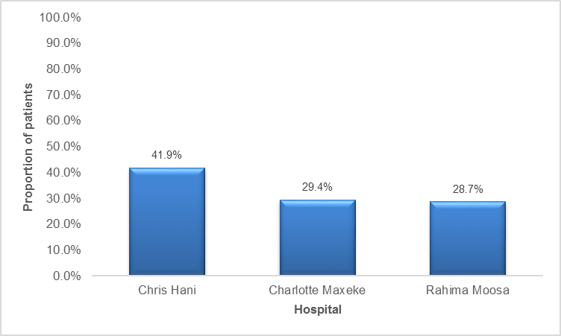
Figure 4.1: Proportion of patients in the study distributed by hospital

4.4: RANK OF SURGEON IN ALL HOSPITALS.
Seventy two and half percent of the total surgeries were performed by the registrars whilst twenty seven and half percent were performed by the consultants.
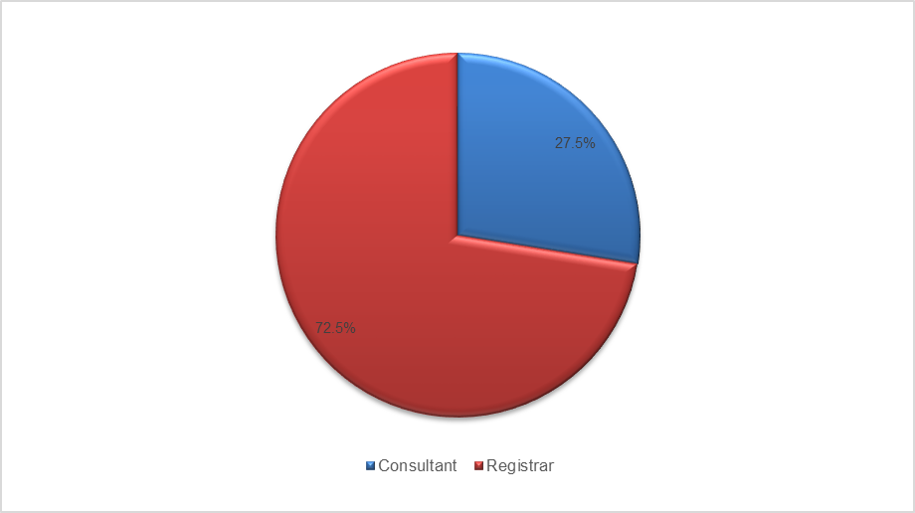
Figure 4.2: Rank of surgeon in all hospitals

Of the 1382 surgeries performed at CHBAH, 80.9% were done by registrars and 19.1% by consultants. The proportions for surgeries between registrars and consultants for CMJAH and RMMCH were 54.6% registrars to 45.4% consultants and 78.6% registrars to 21.4% consultants respectively.

4.5: TYPES OF GYNAECOLOGICAL SURGERY FOR ALL HOSPITALS.
The most common type of surgery performed was laparotomy, 53.8% (1775) followed by TAH±BSO, 30.0% (988) surgeries. Laparoscopy was third at 8.4% (278) and then vaginal hysterectomy at 6.1% (201) surgeries. The proportion of laparoscopic surgery was 17.2% RHMMCH and then 5% and 4.8% respectively for CMJAH and CHBAH.

Figure 4.3: Type of surgery

4.6: INDICATIONS FOR GYNAECOLOGICAL SURGERY FOR ALL HOSPITALS.
Table 4.2; is the summary of all the indications for the gynaecological surgeries that were performed by each of the three Johannesburg academic hospitals during the study period.
Characteristics | CHBAH  n=1,382 (41.9%) | CMJAH  n=969, (29.4%) | RMMCH  n=948 (28.7%) | Total  N=3,299
Abdominal pregnancy | 4 (0.3%) | 1 (0.1%) | 0 (0.0%) | 5 (0.1%)
Abnormal uterine bleeding | 3 (0.2% | 0 (0.0% | 2 (0.2%) | 5 (0.1%)
Acute abdomen | 5 (0.4%) | 0 (0.0%) | 2 (0.2%) | 5 (0.1%)
Adhesiolysis | 3 (0.2%) | 0 (0.0%) | 0 (0.0%) | 3 (0.1%)
Adnexectomy | 13 (0.9%) | 4 (0.4%) | 1 (0.1%) | 18 (0.5%)
CA Cervix | 9 (0.6%) | 13 (1.3%) | 7 (0.7%) | 29 (0.9%)
CIN3/HGIL | 0 (0.0%) | 0 (0.0%) | 3 (0.3%) | 3 (0.1%)
Menstrual disorder | 2 (0.1%) | 1 (0.1%) | 0 (0.0%) | 3 (0.1%)
Ectopic pregnancy | 655 (47.4%) | 383 (39.5%) | 305 (32.2%) | 1,343 (40.7%)
Endometriosis | 2 (0.1%) | 2 (0.2%) | 1 (0.1%) | 5 (0.1%)
Fibroids | 415 (30.0%) | 340 (35.1%) | 335 (35.3%) | 1,090 (33.0%)
Infertility | 2 (0.1%) | 0 (0.0%) | 5 (0.5%) | 7 (0.2%)
Myomectomy | 32 (2.3%) | 43 (4.4%) | 19 (2.0%) | 94 (2.9%)
Ovarian cystectomy | 63 (4.6%) | 42 (4.3%) | 49 (5.2%) | 154 (4.7%)
Ovarian drilling | 1 (0.1%) | 7 (0.7%) | 3 (0.3%) | 11 (0.3%)
Ovarian mass | 15 (1.1%) | 20 (2.1%) | 2 (0.2%) | 37 (1.1%)
Pelvic inflammatory disease | 25 (1.8%) | 16 (1.6%) | 6 (0.6%) | 47 (1.4%)
Pelvic mass | 48 (3.5%) | 18 (1.9%) | 28 (3.0%) | 94 (2.9%)
Uterine prolapse | 15 (1.1%) | 20 (2.1%) | 18 (1.9%) | 53 (1.6%)
Pelvic pain | 35 (2.5%) | 20 (2.1%) | 68 (7.2%) | 123 (3.7%)
Reversal of sterilisation | 9 (0.7%) | 0 (0.0%) | 0 (0.0%) | 9 (0.3%)
Vault prolapse | 1 (0.1%) | 19 (2.0%) | 0 (0.0%) | 20 (0.6%)
Sterilisation | 24 (1.7%) | 20 (2.1%) | 91 (9.6%) | 135 (4.1%)
BSO | 1 (0.1%) | 0 (0.0%) | 0 (0.0%) | 1 (0.1%)
Choriocarcinoma | 0 (0.0%) | 0 (0.0%) | 3 (0.3%) | 1 (0.1%)
Endometrial carcinoma | 0 (0.0%) | 0 (0.0%) | 3 (0.3%) | 3 (0.1%)
Lost intra-uterine device | 0 (0.0%) | 0 (0.0%) | 1 (0.1%) | 1 (0.1%)

4.7: TOP FIVE INDICATIONS FOR GYNAECOLOGICAL SURGERY, ALL HOSPITALS.
The most common surgery indications were ectopic pregnancies 40.7% (1343), followed by fibroid surgeries at 35.9% (1184), including myomectomies.

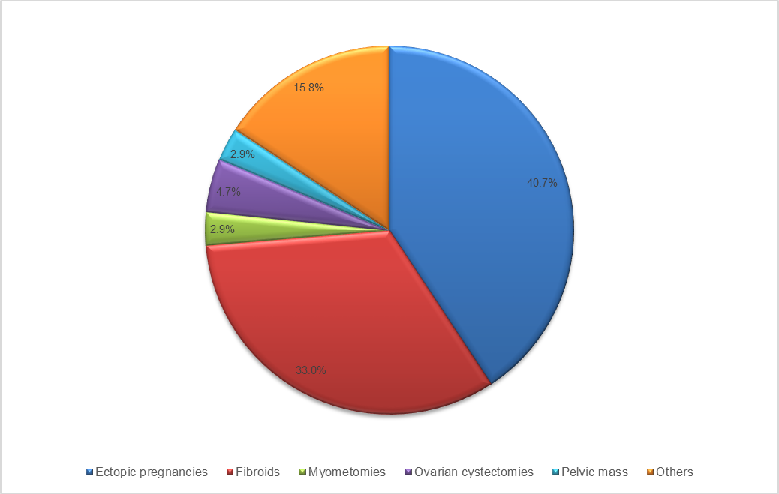

Figure 4.4: Top five Indications for gynaecological surgeries.

4.8: HYSTERECTOMIES PERFORMED FOR BENIGN GYNAECOLOGICAL INDICATIONS.
A total of 1201 hysterectomies were performed for benign gynaecological indications. 82.3% (988) of these operations were performed through open abdominal incisions 16.7% (201) vaginally and 0.99% (12) were performed with the aid of the laparoscope. At CHBAH, 90.3% of 463 hysterectomies were done through open abdominal incisions, 8.64% vaginally and 1.08% were TLH. 74.2% of the 372 hysterectomies performed at CMJAH were through abdominal incisions, 23.9% were performed vaginally and 1.9% were laparoscopic assisted vaginal hysterectomies. At RMMCH, 80.3% of the 366 hysterectomies were performed through the abdominal incisions, 19.7% vaginally and none were performed laparoscopically. A total of 57 hysterectomies were performed for gynaecological oncology indications from the three academic hospitals and all were performed through open abdominal incisions
4.9: GYNAECOLOGICAL LAPAROSCOPIC SURGERY IN ALL HOSPITALS.
A total of two hundred and seventy eight (278) laparoscopic surgeries were performed during the study period. However, four (4) patient records were lost/not found at the clinical records department. The data analysis was then based on two hundred and seventy four (274) patients. RMMCH performed 58.7% (161), followed by CHBAH at 24.1% (66) and then CMJAH at 17.2% (47) laparoscopies. The mean age of the patients was 34.8 (±8.1) standard deviation. 60.2% (165) were performed by registrars compared to 39.8% (109) by the consultants. Based on the Colleges of Medicine of South Africa as well as the international criteria for the levels of laparoscopy procedures, 90.9% of all laparoscopies were levels one. Only a small proportion (9.1%) were levels two or more. Only 2.9% of the ectopic pregnancy surgeries and 4.8% of the surgeries for fibroids were performed with the aid of the laparoscope. A large percentage of laparoscopic surgeries were done for pelvic pain and for sterilizations. More than half (55.1%) of all laparoscopies were diagnostic laparoscopies. At CHBAH the proportion was 57.6%, at CMJAH, it was 63.8% and 51.6% for RMMCH. The second most common type of surgery was sterilizations at 35.8%. Almost half 47.2% of laparoscopic surgeries at RMMCH were sterilizations, 21.2% at CHBAH and 17.0% at CMJAH. More than half (53.5%) of the indications for laparoscopies were due to pelvic pain, 54.6% at CHBAH, 63.8% at CMJAH and 50.0% at RMMCH). A large majority (85.4%) of laparoscopies were performed with two ports. 96.7% of all laparoscopies had no complications, one surgery (0.4%) was abandoned, whilst 8 surgeries (2.9%) were converted to laparotomies. Most patients (92.7%), stayed in hospital for less than two days post-operatively, 6.6% (n=18), stayed for three days whilst 0.7% (2), stayed for more than three days. Points of entry were sub-umbilical for all the surgeries and the method of entry was closed for all the laparoscopies. In all the laparoscopic surgeries, the estimated blood loss was less than 150mls and none of the patients required blood transfusions. None of the patients required intensive care unit admission. Patients at CHBAH as well as RMMCH, received the same post-operative treatment regimen consisting of Pethidine 100mg intramuscularly 6hrly x 3 doses, Prochlorperazine 12,5mg intravenously 6hrly x 3 doses, Cefazolin 1g intravenously 8hrly x 3 doses, Ibuprofen 400mg orally 8hrly x 5 days, Paracetamol 1g orally 6hrly x 5 days. Patients from CMJAH, received Pethidine 100mg intramuscularly 6hrly x 3 doses, Prochlorperazine 12,5mg intravenously 8hrly x 3 doses, Cefazolin 1g intravenously 8hrly x3doses, Indomethacin suppository 100mg rectally 12hrly x 5 days, Paracetamol tablets 1g orally 6hrly x 5 days.

GYNAECOLOGICAL LAPAROSCOPY PROCEDURES, ALL HOSPITALS.
Table 4.3: Gynaecological laparoscopy surgeries.
Characteristics | CHBAH  n=66 (24.1%) | CMJAH  n=47, (17.2%) | RMMCH  n=161 (58.7%) | Total  N=274
Age  Mean (standard deviation) | 36.1 (8.9) | 35.9 (10.2) | 34.0 (6.9) | 34.8 (8.1)
Rank of surgeon  - Consultant  - Registrar | 43 (63.2%)  23 (34.8%) | 42 (89.4%)  5 (10.6%) | 24 (14.9%)  137 (85.1%) | 109 (39.8%)  165 (60.2%)
Laparoscopy surgery types  - BSO  - Cystectomy  - Diagnostic laparoscope  - Ectopic pregnancy  - LAVH  - Ovarian drilling  - Sterilisation  - TLH | 2 (3.0%)  4 (6.1%)  38 (57.6%)  3 (4.6%)  0 (0.0%)  0 (0.0%)  14 (21.2%)  5 (7.6%) | 0 (0.0%)  0 (0.0%)  30 (63.8%)  1 (2.1%)  7 (14.9%)  1 (2.1%)  8 (17.0%)  0 (0.0%) | 0 (0.0%)  0 (0.0%)  83 (51.6%)  1 (0.6%)  0 (0.0%)  1 (0.6%)  76 (47.2%)  0 (0.0%) | 2 (0.7%)  4 (1.5%)  151 (55.1%)  5 (1.8%)  7 (2.6%)  2 (0.7%)  98 (35.8%)  5 (1.8%)
Indication for laparoscopy  - BSO  - Ectopic pregnancy  - Fibroids  - Infertility  - Ovarian cyst  - Pelvic pain  - PCOS  - Sterilisation | 2 (3.0%)  3 (4.6%)  5 (7.6%)  2 (3.0%)  4 (6.1)  36 (54.6%)  0 (0.0%)  14 (21.2%) | 0 (0.0%)  1 (2.1%)  7 (14.9%)  0 (0.0%)  0 (0.0%)  30 (63.8%)  1 (2.1%)  8 (17.0%) | 0 (0.0%)  1 (0.6%)  0 (0.0%)  0 (0.0%)  0 (0.0%)  83 (51.6%)  1 (0.6%)  76 (47.2%) | 2 (0.7%)  5 (1.8%)  12 (4.4%)  2 (0.7%)  4 (1.5%)  149 (54.4%)  2 (0.7%)  98 (35.8%)
Number of Ports  - Two  - Three  - Four | 47 (72.3%)  8 (12.3%)  10 (15.4%) | 26 (55.3%)  21 (44.7%)  0 (0.0%) | 160 (99.4%)  1 (0.6%)  0 (0.0%) | 233 (85.4%)  30 (11.0%)  10 (3.7%)
Complication  - No  - Abandoned  - Converted to laparotomy | 63 (95.5%)  1 (1.5%)  2 (3.0%) | 47 (100.0%)  0 (0.0%)  0 (0.0%) | 155 (96.3%)  0 (0.0%)  6 (3.7%) | 265 (96.7%)  1 (0.4%)  8 (2.9%)
Post operation hospital stay  - Two days or less  - Three days  - More than three days | 57 (86.4%)  7 (10.6%)  2 (3.0%) | 42 (89.4%)  5 (10.6%)  0 (0.0%) | 155 (96.3%)  6 (3.7%)  0 (0.0%) | 254 (92.7%)  18 (6.6%)  2 (0.7%)
Treatment  - Regimen 1*  - Regiment 2** | 66 (100.0%)  0 (0.0%) | 0 (0.0%)  47 (100.0%) | 161 (100.0%)  0 (0.0%) | 227 (82.9%)  47 (17.1%)

* Pethidine 100mg IMI X 3 doses, Prochlorperazine 12.5mg IVI X 3 doses, Cefazolin IG IVI X 3 doses, Paracetamol1G PO 6Hrly X 5 days, Ibuprofen 400mg 8Hrly X 5 days ** Pethidine 100mg IMI X 3 doses, Prochlorperazine 12.5mg IVI X 3 doses, Cefazolin 1G IVI X 3 doses, Paracetamol IG PO 6Hrly X 5 days, Indomethacin Supp.100mg BD X 5 days.
Table 4.3: shows two hundred and seventy four (274) patients that were analyzed. RMMCH performed 58.7% (161) laparoscopies, followed by CHBAH with 24.1% (66) and then CMJAH with 17.2% (47) laparoscopic surgeries. The mean age was 34.8 (±8.1) standard deviation.

4.10: RANK OF SURGEON, ALL LAPAROSCOPIES, ALL HOSPITALS.
60.2% (165) of the laparoscopies were performed by the registrars compared to 39.8% (109) which were performed by the consultants.
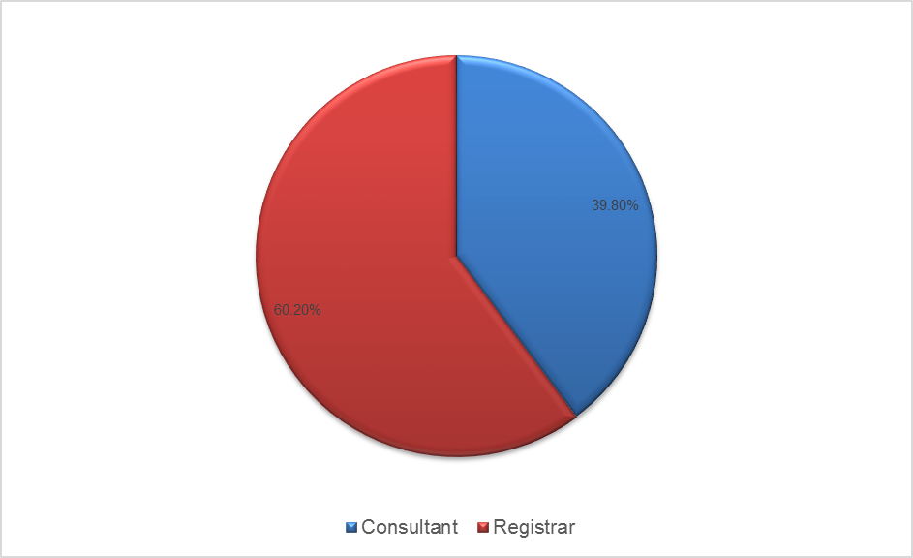
Figure 4.5: Rank of surgeon for Gynaecological laparoscopies.

TYPES OF GYNAECOLOGICAL LAPAROSCOPIES.

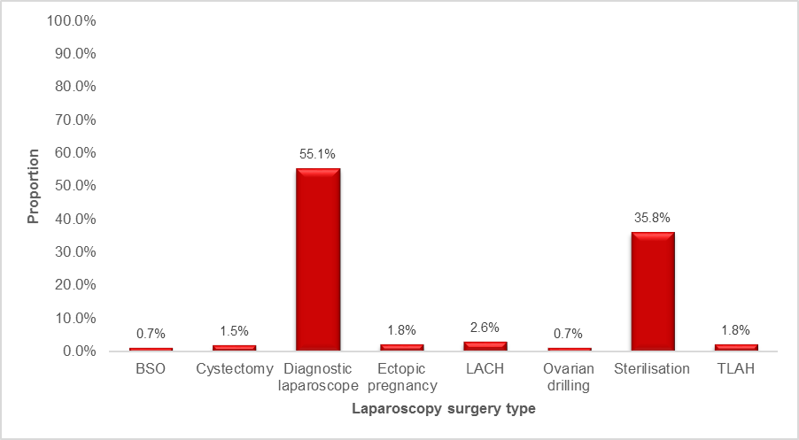
Figure 4.6: Gynaecological Laparoscopy surgery type.
TLH
LAVH

Based on the CMSA as well as the international criteria for the levels of the laparoscopic procedures, 90.9% of all laparoscopies were levels one. Only a small portion (9.1%) were levels two or more. The top two types were diagnostic laparoscopy at 55.1% and bilateral tubal ligations at 35.8%.

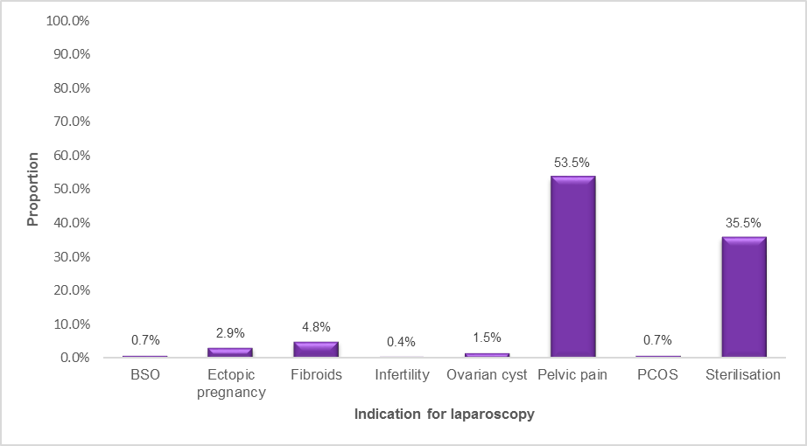
INDICATIONS FOR GYNAECOLOGICAL LAPAROSCOPY.
Figure 4.7: Indications for Gynaecological laparoscopy.

Only 2.9% of the ectopic pregnancy surgeries and 4.8% of the surgeries for fibroids were performed with the aid of the laparoscope. A large percentage of laparoscopic surgeries were done for pelvic pain at 53.5% and bilateral tubal ligations (sterilizations) at 35.5%.

CHAPTER 5
5. DISCUSSION
5.1: INTRODUCTION.
The use of the laparoscope as the surgical tool in the management of surgical conditions has been accepted worldwide. ^{50, 51} The benefits of using the approach over the conventional open surgery, are well documented and far outweigh the disadvantages.¹ In gynaecology, almost all types of surgical procedures and, more importantly, surgery for benign conditions, can and should be done with the aid of the laparoscope.^{3, 4, 5} The widely accepted contra-indications to the performance of laparoscopy include lack of operator skill and experience as well as unavailability of proper laparoscopic equipment and instrumentation.¹Although gynaecological laparoscopy procedures are being performed all over the world, there is still lack of sufficient information regarding the proportion of surgery that is done laparoscopically. ^{9, 10}The available information suggests that implementation is in its initial stages in most countries of world, that the trends are more towards therapeutic procedures than diagnostic procedures and that the training of laparoscopists is ongoing.^{11, 13, 16} In a recent study that reviewed minimally invasive gynaecological surgery in developing nations, Miller et al² found that 14.71% of low income countries and 34.55% of upper income countries reported experience with laparoscopic procedures.² Argentina, Bangladesh, Brazil, Cameroon, China, Egypt, India, Kenya, Nigeria, Pakistan, SA and Thailand; are among the thirty eight countries that were involved in the study.² The incidence of minimally invasive gynaecological surgery as a percentage of all gynaecological procedures was reported between 2.9% to 12% in the majority of low income countries.² An incidence of 23.7%, was reported by one study from Nigeria.² 70.1% to 98.4% of the indications for laparoscopy were diagnostic evaluation of infertility in low and middle income countries, compared to a wider range of indications in upper income countries.² The development of laparoscopic equipment and instrumentation is growing rapidly with the robot and robotic approach being the latest laparoscopic innovation.^{1, 7} There is still a problem in many parts of the world such as the United States of America and Britain, in that 70% of their hysterectomies are still performed with the open abdominal incisions, probably due to lack of operator skill or experience. ^{8, 9 19} There is little data emanating from South Africa on laparoscopic gynaecological surgery.¹² Based on the available information, we hypothesized that, less than 25% of the gynaecological surgery is performed laparoscopically by each of the three Johannesburg academic hospitals.

5.2: PROPORTION OF LAPAROSCOPIC SURGERY.
The study found that 8.4% of all gynaecological surgery was performed laparoscopically by all three Johannesburg academic hospitals from 2012 to 2013. The hospital contributions were 17% RMMCH, 5% and 4.8% respectively for CMJAH and CHBAH. There was limited information in the literature regarding studies done locally and internationally indicating the proportion of surgery performed laparoscopically. ^{9, 10} Many studies showed the increasing trends in the implementation of gynaecological laparoscopy from diagnostic to therapeutic procedures, increasing training of resident doctors and increasing numbers of laparoscopy clinics.^{11, 13,} ¹⁶ Globally, the proportion of hysterectomies performed laparoscopically was 29% Finland in 2008, 14% the USA in 2009, 10% and 3% respectively for the Netherlands and the United Kingdom.¹⁶ The proportion of laparoscopic gynaecological surgery was found to be between 2.9% to 12% in low and middle income countries. ² Our study findings are similar to those by Miller et al ² for low to middle income countries who found the proportion of gynaecological laparoscopic surgery at between 2.9% and 12%. The hospital contributions of 4.8% CHBAH, 5% CMJAH were consistent with those of Miller et al. ² 17% gynaecological laparoscopy performed at RMMCH was higher than that from the other two tertiary hospitals in Johannesburg. They were also higher than Miller’s, ² average range of 2.9% - 12%. They were similar to one Nigerian study ² that reported 23.7%. The higher percentage at RMMCH is attributable to a weekly laparoscopy procedure day on their theatre program. The results of our study were also similar to a study done by Rituka et al. ²¹ in one of the tertiary hospitals in New Delhi (India). He recorded the numbers of gynaecological procedures performed laparoscopically at their hospital each year from 2005 to 2012. Unfortunately, we do not have a record of their patient volume for any particular year to determine the proportion of laparoscopic surgery. However, we know from their study that the numbers of laparoscopy procedures performed each year increased from 27 in 2005 to 69 in 2012.²¹ Their numbers of laparoscopy procedures in 2012, were similar to CHBAH (66), and CMJAH (47) whereas those at RMMCH (161), were far higher than the New Delhi study.²¹ In their study, they showed improvement in the performance of operative compared to diagnostic procedures.²¹ Twjnstra ARH et al. ¹⁶ showed that in the Netherlands between 2002 and 2007, the total numbers of gynaecology surgery clinics increased from 65 to 80, the numbers of non-laparoscopy clinics decreased from 47 to 24 whilst the numbers of laparoscopy clinics increased from 18 to 56.¹⁶ Although we do not know the proportion of procedures performed laparoscopically nationally in the Netherlands in 2002 and 2007, the mean was 289.4 and 210.8 respectively for 2002 and 2007.¹⁶ In our study the total number of laparoscopies was 278. Our results confirm that the three Johannesburg hospitals compare favorably in terms of the total numbers of laparoscopy procedures performed each year; however, we are behind in terms of the therapeutic procedures. This can be improved by the introduction of dedicated gynaecology endoscopy units and infertility clinics.

5.3: TYPE OF LAPAROSCOPY.
35.8% of the 274 gynaecological laparoscopies were sterilization procedures. A large percentage of all the laparoscopies (55.1%) were for diagnostic purposes due to troublesome pelvic pain 54.4%. Whilst the diagnostic procedures were labelled as such, the surgeons were ready to treat the patient’s condition laparoscopically if pathology was detected. The hospital contributions for laparoscopic sterilizations were 47.2% of the 161 laparoscopies at RMMCH, 17% of the 47 laparoscopies at CMJAH and 21.2% of the 66 laparoscopies at CHBAH. The contributions from diagnostic laparoscopies were 51.6%, 63.8% and 57.6% respectively for RMMCH, CMJAH and CHBAH. Laparoscopic treatment for ectopic pregnancies accounted for 1.8% of the 274 laparoscopies and the majority of these were performed at CHBAH. 40.7% of the 3229 gynaecological surgeries were for the treatment of ectopic pregnancies, meaning a large percentage was performed through open abdominal incisions. 1.5% of the laparoscopes were ovarian cystectomies and all these were performed at CHBAH. 2.6% of all gynaecological laparoscopies were laparoscopically assisted vaginal hysterectomies. Only CMJAH performed this type of laparoscopy which contributed 14.9% to the gynaecological laparoscopy in that institution. The performance of LAVH at CMJAH is attributable to the presence of an experienced gynaecological endoscopy surgeon in that institution.1.8% of all laparoscopies were total laparoscopic hysterectomies (TLH). Total laparoscopic hysterectomies were all performed at CHBAH, contributing 7.6% to their gynaecological laparoscopic surgery during the period of the study. The TLH performed at CHBAH are attributable to an experienced visiting gynaecological endoscopy surgeon from Klerksdorp hospital. The types of gynaecological laparoscopies performed by the three Johannesburg academic hospitals is, according to the findings of this study, similar to those done in many other counties of the world.^{1; 3; 8; 9; 11; 14; 15} The difference is that, in most countries of the world, particularly the upper income countries, there is an increasing trend in the implementation of therapeutic gynaecological laparoscopies and a decrease in diagnostic procedures.^{2;13;16} This can be attributable to higher financial resources, availability of laparoscopic equipment, staff training and improved infrastructure in upper income countries. There was a large percentage of patients treated with abdominal incisions for benign gynaecological indications in our study. 53.8% of the 3229 surgeries were laparotomies and 30.0% were TAH ± BSO. We do not have a full disease profile of these patients and therefore unable to determine if they were good candidates for laparoscopic treatment.

5.4: LAPAROSCOPY INDICATIONS.
The indications for gynaecological laparoscopy were pelvic pain in 54.4% of the 274 patients, fallopian tube ligations 35.8%, treatment of fibroids 4.4%, treatment of ectopic pregnancies 1.8% and 1.5% for ovarian cysts. Pelvic pain accounted for 51.6% of the gynaeclogical laparoscopy indications at RMMCH, 63.8% at CMJAH and 54.6% at CHBAH. 47.2% of the sterilizations were done at RMMCH, 17% at CMJAH and 21.2% at CHBAH. Only 1.8% of the 1343 ectopic pregnancies; 1.5% of the 154 ovarian cysts and 4.4% of the (1090) fibroids were managed surgically with the aid of a laparoscope, proving that the implementation of therapeutic gynaecological laparoscopy is still low. 94 myomectomies and 9 reversal of sterilizations were performed with the open abdominal incisions. Miller et al ² reported that 70.1% to 98.4% of the indications for laparoscopy in low to middle income countries were diagnostic evaluation for infertility. This is again almost similar to our findings, except that pelvic pain was the predominant indication in our study. None of the laparoscopy indications in the Miller study ² required sterilizations. In many other countries of the world, particularly the upper income countries, the indications for gynaecological laparoscopy were benign gynaecologic disease such as fibroids, ovarian cysts, endometriosis and laparoscopic treatment of ectopic pregnancies. ^{1; 3; 8; 9; 11; 15}
5.5: OTHER.
The study showed that the majority of the gynaecological laparoscopies (60.2%) were performed by the resident doctors under the supervision of the consultants. The points of laparoscopy entry, the methods of entry and the exit methods were all similar. 96.7% of the 274 Laparoscopy procedures did not have intra-operative complications. One laparoscopic procedure was abandoned due to equipment failure whilst 2.9% were converted to laparotomy. Patients had a short hospital stay and early return to normal daily activities. Patients were given a standardized post-operative treatment from all the three tertiary hospitals.
5.6: CONCLUSION.
To the best of our knowledge, this is the first study of its kind to be done in the Johannesburg area. The study found that the proportion of laparoscopic gynaecological surgery performed by the three tertiary, academic and referral hospitals in Johannesburg from 01 August 2012 to 31 July 2013 was 8.4%. We believe that because of the setting, the large sample size and the long period of this study, the results should be a true reflection of the gynaecological laparoscopies in the South African tertiary public hospitals. Although the main reasons for non-performance of laparoscopies are related to lack of laparoscopic equipment/or instruments, as well as lack of operator skill/or experience, it was not the purpose of this study to determine, nor did we determine, the reasons for the low percentage. We speculate, that once the three hospitals have a dedicated gynaecology laparoscopy unit, an infertility unit and a dedicated Urology-Gynaecology unit, the percentage of gynaecological laparoscopy procedures will increase. This will require more skilled personnel and more equipment leading to significant cost implications. The study showed that more than half (60.2%) of all laparoscopies were performed by the registrars. We speculate that these were teaching laparoscopies. The numbers were, however, almost similar to those at New Delhi (INDIA) as well as the national audit in the Netherlands. The main difference being that most of the laparoscopies in Johannesburg were diagnostic.

5.7: STUDY LIMITATIONS.
Because of its retrospective; record review design, we do not have sufficient information regarding surgeries performed for ectopic pregnancies as well as for fibroids. Almost three quarter (73.7%) of the surgery indications were for ectopic pregnancies and fibroids. During the period of this study, all three hospitals did not have a dedicated gynaecology endoscopy unit as well as an infertility unit. The theatre procedure recording on the theatre records, were done by the theatre nursing personnel and we cannot guarantee the accuracy of the recording.

5.8: STRENGTH OF THE STUDY.
The study setting, the large population size and the long duration are strengths of this study.

5.9: RECOMMENDATION.
A prospective study is recommended. We further recommend the introduction of dedicated gynaecology endoscopy units as well as infertility clinics for each of the three hospitals.

CHAPTER 6
6.1 References:
1. Krishnakumar S and Tambe P. Entry complications in laparoscopic surgery. J Gynaecol Endosc Surg. 2009 Jan-Jun; 1(1):4-11.
2. Miller C, Hoan K, Minig L, Chuang L and Shahabi S. A review of minimally invasive gynaecologic surgery in developing nations. J Gynecol women’s health. 2017 May; 4 (4): 555643.
3. Ng YW, Groenadi CJ, Fong YF. Single incision laparoscopic surgery for large endometriotic cyst. J Surg Tech Case Report 2013; 5:41-44.
4. Rao Prashanth P, Rao Pradeep P and Bhagwat S. Single-incision laparoscopic Surgery-current status and controversies. J Minim Access Surg. 2011 Jan-Mar; 7(1): 6-16.
5. Romanelli JR, Earle DB. Single-port laparoscopic surgery: An overview. J Endosc Surg. 2009; 23:1419-1427.
6. O’Malley C, Cunningham AJ. Physiologic changes during laparoscopy. J Clin Anaesthesiol North Am. 2001; 19:1-19.
7. Nezhat C, Saberi NS, Shahmohamady B and Nezhat F. Robotic-Assisted laparoscopy in gynaecological surgery. J Soc Laparoendosc Surg. 2006 Jul-Sep; 10(3): 317-320.
8. Hurd WW, Falcone T. Gynaecology laparoscopy. In: Tommaso Falcone, William Hurd, editors: Clin Reprod Med and Surg. 2013 Apr; 251-266.
9. Dabrashrafi H and Zomrrodian S. The development of gynaecological laparoscopy. Med J Islamic Republic of Iran1997 Nov; 3: 275-280.
10. Twijnstra D. Laparoscopic hysterectomy: Predictors of quality of surgery. J Minim invasive Gynaecol 2016 Mar-Apr; 23 (3): 317-330.
11. Reich H, Decaprio J, Mcglynn F. Laparoscopic hysterectomy. J Gynaecol Surg.1989; 5: 213-216
12. Thomas V. Laparoscopic safety in benign gynaecological disease: The evidence. Obstet and Gyn Forum 2012; 22: 33-37.
13. Vilos GA, Ternamian A, Dempster J and Leberge Y. Laparoscopic entry: A review of Techniques, Technologies and Complications. J Obstet Gynaecol Can 2007; 29 (5):433-447.
14. Garry R, Fountain J, Brown J, Mavca A, Mason S, Sulpher M. Evaluate hysterectomy trial: a multicenter randomized trial comparing abdominal, vaginal and laparoscopic methods of hysterectomy. Health Technol Assess J 2004; 8 (26): 1-154.
15. Brummer THI, Tomi T, Seppala and Paivi SM. National learning curve for laparoscopic hysterectomy and trends in hysterectomy in Finland 2000-2005. Hum Reprod J 2008; 4 (23):
840-845.
16. Twijnstra ARH, Kolman W, Trimbos-Kemper GC, Jansen FW. Implementation of advanced laparoscopic surgery in gynaecology: National overview of trends. J Minim invasive Gynaecol 2010 Jul-Aug; 17(4): 487-92.
17. Jacoby VL, Jacobson G, Domush R, Nakagawa S and Jacoby A. Nationwide use of laparoscopic hysterectomy compared with abdominal and vaginal approaches. J Obstet Gynaecol 2009 Nov; 5 (114): 1041-1048.
18. AAGL Position Statement: Route of hysterectomy to treat benign uterine disease. J Minim invasive Gynaecol 2011 Jan-Feb; 18(1):1-3.
19. Stovall DW, Fernandez AS and Cohen SA. Laparoscopic training in US Obstetrics and Gynaecology Residency Programs. J Soc Laparoendoscopic Surg. 2006; 10: 11-15.
20. Kolman W, Wolerbeek R, Jansen FW. Gynaecological laparoscopy in residency training program: Dutch perspectives. J Endosc Surg. 2005; 19: 1498-1502.
21. Ritu K, Greetika J, Sumita M, Nidhi A, Atul J ana Neerja G. Changing trends in use of Laparoscopy: A clinical audit. J Minim invasive Surg. 2014; (2014): 562-785.
22. Lapido OA, Adekunle AO, Akande EO. Gynaecological endoscopy and experience with training in Africa. In: Gordon AG, Hulka JF, Walker JM, Campana A, editors. Practical Training and Research in Gynaecol Endosc. 2016 Sept 22.
23. Chrysostomou A. Implications of performing laparoscopic assisted vaginal hysterectomy versus abdominal hysterectomy on suitable patients in South African hospital setting. SA J Obstet and Gyn 2009; 14(2):70-74.
24. Butt JL, Jeffery ST, Van der Spuy ZM. An audit of indications and complications associated with elective hysterectomy at a public service hospital in SA. International J Gyn and Obstet 2012; 116 (2): 112-116.
25. Basic Laparoscopic Procedure: RCOG, Green Top Guideline no. 49 May 2008.
26. Bosteels J, Van Herendael B, Weyers S, D’Hooghe T. The position of diagnostic laparoscopy in current fertility practice. Hum Reprod Update 2007 Sept-Oct; 13(5):477-485.
27. Westhoff C, Davis A. Tubal sterilization: Focus on US experience. Int J Fertil Steril 2000
May; 73(5): 913-922.
28. Kim AH, Adamson GD. Surgical treatment options for endometriosis. Clin Obstet Gynecol.1999 Sep; 42(3): 633-644.
29. Murray H, Baakdah H, Bardell T. Diagnosis and treatment of ectopic pregnancy. Can Med Assoc J. 2005 Oct; 173 (8): 905-912.
30. Tulandi T, Saleh A. Surgical management of ectopic pregnancy. Clin Obstet Gynecol. 1999 Mar; 42(1):31-38.
31. Memon MR, Memon SR, Mirani SH, Memon NY. Role of laparoscopy in acute gynaecologic conditions. Rawal Med J 2014 Jan-Mar; 39(1):48-51.
32. Mettler L, Semm K, Shive K. Endoscopic management of adnexal masses. J Soc Laparoendosc Surg. 1997 April-Jun; 1(2):103-12.
33. Meeks GR, Harris RL. Surgical approach to hysterectomy: Abdominal, laparoscopy assisted, or vaginal. Clin Obstet Gynecol. 1997 Dec; 40(4):886-94.
34. Johnson N, Barlow D, Lethaby A. Methods of hysterectomy: Systematic review and meta-analysis of randomized controlled trials. Br Med J 2005; 330(7506): 1478.
35. Ghezzi F, Cromi A, Uccela S, Siesto G, Zefiro F, Bolis P. Incorporating laparoscopy in practice of Gynaecologic Oncology Service: Actual impact beyond clinical trial data. Annals Surg Oncol 2009 May; 16(8): 2305-2314
36. Chang W, Huang S and Sheu B. Advances in Gynaecological Laparoscopic Surgery. J Formosan Med Assoc. 2010; 109 (4): 245-47.
37. Jansen FW, Kapitein K, Trimbos-Kemper T, Hermans J, Trimbos JB. Complication of laparoscopy: A prospective multicenter observational study. Br J Osbtet Gynecol. 1997; 104: 598-600.
38. Mayol J, Garcia-Aguilar J, Ortiz-Oshiro E, De-Diego CJ, Fernandez-Represa JA. Risks of minimal access approach for laparoscopic surgery: multivariate analysis of morbidity related to umbilical trocar insertion. World J Surg. (1997); 21: 529-533.
39. Nuzzo G, Giulante F, Tebala GD, Vllone M, Cavicchione C. Routine use of open technique in laparoscopic operations. J Am Coll Surg. 1997; 184:58-62.
40. Hackam DJ, Rotstein OD. Host response to laparoscopic surgery: Mechanisms and clinical correlates. Can J Surg. (1998); 41(2):103-111.
41. Srivastava A and Niranjan A. Secrets of safe laparoscopic surgery: Anaesthetic and surgical considerations. J Minim access Surg. 2010 Oct-Dec; 6(4); 91-94.
42. Harkki-Siren P, Sjoberg J, Kurki T. Major complications of laparoscopy: a follow up finish study. J Obstet Gynaecol. 1999 Jul; 94(1):94-98.
43. Green VL. Liability in Obstetrics and Gynaecology. ACOG Liability survey 2003.
44. Ates S, Tulandi D and Leong M. Malpractice claims and avoidance of complications in endoscopic surgery. Best Practice and Research Clin Obstet Gynecol. 2013 Jun; 27(3): 349-361.
45. Khavanin-Zadeh M and Gholipour F. Complaints related to laparoscopic surgery: Survey of files registered at Tehran Legal Medicine Center. International J hospital Research 2013; 2(4): 215-218.
46. Jonsson B and Zethraeus N. Cost and benefits of laparoscopic surgery: A review of the literature. Eur J Surg. 2000; (585): 48-56.
47. JHB population. COJ idp 2013-2016 (May 2013).
48. JHB-in focus. HSRC COJ economic overview 2013.
49. HSRC City of Johannesburg Economic overview: 2013 report. http://bit.ly/13KRrj9.
50. Perugini RA and Callery MP. Complications of laparoscopic surgery. In: Holzheimer RG, Mannick JA, editors. Surgical treatment: Evidence-based and problem-orientated. Munick: Zuckschwerdt; 2001.
51. Agha R and Muir G. Does laparoscopic surgery spell the end of the open surgeon? J Royal Soc Med. 2003 Nov; 96(11): 544-546.

6.2 Appendices:
Appendix A.
Laparoscopic surgery performed by each of the three academic hospitals.
DEPT. 0F OBSTETRICS & GYNAECOLOGY OF THE UNIVERSITY OF THE WITWATERSRAND. MASTER OF MEDICINE RESEARCH SHEET APPENDIX A.
TOPIC: A descriptive study of laparoscopic gynaecological surgery at three academic hospitals in Johannesburg.
SETTING: CHBAH /CMJAH /RMMCH (tick appropriate block)
PATIENT DEMOGRAPHY: PATIENT RESEARCH CODE NO ………AGE: …………
BACKGROUND HISTORY:
HIV STATUS: NEGATIVE (0)…………POSITIVE (1)…………UNKNOWN (9)……….
COMORBID CONDITIONS (explain)……………………………………………………
PREVIOUS INCISION: NONE (0).SUBUMBILICAL (1).TRANSVERSE (2). OTHER (9)
LAPAROSCOPY: Date………………… Indication……………… Type…………………
RANK OF SURGEON: (REGISTRAR /CONSULTANT)…………………………….
PROCEDURE:
- PORT OF ENTRY………………………METHOD OF ENTRY…………….
- NUMBER OF PORTS………………………………………………………….
INTRA-OPERATIVE COMPLICATION (YES/NO). (Explain)………………………..
Abandoned/Converted to laparotomy………………………………………………..
EBL……………………. Transfused…………………… ICU admission……………
POST OPERATION TREATMENT: ……………………………………………………………….
Date of discharge……………………..Length of hospital stay………………………

APPENDIX B. (STRICTLY CONFIDENTIAL FORM)
DEPT. OF OBSTETRICS & GYNAECOLOGY OF THE UNIVERSITY OF THE WITWATERSRAND. MASTER OF MEDICINE RESEARCH SHEET APPENDIX B
A descriptive study of laparoscopic gynaecological surgery at three academic hospitals in JHB.
A LIST OF ALL ELECTIVE & ECTOPIC PREGNANCY GYNAECOLOGICAL SURGERY PROCEDURES PERFORMED BY EACH OF THE THREE ACADEMIC HOSPITALS FROM 01 AUGUST 2012 TO 31ST JULY 2013. “CONFIDENTIAL”

HOSP.NO. | NAME OF HOSP. | RESEARCH CODE | DATE OF SURG. | TYPE OF SURG. | RANK OF SURG.

APPENDIX C …………………………………………… DATA CODES.
S/N. (Patient serial number): EG 1, 2, 3 ……………… etc. AGE: ……………………………….
HOSPITAL: CHBAH ………. 1 CMJAH ………. 2 RMMCH ……….3
TYPE OF SURGERY:
LAPAROTOMY …… 1 LAPAROSCOPY………. 2 TAH+_BSO……….. 3
TAH+BSO+OMANTECTOMY+PERITONEAL WASHINGS ………. 4
VAGINAL HYSTERECTOMY ………. 5 WERTHEIM’S HYSTERECTOMY……. 6
INDICATION FOR SURGERY:
ABDOMINAL PREGNANCY…… 1 ABNORMAL UTERINE BLEEDING ……..2
ACUTE ABDOMEN......... 3 ADHESIOLYSIS…… 4 ADNEXECTOMY ……… 5
CA CERVIX…………… 6 CIN3/HGIL ………. 7 CEREBRAL PALSY …… 8
ECTOPIC PREGNANCY … 9 ENDOMETRIOMA ……10 FIBROIDS ……. 11
INFERTILITY ………12 MYOMECTOMY …13 OVARIAN CYSTECTOMY……..14
OVARIAN DRILLING………. 15 OVARIAN MASS ……………… 16
PELVIC INFLAMMATORY DISEASE …17 PELVIC MASS ………………… 18
UTERINE PROLAPSE ………. 19 PELVIC PAIN…………………… 20
REVERSAL OF STERILISATION …… 21 SACROCOLPOPEXY ………… 22
STERILISATION ………. 23 BS0………. 24 CHORIOCARCINOMA………… 25
ENDOMETRIAL CA………. 26 LOST LOOP………. 27
RANK OF SURGEON: CONSULTANT ………. 1 REGISTRAR ………. 2
LAPAROSCOPIC SURGERY TYPES:
ADHESIOLYSIS …………. 1 BSO ………. 2 CYSTECTOMY …… 3
DIAGNOSTIC L/COPE…… 4 ECTOPIC PREGNANCY … 5 LAVH ……………… 6
OVARIAN DRILLING ……..7 STERILISATION ………. 8 TLH ……………….. 9

INDICATION FOR LAPAROSCOPY:
BSO ………. 1 ECTOPIC PREGNANCY ……….. 2 FIBROIDS ………. 3
INFERTILITY ………. 4 OVARIAN CYST ………. 5 PID ………. 6
PELVIC PAIN ………. 7 PCOS ………. 8 REVERSAL OF STERILISATION ……… 9
STERILISATION ………. 10
POINT OF ENTRY: SUB-UMBILICAL ………. 1 PALMER POINT ………. 2
METHOD OF ENTRY: CLOSED ………. 1 OPEN ………. 2
NUMBER OF PORTS: TWO …… 1 THREE …… 2 FOUR … 3 >FOUR PORTS … 4
COMPLICATION: NO ………. 1 YES ………. 2 ABONDONED ………. 3
CONVERTED TO LAPAROTOMY ………. 4
BLOOD LOSS: < 150 ML ………. 1 (150 – 300) ML ………. 2 >300 ML ……… 3
BLOOD TRANSFUSION: NO ………. 1 YES ………. 2
ICU ADMISSION: NO ………. 1 YES ………. 2
POST OP. HOSPITAL STAY: < 2DAYS …… 1 3DAYS ….. 2 >3DAYS ………..3
POST OPERATIVE TREATMENT:
PETHIDINE 100MG IMI X3DOSES, STEMETIL 12.5MG IVI X3DOSES, KEFZOL IG IVI
X3DOSES, PANADO 1G PO 6HRLY X5DAYS, BRUFEN 400MG 8HRLY
X5DAYS……REGIMENT 1.

PETHIDINE 100MG IMI X3DOSES, STEMETIL 12.5MG IVI X3DOSES, KEFZOL 1G IVI
X3DOSES, PANADO IG PO 6HRLY X5DAYS, INDOCID SUPP.100MG BD
X5DAYS…………..REGIMENT 2.
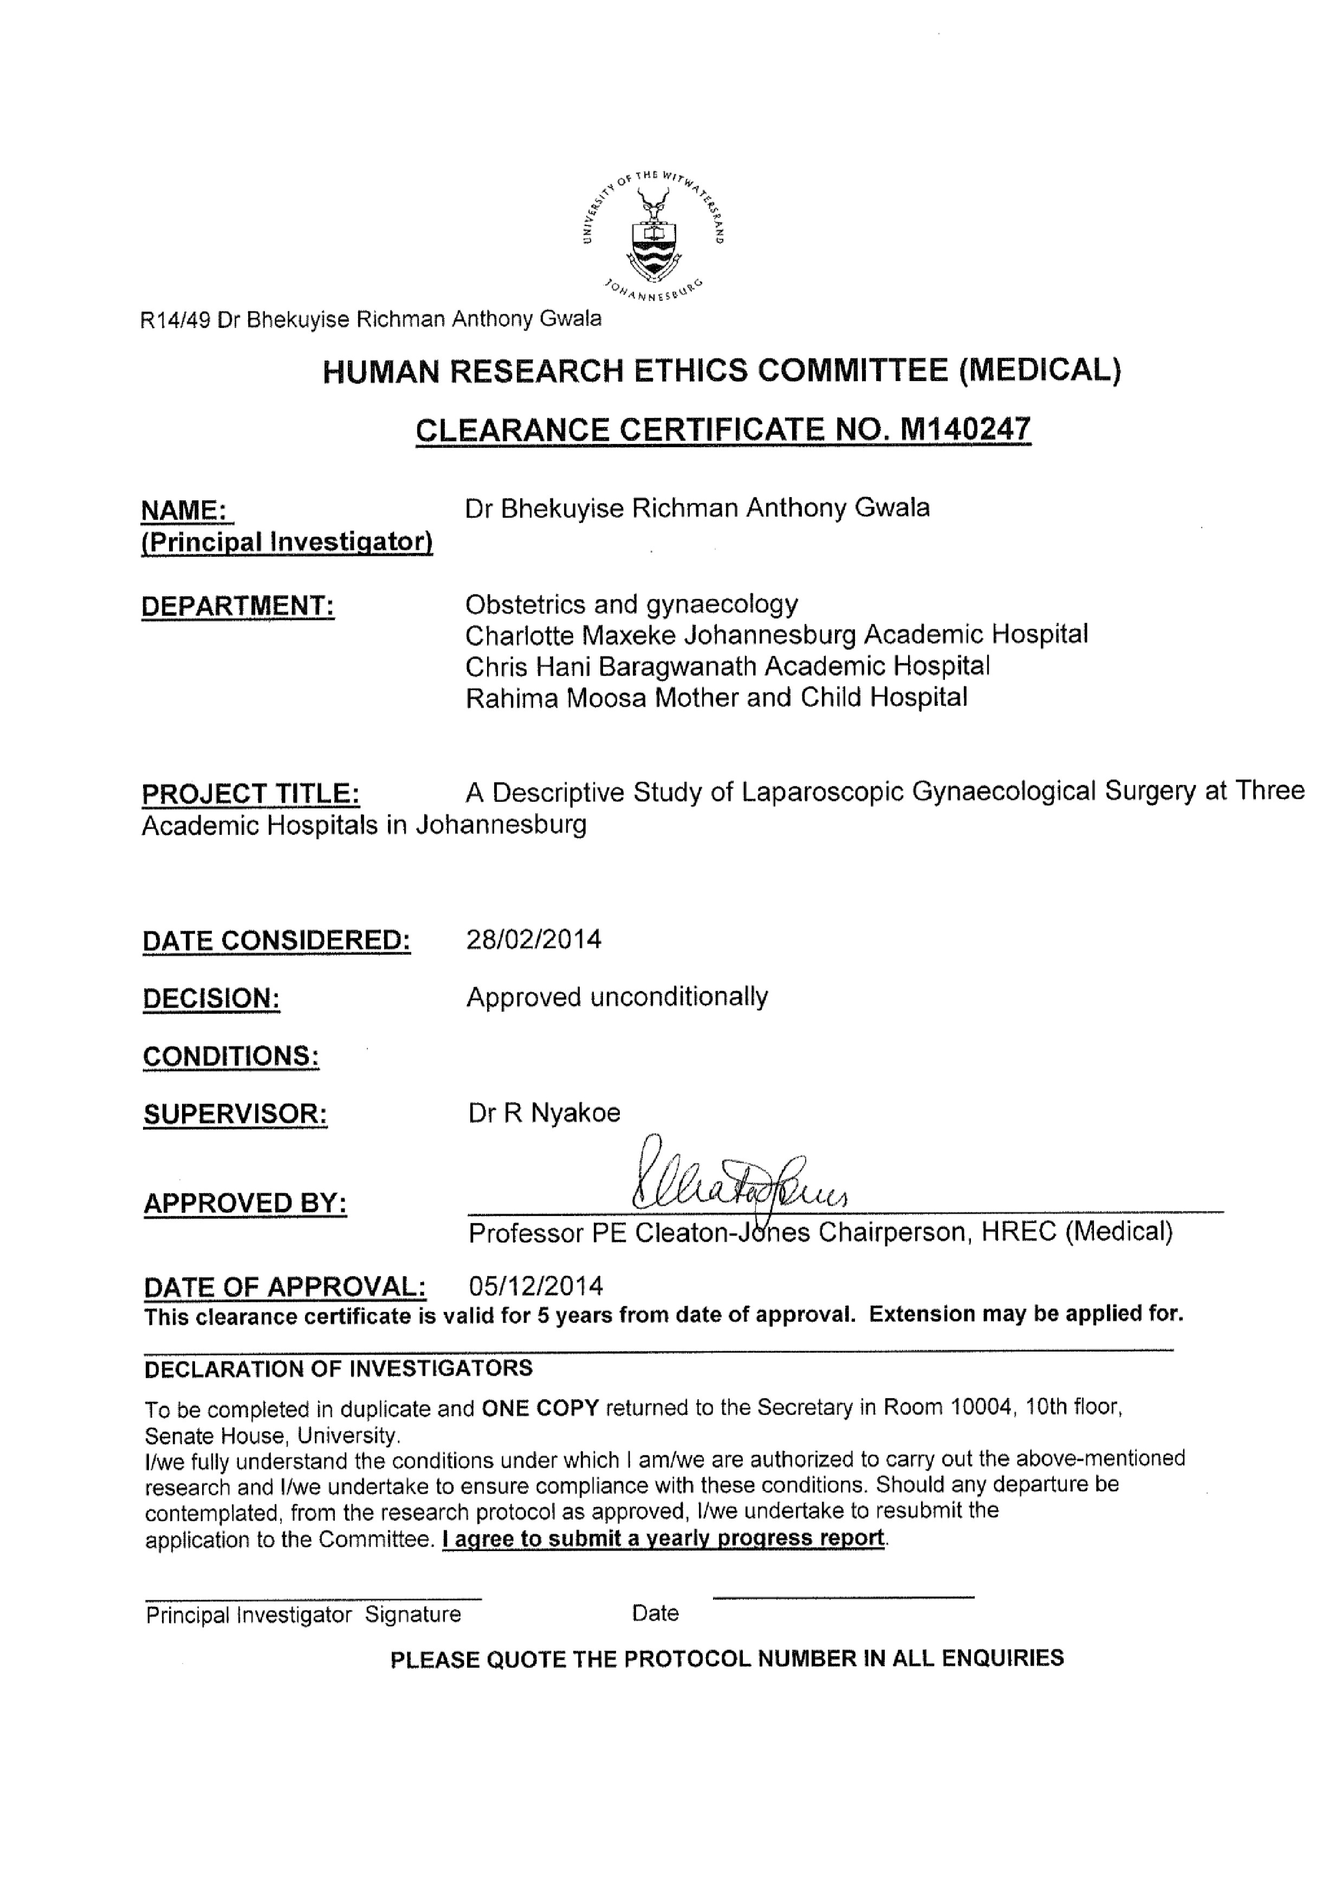
Appendix D
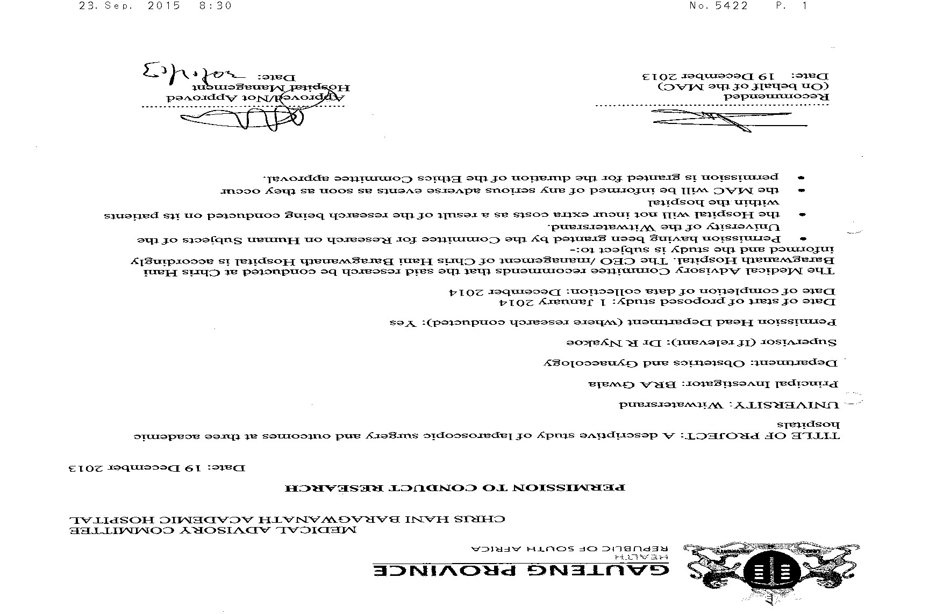
Appendix E

APPENDIX F
APPENDIX G
APPENDIX H
BASIC LAPAROSCOPIC EQUIPMENT AND PROCEDURE: ^{1; 24}
EQUIPMENT:
The laparoscopic equipment is broadly classified into: ¹
Optical instruments:
These; include rod lens system, fiber optic cables and light sources.
Abdominal access instruments:
Hasson cannula for the open technique, Veress needle, trocar, trocar sheath and assembles for the closed entry technique.
Laparoscopic surgery instruments:
These are miniature transformations of the instruments used in the open surgeries. They include aspirator, dissecting forceps, grasping instruments scissors, sutures, clip applicators, staples, needles, needle holders and cautery.
BASIC LAPAROSCOPIC PROCEDURE.²⁴
POSITION.
The patient must be prone with stirrups in Lloyd Davis position. The mattress must be nonslip. The operating table should be horizontal at the start of the procedure and after the insertion of the ports, it must be trenderlamburg. The abdomen should be palpated to check for any masses before insertion of the Veress needle.
PRIMARY PORT CLOSED ENTRY.
The intra-umbilical entry is advisable due to the fixed peritoneum, thin least vascularity and good cosmetic appearance. The incision should be vertical from the base of the umbilicus. Care should be taken not to incise so deeply as to enter the peritoneal cavity. The Veress needle insertion should include pencil grip, vertical then towards the pelvis. The Veress needle should be sharp with a good and tested spring action. Stabilization of the lower abdominal wall should be done in such a way that the Veress needle is inserted at right angles to the skin. Listen to two audible clicks as the layers of the umbilicus are penetrated. Avoid lateral movement of the needle as this may convert a small needle point injury in the wall of bowel or vessel into a complex tear. A Saline test (withdraw-instill-withdraw), should be done to ensure that no intra-abdominal organ has been damaged. If no fluid, frank blood or faeces, then proceed. Ensure that the initial insufflation pressure is less than 8mmhg and is flowing freely. After two failed attempts to insert the Veress needle, either the open Hasson technique or Palmer’s point entry should be used. For insufflation, set the pressure cut-off to between 20-25mmhg. Start flow at 1 l/min, check the gas entering at low pressure and after 0,5l, flow can be increased. Insufflate to pressure cut-off. The greater the gas bubble and the abdominal wall tension the less the risk of bowel injury. An intra-abdominal pressure of 20-25mmhg should be achieved before inserting the primary trocar. The distension pressure should be reduced to between 12-15mmhg once the insertion of trocars is complete. The primary trocar should be inserted at 90 degrees to the skin, through the incision at the base of the umbilicus. Once the laparoscope has been introduced, rotate it through 360 degrees to check for any adherent bowel.
SECONDARY PORTS.
The secondary ports are inserted under direct vision. Avoid inferior epigastric vessels, bowel, aorta, iliac vessels and minimize hernia risk. Insert under direct vision at right angles to the skin at 20-25mmhg pneumo-peritoneum. Inferior epigastric vessels should be visualized laparoscopically prior to port placement. Once the trocar has pierced the peritoneum, it should be angled towards the anterior pelvis.

PRIMARY PORT ALTERNATIVES.
Alternatives to umbilical entry are considered if there is risk of umbilical adhesions, very thin or morbidly obese women, failed saline test or failed Veress needle insertion 2times and unsatisfactory closed Veress insufflation. Alternatives include open entry with variations of Hasson technique or Palmer’s point closed entry.
EXIT TECHNIQUES.
Exit should be done under direct vision to identify potential bleeding, injury to the omentum or bowel. Proper wound closure should be done to ensure closure of fascia within umbilical port site to prevent wound dehiscence or hernia.

APPENDIX I
9512051w: MMED RESEARCH REPORT (WITS).docx ORIGINALITY REPORT

16% 15% 11% 7%
SIMILARITY INDEX INTERNET SOURCES PUBLICATIONS STUDENT PAPERS
PRIMARY SOURCES
www.ncbi.nlm.nih.gov 1  Internet Source | 6%
emedicine.medscape.com 2  Internet Source | 4%
Thomas, V. "Laparoscopic safety in benign  3 gynaecological disease: the evidence",  Obstetrics & Gynaecology Forum, 2012.  Publication | 3%
Submitted to University of Surrey 4  Student Paper | 1%
www.tripdatabase.com 5  Internet Source | 1%
matweb.hcuge.ch 6  Internet Source | 1%
www.sogc.org 7  Internet Source | 1%
www.ajol.info 8  Internet Source | 1%
Exclude quotes on
Exclude matches < 1%
Exclude bibliography off

