

Discovery and resource evaluation of the Lesego Platinum Merensky Reef and UG2 Chromitite hosted Platinum Group Metals deposit adjacent to the Phosiri Dome and the associated effects of the Phosiri Dome on the reef horizons, Bushveld Complex, South Africa
July 2018
Richard Montjoie
Person Number 9809072H
Supervisors:
Professor Judith A. Kinnaird
Associate Professor Paul A. M. Nex

Declaration
All work contained within this research report is the original work of the author, except where specific references acknowledge the work of others. It is being submitted in part for the degree of Master of Science at the University of the Witwatersrand, Johannesburg. It has not been submitted before, for any degrees or examination in any other university.

Declaration of Spelling
This manuscript forms the complete submission of the research report, including appendices. Chapter 2 forms the complete submission, including references, of a regular paper to Economic Geology, an independent journal published by the Society of Economic Geologists (SEG). The paper presents new and unpublished exploration results, exploration techniques, the mineral deposit profile and a potential new source of metal.
Chapter 2’s manuscript text, references, tables and figures follow the format and style required by the SEG. For the purposes of consistency of the research report, spelling, figure and table captions are in the format required by the University. This will be updated on submission for publication to the format and style required by SEG, and conforms to the AGI Glossary of Geology, Chicago Manual of Style, and Merriam-Webster’s Collegiate Dictionary.
The referencing style for chapters 1, 3 and 4 in the format required by the South African Journal of Geology.

________________________ ________________________
Signed Date

Acknowledgements
Professor Paul Nex is thanked for his continued support, mentorship and guidance over the years of developing the project, as well as for his input into this paper. The exploration team involved for their diligence and hard work: Keith Matier, Rob Kiefer, Frieder Reichhardt, Neels van Rooyen and Wiehann Kleynhans. Peter Sebake for his invaluable assistance in the successful liaison with our host communities.
Diane Shearer is thanked for her assistance with the illustrations. Innes Buurman and Jamie Price are thanked for their excellent mineralogical work on the Merensky Reef. The management of Lesego Platinum, Village Main Reef and Umbono Capital are thanked for their continued support of the project. The Industrial Development Corporation of South Africa is thanked for their funding of the project to advance it from exploration stages through to completed feasibility studies. We hope that this project can be used as a means to improve the lives of the communities which live on and around this resource.

Abstract
The recently discovered Lesego Platinum Merensky Reef and UG2 Chromitite deposit is a 39 million-ounce PGE deposit hosted in the northeastern portion of the Bushveld Complex, South Africa. The upward displacement of floor rock during the emplacement of the Rustenburg Layered Suite of the Bushveld Complex as a result of gravitational forces has resulted in the economically important horizons, which would normally be at several kilometers depth, being brought closer to surface by the Phosiri Dome. The Phosiri Dome has, however, had a dramatic effect on the morphology and grade of the Merensky and UG2 reefs. The reefs are almost vertical in close proximity to the Phosiri Dome, but rapidly flatten out at depth to the shallow westerly dips more consistent with traditional Merensky and UG2 reefs in the area. A gabbro contaminated with anatectic melt appears to have obliterated the reef horizons closer to surface, resulting in the upper orebody remaining undiscovered since the area was first explored in the 1980’s. Reef morphology and PGE mineralogy in the Merensky Reef further away from the Phosiri Dome are consistent with that of surrounding deposits.

Table of Contents
Declaration 2
Declaration of Spelling 2
Acknowledgements 3
Abstract 4
Table of Contents 5
List of Figures 7
List of Tables 8
Chapter 1 9
Study Aim and Objectives 9
Introduction 9
Location 9
Regional Geology 9
Local Geology 12
Comparison of Reef Facies 13
UG2 facies variations 13
Merensky Reef facies variations 14
Exploration History 15
Exploration Methodology of the Lesego Project 16
Geophysics 16
Soil Geochemistry 16
Geological Mapping 16
Exploration Drilling and Mineral Resource Statement 16
Author’s Responsibilities 18
Chapter 2 20
Introduction 21
Regional Geology 21
Local Geology 24
Exploration History and Rationale 26
Exploration Methodology and Exploration Results 28
Geophysics 28
Soil Geochemistry 36
Geological Mapping and Trenching 38
Exploration Drilling 39
Lithology and Petrography 42
UG2 Chromitite Horizon 42
Merensky Reef 42
Precious Metal Mineralogy 44
Resource Statement 45
Discussion 47
Conclusions 48
Acknowledgements 49
References 49
Chapter 3 53
Overview 53
Mining and Processing 53
Mining 53
Mineral Processing 54
Surface Infrastructure 54
Chapter 4 56
Discussion 56
Outlook for Commissioning 56
Conclusions 57
References 59
Appendices 64
Evidence of Gathering of Own Data 64
Appendix 1: Geological Map of the Lesego Area compiled from all available data sources 65
Appendix 2: Three-dimensional model of the Merensky Reef and UG2 Chromitite compiled in Geosoft Target 66
Appendix 3: Depth contour map created in Geosoft Target and imported into ArcMap 67
Appendix 4: Draft drill plan layout to determine Measured Resource based on initial Inferred Resource 68
Appendix 5: Typical Cross section compiled by the author in Geosoft Target used to plan exploration drill holes to target the shallow resource from 1,200 to surface. 69
Appendix 6: In field borehole stratigraphic logs (compiled with project geologist) 70
Appendix 7: Selection of Optimised Reef Cuts for Resource Estimation 71
Appendix 8: Basket Price per Ton Comparison for Eastern and Northern Limb Mines and Projects 72

List of Figures
Figure 1: Simplified geological map of the Bushveld Complex and the surrounding Transvaal Supergroup (after Cawthorn. 2015). 22
Figure 2: Stratigraphy of the Lower Portion of the Rustenburg Layered Suite (after Schürmann et al., 1998). 23
Figure 3: Simplified geological map of the northeastern portion of the Eastern Limb of the Bushveld Complex showing the Phosiri, Phepane, Malope and Katkloof Domes, and the Schwerin Fold (after Johnson et al., 2004). 25
Figure 4: Historical Exploration and Drilling on the flanks of the Phosiri Dome 28
Figure 5: Topographical image from aerial photos showing the seismic traverses and shotpoints (Campbell, 2010). 29
Figure 6: Line 3 and Line 4 fence diagram showing continuity of reflectors and marker horizons H_5 through to H_8 representing the Giant Mottled Anorthosite in red through to the UG2 in blue, with the yellow line representing the floor contact of the Rustenburg Layered Suite with Transvaal Supergroup metasediments (Campbell, 2010). 30
Figure 7: Line 1 migrated section with interpretation overlay showing continuity of reflectors and marker horizons H_0 through to H_11 with the yellow line representing the floor contact of the Rustenburg Layered Suite with Transvaal Supergroup metasediments and the location of drill hole LES001 in white (Campbell, 2010). 31
Figure 8: Isopach map of the UG2 Chromitite modeled from the results of the seismic survey showing its continuity and the relative paucity of structural disturbances. The western extent of the Rustenburg Layered Suite as derived from the Lesego gravity survey is indicated with the dashed yellow line, whilst the published location of the Transvaal Supergroup – Rustenburg Layered Suite contact is shown by the grey dashed line (Campbell, 2010). 32
Figure 9: Bouguer Gravity and surface elevation profiles along seismic lines 01 (top), 04 (middle) and 05 (bottom), illustrating the published floor rock contact and the suggested floor rock contact (black arrow) based on increased density of the Rustenburg Layered Suite lithologies (Campbell, 2010). 33
Figure 10: Total field magnetics image from the aeromagnetic survey flown over the project area showing interpreted faults (in black) and dykes (in white) (after Campbell, 2010). Red and purple indicates areas of relatively high magnetic intensity, highlighting IRUPS, dykes, Upper Zone lithologies and the Vermont Formation of the Pretoria Group, whilst green areas indicate areas of relatively low magnetic intensity of Main, Critical Zone and Transvaal Metasedimentary rocks. Note the shift of the Main Zone – Upper Zone boundary to the south based on the magnetic signature of the Upper Zone lithologies (after Schwellnus et al., 1962 and Campbell, 2010). 35
Figure 11: Geological map showing chrome in soil values and mapped and interpreted structures in the Lesego project area, as well as the location of the two trenches. The dotted line refers to the 150 ppm Cr in soil contour (after Schwellnus et al., 1962 and data compiled by the author). 37
Figure 12: Wireframe model showing the extent and dip of the Merensky Reef (image on the left) and UG2 chromitite (image on the right) looking from the southeast towards the eastern flank of the dome. 39
Figure 13: Three-dimensional view looking north of the exploration drill holes on the Phosiri Project showinga gabbro heavily contaminated with anatectic melt in orange. 40
Figure 14: Photograph of drill core from drill hole LES039 located approximately 400 m from the Phosiri Dome, showing the deformed mottled anorthosite hangingwall to the Merensky Reef pyroxenite. The mottled anorthosite shows strong foliations, indicating strain probably due to the post crystallization emplacement of the Phosiri Dome. 40
Figure 15: Location of all diamond exploration drill holes drilled on the Lesego lease area, as well as the seismic traverses conducted in 2007. The white block on the inset denotes the area displayed in the main image. 41
Figure 16: Typical stratigraphy and grade profile across the UG2 Chromitite in the Lesego Lease Area. (a) Single reef facies, (b) Split reef facies with two chromitite seams separated by a pyroxenite parting (after Njowa and Clay, 2010). 42
Figure 17: Typical stratigraphy representing the average width and grade profile across the Merensky Reef in the Lesego Project Area (after Njowa and Clay, 2010). 44
Figure 18: Contoured map of the Lesego Project Area showing 3PGE+Au, Cu and Ni grades over the Merensky Reef (top image) and UG2 (bottom image). Note the general improvement of grade with depth (to the right) and the low-grade portions at the margins of the resource. 46
Figure 19: Oblique section looking northwest showing the primary development and secondary development required to access the steeply dipping portions of the ore body down to 1,200 m below surface. 53
Figure 20: GoogleEarth image with the footprint of the tailings disposal facility in the core of the Phosiri Dome and the location of mine surface infrastructure on the eastern side of the eastern flank of the Dome. 55
Figure 21: A comparison of the grade and tonnage of various mines on the Bushveld Complex (after Forrest, 2012). 56
Figure 22: Comparison of the in-situ value per ton of Merensky Reef and UG2 Chromitite in the Eastern Bushveld Complex for various mines and projects (Source: Barker, 2008). Metal prices are spot prices on 26th January 2018. Note that for ease of comparison, Mogalakwena, PTM T-Zone, PTM F-Zone and Flatreef are all Northern Limb projects and are not considered Merensky Reef or UG2, but these have been included anyway as these projects are actively advancing and are useful benchmarks. 57

List of Tables
Table 1: Local stratigraphy and stratigraphic nomenclature used for the UG2 Chromitite at the Lesego Project (Hall, 2013) 14
Table 2: Local stratigraphy and stratigraphic nomenclature used for the Merensky Reef at the Lesego project (Hall, 2013) 15
Table 3: Mineral Resources of the Lesego Project as at June 2012. A discount of 17% has been applied for geological losses (after Hall, 2013). 18
Table 4: 3PGE+Au prill split and Pt:Pd ratio for the Lesego Resource (after Hall, 2013). 18
Table 5: Summary of the Rustenburg Layered Suite Stratigraphy (Cameron, 1980, 1982; Eales and Cawthorn, 1996; Von Gruenewaldt,1973; Njowa and Clay, 2010) 24
Table 6: Summary of various exploration trenching and drilling campaigns in the vicinity of the Phosiri Dome. 27
Table 7: PGE+Au, Ni and Cu grades over the entire sampled width of the two chromitite horizons identified in Trench 1, as well as the average grades from the UG1A and UG1B from Lesego’s exploration drill holes that intersected the UG1. 38
Table 8: Mineral Resources of the Lesego Project 45
Table 9: Prill splits for the Lesego Resource 46

Chapter 1

Study Aim and Objectives
This Research Report and included paper (Chapter 2) aims to capture the exploration history, methodology, and exploration strategy employed to define a previously undiscovered Platinum Group Elements (PGE) resource in an established mining area. The objective of this paper is to describe the newly defined ore body at the Lesego Project area and compare it to the well documented surrounding Merensky Reef and UG2 Chromitite resources in the Eastern Bushveld Complex, South Africa. The paper should provide guidance on exploration strategies for future exploration around similar structures in the Bushveld Complex.

Introduction
PGE mining in the Western Bushveld Complex is a maturing industry, and traditional Merensky Reef and UG2 Chromitite resources are getting deeper and more expensive to exploit and suppressed metal prices combined with increasing costs in the form of power and labour are threatening the sustainability of these mines. PGE consumers require a stable source of supply to ensure the long-term viability of the PGE industry – consumers will look to other technologies to substitute the use of PGE’s in industry, should PGE producers not be able to guarantee a stable supply of PGE’s. It is thus essential for the PGE industry that new cost-effective mines be brought online to replace depleting resources. Lower grade deposits typically require a high throughput to remain profitable, but the construction of new mines on the Eastern and Western limbs of the Bushveld Complex with a large capacity is capital intensive, and the increasing cost of capital, combined with the difficulties involved with narrow reef mining on the UG2 Chromitite and Merensky Reef makes low-grade high-tonnage targets unattractive investment destinations. The search for new PGE deposits in the Bushveld has traditionally been along strike- and down-dip extensions of known deposits. The Lesego Project represents a previously undiscovered high-grade resource that has been brought to exploitable depths owing to the upward displacement of floor rock during the emplacement of the Rustenburg Layered Suite mafic-ultramafic magmas as a result of gravitational forces. The unusual orientation of the reefs close to surface makes it ideal for mechanisation, resulting in a low cost, safe and modern mine.

Location
The Lesego Project is located approximately 300 km to the northeast of Johannesburg and straddles the non-perennial Olifants River close to Apel, Sekukhuneland, Limpopo Province. The project is easily accessible by an unsealed all-weather road from the R37 Polokwane – Burgersfort road.

Regional Geology
Hans Merensky and his co-workers discovered PGE’s on the farm Maandagshoek (north of Steelpoort in the Mpumalanga Province, South Africa) in 1924 (Cawthorn, 1999a). The PGE’s are contained within a unit that was later became referred to as the Merensky Reef, a specific, highly continuous horizon in the Rustenburg Layered Suite of the Bushveld Complex. The Bushveld Complex has most recently been dated at 2.055 Ga (Zeh et al, 2015) and is the largest layered igneous complex in the world (Cawthorn, 1999b). Situated within the north-central Kaapvaal Craton, this massive Proterozoic intrusive body, or more likely a series of interconnected intrusions (Cawthorn and Webb, 2001), has a surface area of approximately 90,000 km², with an east – west extent of 250 km and a north-south extent in the order of 300 km (Finn et al, 2015). The Rustenburg Layered Suite magmas exhibit a transgressive relationship to the Transvaal Supergroup (Button, 1976, Clarke et al, 2005), a large sedimentary basin of late Archaean-Proterozoic age located within the north-central Kaapvaal Craton, which essentially forms the floor rocks to the Bushveld Complex.
The Bushveld Complex comprises four main lobes which are discussed in more detail in Chapter 2.
The Complex consists of a mafic-ultramafic succession of layered and massive rocks known as the Rustenburg Layered Suite, a penecontemporaneous series of granitic rocks, termed the Lebowa Granite Suite, and felsic extrusive rocks of the Rooiberg Group (Walraven et al. 1990, SACS, 1980), as seen in Figure 1 in Chapter 2.
The Rustenburg Layered Suite stratigraphy is divided into five major units, from lowest to highest which are summarised in Table 5 in Chapter 2.
The four limbs that comprise the Bushveld Complex may be subdivided into sectors, as described by Hatton and von Gruenewaldt (1987). Sectors are subdivided into compartments that are structurally controlled with a unique internal stratigraphy (Scoon and Teigler, 1994). Complex boundary areas, in which the Lower, Critical, and Main zones are either partially absent or structurally disturbed, separate the sectors and compartments. The Upper Zone is generally contiguous between sectors. The eastern limb consists of western, central, and southern sectors with two intervening boundary areas (Figure 3). The geological setting of the eastern limb, with the exception of the disruptive boundary areas, is well known (Wager and Brown, 1968; Von Gruenewaldt et al., 1985), such that only a brief overview is presented here.
Chromitite and the PGE mineralisation are important economic components of the Rustenburg Layered Suite. The largest deposits of chromitite in the world occur in the Critical Zone of the Eastern and Western limbs of the Bushveld Complex. The PGE’s are concentrated in three principal reefs in the Rustenburg Layered Suite, the Merensky Reef, located just below the top of the Critical Zone, and the UG2 Chromitite located between 15 m and 350 m below (Cawthorn and Spies, 2003), in the Eastern and Western Limbs, whereas in the Northern Limb the PGE’s are concentrated in the Platreef (Cawthorn, 2015). Kruger (2005) gives an overview of the evolution of the magma chamber as well as the relationship between the floor, intrusive, extrusive and roof rocks of the Bushveld Complex.
The geology of the Eastern Limb is well described by Von Gruenewaldt (1973), Molyneux (1974) and Cameron (1978). Hatton and von Gruenewaldt (1987) subdivide the Eastern Limb into three sectors, namely the Western Sector, Central Sector and Southern Sector, each separated by major structural features, and each showing significant variations in lithostratigraphy. The Wonderkop Fault and Phosiri Dome forms the boundary between the Western and Central Sector, and the Steelpoort Fault forms the boundary between the Central and Southern Sectors (Figure 3).
The rocks of the Rustenburg Layered Suite on the Eastern Limb, as well as the floor rocks, are particularly well exposed where they are being actively eroded by the advancing Drakensberg Escarpment (Molyneux, 1998). In his doctoral thesis, Von Gruenewaldt (1972) focused on the Main and Upper Zones, with a particular focus on the Eastern Limb, and published this work the following year (Von Gruenewaldt, 1973). Molyneux (1974) focused on the roof rocks (including the Pretoria Group sediments), the Upper Zone and Main Zone in the northern and eastern portions of the Eastern Limb, whilst Cameron (1980) and Cameron (1982) focused on the Lower and Upper Critical zones of the Eastern Limb respectively.
The economically important Critical Zone is exposed throughout the area from the Schwerin Fold westwards across the Katkloof Dome (Figure 3) and, as a broad generalisation, the thickness of the Critical Zone increases from east of the Olifants River southeastwards towards the Steelpoort Fault (Figure 3, Cameron, 1982).
The Lower Critical Zone, approximately 800 m thick, consists mostly of bronzitites, with subsidiary dunites, harzburgites, and chromitites (Cameron, 1980), whereas the Upper Critical Zone, approximately 1,000 m thick, consists of complex cyclical layering primarily of norites with subordinate bronzite, anorthosites and the economically important chromitites. Cameron (1982) divided the Upper Critical Zone into 14 main units, in addition to the sequence from the base of the Merensky Reef to the top of the Bastard Reef. Kruger (1990) placed the Merensky Reef at the base of the Main Zone, based on relationships between petrography, mineralogy, and geochemistry.
Chromite appears as a cumulus phase and forms layers throughout the Critical Zone. The Lower Critical Zone hosts the Lower Group Chromitites (LG1 to LG7) and Middle Group Chromitites (MG3 to MG4), and the Upper Critical Zone hosts the MG1, MG2 and Upper Group Chromitites (UG1 to UG3). Overlying this sequence is the Merensky cyclic sequence and the Bastard sequence (Eales & Cawthorn, 1996) (Figure 2).
The Main Zone, as described by Von Gruenewaldt (1973) is informally divided into three Subzones, namely A, B and C, which are roughly 800 m, 1,400 m and 800 m thick respectively. These zones contain prominent markers:
- Subzone A contains, from the base upwards, the Porphyritic Norite separates the noritic lower portion of Subzone A from a gabbronorite upper portion. Within this upper portion, there are two mottled anorthosite marker horizons, namely the Main Mottled Anorthosite (MMA) and the Upper Mottled Anorthosite (UMA), which forms the top of Subzone A.
- Subzone B consists of a homogenous sequence of gabbronorite with pigeonite (instead of primary orthopyroxene). The Pyroxenite Marker marks the top of Subzone B.
- Subzone C consists mainly of norites and gabbronorites.
Nex et al. (1998) divides the same package into 5 subzones, A through to E, based on the variation in relative abundance of different pyroxenes throughout the Main Zone.
The base of the Upper Zone is defined by the first appearance of cumulus magnetite (Von Gruenewaldt, 1972). It uncomformably overlies the Main Zone (Kruger, 2005).
Generally, the relationship between the Rustenburg Layered Suite and the roof rocks is poorly understood owing to the intense metamorphism and ensuing emplacement of the granite. The sedimentary rocks are sandwiched between granodiorite at the top of the Rustenburg Layered Suite and the overlying Lebowa Granite Suite and Rashoop Granophyre Suite (Molyneux, 1974).
The relationship between the Bushveld Complex and the footwall rocks in the Eastern Limb is documented by Button (1976), who recognised the transgressive nature of the basal contact of the Rustenburg Layered Suite across the Transvaal Supergroup. Button (1978) recognised the occurrence of domal structures in the floor of Pretoria Group metasediments. These domes locally extend up into the Upper Zone, and Button (1976) proposed that these domes are diapiric structures, owing to the density contrast of the Rustenburg Layered Suite with the Pretoria Group metasediments. Sharpe and Chadwick (1982) proposed that the Katloof, Schwerin and Phosiri Domes (Figure 3) are still attached to the floor.
The Phosiri Dome is one of a number of domes consisting of high grade Pretoria Group metasedimentary rocks that occur in the Eastern Limb (Uken and Watkeys, 1997, Gerya et al., 2003, Johnson et al., 2004, Clarke et al., 2005, Longridge et al., 2006, Ireland and Penniston-Dorland, 2015).
Gerya et al.’s (2003) modelling results demonstrated that domes formed by amplification of pre-existing undulations in the floor to the Bushveld Complex intrusion that allowed an increased thermal gradient into the floor rocks in the vicinity of the undulations. It was also noted by the modelling that these domes have significantly influenced the attitude of all the rocks of the Rustenburg Layered Suite in the vicinity of these domes.
Longridge et al. (2006) established that in the vicinity of the Schwerin Fold, partial melts of footwall metapelitic rocks migrated along pre-existing structures. Both Longridge et al. (2006) and Gerya et al. (2003) proposed multiple intrusive pulses for the Rustenburg Layered Suite to allow for sustained heat flow in order to meet the metamorphic temperatures required to allow for the formation of these diapirs and associated migmatites. Cawthorn and Walraven (1998) proposed that the Rustenburg Layered Suite is a crystallisation product of several injections of magma that are not widely separated in time, such that previous injections of magma had not yet cooled significantly before the addition of the next injection of magma.

Local Geology
The Phosiri Dome (also known as the Zaaikloof Dome or Fortdraai Dome) represents a folded inlier of the upper Pretoria Group metasediments of the early-Proterozoic Transvaal Supergroup (Sharpe and Chadwick, 1982) that is thought to have formed when underlying footwall rocks rose into the denser overlying Bushveld magmas (Uken and Watkeys, 1997, Uken, 1998, Gerya et al., 2003). The western side of the Phosiri Dome is bounded by the Stofpoort and Wonderkop faults, and the fold hinge plunges to the southeast at between 30° and 40° (Uken, 1998).
Button (1976) described the uppermost formations of the Pretoria Group in the area. The oldest unit, the Silverton Formation, consists of the Boven Shale Member, the Machadodorp Volcanic Member and the Lydenburg Shale Member. The overlying Magaliesberg Formation consists primarily of arenites and argillites. The younger Vermont Formation consists of cordierite-fibrolite-biotite schists with minor quartzites and carbonates, and the Lakenvalei Formation consists of a micaceous quartzite (Uken, 1998).
The Main Zone and Upper Zone in the area are described by Von Gruenewaldt (1973) and Molyneux (1974). Molyneux (1998) re-examined the area with the objective of unravelling the structure in the vicinity of the Wonderkop Fault and the Olifants River (Figure 3) and differentiated between lithologies within the Main Zone.
Molyneux and Klinkert (1978) examined available geological and geophysical data from the Rustenburg Layered Suite of the Eastern Limb and focused on the Steelpoort, Sekhukhune, Wonderkop and Laersrif fault zones (Figure 3). Du Plessis and Walraven (1990) examined and compared structural and stratigraphic aspects of the Lebowa Granite Suite and Rustenburg Layered Suite in relation to major structural features of the Kaapvaal Craton. From these two studies, as well as Uken (1998), it is concluded that the area between the Wonderkop and Stofpoort faults is a downthrown graben, and the Wonderkop fault is a left-lateral (sinistral) fault as a result of north-south directed compression.
Schwellnus et al. (1962) reported the occurrence of chromitite in close proximity to the contact between the Rustenburg Layered Suite and the Pretoria Group metasediments on Fortdraai, on the southern flank of the Phosiri Dome. In contrast, the contact between the Rustenburg Layered Suite and the Pretoria Group metasediments is less clear on the eastern flank. Uken (1998) described the presence of sporadic granite outcrops on the eastern flank of the Phosiri Dome. Until drilled by Lesego, the orientation and nature of this granite was not known, and the granite appears to have concealed Critical Zone lithologies near the eastern flank of the Phosiri Dome.
Drilling by Lesego Platinum, as discussed in Chapter 2, successfully delineated the UG2 and Merensky Reef close to the Phosiri Dome. The formation of the Phosiri Dome dramatically modified the orientation of the reefs close to the flanks of the Dome. At a depth of 350 m closest to the Dome, the reefs dip at approximately 80° towards the east, gradually changing to a dip of ~30° towards the east at 1,200 m depth below surface, flattening out to a constant 10° towards the east at 1,600 m below surface (Figure 12, Chapter 2).

Comparison of Reef Facies

UG2 facies variations
At Lonmin’s Limpopo Division (previously Messina Platinum Mine), 23 km east of the Lesego Project area, in the Western Sector of the Limpopo Division mining lease area, two facies of UG2 are apparent (Hatton and von Gruenewaldt, 1987). A single reef facies is present in the west, forming a single layer (0.98 - 1.94 m thickness), whilst in the eastern sector of the mining lease area the chromitite layer consists of a lower, sulphide-rich, layer and an upper, sulphide-poor, layer, separated by a pyroxenite parting (Von Gruenewaldt et al., 1990, Lea, 1996). Both facies are hosted in a feldspathic pyroxenite sequence with an olivine-bearing pegmatoidal pyroxenite footwall in the east and an anorthosite footwall in the west.
The UG2 on Bokoni Platinum Mine (previously Atok and Lebowa Platinum Mine), approximately 20 km northeast of the Lesego Project, is described by Mossom (1986) as a 0.60 m thick chromitite with a pegmatoidal feldspathic pyroxenite footwall. Overlying this seam is the 0.2 - 0.3 m thick UG3 chromitite with leader seams, resulting in a combined thickness of approximately 1 m. This is similar to the thickness of the UG2 elsewhere in the Bushveld Complex where the UG3 is absent, notably in the Western Limb (Eales and Cawthorn, 1996).
The UG2 package at the Lesego Project shows both facies present in the Western Sector at Lonmin Limpopo, but the bulk of the deposit consists of a single reef facies, with the split reef facies only present in the northern and southern portions of the orebody. Table 1 shows the typical stratigraphy of the UG2 Chromitite intersections from boreholes drilled at Lesego. On the split reef facies, the upper chromitite seam is termed the UG2A and the lower chromitite seam the UG2B.

Table 1: Local stratigraphy and stratigraphic nomenclature used for the UG2 Chromitite at the Lesego Project (Hall, 2013)

NAME | ABBREVIATION | THICKNESS | DESCRIPTION
1st UG2 Leader chromitite | UG2LDR1 | 0.05 – 0.15 m | Fine grained chromitite with sharp, planar contacts
UG2 Leader chromitite middling pyroxenite | UG2PX1 | 0.1 – 2.5 m | Pyroxenite which may contain disseminated chromite
Upper (UG2A) Chromitite | UG2A | 0.5 - 1.0 m | Chromitite layer with little silicate gangue
UG2 middling pyroxenite | UG2MPX | 0.1 - 1.0 m | Pyroxenite which may contain disseminated chromitite or thin chromite stringers
Lower (UG2B) Chromitite | UG2B | 1.0 – 4.0m | Chromitite layer with much silicate gangue and visible disseminated base metal sulphide mineralisation
UG2 pegmatoid | UG2PEG |  | Noritic composition commonly containing chromite stringers and concentrations, and commonly well- mineralised with base metal sulphides

The UG2 Chromitite on the Lesego Project area is described in more detail in Chapter 2.

Merensky Reef facies variations
The Merensky Reef at Bokoni, Lesego and Lonmin Limpopo Section is situated near the top of the Merensky pyroxenite, which is a characteristic feature throughout the eastern Bushveld Complex (Mossom, 1986). Von Gruenewaldt et al. (1990) noted that chromitite stringers are limited to a few grains at the base of the pyroxenite, or are absent, in the eastern section of Lonmin’s Limpopo Section; however; further west there can be one, two, or even three chromitite stringers.
The Merensky Reef at Bokoni Mine contains two chromitite stringers separated by approximately 0.50 m of pyroxenite; these define the mineable reefs (Mossom, 1986). A pegmatoidal feldspathic pyroxenite (the “M2 pegmatoid”) usually occurs directly beneath the mineralisation at Bokoni Mine, Lesego Project and Limpopo Section.
All three sections also contain sporadic mineralisation below the Merensky Reef in the middle and at the base of the pyroxenite (Von Gruenewaldt et al., 1990), however at Bokoni this would appear to be related to potholing (Mossom, 1986).
Table 2 shows the typical stratigraphy of the Merensky intersections from boreholes drilled at Lesego, which commonly exhibit a single well-developed chromitite layer approximately 5 mm thick and a second, more disseminated, chromitite layer just above, or within, the pegmatoidal feldspathic pyroxenite.

Table 2: Local stratigraphy and stratigraphic nomenclature used for the Merensky Reef at the Lesego project (Hall, 2013)

NAME | ABBREVIATION | THICKNESS | DESCRIPTION
Hangingwall pyroxenite | HWPX | 0.5 - 0.8 m | Pyroxenite, with poor to moderate base metal sulphide mineralisation
M1 pyroxenite | MIPX | 0.5 - 1.0 m | Pyroxenite, 3-5% base metal sulphide mineralisation containing the MCR chromite stringer(s)
M2 pegmatoid | M2PEG | 0.1 - 1.0 m | Pegmatoidal feldspathic pyroxenite with >5% base metal sulphide mineralisation. Often a chromite stringer up to 1 cm thick at the base or within the unit
Footwall pyroxenite | FWPX | 1.0 – 4.0m | Pyroxenite, poorly mineralised, with clinopyroxene phenocrysts, Chromite stringer at base in contact with the underlying Footwall unit

The M2 pegmatoid is a clearly recognised, well-mineralised and omni-present unit in the local stratigraphy and has been used as the datum for defining the reef interval based on grade for the mineral resource estimation exercise. The M1 pyroxenite also carries high-tenor PGE and base metals and is added to the M2 pegmatoid to form an ideal mining cut. In cases where the combined M1 pyroxenite plus M2 pegmatoid thicknesses fall short of the prescribed 1 m, hangingwall and footwall pyroxenite are added to make up the minimum width.
The Merensky Reef at Lesego is described in more detail in Chapter 2.

Exploration History
The earliest exploration activity documented in the area is the DIG1 borehole (Figure 4) drilled by Anglovaal Mining Limited (Anglovaal), described in a memorandum by Ingram and Keenan (1982). DIG-1 was drilled on the farm Eerste Regt 502KS to the east of the Phosiri Dome and was collared in Main Zone rocks and drilled to a final depth of 508.40 m. It stopped some 700 m short of the top of the Critical Zone, having intersected a succession of gabbros, norites, anorthosites and pyroxenites typical of the lower portion of the Main Zone.
In 1987, General Mining (Genmin) undertook a seismic survey, trenching, and a 10-hole drilling program covering part of the Phosiri Dome (Figure 4).
Genmin drilled vertical hole BH2698 on the farm Eerste Regt 502KS to the east of the Phosiri Dome and east of DIG1 (Figure 4 and Figure 15). It was collared in Main Zone rocks and drilled to a final depth of 2,506.51 m. It intersected the Pyroxenite Marker at 195.57 m and Upper and Main Mottled Anorthosites at 1,109.61 m and 1,622.63 m, respectively. It intersected Merensky Reef and the UG2 Chromitite layer at 2,166.80 m and 2,490.00 m respectively. Merensky Reef assays ranged from 3.04 g/t to 5.22 g/t over widths of between 149 cm and 382 cm. The UG2 assays returned 7.60 g/t to 8.83 g/t over 63 cm and 80 cm.
Closer to the eastern flank of the Phosiri Dome, Genmin drilled two more holes. BH 3230 was drilled at -50° towards 250° on Spelonk 478KS (Figure 15) on the eastern margin of the Phosiri Dome. It was collared in quartz-bearing norites of the Main Zone and intersected the Bastard Pyroxenite at 453.42 m. The Merensky Reef was not intersected, and the borehole was terminated at 600 m. The Critical Zone lithologies were sheared and described as “highly disturbed”. The Merensky Reef was considered to be absent and the UG2 was thought to be at least another 150 m below the end of the borehole (Ingram and Keenan, 1982).
BH 3395 was drilled at -60° towards 285° on the farm Spelonk 478KS (Figure 4 and Figure 15). It was collared in granite, which was identified by Uken (1998), on the farm Spelonk 478KS and reportedly intersected a barren anomalous Merensky Reef at 595.70 m. A highly disrupted and sheared UG2 Chromitite over a width of 4 m was intersected at 816.45 m.

Exploration Methodology of the Lesego Project
A re-evaluation of the past exploration results from the 1980’s and 1990’s in 2004 by Lesego Platinum resulted in the decision to undertake further exploration in the area in a phased program, consisting of historical data compilation, geological mapping and trenching, soil geochemistry, a 2D seismic reflection survey, a gravity survey, airborne magnetics and diamond exploration drilling, the results of which are discussed in Chapter 2. A summary of the specifications of the programmes is presented below.

Geophysics
During the period September to October 2006, 2D seismic reflection and refraction, Low Velocity Layer (LVL) ground gravity surveys were carried out by GAP Geophysics (Pty) Limited over the Lesego lease area. The seismic reflection survey was intended to map the distribution and elevations of geological marker horizons within Main and Critical Zone lithologies underlying the lease area and in particular, the thick pyroxenite unit hosting the UG2 Chromitite.
Seismic surveys were shot along five traverses (lines 1 to 5, Figure 5) totaling 23.4 km using a Bolt Land Airgun seismic energy source. Stack and migrated sections from these surveys formed the data input for interpretation. The results of this survey are discussed in Chapter 2.
A high-resolution helicopter-borne magnetic, digital terrain model (DTM) and radiometric survey along 1,520 km of line over approximately 135 km² was flown at 100 m line spacing in an east-west direction. Tie line spacing was 1,000 m in a north-south direction. The magnetic survey was successful in detecting probable iron-rich ultramafic pegmatite (IRUP) (Viljoen and Scoon, 1985) bodies (Figure 11). The results of this survey are discussed in Chapter 2.

Soil Geochemistry
A soil sampling survey was carried out in August 2007 along 13 traverses perpendicular to the eastern flank of the Phosiri Dome (Figure 11 in Chapter 2). A total of 430 individual samples were collected at station spacings of 50 m, covering an area 6.5 km long and approximately 1.5 km wide. The survey was designed to geochemically assess the potential presence of sub-outcropping Upper Critical Zone rocks, including the UG2 Chromitite and the Merensky Reef. The survey area is covered by sandy soils in the relatively flat-lying eastern part and by rock scree along the slopes of the ridge along the western boundary that is underlain by Pretoria Group metasediments. Samples were dried and screened to -0.18 mm prior to an aqua regia digestion and multi-element analysis using an ICP-MS finish.

Geological Mapping
The focus of the geological mapping was to trace the Main Zone mottled anorthosites, pyroxenite layers and other persistent units within the Main Zone in order to detect major faulting and structural disturbances, as well as allow for Merensky Reef and UG2 Chromitite horizon elevations to be modelled where topography precluded seismic coverage. The results of this mapping are presented in Figure 11 in Chapter 2.

Exploration Drilling and Mineral Resource Statement
The seismic survey was used to site an initial series of five diamond boreholes in 2008 and 2009 along the seismic lines to test the nature of the identified reflectors and calibrate the survey with the drilling results, as well as to obtain a statistically relevant sample of intersections to allow for a reasonable estimate of average global grades for both UG2 Chromitite and Merensky Reef. These five holes were drilled in 2007. Combined with the results of the seismic survey which proved the continuity of the reef at depths below 1 200 m below surface, allowed for the declaration of a 27.76 million-ounce 3PGE+Au SAMREC compliant Inferred Resource as at 31st December 2009 (Njowa and Clay, 2010).
A further 51 boreholes were drilled between the period of 2010 to 2012, with several deflections on each reef intersection, totaling 86,550 m, over the lease area. A total of 278 reef intersections, totaling 1 703.52 m, were assayed for PGE, Ni and Cu and used for the mineral resource estimation (Hall, 2013). Each Merensky Reef intersection was optimised for the maximum 3PGE+Au, over a minimum of one meter in true width, while retaining the same stratigraphic interval between intersections in the same borehole.
The UG2 was separated into single and split reef facies. For the single reef facies, the grade was optimised over the true width of the combined UG2B plus UG2A Chromitite layers together with any included pyroxenite parting with a thickness of less than 30 cm. Lengths of the immediate footwall (UG2PEG) were added where this was necessary to make up a minimum one-meter true thickness or where the PGE grade in that unit was higher than the combined UG2B to UG2A interval. For both the Merensky Reef and UG2 Chromitite, the intersections in each borehole were length- and density-weighted and averaged (Appendix 7).
A global discount of 17% was applied to the resource statement to account for geological losses owing to faulting, potholing, dykes and IRUPs. The project resources are presented in Table 3 and resulted in a 39.2 million-ounce 3PGE+Au SAMREC compliant resource at 6.03 g/t 3PGE+Au (Hall, 2013).
The Pt:Pd ratio on the Merensky Reef and UG2 Chromitite is typical of that of the Western and Central sectors of the Eastern Bushveld Complex, with an ~2:1 Pt:Pd ratio for the Merensky Reef and a ~1:1 for the UG2 Chromitite (Table 4).

Table 3: Mineral Resources of the Lesego Project as at June 2012. A discount of 17% has been applied for geological losses (after Hall, 2013).

Table 4: 3PGE+Au prill split and Pt:Pd ratio for the Lesego Resource (after Hall, 2013).

Author’s Responsibilities
The responsibilities and involvement of the author in the work presented in this research report is as follows:
- The complete drafting of the paper to be submitted to the Society of Economic Geologists semi-quarterly journal, Economic Geology, with reviews from co-authors.
- Supervision of the material sampled for co-authors Buurman and Price.
- Compilation of geological maps from various data sources.
- Compilation of figures for the paper.
- I was Exploration Manager and then Project Manager for the Lesego Project since October 2008. My responsibilities included:
  - Development of the exploration program to ensure sufficient information would be available for the completion of a full definitive feasibility study; including the planning of drill spacing and deflections and ensuring that sufficient resource would be in a SAMREC compliant Measured and Indicated Resource category;
  - Liaison with laboratories for assay techniques;
  - Assistance with the collation of historical geological data and literature relating to the area under investigation to ensure an efficient and targeted exploration program;
  - Siting of drill holes to ensure a declaration of a SAMREC compliant Indicated and Measured Resource;
  - Development of a strategy and siting of drill holes to enable the discovery of the resource between 1,200 m and 350 m (prior to my involvement, the resource was only defined to from depths 1,200 m below surface;
  - Examination and partial logging of core with a focus on the Merensky Reef, UG2 Chromitites and UG1 Chromitites
  - Input on the development of a localised stratigraphic column;
  - Project management of the “Large Mine” Scoping, Prefeasibility and Definitive Feasibility Studies, and Project management of the “Upper Mine” Scoping and Prefeasibility Studies; which are briefly discussed in Chapter 3;
  - Project management of all aspects of licensing (Mining Right Application, Integrated Water Use License, Environmental Authorisation);
  - Sample selection for metallurgical and geotechnical testing to ensure adequate characterisation of the deposit;
  - Development, in conjunction with consultants and laboratories, of a metallurgical test work program to allow for the design of a flotation plant;
  - Liaison with three different tribal authorities to obtain permission to drill and surface right access;
  - Liaison with various government departments, communities and tribal authorities for approval of Infrastructure Development Projects within the Social and Labour Plan and overall development of the Social and Labour Plan;
  - Project management of all aspects listed above from 2009 to 2018.
Author | Role | Percentage Involvement
Paul Nex | Initial introduction to the project and for my field orientation, as well as contributed greatly towards the structural understanding of the Lesego project, with particular focus on the timing of the emplacement of the Phosiri Dome with respect to the Rustenburg Layered Suite | 10%
Keith Matier | Exploration Manager for the management of the initial period of exploration on the Phosiri Dome from 2006 through to 2008  planning of the geophysics, soil geochemistry and initial 5-hole drilling programs. | 10%
Jamie Price | Mineralogical studies on the Merensky Reef; provided summaries of the precious metal mineral assemblages presented in Chapter 2 | 2.5%
Innes Buurman | Mineralogical studies on the Merensky Reef; provided summaries of the precious metal mineral assemblages presented in Chapter 2 | 2.5%
Richard Montjoie | Activities as listed above | 70%

This research report and journal submission (Chapter 2) was drafted in its entirety while I was at the University. I was responsible for the compilation and summation of the exploration results presented in this research report.
Chapter 2 forms the complete submission, including references, of a regular paper to Economic Geology, an independent journal published by the Society of Economic Geologists (SEG). The paper presents new and unpublished exploration results, exploration techniques, the mineral deposit profile and a potential new source of metal.
The manuscript text, references, tables and figures follow the format and style required by the SEG. Spelling and grammar is in the format and style required by SEG, and conforms to the AGI Glossary of Geology, Chicago Manual of Style, and Merriam-Webster’s Collegiate Dictionary.

Chapter 2

Submission to Economic Geology

Exploration, Discovery, Characteristics and Resource of the Lesego
PGE Deposit, Phosiri Dome, Bushveld Complex, South Africa
Montjoie, R.¹ Nex. P.A.M.², Price, J.³, Buurman., I¹. Matier, K.⁴
¹ Umbono Financial Services. Suite 201, Private Bag X30500, Houghton, 2041, South Africa. Email: rmontjoie@umbono.com
² Department of Geosciences, University of the Witwatersrand, PO Wits, 2050, South Africa
³ School of Earth & Ocean Sciences, Cardiff University, CF10 3AT UK
⁴ KWJ Matier, Kemajo Holdings (Pty) Ltd, 14a George Street, Bryanston, 2194

Abstract
The recently discovered Lesego Platinum Merensky Reef and UG2 Chromitite deposit is a 39 million-ounce PGE deposit hosted in the northeastern portion of the Bushveld Complex, South Africa. The upward displacement of metasedimentary floor rocks during and after the emplacement of the Rustenburg Layered Suite of the Bushveld Complex as a result of gravitational forces has resulted in the economically important horizons, which would normally be at several kilometers depth, being brought closer to surface by the Phosiri Dome. The Phosiri Dome has, however, had a dramatic effect on the morphology and grade of the Merensky and UG2 reefs. The reefs are almost vertical in close proximity to the Phosiri Dome, but rapidly flatten out at depth to the shallow westerly dips more consistent with traditional Merensky and UG2 reefs in the area. An anatectic melt has obliterated the reef horizons closer to surface, resulting in the upper portions of the orebody remaining undiscovered since the area was first explored in the 1980’s. Reef morphology and PGE mineralogy in the Merensky Reef further away from the Phosiri Dome are consistent with that of surrounding deposits. The Platinum Group Metal assemblage in silicate units of the Merensky Reef consists of PGE-bismuthotellurides, principally moncheite and merenskyite, whereas the chromitite units of the Merensky Reef also contain an additional PGM assemblage comprising braggite, cooperite, and laurite.

Introduction
The Bushveld Complex of South Africa is the world’s largest source of platinum (75%) and rhodium (80%), and a major source of palladium (52%) (Naldrett et al., 2015) that has been exploited from the Merensky and UG2 Chromitite reefs for close to 90 years. As traditional resources of PGE’s are depleted, the PGE mining industry is faced with the increasing costs associated with exploiting deeper resources. Innovative exploration techniques in structurally disturbed areas of the Bushveld Complex can reveal previously undiscovered resources contained within the Merensky and UG2 reefs. The recently discovered Lesego Platinum Merensky Reef and UG2 Chromitite deposit is located approximately 300 km northeast of Johannesburg, South Africa, and is located approximately 20 km downdip of the approximately 50-year-old Bokoni (formerly ATOK) platinum mine. Village Main Reef, through its subsidiary Lesego Platinum Mining (Pty) Ltd, discovered the Lesego deposit through a methodical compilation of geological and historical exploration data in the broader area and applied a systematic exploration program, resulting in the definition of a SAMREC-compliant 39 million-ounce 3PGE+Au deposit from a depth of 350 m to 2,250 m below surface (Njowa and Clay, 2010).

Regional Geology
The Rustenburg Layered Suite of the Bushveld Complex is dated at ±2.055 Ga (Zeh et al., 2015) and is the largest known layered igneous complex in the world (Cawthorn, 1999a). Situated within the north-central Kaapvaal Craton, it has a surface area of approximately 90,000km², with an east – west extent of 250 km and a north – south extent in the order of 300 km (Finn et al., 2015). The Bushveld magmas exhibit a transgressive intrusive relationship to the Transvaal Supergroup, a large sedimentary basin of late Archaean to early Proterozoic age, which forms the floor and roof rocks to the Bushveld Complex.
The Bushveld Complex comprises four main lobes (e.g. Eales et al., 1993, Eales and Cawthorn, 1996, Cawthorn, 2015) (Figure 1).
- A western limb, extending from near Pretoria westward to Rustenburg and then northwards around the Pilanesberg alkaline complex (with an extension of a far western limb).
- An eastern limb, that extends northwards through the western Mpumalanga Province from near Middelburg in the south, to east of Mokopane in the north.
- A northern limb, that extends northwards from a position approximately 30 km south of the town of Mokopane, over a distance of approximately 115 km to Aurora in the north.
- A south-eastern limb, termed the Bethal Limb, which is obscured by younger sediments.
The Bushveld Complex consists of felsic extrusive rocks of the Rooiberg Group, intruded by a mafic-ultramafic succession of layered and massive rocks known as the Rustenburg Layered Suite, which are in turn intruded and overlain by a penecontemporaneous series of granitic rocks, termed the Lebowa Granite Suite that includes the Rashoop Granophyre Suite (Walraven et al., 1990, SACS, 1980).

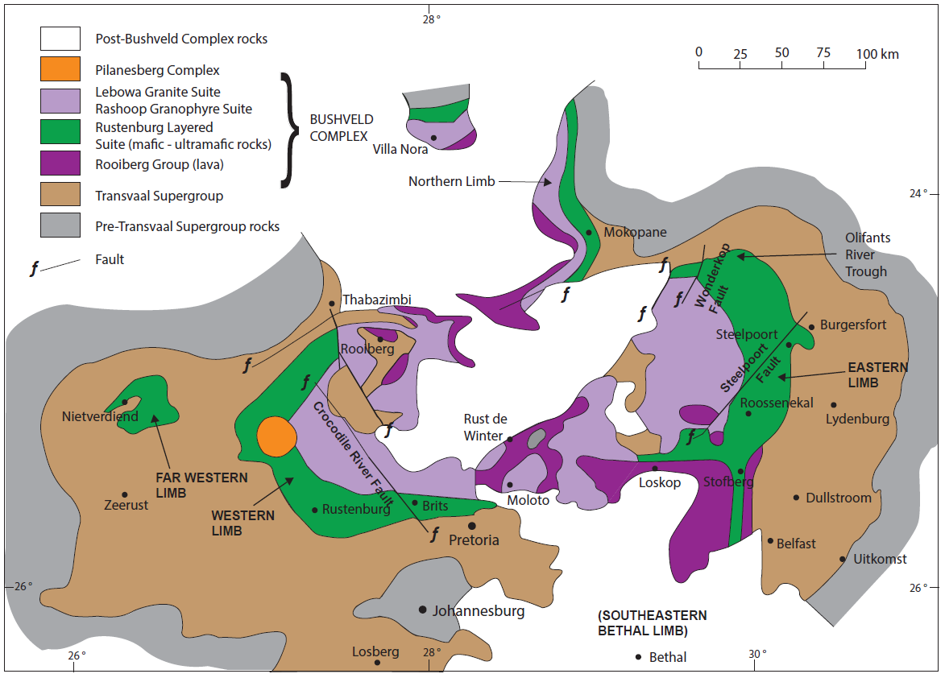
Figure 1: Simplified geological map of the Bushveld Complex and the surrounding Transvaal Supergroup (after Cawthorn. 2015).
The Rustenburg Layered Suite stratigraphy is divided into five major units, which are summarised in Table 5, with the stratigraphy illustrated in Figure 2.
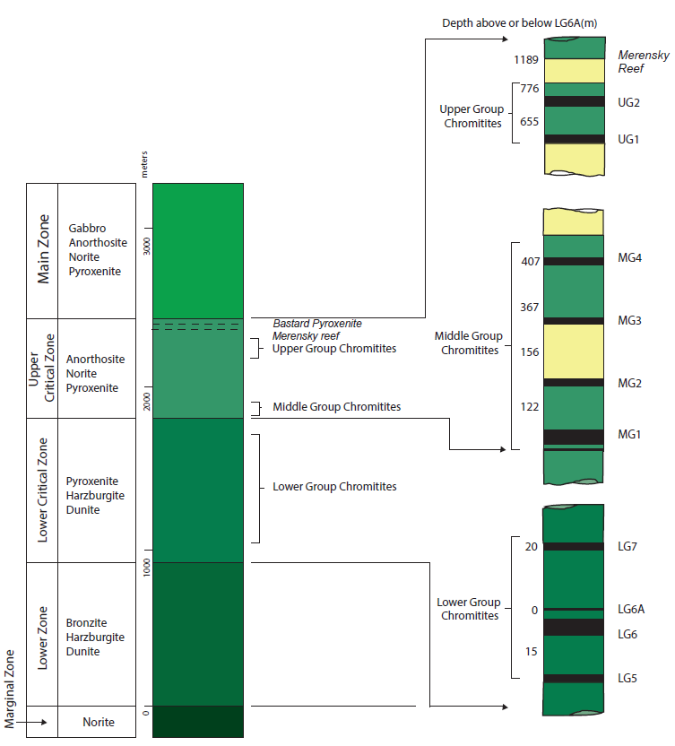
Figure 2: Stratigraphy of the Lower Portion of the Rustenburg Layered Suite (after Schürmann et al., 1998).

Table 5: Summary of the Rustenburg Layered Suite Stratigraphy (Cameron, 1980, 1982; Eales and Cawthorn, 1996; Von Gruenewaldt,1973; Njowa and Clay, 2010)
LAYER/UNIT/ZONE | DESCRIPTION
Upper Zone | The Upper Zone is dominated by gabbros. However, banded anorthosite and vanadiferous magnetite sequences are also present. There is no chilled contact with the hangingwall rocks, which consist of rhyolites and granophyres.
Main Zone | The Main Zone is the thickest unit within the Rustenburg Layered Suite. In general, approximately half the Rustenburg Layered Suite stratigraphic interval is occupied by this zone. The Main Zone consists of gabbro-norites with some anorthosite and pyroxenite layering. Banding or layering is not as well developed as in the Critical and Lower Zones.
Critical Zone | The Critical Zone is subdivided into Lower and Upper units, namely the Lower Critical Zone and the Upper Critical Zone. The Lower Critical Zone is dominated by pyroxenitic cumulates with interlayered harzburgites and chromitite seams. The Upper Critical Zone consists of layered pyroxenites, norites, anorthosites and chromitites. The base of the Upper Critical Zone is marked by the appearance of cumulus plagioclase. Layering occurs on a variety of scales and may also be regular to highly irregular.  Chromitite seams occur in three distinct groupings. The LG series of seams occurs exclusively in the Lower Critical Zone, the MG series of seams straddles the contact between the Lower and Upper Critical Zones, whereas the UG group of seams occurs within the Upper Critical Zone. Economic PGE mineralisation is hosted in the UG2 Chromitite Seam (UG2) and the Merensky Reef, a laterally continuous pyroxenite unit containing PGE and base metal sulphide mineralisation.
Lower Zone | The Lower Zone is dominated by ultramafic rocks. The most complete exposure is in the northeastern part of the Eastern Limb. Here the Lower Zone occurs as a series of cyclically layered dunite-harzburgite units. The Lower Zone varies in thickness, having a trough-like geometry with the thinnest succession developed over structural highs on the basin floor.
Marginal Zone | The Marginal Zone consists of a heterogeneous succession of generally massive noritic rocks. These rocks contain quartz and hornblende believed to be a result of contamination of the mafic magmas by the enclosing host rocks. Sedimentary rock fragments are contained as xenoliths within the lower parts of this zone. The Marginal Zone ranges in thickness from several meters to several hundred meters. Exposures of this zone are poor.

The Complex hosts world-class major deposits of PGE’s, chrome, vanadium and nickel (e.g. Cawthorn, 1999a, 1999b) in the Rustenburg Layered Suite. The largest deposits of chromite in the world occur in the Critical Zone of the Eastern and Western limbs of the Bushveld Complex (Cawthorn, 2015). The PGE’s are concentrated in three principal reefs in the Rustenburg Layered Suite. In the Eastern and Western limbs, the Merensky Reef is located just below the top of the Critical Zone, and the UG2 Chromitite is located between 15 m and 350 m below the Merensky Reef (Cawthorn and Spies, 2003). In the Northern Limb the PGE’s are concentrated in the Platreef between the base of the Main Zone and the floor rocks (Cawthorn, 2015).

Local Geology
The Phosiri Dome (also known as the Zaaikloof Dome or Fortdraai Dome) is one of a number of domes consisting of high grade metasedimentary rocks that occur in the Eastern Bushveld Complex (Uken and Watkeys, 1997; Gerya et al., 2003; Johnson et al., 2004; Clarke et al., 2005; Ireland and Penniston-Dorland, 2015) (Figure 3).
The Dome represents a plunging anticline of the Upper Pretoria Group metasediments of the early-Proterozoic Transvaal Supergroup (Sharpe and Chadwick, 1982) that is thought to have formed when underlying footwall rocks rose into the denser overlying Rustenburg Layered Suite magmas (Uken and Watkeys, 1997; Uken, 1998; Gerya et al., 2003). Button (1976) described the uppermost formations of the Pretoria Group in the area. The oldest unit, the Silverton Formation, consists of the Boven Shale Member, the Machadodorp Volcanic Member and the Lydenburg Shale Member. The overlying Magaliesberg Formation consists primarily of arenites and argillites. The younger Vermont Formation consists of cordierite-fibrolite-biotite schists with minor quartzites and carbonates, and the Lakenvalei Formation consists of a micaceous quartzite (Uken, 1998).
The Main and Upper Zone in the area are described by Von Gruenewaldt (1973) and Molyneux (1974). Molyneux (1998) re-examined the area with the objective of unravelling the structure in the vicinity of the Wonderkop Fault and the Olifants River (Figure 2), the results of which are discussed below.
The sedimentary rocks vary in orientation. On the southern limb of the Phosiri Dome, bedding in the Transvaal Supergroup rocks dip steeply southward, whilst on the eastern limb, the dip changes from moderately steeply eastward dips through vertical, to overturned in the northern portion, where the strata dip between 60° and 85° towards the west.

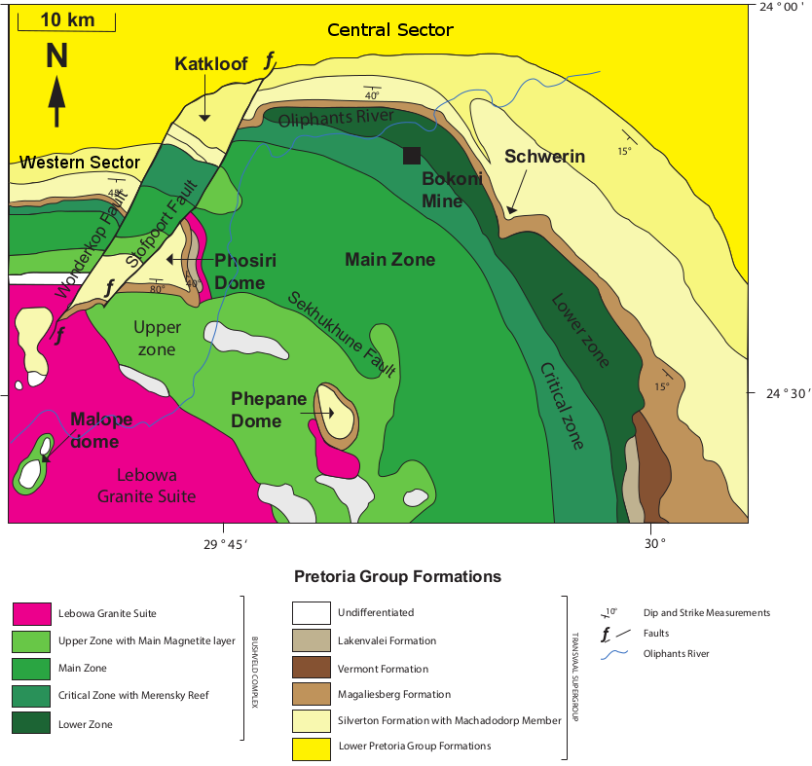
Figure 3: Simplified geological map of the northeastern portion of the Eastern Limb of the Bushveld Complex showing the Phosiri, Phepane, Malope and Katkloof Domes, and the Schwerin Fold (after Johnson et al., 2004).
The emplacement of the Rustenburg Layered Suite magmas triggered a diapiric response as a result of non-linear heat flow into pre-existing basement highs (Gerya et al., 2003) and the density contrast between the less dense metasedimentary floor rocks and the denser mafic-ultramafic magmas.
The upward displacement of the floor rocks is believed to have occurred at approximately the same time as the intrusion of the mafic – ultramafic magmas (Uken and Watkeys, 1997; Gerya et al., 2003; Johnson et al., 2004; Longridge et al., 2009; Ireland and Penniston-Dorland, 2015) and resulted in successive on-lapping of units of the Rustenburg Layered Suite over the up-doming structure. Updoming to a lesser degree of the magmatic layering of the Rustenburg Layered Suite in the vicinity of the Phosiri Dome indicates that the layering has been influenced by the movement of the floor rocks, suggesting that doming occurred post-crystallisation of the Rustenburg Layered Suite.
The uplift of the Rustenburg Layered Suite has important implications as economic horizons, namely the Merensky Reef and UG2 Chromitite, which would normally be at several kilometers depth at this location, are brought closer to the surface. This is most evident on the southern flank of the Phosiri dome where Critical Zone rocks outcrop on surface approximately 18 km downdip of their surface exposure to the northeast at Bokoni Mine (Figure 3).
The southern flank of the dome appears to be somewhat more structurally disrupted than the eastern flank and data from trenching and diamond exploration drilling shows the Upper Zone dips between 5° and 25° to the south, whilst the Main and Critical Zones dip away from the dome at angles between 60° and 70° (Martin, 1999; Scoon 2002; King et al., 2011).
The Dome is bounded in the west by the Stofpoort and Wonderkop Faults, (Figure 3) which cumulatively displace the fold hinge of the Dome by approximately 2 km (Uken, 1998). Molyneux and Klinkert (1978) suggest that the Wonderkop fault is down-thrown to the southeast and Uken (1998) suggests that this is a left-lateral (sinistral) fault as a result of north-south directed compression. Du Plessis and Walraven (1990) interpret the area between the Wonderkop and Stofpoort faults as a graben structure. The Wonderkop Fault extends south into the Bushveld Granite and passes just west of the Malope Dome (Sharpe and Chadwick, 1982).
The hinge of the anticline plunges towards the southeast at approximately 28°. Schwellnus et al. (1962) mapped the occurrence of chromitite on the southern flank of the dome, indicating the presence of Critical Zone lithologies. It is postulated that the separated body of Transvaal Supergroup from the metasedimentary floor rocks at the nose of the Phosiri anticline is thought to represent a xenolith, or floating slab not connected to the floor, although this has yet to be verified by drilling or seismic data.

Exploration History and Rationale
The project area lies at the junction of two distinct structural provinces of the eastern Bushveld; one being the gently dipping Central Sector of the Eastern Limb of the Bushveld Complex and the other the steeply-dipping Western Sector of the Eastern Limb (Hatton and von Gruenewaldt 1987; Lea, 1995) (Figure 3). The Lonmin-operated Limpopo Division (previously Messina Platinum Mine) is situated in the latter sector, where dips of up to 70° south are reported (Lea, 1996).
Sporadic drilling took place to the east of the Phosiri Dome from 1982 to 2013 with possibly the most important result being the intersection of Merensky Reef and UG2 in the borehole BH 2698 on the farm Eerste Regt 502 KS drilled by General Mining in 1987 (Table 6, Figure 4 and Figure 15). This borehole successfully demonstrated the presence of the Merensky Reef and UG2 Chromitite at considerably shallower depths than would be expected if one simply extrapolated the reef horizons at constant dip from their surface outcrop positions in the northeast.

Table 6: Summary of various exploration trenching and drilling campaigns in the vicinity of the Phosiri Dome.
YEAR | COMPANY | FARMS | Results Summary
Pre - 1982 | Anglovaal | Eerste Regt 502KS | Borehole DIG1 collared in Main Zone drilled vertically approximately 600 m and stopped 700 m short of the Critical Zone
1986 - 1996 | Genmin | Davidspoort 499KS, Eerste Regt 502KS Fortdraai 517KS, Zwarthoek 501KS, Spelonk 478KS | 10 boreholes drilled adjacent to the eastern and southern flanks of the dome. BH 3395 and BH 3230 were drilled at -50° towards the eastern flank of the dome. They were collared in quartz-bearing norites and granites and intersected highly sheared and disrupted Critical Zone lithologies. BH 2698 was a vertical hole collared in Main Zone rocks. This drill hole intersected Merensky Reef and the UG2 Chromitite layer at 2,166.80 m and 2,490.00 m, respectively. Merensky Reef assays for 3PGE+Au ranged from between 3.04 g/t to 5.22 g/t over widths of between 149 cm and 382 cm. The UG2 assays returned 7.60 g/t to 8.83 g/t over 63 cm and 80 cm.
1989 - 1994 | Trodex | Dwarsrand 500KS, Davidspoort 499KS, Zwarthoek 501KS, Fortdraai 517KS | Several boreholes on the southern flank of the dome, successfully intersecting Merensky Reef.
1995 - 1997 | BHP - Trodex | Dwarsrand 500KS | Two boreholes collared in Main Zone, both stopped above the Pyroxenite Marker.
2000 - 2002 | Pan Palladium - MinEx | Dwarsrand 500KS | A single borehole collared in Upper Zone lithologies on the southern flank of the Dome, which terminated at a depth of 1,614 m below the Main Mottled Anorthosite in the Main Zone.
2006 - 2012 | South African Mineral Development Company (Pty) Ltd | Davidspoort 499KS, Dwarsrand 500KS, Mooiplaats 516KS, Zwarthoek 501KS, | No apparent drilling.
2006 - 2013 | Lesego Platinum Mining (Pty) Ltd | Dal Josephat 451KS, Eerste Regt 502 KS, Government Ground 503KS, Koppieskraal 475KS, Olifantspoort 479KS, Spelonk 478KS | Fifty-six boreholes drilled, all on the eastern flank of the dome, most of which intersected the Merensky Reef and UG2, resulting in a Measured, Indicated and Inferred Resource.

On the basis of these intersections and the presence of Main and Critical Zone lithologies in close proximity to the eastern flank of the Phosiri Dome, it was demonstrated that the doming of the metasediments which form the Phosiri Dome had had an impact on Critical Zone lithologies. It was therefore postulated that the potential existed for the Merensky Reef and UG2 chromitite to occur at depths above what was currently being economically mined in South African underground platinum mines.

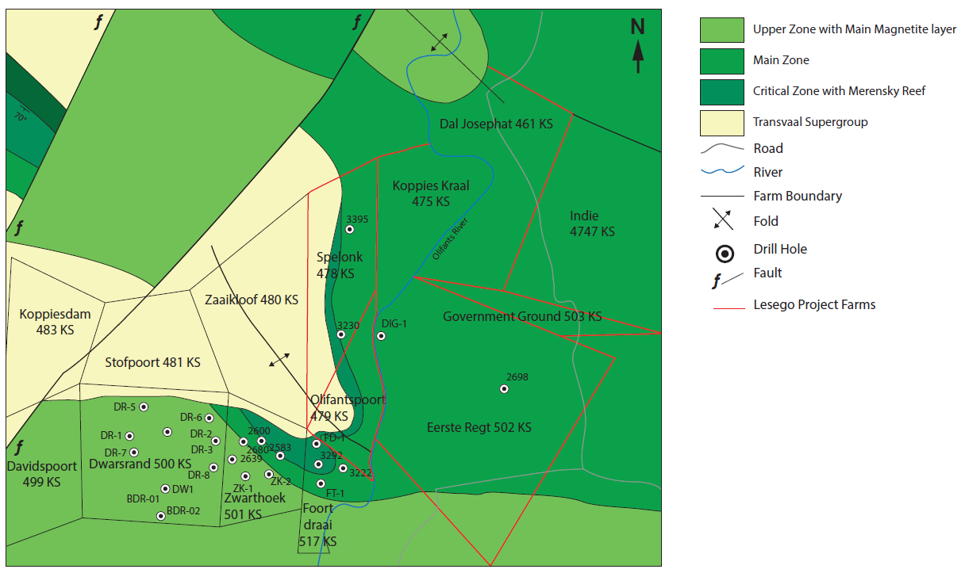
Figure 4: Historical Exploration and Drilling on the flanks of the Phosiri Dome

Exploration Methodology and Exploration Results
A re-evaluation of the past exploration results from the 1980’s and 1990’s in 2004 by Lesego Platinum Mining (Pty) Ltd resulted in the decision to undertake further exploration in the area in a phased program, consisting of historical data compilation, geological mapping and trenching, soil geochemistry, a 2D seismic reflection survey, a gravity survey, airborne magnetics and diamond exploration drilling, the results of which are summarised below.

Geophysics
Seismics. In September and October 2006, a 2D Low Velocity Layer (LVL) seismic refraction and reflection and ground gravity surveys were carried out by GAP Geophysics (Pty) Limited over the Lesego lease area. The seismic reflection survey was intended to map the distribution and elevations of geological marker horizons within Main and Critical Zone lithologies underlying the lease area and in particular, the thick pyroxenite unit hosting the UG2 Chromitite.
Seismic surveys were shot along five traverses, lines 1 to 5 (Figure 5). Stack and migrated sections from these surveys formed the data input for interpretation. Interpreted seismic profiles are illustrated in Figures 6 and 7.

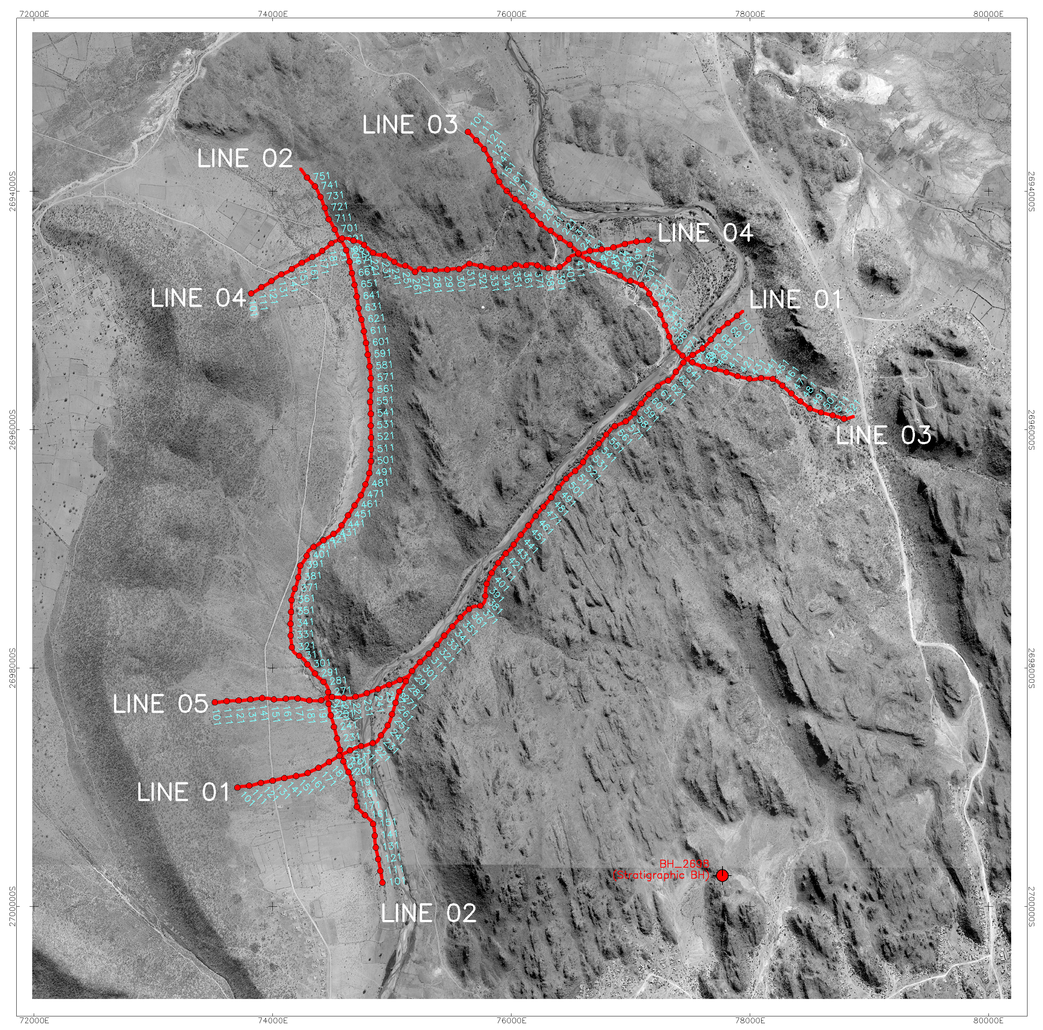
Figure 5: Topographical image from aerial photos showing the seismic traverses and shotpoints (Campbell, 2010).
The survey was successful in mapping 13 seismic marker horizons over the project area from the Upper Main Zone to floor elevations to a maximum floor depth of 3,500 m in the northeast. Markers h_0 to h_10 from Lines 3 and 4 are shown on Figure 6 and Markers h_0 to h_11, as well as the floor rock contact, from Line 1 are shown on Figure 7. The survey showed that Rustenburg Layered Suite horizons comprise an 1,800 m thick, conformable package having an ~NNW strike and ~ENE dip, the latter increasing from ~8°E in the east to ~15°E in the west close to the outcrop location of the floor of the Phosiri Dome. The underlying contact with the Transvaal Supergroup metasediments is discordant in the west with dips of up to 25°E (Figure 7).
Isopach maps created from the survey showed that there is no evidence of large scale faulting or folding over the area surveyed, and sparse, interpreted faults generally have throws less than 20 m (Figure 8). Although these interpreted faults are plotted perpendicular to the seismic lines, they may be orientated obliquely to the lines and may be doming related.
It is apparent that all reflectors are remarkably continuous across the bulk of the project area although they terminate 750 m east of the published location of the floor contact with the eastern flank of the Phosiri Dome (Figure 8). Subsequent drilling revealed that the reason for this loss of response may be explained by a steepening of key units close to the Phosiri Dome or, in the vicinity of line 2, the presence of vertical sheeted contaminated gabbroic material or the absence of Rustenburg Layered Suite lithologies. Marker horizons h_5 to h_8 (red and dark blue lines, respectively, on Figure 6 have an average separation of 370 m and are interpreted as reflecting the base of the Giant Mottled Anorthosite (which is close to the Bastard/Merensky Reefs) and the UG2 Chromitite interval at the top of the Critical Zone, respectively.
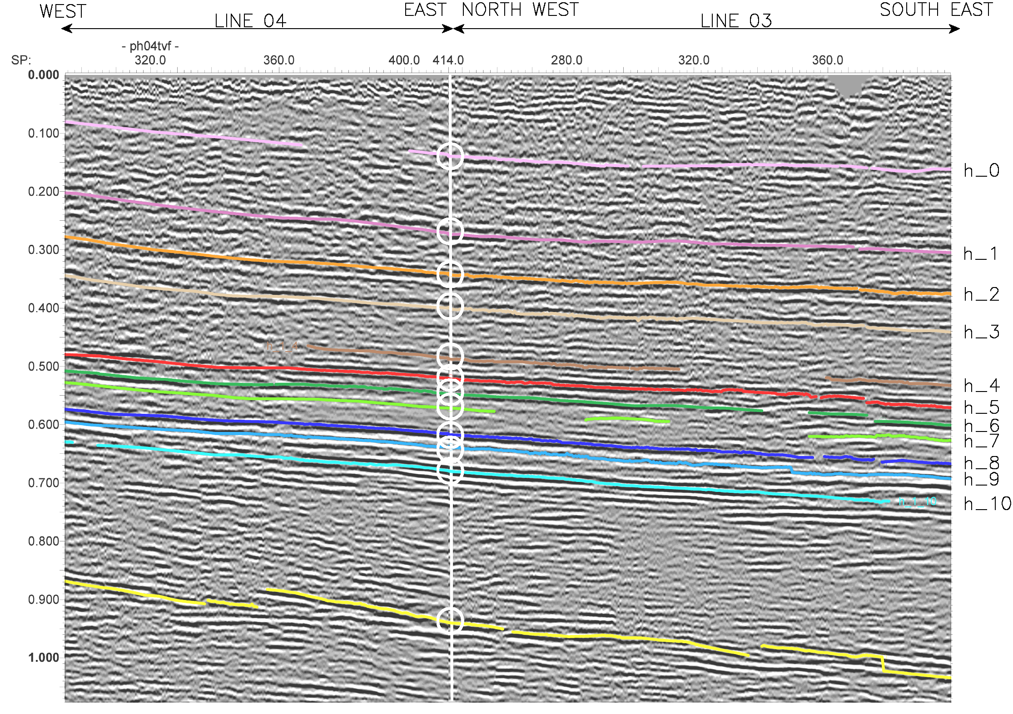
Figure 6: Line 3 and Line 4 fence diagram showing continuity of reflectors and marker horizons H_5 through to H_8 representing the Giant Mottled Anorthosite in red through to the UG2 in blue, with the yellow line representing the floor contact of the Rustenburg Layered Suite with Transvaal Supergroup metasediments (Campbell, 2010).
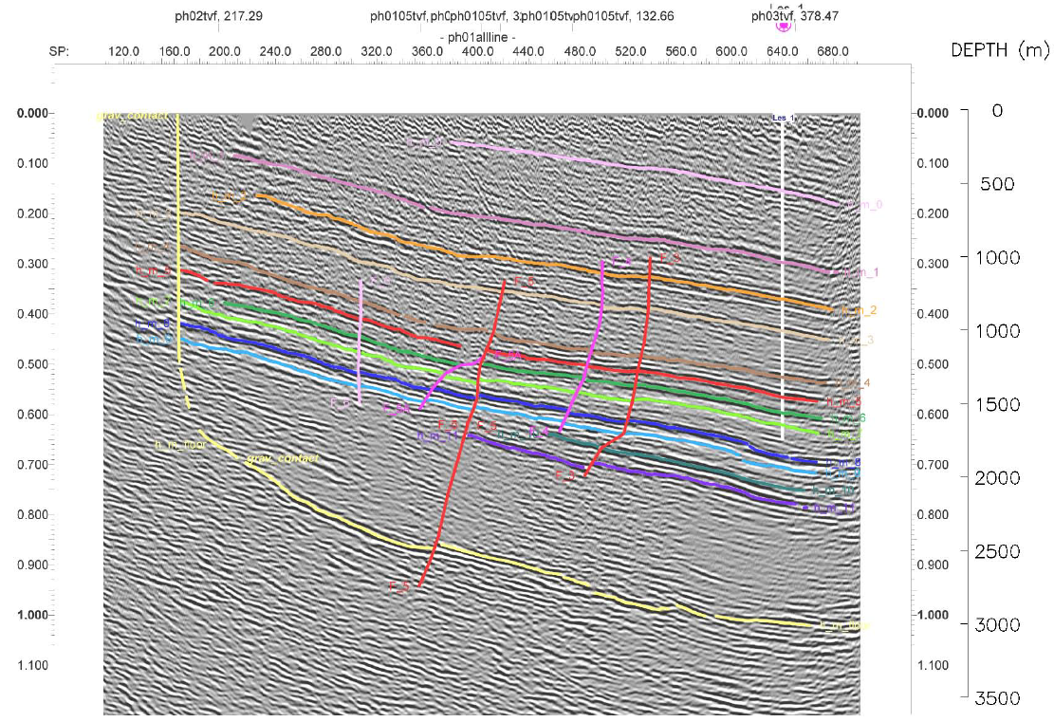
Figure 7: Line 1 migrated section with interpretation overlay showing continuity of reflectors and marker horizons H_0 through to H_11 with the yellow line representing the floor contact of the Rustenburg Layered Suite with Transvaal Supergroup metasediments and the location of drill hole LES001 in white (Campbell, 2010).
Gravity. Gravity survey work was initiated in an attempt to map the outcrop location of the metasediment – Rustenburg Layered Suite contact on the eastern limb of the Phosiri Dome, given that Main Zone gabbros (ρ = 2.85 to 2.9 gm/cc) are significantly denser than the quartzites of the metasediments (ρ = 2.7 gm/cc). Work elsewhere has shown the technique is not particularly sensitive in “normal” Bushveld environments, where contacts typically dip less than <20° and the presence of denser metapelites and sills in the Pretoria Group are not as distinctive from the Rustenburg Layered Suite as that of quartzite. The presence in this locality of a steeply dipping contact rendered the gravity approach viable. Although the area covered by of all seismic traverses were surveyed, attention focused on “contact-type” anomalies over the westernmost ~ 2 km of each traverse.
The published outcrop location of the contact with the Pretoria Group metasediments (Molyneux, 1998; Uken, 1998) shows little correlation with the gravity data (Figure 9). The black arrows in Figure 9 maps the probable western extent of Rustenburg Layered Suite rocks based on the interpretation of gravity profile data at the western ends of traverses 01, 05 and 04, showing a shift of approximately 100 m east of the published floor contact (Campbell, 2010).
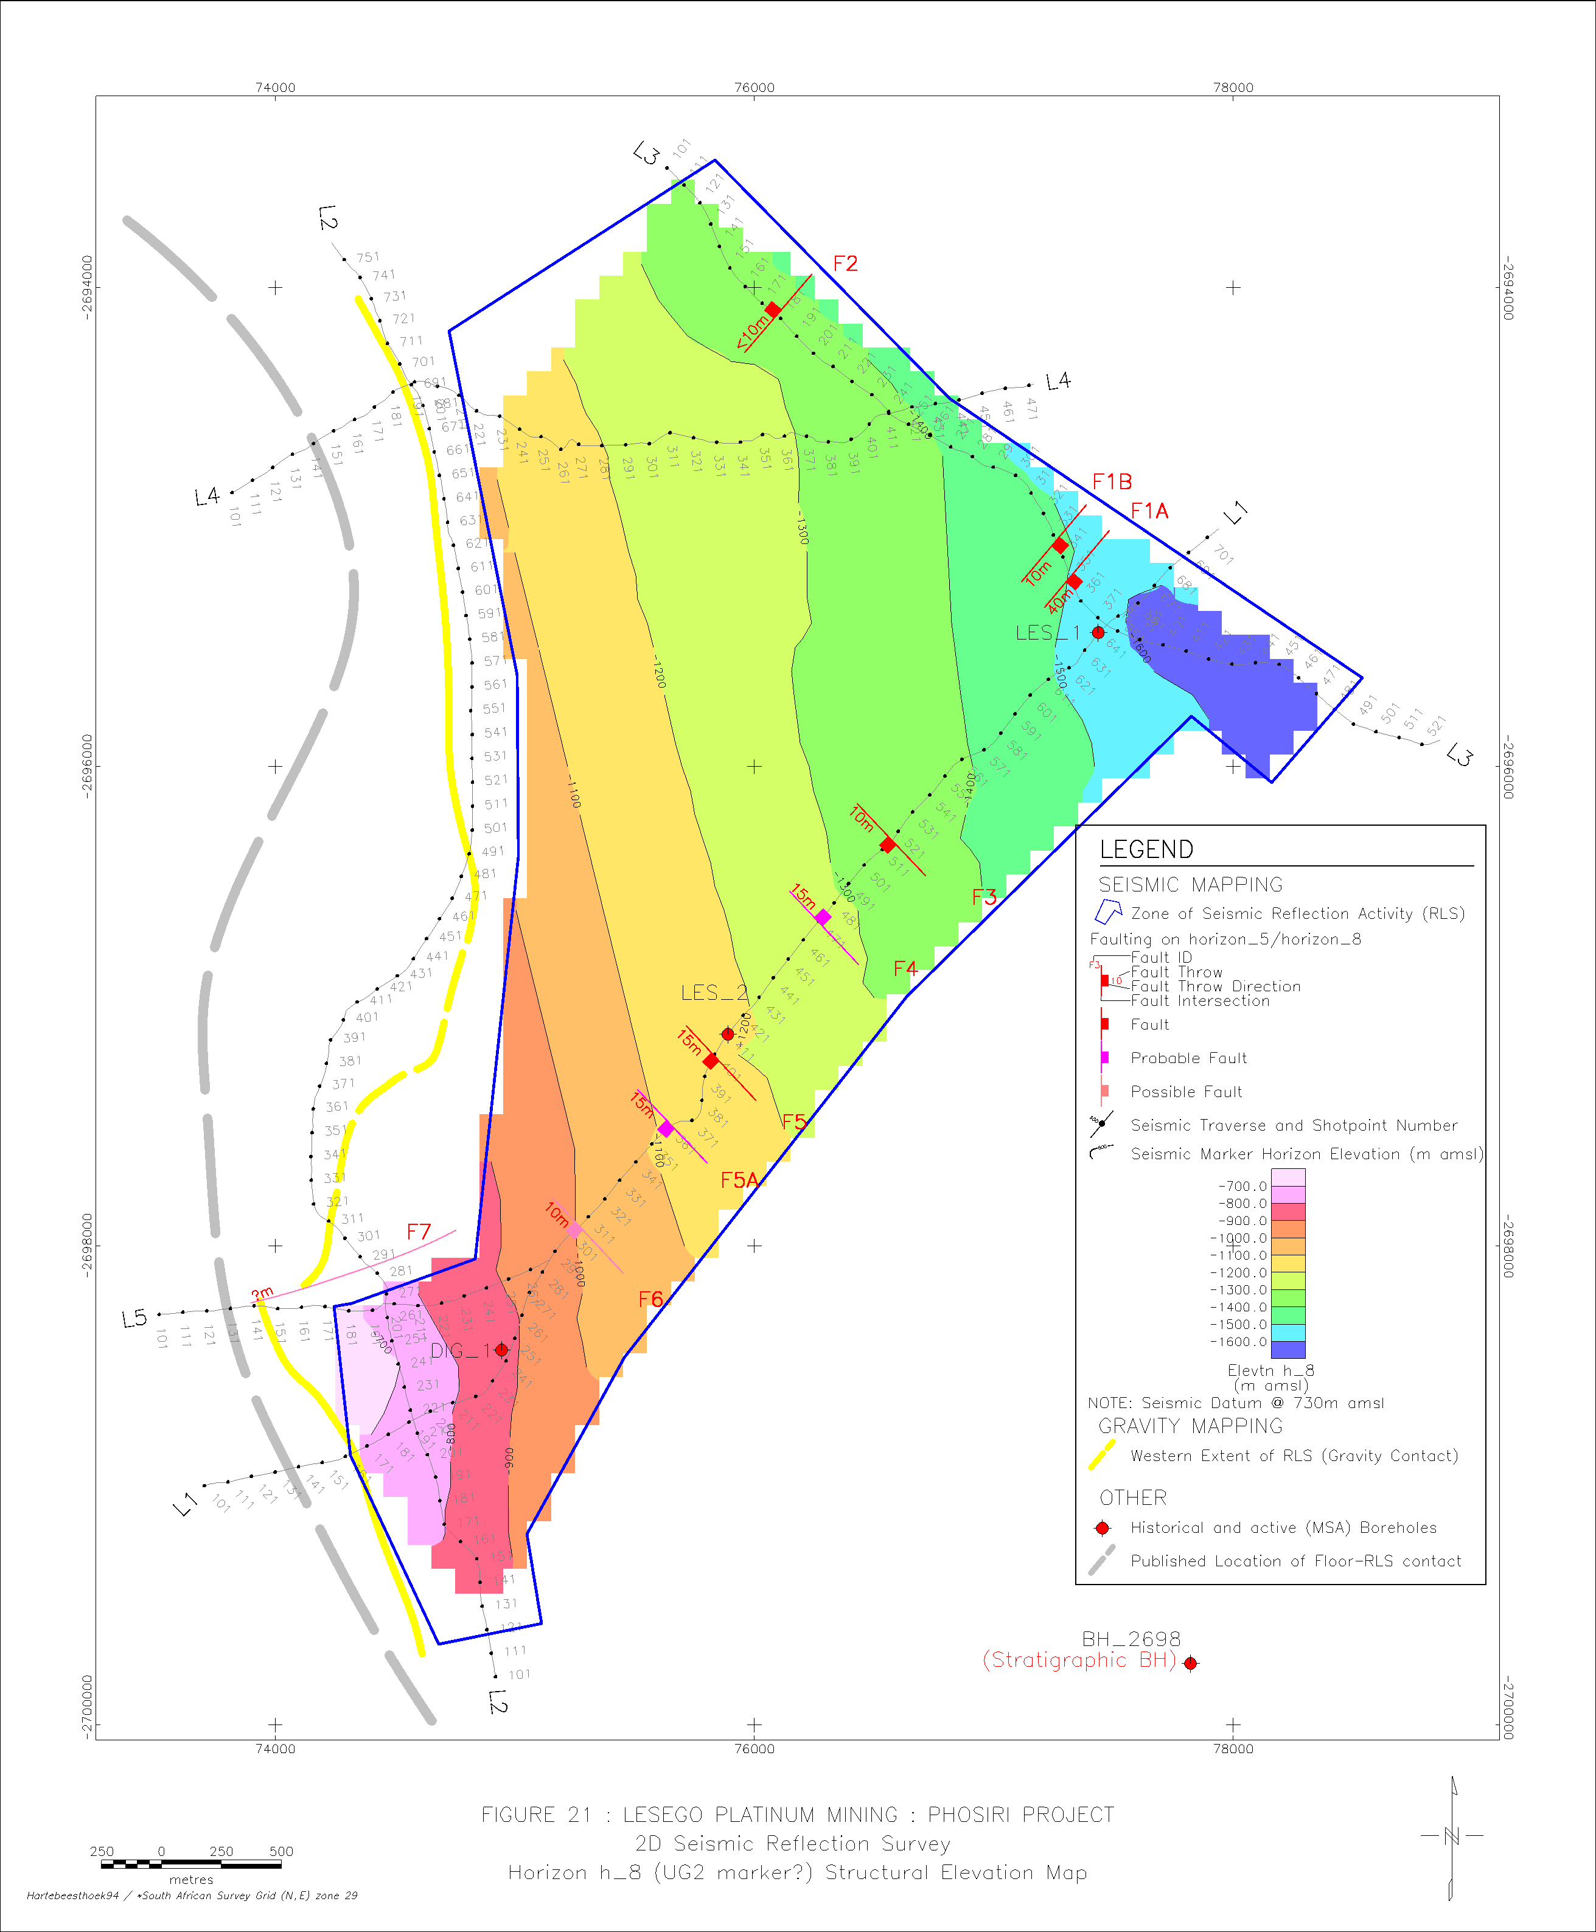
Figure 8: Isopach map of the UG2 Chromitite modeled from the results of the seismic survey showing its continuity and the relative paucity of structural disturbances. The western extent of the Rustenburg Layered Suite as derived from the Lesego gravity survey is indicated with the dashed yellow line, whilst the published location of the Transvaal Supergroup – Rustenburg Layered Suite contact is shown by the grey dashed line (Campbell, 2010).

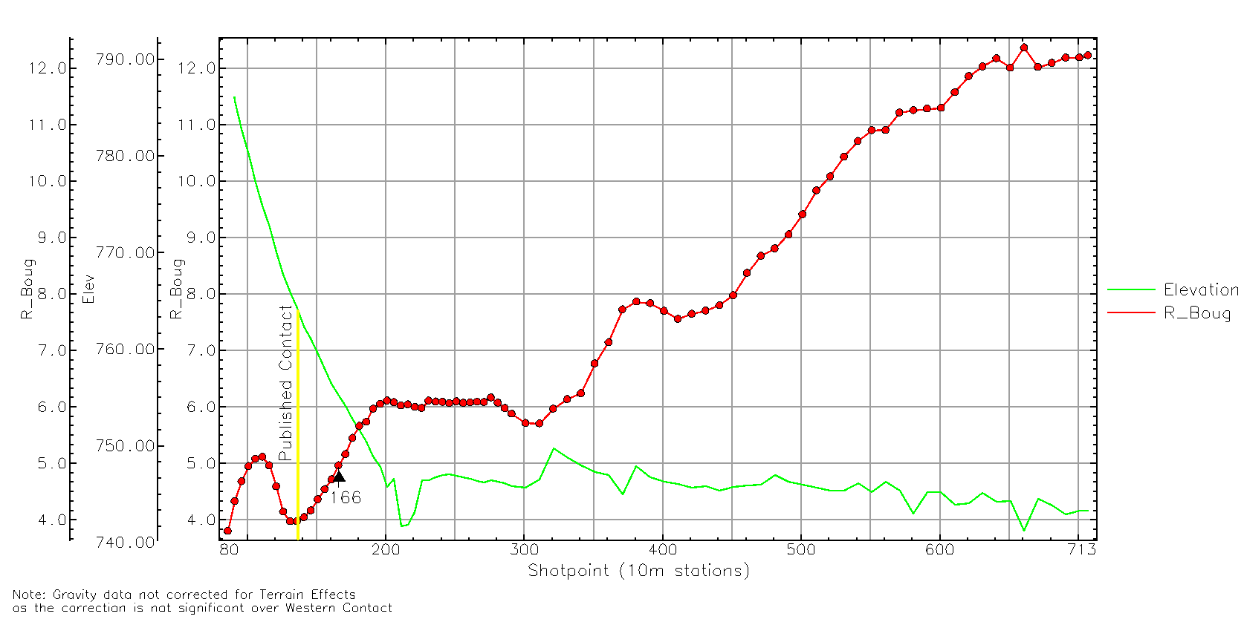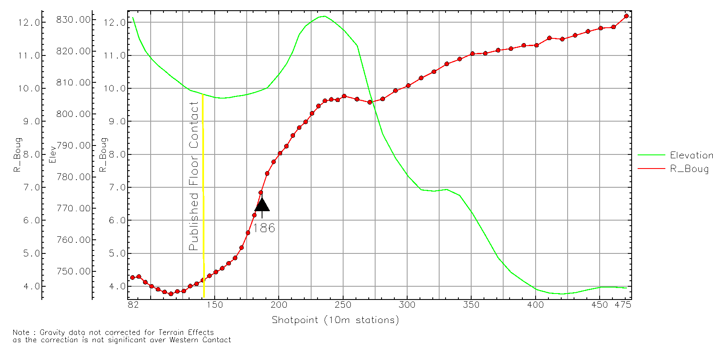
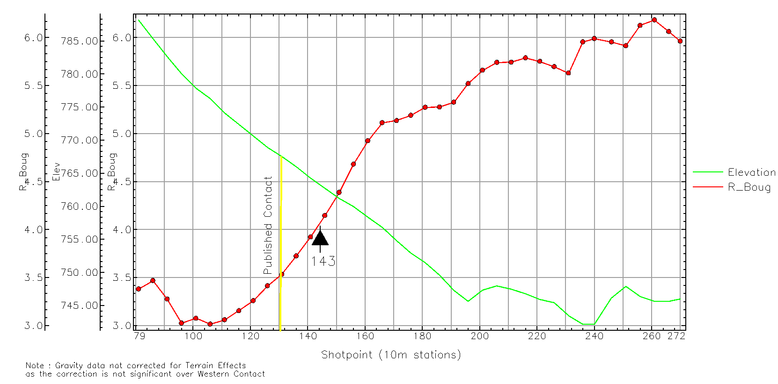

Figure 9: Bouguer Gravity and surface elevation profiles along seismic lines 01 (top), 04 (middle) and 05 (bottom), illustrating the published floor rock contact and the suggested floor rock contact (black arrow) based on increased density of the Rustenburg Layered Suite lithologies (Campbell, 2010).

Aeromagnetics. High-resolution aeromagnetic, DTM and radiometric surveys over the project area mapped the outcrop distribution of Transvaal Supergroup footwall metasedimentary rocks plus Bushveld Complex Main and Upper Zone lithologies. The area flown is shown in Figure 10. The geophysical mapping results largely conformed to published regional geology except over the south of the area, where the location of the Upper Zone contact was refined and mapped approximately 400 m further south than mapped by Schwellnus et al., 1962).
Figure 10 highlights the discordance of the Rustenburg Layered Suite with the southern and eastern flanks of the Phosiri Dome. Critical, Main and Upper Zone lithologies are all present and outcrop within 1,500 m of the southern flank of the Dome, whilst only Main Zone lithologies are apparent proximal to the east flank of the Dome.
The presence of younger cross-cutting dykes appears restricted to 3 sets of NNE striking sets and two sets of NW striking dykes, which, with one exception, outcrop to the north or east of the lease area (Figure 10).
Apart from the Stofpoort and Wonderkop Faults to the west of the Phosiri Dome and the NW trending fault in the north of the area, there are no obvious faults with large displacements that were detected within the lease area from the airborne data.
Twenty-one possible small iron-rich ultramafic pegmatite (IRUP) bodies occur as pipe, vein or sheet like bodies, ranging from a few meters to several tens of meters. According to Viljoen and Scoon, 1985, these formed post-cumulate crystallisation. Magnetite plugs also outcrop over the lease area. Their maximum diameter ranges only up to 130 m and they are recognizable as discrete positive magnetic anomalies on the airborne geophysics (Figure 10).
In general, geophysical findings indicate a relative paucity of “loss-of-ground” features, although strike faulting is not readily mapped with this technique and cannot be ruled out.
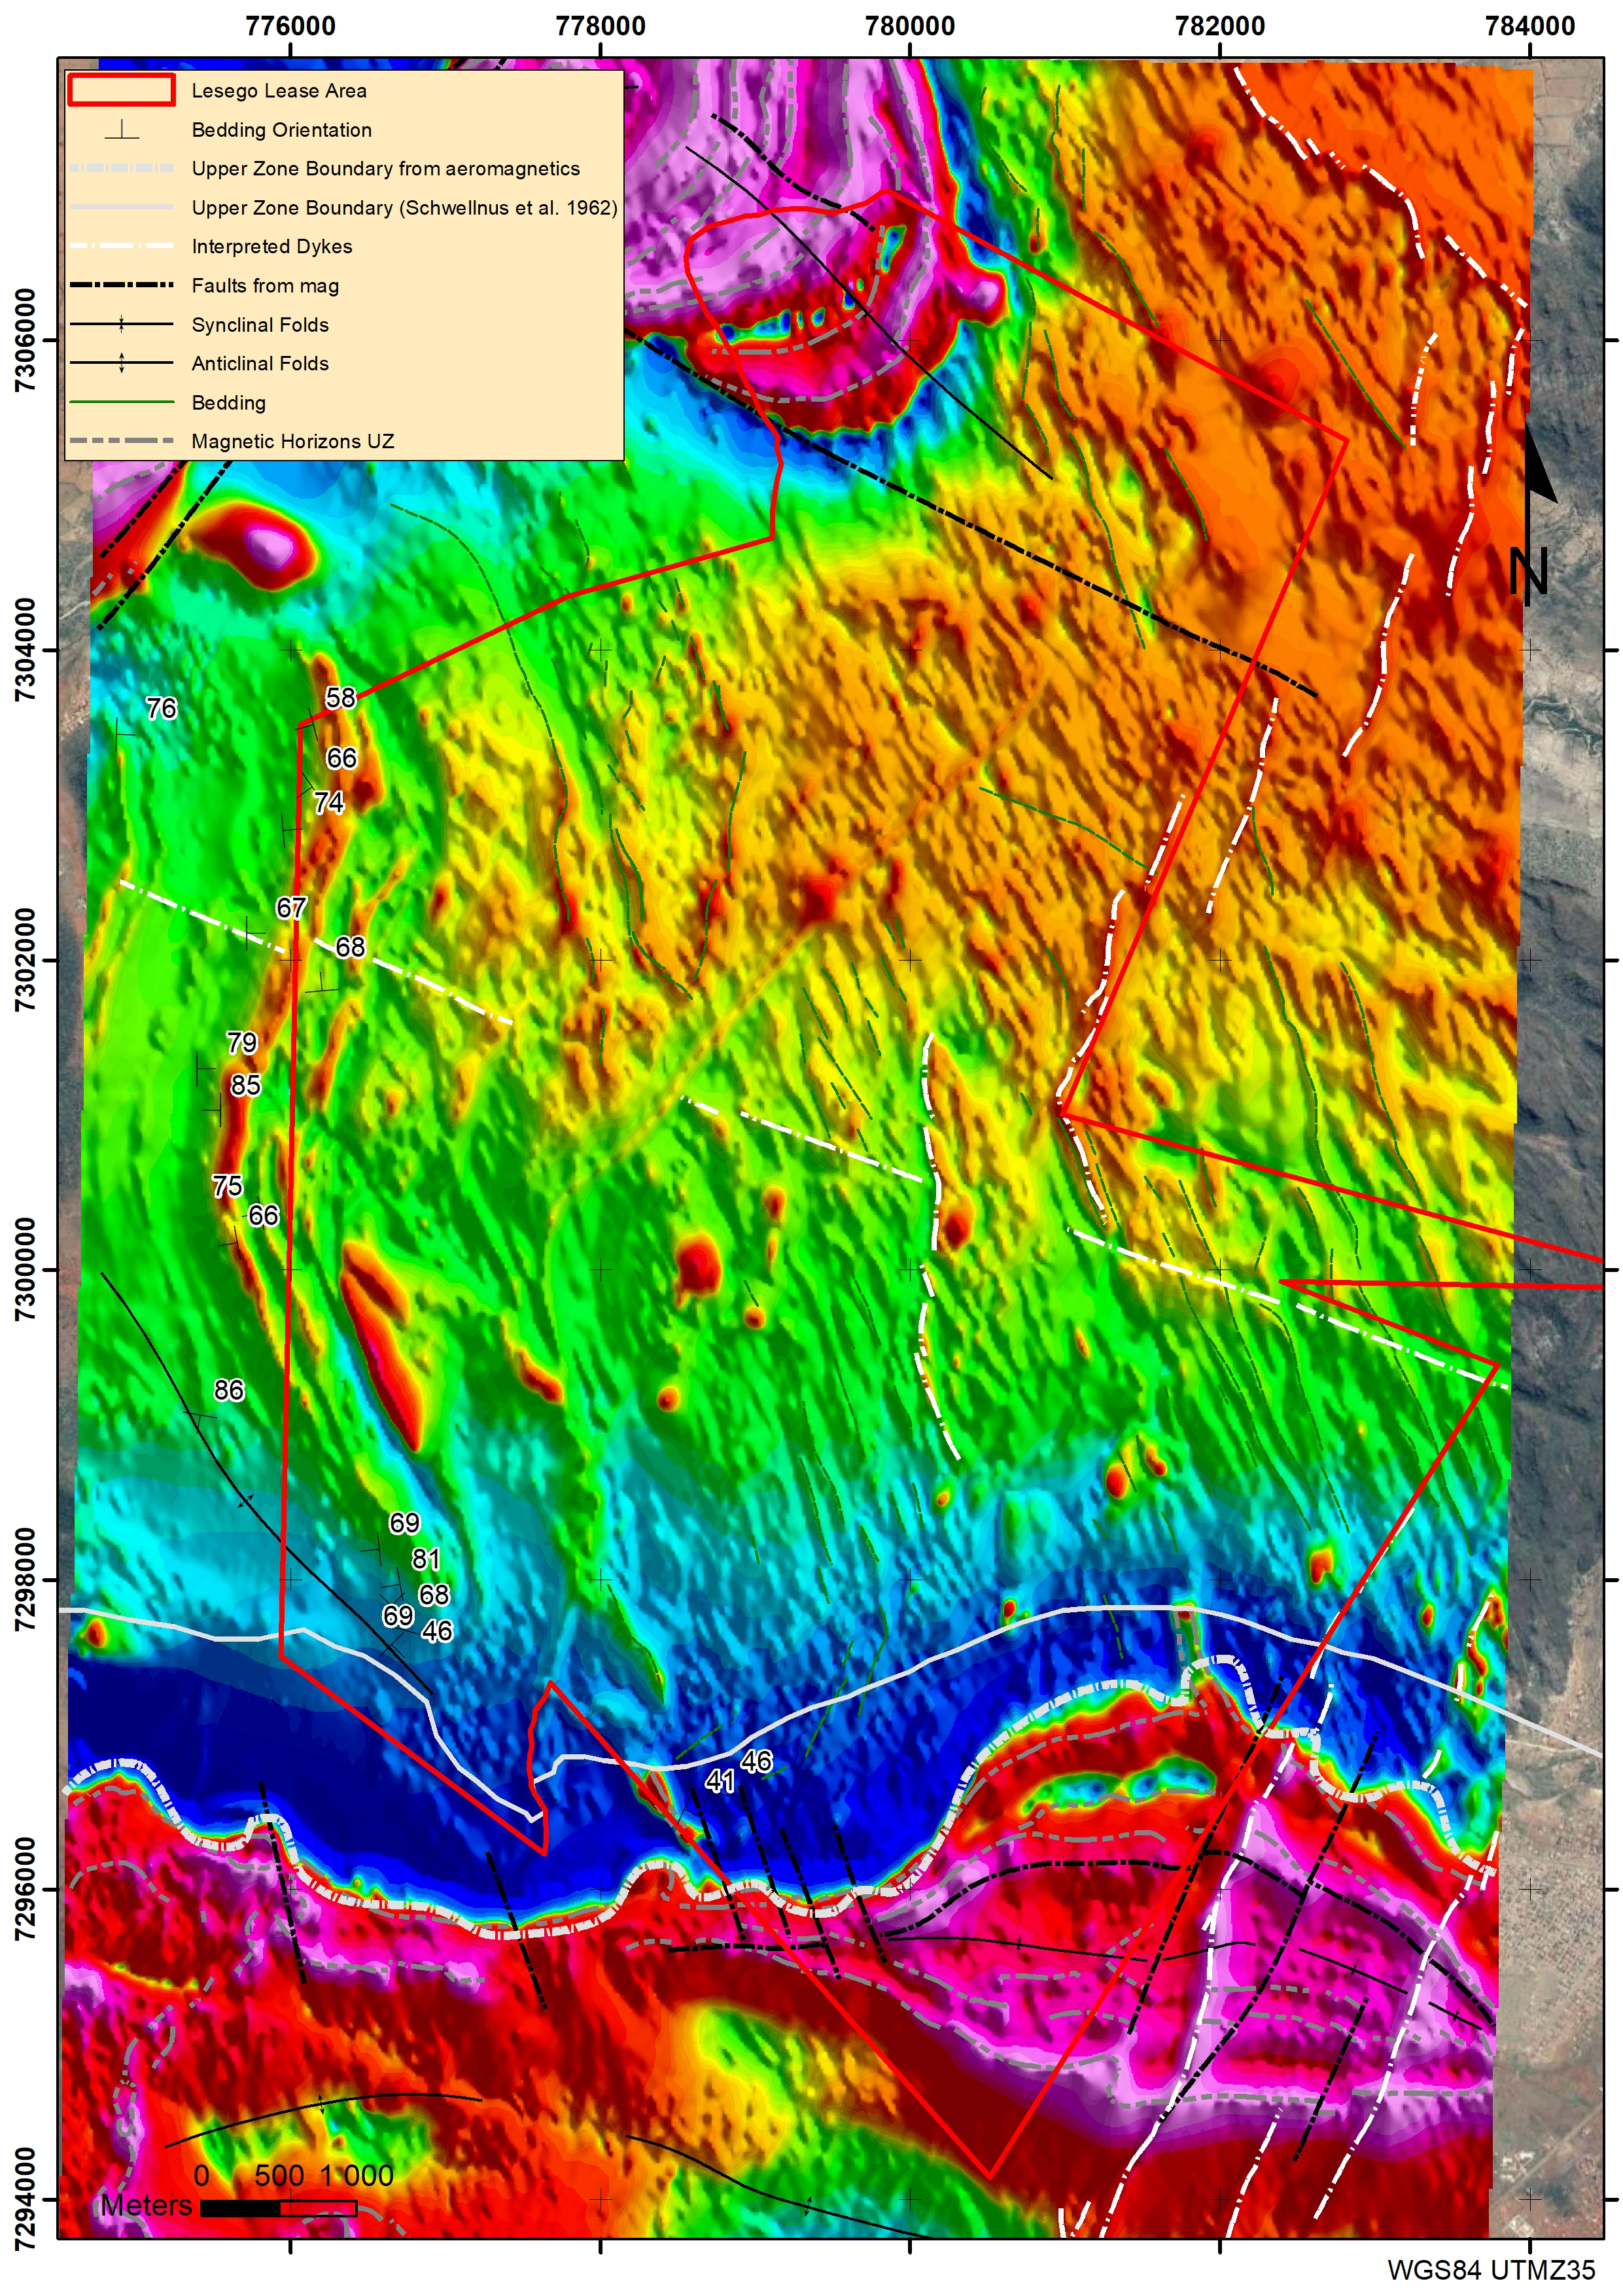
Stofpoort Fault
Figure 10: Total field magnetics image from the aeromagnetic survey flown over the project area showing interpreted faults (in black) and dykes (in white) (after Campbell, 2010). Red and purple indicates areas of relatively high magnetic intensity, highlighting IRUPS, dykes, Upper Zone lithologies and the Vermont Formation of the Pretoria Group, whilst green areas indicate areas of relatively low magnetic intensity of Main, Critical Zone and Transvaal Metasedimentary rocks. Note the shift of the Main Zone – Upper Zone boundary to the south based on the magnetic signature of the Upper Zone lithologies (after Schwellnus et al., 1962 and Campbell, 2010).

Soil Geochemistry
In August 2007 a soil sampling survey was carried out along 13 traverses perpendicular to the western slope of the eastern flank of the Phosiri Dome (Figure 11). A total of 430 individual samples were collected at station intervals of 50 m, covering an area 6.5 km long and approximately 1.5 km wide. The survey was designed to geochemically assess the potential presence of sub-outcropping Upper Critical Zone rocks, including the UG2 Chromitite and the Merensky Reef. The survey area is covered by sandy soils in the relatively flat-lying eastern part and by rock scree along the slopes of the ridge along the western boundary that is underlain by Pretoria Group metasediments. Samples were dried and screened to -0.18 mm prior to an aqua regia digestion and multi-element analysis using an ICP-MS finish.
The gridded and contoured chromium (Cr) values in soil for the 430 samples are shown in Figure 11. The observed overall decrease in Cr content to values below 50 ppm Cr towards the outcropping Main Zone rocks in the east is consistent with published whole-rock data for the upper Critical Zone – Main Zone transition (Sharpe, 1985).
The relatively high Cr concentrations (maximum of 405 ppm Cr along line 8) of the eastern flank of the Phosiri Dome are interpreted to indicate the presence of Critical Zone rocks. The linear anomaly of Cr values above 150 ppm Cr (stippled line in Figure 11) between sampling lines 1 and 11 is noteworthy and best explained by one or more sub-outcropping chromitite layers. Maximum Cr concentrations ranging between 400 ppm and 760 ppm Cr are observed in the immediate vicinity of known outcropping chromitite layers on sampling line 13, which traverses the easternmost part of the southern limb of the Phosiri Dome.
Based on evidence from subsequent trenching and drilling activities, the chrome anomaly in the soil on the eastern flank of the Phosiri Dome is probably the result of sub outcropping UG1 or MG chromitites, or else the remnants of a very thin (less than 2 cm) and highly disturbed UG2 Chromitite which was exposed and mapped in subsequent trenching activities.
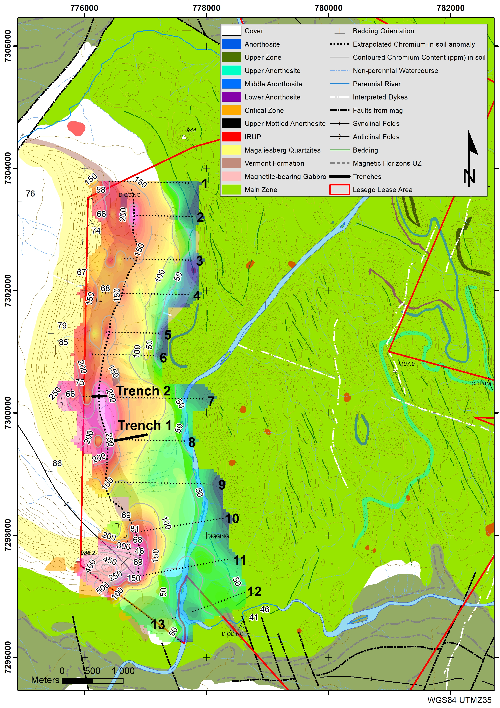
Figure 11: Geological map showing chrome in soil values and mapped and interpreted structures in the Lesego project area, as well as the location of the two trenches. The dotted line refers to the 150 ppm Cr in soil contour (after Schwellnus et al., 1962 and data compiled by the author).

Geological Mapping and Trenching
Geological mapping by the Lesego team resulted in the tracing of the Upper, Middle and Lower Anorthosites of the Main Zone on Dal Josephat and Eerste Regt farms (Figure 11). The continuity of the mapped horizons suggested an absence of significant faulting in the mapped area, which correlated with the results of the seismic survey.
Two trenches were excavated across the contact between the metasediments and the rocks of the Rustenburg Layered Suite approximately 280 m apart along strike on the eastern flank of the Phosiri Dome on Spelonk 478 KS (Figure 11). Both trenches showed that the metasediments are intercalated with the Rustenburg Layered Suite on a centimeter to tens of centimeter scale. It was not possible to discern any foliations in Rustenburg Layered Suite lithologies in the intercalated rocks, so it is unclear on whether the intercalation is tectonic or intrusive. Lithologies are overturned, showing steep (>60°) dips to the west. Little structure could be discerned owing to the high degree of weathering.
Two chromitite layers were exposed in the southern-most trench, Trench 1. The most westerly chromitite (Chromitite 1) exposed in the trench is a 67 cm thick, west dipping (~60°), fine-grained unit hosted by a coarse-grained feldspathic pyroxenite. The second chromitite layer (Chromitite 2) is a 111 cm thick, fine-grained chromitite unit with a mottled anorthosite hangingwall and a very coarse-grained feldspathic pyroxenite footwall unit, striking in a north-south direction and dipping steeply (~55°) to the west. These layers do not appear to be continuous along strike, as the only chromitites intersected in Trench 2 to the north were small (<5 cm), irregular disseminated chromitites within a coarse-grained feldspathic pyroxenite.
The Pt:Pd ratio of Chromitite 1 and Chromitite 2 is similar to that of the average of the Pt:Pd ratio of the UG1B and UG1A respectively, intersected in exploration drill holes LES013, LES026, LES032 and LES059, presented in Table 7, indicating that Chromitite 1 is the UG1B and Chromitite 2 is the UG1A. Both layers have thinned from an average thickness of 121 cm for the UG1A and 148 cm for the UG1B to the values recorded in the trench. No other chromitite occurrences which could be correlated with the UG2 were mapped in the trenches.
Table 7: PGE+Au, Ni and Cu grades over the entire sampled width of the two chromitite horizons identified in Trench 1, as well as the average grades from all UG1A and UG1B intersections from Lesego’s exploration drill holes.
 | Width (cm) | 4E | Pt | Pd | Rh | Au | Cu | Ni | Pt/Pd
Units | cm | g/t | g/t | g/t | g/t | g/t | ppm | ppm
Chromitite 1 (Trench 1) | 67 | 0.87 | 0.55 | 0.16 | 0.15 | 0.01 | 60.87 | 148.46 | 3.44
Chromitite 2 (Trench 1) | 111 | 1.09 | 0.57 | 0.37 | 0.14 | 0.01 | 52.65 | 175.61 | 1.54
Average UG1A | 121 | 0.93 | 0.36 | 0.44 | 0.11 | 0.03 | 229.4 | 957.56 | 1.50
Average UG1B | 148 | 1.28 | 0.60 | 0.49 | 0.17 | 0.01 | 81.34 | 929.04 | 3.59

Uken (1998) noted the previously unpublished presence of a “thin, up to 600 m wide sliver of granite from the Lebowa Granite Suite” in contact with the eastern limb of the Phosiri Dome, which appears to have masked Critical Zone lithologies from surface mapping. These felsic rocks were subsequently lithologically classified from petrographic studies from trench samples by the Lesego team as a weakly altered weakly altered gabbronorite.
A petrographic investigation (Thatcher, 2011) of the same material from drill hole LES035 showed that the material consists of a weakly altered (saussuritised, chloritised, amphibolised), fine- to medium-grained (<50 µm to 4.24 mm), igneous-textured rock with no obvious mineral fabrics. The modal composition consisted of ~45% plagioclase, including minor internal saussurite, ~39% clinopyroxene (augite), including minor internal alteration to hornblende, ~8.5% biotite, including minor alteration to chlorite, 7.5% opaque minerals, and some minor apatite. It is therefore classified as a magnetite-biotite-bearing gabbro.

Exploration Drilling
Following on from the completion of the seismic survey, an initial series of five diamond boreholes (LES001 to LES005, Figure 15) were drilled along the seismic lines to test the nature of the identified reflectors and to obtain a statistically relevant sample of intersections to allow for a reasonable estimate of average global grades for both the UG2 Chromitite and Merensky Reef. This drilling confirmed that marker horizons h_5 and h_8 (Figure 6) represented the Bastard/Merensky Reef and UG2 Chromitite layers respectively.
A further 51 diamond boreholes (Figure 15) successfully delineated both the Merensky and UG2 reefs from 350 m below surface down to 2,250 m. Both reefs show a strike extent of approximately 2,000 m at 350 m depth but this strike length increases considerably at approximately 700 m below surface, and then to approximately 3,500 m at 1,200 m depth and the reefs achieve a full ~7,000 m of strike length at approximately 1,600 m below surface (Figure 12). It is postulated that the Phosiri Dome restricted the formation of the reefs to the north and south of the shallow portions of the ore body and a synclinal structure along the eastern flank of the Phosiri Dome with the fold hinge plunging at 80° in westerly direction (Figure 12) provided enough space to accommodate the formation of the reefs within the Critical Zone package. The Phosiri Dome has had a dramatic effect on the orientation of the reefs close to the flanks of the Dome. At a depth of 350 m, the reefs dip at approximately 80° to the east, gradually changing to ~30° at 1,200 m depth below surface and flattening out to a constant 10° towards the east at 1,600 m below surface (Figure 12).
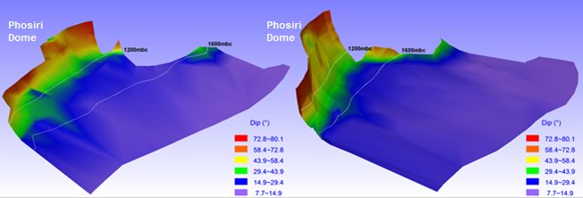
Fold hinge
Fold hinge
Figure 12: Wireframe model showing the extent and dip of the Merensky Reef (image on the left) and UG2 chromitite (image on the right) looking from the southeast towards the eastern flank of the dome.
Between depths of approximately 350 m and surface on Spelonk and Olifantspoort, there appears to be an extensive amount of gabbroic material contaminated with anatectic melt (Figure 13) from floor (or possibly roof) metasedimentary rocks, which have intruded into the mafic-ultramafic rocks of the Rustenburg Layered Suite. This may have possibly played a role in obliterating any Critical Zone rocks on surface adjacent to the eastern flank of the dome on Olifantspoort and the southern portions of Spelonk, save for a small window of Critical Zone rocks mapped in trenches directly adjacent to the dome, as highlighted by the soil chrome anomaly in Figure 11.
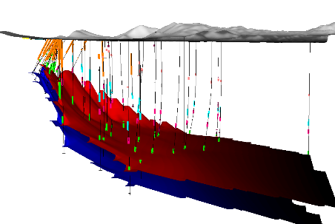
Gabbroic material contaminated with Anatectic melt
UG2 Chromitite
Merensky Reef
Figure 13: Three-dimensional view looking north of the exploration drill holes on the Phosiri Project showing in orange gabbroic material heavily contaminated with anatectic melt.
The presence of this contaminated gabbroic material explains the paucity of reflectors in the seismic survey close to the eastern flank of the Phosiri Dome, and possibly played a role in the disruption of mineralisation mechanisms in the formation of the Merensky Reef and UG2 Chromitite.
The drilling confirmed that the eastern flank of the Phosiri Dome appears to be less disrupted than the southern flank and, whilst the Bushveld Complex lithologies are shown to be steeply inclined close to the footwall contact, the seismic and drilling evidence shows a substantial ‘flattening’ of dip approximately 1,700 m east of the footwall contact, creating a large area of sub-horizontal, largely undisturbed, Rustenburg Layered Suite lithologies at a depth of approximately 1,200 m adjacent to the eastern flank (Figure 12).
The influence of the Phosiri Dome is especially evident in the anorthositic hangingwall to the Merensky Reef in proximity to the Phosiri Dome. The anorthosite commonly shows characteristics of strain in the form of deformed large intercumulus pyroxene mottles (Figure 14), indicating deformation due to the emplacement of the Phosiri Dome after the crystallisation of the mottled anorthosite.
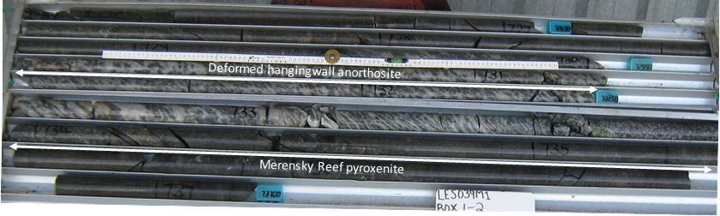
Figure 14: Photograph of drill core from drill hole LES039 located approximately 400 m from the Phosiri Dome, showing the deformed mottled anorthosite hangingwall to the Merensky Reef pyroxenite. The mottled anorthosite shows strong foliations, indicating strain probably due to the post crystallisation emplacement of the Phosiri Dome.
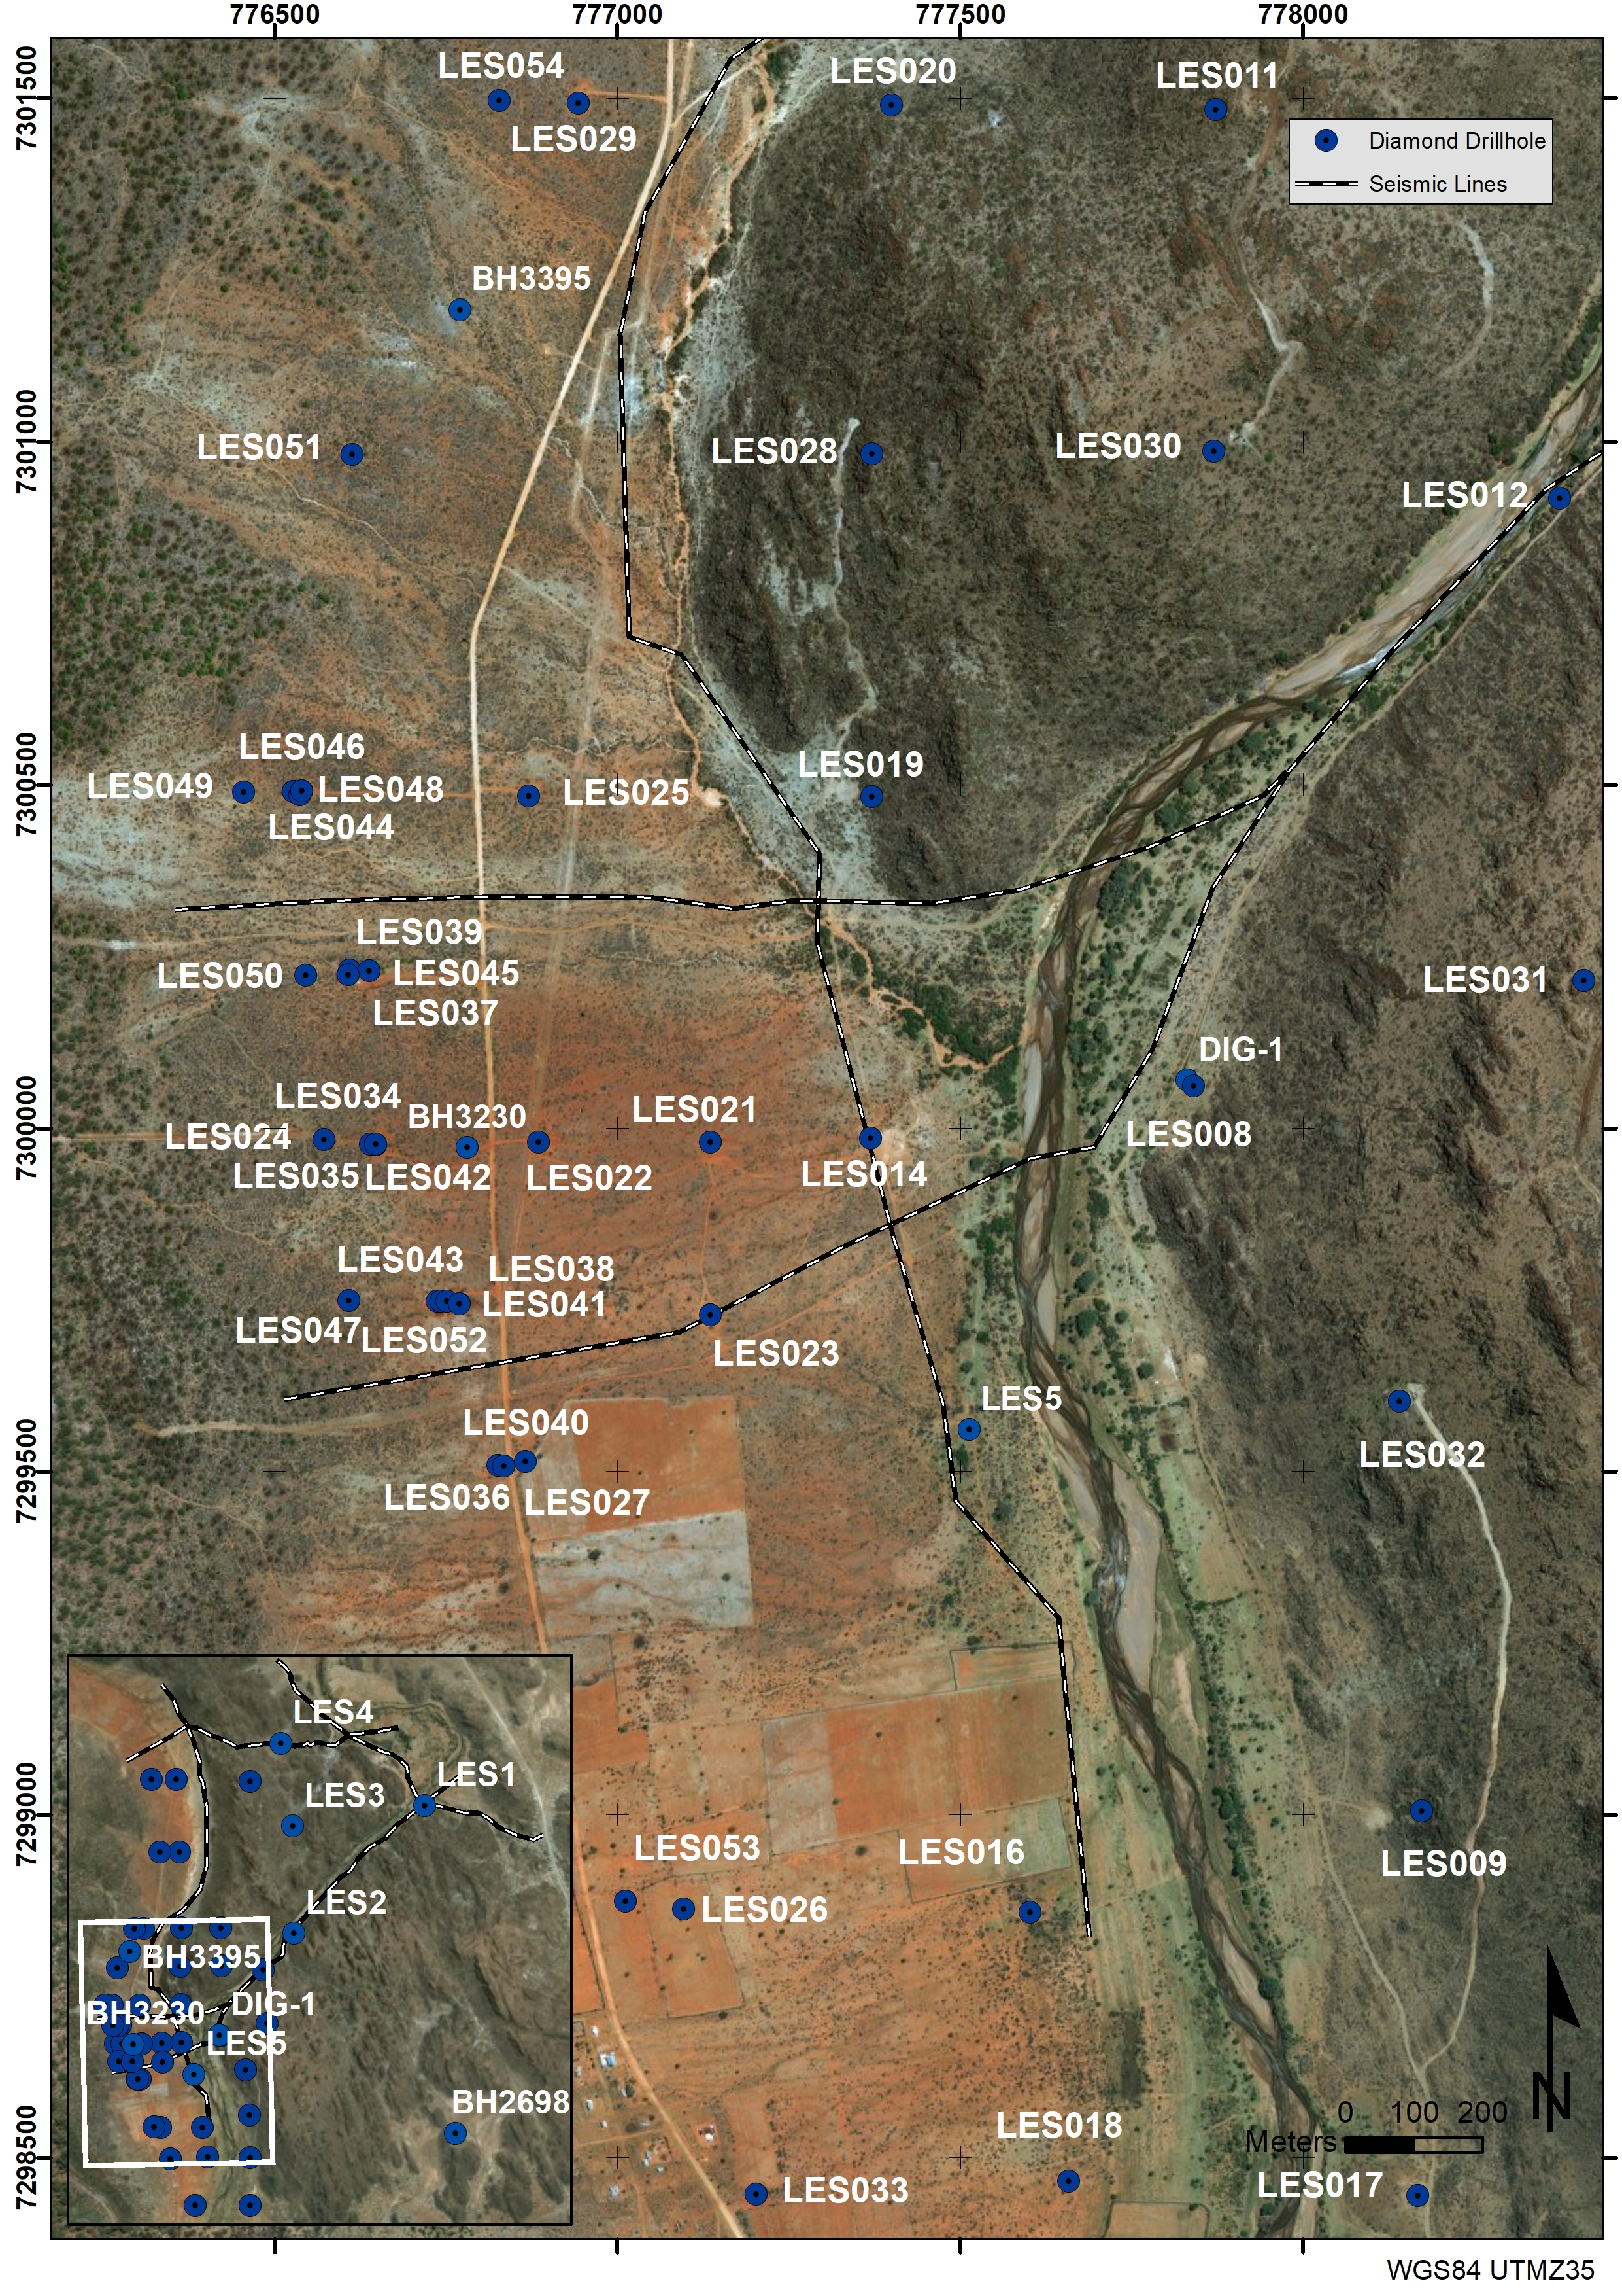
Figure 15: Location of all diamond exploration drill holes drilled on the Lesego lease area, as well as the seismic traverses conducted in 2007. The white block on the inset denotes the area displayed in the main image.

Lithology and Petrography

UG2 Chromitite Horizon
The UG2 Chromitite package on the Lesego Lease Area appears similar to the stratigraphy developed at Lonmin’s Limpopo Division (previously Messina Platinum Mine) (Von Gruenewaldt et al., 1990; Lea, 1996), and at Bokoni Platinum Mine (previously Atok Mine) (Mossom, 1986). The UG2 lies between 200 m and 300 m below the Merensky Reef package. The footwall to the UG2 package is a noritic unit of variable thickness (Figure 15). A basal feldspathic pegmatoidal pyroxenite unit of varying thickness forms the immediate footwall to the main UG2 chromitite seam which is generally between 80 cm and 130 cm thick. Overlying the pegmatoidal pyroxenite unit is the main chromitite seam, which is approximately 110 cm thick. In places, the main chromitite seam is split by a pyroxenite parting varying from a few centimeters to up to 1.5 m thick. The leader chromitite seam occurs in relatively close proximity to the upper contact of the main chromitite seam (within 25 cm to 80 cm). Where the parting is present, the leader chromitite moves proportionally further away from the main chromitite seam, up to several meters in places. On this basis, the UG2 has been divided into two main facies, a “single reef” and “split reef” facies (Figure 16).

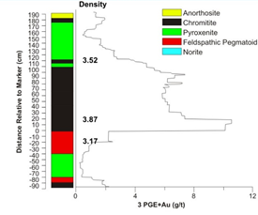 | 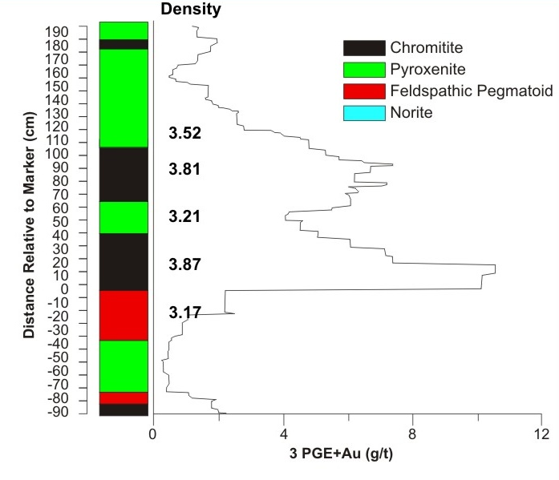

Figure 16: Typical stratigraphy and grade profile across the UG2 Chromitite in the Lesego Lease Area. (a) Single reef facies, (b) Split reef facies with two chromitite seams separated by a pyroxenite parting compiled from composite boreholes (after Njowa and Clay, 2010).

Merensky Reef
The Merensky Reef and Bastard Reef stratigraphy observed within the project area are typical of the north western part of the Eastern Limb of the Bushveld Complex (Lea, 1996), and would be classified as “Thick Reef” based on Cawthorn’s (2011) reef facies classification system.
The immediate footwall to the Merensky pyroxenite is an oikiocrystic chloritised norite. There is evidence in several boreholes of the development of multiple layers of mineralised Merensky pyroxenite and pegmatoid containing significant quantities of PGE+Au, a situation similar to that observed on the easternmost leaseholds of Lonmin’s Limpopo Mine (Von Gruenewaldt et al., 1990; Lea, 1996).
The Merensky pyroxenite consists of a moderate to thick pyroxenite package (generally 4 to 15 m) with a centimeter - scale chromitite stringer occurring between 20 cm to 90 cm below the hanging wall norite/pyroxenite contact (Figure 17).
A second, usually more robust chromitite stringer commonly occurs at the base of the internal pyroxenite unit. This pyroxenite unit corresponds to the more traditional hangingwall pyroxenite seen at Limpopo Mine (Lea, 1996).
The chromitite units consist of 70 - 90% modal chromite, present as euhedral to rounded grains varying in size from 0.1 mm – 1 mm. In places, chromite grains coalesce to form semi-massive chromite seams that can reach a thickness of 3 – 4 mm. The intervening silicate phase between chromite grains consists of a combination of plagioclase and orthopyroxene crystals (10 - 20%), with smaller quantities of plagioclase (5 - 10%), rutile (1%) and base metal sulphides (2 - 3%). The lower contacts of the chromitites are generally sharp, whereas the upper contacts are gradational (Price, 2015).
Below the lower chromitite stringer a footwall feldspathic pegmatoidal unit of variable thickness is generally present, corresponding to the traditional M2 Pegmatoid in the Limpopo Mine area (Lea, 1996). The pegmatoidal pyroxenite is characterised by coarse, rounded crystals of orthopyroxene reaching 4 mm – 18 mm in size, in addition to commonly poikilitic plagioclase and clinopyroxene. Plagioclase exhibits a distinctive interstitial texture, whereas large oikocrysts of clinopyroxene up to 20 mm in size enclose smaller sub-millimetre orthopyroxene chadacrysts.
Some large orthopyroxene grains appear to be composite grains consisting of multiple crystals forced together. Olivine occurs sporadically as large 1 cm crystals and is typically heavily serpentinised. Abundant accessory phases are identified, including hornblende, phlogopite, chromite, apatite, quartz, monazite, carbonate veining and various sulphides, mainly pyrrhotite, pentlandite, chalcopyrite and pyrite, in that order of relative abundance.
Most of the visible sulphide mineralisation occurs within the pyroxenite unit and appears to be concentrated in and around the uppermost chromitite stringer. Visible sulfide mineralisation extends into the footwall feldspathic pegmatoidal pyroxenite as well as the norite hanging wall, albeit to a lesser extent. PGE grade is concentrated between the two chromitite stringers and into the underlying pegmatoidal feldspathic pyroxenite (Figure 16), similar to that described by Mitchell and Scoon (2007) on the Central Sector of the Eastern Limb at Winnaarshoek, approximately 50 km east of the Lesego Project.
The Bastard unit in the Lesego Lease Area consists of norite and feldspathic pyroxenite with rare interstitial sulfides and, locally, a basal chromitite stringer. The sequence between the Bastard Pyroxenite and the Merensky cycle consists of a well-developed package of mottled anorthosite (thicknesses of between 5.6 m and 4.4 m) grading into a spotted anorthosite (thicknesses of between 3.8 m and 2.9 m) and finally a gradational change into a leuconorite (thicknesses between 2.7 m and 1.3 m).
The immediate hangingwall to the Bastard cycle is the Giant Mottled Anorthosite (GMA) of Subzone A of the Main Zone (Figure 2) (SACS, 1980). A well-developed GMA sequence is observed at Lesego, in general ranging in thickness from 61 m to 79 m.

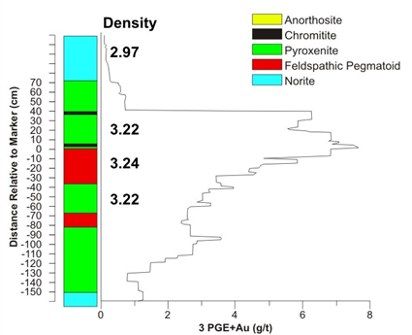

Figure 17: Typical stratigraphy representing the average width and grade profile compiled from composite boreholes across the Merensky Reef in the Lesego Project Area (after Njowa and Clay, 2010).

Precious Metal Mineralogy
Two separate mineralogical studies were carried out (Buurman, 2015; Price, 2015) to determine the composition, distribution, size and abundance of PGM across a complete section of the Merensky Reef from the Lesego Project area, as well as to deduce what effects, if any, the emplacement of the Phosiri Dome has had upon the mineralogy of the Merensky Reef and the PGM distribution present.
The Pt-Pd sulfides cooperite and braggite are typically the most common PGM, with considerable Pt-Pd tellurides and lesser Pt-arsenides, in addition to the Ru sulfide laurite, in the Merensky Reef in this area of the Bushveld (Schwellnus et al., 1976; Kinloch and Peyerl, 1990).
The pegmatoidal feldspathic pyroxenite including the two chromitite seams from drill holes LES037, LES034, LES036, LES040, LES034, LES024, LES022 (Figure 14) was sampled and analyzed by Buurman (2015), whilst the hanging wall, reef and footwall rocks from drill holes LES019 and LES025 (Figure 14) were sampled and analyzed by Price (2015). The samples were examined by transmitted light microscopy, reflected light microscopy and scanning electron microscope (SEM).
The dominant precious metal minerals (PMM) identified using SEM in the thin sections of the borehole samples taken from the pegmatoidal feldspathic pyroxenite are cooperite (33.11%), moncheite (29.18%), sperrylite (13.44%), braggite (7.21%), laurite (5.57%), kotulskite (3.61%), platarsite (2.3%) and michernite (1.64%); the presence of hollingworthite, niggliite, palladoarsenide and rustenburgite was noted (Buurman, 2015; Price, 2015).
In the samples taken from across all lithological horizons of the Merensky Reef in drill holes LES019 and LES025), the PGE sulfides are mainly braggite, cooperite, laurite, an unnamed CuPtRh sulfide and vysotskite, which account by count for 40.0% of total precious metal minerals, whereas PGE bismuthotellurides (michenerite and merenskyite) account for 36.4% of all grains. The remaining 23.6% is made up of minor precious metal minerals.
Price (2015) demonstrated that the highest PMM count by number and area are primarily in the chromitite units and that the PGE mineralisation present is bimodal, with highest concentrations associated in and immediately below the upper chromitite(s) and lesser PGE mineralisation in the thin chromitite atop the footwall anorthosite. These two peaks are separated by several meters of pyroxenites lacking PGE mineralisation. This correlates well with the grade distribution across the Merensky Reef (Figure 17).
The chromitite units and silicate units of the reef have distinctly different PGM assemblages. The bismuthotelluride PGMs occur throughout all rocks and dominate in the silicate lithologies. The chromitite units additionally contain Pt-Pd sulfides, an unnamed CuPt(Rh) sulfide and laurite. This contrast in PGM assemblage is consistent with that previously recorded by Prichard et al. (2004) at Impala Platinum Mines, on the western limb of the Bushveld Complex, but it is unknown at this stage how this compares to the PGM assemblage in the immediate vicinity.

Resource Statement
In total, 86,550 m of core was retrieved from the 56 boreholes drilled over the lease area (Figure 15). A global discount of 17% was applied to the resource statement to account for geological losses owing to faulting, potholing, dykes and IRUPs. This drilling resulted in the declaration of a SAMREC compliant resource of 204.18 Mt containing 39.03 million ounces of 3PGE+Au at a grade of 5.95 g/t above a depth of 2,250 m (Table 8) (Hall, 2013).
Table 8: Mineral Resources of the Lesego Project (Hall, 2013).
Resource | Width | Grade (g/t) | Cu | Ni | Tonnage | Moz | Cu | Ni
Classification | (m) | 3PGE+Au | % | % | (Mt) | 3PGE+Au | tons | tons
Measured | 1.21 | 5.61 | 0.09% | 0.21% | 43.97 | 7.94 | 38 235 | 91 838
Indicated | 1.21 | 6.05 | 0.09% | 0.20% | 83.65 | 16.26 | 71 659 | 168 353
Inferred | 1.18 | 6.03 | 0.09% | 0.21% | 76.56 | 14.83 | 69 434 | 160 733
Total Project Mineral Resources |  | 5.95 | 0.09% | 0.21% | 204.18 | 39.03 | 179 328 | 420 924
MR Mineral Resources | 1.09 | 5.66 | 0.13% | 0.25% | 80.47 | 14.65 | 101 277 | 204 878
UG2 Mineral Resources | 1.27 | 6.13 | 0.06% | 0.17% | 123.71 | 24.38 | 78 050 | 216 046
Total Project Mineral Resources |  | 5.95 | 0.09% | 0.21% | 204.18 | 39.03 | 179 328 | 420 924
*After Geological loss of 17% Combined Merensky Reef and UG2 Chromitite
The 4E prill split is consistent for the area with both the Merensky Reef and UG2 chromitite being platinum dominated; the Merensky Reef has a 1.8:1 Pt:Pd ratio, whilst the UG2 has a 1.3:1 Pt:Pd ratio (Table 9).

Table 9: Prill splits for the Lesego Resource
Reef | Pt | Pd | Rh | Au
Merensky Reef | 59% | 32% | 3% | 6%
UG2 | 48% | 38% | 12% | 2%
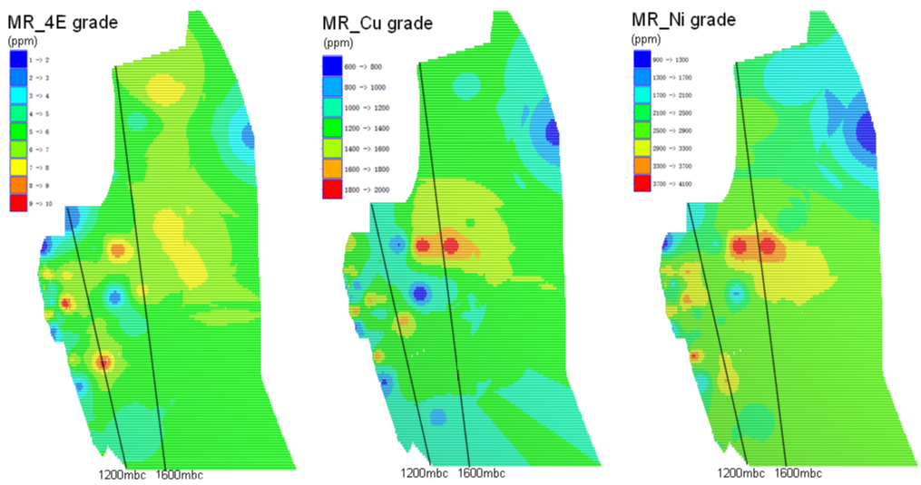
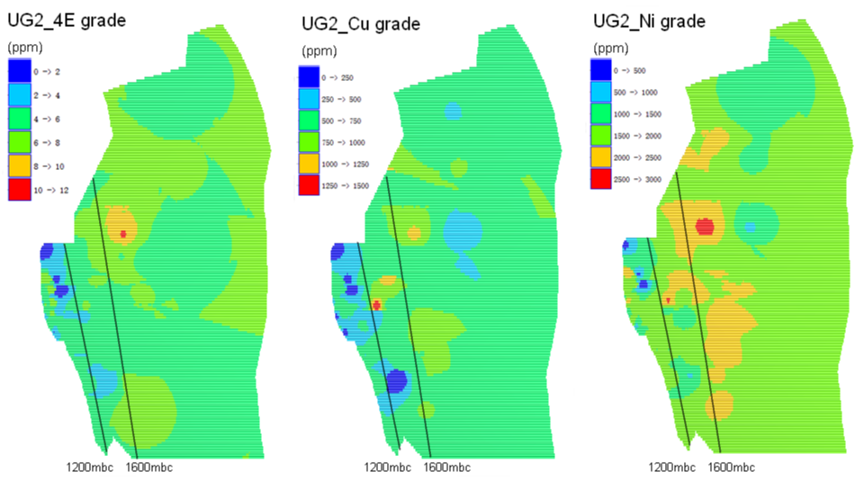

Figure 18: Contoured map of the Lesego Project Area showing 3PGE+Au, Cu and Ni grades over the Merensky Reef (top image) and UG2 (bottom image). Note the general improvement of grade with depth (to the right) and the low-grade portions at the margins of the resource.

The grades, and to a lesser degree, the thickness, of both the Merensky and UG2 reefs improve with depth, and it is clear that the Phosiri Dome had an adverse effect on the grades and thicknesses of the reefs when in close proximity to the Dome (Figure 18). It is unclear at this stage whether this is due to tectonic effects such as shearing or stretching of the Rustenburg Layered Suite lithologies during the emplacement of the Phosiri Dome during crystallisation of the reefs, or whether metamorphism and contamination by anatectic melts from the metasedimentary footwall rocks effected the mineralisation process.

Discussion
The discovery and resulting definition of the resources of the Lesego PGE Project resulted from a systematic phased exploration program testing a conceptual exploration model based on the syn-Bushveld emplacement of the Phosiri Dome.
On the southern flank of the Phosiri Dome, Scoon, page 1,047, (2002) identified a “relatively chaotic sequence underlying the Upper Zone with increased distance from the Zaaikloof (Phosiri) dome” and attributed the occurrence of marker layers in some sections and lack of these marker layers in other sections to not only the non-development or attenuation of these layers, but possibly also to strike-slip faulting associated with the upward movement of the Phosiri Dome. By contrast, the layering of the Rustenburg Layered Suite on the eastern flank of the Phosiri Dome, to the northeast of the fold hinge, appears to be relatively consistent and predictable with increased distance from the floor rocks. This may indicate an asymmetrical emplacement of the Phosiri Dome, or subsequent modification of the area of the Phosiri Dome which only affected the southern flank, however, on both the southern and eastern flanks of the Phosiri Dome, drilling has confirmed that a combination of uplift and tilting has resulted in the absence, or at the very least, the attenuation of marker layers close to the floor rocks (Scoon, 2002). Strain fabrics commonly seen in mottled anorthosites intersected in drill cores in close proximity to the Dome, as well as the steepening of the dip of Rustenburg Layered Suite lithologies, mean that emplacement of the Dome postdated the crystallisation of Rustenburg Layered Suite magmas.
The structural setting of the deposit is unique in the Bushveld Complex, given the sub-vertical dips of the reefs near surface, which shallow out with increasing depth. At depth the Merensky and UG2 reefs typically dip at angles of less than 35°, which lends itself to conventional breast mining techniques. Closer to the Phosiri Dome, the upper parts of the ore body, by virtue of its steep dips above 1,200 m depth, lends itself to an arguably safer, lower cost mechanised mining technique for the upper portions.
The inability to recognize the upper orebody in previous studies was a result of several factors. Firstly, the steep dip of the Rustenburg Layered Suite in close proximity to the Phosiri Dome meant that traditional two-dimensional seismic surveys adjacent to the Phosiri Dome would fail to detect any reflectors. The relatively sharp inflexion point of the Rustenburg Layered Suite at approximately 1,200 m means that the seismic signature of shallow-dipping reflectors disappeared relatively quickly and a gradual change in dip of the reflectors was not detectable. New exploration drilling by Lesego has revealed extensive sheets of gabbroic material contaminated with anatectic melt, which appears to have interfered with magmatic layering in the Rustenburg Layered Suite between 350 m and surface, thus obscuring any Critical Zone lithologies at surface.
This has important implications for exploration strategies around other possible Merensky Reef and UG2 Chromitite dome-associated targets in the Bushveld Complex. In order to increase the chances of success, a counter-intuitive strategy of starting exploration away from the immediate vicinity of the dome should be adopted, in order to understand the undisturbed stratigraphy through a process of mapping, soil geochemistry, seismics and subsequent drilling, and once this is better understood, the exploration program can move from the “known stratigraphy” into the disturbed horizons closer to the dome.

Conclusions
The Phosiri Dome was instrumental in the uplifting of the Rustenburg Layered Suite, bringing the Merensky and UG2 reefs to economically extractable depths. Dome emplacement was post the emplacement of the Critical Zone magmas. Exploration on the eastern flank of the Phosiri Dome has resulted in the discovery and evaluation of a previously unrecognized 39 million-ounce PGE resource that appears to be structurally more coherent than reef horizons identified on the southern flank of the Dome.

Acknowledgements
Company founders Mike Scott, Keith Scott, Rob Gerhard and Dorian Wrigley, who recognised the potential of the area, are thanked for their foresight and technical input. The exploration team involved are thanked for their diligence, technical input and hard work: Rob Kiefer, Frieder Reichhardt, Neels van Rooyen and Wiehann Kleynhans. My gratitude to Peter Sebake for his invaluable assistance in the continued successful liaison with our host communities and helping to build a lasting partnership with our hosts.
Professor Judith Kinnaird is thanked for her review of this paper. Diane Shearer is thanked for her assistance with the illustrations. The management of Lesego Platinum, Village Main Reef and Umbono Capital are thanked for their continued support of the project. The Industrial Development Corporation of South Africa is thanked for their funding of the project to advance it from exploration stages through to completed feasibility studies. We hope that this project can be used as a means to improve the lives of the communities which live on and around this resource.

References
Button, A., 1976, Stratigraphy and relations of the Bushveld floor in the eastern Transvaal: South African Journal of Geology, v. 79, p. 3-12.
Buurman, I., 2015, Applied mineralogical study on a portion of the Lesego platinum project situated in the eastern limb of the Bushveld Igneous Complex. Unpublished B.Sc. (Hons) project, Bloemfontein, South Africa, University of the Free State, 70 p.
Cameron, E. N. 1980, Evolution of the lower critical zone, central sector, eastern Bushveld Complex, and its chromite deposits: Economic Geology, v. 75, p. 845-871.
Cameron, E. N. 1982, The upper critical zone of the eastern Bushveld Complex; precursor of the Merensky Reef: Economic Geology, v. 77, p. 1307-1327.
Campbell, G. 2010, Interpretation of high resolution aeromagnetic and radiometric survey data over the Phosiri Project area, Sekhukhune-Land locality, Limpopo Province on behalf of Lesego Platinum Mining (Pty) Ltd: Unpublished Lesego internal company report, 43 p.
Cawthorn, R. G., 1999a, The platinum and palladium resources of the Bushveld Complex: South African Journal of Science, v. 95, 481 p.
Cawthorn, R.G., 1999b, Platinum-group element mineralisation in the Bushveld Complex – a critical reassessment of geochemical models: South African Journal of Geology, v. 102, p. 268-281.
Cawthorn, R. G., 2011, Geological interpretations from the PGE distribution in the Bushveld Merensky and UG2 chromitite reefs: Journal of the Southern African Institute of Mining and Metallurgy, v. 111, p. 67-79.
Cawthorn, R.G., 2015, A review of the Bushveld complex and its mineralisation, in Hammond, N.Q. and Hatton, C.H. ed., Platinum-group element mineralisation and resources of the Bushveld Complex, South Africa.: Council for Geoscience, p. 17 – 90.
Cawthorn, R. G., and Spies, L., 2003, Plagioclase content of cyclic units in the Bushveld Complex, South Africa: Contributions to Mineralogy and Petrology, v. 145, p. 47-60.
Clarke, B. M., Uken, R., Watkeys, M. K., and Reinhardt, J., 2005, Folding of the Rustenburg layered suite adjacent to the Steelpoort pericline: implications for syn-Bushveld tectonism in the eastern Bushveld Complex: South African Journal of Geology, v. 108, p. 397-412.
Du Plessis, C. P. and Walraven, F., 1990, The tectonic setting of the Bushveld Complex in Southern Africa, Part 1. Structural deformation and distribution: Tectonophysics, v. 179, p. 305-319.
Eales, H. V., Botha, W. J., Hattingh, P. J., De Klerk, W. J., Maier, W. D. and Odgers, A. T. R., 1993, The mafic rocks of the Bushveld Complex: a review of emplacement and crystallization history, and mineralisation, in the light of recent data. Journal of African Earth Sciences (and the Middle East), v. 16, p. 121-142.
Eales, H.V. and Cawthorn, R.G., 1996, The Bushveld Complex, in Cawthorn, R.G. ed., Layered Intrusions: Elsevier, Amsterdam, p. 191-229.
Finn, C.A., Bedrosian, P.A., Cole, J.C., Khoza, T.D. and Webb, S.J., 2015, Mapping the 3-D extent of the Northern Lobe of the Bushveld layered mafic intrusion from geophysical data: Precambrian Research, v. 268, p. 279 - 294.
Gerya, T. V., Uken, R., Reinhardt, J., Watkeys, M. K., Maresch, W. V., and Clarke, B. M., 2003, Cold fingers in a hot magma: Numerical modeling of country-rock diapirs in the Bushveld Complex, South Africa: Geology, v. 31, p. 753-756.
Hatton, C. J., and von Gruenewaldt, G., 1987, The geological setting and petrogenesis of the Bushveld chromitite layers, in Stowe, C.W., ed., Evolution of chromium ore fields: New York, Van Nostrand Reinhold Company, p. 109-143.
Ireland, R. H., and Penniston-Dorland, S. C., 2015, Chemical interactions between a sedimentary diapir and surrounding magma: Evidence from the Phepane Dome and Bushveld Complex, South Africa: American Mineralogist, v. 100, p. 1985-2000.
Johnson, T., Brown, M., Gibson, R., and Wing, B., 2004, Spinel - cordierite symplectites replacing andalusite: evidence for melt‐assisted diapirism in the Bushveld Complex, South Africa: Journal of Metamorphic Geology, v. 22, p. 529-545.
King, H.L., Petit, P.J., Barends, R., 2011, An Independent National Instrument 43-101 Technical Report on the Mooiplats PGE Project, Limpopo Province, South Africa, On behalf of SAMDC (Pty) Ltd: Unpublished SAMDC company report, 92 p.
Kinloch, E. D., & Peyerl, W., 1990, Platinum-group minerals in various rock types of the Merensky Reef; genetic implications: Economic Geology, v. 85, p. 537-555.
Kruger, F.J., 1990, The stratigraphy of the Bushveld Complex: a reappraisal and relocation of the Main Zone boundaries: South African Journal of Geology, v. 93, p. 376-381.
Kruger, F.J., 2005, Filling the Bushveld Complex magma chamber: lateral expansion, roof and floor interaction, magmatic unconformities, and the formation of giant chromitite, PGE and Ti-V-magnetitite deposits: Mineralium Deposita, v. 40, p. 451-472.
Lea, S. D., 1996, The geology of the Upper Critical zone, northeastern Bushveld Complex: South African Journal of Geology, v. 99, p. 263-283.
Longridge, L., Gibson, R. L., and Nex, P. A., 2009, Structural controls on melt segregation and migration related to the formation of the diapiric Schwerin Fold in the contact aureole of the Bushveld Complex, South Africa: Earth and Environmental Science Transactions of The Royal Society of Edinburgh, v. 100, p. 61-76.
Martin, L. E., 2011, The attenuation of the main zone at the Phosiri Dome, Bushveld Complex: Unpublished M.Sc. Thesis, Johannesburg, South Africa, University of the Witwatersrand, 209 p.
Mitchell, A. A., & Scoon, R. N. 2007, The Merensky Reef at Winnaarshoek, Eastern Bushveld Complex: a primary magmatic hypothesis based on a wide reef facies: Economic Geology, v. 102, p. 971-1009.
Molyneux, T.G., 1974, A geological investigation of the Bushveld Complex in Sekhukhuneland and part of the Steelpoort valley: Geological Society of South Africa Transactions, v. 77, p. 321–328.
Molyneux, T.G., 1998, Write-up of Reconnaissance Geological Mapping of Rocks of Main and Upper Zones of the Bushveld Complex North of Latitude 24°30’ (Sheets 2429 BC and BD): Unpublished Internal Company Report. 10 p.
Molyneux, T.G., and Klinkert, P.S., 1978, A structural interpretation of part of the eastern mafic lobe of the Bushveld Complex and its surrounds: Transactions of the Geological Society of South Africa, v. 81 p. 359-368.
Mossom, R.J., 1986, The Atok platinum mine, in Anhaeusser, C.R., and Maske, S., eds., Mineral deposits of southern Africa, Geological Society of South Africa, Johannesburg, v. 2, p 1127-1139.
Naldrett, A.J., Kinnaird, J.A., Wilson, A., Chunnet, G. and Yudovskaya, M., 2015, Platinum-Group Elements in the Critical Zone of the Bushveld Complex, in Hammond, N.Q. and Hatton, C.H. ed., Platinum-group element mineralisation and resources of the Bushveld Complex, South Africa.: Council for Geoscience, p. 17 – 90.
Njowa, G. and Clay, A. N., 2010, Independent competent persons report on the Phosiri Platinum Project, Venmyn Rand Limited: Unpublished Internal Lesego Company Report, 90 p.
Price. J., 2015, PGM Distribution and Reef Characterisation of the Merensky Reef at the Phosiri Dome, Bushveld Complex, South Africa: Unpublished M.Sc. Thesis, Cardiff, United Kingdom, Cardiff University, 123 p.
Prichard, H.M., Barnes, S.-J., Maier, W.D. and Fisher, P.C., 2004, Variations in the nature of the platinum-group minerals in a cross section through the Merensky Reef at Impala platinum mines: implications for the mode of formation of the reef: Canadian Mineralogist, v. 42, p. 423-427.
Schürmann, L.W., Grabe, P.J. and Steenkamp, C.J., 1998, Chromium, in Wilson, M.G.C. and Anhaeusser, C.R. eds., The Mineral Resources of South Africa: Handbook, Council for Geoscience, v. 16, p. 90–105.
Schwellnus, J.S.I., Engelbrecht, L.N.J., Coertze, F.J., Russell, M.D., Maherbe, S.J., van Rooyen, D.P., and Cooke, R., 1962, The geology of the Olifants River area, Transvaal: Geological Survey of South Africa Explanation Sheets 2429B and 2430A, 87 p.
Scoon, R. N., 2002, A new occurrence of Merensky Reef on the flanks of the Zaaikloof dome, northeastern Bushveld Complex: Relationship between diapirism and magma replenishment: Economic Geology, v. 97, p. 1037-1049.
Schwellnus, J.S.I., Engelbrecht, L.N.J., Coertze, F.J., Russell, M.D., Maherbe, S.J., van Rooyen, D.P., and Cooke, R., 1962, The geology of the Olifants River area, Transvaal: Geological Survey of South Africa Explanation Sheets 2429B and 2430A, 87 p.
Schwellnus, J. S. I., Hiemstra, S. A., and Gasparrini, E., 1976, The Merensky reef at the Atok platinum mine and its environs: Economic Geology, v. 71, p. 249-260.
Sharpe, M. R., 1985, Strontium isotope evidence for preserved density stratification in the main zone of the Bushveld Complex, South Africa: Nature, v. 316, p. 119.
Sharpe, M. R., & Chadwick, B., 1982. Structures in Transvaal sequence rocks within and adjacent to the eastern Bushveld Complex: Geological Society of South Africa Transactions, v. 85.
South African Committee for Stratigraphy, 1980, Stratigraphy of South Africa. Part 1: Lithostratigraphy of the Republic of South Africa, South West Africa/Namibia, and the republics of Bophuthatswana, Transkei and Venda (Compiler L.E. Kent): Geological survey of South Africa Handbook 8, 690 p.
Thatcher, T., 2011. Petrographic Description of Thin Section 12th August 2011, Microsearch CC. Unpublished internal Lesego company report, 3 pp.
Uken, R., 1998, The geology and structure of the Bushveld Complex metamorphic aureole in the Olifants River area: Unpublished Ph.D. thesis, Durban, South Africa, University of Natal, 277 p.
Uken, R., and Watkeys, M. K., 1997, Diapirism initiated by the Bushveld complex, South Africa: Geology, v. 25, p. 723-726.
Viljoen, M. J. and Scoon, R. N., 1985, The distribution and main geologic features of discordant bodies of iron-rich ultramafic pegmatite in the Bushveld Complex: Economic Geology, v. 80, p. 1109-1128.
Von Gruenewaldt, G., 1973, The Main and Upper zones of the Bushveld Complex in the Roossenekal area, eastern Transvaal: Geological Society of South Africa Transactions, v. 76, p. 53–61.
Von Gruenewaldt, G., Horsch, H., Dickst, D., and de Wet, J., 1990, PGE mineralisation in the western sector of the eastern Bushveld Complex: Mineralogy and Petrology, v. 42, 71-95.
Walraven, F., Armstrong, R. A., and Kruger, F. J., 1990, A chronostratigraphic framework for the north-central Kaapvaal craton, the Bushveld Complex and the Vredefort structure. Tectonophysics, v. 171, p. 23-48.
Zeh, A., Ovtcharova, M., Wilson, A. H., and Schaltegger, U., 2015, The Bushveld Complex was emplaced and cooled in less than one million years – results of zirconology, and geotectonic implications: Earth and Planetary Science Letters, v. 418, p. 103-114.

Chapter 3

Mining and Processing

Overview
This chapter briefly focuses on the commissioning, mining, processing, economic aspects and environmental issues of the Lesego Project. The chapter aims to put the Lesego discovery into an economic context and its viability for eventual extraction.
A scoping study was conducted on the Project in 2011 based on the inferred resource declared from the seismics and the 5 initial drill holes. A Prefeasibility and Definitive Feasibility study was then completed in 2013 based on the measured and indicated resource presented in Table 3.

Mining and Processing

Mining
The depth, steep dip and narrow width of the reefs dictate the deposit should be exploited by underground mining methods. The preferred method for mining the reefs down to 1,200 m depth below surface is a sub-level open stoping mining method using trackless equipment, which is currently being used in places at Lonmin’s Limpopo Section. Access to the reef will be via a decline from surface, with a main shaft used for hoisting men and material down to 1,200 m and a raise-bored ventilation shaft (Figure 18) (Cox and Montjoie, 2014).
Figure 19: Oblique section looking northwest showing the primary development and secondary development required to access the steeply dipping portions of the ore body down to 1,200 m below surface.
Development of the mine will be phased, with Phase 1 only exploiting the resource from 350 m to 1,200 m depth below surface using a fully mechanized mining method, whilst Phases 2 and 3 will utilize a conventional breast mining method.

Mineral Processing
Both the Merensky and UG2 reefs responded well to bench-scale laboratory metallurgical test work, and plant-scale simulations performed by Lesego predict excellent recoveries in the order of 90% Pt and Pd in a MF2 (mill-float mill-float) plant, which is a standard design for Bushveld PGE mines (Hay, 2013).

Surface Infrastructure
The current mine design is optimized to extract shallow, higher grade portions of the upper orebody in the early years of mine development in order to improve the economics of the project. This area is located on the flat grassland below the eastern flank of the Phosiri Dome, an area ideal for constructing surface infrastructure (Figure 19).
The core of the Phosiri Dome has been identified as a favorable location for the tailings disposal facility (TDF) (Figure 19) owing to the following factors:
- The eastern and southern limbs of the Phosiri Dome, as well as the Machadodorp Volcanic Member forming the hills in the core of the Dome, provide a visual and physical barrier between the TDF and nearby communities and the Olifants River, reducing dust levels;
- There are no known mineral resources in this area, which contains Transvaal Group metasediments, so no potential resources are sterilised;
- The land is currently not being utilised for farming, grazing or homesteads, so impact on the community is minimal;
- The topography allows for the construction of a “valley-fill” style TDF which is more cost-effective than the “paddock” style TDF more commonly found in South Africa;
- The nose of the anticline acts as a funnel for ground water seepage, and water extraction using bore holes in this area will allow for the effective recycling of water from the TDF and the effective control and monitoring of any potential ground water pollution during operational phase as well as after mine closure.

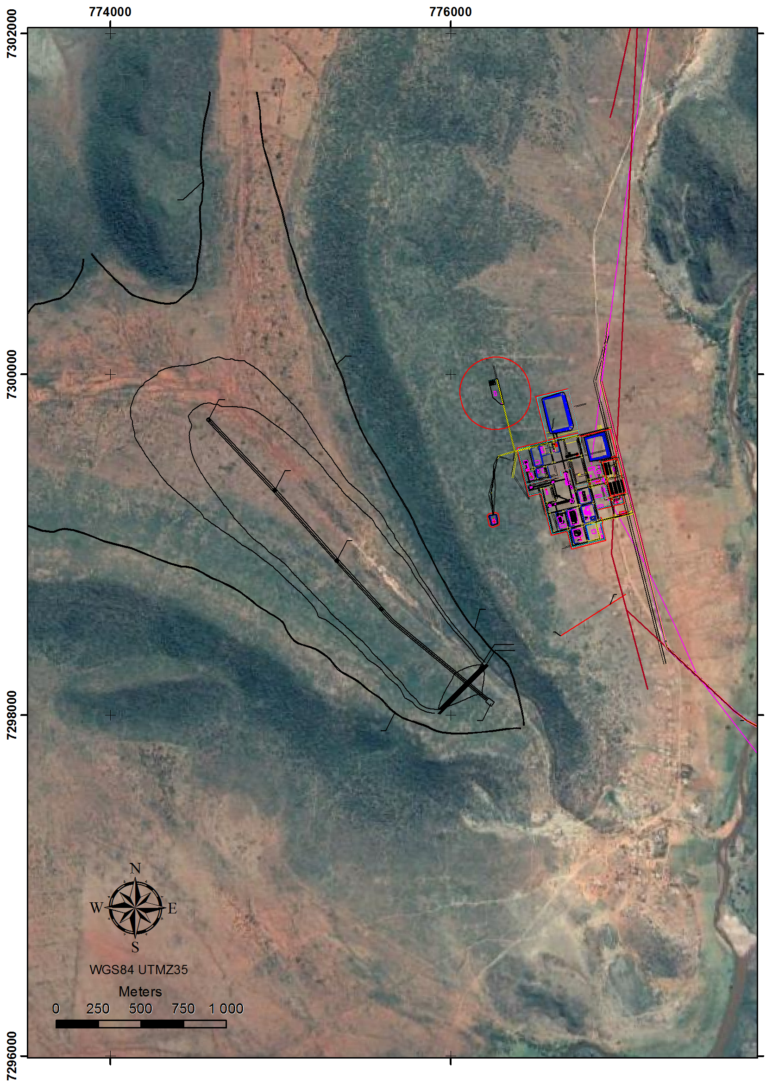
Figure 20: GoogleEarth image with the footprint of the tailings disposal facility in the core of the Phosiri Dome and the location of mine surface infrastructure on the eastern side of the eastern flank of the Dome.

Chapter 4

Discussion and Conclusions

Outlook for Commissioning
PGE producers globally are under pressure to cut costs and meet production targets as PGE prices remain suppressed. Major cost drivers for producers are labour and power, both of which have been increasing at above-inflation rates in recent years. The narrow profile and shallow dip of the Merensky and UG2 reefs do not lend themselves to mechanisation, and current mining technology has not yet managed to exploit underground shallow dipping Merensky and UG2 economically on a fully mechanized basis, owing to excessive dilution because of the increased mining width required to accommodate mining machinery.
Unlike the more common shallow-dipping Merensky and UG2 deposits in the Bushveld Complex, the steep reef dips along the eastern flank of the Phosiri Dome allow for mechanisation of a substantial portion of the ore-body using a tried and tested mining method commonly employed on steeply dipping orogenic gold deposits, as well as at Lonmin’s Limpopo Section.
In the context of the South African mining industry, commissioning a new mine to be mechanized from construction phase is significantly easier than retrofitting a mine to be mechanized that was originally established as a labour intensive conventional operation (J. Grobler, pers. commun., 2017).
A comparison of the grade and tonnage of PGE projects and mines in the Bushveld Complex (Figure 21) shows that the Lesego Project compares favourably in terms of grade and tonnage and is an attractive project just on those merits. The discovery of reef at a depth of only 350 m below surface now means that there is a realistic chance of exploitation.
Figure 21: A comparison of the grade and tonnage of various mines on the Bushveld Complex (after Forrest, 2012).
The relatively high base metal content adds to the basket price of the Lesego ore, making it one of the highest value per ton ores on the Eastern Limb (Figure 22). The lower platinum to palladium ratio in the UG2 Chromitite relative to that of the Merensky Reef (Table 4) further makes the Merensky Reef a more attractive mining prospect. Source data is presented in Appendix 8.

Figure 22: Comparison of the in-situ value per ton of Merensky Reef and UG2 Chromitite in the Eastern Bushveld Complex for various mines and projects (Source: Barker, 2008). Metal prices are spot prices on 26th January 2018. Note that for ease of comparison, Mogalakwena, PTM T-Zone, PTM F-Zone and Flatreef are all Northern Limb projects and are not considered Merensky Reef or UG2, but these have been included anyway as these projects are actively advancing and are useful benchmarks.
The implementation of a mechanized mining method will allow for a safer mine with a lower operating cost than a conventional underground mining operation. The high grade and lower operating cost will ensure that the Lesego Project is economically more robust and less exposed to metal price fluctuations.

Conclusions
The Phosiri Dome had a profound effect on the surrounding lithologies of the Rustenburg Layered Suite. The emplacement of the Phosiri Dome has resulted in the Merensky and UG2 reefs being uplifted to economically extractable depths, as well as resulting in sub-vertical dips of the reefs near surface, which lends itself to an arguably safer, lower cost mechanized mining technique. The resource is relatively high-grade when compared to other Bushveld Complex mines and projects.
The discovery of the Lesego Resource at relatively shallow depths has important implications for further exploration on the Bushveld Complex. A careful evaluation of footwall structures within the Bushveld Complex whilst bearing in mind the transgressive and unconformable relationship of the Upper Zone with Main and Critical Zone lithologies, as well as the transgressive relationship of the Main and Critical Zone lithologies with footwall structures, may lead to the generation of fresh exploration targets.
Unusual structures and stratigraphies are frequently encountered in close proximity to domal structures, and an understanding of the structural history of these domal structures can have important implications for exploration success. A multifaceted exploration program that strives to understand the relationship between the Rustenburg Layered Suite and the relevant footwall domes prior to commencing with exploration drilling on the flanks of the dome may be useful in assisting with achieving exploration success.

References

The following is a complete list of references for Chapters 1, 2, 3 and 4.
Barker, O., 2008. Barkers Platinum Map of Southern Africa. Banzi Geotechnics CC. Books on the Wall, 1 pp.
Button, A., 1976., Stratigraphy and relations of the Bushveld floor in the eastern Transvaal. South African Journal of Geology, Vol. 79, pp. 3 – 12.
Cameron. E. N., 1980. Evolution of the lower critical zone, central sector, eastern Bushveld Complex, and its chromite deposits. Economic Geology, Vol. 75, pp. 845-871.
Cameron, E. N., 1982., The upper critical zone of the eastern Bushveld Complex; precursor of the Merensky Reef. Economic Geology, Vol. 77, pp. 1307-1327.
Campbell, G., 2010., Interpretation of high resolution aeromagnetic and radiometric survey data over the Phosiri Project area, Sekhukhune-Land locality, Limpopo Province on behalf of Lesego Platinum Mining (Pty) Ltd, 43 pp.
Cawthorn, R.G., 1999a. Seventy-fifth anniversary of the discovery of the platiniferous Merensky Reef. Platinum Metals Review, Vol. 43, pp. 146–148.
Cawthorn, R. G., 1999b. The platinum and palladium resources of the Bushveld Complex. South African Journal of Science, 95 pp.
Cawthorn, R.G., 1999c. Platinum-group element mineralisation in the Bushveld Complex – a critical reassessment of geochemical models. South African Journal of Geology, Vol. 102, pp. 268-281.
Cawthorn, R.G., 2015. A review of the Bushveld complex and its mineralisation. In: Hammond, N.Q. and Hatton, C.H. (Editors), Platinum-group element mineralisation and resources of the Bushveld Complex, South Africa. Council for Geoscience, pp 17 – 90.
Cawthorn, R. G., and Spies, L., 2003. Plagioclase content of cyclic units in the Bushveld Complex, South Africa. Contributions to Mineralogy and Petrology, Vol. 145, pp. 47-60.
Cawthorn, R. G., and Walraven, F. 1998. Emplacement and crystallization time for the Bushveld Complex. Journal of Petrology, Vol. 39, pp. 1669-1687.
Cawthorn, R.G., and Webb, S.J., 2001. Connectivity between the western and eastern limbs of the Bushveld Complex. Tectonophysics, Vol. 330, pp. 195–209.
Clarke, B. M., Uken, R., Watkeys, M. K., and Reinhardt, J., 2005. Folding of the Rustenburg layered suite adjacent to the Steelpoort pericline: implications for syn-Bushveld tectonism in the eastern Bushveld Complex. South African Journal of Geology, Vol. 108, pp. 397-412.
Cox, G. and Montjoie, R., 2014. Note for the Record - Lesego Platinum Upper Mine (1,200 m) High Level Scoping Report. Unpublished internal Lesego company report, 26pp.
Du Plessis, C. P., and Walraven, F. 1990. The tectonic setting of the Bushveld Complex in Southern Africa, Part 1. Structural deformation and distribution. Tectonophysics, Vol. 179, pp. 305-319.
Eales, H. V., Botha, W. J., Hattingh, P. J., De Klerk, W. J., Maier, W. D., and Odgers, A. T. R., 1993. The mafic rocks of the Bushveld Complex: a review of emplacement and crystallization history, and mineralisation, in the light of recent data. Journal of African Earth Sciences (and the Middle East), Vol. 16, 121-142.
Eales, H.V. and Cawthorn, R.G., 1996. The Bushveld Complex. In: Cawthorn, R.G. (Editor) Layered Intrusions. Elsevier, Amsterdam, pp. 191-229.
Finn, C.A., Bedrosian, P.A., Cole, J.C., Khoza, T.D., Webb, S.J., 2015. Mapping the 3-D extent of the Northern Lobe of the Bushveld layered mafic intrusion from geophysical data, Precambrian Research, Vol. 268, pp. 279 - 294.
Forrest, S., Clarke, B. and Trickey, S., 2013. Competitiveness, strategic appraisal and valuation of the Lesego Platinum project. SFA Oxford Consultant Report. Unpublished internal Lesego company report. 41 pp.
Gerya, T. V., Uken, R., Reinhardt, J., Watkeys, M. K., Maresch, W. V., and Clarke, B. M., 2003. Cold fingers in a hot magma: Numerical modeling of country-rock diapirs in the Bushveld Complex, South Africa. Geology, Vol. 31, pp. 753-756.
Hall, M., 2013. Phosiri Project Mineral Resources Methodology Report, MSA Groupservices. Unpublished internal Lesego company report, 33 pp.
Hatton, C. J., and von Gruenewaldt, G., 1987. The geological setting and petrogenesis of the Bushveld chromitite layers (pp. 109-143). Van Nostrand Reinhold Company, New York.
Hay, M. 2013. Analysis of Flotation Test Work and Simulation of Production Plant Flotation Performance for Lesego Platinum Merensky and UG2 Ores. Eurus Mineral Consultants. Unpublished internal Lesego company report LPM2/2013, 143 pp.
Ingram, R.H., and Keenan, J., 1982. Final report on the exploration of the farms Eerste Regt 502 KS, Paradys 773 and Government Ground, Sekhukhuneland, Lebowa, and the farms Fortdraai 517, Zwarthoek 501, Crocodilwal 518, Spelonk 478 KS, Koppieskraal 475 KS and Oliphantspoort 479 KS, Thabamoopo District, Lebowa. Report for Anglovaal DGM/RHI/JK/40 dated 5th January 1982 7 pp.
Ireland, R. H., and Penniston-Dorland, S. C., 2015. Chemical interactions between a sedimentary diapir and surrounding magma: Evidence from the Phepane Dome and Bushveld Complex, South Africa. American Mineralogist, Vol. 100, pp. 1985-2000.
Johnson, T., Brown, M., Gibson, R., and Wing, B., 2004. Spinel - cordierite symplectites replacing andalusite: evidence for melt‐assisted diapirism in the Bushveld Complex, South Africa. Journal of Metamorphic Geology, Vol. 22, pp. 529-545.
King, H.L., Petit, P.J., Barends, R., 2011. An Independent National Instrument 43-101 Technical Report on the Mooiplats PGE Project, Limpopo Province, South Africa, On behalf of SAMDC (Pty) Ltd. Unpublished report, 90 pp.
Kinloch, E. D., and Peyerl, W., 1990. Platinum-group minerals in various rock types of the Merensky Reef; genetic implications. Economic Geology, Vol. 85, pp. 537-555.
Kinnaird, J. A., Kruger, F.J., Nex, P.A. and Cawthorn, R.G., 2002. Chromitites of the Bushveld Complex – processes of formation and PGE enrichment. University of the Witwatersrand Economic Geology Research Institute Information Circular No. 369, pp. 1 – 22.
Kruger, F.J., 1990. The stratigraphy of the Bushveld Complex: a reappraisal and relocation of the Main Zone boundaries. South African Journal of Geology, Vol. 93, pp. 376-381.
Kruger, F. J., 2005. Filling the Bushveld Complex magma chamber: lateral expansion, roof and floor interaction, magmatic unconformities, and the formation of giant chromitite, PGE and Ti-V-magnetitite deposits. Mineralium Deposita, Vol. 40, pp. 451-472.
Lea, S. D., 1996. The geology of the Upper Critical zone, northeastern Bushveld Complex. South African Journal of Geology, Vol. 99, pp. 263-283.
Longridge, L., Gibson, R. L., and Nex, P. A., 2009. Structural controls on melt segregation and migration related to the formation of the diapiric Schwerin Fold in the contact aureole of the Bushveld Complex, South Africa. Earth and Environmental Science Transactions of The Royal Society of Edinburgh, Vol. 100, pp. 61-76.
Martin, L. E., 2011, The attenuation of the main zone at the Phosiri Dome, Bushveld Complex: Unpublished M.Sc. Thesis, Johannesburg, South Africa, University of the Witwatersrand, 209 pp.
Mitchell, A. A., and Scoon, R. N., 2007. The Merensky Reef at Winnaarshoek, Eastern Bushveld Complex: a primary magmatic hypothesis based on a wide reef facies. Economic Geology, Vol. 102, pp. 971-1009.
Molyneux, T.G., 1974. A geological investigation of the Bushveld Complex in Sekhukhuneland and part of the Steelpoort valley: Geological Society of South Africa Transactions, Vol. 77, pp. 321-328.
Molyneux, T.G., and Klinkert, P.S., 1978 A structural interpretation of part of the eastern mafic lobe of the Bushveld Complex and its surrounds. Transactions of the Geological Society of South Africa. Vol. 81, pp. 359-368.
Mossom, R. J., 1986, The Atok platinum mine, in Anhaeusser, C.R., and Maske, S., (Editors), Mineral deposits of southern Africa, Geological Society of South Africa, Johannesburg, v. 2, pp. 1127-1139.
Njowa, G., and Clay, A. N., 2010. Independent competent persons report on the Phosiri Platinum Project, Venmyn Rand Limited. Unpublished Internal Lesego Company Report, 90 pp.
Nex, P.A., Kinnaird, J.A., Ingle, L.J., van der Vyver, B.A., and Cawthorn, R.G., 1998. A new stratigraphy for the Main Zone of the Bushveld Complex, in the Rustenburg area. South African Journal of Geology. Vol. 101, pp. 215-223.
Price. J., 2015. PGM Distribution and Reef Characterisation of the Merensky Reef at the Phosiri Dome, Bushveld Complex, South Africa. Unpublished M.Sc. Thesis, Cardiff, United Kingdom, Cardiff University, 123 pp.
Prichard, H.M., Barnes, S.-J., Maier, W.D. and Fisher, P.C., 2004. Variations in the nature of the platinum-group minerals in a cross section through the Merensky Reef at Impala platinum mines: implications for the mode of formation of the reef. Canadian Mineralogist, Vol. 42. pp. 423-427.
South African Committee for Stratigraphy, 1980. Stratigraphy of South Africa. Part 1: Lithostratigraphy of the Republic of South Africa, South West Africa/Namibia, and the republics of Bophuthatswana, Transkei and Venda (L.E. Kent, Compiler). Geological survey of South Africa, Pretoria, Handbook 8, 690 pp.
Schürmann, L.W., Grabe, P.-J. and Steenkamp, C.J., 1998, Chromium. In: Wilson, M.G.C. and Anhaeusser, C.R. (Editors), The Mineral Resources of South Africa. Handbook, Council for Geoscience, Vol. 16, pp. 90–105.
Scoates, J. S., and Friedman, R. M., 2008. Precise age of the platiniferous Merensky Reef, Bushveld Complex, South Africa, by the U-Pb zircon chemical abrasion ID-TIMS technique. Economic Geology, Vol. 103, pp. 465-471.
Scoon, R. N., 2002. A new occurrence of Merensky Reef on the flanks of the Zaaikloof dome, northeastern Bushveld Complex: Relationship between diapirism and magma replenishment. Economic Geology, Vol. 97, pp. 1037-1049.
Schwellnus, J.S.I., Engelbrecht, L.N.J., Coertze, F.J., Russell, M.D., Maherbe, S.J., van Rooyen, D.P., and Cooke, R., 1962. The geology of the Olifants River area, Transvaal: Geological Survey of South Africa Explanation Sheets 2429B and 2430A, 87 pp.
Schwellnus, J. S. I., Hiemstra, S. A., and Gasparrini, E., 1976. The Merensky reef at the Atok platinum mine and its environs. Economic Geology, Vol. 71, pp. 249-260.
Sharpe, M. R. 1985. Strontium isotope evidence for preserved density stratification in the main zone of the Bushveld Complex, South Africa. Nature, Vol. 316, pp. 119-126.
Sharpe, M. R., and Chadwick, B., 1982. Structures in Transvaal sequence rocks within and adjacent to the eastern Bushveld Complex: Geological Society of South Africa Transactions, Vol. 85, pp. 29-41.
Thatcher, T., 2011. Petrographic Description of Thin Section 12th August 2011, Microsearch CC. Unpublished internal Lesego company report, 3 pp.
Uken, R., 1998. The geology and structure of the Bushveld Complex metamorphic aureole in the Olifants River area. Unpublished Ph.D. thesis, Durban, South Africa, University of Natal, 277 pp.
Uken, R., and Watkeys, M. K., 1997. Diapirism initiated by the Bushveld complex, South Africa. Geology, Vol. 25, pp. 723-726.
Viljoen, M. J., and Scoon, R. N. 1985, The distribution and main geologic features of discordant bodies of iron-rich ultramafic pegmatite in the Bushveld Complex. Economic Geology, Vol. 80, pp. 1109-1128.
Von Gruenewaldt, G., 1972. A petrographical and mineralogical investigation of the rocks of the Bushveld Igneous Complex in the Tauteshoogte-Roossenekal area of the Eastern Transvaal. Doctoral dissertation, Pretoria, South Africa, University of Pretoria. 198 pp.
Von Gruenewaldt, G., 1973. The Main and Upper zones of the Bushveld Complex in the Roossenekal area, eastern Transvaal: Geological Society of South Africa Transactions, Vol. 76, pp. 53–61.
Von Gruenewaldt, G., Horsch, H., Dickst, D., and de Wet, J., 1990. PGE mineralisation in the western sector of the eastern Bushveld Complex. Mineralogy and Petrology, Vol. 42, pp. 71-95.
Walraven, F., Armstrong, R. A., and Kruger, F. J., 1990. A chronostratigraphic framework for the north-central Kaapvaal craton, the Bushveld Complex and the Vredefort structure. Tectonophysics, Vol. 171, pp. 23-48.
Zeh, A., Ovtcharova, M., Wilson, A. H., and Schaltegger, U., 2015. The Bushveld Complex was emplaced and cooled in less than one million years–results of zirconology, and geotectonic implications. Earth and Planetary Science Letters, Vol. 418, pp. 103-114.

Appendices

Evidence of Gathering of Own Data

The following pages are examples of work done by the author in advancing the Lesego project.

Appendix 1: Geological Map of the Lesego Area compiled from all available data sources

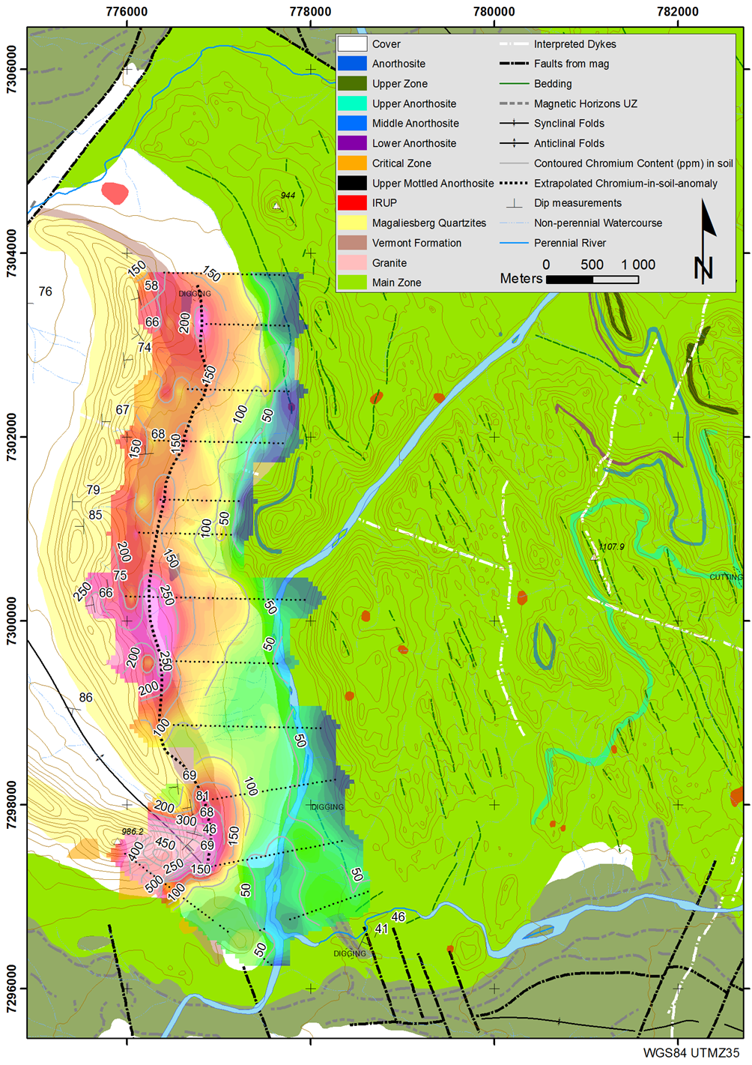

Appendix 2: Three-dimensional model of the Merensky Reef and UG2 Chromitite compiled in Geosoft Target

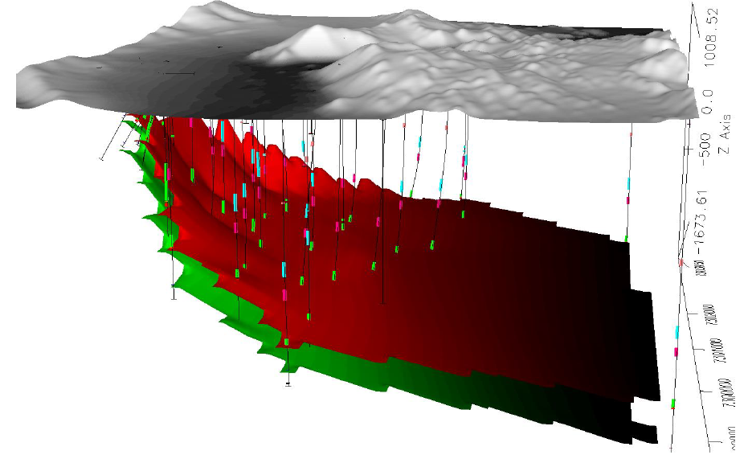

Appendix 3: Depth contour map created in Geosoft Target and imported into ArcMap

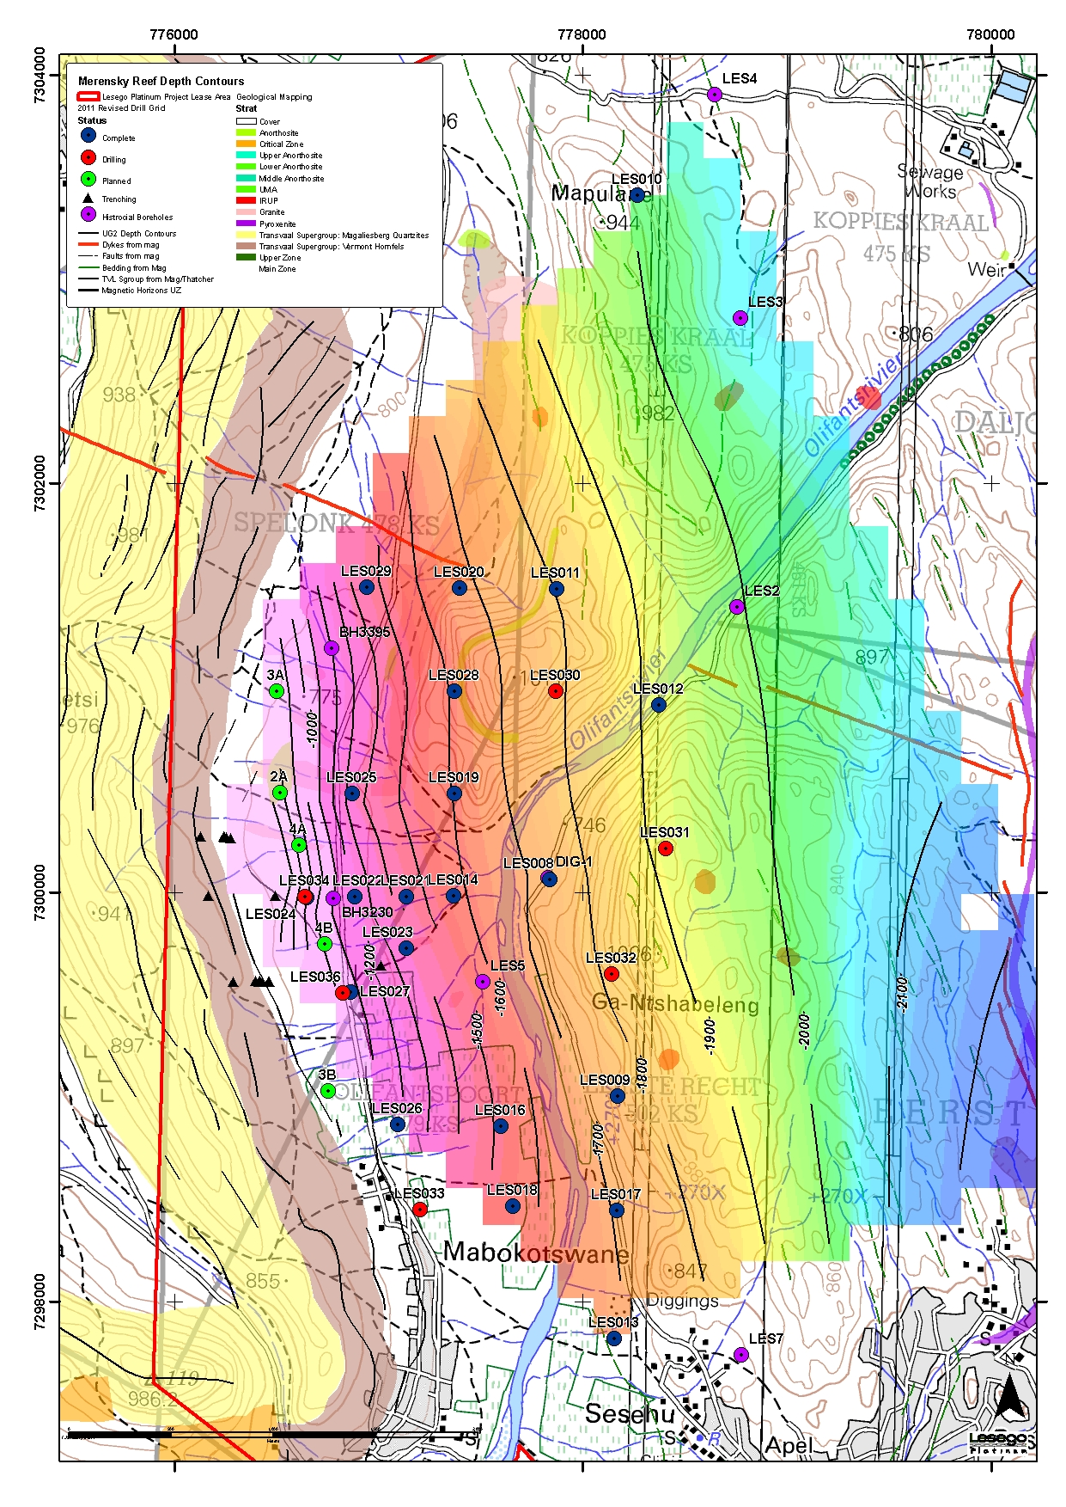

Appendix 4: Draft drill plan layout to determine Measured Resource based on initial Inferred Resource

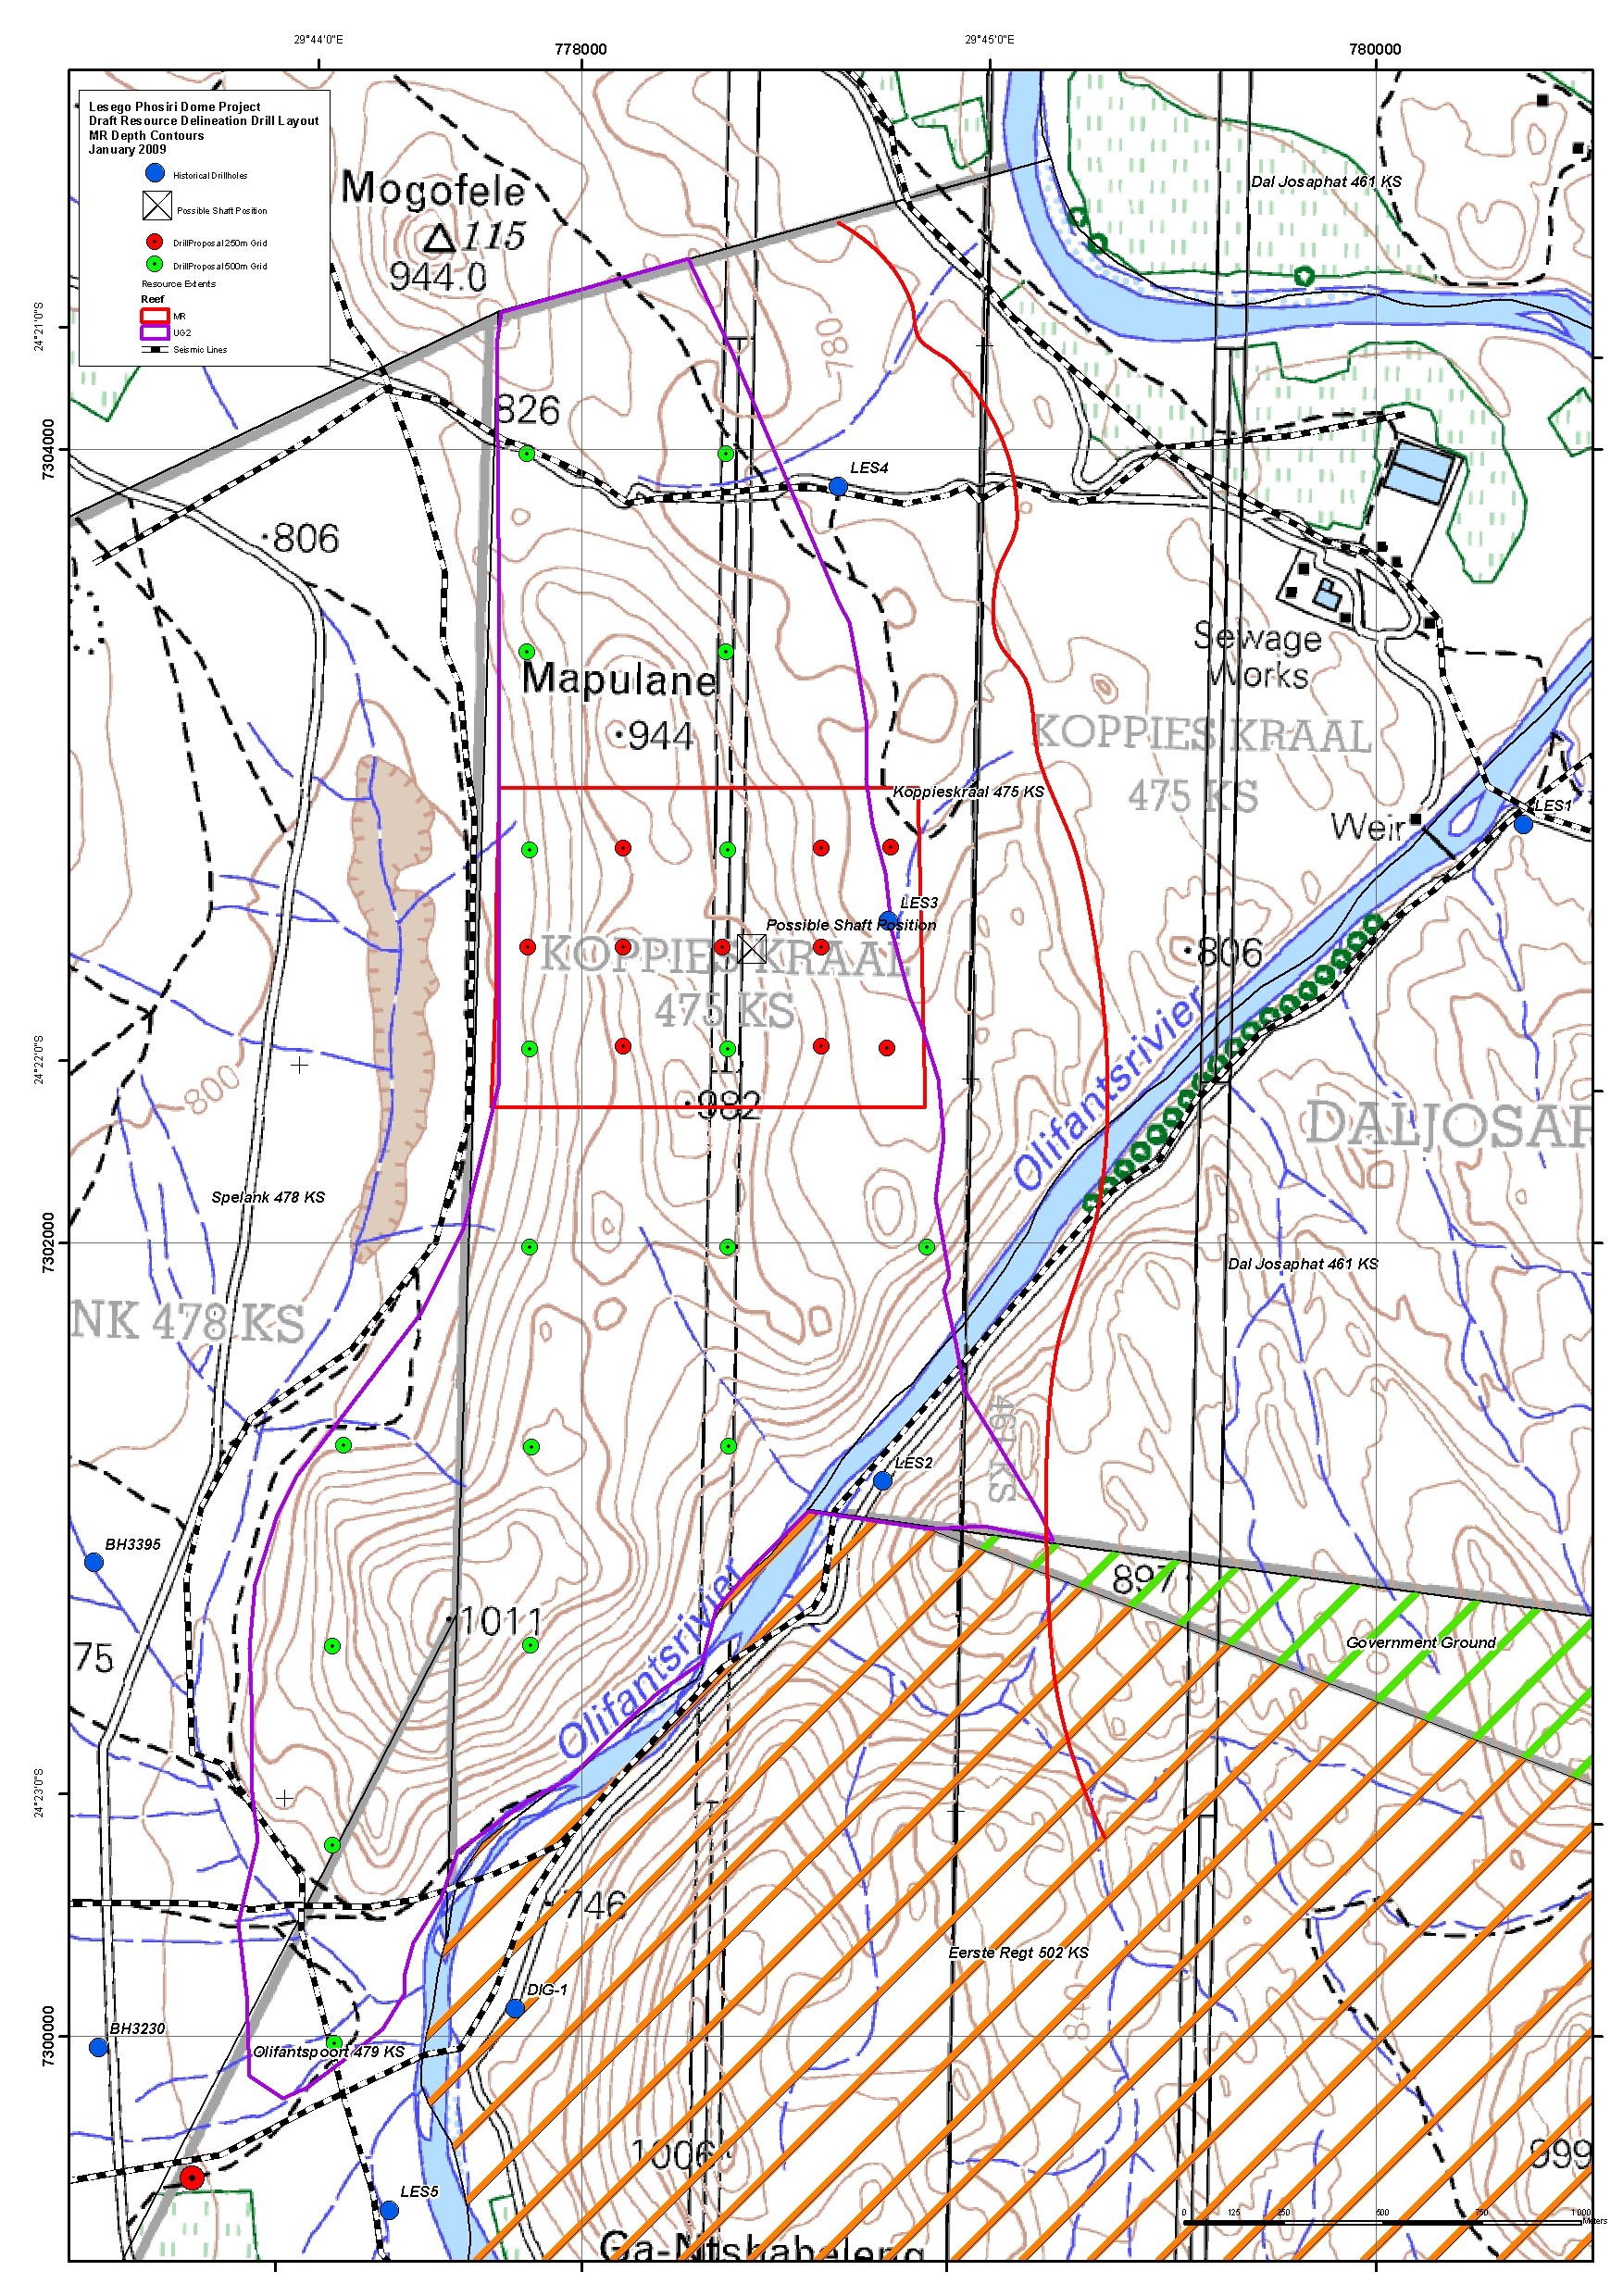

Appendix 5: Typical Cross section compiled by the author in Geosoft Target used to plan exploration drill holes to target the shallow resource from 1,200 to surface.

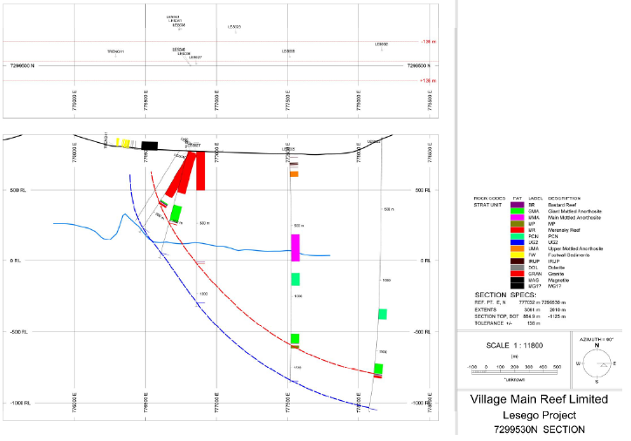

Appendix 6: In field borehole stratigraphic logs (compiled with project geologist)

Appendix 7: Selection of Optimised Reef Cuts for Resource Estimation

Appendix 8: Basket Price per Ton Comparison for Eastern and Northern Limb Mines and Projects

