WATER CONSERVATION AND WATER DEMAND MANAGEMENT PILOT PROJECT: THE CASE OF NEWCASTLE MUNICIPALITY

Submitted by:
Sandile Bonga Dube

A research report submitted to the Faculty of Engineering and the Built Environment, University of the Witwatersrand, Johannesburg, in partial fulfilment of the requirements for the degree of Master of Science in Engineering.

Johannesburg 2016

DECLARATION
I hereby declare that this research report, submitted for the degree of Master of Science in Engineering at the University of the Witwatersrand, apart from the help recognized, is my own work and has not formerly been submitted to another university for a degree.

______________
S. B. Dube

ABSTRACT
The Newcastle Local Municipality (NLM) has been experiencing water supply interruptions since 2010 due to high demand. Between June 2011 to December 2011, water losses ranged from 49% to 62% (about 23 to 30 megalitres per day) in Madadeni and Osizweni townships (Newcastle East). The suburban areas (i.e. Newcastle West) also experienced water interruptions due to collapsing and/or aging infrastructure. About a thousand households in Madadeni were involved in this study to find the cause of the high water losses. Awareness campaigns, repairing household leaks, installation of intelligent meters and the increase of free basic water in indigent households from 6kℓ to 12kℓ per month reduced water losses from about 246 kℓ to 177kℓ per month.
If similar Water Conservation (WC) and Water Demand Management (WDM) could be rolled out to the 35 000 households in the NLM and similar results to those in Madadeni are attained, conservative water saving of about 21Mℓ per day could be achieved. This would reduce the demand on the Ngagane Water Treatment Works (WTW) by 20%.

ACKNOWLEDGEMENTS
My gratitude goes to many individuals and institutions that have helped directly and indirectly throughout this dissertation. Without the interviews, support, assistance and information from the Newcastle Local Municipality (NLM), UThukela Water (UTW), the Department of Water Affairs (DWA), Nqabashe Consulting Engineers (NCE), this pilot project would not have been possible.
In particular, special acknowledgement is due to:
- The honourable Mayor Afzul Rehman, Newcastle Local Municipality (NLM), who made sure that all the necessary approvals required before initiating this study, including convincing the NLM council, were received timorously.
- Nkululeko Ncube, WSA Manager (NLM), who assisted in compiling technical data.
- Sisho Nkosi, Act CFO (NLM) who assisted with Madadeni and Osizweni household profiles.
- Ntando Khumalo, Revenue Enhancement Officer (NLM), who dedicated many hours providing a sincere and frank assessment of the community.
- The project would not have been possible without the financial support from the NLM and DWA. I would like to show my appreciation for this opportunity.
- I am grateful to my research supervisor Prof Adesola Ilemobade, for his guidance, advice and enthusiasm.
- Dr Forster’s support and advice is greatly appreciated.
- Lastly, but most importantly, I would like to thank my wife, Simphiwe Dube, for the support, guidance and valuable advice throughout this project and my studies.
TABLE OF CONTENTS
DECLARATION ii
ABSTRACT iii
ACKNOWLEDGEMENTS iv
LIST OF FIGURES vii
LIST OF TABLES viiI
LIST OF ACRONYMS x
1 INTRODUCTION 1
1.1 Background 1
1.2 Objectives 6
1.3 Locality 6
1.4 Socio-economic status of the Madadeni community 100
1.5 Socio-economic status of the Osizweni community 100
1.6 Scope of the study 111
1.7 Layout of the document 122
2 LITERATURE REVIEW 14
2.1 Definitions and insight to Acts…………………………………………………………...14
2.1.1 Water Conservation (WC) 14
2.1.2 Water Demand Management (WDM) 14
2.2 Seago, Mckenzie and Liemberger, 2007 16
2.3 CSIR, 2006 19
2.4 Herold, 2009 22
2.5 Wegelin, Mckenzie, van der Merwe and Maboyja, 2009 28
2.6 Still, 2006 31
2.7 Blue Drop (No Drop) regulation, DWA 2011 36
2.8 Water reconciliation strategy study for KZN, DWA 2010 367
2.9 Mwiinga, Gumbo and Mkoka, 2008 41
3 METHODOLOGY 48
3.1 Introduction 48
3.2 Assess High Water Usage from Braakfontein Reservoir 48
3.3 Identify Zones With Higher Water Usage 52
3.4 Awareness Campaigns Initiatives 53
4 THE DATA 555
4.1 Introduction 555
4.2 Water Consumption Data 555
4.2.1 Braakfontein Reservoir Data Collection 555
5 RESULTS AND FINDINGS 766
5.1 Introduction 766
5.2 Madadeni and Osizweni Water Consumptions 777
5.3 Subdivision of Madadeni into Zones 80
5.4 Madadeni Interventions 811
5.5 Awareness Campaign Results 86
5.6 Madadeni March 2015 Results 899
6 CONCLUSIONS AND RECOMMENDATIONS 94
6.1 Conclusion 944
6.2 Recommendations 955
6.2.1 Awareness campaign tools 955
6.2.2 Competition for municipal officials 955
6.2.3 School competitions 966
6.2.4 Community Awareness Meetings 977
6.2.5 Newcastle Municipality utility bills 977
6.2.6 Billboards for Advertisement 977
6.2.7 Print Media 977
6.2.8 Radio Station Slots 988
6.3 Indigent Register Review 988
6.4 Water Services By-Laws Review 988
6.5 Establishment of help desks/customer care offices 999
6.6 Smart Water Meters 100
7 REFERENCES 1011
APPENDIX 104

LIST OF FIGURES
Figure 1.1: Ngagane water system layout from raw water extraction to customer .3
Figure 1.2: Schematic layout of Newcastle Water Supply Scheme .5
Figure 1.3: Regional Local Map of Newcastle Local Municipality 6
Figure 1.4: Locality of Newcastle Local Municipality 8
Figure 2.1: Consequesnces of not achieving demand reduction in the Vaal River system 24
Figure 4.1: GPRS Logger at Osizweni Supply Meter 56
Figure 4.2: GPRS Logger at Madadeni Supply Meter 56
Figure 4.3: Bulk Meter Readings for Osizweni Area 57
Figure 4.4: Bulk Meter Readings at Madadeni Area 58
Figure 4.5: Madadeni Layout Map 60
Figure 4.6: Madadeni Zonal Layout Map 66
Figure 4.7: Madadeni Section A Layout Map 69
Figure 4.8: Madadeni Section B Layout Map 70
Figure 4.9: Madadeni Section C Layout Map 71
Figure 5.1: Modified IWA Water Balance 77
LIST OF TABLES
Table 1.1 Population and demographics for Amajuba Water Supply Scheme Area 9
Table 2.1 Historical Water Consumption for the Newcastle Water Supply Scheme Areas 41
Table 3.1 Madadeni Township – Settlement Demographics 49
Table 3.2 Osizweni Township – Settlement Demographics 49
Table 3.3 Domestic Water Demand for Developing Areas 50
Table 3.4 Domestic Water Demand in Developing Areas 50
Table 3.5 Non-Domestic Water Demand in Developing Areas 51
Table 4.1 Madadeni Domestic and Non-Domestic High Water Consumption Properties 62
Table 4.2 Madadeni Zonal Meter Readings 67
Table 4.3 Madadeni Section (A) Domestic Water Consumption 73
Table 4.4 Madadeni Section (B) Domestic Water Consumption 74
Table 4.5 Madadeni Section (C) Domestic Water Consumption 75
Table 5.1 Madadeni Domestic and Non-Domestic Water Demand 78
Table 5.2 Madadeni Zonal Meter and Individual Meter Consumption 81
Table 5.3 Madadeni Water Conservation Questioner 83
Table 5.4 MAA, MBA and MCD Technical Findings and Repairs 84
Table 5.5 Zones MAA, MBA and MCD Water Consumption Results and Savings 85
Table 5.6 Year 2012 vs 2015 Braakfontein Recommendation and Interventions 89
Table 5.7 Year 2012 vs 2015 Zones MAA, MBA and MCD Water Consumption Results 91
Table 5.8 Internal Repairs and Policy Amendments 91
Table 5.9 Awareness Campaign Strategies 92

LIST OF ACRONYMS
NLM | Newcastle Local Municipality
DWA | Department of Water Affairs
UTW | UThukela Water
NCE | Nqabashe Consulting Engineers
WMA | Water Management Area
WSA | Water Services Authority
WSDP | Water Services Development Plan
WTW | Water Treatment Works
WULA  WRYM | Water Use Licence Application  Water Resources Yield Models
NRW | Non-Revenue Water
WC | Water Conservation
WDM | Water Demand Management
WCDM | Water Conservation and Water Demand Management
IPRT | Independent Pricing Regulatory Tribunal
IDP | Integrated Development Plan
CBD | Central Business District
IWRM Integrated Water Resource Management
ILI Infrastructure Leakage Index
HDPE High Density Polyethylene
NWRS National Water Resource Strategy
PRV’s Pressure Reducing Valves
USC Utility System Corporation
MIG Municipal Infrastructure Grant
MWIG Municipal Water Infrastructure Grant
AMR Automated Meter Reading
BABE Burst and Background Estimate
WWTP Waste Water Treatment Plant
WWTW Waste Water Treatment Works
IBT Incline Block Tariff
WSSA Water Supply Scheme Area
UDF Urban Design Framework
NRWC Ncandu River Water Consortium
AWCIV Amajuba Water Catchment Information Verification
IWA International Water Association

INTRODUCTION
Under the Municipal Structures Act (No 117 of 1998), Newcastle Local Municipality was appointed as the Water Service Authority and in this capacity inherited the powers and functions of both the old Water Service Authority and Water Service Provider bodies. Under these responsibilities, the Water Service Authority has a duty to all consumers, potential consumers, in its area of jurisdiction to progressively ensure efficient, affordable, economical and sustainable access to water and sanitation.
The Water Services Authority (WSA) of the Newcastle Local Municipality (NLM) is privileged to have good water resources in the form of the Ntshingwayo Dam. This resource has adequately served the developed areas of the town and the surrounding areas for many years. The NLM’s ultimate goal is to link up all developed and rural areas throughout its jurisdiction with the bulk infrastructure connected to the Ntshingwayo Dam to ensure that all the communities have adequate, clean and uninterrupted water supply (WSDP, 2006). However, this is not the general national situation as: “South Africa is a semi-arid country with an average rainfall of 450 mm per year, which is well below the world average of about 860 mm per year. As a result, South Africa’s water resources are, in global terms, scarce and limited in extent” (DWA, 2004).

Background
Prior to July 2013, uThukela Water (UTW) was responsible for the bulk distribution of treated water throughout the Newcastle Municipal Area. However, following a reallocation of responsibilities in July 2013, Newcastle Municipality has assumed responsibility for the upkeep, operation and maintenance of all water reticulation infrastructures under its jurisdiction. However, UTW retains responsibility for the major water treatment facility at Ngagane and bulk distribution (WSDP, 2014). A study commissioned by the Department of Water Affairs (DWA) in 2010 estimated the losses in the Newcastle Water Supply Scheme Area (WSSA) and surrounding areas to be above 60%. These system losses were very high when compared to the national allowable norm of 10-15% (DWA, 2010). A further study by UTW in 2010 recorded water losses ranging from 70% to 92% (about 23 to 30 Mega litres per day) in Madadeni and Osizweni combined. Between 2010 and 2011, UTW operation teams attend to about 12 pipe bursts on average per week, which delays the scheduled maintenance implementation plan (UTW, 2012).
There are three raw water sources of supply to the Newcastle Water Treatment Works (WTW).
The main source of supply: the Ntshingwayo Dam, where raw water is extracted by means of two gravity pipelines, namely a 800 mm diameter pre-stressed concrete pipeline to the Newcastle WTW and a 700 mm diameter steel pipeline to the Ngagane WTW. There are a number of off-takes on the 700 mm pipeline, which supplies farmers, Silicon Technologies (Siltech) at Ballebgeich, a small village in Newcastle. The total capacity of the two raw water supply mains from the Ntshingwayo Dam was initially rated as 92 Ml/d (million litres per day), because of corrosion and problems with the lining of the pipelines. However, capacity was reduced to approximately 70 Ml/d (WSDP, 2011).
A second raw water source: a pump station and pipeline that abstracts water directly from the Ngagane River, downstream of the dam. This is a 600 mm diameter mild steel lined rising main that also delivers raw water to the Ngagane WTW. The maximum pipeline capacity is 20 Ml/d, and this was insufficient to meet the registered water use of 30 Ml/d (WSDP, 2011).
The third source of raw water: a gravity system at Schurwepoort from the Buffalo River that delivers a maximum of 10 Ml/d. This was built as an emergency measure during the 1982 drought (WSDP, 2011), and it is still currently in permanent use.
The total extraction of raw water is about 100Ml/d when taking all of the above raw water supplies into consideration.
There are three main supply zones in the Newcastle Water Supply Scheme Area (WSSA) namely:
- The Braakfontein Supply Zone, which includes Madadeni and Osizweni to the East,
- The Hilldrop Supply Zone, which includes the Newcastle Central Business District (CBD), Riverside Industrial and Arbor Park, and
- The Ngagane Supply Zone (which is supplied from the Clearwater reservoirs from the Ngagane WTW), which includes the Ekuseni Juvenile Prison.
Figure 1.1 illustrates the Ngagane water system layout from raw water extraction (source) to end user (customer). This layout shows how water reticulation occurs in Newcastle, from raw water, to treatment, to storage, and lastly, to customers.

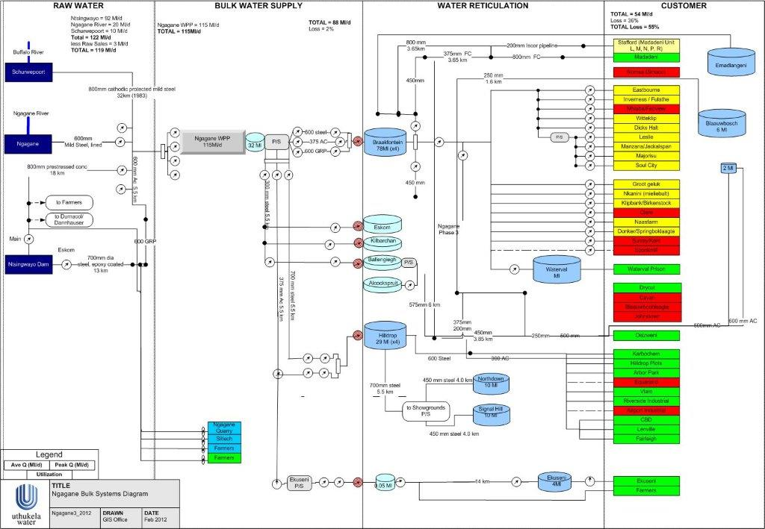Figure 1.1: Ngagane water system layout from raw water extraction to customer (UTW, 2012)

The Newcastle WSSA has a total storage capacity of 128.8 Ml, including the smaller reservoirs supplying the various water supply areas of the town (including Braakfontein that supplies Madadeni and Osizweni). The capacities of the tanks range from 2 Ml to 45 Ml and they are distributed throughout the various water supply areas. The storage capacity provides for a 35-hour storage based on UTW treated water production, but in summer months this reduces to approximately a 23-hour storage capacity, based on UTW water requirements (WSDP, 2011). The storage capacity of the Braakfontein reservoir is therefore significantly less than the accepted norm of 48 hours of summer peak requirement for urban areas (WSDP, 2011). WSDP states that the above norm was set to meet the following requirements:
- to balance the fluctuating demands of the distribution system, permitting the source to give a steady or differently phased output;
- to provide a supply during a failure or shutdown of the treatment plant, pumps or bulk mains leading to the reservoirs; and
- to provide a reserve of water to meet fire and other emergency demands.
Additional storage capacity is therefore required to meet 2016 and future summer peak requirements. Adding to the storage capacity constraints is the 2014 water demand of 110-115 Ml/d, which is well above the water supply of 105 Ml/d (UTW, 2012). Figure 1.2 provides a detailed schematic layout of the NLM water supply scheme, indicating all the rivers that supply raw water to NLM.
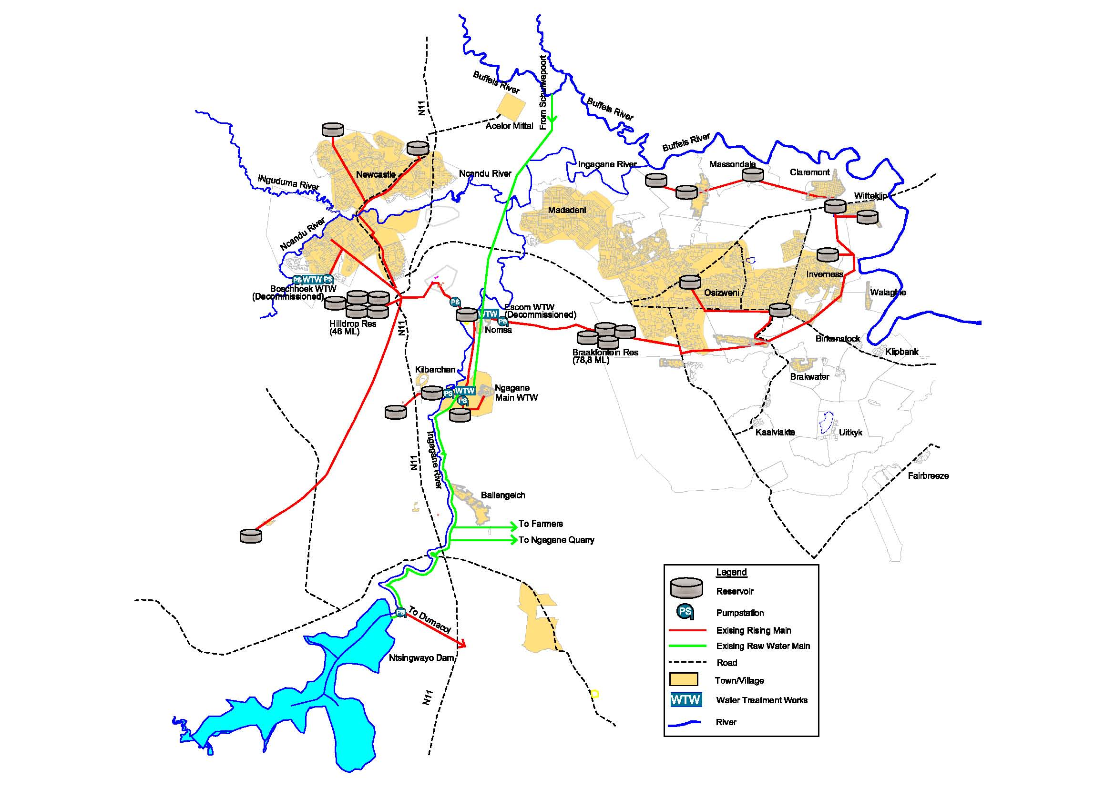
Figure 1.2: Schematic layout of the Newcastle Water Supply Scheme (UTW, 2012)

Objectives

In 2011, the Executive Committee of NLM provided funds for a pilot project as part of a Master’s degree research project. The specific objectives of the project where:
- To assess water usage from Braakfontein to Madadeni and Osizweni
- To identify zones with high water usage through evaluating water consumption in a sampled zone.
- To employ water awareness campaign initiatives prior to and subsequent to WC/WCDM reduction measures

Locality
Figure 1.3 illustrates the location of NLM, it is located between Durban and Johannesburg. NLM is the last town on the west of KwaZulu Natal towards Mpumalanga.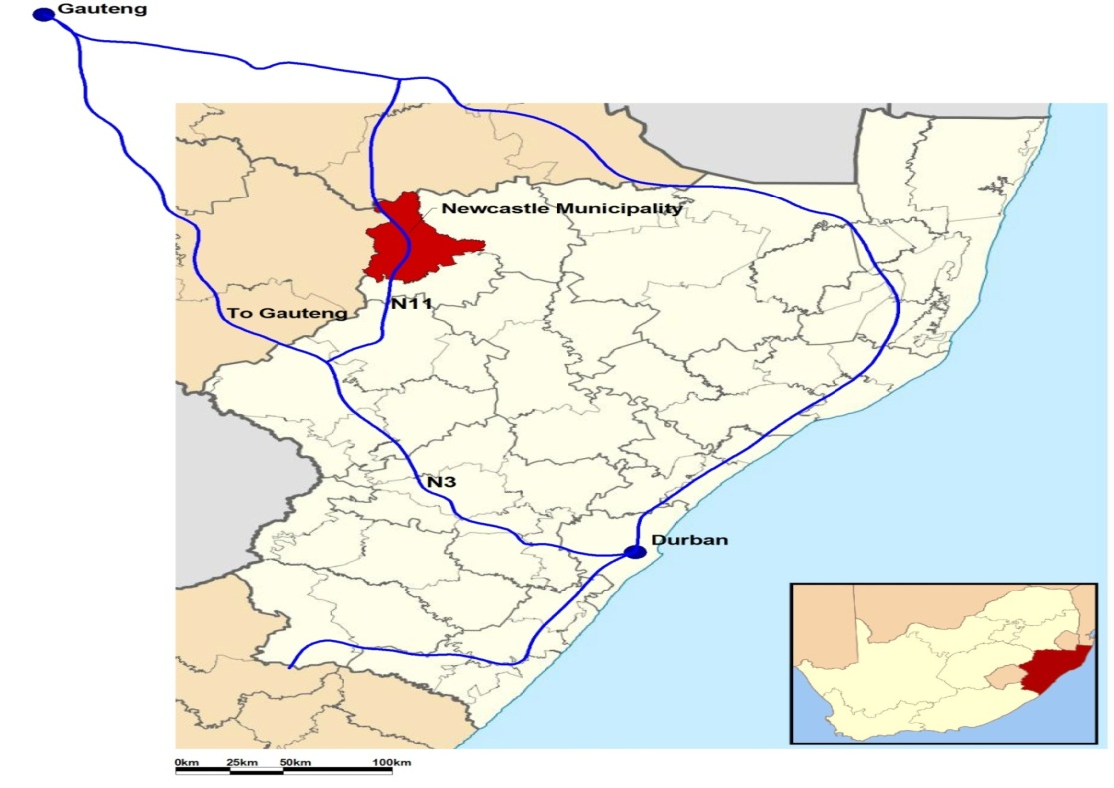Figure 1.3: Map of Newcastle Local Municipality (IDP, 2011)
NLM is the third largest urban centre in KwaZulu-Natal, South Africa It is categorized as a secondary city and is the biggest municipality within the Amajuba district (Stats SA, 2011). The discovery of coal introduced a new era of prosperity to the town and several ambitious building projects were planned for Newcastle during the late 1900’s (IDP, 2011).
Many jobs were created and the workers were mainly black Africans who resided in the first township in Newcastle, called Madadeni. Infrastructure backlogs were more evident in the NLM townships than in the suburbs. These backlogs were mainly related to tarred roads, electricity connections, water reticulation and proper sanitation (IDP, 2011).
This study concentrated on Madadeni due to high water losses recorded by UTW’s (2010-2012) monthly reservoir readings. Madadeni is currently one of the two local townships in the NLM area. It includes 380 houses in Section 2 that still used the old toilet cisterns, which resulted in water running 24 hours per day (WSDP, 2011). This observation confirms the findings contained in the IDP (2011). Madadeni is located approximately 15 km east of the Newcastle CBD. Figure 1.4 illustrates the location of Madadeni in relation to Newcastle CBD. Madadeni is in close proximity to Osizweni Township, and the urban centre of Utrecht in the east is about 40km from Newcastle CBD

Figure 1.4: Locality of Newcastle Local Municipality (NLM, 2011)
The total population of Newcastle was estimated to be 327 637 in 2007, of which 28% reside in Madadeni (Stats SA, 2011). The NLM had an average annual growth rate of 3.5% between 2007 and 2009 compared to the provincial year-on-year growth of 2.8% (Stats SA, 2011). In the periods mentioned above, the NLM experienced an influx of people. This is evident from the increase in the population within the informal settlement, and the increase in the number of occupied residential buildings (IDP, 2011). The increase in population has put strain on NLM infrastructure, making it impossible to properly address the already existing backlogs. Table 1.1 illustrates the historical and projected population numbers for the WSSA of the Amajuba District from 2008 to 2030 (DWA, 2010).
Table 1.1: Population and demographics for Amajuba Water Supply Scheme Area (DWA, 2010)
Growth Scenarios | 2008 | 2010 | 2015 | 2020 | 2025 | 2030
High growth scenario | 466 133 | 520 021 | 663 693 | 827 082 | 1 006 272 | 1 166 544
High growth scenario |  | 5.62% | 5.00% | 4.50% | 4.00% | 3.00%
Median growth scenario | 466 133 | 502 529 | 589 673 | 679 455 | 770 617 | 850 823
Median growth scenario |  | 3.83% | 3.25% | 2.88% | 2.55% | 2.00%
Low growth scenario | 466 133 | 485 827 | 523 373 | 556 912 | 588 222 | 618 227
Low growth scenario |  | 2.09% | 1.50% | 1.25% | 1.10% | 1.00%

Socio-economic status of the Madadeni community
The total number of households in Madadeni is estimated at 20 886 with the number of people living there estimated to be 102 435. The average household size was estimated at 4.9 (NLM, 2011).
Madadeni is approximately 14km from the city centre and about 5km from the industrial area. The distance to the industrial area is closer which assisted the low income earners to walk to work
The Madadeni CBD Urban Design Framework (UDF), 2011 estimated the unemployment rate within Madadeni at 27%. The high unemployment rate can be attributed to a number of factors, including a high rate of illiteracy, the decline of coal mining and textile activities and the downsizing of ISCOR (an industrial company) in the Newcastle area.
Madadeni is generally a low income community with about 6 315 households living in dismal poverty as they do not have any income at all (NLM, 2011). It is assumed in this report that the majority of these households form part of the municipality’s indigent population and receives welfare grants from the government.
People with no income, who do not receive welfare grants make up 31% of the Madadeni community. Most other people fall within the R1 601-R3 200 or R6 401-R12 800 income per month. This is the middle-income bracket of the economy (NLM, 2011).

Socio-economic status of the Osizweni community
The total number of households in Osizweni is estimated at 24 356 with the number of people living there estimated to be 119 343. The average household size was estimated at 4.9 (NLM, 2011).
The Osizweni CBD Urban Design Framework (UDF), 2011 estimated the unemployment rate within Osizweni at 31%. The high unemployment rate can be attributed to a number of factors, including a high rate of illiteracy, the decline of coal mining and textile activities and the downsizing of ISCOR (an industrial company) in the Newcastle area. Osizweni is approximately 30km from the city centre and about 20km from the industrial area. The higher travelling costs made it difficult for low income earners to afford travelling to work.
Osizweni is generally a low income community with about 8 519 households living in dismal poverty as they do not have any income at all (NLM, 2011). It is assumed in this report that the majority of these households form part of the municipality’s indigent population and receives welfare grants from the government.
People with no income, who do not receive welfare grants make up 35% of the Osizweni community. Most other people fall within the R1 601-R3 200 or R6 401-R12 800 income per month. This is the middle-income bracket of the economy (NLM, 2011).

Scope of the study
The following activities were carried out as part of this research project. Each activity listed below relates to each objective described above:
Objective 1: To assess water usage from Braakfontein to Madadeni and Osizweni townships;
Scope related to objective 1
  - Bulk lines supplying Madadeni and Osizweni were assessed for water meters, or where water meters were deemed unreliable, clamp-on water meters were used as a temporary measure for the period.
  - Bulk water meters were read at specific times to identify and compare the demand for the supply area in order to determine the area with the high water usage. This provided a holistic view of the demand through a full week cycle. The information gave a clear understanding of peak times during the week and weekends.
  - The bulk line with high water usage were isolated and further investigation was carried out to determine the reasons for high water usage.
Objective 2: To identify zones with high water usage through evaluating water consumption in sampled zone
Objective related to objective 2
  - The bulk water supply area with high water usage was separated into manageable zones.
  - Zones with higher water usage were grouped into about thousand (1000) households.
  - 1000 household meters were assessed, where water meters were found to be old and non-functioning, new intelligent meters that can detect tampering and are able to remotely control the allowable household water usage were fitted.
  - The water usage for all 1000 households was recorded and any abnormal usage was assessed further.
  - If the abnormal usage was due to tampering, leaking pipe and/or illegal connections, these were repaired.
  - Readings were captured per subdivided zone to determine if there were any significant water savings before and after repairing.

Layout of the document
This report consists of six chapters and two appendices which are organized as follows:
Chapter 1 provides an introduction of the thesis, background information on the research and the motivation for this research. The aims and objectives of this research are outlined in this chapter.
Chapter 2 presents the literature review of previous work on Water Conservation and Water Demand Management and evaluates different water schemes in and around Newcastle area.
Chapter 3 describes the methodology followed to address each objective.
Chapter 4 presents the analysis of the data collected and used in this study.
Chapter 5 provides an in-depth summary of all the results and Chapter 6 concludes by providing the findings of the study. This chapter also provides recommendations for future work and implementation of WC/WDM.
Appendix A presents all the results that were obtained during the data analysis. Appendix A is provided electronically on a CD-ROM as the size makes it impractical to provide a hard copy.
Appendix B presents a water conservation questioner template form utilised in Madadeni survey

LITERATURE REVIEW
Various studies have been undertaken on WC/WDM within the South African context. The challenges, however, have been evident in the implementation of the findings. The most current study (2015) is war on leaks programme which is the Department of Water and Sanitation (DWS) flagship project aimed at reducing water losses through fixing leaks in all municipalities in South Africa. In doing this literature review, it was important to commence by seeking understanding of the important concepts in this study that is the WC/WDM. The discussion below therefore, explains concepts of WC/WDM and the regulatory and governance requirements to ensure a breakthrough in the implementation and monitoring processes.

Definitions and an insight to Acts promulgating the Water Conservation and Water Demand Management

Water Conservation (WC)
WC can be defined as the “minimization of loss or waste, care and protection of water resources and the efficient and effective use of water” (IPRT, 1997). This definition emphasizes the importance of adopting a holistic approach to address water loss challenges. This approach entails a broad status quo analysis, strategic direction and efficient and sustainable measures to ensure long-term monitoring and evaluation of WC/WDM.
According to the Independent Pricing Regulatory Tribunal (IPRT) 1997, WC should be perceived and understood as an overall principle that requires the effective management and protection of water resources. This implies that WC should be considered both as an objective in water resource management and a strategy for a water service institution. Furthermore, irrespective of the WDM objectives, it is necessary to also have long-term WC objectives that recognize that South Africa is water scarce and water stressed country.

Water Demand Management (WDM)
WDM can be defined as the “adaptation and implementation of a strategy by a water institution or consumer to influence the water demand and usage of water in order to meet any of the following objectives: economic efficiency, social development, social equity, environmental protection, sustainability of water supply and services, and political acceptability” (IPRT, 1997).
The IPRT 1997, stresses that WDM should not be regarded as the objective but rather a strategy to meet a number of objectives. One of the reasons pointed out by IPRT 1997 on why the full potential of WDM is often not recognized is that, it is frequently perceived or understood in a limited context. It is common for people to equate WDM only to programmes such as communication campaigns or tariff increases. WDM should equate to the development and implementation of strategies and measures associated with managing water usage.

    - Regulatory and Governance requirements on WC/WDM
The one critical aspect of the WC/WDM is the existing and proposed regulatory and governance requirements to ensure the implementation of WC/WDM by a Water Service Authorities. The Water Service Act (Act 108 of 1997) and the National Water Act (Act 36 of 1998) emphasize the following:
      - Existing requirements promulgated in terms of the Water Services Act (1997)

The Water Services Act (1997) states the following:
- “WSA [are] to meet the WC/WDM requirements as specified in the guidelines of the WSDP.
- WSA [should] comply with the proposed regulations and standards in terms of Section 9(1) and 73(1) (j) of the Water Services Act.
- WSA must adopt bylaws and supply conditions for their consumers that include Water Conservation and Water Demand Management (WCDM) requirements”.

      - The proposed requirements in terms of the Water Services Act (1998) state that the:
- “WC/WDM requirements within the WSDP guidelines should be expanded to also include a submission of a WC/WDM strategy according to the model strategy specified.
- Introduce a regulation requiring WSAs to contribute their WC/WDM strategies to Water Boards or any other bulk supplier in order to facilitate the establishment of a regional WC/WDM strategy and demand targets.
- Review the proposed Water Services Regulations and standards in terms of Section 9(1) and 73(1) (j) of the Water Services Act every 5 years.”

      - Existing requirements prescribed by the National Water Act (1997) state that purpose of this act is to:
- “ensure that the nation and water resources are protected, used, developed, conserved, managed and controlled in ways which take into account amongst other factors”
  - “Promoting equitable access to water;
  - Providing for growing demand for water use;
  - Meeting the basic human needs of present and future generations;”
There are also various economic tests that should be considered before deciding on any WC/WDM initiative and these should include environmental and even political costs if possible. Some of the economic tests developed by the IPRT of New South Wales (Australia) in 1997, include:
- Participating customer test
- Water institution test
- Total resource cost test

Benchmarking of leakage from water reticulation system (Seago, Mckenzie and Liemberger, 2007)
The objectives of the study
This study provides a brief outline of the standard International Water Association (IWA) methodology for assessing real losses and discusses the Infrastructure Leakage Index (ILI) in some detail. It also summarizes the data collected and collated to date from numerous Water Utilities around the world. The data were collected by various leakage management specialists who have been working together for many years as part of a larger IWA initiative and it was their attempt to present the results in a concise manner.
The study provides Water Utility managers with a target against which they can compare their own performances regarding leakage from their systems. Issues and suggested solutions unique to South Africa are also discussed. Latest developments with regard to leakage assessment are presented, including some brief details of new software and the internet-based data management system currently being developed for use in South Africa.
The activities performed in the study to address the objectives
The study makes a statement that ILI is sometimes criticized for being too simplistic and not incorporating some of the key factors which can influence leakage from a water distribution system. This is supported by the discussion which has been summarized in the main points of discussion below:
- ILI values of less than 1.0 should not occur since this implies that the actual leakage is less than the theoretical minimum level of leakage.
- The Unavoidable Annual Real Loss (UARL) equation is too simplistic as it is based only on the length of mains, number of service connections, length of underground pipe from the mains to the point of metering and the average system pressure.
- The use of the ILI in cases where a Water Utility operates under either abnormally high or unusually low pressures.
- The use of the ILI for systems with less than 2000 connections.
- Updating of the ILI parameters as more reliable information becomes available.

While all of the above points are clearly valid concerns and can be debated at length, the ILI has proven to be extremely useful in South Africa even in instances where it is used outside the normally acceptable limitations. In such cases, it must obviously be used with caution and the results should be considered as indicative rather than totally rigorous. Some of the key issues addressed in the South African context are discussed below.

Bulk Storage: This study suggests that bulk storage is often a major source of leakage. This includes the overall water balance. The system input volume for many water supply systems in South Africa is measured before the bulk storage reservoirs and towers. For this reason Utilities are requested to provide their operational capacity of all bulk storage that occurs after the bulk system input meter. A volume is then assigned to the losses through bulk storage depending on how the Utilities rate the condition of their bulk storage. In this manner the losses from the storage facilities are included in the water balance and form part of the real loss calculation. It is important to only include bulk storage in the water balance if the system input volume is measured before the bulk storage.
Systems with less than 2 000 Connections: There has been considerable debate recently (Lambert, 2005) regarding the minimum size of zones that should be evaluated with the ILI calculation. In South Africa, many smaller systems have been included in cases where the areas are completely homogeneous and are fully residential in nature. Some of the key issues addressed in the South African context are accessible and acceptable pressure range.
The highlights and conclusions of the study
The study presented here by Seago et al (2007) discusses models that have been developed and customized for use in many countries throughout the world to assist water utilities in the evaluation of their levels of leakage and NRW using BENCKLEAK software. This software provides water utility personnel with targets against which they can compare their own performances regarding leakage from their water systems.
Of critical importance in this study is the outline of the standard International Water Association (IWA) methodology for assessing real losses and the detailed discussion of Infrastructure Leakage Index (ILI). Issues and suggested solutions unique to South Africa are discussed, including brief details of the new software and internet-based data management systems currently being developed. It is, however, a general statement on their part to expect that the South African Localities would have same if not similar bulk water challenges.
South African water problems mainly occur in local municipalities, and are to some extent based on a fixed monthly tariff linked to the turbulent history of the country. Seago, et al. (2007), point out that the flat rate is used in most township areas where water bills are sent to consumers based on a fixed monthly tariff, which in turn is calculated on the basis of an estimated average monthly use.
In the case of the NLM, there has been a shift away from the use of flat rate to Incline Block Tariff (IBT), which is a concept that simply means that the more an individual consumer uses, the more they will pay, thereby encouraging people to use less water. Furthermore, a free 6kℓ for indigents and now 12kℓ average policy has been introduced for indigents. This is linked to the South African Government policy of providing a free basic water allowance to all properties.
Seago, Mckenzie and Liemberger’s paper offers another important indication. It forms the basis of the NLM’s shift from the use of flat rate. They mention that the major challenge experienced in SA is the fact that the estimated average consumption on which the monthly account is based, tends to be significantly lower than the actual average consumption.
There is still, however, a need to focus more on water that is unaccounted for because there are still households without water meters. This will give a clear indication of what can be categorized as revenue water and what is recoverable revenue and unrecoverable revenue. The main parameters influencing the apparent losses in South Africa are illegal connections, data transfer errors and inaccuracies. The issue of illegal connections is prevalent in the less formal urban areas and areas that are still under traditional leadership. These are usually low income areas within the NLM.
A critical discussion here has been the water audit model based on IWA best practice, which is Aqualibre, and traditional Burst and Background Estimate (BABE) methodology. The ability to assess real losses based on the number of bursts occurring in the system and the associated running times, among other things, are important. Water auditing is an important area that NLM still has to research and implement.
The concluding remarks here are that the ILI is a very helpful indicator that can be used to assist water utilities to identify zones of high water leakage within a larger distribution system.

The state of municipal infrastructure in South Africa (CSIR, 2007)
The objectives of the study
This study by CSIR 20067 was intended to explore into the state and performance of municipal infrastructure, the state of its maintenance, and the underlying causes of this state of maintenance, which has been under way since 2001.

Their aim was to identify measures that could be taken to improve the maintenance of municipal infrastructure, and then to initiate or facilitate a process whereby the necessary actions could be taken by appropriate role-players. One of the first discoveries of study was the affirmation that a large number of municipalities have limited or no knowledge of even the extent and capacity of the infrastructure assets they possess, and in cases where there is some information it was found to be patchy and unreliable. On these bases CSIR 2007 concluded that, many municipalities are not conforming to the requirements of the Municipal Finance Management Act (MFMA), Municipal Systems Act (MSA) and other legislation that requires them to ensure that adequate provision is made for the long-term maintenance of their infrastructure assets.

Within the context of the immense amount of municipal infrastructure, and the often poor records that have been kept of its extent and generally even poorer records of its condition), the CSIR undertook a limited investigation into the state and performance of infrastructure and its maintenance.

The activities performed in the study to address the objectives

This study is based on the direct professional experience of the CSIR team and on the findings of investigations.

The study undertook a sector by sector overview looking into the poor physical condition of specific categories of municipal infrastructure, with consequences for the quality of service delivery, this is illustrated in the points below;

1. Water treatment
According to this study, the most important indicator of the performance of water treatment plants is the quality of water entering the water reticulation system, the standard for which is laid down in SABS 241-2001 "Drinking water". It is the most common immediate cause of water quality not meeting required standards is a breakdown of plant and/or the length of time that it takes to have that plant repaired satisfactorily and for it to resume correct working. The most common causes of plant breakdown typically include inappropriate plant, faulty operating procedures, and lack of routine maintenance.

The study therefore made a conclusion that the subsequent lack of maintenance coupled with no control over the high levels of informal connections means that the majority of Municipalities are no longer capable of providing a consistent daily basic water supply. Thus a large number of such Municipalities are not going to be able to provide services to their indigent communities without considerable financial support from national government. Perhaps the conclusions suggested here are indicative of the need for an indication or a measure to guide the budget by the South African National Government towards a once off upgrade for indigent support to Municipalities.

2. Water reticulation

This study indicated that the most common problems experienced with water reticulation systems are leakage of water. A variety of reasons could contribute to this, including the use of incorrect procedures at the time of laying the pipes, damage due to excavations taking place near to pipes, use of inappropriate pipe materials (and their consequent corrosion), inappropriate repair procedures, and the ageing of the pipes. Illegal connections exacerbate the situation.
The study went further to establish the extent of water leakage in South Africa, an analysis of leakage data from water reticulation systems operated by thirty (30) South African water services providers was compared with international norms. Of the thirty, just over half (16) reported higher leakage ratios than the average calculated by the IWA for 27 supply systems in 19 countries. Seven of these 16 reported leakage ratios double or more than double the international average.

The study suggests that there have been numerous investigations into water leakages in specific municipal areas, including for example:

- A study of part of a Gauteng municipality found that the minimum night flow (when households should be using very little water) was 72% of the average flow, which is very high compared to a well-managed system of between 10 and 30% (Rand Water 2003);
- A study in a Northern Cape municipality found that 78% of the water supplied from the town reservoirs to the system in the middle of the night as a whole was lost to leakage. When the supply was directly pumped from the water treatment works (and the pressures are higher), 81% was lost to leakage (IMESA 2004:49);
- A study in another Northern Cape municipality calculated that savings of 80% of the water supplied could be made by repairing those leaks in mains and on properties that it would be economically feasible to repair, metering of all properties and public water supply points, and pressure management (DWAF 2002:25).

The highlights and conclusions of the study
While the CSIR 2007 assessment highlighted numerous shortfalls in the maintenance of municipal infrastructure, some municipalities around the country have achieved significant success in improving the maintenance of their infrastructure and even restoring it.

The study concluded that several systemic issues contribute to infrastructure maintenance in South African municipalities, ranging from best practice through to the unacceptable. In many municipalities, budgets and staffing policies are severely inhibitive of sound infrastructure maintenance, thereby placing much infrastructure (including a significant proportion of that commissioned since 1994) at risk. The great majority of municipalities are not making adequate provision for the long-term preventive maintenance, refurbishment and eventual replacement of their infrastructure. It is clear that many municipalities will not be able to improve their maintenance policies and practices without strong direction and assistance from national government. If municipal infrastructure maintenance is to be adequate, a great deal should be done.
In conclusion, South Africa is said to have many instances of adequate infrastructure and service delivery, but also an increasing proportion of deteriorating infrastructure, together with poor and often unacceptable quality of services. The areas found to be more severely challenged are the rural municipal areas. There is still more to be done to improve municipal maintenance policies and plans.

Water crisis in South Africa (Herold, 2009)
The objectives of the study

This study seeks to address the question “Are we facing a water crisis similar to the energy crisis?” Several discussions with key role players confirmed that there are indeed a number of challenges that can be described no other way than as crises that have to be resolved with great urgency.

The key concerns on the study question are listed below as the objectives of this study:
- Mismatch between water supply and water demand
- Theft of water resources
- Failure to achieve demand management targets
- Decaying infrastructure
- Deteriorating water quality
- Loss of essential skills
- Strangling of educational pipeline.

The study is premised on the following statements and assumptions:
- Published statement indicating that by 2013 the water demand in the Vaal River system would exceed the available yield. What is not commonly known is that this is based on achieving a 15% saving in water demand.
- To date no noticeable saving has been realized. The next raw water augmentation will not take effect in less than 10 years.
- Moreover, the theft of expensive imported water by farmers in the Upper Vaal catchment has effectively reduced the system yield by 175 MCM p.a., plunging us immediately into a supply deficit in the region supporting half of the GNP of the country.
- Water supply mismatches are also evident in other parts of the country, notably the strategic Umgeni system, which has been in deficit for over a decade.

Herold, 2009 illustrates on the consequences of not achieving demand reduction in the Vaal River system represented graphically below (DWA, 2009) Figure 2.1

Figure 2.1: Consequences of not achieving demand reduction in the Vaal River system (DWA, 2009)

Herold (2009) indicate that the consequences of not achieving demand in the Vaal River is not so much planning problems, but as failure to achieve the demand savings on which the plans were based. Herold (2009) summarizes the following as potential cause:

- Huge amount of water is loss through decaying distribution systems, with further leakage in consumer systems. At the same time widespread sanitation failure is threatening the well-being of users and the environment.

- Underlying all of these crises is the widening loss of essential skills. Over the last decade and a half the municipal sector has lost six-sevenths of its engineers and technicians, rendering most outlying municipalities impotent to deliver even the most rudimentary services. The loss of skills is also creating a widening middle management gap that is starting to unravel the bigger institutions.

- The erosion of maths and science education in secondary schools is also throttling the professional education pipeline, threatening even bigger future crises.
According to this study, despite being of huge proportion, all of these problems can and must be solved. There is great urgency to address the immediate big problems. There is an equally urgent need to deal with the longer term, but potentially much more devastating educational issues
The activities performed in the study to address the objectives
Most of the problems identified in this study require long-term strategies and action plans. The study suggests the following:

- Supply side provision
It is essential to ensure that Phase 2 of the LHWP proceeds on schedule and that Spring Grove Dam is expedited.

- Eradication of water theft
This study suggests that no effort should be spared in speeding up the eradication of the water theft in the Upper Vaal River catchment. Use of the media should not be discounted, plus enlisting the opinion of other famers who would be adversely affected by water restrictions. It further indicates that consideration should also be given to making civil cases against recalcitrant farmers to sue for damages to recover the full cost of the water theft.

- Accelerate WDM / WC initiatives
Herold, (2009) suggests a great urgency to get demand management initiatives operational. It is understood that large sums of money have been allocated for this purpose. This is necessary to deal with the maintenance and refurbishment backlogs. Moreover water revenues have to be strictly ring-fenced to ensure that in the future sufficient allocation is made to fund the all-important routine maintenance and refurbishment programmes.

- Build capacity in Local Authorities
The study suggests that there is an urgent need to build capacity at every level in local authorities and ensure that the WDSPs are produced in time, the water supply infrastructure is maintained and refurbished and that household water leakage and water theft is curbed. This will require active recruiting and substantial improvement in service conditions, including attractive salaries and sufficient status to affect the decision making process.

- Build capacity in DWA
Here the study indicated an urgent need to improve service conditions for professional engineers and scientists in DWA to save the organization from crippling loss of essential middle and top management skills. It is essential to make salary scales and service conditions attractive at every level, doubling of salaries at the entry level might be appropriate and clear growth paths should be established for all competent personnel.

- Refurbish and maintain aging bulk water infrastructure
Herold 2009, makes a proposal for the initiation of programmes for the systematic maintenance of bulk water infrastructure and the necessary funding to be secured.

- Flow monitoring and feedback
Herold 2009, suggests the importance of the rebuild of the capacity to run and interpret flow monitoring systems to ensure that future theft of the resource is identified and dealt with timeously.

- Establish Waste Discharge Charge System
The study suggests that the Waste Discharge Charge System should be established as soon as possible, but be kept simple to implement and manage.

- Implement effective sanitation
Every effort should be made to establish effective sanitation systems in all LAs and to empower proper management (Harold, 2009). This requires the complete buy-in of local politicians, strict control of funding and transparent accountability and may require the removal of ineffective or corrupt managers. Central monitoring and public feedback, such as the blue drop and green drop accreditation are valuable moves in this regard.

- Revamp maths and science education
This study provides recommendations towards education system; as follows; every effort should be made to impress on the Department of Education the damage that they are inflicting on the economy and the urgent need to overhaul maths education in secondary schools with a view to utilizing the full potential of learners. Further, it is essential to raise the bar for teachers to ensure the necessary improvement in education standards; the remuneration of good maths and science teachers should be radically increased and good quality career guidance should be provided, at least from grade 9, to ensure that scholars can make properly informed choices of matric subjects.

- Open up and collaborate
The study concludes by making recommendations directed to DWA, indicating that based on the fact that capacity is currently in a critical condition and the length of time required rebuilding it, it is essential to use the human resources at our disposal to their fullest potential.
The imperative for transparency in DWA cannot be over stated. The public has the right to know about the decisions that affect their and their children’s future.

The highlights and conclusions of the study
Harold’s paper provides insight into the water challenges in South Africa. These include, but are not limited to the mismatch between water supply and demand, decaying infrastructure, deteriorating water quality and failure to achieve demand management targets.
Harold 2009, makes an important observation when stating that the underlying factor to South Africa’s water challenges is the increasing loss of essential skills as over the last decade. The municipal sector has lost engineers and technicians, especially in the rural areas. This creates a gap in middle management, which is bound to worsen the situation.
Harold 2009, puts much emphasis on the point that there is a water supply and demand mismatch. As an example, statistics from the Vaal river system indicate that this water system is already in deficit by about 2%, and the water theft quadruples this to a very significant 8%. This confirms that the system is definitely in deficit.
In many similar cases, demand is always increasing, yet it is not monitored, which not only puts pressure on the water system, but may lead to failure of that system. Demand management failure and the need to balance water demand and water supply attributes to ensure a constant balance also call for infrastructure maintenance.
National Water Resources Strategy (NWRS) was discussed as an important element that should address the availability of the resource and the steps to be taken to meet demands and even to indicate instances where demand cannot be met. In essence this would merge the WC and water demand functions, ensuring that there is a balance.
The study concludes with an emphasis on highlighting the prevalence of the so called well known challenges related to WC, WDM and NWRS. An indication is made that, there are also challenges and or shortcomings with the strategy to date. Ideally the strategy is meant to give a directive on what should happen. However, at the moment authorities are only reactive, so the WC and WDC challenges still persist. This is evident in the two river systems discussed here, namely the Mngeni and Vaal river systems.

The Emfuleni water loss project (Wegelin, Mckenzie, van der Merwe and Maboyja, 2009)
The objectives of the study

Wegelin et al, 2009 investigated the problems encountered with the implementation of the Emfuleni water demand management strategy. The strategy focuses on technical, social, institutional, and financial aspects which have a direct bearing on the Municipality’s political, financial, institutional capacity. The Authors of this paper made an illustration of how all the various interventions necessitated by this study can be implemented using labour intensive construction methods which created in excess of 350 local jobs. Over and above the jobs created, it was essential identifiable benefits and savings resulted from their interventions and to illustrate how water demand management could possibly affect the deferment of the regional sewage treatment plant.

The activities performed in the study to address the objectives

This study grouped the activities into two categories, technical and social interventions. These interventions were running parallel to each other

The technical interventions implemented included the preparation of a water balance, sectorization and bulk metering, pressure management at zone level, the purchase and installation of logging and controller equipment, leak detection and repair, reticulation refurbishment, non-domestic consumer metering, retrofitting of on-site plumbing, residential consumer metering and refurbishment of reservoirs.

According to this study, the social intervention programme was aimed at addressing inefficient use of water by consumers and the identification of problematic areas and critical challenges in order to direct resources to where they were most needed. This programme was said to have necessitated the following; appointment of 50 Water Services Assessors, preparation of educational material, a schools awareness programme, a community awareness programme, water wise gardening programme, removal of wasteful plumbing devices and stakeholder participation.

Key Results from the WDM technical interventions
The study did not manage to address all the municipal challenges it set out to address, but in the client’s view significant progress was made on the tasks listed below:

- Leak detection and repair
Due to the current lack of skilled human resources within the municipality, it was decided not to set-up dedicated leak detection teams. Instead, three contractors were appointed to clean water supply infrastructure and report on any visible leaks found. Their brief was as follows:

- Locate water infrastructure such as isolating valves, hydrants and meter boxes as indicated on drawings;
- Clean the inside of boxes and chambers;
- Clean the area around boxes and chambers to clearly expose it;
- Mark missing infrastructure on maps;
- Record leaks and report back to the client for repairs;
- Ascertain the condition of municipal water infrastructure;
- Generate employment; and
- Improve the level of service to each individual customer.

This approach proved very successful and has the following advantages:
- 11 248 Consumer meters, valve and hydrant boxes were located and cleaned;
- Consumer meters can now be read
- Approximately 544 visible leaks were detected thought the process reported to the Municipality; and
- Local emerging contractors were awarded meter cleaning contracts and generated substantial employment through the exercise.

- Pressure Management
Pressure management in this study was directed at servicing all the existing PRV’s in the system, standardizing the pipe work (pipe rail and pilot) and securing the chambers. In addition to this, 15 smart controllers were installed on key PRVs to reduce the pressures during off peak demands and GSM pressure loggers were installed at critical points throughout the system to monitor pressures at these points.

- Reticulation upgrades
For the purposes of this study the municipality identified a 300mm river crossing in Small farms, which had been washed away on numerous occasions, as an urgent reticulation upgrade that was required. This is an example of several reticulation upgrades in the area to improve the level of service e

- Non-domestic consumer meters
The study indicated that there were a number of non-domestic users who were not paying for water and or were not billed correctly. In an effort to increase revenue, it was decided to audit all non-domestic consumers in Tshepiso,Sharpeville, Bophelong, Boipatong, Sebokeng and Evaton and ensure they are properly metered and billed. The key results from this exercise are summariaed as follows:
- 350 non-domestic consumers were identified;
- schools, clinics, formal business and government buildings formed the focus of the exercise;
- 220 of the consumers do not have account numbers;
- 140 of the consumers have un-metered connections;
- 14% of the existing meters were not working; and
- Most consumers reported that they do not receive a water bill.
The study indicated that the municipality was in the process of updating the treasury database with the results from the audit.

- Reservoir condition assessment
The Vanderbijlpark reservoir complex consists of four reservoirs and two water towers with a total storage capacity of 110.2Ml. Two of the reservoirs at this site and both the water towers are leaking. The water towers are in urgent need of repair with visible concrete spalling on the support columns.
The Sharpville reservoir complex consists of two reservoirs and one tower, with a total storage capacity of 20.76Ml, none of which are operational. All the reservoirs and the tower are leaking and the pump station is constantly submerged.
Having completed this, task this client was now fully aware of the urgency required for repairing and reinstating the reservoir sites to their original condition. The added benefit of reinstating the Sharpville reservoir site includes 48 hour storage security, eliminating the peak-flow on the bulk supply line and improved level of service.
The highlights and conclusions of the study
The study put lot of emphasis on the idea of creating a culture of retro-fitting of onsite plumbing by local residents is of critical importance to instil a culture of fixing problems as they arise. The example given was, replacing a valve when a tap is leaking instead of letting it drip until it becomes a bigger and costly challenge. This makes it undoubtable that WDM cannot be implemented without the support of the client, in this case the community. It is their view that various studies show that major backlogs in maintenance are caused by poor water use practices and a general lack of maintenance.

Understanding real leakage rates from water reticulation (Still, 2006)
The objectives of the study
Still’s paper discusses a more realistic approach, on what he refers to as, making use of the internationally applied concepts of Annual Unavoidable Real Losses (AURL) and the Infrastructure Leakage Index (ILI).
Worldwide, there is an accepted phenomenon that certain level of leakage is unavoidable. The main objective of this study therefore is to introduce an ignored, but important issue in breaking away from just focusing on urban areas to rural water systems. The study looks both at rural and urban water systems focusing on issues of real and apparent losses, unavoidable losses, infrastructure leakage index and the rural water losses. The implication that the study is attempting to address is that there is generally an inadequate under provision made for losses in the planning and design of rural water schemes in South Africa. The failure to plan for realistic losses means that many schemes will only be able to provide a very limited supply of water, substantially less than the intended 25 litres per capita per day.
The activities performed in the study to address the objectives
- Real and Apparent Losses
This study gives an insight into the distinction between what is referred to as revenue and nonrevenue water. Non-revenue water is in turn divided into unbilled, but authorized consumption, apparent losses and real losses. Still 2006, provides us with an interesting description of “Real losses”; it is referred to as the term used to describe leakage from the system, as in water visibly overflowing at storage reservoirs, running down the road, or, more commonly, seeping unnoticed into the ground. Where the ground is highly permeable, losses from buried joints, connections and valves can be almost impossible to detect without the use of highly sophisticated detection equipment.

Still’s 2006, definition therefore takes the understanding a bit further that the accepted definition of real losses which only includes leakage as far as the consumer meter. A dripping tap on the consumer’s property may not result in enough flow to turn the meter, which then results in a metering error, and this adds to “apparent losses”. Typically this leaked water runs down the plughole or toilet and is not be captured by the consumer, and thus the loss is real enough to both the consumer and the municipality (assuming the flow is too small to be detected by the meter), but it is not included in the definition.

- Unavoidable Annual Real Losses (UARL)
The study provides an extensive analysis towards the study of physical losses from water supply systems; it further indicates that worldwide studies have also arrived at the conclusion that a certain level of leakage is unavoidable. As might be expected intuitively, this leakage is a function of the total length of piping in the system, the number of service connections and the operating pressure. The UARL equation was formulated after the collection and analysis of much of the data, and has been found to be so useful that its use soon became widespread. It must also be noted that the UARL levels seen in practice greatly exceed the very small leakage allowances provided for in pipeline pressure testing guidelines.

- The Infrastructure Leakage Index
Coupled with the UARL, Still 2006 discusses the concept of the Infrastructure Leakage Index. This performance indicator is simply the ratio between Current Annual Real Losses (CARL), and the UARL, in short: ILI = CARL / UARL. The ILI therefore gives an indication of how well leakage is being managed within a system.

This study summarizes the issue of the typical urban water utility in South Africa, real losses amount to be five times the estimated technical minimum losses, which are approximately 60 litres per connection per day. The typical figure for real losses is therefore 300 litres per connection per day. If we assume that an average of five people is served at each connection, the typical loss figure comes to 60 litres per person per day. Typical consumption in South African cities is approximately 200 litres per person per day, so the real losses are typically 30% on top of the consumed volume.

- Leakage from Rural Water Systems
The study makes an indication that rural water supply differs from urban water supply in several ways briefly listed below:
- The typical scheme supplies far fewer homes, and these homes are more dispersed than is the case in urban areas
- Relatively few of the homes supplied have internal plumbing. Supply is commonly by means of a shared public standpipe, and as a result consumers have to carry their water some distance to their houses. As a result consumption levels are often in the 12 to 18 litres per person per day range.
- Rural water schemes do not have the luxury of full time professional management. They are generally managed by a combination of community members working part time for very little pay, and by municipal staff (or their contracted agents) who cover vast areas and are therefore seldom on site.

However, the study found a contrast in practice as few rural water supply systems are adequately metered. In cases where they are metered, it is uncommon to find that the meters are all in working order and being read on a regular basis. Until this situation changes, it will not be easy to collect extensive ILI data for rural water supply in South Africa. However, it is quite possible to calculate the expected UARL value for a typical rural water supply scheme in South Africa.

Most of the above features of a dysfunctional water supply system only make matters worse. Therefore once a water system begins to run into supply deficit, it is highly unlikely that ILI figures better than those encountered in urban areas will be achieved. The above discussion and analysis shows that unless the bulk supply is designed to supply two or three times the theoretical water consumption, it is only a matter of time before a rural water supply system will develop problems. Losses of more than 100% (expressed as a percentage of estimated consumption) should not only be expected, they should be planned and designed for.

- Some Rural Water ILI Data
The study indicated that rural water schemes in South Africa tend to be poorly metered, and those meters which are in place are not read as often as one might hope unfortunately.

The ILI and percentage losses are not clearly correlated to scheme size, or to level of service (standpipe vs yard taps). It is notable that two of the schemes with yard taps had high consumption levels, and one did not. In the case of the former there was no charge for water used, or a very nominal one which was not enforced. In the case of the latter each tap owner was receiving a monthly bill based on metered consumption, and was paying for the water consumed.
The highlights and conclusions of the study
The study rests in two key conclusions these are:
- That rural water schemes may be slightly less prone to leakage than their urban counterparts, despite the fact that they are typically very poorly resourced for maintenance and management
- That despite the above, the losses observed in rural water schemes is not 10% of consumption, as is often used in business plans submitted for funding approval in South Africa, but rather an order of magnitude greater than that.

According to the study, the consequences of the latter not being properly understood are serious. If there is not enough provision for a realistic level of losses, taps will inevitably begin to run dry. It is all too commonly observed in rural schemes that the operator switches the limited supply between sections on alternate days of the week. This is because the bulk supply is inadequate – probably because insufficient provision was made for losses. Planners and engineers do not like to allow for high losses, as they believe that pipelines properly constructed should not leak. This may be true of a pipeline which is new and which has just passed its SABS pressure test. However, from an overwhelming national and international data set, it is clear that this is manifestly not true of infrastructure which has been operating for some time.

In the case of rural water supply, while the ILI values observed in a small sample (admittedly by no means authoritative) are in the expected and accepted range, the percentage losses (measured vs. water consumed) are an order of magnitude outside the accepted range. This is because:
- Percentage losses are not a useful indicator for leakage, as they do not in any way reflect the physical make-up of the water infrastructure
- Accepted percentage loss figures (e.g. the 10% figure which is often used in planning reports submitted for government approval) are derived from the urban water supply environment, where leakage is not less, but where the consumption against which it is compared is more than an order of magnitude higher.

The following recommendations are made:
- Planners and engineers must make realistic provision for expected future leakage in rural water schemes, making use of the UARL formula and a realistic ILI. This typically results in allowances for losses in the order of 25 litres per person per day.
- Government funding criteria must be adjusted upwards to allow schemes to be designed for realistic levels of leakage.
- Water Service Authorities (WSAs) must insist that rural water supplies are adequately metered.
- WSAs must furthermore insist that meters are kept in working order and are read.
- WSAs must take an active interest in meter readings and must collect consumption and loss data for all schemes under their jurisdiction.

Blue Drop (No Drop) regulation, DWA 2011
The Blue Drop Certification and Green Drop Certification programmes are based on the core fundamentals of regulatory responsibilities and cannot/should not be regarded as a Municipal Support Programme. One of the approaches to regulation, adapted by DWA, is that of incentive-based regulation. The approach was introduced to the water sector on 11 September 2008 at the National Municipal Indaba in Johannesburg by the Minister of Water Affairs. The concept was defined by two programmes: the Blue Drop Certification Programme for Drinking Water Quality Management Regulation and the Green Drop Certification Programme for Waste Water Quality Management Regulation respectively.
The objectives of the regulations
It clarifies the requirements and obligations placed on Water Services Institutions (Water Services Authorities and Water Services Providers), thereby protecting consumers from a potential unsustainable and unsafe service. In South Africa, this function is undertaken by the DWA, who introduced a robust Water Services Regulation Strategy for the water sector. DWA was cognisant of the need to develop a new regulatory approach based on the fundamentals of conventional regulation to ensure that credibility was not compromised. Incentive-based regulation is a form of regulation and should not be perceived to be a weakened form of enforcement.
No Drop Certification means that the municipality has accomplished its WC/WDM practices and receives public accolade and acknowledgement of its excellence in water supply management against a set of strict criteria. Criteria for awarding No Drop certification is as follows:
WSAs awarded No Drop status must comply with 90% of weighted criteria:
- Criteria 1: Strategy and planning Water resource balance diagram, Water balance, WDM strategy and business plan, Number of metered customers, Percentage of metered connections billed, Flat rate or deemed consumption billing rate and tariffs.
- Criteria 2: Asset management,
- Criteria 3: Technical skills,
- Criteria 4: Credibility,
- Criteria 5: Compliance and performance,
- Criteria 6: Local regulation, and
- Criteria 7: Customer care

Water reconciliation strategy study for the KZN costal Metropolitan (DWA, 2010)
The objectives of the study
The DWA commissioned the development of a reconciliation strategy for all towns in the Eastern region of KwaZulu Natal in 2010. The NLM was part of the study that aimed to determine the water resources situation and the management issues in the different catchments and Water Management Areas (WMAs) of the country.
The reconciliation strategy identified a number of WMAs that were already experiencing water supply deficits due to the growing water requirements in the domestic sector. It was crucial to ensure that economic growth was not constrained due to severe water scarcity, while determining optimal and sustainable ways to source additional water supplies for the selected towns (DWA, 2010).
One of the two phases of the Reconciliation Strategy for Newcastle Water Supply Scheme Areas (RSNWSSA) focused on a situation assessment and water balance assessment of the town in order to determine the water supply and management issues for sustainable water service provision.
The following approaches and methodologies form part of the key objectives of the RSNWSSA:
- Identifying the existing water use and current operating practices;
- Determining the current and future water supply/requirements for various scenarios based on historical consumption and high and low population growth rates. The future water requirements were determined using eight categories of consumption based on the household income groups and changes in the levels of service.
- Performing a water supply/requirement balance assessment to identify the shortfalls in existing water supplies to meet current and future requirements for each town or cluster of communities served by the same water supply scheme.
- Identifying the potential for making better use of existing supplies, for example improved Water Conservation (WC) and WDM (WDM) measures, water trading, and enhanced water re-use.
- Identifying potential reconciliation options for new water supply sources to meet shortfalls.
- Performing a preliminary evaluation of potential water reconciliation options to address water supply deficits.
- Prioritizing Newcastle, based on a list of criteria, which included (a) the water supply and water requirements balance assessment over the planning horizon; (b) reliability of supply, particularly for Newcastle or clusters supplied from run-of-river abstractions; (c) the complexity of identifying and developing reconciliation strategies; and (d) the strategic importance of the towns in the context of the Special Development Framework of the province and the district.
- Combining measures identified in steps (a) and (d) above to provide a water reconciliation strategy for the prioritized towns on the basis of the economic, social and environmental criteria.
- Identifying the actions and the institutional arrangements required to implement the water reconciliation strategy on the basis of a responsibility matrix.
The activities performed in the study to address the objectives
The Newcastle Water Supply Scheme was supplied by three WTWs in the past, namely the Ngagane, Boschhoek and Eskom WTW (WSDP, 2010). The last two WTWs have since been de-commissioned and the Ngagane WTW is the only one currently in operation. There are three sources of supply for the Ngagane WTW. These are the Ntshingwayo Dam on the Ngagane River, the extraction works in the Ngagane River downstream of the dam and the Buffalo River extraction works at Schurwepoort. The Ntshingwayo Dam has a storage capacity of 194.6 million m³ (RSNWSSA, 2010).
The RSNWSSA analysed three water schemes supplying the community of NLM. Below are some of the findings.

Ntshingwayo Dam
- The Ntshingwayo Dam is situated on the Ngagane River with a storage capacity of 194 million m³. The RSNWSSA indicates that the dam was raised during 1982 and cannot be augmented further to increase the system yield. However, there is an excess firm yield of 21 million m³/a available for further allocation.
- The RSNWSSA found that excess water is only available downstream of the Ntshingwayo Dam and that users are supplied directly from the dam. This means that any other development should be accompanied by additional storage in order to secure yield reliability.
- The RNWSSA reaffirms the Ntshingwayo Dam as the main source of supply with an allocation of 33.0 million m³/a.

Buffalo River
- The study identified the Buffalo River as the main Northern tributary of the Thukela River, which flows in a South-Easterly direction from the Newcastle area where it meets the Thukela River near Nkandla. The main storage dam in the Buffalo catchment is Zaaihoek Dam, situated on the Slang River, a tributary of the Buffalo River with a storage capacity of 193 million m³ according to RSNWSSA. The Zaaihoek Dam releases water for downstream irrigation users and the reserve. The RSNWSSA indicated that a transfer of 55 million m³/a is reserved from the Zaaihoek Dam to supply the Vaal System and the Majuba Power Station. This means that no additional water is available from the Zaaihoek Dam for development in the Buffalo River Catchment.
- This source was mainly to supplement the two main sources of supply (the Ntshingwayo Dam and the Ngagane River), particularly during the rainy season (WSDP, 2010). The Buffalo River’s registered water use is 11.0 million m³/a. This source is therefore not very reliable but could, in an emergency, be augmented from the Zaaihoek Dam (WSDP, 2010).

Ngagane River
- The RSNWSSA indicated that the Ngagane WTW is operating above its average annual capacity of about 37.72 million m³/a. This is not acceptable as a long-term sustainable operation of the treatment works. The study also indicated that the actual capacity of the pipeline from the Ntshingwayo Dam to the Ngagane WTW is too small and requires refurbishment/replacement to supply the registered water use. The capacity of the pipeline and extraction works from Schurwepoort on the Buffalo River is also too small to supply the registered water use.
- An observation was made in the study that there is a raw water extraction works downstream of the dam near Ngagane at Roy Point (Northeast of Newcastle), where water is extracted to supply the Ngagane WTW. The registered water use for the Ngagane River is 11.0 million m³/a. The total raw water extraction for treatment at the Ngagane WTW in 2008 was measured to be 40.66 million m³/a with the treated water production estimated to be 32.52 million m³/a of the total raw water extraction (WSDP, 2010).
The highlights and conclusions of the study
Projections of the future raw water requirements were based on historical records from 2005 to 2009 (RSNWSSA, 2010). The historical growth in raw water extraction has been an average of 0.82% per year over the period of 2005-2009 and treated water production growth was 1.68% per year for the period according to RSNWSSA. This implies that a large increase in growth and consumption between 2010 and 2012 can be expected due to the expansion of the water supply scheme in Madadeni (Stafford Hill), Osizweni E and F and Buffalo Flats, and the installation of waterborne sewerage systems.
In 2008, the average water treatment production for NLM and the surrounding areas of Madadeni and Osizweni was 32.52 million m3/a and raw water extraction from the Ntshingwayo Dam, Ngagane and Buffalo Rivers was estimated to be 40.66 million m3/a (WSDP, 2010). Table 2.1 provides NLM’s annual raw water extraction and treatment production from UTW.
Table 2.1 Historical water consumption for the Newcastle Water Supply Scheme Areas (UTW, 2010)
Year | 2005 | 2006 | 2007 | 2008
Raw water extraction (million m³/a) | 39.67 | 39.29 | 40.22 | 40.66
Raw water extraction (Ml/d) | 108.68 | 107.66 | 110.18 | 111.39
Treated water production (million m³/a) | 30.94 | 33.40 | 31.37 | 32.52
Treated water production (Ml/d) | 84.77 | 91.51 | 85.94 | 89.11
Annual Growth on raw water extraction | No info. | 0.94% | 2.35% | 1.09%
The level of water use efficiency and the level of NRW in the Newcastle WSSA indicated that the total system losses were relatively high (DWA, 2010). This study assumed the NRW in the supply area to be 36.4% of the raw water extracted in 2008. This estimate was based on the 2008 consumption figures. However, the study also assumed that the losses will increase by 1.5% per year without any interventions. Newcastle should be counted as one of the municipalities in the country that is doing its share in preserving such a scarce commodity.

Water conservation and water demand management in practice (Mwiinga, Gumbo and Mkoka, 2008)
The objectives of the study

This study particularly addresses Water Conservation and Water Demand Management (WC/WDM) in practice by reviewing various case studies where WC/WDM has been implemented. It also further looks at current attempts to promote the implementation of WC/WDM. The study is limited to WC/DM management practices in municipal potable water supply systems.

The objective of this study by Mwiinga, et al 2008, is to present a review of selected case studies on WC/WDM initiatives and presentation recommendations on how the implementation gap can be narrowed. In the study they introduce a strategy aimed towards ensuring sustainable implementation of WC and WDM in the South African context. This is a holistic and systematic approach, which includes a leak detention and repair programme, community awareness programme and a schools awareness programme.

The activities performed in the study to address the objectives
Mwiinga et al 2008, make reference in their study of the fact that low income areas experience the most difficulties with revenue collection. This is prevalent in rural municipalities, while real losses are high in medium to high income areas. This statement is generally true when you look at the scenario on a larger scale. However, it is important to acknowledge that the problems can be diverse in different areas or communities. The review consisted of four (4) case studies of which all of them were originally reported in different formats. The case studies are summarized below.

- Water demand management in Mangaung
The study highlights how Mangaung had been struggling with high water losses, especially in poorer areas where poverty levels compound the ability to pay for services. The losses were about 50% at the time of the study. These losses were in view of the limited water resources of the municipality and the increasing demand for water services. Given this situation, the municipality realized they had to address the management of water losses. However, it had no water conservation and water demand management strategy in place.

The objective of this project was to address the various causes of unaccounted for water in Mangaung Local Municipality. The municipality started by developing a WC/WDM strategy, of which the first task in its WC/WDM strategy was to undertake a situation analysis of unaccounted for water and determine the extent of water losses and exactly where they were taking place. This allowed the municipality to identify critical success factors.

The outcomes of the interventions in this case study was that water losses were reduced from 49% of which the real losses contributed about 23%. Suburbs with high losses were targeted and about 100 locals were trained in basic plumbing skills to participate in the programme. Water consumption was subsequently reduced and a typical example is a household that previous consumed 17kl per month but was then reduced to 10kl. Community involvement to raise awareness is envisaged to positively contribute to willingness to pay.

- WC/WDM initiatives pay their own way in Ekurhuleni

The study revealed that in the 2008/9 financial year, non-revenue water was reported to be about 38%, which previously was in the order of 54% in 2006/7. EMM consumes about 327 million m3 per year and these water losses translate to about R400 mill per annum. An analysis of water consumption data revealed that consumption in a large number of indigent households had increased to over 100 Kl/month which they could not pay for. In response, the municipal embarked to implement an Indigent Leak Repair programme.

The objective of this programme was to minimize losses and to ensure that indigent households consumed the needed amount of water that they could afford in order to ensure the benefits of free basic water. The implementation of the programme started with a further analysis of water consumption data to determine the households that had highest losses. The 80/20 principle was employed in order to be able to target the 20% high consumers. Repair of the leaks by replacing all faulty plumbing fittings was a key programme activity. The plumbing audit was also carried out for the prioritized households to determine material needs.

A key component of this study was the use of local labour by providing on-site training of Learner Plumbers and including education and awareness campaigns. As a result; leaks were fixed and physical water losses were significantly reduced. A typical example is that of an indigent household whose water consumption was averaging 12.5 kl/month before the leaks were experienced. When the leaks started, the consumption rose to an average of 300kl per month over a period of 2.5 years. After the leak detection and repair, the consumption was finally reduced to 9kl per month, an amount within the free-basic water in that municipality.

The critical success factors for this programme were the incorporation of an awareness education element, the use of local residents in the programme and wide stakeholder engagement. Ultimately the programme benefits both the communities and the municipality.

- WC/WDM initiatives pay their own way in Emfuleni

The municipality formed a water utility company Metsi-a-Lekoa to independently provide water services and sanitation with the aim of ring fencing the management of water services. The municipality consumes about 70 million m3 per annum of which at the time it was estimated that non-revenue water was about 49% (4).
The water conservation and water demand management (WC/WDM) initiative was implemented in the areas of Sebokeng and Evaton. These areas were characterized by low income and high unemployment which resulted in general deterioration of internal plumbing fittings over the period of many years. This situation, combined with the lack of awareness on the value of water, led to some of the water losses to be as high as 80 %.

The objective in this case was to reduce leakage and levels of water wastage in the Sebokeng and Evaton areas through leak detection and repair, and awareness and economy programmes.

The 1st phase in the Emfuleni WC/WDM programme entailed dealing with pressure management by controlling pressures in such a way that during off-peak periods, pressures would be reduced to a minimum and during periods of high demand, pressures would be restored to the original high pressures. This approach ensured pressures were low during low demand times thus reducing leakage and incidences of new pipe bursts usually attributed to high pressures. A public private partnership was used to implement the 1st phase, in which the private party took on the whole financial risk. Given the chosen option of managing pressure, a pressure management system was installed on the mains supplying the two areas.

The 2nd phase comprised of the following elements:
- a leak detection and repair programme;
- a community awareness programme; and
- a schools awareness programme.
Phase 2 was implemented by starting with piloting in two wards after which it was rollout to all the wards in the municipality. The reticulation systems in the areas were isolated and loggers and meters were installed to monitor flows and pressures. Strategically, the municipality started by first fixing the visible leaks in roads and public areas. Some formal training programmes for the municipal personnel were provided.

This programme was later successfully rolled-out to all wards supported by full-scale media campaigns which included monthly publications on water conservation in the local newspapers and a broadcast of water saving tips.

- Maquassi Hills Water Demand Management

The water demand exceeds supply in summer periods and daily shortages are usually experienced. The situation in MHLM was then compounded by high water losses, which were originally at 45% but were later reduced to 35%, which is still an unacceptable level.

The objective here was to implement a comprehensive and integrated water demand management system that can address water shortages and at the same time build capacity of the municipality. The programme was very integrated in approach as it dealt with institutional, technical and financial aspects. The whole project consisted of 17 elements that were divided into four groups: consumer demand management measures; distribution management measures; management and institutional measures; and re-turn flow management measures. Each of these project elements had a separate operational plan.

The critical success factors for this project were the establishment of the establishment of an ‘Oversight and Implementation Monitoring Committee’, ‘Management Information System and support’ and ‘consumer verification and updating of the Debtor Database’. The project was implemented with the aid of the private sector support in view of institutional and skills shortages in the municipality.

The holistic approach in this project is envisaged to ensure sustainability. However, this largely depends on the extent to which the institutional capacity of the municipality to continuously address water demand management issues is built through ring-fencing. Stakeholder engagement was very critical in this project. The municipality did not have the capacity and an external service provider was engaged to assist the municipal.
The highlights and conclusions of the study
The study discovers that embarking on implementing WC/WDM measures entails a systematic approach, in that there is an importance of acknowledging that participation by both the water utility and the consumers at large is a major requirement if WC/WDM is to be a success. Nevertheless, it is important that the utility prepares an action plan and prioritizes undertakings from start to finish.

It is important to institutionalize the practice of WC/WDM since conserving water and managing is not a once-off activity. A reality check on internal resources is important as it determines the sustainability of the implementation and helps with allocation of these resources to the right battles. The management of non-revenue water or water conservation must be a cultural practice. Culture takes time to develop and requires continuous awareness and education campaigns about the benefits of doing things in a certain way. Such campaigns ensure the buy-in and participation of local communities leading to sustained achievement. It must be highlighted that water utilities must first apply water conservation principles in their premises by installing the right fittings and decorating them with awareness messages. It is critical that utilities fix the visible leaks on the streets and pathways before they ask communities to fix theirs.

To close the implementation gap of WC/WDM, the study suggests the following recommendations drawn from the reviewed case studies;
- The water utility and community must know the status and value of their water –one cannot manage what they do not know. A strategy must be developed in this regard how to sustain the supply both from the quantity and quality sides.
- Implementing WC/WDM measures is not a once off activity and therefore dedicated resources must be made available.
- Institutionally, a specific unit or department must be established to deal with WC/WDM; From the aspects of WC/WDM measures, it is recommended to start with pressure management as it impacts on the extent of pipe bursts and leaks as well, in this way the benefits of reduced water losses are realized much more quickly;
- Community awareness, education and involvement are critical, especially where household water losses are the main contributors to losses. Even after some achievements have been attained, the awareness campaigns must never stop.

METHODOLOGY

Introduction
The methodology carried out in this research were developed in order to investigate the water conservation and water demand management within Newcastle Local Municipality focusing on either Osizweni or Madadeni township. The methods for water conservation and water demand management to be followed in this chapter refer to the two objectives stated in Chapter 1.

Assess High Water Usage from Braakfontein Reservoir
In achieving the first set out objectives in Chapter 1 (to assess water usage from Braakfontein reservoir to Madadeni and Osizweni water supply areas). The water demand should be compared with supplies available, therefore, water use data are needed to assess the impact of human activities on the natural hydrological cycle (Kharagpur, 2015).The first step is to request water readings of Madadeni and Osizweni townships in order to understand the different water demands from UTW. The water reading received from UTW, if found inconclusive, means the water meters were either faulty or not working at all.
The total capacity of Braakfontein reservoir is 78,8Ml but at one point the readings received showed water consumption of 10Ml per day for both water supply areas (UTW, 2011). Therefore, clamp-on water meters were utilized as a temporary measure. Sufficient water use information would assist in evaluating the effectiveness of option for demand management and in resolving problems inherent in competing uses of water excessive withdrawal (Kharagpur, June 2015).
The temporary bulk water meters were read every day for six consecutive days in peak and off pick times, from Wednesday to the next week Tuesday (6am, 9am, 17:30pm and 21:00pm). At 6am, it was expected that the community were waking up and getting ready for work and at 9am, most of the community should be at work and lesser water usage was expected. At 17:30pm the community are expected to be back from work, preparing food and taking a bath. At 21:00pm it was expected that the community were getting ready to sleep. These readings assisted in identifying and comparing the demand for the supply area in order to determine the area with the high water usage. The reservoir outlet bulk water meters were read at the same time as the raw water and production water. This provided a holistic view of the demand through a full week cycle. The information gives a clear indication of peak times during the week and weekends.
The Stats SA Census 2011 data found that the average household size in Newcastle is 4.9 people per household, which represent a slight decline from the average recorded in 2001. Below Tables 1 and 2 indicate the total population in the supply area of Osizweni and Madadeni. Osizweni has wards that are more informal settlements and Madadeni all wards are former townships with full-flush sanitation; this means that some of Osizweni area has communal standpipes that are well nearby less than 250m (Stats SA Census 2011). The average number of pupils per school is 750 and the clinic visits is 50 people on average per day. There is one boarding school and one 700 bed hospital in Madadeni (Stats SA Census, 2011). Knowing the population of both supply areas will assist with understanding the typical average water consumption that should be consumed per household.
Table 3.1: Madadeni Township – Settlement Demographics (Stats SA, 2011)
Wards | Total Houses | Indigent Houses | Urban – Former Township | Urban – Informal Settlement | Total Population | Boarding /Day Schools | Hospitals / Clinics | Shops/Business
10 | 20886 | 6315 | 102435 | - | 102435 | 1/49 | 1/5 | 212
Table 3.2: Osizweni Township – Settlement Demographics (Stats SA, 2011)
Wards | Total Houses | Indigent Houses | Urban – Former Township | Urban – Informal Settlement | Total Population | Schools | Hospitals / Clinics | Shops/Business
11 | 24356 | 8519 | 77394 | 41949 | 119343 | 41 | 0/5 | 198
The United Nation ‘best practice’ say that a human being needs 50 litres of water per day in order to prepare a meal and have enough for personal hygiene. Newcastle Municipality water policy of 2008 indicates that all indigent households will receive 6Kl per month. which amounts to 40 litres per person per day, which is lesser than United Nations ‘best practice’. The average water demand estimation guidelines were also published on the ‘Red Book’ (CSIR, 2003). Table 3.3, Table 3.4 and Table 3.5 summarize the ‘Red Book’ guidelines for domestic and non-domestic water demand in developing areas.

Table 3.3: Domestic Water Demand for Developing Areas (CSIR, 2003)
Type of Water Supply | Typical Consumption (litres/ca/d) | Range (litre/ca/d)
Communal Water point
Well or standpipe at considerable distance (>1000m) | 7 | 5-10
Well or standpipe at medium distance (250-1000m) | 12 | 10-15
Well nearly (<250m) | 20 | 15-25
Table 3.4: Domestic Water Demand in Developing Areas Equipped with Standpipes, Yard Connections and House Connections (CSIR, 2003)
Type of Water Supply | Typical Consumption (litres/ca/d) | Range (litre/ca/d)
Standpipe (200m walking) | 25 | 10-50
Yard Connection  With dry sanitation  With LOFLOs  With full-flush sanitation | 55 | 50-100  30-60  45-75  60-100
House connection (developed areas)  Development level:  Moderate  Moderate to high  High  Very high | 80  130  250  450 | 60-475  48-98  80-145  130-280  260-480
Table 3.5: Non-Domestic Water Demand in Developing Areas (CSIR, 2003)
Non-Domestic Users | Water Demand
Schools:  Day  Boarding | 15-20  90-140 litres/pupil/day
Hospitals | 220-300 litres/bed/day
Clinics | 5 litres/bed/day – out patients  40-60 litres/bed/day in patients
Bus stations | 15 litres/user/day for those outside community
Community Halls / Restaurants | 65-90 litres/seat/day
The supply area with higher than acceptable (best practice) average water usage between Osizweni and Madadeni was isolated and further investigation was carried out to determine the reasons for high water usage, taking into consideration Tables 3.3, Table 3.4 and Table 3.5 above.

Identify Zones with Higher Water Usage
In achieving the second set out objectives in Chapter 1, (to identify zones with high water usage by evaluating water consumption in a sampled zone). In a large cities, districts zones are made up of up to 30 000 properties while in smaller towns it could be 1 000 properties or fewer (DWA, 2010). Newcastle Municipality is a smaller town, therefore, the zones of about 1000 properties were sampled for evaluation.
Only one township either Madadeni or Osizweni with higher bulk water usage was separated into manageable zones. Newcastle Municipality Department of Planning and Human Settlement provided the schematic layout indicating the subdivision of zones.
The subdivided zones were labelled and grouped into 1000 properties, only the properties within a specific zone with higher than normal water usage were investigated further.
The Newcastle Municipality Budget and Treasury Office (BTO) assisted in profiling all 1000 households that uses higher than normal water in the specific zone. The profiling included:
- Property number, owner surname and contact details;
- to indicate whether the owner is registered as indigent or not;
- to indicate whether the owner is paying for rates;
- to indicate whether the property is leased or not and
- to provide meter readings for the previous two months.
The information above assisted in understanding the way to deal with each property. The councillor for the ward and all 1000 households affected was notified regarding the reasons for visiting each property. Each property was visited to assess water meters, where water meters are found to be old and non-functioning, the owner was informed about the fitting of new intelligent meters that detect tampering and that are able to remotely control the allowable household water usage.
The Newcastle Municipality assisted in purchasing new intelligent meters. Once the meters had been installed, the water usage for all 1000 households were recorded and any abnormal water usage was investigated by a technical team from Newcastle Municipality.
Newcastle Municipality water policy of 2008 states that any household found to be tempering with a water meter will be fined, and that the Newcastle Municipally will not repair internal leaks. However, for the purpose of this research if abnormal water usage is found to be due to tampering, leaking pipes and/or illegal connections, the Newcastle Municipality will assign a technical team to repair all internal infrastructures that requires attention only once.
Readings on all 1000 properties were captured per subdivided zone to determine if there were any significant water savings before and after repairing.

Awareness Campaigns Initiatives
One major impediment to the implementation of WC/WDM at a local municipal level is the lack of social awareness and understanding from both consumers and water service authorities, successful implementation of WC/WDM is as much about raising awareness as it about technical interventions (CSIR, 2003). Awareness campaigns were held with the community and affected stakeholders to try and make them understand the importance of saving water, reporting leaks, and reporting illegally connected households.
If the social awareness campaigns are not implemented in an integrated, targeted and strategic manner they will have limited success in achieving the desired behaviour change in water use patterns (CSIR, 2003). Community meetings were held, visiting the 1000 households, and affected councillors to raise awareness about water conservation and water demand management issues and to facilitate change in behaviour. Saving water tips were shared with all stakeholders.
The survey tool to be utilized in awareness campaigns is the Knowledge, Attitude and Practice (KAP) which provides a model for facilitating change and to incorporate new practices that were introduced in the community (CSIR, 2003).

THE DATA

Introduction
The data collected from the water consumption records is not always good quality. This study considers Newcastle meter readings as the ideal source for water consumption since the records from Newcastle Budget and Treasury Department indicates that the readings are taken on a monthly basis.
Newcastle Municipality has implemented a software product developed by Negretti and Zambra consultants called N&Z WaMSS. This product downloads data from e-mails sent by Isoil GPRS modules into a database. The data are presented graphically and in tabular form for each meter.
This study is based on water consumption data extracted from N&Z WaMSS database for the bulk readings of Braakfontein reservoir and zonal meters. The individual households’ water consumption records were obtained from Newcastle Municipality Budget and Treasury Department.

Water Consumption Data

Braakfontein Reservoir Data Collection
Braakfontein reservoir data for the water consumption of Madadeni and Osizweni supply areas were collected in February 2012 from N&Z WaMSS database. The temporary clamp-on water meters were placed on the Madadeni and Osizweni supply lines and GPRS loggers were installed. A complete understanding of the N&Z WaMSS software was necessary in order to understand what N&Z WaMSS offered in terms of data.

Figure 4.1 and 4.2 displys a GPRS loggers sending real time flows and pressure data to a server where the data are fed into the N&Z WaMSS model to provide an automated water balance.
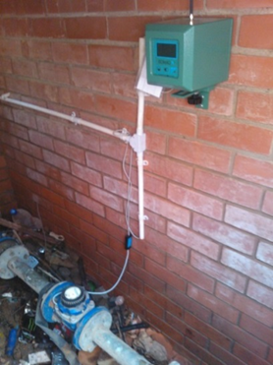
GPRS Logger
Figure 4.1 GPRS Logger at Osizweni Supply Meter, 2012
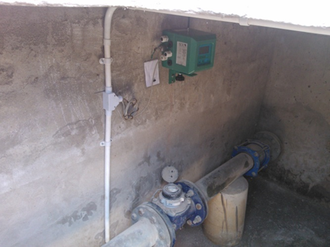
GPRS Logger
Figure 4.2 GPRS Logger at Madadeni Water Supply Meter, 2012
The data extracted from the N&Z WaMSS software covered a time period of three years. However, for the purpose of this study only one month readings in February 2012 were extracted. The water consumption and related data thus had to be exported from N&Z WaMSS database into a Microsoft Word.
The readings below in Figure 4.3 and 4.4 were taken from Braakfontein to Osizweni and Braakfontein to Madadeni. These bulk meter readings indicate significant water consumption in these two townships. Madadeni had a higher consumption than Osizweni, and the decision is to analyse Madadeni further, even though Madadeni’s minimum night flow is lower than that of Osizweni.The consumption water trends for both Osizweni and Madadeni indicated a higher water usage on weekends (Sunday).This might be due to the community doing washing, watering gardens and hosting different ceremonies.
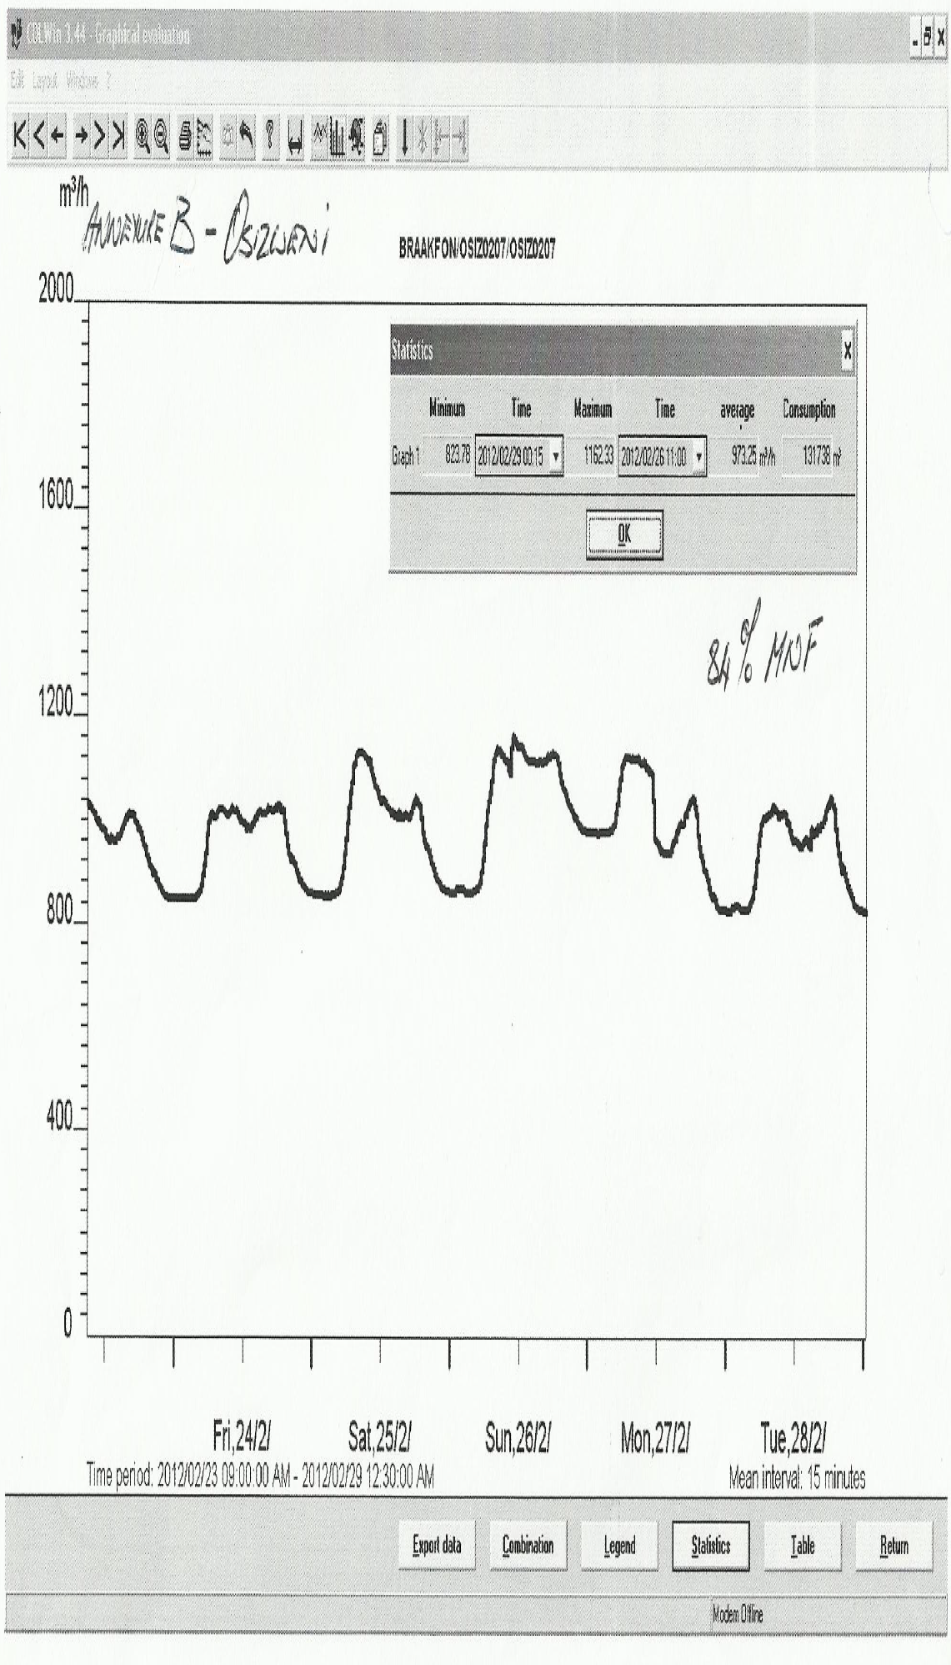
Figure 4.3: Bulk Meter Readings for Osizweni Area (N&Z, 2012)
The meter readings at Osizweni displayed the following:
Minimum consumption = 823, 78 m³/hr
Maximum consumption = 1162, 33 m³/hr
Average consumption = 973, 25 m³/hr
Total consumption = 21956, 33 m³/d. In six days the total consumption was 131738 m³ with a minimum night flow (MNF) of 84%.
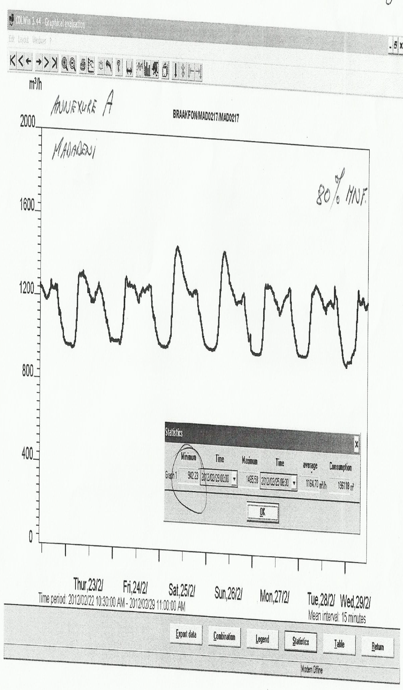
Figure 4.4: Bulk meter readings at Madadeni area (N&Z, 2012)
The meter readings at Madadeni displayed the following:
Minimum consumption = 942, 23 m³/hr
Maximum consumption = 1455, 58 m³/hr
Average consumption = 1164, 70 m³/hr
Total consumption = 32686.33 m³/d. In six days the total consumption was 196118 m³ with a minimum night flow (MNF) of 80%.
Although Madadeni had high water consumption than Osizweni, there was no clear indication as to which section was using high volumes of water. On investigation it was found that Madadeni bulk water meters were not operational. Newcastle Municipality Budget and Treasury Office provided a profile list of properties in Madadeni with high water usage in February 2012 that included:
- The property numbers
- Owner details
- Indigent properties
- Leased properties
- Properties that are paying for rates
- Water meter readings per property
This made it possible to study a very large number of consumers. However, only 1000 properties information was required for this study in order to achieve greater control over the distribution of water. A group of 1000-2000 properties supplied through a single flow meter and interpretation of a sample analysis data was easier (Kay Chambers et al., 2004)
Figure 4.5 represent a layout plan of Madadeni Township that includes all sections with property numbers and classification.

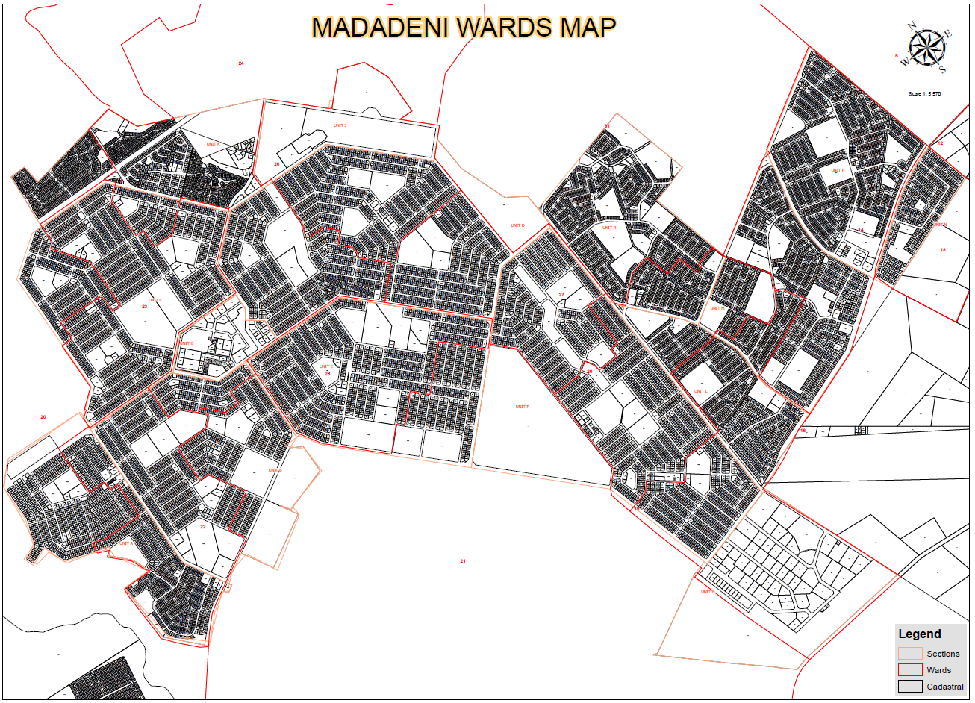
Figure 4.5 Madadeni Layout Map (NLM GIS, 2012)

The data provided by the Newcastle Municipality Budget and Treasury Office covered all Madadeni residents. The properties with higher water usage were spread across the entire Madadeni Township, from Section A to Section F which made it difficult to group 1000 properties in one zone. Table 4.1 summarizes a sample from top 1000 properties with higher water usage in Madadeni Township. The sample comprises 40 properties including domestic and non-domestic water users in kilolitres per month. The three top Sections that have the majority of properties with high water usage are seen to be from Sections C, D and F.

Table 4.1 Madadeni Domestic and Non-Domestic High Water Consumption Properties (NLM BTO, 2012)
(O = Owner, T = Tenant) | Section | House Number | Ward | Surname/Department Name | CELL | Total Amount Owing | Indigent (Yes or Not) | Water Meter (Yes or No) | G=Government, B=Business, I=Individual & O=Unknown | February 2012 Consumption
T | MADADENI F | 1 | 21 | KZNPA(DEPT OF HEALTH) |  | R 304 234 | No | Yes | G | 23988
T | MADADENI B | 2582 | 21 | MAJUBA FET COLLEGE | 0834553615 | R 60 138 | No | Yes | G | 4663
T | MADADENI C | 4216 | 20 | BHENGU | 0833321473 | R 48 430 | Yes | Yes | I | 2024
T | MADADENI B | 2583 | 22 | MAGISTRATE COURT |  | R 10 176 | No | Yes | G | 1927
O | MADADENI F | 2 | 27 | MKHIZE | 0768858461 | R 607 952 | No | Yes | I | 1570
T | MADADENI E | 9309 | 21 | REHABILITATION CENTRE |  | R 71 805 | No | Yes | G | 1477
O | MADADENI D | 7307 | 26 | MADADENI SELF HELP COMMUNITY D |  | R 960 335 | No | Yes | B | 1307
T | MADADENI F | 1441 | 19 | MBATHA | 0795772956 | R 74 417 | Yes | Yes | I | 1261
T | MADADENI B | 2584 | 22 | G. LIVIERO BUILDING |  | R 59 | No | No | B | 1217
O | MADADENI E | 9330 | 28 | MKHIZE |  | R 185 954 | No | Yes | B | 1100
T | MADADENI D | 7170 | 24 | NKWANYANA |  | R 34 691 | Yes | Yes | I | 1093
T | MADADENI D | 6658 | 27 | NKOSI |  | R 373 231 | Yes | Yes | I | 1045
T | MADADENI B | 2576 | 22 | SIYAMUKELA HIGH SCHOOL |  | R -466 575 | No | Yes | G | 975
T | MADADENI C | 3994 | 20 | MDLULI | 0847680555 | R 309 938 | Yes | Yes | I | 926
T | MADADENI F | 2041 | 27 | MATIA | 0823434620 | R 370 602 | No | Yes | I | 902
O | MADADENI F | 259 | 29 | TSHABALALA |  | R 0 | Yes | Yes | I | 858
T | MADADENI A | 713 | 20 | MAZIBUKO | 0846372738 | R 2 302 | No | Yes | I | 784
O | MADADENI D | 7217 | 26 | MOTOUNG | 0845370885 | R 61 714 | Yes | Yes | I | 760
O | MADADENI B | 2306 | 22 | KUBEKA |  | R -900 | Yes | Yes | I | 760
T | MADADENI B | 1846 | 21 | MTHEMBU |  | R 39 | Yes | Yes | I | 745
T | MADADENI D | 7305 | 24 | EZINCWADINI H P SCHOOL | 0834776889 | R -383 532 | No | Yes | G | 698
T | MADADENI C | 4701 | 23 | HLABANA LOWER PRIMARY SCHOOL | 0726369084 | R -692 | No | Yes | G | 685
O | MADADENI D | 5752 | 26 | NGWENYA |  | R 61 971 | Yes | Yes | I | 679
T | MADADENI B | 1971 | 21 | MAHLABA |  | R 8 781 | Yes | Yes | I | 659
T | MADADENI C | 4043 | 23 | MHLONGO |  | R 584 | Yes | Yes | I | 654
O | MADADENI D | 6665 | 27 | MAGUDULELA |  | R 36 204 | Yes | Yes | I | 652
T | MADADENI E | 9288 | 21 | N/CASTLE CIRCUIT MANAGEMENT |  | R 7 707 | No | Yes | G | 646
O | MADADENI E | 8662 | 28 | NKOSI |  | R 10 | Yes | Yes | I | 616
T | MADADENI E | 9289 | 21 | MAJUBA FET COLLEGE | 0834553615 | R 19 448 | No | Yes | G | 615
O | MADADENI D | 6543 | 27 | MADONSELA |  | R 436 386 | No | Yes | I | 611
T | MADADENI B | 1913 | 21 | MSIMANGO | 0781967451 | R 137 400 | No | Yes | I | 608
T | MADADENI B | 1963 | 21 | MAVUNDLA |  | R 266 123 | No | Yes | I | 605
T | MADADENI D | 6170 | 27 | SIBIYA | 0782145831 | R 140 944 | Yes | Yes | I | 604
T | MADADENI F | 2442 | 27 | NTSHANGASE |  | R 3 758 | Yes | Yes | I | 601
O | MADADENI E | 7741 | 28 | SEBEKO | 0737466839 | R 110 169 | Yes | Yes | I | 599
O | MADADENI B | 1640 | 21 | MASANGO |  | R 136 178 | Yes | Yes | I | 560
T | MADADENI F | 113 | 27 | KHUMALO | 0745524561 | R 134 124 | Yes | Yes | I | 554
O | MADADENI C | 3175 | 23 | NDLOVU | 0715368045 | R 108 889 | No | Yes | I | 544
O | MADADENI C | 3435 | 23 | MTHEMBU | 0796898515 | R 56 033 | Yes | Yes | I | 542
T | MADADENI C | 4065 | 23 | MCHUNU | 0825954794 | R 17 263 | Yes | Yes | I | 540

In order to ensure that the zoned properties are supplied through a single meter, the 1000 properties should be close together. Zonal meters had to be installed throughout Madadeni Township to identify a zone with a higher water usage and to identify the zone where the majority of 1000 properties fall under. Figure 4.6 illustrates Madadeni zonal layout plan subdivided into 26 zones.

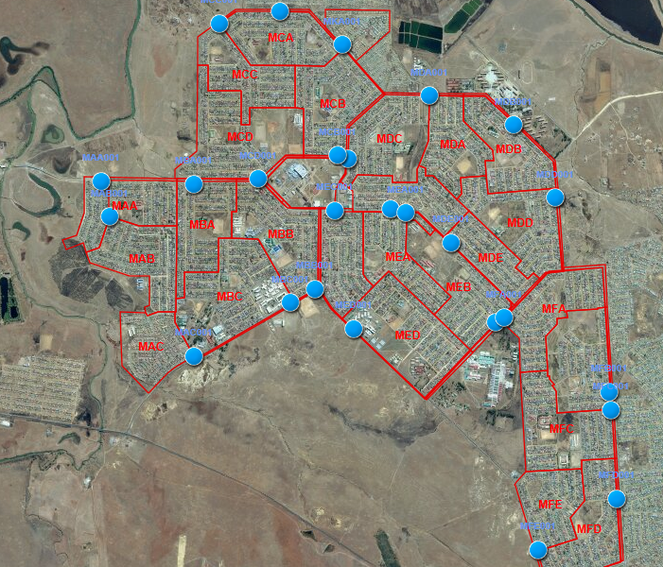
Figure 4.6: Madadeni Zonal Layout Map (NLM GIS, 2012)

Table 4.2 summarizes the data received from the 26 zonal meters in February 2012. The data from the 26 zones indicate that zones MBA, MAA and MCD in Section A, B and C at Madadeni were the top three zones with higher water usage. This contradicts the results from Table 4.1 above indicating Section C, D and F as the Sections with the highest water in Madadeni.
Table 4.2 Madadeni Zonal Meter Readings (N&Z, 2012)
Zones | Feb 2012 Water Consumption (Kl/day) | Feb 2012 Water Consumption (Kl/7days) | Feb 2012 Water Consumption (Kl/month) | Average Consumption (Kl/day)
MBA | 1029.77 | 7208.36 | 30892.98 | 1078.25
MAA | 983.84 | 6886.89 | 29515.26 | 1047.03
MCD | 997.83 | 6984.83 | 29934.99 | 1008.14
MBC | 931.67 | 6521.66 | 27949.98 | 949.66
MAB | 948.42 | 6638.96 | 28452.69 | 946.15
MED | 844.90 | 5914.30 | 25347.00 | 886.98
MCB | 765.83 | 5360.83 | 22974.99 | 795.84
MDD | 837.73 | 5864.13 | 25131.99 | 788.57
MFA | 721.20 | 5048.40 | 21636.00 | 746.39
MEB | 508.50 | 3559.50 | 15255.00 | 664.08
MCC | 826.93 | 5788.53 | 24807.99 | 629.28
MFE | 580.07 | 4060.46 | 17401.98 | 627.25
MDE | 682.60 | 4778.22 | 20478.09 | 626.87
MDB | 589.53 | 4126.73 | 17685.99 | 578.66
MCA | 610.10 | 4270.69 | 18302.97 | 569.86
MFB | 747.50 | 5232.50 | 22425.00 | 565.05
MBB | 562.70 | 3938.90 | 16881.00 | 552.90
MEC | 322.86 | 2259.99 | 9685.68 | 534.84
MDC | 484.40 | 3390.79 | 14531.97 | 507.03
MAC | 458.73 | 3211.13 | 13761.99 | 490.09
MDA | 495.91 | 3471.34 | 14877.18 | 488.07
MKA | 376.03 | 2632.23 | 11280.99 | 466.36
MFC | 437.60 | 3063.20 | 13128.00 | 462.78
MEA | 147.64 | 1033.50 | 4429.29 | 298.24
MDF | 162.43 | 1137.03 | 4872.99 | 117.60
MFD | 78.80 | 551.60 | 2364.00 | 82.31
Total 26 Zones | 16 133.53 | 112 934.73 | 484 005.99 | 16 508.27

The information received above in Table 4.2 indicate the majority properties with a higher water consumption were in Section A, B and C. Figure 4.7, Figure 4.8 and Figure 4.9 represents layout plans for Section A, B and C respectively.

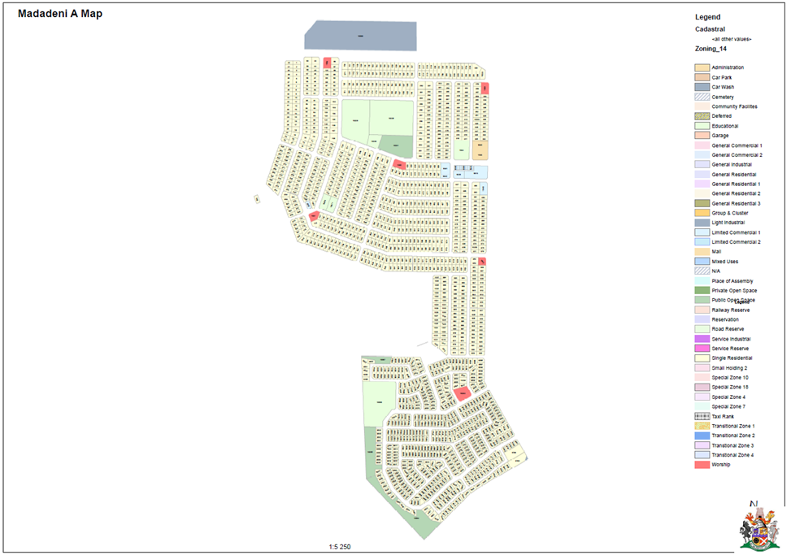
Figure 4.7 Madadeni Section A Layout Plan (NLM GIS, 2012)

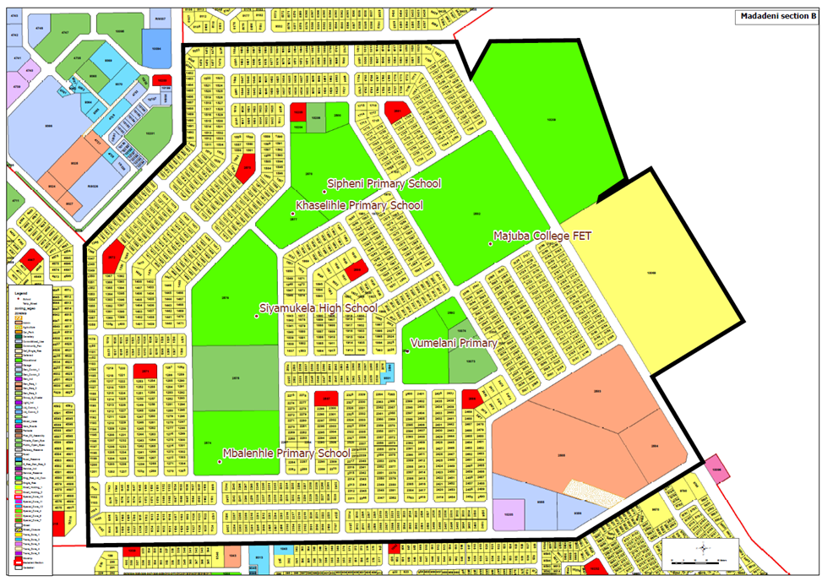
Figure 4.8 Madadeni Section B Layout Plan (NLM GIS, 2012)
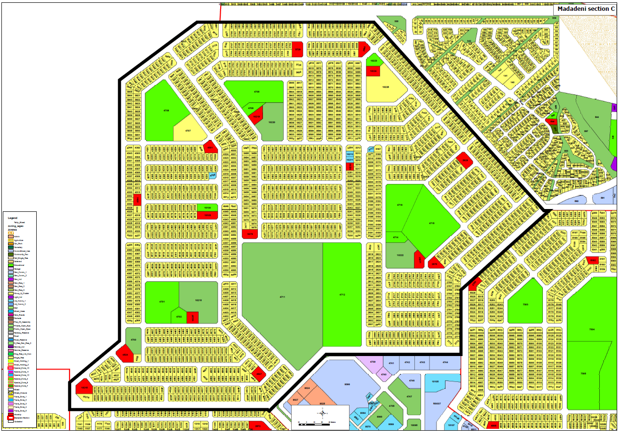
Figure 4.9 Madadeni Section C Layout Plan (NLM GIS, 2012)

A more detail analysis of the properties that fall under zone MAA, MBA and MCD in Section A, B and C was required. Table 4.3, Table 4.4 and Table 4.5 summarizes a sample profile of a combine total of 1000 domestic properties that fall under MAA, MBA and MCD. The sample represents 12 properties in MAA, 12 properties in MBA and 12 properties in MCD with higher water consumption.

(O = Owner, T = Tenant) | Section | House Number | Ward | Surname | CELL | Total Amount Owing | Indigent (Yes or Not) | G=Government, B=Business, I=Individual & O=Unknown | February 2012 Consumption (Kl/month)
T | MADADENI A | 713 | 20 | MAZIBUKO | 0846372738 | R 2 302 | No | I | 784
O | MADADENI A | 579 | 20 | NCAMO |  | R 1 068 | Yes | I | 454
O | MADADENI A | 643 | 22 | SITHOLE |  | R 4 220 | Yes | I | 407
O | MADADENI A | 877 | 20 | THABETHE | 0722278975 | R 18 066 | No | I | 378
O | MADADENI A | 9605 | 22 | MKHIZE |  | R 7 047 | Yes | I | 354
O | MADADENI A | 742 | 20 | ZULU | 0835950285 | R 104 053 | Yes | I | 317
O | MADADENI A | 711 | 20 | MTHEMBU |  | R 11 121 | No | I | 312
T | MADADENI A | 215 | 22 | SITHOLE |  | R 1 830 | Yes | I | 288
O | MADADENI A | 497 | 20 | MTSHALI |  | R 45 290 | Yes | I | 285
T | MADADENI A | 185 | 20 | MASEKO | 0728876501 | R 58 330 | Yes | I | 260
T | MADADENI A | 107 | 20 | DLAMINI |  | R 113 120 | No | I | 255
O | MADADENI A | 801 | 20 | MAHLABA | 0820647744 | R 91 676 | No | I | 253
Table 4.3 Madadeni Section (A) Domestic Water Consumption (NLM BTO, 2012)
(O = Owner, T = Tenant) | Section | House Number | Ward | Surname | CELL | Total Amount Owing | Indigent (Yes or Not) | G=Government, B=Business, I=Individual & O=Unknown | February 2012 Consumption
O | MADADENI B | 2306 | 22 | KUBEKA |  | R -900 | Yes | I | 760
T | MADADENI B | 1846 | 21 | MTHEMBU |  | R 39 | Yes | I | 745
T | MADADENI B | 1971 | 21 | MAHLABA |  | R 8 781 | Yes | I | 659
T | MADADENI B | 1913 | 21 | MSIMANGO | 0781967451 | R 137 400 | No | I | 608
T | MADADENI B | 1963 | 21 | MAVUNDLA |  | R 266 123 | No | I | 605
O | MADADENI B | 1640 | 21 | MASANGO |  | R 136 178 | Yes | I | 560
T | MADADENI B | 1557 | 24 | MAKHAYE | 0733532875 | R 50 419 | Yes | I | 512
O | MADADENI B | 2557 | 22 | MNTSELE |  | R 36 071 | Yes | I | 463
O | MADADENI B | 1220 | 22 | SIBISI |  | R 1 806 | Yes | I | 411
O | MADADENI B | 1900 | 21 | ANGLICAN PRIESTS |  | R 1 004 | No | I | 399
O | MADADENI B | 2517 | 22 | NTSHANGASE |  | R 155 281 | No | I | 394
T | MADADENI B | 1843 | 21 | NKOSI | 0736684750 | R 32 949 | No | I | 329
Table 4.4 Madadeni Section (B) Domestic Water Consumption (NLM BTO, 2012)

(O = Owner, T = Tenant) | Section | House Number | Ward | Surname | CELL | Total Amount Owing | Indigent (Yes or Not) | G=Government, B=Business, I=Individual & O=Unknown | February 2012 Consumption
T | MADADENI C | 4216 | 20 | BHENGU | 0833321473 | R 48 430 | Yes | I | 2024
T | MADADENI C | 3994 | 20 | MDLULI | 0847680555 | R 309 938 | Yes | I | 926
T | MADADENI C | 4043 | 23 | MHLONGO |  | R 584 | Yes | I | 654
O | MADADENI C | 3175 | 23 | NDLOVU | 0715368045 | R 108 889 | No | I | 544
O | MADADENI C | 3435 | 23 | MTHEMBU | 0796898515 | R 56 033 | Yes | I | 542
T | MADADENI C | 4065 | 23 | MCHUNU | 0825954794 | R 17 263 | Yes | I | 540
T | MADADENI C | 4121 | 23 | SERIPA | 0786563183 | R 61 297 | Yes | I | 480
T | MADADENI C | 4294 | 20 | NKOSI |  | R 26 785 | Yes | I | 443
T | MADADENI C | 4367 | 23 | MFEKA | 0723325683 | R 162 234 | Yes | I | 424
T | MADADENI C | 2987 | 24 | LUKHELE | 0834973399 | R 20 | Yes | I | 400
O | MADADENI C | 3097 | 24 | NKAMBULE |  | R 56 245 | Yes | I | 385
T | MADADENI C | 3227 | 23 | MYEMBE |  | R 7 199 | Yes | I | 383
Table 4.5 Madadeni Section (C) Domestic Water Consumption (Newcastle Municipality BTO, 2012)

RESULTS AND FINDINGS

Introduction
In the 2010 State of the Nation Address, the Honourable JG Zuma, President of the Republic of South Africa, stated:
“We are not a water rich country. Yet we still lose a lot of water through leaking pipes and inadequate infrastructure. We will be putting in place measures to reduce our water loss by half by 2014”
There is still no clear indication of what the actual losses are and how they are split between Real Losses (Physical Leakage) and Apparent Losses (Commercial Losses), Although the target was set (Mckenzie et al., 2012). International Water Association (IWA) defines the following water balance definitions as follows:
- Apparent losses or commercial losses: made up from the unauthorized consumption (theft or illegal use), plus all technical and administrative inaccuracies associated with customer metering
- The system input volume (SIV): represents the potable volume input to the water supply system from the WSA’s own sources, (measured at the water treatment works outlet), allowing for all known errors (i.e. errors on bulk water meters) and any water imported from other sources – also corrected for known bulk metering errors.
- The unbilled authorized consumption: the volume of authorized consumption that is not billed or paid for
- Authorized consumption: the volume of metered (authorized metered) and/or unmetered (authorized unmetered) water taken by registered customers, the water supplier and others who are implicitly or explicitly authorized to do so by the water supplier, for residential, commercial and industrial purposes.
- Water losses: the sums of the real and apparent losses and are calculated from the difference between the SIV and the authorized consumption.
- Real losses: the physical water losses from the pressurized system, up to the point of measurement of customer use.
- Non-Revenue Water: the standard term replacing unaccounted-for water (UFW) in many water balance calculations.
Figure 5.1 illustrate the water balance from system input volume and all factors that occur in the distribution network until the water consumption by the end user.
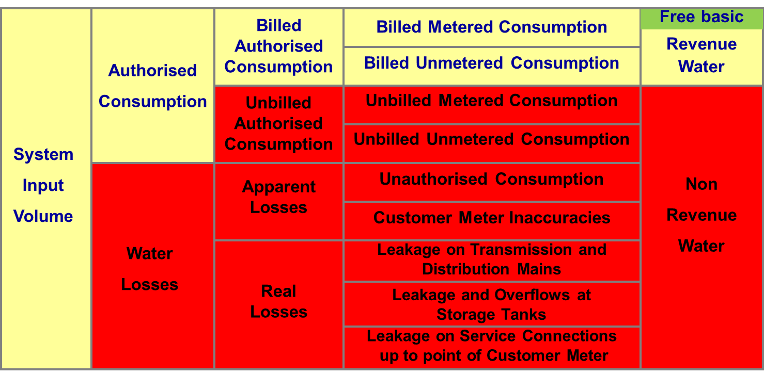
Figure 5.1 Modified IWA Water Balance (Seago et al, 2007)
This chapter focuses on the root cause for different water consumptions in Madadeni and Osizweni supply areas. However, Madadeni were analysed in detail in order to determine the actual cause of huge domestic water consumption as seen from the data received in Chapter 4 above. The high water consumption in Madadeni were analysed in order to determine whether the root cause is due to water losses from authorized or unauthorized consumption.

Madadeni and Osizweni Water Consumptions
The Osizweni total population is 119 343 with the indigent population of 41 743 as opposed to Madadeni total population of 102 435 and the indigent population of 14 571 (Stats SA, 2011). One would expect that Osizweni would use more water than Madadeni due to the higher population and higher Municipal dependency of indigent’s population. Newcastle Municipality Budget and Treasury Office indicated that the last indigent verification process was last conducted in 2008.
Table 5.1 illustrate the analysis of typical water consumption for Madadeni water supply area. In the analysis, the typical water consumption (litre/ca/day) for indigent houses was assumed to be 40 l/ca/d. Typical water consumption of affording houses with full-flush sanitation for developing areas was assumed to be a maximum of 100 l/ca/d. The maximum typical water consumption was assumed for clinic, hospitals, shops and schools. The number of day school learners in a boarding school at Madadeni was assumed to be 0. The total square meter per shop/business was assumed to be 400m², therefore, 800l/ca/d was used as consumption.
The assumptions are based on water policy of Newcastle Municipality and CSIR tables of domestic and non-domestic water use as detailed in Chapter 3 above. The Apparent Losses are considered to be 20% in the South African situation (Mckenzie et al., 2002) The Apparent Losses for this study are assumed to be 25% that is 5% above the norm in South Africa due to the fact that there might be other factors that have been overlooked due to lack of data from Newcastle Municipality, e.g. open space, bus stops, consumer meter age, illegal connections and car washes. System input volumes were received from Braakfontein bulk meter readings in chapter 4 figure 4.4 and authorized consumption was received from Newcastle Budget and Treasury Office February 2012 consumption and converted from Kl/day to l/d.
Table 5.1: Madadeni Domestic and Non-Domestic Water Demand, 2012
Type of water use | Population | Houses /Properties | Type of water Supply | Typical Consumption (litre/ca/d) | Total Consumption (litre//d)
Indigent Houses | 30 945 | 6 315 | Standpipe/With Full-Flush Sanitation | 40 | 1 237 800
Affording Houses | 71 398 | 14 571 | With Full-Flush Sanitation | 100 | 7 139 800
Schools  /Boarding | 750  /750 | 49  1 | With Full-Flush Sanitation | 20 /  140 | 735 000  105 000
Hospitals /  Clinics | 700/  50 | 1  5 | With Full-Flush Sanitation | 300/  5 | 210 000/  1 250
Shops /Business |  | 212 |  | 800 | 169 600
Total Consumption |  |  |  |  | 8 360 650
Add 25% of Apparent Losses |  |  |  |  | 2 090 163
Typical Total Consumption |  |  |  |  | 10 450 813
System Input Volume |  |  |  |  | 32 686 330
Authorized Consumption (Billed and Unbilled) |  |  |  |  | 13 361 000
Water Losses |  |  |  |  | 19 325 330
Apparent Losses of 25% |  |  |  |  | 8 171 580
Real Losses |  |  |  |  | 11 153 750
The data and readings at Chapter 4 Figure 4.2 and Figure 4.3 above of Braakfontein reservoir water consumption to Madadeni and Osizweni supply areas indicated that Madadeni supply area was consuming more water than Osizweni supply area. Therefore, only Madadeni water consumption patterns were analysed, it was recommended that Newcastle Municipality also analyse Osizweni water consumption and losses in order to have correct water balance from Braakfontein reservoir.

This study is based on household water consumption therefore non-domestic water consumption was not analysed further. Households consumed most of the water supplied by municipalities (Obby & Dr Erasmus, 2012). The domestic water consumption of Madadeni supply area was analysed further. Table 5.1 above indicated water losses of 21% in Madadeni and it was necessary to attended to them in order to determine the root cause.

Subdivision of Madadeni into Zones
Madedeni Township was subdivided into manageable zones to achieve greater control over the distribution of water. The zones were equipped with bulk water meters to measure the water consumption entering distribution area. In Chapter 4 above, it was discovered that zones MAA, MBA and MCD were consuming higher water than the other zones.
Table 5.2 summarizes water consumption readings of zones MAA, MBA and MCD comparing it with the individual water meters readings of the properties received from Newcastle Municipality Budget and Treasury Office before any intervention. The water readings from zones MAA, MBA and MCD, and water readings from 994 individual properties indicated a water loss of 864.91Kl/d which is 41%.

Table 5.2 Madadeni Zonal Meter and Individual Meter Consumption, 2012
Zones | Zones Consumption (Kl/day) | Residential Section | Individual Meter Consumption (Kl/month) | Water Loss (Kl/day) | % Water Loss | Total No of Properties
MBA | 1029.77 | Madadeni B | 675.18 | 354.59 | 53% | 354
MAA | 983.84 | Madadeni A | 756.16 | 227.68 | 30% | 391
MCD | 997.83 | Madadeni C | 715.19 | 282.64 | 40% | 249
Total | 3011.44 |  | 2146.53 | 864,91 | 41% | 994
The total number of properties in the three zones analysed ended up to be 994. The reasons for the difference in consumption can be attributed to many facts such as illegal connections, leaking pipes and/or faulty meters.

Madadeni Interventions
To understand the reasons for the water loss of 28,7 of zones consumption% as mentioned above, the 994 properties affected had to be engaged. An assistant from the ward councillors was requested in order to visit each and every household and investigate the root cause for the high water losses. Table 5.3 summarizes a questionnaire that was compiled for distribution to all 994 households. The profile of each household was received from Newcastle Municipality Budget and Treasury Office as mentioned in Chapter 4 above. It was evident that a majority of residents were not aware of cistern leaks within their households. Only 64 of the 994 residents knew something about conserving water and other residents were puzzled in all questions related to water conservation. It was discovered that the average number of people per one family was seven (7) which is two (2) more than the average number recorded by Stats SA in 2011.

Summary of survey form for visited zones in Madadeni |  | MAA |  | MBA |  | MDC
Average number of persons per household |  | 7 |  | 7 |  | 7
 | Yes |  | No | Yes | No | Yes | No
Are there sick people in the property who require more water to wash? | 11 |  | 380 | 15 | 339 | 9 | 240
Was there a funeral at your property in February 2012? | 2 |  | 389 | 3 | 351 | 1 | 248
Do you have a shower? | 27 |  | 364 | 14 | 340 | 11 | 238
Do you have a flush toilet? | 391 |  | 0 | 354 | 0 | 249 | 0
Do you have a geyser? | 102 |  | 289 | 206 | 148 | 155 | 94
Are you a Newcastle Municipality employee | 18 |  | 373 | 13 | 341 | 8 | 241
Are you renting? | 67 |  | 324 | 77 | 277 | 34 | 215
Do you own the property? | 324 |  | 67 | 277 | 77 | 215 | 34
Do you pay for rates? | 68 |  | 323 | 46 | 308 | 19 | 230
Is your account delivered every month? | 345 |  | 46 | 322 | 32 | 202 | 47
Do you know about indigent registration? | 22 |  | 369 | 55 | 299 | 34 | 215
Do you understand the benefits associated with indigent? | 19 |  | 372 | 49 | 305 | 30 | 219
Have you seen municipal meter readers in your property? | 302 |  | 89 | 277 | 77 | 203 | 46
Do they know how much you owe on your municipal account? | 366 |  | 25 | 334 | 20 | 218 | 31
Do you repair any internal leaks immediately? | 155 |  | 236 | 113 | 241 | 33 | 216
Do you know what to do if you see a water leak outside your property? | 111 |  | 280 | 234 | 120 | 123 | 126
Do you know how to check if your water meter is working or not? | 23 |  | 368 | 54 | 300 | 33 | 216
Are there any visible leaks in your home? | 188 |  | 203 | 137 | 137 | 145 | 104
Do you know any water saving methods? | 23 |  | 368 | 18 | 336 | 23 | 226
Do you know anyone who is illegally connected? | 2 |  | 389 | 4 | 350 | 2 | 247
Table 5.3 Madadeni Water Conservation Questioner, 2012

The questioner and a spreadsheet of findings was compiled and handed over to the Newcastle Municipality technical team. Table 5.4 illustrates the spreadsheet of findings received from 994 properties visited. It includes pictures taken before interventions. At zone MBA it was discovered that a high number of properties were still using an old cistern uses six litres of water for a single flush. At zone MAA three properties were using one water meter. In all three zones it was discovered that a number of water meters were missing. The water meters installed in all zones older than 10 years and most of them were not operational. New intelligent meters were installed in all 994 properties and leaks were repaired.

Zone | Total Houses | Registered Indigent Houses | Total Cisterns Repaired | Working Meters Before Replacing | Internal Leaks Repaired | Typical Household Leaks Before Repair Photos  Leaking tap | Typical Household Leaks Before Repair Photos  Broken toilet
MAA | 391 | 78 | 101 | 302 | 231 | 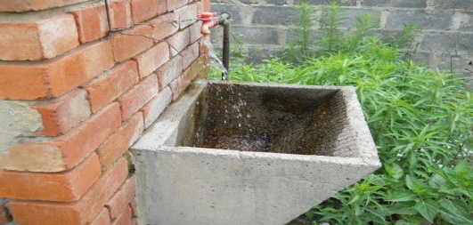  Leaking pipe | 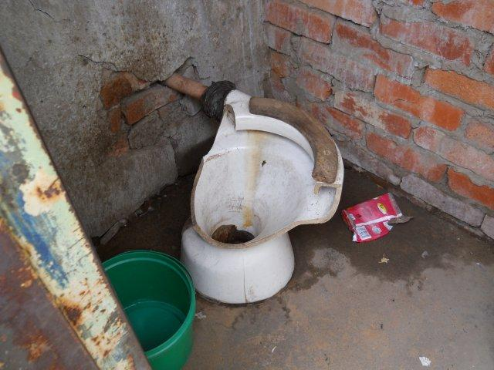  Leaking internal pipe
MBA | 354 | 103 | 88 | 267 | 199 | 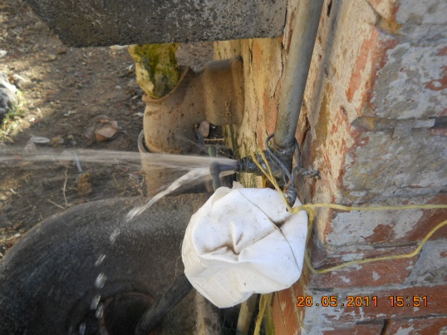  Missing tap | 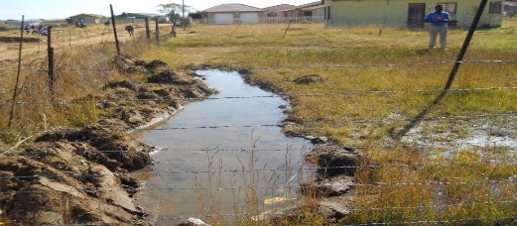  Leaking tap
MCD | 249 | 59 | 79 | 211 | 178 | 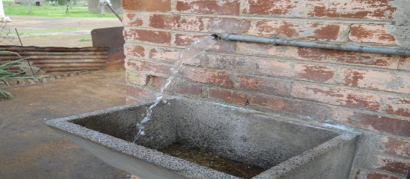 | 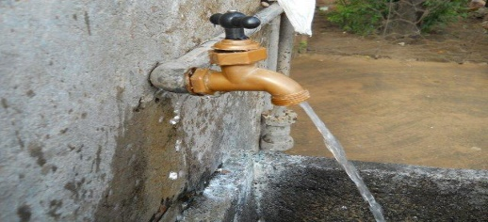
Table 5.4: MAA, MBA and MCD Technical Findings and Repairs, 2012

Table 5.5 summarize the results in the three zones (MAA, MBA and MCD) of before and after the leak repairs. The readings of water consumption before leak repairs were taken after all 994 intelligent meters were installed in order to obtain the correct water consumption. After the leak repairs, the readings were taken again and the difference was recorded as water savings. The total water consumption recoded from the individual meters corresponded with that of the zones. The February 2012 average zones water consumption figures were utilized and compared with the three zonal readings after repairs. There was a noticeable water savings of 1764.56 Kl/d which is 59%, although all the indigent households were not restricted to 6Kl per month as per 2008 Newcastle Municipality water policy. As seen in the case study of Miami-Dade Country, USA, a significant reduction in water demand was observed starting in 2005. This reduction was due to the effectiveness of water conservation education and publicity efforts (Lee, Tansel and Balbin 2011).
Table 5.5 Zones MAA, MBA and MCD Water Consumption Results and Savings, 2012
Zones | Average consumption before leak repairs (Kl/day) | Average consumption after leak repairs (Kl/day) | Total Water Savings (Kl/day) | % of Water Savings
MAA 391 houses | 983.84 | 437.92 | 545.92 | 55%
MCD 229 houses | 997.83 | 386.48 | 611.35 | 61%
MBA 354 houses | 1029.77 | 402.48 | 627.29 | 61%
Total 994 Houses | 3011.44 | 1226.88 | 1784.56 | 59%

The water losses in Madadeni were high and it was recommended that Newcastle Municipality implement internal repairs to all households in Madadeni. If 59% savings achieved in the three zones were to be implemented across all 26 zones. An average total of 9 518.8 Kl/d could save which can service a population equalling that of Madadeni per day. The water consumption levels in Madadeni are averaging 176 litres per person per day based on the results in Table 5.5 above, when you consider an average family of seven and the consumption of 1226.88 in 994 houses. The repairs on the cisterns was thought to reduce night flow consumption. As it was the case at Ekurhuleni, the repairing of household leaks began in 2008 and recorded a significant water saving of more than 50% (Gubuza, Ass/Prof Ilemobade 2015). The Ekurhuleni study also reported a significant reduction in water consumption levels from 30,7% to 10,5% during the first year of implementing water conservation.
Newcastle Municipality can realize additional water saving if they can start restricting indigent houses to 6Kl per household per day as per their water policy. However, it was recommended that Newcastle Municipality amend their indigent water policy from free 6Kl litres per household per day to 12 Kl and restrict all indigent households. This will be in line with other secondary cities, e.g. KwaDukuza Municipality and Ogwini Municipality (DWA, 2010). This is also due to the fact that all houses in Madadeni have a flush toilet and a majority have 100litre geysers

Awareness Campaign Results
It was evident from the 994 house visits and answers from the questioner in Table 5.3 above, that the Madadeni community were not water conscious. The model for facilitating change and incorporating new practices was necessary to be introduced. This model only focused in 994 houses visited and three ward councillors affected in this study.
The survey tool utilized in awareness campaigns was the Knowledge, Attitude and Practice (KAP) which provided a model for facilitating change and to incorporated new practices introduced in the Madadeni community (CSIR, 2003). Therefore two community meetings were held and a total number of 318 community members were present. The meetings focused on the following around educate the community about the value and importance of water:
- Knowledge- the community were informed about the benefits of conserving water and the negative impacts associated with wasting water such as draught. The water savings achieved from the intervention in 994 houses was explained to them.
- Attitude- the point around good attitude was stressed, it was explained that water losses are everyone problems because when there is no water everyone suffers.
- Practice – it was explained that everyone in their home should use water wisely. A pamphlet with 10 ways of saving water in the households was distributed, and it was stressed that everyone should follow them in order to save water. As it was recorded in the case of Australian research regarding implementation of water conservation measures practices of responds. The average of over 80% of answers were positive indicating that the water savings tips were working (Dolnicar & Hurlimann 2010) The following were pamphlet tips distributed to Madadeni residents:
  - Use your water meter to check for leaks
  - Check your toilet for leaks
  - Take shorter showers
  - Use minimum amount of water needed for a bath
  - Avoid flushing the toilet unnecessary
  - Turn off the water while brushing your teeth
  - When washing dishes by hand, don’t leave the water running for rinsing
  - Wash fruits and vegetables in a pan or bowl
  - Water your garden in the early hours of the day, avoid watering when its windy
  - Don’t run the hose while washing your car use a basket
The awareness campaign was a critical component of the successful implementation of WC/WDM. It is very difficult to measure because the results are not tangible. Below are some of the responses received from the residents that were part of the meetings:
- This a new experience as 302 out of 318 indicated that they were not aware of the importance of reporting water leakages.
- 145 of the community indicated that they were not aware that the municipality would repair leakages outside the property at no cost to them.
The impacts of water conservation campaigns in terms of the 994 household recognition, attitude changes, behaviour modification and verifiable water use reduction were not measured in this study. It was recommended that Newcastle Municipality implement a thorough robust awareness campaigns in order to evaluate the linkages and relationships between the water consumption behaviour of Newcastle communities.
It was also recommended that Newcastle Municipality implement the communication channels as described in the Water Research Foundation Study (2010), to utilize the following planning process as the top-ranked communication channels.
- Utility bill inserts about water conservation (68%)
- TV ads demonstrating water conservation tips (55%)
- Newspaper ads (35%)
- Radio ads (26%)
- TV demos (25%)
- Magazine articles (24%)
- Weather Channel (23%)
- Demonstrations (21%)
- Billboards (21%)

Madadeni March 2015 Results
There are many water conservation studies carried out in South Africa between year 2012 and 2015 when this study was commissioned. This study also wanted to review and find out if there were any changes in water consumption patterns in Madadeni between year 2012 and 2015. The March 2015 results and findings were receive from Newcastle Municipality and interventions performed based on the recommendations from this study.
The two specific objectives of this study were:
- To assess water usage from Braakfontein to Madadeni and Osizweni
- To identify zones with high water usage through evaluating water consumption in a sampled zone.

Braakfontein Reservoir 2015 Results
Table 5.6 summarize the recommendation of the study and intervention implemented by Newcastle Municipality between year 2012 and 2015
Table 5.6 Year 2012 vs 2015 Braakfontein Recommendation and Interventions
2012 Study Recommendations | 2015 Newcastle Municipality Interventions
Only Madadeni water consumption patterns were analysed in this study, it was recommended that Newcastle Municipality also analyse Osizweni water consumption and losses in order to have correct water balance from Braakfontein reservoir. | No analyses conducted of Osizweni water consumption, still relied on the Braakfontein reservoir readings.
There was a difference of 16 552 Kl/d which was 49,4% high between Braakfontein bulk readings and zonal meter readings at Madadeni. That difference in water consumption occurred between Braakfontein reservoir and Madadeni households. It was recommended that Newcastle Municipality investigate the bulk line. | 600 mm diameter glass reinforcement pipe supplying Madadeni and Osizweni was reported to have failed four times during 2012. The budget for replacing the pipe was made available by Newcastle Municipality and the portion of the bulk line with problems was replaced.

Madadeni 2015 Zone Results
Table 5.7 summarize the water consumption results from the 2012 study comparing it with the water consumption results in March 2015 received from N&Z data logs. The 2012 results are readings after the interventions in Madadeni zones MAA, MBA and MCD. The March 2015 water consumptions are higher than the 2012 results, which might be due to more leaks occurring after the repairs in 2012. There was an average of 47% more losses recorded between 2012 and 2015. Table 5.8 summarize the recommendations and interventions.

Table 5.7 Year 2012 vs 2015 Zones MAA, MBA and MCD Water Consumption Results
Zones | 2012 Average Consumption After Leak Repairs (Kl/day) | 2015 average Consumption (Kl/d) | Total Water Loss (Kl/day) | % of Water Loss
MAA 391 houses | 437.92 | 614.34 | 176,42 | 40%
MCD 229 houses | 386.48 | 568.78 | 182,3 | 47%
MBA 354 houses | 402.48 | 623.89 | 221,41 | 55%
Total 994 Houses | 1226.88 | 1807,01 | 1784.56 | 47%

Table 5.8 Internal Repairs and Policy Amendments
2012 Study Recommendations | 2015 Newcastle Municipality Interventions
The savings recorded in 2012 was 59% in the three zones MAA, MBA and MCD. It was recommended that internal repairs to all 26 zones in Madadeni be implemented and an average total of 9 518.8 Kl/d could be saved. | No repairs were executed in Madadeni, but 3000 internal repairs were implemented at Osizweni.
It was recommended that Newcastle Municipality amend their indigent water policy from free 6Kl litres per household per day to 12 Kl and restrict all indigent households. | Indigent water policy was amended from 6Kl to 12 Kl

Madadeni 2015 Awareness Campaign Results
Table 5.9 summarize the awareness campaigns strategies recommended to Newcastle Municipality and the intervention implemented.
Table 5.9 Awareness Campaign Strategies
2012 Study Recommendations | 2015 Newcastle Municipality Interventions
It was recommended that Newcastle Municipality implement a thorough and robust awareness campaigns in order to evaluate the linkages and relationships between the water consumption behaviour of Newcastle communities. | Water awareness campaigns were implemented once a year only on the water National Water Week. No evaluation was done between water consumption behaviour and awareness campaigns.
It was also recommended that Newcastle Municipality implement the communication channels as described in the Water Research Foundation Study (2010), to utilize the following planning process as the top-ranked communication channels. | Only three (3) out of nine (9) were implemented.
- Utility bill inserts about water conservation | No utility bills were utilized
- TV ads demonstrating water conservation tips | No TV ads were utilized
- Newspaper ads | Two local Newspapers were utilized
- Radio ads | One local radio was utilized
- TV demos | No TV demos were done
- Magazine articles | No Magazine articles used
- Weather channel | No Weather channels were utilized
- Demonstrations | No demonstration were done
- Billboards | Two billboards were erected

CONCLUSIONS AND RECOMMENDATIONS

Conclusion

The findings both from the results and literature review presented in this study highlighted the high water losses experienced by Water Service Authorities in South Africa. This study also highlighted the lack of willingness from Newcastle Municipality to implement water conservations initiatives in order to reduce high water losses within their communities.

Newcastle Municipality experienced high water losses from the Braakfontein reservoir supplying Madadeni and Osizweni communities. The high water losses were experienced both in the bulk line supplying the two communities and in the internal properties. This study only focused in the domestic water consumption at Madadeni water supply area.

The area of Madadeni was divided into 26 zones, the following three zones MAA, MBA and MCD in Madadeni Section A, B and C were found to be using higher than normal water comparing with the other zones. The total number of 994 properties was visited to establish the root cause of high water consumptions. A number of household leaks were discovered and repaired. The most common cause of water loss discovered was through toilet cisterns.

After three years of commissioning this study, the review of results at Madadeni indicates that the losses from the three zones continued and no thorough awareness campaign was conducted by Newcastle Municipality. The community behaviour and attitude towards the water conservation did not change over the three year period. A more drastic intervention was required by Newcastle Municipality in order to reduce water losses in order to change consumer behaviour and attitude. In the case of.Sydney in Australia, behaviour and attitude views towards water conservation in homes was analysed. It was found that little change recorded in water savings in the period of year. (Randolph & Troy 2008). The findings of the study found that a significant number of Sydneysiders were are aware of water savings measures.

Recommendations
Special emphasis should be given to the following stakeholders to ensure the successful implementation of WC/WDM:
- Municipal officials
- Ward councillors
- Schools in NLM area
- General communities of NLM area

Awareness campaign tools
- Competitions for municipal officials
- Competitions for schools
- Continual community awareness meetings
- Newcastle Municipality utility bills

Billboards/posters

Print media (local newspapers)
- Radio station slots

Competition for municipal officials
All municipal officials should be sensitized to the drive relating to the WC/WDM and the awareness campaign. It is important that all officials in all aspects of their work, whether dealing with the public or with their own colleagues, are part of the drive towards WC and the practice of careful water management.
Again, if funds are to be spent, optimum mileage is needed from such expenditure. Ideally, the officials should enter into a competition where they can be judged similarly to their environment. Therefore, each municipal official who is permanently appointed or appointed on a contract of one year or longer must submit a written proposal on how to apply the principles of the WC/WDM to their home environment. The meter consumption of their home will be monitored with before and after consumption recorded. The official with the largest percentage saving will win a prize to be determined by NLM council.

School competitions
The competition should be based on the best essays for various categories. There are schools with different levels of resources and there are also different grades. It is therefore recommended that competitions are not only school-based, but also grade-based and further divided into two categories, namely rural and urban schools. This is to ensure that rural schools with fewer resources are able to compete in their own competition category and different grades too.
It is proposed that the competition be limited to grades 6, 7, 8, 9, and 10. There should be prizes for first, second and third individual schools in the category Urban and Rural. Therefore six prizes should be given with the first proposed competition session. The prizes for the schools should be R3 000.00 for first prize, R1 500.00 for the second prize and R500.00 for the third prize.
It is proposed that both the school competitions be run by the local radio station. Logistically they are geared towards running such competitions on the one hand, and on the other hand they can account for the money and the fairness of the competition. The competition should be audited by the radio station.
In return for making such competitions available to the station, there could be possible interviews with the mayor, the municipal manager, and the communications officer of NLM. These interviews would assist the NLM to gain more publicity in an area where awareness is greatly needed. Competitions are a good way to get people to sit up and listen to what is being said. However, competitions should, at all times, to show the utmost integrity and fairness when adjudication takes place. A competition can easily turn into bad publicity if not run properly, and this must be guarded against at all costs.
The Newcastle radio station has indicated that its broadcasting is 70% Zulu, which will also benefit the rural population a great deal.

Community Awareness Meetings
The community campaigns should be pitched at a level of basic adult education and present the importance of WC in general and in Newcastle. It should also attempt to highlight not only the responsibility and obligations of water users, but also the gains of being successful/good/wise water users. Broader discussions and longer sessions should be allowed.
General tips on WC, ways to fulfil their responsibility and obligations and information on how citizens can do this should be presented. The importance of paying for services should be highlighted.
Pamphlets should be handed out that are easy to read with tips on WC and sanitation, and all these should be in Zulu and English. Councillors should be on board for potential continuity and for answering possible questions that could generally arise, but are not related to the task at hand.

Newcastle Municipality utility bills
Newcastle Municipality should consider using the utility bills to write any information related to water conservation. The municipality should ensure that the utility bills are distributed to all Newcastle residence and the message of conserving water is clearly articulated on the bill.

Billboards for Advertisement
Billboards, in Zulu and English, highlighting the importance of water conservation should be placed at the entrances to Madadeni, Osizweni and town. Reservoirs that are visible should be painted with the message of saving water and act as permanent billboards. Technical service vehicles should be branded with the slogan of saving water.

Print Media
The print media should be used to reach a larger audience, including Newcastle Advertiser, Newcastle Sun, Newcastle Express and the Newcastle municipality webpage. Some of the newspapers are free so it will help when it comes to the community that cannot afford to pay for newspapers.

Radio Station Slots
Radio and television advertisements are an expensive media in which to advertise. However, most community radio stations have space to address their social responsibility, and although they often address this during late night shows, it may be possible to arrange for a responsible municipal official to be interviewed by a local radio station.

Indigent Register Review
Newcastle Municipality Budget and Treasury Office indicated that the last indigent verification process was last conducted in 2008. This means that the indigent records are outdated and this matter has to be addressed. A survey should be carried out on all households within the NLM to conduct a verification process. This would provide an indication of the percentage of indigent households, thus helping the municipality to identify households that require free basic services and restrict them. This process will also assist the Municipality to start charging those households who can afford to pay for rates.

Water Services By-Laws Review
It is commended that NLM council amended their indigent policy to increase free basic water from 6kℓ per month per household to 12kℓ per month per household for all indigents.
The NLM Water Use Policy 2008 states that “The total bill owing, including penalties, assessment of unauthorized consumption and discontinuation and reconnection fees, and increased deposits as determined by council if applicable, becomes due and payable before any reconnection can be sanctioned.”
The NLM council should also consider formulating a special policy (or reviewing the above policy) and contractual arrangements with households that can afford to pay the rates, but who had not been paying in the past and are in arrears. The council should set aside the moneys owed by that particular household for a period of twelve months. The household could be expected only pay their current account when all leaks have been repaired and the new meter installed. This would assist the Municipality to increase the payment factor in Madadedi and Osizweni.
The NLM Water Use Policy also states that “Any person (natural or juristic) found to be illegally connected or reconnected to municipal services …Council will immediately terminate the supply of services to a customer…”. It continues to say that “The municipality will endeavour to provide meters to every paying client at the cost of the client for all meterable services”.
NLM should consider to reviewing the above policy and legalizing the illegally connected households by providing them with a water meter for free. In this way the municipality can start billing those who are not indigent. During the survey and the house-to-house visits by foot soldiers, members of the community complained about the expensive water meter connections (R3 500).
Connecting illegally connected households will assist council with collecting current accounts because at the moment bad depth is ranging around R8 million per month, of which water accounts for R5 million (NLM Financial Statements, 2010). Innovations like these will encourage residents to start paying their current accounts and in the process they will add to the success of WC/WDM because the NLM can account for all the water supplied to the community.

Establishment of help desks/customer care offices
On investigation it was discovered that there is no toll-free central call centre in the Newcastle Municipality. The developments of a central call centre so that all complaints and queries can be captured and forwarded to the relevant officials, needs attention. Satellite offices should be positioned in the townships so that complaints and queries can be logged by residents with transport difficulties. The satellite offices should be linked to the central station. Senior officials should have access to all complaints relevant to their section from their office computers. From there complaints that have not been attended can be red-flagged after 24 hours, with further red flags if the complaint or query has not been resolved within a further 24 hours, and so on.
The system should be able to provide monthly reports on the types of queries, where the problem occurred in the event of infrastructure failure, and the officials’ reaction times. Additional pay points also have to be considered if necessary and these facilities are usually also catered for at the helpdesk/customer care office. Customer care officials will have to manage these offices dependent on the need.

Smart Water Meters
(Gleiik 2000) indicated that many cities were not measuring or metering water leading to overuse and provided no incentives for efficiency use. Therefore, the installation of meters would enable the cities to charge for water usage. NLM should consider installing smart water meters in the entire Newcastle area that is able to do the following functions:
- to accurately capture consumer consumption data for billing purposes;
- to detect leaks;
- to detect tampering and by-passes;
- to perform accurate real time water balancing for audit purposes ̶ no more estimation;
- and to reduce unaccounted for water loss and NRW.
The installation of smart controllers to reduce pressure during peak demands is also recommended.
The Newcastle Municipality organizational structure approved by council in 2011 indicates no WC/WDM position (IDP, 2011). It is recommended that a new post of WC/WDM Manager be considered to address all infrastructure related matters, including the overall responsibility of WC and demand management.

REFERENCES
Council for Scientific and Industrial Research (CSIR), 2007, The State of Municipal Infrastructure in South Africa and Its Operation and Maintenance; an overview, South Africa.
Council for Scientific and Industrial Research (CSIR), 2003, Guidelines for Human Settlement Planning and Design. A report compiled under the patronage of the Department of Housing, South Africa.
Chambers K, Creasey & Forbes, 2004, Design and Operation of Distribution Networks, London
Department of Water Affairs (DWA), 2004, Water Conservation and Water Demand Management Strategy for Water Services Sector, South Africa.
Department of Water Affairs, 2004, Water Resource Situation in South Africa, South Africa.
Department of Water Affairs, 2010, Water Reconciliation Strategy Study for the KwaZulu Natal Costal Metropolitan Area-(Second Stage Reconciliation Strategy), South Africa.
Department of Statistics South Africa (Stats SA), 2011, Statistics South Africa Census, South Africa.
Department of Water Affairs, 2011, Blue Drop Regulation Report, South Africa.
Dolnicar & Hurlimann, 2010, Australians Water Conservation Behaviours and Attitude, journal of water resources, vol 14(1), pp 43-53. Available from: [04 August 2010]
Gubuza, Ass/Prof Ilemobade, 2015, Sustainability of benefits achieved by on-site water conservation and leak repairs in indigent households, City of Ekurhuleni, vol 23 (25), pp 32-36. Available from: [June 2015]
Gleik, 2000, The changing water paradigm, A look at twenty-first century water resource development, journal of International Water Resources Association, vol 25, pp 127-138. Available from: [March 2000]
Herold, 2009, The Water Crisis in South Africa (Des Midgley Memorial Lecture), South Africa.
Lee, Tansel, & Balbin, 2011, Influence of residential water use efficiency measures on household water demand: A four year longitudinal study, journal of Resource Conservation and Recycling, vol 56, pp 1-6. Available from: [14 August 2011].
Kharagpur, 2015, Module 5 Planning of Water Storage Reservoir –Storage Version 2 CE IIT,
Mwiinga, Gumbo & Mkoka, 2008, Water Conservation and Water Demand Management in Practice-South African Case Study, South Africa.
McKenzie, Siqalaba & Wegelin, 2012, The State of Non-Revenue Water in South Africa, South Africa.
McKenzie, Lambert, Kock & Mtshweni, 2002, Benchmarking of Leakage for Water Suppliers in South Africa-User Guide For the Benchleak Model, South Africa.
Newcastle Local Municipality, 2006, Water Service Development Plan (WSDP), Newcastle, South Africa.
Newcastle Local Municipality, 2014, Water Service Development Plan (WSDP), Newcastle, South Africa.
Newcastle Local Municipality, 2011, Water Service Development Plan (WSDP), Newcastle, South Africa.
Newcastle Local Municipality, 2011, Integrated Development Plan (IDP), Newcastle, South Africa.
Newcastle Local Municipality (NLM), 2011, Strategic Development Framework, Newcastle, South Africa.
Newcastle Local Municipality, 2011, Madadeni and Osizweni Central Business District Urban Design Framework, Newcastle, South Africa.
Obby & Dr Erasmus, 2012, Water Conservation Strategies at Gauteng Municipality, South Africa.
Randolph, Troy, 2008, Attitudes to conservation and water consumption, Journal of Environment Science and Policy, vol 11, pp 441-445. Available from: [7 May 2008].
Seago, Mckenzie & Limber, 2007, Benchmarking of Leakage from Water Reticulation Systems, London
Still, 2006, Understanding Real Leakage Rates From Water Reticulation: Implications for the planning and design of rural water supply systems
The Presidency, Government Gazette, Municipal Structures Act No 117 of 1998, Cape Town.
The Presidency, Government Gazette, National Water Act 36 of 1998, Cape Town, South Africa.
The Presidency, Government Gazette, Independent Pricing Regulation Tribunal (IPRT) 1997, Cape Town, South Africa.
The Presidency, Government Gazette, Service Act 108 of 1997, Cape Town, South Africa.
Uthukela Water (UTW) 2012, Water and Sanitation Annual Operational Report, Newcastle, South Africa.
Wigelin, Mckenzie, Van der Merwe and Maboyja, 2009, The Emfuleni Water Loss Project – A Major Challenge, South Africa.

Appendix B

Water conservation survey form for Madadeni households
Name of owner/tenant:
Erf /Acc No: Total number of people per house:
Meter Number: Meter reading: Date:
Are there sick people in the property who require more water to wash? | Yes | No
Was there a funeral at your property in February 2012? | Yes | No
Do you have a shower? | Yes | No
Do you have a flush toilet? | Yes | No
Do you have a geyser? | Yes | No
Are you a Newcastle Municipality employee? | Yes | No
Are you renting? | Yes | No
Do you own the property? | Yes | No
Do you pay for rates? | Yes | No
Is your account delivered every month? | Yes | No
Do you know about indigent registration? | Yes | No
Do you understand the benefits associated with indigent? | Yes | No
Have you seen municipal meter readers in your property? | Yes | No
Do they know how much you owe on your municipal account? | Yes | No
Do you repair any internal leaks immediately? | Yes | No
Do you know what to do if you see a water leak outside your property? | Yes | No
Do you know how to check if your water meter is working or not? | Yes | No
Are there any visible leaks in your home? | Yes | No
Do you know any water saving methods? | Yes | No
Do you know anyone who is illegally connected? | Yes | No
PLEASE CALL NEWCASTLE MUNICIPALITY IF YOU HAVE ANY QUESTIONS/TO REPORT WATER LEAKS 034 312 1270/0860 014014

