# Introduction

In today’s energy engineering, any power device/component has a chief design requirement of being as efficient as possible. Electric energy losses and manufacturing costs must be minimised, and spatial usage should be constrained. A further chief design requirement in power electronic systems is that strict control on stray oscillations must be maintained, because power signals’high-energy content can easily damage the power devices to which they are connected. Electromagnetic compatibility (EMC) is the field of restrictingthe effect of a power device’s noise on the operation of other devices that are electromagnetically coupled to it. An integrated architecture is recently being developed for power converter circuits, with the above requirements acting as the main constraints and driving forces [1-3]. This dissertation examinesmethods of modelling these integrated architectures.

## Introduction to power converter circuits

For the reader who is unfamiliar with typical power converter circuit topologies, three topologiesfor converter circuitsareshown in this section.These circuits indicate typical elements of converter circuits.

The first converter topology is one of the simplest, the buck converter. Its operation is explained in [4]. The circuit elements are a voltage input source, passive component (the inductor), the switch (commonly implemented as a MOSFET, but also as a BJT, or IGBT), diode, and the resistive load. The switch is controlling the flow of energy: either power flows from source into magnetic field of the inductor, or the energy stored in the inductor is transferred to the capacitor maintaining the output voltage. Energy constantly flows out of the output capacitor into the load.

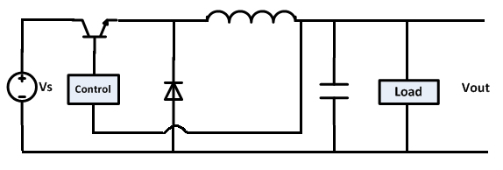

*Figure 1.1*: The Buck converter: a basic Power Electronics converter circuit

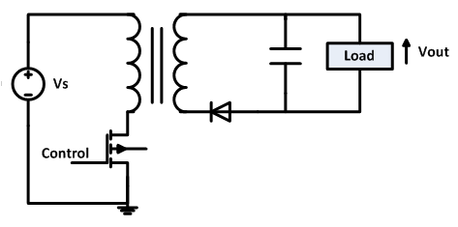

*Figure 1.2*: The flyback topology, which shall be the subject of more investigation in *Chapter 5*

The flyback converter topology is also shown; it will be the subject of further investigation in *Chapter 5*. The circuit elements can be categorised in the same way as for the buck converter: The voltage source providing energy to the supply-side passive components, the switch controlling the flow of energy between passives components, and a constant energy flow being drawn from the passive components by the load.

New topologies for power converters are regularly being developed [3, 5-8]. Increased converter performance can be achieved in terms of higher efficiency, mitigation of harmonics, and higher operating frequency – which allows higher power density, and consequently more compact spatial usage. Below is shown a more advanced power converter circuit that includes both PWM-control and soft-switching via a resonance circuit. This circuit indicates that the elements of an advanced converter circuit can also be categorised into an input power source, passive components to store energy, switches to control the flow of energy, and a resistive load drawing constant power from the output capacitor.This converter lends itself to an integrated architecture, which will be discussed in the following section. Additional sub-circuits that are not shown include the feedback loop controlling the switches; as well as features such as voltage clamping/snubber circuits across inductive elements to prevent overvoltages; and sub-circuits that recover the energy that is conventionally lost through leakage between coupled inductors, or by snubber circuits.

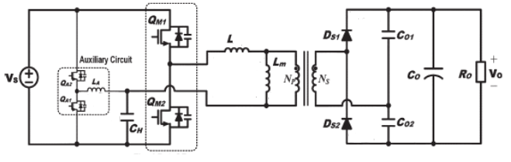

*Figure 1.3*: A more advanced converter topology: a very high-efficiency PWM-controlled quasi-resonant converter;diagram simplified from [7].

Power converter circuits produce noise mainly by their switching action. A fast-changing signal has high-frequency content, which causes parasitic impedances (e.g. layout inductances and capacitances, that are usually considered negligible for low frequency operation) to become significant. These parasitic impedances resonate leading to parasitic oscillations in circuit voltages and currents. Such oscillations pose a risk of exceeding electric field stress limits in power devices - especially semi-conductor devices. These oscillations propagateto adjacent power devices through the power grid via conduction, and also enter neighbouring circuit loops via electric and magnetic field coupling, which become especially significant at high frequency.

Converter circuit parasitic inductances and capacitances are distributed in nature, but are usually modelled and treated as lumped circuit element equivalents. Examples of parasitic inductances include the distributed inductance of interconnections between circuit components; leakage between two coupled inductors; and the inductance of a capacitor’s electrodes (commonly known as a capacitor’s ESL – Effective Series Inductance). Two examples of parasitic capacitance are the junction capacitances in semi-conductor devices, and the inter-winding capacitance found between an inductor’s turns (commonly expressed as an inductor’s EPC – Effective Parallel Capacitance). Reference [9] gives a good definition of ESL and EPC. The flyback circuit is modelled showing a lumped representation of parasitic elements in *Figure 1.4*: The leakage inductance of the coupled inductor and the MOSFET junction capacitance are in the same loop. When the MOSFET is turned off; there will clearly be a resonance between them if excited with a short enough switchvoltage fall-time – i.e. a more rapidvoltage fall-time contains higher frequency content.

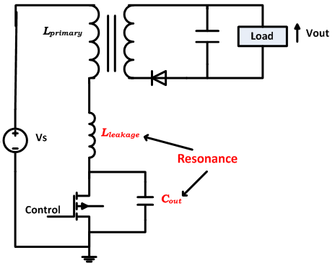

*Figure 1.4*: Flyback converter’s parasitic elements which resonate to give oscillations, after [5].

According to [9], in the frequency range between 100 kHz - 30 MHz, conduction is the primary means that noise signals use to reach other power devices. Above this frequency range, radiated noise coupling and electric and magnetic field coupling also becomes significant. Recent improvements in MOSFET technology has allowed much faster switching speeds, allowing converter operating frequencies of several megahertz [2-3, 10], with edge rise-times of down to 1 ns. This relates to frequencies of the order of 100’s MHz to be significantly present in the circuit. As the frequency of interest increases, the distributed nature of components becomes more significant. Once frequencies increase to the point where the signal wavelengths are comparable to the physical dimensions of a structure, transmission line effects can no longer be ignored.

The switching action of converter circuits is also their chief source of losses. The diagram below shows the voltage across a MOSFET and the current passing through it – they alternate, and during the transition there is simultaneously a non-zero voltage and current. This means there is a power flow in the form of heat losses. Modern technology often uses more advanced circuit topologies to reduce switching losses, namely a technique known as soft-switching has been quite successful in many applications [3].

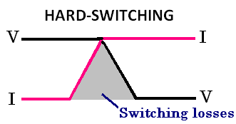

*Figure 1.5*: The concept of switching losses. V - voltage across the switch; I - current through it

## Integrated architectures for passive components in power converters

A current trend in power converter technology is a move from using discrete passive components (inductors, capacitors and transformers) towards a highly integrated architecture [1, 2]. This involves replicating the functionality of the combination of discrete components with an equivalent integrated component.

Some research towards this integrated technology has been carried out in recent years [2], but has been limited to very basic structures due to the complex nature of the electromagnetics. An integrated passive component could be constructed in various ways. A summary of early primitive structures are given by [11-12]. Even with limited understanding of the internal dynamics of these structures, promising results have been shown as to the benefits they could offer over the discrete-component architecture. Some examples of such work found in literature are givenbelow.

A 3 kW integrated LCT component was used in a prototype partial-series-resonant circuit [13]. In the work of [13] a precise effort is made to compare a real integrated circuit with a true equivalent circuit of a conventional discrete architecture. The two architectures showed very similar results; the efficiency of the integrated architecture was slightly lower because material technology is still in a primitive stage for this application. The spatial usage was halved by using the integrated architecture.

Gerber in [14] implements a converter with an LCCT integrated architecture. He also finds the integrated architecture is less efficient by about 4% than an equivalent discrete-architecture converter, citing that the PCB material has high dielectric losses, which is especially significant at the high switching frequencies needed to allow small dimensions for the passive component. Gerber finds that the integrated architecture has substantially lower harmonic content. The functional operation of the integrated and discrete circuits was the same, showing the viability of the integrated architecture for power levels up to the kilowatt range.

The above two examples are power conversion circuits, where high power density is required, and the frequency of operation is around the fundamental resonance of the passive network. Other applications of the integrated architecture have been demonstrated for high frequency resonance networks [15-16]; interconnects that transmit triggering power to gate turn-off thyristors in converters for induction heating [1]; and filter circuits to arrest conducted EMI noise generated by power electronics circuits:A thorough investigation of EMI filter design using the integrated architecture was done by [9]. A three-phase integrated EMI architecture was developed by [17].

### Planar passive structure

There are different techniques used to construct integrated passives [1, 11], but the planar construction has received the most attention in recent developments. Reasons for this are detailed in [1]:

* Suited to simple manufacturing processes that can be streamlined for high production
* Higher capacitance per unit area can be achieved: High permittivity dielectrics are not flexible, they are often brittle, and thus disallow curved capacitor plates.
* Good thermal management characteristics: Heat sinks have a planar surface, whose area should be fully interfaced with heat-carrying parts for maximum heat extraction – planar architectures have an advantage in this aspect over non-planar shapes
* Full three-dimensional electromagnetic analysis is complex; the planar structure lends itself to be modelled in one dimension [12].

The planar construction involves stacking alternate layers of conductive, dielectric and magnetic materials.

The L-C cell shown in *Figure 1.6* is demonstrated by [12] to be an effective building block for replicating a variety of passive circuits found in converters. Multiple L-C cells are usually placed in the same core to allow magnetic coupling, and by using different interconnection configurations between conductor terminals, different electromagnetic functions can be obtained (e.g. series and parallel resonance, L-C-T, L-L-C-T, low/high/band-pass filters, etc) [12]. A strong dielectric allows good control of the electric field, reducing the effect of parasitic capacitance with respect to external elements. The magnetic material and encapsulating core allows effective control of magnetic fields, as well as significantly increasing the system inductance.

An illustrative example for the concept of using integrated passives to replicate the functionality of typical discrete-component architectures can be found in literature. Two good descriptions of this concept can be found in [11, 19], which examine the specifics of integrating an LCT component, as shown in *Figure 1.7*. Although most work in integrated passives has been limited to two-to-four conductors, theconcepts of integration extend easily to systems with many conductors, such as the high-frequency transformer in [20].

The planar passive concept was first developed by Smit in [16], who developed a 44 mm series resonator that could operate at 1 MHz, a circuit common to power electronics. Smit’s work treated the planar passive as a transmission line, and he showed that by cascading two LC cells of different propagation velocities, he could achieve a lower resonance frequency than either of the LC cells alone. His work demonstrates that there may be promising prospects to using integrated passives structures to replicate the functionality of networks of discrete passives in converter circuits.



*Figure 1.6:* The L-C cell used as building block for more complicated integrated passives, after [4]

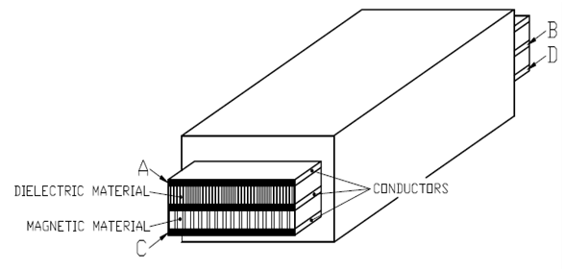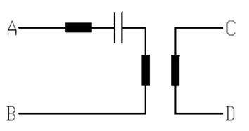

*Figure 1.7*: An integrated L-C-T structure, after [11]

### Motivation for integrated architectures

A good review of the reasons for this drive to an integrated architecture can be found in [1, 2]. A summary is given in this section:

An important objective in power electronics is the decrease of switching speeds [2]. This will provide two main benefits: Firstly, the bulk of energy loss in power electronic circuits occurs during the switching time, so lifting slew rate limits will directly improve efficiency. Secondly, faster switching will support higher operating frequencies, which in turn supports the reduction of size of electromagnetic components.

Recent progress towards this objective has largely been made due to improvement in semi-conductor technology, i.e. the switches themselves [1-3]. Currently, however, other limiting factors are beginning to dominate in the discrete-component architectures, especially parasitic electromagnetic effects, either within the discrete passive components or due to the interconnections between components [1, 28]. The development of an integrated technology would enable circuit designers to incorporate certain significant electromagnetic effects in the design process, i.e. certain effects found in discrete components which are considered to be parasitic would now be well-controlled and quantified because they are included in the design of the integrated component. As a simple example, for theintegrated series resonator shown in *Figure 1.8*, the resonant capacitor’s ESL is now the integrated resonant inductor; and there is no interconnection between resonant components.

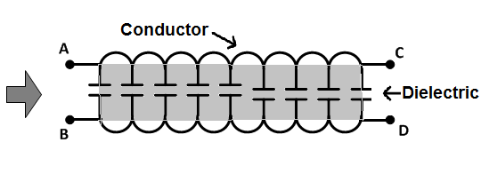

*Figure 1.8*: a primitive integrated passive structure – a series resonator

The integration of passive structures has other advantages besides the integrationinto the design process of classically-parasitic elements found in discrete architectures. The major advantages are as follows:

* Increased power density is possible because of integrating multiple passive functions in the same structure. This supports decreases in volume, a major priority for non-drive power converters [1, 29, and 32].
* Simpler manufacturing processes than for discrete-architectures – promotes cost-effective streamlined processes for mass production.
* Removing the need for interconnections promotes ruggedness and reliability of components.

## Aim of this study defined in the context of modelling integrated passives

### Brief introduction to current modelling methods for integrated passives

Previous work has been done to model integrated passive structures [1-2, 9-23, 44-49], chiefly by the Centre of Power Electronics Systems at Virginia Polytechnic Institute, in Blacksburg, and the Industrial Electronics Technology Research Group at Rand Afrikaans University (now the *University of Johannesburg*), in Johannesburg.

Circuit designers would prefer a model that can be interfaced easily with SPICE, or another similar circuit simulator, because there are many benefits to working in the SPICE environment:

* Different analysis types are possible, e.g. Transient (Time-domain) simulation as well as AC small signal analysis (Frequency domain) are easily conducted interchangeably on the same model.
* The integrated passive model can be connected to a complete converter circuit, i.e. the boundary conditions of the integrated passive are taken care of by the circuit simulator.
* SPICE supports good models for semi-conductor devices, which are not easily modelled from first principles if one was to construct their own circuit simulator.
* Parametric studies are also well supported by the PSPICE A/D environment.

It is probably possible to implement an interface between SPICE and a model coded using a language such as MATLAB, but this option is not implemented in this study.

The structure that will be modelled is initially limited to the two-conductor planar L-C component, as in *Figure 1.6*, which forms a good building block for further integrated passive structures. Most of the models extend easily from two-conductor structures to structures with multiple conductors. Loss models will not be studied in this dissertation, but the ability of each model solution method to incorporate losses will be indicated. Good work on loss modelling of integrated passive structures can be seen in [13, 15, 21].

The two main categories for integrated passive models are simple lumped circuit element models, and a distributed transmission line model. These models will be described in more detail in *Chapter 2*, along with their solution methods, and their various advantages and disadvantages.

The solution methods for lumped models are either analytical equations derived using Kirchhoff’s laws, or simply building a SPICE simulation using standard circuit elements. Circuit designers prefer lumped models to distributed ones because of their simplicity and ease of understanding. The problem is that the approximations made when modelling with lumped circuit elements can lead to significant error at higher frequencies. Such error can result in parasitic oscillations which damage circuits, unpredicted noise and the consequent need for a lot of noise filtering, which is expensive and costly to a converter’s efficiency.

The distributed transmission line model has multiple solution methods, which will be overviewed in *Sections 2.2.3-2.2.6*. The main problem with most of the distributed model’s solution methods is that they cannot directly interface with a circuit simulator. This means that the boundary conditions that can be simulated are limited to simple terminal-terminal impedances, and cannot support a complete converter circuit. We also lose the benefit of the SPICE-like environment to switch from Time domain to Frequency domain. One solution method for the distributed model can be implemented in SPICE, detailed in *Section 2.2.5*, showing good potential for a distributed solution; there are, however, certain problematic convergence issues that have to be overcome.

### Modelling dilemma: Lumped vs. Distributed

Power electronics designers conventionally use the lumped models, because they naturally fit into a simulation package such as SPICE. The integrated passive, however, is a distributed structure. A distributed structure can be represented by lumped circuit elements when the physical dimensions of the distributed structure are electrically small – i.e. the smallest significant wavelength present in the circuit must be significantly larger than the largest physical dimension of the integrated passive.

Lumped circuit models have been found to be suitable until the frequency of operation increases beyond the first resonant point of the structure. After the first resonance point, subsequent resonance points are found to exist, and the lumped models do not predict them. The next step was to develop higher-order lumped models that are able to match the frequency domain impedance curves to up to the 3rd resonance point [22, 23]. However, the shortcomings were twofold:

* The circuits were constructed for a specific terminal interconnection, i.e. they model a two-conductor system (see *Figure 1.9*) with a source connected at A-D, and a load connected between B-C. Extending these models to structures with more conductors is not obvious.
* The model parameters were not directly derived from physical parameters such as material properties and geometries, but were rather determined from a process of curve fitting. Thus, it becomes difficult to distinguish between the causes of certain responses.

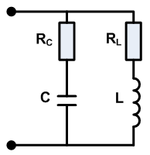

*Figure1.9*: Stielau’s circuit topology, model found in [22]

Present converter technology typically does not operate much higher than the fundamental resonance of their passive sub-systems, but future prospects are looking at pushing the operating frequency increasingly higher. Being able to accurately predict high-order resonance may have significant uses in such developments. Integrated passive technology is being researched with this future trend in view [1]. A distributed model will theoretically offer information to an infinite number of resonant points in the frequency domain.

The distributed model that has been adopted is known as the Multi-conductor Transmission Line (MTL) model, a model that has been successfully demonstrated for low-power signal processing applications [24-26], but is now being applied to high-power structures [2, 9, 12]. An important contribution of their work is the thorough consideration of parameter extraction for the planar integrated passives. This model can handle frequencies that introduce transmission line effects (which would cause a breakdown of a lumped model). The problem with the model is that its solution is not trivial, especially in the time domain. The model’s solution can be time-expensive, unstable, and losses are difficult to model. A description of this model and its possible solutions can be found in [12, 26]. The main limiting issue at present is that the solution methods have not been implemented in a manner that can handle general boundary conditions, i.e. no interface with SPICE-like environment has yet been made available.

The use of lumped circuit elements breaks down when the physical length of the conductor it represents becomes comparable to the wavelengths present in the system. This is expressed in *Equation 1.1*. A system of *n* parallel conductors will have *n* phase velocities, which are determined by the electromagnetic material surrounding the conductors of interest, as in *Equation 1.2.* The electromagnetic materials are directly related to the per-unit-length inductance and capacitance matrices (L and C). The minimum velocity will give the smallest wavelength for any given frequency.

$$λ_{min}=\frac{v_{p(min)}}{f_{max}}≫l_{conductor} …(1.1)$$

$$v_{p}=\frac{1}{\sqrt{LC}} =\frac{1}{\sqrt{εμ}} …(1.2)$$

When implementing *Equation 1.2*, L and C will be in matrix form of dimension *nxn*. The construction of these matrices is detailed in [25]. The MATLAB code to implement *Equation 1.2* is given as follows:

“ Vp = eig( inv( sqrtm(L*C) ) ) ”

Using sqrtm( ) rather than sqrt( ) is important, as the latter takes the square root on an element-wise basis, rather than of the matrix itself.

In the time domain, the system signals will consist of a spectrum of frequencies. A common signal in power electronics circuits is the pulse waveform, see *Figure 1.10*. Reference [27] cites that it is appropriate to use *Equation 1.3* to get *fmax*, which can then be used to obtain the minimum wavelengths in the system. The energy content at frequencies over this frequency can usually be considered negligible.

**1/T**

**1/πtr**

**ω**

**tr**

**T**

**Time**

*-40dB/dec*

*-20dB/dec*

**F**

*Figure 1.10*: Frequency spectrum of a pulse waveform

$$f_{max}≅\frac{1}{10t_{r}} …(1.3)$$

Once transmission line effects become significant, there is no choice but to use the distributed model for accurate results.

### Outcomes of this study

The main objective of this research is to contribute towards the development and verification of a simulation tool that can be effectively and confidently used to predict performance of integrated passive circuits operating in power electronic circuits.

This study seeks to gain a confidence as to the extent of accuracy and the boundaries of application of SPICE-compatible models, both in the frequency and time domains. The SPICE-compatible models include the lumped element models, and one solution method for the distributed model.

The SPICE-compatible solution for the distributed model has yet to be verified for integrated passive applications; it is a method imported from low-power signal processing applications. Integrated passive applications use different boundary conditions, i.e. circuit connections can exist between any pair of terminals, while for signal processing circuits the supply-side terminals are independent of those on the load-side. The viability of this solution for integrated passives is investigated.

Most solution methods for the distributed model are not SPICE-compatible. These are implemented in the frequency domain. The solution is usually given as an impedance observed between any two selected terminals of the integrated passive, with only simple boundary conditions (limited to an impedance) between the other sets of terminals. Since the distributed model more closely represents the actual structure, its analytical solution provided by Zhao in [12] will be used as the benchmark for accuracy. All SPICE-compatible models are implemented in the frequency domain, using SPICE’s AC small signal analysis, and are compared with the benchmark solution. This gives a first-level of confidence as to where the models begin deviating from reality.

Frequency domain data, however, is limited to providing steady-state information, and it is not always clear how this data can be used to inform transient characteristics. In this study, transient simulations are also conducted on the SPICE-models, taking care that the same boundary conditions are used as for the AC analysis. This time domain data is then compared to the frequency domain data to determine how they can be reconciled, e.g. how can oscillations in the transient be related to resonant points in the frequency domain. This gives a first-level confidence in the use of frequency-domain data to predict time-domain characteristics.

The limited boundary conditions implemented by the analytical benchmark solution do not show how an integrated passive would operate in a converter circuit. This indicates the value of the SPICE-compatible distributed solution, which could be used as the benchmark solution for more complicated boundary conditions and complete converter circuits. Promising results are obtained in the frequency-domain, but convergence difficulties in the time-domain have yet to be overcome. Consequently, this solution method can currently be used as a benchmark for integrated passives operating in complete converter circuits in the frequency-domain only.

*Chapter 3 & 4* will compare the performance of the different models for the pure case of a basic two-conductor integrated passive component with simple boundary conditions. This will consist in frequency domain comparisons, as well as the models’ responses to a step input. The models will then be further compared, in *Chapter 5*, with a practical case-study: an integrated passive component operating in a flyback converter circuit. The case-study will involve simulations of a modelled integrated passive component connected to a complete power converter circuit; the robustness of the models when interacting with a complete power electronic circuit will be tested. A physical integrated passive will be constructed and measurements taken of it operating in a physical flyback converter. The physical measurements will be reconciled to simulation results.

Sub-outcomes of this work include the following:

* A thorough overview of different modelling methods for integrated passives, detailing each one’s advantages, disadvantages, and implementation method.
* Demonstration of what kind of information each model can provide.
* Initial investigation as to the causes for convergence difficulty for the SPICE-compatible distributed solution.
* Investigate when a distributed model is actually necessary. According to the theory outlined in *Section 1.3.2* and in [26], the distributed model should only become necessary when the physical length of the structure becomes comparable to the shortest significant wavelength in the system. However, this supposition is questioned by some observations in [12], as well as by an initial investigation into the voltage distribution along the conductors of a integrated passive. The question stands: are there other factors demanding a distributed model even when the physical dimensions are still electrically small?

The main purpose of this work is to contribute to an accurate model, as well as insights into the operation of integrated passives in converter circuits, which will assist power converter designers, e.g. to be able to distinguish various parasitic oscillations that appear in simulation and measurement data, and to differentiate their causes.

# Description of models for integrated passive structures

The two main categories for integrated passive models are simple lumped circuit element models, and a distributed transmission line model. These models are now described in more detail along with their solution methods, and their various advantages and disadvantages.

This dissertation is not an exhaustive study of possible models that can be applied to distributed passive structures. The models chosen to be included in this study are the ones most commonly used in the field of integrating passives.

The lumped models are described in *Section 2.*1. The solution methods for lumped models are either analytical equations derived using Kirchhoff’s laws, or simply building a SPICE simulation using standard circuit elements.

The distributed model is defined in *Section 2.2.1 and 2.2.*2. The distributed transmission line model has multiple solution methods, which will be overviewed in Sections 2.2.2-2.2.6. One solution method for the distributed model can be implemented in SPICE, detailed in *Section 2.2.5*, showing good potential for a distributed solution. *Section 2.2.7* highlights some known limitations found in the solutions methods of the distributed model.

## Lumped models

The advantage of these lumped models is their simplicity, and the natural way in which they can be inserted into a greater power electronics circuit for synthesised time and frequencydomain simulation in standard simulators, such as SPICE; this is essential for efficient design of power electronics circuitry.

### Reeves and Murgatroyd models

These are almost equivalent lumped parameter models. For low frequencies the distributed system can be modelled using lumped circuit elements that represent the total inductance (L) of each conductor, and the total inter-conductor capacitance (C). This inductance and capacitance actually coexist in the same length, so it is an approximation to separate them using lumped circuit elements. Only the capacitance between conductors that are directly next to each other is modelled, as the capacitance between conductors that are separated by other conductors is very small.

The three models shown in this section are separating the inductance and capacitance in different ways. The second two better represent the uniformity of the structure. First order understanding of an integrated passive structure can be obtained with the basic lumped parameter modelling approach shown in *Figure 2.1*. The lumped parameter model was further developed in [30-31] as shown in *Figure 2.2&2.3*, which are sufficient to accurately predict the first resonance point, but do not model any higher-order effects.

When developing a lumped model with the objective of accuracy, there are two aspects that must be considered:

* Are the lumped elements sufficiently representing the distributed L’s and C’s? I.e. how electrically small is the physical length of the conductor represented by any lumped element.
* Have all significant L’s and C’s been included in the model?
  + For example, the capacitance between conductors and the core, which is commonly as treated as a capacitance to ground potential. Often a small capacitance being excluded from the model can be much more significant than the approximation error of using lumped elements to represent distributed reality.
  + Also consider a capacitance from a conductor to itself. This is only possible if a significant length of the conductor is physically parallel to another length of that same conductor, e.g. the case of a conductor being wound into multiple turns. In this case, a good option is to model the parallel section as two separate conductors with an appropriate external connection.

Advantages:

* Naturally supported by circuit simulators such as SPICE
* Computation time is small due to simplicity
* 1st order frequency-independent loss modelling through resistive circuit elements, similar to what is shown in *Figure 2.7* shown later in *Section 2.2.1*.
* This simplicity allows easier troubleshooting, and understanding the contribution of each part of the structure to the system dynamics

Disadvantages:

* Not derived from distributed system, so we need confidence in its reliability, especially at high frequencies
* Only includes lower resonance points in the model (1st resonance point for Reeves’ model, up to 2nd resonance point for Murgatroyd’s model)

**D**

**C**

**B**

**A**

$$C$$

$$L$$

$$L$$

*Figure 2.1*: Basic lumped model for two-conductor integrated passive – commonly used.

**D**

**C**

**B**

**A**

$$\frac{C}{2}$$

$$\frac{C}{2}$$

$$L$$

$$L$$

*Figure 2.2*: Reeves’ model for a two-conductor integrated passive, model from [14]

**D**

**C**

**B**

**A**

$$\frac{L}{2}$$

$$\frac{L}{2}$$

$$\frac{L}{2}$$

$$\frac{L}{2}$$

$$C$$

*Figure 2.3*: Murgatroyd’s model for a two-conductor integrated passive, model from [15]

The simplest solution method for these models is to implement the model directly in SPICE, which supports all the circuit elements. A potential source of simulation problems is when a higher number of conductors are being modelled: the mutual inductive coupling between every conductor results in a high number of coupling terms needing to be simultaneously solved. This can cause convergence problems.

An alternative solution method (for frequency domain) is to take the model into the s-domain, which allows one to obtain the algebraic solution of nodal analysis of the model, including the reactive components. This algebraic solution can be manipulated into an analytical expression for impedance in terms of frequency. This expression is then evaluated in Mathematica.As a case study, the impedance ZA-D is chosen as a point of comparison. The expressions for ZA-D for a load impedance ZL connected between B and C are shown in *Equations 2.1 (Reeves) and2.2 (Murgatroyd)*:

$$Z_{AD}=\frac{Z_{L}C\left(L+M\right)s^{2}+4\left(L+M\right)s+2Z_{L}}{C\left(L+M\right)s^{2}+2Z_{L}Cs+2} …(2.1)$$

$$Z_{AD}=\frac{Z_{L}+2\left(L+M\right)s+Z_{L}LCs^{2}+C\left(L^{2}-M^{2}\right)s^{3}}{1+Z_{L}Cs+LCs^{2}}..(2.2)$$

As ZL→∞ (i.e. an open-circuit load), we obtain *Equations 2.3 and 2.4*:

$$Z_{AD}=\frac{C\frac{\left(L+M\right)}{2}s^{2}+1}{Cs} …(2.3)$$

$$Z_{AD}=\frac{LCs^{2}+1}{Cs} …(2.4)$$

Therefore, for the above case, the Reeves and Murgatroyd models are equivalent for M≈L (high coupling).

For ZL = 0 (a short-circuit load), *Equations 2.5 (Reeves) and 2.6(Murgatroyd)* are obtained:

$$Z_{AD}=\frac{2\left(L+M\right)s}{1+C\frac{(L+M)}{2}s^{2}} …(2.5)$$

$$Z_{AD}=\frac{2\left(L+M\right)s×(1+\frac{C}{2}\left(L-M\right)s^{2})}{1+LCs^{2}} …(2.6)$$

Here we see that the coupling affects the position of the fundamental resonance point in the same way for both the Reeves and Murgatroyd models, but the Murgatroyd model includes a second resonance point, where the inter-conductor capacitance and leakage inductance resonate. The question arises as to whether this second resonance should be included or not in order to match physical reality more closely; or is it rather a parasitic of the model? We also observed a definite equivalence in the models at high coupling. A question arises: what happens at low coupling? These questions will be answered in *Chapter 3*, in a comparison between the lumped models and an analytical solution to a distributed model.

Lumped modelling is often sufficient when designing resonant converters, whose operating frequency is the fundamental resonant point, which is well-predicted by the above models. As discussed in [33], however, non-resonant converters operate at higher frequencies that may excite higher-order resonance, if not carefully designed to avoid them. For such design, accurate modelling of these higher-order resonances must be provided, hence the development of the 2nd and 3rd order models of [12, 23, and 33].

### Higher-order lumped models

Accurate prediction of up to the third resonant point could be achieved by models developed by [22, 23], after which they deviate from physical measurements made on the integrated structures. These models were developed to emulate the output waveforms observed on the integrated structures, rather than derived from an understanding of the structure dynamics. As a result, the parameter determination of these lumped equivalent circuits is not accurate when a structure is used that is different to the spiral-type structures used by the developers.



*Figure 2.4*: Circuit diagram of Stielau’s model

Consider the structure being modelled in [22]: it is a strip of two conductors separated by dielectric material, and this strip is spiralled around the magnetic core for two turns. This is the same structure used by Reeves and Murgatroyd. The higher order resonances troubling the models of [30, 31] are actually a result of the inter-turn capacitance. This is opposed to the idea that high frequency distributed effects cause the resonances. As frequency is increased in these structures, the capacitance existing in the insulation material separating turns becomes significant well before distributed effects become important.

The structure could alternatively be modelled as four parallel conductors, with each conductor having the same inductance because they enclose approximately the same flux. This inductance is easily obtained from the reluctance of the enclosing magnetic core. Capacitance is a simple parallel plate calculation, with the permittivity constant determined by the material property of either the dielectric material (i.e. between conductor pairs 1-2 & 3-4) or insulation material (i.e. between conductor pair 2-3). This perspective gives a more direct approach to deriving circuit parameters from material properties and geometrical quantities, rather than fitting parameters to measurement results, as in [22].

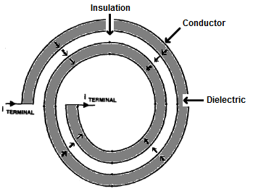

*Figure 2.5*: Structure used by Stielau, adapted from [22]

### Cascaded lumped model

At higher frequencies the lumped models breakdown because the lumped elements begin to represent physical lengths that are electrically large. Usually, at this point, one would have to use the distributed model. In order to continue using the simple lumped models, many circuit designers use the cascaded lumped models.

The main idea is to cascade multiple cells of the 1st order models described in the previous section. The number of cells is chosen such that each single cell represents a physical length that is still electrically small. All the cascaded cells together represent a length that is equivalent to that of the conductors being modelled.

The main problem with this model is that a large number of inductive coupling terms have to be simultaneously handled by SPICE, which can give rise to convergence problems. Secondly, the use of multiple discrete passive elements introduces parasitic resonances at high frequencies. The validity of this model for integrated passive structures is investigated in *Section 3.3*.

**B**

**A**

$$\frac{L}{4}$$

$$\frac{L}{4}$$

$$\frac{L}{4}$$

$$\frac{L}{4}$$

**D**

**C**

$$\frac{L}{4}$$

$$\frac{L}{4}$$

$$\frac{L}{4}$$

$$\frac{L}{4}$$

$$\frac{C}{2}$$

$$\frac{C}{2}$$

*Figure 2.6*: A two-cell Murgatroyd cascaded model

## The Multiconductor Transmission Line (MTL) model

### Mathematical model of distributed circuit

The distributed circuit model is initially developed for the well known two-conductor case to increase clarity [26]. The two conductors are divided along their length into an infinite number of spatial cells, each represented by a lumped circuit element network. The equivalent circuit of such a cell of length Δz for a two-wire system is shown in *Figure 2.7*. The ideal distributed circuit will have Δz tending to zero, which would require an infinite number of infinitesimal cells. This is approximated by choosing the number of cells such that Δz is electrically small in terms of the highest significant frequency components present in the circuit. The parameters *R*, *L*, *C*, and *G* in the circuit are per-unit-length (PUL) values. Therefore, the lumped circuit element parameters for a specific cell are obtained by multiplication with the length of the cell, Δz.

The model elements are now described. Each conductor has a self-resistance which simply comes from the resistivity of that conductor. In general this resistance will be frequency dependent at high frequency. There also exists a mutual resistance between the conductors that arises from the proximity effect between the conductors. Similarly, there is a self-inductance in each conductor as well as mutual inductances representing the magnetic field coupling. The capacitance terms represent the electric field coupling between conductors, as well as the capacitance between each conductor and the ground plane. The conductance (*G*) terms represents real leakage current through the dielectric separating conductors.

C12

C11

C22

R11

R22

G11

G12

G22

L11

L22

V1(z)

V2(z)

V1(z+z)

V2(z+z)

L12

R12

I1(z)

I2(z)

I1(z+z)

I2(z+z)

*Figure 2.7*: Equivalent circuit of infinitesimal section of two-conductor system

The *V1* and *V2* variables are the line voltages of conductors 1 and 2 respectively with reference to a common ground. The *I* variables are clearly the line currents through each conductor.

A simple Kirchhoff voltage loop analysis along each conductor in *Figure 2.7* can be summarised in*Equation 2.7*. This can be reformulated into the more compact form of *Equation 2.8*, where *R*, *L*, *C*, and *G* can be termed the PUL parameter matrices and *V(z,t)* is a vector of the line voltage of all conductors. For increased generality, an independent voltage source *VF* is placed in series with the rest of the model network, to account for external sources. The other circuit elements fully describe all the effects occurring in the inner cells. Similarly, simple Kirchhoff current loop analysis gives *Equation 2.9*. This model can easily be extended to N conductors, using the same equations. The PUL parameter matrices will be of order N x N. Each conductor will have self-parameters that exist on the diagonal of the PUL parameter matrices: *Rii,Lii*, *Cii*, and *Gii*. Mutual parameters representing the effect of coupling on conductor *i* due to conductor *j* will exist in non-diagonal entries *Rij*, *Lij*, *Cij* and *Gij* where *i* ≠ *j*. The reasoning is applied to the solution of MTL’s by [26].

$\left[\begin{matrix}\frac{∂V_{1}(z,t)}{∂z} \\ \frac{∂V_{2}(z,t)}{∂z}\end{matrix}\right]=-\left(\begin{matrix}R_{11} & R_{12} \\ R_{21} & R_{22}\end{matrix}\right)\left[\begin{matrix}I_{1} \\ I_{2}\end{matrix}\right]-\left(\begin{matrix}L_{11} & L_{12} \\ L_{21} & L_{22}\end{matrix}\right)\left[\begin{matrix}\frac{∂I_{1}\left(z,t\right)}{∂t} \\ \frac{∂I_{2}\left(z,t\right)}{∂t}\end{matrix}\right]$... (2.7)

$$\frac{∂V(z,t)}{∂z}=-RI\left(z,t\right)-L\frac{∂I(z,t)}{∂t}+V_{F}\left(t\right) … (2.8)$$

$$\frac{∂I(z,t)}{∂z}=-GV\left(z,t\right)-C\frac{∂I(z,t)}{∂t}+I_{F}\left(t\right) … (2.9)$$

### Theoretical conditions for valid use of MTL

The model developed in the previous section requires Transverse Electromagnetic (TEM) propagation in order to uniquely define line voltages and currents. The electric and magnetic fields must be perpendicular to each other and to the flow of current in the conductor. Under TEM conditions, the electromagnetic field structure will be the same as that under static (or DC) conditions. This allows for the use of methods for solving static field distributions to determine the PUL equivalent circuit parameters. Kirchhoff’s circuit laws, and the use of circuit elements, are defined in the TEM-mode. The MTL formulation is thus founded upon the validity of the TEM assumption. The telegraphist’s equations used in MTL are generalised to include non-TEM propagation by [34], but the solution of this generalisation is not that important for the power electronics applications considered here and will not be discussed in this paper. Full-wave electromagnetic analysis is probably required to determine the extent to which the TEM assumption is valid for integrated passives, but that is beyond the scope of this research.

All conductors must lie in parallel to support TEM propagation. The Transverse Magnetic (TM) condition requires either a zero voltage reference line of infinite conductivity, or an imaginary reference surface in space that has no conductivity; the former forces TM behaviour [25]. Conductors with imperfect conductivity theoretically invalidate the Transverse Electric (TE) condition, because a longitudinal component of the electric field is required to overcome resistance. This is usually ignored because the longitudinal component is much smaller than the transverse. The reason for this can be visualized in the following: The longitudinal electrical field is directly related to the voltage drop across the conductor resistance, while the transverse field is related to the voltage difference between conductors at any point in z. For good conductors used in circuit interconnections, the resistive volt drop will be small, resulting in a small longitudinal electric field. In typical power electronic circuits, the cross-sectional separation between conductors is much smaller than conductor lengths. Therefore, even in the case where the voltage drop across a line’s length is comparable to the voltage difference between lines, the smaller distances involved will result in electric field strengths being greater in the transverse direction.

TEM propagation requires all propagating modes to have equal phase velocity [25, 35]. Conductors embedded in medium that is cross-sectionally homogeneous will meet this requirement. Cross-sectionally inhomogeneous media, due to geometrical or material variation in the plane transverse to the conductor, will cause unequal phase velocities. This condition can be approximated as TEM if the separation between velocity magnitudes remains small [26].This approximation breaks down at high frequencies [25, 34]. In the case of microstrip structures, [26] gives some empirical rules for a quasi-TEM approximation to give an accuracy of within 0.2% for up to 2 GHz:

$$0.01≤\frac{w}{h}≤100 1≤ε_{r}≤128 … (2.10)$$

Where *w* and *h* is the width and height respectively of a rectangular conductor, and ${ ε}_{r}$ is therelative permittivity of the dielectric to which the conductor is adjacent. It is commonly recognised from microwave work that TEM is an excellent approximation up to several GHz [37].

All the line currents and the current of the ground reference must sum up to zero for the MTL model to be valid [26]. This implies that any antenna (or common mode) propagation along the transmission line will be neglected in the solution. This may occur when conductors in close proximity to the system are excluded from the model.

### Zhao’s solution for a two-conductor L-C cell

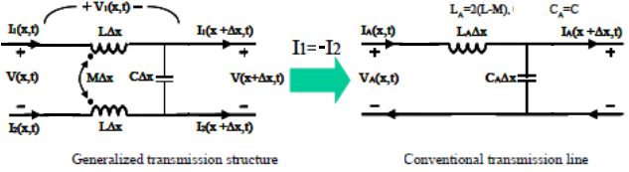

*Figure 2.8*: PUL circuit of a partial section of distributed structure: Zhao’s generalized model(left);The conventional model(right) ;diagram simplified from [12]

Zhao models the L-C structure of *Figure 1.6*as a transmission line of two conductors. He differs from the conventional transmission line model, because in the conventional case I1 = -I2, i.e. current on each conductor is equal and opposite; but this is not true generally. *Figure 2.8* is a representation of a partial length (Δx) along the transmission line: R, L, C, and G being Per-Unit-Length quantities. As Δx→0, these circuit elements exactly represent an infinitesimal section of a distributed structure. Zhao in [12] derives transmission line equations using KVL applied to the above circuit. A summary of the transmission equations are as follows:

$$\frac{d^{2}V(x)}{dx^{2}}-γ^{2}V\left(x\right)=0 …(2.11)$$

$$\frac{d^{2}I_{DM}(x)}{dx^{2}}-γ^{2}I_{DM}\left(x\right)=0 …(2.12)$$

Where IDM is the differential mode current, and γ is the propagation constant:

$$I_{DM}\left(x\right)=\frac{I_{1}\left(x\right)-I_{2}\left(x\right)}{2} …(2.13)$$

$$γ=α+jβ=\sqrt{2\left[R+jω\left(L-M\right)\right][G+jωC]} …(2.14)$$

An important note is that the complex part of γ gives us the wavelength of a signal in the structure of angular frequency ω, according to the definition of wave number:

$$λ=\frac{2π}{β} …(2.15)$$

The characteristic impedance Z0 evaluates to [Zhao]:

$$Z_{0}=\sqrt{\frac{2[R+jω\left(L-M\right)]}{G+jωC}} …(2.16)$$

The above equations give an exact F-domain solution to the 2-conductor integrated structure. For each different terminal configuration (set of boundary conditions), an expression must be obtained for an impedance of interest, in terms of frequency. This procedure is shown in [12]’s work. The expression is then evaluated in Mathematica, and plotted as the impedance against frequency.

The model in [12] is excellent, consisting of analytic expressions for voltage and current distributions along conductors, as well as expressions for the impedance of the integrated system as seen between two defined terminals. The work in [12] also has thorough experimental verification.

Advantages:

* Exact analytical solution for the case where losses are frequency-independent.
* Computation time to solve the solutions’ analytical equations is very small.
* F-independent losses included, i.e. conductor DC resistive losses and DC dielectric losses.

Disadvantages:

* The challenge of incorporating boundary conditions. An expression has to be derived for every set of boundary conditions, which is not trivial. However, [12] has provided a comprehensive set of solutionsfor boundary conditions for the two-conductor case, limited to terminal-terminal connections involving simple impedances only.
* Neglects the self-capacitance of each conductor to some reference ground: This results in stability problems for the case of more than two conductors. The MTL model of Paul in [26] incorporates this self-capacitance, but we still remain with Zhao because he offers full solutions for a comprehensive set of boundary conditions, which is unavailable for Paul’s model.
* Not implemented in SPICE, with the consequent limitations to simulation in complete converter circuits

On pg. 56 of Zhao’s thesis [12], an integrated LC structure is shown to resonate at the first resonance point, and then again when ${ l}_{conductor}$ equals multiples of the wavelength of applied signal. This suggests that the higher order resonance points are due to transmission line effects, but the question arises as to whether this is only true for the case of high coupling. On pg. 34 of his thesis, Zhao’s model predicts higher order resonances well under 1 MHz for a coupling of 0.7, while these resonances hardly appear under 10 MHz for a coupling of 0.99. A proposed explanation is that the low coupling reduces $v_{p(min)}$, thus reducing the frequency at which transmission line effects begin to occur. Using the parameters that Zhao appears to be using to produce his results, the minimum wavelength is over 50 times $l_{conductor}$, at the frequency at which the higher order resonances begin occurring. Is this wavelength comparable to ${ l}_{conductor}$, i.e. can ${ l}_{conductor}$ yet be considered electrically small? Are the resonances caused by transmission line effects significant at this point yet? Or is there another non-transmission line effect contributing to the breakdown of the lumped models at low coupling? These questions must be investigated further.*Chapter 3* will give some insights that contribute to this issue.

### Paul’s F-domain solution for general MTL

Paul makes available a numerical solver implemented using FORTRAN in a programme he calls MTL.FOR, which comes with the referenced book [26]. This is specific to the frequency domain, and has the potential to solve a general n‑conductor structure, including electrical frequency-dependent losses. The challenge here is that only a limited number of terminal configurations have been implemented, and the incorporation of boundary conditions is not trivially extended to the general case. Not even the simple boundary conditions put forward by [12] are supported by MTL.FOR. This is because the terminals on one end of the structure’s conductors are kept independent of the terminals on the other end of the parallel conductors. Due to this limitation, this solution is not included in comparative study of *Chapter 3 & 4*, but is mentioned here as a potential frequency-domain benchmark solution for n-conductor structures, provided an effective handling of boundary conditions is implemented.

### SPICE macromodel

The following isa solution method for the distributed model that can be implemented in SPICE. It consists of using SPICE controlled voltage and current sources with resistors. The term “macromodel” refers to modelling a transmission line as a *2-*port network, a port for both the input and output of the line, where each port is dependent on the other through controlled sources with delays. In an *n*-conductor system, a macromodel will consist of *2n* ports. Relatively few circuit elements are used, which should allow fast execution times, but this was found to not always be the case. An interesting feature of this method is that it offers an exact solution for the lossless case. This must be kept carefully in mind when evaluating the results of this solution, because the systems being simulated are quite sensitive to even small losses. Nevertheless, the lossless approximation will provide good results for initial work in the low frequency region of below 2 MHz. In order to accurately model very high frequency effects, an effective loss modelling method must be developed, but this is beyond the scope of this study.The SPICE macromodel method will now be developed.

***I(0,t)***

***I(L,t)***

***z =0***

***z = L***

***V(0,t)***

***V(L,t)***

***Z0 , TD = L/vp***

*Figure 2.9*: Two-wire transmission line with nomenclature

#### Branin’s method

A two-wire transmission line of length *L* is shown in *Figure 2.9*, the bottom conductor being the common ground. A macromodel requires the partial differential equations of a transmission line to be transformed into ordinary differential equations, which requires conductors to be uncoupled. These equations are then integrated to give an algebraic expression of the terminal voltages and currents given in (4) and (5) [26]:

$$\left[V\left(L,t\right)-V\left(0,t-T_{D}\right)\right]=-Z_{0}\left[I\left(L,t\right)-I\left(0,t-T_{D}\right)\right] … (2.17)$$

$$\left[V\left(0,t\right)-V\left(L,t-T_{D}\right)\right]=+Z_{0}\left[I\left(0,t\right)-I\left(L,t-T_{D}\right)\right] … (2.18)$$

Where *ZC* = and *TD* = *L/vp*. These equations can be easily modelled using the basic circuit elements as shown in *Figure 2.10*, which is the macromodel used in the SPICE simulator’s implementation of a lossless transmission line [38]. This model can be extended to multiconductors only when the conductors are decoupled from each other, i.e. there will be *n*-independent transmission lines.

**Z0**

**Z0**

**1**

**2**

**3**

**4**

**Delayed**

**V1 -V2**

**Delayed**

**V3 –V4**

**Delayed**

**I1**

**Delayed**

**I3**

*Figure 2.10*: The SPICE macromodel of two-conductor transmission line

#### Method of characteristics: Modal decomposition

In the case of multiple conductors, each conductor will be coupled to every other one, either via electric fields (inter-conductor capacitance) or via magnetic field (mutual inductance). This coupling is represented in the L and C parameter matrices. A system with uncoupled conductors will have its L and C matrices in diagonal form. For all lossless lines, a similarity transform can be used to convert a coupled conductor system into an equivalent uncoupled conductor system. Paul in [26] details a mathematical procedure for performing this transformation, which involves two simultaneous orthogonal transformations diagonalising both L and C. These equivalent uncoupled conductors are known as the system’s modal lines, which naturally carry the system modes. A SPICE implementation of the procedure of converting the actual coupled line into its modal equivalent line is also given and is shown in *Figure 2.11*, with *Equations 2.19 and 2.20*. *TV* and *TI* are matrices derived from the similarity transformations of L and C. *Figure 2.12* shows the resulting system circuit: a modal transformation, followed by *n*-decoupled transmission lines, which is then followed by a reverse modal transformation. The decoupled transmission lines are implemented using the SPICE model shown in *Section 2.2.5.1*.

$$F_{i}$$

$$E_{i}$$

$$I_{i}$$

$$I_{mi}$$

$$V_{mi}$$

Actual

Modes

$$V_{i}$$

*Figure 2.11:* SPICE transformation from actual line to modal line, after [8]

$$E_{i}=\sum_{k=1}^{n}{{[T_{V}]}_{ik}{[V_{m}]}_{k}} …(2.19)$$

$$F_{i}=\sum_{k=1}^{n}{{[T_{I}^{-1}]}_{ik}{[I]}_{k}} …(2.20)$$

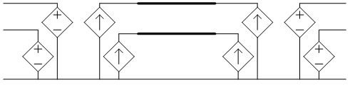

**Modal decomposition transformation**

**Reverse modal transformation**

**Decoupled transmission lines**

*Figure 2.12*: SPICE modal decomposition model for a 2-conductor MTL

#### Advantages and limitations of the modal decomposition SPICE macromodel

The proposed SPICE macromodel is well-suited for integration with external terminal networks, i.e. inserting the integrated component into a power electronics circuit complete with active and passive stages. This enables analysis of how the integrated passive interacts with the external elements of its application. The other attractive aspect of the macromodel is that it gives an exact solution for the lossless case. No real system is lossless, but if it can be shown that the system losses will have no significant effect on the response, a very high degree of confidence can be placed in the macromodel’s solution. This would be especially useful when handling severe breakpoints in an input waveform, which would cause spurious oscillations in the alternative method of FDTD, see *Section 2.2.6.2*.

The main theoretical limitation of the macromodel is encountered in lossy lines, as it can model only lossless lines. The method is still applicable, even in the presence of losses. The essential functionality of an integrated passive structure will usually arise from the energy storage mechanisms (the distributed capacitance and inductance); both the self-parameters of each conductor, and their coupling characteristics. System response will largely be determined by these factors, as well as the interconnections of conductor terminals, as opposed to system losses.

The SPICE macromodel is readily generated, and its terminal networks are even more readily modified due to its integration with the SPICE simulator. Integrated passives are not well-understood structures, and hence a solution that is quick to generate will be a useful tool to observe trends of the effect of parameter or terminal network changes; which in turn will assist the visualisation of the structure that will meet a required response. However, a detailed account of losses must be made for accurate design purposes, especially when designing for efficiency.

Another limitation of the macromodel is that there is only access to the conductor terminals, hiding the voltage and current information distributed along the conductors' length. Access to the internal information is an important reason validating the use of a distributed MTL model rather than a lumped parameter model, which is constructed to emulate the system’s terminal behaviour, but gives no insight to its internal behaviour.

Advantages:

* A SPICE solution
* Theoretical exact solution for lossless case, however, the numerical accuracy of how SPICE implements the transformation is unknown.

Disadvantages:

* Unsure of the consequences of modelling no losses
* Stability problems have been experienced in the time domain
* Long computation times in time domain (Flyback case) for unknown reasons

For the rest of the dissertation this solution method will be named as the modal macromodel.

#### Cascaded modal macromodel

The possibility of cascading the modal macromodel is now mentioned. This is a potential option toovercome the limited access to the current and voltage distributions along conductor lengths,as discussed in the previous section. The total MTL length can be sub-divided into smaller lengths that are each represented by the macromodel. These sub-sections are then interconnected with small resistors between terminals of corresponding conductors. This resistance must be present to prevent a loop made up exclusively of voltage sources, which is unsolvable by SPICE.

This method was tested with a two- and then a three-conductor MTL using five cascaded sub-sections. Different L and C matrices were used to vary the system’s electrical length, phase velocities of propagation, and coupling factors. A close following was maintained in the system response between the 5-segment case and a 1‑segment equivalent set-up. The only discrepancy is a slight smoothing observed in the 5-segment case of the sharp breakpoints present in the 1-segment case. This discrepancy will be increased if the interconnecting resistors are increased to the point of becoming comparable with the other resistances in the system, namely the source and load resistances.

Any convergence problem experienced when using a single macromodel for the whole length will be an amplified problem when dividing the conductor length into multiple cascaded macromodels. In practice this was found to be the worst limitation, as will be discussed in *Chapter 3 and 4*.

The direct benefit of this cascaded approach is the access to internal voltages and currents at chosen points along the line. A greater resolution will demand the use of a greater number of sub-sections, which will increase the number of circuit elements and consequently increase simulation time, as well as increase any discrepancy caused by the cascading.

Another possibility made available by the cascading approach, is the modelling of losses, frequency-dependent losses included. A method for emulating frequency-dependent losses using a network of SPICE elements is given in [39]. The method was proposed for a similar cascading approach as was discussed in this section. The proposed emulation network would be inserted in between cascaded elements, i.e. an interconnection network between elements. The loss-emulation network is not highly intuitive.

### Other time domain solution methods

#### TDFD

This method involves determining a transfer function of a system, which is done in the frequency domain. The transfer function is defined between two sets of two terminals (i.e. a 2-port network) of the integrated passive circuit. The time domain solution is obtained by adding the response of a finite number of frequencies distributed over the spectrum of the transfer function. The spectrum is actually continuous, so choosing a finite number of frequency responses is an approximation. Further details of this method can be found in [26].

An advantage of this method is the ease at which is incorporates losses, which are much simpler to handle in the frequency domain.

A major limitation is that the system must be linear, i.e. both the internal circuit and the external terminal networks. This is because the essence of the method is the superposition of signal responses of a continuum of frequencies. Superposition is not supported by non-linear systems. This removes the suitability of the method from power electronic circuits, because the signals that have a transient nature are caused by switching devices, which are non-linear. Linearising techniques are possible, but are not implemented in this study.

#### FDTD

This is a numerical method that approximates the partial derivatives of the transmission line equations with finite differences, i.e. dividing the total time into a finite number of time steps, and the total conductor length into a finite number of spatial steps. Paul [26] provides a good derivation of the difference equations in a form that can directly be used to increment the spatial and time steps. The complete solution of the internal line voltages and currents is obtained for every spatial point along the line length, and also for every time point along the simulation duration.

The determination of the number of time and spatial steps to use is determined with the following considerations:

* To limit the computational time the number of steps should be minimised
* Accuracy will depend on using a sufficient number of spatial steps to ensure that the length of each incremental spatial cell is much less than the minimum wavelength significantly present in the system. It is to be investigated whether or not there are further conditions requiring a small spatial cell in these multiconductor resonant systems. I.e. Can a non-linear voltage distribution occur along a conductor independently of transmission line effects?
* The main stability criterion determines the minimum number of time steps from the number of spatial steps: The time step Δt must be chosen to be less than the transit time of a wave front propagating across an incremental spatial cell. The maximum phase velocity present in the system (${ v}_{p(max)})$ must be used. This gives the well-acknowledged Courant condition [24-26] in *Equation 2.21*:
$$∆t ≤ \frac{∆z}{v_{p(max)}} …(2.21)$$

* The Courant condition is a good guideline to achieve stability, but there are other factors that may cause the required number of time steps to be higher. These factors are not well-characterised, and very seldom mentioned in the literature. One trend is that the more non-uniformities and asymmetries the system has, the smaller the time step that is required for stability.

Boundary condition limitations are probably the biggest constraint currently being faced in the FDTD method. Only simple resistive connections to ground are currently supported. This does not model the inductance of the terminal networks, which are often very significant according to physical measurements. Interconnections between load and supply side terminals are also not supported, which are necessary to produce many of the response characteristics required to replicate the discrete passive circuits the integrated structure should replace. Reactive components in the termination networks are also not supported. Theoretically, all of the above terminal networks can be implemented in the FDTD method, but this is labour intensive, and not implemented in this study.

The method has been implemented by [26] using FORTRAN, and by the author of this dissertation using MATLAB. Due to the difficulty of implementing boundary conditions, as well as the frequent occurrence of stability issues, the FDTD method is not included in the comparative studies of *Chapter 3 and 4*.

### Limitations found in the MTL solution methods

#### Invalid solutions allowed by simulation methods

Both the modal macromodel and the FDTD solution will give solutions to certain input data which are actually invalid, in that they represent scenarios that cannot physically exist. Invalid input datamostly consists of combinations of L and C parameters that cannot exist. Two known situations are mentioned below.

Neither solution limits the phase velocities to the speed of light. This allows one to obtain solutions for combinations of C and L that cannot exist, since phase velocities of propagation in an MTL are obtained from the reciprocal of $\sqrt{LC}$ [24, 26].

FDTD does not give a stable solution to a system with PUL data that gives complex phase velocities. The modal macromodel, however, does give a solution for this case. It is not well-understood what the physical significance of obtaining a complex phase velocity is, but it certainly isn’t a real scenario. Therefore, the modal macromodel can give an invalid solution in this case.

The lumped parameter models do not have these problems. The difference is that a lumped model has no knowledge of its physical length, as do the MTL models, thus the PUL L&C matrices are not defined for the lumped case. Velocities of propagation are determined by PUL parameters, rather than total inductance and capacitance. A similar argument holds for the problem of complex phase velocities, which are also determined by PUL quantities.

#### Physically realizable scenarios that cannot be simulated

It may also occur that certain scenarios that are physically realizable do not give a solution using the simulation methods described above.

In all solution methods, ideal inductive coupling between two conductors causes of convergence/stability problems. The only exception is the recent SPICE implementation of inductive coupling, which can handle the ideal case (100% coupling). However, even in this implementation, circuits become much more sensitive to convergence problems, especially when numerous coupling elementsare simultaneously included in a simulation model, e.g. when the number of conductors in the structure increases. This limit to the coupling is not usually a problem, because physical structures cannot have perfect coupling. However, there are cases where the coupling is too close to unity to be successfully simulated. Very high coupling increases the phase velocities in the MTL, which necessitates more spatial and time steps in the FDTD solution, as well as the size of the time steps in the SPICE solution.

The capacitance from a conductor to ground cannot be zero in the modal macromodel and FDTD solution. In conventional lumped element modelling, as well as in Zhao’s distributed model, this capacitance is often neglected because its size is much smaller than other circuit parameters. Such analyses are quite valid, because the contribution of these capacitances to ground is often negligible. However, in the MTL numerical solutions (FDTD and modal macromodel) these capacitances have to be unrealistically increased to allow numerical convergence. Of course, there are also physical scenarios where the contribution of these capacitances becomes significant, in which case they can simply be added into a lumped model, but not in Zhao’s model.

FDTD is plagued by instability when there are discontinuities in the PUL parameters along the line length, which is certainly a physically realizable system. Thus, the Courant condition is no longer the only determining factor for stability, and other factors are as yet not well-understood.

# integrated passive structure with simple boundary conditions:frequency domain

## Technique for comparing models

### Order of comparison: flow of thought

*Chapters 3and 4* actually form a unit of work comparing the different models. For clarity’s sake, they were divided into separate chapters, the first containing frequency domain work, and the second containing time domain work, and the reconciliation of the two.

**Main objective:**To gain a confidence as to the extent of accuracy and the boundaries of application of the SPICE models by comparing them with the more accurate distributed model of Zhao [12].

SPICE models, defined in *Sections 2.1.1, 2.1.3, and 2.2.5*, respectively:

* Lumped models: Reeves and Murgatroyd
* Cascaded lumped model
* Paul’s modal macromodel

The model whose solution we have most confidence in is Zhao’s distributed model. Zhao’s work gives an analytical solution to the distributed model. However, Zhao’s work is limited to simple boundary conditions and is restricted to the frequency domain.We shall use this as the **benchmark**. The solution is given as impedance in the frequency domain. Comparisons with Zhao’s model can only be made in the frequency domain.These comparisons will be categorised as follows:

1. First, the first-order lumped models will be compared with Zhao in the frequency domain. The resonant frequencies will be of greatest importance, as well as the frequency where the models’ solutions begin diverging.
2. Then the cascaded lumped model will be compared with Zhao’s solution. The discrete elements that make up this model will all contribute to higher order resonant points, which are parasitic (i.e. not according to reality). This comparison will show where the parasitic resonances occur relative to the actual higher-order transmission line resonances. A different number of cells will have differently-sized discrete elements, and consequently different frequency domain profile.
3. Third, the modal macromodel will be compared to Zhao. Again, the resonant frequencies will be of greatest importance, as well as the frequency where the models’ solutions begin diverging. It will be shown that there is excellent following between these models in the frequency domain. This would suggest that the modal macromodel could be used effectively as the benchmark for the time-domain. However, problems are being encountered with the time-domain simulation of the modal macromodel, which is reported on in *Section 4.3.2*.

The SPICE models are then compared in the time domain. The objects of comparison will be the frequency of all significant oscillation, spike peak magnitudes, and damping characteristics.The test setup used for these comparisons will be a step response with the same simple boundary conditions as used in Zhao’s work, i.e. the same as the frequency domain comparisons.

1. The lumped models will be compared first.
2. The lumped models will then be compared with the modal macromodel. The simulation problems faced in the time domain for the modal macromodel will be discussed here.

Finally, the time domain results will be reconciled to the frequency domain results. Resonance points in the frequency-domain will often cause under-damped oscillations in the step response. Any lack of consistency will be noted.

### Implementation/ set-up information

#### Mathematica frequency domain setup

Frequency domain data is usually given as an impedance in terms of frequency. Impedance is defined between two terminals as V/I: i.e. the voltage across the two terminals, divided by the current going in the one terminal and coming out the other, see *Figure 3.1*. Impedance is a useful quantity because it is independent of input signal sources, and depends only on the parameters of the structure being measured. Impedance is also a useful measure because it is determined by most of a structure’s parameters together: including geometrical dimensions and material properties (permittivity, permeability, and conductivity), hence impedance provides a measure of the overall functioning of an electrical structure.

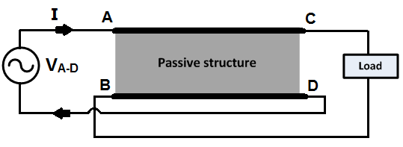

*Figure 3.1*:The setup of the integrated passive structure for frequency domain simulations

The two-conductor system has four terminals. The quantity we will be comparing between models is the impedance between two of the terminals with a defined load connected to the other two terminals. Different terminal configurations will be examined. Impedance is a quantity that incorporates the whole structure’s parameters quite well. Frequency domain impedance gives the resonance profile of the passive structure; these have to match across models if the models are indeed equivalent. The resonance profile shows the interaction between all energy storage components of structure (L’s and C’s, magnetic and electric field storage respectively).

A solution in Mathematica for frequency domain data of an integrated passive is obtained as follows:

1. External circuit is decided on: the two terminals between which we want to characterize impedance, and a single impedance connected between any other pair of terminals.
2. Obtain an expression for the impedance:
   * Zhao: Take equations of *Section 2.2.3* and solve them using the equations denoting the boundary conditions, see Zhao’s work in [12], at pg.29. The external circuit gives equations for the boundary conditions.
   * Lumped: Take full circuit (passive structure + external circuit) into the s-domain, and solve the resulting impedance network using nodal analysis to an expression that involves V, I and circuit impedances. Arrange the expression with V/I as subject of the formula.
   * Cascaded lumped model cannot be practically solved in this way due to the number of circuit elements involved.
3. Plot impedance expression in Mathematica; it will be in terms of frequency.

The above procedure works well for simple single-impedance inter-connections. Adding more external elements increases the number of simultaneous equations to solve. Adding another conductor will also dramatically increase the number of equations to solve simultaneously. This cannot be done manually except for simple external circuits with two-conductor structures. An algorithm for solving the impedance of a three-conductor structure with general boundary conditions has not been developed. This would probably need to be implemented in MATLAB, or some other programming language.

#### SPICEfrequency domain setup

Afrequency domain result for the SPICE-compatible models can be generated by SPICE’s AC analysis option. The setup is simple: the circuit is shown in *Figure 3.1*, and the netlist extract below shows the settings that were used by default.

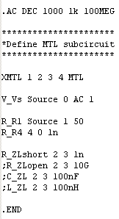

*Figure 3.2*: SPICE AC analysis setup

#### Circuit configurations used for comparison of models

The above setup is specific to one set of external circuitry, that of the configuration of *Figure 3.1 & 3.2*.ZA-D will be the basis of the bulk of the investigations. Other configurations were also simulated, shown in *Figure 3.3*, but there was little further insight gained from those observations.

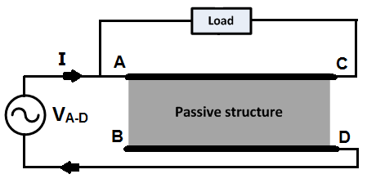

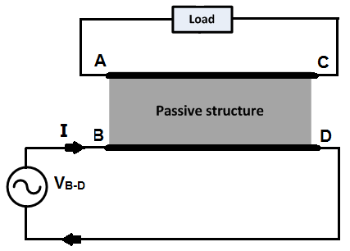

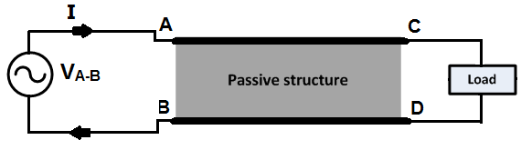

*Figure 3.3*: Three alternative terminal configurations that were also simulated

ZB-D gives the magnetising inductance of the conductor between B-D when A-C is open-circuited, and it represents the leakage inductance when A-C is short-circuited. These are well-known impedances.

ZA-B represents the input impedance of a conventional transmission line, which is already well understood in the literature[26, 40]. The conventional transmission line can also be termed the balanced current case. ZA-D, however, is known as the inversely balanced case. The difference in the current distribution is shown in *Figure 3.4*.Zhao shows that this difference causes resonance to occur in the inversely balanced case before transmission line effects become significant. The conventional transmission line has an equal and opposite current flowing in both conductors, which allows one to lump circuit parameters into a single line and use the other conductor as a reference voltage. In the inversely balanced case, however, we need to include both conductors and refer them both to a common ground.

The inversely balanced current case may cause some concern for those who know that conventional transmission line models assume balanced current. However, Zhao’s development of the model makes no assumption of the current distribution, as in [12], and *Figure 3.4*  is actually a result derived

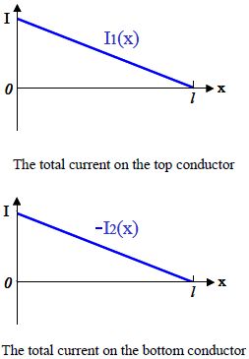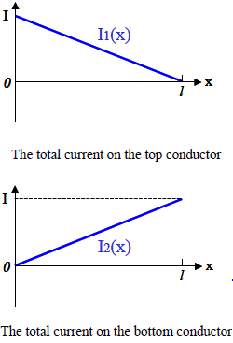

*Figure 3.4*: Current distributions at open circuit load, adapted from [12]:

(left): Balanced case, (right): Inversely balanced case

from the analysis of Zhao’s analytical solution. Similarly, the modal macromodel also does not require a balanced current distribution, because it models each conductor as a transmission line with reference to a third “ground reference” conductor. That ground reference conductor can be imaginary, because the boundary condition equations just need to be set up such that the ground conductor has zero current, i.e. the sum of the currents that balance each real conductor will sum up to zero. See references [24] for more demonstration on how this is used in microwave engineering.

ZA-Dis the impedance that is not as well understood, and it also makes strong use of all energy storage elements (inductance, capacitance, and leakage inductance). This is the reason it will be used as the basis for the bulk of the investigations.

### Validation step: Consistency between SPICE and Mathematica solutions – Lumped models

The solution algorithm is different between SPICE and Mathematica, that of SPICE being largely hidden from theuser. In order to check that they are giving consistent results, a comparison was made between the two simulators, using the same lumped model in the frequency domain. If not consistent, one of them is either inaccurate, or is being implemented incorrectly (i.e. external circuit setup, or boundary conditions, that are not exactly equivalent in both implementations).

Result: both implementations were consistent.

### Default structure parameters used in solution of models

The integrated structure’s parameters that will be used for simulations are tabulated in *Table 3.1*. If parameters values other than what is specified hereare used in a simulation, it will be explicitly stated.For the rest of the dissertation, PUL quantities will be denoted with an apostrophe, such as C’ for the PUL inter-conductor capacitance.

**Table 3.1:Integrated passive structure’s parameters**

|  |  |  |
| --- | --- | --- |
| Parameter | PUL Value | Value |
| L | 50 µH/m | 12.5 µH |
| M | 49 µH/m | 12.25 µH |
| k | n/a | 0.98 |
| C | 5 µF/m | 1.25 µF |
| R, G | 0 | 0 |
| Length | n/a | 0.25 m |

## Lumped models vs. Zhao’s distributed model

The lumped models (Reeves and Murgatroyd) will now be compared to Zhao’s distributed model, which is the benchmark solution. The impedance vs. frequency graph of ZA-D(as will see later in *Figure 3.*6)of all the models will be plotted on the same axes to observe in which frequency ranges the models diverge. The results are categorised as follows:

* Comparisons are made at high coupling between the two conductors of the integrated structure. This is recorded in *Section 3.2.1*.
  + Under this condition of high coupling, four different load types are simulated between terminals B-C, which will give a comprehensive range of simulation results. The load types, and the sections in which they are analysed, are as follows:
    - Short-circuit, in *Section 3.2.1.1*
    - Open-circuit,in *Section 3.2.1.2*
    - Capacitance, in *Section 3.2.1.3*
    - Inductance, in *Section 3.2.1.4*
  + A detailed analysis of the impedance plots will be made for each load type. The analysis will include an analytical approach to reconcile the benchmark solution and the lumped models’ results.
* This pattern of comparison is then repeated at a low coupling. The reason for this is that the circuit equations yielded by nodal analysis on the lumped models predict that the models may diverge much more significantly at low coupling, see *Section 2.1.1*. This is now investigated in *Section 3.2.2*.



Figure 3.5: Terminal configuration used for the comparisons of this section

### At high coupling

The frequency response of the input impedance (ZA-D)was simulated for different load impedances(ZL), which gives a broad range of different energy processing possible within the structure.

High coupling is taken to be k = 0.98.

The following four plots show ZA-D with different load impedances. The short circuit also represents a resistive load with a magnitude much smaller than other impedances in the structure. Conversely, the open circuit load also represents a resistive load of magnitude much bigger than other impedances in the structure. The inductive and capacitive loads show how the structure interacts with external reactive elements.



(a) Short circuit (b) Open circuit



(c) Capacitive load (100 nF) (d) Inductive load (100 nH)

*Figure 3.6*: ZA-D plots against frequency for the four different load types, at a coupling of 0.98

LEGEND: (Blue: Zhao, Red: Reeves, Yellow: Murgatroyd)

#### Short-circuit load

Refer to *Figure 3.6 (a)* for this section. The first resonance point is identical for all models. It is a resonance between the structure’s total inductance and capacitance. This is known as the fundamental frequency and can be determined from mathematical analysis of all the models.

*Equations 3.1 and 3.2* were derived from nodal analysis in the s-domain for both Reeves and Murgatroyd models. They are repeated here, now with the angular frequency ($s=jω$):

$$Z_{AD}=\frac{2jω\left(L+M\right)}{1+C\frac{(L+M)}{2}{(jω)}^{2}} [Reeves] …(3.1)$$

$$Z_{AD}=\frac{2jω\left(L+M\right)×(1+\frac{C}{2}\left(L-M\right){(jω)}^{2})}{1+LC{(jω)}^{2}} [Murgatroyd]…(3.2)$$

These equations show that for both models, the input impedance ZA-D will be inductive at an inductance of 2(L+M) forlow frequencies, since the denominator will be dominated by the “1”. This will be the case until a parallel resonance occurring at a frequency given by:

$$f_{0}=\frac{1}{2π\sqrt{\frac{\left(L+M\right)}{2}C}}\left[Reeves\right]…(3.3)$$

$$f_{0}=\frac{1}{2π\sqrt{LC}}\left[Murgatroyd\right]…(3.4)$$

These equations correctly predict the value of the first resonant frequency shared by all three models at high coupling, which is commonly known as the fundamental resonance point. After this point the two models diverge. Reeves tends to a capacitive impedance towards larger frequencies, with a capacitance of C/4. No further resonance is predicted. Murgatroyd, on the other hand, has a second resonant frequency, after which it has an inductive impedance towards larger frequencies, with an inductance of (L-M), i.e. the leakage inductance. This is an important difference between the two first-order models.

Murgatroyd’s second resonance point is predicted to occur at the following frequency:

$$f_{1}=\frac{1}{2π\sqrt{(L-M)\frac{C}{2}}} …(3.5)$$

The question arises: “Which lumped model is more suitable, and under which conditions?” This question will be pursued in sections pertaining to both the frequency and time domains. From the above equations, the following three questions will now be posed:

* Is the actual fundamental resonance point dependent on coupling, as is predicted by Reeves?
* Is Murgatroyd’s second resonance point valid with respect to the actual distributed structure, or is it parasitic?
* Reeves tends to a capacitive impedance for higher frequencies, while Murgatroyd tends to an inductive impedance? Is either more valid?

To answer these questions we begin to examine Zhao’s distributed solution. By simple qualitative observation, Zhao’s distributed model has infinitely many resonant points, the first is shared with all the other models, and the second resonance point is at a similar but not the same frequency as Murgatroyd. The question is whether the factors determining this second resonant frequency are the same between the two models, and what is causing the difference? Zhao’s model tends to neither a capacitive nor an inductive impedance at high frequencies.

Zhao derives a general impedance equation for ZA-D for a general load ZL, which can be seen in [12, pg. 32-33, 57]. We reduce this equation for the case of a short circuit load (ZL=0), as well as assume lossless conditions:

$$Z_{A-D}=\frac{2jω\left(L^{'}+M^{'}\right)l×\left[\frac{1}{sinh⁡(γl)}+\frac{1}{tanh⁡(γl)}\right]}{\frac{1}{sinh⁡(γl)}+\frac{1}{tanh⁡(γl)}+\frac{jω\left(L^{'}+M^{'}\right)l}{Z_{0}}} …(3.6)$$

where the structure parameters are in PUL form. From the solution equations for Zhao’s model, shown in *Section 3.2.3*, lossless conditions give the following expressions for the propagation constant and the characteristic impedance:

$$γ=jβ=jω\sqrt{2\left(L^{'}-M^{'}\right)C^{'}} …(3.7)$$

$$Z_{0}=\sqrt{\frac{2(L^{'}-M^{'})}{C^{'}}} …(3.8)$$

The hyperbolic trigonometric functions are the source of the higher order resonances.

$$\frac{1}{\sinh\left(γl\right)}+\frac{1}{\tanh\left(γl\right)}=\frac{2+e^{jβl}+e^{-jβl}}{e^{jβl}-e^{-jβl}} …(3.9)$$

And usingEuler’s expressions for trigonometric functions:

$$\frac{1}{\sinh\left(γl\right)}+\frac{1}{\tanh\left(γl\right)}=\frac{-j\left(1+\cos\left( βl\right)\right)}{sin⁡( βl)} …(3.10)$$

In order to derive an equation for the fundamental resonance point, we now consider the case of low frequencies (i.e. such that 𝜆>> length). Considering the definition of *Equation 2.*15(see*Section 2.2.3)*:

$$βl=\frac{2πl}{λ} …(3.11)$$

$$∴βl≪1 since \frac{l}{λ}≪1 …(3.12)$$

Using the small angle approximation, *Equation 3.6* now reduces to:

$$Z_{A-D}=\frac{2jω\left(L^{'}+M^{'}\right)l×\left[\frac{-2j}{βl}\right]}{\left[\frac{-2j}{βl}\right]+\frac{jω\left(L^{'}+M^{'}\right)l}{Z_{0}}} …(3.13)$$

This, after substituting in *Equations 3.7 and 3.8*, reduces to:

$$Z_{A-D}=\frac{2jω\left(L^{'}+M^{'}\right)l}{1+{(jω)}^{2}\frac{\left(L^{'}+M^{'}\right)l}{2}C^{'}l} …(3.14)$$

This equation demonstrates clearly that for frequencies at which the structure is electrically small, the input impedance ZA-D will be inductive at an inductance of 2(L+M), until a parallel resonance at a frequency given by the following expression, which is equivalent to *Equation 3.3*, which favours the correctness of the Reeves model’s prediction of f0:

From *Equation 3.14,* after the fundamental resonance, Zhao’s model tends to capacitive impedancetowards larger frequencies, with a capacitance of C/4.**Therefore it has been shown that, for as long as the structure is electrically small, the Reeves model is perfectly sufficient.**

Now we consider the case when the structure becomes electrically large. Zhao’s distributed model has infinitely recurring resonance point towards high frequencies. The fundamental resonant frequency has been shown to arise by the same factors as the lumped models. The subsequent train of resonance points arise from transmission line effects, according to analysis performed by Zhao [12, pg. 56-58].

Consider Zhao’s equation for ZA-D with a short circuit load, in *Equation3.6.*The hyperbolic functions are giving rise to the higher order resonance points. Zhao cites that resonance peaks occur when $l=nλ, where n=1.2.3,…$, which is equivalent to $βl=n2π$. To understand this, a plot of the magnitude of the hyperbolic functions of *Equation 3.10* is shown below with respect to $βl$.

$$Plot: \frac{\left(1+\cos\left( βl\right)\right)}{\sin\left( βl\right)} vs βl$$

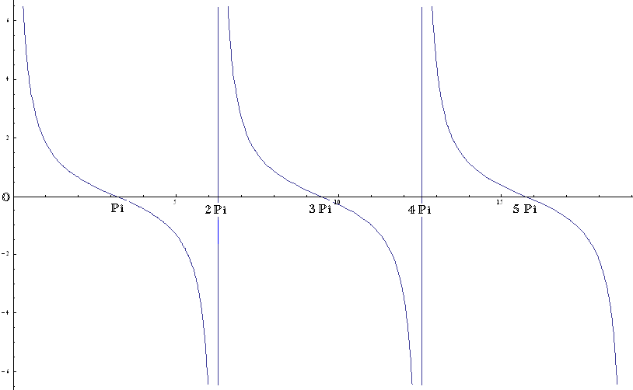

*Figure 3.7*: Plot of the hyperbolic component of ZA-D against frequency, which shows the frequency-positions of the transmission line resonance points

Clearly, at multiples of $2π$, the hyperbolic terms tend to infinity. This makes *Equation 3.6* tend to the equation shown in *Equation 3.16*, at the vicinity of $βl=n2π$.This large inductance will present high impedance at high frequencies, hence the resonance peaks at $βl=n2π$.

$$Z_{A-D}=2jω\left(L^{'}+M^{'}\right)l …(3.16)$$

However, *Figure 3.6 (a)*shows that are also repetitive resonance valleys. These occur when the hyperbolic terms become zero at $βl=π+n2π where n=1,2,3,…$, which results in ZA-D in *Equation 3.6* alsotending to zero (resonance valley).

Therefore, Zhao’s second resonance point is at $βl=π$, which gives:

$$f_{1}=\frac{1}{2\sqrt{2(L^{'}-M^{'}){lC}^{'}l}} …(3.17)$$

Comparing this to *Equation 3.5*, the second resonance point of Murgatroyd and Zhao have the same factors, namely leakage inductance and inter-conductor capacitance, but they are separated by a multiplicative factor of 2/π in the Murgatroyd model.

#### Open-circuit load

Refer to *Figure 3.6 (b)* for this section. All models have the same frequency response, expect that Zhao has small resonance peaks repeating at high frequencies from 1.26 MHz, which is at $βl=2π$. A similar analysis to that of *Section 3.2.1.1* can be carried out for an open circuit load. The following equations summarise such an analysis:

$$Z_{AD}=\frac{C\frac{\left(L+M\right)}{2}{(jω)}^{2}+1}{jωC} [Reeves]…(3.18)$$

$$Z_{AD}=\frac{LC{(jω)}^{2}+1}{jωC} [Murgatroyd]…(3.19)$$

$$Z_{A-D}=\frac{jω\left(L^{'}+M^{'}\right)l}{2}+\frac{Z_{0}}{2}\left[\frac{1}{sinh⁡(βl)}+\frac{1}{tanh⁡(βl)}\right] [Zhao:lossless case] …(3.20)$$

*Equation 3.20* can be reduced for the condition of the structure being electrically small:

$$Z_{AD}=\frac{C'l\frac{\left(L'+M'\right)l}{2}{(jω)}^{2}+1}{jωC'l} …( 3.21)$$

This gives a fundamental resonant frequency given by:

$$f_{0}=\frac{1}{2π\sqrt{\frac{\left(L+M\right)}{2}C}}\left[Reeves\right]…(3.22)$$

$$f_{0}=\frac{1}{2π\sqrt{LC}}\left[Murgatroyd\right]…(3.23)$$

$$f_{0}=\frac{1}{2π\sqrt{\frac{\left(L'+M'\right)l}{2}C'l}}\left[Zhao\right]…(3.24)$$

This shows once again that for the condition of the structure being electrically small, the Reeves model is perfectly correct, whereas the Murgatroyd model’s fundamental resonance will only be correct at high coupling.

The structure has been configured here as a series resonator with the structure’s magnetising inductance and inter-conductor capacitance being the resonating elements. The frequency response is typical to a first order series resonator [41]. At low frequencies all models show a capacitive impedance before resonance, after which an inductive impedance of a magnitude of (L+M)/2is seen towards infinite frequency.

When the structure becomes electrically large, *Equation 3.20* shows that there will be resonant peaks at $βl=n2π$ (when the hyperbolic terms tend to infinity).Why do these peaks not appear in a dramatic manner, as they did in the short-circuit case? The hyperbolic terms are being added to an inductive term with a large inductance. At high frequencies, this inductance will already be at a high impedance, so the relative magnitude of the hyperbolic terms is much less. Similarly, in the case of $βl=π+n2π$ there is no longer any resonance valleys because when the hyperbolic terms tend to zero, the high inductance impedance remains, as is clear from *Equation 3.20*.

#### Capacitive load

Refer to *Figure 3.6 (c)* for this section. The analysis is now repeated for $Z_{L}=1/jωC_{L}$. This configuration’s frequency response has a similar pattern as for the short-circuit load, except for the series resonance at a lower frequency. This is understandable by the fact that at low frequencies a capacitor has high impedance (tends towards open circuit load), while at higher frequencies a capacitor has low impedance (tends towards short circuit load). The load capacitor is an extra energy storage component, giving rise to the extra resonance point. The analysis becomes more tedious with extra terms for loads other than zero or infinity, so not all equations will be shown.

$$Z_{AD}=\frac{(C+4C_{L})\frac{\left(L+M\right)}{2}{(jω)}^{2}+1}{jω(C+C_{L})\left(1+\frac{(L+M)}{2}\frac{CC_{L}}{(C+C_{L})}{(jω)}^{2}\right)} [Reeves]…( 3.25)$$

$$Z_{AD}=\frac{\left[(C+4C_{L})\frac{\left(L+M\right)}{2}{(jω)}^{2}+1\right]\left[(L-M)\frac{CC_{L}}{(C+{4C}_{L})}{(jω)}^{2}+1\right]}{jω(C+C_{L})\left(1+L\frac{CC_{L}}{(C+C_{L})}{(jω)}^{2}\right)} [Murgatroyd] …( 3.26)$$

Zhao’s solution, for lossless conditions, and for the structure being electrically small, Zhao tends to:

$$Z_{AD}=\frac{(C^{'}l+4C_{L})\frac{\left(L'+M'\right)l}{2}{(jω)}^{2}+1}{jω\left(C^{'}l+C_{L}\right)\left(1+\frac{(L'+M')}{2}\frac{C'lC_{L}}{(C'l+C_{L})}{(jω)}^{2}\right)} …( 3.27)$$

There are now two resonances occurring before the transmission line effects begin:

$$f_{0}=\frac{1}{2π\sqrt{(C'l+4C_{L})\frac{\left(L'+M'\right)l}{2}}}\left[Zhao\right]…(3.28)$$

$$f_{1}=\frac{1}{2π\sqrt{\frac{\left(L'+M'\right)l}{2}\frac{C{'lC}_{L}}{(C'l+C_{L})}}}\left[Zhao\right]…(3.29)$$

Using *Equations 3.25 and 3.26* to derive expressions for these frequencies for the Reeves and Murgatroyd models we see that, as before, the Reeves model is exactly equivalent to Zhao’s model for the conditionof the structure being electrically small, whereas Murgatroyd requires high coupling.

An analysis on the high frequency resonances result in a similar patternto the short circuit case. For $βl=n2π$, Zhao’s ZA-D tends to an inductive impedance of inductance $2\left(L^{'}+M^{'}\right)l$, which at high frequencies is very large. For $βl=π+n2π$, the impedance tends to that of the capacitance CL, which at high frequencies is small. Hence, the impedance alternates between peaks and valleys, as in the short circuit case. The only difference to the short circuit case is that the valley’s magnitudes are bounded to the capacitive impedance of CL, instead of to going to zero.

#### Inductive load

Refer to *Figure 3.7 (d)* for this section. The same analysis procedure can be conducted for an inductive load where ${ Z}_{L}=jωL_{L}$:

$$Z_{AD}=\frac{jω\left(L_{L}+2(L+M)\right)\left[\frac{L_{L}\left(L+M\right)C}{2\left(L_{L}+2(L+M)\right)}{(jω)}^{2}+1\right]}{\left(\frac{L+M}{2}+L_{L}\right)C{(jω)}^{2}+1} [Reeves]…( 3.30)$$

$$Z_{AD}=\frac{jω\left(L_{L}+2(L+M)\right)\left[\frac{\left(L_{L}L+(L^{2}-M^{2})\right)C}{L_{L}+2(L+M)}{(jω)}^{2}+1\right]}{\left(L+L_{L}\right)C{(jω)}^{2}+1} [Murgatroyd]…( 3.31)$$

Zhao’s solution, for lossless conditions, and for the structure being electrically small, Zhao tends to:

$$Z_{AD}=\frac{jω\left(L_{L}+2(L'+M')l\right)\left[\frac{L_{L}\left(L'+M'\right)lC'l}{2\left(L_{L}+2(L'+M')l\right)}{(jω)}^{2}+1\right]}{\left(\frac{L'+M'}{2}l+L_{L}\right)C'l{(jω)}^{2}+1} …( 3.32)$$

There are again two resonances occurring before the transmission line effects begin:

$$f_{0}=\frac{1}{2π\sqrt{\left(\frac{L'+M'}{2}l+L_{L}\right)C'l}}\left[Zhao\right]…(3.33)$$

$$f_{1}=\frac{1}{2π\sqrt{\frac{L_{L}\left(L'+M'\right)lC'l}{2\left(L_{L}+2(L'+M')l\right)}}}\left[Zhao\right]…(3.34)$$

Using *Equations 3.30 and 3.31* to derive expressions for these frequencies for the Reeves and Murgatroyd models we see that, as before, the Reeves model is exactly equivalent to Zhao’s model for the conditionof the structure being electrically small, whereas Murgatroyd requires high coupling. This has now been the case for all load types.

*Figure 3.6 (d)* shows that Zhao’s model deviates from both lumped models for the second resonant frequency, in spite of the prediction of *Equation 3.30 and 3.32* (i.e. f0, which is predicted by the denominators, was expected to be identical). Reeves and Zhao diverge even at f0, which was expected to be equal. This is because the frequency is high enough at this point to render the structure electrically large. This highlights an important point: the resonance points obtained by assuming the structure is electrically small do not mean that at those frequencies the structure is necessarily electrically small. **The correct approach is to *first* determine at what frequency the structure is still electrically small, and only then assume the Reeves model is correct under that frequency.**

### Critique of Zhao: Propagation velocity => electrical length

The small angle approximation in *Section 3.2.1.1*was made on the assumption of the conductor’s length being electrically small. In Zhao’s derivation, he makes this same approximation citing an assumption of high coupling. The condition of conductors being electrically small is related to high coupling through the structure’s propagation velocity. This will now be shown.

For a Multiconductor transmission line there will be a propagation velocity for every conductor, excluding the ground reference conductor. Since in the unbalanced current case, both conductors have to be referred to an external ground reference, two propagation velocities should be derived. This will require the construction of PUL L and C matrices, as in *Section 2.2.1,*L11 and L22 is the self-inductance of each conductor. In this case, but not necessarily, they are the same (L). L12 and L21 is the same quantity, the mutual inductance (M). C21 and C12 is the same quantity, the inter-conductor capacitance (C). C11 and C22 are the sum of C and self-capacitances of conductors to ground reference. The self-capacitance in this case we will consider to be the same (Cs). Self-capacitance is usually much smaller than C, and is difficult to determine because the ground reference is seldom geometrically well-positioned with respect to the conductors, i.e. not forming a parallel plate capacitor.

$$L=\left(\begin{matrix}L_{11} & L_{12} \\ L_{21} & L_{22}\end{matrix}\right) …(3.35)$$

$$C=\left(\begin{matrix}C_{11} & C_{12} \\ C_{21} & C_{22}\end{matrix}\right) …(3.36)$$

[Paul] describes in detail the construction of these matrices for the general n-conductor case.

The propagation velocities can be obtained from *Equations 3.35, 3.36 and 1.2*, which gives the following for the two-conductor case:

$$v_{p}=\left[\begin{matrix}\frac{1}{\sqrt{L(C+Cs)-MC+M(C+Cs)-LC}} \\ \frac{1}{\sqrt{L\left(C+Cs\right)-MC-M\left(C+Cs\right)+LC}}\end{matrix}\right]=\left[\begin{matrix}\frac{1}{\sqrt{Cs(L+M)}} \\ \frac{1}{\sqrt{\left(L-M\right)\left(C+Cs\right)+(L-M)C}}\end{matrix}\right]…(3.37)$$

This solution matrix shows us that there will be a higher and a lower propagation velocity. It is the slowest velocity that is more significant, because this will cause the smallest wavelengths (according to *Equation 1.1*) which will soonest cause high frequency effects. In most circumstances Cs << C. Cs is usually some orders of magnitude smaller than the leakage inductance (L-M), thus the second of the two velocities is the smaller. Therefore, the smallest velocity can be expressed as:

$$v_{p(min)}=\frac{1}{\sqrt{2(L^{'}-M^{'})C^{'}}} …(3.38)$$

Therefore a high coupling will cause high propagation velocities, which in turn increases the wavelengths in the system, making the structure electrically small. Hence, Zhao uses high coupling as his condition for making the small angle approximation. A more correct approach makes an actual comparison between the wavelengths in the system, and the conductor lengths. This approach is valid irrespective of the coupling.

In order to investigate whether the Murgatroyd model breaks down before the structure becomes electrically small, consider the following: The analysis in *Section 3.2.1* shows that only one resonance point should occur while the structure is electrically small. A question arising is whether the second resonance point of Murgatroyd, which occurs before the higher order resonances of Zhao, occurs while the conductors are still electrically small. If it did then this resonance point would be invalid, and Murgatroyd would break down before being electrically small. The wavelength is derived for Murgatroyd’s second resonance frequency, using *Equations 3.38 and 3.5*:

$$λ=\frac{v_{p}}{f_{1}}=\frac{π}{\sqrt{2}}l …(3.39)$$

At Murgatroyd’s second resonance point, the wavelength would be about twice the conductor length, i.e. the conductor is already becoming electrically large. **Therefore, as long as the coupling is high enough to ensure that the fundamental resonance point is close enough to Zhao (See *Equations 3.4 and 3.15*), then the Murgatroyd model may also be used with confidence when the structure is electrically small.**

### At low coupling

#### Low coupling: k = 0.7



(a) Short circuit load (b) Open circuit load



(c) Capacitive load: 100 nF (d) Inductive load: 100 nH

*Figure 3.8*: ZA-D plots against frequency for the four different load types, at a coupling of 0.7

LEGEND: (Blue: Zhao, Red: Reeves, Yellow: Murgatroyd)

At low coupling the same frequency response profiles are observed, except for one important difference: the higher order resonance points of Zhao’s model have shifted to lower frequencies. This change is explained from the fact that the low coupling has significantly decreased the propagation velocity, according to *Equation 3.38*, which in turn decreases the wavelength for the same frequency. A decreased wavelength tends to make the structure electrically small, introducing at a lower frequency the transmission line effects that are causing the higher-order resonance points.

A precise investigation of the low frequency resonance points also show that the Murgatroyd model slightly deviates from the other models, as predicted by the equations in *Section 3.2.1*. The difference is only slight even at a coupling as low as k = 0.7, so the Murgatroyd model is still a well-performing alternative to the Reeves model, even at low coupling.

#### No coupling: k = 0



(a) Short circuit load (b) Open circuit load



(c) Capacitive load: 100 nF (d) Inductive load: 100 nH

*Figure 3.9*: ZA-D plots against frequency for the four different load types, at zero coupling

LEGEND: (Blue: Zhao, Red: Reeves, Yellow: Murgatroyd)

There are some interesting observations that can be made under these conditions:

Firstly, there is a frequency error between the different models at the 1st resonance point:

* Murgatroyd (40.6kHz), Zhao (48.8kHz), Reeves (57kHz)

This would seem to indicate that the first resonance point is not being determined by exactly the same factors, as is suggested by the equations in *Section 3.2.1.*In the no coupling case, we have the minimum possible propagation velocity. At no coupling the structure has become electrically large even at the fundamental frequency. Thus,the fundamental frequency of Zhao’s model will be shifted from the predictionmade by the simplification made considering the structure is electrically small. Note, however, that this is specific to the parameters used. Another set of L and C parameters could result in the structure still being electrically small at no coupling. The important thing is to first check at what frequency the structure becomes electrically large, before a lumped model is assumed to be correct.

The second observation is that the Murgatroyd tends to the wrong inductance at high frequencies for the open circuit load. The reason for this can be understood from *Equations 3.18- 3.20*: At frequencies above the first resonance, the equations show that both Reeves and Murgatroyd tend to an inductive impedance, but that Reeves correctly depends on the coupling, while Murgatroyd does not.

### Conclusion of comparison between lumped and Zhao models

Zhao’s model is an analytical solution for the distributed model of the two-conductor integrated passive. This solution was used to thoroughly derive the causes of all resonance points and impedances at low/high frequencies, which are the important factors that characterize the integrated passive. These derivations were compared with the lumped models of Reeves and Murgatroyd.

Reeves follows the distributed model exactly as long as the structure is electrically small. The Murgatroyd model is also correct but requires the additional condition of high coupling. At low coupling, Murgatroyd’s resonant frequencies will occur at lower frequencies than the other models. It was shown that the additional resonance point that Murgatroyd has over the Reeves model (for short circuit and capacitive loads) occurs when the structure is already becoming electrically large. This resonance point was shown to be caused by the same factors as the higher order resonances of Zhao’s model, but separated by a multiplicative factor.

An important approach is to *first* determine at what frequency the structure is still electrically small, and only then assume the Reeves model is correct under that frequency. The electrical size of structure is determined by a comparison between the conductor lengths and the wavelength of the frequency of interest. The propagation velocities of the structure were derived, and shown to be the important factor relating the structure’s parameters, including the coupling, and the electrical size of the structure.

## Cascaded lumped model vs. Zhao

The previous section demonstrates that the lumped models are accurate for frequencies low enough to ensure that 𝜆>>*length*. This brings us to the main purpose for using the cascaded lumped model: to increase the frequency range that the SPICE-compatible lumped models can remain accurate.

The theory of cascading lumped model cells [26] says that the model is accurate when each lumped cell is electrically large. The length of one cell is the total length divided by the number of cells. Therefore, if there are ten cells, the cascaded model should accurately handle frequencies to ten times that of a single cell model. We now investigate this proposition.

The condition determining whether it is valid to use a lumped model is given by:

$$f≪\frac{1}{\sqrt{2(L-M)C}} , equivalent to λ≪l …(3.40)$$

Which comes to f << 1.26 MHz.

The question arises as to what is a sufficiently small frequency? A commonly used rule of thumb for conventional transmission lines is to use a frequency where $λ=10×l$ [26]. Therefore a single-cell Reeves/Murgatroyd model will be accurate for f < 126 kHz. Let’s denote this upper limit as ${ f}_{max}$. ${ f}_{max}=1.26 MHz$ for 10 cascaded cells, according to this prediction. The validity of this indicator has to be validated for integrated passives.

The plots for the input impedance against frequency are shown below for different numbers of cells. In order to compare them effectively, there needs to be a method of measuring the accuracy of a model in a specified frequency range. This can be a difficult task. Two different options are listed below:

* The error in magnitude, using Zhao as the reference. This error will differ for different loads. This error will be noted at ${ f}_{max}$.
* Since the resonance points are of special significance, the error in the position of resonant frequencies will be noted.

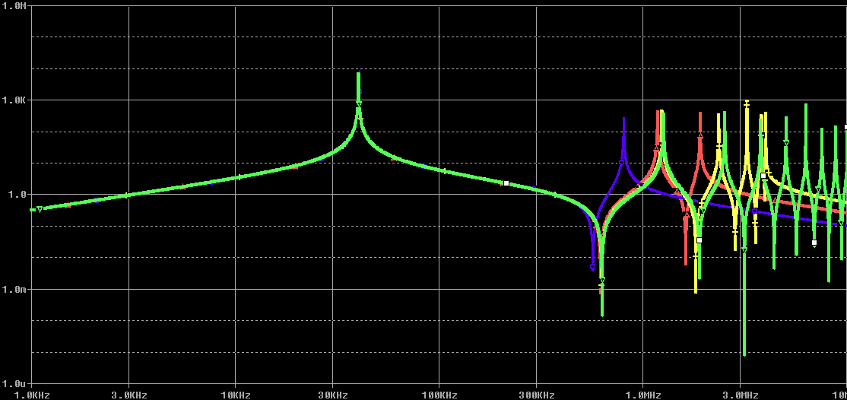

*Figure 3.10*: ZA-D against frequency at short circuit load: comparison for different number of cells.

LEGEND: Modal macromodel (green); 2 cells (blue), 5 cells (red), 10 cells (yellow)

**Table 3.2: Maximum frequencies ($λ=10×l$)**

|  |  |
| --- | --- |
| Number of cells | Fmax |
| 1 | 126 kHz |
| 2 | 252 kHz |
| 5 | 630 kHz |
| 10 | 1.26 MHz |

**Table 3.3: Error of models at different frequencies for short circuit load at a frequency resolution of 1000 points/decade (shaded cells: frequency < fmax)**

|  |  |  |  |  |  |  |  |  |
| --- | --- | --- | --- | --- | --- | --- | --- | --- |
|  | **Reeves** | | | | **Murgatroyd** | | | |
| **Error type** | 1 cell | 2 cells | 5 cells | 10 cells | 1 cell | 2 cells | 5 cells | 10 cells |
| Magnitude at fmax | 2.78% | 2.83% | 350% | 168% | 7.4% | 7.3% | 267% | 61% |
| Frequency error of 2nd res pt | N/A | 569kHz  9.7% | 622kHz  1.2% | 629kHz  0.1% | 402kHz  36.1% | 569MHz  9.7% | 622kHz  1.2% | 629kHz  0.1% |
| Frequency error of 3rd res pt | N/A | 806kHz  36% | 1.19MHz  5.9% | 1.24MHz  1.2% | N/A | N/A | 1.19MHz  5.9% | 1.24MHz  1.2% |

The magnitude at a resonance frequency tends to infinity at peaks and to zero at valleys. These extremities are approximated by SPICE, hence large errors in magnitude are introduced at frequencies near resonance, even if after the resonance the error becomes small again. The error in the frequency-position of resonances is small for all frequencies less than *fmax*. This may be a better measure of the accuracy of a model in the midst of resonance activity.

The size of the error differs for different loads. This is because resonance occurs differently for each load, and resonance is the main contributor to the error. Due to the abrupt variation in magnitude at resonant frequencies, an error in the frequency position of a resonance point will cause large magnitude errors at the model’s predicted resonance frequency as well as the actual frequency at which resonance was meant to occur. Therefore, error will develop differently where resonance points occur differently.For example, the open circuit load has little error even at very high frequencies because the higher order resonances have a small scale effect on the impedance see *Figure 3.6 (b) and 3.10*.

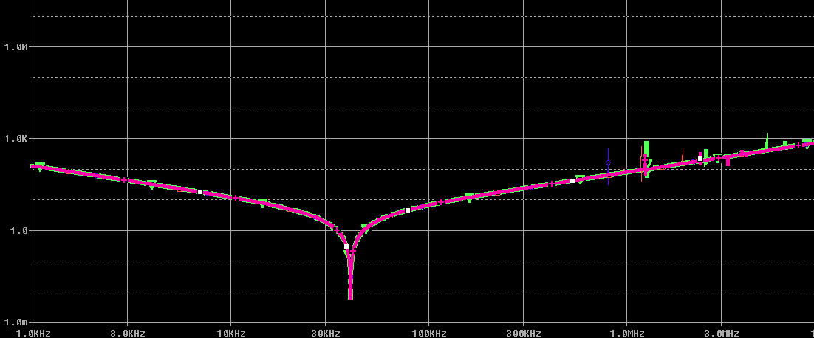

*Figure 3.10*: ZA-D against frequency at open circuit load: comparison for different number of cells.

LEGEND: Modal macromodel (green); 2 cells (blue), 5 cells (red), 10 cells (purple)

A pertinent question iswhether there is a difference between cascading the Reeves or the Murgatroyd model.*Figure 3.11* shows a comparison between 10 cascaded cells of Reeves and 10 cascaded cells of Murgatroyd. Clearly, the resonances of Reeves and Murgatroyd overlap as the addition of cells introduces more resonance points. The models deviate only at frequencies above *fmax*.The errors recorded in *Table 3.3* also show that the errors are very similar between cascading Reeves and Murgatroyd. It is valid to conclude that it is equivalent to cascade either model, as long as the condition is met of the frequency being less than ${ f}_{max}$.

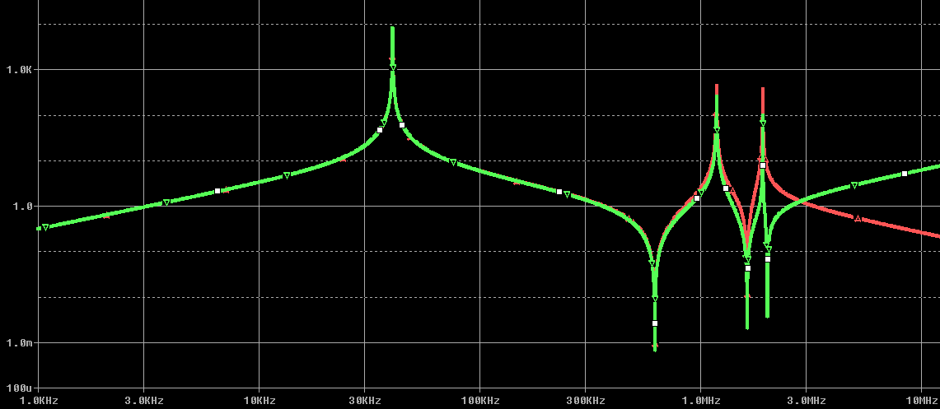

*Figure 3.11*: ZA-D against frequency at short-circuit circuit load: comparison for cascading 10 cells of different model types

LEGEND: Murgatroyd (green); Reeves (red)

In conclusion, the idea that the frequency range increases linearly according to the number of cells that are added is mostly valid. The small errors (≈1%) of resonant frequency near ${ f}_{max}$ caused large magnitude errors to be observed. This would not be a problem for most design applications because it is the position of resonant frequency that is more important, and the error in that aspect is small. Reeves and Murgatroyd tends to the same characteristics when cascaded.

## Modal macromodel vs. Zhao

The modal macromodel theoretically gives the exact solution of the distributed model, even though it is a numerical solution, as described in *Section 2.2.5*. This suggests that it will follow the analytical solution of Zhao very well. This section investigates this supposition.

The two models are compared for different types of loads. The inversely balanced current configuration is used again in this section, i.e. measuring ZA-D with the load impedance connected across the terminals B‑C. These results are shown in *Section 3.4.2*, but first an important difference between Zhao’s model and the modal macromodel is highlighted in *Section 3.4.1*.

### Effect of self-capacitance

The simulation result for ZA-D in the case of an open-circuit is shown in *Figure 3.12*, which shows serious deviation between Zhao and the modal macromodel from around 3MHz. The modal macromodel has multiple repeating resonance peaks of significant magnitude, while Zhao just shows the impedance of an inductor response, at high frequencies.

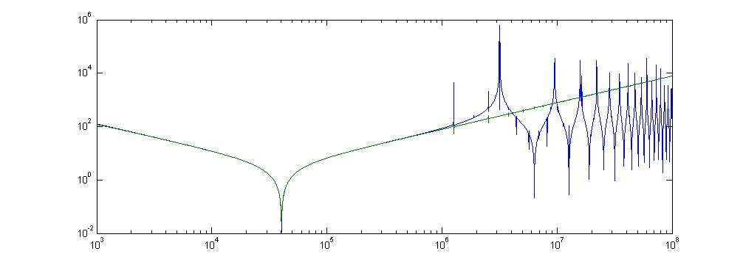

*Figure 3.12*: ZA-D plotted against frequency for open circuit load, showing serious deviation between Zhao’s analytical model (green), and modal macromodel (blue)

The source of the parasitic resonance points was investigated, and is now shown to be the conductors’ self-capacitance, i.e. the capacitance from each conductor to the ground reference. Zhao’s model does not consider the self-capacitance (which in reality is usually negligible), but the modal macromodel gives no solution unless you include a non-zero self-capacitance. This is because the modal macromodel is derived from the parameter PUL matrices (L & C), see *Section 3.2.2*. The matrix manipulation involved results in a singularity if the self-capacitance is zero. The conductor self-capacitance (Cs) in the modal macromodel was reduced from 1 nF to 1 pF, giving the results shown below in *Figure 3.13*.There is now good following between the two models through to above 70 MHz, after which the self-capacitance resonance begins appearing.

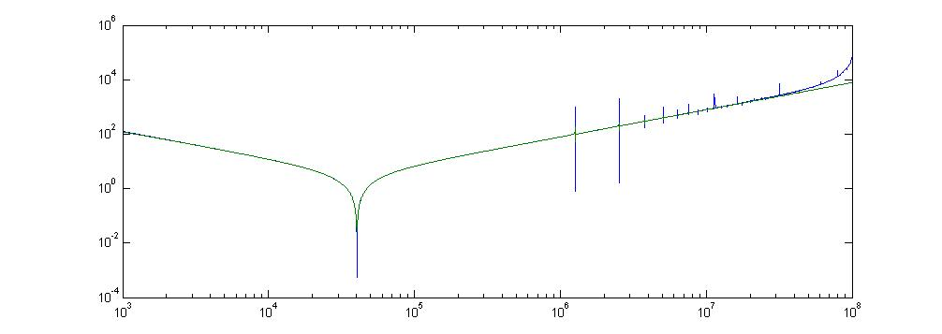

*Figure 3.13*: ZA-D plotted against frequency for open circuit load after reducing conductor self-capacitance, showing excellent following

Clearly, for Cs << C, there is good following between the models. The parasitic resonance points begin at a frequency where Cs and the conductor magnetising inductance (L) resonate.

The question arises as to how large the real self-capacitances are. This is a parameter that is difficult to measure and is very dependent on the surroundings of the conductor of interest. For relatively large self-capacitances, Zhao’s model will not be sufficient at high frequencies. In this dissertation, we will mostly consider the case where the self-capacitance is negligible. This is a good assumption for the case where C is relatively large (i.e. C > 1 nF).

### Comparison for different loads

#### Short-circuit load

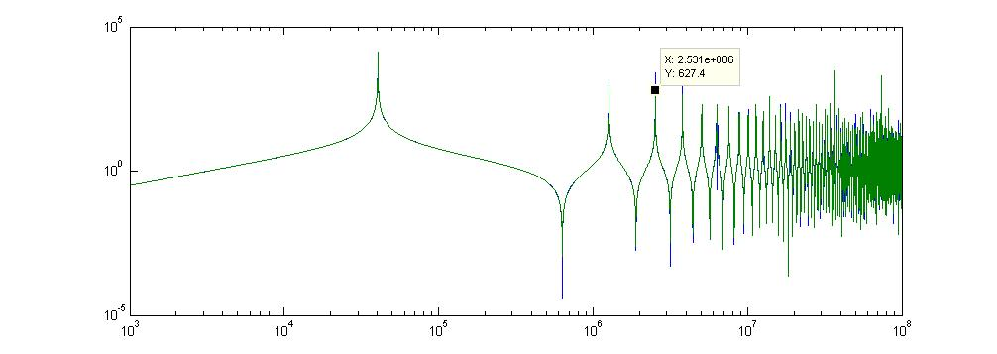

*Figure 3.14*: ZA-D plotted against frequency for short circuit load; showing excellent following, even with the recurring resonance point

**Table 3.4: Comparison of the first five resonance frequencies of two distributed models**

|  |  |  |
| --- | --- | --- |
| **Resonance point** | **Frequency** | |
| **Modal macromodel** | **Zhao’s analytical model** |
| **1** | 40.36 kHz | 40.38 kHz |
| **2** | 632.4 kHz | 632.1 kHz |
| **3** | 1.265 MHz | 1.266 MHz |
| **4** | 1.897 MHz | 1.898 MHz |
| **5** | 2.529 MHz | 2.531 MHz |

The following between the modal macromodel and Zhao in the short-circuit case is excellent, even at high frequency resonance points. This good following is also the case for all the other three load types. The small error between the two graphs is due mainly to the discrete-time sampling, i.e. the graphs are not continuous when we take a zoomed-in view to observe the resonance peak, see *Figure 3.15*. The error in the resonant frequencies is small, and will be considered negligible.

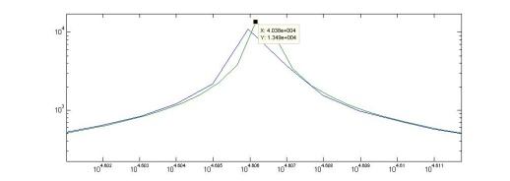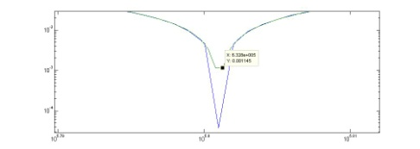

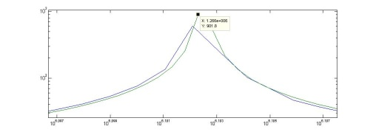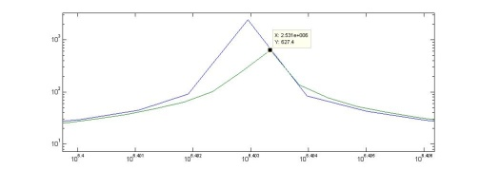

*Figure 3.15*: Zoomed-in view of the resonance peaks show that the error is being introduced by the limited frequency resolution of the simulations

#### ZL = 0.1,1,10,100 Ω

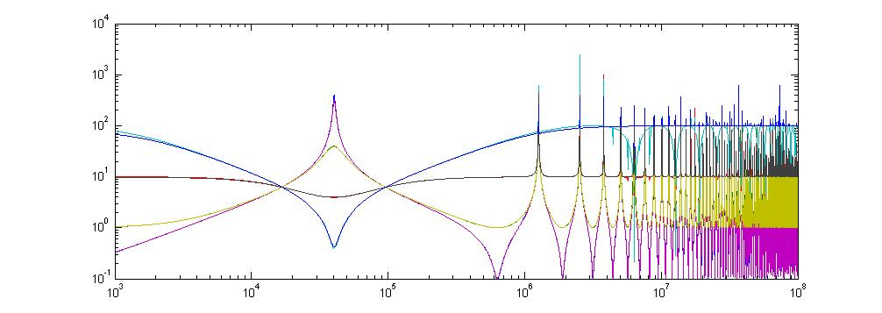

*Figure 3.16*: ZA-D plotted against frequency with loads of different resistances.

Note the reversal in behaviour from series to parallel resonance when ZL exceeds Z0 (defined in Zhao between the two conductors).

### At low coupling

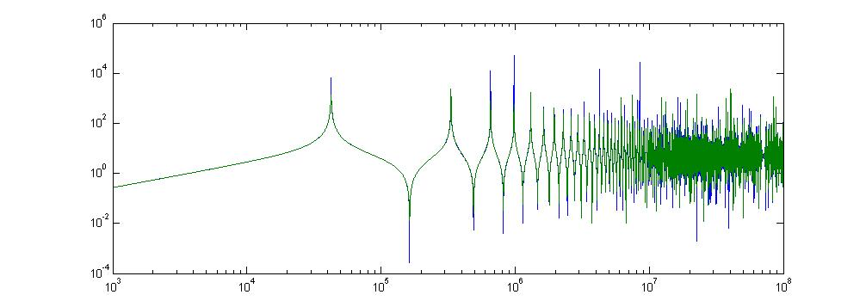

*Figure 3.*17: ZA-Dplotted against frequency for a short circuit load, at low coupling of k = 0.7

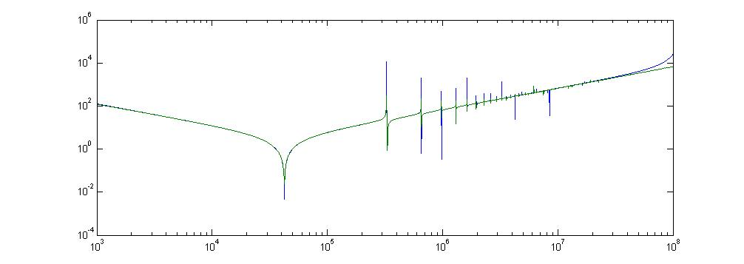

*Figure 3.*17: ZA-Dplotted against frequency for an open circuit load, at low coupling of k = 0.7

At low coupling, the following between the modal macromodel and Zhao remains excellent through to high frequencies, for both the open and short circuit cases.

### Conclusion

The main difference between the modal macromodel and Zhao’s model is that Zhao does not incorporate the conductor self-capacitances. This causes serious deviation between the models at frequencies where the conductor self-capacitance and magnetising inductance resonate.

Therefore, our confidence in the quality of the modal macromodel to predict the frequency response of lossless integrated passives has been greatly strengthened. It is possible, however, that the modal macromodel does not perform as effectively for multiple conductors, but this will not be examined here because we do not have an analytical solution for multiple conductors, such as we have Zhao’s solution for the two-conductor case.

With this excellent following in the frequency domain, the modal macromodel appears to be a good benchmark solution to represent the integrated passive structure in SPICE. The next chapter will examine the time domain solution obtained from SPICE simulations, so the modal macromodel will be used as the benchmark solution in comparisons made with lumped model time domain solutions.

# integrated passive structure with simple boundary conditions:Time domain

## Background

In this chapter the responses to a step input signal will be used to provide a time domain comparison of the different SPICE-compatible models. First, there is a brief discussion around the input signal used for these simulations.

### Simulating the step response

The step response can be mathematically obtained using the convolution of the input signal (a unit step) and the impulse response of the system. The system is shown in *Figure 4.1*, where the source impedance is 50Ω (ZS) for a typical signal generator, and the integrated passive is configured as a single-port network between terminals A-D, with an impedance between B-C. This is the same terminal configuration used for the frequency domain simulations in the previous chapter. The same structure parameters have been used as for the frequency domain simulations.

The circuitin *Figure 4.1*comprises a simple voltage divider of the input step signal in the frequency domain, which gives the step response, as in *Equation 4.1*:

$$V_{A-D (step)}\left(jω\right)=\frac{Z_{AD}\left(jω\right)×V_{in (step)}\left(jω\right)}{Z_{S}+Z_{AD}\left(jω\right)} …(4.1)$$

The step response does not only depend on the magnitude of the integrated passive input impedance (ZA‑D), but also on ZA‑D’s proportion relative to the source output impedance (ZS). This means that the step response will be different between the cases where ZS < ZA‑D and where ZS > ZA‑D. This will be observed in the simulations presented in this chapter.

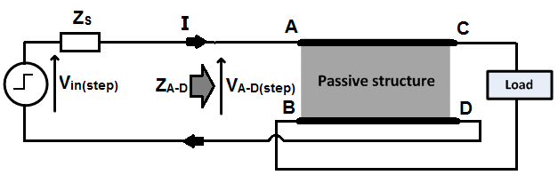

*Figure 4.1*:Circuit setup for step response simulations

### Understanding the input signal

A real input signal is not a perfect unit step, which is not physically realizable. Rise and fall times cannot be instantaneous. A real step-like input signal in a physical setup would be generated by a signal generator as a pulse waveform. The frequency spectrum of a pulse signal is shown in *Figure 4.2.* This can be enveloped by the simplified spectrum developed by [26] for pulse signals, which is shown in *Figure 4.3*.

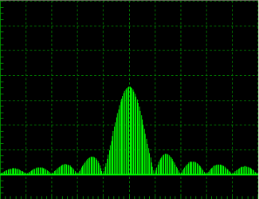

*Figure4.2*: Frequency spectrum for pulse signals

**1/τ**

**1/πtr**

**ω**

**tr**

**τ**

**Time**

*-40dB/dec*

*-20dB/dec*

**F**

*Figure4.3*: Paul’s simplified spectrum for single-pulse signals

The difference between a step input signal and a pulse input is that the step input does not have a falling edge. This difference can be ignored under the condition that the time taken for all the transients following each turn-on/off transition to die out is much smaller than the pulse duration.Another difference is that a pure step has instantaneous rise-time.

The pure input step spectrum is shown in *Figure 4.4*.The pure step input spectrum is defined by the following expression:

$$V_{source}=\frac{1}{jω}+2πδ\left(ω\right) …(4.2)$$

The simplicity of this expression makes it a useful approximation to represent the input signal.



*Figure4.4*: Frequency spectrum of pure step signal on log-log scale



*Figure4.5*: VA-D(step) as per *Equation 4.1*: where ZS = 1Ω (left), and ZS = 50Ω (right)]

The simulations presented in this chapter will show that higher order resonances produce oscillations of much lower amplitude, even though the peak impedance magnitude at that frequency is the same as that of the lower order resonant points. This clearly indicates to the fact of the input signal energy content being much smaller at higher frequencies.*Figure 4.5* shows how *Chapter 3*’s frequency domain plots of impedance are modified by the input signal to give the frequency content of the approximate step response.

*Figures 4.3-4.5*confirm that the input signal energy content is much smaller at high frequencies.An important question is what the highest frequency is that will still have significant energy content. We denote this frequency as *fmax(in)*. **It is this frequency that must be compared to the maximum frequency that a lumped model can support before breaking down (see *fmax* in *Section 3.3*).**Oberholzer’s approach to determining the maximum significant frequency present in the input signalis given in *Equation 4.3*[42]. Considering that the energy content of the input signal would be insignificant at such frequencies, Oberholzer’s approach is quite restrictive in most cases, i.e. it imposes an unnecessarily large safety margin.

$$f_{max⁡(in)}≅\frac{1}{10t_{r}} …(4.3)$$

### Types of signal components in step responses

The next few *sections 4.1.3.1 – 4.1.3.4* will describe four different types of signals that can appear in typical step responses. A step response can be made up of a combination of these signal types.

#### Oscillations

Oscillations are single-frequency signals. The input signal has a continuous frequency spectrum. Therefore, an oscillation will only appear in a step response when a resonance peak in the input impedance causes a sharp increase in *Equation 4.5.* This will happen under two conditions:

* When ZA-D has a parallel resonance peak which exceeds the source impedance, this will result in a voltage oscillation
  + ZA-D must normally be less than ZS for most frequencies other than the resonance point, i.e. the resonance peak acts as a frequency selector.
$$V_{A-D\left(step\right)}\left(jω\right)=\frac{Z_{AD}\left(jω\right)×V_{in (step)}\left(jω\right)}{Z_{S}+Z_{AD}\left(jω\right)} …(4.4)$$

* Conversely, when ZA-D has a series resonance valley which is less than ZS, which will result in a current oscillation
  + ZA-D must normally be more than ZS for frequencies other than the resonance point.

$$I_{\left(step\right)}\left(jω\right)=\frac{V_{step}\left(jω\right)}{Z_{S}+Z_{AD}\left(jω\right)} ….(4.5)$$

Resonant frequencies at higher frequencies do not cause oscillations because the input signal does not have enough energy at those frequencies to sufficiently excite the resonance, i.e. the oscillations have a negligible magnitude at such frequencies, see *Figure 4.5*.

#### Exponential curves

The cause of exponential curves in step responses is when the loop impedance resembles either of the following two cases:

* An RC network:
  + Voltage will decay to zero
  + Current will rise to a steady-state value
  + Time constant, which can be determined by *Equation 4.6*:

$$τ=RC=\frac{t_{2}-t_{1}}{\ln{\frac{y_{1}}{y_{2}}}} …(4.6)$$

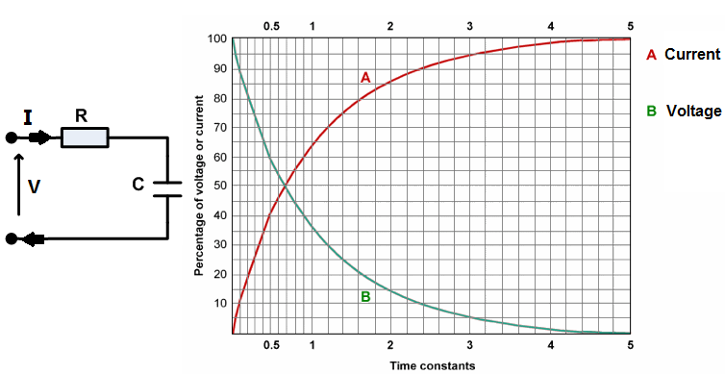

*Figure 4.6*:An RC network and its step response (graph adapted from [41])

* An RL network:
  + Current will decay to zero
  + Voltage will rise to a steady-state value
  + Time constant, which can be determined by *Equation 4.7*:

$$τ=\frac{L}{R}=\frac{t_{2}-t_{1}}{\ln{\frac{y_{1}}{y_{2}}}} …\left(4.7\right)$$

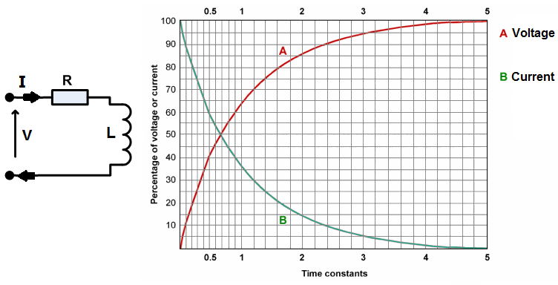

*Figure 4.7*:An RL network and its step response (graph adapted from [41])

#### Spike in a Voltage or Current

This is a phenomenon that occurs immediately after a fast transition in the input signal, in this case it occurs at the turn-on transition of the step signal. The cause of the spikes is the high frequency content that is present near the transition, which quickly dies away as the low frequency content begins to dominate.

A voltage spike will occur under the following conditions:

* There must be no low impedance path to ground for high frequency current. An important example is that there must not be a complete capacitive path between the structure’s terminals, as at high frequency this will be a low impedance path to ground. Such a capacitance will quickly absorb the high frequency energy
* The high impedance path to ground must quickly give way to low impedance as the high frequency content is absorbed.
* In short, the input impedance must be high at high frequencies, and must become low at low frequencies

A current spike will occur under the converse conditions as for the voltage spike. This means a completely capacitive path to ground with no inductance. An important factor in the magnitude of the current spike is the total loop impedance, e.g. once the full source voltage drops across the source impedance, there will be no further increase in the current spike, even if ZA-D was to decrease further. Similarly, the voltage spike is limited to the full magnitude of the source voltage.

These spikes are important because they can occur as a result of very low-energy signals, as opposed to the exponential curves and resonance oscillations, which will only occur in response to a signal of significant energy. Therefore, in the case of a step input - where high frequencies have much less significant energy - these voltage/current spikes are the main way such frequency content can manifest.

#### Transmission line reflections

If a transition is fast enough, thentransmission line reflections will appear. I.e. Such a transition will have high frequency content, such that significant energy content lies at frequencies where the structure becomes electrically small.

## Step response using modal macromodel

The modal macromodel performed with great accuracy in the frequency domain, so we will use it here as the benchmark solution in the time domain. This model theoretically gives an exact solution for lossless systems. This was confirmed in the frequency domain comparisons, except that Zhao does not account for a capacitance between conductors and a ground reference, but the solution of the modal macromodel needs this capacitance. As long as this capacitance is very small compared to the inter-conductor capacitance, the modal macromodel gave almost perfect results, see *Section 3.4*.

Simulation results of the step response are now given for the four different types of load. Two different source impedance values are simulatedto demonstrate the contribution of the source impedance.Observations on key signal characteristics are noted, and their causes are explained. These explanations demonstrate how to relate time domain response to the frequency domain information of the previous chapter.

The short circuit and capacitive load cases will also include plots of the step response showing a comparison between the lumped models and the modal macromodel. This is left out for the other load cases because they give redundant information. A relevant question is which model is more valid to use between the Murgatroyd and Reeves?

### Short circuit load



*Figure 4.8*: ZA-D frequency domain data for all SPICE modelsat short circuit load

LEGEND: Modal macromodel (green); Murgatroyd (blue); Reeves (red)

#### ZS = 50Ω

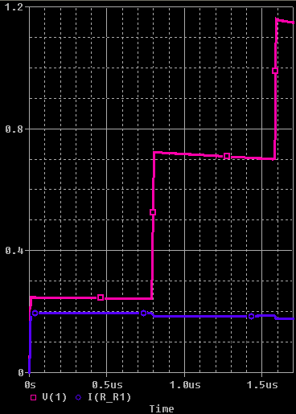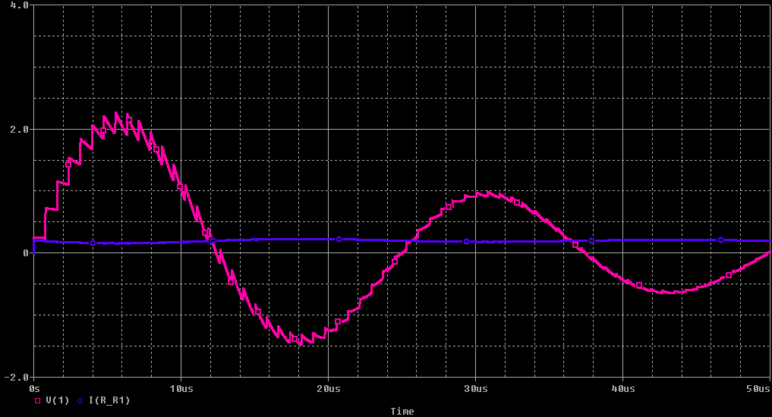

*Figure 4.9*: VA-D step response with short-circuit load: The first 1.7µs (left); the first 50µs (right).

LEGEND: Red – voltage, Blue – current: Both are using modal macromodel.

A large resonance oscillation occurs at 40.2 kHz, which is at the parallel resonance predicted by the frequency domain impedance plot of ZA-D, see *Section 3.2.1.1*. The “reflected” step signals are superimposed on this oscillation.

Immediately following the turn-on transition of the input signal, the step response shows transmission line reflections of the step. These reflections appear at the terminals A-D after every 800 ns, which is actually the propagation time for a signal travelling in the integrated passive (TD). Normally, a signal travels down a transmission line and its reflection appears on the input end after 2xTD (i.e. there and back again). In the terminal configuration being simulated, however, the input signal appears across terminals A-B and C-D simultaneously, and a scaled input signal travels in both directions of the transmission line, and appears on either end simultaneouslyafter TD. Hence, the term “reflections” is now not quite valid.

Relating this step response to the frequency domain impedance plot, we see that the fundamental parallel resonance is causing the resonance. This is understood by the fact that ZA-D<< ZS for most frequencies, with the exception of a selected frequency (f0), hence the only significant voltage seen across A-D is at f0. The other frequencies where ZA-D is comparable to ZS, which would then cause a voltage to appear across A-D, are the transmission line resonant peaks. However, we do not observe any resonance oscillations at those frequencies. There are two possible reasons for this, the latter being the preferred option of the author:

* The input signal is insignificant at such high frequencies. This is certainly a contributing factor.
* The more likely proposition is that the recurring resonance peaks cause oscillations that conglomerate into the transmission line step signals that are present immediately after the step turn-on transition. This idea is analogous to the way a Fourier series constructs a square signal from sinusoids of different frequencies; this idea is confirmed in *Section 4.4*.

#### ZS = 1Ω

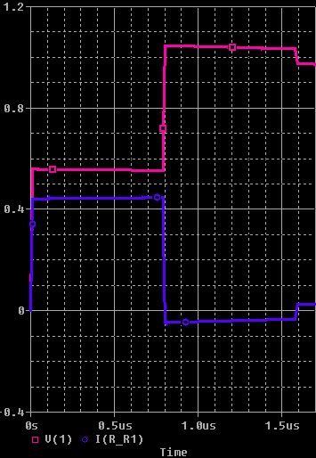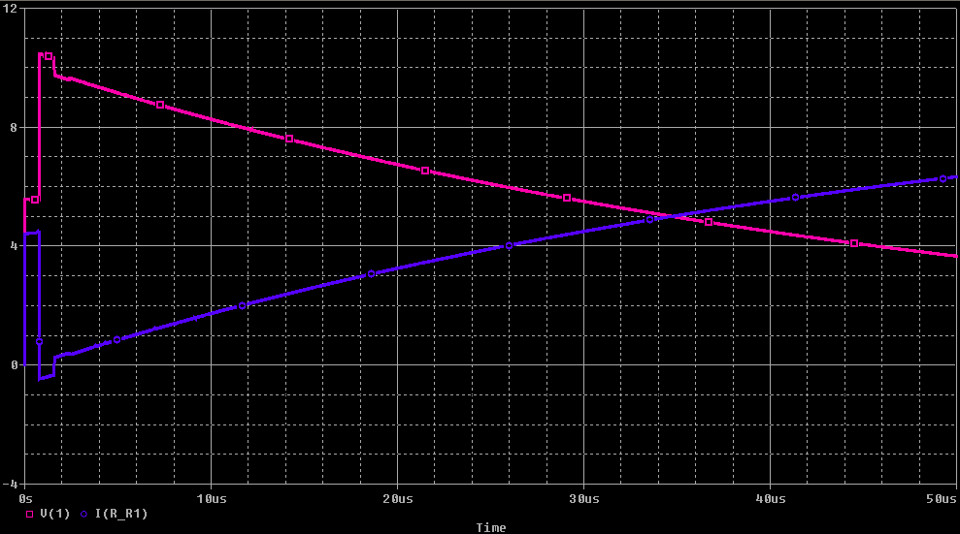

*Figure 4.10*: VA-D step response of short-circuit load: The first 1.7µs (left); the first 50µs (right)

LEGEND: Red – voltage, Blue – current: Both are using modal macromodel.

The step response is now an inductive exponential curve. The change is caused by the change in the damping characteristic. An RL network has a damping characteristic related to L/R. This shows that the decrease of ZS, which makes up the R in the circuit, will increase damping and thus replace oscillations with exponential decay. Using the fact that time constant equals L/R, the exponential curve gives an inductance of 12.5 µH, which is the conductors’ self-inductance.There are transmission line signals superimposed on the exponential decay, which occur every TD, as before.

#### Lumped models vs. modal macromodel: short circuit load

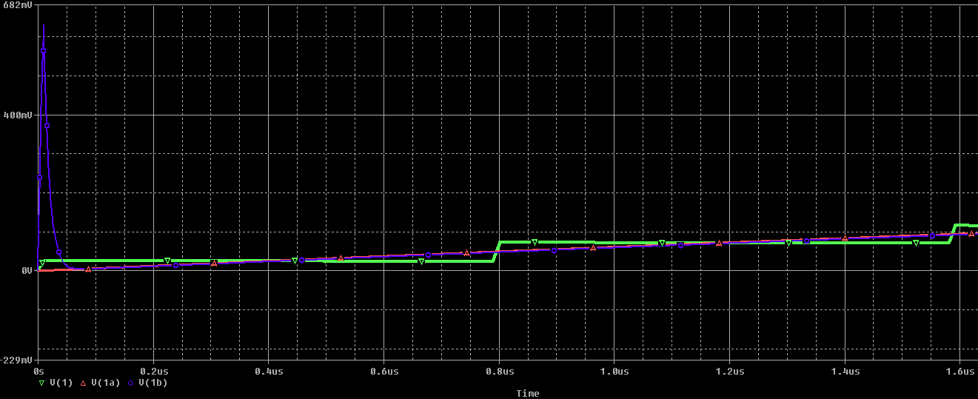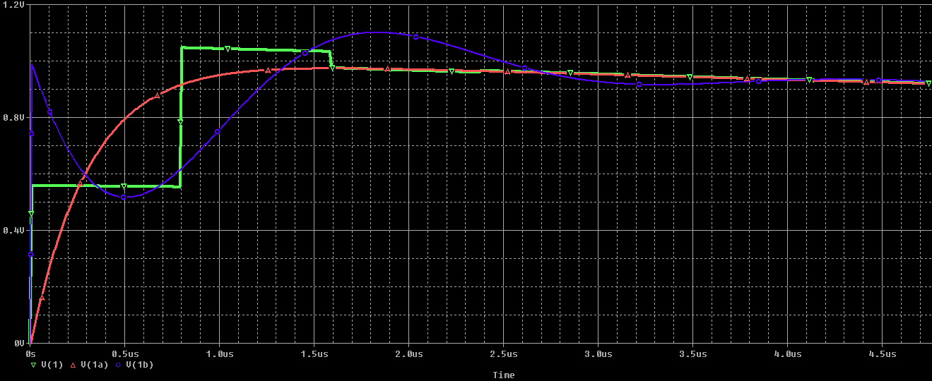

*Figure 4.11*: VA-D step response: The first 1.7µs with ZS = 50Ω (left); the first 4.7µs with ZS = 1Ω (right)

LEGEND: Modal macromodel (green), Reeves (red), Murgatroyd (blue)

For both source impedance cases, the Murgatroyd model has an initial spike in voltage. This is not according to the benchmark prediction of the modal macromodel. This deviation is caused by the circuit configuration of a Murgatroyd model: a voltage step input first encounters a fully inductive path before the capacitor in the middle of the model comes into play, see *Figure 2.2*.In a physical structure the voltage step input will encounter a distributed inductance and capacitance simultaneously.

Note that in physical measurements the inductance of the measurement lead connections can be significant,which will also be a factor contributing to a voltage spike. This is because there would be a completely inductive path between the measurement terminals (high impedance), and thestructure’s capacitance that would normally restrict the voltage spike is not connected directly across the terminals anymore.

Is Reeves or Murgatroyd a better model to use? Neither is capable of simulating the transmission line effects. Looking at *Figure 4.11* one could suggest that the parasitic voltage spike appearing in Murgatroyd’s model would make Reeves a better option, because a falsely predicted voltage spike would have significant impact on a design.However, to conclude that Reeves is the better option is not valid. This could be observed by the current plots that correspond to *Figure 4.10,* where Reeves would show a parasitic current spike for low source impedance. A falsely predicted current spike would also have adverse effects on design. Therefore, neither model is conclusively better, except in the case where strict control on just one of either voltage or current is required.

### Open circuit load

#### ZS = 50Ω

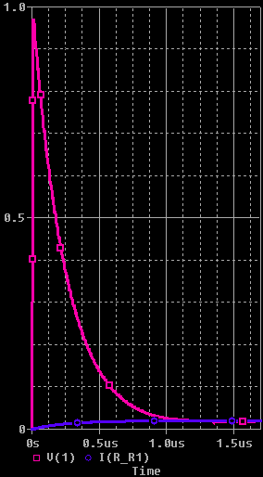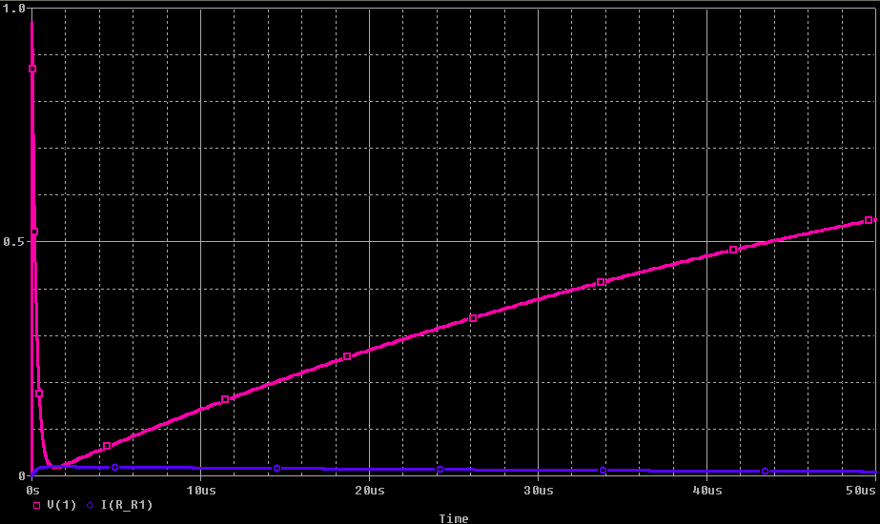

*Figure 4.12*: VA-D step response of open-circuit load: The first 1.7µs (left); the first 50µs (right)

LEGEND: Red – voltage, Blue – current: Both are using modal macromodel.

The structure is configured here as a series resonator. The response tends to a capacitive exponential decay. The time constant RC gives a capacitance of 1.25 µF (which is Cinter), where R is the source impedance of 50  Ω. Immediately after the step turn-on transition, there is a voltage spike, but no transmission line signals. The voltage spike is caused by the high impedance path for the high frequency content that is presented by the inductive conductors. Current has to flow from one end of the structure to the other through the whole self-inductance, irrespective of where the current crosses the capacitance. There are no transmission line step signals present in this response. The reason for that is evident from the frequency domain plot in *Figure 3.6 (b)*, where it is seen that the high frequency resonance points are dominated by the high inductive impedance.

#### ZS = 1Ω

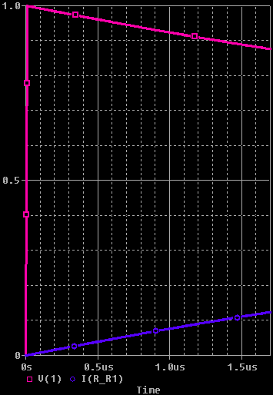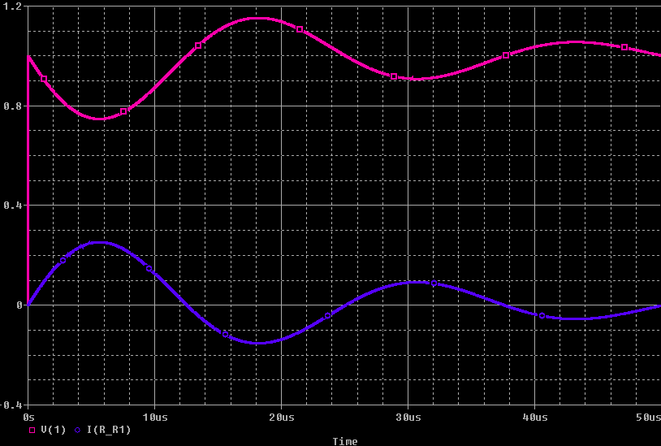

*Figure 4.13*: The step response of open-circuit load: The first 1.7µs (left); the first 50µs (right)

LEGEND: Red – voltage, Blue – current: Both are using modal macromodel.

Just as for the50 Ω source impedance, the voltage increases almost to the input voltage. This is because there is no capacitance across the input terminals to resist the voltage spike that arises because of the high impedance path presented to the input transition, which has high-frequency content. Low-frequency content is also presented with a high impedance path to ground, because of the capacitance that it must pass through to get to ground. This agrees with the frequency domain impedance plot in *Figure 3.6 (b)*. The only frequency at which the impedance drops low is at f0, hence the current oscillates at a significant amplitude at this frequency only.

However, different to before, there is a strong resonant oscillation present at 40.2 kHz, which is a series resonance. Here we see that in order for a series resonance oscillation to appear the resistance of the loop should be small. Otherwise the oscillation is damped out.

### Capacitive load



*Figure 4.14*: ZA-D frequency domain data for all SPICE models at capacitive load

LEGEND: Modal macromodel (green); Murgatroyd (blue); Reeves (red)

#### ZS = 50Ω

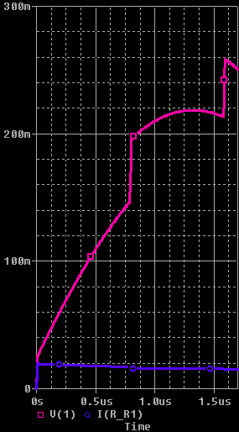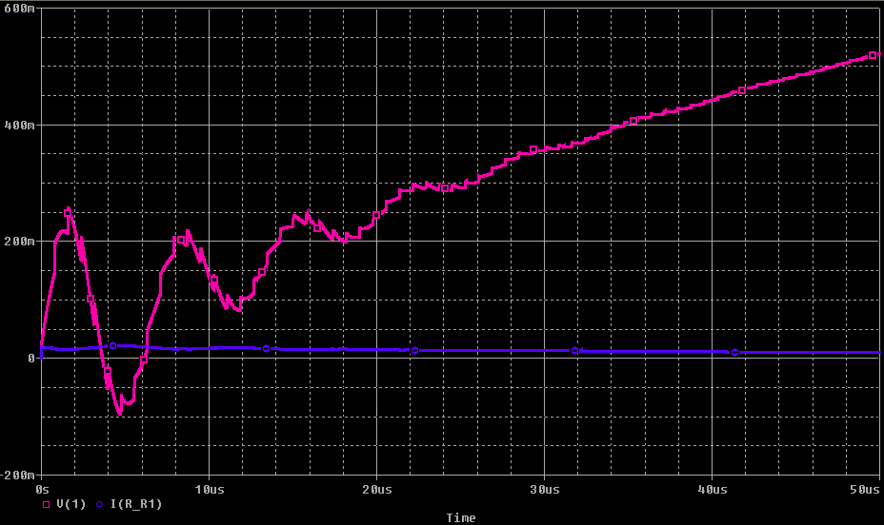

*Figure 4.15*: The step response of capacitive load: The first 1.7µs (left); the first 50µs (right)

LEGEND: Red – voltage, Blue – current: Both are using modal macromodel.

This configuration has a step response has three components superimposed: The largest energy-component is the capacitive exponential curve. This dominates the response the further we go from the input step transition, i.e. as the high frequency content gives way to the higher energy low frequency content. This RC curve relates to the low-frequency capacitive nature of ZA-D, as seen in *Figure 3.6 (c)*. Using the observed time constant, with R being the 50Ω source impedance, the capacitance is calculated to be 1.25µF, which is Cinter. The second component is an oscillation of 148 kHz, which corresponds to the second resonance point of the impedance plot, which is the firstparallel resonance. This oscillation occurs at higher frequencies than the low frequency capacitive part of the impedance plot, thus the oscillation has lower energy than the exponential curve. The third component is transmission line effects showing small step changes with capacitive exponential curves. The capacitive exponential decays of the step changes are much faster than the main exponential curve. The capacitance can be calculated to be 100 nF, which is the same as the conductor self-capacitance in these simulations.

Note that the first resonance point does not affect the step response. This is because the impedance ZA-D is much lower than ZS for all frequencies except the initial low frequency capacitive slope, the second resonance peak, and the transmission line peaks. Thus, it is only the effects at these frequencies that are observed in the step response.

#### ZS = 1Ω

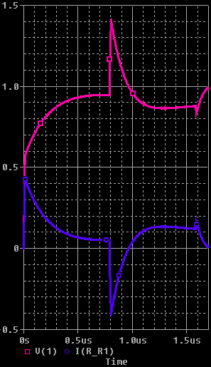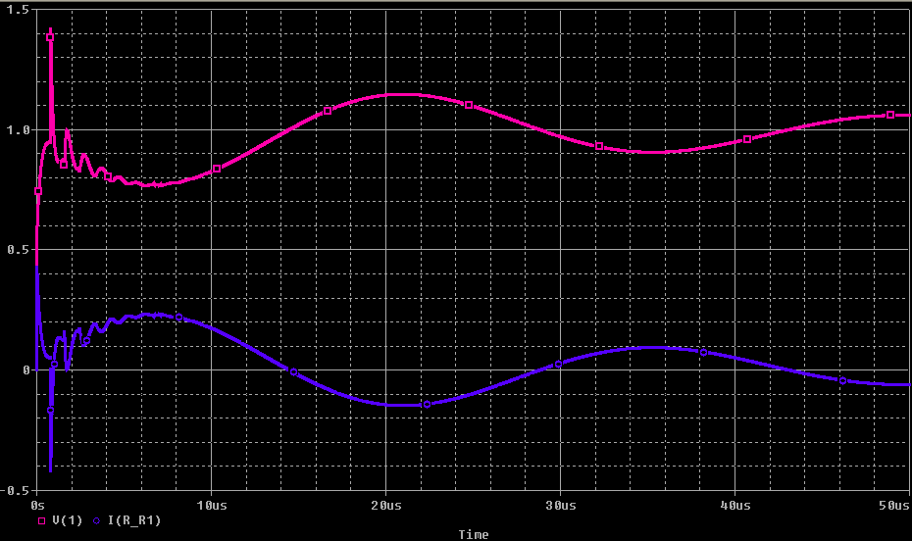

*Figure 4.16*: The step response of short-circuit load: The first 1.7µs (left); the first 50µs (right)

LEGEND: Red – voltage, Blue – current: Both are using modal macromodel.

The low source impedance allows the voltage to rise very quickly, i.e. small time constant of RC loop. The transmission line effects are clearly present, with step changes followed by fast-decaying capacitive exponential curves. The time constant of these curves again gives a capacitance of 100 nF, using R = 1Ω. The resonance oscillation is at a frequency of 35 kHz, as predicted by the first resonance point predicted by *Figure 3.6 (c).* The second resonance point does not feature because the impedance ZA-D is greater than ZS for all frequencies except the first resonance point, and the transmission line resonances. This again illustrates the principle that resonance oscillations occur at frequencies where the ZS/ZA-D ratio crosses from being much less than one to much greater, or vice-versa, and that at just a single frequency.

#### Lumped models vs. modal macromodel

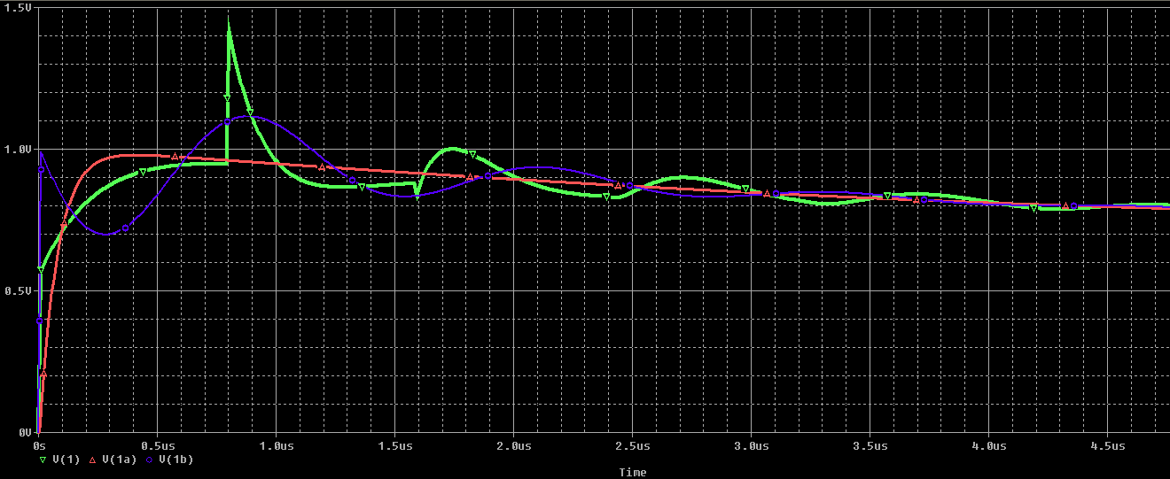

*Figure 4.17*: The step response: The first 1.7µs with ZS = 50Ω (left); the first 4.7µs with ZS = 1Ω (right)

LEGEND: Modal macromodel (green), Reeves (red), Murgatroyd (blue)

This figure has been included for illustrative purposes; its interpretation is similar to that of *Section 4.2.1.3*.

### Inductive load

#### ZS = 50Ω

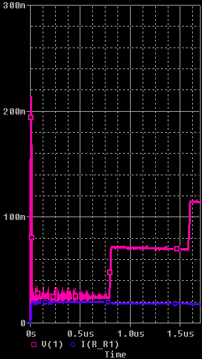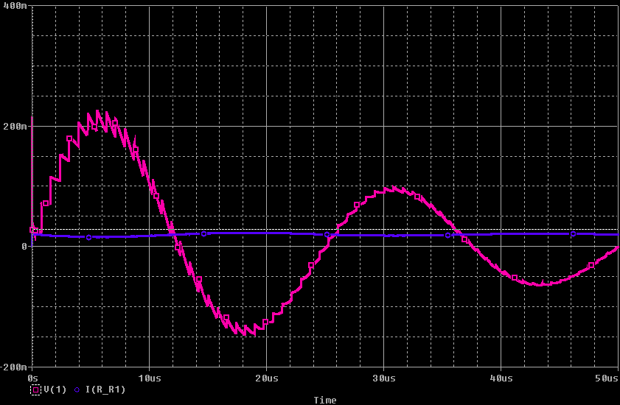

*Figure 4.18*: The step response of short-circuit load: The first 1.7µs (left); the first 50µs (right)

LEGEND: Red – voltage, Blue – current: Both are using modal macromodel.

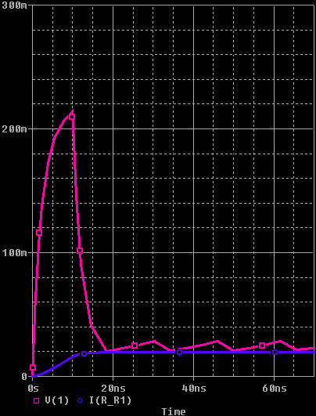

*Figure 4.19*: Zoomed-in plot to observe the voltage spike in first 10ns

LEGEND: Red – voltage, Blue – current

This response is very similar to the short-circuit configuration. The most noticeable difference is a voltage spike just after the input step transition. This is because the connection between B-C is now inductive, which presents a high impedance to high frequency content, but rapidly becomes a low impedance for the lower frequencies that begin to dominate the response.

#### ZS = 1Ω

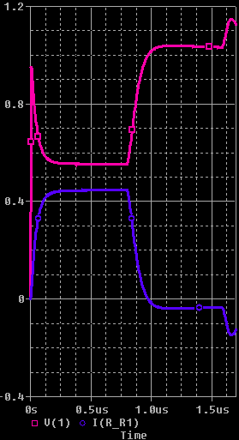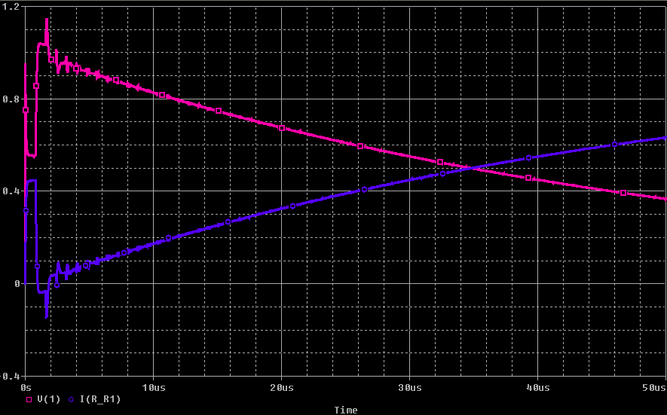

*Figure 4.20*: The step response of short-circuit load: The first 1.7µs (left); the first 50µs (right)

LEGEND: Red – voltage, Blue – current: Both are using modal macromodel.

As in the previous section, this response is similar to that of the short circuit load. There is now an inductive exponential curve after every transmission line step change. The time constant gives an inductance of 100 nH for R = 1Ω, which is the same as the inductive load.The reason this exponential curve is not very observable in *Section 4.2.4.1* is that the increased source impedance makes the time constant very small.

### 10-cell cascaded model vs. modal macromodel

The high order resonant frequencies are not excited, i.e. there are no oscillations at these frequencies; it seems that the resonances that occur where conductor length is a multiple of wavelengthcombine to form the reflection signals. This is evident in the use of the cascaded model, where there is a combination of different high frequencies to make a signal that generally follows the pattern of reflected squares observed in the modal macromodel. This is analogous to how the Fourier series combines builds a square wave by combining a combination of sinusoids.

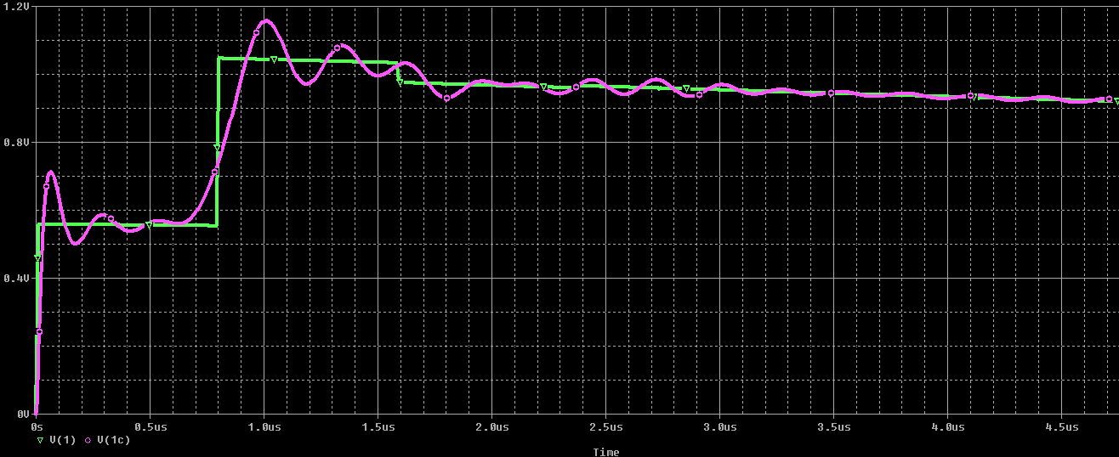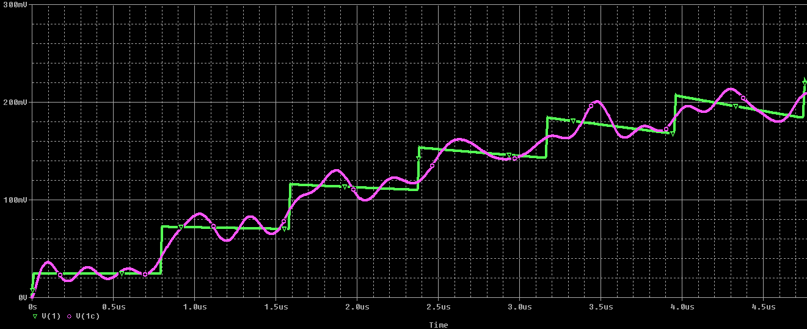

*Figure 4.21*: Short circuit load case: ZS = 1Ω (left); ZS = 50Ω (right)

LEGEND:Modal macromodel (green), 10 cascaded lumped cells (purple)

## Effect of changing structure parameters

The parameters used in the previous sections were obtained from the structure physically built by Zhao to demonstrate the validity of his modelling. However, the high capacitance was obtained using a sprayed-on ceramic. This construction method was not readily achieved in this research, due to the lack of certain important equipment.

The highest capacitance that could be readily achieved in the laboratory available was offered by a material C-Ply, which gives 1nF/cm2. The thickness of the material is manufactured at 15um, which results in high coupling between conductors. A 64x10x50 core gives the following parameters:

* PUL L’ = 80uH/m => L = 24uH
* PUL C’ = 167nF.m => C = 50 nF
* R = 40 mΩ, which we neglect in the modelling of this research
* Coupling k = 0.9999
* Conductor length = 0.3 m

### Short circuit load



*Figure 4.22*: Frequency domain plot of ZA-DforZL=0, using the changed parameters

LEGEND: Modal macromodel (green), Reeves (red), Murgatroyd (blue)

I. Zs = 50Ω

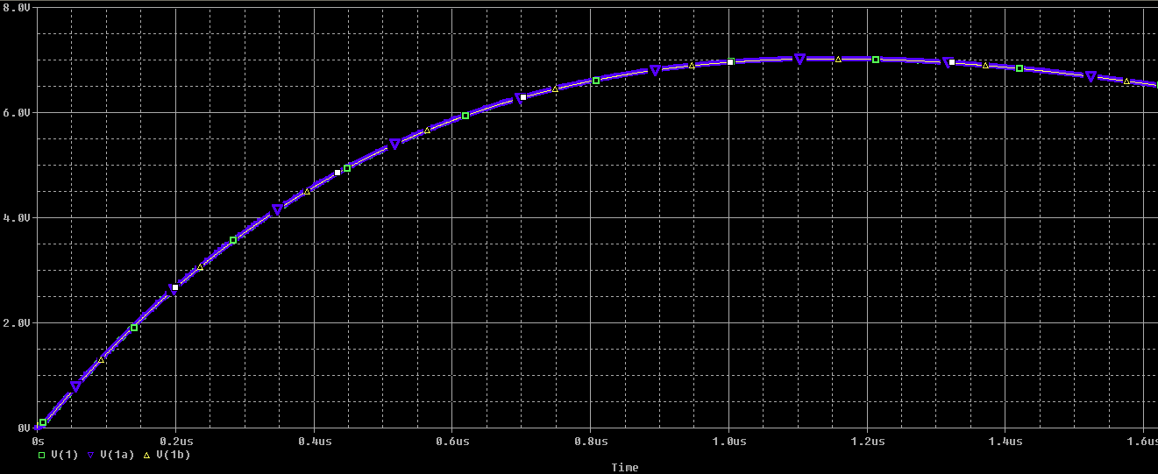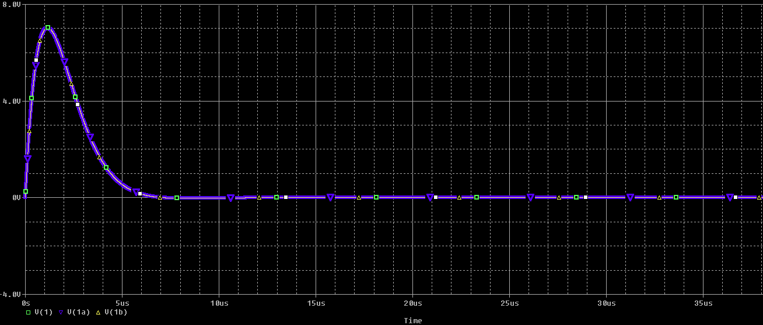

*Figure 4.23*: The step response of short-circuit load: The first 1.7µs (left); the first 50µs (right)

LEGEND: Modal macromodel (blue), Reeves (red), Murgatroyd (yellow)

II. Zs = 1Ω

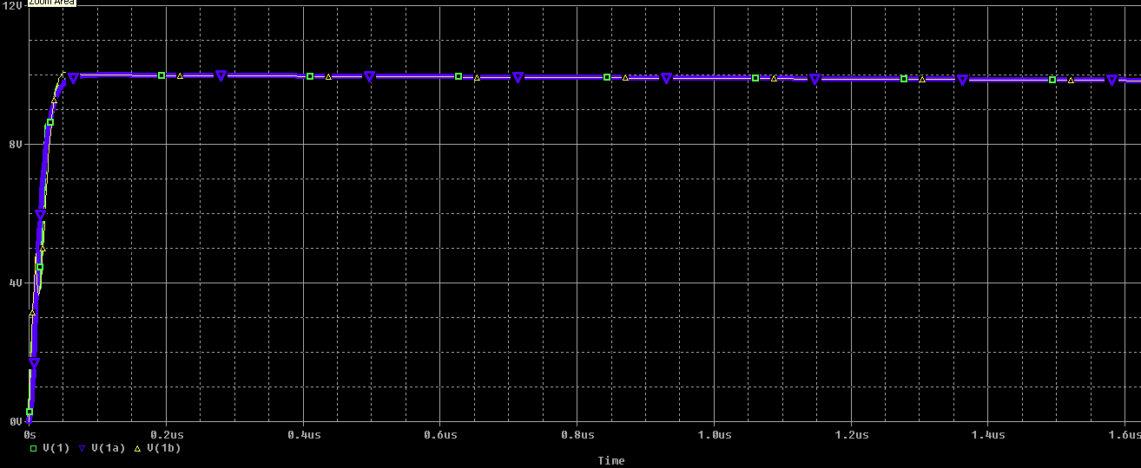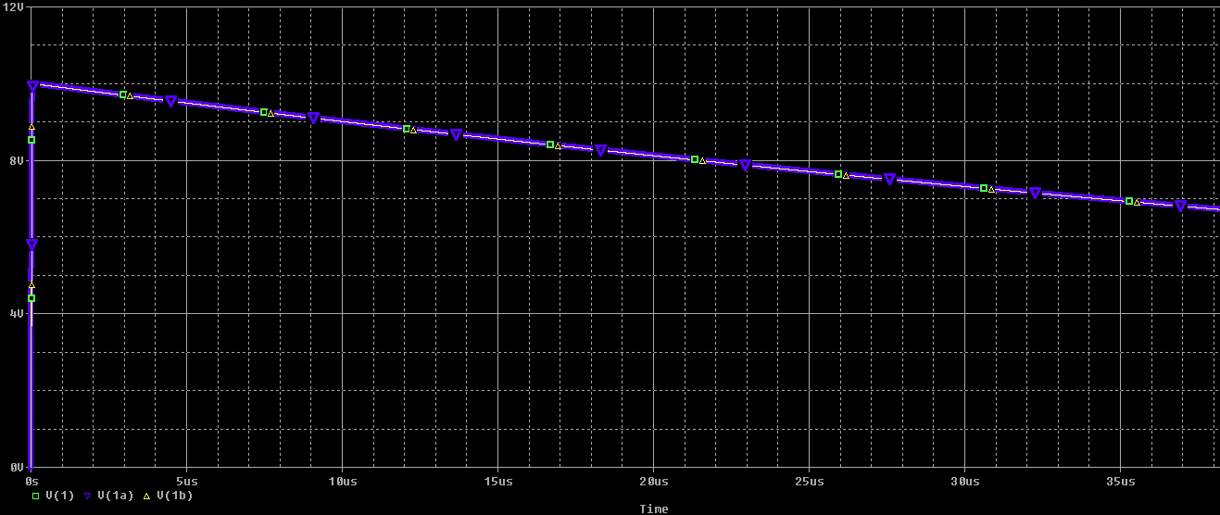

*Figure 4.24*: The step response of short-circuit load: The first 1.7µs (left); the first 50µs (right)

LEGEND: Modal macromodel (blue), Reeves (red), Murgatroyd (yellow)

*Figures 4.23 and 4.24*clearly shows that all the models now follow each other much closer than in *Section 3.2*. This is because the changed parameters give a different phase velocity, giving a higher maximum frequency before the models begin breaking down.

$$f≪f_{max} ;{ f}_{max}=\frac{1}{\sqrt{2(L-M)C}}=64 MHz$$

### Convergence problems

There is anapparent lack of capacity in the modal macromodel to handle fast-transition signals, which are prevalent in power electronics circuits.This was first observed when simulating the structure with the parameters of *Section 4.3*. After investigation into the cause of the convergence problem, it was discovered that there are also convergence problems for Zhao’s structure, when the step rise time is sufficiently small. Close inspection of the current shows slight reflected steps every 16ns, rather than the calculated TD=800ns. This comes from the fact that the modal macromodel incorporates a distributed capacitance from each conductor to ground. This gives rise to the faster propagation velocity of *Equation 3.38,* which has been neglected up till now. This propagation velocity gives a TD(small)=8ns. The reflections are therefore occurring after 2*x*TD(small), meaning that the square wave has travelled from one end of the structure to the other and back again. This is opposed to the previous observation of the reflections of the slower propagation, whose reflected waveforms are observed every TD, as explained in *Section 4.2.1.1*.

Due to the structure’s unconventional boundary conditions, the transmission line reflection dynamics are not well-understood. This could be a subject of further research.

The model begins to fail to converge under two conditions:

* When SPICE’s “maximum time step” setting is of a comparable duration to the shortest propagation time of the passive structure, i.e. the TD related to the highest velocity given by *Equation 3.38*.
* The input signal rise-time is also comparable to the systems smallest TD.

The cause for the problem is not fully understood. The ability of SPICE to automatically determine a sufficiently small time step fails for these simulations. Forcing SPICE to take small enough time steps does seem to work, but this has the problem of simulation execution times becoming very long. It is observed that the convergence difficulties are more prominent for the cases where resonance oscillations occur. It is observed that convergence problems also occur for when the structure is configured as a conventional transmission line, for which the model was originally developed.

## Discussion

This chapter has thoroughly compared models for the integrated passive structure under two simplifying restrictions:

* Limited to two-conductor planar structures
* Simple boundary conditions consisting of two terminals as a port and a single linear load connected between the two terminals not involved in the port

The question arises as to how these results can become useful to the power electronics designer: The time-domain results of an integrated passive operating in a real power electronics circuit depend on thegreater circuit, e.g.non-linear semiconductor devices will interact with the passive. How can the frequency domain information of *Chapter 3* and the step response data of *Chapter 4* become useful in understanding circuits involving an integrated passive, and how confidently can we use the models presented in *Chapter 2* to predict real circuit behaviour?

Hence there is a need for complete-circuit simulation, where the integrated passive will be inserted into a greater power electronics circuit.*Chapter 5* will give the first steps towards such simulation.The simulations in *Chapter 5*will show that the convergence problems experienced by the modal macromodel are exacerbated by the presence of the non-linear semiconductor devices. In these cases, the modal macromodel can no longer be used as a solution.

# Practical case: Flyback converter

Our objective isto find a sufficient model of integrated passive structures for high frequency analysis/prediction. This will assist power converter designers, e.g. to be able to distinguish various parasitic oscillations that appear in simulation and measurement data, and to differentiate their causes.

At high frequencies there are many parasitic oscillations that begin to circulate in the power circuits. Some sources of these oscillations include:

* Inter-component connections, i.e. conductor strips and their environment begin having electromagnetic significance
* Unmodelled characteristics in the semiconductor devices
* Parasitic impedance characteristics of discrete passive components, i.e. ESL of capacitor, and EPC of inductor, etc. [see 9, 12]
* Interference from an imperfect source and ground plane
* Interference from radiation; this occurs at higher frequencies

A simulation tool involving all/most of these factors can prove valuable in distinguishing between the causes of parasitic oscillations. A designer can modify the parameters of a particular parasitic element, and observe its effect on the oscillations, hence seeing which factors are the most significant.

The flyback converter topology is used to provide a practical example of the integrated passive principle discussed in this dissertation. *Section 5.1.1* explains how a flyback works, which gives a background to the reader for the subsequent sections. The major parasitic effects that are designers deal with in a typical flyback circuit are outlined in *Section 5.1.2*. *Section 5.2* illustrates principles that can be used when designing an integrated architecture that will have equivalent functionality to a discrete-architecture converter.

## Introduction to the flyback converter circuit

### Operation principle of a flyback

The flyback converter is an example of switching a clamped inductive load to give a controllable DC-DC converter. *Figure 5.1* shows the circuit diagram of the ideal discrete-component flyback converter. The basic concept of operation is as follows:

* Consider the steady-state where the voltage on the load-side is held relatively constant by the RC load. The switch is often implemented as a MOSFET controlled by a pulse train at its gate terminal.
* Referring to the circuit diagram of *Figure 5.1*; when the switch is closed, the orientation of the voltage excitation across the inductor on the supply side will result in the diode being reverse-biased on the load side. The constant voltage excitation across the supply-side inductor will result in a ramp increase in current flowing through it.
* Upon the switch’s turn-off event, the inductor will resist the sudden change of current to zero imposed by the switch, thus appearing as a current source.
* Therefore, the current source will cause a voltage to arise across the switch to attempt forcing the current through it. When this voltage exceeds the sum of the supply and load voltage, the induced voltage on the load side will turn the diode on, thus allowing current to flow through the load.
* Since the load voltage is held constant, the load-side inductor current will ramp down to zero.
* Thus, the magnetic energy that was stored in the supply side in the switch on-cycle is captured by the load side on turn-off and dissipated at the load in the switch’s off-cycle.

Mathematical theory governing the flyback operation will not be discussed in this study, but the expected waveforms of ideal operation are shown in *Figure 5.2*. A more detailed discussion of the flyback’s operation can be found in [5]. This mode of operation, where the load-side current reaches zero before the beginning of the next cycle is known as Discontinuous Conduction Mode (DCM). The alternative mode is when the load-side current does not reach zero before the switch turns back on, in which case the supply-side inductor recaptures the magnetic energy and begins its ramp up in current from a non-zero initial condition. This is known as Continuous Conduction Mode (CCM).



Figure 5.1: Basic lumped element model for flyback converter circuit

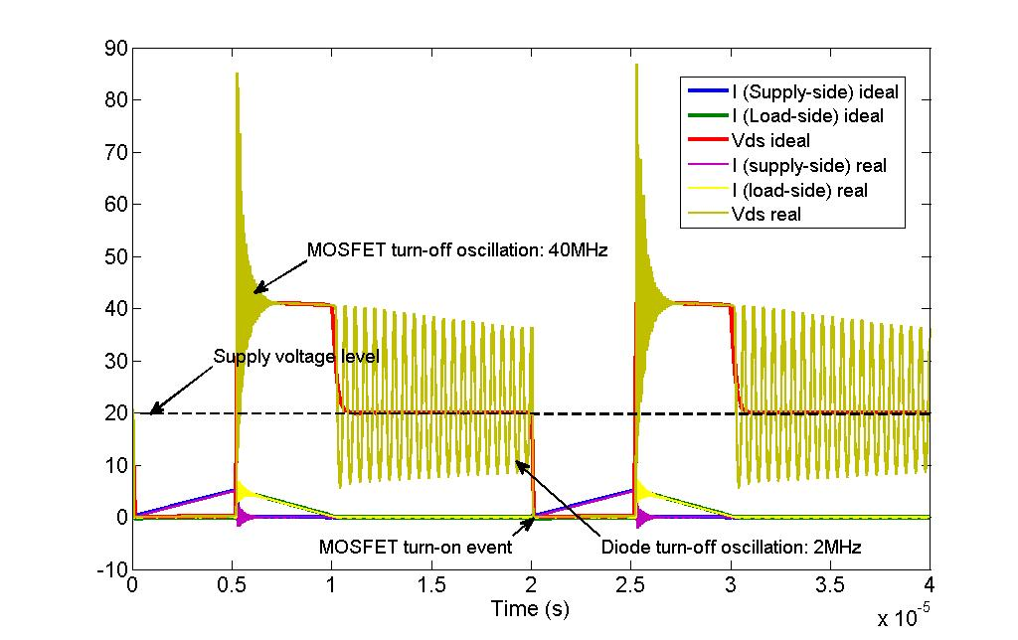

Figure 5.2: Waveforms of flyback ideal operation superimposed with typical parasitic effects

### Typical parasitic effects

There are three main parasitic effects that must be accounted for in the design of flyback converters. The first, and usually the most critical, is that upon the MOSFET turn-off event, a spike occurs at the MOSFET drain-source voltage. This spike is followed by high-frequency oscillations, which usually attenuates to insignificance within the off-portion of the duty cycle. This effect is caused by the presence of leakage inductance in the couple inductor system. Not all the flux is captured by the load-side circuit, so the remaining current is forced to dissipate through the MOSFET in as fast a time as possible. This rapid change in current is resisted by the leakage inductance in the form of an opposing voltage spike. The inductance of the interconnection path between inductor and MOSFET also contributes to this, and is usually lumped together with the inductor leakage inductance. The oscillation is caused by resonance between this inductance and the junction capacitance of the MOSFET. This oscillation is of a high frequency because both the junction capacitance and the leakage inductance are small.



Figure 5.3: The parasitic circuit elements that resonate to cause oscillations

The second parasitic effect occurs in DCM, when the diode current reaches zero, and the diode turns off. Resonance occurs between the magnetising inductance and the junction capacitance of the MOSFET. No current is flowing through the diode, so the parasitic junction capacitance of the diode does not contribute to this oscillation. Since the magnetising inductance is much greater than the leakage inductance, the frequency of this effect is significantly lower than that of the MOSFET turn-off oscillation. The diode turn-off oscillation is present even under the case of unity coupling between inductors, i.e. zero leakage inductance. These oscillations are characterised by low damping because losses are minimised in such circuits, which requires low resistance. Inserting extra resistance to increase damping will decrease efficiency, which is not acceptable in power electronic converters.

The third parasitic effect is a common mode current that flows through the inter-winding parasitic capacitance. This does not reduce functionality of the converter, nor will it threaten to damage any components, but it must be restricted due to the serious EMI issues it raises. Common mode current radiates strongly [26].

The use of the planar integration technique has some advantages to solve these problems. Much lower leakage inductance can be achieved using this architecture. A lower leakage inductance will decrease the voltage spike upon MOSFET turn-off. It will also increase the frequency of oscillation, but at such high frequencies, the skin effect introduces resistance that will increase damping. Multilayer conductor technology can be used as a high-frequency filter [9].However, the inter-winding capacitance is now significantly greater. This capacitance is now well-controlled (i.e. well-quantified and repeatable), as opposed to the wire-wound structure.Considering this improved controllability, it is recommended as future work for structures to be designed that implement a leakage energy recapture strategy.

## Planar passives construction and its physical constraints

This section will describe basic principles to design and construct an integrated passive structure. The concepts and principles illustrated here can give a basic understanding of the practical side of the integrated structures that have been discussed throughout this dissertation. Physical constraints that are encountered in the design of integrated passive structures will be outlined.

### Integrated passive structure for a flyback converter topology

The design and construction of integrated passive structures will now be demonstrated using the flyback converter as an example.

The discrete-component circuit diagram of a basic flyback converter is shown in *Figure 5.4*. The integrated passive structure will incorporate, as an example, the coupled inductors and DC bus capacitors – four passive components. A possible structure makes use of four parallel planar conductors, enclosed in a magnetic core. *Figure 5.5* shows a connection scheme for the terminals of the structure’s conductors.

The conductors are enclosed by a magnetic core, resulting in high coupling. As a result, conductors share a common voltage distribution profile, but at different levels with respect to ground. This is illustrated in *Figure 5.7*, where a linear voltage distribution is assumed (see [12]). The connection orientation of the middle conductors achieves the function of a coupled inductor. Each outer conductor forms a DC bus capacitor with the inner conductor adjacent to it respectively. The outer conductors have one end floating and the other end connected to the rest of the converter circuit.



Figure 5.4: Discrete component circuit diagram for a basic flyback converter

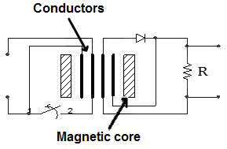

Figure 5.5: Connection scheme for integrated architecture. Cross-sectional layout of proposed structure.

The inter-conductor capacitances and conductor inductances are related to the structure’s dimensions and materials through the following well-known equations:

$$L=\frac{N^{2}}{\frac{l_{c}}{A_{c}μ_{c}}+\frac{l_{g}}{A_{g}μ_{0}}} …(5.1)$$

$$C=\frac{Aε}{d} …(5.2)$$

where $l_{c}$ is the mean path length that magnetic flux would have to flow around the magnetic core. $A_{c}$ is the mean cross-sectional area of the magnetic core. $A_{g}$ is the cross-sectional area of the air gaps in the magnetic core: normally fringing is ignored, so $A_{g}$ is assumed equal to $A_{c}$. These parameters are usually specified in the manufacturer’s datasheet of the core being used, such as in [50].*Equation 5.2* determines capacitance for an ideal parallel plate capacitor: *A* is the area of the parallel surface, *d* is the distance between parallel plates.

In the process of converter design, L and C are usually determined by the required energy flow (i.e. power to be delivered to the load), and then the structure’s dimensions are derived. The DC bus capacitors exist to smooth the output (load-side) and input (supply-side) voltages, ensuring a DC-DC topology. The size of the output capacitance depends on the magnitude of ripple voltage that may acceptably appear across it, and the current being drawn by the load. The supply-side capacitor has a different function. The leads coming from the supply voltage source will have a leakage inductance, which can cause high-frequency oscillations to appear in the DC supply signal. The event that excites such oscillations is the switch (MOSFET) turn-off event, where the current in the supply loop is taken to zero very fast. The supply-side capacitor acts as a low pass filter of these oscillations that appear across the supply-side inductor. The cut-off frequency of this filtering effect should be less than the switching frequency. This requirement is what determines the size of the supply-side capacitor.The required inductance of each conductor is determined by the maximum amount of energy that needs to be stored in the magnetic fields during each switching cycle. Once the required L and C are determined, the structure’s geometric dimensions and material properties can be chosen to meet those requirements.

Examples of design procedures for integrated converter passive structuresare given by [13-18].

The operation of the MOSFET makes the nodes between inductor and switch (e.g. a MOSFET), and between inductor and diode, to be “hot”, i.e. to have rapidly changing signals. The nodes on the opposite ends of the inductors are essentially static voltages – i.e. DC. The floating ends of the outer conductors must be arranged on the same side as the hot nodes. The reason for this can be visualised in two ways that will now be discussed:

**GND**

**GND**

**DC**

**DC**

**VC**

**VC**

**Position along conductor**

**Position along conductor**

**V**

**V**

Figure 5.6: Voltage profiles along conductors for different connections of integrated DC bus capacitor

I. A DC bus capacitor serves as an energy storage component to provide small energy absorption or release while maintaining a constant voltage. The voltage is approximately constant because the bulk of the energy stored in the capacitor is constant, small variations are insignificant. The voltage distribution profile diagrams in *Figure 5.6* show how the capacitor energy (proportional to VC) is constant when the DC node and the ground connection are on the same side, and is varying drastically otherwise. The solid dots represent conductor ends that have a fixed voltage, and the little circles represent conductor ends with varying voltages, hence the arrows on the diagram.

II. The second visualisation method sees any length of conductor as a high impedance path at high frequency (since it is inductive). The DC bus capacitor’s function is to sink into ground any high frequency content appearing at a node which is to held constant (DC). Therefore, if the ground is connected on the same side as the DC node, any high frequency noise on the DC bus has minimal inductive conductor to pass through to reach ground. If connected to the other end, however, high frequency noise has to pass through the full length of the inductive conductors, thus will not be deviated readily to ground. This is illustrated in *Figure 5.7.*

These visualisation thought processes may also be useful in understanding how more complicated structures should be connected.

**I**

**I**

**DC**

**GND**

**DC**

**GND**

Figure 5.7: Path to ground for high frequency content on DC bus for different connections of integrated capacitor

The implementation of the interconnections between the passive structure’s terminals and the external circuit is also important. The interconnecting conductors should be kept as short as possible to limit layout inductance, and to limit the possibility for unwanted electromagnetic coupling with external circuits. It is therefore advantageous to have both ends of the passive structure’s conductors to be close together. To achieve this, as well as to facilitate multiple windings, the planar conductor can be wound around an E-core*.* The bend in the conductor is ignored; the effect of the portion of the conductors hanging outside the magnetic core is taken as negligible because the energy stored in that portion is very small. Zhao in [12] demonstrates accurate modelling which includes the overhanging portion. For the purpose of this study, the whole winded conductor layer will be treated as a uniform one-dimensional length. This length has a distributed inductance, as well as a distributed capacitance between itself and conductor layers that are immediately adjacent and that have a surface parallel to it.

This section has outlined some concepts that are useful for implementing an integrated passive structure.

## Time domain simulation of the flyback

### Time domain simulation setup

The same integrated passive models that were used for frequency domain simulation arealso used in the time domain. These models are inserted into a flyback converter configuration as shown in the following figure. The same circuit is used for both lumped models as well as the modal macromodel; just the contents of the integrated passive subcircuit will be specific to each model (Reeves, Murgatroyd, or modal macromodel).

This section gives some specifications for the setup of the simulations that gave the results that are presented in the next section, *Section 5.3.2*.

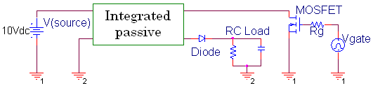

*Figure 5.8:* Circuit diagram of T-domain simulation in a flyback converter configuration.

The circuit details that were used for most experiments are as follows:

* Diode: the model used isthe DSEP8-12A
  + The PSPICE model was found on the internet at the following link: http://www.ixys.com/PSpice_Model/DIODE_TYPE/Diode.html
* MOSFET: model is IRF540
* RC Load:
  + R = 28 Ω
  + C = 1 mF
* Rg = 6 Ω
* Vgate is the pulse-width modulated signal the controls the operation of the circuit. The pulse characteristics are variable, but the standard settings used were as follows:
  + V = {0 V => 13 V)
  + Period = 20 µs
  + Rise/fall time = 100 ns
  + “On” time = 5 µs

The circuit is non-linear because of the presence of the diode and the MOSFET.

The operation mode of the circuit is the Discontinuous Conduction Mode (DCM). Three sections can be identified within the signal’s period:

* Section 1: MOSFET is on, and diode in off
  + Energy is building up in MTL on supply side
  + Energy dissipates from the load capacitor through the load resistor
* Section 2: MOSFET is off, and diode is on
  + Energy is dissipating on load side from MTL
* Section 3: MOSFET is off, and diode is off
  + Low energy is the MTL, energy continues to dissipate from the load capacitor through the load resistor



*Figure 5.9*: Flyback operation in DCM

### Simulation results

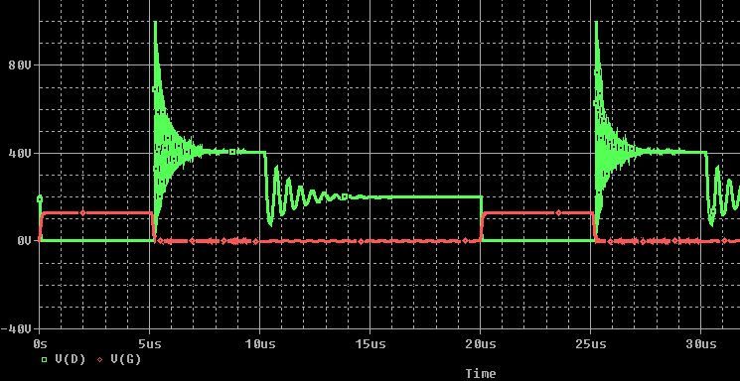

*Figure 5.10*: MOSFET drain and gate voltages while operating in the flyback

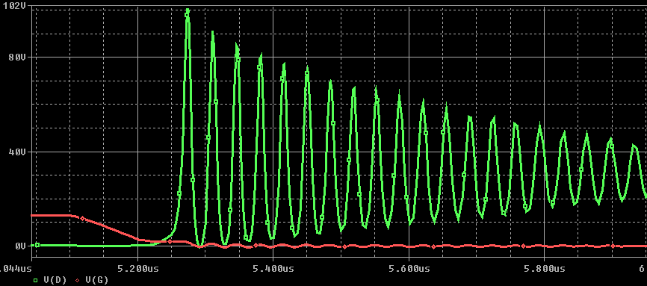

*Figure 5.11*: MOSFET drain and gate voltages: zoomed-in view of the MOSFET turn-off event

A very similar set of results is obtained when using the Reeves, Murgatroyd, or the cascaded lumped models. This means that the electrical length of the physical structure is small. This is verified using the propagation velocity, which is determined by the parameters L and C using *Equation 3.38 - 40*. Using the physical parameters, the frequency at which the wavelength becomes equal to the physical length is 258 MHz (*fmax*). The resonance oscillations occurring in these results are at 2 MHz and 44 MHz, which are both significantly smaller than *fmax*.

The modal macromodel, however, was not able to give a converging solution under these conditions. A further investigation into the factors involved in that problem is discussed in the next section.

### Convergence problems in the modal macromodel

Convergence issues occur when using the modal macromodel in the flyback configuration. This section documents a few observations made that may assist in understanding this issue.

The root cause of this issue was identified in *Section 4.3.5*: SPICE fails to converge if its simulation time step is comparable in size to the transmission line’s propagation delay time. SPICE is supposed to automatically reduce its time step when handling a fast-changing signal. However, this feature is not working correctly in the case of the transmission lines that make up the modal macromodel.

This section examines how this issue arises in a circuit where the integrated passive interacts with non-linear semiconductors, as in the case of the flyback converter.

Parasitic spikes and oscillations that seem to initiate the convergence problem first appear across the diode on the load side of the converter. An investigation was carried out to determine the main determining (most significant) parameters in the diode model. The parameters which cause the most significant change when altered are the transit time and junction capacitance. Reducing the transit time results in slightly better convergence with less parasitic oscillations; this may be because the diode begins conducting sooner, thus reducing the time when large current are forced to flow through the off MOSFET. The removal of the junction capacitance increases oscillations and spikes, which is reasonable because it would resist a rapid change in voltage across the diode. Changes in the other diode parameters had no significant effect on convergence. These spikes and oscillations usually initiate upon the diode turn-off event.

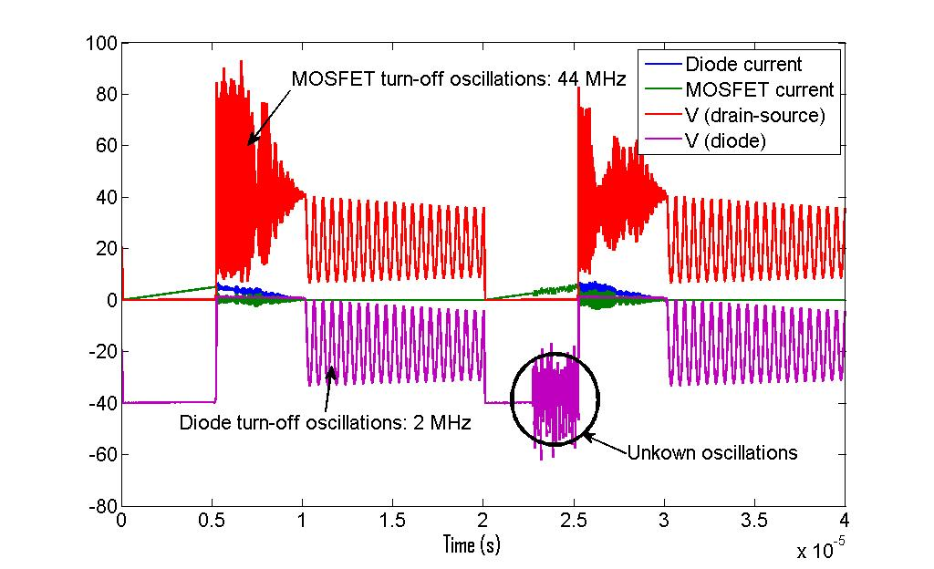

*Figure 5.12*: Flyback simulation with modal decomposition macromodel

An investigation was also made into the contribution of the MOSFET. This is a complex model, and the investigation was inconclusive. However, the following observations were made: The IRF540 model was replaced with a standard SPICE voltage-controlled switch (using parameters Voff = 0 V, Von = 1 V, Roff = 1 MΩ, Ron = 0.055 Ω). This resulted in convergence problems being even more prominent. One factor of this is the removal of the junction capacitor, which was serving to smooth out the MOSFET drain voltage. A 250 pF (Cout from datasheet of IRF540 [43]) capacitor was placed in parallel with the switch, which significantly improved convergence, but was still worse than the MOSFET model. The reason proposed for this is that the MOSFET model includes a capacitor between the drain and gate terminals, which also serves to smooth the drain voltage. The voltage controlled switch does not model this interaction. Such a capacitor would be a further path to ground for the high frequency voltages that occurs across the MOSFET, thus improving damping.

One way of removing the convergence issues is by increasing the resistance in the supply side of the circuit. This significantly changes the system, however, and serves more to hide the problem rather than pinpoint the source of the convergence issues. Similarly, placing a capacitor-resistor branch in parallel with the diode also serves to reduce the spikes and oscillations, but this is just hiding the problem by changing the system that is modelled.

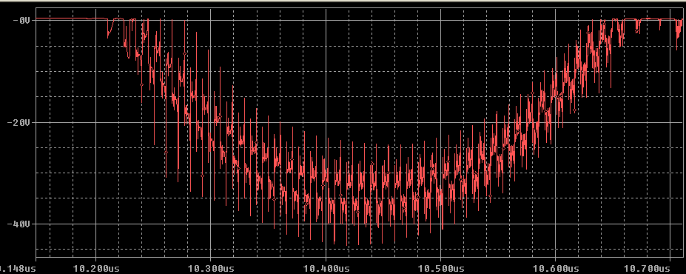

*Figure 5.13*: Voltage spikes across diode on diode turnoff oscillation, caused by numerical parasitic

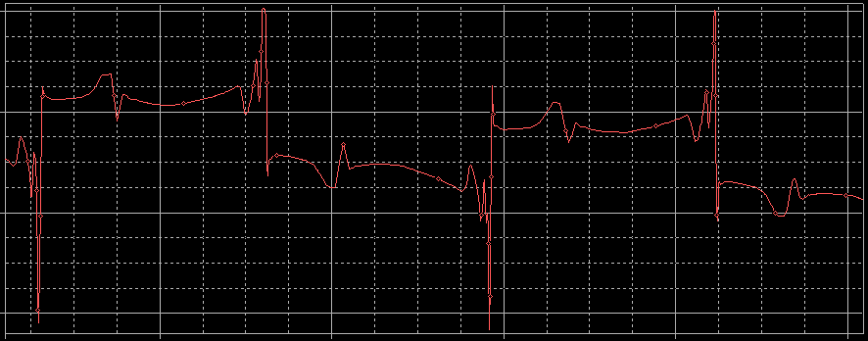

*Figure 5.14*: Zoomed-in view of the above*Figure 5.13*

A concerning phenomenon occurs on the on-cycle of the MOSFET. *Figure 5.15* shows that half-way through the on-cycle oscillations arise across the diode. The oscillations are not being initiated by a switching event, which make it inexplicable. This parasite must be from the numerical solution. Setting the maximum time step lower significantly mitigates this problem, but long simulation times become problematic once the time steps become too small.



*Figure 5.15*: Flyback simulation with modal decomposition macromodel

An important observation from *Figure 5.15*is that the simulations using the macromodel have much less damping on both MOSFET and diode turn-off oscillations than in the simulations using lumped elements. The frequency of oscillation is the same as that of the lumped models. The reason for this not well understood. The first thought to come to mind is the lossless nature of the macromodel. However, higher damping is obtained by lumped parameter model even when the lumped resistance is excluded.

Decreasing the maximum time step in the SPICE simulator improves the convergence of the macromodel. Therefore, the inability to converge is arising from a numerical parasitic, which is caused by a sensitivity in the system to round off errors. The main problem with reducing the time step is long simulation times that result. The macromodel was initially preferred because of its fast execution time due its low number of elements. This advantage is clearly removed by the presence of the parasitic numerical oscillations.

## Physical measurements

This section compares measurements made on two physically constructed flyback converter circuits. The first was built using a discrete component architecture, with a wire-wound coupled inductor. The second circuit uses the planar passive structure discussed in *Section 5.2*.

### Flyback with a wire-wound coupled inductor

A discrete-component flyback converter circuit was constructed. The coupled inductor was constructed using an E30 core, of the 3C30 material, which is standard magnetic material. Ten turns were used to give a magnetising inductance of 17 µH and a leakage inductance of 170nH. This gives a coupling factor between supply and load side of 0.99. The discrete DC bus capacitors were each 1 mF. With the same load configuration as specified for the simulations in *Section 5.3.1*, the constructed converter could operate comfortably at a power output of 40 W.

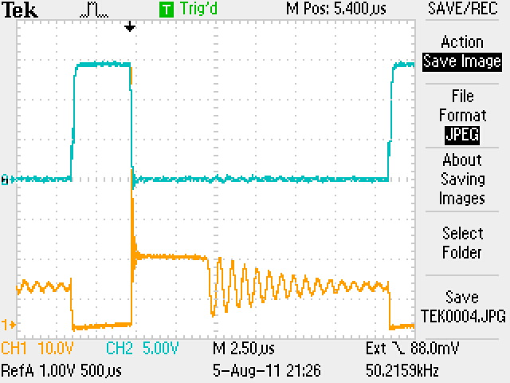

*Figure 5.16*: Measured voltages at MOSFET terminals for wire-wound inductor circuit

(CH1 [yellow]: Vdrain‑source, CH2 [blue]: Vgate‑source).

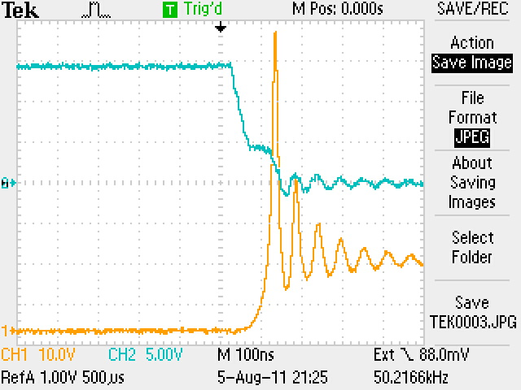

*Figure 5.17*: Measured voltages at MOSFET terminals for wire-wound inductor circuit

(CH1 [yellow]: Vdrain‑source, CH2 [blue]: Vgate‑source), zoomed in.

### Flyback with planar coupled inductor

The wire-wound coupled inductor was replaced with a planar coupled inductor. A planar E-core was used of dimensions 64mm x 10mm x 50mm. This is a large core and, in terms of spatial usage, this is not an improvement on the wire-wound structure. However, the large core is used to allow the use of only a single turn in the planar case, which simplifies its modelling. The planar conductors separated by a dielectric material gave an inter-conductor capacitance of 370pF. Impedance measurements indicated a magnetising inductance of 24 µH and a leakage inductance of 25 nH. This gives a coupling factor of approximately 0.998. This circuit also operated comfortably at an output power of 40 W. The measured waveforms are shown in *Figures 5.18 and 5.19*. One notable feature is that the damping in the planar inductor circuit is significantly greater, which can be observed with a comparison with *Figures 5.16 and 5.17*. The reason for this greater damping is unknown, and can be a subject of interest in future simulation study.

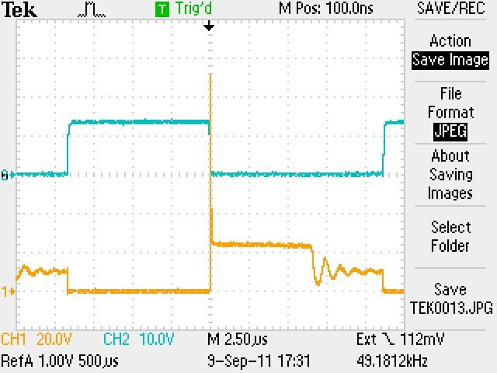

*Figure 5.18*: Measured voltages at MOSFET terminals for planar inductor circuit

(CH1 [yellow]: Vdrain‑source, CH2 [blue]: Vgate‑source).

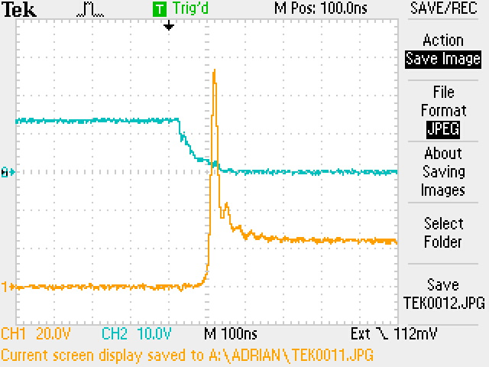

*Figure 5.19*: Measured voltages at MOSFET terminals for planar inductor circuit

(CH1 [yellow]: Vdrain‑source, CH2 [blue]: Vgate‑source), zoomed in.

### Reconciliation of physical measurement and simulation results

The next step was to simulate the flyback converter in SPICE, with a model for the planar coupled inductor included. The simulation results of *Section 5.3.2* are compared with the physical measurements of *Section 5.4.2*.

Two models are used and compared in this section. The first is a cascaded lumped parameter model, and the second is the macromodel implementing the modal decomposition method. The parameters used in these two models are the PUL (per-unit-length) L, C, G and R matrices. G was assumed to be zero. Inter-winding capacitance, conductor self-inductance and resistance are easily obtained by measuring the total quantity along the line at a low frequency, where there can be confidence in the measurement; the total values are then divided by line length to get PUL values. Leakage inductance is much smaller than self-inductance values, so the reading here is less accurate. Conductor self-capacitance (defined between a conductor and a ground reference potential) is also difficult to quantify. Maxwell electrostatic simulation was used to determine the C matrix. Models for interconnects outside the planar inductor was also allowed, being flexible with values used, within reason.

The following is a summary of a comparison between simulation and measured results:

* A matching voltage spike can be achieved within a realistic range of leakage inductance values.
* The oscillation frequencies are closely matched at 2 MHz for the diode turn-off event. The higher frequency oscillation that occurs at the MOSFET turn-off event could also be matched within a realistic range of leakage inductance values.
* The main difference between the results is that there is significantly more attenuation on the measured results than the simulations. This is the case for both oscillations.

There is a large confidence in the PUL values for conductor self-inductance and inter-conductor capacitance. Therefore it is more important to understand the effect of varying the parameters in which we have more uncertainty. These uncertain parameters are the leakage inductance between conductors, and the self-capacitance of each conductor.

Varying the leakage inductance has the following effects:

* Firstly, the MOSFET drain-source turn-off voltage spike will be greater for a greater leakage inductance, since there will be a greater inductance resisting the change in the supply loop current.
* Secondly, the MOSFET turn-off oscillation is a resonance between the leakage inductance and the MOSFET output capacitance. Therefore, a greater value of leakage inductance will result in lower frequency of oscillation.
* One thing to note is that the interconnect inductances of the supply-side and load-side loops is usually lumped together with the leakage inductance of the transformer (for the resonance calculation). Ignoring these interconnects will make a lower coupling to appear than what is really present.

A variation (increase/decrease) in the self-capacitance of each conductor can have the following effects, all of which are very slight effects: (These characteristics are obtained from simulation)

* Less attenuation on MOSFET turn-off oscillation, but more attenuation on diode turn-off oscillation
* Higher MOSFET drain-source voltage spike
* Higher frequency on MOSFET turn-off oscillation

A variation in a conductor’s DC resistance will change the damping characteristics. The effect on the oscillations’ attenuation is slight for any DC resistance under 100mΩ (measured value was 40mΩ). These resistances have little effect on the frequencies of oscillation (which are determined by poles – reactive components), and little effect on the MOSFET drain-source turn-off voltage spike as well.

The conductor resistance will increase from the DC resistance according to the skin effect. The extent of this was investigated at the frequencies of the two oscillations observed in the MOSFET drain-source voltage: 2 MHz and 44 MHz. For a 35 µm thick copper conductor, the diode turn-off oscillation frequency will not cause a change from the DC resistance. The 44 MHz will cause an effective resistance of the order of double the DC resistance, which is still not having a significant effect on the damping of the oscillation. Therefore, there is another reason for the greater attenuation of oscillations observed in physical measurement.

Attenuation in the diode turn-off oscillations is caused by the unmodelled core losses. The 2 MHz frequency is at the bandwidth of operation for the core – which would start invalidating the B-H characteristic curve. However, even before this occurs, core losses will occur from eddy currents and hysteresis effects. In conventional lumped parameter models, core loss is modelled as a resistor in parallel with the winding. This same method was used for the distributed model, i.e. placing one lumped parallel resistor across the winding’s terminals. Core loss is not usually included in a transmission line model, and so distributed way of doing this is not yet known by the author. Placing a 2 kΩ resistor in parallel with the supply-side winding resulted in the correct damping characteristic on the diode turn-off oscillation. Now only observed discrepancy still needing to be accounted for is the lack of attenuation on the MOSFET turn-off oscillation. This oscillation is the resonance between leakage inductance and MOSFET output capacitance. Thus, the flux involved in this resonance is not within the core, so core loss will not introduce damping here.

## Integrating the load DC bus capacitor

### Physical constraints: technological and electromagnetic limits

Physical constraints become important when we become interested in the optimisation of integrated passive design. This section is an overview of good works that have been found in the literature [1, 6, 9-21, 44-49].

Different limitations become significant for different optimisation targets. Maximum efficiency, minimum volumetric usage, and minimum cost are three examples of different targets for optimisation.

Optimisation with regard to efficiency seeks to identify and minimize all system losses. Good work to allocate losses in typical integrated converter systems can be referenced in [10, 13, 15]. Different sources of losses and possible options to minimise them are summarised in the following:

* Dielectric losses increase (approximated as linearly) with frequency. High permittivity increases dielectric loss [44], which is a significant limitation because high permittivities are essential to achieve required capacitances.
* Magnetic core losses are proportional to flux density and frequency of operation, increasing faster than by a linear relationship [15, 21]. These parameters have to be reduced if core losses become a significant contributor to total system loss. Core losses have often found to be less significant in practical cases, as in [13], but in other cases core losses are comparable to other sources of losses [44]. Good work on modelling core losses via eddy currents and hysteresis has been done by [21].
* Conductor losses are predominately I2R losses, but at high frequencies skin effect and proximity effects become rapidly significant. To minimise these losses the conductor width should be maximised to decrease resistance. Conductor width is limited by the core window width that is necessary to achieve the required inductance (which is dependent on core path length), as well as to limit leakage energy that is stored in core windows. At higher frequencies, skin effect limits the value of increasing conductor thickness to decrease resistance.
* Semiconductor losses (MOSFET switch, diodes) linearly increase with frequency [44]. Precise soft-switching technology and decreased frequency is necessary to minimise these losses.

Loss modelling is described by [44] and is taken further in [45] to incorporate proximity and skin effects, an empirical for non-linear dielectric losses, and a core loss model for non-sinusoidal excitation. Losses are slightly underestimated using these models. The models are developed further by [15, 21, 46].At this point the loss models have become quite mathematically complicated, and a decision must be made as to how significant the frequency-dependent losses are. Frequency-dependent losses increase drastically at high frequencies.

When using very precise loss models for the integrated passive structures, one should consider whether the parasitic effects of external interconnections and inaccurate semiconductor loss modelling are actually much more significant. As an example, the work of [47] demonstrates the effect of leakage inductance introduced by conductor terminations, i.e. the interconnection between the integrated passives’ terminals and external circuitry.

Optimisation with regard to volumetric minimisation seeks to maximise power density.The power that can be processed by a given inductance is directly proportional to the frequency of operation. The size of the inductance is a major contributor to the spatial requirements of the integrated passive. The recent trend has been to increase the frequency of operation in the low MHz range [1, 10, and 16]. Frequency of operation is, however, constrained by:

* The slew-rate possible for the semi-conductor switches used; modern advances in MOSFET technology has largely removed this limit.
* Core, dielectric, conductor& semi-conductor losses all increase significantly with frequency. At high frequencies they easily dominate DC losses. If efficiency can be sacrificed for higher power densities, then the frequency can be increased to the point where losses become comparable more significant where loss densities increase.
* The parasitic layout impedances of the rest of the converter circuit become more significant; well demonstrated by [47].
* At frequencies above the low MHz range, the physical dimensions of the structure can become electrically large, at which point transmission line effects become significant. This will introduce higher order resonance points, and the need for accurate high frequency models.
* Conversely, the operational frequency also cannot be too low (i.e. to reduce losses, etc.), because that would require largeinductances and capacitances for a required output power.

Volumetric optimisation for a given frequency has been studied thoroughly by [10, 15]. Acceptable spatial profiles must be maintained, e.g. cannot have a structure that is too long in one dimension, as the structure has to be physically placed in an external environment with spatial constraints. Good work in volumetric optimisation can be found in [10, 15], Strydom [10] builds on the work of [18] to develop volumetric optimisation for a LLCT integrated passive with a spiral winding structure, as shown in *Figure 5.20*. LLCT is an interesting circuit because of the integration of three different passive functions (L, C, and T) that are found in converter circuits. Liu [15] extends this work to develop a volumetric optimisation for LLCT passives for an alternative stacking architecture. An excellent comparison of the two approaches is given by [15], whose work can be highly recommended with its thorough electromagnetic analysis, loss modelling, details of construction procedures and excellent contextualisation with regard to other work done in this field.

The following is a summary of the constraints encountered in maximising power density:

* The most fundamental limits are electromagnetic limits based on the properties of available materials; see [15, 48] for good discussions on how the following material properties can be formulated into well-defined design constraints:
  + Magnetic material: Maximum magnetic field strengths before saturation, and maximum permeabilities.
  + Dielectric material: Maximum electric field strengths before breakdown, and maximum permittivities.
  + Conductor: maximum current density, which is defined by the maximum temperature allowed by the thermal management system.

These fundamental limits are not currently being maximally reached. Technological limits are encountered first such as limitations of construction techniques to achieve very thin thicknesses for dielectric layers [49], minimum core thickness that can withstand a measure of mechanical stress [15], etc. Another important technological limitation is the issue of thermal management. Two good references for thermal management technologies can be found in [1, 15].

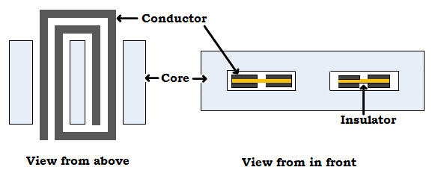

*Figure 5.20*: The concept of horizontal windings to increase inductance, from [12]

### Increasing L and C

This section contains some considerations of the technological limits encountered in the design of the flyback converter used in this dissertation. Consider *Equations 5.3 & 5.4*:

$$L=\frac{N^{2}}{\frac{l_{c}}{A_{c}μ_{c}}+\frac{l_{g}}{A_{g}μ_{0}}} …(5.3)$$

$$C=\frac{Aε}{d} …(5.4)$$

One objective of using the integrated architecture is to achieve a more compact usage of space. Therefore, the geometrical limit to capacitance is the conductor area (*width***x***length*); with a further limit of the permittivity of the dielectric. The best dielectric available to the author was C-ply (1 nF/cm2). Inductance is limited by the reluctance of the magnetic circuit enclosing it. A core size of 64x10x50 (dimensions in mm) translates into a maximum capacitance of 40 nF, and a maximum inductance of 34 µH. This is not enough for most applications involving a higher power range (i.e. > 40W). A properly functioning DC bus capacitor would need a magnitude of the order of a 1 ‑ 1000 µF, depending on the application of course.

There are various strategies for increasing L and C, and consequently increasing the maximum power flow:

A. Increase dielectric permittivities using ceramics: Zhao in [12] reports obtaining 5µF/m for similar core dimensions as specified above. A limitationis that a specialised technology is necessary which complicates the manufacture of the structure. Another limitation is that non-linear capacitance can occur.

B. Increase the number of turns for inductor. This can be done either vertically, by inserting more layers of conductors and connecting the terminals in a series configuration [15], of alternatively horizontally, as in *Figure 5.20*. The disadvantage of the vertical configuration is that there can be a large intra-winding capacitance that will usually introduce unwanted effects of parallel resonance with the conductors’ inductance. The limitation of the horizontal configuration is an increase in conductor resistance (which is usually very small). The horizontal case will also have an intra-winding capacitance, but this will definitely be smaller than for the vertical case. Another limitation of using narrower conductors is that the current density increases, which has thermal management implications.

C. Increase number of parallel plate capacitors, connecting them in parallel. The limit here is that of limited space in the core window. The typical thickness for a conductor-dielectric-conductor layer is about 200µm (using materials available to the author), which allows less than 25 layers in a 5mm core window height. It is possible to have layers outside the core window.

D. An option is to connect a discrete capacitor in parallel with the integrated dc bus capacitance. This means we lose the advantage of reduced components and a compact structure. The remaining benefit of having an integrated capacitance, while still having a discrete one, is that the parasitic effects of the discrete capacitor’s leg inductance (ESL) will be filtered out. This benefit is limited, however, which is now illustrated.

*Figures 5.21 and 5.22* show the effect of an entirely integrated DC bus capacitor, whose function is to smooth the load voltage into a DC signal. When this capacitance is reduced further, the parasitic oscillations begin to grow in magnitude; but from about 2.5 µF and larger, the parasitic oscillations are not significantly changed. The observed parasitic oscillation is caused by a resonance between the inter-conductor leakage inductance and capacitance.This simulation demonstrates that even for very large integrated capacitance, the filtering effect is limited, i.e. there still exists a parasitic oscillation. This is because of the coexistence of the conductor inductance. Therefore, total integration of the capacitors and inductors does not result in perfect elimination of the problem of a capacitor’s ESL.

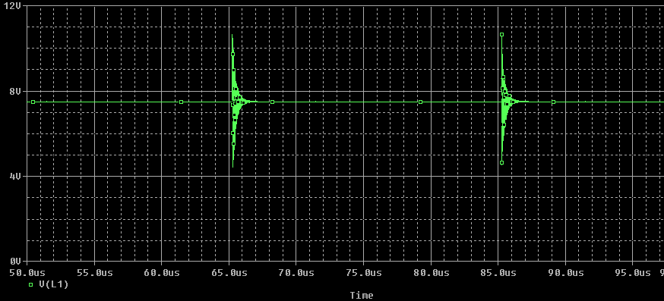

*Figure 5.21*: VLoad with an integrated CDC of 2.5mF, and no external CDC

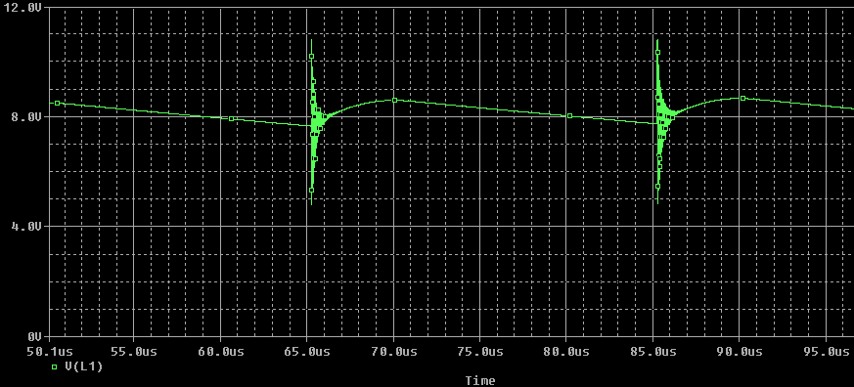

*Figure 5.22*: VLoad with an integrated CDC of 2.5µF, and no external CDC

# Conclusion

The main objective of this research has been to contribute towards effective modelling of integrated passive circuits operating in power electronic circuits. Circuit designers would prefer a model that can be interfaced easily with SPICE, or another similar circuit simulator, because there are many benefits to working in the SPICE environment:

* Different analysis types are possible, e.g. Transient simulation (time-domain) as well as AC small signal analysis (frequency domain) are easily conducted interchangeably on the same model.
* The integrated passive model can be connected to a complete converter circuit, i.e. the boundary conditions of the integrated passive are taken care of by the circuit simulator.
* SPICE supports good models for semi-conductor devices, which are not easily modelled from first principles if one was to construct their own circuit simulator.

Higher frequencies are involved in the current trend towards fast switching speeds in power electronic circuits. The presence of these frequencies requires a circuit designer to consider the distributed nature of the integrated passive structure. The distributed model for a two-conductor case has been presented; this model is easily extendable to multiple conductors. The solution of this model is not trivial, and there exists several solution methods.

The main problem with most of the distributed model’s solution methods is that they cannot directly interface with a circuit simulator. This means that the boundary conditions that can be simulated are limited to simple terminal-terminal impedances, and cannot support a complete converter circuit. We also lose the benefit of the SPICE-like environment to switch from time domain to frequency domain.

Four SPICE-compatible models have been investigated by comparing them with the analytical solution of Zhao [12], which is considered to be the benchmark solution. Zhao’s solution was used to thoroughly derive the causes of all resonance points, as well as impedances at low/high frequencies; which are the important factors that characterize the integrated passive. A summary of the conclusions drawn from the analysis of eachof the four SPICE-compatible models is as follows:

1. **Reeves’ lumped model:**

Reeves follows the distributed model exactly, as long as the structure is electrically small.I.e. “electrically large” means that the physical length of the structure becomes comparable to the shortest significant wavelength in the system.

1. **Murgatroyd’s lumped model:**

The Murgatroyd model is also correct but requires the additional condition of high coupling. At low coupling, Murgatroyd’s resonant frequencies will occur at lower frequencies than the other models. It was shown that the additional resonance point that Murgatroyd has over the Reeves model (for short circuit and capacitive loads) occurs when the structure is already becoming electrically large. This resonance point was shown to be caused by the same factors as the higher order resonances of Zhao’s model, but separated by a multiplicative factor.

1. **Cascaded lumped model (semi-distributed solution):**

The total length of an integrated structure can be divided up into multiple cascaded cells of either Reeves or Murgatroyd models. Each lumped cell must represent a length that is electrically small.The idea that the frequency range increases linearly according to the number of cells that are added was verified.

1. **Paul’s modal macromodel (distributed solution):**

The modal macromodel follows Zhao’s model very closely for all cases in the frequency domain. The main difference between this model and Zhao’s model is that Zhao does not incorporate the conductors’ self-capacitances. This causes serious deviation between the models at frequencies where the conductor self-capacitance resonates with the magnetising inductance.

The main problem with the modal macromodel is that there are convergence difficulties in time domain simulations. SPICE fails to converge if its simulation time step is comparable in size to the propagation delay time of a signal to travel along a conductor. SPICE is supposed to automatically reduce its time step when handling a fast-changing signal. However, this feature is not working correctly in the case of the transmission lines that make up the modal macromodel.*Section 5.3.3* shows how these convergence problems manifest in simulations that involve both integrated passives and semiconductor devices.

Lumped models break down at high enough frequencies, i.e. they deviate from the actual distributed solution. Such error can result in a design that produces parasitic oscillations which damage circuits. Unpredicted noise occurs which has a consequent need of a lot of noise filtering, which is expensive and costly to a converter’s efficiency.

In order to avoid using the distributed solutions for as high a frequency as possible, it is important to have a definite way of determining when a distributed model is actually necessary. An important approach is to *first* determine at what frequency the physical structure is still electrically small, and only then assume the Reeves model is correct under that frequency. The electrical size of a structure is determined by a comparison between the conductor lengths and the wavelength of the frequency of interest. The propagation velocities of the structure were derived, and shown to be the important factor relating the structure’s parameters, including the coupling, and the electrical size of the structure. The equations that accompany these statements can be found in *Sections 1.3.2, 3.2.2 and 3.3*.

The thorough frequency domain analysis of *Chapter 3* is built upon in *Chapter 4*, which shows how frequency domain data can be used to understand, and therefore predict, time domain data. An interesting note can be made regarding the recurring resonance points that arise from transmission line effects: The lower frequency resonances cause oscillations in the time domain (i.e. resonances act as single-frequency selectors), but the recurring high frequency resonances form the step reflections in the time domain. This is analogous to the way a Fourier series superimposes sinusoids to form a square wave.

The limited boundary conditions implemented by the analytical benchmark solution do not show how an integrated passive would operate in a converter circuit. As an initial step towards introducing integrated passive technology to complete converter circuits,*Chapter 5* gives a practical example of a structure that integrates four passive components ina typical converter circuit (i.e. the flyback).The physically measured results were fully reconciled to the simulation results, with the exception of a difference indamping of the oscillations that occur at the MOSFET turn-off event.

Two recommendations for future work are now suggested:

* Zhao’s model is limited to the frequency domain of the two-conductor case. This study demonstrated how this frequency domain data could be used to understand the time domain response. There is the prospect of extending to multiple conductors. Paul in [26] describes a general solution in the frequency domain for an n-conductor system, including losses. Paul’s work includes an implementation of this solution in FORTRAN. The limitation of this code is that there is only a limited number of terminal configurations that have been implemented. Not even the simple boundary conditions put forward by [12] are supported. This is because the terminals on one end of the structure’s conductors are kept independent of the terminals on the other end of the conductors. However, this solution method can become a powerful tool if an algorithm is implemented that can handle more general boundary conditions.
* The convergence issues of the modal macromodel severely limit its usefulness in the time domain. A detailed investigation could be made into SPICE’s numerical solver to see why SPICE’s auto-sizing of the time step is not functioning correctly. SPICE is not correctly handling the fast-changing nature of the reflection step-changes. If this problem can be solved, the modal macromodel can become a powerful solution in the time domain, considering its excellent performance in the frequency domain.

Future work can also investigate the numerous other models that are reported in the literature and explore them for suitability to integrated passive architectures.

References

1. J.D. Van Wyk, J.A. Ferreira, “Some Present and Future Trends in Power Electronic Converters”, *Proceedings of International Conference on Power Electronics and Motion Control*, Vol. 1, pp. 9-18, 1992.
2. F.C. Lee et al, “Technology Trends towards a System-in-a-Module in Power Electronics”, *IEEE Circuits and Systems Magazine*, Vol. 2, Iss. 4, pp. 4-22, 2002.
3. B. K. Bose, “Recent Advances in Power Electronics”, *IEEE Transactions on Power Electronics*, Vol.7, No. 1, pp. 2-16, 1992.
4. J. Tucker, “Understanding Output Voltage Limitations of DC/DC Buck Converters”, *Analog Applications Journal,* 2Q 2008, Texas Instruments Incorporated, pp. 11-13.
5. C. Basso, “Dark Side of Flyback Converters”, *Applied Power Electronics Conference 2011: Professional Education Seminars*, Session 13.
6. D. Fu et al, “Novel Multi-Element Resonant Converters for Front-end DC/DC Converters”, *IEEE Power Electronics Specialists Conference*, pp. 250 – 256, 2008.
7. B. Dobrucky et al, “LCTLC Resonant Converter Analysis with Direct AC and Rectifying Output”, ELEKTRO Conference, pp. 115 – 120, 2012.
8. W. Lee et al, “A New PWM-Controlled Quasi-Resonant Converter for a High Efficiency PDP Sustaining Power Module”, *IEEE Transactions on Power Electronics,* Vol. 23, No. 4, pp. 1782-1790, 2008.
9. R. Chen, “Integrated EMI Filters for Switch Mode Power Supplies”, *Dissertation for PhD in Electrical Engineering*, Virginia Polytechnic Institute and State University, November 2004.
10. J. Strydom, J. D. Van Wyk, J. A. Ferreira, “Some Limits of Integrated L-C-T Modules for Resonant Converters at 1 MHz”, *IEEE Transactions on Industry Applications*, Vol. 37, No. 3, pp. 820 – 828, 2001.
11. G. McMullin, “Frequency and Time Domain Modelling of Integrated Passives”, *Dissertation for Master of Engineering in Electrical and Electronic Science*, University of Johannesburg, June 2006.
12. L. Zhao, “Generalised Frequency Plane Model of Integrated Power Electromagnetic Power Passives”, *Dissertation for PhD in Electrical Engineering*, Virginia Polytechnic Institute and State University, May 2004.
13. P. Janse Van Rensburg et al, “Design, prototyping, and assessment of a 3kW integrated LCT component for deployment in various resonant converters”, *IET Power Electronics*, Vol. 2, Iss. 5, pp. 535-544, 2009.
14. M. Gerber et al, “Construction and Modelling of a Planar Multi-layer Electromagnetically Integrated LCCT Component”, *IEEE Industrial Applications Conference,* pp. 3044-3050, 2000.
15. W. Liu, “Alternative Structures for Integrated Electromagnetic Passives”, *Dissertation for PhD in Electrical Engineering*, Virginia Polytechnic Institute and State University, April 2006.
16. M. Smit et al, “Application of Transmission Line Principles to High Frequency Power Converters”, *IEEE Power Electronics Specialists Conference*, Vol. 2, pp. 1423-1430, 1992.
17. K. De Jager, “An Investigation of Multi-layer Integrated Passive Structures for Application as Three-Phase EMI Filters”, *Dissertation for Master of Engineering in Electrical and Electronic Engineering*, University of Johannesburg, June 2006.
18. I.W. Hofsajer et al, “Design and Analysis of Planar Integrated L-C-T Components for Converters”, *IEEE Transactions on Power Electronics*, Vol. 15, No. 6, pp.1221-1227, November 2000.
19. R. Chen, J. Strydom, J. D. Strydom, “Design of Planar Integrated Passive Module for Zero-Voltage Switched Asymmetrical Half Bridge PWM Converter”, *IEEE*, pp. 2232 – 2238, 2001.
20. D. Fu, P. Kong, F. Lee, S. Wang, “Novel Techniques to Suppress the Common Mode EMI Noise Caused by Transformer Parasitic Capacitances in DC-DC Converters”, *IEEE Energy Conversion Congress and Exposition*, pp. 1252-1259, 2010.
21. A. Prasai, “Methodologies for Design-Oriented Electromagnetic Modelling of Planar Power Passive Processors”, *Dissertation for Master of Science inElectrical Engineering*, Virginia Polytechnic Institute and State University, June 2006.
22. O. Stielau, “High Frequency, High Power Resonant Electronic Converter for Induction Heating”, *Dissertation for PhD in Electrical Engineering*, Rand Afrikaans University, Jan. 1991.
23. M. Ehsani et al, “Computer Aided Design and Application of Integrated LC Filters”, *IEEE Transactions on Power Electronics*, Vol. 11, No. 1, pp. 182-190, 1996.
24. A. Djordjevic et al, “Time Domain Response of Multiconductor Transmission Lines”, *Proceedings of the IEEE,* Vol. 75, No. 6, pp. 743-764, June 1987.
25. A. Agrawal, “Transient Response of Multiconductor Transmission Lines Excited by a Non-uniform Electromagnetic Field”, *IEEE Transactions on Electromagnetic Compatibility*, Vol. 22, No. 2, pp. 119-129, May 1980.
26. C. R. Paul, “Incorporation of Terminal Constraints in the FDTD Analysis of Transmission Lines”, *IEEE Transactions on Electromagnetic Compatibility*, Vol. 36, No. 2, pp. 85-91, May 1994.
27. C. R. Paul, *Introduction to Electromagnetic Compatibility*, second edition, chapter 9, pp. 560-570, John Wiley & Sons Inc., 2006.
28. Li et al, “Reduction of Stray Inductance in Power Electronic Modules Using Basic Switching Cells”, *IEEE Conference on Energy Conversion Congress and Exposition*, 2010, pp. 2686.
29. F. C. Lee et al, “High Density Approaches of AC to DC Converter of Distributed Power Systems (DPS) for Telecom and Computers”, *IEEE Power Conversion Conference*, 2007, pg. 1236 – 1243.
30. R. Reeves, “Inductor-Capacitor Hybrid”, *Proceedings IEE*, Vol.122, Iss. 11, pp.1323-1326, 1975.
31. P.N. Murgatroyd, N.J. Walker, “Lumped Circuit Model for Inductor-Capacitor Hybrid”, *Electronics Letters*, Vol.12, Iss. 1, pp. 2-3, 1976.
32. Z. Gong et al, “Design of High Power Density DC-DC Converter Based on Embedded Passive Substrate”, *IEEE Power Electronics Specialists Conference*, 2008, pg. 273 – 277.
33. R. Chen, J. Strydom, J.D. Van Wyk, “Second Order Approximation Lumped Parameter Model for Planar Integrated L-L-C-T Module”, *Industry Applications Conference 2002*, Vol. 4, pp. 2419-2424, 2002.
34. S. Schelkunoff, “Conversion of Maxwell’s Equations into Generalised Telegraphist’s Equations”, *Bell Systems Technical Journal*, vol. 34, pp.995-1043, Sept 1955.
35. A. Agrawal, “Experimental Characterisation of Multiconductor Transmission Lines in Inhomogeneous Media Using Time Domain Techniques”, *IEEE Transactions on Electromagnetic Compatibility*, Vol. EMC-1, No. 1, pp. 28-32, 1979.
36. M. Krage, “Characteristics of Coupled Transmission Lines I: Coupled Mode Formulation of Inhomogeneous Lines”, *IEEE Transactions on Microwave Theory and Applications*, Vol. MIT-18, No. 4, 1970.
37. G. Zysman, “Coupled Transmission Line Networks in an Inhomogeneous Dielectric Medium”, *IEEE Transactions on Microwave Theory and Techniques*, Vol. MTT-17, No. 10, pp. 753-759, 1969.
38. Cadence, *PSpice A/D Reference Guide*, Product Version 10.5, July 2005.
39. V. Tripathi, A. Hill, “Equivalent Circuit Modelling of Losses and Dispersion in Single and Coupled Lines for Microwave and Millimeter-wave Integrated Circuits”, *IEEE Transactions on Microwave Theory and Techniques*, Vol. 36, No. 2, Feb. 1988.
40. U. Inan and A. Inan, “Chapter 2: Transient Response of Transmission Lines”, *Engineering Electromagnetics*, Menlo Park Calif.: Addison-Wesley, pp. 17-70, 1999.
41. C. Wells, “Electrical Principles – RC Circuits”, *www.technologyuk.net*, URL: http://www.technologyuk.net/electronics/electrical_prinicples/rc_circuit.html, last accessed 28 February 2013.
42. C. M. Oberholzer and I. W. Hofsajer, “Modelling and Simulation Techniques for Multilayer Integrated Passive Structures in the Time Domain”, *IEEE Power Electronics Specialists Conference*, pp. 2248-2253, 2007.
43. International Rectifier datasheet for IRF540N, “HEXFET Power MOSFET”, www.irf.com, 2001.
44. J. Strydom, “Integration of a 1 MHz Converter with Active and Passive Stages”, *IEEE Applied Power Electronics Conference and Exposition*, pp.1045 – 1050, 2001.
45. J. Strydom, J. D. Van Wyk, “Improved Loss Determination for Planar Integrated Power Passive Modules”, *IEEE Applied Power Electronics Conference and Exposition*, pp. 332 – 338, 2002.
46. R. Chen et al, “Volumetric Optimal Design of Passive Integrated Power Electronic Module (IPEM) for Distributed Power System (DPS) Front-end DC/DC Converter”, *IEEE Industry Applications Conference*, pp. 1758 – 1765, 2002.
47. G. Skutt et al, “Leakage Inductance and Termination Effects in a High Power Planar Magnetic Structure”, *Applied Power Electronics Conference and Exposition*, pp.295 – 301, 1994.
48. J. Strydom et al, “Electromagnetic Limits of Planar Integrated Resonant/Tranformer Structures for Power Electronic Applications”, *International Workshop on Integrated Power Packaging*, pp. 97 – 101, 2000.
49. J. Strydom, “Some Limits of Integrated L-C-T Modules for Resonant Converter at 1 MHz”, *IEEE Transactions on Industry Applications*, Vol. 37, No. 3, pp. 820-828, 2001.
50. Philips Magnetic Components, *Application Note: Planar E-Cores*, 1997.