An evaluation of the effectiveness of Transnet Capital Project’s Preferential Procurement in Civil Engineering Construction Projects.

Lusanda Siphesihle Nomcebo Dlamini
(Student number: 977675)

Supervisors: B. Sunjka
School of Industrial Engineering

A research report submitted to the faculty of Engineering and Built Environment, University of the Witwatersrand, Johannesburg, in partial fulfilment of the requirements for the degree of Masters in Industrial Engineering
Johannesburg, 2017

Plagiarism declaration

I, Lusanda Dlamini (977675), am a student registered for a Master’s degree in Industrial Engineering. I hereby declare the following:
- I am aware that plagiarism (the use of someone else’s work without their permission and /or without acknowledging the original source) is wrong;
- I confirm that the work submitted for assessment for the above course is my own unaided work except where I have explicitly indicated otherwise;
- I have followed the required conventions in referencing the thoughts and ideas of others; and
- I understand that the University of the Witwatersrand may take disciplinary action against me if there is a belief that this is not my own, unaided work or that I have failed to acknowledge the source of the ideas or words in my writing.

Signature:  Date: 31.03.2017

Acknowledgments
I would like to acknowledge Transnet for sponsoring my studies. A special thank you to my research supervisor for the support during the execution of this research. A special thank you to the Supplier Development and Procurement Department for sharing the data that was used for this research and my Transnet colleagues that were available to respond to the questionnaires.

abstract
Preferential procurement is one of five elements of the Broad-Based Black Economic Empowerment which is used to measure the compliance of organizations. This research evaluates the effectiveness of Preferential Procurement that Transnet Capital Projects (TCP) has in civil engineering contracts. This research was conducted to understand the contribution made by of the civil engineering contracts in isolation to all the other procurement activities done TCP as the business mandate is to deliver Infrastructure projects reliably. A mixed research method was used to analyze the data for this research. Analysis of Variance (ANOVA) tool was used to compare the overall organization scores to the scores calculated by this research, after which, a questionnaire was developed and interviews conducted to validate the quantitative results. The outcome of the analysis was that civil engineering projects were non-compliant to the desired targets outlined by TCP. As a result, initiatives were proposed by this research to assist both TCP and the service providers to improve future scoring in preferential procurement. As a deliverable for this research, a Microsoft Excel Model to track the compliance and monitor the preferential procurement scores was developed.

Contents
Plagiarism declaration i
Acknowledgments ii
abstract iii
1. INTRODUCTION 1
1.1 Background 1
1.2 Research Background/Context 1
1.3 Research problem 2
1.4 Research question 3
1.5 Research objectives 3
1.6 Research contribution 4
1.7 Study limitations and assumptions. 4
1.8 Research structure chapter outlines 5
2. Literature review 7
2.1 Literature Sources 7
2.2 Freedom Chapter 7
2.3 Black Economic Empowerment 8
2.4 Broad –Based Black Economic Empowerment 9
2.5 BEE codes of good practise 9
2.6 BBBEE amendments in 2013 11
2.7 Procurement Activities 11
2.8 Preferential Procurement 13
2.9 Recent literature on preferential procurement 14
2.10 Preferential procurement practices in other African states. 16
2.11 Transnet 17
3. Research Method 19
3.1 Purpose of the analysis 19
3.2 Research Framework 20
3.3 Research Approach 21
3.4 Quantitative Research Method 22
3.4.1 Research Data 22
3.4.2 Data Analysis 23
3.4.3 Quantitative results analysis 24
3.4.4 Research formulae 25
3.4.5 ANOVA analysis 27
3.4.6 Validation and Verification 27
3.5 Qualitative Research Methodology 28
3.5.1 Questionnaire development 28
3.5.2 Respondents selection criteria 29
3.6 Model Development 30
4. Data Analysis 31
5. Quantitative Results 32
5.1 BBBEE and preferential procurement scoring 32
5.2 Preferential procurement score 33
5.3 2013/14 Financial Year 34
5.4 2014/15 financial year 41
5.5 2015/16 Financial Year 47
5.6 Summary of results 53
5.7 Preferential procurement comparison 53
5.8 Commentary on quantitative analysis 55
6. QUALITATIVE RESULTS 58
6.1.Data validity and accuracy 58
6.2 Monitoring and controlling techniques 58
6.3 Contributing factors 59
6.4 Commentary on qualitative analysis 61
7. DISCUSSION 62
7.1 Key Research findings 62
7.2 Literature comparisons 63
7.3 Evaluation criteria 63
7.4 Fronting 64
7.5 Gap analysis 64
7.6 Research summary 65
8. Recommendations 67
8.1 Internal initiatives 67
8.1.1Closely monitor service providers 68
8.1.2Parceling of work 68
8.1.3Contractual obligations 69
8.1.4Tendering process durations 69
8.1.5Enforce penalties 70
8.1.6Process mapping 70
8.2 External initiatives 71
8.2.1Corporate Social Responsibility (CSR) program 71
8.2.2Engineering Training at disability schools 72
8.2.3Database registration 72
8.2.4Incentivizing organizations 73
8.3 Initiative analysis 73
8.4 Model Development 75
9. Conclusions 79
10. Bibliography 81
11. Appendices 85
11.1 Appendix 1 - Ethical Clearance Form B 84
11.2 Appendix 2 - Questionnaire 85
11.3 Appendix 3- Questionnaire Transcripts 86
11.4 Appendix 4- TCP BEE Annual Report- Preferential Procurement 92
11.4.1 Financial year 2013/14 93
11.4.2 Financial year 2014/15 94
11.4.3 Financial year 2015/16 95

Table of abbreviations
BBBEE Broad Based Black Economic Empowerment
BEE Black Economic Empowerment
CIDB Construction Industry Development Board
CSI Corporate Social Investments
EME Exempted Micro Enterprises
TCP Transnet Capital Projects
TMPS Total Measurable Procurement Spend
PPPFA Preferential Procurement Policy Framework Act
QSE Qualifying Small Enterprise
RME Rehabilitation, Maintenance and Emergencies
SME Subject Matter Experts

INTRODUCTION

Background
As a tool for South Africa’s Economic Development post 1994, Black Economic Empowerment (BEE) was planned for implementation. The program was launched in 2003 to bridge the economic inequality gap between the affluent and the poor. Through developing this BEE program, industries were urged to conduct business with entities that were historically disadvantaged during the apartheid era. An amendment to the Broad based-Black Economic Empowerment (BBBEE) initiative took effect in March 2015, with the objective to promote socio-economic inclusion of Qualifying Small Enterprises (QSE) and Exempted Micro-Enterprise (EME) in business. The BBBEE has 5 codes that govern the policy, to ensure inclusion of small to medium business.
As required by legislature, all companies submit their BEE information for verification to enable a rating to be allocated to the company for that financial year. The rating is based on all the procurement activities that the company had conducted in that financial year. For large organisations, all procurement activities are consolidated regardless of the procurement categories to report on the overall score per code of good practise. Amongst the 5 BBBEE Codes, this research focusses on Code 400, which is the Measurement of the Enterprise and Supplier Development which is a sum total of points from i) Preferential Procurement and ii) Enterprise Development, which has a relative weight of 40 points with preferential procurement’s relative weight of 20%.

Research Background/Context
This research is based on Transnet Capital Projects (TCP), a Transnet subsidiary that offers Engineering, Procurement, and Construction Management (EPCM) services to the Transnet Operating Divisions. This specialist unit is fully equipped with human resources that ensure that mega projects are executed within the stipulated time frame, costs, specifications and the acceptable quality. TCP has the following departments that work together to ensure that all projects are executed effectively and efficient: Engineering; Project Management; Communications; Legal, Risk, Quality & Sustainability; Human Resources; Information, Technology and Communications; Safety, Fleet Facilities & Security, Procurement and Project Support Services. The mentioned departments all have procurement activities that they participate in whereas the core business in TCP is Engineering and Project Management. All of the procurement activities that TCP participates in regardless of the department, is an input to the consolidated BEE score card and scores as reported on in the BEE certificate.

Research problem
TCP is involved in procurement activities in 4 regions namely: Eastern Cape, Gauteng, Kwa-Zulu Natal and Western Cape. The geographic regions are where most engineering projects are being implemented. Studies indicate that the project spend during the execution phase utilizes 70 % of the project budget from initiation to close-out. Therefore the importance of evaluating the effectiveness of preferential procurement is during execution of projects, since most of the project budget is spent during execution.
Preferential procurement for the purpose of BEE verification rating focuses on all active contracts that are active within the organization regardless of the procurement category. The overall score gives the impression that TCP is compliant with the BEE element of preferential procurement in all contracts and procurement categories in which they conduct business. The overall score that is calculated for TCP by the verification body is a reflection of all procurement activities which is contaminated with non- engineering contracts which augment the actual score of the organization whose core business is civil engineering project implementation. Thus, to obtain a true reflection of the BEE preferential procurement contribution of civil engineering contracts, the overall scorecard needs to be analyzed in more detail. This lead to the critical research question.

Research question
What is the effectiveness of preferential procurement in Civil Engineering Construction Projects in the Transnet Capital Project division?

Research objectives
Delivery of infrastructure projects is the core business for Transnet Capital Projects (TCP), the purpose of this research is to investigate whether the procurement activities, strictly for the civil engineering construction projects are i) compliant with the BEE legislation requirement and ii) the scoring is consistent to the overall BEE score reported on an annual basis. Therefore, the purpose of this study is to assess and evaluate whether Transnet Capital Projects (TCP), is compliant with the National Economic Development Plan of sourcing services from small to medium enterprises. The objectives of this research are to:
- Evaluate and calculate the contribution of Civil Engineering Construction Projects as per the preferential procurement scorecard and formulas to establish the actual BEE contribution of the Civil Engineering Construction Projects.
- Analyze the data with the use of ANOVA statistical analysis the trends generated by the 3 financial years.in comparison the overall preferential procurement scores calculated as a result of this research and the results reported on the annual BBBEE validation report.
- Identify the contributing factors to the scoring obtained in objective 2 and recommend initiatives that could be implemented to improve the preferential procurement scores.
- Develop an improvement model that can be used to track the compliance and effectiveness of preferential procurement, pre-tender award and also tracking compliance during execution.

Research contribution
The value that this research will add is to quantitatively indicate TCP’s contribution to preferential procurement in the civil engineering construction industry since the scores calculated for all the active contract in TCP inclusive of all the TCP support departments. The results of this research will inform 5 Government departments namely; Public Enterprise, Women; Trade and Industry, National Treasury and Social Development of the performance in civil engineering projects that are being undertaken by TCP. This research topic is aligned to the objectives of the above mentioned departments as the elements of preferential procurement are the respective department’s strategic goals.

Study limitations and assumptions.
The study only looks at recent 3 financial years that have passed and not the other years that the BEE score card had been implemented and monitored. The rationale behind selecting the 3 years was due to the fact that a single individual had been responsible for updating the information for the past 3 years, this can therefore give confidence on the data integrity. Though the BEE codes were updated in 2015, this study looks at two financial years that were prior to the implementation and one financial year post the implementation of the BEE act.
The assumption that was made for this research was that the BEE data on the 3 financial years BEE certificates and the preliminary reports are accurate since the information was audited and published. To validate this report, the comparison will be drawn to the BEE certificates and preliminary verification reports.
Interviews with the Transnet Procurement and Supplier Development personnel will be conducted as part of this research and the Ethical Clearance Form B was approved by the TCP Human Resource Department and Witwatersrand Ethics Comity allocation a clearance number MIAEC 012/17. Three interviews were conducted with the subject matter experts in relation to the qualitative data collected. The changes in the BEE Codes came into effect in March 2016, which does not affect the reporting period of this research. However the service providers were implementing the changes in their BBBEE score cards during the 2015/16 financial year in preparation of the changes.

Research structure chapter outlines

Chapter 1, is the introduction to the problem statement; a background of the study, the problem statement, the project description, the goals and objectives of this is study and the plan of development. In this chapter, the topic of interest will be introduced.
Chapter 2 details the literature review, where studies similar to this thesis topic would be compared, contrasted and applying it to this study so as to execute this project. This would be done by critically analyzing what has been done before for studies of the same nature and its relevance to the research being conducted.
Chapter 3 defines the research methods used to execute this research. This chapter details the research methods and plan of action to ensure that the research objectives are met.
Chapter 4 does an analysis the data deploying the methods detailed in chapter 3. The data analysis evaluates the effectiveness of Transnet’s preferential procurement in civil engineering construction projects.
Chapter 5 details the quantitative results obtained the analysis in Chapter 4 and summarizes the results into graphic representations.
Chapter 6 details the qualitative research results obtained through conducting interviews with subject matter experts in the Supplier Development Department in Transnet Capital Projects.
Chapter 7 has the interpretation and discussion of the results that were analyzed and detail the results from the interviews with the Subject Matter Experts. Contributing factors and remedial actions are made in this chapter.
Chapter 8 concludes on the research and offers recommendations to ensure that preferential procurement scores increase in the civil engineering contracts.

Literature review
The purpose of this literature review is to explore studies that have been done in relation to preferential procurement over the years. Reviewing literature from previous studies ensures that the research conducted is not flawed as reference is made to previous studies. Therefore, the understanding of the topic and the literature prepared in the field is important for the execution of the research.

Literature Sources
The literature used for this research was obtained from the following sources:
- Recently published journals
- Published books
- South African Government Publications- Gazette
The literature used for this research is dated from 1994 to 2016. The rationale behind the lengthy period of time to review literature was due to the changes in South African democratic situation, which led to the changes that are being implemented to date.

Freedom Chapter
Twenty one years into the democracy, the South African government has developed multiple initiatives to augment the system from the apartheid era to a system where economic transformation is achieved by all citizens. One of the Freedom Charter’s declaration was that;
“The people shall share in the country's wealth; the national wealth of our country, the heritage of all South Africans, shall be restored to the people.”(Education, 2005)
Work had to be done to ensure that the Freedom Charter declaration came to fruition. To ensure that the wealth of the country was not only enjoyed by a few, multiple initiatives were developed aimed at achieving the goals of equality. Post the 1994 elections, (Hoffman, 2008) explained that the newly elected South African Government was forced to consider constitutional issues in implementing necessary policies to assist previously disadvantaged groups while its new Constitution was drafted. After the constitution was approved in 1997, the initiatives that were developed continued with implementation. The mandate given to government was that by the early 21st Century, every South African should enjoy a wide range of economic, social and cultural opportunities (Radebe, 1997). This can only be evident if the correct measures were put in place to assess whether the mandate is being achieved.

Black Economic Empowerment
Amongst multiple devices used for economic transformation to ensure that the mandate to government described by (Radebe, 1997) is achieved in South Africa in our lifetime, are initiatives such as the Black Economic Empowerment (BEE). The initiative took ground effectively after the 2008 financial recession (Satorius & Botha, 2008) and this was when more individuals were aware of the economic regrowth of the country and the historically disadvantaged individuals were informed of the opportunities available to them. The regrowth of the economy after the recession and the initiatives that were developed to achieve government’s mandates for economic inclusion meant the country could have a new start.
The objectives of the Black economic empowerment as defined by the (DTI, Broad-Based Black Economic Empowerment, 2004)are to:
• Promote the achievement of the constitutional right to equality, increase broad-based and effective participation of black people in the economy and promote a higher growth rate, increased employment and more equitable income distribution; and
• Establish a national policy on broad-based black economic empowerment so as to promote the economic unity of the nation, protect the common market, and promote equal opportunity and equal access to government services.

Broad –Based Black Economic Empowerment
Broad –Based Black Economic Empowerment (BBBEE), which is defined in the Broad –Based Black Economic Empowerment Act of 2014 as, “ economic empowerment of all black people including women, workers, youth, people with disabilities and people living in rural areas through diverse but integrated socioeconomic strategies (DTI, Broad-Based Black Economic Empowerment, 2004).This initiative was developed to reinforce the BEE initiative because BEE was seen to be ineffective to what had been planned. The amendment to the BEE act was the BBBEE act which ensures and enforces compliance of all businesses to the economic empowerment and economic transformation. The difference between BEE and BBBEE is the monitoring and controlling of the initiative to ensure that the businesses are being compliant with the requirements. Amongst other reasons, amendments to the BEE act into the BBBEE act was to track and enforce compliance of the state owned companies whilst reinforcing the evaluation and monitoring of the companies. The BBBEE scorecard is the tool used to ensure compliance, the new act includes the BBBEE score card and Codes of Good Practice.

BEE codes of good practise
In March 2016, the Department of Trade and industry published as comprehensive document on the updated code of good practice in the BBBEE score card. The following elements form part of the score card:
Code series reference | Element | Aspects covered
100 | Ownership | Overall business ownership by black people.
200 | Management control | Overall management control of the business by black people.
300 | Skills development | The contribution made by businesses towards developing the competencies of people internally or externally the business.
400 | Enterprise & supplier development | The degree at which businesses procure from suppliers with high scores in BBBEE. This is a summation of the preferential procurement and enterprise development.
500 | Socio-economic development | The degree at which businesses contribute towards the uplifting of communities at which they conduct business and the black community.
Table 1BEE codes of practice, (Author, 2017)

The 5 listed code of good practice series all contribute towards the overall BBBEE scoring that is allocated to business entities as detailed by (DTI, 2016). The score summation of the 5 elements is what the BEE score of organizations is derived from.

BBBEE amendments in 2013
The amendment of the BBE codes to BBBEE act introduced the code of practice that ensured that the businesses involved in the economic development and transformation of South Africa are compliant to the BBBEE act. The Measurement of the businesses is measured using the Codes of good practice.
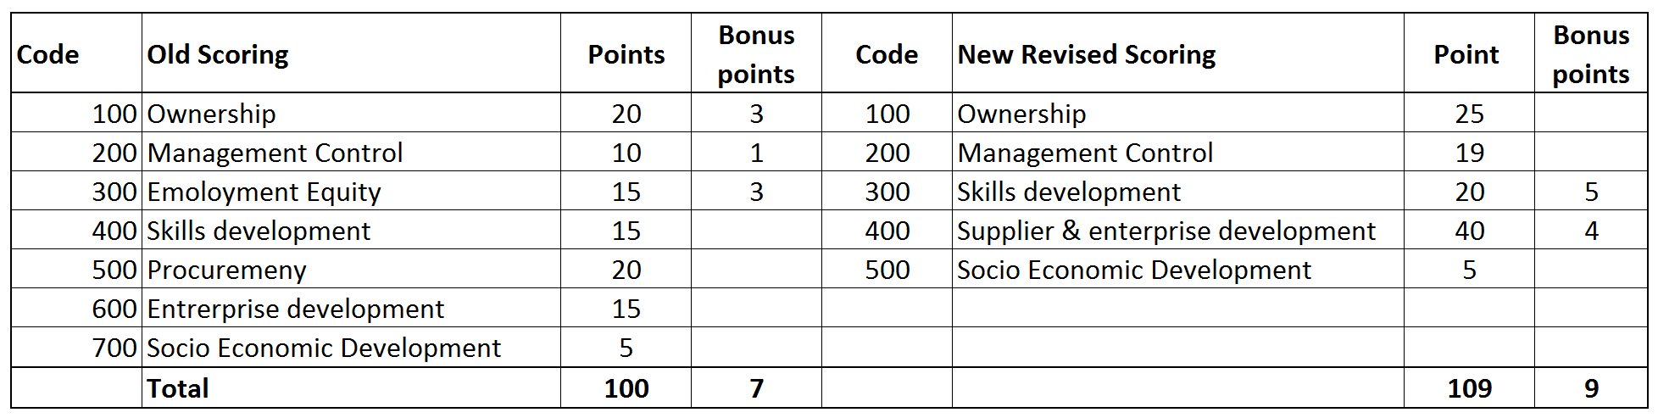
Table 2 Revised BEE scoring score card, (Author, 2017)
The weighed elements detailed by figure above are a guideline for the calculations on each criterion are done to qualify the business to participate and compete for tenders. The outcomes of the calculations result in the company’s BEE status Level, also referred to as the BBBEE recognition level. The preference of doing business lies more on the companies with the highest preference points based on the score card.

Procurement Activities

The constitution of South Africa denotes that, “when an organ of state in the national, provincial or local sphere of government, or any other institution identified in national legislation, contracts for goods or services, it must do so in accordance with a system which is fair, equitable, transparent, competitive and cost-effective.” Reference the Constitution Procurement as defined by (Novack & Simco, 1991) are those activities necessary to acquire goods and services consistent with the user requirement, and preferential procurement is acquiring the goods and services from suppliers that were historically disadvantaged during the apartheid era. The main objective of conducting procurement is that it is conducted in a manner that the constitution refers to the result would be such that no special treatment or fraudulent activities and promote economic empowerment. To cure the inequalities of the past, procurement has been the mechanism used to ensure inclusivity for the smaller companies to trade with government and also other companies of larger magnitude. Through procurement, (Bolton, 2006) explained that procurement is an important item of public expenditure with far reaching social, economic and political implications.

Procurement can simply be defined as “purchasing or buying” something from another. However, before buying something, it is imperative to know what it is that you need and how much you are willing to pay. Defined by (Novack & Simco, 1991), procurement consists of all those activities necessary to acquire goods and services consistent with the user requirements. Procurement as defined by (Govender & Watermeyer , 2000), is a process that creates, manages and terminates contracts. The creation of contracts entails scoping of the required result, obtaining funding, advertising the required result through a tendering and requesting for quotations and other tender returnable documents to enable evaluation of the submitted documents. Usually forming part of the returnable document is the bidders BEE information. The information is used to further evaluate the bidders. Having a BEE rating that is high is an incentive for any businesses, as explained by (Ishmail, 2013) that there is a commercial incentive for a South African company to have a high BBBEE score, as it results in it being more attractive to counterparties. Explained by (DTI, 2017), in the event that two or more tender have scored equal total points, the successful tender must be the one scoring the highest number of preference points for B-BBEE.

Preferential Procurement

Preferential procurement is defined as, “a system of procurement which provides employment and business opportunities for marginalizes individuals and communities, enables procurement to be used as an instrument of social policy in fair, equitable, competitive, transparent and cost effective manner and permits social objectives to be quantified, measured, verified and audited,” (Manchidi & Harmond, 2002). By offering opportunities to the marginalized individual, the standard of living and economic growth of the less attractive areas improves. As the South African Government slogan is trying to make a better life for all by creating jobs and inclusion of the historically disadvantaged individuals.

Preferential procurement is a tested method of ensuring that small businesses participate in the economic empowerment in South Africa. Through conducting procurement activities, (Bolton, 2006) detailed that the size and volume of government procurement contracts facilitates the governments decisions relating to when and whom it contracts with. As alluded by (Chimwani, Iravo, & Tirimba , 2014) public procurement is key to government service delivery, yet constraints affect its performance. The term “decisions” seems like an easy process that can be undertaken in an hour; however there are multiple processes which all have legislature requirements and procedures attached to it and that have to be adhered to. Process of inclusion of small businesses was only, facilitated accurately after the implementation of the BEE laws, before that, the government had only done business with big reputable companies. Doing business with big and reputable companies gave comfort to government that the work would be done within the scope and budget, which was less risky because the reputable companies were well established.

The objectives of preferential procurement as defined by the Preferential Procurement policy are as follows:
• The tendering process was made more accessible to black people,
• Tenders were ‘unbundled’ into smaller tenders to allow smaller enterprises to tender for work,
• A point system was introduced to award tenders on the basis of the combination of price and preference for targeted groups. Explained by (Ishmail, 2013), companies operating in South Africa are measured on the degree to which they integrate previously disadvantaged individuals in the economy through equity ownership, directorships, employment, training and procurement. The companies themselves have a greater competitive advantage if their BBBEE level status in the score card.

Detailed by (DTI, 2003), South Africa’s economy cannot operate to its full potential because the majority of South Africans earn very low incomes and are still excluded from ownership of fixed assets and the possession of advanced skills. Through preferential procurement the SMME’s are also given an opportunity to participate economically. Contracts with the international company’s exposes the national companies to international standards through skills transfer programs and empowering South African to compete internationally.

Recent literature on preferential procurement

Governments use procurement to promote social responsibility and sustainable principals with in the construction industry as explained by (Murray & Dainty , 2013), therefore the investigating the contribution made by civil engineering contracts is imperative. As detailed by (Brynard & Majoro , 2010) the dismal state of monitoring and controlling of procurement activities in the construction industry contributes towards the failure of government to increase spending towards the historically disadvantaged communities. The motivation to track the contribution towards civil engineering contracts encourage organization’s to constantly improve all aspects of their procurement systems, (Chimwani, Iravo, & Tirimba , 2014).
(Martin & Root, 2010) Explained that contractors usually fail to develop into sustainable enterprises due to the lack of experience and construction knowledge. Construction experience and the company track record is required for contractors to formally participate in construction projects in big organizations such as parastatals. This improves the chances of contractors contributing towards economic growth as defined by (Abor & Quartey, 2010). This however becomes an issue for SME’s and EME’s as they compete with their highly experienced counterparts for all tenders as they are expected to operate in the same environment as explained by (Smit & Watkins, 2012). The importance of “leveling the play field”, as elaborated by (Magoro & Brynard, 2010) is important, therefore an investigation of the contribution made by the SME’s and QME’s in relation to preferential procurement is important to understand.
Preferential procurement indicators focus on the historically disadvantaged individuals, who are participating in socio-economic activities. People living with disabilities are also included in the category of historically disadvantaged individuals. (Shakespeare & Officer, 2011), stated that the world objective is to empower people living with disabilities and remove barriers that prevent them from participating. Issues that are associated with the civil engineering industry discourages the preferential procurement target market due to the demanding nature of the industry.

Preferential procurement practices in other African states.

Kenya, similar to South Africa has gone through transformations in their procurement regulations, where there were no public procurement regulations until 1970 (Kiama, 2014). A study was done by (Vyas-Doorgapersad & Kinoti, 2015) where an investigation into gender based procurement practices in South Africa and Kenya were investigated. The study indicated that in both countries, women were not benefitting on a large scale due to access to information in relation to procurement processes and comprehension of tenders. Advancements of procurement practices in Kenya include the implementation of the Procurement and Disposal Act of 2005, which offers reservations for historically disadvantaged groups including women, youth and persons living with disabilities (Vyas-Doorgapersad & Kinoti, 2015). Similarities are seen between the Preferential Procurement of South Africa and the Procurement and Disposal Act of Kenya where historically disadvantaged, women, youth and disabled individuals are considered whenever procurement activities are conducted.
Neighbor to South Africa, Zimbabwe, with a dire economic climate due to political factors has the Indigenization and Economic Empowerment (IEE) Act 14/.2007. The act was implemented to ensure that businesses procure 50% of goods and services from indigent Zimbabweans which also prefers conducting business with organizations that are 51% Zimbabwean owned. (Deputy Chairman, 2017). The indigenization and empowerment act shares similar sentiments as the preferential procurement Act as women, young and disabled individuals are considered when conducting procurement activities. Many have criticized the IEE act to be among the contributing factors to the dire economic climate in Zimbabwe as foreign investments are limited due to the prioritization of Zimbabwean. (Warikandwa & Osode, 2017) Compared and contrasted the Preferential Procurement Act and Indigenization and Economic Empowerment and revealed that though the two act are similar, the IEE was seen not to benefit the Zimbabweans as did the preferential procurement to South Africans, this was detailed by (Warikandwa & Osode, 2017).

Transnet
Transnet is a National logistics company that transports the bulk commodities for domestic and export use. Transnet State Owned Company (SOC) has five (5) Operating Divisions namely, Transnet Freight Rail, Transnet Port Authorities, Transnet Engineering, Transnet Pipeline and Transnet Port Terminals. These operating divisions work as functional businesses but also do business amongst each other. The operating divisions then utilize specialist units that assist the operating divisions with expertise such as property acquisition and management, Project Management and Charity work. These Specialist units are Transnet Property, Transnet Capital Projects and Transnet Foundation. See Fig 1.
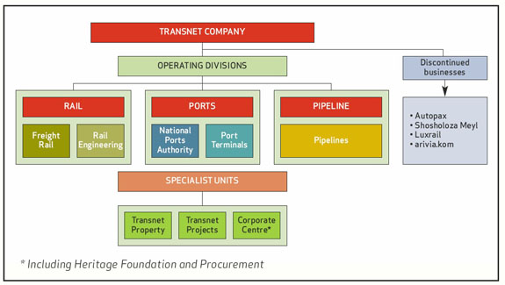
Figure 1Transnet Organization Structure (Transnet, 2015)
The Market Demand Strategy was introduced in 2012, where the strategy was to increase the infrastructure capacity before the infrastructure is required by the market. An allocation of 300 billion was allocated towards the strategy over a periods of 7 years from 2012 to 2019. The market demand strategy encourages that the organisation spends towards infrastructure projects so as to increase the capacity prior to the customer’s requirements of the infrastructure. The execution of most infrastructure projects is the mandate of Transnet Capital Projects as they are the project management subsidiary of Transnet.

As a parastatal organisation, Transnet is required by law to abide by the regulations stipulated by South Africa’s Department of Trade and Industry during the tendering process. Therefore the review of the preferential procurement element will assist in validating the compliance levels of the Transnet on the BBBEE targets.

Research Method
This chapter outlines the analytical purpose of this research and the logical methodology that was trailed to get the desired results of this research. The methodology employed to execute this research is detailed in this section of the report.

3.1 Purpose of the analysis
This investigation will assess the 4 items that are in the Preferential Procurement scorecard reported on between the periods of April 2013 to March 2016, viz;
a) BEE Procurement from all Suppliers
b) BEE Procurement from Qualifying Small Enterprises (R10 – R50 million per annum) or from Exempted Micro-Enterprises (R0 – R10 million per annum)
c) BEE Procurement from any of the following Suppliers as a percentage of Total Measured Procurement Spend:
- Suppliers that are more than 50% black owned
- Suppliers that are more than 30% black women owned.
d) BEE procurement with the disabled.

The assessment of the 4 elements listed above should indicate percentage contribution to the civil engineering projects being executed by TCP. The investigation will shed light whether TCP is contributing towards the socio-economic growth specifically in the civil engineering industry or not. The investigation of the effectiveness will demonstrate whether the preferential procurement for the civil engineering construction contracts are as per the desired strategic outcomes which are the organizational targets. The BEE scorecard will be used as a template and benchmark to draw comparison to the scores calculated for the overall organization and the calculated scores for the civil engineering contracts.

Effectiveness in the context of this research is related to the extent of the preferential procurement is contributing towards civil engineering projects. The extent of effectiveness will be measured on the basis of the targets that are achieved as per the BEE score card which stipulates the following scores for the preferential procurement parameters that the target of the organization is to ensure that the suppliers achieve at least 50% of the preferential procurement points. Though 50% is not the ultimate goal, this research will introduce a preferential procurement scale to rate the organizations contribution and also recommend initiatives to be implemented to ensure that the scoring increases.

3.2 Research Framework
The BEE codes of good practise will be used as the benchmark for this research. According to the BEE score card, there are five (5) elements that are weighed which inform whether the company is compliant to the BEE standards. This study focuses on one of the 5 elements which weigh 20% on the score card which is the preferential procurement. The following framework was used for this research:
a. Understanding of the key performance indicators that inform the 20% allocated to the preferential procurement and thus understand the effectiveness of preferential procurement;
b. Understanding the targets set by the company compared to the calculated scores;
c. Apply the performance indicators to assess the performance of Transnet TCP; and
d. Analyse the effectiveness using the score card and calculations.

Empirical data used and analysed for the purpose of investigating the effectiveness of preferential procurement at Transnet was sourced from the Supplier Development Department. The data for this study is only limited to the information that was supplied submitted for the purposes of reporting on the contractual spending. The data sample size is limited to 3 financial years 2013/14, 2014/15 and 2015/16 since data for the BBBEE was only documented formally and accurately in a standardised from for all operating divisions dating from 2013. The data that was collected prior to 2013 was be disqualified for the purpose of using standardized information as it would be impossible to compare and contrast with the financial years prior to 2013.

3.3 Research Approach

A combination of quantitative and qualitative research methodologies will be used to conduct this research. Both research approaches are appropriate for this research since statistical data will be collected and analysed, which would inform the questions to be asked in the interviews which will be conducted with subject matter experts. The rationale for the use of a mixed research methodology was selected to check the accuracy of both research methodologies as explained by (Creswell, 2013 ). The mixed method approach was applicable for this research since a comparative exercise of data analysis was conducted, therefore, both the qualitative and quantitative analysis would better explain the results obtained by the study. As alluded by (Burke & Onwuegbuzie, 2004), “A key feature of mixed methods research has its methodological pluralism or eclecticism, which frequently results in superior research”. Therefore the validity and verification of the study can be conducted with ease by employing both research methods.

3.4 Quantitative Research Method

Empirical data collected from the TCP Supplier Development was used to investigate the effectiveness of preferential procurement in the Civil Engineering Construction Projects. The overall effectiveness will be established by assessing the following:
i. TCP’s preferential procurement targets;
ii. The Civil Engineering contract’s score evaluated by this research; and
iii. The published score on the BEE verification certificate.

The comparison of the 3 items above should indicate whether TCP is achieving the set targets on preferential procurement in the Civil Engineering Contracts.

3.4.1Research Data
The data that was used for this research project is the same as that which is used by Transnet Capital Projects to rate the businesses BEE status score. The overall scoring is validated by BEEver Agency that analyses the data and issues TCP with the BEE certificate valid for a duration 12 months. The data that is sent for verification is classified into 237 categories.
The projects analysed by this research were under the following sub-divisions:
i) Civil Engineering Construction
ii) Civil Engineering
iii) Civil and building contracts
iv) Construction.
The 4 categories listed above are amongst 237 other contract categories that were consolidated for the purpose of obtaining a BEE certificate for a financial year.
Two data sources were used for the purpose conducting quantitative analysis. The primary data was sourced from the Transnet Capital Project’s supplier development department. This was the data used to report the consolidated research information that is compiled for the department on a monthly basis with the objective to report on the compliance of the active contracts to the BBBEE score card requirements. The secondary data was from BEEVer Agency BEE scorecard that is generated for Transnet. Comparison of the data was done on the calculated scores and the BEEVer agency score card.

3.4.2 Data Analysis
Data was analysed using the following four (4) step methodology:
- Assessing of raw data: the data will be received and screened for relevance for this research.
- Data cleaning: the data that is for the purpose of reporting is for collected for the purpose of contractual reporting. The data that is being assessed has 253 different categories that contribute towards the BEE score and only 4 categories in the data is specifically for the civil engineering construction contracts. Most of the data that is presented is not relevant to this study, thus the data will be customised to ensure that information not relevant to research is filtered. Cleaning of data will also ensure that the data that is being used is relevant to the study that is being undertaken.
- The data will then be analysed through the use of Microsoft Excel functions to simplify and graphically represent the data for ease of use and further analysis. Calculations to obtain the civil engineering project’s preferential procurement scores will be done so as to enable the comparison with the overall preferential procurement score to be done. The formulae used for the calculation of the preferential procurement scores is that of ANNEXW FS4000 of the Government Gazette, (DTI, 2016)
- With reference to the literature that this research would be founded on, the data will be analysed and verified such that the performance of TCP on preferential procurement is understood. The comparison will be done using the BEE Verification Report and the BEE certificates for the 3 financial years
This 4 step methodology was customised to answer the research questions and achieve the research objectives.

3.4.3 Quantitative results analysis
Empirical data used and analysed for the purpose of investigating the effectiveness of preferential procurement at Transnet. The data sample size is limited to 3 financial years 2013/14, 2014/15 and 2015/16 since data for the BBBEE was only documented formally and accurately in a standardised format. The data that will be used for this study was compiled and updated on a monthly basis over the years of interest, for the purpose of reporting on all the procurement activities on all active contracts. The following content was populated on the Microsoft Excel spreadsheet sourced from the supplier development department:
a. Entity identity
b. Commodity or industry
c. Entity BEE status level
d. Total procurement spend
e. Percentage BEE spend
f. Total percentage spend distribution of:
i) Black Owned
ii) Women Owned
iii) EME and QSE
iv) Spend with youth
v) Spend with disabled owned entities
The data reported by the Supplier Development Microsoft Excel spread sheet represents all the procurement activities during the period of 2013/14, 2014/15 and 2015/16. The Civil Engineering Project data will be extracted from the BEE reporting spread sheet with the use of excel filter commands to eliminate data entries that are not related to Civil Engineering Projects.

3.4.4Research formulae
The following formulae was used to calculate the contribution of Civil Engineering contracts as per the calculations detailed in the Code 500 Statement 500.

Formulae for Total procurement spend:
$$A=Σ(B x C)$$
Where :
A is the total calculated procurement spend
B is the value of the procured items for the categories in question.
C is the BBBEE procurement levels of recognition for the organisation are being measured.
Table 3 Source: DTI (2005)

Formulae for the measurements of the three other listed preferential procurement indicators individually is:
- B-BBEE Procurement Spend from Qualifying Small Enterprises or Exempted Micro-Enterprises based on the applicable B-BBEE Procurement Recognition Levels as a percentage of Total Measured Procurement Spend
- B-BBEE Procurement Spend from any of the following Suppliers as a percentage of Total Measured Procurement Spend:
1. Suppliers that are 50% black owned (3 out of 5 points); or
2. Suppliers that are 30% black women owned. (2 out of 5 points)
- Bonus: Procurement from black people living with disability

$$A= \frac{B}{C } x D$$
Where:
A is the preferential procurement score of the for the desired preferential procurement indicator detailed above.
B is the BBBEE procurement spend of the measured organisation
C is the preferential procurement compliance targets as per the preferential procurement indicator on the preferential procurement score card.
D is the weighted points as per the organisation’s preferential procurement score card.
Table 4 Source: DTI (2005)
The above formulae were used to calculate the quantitative results of this research.

3.4.5ANOVA analysis
The analysis of variance would be done to understand the similarities and or dissimilarities in the i) financial years of interest and ii) the civil engineering contracts and the variance in the overall TCP contracts and iii)Transnet’s preferential procurement scores compared to the TCP civil engineering scores. The analysis is summarised in Section 5 of this report. The ANOVA analysis statistical information will aid in understanding the differences in comparison of the financial years and also the overall scores that are calculated for all procurement activities.

3.4.6Validation and Verification
Validation and verification of the qualitative results was done through checking selected data supplied by the Supplier development compared to the number of SAP entries of civil engineering active contracts. Further analysis of the results obtained in the quantitative results was further verified and validated by subject matter experts that work in the Procurement and Supplier Development departments, whose profiles are elaborated on in section 3.2.2 of this report. Further validation and verification of this research results of this research was done through the comparison of the research results to the literature reviewed for the purposes of conducting this research. Furthermore, since the study was limited to civil engineering contracts within Transnet and no other research was done before to this regard, therefor, if further studies are done in relation to preferential procurement in the civil engineering and construction fraternity, then this study could be used as a benchmark to assess the results.

Qualitative Research Methodology

Interviews were conducted to validate or disprove the results calculated quantitatively and assist in better understanding of the business position over the 3 financial years that were being investigated. The interviews were conducted with the subject matter experts in the organisation, who work in the procurement and supplier development departments. The subject matter experts were able to justify the variance on the data and influencing factors on the data variance.Appendix 2 details the sample questionnaire that was used for the interviews with the subject matter experts. The questionnaire questions were based on the results obtained in the summary of results in Section 5.2.6.

Questionnaire development
A questionnaire was developed and interviews were held with the Subject Matter Experts (SME) to validate or disprove the results achieved from the qualitative analysis. This questionnaire tool was developed to ask standardized questions to a selected few who would be knowledgeable in the preferential procurement practises in the in TCP. (Brace , 2008) Explained that asking a question the same way to different people was key to qualitative research, therefore it was important to develop a standard set of questions to be asked in relation to the qualitative results obtained by the research. Questions in the standardized questionnaire were based on the summary of results that were developed from the qualitative results in Section 5.2.6. The summary table contained results from the 3 financial years that were to be compared. Appendix 3 details the questionnaire that was used to interview the SEM’s.

Respondents selection criteria
The respondents for this research were limited to Transnet employees who work in the supplier development and procurement departments. The criteria used to select the respondents for this research was based on the employment employee role of the respondent. The questionnaire was structured such that resources that work in the procurement and supplier development would be able to prove or disprove the results obtained as results of this research. The Transnet National Supplier Development Manager, TCP Procurement Executive Manager, and the TCP Procurement Managers were interviewed for the purpose of this research. The rationale behind the selection of these individuals was that they would have the global view of the i)organisation’s procurement policies, ii) an understanding in the BEE legislation, iii) an overall understanding of the active contracts that had been active during the financial years of interest and iv) confirm the validity of the qualitative results calculated by this research.

Model Development
The model developed for this research can be used as a tool to monitor and control the procurement activities pre and post the contract awards to monitor, control and standardize the processes.
The following contents could be found in the model:
- Home page
- Procurement planning
  - Project data
  - Project Pricing information
- Contract Management
  - Preferential procurement compliance
  - Remedial actions
The use of the model would enable Transnet to monitor the compliance of the preferential procurement elements before the contract is awarded and during contract execution.

Data Analysis
This section of the report details the results that were derived from the data sourced from the Supplier Development Department. The analysis was structured as follows:
- Quantitative Analysis
Firstly, the BEE contributions made by TCP as a whole will be analyzed;
Secondly, the contributions of Civil Engineering contracts will be determined through filtering the data from all contracts in TCP, this will be done for the 3 financial years of interest;
Thirdly, analysis through the comparison of the preferential procurement results in Transnet results, TCP contracts and the civil engineering contracts calculated by this research; and
Finally, populating the results into a summary table which will be used as an input into the qualitative research method.
- Qualitative analysis
The qualitative analysis followed the analysis was structured as follows:
Firstly, with the use of the summary table developed in the quantitative research method, the results will be analysed so as to develop questions in relation to the results obtained quantitatively.
Secondly, conduct interviews with the subject matter experts; and
Finally, analyse the responses from the subject matter experts into common themes that are revealed during the subject matter expert interviews.

Quantitative Results
The following results were obtained from filtering and calculating the preferential procurement scores from the Microsoft Excel spreadsheets that were developed for tracking and reporting on the BEE scores.

BBBEE and preferential procurement scoring
BEEVer was appointed to compile the BBBEE verification for TCP and the data in the table below is extracted from 3 reports representing the financial years.
 | 2013/14 | 2014/15 | 2015/16
Overall BBBEE score  (Target = 107 points) | 84.94 | 90.29 | 94.68
BBBEE contribution Level | 3 | 2 | 2
Preferential Points achieved (Target = 33 points) | 24.94 | 28.2 | 28.34
Compliance percentage | 75.58% | 85.45% | 85.88%
Table 5 BBBEE scores, Source: Transnet BBBEE Audits, by Author

Table 4 illustrates the compliance percentage of TCP as an organisation on BEE and preferential procurement. The results reflect all the procurement activities that took place over the 3 financial years of interest. Additional information pertaining to Table 5 is further discussed in this section.

Preferential procurement score
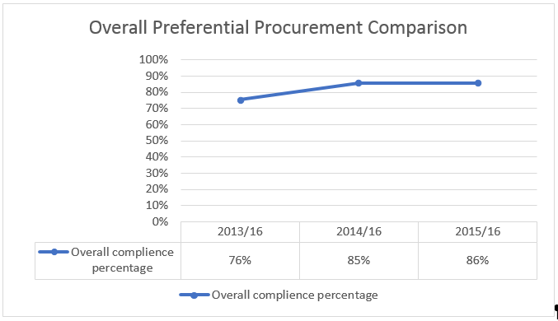
Graph 1Transnet Capital Project's Preferential Procurement Comparison, Source: Author, 2016

Graph 1 depicts the summarised results of the preferential procurement scores obtained by Transnet Capital Projects for all the procurement activities that were done by the organisation in the 3 financial years. The scores indicate that there has been an increase in the preferential procurement scores have been increasing if the financial year 2013/14 is used as a benchmark for the 3 years being evaluated. There was an increase of 9% between 2013/14 and 2014/15 and a 1% increase between 2014/15 and 2015/16. Graph 1 was used as a benchmark against which the results obtained from the quantitative analysis for civil engineering contracts be compared to.

2013/14 Financial Year

Transnet’s contribution

The Transnet audited results from the financial year 2013/14 in relation to BBBEE are illustrated in Figure 2 below. The information portrayed by Figure 2 indicates that the BBBEE spend in the organisation has been increasing at a rate of 7.8% over a period of 4 years since 2011, with the total measured procurement spend above the organisation’s targets.
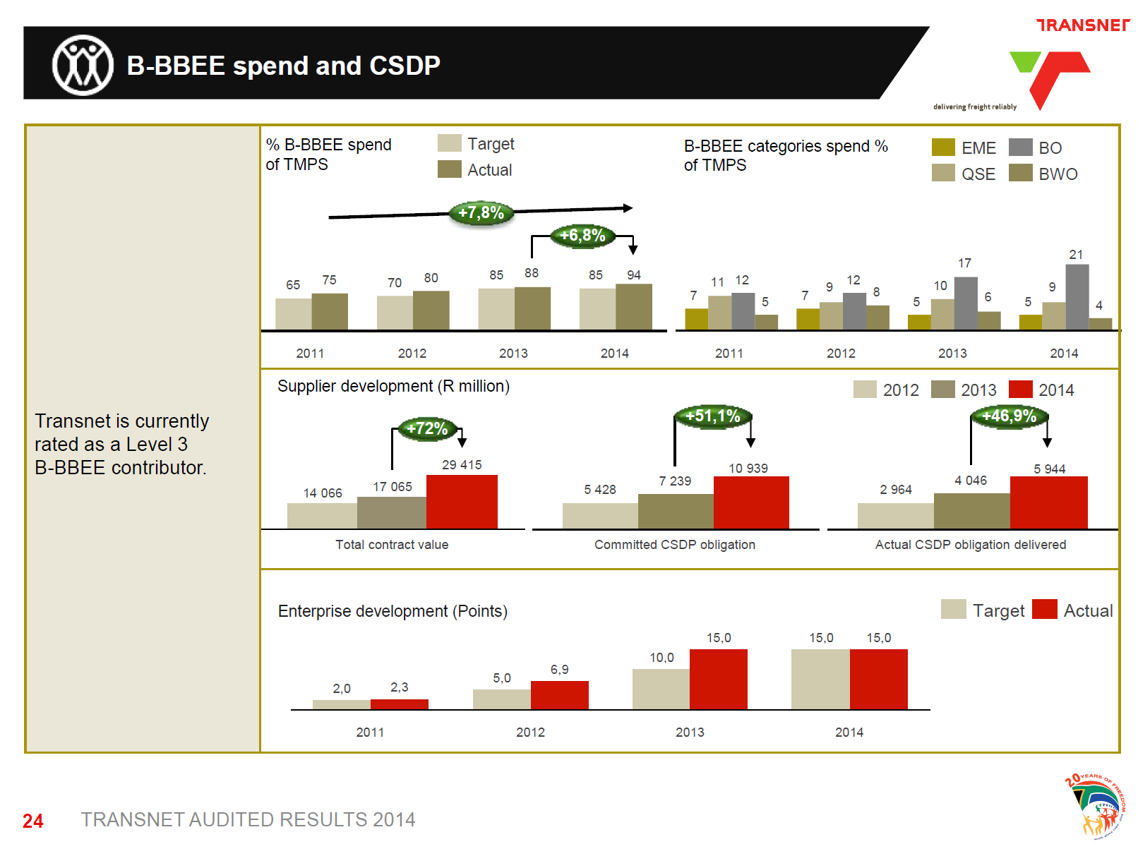
Figure 2 BBBEE audited results 2013/14, (Source: www.transnet.net , 2014)
Also portrayed by the graphs in Figure 2, is the contributions made by Exempted Micro Enterprise’s, Qualifying Small Enterprises, Black owned businesses and Black women owned, which are the preferential procurement indicators. Over the 4 years, being 2011 to 2014, the organisation’s contribution towards black owned entities was increasing and fluctuations are observed in the EME’s, QSE’s and black women owned.

5.4.2 TCP preferential procurement contribution

Information presented by the BEEver Agency indicated that the preferential procurement was 24.94 points where the maximum points that could be accumulates is 33 points.
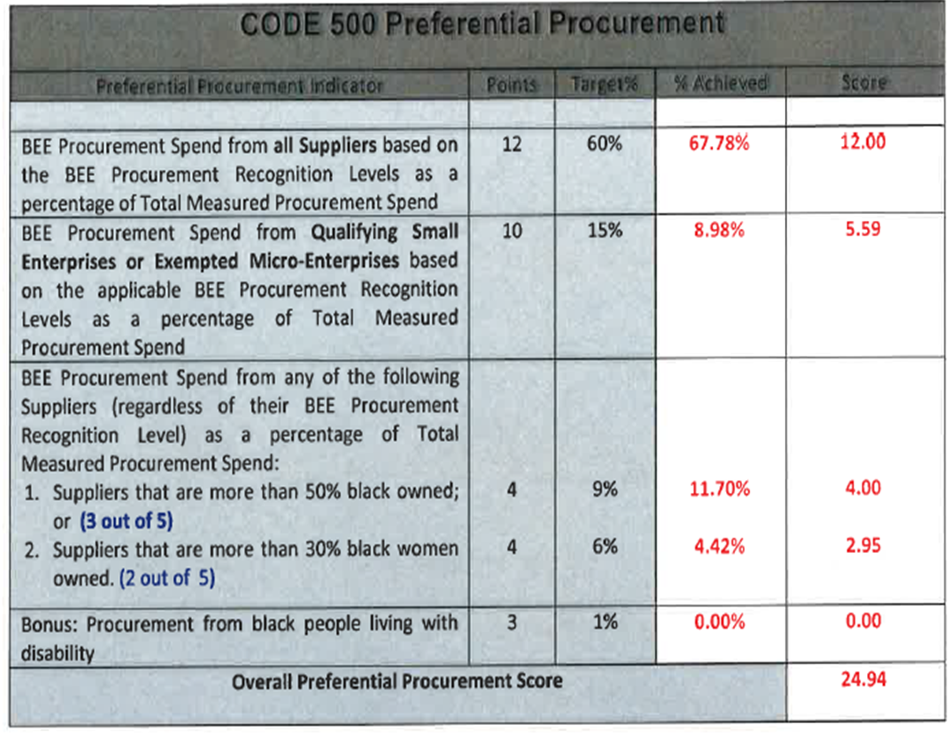
Figure 3 TCP Preferential Procurement 2013/14 Score Card, Source: BEEVer Agency

The information above illustrates that TCP was at an overall 75.75 % compliance with regards to preferential procurement for all contracts that were active and for payment made during the 2013/14 financial year.

Civil Engineering Contracts contribution

During the 2013/14 financial year, 325 payments were made towards civil engineering contracts. The information analysed below analyses the preferential procurement scoring for payment towards civil engineering contracts.
Preferential procurement indicators
Indicator 1: B-BBEE Procurement Spend from all Suppliers based on the B-BBEE Procurement Recognition Levels as a percentage of Total Measured Procurement Spend.
CODE 400 Preferential Procurement for Civil Engineering Projects: B-BBEE Procurement Spend from all Suppliers based on the B-BBEE Procurement Recognition Levels as a percentage of Total Measured Procurement Spend.
Points | Target | % Achieved | Score
12 | 60% | 37% | 7.4
Table 6 Total Procurement Spend, Source: Author
Table 6 indicates that twelve (12) points were allocated towards the procurement spend from all suppliers based on the recognition levels. The overall score that was calculated for the total procurement spend during the 2013/14 financial year were was 37%. Since 37% was the achieved percentage compared to the target of 60 %, the converted score of 7.4 points was calculated. The score of 7.4 was calculated as a fraction of the overall score of 12 points.

Indicator 2: Qualifying Small and Exempted Micro-Enterprises
CODE 400 Preferential Procurement for Civil Engineering Projects: Qualifying Small and Exempted Micro-Enterprises
Points | Target | % Achieved | Score
10 | 15% | 0.07% | 0.67
Table 7 Procurement for EME & QSE, Source: Author
Table 7 indicated that ten (10) points were allocated towards Qualifying Small and Exempted Micro-Enterprises which had active contracts with TCP in 2013/14. The overall score that was calculated for QSE and EME’s in the 2013/14 financial year was 0.07%. Since 0.07% was the achieved percentage compared to the target of 15 %, the converted score of 0.67 was calculated. The score of 0.67 was calculated as a fraction of the overall score of 10 points.

Indicator 3.1: Suppliers that are more than 50% black owned
CODE 400 Preferential Procurement for Civil Engineering Projects :
Suppliers that are more than 50% black owned
Points | Target | % Achieved | Score
4 | 9% | 3.84% | 1.71
Table 8 Preferential procurement for 50% black owned, Source: Author
Table 8 indicates that four (4) points were allocated towards suppliers that were more that 50% black owned. The overall score that was calculated for suppliers more than 50% black owned that were active during the 2013/14 financial year were was 3.84%. Since 3.84% was the achieved percentage compared to the target of 9%, the converted score of 1.71% was calculated. The score of 1.71 was calculated as a fraction of the overall score of 4 points.

Indicator 3.2 Suppliers that are more than 30% black women owned.

CODE 400 Preferential Procurement for Civil Engineering Projects: Suppliers that are more than 30% black women owned.
Points | Target | % Achieved | Score
4 | 6% | 0.64% | 0.43
Table 9 Preferential procurement for 30% women owned, Source: Author
Table 9 indicates four (4) points were allocated towards suppliers that were more that 30% women owned. The overall score that was calculated for suppliers more than 30% women owned that were active during the 2013/14 financial year were was 0.64%. Since 0.64% was the achieved percentage compared to the target of 6%, the converted score of 0.43 was calculated. The score of 0.43 was calculated as a fraction of the overall score of 4 points.

Indicator 4- Bonus: Procurement from black people living with disability
CODE 400 Preferential Procurement for Civil Engineering Projects : Bonus: Procurement from black people living with disability
Points | Target | % Achieved | Score
3 | 1% | 0.00 | 0.00
Table 10 Preferential procurement for black people living with disability, Source: Author
Table 10 indicated that there were three (3) bonus points that are allocated towards preferential procurement for procurement activities from black people living with disabilities. No points were calculated for black people living with disabilities since the data depicted that no active civil engineering project contracts were awarded to entities that were owned by black people with disabilities. Thus no bonus points were allocated toward the overall preferential procurement score.

Overall preferential procurement score 2013/2014
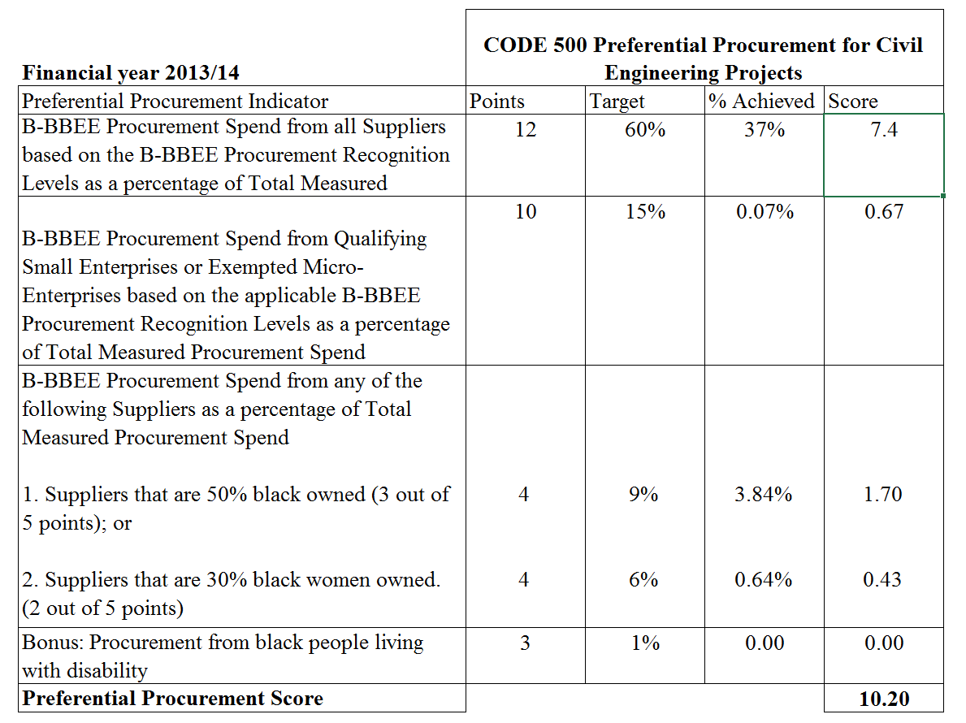
Table 11 Overall preferential procurement score card for civil engineering contracts, Source: Author

A total of thirty three (33) points were allocated towards preferential procurement. The overall score that was calculated for preferential procurement for Civil Engineering Projects was 10.20 points. This calculation demonstrated that civil engineering project contracts that were awarded in financial year 2013/14 were only 30.90% compliant to the preferential procurement requirements.

2014/15 financial year

Transnet’s Contribution

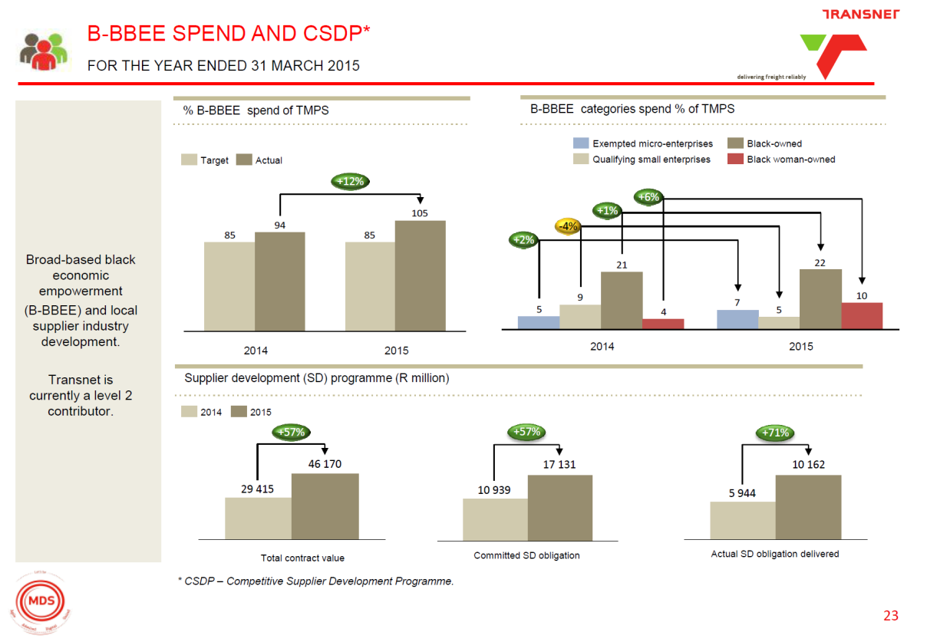
The Transnet audited results from the financial year 2014/15 are illustrated in Figure4. The information portrayed by Figure 4 indicates that the BEE spend in the organization increased at an rate of 12% between 2014 and 2015. The actual spend was above the organisation’s targets.
Figure 4 BBBEE audited results 2014/15, Source: www.transnet.net (2016)

Also portrayed by the graph above is the contributions made by EME’s, QSE’s, Black owned businesses and Black women owned, which are the preferential procurement indicators. Between 2014 and 2015, the organisation’s contribution towards black owned entities increased and fluctuations were observed in the other 3 indicators.

TCP contribution

Information presented by BEEver Agency in the TCP’s BEE certificate in Annexure 4, indicated that the preferential procurement is 28.20 points where the maximum points that could be accumulates is 33 points.
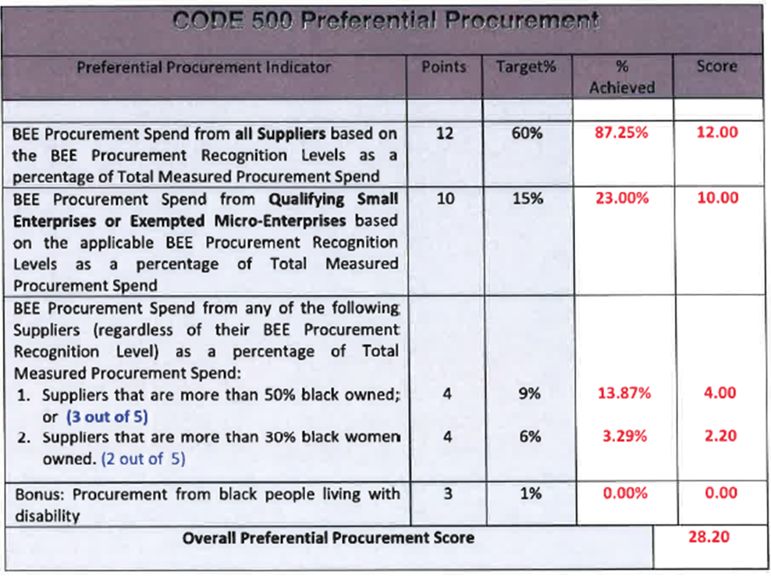Figure 5 TCP Preferential Procurement 2014/15 Score Card,Source: BEEVer Agency
The information above illustrates that TCP was at an overall 85.45 % compliance with regards to preferential procurement for all contracts that were active and for payment made in 2014/15.

Civil Engineering Contracts contribution

During the 2014/15 financial year, 458 payments were made towards civil engineering contracts. The information analyzed below analyses the preferential procurement scoring for payment towards civil engineering contracts.
Preferential procurement indicators:
Indicator 1: B-BBEE Procurement Spend from all Suppliers based on the B-BBEE Procurement Recognition Levels as a percentage of Total Measured Procurement Spend.
CODE 400 Preferential Procurement for Civil Engineering Projects: B-BBEE Procurement Spend from all Suppliers based on the B-BBEE Procurement Recognition Levels as a percentage of Total Measured Procurement Spend.
Points | Target | % Achieved | Score
12 | 60% | 37% | 7.4
Table 12 Total Procurement Spend, Source: Author

Table 12 indicated that twelve (12) points were allocated towards the procurement spend from all suppliers based on the recognition levels. The overall score that was calculated for the total procurement spend during the 2013/14 financial year were was 37%. Since 37% was the achieved percentage compared to the target of 60 %, the converted score of 7.4 points was calculated. The score of 7.4 was calculated as a fraction of the overall score of 12 points.

Indicator 2: Qualifying Small and Exempted Micro-Enterprises
CODE 400 Preferential Procurement for Civil Engineering Projects: Qualifying Small and Exempted Micro-Enterprises
Points | Target | % Achieved | Score
10 | 15% | 0.07% | 0.67
Table 13 Procurement for EME & QSE, Source: Author (2016)
Table 13 indicated that ten (10) points were allocated towards Qualifying Small and Exempted Micro-Enterprises which had active contracts with TCP in 2013/14. The overall score that was calculated for QSE and EME’s in the 2013/14 financial year was 0.07%. Since 0.07% was the achieved percentage compared to the target of 15 %, the converted score of 0.67 was calculated. The score of 0.67 was calculated as a fraction of the overall score of 10 points.

Indicator 3.1: Suppliers that are more than 50% black owned
CODE 400 Preferential Procurement for Civil Engineering Projects: Suppliers that are more than 50% black owned
Points | Target | % Achieved | Score
4 | 9% | 3.84% | 1.71
Table 14 Preferential procurement for 50% women owned, Source: Author

Table 14 indicated that four (4) points were allocated towards suppliers that were more that 50% black owned. The overall score that was calculated for suppliers more than 50% black owned that were active during the 2013/14 financial year were was 3.84%. Since 3.84% was the achieved percentage compared to the target of 9%, the converted score of 1.71% was calculated. The score of 1.71 was calculated as a fraction of the overall score of 4 points.

Indicator 3.2 Suppliers that are more than 30% black women owned.
CODE 400 Preferential Procurement for Civil Engineering Projects: Suppliers that are more than 30% black women owned.
Points | Target | % Achieved | Score
4 | 6% | 0.64% | 0.43
Table 15 Preferential procurement for 30% women owned, Source: Author
Table 15 indicated that four (4) points were allocated towards suppliers that were more that 30% women owned. The overall score that was calculated for suppliers more than 30% women owned that were active during the 2013/14 financial year were was 0.64%. Since 0.64% was the achieved percentage compared to the target of 6%, the converted score of 0.43 was calculated. The score of 0.43 was calculated as a fraction of the overall score of 4 points.

Indicator 4: Bonus: Procurement from black people living with disability
CODE 400 Preferential Procurement for Civil Engineering Projects: Bonus: Procurement from black people living with disability
Points | Target | % Achieved | Score
3 | 1% | 0.00 | 0.00
Table 16 Preferential procurement for black people living with disability, Source: Author
Table 16 indicated that there are three (3) bonus points that are allocated towards preferential procurement for procurement from black people living with disabilities. No points were calculated for black people living with disabilities since the data depicted that no active civil engineering project contracts were awarded to entities that were owned by black people with disabilities. Thus no bonus points were allocated toward the overall preferential procurement score.
Overall preferential procurement score
Table 17 Overall preferential procurement Score for 2014/15
Thirty three (33) points were allocated towards preferential procurement. The overall score that was calculated for preferential procurement for Civil Engineering Projects was 10.20 points. This calculation demonstrated that civil engineering project contra that were awarded in financial year 2013/14 were only 30.90% compliant to the preferential procurement requirements.

2015/16 Financial Year

Transnet’s contribution

The Transnet audited results from the financial year 2015/16 are illustrated in Figure5. The information portrayed by Figure 5 indicates that the BEE spend in the organization increased at an increasing rate of 11% between 2008 and 2016. The actual spend was above the organization’s targets.

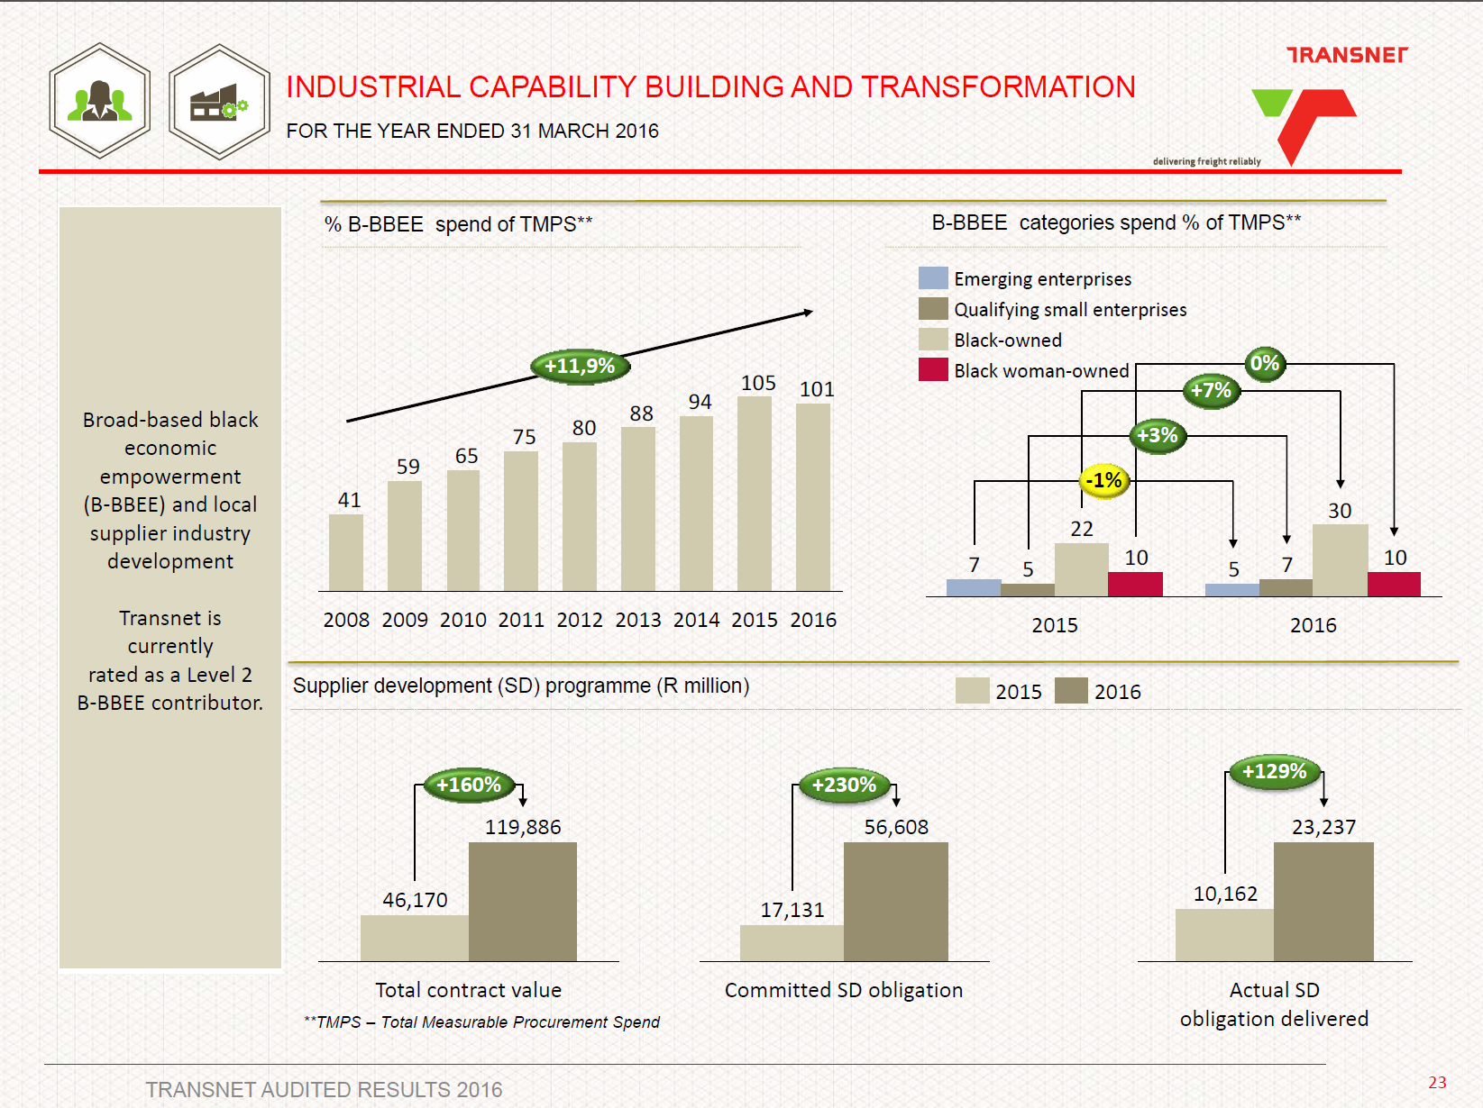
Figure 6 Figure 5 BBBEE audited results 2015/16, Source: www.transnet.net

Also portrayed by the graphs above is the contributions made by EME’s, QSE’s, Black owned businesses and Black women owned, which are the preferential procurement indicators. Between 2015 and 2016, the organisation’s contribution towards black owned entities increased and there were fluctuations in the other 3 indicators that contribute towards preferential procurement.

TCP preferential procurement contribution

Information presented by BEEver Agency in the TCP’s BEE certificate in Annexure 4, indicated that the preferential procurement is 28.34 points where the maximum points that could be accumulates is 33 points.
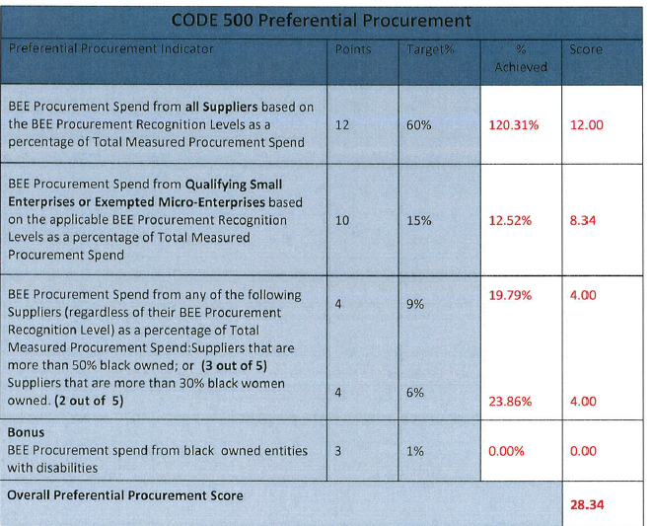Figure 7 TCP Preferential Procurement 2015/16 Score Card, Source: BEEVer Agency
The information above illustrates that TCP was at an overall 85.88 % compliance with regards to preferential procurement for all contracts that were active and for payment made in 2015/16.

Civil Engineering Contracts contribution.

During the 2015/16 financial year, 76 payments were made towards civil engineering contracts. The information analysed below analyses the preferential procurement scoring for payment towards civil engineering contracts.
Preferential procurement indicator:
Indicator 1: B-BBEE Procurement Spend from all Suppliers based on the B-BBEE Procurement Recognition Levels as a percentage of Total Measured Procurement Spend.
CODE 400 Preferential Procurement for Civil Engineering Projects: B-BBEE Procurement Spend from all Suppliers based on the B-BBEE Procurement Recognition Levels as a percentage of Total Measured Procurement Spend.
Points | Target | % Achieved | Score
12 | 60% | 18% | 3.6
Table 18 Total Procurement Spend, Source: Author
Table 18 indicated that twelve (12) points were allocated towards the procurement spend from all suppliers based on the recognition levels. The overall score that was calculated for the total procurement spend during the 2015/16 financial year were was 18%. Since 18% was the achieved percentage compared to the target of 60 %, the converted score of 3.6 points was calculated. The score of 3.6 was calculated as a fraction of the overall score of 12 points.

Indicator 2: Qualifying Small and Exempted Micro-Enterprises
CODE 400 Preferential Procurement for Civil Engineering Projects: Qualifying Small and Exempted Micro-Enterprises
Points | Target | % Achieved | Score
10 | 15% | 0.01% | 0.14
Table 19 Procurement for EME & QSE, Source: Author (2016)
Table 19 indicated that ten (10) points were allocated towards Qualifying Small and Exempted Micro-Enterprises which had active contracts with TCP in 2015/16. The overall score that was calculated for QSE and EME’s in the 2015/16 financial year was 0.01%. Since 0.01% was the achieved percentage compared to the target of 15 %, the converted score of 0.14 was calculated. The score of 0.14was calculated as a fraction of the overall score of 10 points.

Indicator 3.1: Suppliers that are more than 50% black owned
CODE 400 Preferential Procurement for Civil Engineering Projects :
Suppliers that are more than 50% black owned
Points | Target | % Achieved | Score
4 | 9% | 0.128% | 0.06
Table 20 Preferential procurement for 50% black owned, Source: Author
Table 20 indicated that four (4) points were allocated towards suppliers that were more that 50% black owned. The overall score that was calculated for suppliers more than 50% black owned that were active during the 2013/14 financial year were was 0.128%. Since 0.128% was the achieved percentage compared to the target of 9%, the converted score of 0.06% was calculated. The score of 0.06 was calculated as a fraction of the overall score of 4 points.

Indicator 3.2: Suppliers that are more than 30% black women owned.
CODE 400 Preferential Procurement for Civil Engineering Projects: Suppliers that are more than 30% black women owned.
Points | Target | % Achieved | Score
4 | 6% | 14.33% | 4
Table 21 Preferential procurement for 30% women owned, Source: Author

Table 21 indicated that four (4) points were allocated towards suppliers that were more that 30% women owned. The overall score that was calculated for suppliers more than 30% women owned that were active during the 2013/14 financial year were was 14.33%. Since 14.33% was the achieved percentage compared to the target of 6%, the converted score of 9.55 was calculated, therefore the maximum score of 4 was allocated to the criteria.

Indicator 4: Bonus: Procurement from black people living with disability
CODE 400 Preferential Procurement for Civil Engineering Projects : Bonus: Procurement from black people living with disability
Points | Target | % Achieved | Score
3 | 1% | 0.00 | 0.00
Table 22 Preferential procurement for black people living with disability, Source: Author

Table 22 indicated that there are three (3) bonus points that are allocated towards preferential procurement for procurement from black people living with disabilities. No points were calculated for black people living with disabilities since the data depicted that no active civil engineering project contracts were awarded to entities that were owned by black people with disabilities. Thus no bonus points were allocated toward the overall preferential procurement score.

Overall preferential procurement score
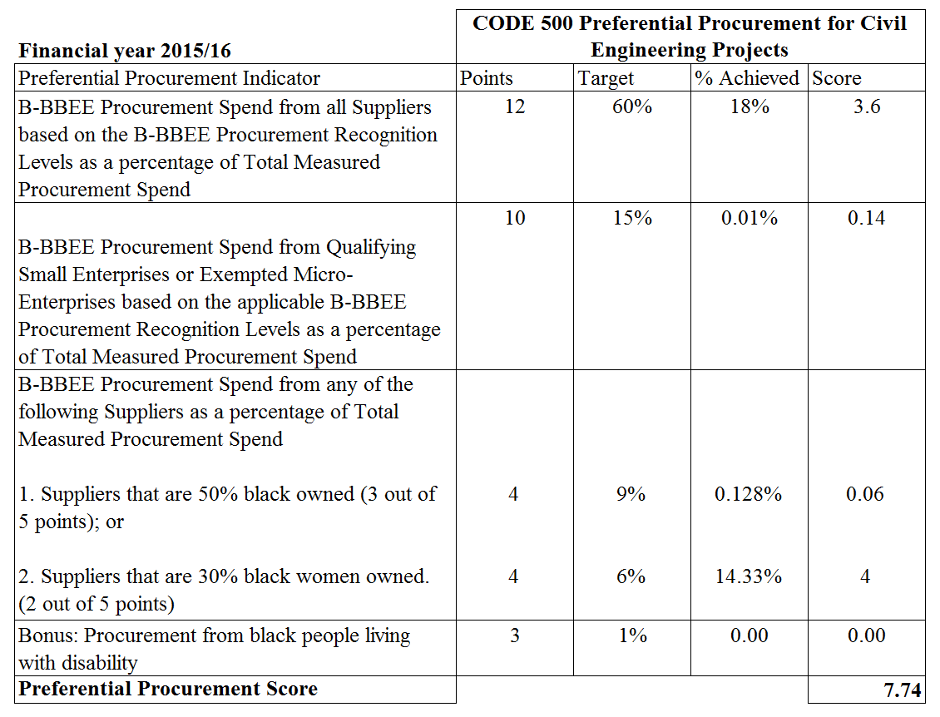
Table 23 Overall preferential procurement Score for 2015/16, Source: Author
Thirty three (33) points were allocated towards preferential procurement and the overall score that was calculated for preferential procurement for Civil Engineering Projects was 7.74 points. This calculation demonstrated that civil engineering project contra that were awarded in financial year 2013/14 were only 30.90% compliant to the preferential procurement requirements.

Summary of results
The table below depicts the overall comparison of the financial years of interest.
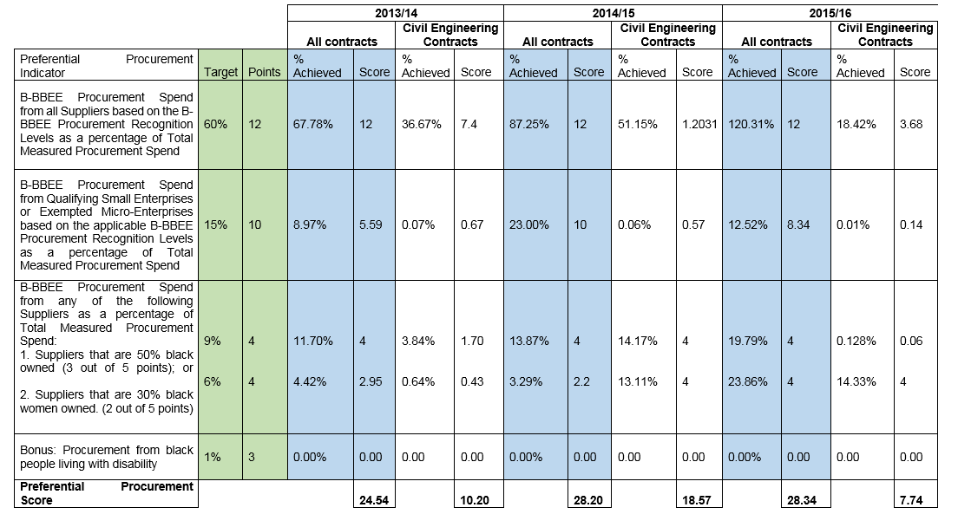
Table 24 Summary table, Source: Author 2017

Preferential procurement comparison
The graph below plots the preferential procurement percentages of the Organization and the percentage of contribution towards civil contracts. 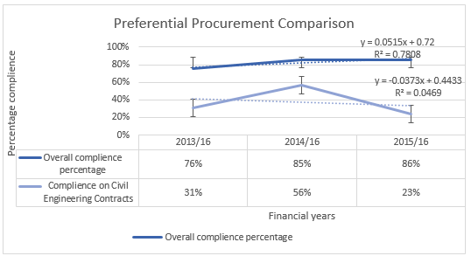
2014/15
2013/14
2013/14
Graph 2 Preferential procurement comparison, Source: Author

The analytical data in Graph 2 indicates that there was an increase in the overall preferential procurement for TCP, which is at positive mean slope of 0.0515 indicating that the relationship between the 3 points in relation to all contracts is positive an and was increasing. The linear relationship illustrates the regression line on the 3 points within the 3 financial years, indicating that there is a 78% definition, whereas the 22% is the uncertain of the performance of the preferential procurement. The average percentage over the 3 financial years of interest was calculated to be 37% which is below the acceptable target of 50%.

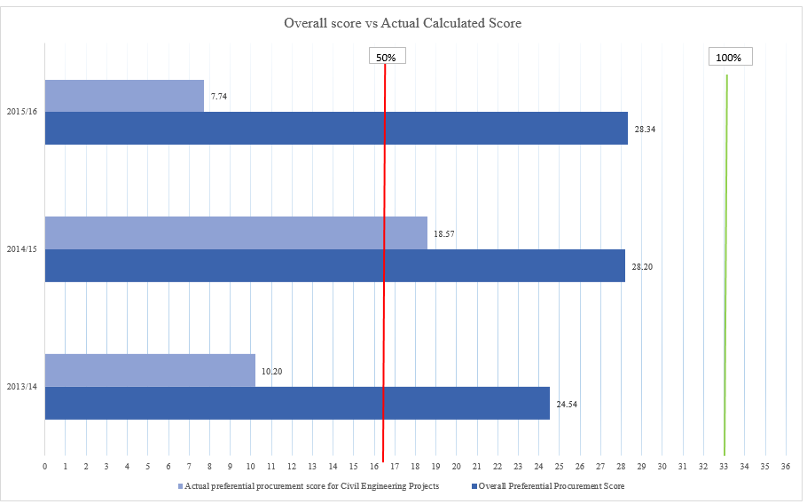
Graph 3 Comparisons of compliance to targets, Source: Author

The target score for the preferential procurement is at least a 50% compliance score, therefore, Graph 3 above illustrates the targets achieved by the overall contracts achieve the targets, however, other than in the 2014/15 financial year, the civil engineering contracts compared to the target scores and the total points that could be achieved.

Commentary on quantitative analysis

Transnet’s BEE results

The data reported in the annual reports indicates that Transnet has been improving with regards to the BBBEE scoring over the past 8 years. A cumulative increase of 11.9% has been calculated over the 8 years between 2008 and 2016. Transnet also improved from a Level 3 contributor to a level 2, which indicates that the organisation has improved its contribution towards the BEE elements. With this knowledge, it can be inferred that the preferential procurement score has also increased as it is an element which contributes towards the overall BBBEE contribution with a weight of 20%.

Transnet Capital Project’s results

The BEE scores for TCP indicate that there has been an improvement in the overall scores in the 3 financial years of interest. The preferential procurement score for Transnet Capital Projects has increased over the 3 financial years of interest, as TCP migrated from being a Level 3 Contributor to being a Level 2. However, the data illustrated that the civil engineering scores, were not reaching the targets that are stipulated by the organisation. The maximum points that could be achieved for preferential procurement is 33 points, however the highest achieved calculated points in the civil engineering contracts over the 3 financial years was 18.57 in 2014/15, which is above the minimum required 50%, however there was other 2 financial years of interest were below target.

Financial year comparisons.

It is evident that there has been an increase in the BEE scoring in Transnet and also in Transnet Capital Projects. Figure 6 indicated that Transnet has had an 11.9% increase in BBBEE spend for past 8 years. The preferential procurement scores also increased as observed in the BEE ratings and the preferential procurement scores over the 3 years of interest. In relation to the Civil engineering contracts, there was a 25 % increase in the scoring between 2013/14 and 2014/15 and a 33% decrease between 2014/15 and 2015/16 was the changes in the BEE codes and the moratorium that was put in place after there was a change in management in the organisation. The business strategic objectives changed, resulting in projects being deferred or cancelled.
The enactment of the moratorium contributed towards in less infrastructure projects to be implemented and the organisation deployed most resources towards the operations and maintenance projects. The prioritization of projects to those of maintenance limited the amount of work that could be executed by TCP. As a result, only 76 payments were made towards civil engineering contracts in the 2015/16 financial year. Through further analysis of the payment made, the 76 payments were made to only 12 organisations that were executing civil engineering contracts for TCP.

TCP and civil engineering contract comparison

The grounds of comparison for the overall contracts and the civil engineering contracts were that the data used is from the same source. It was expected that the trends that was displayed by the civil engineering contracts would be similar to the overall contracts since the civil engineering data was extracted from the overall contracts. However, the graphs that were plotted were different since the expected trend of both the civil engineering contracts and all active contracts to be similar. The dissimilarity of the graphs indicates that there is no direct relationship between the civil engineering contracts awarded and the procurement activities that are conducted. This assumption was done with the knowledge that TCP’s core business is engineering and project management, therefore, all the supporting business functions which form part of the company overheads were expected to be a fraction of the overall civil engineering procurement spend. The gradients for both graphs respectively indicate that there is an increase in the preferential procurement and a decrease in the civil engineering contracts.

QUALITATIVE RESULTS
The following results were obtained from research questionnaire that was distributed to three Transnet Capital Projects resources in the Procurement and Supplier Development department. The resources were interviewed with the purpose of understating what the contribution towards the Civil engineering contracts was. The SME selection criteria and profiles were detailed in section 3.2.2.
The following themes emerged from the interviews with the SME’s:

6.1. Data validity and accuracy
The data analysed was said to be an accurate scoring for the civil engineering because the data used is also verified in the Primavera Contract Reporting software and SAP software. Another check to see whether the data is accurate was a check on Transnet’s Annual report slide Figure 4, which has the B-BBEE percentage spend, a similar trend seen on the graph and the calculated results. TCP is a subsidiary to Transnet and the results calculated by this research are a small sample size of Transnet as an organisation, therefor if the trend observed for the civil engineering contracts is the same as that of Transnet overall B-BBEE annual results over the 3 financial years of interest.

6.2 Monitoring and controlling techniques
RAMIS is the only tool used to monitor and control the BBBEE status, the software is used to trigger the expiry of the BEE certificates. RAMIS tool is used to ensure that the organisations that are doing business with Transnet still have valid BEE certificates. The other method of monitoring and controlling of the BEE compliance is by conducting project audits, which is only done for projects that are above the value of R 2 million. The shortfall with the monitoring and controlling is that the subcontractor’s information is never reported on and most of the emerging engineering organisations with the required BEE scoring would be recognised and also qualify and contracts below R 2 million do not get audited with the same parameters as the high value contracts.

6.3 Contributing factors
The factors contributing towards the low scores in civil engineering contracts as alluded by the SME’s are listed below. The contributing factors were organised into two order themes to better understand the results obtained from the interviews. The first order theme of analysis the root cause of the factors contributing towards the low scoring in civil engineering contracts in relation to preferential procurement. The second order analyses whether TCP is responsible for the low scores contributing factors or not.

No. | Contributing factor | First Order: Source of contributing factor | Row Labels
1 | The area a limited number of civil engineering construction service providers that are above Level 3 contributors, thus resulting in most high value contracts being awarded to large organizations. | Limit to exposure  Adherance to legislature | External
2 | The changes in the BEE codes in March 2015 cause of the drop in the scores after the 2014/15 financial year is contributed to the changes in the codes that was implemented in 2015, the changes result in downgrading of the BEE ratings of organizations. | Changes in legislation  Governance  Policy review | External
3 | Most civil engineering contracts that are undertaken by Transnet Capital Projects are rail projects which is a specialized skill and there are limited rail construction organizations in South Africa. | Specialized skills  Barrier to entry | Internal
4 | Lack of interest in business registration for organizations due to the perception that the business registration process is stringent and tax requirements will take money out of their businesses. | Legislation  Governance | External
5 | Transnet has a subsidiary in Transnet Freight Rail known as Rehabilitation Maintenance and Emergencies (RME) that is contracted for most rail related engineering contracts | Specialized skills  Barrier to entry | Internal
6 | Construction Industry Development Board (CIDB) has stringent rules for new entrants into the construction discipline, this causes a barrier to entry. | Legislature  Barrier to entry | External
7 | Parcelling projects such that work packages are of high value, thus disqualifying the small organizations from doing mega projects as small organizations do not have the resources to undertake the large projects. | Barrier to entry | Internal
8 | Multinational organizations procuring small BEE fully compliant organizations to improve their BBBEE scores and never transfer the skills to the small organizations that they bought. | Legislature manipulation | External
9 | The lack of understanding of the New Engineering Contracts methodology that is used by Transnet for awarded | Barrier to entry  Contracting strategy | External
10 | The stringent technical pre-qualification requirements for all tenders regardless of the project value and complexity. The pre-qualification criteria is score card is standard and the changes are only made on the weighting. This limits EME’S and QSE’s interest in applying work as most do not meet the qualification criteria and do not understand the requirements. | Contracting straegy  Barrier to entry | Internal
11 | Transnet having framework agreements lists with reputable organizations. These agreement was implemented in 2011 and came to an end in July 2016. This list promoted that organizations that were registered in that list as the organization had done business with them before. This limited the | Barreir to entry | Internal
12 | The lengthy contracting periods for all contracts leading to appointing just one service provider over a long period of time. | Contracting strategy  Barrier to entry | Internal
13 | Transnet does not have influence with regards to the sub-contractor that the main contractors appoint, the only influence is in the approval of the sub-contracts that work on the sites. This promotes that the main contractors keep contracting with their preferred service providers and not the emerging sub-contractors. | Contracting strategy  Adherence to legislation | Internal
14 | Limiting the Subcontracting of work to 25% of the total project value. | Contracting strategy  Adherence to legislation | Internal
15 | Short tendering dutrations, thus limiting the QME's and EME's to form coalitions or joint ventures to then qualify to tender for contracts | Barreir to entry | Internal

6.4 Commentary on qualitative analysis
Table 26 indicated that of the 15 contributing factors, 9 were as a result of TCP’S doing and the other 6 were external to the organisation. With this knowledge, initiatives can be developed to improve upon the preferential procurement scores focusing on the whether the issue causing the low scores are external and internal. The proposed initiatives in the section 8 of this research should aid in increasing the preferential procurement scoring. Barrier to entry was the prevailing issue that contributed to the low scoring in the preferential procurement. This is an issue that TCP could resolve alongside the legislating bodies to assist in the increasing the scoring in the civil engineering discipline.

DISCUSSION
This chapter interprets the results that were obtained from the qualitative and quantitative results. Inferences will be drawn from the results to understand whether preferential procurement in civil engineering contracts is effective.

Key Research findings

The key findings of this research was that Transnet Capital Projects is achieved the specified targets of achieving above 50% in the preferential procurement score. This is observed in the overall organisation’s BBBEE verified scores. The scoring however is not achieved in the civil engineering contracts as the calculated scores. The results for the civil engineering contracts were however not compliant to the score card targets. Therefore by not meeting the targets, the civil engineering contracts are not effectively contributing towards the preferential procurement targets. This is confirmed by (Brynard & Majoro , 2010) that the tracking during the execution of the projects is important to ensure that all issues in the project are caught in time and rectified, therefore ensuring a high project success rates .
There was no representation of the disabled individuals, this could be due to lack of exposure to engineering competencies taught to the disabled individuals. These results indicate that the objectives of (Shakespeare & Officer, 2011), are not being met since there is a 0% contribution to preferential procurement in relation to people living with disabilities in both the civil engineering contracts and overall contracts that were undertaken during the periods of interest.

Literature comparisons

Studies that have been done indicate that there are challenges in government institutions to with regards to procurement activities. (Ambe & Badenhorst-Weiss, 2012) Mentioned that, “implementation in many government entities is far from satisfactory”. Thought the results achieved by Transnet and Transnet Capital Projects are exceptional with regards to all the procurement activities and also complying with the BEE requirements, the civil engineering contributions were calculated to be below the 50% minimum target.

Evaluation criteria

As alluded by the qualitative results, the barriers of entry in the built environment fraternity discourages the eager participants who want to peruse business in the construction industry. The barriers are due to the pre-qualifying evaluation criteria for the tenders that require but is not limited to:
- Company previous experience & completion certificates
- Work method statements
- Health & safety requirements
- Quality requirements
- CV’s of key personnel.

For a small to medium organizations, the pre-qualifying criteria requirements become a barrier to entry as the organizations do not have the minimum requirements and resources to meet the minimum requirements. Transnet as the client does uses the evaluation criteria to sieve through the prospective contractors, hence ensuring quality of the final product and minimizing risks, however this disqualifies most SMME’s. Through desperation of wanting to conduct business and generate income, fronting becomes an option when presented to the SMME’s.

Fronting
Listed as one of the contributing factors in 6.2 was the manipulation of the legislature, where the multinational or large South African organizations absorb SMME’s into their business to improve their BEE scores to qualify to tender for projects. This is only successful if the SMME’s get the experience, exposure and financial benefits that are agreed upon at the merging of the businesses. This has however been seen as complete failure and the SMME’s declare bankruptcy. (Bowen , Akintove, Pearl, & Edwards, 2007) listed fraud, dishonesty and unfair practices as problems that are encountered in the construction industry.

Gap analysis

A gap identified by this research was that there is a variance in the calculated scores compared to the overall contracts. The trend for the civil engineering contracts was expected to be similar to that of the overall contracts as the information extracted for the civil engineering contracts was obtained from the overall active contracts. The variance in the spacing between the two plots on Graph 2, Section 5.7 was expected as the sample sizes were different. However, the trend that the graphs plotted was expected to be similar as the civil engineering contract data was extracted from the master database.

The objective of this research was to understand the contributions made by the civil engineering contracts towards the preferential procurement as a BBBEE indicator. The rationale was to ascertain the civil engineering contribution in isolation to all the other procurement activities as the main TCP objective is to deliver infrastructure projects reliably. This research has proven that amongst many procurement activities, civil engineering contracts. Through the analysis done both quantitatively and qualitatively, in summary, the following can be said:
- The information calculated indicated that an average contribution civil engineering contracts towards preferential was 37% was over the 3 financial years of interest, whereas the minimum target is 50% made by the procurement was below the 50% target
- 60% contributing factors was due to internal activities at TCP. Therefore, improvements implemented by TCP could improve on the current scoring in the civil engineering contracts that are currently awarded and future project.
It can be said that the research objectives were met as the contribution of the civil engineering contracts towards preferential procurement were calculate, indicating the required targets were not being met and the model development is further discussed in Section 8.3 of this report.

Research summary
The results of the qualitative and quantitative analysis of this research have proven that in civil engineering construction projects, the preferential procurement element of BBBEE is not effective. This statement is justified by the following:
The question posed by this research was,” What is the effectiveness of preferential procurement in Civil Engineering Construction Projects in the Transnet Capital Project division?” and the data analysed by this research indicated that the average percentage over the 3 financial years for the civil engineering contracts was 37%. Therefore, the civil engineering contracts awarded during the 3 financial years on average were not compliment to the preferential procurement target score of 50% and above to be compliant. The recommendation listed in this section were made after the qualitative and quantitative results indicated that the contribution towards preferential procurement by the civil engineering contracts was below the recommended minimum target, therefore proving to be ineffective. Though preferential procurement is one of the 5 elements of the BEE codes, the focus on improving preferential procurement score would increase benefit the historically disadvantaged businesses that are and want to participate in activities in the construction industry.
The general perception, as defined by (Magoro & Brynard, 2010) was that government entities as the client are only concerned with project completion and not how the completion is achieved. Therefore the involvement of Transnet has been identified as a shortfall by both the quantitative and qualitative results obtained by this research. Table 23 of the contributing factors have illustrated that two thirds of the issues that contribute towards the low scores in preferential procurement are issues that Transnet can address and rectify to ensure compliance.
In comparison with the international practices with relation to preferential procurement, South Africa has recently imposed a preferential procurement regulation Act that ensures that contracts from the value of R30 million contribute at least 30% of their total spend towards preferential procurement to increase economic transformation. The changes in the Act will increase the total procurement spend allocation towards historically disadvantaged, women and disabled. However, the investor confidence in South Africa is declining due to political climate and the downgrading of the country by 3 rating agencies to a negative outlook (M&G, 2017).

Recommendations
This section offers recommendations of initiatives that could be implemented to increase the preferential procurement scores contributed by the civil engineering contracts.

Internal initiatives

This research has recommended the following initiatives to be implemented as possible solutions towards improving, managing and controlling preferential procurement in the civil engineering contracts and also the overall preferential procurement scores. These recommendations were as a result of the contributing factors listed in section 6.3 to assist in improving the status quo in the preferential procurement. Through these initiatives, the trend displayed by the overall Transnet contracts and the civil engineering contracts would be expected to be similar as the civil engineering contracts are the selected sample size to the overall contracts. The internal initiatives promote the alignment of TCP and the contractors towards achieving the preferential procurement desired targets.
The internal initiatives recommended by this research are those that Transnet Capital Projects can implement internally to ensure that there is an increase in the contribution that is made in the preferential procurement scoring in the civil engineering contracts.

Closely monitor service providers
The assessment done by (Brynard & Majoro , 2010) indicated absence of regular progress reporting results in project failure. As a result, the desired objectives of achieving the targeted preferential procurement scores could be jeopardized. Therefore, the initiative of closely monitoring the contractors can be done at an individual project level. Monitoring the performance of the service providers will enable the organization to track the performance compliance in the contracts that are awarded. The targets that the service provider had set at the tendering and contracting stages will be monitored by the project manager to ensuring that the service provider is performing. This initiative would assist both Transnet and the service providers to monitor the service provider’s performance with regards to preferential procurement and implement remedial actions immediately instead of at the end of the contract. As a result of not tracking the preferential procurement activities, (Ambe & Badenhorst-Weiss, 2012) explained that deviations and noncompliance goes undetected or is identified after the fact.

Parceling of work
This initiative can be implemented such that a major project is broken up into smaller packages so that EME’s and QSE’s can also qualify to do some of the work required for that package. The reduction of major scope into smaller packages will require more resources to be allocated to the complete projects from TCP’s capacity, however the reduction of scope will encourage inclusion of organization’s that could not participate in the mega projects. The parceling of work can also be done such that the mega projects get awarded to big reputable service providers who will be obliged to sub-contract to smaller service providers. The parceling of work into smaller packages will improve technical and business skills to be transferred to the small sized service provider.

Contractual obligations
To form part of all contractual agreements, the large and reputable organization should be compelled to create tendering opportunities for smaller organizations. Acknowledgement of the requirement during the tendering stage and also implementing the contractual obligation of subcontracting would increase the probability of SME’s and QSE’s to build their business profiles and qualify participate in high values contracts. Currently, the New Engineering Contracts (NEC) limits the subcontracting of work by the main contractor to 25%, by increasing the subcontracting percentage, SME’s and QSE’s could participate in commercial activities. The SME’s and QSE’s would be required to tender for the subcontracting work to familiarize themselves with the tendering processes and tender deliverables. Execution schedules are to be considered when enforcing the contractual obligations to the main contractors as subcontracting would take up more time as the subcontracting would be conducted in the same manner at which the formal tendering process is conducted, also using SME’s and QSE’s that are at the database initiative as detailed in 8.2.3.

Tendering process durations
The scheduling of tenders are usually have a short return periods. This limits the prospective tenderers to form partnerships or find suitable subcontractors that will execute the work. The adverts are time driven and tenderers are usually not given enough time to form new coalitions with subcontractors that they have not worked with previously, therefore, main contractors tend to repeatedly use service providers that they have done prior business with. Transnet should also consider adding the database information that is referred to in section 6.2.3 to the tender document pack so as to ensure that the small businesses that are registered can be approached instead of the service providers searching for businesses that are eligible for subcontracting.

Enforce penalties
The organization should enforce penalties towards service providers that are not compliant to the preferential procurement targets that were stipulated at the tender award. The penalties should be established at tender award and communicated with the service provider. Therefore, whenever the service provider defaults in their commitments, after monitoring and implementing remedial actions as referred to in section 6.1.2 would be implemented, penalties would be enforced. A demerit exercise could be implemented in the database as referred to in section 6.2.3 where the service provider’s appraisals could be revoked for a particular duration until the service provider improves.

Process mapping
As an initiative to increase the BEE scoring of Civil engineering contracts, a question of whether process maps would improve the scoring, the subject matter experts advised that the focus of this report is only on Civil engineering and had the scope been the whole of Transnet. Developing process maps customized for the civil engineering contracts would result in the destabilization of the current processes that are currently being implemented by TCP. At a broad organizational scale, the process mapping could be implemented. Therefore for the purposes of this research, process mapping as a recommendation was excluded from the model development.

External initiatives

The external initiatives recommended by this research are those that Transnet Capital Projects needs to merge with external organization or stakeholders to empower suppliers. The following external initiatives can be implemented:

Corporate Social Responsibility (CSR) program
Corporate social investments are the initiatives that organizations deploy to empower communities. The corporate social responsibility programs form part of the initiatives that could be developed to ensure that inclusion of small civil engineering contracts. The initiative of SCR programs throughout the organization, the emphasis should be made that the local community businesses should participate in the construction of the programs. Through the initiatives, the community businesses would have to go through the tendering processes, and tender for the work that is required. The tendering process will be a practical exercise that the businesses can participate in to learn how to tender for project, as the small businesses are limited to informal tendering and contracting when conducting business. The benefits of this initiative would be to:
- increase the exposure that the small businesses have with regards to tendering processes;
- increase small business exposure to exposure and experience,
- improve the probability for the organization to conduct procurement activities as they will build their business profile as completed work the business has done
- empower communities.
The implementation of the initiative of CSR’s should form part of all the contracts that should be entered into to ensure that the community in which the projects are implemented benefit. This initiative is more practical as compared to the other initiatives where participants would be taught rather than given practical experience. Practical experience is also promoted by (Martin & Root, 2010), where most government initiatives use the instructivism framework rather than the practical framework.

Engineering Training at disability schools
It was observed that there was no representation of disabled individuals in the preferential procurement for both civil engineering contracts and TCP as an organization’s scores. To improve the scoring, Transnet could invest in Corporate Social Responsibility program to offer training programs for the disabled. The training will be limited to the engineering and business skills. This initiative will encourage the disabled individuals to participate in engineering business opportunities. After the training, organizations formed by the disabled individuals will be added a database that will increase the organization’s probability of participating in business activities.

Database registration
A database should be prepared for the disabled persons businesses should be kept by the National Treasury to be used by any organization that requires to empower the disabled. This initiative will ensure that there is a centralized portal where information can be sourced by other organizations that want to conduct business with the disabled community. This initiative will ensure that businesses do not have the excuse that they did not have access to businesses that are represented by disabled individuals. This initiative would ensure that when penalties are imposed to organizations such as Transnet who have been reporting a zero contribution to disabled will be penalized since the database is readily available for use.

Incentivizing organizations
Providence of incentives for organizations that are high achievers and in the preferential procurement activities will encourage others that are not compliant to achieve their targets. The incentives would encourage the service providers to achieve their targets with regards to the preferential procurement objectives. The incentives should be linked to the database registration as mentioned in section 6.2.3, where the businesses listed in the database would be rated and appraised by the organization’s that they have done work for, therefore the incentive would be that the more appraisals an sub-contractor receives, the higher the probability of more business.

Initiative analysis
Influences for the recommended initiatives in section 8.1 and 8.3 were analyzed on time and cost. In Table 24, the Likert scale was used to establish the relative time and cost values in the 1-10 range where 1 was low and 10 the most. The multiplication of cost and time values resulted in a relative value that was used to plot the Time- Cost analysis of the initiatives.


Table 24 Cost-time analysis

Graph 4 illustrates that most of the initiatives that were recommended by this report would be easy to implement because 7 of the 10 initiatives are within the ‘easy to implement region.

Graph 4 Time-cost analysis of initiatives
Threshold Region | Definition
0≤ Cost x Time ≤ 10 | Initiatives would be easy to implement, with acceptable cost and time implications.
10≤ Cost x Time ≤ 60 | There would be some level of complexity to execute the initiatives
60 ≤ Cost x Time ≤ 100 | Complex initiatives to implement which require lengthy durations and high costs.
Legend 1: Time Cost analysis

Model Development

The model was developed to assist the consolidation of the initiatives recommended in section 8.1 and 8.2 depending on the contractual issues. The developed model assist with the verification of the contract values that a contractor can tender for and the level of compliance post tender award. The aim of the model is to indicate the compliance levels of the contractors while motivating the contractors to perform better, so as to qualify for high value contracts in future.
The inputs to the model are: i) Oorganization BEE rating, ii) Project estimated value, iii) Project complexity and iv) Project risk profile. The combinations of the 4 elements result in a project qualification bracket that the organisation being investigated can tender for. The first sheet of the model is illustrated by Figure 8.
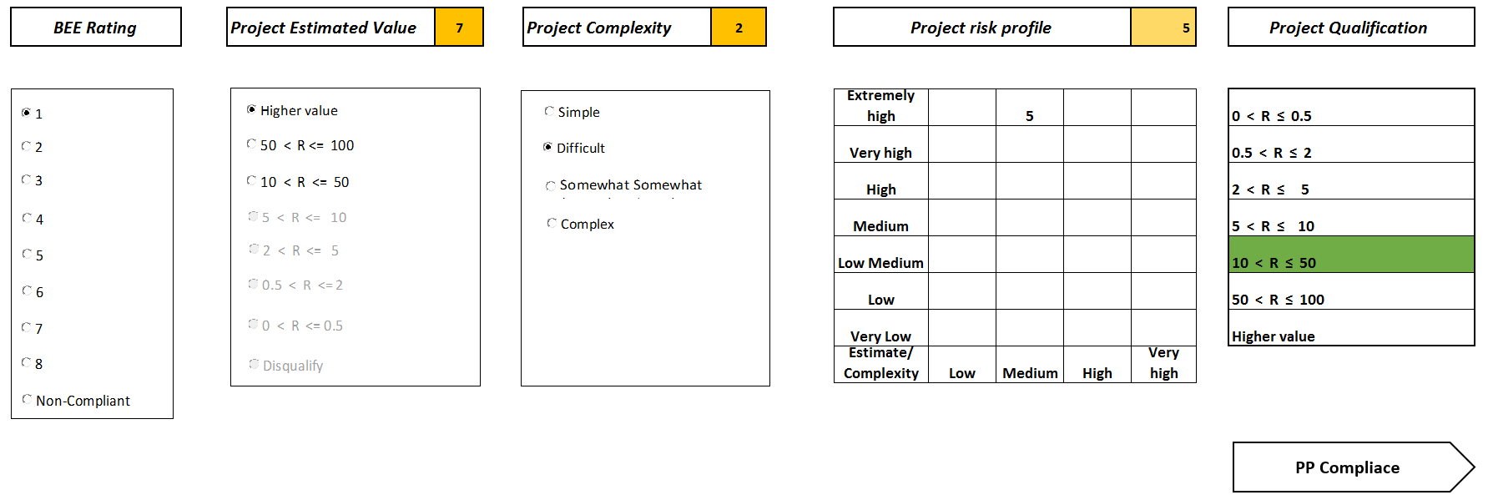
Figure 8 Project pre- qualification, Source: Author

With this information, the contractors can then know what tender values that they qualify to tender for, also considering the CIDB ratings. The contractor would then be expected to populate their current preferential procurement indicators so as to understand where the organisation is currently and on a quarterly basis after the project is awarded. The outcomes of the preferential procurement indicator is illustrated in Figure 9.

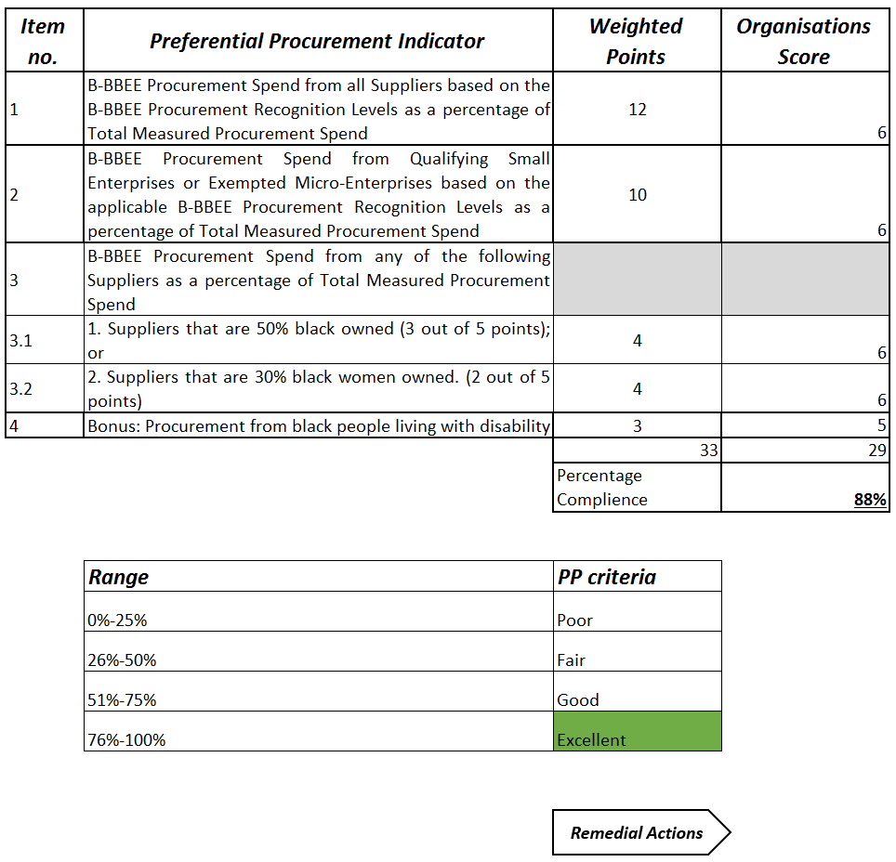
Figure 9 Preferential procurement score, Source: Author, 2017

Thereafter, the combined project pre-qualification and preferential procurement score will indicate the remedial actions that the contractors and TGC could employ to increase their preferential procurement scoring. The remedial actions would also change on a quarterly basis depending on the preferential procurement scoring of the contractors, as illustrated by Figure 10.

Figure 10 Model Output: Remedial actions, Source: Author, 2017

The final output of the model are the remedial actions that are to be implemented depending the status that the EME or QSE is in relation to preferential procurement.

The above are the recommendation that could be implemented by TCP to improve the preferential procurement scoring in the organisation.

Conclusions
The main objectives of Transnet Capital Projects is to deliver infrastructure projects reliably and the contamination of other contracts that are entered into. The main objective of this research was to calculate and understand the TCP contribution in the preferential procurement sphere. The results indicate that though the organization is achieving high compliance scores for all contracts, there is incongruity regards to the core business of executing engineering contracts.
This report indicates that the contribution that the organization makes toward civil engineering is minimal. With the implementation of the recommended initiatives, an improvement in the scoring and contribution towards civil engineering projects can be achieved. By implementing the recommendations, further analysis of the financial years after the implementation to observe the impacts that the initiatives have made on the preferential procurement scores.
Preferential procurement is a good starting point in improving the scoring amongst all the BEE codes as the preferential procurement weight is the highest amongst all five codes. Through improving the preferential procurement scores, all the other 5 codes are indirectly influenced, this increasing the inclusion of historically disadvantaged communities in business opportunities.
The recommendations listed as internal initiatives of this report should not limited to the civil engineering contracts, they can be rolled out for all engineering contracts that could be awarded since the recommendations are directed to internal processes. The implementation of the internal initiatives would result in the Transnet Capital Projects supplier development department being a more efficient and have standardized processes within the organization and also motivate contractor to improve.
This research only focused evaluating the effectiveness of the civil engineering contracts and not the other engineering disciplines that Transnet contracts on. Further to this study, the contribution of all engineering disciplines could be done so as to ascertain the preferential procurement contributions. Furthermore, a contribution be the state owned entities that participate in engineering activities should also be evaluated so as to understand the preferential procurement compliance in the engineering field.
The implementation of the BEE act in South Africa is more effective compared to the other Africa states being Kenya and Zimbabwe that were investigated in the literature. Transnet’s results affirm the statement that the preferential procurement and BEE scoring is more effective as the results for the overall scores have been increasing year by year. Though the results calculated by this research indicate a slow growth in the civil engineering fraternity in relation to preferential procurement, large organizations with low BEE scores qualify to tender due to their track record.
The expected results for conducting this research was that the contribution of civil engineering contracts would have a similar trend to the overall BEE score but a lower contribution since the civil engineering data was extracted from all the contracts from TCP. The justification of the decline in 2015/16 was due to the changes in legislation and reduced spending in Transnet. This is expected to improve because the changes in the Preferential Procurement Regulation effective in 2017 that stipulated that requires that 30% of the procurement spend for contracts above R 30 million should subcontract to entities that are historically disadvantaged, which are represented by the preferential procurement aspects of the BEE score card. The baton is with the parastatal organizations to actively implement the legislation and transform the augmented social standing of the historically disadvantaged individuals in South Africa.

Bibliography

Abor, J., & Quartey, P. (2010). Issues in SME development in Ghana and South Africa. International Journal of Finance and Economics, 215-228.
AECOM. (2009 ). Strategic Operations Review. Australia : Maunsell Australia.
Ambe, I. M., & Badenhorst-Weiss, J. A. (2012). Supply chain management challenges in the South African public sector. African Journal of Business Management, 11003-11014.
Ambe, I., & Badenhorst-Weiss, J. (2012). Procurement challenges in the South African public sector. Journal of Transport and Supply Chain Management, 242-261.
Black economic empowerment ownership initiatives: a Johannesburg Stock Exchange perspective . (2008). Development of Southern Africa, 25 No. 4.
Bolton, P. (2006). Government procurement as a policy tool in South Africa. Journal of public procurement , 6(3), 193-217.
Bowen , P., Akintove, A., Pearl, R., & Edwards, P. (2007). Ethical behavior in the South African construction industry . Construction Management and Economics, 631-648.
Brace , I. (2008). Questionaire design: How to plan, structure and write survey material for effective market research. Kogan Page Publishers .
Brynard , M. J., & Majoro , P. A. (2010). Difficulties associated with the implementation the preferential procurement policy in conjunction with a low-cost housing programme: a South African contextualisation. Unisa Press, 4-23.
Burke , J. R., & Onwuegbuzie, A. J. (2004). Mixed Methods research: Aresearch paradigm whose time has come . Educational researcher , 14-16.
Chimwani, B. I., Iravo, M. A., & Tirimba , O. I. (2014). Factors influencing procurement performance in the Kenyan public secotor : Case Study of teh state of law office. Innovative Space of Scientific Research Journals, 1626- 1650.
Creswell, J. W. (2013 ). Research design: Qualitative, Quantitative, amd mixed method approaches. Sage Plublications .
Deputy Chairman, L. D. (2017, June 27.06.2017). INDIGENISATION AND ECONOMIC EMPOWERMENT ACT. Retrieved from ldc@gta.gov.zw: http://www.eisourcebook.org/cms/January%202016/Zimbabwe%20Indigenisation%20and%20Economic%20Empowerment%20Act.pdf
DTI. (2003). Broad- Based Black Economic Empowerment Bill. Government Gazette, 27B, 3-9.
DTI. (2004). Broad-Based Black Economic Empowerment. Government gazette , 463(25899), 19 .
DTI. (2005). Department of Trade and Industry. Retrieved from www.thedti.gov.za: https://www.thedti.gov.za/economic_empowerment/docs/2nd_phase/Code500Statement500.pdf
DTI. (2016, March 17). Retrieved from www.dti.gov.za: http://www.dti.gov.za/gazzettes/39818.pdf
DTI. (2016, November 21). Retrieved from www.thedti.gov.za: https://www.thedti.gov.za/economic_empowerment/docs/2nd_phase/Code500Statement500.pdf
DTI. (2017, February 22). www.thedti.gov.za. Retrieved from www.thedti.gov.za: https://www.thedti.gov.za/economic_empowerment/docs/PPPFA%20Regulation.pdf
Education, D. o. (2005). Celebrating 50 years of the Freedom Chater . (ISBN 1- 77018-047-8).
Goldman , E., Rocholl, J., & So, J. (2013). Political conneted board of directors and the allocation of procurement contracts. Review of finance(17), 1617-1648.
Govender , J., & Watermeyer , R. (2000). Potential procurement strategies for construction industry development in the SADC region. Unpublished paper, Department of public works, Pretoria, 3.
Hoffman, E. (2008). A wolf in sheep clothing: Discrimination against the majority undermines equality, while continuing to benefit few under the guise of Black Econominc Empowerment. 36:87.
Hoffman, E. (n.d.). A wolf in sheep clothing: Discrimination against the majority undermines equality, while continuing to benefit few under the guise of Black Econominc Empowerment. 36:87.
Industry, D. o. (2017, January 18). Department of Trade and Industry . Retrieved from https://www.thedti.gov.za/economic_empowerment/bee_veri.jsp
Ishmail, L. (2013). the truth about Broad Based Black Economic empowerment in South Africa. International Financial Law Review , 0262-6969.
Jones , S. (2014). Public procurement in FTAs: The challenges for Malaysia. Institute for dempocracy and economic affairs, 1-13.
Kiama, G. (2014). Factors affecting implementation of public procurement act in SACCO societies in Kenya. International Journal of Academic Research in Business and Social Sciences, 169.
Lavaton, D., Ha, I., & Meyers , S. (2012 ). Affirmative action retrenchment in public procurement and contracting . Applied Economics Letters, 1857-1860.
M&G. (2017, June 12). Moody's downgrades SA's top five bank. Retrieved from mg.co.za: https://mg.co.za/article/2017-06-12-moodys-downgrades-sas-top-five-banks
Magoro , M. J., & Brynard, P. A. (2010). Difficulties associated with the implementation of preferential procurement policy in conjunction with a low-cost housing programme: South African contextualisation . Politeia, 4-23.
Manchidi, T. E., & Harmond , I. (2002). Targeted procurment in the Republic of South Africa- An independant assessment. Pretoria : Department of public works .
Martin , L., & Root, D. (2010). Emerging contractors in South Africa: Interactions and learnings . Journal of Engineering , Desugn and Technology , 64-79.
Merbratie, A. D., & Bedi , A. S. (2013). Foreign direct investment, black economic empowerment and labour productivity in South Africa. Journal of international trade and economic development, 22(1), 94-115.
Mfolo, Y. (2015 ). Anglo American. Retrieved July 22, 2016 , from http://www.angloamericankumba.com/media/press-releases/year-2015/16a-07-2015.aspx
Miss Dlamini. (2014). dsaje;gf (pp. 123-126). Johannesburg: jfeqgfiu;p.
Murby, L., & Gould, S. (2005). Effective Performance Management with the balanced scorecard. London: The Chartered Institute of Management Accountants.
Murray , M., & Dainty , A. (2013). Corporate social responsibility in the construction industry . Routledge.
Novack , R., & Simco , S. (1991). The industrial procurement process: A supply chain perspective . Journal of business logistics , 12(1), 145-167.
Radebe, J. (1997). White paper - Public Works towards the 21st Century .
Rob , D. (2013). Government Gazette. 580(36928).
Satorius , K., & Botha , G. (2008). Black economic empowerment ownership initiatives: a Johannesburg Stock Exchange perspective. Development Southern Aafrica, 25 No.4.
Shakespeare, T., & Officer, A. (2011). World report on disability. World Health organization, 17-18.
Smit, Y., & Watkins, J. (2012). A lietrature review of small and medium enterprises (SME) Rrisk practises in South Africa . African Journal of business management , 6324.
Transnet. (2010). Retrieved April 26.04.2016, 2016, from https://www.google.co.za/search?q=transnet+organisational+structure&safe=active&espv=2&biw=1706&bih=861&source=lnms&tbm=isch&sa=X&ved=0ahUKEwjSls6V56HMAhWmLMAKHXGwAUoQ_AUIBigB#imgrc=MS0gmjVydTJQ9M%3A
Vyas-Doorgapersad, S., & Kinoti, A. (2015). Gender-based Public Procurement. African Journal of Public Affairs, 96-109.
Warikandwa, T., & Osode, P. (2017). Regulating Against Business "Fronting" to Advance Black Economic Empowerment in Zimbabwe: Lessons from South Africa. PER: Potchefstroomse Elektroniese Regsblad, 1-43.

Appendices

Appendix 1 - Ethical Clearance Form B

Appendix 2 - Questionnaire

Appendix 3- Questionnaire Transcripts

Interview 1 – Head of Procurement (TCP)
Is the data above an accurate illustration of the BBBEE scoring in the Civil Engineering Contracts? Please explain your answer | If the data of from the Supplier development department, then the information is accurate since the Supplier Development Department is the custodians of the BEE reporting.
What could be the contributing factors to the low scores calculated in the Civil Engineering Contract? | There are a limited number of service providers in the civil engineering industry that qualify to be service providers to large entities.  CIDB ratings and the qualifying thresholds limit the entry of historically disadvantaged  Limitations due to experience to the  The civil engineering contracts that Transnet Capital Projects usually undertakes is specialised activities.
What could be the contributing factor to the scoring in 2014/15 compared to the other years? Explain. | Changes in the BEE legislature resulting in changes in the business BEE levels of recognition.  The cost cutting drive in the organization that led to less projects being executed.
What methods cold be employed to improve the BBBBEE scoring in the Civil Engineering Contracts? Why would your recommendations be appropriate? | Introduce training or incubation programs dedicated to women and disabled entities as they are the least represented as displayed by the data.  Monitor the individual BEE elements instead of being pleased with a service provider for having a high overall BEE score.
What quality monitoring tools are used and could be used to monitor preferential procurement pre and post contract award? Why? | Audits conducted by the supplier development resources, of which not all projects get audited. When projects are not audited, TCP relies on the information supplied by the contractors.
Would a use of process maps be a useful tool for ensuring compliance to the preferential procurement targets? Yes/No – Why? | Compliance to the preferential procurement targets is not a matter that can be solved by process maps. The recommended process maps could be one of many tools that could be used to track the performance of contractors.

Interview 2- Transnet national supplier development manager
Is the data above an accurate illustration of the BBBEE scoring in the Civil Engineering Contracts? Please explain your answer | The information that is reported by the Supplier development department is validated using SAP and primavera contracts, therefor the information used is the accurate. The information is accurate and the official information used for BEE verification.
What could be the contributing factors to the low scores calculated in the Civil Engineering Contract? | The changes in the BEE codes caused a change in the scoring allocated to the organisations. Organisations that Transnet wait until the last minute to update their BEE certificate or the certificate lapses before the organisation updates the information.
What could be the contributing factor to the scoring in 2014/15 compared to the other years? Explain. | The changes in the BEE codes and the expiry of the certificates could be the contributing factors to the decline in the preferential procurement scores in 2014/15.
What methods cold be employed to improve the BBBBEE scoring in the Civil Engineering Contracts? Why would your recommendations be appropriate? | To engage the contractors that have long contracts with Transnet to  To develop a BEE improvement plan, not just looking at the preferential procurement portion of the plan, to ensure that all aspects of the BEE score card are compliant.
What quality monitoring tools are used and could be used to monitor preferential procurement pre and post contract award? Why? | There is no tool that is used to monitor and control preferential procurement, the information that is populated and provided by the contractors is used to monitor the preferential procurement compliance.  Audit are conducted findings
Would a use of process maps be a useful tool for ensuring compliance to the preferential procurement targets? Yes/No – Why? | Yes, however the issues are not only internal Transnet contributions that result in the low scores, the civil engineering industry is also responsible. Therefore, to some extent the process maps could be useful for Transnet internal standardization.

Interview 3- Procurement executive
Is the data above an accurate illustration of the BBBEE scoring in the Civil Engineering Contracts? Please explain your answer | The data is verified with the supplier development department, therefore the information used to conduct the research is valid.
What could be the contributing factors to the low scores calculated in the Civil Engineering Contract? | Awarding large contracts to reputable companies as a result, SMME’s do not participate in procurement activities.  There has been a decline I the number of contracts being awarded, due to the prioritization of maintenance projects which are done by RME.  The contracts awarded to RME are not closely monitored with regards to BEE compliance since it is work being done by TCP’s brother company.
What could be the contributing factor to the scoring in 2014/15 compared to the other years? Explain. | Reduced number of contracts awarded due to the cost saving drive that took place.  There is a difficulty of entry of the small to medium contractors into the Transnet data base due to the stringent pre-qualifying requirements and the EME’s and QSE;s do not qualify to tender.
What methods cold be employed to improve the BBBBEE scoring in the Civil Engineering Contracts? Why would your recommendations be appropriate? | Going to the construction communities and teaching them and role play applying for a tender because teaching people how to complete tender documents is not enough.
What quality monitoring tools are used and could be used to monitor preferential procurement pre and post contract award? Why? | Closely monitoring of the projects with regard to the BEE compliance.  Development of a model to track and monitor the preferential procurement compliance pre and post tender award.
Would a use of process maps be a useful tool for ensuring compliance to the preferential procurement targets? Yes/No – Why? | No, process maps can be one of the tools used to measure preferential procurement, however the tool will only be focusing on the internal issues of Transnet in isolation excluding the factors contributed by the contracts.  The best solution for this research could be to look at tools that could be implemented internally and also externally

Appendix 4- TCP BEE Annual Report- Preferential Procurement

Financial year 2013/14

Financial year 2014/15

Financial year 2015/16

