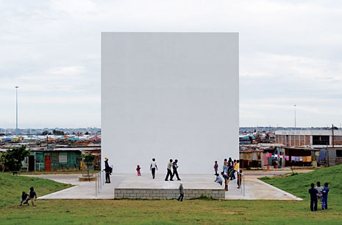

Architecture from the frontline

In the slums of Port Elizabeth, South Africa, a museum in memory of the struggle against apartheid stands as an act of faith in a different future. Design Noero Wolff Architects. Text Hannah Le Roux. Photos David Southwood, Rob Duker.
Architecture
- Published
31 July 2008
- Sections
Architecture
- Keywords
Art Spaces, Human Rights
  - 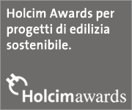
The photographs of Noero Wolff’s Red Location Museum suggest a post-traumatic state: all debris, dust and raw material, roaming children, and a tight, almost tense order that holds it all together. The building has striking composure, but it is the gritty setting that locates it in a compelling narrative. Noero Wolff won the commission in an open competition in 1998. The brief envisaged a museum and craft centre to celebrate South Africa’s history of struggle at its heart, in Red Location, an old township that had shown strong resistance to apartheid. The post-apartheid government developed such sites as a policy of representation: unable to bring immediate wealth to their vast numbers of impoverished supporters, it invested in symbolic projects for museums and parks that could bring the subsequent benefits of tourism.
Noero Wolff’s museum should be seen as architecture in waiting. The museum was conceived as a catalyst for the development of its surroundings, and projects aimed at the township’s users have already unfolded on its fringes, such as experimental housing and an outdoor cinema. The end goal is to create a town centre around the museum, including civic and commercial buildings. But as it stands, with local community life largely unchanged, the building’s sophisticated function and large scale seem at odds with its desperately needy context.
The now stunning interior also invites reoccupation. The architects envisaged it as the repository for an array of memory boxes, linked in scale and material to the houses of the location. It is a container of containers to hold the ephemeral stuff of memory that other authors will bring in, either the artists of the installations or those who view and imagine the lives of others.
The terms of engagement reflect a hypersensitivity to the politicised nature of architecture. Since the 1980s, Jo Noero has worked between private and community projects, and has said that his ambition is to work between their respective architectural languages – the beautiful but useless, and the ugly but useful. Within apartheid South Africa, these divisions translated into white and black space. Noero was one of only a handful of architects who worked in the zone between communities. His background is reflected in the duality of his practice’s concerns. Their work is both poetic, expressing meaning through images from memory, and pragmatic, responding to the most basic needs for urban infrastructure.
Noero spoke of the need in his work to find sanity in the madness of apartheid’s divisive legacy, by making spaces and forms that mediate between extreme conditions. Geometry became a stabilising order; at Red Location, an underlying grid links the township to the museum space, and extends to the serene proportions of the facade elements. The museum’s materiality is also familiar, evoking images of the nearby factory sheds, the rusted corrugated metal of the houses, the timber piling, concrete screeds and packing crates from the port.
The portico at the entrance to the museum is the most intense moment of transference within the complex whole of the work and its surroundings. The interior column grid continues outwards but shifts from concrete to raw timber poles, evoking the language of the seashore. Outside is a turbulent world, exposed and unpredictable. The portico creates porosity between inside and outside in the most material way, allowing shelter, informal events and public art to happen between the museum and the community. Making something of the philosophy of Andreas Huyssen and the activism of John Turner, this space proposes a meaning for architecture as an act of opening towards its outside, the unfinished and the undone.
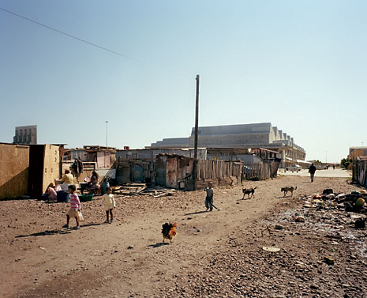
View towards the Entrance. Photo David Southwood
The South corner
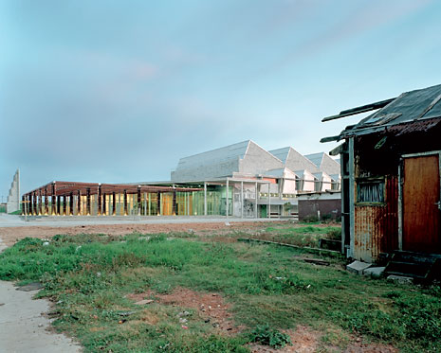
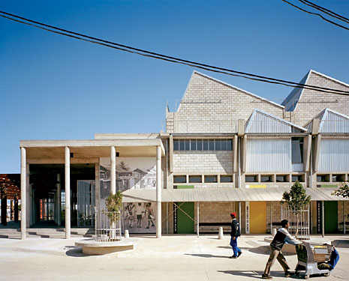
East elevation of the Museum
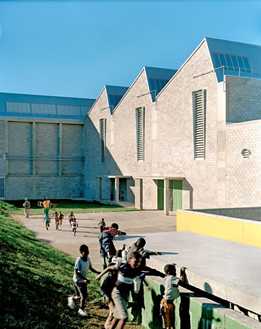
Detail of the West facade
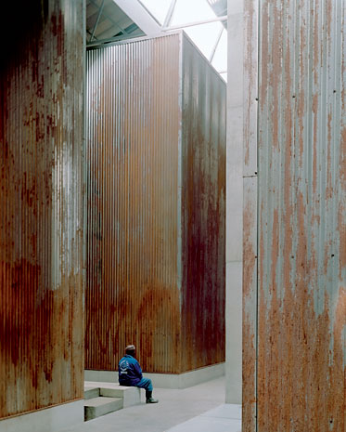
The "memory box". Photo David Southwood
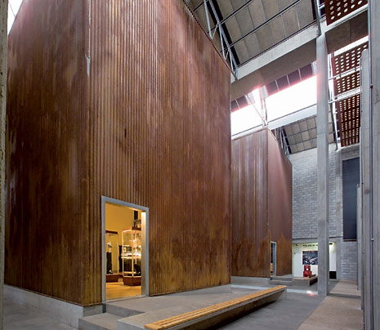
The "memory box". Photo Rob Duker
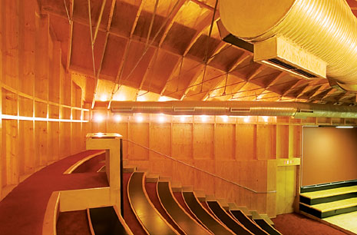
The auditorium
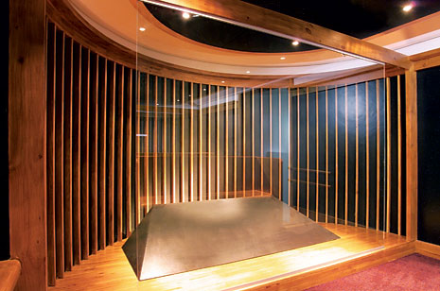
The “Memorial space”
- Sections
Architecture
- Keywords
Art Spaces, Human Rights
- Network
  - Like on FacebookShare on TwitterPin to Pinterest

Your comments

<div> <img src="http://edidomus01.webtrekk.net/778835614863159/wt.pl?p=321,0" height="1" width="1" alt=""/> </div> <div><img src="//secure-it.imrworldwide.com/cgi-bin/m?ci=Domus-it&cg=0" style="display:none" alt=""/></div>

