Critical evaluation of the chemical composition of acid mine drainage for the development of statistical correlations linking electrical conductivity with acid mine drainage concentrations

SUPPLIMENTARY MATERIAL
APPENDIX A
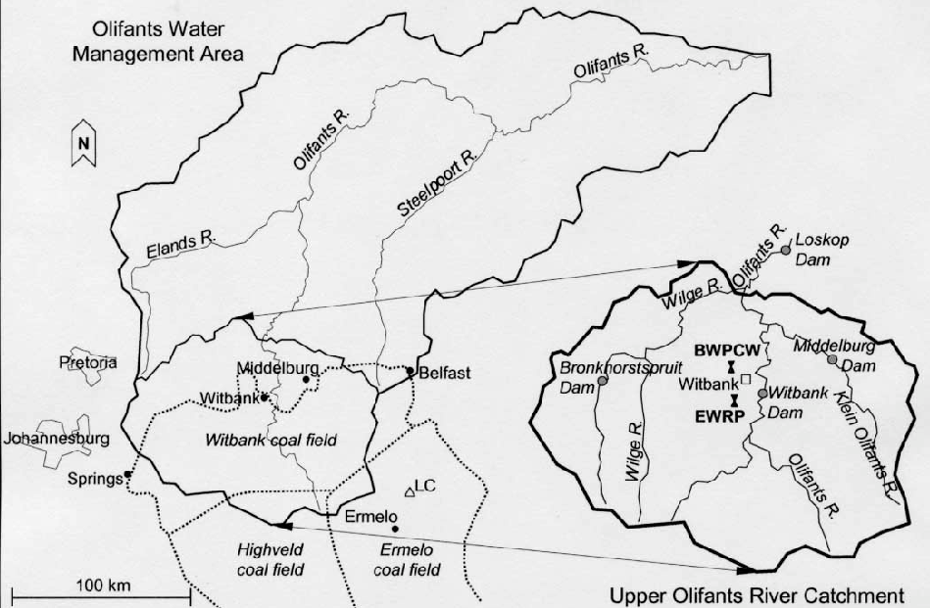
Figure A1. Olifants River management and catchment area (Hobbs et al., 2008)

APPENDIX B – CHEMICAL AND PHYSICAL DATA
Table B.1. Chemical and physical data

Table B.2. Chemical, physical and Dissolved metals data

Table B.3. Dissolved metals data

Table B.4. Dissolved metals data

Table B.5. Dissolved metals data

Table B.6. Dissolved metals data

Table B.7. Dissolved metals data

Table B.8. Dissolved metals data

Table B.9. Dissolved metals data and cation/anion balance

APPENDIX C – Analytical Data
Table C.1. Legislative limits and concentration ranges for physical and dissolved chemical parameters for acid mine drainage Sites 1 and 2
Parameter | Maximum Concentration Level/ Recommended Level | Legislative/Advisory Source | Site 1  Concentration/valuerange | Site 2  Concentration/value range
pH | ≥ 5 to ≤ 8.5 | SANS 241– 1:2015 | < 3 for all samples | < 3 for all 2018 samples  April 2019 – pH 7
Total acidity (TA)  (mg/L as CaCO₃) | Not classified | Not classified | 5760 – 12 550 | 2018: 1260 – 3673  April 2019 – total alkalinity 304
Electrical Conductivity (EC) (mS/m) | ≤ 170 | SANS 241– 1:2015 | 2335 – 3 990 | 727 – 1935
Total Dissolved Solids @ 180 ˚C (TDS)  (mg/L) | ≤ 1 200 | SANS 241– 1:2015 | 12 015 – 26 635 | 4525 – 10 700
Turbidity (NTU) | ≤ 1 (Operational)  ≤ 5 (Aesthetic) | SANS 241– 1:2015 | 3 – 413 | 20 – 408
Sulfur (S) /  Sulfate$({SO}_{4}^{2-})$  (mg/L) | ≤ 500 as${SO}_{4}^{2-}$  (Acute health)  ≤ 167 as S  (Aesthetic)  ≤ 250 as ${SO}_{4}^{2-}$ ≤ 83 as S | SANS 241– 1:2015 | (S): 2350 – 6845  converted to  (${SO}_{4}^{2-}):$7050 – 20 535 | (S): 824 – 2135  converted to  ${(SO}_{4}^{2-}$) 2472 – 6405

Table C.2. Legislative limits and concentration ranges for dissolved chemical parameters for acid mine drainage Sites 1 and 2 continued
Parameter | Maximum Concentration Level/ Recommended Level | Legislative/Advisory Source | Site 1  Concentration/valuerange | Site 2  Concentration/value range
Aluminium (Al)  (mg/L) | ≤ 0.3 | SANS 241– 1:2015 | 191 – 518 | 2018: 126 – 230  April 2019 – 0.04
Boron (B)  (mg/L) | ≤ 2.4 | SANS 241– 1:2015 | Three samples reported 2.5  Where analysed, remaining samples, within limits | All samples, within limits
Beryllium as (Be)  (mg/L) | 0.004 | EPA – 2018 MCL | 0.04 – 0.11 | 2018: 0.02 – 0.07  April 2019 – <0.001
Calcium (Ca)  (mg/L) | < 150 | SANS 241:2006 (Ed. 6) - Class 1 recommend operational limit. | 310 – 752 | 447 – 811
Cadmium (Cd)  (mg/L) | ≤ 0.003 | SANS 241– 1:2015 | Where tested,  0.01 – 0.02 | 2018: 0.003 – 0.01  Feb 2019 – <0.003
Chromium (Cr)  (mg/L) | ≤ 0.05 | SANS 241– 1:2015 | 8 samples between 0.05 – 009  5 samples below recommended limits | Four samples between 0.05 – 0.08  August 2018, April 2019 – below recommended limits

Table C.3. Legislative limits and concentration ranges for dissolved chemical parameters for acid mine drainage Sites 1 and 2 continued
Parameter | Maximum Concentration Level/ Recommended Level | Legislative/Advisory Source | Site 1  Concentration/valuerange | Site 2  Concentration/value range
Iron (Fe)  (mg/L) | ≤ 2 (Chronic Health)  ≤ 0.3 (Aesthetic) | SANS 241– 1:2015 | 1735 – 7950 | 4 – 828
Manganese (Mn)  (mg/L) | ≤ 0.4 (Chronic Health)  ≤ 0.1 (Aesthetic) | SANS 241– 1:2015 | 50 – 153 | 17 – 58
Magnesium (Mg)  (mg/L) | < 70 | SANS 241:2006 (Ed. 6) - Class 1 recommended operational limit | 201 – 725 | 239 – 397
Nickel (Ni)  (mg/L) | ≤ 0.07 | SANS 241– 1:2015 | 0.57 – 1.6 | 0.31 – 1.3
Lead (Pb)  (mg/L) | ≤ 0.01 | SANS 241– 1:2015 | 0.01 – 0.43  25/6/18 sample – 0.003 | 0.01 – 0.12  April 2019 – 0.005
Uranium (U)  (mg/L) | ≤ 0.03 | SANS 241– 1:2015 | 2/8/18 sample reported 0.06  Remaining samples below limits | 31/5/18 sample reported 0.03  Remaining samples below limits

Table C.4. Legislative limits and concentration ranges for dissolved chemical parameters for acid mine drainage Sites 1 and 2 continued
Parameter | Maximum Concentration Level/ Recommended Level | Legislative/Advisory Source | Site 1  Concentration/valuerange | Site 2  Concentration/value range
Vanadium (V)  (mg/L) | 0 – 0.1 | DWAF 1996 TWQR | 0.04 – 0.76  26/3/18 sample reported <0.004 | 3 samples reported 0.01-0.08  Remaining 3 samples below limits
Zinc (Zn)  (mg/L) | ≤ 5 | SANS 241– 1:2015 | 5.0 – 13  17/10/18: 4.5 | All concentrations below required limits.

APPENDIX D – POTENTIAL HEALTH EFFECTS
Table D.1. Potential health and /or environmental effects from long-term exposure to parameters found in excess of regulatory or advisory concentration levels
Parameter | Potential health effects from long-term exposure above maximum concentration level (MCL) (unless specified as short-term)
pH | pH can affect the degree of solubility/corrosion of metals as well as treatment efficiency; thus, any effect on health is likely to be indirect and due to increased ingestion of metals or inadequate disinfection (DWAF, 1996).
Total Dissolved Solids @ 180 ˚C (TDS) | High TDS affects the taste and appearance of water, can cause corrosion or scaling and consumption can disrupt the body salt balance (DWAF, 1996).
Electrical Conductivity | Indicates mineralization in water. Because EC can be used as an approximation of the TDS value, health effects as described for TDS are relevant to this parameter. The conversion factor used to approximate TDS concentration should be specific to the water system being measured (DWAF, 1996, Van Niekerk et al., 2014)
Turbidity | Aesthetic impacts as water appears dirty, high levels could indicate increased concentrations of disease-causing microorganisms; ingestion could cause nausea, cramps, diarrhea, and headaches (EPA, 2022).
Sulfate | Ingestion of high concentrations can lead to diarrhea and dehydration . Imparts a salty or bitter taste to water in elevated concentrations (DWAF, 1996)
Aluminium as Al | Excessive quantities could impart undesirable colour and turbidity to water. Possible link to neurological disorders, such as dementia, and Alzheimer’s disease (DWAF, 1996).
Boron as B | Can affect stomach, intestines, liver, kidney and brain. May lead to death (ATSDR, 2010)
Beryllium as Be | Intestinal lesions (EPA, 2022).
Calcium as Ca | Dietary requirement for all organisms to maintain teeth and bones (DWAF, 1996).
Cadmium as Cd | Possible kidney damage (DWAF, 1996, EPA, 2022)
Chromium as Cr | Allergic skin rashes (EPA, 2022)
Table D.2. Potential health and /or environmental effects from long-term exposure to parameters found in excess of regulatory or advisory concentration levels continued
Parameter | Potential health effects from long-term exposure above maximum concentration level (MCL) (unless specified as short-term)
Iron as Fe | Predominantly aesthetic effects. Chronic and acute health effects from iron poisoning if present in high concentration. Iron poisoning is more common from overdose of iron supplement tablets rather than water (DWAF, 1996)
Magnesium as Mg | Essential nutrient. High concentrations impart a bitter taste to water and may cause diarrhoea (DWAF, 1996)
Manganese as Mn | Essential to humans and animals but toxic in excessive quantities. Aesthetic effects in water, unpleasant taste and neurotoxic effects in high concentrations (DWAF, 1996)
Nickel as Ni | Allergic skin reactions, increased red blood cells and protein in urine. More serious health effects from exposure to dust (ATSDR, 2005)
Lead as Pb | Developmental delays in children. Kidney problems and elevated blood pressure in adults (EPA, 2022).
Uranium as U | Chemical toxicity and increasing cancer and renal damage risk as concentrations increase (DWAF, 1996).
Vanadium as V | Has metabolic effects and toxicity symptoms include eye, nose and throat irritation. Excessive concentrations can cause chronic bronchitis (DWAF, 1996).
Zinc as Zn | Essential nutritional trace element for plants and animals. High concentrations has aesthetic effects and imparts a bitter taste to water. Health effects include possible gastrointestinal irritation, nausea and vomiting, electrolyte disturbances and renal damage (DWAF, 1996).

APPENDIX E
Table E.1. Summary output regression statistics at a 95 % confidence level
Independent Variable | Dependent Variable
EC | TDS | TA | Fe | S
Multiple R | 0.9627 | 0.9912 | 0.8810 | 0.8829
R Square | 0.9268 | 0.9824 | 0.7764 | 0.7795
Adjusted R Square | 0.9223 | 0.9813 | 0.7622 | 0.7658
Standard Error | 1969.45 | 569.97 | 1078.61 | 742.66
Observations | 18 | 18 | 18 | 18

Table E.2. Summary of regression coefficients at a 95 % confidence level
Regression of TDS on EC | Coefficients | Standard Error | t Stat | P-value | Lower 95% | Upper 95%
Intercept | -963.45 | 1392.27 | -0.6920 | 0.4989 | -3914.93 | 1988.04
TDS | 6.2384 | 0.4381 | 14.2382 | 1.6652E-10 | 5.3096 | 7.1672
Regression of TA on EC | Coefficients | Standard Error | t Stat | P-value | Lower 95% | Upper 95%
Intercept | -3103.27 | 402.93 | -7.7018 | 9.0454E-07 | -3957.43 | -2249.10
TA | 3.7910 | 0.1268 | 29.8977 | 1.8098E-15 | 3.5222 | 4.0598
Regression of Fe on EC | Coefficients | Standard Error | t Stat | P-value | Lower 95% | Upper 95%
Intercept | -2133.15 | 762.26 | -2.7985 | 0.0129 | -3749.07 | -517.23
Fe | 1.7878 | 0.2399 | 7.4527 | 1.3732E-06 | 1.2792 | 2.2963
Regression of S on EC | Coefficients | Standard Error | t Stat | P-value | Lower 95% | Upper 95%
Intercept | -63.8190 | 525.32 | -0.1215 | 0.9048 | -1177.45 | 1049.82
S | 1.2429 | 0.1653 | 7.5184 | 1.2293E-06 | 0.8925 | 1.5934

APPENDIX F – STATISTICAL DATA
F1. Total Dissolved Solids (TDS) vs Electrical Conductivity (EC)
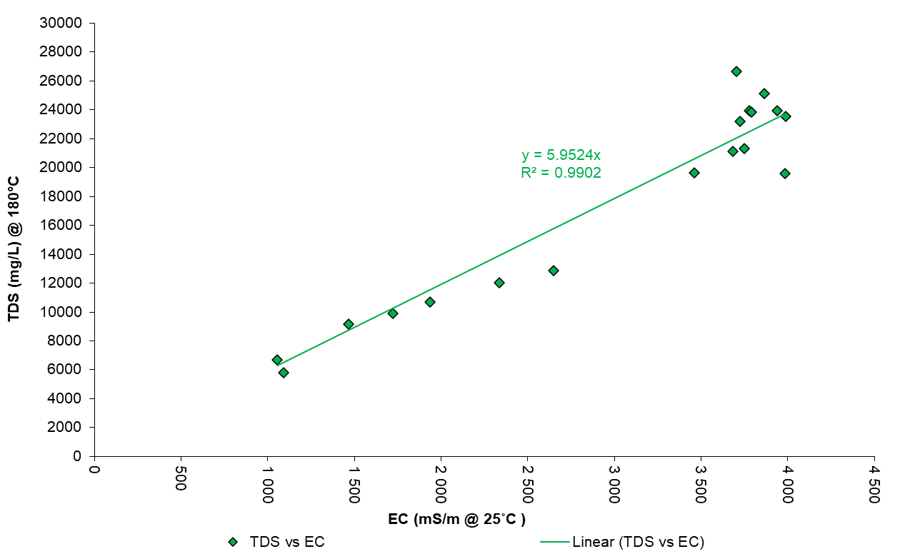
Figure F1.1: Total Dissolved Solids (TDS) vs Electrical Conductivity (EC) - Graphs - All Data

Table F1.1: All Data
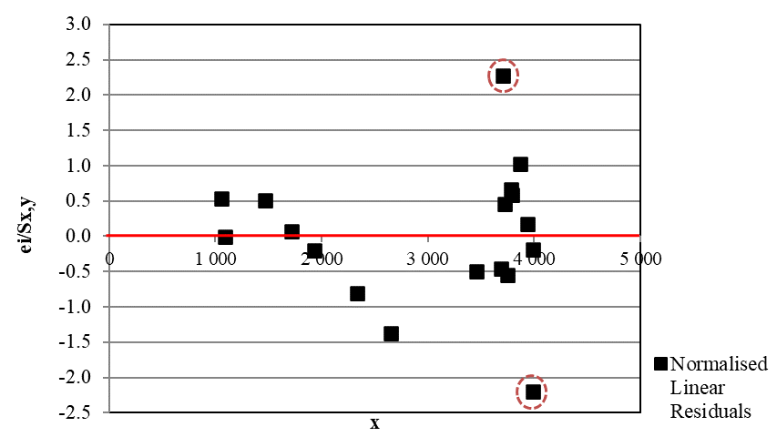
The normalized linear residuals e_{i}/Sx,y for data points 9 & 13 > 2 and the standard residuals are not consistent with neighbours – Reject data pt. 9 & 13
F 1. 2 Total Dissolved Solids (TDS) vs Electrical Conductivity (EC) - Data point 9 & 13 rejected
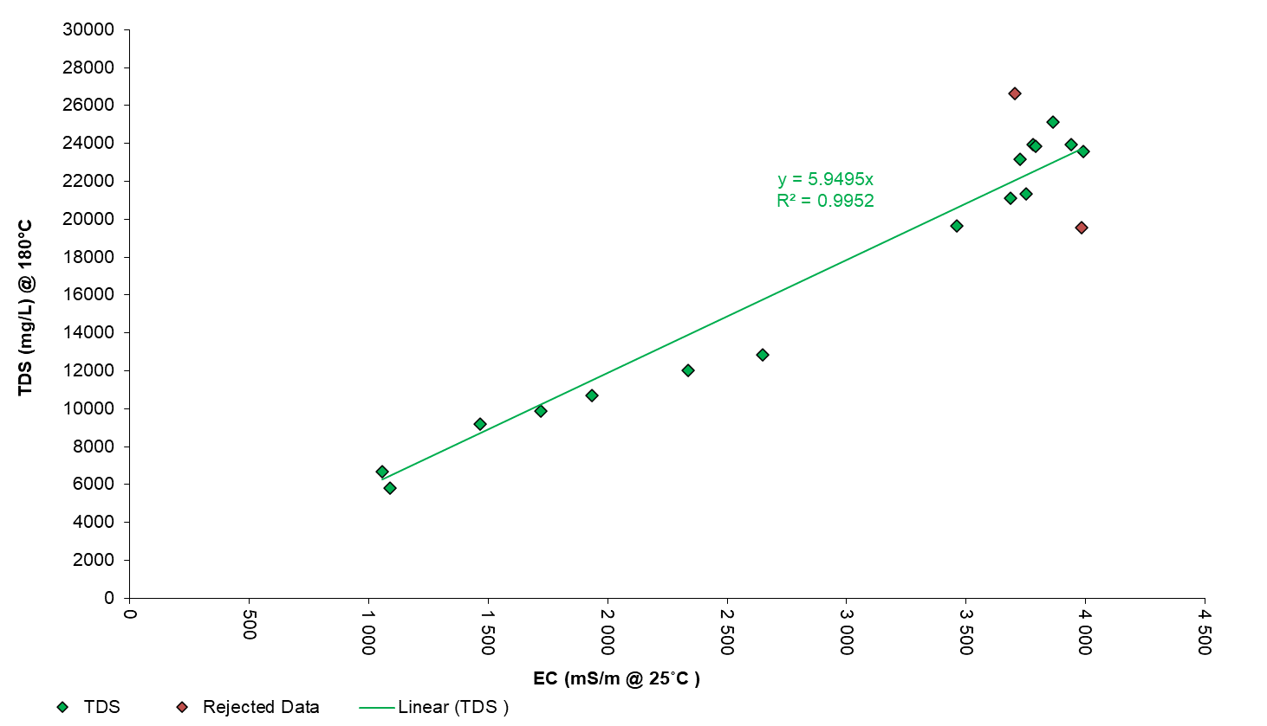
Figure F1.2: Total Dissolved Solids (TDS) vs Electrical Conductivity (EC) - Data pt. 9 & 13 rejected

Table F1.2 Total Dissolved Solids (TDS) vs Electrical Conductivity (EC) - Data point 9 & 13 rejected
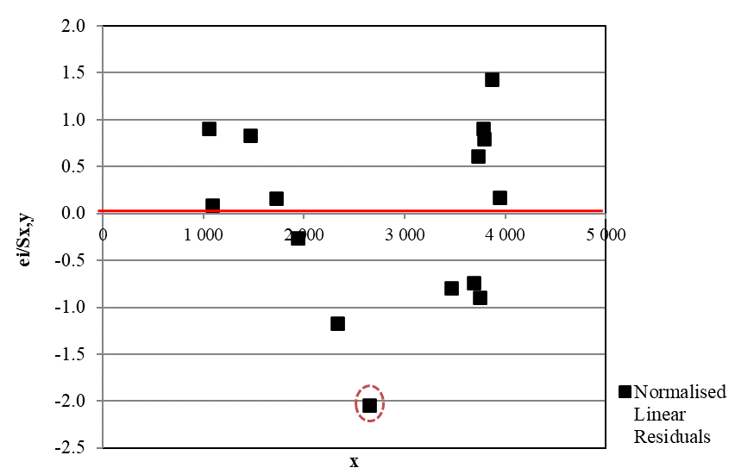
The normalized linear residual e_{i}/Sx,y for data point 10 > 2 and the standard residual is not consistent with neighbours – Reject data pt.10
F1.3 Total Dissolved Solids (TDS) vs Electrical Conductivity (EC) - Data point 9, 10 & 13 rejected
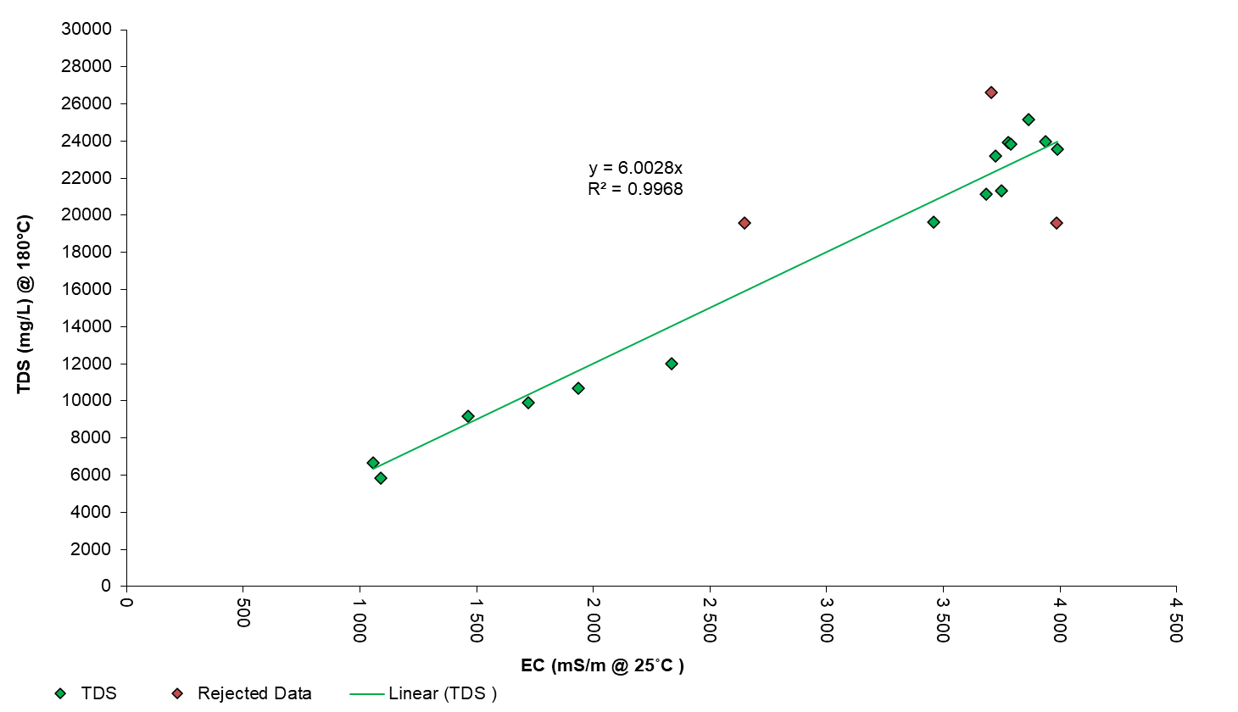
Figure F1.3: Total Dissolved Solids (TDS) vs Electrical Conductivity (EC) - Data pt. 9, 10 & 13 rejected

Table F1.3 Data points 9, 10 & 13 rejected
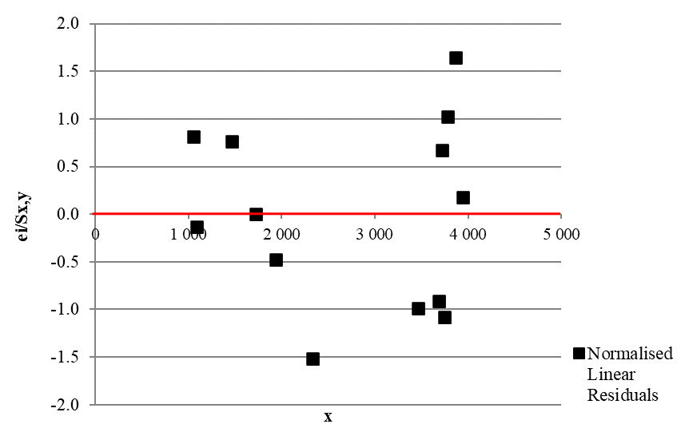
All normalized linear residuals e_{i}/Sx,y for all data are < 2 and standard residuals are consistent with neighbours – No further points to reject

F2. Total Acidity (TA) vs Electrical Conductivity (EC)
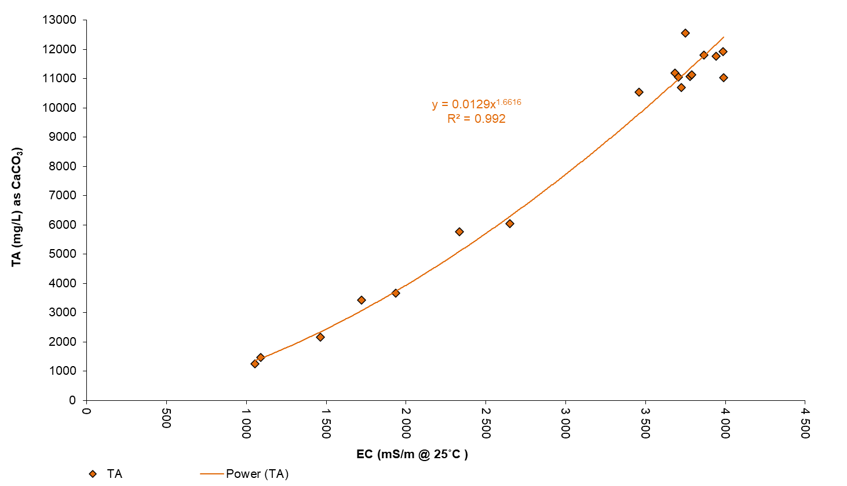
Figure F2.1: Total Acidity (TA) vs Electrical Conductivity (EC) – All Data

Table F2.1: All Data
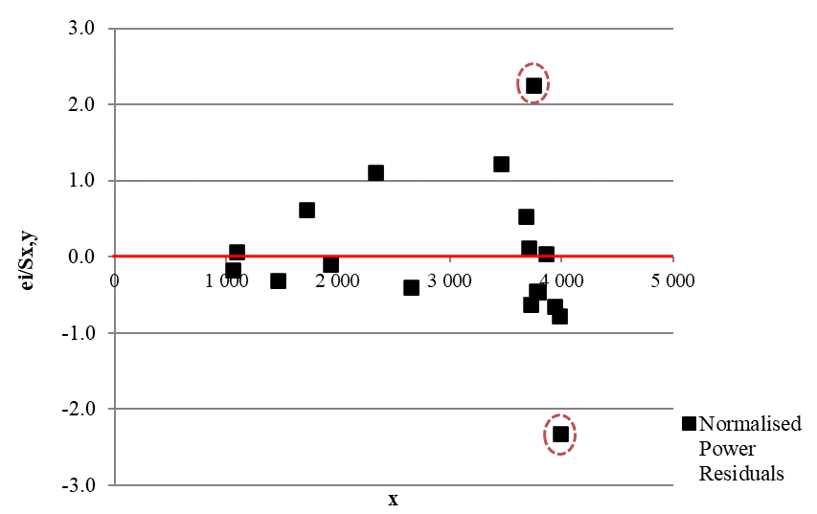
The normalized power residual e_{i}/Sx,y for data point 4 & 12 > 2 and the standard power residuals are not consistent with neighbors – Reject data pt.4 & 12
F2.2 Total Acidity (TA) vs Electrical Conductivity (EC) - Data point 4 & 12 rejected
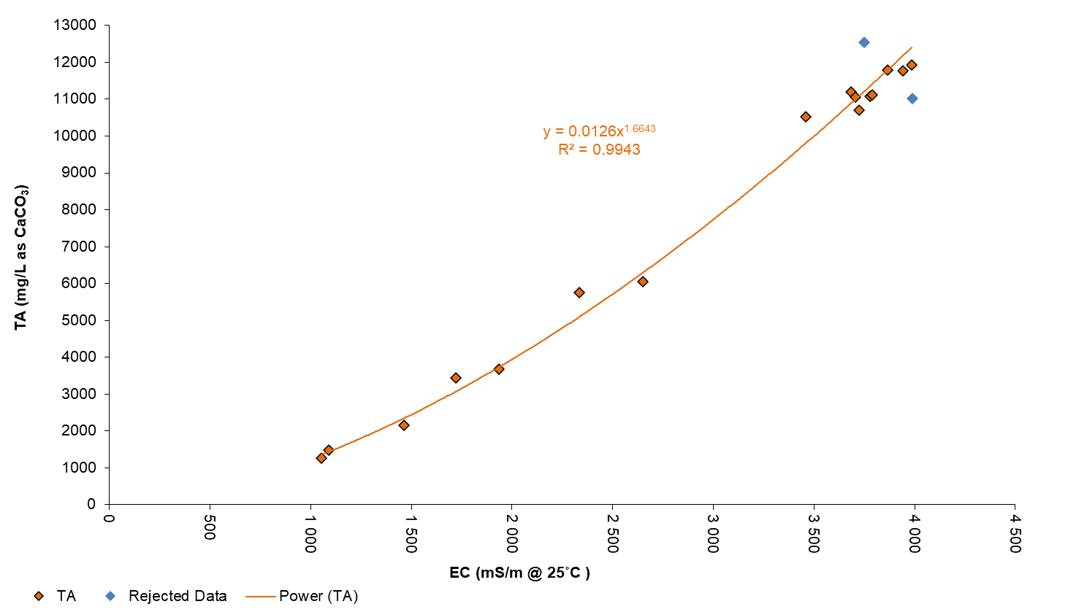
Figure F2.2: Total Acidity (TA) vs Electrical Conductivity (EC) – Data points 4 and 12 rejected

F2.2 Total Acidity (TA) vs Electrical Conductivity (EC) - Data point 4 & 12 rejected

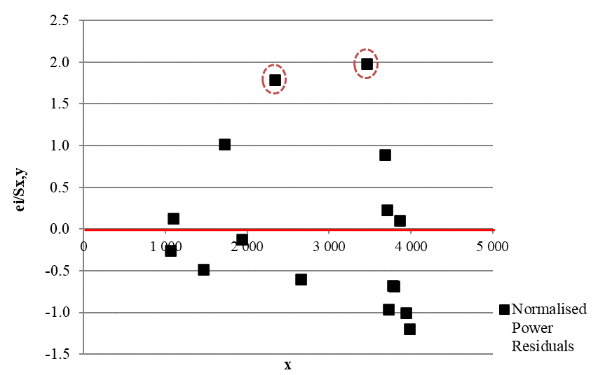

The normalized power residual e_{i}/Sx,y for all data points < 2, however the standard power residual points 1 & 3 are not consistent with neighbors – Reject points 1 & 3

F2.3 Total Acidity (TA) vs Electrical Conductivity (EC) - Data points 1, 3, 4 & 12 rejected
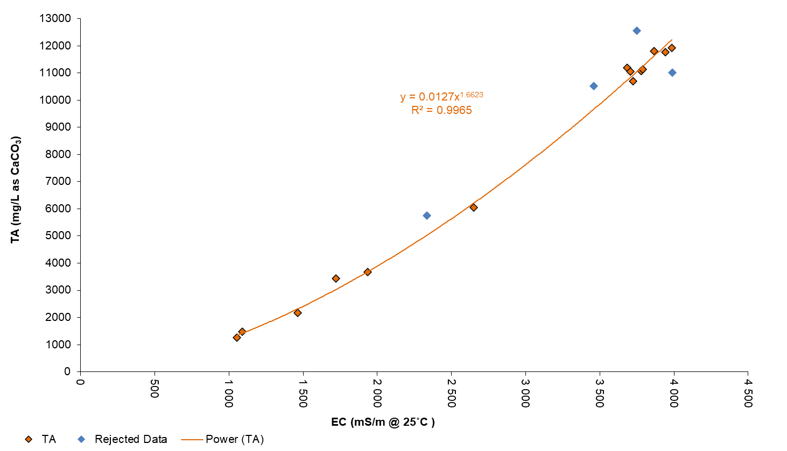

Figure F2.3: Total Acidity (TA) vs Electrical Conductivity (EC) – Data points 1, 3, 4 and 12 rejected

Table F2.3: Total Acidity (TA) vs Electrical Conductivity (EC) - Data points 1,3, 4 & 12 rejected
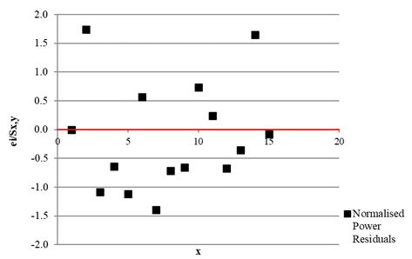
The normalized power residual e_{i}/Sx,y for all data points < 2, and all standard power residualpoints are consistent with neighbors – No further rejection
F3. Dissolved S (S) vs Electrical Conductivity (EC)
Figure F3.1: Dissolved Sulfur (S) vs Electrical Conductivity (EC) – All Data
Table F3.1: Dissolved Sulfur (S) vs Electrical Conductivity (EC) – All Data

The normalized linear residual e_{i}/Sx,y for data point 2 > 2 and the standard linear residuals are not consistent with neighbors – Reject data pt.2
F3.2 Dissolved Sulfur (S) vs Electrical Conductivity (EC) - Data point 4 rejected

Figure F3.2: Dissolved Sulfur (S) vs Electrical Conductivity (EC) – Data pt. 2 rejected

Table F3.2: Dissolved Sulfur (S) vs Electrical Conductivity (EC) – Data pt. 2 rejected
The normalized linear residual e_{i}/Sx,y for data point 4 > 2 and the standard linear residuals are not consistent with neighbors – Reject data pt.4
F3.3 Dissolved Sulfur (S) vs Electrical Conductivity (EC) - Graphs – Data point 2 & 4 rejected
Figure F3.3: Dissolved Sulfur (S) vs Electrical Conductivity (EC) – Data pt. 2 and 4 rejected

Table F3.3: Dissolved Sulfur (S) vs Electrical Conductivity (EC) – Data pt. 2 and 4 rejected
All normalized linear residuals e_{i}/Sx,y for all data are < 2 and standard linear residuals are consistent with neighbours – No further points to reject
F4. Dissolved Iron (Fe) vs Electrical Conductivity (EC)
Figure F4.1: Dissolved Iron (Fe) vs Electrical Conductivity (EC) – All Data

Table F4.1. Dissolved Iron (Fe) vs Electrical Conductivity (EC)
The normalized power residual e_{i}/Sx,y for data point 2 is > 2 and the standard power residual is not consistent with neighbours – Reject pt. 2
F4.2 Dissolved Iron (Fe) vs Electrical Conductivity (EC) – Data point 2 rejected
Figure F4.2: Dissolved Iron (Fe) vs Electrical Conductivity (EC) – Data point 2 rejected

Table F4.2: Dissolved Iron (Fe) vs Electrical Conductivity (EC) – Data point 2 rejected
The normalized power residual e_{i}/Sx,y for data point 4 is > 2 and the standard power residual is not consistent with neighbours – Reject pt. 2 and 4
F4.3: Dissolved Iron (Fe) vs Electrical Conductivity (EC) – Data points 2 and 4 rejected
Figure F4.3: Dissolved Iron (Fe) vs Electrical Conductivity (EC) – Data points 2 and 4 rejected

Table F4.3: Dissolved Iron (Fe) vs Electrical Conductivity (EC) – Data points 2 and 4 rejected
The normalized power residual e_{i}/Sx,y for all data points are < 2 and the standard power residuals are consistent with neighbours – No further rejection

REFERENCES FOR SUPPLEMENTARY MATERIAL

ATSDR 2005. Public Health Statement, Nickel. DEPARTMENT of HEALTH AND HUMAN SERVICES, Agency for Toxic Subsatances and Disease Registry, .
ATSDR 2010. Toxilogical Profile for Boron. Acency for Toxic Subsatances and Disease Registry.
DWAF 1996. Department of Water Affairs and Forestry, 1996. South African Water Quality Guidelines (second edition). Volume 1: Domestic Use.
EPA 2022. National Primary Drinking Water Regulations. US Environmental Protection Agency, .
Hobbs, P., Oelofse, S. H. & Rascher, J. 2008. Management of environmental impacts from coal mining in the upper Olifants River catchment as a function of age and scale. Water Resources Development, 24, 417-431.
Van Niekerk, H., Silberbauer, M. & Maluleke, M. 2014. Geographical differences in the relationship between total dissolved solids and electrical conductivity in South African rivers. Water Sa, 40, 133-138.

