APPENDIX 11
DATA SOURCE FOR CRITERIA EVLUATION
Secondary Criteria | Unit/(MoM) | Information source
Waste (Sludge) recycling and reuse based on the nutrient and energy value of bio-solid produced from water reuse systems/schemes | % of sludge produced that can be reused for other beneficial purposes | Plant information (calculated)
Spreading of toxic compound from reuse system to arable land | Qualitative | Plant information and literature Plant information and literature review
Impact of reuse system on groundwater aquifer | Qualitative | Plant information and literature review
Impact of water reuse system on habitat/wetland restoration/conservation | Qualitative | Plant information and literature review
Management plan for controlling disease vectors from water reuse system | Qualitative | Plant information and literature review
Total energy consumption of the water reuse systems | KWh/m³ | Plant information (calculated)
Unit operational cost of production of water reuse system | ZAR/m³ | Plant information (calculated)
Unit maintenance costs of water reuse system | ZAR/m³ | Plant information (calculated)
Operation and maintenance skills requirement for water reuse system | Qualitative | Plant information (calculated)
Security of water supply to community | Number of interruptions to supply/annum | Plant information (calculated)
Quality of effluent produced/supplied by water reuse scheme | Compliance with required standards for physical, chemical and microbial tests performed throughout the year (%) | Plant information (calculated)/Consultation with plant operators
Water quality complaints (aesthetics)e.g., odour, colour, taste | % Number of reclaimed water quality complaints/year | Municipal information (calculated)
Acceptability of reuse for potable applications by users | Percentage of survey respondents/users that find potable reuse acceptable | Questionnaire survey
Perceived health and safety impact due to reuse | Percentage of survey respondents/users with concerns about injury, risk of infection | Questionnaire survey
Trust in water services provider | Percentage survey respondents who trust the WSA to provide safe reclaimed water | Questionnaire survey
Public education and awareness programmes | Percentage of survey respondents’ awareness on reuse | Questionnaire survey
Social inclusion | Percentage of survey respondents living in formal dwellings | Questionnaire survey
Community spirit | Percentage of survey respondents willing to engage in activities to encourage reuse | Questionnaire survey
Risk of waterborne infection as a result of reuse | Percentage of survey respondent awareness of incident of disease outbreak | Questionnaire survey
Availability of clean water | Percentage of survey respondents with piped water inside dwelling | Questionnaire survey
Operators training package/plans provided by water services authorities and providers to meet training needs | Qualitative | Interview
Appropriate coordination across all government entities on reuse | Qualitative | Interview
Actions for better law implementation and enforcement | Qualitative | Interview
Tools and methods for evidence-based transparency and accountability associated with water reuse | Quantitative | Integrated Regulatory Information System (IRIS), Plant information
Information and technical resources | Qualitative | Interview
Human resources strategies and policies covering the main gaps in the field of water reuse | Qualitative | Interview
Incentives and subsidy on resources utilized by water reuse scheme | Qualitative | Interview

Description of scores to evaluate institutional secondary criteria
Table 1: Score and description the secondary criterion: Operators training package/plans provided by water services authorities and providers to meet training needs
Criterion | Score | Description
Operators training package/plans provided by water services authorities and providers to meet training needs | 5 | Provided, fully adopted and implemented
 | 4 | Provided, partially adopted and implemented
 | 3 | Provided, partially adopted and not implemented
 | 2 | Provided, minimal adoption and not implemented
 | 1 | Provided, not adopted and implemented
 | 0.1 | None

Table 2: Score and description of the secondary criterion: Appropriate coordination mechanism across all government entities on reuse
Criterion | Score | Description
Appropriate coordination mechanism across all government entities on reuse | 5 | Significant
 | 4 | Above average
 | 3 | Average
 | 2 | Minimal
 | 1 | Stalled process
 | 0.1 | None

Table 3: Score and description of the secondary criterion: Actions for better policies/laws implementation and enforcement associated with water reuse
Criterion | Score | Description
Actions for better policies/laws implementation and enforcement associated with water reuse | 5 | Supportive policy and legislation environment, good implementation and enforcement
 | 4 | Appropriate policies/laws and implementation environment
 | 3 | Poor implementation, capacity in a good policy environment
 | 2 | Progress towards policy setting
 | 1 | No policy and poor capability for implementation and enforcement
 | 0.1 | Inaction (sterile environment and no progress)

Table 4: Score and description of the secondary criterion: Human resources strategies and policies covering the main gaps in the field of water reuse
Criterion | Score | Description
Human resources strategies and policies covering the main gaps in the field of water reuse | 5 | Supporting strategies and policies, good implementation capacity
 | 4 | Appropriate policy, inadequate implementation capacity
 | 3 | Poor implementation capacity
 | 2 | Progress towards strategies and policies setting
 | 1 | No policy, poor capacity
 | 0.1 | Inaction / no progress

Table 5: Score and description of the secondary criterion: Availability and accessibility of information and technical resources
Criterion | Score | Description
Availability and accessibility of information and technical resources | 5 | Readily available, readily accessible
 | 4 | Readily available, partially accessible
 | 3 | Readily available, occasionally available
 | 2 | Available, difficult to access
 | 1 | Not available, not accessible
 | 0.1 | No policy

Table 6: Score and description of the secondary criterion: Incentives and resources utilized for production of reclaimed water
Criterion | Score | Description
Incentives and resources utilized for production of reclaimed water | 5 | Significant
 | 4 | Above average
 | 3 | Average
 | 2 | Minimal
 | 1 | Stalled processes
 | 0.1 | None
APPENDIX 12
EMALAHLENI MUNICIPALITY AND WATER RECLAMATION PLANT DATA FOR ISI CALCULATION
Secondary Criteria | Unit/(MoM) | Calculation
Waste (Sludge) recycling and reuse based on the nutrient and energy value of bio-solid produced from water reuse systems/schemes | % of sludge produced that can be reused for other beneficial purposes (Gypsum) | (18.001ML÷109.74ML)×100=16%
Spreading of toxic compound from reuse system to arable land | Qualitative | 1.4÷5=0.28
Impact of water reuse system on groundwater quality and preservation | Qualitative | 1.4÷5=0.28
Impact of water reuse system on habitat/wetland restoration/conservation | Qualitative | 1.4÷5=0.28
Management plan for controlling disease vectors from water reuse system | Qualitative | 9÷5=1.8
Total energy consumption of the water reuse systems | KWh/m³ | 4.53
Unit operational cost of production of water reuse system | ZAR/m3 | 14.85
Unit maintenance costs of water reuse system | ZAR/m3 | 1.25
Skill requirement for operation and maintenance | Qualitative | 7÷5=1.4
Security of water supply to community | % (day) times system performed to expected capacity | (341÷365)×100%=93%
Quality of effluent produced/supplied by water reuse scheme | Compliance with required standards for physical, chemical and microbial tests performed throughout the year (%) | 98.7% (Malan per. comm 2017)
Water quality complaints (aesthetics)e.g., odour, colour, taste | % Number of reclaimed water quality complaints/year | (Average complaints on water quality/year = 175, Complaints about busted water conveyance pipes/year 216, Complaints about loss in water pressure/year 18. Complaints about dry tap (i.e. tap not running)/year 91) (175÷500)100% =35%
Acceptability of reuse to stakeholder | Percentage of survey respondents/users that find potable reuse acceptable | 54 % of survey respondent/users per household that find potable reuse acceptable
Perceived health and safety impact due to reuse | Percentage of survey respondents/users with concerns about injury, risk of infection | 29.6 % of survey respondents/users with concerns about injury, risk of infection
Trust in water services provider | Percentage survey respondents who trust the WSA to provide safe reclaimed water | 21% survey respondents who trust the WSA to provide safe reclaimed water
Public education and awareness programmes | Percentage of survey respondents’ awareness on reuse | 21% of survey respondents’ awareness on reuse
Social inclusion | Percentage of survey respondents living in formal dwellings | 90.3 % of survey respondents living in formal dwellings
Community spirit | Percentage of survey respondents willing to engage in activities to encourage reuse | 83% of survey respondents willing to engage in activities to encourage reuse
Risk of waterborne infection as a result of reuse | Percentage of survey respondent awareness of incident of disease outbreak | 2.8% of survey respondent awareness of incident of disease outbreak
Availability of clean water | Percentage of survey respondents with piped water inside dwelling | 86% of survey respondents with piped water inside dwelling
Operators training package/plans provided by water services authorities and providers to meet training needs | Qualitative | 4
Appropriate coordination across all government entities on reuse | Qualitative | 2
Actions for better law implementation and enforcement | Qualitative | 3
Tools and methods for evidence-based policy making on water reuse | Quantitative | 98.5
Information and technical resources | Qualitative | 2
Human resources strategies and policies covering the main gaps in the field of water reuse | Qualitative | 3
Incentives and subsidy on resources utilized by water reuse scheme | Qualitative | 1

APPENDIX 13
HENDRINA MUNICIPALITY AND WATER RECLAMATION PLANT DATA FOR ISI CALCULATION
Secondary Criteria | Unit/(MoM) | Calculation
Waste (Sludge) recycling and reuse based on the nutrient and energy value of bio-solid produced from water reuse systems/schemes | % of sludge produced that can be reused for other beneficial purposes (gypsum) | (16.822MLof gypsum ÷101.58ML of mixed slurry)×100=17%
Spreading of toxic compound from reuse system to arable land | Qualitative | 1.4÷5=0.28
Impact of water reuse system on groundwater quality and preservation | Qualitative | 1.4÷5=0.28
Impact of water reuse system on habitat/wetland restoration/conservation | Qualitative | 1.4÷5=0.28
Management plan for controlling disease vectors from water reuse system | Qualitative | 9÷5=1.8
Total energy consumption of the water reuse systems | KWh/m³ | 2.18
Unit operational cost of production of water reuse system | ZAR/m3 | 10.41
Unit maintenance costs of water reuse system | ZAR/m3 | 0.98
Skill requirement for operation and maintenance | Qualitative | 7÷5=1.4
Security of water supply to community | % (day) times system performed to expected capacity | (330÷365)×100%=90%
Quality of effluent produced/supplied by water reuse scheme | Compliance with required standards for physical, chemical and microbial tests performed throughout the year (%) | 98% (Hammond per. comm 2017)
Water quality complaints (aesthetics)e.g., odour, colour, taste | % Number of reclaimed water quality complaints/year | (Average complaints on water quality/year = 15, Complaints about busted water conveyance pipes/year 250, Complaints about loss in water pressure/year 45. Complaints about dry tap 25(i.e. tap not running)/year 240, Others 6,) (15÷335)100% =5%
Acceptability of reuse to stakeholder | Percentage of survey respondents/users that find potable reuse acceptable | 88.8% of survey respondent/users per household that find potable reuse acceptable
Perceived health and safety impact due to reuse | Percentage of survey respondents/users with concerns about injury, risk of infection | 13.1% of survey respondents/users with concerns about injury, risk of infection
Trust in water services provider | Percentage survey respondents who trust the WSA to provide safe reclaimed water | 97% survey respondents who trust the WSA to provide safe reclaimed water
Public education and awareness programmes | Percentage of survey respondents’ awareness on reuse | 97% of survey respondents’ awareness on reuse
Social inclusion | Percentage of survey respondents living in formal dwellings | 98.5% of survey respondents living in formal dwellings
Community spirit | Percentage of survey respondents willing to engage in activities to encourage reuse | 80% of survey respondents willing to engage in activities to encourage reuse
Risk of waterborne infection as a result of reuse | Percentage of survey respondent awareness of incident of disease outbreak | 2% of survey respondent awareness of incident of disease outbreak
Availability of clean water | Percentage of survey respondents with piped water inside dwelling | 89% of survey respondents with piped water inside dwelling
Operators training package/plans provided by water services authorities and providers to meet training needs | Qualitative | 4
Appropriate coordination across all government entities on reuse | Qualitative | 3
Actions for better law implementation and enforcement | Qualitative | 4
Tools and methods for evidence-based policy making on water reuse | Quantitative | 99.07
Information and technical resources | Qualitative | 2
Human resources strategies and policies covering the main gaps in the field of water reuse | Qualitative | 2
Incentives and subsidy on resources utilized by water reuse scheme | Qualitative | 1

APPENDIX 14
BEAUFORT WEST MUNICIPALITY AND WATER RECLAMATION PLANT DATA FOR ISI CALCULATION
Secondary Criteria | Unit/(MoM) | Calculation
Waste (Sludge) recycling and reuse based on the nutrient and energy value of bio-solid produced from water reuse systems/schemes | % of sludge produced that can be reused for other beneficial purposes | 35% of the brine generated is used for agricultural purpose (Pierre Marias pers, comm, 2017)
Spreading of toxic compound from reuse system to arable land | Qualitative | 5.3÷7=0.76
Impact of water reuse system on groundwater quality and preservation | Qualitative | 3.5÷7=0.5
Impact of water reuse system on habitat/wetland restoration/conservation | Qualitative | 3.5÷7=0.5
Management plan for controlling disease vectors from water reuse system | Qualitative | 13÷7=1.9
Total energy consumption of the water reuse systems | KWh/m³ | 1.9 (plant information and calculation)
Unit operational cost of production of water reuse system | ZAR/m3 | 8.03
Unit maintenance costs of water reuse system | ZAR/m3 | 2.61
Skill requirement for operation and maintenance | Qualitative | 12÷7=1.7
Security of water supply to community | % (day) times system performed to expected capacity | 96% (plant information)
Quality of effluent produced/supplied by water reuse scheme | Compliance with required standards for physical, chemical and microbial tests performed throughout the year (%) | 99% (Plant information)
Water quality complaints (aesthetics)e.g., odour, colour, taste | % Number of reclaimed water quality complaints/year | Average complaints on water quality/year = 2% Christopher Wright pers. comm (2017)
Acceptability of reuse to stakeholder | Percentage of survey respondents/users that find potable reuse acceptable | 94% of survey respondent/users per household that find potable reuse acceptable
Perceived health and safety impact due to reuse | Percentage of survey respondents/users with concerns about injury, risk of infection | 10% of survey respondents/users with concerns about injury, risk of infection
Trust in water services provider | Percentage survey respondents who trust the WSA to provide safe reclaimed water | 96% survey respondents who trust the WSA to provide safe reclaimed water
Public education and awareness programmes | Percentage of survey respondents’ awareness on reuse | 98% of survey respondents’ awareness on reuse
Social inclusion | Percentage of survey respondents living in formal dwellings | 99.25% of survey respondents living in formal dwellings
Community spirit | Percentage of survey respondents willing to engage in activities to encourage reuse | 40% of survey respondents willing to engage in activities to encourage reuse
Risk of waterborne infection as a result of reuse | Percentage of survey respondent awareness of incident of disease outbreak | 2% of survey respondent awareness of incident of disease outbreak
Availability of clean water | Percentage of survey respondents with piped water inside dwelling | 96.8% of survey respondents with piped water inside dwelling
Operators training package/plans provided by water services authorities and providers to meet training needs | Qualitative | 5
Appropriate coordination across all government entities on reuse | Qualitative | 4
Actions for better law implementation and enforcement | Qualitative | 4
Tools and methods for evidence-based policy making on water reuse | Quantitative | 95.22%
Information and technical resources | Qualitative | 4
Human resources strategies and policies covering the main gaps in the field of water reuse | Qualitative | 4
Incentives and subsidy on resources utilized by water reuse scheme | Qualitative | 4

APPENDIX 15
Engagement with experts and municipal authority officials
Emalahleni Municipality
Specific information requested for during interview
PLANT A: Interview with Neil Rein, plant manager and Ms Maryke Malan, process support officer at water reclamation plant A for potable application in Emalahleni municipality (Name withheld due to confidentiality agreement)
- Please in your expert opinion, provide an indication of the unit electrical energy consumption as a benchmark/”best practice” for the production of reclaimed water 1-6 (in KWh/m³)
- Please in your expert opinion, provide an indication of the unit operation and maintenance cost as a benchmark/”best practice” for the production of reclaimed water 1-20 (in ZAR/m³)
- Please, provide an indication of the blue drop certification achieved by your establishment
98.5
- Please provide an indication of the availability of skill development and training mechanisms available to plant operators in your establishment

Operators training package/plans provided by water services authorities and providers to meet training needs
 | Provided, fully adopted and implemented
X | Provided, partially adopted and implemented
 | Provided, partially adopted and not implemented
 | Provided, minimal adoption and not implemented
 | Provided, not adopted and implemented
 | None

- Please provide an indication of on any financing opportunities, incentives, such as direct subsidies, reduce government taxes or regulatory relief received from the government on resources utilized for production of reclaimed water.
Incentives and resources utilized for production of reclaimed water
 | Significant
 | Above average
 | Average
 | Minimal
x | Stalled processes
 | None

EP2: Interview with Tersia Mbokane at the Water & Sewer branch, at Emalahleni Municipality on October 10, 2017. Ms Mbokane is responsible for monitoring water and sewer operations, water and waste conveyance complaints analysis. Ms Mbokwane liaises between the municipality and private contractors for water and wastewater services.
- Please, provide an indication of governance model in your establishment in terms of:
- Appropriate coordinating mechanism across all government entities on wastewater reuse
- Actions toward better policies/laws for implementation and encouragement of wastewater reuse
- Human resources strategies and policies covering the main gaps in the field of wastewater reuse
- Availability and accessibility of Information and technical resources for wastewater reuse

Appropriate coordination mechanism across all government entities on wastewater reuse
 | Significant
 | Above average
 | Average
X | Minimal
 | Stalled process
 | None

Actions toward better policies/laws for implementation and encouragement of wastewater reuse
 | Supportive policy and legislation environment, good implementation and enforcement
 | Appropriate policies/laws and implementation environment
X | Poor implementation, capacity in a good policy environment
 | Progress towards policy setting
 | No policy and poor capability for implementation and enforcement
 | Inaction (sterile environment and no progress)

Human resources strategies and policies covering the main gaps in the field of wastewater reuse
 | Supporting strategies and policies, good implementation capacity
 | Appropriate policy, inadequate implementation capacity
X | Poor implementation capacity
 | Progress towards strategies and policies setting
 | No policy, poor capacity
 | Inaction / no progress

Availability and accessibility of Information and technical resources for wastewater reuse initiatives
 | Readily available, readily accessible
 | Readily available, partially accessible
 | Readily available, occasionally available
X | Available, difficult to access
 | Not available, not accessible
 | No policy

- Please, provide an indication on the number of complaints received from the community/users on the following:
- Complaints on water quality/year: 175
- Complaints about busted water conveyance pipes/year:216
- Complaints about loss in water pressure/year: 18
- Complaints about dry tap(i.e. tap not running)/year: 91
- Other

APPENDIX 16
Hendrina Municipality
Specific information requested for during interview
PLANT A: Interview with Andrew Hammond, senior process engineer at the water reclamation plant B for potable application in Hendrina municipality (Name withheld due to confidentiality agreement)
- Please in your expert opinion, provide an indication of the unit energy consumption as a benchmark/”best practice” for the production of reclaimed water for potable purposes 1-5(in KWh/m³)
- Please in your expert opinion, provide an indication of the unit operation and maintenance cost as a benchmark/”best practice” for the production of reclaimed water 1-20 (in ZAR/m³)
- Please, provide an indication of the blue drop certification achieved by your establishment
99.07%
- Please provide an indication of the availability of skill development and training mechanisms available to plant operators in your establishment

Operators training package/plans provided by water services authorities and providers to meet training needs
 | Provided, fully adopted and implemented
X | Provided, partially adopted and implemented
 | Provided, partially adopted and not implemented
 | Provided, minimal adoption and not implemented
 | Provided, not adopted and implemented
 | None

- Please provide an indication of on any financing opportunities, incentives, such as direct subsidies, reduce government taxes or regulatory relief received from the government on resources utilized for production of reclaimed water.
Incentives and resources utilized for production of reclaimed water
 | Significant
 | Above average
 | Average
 | Minimal
x | Stalled processes
 | None

EP2: Interview with Mpho Makgatha, assistant director, Water Quality, Steve Tshwete Local Municipality. Mpho Makgatha is responsible for monitoring water quality operations within Steve Tshwete Local Municipality (Hendrina municipality is under Steve Tshwete Local Municipality)
- Please, provide an indication of governance model in your establishment in terms of:
- Appropriate coordinating mechanism across all government entities on wastewater reuse
- Actions toward better policies/laws for implementation and encouragement of wastewater reuse
- Human resources strategies and policies covering the main gaps in the field of wastewater reuse
- Availability and accessibility of Information and technical resources for wastewater reuse

Appropriate coordination mechanism across all government entities on wastewater reuse
 | Significant
 | Above average
X | Average
 | Minimal
 | Stalled process
 | None

Actions toward better policies/laws for implementation and encouragement of wastewater reuse
 | Supportive policy and legislation environment, good implementation and enforcement
X | Appropriate policies/laws and implementation environment
 | Poor implementation, capacity in a good policy environment
 | Progress towards policy setting
 | No policy and poor capability for implementation and enforcement
 | Inaction (sterile environment and no progress)

Human resources strategies and policies covering the main gaps in the field of wastewater reuse
 | Supporting strategies and policies, good implementation capacity
 | Appropriate policy, inadequate implementation capacity
 | Poor implementation capacity
X | Progress towards strategies and policies setting
 | No policy, poor capacity
 | Inaction / no progress

Availability and accessibility of Information and technical resources for wastewater reuse initiatives
 | Readily available, readily accessible
 | Readily available, partially accessible
 | Readily available, occasionally available
X | Available, difficult to access
 | Not available, not accessible
 | No policy

- Please, provide an indication on the number of complaints received from the community/users on the following:
- Complaints on water quality/year 15
- Complaints about busted water conveyance pipes/year 250
- Complaints about loss in water pressure/year 45
- Complaints about dry tap(i.e. tap not running)/year 25
- Other service standard for the repair of burst pipe lines is 4 hours, and on average they are replaced within 4.5 hours.
APPENDIX 17
Engagement with experts and municipal authority officials
Beaufort West Municipality
Specific information requested for during interview
PLANT A: Telephone interview with Pierre Marais, plant operations consultant at Beaufort West water reclamation plant and Christopher Wright, manager, technical services, Beaufort West municipality.
- Please in your expert opinion, provide an indication of the unit electrical (energy) consumption as a benchmark/”best practice” for the production of reclaimed water 1-7.5 (in KWh/m³)
- Please in your expert opinion, provide an indication of the unit operation and maintenance cost as a benchmark/”best practice” for the production of reclaimed water 1-20 (in ZAR/m³)
- Please, provide an indication of the blue drop certification achieved by your establishment: 95.22%
- Please provide an indication of the availability of skill development and training mechanisms available to plant operators in your establishment
Operators training package/plans provided by water services authorities and providers to meet training needs
x | Provided, fully adopted and implemented
 | Provided, partially adopted and implemented
 | Provided, partially adopted and not implemented
 | Provided, minimal adoption and not implemented
 | Provided, not adopted and implemented
 | None

- Please provide an indication of on any financing opportunities, incentives, such as direct subsidies, reduce government taxes or regulatory relief received from the government on resources utilized for production of reclaimed water.
Incentives and resources utilized for production of reclaimed water
 | Significant
x | Above average
 | Average
 | Minimal
 | Stalled processes
 | None

- Please, provide an indication of governance model in your establishment in terms of:
- Appropriate coordinating mechanism across all government entities on wastewater reuse
- Actions toward better policies/laws for implementation and encouragement of wastewater reuse
- Human resources strategies and policies covering the main gaps in the field of wastewater reuse
- Availability and accessibility of Information and technical resources for wastewater reuse

Appropriate coordination mechanism across all government entities on wastewater reuse
 | Significant
x | Above average
 | Average
 | Minimal
 | Stalled process
 | None

Actions toward better policies/laws for implementation and encouragement of wastewater reuse
 | Supportive policy and legislation environment, good implementation and enforcement
x | Appropriate policies/laws and implementation environment
 | Poor implementation, capacity in a good policy environment
 | Progress towards policy setting
 | No policy and poor capability for implementation and enforcement
 | Inaction (sterile environment and no progress)

Human resources strategies and policies covering the main gaps in the field of wastewater reuse
 | Supporting strategies and policies, good implementation capacity
x | Appropriate policy, inadequate implementation capacity
 | Poor implementation capacity
 | Progress towards strategies and policies setting
 | No policy, poor capacity
 | Inaction / no progress

Availability and accessibility of Information and technical resources for wastewater reuse initiatives
 | Readily available, readily accessible
x | Readily available, partially accessible
 | Readily available, occasionally available
 | Available, difficult to access
 | Not available, not accessible
 | No policy

- Please, provide an indication on the number of complaints received from the community/users on the following:
- Complaints on water quality/year 2% Christopher Wright pers. comm (2017)
- Complaints about busted water conveyance pipes/year
- Complaints about loss in water pressure/year
- Complaints about dry tap(i.e. tap not running)/year
- Other

APPENDIX 18
DECISION SUPPORT SYSTEM USER MANUAL
18.1 Introduction
The methodology for assessing water reuse sustainability described in chapter 8 was implemented in a user friendly tool called WRSAT. WRSAT is an acronym for Water Reuse Sustainability Assessment Tool. It is a software tool developed to assist financiers, engineers, water resources planners and decision makers in assessing the sustainability of water reuse for potable application in South Africa communities. International records of water reuse to date are characterized by both failures and successes testimonies due to several factors - technical, economic, social and institutional. WRSAT is a suit of computer programs that incorporate all these factors in its analysis to assist decision makers to successfully assess the sustainability of reuse for potable implement reuse schemes through improved strategies.
18.2 Target User Audience
This manual is intended to supply basic information about the operation of WRSAT. It provides an overview of the information display and editing conventions that have been adopted as well as the functions performed by each of the program’s commands and dialogs. It is assumed that the users of WRSAT will have some background in water reclamation practices. It is also assumed that users will be familiar with the MS-Windows operating system, and have basic keyboard and mouse skills.
18.3System Requirements
WRSAT was written using C-SHARP programming compatible to computers running Microsoft Windows ® 98 or later version. Recommended minimum Random Access Memory (RAM) is 1024MB (1GB) and screen resolution is 1024 x 768; True Color (24 bit), 60 Hz (refresh rate) is required to install WRSAT.
18.4 Installing/Launching WRSAT
To start the software, click on the water project folder, click on the folder “setup.exe”, and the clink on “install” to launch the tool.
18.5 Limitation of the program
WRSAT is not a dynamic program and does not directly analyze the response of a given system to variable influent conditions. With regards to treatment technology for reuse initiatives, WRSAT does not build the treatment trains to be evaluated. However, violation of acceptable engineering practices of combining treatment unit processes to form treatment trains is not allowed. The building of treatment trains must be done by a user familiar with these processes and their general capabilities. WRSAT is primarily intended for uses on real life water reuse initiatives, although it can be used for theoretical or academic problems as well. The user should validate the reasonableness of all treatment train, cost and other criteria as well as performance data for all water reclamation processes.
18.6 Working with WRSAT

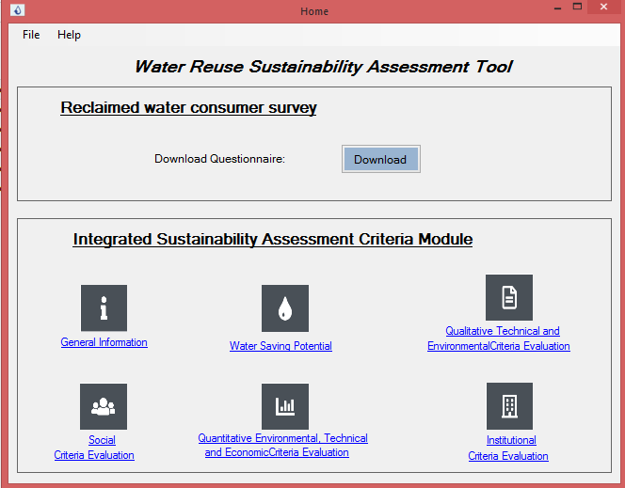
Figure 18.1: WRSAT’s Welcome Page
General Information – This is the button that activates a dialog box with a set of possible actions via button as shown in Figure 18.2.

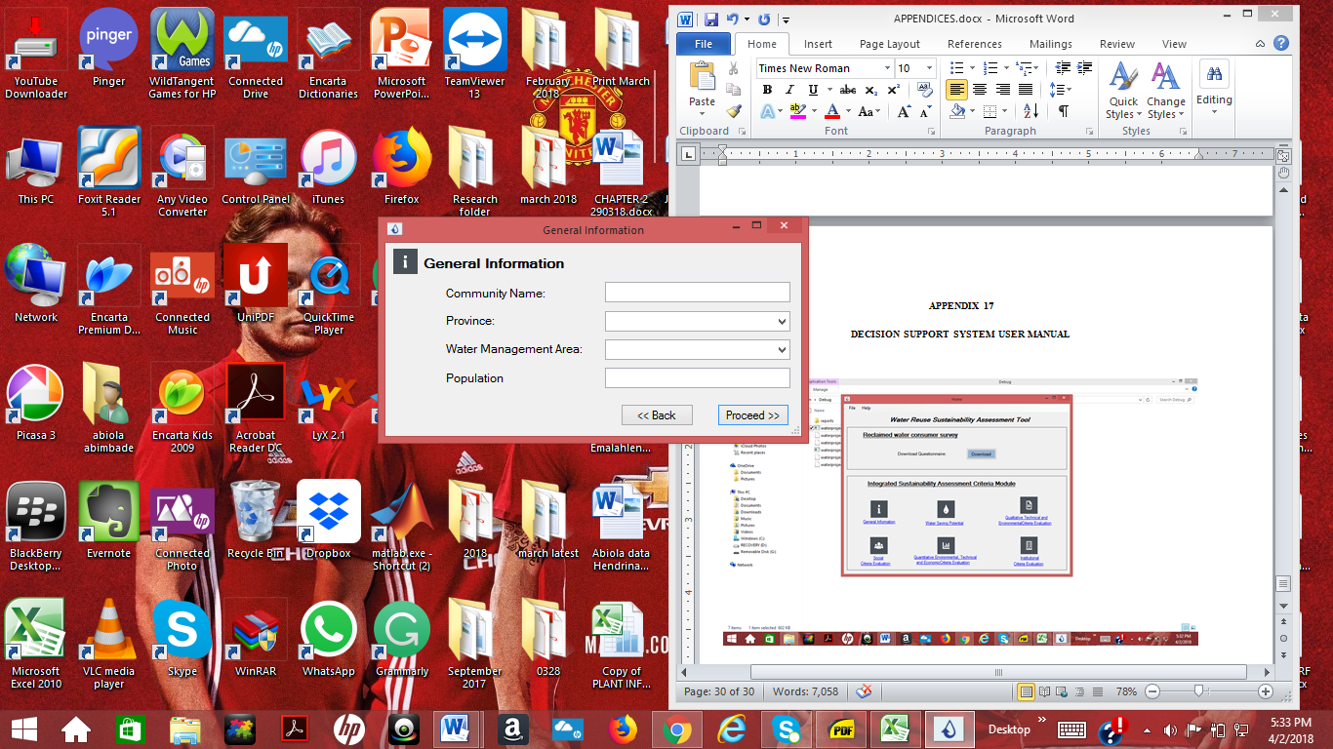
Figure 18.2: General information form
Under general information, the input information is a community name its population while province and water management area is selected from the list using a drop down button. The community name depicts the project name. Figure 18.3 shows the WRSAT water saving potential module. The user is expected to input data on the 7 sections: (i) Return flow from bathing activity, (ii) Return flow from showering activity, (iii) Return flow from hand washbasin activity (iv) Return flow from toilet flushing activity, (v) Return flow from laundry activity, (vi) Return flow from dish washing activity, (vii) On-site leakage to sewer. The last section automatically sums up the values obtained from the first seven sections to give the total volume of wastewater generated from the six domestic activities and volume of on-site leakage to sewer. Each section contains “OK” buttons. The water saving potential estimation module is divided into two dialogue screens. The user is expected to have an idea of the following information such as conveyance leakage factor, recovery rate factor, and the water demand per person per capita per day. Filling all the necessary information, the domestic water saving potential (i.e. the share of domestic water that can be covered by reclaimed water is presented).
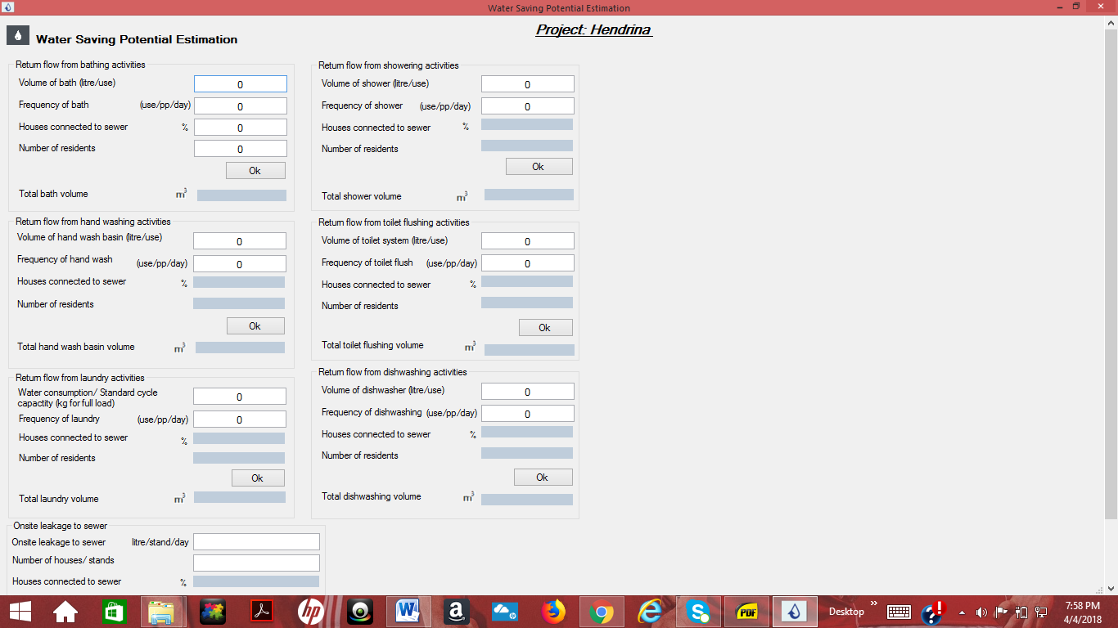
Figure 18.3a: Water saving potential estimation
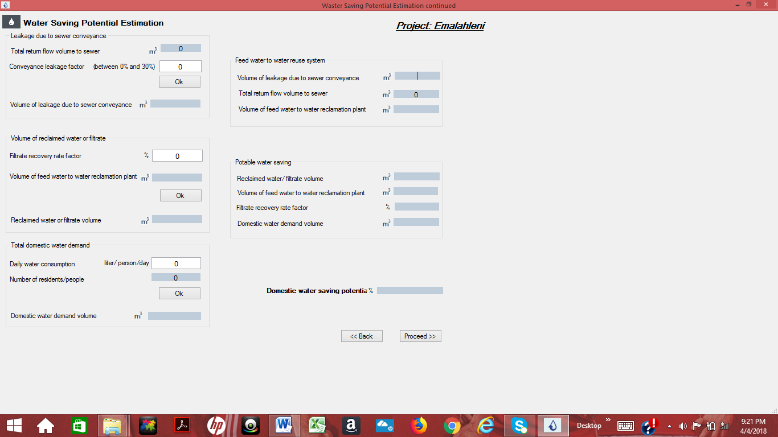
Figure 18.3b: Water saving potential estimation (contd.)
Clicking on “proceed” directs the user to the next dialogue box for selection of treatment train for the water reclamation process (Figure 18.4). After selecting the treatment unit processes, the dialogue screen to input qualitative information to assess the treatment unit processes opens up in the dialog box shown in Figure 18.5. The user is expected to select one of Nil, Low, Medium or High evaluate the selected treatment unit process with respect to each assessment criteria. The drop arrow to the right of the dialogue box for each assessment criterion allows for the section of the qualitative item. After selecting the qualitative items, click on the “save” button to save the selected qualitative items for assessment of the treatment unit process for each criteria. The scroll bar on the left hand side of the form allows user to scroll up or down to select other unit processes for assessment before proceeding from the page. Pressing the “proceed” button directs the user to the dialog box for estimating quantitative environmental and technical aspects. Figure 18.6 shows the dialogue box form inputting information to assess quantitative technical, economic and environmental criteria.

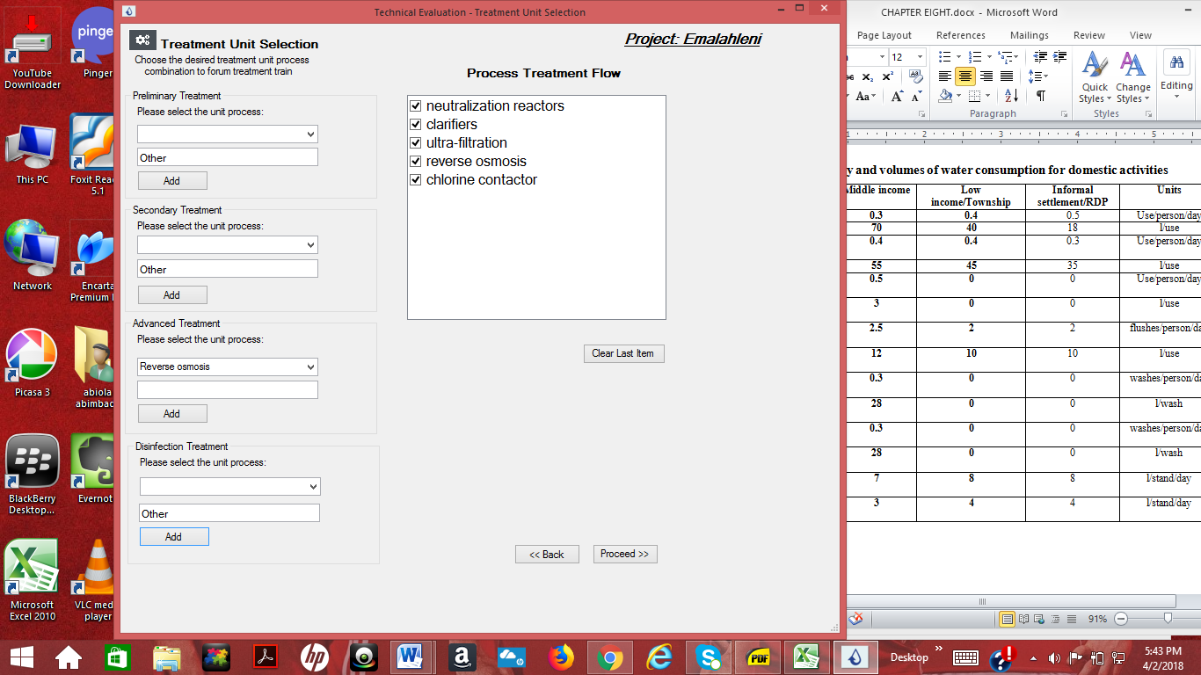
Figure 18.4: Dialogue box for selection treatment train selection

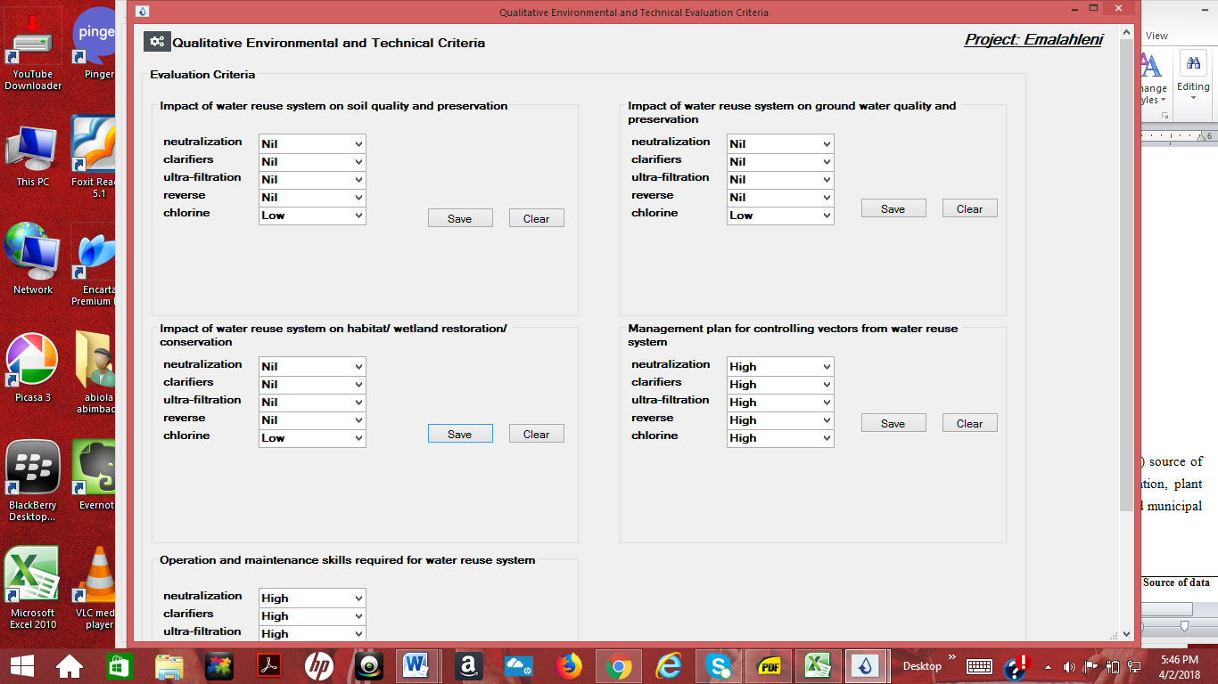
Figure 18.5: Dialog box for estimating qualitative environmental and technical aspects
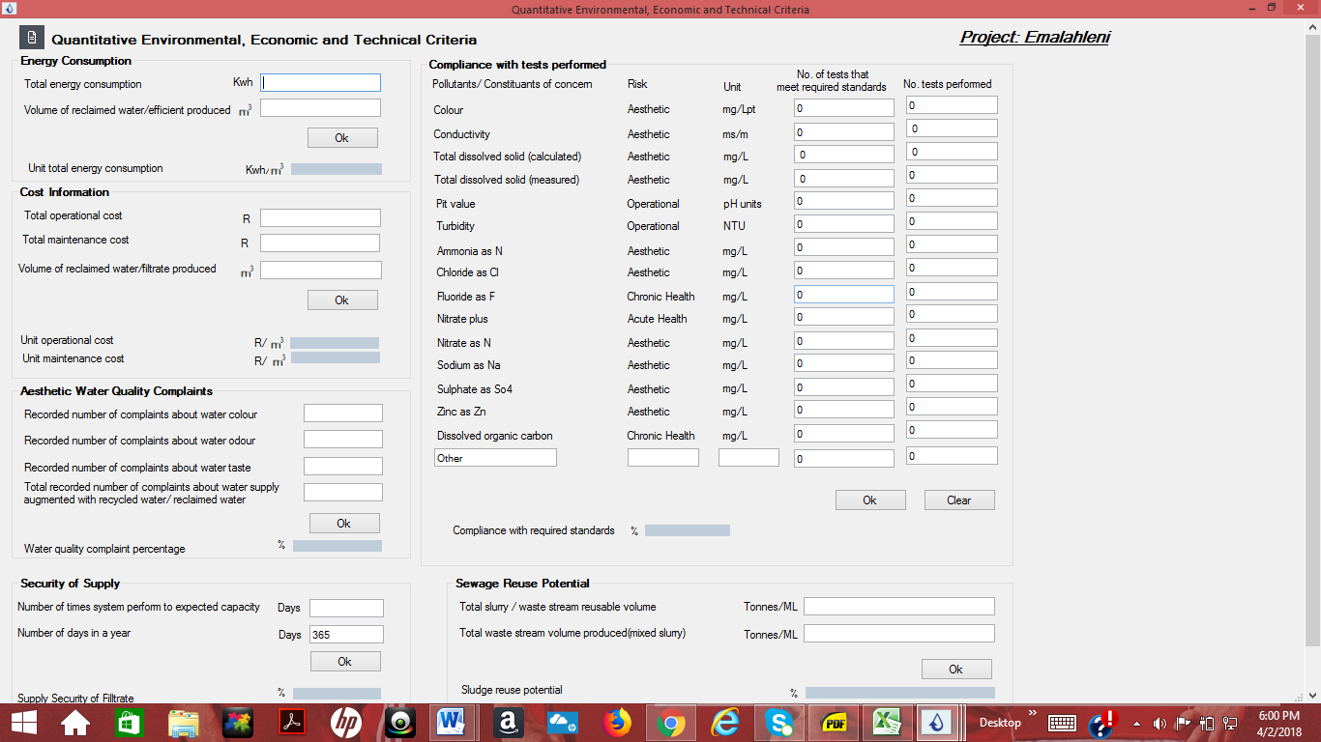
Figure 18.6: Dialog box for estimating quantitative economic, environmental and technical aspects

The user is expected have access to reliable plant information/literature review data to reasonable input necessary information to evaluate the quantitative environmental, technical and economic aspects. The dialog box shown in Figure 18.6 appears with a set of possible actions accessed via buttons. The user is allowed to edit and clear information as often as necessary. Please note that all text boxes must be filled with a figure or zero. For example, if a user have a specific figure for compliances test in percentage, then the figure can be insert in decimal (i.e. 70% of compliance is written 0.70 in the color text box for “number of tests that meet required standards” and 1 is inserted into the text box for “number of test performed” then click “ok”, then 70 appears in the result for “compliancy with required standard” blue textbox. The “proceed” directs the user to the next dialogue box consisting of for social dimension evaluation criteria (Figure 18.7).
The domestic consumer survey questionnaires can be downloaded from the internet from the “download” button on the welcome page. The user is expected to print the questionnaire and administered them in the study community. Results from the administered questionnaires are then feed into the relevant assessment criterion by the user. Clicking on the “proceed” button directs the user to the next dialogue box for evaluating institutional aspect (Figure 18.8).

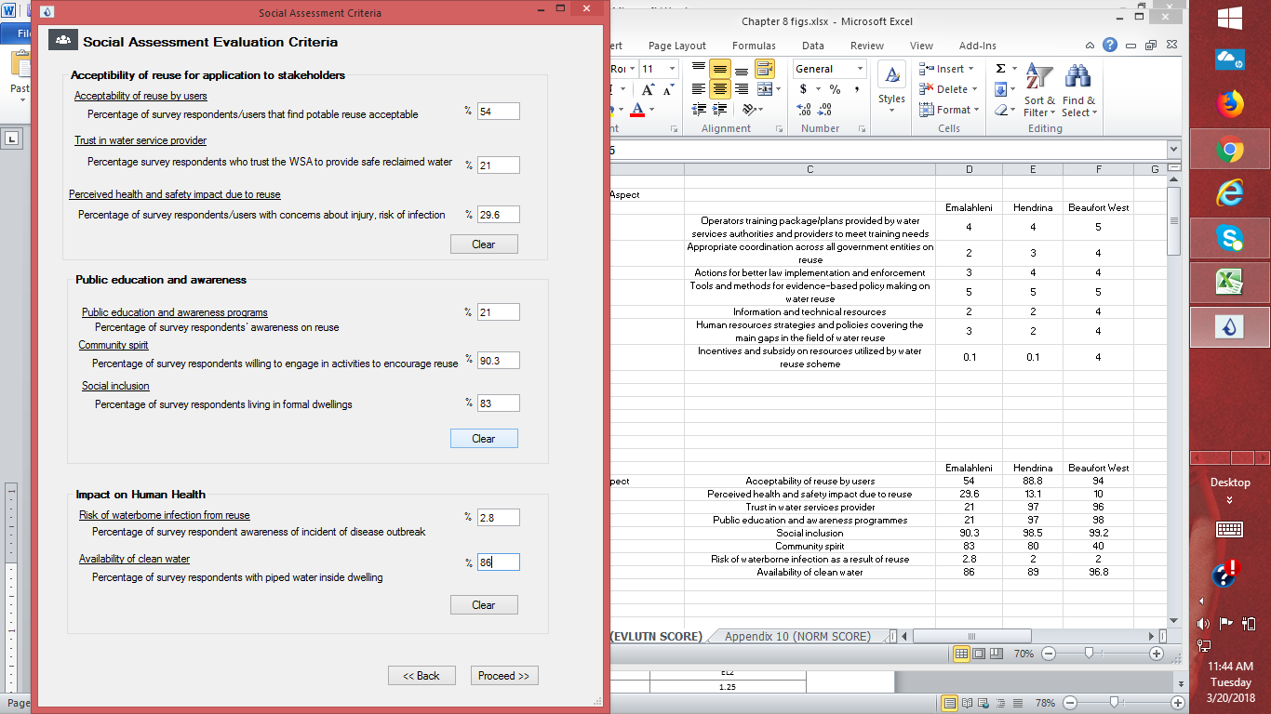
Figure 18.7: Dialog box for estimating social aspects

The user selects the appropriate option from the drop down selection for each criteria, only the blue drop score for the water reclamation plant is a quantitative score that the user have provide a reasonable value in percentage with regards to the system under consideration. The “proceed” directs the user to the next dialogue box for the score normalization exercise (Figure 18.9). The text boxes for the raw scores of criteria are automatically populated with the raw scores from all the previous dialogue boxes. Clicking on the “normalize” button performs the score normalization exercise. The normalized score text boxes for the criteria are automatically populated from the clicking the normalize button. Clicking on “proceed” directs the user to the next dialogue box for the attaching of weights to criteria and aggregation as well (Figure 18.10).

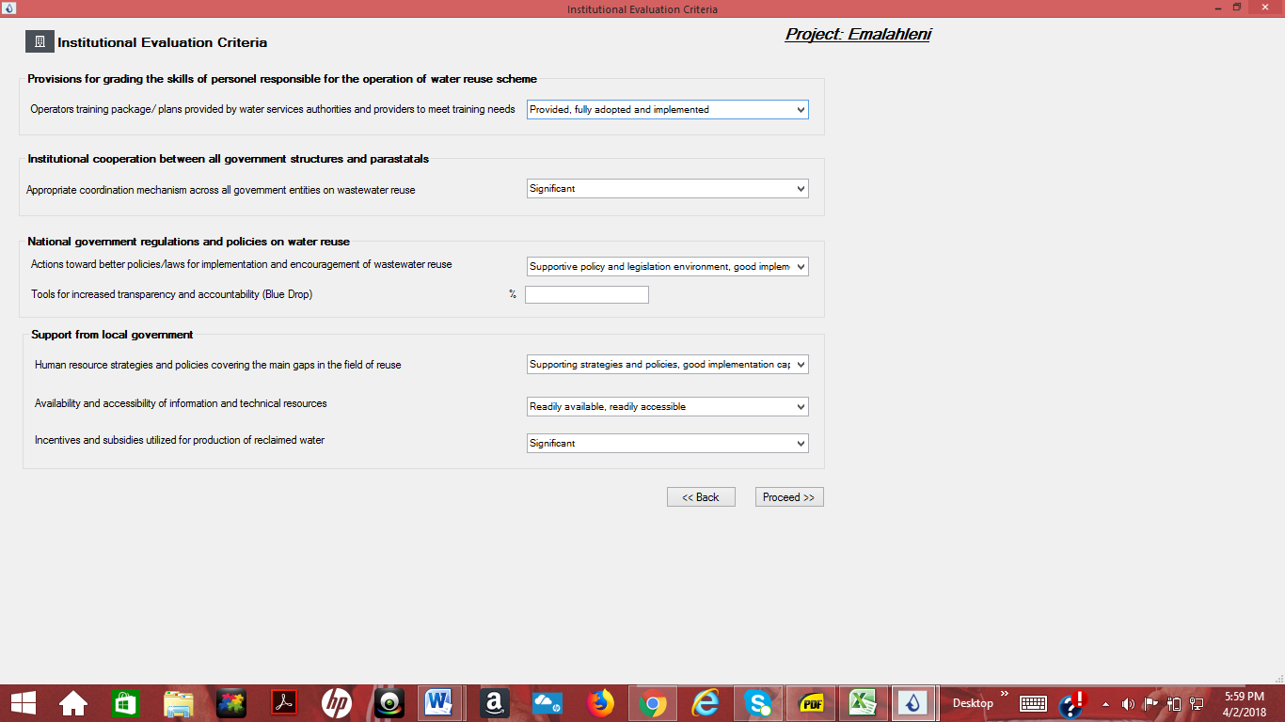
Figure 18.8: Dialog box for evaluating institutional aspects
The weight assigned to each criterion is at the user’s discretion. Assigned weights are inserted into the “weight” textboxes. Please note, all text boxes must be filled with a digit. Clicking on the “proceed” direct the user to dialogue box show in Figure 18.11. Pop-up text box that display scores for individual sustainability dimension appears. The user has to keep pressing “ok” then clicking on the “proceed” bottom directs the user to the result page
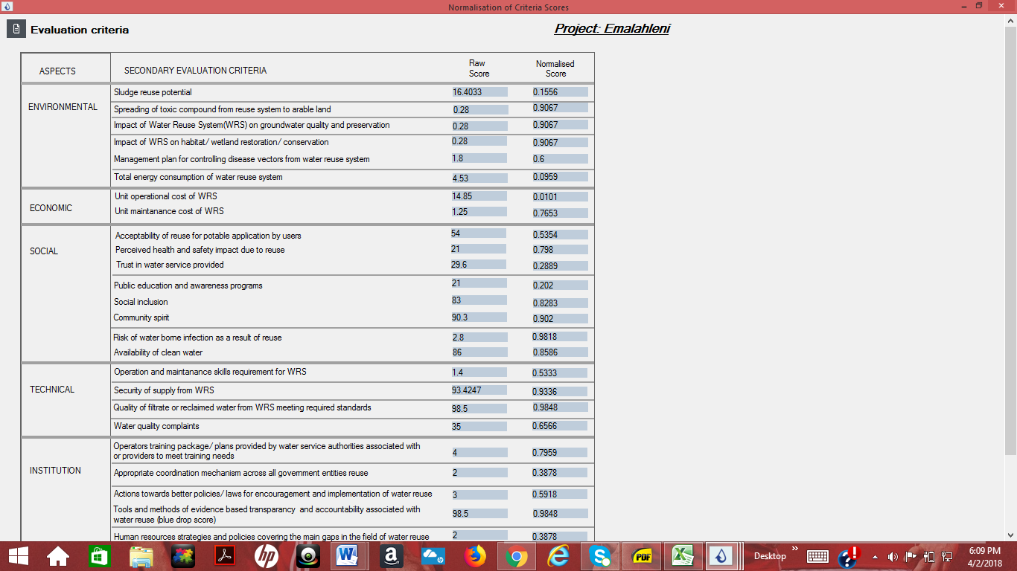
Figure 18.9: Dialog box for normalization of raw scores
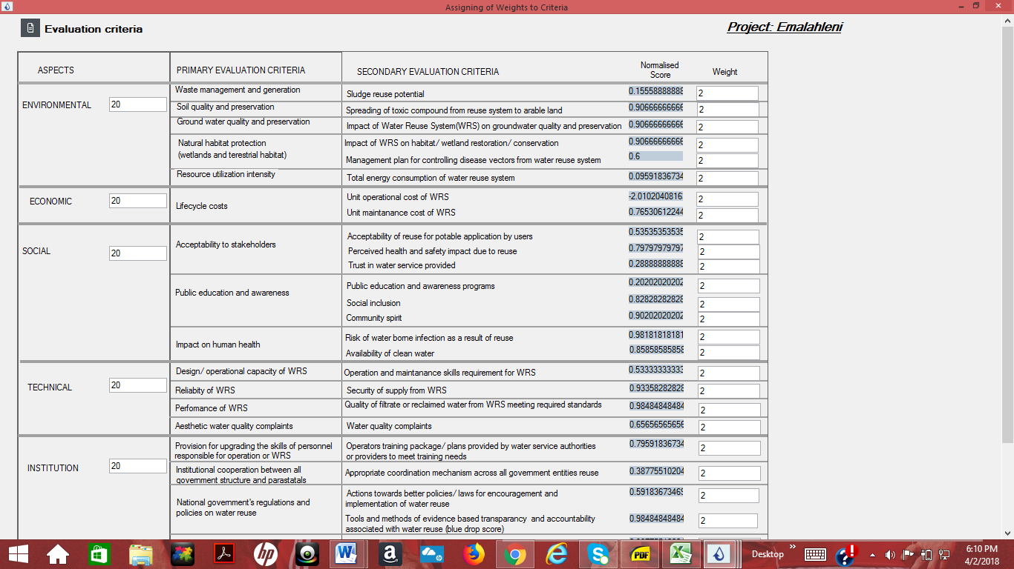

Figure 18.10: Dialog box for attaching weights and aggregation of normalized scores

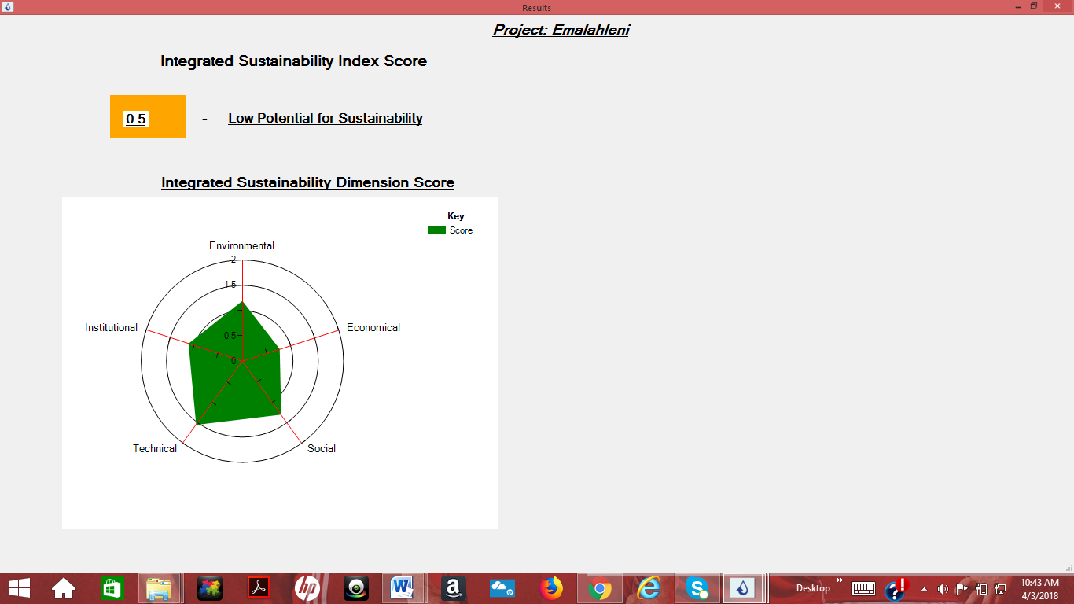
Figure 18.11: Dialog box showing the ISI score for case study site under consideration

APPENDIX 19
RESEARCH QUESTIONNAIRE FOR CONSULTATION WITH EXPERTS JUNE 2015
AIM: The purpose of this questionnaire is to explore South African experts’ opinions on criteria suitable for assessing the sustainability performance of urban water reuse schemes/systems for potable applications in SA over time. Each primary criterion selected/recommended requires a set of secondary criterion/criteria corresponding to quantifiable facts and figures, or qualitative data to comparatively assess different alternatives in the decision process.
DEFINITIONS:
- Water reuse – involves processing and utilization of recycled (reclaimed) water (i.e. partially or fully treated wastewater effluent) from a variety of sources (e.g. domestic, industrial and/or mining activities) for a new or different beneficial application such as drinking, groundwater recharge, reservoir augmentation, industrial use or irrigation.
- Direct potable reuse – refers to the introduction of recycled (reclaimed) water directly into a drinking treatment plant.
- Indirect potable reuse – refers to augmentation of a drinking water source (surface or groundwater, reservoir) with reclaimed (recycled) water followed by an environmental buffer that precedes normal drinking water treatment with recycled (reclaimed) water
- Criteria – are set of factors that may be used to make a judgement about the relative sustainability of a set of options or system

- Please tick the sector in which your organization falls
Organization sector | Tick | Organization sector | Tick
Water engineers and consultants |  | Municipality officials
Academic institutions |  | Water boards and water service provider
Non-governmental research institutions |  | Water regulatory authority
Governmental research institution |  | Other (Please specify…………………………….)
Government departments |  | Other (Please specify…………………………….)
Water and wastewater operation |  | Other (Please specify…………………………….)

- Please rate from 1(not applicable) to 4(most applicable) water reuse options you would consider applicable in a South African context.
Water reuse options | 1 | 2 | 3 | 4
Water reuse for drinking purpose
Water reuse for groundwater recharge
Water reuse for reservoir augmentation
Water reuse for surface water recharge
- Please rate from 1(not appropriate) to 4(most appropriate) effluent sources you would consider for reuse purpose in a South African context.
Effluent source | 1 | 2 | 3 | 4
Municipal/Central wastewater treatment plant
On-site wastewater treatment plant
Harvested rainwater
Storm runoff
Other (Please specify……………………………………..)
Other (Please specify……………………………………..)
- Please rate from 1(not applicable) to 5(most applicable) reuse scale you would consider applicable in a South African context.

Water reuse scale | 1 | 2 | 3 | 4 | 5
On-site water reuse for a building/facility
On-site water reuse for a group or cluster of buildings/facilities
Municipal/Centralized water reuse
Other (Please specify…………………………………….)
Other (Please specify……………………………………..)

- Please rate from 1(not appropriate) to 4(most appropriate) how stakeholders can effectively participate in and contribute to strategic decision making to enhance the sustainability performance of water reuse schemes/systems in SA?
Stakeholders’ participation approach | 1 | 2 | 3 | 4
Citizen’s jury, i.e. group of randomly selected citizens, representative of the demographics in a specific area to participate in decision making
Expert panel, i.e. group of individuals with extensive knowledge/skill in a particular field
Use of tailored/structured questionnaires as a tool for gathering information
Other (Please specify………………………………………………….)
Other (Please specify………………………………………………….)

- Please rate from 1(not important), 2(least important), 3(important) to 4(very important) the importance of each indicator for assessing the sustainability performance of water reuse schemes/systems for potable applications in SA.

Indicator category | 1 | 2 | 3 | 4
Environmental
Technical
Economic
Social
Institutional

- Several secondary criteria can measure how well a primary criterion is performing in relation to an indicator category. Please rate from 0 (negligible), 1(not important), 2(least important), 3(important) to 4(very important) the importance of the below secondary criteria for assessing the sustainability performance of water reuse schemes/systems for potable applications in SA.

NOTE: Please feel free to revise/modify the criteria (Primary and secondary) and units of measurement (UoM); and feel free to suggest additional criteria and units of measurement. Thank you.
Environmental Indicator Category
Primary Criteria | Secondary Criteria | Unit/(UoM) | Rate
Surface water quality and quantity (intake and discharge location) | Eutrophication potential - load of Nitrogen (N) present as nutrient in effluent to/in receiving water bodies | mg/L
 | Eutrophication potential - load of Phosphorus(P) present as nutrient in effluent to/in receiving water bodies | mg/L
 | Total annual fresh water saving due to water reuse systems/schemes | KL/y
 | Contribution to environmental water requirement | % increase in ecological reserve
 | Other (Please specify………………………………………...)
 | Other (Please specify………………………………………...)
Waste generation and management | Quality of sludge e.g. Heavy metal (Cd, Hg, Pb) content in sludge produced | mg/L
Waste generation and management | Quantity of sludge produced from water reuse schemes/systems | Kg/day
Waste generation and management | Waste (Sludge) recycling and reuse | Tonnes/year
Waste generation and management | Spreading of toxic compound to arable land e.g. heavy metal (Cd, Hg, Pb) content | mg/kg
Waste generation and management | Other (Please specify………………………..)
Waste generation and management | Other (Please specify………………………..)
Groundwater quality and preservation | Toxic compounds (heavy metal) e.g., Fe, Pb, Hg, Ni, Cd present in groundwater after recharge/percolation of effluent into the groundwater aquifer | mg/L
Groundwater quality and preservation | BOD, suspended solids | Mg/L
Groundwater quality and preservation | Other (Please specify………………………………………...)
Groundwater quality and preservation | Other (Please specify………………………………………...)
Contribution to climate change and air quality | Ambient concentration of air pollutants | % of days when  standards/guideline values are exceeded
Contribution to climate change and air quality | Green-house gas emission resulting from water reuse systems/scheme calculated per unit volume | KgCO²/KL
Contribution to climate change and air quality | Other (Please specify………………………………………...)
Contribution to climate change and air quality | Other (Please specify………………………………………...)
Natural habitat protection (wetlands and terrestrial habitats) | Habitat/wetland restoration/conservation as a result of reuse | Annual (Qualitative)
 | Management plan for controlling disease vectors as a result of reuse | Annual (Qualitative)
 | Other (Please specify………………………………………...)
 | Other (Please specify………………………………………...)
Land use and infrastructure compatibility | Area of available land which is used for water reuse system development | Km²
Land use and infrastructure compatibility | Ease of access to water reuse scheme | Qualitative
Land use and infrastructure compatibility | Other (Please specify………………………………………...)
Land use and infrastructure compatibility | Other (Please specify………………………………………...)
Resource utilization intensity | Total energy consumption of the water reuse systems | KWh/m³
Resource utilization intensity | Use of electricity and fossil fuels by water reuse systems/schemes | KWh/m³
Resource utilization intensity | Quantity of chemicals used by water reuse systems e.g. Fe, Al, Cl | g/KL
Resource utilization intensity | Other (Please specify………………………………………...)
Resource utilization intensity | Other (Please specify………………………………………...)
Other (Please specify…………....)
Other (Please specify…………….)

NOTE: Please feel free to revise/modify the criteria (Primary and secondary) and units of measurement (UoM); and feel free to suggest additional criteria and units of measurement. Thank you.
Economic Indicator Category
Primary Criteria | Secondary Criteria | Unit/(UoM) | Rate
Life cycle costs | Operational cost of production of water reuse system | ZAR/year
Life cycle costs | Maintenance costs of water reuse system | ZAR/year
Life cycle costs | Other (Please specify……………………………………………………....)
Life cycle costs | Other (Please specify……………………………………………………....)
Benefit:cost ratio | Payback period: length of time to recover cost of investing in water reuse system | Years
Benefit:cost ratio | Average incremental cost of adding one/more unit of production to water reuse system | ZAR/year
Benefit:cost ratio | Annualised cost: cost per year of owning and operating water reuse system | ZAR/year
Benefit:cost ratio | Other (Please specify……………………………………………………….)
Benefit:cost ratio | Other (Please specify……………………………………………………...)
Other (Please specify…………)
Other (Please specify…………)

NOTE: Please feel free to revise/modify the criteria (Primary and secondary) and units of measurement (UoM); and feel free to suggest additional criteria and units of measurement. Thank you.
Technical Indicator Category
Primary Criteria | Secondary Criteria | Unit/(UoM) | Rate
Design/operational capacity of water reuse systems/schemes | Water reuse systems capacity utilization | Ratio between design capacity and actual wastewater feed rate (%)
Design/operational capacity of water reuse systems/schemes | Operation and maintenance | Standard operation and prevention procedures e.g. log books and records keeping
Design/operational capacity of water reuse systems/schemes | Other (Please specify…………………..)
Design/operational capacity of water reuse systems/schemes | Other (Please specify…………………..)
Flexibility of water reuse systems/schemes | Water reuse systems flexibility to upgrade and extend | Level of accommodation in design: potential and ability to accommodate future changes (qualitative)
Flexibility of water reuse systems/schemes | Other (Please specify…………………..)
Flexibility of water reuse systems/schemes | Other (Please specify…………………..)
Reliability of water reuse systems/schemes | Reliability of water supply to community | Number of interruptions to supply/annum
Reliability of water reuse systems/schemes | Security of supply | Ratio between total water delivered to customers and total demand
Reliability of water reuse systems/schemes | Other (Please specify……………………)
Reliability of water reuse systems/schemes | Other (Please specify…………………..)
Performance of water reuse systems/schemes | Quantity of wastewater available for reuse | Average effluent production from water reuse scheme in KL/day
Performance of water reuse systems/schemes | Quality of effluent produced/supplied by water reuse scheme | Compliance with required standards (SANS 241) for physical, chemical and microbial tests performed throughout the year (%)
Performance of water reuse systems/schemes | Water quality complaints (aesthetics)e.g., odour, colour, taste | Number of water quality complaints/year
Performance of water reuse systems/schemes | Water recovery rate | Volume and % of water savings due to reuse
Performance of water reuse systems/schemes | Water recovery rate | Volume and % of wastewater treatment/treated due to reuse
Performance of water reuse systems/schemes | Other (Please specify…………………..)
Performance of water reuse systems/schemes | Other (Please specify…………………..)
Other (Please specify……….)
Other (Please specify……….)

NOTE: Please feel free to revise/modify the criteria (Primary and secondary) and units of measurement (UoM); and feel free to suggest additional criteria and units of measurement. Thank you.
Social Indicator Category
Primary Criteria | Secondary Criteria | Unit/(UoM) | Rate
Acceptability to stakeholders | Acceptability of reuse to stakeholder | Number of complaints/100 population
Acceptability to stakeholders | Perceived health and safety impact due to reuse | Percentage of ‘users’ with concerns about injury, risk of infection
Acceptability to stakeholders | Trust in water services provider | Number of people/100 population
Acceptability to stakeholders | Willingness to use | Percentage of 100 population willing to use reclaimed water
Acceptability to stakeholders | Willingness to pay | Percentage of 100 population willing to pay for reclaimed water
Acceptability to stakeholders | Other (Please specify……………..)
Acceptability to stakeholders | Other (Please specify………………)
Participation | Participation in sustainable behaviour | Number of people/100 population participating in reuse initiative
Participation | Other (Please specify……………….)
Participation | Other (Please specify……………...)
Responsibility | Individual action to encourage water reuse scheme | Number of people willing to change behaviour/100 population
Responsibility | Other (Please specify……………..)
Responsibility | Other (Please specify……………..)
Public education and awareness | Public education and awareness programmes | Percentage awareness in local community/100 population
Public education and awareness | Social inclusion | Percentage of 100 population with access to information
Public education and awareness | Community spirit | Percentage of 100 population with access to watercourse
Public education and awareness | Other (Please specify……………….)
Public education and awareness | Other (Please specify………….…..)
Impact on human health | Risk of waterborne infection as a result of reuse | Number of waterborne disease outbreaks /100 population
Impact on human health | Risk of gastrointestinal infection as a result of reuse | Number of affected users/ 100 population
Impact on human health | Cases of gastrointestinal cases reported | Person/year
Impact on human health | Availability of clean water | Percentage of population with access to clean water
Impact on human health | Other (Please specify……………..)
Impact on human health | Other (Please specify……………..)
Other (Please specify………….)
Other (Please specify………….)

NOTE: Please feel free to revise/modify the criteria (Primary and secondary) and units of measurement (UoM); and feel free to suggest additional criteria and units of measurement. Thank you.
Institutional Indicator Category
Primary Criteria | Secondary Criteria | Unit/(UoM) | Rate
Provisions for upgrading the skills of personnel responsible for the operation of reuse schemes | CPD points for operators/engineers for increasing skills set regarding water reuse | Hours/annum
 | Operators training package/plans provided by water services authorities and providers to meet training needs | Qualitative
 | Establishment and participation in learning networks | Qualitative
 | Other (Please specify………………………………….)
 | Other (Please specify………………………………….)
Institutional cooperation between all government structures and parastatals | Appropriate coordination across all government entities on reuse | No. of coordination mechanisms
 | Other (Please specify………………………………….)
 | Other (Please specify………………………………….)
National government’s regulations and policies on water reuse | Tools and methods for evidence-based policy making on water reuse | Qualitative
 | Actions for better law implementation and enforcement | Qualitative
 | Tools for increased transparency and accountability | Blue drop score, green drop score
 | Other (Please specify…………………………………..)
 | Other (Please specify…………………………………..)
Support from Local government | Information and technical resources | Qualitative
Support from Local government | Human resources strategies and policies covering the main gaps in the field of water reuse | Qualitative
Support from Local government | Incentives and subsidy on resources utilized by water reuse scheme | % of subsidy on resources utilized received from government
Other (Please specify……………...)
Other (Please specify………………)

Please add any comments you would like to make:

APPENDIX 20
QUESTIONNAIRE FOR DOMESTIC RESPONDENTS
RESEARCH QUESTIONNAIRE JULY 2017
AIMS: This questionnaire aims to determine (i) acceptability of recycled water, (ii) public education and awareness of water reuse for drinking purposes and (iii) trust and credibility of the municipality/Municipal Water Service Authority (MWSA) to provide good quality water supply in South African communities. Your responses will be confidential.
DEFINITIONS:
- Water reuse – involves processing and utilization of recycled (reclaimed) water (i.e. partially or fully treated wastewater effluent) from a variety of sources (e.g. domestic, industrial and/or mining activities) for a new or different beneficial application such as drinking, groundwater recharge, reservoir augmentation, industrial use or irrigation
- Recycled/reclaimed water – is former wastewater (sewage/ industrial effluent) that is treated to remove solids and impurities, and used in sustainable landscaping irrigation, to recharge groundwater aquifers, to meet commercial and industrial water needs, and for drinking.
- Direct potable reuse – refers to the introduction of recycled (reclaimed) water directly into a drinking treatment plant while Indirect potable reuse - refers to augmentation of a drinking water source (surface or groundwater, reservoir) with reclaimed (recycled) water followed by an environmental buffer that precedes normal drinking water treatment with recycled (reclaimed) water. Thank you for your time and information

- Name of residential area:
- Please rank the following about the water supplied by the municipality/MWSA:
Unacceptable Poor Fair Good Excellent
Overall water quality
- Have you or any member of your household gotten any particular disease(s) as a result of using the water supplied for drinking purposes by the municipality/MWSA? Yes No I don’t think so
- If your answer is Yes, please list them
- Are you aware of any case(s) in your community of water borne disease outbreak reported as a result of using the water supplied for drinking purposes by the municipality/MWSA? Yes No I don’t know
- If your answer is Yes, please indicate the number of cases
- Are you aware that the water supplied by the municipality/MWSA is mixed with recycled water? Yes No I don’t know (Please tick which is applicable)
- Which of the following words best describes your reaction to recycled water? Disgusting Unhealthy & dangerous Good & OK Environmentally friendly Unsure/neutral
- Please tick your preferred source for the wastewater to be recycled, i.e. wastewater from Municipal/Central wastewater treatment plant On-site wastewater treatment plant Harvested rainwater Storm runoff Mine water Other
- If the municipality/Municipal Water Service Authority (MWSA) propose a water recycling scheme for drinking purposes, how acceptable is the recycling scheme to you? Extremely unacceptable Unacceptable Unsure/Neutral Acceptable Extremely acceptable
- Are you willing to engage in activities to encourage water reuse for potable applications in your community
Yes No Not sure
- How likely do you think it is that there would be any problem with the water recycling scheme. (Please complete the sentence by ticking the option that is most applicable to you) Highly unlikely Unlikely Neutral/Unsure Likely Highly likely
- How serious do you think the problem will be if something went wrong with the water recycling scheme? (Please complete the sentence by ticking the option that is most applicable to you) Extremely serious Serious Neutral/Unsure Not serious Not at all serious
- What level of control do you think the municipality will have if there is a problem with the water recycling scheme? (Please complete the sentence by ticking the option that is most applicable to you) No control at all Some control Neutral/Unsure Low level of control High level of control
- To what extent do you agree/disagree with each of the following statements? Please tick (√) against the option that is most applicable to you using the 5-point response scale provided.
Statement  Please note: Municipal Water Service Authority (MWSA) | Strongly Agree | Agree | Neutral | Disagree | Strongly Disagree
The use of recycled water for drinking purposes can save many South African communities from drought and challenges facing drinking water supply.
The use of recycled water for drinking purposes will reduce depletion of groundwater and surface water
The use of recycled water for drinking purposes will reduce the amount of wastewater discharged to the environment
I find the source of the wastewater to be recycled for drinking purposes to very important
I have the right to know the source of the wastewater to be recycled for drinking purposes
I have the right to know if the water supplied for drinking purposes by the municipality is mixed with recycled water
I am concerned about the income class area within my community that will be the major recipient of the recycled water
The municipality/MWSA makes fair decisions about water provision to all the different income class areas within the community
The municipality/MWSA makes an effort to treat everyone within the different income class areas within the community fairly
The municipality/MWSA will ensure that the recycled water is distributed to all the different income class areas within the community
Adequate public education campaigns were conducted by the municipality/MWSA to provide information about the use of recycled water for drinking purpose
The public education campaigns provides the public with everything that they need to know about the use of recycled water for drinking purposes
The tools used by the municipality/MWSA to educate the public on the use of recycled of water for drinking purposes are effective and efficient
The municipality/MWSA programs and information on the use of recycled water for drinking purposes is easy to get
The municipality/MWSA will not listen to concerns raised by people like me
The municipality/MWSA acts in the public’s interest when it comes to water quality
In relation to providing good quality water, the municipality/MWSA shares similar values as me
I see the municipality/MWSA as an important member of my community
In relation to my community, I see the municipality/MWSA as “one of us”
I believe that the municipality/MWSA has the same opinion as I do about how to provide good quality water to the municipality
I believe the municipality/MWSA is a good representative of the people in my community
The municipality/MWSA provides the public with all that is to know about the water supplied to their community
I am confident that the municipality/MWSA will ensure that the recycled water is safe
I can depend on the municipality/MWSA to provide me with good quality water supply
I have complete trust in the municipality/MWSA to provide me with a good quality water supply
The municipality/MWSA is competent enough to manage the municipality’s water supply
I am willing to use recycled water for drinking purposes
I am willing to use recycled water for cooking purposes
I am willing to use recycled water for showering
I am willing to use recycled water for laundry
I am willing to use a recycled water for outdoor use
I can get sick from using a water supply mixed with recycled water for drinking purposes on a long term basis
People can get sick from using a water supply mixed with recycled water for drinking purposes on a long term basis
I have concerns about possible problems or risks linked with the water recycling scheme for drinking purposes
I feel personally obligated to do whatever I can to save water
I am willing to promote the use of recycled water for drinking purposes among my friends and family
I feel personally obligated not to dispose toxic substances into household water drains and sewers
I am willing to use water saving devices to reduce household water consumption

- Please tick your gender: Male Female
- Please tick your marital status: : Single Married Married + children Divorced
- Please tick your race: Black White Asian Indian Coloured Others
- Please tick your age bracket? 18 -23 24 – 29 30 – 34 35 – 39 40 – 44 45 – 49 50 – 54 55 and above
- Please tick your highest level of education received? <Matric Matric Diploma/equivalent Undergraduate degree Honors degree Master’s degree PhD
- Please tick how your household receives water from the municipality/MWSA: Tap Standpipe Well Borehole Water tanker to my tank Water vendor
- Where does wastewater from your house drain to? Sewer Septic tank into the street into the garden Recycled Others (specify_______)

