THE DEVELOPMENT OF CRITICAL THINKING SKILLS THROUGH THE EVALUATION OF INTERNET MATERIALS

THE DEVELOPMENT OF CRITICAL THINKING SKILLS THROUGH THE EVALUATION OF INTERNET MATERIALS

By

DAVID BARNETT

Submitted in partial fulfilment of the requirements for the degree

MASTERS IN EDUCATION
(Educational Technology)

SCHOOL OF EDUCATION

FACULTY OF HUMANITIES

UNIVERSITY OF THE WITWATERSRAND

SUPERVISOR: DR NOKULUNGA NDLOVU

OCTOBER 2016

DECLARATION

I, David Barnett, declare that “The development of Critical Thinking Skills through the evaluation of Internet materials” is my own unaided work. It has not previously been submitted for any degree or examination at this or any other university.
I further declare that all the sources that I have used or quoted have been indicated and acknowledged by means of complete references.


______________________ _________

DAVID BARNETT

2016 10 05

Student number: 968537
Ethics Clearance protocol number:2015ECEO53M
ACKNOWLEDGEMENTS

I am grateful to:

My wife Gillian and my children, for encouraging me and for freeing up time so that I could complete this study;

Dr Nokulunga Ndlovu for being my supervisor;

My colleagues at school for making allowances for my occasional grumpiness;

The enthusiastic students who participated in this research.

The colleagues who read this report and made constructive criticism and moderated my evaluations, especially: Kate Fitzsimons, Life Orientation teacher, and Ms. E Kennedy, Dept. Head Biology.

TABLE OF CONTENTS

CHAPTER 1 INTRODUCTION......................................................................1
1.1 Problem Statement........................................................................................ 1
1.2 Purpose and Rationale...................................................................................3
1.3 Key Research Question………………………………………………………..…4
1.4 Sub Questions…………………………………………………………………….. 5
1.5 Conceptual framework....................................................................................6
1.6 Overview of the chapters................................................................................9

CHAPTER 2 LITERATURE REVIEW...........................................................12
2.1 Literature Review..........................................................................................12
2.1.1 Boundaries of Critical Thinking...........................................................12
2.1.2 Critical Thinking defined.....................................................................13
2.2 The Delphi definition of Critical Thinking.......................................................16
2.2.1 Self-regulatory or meta-thinking..........................................................17
2.2.2 Argument............................................................................................18
2.2.3 Creative and Critical Thinking.............................................................20
2.2.4 Transferability of Critical Thinking Skills.............................................21
2.3 Review of the crucial elements used in the intervention...............................22
2.3.1 The ICARE pathway...........................................................................22
2.3.2 The Learning Management System....................................................24
2.4 Review of the Theories that influence the teaching and application of
Critical Thinking skills.........................................................................26 2.4.1 Post-modernism.................................................................................27
2.4.2 Constructivism…………………………………………………………….28
2.4.3 Social Constructivism…………………………………………………….29
2.4.4 Connectivism......................................................................................30
2.4.5 Anchored Instruction...........................................................................31
2.4.6 Blended Learning................................................................................33

CHAPTER 3 RESEARCH DESIGN AND METHOD.....................................34
3.1 Research design.............................................................................................34
3.2 Considerations of a method to use in this study.............................................35
3.2.1 Influence of the research question on the design................................35
3.2.2 Influence of investigator control ..........................................................36
3.2.3 Consideration of contemporary events................................................36
3.3 The Case Study..............................................................................................37
3.3.1 Type of case study...............................................................................38
3.3.2 Boundaries of the case study...............................................................39
3.3.3 Overcoming case study criticisms........................................................40

CHAPTER 4 DESCRIPTION OF THE INTERVENTION................................42
4.1 Content and criteria.........................................................................................42
4.2 The SCRAP criteria.........................................................................................44
4.3 The research situation – the students.............................................................47
4.4 Motivating adolescents to think critically.........................................................48
4.5 Using YouTube in the intervention..................................................................50

CHAPTER 5 PLANNING FOR DATA COLLECTION AND ANALYSIS........53
5.1 Mixed method – qualitative and quantitative approaches...............................53
5.2 Using coding with qualitative research............................................................55
5.3 Effectiveness of a code – an example............................................................57

CHAPTER 6 LESSONS WHICH DEVELOP CRITICAL THINKING SKILLS...........59
6.1 Introductory lesson........................................................................................ 60
6.2 Lesson 1 Structure....................................................................................61
6.3 Lesson 2 Currency....................................................................................62
6.4 Lesson 3 Reliability...................................................................................63
6.5 Lesson 4 Authority and Point of View.......................................................64
6.6 Lesson 5 Using SCRAP criteria for evaluation and
forming an argument................................................................ 65

CHAPTER 7 DATA PRESENTATION AND DISCUSSION......................... 67
7.1 Results from the qualitative and quantitative approach..................................67
7.1.1 Structure...............................................................................................67
7.1.2 Currency...............................................................................................68
7.1.3 Reliability..............................................................................................69
7.1.4 Authority...............................................................................................70
7.1.5 Point of View........................................................................................71
7.2 Representation and analysis of results pre- and post-evaluation...................72
7.2.1 Volume of words - pre and post-evaluation.........................................72
7.2.2 Pre- and post Likert results..................................................................73
7.2.3 Comparison of the SCRAP elements – pre- and post-test..................77
7.2.4 Analysis of the pre- and post-test views of making an argument .......78
7.3 Analysis of an argument using Kuhn’s scale..................................................79
7.4 The allowance for creative insight within Critical Thinking............................ 82
7.5 Correlation and triangulation...........................................................................83

CHAPTER 8 CONCLUSION..........................................................................85
8.1 Students’ opinion of the CT intervention.........................................................85
8.2 Positives and negatives of the intervention.................................................... 86
8.3 Impact of extraneous factors...........................................................................87
8.4 Validity and reliability..................................................................................... 88

LIST OF FIGURES

Figure 1.1 Paths followed in this research report................................................1
Figure 1.2 The key research question and the supplementary questions...........5
Figure 2.1 Integration of the ICARE system into the lessons used.....................22
Figure 2.2 Diagram of theories, models and philosophies underpinning this research report...................................................................................27
Figure 3.1 Representation of the research design and methodology used in this study...................................................................................................34
Figure 3.2 Diagrammatic representation of the data collection process..............36
Figure 5.1 Graphical representation of the data collection process.....................53
Figure 5.2 Coding and analysis of data................................................................55
Figure 6.1 Screen shots of two « false » sites on the LIMU LMS.........................60
Figure 6.2 Screen shots of the resources available on the LIMU LMS
that were used in lesson one...............................................................61
Figure 6.3 Screen shots of the resources available on the LIMU LMS
that were used in lesson two...............................................................62
Figure 6.4 Screen shots of the resources available on the LIMU LMS
that were used in lesson three.............................................................63
Figure 6.5 Screen shots of the resources available on the LIMU LMS
that were used in lesson four...............................................................64
Figure 6.6 Screen shots of the resources available on the LIMU LMS
that were used in lesson five...............................................................65
Figure 6.7 Screen shots of the students’ submission on the LIMU LMS…………66
Figure 6.8 Comparison of two sites on the same subject......................................66
Figure 7.1 Questions used in the STRUCTURE component of SCRAP...............68
Figure 7.2 Questions used in the CURRENCY component of SCRAP.................69
Figure 7.3 Questions used in the RELIABILITY component of SCRAP................70
Figure 7.4 Questions used in the AUTHORITY component of SCRAP................71
Figure 7.5 Questions used in the POINT OF VIEW component of SCRAP..........72
Figure 7.6 Numbers of words used in the pre- and post-evaluations....................73
Figure 7.7 Comparison of pre- and post Likert results of assessing the STRUCTURE of web material………………………………….…….…. 74
Figure 7.8 Comparison of pre- and post Likert results of assessing the CURRENCY of web material………………………………….……...…. 75
Figure 7.9 Comparison of pre- and post Likert results of assessing the RELIABILITY of web material………………………………….…..……. 75
Figure 7.10 Comparison of pre- and post Likert results of assessing the AUTHORITY of web material………………………………….…….…. 76
Figure 7.11 Comparison of pre- and post Likert results of assessing
POINT OF VIEW of web material……………………………...……….77
Figure 7.12 SCRAP components mentioned by the students in the final evaluation............................................................................................78
Figure 7.13 Making an argument............................................................................79

LIST OF TABLES

Table 1.1 Sub-questions forming part of key question..........................................6
Table 1.2 Main concepts in chapters 1 - 8...........................................................11
Table 4.1 Structure component criteria................................................................44
Table 4.2 Currency of the information material....................................................45
Table 4.3 Reliability of the information.................................................................45
Table 4.4 Authority of the author..........................................................................46
Table 4.5 Reasonableness of the material...........................................................46
Table 5.1 Students’ analysis using Critical Thinking criteria................................58
Table 7.1 Comparison of the pre and post Likert scales of 20 respondents...... 73
Table 7.2 Number of references..........................................................................77
Table 7.3 Quality of argument..............................................................................80
Table 7.4 Quality of arguments before and after the intervention........................82

APPENDICES

Appendix A | Critical Thinking certificate | 91
Appendix B | Ethics Clearance | 92
Appendix C | Internet sites | 93
Appendix D | Likert Scale | 98
Appendix E | Final qualitative questions | 99
Appendix F | Examples of students answers | 100

REFERENCES........................................................................................................104

“Knowledge emerges out of complex processes of selection, distinction and judgement- out of the irreducible interactions of humans and technology.”
Chad Wellmon (2012)

Chapter 1 Introduction

Topic: The development of Critical Thinking skills through the evaluation of Internet materials
B
elow is a broad representation of the path that that was followed in this research report.

Figure 1.1 Paths followed in this research report.
1.1 Problem Statement

This problem statement points out that there were two primary motives for conducting this specific research.
Firstly, it was necessary for students to develop Critical Thinking skills and, secondly, it was necessary for these students to apply these Critical Thinking skills to Internet materials in the search for trustworthiness of information. In this report the terms trustworthiness and credibility, although having subtle differences, are used as synonyms. In a checklist for information quality Harris, (2007) explains that the key to credibility is the question of trust. Within this report the concepts of trustworthiness and credibility are inseparable and complementary in the search for quality of information.

The need for developing Critical Thinking and its application is advanced both internationally and in South Africa. Locally the Independent Examinations Board of South Africa (IEB) has included a “thinking skills” module within its curriculum. In a 2013 framework the IEB justified this inclusion by arguing that “universities and businesses are complaining about the lack of independent critical and creative thinking in their students and employees” (Assessment Matters, 2013:1) The IEB further rationalised this decision by stating that that there should be a shift in education from teaching scholars what to learn to teaching them how to learn. The IEB stated that students are surrounded by information, media and social networking on a scale never before experienced.
*The views of George Siemens (2004) and those of Dr Robert Harris (2007) were taken into account when considering the value of evaluating Internet materials for trustworthiness.
Two statements by Siemens represent the crux of this research report. (Siemens, 2005:1). Siemens, an educator and researcher in learning theories for the digital age uses the term “paucity” to describe knowledge that is available on the Internet. He goes on to point out that “When knowledge is subject to paucity, the process of assessing worthiness is assumed to be intrinsic to learning” (Siemens, 2004:1). Siemens explains that information is ever-changing, thereby making it scanty and difficult to trust, and that therefore it is difficult to use this fluctuating information for learning.
Siemens argues that there is a need to assess knowledge for currency as, “While there is a right answer now, it may be wrong tomorrow due to alterations in the information climate affecting the decision.”(Siemens, 2004:1). It is the sifting of the ever-changing Internet material for accurate, current and reliable information that is at the heart of this research report.
Secondly, in his introduction to Evaluating Internet Resources, Harris (2007:1) states that,“Information is everywhere on the Internet, existing in large quantities and continuously being created and revised. Information exists in a large variety of kinds (facts, opinions, stories, interpretations, and statistics) and is created for many purposes (to inform, to persuade, to sell, to present a viewpoint, and to create or change an attitude or belief). For each of these various kinds and purposes, information exists on many levels of quality and reliability. It ranges from very good to very bad and includes every shade in between.”

Again, these statements motivate my proposal for the improvement in Critical Thinking skills. In the school environment, in which this study was conducted, the students have access to information via the Internet. It has become necessary, as pointed out by Siemens (2004) and Harris (2007), to develop and enhance the student’s Critical Thinking skills and apply these skills to the information that “surrounds them” so that they can look for trustworthy information.

Within this study a series of lessons were designed to develop Critical Thinking skills. Once these skills are acquired, the students would be able to analyse and evaluate Internet-based materials for trustworthiness.

The study was contextualised within a boys’ high school in Gauteng. This school writes the Independent Examination Board (IEB) examinations. The IEB is an assessment body that is accredited by Umalusi (the South African statutory body responsible for quality assurance for school and adult assessments).

All the Grade 11 boys participated in this study. However data was collected only from the 20 boys who were Business Studies students. The reason for the selection of this sample group was elaborated upon in this report.

  - Purpose and rationale
A Learning Management System was used in this study as a space in which Critical Thinking skills could be applied to Internet material. The primary purpose of this research was to see if the learning activities, presented on a Learning Management System (LMS), would developed into specific Critical Thinking abilities so that they could become an invaluable tool for evaluating the trustworthiness of Internet material.

A more explicit version of the primary purpose posited above is:
To teach the key skills by making use of a Learning Management System (LMS) as a medium for isolating selective web-based material and developing a pathway of learning. This pathway displayed Internet materials in a specific order. This order of arrangement can be regarded as a pathway for the students to follow. The steps in this pathway have been carefully chosen so as to inculcate an interest in and demonstrate the relevance of Critical Thinking.

A secondary, but integral, purpose of the research was to investigate the application of the critical skills through argument. The reason for applying Critical Thinking to Internet material is perhaps best elucidated by Oppenheimer (1997:16) who stated that, “On almost any subject the Net offers a plethora of seemingly sound research. However, under close inspection much of it proves to be ill informed or just superficial.” A pragmatic approach was therefore adopted in this research project and the students would learn to identify and apply Critical Thinking to specific materials so that trustworthy material could be identified. The students were asked to compare two different sites and to compare and contrast the trustworthiness of these sites. An evaluation was made to ascertain the ability of the students to formulate an argument based on the merits of different Internet sites. The purpose of this exercise was to see if the students could apply their newly mastered skills at an advanced level of thinking.

In the final stage of this study the purpose was to gather data from both qualitative and quantitative measures that were introduced into the research design. The purpose was to analyse and measure the data so that information could be compared, qualified and triangulated to prove that the Critical Thinking skills had been developed and are invaluable when sifting Internet material for trustworthiness.

1.3 Key Research Question
To what extent does the evaluation of Internet materials for trustworthiness, in a learning management system, develop Critical Thinking skills?

The key research question and supplementary questions are illustrated in Figure 1.2 below.

Figure 1.2 The key research question and the supplementary questions

1.4 Sub questions

Several sub-questions were linked to the primary research question. These sub-questions were asked at three different periods during the study. Questions that preceded the study, questions that were asked during the study and questions that qualified the intervention which occured at the end of the study.
The sub-questions are listed in Table 1.1 below.

Table 1.1 Sub-questions forming part of the key question
Pre Intervention | During the intervention | Post intervention
Can students be taught specific Critical Thinking skills which are required for the evaluation of Internet materials?  How does the teacher develop CT skills for the evaluation of Internet materials? | Can students use these specific skills to critically evaluate Internet materials for trustworthiness?  Can argument, as a form of comparison, reveal that there is evidence of improved levels of Critical Thinking? | Does the correlation of data prove that there is an enhancement of specific Critical Thinking brought about through the intervention?  Do the students consider that these specific critical evaluation skills have improved?  Do the students consider the intervention a worthwhile experience?  Do the students think that these critical skills could be transferable to other learning areas?

There is only one key research question within this research but, by answering this question, the supplementary questions are unlocked. The question is complex as it encapsulates the entire research and the question is disassembled into supplementary questions that need to be unravelled before an answer can be reached.

1.5 Conceptual Framework
In the conceptual framework assembled the key constructs that have emerged from this research into Critical Thinking were assembled and compared.
The initial concepts that underpinned this research were drawn from the literature review. Fritch & Cromwell (2001), Fritz (2003) and Schrock (1997) are authors who recognise the need to evaluate Internet material for trustworthiness and reference was made to their opinions in this research report. This research set out to formulate and test Critical Thinking criteria with which to evaluate Internet materials so that critical thinking could be advanced.
As a deductive approach was used the research began with the supposition that Internet material may be untrustworthy. Furthermore, an assumption was made regarding the value of Critical Thinking skills as a means of evaluating Internet sources. In this research a pragmatic approach was adopted and the student had to learn to identify and apply Critical Thinking to specific materials so that trustworthy material could be identified.
The content used in the teaching lessons related to Business Studies and was thus anchored to specific subject matter. The students worked together to construct a set of criteria with which to evaluate Internet materials.

Within the lessons three different approaches were used to construct and apply criteria with which to assess Internet materials.

Although the emphasis in this study was on a constructionist approach, there were still instances where the traditional ‘face-to-face” teacher-centred approach was used. An example of this is found in the introductory lesson (page 61) where the crux of the course was set by the teacher by asking leading questions about the use of the Internet and its trustworthiness.

This blended approach was the mingling of face-to-face learning with technology for imparting and presenting information. Within the lessons the blended approach was used to introduce the content. Although an example, is found in most of the lessons in this study, particular reference is made to the use of the blended approach in the introductory lesson. In this lesson the students and teacher view an Internet site and discussed the positive and negative features.

In addition to the blended approach there was a strong reliance on technology, without teacher assistance, in the form of a Learning Management System. A Learning Management System (LMS) was used to create a “space” in which Internet materials could be accessed. The medium for imparting critical skills and for access to information of various qualities is primarily a Learning Management System. The LMS affords the opportunity for the attachment of specific Internet material. The advantage of the isolation of specific Internet material was that the entire Internet is not available to the students. An example of the use of this technological approach is given in the introductory lesson (see page 61), where the sites to be assessed were viewed on an LMS and then assessed by the students using specific criteria.

The three approaches mentioned above were used to enhance a particular pathway of learning. The pathway of learning chosen for this study is called the ICARE model. ICARE is an acronym for the following steps within a learning pathway: Introduce, Content, Apply, Reflect and Extend. A further elaboration of this concept is found on page 22 of this report.

By using the three different approaches and directing the learning using a particular learning pathway the students were able to form criteria with which to evaluate the Internet materials for trustworthiness. The Internet materials were evaluated using a set of criteria known as SCRAP. SCRAP is an acronym, for Structure, Currency, Reliability, Authority and Point of view. The materials were checked for trustworthiness by applying these criteria.

To assess the outcomes of this study data were collected using a mixed method approach. By employing the mixed method data were both quantitative and qualitative data were collected . An example of the quantitative assessment was the completion of a Likert scale which had defined categories and ratings. At the beginning of the study the students gave their opinion about their ability to assess Internet material using the SCRAP criteria. At the end of the study the students again assessed their ability to use the SCRAP criteria to evaluate materials. A comparison was made between the pre- and post-evaluation Likert scores and the data was studied to determine whether the students were more confident in their ability to assess Internet materials using the SCRAP criteria.

An example of a qualitative evaluation in this study is the rating of the students’ arguments on the trustworthiness of Internet materials. A scale was devised to rate the strength and sophistication of the arguments that the students made to support their view of the trustworthiness of Internet materials. The scale was devised from the Kuhn (1999) levels. (See page 81.) Kuhn’s scale was used to evaluate the strength and sophistication of the students’ answers before and after the lessons, following which comparisons were made.

Both the qualitative data from the Likert scale and the SCRAP tests were compared with the qualitative data from the evaluation of arguments. Through inductive thinking about the results of the data, a discussion could be used to support or refute the claims made at the beginning of the process. Thus the conclusion would be based on the data collected and is thus a form of inductive analysis.

1.6 Overview of the chapters
The main concepts in the chapters are given in Table 1.2 below.

Chapter 1
In this initial chapter the motives for undertaking this study are explained. The purpose of this study is outlined and the key research question is clarified. The chapter ends with a discussion of the key constructs that have emerged from this research into Critical Thinking.

Chapter 2
This chapter contains a literature review of the key components of this study. The emphasis in this review is on a definition of Critical Thinking. The elements which are used within the intervention are also reviewed. The chapter ends with a review of the theories that impact on the teaching and application of Critical Thinking skills.

Chapter 3
This chapter contains a discussion on the design and method used within this study. Consideration is given to factors which influence the choice of design and method. The case study is chosen as a tool with which to investigate the research question within this study.

Chapter 4
A description of the intervention and the criteria used within the intervention is given in this chapter. The research situation is described with special reference to the adolescent students and to a description of ways of motivating these students.

Chapter 5
Within this chapter the plans are laid out for the collection and analysis of data. A discussion outlines the mixed method approach of assessment and collecting data. There is a detailed explanation of the way a code is used to gather data.

Chapter 6
The Critical Thinking lessons are set out within this chapter. The lessons are focussed on the teaching of the SCRAP criteria which are used to assess Internet material for trustworthiness. The SCRAP acronym stands for: Structure, Currency, Reliability, Authority and Point of View.

Chapter 7
This chapter contains the results of the assessments of Internet materials using the SCRAP criteria. It also shows the results of the pre- and post-Likert tests. The chapter also includes an analysis of the results obtained when using a scale to evaluate an argument. The chapter concludes with a short paragraph that confirms that there was a positive correlation between the qualitative and quantitative results.

Chapter 8
This is the final chapter and the students’ opinions regarding this intervention are analysed. The variables that impact on this study, both internal and external, are explained. Finally, an assumption is made that this study is both valid and reliable and that the key and sub-questions have been answered.

Table 1.2 Main concepts in chapters 1 to 8
- Chapter 1  - Background | - Problem statement  - Purpose and rationale  - Key question
- Chapter 2  - Literature Review | - CT defined and the boundaries of CT  - Delphi definition  - Meta thinking and argument  - Creative and CT  - Transferability of CT  - Theories which influence the teaching of CT skills.  - LMS and ICARE
- Chapter 3  - Research design and  method | - Consideration of the design  - The case study within this report
- Chapter 4  - Description of the  intervention and  research situation | - The content within the intervention  - The criteria with which to evaluate Internet materials  - The students who participated
- Chapter 5  - Planning the data  collection and analysis | - Qualitative and quantitative approaches  - Applying a code when analysing data.
- Chapter 6  - The lessons | - The 5 lessons used to teach the SCRAP criteria
- Chapter 7  - Data presentation and  discussion | - Analysis of pre- and post-evaluation tests  - Assessment of students’ ability to make an argument
- Chapter 8  - Conclusion | - Students’ evaluation of the intervention  - Variables that effect this study  - Validity and reliability

Chapter 2 Literature Review

2.1 Literature review
The essence of this research report is a study of Critical Thinking. The research question asks:
To what extent does the evaluation of Internet materials for trustworthiness, in a learning management system, develop Critical Thinking skills?

The additional elements within this research were bonded together because of the study of Critical Thinking. It is therefore fitting to begin this literature review with a discussion on Critical Thinking.

2.1.1 Boundaries of Critical Thinking
The emphasis in this research report is on the skills needed for problem-solving, decision-making and concept-learning within a school environment. Thus the context of this study into Critical Thinking was framed or bounded within an educational framework.

Before an attempt is made to define Critical Thinking consideration will be given to the “boundaries” of Critical Thinking as outlined by Sternberg, (1986,3.) Sternberg states that there are three boundaries within which we can frame a discussion on Critical Thinking. He names these boundaries as: the philosophical tradition, the psychological tradition and the educational tradition. It is worth reviewing these “boundaries” in order to contextualise this research on Critical Thinking.

Sternberg values the philosophical perspective because it consists of theories that measure what people can do. Sternberg values these theories as they described the maximum potential for Critical Thinking and also recognise the personal and situational constraints that “often impinge upon our working up to full capacity” (Sternberg 1986:4).These constraints, which had a bearing on this research, are examined when discussing the limitations of this research task.

As this research design and method were set in an open environment with many extraneous influences it certainly did not meet the parameters of a scientific study. If this were a scientific study completed with a controlled laboratory, then it might have been possible to measure how people think. Sternberg (1986:5) warns that the concern with “how people think” is a psychological boundary which can oversimplify results. This oversimplification can occur because the test was not conducted in a realistic environment with activities that subjects experience in their “everyday lives” (Sternberg, 1986:5).

To put this research in context, with regard to the boundaries set by Sternberg, it should be noted that this research used a case study methodology to test an educational hypothesis. This hypothesis “is not subjected to the logical tests of philosophical theories nor the psychological tests of psychological theories” (Sternberg, 1986:7).

2.1.2 Critical Thinking defined
Critical Thinking seems to have become a “buzz word” within educational circles and is endorsed in the USA by the 21st century Skills Organisation (2008) which encourages the “infusion” of Critical Thinking skills into education. As mentioned already, the IEB has emphasised the need for the development of critical thinkers. In the 2015/2016 budget vote the Member of the Executive Council (MEC) for Education In South Africa, Panyaza Lesufi, stated that “Given the legacy of our past, achieving equity in this regard is imperative to ensuring all our students have the skills for the 21st Century: namely Critical Thinking, problem solving, creativity, innovation, to name but a few”.

Although it was not within the scope of this study to trace theories relating to learning and cognitive development, it is felt that reference must be made to Piaget (1971) and Vygotsky (1978), as their conclusions are relevant to this report.

Jean Piaget’s research on cognitive development (1971) and his theory regarding the four universal stages of cognitive development were particularly relevant to this report as the participants in this particular study are in the formal operational stage. This last stage, according to Piaget, is achieved in adolescence. Within this last stage the individual is able to consider a variety of resources and to engage in abstract thought to make deductions. These characteristics were necessary for the Critical Thinking which is under investigation in this report.

Vygotsky (1978) viewed cognitive functions as a product of social interaction and not just a cognitive development. Vygotsky valued the guidance that a child could receive from a knowledgeable person so that the learner could move to a new understanding. He believed that community played an important in the process of cognitive development .Vygotsky’s ideas are relevant to this study as, not only would the students be interacting with peers, I was guiding the students through a blended approach to learning Critical Thinking tools.

Sternberg (1986:2) broadly defines Critical Thinking as “Critical Thinking comprises the mental processes, strategies, and representations people use to solve problems, make decisions and learn new concepts.” Willingham (2007:7) offers a similar viewpoint by simplifying Critical Thinking into a subset of three types of thinking: “reasoning, making judgments and decisions and problem solving”. Although this report is not a study of cognitive processes, the students followed the steps mentioned by Willingham. The students made a comparison of different Internet materials using a set of criteria and formulated arguments on the merits of these materials.

Sternberg regards Dewey, “as the modern day founder of the Critical Thinking movement” (Sternberg, 1986:3). In 1909 Dewey referred to Critical Thinking as Reflective Thinking and described it as an “Active, persistent, and careful consideration of a belief or supposed form of knowledge in the light of the grounds which support it and the further conclusions to which it tends” ( Shermis,1999:1). Dewey recognised that to think critically requires an active role and a critical perspective of knowledge. This definition lent itself to this research report as the students were actively questioning the trustworthiness of Internet material in order to reach a conclusion regarding reliable resources.

If Dewey is regarded by Sternberg (1986:3) as the, “modern day founder of Critical Thinking,” then certainly Plato, Aristotle and Socrates were critical thinkers 2000 years ago. The reason for the reference to Plato is based on his belief that man has an innate knowledge and Plato encouraged debate and questioning and critical thought to unlock this knowledge. It was not within the scope of this research to discuss the reasoning skills of the Greek philosophers, but what was particularly pertinent to this research, was that Plato saw debate and argument as a way of advancing thinking.

The value of debate and argument has been inculcated in this research report as a way to enhance Critical Thinking and this is approach is supported by both the philosopher Matthew Lipman (2003) and the psychologist Jerome Bruner (1991) who advocate the move from teacher-centred learning to a situation in which students would be encouraged to think independently and create meaning. Lipman (2003), the American philosopher, was a strong proponent of thinking skills and advised that there should be a move away from a structured teaching environment to one in which students could autonomously construct knowledge. Jerome Bruner (1991), an American psychologist, is a vocal supporter of Critical Thinking as he endorses the idea that the role of education is not just to impart education but also to encourage thinking and problem-solving skills and to create independent thinkers. In the introductory lesson in this study the students were encouraged to give their opinions on the trustworthiness of Internet material as well as on the value of the Internet. The students went on to construct criteria with which to assess Internet materials and they put forward arguments to support a point of view about trustworthy and doubtful materials. It can be seen that the ideas of Bruner and Lipman were certainly evident within this study.

A contemporary view on the stages of thinking was posited by Labouvie-Vief (2003). She posited that there was a more sophisticated type of thinking which was named post-formal thinking. Post-formal thinking maintains that consideration must be given to relativistic and dialectical thinking which goes beyond Piaget’s formal operations stage. In other words, post-formal thinking accepts that there is as a type of thinking which is based on reason and intuition rather than pure logic. Labouvie-Vief (2003) also values argument and Critical Thinking as an integral part of post-formal thought. She states that critical thinkers need to engage with other thinkers and to think beyond the logical so that moral and social issues are included when reaching solutions to problems. This type of thinking is valuable when drawing up criteria for evaluating the success of Critical Thinking, as recognition must be given to these new features of thinking. The search for reasonableness is one of the components of the test of trustworthiness that has been inculcated in the lessons within this study. In this study the concept of reasonableness included the evaluation of the points of view of the authors of the Internet materials that are under review. Within the different points of view were the values and social issues of the writers of Internet material. An example of this is shown in the material used for the final evaluation (lesson five).This material contained biased views regarding the value of a product. The bias was related to the values held by the writers.

2.2 The Delphi Definition of Critical Thinking
Given the many and varied definitions that are available it is not surprising that in 1990 an interactive panel of experts was commissioned by the American Philosophical Association and used the Delphi technique to clarify the Critical Thinking concept. As the Delphi process is a method which calls for experts to define concepts it is perhaps the best way of getting a synthesised definition of Critical Thinking. The definition given was ,“We understand Critical Thinking to be purposeful, self-regulatory judgment which results in interpretation, analysis, evaluation, and inference, as well as explanation of the evidential, conceptual, methodological, criteriological, or contextual considerations upon which that judgment is based” (Facione, 1990).

Four concepts that stem from this definition were particularly relevant to this research. The following concepts were discussed: Self- regulatory or meta- thinking; Argument and judgement; Creative and critical thinking, and Transferability.

2.2.1 Self-regulatory or meta-thinking
The opening phrase of the Delphi definition is important to this research report. The opening phrase emphasises that Critical Thinking is a, “purposeful self-regulatory judgement” Before explaining the relevance of ‘self-regulatory thinking, to this research, it is important to note the support for meta thinking as an essential Critical Thinking ability.

Paul, Fisher and Nosich (1993) take a view similar to that elaborated within the Delphi report when they state that “Critical Thinking is that mode of thinking – about any subject, content or problem – in which the thinker improves the quality of his or her thinking by skilfully taking charge of the structures inherent in thinking and imposing intellectual standards upon them. (Paul, Fisher and Nosich, 1993:4). By the end of this research it was considered that the students were able to “take charge of the structures inherent in thinking” by selecting and applying specific Critical Thinking skills so that trustworthy Internet material could be selected.

There is also support for meta-thinking by Ennis (2011). In the set of essential Critical Thinking abilities compiled by Ennis he states that critical thinkers should be able to “Monitor their own thinking (that is, engage in meta-cognition)”
(Ennis, 2011: 2).

In New York, Deanna Kuhn (1999) explains that there was a need for a meta-thinking so that students could have knowledge of their own thinking processes and would therefore know how to develop these methods of thinking. Kuhn states that “one non-controversial claim we can make about Critical Thinking is that it entails awareness of one's own thinking and reflection on the thinking of self and others as an object of cognition” (Kuhn, 1999:270).

According to Kuhn and Dean (2004: 269) educationalists set “lofty goals” in school mission statements for the development of critical skills and that teachers do not know precisely what these skills entail. Kuhn makes the assumption that one commonality about Critical Thinking is that it entails awareness of one’s own thinking. A study by Darling-Hammond, Austin, Cheung and Martin (2001) on “Thinking about Thinking” explains that meta-cognition can be developed by planning approaches to tasks and choosing strategies to solve problems.

Thus meta-cognition, or thinking about thinking, was integral to this research since, for it to succeed, the students had consider which process was most suitable for evaluating Internet materials. The establishment of a strategy for evaluating Internet material is set out in this research report. The students thought about the SCRAP test as a way of evaluating Internet materials. The SCRAP acronym is represented by the following terms: Structure, Currency, Reliability, Authority and Point of View. A full definition of the SCRAP test is given on pages 44 to 47 of this research report. The students had to think about a way of evaluating the trustworthiness of Internet material before they could begin this task. They therefore think about thinking before they began evaluating the Internet material.

2.2.2 Argument
The Delphi report makes reference to judgement as a key component of Critical Thinking. In this research the students are required to evaluate Internet material and argue the merits of certain material as opposed to others. Argument is seen as a higher order thinking skill and is used as a way of measuring the application of Critical Thinking skills. Kuhn (1999) considers argument to be a powerful way of enhancing Critical Thinking.

Kuhn and Dean (2004) put forward strong reasons for argument as a way of enhancing meta-cognition. They state that argument facilitates Critical Thinking as it “entails awareness of one's own thinking and reflection on the thinking of self and others as an object of cognition” (Kuhn and Dean 2004:270). When there is discussion and debate then, according to Kuhn and Dean (2004:270), “interiorization” may occur as individuals may begin to ask themselves questions: this becomes meta-cognition. I included questions within my Critical Thinking pathway that should elicit responses to demonstrate that meta-cognition is taking place.

Kuhn is certainly not alone in her view of argument as a measure of Critical Thinking abilities. In the list of essential abilities for critical thinkers, compiled by Ennis, she explains that critical thinkers have the ability to make and analyse arguments
(Ennis, 2011: 2). Ennis saw argumentation as an essential element of the Ennis-Weir Critical Thinking test which was, “ a general test of critical thinking ability in the context of argumentation” (Ennis Weir, 1985:1).

American educational psychologist Benjamin Bloom saw the value of analysis synthesis and argument as a higher order skill when he constructed the well-known taxonomy of educational objectives (Bloom, 1956). These top tiers of Bloom’s taxonomy are associated with Critical Thinking abilities.

In this research the ability of students to formulate their own arguments based on a Critical Thinking evaluation demonstrated that they had gained in meta-cognition abilities. There was an application of these new thinking patterns to new materials which avoided the simple repetition of what has been taught but is an indication that Critical Thinking had taken place. There was therefore a marriage of instructional design to situated or contextualised learning, as the skills that had been acquired by students were being applied in a new context.

According to Kuhn and Dean (2004), Critical Thinking abilities develop from a one-dimensional absolutist ability to an advanced level when values and ideas can be judged and arguments proposed.

Kuhn and Dean present four levels of thinking ability (Kuhn and Dean, 2004). In the first level the knowledge is perceived as a copy of reality. The second level regards knowledge as a comparison with reality. Thirdly, knowledge is an opinion. Finally, knowledge is constructed through judgement and evaluation. The names attached to these levels are: Realist, Absolutist, Multiplist and Evaluativist. Kuhn and Dean’s levels (Kuhn and Dean, 2004) were particularly important to this study as after the intervention it is expected that the students would be able to apply critical skills at an evaluativist level. Kuhn and Dean’s levels were used to construct a scale to evaluate the arguments that were constructed by the students. This scale is shown on page 82 of this research report.

An attempt was made to enhance this higher order thinking skill by developing ways of analysing Internet materials and thus of being able to evaluate and argue the strengths and weaknesses of Internet materials. Although not all the students were expected to reach this higher order level, it was expected that the qualitative evaluation rubric would reflect an improvement in the depth of thinking of the majority of students.

In the rubric Kuhn and Dean’s levels have been adapted and applied to an argument. This argument formed part of the pre-test and post-test phases of this study and would be evaluated quantitatively.

2.2.3 Creative and Critical Thinking
The Delphi report compiled by Facione, (1990) refers to analysis and interpretation as key elements of Critical Thinking. Since not all the students would interpret information in the same way, there had to be room for creative and unusual interpretations. It is interesting to review the relationship between Critical Thinking and creative thinking as it was anticipated that the students in this research would not only assess material based on given criteria but also evaluate Internet resources and reach conclusions based on their own judgements.

A researcher who has investigated the relationship between critical and creative thinking is Sharon Bailin. In the papers written on Critical Thinking she initially differentiates between Critical Thinking and creative thinking. Bailin (1987) explained that Critical Thinking could be thought of as a means of making reasoned judgements based on preconceived standards that are limited by frameworks. In other words, Critical Thinking is based on the application of criteria that have been mastered by students. She states that Critical Thinking is, “analytic, evaluative, selective and highly rule bound” (Bailin et al, 1987:25).

Bailin suggests that Critical Thinking and creative thinking are inextricably linked. She explains that there is a need to master the knowledge about the topic before there can be “creative achievement” (Bailin et al, 1987:28). Ennis also sees the link between critical and creative thinking when he states that the critical thinker is able to analyse information and then “imaginatively suppose and integrate” the information to form a new whole (Ennis, 2011: 5).

An example of the type of combination between critical and creative thinking is evident in this research when the students applied a predetermined framework – the SCRAP framework – and then made a comparison of Internet materials based on their interpretation of the SCRAP criteria. The SCRAP framework is explained in detail on page 44 of this research report. When the students made a critical evaluation of Internet material and argued about the merits of the material they were making use of an evaluativist level of thinking. When the students integrated their unique ideas in a cohesive argument they were being creative.

The students are applied the concepts that they had practiced in the lessons and then there was a “creative achievement “when they reached a conclusion as to which were superior materials that were both significant and could be trusted.

2.2.4 Transferability of Critical Thinking Skills
Although there are diverse views regarding the transferability of Critical Thinking skills across learning areas it is suggested that the skills learnt in this study are transferable.

The Delphi report (1990) on Critical Thinking makes reference to the “contextual considerations upon which judgement is based” In his discussion on Critical Thinking Willingham questions the ability of students to transfer Critical Thinking skills from one context to another. Willingham disputes the existence of multi-purpose Critical Thinking skills. He sees the importance of background knowledge as one of the keys to think critically within a specific domain (Willingham, 2007: 17)

Bailin agrees with Willingham and explains that Critical Thinking skills may be specific to a learning area. In other words Critical Thinking skills practised in History may not be transferable to Mathematics. Sternberg (1986) also questioned the transferability of Critical Thinking skills from familiar to unfamiliar situations.

Lipman (1998) does not agree with the Bailin and Willingham and reasons that, although Critical Thinking can be “sensitive” to the particular domain, the criteria have a high level of generality. He is implying that the criteria can be used in a generic sense stretching from specific to the general (Lipman, 1988:40).

Although the skills that were practised in this research were concerned with the evaluation of specific Internet materials it is assumed that they can be extrapolated to many resources on the Internet. This assumption is made as the analysis techniques used in this study are transferable to other learning areas. The process of evaluating Internet material for Structure, Currency, Reasonableness, Authority and Point of View can be generalized to the evaluation of most Internet materials, irrespective of their content. In other words, these skills can be applied when searching and sifting through material as not only is it the content but also several other standards that are being tested.
2.3 Review of the crucial elements used in the intervention
2.3.1 The ICARE pathway
The content within each Critical Thinking lesson is structured in a particular way using the ICARE model. This acronym is represented by the following terms: Introduce, Connect, Apply, Reflect and Extend. The ICARE model is a pathway of learning based on an instructional theory of Robert Gagne (1985). The purpose of the ICARE model is to create an effective way of providing the materials so that the goal of enhancing Critical Thinking can be achieved.

Figure 2.1 below illustrates the way that the ICARE system was integrated into the lessons that were used during the intervention stage of this study.

Figure 2.1 Integration of the ICARE system into the lessons used

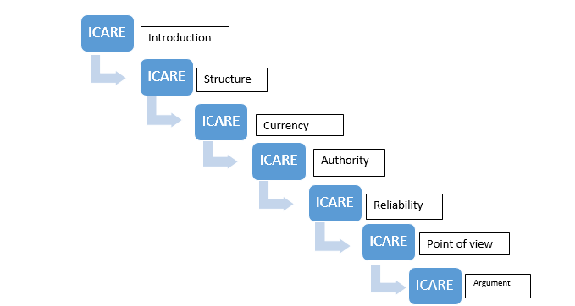

Within each lesson the following ICARE format was followed:
Introduction of students to content-Internet material;
Connect the content of the lesson to the students by active discussion.
Application of new knowledge and Critical Thinking to test Internet material;
Reflection on what has been learnt, and
Extension of the students’ learning through the provision of alternative resources for comparison,

The ICARE pathway of learning is based on a form of Gagne’s nine events that provide a framework for an effective learning process Gagne (1985). Gagne listed this process as: gain attention, provide a learning objective, stimulate recall of prior knowledge, present the material, provide guidance for learning, elicit performance, provide feedback, assess performance, and enhance retention and transfer.

It gains attention and informs students of expectancies within the introductory component. It recalls previous concepts and presents a new stimulus within the connect module. It provides learning guidance and elicits performance within the application module. It provides feedback and assesses performance within the reflect phase and finally it enhances retention and transfer within the extend module
(Anagnostopoulo, 2002). This model is adaptable and suits a constructivist approach. If the designer places the emphasis on the apply and reflect portion the course can reflect a more constructivist learning approach – which is ideal for the construction and application of Critical Thinking skills.

It should be noted that this does not mean that each of the steps, within each lesson, were identical. By this I mean that all lessons began with the introductory step but that not every introduction was identical. For example, an introduction was presented so that the students deduced the focus of the lesson, or an introduction followed the inductive approach.

Each lesson contributed to the common goal of this course, which was to advance the students’ Critical Thinking about Internet material. There was a common element within each of the lessons- the evaluation of Internet material. Each lesson therefore included Internet material for evaluation purposes.

A static (offline) version of the Internet material was housed on the LMS but there was also a live (online) version of this material with a link to the Internet. The link to the Internet allowed connectivity to hyperlinks and social media spaces. The access to these links enabled the students to check the Internet material for concepts such as the credentials and authenticity of the authors.

The connect step in the ICARE pathway connected the students to the concepts that were introduced in the first phase. An example of this is seen in the lesson in which the concept of relevancy was demonstrated by drawing students’ attention to the relevancy of specific information Internet material.

In the third step of the ICARE pathway the specific criteria were applied to the Internet material. An example of this can be found in the lesson in which students compare different Internet material and then decided which were biased.

The final step extended the students’ knowledge by asking them to make an argument for the trustworthiness of certain material as opposed to other material. These arguments were evaluated in two ways. Firstly, the arguments were evaluated using a system of coding. Secondly, these arguments were evaluated using the revised Kuhn scale for Critical Thinking. (Kuhn, 1999) An explanation of these evaluations is included in the section on Data Analysis and Interpretation.

The format of each of the lessons can be seen in Chapter 6 (page 60).

2.3.2 The Learning Management System
Many Learning Management Systems (LMS) are available, for example: Sakai, Moodle, Edmodo or LIMU. A learning management system such as LIMU has the affordance to: upload files, add web links, create text documents, submit assignments and answer quizzes.

Szabo and Flesher (2002), quoted in an article by Watson and Watson (2007), define an LMS as an infrastructure that delivers and manages instructional content, identifies and assesses individual and organizational learning or training goals, tracks the progress towards meeting those goals and collects and presents data for supervising the learning process of organization as a whole. This is reiterated by Gilhooly (2001) who states that an LMS delivers content but also handles registering for courses, course administration, skills-gap analysis, tracking and reporting.

Martin Dougiamas (2000) – a co-author of Moodle – realised the shortcomings of a static course and saw the benefit of a system that could integrate learning with the Internet. A static course is seen as a course with no interface with IT.

The LMS included in this study has affordances which were advantageous to this study.
The LIMU system enables the researcher to create a space in which Internet materials can be accessed. The LMS affords the opportunity for the attachment of specific Internet material. The advantage of the isolation of specific Internet material was that the entire Internet was not available to the students. If the entire Internet had been available there would have been great wastage of time as the students searched for sites. Also there would have been a danger that students couldhave accessed inappropriate sites which would not enhance the purpose of the research task.

Specific Internet materials can be used as examples of sites that are trustworthy and other materials could be used as detractors. Thus a situated learning environment was created so that the Internet material was available in a location which was very close to using the Internet online. The qualitative part of this method of research asked the participants to construct an argument. The Internet materials that had been accessed on the LMS were used to support the final discursive argument made by the students.

The LMS creates a defined environment in which Internet material can be linked and reviewed. The teacher w oversaw the process as the students worked through the skills that were necessary to improve Critical Thinking. The Internet material was loaded onto the LMS. However, technology allowed the learner to interact with these sites. The sites could be used for analysis so that Critical Thinking skills could be identified and applied.

In this study it should become evident that an LMS allows the user to interact with material in a unique way, thus allowing for the application of Critical Thinking techniques to this material. This process can enhance Critical Thinking skills.

The lack of internet connectivity, within the school where this study was conducted, limited the accessibility to the LIMU learning management system thus impacting on the affordances that are afforded by the LMS. These limitations are elaborated on in Chapter 8.

2.4 Review of the theories that influence the teaching and application of Critical Thinking skills
There were several theories and models of learning that had an impact on the specific approach to Critical Thinking in this intervention. It would be meaningless to discuss these theories without investigating how they had been layered into the fabric of this research. Figure 2.2 below illustrates the theories, models and philosophies underpinning this research report.

Figure 2.2 Diagram of theories, models and philosophies underpinning this research report

The relevance and application of these theories is discussed in this section of the literature review.

2.4.1 Post-modernism
There is some scepticism within post-modernism which questions assumptions. Within this research a similar scepticism was encouraged so that information could be deconstructed. In their search for trustworthiness the students will view Internet material and deconstructed it using specific criteria. For example, they investigated the material by deconstructing it using each of the components of the SCRAP test. They evaluated the material for Structure, Currency, Reliability, Authority and Point of View. It is difficult to define post-modernism as this is a movement that extends throughout several disciplines or genres. It is thought of as a reaction against the grand narratives of modernism or “incredulity towards meta-narratives”
(Lyotard, 1979). “The assumptions, developed under modernity, that the universe is ordered and completely knowable by observation and that a knowable reality exists was explained by meta-narratives gave way to a view that the universe is chaotic and unknowable.” (Grbich, 2004:25). Post-modernism views the world as “Complex and chaotic and reality as multiply constructed and transitional – unable to be explained by a grand narrative – which make universal claims to truth. Truth is multifaceted and subjectivity is paramount” (Grbich, 2013:8).

The thinking behind the theory, that drove this study, is that it was necessary for the students to be critical about material found on the Internet, since not all sources are trustworthy. A similarity can be found in this philosophy and in the sceptical approach to post-modern thought because, in both points of view, there is a move to become critical about the narratives that are offered as information. Within this research the “social construction and questionable discourses” were examined. (Grbich, 2013:109). An example of this was the search for bias within Internet material.

A second similarity can be found between Grbich’s definition of post-modern view and the definition of the Internet. The Internet is also a chaotic and complex web of parts and paths which is continually changing. Within the Internet there are many ways of navigating and finding information and this plurality is similar to the underlying abstract of post-modernism. It may be “a bridge too far” but perhaps post-modernism could be used as a metaphor for the Internet or vice versa. However this is a topic for another study.
A powerful idea within post-modernism is the idea of “deconstruction.” A basic definition is that this is a theory for critical and textual analysis of different genres. I do not propose that this technique be used in a complex form in this research. However, when an analysis is made of the Internet material, there was a deconstruction of the material to search for meaning.

2.4.2 Constructionism
In this study the students questioned the trustworthiness of information found on Internet sites. They constructed their own views on the value of appropriate material and this reliance on interpretation has ties with the constructionism theory. Stager (2005:3) quotes Papert’s view on constructionism within learning and states “Nobody can teach you everything you need to know. You have to take charge of your own learning.”

In an instructivist design little emphasis is placed on the views of the learner to construct knowledge but rather the knowledge is decided on by the educator who imparts it to the student. The approach taken in this research was not based on an instructivist design but rather on a constructionist design.

The constructionist view is especially relevant to this study as the lessons that were been prepared for the students were built on a problem-based constructionist approach. Stager (2005) describes Papert’s view on learning and reasons that we learn best when we use are doing something, solving problems and are motivated to learn. In other words the design of the programme of learning was focussed on creating an experience in which students were intrinsically motivated to solve problems.

2.4.3 Social Constructivism
The students did not work in isolation in the learning environment. They interacted with their peers and together constructed an argument for the validity of Internet material. The Internet and Information Technology terminology or IT jargon was discussed by the students, thus making sense of the Internet “environment.” There were thus strong elements of social constructivist theory in operation within this research process.

Lave and Wenger (2009) do not see learning as individual: in their view students make sense of their surroundings in a social setting by communicating with others. Knowledge is situated within a community in which a more 'knowledgeable other' facilitates the move from the periphery to the centre of the community. People build on earlier experiences and knowledge (Lave and Wagner, 2009:6).

Social constructionism emphasises the interactions between people and how they use language to create their reality. The difference between the ideas of constructivists and those of social constructivists is that constructivists emphasize the individual and how he makes sense of his environment, whereas social constructivists claim that reality is constructed through interaction between people and the understanding of social processes like culture.

One of the most important advocates of social constructivism is the Soviet psychologist Lev Vygotsky. According to Vygotsky (1978: 57), every function in the child’s cultural development appears twice: first, on the social level and, later on, on the individual level; first, between people (inter-psychological) and then inside the child (intra-psychological). This theory can be associated with the approach that is used in this research process. As the pathway of learning was followed the students will discuss the concepts and the language that were unique to the Internet material. A collaborative style of learning was undertaken so that the students would be able to deliberate and learn from each other and then individually make arguments about the trustworthiness of websites.

2.4.4 Connectivism
In the Internet material under study there were hyperlinks to related sources and also to social networks. The students accessed these links to assess the trustworthiness of the material. This type of networked or linked learning can be associated with the concept of Connectivism, as one of the principles of connectivism is that “Learning is a process of connecting specialized nodes or information sources” (Siemens,2004:.4).
In this research project material was accessed from the Internet. The material contained key words which were hyperlinks to related sources of information. For example, as shown in Appendix C, the links to social media were able to evident within the source materials. By accessing these links the student were able to connect to this additional information and to views on the material that is being reviewed. Within the principles of Connectivism, as listed by Siemens (2004:4), it is stated that learning and knowledge rests in “diversity of opinions” and that learning is a process of connecting “specialised nodes or information sources”. The ability to see the connections between “fields, ideas and concepts” and to access current information is one of the features in connectivism and certainly within the criteria that are listed in the SCRAP test. The principle of connectivism, which is invaluable to Critical Thinking, is ”decision-making is itself a learning process,” as the students had tomake decisions about the trustworthiness of Internet material.

Connectivism recognises that learning takes place through making sense of the chaos and complexity of interrelated sources of information (YouTube interview with Siemens in 2013). This was relevant to this study as there was an inclusion of several different sources of information on the Learning Management System. The students hd to examine these sources for relevance and trustworthiness. The process of examination will involved the three steps of connectivism.

The students had to think critically about the Internet materials and compare these resources so as to form a conceptual perception for reliable resources. By using the hyperlinks and accessing “spatial spaces” such as Twitter, Blogs and Facebook, they were able to cross-reference the sites to check the authority of the authors. The students thus used a networked system to critically evaluate the Internet resources within this research project.

The dissemination of information and the Critical Thinking process, which are key components of this research, are also recognised as important elements of the concept of connectivism. I make this assumption by referring to a claim made by Siemens in the International Journal of Instructional Technology (1995), in which he suggested that connectivism was a model of learning that is driven by the understanding that decisions are based on rapidly altering foundations. New information is continually being acquired. The ability to draw distinctions between important and unimportant information is vital.

2.4.5 Anchored Instruction
All the Internet material used in the SCRAP analysis in this study had a commonality. It was anchored within the Business Studies learning area. As the content relates to the business world, the material were both contemporary and relevant.

The Anchored Learning Model advocates that lessons should be centred on an “anchor” which is a problem-solving scenario. The “anchor” within this study was the Business Studies material which was used as source material. The second recommendation is that a constructivist approach be followed so that the students can delve into the problem so as to locate elements that can be found in order that a solution can be constructed.

The Anchored Learning Model blended well with my approach within this research, since Critical Thinking is not a list of skills that can be taught in isolation. Bailin et al. (1999) believes that Critical Thinking is best practised within a context of knowledge and supports the notion that we teach Critical Thinking by “infusing it “within any curricular practice in which our students are involved”.( Bailin,et al.,1999: 299). In this research on Critical Thinking the students practised Critical Thinking within a specific area. The skills they were learning relate to the evaluation of materials containing Business Studies information. Business Studies is a learning area within the Grade 11 curriculum and thus the Critical Thinking was not taught in isolation and has been “infused” into a learning area.

Anchored Instruction is a term which seems to have originated from the Vanderbilt Cognition and Technology Group (1990) to describe a special type of situation for learning. The multidisciplinary team of researchers at the Vanderbilt Group state that “Perhaps the strongest and most obvious advantage of anchored instruction is the use of complex realistic contexts to provide meaning and reasons for why information is useful” (Vanderbilt Group, 1990: 9).
The goal of Anchored Instruction, according to the Vanderbilt Cognition and Technology Group is to “include the establishment of semantically rich, shared environments that allow students and teachers to find and understand the kinds of problems that various concepts, principles, and theories were designed to solve, and that allow them to experience the effects that new knowledge has on their perception and understanding of these environments” (Vanderbilt Group, 1990: 9).
The Anchored Instruction Theory emphasizes technology-based learning media. The reality of the living world is referred to as the “anchor,” and the process of establishing and identifying the real living world to solve the problems is figuratively called “casting the anchor. The Anchored Instruction Theory emphasizes technology-based learning. Students take the technology as the carrier, use the reality of living world as main contents to discover problems, generate questions, and ultimately solve the problems.

Brown, Collins and Duguid (1989) state that perhaps the strongest and most obvious advantage of Anchored Instruction is the use of complex realistic contexts to provide meaning and reasons why information is useful. This statement is appropriate when I considered the course I devised to analyse Internet materials.

The students engaged with Internet material and test the authenticity of this material by activating hyperlinks. The websites provided material into which the students could delve. The websites are presented on an LMS and there were even “bogus” sites which were used to accentuate the importance of Critical Thinking.

The students in this process were assessed continuously as they would be giving written and oral opinions when they applied the criteria for evaluating Critical Thinking to websites. According to the Vanderbilt Cognition and Technology Group (1990), the method of applying various assessment procedures and applying them regularly is also a focus for Anchored Instruction.

2.4.6 Blended Learning
The mingling of face-to-face learning and technology for imparting and presenting information is called Blended Learning. Although a Learning Management System was use as a primary communicator of the Critical Thinking process there was also a reliance on the teacher for motivating the need for Critical Thinking.

The intention at the outset of this study was to structure a research process that was primarily based on the learning pathway that is set out on a Learning Management System. It was pointed out that Internet availability was unreliable at the school in which the research was carried out. It was therefore decided to combine the Internet with face-to-face learning. The mingling of face-to-face learning with technology for imparting and presenting information can be called blended learning.

The advantage of using a blended learning approach, in this study is that not only was it a substitute for the unreliable Internet supply, but also allowed the teacher to teach students who might not have been completely familiar with learning from a Learning Management System and with the Internet.

This combined approach is not unique to this study and the director of the Centre for Innovation in Teaching and Learning at the University of Cape Town (UCT), Czerniewicz & Brown (2005), have written extensively about the role of this blended technique. Research carried out internationally by the Victoria Education Department in Australia from 2006 to 2011 shows definite reasons for supporting a Blended Learning method. Advantages of Blended Learning that are listed in this research show that Blended Learning offers more differentiated learning opportunities for students and allows for more collaboration. The differentiation of learning opportunities suits the differing learning abilities of the students within the group taking part in this research. It also allows collaboration between the teacher and student, between the students themselves and between the classroom and the wider world through the Internet.

Chapter 3 Research Design and Method
Consideration was given to complexities of the research question before decisions were made as to the design of the research and method to be used within this study.
3.1 Research design
The research premise was based on deductive reasoning. The reasoning has been gleaned from authors mentioned in the literature review and presumed that it is necessary to use Critical Thinking to search Internet material, since not all Internet material is trustworthy. The design made use of a case study as the preferred model with which to investigate the premise. A series of lessons was used to enhance, develop and test Critical Thinking skills and the data from these tests were then compiled and interpreted. An inductive approach was then implemented to interpret the data to see if the results could prove the initial premise,

The design and methodology used are illustrated in Figure 3.1 below.

Figure 3.1 Representation of the research design and methodology used in this study.

3.2 Considerations of a method to use in this study
Robert Yin (1984) recommends that consideration be given to the following three factors before a decision is made on the method for research:
Firstly, the type of research question;
Secondly, the degree of investigator control possible, and
Thirdly, the degree of focus of contemporary events desired.

Each of these recommendations was considered, with particular relevance being paid to this research report. The research question had a significant influence on the design of this study, as explained below.

3.2.1 Influence of the research question on the design
The research question “To what extent does the evaluation of Internet materials for trustworthiness, in a learning management system, develop Critical Thinking skills?” led to a design with the following stages:
- Initially, a qualitative and a quantitative method was devised to explore the students understanding of web site evaluation.
- Secondly, a learning pathway was presented on a Learning Management System to build Critical Thinking skills.
- Thirdly, the students used the CT skills for evaluation.
- Finally, data were analysed so that an explanation could be made as to the effectiveness of the study.

In Figure 3.2 it can be seen that this research design led to a strategy which had exploratory, descriptive and explanatory stages. Yin posits that some of the best case studies include “exploratory and descriptive or descriptive and explanatory” processes (Yin, 1984). The following diagram illustrates the four stages of the method used within this study. These sequential stages were necessary as there was an intervention through the lessons and data was collected pre and post this intervention.

Figure 3.2 Diagrammatic representation of the steps in the design process

3.2.2 Influence of investigator control
Consideration should now had to be given to the degree of investigator control. The investigator in this particular research was submerged in the process, as opposed to the characteristics of experimental research – outlined by Mc Millan and Schumacher (2010) – who state that “researcher-controlled interventions are independently and uniformly applied to all subjects.” In other words, the researcher in this report was interacting, subtly, with the participants and continually collecting data. This approach, according to Yin, is one of the principles of case studies.
Yin (2004: 4) states that, “A key demand of the case study method is the investigator’s skill and expertise at pursuing an entire (and sometimes subtle) line of inquiry at the same time as (and not after) data are being collected.”

3.2.3 Consideration of contemporary events
The inventor of the Lotus computer application stated that “Getting information off the Internet is like taking a drink from a fire hydrant” (Kapor, 2012). This analogy describes the explosion of knowledge and the difficulty we have in making sense of the mass of information that surrounds us.

There is a “degree of focus of contemporary events”, as the Internet is certainly a contemporary phenomenon. But it is not only the investigation of Internet material that is included within this report. There is also a complexity involving the development of Critical Thinking skills through the use of a Learning Management System. Watson and Watson (2007: 32) explain how “LMS’s are a powerful technology that have yet to reach their full potential and are important for the Information Age paradigm of education.” Therefore it can once again be concluded that the areas under the spotlight, within this research report were indeed contemporary.

A contemporary researcher, Wilson (2009: 264), states that, “One of the areas in which case studies have been gaining popularity is education and in particular educational evaluation and instructional use in order to develop Critical Thinking skills and knowledge.” If accept Wilson’s viewpoint is accepted then the use of case studies as a method to describe the development of Critical Thinking can be viewed as having a contemporary focus. So it is not only the evaluation of Internet material that could be considered current but also the development of Critical Thinking.

3.3 The Case Study
In his work, the American social scientist, Robert Yin (1984: 23), makes the following three points concerning case studies. Firstly, a case study is an empirical inquiry that investigates a contemporary phenomenon within a real-life context. Secondly, a case study is an inquiry where the boundaries between phenomenon and context are not clearly evident. Lastly, he states that multiple sources of evidence are collected within a case study.

Yin is certainly not the only “methodologist” who has a definition of case studies but, if his ideas are accepted as a starting point for the justification for a case study research design, then it can be argued that the criteria of an empirical enquiry, as outlined above, seem to gel with this study of Critical Thinking.

Firstly, the investigation was being undertaken was certainly contemporary as it concerned the application of Critical Thinking to Internet materials. The Internet is certainly a contemporary phenomenon and the fact that this study was conducted in a classroom situation during a timetabled lesson and is related to a year 11 subject area gave it a real-life context.

Secondly, the question that is being investigated was immersed within the milieu of education. In other words it was not possible to separate the area of research from the context. It was not research that is carried out within a scientific environment in which the subjects are separated into predetermined and demarcated categories.

Lastly, the evidence that is being collected came from a combination of qualitative and quantitative research. The students who were involved with this study were interviewed and also completed a self-evaluation survey. Responses will also be evaluated on a Likert scale and finally they will constructed a written argument to justify their choices of certain Internet materials. Therefore it is evident that “multiple sources of evidence “ were being used and triangulated to understand the phenomena that were being described. In collecting case study data, the main idea was to “triangulate” or establish converging lines of evidence to make the findings as robust as possible (Yin, 2004).

3.3.1 Type of case study
Yin (2004) differentiates between single and multiple case studies. He goes further and also distinguishes between holistic and embedded case studies. Therefore he has created a, “two by two combination producing four basic designs for case studies” (Yin, 2004: 5).

The case study in this report is holistic Even though it had complex components, the research had as its primary aim the understanding of a holistic theme. Mc Millan and Schumacher (2010) define a holistic case study as one in which an instrumental case is studied that provides insight into a specific theme or issue. The specific theme in this study was once again the evaluation of the trustworthiness of Internet material.

Even though this research was not being conducted in a scientific or even quasi-scientific way, which is normally associated with a single case design, it still had some of the characteristics of a single-case design. No comparisons were made with other cases, which is a feature of multiple-case designs and it had the longitudinal aspect which is a feature of single-case designs, as the research took place over an extended period.

Another feature of this study that links it closely to a single-case design is the reliance on theoretical propositions that were made and that led to the study. Conrad and Serlin (2006: 382) explain that a theoretical led research is often a feature of single-case studies.

In this research Kuhn’s theory regarding argument as a measure of Critical Thinking,(1999), were be adapted and applied to the evaluation of Internet materials. In other words the students were evaluated, at a qualitative level, by making an argument for the acceptance of certain materials and the rejection of other Internet material

3.3.2 Boundaries of the case study
One of the first considerations for a case study, according to Conrad and Serlin (2000), is to define the study’s purposes and research questions, thus defining the scope of the case study.

Conrad and Serlin (2006: 379) refer to Merriam (1998), who describes bounding the case study as a “Consideration about the setting and data collection so that the study will be manageable and the types of information collected will maximize the investigator’s time.” The identification of the unit of analysis depends on the particular research question that has been asked. In an attempt to set the boundaries of this research two key questions were set. The first question enquired about the development of specific Critical Thinking skills which could be applied to Internet material. The second question investigated the ability of students to make an argument to compare the trustworthiness of Internet materials.

It would be easy for the researcher to lose focus when investigating contemporary phenomena such as the Internet, Critical Thinking and Learning Management Systems. These areas are very broad, containing an abundance of information and having many permutations. For example, the following question could have been included within this project: Do students who use the Internet primarily for recreation achieve better research results than students who use the Internet for schoolwork?

Conrad and Serlin (2006,379) refer to Bogdan and Biklen (1998) who state that “One should make decisions that narrow the study: otherwise one is likely to end up with data that are too diffuse and often unrelated to what one is doing.” With this in mind a conscious effort was made to refine and narrow the questions so that valid and reliable data could be gathered.

Another boundary that can be imposed on research is time limitations. The time limit that was set for conducting the “intervention” with students was limited to one school term. During this time the students will experience a pathway of learning that was presented on a Learning Management System. A case study could also be considered bounded when a full understanding of the phenomenon is possible (Yin, 1989). With this in mind it should be explained that the process of building the specific Critical Thinking skills were fragmented into separate lessons. In other words there are lessons on the following critical dimensions: trustworthiness, authority, objectivity and relevance. Once these lessons had been concluded then a comparison of Internet material was made followed by a quantitative and qualitative evaluation of arguments.

3.3.3 Overcoming case study criticisms
Case study methodology is not without criticism. Wilson (2009) refers to Helen Demetriou of Cambridge University who argues that case studies have been criticised for limitations in validity and construct validity in particular, the result of which is potential subjectivity by the researcher. Another criticism is that case studies have had an ambiguous place in education and social science research. Punch (2009) refers to Reinharz (1992) who reasons that historically there has often been a disapproving attitude towards the case study. Kahn and Best (2006) also offer a warning about case study methodology. They advise that certain precautions should be considered as the method “may be deceptively simple” (Kahn and Best, 2006) and they also warn of subjective bias.

According to Reinharz (1992) case studies have had an ambiguous place in education and social science research and historically there has often been a disapproving attitude towards case studies. “This attitude is usually based upon the generalizability criticism but properly conducted case studies – especially in situations where our knowledge is shallow, fragmentary, incomplete or
non-existent, have a valuable contribution to make in educational research in three ways” (Punch, 2009: 123).

Yin 1994 proposed three ways of overcoming this weakness:
Use multiple sources of evidence;
Establish a chain of evidence, and
Have a draft case study report reviewed by key informants.

In this particular case study an attempt was be made to collect evidence using both qualitative and quantitative procedures. This study makes use of a mixed method to collect data. A student self-evaluation survey was used to gather evidence of the students’ perceptions of their ability to evaluate Internet material. A Likert technique was employed to get a quantitative measure of the students’ perceptions of their ability to evaluate Internet material. A quantitative evaluation was used to evaluate the results for the quality of an argument. All of these procedures were carried before and after the learning pathway process, thereby providing a “chain of evidence.”

Filed notes were kept during the entire process of this inquiry. These notes were invaluable as they will gave direction to the information that was being constructed on the learning pathway. In other words, if the field notes revealed that there was misdirection then there would be a chance to redefine the learning pathway that is being constructed on the Learning Management System.

Before the case study was completed it was be perused by several of the participants as well as by colleagues who had given their input during the construction of this research project. This fostered confidence and ensure that the project could be regarded as reliable.

Chapter 4 Description of the Intervention

4.1 Content and criteria
This course was run over a series of lessons. These lessons were timetabled on the LIMU Learning Management System and took place during May and June (the second school term) of 2016. All activities and links for these lessons were housed on the LIMU system.

The core content for the lessons was built on the set of criteria used to evaluate Internet material. Bailin et al. (1999) regard criteria as the standards for judging the adequacy and trustworthiness of claims of meaning made by authorities
(Bailin et al, 1999: 291).

The criteria used in this research was derived from the works of Harris (2007), Fritch and Cromwell (2001), Fritz (2003) and Schrock (1997). These authors recognised the need to evaluate Internet material for trustworthiness. It was necessary to examine the processes constructed by these authors to establish reliability of the evaluation technique that was used in this report.

Each of the following authors constructed a system to evaluate the trustworthiness of Internet material. Fritch and Cromwell (2001) compiled four theoretical filters that are used to evaluate Internet materials. The filters were used to check Internet material for: currency, authority, reputation of institution and affiliation or bias.

Fritz (2003), also suggested a model, but one with two filters. The first filter “‘considers the information process tailored to identifying the websites – in other words, search engines. The second filter evaluates the information quality of the identified websites” (Fritz, 2003: 347).

The second filter was pertinent to this study as it was not the search engines that were being investigated but the content of sites. In the second filter Fritz distinguished three dimensions of information quality: technical and juridical quality, application quality and inherent quality. Fritz was concerned with information relevancy, its currency, its language and the “understandability of its content” (Fritz, 2003: 349).

Harris (2007) formulated a checklist for evaluating Internet material. The acronym that he used to remember this checklist is CARS which is expanded as: Credibility, Accuracy, Reasonableness and Support. Harris made available a series of queries to investigate each of the concepts within the CARS model. For example he suggested that a test for credibility would examine the evidence regarding the author’s reliability, truthfulness and knowledge. Harris also offers a list of tell-tale signs that can be used as an indicator of unreliability, e.g. the anonymity of the author.

Kathy Shrock is a prolific writer of educational articles, especially in the domain of educational technology. Schrock is the final source that I relied upon to formulate my evaluation criteria. Schrock (1997) formed a set of critical standards with which to examine Internet material. She grouped the standards into four categories, namely: reliability, authority, objectivity and relevance. Permission was obtained, from Schrock to refer to these criteria. She also attached indicators to each standard. The indicators are signposts that can be used to measure a critical standard. For example the indicators that are used to test authority are: source, qualifications, credentials, experience and level of articulation. Schrock (1997) has developed a series of questions and online worksheets that can be downloaded by teachers and that can be used for testing Internet materials.

There are commonalities within the writings of Harris (2007), Fritch & Cromwell (2002), and Schrock (1997). All these writers state that it is necessary to test Internet material for trustworthiness. The authors have developed filters and criteria with which to test Internet information. I have formulated a set of criteria and indicators based on the indicators that are common to the findings of these authors. I devised and named the criteria that are used in this study as the “SCRAP” criteria. These criteria are the core of the intervention and were used as a guide for Critical Thinking about Internet material. As these indicators were derived from recognised resources they are considered to be credible and they give weight to the reliability of this research report.

4.2 The SCRAP criteria
The acronym SCRAP is represented by: Structure, Currency, Reliability, Authority and Point of View.

The structure component is a set of criteria which examines the appearance and the way the site functions. The criteria are represented in Table 4.1 below.

Table 4.1 Structure component criteria
Structure of the site –the way it functions and its appearance
Instructions: Read these questions and answer with a Yes or No and then complete the activity
 | Yes | No
- Is the information displayed clearly?
- Is the information in this site listed by topics?
- Is the information in this site randomly displayed?
- Is it easy to navigate around this site/page?
- Is the layout consistent from page to page?
- Is the purpose of the page obvious?
- Do the pictures appear to be original?
- Are there adverts on this site?
- Do the adverts distract from the purpose of the site?
- Is the home page accessible from all of the pages?
- Are their links on this page?
- Are their links to social media?
- Do the links connect effectively?
- Are the links logically grouped?

The currency component is a set of criteria that examines the currency of the information. These criteria are represented in Table 4.2 below.

Table 4.2 Currency of the information material
Currency of the material-relevant and up to date
Instructions: Read these questions and answer with a Yes or No and then complete the activity
 | Yes | No
- Does the site show today’s date?
- Is there an indication of when the site was made?
- Is there an indication of when the site was revised?
- Is there an indication of whether there is a schedule to revise this site?
- Does the information seem current?
- Are there modern terms within the language?
- Does the information come from a specific time period*?
- Is up to date information necessary in this topic?
- Is the information still valuable today?
- Does the information refer to the most recent technology?
*Period of time - e.g. the 1990’s

The reliability component is a set of criteria that is used to assess the evidence that supports reliability. The criteria are represented in Table 4.3 below.

Table 4.3 Reliability of information
Reliability - Supported information
Instructions: Read these questions and answer with a Yes or No and then complete the activity
 | Yes | No
- Is the information in this site similar to information on other sites?
- Is there a bibliography on this site?
- Are references made to the sources of information?
- Are there tables and graphs which support the information?
- Are there statistics that support the information?
- Does the author give his contact details in case you have queries?
- Are the pictures or adverts there to support the information?
- Are there pictures or adverts to sell a product or service?
The authority component is a set of criteria that investigates the authority of the author. The criteria are represented in Table 4.4 below.
Table 4.4 Authority of the author
Authority-Investigating the author.
Instructions: Read these questions and answer with a Yes or No and then complete the activity
 | Yes | No
- Can you identify the *domain of the page?
- Is the author anonymous?
- Is the author working for the government?
- Is the author working for a company?
- Is the author a journalist?
- Is the author an* academic?
- Does the author provide details of his experience of expertise?
- Is the author from a well-known organisation?
- Does the author write on behalf of the organisation?
- Can you find more details about the author through a web search?
- Are there spelling and grammatical mistakes on the site?
*Academic – e.g. A university professor or lecturer
*domain- .com.edu.gov.org.net

The final set of criteria measures the reasonableness of the material and it considers the point of view of the author. The criteria are represented in Table 4.5 below.

Table 4.5 Reasonableness of the material
Reasonableness: the point of view of the material.
Instructions: Read these questions and answer with a Yes or No and then complete the activity
 | Yes | No
- Does the information come from one source only?
- Does the information come from multiple sources?
- Is the information from a primary* source?
- Is the information from a secondary* source?
- Is the site trying to sell something?
- Are there strong adjectives being used within this site?
- Does the writer’s personal point of view come across?
- Is there a negative point of view in this material?
- Is the page free from stereotyping*?
- Are their contradictions within the material?
- Are political views being expressed in this material?
*
Primary source – original 1st source
Secondary source – material that is being interpreted by someone else
Stereotyping – “ a CEO is a man”

4.3 Research situation – the students
The students who participated in this study were all Grade 11 students at a private high school in Gauteng. All had chosen to study Business Studies as an elective for the matriculation examination at a private school whose students write the Independent Examination Board (IEB) examinations. The boys were mostly seventeen years of age and resided in Boksburg or Benoni and in the neighbouring suburbs and townships such as Vosloorus, Kathlehong and Tembisa. Most of the boys had been at this school since Grade R and their command of English is of a satisfactory standard. Most of them were not pure mathematics students and their subject combination includes Business Studies and Mathematics literacy. The boys had achieved an average mid-year mark of approximately 65 % in their Business Studies examinations. (Over the past few years the IEB national average matriculation mark for the Business Studies students was approximately 62%).

The method used to select the participants for this research project is known as “convenience sampling” (Mc Millan and Schumacher, 2010: 136). This group of boys was chosen as the researcher was scheduled to teach both the Grade 11 and Grade 12 students. The researcher saw this class for five 45 minute periods per week and it was convenient to implement the research task during these periods.

There were many relevant Internet sites that could have been accessed for a Critical Thinking exercise but this researcher decided to review material related to the Grade 11 syllabus. The reason for researching business related sites was because this material was relevant to the Grade 11 Business Studies syllabus and therefore provided justification for using the time allocated to Business Studies.

Formal computer technology lessons are not provided to the High School students at this school but most of the boys had attended the Preparatory school and had experience in using a computer and accessing the Internet. In 2014 tablet computers were introduced to the school and the majority of the boys had these tablets. Electronic versions of text books were loaded onto these tablets and the tablets also have Internet connectivity. However a disadvantage at this school was that Internet access at the school was unreliable and intermittent. Most of the boys had smart phones and regularly use them to access the Internet, through their own personal accounts, and this will allowed them to view the Internet sites that are being analysed in this research.

The programme for this research was presented in a classroom. This particular classroom had both Internet access and a facility for projecting the Internet onto a screen. Therefore the students were able to view the learning pathway on the screen as well as on their tablets. The students had several options when completing evaluations. Depending on the type of evaluation, quantitative or qualitative, they could complete the evaluation on the LIMU system or they could e-mail answers to the researcher or, if need be, they could hand in their completed answers.

4.4 Motivating adolescents to think critically
The students who participated in this research are adolescents. After 35 years of teaching adolescents I can claim that most 17year old students need continual motivation. Mackey and Appleman (1983) state that “Although the increase in adolescent apathy is cause for concern the situation is not hopeless. Instead of helplessly watching students float further away, teachers have the responsibility to pull them back into the mainstream of school life” (1983: 31). Consideration was given to motivating the students so that they could approach the investigation with enthusiasm. Motivation is also regarded as a requirement for the process of Critical Thinking.

The motivational model for Critical Thinking (Eccles and Wigfield, 2002) was given consideration when structuring a pathway for critical learning. This model proposed the following four items which are seen as motivators of Critical Thinking.

Firstly, within the attainment item the individual had to realise that it is important for him to be able to practice Critical Thinking. The second item emphasized the utility value of Critical Thinking. That meant that the value of Critical Thinking should be appreciated for its usefulness. Thirdly, within the intrinsic item the student must like using Critical Thinking. Finally, the cost item stressed the cost of time to think critically, as opposed to using this time for other purposes.

Eccles and Wigfield (2002) were not alone in their discussion on motivation as a driver of Critical Thinking. Facione (2000) regards motivation and a positive disposition as essential and states that “consistent internal motivation” is necessary to engage problems and make decisions. He reasons that “The disposition toward engaging in Critical Thinking is a product of having positive attitudes toward the perceived consequences of thought-guided behaviour” (Facione, 2000: 65). In the Elder and Paul model of Critical Thinking, (2010), there is recognition that motivation is one of the keys for the accomplished critical thinker .
The students in this Critical Thinking programme were motivated in the following ways.
In the initial lesson the students were asked to analyse an Internet site that was entirely “phoney”. The site had all the features that would be found in an Internet site but the content was totally fictitious. The site was constructed to demonstrate that there is untrustworthy information on the Internet. The students discussed the implications of untrustworthy material information and became aware that unsound material can affect Internet research. The students were motivated to search for trustworthy material by becoming aware of how easily they could be fooled through “unreflective” thinking (Elder and Paul, 2010).
The realisation that not all Internet material is trustworthy is a form of intrinsic motivation to search for trustworthy Internet material which is a critical feature of this process of Critical Thinking.
Another way that was used to motivate the students was to draw their attention to the value of locating trustworthy Internet materials for school and university assignments, as opposed to the inclusion of irrelevant material. It was emphasised that the quality of their research would earn them improved grades on assignments. Thus the
self-motivation to think critically could lead to an improvement in their grades. This is combination of intrinsic and extrinsic motivation as the self-motivation which is intrinsic is influenced by the reward of better results which is an extrinsic motivator.
Another extrinsic motivator that was included in this particular research process was the awarding of a Critical Thinking certificate (see appendix A). The students who completed the six week study were awarded a certificate. The purpose of the certificate was to motivate the students and to demonstrate the significance to the course to parents and students. The certificate was included in the students’ Life Orientation portfolio as evidence of self-improvement.

During the selection of the Internet sites consideration was given to the abilities and interest of the 17-year old boys. An example of this is the choice of business-related advertisements which were used to illustrate and analyse bias. Advertisements that would retain the boys’ interest were chosen and there was also an emphasis on humour and enjoyment. By observing the boys it was evident that they enjoyed the process of thinking critically to find bias and stereotypes. This enjoyment is one of the intrinsic motivators mentioned by Eccles and Wigfield (2002).

In the selecting of the two websites that were used for comparison and argument consideration was given to the utility value of this process. In other words, the sites were chosen because it was useful for the boys to know how to judge the trustworthiness of the information. The sites gave two differing opinions on goods that were offered for sale. It was thus useful for the boys to know how to think critically about these two opposing sites and to reach a conclusion as to the trustworthiness of the information lbeing reviewed.

4.5 Using YouTube as a means of motivation
YouTube is regarded as a source for entertainment but it has also become a medium with which to communicate. Wilkes, Pearce and Barker (2011) state that the YouTube site has been used within higher education as a way to communicate with current and potential students. Azyan (2011) states that, as of 2009, there were 102 university-based YouTube channels in the UK and 400 in universities worldwide. After investigating literature reviews of YouTube, Snelson (2011) stated that there were 188 peer-reviewed journal articles and conference papers with ‘YouTube’ in their titles.

It is thus evident that the use of You Tube for academic and teaching purposes is becoming more popular. The use of clips from YouTube has merit in the Critical Thinking lessons as they create interest and stimulate the flow of ideas. In conversation with Paulo Freire in the late 1980’s Seymour Papert was recorded as relating his view that people learn because they become interested in a topic (Papert and Freire, 2000). In this discussion Papert also gives an example of how exposure to video can advance one’s interest in a subject area.

It should be noted that the clips that were included in this course were chosen for three reasons. Firstly, the clips stimulated the interest of the students. Secondly, the clips provided stimuli for the different learning dispositions of the students and, thirdly, the clips helped the students to understand the concepts by providing realistic images. Multimedia not only creates interest but also may suit students who have differing aptitudes and “intelligences.” Gardner (1993) posits that there are nine different types of intelligences. He stated that all humans possess these intelligences but in differing degrees. Berk (2009) summarises the different views on intelligences and also acknowledges the value of multimedia teaching when he explains that multimedia can stimulate the, “three intelligences which are part of that unique profile of strong and weak intelligences that every student possesses.”

Berk lists the following “intelligences” as those most recognised by researchers (Berk, 2009: 3):
Verbal/linguistic: Learning by reading, writing, speaking, listening, debating, discussing, and playing word games;
Visual/spatial: Learning by seeing, imagining, drawing, sculpting, painting, decorating, designing graphics and architecture, coordinating colour, and creating mental pictures, and
Musical/rhythmic: Learning by singing, humming, listening to music, composing, keeping time, performing and recognizing rhythm.

You tube video clips include a combination of the above aspects and thus appeal to the different “intelligences”
Another invaluable quality of the YouTube clip is that it can serve as a representation of key ideas. Miller (2009) states that “Multimedia resources can markedly augment learning content by virtue of generating vivid and complex mental imagery”
(Miller, 2009: 1).
An example of a YouTube clip that was used in this research is:
https://www.youtube.com/watch?v=wxug0BnG-K4
This video depicts bias and stereotyping in the workplace. It depicts the bias that occurs when a Hispanic man is interviewed for a position and it is a visual representation of bias. Bias is one of the components of the SCRAP test and the students had to identify bias within Internet material in order to ascertain trustworthiness.

Chapter 5 Planning the data collection and analysis

5.1 Mixed Method – qualitative and quantitative approaches

In this study data was collected using a mixed method. The mixed method to be employed enabled data to be collected using both quantitative and qualitative methods. Yin (2004) states that both quantitative and qualitative evidence can be used to address the initial propositions of a study.

This method is aligned with a postmodernism outlook on knowledge creation. Hence meanings become recognised as “individual creations which require interpretation and negotiation” (Grbich, 2013: 109) instead of the acceptance of fixed views of knowledge. In other words the students will examined and interpreted the information that is presented within the websites and then constructed their own meaning as to its value.
The data collection process is illustrated in Figure 5.1 below.

Pre Evaluation POST Evaluation
Students complete Likert scale regarding abilities

abilities
Students complete Likert scale regarding abilities
Data is collected and analysed from:
PRE and POST
Likert scales
SCRAP criteria
Arguments

Students view Internet materials
A set of qualitative questions is posed.
The intervention occurs. All the learning theories come into play. The ICARE pathway and the LMS are integrated into the intervention.

Students write a paragraph comparing Internet material

ir
Students write a paragraph comparing Internet
materials

Figure 5.1 Graphical representation of the data collection process

Several researchers support the idea that qualitative research tends to be seen primarily as an inductive approach using a research question to move from instances gained in the data collection to some form of conclusion. (Fielding and Lee, 1998) (Gribich, 2013). Questions tend to be exploratory or open- ended and data are often in narrative form. Analysis predominantly deals with meanings, descriptions, values and descriptions of people and things. As indicated, in the conceptual framework, an inductive approach was used at the end of this intervention to validate the hypothesis that was proposed.

Quantitative research is generally viewed as deductive, with the conclusions drawn following logically from theories or rules (Grbich, 2013). Outcomes are the major focus and pre-specified and developed hypotheses will dictate questions and approach. Quantitative research can be used to gather data to predict and explain the outcomes of a theory (Neuman, 2000). Quantitative research is more objective in nature and the researcher collects numbers and statistics but may miss out on the subtleties of the individual. Quantitative research can measure each part of the linear process used within this investigation. Examples of some of these components in this process are: trustworthiness, authority, objectivity and relevance.

In this study the qualitative and quantitative approach ran concurrently, as there was continuous assessment throughout the process using both approaches. The questioning techniques generated both qualitative and quantitative data and ensured that both methods were integrated. This flexibility is one of the advantages of using a case study to explore a topic.

By employing both qualitative and quantitative research methods a balance can be achieved between the subjective and objective. The results obtained through quantitative research methods are more objective than those obtained through qualitative research methods. An example of this is asking the students to complete a Likert scale which has defined categories and ratings. The triangulation of results, from quantitative and qualitative research, will determine whether the qualitative interpretation of answers was skewed because of subjectivity.

The difficulty of obtaining “equality” between the two methods is discussed by Grbich (2013:33). She advises that the data be transformed to basics, for example by coding the qualitative answers so as to reduce their subjectivity. Gribich also suggests that data from both methods can be integrated visually, i.e. by presentation of both sets of data as one. In this study the results from the Likert investigation were combined with the results from the Critical Thinking analysis. This facilitated Data Collection and Data analysis.
.
5.2 Using coding with qualitative research
A code was developed by the researcher to evaluate the qualitative research.

Its primary purpose is to “disassemble” and capture the essence of what the students were expressing. Items that are seem to be essentially similar will be assigned the same code. Another way of stating this is given by Saldana (2010). Coding is not just labelling, it is linking: “It leads you from the data to the idea, and from the idea to all the data pertaining to that idea” (Richards & Morse, 2007: 137). The code will be used to summarize or condense data and not simply to reduce it. Even at this “disassembling” phase attention will be given to the broader meaning of the data (Yin, 2011). In the first cycle of coding I looked for key words that showed that the students had used the elements of evaluating Internet material. The key words are the words or synonyms that occur in the SCRAP criteria.

The coding and analysis are shown in Figure 5.2 below.

Figure 5.2 Coding and analysis of data

An example of how this functions is given by examining a student’s work.

- Phase one
A student who compared the Internet material commented that “Both sites don’t show today’s date.”

It can be concluded that the student is thinking critically about the trustworthiness of Internet material currency as he used the key word “date,” which is one of the concepts in the SCRAP criteria.

- Phase two
At a higher “conceptual level” a secondary cycle of coding will be used to sort these meanings into categories of similar groups. I will relate these elements to one of the broader categories that are used for evaluating Internet material.
I refer again to the student’s response: “Both sites don’t show today’s date.”

In the second cycle of coding the word “date” can be categorised into the currency component of the SCRAP test as date relates to time and currency.

- Phase three
In the third phase of the coding cycle the student’s response is again considered
“Both sites don’t show today’s date.”

The first question listed in the Currency component of the SCRAP criteria asks “Does the site show today’s date?” Thus the student’s response is directly related to the first question of the currency component. This question is labelled C1 (Currency component Question 1).

Once these concepts have been sorted the related features can be examined in a fourth “reassembling phase” (Yin, 2011:192) and patterns may be observed. For example, if one or other of the categories or questions is predominant it can be represented graphically and interpreted. According to Saldana (2010) a pattern can be characterized by: similarity, difference, frequency, sequence, correspondence and causation. In this fourth “reassembling” phase the intention was to examine the material for patterns which would show how the students had used the factors which are needed to evaluate Internet material.

- Phase four
The requirements in this phase were: Look for patterns of answers, present Information/graphs and tables and create a narrative to describe information.

5.3 Effectiveness of a code: an example
Consideration was given to the use of a Computer-Aided Qualitative Data Analysis. Although the NVivo system was considered, a manual code was preferred. This decision was reached as the researcher had a holistic idea about the research criteria as this research project was designed by the researcher and the data analysis is thus not being carried out by a researcher who had only been “brought on board” at the end of the project.

The code was constructed in collaboration with colleagues. The colleagues who assisted discussed the way the students’ answers were disassembled, coded and then reassembled. My colleagues and I considered the pitfalls of subjectivity and bias and, by discussing together the process of coding, a balanced approach to the coding was achieved

This manual code also lends itself to creating an analytic pathway. In the first cycle the key words and the techniques (see Table 5.1) were related to a theme – Critical Thinking about Internet material. In the second cycle of the coding process I will apply the Axial coding method. Axial coding was used to reassemble the data that were fractured.

The Structural/Axial Coding method that I applied was effective because it was designed to organize data around specific research questions. An example of the question that I asked is: Can the student identify bias within Internet material?

According to Yin (2011) a fourth phase is necessary. This fourth phase is concerned with reassembling the material to create a “new narrative”. The fourth phase interprets the data that have been analysed and presented graphically.

Table 5.1 below shows the analysis of a student’s work using coding.

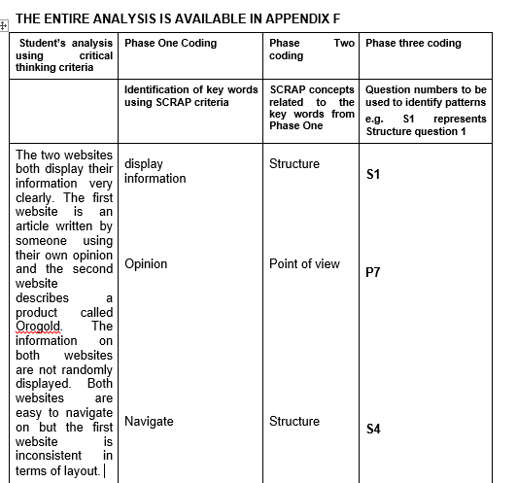

Chapter 6 Lessons which develop Critical Thinking skills

The following lessons were presented, using a blended approach, and are key to the development of the Critical Thinking criteria. The ICARE system, as explained on page 22 of this study, has been incorporated within each lesson and lesson deals with a new critical thinking skill as explained below.

In the introductory lesson the aim was to motivate the students to realise that it is important to investigate Internet materials for trustworthiness. In each of lessons 1-5 there is a Critical Thinking topic that was highlighted.

The topics for each lesson are listed below. The success of each lesson was determined by evaluating the data that were collected in the final evaluation.

Lesson 1
Critical Thinking Criteria – Structure.

Lesson 2
Critical Thinking criteria – Currency.

Lesson 3
Critical Thinking criteria – Reliability.

Lesson 4
Critical Thinking criteria – Authority and Point of View.

Lesson 5
Critical Thinking skills – using the “SCRAP” criteria for the evaluation and formulation of an argument.

6.1 Introductory lesson

Introduction
Discussion topics:
- What do you use the Internet for?
- Are all Internet materials trustworthy?
- How do we determine the difference between trustworthy and untrustworthy materials?
- Which questions can we put together so that we can evaluate Internet sites?

Complete the scale to judge your ability to evaluate Internet materials.

Connect
View the following site and discuss the positive and negative features.
Write your own list of good and poor features of the site.

Apply
With your peers devise a method of testing Internet materials.
How could this site be improved?

Reflect
Pupils re-process the critical criteria, by discussing it with peers and the class.

Extend
View the second site and evaluate this site with the method that you devised.
Reveal that the sites are false and emphasise the importance of establishing trustworthy material for the use at school and for tertiary studies.

Figure 6.1 below shows screenshots of two” false” sites that are available on the LIMU LMS.

Figure 6.1 Screenshots of two” false” sites on the LIMU LMS.

6.2 Lesson 1 – Structure
Critical Thinking Criteria – Structure
Business Studies Topic: Why do businesses fail?
Introduction: Discuss the importance of a well-structured Internet site.
Look at the structure of the Standard Bank and the informal Heart-lines sites.
Connect: View the sites that are loaded onto the LMS and discuss the structures.
Apply: Apply the students’ criteria for assessing the structure of a site.
Reflect: Discuss these sites as a group and then decide which site has the best structure.
Extend: Use the CT criteria to evaluate a new Internet site which is available on the LMS.
Figure 6.2 below displays a screenshot of the resources used in lesson one that are available on the LIMU LMS.
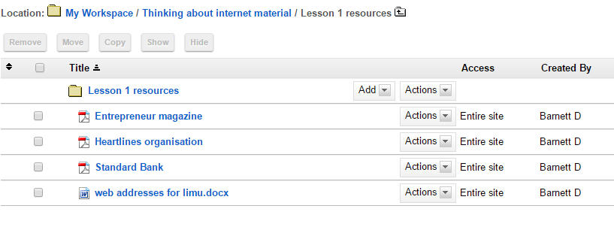

Figure 6.2 Screenshot of the resources available on the LIMU LMS that were used in lesson one

6.3 Lesson 2 – Currency
Critical Thinking criteria – Currency

Business Topic: The value of Small Business in South Africa
Introduction: View a site that has “outdated” material from UNISA. The students looked at the language and terminology to see if the material was relevant.
Connect: Discuss the importance of relevant material. Also discuss the difference between primary and secondary resources. A primary resource might be relevant as it comes from a specific time period, e.g. a first-hand report on the Great Depression.
Apply: Look for clues to determine the currency of an article. Students constructed criteria to review currency.
Reflect: Discuss the criteria for determining currency.
Extend: Use the criteria to examine a new resource from the LMS.
Sing the SCRAP song – a mnemonic to remember the SCRAP test.

Figure 6.3 shows a screenshot of the resources available on the LIMU LMS that are used in lesson two.
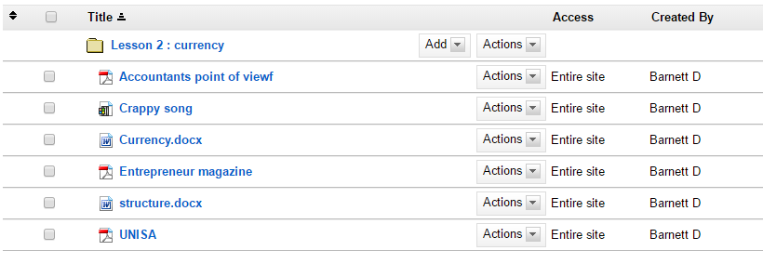

Figure 6.3 Screenshot of the resources available on the LIMU LMS that were used in lesson two.

6.4 Lesson 3 – Reliability
Critical Thinking criteria – Reliability.
Business studies topic: Secrets of business success from entrepreneurs.

Introduction: Advice from Entrepreneurs such as: Richard Branson, Mark Shuttleworth and Leon Musk. The students examine the advice that is given by famous business people.
Connect: Examine several sites that give advice on how to be a successful entrepreneur. Students discussed the reliability of the information. Find commonalities and differences within the advice. Construct criteria to review reliability.
Apply: Apply the students’ criteria for judging reliability of information.
Reflect: Make a decision as to the best criteria for assessing reliability.

Extend: Compare Internet sites using CT reliability criteria.

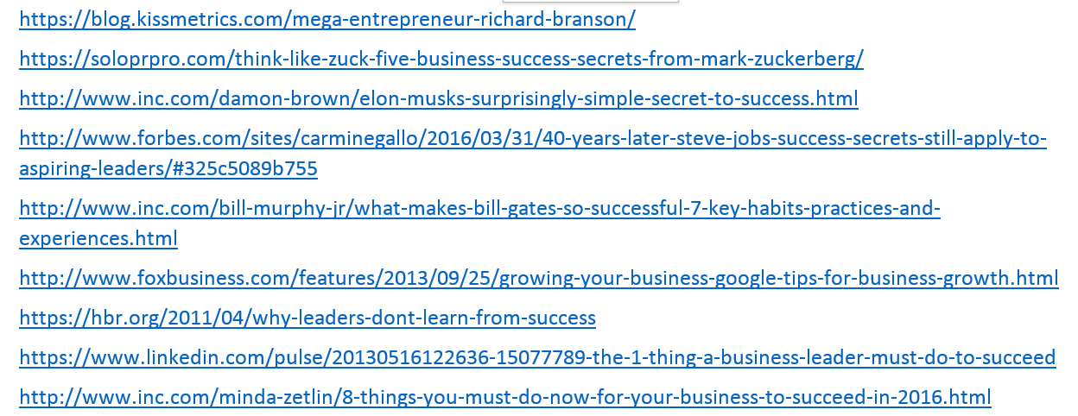

Figure 6.4 Screenshot of the resources available on the LIMU LMS that were used in lesson three.

6.5 Lesson 4 – Authority and Point of View
Critical Thinking criteria: Authority and Point of View.
Business Studies Topic: Bias in the workplace.

Introduction: YouTube clip showing stereotyping and bias in the workplace.

Connect: Students analysed the bias in the video and also discuss the “authority” of the author who presents the information. The video showed how stereotyping and racial bias prevented a Hispanic person from getting a job.
Apply: Determine the details, in a site, that give an author credibility and validity. Look at social media and hyperlinks that pertain to the author. Identify the point of view and bias in a site.
Reflect: Reflect on criteria to determine the authority of the author and the bias within a site.
Extend: Compare sites using the CT criteria for authority and point of view. View the mnemonic for the SCRAP technique as seen on the YouTube clip.

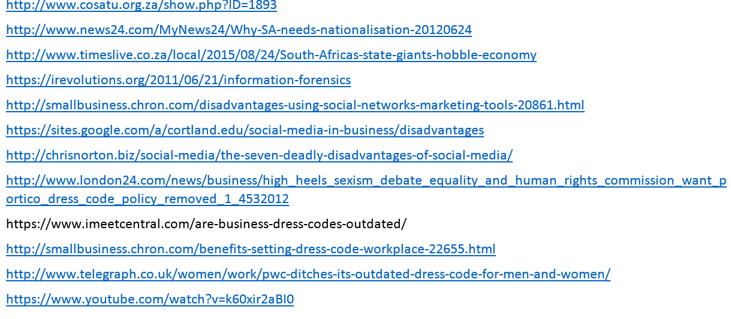

Figure 6.5 Screenshot of the resources available on the LIMU LMS that were used in lesson four.

6.6 Lesson 5 – Using SCRAP criteria for evaluation and forming an argument
Critical Thinking skills: using the “SCRAP” criteria for evaluation and formulation of an argument.

Business Studies Topic: Trustworthy advertising techniques
The students were given a hardcopy of the Internet material before this final lesson so that they could familiarise themselves with the information to be compared. There were two contrasting opinions from two very different authors regarding the value of a specific product. The first opinion was from a doctor who supported the product, but may have a vested interest and the other was a blogger who felt she had been scammed because of false advertising. Both sites had links to support their opinions and they both had proof of authority and currency.

Introduction: Access the websites on the LMS.
Connect and Apply: Students analyse the sites using the SCRAP criteria.
Reflect: Which was most trustworthy site of the two that were available on the LMS?
Extend: Reach a conclusion and formulate an argument to justify your opinion.
Figure 6.6 contains a screenshot of the resources available on the LIMU LMS that are used in lesson five.
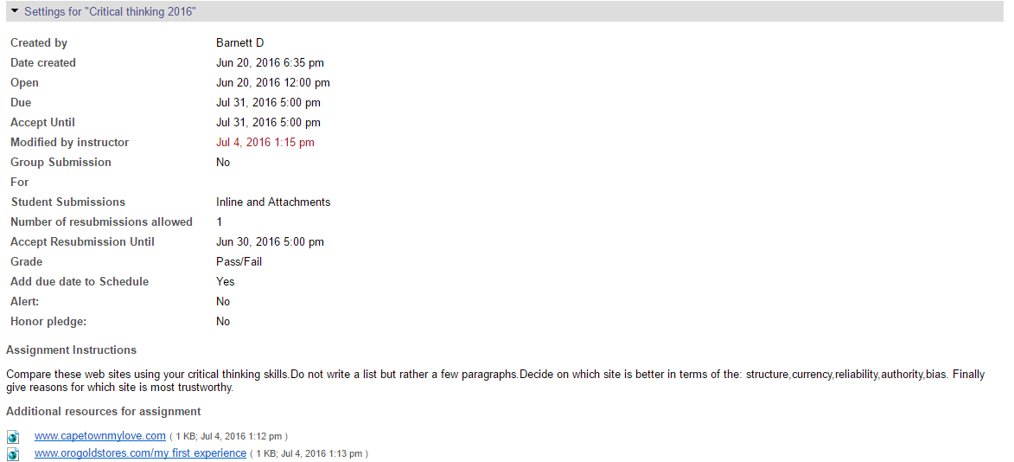

Figure 6.7 Screenshot of the students’ submissions on the LIMU LMS.
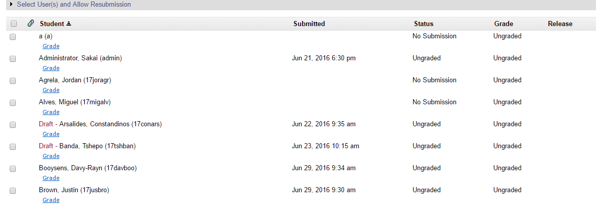

A screenshot of two sites that are compared by the students was shown in Figure 6.8.
Only an introduction was shown but the full text for each site was shown in Appendix C.

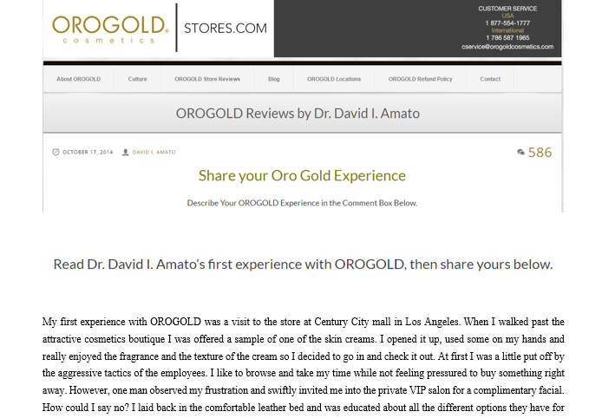


Chapter 7 – Data presentation and discussion

7.1 Results obtained from assessing the sites using SCRAP criteria
The students used the criteria from the SCRAP test to evaluate the two websites and to see which site was the more trustworthy. By applying the coding method already described, the following observations could be made:

7.1.1 Structure
This element of the test was the most thoroughly investigated. The students were able to get a general view of the sites by applying the criteria that related to structure. The question within this element that was answered least successfully was question S13. This question asked “Do the links connect effectively?” It was considered that this question was poorly answered as the speed of Internet connection in the computer room was very slow on the day that this task was completed. The students thus found it difficult to test the links. This was an indication of the effect that technology has on the ability to apply the Critical Thinking process.

The questions in this test are represented in Figure 7.1 below.

Figure 7.1 Questions used in the Structure component of SCRAP

7.1.2 Currency
The element of currency was also well assessed. The students were able to compare the currency of the sites and justify whether the information was still relevant. The question that no student answered was Question C7: “Does the information come from a specific time period?” The purpose of this question was to ask the students to consider how a time period can be relevant to a topic. As this question was not relevant to the sites under review, the students were justified in not answering it.

The questions in this test are represented in Figure 7.2 below.

Figure 7.2 Questions used in the Currency component of SCRAP

7.1.3 Reliability
Most of these questions were easy to answer as the answers were visible. For example, question R4 asked whether there were tables and graphs on the sites. Question R1: “Is the information in this site similar to information on other sites?” was attempted by only three students. A possible reason for the poor response to this question was there was not enough time to investigate other sites that could possibly have similar information. The students had only 45 minutes to apply the Critical Thinking criteria to the material and reach conclusions before the next class arrived in the computer centre. If the students had had fully functioning tablets and fast Internet access the questions that required web searches could possibly have been answered more successfully.

The questions in this test are represented in Figure 7.3 below.

Figure 7.3 Questions used in the Reliability component of SCRAP

7.1.4 Authority
Only five of the twenty students were able to identify the domain name. Therefore this clue, that of Authority, was not fully comprehended. Domain name was important as it can indicate the origin of the material, for example, a university or a company. The lack of time and the slow Internet speed also prevented the students from effectively answering question A10: “Can you find more details about the author through a web search?” Answering this question correctly would give insight into the credibility of the two different authors. However, without accessing further sites, the students were still able to deduce that the author of the first site was a medical doctor and the author of the second site was a young blogger with a B Com degree. This information enabled the students to complete question A7. This deduction could also influence the search for bias within the Internet material, as the views projected on the sites were influenced by the authors’ backgrounds.

The questions in this test are represented in Figure 7.4 below.

Figure 7.4 Questions used in the Authority component of SCRAP

7.1.5 Point of View
This element was particularly relevant as biased viewpoints were evident in both sites. Most of the students were able to identify the biased and opinionated point of view in the second website but there was a more veiled point of view in the first website. A doctor gave his point of view in the first site and although it was more difficult to identify the bias but six students did identify it. Five students also realised that the strong adjectives were indicative of a point of view. Adjectives such as “legendary, attractive and finest” were used in the first source. (See Appendix C .) None of the students was able to find any contradictions within the first site. Another question that was poorly answered was question P1. This question distinguished between primary and secondary sources. This question was included as it was necessary for students to realise that a primary source was the original source and could be more trustworthy than a secondary source which could be untrustworthy.

The questions in this test are represented in Figure 7.5 below.

Figure 7.5 Questions used in the Point of View component of SCRAP

It should be noted that, even though the twenty students referred to the SCRAP criteria 264 times in their evaluations, not all of these references could be coded according to the questions. The students did not answer the specific questions but spoke in general terms about the SCRAP components and these could not be coded and included in Figures 7.1 to 7.5.

7.2 Representation and analysis of results – pre- and post-evaluations
It would be illogical and invalid to compare the pre- and post-evaluations of the websites based on the application of the SCRAP criteria. This conclusion was based on the fact that the students had not been exposed to the SCRAP method at the beginning of this six-week course and that therefore their initial pre-test evaluations could not be comparable to their post-test evaluations.

7.2.1 Volume of words: pre- test and post- test - evaluations
I compared the volume of the students’ work in their initial evaluations with the volume of their work in the post-test evaluations. The total word count in the initial evaluation of the Internet material, for twenty students, was 1150 words but after the lessons the word count for the final evaluation was 4460. This volume increased by almost 400% in terms of word count and indicates that the students were certainly motivated to conduct an in-depth investigation when comparing the Internet materials.
This word volume is represented in Figure 7.6 below.

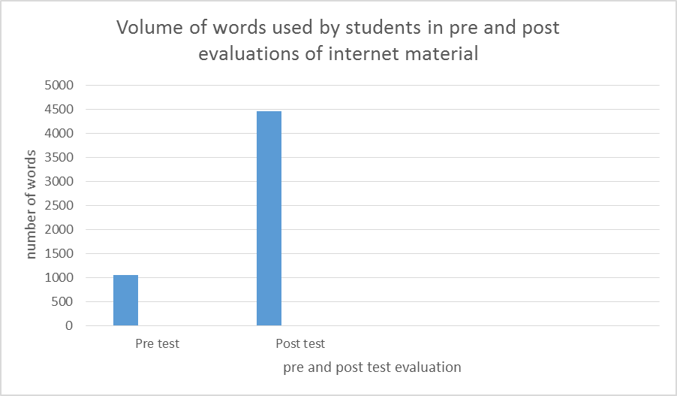
Figure 7.6 Numbers of words used in the pre- and post-evaluations

7.2.2 Pre- and Post–test Likert scales
The students’ pre and post-test Likert scales are listed in Table 7.1 below.

Table 7.1 Comparison of the pre- and post-test Likert scales of 20 respondents
 | Students’ self-assessment before lessons |  |  |  | Students’ self-assessment after lessons. |  |  |  | POSITIVE  Change in ratings
 | Str  agr | agree | dis | Str  dis | Str  Agr | agree | dis | Str  dis | Str  agr | agree | Dis | Str  dis
Structure | 0 | 10 | 8 | 2 | 3 | 17 | 0 | 0 | 3 | 7 | 8 | 2
Currency | 4 | 10 | 6 | 0 | 12 | 8 | 0 | 0 | 8 | 2 | 6 | 0
Reliability | 2 | 7 | 10 | 1 | 8 | 12 | 0 | 0 | 6 | 5 | 10 | 1
Authority | 1 | 7 | 9 | 3 | 10 | 10 | 0 | 0 | 9 | 3 | 9 | 3
Point of view | 4 | 8 | 5 | 3 | 9 | 11 | 0 | 0 | 5 | 3 | 5 | 3
Argument | 6 | 7 | 6 | 1 | 11 | 9 | 0 | 0 | 5 | 2 | 6 | 1

The Structure component of SCRAP evaluates the technical and visual aspects of Internet material. This is illustrated in Figure 7.7 below. In this graph it can be seen that there was a positive improvement in the students’ opinion of their ability to evaluate the technical and visual aspects of the Internet materials. There were no votes for “disagree” or “strongly disagree” after the intervention.

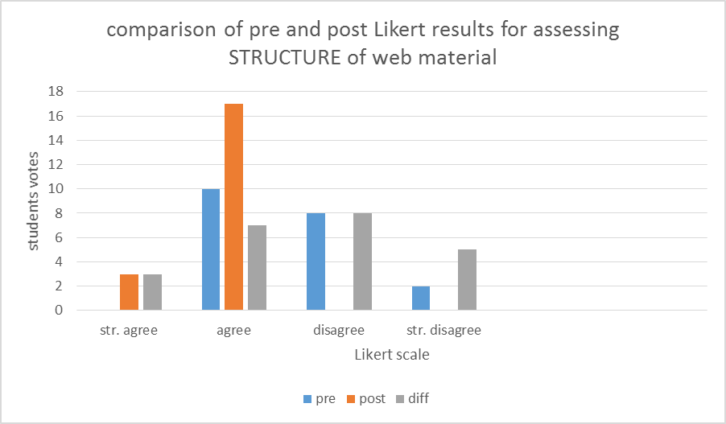
Figure 7.7 Comparison of pre- and post-test Likert results of assessing the STRUCTURE of web material

There was a significant improvement in the students’ opinion of their ability to evaluate the currency of Internet materials. There were no votes for “disagree” or “strongly disagree” after the intervention. This was an indication that the students were confident of their ability to evaluate Internet material for currency.

This is illustrated in Figure 7.8.

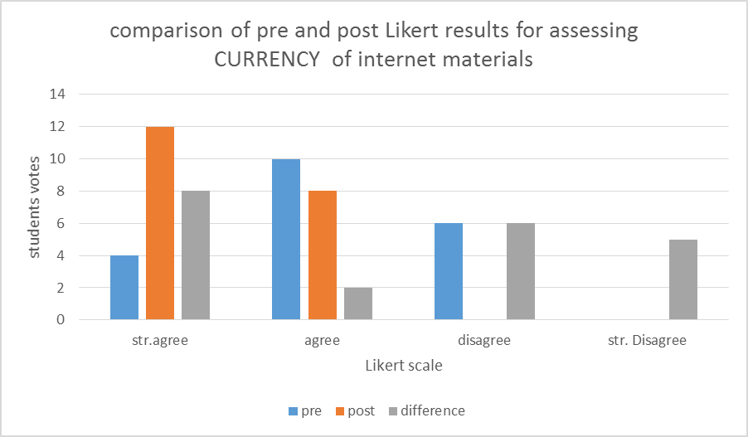
Figure 7.8 Comparison of pre- and post-test results of assessing CURRENCY of web material

There was a significant improvement in the students’ opinion of their ability to evaluate the reliability of Internet materials. This is illustrated in Figure 7.9.There were no votes for “disagree” or “strongly disagree” after the intervention. This is an indication that the students are confident of their ability to evaluate Internet material for reliability.

Figure 7.9 Comparison of pre- test and post-test Likert results for assessing RELIABILITY of web material
There was a significant improvement in the students’ opinion of their ability to evaluate the authority of Internet materials. This is illustrated in Figure 7.10.There were no votes for “disagree” or “strongly disagree” after the intervention. This is an indication that the students are confident of their ability to evaluate Internet material for authority.

Figure 7.10 Comparison of pre- and post-test Likert results for assessing AUTHORITY of web material

There was a significant improvement in the students’ opinion of their ability to evaluate the point of view in Internet materials. This is illustrated in Figure 7.11.There were no votes for “disagree” or “strongly disagree” after the intervention. This was an indication that the students are confident of their ability to evaluate Internet material for point of view.

Figure 7.11 Comparison of pre- and post-test Likert results for assessing POINT OF VIEW of web material

7.2.3 Comparison of SCRAP elements
The pie chart in Figure 7.12 was constructed by adding up the total number of times that the SCRAP categories were referred to in the students’ final evaluation.

The numbers of references are indicated in Table 7.2 below.

Table 7.2 Number of references
Component | S | C | R | A | P
Times mentioned | 75 times | 52 times | 44 times | 47times | 46 times
% | 28 | 20 | 17 | 18 | 17

Figure 7.12 SCRAP components mentioned by the students in the final evaluation

The data show that the students paid most attention to evaluation of the structure of the Internet material. A possible reason for the higher percentage was because this component, Structure, had 14 questions attached to it, whereas the other components had fewer questions. Another possible reason was that the students found that the evaluation of Structure could be done quickly because it required less reading and could be done by glancing over the material to check the criteria. The remaining components namely: Currency, Reliability, Authority and Point of View were evaluated on a relatively equitable basis. By this I mean that the students referred to these categories the same number of times in their final evaluations. This was a positive for this research as this can be interpreted to mean that the students understood the main components and the criteria within each component and could apply all five SCRAP components on an equitable basis when evaluating the material for trustworthiness.

7.2.4 Pre-test and post-evaluation Likert comparison regarding students’ attitude to making an argument
There was a significant improvement in the students’ opinion of their ability to make a comparison between different materials. There were no votes for “disagree” or “strongly disagree” after the intervention. This was an indication that the students were confident in their ability to compare and make an argument when evaluating Internet material for reliability.

Figure 7.13 Comparison of pre-test and post-test Likert results for assessing MAKING AN ARGUMENT about Internet materials

  - Analysis of the argument using Kuhn’s scale
Included are two examples of pre-evaluations from students who were asked to compare two sites. These examples were chosen to illustrate how Kuhn’s scale had been applied so that the results could be clearly understood The scale in Table 7.3 below was derived from the research on thinking by Kuhn (2004) – as discussed in the Literature Review (section 2.1). It should be noted that two of my colleagues assisted in constructing this scale. Both these colleagues have more than one university degree and each has expertise in research. In discussing the levels within Kuhn’s scale and the way it can be applied to the students’ answers I attempted to ensure that the scale was fair and valid. Kuhn presents four levels of thinking ability (Kuhn, 2004). The levels have been interpreted by the author and applied to the quality of argument. After the intervention it was expected that the students will be able to apply critical skills at an evaluativist level.

Table 7.3 Quality of argument
Quality of argument
A | B | C | D | E
Sophisticated skilful reasoning  Synthesis, evaluation and analysis.  Possibilities are generated contemplated and evaluated.  Own and other views are considered. | Clear with substance.  Comparative reasoning and analysis. Mostly based on subjective viewpoint. Most sites have merits. Accept most material. | Adequate but pedestrian.  Reason simplistically that the material is trustworthy after looking at several sites but limited analysis of the concepts that create trustworthiness. | Superficial  Recognise and trust many sources because they can be described by the participants singular point of view | Vague with little conviction.  Trust one source implicitly because the site clams it is trustworthy.

Examples of some of the students’ evaluations are given below.

Example one
“The first site is better because it is the official site from America. It is the website that I prefer because it has more information than the other. It tells us more about the subject. They have facts and pictures that support the website. The grammar is sophisticated and the layout is good.”

As the students would not have been exposed to the criteria for evaluating Internet materials, a rating of C will be attributed to this short paragraph.
Example two
“The first website is better than the second one as I trust the website because it has to be updated each year while the second one does not.”

A rating of E will be given to this second comparison as the student was trusting only one factor upon which to make his choice.

In the application of scales to these pre- evaluations consideration was given to the fact that the students had not been exposed to the SCRAP criteria when writing these comparisons and therefore the criteria were applied leniently.

Appendix F contains three examples of post-evaluations from students who were asked to compare two sites. These examples were chosen to illustrate how Kuhn’s scale has been applied so that the results can be clearly understood.

Consideration was given to the fact that the students had been exposed to the SCRAP criteria when writing these comparisons and thus the criteria were stringently applied by the author of this report.

A “B” rating would be given to example one (see Appendix F) as the student had made a thorough comparison using the criteria in the SCRAP test. Besides the technical aspects, the writer gave a cohesive answer fulfilling most of the criteria for a “B” rating according to the scale devised to assess this activity.

A “C” rating would be attributed to this second example (see Appendix F) as the student did not conduct a thorough SCRAP analysis. The student also relied too much on the viewpoint of the writers to make his decision about trustworthiness.

Table 7.4 below reflects a comparison of the quality of arguments before and after the intervention. Two teachers were asked to assist when this scale was applied so that the results could be considered to be both impartial and reliable. Kuhn’s scale was applied to the arguments. The results are given in Table 7.4 below.

Table 7.4 Quality of arguments before and after intervention
Quality of arguments before the intervention
A | B | C | D | E
 |  | 6 | 11 | 3
Quality of arguments after the intervention
A | B | C | D | E
3 | 9 | 5 | 3
Change in ratings
+4 | +8 | +1 | +8

It can be seen that there was an improvement in the students’ abilities to make an effective argument, as detailed on Kuhn’s scale.

7.4 The allowance for creative insights within critical thinking
Several students presented unusual and creative insights into the material. I was looking for not only integrated and synthesised answer but also for creative answers. Ennis sees the link between critical and creative thinking when he states that the critical thinker was able to analyse information and then “imaginatively suppose and integrate” the information to form a new whole (Ennis, 2011: 5).

Bailin (1987) says that “Creativity is not merely a question of generating new solutions to problems, but of generating better solutions, and is thus not a matter of arbitrary novelty or random invention, but involves change which is effective, useful, and significant.”

Several students came up with “useful and significant insights” One student compared the formal and structured language in the first site with the colloquial language of the second site and based his decision on trustworthiness on this aspect.

Another student correctly interpreted the opinion of the blogger as “negative feedback,” which was contrasted with factual information.

One student was able to investigate the credibility of the “doctor” who was promoting a product on the first site and found that the doctor was a herbalist who had a vested interest in the product. This student established that the doctor worked for the company whose product he was endorsing.

One student considered that the blogger was more trustworthy as she was not being financially rewarded, whereas the doctor “wouldn’t want to play down their own product.”

What was significant was that not all the students reached the same outcome regarding the trustworthiness of the Internet material. By “significant” I mean that the students were able to make a decision about the material based on judgement and evaluation. The students are making decisions which concur with the third and fourth levels of thinking, as outlined by Kuhn (2004). The decisions are based on critically evaluating material and making informed decisions. Fifteen of the students justified their choice for one site and five justified their choice of the other site. The students were not disadvantaged by having reached differing conclusions but it was pleasing to see that the criteria inspired different answers and that the students were extended.

Only four of the twenty students fully integrated the SCRAP test into a cohesive argument. By “cohesive argument” I mean that the students evaluated and analysed the material and then presented a synthesised argument. The students did not list the answers to the SCRAP test but integrated these into paragraphs and wrote a cohesive answer. This was an answer that would fulfil the requirements of an “evaluativist” argument as described by Kuhn (2004). The levels of thinking, as discussed by Kuhn, were outlined on page 82 of this study. It can be seen that there was an improvement in the students’ ability to make a sophisticated argument. Such an argument not only includes the Critical Thinking criteria but also was sophisticated because the elements are integrated into a cohesive whole.

7.5 Correlation and triangulation
A comparison can be made with two sets of data .Firstly the data that illustrated a positive correlation between the improvements in the students’ opinion of their abilities, as measured on the Likert scale (table 7.1), and secondly, the set of data that shows the quality of the arguments, as measured with the Kuhn’s analysis.(table 7.4) There was a positive improvement in both of these sets of data and it could be reasoned that the students had engaged with the Critical Thinking criteria and successfully applied it to the analysis of Internet materials. The results obtained from the Likert scale were compared to the results obtained from the Kuhn scale .Thus two different methods were used to collect and data and the comparison of the results was referred to as methodological triangulation.(Denzin,1978)

A final chapter has been added to this research to discuss the students’ views on the intervention and the unique factors that influenced the running of the lessons. Consideration was given to the validity and reliability of this study and a conclusion was reached

Chapter 8 Conclusion

8.1 Students’ opinions of the Critical Thinking intervention
The following questions were asked at the end of the course. The purpose of the questions was to gain insight into the students’ opinions of the course and this will foster confidence and ensure that the inquiry can be deemed reliable. The answers were also taken into consideration to establish whether there were changes that could be made to this study if it were run again.

The questions were given to the students by a fellow teacher who has a master’s degree and was therefore aware of the need for reliable results. I was not in the venue when the questions were presented so there was no influence on the students to give answers that would be favourable.(See Appendix E)
- Was this course beneficial? Give a reason for your answer.
Responses: The entire group 20 students found the course and beneficial and most of the students gave the reason as “It helps me to analyse Internet materials.”
- Were there any problems that you encountered in this course? Explain
Responses: The majority of the students, 16 out of 20, indicated that they had had no problems. The following problems were listed by the students: difficulty in accessing the websites as the Internet was too slow; repetition of SCRAP test made the course boring; difficulty to typing out the comparison on the LIMU app; difficulty in getting into the links and checking the bibliography because the net was slow
- Would you apply any of the Critical Thinking skills in other areas?
Responses: All of the students said they would be able to apply the Critical Thinking skills to other areas. A few students gave reasons for their answers and said that they could apply the skills when doing research for “my own projects as well as in real life situations.”
- Would you trust the results of the course?
No student doubted the credibility of the results.
- What would you change in this course?
Three of the students would make the following changes but the other 17 found nothing to change. They suggested the following: “I would change the length of the course because I got bored after the fourth lesson; I needed to compare more websites as we don’t necessarily have enough experience to tell the difference between the good and bad sites.”

8.2 The positives and negatives of the intervention
It was felt the students over-estimated their ability to make effective arguments. This observation is based on the rating that they gave themselves on the Likert scale and the results that were achieved in the final analysis. On the Likert scale during the post- evaluation, the students stated that they felt more confident in making an argument than they did during the pre-evaluations. However not all the students demonstrated their ability to construct effective arguments when comparing the Internet materials. Perhaps this was a shortcoming of this course and more time should perhaps have been allocated to analysis of the art of constructing effective arguments. The students were successful in applying the Critical Thinking criteria but the construction of a cohesive argument was tricky. It was again stated that the purpose of this study was not to teach the students to write argumentative essays so the Kuhn scale was perhaps too stringent and could possibly be applied more leniently if this study was repeated.

Another point to consider was the comparison of the results between the boys who took Business Studies and the boys who took other subjects. I only used the results for the boys who were studying Business and excluded the results of the other boys who took part in the intervention. The reason for this, as mentioned earlier, was to ensure the internal validity of the intervention. It was not within the scope of this research to compare the results of the boys who study Business with the other boys. It should be stated that I read through the results of both groups of boys and, although these were not analysed, there were very few differences. Perhaps it was not necessary to include only the results of the twenty Business students as it was felt that there might have been very little difference in the final conclusion if all forty-seven sets of data had been analysed. There was a positive that can be read into this assumption because the skills that were meant primarily for analysing Business-related material were absorbed and applied by all students, showing that Critical Thinking criteria was transferable.

The students were exposed to a song and mnemonic through viewing a You Tube video. The lyrics in this song reinforced the SCRAP process which was invaluable as the students walked around the school humming this song. When the boys were evaluating the websites they were able to recall the process through the lyrics and now had a method of thinking about Internet material. This ability to take charge of the structures which are necessary for evaluation was an indication that the students were practicing a form of “meta thinking”. This was evidence of the application of a key element of Critical Thinking.

8.3 Impact of extraneous factors
The problems that I encountered during this project were centred on technology and timetables. The students at this school bought electronic tablets in 2014 and it was the plan for the students to access electronic versions of their text books on the tablets and also to eventually interact with the Learning Management System. It was not relevant to this paper to discuss the success of the tablets for accessing the text books but the enabling of the LMS was of interest. For various reasons the use of tablets, instead of the use of text books, was a failure. In 2016 the students reverted to text books and, because of this failure, a negative perception developed about the use of tablets in the classroom.

In this research it was planned for the students to access the LIMU LMS through their tablets but many students had discarded their tablets and the few who still brought them to school were using them for games or they were uncharged. The Internet connection at this school was also ineffective as also does not reach all the classrooms. So at times the implementation of this research project was compared to “pushing a boulder up a mountain”. Nevertheless the students were able to access the Internet in my classroom through the use of my personal router and also at times through the schools Internet signal. In the first lesson the students viewed the sites on the overhead screen in my classroom via my laptop and a projector, but this prevented the boys from scrolling through the sites on an individual basis. To overcome this disadvantage the students were taken to the computer laboratory for the rest of the lessons. The timetabling for the computer laboratory did not include allocation of periods for the senior school as computer lessons were only available to the pre- and primary schools. This meant that the time available for these lessons was restricted and I had to continually “bargain” with the computer teacher to free up time.

The LIMU LMS was available to the boys through the computers in the computer laboratory but not all the boys had used this system on the tablets. I had to allow for a period of familiarisation before I could proceed and also gave each boy a printed instruction of how to access the LIMU site and the lessons that were loaded onto it. As the Internet speed in the computer laboratory made it difficult for boys to simultaneously access the LMS patience and perseverance were necessary.

Another difficulty that I did not anticipate was that there were some boys who still found it difficult to save their work onto the LIMU system or even to the documents on the hard drive. It seems that not all the Grade 11 boys are as computer literate as was first thought.

8.4 Validity and reliability
At the beginning of this report a complex key question was asked. This question has been simplified into several sub-questions. The intervention used within this study and the resultant evidence show that these questions have been answered. These sub-questions were:

Could students develop specific Critical Thinking skills which were required for the evaluation of Internet materials?

Could students use these specific skills to critically evaluate Internet materials for trustworthiness?

Could an argument, as a form of comparison, reveal that there was evidence of improved levels of Critical Thinking?

Did the correlation of data prove that there was an enhancement of specific Critical Thinking brought about through the intervention?

Did the students consider that these specific critical evaluation skills had improved?

Did the students consider the intervention a worthwhile experience?

Did the students think that these critical skills could be transferable to other learning areas?

I am confident in concluding that there had been a degree of success in answering these questions. The results obtained from comparing a pre intervention and a post intervention Likert scale indicated the students now had improved confidence when assessing internet materials. The results obtained by comparing the students’ ability to make considered arguments pre and post interventions also reflected an improvement in students’ abilities to effectively apply critical skills. Through a mixed method approach data had been collected then interpreted and triangulated. As shown in the interpretation of results there was a positive correlation between the results obtained from the Likert scale and the data obtained from Kuhn’s analysis of argument.

It was felt that the participants had been taught specific Critical Thinking skills which were required for the evaluation of Internet materials. They had used these specific skills to critically evaluate Internet materials for trustworthiness. An argument, as a form of comparison, revealed that there was evidence of improved levels of Critical Thinking. Through the results of a post-test Likert questionnaire the boys revealed that they believed that their Critical Thinking skills had improved. The responses from the students also indicated, in writing, that they believed the intervention to be reliable and the skills transferable. Finally, the comparison of both qualitative and quantitative results proved that there was an enhancement of the specific Critical Thinking skills (SCRAP components) brought about through the intervention.

There were limitations which had to be overcome so that this study could be completed. The inefficient technology at the school created a hurdle which had to be overcome by making alternative plans and through perseverance.

Although all students said that they felt more confident in making an argument, not all of them were effective in making a complex argument based on the Kuhn scale. As can be seen in the raw data and through the interpretation of results, there was a positive improvement in all the criteria that were measured.

It may be concluded that, by constructing and using a set of criteria which have commonalities with critical thinking criteria used in research on internet material, I have given this report construct validity. By using multiple pieces of evidence from multiple resources I have given this research internal validity. By using carefully constructed measuring “instruments,” such as the Likert scale and Kuhn scale, I have given this research reliability. It remains to be seen if a fellow researcher would arrive at similar results in a comparable research, as this would give this report the final validity test – called external validity.

APPENDICES

Appendix A
Critical Thinking certificate

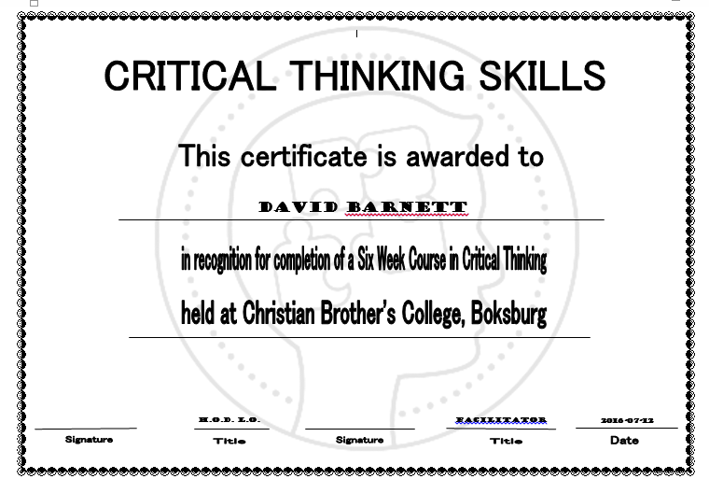

Appendix B
Ethics clearance:
Wits School of Education WITS UNIVERS ITY
27 St Andrews Road, Parktown, Johannesburg 2193 Private Bag 3, Wits 205O South Africa. Tel: +27 17 777-3064 Fax:. +27 LL7t7-3tOO E-mail: enqulries@educ.wits.ac.za Website: www.wits.ac.za
09 March 2016
Student Number: 968537
Protocol Number: 2015ECE053M

Dear David Barnett
Application for Ethics Clearance- Master of Education
Thank you very much for your ethics application. The Ethics Committee in Education of the Faculty of Humanities, acting on behalf of the Senate, has considered your application for ethics clearance for your proposal entitled:
Development of learner critical thinking skills through internet materials on a Learning Management System
The committee recently met and I am pleased to inform you that clearance was granted.
Please use the above protocol number in all correspondence to the relevant research parties (schools, parents, learners etc.) and include it in your research report or project on the title page.
The Protocol Number above should be submitted to the Graduate Studies in Education Committee upon submission of your final research report.
All the best with your research project.

Yours sincerely,
VI4arg..
Wits School of Education
oLL7L7-3416
cc Supervisor - Dr Nokulunga Ndlovu

Appendix C -Text of Internet materials for final evaluation

Site one

http://orogoldstores.com/my-first-experience-with-oro-gold/

Share your Oro Gold Experience

Describe Your OROGOLD Experience in the Comment Box Below.

Read Dr. David I. Amato’s first experience with OROGOLD, then share yours below.

In store Experience by Doctor David I. Amato
My first experience with OROGOLD was a visit to the store at Century City mall in Los Angeles. When I walked past the attractive cosmetics boutique I was offered a sample of one of the skin creams. I opened it up, used some on my hands and really enjoyed the fragrance and the texture of the cream so I decided to go in and check it out. At first I was a little put off by the aggressive tactics of the employees. I like to browse and take my time while not feeling pressured to buy something right away. However, one man observed my frustration and swiftly invited me into the private VIP salon for a complimentary facial. How could I say no? I laid back in the comfortable leather bed and was educated about all the different options they have for skin care.
OROGOLD products are some of the finest in the world of luxury skin care. OROGOLD Cosmetics fuse east and west as the company combines gold, the jewel of ancient beauty, with the highest quality ingredients produced through modern research. Gold has been used in medicine for thousands of years on record. Everyone from the ancient Egyptian and Mayan cultures to modern Chinese and American civilizations utilize gold in the practice of medicine and healing. The use of gold ranges from the legendary golden face masks of Cleopatra to the golden acupuncture needle of the Far East to the gold enhanced radiation and chemotherapy found in modern medicine.
I was certainly impressed by his knowledge, especially considering he did not know I am a doctor of natural medicine. I liked that he also explained the importance of caring for one’s skin whether or not one is concerned with beauty or vanity. The skin is the largest organ system in the body and uses a lot of the body’s precious resources to maintain its integrity. The less you care for your skin, the harder your body has to work to maintain moisture levels and protective elements. In contrast, one who is already deficient in blood and energy, like many of my patients, will have these resources moved away from the skin in order ensure that all of the vital organs such as the heart and kidneys, have enough supply to maintain vital function. In such individuals, the skin will be more prone to issues such as roughness and dryness.
It is very important to increase consumption of healthy foods and herbs and it is equally important to enhance the look of your skin with nourishing and high-quality products. Our skin or integumentary system is the first line of defence in our body. Maintaining healthy skin helps our body defend against numerous antigens including, bacteria, viruses, fungus, and ultraviolet radiation from the sun. High-quality skin care products can help to seal the integument and lock in the body’s own resources, blood, pigment, moisture, oils, and most importantly vital healing energy or Qi. Oriental medicine teaches that Qi is the greatest resource in our bodies. Qi has several functions and one of the most crucial is our Wei Qi or immune system function. The harder the Wei Qi must work to protect the exterior of our bodies, the less effective it will be in defending our whole system, leading to imbalance, illness, and disease.
In spite of all the benefits offered by a proper skin care regimen with the right products, like those from OROGOLD, the most sought after benefit remains beautiful looking skin. Keeping your skin nourished and healthy will help you look younger and feel more beautiful as you age gracefully. These are the kind of results I was searching for myself, so when I finished my complimentary facial at OROGOLD, I asked the salesperson what would be the best products for me to take home. He recommended the Men’s Collection Facial Cleanser and Daily Moisturizer to use daily and the Vitamin C Facial Serum to use weekly.

UPDATE: 04/30/2014 – After my great experience with OROGOLD I was eager to come back again. Now I am writing to update everyone on my experience with the OROGOLD 24K Deep Peeling. After the harsh winter months, my skin was feeling a little dry and flaky, so I went back to OROGOLD Century City for some help. I went back for another personal consultation with one of their beauty advisers. Upon discussion, we agreed that an OROGOLD Deep Peeling product would be perfect for my skin. As a herbalist, I know how important it is to intake the right balance of nutrients for our body to work well. Even though I am careful about keeping a healthy diet and taking the correct supplements, there are times when my skin needs something more! I trust the quality ingredients that OROGOLD uses in all their products to help in such a situation. After my great experience with OROGOLD last time, I knew they were the right place to turn for help. During my last visit, I was treated to a complimentary facial and this time was no exception either.
After we decided on the OROGOLD Deep Peeling during my consultation, one of the beauty advisers proceeded to apply it to my skin during my facial. I could almost feel my skin being exfoliated and my pores being cleaned out. I love the personalized consultations because the staff really take the time to explain each product. During my facial, they also explained how to use the OROGOLD Deep Peeling, so when I take it home it will be easy for me to replicate the results. Since going in, I have been using the peeling product once a week at home, and I am very happy with the results. The rough and dry patches of my skin are fading away. Seeing positive results makes me look forward to having my skin completely returned to its soft and smooth usual self. Thanks again OROGOLD for the 24K Deep Peeling and for the demonstration on how to use OROGOLD Deep Peeling at home.
Take a look at what some other people think about the OROGOLD Deep Peeling:
- Vanessa Acousta loves OROGOLD 24K Deep Peeling
- Rciyah thinks the OROGOLD 24K Peeling is flawless!
Have you tried the OROGOLD 24K Deep Peeling yet?

http://epltt.coe.uga.edu/index.php?title=Multiple_Intelligences_and_Learning_Styles

Site two

http://www.capetownmylove.com/2011/12/18/i-totally-got-scammed/

I totally got scammed
So the other night, while trying to get through some much dreaded Xmas shopping at Canal Walk, I got cornered by a crazy salesman who just wouldn’t let me go…
He was an Israeli guy named Oz (well that’s likely not his real name) with a very heavy accent and he was punting a skin care range called Oro Gold which claims to contain 24 karat gold in the products. He also claimed that gold can actually be absorbed by the skin and that it had huge anti-aging and anti-inflammatory abilities blah blah blah, etc etc.
Oz totally freaked me out. He was very aggresive in his sales manner and I felt totally trapped… He forced me to sit there while he plastered all kinds of products me, telling me in detail how “magical” each one was. I knew 100% that his pitch sounded way too rehearsed and far-fetched. But you see – I’m someone who hates confrontation, making a scene or drawing attention to myself in situations such as these – so he had the perfect captive in that chair.
Eventually I felt so bullied, I decided that my only way out would be to just buy something and get outta there. I settled on this24K Deep Peeling facial scrub cause it seemed pretty descent when he did his little demo. Oz started with an insane price of R2400. When I said that’s way too much money for me, he then said because he “really likes me” he can give it to me for R1500. I still wasn’t biting, so he then went down to R1200 and eventually R1000. I was like OK fine, I’ll take it for a bloody grand then. I just want to get away!!!
I thought I was finally free… but no… there was of course more…
Then he started with some mineral make up range and a body range made out of Dead Sea minerals. The make up seemed pretty decent, but also had crazy crazy prices. The body products were also fine, but then again – they’re just pretty standard body products and again the prices were seriously steep.
I got bullied into a 2nd product – an Obey Your Body Dead Sea Mineral Salt body scrub, starting off at a price of R750! Yes – for a bloody body scrub! It eventually came down to R250 and I gave in. I really really just wanted to escape
The next morning I confessed my stupid purchases to my beauty guru, Leigh, and she directed me to this link where they explain how gold actually doesn’t really do anything for your skin. Oh how awesome. But then again – I kinda knew that already.
Then I did a bit of research online and found that the crazy prices Oz was quoting was total bullshit. That Oro gold face scrub you can pick up on Amazon.com for $37.10 (normal price $114.95). At the current USD to ZAR exchange rate of approx. 8.3 – that means even if I was buying it at the normal price, I’d only be paying R954. So where the hell did the original price of R2400 come from?
That body scrub you can get on Amazon.com for $14.21 (normal price $59.99) – again that’s way below his R750 opening offer.
I also found tons of complaints here submitted by women from across the US to the US Complaints board. They all make mention of the pushy sales tactics, false pricing and false information about their returns policy.
I have since tried the face scrub and can tell you that it’s crap – the scrub turns into a glue like texture which sticks to the little fine hairs on your face and it’s a total bitch to get off. Not cool. I have also noticed lots of little bumps on my face which was not there before – kind of like a minor allergic reaction. I’m likely just going to bin it now.
So ja – I was an idiot – I should have been more assertive and told the guy to piss off. But instead I allowed him to make me feel awkward and uncomfortable. I can assure you I will NEVER fall for something like this again.
I wanted to share my story to avoid others from falling for the same scam. I don’t think his stand is still at Canal Walk – because he did mention that he was only there for the day. But I’m sure he’ll be popping up at a shopping centre near you. So keep an eye out people, please…
xxx

Share this:

Appendix D
Likert scale –used pre and post intervention

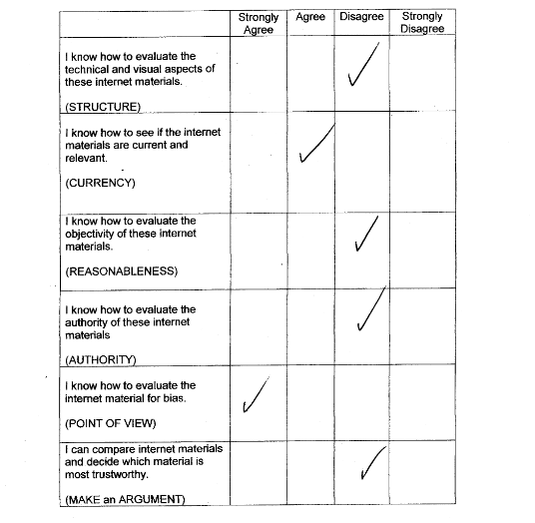

Appendix E
Final questionnaire presented to students.

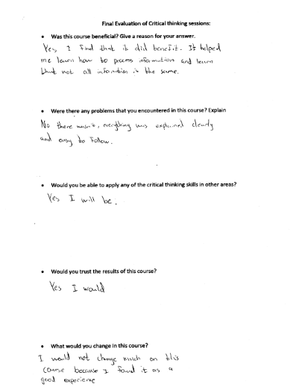

Appendix F
Three examples of the students’ evaluation of Internet material:
Example One:
In terms of structure http://orogoldstores.com/my-first-experience-with-oro-gold (website1) has a good structure as its information is displayed in a clear manner and it is easy to navigate. All links work correctly and it had a consistent layout. On the other hand website 2 also has a good structure as there were no adverts and pictures seemed to be original. In terms of currency website 1 is better than website 2 as there was an indication of when last the website was updated. The information found was quite modern in terms of language and references. Website 2, however, has no indication of any updates to the website. The information seemed to have modern terms but it also seemed to be slightly outdated. In terms of reliability, website 1 is very reliable as there is a bibliography and references to the source of information are given. There are some statistics and the author has given his contact details for queries. In website 2 there are no references or bibliography given and there are no statistics given. In both cases the domain can be identified and neither author is anonymous. The author of website one is an academic and the author of website 2 is also an academic. In terms of “authority” both websites are equal. Website 2’s information comes from more than one source. There are no contradictions with any materials and there seems to be no sense of bias. Website 2 however does not come from multiple sources and gives a negative opinion. There seems to be a strong sense of bias in this website. In conclusion I find website 1 more reliable and better than website 2 and I would rather choose website 1.

Example Two
Girl blogger from Cape Town
The site with the girl blogger she didn’t really like her experience with Orogold as the salesman was pushy and she was bullied into buying the products. This girl is not the type to cause a scene so she just agreed to buy the product so that she could leave. Later on when she used the product she found out that she as minor allergic reactions. This website does not refer to any other websites that mention a rubbish experience with the Orogold sales people the information is displayed clearly.

Orogold website
The website with the doctor states that he had a good experience and the skin products were effective on his skin. That same website also refers to other websites that people said they had a good experience it also has a picture of the doctor and all his qualifications. The information is displayed clearly there are other adverts on this site, it is easy to navigate around this site, there are clear pictures of the Orogold product.

Conclusion
So in conclusion the website that has the doctor on it is a much better review of the Orogold product and give better information about the product, so in would much rather trust the Orogold official website rather than the girl blogger’s website.

Example three
Students analysis using CT criteria | Phase one | Phase two | Phase three
Students analysis using CT criteria | Identification of Key words using SCRAP criteria | SCRAP Concepts/techniques related to key words | Identification of key question
“The two websites both display their information very clearly.The first website is an article written by someone using their own opinion and the second website describes a product called Orogold. The information on both websites are not randomly displayed. Both websites are easy to navigate on but the first website is inconsistent in terms of layout. And the second one is rather consistent. The purpose of both websites are clear as the first website talks about a scam from someones point of view and the second describes a product or sorts of promotes the product.  Both sites don’t show todays date. They do indicate the dates they were made and when they were last revised. The information on these sites don’t seem current.The first site does not have modern terms within the language where as the second site has modern terms and the information does seem valid and could be valuable today.  Both sites do have bibliographies . But as far as reliability is concerned the second site is much more reliable because it supplies us with the details and information on the author  .The second site its self contains pictures and to sell the product and some of the pictures support the information.  I can identify the domain of both sites . The first author rather to be anonymous wheras the second gives full details on the author as well as his place of work,details of his experience. Judging by the information of he author he does appear from a well known organisation.  The information from the first site comes from one source only because its from someones own opinion The second site displays information from multiple sources and is trying to sell the product. The first site is rather biased and a lot of the writer’s personal point of view comes across.  In conclusion I think that the second site is much more reliable because it is not biased at all ,it gives details of a product willing to sell.It gives us information on the author which is very mush useful when you find a resource to be reliable” | Display information  opinions  navigate  layout  point of view  date  information  current  terms  information  validity  bibliographies  reliability  author  pictures  domain  experience of author  organisation  source  opinion  sources  bias  point of view  reliable  bias  author.  reliable  bias  author | structure  reasonableness  structure  structure  reasonableness  currency  currency  currency  reliability  authority  structure  Authority  authority  authority  reliability  reasonableness  reliability  reasonableness  reasonableness  reliability  reasonableness  reliability  reasonableness  authority | S1  P7  S4  S5  P7  C1  C5  C5  R2  A2  S7  A1

REFERENCES
Anagnostopoulo, K. (2002). Designing to learn and learning to design: An overview of instructional design models. Retrieved from http: //www.jiscinfonet.ac.uk

Azyan, L. (2011). List of UK universities and their departments on YouTube. Retrieved from http://www.lizazyan.com/uk-universities-on-youtube/

Bailin, S., Case, R., Coombs, J. R .& Daniels, L. B.(1999) Conceptualising Critical Thinking. Curriculum Studies Vol 31 .No.3. Retrieved from http://ctl.ok.ubc.ca/__shared/assets/ct-conceptualize45378.pdf

Berk, R. A. (2009). Multimedia teaching with video clips: TV, movies, YouTube, and mtvU in the college classroom. International Journal of Technology in Teaching and Learning, 5(1), pages 1–21.

Blended learning (2011). A synthesis of research findings in Victorian education 2006-2011 Retrieved from http://www.education.vic.gov.au/blended learning/pdf

Bloom, B. S. (ed.) (1956). Taxonomy of Educational Objectives, the classification of educational goals Handbook I: Cognitive Domain, New York: McKay.

Bogdan, R. C., & Biklen, S. K. (1998). Qualitative research in education: An introduction to theory and methods (3rd Ed.). Needham Heights, MA: Allyn & Bacon.

Brown, J. S., Collins, A. & Duguid, P (1989). Situated cognition and the culture of learning. Educational researcher 18, pages 32-42.

Bruner, J. (1991). Critical Inquiry Vol. 1 No 1, University of Chicago Press. Retrieved from http://www.jstor.org

Conrad, C. F. & Serlin, R. C. (2006). The Sage handbook for research in education: Engaging ideas and enriching enquiry, California: Sage Publications.

Cooper, P.A. (1993). Paradigm Shifts in designed instruction: From behaviourism to cognitivism to constructivism. Educational Technology. Vol. 33, No. 5. Retrieved from http://ocw.metu.edu.tr/pluginfile.php/9156/mod_resource

Czerniewicz, L. & Brown, C. (2005). Access to ICTs for teaching and learning – from single artefact to interrelated resources. IJEDICT, 1(2), pages 42-56.

Darling-Hammond, L., Austin, K., Cheung, M. & Martin, D., (2001).Thinking About Thinking: Stanford University School of Education. Retrieved from ttps://www.learner.org/courses/learningclassroom/support/09_metacog.pdf

Denzin, N.K. (1978). Sociological Methods. New York: McGraw Hill

Dougimas, M. (2000). Improving the effectiveness of tools for Internet based education. Retrieved from http:// www. sn.curtin.edu.au/tlf/tlf2000/dougiamas.html

Driscoll, M.P. (1994). Psychology of learning for instruction. Boston: Allyn & Bacon.

Elder, L & Paul, R. (2010). Critical Thinking Development: A Stage Theory with implications for instruction. Retrieved from http//www.criticalthinking.org

Eccles, J.S. & Wigfield, A. (2002). Motivational Beliefs Values and Goals. Annual Review. Psychol. Institute for Social Research, University of Michigan, Retrieved from http://outreach.mines.edu/cont_ed/Eng-Edu/eccles.pd

Ennis, R. H. (2011).The Nature of Critical Thinking: An outline of critical dispositions and abilities. University of Illinois. Retrieved from http://faculty.education.illinois.edu/rhennis/documents

Ennis, R.H. & Weir, E (1985). The Ennis Weir Critical Thinking Essay Test. Pacific Grove, California: Midwest Publications

Facione, P. A. (1990). Research Findings and Recommendations. Prepared for the Committee on Pre-College Philosophy of the American Philosophical Association, California State University, Fullerton.

Facione, P. (2000).The Disposition Toward Critical Thinking: Its Character, Measurement, and Relationship to Critical Thinking Skill, Informal Logic, Vol. 20, No. 1 (2000), pages 61-84. Santa Clara University

Fielding, N.G. & Lee, R.M. (1998). Computer Analysis and Qualitative Research, London: Sage Publications.

Flick, U. (2006). An introduction to qualitative research. (3rd edition). California: Sage Publications.

Fritch, J. W. & Cromwell, R. L. (2001). Evaluating Internet resources: Identity, affiliation, and cognitive authority in a networked world. Journal of the American Society for Information Science and Technology, 52(6), pages 499-507.

Fritch, J. W. & Cromwell, R. L. (2002). Delving deeper into evaluation: Exploring cognitive authority on the Internet. Reference Services Review, 30(3), pages 242-254.

Fritz, M. (2003). Identification and evaluation of internet resources for business information needs. Retrieved from, http://www.informatique-agricole.org/download/efita-conference/Congres_EFITA_2003/0504.pdf

Gagné, R. & Driscoll, M. (1988). Essentials of Learning for Instruction (2nd Ed.). Englewood Cliffs, NJ: Prentice-Hall.

Gagné, R. (1985). The Conditions of Learning and the Theory of Instruction (4th ed.). New York: Holt, Rinehart, and Winston.

Gardner, H. (1993). Frames of mind: The theory of multiple intelligences (10 anniversary ed.). New York, NY: Basic Books.

Gilhooly, K. (2001). Making e-learning effective. Retrieved from http://www.computerworld.com/article/2582540/it-skills-training/making-e-learning-effective.html

Greenlaw, S. A. & De Loach, S. (2003). Teaching Critical Thinking with Electronic Discussion: The Journal of Economic Education, Vol. 34. (No. 1) (Winter, 2003), pp. 36-52 Heldref Publications Stable. Retrieved from http://www.jstor.org/stable/30042522

Grbich, C. (2013).Qualitative Data Analysis: An Introduction. California: Sage Publications.

Grbich, C. (2004). New Approaches in Social Research. London: Sage Publications.

Harris, R. (2007). Evaluating Internet Research Sources. Retrieved from http//:www.virtualsalt.com/evalu8.htm

Hoffman, B. & Ritchie, D. (1998). Teaching and Learning online: Tools, templates and training ERIC. (Ed421 092IR) retrieved from http://files eric.ed.gov/ full text /ED421092pdf.

IEB (2013) Assessment Matters –An IEB framework for the testing of higher-order thinking skill. Retrieved from http://.www.ieb.co.za

Jensen, J. L. & Rodgers, R. (2001). Cumulating the Intellectual Gold of Case Study Research. Public Administration Review, 61: 235–246. doi:10.1111/0033-3352.00025

Kahn, J.V. & Best, J.W. (2006). Tenth Edition in Research in Education University of Illinois at Chicago, Allyn and Bacon.

Kapor, M. (2012). Getting information off the Internet is like taking a drink from a fire hydrant. Retrieved from http://www.goodreads.com/quotes/1432753-getting-information-off-the-

Kozma, R. (2005). National policies that connect ICT-based education reform to economic and social development. Human Technology, www.21st centuryskills.org

Kuhn, D. & Dean, D. (2004). A Bridge between Cognitive Psychology and Educational Practice. Taylor & Francis, Ltd. Retrieved from http://www.jstor.org/stable/3701534 Accessed: 24/05/2014.

Kuhn, D. (1999). A Developmental Model of Critical Thinking: Educational Researcher, Vol. 28, No. 2), American Educational Research Association Stable Retrieved from http://www.jstor.org/stable/1177186

Labouvie-Vief, G, (2003). Dynamic integration: Affect, cognition, and the self in adulthood. Current Directions in Psychological Science, 12, pages 201-206.

Lave, J. & Wenger, E, (2009). Community of Practice Theory Greg Megowan E-Learning Theory and Practice – Utah: Pepperdine University.

Lee, T.W. (1998). Using qualitative methods in organisational research. California: Sage Publications.

Lipman, P. (2003). Thinking in Education. Great Britain: Cambridge University Press

Lipman, M. (1998). Critical Thinking What Can It Be. Retrieved from http://www.ascd.org/ASCD/pdf/journals/ed_lead/el_198809_lipman.pdf

Lyotard, Jean-Francois.(1993). The Postmodern Condition: A Report on Knowledge. Translated from the French by Geoff Bennington and Brian Massumi. Minneapolis: University of Minnesota Press
Mackey, J. & Appleman, D. The growth of adolescent apathy .Retrieved from http://www.ascd.org/ASCD/pdf/journals/ed_lead/el_198303_mackey.pdf

Maykut, P.S. & Morehouse, R.E. (1994). Beginning qualitative research: A philosophical and practical guide. Great Britain: Burgess Science Press.

Mc Millan, J. & Schumacher, S. (2010). Research in Education. Evidence -based inquiry (7th Ed) . Upper Saddle River, New Jersey: Pearson

Merriam, S.B. (1998). Qualitative research and case study applications in education. San Francisco: Jossey-Bass Publishers.

Miller, M. (2009). Integrating online multimedia into college course and classroom: With application to the social sciences. MERLOT Journal of Online Learning and Teaching 5, No. 2, pages 395–423.

Neuman, W. L. (2000). Social research methods: Qualitative and quantitative approaches (4th Ed.). Boston: Allyn and Bacon.

Oppenheimer, T. (1997). The Computer Delusion; The Atlantic Monthly Company, Volume 280, No. 1, pages 45-62.

Panyaza, L. (2015): Gauteng Education budget vote 2015/16.Retrieved from http://www.gov.za/speeches/mec-panyaza-lesufi-gauteng-education-budget-vote-10516-19-jun-2015-0000

Papert, S (1991). Constructionism, Research reports and essays, 1985-1990 (p. 1). NJ: Norwood

Papert, S. (1999). The Eight Big Ideas of the Constructionist Learning laboratory. Unpublished internal document. South Portland, Maine. Retrieved from http://stager.org/articles/8bigideas.pdf

Papert, S. & Freire, P. A. (2000). Transcript of a conversation in Brazil in the late 1980’s. Retrieved from //www.papert.org/articles/freire/freirePart1.html

Paul, R., Fisher, A. and Nosich, G. (1993). Workshop on Critical Thinking strategies. CA: Foundation for Critical Thinking, Sonoma State University.

Piaget, J. (1971) the theory of stages in cognitive development. In D. R. Green, M. P. Ford, & G. B. Flamer (Eds.), Measurement and Piaget. New York: McGraw-Hill.

Punch, K. (2009). Introduction to research Methods in Education, London: Sage Publications.

Richards, L. & Morse, J.M. (2007) Read me first for a user’s guide to qualitative methods, (2nd edition), Thousand Oaks, California: Sage Publications.

Reinharz, S. (1992). Feminist methods in Social Research. New York: Oxford University Press.

Saldana, J. (2010). The coding manual for qualitative researchers, London: Sage Publications.

Shermis, S. (1999). ERIC Clearinghouse on Reading English and Communication Bloomington. Retrieved from http://www.ericdigests.org/2000-3/thought.htm

Shrock, K. (1997). Evaluating Information Sources: Applying Critical Standards to the Internet. Retrieved from http://www.teleport.com/janetm/oli

Shuell, T. J. (1986). Review of Educational research, Vol.56, No.4, pages 411-436. American Educational Research Association. Retrieved from http//www.jstor.org/accessed

Shulman, L. (1986). Those who understand: Knowledge growth in teaching.
Educational Researcher, 15(2), pages 4-14. American Educational Research Association. Retrieved from http//www.jstor.org

Siemens, G. (1995). Connectivism: A Learning Theory for the Digital Age, International Journal of Instructional Technology and Distance Learning, Vol. 2 No. 1.

Siemens, G (2004).Connectivism: A Learning Theory for the Digital Age. Retrieved from, http://www.elearnspace.org/Articles/connectivism.htm

Siemens, G. (2013) Connectivism Recorded at the University of the Sunshine Coast, Queensland, Australia, August: http://www.usc.edu.au) Retrieved from https://www.youtube.com/watch?v=yx5VHpaW8sQ

Snelson, C. (2011). YouTube across the disciplines: A review of the literature. MERLOT Journal of Online Learning and Teaching 7, no. 1: 159–69.

Stager, G. (2005) Papertian Constructionism and the Design of Productive Contexts for learning. University of Melbourne. Retrieved from http://www.stager.org/articles/eurologo2005.pdf

Sternberg, R. (1986).Critical Thinking: Its Nature Measurement and Improvement. National Institute of Education, Washington. Retrieved from http://www.tnellen.com/ted/tc/computer.htm

Szabo, M. and Flesher, K. (2002). CMI Theory and Practice: Historical Roots of Learning Management Systems. World Conference on E-Learning in Corporate, Government, Healthcare and Higher Education, Montreal, Canada, AACE.

Thomas, R.M. (2003). Blending qualitative & quantitative research methods in theses and dissertations. California: Corwin Press.

Vanderbilt Group, (1990). Anchored Instruction and its Relationship to Situated Cognition.: Educational Researcher, Vol. 19, No. 6 (Aug. - Sep., 1990), pages. 2-10. Retrieved from http://www.jstor.org/stable/1177136

Vygotsky, L. (1978). Mind in Society. London: Harvard University Press:

Vygotsky, L.S. (1978). Interaction between learning and development. Mind in Society. (Pages.79-91) Cambridge, MA: Harvard University Press.

Watson, W.R. & Watson, S.L. (2007). An argument for clarity: What are learning management systems, what are they not and what should they become. Techtrends, Springer Verlag.

Wellmon, C. (2012). Why Google isn’t making us stupid or smart. The hedgehog review.vol.14, no.1.Retrieved from https://www.google.co.za/url?sa=t&rct=j&q=&esrc=s&source=web&cd=2&cad=rja&uact=8&ved=0ahUKEwieqdfkjqjPAhXDIMAKHToBB1IQFggfMAE&url=http%3A%2F%
Wilkes, L., Pearce, N. & Barker, E. (2011). Fostering an ecology of openness: The role of social media in public engagement at the Open University. Ed. Wankel. Emerald Publishing Group.

Willingham, D.T. (2007).Critical Thinking: Why is it so hard? The American Educator. Retrieved from http://www.aft.org/sites/default/files/periodicals/Crit_Thinking.pdf

Wilson, E. (2009). School Based research: A guide for education students, London: Sage Publications

Yin, R. K. (1984). Case study research: Design and methods. Beverly Hills, California: Sage Publications.

Yin, R.K. (1989). Case Study Research Design and Methods, Newbury Park: Sage Publications.

Yin, R.K. (2004). Case Study Methods: Revised Draft. Cosmos Corporation. Retrieved from: http: www.cosmoscorp.com/docs/aeradraft.pd

Yin, R.K. (2011). Qualitative Research from Start to Finish. New York: Guildford Press.

Young, M.F. & Kulikowich, J.M. (1992). Anchored Instruction and Anchored Assessment: An Ecological Approach to Measuring Situated Learning. Connecticut University. Research Foundation: Storrs.

21st Century Skills Organisation. (2008). Tucson , Arizona. Retrieved from:
http://www.p21.org/storage/documents/21st_century_skills_education_and_competitiveness_guide.pdf

