The African Research on Kidney Disease (ARK) Consortium
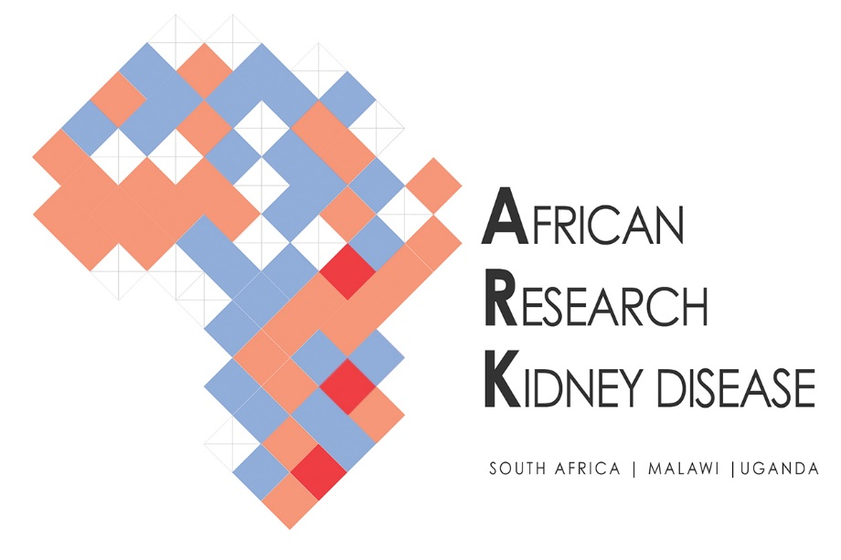
Title of the paper: Chronic kidney disease (CKD) and associated risk in rural South Africa: a population-based cohort study

Authors: June Fabian, Mwawi Gondwe, Nokthula Mayindi, Shingirai Chipungu, Bongekile Khoza, Petra Gaylard, Alisha N. Wade, F. Xavier Gómez-Olivé, Laurie A. Tomlinson, Michele Ramsay, Stephen Tollman, Cheryl Winkler, Jaya George, Saraladevi Naicker, on behalf of the ARK Consortium.

About the study: The African Research on Kidney Disease (ARK) Consortium is a multicentre partnership between Malawi, South Africa, Uganda, and the United Kingdom. The study sites for the ARK Consortium are nested within population cohorts hosted by the Malawi Epidemiology and Intervention Research Unit (MEIRU), the Medical Research Council/Uganda Virus Research Institute (MRC/UVRI) and London School of Hygiene and Tropical Medicine (LSHTM) Uganda Research Unit; and the Medical Research Council/Wits University Rural Public Health and Health Transitions Research Unit, South Africa.
Our primary objectives were to determine chronic kidney disease (CKD) prevalence (estimated from serum creatinine) and identify associated risk factors. This paper presents the findings from the ARK-South Africa partner. Findings from Malawi and Uganda are already published, as detailed below:
“Prevalence of impaired renal function among rural and urban populations: findings of a cross-sectional study in Malawi.” Wellcome Open Res. 2019; 4: 92. https://doi.org/10.12688/wellcomeopenres.15255

“Impaired renal function in a rural Ugandan population cohort.” Wellcome Open Res. 2018; 3: 149. Published online 2019 May 20. https://doi.org/10.12688/wellcomeopenres.14863

Study Methods
This longitudinal cohort study was conducted from November 2017 to September 2018 in the Medical Research Council (MRC)/Wits Rural Public Health and Health Transitions Research Unit (otherwise referred to as "Agincourt") in Bushbuckridge, a rural subdistrict of the Mpumalanga province in north-eastern South Africa. Agincourt is a Health and Socio-Demographic Surveillance System (HDSS) site that includes approximately 115,000 people. For this study, a minimum sample size of 1800 was required to provide at least 80% power to determine CKD prevalence of at least 5%, provided the true prevalence was equal to or more than 6.5%. Proportional allocation of Black African adults aged 20 to 79 years ensured a representative sample based on the most recent annual population census. Sample size was increased proportionately to 2759 individuals to accommodate a 25% non-participation rate.

