When you don’t belong: Using story drama to deepen the understanding of belonging among black international students at University of Witwatersrand, Johannesburg

By
Molebi Popoola
(1789409)

Supervisor
Petro Janse Van Vuuren (PhD)

This research was submitted to the Faculty of Humanities, University of the Witwatersrand, Johannesburg, in partial fulfilment of the requirements for the degree of Master’s in Applied Drama.

Johannesburg 2018

Declaration
I declare that this thesis is my work. It is submitted for the degree of Master of Arts by Coursework and Research Report (Applied Drama: Theatre in Education, Communities and Social Contexts) in the University of Witwatersrand, Johannesburg. It has not been submitted before for any other degree or examination in any other university.

- I know that plagiarism is wrong.
- I have used the author-date convention for citation and referencing to acknowledge contributions.
- This essay is my work.
- No one has copied my work.

- I did the word processing and formatting myself.

Signed __________________________ Date: 06/11/2018

Abstract
The aim of this study was to highlight the potential of story tableau in enabling black international students at the University of Witwatersrand (Wits) to explore the meaning of belonging. Eight black international students who were current students at Wits were purposively recruited into the study and they provided the data for the study. To collect the data, participants were engaged in applied drama exercises and these resulted in the production of still images and a story-drama play. Additional data were collected by engaging the participants on what their participation in the dramatic exercises and the issue of belonging mean for them. The discussions were analysed thematically and the four themes that emerged were: you don’t give what you don’t have; a community that breaks your sense of communality; home will always be our countries and language as a form of exclusion. In addition, nine images relating to the issue of belonging also emerged from the study. In essence, the participants draw attention to the social and contextual factors that play a role in how they perceive themselves within the community of Wits. This study is limited in that, apart from the fact that only few participants participated; they were also engaged for only few hours and this means caution needs to be exercised when extrapolating the findings of the study. However, regardless of the limitations, the value of this research is that dramatic techniques have the potential of revealing taken for granted assumptions about issues such as belonging.

Acknowledgement
It is not by might nor by power, but by the Spirit of God (Zechariah 4:6) that I had the opportunity to complete this master’s programme. For this reason, I would like to express my sincere gratitude to my Father and my God for his favour and for seeing me through.

I can never cease to appreciate my parents, Mr & Mrs Mokobi and my brother Topo Mokobi. Thank you so much to the Mokobi family for your love and unwavering support. My mother always told me she has set a mark on how far I should go in my education and since she has a master’s degree, she has always challenged be to rival the standard she has set. Thank you, mother for setting a mark for me.

My sincere appreciation also goes to my supervisor, Dr Petro Janse Van Vuuren for her invaluable academic guidance and understanding throughout the time I worked under her supervision.

All my lecturers (Cherae Halley, Refiloe Lepere and Waren Nebe) also deserve my huge appreciation because they contributed enormously to the shaping of my knowledge, especially the kind of thinking that is required of a drama practitioner.

I also thank the whole Drama for Life (DFL) staff for affording me the opportunity to be one of the few selected students to go through this prestigious department. DFL was my dream from the time I was an undergraduate student in Botswana and to finally finish from this great school is truly an honour. Being a student in this school challenged me as a foreigner, as a Christian and most importantly as an educator. I have become a better version of myself and I have come to realise the power of theatre as a tool that allows one to approach things from alternative approaches.

Finally, I also want to thank my in-laws for all their support and unfailing prayers for a journey that was truly unique and challenging. God bless you all.

Dedication
This thesis is dedicated to my lovely husband Tosin Popoola and our daughter Oluwaseyi Popoola. Both of you are my everything and I love you.

Table of Contents
Declaration 2
Abstract 3
Acknowledgement 4
Dedication 5
Chapter 1: Introduction 7
Theoretical framework 12
Aim 15
Research questions 15
Rationale 15
Chapter two: Research method 17
Introduction 17
Data collection approach 20
Chapter three: Data Analysis and Discussion 36
Image representations: Tableaux 36
The findings from the story-drama 41
Chapter 4: Reflection, Recommendations and Conclusion 49
Reflections of the researcher 49
Recommendations 53
References 58
Appendix 60
Appendix A: Ethics Clearance Certificate 60
Appendix B: Turnitin Report 62

Chapter 1: Introduction

The University of Witwatersrand (Wits) like many universities in South Africa (SA) plays host to many international students from many countries around the world. For instance, the 2015 Annual Report of the University of Witwatersrand recorded that at the end of 2015, a total of 2 674 of its students are international students (University of the Witwatersrand, 2015:1). Apart from this, the University of Wits Enrolment Plan for 2013-2019 is that the proportion of international students must be grown, so that by 2022, international students will constitute 30 percent of the total enrolments (University of the Witwatersrand, 2016:7). Since Wits is trying to cap its headcount enrolment to 35 000 in any given year (University of the Witwatersrand, 2016:17), the implication is that the number of international students at Wits will eventually exceed 10 000 at any given year if the University achieves and remains committed to its plan. Many may wonder why Wits prioritises the achievement and maintenance of a high proportion of international students as one of its 2022 strategic goals (University of the Witwatersrand, 2015:2). The truth is that the visibility of international students is integral to Wits achievement of its vision and mission for 2022. The vision and mission of Wits states the following:
THE WITS VISION 2022
The Vision 2022 Strategic Framework positions Wits as an internationally leading research-intensive university located in Africa.
THE WITS MISSION
Wits’ mission is to grow its global stature as a leading research-intensive university and a gateway to research engagement and intellectual achievement in Africa. This will be achieved by building on the principles of intellectual excellence, international competitiveness and local relevance. As an institution Wits is committed to providing high-quality, internationally competitive education, founded on high academic standards, cutting-edge research, public engagement, and productive partnerships with leading institutions throughout the world (University of the Witwatersrand, 2016:4).

To achieve the above-stated mission and vision, the University identifies diversity as one of the values that must be embraced by the university community. However, the Risk Management Committee and the Insurable Risk Committee of the University of Wits notes that “Wits is not “meeting the vision of being a global university due to international students being marginalised. There is a perception amongst international students that they are seen as outsiders and are being alienated” (University of the Witwatersrand, 2016:44). This means that if the University is unable to curtail the perceived marginalisation of its international students, the University risks becoming less attractive to international students. And the thought that about 10 000 international students who could be registered at Wits by 2022 could feel alienated is likely to thwart the University's drive towards the achievement of its goals.
Having realised that the alienation and marginalisation of key populations, such as that of international students could spell trouble for the University's drive to position itself as an internationally leading University, the Senior Executive Team (SET) in conjunction with the University Council developed an institutional performance scorecard for 2016. This scorecard focused on seven strategic goals: (i) teaching effectiveness and enrolments; (ii) research output and research profile; (iii) technology and infrastructure; (iv) finance (stability); (v) transformation; (vi) transformation of student life; and (vii) operational efficiency and effectiveness (University of the Witwatersrand, 2016:169). The strategic goal six, which is ‘transformation of student life' incorporates international students in its strategic attempt to ensure that the voices of international students are heard (University of the Witwatersrand, 2016:23). To ensure that the voices of its international students are heard, Wits has identified that it needs to make space for the representation of international students in Governance Structures and regular surveys about the experience of international students have also been proposed. By doing the aforementioned, Wits hopes that the voices of the international students can be heard, thus assisting the University to achieve an institutional structure where diversity is appreciated, and racism eradicated. Through these measures, Wits believes the experience of its international students can be enriched and embedded in cultural diversity.
While the University has demonstrated a commitment to a rich and satisfying experience for its students, Wits carries out its functions within the boundaries of the society in which its located. This means that the international students are still not immune from any social ills that may be affecting their host community. One of the societal ills that have bedevilled the South African community in recent times is the widespread anti-foreigner sentiments. This anti-foreigner' sentiments have often resulted in violent attacks against black immigrants, and there is little change to the situation since 2008 when the first large-scale xenophobic violence broke out (Kessi, 2015:10).

In South Africa, the popular notion is that African immigrants are in SA to take and not to give, a belief that is shared by many South Africans, regardless of race, gender and class (Neocosmos, 2008:587). The deep-seated sentiments against black foreigners embody discriminatory attitudes and behaviours, and this could be displayed in either subtle or violent ways depending on the context the black foreigners find themselves (Dodson, 2014:4). As in illustration, Mogekwu (2005:10) argues that in institutions of learning such as the universities in SA, one is unlikely to see the manifestation of xenophobia in violent forms but rather in subtle forms that make the foreigner feel unwelcome.

The issue of xenophobia within educational settings in SA is also starting to gain increased attention. Researchers such as Singh (2013:90) and Domininguez-Whitehead and Sing (2015:80) have used both surveys and interviews to draw attention to the endemic issues of xenophobia and the challenges it poses for black international students in SA universities. It is not surprising that xenophobic attitudes have slipped through the boundaries of higher institutions of learning in SA since the university staff and students are members of the same society that holds deep-seated anti-foreigner sentiments. And as such, it is reasonable to expect that black international students are not immune from the discriminatory attitudes that make black foreigners feel unwelcome and unwanted in the society. Since it has now been established that xenophobic attitudes have slipped through the boundaries of higher institutions of learning in SA, it is reasonable to expect that xenophobia could be the driving force for feelings of alienation reported among black international students at Wits (Annual report, 2016:44).
In the context of higher educational institutions, extant literature suggests that black international students perceive South African society as intimidating and violent and that the derogatory attitudes of locals' fuel feelings of fear and non-belonging (Singh 2013:97). However, considering that many top universities in SA are embarking on strategic plans to increase the number of international students (Dominguez-Whitehead and Sing 2015:78); one can argue that perceived feelings of exclusion by black international students represents a defeat to the idea of internationalisation which many SA universities are embracing. As such, it is crucial to understand belonging (or non-belonging) and the factors driving it, if universities such as Wits are to respond to the issue of belonging adequately.
Many researchers reporting on the issue of xenophobia and its impact on black international students have relied primarily on conventional methods of surveys, interviews and focus group discussions to tease out insights from international students. But merely documenting the experience of xenophobia and its role in creating ‘difference’ and ‘othering’ as it pertains to black international students at SA universities such as Wits may not be robust enough to facilitate public understanding of a subject that is often misunderstood and misrepresented. This means that approaching xenophobia within the context of black international students must shift from the dominant discourse of merely asking international students about their experience of discrimination or inequality to that which can facilitate the construction of counter-discursive identities and subjectivities.
An appropriate approach for the current study is one that goes beyond limiting discourses to an approach that allows the participants to imagine who they are, as they negotiate being the ‘other'. As such, I approach this research from the position of story tableau because it enables black international students to imagine multiple resistant subjectivities and realities that are shaping their experience of being a black international student in Wits. In this research, I used image theatre (tableau), which is a form of theatrical technique in conjunction with story-drama to achieve a deeper understanding of the issue of belonging among black international students at Wits. With Tableau, the black international students who were new to drama were tasked with conjuring images of belonging as they have experienced it in Wits and then represent this, using their bodies in still or frozen images so that their mental picture of belonging can be created in images. The question on my mind as a researcher when I was choosing tableaux for this study is that, if black international students cannot imagine and represent their experiences of exclusion or belonging with their bodies, how then do the University, lecturers and international Student Office learn about their perceived feelings of exclusion? Like Michelle Wallace (2014:1) said, the priority of tableau is to tell an accurate story about one's data, but she argued that tableau alone is insufficient in getting people to appreciate the stories of these black international students. And as a result, she explains that tableau drama activities should be expanded with other drama strategies such as story-drama to make the stories of the participants to be more provocative (Wallace, 2014:1). Flynn (2017:1) also added that using story-drama alongside tableaux enriches the tableau drama experience because it invites the student actors (the black international students in this case) to create dialogue and deepen inferences about what the characters in a tableau are thinking. In this research, incorporating story-drama with still images was an attempt to expand and deepen understanding of the construct of belonging which has repeatedly been reported among black international students in SA (Singh, 2013:98). I created a story from the personal experiences of black international students in SA, and this was enacted by the participants to deepen the understanding of belonging. The sharing of the story of a black international student from Nigeria, who was denied a study permit extension to finish his PhD study was used to draw the participants into roles, where they collectively tackle the issue of belonging as black international students at Wits. Through the story-drama, the understanding of belonging was deepened because the black international students were able to articulate and explore emotions, and in fact, one of the participants of this study said that his participation in the story-drama enabled him to view the world from different perspectives. This means that at the end of the research, the participants were able to see belonging from multiple angles.
The use of story-drama with tableau also prevented creating a distance between the participants and the emotionality that accompanies their stories of belonging as Wits students. The incorporation of the tableau in the story-drama was vital because it aroused the interest, attention and curiosity of the participants, while also engaging their intelligence and experiences in multiple ways (Read, 2008:6,7). The tableau enriched the story-drama, and it allowed the black international students to think from within the story, thereby enabling them to explore the issue of belonging from multiple perspectives. Throughout this research report, the term story tableau is used to describe the techniques of story-drama and tableau that were used to engage the participants during the study.

Theoretical framework
The issue of belonging or exclusion which the University of Wits itself has identified as an emerging risk is a social issue that occurs through the interactions between the black international students and their environment. Before an international student can feel like an outsider in Wits, he or she must have been involved in social interactions and exchanges with the staff or students of the University before coming to a conclusion about his or her belonging. This means that the plan of the University of Wits to run periodic surveys among international students on their perception of life at Wits is not realistic to the social interactions that are making black international students conclude that they feel excluded. This necessitated the need to place a human face on the issue by helping members of the Wits community understand the human toll of what can be considered a pressing challenge for many international students.
This research has significance for oppression studies since the circumstances that make an international student, for instance, to feel excluded is an issue of power imbalances between the black international students, and their new environment. Because of this, I called on Augusto Boal's Theatre of the Oppressed, and I contextualise this study in Boal's formative "Image Theatre" techniques. In conjunction with Augusto Boal, I also utilise the writings of Paulo Freire, especially Freire’s concepts of codification and decodification, where he talks about the use of Image Theatre to bring a particular issue such as belonging into focus. The use of these two theorists (Augusto Boal and Paulo Freire) was significant in this study because the black international students’ perception of belonging needed to be stretched to the point where its various dimensions can be accommodated.
In his writings, Perry (2012:103) concludes that Image Theatre is the analytical basis of Boal’s Theatre of the Oppressed (TO). Boal’s use of images in TO arose from his growing awareness of the unhelpful ambiguity of spoken verbal language, especially when he was working with Spanish participants who had a variety of other mother tongues (Boal, 2002:174). Boal discovered that still images, using participants' bodies, provided an alternative way of sharing ideas which were less dependent on verbal language (Grant, 2017:187). The use of Image Theatre is very significant in this study because the participants were from different African countries. So, Image Theatre provided an avenue where all participants have an equal opportunity to dialogue with language barriers. Boal explains that the use of Image Theatre provides a form of visual container where visual modes of communication are used to present perspectives and knowledge possessed by the oppressed (Boal, 1979). In other words, the metaphorical container that Image Theatre creates enables participants to physically experience how it feels to embody their own and each other's oppression, interactions, dreams and triumphs through image (Boal, 1979). The use of still images in this study was powerful, because as Boal himself said, “it is an alternative way of sharing ideas which are less dependent on language” (Boal, 2002: 165).
Grant (2017:187) writes that Boal's Image Theatre can be created in many ways. However, Warstat (2009:185) argues that the Image Theatre concept is one in which the following are possible for the participants. The participant(s) must be able to: (a) understand a perceived situation at first glance; (b) project interior notions outside themselves and to others; (c) rework a given scene relying on their own personal authority and lastly; (d) undertake this reworking freed from limitation of language. While Grant (2017:187) comments that the image produced can be realistic, allegorical, surrealistic, symbolical or metaphorical, Boal (1995:77) argues that regardless of the kind of approach used in the image production; what matters most is that the participants must feel that the image created is an accurate reflection of their reality. Because the still images are a compelling and authentic reflection of the participants' realities, Boal warns against the temptation of trying to interpret or understand the images, because in so doing, we stand the risk of dismissing the possibility that the images may have more than one meaning. Boal writes that:
Dealing with images we should not try to ‘understand' the meaning of each image, to apprehend its precise meaning, but to feel those images, to let our memories and imaginations wander. Images don't replace words, but they cannot be translated into words either – they are a language in themselves… The meaning of an image is the image itself. Image is a language … If an image is interpreted in just the one way … it ceases to be Image Theatre and becomes a mere illustration of the words spoken (Boal, 2002:175)
The position taken in this study aligns with Boal’s idea that images should not be interpreted. This is important in the context of this study because black international students are diverse, and this study does not intend to suggest that they will have a common language or shared experience. Instead, by looking at the images, black international students, regardless of their location, have an opportunity to reflect on their own experience of belonging and compare it with what the participants of this study experienced as black international students at Wits. Because this study utilised Boal’s idea of Image Theatre, the images produced in this study were not interpreted, instead they were just captioned to reflect the activities and the processes that the participants used to tell their stories of belonging. Without interpreting what each participant was doing in each image, the readers of this study have the unique opportunity to put themselves in the situation of the participants. And as the readers connect with the images, they convey and project emotions and feeling into the images, and this means the readers are collaborating with the participants in the creation of the meaning of the images. When this happens, Boal (2002:140) believes that a dialogue between the real and imagined images has occurred, and not just juxtaposition.
The use of Image theatre in this study is a form of what Paulo Freire (1970) terms as codification. Freire (1970) explains that
Codification is a way of gathering information in order to build up a picture (codify) around real situations and real people. Decodification is a process whereby the people in a group begin to identify with aspects of the situation until they feel themselves to be in the situation and so able to reflect critically upon its various aspects, thus gathering understanding"
The basis of Image Theatre is its aesthetic quality as it enables participants to collectively process varying perspectives of a problem and engage to solve the problem. In this research, the black international students united as image makers, and this connection that they shared together, despite that they hailed from different countries, was effective in overcoming the barriers of language and tribalism. While the images were allowed to speak for themselves, I also agreed with Paulo Freire (1970) that oppression and issues of exclusion are antithetical to dialogue and it is because of this that the findings from the tableau were extended using story-drama. Freire’s pedagogy informed the need for the dialogue with black international students to be as democratic and collaborative as it can be, while the use of tableau provided the medium for conversation as it informed a creative way of engaging with a group of international students about belonging. Paulo Freire's (1996) Pedagogy of the Oppressed was critical in this study because, as a researcher, I did not want to deposit my ideas of belonging into other international students, but instead, create an authentic dialogue between a group of black international students and myself as equal knowing participants. This dialogue was achieved by using story-drama because it enabled the participants to move from passive observers to active change agents. Engaging the participants in role plays about a story of a black international student that had issues with extending his SA study permit allowed the participants to become other people in other places and to explore the issue of belonging from different perspectives. And as Booth (1985) commented regarding story-drama, the use of story-drama in this study enabled the participants and me to explore the issue of belonging in a concrete and authentic way.

Aim
The aim of this study was to highlight the potential of story tableau in enabling black international students at Wits to explore the meaning of belonging.

Research questions
- What are the influential, contextual and social factors perpetuating students’ perception of lack of belonging?
- What does story tableau reveal about the contentious dimensions of belonging?
- How does black international students’ participation in story tableau enable them to reflect on the issue of belonging?

Rationale
I was drawn to the potential of story tableau in this research because I realised that stories and tableau operate on a personal and community level, thus building a bridge between sociological/abstract and the psychological/personal contours of daily experience (Bell & Roberts 2010:2304). The potential of story tableau to commit the black international students to explore the issue of belonging in a concrete and authentic way offers a powerful way to teach themselves, the researcher and the broader community of Wits on what can be done to provide an inclusive educational experience for the international student community. In this vein, story tableau offers a means for engaging emotion, ideas, worries, wonderings, and questions that keep us aware of the hidden and unconscious ways that social injustices operate in the society and its institutions (Bell & Roberts 2010: 2302). Teaching and learning occur in a socio-cultural-political context that is not neutral but based on relations of power and privilege (Hopkins-Gillispie 2011:9). Therefore, a teacher or drama practitioner striving towards intercultural education competency must integrate cultural recognition with social justice by providing students with the means to resist oppression and improve their experience of learning. Story tableau provided a means to achieve this because it assisted in raising the critical consciousness of international students about their class, gender, racial identity or beliefs and how perceived lack of belonging affects these realities.
This chapter introduced the issue of belonging as it related to black international students at Wits and provided the rationale for the use of story tableau as a dramatic approach to understanding the issue. The next chapter is an exploration of the research method and its relationship to story tableau as a facilitation methodology.

Chapter two: Research method

Introduction
This study aimed to highlight how story tableau can enable conversations about the theme of belonging among black international students at Wits. To achieve this aim, it was imperative to utilise the appropriate research methodology that will not only do justice to the research questions, but that will also ensure that the findings of this research are useful. As this study is about deepening our understanding of belonging, this chapter outlines the research methodology of this study and justifies participants selection criteria, data collection methods and data analysis. Justifications were also provided for particular strategies and decisions made in the study.

Generally, in research, researchers have a range of approaches available to them to investigate social issues. Some of these approaches lean towards quantitative or qualitative research methods, while others use a combination of both. The nature of this research requires an understanding of the issue of belonging, and because this required delving into the experiences of perceived inclusion or exclusion by the black international students, I believe this study is not suited for quantitative methods because participants' experience of belonging cannot be adequately studied through statistical methods. The best way to highlight the potential of story tableau as it relates to its possibilities in furthering our understanding of the concept of belonging among international students is by talking to a group of black international students. And since the nature of this research involves interacting with a select group of black international students in an attempt to get close to their experience and understanding of belonging, a qualitative methodology appears to be the most appropriate framework for this research.

Adopting a qualitative approach in this research was crucial because the nature of this research requires the participants to tell their stories and these stories are not only told with specific relevance to their own circumstances but also with the cultural, historical and social context (Sandelowski, 1997:128) of their new environment. The connotation and tag of ‘international student' which is attached to the participants of this study allows them to self-reflect and compare their lives before they left their countries of origin to SA for further studies. And this means that the qualitative approach of research allowed the participants of this study to compare their lives before and after migrating to SA and this, in turn, allowed them to genuinely discuss what belonging means to black international students at Wits.

The use of story tableau, which was employed to make this research to be as participatory as possible was to ensure that the stories and experiences shared by the black international students are situated within a cultural, social and historical context. The use of story-drama allowed for a participatory method of data collection, and this means that the participants had the freedom to share as much or as little information with which they were comfortable. The freedom of expression (both verbally and bodily) that story tableau afforded the participants meant that the participants had the opportunity to express themselves and their perspectives truthfully and this was helpful because it also assisted me, as the researcher to report their viewpoint accurately.

The data for this research was contributed by black international students from Wits University who at the time of the data collection (18 November 2017) were bona fide students of the University. With qualitative research, the most favourable approach to participant selection has been through purposive sampling. With purposive sampling, the researcher intentionally looks for and selects those participants who are knowledgeable enough to comment on a particular issue. Likewise, in qualitative studies, the depth and richness of the data take precedence over quantity, and as a result, the aim was to recruit only six black international students to contribute their stories and their experiences to the study. The recruitment started with what can be called an opportunity sampling because the first participant was coincidentally met after he offered to assist the researcher with her luggage. It turned out that he was an international student and I used the opportunity of our brief interaction to tell him about the study and invited him to be part of the study, and he agreed. Thereafter, I made several visits to the International House (a school hostel that houses majorly international students) to recruit participants. I also visited several hot spots where international students are known to congregate such as the International Student Office and the Postgraduate Common rooms in the Science faculty for recruitment. However, because many students were preparing for exams and trying to finish their programmes, it was challenging to have participants commit to the study. In fact, the scheduled date for the data collection had to be cancelled on two occasions because of last minute cancellations and lack of response from participants. These circumstances necessitated a change of plan because initially, the idea was to collect the data in a seminar room in my host department (Drama for Life [DFL]) but the reality with difficulty in having participants’ commit necessitated flexibility on my part as the researcher.

Finally, three participants were eventually secured through purposive sampling from the International House and one participant was recruited during one of my visits to the International Student Office. The three participants that committed to the study from the International House advised that rather than using the DFL seminar room for the data collection, they could facilitate the release of a large and spacious room inside the International House. This, they argued would be more convenient for them. The data was finally collected on the 18th of November 2017 at the International House, with eight black international students participating in the research. The three participants who are resident of the International House invited other residents, and three of their friends joined in the study (snowballing sampling). Four of the participants were from Lesotho, two were from Botswana, and the remaining two were from Nigeria and Swaziland. The table below summarises the characteristics of the participants' that participated in this study.

Sample characteristics of the participants
Participant code | Gender | Age | Level of education  and  Field of study | Number of years spent at Wits | Country of origin
Participant-1 | Male | 38 | Postgraduate (Education) | 5 years | Swaziland
Participant-2 | Male | 28 | Postgraduate (Applied Sciences) | 3 years | Nigeria
Participant-3 | Male | 25 | Undergraduate (Medicine) | 3 years | Lesotho
Participant-4 | Make | 26 | Undergraduate (Medicine) | 3 years | Lesotho
Participant-5 | Male | 26 | Postgraduate (Education) | 4 years | Lesotho
Participant-6 | Female | 27 | Postgraduate (Arts) | 2 years | Lesotho
Participant-7 | Female | 22 | Postgraduate (Education) | 2 years | Botswana
Participant-8 | Female | 30 | Postgraduate (Psychology) | 2 years | Botswana

Data collection approach
This section deals with the data gathering. The data for this study was produced by collaborating with the participants on the issue of belonging. The participants and I worked collaboratively to create a fictional world that allowed the participants to assume roles which enabled them to explore the issue of belonging. I used the method of facilitation to engage the students in exploring the issue of belonging and with facilitation; the goal is to create an atmosphere where the participants and the researcher are equals. This means we all share the responsibility to create a good learning experience about the issue of belonging at Wits. By being a facilitator, my job was to set up activities that enabled the participants to ease into the fictional world, provoke and probe the conversation on the issue of belonging. Through this the participants and I were able to learn from each other’s experience of belonging and, I was also able to deepen my understanding of the issue.
To collect the data, I introduced the participants to applied drama exercises using workshops which focused on the creation of frozen images and role plays based on a short story. By facilitating the workshops, additional data was also gathered through the observation of the participants as they participated in the drama exercises. Oral feedback was also collected as participants were made to reflect on their experiences and their views of using story tableau to explore the issue of belonging. It is also important to point out that it was a black international student that assisted with the picture and video taking but she was not part of the study. She was excluded because she was still new at Wits and could not comment fairly on the issue that was explored in this study.
The data collection started around 10:30 on 18 November 2017. The data collection started by calling all the participants to be in a circle where each participant introduced themselves to the other participants. During the introduction, the ground rules for the group was laid out, and it emphasises respect for others, putting phones on silent and maintaining the anonymity of the group members. After that, we started with stretching exercises and the instruction was that the participants should give their bodies some attention by moving around the room and stretching any parts of their bodies that are numb or painful. The image below shows participants in a stretching exercise.
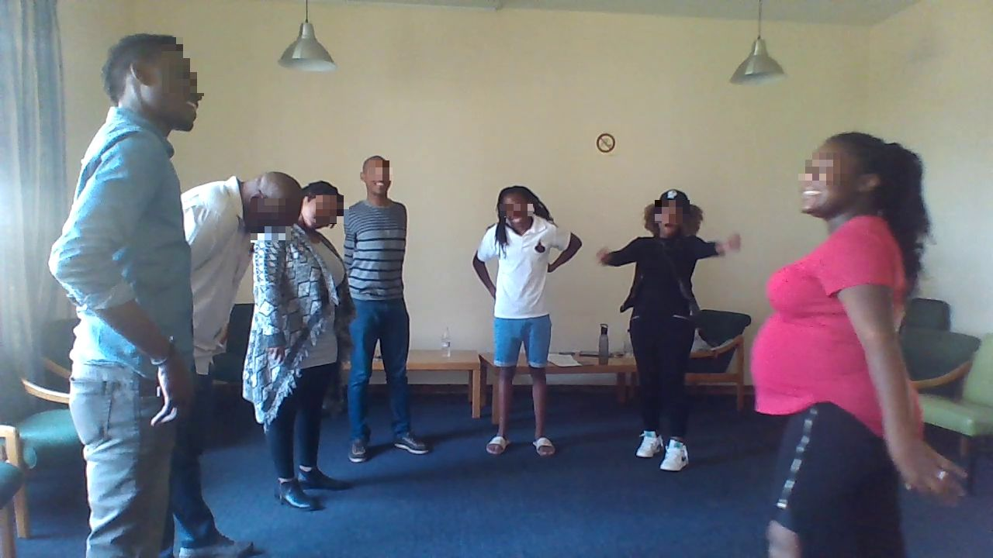
Figure 1: Stretching exercises
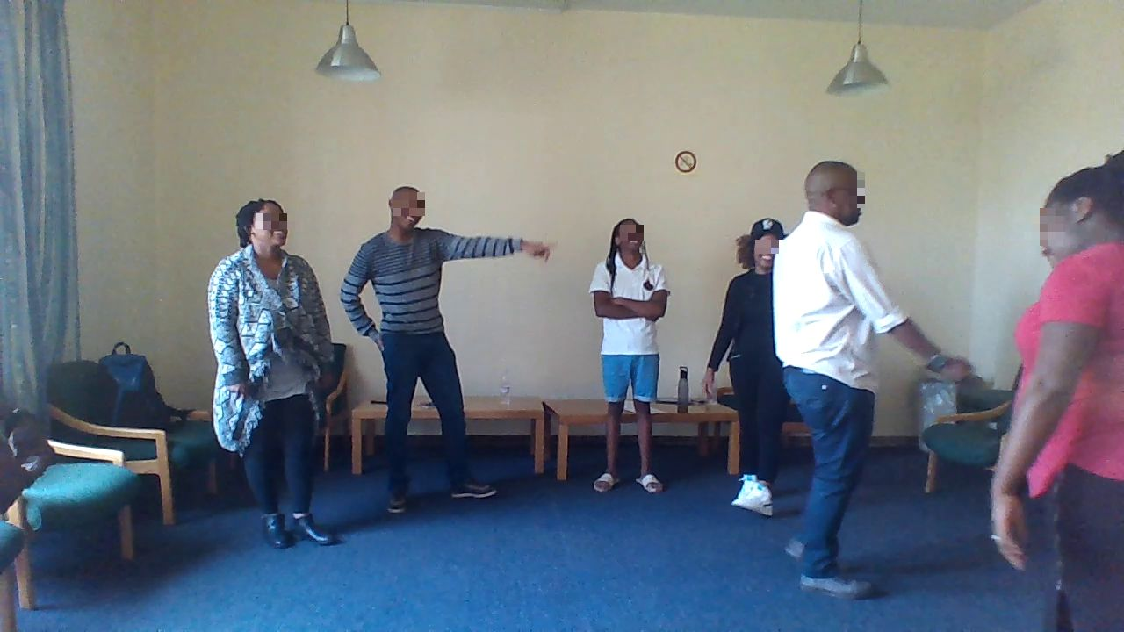
Figure 2: Stretching exercises
The stretching exercise allowed the participants to move their bodies around and since they have no drama experience, this activity assisted in breaking the barrier that could hamper their participation.
Next, the participants were involved in a game called ‘moving ball'. This game aimed to draw the participants further into the mood of the performance and the activities required for producing the tableaus. In the ‘moving ball' activity, the instruction was that the participants would receive an invisible ball from the participant next to him or her and then pass the same invisible ball to the next participant in the circle. The images below are from the moving ball game.
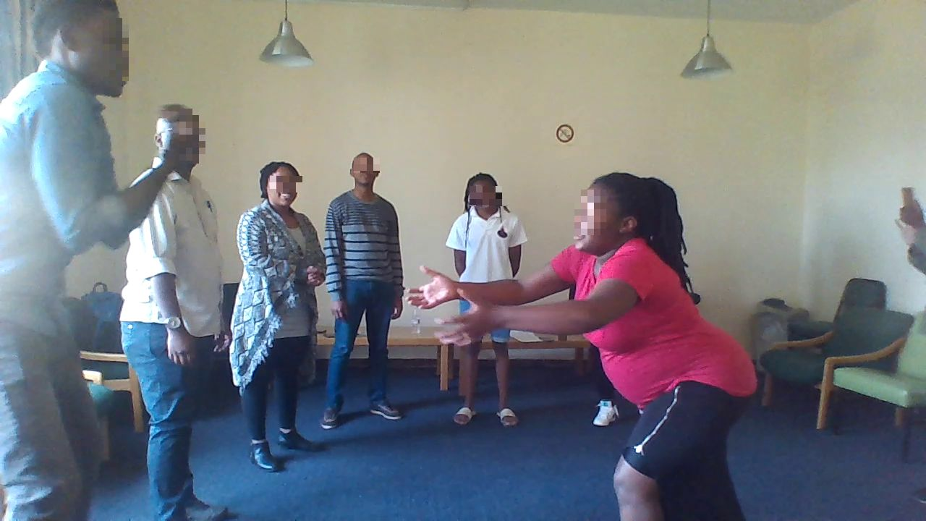
Figure 2: Moving ball game
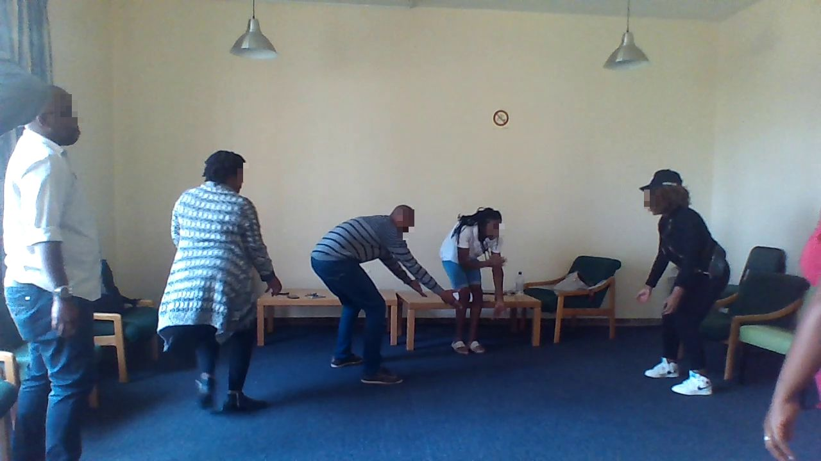
Figure 3: Moving ball game
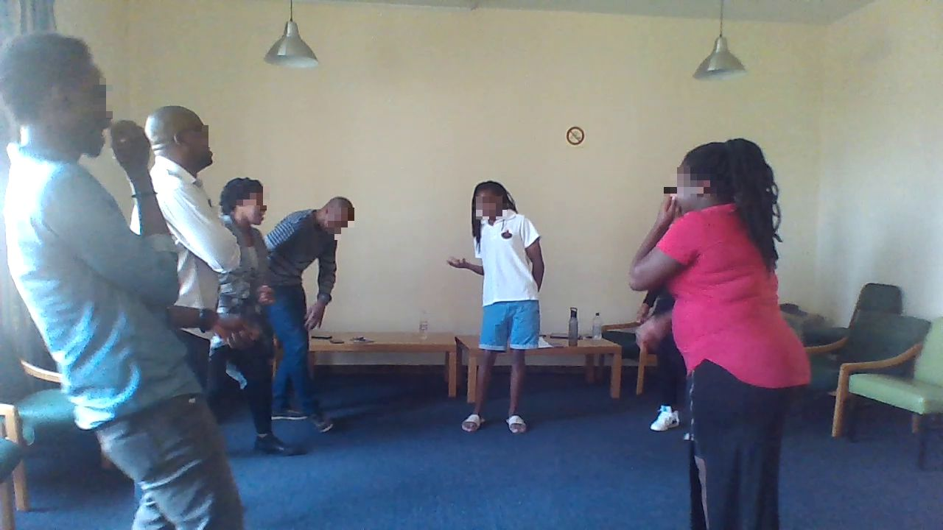
Figure 4: Moving ball game
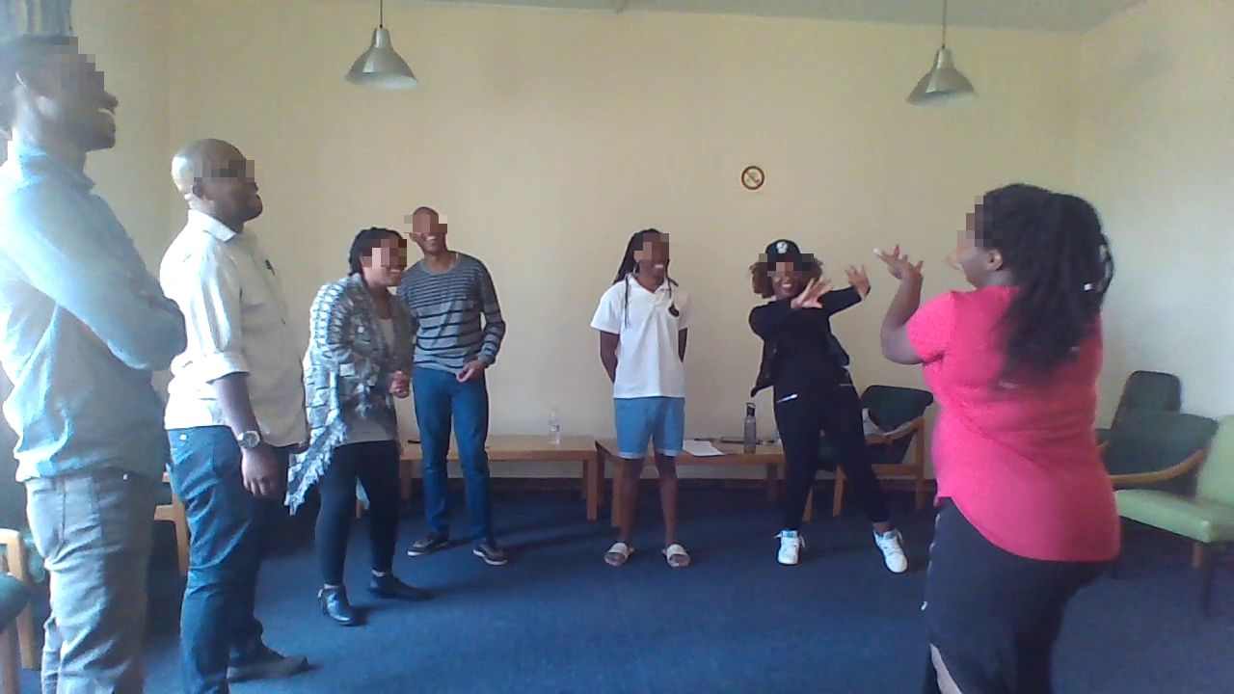
Figure 5: Moving ball game
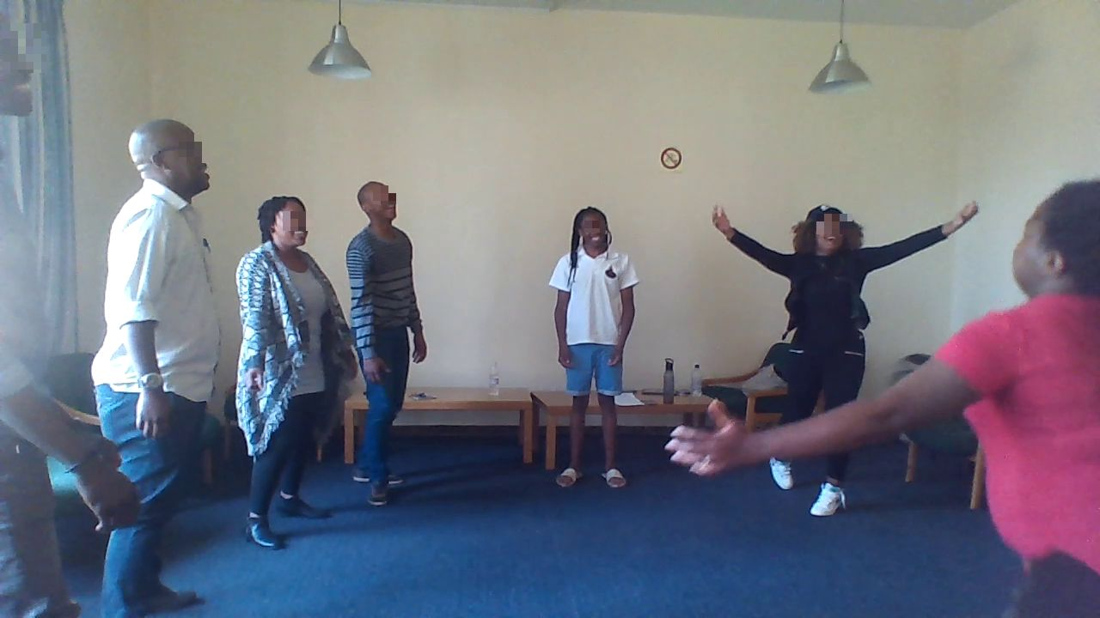Figure 6: Moving ball game
With increasing presence of their bodies in the room and the exercises, the next activity was to invite everyone in the room to use their bodies to demonstrate how they felt about being in the room. After each participant demonstrated how they were feeling using gestures and their bodies; the other participants imitated the demonstrating participants. Below are some of the ways participant used their bodies to express how they felt to be in the group.
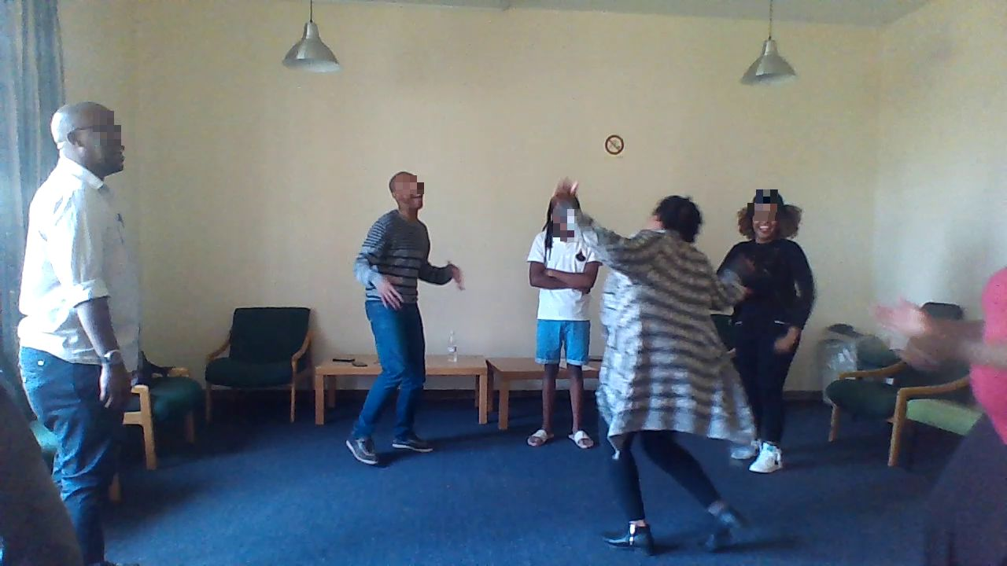
Figure 7: How I feel to be here exercises
Figure 8: How I feel to be here exercises
Lastly, the participants were engaged in a game called ‘Chomi Chomi’. Chomi Chomi was a game that required singing and dancing around the room; singing Chomi, Chomi. I was leading the song while the participants were singing the chorus and shouting Chomi Chomi. Before the singing game, the participants had been told that they would randomly be given instructions to use their bodies to tell some stories. Firstly, they were asked to be in groups and use their respective bodies to describe what they like about being in Wits. Secondly, they were asked to use their bodies to describe what they miss about their home country. This was a very sobering experience, and one could suddenly see the sadness on many of the participants' faces. The smiles fizzled, and their energy suddenly went down as participants tried to use their bodies to demonstrate different things that they miss about their home countries. Thirdly, the participants were asked to use their bodies to share things that make them feel left out in the University and how they would want to see themselves within the Wits community. Each group showed their images to the rest of the group as audience, and the audience were asked to guess what the still images meant for the participants. Some were obvious and were guessed correctly, while some were not correct and this prompted the image makers to describe what their images meant. This game was very important because it kept the participants on high alert and no one wanted to be in the middle standing alone by him or herself. The following images illustrate the activities that resulted in the creation of the still images about what they like about Wits, what they miss about home and what makes them feel they do not belong in Wits.
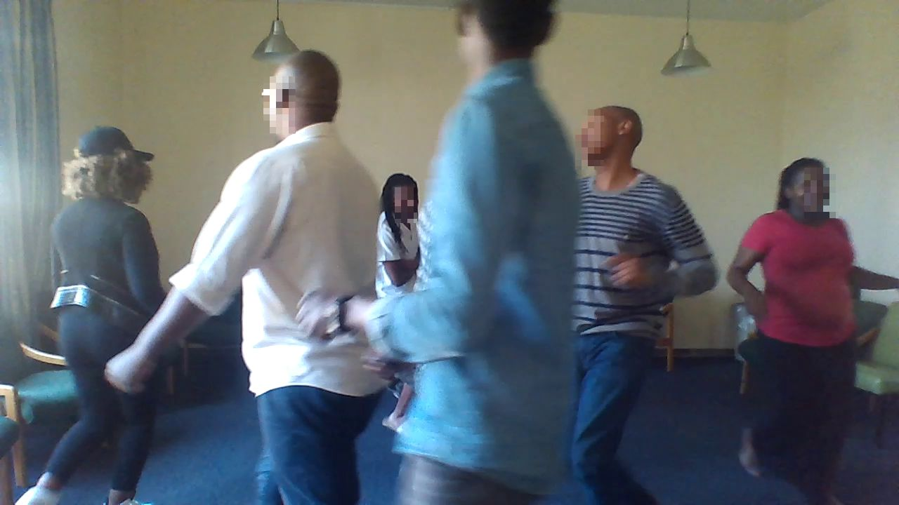
Figure 9: Chomi Chomi dancing and singing
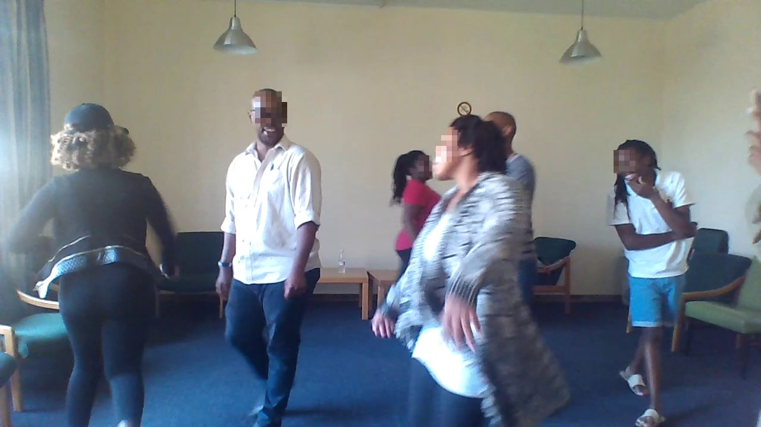
Figure 10: Chomi Chomi dancing and singing
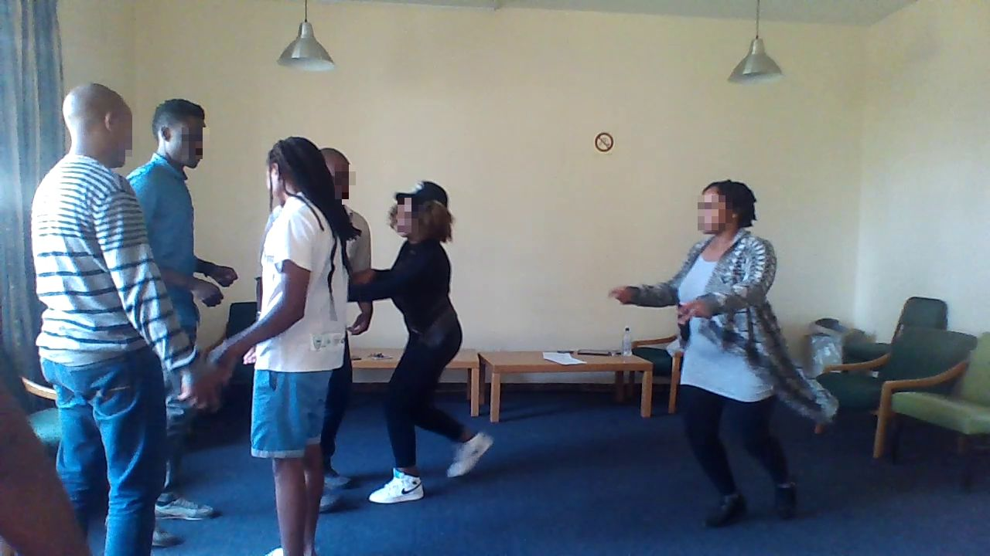
Figure 11: Participants sprinting to join a group after the singing stopped
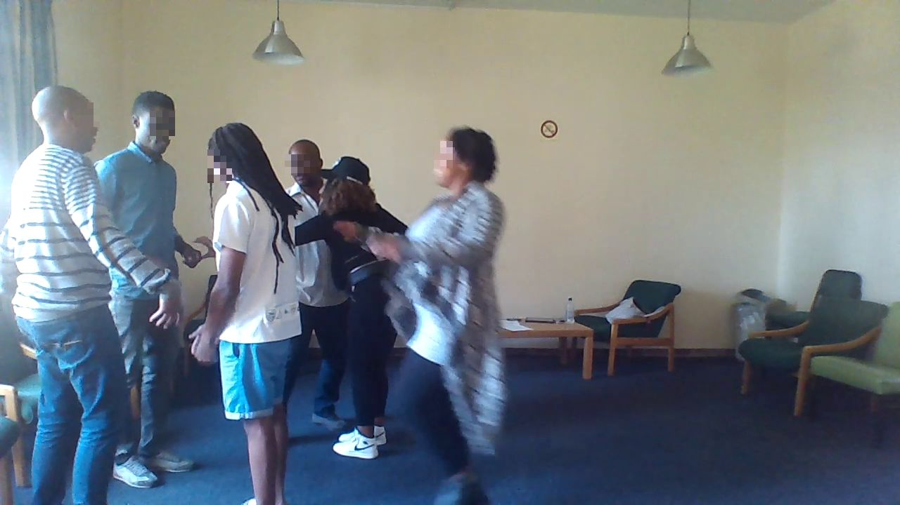
Figure 11: Sprinting to be in groups
After the still images were successfully produced (the still images are presented in the following chapter below [analysis chapter]), we had a break of 10 minutes to allow participants to stretch, use the restroom and socialise among themselves. At the end of the 10 minutes break, we assembled again in a circle, and I told the participants a story. I began the story by narrating a real-life experience of a PhD student from Nigeria. The PhD student came to South Africa on a four-year study permit, but as he was approaching the end of his four-year PhD program, his supervisor was suspended by the school because he was being investigated for financial misconduct. The suspension of his supervisor meant that this particular student was unable to finish his PhD in time, necessitating the need for the extension of his study permit, while the University salvages the situation by getting him another supervisor. Since the University knew the student's predicament, they produced a letter of visa extension support, but the Department of Home Affairs (DHA) would not renew the visa.
After this story was narrated, participants were engaged in the central issues of the story by asking them what should be done about the issue. The participants were asked to explore the problem that the student is facing, and they should try to solve it so that the student will be able to finish his PhD before heading back to Nigeria. The participants were curious at the end of the story, and one could see their eagerness to delve into the issue. They started questioning whether the solution should be after the DHA officials told him that his visa would not be extended or before. To encourage the thoughts of the participants, I asked some questions to stimulate the participants. For instance, I asked them: Who do you think can help the student? What would it be like to go back home without your PhD certificate? What should be the response of the international student community? These prompting questions were enough for the participants to consider power, Student Representative Council, International Student Office, identity and solidarity.
Everyone started talking about systemic unfairness, they spoke of making Home Affairs fall, they talked about protesting, and all this led me into breaking the participants into groups of individuals and assigning them roles and they were tasked on working collaboratively to assist the student and get to the bottom of the issue. In this aspect of the study, the participants used movements, discussion-in-role and got into roles. In the first scene, for instance, the affected student was seen approaching a staff of the International Student Office for assistance regarding his predicament.
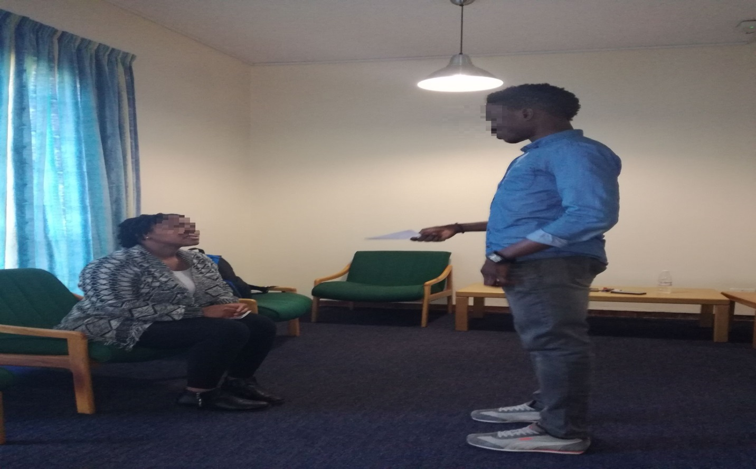
Figure 12: Affected student at the International Office
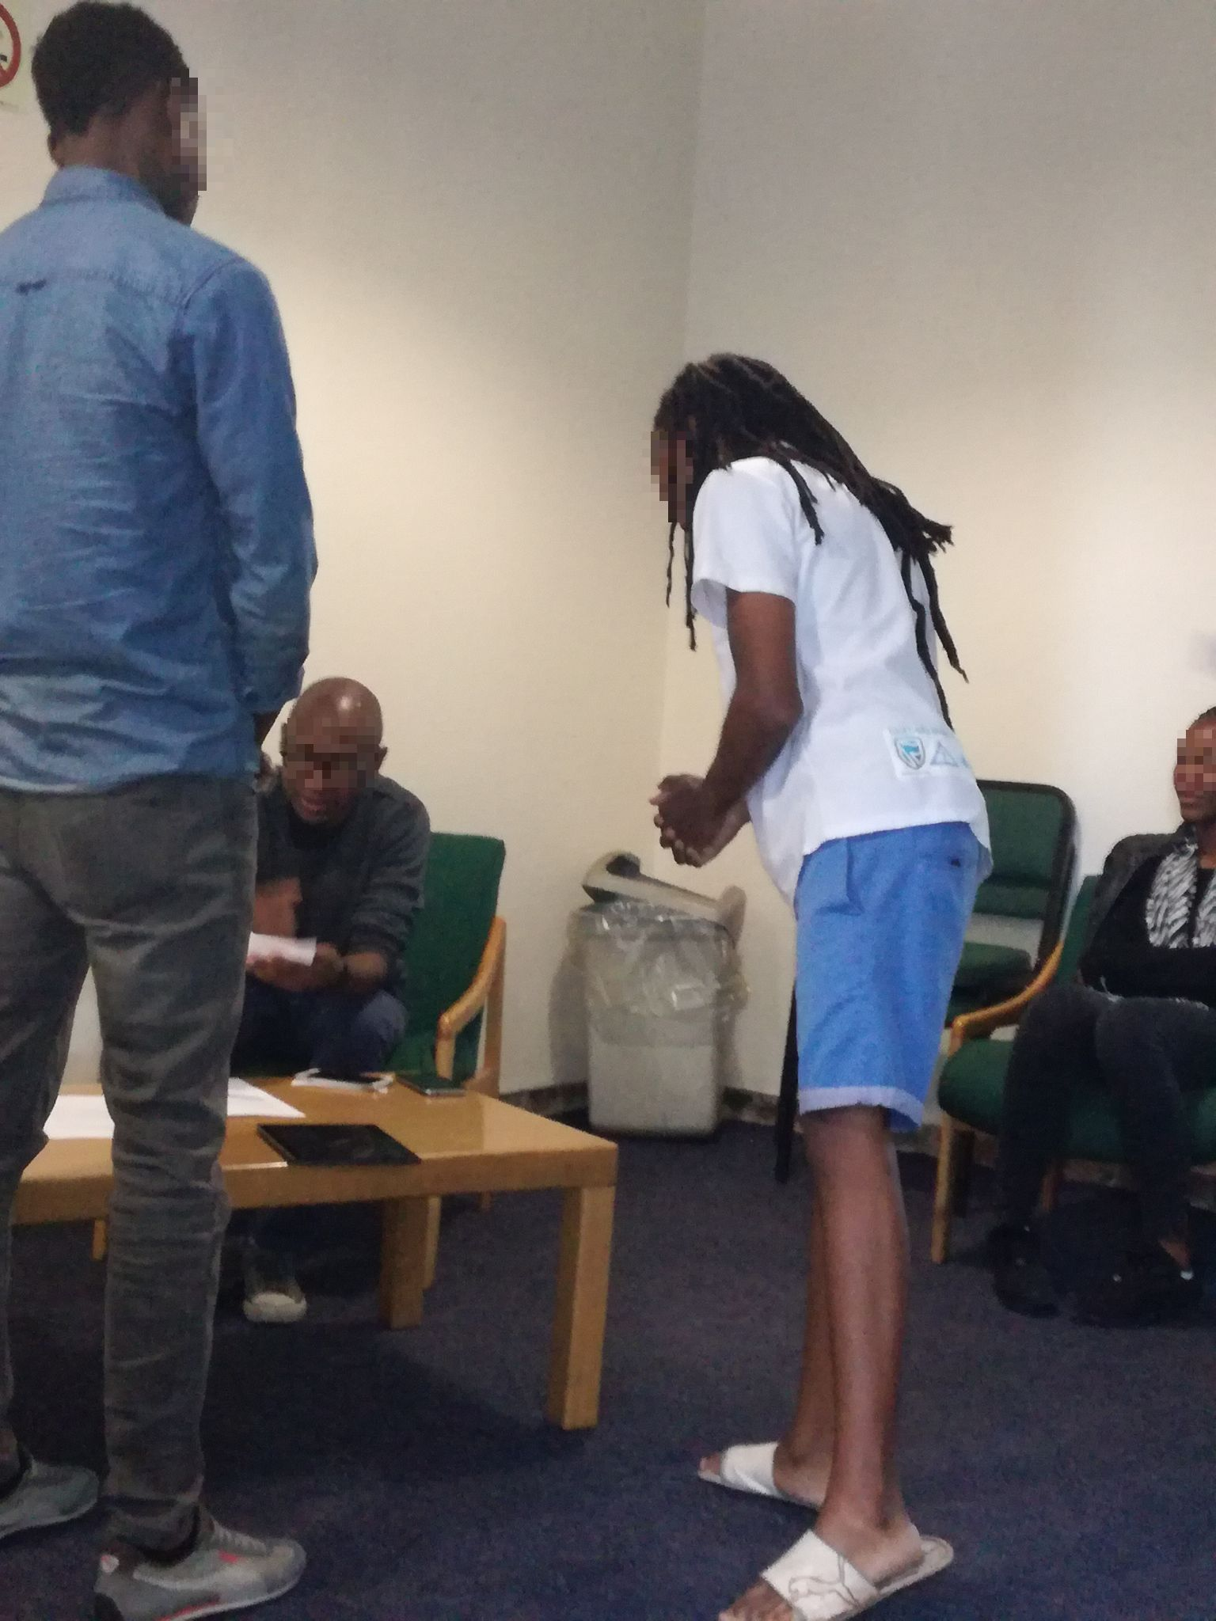
Figure 13: Affected ‘comrade’ with other international students trying to process visas.
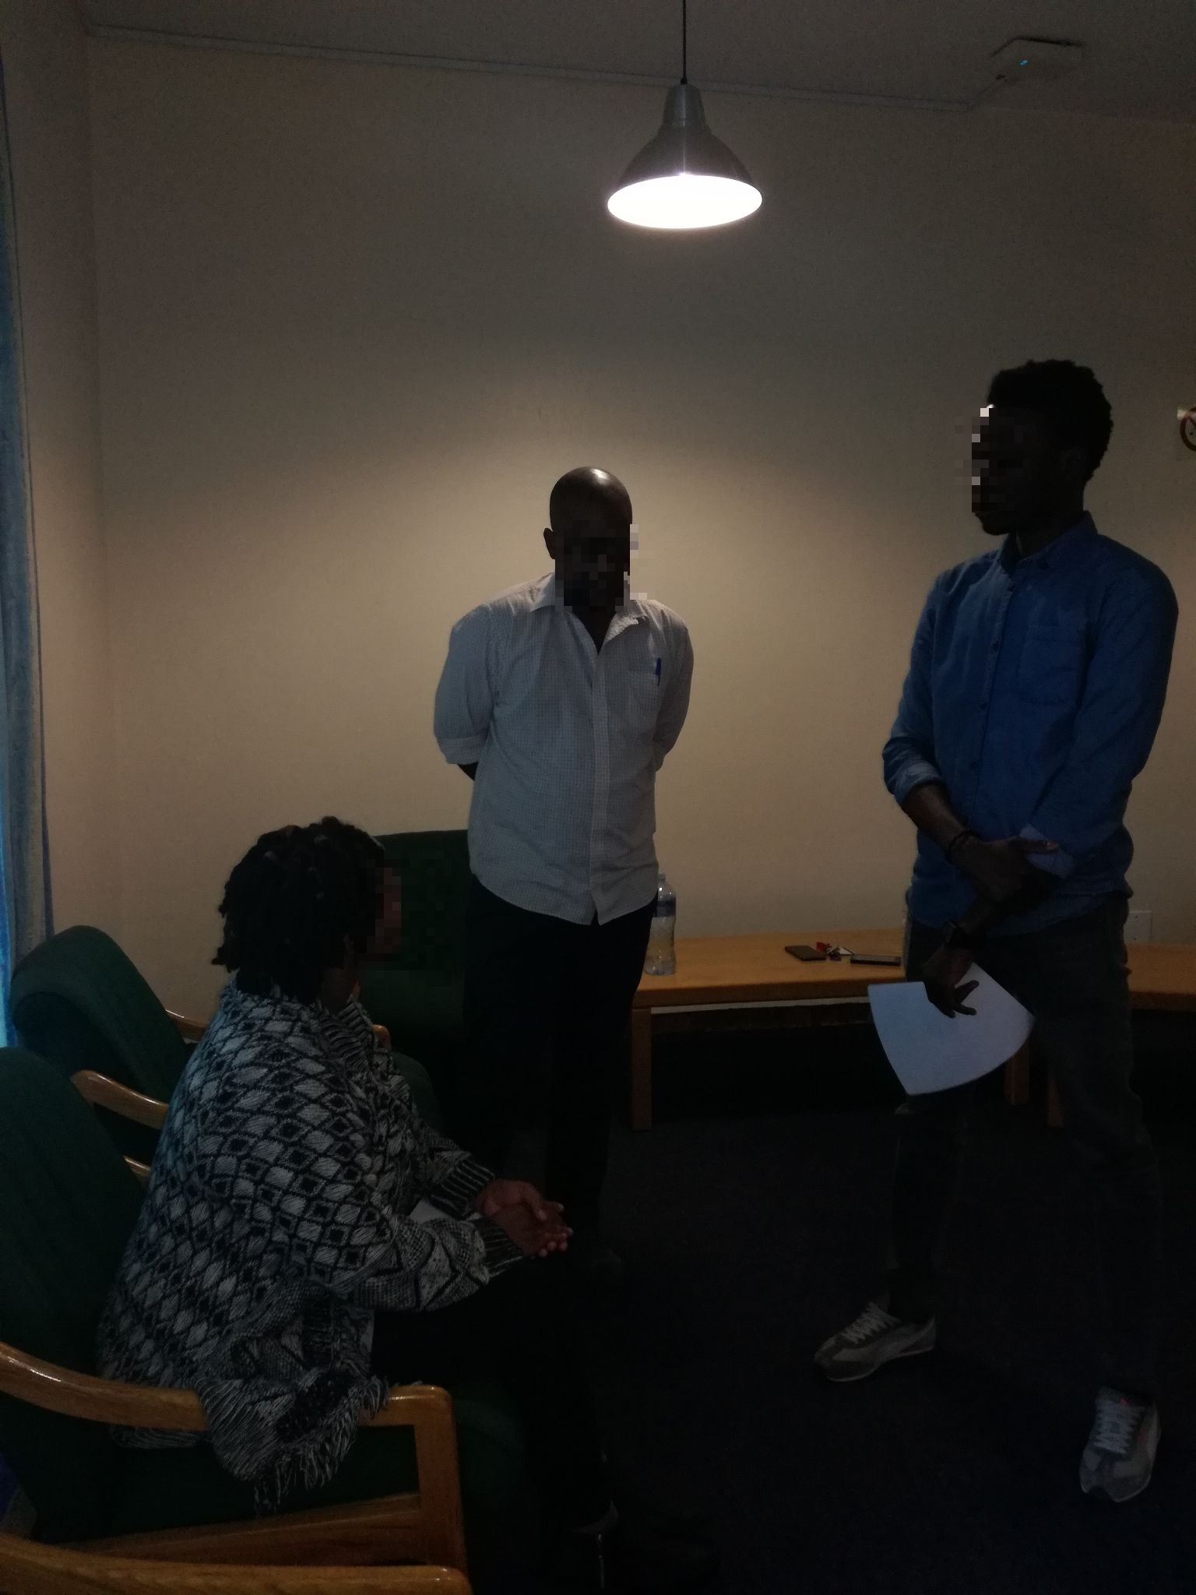
Figure 14: A student representative is trying to plead the case for the affected ‘comrade.'
As the participants came together in roles, they examined various dimensions of the issue. Some of the participants acted as Home Affairs officials, and they argued that the student cannot remain in South Africa because of stated reasons, some played the roles of Advocates and argued that the student's visa must be extended, or all hell will be let loose. As the participants come together because of a crisis that binds them together as international students, they transcended the narrow confines of their personal identities and participated in other forms of existence. As the drama unfolded, one can see a transformation. The participants reacted to a threat to their personal identities, and the identity of being a black international student now took on new importance. The tension of the drama was about who should be blamed for the predicament faced by the student: the student himself, the Home Affairs or the University. The dramatic tension became real and intense when participants started talking about Home Affairs must fall and that the concept of borders needs to be reconceptualised in the light of blackness and Africanness. Finally, the participants reflected on their participation, and this is captured in the picture below:
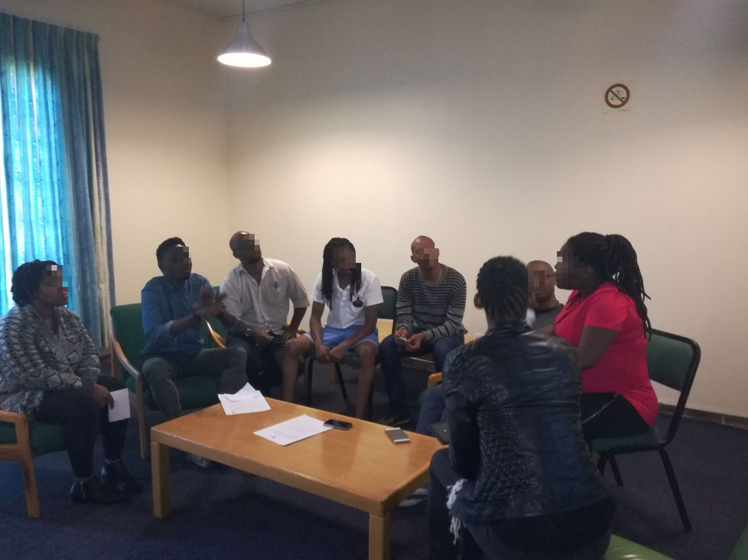Figure 15: The participants came together as a group to reflect on their involvement in the play
The oral discussions and stories were transcribed verbatim, and the transcripts were read in their entirety to obtain an overall sense of the content. The discussions were then divided into meaning units, and these were used to expand specific issues, and some were used to illustrate the images produced. All the participants' consented to the study participation and they were happy for their pictures to be taken, and their voices recorded. The WSOA Ethics Committee approved this study, and it was after the ethics approval was granted that the data was collected. All the images obtained were blurred to hide the identities of the participants, and no names were used throughout the study to ensure the anonymity of the participants. All participants signed the informed consent form voluntarily.
This chapter presented the methods that were used in engaging the participants in the issue of belonging. The data was collected by collaborative work between the researcher and the participants and this blurring of roles which means there is no expert or novice, also strengthened the choice of the qualitative paradigm that was chosen for this study. In the following chapter, the findings of the study are presented in forms of themes and images.

Chapter three: Data Analysis and Discussion
In analysing the findings of this study, this chapter presents the findings that assisted me to answer the research questions. The study aimed at understanding: the influential, contextual and social factors perpetuating students’ perception of exclusion; the dimensions of belonging; and students’ reflexivity after participation in story-drama.

Image representations: Tableaux
The data from this research are presented in two phases. Firstly, the still images and secondly, the story drama was presented. In this segment, the still images are presented to stand for themselves without any interpretation. Rather than interpreting the images, the images are presented to show what the participants were communicating. This approach is in keeping with Boal’s (2002, 175) argument that “the meaning of an image is the image itself… If an image is interpreted in just the one way … it ceases to be Image Theatre and becomes a mere illustration of the words spoken (Boal 2002, 175). Also building upon Freire’s idea of codification and decodification, it was decided to just present the images as they were, so that anyone reading this report would be able to deduce his or her meaning from the images. When readers attribute their own personal meanings to the images, Boal (2002) states that it means there is a dialogue between the reader and the images. A total of nine images are presented here and these images were produced with different and specific instructions. Each image was captioned with the instruction that resulted into the production of the specific image(s).

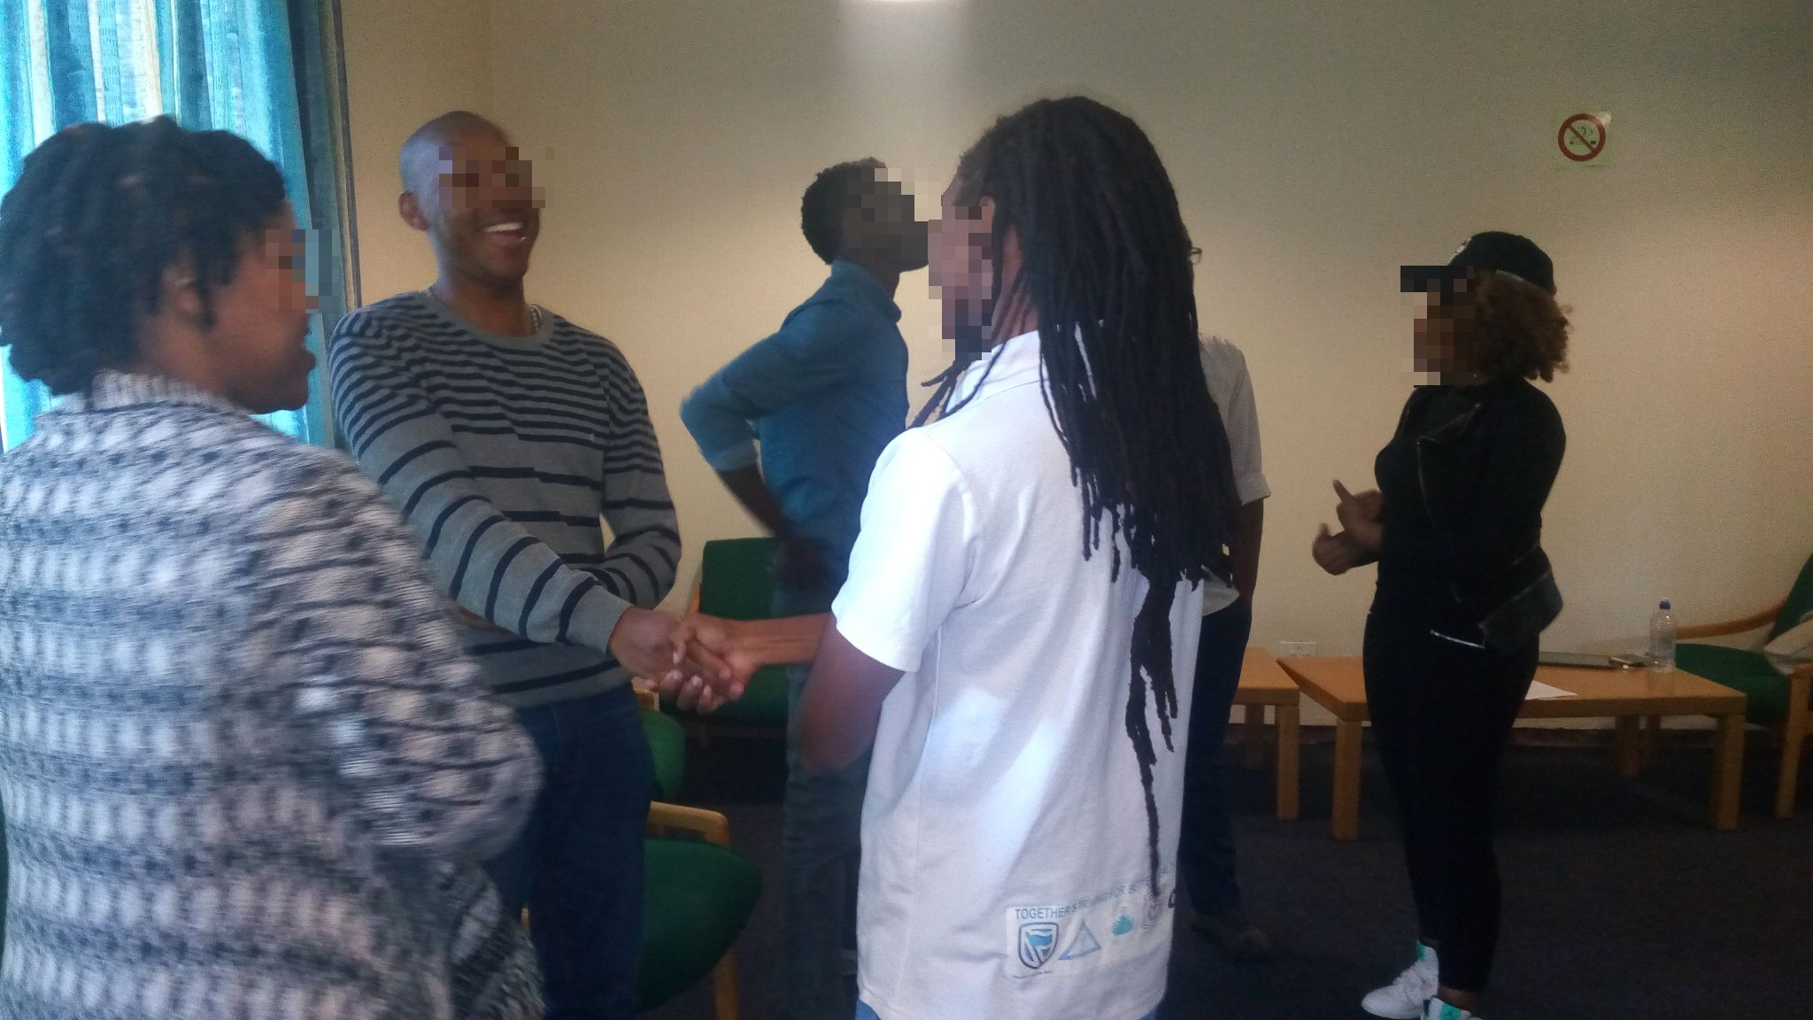
Figure 16: What we like about being at Wits
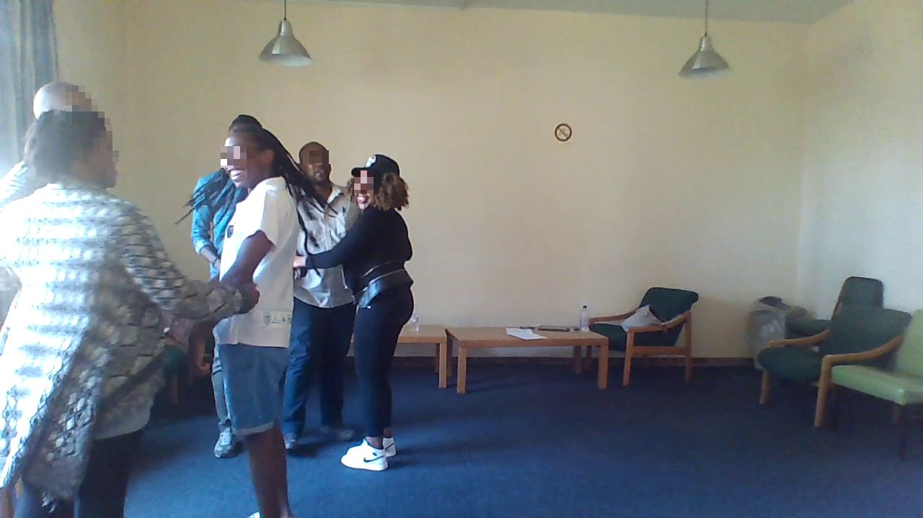
Figure 17: What we miss about our home country
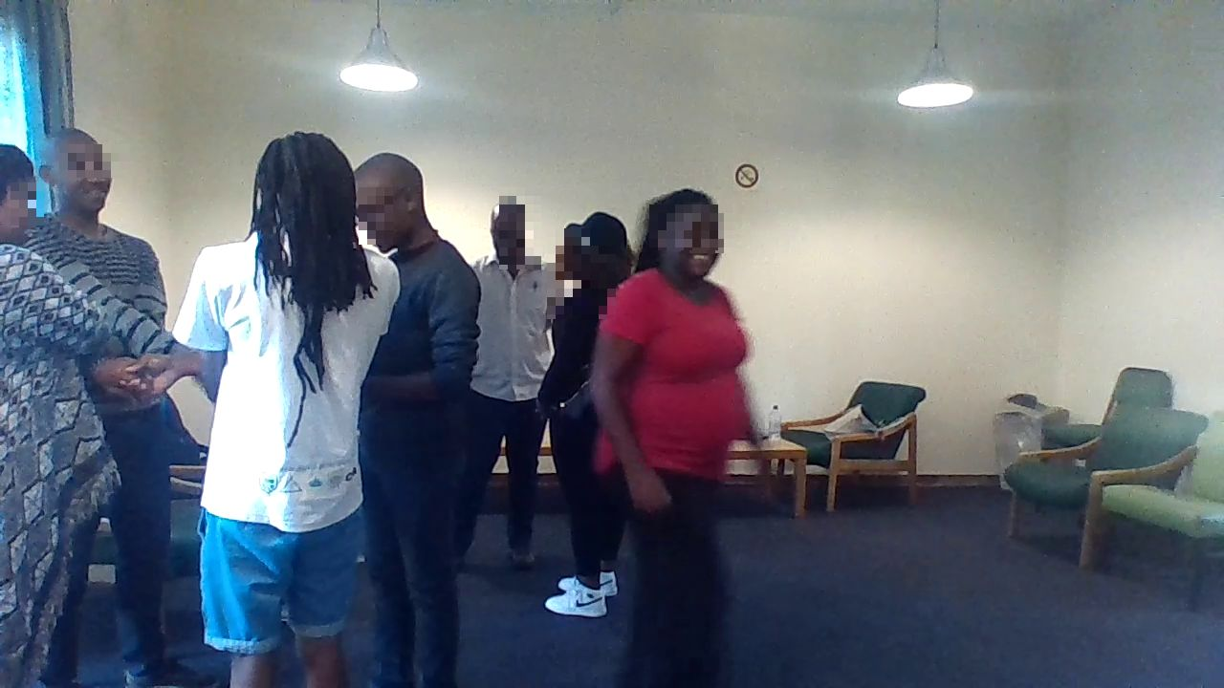
Figure 18: This is how we want to see ourselves in the community of Wits
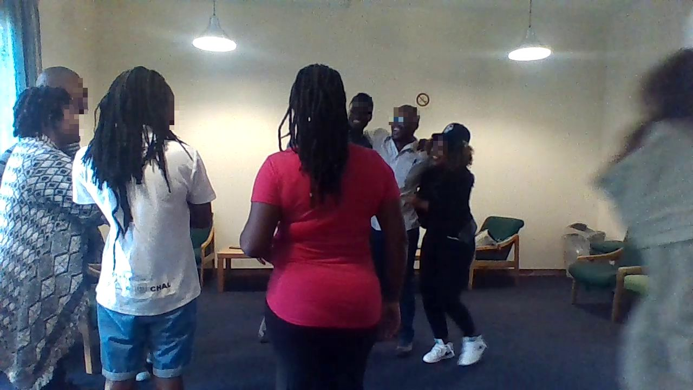Figure 19: This is how we want to see ourselves in the community of Wits
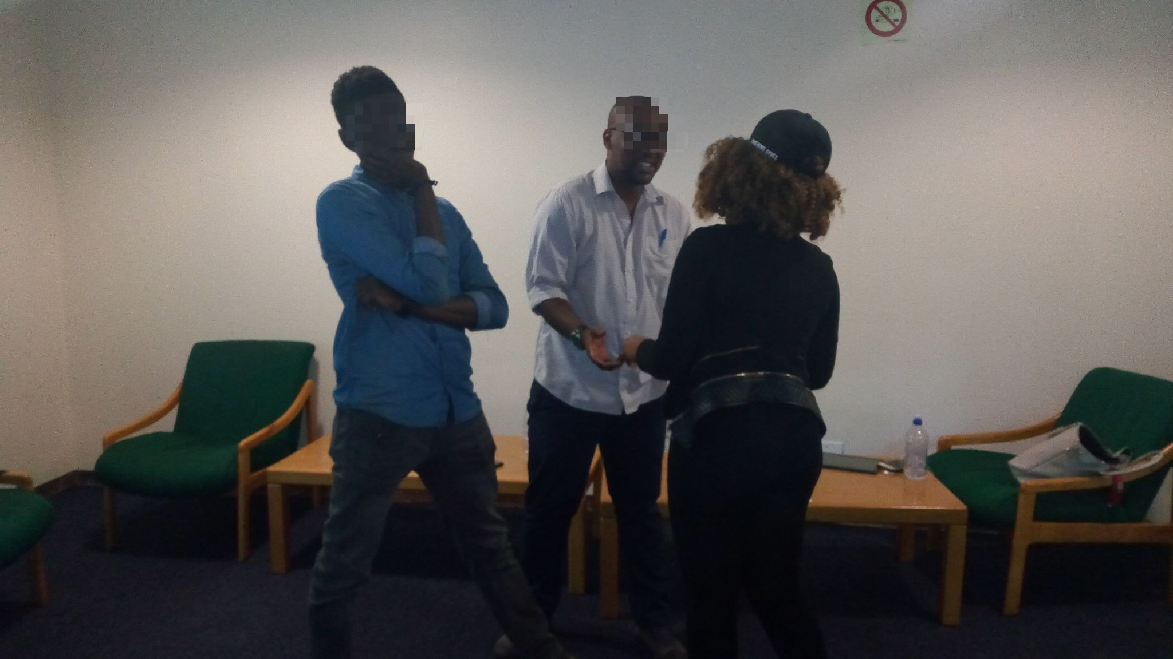
Figure 20: What it means to be a black foreign student1
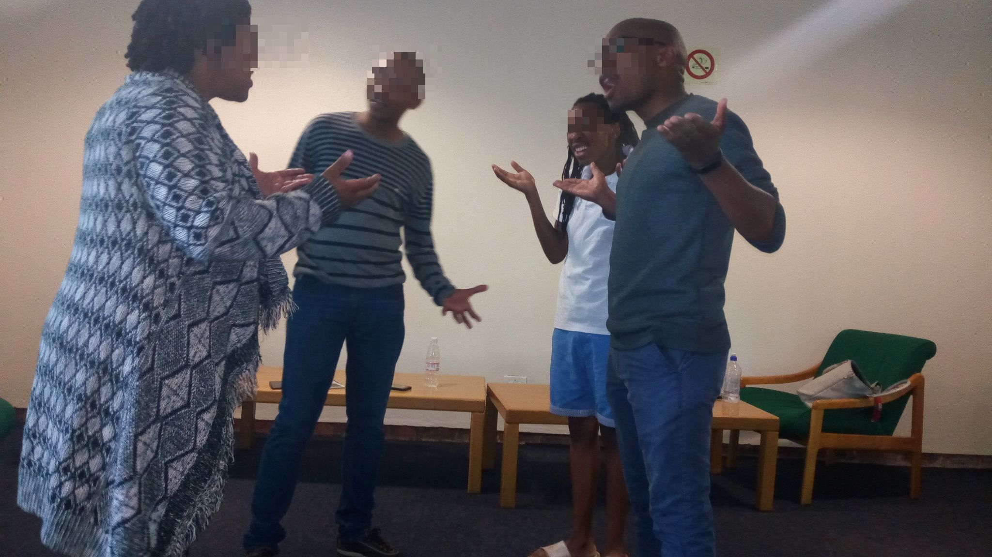
Figure 21: What it means to be a black foreign student2
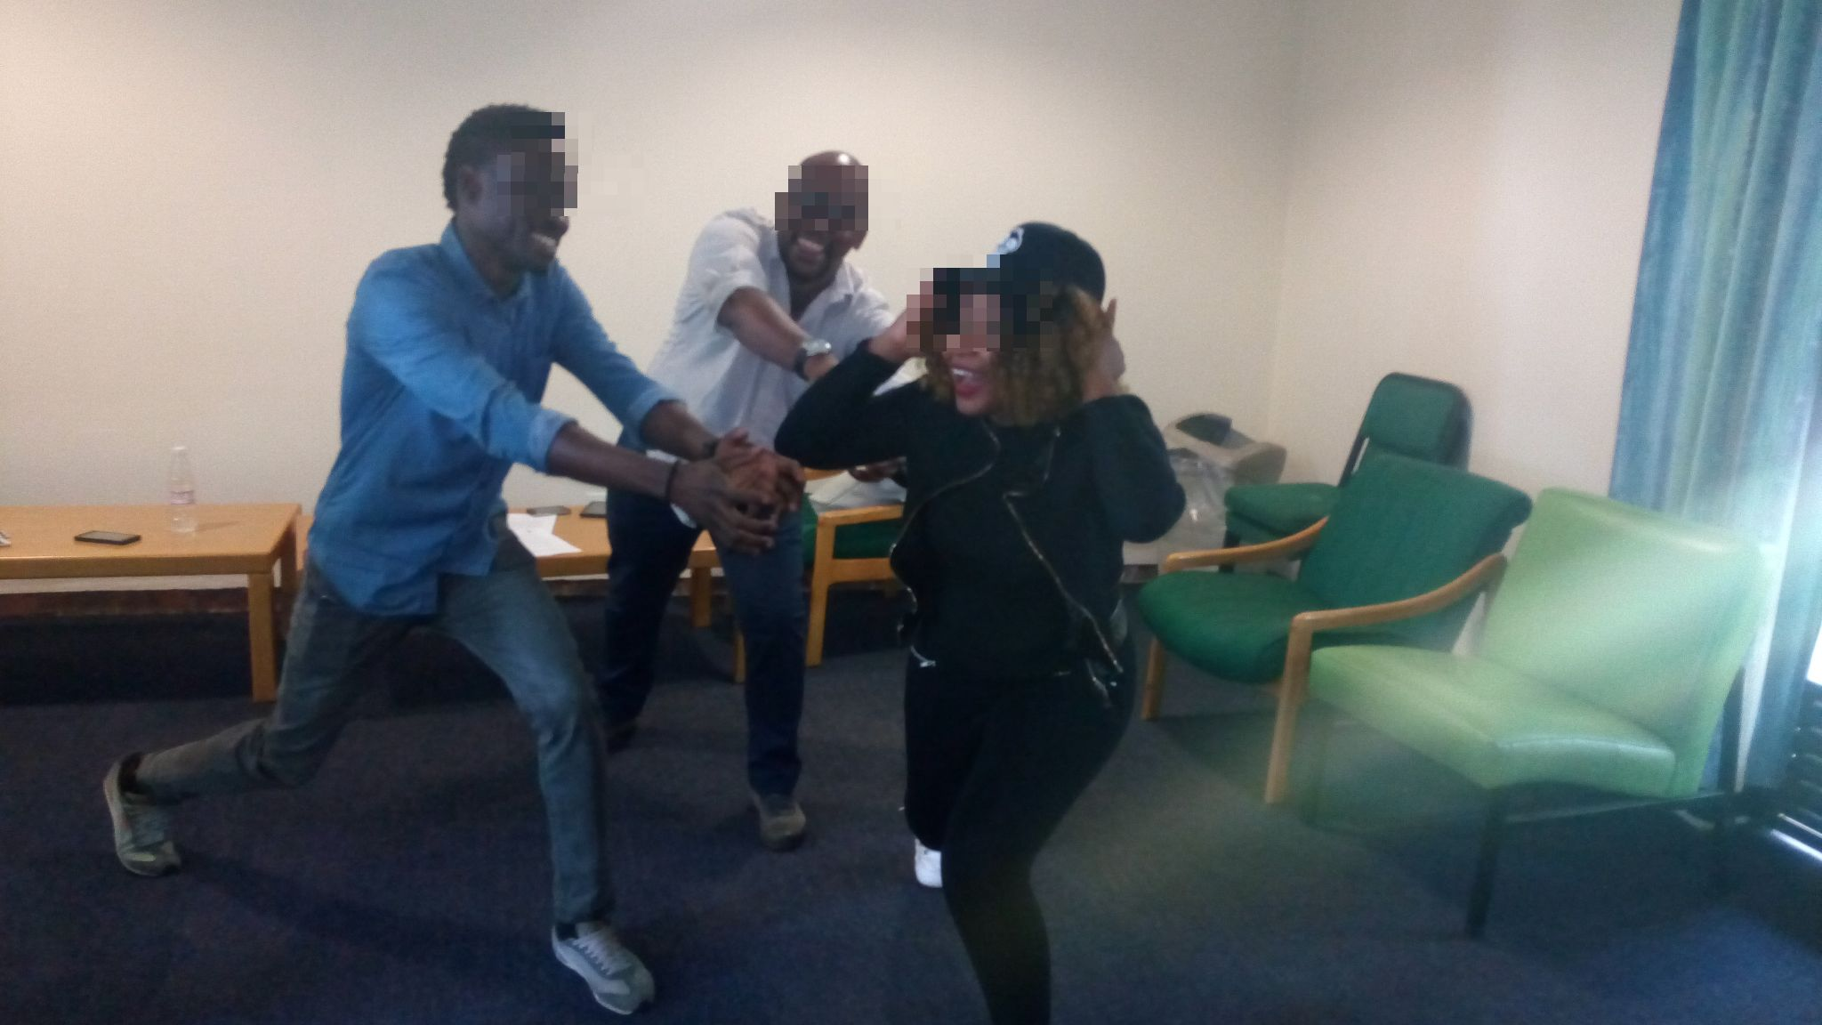
Figure 22: What it means to be a black foreign student3
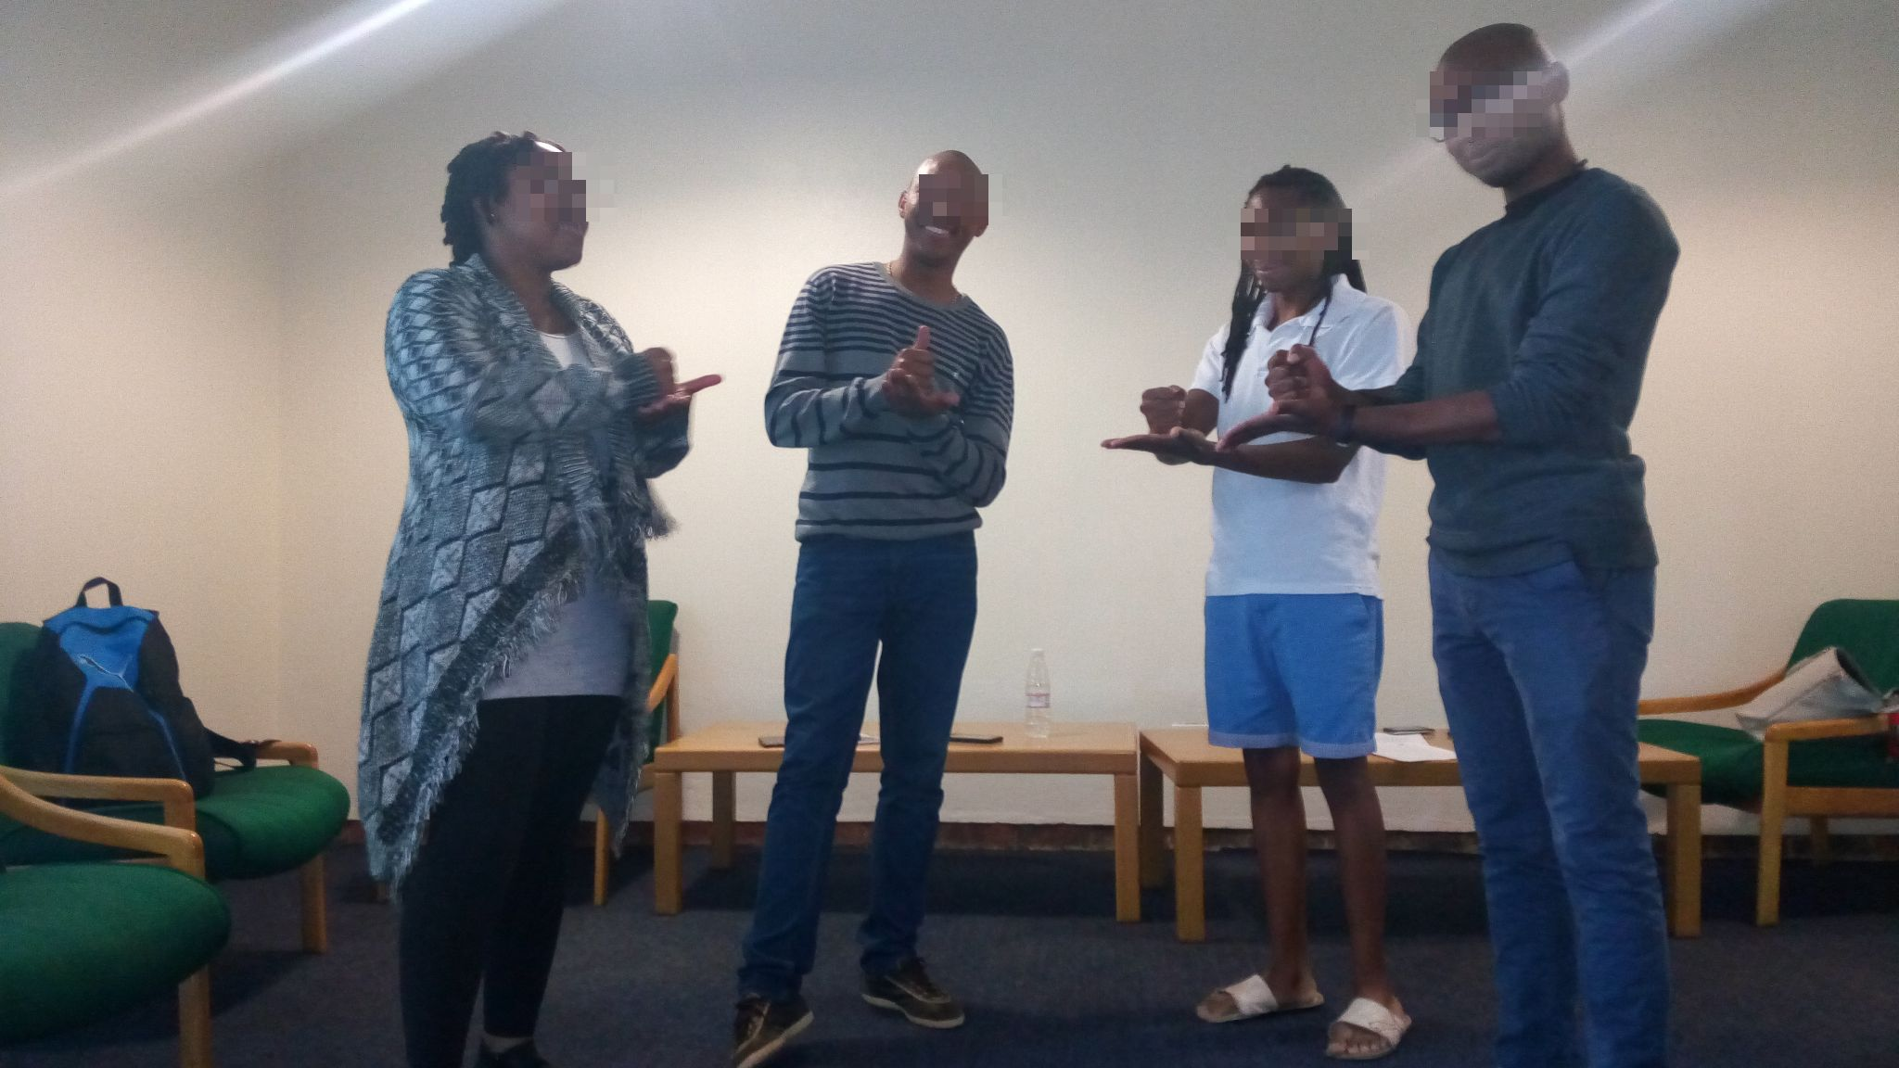
Figure 23: What it means to be a black foreign student4
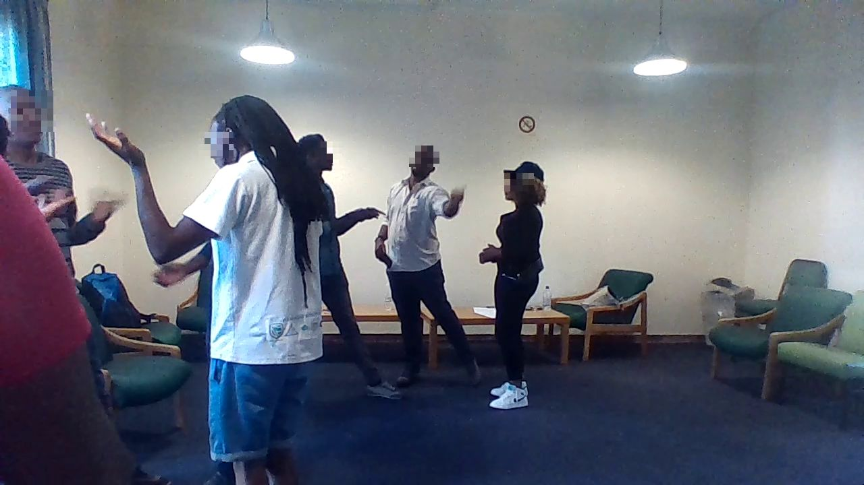
Figure 24: What it means to be a black foreign student5

The findings from the story-drama
This segment of the data is a thematic analysis of the discussion that ensued after the completion of the story-drama. This discussion was premised on the participants thoughts and reflection on taking roles to tackle the issue identified in the story drama. As this was an unstructured discussion, the participants talked on a range of issues, and their discussions included what the story tableau and the story drama meant for them in the broader context of their status as black international students at Wits. This suggests that the following themes were not only based on what happened during the story drama, but rather, it encompasses the contextual experience of what it means to be a black international student at Wits. This is because, some of the participants referenced things that were happening as early as 1995 to drive home their point and this means that the story drama was just an avenue to deepen the participants engagement on the theme of belonging. In some cases, the researcher directs the participants to specific issues that needs further unpacking. For instance, two of the still images were specifically about the use of language as an exclusionary measure and to understand what this meant, participants were asked to comment on it. And in another scenario, the researcher noticed that during the role play, some of the students who had the same problem with Home Affairs showed no empathy or concern for each other. And during the discussion, the researcher also used the opportunity to find out why they acted like that. The discussion that resulted to the themes below were transcribed and read several times before the following themes emerged.
Theme 1: You don’t give what you don’t have
From the discussion, it appears that the participants think they are victims of the pervasive racial divide that continues to plague the South African society. Even though on paper, the era of apartheid is over, many South Africans continue to live their lives according to the colour and racial divide that existed in the past. Because of this, the black international students believed that there is no genuine love among those who called themselves South Africans. This made the participants of this study question whether it is fair to expect love and belonging in Wits, since even among the South Africans themselves, the racial divide is palpable. Participants explain that South Africa is one country that decides everything (scholarships, internship, opportunities for learning) according to race or colour. This led to the perception that nothing in Wits is based on merit, but rather, on one’s colour or background. Participants even questioned that if South Africans themselves are dividing themselves based on whether they are White, Black or Coloured; then there is no hope for a black international student. Some of the participants explain that:
When you want to apply for anything, they ask, are you Black, are you Coloured, are you White and I am like, why does it matter (Participant 6).
It was when I got to South Africa that I realise the issue of race is not a joke. I remember when I was completing a form and I saw a segment for my race, I was confused and I asked the staff to make me understand. She said they just wanted to know whether you are black, or White or Coloured or foreign… She later told me it was insignificant, but I thought if it does not matter, why was it on the form in the first place (Participant 8)
The participants statements suggest that they are being held to a different standard and that the system unfairly targets international students. And sadly, the University seems oblivious to this and is doing nothing to assist the international students. For instance, participants discussed the idea that international students are treated like sacrificial lambs for the local students. Some of the participants explained that:
You receive hundreds of emails saying scholarships are open, but you can go through each one of them one after the other and you will still not be eligible just because you are an international student (Participant 5)
Even placement and internships are designed to force international students out and sometimes you ask yourself what the essence of schooling in South Africa is when you are not given the opportunity to experience the South African work culture (Participant 7)
The statements from the participants is rife with sentiment of being treated differently despite contributing to the revenue of Wits. They explained how absurd it is that they get admitted to Wits but are being deprived of the opportunities to get immersed in the society because of unnecessary bureaucracies.
Theme 2: A community that breaks your sense of communality
The data suggests that the international students believe that the system is designed in such a way to frustrate their lived experience of being a student in South Africa. The participants do not have any sense of belonging because even when they have valid study permits, they endure constant harassment from the police and when they need visa renewals, the University makes it harder for them even when it is apparent that the delay in visa processing lies with the Home Affairs office. As an illustration, the participants explain that international students in the University of Johannesburg can register for courses while their visa applications are being processed but that is not the case with Wits. They commented that Wits staff do not show understanding and empathy when dealing with these issues. The uncertainty that comes with the visa renewal issues means that international students do not have any sense of communality and Participant 3 even exclaimed: "International Office is your worst enemy when you have a problem".
The conversation suggests that many international students just care only for themselves and do not look out for each other, because each one of them has one issue or the other that they are dealing with that constantly reminds them that Wits and even South Africa is not their home, and they need not establish long-term relationships since they are leaving. As an illustration, during the role play in the story-drama, as the Nigerian student was being told loudly that he must leave the country, the other students just barged into the conversation and said: "sorry, sir; my issue is not a complicated one". The immigration officer listened to him, stamped his passport and off he goes. Since this was an unscripted drama, one can sense that there is no sense of communality and identity among the black international students and this makes them more vulnerable because they do not have a voice. The two international students who were in the queue heard everything that happened to the student through his narration, but they cannot be bothered to assist him in any way.
During the reflection, the international student who got his documents stamped said "I did not care. All I care for was to get mine, and that is how it is. I mean, everybody is for themselves". Other participants commented that:
Everyone for his own struggles (Participant 3)
People don't care. They don't sympathise, and this makes your stay in SA very lonely (Participant 6)
The student from Nigeria alluded that there are layers of exclusion against black international students. He explained that people from countries which are geographically close to South Africa like Botswana, Lesotho are seen more favourably than people from countries like Nigeria; suggesting there are layers to anti-foreigner attitudes. Since participants have realised that a Swati, for instance, is more likely to be treated more favourably than a Nigerian by the student and staff at Wits, the black international students then think they do not have the same challenges, and issues and this breaks any communality that should bind them together. One of the participants explained that:
The system is designed in such a way to frustrate you until you give up… If you are not careful, you will end up as a broken soul (Participant 1)
The statements from some of the participants also made one think that the Student Representative Council (SRC) does not represent the views of the international students. Participants described that:
The Wits Student Representative Council cannot truly represent the voice of the international students because their commitment is to the issues affecting the South African students (Participant 4).
SRC only exist for local students. They do not represent the interest of international students. Look at the issue of fees must fall, they think we do not deserve the affordable education just because we are international students. At no point did we feel we belong in the struggle (Participant 2)
Their mandate is more aligned with the issues of local students and not that of foreigners (Participant 7)
Because of the above issues, the participants suggested that a people-focused approach should be adopted by the International Student Office, with a genuine interest in the issues affecting the international student community. However, the International Student Office may seem indifferent to these issues when one considers the participants portrayal of their past interactions with the staff of the International Student Office. During the play, the following exchanges occurred between students and the representative of the international student office:
Student: But I have a letter from the school, and this means I have a genuine case
Home Affairs Staff: The University will not tell us how to do our job… We insist you are ineligible for any extension:
International student staff: If they say they can’t extend it, there is nothing we can do
Confusion broke out…
Students (many students talking at the same time): No man!! (making loud gesturing sounds with his tongue), this is unacceptable. How do you say there is nothing that can be done? Do you realise what it means? This is the life of someone being destroyed.
International student staff: Well, what do you want us to do that we have not done ?
Students (many talking and supporting each other): Firstly, you are supposed to have assessed the situation and conclude that this is bigger than the student. You know Home Affairs will be reluctant to renew his visa and that is why rather than throwing the students straight at Home Affairs, it is your office that should be doing the advocacy on behalf of the student.

Theme 3: Home will always be our countries
The participants explained that the general perception of South Africans is that black Africans from other countries are coming to invade South Africa. And this makes them wonder why they were given admission and study permits, only to be treated as outcasts. The participants explained some of those things that led them to perceive that the Wits Community cannot wait to see them leave:
When you come to Wits, you should be prepared to answer questions like: Why are you here? When are you going back? (Participant 2)
It is unfortunate how things had quickly changed since 1995 when I first came to Wits. I think things are even getting worse because every day, the sentiments that you are not wanted here keeps increasing. It was very different in 1995, but maybe it was because there were fewer international students then (Participant 1)
It seems to be a frustrating experience for the participants when they are being prejudiced as an economic opportunist, like many other black immigrants. They explain that:
It is not everyone who wants to settle in South Africa. Some of us are happy with our homes, and we want to go back after our study (Participant 8)
I love my country; Swaziland and I want to go back. As you can see, since 1995, if I want to be a resident here, I would have achieved it, but no, I love my country, and I am just here to study (Participant 1).
They think you are here for the jobs, but I look around and I see no jobs. You can’t even get the job if you are not from here (Participant 2)
Statements from the participants suggest that the issues affecting black international students are not a priority for the University. As an illustration, one of the participants explained how he is now very fearful of unusually loud noise, because of what the last University protest and the subsequent strike did to him. He said
Student unrest and protest has cost for international students but the University doesn't realise it, and they pay no attention to it. During the protest of last year, I was unable to see my supervisor, and he has already resigned. He locks himself in the office and seeing him was impossible because he was scared for his life. This delayed me from submitting my thesis for examination, and I had to come back to Wits the following year. Coming back to Wits meant I spent about R10,000 to renew my permit, I had to pay rent of R6,000. If my home is in Mpumalanga, I would not have cared about this (Participant 2)
Participants complained that the visa requirements constantly change, but the University usually do not bother to update its international students until they run into problems. As Participant 3 said, “they change things all the time without informing students” and this made Participant 1 comment that “I wish I have gone overseas for the course I am doing here”. Another participant (Participant 2) added that “in South Africa, they blanket everybody. It does not matter if you are a student or a trader. They just think you are here to do funny things”. It is even worse if you are Nigerian."
Theme 4: Language as a form of oppression
Since the issue of language was brought up during the making of the tableau, the participants were asked to try and unpack the issue. The participants were asked if the issue of language was specific to Wits or outside Wits and they chorused "everywhere". The participants of this study strongly believed that language is used as a weapon to exclude international students intentionally. Participants recounted several occasions where both lecturers and students have used language to exclude them from conversations intentionally. According to the participants, language is used strategically to disadvantage them both academically and socially, and this is a powerful weapon because it effectively neutralises their desire to become part of the community. Like Participant 4 said “Ok, in my class, our lecturer is Coloured and the Coloured students are like 16 or so, while the Blacks are like 4. Most of us that are Blacks are international students, and the lecturer knows. But I don't know if it is a joke, but she uses Afrikaans when lecturing and leaves us behind."
The participants even argued that the use of language within and outside the classroom is not about decolonisation of the curriculum but rather, it is about reminding the international students that they should not get too comfortable because this is not their home. The participants maintained that while they believed the curriculum needed to be decolonised and that African education should be the kind of education that speaks to the reality and challenges of Africans; they claimed that the use of language in Wits is used to accentuate racial division and this magnifies feelings of exclusion for international students. One of the participants said justifying the use of any other language apart from English in the classroom is baseless because excluding other people is not decolonising and in the context of South African, Afrikaans will represent the language of the oppressor (Participant 6). Also, they stated that the further the black international student goes from the University, the more difficult it becomes to connect with the society since the locals do not believe any black person would not be able to converse in IsiZulu for instance. As such, the fear of being ‘othered' this limits the interaction of black international students with their host society. One of the participants commented that "is it not interesting to you comrades, that a black South African student would never speak Tswana or IsiZulu to a White or Brown-coloured individual, but would not mind using it intentionally to make a fellow black man feel unwanted.
This chapter presented the findings from the story tableau, and they were presented in form of frozen images and themes. The following chapter brings the study to a close by discussing the implication of the findings, the reflection of the researcher and the limitations of the study.

Chapter 4: Reflection, Recommendations and Conclusion
This chapter presents the researcher’s thoughts about the use of story tableau and the implications of the findings for story tableau. The findings were also discussed in light of recommendations and the use of story tableau.

Reflections of the researcher
From my interactions with the participants, it was apparent to me that the issue of race is very pronounced in SA. The use of story-drama was very empowering in this study because participants were not passive in the issue affecting them. In the image below, which was a scene about the deliberations and the consultation between the student body, the Home Affairs office, the International Office and the students; the students can be heard raising their voices and saying things like "is it because we are not from here?", "if it was a White student, is this how you are going to treat them?". This shows how story-drama can transform passive participants into active meaning making people who are now very concerned about issues affecting them. It was also very empowering to see that at the end of the research, participants were exchanging contacts and they left with the belief that issues facing international students are shared.
The dramatic tensions were so intense for people who are doing role plays for the first time, because, at a point, the students raised the expectation by challenging the Home Affairs officials about their limited worldview, which they think, is the reason for their lack of understanding towards the issue. One of the participants asked, "have you ever been to tertiary education before?". The Home Affairs official responded, "oh, so you are insulting us now; because this is no longer about study permit, it is now about us and our certificates". This heated verbal exchange made me realise that the University must infuse more humanity in the academic, social and administrative affairs of the University. As the Home Affairs official was insisting that her decision not to extend the visa is because of laid down rules as contained in the policy, the students were arguing that the rules should be made flexible for exceptional cases.
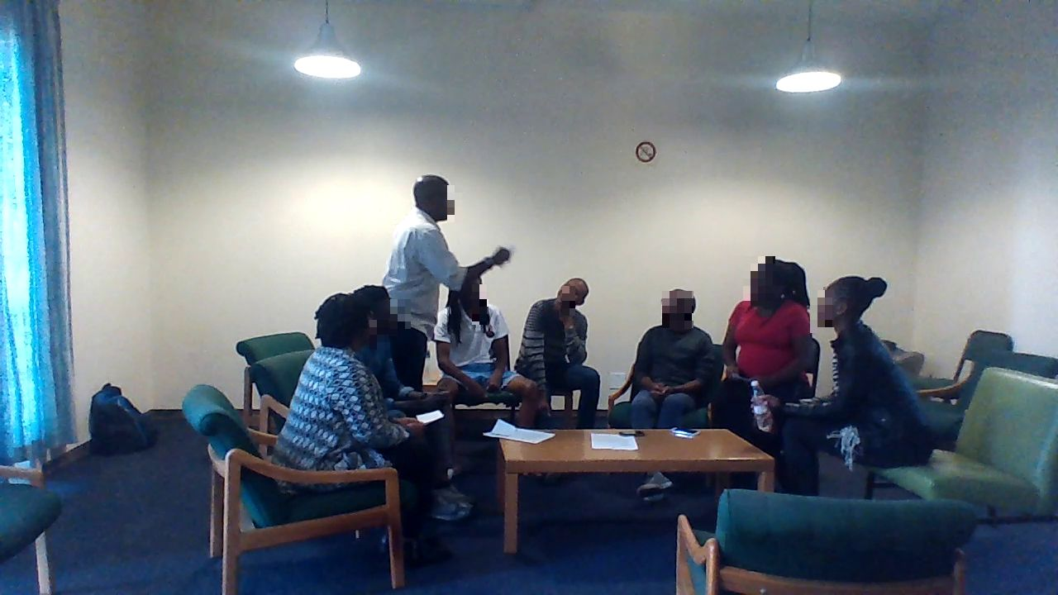
Figure 25: Heated conversations between a black international student and the Home Affairs official who would not renew student’s study permit
The participants were asked to describe how it was playing the specific role they played. They explained that:
There are lots of things going on in the interactions. To some extent, I could see where the international students are coming from, even though I played the role of the Home Affairs official (Participant 5).
Playing the role of a journalist, I was forced to take a side in the story (Participant 8)
This drama helped me to relate to the problems of international students (Participant 4)
Even though it was not real, I felt misunderstood. The Home Affair staff were being horrible (Participant 2)
Whatever their role was, the creation of illusion allowed the participants to transcend the narrow confines of their personal identity to participate in other forms of existence. As a drama practitioner, I found it very powerful that the original story could be lifted to a broader archetypal framework (Haine, 1985:187) by adults who are doing this for the first time. I temporarily participated in the drama in-role as one of the Department of Home Affairs officials (DHA 1), and this means the students were at my mercy because I was fuelling the tension. As an illustration, the following dramatic monologue depicts a scene during the role play:
DHA 1: The Republic is governed by rules and regulations. We are a sovereign nation.
Students: Can we talk to your boss? A higher level officer.
DHA 2: Which boss? I am the boss here, and I don't understand which higher officer you are talking about, unless you mean the Minister of Home Affairs.
DHA 1: Even if you speak to the Minister, we cannot change our policy over one Nigerian.
DHA 2: If you are asking us to change our rules because of one Nigerian, then you must be joking.
Student 1: Oh! If that is the case, then Home Affairs must fall. Our embassies will be involved in this
Student 2: No, man: We [international student] are here complaining on behalf of a comrade.
Student 3: If he were a White student, you would have helped.
Student 4: You are a black person, and you can't help another black man?
Student 1: No, man; South Africans always exclude us as international students, yet we contribute heavily to the economy of this country and even the revenue of the University.
Although my time in-role was just for a short period and only during the scene of the consultations between stakeholders and the Home Affairs, it yielded positive results. My role was that of the adamant Home Affairs official, who would not listen to any pleas for the visa extension. The student and his representatives were at my mercy because I held power to grant their wish. This was very crucial because while in role, I helped other actors to find their own character and power. The students knew they had to be more ferocious, and more persistent if they were going to leave the Home Affairs office with a solution. This means I challenged their commitment to finding the answer because this "ignorant Home Affairs official” will not budge unless they do something unique. And as a result, during the play, issues of belonging were raised as critical issues for black international students.
Participants were also asked about the significance the play had for them, and they describe that:
It brought back memories of difficulties that I have had with International Office in the past. I remember the International Office refused to register me, even though I showed them the barcoded proof from the Home Affairs that my permit was being processed (Participant 4)
The play made me reflect on how things have changed in South Africa. Back in the days, study permit used to be a stamp; easier and faster to process. Now it is very impossible (Participant 1)
I created avenues for the participants to step out of their roles in order to evaluate their commitment to the drama. They were able to consider consequences of their decisions, and this opened a new avenue for further exploration of the theme of belonging. Since this reflection gave an opportunity to the student and me to view ourselves in relationship to the roles we played in the drama, I was able to reflect on what I could have done better. In this research, I played the roles of a participant, facilitator and researcher and this was tough because I had to keep reminding myself of the boundaries I need to keep so that the participants could be in charge of the process. Because of the need to play these three roles, without compromising the integrity of the technique of both the story tableau and the research, I thought I did not do enough to explore their character before starting the game. Because the data collection took about five hours, and because of the fears of losing the participants due to their other engagements, I thought the roles played by the participants could have been explored further through questioning.
As an illustration, I realised that Participant 2, who is a Nigerian did not want to talk about exclusion initially. It was like he was not feeling safe to talk about it initially, considering that he thought that people from SADC regions are treated more favourably in South Africa. Although, he later modified his behaviour because other participants were also talking about how they have been othered or profiled because of being international students. So, hearing the stories of other participants created this shared identity where participants realised that they have similar challenges as international students. As an illustration, during the reflection, the Participant 2 started commenting things like “I come from Nigeria but my first ever robbery experience was in South Africa. If you have not been robbed yet, then you are living in a different South Africa”.
The story-drama allowed me as a teacher-in-role to challenge the students and help them find their character and power. In this way, story-drama allowed me to experience the potential of story-drama in breaking down barriers that can exist between teachers and students. In the case of this study, the ability to participate in the dramatic process through the teacher-in-role strategy allowed me to stimulate the thoughts and actions of the participants and this played a significant role in the way we tackled and explored the issue of belonging. As a facilitator, I was unable to explore the character of the participants beyond the superficial level and I would have also wished to engage the participants in in-depth questions which could have resulted in deepening the understanding of belonging beyond what was revealed in this study. While the aim of this study is just to understand factors that appears to be driving non-belonging among international students, future studies may want to use other forms of dramatic techniques, especially those that are more empowering and that can lead to change. However, the participants of this study left with the awareness of the factors shaping their experience of being a black international student. This new form of awareness can lead to change, solidarity and critical consciousness.

Recommendations
From the findings of this research, it is essential for the university to listen to the voices and the concerns of its international students. The black international students that took part in this study echoed the concerns of the Risk Management Committee of the University about the exclusion of international students. Although this issue has been flagged as an area that the University wishes to pay attention to, it is important for the University to open dialogue with the international students. The use of drama techniques, like those used in this study, are powerful mechanisms through which the various dimensions of belonging can be fully understood so that the University can design that appropriate measures of inclusiveness. The University can do more to increase interaction between international students and local students so that high cultural intercourse can occur on an ongoing basis between the locals and the international students. The international students represent a fertile ground because they can be the avenue through which the local students and staff can see the world. But with the continuing divide which seems to be perpetrated by the use of language and anti-foreigner policies of the University, it is imperative that the University re-consider the use of surveys if they genuinely want to hear the voice of the black international students.
As the international students contribute to the image and revenue of the University, they are of the perspective that they deserve to be recognised as bona fide learners who contributes to the attainment of the goals and missions of the University. The boundaries of studentship at Wits means need to be reconsidered in the light of the concerns raised by the participants of this study. If participants are admitted and pay full tuition; but do not have the same opportunity in terms of placement and internship; then it is essential for the policymakers to ask themselves the kind of graduate attributes that international students leave with when they graduate. The black international students are also ambassadors of the Universities but when they feel they are being treated as second-class citizens, then they cannot truly represent the values of Wits, and they cannot truly possess the graduate attributes that the University expects in its students.
Furthermore, the University needs to do more in tailoring services to the needs and peculiarities of the black international student. For instance, information about scholarships and internship opportunities should be more tailored to the needs of specific audiences. For example, the university can do more in providing opportunities for black international students so that they can truly experience the South African education. It is evident that the International Student Office needs to adopt a more flexible approach to issues affecting the international students. Rather than using a one-size fits all approach for all situations; they need to start considering alternative approaches that involve being present in the lives and circumstances of the international students. As an illustration, the International Office could provide schemes where international students can be involved in issues that involve them by giving them the opportunity to design programs relevant to their challenges.
Although the issue of language as a form of exclusion has been previously reported in the literature, the use of story-drama in this study allows one to appreciate how it truly works to exclude the international student. Literature is replete with the subtle form of xenophobia against international students in the form of ‘harmless jokes’ about their accent or culture, excluding them from classroom participation using language and adopting dominant frames of reference that leaves out other cultural perspectives in the classroom (Lee, 2007:29). In one of his writings, Ngũgĩ wa Thiong’o (1985:286) explained that “in my view language was the most important vehicle through which that power [colonial] fascinated and held the soul prisoner”. In the same article, Ngũgĩ wa Thiong’o (1985:286) berated Africans for their feebleness towards their own language and argues that Africans show more aggressiveness in claiming the language of colonisation. This means that the use of languages such as Afrikaans, IsiZulu, IsiXhosa is an attempt by South Africans to claim their language and identity in an institution that has the history and footprint of colonisation. But when this is considered in the broader context of black international students, do we need to start a conversation about language and inclusivity in the era of internalisation?
This role of language in creating an exclusion in institutions of learning is not peculiar to South Africa alone. As an illustration, in Australia where English is the main language, the inability of foreign students to demonstrate acceptable English competency has contributed in framing them as problematic out-group (Paltridge, Mayson & Schapper, 2014:103). This means that the history of South Africa and its present realities need to be considered in light of the concerns raised by the black international students, especially because they are of the opinion that black staff or students would not use any other language, apart from English when dealing with a White international student, for instance. However, Armstrong (2006:184) comments that the use of Boal’s TO in issues like belonging might unnecessarily simplify the problem, but Armstrong also acknowledges that Boal’s TO could also be advantageous in exploring the fluidity within the division that exists between the oppressor and the oppressed. This could be true because when one considers Figures 17, 18 and 19 which was about what the black international students like about South Africa and how they want to see themselves in the Wits community; then one can agree with Armstrong that issues like belonging can be overly complex and convoluted to understand. The black international students do not want to see themselves as different in the University and one can attest to this by examining Figures 18 and 19 and this means that rather than advancing the identity of individual groups, like the black international students’ community, maybe we should instead be considering ways of creating a shared language that can assists in the realisation of an African identity.
Working with characters through story tableau helped the participants to understand the broader connections and implications of stories. The participants of this study entered story worlds and explored all of the narrative elements actively and creatively. They assigned themselves the roles of a student, SRC, Home Affairs and even international office staff. This means that the story tableau experience took the participants beyond the kind of data that would have been derived if the participants were merely asked about what belonging means for them in an interview. Unlike other forms of data collections like interviews, the participants spent five hours trying to tease out what belonging meant for them, and this implies story tableau enabled them to explore the issue for a sustained amount of time. At the end of the data collection, I was confident that the participants realised that they had common challenges and experiences, and this fostered a spirit of solidarity, friendship and caring. The participants came as an individual, but the left as a group of people with a shared language.
As the participants tried to understand the theme of belonging, the drew not only on their knowledge of story elements, but they also imbued character roles with personal interpretations, movements, voice, intonation and gestures. The participants moved beyond considerations of gender, nationality or age to explore character feelings, and conflicts, and the dilemmas of their difference. By reflecting on their experience, which would not have happened with other research methods, the participants understood from their own experiences and that of others, and this was a powerful moment in this research.
Finally, the use of story tableau shows that story tableau can be easily adapted to facilitate conversation about the issue of belonging. This is because, for instance, lack of communality among the international students that was revealed in this study is one of the contextual and influential factors that are unlikely to be exposed through other methods of data collection. Yet, lack of communality among the black international students perpetuates their exclusion because they do not have a collective voice, and this means they are collectively weaker and unable to demand change. One of the ways through which the perceived exclusion of black international students can be addressed is by fostering a collective African identity rather than continually perpetuating the idea of individual ethnic identities. This is even more important because Africa is diverse and if we continue to pander to the idea of appealing to individual ethnic groups, then we will soon become fatigued, both mentally and physically.
Limitations
Like any other research, some limitations need to be considered when considering the transferability of this research. First, the participants of these study were not professional actors. Coupled with that, the data for this study were collected in just one day, and this means, the participants did not have the time to build rapport and relationships with each other before the day of the story drama. This would not have been an issue if this was purely qualitative research, but in the realm of drama, the implication is that there was no character building and as such the images produced and the character that the participants assumed could be seen as a mere cliché or caricature. As previously discussed, I also felt that some of the participants initially struggled to be in roles because of shyness and lack of familiarity with the other group members. This means that the findings of this study could be different if the participants were engaged over a more extended period to build character and develop relationships. Also, they were also very diverse in their nationalities and course of study. For instance, one of them was a PhD student, some were training to become medical doctors, and some were undergraduates. However, as I continued to engage with them during the course of the story-drama, the participants eased into the performer role and there were significant interactions among the participants and with me as well. These interactions and the processes that culminated into the production of images and the narration of stories of belonging is as significant as the interaction between an audience and a stage in a traditional theatre.
My time with the participants was filled with emotions, fantasies and struggles that were peculiar to the participants because of their status as black international students. Further, as this study was only conducted at the University of Wits, with just eight participants, the findings of this study cannot be generalised to the wider population of black international students at Wits or the whole of SA. The issue of belonging is always a contentious issue, and it is hoped that this study can contribute to the debate about belonging among international students and also stir up new ideas regarding the use of dramatic techniques when researching belonging. Unlike other methods such as surveys that are being planned by the University of Wits, story tableau is participatory, allowing for the communication of personal narratives that are unacknowledged by the public. Story tableau techniques also offer a mechanism for addressing the reluctance to speak about issues such as belonging. The unwillingness to talk and the inability to find a way to facilitate a genuine conversation about exclusion at Wits, especially among the black international students could have contributed to the silencing of their voice.

References
Armstrong, A. E. 2006. Negotiating feminist identities and Theatre of the Oppressed. A Boal companion: Dialogues on theatre and cultural politics, 173-84.
Bell, L. A. & Roberts, R. A. 2010. The Storytelling Project Model: A Theoretical Framework for Critical Examination of Racism through the Arts. Teachers College Record, 112, 2295-2319.
Boal, A. 1985. Theatre of the Oppressed. 1979. Trans. Charles A. and Maria-Odilia Leal McBride. New York: Theatre Communications.
Boal, A. 1995. The Rainbow of Desire: The Boal method of theatre and therapy. Trans. A. Jackson. London and New York: Routledge.
Boal, A. 2002. Games for actors and non-actors, Psychology Press.
Booth, D. 1985. “Imaginary gardens with real toads”: Reading and drama in education. Theory into Practice, 24, 193-198.
Dodson, B. 2010. Locating xenophobia: Debate, discourse, and everyday experience in Cape Town, South Africa. Africa Today, 56, 2-22.
Dominguez-Whitehead, Y. & Sing, N. 2015. International students in the South African higher education system: a review of pressing challenges. South African Journal of Higher Education, 29, 77-95.
Flynn, R. 2017. Introducing tableau to students. Thoughtco. https://www.thoughtco.com/introducing-tableau-to-students-3938471 [Accessed 03 January 2018]
Freire, P. 1970. Pedagogy of the Oppressed. Trans. Myra Bergman Ramos. New York: Continuum, 65-80.
Freire, P. 1996. Pedagogy of the Oppressed (revised). New York: Continuum.
Grant, D. 2017. Feeling for meaning: the making and understanding of Image Theatre. Research in Drama Education: The Journal of Applied Theatre and Performance, 22, 186-201.
Hopkins-gillispie, D. 2011. Curriculum & Schooling: Multiculturalism, Critical Multiculturalism and Critical Pedagogy. The South Shore Journal, 4, 1-10.
Kessi, S. 2015. Xenophobia and the politics of citizenship and belonging in South Africa. The Johannesburg Salon, 10.
Lee, J. J. 2007. Neo-racism toward international students. About Campus, 11, 28-30.
Mogekwu, M. 2005. African Union: xenophobia as poor intercultural communication: research section. Ecquid Novi, 26, 5-20.
Neocosmos, M. 2008. The politics of fear and the fear of politics: Reflections on xenophobic violence in South Africa. Journal of Asian and African Studies, 43, 586-594.
Paltridge, T., Mayson, S. & Schapper, J. 2014. Welcome and exclusion: an analysis of The Australian newspaper’s coverage of international students. Higher Education, 68, 103-116.
Perry, A. 2012. A silent revolution:‘Image theatre’as a system of decolonisation. Research in Drama Education: The Journal of Applied Theatre and Performance, 17, 103-119.
Read, C. 2008. Scaffolding children’s learning through story and drama. IATEFL Young Learner Publication, 2, 6-9.
Sandelowski, M. 1997. " To be of use": Enhancing the utility of qualitative research. Nursing outlook, 45, 125-132.
Singh, R. J. 2013. Examining Xenophobic Practices amongst University Students–A Case Study from Limpopo Province. Alternation Special Edition, 7, 88-10.
University of the Witwatersrand. 2015. Annual Report 2015. Johannesburg: University of the Witwatersrand Communications and Publications.
University of the Witwatersrand. 2016. Annual Report 2016. Johannesburg: University of the Witwatersrand Communications and Publications.
Wa Thiong'o, N. 1985. The language of African literature. New Left Review, 109.
Wallace, M. 2014. "Why use drama in a Viz". Blog. Tableau Community. https://community.tableau.com/thread/149285. [Accessed 25 November 2017]
Warstat, M. 2009. Images of the future in drama therapy. Theatre research international, 34, 180-186.

Appendix

Appendix A: Ethics Clearance Certificate

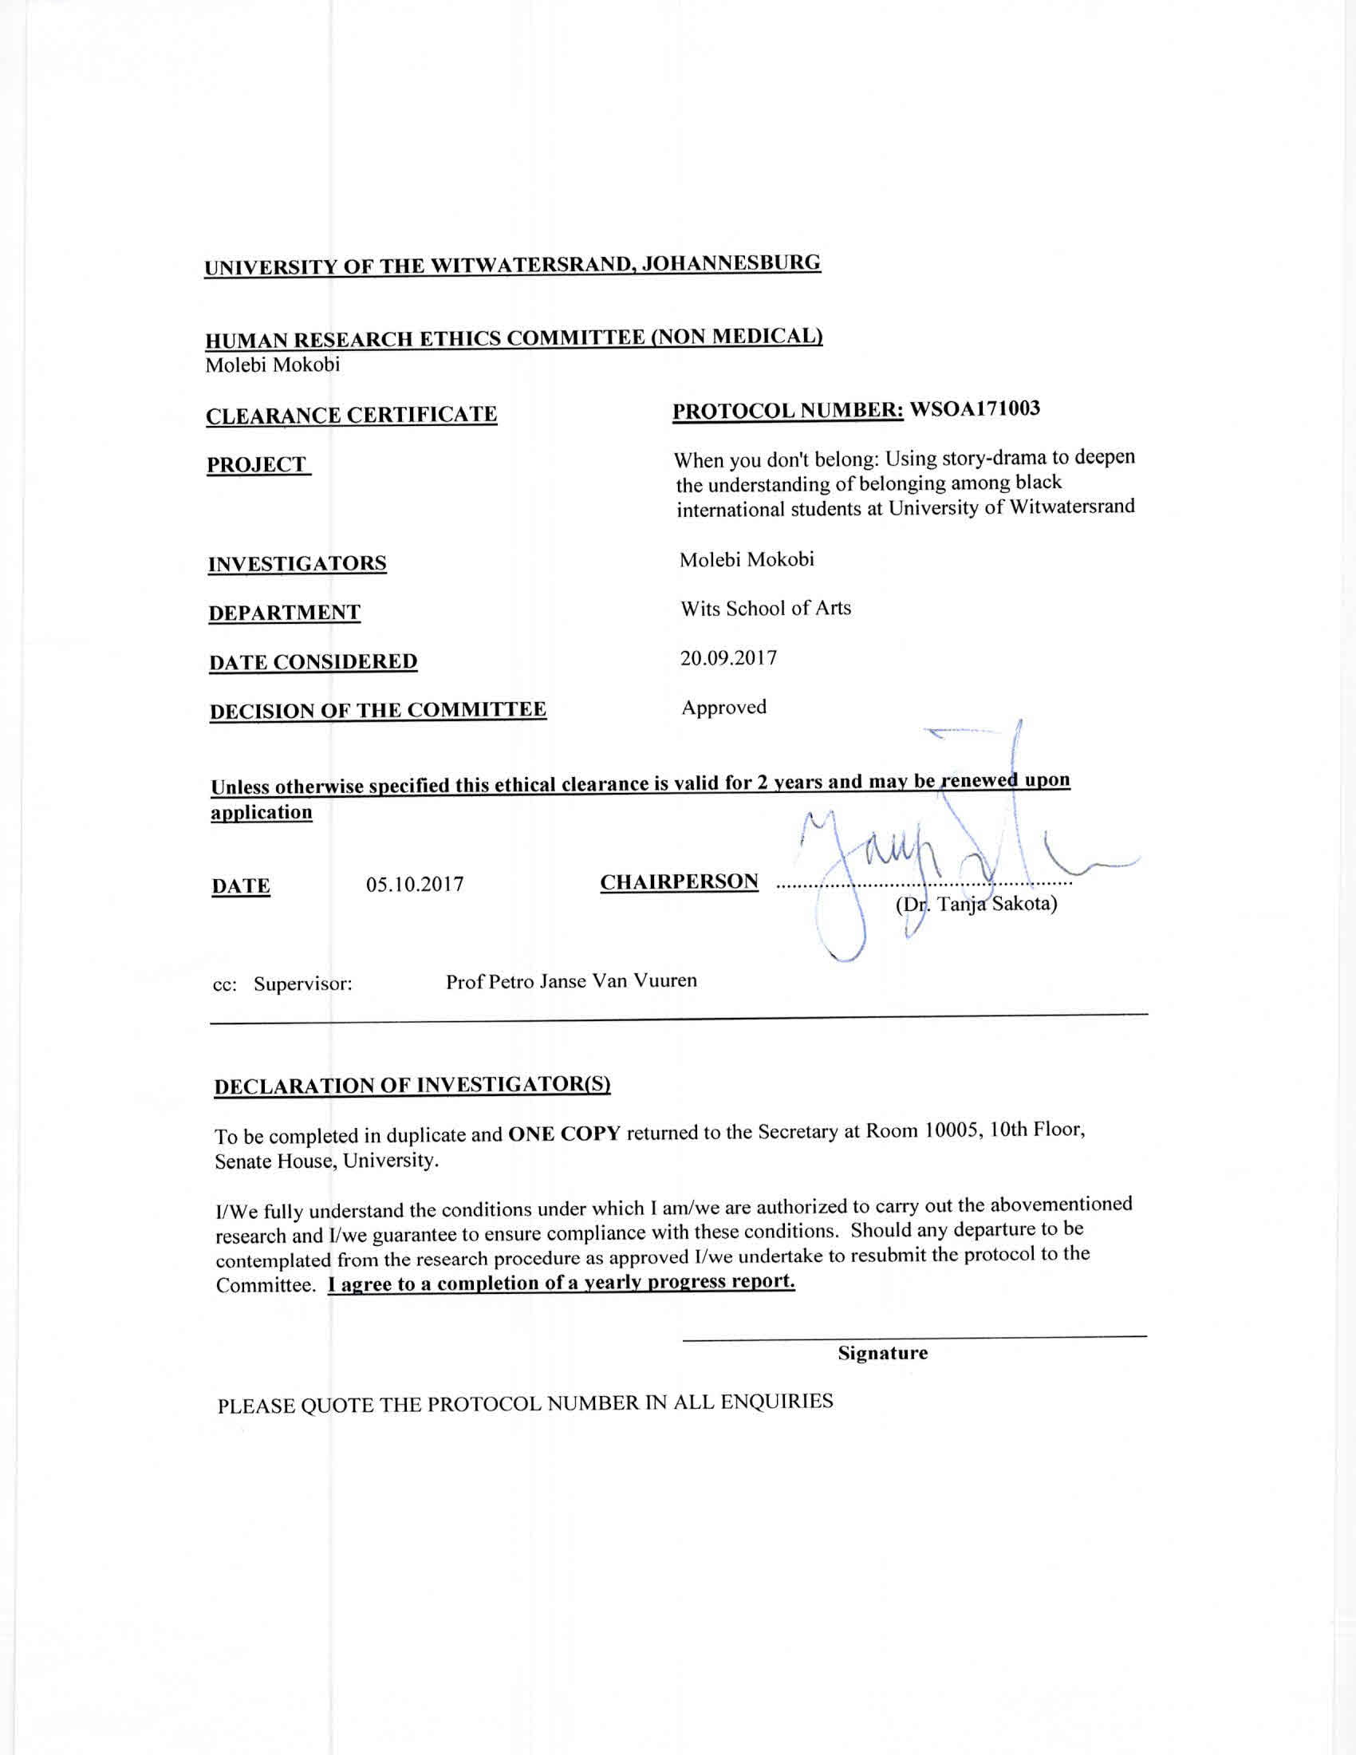

Appendix B: Turnitin Report
