University of the Witwatersrand School of Architecture and Planning

The Flexibility of Urban Planning Policy, Processes and Outcomes in Response to Cultural Diversity

By
Angeline Ramahlo

A Thesis Submitted to the University of the Witwatersrand , Johannesburg in Partial Fulfilment of the Requirements for the Honours Degree in Urban and Regional Planning .

December, 2015

Contents
1 Chapter 1: Introduction. 4
1.1 Introduction. 4
1.2 Problem Statement. 8
1.3 Purpose of the Study 10
1.4 Methodology 11
1.5. Outline of the study 13
2 Chapter2: Literature Review 15
2.1 Introduction 15
2.2 The Foundations and Evolution of Planning Theory. 17
2.3 Contextualising planning within the cultural values of society. 21
2.4 Participation and Power 26
2.5 Planning policy in the South African context 33
2.6 Planning Policy and Processes Within the Context of Johannesburg. 35
2.7 Chinatowns and Chinese Culture 42
2.7.1 Chinese culture, value systems 45
3 Chapter 3: Research Methodology 50
3.1 Introduction 50
3.2 Qualitative Research Methodology 51
3.3 Quantitative Research. 54
3.4 Ethical Considerations 55
4 Chapter 4: Case Study 56
4.1 Introduction 56
4.2 Setting the Context of Planning and Challenges in Cyrildene 56
4.3 Background History of Cyrildene 57
4.4 The Cyrildene Precinct Plan 65
4.4.1 Phase 1: Research and analysis. 65
4.4.2 Phase 2: Development of land use controls and standards 66
• Stakeholder involvement. 66
4.4.3 Phase 3: Development of Precinct Plan key recommendations and Interventions. 67
4.4.4 Phase 4: Implementation phase 67
4.5 Interviews 67
4.5.1 Development control Proposal 70
5 Chapter 5: Recommendations and Conclusion 73
5.1 Introduction 73
5.2 Recommendations 73
5.2.1 Flexibility of process 73
5.2.2 Flexibility of Cultural expression 75
5.3 Limitations of the Study 77
5.4 Conclusion 77
6 References list 80

List of Figures, Maps and Tables
Figure 1: Spatial manifestation of apartheid City model in Johannesburg 5
Figure 2: Apartheid City planning model 5
Figure 3: Traditional Nguni Kraal 16
Figure 4: Representation of a normative modern Single-family unit. 16
Figure 5 : Sherry Arnstein, A Ladder of Citizen’s participation (1969) 30
Figure 6: A synopsis of the hierarchy of planning policies in the City of Johannesburg. 40
Figure 7: Guideline for policy formulation process 41
Figure 8: Chinese traditional Siheyuan compound 47
Figure 9: Illegal land use chart 64

Map 1: : Clustering of Chinese enclaves. 58
Map 2: Business area on Derrick Avenue 59
Map 3: Cyrildene land use Zoning 60
Map 4: Illegal backyard residential buildings 61
Map 5: Residential properties in Cyrildene display signage whicich is not permitted 62
Map 6: Illegal land uses 63

Table 1- Illustrates the external Stakeholder meetings that were held by the City of Johannesburg during the development of the Cyrildene Precinct Planning Process. 66
Table 2: Proposed development controls for the Study area. 71

Chapter 1: Introduction.

Introduction.

Despite growing criticism, urban planning has largely remained a technical process concerned with the rigid arrangement of land use, supporting transport planning systems and infrastructure (Taylor and Nigel, 2007). The traditional system of master plans as frameworks for guiding development has enabled planning to develop in a disconnected relationship to the urban environment without taking cognisance how this ‘technical focus’ affects people and the ways in which they use land. This continued paradigm of planning, often referred to as ‘modernist planning’ is well described by authors such as Beauregard(1996), Campbell and Fainstein (1996) and Fainstein (2005).
The ‘survey before plan’ principle in which Geddes asserts that 'there is a need to unearth the layers of cities downwards, into their original past and thus we must read them upwards, visualising as we go” has continued to be a central idea of planning ideology (in Hall, 1988:142). Hall (1988) asserts that planners must have the ability to integrate the multifaceted histories, qualities, recollections of urban environments and their inhabitants into the planning process. We must conduct several cultural mappings that in turn will encourage locating people's memories, visions and beliefs before we begin planning. Cultural mapping is undertaken specifically to identify, investigate or reclaim community’s strengths. Once these strengths have been identified, they can be utilised to create a wide variety of outcomes. This idea is borne by theorists such as Freire (1970), Lynch (1960), Chambers (1983) and Jacobs (1961).
The South African City is partly a product of apartheid policy (Smith, 1992; McCarthy and Smit, 1984). The ideology of racism was the social context within which racial segregation in South Africa was forged (Smith, 1992). Although evidence of this ideology still exists in South Africa, there has been a paradigm shift. According to South African History Online (2015) an attempt to confront these obstacles will be subject to a number of factors such as the availability of resources, policy choices, and constraints imposed on the country. South Africa has made significant progress in the past decade; however, efforts to develop the conditions for normal people have to continue (South African History Online, 2015). Although obvious forms of discrimination have declined and the City is promoting socio-economic integration, planning policy is still criticised by authors such as Beavon (1992), Berrisford (2013), Dewar and Uyttenbogaardt (1991), du Plessis (2013) amongst many others for the lack of consultative process and the inability to address the concerns and needs of the community as proposed by critiques of modernism.
Throughout the apartheid regime, planning established itself as a rational technocratic system through master planning whereby planning was used as an instrument for realising racial segregation (Harrison and Khan, 2002). Based on the British system of planning, the City was organised and separated along class a racial classifications (Smit and McCarthy, 1997) see figure 1 and 2.
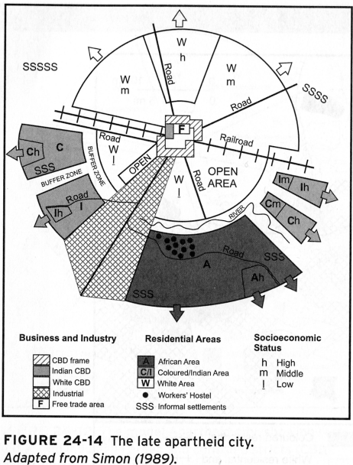
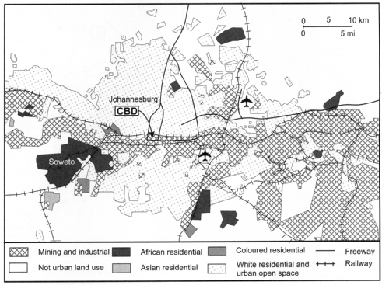
(Cole and Blij, 2007)
Figure 1: Spatial manifestation of apartheid City model in Johannesburg
Figure 2: Apartheid City planning model
Under the apartheid government, the City was organised and separated according to ethnicity, race and class and therefore, social, cultural and economic interactions were kept to a minimum with tightly controlled social and public spaces (Tomlinson et al, 2003). Vast spaces of buffer strips were intentionally inserted between different social and class groups, and were made virtually difficult to pass through (see fig 1 and 2).The state dictated and had the final say in how South African cities should be developed with little consensus from the majority of the cities inhabitants (Parnell and Mabin, 1995).
In the 1960’s, there was a gradual but steady exodus from the urban core of the Inner City in favour of suburbanisation (Garner, 2011). This eventually resulted in the formation of middle-class life that was almost exclusively located in ‘white’ suburbs. Thus, the history of Johannesburg has been one of an ongoing and more firm segregation based on race and class (Tomlinson et al, 2003). These areas then served as a means of maintaining cultural and class homogeneity. As Smith (2003) points out, in the ‘multicultural City’, populations with equal rights but different traditions and ways of life coexist with varying degrees of comfort and discomfort.
Racially segregated areas served as spaces whereby cultural expressions could be freely observed with little objection and interruption. According to Bahmann and Frenkel (2014) this racial and class segregation forms the foundation of the enclave mentality in Johannesburg. The apartheid regime intentionally eradicated cultural and racial mixing in order to prevent diversity. It established a social norm that was based on uniformity or homogeneity. Whilst numerous examples of resistance to this norm exist, there is a culture of uniformity within suburban environments in both the past and present forms of Johannesburg. The same uniformity is visible within the built form of older established suburban areas.
The cost of living in cities that are segregated is that whilst diverse contacts disappear, social differences are more insensitively apparent, and the proximity to people from dissimilar groupings is considered “dangerous”, therefore emphasising the need for distance, privacy and security (Caldeira, 1999).
Despite various attempts post democracy, outdated systems and planning process are still applicable in current urban planning decision-making process. The built form has been fairly stagnant and consistent in most suburban areas. In the last decade or so there has seen a reaction against the homogeneity, isolation and predictability of the suburban lifestyle by various sections of society, especially in areas where there is a strong presence of migrant enclaves. The resistance to this uniformity has been met by a substantial amount of disapproval from residents in these areas. There has been a call for the municipality to react to this disruption to “normal life” as the older resident’s term it. In some of the areas the municipalities approach has been to develop a Precinct Plans that would attempt to address and accommodate the infiltration of land uses and rapid changes that are occurring in these once quaint residential areas.

Cities struggle with various challenges that are as a result of the built environment. Some of the key issues include space equity, environmental health, transport planning, residential settlement and design, discussion with the public, culture, and identity, in addition to rigid institutional and traditional and predictable systems of urban planning (Leung, 1989). Traditional development planning practices and processes of previous administrations were criticised for showing no social justice in dealing with challenges of the built environment in development of cities and urban areas.

Leung (1989) asserts that setting the plan for planning determines basic parameters, which include priorities for the community, resources that can be devoted to it and the programme for planning. Leung argues that the reason master plans will never work is due to the fact that they are vague and deterministic at the same time. Cities are in a constant phase of change, thus any long-term planning will not be able to address the changing state of cities rather planning should focus on critical issues (Bryson and Crosby, 1989; Forester, 1989)
In the South African context local government has since its commencement introduced a sequence of policies and legislation intended to address spatial planning issues such as environmental health and safety, integration, sustainability, housing etc. These policies and legislations have achieved unprecedented growth; however, they have been met with a lot of criticism from authors such Mabin and Smit (1997), Parnell (1993), Todes (2012) and others who argue that whilst the affluent are reacting positively to some aspects of planning, efforts to move in the direction of better spatial equity remains challenging.
Urban Planning has evolved over recent years and has seen the transformation and fundamental role of planning in relation to the ways that society lives. There has been a move in favour of more democratic planning approaches in the development processes (Mabin and Smit, 1997). Mabin and Smit (1997) argue that the principal instrument for rebuilding society has been recognised to lie in urban planning (Watson, 2014; Harrison et al, 2008). Post-apartheid Government has endeavoured to rebuild society and cities by developing new institutions, visions, laws, systems and plans that would respond to the needs of all citizens equally. The public is recognised as a critical partner that plays an important role in the planning and decisions making process.
Post 1994 there was a call for a more transformational government that would address spatial inequality problems that came about as the result of apartheid planning (Todes, 2006). Todes (2006) asserts that post 1994 policies such as the White Paper on local government, were built on the academic critiques of the apartheid planning systems (Todes, 2006; Harrison et al, 2008). The White paper on local government outlined the mandate of local government. Amongst other things, it called for institutional transformation of the spatial planning practices of the apartheid regime, which would be dependent on local government (Todes, 2006; Harrison et al, 2008). The principal was that local community participation and experience would feed back into the decision-making process of legislation and procedure in order to ensure that the communities had ultimate power in giving inputs in terms of developments (Parnell and Peterse, 2002). Participatory practice is an instrument that is often utilised to engage with communities. Its understanding and practice is however frequently a reductive one that intends to gain consensus from communities in relation to their needs rather than making them part of the process from beginning to end. Failure in this realm is more frequent than is generally believed and this might be attributed to the failure of processes to genuinely interface with communities (Low, 2010)

Problem Statement.

Past frameworks dating back to eras of imperialism, colonialism and most recently, apartheid have utilised political power as a means of influencing and shaping spaces in cities. These administrations have resulted in negative outcomes for space that have resulted in the fragmented City form. In an attempt to resolve these disparities, new urban policies are constantly being developed and implemented. The problem investigated in this study concerns the ability of local government to overcome past legacies through different approaches to flexible policy development and the involvement of communities and whether the cultures within communities have any influence during the policy-making process, which may affect the outcomes of these policies.

As a result, of the history of past planning regimes, parts of South Africa’s population have been left out of participating in planning processes. The imperative to accommodate different needs in newly produced planning systems and policies has been little understood. A renewed approach was required post-apartheid to deal with disparities in planning and thence the function of planning, required reconfiguration that would make it more responsive to the needs of communities (Platt, 2004).

In the book “The Planning Playing Field after 10 years of Democracy”, Platt (2004) provides a summary of the changes that took place in the planning vocation because of the political transformation that occurred in the first 10 years of democracy in South Africa. Post-apartheid local government was tasked with the administrative and legislative authority over planning which was seen as the most significant transformation in planning. This approach was founded on a system of integrated development planning, which was previously not required. This new approach brought about a critical change in terms of the importance of the role that local government contributed in strategic planning (Platt, 2004).

Even though socially responsive planning is not a new concept, community-led and socially conscious systems of planning, as a form of community engagement lacks adequate consistency. Planners are frequently criticised for not linking their work, sharing information, or learning from communities’ experiences within which they work. The impact of planning is often unsubstantiated, remote, or indiscernible, which inhibits the work from gaining the public interest and support it ought to have (Platt, 2004).

According to the Municipal System Act of 2000 any piece of policy or legislative framework needs to involve participation with all affected stakeholders, the community included. The question at hand is the legitimacy of the process that are undertaken in order to ensure that all affected stakeholders legitimately participate in the development of these policies and or legislation.
The chaos that arose as a result of the Industrial revolution indicates that there needs to be some degree of regulation and planning in terms of the manner in which land is used. A plan can take a variety of forms and detail such as spatial development frameworks, on a broader scale, to urban development frameworks and more comprehensive and detailed plans such as Precinct Plans and incentive strategies. Public sector planners are mostly responsible for enforcing and implementing the preferred policies and plans. However cities and urban areas alike are in a contestant phase of transition. This results in a growing demand for the change of different land uses in different areas for different reasons and thus planning policy guidelines should take into cognisance the changing circumstances and context of the cities inhabitants and their needs and thus provide a regulatory framework that is able to accommodate the changing nature and circumstances of urban area.
The purpose of planning is to regulate the manner in which land is used, protect the environment to create and encourage sustainable development amongst other things. The perception and meaning of the use of space varies from individual to individual. In communities that are rooted in culture there are certain roles in which the need for the uses of different space should be expressed. However, planning policy tends to be a rigid standardised process which in some instances may limit the freedom for individuals or communities to freely express their needs. According to legislation and Municipal By-laws any change in land uses needs approval of council before it can be exercised. The process of the assessment of land use applications is guided by a number of land use policy frameworks and numerous legislative frameworks.
A lot of planning paradigms and theory provide different methods and processes which can legitimately include communities/stakeholders in the planning process. Cities should not be planned in isolation of the inhabitants of the area, as they are the ones who will live and experience the built environment on a daily basis and thus their particular needs should be met and in the same token protected in terms of the environment that they inhabit.
The problem therefore to be addressed revolves around the ability of local government policy processes to legitimately involve diverse stakeholders in the process of deciding how their neighbourhoods should develop over time.The purpose of this report will be to examine how flexibleurban planning policy, approaches and outcomes are in responding to different cultural settings? The case of a relatively recent development of a Precinct Plan for Johannesburg’s “Chinatown” will be used in order to review this question.
Further sub-questions include:
- What is the intended purpose of planning?
- What mechanisms are used to regulate land uses?
- How are processes of formulating planning regulation mechanisms achieved?
- What is the role of culture in planning and development processes and how is culture manifested in space?
- How can planning processes positively contribute to promote cultural difference?
- Are processes of consulting the community through planning mechanisms ensuring that communities have maximum influence on how their neighbourhoods are developed?

Purpose of the Study

The system of government that regulate planning policy and processes, under which most planners are required to work, tend to obstruct the efficiency and efficacy of the planning process. Notwithstanding rising criticism, planning remains a largely technocratic process that is exorbitantly concerned with “procedure” and technocratic bureaucratic processes. Despite criticisms of planning, the manner in which land use management is regulated is still processed in terms of bureaucratic procedures that are guided by rigid rules and regulation which sanction for very little scrutiny from the public (Taylor, 2007). Government initiatives are often met with criticism and resistance from the community, owing to the fact that government does not follow thorough consultative processes and that various programmes are simply “forced down communities throats”. Are there ways in which the participatory process can be improved given the bureaucratic processes and constraints that municipal planners have to work under? Can synergy and compromises be solicited amongst the different cultural settings that coexist within the cities? A case in point is the Chinese community located in the suburb of Cyrildene that has experienced a rapid change in land uses that are occurring outside the bounds of the applicable planning regulatory frameworks of the City of Johannesburg.

Methodology

The study will adopt the case study approach, which will focus on a suburb of Cyrildene in Johannesburg with a strong presence of a Chinese cultural enclave, located east of the City. The study is intended to look at the question through a range of lenses. As Yin (2013) explains, a case study is an experiential investigation that examines a current phenomenon contained by its contextual background. Yin (2013) argues that the limitations between phenomenon and background are not always obvious and hence several sources of substantiation should be used. It is for this reason that a number of other methods are used including photographic analysis and interviews in order to substantiate some of the phenomenon. Yin (2013) explains that case study research includes single cases and studies over a comprehensive period. However, given the level of this report the time period in which the study is conducted is limited and thus the period that will be spent into research will be brief.
“Case studies are not a method of data collection, but a research model which employs a number of methods of data collection and analysing a variety of contexts” (Yin, 2013: 222). The case study will assist in answering the research question, which is “How flexible are urban planning policy processes and outcomes in responding to different cultural settings: A case study of the Chinese community in Cyrildene.” Desk-studies of relevant research publications and reports will also be done to complement the primary sourced data. This will also provide a deeper understanding of the phenomenon of the influence of culture on policy planning. The research approach will also be influenced by the knowledge I gained as a Planner for the City of Johannesburg working within the area. The positionality of my being an “insider” to the organisation is discussed in the Research Methods chapter.
The study seeks to understand the problems associated with implementing successful and pragmatic planning policy as they stem from each individual community and the flexibility of the processes and plans that are followed in resolving these problems. I accept that the approach and interpretation in this study will be informed by my own experience as a municipal planner working with projects within the specific case study area.
Planners should place a strong value on shared space in urban communities and a strong belief that community members should have a voice in the functionality of their own environments. I have identified a lack of understanding of the dynamics of the various areas from the perspective of both communities within and outside of these cultural groups, including the City. Theory around researchers being part of a member group of the study will also be examined as part of the study process is partly influenced by the perceptive of the researcher as a member of one of the groups under examination.
The study is conducted with the intention of improving participation strategies, practice and means of gaining knowledge of the environments in which communities live and the City regulates within a normative position of celebrating diversity and change. The study will draw attention to the need for this type of research and encourage further research. This research is meant to encourage debate and discussion so that positive change can take place. By recognising propositions for the field, the study will increase the importance and support for the furthering of this type of work. A greater understanding of the responses of the residents living in and around cultural enclaves will also be useful, including their perceptions of changes, and overall satisfaction with their neighbourhood, which can be used for future reference.
Dandekar (1986) asserts that qualitative research is mainly tentative research, which will be useful and used to inform the outcomes of the study. It will be used to gain an understanding of the fundamental rationale, opinions and motivations. It provides insight into a phenomenon or helps to develop ideas or hypotheses for potential quantitative research (Dandekar, 1986).
The qualitative method of research will be used to collect data and information in the form personal interviews with City officials, members of the communities both from within and outside these cultural settings. Observations by the researcher will also form part of this research. Qualitative data is also valuable especially concerning the understanding and analysis the implicit elements that are not available in any literature and also to help source the information that will be relevant to the research report.
In accordance with the main objectives of the study, these interviews will give insight into how the different members of the communities perceive their ability to influence and some of the possible tensions between diverse members of the community and the City, that are as a result of cultural differences.
Quantitative research is used to explain phenomenon by means of collecting numerical data that is analysed using mathematically based methods (Tashakkori and Teddlie, 2000). Although not the main research methodology of the study, quantitative data, which was obtained from the City, will be used to determine development trends in this area to demonstrate the nature of development of the area and how space is used. For the purpose of this study and given the limited time, the study will only concentrate on a small portion of the greater area where there is a concentration of these enclaves. This will substantially narrow the scope of investigating in order to create in-depth exploration and to draw a stronger conclusion and provide a sample that may have broader relevance.
Photographic images in the case study will also be used and analysed to visually assess the impact of these changes on the environment. Photography can be used in aid of substantiating qualitative data. Photography is also seen as presenting less biased recordings than personal observations. In addition, they can also be critically analysed by others in their original state (Tashakkori and Teddlie, 2000).
The literature related to this study seeks to use and focus on the work of various theorists in order to introduce the concepts of planning policy processes and outcomes, participation, power and culture and its implications not only for communities and the neighbourhoods they live in but also decision makers by exploring these theories within the context of Cyrildene and Chinese culture.

1.5. Outline of the study

This research report is composed of five chapters including this introductory chapter. This chapter has outlined a background to the study with a particular focus on the complex and diverse nature of South African society and the legislative constructs that are in place. This chapter has also provided the aim of this research, which is to understand why this is an important area of study. The aim of the research was put forward as understanding ‘flexibility’ in a context of policy and to understand this within a specific diverse context of Cyrildene which has in the recent past acquired a Chinese cultural influence.

The second chapter will explore the meaning of flexibility as a concept in relation to culture, participatory frameworks and power in diverse societies within the inherited and current policy frameworks. The concept of flexibility will be discussed in chapter two by looking at ideas of participation, culture and power amongst other issues and a conceptual framework will be developed from this.

Chapter 3 will outline the research methods used. Firstly, the study will outline the effectiveness of using a case study as method of research in relation to research question. Secondly, it will be argued that this study is best framed within qualitative, quantitative and visual methods of research. Lastly, the different methods used in the study will be motivated.

The fourth chapter will analyse the Cyrildene Precinct Plan the case study as per the recommended methods suggested in chapter 3. The suburb of Cyrildene was chosen as to be analysed whereby the city of Johannesburg has embarked on a processes to develop a Precinct Plan within a context of a Chinese enclave. Collected data, interviews and photographs will assist in illustrating whether the Cyrildene Precinct Plan was flexible in accommodating the diverse needs of the community whilst being sensitive to Chinese culture that exist in the area. As stated earlier the Precinct Plan has been met by resistance from the community members in this area and the plan has since been put on hold as a result of this resistance.

In conclusion, chapter five summarises the approach taken by the research and the findings that have resulted due to the investigation done on the Cyrildene Precinct Plan.

Chapter2: Literature Review

Introduction

In order to assess “how flexible urban planning policy processes and outcomes in responding to different cultural settings in the City of Johannesburg”, an exploration of flexibility as a concept will underpin the study. The study will focus on the significance and evolution of planning practice and the power that communities can have in influencing the process of determining appropriate urban planning policy processes and outcomes in relation to cultural practices. Amongst the theories on planning practice, power and culture, there are a number of prominent writers that are relevant with regards to this research. The following chapter therefore examines the work of these theorists as they will create a framework of understanding the way in which planning policy formulation and outcomes should be developed and adopted by planners and allow for one to evaluate flexibility of planning policy and outcomes. The investigation of these theories will allow for an insight in understanding how it might be possible for planning to accommodate diverse needs without necessarily being excessively rigid and totalitarian.
Perhaps the pioneers of the modernist movement such as Le Corbusier and Ebenezer Howard were accurate in arguing that there is a uniform public interest, perhaps the excessive complexity of diverse public interest prevents planning from efficiently serving communities (Campbell and Fainstein, 1996). Perhaps design is an active force that can direct the community onto paths of social harmony (Fishman, 1996). Howard and Le Corbusier’s theoretical approach was based on the notion that the creation of better living conditions and a better society could be achieved through uniform physical environments.
For many years, society had certain customs and traditions that informed by their culture, this was inherently expressed in the built form. With the introduction of laws/legislation, society had to learn to adapt to living and doing things within the bounds of legislation that dictates how they can or cannot build. Historically buildings were configured according to the needs and customs of that particular community/society as illustrated in figure (3). Figure 3 depicts how a single property served multi-purposes for a single traditional African family. Harvey (1973) argues that even the spatial layout of primitive cultures was reflective of social relationships amongst groups and not merely a form of architectural expression but how they attached meaning to space. The allocation of space was determined by the leaders of communities and the users of that space who could freely choose how they made use of that space. Any disputes were settled through negations and discussions with affected parties.
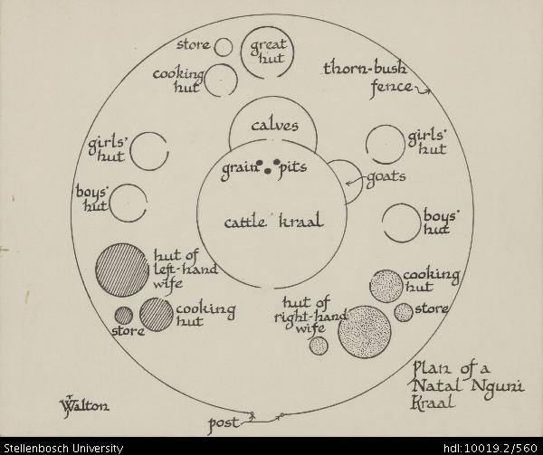
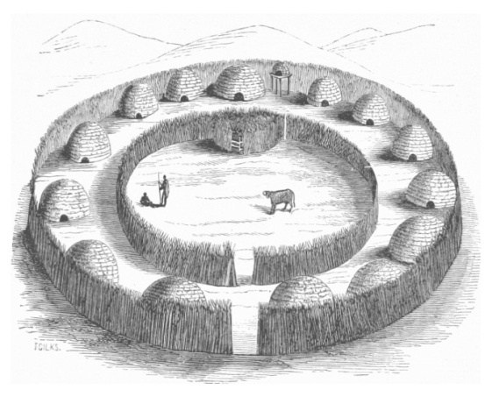
(https://digital.lib.sun.ac.za/handle/10019.2/560)
Figure 3: Traditional Nguni Kraal, depicting how a single property serves multi-purposes for a single traditional African family.
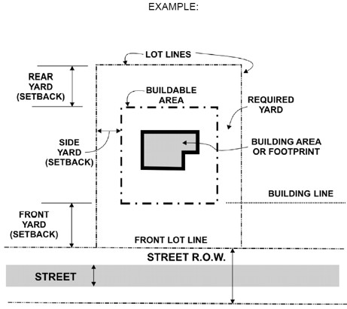
In recent days, there are limitations in terms of what one can and cannot achieve on one’s property as indicated on figure (4) below and what is acceptable and normative in terms of the built environment. In order for one to expand on the uses that are permissible on their property vigorous town planning process need to be followed in order for one to achieve this.

(http://gis.stackexchange.com/questions/156896/drawing-zoning-setback-lines)
Figure 4: Representation of a normative modern Single-family unit depicting building restriction and what is architecturally acceptable model of buildings.
In order to explore Cyrildene, it is imperative to try to understand the history of Johannesburg and how this area has developed, adapted to or challenged the course of that history. As stated in chapter 1, as an apartheid City, Johannesburg’s landscape and infrastructure are extremely fragmented. Under the apartheid regime, the City was organised and separated according to ethnicity, race and class and therefore, social, cultural and economic interactions were kept to a minimum with tightly controlled social and public space (Tomlinson 2003). Post-apartheid the City has moved towards a more strategic, integrated and transparent form of planning which desires to address the spatial inequalities that were as a result of apartheid planning.
The following section therefore includes the work of theorists that have taken a participatory approach to planning policy processes and outcomes thus creating a framework for interpreting and investigating the power that the ordinary citizen has in influencing in policy planning process and outcomes in relation to their cultural practices and the flexibility of planning policy to facilitate this. The following section also gives a partial narrative adequate to provide a sense of the themes and relevance of how planning theory has evolved from a technocratic process to a process that envisions a strategic and flexible approach, which takes into consideration inputs of diverse and multiple needs of cities inhabitants.
Flexibility or robustness as Bentley at al (1985) put it is the adaptability and liveability of space as a user requires it. The more robust space is the more flexible it is to various users. The objective of flexibility is to make spatial and constructional organisations suitable for a range of likely activities. The growing demand for diverse land uses in Cyrildene necessitates that flexibility must be adapted in the planning process in order facilitate positive change. The growing number of recorded illegal land uses in the area demonstrates just how necessary the need for policy to adapt is.

The Foundations and Evolution of Planning Theory.

Planning is a multifaceted discipline that aims to resolve multifaceted objectives. Planning was born out of the idea of the ordering and regulation of space in order to create spatial order and safe environments. The initial modernist approach to planning was concerned with creating a humane and equitable substitute to the terrible conditions that many City inhabitants faced during the 19th century as a result of industrialisation (Beauregard, 1989). The modernist approach to planning was rooted in the belief that the physical environment can change society. Utopian cities could be created through master plans that detailed programmes for radical social change in the distribution of wealth and power (Fishman, 1977). The intention of modernist planning was to combine the good elements of town and countryside in a rationale and ordered plan (Fishman, 1977). Modernism is a system of approach influenced by Fordism, which is a term broadly used to illustrate the system of mass production that was established in the early 19th century. Modernism was rooted in the rejection of traditional ways of thinking in favour of the application of scientific knowledge and reason to resolving human affairs (Healey, 1992).
The initial modernist attempt at creating planned cities was achieved through master planning which sought to transform cities through the reconstruction of cities and satisfying the needs of the masses, especially housing. The principle foundation of master plans was the rejection of gradual improvement of cities in favour of extensive planned mass reconstruction of whole cities that would create controlled environments that would lead to controlled and content societies (Fishman, 1997; Friedman, 1987; Campbell and Fainstein, 1996). The plans defined land uses, appropriate locations and indicated how a City should be developed (Pieterse, 2002). Therefore, these plans were deterministic, rigid and technocratic in nature informed by very little input from the public. The creators of these plans were viewed as having sufficient knowledge in determining how cities should be developed. Taylor (2007) argues that the role of the planner has changed significantly. 50 years ago city planners literally planned City through master plans. More recently, the role of an urban planner is to manage development in order to balance conflicting needs (Taylor, 2007)
There has been a radical change in planning thought that seems to advocate and put emphasis on the importance of involving the community in planning processes. Whilst participatory planning has gained importance as a crucial part of academia over the past two to three decades, a substantial amount of this philosophy is yet to be practiced by planners, developers and various public institutes. There is a variety of explanations for this, from the vagueness of its designation, to a lack of sufficient evidence about what works in addition to the difficulties of responding to the intricacy and diversity of urban convivial life (Platt, 2004).
The postmodernism era called for the transformation of top-down technocratic planning to a more participatory process of planning (Fainstein and Fainstein, 1996). During the postmodern era, advocacy planning emerged as a drastic change from past planning theoretical models. The advocacy planning model asserts that there are great inequalities in any political system and in the negotiating process between various factions of society that result in large unorganised and unrepresented numbers of people being marginalised in the planning process (Fainstein and Fainstein, 1996; Harvey, 1985). Postmodernism is rooted in the belief that planning processes should ensure that all people are equally represented in any given process and advocates for the interests of the underprivileged whilst soliciting social change (Angotti et al, 2007; Fainstein and Fainstein, 1996).
Key proponents of the postmodernism paradigm believe that underprivileged and exploited people should be, enabled to analyse their own reality as a basis of inspiration for the participatory planning movement. Lewis Mumford (1895) particularly noted that urban planning should put emphasis on the natural relationship between communities and the spaces they live in. Proponents of postmodern planning approach attack the philosophy and objectives of modernist planners, traditional City planning for having a misunderstanding of how cities actually work (Jacobs, 1961; Gans, 1969; Webber, 1963). These proponents assert that the most appropriate information on liveable cities stem from close observation of City life rather than deductive theories or master plans.
The common theme amongst the critiques of modernist planning in the 1960’s was that “good” planning couldn’t be achieved in isolation of taking into consideration the needs of the people cities were planned for (Jacobs,1961; Davidoff,1965; Healey, 1992). According to Jacobs (1961), responsive planning embraces various aspects social, cultural, ethnic, gender differences. It also intends to reallocate power and resources equitably. In the process of developing strategies for public intervention and participatory democracy, socially responsive planning recognises that those communities affected by an environment have the fundamental right to determine its outcome (Jacobs, 1961). Landman (1987) emphasises that “social drivers influence spatial change leading to specific social interpretation and response” (Reinstra and Hook, 2006: p8).
Most of the recent planning theory since the 60’s has revolved around aspects that seek to improve and change the technocratic ideals of planning, by advocating for planning to be more receptive to the desires of communities rather than communities being responsive to environments determined for them in terms of rigid master plans (Reinstra and Hook, 2006, Huxley, 2000). Planning systems are more often than not criticised for being too rigid and deterministic. Most urban settings are composed of people from diverse backgrounds, with diverse needs. Given the complexities that exist within cities, the purpose of this report is to focus on the relationship between culture and the flexibility of planning in responding to these diverse needs that exist within communities. In essence, proponents of advocacy and communicative planning promote the idea of communities being able to influence the outcomes of the environments that they live in.
Adler (1979) (as cited in Morris, 2006) argues that it is essential for government to impose restrictions on land uses, however such restrictions should be taken in the context to which the ordinary citizen should have a say in the matter. Cities are constantly evolving and so do the needs of the people living in cities. This results in a growing demand for the change in the manner in which land is used, in different areas for different reasons and thus policy guidelines should take into cognisance the changing circumstances and context of the cities inhabitants and their needs. Therefore planning policy needs to be able to be robust enough to respond to these changing circumstances.
Angotti et al (2007) assert that public participation is a fundamental component of the advocacy-planning model. Varieties of public interests are assumed in the advocacy model. The role of the planner in this model is to either facilitate directly for underrepresented groups or support communities to become part of the process. What is crucial to note is that this theory of planning puts public participation at the centre of the decision-making process. Decisions are made first by the public, and the planner plays a minor facilitation role (Angotti et al, 2007).
Another more recent departure from modernist planning is known as communicative planning (Healey, 1992). Communicative planning theory has emerged as one of the most important planning approaches during the past two to three decades by proponents such as Habermas (1984), Lukes (1974) and Foucault (1980). It proposes a political field whereby decision-making on collective issues is made by all stakeholders involved. Communicative planning advocates for the flexibility and adaptation of policies and their implementation to localised circumstances (Huxley, 2000; Reinstra and Hook, 2006).
Although there are consensus that citizens play a vital role in the development process, planning theories suggests a number of ways in which citizens can be included in the planning process (Harvey, 1996). Given the complexity of planning no one system can be applied universally in every community as circumstances vary. It is up to the discretion of the planner to decide the most appropriate manner/method in which this can be achieved. However how do planners then measure if a plan has achieved the collective objectives of all stakeholders? Various methods of participation are proposed by various proponents with varying characteristics. These methods have long been used in public participation and have been viewed as having remarkable benefits and advantages that have proven to be effective for a long time in the field of planning (Sillitoe, 2002). It should be noted that there are some disadvantages of using them, which cannot be ignored for the results that they yielded in terms of the quality and quantity of the planning processes.
Campbell and Fainstein (1996) state that planning is a vague subject, which draws on a variety of disciplines and thus has no real norms and standards as a simple definition of what planning is limits the scope of planning. Planning is a process of decision-making in order to achieve certain objectives. In terms of planning there is no one objective and no one method of achieving the objective hence the difficulty with a universal definition for what planning is.
The above section has highlighted the rational of why the focus of planning theory has evolved from a technocratic process to a more inclusive and democratic process, that should be guided by the needs of citizens. The next section aims to understand how planning participatory process can be understood in responding to cultural differences that are characterised by particular attitudes, beliefs, values, traditions.

Contextualising planning within the cultural values of society.

In understanding the contextual background of communities, it is important to assert the factors that shape the norms and standards of communities. Theories of culture are useful for this study. The cultural turn is centred around the awareness of cultural contexts and their significance in the planning process (Knieling and Othengrafen, 2009).

A City is manifestly a complicated thing. Harvey (1973) acknowledges that the difficulty with dealing with this complexity is with the failure to conceptualise the situation correctly. If the concepts are incorrect then we cannot formulate appropriate policy solutions. Any theory of the City must relate to the social process of spatial form. Sociological imagination as Harvey (1973) calls it enables individuals to recognise the role of space and place in their own biography.

Notable proponents of anthropology and sociology such as Hall (1966), Webber (1963), Hallowell (1955) and Lorenz (1966) amongst others recognise the significance of spatial dimensions in social process. Webber (1963) advocates for greater awareness of the social process as a vital component that needs to be considered by planner in spatial design (Harvey, 1973). Thus, there is a strong appeal by anthropologist and sociologist for planning to incorporate “sociological imaginations” such as culture into the context of planning.

Sociological imagination refers to the symbolic or imagined meaning of space in relation to culture. It is the particular qualities given or associated to a place. Multicultural cities face a dilemma of how to balance the acknowledgement of cultural differences and conflicting use of space. In order to assess the interrelation between culture and space it is critical to understand how culture is manifested through space (Mercer, 2006). This will enable one to understand some of the factors that need to be considered in order to assess the role that space can play in allowing people to express their cultural needs. Ethnic or cultural approaches assume that identity as a distinct ethnic or religious group is of fundamental importance to understanding people’s role in the political process (Freedman, 2000).

Harvey (1937) argues that social processes are different ways of thinking about the same thing. Not taking these differences into consideration may lead to the risk of creating contradictory and irrelevant strategies of dealing with problems in the City (Harvey, 1973). Therefore it is crucial to relate social behaviours to the way in which the City assumes certain geography (Harvey, 1973).

Patterns that express the human environment are symbolic of our cultures. Man-made environments have different meanings to its inhabitants (Harvey, 1973). The measurement of spatial environment symbolism is useful in understanding how people perceive space. Psycholinguistic allow us to assess the significance of an object or event by examining behavioural dispositions by sampling the mental state of groups towards their perceptions of space that surround them (Harvey, 1973). Harvey (1973) asserts that this can be done by observing their behaviours which might in turn offer clues that will enable us to understand the spatial significance in relation to a specific group.

The spatial shape of a City, the design of the City, streets, and building assume a critical part in creating liveability. Liveability implies distinctive things to diverse individuals as their normal encounters will vary as per their circumstances (Mercer, 2006: Freedman, 2000). Liveability has been characterised as giving residents access and networks to a scope of social, administrations and other amenities. This will also change isolated spaces in our City by making proficient liveable and safe neighbourhoods. We assume development control can reduce negative impact of development, guarantee optimal use of space, cost of infrastructure (Leung, 1989). The value systems that people place on space are inevitably shaped by how they are socialised. Therefore, the built environment should reflect the sentiments of its inhabitants (Mercer, 2006)
Groups of people identify to similar images with regards to spaces that surround them and tend to judge them in similar ways as derived from a groups norms. Lynch (1960) suggests that there are certain features in the physical environment that create “edges” beyond which people do not penetrate. These features create distinct neighbourhoods such as Chinatowns and various other districts thus creating discontinuity in spatial structures (Harvey, 1973).
Harvey (1973) argues that parts of the City have different attractive power that can accommodate the distinctive characteristics and different activities exist within a group. Therefore the meaning of space is different from the physical space in which the technocrat might typically work.

Cultural learning shapes an individuals’ spatial representation (Harvey, 1973). Smith (2008) in his book Religion, Culture and Sacred Space explores “meaning” as the central task of culture. Smith (2008) argues that a layer of shared culture covers the physical world. Different cultures perceive the world through their own reference. Cultures share the human process of creating meaningful places through the association of cultural significant texts with those places. Spaces are perceived differently and have a different meaning to everyone. We assign meaning to otherwise insignificant spots on earth. However this meaning can change over time, it is a continuously evolving product of people interacting with each other (Smith, 2008).
Proponents of cultural planning argue that “cultural planning is the strategic and integral use of cultural resources in urban and community development”, (Mercer, 2006:6). This 'cultural turn' in the showcasing of towns and urban areas is, in itself, a reaction to the significant ramifications of how urban areas function and get by in the setting of two noteworthy forces: globalisation and the 'new economy', in which innovation, innovativeness, human capital, and need for advancement are the driving engines (Knieling and Othengrafen, 2009).
The word culture has many different meanings. Therefore, one has to look at the definition in context. Nevertheless, for anthropologists and other behavioural researchers, culture is characterised as the complete array of learned social behaviour patterns. The word was originally utilised by the pioneer English Anthropologist Tylor in his book, Primitive Culture. Tylor (1871) contends that culture is "that unpredictable whole which incorporates learning, conviction, craftsmanship, law, ethics, custom, and whatever other abilities and propensities obtained by man as an individual from society". It is continuously displaying signs of change and effectively lost on the grounds that it exists just in our imagination. Written language, government structures, and other man-made things are also merely the results of culture and are not a culture in themselves (Tylor, 1987).
Culture can offer individuals an association with certain social qualities, religions, beliefs, and traditions. It enables them to relate to others of comparative personality sets and backgrounds. Cultural heritage can give an automatic feeling of unity and a sense of belonging within communities (Jenks, 1993). Expressions and culture assume imperative roles in safeguarding the history and legacy of a culture (Mercer, 2006).

Prohibiting social expression can result in restricting the expression of one’s unique identity of, view on life and the transmission of information from era to era. Lucas (1995) debates that in the distribution and usage of space and its meaning, the articulation of social and cultural processes within spatial form can have different consequences. He concludes that it is vital to consider the situated context when investigating these areas.
A motive for the greater attentiveness of cultural contexts in urban planning can be found in the ‘cultural turn’ in the 1990s which symbolised a turning point which recognised the significance of culture (and also space) compared to the debates in the 1970s and 1980s when culture, specific contexts and settings amongst nations and regions were neglected (Mercer, 2006). For the purpose of this report, it is important to investigate the meaning that people attached to these spaces and how this is manifested in terms of the value placed on the built environment. This will in turn inform some of the recommendations as to how the City might be able to respond more appropriately in the formulation of policy and stakeholder and make policy flexible enough to respond to these differences.
Proponents of cultural planning assert that, culture must be part of a wider plan for urban planning and community development. Urban planning has to make linkages between physical planning, economic and social justice initiatives. Planning policy cannot be developed from the self-satisfied and enclosed positions which claim to know what is appropriate for the environments that communities live in. Planners have to make links between their own interests and activities and other organisations responsible for planning and development. The community should steer, and negotiate a hard position, make the connections, establish a voice and a presence in the development of methodologies and implementation plans to reach long-term goals. Planners will have to use the language of 'leverage and negotiation' to achieve social cohesion. They must act as brokers, matching the resources for development with those who need them (Mercer, 2006). Cultural planning must make its foundation the pragmatic principle that “culture is what counts as culture for those who participate in it” (Mercer, 2006). If planners are not able to widen the planning agenda to include diverse cultural products and experiences, then the fundamental components of a vibrant culture will be marginalised (Mercer, 2006).

The intention behind apartheid planning may have been injudicious, however the result of the fragmented City was the creation of enclaves, where communities perceived homogenous forms of living that lacked diversity (Harrison and Khan, 2002; Juggins et al 2003). The results of enclave mentality thrived under the circumstances that were created by racial segregation. The processes of planning and systems of planning have gone unchallenged by residents. However, the City of Johannesburg has experienced a growth in the amount of illegal land uses in and around the City. This could be a sign that policy no longer responds to the needs of the inhabitants.
Jacobs (1961) recognises that meaningful place-making is only possible when it combines the technical and creative aspects of urban design with the unique cultural and social needs of the community. Urban planning literature defines planning as a process, with and objectives, which encompasses the use of land in relation to human activity. The roles of the state in the planning system is said to be that of a mediator between the different stakeholders in cities. The ultimate measure of how pragmatic a plan is lies within the measurement of how the stakeholders affected by the plan are content with its outcomes.
The distrust and dread of difference, which often result from isolation from other cultures, can be overcome by encouraging cultural understanding and by emphasising the common interests that all people share. Communities can achieve an equal and fairer society that respects and values its diversity by working together. A lesser amount of importance should be put on the idea of space as a surface on which things happen and more on the meanings that are given to specific qualities of specific places (Jenks, 1993)

The above section has highlighted the importance of culture and how the perception of culture should shape the manner in which we think about culture in relationship to planning as a process and a means to an end. The end product (built environment) should be able to be flexible enough to accommodate the elements that people value in terms of their cultural setting. In order to understand these different elements it is important that these are identified in the beginning stages of the planning process as they vary from one place to another.

The understanding of theories of culture is not only useful in understand how people perceive space but it also assists in providing an understanding how a group will be motivated to participate and why its members form the organisational structures that they do. Many theorists such as Ferguson and Ferguson (1997), Smith (2008), Lucas (1995) and Jenks (1993) point to the particular traits of a group as the defining characteristic in understanding their participation in the political arena. The way that the differences between groups are treated shapes political actions. Each group’s mode of participation has developed from its socialisation process within the host country rather than being directly imported from the home country (Young, 2008; Mercer, 2006).
The following section aims to create an understanding of the relationship between planning practice and the role that the ordinary citizens play in the planning process. It seeks to create and understanding of how the planning process and outcomes contexts characterised by power struggle and misinformed interests in the participatory process, have resulted in various theoretical response that have defined the relationship between urban planning process and communities and their values. The following section discusses theories of participation and power. It seeks to create an understanding of who makes policy decisions with regards to Precinct Plans and who should be making these decision and how.

Participation and Power
Public participation is a process, which affords ordinary citizens a chance to persuade public decisions and has long been a fundamental component of democratic decision-making processes (Parker, 2002). Public participation was institutionalised in the mid-1960s (Parker, 2002). Public participation is a means to make sure that citizens have a direct voice in public. However, a number public institutes tend to minimise public participation in planning as it is viewed as too time consuming (Parker, 2002).
Leung (1989) argues that a sensible plan will try to maximise the potential of the environment for the use and enjoyment of the community as a whole and safeguard all users from unacceptable hardship. Therefore, the purpose of the plan is to respond to the needs of the community. Arnstein’s (1969) ladder of participation indicates that the motive behind how communities participate will answer what it is that they participate in, be it as part of a meaningful process or as a mere fulfilment of a prerequisite of procedure and legalisation. In practice, it is possible that all the various forms and meanings and typologies of participation identified may be found in a single project at different stages (Leung, 1986).
Parker (2002 ) points out that criterion for assessing policies in a democratic process is the flexibility of the process or the responsiveness of the policy to those who are affected by it, as opposed to the efficiency or rationality of the decision (Parker, 2002).
Leung (1989) uses quotes by Wildavsky and Alexander to capture the dilemma of planning that state “If planning is everything, Maybe it’s nothing” and “If planning isn’t everything, maybe it’s something”. There is no consensus on what the planning process should be, but rather what it should achieve and how to achieve it. The objective a particular planning process will determine what process needs to be followed. Kaufman and Jacobs (1987) conclude that trying to create a comprehensive planning process is a futile exercise. Planning processes are similar to fads they go in and out of fashion until the next best thing comes along. Therefore every circumstance should be treated differently perhaps by incorporating the different elements of different models of planning that are tailor made to suit the situated context.

In his article “The Challenges’ of Planning Practice ” Forester (1989) states that planning is meant to guide future actions, however various conflicting needs have to be considered in planning for the future of our cities. He states that planning can take many forms to address a number of spatial issues, however he emphasises that ultimately planners plan for people.
Planning theory proposes a fundamental transformation to the present modes of governance, which seek to replace traditional methods of decision-making by promoting democratic practices that allow for inclusive forms of policy deliberation and policy setting (Forester, 1989). This is why strategic urban planning is indispensable (Leung, 1989). Knieling and Othengrafen (2009) argue that traditional planning practices are outdated in terms of keeping up with the pace of urban change. Planning should not be the technocratic planning of the 20th century, which in many third world countries has been entrenched by colonial governments and never effectively modernised. “Innovation, knowledge transfer and capacity building must at least match the rate of 21st century urbanisation” (Knieling and Othengrafen, 2009: pg. 89). There is no rigid blueprint for how to achieve a perfect plan. Rather there should be strategic planning guiding principles that the various cultures and legal systems around the world can interpret, adapt and develop. Harvey (1996) argues that planning should be seen as a reflection rather than a determinant of social relations. It should be seen as a process rather than a plan.
As discussed earlier, the social dimensions of sustainability, wellbeing, fairness, social equity, democratic participation, community cohesion are often disregarded in policy and practice (Leung, 1989). It has been demonstrated particularly challenging to incorporate these ideas into thinking about place-making and creating a sense of belonging in urban communities (Lynch, 1960). It is not uncommon for neighbourhoods to be ill-equipped with amenities that do not gratify local needs because residents have had no opportunity to influence decision-making (Forester, 1989). According to the South African Human Rights Commission (2006), oversight and public participation mechanisms are often not as strong as they should be. The formal structures of democracy are often not supported by concrete action or implementation.
Flexibility is the fundamental concept that is examined throughout the study. It is the one theme that connects the various elements of the research as it will enable one to measure the ability of policy to respond to diverse needs and in particular culture. The study aims to measure or assess how policy within the City of Johannesburg appropriately responds to different cultural settings. The study thus will be focused around studies related to power/politics, policy and culture.
The analysis of planning in the context of this study is based on the ability of planning policy to accommodate different needs, specifically related to cultural needs that exist within diverse urban cultural settings. An exploration of planning policy approaches and processes can reveal the value and influence that local knowledge has on planning. As stated by Forester, planners untimely plan for people and it is important that they not only form part of the process of policy planning, which will eventually determine the future environments that they inhabit, but also provide valuable insight into the direction and issues that policy should address(Forester, 1989).
However, Forester (1989) also emphasises that planners have complex and contradictory mandates. Fischer (1996) cautions that it is critically valuable to also appreciate the circumstances under which planners operate. Political agendas may be hindrances to the process of planning. He argues that planners cannot divorce themselves from the political bureaucracies that they work under. He critiques Forester for overestimating the freedom of discretion that a planner has in terms of any planning process. Whether a planner chooses to be a technocrat or activist, ultimately they are bureaucrats. Although the role of the planner is not the focus of the study, it is important to understand the influence of the planner in facilitating the concept of inclusiveness in relation to accommodating multiple needs and the value they can add to planning process (Forester, 1989). Within the context of the City of Johannesburg the planner needs to fulfil mandates from mainly three different structures, administrative structure (employer), political structure (mediator between the administration and community) and community structures(end users of municipal services).
The administrative structure of the municipality is held accountable in terms of certain policies, deliverables and objectives such as budgeting processes of the municipality which in turn determine what can be fulfilled, how it should be fulfilled and by when it should be fulfilled. The political structure which vary from one area to another also have their own time frames in which they have to ensure that they deliver on the promises made in their manifestos to the community. Different communities require different services at different levels to be provided by the municipality, the complexities of these communities’ means that every community needs to be treated differently so as to accommodate the various and complex needs of the community.
Forester (1989) acknowledges that planners work within institutions that have a number of restrictions. Understanding the context within which you are working is critical, different strategies are needed in different settings. The fact that there is no one way to solve problems, planning cannot purely be a rational process. Planning organisations are constrained by planning process. Organisations are not egalitarian utopias (Forester, 1989). Forester (1989) argues that planners work within three settings, instrumental, social and reproductive view. Planners work as mediators in cases where they have no interest. He argues that the most neglected aspect of planning is sensitive and critical listening. Forester (1999) argues that planners must shape hope by speaking to the real possibilities of public actions in order to facilitate legitimate participatory planning processes as proposed by proponents of communicative and advocacy planning.
Forester (1989) argues that the technical expertise of the planner is important, planners should anticipate possible conflicts. In most of his literature, Forester emphasises the importance that the influences of the power struggle and politics play in planning. He argues that planners have to face three types of powers that include the ability to make decisions, the ability to filter issues and the ability to shape the perception of issues. He argues that with respect to the second form of power the ability to filter issues, planners need to be careful not to create exclusionary process that will render others more important than others. When dealing with multiple interest groups often as planners we neglect to recognise the power that we have to influence planning process and thus maybe given the environments within which planners operate, they may fail to consider the importance of any small action (Forester, 1989).
Advocacy planning acknowledges the political nature of planning, urges planners to recognise that their actions are not value-neutral, and encourages marginalised and underrepresented communities to be part of planning decisions (Angotti et al, 2007). In the context of Johannesburg, which is multi diverse City with a multicultural population, it is critical in understanding the root of conflict and how it may be addressed in order to ensure that planning process especially in terms of getting buy in from communities and various stakeholders. Forester (1986) argues that organising a real discussion is not merely conceptual or procedural, but also a substantive, pragmatic matter that can turn abstract arguements into concrete planning proposals.
Therefore the “power” given to communities should empower the commuinites to determine the future of development within their neighbourhoods. The role of the planner is thus to be sensitive to the compostion of the various actors within the community and be able to stratigically ensure that all community memebers are equally empowered (Forester, 1989).
Therefore, the grassroots and foundation of any planning process should be at a local community level. Within the South African context, community participation is recognised as an integral part of planning and embedded within the Constitution of the country (Pieterse, 2002). The manner in which it is applied within the process of planning may give substance to the understanding of whether or not the basis of planning is developed at foundation level.
In terms of the ability to make decisions Leung(1989) adds that development control as a tool for decision-making may add in provoking campaigns which are usually connected with self-interest. He argues that the situation is further exacerbated by inflexibility on the part of bureaucrats including planners. The environment is a major determinant of society and culture. Planners should provide diversity at small scale developments (Leung, 1989). The rational of planning is the satisfaction of the social, economic and psychological needs of communities. Planners have to work within local contexts in interpreting the land use implications of various public interests before plans can be made and tools devised to carry them out. Planners and planning systems need to respond to difference, to be legitimately participatory and to strive to create unambiguous contexts that, as far as possible, minimise inequalities of power and knowledge (Forester, 1989).
We should examine what can facilitate land development in line with broader needs and interest. Good planning facilitates in creating communities that offer better options of locations and the manner that people live (Leung, 1986). Planning should assist communities to envision their own future. It should assist communities to discover the correct balance between new development and essential services, environmental protection, and innovative change (Forester, 1989).
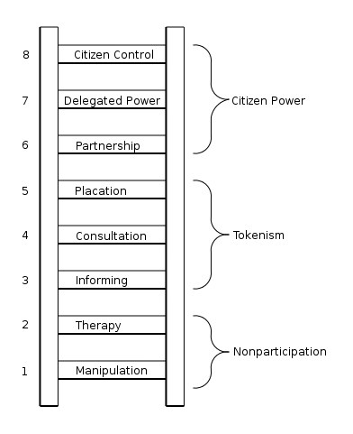
Inclusive planning should refuse to give in to prevailing social trends in order to promote social justice, democracy and work towards liberty by assisting communities with accomplishing a spatial voice in new forms of planning and cohesion, envisaged within difference (Arnstein’s, 1969).
The processes that are “prescribed” as community/public participation may have unintended consequences in terms of the steps followed in policy development, that may deem them to be a mere information dissemination exercise rather than a legitimate participation process (Arnstein, 1969).
Figure 5 : Sherry Arnstein, A Ladder of Citizen’s participation (1969), arranged in a ladder model illustrates each step as equivalent to the level of communities' power. The highest step represents the highest level of community involvement and the lowest step represents the least amount of community involvement.
The eight forms of participation are arranged in a ladder model with each step equivalent to the level of communities' power in influencing the end result. (See Figure 5)
The bottom levels, 1 and 2, of the ladder represent manipulation and therapy. These two steps illustrate levels of what is described by Arnstein (1969) as "non-participation". This form of participation is created to replace legitimate participation. The actual intention of this form of participation is not to enable people to participate, but to enable power holders to "educate" or "cure" the members (Arnstein, 1969). Level 3 and 4 advance to levels of "tokenism" that allow the marginalised to listen to and to have a say. However, under this form of participation participants lack the ability to insure that their views will be taken note of by those in charge. Arnstein (1969) adds that when participation is restricted to these levels, there is no follow up, no "influence”, thence no guarantee of changing the status quo. Level 5“placation” is purely an advanced level tokenism because the basic rules allow the marginalised to make suggestions, but influence is still retained by power holders who also maintain the continued right to make a decision.
The upper levels of the ladder represent community power with increasing degrees of decision-making influence. Level 6 of the ladder are forms of participation that allow for communities to enter into a partnership that allows them to bargain and negotiate in with traditional power holders. At the topmost level 7 and 8 the delegated power and citizen control, marginalised communities acquire the majority of decision-making votes, or complete executive power (Arnstein, 1969). The analogy of ladder allows for evaluation of how legitimate the participation process is, how much power is given to the citizen and some extent the intensions of power holders in decision-making process.
Clearly, the eight-level ladder is a generalisation for illustrative purposes; however, it assists to demonstrate the point that participation is not only including communities in the planning process it is important to note how they are included. There are considerable degrees of citizen participation. Being aware of these levels makes it possible to evaluate overzealous demands for participation from the marginalised as well as the scope of confusing responses from the power holders.
Strong civil organisations can exert influence and assert rights. In order to plan with communities, planners should be held accountable to the public that they serve, with all activities available and receptive to public inspection through mechanisms such as public hearings, integrity agreements and so on. Planners and planning processes and systems have to be responsive to difference, to be authentically participatory and to strive to create deliberative contexts that, as far as can be achieved, reduce disproportions of power and knowledge. Even if they are successful in mobilising a significant portion of the community behind a particular goal, by itself mobilisation does not necessarily lead to influence (Forester, 1989).
It is imperative to examine the complete needs of communities, not just the perceived needs. The critical element in effective planning is community involvement. Place-making captures the importance of place to people (Lynch, 1960; Healey, 1998, Harvey, 1996). It goes beyond the borders of place-marketing to the concern with local identity and feeling of belonging (Healey, 1998). Healey (1989) asserts that people may feel a strong sense of cultural “embeddedness” in a place.
People feel strongly and react violently if they have the perception that their ownership rights are threatened by public controls or by proposals on other properties that may affect them. “There are always too many restrictions on the use and development on ones own land and too little restrictions on other properties. Leung (1989) argues that the public is more often than not ignorant about land use planning. It (the public) knows what it wants but does not have the know how of how these wants can be achieved. It becomes apparent in relation to this study the importance that a plan plays in providing information that can adequately inform the communities’ participation process and give it meaning. Healey (1998) argues that all planning activity involves some interactive ration and some kind of governance. With reference to the study, it becomes apparent that different forms of participation represent considerably different degrees of engagement.

As it has been demonstrates in the sections above planning practice processes have evolved over time. Planning evolved from only being concerned about the physical environments impact on human behaviour but also on how human behaviour influences the functionality of the built environment. Leung (1989) states that there is a growing desire for planners to be more than physical planners. The rational for planning is the satisfaction of the social, economic and psychological needs of the community. The role of the planner is to find means by which to satisfy these needs (Leung, 1989).
Historically, the approach to planning in the South Africa local government context was informed by the idea of ‘blueprint’ planning, which posited the existing urban form against an imaginary ideal. Planning instruments such as municipal structure plans and planning guides detailed the precise interventions required to develop the imagined City (Harrison and Khan, 2002). Furthermore, the realisation of the blueprint was seen as the technical manipulation of social, demographic and transport trends, where town planners were responsible for ‘development control’ (Pieterse, 2002). Frankel (1998) acknowledges that some neighbourhoods developed as restriction by prejudice, limitations of language or economic pressure often “forced” the cultivation of neighbourhoods identified by distinctions made other than choice.
Leung (1989) argues that the essential justification for land use is the protection of public interest. Public interest is the base for a set of values that planners should hold dear (Leung, 1989; Jacobs, 1960). Underlying this is an implicit consensus that there is a need for public sector planning to achieve social justice. The public should be the ultimate authority in the formulation of plans. He also asserts that government is at the centre of ensuring that the public interest is met (Leung, 1989).
As stated earlier land Use, planning is an important government function, directly affecting the lives of all communities (Leung, 1989). This is a departure from the modernist idea that planning is the independent negotiator of public interest. Planning process should be less of a mechanism of control by government, and more of a process of good governance, to deliver quality.

Planning policy in the South African context
In the South African context, in terms of section 152 of the Constitution of South Africa the objectives of local government amongst many others are as follows to:
(a) Provide democratic and accountable government for local communities;
(b) Ensure the provision of services to communities in a sustainable manner;
(c) Promote social and economic development;
(d) Promote a safe and healthy environment and
(e) Encourage the involvement of communities and community organisations in the matters of local government.
Its significance is that local government is specifically directed to promote social and economic development, provide services and ensure participation. Since it is a rights-based Constitution, it means that local government as an organ of the state is required to progressively address socio-economic rights of its citizens (Mhone, 2003).
Leung (1989) states that more often than not, planning control is perceived as being negative as it promotes “physical determinism”. It often prevents people from doing thing that they may have been able to do had there been no regulations. However, it is necessary in directing and guiding desirable urban form. He cautions that control is not planning. He argues that the hidden agenda of early development control was to establish and protect the homogeneity of the socio-economic character of areas so as to exclude the intrusion of “outsiders”. Planners have aided and entrenched biases through the segregation of land uses and categorisation of various land use types, through planning controls (Leung, 1989).
As is the case in the South African context planning was used as a tool to create segregated communities in terms of class and races. As stated earlier segregation and homogeneity has become entrenched into the South African planning system. Planning controls that were developed and adopted under the system of apartheid are still applicable and used in decision-making despite calls and attempts of more inclusionary planning processes.
Any contravention of planning controls is an infringement of law. According to Leung (1989), planning controls are predetermined but reality is that they are a number of problems with these. One of the problems is that social changes bring about new conceptions about the categorisation of the relationship between land use relationships. Changing times and circumstances may render some policies obsolete. Land transactions may render the desired use of land obsolete. It is desired for planning policy and legislation to protect property owners and at the same time have more flexibility.
Leung (1989) adds that the negative aspect of land use “control” is the extent to which it prevents people from achieving the things that they would be able to achieve had there been no control. He asserts that control is not necessarily planning. The intention of planning amongst many other objectives is to guide governments’ action in decision-making in order to assess what may or may not be appropriate. Leung argues that planning has lost its meaning and has merely become no more that bureaucratic function. He asserts that without the emphasis on the future planning is no more than management without an objective. Therefore planning for the future is critical for the development of the future of cities.
The above section highlighted how planning practices and processes and how it should be understood and practiced in relation to participatory processes that ultimately should inform the process and outcomes of planning objectives. The is no one way of engaging communities however citizens should be given appropriate power to influences planning process that will allow for them to shape planning outcomes. Governments are also seen as playing a critical role in making sure that the power to influence decisions is distributed equally. Planning processes need to be responsive to difference, to be legitimately participatory and to strive to create deliberate contexts that minimise inequalities of power and knowledge (Huxley, 2000:369).
This following section aimed at providing a brief introduction of planning and particularly municipal planning in South Africa, with a view to giving an understanding of what has influenced planning in the context of Johannesburg. The intension will be to scrutinise the evolution of the planning context within the City of Johannesburg.

Planning Policy and Processes Within the Context of Johannesburg.

The central focus of this study is based on the discussion around Precinct Plans. Precinct plans are non-statutory. It is up to individual municipalities’ discretion whether to develop them or not. There are no prescribes guidelines on how these should be developed. The process of developing these plans is also at the discretion of the Municipality. As stated earlier by Forester(1989) and Leung(1989), the process of planning should not be rigid. Bickenbach and Hendler (1994) also add that” the definition of planning leads to the prospect of diversity and incoherence. The notion that there is a single, unifying basis of planning is at best intangible. Therefore, this form of policy has the potential to allow for flexibility and different ways in which the communities can participate in the process of developing the plan as advocated by proponent s of advocacy and communicative planning.
For the validity of this study, it becomes commonsensical to make reference to legislation and policies supporting the land development use. In the context of the City of Johannesburg, there is a specific hierarchy of interrelated plans. The following list provides a summary the associated spatial planning frameworks:
- Spatial Development Framework
- Town Planning Schemes
- Urban Development Framework and
- Precinct Plans.
The Spatial Development Framework (SDF) is the main strategic planning mechanism, which guides and informs all spatial planning and development, and all decisions with regard to the spatial management, planning and development principals in municipalities. It also consists of the stipulation of fundamental “guidelines” for a land use management processes.

Planning in South Africa is guided by a legal framework, which endeavours to guarantee that municipalities deliver their planning objectives in terms of the Constitution. A balance needs to be established between various and often competing social, economic and environmental interests, both from a public and private perspective.

The theoretical foundation of planning in Africa and South African is mainly founded on old British Systems of Planning, based on modernistic system planning (SALGA, 2011). The nature of this system of planning has been criticised for having a strong physical planning focus, which pays an inadequate attention to social, economic, environmental cultural aspect (Berrisford, 2013). As mentioned before under the apartheid regime, the City was organised and separated according to ethnicity, race and class and therefore, social, cultural and economic. Planning was used to control and minimise interactions through tightly controlled social and public space (Tomlinson 2003). Knieling and Othengrafen (2009) argue that urban planning is influenced by culture through its manifestation in history or by current developments in invisible and subtle ways. As a result planning systems and traditions are always influenced by cultural contexts and the cultural background of the people involved in planning processes. The roots of planning system in South Africa were “imported” by minority groups and never considered the cultural influences of the majority of the countries citizens. As a consequence the value systems of the majority groups, who had little influence and power to influence decision-making processes were ignored.

Strategic planning enables decision makers to set appropriate goals and objective that can guide them in the direction of achieving a collective future vision. Ideally, this vision should be informed through participation and partnership with communities and stakeholders (Kaufman and Jacobs, 1987). Strategic planning complements other planning tools and usually results in a planning product such as a SDF (Kaufman and Jacobs, 1987). These development frameworks are usually legally binding mechanisms. As advocated by proponents of postmodern planning in essence strategic development frameworks should be flexible tools for long-term planning and enable revision and adaptation to changing circumstances (Kaufman and Jacobs, 1987).

Municipal Planning is a function dispensed to municipalities in terms of the South African Constitution (SALGA, 2011). There are variable pieces of legislation that regulate and guide planning within the geographic the various boundaries of South Africa. For the purpose of the study, the focus will be on the ones applicable to municipal planning.

Municipal planning is enshrined in the Constitution. The significance of the Constitution is that its assignment of municipal planning responsibility to municipalities. The Constitution is at the national level and it recognises that municipal planning as a critical component of the function and responsibilities of municipalities. However, the Constitution lacks a clear definition of what municipal planning is as it loosely defines it by means of listing the areas that municipal planning should be concerned with. However, it is important to note that, land use planning is considered to be a central government function of importance, directly affecting the lives of all people. Thence it is for the most part imperative that it is characterised by equality and transparency in order to afford people a meaningful right to participate in decisions making process (SALGA, 2011).
The Municipal Systems Act No 32 of 2000 sets out the different processes and policy imperatives that municipalities should encompass. It also sets outs the requirement for municipalities to develop and implement an integrated development plan (IDP) for their respective areas. As a prerequisite, the act requires that the IDP include a SDF, which must include broadly the provision of basic guidelines for a land use system for the municipality (SALGA, 2011). In terms of the municipal systems act, it is important that decision-making on planning matters is based on sound planning policies, and supported by appropriate policies, procedures and standards. Spatial planning framework should further be framed within a “suitable and user-friendly land use management system” (SALGA, 2011).

A number of plans are legally required to be prepared by the municipality ranging in level to cover the entire municipality down to a very detailed plans that may either be area specific or property specific at which specific land use rights are assigned to individual properties. In addition to these plans, municipalities may choose to impose other non-statutory plans, based on contextual circumstances. The intention of the various plans is mostly the same in their intention to direct development from the strategic to the specific. Healey (2003) argues that plans should become broad statements of policy “principles” and regulatory norms to guide development process. The principle and norms can be assessed to negotiate the outcomes of proposed developments rather than being prescriptive. The following plans are the likely set of plans applicable in the City of Johannesburg and this study. As stated in chapter 1, the intension of the study is to evaluate how rigid or flexible planning processes, approaches and outcomes are, with a narrowed focus on specifically Precinct Plan process and outcomes in responding to different cultural settings. Therefore, it is critical that we examine the principles of the plans in order to evaluate how flexible they are.

Town planning schemes are land use regulatory frameworks that are prepared in terms of a provincial Ordinance or Act. The Scheme prescribes zoning maps and controls, which form the crux of daily development administration within a municipality. The Scheme amongst assigns and categorises land use zones that prescribe what activities may, or may not, be carried out on any piece of property, whether by free will or by sanction. The purpose of a Scheme is to minimise conflict around land uses in urban areas (SALGA, 2011). The fundamental organisation of the plan, when not initiated by the municipality, as a rule includes the consideration of rezoning and (exceptional) consent applications brought by general community (Leung, 1989). It is imperative that municipalities create an environment for the mediation of planning and building applications (SALGA, 2011). It is critical to note that town‐planning measures as embraced by the apartheid government were worded in the dialect of universal planning that was not clearly worried with the regulation of settlements. Rather the planning regulations presented in the 1910s were part of the emerging racial system of government of the South African City (Parnell, 1993; Home, 1990).

As mentioned earlier most town planning schemes developed during the apartheid era in South Africa were based on the British planning system. The Johannesburg Town planning Scheme of 1979, which the British model of planning also influenced, has had very little amendments to it since it was developed and is still used as an administrative planning assessment tool. The Scheme is prescriptive and provides no room for negotiation thus as rendering it technocratic. In his article How to Make Planning work for Africa, Berrisford (2013) acknowledges the fundamental value of planning law in managing the growth of cities; however he criticises these laws for being inappropriate and outdated. He state the “one size fits all” and model of planning have not served Africa well. He proposes that minimum standards should be applied to secure health and safety and create room for flexibility. He states that current planning ideals of how a City should function are far from the reality of what happens on ground (Berrisford, 2013).
Cities and urban areas alike are in a constant phase of transition. This results in a growing demand for the change in land uses in different areas for different reasons and thus policy guidelines should take into cognisance the changing circumstances and context of the cities inhabitants and their needs (Berrisford, 2013). Non-Statutory plans such as urban development frameworks (UDF) and Precinct Plans usually interlink the SDF and the Scheme. As a consequence of the generic character of the SDF, non-statutory frameworks are formulated to assist with issues of a detailed nature, by recognising and harnessing the unique character of each area, region or strip within the City of Johannesburg (SALGA, 2011).
As stated earlier non-statutory plans are developed at different levels, and typically give a greater level of understanding than the SDF over a specific geographic area. In essence they are the plans that are more reactive to planning issues that are not addressed in both the SDF and Town Planning Scheme (SALGA, 2011). These plans are mainly reactionary in nature and are developed on an ad hoc basis. Therefore, these plans provide for planning policy that is outside of the norms of legislated regulatory frameworks such as the SDF and Town Planning Scheme.
There are also other parts of legislation that compliment planning regulation, which may include the National Building Regulations and Building Standards Act (Act 103 of 1977), public health By-laws and various other Municipal By-laws. These various pieces of legislation are meant to ensure the safety of the built environment. Any development of land that does not comply by these pieces of legislation and its various sets of regulations may result in prosecution in terms of the applicable legislation (SLAGA, 2011).
Each of the plans, illustrated in figure 6, serves a specific function, which is clearly described in the relevant City of Johannesburg (CoJ) document (i.e. IDP and SDF). The purpose here is to place urban Precinct Plans in context and to describe their role and function in the planning context. The intension of Precinct Plans is to outline development principles and guidelines at a level of detail that may not be possible within wider framework plans such as UDFs. The purpose of such plans are that the promoted principles and guidelines, not only within the document but also other planning documents, provide a platform or bridge where official plan policies can be translated to implementable projects in line with the town planning Scheme provisions.
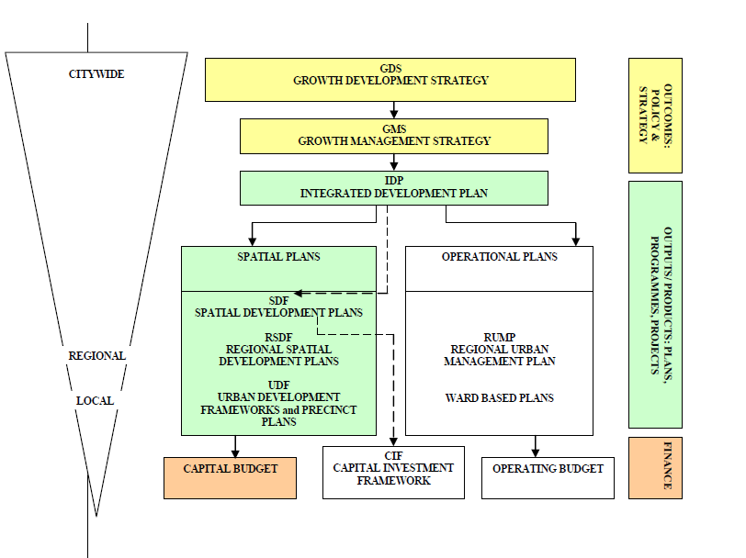
(City of Johannesburg, 2009)
Figure 6: Represents a synopsis of the hierarchy of various planning policies and the interrelationship between various plans in the City of Johannesburg.

Precinct plans are prepared for functional areas, which are clearly delineated for the purpose of the Precinct Plan and can be associated with a scale similar to a neighbourhood or even smaller. These plans are typically viewed as short-term plans, which seldom extend past a five-year horizon (SALGA, 2011).
The following procedure should ideally be followed, however, it is understood that deviation from this process may occur in special circumstances. In such an event, the deviation must be motivated in writing to the CoJ (as part of evidence) and it must be clearly illustrated what the course of action is and how it involves sufficient public participation.

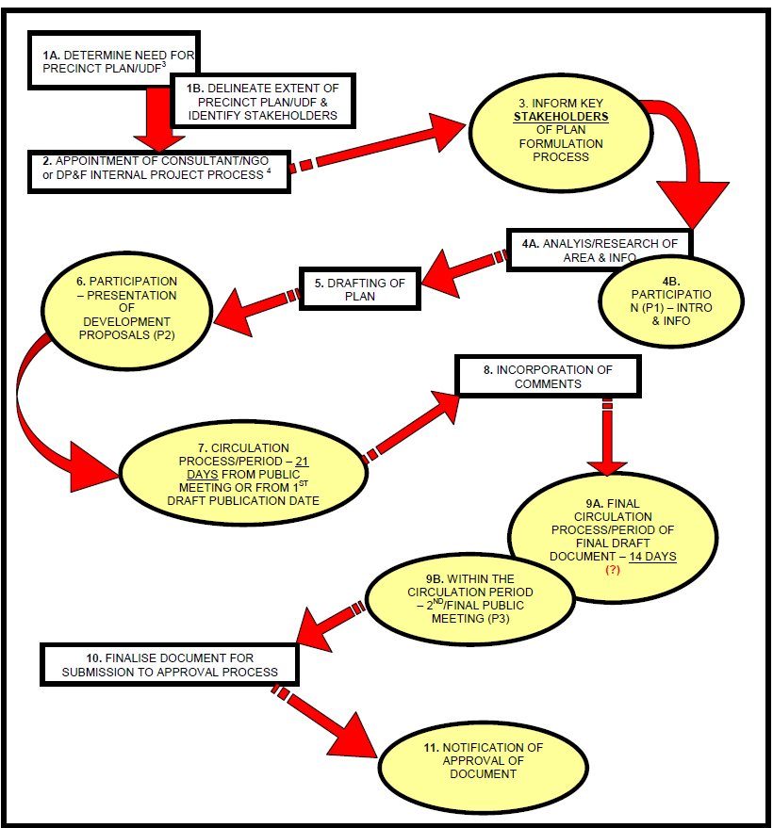
According to the process outlined below, figure 7, the community should be consulted at various stages of the plan. The policy also stipulates the minimum public participation that should be undertake in process. With regards to the study communication between planning officials and the types of interactions at various stages of the process are transformed into knowledge that we use in the planning process.

Figure 7: Illustrates the guideline of the various steps that should be undertaken in developing a precinct plan and the various stages that the public should be consulted.
(City of Johannesburg, 2009)

The public and stakeholder process initiated by the Precinct planning process should overcome the perception that limited participation is a form of public control by involving all stakeholders involved in the process at all stage where possible. Limiting the knowledge given to communities implies that the intentionality of those who initiate community participation or use participatory methodologies to facilitate community development is tokenism. Leung (1989) asserts that planners have a mandate to demonstrate substantive knowledge and to foster a participatory approach.

The above section has highlighted the planning in the context of Johannesburg and how it has evolved in line with international planning theory paradigms. Therefore the policy realises the importance of the role of participation in the development process. During the formulation process the Precinct Plan may be accepted, changed, added to or rejected. Decision-making powers clearly do not rest in the hands of an individual; it is decentralised to distribute power in the decision-making process.

As discussed as a result of globalisation culture is not fixed in a single territory it is the meaning that communities place in which ever area they choose to live in the place-making process that that shapes the communities we live in. The next section seeks to explore the Chinatowns and Chinese culture as the study is mainly focused on the Chinese enclave within the CoJ.

Chinatowns and Chinese Culture

Freedman (2000) explains that prior studies of Chinatowns, view that the community as a closed enclave independent of the larger society’s influence. Freedman (2000) and Crissman (1967) argue that the overall organisation of Chinese immigrant communities is based on distinctly “Chinese” characteristics. The Chinese community in Cyrildene is the myriad of organisations established for economic, political, and cultural goals. The community serve as a conduit for culture and for socialisation.

Totok Chinese are those who immigrated towards the end of the 19th century and in the 20th century, and who have retained the use of Chinese language, dress, and customs. To the present, the Totok’s have continued to emphasise business and self-employment. Chinese communities overseas have often are seen as economically significant but often blamed for a country’s problems and persecuted (Crissman, 1967).

Enclave groups are understood as a designate population that, shares fundamental cultural values, released in overt unity in cultural forms amongst other things; however, it is important to note that ethnic groups only persist as significant units if they imply marked differences in behaviour i.e. different cultural differences (Mohamed, 2005).

Enclaves result from the concentration of household of particular ethnicity, culture, or religion in a specific area. These enclaves are composed of ethnic minority groups. They invest in an area and give it a particular identity until it evolves into an enclave. Concentration reflects and is influenced by householders choices framed by class and income (Mohammed, 2005)
Peter Marcuse (1960) discusses the implications of the enclave, citadel and ghetto in post 1960-70 cities. He begins by defining each system of division, and continues in familiarising the reader with each concentration of people by describing the classification behind each concentration, ranging from “spatial formation” to the “identifying characteristics” of any one group (Marcuse, 1960).
Marcuse (1960) discusses the number of reasons why an ethnic minority would choose to settle in close proximity to people of a similar background and culture in what is known geographically as ‘ethnic cohesion’. The reasons vary from living close to friends and family; having access to places of worship; stores which stock ethnic food; educational facilities; and care institutions. These features would make certain places more attractive than others, which lack these facilities. There are other reasons that should also be considered such as congregating together as a form of self-protection and having areas in which ethnic minorities can comfortably express their cultural and religious identities. It is also through a conglomerating in specific enclaves that they are able to maintain and reproduce their identity (Marcuse, 1960).
There is a general consensus in most literature that enclaves play an important socio-economic role in cities (Qadeer, 2005; Marcuse, 1960, Mercer, 2005; Selzer and Heller 2010). However often policy fails to recognise the importance of these enclaves as they are mainly composed of minority groups that are often overlooked in the public participation process of development. The problem is not the policy, but how the policy development process fails to address issues pertaining to these enclaves.
Qadeer (2005) asserts that ethnic enclaves foster entrepreneurship and the flow of capital and labour and as such should be viewed as a positive contribution for the development in areas. In his exploration of the viability of ethnic enclaves and the potential to contribute positively to urban regeneration, Qadeer (2005) argues that the economic contribution provided for by ethnic enclaves is often overshadowed by the fact that they are overlooked as important.
A number of theorists such as Marcuse (1960), Qadeer (2006), Selzer and Heller (2010) who write on enclaves seem to concentrate the economic value and economic policies and programmes aspect of enclaves. However there is little mention on how perhaps the individuals that may not choose to participate in economic activates within the enclaves themselves are accommodated or affected by policy.
Juggins et al (2003) make reference to the fact that in the South African context, ethnic enclaves have had negative impacts in specific areas. They emphasise how ethnic enclaves push locals out of areas and thus change socio-economic dynamic in these particular areas. Juggins et al (2003) states that policy has failed to address issues within enclaves in terms of policy mechanism. Especially in the context of Johannesburg these enclaves have been in existence for a number of years, some before recent policy documents, their role and significance is not recognised in planning policy documents.
According to Bahmann and Frenkel (2014) attempted racial and class segregation forms the foundation of the enclave mentality in Johannesburg. The apartheid regime intentionally eradicated cultural and racial mixing in order to prevent diversity. It established a social norm that was based on homogeneity. Whilst numerous examples of resistance to this norm exist, there is a culture of homogeneity within suburban environments in both the past and present forms of Johannesburg.
The same homogeneity is visible within the built form of older established suburban areas. The built form has fairly been stagnant and consistent. In the last decade or so there has seen a reaction against the homogeneity, isolation and predictability of the suburban lifestyle by a small section of society especially where in areas where there is a strong presence of migrant enclaves. The resistance to this homogeneity has been met by a substantial amount of resistance from residents in these areas.
In the context of Johannesburg, these enclaves are not celebrated and the value they add to these communities is not understood. They are rather viewed by older residents in established communities as a nuisance and creating a “playground” that fosters illegal activities and allow them to thrive. The City views these areas as administrative “problems” whereby illegal land uses occur in a manner that is not prescribed by current land use policy and Municipal By-laws.
The regulation of land use management and development must be strategic, viable, effective, and sensitive to the needs of the communities whilst also attempting to conserve critical ecological assets, rather than attempting to tightly control land use change and small developments. Stringent land use control is probably only affordable in wealthy markets with highly advanced legal frameworks and an abundant source of trained. Critiques of planning practice recognise that inflexible land use control is not an achievable, equitable or affordable policy approach, in response to rapid urbanisation. Land use controls ought to never be utilised as a reason for means of discrimination in established communities (Leung, 1989).
Urban planning should be influenced by the objectives and mainly convey the concerns of all people in the City. Planning is chiefly concerned with discovering strategies to accommodate the needs of distinctive groups, presently and in the future. Specific considerations need to be given to those whose voices have often been marginalised in normal public policy-making such the aged, kids, those with disabilities, women, ethnic minorities, the displaced, the poor and so forth (Mercer, 2005). All citizens should have an equivalent right to the City and the right to be engaged in discussion, particularly with regards to developments that may affect them. Previously, planning approaches have been revealed to be an advantage to mainly the better off. Urban Planning should directly confront the need for equity.

The distrust and dread of difference, which is often results from isolation from other cultures, can be overcome by the encouragement cultural understanding and by emphasising the common interests that all people share. United communities can achieve a more equal and just society that respects and values its diversity. A lesser emphasis should be put on the idea of space as a surface on which things occur and more on the meanings that are given to specific qualities of particular places (Jenks, 1993)

This section has highlighted the importance of culture in influencing planning policy especially with regards to the concentration of households of particular ethnicity, culture or religion in specific areas. The role that these cultural enclaves contribute to planning policy and process is not widely recognised in terms of policy planning. Culture plays an integral part in place-making and the meaning that people place in an area. The following section gives a brief overview of the some of the characteristics of the China Towns as the focus of the study is based in an area that has the presence of Chinese enclave also widely known as China Town within the CoJ.

Chinese culture, value systems

Chinese societies call Chinatowns Tangrenjie (streets of Tang people) and regard them as urban centres within cities. The entry of most Chinatowns can be compared to entering a different country, as one come across exotic visuals, sounds and scents. The striking environment of these communities has always made them centres of attraction for travellers, authors. Some of their residents find all they require to sustain them and infrequently leave or interact with outsiders (Chin, 2005).
Ethnic organisations and leaders within the Chinese community play a vital role in impacting both the nature and scope of participation and influence, and results vary depending on the type of association and leadership that are at the forefront; business groups are more effective at achieving influence, whereas social service organisations are better at community mobilisation. Even if they are successful in mobilising a significant portion of the community behind a particular goal, by itself mobilisation does not necessarily lead to influence (Chin, 2005).
In the present day, Chinese culture is a consolidation of old traditions and a westernised lifestyle. In China, this can be seen in the contrast of tall skyscrapers with heritage buildings, the contrast of western fashion with the traditional Chinese Qipao dress (Chin, 2005).
Historically, Chinese culture has been and still is heavily influenced by the particular emphasis on Confucianism, which emphasises the importance of family and social harmony and conservative philosophies. Modern Chinese culture believes in the value of family over personal preservation and personal rights.They tend to always behave with restraint and will avoid causing others public humiliation, in order to preserve a sense of tranquillity. In most Chinese customs, individuals are taught to subdue their own feelings for the good of the collective. This is often demonstrated by the use of silence in very formal gatherings. If someone disagrees with what another person says the person will remain quiet, rather than disagree publicly. This gives face to the other person, whilst speaking up would make both parties lose face (Chin, 2005).Subsequently the Chinese strive for harmony and are group dependent; they rely on facial expression, tone of voice and posture to tell them what someone feels (Chin, 2005).
Qadeer (1997) asserts that cultural and racial diversity bears on the planning process. The scope of procedure of citizents involvement in planning process have to be modified to accommodate mulicultural settings. Therefore carfefull attention has to be given to language and the manner in wich different cultures communicate and “do not” communicate. Forester(1989) asserts that plannes have to be able to anticipate possible tension and knowing the background of communities can better help to faclitate comminication processes and more meaningful particiaption. Where dominant interest groups exist within the public, well-intended efforts may be fruitless as they may use opportunities to satisfy their own ends. The most transformational objectives can meet a dead end when ‘intended beneficiaries’ choose not to take part (Cornwall, 2008).
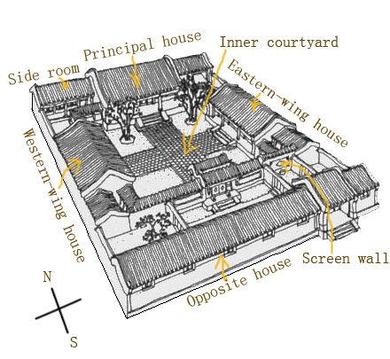
Overall, the Chinese are a communal society with a need for group connection, whether to their family, school, work group, or country.Siheyuan as depicted (in figure 10) is a reflection of Chinese culture, reflecting the sense of belonging in the mind of Chinese people. Its architecture made it suitable to accommodate certain religious and moral principle that was essential to maintaining order in a traditional family (Chin, 2005).
Figure 8: Chinese traditional Siheyuan compound
(http://arts.cultural-china.com/en/83Arts7487.html)
In contemporary society, and also with the change in social and family structures, traditional Siheyuan no longer fits the need of Chinese people. Limited spaces, lack of accessories, detached family structure all deem the Siheyuan less appropriate for contemporary lifestyles (Chin, 2005).However Chinese society is traditionally patriarchal and hierarchical. Seniors are highly respected and are addressed by their title and last name (Chin, 2005). Eldest males take most decisions, and females assume a subordinate role to men.

Ancient Chinese people designed housings to fit human dimensions so that they may feel intimate and safe, and this idea reflects the practical thinking in Chinese culture. Two typical types of Chinese ancient architecture represent the insightful influence of Chinese culture are Fengshui and Memorial arch. In terms of architecture, visual signs dominate design. The choices of images and colours were established by tradition according to the function and status of the structure and its owner (Chin, 2005).
This chapter has highlighted the general themes that have shaped planning theory and our understanding of the relationship between communities and the planning process with particular reference to culture. As highlighted above planning has moved from a technocratic rigid process to a more inclusive process that recognises the integral part that communities contribute in shaping our cities
Planning permits for the orderly growth and development of communities. Planners are expected to protect public interest. Planners should endeavour to promote social justice by working to increase choice and opportunity for all. As stated earlier, modern urban planning emerged as a profession in the early decades of the 20th century, largely as a response to the dreadful sanitary, social, and economic conditions of rapidly-growing industrial cities where planning was seen is a tool for achieving social ends.
Land use management is necessary in order to promote safe and healthy environment for all. It is function that seeks to balance the conflicting needs of various stakeholders and protect public interest. In order to accommodate and balance conflicting needs, land use management needs to be flexible enough to be able to responding to those needs without necessarily compromising the protection of other people’s rights.
Cities represent the spatial and physical features signature of human behaviour manifested in space and time. Planning is a dialogue where planners are negotiators, brokers and fixers who engineer a consensus which is the plan. Planning is about developing optimal outcomes. Emphasis is put more on process rather than outcome and the integration of local knowledge, the everyday life of local communities serving as a basis for knowledge and education (Forester, 1989). Cultural attachment to a place extends from a personal to various collective manifestations.
Community participation as defined by Stoker (1997) is participation of members of the public taking part in any of the processes of formulation, passage and implementation of public policies. Various definitions encompass the emphasis of public participation beyond the limits of the development of policy, but also to decision-making and implementation (Stoker, 1997). Patrick Geddes (1854) advocated for the notion of the civic survey as being essential to urban planning: his motto was "diagnosis before treatment" (Geddes, 1854).
The value systems that people place on space are inevitably shaped by how they are socialised. Therefore planning policy should reflect the sentiments of its inhabitants. In order to embrace cultural pluralism, it is important that planners understand what different components make up communities, carry out discussions and conduct research with each group, and include representations from each group on boards, committees and in the evaluation process (Berrisford, 2013).
The better the synchronisation, cooperation and transparency of the planning process within government the better will be the chances of members of the public being able to engage with the decision-making in a constructive manner (Berrisford, 2013). It is hoped that the results of this study will contribute towards understanding the dynamic that will contribute towards a legitimate process of participation in the development of planning guidelines in these areas.
Planners should continually question the motives of their political leaders and the motives of the spatial policy they validate. Although the policy formulation process of the City does not prescribe who and how people should participate, it is important to understand the dynamics that may enable communities to have a more meaning role in the participation process. As Forester (2007) argues it is important that a planner is able to anticipate potential tensions in the planning process. This will enable the planner to formulate process that will facilitate a more meaningful process.
However cities and urban areas alike are in a contestant phase of transition. This results in a growing demand for the change of different land uses in different areas for different reasons and thus policy guidelines should take into cognisance the changing circumstances and context of the City's inhabitants and their needs. Leung (1989) argues that a sensible plan will try to maximise the potential of the environment for the use and enjoyment of the community as a whole, safeguard all users from unacceptable hardship (Leung, 1989). Planning is only as appropriate as the information on which it is based. Frequently, planners rely on unproven assumptions or guesses; basing their plans on unstable foundations. “It’s the obvious things that everyone just knows that are most likely to trip you up” (Cornwell, 2008). If you’re going to plan, it’s worth the additional time to test hypothesis and guesses against reality.
Harvey (1973) explains that an analytical framework for dealing with the complex problems of the interface between social and spatial analysis can be framed within two temporary frameworks namely the approach of spatial environment determinism and democratic process. He further explains that spatial environment determinism is the physical plan aimed at promoting social order by manipulating the spatial order of a City. It’s an easy way of breaking into complexities between spatial form and processes and social process such as culture.
Democratic processes put emphasis on the people want is important and evidence that changing spatial order may have little effect on behaviour patterns. Social processes poses their own dynamics, in spite of policy efforts, social processes will achieve their own appropriate form (Harvey, 1973).
The physical environment does not play a noteworthy part in peoples’ lives as was previously believed by modernist planners. Although people live, work and play in buildings their behaviour is not determined by those buildings but by social relationships within them (Harvey, 1973).

Chapter 3: Research Methodology

Introduction

Dandekar (1986) asserts that planners use methods derived from various disciplines. These methods are then changed and adapted to meet planner’s requirements to obtain and examine a number of diverse data sources helpful in dealing with complex problems. Lynch (1960) defined ways of looking at and analysing the form of a City, spatially, visually, and as it was entrenched, differentially, in the thoughts of various people of that place.
This research is conducted using a case study approach. A case study approach examines a current phenomenon within its real-life context, “especially when the boundaries between phenomenon and context are not clearly evident” (Yin, 1994:13). The case study under consideration is the Cyrildene Precinct Plan, where there recently have been tensions amongst community members and the City in response to the Precinct Plan that was developed to address the changing nature of land uses within this specific neighbourhood.
Qualitative case studies afford academics the prospect to examine or explain the contextual occurrence using a range of sources of information. It allows the academic to evaluate people and institutions, through complex interventions, relationships, communities, or programs through a variety of lenses which allows for multiple facets of the phenomenon to be revealed and understood (Yin, 2003).
According to Yin (2003) a case study design should be considered when the focus of the study is to answer “how” and “why” questions. A case study was chosen in order to illustrate and examine planning process in relation to cultural phenomenon which is the Chinese culture thus the case could not be considered without the context, the community, and more specifically the understanding of the actual cultural settings within the community from the perspective of the communities rather than a purely theoretical approach.
In addition to the Precinct Plan additional information was gathered through interviews with eight participants. These included four community members. Two of the four participants were from the Jewish community in the area and had been residing in the area for a substantial amount of time. One of the participants was of Chinese origin and the other Taiwanese origin. Both these participants both migrated from their countries over 20 years and had settled in Cyrildene on a permanent basis. Another participant was the former Councillor of the area who was involved in the Precinct Plan process at the time it was being developed. In essence the Councillor played a mediating role between the City and the Community of Cyrildene. The participants were specifically chosen in order to asses if there would be any similarity or differences in sentiments expressed towards the development of the precinct plan and to gain a varied responses from participants who may feel negative or positive about the plan. The second motivation for the varied participants was to also aid in understating if there were any clashes in how different groups of society viewed the use of space and any specific cultural needs that may have been supported or hindered by the plan.
Lastly, three of the participants were CoJ officials. All three participants were from different departments in the City that deal with various land use processes. One of the participants works with the department that develops spatial planning policies in the City, the other land use management and the last participant works with land use law enforcement. All three departments were tasked to formulate a response to the illegal land uses occurring in the area. The participants all spoke in their own capacity their opinions and thoughts on the Precinct Plan development process and the outcomes of the process.
Given the limited scope and timeframes of the study, these specific participants were chosen according to the experience and knowledge in the participation process of the Precinct Plan development process and the different backgrounds and social groups they represented.
The following methodology will direct the research in order build on and introduce the concept of culture, power and participation and its relationship to planning process and outcomes. Quantitative, qualitative and visual methods will be undertaken in order to unpack the concepts mention above.

Qualitative Research Methodology

Qualitative research as Dandekar (1986) explains is a form of scientific examination. In broad terms, scientific research consists of an investigation that:

• tries to find answers to a question
• methodically use a set of procedures to answer a question
• gathers proof
• produces outcomes that were not determined beforehand
• produces outcomes that are valid beyond the limits of the research

This scientific method can however be adjusted to suit the researcher. In addition, qualitative research pursues an understanding of a particular research problem or theme from the viewpoints of the local inhabitants it encompasses. Qualitative research is especially valuable in finding culturally specific information about the values, opinions, behaviours, and social contexts of specific populations Dandekar (1986) explains that a person’s surroundings and actions can be observed and empirically described, qualitative approaches are necessary to integrate those observations into a logical narrative that adequately accounts for identities, perceptions and motivations such as culture.

This is important for this study as it will give insight from localised environments, cultural systems, and society in order to understand and engage with the research question which is how flexible are urban planning processes approaches and outcomes in responding to different cultural settings.

The study is grounded on theoretical approaches and thus substantially dependent on qualitative methods of research. The value of qualitative research is its capacity to provide multifaceted documented explanations and illustrations of how people experience their surroundings given the fact that the study primarily revolves around social systems (culture), what they value and how they relate to space, in developing strategies for intervention Dandekar (1986). As Dandekar (1986) puts it, it presents knowledge about the “human” perspective of a problem that may not have been known beforehand (Dandekar, 1986). Qualitative methods are also effective in identifying intangible elements, such as social norms, gender roles, ethnicity, and religion, socio-economic status whose contribution in the research may perhaps not be obvious (Dandekar (1986).

Yin (2013) argues that outcomes from qualitative material can often be applied to contexts with characteristics similar to those in the study group, gaining a thorough and complex understanding of a specific social context or phenomenon typically takes precedence over obtaining information that can be generalised to other geographical areas or populations.

There are three commonly used methods of qualitative research which include observation, interviews, and focus groups. Each method is specifically appropriate for obtaining a specific type of information (Yin, 2013).The qualitative methods used in urban planning can be categorised by the characteristics of the activity they are best qualified to examine (Dandekar, undated). The study will also incorporate the qualitative method of observation and interviews in order to substantiate literature frameworks.

Participant observation is appropriate for gathering information on naturally occurring behaviours in their usual contexts. As stated earlier in the chapter, the study is undertaken from the perceptive of the insider. Observations gained from knowledge of working on the plan will be used to substantiate some of the arguments of the study. Objectivity is crucial in this instance so as not to compromise the credibility of the study. It is important that participants are made aware and have an understanding of the researchers’ position and purpose of the study so that honest responses may be obtained. Secondly it is important the researcher is open minded to any response that may be given by participants and receives them with objectivity so as not to compromise the findings of the research.

As indicated by Adler and Adler (1994) researchers that embrace subjective studies may assume a number of roles when they are in the research setting. These roles vary from being a member of a group (insider) to a stranger (outsider) (Adler and Adler, 1994).

Bonner and Tolhurst (2002) distinguished three key points of being an insider analyst: (a) having a more prominent comprehension of the subject being studied; (b) not modifying the stream of social cooperation unnaturally; and (c) having a built up close relationships which advances peoples trust in providing truth and honest judgement.

In spite of the reality that there are different points of interest of being an insider-researcher, there are additional issues connected with being an insider. For instance, more prominent recognition can prompt lost objectivity. Unintentionally making incorrect presumptions about the research procedure based on former learning can be viewed as being subjective (DeLyser, 2001; Hewitt-Taylor, 2002).

To complete sound insider examination, insider-analysts should constitute a clear familiarity with the imaginable impacts of subjectivity on information gathering and investigation with regards the moral issues identified with the murkiness of the association and individual members. The researcher should consider and address the issues about their role on intimidation, compliance and access to confidential information, at each and every stage of the research (Smyth and Holian, 2008).

In-depth interviews are ideal for collecting information on people's personal accounts and histories, points of view, and experiences, especially when sensitive issues are being investigated (Dandekar, 1986). As clarified prior in the chapter there are existing tensions amongst residence in the in the area, in order to solicit genuine responses individual interviews were conducted through field notes in spaces where they felt free to give input without fear of being discriminated against.

Qualitative research methods are normally adaptable. They permit more spontaneity and flexibility in the relationship between the researcher and the participant (Dandekar, 1986). Qualitative research methods usually use “open-ended" question that can be adjusted and reworded to suit each member. Open-ended questions allow participants to respond by their own accord. The researcher must listen attentively to what participants say in order to be able to engage them according to their personal traits and styles, and utilise “probes” to urge them to expound on their answers.

When used along with quantitative methods, qualitative research can assist to substantiate qualitative information and enhance the understanding of the complex reality of a given situation and the implications of quantitative data (Dandekar, 1986). The following section will expand the notion and usefulness of qualitative research methods with regards to the study at hand

Quantitative Research.

This study did not undertake quantitative methods. However, the City of Johannesburg has undertaken some statistics which are helpful in this study. The quantitative methods are therefore secondary materials which assist in the validation of the analysis. While quantitative methods were not a primary part of this research it is useful to discuss the usefulness of quantitative methods.

The main variation between quantitative and qualitative methods is their flexibility. Normally, quantitative methods are inflexible highly scientific. Quantitative research methods such as surveys allow for the collection of specified information and the analysis raw data that has not been influenced or manipulated in anyway (Dandekar, 1989). Urban planners work with spaces and the built form and structures, things that have a tangible presence in space. It is important that planners are able to substantiate qualitative data with quantitative data in order to justify actions. The following section will briefly explain how the use of visual aids will be used to enhance research in the area.

There is some debate around the use of mixed methods – using both quantitative and qualitative together. However, given that this research does not use primary quantitative material I have not entered into the debates.

Ethical Considerations
Research ethics are mainly concerned with the interaction between researchers and the people they study and especially with reference to qualitative methods of research. The following were taken into consideration during the study:

- Formal consent is required for all qualitative research methods.
- The researcher should be conducted in a non-judgmental way
- As a student who is also a City official it will be necessary to declare my position as a City employee.
- The information gathered will solely be used for the purpose of the research report.
- Respect for participants requires a commitment to ensuring the independence of research participants and to shield people from misuse of their vulnerability.
- The dignity of all research participants must be respected. Adherence to this principle ensures that people will not be used simply as a means to achieve research objectives.

This chapter has briefly highlighted the various methodologies that will be adopted. Cyrildene was chosen as the case study document wherein a Precinct Plan approach was adopted by the City in reaction to addressing some of the development challenges in the area. Cyrildene was also chosen as a case study as it is consistent of a Chinese enclave, which will allow for the exploration of this culture within the context of the planning policy and process adopted in this area by the CoJ.

Chapter 4: Case Study

Introduction

There are different levels of policies that guide development within the CoJ. This chapter at a basic level aims to evaluate the process followed in the formulation of the Cyrildene Precinct Plan and whether the outcomes of the plan reflected the cultural sentiments of all the stakeholders in the area. The following chapter is a case study of the area which also investigates how flexible the Cyrildene Precinct Plan process was in taking into consideration the cultural context of the Chinese enclave within the area. This section of the research will start by setting the context of the study area in order to assess some of the key features and challenges the area. The study begins by examining the Chinese culture in the area and how this culture is manifested in space and in the participation process. Secondly the chapter will focus on the Precinct Plan process followed by the CoJ in developing the Precinct Plan and the outcomes of this process. Thirdly Interviews with residents and municipal officials will be analysed in terms of their contribution in the participation process and their satisfaction with the outcomes of the process so as to assess whether the sentiments of the residents are well reflected in the outcomes of the plan.

Setting the Context of Planning and Challenges in Cyrildene

Cyrildene is one such example of an area where broader policy may no longer accommodate the growing demand for the different needs of the areas inhabitants. The CoJ responded to addressing these challenges in the area through a Precinct Plan approach. A Precinct Plan approach is expected to represent a detailed overall plan guiding the future development of Cyrildene (CoJ, 2013).

The quaint and once mainly residential suburb is experiencing a rapid change in land uses that are changing the urban form of the suburb. Older residents have reacted to these changes and called for the CoJ to put an end to these changes. These changes necessitated the CoJ to develop Precinct Plan in order to balance the conflicting demands of various land uses in order to allow appropriate development to take place(CoJ, 2013). The plan however has been met by resistance from “older” community locals.

Background History of Cyrildene

The initial Chinese immigrants are thought to have settled in South Africa in the early 19th century. Contract labourers were brought to South Africa from northern China between 1904 and 1907 to work on the gold mines (Harrison et al, 2012). From the early 1980s, Chinese migrants established industries in what was previously termed homeland areas. They were attracted to South Africa by incentives such as cheap labour in the peripheral edges of the country (Harrison et al, 2012).
The largest wave of Chinese immigration began in the early 1990s, coming from various parts of mainland China (Harrison et al, 2012).After 2000 increasingly, South Africa attracted small traders and previous peasants from economically distressed parts of China. Many of these migrants arrived illegally and generally had lower levels of education, fewer business networks, and fewer resources than previous migrants from China (Harrison et al, 2012). They assembled, forming cultural enclaves to provide refuge and a sense of belonging around Newtown. Johannesburg’s first “Chinatown” was created just below Commissioner Street in the City Centre. With businesses structured around the family, Chinese migrants largely avoid dependence on the labour and skills of the host society (Harrison et al, 2012). There, the Chinese community could gain access to cooking ingredients and familiar cuisine and merchandise. Locals also started visiting the area to experience the exotic cuisine. In the 1960’s, there was a gradual but steady exodus. Chinatowns are no longer secluded or ghettoised areas they have become places of ethnic identity and solidarity that give Chinese immigrants a significant advantage in a competitive commercial environment (Harrison et al, 2012). Chinatowns therefore represent globally connected nodes that contribute in the wider capitalist economy (Harrison et al, 2012).
Traditional Chinatowns remain predominantly working class and entrepreneurial and are well placed to take advantage of transnational markets and capital flows from the urban core of the Inner City in favour of suburbanisation (Garner 2011). As Johannesburg’s central business district became degraded due to urban decay and crime, so did Johannesburg’s Chinatown in Newtown. It gradually became derelict and degraded resulting in the migration of the Chinese population moving into Cyrildene (see Map 11).
Cyrildene was established as a suburb that was predominately Jewish. Derrick Avenue was mainly developed as an activity street that mainly housed shops on a localised level. Currently Derrick Avenue is now lined with Chinese Shops. There is a cosmopolitan array of shops but the residential area still retains the feel and architectural style of the 1950’s (CoJ, 2013) (see Map 1, p58). As a residential cluster, it now functions as South Africa’s leading gateway for new Chinese arrivals (Harrison et al, 2012).

The relationship between the South African state and the various groupings of Chinese in South Africa is a complex issue, characterised by contradiction (Harrison et al, 2012). The South African government seeks to attract Chinese investment and political favour; therefore, action against Chinese migrants is constrained (Harrison et al, 2012). The Chinese present a significant competitive threat for South African business. As a result anti-Chinese sentiment is expressed on occasion within government and from within the South African business community(Harrison et al, 2012).In the Cyrildene area, the relationship between the local ward councillor and the Chinese community has been sensitive, and mainly centred around Chinese transgression of local by-laws (Harrison et al, 2012).

Map 1: : Illustrates the clustering of Chinese enclaves mainly east of Johannesburg in relation to the original location of the Old Chinatown, which was located in the Inner City.

(Harrison et al, 2012)
Derrick Avenue is characterised mainly by mixed-use developments with retail at the street level and residential above. The whole of Derrick Avenue has a rich Asian theme, branding and architecture that give it its unique identity. The Chinese architectural expressions however are only explicitly expressed in buildings along Derrick Avenue. Beyond the red area s indicated on the map the character and theme of the area reverts back to the quaint 60’s character of the area. This may symbolise what Lynch (1960) describes as discontinuities of spatial structures that are created by the features of the physical environment that create edges. On the surface explicit traces of the Chinese culture and activity seems to start and end on Derrick Avenue. Beyond Derrick Avenue, the signage is discrete and informal. Harrison et al (2012) assert that there is often an open display of Chinese culture in the business environment as the Chinese brand is important for low income consumers, but residential space is often hidden, which according to Harrison et al (2012) is a reflection of high levels of fear amongst Chinese locally (Harrison et al, 2012).
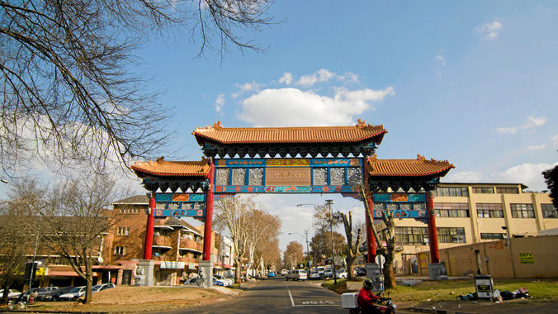
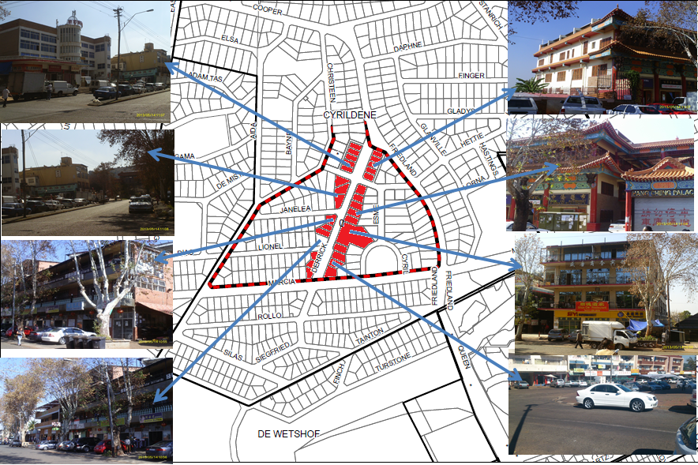


Map 2: Business area on Derrick Avenue

Most erven in and around the study area are zoned “Residential 1”, as illustrated on Map 3 below, with the exception of Derrick Avenue which was historically zoned for business use and special uses. However, there is a change in land use trends beyond Derrick Avenue with an increase in illegal land uses within the mainly residential areas of the suburb.

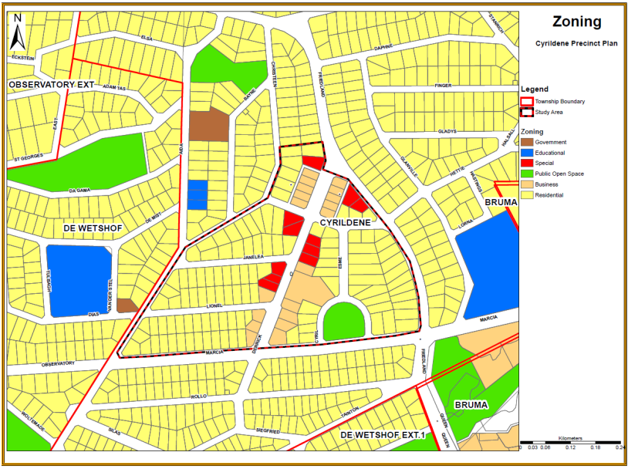

Most of the illegal land uses within the study area are developed with a single residential unit in the front of the property and residential buildings or rooms at the back of the property. Most these structures are not built in line with building regulations i.e. stipulated ventilation requirements and minimum room size) and town planning regulations (i.e. stipulated density and maximum number of rooms, parking provision, coverage). The additional building at first glance are hardly noticeable, the high impermeable high walls and gates make it difficult to see through some of the properties.
Map 3: Cyrildene land use Zoning

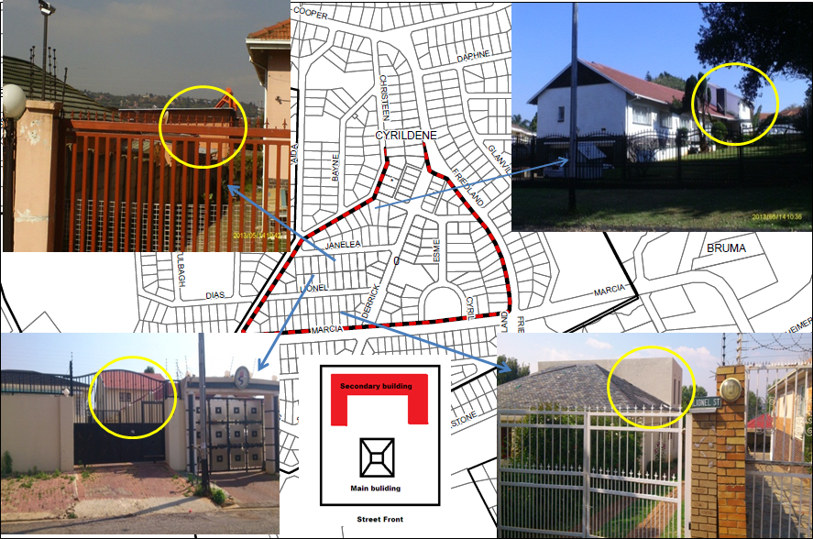
Map 4: Illegal backyard residential buildings in the area are well blended with the existing character of existing legal buildings

However, these buildings still maintain the residential character that already exists in the area as illustrated, on map 4 above. Some of the typical traditional residential developments have illegal structure constructed at the back of these properties. Migrants in Johannesburg occupy ‘hidden spaces’, and employ tactics of evasion and escape, to avoid the attention of local authorities (Harrison et al, 2012). Chinese migrants in Johannesburg also exercise this strategy, in relation to business and the state in South Africa (Harrison et al, 2012). Harrison’s (2012) study also suggests that the strategy of Chinese migrants cannot only be framed in relation to the powerful but must also be understood as responses to the pressures and attitudes of other groups (Harrison et al, 2012). Mutual support through tight networks, based on family and village or area of origin, is critical as an adaptive strategy for many migrants, and especially those who are not supported by formal business networks (Harrison et al, 2012).

Most developments along this activity street have rights that allow developments to be three (3) to four (4) stories in height. Blitz operations in the area revealed that some of the basements parking facilities have been illegally converted into residential rooms, which are non-compliant with building regulations most of them were basic and too small to be considered habitable in terms of building regulation standards (Law enforcement Strategy, 2010/2011).

According to the city of Johannesburg’s’ outdoor advertising by-law the hoarding of signs in residential areas is prohibited (See Map 5 below) (CoJ, 2008). However, a number of residential properties in the area have some sought signs. This is also a cause of disagreement amongst some of the older residents. Cyrildene is now considered the “New” Chinatown (see Map 1, p58). Its streets, particularly Derrick Avenue, are lined with a number of Chinese Shops that have given the suburb a unique identity. The area has also experience a steady influx of Asian nationals who have established enclave around the area.
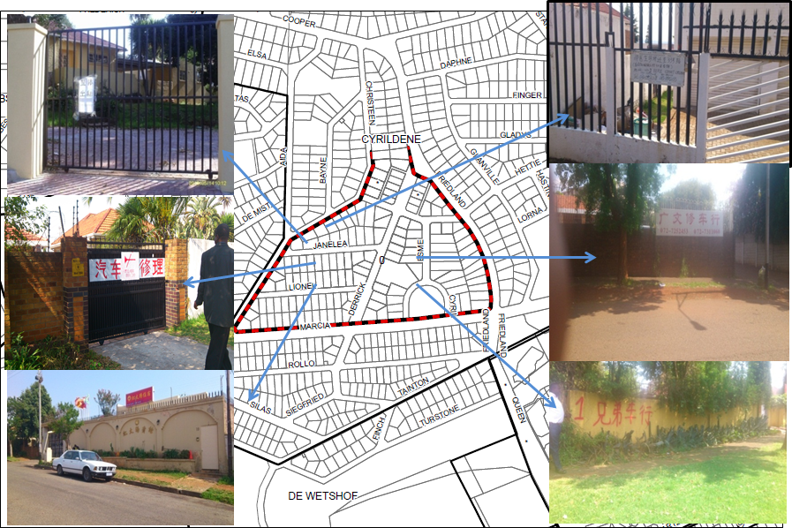
Map 5: A number of residential properties in Cyrildene display signage, which is not permitted in terms of the City s' By-Laws
However signage outside some of the properties bares Mandarin symbols, which give an indication of the ethnicity of the people residing in the area as can be seen on map 4 (p.61) above. Some of the retail facilities such as food markets are illegally extended onto sidewalks as illustrated on map 2 (p.59). However within the CoJ is considered illegal to trade on the City’s walkways/pavements and hence some of the business activities are considered illegally encroaching on the City property.

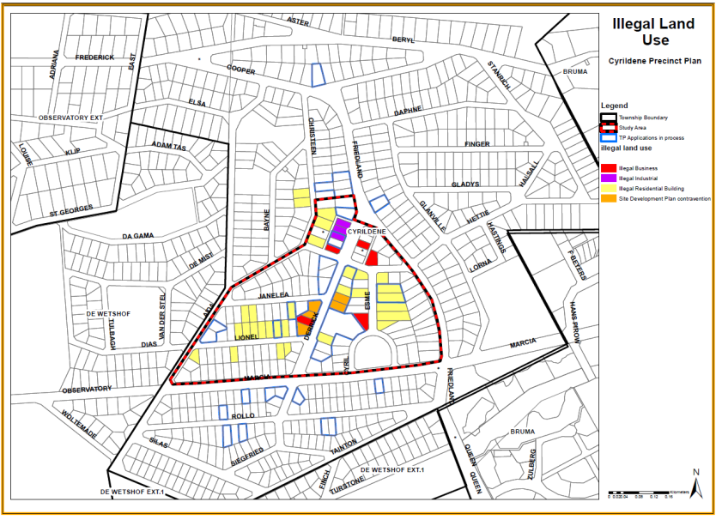
According to the Cyrildene law enforcement Strategy, 2010/2011 conducted by Building Control and land Use Development Management, the majority of illegal land uses located within the study area were residential buildings with some sites contravening approved site development plan conditions and some illegal businesses and industrial uses. As illustrated on the illegal land use map 5 below and figure 9 p.64, 65 erven investigated the following were found:
Map 6: Illegal land uses

- 30 of these erven all operate illegal accommodation establishments.
- 5 contraventions were issues related with non-compliance of approved Site Development Plans,
- 5 illegal business establishments and
- 3 Industrial uses.
Figure 9: Illegal land use chart
The remaining 53 erven investigated comply with the current zoning and no contraventions were found. At the time of the survey, 22 of the illegal uses had been handed over to attorneys to proceed with legal action.

Most of these illegal residential developments were found to be the provision of individual rooms with communal facilities. The number of rooms provided in illegal structures exceeds the number of rooms prescribed by the applicable density guidelines and town planning Scheme guidelines. Lesego (A law enforcement officer) adds although the rooms are illegal they seem to be neat and self-contained. However unfortunately we have to enforce any transgression against the By-laws until there is an alternative. Some of the rooms were not built in line with the National Building Regulations (Act No. 103 of 1977) in terms of size, ventilation requirements etc. According to the City of Johannesburg (2010/2011) most of the properties with illegal land uses are owned by Asians.

Harrison, Moyo and Yang (2012) in their article Strategy and Tactics: Chinese Immigrants and Diasporic Spaces in Johannesburg, South Africa discuss how different groupings of migrants deploy varying tactics over time and across space. While the state and capital impose spatial strategies to organise cities, the subordinate manipulate space, sometimes unconsciously, to challenge established orders to their own advantage.
The crux of the Precinct Plan is to try to find a way in which this growing demand for residential developments can be accommodated without necessarily affecting the existing residential amenity of the area and to encourage and allow developers to adhere to the proper processes and procedures for applying for additional development rights. David Mathinye (a land use planner) argues that the law enforcement efforts by the City are unsustainable. To expect law enforcement with limited powers and capacities is unrealistic. Perhaps the Precinct Plan may provide a more sustainable approach to addressing the problem. Clearly, the demand is there and the City needs to acknowledge the changing circumstance of area. It also make our job easier as there have been many applications in the area for higher densities a lot of them have been rejected. “Our hands are tied by the legislative frameworks applicable in the area” (Lesego, 2015).

The Cyrildene Precinct Plan

The Cyrildene Precinct Plan is intended to guide development as well as to ensure that development occurs in a manner that is safe and sustainable for all of the City’s inhabitants whilst promoting key development objectives. In order to achieve this, the plan needs to address development needs without compromising the existing urban fabric. Within this area, there is an established ethnic enclave of Chinese nationals. The area has been subject of debate within the City. There has been a steady incline in the number of illegal land uses. The older community residents have shown discontent with the situation. The CoJ has responded to the situation in the form of developing a Precinct Plan for the area. The plan has been met by resistance from residents in the area.
During the various public participation meeting, held in January 2013, at the request of the residents (Community policing Forum) Community Policing Forum (CPF), residents raised their concerns with the manner of which some developments were occurring in the area. The residents, the Councillor and the CPF agreed that a Precinct Plan approach would be a viable solution in the area. The Member of the Mayoral Committee (MMC) for development Planning and the Councillor for that area at the time requested on behalf of the residents that the planning department formulate a Precinct Plan that would address the challenges of the area. The initiation of the plan was a joint effort and agreement between the City and the some of the residents of Cyrildene.
The department of City Transformation and Spatial Planning went about developing the plan for the area. The following provides a summary of the process followed in formulating the plan.

Phase 1: Research and analysis.
- A desktop study was undertaken in addition to reviewing previous studies completed that examined law enforcement issues and challenges
- Analysis of existing policies.
- An analysis of building plan submissions.
- An analysis of land uses in Cyrildene including land use surveys
- Consultation with the community, Council Departments, and Ward Councillors.

Phase 2: Development of land use controls and standards

Stakeholder involvement.
A number of stakeholder engagements were held during the development of the Precinct Plan, with both external and internal stakeholders as indicate on Table 1..
- External stakeholder participation
External stakeholders including the ward Councillor were consulted during three public participation meetings that took place in the course of drafting the Precinct Plan. Smaller meetings with particular stakeholder groups were also held. The meetings were advertised through the distribution of flyers, posters in public places including, shops, bakeries and restaurants in the area and local newspapers. Table 1 gives a schedule of all the external stakeholder engagements held during the development of the Precinct Plan.
Table 1- Illustrates the external Stakeholder meetings that were held by the City of Johannesburg during the development of the Cyrildene Precinct Planning Process.
Meeting type | Venue
Public meeting 1 | Queens High School
Public Meeting 2 | Queens High School
Public Participation Chinese Community | 10th Floor Boardroom Metro Centre
Public Meeting 3 | Queens High School
Public Participation Chinese Community | 10th Floor Boardroom Metro Centre
Ward Councillor | 10th Floor Boardroom Metro Centre

The purpose of the first meeting was to obtain an initial input from the stakeholders to give them an opportunity to express their needs, requirements, interests and concerns (CoJ, 2013).
The second public meeting was intended to highlight some of the challenges in the area and to come up with possible development guidelines in order to address some of the issues in the area and how to best accommodate the needs of the community whilst taking into consideration the communities aspiration concerns and sentiments (CoJ, 2013).
The last public meeting was aimed at presenting the draft development concept and development controls. This process was intended to inform stakeholders of planning activities and also used to measure attainable objectives, evaluate impact.

Phase 3: Development of Precinct Plan key recommendations and Interventions.
Concerns from all various stakeholders were investigated and raised with all relevant departments. The third phase entailed the development of key strategic recommendations and interventions needed in the area in order to make the Precinct Plan feasible and sustainable guided by the all the background work conducted and all inputs from various internal and external stakeholders.

Phase 4: Implementation phase
The last phase will be to ensure that all key interventions needed in the area are included in the budgeting process by the various responsible departments and Municipal Entities (ME’s). The document should become a reference against which developments can be evaluated in terms of their desirability, suitability and sustainability.

Interviews
According to Liana Strydom (CoJ official) although the precinct planning development process proposed by the City sounds perfect and its intensions are rooted on sound planning principal, in reality processes in the municipality are not always cut and dry” (Lianah, 2015). As much as they would like to think that they are in charge of the process, there are “forces” beyond their control that tend to direct and dictate what planning should be. Inevitably politics runs the City, the more power you have the more you are heard. Campbell and Marshall (2002) argue that political agendas and obligations tend to generate significant tensions for practitioners as they struggle to balance multiple and, often competing obligations. The political forces at play seem to hinder the intended purpose of the process in ensuring that power is equally distributed amongst all role players.

The problem is that most people even within the City still have no understanding of what planning is and its intended purpose (Liana Strydom). The ability and opportunity to design one’s own process is dependent on who initiates the process within the City. The initiator will determine what its outcomes should be. For example a project initiated by a planner allows for the planner to determine the process to be followed and timelines for the project, whereas a project initiated by political heads forces the planner to work within the timeframes and visions of the initiator. She adds that as you become a seasoned planner you will gain the confidence and strategies that allow you to factor in your own process. Platt (2004) states that Politics is primarily concerned with resource distribution and the role of planners is, inter alia, to provide a reasoned and responsive contribution to political decision-making (Platt, 2004).
Klostermen (1996) argues that systematically excluded groups from the bargaining process lack the time, training, resources, leadership information or experience required to participate effectively in the planning process hence they have no effective voice in the planning process. Political processes also tend to exacerbate existing inequalities by failing to provide adequate information to allow participants to be fully informed in policy-making processes.
Alice Hue who is of Taiwanese origin and has been residing in Cyrildene for over 25 years, explains that Derrick Avenue was once composed of shops that mainly served the Jewish community. A small restaurant that served Taiwanese cuisine open up in one of the vacant shops and its popularity grew. At that point the restaurant provided that sense of “homeliness” to most immigrants. She states that eating out is a favourite past time amongst most Asians. As the popularity of that one restaurant grew others saw opportunity and started opening up businesses that catered for the Asian market in that area. As explained by one of the Chinese during interview, eating out is a favourite past time for the Asian. Eating out not only provides the opportunity to nourish yourself but it is a time when you can interact and talk to people. Social relations are very important in the Chinese community. She says that there is an old Chinese saying that state that “A close neighbour is better than a far relative”.
She also states that she also saw opportunity in the property market around that area, as there was a growing demand from Asians to locate around the area. Due to the language barrier, estate agents around that area could not communicate efficiently with the Asians and she sought to capitalise and bridge that gap. This should also be an indication of the possible communication barriers that may result in different cultural settings.
One of the Chinese residents’ interviewed states that Chinese people are accustomed to living in dense and confined spaces. As stated in Chapter 2 Chinese are accustomed to living in dense environments, as they are accustomed to the high population rates in most Chinese cities. There is a demand for accommodation and property owners have seen the need to supply accommodation for people. When asked if I could rent one of the rooms, he laughed and replied that it is highly unlikely to happen. “The cultural difference would make it hard for you to get along with other tenants. Chinese people are accustomed to doing and living in a certain way and can tolerate each other. The fact that they live in confined spaces will make it hard for a person from the outside to understand” (Anonymous, 2015).

According to one of the Chinese residents, the majority of the participants during public participation meetings were the older neighbours; the Chinese community at various meetings made little representation. The handfuls of participants were mainly the representatives of the Chinese business Forum of the area. The meetings were dominated by older residents who were very vocal about their dissatisfaction with the outcomes of the plan in terms of increasing density and condoning and legalising illegal land uses. During the meeting, most of the Chinese residents did not give much input into the process. The resident also added that some of the words used are difficult to understand and most Chinese would not be able to understand them anyway.

A resident who was of Jewish origin stated that “they” advertised in a language that is not South African and have total disregard for the way things are done in this country. “They simply do as they please” (Anonymous, 2015). When asked how the signage affected him, he did not give a clear answer but maintained that residents need to know what is going on in their neighbourhood. They should be able to have a say and enjoy their neighbourhood.

In light of this the City arranged a separate engagement with the Chinese community on what they term neutral ground in order to get them involved in the process and assess what their issues were. One of the challenges was the language barrier. The majority of the participants were not fluent in English. The participants relied on two members of the community to translate on their behalf. Harrison et al (2012) conclude that Chinese migrants in Johannesburg are not an undifferentiated group but are segmented in multiple ways and act differently depending on their characteristics. Any strategy initiative within the Chinese community needs to be adapted to the highly differentiated nature of diasporic groups.

As stated by Forester the planner needs to anticipate tensions before they arise. The City in recognising this challenge did not address this issue appropriately. Town planning jargon is not easy to understand and the City had no way of knowing if the message they were trying to convey was well delivered and well received. Mercer uses the example of Geddes’ theory of Survey before plan. He asserts that we need to do some cultural mapping before we start the planning (Mercer, 2006).

When the residents were questioned about the plan there seemed to be little understanding of what the plan was proposing and what exactly the consequences would be. One resident sates that the plan “wants to turn the suburb into Hillbrow by allowing masses of people to come and live on a property meant for a single family” (anonymous, 2015).

The stage at which the Chinese community was involved came at almost the conclusion of the process. However, the City officials responsible for developing the plan, insist that the Chinese community was content with the proposals of the plan. Kaufman and Jacobs (1987) emphasise the fact and important contribution to the planning process is environmental scanning. Planners need to be able to identify scan the environment and assess the strength and weakness in relation to strengths and opportunities. Therefore had this process been followed perhaps the municipality may have been able to foresee the potential conflicts and restrictions to their participation process.

However, the development of the actual plan was completed and developed in the absence of the communities’ involvement, contrary to the proposals of the policy formulation process of the City. As stated by one of the City officials, ideally the community should be involved more, however we work within time constraints and most involve the community just enough. The planning process thus “legitimises” the process from bureaucratic point of view and too little to legitimise the process from a “planning principal” point of view. One of the resident in the area alleges that the City is trying to turn their neighbourhood into Hillbrow and wants to force their (the City) ideas down our throats. The area has been like this for a long time why should it change now he adds.

Allison van der Molen (the Councillor for the area at that time) asserts that the plan is a positive step for the area; however, it will be a challenge for the older residents to accept changes until they feel that the City is acting equitably in addressing everyone’s issues and favouring outsiders. “They will use every given opportunity to voice their frustration with the City and honestly there will never be any fruitful engagement unless it addresses problems that they value as important”.In terms of power and participation, a lot depends on how people take up and utilise what is on offer, in addition to supportive processes that can help build capacity, nurture voice and enable people to empower themselves” (Allison).

Development control Proposal
Table (2) indicate the development “controls” put forward by the CoJ. Table 2 provides the summary of the development controls as proposed in the Johannesburg Town Planning, 1979.
Table 2: Proposed development controls for the Study area.
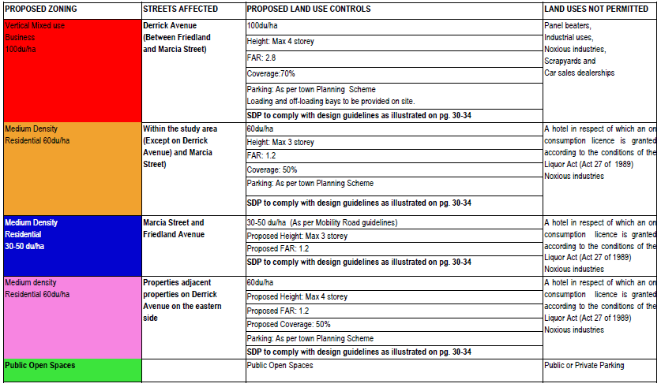
The plan is slightly different from table H of the Johannesburg Town planning Scheme, 1979, which is attached as Appendix A, with the only difference being the density proposals. The plan seems to be regressing towards the very rigid development controls set on British planning system of development controls. Leung (1989) argues that instead of being extremely prescriptive a flexible plan should limit the number of controls applicable to properties. Berrisford (2013) also asserts that minimum control will allow people to control what is and is not achievable for them.
As concluded in Mohamed’s’ (2005) thesis that investigated the role played by enclaves in urban regeneration strategies, ethnic enclaves can play vital in contributing towards the revitalisation of our cities. The case studies illustrate that there is a contradiction between what the CoJ’s formulation policy propose and what process are actually followed. The Cyrildene Precinct Plan provided an opportunity for communities to be involved in influencing the manner in which the suburb could be developed in future. However, the process of the development of the plan has many flaws, which did not enable the community to participate meaningfully.

Ethnic organisations and leaders within the Chinese community do play a vital role in affecting both the nature and scope of participation and influence, and results vary depending on the type of association and leadership that are at the forefront; business groups are more effective at achieving influence, whereas social service agencies are better at community mobilisation. The utmost transformational intentions can meet a dead end when ‘anticipated recipients’ select not to participate, or where powerful interest groups or gatekeepers within the community turn well-intentioned efforts to satisfy their own ends and push their own agendas.
Barth’s (1998) argument is that it is not so much the cultural values and practices themselves which impact political behaviour, but it is the way that the differences between groups are treated that shapes political actions. Each group’s mode of participation has developed from its socialisation process within the host country rather than being directly imported from the home country.

As stated earlier ethnic or cultural approaches assume that the immigrants’ identity as a distinct ethnic or religious group is of fundamental importance to understanding their role in the political process. Berrisford’s (2013) call to recognise ‘multiple local and individual realities’, so as to enable planners to provide communities with the spaces of empowerment. The process chosen to develop a policy is crucial in determining how people can meaningfully participate in the planning process.

The case study demonstrates that there is room for policy processes, approaches and outcomes to be flexible, however despite the fact that the mechanisms are available to allow for policy to do so, it is apparent that there needs to be willingness on the part of the City to embrace this. There seems to be a lack of innovation that is able to move away from the normative standards of land use regulations. Public participation and inputs from the community seem to represent Tokenism as described earlier in Chapter 2. The main sources of data collection are focused on quantitative technical aspects and less focus is on obtaining qualitative data sources. The social dynamics and diversity in these areas are more of stumbling blocks as they seem to either be disregarded or little understood. The lack of social cohesion between the various interest groups in the area also adds as another stumbling block in the achievement of any effective initiative in the area.

Chapter 5: Recommendations and Conclusion

Introduction

In the past five decades or so planning has undergone various transformations with the aim of overcoming rigid technocratic methods of planning in isolation of citizen participation. However many of these transformations have not yielded the intended results, planning processes continue to be developed in a similar fashion to those of traditional modernist methods. These outcomes in planning practice can mainly be attributed to the ineffectiveness of institutions responsible for spatial planning processes. Non-statutory plans such as precinct planning processes in the CoJ are such processes that aim to bridge the inefficiencies and rigid planning requirements of other planning frameworks. The CoJ initiates these processes aimed at responding to changing circumstances within the greater area of Johannesburg, however there is still minimal consultation with the various stakeholders affected by these process that are initiated in their areas. It is critical to understand the purpose of planning, how planning has evolved, why it has evolved and what it entails however complex it may be. This gives a deeper meaning and understanding as to the purpose and existences of planning. However, it is an ever-changing discourse as a result of the ever-changing state of the nature of cities.

Recommendations
In the study two related concerns emerged within the idea of ‘flexibility’, that is flexibility of the process and flexibility for increased diversity and expression of culture.

Flexibility of process
There are still too many gaps in policy-making and implementation processes within the planning fraternity. The inefficiencies and in some occasions, total absence of the requisite institutional arrangements, inadequate participatory processes and a non-existent community development programme jeopardise the growth and further development of communities. Planning policies that are restrictive in nature, the challenges of monitoring and enforcing policy implementation are the biggest contributors of the large number planning problems within the City.
Thus policy needs to accommodate, and consolidate the needs of the community as best as possible, whilst taking into consideration the already existing urban fabric, socio-economic factors and environmental factors. More inclusive, just and economically productive urban centers cannot be created by new legislation alone.
There needs to be a change in the mind-sets of the officials responsible for implementing urban legislation in African countries. Officials are influenced by a mix of international, professional and legal pressures, which must be taken into account by planning law reformers (Berrisford, 2013).
Planners need to be aware of the socio-economic and political dimensions that exist within each community.
Current planning process especially within the context of the City of Johannesburg, can be adjusted to accommodate different situated contexts, however the willingness of planners to do so remains questionable.
There is still too much reliance on rigid systems of land use controls in an attempt to regulate land development. Planning still lacks innovative methods of guiding land use development without being too prescriptive.
Planning is critical to success in every facet the lives of communities. Planning offers an opportunity for communities to create a roadmap unique to their needs, aspirations and strengths.

By planning strategically, local governments and can work together to integrate culture more fully into the community.

For years non-conformity to acceptable standards has been regarded as non-progressive, thus one must conform to “popular” norms and standards. Culture is wide-ranging, fluid and situational, communities and individuals within communities are not the same, instead of forcing communities to be the same difference needs to embrace and its benefits enhanced.

Various forms of data and data collection methods need to be incorporated into planning process. Planning processes tend to have a narrowed and quantitative focus and reliance on quantitative data.
Since urban planning cannot be done in isolation of the people that affected by it, communities are regarded as a crucial component of ensuring that public interest legitimate and not perceived. The common link amongst most planning literature is the acknowledgement of the critical role communities’ play within the planning process. We have explored theories of planning practice and the common emphasis on the importance of planning responding and integrating the inputs of communities in the planning process. Furthermore, we come to realise how the planning process plays an important role in ensuring that plans respond to situated context of communities.

Flexibility of Cultural expression

Strategic planning has become an important technique to develop a program of action based on public private partnerships for public planning. It offers significant opportunities for public planners especially at the level of engaging communities. It can enhance the process of communication, analysis, and secondary data and forecasting

Local experts and community leaders provide key guidance and advice that the research team should be respectful of and responsive to. Local organisations and community leaders provide a critical link to members of the community.

By practising good planning, one is able to help create communities that offer variety in choice concerning how and where people live.
Communities should be assisted and equipped to envision their own future through planning. Planning aids communities in determining the most equitable balance of new development and the provision of essential services, protection of the environment, and innovative change. Negotiating the location and manner in which development will occur is a primary function of participatory planning.
Participatory planning is about including all sectors of the community in the planning processes as they too have a stake/ interest in what happens in their areas- this includes amongst others private and public sector organisations/ institutions, civil society and voluntary agencies.
Making City development processes more participatory through new and better methods is the endeavour of good urban planning, simply because when planning is driven by demand it is increasingly dynamic and much more effective, is the instrument of performance in this case is determined by public interest.
Effective and inclusive planning needs to be upheld by public accountability, this means that there should be transparency with all planning processes, which have to be subject to scrutiny by the public. This can be achieved through mechanisms that provide oversight on processes and decisions such as public hearings and other similar and appropriate oversight mechanisms.
Culture should be understood as resources for social and public development, when the understanding of culture is inclusive and broader then we can address civic goals.

The understanding of cultural practices provides a different perspective of looking at the community, its issues and concerns (Creative City, 2010). This understanding and knowledge provides a new perspective in finding ways to support community empowerment through community involvement and ownership of local community initiatives.

It is important to assess and properly understand the full needs of the community, not just perceived needs. Inclusive planning should refuse to give in to dominant social trends in order to promote social justice and “radical democracy” and work towards liberation by helping groups achieve a spatial voice in new forms of community and solidarity, conceived within difference” (Dutton and Mann, 1996, p. 159).
An explanation for mobilisation of a minority community into politics is that persecution pushes them into it. There is little doubt that discrimination can cause a group to unify in order to combat a threat from outside the community. However, this alone cannot explain when and how a group will participate. The public nature of some forms of consultation can serve as a space for the discussion of grievances that may become more complicated for those in power within and beyond the community to ignore.

Emphasis should be on what can be done rather than what shouldn’t be done (Berrisford, 2013). Planning with community stakeholders should be a means of negotiating appropriate locations and the manner that development should occur. Planning should be about panning with all sectors of the community with a stake in the place.

Focus on minimum standards to secure desirable urban form Planning should focus on the process of protecting and improving the living, production and recreational environments in a City through the proper uses and development of land rather than rigid development controls. There should be a move away from traditional forms of planning. Planners should seek social justice by working to expand choice and opportunity for all.
Innovative methods of planning process should be further investigated in order to provide alternative and flexible methods for future planning initiatives and urban planning management especially within the government sector. These innovative methods should encourage alternative methods of data collection and the importance and relevance of localised knowledge in creating pragmatic planning initiatives.

Limitations of the Study

Given the time limit of the study a more in-depth analysis and interviews with the Chinese population was necessary. The interviews also took time. The language barrier made communication difficult to a certain degree. It also limited the number of participants that could be interviewed for the research.

The positionality of the researcher as an insider and mainly as part of the municipality may have limited the extent to which participants especially from the view of the Chinese community could freely participate in the study.

Interviews conducted with the community outside the Chinese community yielded very generic and similar answers, as the participants seemed more eager to discuss their dissatisfaction with the municipality.

There are various areas within the City that have had precinct pans developed and the process followed in those areas might not necessarily have been the same as that followed during the development of the Cyrildene Precinct Plan. Thus, the study may not be a true reflection of how all process are conducted.

Flexibility is difficult to measure and assess adequately including the multitudes of factors that are included in determining how flexible policy is.

Culture can also have varied meanings and a very narrow definition of culture was used to demonstrate the flexibility of policy in responding to culture.

Conclusion

The study intended to examine the flexibility of planning processes and outcomes in responding to the needs of the community with the special focus on culture. The following was done in examining the flexibility of planning and planning outcomes:
Chapter 1 illustrated that there were still discrepancies between planning processes and the communities they served. It introduced the rational of planning in relation to the inhabitants of the City and the factors that shape the needs and wants of these inhabitants. The following research question was formulated in order to examine this phenomenon: How flexible are planning processes in responding to different cultural settings. The study focused on a non-statutory plan, which was the Cyrildene Precinct Plan developed by the CoJ for the Cyrildene area, in order to answer the research question.

The second chapter explored the meaning of flexibility as a concept in relation to culture, participatory frameworks and power in diverse societies within the inherited and current policy frameworks. Flexibility was not only examined in terms of prevailing policy but also the process of formulating it and how it responds to the diversity of culture especially within the context of multicultural cities such as Johannesburg.

Out of this set of literatures themes around how and why planning process and policy has evolved in relation to participation, power and culture were examined. Through this exploration we came to an understanding of how planning theory evolved from a technocratic process to a more inclusive and robust process that embraced the importance of participatory process in planning practice. This led to the investigation of the meaning of space in relation to people using and how culture practices shaped the manner in which people perceive space. The next section of the chapter focused on factors that enabled participants to meaningfully feed their perceptions of space into the planning process and shape the outcome of these processes.

These theories provided insights into the various aspects of planning that contributed to making plans more flexible in responding to different environments. Place-making, inclusion, diversity, collective objectives, influence, conflicting needs and variety of process were the main reoccurring themes throughout all the literature reviewed. Berrisford (2013) argues that, “more progressive, realistic urban planning in Africa will require a radically different approach to planning reform (Berrisford, 2013: 15).

The chapter also reviewed planning process in South Africa with a narrowed focus on Precinct Plans. The chapter illustrated that Precinct Plans are non-statutory plans that could possibly provide for the flexibility needed in plans and in terms of accommodating diverse needs. These theories then provided a conceptual framework that enabled for the evaluation of planning process and outcomes within the CoJ.

Chapter 3 outlined the research methods used to answer the research question. The study argued for a case study researched method best framed within qualitative, quantitative and visual methods of data collection. It also argued for the different methods that needed to be used in examining the research question.

The fourth chapter analysed the case study of the Cyrildene Precinct Plan as per the recommended methods suggested in chapter 3. The suburb of Cyrildene was chosen as to be analysed whereby the CoJ has embarked on a processes to develop a Precinct Plan within a context of a Chinese enclave. Collected data, interviews and photographs will assist in illustrating whether the Cyrildene Precinct Plan was flexible in accommodating the diverse needs of the community whilst being sensitive to Chinese culture that exist in the area. As stated earlier the Precinct Plan has been met by resistance from the community members in this area and the plan has since been put on hold as a result of this resistance.
The prevailing policies in planning are rigid as they tend to be inflexible in providing the requisite infrastructure and services that respond to community needs. Planning policies need to match and respond to the growth and evolution that community’s experience. In order to create a sustainable place from a social perspective, making allowances for spaces where ‘growth’ can occur is crucial in terms of an adaptable policy approach. Socially sustainable spaces also create opportunities for communities to participate actively in shaping their civic, democratic, social and cultural existence. Shared experiences, which occur in spaces, create a common sense of inclusivity and belonging.
In conclusion, it must be emphasised that flexibility is the underlying notion that the study wished to examine. Flexibility in terms of policy planning process and how responsive flexible policy can be in addressing different planning contexts and dynamics such as culture, power and participation in creating effective and pragmatic plans that are accommodative of different cultural settings.

References list

- Angotti, T., Kennedy, M., Pascual, R., Hoffman, R., & Jeanpierre, E. (2007). Advocacy and Community Planning: past, present and Future. Progressive Planning, 171, 21-24.
- Bickenham, J. and Hendler, S. (1994). The moral mandate of the ‘profession of planning, in Thomas, H. (eds) Values and Planning, Aldershot: Avebury
- Bahmann, D. & Frenkel, J. (2014).Renegotiating Space Arts on Main, 44 Stanley + Johannesburg.
- Barth, F. (1998). Ethnic groups and boundaries: The social organization of culture difference. Waveland Press.
- Beavon, K. (1992). The post-Apartheid city: Hopes, possibilities, and harsh realities. In: D. M. Smith, ed., The Apartheid City and Beyond. Routledge, London, and University of Witwatersrand Press, Johannesburg.
- Beauregard, R. (1996). Between modernity and postmodernity: the ambiguous position of US planning. Readings in planning theory, 213-234
- Berrisford, S. (2013). How to make planning law work for Africa. Africa Centre for Cities, University of Cape Town.
- Bryson, J, & Crosby, C. (1989). The design and use of strategic planning arenas. Planning Outlook, 32(1), 5-13.
- City of Johannesburg (2009). Plan formulation policy – requirements & procedure.
- City of Johannesburg (2010/2011). By-law Enforcemnt strategy.
- City of Johannesburg (2013). Cyrildene Precinct Plan
- Caldeira, T. (1999). Fortified enclaves: The new urban segregation in theorising the city: The new urban anthology reader, edited by Low, S. New Brunswick: Rutgers University Press: 83-107.
- Chambers R (1983) Rural Development: Putting the Last First. Longman
- Cole Rand & Blij H. (2007). Survey of Sub-Saharan Africa: A Regional Geography. New York: Oxford Press.
- Dandekar, H. C. (1986). Some uses and potentials of qualitative methods in planning. Journal of planning Education and Research, 6(1), 42-49.
- Dewar, D., & Uytenbogaardt, R. (1991). South African cities: A manifesto for change. Cape Town: University of Cape Town.
- Du Plessis, D (2013). A Critical Reflection on Urban Spatial Planning Practices and Outcomes in Post-Apartheid South Africa. Springer Science and Business Media Dordrecht.
- Fainstein, S. S. (2005). Planning theory and the city. Journal of Planning Education and Research, 25(2), 121-130.
- Fainstein, S. S., & Campbell, S. (Eds.). (1996). Readings in urban theory. Oxford: Blackwell.
- Ferguson, G. and Ferguson, J. (1997). Culture, Power, Place : Ethnography at the End of an Era in Ferguson, G. and Ferguson, J.(eds) Culture, Power, Place: Exploration in Critical Anthropology, Duke University Press.
- Fishman, R. (1996). Beyond suburbia: the rise of the technoburb (pp. 484-491). London: Routledge.
- Forester, J & Stitzel, D. (1989). Beyond neutrality. Negotiation Journal, 5(3), 251-264.
- Forester, J. (1989) Planning in the face of power. University of California Press, Berkeley.
- Frankel, J. (1998). Legal and Regulatory Climate for Investment in Post-Apartheid South Africa: An Historical Overview, The. Cardozo J. Int'l & Comp. L., 6, 183.
- Freedman A. L. (2000). Political participation and ethnic minorities: Chinese overseas in Malaysia, Indonesia and the United States. Routledge, London.
- Freire, P. (1970). Pedagogy of the oppressed. New York: Continuum.
- Gans, J. (1967). The Levitt owners: How People Live and Politic in Suburbia. New York, Pantheon Books, 1967.New York: Free Press of Glencoe.
- Gans, H. J. (1969). Planning for people, not buildings. Environment and Planning, 1(1), 33-46.
- Hall, P. (1988). Cities of tomorrow. Blackwell Publishers.
- Harrison and Khan (2002) The ambiguities of change: The case of the planning profession in the province of Kwa Zulu-Natal, South Africa. In a Thornley & Y Rydin (eds) Planning in global era. Aldershot: Ashgate.
- Harrison, P., Todes, A., & Watson, V. (2008). Planning and transformation. Learning from the post-apartheid experience. The RTPI library series, 16.
- Healey, P. (1998). Building institutional capacity through collaborative approaches to urban planning. Environment and Planning a, 30(9), 1531-1546.
- Jacobs, J. (1961). Death and Life of Great American Cities. New York: Random House.
- Jürgen’s, U.,Gnad, M. and Bahr, J. (2003). New Forms of Class and Racial Segregation: Ghettos or Ethnic Enclaves?” in Tomlinson, R., Beauregard, R. Bremner, L. & Mangcu, X. (eds) Emerging Johannesburg: Perspective on the Post-apartheid City.
- Knieling, J., &Othengrafen, F. (Eds.) (2009). Planning cultures in Europe: Decoding cultural phenomena in urban and regional planning. Ashgate Publishing, Ltd.
- Lucas, J. (1995). Space, Society and Culture: Housing and Local-Level Politics in a Section of Alexandra Township, 1991-1992.
- Leung, H. (1989). Land Use planning made plain, Ronald Frye & Company
- Leung, H. L. (2003). Land use planning made plain. University of Toronto Press.
- Lynch, K. (1960). The image of the city (Vol. 11). MIT press.
- Low, S. M. (2010). On the plaza: The politics of public space and culture. University of Texas Press.
- Mabin, A., & Smit, D. (1997). Reconstructing South Africa’s cities? The making of urban planning 1900–2000. Planning perspectives, 12(2), 193-223.
- Marcuse, P. (1960). The Enclave, the Citadel, and the Ghetto. What has changed in the Post-Fordist U.S. City?
- McCarthy, J, Smit D (1984). South African City: Theory in Analysis and Planning. Cape Town, Juta.
- Morris, B. (2006). Religion and Anthropology: A Critical Introduction, Cambridge : New York
- Parnell, S., & Mabin, A. (1995). Rethinking urban South Africa. Journal of Southern African Studies, 21(1), 39-61.
- Parnell, S. (1993). Creating racial privilege: the origins of South African public health and town planning legislation. Journal of Southern African Studies, 19(3), 471-488.
- Pieterse, E. (2002). From divided to integrated city. In Urban Forum (Vol. 13, No. 1, pp. 3-37). Springer Netherlands.
- Platt, R. H. (2004). Land Use and Society, Revised Edition: Geography, Law, and Public Policy. Island Press.
- Qadeer, M. (2005), “Ethnic Segregation in a Multicultural City” in Varady, D. (eds) 2005 Desegregating the City: Ghettos, Enclaves &Inequality, Red Space, Palgrave Macmillan
- Rienstra, B., & Hook, D. (2006). Weakening Habermas: the undoing of communicative rationality. Politikon, 33(3), 313-339.
- Sillitoe, P (2002). Participant observation to participatory development. Participating in development: approaches to indigenous knowledge. London and New York: Routledge, 1-23.
- Smith, D. M. (1992). Redistribution after apartheid: who gets what where in the new South Africa. Area, 350-358.
- Smith, M. (2008). Religion, Culture and Sacred Space, Palgrave: Macmillan.
- South African Human right Commission (2006), Reflections on Democracy and Human Rights: A Decade of the South African Constitution (Act 108 of 1996). Cape Town
- Tashakkori, A. & Teddlie, C. (2000) Mixed Methodology . Sage.
- Taylor, N. (2007). Urban Planning Theory since 1945, London, Sage.
- Todes, A. (2006). Urban spatial policy. Democracy and delivery: Urban policy in South Africa, 50-75.
- Todes, A. (2012). Urban growth and strategic spatial planning in Johannesburg, South Africa. Cities, 29(3), 158-165.
- Tomlinson, R, Beauregard, R, Bremner, L and Mangcu, x. (eds). (2003). Emerging Johannesburg. Perspectives on the post-apartheid city. New York: Routledge.
- Tylor, E, (1871).Primitive Culture. University of Cape Town 2010
- UN-HABITAT, 2011 Place-making and the Future of Cities
- Watson V (2014): Will the profession speak out? Winners and losers in the future African city. Planning Theory and Practice, Interface, 15 (1) pp 115-118
- Webber, M. M. (1963). Comprehensive planning and social responsibility: toward an AIP consensus on the profession's roles and purposes. Journal of the American Institute of Planners, 29(4), 232-241.
- Yin, R. K. (2013). Case study research: Design and methods. Sage publications.
- Yin, R. (1994). Case study Research Design and Methods.2ndedition.Sage Thousand Oates
Websites

http://www.plannersnetwork.org/2007/04/advocacy-and-community-planning-past-present-and-future/. 8June2015
- (http://www.sagepub.com/upm-data/36869_muijs.pdf.). 21 April 2015
- (http://www.ccs.neu.edu/course/is4800sp12/resources/qualmethods.pdf). 21 April 2015.
- (http://arts.cultural-china.com/en/83Arts7487.html). 8 June 2015
- (http://www.qualitative.net/index.php/fqs/article/view/394/856). 21 April 2015
- PlanAct, (2007) Urban land: space for the poor in the CoJ? Summary of findings of a joint study on land Management and Democratic Governance in the CoJ. http://www.planact.org.za/wp-ontent/uploads/2014/08/2.-Urban-land-Space-for-the-Poor-Research-Summary.pdf m (8 June 2015)
- William, H. (05 May 2008),”How urban planning Works". http://science.howstuffworks.com/environmental/green-science/urban- planning.htm>. 21 April 2015.
- South African History Online (2015). The fruits of Freedom (www.sahistroy.org.za). 7 November 2015
- http://gis.stackexchange.com/questions/156896/drawing-zoning-setback-lines. 10 November 2015

The concept of flexibility will be discussed in chapter 2 by looking at ideas of participation and power (amongst other issues and a conceptual framework will be developed from this.

