University of the Witwatersrand, Johannesburg
Wits School of Arts

Arts Education: Exploring Dialogical Artistic Practice in the City of Johannesburg

Surname: Plessie

First name/s: Bonolo Puleng

Student number: 919070

Supervisors: Professor David Andrew
Rangoato Hlasane

Ethics Clearance Number: WSOA151201

Table of Contents

Arts Education: Exploring Dialogical Artistic Practice in the City of Johannesburg 1
Table of Contents 2
Table of Figures 4
Declaration 6
Acknowledgements 8
Abstract 10
Chapter 1: Introduction 11
Rationale for the Research Study 12
Methodology 17
Ethical Considerations 18
Chapter 2: Literature and Practice Review 19
Section 1: Facilitation and Dialogical Practices. 19
Section 2: Inkulumo-Mpendulwano Practices: Investigating the Importance of Space, Body, Storytelling and Performance in the City of Johannesburg. 24
1. Carli Coetzee Accentedness (2013): Facilitation and Community Spaces as important elements of Inkulumo-Mpendulwano Practices. 24
2. Two Thousand and Ten Reasons to Live in a Small Town (2010): Community Spaces, Storytelling and Performance as important elements of Inkulumo-Mpendulwano Practices. 27
3. Umhlangano Womphakathi: Interviews with Keleketla! After School Programme facilitators (2012) and learners from the Artucation Programme. 36
Chapter 3: Selected Artucation Programme Workshops which influenced the Inkulumo-Mpendulwano Exhibition. 48
Section 1: Before the Artucation Programme: Investigative Process 48
Section 2: Artucation Programme: Learning… Unlearning 50
Exhibitions and Classroom Processes Which Informed the Inkulumo-Mpendulwano Exhibition 50
Rise and Fall of Apartheid: Photography and the Bureaucracy of Everyday Life Exhibition organised by the International Centre of Photography (2014) 51
Johannesburg Street Exhibition by Alphabet Zoo (2014) 53
In Search of… Exhibition by Musa N. Nxumalo (2015) 53
Curatorial Process with learners 56
Chapter 4: The Inkulumo Mpendulwano Exhibition - Outcomes of the Artucation Programme 59
Aerial Overview of the Area 59
Izimpekupheku: Energies, Movement and Impermanence in Arts Education 61
Abalingiswa - Characters 62
Abalingiswa at the Playground Area 64
Abalingiswa in the Waiting and Reception Area 65
Abalingiswa in Corridor 3 and Outside Passage 67
Abalingiswa in the Reflective Room 69
Text 70
Corridor text 71
Text in Reception 72
Text and Ethics 72
Notice Board Text 74
Way Forward 77
Glossary 79
Bibliography 81

Table of Figures

Figure 1: Celebrating Simplicity exhibition, GoetheOnMain project space, March 2010. The workshops focused on the processing of ideas, production and interactions. Learners mapped out their personal journeys and social environments, and in doing this, transformed the gallery through a dialogical and material process. 14
Figure 2: Lamine Seck’s map. 15
Figure 3: The Trinity Session at Kher Thiossane Media Lab, Dakar, 2007. The three photographs show The Trinity Session’s interpretation of and interventions on, Seck’s map with various mediums, methods and outcomes as dialogical process and experience. 15
Figure 4: MADE IN MUSINA Project by Thenjiwe Nkosi, Rangoato Hlasane and Raymond Marlowe, The Musina Nancefield Community Hall, 2010. Photographer: Thenjiwe Nkosi. A t-shirt workshop which functions as an opportunity to unify and encourage collaboration as part of the art making process. 29
Figure 5: MADE IN MUSINA group discussion, The Musina Nancefield Community Hall, 2010. Facilitator uses a Community Hall as space which encourages community engagement, learning and interaction. 30
Figure 4: The Incidental Audience by Vaughn Sadie and Neil Coppen, Dundee, 2010. Studio-classroom space as an intimate place of planning, reflecting, processing and storytelling. 33
Figure 5: Living Within History by Vaughn Sadie and Neil Coppen, Dundee, 2010. Re-enactments of History which involve participation and collaboration. 35
Figure 8: First experience and encounter at the Rise and Fall of Apartheid: Photography and the Bureaucracy of Everyday Life Exhibition organised by the International Centre of Photography (2014). 52
Figure 9: Learners leading the programme and facilitating and interpreting the exhibition. 52
Figure 10: Learners from MC and NMPC performing their Eish performance for Drama for Life university students who further responded to these performances. 55
Figure 11: Eish performance with themes around relationships. 56
Figure 12: Zines produced by the learners 56
Figure 13: Aerial view of the resources available to MC (number 15) and surrounding schools (Number 8 and 9). The different languages, cultures and classes intertwine and enhance the arts educational programmes offered here. 60
Figure 14: Inkulumo-Mpendulwano, Metropolitan College, 2016. Ground floor plan with the depiction of where the Abalingiswa (characters) were located 63
Figure 15: Inkulumo-Mpendulwano, Metropolitan College, 2016 – Izimpekupheku as the different energies that may transform a space. 64
Figure 16: Inkulumo-Mpendulwano, Metropolitan College, Playground Area, 2016. 65
Figure 17: Inkulumo-Mpendulwano, Metropolitan College, Waiting Area, 2016. Placing Abalingiswa in certain positions which speak to movement and flexibility in arts education. 66
Figure 18: Inkulumo-Mpendulwano, Metropolitan College, Reception Area, 2016 67
Figure 19: Inkulumo-Mpendulwano, Metropolitan College, Corridor 3 Area, 2016. 68
Figure 20: Inkulumo-Mpendulwano, Metropolitan College, Outside Passage Area, 2016. This Umlingiswa seemed hidden in the outside area, if viewers did not pay close attention, it could be missed. This addresses the learner-teacher relationship in arts education. 69
Figure 21: Inkulumo-Mpendulwano, Metropolitan College, Reflective Space Area, 2016. This space depicted different reflective moments which informed the Inkulumo-Mpendulwano process and exhibition. 70
Figure 22: Text from NMPC learner who wrote about her journey in the Artucation Programme. 71
Figure 23: Inkulumo-Mpendulwano, Metropolitan College, Reception Area, 2016 72
Figure 24: Inkulumo-Mpendulwano, Metropolitan College, Outside Passage Area, 2016. 73
Figure 25: Inkulumo-Mpendulwano, Metropolitan College, Reflective Space Area, 2016. Close up of the written text on the floor. 74
Figure 26: Inkulumo-Mpendulwano, Metropolitan College, Reflective Room Area, 2016. Ethics text and video projection. 74
Figure 27: Inkulumo-Mpendulwano, Metropolitan College, Notice board Area, 2016. Learners’ invitation to the Inkulumo-Mpendulwano exhibition and collaboration of participants of the Artucation Programme. 75

Declaration

I declare that this research report is my own unaided work. It is being submitted in partial fulfilment of the Degree of Master of Arts in Fine Arts at the University of the Witwatersrand, Johannesburg. It has not been submitted before for any degree or examination in any other university.

Acknowledgements
To God, the creative genius of all things, who has carried me, granted me strength, direction and wisdom.
To my sister Lerato Plessie and my two children Mandisa Plessie and Musawenkosi Plessie for their continuous love, patience and support.
Facilitators:
There are a few people who have collaborated and journeyed with me through the Artucation Programme:
To Genevieve Louw who has collaborated with me in several arts educational projects, and for this research in particular has co-facilitated Photo Voice inspired workshops with Chase Daenos.
To Thembeka Mndebele, Khanyisile Jwaha, Gabisile Simelane, Siseko Pame and Nomaswazi Nkosi who would from time to time give support in the Artucation Programme.

To Alphabet Zoo and Claudia Hartwig who facilitated silk-screening workshops with learners.
To Teboho Radebe and Moses D. Rasekele who co- facilitated applied drama activities with learners. To Tshego Khutsoane my mentor in the Mvuso Schools and Community Project.
To Henrik Louw who has also given of his time even in the early hours of the morning to help me with editing.
Organisations:
I would like to thank the Goethe Institute Johannesburg for their partnership in the Artucation Programme and Drama for Life for allowing me to be part of their Mvuso Schools and Community Project where I was able to acquire applied drama techniques.
To the schools who allowed learners to participate in the Artucation Programme: New Model Private College and Metropolitan College.
To the learners (the artists) who have inspired me to learn and unlearn consistently.
Supervisors:
To David Andrew and Rangoato Hlasane, I would like extend my appreciation for their patience, encouragement and continuous support. They have believed in me even when I did not believe in myself. I am truly grateful.
Dedication
To my mother Mapula Plessie who has been a pillar and inspiration, she has been supportive, loving and carried me in the difficult times throughout this journey.

Abstract
This research explores the dialogical in arts pedagogy. This form of pedagogy is understood to allow for both the learner and educator to participate by exchanging experiences without the one being more superior to the other (Freire 1968, p. 169). In this thesis I use the Zulu term Inkulumo-Mpendulwano, which, rudimentarily, means dialogue. Broken down, Inkulumo means to talk or to have a conversation and Mpendulwano means to respond. However, I also use the term Ukufundisa, which means “to teach” but also “to instruct” and “to school” which is an authoritarian way of teaching. What is emphasised in this research is not only the potentiality of Inkulumo-Mpendulwano interactions which can be adapted in the classroom as well as curated spaces, but by introducing different terminologies I attempt to reimagine the language and practices associated with arts education. This further engages with the possibility of changes in terminology and vocabularies, how the written and spoken is understood differently and how visual and spatial modes become central to changing the learner/teacher dynamic. This dissertation exemplifies two cases of the dialogical arts pedagogy. The first is a case study of Keleketla! Library and the second is a participatory action research approach where I work as an artist-educator for the practical component of this research entitled Artucation Programme. The outcome of this research is a written dissertation and a creative project that investigates Inkulumo-Mpendulwano interactions in arts education.

Key words
Pedagogy, Arts Education, Dialogue, Authoritarian, Terminology, localising content, Teaching, Facilitating, Learning, Unlearning.

Chapter 1: Introduction

This research explores the notion of facilitating through dialogue to better understand pedagogy in arts education in the city of Johannesburg. Maria Lind (2011, p. 173), an independent curator and writer, argues that facilitating should be a dialogical process which provides room for less didacticism, less schooling and persuasion but rather active engagement that is not compensatory. This research argues, that Lind’s explanations, with words such as “to school”, “to instruct” and “didactic” have authoritarian associative meanings (Lind 2011).
Similarly, Ukufundisa is an isiZulu (Zulu) word which means “to teach”, a word that I often used as an art education facilitator to describe the facilitation process. Zulu is usually my medium of instruction as this is the language I am most familiar with. The Zulu dictionary - in addition - ascribes denotative values of ‘instructing’ and ‘schooling’ to it. It became quite clear that I had been using the word Ukufundisa incorrectly and subsequent scrutiny of the Zulu dictionary brought to light that the dialogical process between facilitator and learners is semantically more aptly encapsulated in the hyphenated word Inkulumo-Mpendulwano.
This hyphenated word comes closest to the dialogical pedagogies I seek to understand as opposed to those that emphasise schooling, instructing or asserting superiority over a learner (Freire 1968, p. 169). Analysis of this word’s constituent parts reveals that Inkulumo means to talk or to have a conversation and Mpendulwano means to respond. It therefore correlates with the emphasis in this research - which is on the potentiality of Inkulumo-Mpendulwano interactions to be adapted in the classroom as well as exhibition spaces, in order to understand pedagogic outcomes. Although the term Inkulumo-Mpendulwano is the Zulu equivalent for dialogue, it is not an inclusive common word in circulation; it is however, a theorising exercise for this dissertation.
One can associate such Inkulumo-Mpendulwano methods with a “call-and-response” action that is present in the work of organisations such as Keleketla! Library (Keleketla: to participate in Sesotho and Setswana) and Ba re e ne re (a Sesotho and Setswana word) which, when directly translated, means “They say it was said that…” which is similar to the “Once upon a time…” used for story telling (Ba re e ne re, 2016). These words connote a sense of participation, community involvement and storytelling, with the latter’s manifestation often the direct result of communal and collaborative effort.
This research aims to investigate the pedagogical implications of these call and response methods and particularly the role of the facilitator within the open-ended process initiated through Inkulumo-Mpendulwano. The Keleketla! After School Programme (KASP) programme and a participatory action research project, the Artucation Programme, that comprised the practical component of this research, both aim to further understand the dialogical pedagogy in arts education.
It is also vital to ascertain which dialogical facilitation methods prevail in arts education and if the dialogical, Inkulumo-Mpendulwano methodology – if not one of the prevailing methodologies - could be adapted in classroom and pedagogical artistic practices. It further aims to highlight the current educational need in South Africa for pedagogical terminology to appropriately and adequately describe local, meaningful teacher-student engagements.

Rationale for the Research Study

The state of arts education in the city of Johannesburg is such that high schools offer Creative Arts as a compulsory subject in grades 8 and 9, from which learners are given two options depending on the school’s financial resources. If schools are financially well resourced and offer at least one of the four art disciplines within the Creative Arts (visual arts, music, dance and drama), they have the option to continue with this subject as one of the six elected subjects until grade 12. In some cases, the teaching method leans more towards “schooling”, “instructing” and the “didactic” methods mentioned earlier in the introduction of this research. If the school has limited financial resources, they would have to approach or be approached by arts organisations or individual arts practitioners to allow some involvement in arts education. This research does not explore the lack of arts education owing to financial constraints but rather investigates pedagogy in the classroom and artistic practices. I am conducting this research because it is my conviction that there are possible alternatives to the often-inadequate methodologies initiated in schools, where artist-led or organisation-led dialogues in Johannesburg can bridge the gap.
In 2001, the Department of Education (DoE) conducted research entitled Values, Education and Democracy School Based Research: Opening Pathways for Dialogue. This document aims to initiate dialogues as pathways to communication in schools where the teacher, parent and student are encouraged to think and talk about ‘values’ in education (Department of Education 2001, p. 1). They identify a place for dialogue to take on a far more prominent role in the reconceptualising of a school (Department of Education 2001, p. 42). In this document (2001), learners describe their relationship with educators as authoritarian and educators emphasise values of ‘discipline’ and ‘obedience’. While this is not specific to arts education, it offers an entry point worthy of consideration for this research. The document (2001) concludes nine possible strategies/ways forward for these dialogues to take place, such as the need to deepen dialogue between parents, teachers and educators; to aggressively pursue multilingualism; and to place emphases on the localisation of history and knowledge.
The Human Sciences Research Council together (HSRC) with other institutions (2010, p. 17) compiled a report which indicates that the National DoE and Department of Arts and Culture (DAC) drew up a Memorandum of Understanding which highlighted the gaps that exist in arts education and therefore decided to undertake a venture which would promote artist-led programmes in schools. I have been an artist-educator since 2010 working with schools in the city of Johannesburg. At first, I assumed that there was a lack of access to arts education because of a concomitant lack of resources. Once I started working closely with schools, I realised that although there were elements of financial need, pedagogy itself was also a fundamental challenge to access.
Personal Experiences
I began facilitating arts education in 2010. This was my first co-curated exhibition with visual art lecturer, Shonisani Netshia (née Maphangwa), entitled Celebrating Simplicity at the GoetheOnMain project space, previously located in the city of Johannesburg. This process began when we worked with learners from P.J. Simelane Secondary School in Dobsonville, Soweto, using indigenous games to explore themes of social commentary in communities. Although this was the beginning of my journey of working with learners, I have, in retrospect, come to understand that this was an example of Inkulumo-Mpendulwano interaction. We arrived at an empty gallery with the intention of gradually building an exhibition. This meant that we had a two-week process of workshops, which focused on the processing of ideas, production and interactions as a collaborative process between the learners and curators but also with other specialists in the field. The exhibition entailed mapping exercises that revolved around learners’ personal journeys in navigating the city every day, and interpretations and shared experiences of encounters on those journeys. It was co-facilitated by the artist and visual arts lecturer, Rangoato Hlasane, who focused on a process revolving around learner-centeredness.
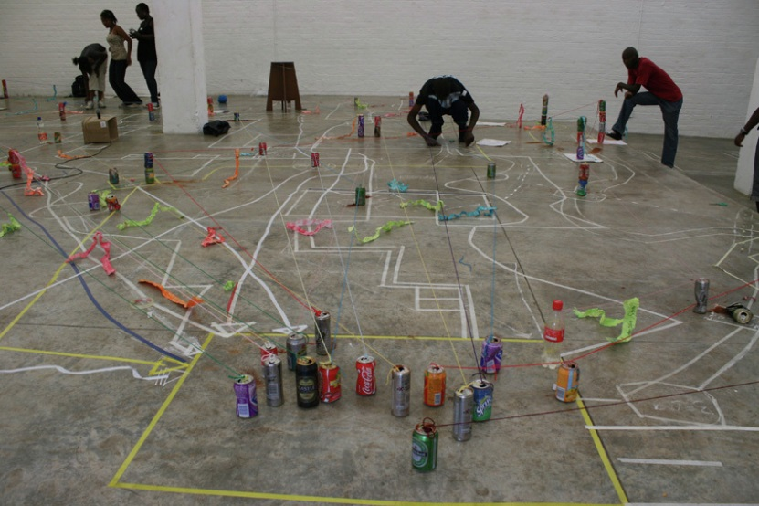
Figure 1: Celebrating Simplicity exhibition, GoetheOnMain project space, March 2010. The workshops focused on the processing of ideas, production and interactions. Learners mapped out their personal journeys and social environments, and in doing this, transformed the gallery through a dialogical and material process.
This mapping process was similar to that often used by public art curators The Trinity Session. They interpreted maps and produced a manual to navigate the city in their project called Hillbrow/Dakar/Hillbrow (2006). They were about to travel to Dakar, Senegal, when they met a Senegalese man named Lamine Seck. They met Seck in Hillbrow, located in the city of Johannesburg. He drew a map for The Trinity Session on how to navigate the city of Dakar (See figure 2).Once they arrived in Dakar; The Trinity Session used this map to navigate their own experiences in the different places and spaces that Seck had spoken about (Hobbs & Neustetter 2007). Similar to the mapping, sharing and exploring of learners experiences navigating in the city, Hillbrow/Dakar/Hillbrow seems to provide a dialogical learning space as an example of Inkulumo-Mpendulwano. The drawing of the map and the ensuing conversation in response to the map represent the kind of generatively and potentiality present throughout this research project.
Figure 2: Lamine Seck’s map.
Similar to the Celebrating Simplicity project, the outcomes of this process manifested in different mediums, methods and processes. The Trinity Session projected images on the wall, and Seck’s map was superimposed onto their own interpretation and experiences of Dakar (See figure 3). The two artists then used the wall as a surface upon which to draw, mapping further experiences in the city.
Figure 3: The Trinity Session at Kher Thiossane Media Lab, Dakar, 2007. The three photographs show The Trinity Session’s interpretation of and Interventions on, Seck’s map with various mediums, methods and outcomes as dialogical process and experience.
At the time of the Celebrating Simplicity project, I did not realise that the process we followed was an example of what art historian Grant Kester might describe as dialogical art practice (2004). The project: Hillbrow/Dakar/Hillbrow captured the essence of the engagements and reiterations.
Later in 2010, I was asked to facilitate an exhibition entitled Space: Currencies in Contemporary African Art at Museum Africa, located in the city of Johannesburg. This exhibition, curated by Thembinkosi Goniwe and Melissa Goba, displayed contemporary African art. All tour-guides were briefed about the exhibition. Tour guiding in the gallery at the time meant walking around the exhibition with participants and viewing one work at a time. At each artwork, I was instructed to stand, explain, and offer an interpretation of the work. Reflecting on this facilitation method, I realise that I could have engaged far more with the participants. Ukufundisa, the word meaning, “to teach”, or in this case “provide information”, dominated these exchanges. Without intending it, these exchanges had become about “schooling” and “instructing”, and although not overtly, somewhat authoritarian. I was left asking myself the question: How do I understand the differences in these two moments in order to further my own practice as an arts-educator and to engage learners in the processes of meaning making?
Director of the Institute of Arts Education at the University of Arts in Zurich, Switzerland, Carmen Mörsch (2009) identifies four discourses of gallery education: Affirmative, Reproductive, Deconstructive and Transformative. The Affirmative discourse focuses on gallery education as the outward communication through the gallery’s mission and standards such as lectures, film programs, and exhibition catalogues. The Reproductive discourse educates and introduces the public to art through workshops. However, the Deconstructive discourse is in a form of guided tours, where gallery education is conceived as “starting from art” intend to make visible many voices rather than one (Mörsch 2009). The Transformative discourse “works against the categorical or hierarchical differentiation between curatorial effort and gallery education. In this practice, gallery educators and the public not only work together to uncover institutional mechanisms, but also to improve and expand them.” (Mörsch 2009, p. 11). Although Mörsch (2009) states Affirmative and Reproductive discourses as most prevalent and dominant, she further states that they should not be considered in terms of different development levels such as chronological or hierarchical. These discourses entail the presence of critical methodologies and the presence of what might be described as intense dialogical encounters. It became clear that the dialogical is not limited to dialogue in the sense of oral exchange but a combination of “starting from art”, the oral and the production that is central to an ‘outcome’.
Reflecting on my role in the Space: Currencies in Contemporary African Art exhibition, I realised I should have worked towards facilitating dialogical Inkulumo-Mpendulwano encounters, allowing the teaching as well as learning and unlearning process to occur by using the museum arts space and artworks as a starting point to initiate, interpret, re-interpret and engage Deconstructive and Transformative discourse.

Methodology

The primary methodology underpinning this research is of a qualitative nature - and this is understood as being about the practices of the artist-educator. This is not a single approach to methods but, as outlined by Keith. F. Punch, an umbrella term with complex, multiple methodologies and research practices (Punch 2009, p. 115). There are two methods that are central to this research. The first is a case study with 2012 Keleketla! After School Programme facilitators. Punch (2009, p.119) describes case study research as single or multiple cases that are studied in detail to collect relevant data. I used this particular method because the Keleketla! After School Programme is a model that is premised on multiple interactions with learners through what I term Inkulumo-Mpendulwano. This interdisciplinary arts educational programme with learners uses dialogue as a starting point to initiate programmes and youth events. The instrument used to collect data is individual interviews with Keleketla! After School Programme 2012 facilitators. These interviews are semi-structured in a manner which Punch (2009, p. 146) describes as a series of pre-established questions by the interviewer which at times may be open-ended and allow for the interaction and dialogical process to occur.
The second qualitative method of this research draws on participatory action research (PAR). Punch (2009, pp. 135, 136) states that PAR aims to solve practical problems by bringing together practice and research. I decided to use this method as an artist-educator working with learners on a non-formal, eighteen-month interdisciplinary arts education programme in curated and non-curated spaces as well as the classroom, as the practical component of this research. This practical component involves learners from grades 10 and 11 at the New Model Private College and Metropolitan College. I chose these schools, not only because I have been working with them for a period of three years and have built a strong relationship with them, but also because they are located in the city of Johannesburg and they do not offer arts education in grades 10 – 12. I was guided by the writings of Nelson (2013, pp. 8, 9) who states that creative writing, exhibitions, performances, films or any other cultural practices can be submitted as evidence of such research.
Alongside these methods and instruments which focused on the journey with learners, pedagogy and process, I took into account ethical considerations which were an important part of this research.

Ethical Considerations

Punch (2009, p. 49) argues that research in education necessitates ethical issues because it involves collecting data from people, about people. This means that one must identify the ethical issues and determine suitable methods to deal with these. By interviewing participants (four learners from each school, namely New Model Private College and Metropolitan College as well as two facilitators from Keleketla! Library) ethical issues needed to be addressed to protect both myself and the participants from harm. The ethics discussion with participants focused on an understanding and agreement on what the research aimed to achieve and what was expected of them as participants. Participants were made aware that their involvement in the research was voluntary and not compulsory. This was evident in the way the selection process was facilitated with learners. All grade 10 learners were invited to meet in one classroom and informed about the research and the participatory action research project, called Artucation Programme. Twenty learners from the New Model Private College expressed interest in the programme. The same procedure was followed with the learners from Metropolitan College. Learners were made to understand that even though they might begin the process, they were allowed to leave or withdraw at any point. This included the Artucation Programme and the focus group interviews. I found that part of the Artucation Programme meant talking about themes and issues that may have been sensitive and uncomfortable such as abuse, teenage pregnancy, HIV/AIDS and gender inequality, which could awaken feelings of past trauma. In instances such as these, I would be accountable for arranging with the school counselling services to provide further support for learners. Providing information about the research and the clarifying and signing of consent forms were critical aspects that were jointly considered.

Chapter 2: Literature and Practice Review
Fundisa – Teach, school, instruct
Ukufundisa – to teach, to school, to instruct
Siyafundisana –We teach
Siyafundisana – We teach each other / together
Siyafundisana na? – Are we teaching each other?

Literature and practices pertinent to this study will be examined in two sections. The first section explores the essence of dialogical practices as encapsulated in the writing of Paulo Freire (1968), Robin. J. Alexander (2008), Grant Kester (2004), Maria Lind (2008) and Claire Bishop (2012). The second section investigates local dialogical art practices in arts education. Through an interrogation of the writing of Carli Coetzee (2013) and publications emerging from organisations such as the Visual Arts Network of South Africa and Keleketla! Library, I will investigate the importance of space, body, storytelling and performance in the city of Johannesburg which focus on what I refer to as Inkulumo-Mpendulwano practices.

Section 1: Facilitation and Dialogical Practices.

Facilitation plays a critical role in the implementation of arts educational programmes. This research argues that the facilitation process should be one, which is a dialogical Inkulumo-Mpendulwano interaction with the learners, and not one that is authoritarian. My understanding of authoritarian is borrowed from Brazilian educator and philosopher Paulo Freire who was a leading advocate of critical pedagogy and dialogical relationships in teaching and learning. He refers to this concept as The Banking Concept of Education in Pedagogy of the Oppressed (1968) where:
(a) The teacher teaches and the students are taught;
(b) The teacher knows everything and the students know nothing;
(d) The teacher talks and the students listen—meekly;
(j) The teacher is the Subject of the learning process, while the pupils are mere objects.” (1968, p. 164)

Freire (2005) argues that this is the Banking Concept of Education for the reason that the teachers deposit their knowledge into the learners. Learners then receive, file and store this knowledge through memorising and repeating that which the teacher has deposited. Freire (1968, p. 169) advises that the student-teacher relationship should merge to allow transformation, creativity and knowledge for both the teacher and the learner. Freire calls this process Problem-Posing Education which is a way of learning and unlearning through dialogue. Freire writes the following:
Through dialogue, the teacher-of-the-students and the students-of-the-teacher cease to exist and a new term emerges teacher-student with students-teachers. The teacher is no longer merely the-one-who-teaches, but one who is himself taught in dialogue with the students, who - in turn - while being taught, also teach. They become jointly responsible for a process in which all grow. (2005, p. 80)
In this quote, there is a merging of the relationship between the teacher and the student. Freire describes the teacher-student with students-teachers - relationship as one where they are jointly responsible for the process, which comes close to what this research calls Inkulumo-Mpendulwano encounters and interactions. Similarly, Robin J. Alexander, a lecturer at the University of Cambridge, investigates both dialogical and authoritarian pedagogies and clarifies the difference between them:
Process Orientation vs. Product Orientation
Teaching students vs. teaching programs
Teacher as facilitator vs. teacher as manager
Developing a set of strategies vs. mastering a set of skills
Celebrating approximation vs. celebrating perfection
Respecting individual growth vs. fostering competition
Capitalising on students’ strengths vs. emphasising students’ weaknesses
Promoting independence in learning vs. dependence on the teacher (2008, p. 10)
Alexander notes the differences between what Freire would define as Problem-Posing Education and the Banking Concept of Education. Freire (2005, p. 80), however, argues that in order for the dialogic to occur, the different authorities present in any given teaching and learning situation must be on the side of freedom, not against it. This would then mean that the teacher’s “authority” is shifted to the side of freedom by allowing both the teacher and student to be in authority when learning.
This process and interaction is one which art historian Grant Kester, who works with critical dialogical art practices, would call the Performative Process Based Approach. In his book Conversation Pieces: Community and Communication in Modern Art (2004), he argues that facilitators are context providers, not content providers (Kester 2004, p.1). This would mean that the learners initiate the content and - with the facilitator - establish the necessary context for the programme. This then becomes a response to a conversation or rather, an Inkulumo-Mpendulwano in the student-teacher and teacher- student relationship.
Kester (2004, p. 4) illustrates an example of this form of practice when he writes about a project initiated by artists Suzanne Lacy, Annice Jacoby and Chris Johnson with two hundred high school learners. The community and the media were invited to a performance called The Roof is on Fire (1994) to listen to learners’ conversations on the roof top parking area, which focused on how society viewed them as black, young, violent media stereotypes in California (Kester 2004, p. 4).
Lacy, Jacoby and Johnson became context providers and allowed learners to take the literal and figurative “violent image” of clichéd media representation, and gave room for them to talk about these issues; express; interpret them in their own way; and take control of the process.
The event on the rooftop was not the outcome of the project, whether intended or unintended, but further initiated youth-led conversations led through a number of collaborations. This included a six-week video series with discussions between learners and the Oakland Police Department. This further led to conversations between 150 learners and 100 police officers called the Code 33 project (1999) on the same rooftop (Kester 2004, p. 5).
The facilitation process by Lacy, Jacoby and Johnson encouraged the learners to be Subjects of the process by allowing them to address these issues in society and take control of the programme. The process of this project went from a single image, which portrayed violent youth, to conversations on the rooftop, to a six-week video series which in turn led to conversations with police and learners on the same rooftop. The realisation of one process informing the next becomes a crucial aspect of this dialogical process as the unintentional planning of the projects which followed were not planned in the beginning, but grew as the conversations continued.
Art historian and critic Claire Bishop (2012, p. 11) argues that the outcome of the dialogic process “…is less likely to be "works" than social events, publications, workshops, or performances.” Bishop (2006, p. 2) further explains these “works” as “…socially engaged art, community-based art, experimental communities, dialogic art, littoral art, participatory, interventionist, research-based, or collaborative art.” In trying to understand the outcome of a dialogical process in arts education, I am made aware that the outcome may not be a physical artwork one but one which engages dialogue. Kester (2004, p. 10) states that outcome to not be limited to physical works of art, but argues that an artwork can be viewed as a conversation with different meanings, interpretations and points of view. I found that this was also evident in my journey with learners through the Artucation Programme where the discussion with learners would inform the outcome of the “artwork” or practical component, further elaborated, in the third chapter of this research.
In concluding the facilitation process of this section, Kester, Lind and Bishop define and interpret the role of the facilitator or facilitation process as context providers (Kester 2004, p. 1), mediators (Lind 2011, p. 173) and participatory and collaborative (Bishop 2012, p. 219). These call and response processes are highlighted in this research as Inkulumo-Mpendulwano pedagogical encounters. It is safe to note that Inkulumo-Mpendulwano strongly associates itself with dialogical influences and theories by, Freire, Baktin, Alexander, Lind, Kester and Bishop, who highlight the dialogical process as integral to the artistic process. They, however, write from a perspective, which is not rooted in the African context.

Professor and Kenyan writer Ngugi wa Thiong’o’s (1986, p. 87) exemplifies the discomfort of speaking about African literature (poetry, theatre or fiction) in English. He emphasises how African literature has its idiosyncratic and authentic structure of beats, rhymes, half rhymes, internal rhymes, lines and images, getting lost in translation. I conducted a focus group discussion with learners (Section 2 of this chapter), I assumed that the class understood the dialogical processes but it was plain that they still grappled with the term dialogue. The word dialogue in the MC focus group discussion made the classroom encounter move away from Inkulumo-Mpendulwano engagement of the Artucation Programme into a right-wrong-question-answer classroom session. It was tense. Freire (1968, p. 87) defines the word dialogue as action and reflection where both these words cannot function without the other. He further states that humans exist to name the world in order to transform it; however, if the name is problematical, new naming is required (Freire 1968, p. 88). Dialogue therefore also denotes the acts of creating and re-creating (Freire 1968, p. 89). I found that the word dialogue as an action speaks to the Inkulumo-Mpendulwano encounter, however; it is problematical as a theoretical term when communicating with learners. Freire (1968, p. 96) states that the reason educators speak and are not understood is because the language is alienating and not suitable to the people they address. The collaborative Arts Schoollaboratory’s project (2014; p. 4) uses the term Learnagogy, which refers to a “methodology” that involves a process in which the teaching/learning experience is based upon self-critical dialogues that use questions as the basis for discussion. Although this may specifically refer to authoritarian language and pedagogy, it is evident in dialogic educational situations too: words may also alienate this particular process and would then have to be re-created. I was sufficiently critically aware of my idiosyncratic facilitation style and level of engagement with learners. This re-creation of words relates to Coetzee’s Accentedness (2013).

Russian theorist Mikhail Bakhtin (1981, p. 426) refers to the dialogue (dialog) as a language between facilitator and learner that harmonises the relationship and further re-creates words such as dialogism, dialogized (dialogizovannij), dialogizing (dialogujuscij) and dialogization to capture particular essences and nuances of the dialogical process. He at times uses the Russian language or word to describe or define something which the English language does not quite establish. The Russian word Slovo is a word he uses which is similar to the English word “discourse” but it resonates more effectively with some sub-cultures in society. Likewise wa Thiong’o (1981, p. 91) states that he summarises European universal English literature in African languages for African learners, libraries and universities, incorporating an African context.

The next section introduces local Johannesburg artistic practices such as the ideas of Carli Coetzee who creates productive global North/South comparable cases that have purchase to my practice, as well as Two Thousand and Ten Reasons to live in a Small Town a Johannesburg based organisation which initiated a project that addresses dialogical artistic practices in arts education.

Section 2: Inkulumo-Mpendulwano Practices: Investigating the Importance of Space, Body, Storytelling and Performance in the City of Johannesburg.

This section of the dissertation is divided into three parts which investigate local dialogical art practices (I will further use the word Inkulumo-Mpendulwano rather than dialogical as local terminology) and the importance of space, body, storytelling and performance as part of arts education in the city of Johannesburg. The first part will interrogate the writing of Carli Coetzee (2013), followed by Johannesburg based organisations: Visual Arts Network of South Africa’s (VANSA) project titled Two Thousand and Ten Reasons to Live In A Small Town and Keleketla! Library’s Keleketla! After School Programme (KASP). These projects focus on what I am referring to as Inkulumo-Mpendulwano practices.

1. Carli Coetzee Accentedness (2013): Facilitation and Community Spaces as important elements of Inkulumo-Mpendulwano Practices.

Researcher and teacher Carli Coetzee (2013, p. 158) defines the pedagogies that lecturer Alexander (in section 1 of this chapter) identifies as Accentedness. Coetzee (2013, p. x) defines this term as a position and power relation that requires consistent work, where the learning and teaching encounters reveal the beneficiaries of knowledge as not just the student being transformed but also the teacher and teaching institution. In this, we are introduced to not only the student-teacher relationship, but also to the introduction of the institution as a space and space of transformation. In this section, this triangular relationship will be examined through two examples of accentedness from Coetzee’s writing. The first is an example of what she would call “ideal” facilitators, followed by her personal encounters of learning and unlearning of the different pedagogies. Both these examples examine Inkulumo-Mpendulwano in a local context using personal experiences in the learning process as premises and important facilitation tools.
Coetzee writes about the facilitation process of Accentedness when she examines a film entitled Ask Me, I’m positive. Coetzee (2013, p. 113) notes how three “ideal” film teachers (whom I would call facilitators and also refers to how STEPS would name it) namely Thabiso Motsusi, Thabo Rannana and Moalosi Thabane who are HIV positive, allow the audience to have conversations around mobile films with content around HIV through a STEPS programme. Coetzee (2013, p. 113) describes this as the directors developing the content of the films, however, “…the value of the films lie not only in the educational content, but also in how the audience’s responses become part of learning.” These examples are indicative of a process that results, quintessentially, in Inkulumo-Mpendulwano learning experiences.
In the STEPS programme, the facilitators had to mediate this process and allow room to be taught by the audience. Two of the STEPS facilitators were HIV positive, and Coetzee (2013, p. 121) writes that these facilitators were remarkably engaging, responsive, self-aware and often showed vulnerability. Furthermore, Coetzee (2013, p. 112) states that a clear example of accented teaching is when the teacher brings his/her story, shares his/her vulnerability, knowledge and openness to context.
However, in sharing vulnerabilities, Coetzee (2013, p 116) also highlights a behind the scenes footage of the film when the HIV positive facilitators refused to understand the position of a colleague who was not HIV positive. They expressed that she does not “get it.” and she could not know what it really feels like to go through this experience. If there is anyone who knew what they were going through, it was her, because she has facilitated with them, travelled and engaged with them. However, this moment reveals a non-accented one-sided narrative. They started to limit her grieving and empathetic experience to their ‘authentic’ experience. Coetzee further complicates accentedness as not so straight forward; these shifting moments are when accentedness happens.
In these moments, Coetzee argues that place and special environment enhance this experience:
Often, we see the films screened in public rooms, schools or church halls. These rooms already carry in them a promise of learning and its power to transform. Screening the STEPS films in these community spaces and having energetic and inspiring teachers present, draws a sense of group identity, but can also reinforce the sense of collaborative learning and responsibility (2013, p. 116).
What Coetzee is identifying is an enhancement of accentedness through the space and location, which gives participants a sense of responsibility, ownership and becomes a joint venture and learning process. The practical component of this research, called Artucation Programme, implemented such a strategy by using a gallery or curated space to elect content and initiate dialogue, and then unpack these themes in the classroom space. Both these situations become a response to a space where these “reality spaces” become part of the learning process.
The second example of Coetzee’s accentedness explores this notion in the classroom, specifically in a university space. She compares and examines her exposure to two pedagogical styles: one from South Africa (Johannesburg and Cape Town) and the other from London.
Coetzee was born and raised in South Africa, and had the privilege of lecturing at two South African universities then went to London. Coetzee (2013, p. 159) explains these pedagogical experiences as the South African Accented Classroom (assuming she means Johannesburg and/or Cape Town) and the London Accented Classroom and further elaborates on her personal struggles and transitions from one pedagogical encounter to the next.
At first, she was taken aback by both the London institution’s expectations of her in terms of deliverables (as well as the general conduct) in the classroom. She states:
As part of this pedagogy of the class, students were invited explicitly to resist dominant ways of consuming cinema and text […] but while encouraging students to resist, I was expecting them to comply. This compliance, as I framed it, was a way of regulating the relationship between the students and me, and between them as a group […] I also invoked (mistakenly and irrelevantly, I see now) the levels of compliance expected – and delivered – at South African universities, as if this proved that we should do it the same way (Coetzee 2013, p. 159).
In these quotes, Coetzee states explicitly that there are many moments of well-intentioned claims to “resistance”. However, she rightly identifies how these moments are framed in such a way that compliance is in fact the result: students are told how and what to do as they watch a specific film, which restricts the scope of the topic. Students are expected to comply in order to maintain a normative student-teacher-relationship. This “compliance” is that which the Ukufundisa methods of “schooling” and “instructing” aim to achieve.
Coetzee (2013, p. 163) does state that she felt uncomfortable as a teacher, who sought authority and control, she acknowledges, reflects and corrects her Ukufundisa way of teaching by the words “(mistakenly and irrelevantly, I see now).” This emphasises how she too as the facilitator uses moments of learning, reflecting and re-learning through her process as an integral aspect of Inkulumo-Mpendulwano encounters.
I similarly experienced times when I would find myself doing something that seemed to be authoritarian. These realisations helped me to acknowledge, reflect upon and subsequently shift my pedagogical style to accommodate openness, a willingness to exchange information with my students as my equals and to collaborate with learners.
Coetzee’s examples of accentedness emphasise the enhancement of the pedagogic process when a facilitator of learning is, through personal experience, immersed in the subject matter and self-critically aware of his or her own vulnerabilities – especially those that relate to personal experiences in the particular subject matter facilitated. Vulnerability is evident in the STEPS facilitators’ engagements with their audiences, promoting an interactive, transformative teacher-student relationship. Similarly, Coetzee’s critical reflections upon her pedagogic engagements in London and South Africa and resultant evaluative and corrective stance taken with regard to her facilitation style, became inextricably interwoven prerequisites for her own learning and unlearning in respect of the dialogical process.

2. Two Thousand and Ten Reasons to Live in a Small Town (2010): Community Spaces, Storytelling and Performance as important elements of Inkulumo-Mpendulwano Practices.

The Visual Arts Network of South Africa (VANSA) is a Johannesburg and Cape Town based development and networking agency for the visual arts in South Africa. It promotes connection, access and innovation in the industry (Visual Arts Network of South Africa 2015). VANSA initiated a project titled Two Thousand and Ten Reasons to Live in a Small Town (2010) which engages with the integration of contemporary art in rural communities and public spaces. This project was implemented with arts practitioners who had to re-imagine public spaces by exploring the place and community in different provinces of South Africa (Visual Arts Network of South Africa 2012, p.6).
I engage with two programmes from this project which arguably draw on the Inkulumo-Mpendulwano framework discussed earlier in this dissertation. These projects are titled MADE IN MUSINA and Living Within History which use focus groups as a starting point to create a call and response similar to that of Inkulumo-Mpendulwano encounter.
Artist and community based-projects facilitator, Thenjiwe Nkosi, Rangoato Hlasane, an artist-activist and lecturer, and Raymond Marlowe, a documentary photographer and community workshop facilitator (VANSA 2012, p.75) initiated the MADE IN MUSINA project (2010). MADE IN MUSINA evolved from a focus group discussion during which arts organisations and artists in Musina, Limpopo, identified that they were working in isolation and that potential audiences did not know them. Besides funding being scarce in the arts, community members also did not know of the funding opportunities available to them. These organisations were “The Musina Community Theatre Group; The Musina Arts Council; Field Band Foundation; Renaissance Band; Musina Theatre Youth Development; Musina FM and a variety of poets, actors, musicians and visual artists.” (VANSA, 2016.)
The facilitators (Nkosi, Hlasane and Marlowe) aimed to facilitate, collaborate and build networks between community arts members and organisations (VANSA 2012, p.74). After listening to the community, their role as facilitators was to respond by establishing networks. They questioned how to create a network and if a network itself might be defined as “visual arts” (VANSA 2012, p.81). Compared to the Living within History project, these similar, critical questions would inform the decisions that would give direction to the project. This incited questioning about the evolving nature of art and a re-examination of what Inkulumo-Mpendulwano intrinsically wishes to embody and convey. The MADE IN MUSINA project amalgamated networking and aesthetics focused on the two-way process of encapsulating the designing and printing of t-shirts and the Musina arts community and its location (Visual Arts Network of South Africa, 2016). The MADE IN MUSINA t-shirts were a batch of personalised prints representing the different groups and organisations on the front of the t-shirt. ‘MADE IN MUSINA’ was printed on the back of the t-shirt. The different colours and organisations represented on each batch began to factor in the different embodied conversations and collaborations as a performance.
Judy Seidman, an artist-activist during the apartheid era and part of the Medu Art Ensemble, made posters that protested against the apartheid era - in South Africa. Seidman states “… [Medu Art Ensemble artists] were inspired by the Black Consciousness ideas of Steve Biko […] so young people exploring cultural ideas and making artwork found space where they could publicly express their ideas around the Black Consciousness student movement.” (Keleketla! Library 2012, p. 50). Posters in this instance, like the MADE IN MUSINA t-shirts, became much more than just artworks, but confronted the social political issues. Analogously, the MADE IN MUSINA t-shirts began to “speak” in a multiplicity of voices about the issue of the lack of a coherent network and sponsors in Musina.
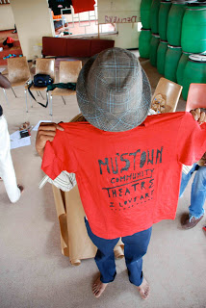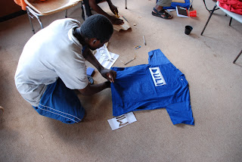
Figure 4: MADE IN MUSINA Project by Thenjiwe Nkosi, Rangoato Hlasane and Raymond Marlowe, The Musina Nancefield Community Hall, 2010. Photographer: Thenjiwe Nkosi. A t-shirt workshop, which functions as an opportunity to unify and encourage collaboration as part of the art making process.
These t-shirts were later sold to audiences at an event organised by MADE IN MUSINA community members. The event was an arts festival, another practical way of establishing the project as a mass networking activity and served as an official launch of the MADE IN MUSINA Arts Network (VANSA 2012, p.82). MADE IN MUSINA audiences were encouraged to wear these t-shirts as a further form of embodied and performed collaboration that encouraged community engagement, collaboration and a stage shared by both the creators of the t-shirts and the audiences.
The following year the MADE IN MUSINA Arts Network decided to grow their network and become more accessible to a wider community. The arts network decided to build a Facebook page and blog; it became a task for the Action Committee that, besides creating a blog and Facebook page, had to define goals and action plans to apply for funding. This brings us back to what was addressed in the first meeting when MADE IN MUSINA community members identified issues that artists worked in isolation; that there were no potential audiences or funds for projects. The Inkulumo-Mpendulwano interaction meant that the facilitators had to mediate this process by ensuring that they were able to respond to the needs of the community. In addition, the MADE IN MUSINA Arts Network was able to establish a profile in order to enable the attraction of possible funding. - The facilitators expressed their inexperience of this type of visual arts process (Inkulumo-Mpendulwano) allowed them to engage and learn from each other (VANSA 2012, p.81). It becomes Freire’s Problem-Posing Education process of collaboration and exchange of information, where the subjects are not only the facilitators or teachers, but they also allowed themselves to be students, participants and artists.
This type of collaboration is visible from their first meeting and discussion point where the facilitation took place: at the Musina Nancefield Community Hall. In figure 7, it is not apparent who the facilitator is; the oval circle structure makes it possible for multiple focal points to be present. Everyone is seen, listened to and heard. In a conventional classroom situation, the teacher is usually the one standing and the learners seated; the teacher is the focal point and Subject and the learners, (who then become the Objects) see and hear the teacher only. In this image, we see something different taking place, something that invites participation, communication and equality. A community hall is a space that allows engagement with participants far beyond the classroom; it is not limited to the arts and it is accessible to any member of the community. It is vibrant and allowing for dynamic interaction. As mentioned previously, Coetzee (2013, p. 116) states that spaces such as community halls, churches and public rooms carry a promise to learn, a power to transform and offer a sense of collaborative learning and responsibility.
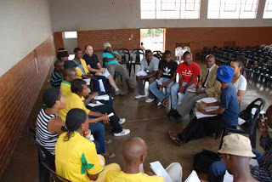
Figure 5: MADE IN MUSINA group discussion, The Musina Nancefield Community Hall, 2010. Facilitator uses a Community Hall as space, which encourages community engagement, learning and interaction.
The Musina Nancefield Community Hall was a space used for the first meeting, t-shirt workshops as well as the subsequent festival event. This Community Hall, like other community spaces, was flexible and responsive to the needs of the community. The name in itself carries a sense of community and welcomes art practices like the applied drama programme called Town Hall at the Wits School of Arts by Drama for Life, which is located in Johannesburg. I was intrigued by how Town Hall would at times allow audiences to watch performances and encourage dialogue after the session; at times, that same space would have workshops and participatory performances. Town Hall has the same engagement and interactions with spaces such as those found in Dundee at the abandoned plot in 97 McKenzie Street, Umzinyathi Education Centre and Talana Museum (see next section), as well as those found at the Musina Nancefield Community Hall and in the Keleketla! Library in Johannesburg. These Inkulumo-Mpendulwano learning spaces allow the community to feel a sense of ownership and belonging encouraging collaborative learning.
The second project, Two Thousand and Ten Reasons to Live in a Small Town, which I will be writing about is Living Within History project (2010) which draws on how history is founded on small narratives (VANSA 2012, p. 8). Conceptual artist and educator Vaughn Sadie and Neil Coppen, a writer/director and designer, were the facilitators of this project which introduces a series of performance-based workshops with learners and the community. They started by identifying an abandoned plot with a foundation where an old house once stood at 97 McKenzie. They felt that it was necessary to launch a site-specific project which would explore the notion of history and imagined futures in several phases (Sadie 2012, p. 12).
The first phase, allowed for learners from Umzinyathi Education Centre to re-imagine the abandoned plot and how it looked based on its remains. At the end of each activity, learners had to close the gate behind them as if it existed. Incidental audiences who would pass by would make the learners feel uncomfortable because they were accused of being ‘crazy’. This was interesting for the facilitators who asked themselves a particular set of questions which would inform the continuation of the project: “Why were the learners thought of as foolish? Would pedestrians and passers-by think differently about these activities if they were somehow involved? Was the fact that they were making comments a suggestion of interest in what was going on?” (Sadie 2012, p.13). This is an important aspect pertaining to Inkulumo-Mpendulwano: the process starts to question, inform and define the outcomes of the project. Learners were encouraged to engage with the community through a collage workshop of past and current architectural details of the area. Learners became facilitators this session: they invited the audience to enter into their ‘crazy space’ to engage in meaningful, ‘as close as possible’ re-enactments of past and present histories (Sadie 2012, p.13). Community suggestions of what the space might become varied from a cinema, a hospital, a crèche and even a mall.
Anthropologist Arjun Appadurai (2004, p. 2) explains how culture and development in anthropology are viewed in terms of future-plans, hopes, goals and targets. He further links this to people having a future, with keywords such as wants, needs, expectations and calculations, which he defines as Aspirations. This becomes part of a culture that addresses the same issues, future-plans, needs and expectations found in the Dundee community. Appadurai (2004, p. 3) argues that a community shares platforms in a democratic conversation from one generation to the next where children become culture-bearers through specific forms of education and discipline. I would add that community members from Dundee became empowered enough, in conversation with other members of their community, to allow them to be “community-bearers” and carry the historical aspirations of the Dundee community forward.
The second phase of the Living Within History project evolved into a series of puppet collage making workshops at the Umzinyathi Education Centre with learners from local schools and communities. Coppen (2012, p. 15) states that the aim of these workshops was to allow learners access to the archives and were encouraged create a collage of puppets. These collages were of historical figures which involved storytelling, familiar to me as Inganekwane, an indigenous folk tale which not only tells a story but is in itself a learning tool. Inganekwane is marked by a call (from the facilitator commencing the process with Kwasuka Sukela: ‘once upon a time’) and response by learners (Cosi: a go-ahead and permission to continue with the story). These puppet collage workshops later evidently evolved into the learners’ own conceptual re-imaginations, manipulations and re- interpretations of historical content and context. The exercise is indicative of active participation by learners focusing on a future-directedness in which abhorrent past racial discriminatory practises were altered and distorted to make way for a reformed, to them, more equitable reality of racial engagement.
The third phase of the Living within History project was relocated to Talana Museum, a museum/workshop space in the city of Dundee. The process allowed Coppen and Sadie to display around four hundred archived images of Dundee in the museum. This became relevant to the project because the museum was looked at in a transformative, interactive and participatory manner that resulted in it serving as a community hall and/or classroom. Theorist and artist Lan Tuazon addresses the different interventions that can take place in the museum as well as the classroom space. Tuazon calls this a ‘classroom-museum-gallery’ where the facilitator becomes the ‘teacher-artist-curator’ with education as its premise. Classrooms are museums and the students play the three-part role of being artist, viewer and critic (Tuazon 1996, p.28). She further mentions that infrastructures are not only places of memory, but for production by both teacher and learners. In Living within History, we are made aware of historical memory as well as a museum being transformed into an interactive space. It starts to fuse concepts of space and creative production when the community started to participate; they added personal photographs and objects to the gallery which I find pertinent to the Inkulumo-Mpendulwano concept which starts to depict personal narratives and responses through space, inganekwane and performance. In Figure 4 (consisting of three images), we see interactions by different generations engrossed in inganekwane, spontaneous and on-the-spur-of-the-moment additions and re-enactments. This inganekwane ‘call-and-response’ approach is similar to that of the Ba re e ne re organisation (as mentioned in the introductory section of this research), a Sesotho and Setswana expression which, when directly translated, means “They say it was said that…” which is similar to “Once upon a time…” used for story telling (Ba re e ne re, 2016). Through these initiatives, Basotho people get to share their informative and educational stories about Lesotho. Similar to this is writer Barbara E Bowen’s Untroubled Voice: Call and Response in Cane, one finds the “call and response” a gesture of waiting in anticipation to listen to a voice, as well as the anticipation of the response (Barbara 1982, p.12). In the Untroubled Voice: Call and Response in Cane (1982) we are introduced to King Barlo who responds to a silent call by members of the community to address the crowd as it waits in anticipation to hear his voice/message. The community further responds to King Barlo with gestures of “amen”, “Preach it! Preacher! Preach it” which further confirms his own ability to speak (Barbara 1982, p.12).
The unfortunate part of the Living within History project is that these iziganekwane [pl] are embedded within the colonial time in the South African era. The starting point was not their own story, but inganekwane of what Sadie and Coppen had imagined although later insertions of the personal became relevant.
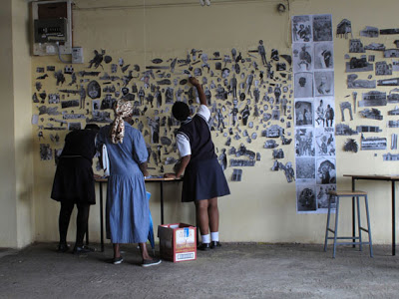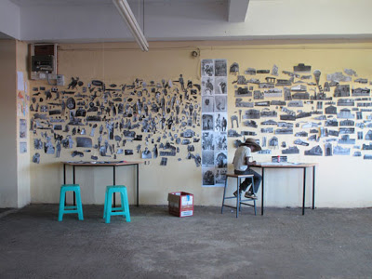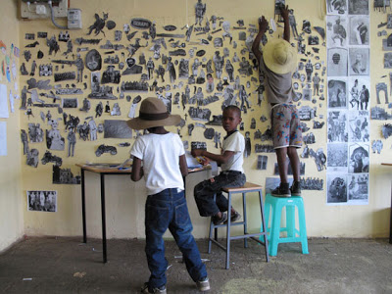
Figure 4: The Incidental Audience by Vaughn Sadie and Neil Coppen, Dundee, 2010. Studio-classroom space as an intimate place of planning, reflecting, processing and storytelling.
The wall in itself started to create its own inganekwane through movement discernible in the flow of images that were being added during the growing narrative process. There are moments in this image which began to speak about the different processes one might encounter in a project. The quiet, reflective process depicted with the one boy who seems to be writing; to the interactive, busy movement with the boys; to the informative sharing and exchanging with the women on the left. This is the same process that one may encounter in Inkulumo-Mpendulwano and reminds one of how facilitators utilise similar moments to encourage participants to optimise contributions and participate in the creative process.
Following the interactions on the wall were several public performances on the main streets of Dundee. I will focus my writing on the performances by four local artists to elaborate on Inkulumo-Mpendulwano moments (See figure 5). However, there had been several other performances, which I will briefly comment on in the conclusion of this section. The performances by the four artists was at the museum where the puppet collage workshops had taken place. This performance may have been created before or during the Living within History project however the museum become a safe space to showcase their performances and collaborations, again shared by different generations. These were traditional Zulu performances and are dependent on the performers displayed kinesics for sonic movements and patterns. This simplistic, yet effective Zulu performance is participatory, inviting the audience to be part of it and voluntarily clap, sing or at times be part of the performance. This sensory experience does not proclaim its success by outcomes with perfectly written scripts, live bands and perfect-pitch voices, but by its participation and collaboration of the audience and the performers.
This community engagement of the Living within History project is one that plays a vital role in Inkulumo-Mpendulwano because it involves sharing inganekwane, engaging, participating and the sharing of the “stage” by everyone.
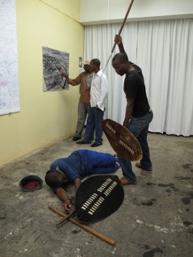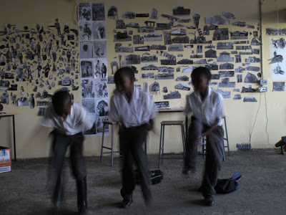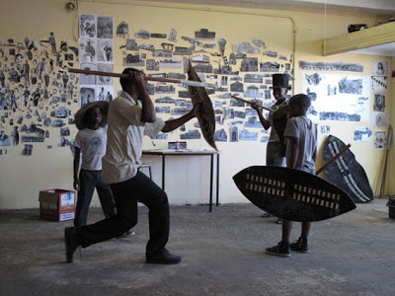
Figure 5: Living Within History by Vaughn Sadie and Neil Coppen, Dundee, 2010. Re-enactments of History which involve participation and collaboration.
However, this Inkulumo-Mpendulwano pedagogy lacks the expressive visible presence of facilitators, Sadie and Coppen. In this project, learners seem to be facilitating the process and the community members inform each other of the process. I compared this to The Roof Is On Fire project (mentioned in the first section of this paper) where learners took ownership of their own process which began to inform the series of collaborative projects within the community. In the early phases of the Living within History’s project, both learners and community were involved in aspects of Inkulumo-Mpendulwano encounters and interactions. The process I believe could have been (like The Roof Is on Fire) a series of interventions and ownership by learners even after Coppen and Sadie - had ‘completed’ the project. Instead, at the end of this whole process Sadie and Coppen invited other artists to a public viewing and ‘closing’ of this process.

I further questioned the language of instruction for the Living within History project. Sadie and Coppen are white males who for the Two Thousand and Ten Reasons to Live in a Small Town project were commissioned for a project to be conceived in the small rural community of Dundee surely there must have been a language barrier as Dundee is a predominantly Zulu dominated area? The collective had a Zulu speaking facilitator Bongikosi Ngobese who acted as translator and tour-guide, explaining the aims and outcomes of the project (Dundee: Soni Project Space 2017). Coetzee (2013, p.23) writes about award-winning author Jonny Steinburg who travels to a small rural community in the Ithanga area to explore the AIDS epidemic and who lives in that community for the duration of his research. In his book, Three Letter Plague Steinburg refers to a translator who is introduced as Sizwe, a small business owner. Sizwe acted as a translator and guide to Steinberg’s interaction with the community, but Sizwe became more and more the subject of Steinburg book and his interaction with the community. Despite their educational hierarchal differences, Coetzee (2013, p.25) mentions Sizwe as the accented teacher and Steinburg as the “ideal” learner. Although this statement doesn’t aim to deal with the complexities of authorship but rather facilitation, Coetzee mentions that Sizwe’s role as a translator is more complex where there are moments in conversations and silences, which gave meaning to education and knowledge (Coetzee 2013, p.25). I realise that the Inkulumo-Mpendulwano process of the Living within History project may have been embedded with Ngobese who, in my opinion becomes the facilitator and mediator for not only the learners, but also Sadie and Coppen. The conversations-silences-communications-miscommunications are further elaborated when the author and contributor of Two Thousand and Ten Reasons to live in a Small Town Rike Sitas (2012, pp. 23 – 24) writes about the ‘closing’ performances of the Dundee project by inserting a westernised concept of DADA in Dundee or Re-enacting the archive: DADA in Dundee in this project. Dada was an artistic movement that began in Zürich, Switzerland as a reaction to the World War 1, which at this point is not related to the Zulu-cultured processes and interactions in Dundee, Kwa-Zulu Natal. It had been made clear to me that Ngobese was indeed in my opinion the crucial facilitator of this project.

3. Umhlangano Womphakathi: Interviews with Keleketla! After School Programme facilitators (2012) and learners from the Artucation Programme.

For this research project, I conducted individual interviews with KASP 2012 facilitators KASP TS and KASP ZM as well as focus group interviews with learners from NMPC and MC separately. I aimed to understand the methodologies from learners and facilitators’ perspectives. In this section of the chapter, I have combined individual interviews by KASP facilitators, KASP TS and KASP ZM as well as responses from the focus group interviews conducted with learners from NMPC and MC after participating in the 18-month Artucation Programme. The methodology of putting together interviews with KASP facilitators and learners from MC and MNPC as if they were in one room, is what historian and cultural theorist Nicola Laure Al-Samarai (2014, p.135) would call Dialogic Collage, which was to provide access to information from different locations and individuals. In her book, Al-Samarai (2014, p.135) recommends the placing of individuals from different standpoints and positions in one imaginative space to discuss arts education. Similarly, this section places KASP facilitators and learners from NMPC and MC in conversation and discussion like the Round table to respond to various pedagogies.
I use the Zulu phrase Umhlangano Womphakathi to actualise the essence of the Round table in – if not in an entirely South African, at least some probable dominant South African context. Umhlangano is defined as a meeting, gathering or an assembly and Umphakathi is another Zulu word, which means community, it means that Umhlangano Womphakathi is a community gathering. However, we casually use the word Umhlangano without adding Womphakathi because of the obvious fact of the community that gathers. Usually in such gatherings, community members would get a hand-delivered invitation by mail or at the doorstep from the local municipality. As the meeting date gets closer, there is an old van with a loud hand-microphone speaker which repeatedly reminds the community about the meeting date, time, venue and the purpose of the meeting. Upon arrival at the meeting, an agenda pertaining to the needs of the community and possible way forward is distributed.
I title this section of this research Umhlangano which imagines a community meeting between KASP facilitators and learners from MC and NMPC. The aim of this Umhlangano seeks to understand KASP facilitators’ methodologies and how they relate to the Inkulumo-Mpendulwano pedagogy. Parallel to this is learners’ perspectives of the advantages and disadvantages of this Inkulumo-Mpendulwano pedagogy. Like every Umhlangano the agenda is as follows:
Agenda
Item 1: Keleketla! Library Introduction
Item 2: Discussion with KASP Facilitators and learners from MC and NMPC
Part 1: Isithunzi.
Part 2: Punishment.
Part 3: Dialogue: Localising Content.
Part 4: Disadvantages of teaching through dialogue.
Item 1: Keleketla! Library Introduction
Keleketla! Library is an organisation previously located at the Drill Hall between 2008 and 2015. The organisation used the history of this heritage site to initiate educational programmes which translate into dialogue as a stimulating, evocative tool for learning (Keleketla! Library 2012, p. 7). Keleketla! Library runs a programme which was established in 2008 until 2014 called Keleketla After School Programme (KASP). This ten-week programme aims to engage youth in a critical analysis of contemporary social, political and economic issues of the city (Keleketla! Library 2012, p.8). My interest in KASP mainly lies in not only the fact that they work with learners from the city of Johannesburg like the Artucation Programme, but also their facilitation techniques are strongly embedded within the Inkulumo-Mpendulwano pedagogy. I focus my discussion primarily on how the programme is designed to incorporate the needs of learners, teachers and artist-educators, who are the 2012 KASP facilitators. I will further discuss the KASP facilitator’s methodologies through individual interviews.
A brief overview of how the KASP process would be facilitated will precede the discussion. The programme entails five phases:
- Focus group discussions where Keleketla! Library would identify learner’s interests, themes and seek relevant skilled facilitators.
- Keleketla! Library briefing KASP facilitators about possible themes and content derived from the focus group discussions with the learners.
- Involve schoolteachers who would be part of a workshop in discussion to identify possible mergers or links with the grade 11 and 12 curriculum.
- Encompass a ten-week arts educational programme with the relevant, skilled facilitator.
- The final phase would range from publications, posters, murals, events or performances that would be open to the public.

These chronological stages demonstrate that the first and most important phase is the focus group discussion where learners identify and negotiate content for the KASP activities. Like the previous examples from Two Thousand and Ten Reasons to Live in a Small town Project, starting the project in a consultative manner develops and responds to needs or issues addressed by the community (in this instance the learners). While all these five phases may be equally significant, I would like to focus mainly on the facilitator’s role during this process. This is productive for my research as facilitators play an important role in finding links between learners’ interests, the curriculum and Keleketla! Library objectives.

Item 2: Discussion with KASP Facilitators and learners from MC and NMPC

Part 1: Isithunzi

KASP ZM: There was a project that developed which was based on struggle songs. They [Keleketla] wanted to reimagine struggle songs from the prison context. With that in mind they wanted the youth to be more involved in getting the message across. […] It became very interesting because at first we were daunted […] we had never worked with children. The beauty of that whole process for us was not to teach music, we don’t teach music but we helped to create an interest for the children to commit to the bigger world of music. That was the most important part of the facilitation process for us. We asked the children what struggle song they liked. The song which resonated with them was Senzeni Na? We tried to create our own version but it was way too rowdy. Rangoato [co-director] saw this and he said: “There is one thing that is needed in this situation that will calm everything down… a woman.” and because Ra [Rangoato] is so wise, he brought in [he mentions KASP TS] a violin player, a classical musician and also a very, very good and amazing teacher. She also had that aura of a teacher, so in the next rehearsals when she stepped into the room, she was able to bring quietness amongst those children. That’s when it became amazing, because she started to become a voice for all of us to speak through because she had the ability to control those children and that’s when the facilitation process started.
KASP TS: […] With me I would just go in there, and I would like to think that I am quite good with kids, but I can be a little bit of a tyrant, I won’t lie. That’s also because of my own background. The kind of training I had was such that the woman who trained me was such a tyrant. I realised that I am what I am because of her, and there are certain things that have been imparted to me that I can be able to use in life, outside of the music, outside of the arts. I am so grateful, of course I was not grateful then, but because of that I can be very strict.
One understands from this dialogue that KASP ZM refers to elements of Inkulumo-Mpendulwano such as the beauty of the process not limited to teaching music but to creating an interest and to committing to the bigger world of music. However, the challenge of the encounter was its rowdiness. It was assumed that the solution to this “encounter” was KASP TS who brought a desirable aura with her, invoking a peaceful composure amongst the learners.
The keywords deserving closer scrutiny in respect of their influence in the facilitation process by KASP TS are “encounter” and “aura”. An “encounter” is a noun that denotes an unexpected experience. “Aura” is defined as an invisible but perceived, distinctive quality generated and surrounding a person (The Concise Oxford Dictionary 2016). Isithunzi is the Zulu word closest to a description of a particular kind of character and personality emanating from a person’s “aura”. Isithunzi can also denote “shadow”, one would assume that these “shadows” have no personal freedom, but follow what is being said and done by the authority. These Izithunzi [pl] translations, depending on how they are used in a sentence could express the Ukufundisa pedagogy of “shadow” and the Inkulumo-Mpendulwano “aura”. The Isithunzi that KASP ZM was referring to when he stated “She was able to bring quietness amongst those children. That’s when it became amazing because she started to become a voice for all of us to speak through her […] and that’s when the facilitation process started” was one which was embedded in the Inkulumo-Mpendulwano facilitator. What KASP TS possesses is a particular authoritative Isithunzi “aura” associated with one’s character.
Authoritative
1. Able to be trusted as being accurate or true; reliable.
"Clear, authoritative information and advice"
synonyms: | reliable, dependable, trustworthy, good, sound, authentic, valid, well founded, attested, certified, verifiable.
antonyms: | unreliable
2. Commanding and self-confident; likely to be respected and obeyed.
"His voice was calm and authoritative"
synonyms: | self-assured, assured, self-confident, confident, sure of oneself.
antonyms: | timid, diffident

Authoritarian
- Favouring or enforcing strict obedience to authority at the expense of personal freedom.
"The transition from an authoritarian to a democratic regime"
synonyms: | autocratic, dictatorial, totalitarian, despotic, tyrannical, autarchic, draconian, absolute, arbitrary, oppressive, repressive, illiberal, undemocratic, anti-democratic.
antonyms: | democratic, liberal, lenient, permissive
- Showing a lack of concern for the wishes or opinions of others; dictatorial.

KASP TS’s authoritative Isithunzi as defined above, allows KASP TS to be reliable and trustworthy but also self-confident and respected. We are further given examples of how to use the word authoritative in a sentence as "Clear, authoritative information and advice" and "His voice was calm and authoritative". I question whether this could be what KASP ZN was referring to when he said that KASP TS brought calmness to the rowdiness.
I decided to conduct focus group discussions with learners from NMPC and MC to ascertain whether the Isithunzi style would be deemed preferable. When I asked both classes (separately) if learning arts education through “dialogue” was effective, they responded as follows:
[NMPC Classroom]
PP: Does it work?
NMPC G: Yes, it does work because you have different ideas and opinions.
NMPC H: Yah, siyakhona ukusebenzisana sonke [Yes, We get to work together]
NMPC E: We learn new things.
NMPC F: You [referring to me] are too soft. You are supposed to show us tough love.

[MC Classroom]
MC C: It’s not effective because there is no violence.
PP: What do you mean? Do you mean it’s better to be aggressive when I teach?
MC C: Yes.

I became unsure about the learning of a suitable Isithunzi as learners perceived my uncertainty and lack of confidence as meekness. In contrast, KASP TS realised that learners’ respect was gained when she became a “strict tyrant”. These unexpected, direct responses from learners made me question if learners also had to go through a process of learning certain pedagogies. I also questioned if the use of the word “dialogue” was used accurately to describe the Isithunzi and Inkulumo-Mpendulwano encounter. It became important to understand the notions of punishment and the dialogical in a classroom environment.

Part 2: Punishment

During the focus group discussions, one of the learners was disruptive. He was constantly sniggering and therefore irritating the rest of the group. Learners naturally initiated a “tough love” punishment without my permission. It was suggested by NMPC H to punish him by making him stand on one leg in the corner. We voted and the democratic decision was finalised. Later in the interview I invited him to come back to the discussion and used that opportunity to discuss school punishments.
NMPC G: We are always getting punished […] but this one [referring to NMPC F’s recent punishment] is better than that one [referring to schools punishments]. Ngoba lena bayaku cleanisa bakufakisa amacobra [because with this one (school punishment) they make you clean and polish the floor].
PP: Who comes up with these punishments in the school?
NMPC G: [he mentions the name of Head of Department (HOD)]
PP: And right now? Who came up with this punishment?
NMPC F: It was NMPC H! [frustrated]
PP: And then what happened?
NMPC G: We all agreed.
PP: I just want to touch on that a little bit. In this instance, NMPC H came up with the punishment and we all agreed. And what happens when the teacher comes up with the punishment at school?
NMPC H: Whether you like it or not you have to do it.
NMPC F: You are forced.

KASP TS: There are different characters in the classroom, you have the “Too cool for school” boys and the “I’m hot and I know it” girls in the class. So I would just sing, get a ‘wow’ reaction; then take out an instrument and get another great reaction and I become one of the “cool cats” that is my super power. […] You also have kids who are teacher’s pets and there are two ways to deal with that. It’s either you just tell them to stop being so needy or you can stress that validation from others is unnecessary.

Learners from NMPC and MC pointed out that the dialogical pedagogy was not effective because there was no punishment; they preferred tough love and aggression. Later in the interview, however, learners from NMPC mentioned that peer-led punishments were better than those which came from teachers and HODs. The democratic solution of making NMPC F stand with one leg in the corner becomes an effective punishment for a classroom space, assuming that there is a buy-in from all. In KASP TSs explanations of dealing with particular characters in the classroom space, we are aware of her Isithunzi as not only being strict but also “cool” by using her artistic capabilities and instrument. She was also able to understand each character and deal with them as individuals, which highlights an assertive behavioural style characterised by respect and empathy, because the “punishment” was matched with a learner’s character. I believe, as a black female facilitator who first lacked this Isithunzi, that Hlasane’s advice to get a female facilitator was not an intended gendered solution, but an awareness that she was a facilitator who had the Isithunzi and all the qualities of an authoritative teacher who was able to bring an Inkulumo-Mpendulwano encounter in the classroom.

Part 3: Dialogue: Localising Content.

What Does Teaching through Dialogue mean and is it Effective?
KASP TS: Interactivity. I think it’s about being able to say ‘I don’t know everything’. Realising that I am working with a fifteen year old but there is something that I am going to learn from this person if I allow myself to be open to it. This means encouraging learners to speak up; to speak their minds; to develop their own ideas and sense of self.

KASP ZM: The creative process is so organic in a sense that the children [from KASP] were also allowed to share ideas in the space. We were not constantly spoon feeding them and saying ‘this is the right thing’.

What is Dialogue?
[MC classroom]
MC A: A conversation between two people…
MC B: Two or more people…
MC D: …and there are many views.

[NMPC classroom]
NMPC H: A conversation
NMPC G: …between two or more people

Did the Artucation Programme teach through dialogue?

[MC classroom]
MC D: Yes
PP: Really? How so?
MC A: We were communicating.
PP: Okay, Anyone else?
(Silence)

[NMPC Classroom]
NMPC F, NMPC G, NMPC H: Yes
PP: Really? How so?
NMPC G: Because we work as a group.
NMPC F: I say yes because each and every session we sit down as a group and discuss what was happening… almost each and every session.
PP: Okay, would you say that was dialogical?
NMPC F: I think the problem here is the word dialogical. What do you mean by dialogical?
NMPC H: It’s a conversation…
NMPC G: It’s a conversation.
NMPC F: Okay, so if you put it that way then, the teaching is fine, it’s motivational.

Learners from NMPC and MC were asked the same question as KASP facilitators who had explained teaching through dialogue as the core explanation and encounter of what I would call the Inkulumo-Mpendulwano. However, I questioned, whilst interviewing the learners, if dialogue is an accurate word used to describe the process which they had experienced during the Artucation Programme. I realise that “dialogue” in an African context makes it inadequate to explain and express the process in the classroom space, as mentioned previously in wa Thiong’o’s explanation of localising content. In both classrooms I found that the method I used to interview KASP facilitators could not be the same as with the learners. There was clearly a language barrier, I thought the best way to interact and ease the formal tension in the classroom was to have learners participate and show me instances of teaching through dialogue. This was through a documented process of the Artucation Programme on several pieces of flip chart paper with images and text of the classroom processes, visits and tours of the eighteen-month programme. This made it easier for me understand moments of “dialogue” which they thought worked in the process.

[MC classroom]
PP: Can I try to make it a little bit simpler? Can we look at these images [pointing at sheets of flip chart paper which showed images of past classes of the Artucation Programme], then you can give me examples of what you thought was dialogue or was not dialogue. Is that ok?

The first learner pointed to images that were about an exhibition on the 13th of August 2014. It illustrated how learners were participating in an exhibition entitled Only Parts at the Wits School of Arts Substation. My role in the exhibition was to provide an arts educational aspect to the exhibition. Learners viewed and interpreted the artworks through their own social context and further defined that aspect as dialogical. MC D furthermore described that exhibition process as empowering because they presented them to the class. This would be the same dialogical Deconstructive Process which Carmen Mörsch writes about when she mentions that the positions and roles of the learner and teacher in museum education change and exchange and the educational process becomes a reciprocal act (Mörsch 2009, p. 12).

MC D: Amaviews namaskills bewahlangana together [different views and skills working together]. [… and] It was us who were explaining the artworks.

[NMPC Classroom]
PP: What was it about this teaching that made it dialogical?
NMPC G: You used to ask us questions.
NMPC F: And what we think about what you were going to do before you did it.
NMPC G: Sort of like brainstorming.
PP: So what happens when we brainstorm?
NMPC H: We have new ideas.
NMPC G: We think out of the box.
PP: And who did the brainstorming?
NMPC H: Everyone.

NMPC F selected another sheet of paper which showed learners participating in a print-making workshop. Claudia Hartwig director and master screen-printer at Chocolate Ink Studio was facilitating the printmaking screening process, while I facilitated content, themes and concepts. A debate amongst the learners ensued as to whether she was facilitating through dialogue or not.

[NMPC Classroom]
PP: Do you remember this lady [Pointing at her image]?
NMPC All: Yes!
PP: Does she teach through dialogue?
NMPC H: She was demonstrating.
PP: Is there a difference between demonstrating and dialogue?
NMPC G: It’s the same thing.
NMPC H: It’s not the same thing. Mawdemonstrata usuke sewobonisa abantu, uzoba ukhuluma uyione. Say uNMPC G ufuna ukujuyiva, uyademonstraita uguthikuyenza kanjani. Bese masiba neconversation, ngizoku explianela ukuthi bekayenzani. [When you demonstrate, you are showing people and you are the only one talking. Let’s say NMPC G wants to dance, you demonstrate to him how it’s done. However, when we have a conversation, I explain to you what he was doing].

What NMPC H was trying to highlight is the fact that the demonstration was merely showing how the “artwork” is created. The mere fact that interviewed learners from MC and NMPC were not able to define the word “dialogue” but understand “demonstration” and respond in a participatory way indicated that the word “dialogue” was insufficient for learners. The term Inkulumo-Mpendulwano should be introduced to localise context in South African pedagogical practice to ensure that the dialogical process becomes relatable to both the learners and the educator.

Part 4: Disadvantages of teaching through Dialogue (... the conversation continues)
[NMPC Classroom]
NMPC F: You get tired…
NMPC E: Your brains work a lot.
NMPC F: Your body gets tired.
NMPC G: Some individuals don’t want to work as a group because they are lazy…
NMPC H: …Nokhuthi abanye angeke bathande amaideas akho [Also, others may not like your ideas]. So then leyonto iyenza ukuthi ungafuni ukukhuluma [that will make you not talk freely.]
NMPC F: Some people don’t want to be opposed.
PP: So the disadvantages are more about working with your fellow peers in the space?
NMPC All: Yes.

I learned that the student-teacher relationship and facilitation process of the Artucation Programme allowed the learners and facilitator to express, think and have conversations. However, I also noted that collaborations further become a disadvantage to the classroom process where learners become lazy, have a lack of confidence and suppress ideas. It is imperative that the facilitator mediates this process efficiently and allows interactions, interpretations and exchange as part of the Inkulumo-Mpendulwano encounter.
It became quite clear that the Inkulumo-Mpendulwano practices in the city of Johannesburg outlined by Coetzee (2013), Two Thousand and Ten Reasons to Live in a Small Town (2010), Keleketla After School Programme (2008) and learners from MC and NMPC incorporated the relevance of localising content. This was implemented by: using the community space as an informal institution of learning; emphasising the body in relation to space; implementing methodologies (such as focus group discussions and storytelling) to elect content as a starting point for the exchange of information; and most importantly, the localising of content through language and terminology. The outcomes of these Inkulumo-Mpendulwano methodologies were informed by Isithunzi of the facilitator. In this encounter - and as a result of an assertive rather than aggressive aura - learners and the educator learnt.

Chapter 3: Selected Artucation Programme Workshops which influenced the Inkulumo-Mpendulwano Exhibition.

I facilitated this eighteen-month programme titled Artucation Programme as an artist educator with learners from NMPC and MC as the practical component of this research. The Artucation Programme takes place once a week in the city of Johannesburg during Activity Period, a session during school hours where learners get to participate in sports related activities offered by the school. These schools are private schools but sadly, are not financially resourced. Many of these schools in the inner-city of Johannesburg are owned by private organisations or individuals who do not offer Arts subjects in grades 10 - 12. This therefore allows me to offer the arts educational programme to learners who have an interest in arts rather than sports.
This chapter is divided into two sections. The first section focuses on my first experience on how museums/galleries conduct museum educational tours. These experiences had taken place before the Artucation Programme, allowing me to visit sites and to establish insight into the various pedagogies in arts education. The second section is the Artucation Programme where I learnt / discovered Inkulumo-Mpendulwano.

Section 1: Before the Artucation Programme: Investigative Process

I had been an arts educator for several years and I found myself in a position where I wanted to deepen my understanding around pedagogy in order to develop skills and knowledge for an educational programme. This section of the research relates to my journey of briefly exploring methodologies from The Johannesburg Art Gallery (JAG) and Wits Art Museum (WAM), both located in the city of Johannesburg. I wanted to practically evaluate, compare and identify the elements inherent in Inkulumo-Mpendulwano and Ukufundisa practices in arts education.
In May 2014 I began this journey at Johannesburg Art Gallery: observing an educational tour of the exhibition which viewed the collection of Gerald Sekoto and was narrated by one of the docents (- a term used for museum facilitators, however for the purpose of this facilitation I will continue to use the term Facilitator). This facilitator was well spoken and clear in her communication with learners and the information about the gallery; however I made a number of key observations which led me to the identification of practices which I wished to avoid before starting the Artucation Programme. The facilitator made the learners sit down on the concrete floor and face her every time they moved into a different space in the gallery, which meant that they were looking up at the artworks and at the facilitator. This not only physically placed the facilitator in a position of power, but did not allow the learner to have full access to the artwork. I therefore questioned whether learners were engaged and if they really learned something about the artworks; they were not facing them at eye level and if the facilitator could have used that process as part of a participatory and interactive facilitation process. The engagement of this facilitator with her learners reminded me of Freire’s The Banking Concept of Education as the facilitator described and interpreted the artwork and the learners listened; she was standing, they were sitting on the floor looking up at her; she was the Subject, the learners were objects; she was teaching and they were being taught (Freire 1968, p. 164). This process made me reflect on my first museum educational encounter at Museum Africa and I realised that it is fundamentally a Ukufundisa pedagogy.
The facilitation process, as it was portrayed in visual form, showed her standing in a position which made the learners look like shadows (Izithunzi) on the concrete floor they could only be seen and not heard. This particular Izithunzi differs from the Isithunzi which is the aura of the facilitator from the previous chapter. Whilst ruminating about the visual representation of these shadows, I thought of their capabilities to transform, be mobile and flexible. Shadows have this magical way of blending to create an active, constantly changing hybrid shape. As one big shape, these shadows would be able to do things which the facilitator alone could not accomplish; the power relation, therefore, would shift: allowing the learners to become a powerful part of the process. The educational tour then moved into another section of the gallery which depicted African Art. On a glass contained wall were head rests and in the middle of the room there were African ornaments on a glass table. This time there was no room to sit on the floor, however the facilitator was explaining head rests on the wall whilst most of the learners gathered in the middle section of the room where the African ornaments were displayed. I assumed that learners were interested in the African ornaments because the glass table was approximately 1.5 metres high, so they were able to see the works more clearly. I wondered whether the facilitator should have paused her facilitation and shifted her attention to what learners found interesting, thereby allowing the facilitation process to be more flexible. Learners would have further provided the content with what they identified as interesting.
The next educational tour I observed was at the Wits Art Museum (WAM) with an exhibition titled Ngezinyawo - Migrant Journeys. The facilitator was standing next to the artworks and the learners surrounded her in a semi-circle. She explained the works and allowed the learners to engage by means of additional educational resource, which not only provided brief information about the different artworks, but allowed them to participate through drawing, writing or reflecting or discussing themes which were related to the exhibition. This educational resource could aid in learners’ personal reflections about their interactions with the exhibition and take hose reflections home to, if they wanted to, further reflect.
In briefly exploring both JAG and WAM spaces, facilitators and their methodologies, I was able to distinguish slight resemblances of Inkulumo-Mpendulwano and Ukufundisa. I became cognisant of aspects to avoid when starting an educational art programme: I would not impose my superiority in relation to myself and learners; learners had to be involved with the content I would be attentive to learners’ interactions which would assist guide my facilitation process. I mapped out what I would do for learners to truly engage in the process; how Inkulumo-Mpendulwano could be included in the facilitation process; whether the physical position of the facilitator versus learners’ positions had to reflect equality; how power had to be distributed in the pedagogical relationship; how to ensure that learners would not become Izithunzi (shadows) which are seen and not heard but become hybrid, mobile, transforming and active learners; how to use an educational resource not only to inform, but to aid an interactive and reflective action during the facilitation process.
These reflections upon my role as facilitator spurred me on to bring about a meaningful Inkulumo-Mpendulwano practice that would have its aim on impactful, empowering engagements with learners during which I would listen, show empathy, be assertive, focus on essential outcomes, respect my learners’ equal status and focus on solutions to obstacles on their learning paths.

Section 2: Artucation Programme: Learning… Unlearning

Exhibitions and Classroom Processes Which Informed the Inkulumo-Mpendulwano Exhibition

In this section I have selected, amongst others, three exhibitions which were part of the Artucation Programme workshops and informed the final exhibition of this research. These workshops took place first in a gallery/museum space to elect content, and then continued in the classroom for the unpacking of these themes and content. The first exhibition I will be discussing is the Rise and Fall of Apartheid, an exhibition organised by the International Centre of Photography (2014), the second is Johannesburg Street by Alphabet Zoo, and the third is In Search Of…by Musa Nxumalo. Finally, I will be discussing the curatorial process with learners before the exhibition.

Rise and Fall of Apartheid: Photography and the Bureaucracy of Everyday Life Exhibition organised by the International Centre of Photography (2014)

My first experience of learning and trying to understand the Inkulumo-Mpendulwano practice in the Artucation Programme was an exhibition focused on South Africa’s apartheid era entitled Rise and Fall of Apartheid: Photography and the Bureaucracy of Everyday Life Exhibition. This exhibition looked at South African history leading into its (at the time) 20 years of democracy at Museum Africa in Johannesburg. I thought the exhibition would be a simple facilitation process because it contained important visual and textual information about South Africa's history, but in retrospect, I was wrong.
In preparing for the Artucation Programme, I booked a one-on-one educational tour with the museum facilitator, took notes and pictures for a simplified document that would serve as an educational resource. This document was divided into three sections. The first section (which in retrospect appears to be authoritarian) instructed learners on how to navigate the museum space and further selected artworks they would be viewing through the exhibition entitled Ngezinyawo - Migrant Journeys at WAM which linked with The Rise and Fall of Apartheid: Photography and the Bureaucracy of Everyday Life Exhibition educational tour. Both encapsulated a brief history of Apartheid in South Africa. During these sections, I had constantly also found myself in front as the Subject and learners looking at me as objects. They listened as I spoke, and without being aware, I had made them shadows of this section. In realising this it became easier to facilitate the next section which I thought seemed to encompass the Inkulumo-Mpendulwano pedagogy.
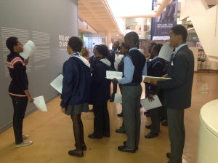
Figure 8: First experience and encounter at the Rise and Fall of Apartheid: Photography and the Bureaucracy of Everyday Life Exhibition organised by the International Centre of Photography (2014).
The second section was more interactive where learners were divided into five groups of four. They had to find images in the gallery which spoke to the themes which they aimed to address in the South African History of Apartheid. This section moved from me placing myself in the foreground and allowing learners to be involved in the programme through Inkulumo-Mpendulwano.
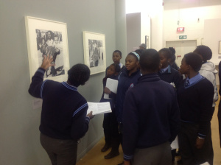
Figure 9: Learners leading the programme and facilitating and interpreting the exhibition.
Although this section of the facilitation was interactive, the conclusion revealed Ukufundisa pedagogy.
Conclusion
In principle, apartheid did not differ that much from the policy of segregation of the South African government which had existed before the Afrikaner Nationalist Party came to power in 1948.
The main difference was that apartheid made segregation part of the law. Apartheid cruelly and forcibly separated people, and had a fearsome state apparatus to punish those who fought against it.
In preparation, I did not consider that the classroom facilitation could have changed direction and therefore allowed the learners to rather come up with their own conclusions in the museum. The importance of the Inkulumo-Mpendulwano encounter is that it is not only a process in the beginning where learners elect the content; it is also like this in the middle, where learners unpack the content; and also at the end by encouraging a collaborative conclusion.

Johannesburg Street Exhibition by Alphabet Zoo (2014)

Johannesburg Street was an exhibition which incorporated printmaking, painting, photography, videography and publications by Alphabet Zoo, a duo of Minenkulu Ngoyi and Isaac Zavale. For this exhibition, they were running silkscreen and zine workshops in collaboration with other artists, and in this particular workshop, a demonstration to learners from MC where I facilitated the content. Learners decided to dedicate one page of their zine to a fellow classmate who had been part of the Artucation Programme but sadly had passed away a few days before this particular workshop. The end result of this workshop was a small A7 size (105mm x 47mm) zine with drawings and text which included a lino print as the zine cover. For the next two Wednesdays, learners worked in the classroom first completing the drawings of these zines then individually presenting them to the class. This particular facilitation process was different to any of the other workshops I had co-facilitated because of its sensitive nature.
The advantage of Inkulumo-Mpendulwano encounters in this instance was to allow the learners to express themselves and to dedicate an ode to the deceased. These small black zines started to be a reflection of this personal-intimate journey with learners and their classmate. In Inkulumo-Mpendulwano, one must be able to understand how to respond to a particular situation and mood of the classroom space; deal with its sensitivity and mediate these processes at the same time. I noted in the previous chapter in the section on Coetzee’s theorising of “accents”, the importance of a facilitator showing vulnerability cannot be underestimated in this practice.

In Search of… Exhibition by Musa N. Nxumalo (2015)

In Search of… Exhibition by Musa N. Nxumalo (2015) is an exhibition which explores youth culture and using photography as a tool to document associated social activities. Whilst preparing for the educational aspect of the exhibition and doing some research, I decided to acquire more information by attending a walkabout by the artist. I found that, like many other walkabouts, the artist’s view and journey. As much as this information was indeed relevant to the talk, it was as if the audience was not invited to participate in the conversation until the end, which was the question and answer session. This particular encounter of the artist/teacher speaking whilst the audience/learners is/are listening refers back to Freire’s Banking Concept of Education.
What Inkulumo-Mpendulwano argues is not that Nxumalo should not have provided information or his personal view and journey of the exhibition - rather, that he should have allowed the audience to interpret the works for themselves first, then inform that process through his journey. The process therefore enables the engagement and discussion to be participatory, and an important aspect to note when facilitating learners for the Artucation Programme. The following week, during the Artucation Programme, I wanted to see if this methodology would work. The moment learners walked into the space they were interested in the title of the exhibition, then the images and then in how they were linked. They shared stories that they had either experienced or those of people that they knew. The themes, which grew out of these stories, included: social media as an influence on youth culture, drug abuse, alcohol and relationships were key aspects to these presentations. For the next three lessons, I invited arts educational researcher Genevieve Louw to facilitate photo voice inspired workshops. Even though the exhibition was predominantly photography, learners decided that they wanted to act out these stories through drama which for them would be the best way to portray youth culture.
For the next few weeks we brainstormed themes and worked them into a performance. At the time I was unfamiliar about drama facilitation; what Inkulumo-Mpendulwano argues is that the learners will consistently challenge the way you think and therefore the facilitator should also acquire knowledge to be added to this learning process in the classroom. I decided to co-facilitate with applied drama facilitator Moses D. Rasekele whilst attending a course on applied drama techniques with Drama for Life’s Mvuso Schools and Community Project. These applied drama techniques assisted with methodologies which are not limited to applied drama, in the manner in which they dissect, link and intertwine across other disciplines through dialogue.
For the next few weeks Rasekele and I started facilitating the performance with learners, using applied drama. These workshops centred on themes which had emerged from the Nxumalo exhibition and the photo voice exercise such as love, youth culture, peer-pressure and relationships. After seven lessons, the performance titled Eish, took place at the University of the Witwatersrand as part of Drama for Life’s Sex Actually Festival. The main audience were university applied drama students. This performance expressed the content that learners were dealing with, and also showed the different applied drama elements which had been learned during the workshops.

EISH!
We all have our EISH! moments, expressed through love, hate, hurt, frustration, surprise or guilt. This proudly South African word that expresses various moods of expression has no boundaries, no limits and can be expressed anywhere at any time. Performed by learners from New Model Private College and Metropolitan College EISH! is a performance that looks at all these moments that one goes through in life which can be adapted and related through all ages. This performance forms part of the Artucation Programme.

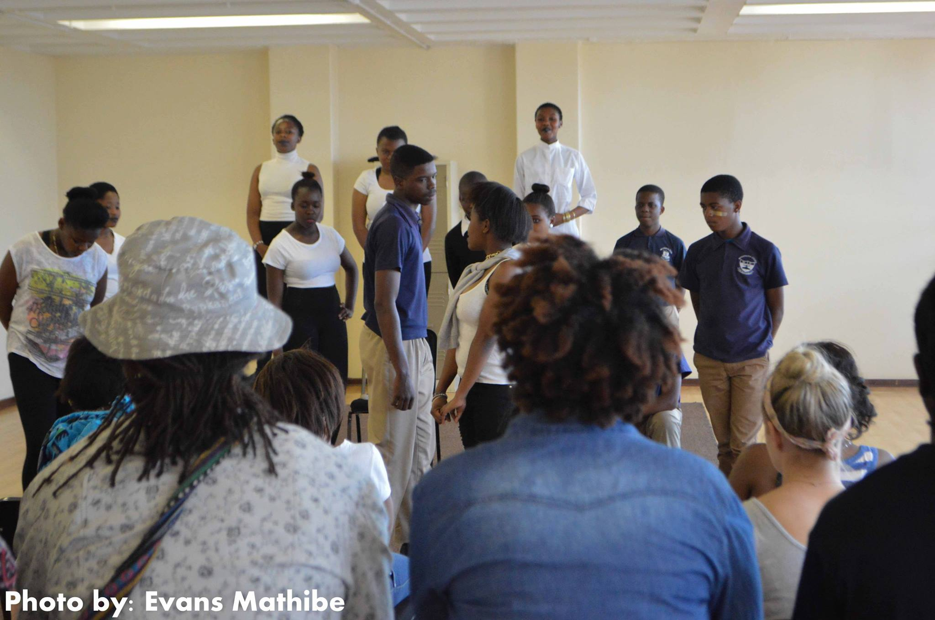
Figure 10: Learners from MC and NMPC performing their Eish performance for Drama for Life university students who further responded to these performances.
At the end of the performance, a poem written by one of the learners was recited: university students got into groups and responded to the last sentence - posed as a question - to the audience:
It is often said that when you have EISH in your heart you should follow your heart but which way do you go when your heart breaks into two?
-Priscilla

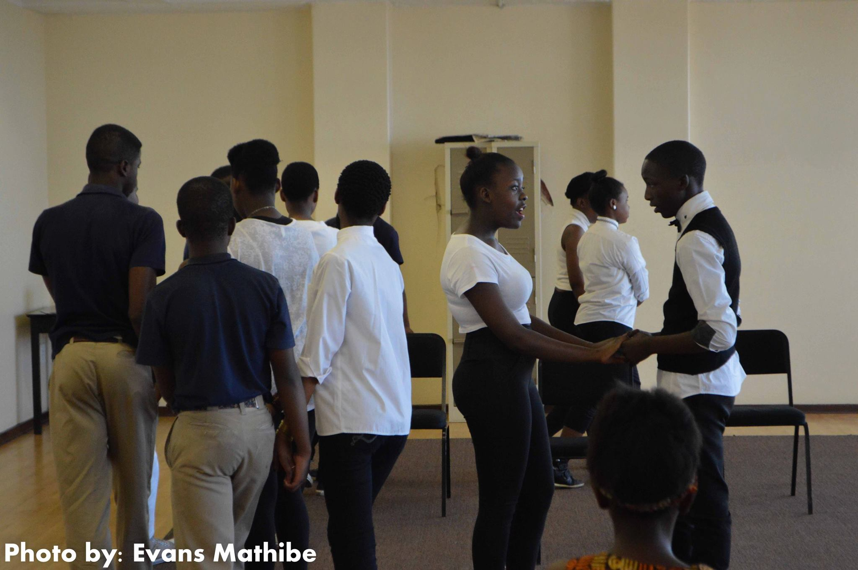
Figure 11: Eish performance with themes around relationships.
This process was one which developed its content from Nxumalo’s visual art exhibition with themes around youth culture. Inkulumo-Mpendulwano encourages the facilitator to acquire more knowledge, and in acquiring applied drama skills, I learned a variety of techniques which I thought could be used for Inkulumo-Mpendulwano encounters such as: Using Pre-Text: Instillations, Statements, Articles and Headlines as story making technique; Working with Role: Embodiment and Characterization; and Working with elements of Drama and Theatre. The response from the university students further translated into a reinterpretation of learners’ interpretation of Nxumalo’s exhibition.

Curatorial Process with learners

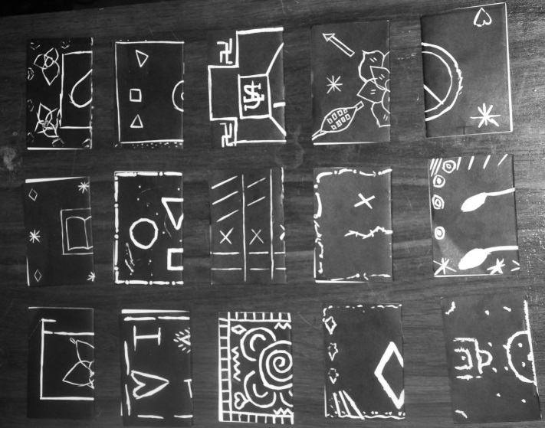
Figure 12: Zines produced by the learners
This section of the programme prompted learners to think about the Artucation Programme journey as I was coming close to the completion of the practical component of this research and wanted to invite them to be part of the curatorial process too. This was for the final exhibition and examination process of this research. I decided to have a conversation with the learners about the different artworks we had produced and reflected on what would work best in a gallery space. On the first day it was decided that the process and subsequent reflections on the zine workshops with Alphabet Zoo were to be the emphasis of the proposed exhibition. As previously mentioned, the zine workshops allowed learners from MC to dedicate a page to a class member whom they had lost in 2014. Without explaining and defining the role of a curator, I asked them to imagine how not only the zine making process but other programmes which took place during the Artucation Programme could be placed in the GoetheonMain project space which the learners were quite familiar with and at the time a possible place where the final exhibition would take place.
Day two Learners decided that the zines were too small to be exhibited in such a big gallery space, the intention was to use the zines as maquettes of the final works in the gallery on canvas. The importance of this process was to make learners aware of the importance of the Inkulumo-Mpendulwano collaboration during the Artucation Programme and in the curating of the exhibition, and just as we would use a gallery as a starting point to select content, we used the zines as a starting point for the curatorial conceptualisation. As a practice towards enlarging the A7 size (105mm x 47mm) zine to A4 size (297mm x 210mm), learners were asked to sketch and imagine the different materials they would use on canvas.
Day three I facilitated and amended Pretext - from Drama for Life applied drama elements I learned earlier from the Mvuso Schools and Community Project. I placed all the zines on the floor and asked the learners to group them according to “characters”. After intense negotiations around these “characters”, they were asked to introduce themes or titles for each group. These themes were: Shapes; Education; Heritage; RIP; and Love.
On the fourth day we started imagining these “characters” in the GoetheOnMain Gallery. I divided them into groups of four and asked them to physically construct the gallery using foam board in order to imagine the artworks in the space. They then had to write where each theme would be placed on the walls of the created gallery and give a brief explanation and presentation in their groups. Together as a group we took notes on what worked best in the four groups and assembled that into one exhibition.
On the fifth day canvases were brought into the classroom, together with the different materials that learners requested for each artwork. We mostly agreed that backgrounds would be black (which was the original colour of the zine); and the foreground would be the original white colour, whilst others were explorative in their creativity requesting tissue paper, neon pink and so forth.
Viewing the completed works in the classroom on the sixth day, I placed them in the themes which learners previously presented. They looked at these canvases which looked different because of size and material, and facilitated the same Pretext technique to see if they would change anything. They agreed that they would still keep the themes but left it to me to decide how to place them so that they would work within that theme in the gallery.
This was the last day I was with the learners as schools closed and when they reopened the following year, they were grade 12. This meant that, because of the pressures of this grade, I had no access to them. When learners left it to me to assemble the exhibition of this research, I was aware of the important points which were emphasised, the themes discussed and what I needed to avoid. Although I could feel the void, the decision for learners to allow me to “continue” was one, which made me realise that there was trust in the collaborative decision. This process became more intense when the gallery space, which we mostly visited during the Artucation Programme, was unavailable for the Inkulumo-Mpendulwano exhibition. I had to think of a space where the facilitation and learning process of the Artucation Programme took place. I found that the school premises was indeed a space, which not only spoke to education and pedagogy, but it was a space which learners found to be familiar and where we had the Artucation Programme.

Chapter 4: The Inkulumo Mpendulwano Exhibition - Outcomes of the Artucation Programme

The exhibition, titled the Inkulumo-Mpendulwano was the outcome of the practical component of this research and process of the Artucation Programme. It revolved around a facilitator’s engagement with learners and participation whilst on the MC school premises. The exhibition aimed to accentuate the role of the facilitator as a responsive participant during instances and moments of Inkulumo-Mpendulwano encounters in arts education.
This section of the research is divided into two sections. The first pertains to the geographic location and includes references to an aerial view of the surrounding areas as well as activities and institutions around MC which influence the different energies and the resources of both the school and its surroundings. In the second section I will relate these spaces to the site-specific locations of the exhibition in MC and the energies which influenced movement, impermanence and unfixed structures generally underpinning the Inkulumo-Mpendulwano interactions.

Aerial Overview of the Area

Figure 14 depicts a hand-drawn aerial image and demonstration of not only MC (where the exhibition took place - number 15), but also the infrastructure around the school which learners interacted and engaged with on a daily basis. These include: Number 1 - The University of the Witwatersrand (Wits) with the Wits Arts Museum and previously The Substation; Number 17 - located opposite the university is The Point Of Order project space; Number 3 - The Johannesburg Art Gallery; Number 13 – Arts On Main (which has ten arts galleries, workshops and studios).
We focused on the GoetheOnMain gallery, not only because the Goethe Institute were the partnering organisation and funding the Artucation Programme, but because the GoetheOnMain gallery was an interdisciplinary arts projects space, which incorporates visual arts and performance art in their programmes. In close proximity to Arts On Main is Number 14, The Bioscope Independent Cinema, where for the past 4 years I have been hosting educational film programmes including the Artucation Programme.
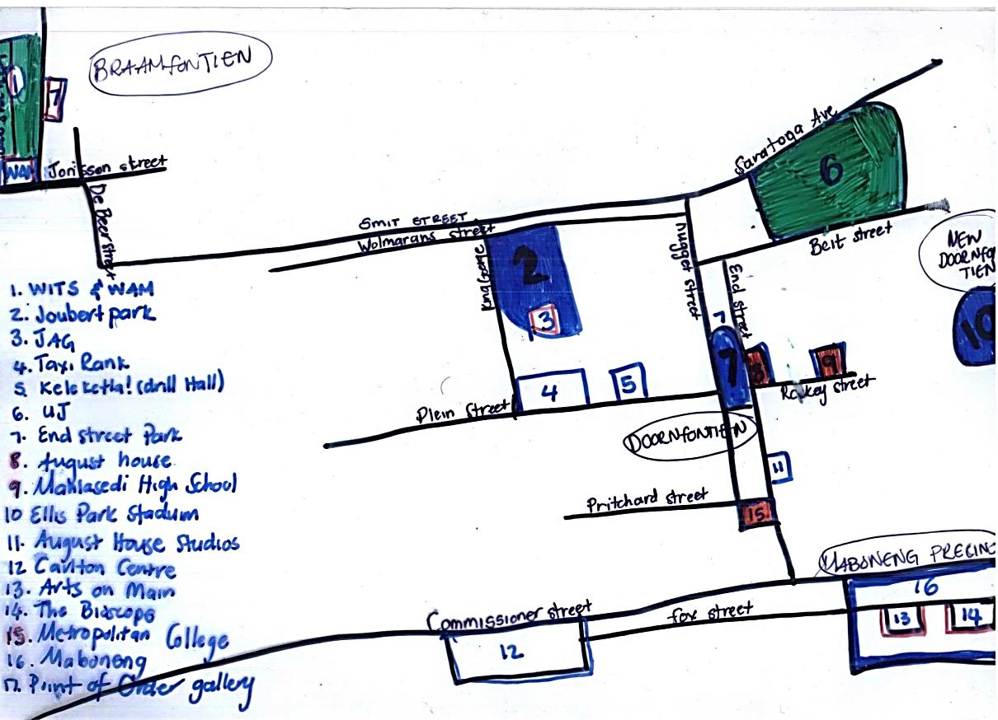
Figure 13: Aerial view of the resources available to MC (number 15) and surrounding schools (Number 8 and 9). The different languages, cultures and classes intertwine and enhance the arts educational programmes offered here.
Arts On Main and The Bioscope Independent Cinema are located in the Maboneng Precinct (Number 16) which began as an arts hub and evolved into a high-end urban business, retail and residential area with restaurants. Down the same road from Maboneng Precinct is a similar retail and restaurant hub called Carlton Centre, accessible to the broader middle-class community. MC is centred between the Maboneng Precinct and the Carlton Centre; the latter being frequented more by MCs broader community. There is an Internet Café opposite MC (See figure 15 – Number 16) where learners do research for the Artucation Programme. The arts educational programme affiliates with not only local arts organisations and institutions, but also local businesses.
There are also three other schools in this area, Number 8 - NMPC and Number 9 is one building containing two schools: KS and MHS. The number of foreign African learners exceeds that of South African learners. These schools may not have the financial resources to host an educational arts programme in the school, but they are exposed to resources in the surrounding areas that are exceed well- resourced high-end private schools such as the National School of The Arts (which is located 2.8 km from MC) and King Edward VII School (KES) (located 2.8 km from MC) and Sacred Heart College (located 4.5 km from MC). KES has a museum that exhibits the history of the school rooted in South Africa’s colonial apartheid era. KES hosts visual art exhibitions each year showcasing learners’ talents. My observations of both KES and MC made me aware that: the lending and borrowing of resources is not limited to art materials or museums; to redefine resources in arts education and how they can be utilised to enhance arts education and activate related spaces.
The city of Johannesburg area hosts a wide variety of people from the working-class to high-end society not so far away from each other, yet there seems to be an intertwining of language, culture and identity, clearly evident and reflected in the arts education facilitation of the Artucation Programme and Keleketla! Library (Number 5). The dynamic combination of culture, language and identity infuses vibrancy and energy which are clearly detectable in the classroom.

Izimpekupheku: Energies, Movement and Impermanence in Arts Education

Impekupheku is a Zulu word which defines a particular kind of energy which is associated with a person. An example of these energies may be found at figure 16 right outside MC (number 1) which is a bus stop for travellers going to Zambia. From time to time, you can find a bus parked outside the school, with possible passengers sitting on the pavement with their luggage, ready to visit their homeland. That particular space brings different levels of Izimpekupheku (pl) at certain times of the day. For instance, if the bus leaves at noon, the Izimpekupheku at the bus stop at 9:00 will be different to the Izimpekupheku at 11:55 and subsequently 13:00. The space remains the same, but there are aspects pertaining to those Izimpekupheku that come together and somehow transform it. This is similar to MC. The school gate opens from 6:30am and the Izimpekupheku of learners begin to fill the outside area. At 8:00 the bell rings and school starts; the gate is closed and the learners move into the building, through corridor 1 and up the stairs and into their classrooms.
A few minutes after 8:00, the Izimpekupheku, can be characterised as learning time, quiet time and reflective time and results in these learners’ different voices, cultures and languages being silenced by a particular kind of authoritarian language. They start to look the same, talk the same and even start to sound the same. This method of Ukufundisa has forced the diversity of Izimpekupheku to become uniform, scheduled, timetabled and rigid.
What the exhibition aimed to do was to show instances of how schedules and timetables could be altered, how movement and impermanence informed the role of the facilitator and further examined the impermanent structures and schedules pertaining to Inkulumo-Mpendulwano processes. I discuss how this was achieved in the Inkulumo-Mpendulwano exhibition in two sections: ‘Characters’ and ‘Text’.

Abalingiswa - Characters

I installed seventeen canvases in the school premises that aimed to address impermanence, participatory engagements in learning and the role of the facilitator found in Inkulumo-Mpendulwano pedagogy. It was my intention to install these canvases with Impekupheku and portray them as characters of the space. For this reason, I will not describe them as canvases, but rather as “characters” in the space.
During the exhibition I called them characters, but after reflecting on recollections of the process I prefer to use the Zulu word Umlingiswa which defines characters in a book, play or theatre. This particular word reflects the Inganekwane (Storytelling) mentioned in the previous chapter. These Abalingiswa (pl) began to share stories influencing the Inkulumo-Mpendulwano exhibition and, subsequently, what the classroom facilitation encounter should ideally embody. These Abalingiswa transformed from intimate small zines to large canvases through different interpretations and collaborations. Each Umlingiswa originated from complex and ‘seemingly invisible’ processes: the eighteen-month workshops; to the zine workshops; and the collaborative curatorial processes. For me the Abalingiswa addressed three key things which are important in the Inkulumo-Mpendulwano pedagogy and encounter: storytelling, impermanent processes and local terminology.
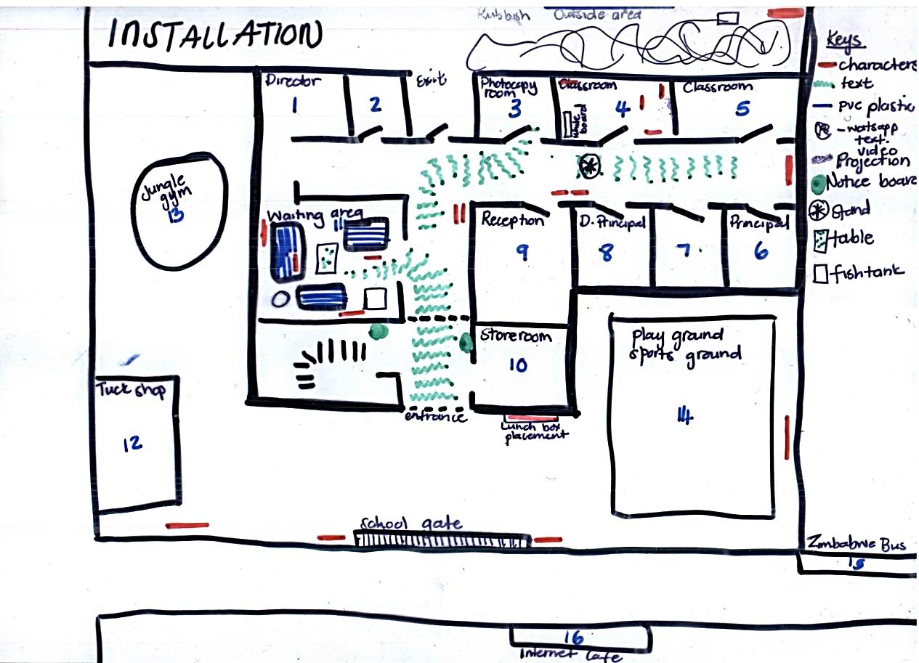
Figure 14: Inkulumo-Mpendulwano, Metropolitan College, 2016. Ground floor plan with the depiction of where the Abalingiswa (characters) were located
In the exhibition these Abalingiswa were placed in various spaces on the school premises: on the periphery wall facing the school ground, inside the waiting room area, at the reception counter (corridor 2), on the wall next to the Deputy Principal’s office (corridor 3), at the end of a corridor, in a classroom and in an outside area. My intentional placement of these Abalingiswa was to observe if a reciprocal exchange of ideas could become apparent in slightly altered daily patterns, movements, and schedules of these Izimpekupheku during peak times. The school schedule is usually programmed as follows:
- At 10:30, it is break time for the primary school learners where the jungle gym area starts to exude Izimpekupheku.
- By 10:45, a stack of colourful lunch boxes can be observed next to the jungle gym in that area and at 11:00, break time for the primary school learners is over.
- At 11:20, the bell rings for the high school learners to take their break.
- At 14:00, it is after-school supervision time for the primary school learners; 15:30 for the high school learners. The tuck shop area experiences peak times of Izimpekupheku before school starts, during lunch breaks and after school.
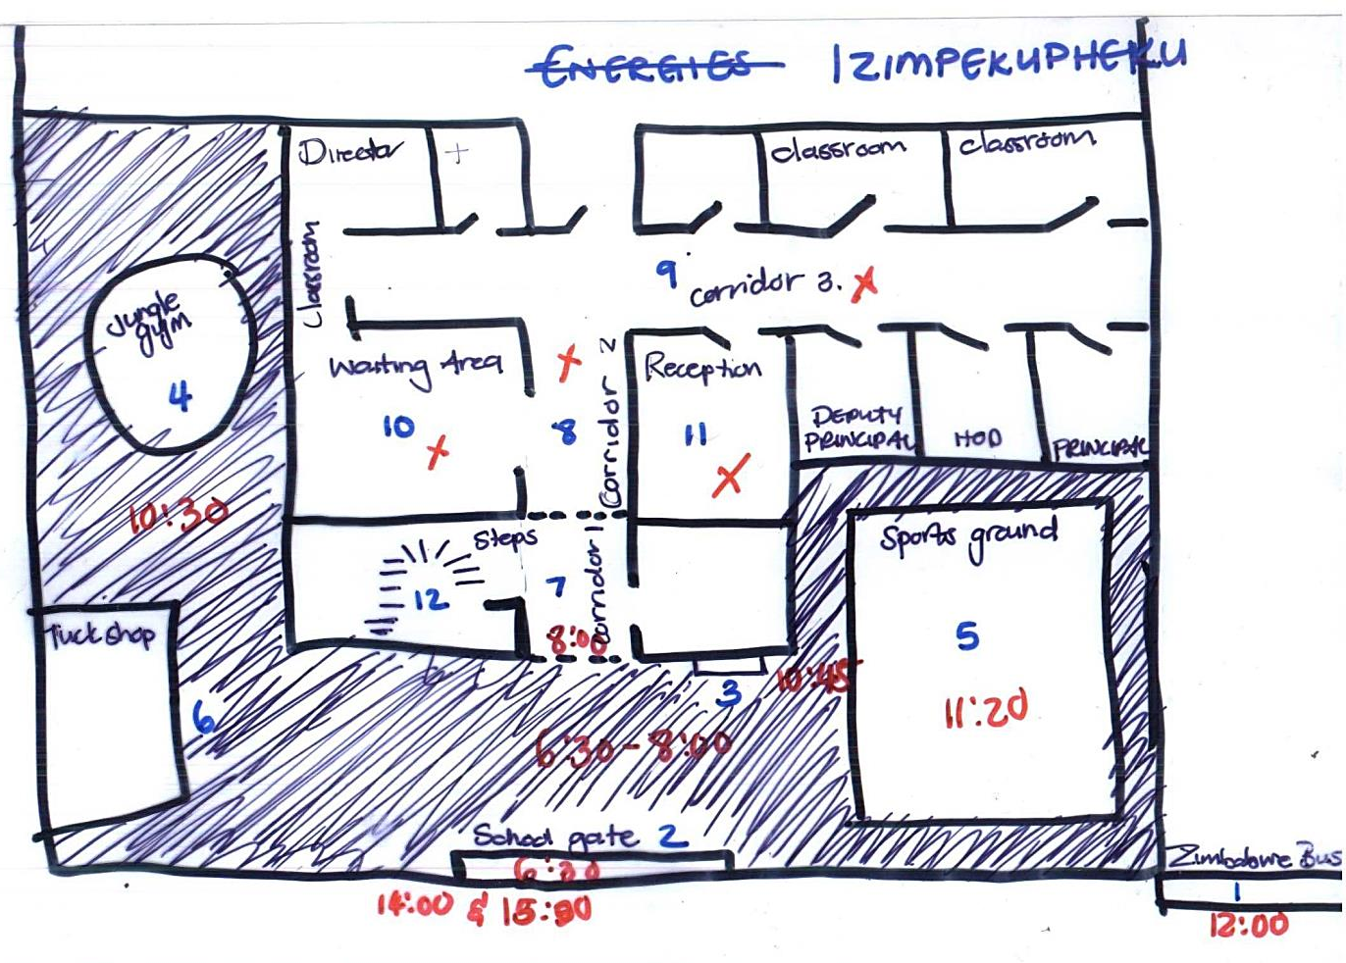
Figure 15: Inkulumo-Mpendulwano, Metropolitan College, 2016 – Izimpekupheku as the different energies that may transform a space.

Abalingiswa at the Playground Area

In figure 17, there are five Abalingiswa. The first Umlingiswa is a black and white acrylic painting of a soccer field which was strategically placed where primary school learners would usually pile up their lunch boxes during lunch break. I purposely placed the Umlingiswa in that space before lunch break, and as the bell rang, learners saw this Umlingiswa in their spot and decided to place their lunch boxes elsewhere. The same process happened with the second Umlingiswa placed on the floor, leaning against the wall which seemed to try to “blend” in with the other shapes on the sports field. This is a space where mainly high school learners play soccer during their lunch break. The learners became aware of the Umlingiswa’s presence in the space and seemed to play more cautiously. If it happened that the ball landed on the Umlingiswa and it fell, the learners would pause the game and place it back into position. The third, fourth and fifth Abalingiswa in the play area (see figure 15) were purposefully installed by myself to “interact” with the learners and Impekupheku in the space, similar to the third Umlingiswa seen in figure 17, that was tilted because the learners had shifted it whilst playing.

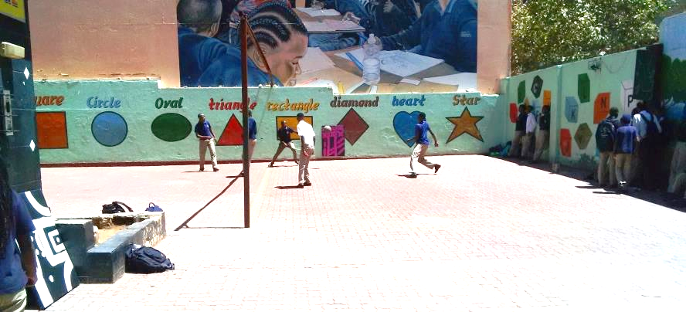
Figure 16: Inkulumo-Mpendulwano, Metropolitan College, Playground Area, 2016.
A few minutes after break - when the Impekupheku in the space was quiet, these Abalingiswa would have moved out of their original positions. This was due to interactions with learners moving around them and at times manipulating their placements. As a result, these Abalingiswa could not be compared to canvases one would see installed in a gallery space. Their impermanence and mobility became an important aspect of the process for me to observe.
Moving them to the outside area (installation) and back to the Deputy Principal’s office (de-installation) reflected a symbolic representation of the ever-transforming school space and the Inkulumo-Mpendulwano encounter. Inkulumo-Mpendulwano thus intends to suggest that encounters in educational practice should encourage a constant change and shift in programmes, where learners adjust and lead the direction of the class facilitation. Similarly, some of the Abalingiswa could have been interpreted as “interruptions” in the rigid structures and schedules that operate in the school environment. This may allude to a process of questioning pedagogy, facilitation and teacher-student-relationships.

Abalingiswa in the Waiting and Reception Area

The Izimpekupheku one may experience in the waiting area, reception area and corridor 2 from figure16 is different to that of the playground area. This could be because there are fewer learners and more parents, teachers or visitors who enter that area. On could assume that this section of the school contains approximately the same Izimpekupheku through-out the day. Three Abalingiswa were placed in the waiting area and two in the reception area, as seen in figure 15. The reception area is a space were one receives or provides information depending on which side of the glass you are positioned. The waiting area lives up to its name as it is a place where you are required to wait for various reasons.
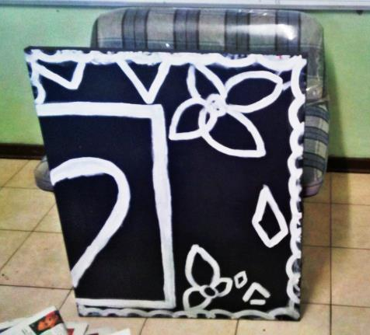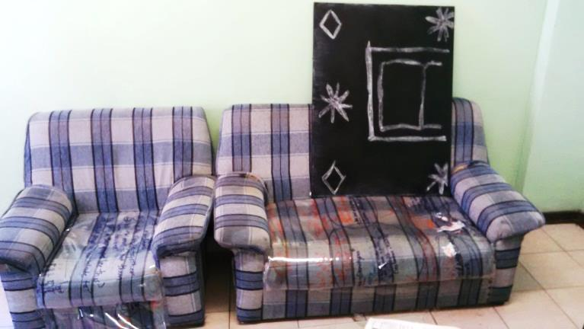
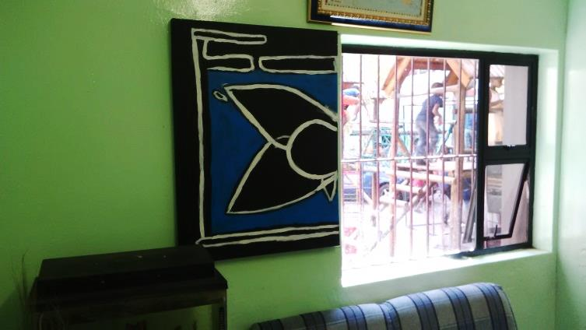
Figure 17: Inkulumo-Mpendulwano, Metropolitan College, Waiting Area, 2016. Placing Abalingiswa in certain positions which speak to movement and flexibility in arts education.
The waiting area at MC has three couches and three Abalingiswa. The first Umlingiswa was placed on the floor in front of the couch, the next Umlingiswa was placed on top of the middle couch facing reception, and the last one was placed on the wall as if looking slightly through the window as if to “see” learners play in the jungle-gym. The two Abalingiswa on and in front of the couch were placed where visitors would usually be seated. The maintenance person would always sit on the single couch which had the Umlingiswa on the floor. As a result of the intervention in the space, he changed his usual pattern and sat on the couch next to the fish tank which did not have an Umlingiswa on it. I observed several visitors who sat very uncomfortably where the Umlingiswa were situated on the couches; they would sit on the arm rest, or on the edge of their couch commenting on the impermanence and flexibility of arts education.
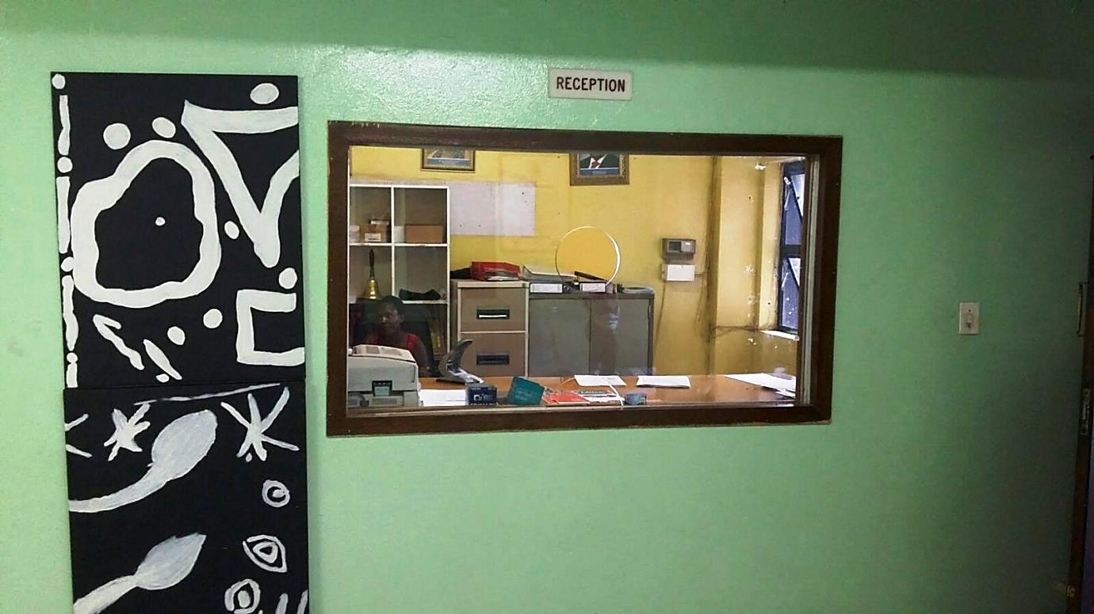
Figure 18: Inkulumo-Mpendulwano, Metropolitan College, Reception Area, 2016

The two Abalingiswa in the reception area (figure 19) were placed on top of each other and seemed to be dominant because of their size, reminiscent of The Banking Concept of Education by Freire in which the teacher is the only one who provides information and learners passively receive this information (1968, p. 164). It can be interpreted that the reception area reflects a banking model because of this process of “providing information”. The Abalingiswa were purposefully placed at a high vantage point on the wall, with the intention to reflect authoritarian power structures that “looked down” upon those who encountered them. Their positioning was fixed due to the fact that they were glued onto the wall space, unlike those Abalingiswa placed in the playground area.

Abalingiswa in Corridor 3 and Outside Passage

In corridor 3, (see figure 20), two Abalingiswa were installed next to the Deputy Principal’s office. They were glued to the lower part of the wall with the intention that viewers would look down on them. The power relation in this instance shifted from the Abalingiswa to the viewer, which still addressed the Ukufundisa pedagogy as if a power relation, still prevailed. In Inkulumo-Mpendulwano pedagogy, neither the student nor the teacher is supposed to have exclusive power; rather they are supposed to work together to make a learning programme a success.
Corridor 3, is where the Director, Principal, Deputy Principal and Head of Department have their offices. I would go into the deputy principal’s office to negotiate schedules and projects, and in this case the Inkulumo-Mpendulwano exhibition. I felt that the Izimpekupheku in this space was quiet and reserved due to the presence of these authoritarian figures.
Facing the Deputy Principals door was an Umlingiswa at eye-level. This spoke to my personal encounter with the Deputy Principal and was therefore an acknowledgement of him and his willingness to make the programme a success.
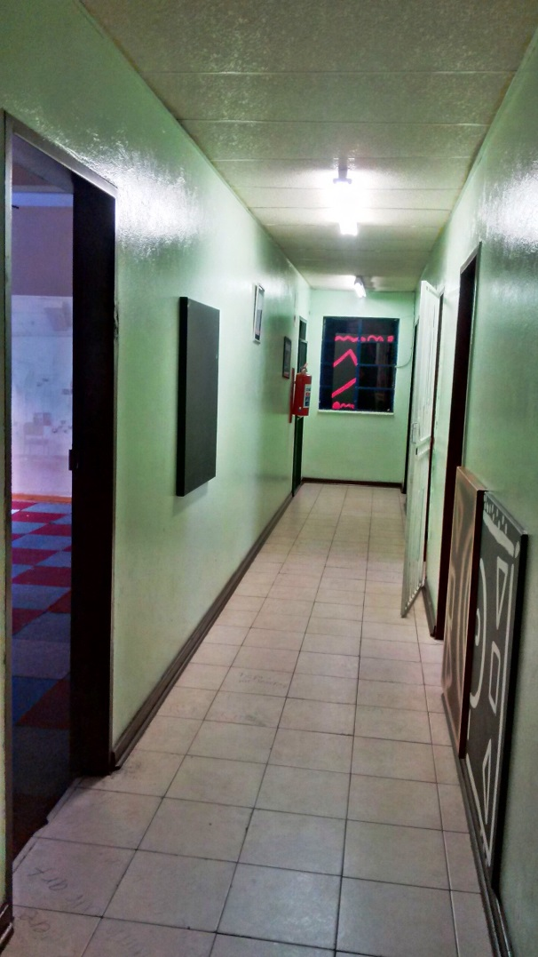
Figure 19: Inkulumo-Mpendulwano, Metropolitan College, Corridor 3 Area, 2016.
At the end of the corridor 3, was a tilted window with one Umlingiswa “peeping through” it could be observed as if it “tried” to be in the space, but was outside and “peeking” in. It may have seemed intended to “invite” the viewer to come closer to satisfy their curiosity, which could speak back to the act of a facilitator/educator giving students individual attention. This sentiment was also reflected in the act of placing Umlingiswa outside of the classroom spaces where most of the rubbish is dumped (figure 21). This Umlingiswa was placed in the corner of the outside passage on top of two truck tyres. One could only see it from the classroom (Reflective Room) and if one did not pay close attention, it would not be seen. (See figure 26).
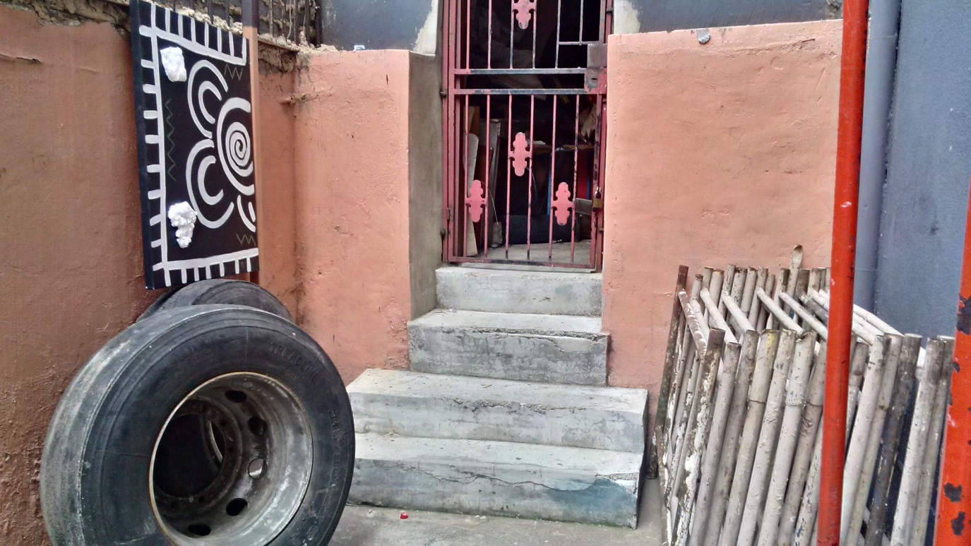
Figure 20: Inkulumo-Mpendulwano, Metropolitan College, Outside Passage Area, 2016. This Umlingiswa seemed hidden in the outside area, if viewers did not pay close attention, it could be missed. This addresses the learner-teacher relationship in arts education.

Abalingiswa in the Reflective Room

As observed in the play area, reception, waiting area and corridor 3, the classroom space also had its own Izimpekupheku. I decided to call this space the Reflective Room. I installed a video projector, projecting a video frame titled Remnants 2015 and placed chairs and tables to the side of the room by the window (see figure 21). This space was quiet and revealed process, movement and imagined bodies in the space reminiscent of figure 4, in the Dundee museum. The Reflective Room was a space intended to engage reflective moments and was informed by the eighteen-month process leading up to the exhibition. The Abalingiswa were spontaneously placed in various positions in the classroom, with the intention of reflecting the act of “flexibility”. One was placed on the floor in the corner, the other was facing upside-down (close to the ceiling) and the last one was placed at the top of the window. The Abalingiswa’s positioning in the classroom allowed for the space to transform, and to give character and meaning to the Abalingiswa.
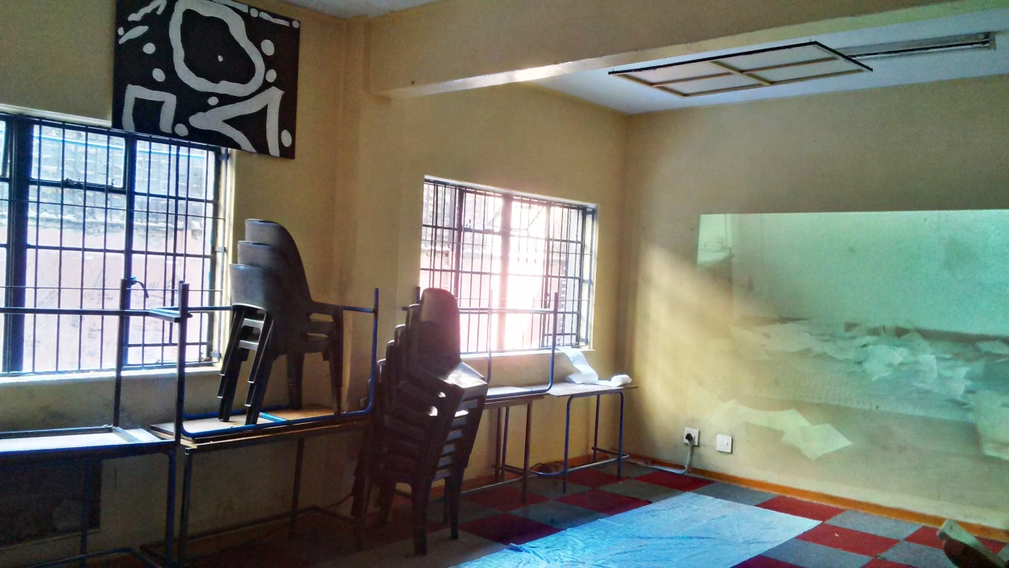
Figure 21: Inkulumo-Mpendulwano, Metropolitan College, Reflective Space Area, 2016. This space depicted different reflective moments which informed the Inkulumo-Mpendulwano process and exhibition.
The video projection, entitled Remnants (2015), was installed in the Reflective Room (as seen in figure 22). Remnants was a collaborative work made with Genevieve Louw with whom I shared a studio space. It was a stop frame video depicting my personal planning and reflective process of the Artucation Programme in my studio space at the University Corner at Wits University. The video reflects pace, pattern and rhythm which may allude to the process of planning, processing and reflecting. The stop frame video intended to represent the moment when the practical component of this research had been completed, the planning and reflective process had to came off the wall. This was difficult for me as I felt too connected to the process, I decided to document my visual archive which had acted as a recording of what had become a two-year period.
Louw witnessed my engagement with the studio space and transformed these recorded images into a stop frame video piece that translated into her interpretation of my own struggle and reflections with the process. In the studio, the video was projected onto what seemed to be fragments and pieces of memory that remained on the wall of the studio such as staples, prestik and small pieces of torn paper (hence its title Remnants). When the video was moved from the studio to the Reflective Room in the Inkulumo-Mpendulwano exhibition, I imagined that it carried the same Izimpekupheku as the studio space it was depicting.

Text

There were four text pieces that I incorporated into the exhibition. The first piece was a hand written note from one of the learners who shared her experiences and journey through the Artucation Programme; the second was in the reception area, followed by an ethics text, and lastly, some notice boards text.

Corridor text

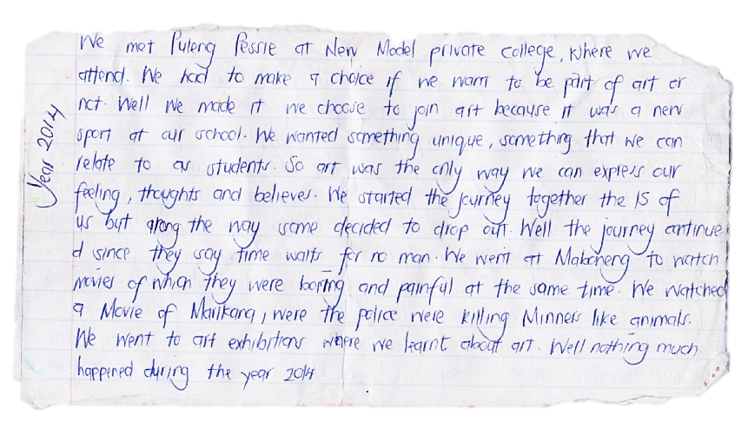
Figure 22: Text from NMPC learner who wrote about her journey in the Artucation Programme.
The first text was written on the black vinyl floor of the entrance of the school (Corridor 1) and continued through the reception area (Corridor 2), into the office spaces (Corridor 3), which had cream ceramic tiles. This text piece was copied from one of the participants who wrote about her personal experience, journey, moments and recollection of the eighteen-month Artucation Programme (see Figure 24). This text was written in chalk pastel for the vinyl black section and white board marker for the cream ceramic section. I purposefully chose these materials to write with, as they are used for learning and teaching purposes. Whist I was writing it on the floor, I too began to reflect on her interpretation of the same journey. I found that during this process of writing on the floor I became the learner, and I was writing on her behalf. I felt that I empathised with her journey because of her experiences and challenges evident in the text. Whilst writing, I observed my immediate surroundings, how the learners’ normal pattern of walking through the corridors changed due to my presence. It looked as though they were walking on eggshells, trying not to erase the text on the floor. At times some of the learners would stop to read a sentence or two, and then move on again, showing an awareness of the space that was different to their usual interaction with the space.

Text in Reception

The text in the waiting area was on the aforementioned floor, the table (newspapers), and the couch. The texts on the table contained newsprint sheets which were used as reflective exercises for learners during the Artucation Programme. This aptly encouraged visitors to engage with the eighteen-month process as they waited in the reception area.
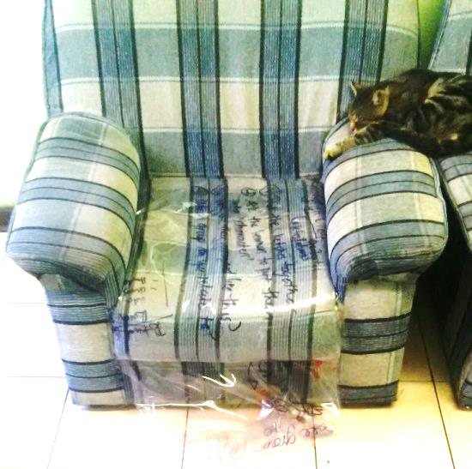
Figure 23: Inkulumo-Mpendulwano, Metropolitan College, Reception Area, 2016
The text on the couch was written on a piece of plastic which I had previously used in my studio to plan, process and reflect. This PVC plastic was also installed in the outside area next to the classroom space which showed my personal arts educational journey dating back to 2010.

Text and Ethics

After extensive engagement with the ethics clearance application process of this research project, I selected important information which learners provided though a WhatsApp group chat we had produced to create a text piece. This selected text was a collaborative conversation that pointed out possible problems, solutions and lessons that I felt were relevant in relation to the Inkulumo-Mpendulwano pedagogical process. I placed the text/conversations outside a restricted area where the viewer has no access and this aimed to represent my own experiences with the ethics application process. It was as though viewers of the exhibition and readers of this research were only exposed to my interpretation of the process, and the specificity of these communications could not be observed due to the fact that they were difficult to access.
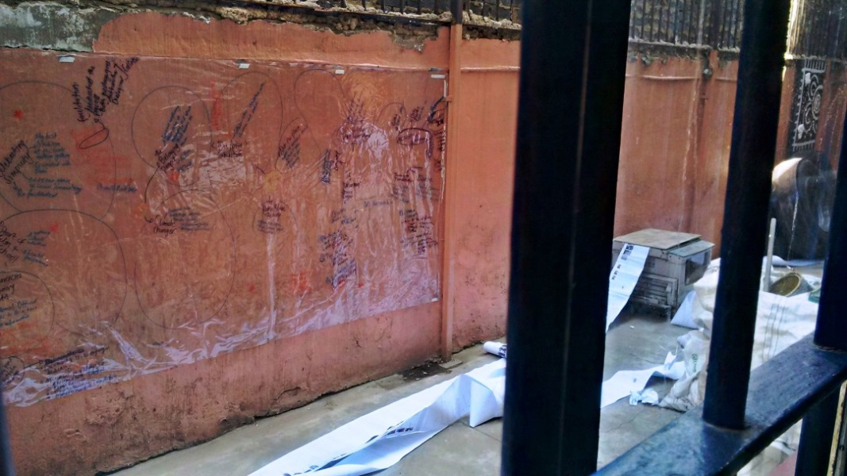
Figure 24: Inkulumo-Mpendulwano, Metropolitan College, Outside Passage Area, 2016.

The ethics application process felt like a punishment, as it became a tedious, repetitive and frustrating process that had to be completed in order to conduct this participatory research project within academia. The second text responds to this ethics process and is represented on two 3m x 1m plastic blue sheets on the floor of the Reflective Room. This text on the floor of the Reflective Room read: “I promise to try my best to protect protect your privacy, Information…” on the one sheet, and the other sheet continued the sentence and read as: “… given to me will be stickily strictly confidential”. The repetitive nature of this writing, although it claims to be ethical, was enforced and felt like a punishment. The viewer would be able to read this ‘punishment’, but would not be able to read or observe the intimate conversations in the text pieces I had installed outside, on the other side of the window.
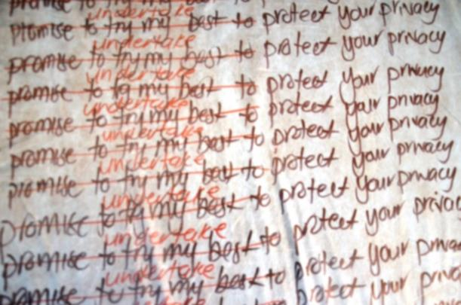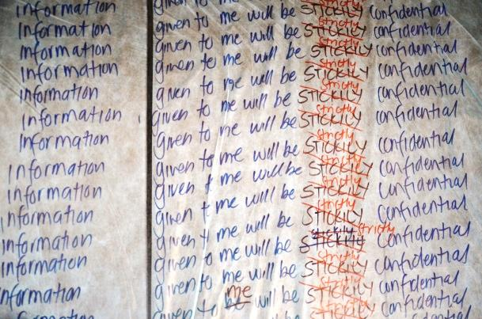
Figure 25: Inkulumo-Mpendulwano, Metropolitan College, Reflective Space Area, 2016. Close up of the written text on the floor.

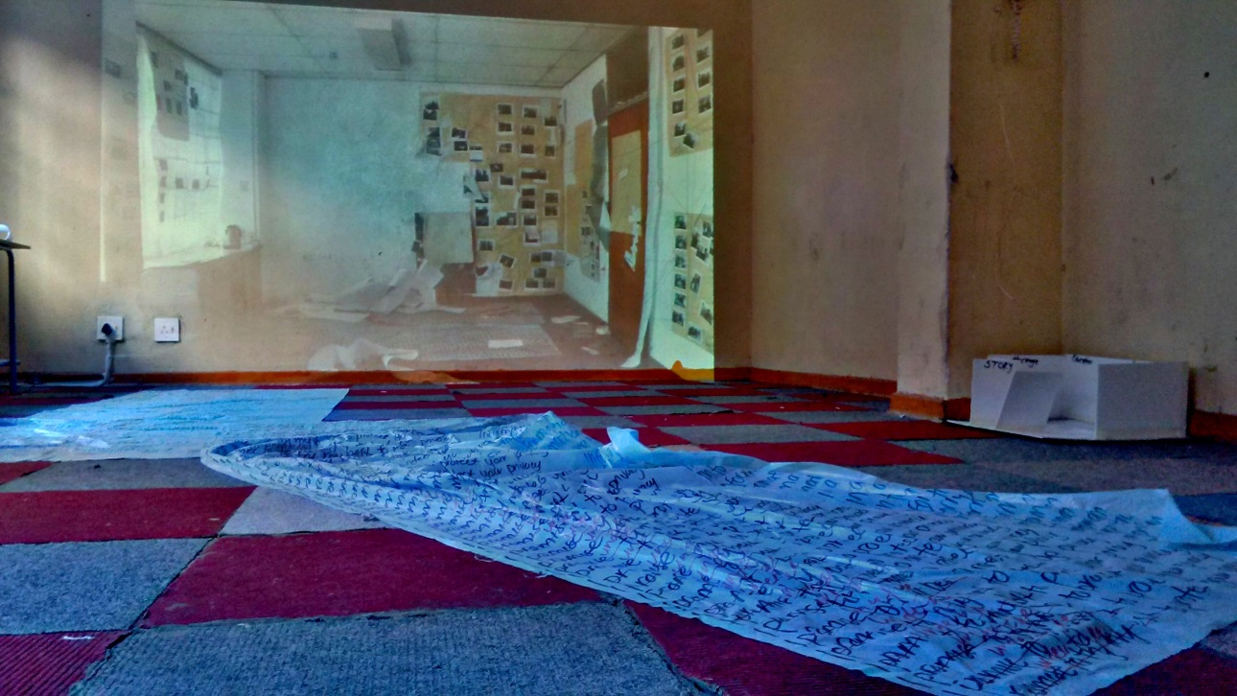
Figure 26: Inkulumo-Mpendulwano, Metropolitan College, Reflective Room Area, 2016. Ethics text and video projection.

Notice Board Text

The text on the notice boards originally functioned as notices for the learners, visitors and viewers of the exhibition. The first notice board was an invite and information about the exhibition. Learners created this invite and placed it on the notice board. After visiting the space frequently, I saw that a new artwork or comment from anonymous learners would appear on the notice board. - The second notice board depicted participants who were involved in the programme such as learners from MC, NMPC, I as the facilitator and various other collaborators. On this notice board there was an anonymous learner who was not part of the Artucation Programme, but added a piece of artwork with the intention to become part of the exhibition. These “inserts” from anonymous learners demonstrated spontaneous participation and involvement from learners.
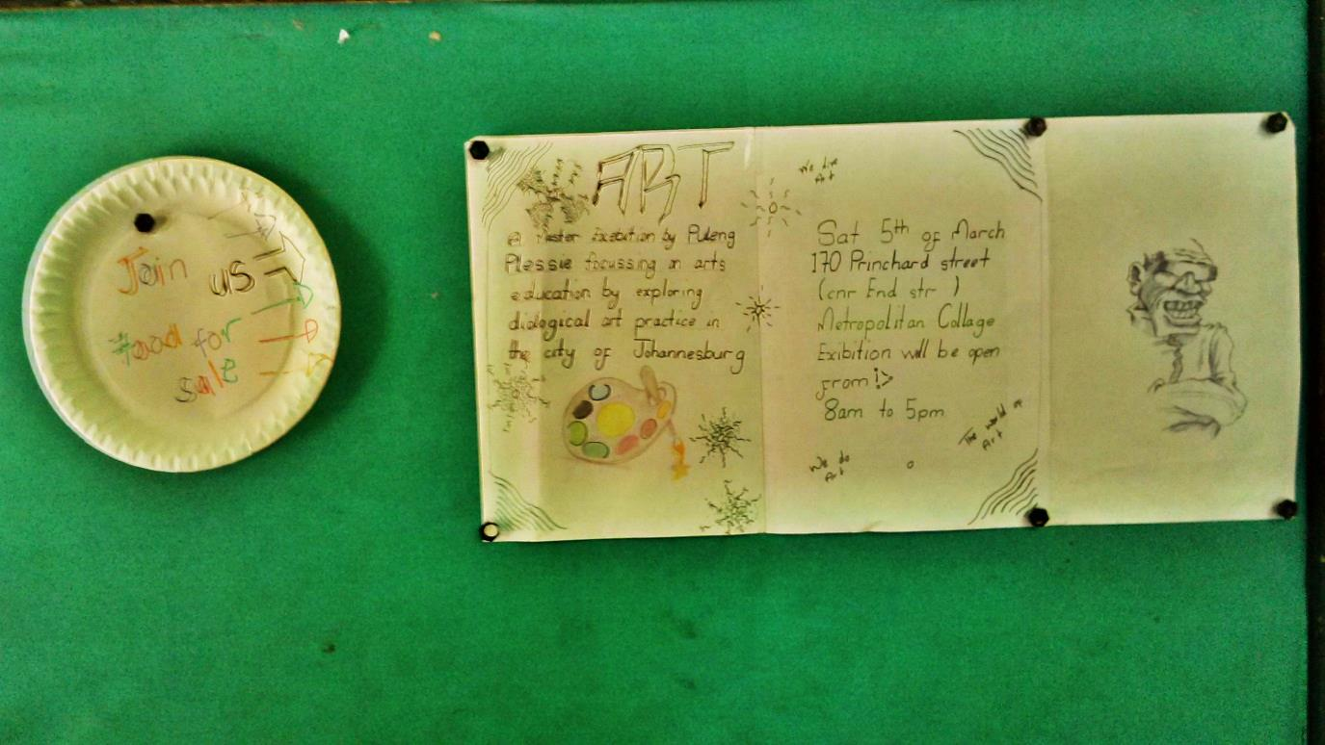
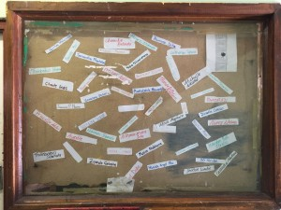
Figure 27: Inkulumo-Mpendulwano, Metropolitan College, Notice board Area, 2016. Learners’ invitation to the Inkulumo-Mpendulwano exhibition and collaboration of participants of the Artucation Programme.

This exhibition combined different elements of Inkulumo-Mpendulwano and aimed to challenge the role of the facilitator and student-teacher relationship. In addition, the exhibition attempted to question how internal, external and combined resources transform spaces in an art educational programme. The Abalingiswa were intentionally placed in the school space to disrupt and problematise various modes of execution and display in arts education.
The exhibition also explored the notion of Abalingiswa as visual representations of Izimpekupheku. This translated into a laborious investigation of complexities inherent in pedagogical practice. Themes of mobility, impermanence and the need for flexibility in pedagogical methodology frequently alerted me to the importance of the process that lead up to the exhibition. It is this process that contained the Izimpekupheku, which then became embodied in the Abalingiswa and in turn, replicated Inkulumo-Mpendulwano.

Way Forward

This section aims to introduce possible ways forward to dialogical methodologies as well as terminology used in arts education practice.
This research has led me to believe that there is always new information which needs to be adapted because arts education is not rigid. New information calls for new research which is consistently evolving. I have further acknowledged Ngugi wa Thiong’o who probes the notion of localising content which I questioned to ascertain if the “dialogical” concept could be adapted to fit in with art practices in Johannesburg. Engaging with Johannesburg based Carli Coetzee (2013) who uses the word Accentedness and Accented teaching, VANSA’s Two Thousand and Ten Reasons To Live In a Small Town, as well as conversations with Keleketla! Library’s KASP facilitators and learners from MC and NMPC, has helped me realise the importance of localising content and terminology through community spaces, storytelling and performance which influence Inkulumo-Mpendulwano practices which could be adapted in schools, museums and galleries.
Throughout the process of engagement with this research project, there has been a development of Zulu terms which help to localise content. I suggest that this integration of language can be used to further create new terms and approaches that can assist in the development of local content. The Zulu words proposed in this dissertation are not merely a translation of existing English terminology, but rather suggest previously unexplored didactical nuances as important forms of knowledge production such as Ukufundisa – dialogic – Inkulumo-Mpendulwano. Lecturer and curator Nontobeko Ntombela, also the external moderator for this research, further questions this term Inkulumo-Mpendulwano:
There is something aggressive about the term ‘Inkulumo-Mpendulwano’ because it connotes words like debate or argument rather than discussion. I say this because it can quickly link itself to the phrase ‘Inkulumo-Mpikiswano’, which is premised on only two people exchanging words in a heated debate. It may be worth thinking about limiting your phrases ‘ingxoxiswano’ / ‘inxoxo’ or ‘inkulumiswano/ ‘inkulumo’ which speaks more directly to the word ‘discussion’.
There needs to be a deeper understanding of these terms, how they relate to arts education and how they should be implemented in pedagogical arts practice.
In October 2016 I attended a talk by Keleketla! Library, a collaboration between #longstorySHORT in the context of the Another Road Map School research project. #longstorySHORT is a project that invites storytellers to read African stories which become a digitally archived resource for the public whereas Another Road Map analyses cultural policies in arts education (Another Roadmap School, 2016). Medu Art Ensemble is the case study in this particular storytelling with South African Poet Laureate and a member of the Medu Art Ensemble Professor Keorapetse Kgositsile playing a central role. The conversation consisted of four panelists: Prof Kgositsile; researcher and lecturer Dr. Lindelwa Dalamba; artist Masello Motona and actor Khulu Skenjana. The audience ranged across four generations with different backgrounds, race, gender and class. Izinganekwane were shared from both the panelists and the audience.
Themes ranged from financial stability as a writer, to the Umlando of South Africa. Dominant in these conversations were terminologies relevant to the post-apartheid South Africa. An example of this is how an elderly man in the audience mentioned that there were structures put in place for apartheid, however there were no structures put in place for the transition of post-apartheid South Africa. He emphasised how we are currently living in a society which still needs interventions such as a country which needs a new name, identity, national anthem, currency and flag which all stem from the apartheid system. He emphasised how we still find ourselves at a point of transitioning.
One of the panellists recalled the term Solanka for this post-apartheid South Africa which is a slang word for in the meantime. Another panellist further interpreted this by singing one or two verses from Kwaito artist Mgarimbe’s song Sister Bettina (2013) which has in the meantime in the lyrics. The storytelling, dialogue, intergenerational conversations and the agreement amongst panelists and audience, address the complexity of dialogue as not only the space of agreement and consent, but also of dissent, contradiction and paradox.
Like elements pertinent to the Inkulumo-Mpendulwano pedagogy: constructing, deconstructing and reconstructing-terms in language, terminology and art educational practice-we still find ourselves at a point of transitioning.

Glossary

Zulu words in this research
Inkulumo-Mpendulwano - Inkulumo-Mpendulwano is an IsiZulu hyphenated word that comes closest to the dialogical pedagogies in arts education. Broken down Inkulumo means to talk or to have a conversation and Mpendulwano means to respond. This call-and-response method of Inkulumo-Mpendulwano not only emphasises facilitations that can be adapted in the classroom as well as curated spaces, but also the relevance of language and terminologies used to localise content.
Ukufundisa - Ukufundisa is a IsiZulu word which means “to teach”. I have been using this word to describe the classroom facilitation process through-out my years as a child and artist-educator. The Zulu dictionary defines the teaching aspect, however, further elaborates and defines Ukufundisa as “to instruct” and “to school” which has didactic associations.
Inganekwane -. Inganekwane is an indigenous folk tale which not only tells a story but is in itself a learning tool, re-enactment and Inkulumo-Mpendulwano encounter, probing questions and allowing for interaction and engagement.
Kwasuka Sukela ... Cosi - Kwasuka Sukela means ‘once upon a time’ and Cosi is a response for the story teller, teacher or facilitator to continue with the story.
Isithunzi - Aura is defined as the distinctive quality that can be generated, projected and surround a person. There are no Zulu dictionary words for aura, however, Isithunzi describes a particular kind of character and personality which the facilitator or teacher should possess. This Isithunzi can also be defined as a shadow depending on how this word is used.
Izithunzi - Plural for aura but I also describe Izithunzi learners as shadows who are seen but not heard in the thesis.
Abalingiswa - Canvases used to describe the characters in the Inkulumo-Mpendulwano exhibition space in school premises.
Izimpekupheku / umoya - Energies which begin to transform the space.
Umphakathi – Community
EISH! - A proudly South African word that expresses various moods, has no boundaries, no limits and can be expressed anywhere at any time.
Possible Zulu words to be investigated

Umlando - History
Umhlangano: Gathering, meeting or assembly
Ukuhlanganyela – a word used to describe coming together, participation and collaboration.
Ukuhlanganisa – Putting things together; assemble; combine; group; unite; bring together connect mix; put together; join and link. These are the same qualities found in a facilitator and curator.
Mistress – Colonial word for a female teacher, now referred to as Uthisha Wesifazane
Isikhundla – Where one is positioned physically and mentally in a space.
Umcabango/ Umfanekiso – Thought process and reflection
Ubuciko - Art and artistic skills
Isikole - School
Umbhalo - text; writing; inscription; entry; note and document
Umfundi – learner

Bibliography

Al-Samarai, N 2014, Creating Spaces: Non-formal Art/s Education and Vocational Training for Artists in Africa between Cultural Policies and Cultural Funding, in series Contact Zones NRB, Text 12, Goethe-Institut, Kenya.
Alexander, R 2008, Education for All, the Quality Imperative and the Problem of Pedagogy, University of Sussex, Brighton.
Besler, L 2007, International Handbook of Research in Arts Education, Springer, Netherlands.
Beudert, L 2006, Work, Pedagogy and Change: Foundations for the Art Teacher Educator, National Art Education Association, Reston, VA.
Biling, J, Lind, M & Nilsson, L 2007, Taking the Matter Into Common Hands, Black Dog Publishing, London.
Bishop, C 2012, Artificial Hells: Participatory Art and the Politics of Spectatorship, Verso Books, Brooklyn, NY.
Bishop, C 2006, Participation, Whitechapel Gallery, London.
Bishop, C 2006, The Social Turn: Collaboration and Its Discontents Claire Bishop, Artforum Inc, New York.
Bishop, C 2011, Something for Everyone, Artforum Inc, New York.
Bishop, C 2012, 'Delegated Performance: Outsourcing Authenticity', October, 140, pp. 91-112, Literary Reference Center, EBSCOhost, viewed 1 October 2014.
Bishop, C 2007, The New Masters of Liberal Arts, Modern Painters, pp. 86-89, Art & Architecture Complete, EBSCOhost, viewed 1 October 2014.
Bowen, B 1982, Untroubled Voice: Call-and-Response in Cane viewed 18 July 2017, http://www.jstor.org/stable/2904267
Burnham, R & Kai-Kee, E 2011, Teaching in the Art Museum: Interpretation as Experience, J. Paul Getty Museum, Los Angeles.
Coetzee, C 2013, Accented Futures: Language Activism and The Ending of Apartheid, Wits University Press, Johannesburg.
Creswell, J 2012, Educational Research: Planning, Conducting, and Evaluating Quantitative and Qualitative Research, Pearson, Boston.
Chimurenga 2010, Chimurenga 15: The Curriculum is Everything, Africa Centre and the Prince Claus Fund.
Desai, D, Hamlin, J & Mattson, R 2010, History as Art, Art as History: Contemporary Art and Social Studies Education, Routledge, New York.
Denzin, N & Lincoln, Y 2013, Collecting and Interpreting Qualitative Materials, SAGE, London.
Department of Basic Education 2011, Curriculum and Assessment Policy Statement Grades 7-9, Creative Arts. viewed 9 March 2014, http://www.education.gov.za/LinkClick.aspx?fileticket=Smibi3lrXl0%3d&tabid=672&mid=1885.
Department of Education 2001, Values, Education and Democracy School Based Research: Opening Pathways for Dialogue [PDF].
Francis, S & Rico 2015, Madam and Eve, viewed 13 December 2015, http://www.madamandeve.co.za/all_about_mandamandeve.html
Freire, P 1968, Pedagogy of the Oppressed, Seabury, New York.
Gauteng Department of Sport, Arts, Culture and Recreation 2012, Gauteng Arts in Schools / Creative Classrooms Strategy [PDF].
Hall, K. Murphy, P & Soler, J (eds) 2008, Pedagogy and Practice: Culture and Identities, The Open University, London.
Haroutunian-Gordon, S 2009, Learning to Teach Through Discussion: The Art of Turning the Soul, Yale University Press, New Haven.
Hobbs, S & Neustetter, M 2007, Hillbrow/Dakar/Hillbrow University of Johannesburg Kuns Sentrum. [PDF]
Hoff, M 2013, The Cloud. [PDF]
Holquist, M 1990, Dialogism: Bakhtin and His World, Routledge, New York.
Human Sciences Research Council, African Micro Economic Research Umbrella (AMERU), University of the Witwatersrand, Thompson Research Services 2010, Research Report: An Assessment of the Visual Arts in South Africa, viewed 10 March 2014. http://www.gov.za/documents/detail.php?cid=323027.
Illich, I 1974, Deschooling Society, Calder & Boyars, London.
Keleketla! Library 2012, 56 Years to the Treason Trial: Intergenerational Dialogue as a Method for Learning, Keleketla Media Arts Project NPC, Johannesburg.
Keleketla! Library 2012, 58 Years to the Treason Trial: Intergenerational Dialogue as a Method for Learning, Keleketla Media Arts Project NPC, Johannesburg.
Kester, G 2004, Conversation Pieces: Community and Communication in Modern Art, University of California Press, Berkeley.
Lind, M & Steyerl, H 2008, The Green Room, Sternberg Press, Berlin.
Malatjie, P 2012, <dis/play> Exhibition catalogue 18 July - 4 August 2012, GoetheonMain, Johannesburg.
Mgarimbe, 2013, Sister Bettina, Ghetto Ruff Entertainment, Johannesburg
McNiff, J 2009, Doing and Writing Action Research, SAGE, London.
Mörsch, C 2009, Documenta 12 Education, vol. 2, Diaphanes, Berlin.
New Museum 2013, City as Curriculum: The 9th Mercosul Biennial, viewed 7 April 2014, http://www.newmuseum.org/blog/view/city-as-curriculum-the-9th-mercosul-biennial.
Pechey, G 1989, ‘On the Borders of Bakhtin: Dialogisation, Deconstruction’ in Hirschkop, K & Shepherd, D [eds] Bakthin and Cultural Theory, Manchester University Press, Manchester.
Punch, K 2009, Introduction to Research Methods in Education, SAGE, London.
Sound Cloud Ntatemogolo Speaks! Prof Kgositsile revisits Medu Art Ensemble by Keleketla! Library, podcast, viewed 12 January 2017, https://soundcloud.com/keleketla-library/ntatemogolo-speaks-prof-kgositsile-revists-medu-art-ensemble
South Africa.Net http://www.southafrica.net/blog/en/posts/entry/the-purple-shall-govern, 6 June 2016
South African History Online (SAHO) 2014, Bantu Education Act No 47 of 1953, viewed 14 April 2014, http://www.sahistory.org.za/bantu-education-act-no-47-1953.
Tauzon, L 1996, What’s In It for Me? Radical Common Sense in Art and Education, in Cahan, S & Kocur, Z [eds], Rethinking Contemporary Art and Multicultural Education, New Museum of Contemporary Art: Routledge, New York.
United Nations Educational, Scientific and Cultural Organization (UNESCO) 2006, Road Map for Arts Education, viewed 7 April 2014, http://portal.unesco.org/culture/es/files/40000/12581058115Road_Map_for_Arts_Education.pdf/Road%2BMap%2Bfor%2BArts%2BEducation.pdf.
Visual Arts Network of South Africa 2012, 2010 Reasons To Live In A Small Town, Visual Arts Network of South Africa, Johannesburg.
Visual Arts Network of South Africa, viewed 8 October 2015, www.vansa.co.za

Izingedo: Stones are placed in a circle on the floor, then moved around by simultaneously throwing the one main stone in the air and moving the other stones at the same time Bathi: This game is played with a tennis ball and three or more players. One or more at each end throwing a ball to each other and in between the third player where they need to make sure that the ball doesn’t touch them. Umgusha: This is a game similar to Bathi played by three or more players where two of them ( at opposite ends) hold cut-out pieces of stocking. The player gets to jump inside the stocking. The trick is to make sure you don’t fall over. Chigago: This is a game played by two teams. The aim of this game is to make sure you build a tower using different shaped tins (biggest at the bottom, smallest on the top for balance), move to the safe area behind the drawn line and you have three shots to make sure you hit those tins with a tennis- ball or home-made plastic ball, and your team earns a score. However, you are not allowed to be hit by the ball at any time Tin Stuff: Similar to Chigago, each team in this game is encouraged to place a pile of tins into a crate using their feet. The trick here again is to make sure the ball does not touch you. Sawbona MaSithole: A theoretical musical game where boys and girls sing and dance along in the same song and tune.
In Something for Everyone (2011), Delegated Performance: Outsourcing Authenticity (2012) and The New Masters of Liberal Arts, Modern Painters (2007)
in The Social Turn: Collaboration and Its Discontents
STEPS is a non-profit organisation that uses socially relevant documentary films to stimulate interest and educate (STEPS 2016).
Drama for Life looks at the creation of critical reflexive pedagogies and explores how drama is not only dialogical, but enhances and fosters service to the community, and creative and compassionate engagement in learning (Drama for Life, 2016).
These artists included: three groups of local musicians who wanted to develop new songs out of traditional genres; two female dancers from Siwela Sonke; a male dominated choir group; performance by Ntombi Gaza and Nelisiwe Rushualang dressed in white and red; local musicians and many more (Kreutzfeldt 2012, pp. 20, 21).
In South Africa's Eastern Cape lies the village of Ithanga, Jonny Steinberg travels to explore the lives of a community caught up in a battle to survive the ravages of the greatest plague of our times, the African AIDS epidemic. He befriends Sizwe, a young local man who refuses to be tested for AIDS. It is Sizwe's deep ambivalence, rooted in his deep sense of the cultural divide, that becomes the key to understanding the dynamics that thread their way through a terrified community (Jonny Steinberg 2017)
A violinist, vocalist, flautist and the conductor-facilitator for KASP.
Musician, vocalist and guitarist for a South African band.
NMPC learners include: NMPC E: Grade 10 male; NMPC F: Grade 10 male; NMPC G: Grade 11 male and NMPC H: Grade 11 female
MC learners include: MC A: Grade 11 male; MC B: Grade 11 male; MC C: Grade 11 male and MC D: Grade 11 male
Creating Spaces: Non-Formal Art/s Education and Vocational Training for Artists In Africa Between Cultures and Cultural Funding (2014)
Keleketla! Library is a Johannesburg based arts organisation which runs several art projects with learners, organisations and artists. Their arts educational programmes allow learners to have access to a space where creative programming takes place (Keleketla Media Arts Project 2014).
The Drill Hall is a heritage site where the beginning stages of the Treason Trial took place during the 1950’s in South Africa.
WhatsApp is a cross platform messaging app for mobile phones (www.whatsapp.com)

