THE SOUTHWARD SPREAD OF JOHANNESBURG AND ITS IMPACT ON PRECOLONIAL STONE WALLED STRUCTURES.
Saireeni Latisha Naidu
(549256)
Supervisor: Prof. Karim Sadr


Archaeology Division
School of Geography, Archaeology and Environmental Studies
University of the Witwatersrand
April 2018

A dissertation submitted to the Faculty of Science, University of the Witwatersrand, in partial fulfilment of the requirements for the degree of Master of Science.

ABSTRACT

There are thousands of Stone Walled Structures (SWS) located in the southern half of the Gauteng Province. In the absence of relevant historical documents, these SWS are all the information we have about how pre-colonial societies were organized in this area. Unfortunately, they are threatened by rapid urbanization and development. This research attempts to estimate how many Iron Age SWS have been lost to urban development in Johannesburg South during the last 80 years. I mapped and quantified the SWS and urbanization in four chronological snapshots using remote sensing techniques. Aerial photographs from 1937 and 1961 were used as well as Google Earth satellite images from 2005 and 2015. The data was analyzed on the ESRI software ArcGIS 10.3. The four snapshots show the trend in urban sprawl and destruction of SWS and this information is valuable for mitigation strategies. Fortunately, there are legislations and procedures in place to ensure that not all these sites are lost forever.

KEY WORDS

Stone Walled Structures, Southern Johannesburg, Heritage Management, Remote Sensing, GIS.

Dedicated to my Parents,

“Our Rich and Varied Cultural Heritage has a profound power to help build our nation”
Nelson Mandela

ACKNOWLEDGEMENTS

Firstly, I would like to thank my supervisor Prof. Karim Sadr for his guidance and support, without him this project would not be. To my parents, sister and brother for dealing with my craziness during the last two years and for their utmost support. To my puppies Max and Rayna who made me laugh throughout this process and “nudged” me in the right direction. And to the National Research Fund (NRF) who funded this project under grant 99575.

DECLARATION
I, Saireeni Latisha Naidu, declare that this research report is my own work except as indicated in the references and acknowledgements. It is submitted in fulfilment of the requirements for the degree of Master of Science in the University of the Witwatersrand, Johannesburg. It has not been submitted before for any degree or examination in this or any other university.



Saireeni Latisha Naidu
Date: 19th of December 2017

TABLE OF CONTENTS

ABSTRACT i
KEY WORDS i
ACKNOWLEDGEMENTS iii
DECLARATION iv
TABLE OF CONTENTS v
LIST OF FIGURES vii
LIST OF TABLES ix
CHAPTER 1: INTRODUCTION 1
1.1. RESEARCH QUESTIONS 2
1.2. AIMS 2
1.3. OBJECTIVES 2
1.4. RATIONALE 2
1.5. STUDY AREA 2
1.6. VEGETATION 3
1.7. BUILT ENVIRONMENT 3
CHAPTER 2: LITERATURE REVIEW 5
2.1. HISTORY OF JOHANNESBURG 5
2.2. HISTORY OF THE “SOUTH” 6
2.3. STONE WALLED STRUCTURES (SWS) 7
2.4. REMOTE SENSING: AERIAL PHOTOGRAPHY (AP) AND GOOGLE EARTH (GE) 8
2.5. HERITAGE MANAGEMENT IN SOUTH AFRICA 11
CHAPTER 3: MATERIAL AND METHODS 16
3.1. COLLECTION OF DATA 17
3.2. GEOREFERENCING 17
3.3. DIGITIZING 17
3.4. SPATIAL ANALYSIS AND QUANTIFICATION 19
3.5. MITIGATION REVIEW 20
CHAPTER 4: RESULTS 21
4.1. OBJECTIVE 1 21
4.2. OBJECTIVE 2 22
4.3. OBJECTIVE 3 23
4.4. OBJECTIVE 4 30
CHAPTER 5: DISCUSSION AND CONCLUSION 38
REFERENCES 40
APPENDICES 44
APPENDIX A: THE SPATIAL DATA (METADATA) USED IN THIS PROJECT AND THEIR CORRESPONDING SOURCES. 44
APPENDIX B: THE STONE WALLED STRUCTURES IDENTIFIED IN EACH SNAPSHOT. 45
APPENDIX C: FLIGHT PLANS FOR 1937 AND 1961 AIR PHOTOGRAPHS 56
ABBREVIATIONS: 59

LIST OF FIGURES
FIG. 1. The geographical location of the focus area and the greater study area (SGSWS), including the municipalities which occur within the focus area (JHB and Ekurhuleni) in the Gauteng Province. 1
FIG. 2. The biomes of South Africa, the Grassland biome is highlighted by the dark green and the area of interest enclosed by circle (Mucina & Rutherford 2006:3). 3
FIG. 3. A 2017 Google Earth image of the focus area (Google Earth 2017). 4
FIG. 4. A comparison of a portion of Stone Walled Structures (SWS)in the Meyersdal Area from the 1961 air photos (above) and a 2016 Google earth image(below). 10
FIG. 5. A flow chart of tasks completed in this thesis. 16
FIG. 6. The overlaid air photos from 1937(above) and 1961(below)on Google earth, the focus area is highlighted by black square. 18
FIG. 7. The mapped urban footprint of the four snapshots. Blue: 1937; Yellow: 1961; Pink: 2005; Purple: 2015. 21
FIG. 8. Standard deviational ellipse (directional distribution) of the urban footprint from the four snapshots in 1 standard deviation. 22
FIG. 9. The mapped geographical location of the Stone Walled Structures (SWS) from the four snapshots, with clusters visible in the western area, central area, and eastern area. 23
FIG. 10. A map showing the geographical relationship between the Stone Walled Structures (SWS) and the corresponding urban footprint from each snapshot. Recent destruction of SWS highlighted by the red square. 24
FIG. 11. Calculated urban footprint (m) from the four snapshots, including a trendline ($R2$) and standard error. 25
FIG. 12. Number of Stone Walled Structures (SWS) identified from the four snapshots, including a trendline ($R2$) and standard error. Note that the 1937 air photos only cover the northern half of the study area so the SWS count is under-represented. 25
FIG.13. The relationship between the SWS and the corresponding urban footprint in 1937. Note that the 1937 air photos only covered the northern half of the focus area. 26
FIG. 14. The relationship between the SWS and the corresponding urban footprint in 1961. 26
FIG. 15. The relationship between the SWS and the corresponding urban footprint in 2005. 27
FIG. 16. The relationship between the SWS and the corresponding urban footprint in 2015. 27
FIG. 17. Kernel Density of the Stone Walled Structures for 1937. 28
FIG. 18. Kernel Density of the Stone Walled Structures for 1961. 28
FIG. 19. Kernel Density of the Stone Walled Structures for 2005. 29
FIG. 20. Kernel Density of the Stone Walled Structures for 2015. 29
FIG. 21. Purple dots show the location of the 77 sites recorded on maps in the archaeology archives at Wits University. 34
FIG. 22. SWS from 1937 against archive sites buffered at 50, 100, 250m. 35
FIG. 23. SWS from 1961 against archive sites buffered at 50, 100, 250m 36
FIG. 24. SWS from 2005 against archive sites buffered at 50, 100, 250m. 36
FIG. 25. SWS from 2015 against archive sites buffered at 50, 100, 250m. 37

LIST OF TABLES
Table 1. List of sites from the University of the Witwatersrand’s Archaeology Department archive as identified on Topographical map 2627BD and 2628AC. 30
Table 2. The 15 archive sites which were not visible on the 2015 snapshot. Some were not visible on earlier snapshots either. For ID, see Table 1. 34

CHAPTER 1: INTRODUCTION
There are thousands of Stone Walled Structures (SWS) in the southern half of the Gauteng Province. Many of these structures have been studied by University of the Witwatersrand archaeologists such as Revil Mason and Thomas Huffman. The Stone Walled Structures located in the southern Gauteng are associated with ancestors of Sotho-Tswana speakers. This is supported by oral histories, ethnography and archaeological remains. Stone Walled Structures are an important heritage resource and much remains to be studied about them. Fortunately, with recent advances such as satellite imagery and Geographic Information Systems (GIS), we can analyse urban sprawl and its effect on archaeological remains. This study uses remote sensing techniques to map the relationship between Stone Walled Structures and expanding urbanization during an 80-year period for a focus area located in Johannesburg South (Fig. 1).
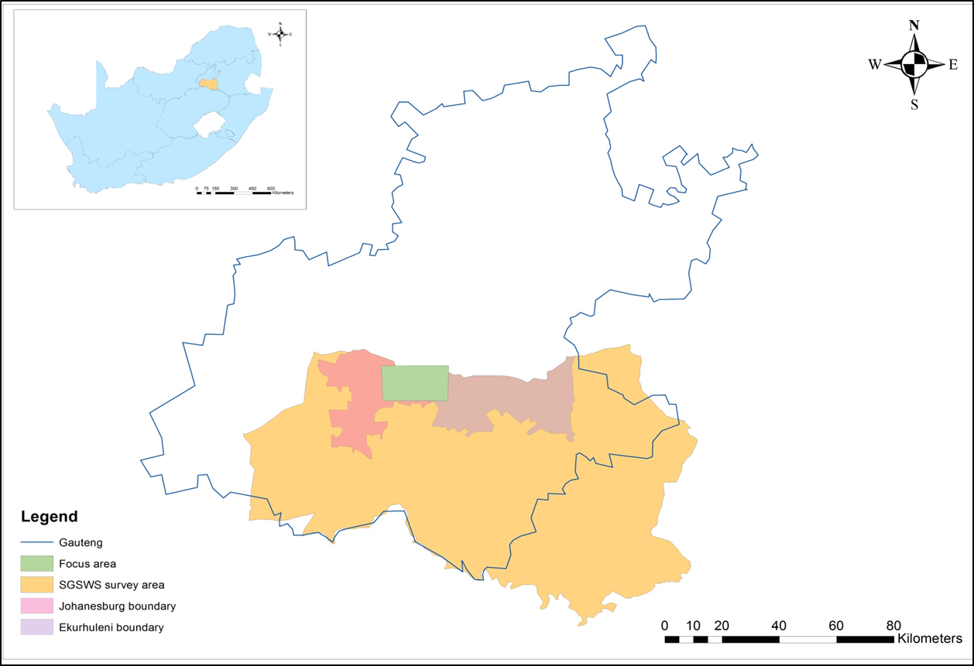
FIG. 1. The geographical location of the focus area and the greater study area (SGSWS), including the municipalities which occur within the focus area (JHB and Ekurhuleni) in the Gauteng Province.

RESEARCH QUESTIONS
- How many Iron Age SWS have been lost to urban development in the study area during the last 80 years?
- Have heritage resource management procedures adequately mitigated the impact on these pre-colonial ruins?

AIMS
- To map and quantify the destruction of SWS in the study area over the last 80 years.
- To determine what percentage of the SWS were adequately recorded before destruction.

OBJECTIVES
- Map the expansion of Johannesburg in the study area in four chronological ‘snapshots’ from the late 1930’s to the present using historical air photographs and data from the Gauteng City Region Observatory (GCRO).
- Map the location of SWS in four equivalent chronological snapshots using historical air photographs and satellite imagery.
- Quantify the urban expansion and corresponding impact on SWS in the study area
- Assess the cultural resource management interventions in the study area, and their efficacy in mitigating the damage to the ruins.

RATIONALE
Stone Walled Structures provide us with valuable information about the pre-colonial communities and their changing social, economic and political organization. In the absence of relevant historical documents, these SWS are all the information we have about how pre-colonial societies in the southern Gauteng Province were organized. Unmitigated destruction of the ruins will efface an important part of local history.

STUDY AREA
The greater study area is the southern Gauteng province and the focus area is Johannesburg South, basically the Alberton and Soweto area (approximately 270 sq km) (Fig.1). The focus area spans through two municipalities: City of Johannesburg and Ekhuruleni, and the Klip River flows through the area. This focus area was chosen because Johannesburg is growing rapidly and there are a lot of SWS present and many have been destroyed (Mason 1962; Taylor 1979b; Huffman 2007b; Sadr & Rodier 2012). Also a fair amount of heritage impact assessments (HIA’s) have been carried out in this area (Huffman & Steel 1996; Huffman 1999a, 1999b, 1999c, 1999d, 2004a, 2004b, 2007a, 2007b, 2008).

VEGETATION
Gauteng is predominantly a grassland biome (Fig. 2) (Mucina & Rutherford 2006). Summer rainfall is a characteristic of this biome and during June, July and August rainfall is at its lowest. This dry season is best for identifying Stone Walled Structures on satellite imagery and air photographs and to conduct ground truthing.
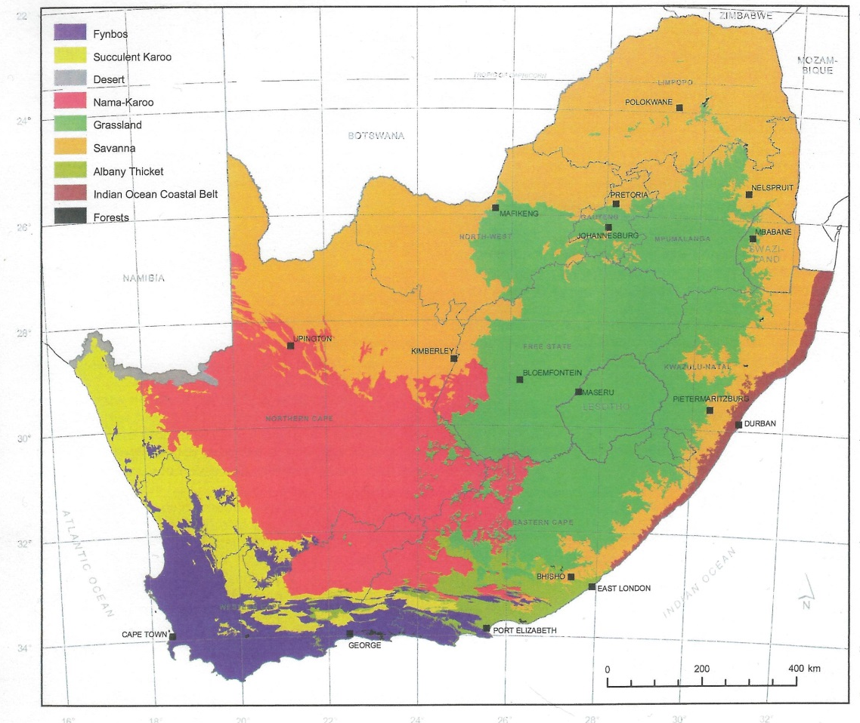
FIG. 2. The biomes of South Africa, the Grassland biome is highlighted by the dark green and the area of interest enclosed by circle (Mucina & Rutherford 2006:3).

BUILT ENVIRONMENT
The study area is characterized by the southern suburbs of Turffontein, Mondeor, La Rochelle, Liefde en Vrede, Kibler Park, Robertsham, Rosettenville and others. There is an extensive road network in the area linking the study area to the northern and southern suburbs (Fig.3). The northern region of the focus area not only contains residential areas but mines and slime dams (e.g. Crown Mines/Mooifontein). The southern portion of the focus area is not as “built up” compared to the north of the focus area, and this is mainly because of the Klipriviersberg Nature Reserve, an area of 680 hectares of protected land, which has numerous Stone Walled Structures located near Kibler Park, Glenvista, Mulbarton and Aspen Hills. There are also a few “Eco” developments in the area (e.g. The Thaba Ya Botswana Eco Hotel and Spa, Meyersdal Eco Estate). Recent developments are also apparent in the region including the Mall of the South, and many gated communities commonly known as estates (e.g. Aspen Hills, Liefde en Vrede). Likewise, there are known developments in the area that have destroyed SWS.
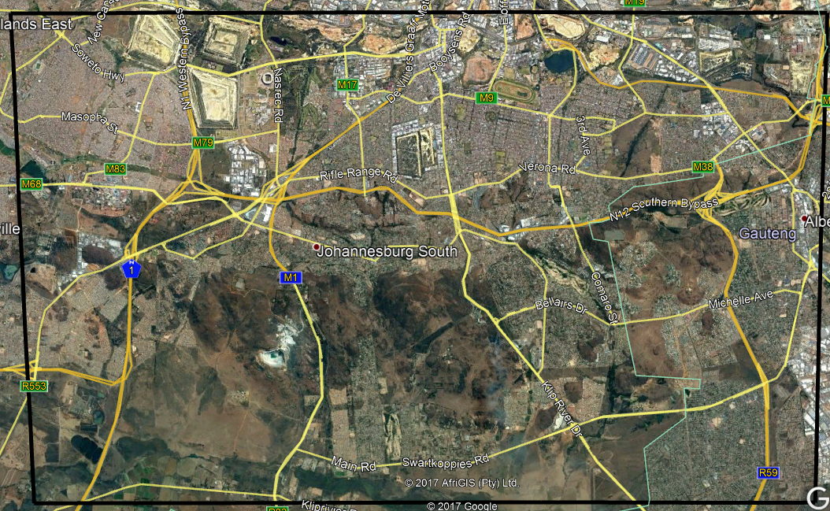
FIG. 3. A 2017 Google Earth image of the focus area (Google Earth 2017).

CHAPTER 2: LITERATURE REVIEW

HISTORY OF JOHANNESBURG
With the discovery of gold in 1886, a mining camp was established on the Witwatersrand plateau (Beavon 2004). This camp became known as Johannesburg, and developed into a town, then into a city and finally into today’s Gauteng City Region (GCR) (Mabin 2013). The GCR is a “integrated cluster of cities; towns and urban nodes that together make up what is arguably Africa's leading city region” (Mubiwa & Annegarn 2015: 5). Gauteng is the economic hub of South Africa and Johannesburg is the largest municipality with a population of 3.9 million (Todes 2011).
Johannesburg like any city has its own political, economic and socio-cultural relationships (Harrison & Zack 2014). Until 1994, apartheid and segregation shaped Johannesburg spatially and as a result of poverty and expanding population many informal settlements were built (Beavon 2004; Mubiwa & Annegarn 2015). Townships are dominant in the South, as a result of the apartheid government’s Group Areas Act (Todes 2011; Beavon 2004). After apartheid was abolished Johannesburg was seen as the “city of gold”, and this contributed to rapid spatial change within the city when new suburbs emerged and informal settlements continued to grow (Todes 2011).
Earlier, from 1900 to 1910 there was extensive growth in northern suburbs away from mining activity in the south (Mabin 2013). Decentralisation, the movement out of the Central Business District (CBD) was caused by an increase in rental costs, and many businesses moved into peri-urban areas such as Sandton, Randburg and Rosebank (Beavon 2004).
After World War II there was an increase in urbanisation and growth of industrial areas, such as Kempton Park and Alberton (Mubiwa & Annegarn 2015). Johannesburg housed several manufacturing industries, with concentrations located in Germiston, just east of the study area. By the 1930s industrial areas were common, which continued to grow rapidly influencing the residential capacity of the region, and more houses were built (Mabin 2013).
Apart from industry and mining, transport networks also influenced urban expansion (Mubiwa & Annegarn 2015). Trams were first introduced, then came railway networks which linked the south of Johannesburg to mining areas. The tramline provided transport between the Johannesburg CBD and southern suburbs, which increased the expansion of residential areas to the south. The electric tram was introduced in the south in 1906 and continued until the early 1930s.
In the early 20th century the tramline was extended and this gave rise to new suburbs like Regents Park, The Hill, Townsview and then in the 1940s more suburbs were introduced including South Hills, Linmeyer, Mondeor and Robertsham. And by the 1950s minor changes were made to the railway and some more extensions were built (Harrison & Zack 2014). In the 1960s the railway route extended to Germiston (Mubiwa & Annegarn 2015). Transport networks continued to increase from the 1960s until the 1980s when the freeways were built (Harrison & Zack 2014). Then in the 1970s and 1980s freeways were completed, which aided expansion and opened more land to develop (Harrison et al. 2001). The 1970s and 1980s saw the development of the orbital motorway, the N12 (southern bypass) which was completed in 1986, which led to the formation of the “new south” (Harrison et al. 2001). By the late 1960s the south changed even more with an increase in private car ownership (Harrison et al. 2001).
Essentially the population of the south grew to 170 000 by 2011, from 80 000 in the 1950s. Just from 1996 to 2011 the population doubled. The residential boom of the south was the result of this increasing population. In September 1994, the chamber of mines agreed to the realignment of boundaries for the ‘New’ Johannesburg. These new boundaries were profoundly different from those drawn on the basis of race, and Johannesburg became divided into North, South, East and West (Beavon 2004).

HISTORY OF THE “SOUTH”
Not much research has been given to the development of the “South.” This is mainly because the mining belt created a division between southern suburbs and the north of the city, and essentially the southern suburbs were located on the wrong side of the mining belt (Harrison et al. 2001). Southern suburbs initially bordered mining land in the north and Klipriviersberg to the south and with Soweto to the west and Alberton in the east. The “south” can be divided into a “new south” and an “old south”, the difference between the two is based on economic class. The “new south” is a suburb that emerged in the late 1960s aimed at middle and upper class and located on the Klipriviersberg ridge (Harrison et al. 2001), while the “old south” was created for the working class, being located near mine dumps and slime dams and associated with industrial development (Harrison & Zack 2014).
While the new south includes gated communities such as Aspen Hills, there are no gated communities in the old south (Harrsion & Zack 2014). A well-known example of a gated community is the Eye of Africa estate, which was developed further south of the focus area. Gated communities are residential areas aimed at the middle and upper class (Huffman 2008). Eco- estates are common in the new South, with quiet roads, hiking trails, wild animals and secure perimeters (Harrison et al. 2001).
Developers had little concern for the environment and built over the Klipriviersberg, offering new residents breath-taking views. The Klipriviersberg Nature Reserve was established in 1984 and covered 680 hectares, containing many Iron Age and historical Stone Walled Structures. The expansion of Johannesburg affected many heritage resources, and most of these resources are Iron Age SWS.

STONE WALLED STRUCTURES (SWS)
There are numerous stone walled structures (SWS) that have been identified and mapped throughout the southern African interior (Sadr 2012), and SWS are a regular feature of the Late Iron Age in the Highveld (Maggs 1976; Mason 1968; Huffman 2007b). The Iron Age is commonly divided into three phases, the Early Iron Age which occurs from ca. 200 to 900 AD, the Middle Iron Age (900 to 1300 AD) and the Later Iron Age which occurs from 1300 to 1840 AD (Huffman 2007b).
According to Mason (1968), the missionary Robert Moffat should be accredited for beginning Iron Age research in 1828. However the first archaeologist to report on an Iron Age SWS in the Highveld was Clarence van Riet Lowe.It is been accepted that many SWS in the Highveld are associated with the Sotho-Tswana speakers (Huffman 2007b; Maggs 1976; Mason 1968). This is supported by oral histories, ceramic traditions and excavations. Mason believed that the SWS would provide researchers with information about the social, economic and cultural organization of the communities who occupied these settlements (Mason 1968). According to Huffman (2007b) SWS also provide information on the communities’ ethnicity and linguistic groups.
In the 1950s Mason excavated numerous small Iron Age sites near Johannesburg as part of the Transvaal Iron Age project (Mason 1968). Particularly in 1963 he recorded and excavated the Iron Age settlement at Melville Koppies. He has also conducted a topographic survey and large- scale excavations at Klipriversberg, Matluassi, Waterval, Kaditshwene, Olifantspoort and Phalaborwa (Mason 1968). In association with the excavation, air photos were analysed and as a result nearly 2000 Iron Age settlements were identified in an area of 1211 sq miles in the old Transvaal Province (Mason 1968). Maggs (1976) also used air photos to survey the southern Highveld because the area was too large to cover on foot.
Terminology used to describe SWS is variable when classifying structures. Maggs (1976) uses the term settlement unit, and other researchers use the term stone walled structures or stone walling. SWS are usually classified according to architectural type, and different researchers have created different schemes for classifying them (e.g., Mason 1968; Maggs 1976; Taylor 1979b; Huffman 2007b). Taylor (1979b) identified a Group I type of SWS, which has a larger outer circle with one or two circular structures inside and dates to ca. AD 1500 to AD 1650. His Group II structures have a scalloped outer wall and date between AD 1650 and AD 1820. His Group III structures have been described as a complex version of Group I and radiocarbon dates suggest that they belong to the same period as Group II. Mason (1968), on the other hand, identified 5 “classes” of walling, some of which have subdivisions. Class 1 is described as the simplest structure, while class 4 as the most complex structure. Mason was the first to note inter-analyst variation in classifying the SWS (Mason 1968). According to Maggs (1976) the simplest of SWS contain a single circular structure, as time goes on structures become more complex. Maggs (1976) identified three types of stone walling in the southern Highveld, Type N, Type V and Type Z. Type N, which dates to the 15th Century AD, is the same as Taylor’s Group I and Mason’s Class 1. Type Z is the most complex type of walling in the southern Highveld (Maggs 1976). Recently Huffman (2007b) has attempted to standardize nomenclature for the SWS types in the Highveld
Generally, it has been recognised that Iron Age settlers built on high ground, slopes of hills and there is a high concentration of settlements in the major river valleys. The builders avoided open grasslands because of the lack of water and rocks to build with (Mason 1968). The Iron Age SWS in the Highveld date to within the last 500 years (Huffman 2007b). Early dates were reported by Mason from Uitkomst Cave (Mason 1962), Klipriversberg and Melville Koppies (Mason 1986). Maggs (1976) obtained a radiocarbon date of 15th century AD in the southern Highveld.

REMOTE SENSING: AERIAL PHOTOGRAPHY (AP) AND GOOGLE EARTH (GE)
Remote sensing techniques in archaeology have been used from the beginning of the 20th century (Deuel 1969). Remote sensing allows a shorter period of time for the discovery of sites that would take longer from a ground survey and helps in mapping change over time (Wiseman and El-Baz 2007). Aerial photography (AP) gives a bird’s eye view of the landscape and has proven to be a great resource in archaeological investigation. This technology was first introduced by the French photographer and balloonist Gaspard Felix Tournachon, better known as Nadar in 1858, who took an aerial picture of Paris (Deuel 1969). AP was subsequently used mainly for military purposes but soon enough became commonly used in archaeology. Archaeological work with air photos began in the 1920s with the work of O.G.S. Crawford in England (Riley 1987). Yet even before Crawford there were cases in which air photos were used for archaeological purposes. In 1899 Giacomo Bani documented the progress of the excavations at the Roman forum and in 1906 R.H. Sharpe took pictures of the Stonehenge from a military hot air balloon (Cerauda 2013; Renfrew & Bahn 2012). In southern Africa Gertrude Caton Thompson was the first to use aerial photography in the Iron Age site of Great Zimbabwe in 1931. In the then Transvaal Province of South Africa, Revil Mason was the first archaeologist to conduct large scale systematic aerial surveys (Mason 1968). He was followed by Tim Maggs who focused on the then Orange Free State Province (Maggs 1976). Others such as Seddon (1968), Taylor (1979b) and Hall (1981) also made good use of air photos in their archaeological research. Aerial photographs have helped in identifying and classifying many SWS.
The National Geo-Spatial Information (NGI) also known as South African mapping service, has the largest and most extensive archive of South African air photographs extending back to 1926, with each of the photographs identified by the associated job number, strip number and photo number. This information is usually documented in the flight plan corresponding with the air photos. These photographs act as a historic record of what was present in the landscape at the time of the images (Department of Rural Development and Land Reforms 2016).
Recent technological advancements such as the Google Earth (GE) software have facilitated remote aerial survey even further (MacQuilkan & Sadr 2010). Satellite images come in various resolutions and become more expensive with better resolution: Ikonos has 1m resolution, while quickbird has 60cm resolution and Geoeye a 40cm resolution (Campbell 2006). Google Earth uses satellite images from various sources and was launched in 2005. Air photographs extend back further, however GE is always in colour and allows the researcher to use the historical imagery tool to view images taken in different years and seasons, consequently allowing the researcher to choose the most appropriate image (Sadr 2016). Black and white air photographs on the other hand tend to have lower resolution and can be misleading because of shadows (Riley 1987) (Fig. 4). GE allows both vertical and oblique views. Regardless, ground truthing or survey is one of the most important activities in archaeology, as this helps to locate and record features (Renfrew & Bahn 2012).
There are various devices which are used to take air photos, kites, balloons, blimps, airplanes and even pigeons. The choice of device depends on the researcher, cost and context of study. In 1903 the engineer Julius Neubronner mounted cameras on carrier pigeons, while the kite was initially used by Sir Henry Wellcome who recorded the site of Jebel Moya in 1911 (Verhoeven 2009). Recently drones have been gaining popularity (Verhoeven 2009).


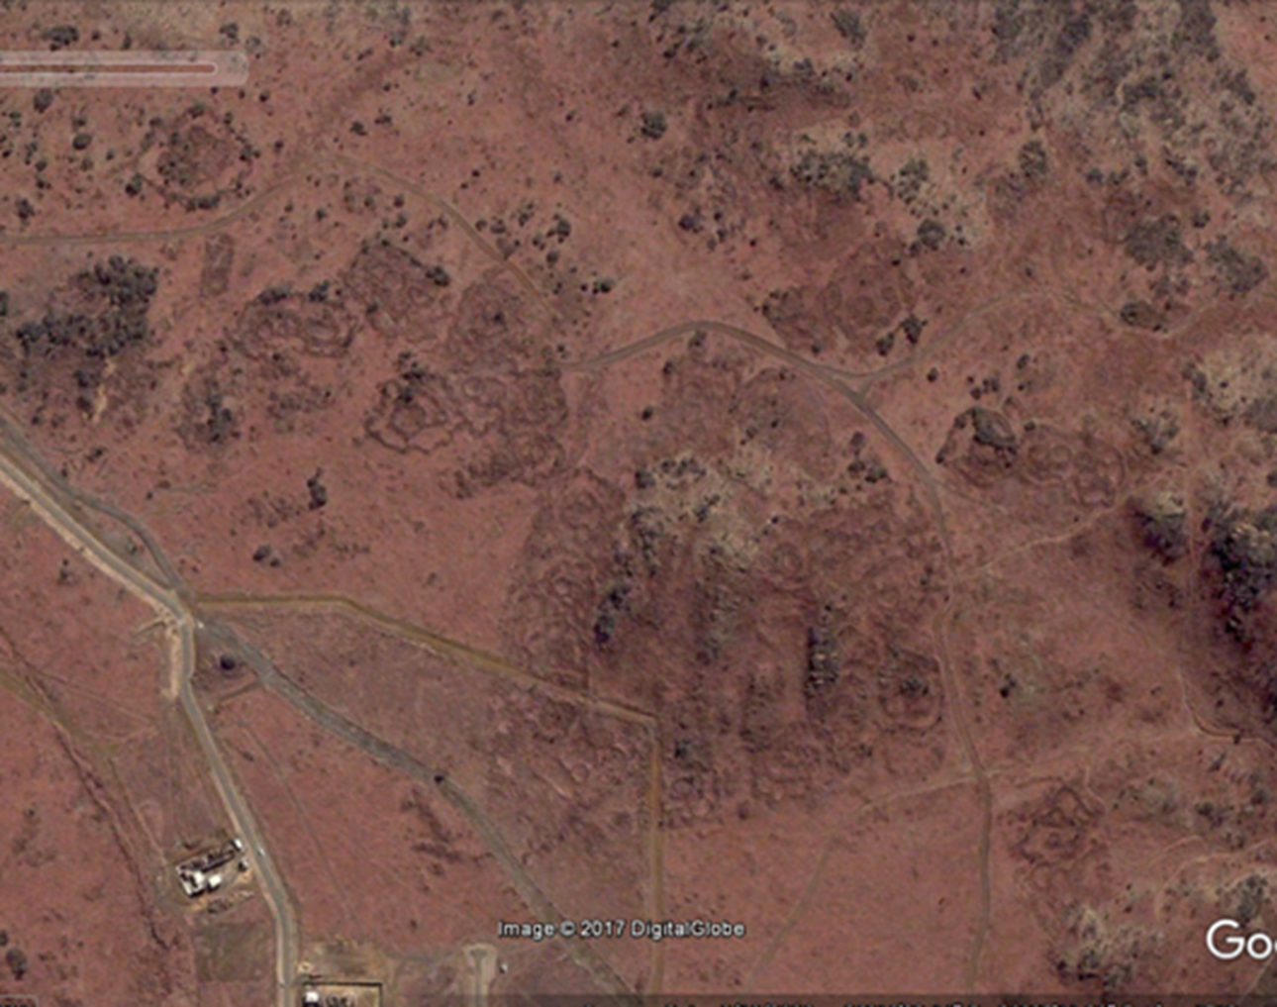
FIG. 4. A comparison of a portion of Stone Walled Structures (SWS)in the Meyersdal Area from the 1961 air photos (above) and a 2016 Google earth image(below).
Fortunately, the first air photographs of Johannesburg south were taken in 1933 before many stone walled structures were destroyed by buildings (Mason 1987). Remote sensing techniques have allowed archaeologists not only to record sites from above but to notice how they are affected over time by urbanization. Fortunately, there are legislations and procedures in place to ensure that not all these sites are lost forever.

HERITAGE MANAGEMENT IN SOUTH AFRICA
Legislation is defined as a regulatory framework that defines the roles and responsibility of various departments and agencies while formalizing institutional arrangements (Ndlovu 2011a). The main objective of heritage legislation is to protect sites or resources from destruction. Ndlovu (2011a) argues that traditional heritage management has been long existent, even before there were written laws. However, the written legislation disregarded traditional management practices. For this study, I will focus upon the written legislation.
The beginning of heritage legislation in South Africa can be traced back to the Bushman’s Relics Protection (BRP) Act of 1911. This act disregarded any other archaeological or historical resources. This act was followed by the Natural and Historical Monuments, Relics, and Antiques (NHMRA) act of 1934, which was then replaced by the National Monuments (NM) act of 1969, the predecessor of the National Heritage Resources (NHR) act of 1999, which is the current legislation that governs South African heritage management.
The BRP act was focused on San cultural preservation. The heritage conservation authority which served during 1923 to 1969 implemented the NHMRA act, which replaced the BRP act of 1911. This new act was the first to declare archaeological sites and objects as monuments, relics and antiques worthy of protection (Ndlovu 2011a). The NM act of 1969 aimed to protect and maintain burials, gardens of remembrance, immovable and movable property (e.g. monuments) and to improve the legislation regarding the monuments, relics and antiques. Unfortunately, this law was biased with a strong colonial influence. Nevertheless, this legislation did have section 35(4) which focused on archaeological sites and objects. According to the NM act a historical site means any milestone or grave older than 50 years and a monument is any property declared under this act, and may not be destroyed without a permit. Only the NM act of 1969 and the NHR act of 1999 have a section dedicated to penalties for the damage and destruction of heritage resources, but whether these are implemented or not is the issue. As Ndlovu (2011a) notes, the South African Police (SAPS) is not well trained regarding heritage offences, and since 1934 only three court cases and one conviction have been recorded. This is toothless legislation. The maximum sentence one can receive is two years imprisonment and/or a fine of up to ZAR 10 000.
In South Africa under section 34 of the NHR act no one may destroy or alter a part of a structure or the entire structure which is older than 60 years without a valid permit issued from the relevant provincial heritage authority (PHRA). Under section 35 (4a) no one may destroy, damage, excavate, disturb or alter any archaeological site without the necessary permit issued by the PHRA. Although this is mandatory legislation, heritage resources continue to be negatively impacted by expanding infrastructure. Such impact may come from transport networks, where continuous vibrations from the heavy traffic usually affects the stability of structures (e.g., Huffman & Steel 1996; Dreyer 1995; Agapiou et al. 2015), as well as the building of water management infrastructure such as the Rand Water Station in Johannesburg South (e.g., Taylor 1979a), as well as from the construction of residences (e.g., Huffman 2007a, 2008).
The South African Heritage Resources Agency (SAHRA) is the organisation which protects heritage resources on a national level and was established by the NHR act under section 11. Heritage resources are graded according to a three- tiered system. Grade 1 is heritage resources that have special national significance; Grade 2 is heritage which has special qualities in a province; and Grade 3 is other heritage resources worthy of conservation on a local level. Usually Grade 3 sites are disregarded for protection (Chirikure 2013).
SAHRA is expected to keep records of all work regarding heritage resources. However, communication between SAHRA and the PHRA has been problematic. Until recently there were only two functioning PHRAs, one in the KwaZulu-Natal Province and the other in the Western Cape Province. On the positive side, SAHRA has introduced an online system, the South African Heritage Resources Information System (SAHRIS) (South African Heritage Resources Agency 2012). This online system contains Cultural Resources Management (CRM) reports. All CRM practitioners should be affiliated to the Association of Southern African Professional Archaeologists (ASAPA); however there is no mandatory legislation to advocate this (ASAPA 2016; Chirikure 2013).
CRM is one of the fastest growing fields in southern African archaeology (Ndlovu 2009). CRM archaeology helps record sites that would be destroyed during construction (Refrew & Bahn 2012). An archaeological impact assessment (AIA) is conducted by a professional archaeologist on areas that are to be developed. The professional makes decisions regarding the protection and mitigation of the sites (SAHRA 2012- Minimum Guidelines, NHRA Section 38). The AIA is also a component of the Environmental Impact Assessment (EIA) required by NHRA under section 38(1) and the National Environmental Management Act (NEMA) section 38(8) (ASAPA 2016, NHRA 1999). In most of these Archaeological Impact Assessments the determining of significance of the archaeological or historical features is of utmost importance, but significance is an ambiguous term. And often the person examining the remains establishes this significance, which is problematic in the sense that often these individuals are not archaeologists or have a narrow understanding of the remains. There are criteria to determine this significance, which includes primary vs. secondary context; amount of deposit; variety of features; condition of walling; and the ability to answer present research questions (Huffman 2004a). Usually sites with no significance require no mitigation, low to medium significance requires limited mitigation and high significance requires mitigation and sites of outstanding significance are not to be disturbed.
The National Heritage Resources Act of 1999 has a specific section (Section 38(3)) on what to include in a heritage report. The criteria include the mapping and identification of all heritage resources in the area; an assessment of significance according to section 6 (2); an assessment of impact from the developer; evaluation of this impact and the social and economic benefits; consultation with the communities affected by development; and plans for mitigation. Most archaeological and historical sites cannot be preserved and it is understandable that not everything should be preserved (Ndlovu 2011a). There are many phase 1 CRM reports which deal with the initial survey of an area to be developed, but few phase 3 CRM reports which concern the mitigation of any damage through excavation and salvage of the archaeological remains. Most of the CRM reports are perfunctory and only fulfil the minimal requirements.
The disregard for heritage management is arguably the outcome of colonialism, as people have become alienated from their cultural heritage (Pwiti & Ndoro 1999). Earlier thoughts of protection of heritage resources such as SWS were controversial as the antiquity and the makers of the structures were unclear (Pwiti & Ndoro 1999). Fortunately in Johannesburg South, successful interventions have preserved information about many SWS. In 1999 Huffman did a survey of the Klipriviersberg because the land close to Meyersdal was going to be developed as a residential, business and open space area (Huffman 1999a, 1999b). Van Schalkwyk and Pelser also conducted a survey in 1999 on farm Rietvlei 101IR, which was going to be redefined for mining activities (Van Shalkwyk & Pelser 1999). Mason (1986) had previously identified some Iron Age settlements in this region. These structures required mitigation. According to Huffman (1999b) to comply with heritage legislation a minimum level of mitigation on each settlement that will be destroyed is required. Such mitigation was conducted by the University of the Witwatersrand Archaeological Resources Management (ARM) division (Huffman 2004a, 2004b). Similarly, in 1999 the proposed Thaba Ya Bostwana development located near the Klipriviersberg Nature Reserve was surveyed for structures older than 50 years by ARM (Huffman 1999d). Some of the development was shifted to avoid damaging structures of significance (Huffman 1999d). ARM also conducted an impact assessment for Olivantsvlei, which was developed for residential purposes. Of the 10 sites identified eight where located in the development footprint and required phase 2 mitigation before being destroyed (Huffman 1999c). And again in 2004 ARM conducted another impact assessment for the Liefde en Vrede residential development in my study area. The development company had exchanged 78 hectares of hilly terrain (Farms Rietvlei 101IR Portions 31, 34-36 and 62) for 38 hectares of flat land (Portion 32 Liefde en Vrede 104IR), so that the cultural features could be preserved (Huffman 2004a). While these developments were in compliance with the National Heritage Resources Act of 1999, there are cases of site destruction in the area (e.g., Wildebeestfontein, Taylor 1979a).
Problems of applying the legislation are manifold. Many local communities are unaware of heritage laws (Esterhuysen 2009). The NHR act has not been well advertised regarding the conservation of heritage resources on a national, provincial and local scale. Nor does the NHR act establish adequate principles and standards for archaeological impact assessments (AIA) and the granting of permits. And the act fails to address why heritage conservation must be implemented (Ndoro 2015). There is also a lack of communication between stakeholders, government departments, heritage agencies and communities (Esterhuysen 2009; Ndlovu 2011a, 2011b). If all parties work together efficiently heritage management can be more successful in South Africa (Esterhuysen 2009). Nevertheless, as far as it goes the NHR act has had a positive impact in the assessment, mitigation and conservation of archaeological sites (Deacon 2015).
Ndlovu (2011b) believes that current archaeological heritage management is eurocentric. Heritage management as a discipline has changed over the decades and continues to change, but community involvement is something that still poses a problem today in heritage management. There is a presumption that most African communities don’t care about heritage management but what is important to them is not necessarily the same as for heritage practitioners; “significance” is an ambiguous and a culturally biased concept (Ndlovu 2011a, 2011b). Usually local communities are not consulted until the very end and at that stage they should consider themselves lucky that they have been consulted at all (Esterhuysen 2009; Ndlovu 2011a, 2011b; Chirikure 2013). Even though the National Heritage Resources act has included the role of communities in archaeological sites, specifically in sections 6.2 and 6.5, it is difficult to apprehend and punish a person who has committed a heritage crime (Ndlovu 2011a). This is the result of limited financial aid by resource agencies and the lack of skills and shortage of staff that are needed (Esterhuysen 2009; Ndlovu 2011; Chirikure 2013; Deacon 2015). Ndlovu believes that the incorporation of African principles is needed in heritage management, not more laws on heritage (Ndlovu 2011a, 2011b).
Notwithstanding theses positive suggestions, it is difficult to determine the correct balance between urbanization, development and heritage management (Ndlovu 2011a, 2011b). In the end, heritage management usually takes a back seat when it comes to development (Chirikure 2013).

CHAPTER 3: MATERIAL AND METHODS

I separate the methods adopted in this project according to each task. The tasks follow the format stipulated in the flow chart below (Fig.5).
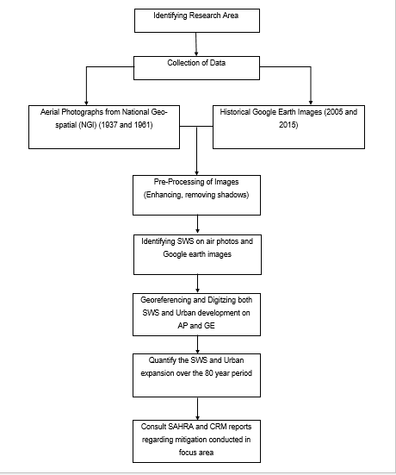
FIG. 5. A flow chart of tasks completed in this thesis.

COLLECTION OF DATA
I acquired aerial photographs from the National Geospatial Information (NGI) for the Alberton area for years 1937 and 1961. These are the earliest series of air photos available for my study area. I was able to identify my focus area on the flight plans and used this as a guide to help sort the air photos into strips. This allowed me to determine which strips and subsequently which aerial photographs were in my focus area. This process showed that air photos from 1937 only cover the northern half of my study area. The 1961 series covers the entire study area. The 1937 series has a scale of 1:18 000 and was known as job 123, comprising of 154 square miles and used a 5x5 format. While the 1961 series also referred to as job 438 comprises of 4500 square miles, uses a 6x6 format and has a scale of 1: 36 000. Subsequently, on Google Earth I chose the 2005 and 2015 historical satellite because of their clarity and season in which the images were taken. As the air photos seem to have been taken during winter (June/July), I chose winter images from Google Earth. As a result, I choose Google Earth images from the 6/9/2005 and 6/21/2015.

GEOREFERENCING
After the four snapshots were chosen I had to georeference the air photos. I used 1st polynomial (affined) and when georeferencing I began with a single strip (e.g. strip 11) and I tried to take control points from each corner of the image and a single point in the centre of the image but certain images just had agricultural land and no identifiable landmarks. Unfortunately, the aerial photographs were taken diagonally according to the flight plan, making it more difficult to georeference. I georeferenced the air photos using common features (e.g. roads, mine dumps, dams) that were visible on both maps and air photos. The majority of the georeferenced images had georeferencing residuals of less than 0.5. I did this using the Esri software ArcGIS 10.3 and the geographic coordinated system GCS WGS35S.
Unfortunately, the resolution of the scanned aerial photographs was poor. I attempted to enhance the images using the editing software GIMP 2.1. The enhanced images were of a fair quality but I decided to overlay the air photos in TIFF format onto Google Earth, I did this using the add overlay image button. I looked for common features on the air photos and satellite imagery and used that to assist me in overlaying the air photos correctly (Fig. 6). I decided to begin overlaying the 1961 series on Google Earth because it is the more recent of the two air photo series and some features are still recognizable on the satellite imagery.

DIGITIZING
Once all the images were georeferenced I began digitizing the visible SWS. I used the transparency tool and editing tool from ArcGIS to achieve this. I began with the 1937 dataset and because of the poor resolution of the air photos I initially digitized almost everything that appeared to be a SWS.

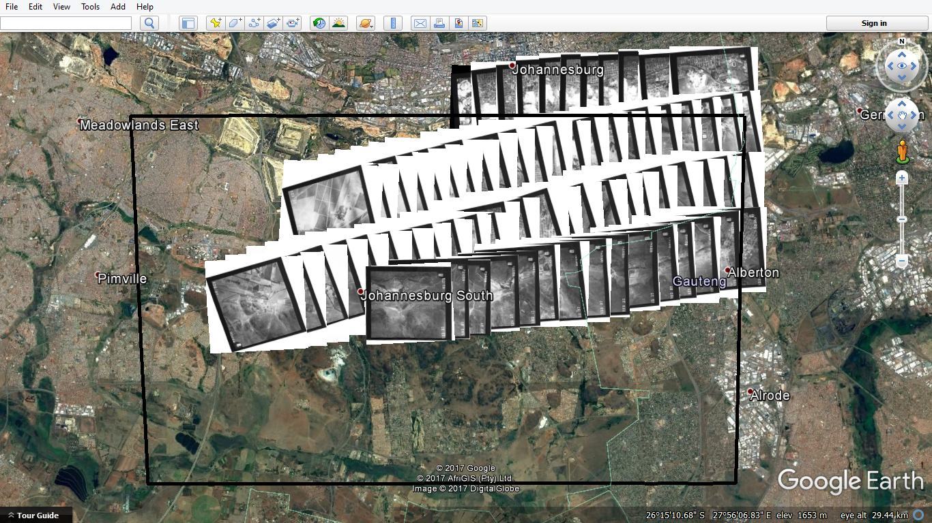
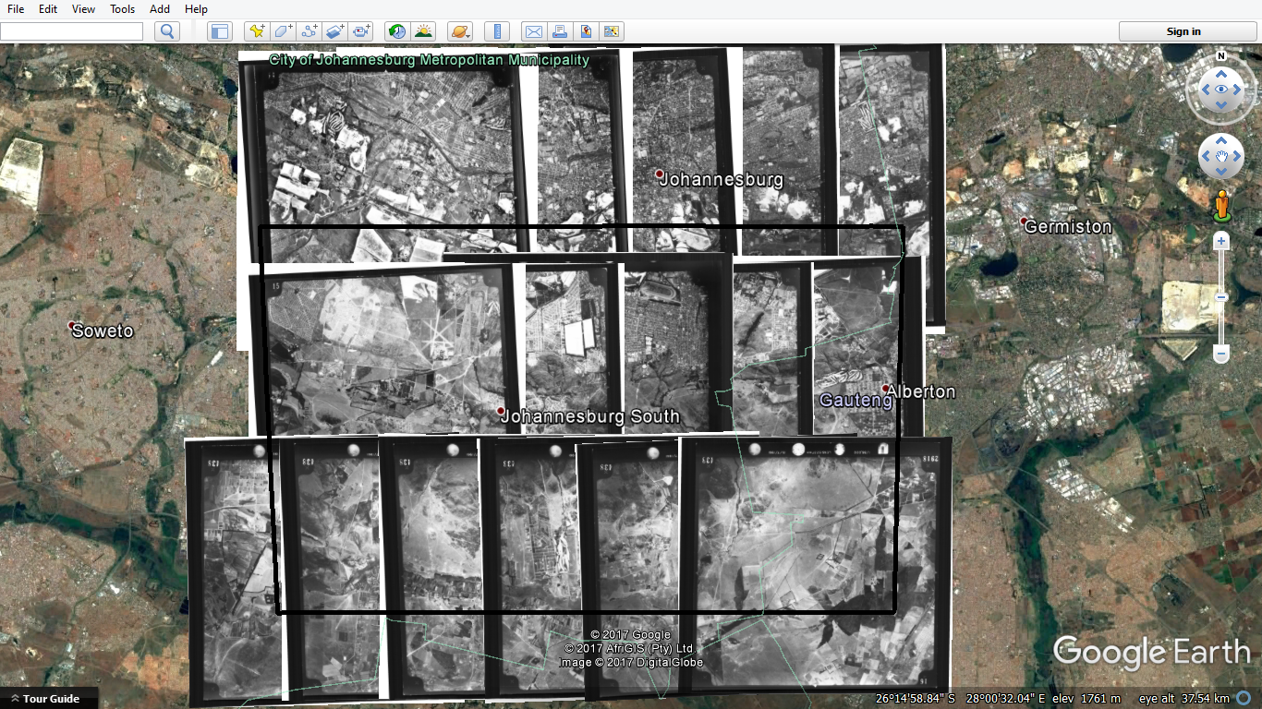
FIG. 6. The overlaid air photos from 1937(above) and 1961(below)on Google Earth, the focus area is highlighted by black square.

I marked SWS with points in green for definite and in yellow for possible ruins. Upon checking against the Google Earth images it appeared that all the yellow dots were false positives and so I focused upon the green points for this research. I created folders on Google Earth to add the Stone Walled Structures from each snapshot and saved these files as kml. After I had completed identifying the Stone Walled Structures from the four snapshots, I converted the kml files to shapefiles (shp), which allowed me to view the data in ArcGIS.

SPATIAL ANALYSIS AND QUANTIFICATION
While I was identifying the Stone Walled Structures I used excel to create a database for each site from each snapshot and included information on coordinates, status of site (definite/possible) and what is currently developed in the area (APPENDIX B). In ArcGIS I used the export table tool, to transfer the data from the attribute table to Excel format, I also did this for the statistical summary tables. Once the database was completed I re-numbered the SWS using the 1961 snapshot as the base. I then used this database to calculate the amount of SWS lost over time.
Once all my data was in a readable format for ArcGIS, I ran a number of spatial analyses. However, before I could do this I needed to re-project the dataset to the projected coordinated system UTM 35S. This made it simpler to quantify urban expansion for the four snapshots. I used buffers of 50m, 100m and 250m around each SWS point to give better representation of the size of each and to see which would have been affected by development. I also calculated standard deviational ellipse, also known as directional distribution to 1 standard deviation, which covers 68% of features. This analysis would measure the distribution of features and indicate a directional trend. Then kernel density and optimized hotspot analysis was done to identify which areas are richest in SWS. Summary Statistics helped me in counting the SWS and calculating standard deviation from the attribute tables in each snapshot.
I then proceeded to digitize urban expansion in each of the four snapshots. I did not digitize the urban footprint on each individual air photo because of the overlap between images but simply digitized the built environment as outlined in each flight plan. I used the land use data from the Gauteng City Region Observatory (GCRO) for the years 2000 and 2013, but since these do not correlate perfectly with my GE snapshots from 2005 and 2015 I decided to digitize the urban expansion for the associated snapshots on Google Earth Pro. I used the create polygons tool to digitize urban expansion. I had to re-project the shapefiles so I could calculate area or run any spatial analysis. In each snapshot I had to open the attribute table and add a new field, give this new column a name (e.g. Area) and set precision and scale, which I set to double and 0 respectively, then calculated the area. Once this was done I calculated the sum of the new attribute column using the summary statistic tool and chose the necessary column to calculate and export these results to excel format using table to excel tool. Finally, I calculated the sum of urban expansion per snapshot using the statistical summary table in ArcGIS and exported this data into excel. And when in excel I calculated percentage change using the formula:
$\left(\frac{After Value-Before Value}{Before Value}\right)X 100=Percentage change$
I also created the graphs to represent the trend in urban expansion from each snapshot.

MITIGATION REVIEW
I consulted the University of the Witwatersrand archaeology division archives to obtain information on CRM/ AIA’s that were conducted in my focus area. I specifically viewed work done in Johannesburg concerning SWS and focused on work done by the scholars Thomas Huffman and Revil Mason who have done most of the excavations and surveys in this area. Both contributed a great deal to mitigating site destruction by development and improving heritage management in the area. I created an excel table with all sites that had some form of mitigation and mapped it using Google Earth and ArcGIS. The recorded sites in the archives are marked on 1:50 000 topographic maps which I georeferenced and digitized. I then added this archive shapefile to the SWS shapefiles from each snapshot to see the relationship between sites that were recognized, recorded and/or mitigated in CRM work and those SWS that I recorded in the four snapshots. Using the data management tools for raster dataset I used mosaic to raster and ensured that I ignored background value with zero for a seamless image.
Since the sites recorded on the topographic maps may have been placed with some degree of error in the pre-GPS days, I also created buffers for these sites to check overlap with those I digitized in the four snapshots. I created a list of which sites identified during this study could be related to the archived sites and in which period, if any, they were built over. I then used the catalogue of sites identified from the archives and added the site with coordinated onto Google Earth and I checked if some of these sites are still present today.
When using the online system SAHRIS, I used keywords to search for CRM documents such as “Archaeological Impact Assessment, Gauteng, Johannesburg, Stone Walled Structures.” I did a limited amount of ground truthing, in the Klipriviersberg Nature Reserve and the Meyersdal Eco-Estate, as these areas contained many SWS.

CHAPTER 4: RESULTS

OBJECTIVE 1
The first objective in my study was to map the expansion of Johannesburg in four chronological snapshots from the late 1930’s to the present using historical air photographs, Google Earth imagery and data from the Gauteng City Region Observatory (GCRO). On Figure 7, the 1937 urban footprint is represented in blue while the 1961 urban footprint is highlighted in yellow, the 2005 footprint is in pink and lastly the 2015 urban footprint is shown in purple. The detail of urban expansion is greatest in snapshot 2005 and 2015, which was digitized from satellite imagery and not aerial photographs. Between these two most recent snapshots there is little change in the urban footprint. The main change in urbanization between these two last snapshots was that in 2015 the clear spaces near established buildings were extended or completed.
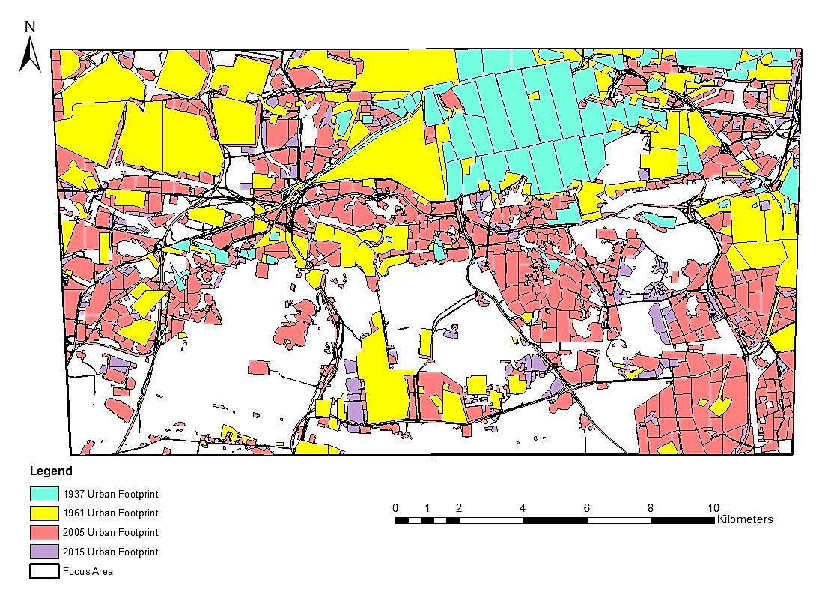
FIG. 7. The mapped urban footprint of the four snapshots. Blue: 1937; Yellow: 1961; Pink: 2005; Purple: 2015.
In snapshot 1961 there are more roads compared to that in 1937. The urban expansion has been progressing in a southerly direction throughout the four snapshots (Fig. 8). In 1937 the urban footprint covered only the northeastern corner of my focus area and then over the next three snapshots progressed to cover most of the focus area, with 2015 expanding slightly more toward the westerly direction as highlighted by the grey ellipse on Figure 8.
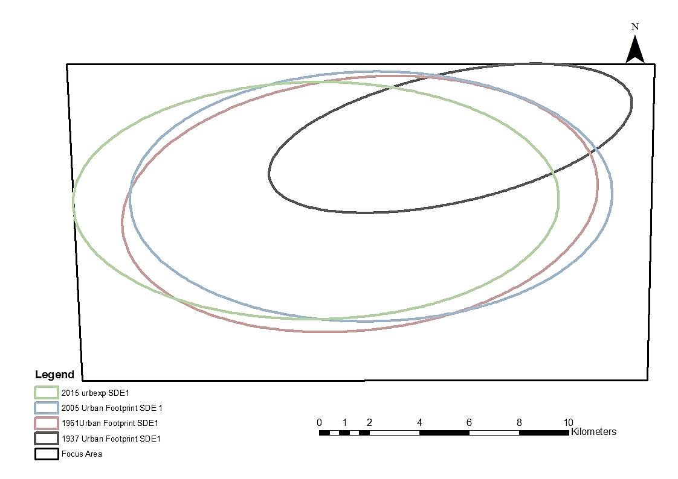
FIG. 8. Standard deviational ellipse (directional distribution) of the urban footprint from the four snapshots in 1 standard deviation.

OBJECTIVE 2
The second objective of my study was to map the location of SWS in four equivalent chronological snapshots using historical air photographs and satellite imagery. On Figure 9, the 1937 SWS are marked by yellow circles, the 1961 series are represented by blue circles and the 2005 series by green circles and the 2015 SWS by red circles. I have also highlighted the 2015 SWS in a bolder and larger format to show what structures remain (Fig. 9). The 1937 SWS are located along the central axis of the focus area, while the structures from the other three snapshots follow a general geographical trend clustering towards the southern section of the focus area along the east-west axis. It should be kept in mind that the 1937 air photos only cover the northern half of my focus area. Three main SWS clusters are distinguishable on Figure 9: the central western cluster near Naturena, Lenaron, Eikenhof; the central cluster near Klipriviersberg Nature Reserve, and lastly the north eastern cluster near Meyersdal. These clusters of SWS are still visible in the 2015 snapshot, the most recent of the four series.
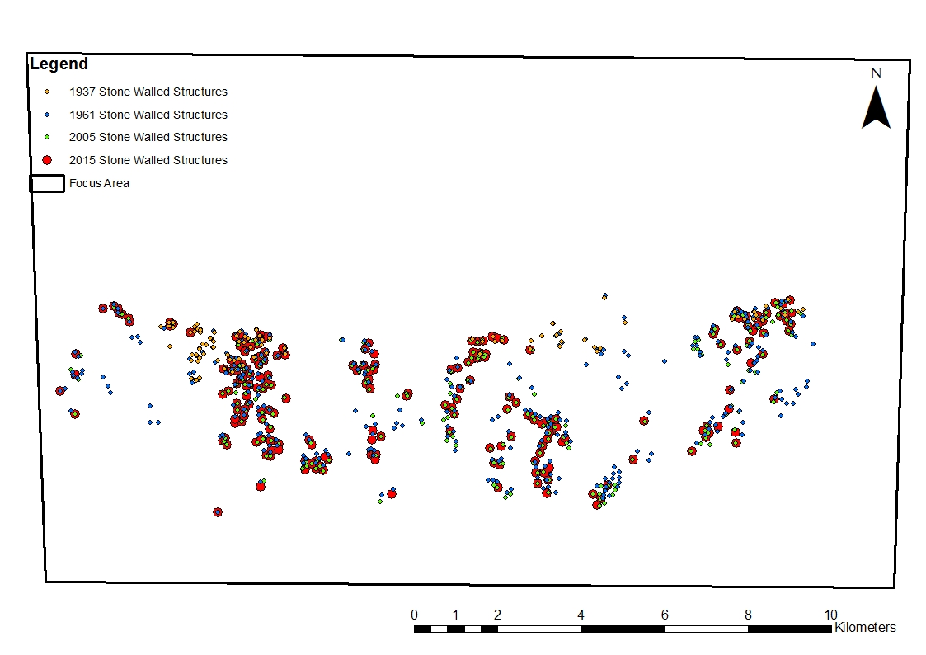
FIG. 9. The mapped geographical location of the Stone Walled Structures (SWS) from the four snapshots, with clusters visible in the western area, central area, and eastern area.
There is a dominance of SWS from snapshot 1961 while the fewest structures are visible in 2005 (Fig.9). However, the identification of these structures is susceptible to inter-analyst variation (e.g., Hunt & Sadr 2014). It is difficult to identify the same SWS across the four snapshots on the basis of a single point placed on an SWS so I used buffers of 250, 100 and 50 m around each SWS to see which overlap across the four snapshots and might be the same ruin.

OBJECTIVE 3
The third objective of my study was to quantify the urban expansion and corresponding impact on SWS in the study area. The first aspect to stand out is that most of the SWS identified on the 1937 snapshot were destroyed by 2005, just 68 years later. And a few structures from the 1961 snapshot located in the central western region and in the central region of the focus area were also destroyed by 2005 (Fig. 10). Several SWS located near the newly developed Mall of the South have been recently destroyed, as seen in snapshot 2015, highlighted by the red square (Fig. 10.)
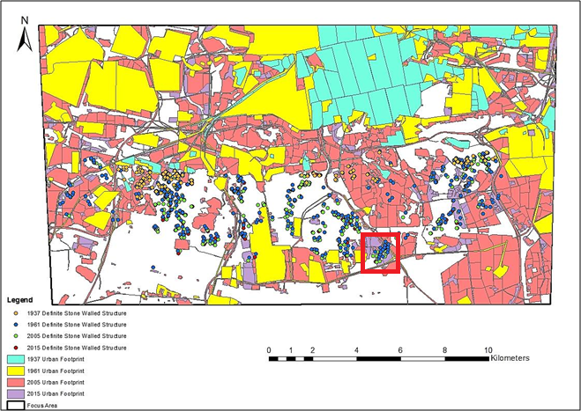
FIG. 10. A map showing the geographical relationship between the Stone Walled Structures (SWS) and the corresponding urban footprint from each snapshot. Recent destruction of SWS highlighted by the red square.
When quantifying urban expansion, the 1937 urban footprint has the smallest footprint with 2688 hectares while the 2015 footprint shows the largest urbanization with nearly 15000 hectares (Fig. 11). Thus for the 80 year period (1937 to 2015) the urban footprint has increased nearly five-fold (Fig. 11). The highest change in urban development occurred during the 1937 to 1961 period, and the least change occurred between 2015 and 2005. Correspondingly, a third of the 1961 SWS were destroyed by 2015 (Fig. 12).
Figures 13-16 show the distribution of SWS against the urban footprint in each snapshot. Kernel density tests indicate that there are three dense clusters of SWS identified in each snapshot (Figs.17-20). These clusters are located in the central western, central, and central eastern parts of the focus area. However, in the 2005 snapshot the eastern central cluster has diffused into two smaller clusters which are more apparent by 2015. Also in the 2015 snapshot the central cluster becomes two smaller clusters (Fig. 20).

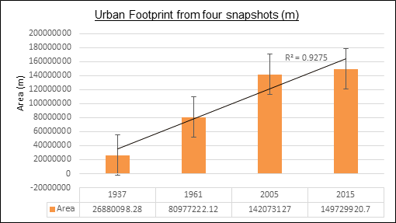
FIG. 11. Calculated urban footprint (m) from the four snapshots, including a trendline ($R^{2}$) and standard error.
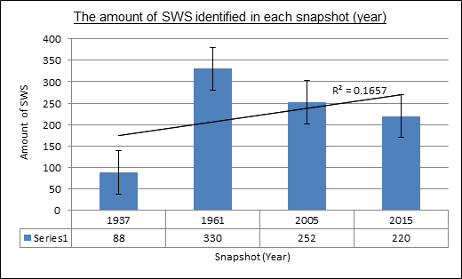
FIG. 12. Number of Stone Walled Structures (SWS) identified from the four snapshots, including a trendline ($R^{2}$) and standard error. Note that the 1937 air photos only cover the northern half of the study area so the SWS count is under-represented.
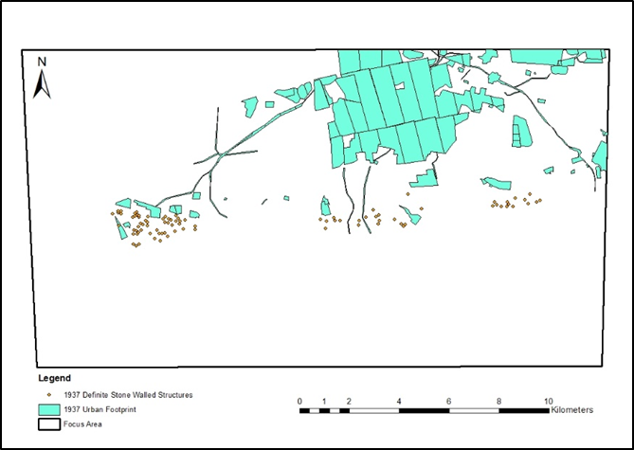
FIG.13. The relationship between the SWS and the corresponding urban footprint in 1937. Note that the 1937 air photos only covered the northern half of the focus area.

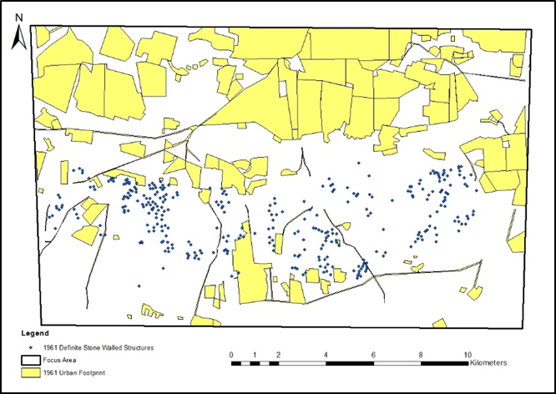
FIG. 14. The relationship between the SWS and the corresponding urban footprint in 1961.

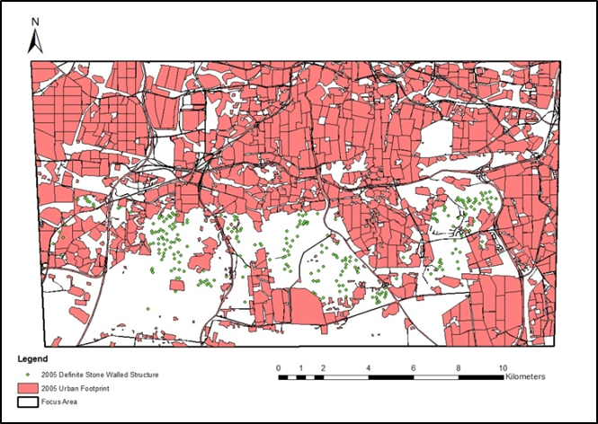
FIG. 15. The relationship between the SWS and the corresponding urban footprint in 2005.

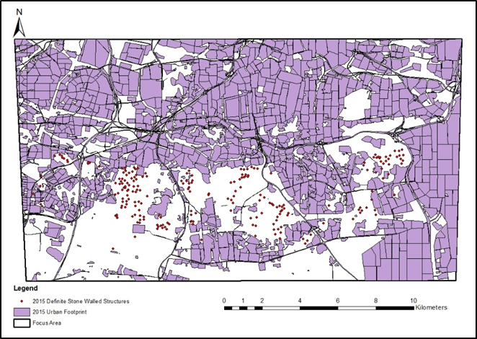
FIG. 16. The relationship between the SWS and the corresponding urban footprint in 2015.

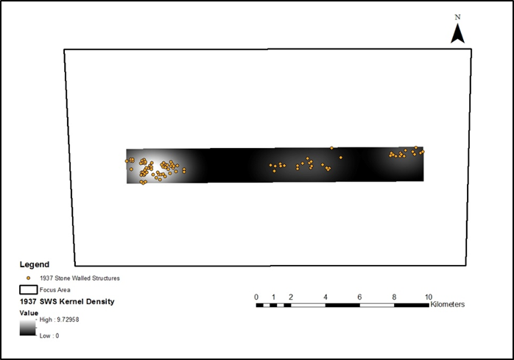
FIG. 17. Kernel Density of the Stone Walled Structures for 1937.

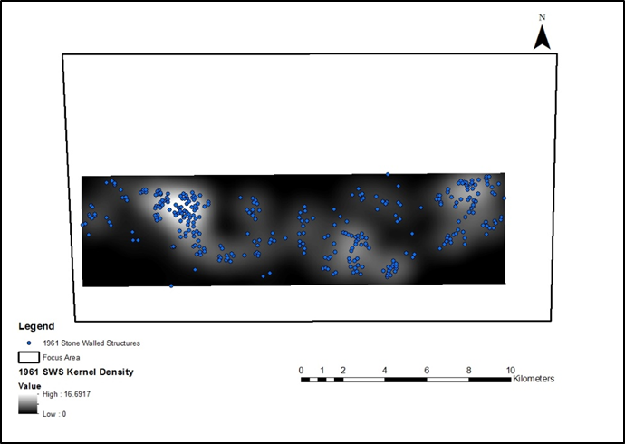
FIG. 18. Kernel Density of the Stone Walled Structures for 1961.

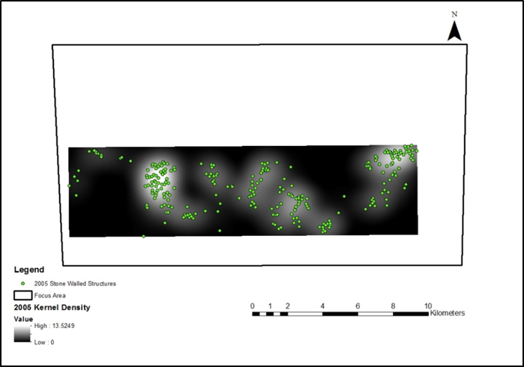
FIG. 19. Kernel Density of the Stone Walled Structures for 2005.

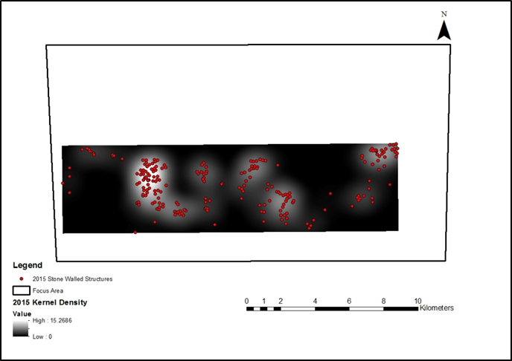
FIG. 20. Kernel Density of the Stone Walled Structures for 2015.

OBJECTIVE 4
The fourth objective was to assess the cultural resource management interventions in the study area, and their efficacy in mitigating the damage to the ruins. In the Wits University archive, a total of 77 sites have been identified in the focus area (Table 1). The main contributors in the identification of these are Revil Mason and Thomas Huffman.
Table 1. List of sites from the University of the Witwatersrand’s Archaeology Department archive as identified on Topographical map 2627BD and 2628AC.
ID | Map | Site | Site Name | Period | Site Type
1 | 2627 | BD9 | Kibler Park (TME) | LIA
2 | 2627 | BD10 | Kibler Park | LIA
3 | 2627 | BD11 | Kibler Park | LIA
4 | 2627 | BD12 | Kibler Park | LIA
5 | 2627 | BD13 | Kibler Park | LIA
6 | 2627 | BD14 | Kibler Park | LIA
7 | 2627 | BD15 | Kibler Park | LIA
8 | 2627 | BD16 | Kibler Park (TME 3) | LIA
9 | 2627 | BD17 | Kibler Park (TME 17) | LIA
10 | 2627 | BD18 | Kibler Park (TME 15) | LIA
11 | 2627 | BD55 | 6/82 | LIA | Stone Walled
12 | 2627 | BD56 | Hippospruit 4/82 | LIA | Stone Walled
13 | 2627 | BD57 | Kliprivier 26/82 | LIA | Stone Walled
14 | 2627 | BD58 | Quarry | LIA
15 | 2627 | BD59 | Misgund Beacon 15/28 | LIA | Stone Walled
16 | 2628 | AC1 | Forest Hill | LIA | Stone Walled
17 | 2628 | AC3 | Klipriviersberg 1 | LIA
18 | 2628 | AC4 | Mondeor | LIA | Stone Walled
19 | 2628 | AC5
20 | 2628 | AC6 | Kibler Park II | IA | Stone Walled
Table 1 Continued
21 | 2628 | AC7 | Kibler III | IA | Stone Walled
22 | 2628 | AC8 | Kibler Park IV | IA | Stone Walled
23 | 2628 | AC9 | Klipriviersberg 85/74 | LIA
24 | 2628 | AC10 | Klipriviersberg MDS 31/78 | LIA
25 | 2628 | AC12 | Liefde & Vrede 1 | LIA | Stone Walled
26 | 2628 | AC13 | Reservoir | LIA | Stone Walled
27 | 2628 | AC14 | Zoo Farm 21/82
28 | 2628 | AC15 | Loop Road 22/82
29 | 2628 | AC16 | Riool 32/82
30 | 2628 | AC17 | Kibler Park V | LIA | Stone Walled
31 | 2628 | AC18 | Rispark | IA | Stone Walled
32 | 2628 | AC19 | Rietvlei Reserve I | IA | Stone Walled
33 | 2628 | AC20 | Rietvlei Reserve II | LIA | Stone Walled
34 | 2628 | AC21 | Rietvlei Reserve III | LIA,Historic
35 | 2628 | AC22 | Klipriviersberg II | LIA | Type 1 & 2
36 | 2628 | AC23 | Tributary | LIA,Historic | Cattle Station
37 | 2628 | AC24 | Bloubos 71/81 | LIA | Stone Walled
38 | 2628 | AC25 | Peak 76/81 | LIA | Stone Walled
39 | 2628 | AC26 | Otley's Hoek | LIA | Stone Walled
40 | 2628 | AC27 | Tussenkoppies 60/81 | LIA | Type 1

Table 1 Continued
41 | 2628 | AC28 | Hilltop 60/81 | LIA | Stone Walled
42 | 2628 | AC29 | Beacon 312 | LIA | Stone Walled
43 | 2628 | AC30 | Rietvlei | LIA | Stone Walled
44 | 2628 | AC32 | Pistol Club 24/82 | LIA | Type 1
45 | 2628 | AC33 | Mulbarton I 9/82 | LIA | Stone Walled
46 | 2628 | AC34 | Mulbarton II 14/82 | LIA | Complex
47 | 2628 | AC35 | Gleneagles | LIA | Stone Walled
48 | 2628 | AC36 | Berg I | LIA | Stone Walled
49 | 2628 | AC37 | Berg II | LIA | Stone Walled
50 | 2628 | AC38 | Randhart | LIA | Stone Walled
51 | 2628 | AC39 | Alberante I | LIA | Cluster
52 | 2628 | AC41 | Alberante II | LIA | Stone Walled
53 | 2628 | AC42 | Alberante III | LIA | Type 1 ?
54 | 2628 | AC43 | Klipriviersberg III | LIA | Stone Walled
55 | 2628 | AC44 | Glen | LIA | Stone Walled
56 | 2628 | AC45 | Rietvlei Reserve Vlei IV | LIA | Type 1
57 | 2628 | AC46 | Rietvlei III | LIA | Stone Walled
58 | 2628 | AC47 | Rietvlei IV | LIA | Stone Walled
59 | 2628 | AC48 | Aerial Photo I | LIA
60 | 2628 | AC49 | Aerial Photo II | LIA | Type 2?

Table 1 Continued
61 | 2628 | AC50 | Rand Water Board | LIA | Stone Walled
62 | 2628 | AC51 | Meyersdal | LIA | Type 2?
63 | 2628 | AC52 | Casino Koppe | LIA
64 | 2628 | AC53 | Rietvlei | LIA,Historic | Group 3 Walling
65 | 2628 | AC54 | Rietvlei | LIA | Group 1 & 3
66 | 2628 | AC55 | Rietvlei | LIA | Group 3 Walling
67 | 2628 | AC57 | Klipriviersberg | LIA | Stone Walled
68 | 2628 | AC58a | Aspen Hills | LIA | Stone Walled
69 | 2628 | AC58b | Aspen Hills | LIA | Stone Walled
70 | 2628 | AC59a | Aspen Hills | LIA | Stone Walled
71 | 2628 | AC59b | Aspen Hills | LIA | Stone Walled
72 | 2628 | AC59c | Aspen Hills | LIA | Stone Walled
73 | 2628 | AC59d | Aspen Hills | LIA | Stone Walled
74 | 2628 | AC59e | Aspen Hills | LIA | Stone Walled
75 | 2628 | AC59f | Aspen Hills | LIA | Stone Walled
76 | 2628 | AC59g | Aspen Hills | LIA | Stone Walled
77 | 2628 | AC59h | Aspen Hills | LIA | Stone Walled

Comparing these 77 sites (Fig. 21) with my findings, it appears that 15 of them had been destroyed or damaged by 2015 (Table 2). However, these 77 sites sometimes represent a cluster of SWS and label them as one “site,” so the numbers of individual SWS damaged or destroyed is higher. On the other hand, some of the archive sites are not visible on any of the snapshots. Those that were not visible on any of the four snapshots may have been either sites that were mis-placed on the archive maps, or were not SWS at all, or were SWS but not visible on aerial imagery, for example because of vegetation cover. Thirteen of my identified SWS clearly correspond to seven of the archive sites. The other eight archive sites have no corresponding SWS that were identified on the snapshots.

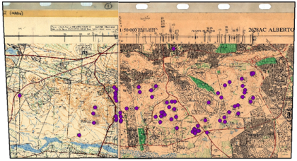
FIG. 21. Purple dots show the location of the 77 sites recorded on maps in the archaeology archives at Wits University.
Table 2. The 15 archive sites which were not visible on the 2015 snapshot. Some were not visible on earlier snapshots either. For ID, see Table 1.
ID | 1937 | 1961 | 2005 | 2015
18
28
29
30 |  | visible
34 |  | visible
37 |  | visible | visible
39

Table 2 Continued
42 |  | visible
44
46
47 |  | visible
48
50 |  | visible | visible
57 |  | visible | visible
61

When consulting the SAHRIS online data base I found it difficult to identify many AIA reports for my focus area regardless of how I refined my search. Searching by specific authors yielded the best results. Revil Mason and Karim Sadr had two reports that are associated with my study area, whilst Thomas Huffman had numerous reports. Figures 22-25 show the 77 sites recorded in the Wits archive, with their buffer zones at 50, 100 and 250 m, against the SWS that I recorded respectively in the 1937, 1961, 2005 and 2015 snapshots.
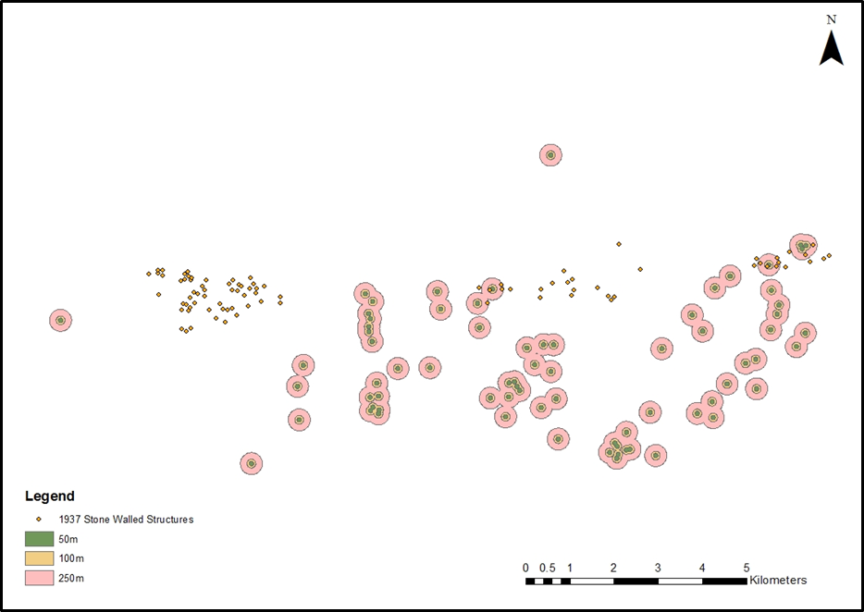
FIG. 22. SWS from 1937 against archive sites buffered at 50, 100, 250m.
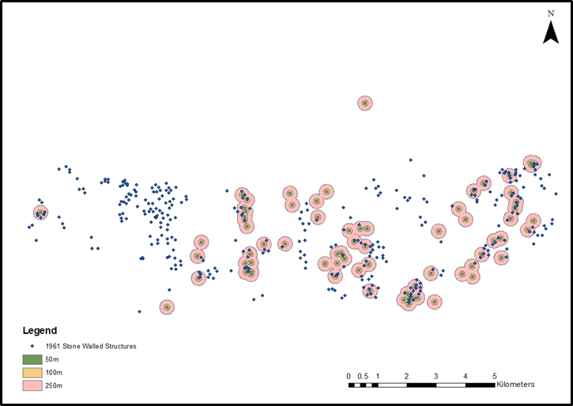
FIG. 23. SWS from 1961 against archive sites buffered at 50, 100, 250m

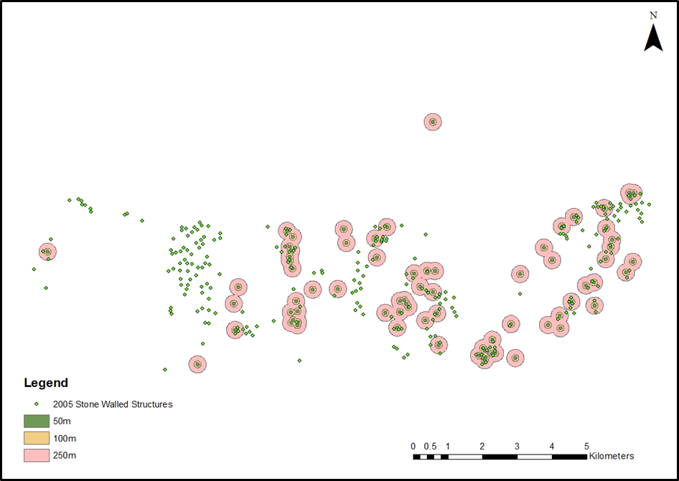
FIG. 24. SWS from 2005 against archive sites buffered at 50, 100, 250m.

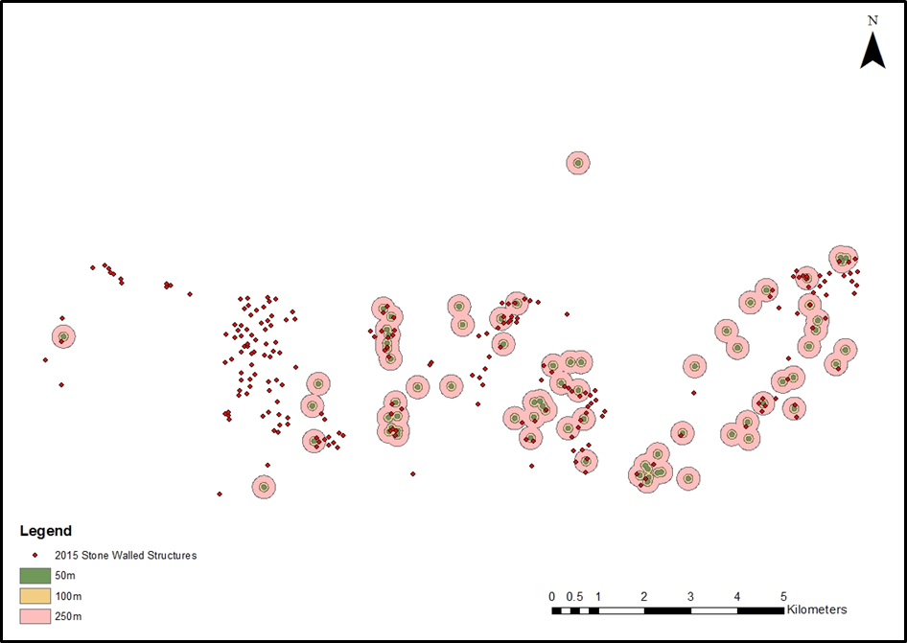
FIG. 25. SWS from 2015 against archive sites buffered at 50, 100, 250m.

CHAPTER 5: DISCUSSION AND CONCLUSION
The aims of my study were to map and quantify the destruction of SWS in the study area since the 1930s; and to determine what proportion of the Iron Age stone walled structures (SWS) were adequately recorded before destruction. The first aim was partially achieved insofar as a complete picture of the distribution of SWS in my focus area during the 1930s could not be obtained since the 1937 series of air photos only covered the northern half of my study area. However, the aim was fully achieved for the period 1961-2015. My second aim was not possible to achieve as well as I had hoped because the evidence for whether the SWS were adequately recorded before destruction, that is to say the reports and publications of cultural resource management interventions and archaeological impact assessments, are not adequately catalogued anywhere for me to know what proportion of them I have been able to consult. The reports that I have seen suggest that most of the destroyed SWS were not adequately recorded, let alone mitigated.
The four objectives of my study were achieved to varying degrees. The first objective was to map the expansion of Johannesburg in my focus area in four chronological ‘snapshots’ from the late 1930’s to the present using historical air photographs and data from the Gauteng City Region Observatory (GCRO). This was accomplished as well as it could be, keeping in mind the limitation posed by the incomplete coverage of my focus area in the 1937 air photos. The second objective was to map the location of SWS in four equivalent chronological snapshots using historical air photographs and satellite imagery. As for the first objective, this was achieved fully for the 1961, 2005 and 2015 snapshots, but not for the 1937 one. The third objective was to quantify the urban expansion and corresponding impact on SWS in the study area. This was achieved fully for the three snapshots since 1961, and insofar as the 1937 air photos covered all of Johannesburg at that time, I can assume that the quantification of the urban footprint in my focus area for the 1930s is also accurate and complete. The fourth objective was to assess the cultural resource management interventions in the study area, and their efficacy in mitigating the damage to the ruins. This was the least satisfactorily achieved objective. Although a good assessment of the rate of urbanization and rate of destruction of SWS in my focus area was possible, and although it was clear which SWS had been destroyed in which parts of Johannesburg South, it was not possible to determine if I had been able to access all the records of CRM and AIA interventions in the focus area. If the records I found are all there is, then the CRM and AIA interventions were paltry and only 10-20% of the destroyed SWS were adequately recorded before they disappeared.
My results indicate a significant decline in the number of SWS in the focus area from around 330 in 1961 to around 220 in 2015. Over the same period, the amount of land under urban development rose from around 9000 hectares to around 15 000 hectares within my approximately 27 000 hectare focus area. The rate of destruction of SWS in my focus area can thus be summarised as 110 SWS lost to 6000 hectares (60 square kilometres) of urban development; that is to say roughly one SWS per 55 hectares of development. In a recent paper, Sadr (2017: 78) had estimated that over the entire southern half of Gauteng Province, every 10 square kilometres of new urban development would result in the destruction of five SWS. That is roughly one SWS destroyed for every 200 hectares of development. Evidently, the rate of SWS destruction in my focus area at the southern edge of Johannesburg has been about four times higher than predicted for the entire southern Gauteng. This is because of the high density of SWS and the intensity of urbanization on the southern slopes of the Witwatersrand Ridge overlooking the upper reaches of the Klip River.
The rate of destruction of SWS in my focus area would have been higher were it not for the successful CRM interventions by Revil Mason and Thomas Huffman. Nevertheless, only a small proportion of the destroyed SWS were recorded, let alone mitigated. Exact numbers are difficult to calculate because CRM reports and Archaeological Impact Assessments (AIA) are difficult to find. The archives of the archaeology division at the University for the Witwatersrand are very patchy and incomplete and the online system, SAHRIS, managed by the South African Heritage Resources Agency (SAHRA) is not user friendly and contains only reports since 1999, as far as I can ascertain. It is hard to tell how much AIA work was done without the reports being lodged in the Wits archive or with SAHRIS. Most of the assessments that I found were Phase 1 reports (initial survey to record and assess heritage sites); rarely did I find a Phase 3 report (mitigation of damage and excavation). Linking heritage management to urban planning has helped improve the protection of archaeological and historical resources, and according to the National Heritage Resources Act of 1999 the developer is required to commission an AIA prior to development. However, SAHRA manages heritage on a national level and the best and most complete catalogue of CRM and AIA reports for provincial (Grade II) sites should be housed at the Gauteng Provincial Heritage Resources Agency (PHRAG).
I finish with an anecdote. Revil Mason conducted an archaeological survey of the Johannesburg ridges from 1981 to 1982. In 1984 he contacted the National Monuments Council (NMC)--the precursor of SAHRA--about preserving structures in Rietvlei, which were in danger from a new sports complex. By 1988 most of the structures had disappeared and he questioned the Council about this. The chairman of the NMC replied that it’s not feasible to preserve everything from development. That is understood. But in the absence of written and oral histories, the Iron Age SWS are all we have to reconstruct the lifeways and social organizations of the ancestors of the African South Africans in these parts.

REFERENCES
Agapiou, A.,Alexakis, D.D., Lysandrou, V., Sarris, A., Cuca, B., Themistocleous, K., Hadjimitsis, D.G. 2015. Impact of urban sprawl to cultural heritage monuments: The case study of Paphos area in Cyprus. Journal of Cultural Heritage 16: 671-680.
Beavon, K. 2004. Johannesburg: The Making and Shaping of the City. South Africa: Unisa Press.
Campbell, J.B. 2006. Introduction to Remote Sensing. New York: The Guilford Press.
Ceraudo, G. 2013. Aerial Photography in Archaeology. In: Corsi, C., Slapšak, B., Vermeulen, F (eds). Good Practice in Archaeological Diagnostics: pp. 11-30. Switzerland: Springer International Publishing.
Chirikure, S. 2013. Heritage conservation in Africa: The good, the bad, and the challenges. South African Journal of Science 109 (1-2): 1-3.
Deacon, J. 2015. Great Expectations: Archaeological sites and the National Heritage Resources Act (Act 25 of 1999). The South African Archaeological Bulletin 70(202): 220-223.
Department of Rural Development and Land Reforms. 2013. Maps and Charts (Digital/ Raster or Printed). (Accessed 10 February 2016). http://www.ngi.gov.za.
Deuel, L. 1969. Flights into Yesterday, The story of Aerial Archaeology. Great Britain: Hazel Watson & Viney Ltd.
Dreyer, J. 1995. Late Iron Age Sites in the Magaliesberg Valley: Jones’ (1935) Stone Structures Revisited. Southern African Field Archaeology 4: 50- 57.
Esterhuysen, A. 2009. Editorial: Undermining Heritage. The South African Archaeological Bulletin 64 (189): 1-3.
Google Earth 2017. Google Earth Pro Version 7. 3.0. 3832 (32 bit).
Hall, M. 1981. Settlement Patterns in the Iron Age of Zululand: An Ecological Interpretation. Cambridge Monographs in African Archaeology 5: Bar International series 119.
Harrison, P & Zack, T. 2014. Between the ordinary and the extraordinary: socio-spatiall transformations in the “Old South” of Johannesburg. South African Geographical Journal 96(2): 180-197.
Huffman, T.N. 1999a. Archaeological Survey of Klipriviersberg Part One. Johannesburg: Archaeological Resources Management.
Huffman, T.N. 1999b. Archaeological Survey of Klipriviersberg Part Two. Johannesburg: Archaeological Resources Management.
Huffman, T.N. 1999c. Archaeological Survey of Olivantsvlei, Klipriviersberg. Johannesburg: Archaeological Resources Management.
Huffman, T.N.1999d. Archaeological Survey for the Thaba Ya Bostwana Project. Johannesburg: Archaeological Resources Management.
Huffman, T.N. 2004a. Archaeological Assessment of Portion 37 Liefde en Vrede 104IR. Johannesburg: Archaeological Resources Management.
Huffman. T.N. 2004b. Archaeological Mitigation for the Aspen Hills Development Project. Johannesburg: Archaeological Resources Management.
Huffman, T.N. 2007a. Archaeological Impact Assessment for the Eye of Africa Valleys, Gauteng. Johannesburg: Archaeological Resources Management.
Huffman, T.N. 2007b. Handbook of the Iron Age: The Archaeology of Pre-Colonial Farming Societies in Southern Africa. Pietermaritzburg: University of KwaZulu-Natal.
Huffman, T.N. 2008. Mountain View Heritage Assessment, Gauteng. Johannesburg: Archaeological Resources Management.
Huffman, T.N. & Steel, R.H. 1996 Salvage Excavations at Planknek, Potgietersrus, Northern Province. Southern Africa Field Archaeology 5: 45- 56.
Hunt, T. & Sadr, K. 2014. Inter-Analyst variability in identification and classification of pre- colonial Stone-walled structures using Google Earth, Southern Gauteng, South Africa. The South African Archaeological Bulletin 69 (199): 87-95.
Mabin, A. 2013. The Map of Gauteng: evolution of a city-region in concept and plan. Gauteng City -Region Observatory Occasional Papers No. 5.
MacQuilkan, P. & Sadr, K. 2010. Remote sensing of archaeological ruins: a comparison. PositionIT Nov/Dec 2010: 50-51.
Maggs, T.M.O’C. 1976. Iron Age communities of the Southern Highveld. Pietermaritzburg: The Council of the Natal Museum.
Mason, R. 1962. Prehistory of the Transvaal: a record of human activity. Johannesburg: Witwatersrand University Press.
Mason, R. J. 1968. Transvaal and Natal Iron Age settlement revealed by aerial photography and excavation. African Studies 27 (4): 167 – 180.
Mason, R. 1986. Origins of Black People of Johannesburg and the Southern Western Central Transvaal AD 350-1880. (Occasional Paper 16). Johannesburg: University of the Witwatersrand Archaeological Research Unit.
Mason, R.J. 1987. Origins of the African People of the Johannesburg area. Johannesburg: Skotaville Publishers.
Mitchell, P. 2002. The Archaeology of Southern Africa. Cambridge: Cambridge University Press.
Mubiwa, B. & Annegarn, H. 2013. Historical spatial change in the Gauteng City-Region. Gauteng City -Region Observatory Occasional Papers No. 4.
Mucina, L and Rutherford, M.C. (eds) 2006. The vegetation of South Africa, Lesotho and Swaziland. Strelitzia 19. Pretoria: South African National Biodiversity Institute.
National Heritage Resources Act 25 of 1999. (Accessed 18 January 2016). http://sahra.org.za/legislations
Ndlovu, N. 2009. Transformation challenges in South African Archaeology. South African Archaeological Bulletin 64 (189): 91-93.
Ndlovu, N., 2011a. Legislation as an instrument in South African heritage management: Is it effective? Conservation and Management of Archaeological Sites 13(1): 31-57.
Ndlovu, N. 2011b. Management Versus Protection: Archaeological Heritage Management in Transforming South Africa. Conservation and Management of Archaeological Sites 13(2-3): 123 -133.
Ndoro, W. 2015. Heritage Laws: Whose Heritage are we protecting? The South African Archaeological Bulletin 70 (202): 136-137.
Pwiti, G. & Ndoro, W. 1999. The legacy of colonialism: Perceptions of the cultural heritage in Southern Africa, with special reference to Zimbabwe. African Archaeological Review 16(3): 143-153.
Renfrew,C & Bahn, P. 2012. Archaeology Theories, Methods and Practice. London: Thames & Hudson Ltd.
Riley, D.N. 1987. Air Photography & Archaeology. London: Gerald Duckworth & Co. Ltd.
Sadr, K. & Rodier, X. 2012. Google Earth, GIS, and stone-walled structures in southern Gauteng, South Africa. Journal of Archaeological Science 39: 1034-1042.
Sadr, K. 2016. A Comparsion of Accuracy and Precision in Remote Sensing Stone-walled Structures with Google Earth, High Resolution Aerial Photography and LiDAR: a Case Study from the South African Iron Age. Archaeological Prospection. 23(2):95-104.
Sadr, K. 2017. The effect of urban sprawl on archaeological sites between Johannesburg and the river Vaal. The South African Archaeological Bulletin 72 (205):71-79.
Seddon, J. D. 1968. An aerial survey of the settlement and living patterns in the Transvaal Iron Age: preliminary report. African Studies 27(4): 189-194.
South African Heritage Resources Agency. 2012. (Accessed February to March 2016). http://sahra.org.za.
Taylor, M.O.V. 1979a. Wildebeestfontein: A Late Iron Age Site in the Southeast Transvaal. Goodwin Series 3: 120-129.
Taylor, M.O.V. 1979b. Late Iron Age settlements on the northern edge of the Vredefort Dome. Unpublished MA dissertation. Johannesburg: University of the Witwatersrand.
The Association of Southern African Professional Archaeologists. 2016. The CRM section of ASAPA (Accessed February 2016). http://www.asapa.org.za/content/page/the-crm-section-of-asapa
Van Riet Lowe, C. 1927. A Preliminary Report on the Stone Huts of Vechtkop. The Journal of the Royal Anthropological Institute of Great Britain and Ireland 57: 217-233.
Van Schalkwyk, J & Pelser, 1999. A. Survey of Cultural Resources in the Klipriviersberg Nature Reserve, Johannesburg District. Pretoria: National Cultural History Museum.
Verhoeven,G.J.J. 2009. Providing an Archaeological Bird’s-eye View – an Overall Picture of Ground-based Means to Execute Low-altitude Aerial Photography (LAAP) in Archaeology. Archaeological Prospection 16: 233 – 249.
Wiseman, J & El-Baz, F. Introduction. In Wiseman, J. & El-Baz, F. (eds). Remote Sensing in Archaeology, 1-8. USA: Springer Science.

APPENDICES

APPENDIX A: THE SPATIAL DATA (METADATA) USED IN THIS PROJECT AND THEIR CORRESPONDING SOURCES.

Data | Source | Other Information
Aerial Photographs of the Albertan area from 1937 and 1961. | NGI, also known as South Africa’s national mapping organization. | 1937 image format 5X5  1961 image format 6X6
Google Earth historical imagery for the Albertan area. | Google Earth V 7.1.5.1557 | Data source on GE: SIO, NOAA, U.S. Navy, NGA, GEBCO
Focus Area | Google Earth V 7.1.5.1557 | Digitized area from GE
Stone- Walled Structures in Southern Gauteng | SGSWS project archive | From Prof. K. Sadr
GCRO time series of land use changes | GCRO, GeoTerraImage
GCRO time series of population density per hectare | GCRO, GeoTerraImage
South African Provinces | SGSWS project archive
South African roads | Open Street Map | Old information
Municipalities boundaries | SGSWS project archive
SGSWS transport 2016 and transport buff100 | OSM | all transport routes in survey area SGSWS, downloaded from Open Street Map in QGIS
SGSWS survey area | SGSWS project archive | Digitized boundary of SGSWS survey on GE
SGSWS water bodies | NGI | Water bodies layer from digitized 1:50 000 map shapefiles

APPENDIX B: THE STONE WALLED STRUCTURES IDENTIFIED IN EACH SNAPSHOT.
Site No. | 1937 | 1961 | 2005 | 2015
1 |  | X | X | X
2 |  | X |  | X
3 |  | X | X
4 |  | X |  | X
5 |  | X | X
6 |  | X
7 |  | X | X | X
8 |  | X
9 |  | X
10 |  | X | X
11 |  | X | X | X
12 |  | X
13 |  | X
14 |  | X
15 |  |  | X | X
16 |  | X | X | X
17 |  | X | X | X
18 |  | X | X | X
19 |  |  | X | X
20 |  | X | X | X
21 |  | X
22 |  | X
23 |  | X
24 |  | X
25 |  | X
26 | X | X
27 |  | X
28 | X
29 | X | X
30 | X | X | X | X
31 | X | X |  | X
32 | X | X | X | X
33 | X | X
34 | X | X
35 | X | X
36 | X | X
37 | X | X | X | X
38 | X | X
39 | X | X
40 | X | X
41 | X
42 | X | X
43 |  | X
44 | X | X
45 |  | X
46 | X | X
47 | X | X
48 | X | X
49 | X | X
50 | X | X
51 | X | X
52 | X | X
53 | X | X
54 | X | X
55 | X | X
56 | X | X
57 | X | X
58 | X | X | X
59 | X | X
60 | X | X | X | X
61 |  | X | X
62 |  |  | X | X
63 |  |  | X | X
64 |  | X |  | X
65 |  | X | X | X
66 |  | X | X | X
67 |  |  | X | X
68 |  | X | X | X
69 |  | X |  | X
70 |  |  | X | X
71 |  |  |  | X
72 |  | X | X | X
73 |  |  | X | X
74 |  | X | X
75 |  |  | X | X
76 |  | X |  | X
77 |  | X | X | X
78 |  | X |  | X
79 | X | X | X | X
80 |  | X | X | X
81 |  | X |  | X
82 | X | X | X | X
83 | X |  |  | X
84 | X | X
85 | X | X |  | X
86 |  |  | X | X
87 | X | X | X
88 | X | X |  | X
89 | X | X
90 | X | X
91 | X | X |  | X
92 | X | X | X | X
93 | X | X
94 | X | X | X
95 | X | X | X | X
96 | X | X | X | X
97 |  | X | X | X
98 | X | X | X | X
99 |  | X | X | X
100 |  | X | X | X
101 |  | X | X | X
102 |  | X | X | X
103 |  | X | X | X
104 |  | X | X | X
105 |  | X | X
106 |  | X | X | X
107 |  | X | X | X
108 |  | X | X | X
109 |  | X | X | X
110 |  | X | X | X
111 |  | X | X | X
112 |  | X | X | X
113 |  | X |  | X
114 |  | X | X | X
115 |  | X | X | X
116 |  | X | X | X
117 |  | X | X | X
118 |  | X | X | X
119 |  | X | X | X
120 |  | X | X | X
121 |  | X | X | X
122 |  |  | X | X
123 |  |  | X | X
124 |  | X | X | X
125 |  | X |  | X
126 |  | X | X | X
127 |  | X | X | X
128 |  | X | X | X
129 | X | X | X | X
130 | X | X | X | X
131 | X | X | X | X
132 | X | X | X | X
133 | X | X | X | X
134 | X | X | X | X
135 |  | X | X | X
136 |  |  | X | X
137 |  | X | X | X
138 |  | X |  | X
139 |  | X
140 |  | X |  | X
141 |  |  | X | X
142 |  | X | X | X
143 |  | X | X | X
144 |  | X | X | X
145 |  | X | X | X
146 |  | X | X | X
147 |  |  | X | X
148 |  | X | X | X
149 |  | X | X | X
150 |  | X | X | X
151 |  | X |  | X
152 |  | X | X
153 |  | X | X
154 |  | X
155 |  | X | X | X
156 |  | X | X | X
157 |  | X | X | X
158 |  | X | X
159 |  | X | X | X
160 |  | X | X | X
161 |  | X |  | X
162 |  | X | X | X
163 |  |  | X | X
164 |  |  | X | X
165 |  | X | X | X
166 |  | X | X | X
167 |  | X | X | X
168 |  | X
169 |  | X |  | X
170 |  | X
171 |  | X |  | X
172 |  | X |  | X
173 |  | X |  | X
174 |  | X | X | X
175 |  | X | X | X
176 |  | X | X
177 |  | X |  | X
178 |  |  | X | X
179 |  |  | X
180 |  |  | X | X
181 |  |  | X | X
182 |  | X
183 |  | X
184 |  | X
185 |  | X
186 |  | X | X
187 |  | X | X
188 |  | X | X | X
189 |  |  | X
190 |  | X | X
191 |  |  | X | X
192 |  |  | X | X
193 |  | X | X
194 |  | X | X
195 |  | X | X | X
196 |  | X
197 |  | X |  | X
198 |  | X | X | X
199 |  | X | X | X
200 |  | X | X | X
201 |  | X | X
202 |  | X | X
203 |  | X
204 |  | X | X | X
205 |  |  | X | X
206 |  |  | X | X
207 |  |  | X | X
208 |  |  | X | X
209 | X |  | X | X
210 |  |  | X | X
211 |  |  | X | X
212 | X |  | X | X
213 | X |  | X | X
214 | X |  |  | X
215 | X |  |  | X
216 |  |  | X | X
217 |  |  | X | X
218 |  | X
219 |  | X
220 |  |  | X | X
221 |  | X | X | X
222 |  | X
223 |  | X | X
224 |  | X | X | X
225 |  | X | X
226 |  | X | X
227 |  | X | X | X
228 |  | X | X
229 |  |  | X | X
230 |  | X
231 |  | X | X | X
232 |  |  | X | X
233 |  | X | X | X
234 |  | X
235 | X |  | X | X
236 | X
237 | X |  | X | X
238 |  | X | X
239 |  |  | X | X
240 |  | X | X | X
241 |  | X | X | X
242 |  | X | X | X
243 |  | X | X | X
244 |  | X | X | X
245 |  | X | X | X
246 |  | X | X | X
247 |  | X | X | X
248 |  | X | X
249 | X | X
250 | X | X
251 | X | X
252 |  | X | X | X
253 |  | X | X | X
254 |  | X | X | X
255 |  | X |  | X
256 |  | X | X | X
257 |  | X | X | X
258 |  | X |  | X
259 |  | X | X | X
260 |  | X | X | X
261 |  | X
262 |  | X | X | X
263 |  | X
264 |  | X
265 |  | X
266 |  | X | X
267 |  | X | X | X
268 |  | X | X | X
269 |  | X
270 |  | X | X | X
271 |  | X | X
272 |  | X | X | X
273 | X | X
274 | X | X
275 | X | X
276 | X | X
277 |  | X
278 |  | X | X | X
279 |  | X | X | X
280 |  | X | X | X
281 |  | X | X
282 |  | X | X
283 | X | X
284 | X | X
285 | X | X
286 | X | X
287 |  | X
288 |  | X | X
289 |  | X | X | X
290 |  | X | X
291 |  | X
292 |  | X | X
293 |  | X | X
294 |  | X | X
295 |  | X | X
296 |  | X
297 |  | X | X | X
298 |  | X
299 |  | X
300 |  | X
301 |  | X
302 |  | X
303 | X | X
304 |  | X | X | X
305 |  | X
306 |  | X
307 |  | X
308 |  | X | X
309 |  | X | X
310 |  | X | X
311 |  | X | X
312 |  | X | X
313 |  | X | X
314 |  | X | X | X
315 |  | X | X | X
316 |  | X | X | X
317 |  | X | X | X
318 |  | X | X
319 |  | X | X | X
320 |  | X | X
321 |  | X |  | X
322 |  | X | X | X
323 |  | X | X | X
324 |  | X | X | X
325 |  | X
326 | X | X | X | X
327 | X | X | X | X
328 |  | X | X | X
329 |  | X
330 |  | X | X
331 |  | X | X | X
332 |  | X | X | X
333 |  | X | X
334 |  | X | X | X
335 |  | X | X | X
336 |  | X | X
337 |  | X | X
338 |  | X | X
339 |  | X | X
340 |  | X | X | X
341 |  | X
342 |  | X
343 |  | X | X
344 |  | X | X | X
345 |  | X | X | X
346 |  | X | X | X
347 | X | X | X
348 | X | X | X | X
349 |  | X | X | X
350 |  | X | X | X
351 | X | X | X | X
352 | X | X | X | X
353 | X | X | X
354 | X | X | X | X
355 | X | X | X | X
356 |  | X
357 |  | X | X | X
358 |  | X | X | X
359 |  | X
360 |  | X | X | X
361 |  | X
362 |  | X | X | X
363 |  | X
364 |  | X | X
365 |  |  | X
366 |  | X | X | X
367 | X | X | X
368 |  | X | X | X
369 |  | X | X | X
370 | X | X | X | X
371 |  |  | X | X
372 | X |  | X | X
373 |  |  | X | X
374 |  | X | X | X
375 |  | X | X | X
376 |  | X | X
377 |  | X
378 |  | X
379 |  | X
380 |  | X
381 |  | X
382 |  | X
383 |  | X
384 | X | X | X
385 |  | X

APPENDIX C: FLIGHT PLANS FOR 1937 AND 1961 AIR PHOTOGRAPHS

1937:
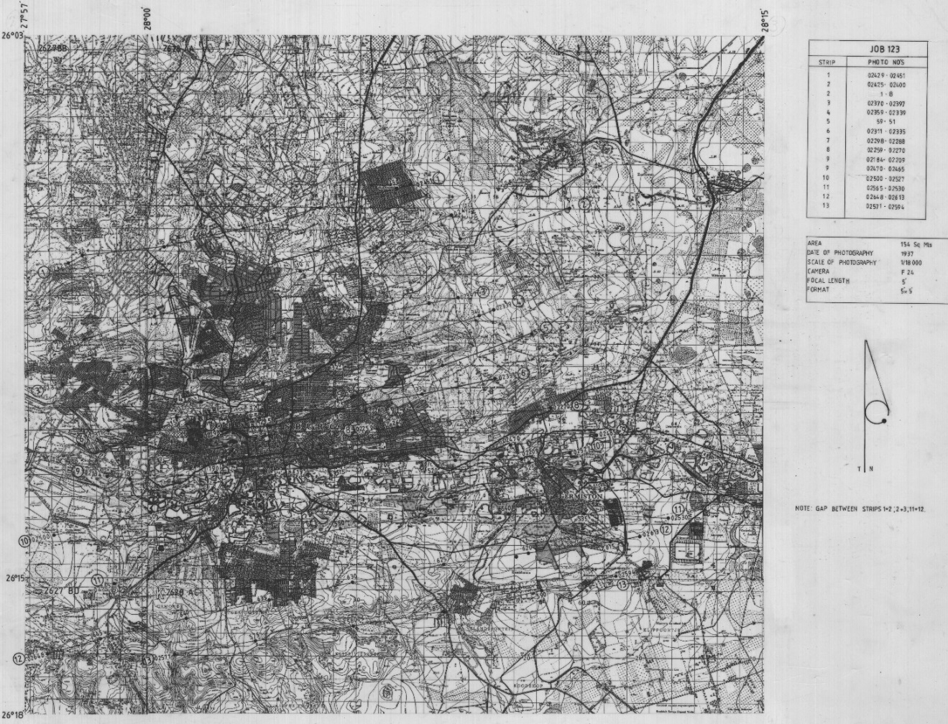

1961:
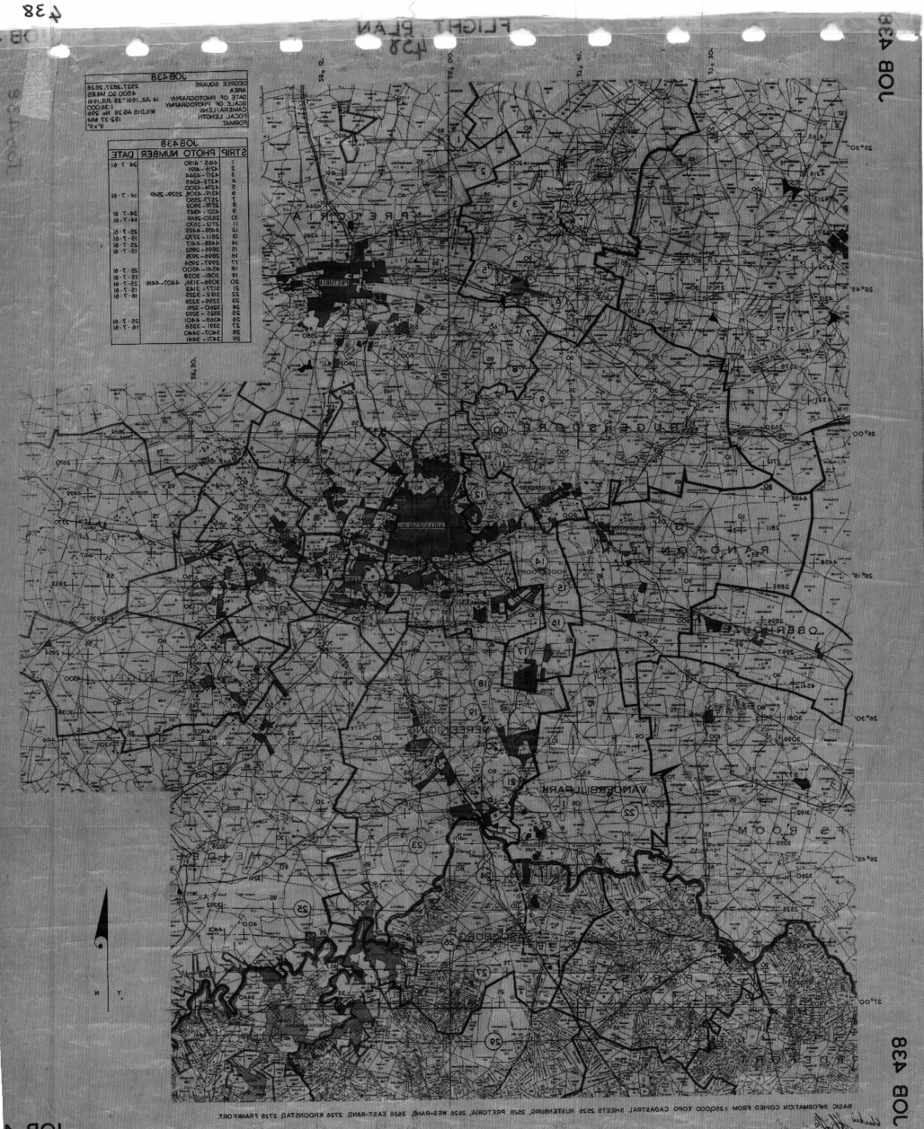

ABBREVIATIONS:
AD: Anno Domini
AIA: Archaeological Impact Assessment
AP: Aerial Photographs
ARC-ISCW: Agricultural Research Council Institute for Soil, Climate and Water
ARM: Archaeological Resources Management
ASAPA: Association of Southern African Professional Archaeologists
BRP: Bushman’s Relics Protection Act
CRM: Cultural Resources Management
EIA: Environmental Impact Assessment
GCR: Gauteng City Region
GCRO: Gauteng City-Region Observatory
GDARD: Gauteng Department of Agricultural and Rural Development
GE: Google Earth
GEBCO: General Bathymetric Chart of the Oceans
GIS: Geographic Information Systems
HIA: Heritage Impact Assessment
Kml: Keyhole makeup language
NEMA: National Environemtal Management Act
NGA: National Geospatial- Intelligence Agency
NGI: National Geo-spatial Information
NHMRA: National and Historical Monuments, Relics and Antiques Act
NHR: National Heritage Resources (Act)
NM: National Monuments (Act)
NOAA: National Oceanic and Atmospheric Administration
OSM: Open Street Map
PHRA: Provincial Heritage Resources Agency
PHRAG: Provincial Heritage Resources Authority Gauteng.
SAHRA: South African Heritage Resources Agency
SAHRIS: South African Heritage Resources Information System
SAPS: South African Police Services
SGSWS: Southern Gauteng Stone-Walled Structures
Shp.: Shapefile
SIO: Scripps Institution of Oceanography
SRTM: Shuttle Radar Topography Mission
SWS: Stone Walled Structures
TIFF: Tagged Image File Format
ZAR: Zuid-Afrikaanse Rand/ South African Rand

