APPENDIX 5: FEEDBACK TO PILOT ORGANISATION

Below is the report that was generated a feedback provided to the Organisation at which the pilot study was conducted. To protect the confidentiality of the Organisation, their name and any identifiable terms have been omitted and generic descriptors used instead.

WORKSPACE EFFICIENCY POST OCCUPANCY EVALUATION SURVEY

Conducted by Prof. Andrew Thatcher

(Registered Psychologist (Industrial): PS0060984)
and Ms Keren-Amy Laughton

INTRODUCTION

This post-occupancy evaluation survey survey forms part of the submission in application for the Workspace Efficiency credit in the GreenStar Interiors rating tool. The survey was constructed based on the Workspace Efficiency credit using standardised instruments available in the published literature. The survey was first distributed on Friday 19 May 2017 and closed on Friday 2 June 2017 (i.e. for two weeks). Reminders were sent out on Friday 26 May 2017 and Wednesday 31 May 2017. There were approximately 200 people working in this office area meaning that we were aiming for a sample size of approximately 134 respondents. In total, 152 people responded to the survey of which 6 responses were removed because there were insufficient answers to the primary survey questions (i.e. more than 80% of their responses were missing), leaving 146 complete responses and a response rate of 73%. This meets the criterion as set out in the GreenStar’s Workspace Efficiency credit.

SAMPLE DESCRIPTION

The sample consisted of more female respondents than male respondents. This is fairly typical of surveys although may also be a true reflection of the demographics of the surveyed population.

Gender
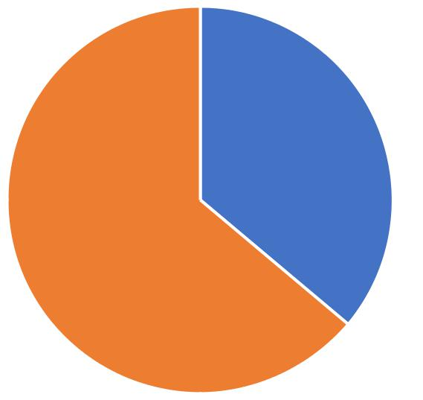

36.11%

63.89%

Male Female

Similarly, the largest group in the response pool was for White respondents followed by Black African respondents. This is likely to be a true reflection of the surveyed population.

Race
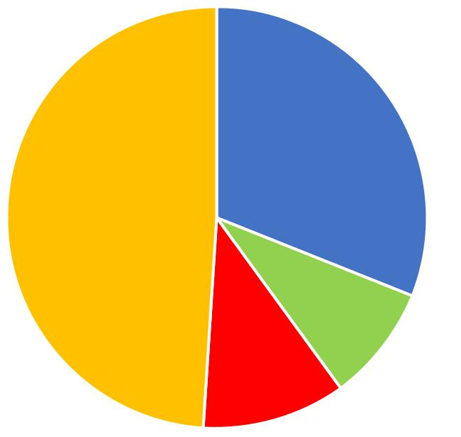

31.03%

48.97%

 |  |  | 8.97%
 |  | 11.03%
African | Indian | Coloured | White

Departments

 | 0.74% ^{5.15%} 1.47%
12.50% | 2.94%
12.50% | 3.68%
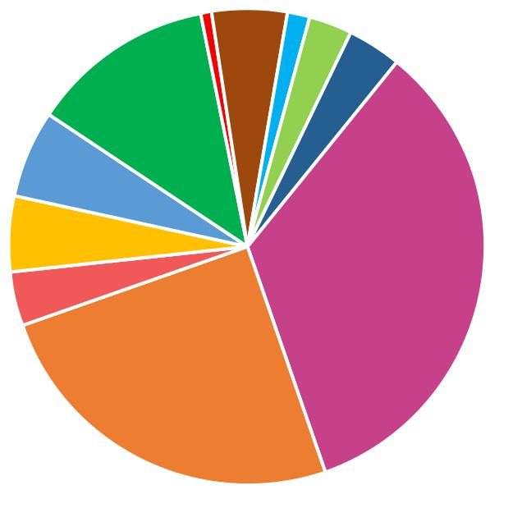

5.88%

5.15%

3.68% | 33.82%

25.00%
Property Management | Finance | Development
Admin | Human Resources | Facilities & Retail
IT | Legal | Marketing
Internal Audit | Utilities

Most respondents were from the Property Management and Finance Departments. However, there were also a fair distribution of respondents from a number of other Departments including general Administration, Human Resources, Marketing, Development, Utilities, and Legal.

Participant's current office workspace

2.76%
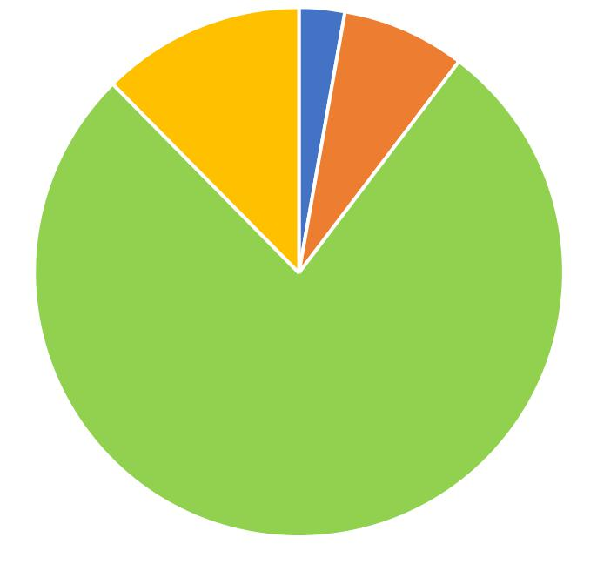12.41% 7.59%

77.24%

A private office | A shared office

An open-plan office with individual cubicles Collaborative team spaces

In this office space the majority of respondents worked in an open-plan office environment (usually with individual cubicles). Only a small proportion of the respondents worked in private offices.

AMBIENT WORK ENVIRONMENT

All aspects of the ambient work environment were experienced as at least “comfortable” by the majority of respondents. The most comfortable aspects of the ambient work environment were the provision of daylight, the office lighting, the office furniture, and the overall working conditions. The least comfortable aspects were the air temperature and the noise. These aspects were still perceived by the majority of respondents as at least “comfortable”. The comfort perceptions are supported by the perceptions of what hinders or supports work performance. The perceptions of air temperature and noise were most likely to have a negative impact on work performance. The acoustic (noise) environment will be looked at in more detail below. With respect to air temperature, research has shown that women, in general, feel more comfortable at a higher ambient temperature than men. Given that the sample consists predominantly of women it is possible that the ambient temperature is set too low (particularly as the survey was also conducted in Winter). Personal control of temperature is the best solution, but it is also expensive to implement. It is recommended that more indepth exploration of the temperatureissue is undertaken, particularly as this is perceived to have a possible negative impact on work performance for some (see Table 2). Other aspects of the ambient work environment were perceived to support and even enhance work performance. On average respondents indicated that they were operating at 80.06% of full capacity. This is typical of a good functioning work environment.

Table 1. Perceived comfort of current workstation
 | Very | Uncomfortable/ | Comfortable/ | Very
 | Uncomfortable/ | Uncomfortable/ | Comfortable/ | Comfortable/
 | Uncomfortable/ | Poor | Good | Comfortable/
 | Very Poor | Poor | Good | Very Good
Air | 17.73% | 27.66% | 46.81% | 7.80%
Temperature
Air Freshness | 12.86% | 13.57% | 55.71% | 17.86%
Air Quality | 12.23% | 15.11% | 53.24% | 19.42%
Noise | 16.55% | 30.22% | 45.32% | 7.91%
Office | 1.43% | 9.29% | 55.71% | 33.57%
Lighting
Daylight | 1.43% | 9.29% | 47.86% | 41.43%
Office | 2.13% | 9.22% | 48.94% | 39.72%
Furniture
Overall
Workstation | 2.13% | 8.51% | 54.61% | 34.75%
Conditions
Table 2. How ambient environment supports work
 | Definitely | Somewhat | Somewhat | Definitely
 | hinders work | hinders work | helps work | helps work
 | performance | performance | performance | performance
Air | 16.79% | 33.58% | 28.47% | 21.17%
Temperature
Air Freshness | 9.63% | 21.48% | 38.52% | 30.37%
Air Quality | 11.11% | 20.00% | 39.26% | 29.63%
Noise | 27.21% | 44.85% | 19.85% | 8.09%
Office | 3.01% | 9.77% | 40.60% | 46.62%
Lighting
Daylight | 1.48% | 8.89% | 43.70% | 45.93%
Office | 2.26% | 11.28% | 47.37% | 39.10%
Furniture
Overall
Workstation | 2.21% | 12.50% | 46.32% | 38.97%
Conditions

In general there was the perception that most aspects of the ambient work environment support physical health. The one exception was noise which the majority of respondents felt was detrimental to workers’ physical health. This aspect is explored in more detail in the next section. The lighting aspects (office lighting and daylighting) and the office furniture aspects were particularly supportive of perceived employee health. The air temperature was fairly marginal with regards to whether it supported or hindered health. Suggestions for these aspects have already been made.

Table 3. How ambient environment supports health
 | Definitely | Somewhat | Somewhat | Definitely
 | makes me feel | makes me feel | makes me | makes me
 | less healthy | less healthy | feel healthier | feel healthier
Air | 20.44% | 29.20% | 38.69% | 11.68%
Temperature
Air Freshness | 13.24% | 19.12% | 48.53% | 19.12%
Air Quality | 12.69% | 18.66% | 50.00% | 18.66%
Noise | 12.69% | 43.28% | 37.31% | 6.72%
Office | 1.50% | 11.28% | 62.41% | 24.81%
Lighting
Daylight | 0.75% | 9.70% | 50.75% | 38.81%
Office | 2.26% | 13.53% | 52.63% | 31.58%
Furniture
Overall
Workstation | 1.49% | 15.67% | 55.97% | 26.87%
Conditions

ACOUSTIC ENVIRONMENT

Noise was identified as one of the aspects that was least comfortable in the working environment. Noise is defined as unwanted sound. However, people cope with unwanted sound in different ways. For example, some people find it easier to concentrate on mundane tasks if there is some type of ambient noise while other people will find even the slightest noise disruptive if they have to concentrate on a highly challenging task. As is typical in open-plan office environments, the survey found that noise was experienced from multiple sources on an occasional basis. The three most frequently experienced noises were from telephones ringing, from other peoples’ intelligible conversations, and from foot traffic.

Table 4. Noise at the workstation
 | Never | Occasionally | Frequently | Often | Constantly
General | 13.10% | 36.55% | 17.93% | 22.07% | 10.34%
Noise
Machines in | 25.52% | 34.48% | 12.41% | 14.48% | 13.10%
Operation
Telephone | 3.47% | 36.11% | 30.56% | 13.19% | 16.67%
Ringing
Intelligible | 4.23% | 28.17% | 19.72% | 26.06% | 21.83%
Conversation
Unintelligible | 22.70% | 43.26% | 18.44% | 12.06% | 3.55%
Conversation
Foot Traffic | 23.24% | 38.03% | 11.97% | 13.38% | 13.38%

The three most distracting noises were from other intelligible conversations, other unintelligible conversations, and from telephones ringing. Since telephones ringing and other intelligible conversations are also some of the most frequently occurring noises, there is evidence to suggest that efforts should be made to reduce the production of these noises or to dampen their impact on building occupants. One possible intervention could include the provision of headsets. People who speak on the telephone with headsets tend to speak more quietely because they feel they don’t have to speak above other ambient noises. Also, headsets can be used to block out noise when a person has to concentrate on a task. Telephones can also be set to ring on a lower volume.
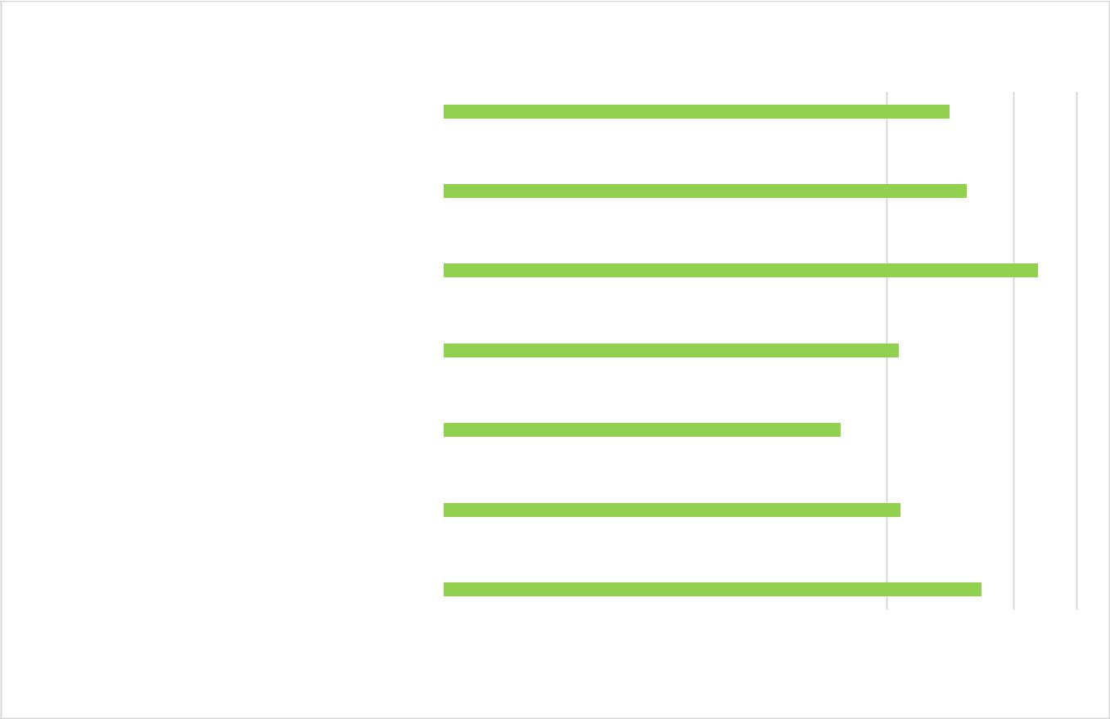

Rank of most distracting noise

Type of Noise

Noise linked to one person in particular |  |  |  |  |  |  |  |  |  |  |  |  |  |  |  |  | 4.00
Noise of people working |  |  |  |  |  |  |  |  |  |  |  |  |  |  |  |  | 4.13
Foot Traffic |  |  |  |  |  |  |  |  |  |  |  |  |  |  |  |  |  | 4.69
Unintelligible Conversation |  |  |  |  |  |  |  |  |  |  |  |  |  |  | 3.59
Intelligible Conversation |  |  |  |  |  |  |  |  |  |  |  |  |  | 3.14
Telephones ringing |  |  |  |  |  |  |  |  |  |  |  |  |  |  | 3.61
Machines running |  |  |  |  |  |  |  |  |  |  |  |  |  |  |  |  | 4.25
0 |  | 0.5 |  | 1 |  | 1.5 |  | 2 |  | 2.5 |  | 3 |  | 3.5 | 4 |  | 4.5 | 5

Ranking of Level of Distraction

*Note that the level of distraction is scored from 1 to 7 with 1 being the highest ranked distractor.

6

PHYSICAL OFFICE LAYOUT

In general, respondents felt that they personally belonged in their workspace and that their work teams belonged in the workspace. However, there were potential problem areas with how respondents choose how many face-to-face interactions they have, how much personal choice they have over their available workspace, and that their workspace may not provide suitable privacy when required. In workspace design these aspects are fairly easily addressed by including a small number of private break away areas. These can be used when people have sensitive telephone calls to make or when privacy is required to focus on a specific solo task.

Table 5. Perceptions of physical office layout

 | Never | Occasionally | Frequently | Often | Always
Feel that they
belong in their | 8.79% | 23.08% | 15.38% | 20.88% | 31.87%
own workspace
Feel that they
belong in the | 7.69% | 17.58% | 21.98% | 18.68% | 34.07%
workspace their
team works in
Feel able to
choose how
much face-to- | 25.27% | 19.78% | 19.78% | 15.38% | 19.78%
face interaction
they have
Feel able to
choose where | 33.71% | 21.35% | 8.99% | 22.47% | 13.48%
they work
Feel they can
complete their | 20.22% | 21.35% | 21.35% | 21.35% | 15.73%
work in
confidentiality
Feel that their
workspace | 14.29% | 27.47% | 18.68% | 19.78% | 19.78%
doesn’t allow for
privacy

7

PHYSICAL HEALTH

Most physical health symptoms were experienced in the neck, shoulders, and upper back. These are indications that there may be issues with the workspace layout (especially in the neck region). In particular, these are indications for office-bound workers who use computers for a significant portion of the day that the computer screen and keyboard may be misaligned. Without doing a physical inspection of the workspace, the most likely issue is that the computer screen (or the desk) is set too high or too low for individual workers. For respondents who are on the phone for a significant portion of the day, this could be an indication that the desk layout is incorrect for this type of work and is another indication in support of providing headsets. It is recommended that a proper ergonomic inspection and fit-out is considered to reduce these complaints which are likely to have serious long term negative health effects on employees if not addressed. Other physical health complaints were of fairly low frequency and should be attended to on an individual basis.
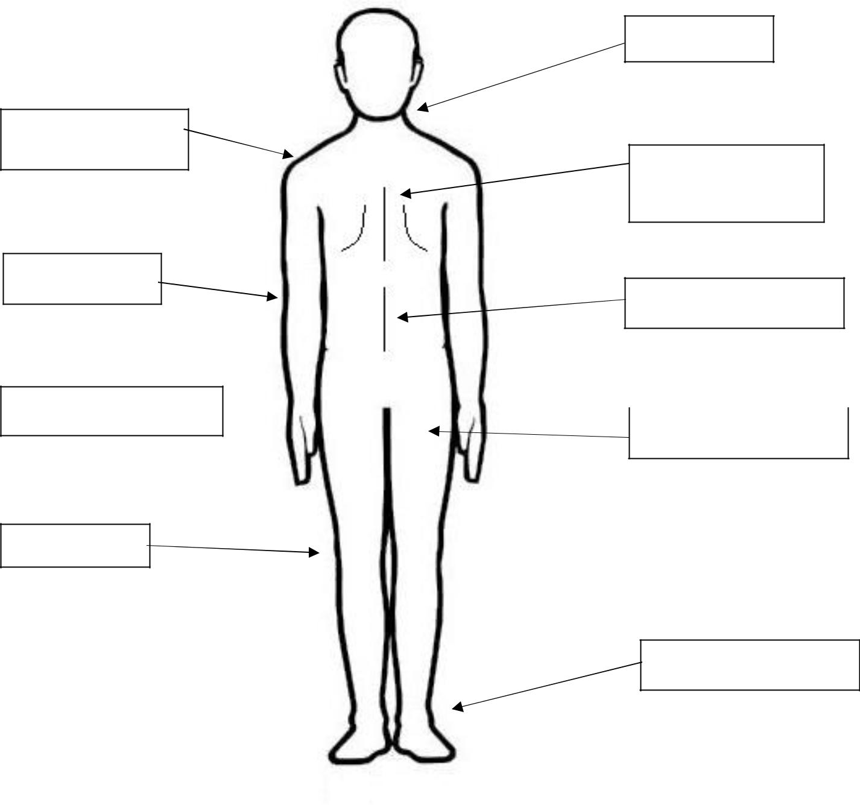

Shoulders =

43.17%

Elbows = 2.90%

Neck = 52.86%

Upper back=

36.23%

Lower back = 11.76%

Hands/Wrists = 13.04% Thighs/Hips = 5.88%

Knees = 0.74%

Ankles/ Feet = 3.68%

8

PSYCHOLOGICAL HEALTH

In general, the perceptions of psychological wellbeing were postive. The only area which was below normal was the ability to feel relaxed. This is unsurprising given normal work demands combined with circumstances beyond the control of the organisation and the workplace.

Table 6. Perceptions of psychological well-being:
 | None of the | Rarely | Some of the | Often | All of the
 | time | Rarely | time | Often | time
Feel optimistic
about the | 5.56% | 8.89% | 28.89% | 31.11% | 25.56%
future
Been feeling | 4.44% | 5.56% | 24.44% | 33.33% | 32.22%
useful
Been feeling | 6.59% | 20.88% | 40.66% | 21.98% | 9.89%
relaxed
Been dealing
with problems | 0.00% | 4.44% | 16.67% | 55.56% | 23.33%
well
Been thinking | 0.00% | 2.20% | 27.47% | 42.86% | 27.47%
clearly
Been feeling | 1.10% | 13.19% | 28.57% | 36.26% | 20.88%
close to others
Been able to
make up their | 0.00% | 2.22% | 21.11% | 44.44% | 32.22%
mind about
things
CONCLUSIONS

The results of the POE survey indicate that the workspace is perceived as efficient by building occupants in Redefine. There were some negative aspects related to noise which can easily be addressed through simple workplace interventions such as headsets and privacy areas. There were also slightly negative perceptions of the temperature. Temperature is much more difficult to control, particularly because of the wide range of individual preferences. It is recommended that a more in-depth investigation is conducted on whether the temperature is too high or too low before interventions are suggested. There was also some evidence that workspace layout needs attention, particularly as this is leading to unusually high levels of discomfort in the neck and shoulder regions. This will lead to work inefficiencies and potentially significant health costs unless addressed.

9

