Team Collaboration during the Concept and Viability Stage of the Development Process

A research paper submitted by
Dewald Veldsman
Student number: 748112
Tel: 076 260 5685
Email: dew.veldsman@gmail.com

Supervisor:
Dr Oluwayomi Babatunde

University of the Witwatersrand, School of Construction Economics
July 2018

Acknowledgement:
I would like to acknowledge my supervisor, Dr Oluwayomi Babatunde, for his invaluable guidance, contribution and patience for which I have an earnest appreciation.

A special thanks to my wife, Birte Veldsman, for her unwavering love and support throughout my studies.

A special thanks to all the individual respondents who took time to participate in the survey and share their knowledge.

Declaration:
I declare that this research report is my own, unaided work. It is being submitted for the MSc. (Building Science and Economics) in Property Development and Management to the University of the Witwatersrand, Johannesburg. It has not been submitted before for any degree or examination on to any other University.
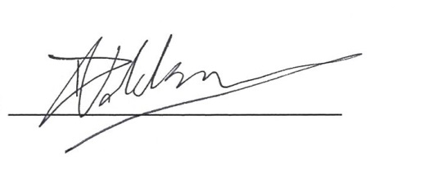

Dewald Veldsman

ABSTRACT
PURPOSE: The purpose of the research is to study team collaboration during the concept and viability stage of the property development process. Most construction project teams comprise participants from different professions that combine to form temporary organisations aimed at achieving the common objective of delivering a project. Available tools can facilitate an environment, conducive to better collaboration and integration of people and processes, which ultimately contributes to better value for the producer. However, the implementation of these tools among the professional team in the Johannesburg context is not well understood.
METHODS: A pragmatic approach was used in this exploratory study. Qualitative and quantitative data were collected through semi-structured interviews. The results were analysed using qualitative content analysis and descriptive statistics using the mean and median.
RESULTS: The qualitative data indicated, across teams, that there is a focus on design related roles and responsibilities and that legislative functions are least fulfilled. Quantitative analysis indicated that teams’ overall implementation of available tools and techniques are relatively low, and knowledge boundaries related to cost domain are most common. Reasons for not implementing proposed collaborative tools and techniques include the lack of skills, not understanding the need for implementation, poor communication, perceived risk and preference. Means to improve the current level of collaboration and integration include; improving the process and implementation, better communication, teamwork and training.
IMPLICATIONS: The lack of collaboration impacts the effectivity of the development process.
CONCLUSIONS: The misalignment between the prescribed and practiced roles and responsibilities suggest that there is a disconnect between the regulative authorities` theoretical understanding of the project design delivery processes and the actual processes. Contractual relations are based on this understanding, resulting in teams where members are driven to achieve individual goals and are not necessarily focusing on creating value for the client. A conscious effort to understand and improve the context in which teams operate is conducive to better collaboration and is essential for an improvement in development design delivery process efficiency. Knowledge boundaries can be bridged through the use of collaborative tools. The study`s appraisal of the level of implementation of digital collaborative tools used by the various team members underlined areas in need of improvement within the Northern Johannesburg context. These include real time project communication, transparent project information, online management services and collaborative cost estimation.
Key words: concept and viability stage, value creation, socio-cognitive theory, project team collaboration, knowledge boundaries

LIST OF ACRONYMS
BIM: Building Information Modelling
CBE: The Council for the Built Environment
CoP: Communities of practice
ECSA: The Engineering Council of South Africa
FTP: File transfer protocol
GPPD: Gauteng’s Provincial Planning Division
JBCC: Joint Building Contract Committee
PRR: Prescribed Roles and Responsibilities
PTT: Proposed Tools and Techniques
SACAP: The South African Council for the Architectural Profession
SACLAP: The South African Council for the Landscape Architectural Profession
SACPCMP: The South African Council for Construction Project Management and Construction Management Professions
SACPVP: The South African Council for the Property Valuers` Profession
SAQSP: The South African Council for the Quantity Surveying Profession
SD: Standard Deviation
SCT: Socio-cognitive theory
TOD: Transit-oriented development
RIBA: Royal Institute of British Architects
URL: Universal resource locator
TABLE OF CONTENT
Acknowledgement: ii
Declaration: iii
ABSTRACT iv
LIST OF ACRONYMS vi
LIST OF TABLES xi
LIST OF FIGURES xii
CHAPTER 1. INTRODUCTION 1
1.1 Background 1
1.2 Problem statement 2
1.3 Problem substantiation 3
1.4 Aim 3
1.5 Research Question 3
1.6 Objectives 4
1.7 Significance 4
1.8 Scope 4
1.9 Assumptions 6
1.10 Ethical Considerations during the Study 7
1.11 Dissertation Structure 7
1.12 Chapter Summary 8
CHAPTER 2. LITERATURE REVIEW 9
2.1 Introduction 9
2.2 Objective of literature review 9
2.3 The concept and viability stage 9
2.4.1 RIBA: 11
2.4.2 South African CBE: 11
2.4.1 Coalitions of participants: 15
2.5 Collaboration and Integration 16
2.5.1 Collaboration within the Development Design Delivery Process 16
2.5.2 Material and Knowledge Boundaries 16
2.5.3 Operationalizing the Boundaries 17
2.5.4 Collaboration technologies 19
2.5.5 Digital collaboration 21
2.6 Building Information Modelling (BIM): 23
2.6.1 BIM as a collaboration tool: 23
2.6.1 Online BIM collaboration: 24
2.7 Management of the Development Process 25
2.7.1 Process improvement 26
2.7.2 System improvement 26
2.7.3 Change management 26
2.7.4 Process management 27
2.7.5 Value management 28
2.8 Chapter Summary 30
3 RESEARCH METHODS 31
3.1 Introduction 31
3.2 Research Philosophy 32
3.3 Research Approach 32
3.4 Research Method and Research Design 32
3.5 Research Strategy 33
3.6 The Research Instrument 34
3.6.1 Background Information 34
3.6.2 Prescribed Roles and Responsibilities 34
3.6.3 Integrational tools and Techniques 35
3.6.4 Open-ended Questions 35
3.7 Population, Sample and sampling method 35
3.8 Data analysis and interpretation 36
3.9 Validity and reliability 36
3.10 Ethics 38
3.11 Chapter summary 38
4 DATA ANALYSIS AND RESULTS 39
4.1 Introduction 39
4.2 Response Rate of Questionnaire 39
4.3 Profile of Respondents 40
4.3.1 Qualifications and Professional registration 40
4.3.2 Years of experience 43
4.3.3 Type of projects, project location and roles on the project 43
4.3.4 Forms of contracts and the perceived effect on concept and viability stage 44
4.3.5 Continual practice development and use of hardware 46
4.4 Prescribed Roles and Responsibilities 46
4.4.1 Client/ Developer Group 47
4.4.2 Architect Group 48
4.4.3 Quantity Surveyor Group 49
4.4.4 Engineer Group 50
4.4.5 Project Manager Group 51
4.4.6 Landscape Architect 52
4.4.7 Comparing Team Member’s Groups 53
4.4.8 Findings on Prescribed Roles and Responsibilities 53
4.5 Implementation of collaborative tools and techniques 54
4.5.1 Client/Developer Group 55
4.5.2 Architect Group 56
4.5.3 Quantity Surveyor Group 57
4.5.4 Engineer Group 58
4.5.5 Project Manager Group 59
4.5.6 Landscape Architect Group 60
4.5.7 Comparing the groups 61
4.5.8 Findings on implemented tools and techniques 63
4.6 Open ended question 63
4.6.1 Current level of integration and collaboration. 65
4.6.2 Reasons for not implementing proposed tools and techniques. 67
4.6.3 Advice on improving collaboration and integration. 68
4.6.4 Synthesis of the findings on open ended questions 69
5 CONCLUSION 70
5.1 Introduction 70
5.2 Achievement of Study Objectives 70
5.3 Conclusion on the overall Research 71
5.4 Implications 71
5.4.1 Theoretical implications 71
5.4.2 Practical/ Managerial implications 72
5.5 Study limitations and areas for further research 72
REFERENCES 73
APPENDIX A: Request for participation in a research project 79
APPENDIX B: Questionnaire 81
Section A: Background 81
Section B: Roles & Responsibility 82
Section C: Tools & Techniques 88
Section D: Open ended Questions 90

LIST OF TABLES
Table 1-1: Summary of roles and deliverables prescribed by South African professional councils……………………………………………………………………13
Table 1-2: Investment in construction-technology tools (McKinsey Global Institute, 2017)……………………………………………………………………………………..19
Table 1-3: Construction-technology use cases (McKinsey Global Institute, 2017)………………………………………………………………………………….….20
Table 2-1: Survey time-line………………………………………………………….…39
Table 4-2: Qualifications and Professional registration.........................................40
Table 4-3: Years of experience.............................................................................41
Table 4-4: Location of experience ….....................................................................42
Table 4-5: Perceived Effect of contract type on Concept and Viability ………......43
Table 5-1: Categories, ratings and ranking of various prescribed roles and responsibilities………………………………………………………………………..…52Table 6-1: A snapshot of the results……………………………………………….…61
Table 7-1: Characteristics of temporary organisations, Livesey (2016) ………….64
Table 8-1: Summary of the problems resulting from the nature of projects, Livesey (2016)…………………………………………………………………………………….66

LIST OF FIGURES

Figure 1 1: Level of Influence on Project Cost (Author, 2017) …………………....5
Figure 1 2: Gauteng`s Economic Activity (Adapted from Afrigis 2017) ………..…5
Figure 1 3: Gauteng City Region Population Density (Stats SA, 2011)…………..6
Figure 2 1: Generic cause-and-effect diagram of design changes (Boon, et al., 2016)……………………………………………………………………………………..26
Figure 2 2: Application of Value Management and Value Engineering in the building procurement process (Bowen, et al., 2010) ……………………………….29
Figure 3 1: The research ‘Onion’ (Adapted from Saunders, et al., 2012) ………..30
Figure 4 1: The Likert Scale Key……………………………………………………...43
Figure 4 2: Implementation of the prescribed roles and responsibilities: client/developer group …………………………………………………………………45
Figure 4 3: Implementation of the prescribed roles and responsibilities: Architect group……………………………………………………………………………………..46
Figure 4 4: Implementation of the prescribed roles and responsibilities: Quantity surveyor group…………………………………………………………………………..47
Figure 4 5: Implementation of the prescribed roles and responsibilities: Engineer group. ……………………………………………………………………………………48
Figure 4 6: Implementation of the prescribed roles and responsibilities: Project manager group ………………………………………………………………………....49
Figure 4 7: Implementation of the prescribed roles and responsibilities: Landscape architect group ………………………………………………………………………….49
Figure 0-8: Average level of implementation per group …………………………....50
Figure 0-9: Implementation of tools and techniques: Client/developer group……53
Figure 0-10: Implementation of tools and techniques: Architect group…………...54
Figure 0-11: Implementation of tools and techniques: Quantity surveyor group……………………………………………………………………………………..55
Figure 0-12: Implementation of tools and techniques: Engineer group…………..56
Figure 0-13: Implementation of tools and techniques: Project manager group….57
Figure 0-14: Implementation of tools and techniques: Landscape architect group……………………………………………………………………………………..58
Figure 0-15: Implementation of tools and techniques: Comparison between the groups……………………………………………………………………………………59
Figure 0-16: Categorising the open-ended responses……………………………..61

INTRODUCTION

Background
Real estate development constitutes one of the largest business enterprises and gross domestic product contributors in the world (Botha et al., 2014). The construction industry is also recognised as a wasteful and high-cost sector, emphasised by the rise of sustainability, the banking crisis and the subsequent recession (Salvatierra-Garrido & Pasquire, 2011). McKinsey Global Institute (2017) affirmed that the industry’s productivity has trailed behind that of other sectors for decades and estimated there is a $1.6 trillion gap. This gap can be filled by increasing productivity in the following areas: regulation, contractual relations, design process, supply chain integration, on-site execution, innovation and the implementation of technology and reskill the workforce. The real estate development processes, presently discernible in South Africa, are also the result of socio-cultural and economic history and a reflection of particular, political thought patterns (Ramabodu et al., 2007).
In a recently released draft proposal, titled “Gauteng Spatial Development Perspective 2030”, local planning authorities argued that gated estates and communities should be eliminated to improve social cohesion. This report, published by Gauteng’s Provincial Planning Division (GPPD), aims to create the basis for a new statutory framework to guide future land use, transport and infrastructure development in the region. The document states that gated estates and communities cause spatial fragmentation, congestion on major arterials, sterilised urban environment and reduced viability of a public transport system, preventing urban compaction. This draft proposal aims to promote high-density residential and mixed-use development around designated public transport nodes and major road corridors referred to as transit-oriented development (TOD).
Graaskamp (1992) states that real estate development processes involve three major groups – a consumer group, a production group and a public group. The production group should ensure the development product fits as closely as possible to the needs of the tenant or purchaser while considering the values of the politically active, collective consumers and the land use or the ethic of society (Graaskamp, 1992). This is difficult to achieve because each group has different value definitions and, subsequently, they have different priorities.
The process of real estate development is, in itself, complex and involves multiple drivers, stakeholders and contributions from many disciplines (Fisher & Collins, 1998). The increasing complexity of construction projects and the fragmentation of the construction industry undertaking those projects have effectively resulted in [non]-linear, uncoordinated and highly variable development processes (Kagioglou et al., 2000). Most importantly, there is close interdependency among different design disciplines during the concept and viability stage. The development team, in the Johannesburg context, typically consists of the developer, quantity surveyor, architect, civil engineer, structural engineer, electrical engineer and landscape architect (Bowen et al., 2010).
Appropriate design process planning and controlling is essential to support downstream processes, especially regarding projects that are fast and complex (Wesz et al., 2013). This is because better integration and collaboration has been identified as key issues necessary to achieve construction performance and improvement (Jørgensen & Emmitt, 2009). On the other hand, collaboration requires an environment that is conducive to developing and nurturing communities of practice conducive to the transfer of knowledge (Ruikar et al., 2009).

Problem Statement
This study intends to address the problem of a lack of tools of collaboration in the concept and viability stage of the development process that cause socio cognitive barriers and reduce effectiveness of the development team (Al Sehaimi et al., 2014; Boon et al., 2016; Forgues et al., 2008; Pikas et al., 2016).

Problem Substantiation
The current level of integration and collaboration of the development team and organisation of work on design practice and processes in the Johannesburg context during the concept and viability stage, are not well known.
A better understanding of the team collaboration during the development process will assist in breaking down socio-cognitive barriers related to mental model fragmentation (Pikas et al., 2016). This may result in overcoming cognitive inertia, a major source of waste (Forgues et al., 2008). Increased efficiency during the concept and viability stage is important due to the relative impact on construction cost over time.

Aim
The purpose of this study is to understand the academic landscape on collaboration in the concept and viability stage of the development process. Additionally, it addresses its characteristics and related tools and concepts for promoting collaboration within the development team and compares it to practice in the Johannesburg context. Therefore, the prescribed roles and responsibilities are interrogated to illustrate an actual process in practice and provide insight towards team members’ perceptions, motivations and barriers. This not only helps to describe the team focus, environment and its conduciveness to collaboration but also highlights the need for various tools of collaboration. Available tools can facilitate an environment which is conducive to better collaboration and integration of people and processes, which ultimately contributes to better value for the producer. However, the implementation of these tools among the professional team in the Johannesburg context is not well understood.

Research Question
Following from the preceding aim, the study aimed at answering the following research questions:
Q1: What is the level of implementation of various project team members’ prescribed roles and responsibilities at the concept and viability stage?
Q2: What is the level of implementation of the available digital tools for integration and collaboration during the concept and viability stage?

Objectives
- To determine the level at which project team members implement their prescribed roles at the concept and viability stages.
- To appraise digital tools of integration and collaboration used by the various team members.

Significance
A survey of coalitions of design professionals, their organisation of work, processes and tools used will assist in the identification of the causes of socio-cognitive barriers (Forgues et al., 2008). This will enhance analysis, planning and management of the underlying generic processes towards facilitating better integration and collaboration (Forgues & Koskela, 2009). Lastly, better integration in the concept and viability stage will increase effectiveness, ultimately contributing to better value for money (Pikas et al., 2015).

Scope
- The study focuses on the concept and viability stage by the development project team. This stage is considered to have a significant impact on the overall cost of the project; however, it is often disregarded (Boon et al., 2016). Figure 1.1 illustrates the impact different work stages have on the project cost.
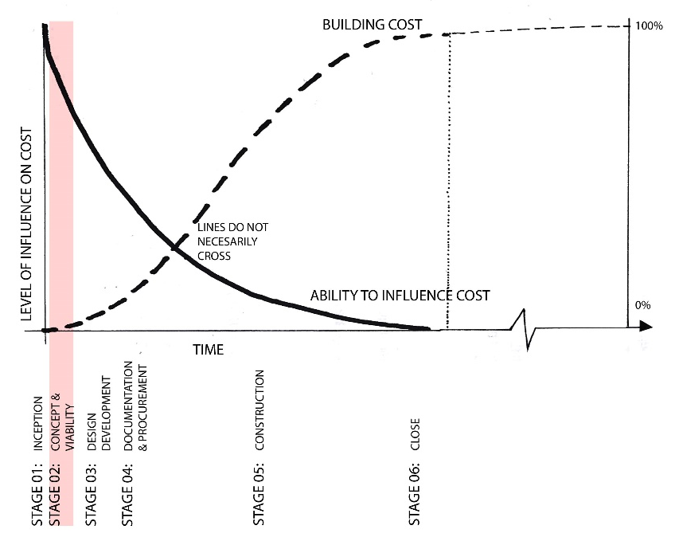
Figure 1-1: Level of Influence on Project Cost (Author, 2017)
- The focus was on project participants based in Northern Johannesburg. This is considered the economic centre of South Africa (National Planning Commision, South African Government, 2011). Figure 1.2 illustrates where recent economic activity is concentrated in relation to the area of focus.
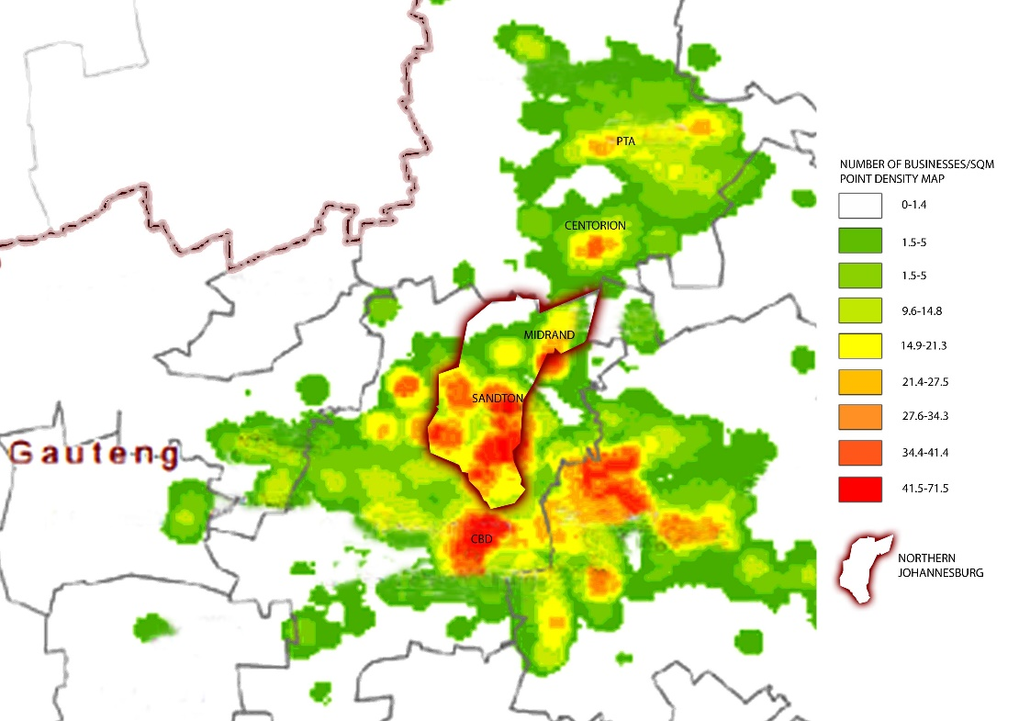
Figure 1-2:Gauteng`s Economic Activity (Adapted from Afrigis 2017)
- The research is confined to high-density private residential projects. High density residential development in this study is considered to be any dwelling typology with more than 50 units per hectare (Stats SA, 2011). Local planning authorities are promoting high-density residential development around designated public transport nodes and major road corridors in this area. The city region population density is presented in Figure 1.3 below.

Figure 1-3: Gauteng City Region Population Density (Stats SA, 2011)

Assumptions
- It is assumed that one of the developer’s most important needs is to maximise value for money (Jallow et al., 2014). The profitability factor is a key indicator of a project’s perceived success (Botha et al., 2014).
- The development project team`s role is to facilitate the developer’s value needs (Bowen et al., 2010). It can be argued that the objective of real estate development is value creation. (Roulac et al., 2006). The original brief, which holds the client’s requirements, is often not carried along throughout the project phases, not updated to reflect changing needs, and not widely distributed and accessed by all team members and stakeholders (Jallow et al., 2014; Livesey, 2016).
- Poor communication among the project team also contributes to inefficiencies during the concept and viability stage. The lack of a common tool is a major problem that hinders the communication of requirements information between stakeholders (Jallow et al., 2014; Pikas et al., 2016). Rizal (2011) affirms that improved collaboration necessitates better communication in the project delivery processes.

Ethical Considerations during the Study
Remaining ethical throughout the process of this research was a formative principle as supported by Alowitz & Toole (2010). Therefore, voluntary consent to participation was imperative to data collection and every effort was made to help protect the privacy of the research participants and ensure confidentiality (Fellows & Liu, 2009). Anonymity of participants was thus central and the supervisor reviewed the research to ensure the participants were protected against any unethical conduct (Saunders et al., 2012).

Dissertation Structure
Chapter one provides background for the research. It also provides a brief description of the research methods. The assumptions of the study and ethical principles on which research was based were also discussed. Chapter two presents the background of the development process, the role players involved and their relationship within the team. Literature regarding related concepts of collaboration was also reviewed. Chapter three explains the research process and design in depth, including the methods used in this study for data collection and analysis. Chapter four presents the results from the questionnaire survey. Conclusions related to the study are presented in this last chapter. Based on this study’s conclusions, recommendations for future studies are underscored.

Chapter Summary
This chapter introduced the complexity of the real estate development process with its multiple team members. The chapter stressed the importance of the impact of the concept and viability stage on value for money and how collaboration within the team increases effectivity in the production process under its scope. It delineates the research to selected coalitions of participants in high density residential projects within the Northern Johannesburg area. The study proposed a review of the prescribed roles and responsibilities to illustrate an actual process in practice, providing insight towards team members’ perceptions, motivations and barriers. These results described the team environment and it`s conduciveness to collaboration. Within this context the implementation of tools of integration and collaboration are established. By doing so, areas that lack implementation designate where social cognitive barriers exist and underline recommended further research. Chapter two will firstly present the review of literature on project processes, participants, and their roles and responsibilities. Secondly, literature on tools and techniques are presented.

LITERATURE REVIEW

Introduction
The basis of the following literature review will be a critical analysis of the extant literature. This is achieved by reviewing literature focusing on the development process with the aim of identifying socio-cognitive barriers to improve project design delivery processes. The majority of the literature used is based on process improvement initiated by the Latham (1994) and Egan (1998) reports.
This chapter commences with making the objective of the literature review explicit; then, it continues to describe the development design delivery process, participants, their relationships and the management thereof.

Objective of Literature Review
The primary objectives of the literature review are to appraise the development design delivery process and understand the context in which collaborative tools and techniques are applied. The study explored various aspects of the development design delivery process in order to describe the context within which these tools and techniques are implemented.

The Concept and Viability Stage
A production system that minimises waste of materials, time, and effort in order to generate the maximum possible amount of value is only possible through the collaboration of all project participants at early stages of the project (Koskela et al., 2002). Different professional bodies have delineated the development process into different stages. The various stages of the development process are specified and the roles and responsibilities are prescribed for the various participants. For example, the Royal Institute of British Architects (RIBA) plan of work specifies the main stages of a project lifecycle as: 0-Strategic Definition, 01-Preparation and brief, 02-Concept design, 03-Developed design, 04-Technical design, 05-Construction, 06-Handover and close-out and 07-In use.
Locally, the South African Council for the Built Environment Act No. 43 of 2000 defines the phases of a development as follows:
Stage 1: Inception
Stage 2: Concept and viability
Stage 3: Design development
Stage 4: Documentation and procurement
Stage 5: Construction
Stage 6: Close
This study is focused on stage 2 because of its considerable impact on value creation.
The construction industry forms a significant part of the economy and is one of the largest and most diverse industries that develop its projects and services through integrated project teams and professionals who may be dispersed over several geographical locations and organisations (Jallow et al., 2014). The process of project development is complex and involves multiple drivers, stakeholders and contributions from many disciplines (Fisher & Collins, 1998). The increasing complexity of construction projects and the fragmentation of the construction industry undertaking those projects have effectively resulted in [non]-linear, uncoordinated and highly variable development processes (Kagioglou et al., 2000)
The commencement of a project is crucial because the decisions made by the client at that point in time, and the resultant initial appointments that are made, have a fundamental impact on how the project team will subsequently be assembled (Al Sehaimi et al., 2014; Wesz et al., 2013). Various procurement strategies implement different forms of contracts and this further prescribes roles and responsibilities. (For example: in the Joint Building Contract Committee (JBCC); there is a Principal Consultant, a Principal Agent and a Project Monitor). One should carefully consider the required roles for each project stage and assess who is best placed to undertake them. These are not necessary assigned to specific types of professionals but rather agreed on in the respective consultant`s agreement. For the purpose of this study, the specific form of contact is not considered.
    - RIBA:
In the United Kingdom seminal work like the Latham Report in 1994, titled “Constructing the Team” and the Egan Report in 1998, titled “Rethinking Construction”, did much to highlight the need for efficiency improvements in construction industry practices. The lack of communication and collaboration has been considered as a major issue for the underperforming construction industry (Pikas et al., 2016). The Latham Report stimulated various initiatives and government action to get the industry to make the necessary changes. Egan was commissioned to look at the construction industry from the clients' perspective and to advise on opportunities to improve the efficiency and quality of the construction industry's service products as well as to make the industry more responsive to its customers’ needs. These seminal studies have served as a justification for further academic investigations and provided a basis for reforms in professional bodies (such as RIBA, RICS, etc.).
The RIBA plan of work (2016) is a document that identifies the following key roles within the project development process: Client Adviser, Project Lead, Design Lead, Construction Lead, Architectural Design, Landscape Design, Structural Design, Building Services Design, Cost Consultancy, Contract Administrator, Information Manager and Health & Safety Consultant. Prescribed services and deliverables are allocated to these roles for each stage of the process.
    - South African CBE:
Similarly, in South Africa, the different professional councils have prescribed standard services and deliverables of various professionals for each stage of the development process. The Council for the Built Environment (CBE) is a statutory body, established under the Council for the Built Environment Act (No. 43 of 2000). It is an overarching body that coordinates the following six Professional Councils of the built environment:
  - The South African Council for the Quantity Surveying Profession (SAQSP) in terms of the Quantity Surveying Profession Act (Act 49 of 2000);
  - The South African Council for the Architectural Profession (SACAP) in terms of the Architectural Profession Act No 44 of 2000;
  - The Engineering Council of South Africa (ECSA) in terms of the Engineering Profession Act (EPA), 46 of 2000;
  - The South African Council for the Landscape Architectural Profession (SACLAP) in terms of Section 2 of the South African Council for the Landscape Architectural Profession Act – Act 45 of 2000;
  - The South African Council for Construction Project Management and Construction Management Professions (SACPCMP) in terms of Act 48 of 2000; and
  - The South African Council for the Property Valuers Profession (SACPVP) in terms of section 2 of The Property Valuers Profession Act, 2000.
These councils have identified work that may only be performed by persons registered in any category of registration recognised by that particular professional council, according to that profession’s act. The Plan of Work provides a model for the design team and a basis for managing the design and administration of the building project. The identified standard services during the Concept and Viability Stage for the various professionals is summarised in the following Table 2.1.

Table 2-1: Summary of roles and deliverables prescribed by South African professional councils
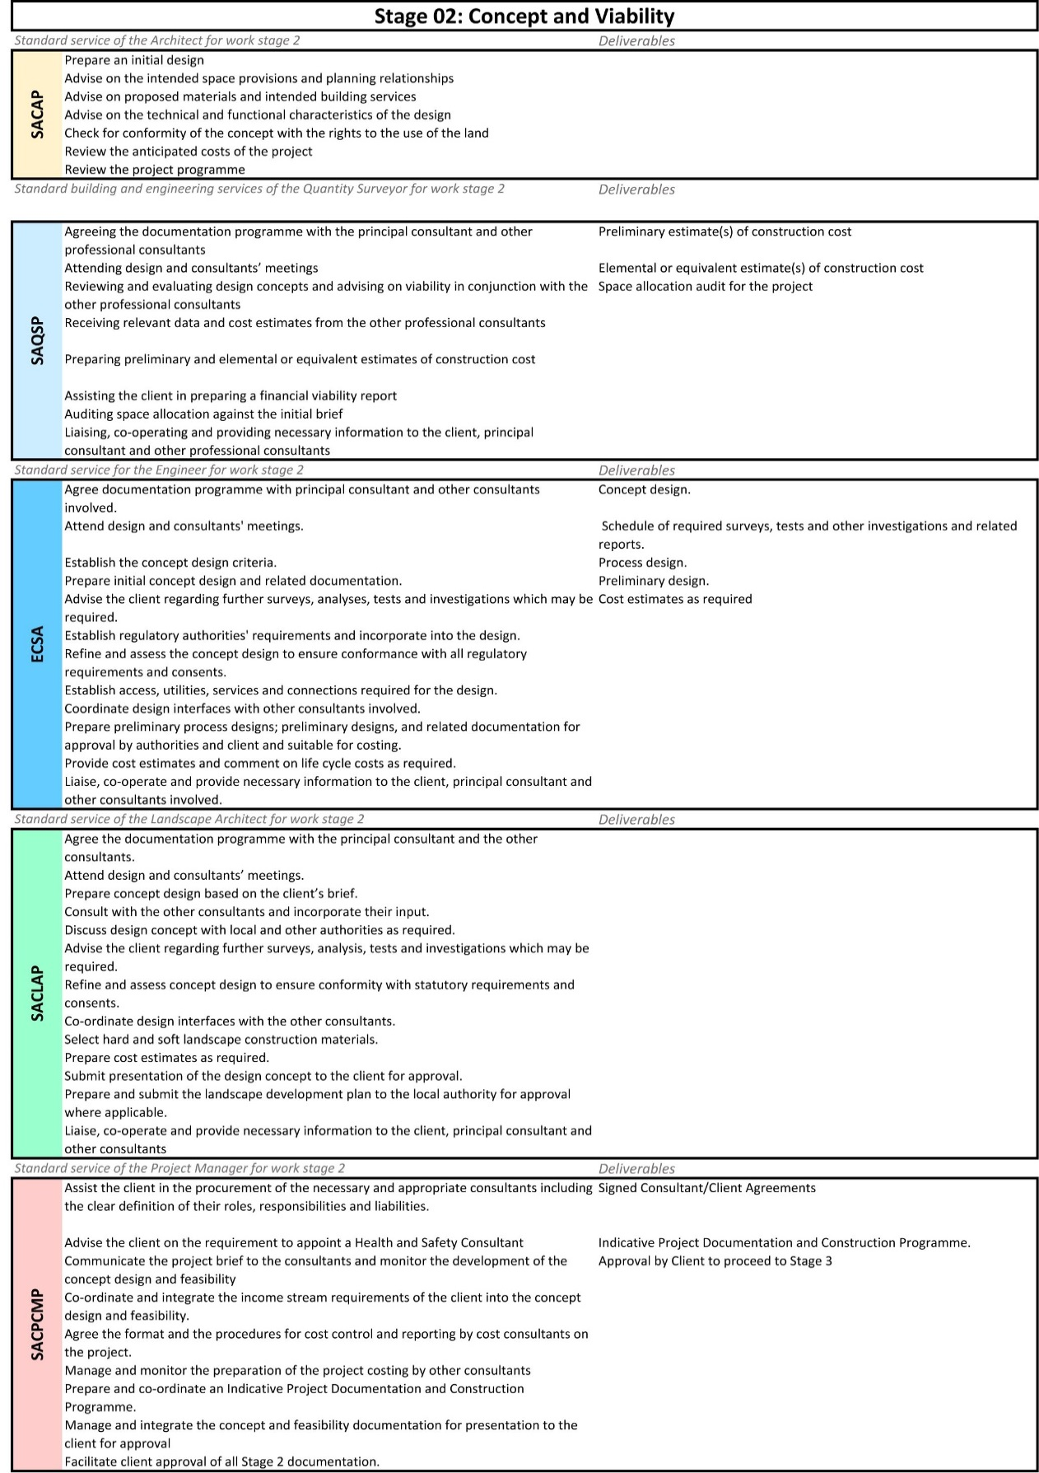
    - Coalitions of Participants:
In practice, project objectives are achieved by coalitions of participants. Socio-cognitive theory (SCT) states that portions of an individual`s knowledge acquisition can be directly related to observing others within the context of social interactions, experiences, and outside media influences (Bandura, 2002). New behaviours can be learnt by replicating the actions of others. It is the collective learning that takes place within the social systems, i.e. communities of practice (CoP) that are of particular significance to an organisation from a knowledge management perspective (Ruikar et al., 2009). A CoP`s ability to communicate effortlessly directly correlates with team integration (Papadonikolaki et al., 2015). Forgues and Koskela (2009) affirmed findings relating to team efficiency in the integration of design and construction processes with the following:
- Efficiency is related to context and not process and socio‐cognitive, not technical processes;
- Fragmented transactional contracting increases socio‐cognitive barriers that hinder integrated team performance;
- New forms of relational contracting may help to mitigate socio‐cognitive barriers and improve integrated design team performance; and
- Changing the context through procurement does not address the problem of obsolete design practices.
As such, various integrational tools help to improve collaboration but need to be implemented in an environment conducive to the transfer of knowledge. However, the key challenge, from an organisational perspective, is to provide an environment that is conducive to developing and nurturing CoP and is conducive to the transfer of knowledge as opposed to merely creating it (Ruikar et al., 2009).

2.5 Collaboration and Integration

2.5.1 Collaboration within the Development Design Delivery Process
Learning new behaviours can be done, for example, through the use of integrational tools and conducive environments favour collaboration. The lack of collaboration has been considered as one major issue for the underperforming construction industry (Egan, 1998; Latham, 1994). According to Pikas et al. (2016), collaboration in design, “…is the process through which actors from different disciplines share their knowledge about the design process and the design itself”.
Pikas et al. (2015) sustain that collaboration is a complex phenomenon, which explains the diversity of views and the many complimentary concepts in organisational and design literature. The boundaries between fields of knowledge (Knowledge boundaries) are, contradictorily, not only a critical challenge but also a perpetual necessity of a development team because much of what members produce and sell has roots in the specialisation of various kinds of knowledge (Forgues & Koskela, 2009). The team members are most often incentivised not to share their specialised information. Knowledge remains a critical but challenging source of competitive advantage for development teams. It is problematic in the sense that knowledge in the development process constitutes both a barrier to and a source of innovation (Carlile, 2004). Collaboration requires the management of material and knowledge boundaries, in order to develop common goals, processes and products (Pikas et al., 2016).

Material and Knowledge Boundaries
Based on the work by Carlile (2004), boundaries can be divided into two ontological realms including material and knowledge boundaries. Material boundaries are caused by the arrangement of individuals into organisations, disciplines, tasks and physical locations. Knowledge boundaries are caused by the paradigmatic differences in sociocultural worlds. These two types of boundaries do not exist separately but are intertwined into the relations of the development team (Pikas et al., 2016).
Carlile (2004) used the following three concepts of knowledge to propose categories of boundaries:
- The difference in the amount and type of knowledge accumulated;
- Dependence between two or more entities that need to take each other into account; and
- The novelty of the circumstances.
Based on these, the following three categories of sharing and assessing knowledge across boundaries have been derived (Carlile, 2004):
- “Syntactic – Differences and dependencies between actors are known. A common vocabulary is developed that is sufficient to share and assess knowledge at a boundary”;
- “Semantic – Novelty generates some differences and dependencies that are unclear - different interpretations exist. Common meanings are developed to create shared meanings and provide an adequate means of sharing and assessing knowledge at a boundary”; and
- “Pragmatic – Novelty generates different interests between actors that impede their ability to share and assess knowledge. Common interests are developed to transform knowledge and provide an adequate means of sharing and assessing knowledge at a boundary.”

Operationalizing the Boundaries
These characteristics of knowledge in practice help to explain how knowledge boundaries can be localised, embedded and invested. Localised knowledge refers to how problems are solved for a given practice. Since different internal teams in a practice are not the same, it complicates communications and efficiency comes from developing knowledge bases that help address the common problems that teams face. This deals with the syntactic boundaries. Secondly, embedded knowledge relates to how it is difficult to express knowledge outside of practice or the implied knowledge area. Different development team members have difficulty communicating outside their disciplines. This is the semantic boundary. Lastly, invested knowledge in practice relates to how people want to do things according to what they already know. However, they are faced with a dependency on knowledge from another group and the novelty of the situation; for success they must be willing to transform their existing knowledge; thus, the pragmatic boundary.
A boundary object is information used in different ways by different communities with enough unchallengeable content to maintain integrity (Bandura, 2002). Boundary objects are used to overcome knowledge boundaries. Carlile (2004) also categorised these boundary objects in the four following types:
  - Repositories are stores of information that have common meaning across functional teams;
  - Standardised forms and methods provide a shared approach for addressing problems across boundaries;
  - Objects or models are detailed representations that different groups can use during problem solving; and
  - Maps of boundaries express the dependencies across groups.
Pikas (2016) explained the characteristics and purpose of the different types further as discussed subsequently. Firstly, repositories comprise of information shared by different people to solve problems. It must be adequately representative among teams to overcome syntactic boundaries. Secondly, standardised forms and methods must express differences and dependencies in order to define a shared approach to a problem. To address communication issues, it represents information in a similar fashion to repositories; however, by identifying the differences and dependencies it also facilitates learning between teams. Transformation of knowledge is, however, required to address these differences and dependencies and the consequences thereof, as typical of the pragmatic boundary. Thirdly and lastly, objects, models and maps are the only types of boundary object that achieve all three purposes. It is a representation supporting communication, the definition of differences and dependencies to facilitate learning, and it provides a process for the mutual transformation of knowledge (Pikas et al., 2016).

Collaboration Technologies
Following from the preceding discussion on the material and knowledge boundaries, the development process could be at the brink of major industry-wide disruption. New applications and tools being introduced are changing how companies design, plan, and execute projects. By providing advanced software and analytics capabilities, these innovative tools are aiming to eliminate many of the problems that have troubled the process, including improved collaboration and the transfer of knowledge (Ruikar et al., 2009). Construction projects are becoming increasingly complex and expensive, putting the development team under greater pressure to improve costs, timelines, and efficiency (Livesey, 2016). In order to manage projects successfully, one should consider utilising the project management tool and technique that match the characteristics of phases and that are signiﬁcant contributors to success measures in each phase of the project life cycle (Patanakul et al., 2010). Representatives of the various enterprises transfer knowledge through shared mental constructs (Forgues et al., 2008). Rizal (2011) affirms that collaboration and communication are keys to better integration of project delivery processes. The lack of sharing of accurate, controllable and integral information among organisations is a major contributor to the industry’s fragmentation (Papadonikolaki et al., 2015). Currently, there are various innovations in collaboration technologies pointing towards creating new product delivery processes and value networks within the construction industry (Rizal, 2011).
Table 2.2 illustrates different tools developed for the various stages of the development process and Table 2.3 indicates which type of tools the market is investing in and developing.

Table 2-2: Construction-technology use cases (McKinsey Global Institute, 2017)
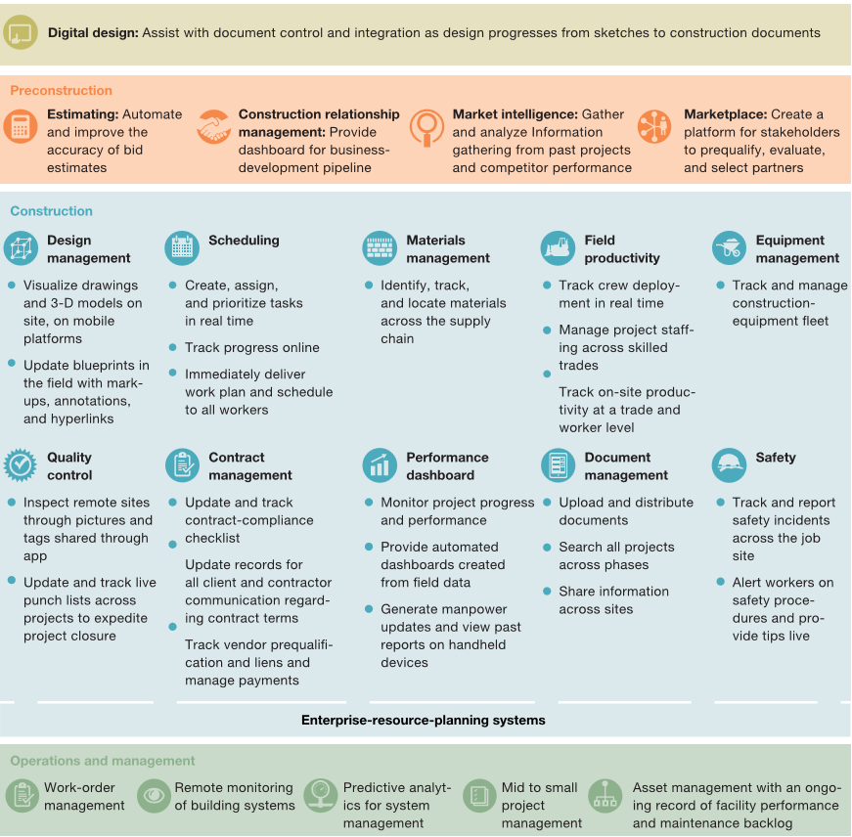

Table 2-3: Investment in construction-technology tools (McKinsey Global Institute, 2017).
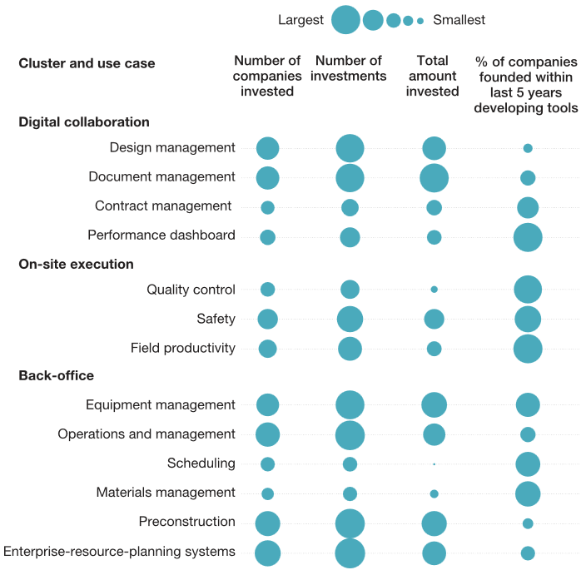

Digital Collaboration
The development project participants in construction projects are more diverse and widely dispersed than those in most other industries (Livesey, 2016). They need to communicate and align frequently, since minor changes could significantly increase the construction program or costs. This contributes to why many construction-technology companies have focused on tools that promote digital collaboration (Blanco et al., 2017). Some of the available tools for collaboration are now discussed subsequently.
2.5.5.1 Online document editing systems: Online document editing systems allow you to create and share work online. You can create spreadsheets, documents, presentations, forms and drawings, save them online and invite others to edit and view them. The team can work on the files simultaneously, view all editing in real-time and use a comments feature for discussion. An example is ‘Google Docs’.
2.5.5.2 Project file sharing platforms: File Transfer Protocol (FTP) sites facilitate the transfer of large files that can be made available online to all project participants by using a project file sharing platform. An example is ‘Dropbox’ or private FTP sites.
2.5.5.3 Online project meetings management services: Online project meeting management service platforms provide online space for meetings, webinars and workshop sessions. These services manage invites, scheduling, registering, screen sharing, file sharing, custom universal resource locators (URLs) and attendee feedback. Examples include ‘GoToMeeting’ or ‘Join. Me’.
2.5.5.4 Web-based phone tools: The geographically distributed teams and the different heterogeneous systems used make the much-needed effective information communication difficult to achieve (Jallow et al., 2014). Web-based phone tools can be used for group video calling, call forwarding, voicemail, instant messaging or file sharing capabilities. Examples include Skype, Yahoo, Viber and Whatsapp
2.5.5.5 Project information distribution and communication: The construction process is known to be information intensive with large amounts of information, such as drawings, specifications and bills of quantities, generated mostly in paper-based form, which are complex to manage (Jallow et al., 2014). Cloud based project information distribution and communication solutions can be organised by project participants and managed by an invitation communication process. An example is ‘SmartBidNet’.
2.5.5.6 Collaborative cost estimation: Web-based cost estimation solutions with real-time collaboration is a type of software that provides editing and sharing capabilities and allows multiple people to work on one file, see each other’s work, exchange instant messages, and produce one complete file. An example is ‘Takeoff’.
2.5.5.7 Quick, real-time project communication: Group messaging services allow one to send group text messages online or from a phone, manage and forward replies and organise contacts into groups to quickly send project updates and broadcasts. These services sometimes connect to online databases of the construction industry which manages and organises profile data, requests information updates and syncs with other solutions to keep information current and available. Users can browse companies, projects and geographic regions and write and read peer reviews of company services. Examples include ‘GroupeMe’ and ‘JobSite123’.
2.5.5.8 RIBA`s “Assembling a Collaborative Project Team” Tool: “Assembling a Collaborative Project Team” has been developed in conjunction with the RIBA Plan of Work 2013. The plan of work (2013) provides more detailed guidance, specific activities and the focused tools that are essential for those responsible for and involved in assembling a project team.

Building Information Modelling (BIM):
BIM is a process involving the generation and management of digital representations of physical and functional characteristics of places (Eastman et al., 2011). Traditional building design was largely reliant upon two-dimensional technical drawings. BIM extends this beyond three dimensions. It augments the three spatial dimensions of length, breadth and width with time and cost as the fourth and fifth dimension. BIM therefore covers more than just geometry. It also covers spatial relationships, light analysis, geographic information, quantities and properties of building components.

2.6.1 BIM as a Collaboration Tool:
BIM not only facilitates better communication and coordination but also calls for reconsidering the roles of procurement participants, re-organising collaborative processes and new contractual relationships (Rizal, 2011). In construction projects, BIM influences the common way of collaboration, including the roles of different participants. Eight concepts influencing the development of BIM collaboration have been identified and classified as: (1) IT capacity; (2) technology management; (3) attitude and behaviour; (4) role-taking; (5) trust; (6) communication; (7) leadership; and (8) learning and experience (Boon, et al., 2016). New procurement modes can transform the dynamics of relationships between the client and the members of the supply chain, and have a positive impact on team performance (Forgues & Koskela, 2009). BIM can facilitate better incorporation of people, processes and technology and, therefore, lead to improvements in processes, technological infrastructure and up-skilling of staff, attaining efficiency and competitive advantages (Arayici et al., 2011).

2.6.1 Online BIM Collaboration:
The introduction of BIM has greatly improved integration of communities; however, it is not yet implemented to its full potential (Rizal, 2011). Rizal (2011) identified the main factors for successful collaboration using BIM as: (1) Product information sharing; (2) Organisational roles synergy; (3) Work processes coordination; (4) Environment for teamwork; and (5) Reference data consolidation. BIM Collaboration was originally developed to allow information sharing within internationally dispersed teams and the dissemination of information by support groups (Eastman et al., 2011). It uses a centralised information integration approach through a shared Web server or a database behind the Web server. BIM is currently the most advanced information system deployed on the Internet (Shen et al., 2008). Cloud-based BIM collaboration services have been introduced to eliminate file exchange issues, send notices and request for information (RFI). It also manages clash detection and performs cost estimations and budgeting on all models, with everyone involved. As a result, project management and BIM systems can communicate directly and connect general contractors and subcontractors through an online platform where changes can be recorded and all files can be stored for central reference. An example of an online BIM collaboration tool is the ‘Horizontal Glue’ programme.

Management of the Development Process
With the available digital collaboration tools and even a robust system like the BIM, managing the development process is still a challenge. Despite its failure to deliver customer value, a single-minded transformation view of operations has been the dominant approach taken in design management and processes, leading to inefficiencies in design practices (Pikas et al., 2015). Forgues and Koskela (2009) argue that construction project management is usually based on conventional project management theory that applies a sequential procedural approach. In such an approach, a project`s success is achieved by following a series of steps and processes for planning, executing and controlling activities and tasks (Kraemer et al., 2004). It is clear from the literature that there is a dispute on the theoretical foundation behind project management bodies of knowledge, their lack of relevance to practice and the poor performance in the context of complex projects or self-managing teams (Al Sehaimi et al., 2014; Forgues et al., 2008; Forgues & Koskela, 2009; Koskela et al., 2007; Pikas et al., 2015; Ruikar et al., 2009). Koskela (2009) has headed the critique and identified some problems with this approach leading to inefficiencies, including the following:
- The lack of iterations in the design process;
- The lack of consideration of constraints within subsequent phases or the unnecessary constraints set in design for these phases;
- The lack of leadership and accountability; and
- The focus on efficiency and not effectiveness.
The industry’s fragmented nature of project development and lack of integration have also been reported to be the main cause of several problems and difficulties, especially with the project delivery systems (Jallow et al., 2014).
These problems lead to sub-optimal solutions, poor constructability and operability, rework in design and construction, and lack of innovation (Koskela et al., 2002). A core issue is that the project management process is deeply embedded in bodies of knowledge, contractual arrangements and legislation that favour a linear and fragmented approach to project delivery (Forgues & Koskela, 2009).

Process Improvement
As a result, two alternative procedural approaches have been identified by Forgues and Koskela (2009), from best practice in manufacturing, including:
- To redefine the design process from sequential to iterative, while maintaining a traditional project lifecycle and procurement modes; and
- Changing the context in which the design is realised, and abandoning fragmented and transactional procurement routes in favour of an integrated and relational procurement approach.

System Improvement
Ruikar et al., (2009) identified a need for better models and theories of practice that take into account the complexity of projects, the recognition of projects as social processes involving CoPs having multiple purposes and a shift of focus from the procedural approach for meeting objectives of cost, time and quality to one seeking value creation through better collaboration. Hence, many construction companies are seeking to improve their design process by using lean production principles. However, appropriate implementation requires that companies achieve basic process stability (Matsumoto, et al., 2005). Such basic stability reduces the variability of the processes, increasing their reliability and the availability of resources, producing systematic and coherent results through time (Salvatierra-Garrido & Pasquire, 2011).
Jørgensen & Emmitt (2009) emphasise the importance of a number of factors for achieving more stability and better integration, including: (1) value identification/specification; (2) an appropriate project delivery framework; (3) structuring and planning of delivery processes; (4) transparency; (5) management and leadership; (6) learning; and (7) the importance of local context.

Change Management
Change brings uncertainty and variability that translates to inefficiency in a production system. Boon (2016) established that design changes are the most significant factor for time delays and cost overruns in construction projects and stresses the importance of communication and management decisions as control mechanisms. Dynamic project management, using simulation and predictive models, improves results by minimising risks and uncertainties. The development team could use these tools to view the impacts of design changes to project performance before actually implementing proposed design changes. Simulated data provide crucial information for facilitating effective decision making by managers as depicted in Figure 2.3.
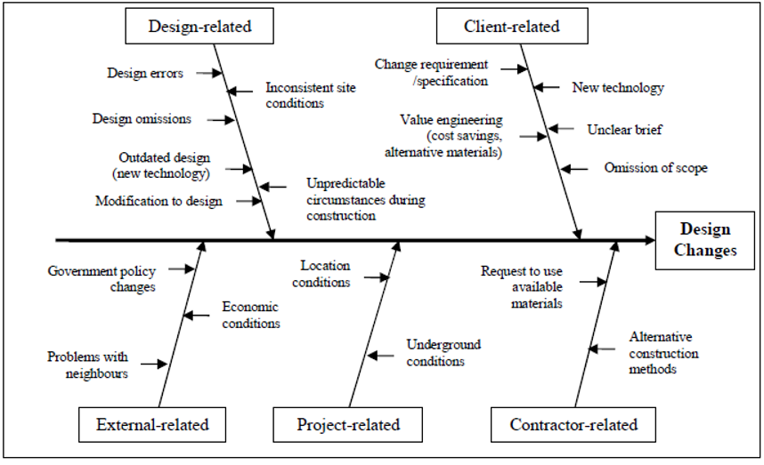
Figure 2-1: Generic cause-and-effect diagram of design changes (Boon, et al., 2016)

Process Management
In addition to process improvement, the phase of the project process determines which project management tools and techniques are appropriate. The characteristics and required deliverables of each phase inﬂuence the activities necessary in the phase; which in turn inﬂuence which project management tool and technique are required (Patanakul et al., 2010).
It is postulated that the underlying fundamentals in all commercial development projects are the same and that one can deduce universally applicable process framework models (Kagioglou et al., 2000). Different process models have been developed by academia and industry to enhance the effectiveness and efficiency of design and construction activities in response to the need for improving value generation (Tzortzopoulos et al., 2005). These models provide an overview and lead to a more holistic understanding of how production works (Matsumoto et al., 2005) and assist in the management thereof (Formoso et al., 2002). A Process Protocol is a conceptual, improved project process which considers the whole lifecycle of a construction project whilst integrating its participants under a common framework (Kagioglou et al., 2000). Examining implementation within company speciﬁc settings is a method to better understand how process models can effectively improve process management. Additionally, a process model could have different roles within a development team: for instance, it could be a learning instrument or the basis for planning process activities (Kagioglou et al., 2000).
Process framework models, like these, work in theory but, unfortunately, the majority fail to be implemented in practice successfully (Tzortzopoulos et al., 2005). Matsumoto et al., (2005) also acknowledges the potential change that process framework modelling can bring to an organisation but also emphasises the importance of successfully implementing these changes. Tzortzopoulos (2005) synthesised the body of knowledge on process framework model implementation around three main issues, including process management, change management and technology transfer.

Value Management
Despite the ongoing efforts by researchers, there is not yet a universal theory of value in construction (Salvatierra-Garrido & Pasquire, 2011). In ‘Lean Thinking’ and for the purpose of this study, value generation is defined as meeting client requirements while minimising waste (Forgues et al., 2008). This study considers value from the production group`s perspective. It is assumed that one of the most important needs of the producer is to maximise value for money. According to Pikas (2015), one of the key ideas of design science is that design inquiry begins with the needs of the client. Thus, the main function of design inquiry is value generation for the client/producer, and construction is the realisation of a proposed solution with the lowest possible loss in value.
When the production philosophy of Lean Thinking was introduced to the construction sector from manufacturing, it necessitated a modification of Lean Thinking`s original value concept. According to Salvatierra-Garrido & Pasquire (2011); Lean construction originally considered value from a specific “objective perspective” and, as a result of earlier studies, focused on the improvement of the production process on site. They did not acknowledge the potential impact the concept and viability stage has on the generation/destruction of value.
Great emphasis has also been given to the added value of real estate in general. However, most current studies on value miss the concept and viability stage when the actual value is created as discussed earlier (Jylhä & Junnila, 2014). Although it can be argued that the objective of real estate development is value creation, there is, paradoxically, little literature about creating value Roulac et al. (2006). The front end of the production phase [the concept and viability stage] has been identified by Roulac et al., (2006) as the phase with the largest impact upon value for the producer.
Value management maximises the functional development from project inception to close-out, through the comparison and audit of all decisions against a value system determined by the client. Value management is an analytical process which seeks to achieve value for money by analysing the functions of a project, involving multiple disciplines and it is not merely a cost cutting exercise (Boon et al., 2016). Value engineering is seen as a sub-set of value management. According to Bowen (2010), value engineering is a “hard systems” approach to cost reduction, carried out during the design phase. On the other hand, value management is seen more as a “soft systems” approach to developing a common understanding of the project/design objectives and their solutions, normally carried out during the project inception or early conceptual design stage. Value engineering relies on the synergetic advantage of probing stakeholder perceptions of these more ﬂuid issues, and is, as a result, applicable throughout almost the entire procurement process as presented in Figure 2.4.
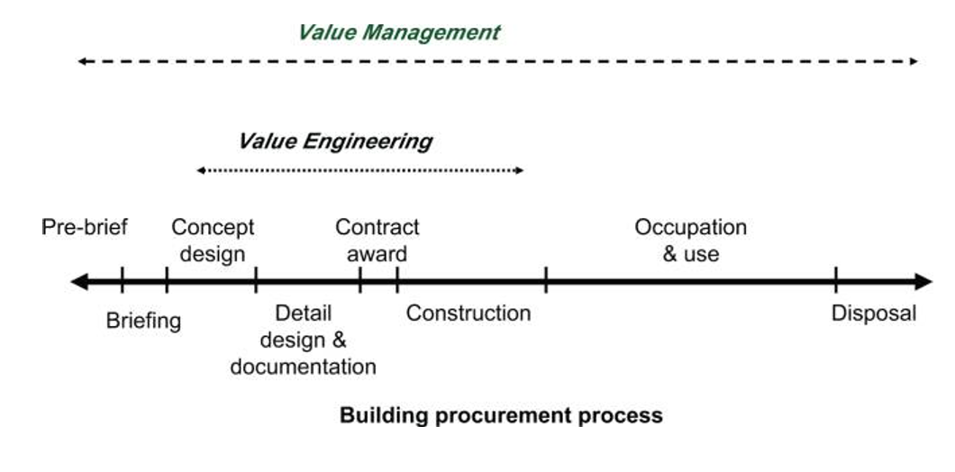
Figure 2-2: Application of Value Management and Value Engineering in the building procurement process (Bowen, et al., 2010)

2.8 Chapter Summary
This chapter reviewed literature on the development design delivery process and its relevant participants. Prescribed roles and responsibilities for each team member were identified during the concept and viability phase and the physiognomies of collaboration were further explored. A better understanding of the nature of boundaries in a team, material and knowledge based boundaries, assisted in explaining current lack of collaboration. Tools and techniques used to facilitate collaboration during the concept and viability phase were identified and explained. This appraisal of the context in which collaborative tools and techniques are applied, enables improved levels of collaboration by better managing material and knowledge boundaries.

RESEARCH METHODS

Introduction
The research was conducted from a pragmatist`s perspective and concepts were considered relevant where they supported action (Creswell, 2009; Fellows R & Liu A, 2009: Saunders et al., 2012). The research question is viewed as the most important determinant of the researcher`s position.
Research Question 01: What is the level of implementation of various project team members’ prescribed roles and responsibilities at the concept and viability stage?
Research Question 02: What is the level of implementation of known digital tools of integration and collaboration in the concept and viability stage?
The respective, prescribed roles and responsibilities were investigated in order to understand the process in practice. Saunders` (2012) ‘Onion’ model was used to illustrate the research decisions highlighted in red in Figure 3.1 and discussed in the sections that follow:
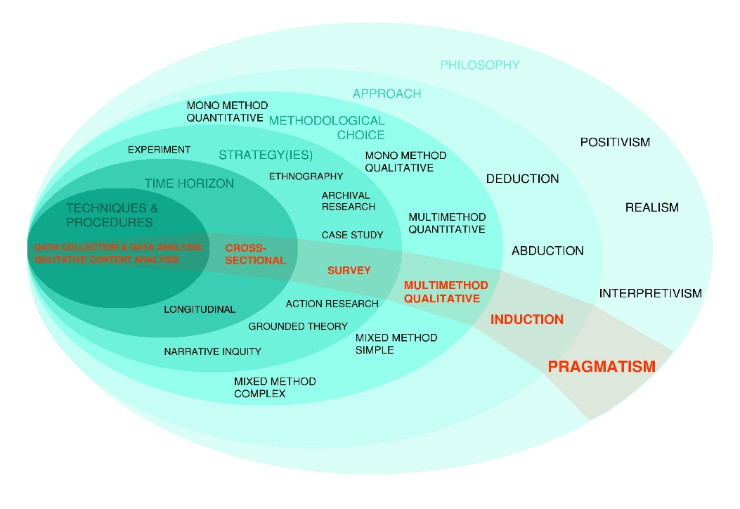
Figure 3-1: The research ‘Onion’ (Adapted from Saunders, et al., 2012)

Research Philosophy
This study makes use of social constructionism to contribute knowledge to the field (Fellows & Liu, 2009). Project teams are considered to be temporary collaborative organisations in which knowledge is commonly socially constructed. The study seeks to understand the subjective reality of team members and their relationships with one another through an interpretive philosophical lens (Kohlbacher, 2006). The complexity of various viewpoints assists in understanding these temporary organisations. A subjectivist mind-set of radical change could describe how the researcher intends to examine and gain a better understanding of the relationships between development team members and subsequent explanations (Saunders et al., 2012).

Research Approach
The main research approach utilised within this study is the collection of data by utilising predetermined, semi-structure questionnaires and interviews. Pikas et al., (2015) and Pikas et al., (2016) used a similar approach to investigate typical design management inefficiencies, possible remedies and collaboration in a small sample set. Kohlbacher (2006) reviews literature on a similar approach and verifies it in his study on the implementation of qualitative content analysis. In this study, inductive inferences are similarly made from a small sample set focussing on the context of the problem.

Research Method and Research Design
The research methodology was based on a mixed method as suggested by Alowitz & Toole (2010). Qualitative interpretation of case studies, surveys and interview methods are suggested by Fellows and Liu (2009) for similar studies. The attainment of context-dependent knowledge necessary for understanding these management approaches and processes is facilitated by a qualitative methodical design (Kohlbacher, 2006). Additionally, this research is exploratory and incorporates a qualitative design to study the context and relationship between team members using a combination of non-standardised and standardised data collection techniques.

Research Strategy
A literature review was conducted and the research strategy in this study was as follows:
Firstly, understanding was sought for discussions on the development process, collaboration in the team and related concepts by means of qualitative research and interpreting various bodies of existing knowledge. These bodies of knowledge included global academic peer reviewed journal articles and conference papers, which are seen as credible sources. Government reports, South African statistics, regulatory prescriptions of various professional councils and local studies on related subject matter also formed part of the limited South African body of knowledge.
Secondly, the study seeks to understand the subjective reality of team members and their relationships with one another through an interpretive philosophical lens. A subjectivist mind-set of radical change could describe the way in which the researcher intended to examine and gain a better understanding of the relationships between development team members and subsequent explanations.
Lastly, a sample of respondents who were in-charge of the development phase of projects was surveyed. A combination of interviews and questionnaires was used to collect the data. Within these questionnaires, Likert scales revealed the significance rating of the prescribed roles and responsibilities. The Likert scales were also implemented to measure the level of implementation of integrational tools during the concept and viability stage. An open-ended section supplied further insight into the topic from the various team members` perspectives. Qualitative content analysis was used to categorise and analyse nonstandard data (Elo et al., 2014). From these qualitative surveys, the level of implementation of integrational tools amongst leading firms in the Northern Johannesburg area was interpreted for where collaboration can be improved. Thus, it formed an important contribution to the South African body of knowledge. The research methodology, in essence, elaborates and expands on the initial research method, which then ultimately results in an Interpretivist research solution (Creswell, 2009).

The Research Instrument
The research was conducted using 25 questionnaires. The purpose of the research was to gain understanding of the relational context of the respondents. Their attitudes and opinions are important and a semi-structured interview process was suitable to allow respondents to build on and explain their answers. According to Teddie & Yu (2007), when using self-selecting sampling, individuals should be allowed to identify their desire to take part in the research. Therefore, the work needed to be publicised to respondents and data was only collected from those who responded positively to the request.

3.6.1 Background Information
The survey kicked off with an introduction and information in a letter (sample attached in annexure A) with regard to the research study. This was followed by the questionnaire (sample attached in annexure B). Section A of the questionnaire addressed all relevant background information. Emphasis was placed on background and professional context as this study focussed on qualitative information of the relationships between team members (Kohlbacher, 2006; Pikas et al., 2015). The questions revolved around the demographics of the respondents and included: the professional qualifications; professional registration; duration of experience; type of project experience; location of projects; forms of contract and its perceived effect on the concept and viability stage; type of seminars, lectures or conferences attended; and whether the respondents utilise hardware needed for the list of identified tools.

3.6.2 Prescribed Roles and Responsibilities
Section B of the questionnaire consisted of a list of roles and responsibilities prescribed by the relevant regulatory councils. This section aimed to achieve the study’s first objective and determine the level at which project team members implement their prescribed roles at the concept and viability stage. The frequency of fulfilment is indicated by means of a Likert scale from 1(never) to 10(always). Each type of team member has their own specific prescribed list compiled out of all their council`s prescriptions for the South African Construction Built Environment. A list of roles and responsibilities was also inferred out of these prescriptions for the Client/Developer.

3.6.3 Integrational Tools and Techniques
Section C appraised the digital tools of integration and collaboration used by the various team members. It implements a list of relatively new cloud-based software tools and the frequency of use indicated by means of a Likert scale. It aimed to appraise collaboration through the level of implementation of these tools by the various team members in high-density private residential developments.

3.6.4 Open-ended Questions
Section D consists of open ended questions and the respondents are to elaborate on the topic, providing further in-depth insight from various perspectives on this topic. The researcher provided respondents the option to participate in an additional interview that provided the opportunity to elaborate and explain their individual perspectives of the topic and related concepts.

Population, Sample and Sampling Method
A list of respondents was identified by contacting various professional practices involved in high density residential projects in the study area. The research objectives were publicised to the possible respondents in an email and a follow up telephone call. Appointments were made to conduct face to face, semi-structured interviews with respondents who provided positive responses to the request to participate. Alternatively, the respondents returned their replies via e-mail according to their preference. Consent was affirmed on paper before any interview commenced. A list of conversational themes was compiled that introduced the open questions in the questionnaire. Interviews were transcribed and respondents’ organisations and projects shall remain anonymous.
A small sample of team members was used due to practical, budget and time constraints. Access was difficult to obtain but once achieved the cases were easily identified. A non-probable, self-selecting, volunteering technique was implemented amongst development team members of high-density private residential developments based in Northern Johannesburg (Creswell, 2009). Team members consisted of developers, quantity surveyors, architects, project managers, engineers and landscape architects.

Data Analysis and Interpretation
The data received was well grouped with few outliers; hence the mean was used as a central tendency measure to condense data sets to single representative values, facilitating comparison between sets.
Qualitative content analysis was also used to analyse and categorise results. The study is qualitative and exploratory and no statistical inferences were made from the data and the sample was not able to proportionally represent the population. Qualitative content analysis was used to analyse and categorise non- standardised responses. Qualitative data collection and analysis is interrelated and interactive in nature (Elo et al., 2014). The interpretation and analysis of data happened simultaneously to the collection and interview process. The data was based on meanings expressed in words and analysis conducted through conceptualisation. The collection of data resulted in non-standardised data classification categories. The data was verified by the researcher and qualitative content analysis was used to sort and analyse it by category (Kohlbacher, 2006).

Validity and Reliability
- Reliability: According to Nahid (2003) reliability of qualitative studies refers to (1) the degree to which a measurement, given repeatedly, remains the same; (2) the stability of a measurement over time; and (3) the similarity of measurements within a given time period. The interviews should be conducted in such a manner that alternative researchers would reveal similar information in similar time periods. Noble & Smith (2015) argues that qualitative research is frequently criticised for lacking scientific rigour with poor justification of the methods adopted, lack of transparency in the analytical procedures and the findings being merely a collection of personal opinions subject to researcher bias. Demonstrating scientific rigor is thus essential to achieve reliability.
- Forms of bias: According to Saunders, et al., (2012) there are three types of potential bias that one should avoid. They include; (1) interviewer bias; (2) interviewee/response bias, and (3) participation bias. Firstly, Interviewer bias could be caused by enforcing your own beliefs and frame of reference by any means throughout the process of data collection. Secondly, interviewee bias can be as a result of perceptions formed around the interviewer. Structured interviews can be intrusive towards sensitive areas. As such, the interview should be structured in such a way that participants can choose not to respond to any of the questions if they feel uncomfortable about the nature of the question. Lastly, participation bias should be avoided by considering the nature of people and organisations willing to participate carefully.
- Generalizability: The extent to which findings are applicable to other settings should be considered. The theoretical propositions will be compared to the interviews and it is argued that it should contribute to a broader theoretical significance by investigating a new context (Saunders, et al., 2012). This relationship will allow the study to test the applicability of existing theory to the setting.
- Validity: Nahid (2003) states that, in qualitative research, validity determines whether the research truly measures that which it intended to measure or how truthful the research results are. It is achieved when the research question is successfully answered by the research instrument and the extent to which the researcher has gained access to participants’ knowledge and experience. Researchers generally determine validity by asking a series of questions, and will often look for the answers in the research of others (Nahid, 2003). A high level of validity can be achieved through carefully structured questions where the scope is clear; meanings can be probed and responses can be explored through a variety of angles (Saunders, Et al., 2012).

Ethics
Objectivity, confidentiality and anonymity were maintained to ensure that any possible harm to anyone was avoided. According to Creswell`s (2009) recommendations, the following steps were taken. Sufficient knowledge of the potential team members’ organisations and their contexts were obtained prior to consideration. The researcher presented himself formally and interviews were conducted in either the researcher`s or respondent’s boardroom depending on the respondent`s preference. The respondents were provided with enough information about the study, in a formal letter requesting participation, before consenting to participate. The letter summarised the research problem, objectives and relevance briefly. Careful consideration was given to the nature of the opening comments, the approach to questions and the nature of questions in the survey. The researcher conducted himself in a professional manner and displayed attentive listening skills by summarising and testing respondents’ understanding.

Chapter Summary
This chapter explained the methodological decisions made in conducting this study. A pragmatic philosophical lens was applied on an inductive approach. The use of a qualitative multi-method in a cross-sectional survey was implemented. Qualitative content analysis was chosen to categorise and analyse the responses further. Descriptive statistics were chosen to analyse the data obtained through the Likert scale questions.

DATA ANALYSIS AND RESULTS

Introduction
In this chapter, results from the survey are presented. The results include central tendency scores on the prescribed roles and responsibilities as well as the implementation of digital tools and techniques. The last section categorises responses from the open-ended questions by means of qualitative content analysis.

Response Rate of the Questionnaire
A questionnaire survey was launched in July 2017 after ethical clearance was obtained from the School of Construction Economics & Management at Wits. In total, 54 participants were sent invitations via e-mail with a target of at least a 50% valid response rate.
A valid response is one that adheres to all of the following:
- The respondents must have given approved consent that their data may be utilised for the purpose of this study;
- The respondents must have answered all the critical questions to fulfil the objectives of the study;
- The respondents must have participated in the concept and viability stage of a project, which also forms the sampling criteria; and
- The projects they were invested in should be high density residential projects in the Johannesburg context.
After the first month of launching the questionnaire, only nine valid responses were received, which was lower than the required 50% response rate. A reminder was then sent out to all potential respondents in an attempt to increase the response rate and generalizability of this study. Two weeks after the first reminder e-mail was sent, an additional 12 valid responses were received which brought the total number of valid responses to 21. A second and final reminder was then sent out on the same day. On 31 August 2017, an additional six valid responses were received which brought the total number of valid responses up to 27 and the survey was officially closed. There were thus 27 valid responses (out of the 54 target respondents) received in total which yields a 50.0% response rate after eight weeks of survey as presented in Table 4.1.
Table4-1: Survey time-line
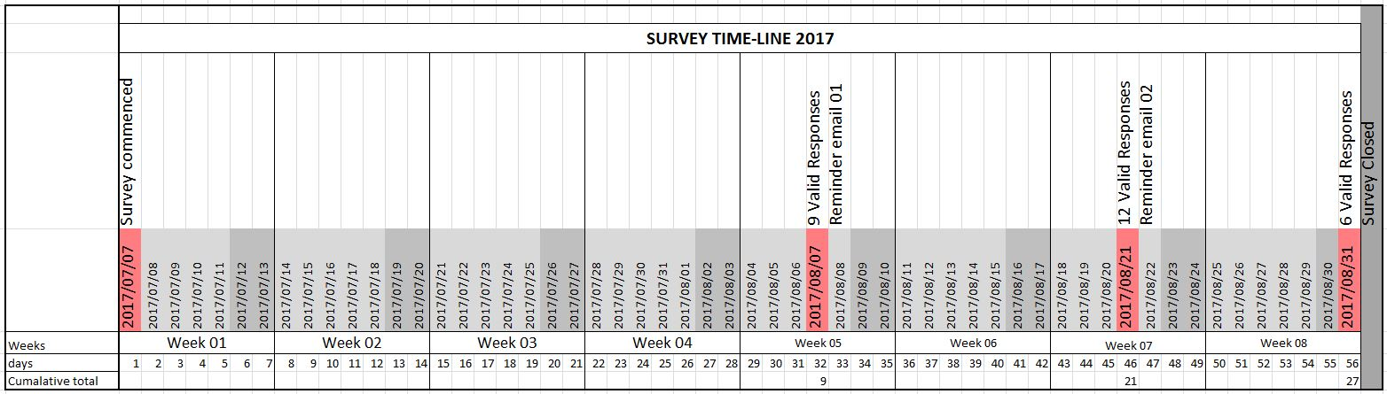

Profile of Respondents
Based on the data obtained from Section A in the questionnaire, the following results were observed:
    - Qualifications and Professional Registration
All consultant respondents had tertiary qualifications related to their specific disciplines and were all registered with their professional councils as presented in table 4.2. Some of the client/developer group had a financial and/or a construction background; while, 75% of developers had obtained multiple tertiary qualifications.

Table 4 .2: Qualifications and professional registration

Years of Experience
The mean and median for the years of experience for all respondents 16 years and 17 years respectively. The respective mean and median years of experience for the various groups are as presented in table 4.3:
Table 4 .3: Years of experience
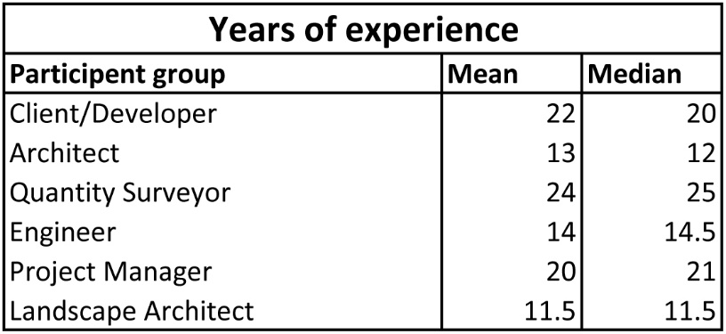

Type of Projects, Project Location and Roles on the Project
72% of respondents have experience in more than one African country and all respondents have worked on high-density residential projects in the Northern Johannesburg area as presented in Table 4.4. High-density residential development in this study is considered to be any dwelling typology with more than 50 units per hectare.

Table 4 .4: Location of experience
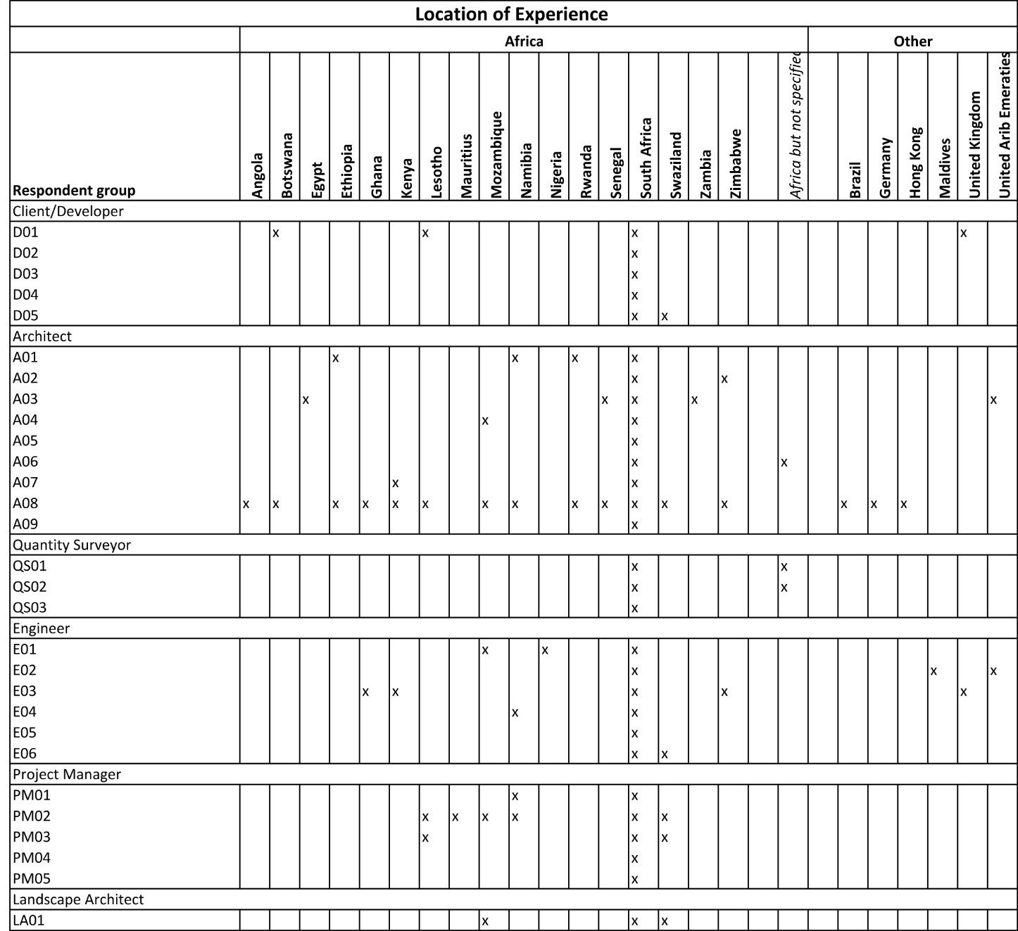

Forms of Contracts and the Perceived Effect on Concept and Viability Stage
The type of contract is unanimously perceived to almost have no impact on the concept and viability stage as presented in Table 4.5. The main construction forms of contracts, used predominantly, consist of the JBCC and FIDIC agreement. The PROCSA agreement was preferred for the professional service agreement.

Table 4 .5: Perceived effect of contract type on concept and viability

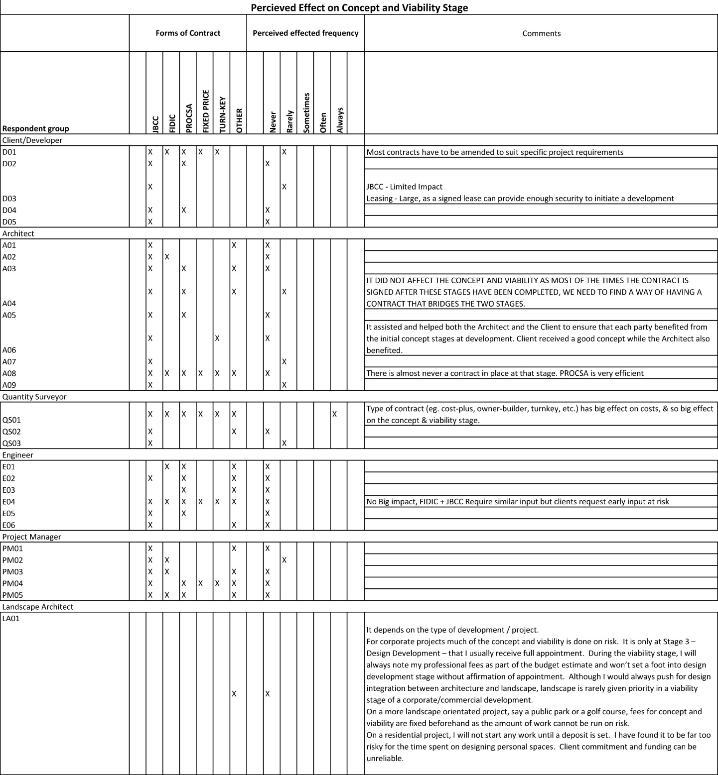

Continual Practice Development and Use of Hardware
The majority of respondents [96%] attend some form of continual practice development like professional seminars related to their specific expertise and all use work based devices like cell phones and laptops daily.

Prescribed Roles and Responsibilities
Based on Section B of the survey questionnaire, the study used the Prescribed Roles and Responsibilities (PRR) to define the actual concept and viability stage to determine the relevance and focus in practice within the Northern Johannesburg context. The study`s first objective is to determine the level at which project team members’ implement their prescribed roles at the concept and viability stage. Following a study of Kohlbacher (2006), the process and context to be interrelated were simultaneously investigated. The central tendency measures were used to indicate the significance of the various roles and responsibilities. The roles and responsibilities were then ranked for each group according to the level and frequency of fulfilment and then compared across the team according to category.
The Likert scale rating has been visually represented by a coloured circle corresponding to its correlating numeric value as per Figure 4.1. The size and colour of the circle changes from a small red circle, representing ‘never fulfilled’, to a large, dark green circle representing ‘always fulfilled’.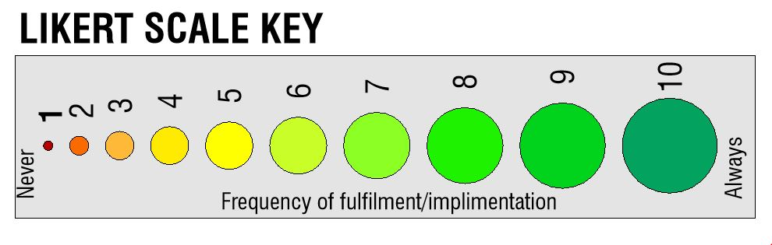
Figure 4-1: The Likert Scale KeyThe data is sorted by type of team-member (i.e., consultant/respondent group member) and arranged in separate tables for each type group of participants as presented in Figure 4-2 to Figure 4-7. The individual respondents are arranged per group on the far right-hand side vertical axis and the group specific roles are arranged along the horizontal axis as per Figure 4.2. The grey column on the far right-hand side of the table provides the individual respondent`s mean rating and the grey row at the bottom of the table provides the mean rating of the individual roles and responsibilities. The roles and responsibilities and group members are ranked in descending order of their mean rating. The overall mean and median ratings for the group are in the bottom right corner. By presenting the data in this visual format one can easily compare different respondent’s ratings of the prescribed roles and responsibilities and also compare different types of groups and their perceived level of fulfilment of their prescribed duties.
    - Client/Developer Group
The Client/Developer group’s perceived focus is on their design related roles and responsibilities and they are perceived to be least focused on their legislative functions. This group seems confident that they are achieving high levels of fulfilment of their roles and responsibilities with an overall mean score of 7.54 and a group median score of 7.8 as presented in Figure 4.2. This perception could be related to their autonomy in the process, having the most financial interest in the project and the responsibility of remunerating the rest of the team.
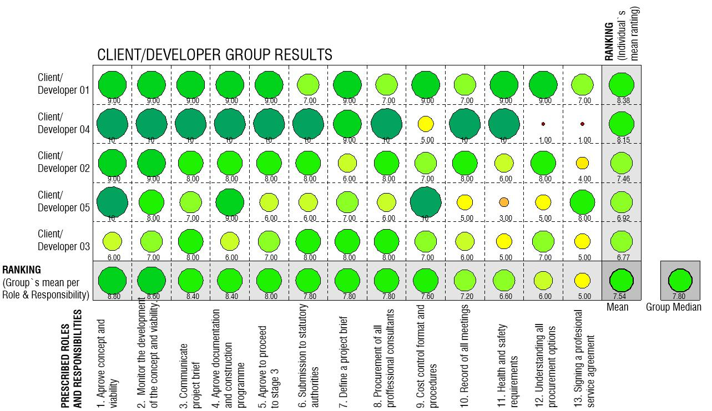
Figure 4-2: Implementation of the prescribed roles and responsibilities: client/developer group

Architect Group
The Architect Group’s perceived focus is on the design related tasks. The Architect group rates their legislative tasks as low but considers their responsibility to review the project programme as their least realised. Their overall rating of fulfilment of all their roles and responsibilities has a mean score of 5.79 and a group median score of 5.61 as presented in Figure 4.3.
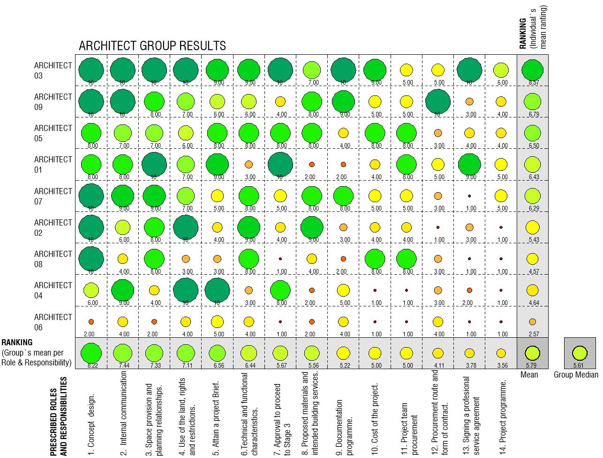
Figure 4-3: Implementation of the prescribed roles and responsibilities: Architect group

Quantity Surveyor Group
The Quantity Surveyor Group perception is that they always fulfil all their functions relating to cost and the administration as presented in Figure 4.4. Assisting the client in preparing a financial viability report is the only cost related function not achieving a maximum rating, having a score of 7.67. The design and legislative functions are considered to be their least attained functions. The group’s overall perception of their level of fulfilment is high, with a mean score of 8.03 and a group median score of 9.17 as depicted in Figure 4.4.
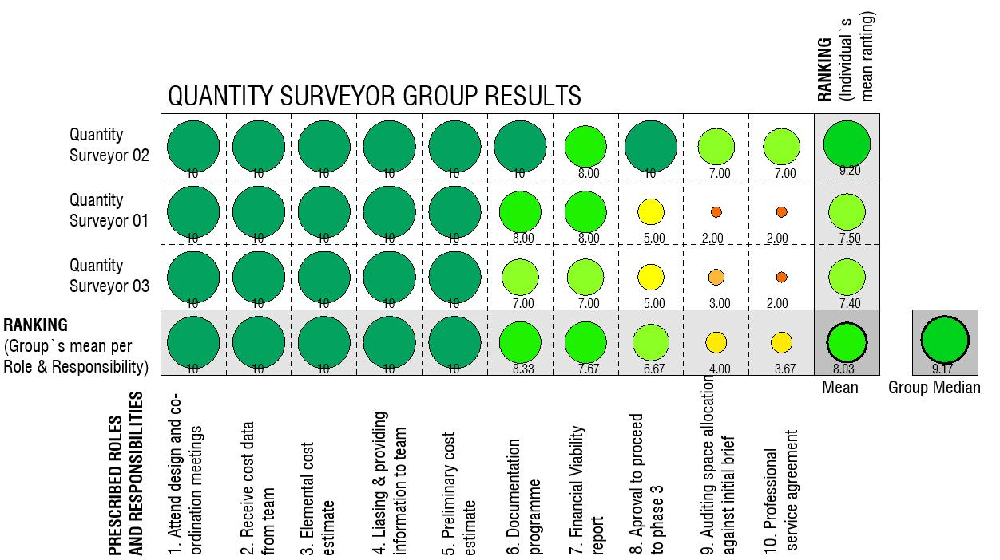

Figure 4-4: Implementation of the prescribed roles and responsibilities: Quantity surveyor groupEngineer Group
The Engineer Group’s perceived focus is high on their design related functions but, contradicting this view, their responsibility to coordinate design interfaces with other consultants involved, is viewed as one of their least accomplished functions as presented in Figure 4.5. This raises the question as to whether this group views their design responsibilities as an isolated function divorced from the rest of the team. Establishing access, utilities, services and connections required for the design and a documentation programme are viewed as low levels of attainment but “documentation programme” is the lowest with a value of 6.67. This group’s overall rating of fulfilment of their roles and responsibilities is the highest with a mean score of 8.74 and a group median score of 8.58.
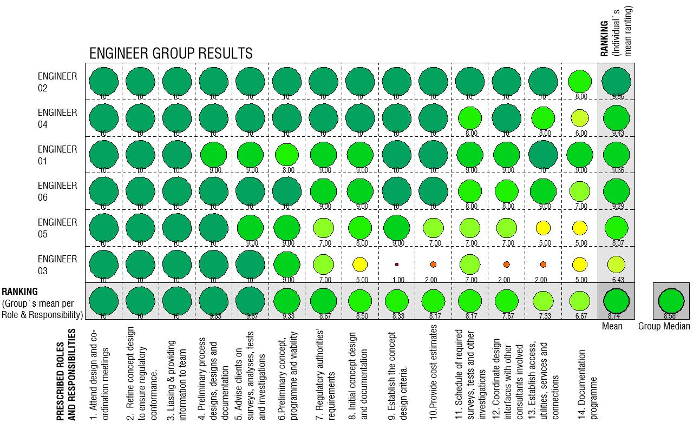
Figure 4-5: Implementation of the prescribed roles and responsibilities: Engineer group

Project Manager Group
The Project Manager Group ranked their responsibility to prepare and co-ordinate indicative documentation and construction programmes as the most fulfilled of their functions and the co-ordination and integration of the client`s income stream requirements as their least fulfilled, as presented in Figure 4.6. This group has a low overall rating with a mean score of 5.97 and a group median score of 5.33.
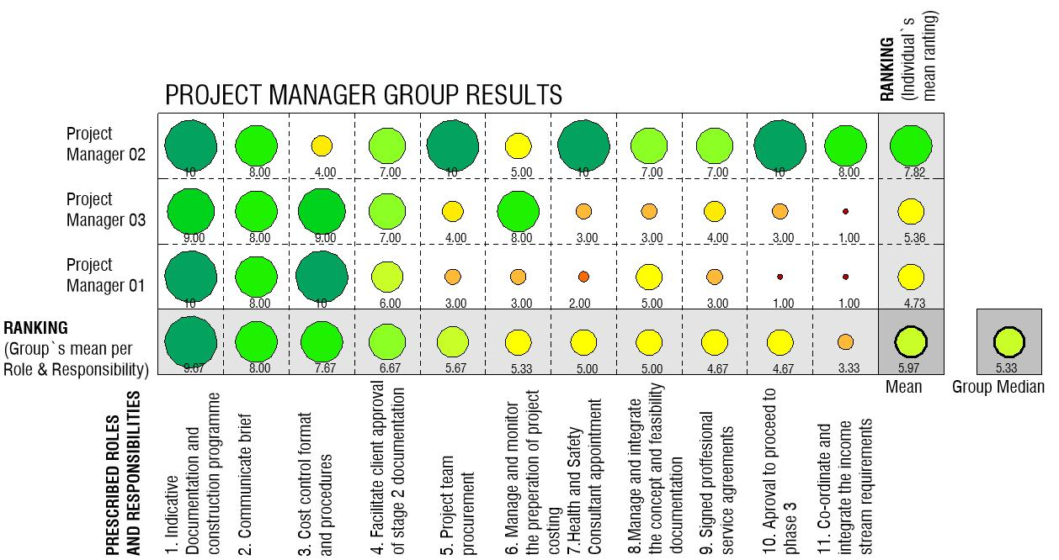
Figure 4-6: Implementation of the prescribed roles and responsibilities: Project manager group

Landscape Architect
The Landscape Architect Group’s perceived focus is on presenting a design concept for approval and providing a cost estimate as presented in Figure 4.7. Their least realised function is selecting hard and soft landscape construction materials. Their overall mean and median scores are 7.34 and 8.50 respectively.

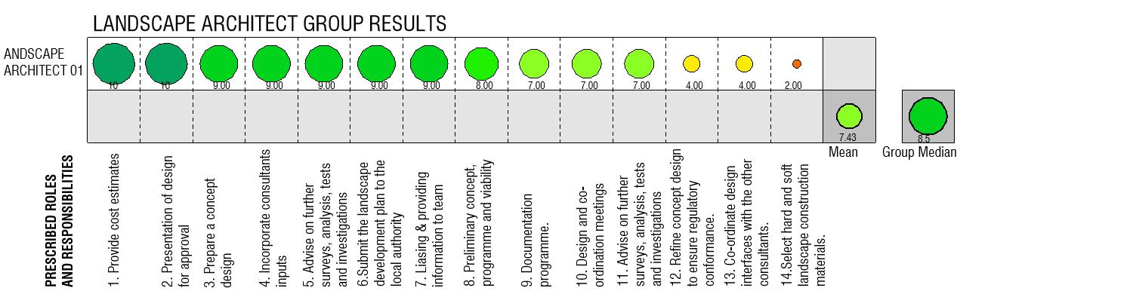
Figure 4-7: Implementation of the prescribed roles and responsibilities: Landscape architect group

Comparing Team Member’s Groups
Figure 4.8 indicates the measures of central tendency of the perceived level of fulfilment of various roles and responsibilities of the different groups below. The Engineer Group has the highest rating and the Architect Group has the lowest.
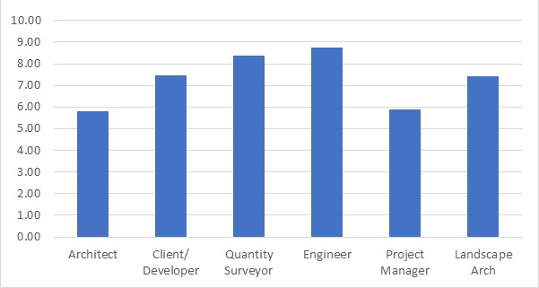
Figure 4-8: Average level of implementation per group
Qualitative content analysis was then applied to categorise, rate and rank the various prescribed roles and responsibilities in Table 4.5

Findings on Prescribed Roles and Responsibilities
Through qualitative content analysis of the mean measure of central tendency, the study found that the type of functions with the highest level of fulfilment are design related and the type of functions with the lowest level of fulfilment are contractual and regulation. This correlates with the theory stating that the biggest determinant of value generation is the development of the design concept and that the prescribed contractual relationship discernible during this stage is not conducive to team work opposing value creation (Egan, 1998; Latham, 1994; Jylhä & Junnila, 2014;Roulac et al., 2006).

Table 4-5: Categories, ratings and ranking of various prescribed roles and responsibilities

Implementation of Collaborative Tools and Techniques
Based on Section C of the questionnaire, this study reviewed the level of implementation of collaborative tools and techniques during the concept and viability stage of the process in the Northern Johannesburg context. The study`s second objective is to appraise digital tools of integration and collaboration used by the various team members. This study implemented the Likert scale in a similar way to the previous section and the central tendency measures indicate the level at which these tools are implemented per group. The same 10 collaborative tools and techniques were ranked for each group according to the level of implementation and then compared across the team members. These tools are colour coded according to the overall level of implementation at the end of this section. These colours assist one when comparing rankings across groups. The last table in this section compares the level of implementation of each collaborative tools and techniques across the various groups to construct overall scores for the team.

Client/Developer Group
Meeting management software, File transfer protocols and web based phone tools are the only functions implemented regularly by this group as presented in Figure 4.9. There is some degree of implementation of the rest of the functions available, nonetheless, cloud-based meeting management software is implemented the least. The group`s overall rating is low with a mean score of 4.05 and median score of 3.5.

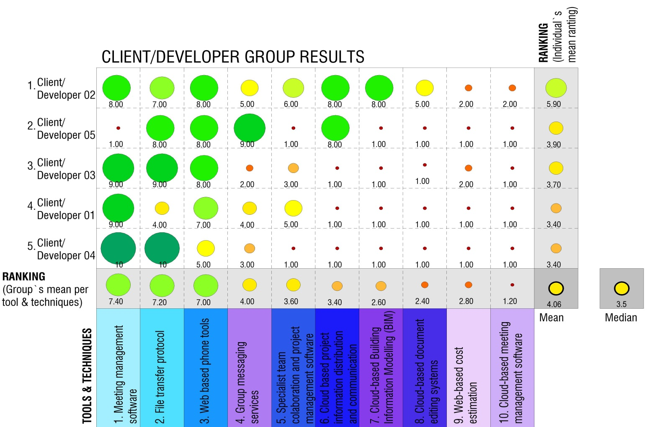
Figure 4-9: Implementation of tools and techniques: Client/developer group

Architect Group
Meeting management software, File transfer protocols and web based phone tools are also the only functions implemented regularly by this group as presented in Figure 4-10. There is some degree of implementation of the rest of the functions available, with Web-based cost estimation being the least implemented. The group`s overall rating is low with a mean score of 4.04 and median score of 3.9.
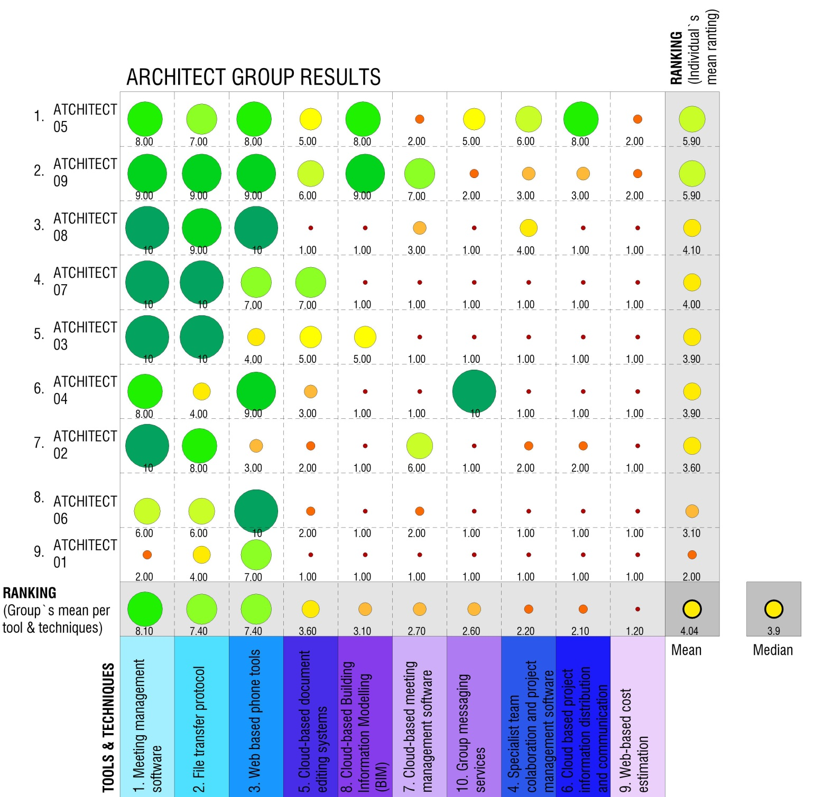
Figure 4-10: Implementation of tools and techniques: Architect group

Quantity Surveyor Group
Meeting management software, File transfer protocols and web based phone tools are the only functions implemented regularly by this group as presented in Figure 4.11. There is some degree of implementation of Specialist team collaboration and project management software but no implementation of the rest of the functions. The group`s overall rating has a mean score of 3.73 and median score of 1.0.
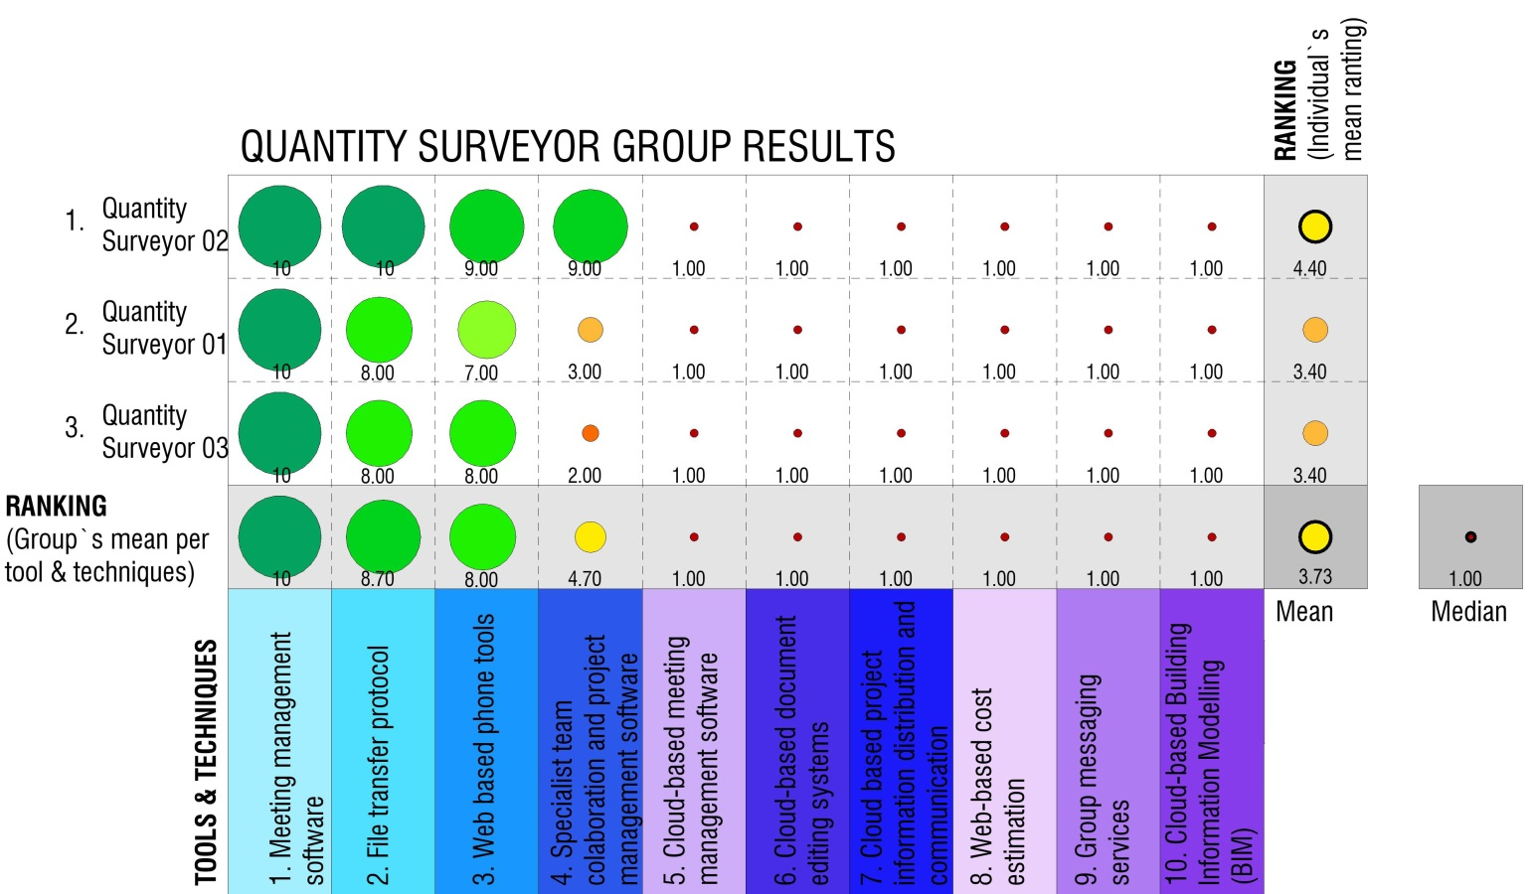
Figure 4-11: Implementation of tools and techniques: Quantity surveyor group

Engineer Group
Meeting management software, Web based phone tools and File transfer protocols are also the only functions implemented regularly by this group as presented in Figure 4.12. There is some degree of implementation of the rest of the functions available and Web-based cost estimation is the least implemented. The group`s overall rating has a mean score of 4.28 and a median score of 3.5.
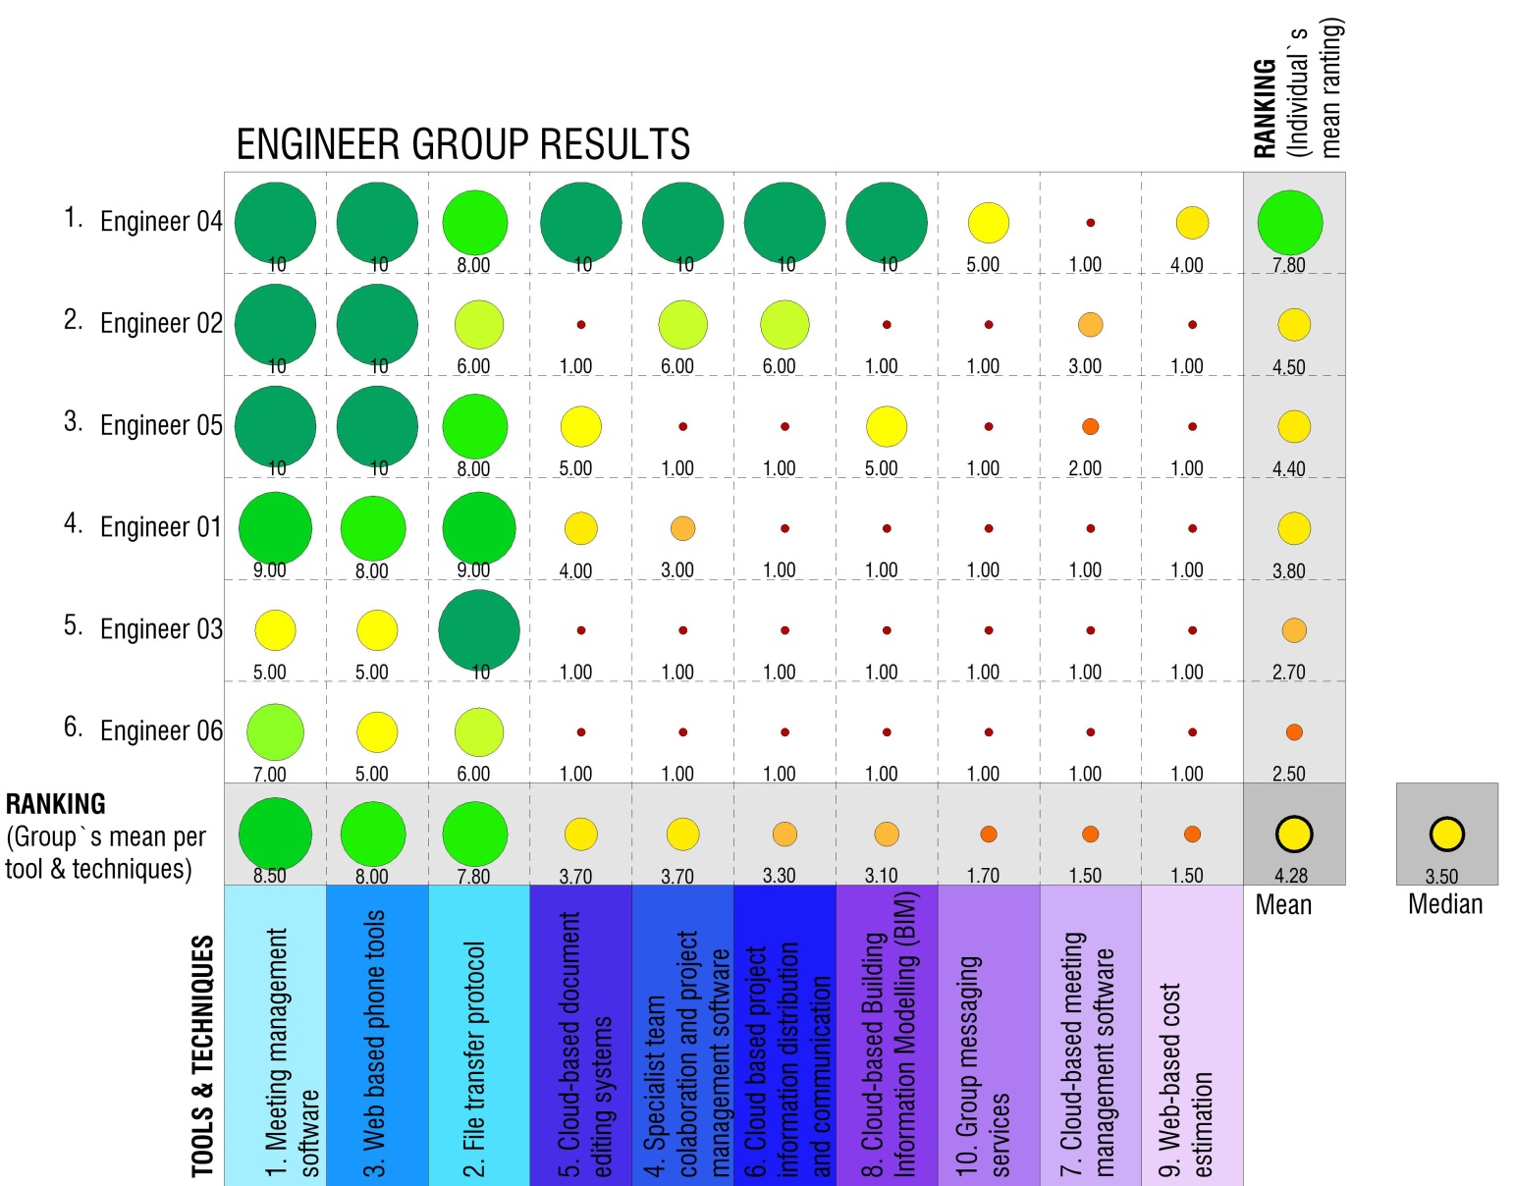
Figure 4-12: Implementation of tools and techniques: Engineer group

Project Manager Group
Meeting management software, file transfer protocols, web based phone tools and specialist team collaboration and project management software are the only functions implemented regularly by this group, as presented in Figure 4.13. There is some degree of implementation of the rest of the functions available and Web-based cost estimation is used the least. The group`s overall rating has a mean score of 4.2 and a median score of 3.0.
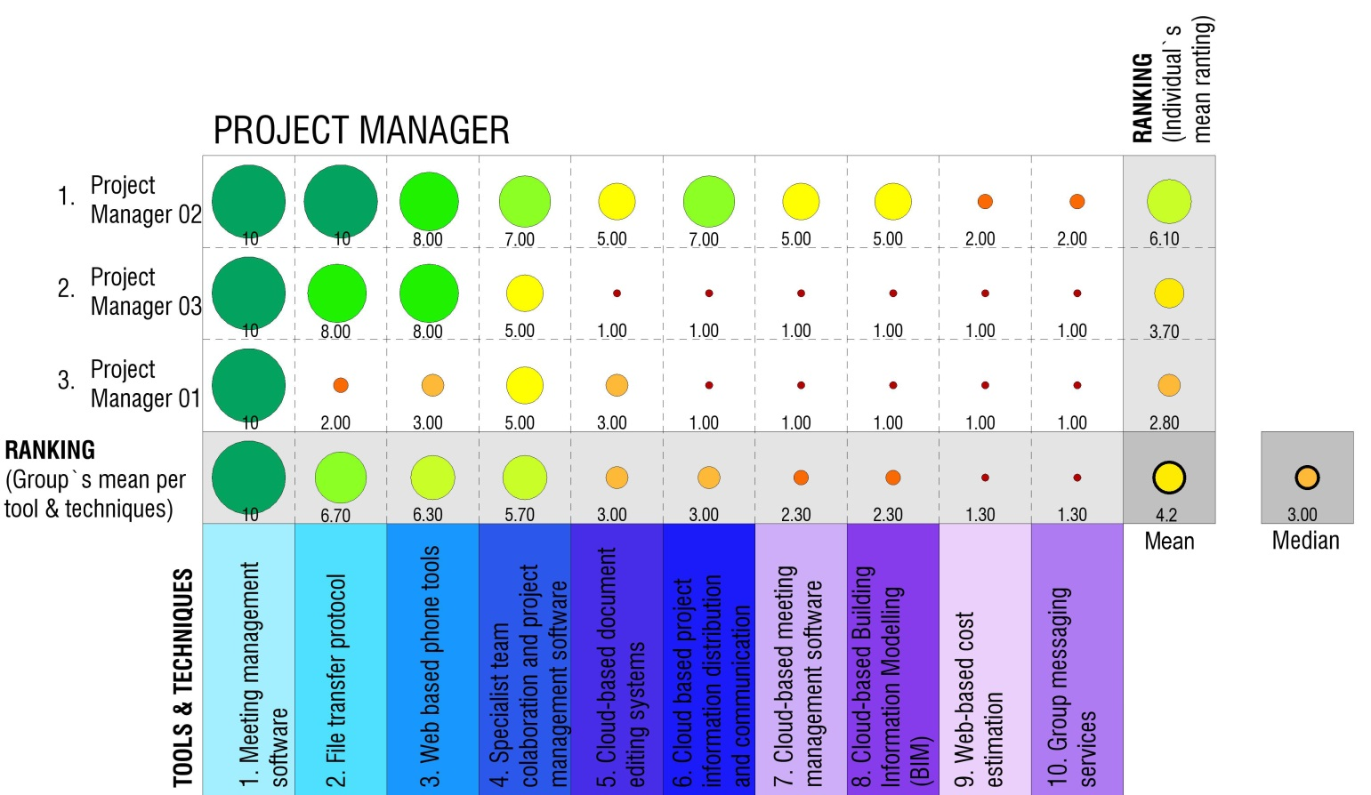
Figure 4-13: Implementation of tools and techniques: Project manager group

Landscape Architect Group
Meeting management software, File transfer protocols and web based phone tools are the only functions implemented regularly by this group, as presented in Figure 4.14. There is some degree of implementation of Specialist team collaboration and project management software but no implementation of the remaining functions. The group`s overall rating has a mean score of 3.6 and a median score of 1.0.
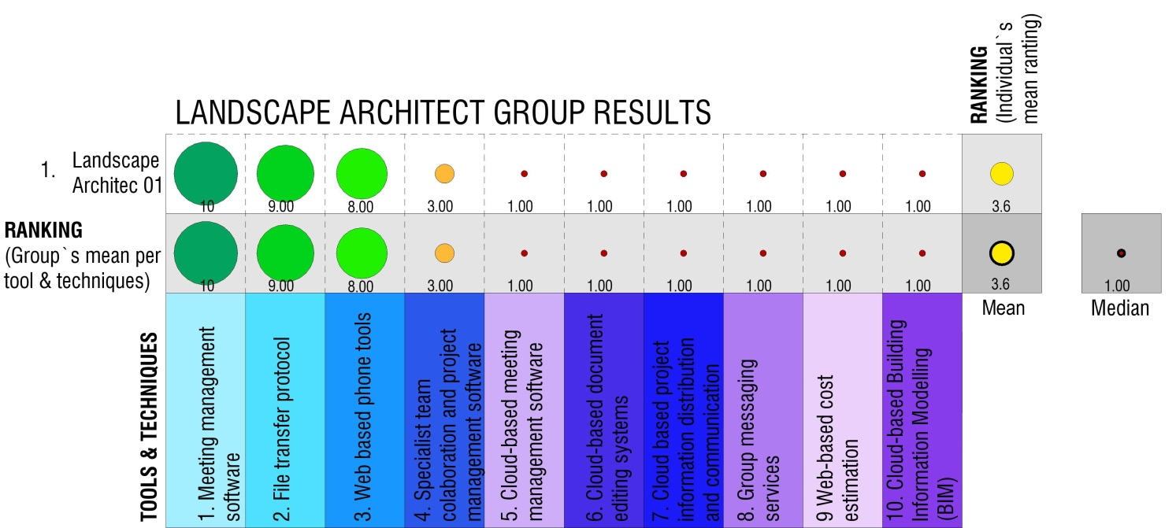
Figure 4-14: Implementation of tools and techniques: Landscape architect group

Comparing the Groups
Meeting management software, file transfer protocols and web based phone tools are, with the exception of specialist team collaboration and project management software in the Project Manager Group, the only functions implemented regularly as presented in Figure 4.15. Group messaging services, cloud-based meeting management services and web-based cost estimation are almost never implemented. The team`s overall rating consists of a mean score of 4.06 and median score of 2.27.
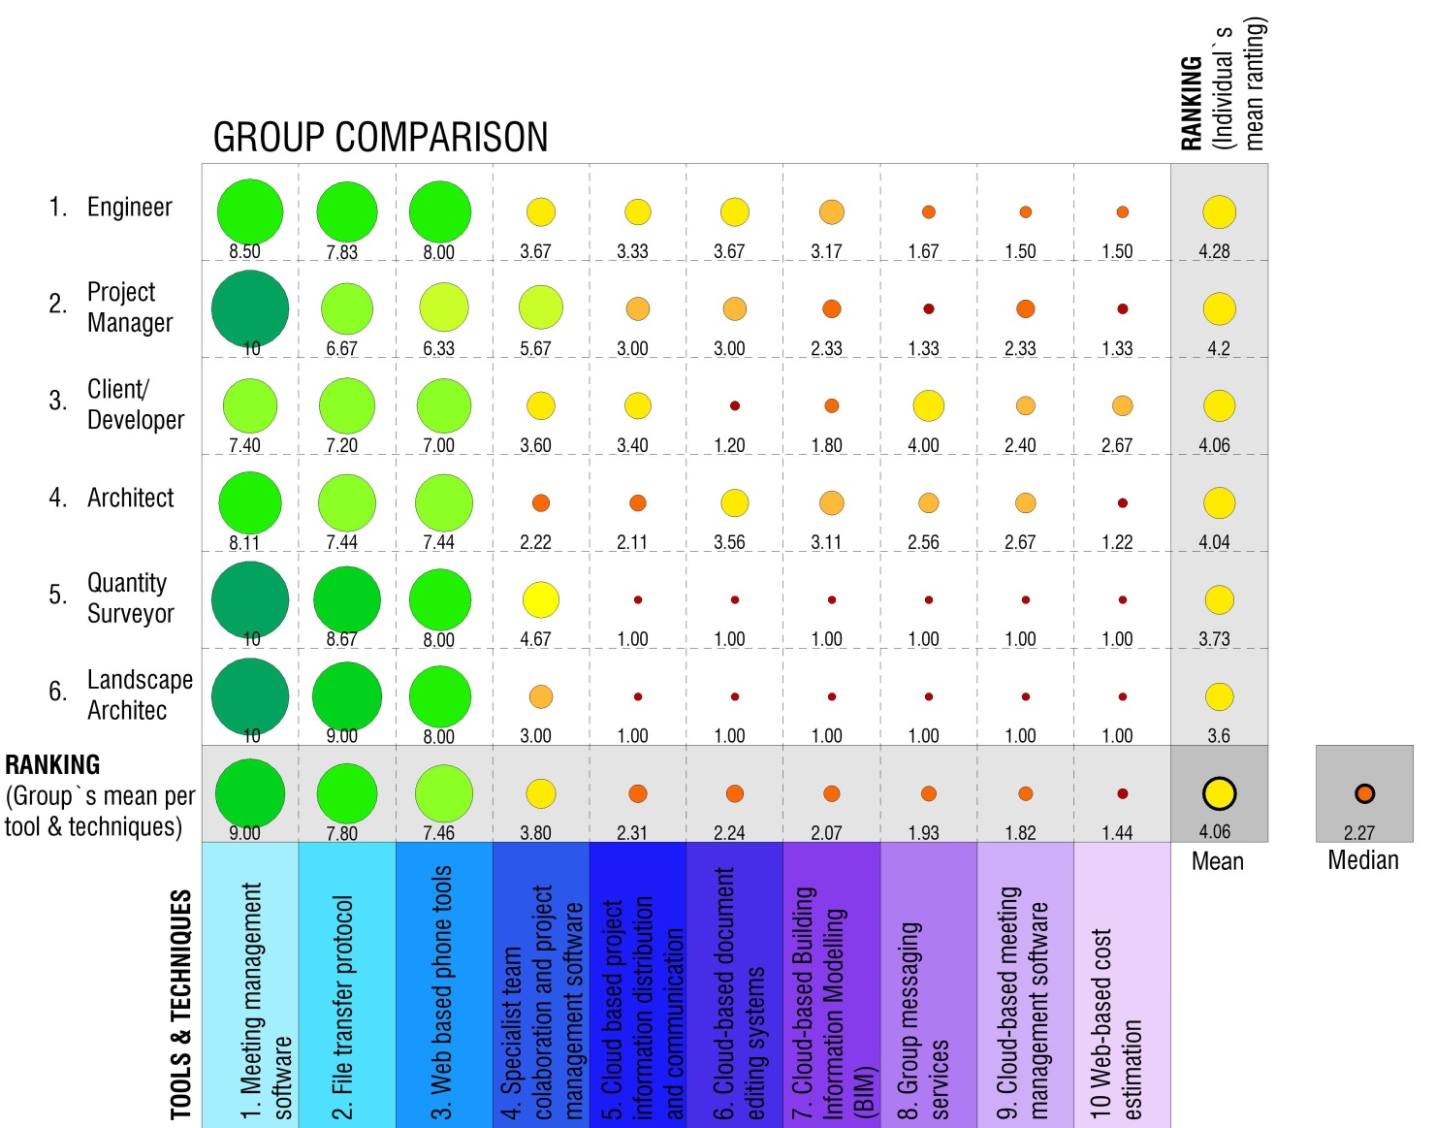
Figure 4-15: Implementation of tools and techniques: Comparison between the groups

Findings on Implemented Tools and Techniques
The team`s overall rating for their level of implementing the proposed tools and techniques are relatively low. The prescribed tools and techniques for all the groups are ranked according to the level of implementation in Table 4.6 below. The tools and techniques that are implemented throughout the group are common practice and part of one`s general office software package. The tools lacking implementation indicates which type of knowledge boundaries are most common.
Table 4-6: A snapshot of the results
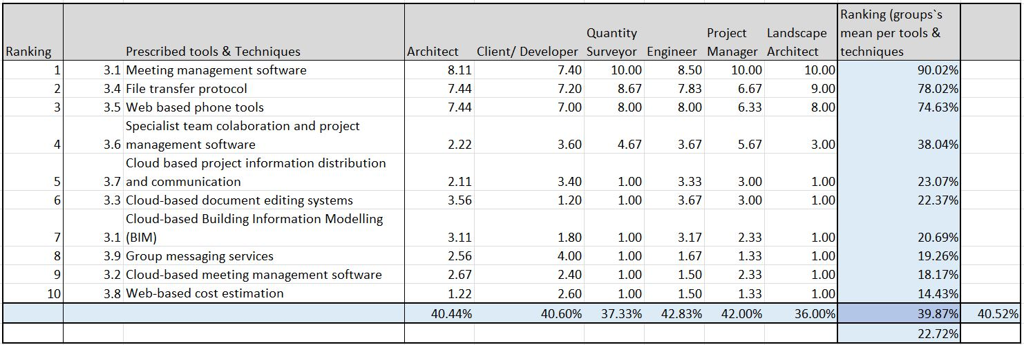

Open Ended Question
The respondents were given the opportunity, in Section D of the questionnaire, to elaborate on their opinion of the current level of team integration, the reasons for not implementing certain tools and techniques and advise on methods to improve on collaboration. This elaborated on the context in which tools and techniques are implemented. Qualitative content analysis was used to sort all the responses of the open-ended section in three categories and various sub-themes as per Figure 4.16.
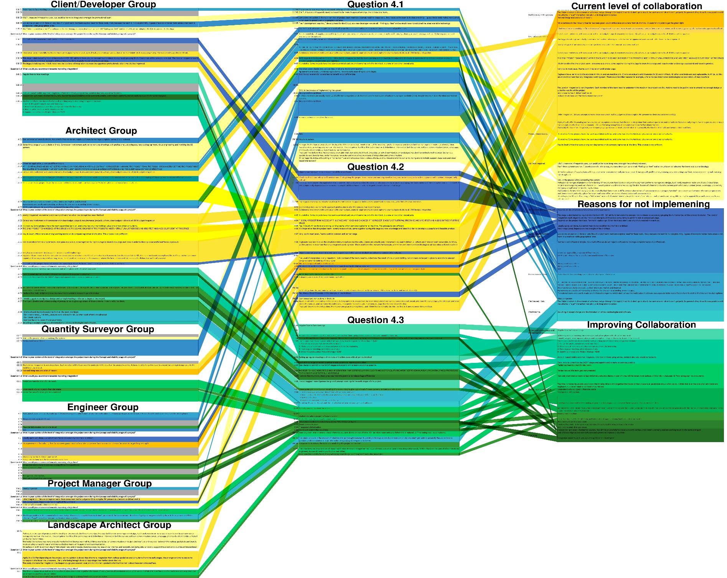Figure 4-16: Categorising the open-ended responses

Current Level of Integration and Collaboration
    - Inefficiencies in the process: Only a small percentage of projects progress to work stage 03 and consultants are mostly not paid for any work before then. This encourages an attitude of doing as little as possible to get to a point where one earns fees and then one can retrospectively make the project work. The process before Stage 03 is often very informal and consultants feel that the cost of their time is disregarded by the clients. They also stated that an unnecessarily large amount of rework is common during this stage and that the duration of this stage is normally between 3-12 months, depending on the size and complexity of the project. Team members often work in isolation during this stage. Architects are accused of disregarding cost and functionality in their design proposals. The Quantity Surveyor group alleged that the rest of the team seldom understands the financial viability of a project. Engineers are accused of being reactive only and do the absolute minimum effort during this stage. The use of email is considered to be an inefficient way of managing information.
    - Level of collaboration: All respondents acknowledged the need to come together and share knowledge and ideas in order to develop a successful and feasible product. The Developer/Client respondents stated that the level of collaboration between team members is one of their largest obstacles. The complete team is seldom formally appointed during this stage and many of them often get involved only after the concept and viability stage.
    - Skill level required: The current level of collaboration is said to be dependent on the skill level and experience of the team leader. Some feel Stage 2 (Concept and viability) is dominated by the Architect and the Quantity Surveyor and the level of collaboration is purely dependant on their individual capabilities.
    - Project idiosyncrasies: The respondents expressed that every project is seen as a unique process that varies widely. A noticeable improvement in efficiency happens when the same team work together on more than one project and when the complete team is involved from the start of the project.

Similar findings have been made by Livesey (2016) and summarised below in Table 4-7.
Table 4-7: Characteristics of temporary organisations, Livesey (2016).
Characteristic | Potential consequences/challenges
Temporariness | Hampers development of positive relations (i.e. trust) and shared value/norms.  Little or no experience of working with team members
Missing/ambiguous hierarchies | Team members also report to line function manager, potential "authority gap" of the project leader.  Inter-divisional and hierarchical collaboration hamper the team building processes.  Team has to develop its own culture.
Changing work teams | Frequent changes allow for less time for beneficial group processes.  Difficulties in developing group cohesiveness and commitment.  Loss of trust previously developed between team members.
Heterogeneity of members | Coordination and communication across disciplinary boundaries may be difficult.  Individual knowledge is not sufficient.  Limited recourse on experiences and routines.  Different professional backgrounds and cultures.  Competition for team members` time from other projects.
Unique project outcome | Higher uncertainty and risk involved, creativity and autonomous decision making required.  Unable to fall back on past experience, novel approaches often required.  Coordination of professionals with different backgrounds.

Reasons for not Implementing Proposed Tools and Techniques
- Lacking necessary skills: Respondents generally recognise the potential benefit of the tools and techniques presented but lack the knowledge, resources and training to successfully implement new tools and techniques in practice. The latest technologies are distributed slowly in the industry and perceived to be difficult to implement in multidisciplinary team environments. Teams are also made up of different companies and training can take a long time.
- Need for implementation unseen: Some of the prescribed roles and responsibilities prescribed are often only attended to at Stage 3 (design development) of the development process and thus do not justify a need for implementation. There is also perceived to be less need for implementation when the team is in close geographical proximity to each other or involved in simple projects. Many respondents do not want to interact outside of their field of knowledge and are under the impression that the rest of the process does not concern them.
- Poor communication:
When consultants know the client/developer well, much of their values and needs become assumed and implicit. This is not conducive to changes in processes and implementation but rather refinement of the existing framework. Additionally, by not defining a brief, one creates ambiguity, resulting in abortive work. The financial information of a project is almost never transparent and only revealed to various degrees for each of the consultants as the project proceeds. This also makes any improvement in the process difficult to appraise and measure.
- Perceived Risk: The consultants want to minimise time spent during this stage and implementing new tools is seen as an unacceptable risk. Not fully understanding the potential advantages to everyone contributes to reluctance of implementation.
- Preference: There are older respondents in senior positions who prefer familiar collaborative tools and techniques, face to face interaction and “old fashioned, tried and tested ways”.

Livesey (2016) summarised similar problems resulting from the nature of projects as per table 4.8 below.
Table 4-8: Summary of the problems resulting from the nature of projects, Livesey (2016).
Summary of the problems resulting from the nature of projects
1 | Limited time duration for building a team, developing rapport with stakeholders, obtaining organisational support and building a working control system.
2 | The temporary nature of the project teams formed within time constraints results in the need to blend team members from different professional and social backgrounds, and understand and develop relationships with stakeholders who are also from different backgrounds. All of whom may be in different geographic locations.
3 | The unique nature of the project requiring a solution in a condensed time-frame puts pressure on the team to understand a particular project`s requirements.
4 | The frequent lack of definition, often due to time constraints, results in considerable ambiguity and changes to scope, coupled with changes to team membership. This problem can be exacerbated by changes in the external environment.
5 | Team structure and stakeholder organisation may change as the project progresses due to a variety of forces, including: pressure from competing projects, identification of additional or redundant skill sets and natural attrition. All resulting issues must be solved within the given timeframe for the particular project.
6 | Conflict results from communication problems, scope and personal changes.

Advice on Improving Collaboration and Integration
- Improved processes and implementation: Revising the way in which teams are remunerated can incentivise individual members to focus on value creation and not just on asserting the next invoice. Multi-disciplinary practices could potentially facilitate better integration. Better collaboration tools, for instance a single mobile application that integrates all aspects of the process in a user-friendly way, can be developed to contribute to improved integration and collaboration.
- Better communication: The definition of a proper brief at the start of the process and revising it at various milestones will aid communication. Facilitating a clear decision-making process could reduce ambiguity. Transparent project information will enable team members to understand the cause and effect of their actions in relation to the project’s aims. Regular recorded meetings are considered essential and face to face meetings, even via video conference calls, are considered to aid communication.
- Teamwork: Get the whole team involved as early as possible, including the contractor. Team members that have previously worked successfully together are perceived as more productive than those who have not.
- Training: A platform to provide support and training for clients could be investigated. The client is a key determinant in the process and is seldom properly informed or trained in the industry. The whole team, including the client, also need to be regularly informed on what tools and techniques are available and what their advantages are.

Synthesis of the Findings on Open Ended Questions
All respondents acknowledged the need to come together and to share knowledge and ideas during the concept and viability stage in order to develop successful and feasible products within the given timeframe. Low levels of collaboration amongst team members, inefficiencies in the process, lack of skills and idiosyncratic projects were used to describe the current level of collaboration. Suggested reasons for not implementing proposed collaborative tools and techniques include lack of skills, not understanding the need for implementation, poor communication, perceived risk and preference. Improving the process and implementation, better communication, and teamwork and training are suggested means to improve the current level of collaboration and integration.

CONCLUSION

Introduction
In this chapter, the study objectives were achieved as discussed and compared to the findings found in previous research. Based on this study’s findings, conclusions were drawn. In addition, strategies to address the problems were recommended. Areas for further study are highlighted throughout the study, summarising the study’s limitations.

Achievement of Study Objectives
The first objective was to determine the level at which project team members implement their prescribed roles and responsibilities at the concept and viability stage; this was achieved by comparing what the respective councils prescribe with practice. The study found that this level is relatively low. Through qualitative content analysis it was found that the type of functions with the highest level of fulfilment are design related and the types of functions with the lowest level of fulfilment are contractual and regulation. These results reinforce the need to overcome existing organisational and behavioural barriers if further improvements in project performance are to be fully realised. (Egan, 1998; Latham, 1994; Jylhä & Junnila, 2014;Roulac et al., 2006).
The second objective was to appraise known digital tools of integration and collaboration used by the various team members. This was achieved by rating the level of implementation per group. The team`s overall rating for their level of implementing the proposed tools and techniques is relatively low. The tools and techniques that are implemented throughout the group are common practice and part of one`s general office software package. The tools lacking implementation indicates which socio-cognitive factors might undermine team collaboration in project coalitions. Forgues, et al. (2008) suggest that these factors are; firstly, the lack of self-regulation, where team members duplicate each other`s work, and fail to resolve many problems quickly or to anyone’s satisfaction; secondly, not sharing information held by individuals; thirdly, knowledge boundaries that specialised knowledge creates; and lastly, cognitive inertia, paradoxically caused by both compartmentalization and groupthink modes of thinking by experts within the team context.

Conclusion of the Overall Research
The misalignment between what is prescribed and actual practice suggests that there is a disconnect between the regulative authorities` theoretical understanding of the project design delivery processes and the actual processes. Contractual relations are based on this understanding, resulting in teams where members are driven to achieve their individual goals instead of focusing on creating value for the client (Forgues et al., 2008; Pikas et al., 2015). A conscious effort to understand and improve the context in which teams operate is conducive to better collaboration and essential for an improvement in development design delivery process efficiency (Pikas et al., 2016). Knowledge boundaries can be bridged through the use of collaborative tools (Shen et al., 2008). The study`s appraisal of the level of implementation of digital collaborative tools used by the various team members underlined areas in need of improvement within the Northern Johannesburg context. These areas include real time project communication, transparent project information, online management services and collaborative cost estimation.

Implications

Theoretical implications
Sharing of domain-specific knowledge is crucial in team collaboration. The need for improved knowledge management within the concept and viability stage exists. There is conceptual and prescriptive value in developing a framework describing the three progressively complex types of knowledge boundaries within the concept and viability stage – syntactic, semantic and pragmatic. These types of boundaries necessitate three progressively complex processes – transfer, translation and transformation of knowledge. Additionally, there is a need to facilitate these processes around the cost specific knowledge domain to overcome the most significant boundaries during the concept and viability stage of the development project. Overcoming these boundaries should improve collaboration.

Practical/Managerial Implications
There is a need to prescribe and regulate the concept and viability stage better. Further studies would establish if this is also the case for the other stages of the development process in the South African context. These studies would enable the aligning of all team members` roles, responsibilities, motivation and risk with those of the developer/client throughout the development process. Further, the construct of a specific development design delivery process, requirements management system that focuses on creating value for the client could be developed.

Study Limitations and Areas for Further Research
This study only focused on the development project team’s concept and viability stage. Further studies are required to determine whether findings are applicable to other project stages. An industry wide survey would support findings on a limited portion of the market. The focus was on teams based in Northern Johannesburg, excluding the rest of the country and confined to high-density, private residential sectors.

REFERENCES
Afrigis, 2015. Afrigis. [Online]Available at: www.afrigis.co.za[Accessed 25 March 2017].
Al Sehaimi, A., Tzortzopoulos-Fazenda, P. & Koskela, L., 2014. Improving construction management practice with the Last Planner System: a case study. Engineering, Construction and Architectural Management, 21(1), pp. 51-64.
Alowitz, D. & Toole, M., 2010. Mixed Method Research: Fundamental issues of design, validity, and reliability in construction research. Journal of Construction Engineering and Management, 136(1), pp. 108-116.
Arayici, Y. et al., 2011. BIM adoption and implementation for architectural practices. Structural Survey, 29(1), pp. 7-25.
Bandura, A., 2002. Social cognitive theory of mass communication. Media Effects: Advances in Theory and Research, 1(4), pp. 94-124.
Blanco, J., Mullin, A., Pandya, K. & Sridhar, M., 2017. The new age of engineering and construction technology. Flipboard, 30 07.
Boon, J., Yap, H., Abdul-Rahman, H. & Wang, C., 2016. A conceptual framework for managing design changes in building construction. MATEC Web of Conferences, 66(21), p. https://doi.org/10.1051/matecconf/20166600021.
Botha, B., Adendorff, C. & Smallwood, P., 2014. Property development: A business process model. Journal of Construction Management and Innovation, pp. 1012-1033.
Bowen, P., Edwards, P., Cattell, K. & Jay, I., 2010. The awareness and practice of value management by South African consulting engineers: Preliminary research findings. International Journal of Project Management, Volume 28, p. 285–295.
Bowen, P., Edwards, P., Cattell, K. & Jay, I., 2010. Value management awareness and practice by South African architects: an empirical study. Construction Innovation, 10(2), pp. 203-222.
Bowen, P., Edwards, P., Cattell, K. & Jay, I., 2010. Value management practice by South African quantity surveyors. Facilities, 28 (1/2), pp. 46-63.
Carlile, P. R., 2004. A pragmatic view of knowledge and boundaries: boundary objects in new product development. Organization Science, 13(4), pp. 442-455.
Creswell, J. W., 2009. Research design: Qualitative, quantitative and mixed method approaches. 3rd ed. Los Angeles: Sage Publication.
Davenport, T., 1994. Saving IT`s soul: Human centred information management. Harvard Bussiness Review, 72(3), pp. 119-131.
Eastman, C., Tiecholz, P., Sacks, R. & Liston, K., 2011. BIM handbook: A guide to building information modeling for owners, managers, designers, engineers and contractors. 2nd ed. New Jersey, Hoboken: John Wiley and Sons.
Egan, J., 1998. Rethinking construction, London: Construction Task Force to the Deputy Prime Minister, John Prescott of the United Kingdom.
Elo, S. et al., 2014. Qualitative content analysis: A focus on trustworthiness. SAGE Open, January.pp. 1-10.
Fellows R, F. & Liu A, M., 2009. Research methods for construction. 1st ed. West Sussex, UK: John Wiley and Sons.
Fisher, P. & Collins, T., 1998. The commercial property development process. Property Management, 17(3), pp. 219-230.
Forgues, D. & Koskela, L., 2009. The influence of a collaborative procurement approach using integrated design in construction on project team performance. International Journal of Managing Projects in Business, 2(3), pp. 370-385.
Forgues, D., Koskela, L. & Lejeune, A., 2008. Breaking socio-cognitive barriers to value generation in integrated teams. Manchester, UK, 16th Annual Conference of the International Group for Lean Construction Proceedings IGLC-16.
Formoso, C., Tzortzopoulos, P. & Liedtke, R., 2002. A model for managing the product development process in house building. Engineering, Construction and Architectural Management, 9(5/6), pp. 412-432.
Graaskamp, J., 1992. Fundamentals of real estate development. Journal of Property Valuation and Investment, 10(3), pp. 619-639.
Jallow, A., Demian, P., Baldwin, A. & Anumba, C., 2014. An empirical study of the complexity of requirements. Engineering, Construction and Architectural Management, 21(5), pp. 505-531.
Jørgensen, B. & Emmitt, S., 2009. Investigating the integration of design and construction from a “lean” perspective. Construction Innovation, 9(2), pp. 225-240.
Jylhä, T. & Junnila, S., 2014. The state of value creation in the real-estate sector – lessons from lean thinking. Property Management, 32(1), pp. 28-32.
Kagioglou, M., Cooper, R., Aouad, G. & Sexton, M., 2000. Rethinking construction: the generic design and construction process protocol. Engineering, Construction and Architectural Management, 7(2), pp. 141-153.
Kagioglou, M. et al., 2002. Mapping the production process: A case study. Gramado, Bazil, 10th Annual Conference of the International Group for Lean Construction Proceedings IGLC-10.
Kohlbacher, F., 2006. The use of qualitative content analysis in case study research. Forum: Qualitative Social Research , 7(1), pp. http://dx.doi.org/10.17169/fqs-7.1.75.
Koskela, L., 1992. Application of the new production philosophy to construction, Stanford: Centre for Integrated Facility Engineering, Stanford University.
Koskela, L., Howell, G., Ballard, G. & Tommelein, I., 2002. 'The foundations of lean construction', in: Design and construction: building in value. Oxford: Butterworth Heinemann.
Koskela, L., Rooke, J., Bertelsen, S. & Henrich, G., 2007. The TFV theory of production: New developments. Michigan, USA, 15th Annual Conference of the International Group for Lean Construction Proceedings IGLC-15.
Kraemer, K., Henrich, G., Koskela, L. & Kagioglou, M., 2004. How construction flows have been understood in lean construction. Salford, UK., International Group for Lean Construction (IGLC) conference paper.
Latham, M., 1994. Constructing the team, Joint review of procurement and contractual arrangements, London: Government of the United Kingdom.
Livesey, P., 2016. Insight of project managers into the problems in project management. Construction Economics and Building, 16(1), pp. 90-103.
Lundgren, B., 2010. Measuring the perceived performance of a residential development. Journal of Place Management and Development, 3(1), pp. 38-56.
Matsumoto, I., Stapleton, J., Glass, J. & Thorpe, T., 2005. 21. Use of process maps to develop a management briefing sheet for a design consultancy. Engineering Construction & Architectural Management, 12(5), pp. 459-469.
Mugo, F., 2002. Sampling in Research. [Online]Available at: http//trochim.human.cornell.edu/tutorial/mugo/tutorial.htm [Accessed 15 10 2017].
Nahid, G., 2003. Understanding reliability and validity in qualitative research. The Qualitative Report, 8(4), pp. 597-606.
National Planning Commision, South African Government, 2011. The State of Cities Report, Pretoria: National Planning Commision, South African Government.
Noble, H. & Smith, J., 2015. Issues of validity and reliability in qualitative research. Evidence Based Nursing, 18(2), pp. 34-35.
Papadonikolaki, E., Vrijhoef, R. & Wamelink, J., 2015. A BIM-based supply chain model for AEC. WIT Transactions on The Built Environment, 149(ISSN 1743-3509 (on-line).), www.witpress.com.
Patanakul, P., Lewwongcharoen, B. & Milosevic, D., 2010. An empirical study on the use of project management tools and techniques across project life-cycle and their impact on project success. Journal of General Management, 35(3), pp. 41-66.
Pikas, E., Koskela, L., Dave, B. & Liias, R., 2015. Case study on design management: Inefficiencies. Perth, Australia, Proc. 23rd Ann. Conf. of the Int’l. Group for Lean Construction.
Pikas, E. et al., 2016. Collaboration in design – Justification, characteristics, and concepts. Boston, s.n., pp. 143-152.
Ramabodu, M., Kotze, B. & Verster, J., 2007. Diversity and value in Africa`s real estate. Journal of Property Investment & Finance, 25(1), pp. 7-22.
Rizal, S., 2011. Changing roles of the clients, architects and contractors through BIM. Engineering, Construction and Architectural Management, 18(2), pp. 176-187.
Roulac, S. et al., 2006. Real estate value: creation and destruction. Journal of Property Investment & Finance, 24(6), pp. 474-489.
Ruikar, K., Koskela, L. & Sexton, M., 2009. Communities of practice in construction case study organisations: Questions and insights. Construction Innovation, 9(4), pp. 434-448.
Rymarzak, M. & Siemińska, E., 2012. Factors affecting the location of real estate. Journal of Corporate Real Estate, 14(4), pp. 241-225.
Salvatierra-Garrido, J. & Pasquire, C., 2011. Value theory in lean construction. Journal of Financial Management of Property and Construction, 16(1), pp. 8-18.
Saunders, M., Lewis, P. & Thornhill, A., 2012. Research Methods for Business Students. 6th ed. Essex, UK.: Pearson.
Shen, W., Hao, Q., Mak, H. & Neelamkavil, J., 2008. Systems integration and collaboration in construction: a review, Proceedings of the 12th International Conference on Computer Supported Cooperative. China, Xi’an, P.R. , pp. 11-22.
Teddie, C. & Yu, F., 2007. Mixed methods sampling: A typology with examples. Journal of Mixed Methods Research, 77(1), pp. 50-75.
The McKinsey Global Institute, 2017. Reinventing construction: A route to higher productivity. [Online]Available at: www.mckinsey.com/mgi[Accessed 30 07 2017].
Tzortzopoulos, P., Sexton, M. & Cooper, R., 2005. Process models implementation in the construction industry: a literature synthesis. Engineering, Construction and Architectural Management, 12(5), pp. 470-486.
Wesz, J., Formoso, C. & Tzotzopoulos, P., 2013. Design planning and control: Last planner system adaptation. Brazil, Proceedings IGLC.

APPENDIX A: Request for participation in a research project

“Collaboration and integrational tools in the concept and viability stage of the development process.”
Background and purpose:
This is a request for you to participate in a research study that intends to study the relationships between participants in the project team during the concept and viability stage of the property development process. There are tools available that can facilitate an environment conducive to better collaboration and integration of people and processes, ultimately contributing to better value for the producer. However, the implementation of these tools throughout the professional team is not well understood.

What does the study entail?
The problem this study intends to address is a lack of integration in the concept and viability stage of the development process (Boon, et al., 2016) (Pikas, et al., 2016). A better understanding of tools used to facilitate integration and collaboration in the concept and viability stage can reduce socio cognitive barriers and increase effectiveness during the development process (Al Sehaimi, et al., 2014) (Forgues, et al., 2008).
Potential advantages:
A survey of coalitions of design professionals, their organisation of work, processes and tools used will assist in the identification of socio-cognitive barriers. This will enhance analysis, planning and management of underlying generic processes, facilitating better integration. Lastly, better integration in the concept and viability stage will increase effectiveness contributing to better value for money.

What will happen to the information about you?
The data that are registered about you will only be used in accordance with the purpose of the study as described above. All the data will be processed without name, ID number or other directly recognisable type of information. Only authorised project personnel will have access to the list of names and be able to identify you. It will not be possible to identify you in the results of the study upon completion and if these are published.

Voluntary participation:
Participation in the study is voluntary. You can withdraw your consent to participate in the study at any time and without stating any particular reason. This will not have any consequences for you. If, later on, you wish to withdraw your consent or have questions concerning the study, you may contact Dewald Veldsman: 076 269 5685

APPENDIX B: Questionnaire

Section A: Background

  - What are your professional qualifications?
______________________________________________________________________________________________________________________________________________________

  - Are you professionally registered and which association(s) do you belong to?
___________________________________________________________________________
___________________________________________________________________________

  - How many years of experience do you have in your profession and related professions?
___________________________________________________________________________
___________________________________________________________________________

  - What type of projects have you worked on?
______________________________________________________________________________________________________________________________________________________

  - Where were the projects located?
______________________________________________________________________________________________________________________________________________________

  - What were your roles in the projects? _________________________________________________________________________________________________________________________________________________________________________________________________________________________________
  - What form of contracts do you use? _________________________________________________________________________________________________________________________________________________________________________________________________________________________________
  - How did the type of contract used affect the concept and viability stage? _________________________________________________________________________________________________________________________________________________________________________________________________________________________________
  - Are you using a smartphone, tablet or laptop extensively during your day at the office? _________________________________________________________________________________________________________________________________________________________________________________________________________________________________
  - What type of professional seminars, lectures or conferences do you attend? ______________________________________________________________________________________________________________________________________________________

Section B: Roles & Responsibility

Client/Developer
Please indicate the frequency of fulfilment for each of the following statements during the concept and viability stage (Stage 02):
 | Never |  |  |  |  |  |  |  |  |  |  |  |  |  |  | Always
2.1. Procurement of all necessary and appropriate professional consultants including the clear definition of their roles and responsibilities. | 1 | 2 | 3 |  | 4 |  | 5 |  | 6 |  | 7 |  | 8 | 9 |  |  | 10
2.2. Define a clear project brief. | 1 | 2 | 3 | 4 |  | 5 |  | 6 |  | 7 |  | 8 |  |  | 9 | 10
2.3. Communicate the project brief to all professional consultants. | 1 | 2 | 3 | 4 |  | 5 |  | 6 |  | 7 |  | 8 |  |  | 9 | 10
2.4. Monitor the development of the concept and viability. | 1 | 2 | 3 | 4 |  | 5 |  | 6 |  | 7 |  | 8 |  |  | 9 | 10
2.5. Agreeing on format and procedures for cost control and reporting by the professional consultants. | 1 | 2 | 3 | 4 |  | 5 |  | 6 |  | 7 |  | 8 |  |  | 9 | 10
2.6. Understand the different procurement options and agree on a form of contract. | 1 | 2 | 3 | 4 |  | 5 |  | 6 |  | 7 |  | 8 |  |  | 9 | 10
2.7. Understand the requirement to appoint a health and safety consultant and the appointment of one. | 1 | 2 | 3 | 4 |  | 5 |  | 6 |  | 7 |  | 8 |  |  | 9 | 10
2.8. Approve a documentation programme and indicative construction programme. | 1 | 2 | 3 | 4 |  | 5 |  | 6 |  | 7 |  | 8 |  |  | 9 | 10
2.9. Approve the concept and viability. | 1 | 2 | 3 |  | 4 |  | 5 |  | 6 |  | 7 |  | 8 | 9 |  |  | 10
2.10. Approve the concept and viability submission to statutory authorities. | 1 | 2 | 3 | 4 |  | 5 |  | 6 |  | 7 |  | 8 |  |  | 9 | 10
2.11. Signed client/consultant professional services agreements. | 1 | 2 | 3 | 4 |  | 5 |  | 6 |  | 7 |  | 8 |  |  | 9 | 10
2.12. Keep a record of all meetings. | 1 | 2 | 3 | 4 |  | 5 |  | 6 |  | 7 |  | 8 |  |  | 9 | 10
2.13. Approval to proceed to Stage 3 | 1 | 2 | 3 | 4 |  | 5 |  | 6 |  | 7 |  | 8 |  |  | 9 | 10

Architect
Please indicate the frequency of fulfilment for each of the following statements during the concept and viability stage (Stage 02):
 | Never |  |  |  |  |  |  |  |  |  |  |  |  |  |  | Always
2.1. Ensure that there is a clearly defined brief before commencement. | 1 | 2 | 3 |  | 4 |  | 5 |  | 6 |  | 7 |  | 8 | 9 |  |  | 10
2.2. Agreeing on the documentation programme with the principal consultant/client and other professional consultants. | 1 | 2 | 3 | 4 |  | 5 |  | 6 |  | 7 |  | 8 |  |  | 9 | 10
2.3. Agreeing on a procurement route and form of contract. | 1 | 2 | 3 | 4 |  | 5 |  | 6 |  | 7 |  | 8 |  |  | 9 | 10
2.4. Clearly communicate all relevant project information to the rest of the architectural team within the architectural practice. | 1 | 2 | 3 | 4 |  | 5 |  | 6 |  | 7 |  | 8 |  |  | 9 | 10
2.5. Prepare an initial design. | 1 | 2 | 3 | 4 |  | 5 |  | 6 |  | 7 |  | 8 |  |  | 9 | 10
2.6. Advise on the intended space provision and planning relationships. | 1 | 2 | 3 | 4 |  | 5 |  | 6 |  | 7 |  | 8 |  |  | 9 | 10
2.7. Advise on the proposed materials and intended building services. | 1 | 2 | 3 | 4 |  | 5 |  | 6 |  | 7 |  | 8 |  |  | 9 | 10
2.8. Advise on the technical and functional characteristics of the design. | 1 | 2 | 3 | 4 |  | 5 |  | 6 |  | 7 |  | 8 |  |  | 9 | 10
2.9. Check conformity of the concept with the rights to use of the land. | 1 | 2 | 3 |  | 4 |  | 5 |  | 6 |  | 7 |  | 8 | 9 |  |  | 10
2.10. Review the anticipated project cost. | 1 | 2 | 3 | 4 |  | 5 |  | 6 |  | 7 |  | 8 |  |  | 9 | 10
2.11. Review the project programme. | 1 | 2 | 3 | 4 |  | 5 |  | 6 |  | 7 |  | 8 |  |  | 9 | 10
2.12. Review the project team. | 1 | 2 | 3 | 4 |  | 5 |  | 6 |  | 7 |  | 8 |  |  | 9 | 10
2.13. Signed client/consultant professional services agreements. | 1 | 2 | 3 | 4 |  | 5 |  | 6 |  | 7 |  | 8 |  |  | 9 | 10
2.14. Approval by the client to proceed to Stage 3. | 1 | 2 | 3 | 4 |  | 5 |  | 6 |  | 7 |  | 8 |  |  | 9 | 10

Quantity Surveyor
Please indicate the frequency of fulfilment for each of the following statements during the concept and viability stage (Stage 02):
 | Never |  |  |  |  |  |  |  |  |  |  |  |  |  |  | Always
2.1. Agreeing on the documentation programme with the principal consultant and other professional consultants. | 1 | 2 | 3 |  | 4 |  | 5 |  | 6 |  | 7 |  | 8 | 9 |  |  | 10
2.2. Attending design and consultants’ meetings. | 1 | 2 | 3 | 4 |  | 5 |  | 6 |  | 7 |  | 8 |  |  | 9 | 10
2.3. Receiving relevant data and cost estimates from the other professional consultants. | 1 | 2 | 3 | 4 |  | 5 |  | 6 |  | 7 |  | 8 |  |  | 9 | 10
2.4. Receiving relevant data and cost estimates from the other professional consultants. | 1 | 2 | 3 | 4 |  | 5 |  | 6 |  | 7 |  | 8 |  |  | 9 | 10
2.5. Preparing preliminary and elemental or equivalent estimates of construction cost. | 1 | 2 | 3 | 4 |  | 5 |  | 6 |  | 7 |  | 8 |  |  | 9 | 10
2.6. Assisting the client in preparing a financial viability report. | 1 | 2 | 3 | 4 |  | 5 |  | 6 |  | 7 |  | 8 |  |  | 9 | 10
2.7. Auditing space allocation against the initial brief. | 1 | 2 | 3 | 4 |  | 5 |  | 6 |  | 7 |  | 8 |  |  | 9 | 10
2.8. Liaising, co-operating and providing necessary information to the client, principal consultant and other professional consultants. | 1 | 2 | 3 | 4 |  | 5 |  | 6 |  | 7 |  | 8 |  |  | 9 | 10
2.9. Prepare preliminary estimate(s) of construction cost. | 1 | 2 | 3 |  | 4 |  | 5 |  | 6 |  | 7 |  | 8 | 9 |  |  | 10
2.10. Prepare elemental or equivalent estimate(s) of construction cost. | 1 | 2 | 3 | 4 |  | 5 |  | 6 |  | 7 |  | 8 |  |  | 9 | 10
2.11. Complete a space allocation audit for the project. | 1 | 2 | 3 | 4 |  | 5 |  | 6 |  | 7 |  | 8 |  |  | 9 | 10
2.12. Approval by the client to proceed to Stage 3. | 1 | 2 | 3 | 4 |  | 5 |  | 6 |  | 7 |  | 8 |  |  | 9 | 10

Engineer
Please indicate the frequency of fulfilment for each of the following statements during the concept and viability stage (Stage 02):
 | Never |  |  |  |  |  |  |  |  |  | Always
2.1. Prepare and finalise the project concept in accordance with the brief, including project scope, scale, character, form and function, plus preliminary programme and viability of the project. | 1 | 2 | 3 | 4 | 5 | 6 | 7 | 8 | 9 | 10
2.2. Agree on documentation programme with principal consultant and other consultants involved. | 1 | 2 | 3 | 4 | 5 | 6 | 7 | 8 | 9 |  | 10
2.3. Attend design and consultants' meetings. | 1 | 2 | 3 | 4 | 5 | 6 | 7 | 8 | 9 |  | 10
2.4. Establish the concept design criteria. | 1 | 2 | 3 | 4 | 5 | 6 | 7 | 8 | 9 |  | 10
2.5. Prepare initial concept design and related documentation. | 1 | 2 | 3 | 4 | 5 | 6 | 7 | 8 | 9 |  | 10
2.6. Advise the client regarding further surveys, analyses, tests and investigations which may be required. | 1 | 2 | 3 | 4 | 5 | 6 | 7 | 8 | 9 |  | 10
2.7. Establish regulatory authorities' requirements and incorporate into the design. | 1 | 2 | 3 | 4 | 5 | 6 | 7 | 8 | 9 |  | 10
2.8. Refine and assess the concept design to ensure conformance with all regulatory requirements and consents. | 1 | 2 | 3 | 4 | 5 | 6 | 7 | 8 | 9 |  | 10
2.9. Establish access, utilities, services and connections required for the design. | 1 | 2 | 3 | 4 | 5 | 6 | 7 | 8 | 9 | 10
2.10. Coordinate design interfaces with other consultants involved. | 1 | 2 | 3 | 4 | 5 | 6 | 7 | 8 | 9 |  | 10
2.11. Prepare preliminary process designs; preliminary designs, and related documentation for approval by authorities and client and suitable for costing. | 1 | 2 | 3 | 4 | 5 | 6 | 7 | 8 | 9 |  | 10
2.12. Provide cost estimates and comment on life cycle costs as required. | 1 | 2 | 3 | 4 | 5 | 6 | 7 | 8 | 9 |  | 10
2.13. Liaise, co-operate and provide necessary information to the client, principal consultant and other consultants involved. | 1 | 2 | 3 | 4 | 5 | 6 | 7 | 8 | 9 |  | 10
2.14. Provide a schedule of required surveys, tests and other investigations and related reports. | 1 | 2 | 3 | 4 | 5 | 6 | 7 | 8 | 9 |  | 10

Landscape Architect
Please indicate the frequency of fulfilment of each for the following statements during the concept and viability stage (Stage 02):
 | Never |  |  |  |  |  |  |  |  |  |  |  |  |  |  | Always
2.1. Prepare and finalise the project concept in accordance with the brief including the scope, scale, character, form, function and viability of the project. | 1 | 2 | 3 |  | 4 |  | 5 |  | 6 |  | 7 |  | 8 | 9 |  |  | 10
2.2. Agree on the documentation programme with the principal consultant and the other consultants. | 1 | 2 | 3 | 4 |  | 5 |  | 6 |  | 7 |  | 8 |  |  | 9 | 10
2.3. Attend design and consultants’ meetings. | 1 | 2 | 3 | 4 |  | 5 |  | 6 |  | 7 |  | 8 |  |  | 9 | 10
2.4. Prepare concept design based on the client’s brief. | 1 | 2 | 3 | 4 |  | 5 |  | 6 |  | 7 |  | 8 |  |  | 9 | 10
2.5. Consult with the other consultants and incorporate their input. | 1 | 2 | 3 | 4 |  | 5 |  | 6 |  | 7 |  | 8 |  |  | 9 | 10
2.6. Discuss design concept with local and other authorities as required. | 1 | 2 | 3 | 4 |  | 5 |  | 6 |  | 7 |  | 8 |  |  | 9 | 10
2.7. Advise the client regarding further surveys, analysis, tests and investigations which may be required. | 1 | 2 | 3 | 4 |  | 5 |  | 6 |  | 7 |  | 8 |  |  | 9 | 10
2.8. Refine and assess concept design to ensure conformity with statutory requirements and consents. | 1 | 2 | 3 | 4 |  | 5 |  | 6 |  | 7 |  | 8 |  |  | 9 | 10
2.9. Co-ordinate design interfaces with the other consultants. | 1 | 2 | 3 |  | 4 |  | 5 |  | 6 |  | 7 |  | 8 | 9 |  |  | 10
2.10. Select hard and soft landscape construction materials. | 1 | 2 | 3 | 4 |  | 5 |  | 6 |  | 7 |  | 8 |  |  | 9 | 10
2.11. Prepare cost estimates as required. | 1 | 2 | 3 | 4 |  | 5 |  | 6 |  | 7 |  | 8 |  |  | 9 | 10
2.12. Submit presentation of the design concept to the client for approval. | 1 | 2 | 3 | 4 |  | 5 |  | 6 |  | 7 |  | 8 |  |  | 9 | 10
2.13. Prepare and submit the landscape development plan to the local authority for approval where applicable. | 1 | 2 | 3 | 4 |  | 5 |  | 6 |  | 7 |  | 8 |  |  | 9 | 10
2.14. Liaise, co-operate and provide necessary information to the client, principal consultant and other consultants. | 1 | 2 | 3 | 4 |  | 5 |  | 6 |  | 7 |  | 8 |  |  | 9 | 10

Project Manager
Please indicate the frequency of fulfilment for each of the following statements during the concept and viability stage (Stage 02):
 | Never |  |  |  |  |  |  |  |  |  |  |  |  |  |  | Always
2.1. Assist the client in the procurement of the necessary and appropriate consultants including the clear definition of their roles, responsibilities and liabilities. | 1 | 2 | 3 |  | 4 |  | 5 |  | 6 |  | 7 |  | 8 | 9 |  |  | 10
2.2. Advise the client on the requirement to appoint a Health and Safety Consultant. | 1 | 2 | 3 | 4 |  | 5 |  | 6 |  | 7 |  | 8 |  |  | 9 | 10
2.3. Communicate the project brief to the consultants and monitor the development of the concept design and feasibility. | 1 | 2 | 3 | 4 |  | 5 |  | 6 |  | 7 |  | 8 |  |  | 9 | 10
2.4. Co-ordinate and integrate the income stream requirements of the client into the concept design and feasibility. | 1 | 2 | 3 | 4 |  | 5 |  | 6 |  | 7 |  | 8 |  |  | 9 | 10
2.5. Agree on the format and the procedures for cost control and reporting by cost consultants on the project. | 1 | 2 | 3 | 4 |  | 5 |  | 6 |  | 7 |  | 8 |  |  | 9 | 10
2.6. Manage and monitor the preparation of the project costing by other consultants. | 1 | 2 | 3 | 4 |  | 5 |  | 6 |  | 7 |  | 8 |  |  | 9 | 10
2.7. Prepare and co-ordinate an Indicative Project Documentation and Construction Programme. | 1 | 2 | 3 | 4 |  | 5 |  | 6 |  | 7 |  | 8 |  |  | 9 | 10
2.8. Manage and integrate the concept and feasibility documentation for presentation to the client for approval. | 1 | 2 | 3 | 4 |  | 5 |  | 6 |  | 7 |  | 8 |  |  | 9 | 10
2.9. Facilitate client approval of all Stage 2 documentation. | 1 | 2 | 3 |  | 4 |  | 5 |  | 6 |  | 7 |  | 8 | 9 |  |  | 10
2.10. Signed Consultant/Client Agreements. | 1 | 2 | 3 | 4 |  | 5 |  | 6 |  | 7 |  | 8 |  |  | 9 | 10
2.11. Indicative Project Documentation and Construction Programme. | 1 | 2 | 3 | 4 |  | 5 |  | 6 |  | 7 |  | 8 |  |  | 9 | 10
2.12. Approval by Client to proceed to Stage 3. | 1 | 2 | 3 | 4 |  | 5 |  | 6 |  | 7 |  | 8 |  |  | 9 | 10

Section C: Tools & Techniques
Please indicate the frequency of use for each of the following during the concept and viability stage.
 | Never |  |  |  |  |  |  |  |  |  |  |  |  |  |  | Always
3.1. Meetings Management Software.  How often do you use meeting management software?  Example: ‘Microsoft office, Outlook calendar’ or ‘Google Calendar’ | 1 | 2 | 3 |  | 4 |  | 5 |  | 6 |  | 7 |  | 8 | 9 |  |  | 10
3.2. Online Project Meetings Management Services.  How often do you use cloud based meeting management services?  Example: ‘GoToMeeting’ or ‘Join. Me’ | 1 | 2 | 3 | 4 |  | 5 |  | 6 |  | 7 |  | 8 |  |  | 9 | 10
3.3. Online Document Editing Systems.  How often do you use cloud based document editing systems?  Example: ‘Google Docs’ or ‘Microsoft office Live’ | 1 | 2 | 3 | 4 |  | 5 |  | 6 |  | 7 |  | 8 |  |  | 9 | 10
3.4. Project File Sharing Platforms.  How often do you use File Transfer Protocol sites (FTP)? Example: “Dropbox” or private FTP sites | 1 | 2 | 3 | 4 |  | 5 |  | 6 |  | 7 |  | 8 |  |  | 9 | 10
- Web-based Phone Tools.  How often do you make use of web-based phone tools for group video calling, call forwarding, voicemail, instant messaging or file sharing capabilities?  Example: “Skype” or “WhatsApp” | 1 | 2 | 3 | 4 |  | 5 |  | 6 |  | 7 |  | 8 |  |  | 9 | 10
- Team Collaboration & Project Management Software.  Do you make use of specialist team collaboration and project management software?  Example: “Evernote Business” and “Microsoft Project” | 1 | 2 | 3 | 4 |  | 5 |  | 6 |  | 7 |  | 8 |  |  | 9 | 10
- Project Information Distribution and Communication.  Do you use cloud based project information distribution and communication solutions? Example: ‘SmartBidNet & Aconex’ | 1 | 2 | 3 | 4 |  | 5 |  | 6 |  | 7 |  | 8 |  |  | 9 | 10
- Collaborative Cost Estimation.  Do you use Web-based cost estimation solutions with real-time collaboration?  Example: ‘Takeoff’ | 1 | 2 | 3 | 4 |  | 5 |  | 6 |  | 7 |  | 8 |  |  | 9 | 10

- Quick, Real-Time Project Communication.  Do you use group messaging services allowing you to send group text messages online or from your phone, manage and forward replies and organise contacts into groups to send project updates and broadcasts?  Example: ‘Groupme’, ‘WeTxt’, ‘TxtSignal’ and ‘JobSite123’ | 1 | 2 | 3 |  | 4 |  | 5 |  | 6 |  | 7 |  | 8 | 9 |  |  | 10
- Building Information Modelling (BIM) Collaboration.  Do you use cloud-based Building Information Modelling (BIM) collaboration services?  Example: ‘Horizontal Glue’ | 1 | 2 | 3 | 4 |  | 5 |  | 6 |  | 7 |  | 8 |  |  | 9 | 10

Section D: Open ended Questions

4.1 Please elaborate on any of the previous answers with a low score.
__________________________________________________________________________________________________________________________________________________________________________________________________________________________________________________________________________________________________________________________________________________________________________________________________________________________
4.2 What is your opinion of the level of integration and collaboration amongst the project team during the concept and viability stage of a project?
__________________________________________________________________________________________________________________________________________________________________________________________________________________________________________________________________________________________________________________________________________________________________________________________________________________________
4.3 What would you recommend towards improving integration?
__________________________________________________________________________________________________________________________________________________________________________________________________________________________________________________________________________________________________________________________________________________________________________________________________________________________

